Erasmus University Rotterdam

Erasmus School of Economics

Master Thesis Marketing
“Understanding the potential of providing in-store Unique Customer Experiences (UCEs)”

Elisa López
(322588)

Advisor: Carlos Lourenço
Date: Wednesday 20th August 2009

“It is only by enlarging the scope of one's tastes and one's fantasies, by sacrificing everything to pleasure, that that unfortunate individual called man, thrown despite himself into this sad world, can succeed in gathering a few roses”.
MARQUIS DE SADE

CONTENTS

1. Introduction 5
1.1 Identification of the problem 5
1.2 Experiences within that problem 5
1.3 Definition and examples 6
1.4 Why are experiences important? 10
1.5 Problem statement and research questions 12
2. Literature Background 13
3. Main Dimensions of UCE Approach 16
3.1 Store atmosphere 16
3.2 Customer participation 19
3.3 Unique Additional Offerings (UAO) 21
4. Hypotheses 24
4.1 Word of mouth 25
4.2 Revisit intentions 27
4.3 Satisfaction 28
4.4 Mood 29
4.5 Customer Characteristics 32
4.5.1 Motivational orientation 32
4.5.2 Demographics:gender, age and education level 34
5. Methodology 37
5.1 Experiment design 37
5.2 Questionnaire design 40
5.3 Measures 40
5.3.1 Independent variable 40
5.3.2 Dependent variables 41
5.3.3 Intervening variables 41
5.3.4 Control variables 42
6. Analysis and Results 43
6.1 Sample 43
6.2 Manipulation checks 43
6.3 Controlling for “time of the day effects” 45

6.4 Hypothesis Tests 45
6.4.1 Main effects of the experiment 45
6.4.2 Investigating the effects of introducing a wider beverage choice 47
6.4.3 Focusing the analysis on first time visitors 48
6.4.4 Understanding the underlying process: mood and satisfaction mediation 50
6.4.5 Boundary conditions: gender and motivational orientation 52
6.4.6 Dimensions of UCEs 54
7. General Discussion 56
8. Conclusions and Recommendations 58
9. Limitations and Further Lines of Research 60
9.1 Limitations 60
9.2 Further Lines of Research 61
10. Managerial implications 63
References 65
Appendix 1 Differences among economic offerings 73
Appendix 2 Real examples of UCEs 74
Appendix 3 Critical review on atmospherics research 75
Appendix 4 Customer roles (Baron et al., 2001) 77
Appendix 5 Picture of the hairdresser of the experiment 77
Appendix 6 Sample distribution 78
Appendix 7 SPSS outputs 79
Appendix 8 Mood Short Form (MSF) 89
Appendix 9 Questionnaire (English) 90
Appendix 10 Questionnaire (Spanish) 92

ABSTRACT
To address the lack of empirical research on the effects of providing in-store unique customer experiences (UCEs), a conceptual model is proposed in order to study the specific effects of these UCEs on word of mouth (WOM) and revisit intentions. In addition, the potential mediation of the constructs of customers’ mood state and satisfaction is examined.
In order to test the occurrence of the aforementioned effects, a field experiment was conducted in a hairdresser establishment. The findings revealed that the provision of these UCEs leads on one hand to substantial improvements in mood states and on the other hand to higher levels of overall customer satisfaction. As a consequence, word of mouth and revisit intentions, both posited as antecedents of satisfaction, appear to be reinforced from the provision of these in-store UCEs.
The research concludes setting some guidelines for future research on the topic of UCEs and exploring the theoretical and managerial implications that could be derived from the findings of the experiment.
Overall, the present study presents an innovative marketing strategy, opening a door for businesses struggling to succeed in the challenging nowadays world.

Keywords: Unique Customer Experiences (UCEs), Unique Additional Offerings (UAOs), hedonic consumption, customer delight, emotional customer responses and sensory stimulation.

- INTRODUCTION
“Searching for the truth equals to satisfy a noble passion that encloses its own reward”

Albert Einstein
  - Identification of the problem
According to Pine and Gilmore (1998) “We live in a commoditized world, where services, as goods before them, are increasingly becoming commoditized”. In this line, the overwhelming choice of options in nowadays markets render increasingly more difficult for consumers to discriminate among the uncountable amount of goods and services available; as a consequence, it makes indispensable for today´s businesses to differentiate somehow in order to be competitive and succeed in the long run.
  - Experiences within that problem
Under this commoditizing issue, the provision of great customer experiences seems to has emerged as the next marketing competitive arena, and for nearly every firm willing to truly be successful nowadays it is certainly critical to take the initiative and move ahead into the experience economy. As a consequence, the twenty-first century has been witnessing a growing number of businesses that are progressively shifting towards the trade of experiences around the core goods or services offered. Therefore, experiences come out as a unique new economic offering that is distinctively different from goods and services and that seems to represent the next step in the progression of economic value as proposed by Pine and Gilmore (1998). The current paper is devoted to unleash the invaluable potential enclosed by this kind of experiences, enabling companies to face the increasing challenges of nowadays´ world.
Furthermore, it is certainly clear that we live, and we are undergoing, quite a hard time of crisis; under these circumstances, it is very likely that businesses will be required to come up with new ideas in order to capture and retain customers for being able to survive and avoid sinking as a result of the current unfavorable situation. In this context, the economic crisis appears to posit another good reason for businesses to strive to stage great customer experiences in our days.
  - Definition and examples
“Experiences”, as stated by Joy and Sherry (2003), and according to the American Heritage Dictionary, are "the apprehension of an object or emotion through the senses or mind" and the verb to experience refers "to the act of participating in personally”. Thus, the own definition emphasizes the sensorial and corporeal dimensions involved in experiences, which will be much related to the concepts of emotions, delight and hedonic consumption. Moreover, experiences are said to be somatic as they represent the way in which the diverse store environment stimuli are “marked” in the body (Damasio, 1994). In this sense, emotional experiences are just the “point of departure” of individual decisions, and accordingly in the marketing context, of consumer decisions. More specifically, experiences are “the “takeaway impression” formed by people encounters with products, services and businesses, a perception produced when humans consolidate sensory information” (Carbone and Haeckel, 2002). As it has been posited by these authors, experiences are not about product performance but rather about the context clues elicited during the shopping activity in the retailer milieu. These context cues can be classified into “mechanics” (emitted by things that appeal to the senses) and “humanics” (elicited by people). Thus, it can be stated that anything that could be perceived or sensed constitutes an experience cue.
Kwortnik and Ross (2007) in their analysis of an experiential product such as vacations highlighted the vital role played by experiences in the consumption environment. In this way, the focus of their study was intended to disentangle how emotional responses truly worked within the customer consumption decision process. For the purposes of the current study we rest on their following experiential products definition:"We conceptualize an experiential product as fusing tangible (sensory) and intangible (symbolic) attributes and co-produced by consumer and marketer to create an event that is pleasurable, meaningful, and memorable. The experience is the product in a holistic sense. An experiential product is sought for subjective, psychological reasons—“fantasies, feelings, and fun” (Holbrook & Hirschman, 1982), as opposed to objective, instrumental benefits (Van Boven & Gilovich, 2003)."
Another issue that might be tackled is the one of “brand experiences”, as it is currently called in the marketing field. Brand experiences are “subjective, internal consumer responses (sensations, feelings, and cognitions) and behavioral responses evoked by brand-related stimuli that are part of a brand’s design and identity, packaging, communications, and environments.” (Brakus et al., 2009). In this way, it is important to remark and distinguish that in-store “unique customer experiences” (UCEs), that constitutes the main object of this research, are integrated in the broader concept of brand experiences; more concretely, UCEs represent all those in-store stimuli aimed to induce the arousal of positive customer sensations and feelings, which will ultimately lead to a number of favorable behavioral responses, such as larger spending rates or an increase in the desire to revisit the store in order to take part, once more, of the whole unique shopping experience.
Brakus et al. (2009) have just demonstrated that the provision of brand experiences encloses the potential of increasing customer satisfaction and loyalty levels; this fact visibly highlights the interesting possibilities offered for those managers willing to go deeper and dive into the world of experiences. Besides, it is crucial to distinguish and understand that the issue of UCEs does not refer to the regular customer service encounters that could always occur when a customer is visiting a certain store, but rather to the provision of truly memorable holistic UCEs that, intimately and unconsciously, mark consumers mind as an unavoidable guidance for their further decisions.
These UCEs are already taking over in the real world and thus, it is possible to find cases of businesses striving to innovate in this line of thought, as a mean of fighting back the actual economic crisis. This is the case of a fish shop located in the Chamberí market in Madrid (Spain) (Rives, 2009). This establishment has decided to re-launch the business by providing an interesting and remarkable experience for fish selling. First of all, the owner, Mr. Martín, has created “The Tuesdays of Mr. Martin”, in which a different type of fish is chosen to be the main character of the day and a compelling event is created around this kind of fish, supporting a unified theme for the experience. For instance, in June 2009, the main character was the tuna, and a sword Japanese master was that Tuesday providing the event of cutting a huge tuna into pieces in front of customers (the audience). This performance brings quite a nice spectacle to revive the market and attract new customers to the business. But the fish experience does not finish here, and Mr. Martin also innovated in the way the core offering (the fish) is presented (with beautiful labels for each type of fish including some relevant information about the sort of fish, the nutritional properties, and the concrete conditions in which the fish was captured). To conclude, when a certain type of fish is acquired, customers will be given a recipe as a gift on how to nicely prepare that concrete piece of fish. All these aspects combined created the whole experience of buying fish and, as a result, customers are increasingly willing to pay a price premium in the “Mr. Martín fish shop” for enjoying the added value it encloses. In this way, Mr. Martín commitment to innovation by providing this UCE has unquestionably paid off as customers are piling up to make their fish purchases. This experience should serve as an example to be followed by other businesses, as even for those that dispatch and sell products with an intrinsic nature as utilitarian as a piece of fish, wrapping experiences around the core product seems to be a very viable option to face the challenges posed by today´s world.
Other example is “The Inn at Little Washington”, in Virginia’s Shenandoah Valley, one of the best considered restaurants in America. The reason of its success is that, according to O´Connell (2006), the chef and co-owner of the restaurant, serving splendid and delicious dishes is not enough to make a difference any longer, and so his restaurant strives to provide a far more pleasurable whole dining experience. They do it by assessing customers´ initial mood states and trying onwards to recover them as much as possible during the service.. In this line, if for instance the initial mood of a table is considered very low, the whole waiters´ team will work out something together such as providing them with a free dessert in order to improve their moods, feelings and vibes. On other example, sometimes the restaurant can allow certain customers, such as an old woman dining alone, to visit and explore the restaurant kitchen to see, sense and experience what is going on behind the kitchen doors. Therefore, as quoted by O´Connell (2006) “Treating the dining experience as a form of healing is a far more rewarding approach than just selling food”.
In addition, it is also possible to find interesting examples of UCEs taking place precisely within the Netherlands, such as a jewelry store in Delft (Lazuli), a shirts´ store in Rotterdam (Shirts & Cappuccino) and a games´ store in Amsterdam (Games Workshop). To begin with, Lazuli is not like any other regular jewelry store one can imagine, but rather represents a magic place in which customers are invited to sit down and be taught by store managers about how to create their own jewelry; in this way, Lazuli provides a unique value proposition that keep customers coming back to the place accompanied by family or friends in order to participate together and enjoy this distinctive market offering which encourages customer participation in an innovative workshop experience. Secondly, the case of Shirts & Cappuccino deserves also a special mention; when interviewing the manager of the store it was amazing to discover how this small store was delivering a UCE that brings together, as its own name indicates, quality shirts and Italian coffee. Once inside the store, customers are offered a delicious cup of cappuccino while examining the shirts and lingering in the store, and in words of the own manager “ the clerk is required to act more like a host than like a regular sales man and as a consequence, customers are treated more as guests than as simple clients”. Therefore, Shirts & Cappuccino offers a distinctive experience that make a large number of customers to choose this specific store instead of others even when the core product offered (the shirts) are considerably more expensive than in competitors’ establishments. To conclude, Games Workshop stores, which are spread around the world, offer a real engaging experience as well. Visiting the one located in Amsterdam and chatting with the manager, it was easy to find out the reason why this establishment has been working so well up to now. Roll games is their core offering, but in fact, what brings people coming back to this particular store is not the offering but rather the experience that surrounds it all; inside the store, customers are encouraged to learn about how to paint the figures used in this game, they can build fortresses or other parts of the stage needed for the game and most importantly, they have the opportunity of playing with other customers (sometimes even official competitions are organized). In words of the store manager “the store works because people come here not for buying the accessories of the game but rather to actively participate in several ways, and it is so engaging that they usually recommend it to others; this keep coming a flow of new customers that have been told about the place and are willing to experience it by themselves. Eventually, they become so engaged that they will also purchase the core offering”
  - Why are experiences important?
It is crucial to remark that UCEs, especially if they achieve to engage all five senses (becoming then into total customer experiences), turn to be quite hard to copy or imitate by competitors precisely due to their holistic and intangible nature, thus constituting without a doubt a true competitive advantage for any business aiming to be survive and succeed in nowadays´ markets. Moreover, it is important to highlight that experiences can be characterized as an “emotional based marketing” tactic, as their main intent, as introduced earlier, is to elicit certain emotional customer responses that will eventually lead to pleasure, increased satisfaction and ultimately delight. It is very likely that customers will much appreciate the provision of in-store UCEs and consequently, they will probably express it in the form of a higher willingness to pay a price premium for the experience provided inside the store; this will enable any company providing UCEs, to be able to charge a higher price for their offerings consistent with the higher customer value they provide.
Furthermore, a great percentage of buying decisions, as much as 80% as it has been indicated by several studies, are actually made inside the store (POP), when consumers are strolling around the retailer setting. This finding suggests that retailers´ endeavors to superiorly design and provide the whole in-store experience will be rewarded, hopefully, with an increase in their goods and services´ sales as a result of staging this kind of in-store customer stimulation.
To conclude, another important reason that could be argued in order to justify the importance of providing UCEs in our time is the enormous challenge that the growing importance of the online channel has posited for brick and mortar stores. Progressively, this new channel is becoming into the main alternative for many customers when deciding where to shop. The causes of this phenomenon are fairly clear due to its numerous advantages over conventional stores; Wolfingbarger and Gilly (2001) identified several advantages of the online shopping transaction such as saving time and higher convenience. In addition, it offers wider and attractive possibilities for searching relevant information about products or services: it´s easier, more accurate and takes considerably less time for making comparisons (Park and Kim, 2003). To conclude, Internet represents a geographically open market and hence, almost everything from nearly every single part of the globe can be available to the customer at his home within a certain period of time (that will be shorter or longer depending on the distance). This is supported by Alba et al. (1997), who stated that one of the main advantages of online shopping, on the side of the customers, is that “it enables consumers to access merchandise unavailable at their local markets”. These authors also stated that the main reason for customers to buy online lies on “the reduction of their decision-making effort thanks to the vast selection, information screening, reliability and product comparison possibilities provided by the Internet”. In summary, it is sufficiently demonstrated that Internet represents a serious challenge for brick and mortar stores in our days and therefore, the physical stores are called to look for strategies that make traveling to the store a worthy choice. The provision of UCEs seems to be a compelling strategy at this respect.
As a final point, in order to overcome the exhaustion of the traditional 4P´s, which clearly are not sufficient anymore for any company seeking continuous growth as a core objective, businesses appear to be calling for new marketing strategies; in this milieu, it could be argued that the provision of in-store UCEs could be seen as an interesting and innovative strategy with the potential of generating several crucial consumer responses in these times.
  - Problem statement and research questions
The problem statement of the present research is the following:
- Does the provision of unique customer experiences (UCEs) with products and services affect consumer behavioral responses such as word of mouth and revisit intentions?
To answer to this statement, we posit the subsequent research questions:
- Is the effect of UCEs on WOM and revisit intentions mediated by mood and/or satisfaction?
• What are the potential moderators of these relationships? More explicitly, do customer characteristics (gender and motivational orientation) moderate the effect of UCE on satisfaction, WOM and revisit intentions?
• What are the main dimensions of a unique customer experience (UCE)?

- LITERATURE BACKGROUND
"The eternal mystery of the world is its comprehensibility."

Albert Einstein

Although the potential of Unique Customer Experiences (UCEs) has been certainly recognized by marketers and business managers nowadays (Pine and Gilmore, 1999; Schmitt, 1999; Berry et al., 2002; Carbone and Haeckel, 2002; Smith, 2002), it is somewhat striking that their research in the empirical field has been quite scarce up to now. In this way, theoretical conceptualization of experiences can be found in papers back in the 1980´s such as the one by Holbrook and Hirschman (1982), in which they proposed that the consumption of experiences as a distinct economic offering should be distinguished as an alternative way for customers to process information and make purchase decisions or choices. This experiential side of consumption is related to its hedonic and aesthetic facets and is directed toward the search of fantasies, feelings and fun in the shopping activity.
In addition, Hirschman (1984) explored more in depth the three customer categories (cognitive seekers, sensation seekers, and novelty seekers) recognized in consumer research in order to analyze the Experience Seeking perspective of the consumer under a more holistic multidimensional approach. First, cognitive seekers are those whose main interest lies on searching for information and thus are active mental processers. Secondly, sensation seekers are the ones that look for every kind of sensory stimulation (both internal and external) and thus, seem more likely to be affected by external stimuli. Finally, novelty seekers are those individuals interested in continuously becoming part of truly new and innovative experiences. As stated by the author, experience seeking will occur when all three categories are pursued by a certain individual that seeks the whole experience. The major contribution of Hirschman (1984) lies in the elaboration of a combined measure of experience seeking that accounts for all three categories suggested. Overall, her work served essentially to emphasize and better comprehend the experience seeking subjectivist facet of consumption which is the one that is unquestionably connected to the issue of UCEs tackled in this paper.

From the empirical standpoint, Schouten et al. (2007) recently applied the concept of UCE, or what they called Transcendent Customer Experience (TCE) to the analysis of brand communities to conclude stating that personal social ties could be strengthened as a consequence of the customer´s exposure to TCEs. In this way, the authors recognized the relevance, desirability as well as some of the advantages associated with the provision of UCEs in the marketing context in our days. The authors analyzed two different kinds of TCEs: one associated with flow and the other with peak experience (Privette, 1983). On one hand, as proposed by Laski (1962), peak experience relates to “an intensity of perception, depth of feeling, or sense of profound significance as to cause it to stand out, in the subject's mind, in more or less permanent contrast to the experiences that surround it in time and space”. On the other hand, flow is defined more as an enjoyment or an inherently gratifying experience that people seek generally for its own sake (Csikszentmihalyi, 1975). In addition, it seems that both flow and peak experiences tend to share the enjoyment facet and that they usually lead to a transcendent emotional state, which is the reason why Schouten et al. (2007) decided to argue about what they called TCEs in consumption. In this framework, TCEs could be prompted or triggered either by multisensory stimulation (smells, sounds, sights, etc) or by extraordinary interpersonal encounters with sales personnel or other customers.

Furthermore, emotional decisions present two different components. On one hand, fantasy feelings (hedonic imagery that directly affect preference for this kind of products) and on the other hand, facilitative feelings (simple vibrations that make a customer to feel better with a product and that indirectly guide the individual towards a higher information processing level that ultimately will shape his concrete individual preferences) (Kwortnik and Ross, 2007).
Arnould and Price (1993) focused on the provision of extraordinary experiences and tested the practicality of the concept in a real peak experience: river rafting in Colorado. Some of the subjects interviewed by the authors even reported and recalled this extraordinary experience as “magic” and “delightful”, which illustrated the hedonic and pleasurable nature of the experience itself. Moreover, the authors pointed out at the incredible value created through this kind of shared experiences for the customer which suggests the possibility of transforming the provision of UCEs into the value proposition of companies nowadays. Additionally, these extraordinary experiences are characterized as being exceptionally immersive and enjoyable and thereby triggering peak experience emotional states. In this way, it seems that river rafting experiences could be classified at the higher end of the experience design pyramid. However, even companies committed to provide less immersive experiences are expected to be successful and rewarded by customers for their endeavors to increase their overall customer satisfaction in our days.
Ali-Knight and Pitt (2001) also embraced the experience economy and applied the Pine and Gilmore (1998) framework to provide an illustrative example about how a number of managers have already succeeded by providing a UCE for selling wine (for instance, Kendall Jackson Winery in the Sonoma Valley, California created a sensory garden where the customer could actually explore and taste by himself the different varieties of wine available; this achieved to make a connection between the wine, the place and the customer that resulted in an undeniably successful UCE).
Despite the aforementioned authors, who seem to have attempted to approach conceptually the topic of UCEs in different ways and under different perspectives, the research on the subject of UCE has unfortunately lacked a more practical focus on its potential behavioral consequences up to now. In particular, marketing research centered on consumer long-lasting and impactful responses such as word of mouth or revisit intentions is missing so far. Nevertheless, it is quite interesting to point out, and it deserves an special mention the recent paper published by Brakus et al. (2009) in the Journal of Marketing, which recently explored more in depth a number of issues concerning the provision of brand experiences nowadays. Their study researched the broader concept of brand experiences (in which as stated, in-store experiences are just a component) and seems to confirm, that the story we tell is actually quite emergent in the marketing field. In any case, the field of in-store UCEs, which represents the core of this paper, remains fairly unexplored up to date and has not been directly tackled by previous authors; this fact highlights indeed the novelty of the issue investigated in this paper and anticipates the growing importance it is acquiring at the present time.
Furthermore, I propose as an initial approach to the dimensions of UCE the following: store environment (design, social and ambient cues), customer participation and unique additional offerings (UAOs).
- MAIN DIMENSIONS OF Unique Customer Experiences (“UCE”) APPROACH
“Management is the universe, consumer its center…and imagination its limits”
Gerald Zaltman

  - Store atmosphere
The dimension of UCE that has been most widely explored in the academic field seems to be undoubtedly “Store atmosphere”, which refers to all the cues (lighting, scent, crowding, color, personnel, etc.) that create the overall ambiance and environment of a store. When approaching retail environments, the term “Atmospherics” seems crucial to the task. According to the dictionary, atmospherics are “events, or statements intended to create a particular mood or attitude or the attitude or mood so created”, what suggests that the proper management of store atmosphere might result in an enhanced mood state of the customer, and this eventually could affect and shape consumer responses or behaviors in a way that is favorable for the retailer. The study of atmospherics as a marketing tool has to settle its departure point in Kotler (1973), who firstly conceptualized the term as “the conscious designing of the store space or the effort to design buying environments to produce specific emotional effects in the buyer that enhance his purchase probability”. Thus, Kotler (1973) was the first to propose that store environments could actually influence response consumer behaviors in a way that is undeniably extremely desirable by managers aiming to trigger this kind of consumer approach responses. The author additionally emphasized that store atmosphere should be considered by retailers and service providers as a part of the total product, and as a consequence, it must receive the real attention it deserved in the marketing field; this idea is further supported by the author when mentioned that in some circumstances the place where the product is sold or consumed could even have more influence in the buyer decision than the product itself.
Since then, following Kotler´s proposition, a number of authors has emerged in order to try to verify if the importance of atmospherics in retail settings could in fact find evidence in the empirical field. In this context, the environmental psychology approach and the Stimulus-Organism-Response model (S-O-R) proposed by Mehrabian and Russel (1974) is the model most generally followed by researchers. This model approaches the effects of store environment on behavior responses by distinguishing between Stimuli (from the environment) that have an effect in responses (of the individual) through some intervening variables (emotions aroused by the environment in the individual). Thus, they identified three emotional dimensions that can result from the interaction of an individual with the environment: Pleasure-Arousal-Dominance; these emotional dimensions combined can produce two types of consumer responses: approach and avoidance behaviors. The authors also found an interaction effect between pleasure and arousal. Donovan and Rossiter (1982) validated the applicability of the Mehrabian and Russel (1974) framework to retail settings. The complete M-R model is the following:
Source: Donovan and Rossiter (1982)
In addition, the authors remarked the multidimensionality of the store atmosphere concept and suggested that a more detailed approach with regard to all the dimensions of the concept separately should be adopted instead of the simplistic treatment of store atmosphere just as “good or bad” in order to better comprehend the implications of the retail environment decisions. Since then, several authors have appeared in scene and applied the PAD framework to study retail settings and the potential effects that changes in the store atmosphere could have in several consumer response variables.
In this manner, while some authors have focused on the effects of particular atmospheric cues on consumer approach/avoidance response: [lighting (Areni and Kim, 1994; Summers and Herbert, 2001), color (Belizzi et al., 1983; Bellizzi and Hite, 1992; Crowley, 1993), scent (Hirsch, 1995; Mitchell et al., 1995; Spangenberg et al., 1996; Fiore et al, 2000; Chebat and Michon, 2003; Chebat J. et al., 2009) and music (Smith and Curnow, 1966; Milliman, 1982; Milliman, 1986; Yalch and Spangenberg, 1990; Kellaris and Kent, 1992; Yalch and Spangenberg, 1993; Areni and Kim, 1993; Kellaris and Kent, 1994; Beverland et al., 2006)], others have attempted to construct a more holistic and comprehensive store atmosphere approach and have strived to understand and determine the concrete interaction effects that several atmospheric cues can have in the individual when working simultaneously (Donovan and Rossiter, 1982; Baker, 1986; Baker et al., 1992; Baker et al., 1994; Donovan et al., 1994; Chebat and Dubé, 2000; Baker et al., 2002).

Overall, all these previous studies seem to prove that the mindful design of agreeable atmospheres by the retailer, as a contextual factor, will indeed have an effect on customers, hopefully inducing an arousal of pleasant customer sensations that eventually could lead to certainly desirable consumer behavioral responses for store managers at the present time such as positive WOM or an increase in revisit intentions. Thus, these empirical research findings suggest that indeed atmospheric cues play a significant role in shaping shopper responses and behaviors within the retail and service environment serving as a basis to develop this research on the effects and dimensions of a unique customer experience.
  - Customer participation
As proposed by Pine and Gilmore (1998, 1999), customers can participate inside the store in a couple of ways. On one hand, they can participate passively (e.g. attending to a class), as observers or listeners in the retailer performance. On the other hand, customers can become more actively involved by taking part creating and shaping the event itself (e.g. practicing extreme sports such as river rafting); the latter case has been referred to as the theater of the store. This customer role in the creation of UCEs is quite well illustrated in the following figure presented by Pine and Gilmore (1998, 1999):
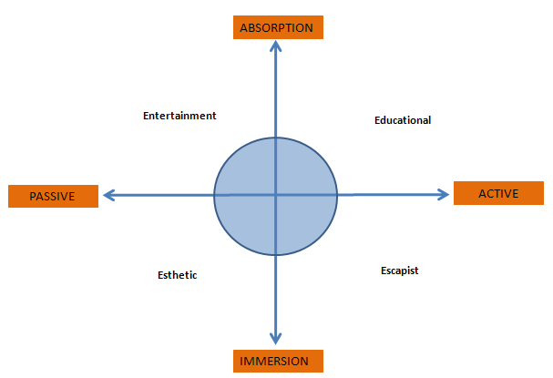
Source: Pine and Gilmore (1999)

According to this depiction, customers can participate in four different kinds of UCEs. Firstly, they can get involved into esthetic experiences, for instance when attending to a museum and observing several art pieces. Secondly, customers can take part in entertaining experiences, which are passively processed through the senses, such as for instance when attending to the circus or to any other kind of performance. Thirdly, we find educational experiences, which imply a higher degree of customer involvement such as in the case of a customer that is being taught about how to use some product inside the store, where some intellectual effort on their behalf is required. To conclude, escapist experiences are without a doubt the more engaging ones; a pretty good example of a truly escapist experience is the one represented by a visit to Disneyland. Deighton (1992) also suggested the idea of marketing as a theater, in which a whole performance is developed entirely with and for the customer; along these lines, the customer is said more to start appreciating and consuming these performances than the goods or services that serve as prompts to that performances.
Harris et al. (2001) also provided some insight into the transformed role of the customer as an active participant in retail settings. They did it by applying a mixture of rules extracted from the epic theater of Bertolt Brecht, who was reluctant to accept the role of the audience as a passive component of the whole theatrical performance and continuously strived for involving the audience up to a point in which it was even encouraged to shape the content of the performance. In the retail environment context, the authors proposed that the customer might be potentially involved in a similar way within the context of the consumption/shopping experience, and established some guidelines to be followed by retail managers on how to better accomplish this task. Baron et al. (2001) pointed out as well at the metaphor of Retail Theater as an innovative marketing approach that emphasizes the role of the customer as an interactive participant in increasingly more engaging store settings. The authors applied four different roles played by modern theater audiences to the role played by customers in retail environments. From their work, it is worth mentioning the following authors´ statement “what appears to be associated with the use of the theater metaphor is the desire to create general effects such as experiences and, in some cases, entertainment for customers”. In the same line, Harris et al. (2003) deepened into the analysis of the retail theater metaphor, and intertwined it with Pine and Gilmore (1999) conceptualization of experiences, taking thus the first step towards a more unified theory of holistic customer experiences. In addition, the research by Stuart and Tax (2004) deserves also a special mention, as the authors empirically researched a real theatrical performance aiming to extract some guidelines that could be potentially applied in retail settings according to the abovementioned retail theater metaphor.
To conclude, Arnould and Price (1993) research on the provision of extraordinary experiences also stated that active customer participation was an essential determinant in order to deliver truly memorable customer experiences and accordingly, our identification of customer participation as one of the main dimensions of UCE seems reasonably consistent with all the authors´ thoughts presented in this section.
  - Unique Additional Offerings (UAO)
The dimension “Unique Additional Offerings” (UAO) refers to everything that goes beyond the core product or service that one can expect to be offered in a given type store (e. g. when entering a shoe store one can expect to encounter shoes but not to be offered a glass of wine or some chocolates; in this manner, the glass of wine and the chocolates are two illustrative examples of an UAO). These unexpected augmented products or services, hopefully, present the potential to end in higher satisfaction scores and in turn, trigger positive word of mouth, reinforce revisit intentions or influence other consumer responses.
Bearing in mind the aforementioned, why should we consider UAOs as one of the dimensions of UCE? First of all, because this kind of special offerings, which are quite “unexpected” and surprising for the customer, can be seen as an enhancer of the whole shopping experience in the sense that their existence is fully endeavored to make a difference for the client. Secondly, because they are reasonably “unique” according to their unusual nature (not commonly found in the competition establishments), representing a pleasant surprise for customers when offered; finally, they are “additional” or extraordinary and so they offer something that goes beyond the core product or service, which will be probably highly appreciated by customers.
A few studies, have lately considered “Surprise” as a marketing tool. To begin with, Vanhamme (2000) firstly explored the emotion of surprise and indicated that this emotion could come out of unexpected or misexpected services or product attributes by the customer. Therefore, focusing on the case we have at hand of UAO, it is easy to notice that the unexpectedness of the experience seems to fit this subject. The author emphasized as well that eliciting positive surprises serve as an amplifier of the desirable customer emotional responses it generates. In this line, more positive emotions will lead to more positive evaluations of the surprising agent such as satisfaction. For instance, Vanhamme and Lindgreen (2001) conducted another exploratory study on the role of surprise in the marketing context, and demonstrated the strong correlation existent between the constructs of surprise and satisfaction. In this line, they highlighted the potential value of surprising customers in order to satisfy them, or at the higher step of the satisfaction ladder, to delight them. This suggestion matches-up with the necessity of reinventing experiences proposed by Pine and Gilmore (1999). They also warned about the updated expectations issue, which refers to the fact that surprised customers would probably increase their expectations toward future encounters with the service providers and so would be more difficult to serve satisfactorily by the company in following visits; it remains essential to bear in mind this concern and to be very cautious about these updated expectations in order to be eventually successful in the provision of surprises and, in our case, UAO. At a later point in time, Vanhamme and Snelders (2001) conducted a pilot experiment to further explore the construct and of surprise in marketing. They discovered that surprise positively influenced customer evaluations of the provider and the product and that within the surprise condition customer appeared more satisfied.
Several authors have examined the antecedents of customer delight (Hines, 1995; Cohen, 1997; Oliver et al., 1997; James and Taylor, 2004; Arnold et al., 2005) and the present study is devoted to discover if offering this kind of UAOs is indeed one of them. Perhaps the most important paper we found on the issue of delight is the one by Oliver et al 1997, in which a combination of pleasure and arousal is determined to result in the intended and desirable customer delight. Interestingly, the UAOs, as we will propose in detail later on in the hypothesized effects of UCEs, will quite likely result in pleasure and arousal, which combined, according to the previous author will probably lead eventually, in the best of the cases to customer delight. Spies et al. (1997) also pointed out at the fact that in-store emotional stimuli should be established at an optimal level. This means that the unexpectedness of physical stimuli should not be too low, for actually get the customer interested but neither too high as it could make customers afraid and overwhelmed as a cause of too many stimuli one at a time. In this line, we propose to fix an optimal level of UAO in the same line for it to achieve the intended objectives and not backfire to the retailer.
To conclude, a load of studies have researched how eliciting certain emotions such as pleasure influence the manifestation of positive consumer responses. This study proposes that UAOs can elicit this type of emotions and consequently have important effects for retailers in terms of desirable consumer behaviors.

- HYPOTHESIS
“If it were not for the questions, ¿where would be the answers?”
Gerald Zaltman

As it has been addressed in the lines above, Unique Customer Experiences (UCEs) consist of three dimensions: store atmosphere, customer participation, and unique additional offerings (UAO). According to this three dimensions, and considering that store atmosphere has been the one most widely explored and that a up to now and that a number of papers have also dealt with the role of the customer as an interactive participant inside the store, the current research will tackle the third dimension identified: Unique Additional Offerings (UAO). Concretely, the present paper will try to discover the effects of offering a beverage in a hairdresser (as a UAO) on WOM and revisit intentions. Furthermore, we posit that these two constructs are probably mediated through satisfaction. In addition, the general importance assigned by customers to all the dimensions of UCE will be explored.
Why offering a beverage in a hairdresser could be considered as a Unique Customer Experience? Pine and Gilmore (1999) noted that “indeed, in most any situation the easiest way to sensorialize a service is adding taste sensations simply by serving food and drink”. According to this suggestion, it seems that offering a beverage in a hairdresser could constitute quite a really good example on how to make the hairdresser experience more engaging in terms of appealing to the senses. In this manner, offering a cup of coffee to the hairdresser customer encloses the potential of stimulating almost all five senses. Firstly and most importantly, it appeals to the taste, which will be clearly stimulated when the customer takes the cup of coffee. Secondly the sense of smell will be stirred up as well by the pleasant aroma released by the coffee. Thirdly, a cup of coffee is also susceptible to induce interpersonal warmth by appealing to the sense of touch; in this line, as proven by Williams and Bargh (2008), when an individual is holding a hot cup of coffee, an unconscious neurobiological reaction occurs that make individuals to better evaluate products and personnel around them, thus influencing overall customer judgments. Finally, it is important to mention that, at least indirectly, sight will also play a role when the customer is staring at the cup of coffee he has just being kindly offered. Thus, it is easy to see that the coffee offering manipulation will be able to appeal to all senses except hearing and thus, it seems to represent an interesting way to successfully create a hairdresser UCE.
In the following lines, the model development and the specific effects hypothesized in this paper will be described more in detail. First of all, the research questions posited earlier in this article could be hypothesized in the line represented in the following conceptual framework:
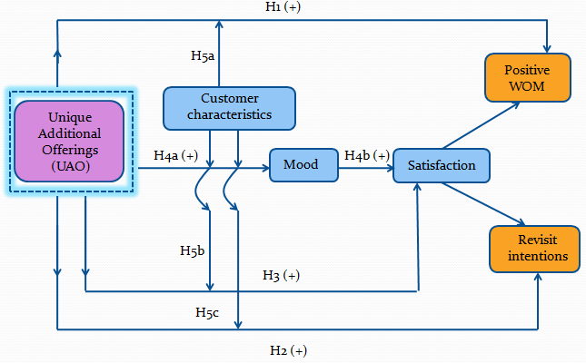
  - Word of mouth
WOM is one of the most essential advertising tools any business can use nowadays. In this line, according to previous research, it seems that any company committed and endeavored to trigger this kind of WOM communications will achieve exceptionally advantageous results in terms of attracting and acquiring new customers. Moreover, as posited by Keller (2007), marketers´ words are not as easily trusted by consumers as before; in this context, opinions and recommendations from closer friends, colleagues or even family seem to be a highly valuable resource in order to influence customers´ purchase and shopping decisions. In addition, Reichheld (2003) determined that for a company to grow, especially in more and more commoditized markets, it is crucial to strive to increase the percentage of promoters (those customers who are very likely to recommend the company). In this way, the author showed that probably the higher measure of loyalty of a customer was the willingness to recommend as it implies for a given customer to jeopardize their own reputation.
Dichter (1966) noted that much research had already shown and made clear that satisfaction lead to WOM after product experience; thus, several previous studies have found and shown a positive link between satisfaction and WOM (Ranaweera and Prabhu, 2003; Brown et al., 2005; Wangenheim and Bayón, 2007; Ladhari, 2007; De Matos and Vargas, 2008).
In addition, Vanhamme and Lindgreen (2001) proposed the use of surprise as a marketing tool and stated the following in relation to WOM: “It is worth thinking thoroughly about how to elicit (positive) surprise. That is, to give a unique experience to the consumers because such surprised consumers might not only be more satisfied and, as a result, repurchase from the company but might also advertise their experience. They might, therefore, convince other consumers - through word-of-mouth – to purchase the product/service with this particular company”. Furthermore, on the supplementary study of surprise, Derbaix and Vanhamme (2003) determined, once more, that eliciting surprise certainly triggered WOM. In this line, considering that providing in-store UCE seems to be, up to some extent, fairly surprising for the customer, we propose that our main construct, UCE could be potentially positively correlated with WOM.
To conclude, it is also interesting to remark that according from the findings of Allsop et al. (2007), which indicated that personal experiences can lead directly to WOM without been necessarily mediated through satisfaction, it could be hypothesized a direct link between UCE and WOM.
In accordance to the studies above, it seems very likely that WOM behaviors will have satisfaction with the product, service or experience as a clear antecedent or determinant of this kind of referral responses. Therefore, we hypothesize:
H1: Consumers exposed to a UAO have a higher propensity to engage in WOM than consumers not exposed to UAO.
  - Revisit intentions
A number of authors have demonstrated an existent direct positive link between satisfaction and repurchase intentions (Oliver, 1980; Mittal and Kamakura, 2001; Yi and La, 2004).
In addition, Donovan and Rossiter (1982) mentioned in their study that proper environment stimuli could result in approach responses such as “likelihood of returning to the store” which supports the idea presented in the current paper of using “revisit intentions” as a potential approach response that could arise when an individual is subjected to certain stimuli inside the store. This relationship between store environment stimuli (one of the mentioned dimensions of UCE) and revisit intentions could be potentially transferred in the environment of the third dimension: unique additional offerings (UAOs). Furthermore, Schouten et al. (2007) study on what they called Transcendent Customer Experience (TCE) also discussed the potential of TCEs (which are said to have a lasting effect in time) to influence consumers’ attitudes and behaviors in the context of Harley Davidson and Jeep´s customers’ participation at brand events. They demonstrate that a halo effect can emerge from experiences as customers, willing to escape from the mundane, enjoy this combination of fantasy and reality and develop positive feelings and attitudes towards the products and individuals that make possible that UCE. The authors also used the repurchase intention question in their study of TCEs (Transcendent Customer Experiences) in order to try to capture customer-brand relationships.
According to the literature mentioned in the lines above, it seems that the link between satisfaction and repurchase or revisit intentions is fairly supported in previous research; thus, we hypothesize:
H2: Consumers exposed to a UAO have higher intentions to revisit the store than consumers not exposed to UAO.
  - Satisfaction
Previous research has shown that satisfaction with a given store, will depend on the gap between previous expectations towards the store performance and actual delivery received by the customer once inside the store; this statement is based on the disconfirmation paradigm which has been widely analyzed in the study of customer satisfaction (Oliver, 1980; Oliver and De Sarbo, 1988; Spreng et al., 1996; Babin and Griffin, 1998).
This general rule, applied in our context, seems to suggest that satisfied or even delighted customers will be those whose previous expectations were surpassed with the actual consumption or shopping experience. In this sense, providing something unexpected to the customer such as UAO, besides surprising, will be very likely to result in higher satisfaction levels according to this theory. Specifically, according to Westbrook and Oliver (1991), pleasant surprise will be one of the possible antecedents of customer delight, which is the highest level of satisfaction assessments. They determined that pleasure elicited by surprise was highly correlated with satisfaction. Their findings could be extrapolated to our case due to the fact that UCE, and more concretely UAO, is fully intended towards the generation of pleasant surprise in the service consumption setting by offering the customer something unusual and unexpected. In addition, Ladhari (2007) findings suggest that both pleasure and arousal (directly associated with the mood construct) are relevant antecedents of satisfaction judgments.
The aforementioned research studies seem to support the idea that eliciting pleasant surprises inside the store leads to an increase in customer satisfaction levels: Accordingly, we propose:
H3: In-store UAO has a positive effect on customer satisfaction.
  - Mood
One of the transient positive emotions that seem to be more relevant within the consumption/shopping experience milieu is the enhancement in mood state. First of all, from Mehrabian and Russel (1974) we know that mood is measured and considered as the emotional response that comes from the store atmosphere stimulus. This idea could be applied also to the provision of unique additional offerings (UAO), our main construct, as they could be clearly considered as stimuli to the individual with the potential of affecting the customer mood state during the consumption/shopping experience. Yalch and Spangenberg (1993) illustrated this fact presenting the following framework (adapted from M-R model) for analyzing the effect of in-store environment stimuli:
Source: Yalch and Spangberg 1993
Additionally, Gardner (1985) presented a critical review focused on the role of mood state as a direct and indirect mediator of consumer behaviors and evaluations. One of the constructs she dealt with is the one of point-of-purchase stimuli, which is the one that the present paper tries to approach. Their study pointed out at the topic of atmospherics, and suggested that according to prior findings, properly managing several store atmosphere cues will lead to improvements in individuals´ mood state. Sherman and Belk (1986), further explored the role of mood in purchasing behaviors and tested the validity of the M-R theoretical framework on the specific field of the point-of-purchase or store environment, therefore extending the study of Donovan and Rossiter (1982). Their findings, once more, sustain that the measure of mood elicited from in-store stimuli interacts with store image perceptions and in turn, ultimately shapes consumer behaviors. Furthermore, Belk and Sherman (1993) drew attention to the importance of enhancing positive moods by retailers in order to induce affiliative or approach behaviors such as an increase in the time and money spent in the store and a higher willingness to return in the future. Their findings support previous studies and verify the crucial role of influencing shoppers’ mood in order to encourage approach responses such as the ones mentioned before. Spies et al (1997) also found that pleasant store environments resulted in higher levels of satisfaction and spending, and that this relation was mediated through changes in individuals´ mood state. The authors also consider essential to bear in mind that under positive mood states, individuals tend to focus more on the affirmative than on the negative aspects of a certain situation and so evaluate the whole more favorably. Their proposed model is showed in the figure below.
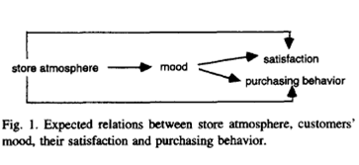
Richins (1997) also posited that the “feel experience” encompasses variation in mood states and emotional responses and so suggests the appropriateness of considering mood as a possible mediator in the relationship between UAO and satisfaction.
Furthermore, Vanhamme (2000) interestingly highlighted the relationship between a positive emotion elicited from surprising the customer and satisfaction judgments. In this context, the surprising effect of finding something unique that is provided within the store (UCE) could equally induce a positive mood state that will eventually lead to satisfaction. Qiu and Yeung (2008) also pointed out that eliciting a positive mood would provoke affective responses that will as a consequence lead to a more favorable evaluation of the store and the products sold in the retail setting. In their research they settled and experiment in which individuals experienced a positive feeling, demonstrating that this definitely affected mood state and in turn product and store evaluation patterns. All the aforementioned research propositions suggest that mood could be probably enhanced when individuals are exposed to UCEs and as a consequence, this transient emotion may be mediating the relationship between UAO and satisfaction. In this line, we propose:
H4a: The provision of in-store UAO will enhance mood state.
A number of marketing research studies have extensively demonstrated and confirmed the role of mood state as a mediator in the relationship between store characteristics or stimuli and satisfaction (Gardner, 1985; Wesbrook and Black, 1985; Westbrook, 1987; Peterson and Wilson, 1992; Spies et al., 1997; Bagozzi et al., 1999), what suggests the probability of finding a link between these constructs. In addition, Dawson et al. (1990) highlighted the potential confounding effects of mood in satisfaction judgments measured at the point of purchase due to the sentimental character of customers’ evaluations in this milieu. Accordingly, it is indicated to control for mood states of the individuals right after the consumption experience.
Consistent with the research findings explained above, we consider a potential mediation effect of mood between UAO and satisfaction and consequently, we hypothesize:
H4b: The enhancement in mood state due to H4a will lead to an increase in customer satisfaction.
  - Customer characteristics
The intrinsic nature of experiences entails that they take place differently in the mind of each individual, as we are all completely different human beings. This fact suggests the necessity of considering certain consumer characteristics as potential moderators in the relationship between UCE and positive WOM or revisit intentions (either directly or indirectly through satisfaction). The possible moderators that will be controlled and accounted for in this study are motivational orientation (i.e. whether a consumer follows a utilitarian or an hedonic orientation), gender, age and education level.
    - Motivational orientation
To begin with, according to previous findings and to the hedonic nature of experiences, it is suspected that people with a goal-oriented shopping approach (utilitarian attitude) could be potentially annoyed by the provision of these UCEs due to the fact that they view shopping more as a task to be completed than as a moment of enjoyment, and as a consequence, they could possibly get irritated by anything that impede them to achieve their objective. This distinction is well supported by literature such as in the cases that follow.
First of all, Tauber (1972) conducted and exploratory research in order to identify the main motives for people to engage in shopping activities. From all the different motives discovered, some apply clearly to the provision of UCE and so suggest that customers with these shopping motives will be more likely to appreciate their provision. In this manner, the main reasons for people to shop that relate to the concept of hedonic consumption are diversion (for example, family or self entertainment), self-gratification (according to the personal utility associated to the shopping process), sensory stimulation (to stimulate the senses, as proposed by the UCE conceptualization, such as manipulating atmospheric cues or being able to freely touch and try all the products in the store) and finally, the seeking of social experiences outside home (e.g. the social experience provided by Starbucks Coffee). Furthermore, Bellenguer and Korgaonkar (1980) devoted special attention to one of the sides of the consumption spectrum: the recreational shopper. At this respect, they posited that according to the conceptualization of the recreational shopper, in-store merchandising and store atmospherics were the most likely effective marketing tools to cater the needs of this kind of shoppers. Thus, recreational shoppers seem very likely to be more sensitive to the development of attractive and exciting environments. Hirschman and Holbrook (1982) also emphasized the relevance of considering hedonic consumption as an important facet of consumption and provided a conceptual framework in order to settle a starting point in this area of consumer research. They conceptualized “hedonic consumption” as “those facets of consumer behavior that relate to the multisensory, fantasy and emotive aspects of product usage experience.” This definition, according to the concept of UCE proposed in this paper, relates almost undoubtedly to the notion of UCEs and so suggests that hedonic shoppers will be probably more likely to be seeking the provision of these UCEs when shopping. Williams et al. (1986) dealt with the recreational/economic shopper distinction as well, and indicated that while the first ones were those for whom shopping was just a means to an end, the others were more open to enjoy and receive pleasure from the shopping experience. The authors further suggested that providing an exciting atmosphere will be more appropriate and desirable for recreational shoppers. Again, their proposition gives support to our approach to UCEs as an interesting strategy to cater these segments interested in delighting themselves in the shopping experience.
Voss et al. (2003) also recognized the value of distinguishing between hedonic and utilitarian shopping attitudes owing to their plain influence in attitudes toward the products or services offered.
Nonetheless, indisputably the most important paper in order to support the potential moderator role of motivational orientation proposed in this dissertation is the one from Kaltcheva and Weitz (2006). These authors discovered that motivational orientation moderated the arousal provoked in individuals by store environment stimuli and as a consequence, only when this motivational orientation was recreational or hedonic, arousal resulted in higher levels of pleasure. Thus, on the opposite, economic or utilitarian shoppers were annoyed and shown to readily reject their exposure to an exciting environment. In other order of things, it is interesting to mention Nelson and Meyvis (2008) recent findings, which showed how the interruption of a hedonic or pleasant experience could actually enhance the whole experience. Thus, important managerial implications can be derived from their findings. For instance, they imply that a retailer providing a demonstration of a massage chair in a store (a possible UCE) could achieve to cause stronger positive feelings elicited from the experience in the customer, if the demonstration is interrupted at several points in time, what will culminate in a higher number of peaks experienced during the exhibition. Their findings therefore apply also to the provision of the proposed UCEs.
In summary, while utilitarian shoppers derive satisfaction from the outcome of completing a task when shopping, the recreational shoppers experience pleasure and joy in the activity of shopping itself and so it seems that they will be probably more opened to the provision of richer UCE.
    - Demographics: gender, age and education level

Individual differences in some demographic variables such as age, gender and education level are thought to potentially moderate the relationship between UCE and satisfaction, positive word of mouth and revisit intentions. For this reason, the present study will control for the possible moderator role of these variables in order to draw more accurate conclusions on the issue. However, the expected moderation effect concerns mainly to the gender. Several authors have previously controlled for demographics in their studies and this fact suggest that perhaps, we are not that mistaken when suggesting that this moderator role could be present; consequently, it was decided to control for it in this research study.

The study by Mittal and Kamakura (2001), for instance, extensively explored the moderation role of customer individual characteristics in their research on the relationship between satisfaction, repurchase intentions and repurchase actual behavior. Thus, they focused on analyzing the moderator role of individual traits or characteristics such as the ones considered in the current paper. Dawson et al. (1990) also controlled for all the different individual characteristics contemplated in this research, finding significant differences regarding shopping motives. Their conclusions serve as a guideline to the present study in order to control for these possible moderators in the model proposed hereby.
- Gender
Could it be expected that either women or men will be more likely to embrace UCE? Indeed, it could be possible to find significant differences according to gender and for this reason, the potential moderator of gender as a moderator between UCE and mood or satisfaction will also be controlled in the study. For instance, Yalch and Spangeberg (1993) found significant differences in the store perceptions depending of the gender of the subjects. Therefore, for their sample, female shoppers seemed to perceive the store as more mature whereas males perceived it more mature when foreground music was played. However, in other respects such as time and money spent shopping, these differences were not significant at all. In addition, Bellenguer and Korgaonkar (1980) found that women represented the highest proportion of recreational shoppers, which are those that, as proposed, seem more likely to enjoy the provision of UCEs and so it could be expected that more favorable responses towards UCE will emanate from women than men.
Mittal and Kamakura (2001) also found higher average satisfaction ratings for women than for men, what once more suggests that being woman or man could be an important fact to be taken into account and controlled in our study.
- Age

Could it be expected that either younger or older people will be more likely to embrace UCE? It is our suspicion that perhaps older people will be less open to the provision of UCEs according to a more traditional mind setting. Thus, it is expected, a priori, that younger people will be more eager to embrace UCE than individuals with older ages.
Several studies have contemplated the role of age as a potential moderator. For instance, Yalch and Spangenberg (1993), in their study about the effects of music, discovered that music preferences were significantly different depending on the age of the subjects. Thus, while younger shoppers favored foreground music, older shoppers (over 50 years) seemed to prefer the background music. Mittal and Kamakura (2001) also found that satisfaction scores in their sample were significantly higher for older than for ages. Chebat J. et al. (2009) also studied the role of age in consumer responses elicited by several scent conditions in a mall setting. Their findings suggest that indeed, age was an important moderator of the consumer behaviors and perceptions caused by the different scent conditions.
- Education
What about education level? Will significant differences appear in the approach to UCEs regarding the education level of the respondents? On one hand it is expected that less educated people will be more likely to process in-store stimuli following the peripheral route (Petty and Cacciopo, 1983), without too much cognitive processing and following heuristic rules, and thus, in turn, could be more likely to appreciate and be affected by the provision of in-store UCEs.
For example, Mittal and Kamakura (2001) findings on educational differences among the individuals observed in the study, which indicated that better educated people (e.g. owning a postgraduate degree) bestowed lower satisfaction rates on product provided performance than less educated customers (high school or less). Applying these finding to the present studies, we could suspect that people in lower education levels will attribute larger satisfaction scores with the experience. In this manner, testing these possible educational differences remains an essential issue to be covered in the present research.
In line with all the aforementioned studies, that have considered, and in most cases confirmed, the role of both motivational orientation and demographics as potential moderators in several relationships between numerous constructs in different settings, we hypothesize the following:
H5a: Customer characteristics (motivational orientation, gender, age and education level) moderate the relationship between UAO and positive WOM.
H5b: Customer characteristics (motivational orientation, gender, age and education level) moderate the relationship between UAO and satisfaction.
H5c: Customer characteristics (motivational orientation, gender, age and education level) moderate the relationship between UAO and revisit intentions.
- METHODOLOGY
“Methodology serves to properly drive reason in seeking the truth in science”

René Descartes
  - Experiment design
A real experiment was conducted in a hairdresser in Madrid (Spain) in order to examine the validity of the set of hypothesis proposed above. This research method based on causality, will try to discover if the provision of UCE truly leads to an increase in the likelihood of customers subjected to the experience for engaging in positive word of mouth communications and intentions to revisit the establishment in the future.
The experiment was conducted with real daily customers of the hairdresser object of this study who happened, casually, to enter the establishment during the days in which the experiment was carried out. Three experimental treatment conditions were analyzed: a “control” group, an “only coffee” group and an “assortment” group. On one hand, the “control” group was exposed to the regular hairdresser service and thus, customers in this group were not offered anything during the visit; in this manner, this group was settled only as a point of reference for testing the hypothesized effects. On the other hand, two different treatment conditions were established; firstly, the “only coffee” group, which was kindly offered a cup of coffee during the service, as a hairdresser courtesy; secondly, the “assortment” group, which was offered not just coffee but rather a wide variety of beverages from which to make a choice (tea, refreshments, juice, etc.). This assortment condition was included fundamentally in order to discover if there was an optimal level of the experience and so if when facing a wider choice of beverages the desired effects of the experience could eventually backfire, mainly due to the increasing complexity and effort that implies for customers to be required to make a difficult choice. In addition, it could occur, especially for loyal customers, that offering too much beyond the core service could make them suspicious about the real intentions of the service provider; thus, these customer could be thinking that perhaps, the additional offering was provided in order to cover a possible core service deficiency.
The experiment took place during the days Tuesday 26th, Thursday 28th and Friday 29th May 2009. Due to its intrinsic nature, and taking into account that the manipulation consisted in that a beverage was offered, possible time of the day effects could be expected (e. g. it could happen that being offered a coffee was better accepted by individuals in the morning than in the evening, when only a reduced group of individuals would probably feel like a coffee). Thus, each of the three treatment conditions (control, only coffee and assortment group) was varied during the three days that the experiment lasted across the three different time frames of the day: morning (10 a.m.-13 p.m.), afternoon (13p.m.-16 p.m.) and evening (18 p.m.-21 p.m.) in order to rule out this possible time of the day effect and control for this extraneous variable. Therefore, data was gathered for each of the experimental groups in each of these different time frames of the day. The total sample consisted of 132 hairdresser customers. Overall, the sample size was fairly distributed among the three group conditions studied.
The data was collected by means of a self-administered questionnaire that was handed in to customers right after paying in the cash desk and thus, when the overall hairdresser experience was already ended. In addition, a mood form was also provided to customers together with the questionnaire.
The own design of the hairdresser, allowed dividing the establishment in two separate sections; one were the customers received the hairdresser service and the other were the customers that had already finished with the service could sit down and complete the questionnaire before leaving the establishment. In this way, the potential contamination of the experiment that could result from the possible hairdresser customers awareness of being analyzed (fact that would obviously alter the responses of the subjects) was overcome thanks to the aforementioned hairdresser design, which permitted that new customers did not notice that they were going to fill in a questionnaire before the arrival of the adequate moment to do it, at the end of the visit.
Furthermore, as a result of running the experiment in a real setting, it was certainly guaranteed that the independent variable under study (the beverage as a form of UCE in a hairdresser) would be most likely the only possible causal explanation due to the fact that the rest of cues of the regular hairdresser service were carried out as usual, and so the only change was the surprising beverage offering on those days.
  - Questionnaire design
The questionnaire consisted in double-page sheet that included questions about the beverage and the experience assorted with some typical satisfaction survey questions. In this manner, customers were told that they were going to fill in a questionnaire in order to help the company to find out how to be able to improve the quality of the hairdresser service and thus, the real purpose of the experiment (to test the effect of the beverage offering on consumer behaviors) was appropriately disguised.
Moreover, a set of items was also presented to the customer aiming to identify the importance and structure of the aforementioned UCE dimensions. The items that correspond to the proposed “Store environment” dimension of UCE were adapted from the identified components of this construct (design, ambient and social cues) by Baker et al 2002.
  - Measures
    - Independent variable

The independent variable was the beverage offering as a form of a simple UCE that could be provided in a hairdresser establishment as it constitutes the construct manipulated in the experiment.

    - Dependent variables

The dependent variables subjected to study are Word of mouth and Revisit intentions. The variable WOM was analyzed with two different questions in order to distinguish between two different portions that characterize this construct: on one hand the “tell about it” part (WOM experience) and on the other hand the “recommend it” part (WOM recommendations). Vanhamme and Snelders (2003) experiment on the use of surprise in marketing employed the “would you recommend” question, and according to the similarities between their research and the present one, it resulted quite appropriate for the case tackled hereby. The likelihood of customers to engage in these distinctive word of mouth behaviors after the hairdresser UCE was measured by means of a five-point Likert scale. On the other hand, the likelihood to revisit was also measured using a five-point Likert scale.
    - Intervening variables

Two possible intervening variables were contemplated in the study: mood and satisfaction. These variables were controlled as they constitute potential influencers that may mediate the results of the experiment treatment on the aforementioned dependent variables. Firstly, customers’ mood was measured by means of the MSF proposed by Peterson and Sauber (1983). This mood scale was also the one used by Vanhamme and Snelders (2001) in their study, and was selected for the current research fundamentally for two reasons. On one hand, because it is simple, straightforward and easy to answer by respondents. On the other hand, owing to the similarities that exist between Vanhamme and Snelders (2001) experiment design and the one we propose hereby.

Secondly, customers’ overall satisfaction was measured by means of a six-point Likert scale that included delight at the top of the satisfaction assessments. This higher level of satisfaction did not come without a reason, but rather responded to the idea, as it is proposed in this paper, that the provision of UCEs will ultimately result in not just an increased customer satisfaction (meeting the expectations) but rather on an exceed of customers’ expectations. In this manner, surpassing customers´ expectations, according to previous literature on the topic of satisfaction is said to encompass the achievement of customer delight.
    - Control variables

Concerning control variables, several demographics (age, gender and education level) and customer motivational orientation when shopping (hedonic vs. utilitarian) were assessed. This was made in order to find possible moderators in the relationship between UCE and the dependent variables and identify any possible confounding effects in the experiment posed by these variables. However, it was thought that concretely gender and motivational orientation could be more likely to have an influence in the experiment results. Demographic questions were presented at the end of the questionnaire due to its intrinsic sensitivity.

Furthermore, with the purpose of testing the potential moderator role of motivational shopping orientation, the hedonic and utilitarian shopping values scale of Babin et al., (1994) was partially used, by selecting one item of the list proposed by these authors to measure each of the two dimensions (hedonic/utilitarian).

- ANALYSIS AND RESULTS
“Looking for differences trains observation... Looking for similarities trains comprehension”

Jorge Wagensberg
  - Sample
The sample is fairly balanced in terms of gender and age for both the whole population and within the different treatment conditions considered in the experiment. Especially compelling is the fact that for a hairdresser service, which is usually mainly dominated by female customers, the proportion of male customers analyzed in the present study is indeed reasonably large (38,6%), which allows to draw valid conclusions to a larger population of individuals. However, concerning education level it is also important to point out that the sample is pretty biased to those owning an university degree, as those individuals represent the majority of the sample studied for all cases (aggregated and within treatment conditions).
  - Manipulation checks
In order to verify the degree of unexpectedness of the beverage offered in the hairdresser for the customers analyzed in the experiment, and therefore demonstrate that indeed the beverage offering resulted successful in surpassing the level of customers’ expectations towards the hairdresser service, a question at this respect was included in the questionnaire. In this line, it is widely established by previous research that the construct of satisfaction can be studied under the so-called disconfirmation paradigm between previous expectations and performance (Oliver 1980, Oliver and De Sarbo 1988, Spreng et al 1996, Babin and Griffin 1998). In this sense, it is possible to state that when customers’ expectations are largely surpassed by the establishment or product performance, this gap will lead to an increase in customers’ satisfaction ratings. According to the aforementioned, the results obtained in this analysis of satisfaction and expectations clearly demonstrate that customers under the different experience treatments (both only coffee and assortment) resulted to be more satisfied (M_{control}=4,75 vs. M_{coffee}=5,02 vs. M_{assortment}=5,32; p=0,004) and that their expectations were visibly more surpassed (M_{control}=3,60 vs. M_{coffee}=4,00 vs. M_{assortment}=4,37; p=0,000) in relation to the control group (very likely due to the beverage offering) and so, we can conclude that UCE was effectively created. In addition, to further check for the unexpectedness of the beverage, question 8 was included with the purpose of finding out if customers anticipated to be offered a beverage when entering the hairdresser establishment among other possible things that could be potentially provided in a hairdresser; the analysis of the results for this question revealed that only two individuals from the total sample of the experiment expected the beverage offering. Hence, all these manipulation checks provide evidence to the fact that offering a beverage in a hairdresser was in fact certainly unexpected by the hairdresser customers. This experience offering, which is something that goes beyond the core service and thus constitutes an augmented product, also resulted, as hypothesized, in considerably higher values of customer satisfaction. Furthermore, question 10 was incorporated in the questionnaire to further analyze if customers really cared about the beverage offering or if, on the contrary, it was nothing outstanding to point out from the hairdresser visit. Frequency analysis for this question revealed that 84, 52% of the customers surveyed felt that the beverage had achieved to make their hairdresser experience more pleasurable and that as a consequence, it indeed had make a difference for them.
In conclusion, findings indicate that the beverage offering had increased customer overall satisfaction, help to surpass their previous expectations of the service and enhanced the global hairdresser experience.
  - Controlling for “time of the day effects”
Due to the fact that in the hairdresser experiment subjects were not selected at random but either depending on their casual visit to the hairdresser in the days the experiment was carried, we decided to investigate if perhaps the moment of the day in which the beverage was offered (morning, afternoon or evening) could actually lead to different results and conclusions in the present study to rule out possible “time of the day effects”. At this respect, according to the data analyzed for testing this issue, we can conclude that it seems that no time of the day effects are present in our experiment as the results were all found insignificant. Therefore, we can state that, in general terms, there are not significant differences across the different times of the day tested in the experiment and so that it does not make a difference in customers’ hairdresser experience the specific time frame of the day in which the beverage was offered.
  - Hypothesis tests
    - Main effects of the experiment
The purpose of the present experiment was to determine if in reality the provision of Unique Additional Offerings (UAO), as a form of UCE in a hairdresser, would result in more positive word of mouth and increase customers revisit intentions as hypothesized before. In order to test this problem statement, ANOVA statistical tests were performed to the data gathered during the experiment. The main results casted by these tests are commented subsequently.
To begin with, it was discovered that in the beverage treatment condition, the likelihood of customers to talk about the hairdresser experience (WOM experience), recommend it (WOM recommendations) and revisit the establishment was higher than in the control group (whose customers had not been offered anything during the hairdresser service). The concrete mean differences were M_{control}=3,79 vs. M_{beverage}=4,38 for WOM experience, M_{control}=4,25 vs. M_{beverage}=4,42 for WOM recommendations and M_{control}=4,58 vs. M_{beverage}=4,67 for Revisit intentions. These findings are well illustrated when looking at figure 1, which presents the mean plots for all three dependent variables for the two groups. Nevertheless, according to the results presented in table 1 below, it is important to remark that these mean differences showed significant results only for the first dependent variable: WOM experience (M_{control}=3,79 < M_{beverage}=4,38, p=.001).
Thus, we conclude that H1a was partially supported for the WOM experience part of the construct of word of mouth (F_{(1,130)} =11,915, p=.001), while rejected for the WOM recommendations according to the insignificant mean differences observed (F_{(1,130)} =1,008, p=.317). Furthermore, H2a was rejected as although mean values for revisit intentions likelihood were higher in the beverage group, the differences were found non-significant as it was mentioned before (F_{(1,130)} =0,457, p=.500).
Table 1
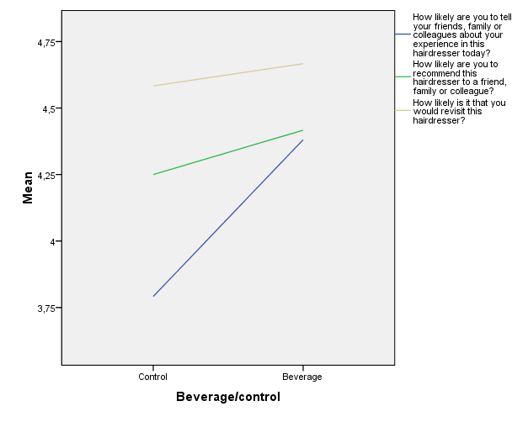
Figure 1

    - Investigating the effects of introducing a wider beverage choice
“To the vast majority of mankind nothing is more agreeable than to escape the need for mental exertion…To most people nothing is more troublesome than the effort of thinking”
James Bryce (The American Commonwealth, 1888)

As it has been proposed earlier in this paper, it was possible to suspect that when subjected to a higher degree of UCE, represented in this experiment by the “assortment” condition, the experience could potentially backfire and consequentially lead to somewhat undesired effects if the hairdresser customers appeared bothered by the necessity of making the mental effort that always implies to make a choice. In this line, we should not forget that individuals due to their bounded rationality (Simon; 1955, 1956) tend to avoid complexity in decision making (López and Blasco, 2008).
At this respect, the results obtained in the experiment showed, on the contrary, that this potential backfire effect did not hold in the hairdresser case; in this way, it was found out that when offered a wider range of beverages, customers actually responded even better to the experiment treatment, increasing their likelihood to talk about (M_{coffee}=4,23 < M_{assortment}=4,42), recommend (M_{coffee}=4,28 < M_{assortment}=4,56), and revisit the establishment (M_{coffee}=4,56 < M_{assortment}=4,78), than in the “only coffee” condition. These results are presented in table 2 and figure 2 below. Nevertheless, it is important to remark that still significant results were found only for the WOM experience variable (F_{(2,129)} =7,112, p=.001).
Table 2
Figure 2
    - Focusing on first time visitors
According to the existent differences between loyal and non-loyal customers service assessments, it was suspected that dissimilar results could be obtained when focusing just on those customers that attended to the hairdresser for the very first time during the days in which the experiment took place. These clients do not have the benchmark of previous experiences in this hairdresser and obviously cannot be already loyal for any reason, what makes their opinion especially precious for the purposes of the present study. In this way, while usual customers already value the hairdresser service for other reasons different than the beverage (as it was never offered to them before), new customers lack a point of reference and thus, will be probably more likely to evaluate all the hairdresser experience cues (including the beverage) more objectively than loyal customers. Therefore, it seems that those new customers will be less biased when judging the hairdresser UCE. The results for this first time visitor analysis are gathered in subsequent table 3 and figure 3:
Table 3
In this case, we find significant effects for WOM experience at the 1% level (F_{(1,17)} =8,421, p=.01) and for WOM recommendations at the 10% level (F_{(1,17)} =3,608, p=.075). On its behalf, Revisit intentions, though still insignificant (F_{(1,17)} =2,386, p=.141), show interestingly a p-value that is closer to the 10% level of significance than when all customers were studied in aggregation earlier in this paper. In this way, the results seem certainly different for the customers that attended to the hairdresser for the first time and without previous expectations (or at least not based on previous experiences in this hairdresser). These customers are more likely to talk about, recommend and perhaps revisit the hairdresser in the future. This finding is in accordance with the results obtained by Yi and La (2004), who discovered that non-loyal customers were the ones more affected by the transient consumption experience and so they were the ones that were more likely to translate the satisfaction produced by the current shopping experience into direct repurchase intentions than loyal customers. In this way, according to them, in theory new customers (non-loyal) could expected to be more impressed with the provision of UCE in the hairdresser than loyal customers (as the latter seem to exhibit more settled and invariable satisfaction patterns), and this is exactly what the results of our hairdresser experiment have revealed.
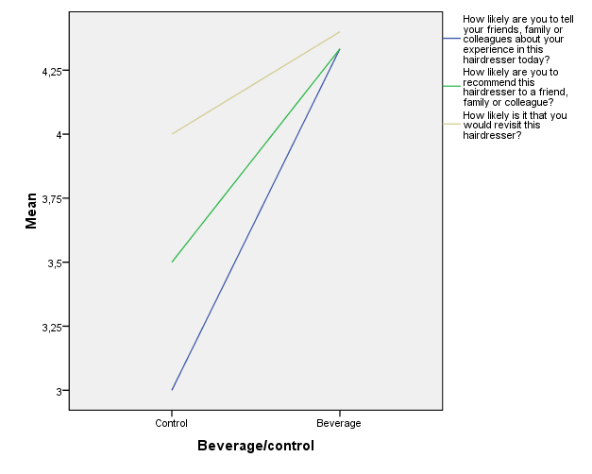
Figure 3

Additionally, it is interesting to point out that when including the third treatment condition of “assortment”, the mean differences between groups are greater than for the whole sample studied in aggregation. However, despite the mean differences reveal that the hairdresser customers respond more favorably when offered a coffee and even more when offered a wider assortment concerning the dependent variables, again only WOM experience shows significant results (F(2,16)=4,803, p=.023). These results are shown in table 4:
Table 4
Figure 4
    - Understanding the underlying process: mood and satisfaction mediation
The methodology proposed by Baron and Kenny (1986) was the one followed in the present study in order to test if mood and satisfaction mediate the effects of UCE on positive WOM and revisit intentions. Thus, regression analyses were conducted for the independent variables (UCE), potential mediators (mood and satisfaction) and the dependent variables (WOM and revisit intentions) in the line proposed by these authors.
To begin with, concerning the main effects of the beverage (UCE), it was found that UCE (as the independent variable) significantly and positively affects overall satisfaction (β=0,417; p=0, 05) and WOM experience (β=0,589; p=0, 01). Nevertheless, the effect of UCE on WOM recommendations and revisit intentions was found, on the contrary, non-significant.
Regarding “mood” mediation analysis, we obtained that UCE indeed significantly affects mood state, leading the beverage offering to improved customer mood states (β=0,510; p=0,000). In addition, mood state was showed to have a direct positive influence in all dependent variables accounted for in the experiment: satisfaction (β=1,338; p=0, 00), WOM experience (β=1,046; p=0, 00), WOM recommendations (β=0,886; p=0, 00) and revisit intentions (β=0,555; p=0, 00). Considering these findings, mediation tests for mood revealed on one hand total mediation between UCE and WOM experience and on the other hand partial mediation between UCE and satisfaction. In this way, it can be stated that UCE affects WOM experience exclusively through mood (β=1,046; p=0,000). Besides, UCE was discovered to affect satisfaction both directly (β=-0,265; p=0,040) and indirectly through mood (β=1,338; p=0,000).
Concerning “satisfaction” mediation analysis, the results showed a complete mediation of this construct between UCE and WOM experience (β=0,621; p=0,050). For the rest of the dependent variables, although no mediation effects in the line suggested by Baron and Kenny (1986) were found, it is crucial to remark that overall satisfaction was discovered to significantly and positively affect both WOM recommendations (β=0,628; p=0,000) and revisit intentions (β=0,229; p=0,016).
According to the aforementioned mediation analysis results it is possible to conclude the following; firstly, H1b was fully supported for the “talk about it” portion of word of mouth, referred in this research as WOM experience. Secondly, for H2b the mediation analysis was found non-significant. However, it is worth mentioning that satisfaction was shown to directly and positively affect revisit intentions. In addition, H3, H4a and H4b were all supported as indicated by the experiment findings presented above.
    - Boundary conditions: gender and motivational orientation moderation
In the context of UCEs, it was expected to find differences among the individuals analyzed in the experiment according to their gender and their motivational orientation when shopping. Thus, this study controlled for both variables in order to find out if indeed these moderation effects took place in a real setting. On one hand, concerning gender, as it has been hypothesized before, it was expected that women would be probably more likely to embrace the provision of UCE than men. On the other hand, due to the intrinsic nature of UCEs and according to previous research on the topic of motivational orientation, it was expected that individuals presenting a more hedonic motivational orientation (focused on the pleasure of shopping) would respond more positively to the provision of UCEs than would do individuals with a more utilitarian orientation (focused on goal attainment), as the latter customers could be potentially annoyed by the experience provision as it could distract or make more difficult for them to achieve their objectives when shopping (to get the task done).
According to the results yielded by the moderation analysis both for gender and motivational orientation it is possible to mention several interesting findings. Firstly, it was found that gender moderated the relationship between UCE and WOM experience at the 10% level (β=-0,577; p=0,099) what indicates that being male or female indeed makes a difference on the likelihood to talk about the experience lived in the hairdresser. Thus, H5a was partially supported for the portion of word of mouth represented by WOM experience in relation to gender. Additionally, concerning the level of surpassed expectations, it was discovered that gender had a direct negative effect on the level of surpassed expectations (β=-0,450; p=0,03). In this way, as females were codified with 1 and males with 0, it is possible to state that women tend to be less surprised for the beverage offering than men. Furthermore, for the moderation analysis of gender on satisfaction and revisit intentions, results were found non-significant in both cases and thus, H5b and H5c were rejected in reference to gender.
On the other hand, pertaining to motivational orientation, several interesting findings were found that partially support the effects hypothesized before on this issue. To begin with, a direct main effect of motivational orientation on satisfaction, WOM experience and level of surpassed expectations was found significant and so although the interaction that would indicate moderation was non-significant, the direct effects partially support H5a and H5b with regard to motivational orientation. These effects, having codified hedonic orientation with 1 and utilitarian orientation with 0, indicates that as hypothesized, individuals seeking hedonism when shopping were found to be more likely to be more satisfied, surprised and talk about the beverage offered in the hairdresser than individuals presenting a more utilitarian orientation towards shopping.
Moreover, another interesting finding in this subject is that motivational orientation appeared to moderate the relationship between UCE and WOM recommendations, indicating that differences exist among hedonic and utilitarian customer when making recommendations of the establishment in which the experience was provided. Thus, H5a was partially supported relating to the moderation of motivational orientation on the portion of word of mouth of WOM recommendations. In addition, moderation analysis of this control variable on revisit intentions appeared non-significant and thus, H5c was also rejected for motivational orientation (as it happened with gender).
Besides the aforementioned results for gender and motivational orientation, age and education level were also controlled in the experiment and thus, moderation analysis were also performed on those control variables. The main findings at this respect were the following: on the side of age, customers younger than 25 years tended to be less likely to talk about it with friends, families or colleagues owing to the beverage offering in the hairdresser and also moderate the relationship between UCE and satisfaction.
Referring to education level, it was discovered that the less educated group tended to be more satisfied with the experience and that individuals owing a high school diploma were less likely to revisit the store when the beverage was offered than the rest of education level groups accounted for in the experiment.
    - Dimensions of UCEs
In order to identify the structure and components of the construct of UCE and to be able to establish the importance given by customers to each of these UCE dimensions, a confirmatory factor analysis was performed to the set of UCE items presented in question 12. The findings indicate that UCE consists indeed of three distinctive dimensions according to the three factors retained in the analysis (the factor selection criteria was taking those factors with eigenvalues > 1 and the KMO value obtained was 0,769). The specific structure of these factors is presented in the table below:
Additionally, according to the results of the experiment in reference to the concrete degree of importance given by customers to each of these conceptualization of UCE potential components, it is possible to establish the following order of importance (under a seven-points Likert scale) by looking at the mean values obtained that are presented in the next table:
Considering the results presented in the table above, it can be concluded that customers what customers value more is the “Employees” dimension together with the opportunity to be taught on how to use the products inside the store. In addition, “Facilities” appeared to be less considerably less important for customers’ evaluations of a certain establishment.
Additionally, the extremely low value showed by the chocolates offered in a shoe store could find its justification in the low fit existent between the core product and the UCE element or perhaps owing to the fact that customers may dislike chocolates or simply do not find them that compelling.

- GENERAL DISCUSSION
“It is better the approximately right than the exactly wrong”

Jorge Wagensberg

Significant differences across groups were found just for the first dependent variable, what is the same as saying that there is just a beverage effect for the variable WOM experience, which refers to the portion of WOM that is related to the “talk about it” and not to the “recommend it” one.
These findings could be justified by arguing that the mean averages presented by the control group for the other two dependent variables (WOM recommendations and Revisit intentions) are already certainly high among the hairdresser customers (4, 58 and 4, 25 respectively in a five-points Likert scale) and so it is difficult, even if the beverage had made an incredible effect, to find significant differences between groups for these two variables. Furthermore, this finding seems pretty reasonable taking into account the fact that the hairdresser of the experiment already accounted with a high loyalty level before the study took place (which affects especially the intentions to revisit the store as it is clear that loyal customers will keep on coming back even without the beverage offering as they have been doing so up to now).
Especially unexpected and intriguing was the finding of a lower likelihood to revisit the store showed by those customers that were offered just a coffee in comparison with those in the control group that were not offered nothing (M_{coffee}=4,56 < M_{control}=4,58). A possible explanation to these results could be that indeed the offering of the beverage could backfire, especially for loyal customers as they could perhaps think that the company is trying to glamour them with the coffee instead of focusing on the core service expected in the hairdresser: a haircut. However, the means difference is certainly small and insignificant and so these results are not in principle a cause for concern for drawing definitive and reliable conclusions on the issue.
In addition, one interesting unexpected finding was that mood state was found to directly and positively influence all dependent variables considered in this study: WOM experience, WOM recommendations and revisit intentions. According to this finding, it can be stated that the provision of the UCE in the hairdresser puts customer in better moods, what evidently, as stated by previous research, will result in desirable consumer responses triggered inside the store.
According to the aforementioned results obtained in this research, it is possible to depict the following model of relationships that hold for the case of UCE tested and presented in this paper:
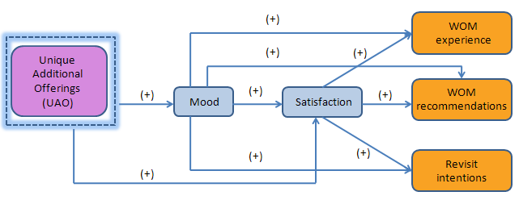
Looking at this depiction, it seems interesting to point out that UCE induces better mood states and higher satisfaction levels. The latter construct appears partially mediated by mood state. In this manner, it is possible to conclude that UCE affects WOM experience, WOM recommendations and Revisit intentions through an increase on mood and/or satisfaction, but not directly, which implies that UAO could be seen as an innovative marketing approach with the potential of inducing better moods and higher satisfaction levels. These effects, eventually could lead to other positive consumer responses such as positive WOM and increase in revisit intentions.
- CONCLUSIONS AND RECOMMENDATIONS
“Science is knowledge that tends to be as much objective, intelligible and dialectical as possible”
Jorge Wagensberg

According to the results obtained in the present research, it seems clear that the provision of UCEs nowadays results quite compelling for almost every business willing to succeed in the long run in a continuously challenging world. In this manner, managers who adequately endeavor to orchestrate these UCEs will find, almost for sure, satisfactorily rewarded their efforts in the form of certainly desirable consumer responses such as a buzz of positive word of mouth that will incessantly attract new customers to the business. Therefore, this study has revealed that providing even a simple UCE such as the one presented hereby (offering a beverage in a hairdresser) will indeed make a difference and will also be highly appreciated by customers, which will be probably willing to pay even a price premium for enjoying experience itself. Consistent with this finding, the current paper suggests that managers will be almost certainly better off by start auditing, exploring and monitoring systematically the customer experience they are currently delivering in order to identify several promising opportunities with the potential of improving and enhancing certain customer feelings and emotions at the POP. The arousal of this positive emotions and feelings will eventually be translated into the desired and intended consumer behaviors.
In addition, it is interesting to make a special point on the increasing opportunities originated from current technological advances and innovations regarding the proposed dimension of customer participation. At this respect, and taking into account the fact that individuals are increasingly getting used to the utilization of a large number of technological innovations such as for instance touch screens or electronic displays located inside the stores, a possible alternative for enabling this customer interaction could be precisely the implementation of this kind of technological devices; according to this, for instance, an idea could be to allow customers to browse and explore the product offer of a given store by themselves, using an electronic device such as the one proposed before and becoming, as a consequence, more widely engaged into the whole shopping task.; it is also important to remark that this action will encompass at the same time, the advantage of saving some of the time employees devote to customer explanations, as they would be indeed delegating this task on them. Concerning the main dimension studied in this research, the inclusion of UAOs as part of the whole business value proposition, it is important to bear in mind that the surprising effect will hold especially for the first customer visit to a particular store.
After this first instance, the UAO will not be unexpected anymore but it will still be delightful and undoubtedly an enhancer of the global experience offered by a given store; this UAO will, hopefully, improve satisfaction assessments when thoughtfully orchestrated and appropriately presented to the customer. However, it is important to point out as well that experiences must be updated, renovated and reinvented from time to time in order to be able to maintain the customer emotionally engaged and interested in what the company is innovatively bringing to the market. Thus, reinventing the UCE will facilitate keeping customers’ suspense, which will probably result in customers willing to return to the establishment that offers the UCE in seeking for new emotional surprises elicited in every visit to the store. In this line, Vanhamme and Lindgreen (2001) also noted that surprises should be changed over time in order to maintain customer expectancy and be able to continuously delight them in following visits. This suggestion matches-up with the established necessity of reinventing experiences proposed by Pine and Gilmore (1999).
The former authors also drew attention to and warned about the updated expectations issue, which refers to the fact that surprised customers would probably increase their expectations toward future encounters with the service providers and as a consequence, would be evidently more difficult to serve satisfactorily by the company in the future; in this sense, it remains essential to bear in mind this concern and to be very cautious about it, in order to be eventually successful in the provision of surprises and in our case UAO as a form of UCE. In addition, as a final caution according to the findings, it is essential for retailers to analyze their target markets and identify if the majority of their customers present a hedonic or utilitarian motivational orientation in order to decide if it is worth to enter in the store experience economy. In many occasions, looking at the kind of product or service offered, it is possible to identify the typology of shoppers’ orientation. However, as it was exemplified at the very beginning of this paper, we propose that even in the case of real utilitarian products such as fish, it is possible to achieve incredible results from the provision of UCEs.
- LIMITATIONS AND FURTHER LINES OF RESEARCH
“Most of the failures come from trying to rush the time of success”
Amado Nervo
  - Limitations
Assuming the potential problems associated with field experiments, the present study might lack internal validity. Furthermore, it is possible to expect a selection bias concerning the fact that subjects in the study were assigned to each of the three experimental conditions on the basis of their casual entrance to the hairdresser during the days in which the experiment took place and thus, were not randomly assigned to each conditions. In this line, it would be possible as well to expect substantial differences regarding demographics or purchasing behavior patterns among the three groups studied, which could have slightly polluted the results of the experiment. However, we have attempted to overcome this problem by means of examining the distribution by age, gender and education level in the three sample groups considered. Nevertheless, the limitations in this context arise mainly from the fact that other possible uncontrolled differences between subjects could be present in the experiment sample. However, it is essential to point out that experimental designs always require to make internal/external validity trade-offs, and that in the case at hand, the hairdresser field experiment is indeed superior in achieving external validity in relation to other potential alternative methodologies which means and implies that the results of the study could be more easily and properly generalized to the whole population than if a laboratory experiment would have been used..
As it was stated before, another possible limitation of the current research is the one represented by selection bias, which could be present if individuals in the sample already presented differences previous to the experiment treatment regarding the dependent variables considered in the study.
To conclude, an additional limitation that could be eventually argued is the impossibility of the present research, fundamentally owing to economic and time constraints, to create and test the effects of providing a more holistic and compelling experience, going beyond a simple beverage offering to a more complete set of experience cues (e. g. snacks or chocolates), which would have resulted in a more comprehensive approach to the effects of in-store UCEs. Nonetheless, it should be mentioned that this fact poses an opportunity and leaves the door open to further researchers aiming to go deeper in the investigation of the consequences that come along with the provision of these unique customer experiences.
  - Further Lines of Research
According to the outcomes of the hairdresser experiment, different results could be expected for the provision of UCEs in the context of a more utilitarian product such as for instance, a shoe store; especially compelling for further researchers would be to extend the findings of the current study in the milieu of a product or service that did not serve to enhance one´s image, as it happened for the case of the hairdresser service investigated in this paper. The reasoning behind this idea is that it seems logical that when the core offering has the potential to change or affect someone´s image it is less likely to expect an individual jeopardizing his own reputation and recommending the establishment to a friend relying merely on a beverage offering or other additional experience cue. In this sense, the core service (a haircut) still remains extremely important for customers when making recommendations to friends or colleagues and the beverage is regarded as definitely less important concerning the concrete decision of recommending the establishment. In the same line, to revisit a hairdresser where the haircut is not extremely satisfactory just for having been offered a beverage during the service does not seem very likely to occur. All the aforementioned together suggests the importance for further researchers attracted by the topic of UCEs, to investigate more in depth its possible consequences in a different setting (especially in a more utilitarian one).
In addition, it is also possible to further explore the issue of UCEs by using larger and more fairly distributed samples concerning education level in order to overcome the bias of the present study to those individuals holding a university degree, as they represent the majority of the sample for all treatment conditions in the hairdresser experiment.
Furthermore, a wide field of possibilities exists in order to investigate other potential consequences from the provision of UCEs different from the ones presented here, owing to the scarce empirical research focused on this issue that we can find at the present time. In this way, other dependent variables could be subjected to analysis by further researchers willing to make a contribution to the study of these emergent unique consumer experiences.
To conclude, it is important to remark that customer experiences can occur everywhere (not just inside the store as it was the focus of the present paper), and so there is still plenty space for future research to analyze the consequences of UCEs in different contexts such as for instance the online channel. Regarding this channel, it could be argued that experiences can take place for example when mass customization systems are offered to customers allowing them to take place in the collaborative experience of designing a customized computer (e.g. Dell computers) or a personal pair of glasses, which will be designed by the customer to exactly fit his needs and face (e.g. Paris Miki).
- MANAGERIAL IMPLICATIONS
“Individuals tend to codify the expected results of a certain decision in the way that makes them happier”
Richard Thaler
The main intent of the present paper was to encourage present and future managers to approach and increasingly think about their businesses in terms experiences. Once this step is taken, the design of businesses in a way that allowed for the creation of such UCEs will probably pay off in the future in the form of significant business improvements (e.g. increases in overall customer satisfaction ratings, a buzz of WOM attracting new customers and hopefully, a reinforce in customer repurchase or revisit intentions; the latter will apply especially for non-loyal customers that still lack a reason to come back). All these outcomes are undoubtedly quite desirable for any company in almost any business nowadays, and as a consequence, retailers committed to design and provide these in-store UCEs will be offering a value proposition that will permit to overcome the market challenges of today´s world. These challenges are namely the high degree of markets´ maturity (which are progressively becoming more commoditized), an increasing number of customers choosing the online channel when shopping, and to conclude, the most recent challenge to add up to the list: the unfavorable current economic crisis. In a nutshell, the main goal of this paper has been trying to draw today´s business managers’ attention to the unleveraged and unexploited potential that encloses the provision of in-store UCEs at the present time, and to demonstrate the desirable consumer behaviors that could be potentially unleashed by this innovative and emergent experiential marketing approach to retail environments design.

ACKNOWLEDGEMENTS

This research study would not have been possible without the support and encouragement of my supervisor Carlos Lourenço, who I would like to specially thank for several invaluable and insightful comments into the topic of UCEs.

In addition I would like to thank my mother for having arranged the hairdresser setting where the experiment finally took place and to conclude to my father, for giving me the inspiration of seeking perfectionism in life.

CITED REFERENCES
Alba, J., J. Lynch, B. Weitz, C. Janiszewski, R. Lutz, A. Sawyer and S. Wood (1997) “Interactive Home Shopping: Consumer, Retailer, and Manufacturer Incentives to Participate in Electronic Marketplaces” Journal of Marketing 61, 38-53.
Ali-Knight, J. and L. Pitt (2001) "Attract, engage and entertain: wine as an experience!" in Chetty, S., Collins, B. (Eds), Conference Proceedings, Australian and New Zealand Marketing Academy Conference, Massey University, New Zealand, Vol. 1-5 December.
Allsop, D. T., B. R. Basset and J. A. Hoskins (2007) “Word-of-mouth research: Principles and Applications”. Journal of Advertising Research 34, 398-411.
Areni, C. S. and D. Kim (1993) “The Influence of Background Music on Shopping Behavior: Classical Versus Top-Forty Music in a Wine Store”. Advances in Consumer Research 20 336–340.
Areni, C. S. and D. Kim (1994) “The Influence of In-Store Lighting on Consumers’ Examination of Merchandise in a Wine Store” International Journal of Research in Marketing 11, 117–125.
Arnold, M. J., K. E. Reynolds, N. Ponder and J. E. Lueg (2005), “Customer delight in a retail context: investigating delightful and terrible shopping experiences”. Journal of Business Research 58, 1132-1145.
Arnould, E. J. and L. L. Price (1993), “River magic: Extraordinary experience and the extended service encounter”. Journal of Consumer Research 20, 24–45.
Babin, B.J. and M. Griffin (1998) “The nature of satisfaction: an updated examination and analysis”. Journal of Business Research 41, 127-136.
Babin, B.J., W. R. Darden and M. Griffin (1994) “Work and/or Fun: Measuring Hedonic and Utilitarian Shopping Value”. Journal of Consumer Research 20, 644-656.
Bagozzi, R. P., M. Gopinath and U. N. Prashanth (1999) “The role of emotions in marketing”. Journal of the Academy of Marketing Science 27, 184-206.
Baker, J. (1986) "The Role of the Environment in Marketing Services: The Consumer Perspective". The Services Challenge: Integrating for Competitive Advantage. Chicago: American Marketing Association.
Baker, J., D. Grewal and M. Levy (1992) “An experimental approach to making store environmental decisions” Journal of Retailing 68, 445-460.
Baker, J., D. Grewal and A. Parasuraman (1994) “The Influence of Store Environment on Quality Interferences and Store Image” Journal of the Academy of Marketing Science 22, 328-339.
Baker, J., A. Parasuraman, D. Grewal and G. B. Voss (2002) “The Influence of Multiple Store Environment Cues on Perceived Merchandise Value and Patronage Intentions” Journal of Marketing 66, 120-141.
Baron, R. M. and D. A. Kenny (1986) “The moderator-mediator valuable distinction in social psychological research: conceptual, strategic and statistical considerations” Journal of Personality and Social Psychology 51, 1173-1182.
Baron, S., K. Harris and R. Harris (2001) “Retail theater: the intended effect of the performance” Journal of Service Research 4, 102-117.
Bellenguer, D. N. and P. K. Korgaonkar (1980) “Profiling the recreational shopper”. Journal of Retailing 56, 77-92.
Bellizzi, J. A. and R. E. Hite (1992) “Environmental Color, Consumer Feelings, and Purchase Likelihood” Psychology and Marketing 9, 347–363.
Bellizzi, J. A., A. E. Crowley and R. W. Hasty (1983) “The Effects of Color in Store Design”. Journal of Retailing 59, 21–45.
Berry, L. L., L. P. Carbone and S. H. Haeckel (2002) “Managing the total customer experience” MIT Sloan Management Review 2, 85-89.
Beverland, Michael, E. A. C. Lim, Michael Morrison and Milé Terziovski, (2006) “In-store music and consumer–brand relationships: Relational transformation following experiences of (mis)fit” Journal of Business Research 59, 982–989.
Brakus, J. J., B. H. Schmitt and L. Zarantonello (2009) “Brand Experience: What Is It? How Is It Measured? Does It Affect Loyalty?” Journal of Marketing 73, 52-68.
Brown, T.J., T. E. Barry, and P. A. Dacin (2005) “Spreading the Word: Investigating Antecedents of Consumers' Positive Word-of-Mouth Intentions and Behaviors in a Retailing Context” Journal of the Academy of Marketing Science, 33, 123-138.
Carbone, L. P. and S. H. Haeckel (2002) “Engineering Customer Experiences” Marketing Management 3, 9-19.
Chebat, J. C. and L. Dubé (2000) “Evolution and Challenges Facing Retail Atmospherics: The Apprentice Sorcerer Is Dying” Journal of Business Research 49, 89–90.
Chebat, J. C. and R. Michon (2003) “Impact of ambient odors on mall shoppers’ emotions, cognition and spending: A test of competitive causal theories”. Journal of Business Research 56, 529-539.
Chebat, J. C, M. Morrin and D. R. Chebat (2009) “Does Age Attenuate the Impact of Pleasant Ambient Scent on Consumer Response?” Environment and Behavior 41, 258-267.
Cohen, Barry (1997) “The WOW effect: How one restaurateur continues to delight customers” Cornell Hotel and Restaurant Administration Quarterly 38, 74–81.
Crowley, A. (1993) “The Two-Dimensional Impact of Color on Shopping”. Marketing Letters 4, 59-69.
Csikszentmihalyi, M. (1975) “Beyond boredom and anxiety: The experience of play in work and games”. San Francisco, Calif.: Jossey-Bass.
Damasio, A. (1994) “El error de Descartes”. Ed. Crítica, Barcelona.
Dawson, S., P. H. Bloch and N. M. Ridgway (1990) “Shopping Motives, Emotional States, and Retail Outcomes”. Journal of Retailing 66, 408–427.
De Matos, C. A. and C.A. Vargas (2008) “Word-of-mouth communications in marketing: a meta-analytic review of the antecedents and moderators” Journal of the Academy of Marketing Science, 36, 578-596.
Deighton, J. (1992) "The Consumption of Performance" Journal of Consumer Research 19, 362-372.
Derbaix, C., and J. Vanhamme (2003) “Inducing word-of-mouth by eliciting surprise: a pilot investigation”. Journal of Economic Psychology 24, 99–116.
Dichter, E. (1966), “How word-of-mouth advertising works” Harvard Business Review 44, 147-160.
Donovan, R. J., and Rossiter, J. R. (1982) “Store Atmosphere: An Environmental Psychology Approach”. Journal of Retailing 58, 34–57.
Donovan, R. J., J. R. Rossiter, G. Marcoolyn and A. Nesdale (1994), “Store atmosphere and purchasing behavior” Journal of Retailing 70, 283-294.
Fiore, A. M., X. Yah and E. Yoh (2000) “Effects of a product display and environmental fragrancing on approach responses and pleasurable experiences”. Psychology & Marketing 17, 27-54.
Gardner, M. P. (1985) “Mood states and consumer behavior: a critical review” Journal of Consumer Research, 12, 281-300.
Harris, K., R. Harris and S. Baron (2001), "Customer participation in retail service: lessons from Brecht". International Journal of Retail & Distribution Management 29, 359-69.
Harris, R., K. Harris and S. Baron (2003), "Theatrical service experiences: Dramatic script development with employees". International Journal of Service Industry Management 14, 184-199.
Hines, J. (1995), "Delight makes the difference: The story of AT&T Universal Card” The TQM Magazine 7, 6-11.
Hirsch, A. R. (1995) “Effects of Ambient Odors on Slot-Machine Usage in a Las Vegas Casino”. Psychology & Marketing 12, 585-594.
Hirschman, E. (1984) "Experience Seeking: A Subjectivist Perspective of Consumption" Journal of Business Research 12, 115-136.
Hirschman, E. C. and M. B. Holbrook (1982) “Hedonic Consumption: Emerging Concepts, Methods and Propositions”. Journal of Marketing 46, 92-101.
Holbrook, M. B. and E. Hirschman (1982) "The Experiential Aspects of Consumption: Consumer Fantasies, Feelings, and Fun," Journal of Consumer Research 9, 132-140.
James, Y. and S. Taylor (2004) “Delight-As-Magic: Refining the Conceptual Domain of Customer Delight”. Advances in Consumer Research 31, 259–282.
Joy, A. and J. F. Sherry Jr. (2003) “Speaking of Art as Embodied Imagination: A Multisensory Approach to Understanding Aesthetic Experience”. Journal of Consumer Research 20, 259–282.
Kaltcheva, V. D. and B. A. Weitz (2006), “When should a retailer create an exciting store environment?”. Journal of marketing, 70, 107-118.
Kellaris, J. J. and R. J. Kent (1992) “The influence of music on consumers´temporal perceptions: Does time fly when you´re having fun? Journal of Consumer Psychology 4, 365-376.
Kellaris, J. J. and R. J. Kent (1994) “An exploratory investigation of responses elicited by music varying in tempo, tonality and texture” Journal of Consumer Psychology 4, 381-401.
Keller, E. (2007) “Unleashing the power of word of mouth: creating brand advocacy to drive growth” Journal of Advertising Research, 47, 448-452.
Kotler, P. (1973)"Atmospherics as a marketing tool". Journal of Retailing 49, 48-64.
Kwortnik Jr., R.J. and W. T. Ross Jr. (2007) "The role of positive emotions in experiential decisions". International Journal of Research in Marketing 24, 324-335.
Ladhari, R. (2007) “The effect of consumption emotions on satisfaction and word-of-mouth communications”. Psychology & Marketing 24, 1085–1108.
Laski, M. (1962) “Ecstasy: A study of some secular and religious experiences”. Bloomington: Indiana University Press.
López, F. and F. Blasco (2008) "Cuentas mentales en la toma de decisiones de los consumidores”. Harvard Deusto Marketing & Ventas 87, 6-11.
Mehrabian, A. and J. A. Russell (1974) “An Approach to Environmental Psychology”. MIT Press, Cambridge, MA.
Milliman, R. E. (1982) “Using Background Music to Affect the Behavior of Supermarket Shoppers” Journal of Marketing 46, 86–91.
Milliman, R. E. (1986) “The Influence of Background Music on the Behavior of Restaurant Patrons” Journal of Consumer Research 13, 286–289.
Mitchell, D. J., B. E. Kahn and S. C. Knasko (1995) “There’s something in the Air: Effects of Congruent or Incongruent Ambient Odor on Consumer Decision Making”. Journal of Consumer Research 22, 229–238.
Mittal, V. and W. A. Kamakura (2001), “Satisfaction, Repurchase Intent, and Repurchase Behavior: Investigating the Moderating Effect of Customer Characteristics” Journal of Marketing Research, 38, 131-142.
Nelson, L. D. and T. Meyvis (2008), “Interrupted consumption: Adaptation and the disruption of hedonic experience”. Journal of Marketing Research 45, 654-664.
O'Connell, P. (2006) “Taking the measure of mood”. Harvard Business Review 84, 25-26.
Oliver, R. L. (1980), “A Cognitive Model of the Antecedents and Consequences of Satisfaction Decisions” Journal of Marketing Research, 17, 460-469.
Oliver, R. L. and W. S. de Sarbo (1988) “Response determinants in satisfaction judgments”. The Journal of Consumer Research 14, 495-507.
Oliver, R. L, R. T. Rust and S. Varki (1997) “Customer delight: foundations, findings, and managerial insight”. Journal of Retailing 73, 311– 336.
Park, Ch. and Y. Kim (2003) “Identifying key factors affecting consumer purchase behavior in an online shopping context”. International Journal of Retail and Distribution Management 31, 16-29.
Peterson, R. A. and M. Sauber (1983), "A Mood Scale for Survey Research." In AMA Educators' Proceedings, pp. 409-414, Ed. Patrick B. Murphy, et al. Chicago: American Marketing Association.
Peterson, R. A. and W. R. Wilson (1992) “Measuring customer satisfaction: Fact and artifact” Journal of the Academy of Marketing Science, 20, 61-71.
Petty, R. E. and J. T. Cacioppo (1983) “Central and peripheral routes to persuasion: Application to advertising”. In L. Percy & A. Woodside Ed. Advertising and consumer psychology 3-23.
Pine II, B. J. and J. H. Gilmore (1998) “Welcome to the experience economy”. Harvard Business Review 76, 97–105.
Pine II, B. J. and J. H. Gilmore (1999) “The Experience Economy: Work Is Theatre and Every Business a Stage”. Cambridge, MA: Harvard Business School Press.
Privette, G. (1983) “Peak experience, peak performance, and flow: A comparative analysis of positive human experiences”. Journal of Personality and Social Psychology 45, 1361–1368.
Qiu, C. and C. W. M. Yeung (2008) “Mood and comparative judgment: Does mood influence everything and finally nothing?”. Journal of Consumer Research 34, 27-40.
Ranaweera, C. and J. Prabhu (2003,) “On the relative importance of customer satisfaction and trust as determinants of customer retention and positive word of mouth”. Journal of Targeting, Measurement and Analysis for Marketing, 12, 82–90.
Reichheld, F. E. (2003) "The One Number You Need to Grow" Harvard Business Review 81, 12, 46-54.
Richins, M. L. (1997) “Measuring Emotions in the Consumption Experience”. Journal of Consumer Research 24, 127–46.
Rives, R. (2009) “La pescadería pedagógica” [http://www.elpais.com/solotexto /articulo.html?xref=20090604elpmad_12&type=Tes&anchor=elpepiespmad].
Schmitt, B. H. (1999) “Experiential Marketing” Journal of Marketing Management 15, 53-67.
Schouten, J. W., J. H. McAlexander and H. F. Koenig (2007) “Transcendent customer experience and brand community”. Journal of the Academy of Marketing Science 35, 357-368.
Sherman, E. and R. S. Belk (1986) "Mood States of Shoppers and Store Image: Promising Interactions and Possible Behavioral Effects". In Advances in Consumer Research, 13, Richard J. Lutz (ed.). Provo, UT: Association for Consumer Research.
Simon, H. A. (1955) “A behavioral model of rational choice” Quarterly Journal of Economics 69, 99-118.
Simon, H. A. (1956) “Rational choice and the structure of the environment”. Psychological Review 63, 129-138.
Smith, P. C. and R. Curnow (1966) “Arousal Hypothesis” and the Effects of Music on Purchasing Behavior” Journal of Applied Psychology 50, 255-256.
Smith, S. (2002) “Managing the customer experience: turning customers into advocates” FT Press.
Spangenberg, E. R., A. E. Crowley and P. W. Henderson (1996) “Improving the Store Environment: Do Olfactory Cues Affect Evaluations and Behavior?” Journal of Marketing 60, 67-80.
Spies, K., F. Hesse and K. Loesch (1997) “Store atmosphere, mood and purchasing behavior”. International Journal of Research in Marketing 14, 1-17.
Spreng, R. A., S. B. MacKenzie, R. W. Olshavsky (1996), “A reexamination of the determinants of consumer satisfaction” Journal of Marketing, 60, 15-32.
Stuart, F. I. and S. Tax (2004) “Towards an integrative approach to designing service experiences. Lessons learned from the theater”. Journal of Operations Management 22, 609-627.
Summers, T. A. and Paulette R. Hebert (2001) “Shedding some light on store atmospherics Influence of illumination on consumer behavior”. Journal of Business Research 54, 145– 150.
Tauber, E. M. (1972) “Why Do People Shop?”. Journal of Marketing 36, 46-49.
Vanhamme, J. (2000) “The Link between Surprise and Satisfaction: An Exploratory Research on how best to Measure Surprise”. Journal of Marketing Management 16, 565-582.
Vanhamme, J. and A. Lindgreen (2001), “Surprise as a marketing tool?”. Proceedings of the Australia and New Zealand Marketing Academy Conference. 3-5 December, Massey University, Albany Campus, Auckland.
Vanhamme, J. and D. Snelders (2001) "The role of surprise in satisfaction judgments". Journal of Consumer Satisfaction, Dissatisfaction and complaining Behavior 14, 27-45.
Voss, K. E., E. R. Spangenberg and B. Grohmann (2003) “Measuring the hedonic and utilitarian dimensions of consumer attitudes”. Journal of Marketing Research 40, 310-320.
Wangenheim , F. and T. Bayón (2007) “The chain from customer satisfaction via word-of-mouth referrals to new customer acquisition” Journal of the Academy of Marketing Science, 35, 233–249.
Westbrook, R. A. (1987) "Product/Consumption-Based Affective Responses and Postpurchase Processes". Journal of Marketing Research, 24, 258-270.
Westbrook, R. A. and R. L. Oliver (1991) “The Dimensionality of Consumption Emotion Patterns and Consumer Satisfaction”. Journal of Consumer Research 18, 84-91.
Westbrook, R. A., and W. C. Black (1985) “A Motivation-based shopper typology” Journal of Retailing 61, 78-103.
Williams, T., M. Slama and J. Rogers (1986) “Behavioral characteristics of the recreational shopper and implications for retail management” Journal of the Academy of Marketing Science, 13, 307-316.
Williams, L. E. and J. A. Bargh (2008) “Experiencing Physical Warmth promotes Interpersonal Warmth”. Science 322, 606-607.
Wolfingbarger, M. and M. C. Gilly (2001) “Shopping online for freedom, control, and fun”. California Management Review 43, 34-55.
Yalch, R. and E. Spangenberg (1990) “Effects of Store Music on Shopping Behavior”. Journal of Consumer Marketing 7, 55–63.
Yalch, R. and E. Spangenberg (1993) “Using Store Music for Retail Zoning: A Field Experiment” Advances in Consumer Research 20, 632–636.
Yi, Y. and S. La (2004) “What influences the relationship between customer satisfaction and repurchase intention? Investigating the effects of adjusted expectations and customer loyalty”. Psychology & Marketing, 21, 351-373.

OTHER REFERENCES

Fields, Andy (2009) “Discovering Statistics using SPSS” In Sage Publications, 2nd ed.
Bearden, William O., Richard G. Netemeyer and Mary F. Mobley (1999) “Handbook of marketing scales: multi-item measures for marketing and consumer behavior research” 2nd ed. Sage publications.
Bruner II, G. (1990) “Music, mood and marketing” Journal of Marketing 54, 94-100.
Haeckel, S. H., L. P. Carbone and L. L. Berry (2003) “How to lead the customer experience” Marketing Management 15, 18-23.

Joseph Pine “talk” [available at www.TED.com]
Kellog, D. L. (1997), “On the relationship between customer participation and satisfaction: two frameworks” International Journal of Service Industry Management 8, 206-219.
Goodstein, R. C. (1994), “Mood effects in consumer behavior: A unifying theme” Advances in consumer research 21, 526-529.
Meyer, C. and A. Schwager (2007) “Understanding Customer Experience” Harvard Business Review, 14, 1-11.
Swinyard, W. R. (1993) “The Effects of Mood, Involvement, and Quality of Store Experience on Shopping Intentions” Journal of Consumer Research, 20, 271-280.
Vanhamme, J. (2000), “The Link between Surprise and Satisfaction: An Exploratory Research on how best to Measure Surprise” Journal of Marketing Management 16, 565-582.

APPENDIX

1. Differences among economic offerings
2. Real examples of UCEs
3. Critical review on Atmospherics research
4. Customer roles (Baron et al. 2001)
5. Picture hairdresser of the experiment
6. Sample distribution
7. SPSS Outputs
8. Mood Short Form (MSF)
9. Questionnaire (English)
10. Questionnaire (Spanish)

APPENDIX 1: Differences among economic offerings

APPENDIX 2: Real examples of UCEs
APPENDIX 3: Critical review on Atmospherics research

APPENDIX 4: Customer roles (Baron et al. 2001)

APPENDIX 5: Picture of the hairdresser of the experiment

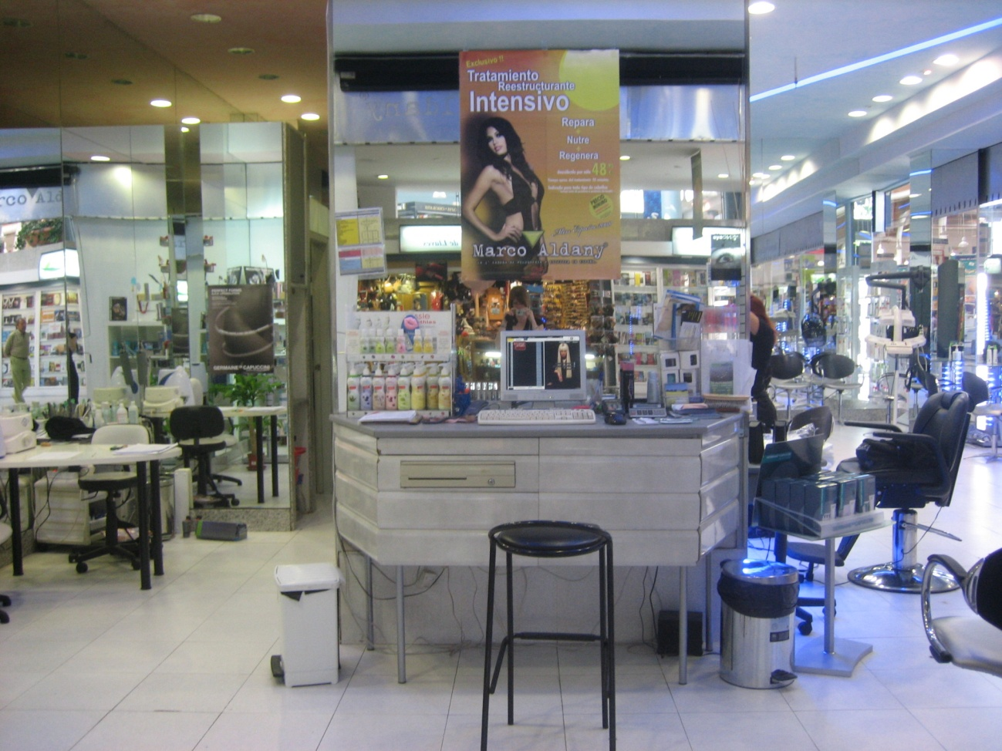

APPENDIX 6: Sample distribution

APPENDIX 7: SPSS OUTPUTS
- Control for “time of the day effects”
- Mood mediation analyses
- Satisfaction mediation analyses
- Moderation analyses
- Factor analysis

- Control for “time of the day effects”
- Mood mediation analyses
- The beverage significantly affects mood state.
- Mood state has a direct positive effect on all dependent variables.
- Satisfaction
- WOM experience

- WOM recommendations
- Revisit intentions
- Total mood mediation between UCE and WOM experience
1st step
Beverage affects WOM experience (β=0,589; p=0,001).
2nd step
Beverage affects mood (β=0,510; p=0,000).
3rd step
Introducing mood in the regression renders beverage insignificant for explaining WOM experience, what indicates total mediation.
- Partial mood mediation between UCE and satisfaction
1st step
Beverage affects Overall satisfaction (β=0,417; p=0,05).
2nd step
Beverage affects mood (β=0,510; p=0,000).
3rd step
When introducing mood in the regression, the beverage is still significant in explaining overall satisfaction.

- Satisfaction mediation analyses
- Total satisfaction mediation between UCE and WOM experience.
1st step
Beverage affects WOM experience (β=0,589; p=0,01).
2nd step
Beverage affects overall satisfaction (β=0,417; p=0,05).
3rd step
Introducing overall satisfaction in the regression renders beverage insignificant for explaining WOM experience, what indicates total mediation.
- Overall satisfaction has a direct positive effect on WOM recommendations and Revisit intentions.
- WOM recommendations
- Revisit intentions
- Moderation analyses
- Gender
- WOM experience
- Level of surpassed expectations
- Motivational orientation
- Satisfaction
- WOM experience
- Level of surpassed expectations

- WOM recommendations
- Age
- WOM experience
- Education level
- Satisfaction
- Revisit intentions

- Factor analysis

APPENDIX 8: Mood Short Form (MSF)
- English version

- Spanish version

APPENDIX 9: Questionnaire (English)

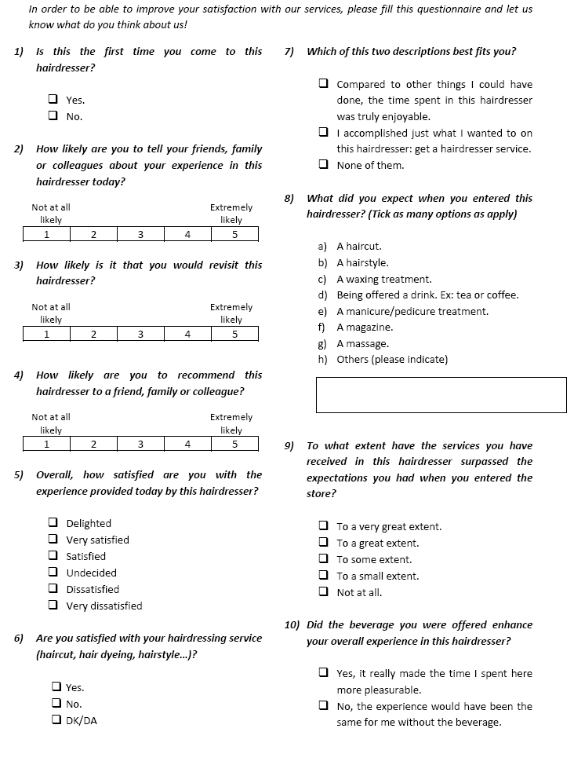

APPENDIX 10: Questionnaire (Spanish)
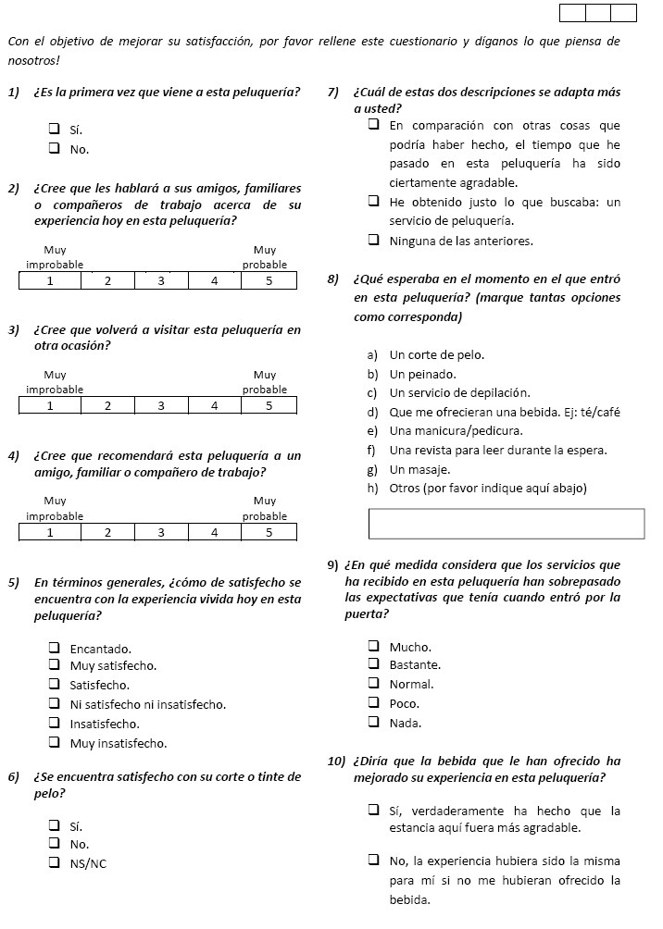

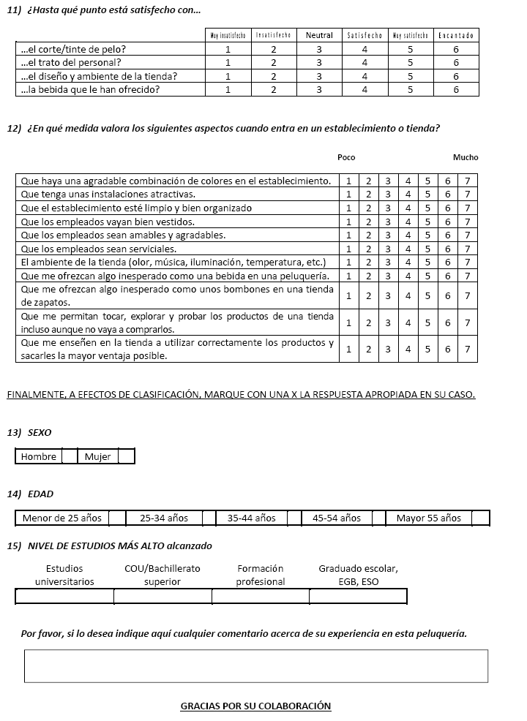

A table presenting the main differences among these economic offerings is presented in appendix 1.
Other additional examples of UCEs are accessible in the appendix section.
A critical review on the findings of these studies is available in the appendix section.
A number of real life examples of retail theatre are also collected in appendix 1.
The four customer roles are presented in the appendix section.
Goodstein (1994) presents an integrated critical review on the study of the relationship between mood and consumer behavior.
The concrete percentages are showed in a table in the appendix section.
A picture of the hairdresser object of study is available in the appendix section.
The two versions of the questionnaire (English and Spanish) are available in the appendix section.
The set of questions that gathers the UCE dimensions proposed is presented in question 12.
This dependent variable was measured in questions 2 and 4 of the questionnaire.
This dependent variable was measured in question 3 of the questionnaire.
The MSF mood scale is available in the appendix section.
Customer delight is measured in question 9 of the questionnaire.
Demographic questions are presented in questions 13, 14 and 15 of the questionnaire.
The items selected are presented in question 7 of the questionnaire.
All these demographic distributions are accessible in the appendix section.
Question 9 gathers the level of surpassed expectations.
The F-values and p-values associated are presented in the appendix section.
The SPSS outputs related to this “time of the day effect” test are showed in the appendix section.
The SPSS outputs are reported in detail in the appendix section.
The SPSS outputs are reported in detail in the appendix section.
The SPSS outputs are reported in detail in the appendix section.
The SPSS outputs are reported in detail in the appendix section.

