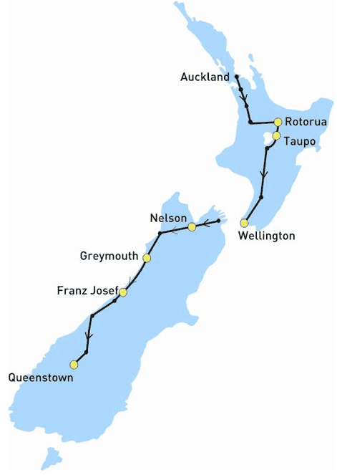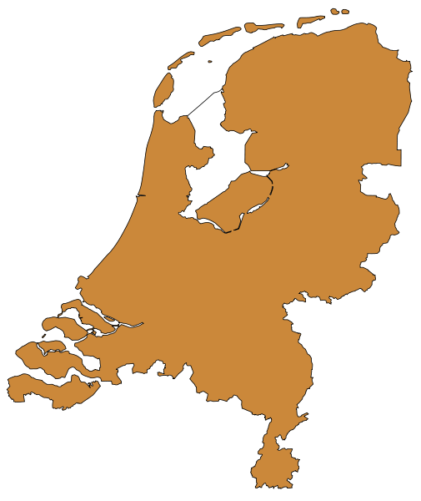The long-run trend in the liberalized Dutch electricity market, in particular with respect to energy distribution by new entrants
Based on a case study analysis of New Zealand’s electricity market.



Gawithrie Vishwanathan
308143
International Economics and Business Economics (IBEB)
Bachelor Thesis
28 August 2009

Supervisor: Ronald Huisman
Contents
Chapter 1 Introduction
1.0 Introduction.............................................................................................................3
Chapter 2 Literature Review
2.1 Theoretical Analysis on the Liberalization effects..................................................7
2.1.1 Electricity Prices...............................................................................................9
2.2 The current situation in the Dutch Electricity Market...........................................10
2.2.1 Vertical- and horizontal integration................................................................10
2.2.2 Degree of Competition....................................................................................12
2.2.3 The Dutch electricity prices............................................................................12
Chapter 3 Methodology
3.1 Relevant Theory behind Case Studies....................................................................13
3.2 Limitations on Case Studies...................................................................................16
Chapter 4 Case Study
4.1 Case Study..............................................................................................................17
4.1.1 New Zealand's developments in the electricity market (1987-2009)..............17
4.2 Case Study Analysis...............................................................................................21
4.2.1 Market Competition........................................................................................21
4.2.2 Entry Barriers..................................................................................................22
4.2.3 Electricity Prices.............................................................................................25
4.3 Case Study Comparison NZ vs. NL.......................................................................27
4.3.1 Market Competition.......................................................................................27
4.3.2 Entry Barriers.................................................................................................29
4.3.3 Electricity Prices............................................................................................30
4.3.4 Summary Case Study Comparison NZ vs. NL..............................................31
Chapter 5 Conclusion
5.0 Conclusion..............................................................................................................32
- Appendix..................................................................................................................35
- References................................................................................................................38

1. Introduction
The electricity industry in the Netherlands is currently facing a process of transition from a strongly regulated market to a more market-oriented regime. Until 2004 the Dutch electricity industry has been dominated by the public sector and has held a monopoly position. The Dutch government owned and operated electricity generating and distribution companies. All major allocation decisions, including pricing and investments, were made within a system of central national planning.
In July 2004 the Dutch public authorities has decided to liberalise the entire Dutch electricity market and let the free market take the leading invisible hand. The decision to liberalise was based on one of the important requirements of the EU’s European Guidelines, with the objective to create a well-functioning competitive European electricity market that delivers on competitive electricity prices, on security of supply and ensuring investments, and on environmental objectives. The first step of the Dutch deregulation process was to enforce a legal split in the electricity entities, which entailed separation of generation, transmission, distribution and retail of electricity, into independent legal entities. As a result, the Dutch end-consumer of electricity now enjoys having the option to choose its own energy supplier for his/her household, independent of its location.
After successfully satisfying the requirement of the EU for a legal split of the electricity market, the Dutch government decided to take further actions in the liberalization process. The Dutch Minister of Economic Affairs proposed to further split the Dutch electricity distribution, which is also referred to as an ownership unbundling or ownership split. An ownership split can be defined as the separation of firms' generation assets from their transmission networks. The government has set the proposal to ownership split in the electricity market to be implemented in January 2007.
Although the ownership split of the electricity market has never been part of the official requirements of the European Guidelines. The Dutch Ministry of Economic Affairs claimed that the ownership split brings additional benefits and that therefore it is requisite for successful liberalization benefits.
The main objective of the ownership split according to the Dutch government is to increase the number of new entry into the electricity market and enhance fair competition within the generation, distribution and the retail of electricity which should eventually result in lower electricity prices for consumers.
The decision to implement an ownership split in the electricity sector will not completely pay off without any implications. Despite of the fact that the government has clear positive intentions to increase competition between the incumbent firms and the new entrants, the desired long-run effects might not be as favourable as the government assumed.
The main problem is that the new regulations of the ownership split can have a negative impact on competition between electricity companies and consequently, fail to bring the desired beneficial results for end-consumers. Clearly, there are gaps in the state of knowledge of the government to believe that this development will only have beneficial result in the short-run as well as in the long-run. One of the reasons why the government intends to increase competition is to provide lower prices for a primary good, such as electricity. In The Netherlands however, this is not (yet) the case. Specially, during the last few years the prices have gone through a period of structural increase and have led to an upward shift in the electricity price market. A recent web survey conducted by the Directie Toezicht Energie (DTe) found that only 30 percent of the Dutch citizens have confidence that the long-run effects of the Dutch electricity market will have a positive outcome on the economy.
Furthermore, mergers and acquisitions will play a crucial role in the long run as large incumbent firms are likely to attempt to re-obtain the vertical integrated business system that would enable them to still exercise dominant market power, regardless of the new regulations.
These undesirable but inevitable long-run effects are analysed and discussed in detail in this paper. Based on a case study on the developments of the electricity market in New Zealand in the period 1987-2009, this paper tends to identify long run effects of the New Zealand’s electricity market. These effects can be translated into a long-run trend that other nations, such as the Netherlands, will most likely face in the long-run of the liberalization process, especially with respect to a forced ownership split.
A case study comparison between the New Zealand’s electricity market and the Dutch electricity market is desirable because especially in this sector of the economy, theoretical models are not always applicable. A case study of two countries that underwent and still undergo similar developments presents a better perspective and in this particular situation, will reflect problems that The Netherlands is likely to be subjected to in the future.
Throughout this study, facts, figures, comments and assumptions are formulated in order to shape a clear answer to the research question stated below.

How will the Dutch Energy Market evolve in the long run after the ownership split, in particular with respect to energy distribution by new entrants?
The remaining sub questions that need to be answered first to corroborate the credibility of the conclusion are as follows:
- How will the market structure and market behaviour develop for new entrants after the liberalisation according to the literature?
- How are the Dutch electricity prices determined?
- How is the theory constructed concerning case study comparisons is order to make a credible case study comparison of The Dutch and the New Zealand’s electricity market?
- What have been the major developments in the energy market in New Zealand?
- To which extent can the effects in New Zealand predict the long-run trend in the Netherlands?
This study has an emphasis on the long run effects of electricity markets and is structured as follows.
Firstly, the focus will be on the relevant literature concerning liberalization and competition in which theoretical models of the consequences and results of the liberalization process are presented. Secondly, the current situation in the Dutch electricity market is thoroughly discussed, as it is of crucial importance to establish where the Dutch are positioned at this point in time, and whether this point in time is likely to be determined as either short run or long run in the New Zealand’s trend of transformation.
In the third section, the paper explores the theory concerning the methodology of case studies, and evaluates to which extent a case study can be utilized to predict long run trends in the dynamic electricity market. Subsequently, an in-depth case study of the New Zealand’s electricity market is conducted. In the final section a case study comparison is presented which reveals similarities and differences among the Dutch and New Zealand’s electricity market. Ultimately, based on the gathered data and the comparative analysis, a clear prediction is stipulated with respect to the trends in the electricity market that The Netherlands will face in the long-run.

2. Literature Review
This chapter presents an overview on the literature developed regarding the liberalization effects of the electricity market. First, this chapter presents a theoretical analysis of the liberalization effects with a subsection explaining the formation of electricity prices. Subsequently, an in-depth analysis is performed to highlight the current situation in the Dutch electricity market with an emphasis on the degree of vertical and horizontal integration, degree of competition and the current state of de Dutch electricity prices.
2.1 Theoretical Analysis on the Liberalization effects
In general, liberalisation refers to a relaxation of previous government restrictions, usually in areas of social or economic policy. Various theoretical and empirical studies indicate that liberalization will result in lower prices, better services and significant welfare gains (van Damme 2004). In addition the design and implementation of the right market institutions should provide the right incentives for firms operating in the industry, towards dynamic (innovation) and static (prices close to marginal costs) efficiencies (Groenewege, 2005).
To maintain these effects in the long run, it is crucial that the electricity market develops a competitive market structure, where new entrants are of crucial importance. The market forces that will develop through liberalisation will shape a new market structure and therefore influence the behaviour of the main players and potential new entrants.
The electricity market is characterised by a value chain model from generation of electricity to retail of electricity.
There are three important indicators within the value chain of the electricity market which will signify the characteristics of the new market structure (Coevering and Werff 2001). Firstly, the degree of vertical integration is an important aspect which refers to the extent to which firms are united through a hierarchy with a common owner.
The second indicator is the degree of horizontal integration. Horizontal integration is typically obtained when firms are in the same stage of production and are taken over or merged by other firms in the same industry.

The third indicator is the degree of competition based on the number of new entrants in a market. In a liberalized market the number of new entrants is likely to increase as a result of low entry barriers. Simultaneously, the least efficient new entrants will exit the market through for instance bankruptcy. Due to liberalization, these indicators should form the new market structure which should be characterized by perfect competition. This type of market structure can be defined by four simple conditions. First, the product sold by one firm is assumed to be a perfect substitute for the product sold by the competing firm. Second, all firms and consumers take the price of the product as given. Third, the factors of production are perfectly mobile in the long run, this includes that firms should be able to hire the factors or production at any given time. The last condition is that firms and consumers should have perfect information on the product it sells/buys.
Apart from the transformation in the market structure, the behaviour in a market will be influenced as well due to liberalization. The most important behavioural effect is the influence on prices of electricity. This is because it is not common in a market characterized by perfect competition that high price differences occur. However, the fluctuations of prices are likely to occur, due to the fact that steady price formulas have a decreased importance after the liberalisation in a market. These price formulas are often set by the government to ensure competition restrictive practises, thus when the steady price formulas are not in force firms will attempt to differentiate from each other by introducing competitive products and services.
Transformation in the market structure and market behaviour will consequently influence the profit margins for electricity firms. Many firms will have to cope with competitive pressure by new entrants, which leaves less to no room for high profit margins.
The next subpart will focus on the elements that essentially construct the price for electricity and on how these prices are determined by the market.

2.1.1 Electricity Prices

The prices in the electricity market are characterized by high volatility, complex demand and supply forces and their unusual composition. Electricity prices are generally determined by three main factors. The first factor which determines the price of electricity is the cost of generation by the network owner. The tariffs which the network owners have to pay are determined by independent supervisors from DTe. Due to this regulated supervision, the market for prices will be more transparent, however there is a possibility that information asymmetries may arise when supervisors lack in obtaining firm specific information to accurately determine the prices. The second price determining factor is the transportation cost of electricity. This cost consists of current power per KiloWattHour (KWh), which is used by consumers. The remaining of the price is determined by national energy taxes. This percentage is set by the government to enforce environmental conscious behaviour by consumers. Figure 1 illustrates the percentage composition which determines the prices in the electricity industry. More precisely, the figure represents the electricity invoice of the firm NUON, based on a yearly utilization of 14 000 KWh. In total the governmental taxes consist of 54 %.
Figure 1
Source: Adapted from NUON electricity invoice 2009
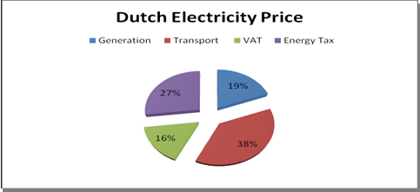Likewise the Dutch electricity market, many other European markets for electric power are rapidly deregulating the processes for power generation and distribution. All these markets face the problem of instable prices. The complex supply- and demand forces are the reason behind the dynamic and uncertain electricity prices.
The main factors that influence aggregate demand among local-market distributors by electricity spot market include weather, season, and the regional concentration and location of retail customers.
The aggregate supply is mainly influenced by the location of generators, their market concentration, the transmission structure and the bidding and auction process of the market.
It is important that distributors, generators and market regulators understand the volatility process, as it influences the pricing of derivative contracts traded on electric power prices which allow them to better control their financial risks (Goto, 2004). A derivative contract holds that part of the electricity supplied by generators are purchased in advance and sold on the hedge market. The problem that may arise is that the traded volume on the market for derivative contracts is very scarce due to the fact that electricity cannot be stored and changes its composition every 30 minutes. Because there are no markets where high trade volumes of electricity can be stored, the prices stay high and unpredictable which may invoke opportunistic behaviour of suppliers.
2.2 The current situation in the Dutch Electricity Market
Currently, the Dutch electricity market has transformed from a state monopoly to a new type of market structure. As mentioned earlier, there are three important indicators which help to identify a new market structure. The first, which is the degree of vertical integration, becomes very interesting when looking at the Dutch market.

2.2.1 Vertical- and horizontal integration
Limiting the extent of vertical integration within a firm was an important objective in enforcing an ownership split in The Netherlands. The vertical integration situation before and after the ownership split at the firm level, is illustrated in the figure below.
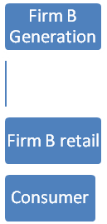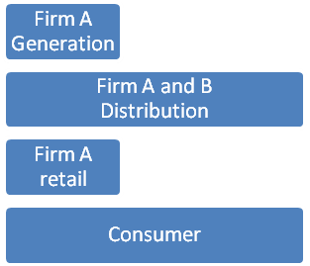 Pre- Ownership Split Post- Ownership Split
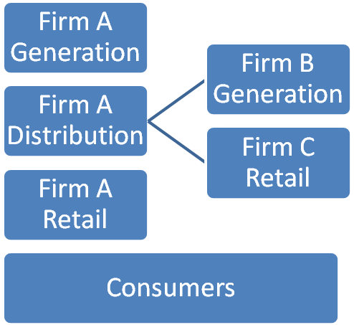

Figure 2: Vertical Integration Pre- and Post Ownership split
Source: Aalbers and Beersma p356
Figure 2 explains the pre- and post situation of the ownership split in The Netherlands. In the left diagram it is shown that electricity companies are allowed to vertically integrate their electricity network. Firm A is completely vertically integrated with the generation, distribution and retail of electricity to the end consumer. Firm B is an independent generator of electricity and firm C is an independent retailer.
According to the Dutch government, one of the most important reasons to implement an ownership split is to provide equal opportunities for independent firms which are not vertically integrated as the firms that do manage a vertically integrated business process. Theoretically, after the ownership split, integrated firms such as firm A in the left diagram, should no longer have the incentives to favour the retailer on its integrated network.
In practise however, this is not the case as shown in the right diagram. After the ownership split firm A has split up its network, while Firm B has taken over Firm C.
The reason why this phenomenon occurs is because generation- and retail firms have a strong stimulus to integrate the business process. This will lead to a decrease in market competition. Independent retailers will not be able to compete against firms due to the fact that it will be impossible for the independent retailers to cover up against the competing conditions of price fluctuations (Aalbers & Baarsma 2005).
Referring to the developments after ownership split on firm level, firms will consequently act in such a way that will result in horizontal integration of a firm. This is respective to the second indicator of identifying a market structure. Due to the developments in the electricity market, there exist an increasing stimulus for firms to get involved in mergers and acquisition. The last few years many Dutch electricity companies were taken over by or merged with foreign energy concerns. A few examples of this are the takeover of NRE by the German firm E.On, the British firm Centrica has merged with the firm Oxxio. Intergas Energie is now part of the Danish Dong. One of the most recent events is the merger between Nuon and the Swedish Vattenfall. As a result, many new entrants are not in the position to compete against these large firms. The increase dominance of foreign firms in the European market will lead to a platform whereby foreign firms increase their share in the Dutch market. Mergers and acquisition is an important strategy for initially Dutch firms to preserve competitiveness with the large French and German firms in the European industry.

2.2.2. Degree of Competition
With respect to the third indicator, which is the degree of market competition based on the number of new entrants in the markets, The Netherlands is not yet at its desired stage.
Currently the Dutch electricity market is characterised with an oligopolistic market structure. An oligopoly is a market structure identified by two main determinants. First there are a small number of firms competing in the market. Second, there exist a natural of legal barriers preventing the entry of new firms. With respect to the first determinant, the Dutch market has four major players dominating the electricity market which are Essent, Nuon, Delta and Eneco. Next to the four big players, The Dutch market counts approximately 22 other electricity suppliers with a relatively smaller market share. This is due to the second determinant, which is that there exists a natural entry barrier for new entrants.
According to the DTe, the market share of the big four has not decreased since the liberalization, and therefore these firms have not left much room for new entrants to compete with the large dominating firms.
Only two new entrants in the market have managed to gain 1 % of the total Dutch market share. This development does not extremely contribute to gaining higher market efficiency.

2.2.3 The Dutch electricity prices
Concerning the current electricity prices, The Netherlands is an extraordinary case as The Netherlands is known to be one of the top three countries with the highest electricity prices. This is much due to the Dutch tax percentage, which is the second largest in the EU. Recent studies by the Centraal Bureau voor Statistiek (CBS) have revealed the comparison between the developments of The Dutch electricity prices and the average prices of Europe.
Currently, there is not much price differentiation in the market price for consumers (van Damme, 2004).
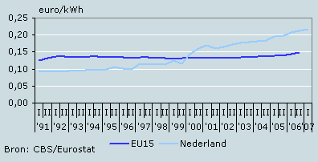
Figure 3: Development of prices in comparison to other EU countries
Source: CBS
In the long run, electricity prices are intended to decrease as the liberalisation on the European scale will increase the opportunities for firms to integrate with other European firms. As electricity is one of the most important input factors for almost all production processes, stabilizing price differences on the European scale will contribute to a more balanced competition between the EU member states.
In sum, The Dutch electricity market has transformed from a state monopoly to a more oligopolistic market structure. The degree of vertical integration is still present together with an increase horizontal integration structure that jointly intensifies each other within the whole European electricity industry. The dominant players in the market exhibit opportunistic behaviour to influence market prices such that the entry barrier for new entrants is high. These developments are short run effects, as being present today.
3. Methodology
The methodology used in this paper to investigate the long-run effects of liberalization of the electricity market in The Netherlands is by carrying out a case study on the developments of the New Zealand electricity market. To obtain reliable results by effectively using this methodology, it is of crucial importance to first get familiar with the theory concerning case studies and to obtain an understanding of the important characteristics and steps involved. In addition, one must become aware of the limitations of case study comparisons. The utilized source for this part that clearly explains the theory, characteristics and implications concerning case studies is the book written by George and Bennett, Case study and theory development in social science. The content of this book has been of great importance for this study. Furthermore the strength and weaknesses of case studies are discussed in the final part of this chapter.
3.1 Relevant Theory behind the case study
Case studies are mainly conducted for the purpose to test the practical impact on theoretical examples and in some cases it emphasizes that theory may fail to hold in certain fields.
The case study conducted of New Zealand is based on a qualitative and inductive study.
A qualitative case study involves an analysis of data such as articles, papers, facts and figures on a certain topic or historical event. In this particular study data of prior research in the field of liberalisation in electricity markets is analyzed.
The inductive approach is common to be used in case studies as inductive reasoning are more open-ended and tend to have an exploratory characteristic.
According to George and Bennett (1995) there are five important requirements integrated into five designing tasks that should be satisfied in order to conduct a qualitative case study. Firstly, it is important to specify the problem and research objective. This is done by identifying the gap in the current state of knowledge. Lijphart and Eckstein have identified five main theory-building research objectives (Lijphart and Eckstein, 1971). Particularly for the case of New Zealand, the research objective can be characterised as a heuristic disciplined configurative case study. The heuristic disciplined configurative case study approach is an objective reached by the use of theories to explain a specific case and contributes to theory testing because it impugn former established theories when the pre-existing theories in specific fields do not hold. This approach also tends to serve heuristic purposes by emphasizing the need for potential new theories in certain fields that are overlooked. This is done by inductively identifying new hypotheses and causal paths that do not have the predicted outcome that traditional theories would anticipate. The second designing task is identifying the comparison design. This starts with deciding on whether conducting a single- or multiple case study and secondly on which method to use for comparison. Despite that there are more cases that could qualify as plausible case study material for predicting long-run trend in a liberalised electricity market, the case of New Zealand has the most credible data available regarding the dependent variables such as market concentration and new entry in the market. Due to this, a single case study is conducted to analyse the long-run trend concerning competition, prices and entry barriers. The single-case study of New Zealand attempts to identify similarities in the independent variables associated with a common outcome of the Dutch case. The method of comparison used is namely the congruence method. This approach focuses on the causal path of the single-case and is mainly used for cross-case comparisons. The method requires a pre-existing theory that predicts outcomes based on certain conditions. The congruence method can therefore stress the importance of the dependent and independent variables, and subsequently compare the observed outcome with the predicted theory. When this results in consistency with the predicted theory outcome, then there exist a causal relationship. This can be illustrated in statistical terms and in shown in figure 4.

Dependent Variable Independent Variables
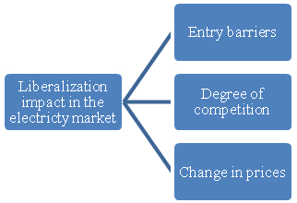
Figure 4; The qualitative variables of the case study
The third task includes the case selection and the reasoning why the particular case is of interest. The case of New Zealand is characterised as a historical event and its long-run trend of market transformation is analysed for the purpose of its explanatory and predictive power for the market transformation in The Netherlands.
The fourth designing task is the description of the theoretical framework that describes the variance in variables. This includes the description of the difference between the desired state (theoretical outcome) and the actual state (practical outcome). This part will be outlined in the case study comparison where the typology of failure is identified with each type of failure having a different explanation. Specifically for the case of New Zealand, there is a focus on the impact of liberalization on the independent variables and the causal reasoning for these failures to occur.
The last task includes the formulation of data requirements and general questions. This is done by including a specification of the data that needs to be gathered for the case study comparison by which it is important to follow a systematic collection of the data. The questions asked throughout the study must be of general nature which does not include very specific questions where in-depth knowledge is required. For the case study here, it is crucial to find parallel data of both countries is a specific period with similar developments. As the essence of the research is to illuminate long-run trends in a liberalized electricity market, the time frame is of extreme importance. The official reforms of ownership split enforcement started in New Zealand in 2004, whereas in The Netherlands it was introduced in 2007. The case of New Zealand’s market is analysed including recent developments in 2009 which can be referred to as long-run. However, the Dutch are currently still coping with short-run developments.
The key study is to analyse what New Zealand have faced over the years and where the island is currently positioned, and bring this in line with developments of The Netherlands to predict what this country will face in the near future.
3.2 Limitations of case study research
The degree of strength of case study research has raised doubts over the years among many scientists, due to the implications that may arise when the research has not properly been conducted or when case studies fail to represent conventional outcomes. Case study research is characterized by the use of a descriptive method instead of an explanatory method. George and Bennett (1995) addressed several implications that will be briefly discussed.
First of all, the observations of a case study analysis or case study comparisons are difficult to be assessed and judged on its validity of the explanations. In fact, single-case studies yield limited results on refinement or complete new theory building. However, certain case study outcomes do raise doubts and questions on pre-existing theory. In addition, conducting a case study does not always include secondary influences on the policy decision making process, mainly because policy makers ought to take into account relevant information about trade off judgments and the current domestic situation which are not always included in theory and generic knowledge. Examples of secondary influences are judgments on whether to satisfy or to optimize, judgment of utility and perceived risk and trade off between beneficial results in the short-run or long-run.
Another limitation is the risk of generalization due to the existence of interference because case studies differ in values of potential causal variables that have already been theoretically frameworked as causally related outcomes. Furthermore, refining existing theory as a result of case studies outcomes does not necessarily imply that the existing theory is weak in explaining other unrelated cases. When it occurs that an existing theory does not hold, this may only be in one specific field and therefore cannot be generalized for the entire economy.
Finally when conducting a case study research, it is vital to consider the objectivity in the study. No matter how rigorous the study tends to be, it is almost impossible to be completely objective. Therefore it should be noted that one should be cautious of potential biases.

“Like all good researchers, we try to present adequate evidence, from the data, to support the stories we tell, but a certain amount has to be taken on trust. For some researchers, this makes work like ours highly dubious, especially when combined with others of the limitations already listed” (Hodkinson and Hodkinson, 2001)”
4. Case Study
In this section the developments in the electricity industry of New Zealand in the timeframe of 1987 until 2009. The information presented below is to a large extent a review of the research conducted by Daniel Kalderimis, who has published the paper pure ideology: the ownership split of power companies in the 1998 electricity reforms (2000). The author used several papers of the Ministry of Commerce and papers from the Ministry of Energy in New Zealand to conduct his research and present his findings.
The reforms in New Zealand’s electricity industry over the years can be divided into four different phases. Phase I runs from 1987 to 1992, Phase II runs from 1992 to 1998, Phase III runs from 1998 to 2000, and finally Phase IV runs from 2000 until now. In addition, the major developments of the reforms during this period are illustrated in Appendix A with the use of a timeline.

4.1 New Zealand’s developments in the Electricity Market (1987-2009)
Phase I of the reforms in the electricity market started dating back to 1987. Prior to this radical development, the New Zealand’s government maintained a statutory monopoly position on the generation of electricity. An important division of the government department was responsible for supplying electricity for the entire island and was named the New Zealand Electricity Division (NZED) of the Ministry of Energy. This division was however not responsible for the supply of electricity directly to the consumers. The supply to consumers was regulated by either power boards of local authorities, collectively known as the Electricity Supply Authorities (ESAs), which purchased electricity in bulk from the State.
One of the earliest developments in the transformation process of the electricity industry in New Zealand began when NZED became Electricity Corporation of New Zealand (ECNZ), which was the country’s largest State owned enterprise. Shortly after ECNZ was established, the government decided to remove the requirements for state approval to set up hydro generation schemes and allowed ESA’s to generate electricity themselves and to purchase electricity from others than the state.

Phase II started in 1992 when the Energy Companies Act forced ESA’s to submit for government approval an “establishment plan” including the method by which the ESA would transfer their electricity undertaking to a newly established energy company. The establishment plan was complex to create as it was mandatory to include all relevant details of the transfer. The most difficult part was the allocation plan, due to uncertainty who exactly owned ESAs and their assets which had been locally built up over more than a century. As a consequence, the government had intended share issue that eventually would lead to widespread privatisation. By 1994, full retail competition was permitted and encouraged. From that moment on, there was no longer a presence of statutory state monopoly. In 1988 the Government had restructured ECNZ to ensure the national network was run by a subsidiary company, named Transpower. In July 1994 the government made Transpower a separate State owned enterprise. After this development, ECNZ was a solely generator which provided equal access to the national network for all companies active in the electricity industry. In 1996 another split from ECNZ established namely, Contact Energy. This State owned enterprise was to be a significant generator owning eight power stations. Overall, it represented 22 per cent of New Zealand's electricity production. The change in the entity composition of this industry during the years is presented in appendix B.
In late 1996 a wholesale electricity market was established by the industry. A wholesale electricity market is basically a multilateral contract whereby generators, purchasers and traders agree to a methodology for determining the electricity price and transmission of electricity.
In Phase III around 1998, New Zealand had one of the most deregulated electricity industries in the world. The transmission network was owned by a separate entity. Competitive generation was not only permitted but actively encouraged by the government. In short, anyone could produce electricity, gain access to the national grid and sell to any consumer.
However in the period between 1997 and 1998, the first problems arose in the New Zealand’s electricity industry reforms and were identified as follows. Firstly, there was a lack of domestic competition in the market. It was clear that still after the split of ECNZ, that the firm was the dominant player in the market. The second problem addressed was basically a theoretical problem. The government had their concerns on the fact that companies were compounded of two and sometimes three related businesses.
The first was a network business, which was characterised by a natural monopoly in the sense that it would not be efficient for other players in the market to duplicate the local network. In the remaining business, which was retail and generation, there is to some extent potentially competitiveness. The government had its doubts by leaving both the natural monopoly and the potentially competitive businesses in one single entity, because it would lead to competition constraining activities such as charging monopoly rents for use of the networks of the existing firm or completely restrict competitor access to their lines.
In 1998 New Zealand’s government found a solution to conceivably repair these problems. The suggested solution was an ownership split. Before the Ministry of Energy could make a careful deliberation on the plan, the largest city of New Zealand underwent a major crisis. On February the 20th, Auckland experienced a dramatic power crisis of a total duration of five weeks power outage.¹¹ During that period almost the entire city of Auckland was supplied electricity by Mercury Energy through four power cables. These cables were more than 40 years old, and some critics argue that Mercury Energy, which was a private electricity retailer, cut back on maintenance and technical staff as the firm was pursuing other utility takeovers. The firm had been accused of non-altruistic behaviour by prioritizing profits before providing efficient service. Mercury Energy denied all these charges. Due to the fact that New Zealand is an island it was difficult to import the electricity from other countries, however New Zealand gained temporary power supply through large container ships at the port of Auckland. The power crisis in early 1998 was the major breakthrough for the Ministry of Energy and consulting parties to introduce the Electricity Industry Reform Act (EIR Act). The EIR includes an enforcement of an ownership split within incumbent firms and new entrants in the electricity industry. The Act was very complex and defined two types of electricity businesses: lines businesses, which transport electricity by existing networks, and supply businesses, which generate and/or sell electricity. There were several options on when to comply with the new Act. Basically, the Act required a complete ownership separation by 2004. If this was done before July 1999, expansion of the existing firms was allowed in the meantime. If not complied by 1999, expansion was prohibited and strict corporate separation laws would apply from April 1999. In response, almost all energy companies in New Zealand chose to comply with the ownership separation before July 1999.
There are several reasons for this. First, the state owned enterprise generators (Transpower, Contact and ECNZ) and the major foreign-owned energy companies perceived an opportunity to expand and become large generator/retailers (Genrets). Consequently, these large corporations aggressively attacked the retail and generation businesses of smaller energy companies. Conversely, the smaller energy companies were concerned that they would be unable to compete with the new kind of Genrets, especially as they would now have to buy most of their electricity from their competitors. Another reason is the advantages of size that was not in force in smaller electricity companies. Economies of scale of an independent supply business effectively restricted this option to large players.
In the last phase, which began after 2000, there were six major Genrets and 31 exclusive lines companies. The "big six" now controlled almost all the generation and retail businesses in New Zealand. The developments after 2000 is characterised by the situation prior to the liberalisation in New Zealand (Paul Nillesen & Michael Pollitt, 2008). In 2003 the Government introduced a sector-specific regulator, namely the Electricity Commission. The Commission was responsible to regulate the operations of the electricity industry and markets. In addition, in 2004 further changes were made to the EIR Act. The Commerce Act had the objective to promote the increase of supply and competition protection in the generation market. As part of the re-regulation process, several other options were suggested. Specifically with respect to the EIR, there were proposals aimed at further relaxation of some aspects of the EIR. One proposal even suggested that without a complete overhaul of the EIR effective participation of the lines businesses in the electricity generation market would not be possible.
In June 2006, when it was most unexpected, there was another power blackout that Auckland had to face. Fortunately it was not that dramatic as in 1998, still it caused many inhabitants of Auckland to doubt their electricity industry again. This time Transpower caused the power blackout, and once again, it was due to poor maintenance.
In November 2007 The Government announced further proposed changes to the Commerce Act, leading almost the complete industry re-transforming to its initial regulated electricity industry.

4.2 Case Study Analysis
In this subsection of the case study, the developments in New Zealand are analysed.
Firstly, the focus is on the degree of competition in the market in order to evaluate whether the desired objective of liberalisation is obtained. Subsequently, the entry barriers for potential new entrants into the electricity market are analysed. Finally the developments of electricity prices are discussed and illustrated in the time frame of pre- and post liberalisation.
4.2.1 Market Competition
In 2008, an empirical research was conducted by Nillesen and Politt to measure the economic impact of ownership spliy in New Zealand. One of the hypotheses of their study was that market competition will increase after the ownership split. However, results indicate that the number of players and concentration in the market has dramatically decreased following unbundling. There are no retailers active without asset-backing of generation capacity (Nillesen and Politt, 2008). To illustrate the precise developments over the years of deregulation in New Zealand with respect to market concentration, the graph below is drawn. This graph captures the data gathered by Nillesen and Politt on number of retail firms and major generators that entered the electricity market. (The data for the graph can be found in appendix C
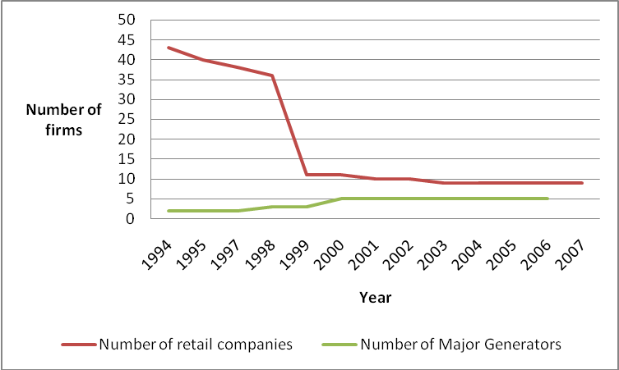
Figure 5: Number of firms entering the New Zealand’s electricity market.
Source: Adapted from data from Nillesen and Politt (2008)

In practice, competition in generation in the New Zealand’s electricity industry was tame, competition for industrial consumers was moderate, and competition for most commercial and all domestic consumers was non-existent.
With respect to the generation, ECNZ had market dominance and was able to control both wholesale and hedge markets because ECNZ had the power to determine the fixed prices for hedge contracts. Regarding the competition in the retail sector, competition was low and it has been decreasing ever since. By 1997, it appeared that the proportion of the "contestable" industrial customers being supplied by competing retailers was between 3.3 per cent and 8.5 per cent and it was shrinking (Kaldermis, 2000). This type of market structure characterised with a few major firms dominating a market is the one of an oligopolistic market structure.
Murray and Stevens formulated a report in 2004 presenting an analysis of the state of competition and investment and entry barriers to New Zealand’s wholesale and retail electricity markets. This report was prepared for the electricity commission of New Zealand.
According to Murray and Stevens, both the wholesale and retail markets are highly concentrated. In the wholesale market, the top 5 generators account for 91% of total generation capacity. In the retail market, the top 5 retailers capture 95% of all customers, and therefore state that there appear to be significant barriers to investment and entry to this industry. From the data it is evident that all the top 5 generators are vertically integrated into retail activities, which results that the top 5 generators are as well the top 5 retailers.
The prevalence of vertical integration between generation and retail firms may constrain entry by independent retailers when these firms experience difficulty to access firm generation capacity. All the above mentioned characteristics can be identified as an oligopolistic market structure.
4.2.2 Entry barriers
As mentioned earlier, the top 5 generators of New Zealand are also the top retailers due to vertical integration. The prevalence of vertical integration between generation and retail may constrain entry by independent retailers due to the existing difficulties of accessing firm generation capacity. Moreover, compared to a net retailer, a vertically integrated Genret is characterised by different business focus and consequently by different business strategies and practiceswhich interferes with the nature and level of competition in the retail market. Vertically integrated Genrets gain their revenue mainly from generation.
These major companies report their retail revenue but due to the fact that their businesses are managed on an integrated basis with profits for generation mainly gained through sale of generation into the unhedged wholesale market (spot market). The profit margins are composed of the difference between generation costs and price attained through any channel. For the Genrets, the retail business is essentially a hedge, which needs to be competently carried out to maintain their retail base. Contrarily, sole retailers generate their revenue exclusively from selling at a margin based on their costs. For this reason, net retailers have an incentive to bargain a cheaper purchase arrangement and pursue upon customer demands to reach the largest retail base they can serve profitably. Due the fact that 95 % of New Zealand’s retail market is already covered by vertically integrated Genrets, whose main goal in retail is to provide a hedge, and only 5% of the market is served by net retailers, this leads to a shift of retail competition that is more focused on maintenance of retail base rather than competition to gain market share. The degree of competition is weaker in this type of market where Genrets basically own the generation- and retail market than in a situation when the retail market was mainly served by net retailers and consequently the price-cost margins over time are high. See appendix c.

According to the state competition report written by Murray and Stevenson, five major entry barriers can be identified in the New Zealand’s electricity market. Firstly, there is an uncertainty with the supply of fuel. All existing generators and potential new generators in New Zealand face increasing difficulties sourcing fuel for generation. The pressure on existing sources of fuel through the implementation is increasing since the Resource Management Act in 1991 (RMA) was in force. Factors including declining reserves in gas and the competing demands on fuel had contributed heavily to the increasing real cost of energy and therefore the rise of cost in investments in generation. These large capital intensive infrastructure projects challenges new entrants and may constrain them eventually from trading engagement in the electricity market.

The availability of hedge products is the second constraint for potential new entrants. New Zealand’s hedge market was highly underdeveloped given that no agencies were assigned to develop this forward market. The available hedge products in the market were likely to be codified to contracts written largely on the terms of the major generators without regard of the position and risks of other retailing firms.

These hedge markets faced a lack of transparency and it was perceived that the generators had more market power than would be expected in a typical seller’s market. The entry barriers exist due to difficulties in obtaining a competitive hedge on comparable terms with the existing vertically integrated major Genrets that sell electricity for a high price that lies far above the actual fair market value of the forward price. This poses a barrier upon independent retailers intending to enter the electricity market.

Third, there exists a regulatory uncertainty in the market. The scale and nature of the transformations associated with deregulation created uncertainty for new entry in generation or retail activities. The uncertainty includes the doubt among new entrants how radical and definite the new regulations are. There might be concerns that regulators may change the rules once investments have been made, particularly when an industry like electricity industry is characterised by large irreversible investments. Another example is when electricity prices increase while the level of services fall, there could be the possibility that politicians may tend to intervene as electricity is a basic need for every individual. Firms which are exposed to risks and regulatory uncertainty are tempted to exit from the industry or to heavily protect themselves, which is costly.
The fourth possible entry barrier is the investment in transmission. The investment in transmission can be reached by allowing other locations other than New Zealand, where electricity can be generated comparatively cheaper, the transport to New Zealand where it has a much larger value. However, to accomplish this, large investments must be made, which are only feasible for Transpower. Other providers whose intention is to promote a generation-based transmission alternatives will face costs and risks associated with securing approval that Transpower will not face. This unfair policy levied by the New Zealand’s government poses a barrier for any other provider who wishes to enter the generation market. Even if alternative generation providers enter the markets and bare the additional costs, customers wishing to purchase this alternative will consequently be entailed to pay for these additional costs, which would not be a rational consumer decision.

The last aspect that may limit new entry is the perception by new entrants, on market power and non-commercial behaviour in the market. Potential new entrants have the desire to expect that the Commerce Commission have the necessary information and tools available to identify and take legal actions towards collusive behaviour which is welfare reducing and therefore not beneficial for the public.
However, distinguishing legitimate commercial actions and the abuse of market power is much more complicated in electricity markets than in most other markets due to the not storable nature of electricity and the volatility of electricity prices.
Furthermore, firms have the incentive not to behave in an altruistic way and may unintentionally damage new entrant retailers or generators. The perceptions of potential new entrants regarding market power of incumbent firms and the risk of collusion is a major barrier to entry. As the market structure is characterised as highly concentrated and politicised, it is not surprising that some participants or prospective participants are concerned that state-owned or community-owned entities might pursue non-commercial activities.
4.2.3 Electricity prices
The price composition of electricity prices in New Zealand can be divided into three parts which are the wholesale price, the retail price and the taxes. The wholesale price is commonly referred to as the spot price and affects the retail price. The wholesale price tends to fluctuate a lot more as it is set by competitive behaviour in the market. The taxes incorporated within the domestic prices that the consumers have to pay are rather low compared to other countries. According to the International Energy Agency, the tax percentage for the last quarter of 2007 was 12,5 %.
One of the major objectives of the ownership split was to enhance competition among firms in the electricity industry which was intended to result in a fall of electricity prices. The desired effects of the forced ownership split in New Zealand and the split of ECNZ did not have the desired long-run results with respect to electricity prices.
Figure 6 illustrated the pricing developments in the New Zealand’s market in the 1992 until 2004.
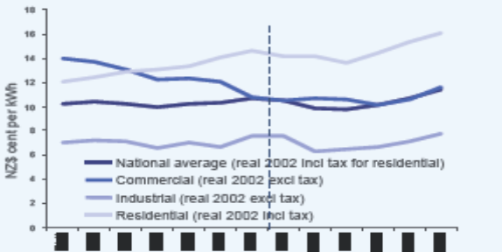
Figure 6: Price development in the period 1992-2004
Source: Ministry of Economic Development (MED) of New Zealand, Energy Data file of July 2005.

As shown in the figure, the long run trend for average real prices for electricity is increasing post liberalisation. In the 12 year period, the real national average prices increased by 1.1 percent per year. In the same period household prices increased even with 1.6 percent per year (Nillesen and Politt 2008). Another observation from the figure is that the prices initially do fall however in the long-run the electricity prices tend to increase above the pre-unbundling level. To examine the causes of domestic price increase, one must observe the trend of unit cost and the price-cost margin set by the firms. The empirical study conducted by Nillesen and Politt examines these causes of price increases.
The research indicates that the effect on unit operational cost post ownership unbundling is positive. The ownership unbundling provided great incentives and opportunities for firms to realise substantial cost savings. The possible reasons indicated of decrease in operational costs are firstly, economies of scale and consolidation. The average size of companies has doubled in the last decade. The second factor could be the increasing importance of technological progress. The next step is to investigate the price-cost margins of the networks. The price-cost margin can be explained as the difference between the unit operational revenues and the unit operational costs as a percentage of unit operational revenues.
Bertram & Twaddle (2005) conducted another study on the price-cost margins of networks in New Zealand. The analysis presents that price-cost margins have increased from NZ$ 1.63 cents per kWh in 1995 to NZ$ 2.64 cents per kWh in 2002. This is an increase of 60 % within a 7 year period. This signifies that even though there were substantial reductions in operational costs, the reductions were not beneficially transferred to consumers in the form of a decrease in electricity prices. The figures evidencing the above statements can be found in the appendixes D and E.The electricity price increase started back in April 1999, when the small electricity firms announced an increase in the electricity prices and argued that the high line charges were the reason for the rise in prices. Responsively, a week later the larger firms such as Transpower announced price rises as well, and this phenomenon continued for several years. Besides the higher charge for line usage, the hedge prices were also a considerable factor for increasing domestic prices for electricity. The figure presented in the Appendix F compares spot prices and hedge prices to estimated long-run marginal cost of generation. The data is collected by Ministry of Economic Development for the period 1994 – 2004. The figure shows that the mean spot market prices have reached higher than some estimates of generation long-run cost. In addition, the short-run hedge prices are being issued in price ranges which exceed long-run costs by a significant margin (Murray and Stevenson, 2004).
4.3 Case study comparison NZ vs. NL
In this final part of the case study, the analysis of New Zealand is compared with the developments after the liberalization in the electricity market in The Netherlands. These reforms have had a major impact on both nations and consequently have resulted in both negative and positive outcome on the economy. Similarly to the previous chapters, the structure is build by firstly focusing on the degree of competition in the market in order to evaluate whether the desired objective of liberalisation is attained. Secondly, the entry barriers for potential new entrants into the electricity market are brought in line with the Dutch barriers. Finally the developments of electricity prices are discussed in the time frame of pre- and post liberalisation.
4.3.1 Market Competition
After the enforced ownership split in 1998 in New Zealand and in 2004 in The Netherlands, the degree of competition in the market have similar results in both countries. The results however are not completely identical. The Netherlands borders many different countries that are able to supply electricity efficiently. These international influences increases competition in a small country like The Netherlands in contrary to New Zealand which is an island coping with limited supply. However, the desired status in The Netherlands in the short run is still far from a satisfied outcome. According to the report of 2007/2008 published by the DTe, some interesting figures are illustrated regarding the market share of new Dutch firms. The number of network license holders has been steady for the past few years, however the number of independent players in the market has decreased as a result of takeovers. The three big players own approximately 81% of the whole industry whereas in New Zealand the top 5 Genrets own 91 % of the industry. The DTe also remarks that the number of firms existing in the market is larger than the number that enters the market. The market share of the new entrants in the Dutch, Belgian and UK market since the liberalization is therefore illustrated in the figure below. The purple dots represent the gained market share of new entrants in the Dutch electricity market. The data in the graph is only representative until mid 2006.

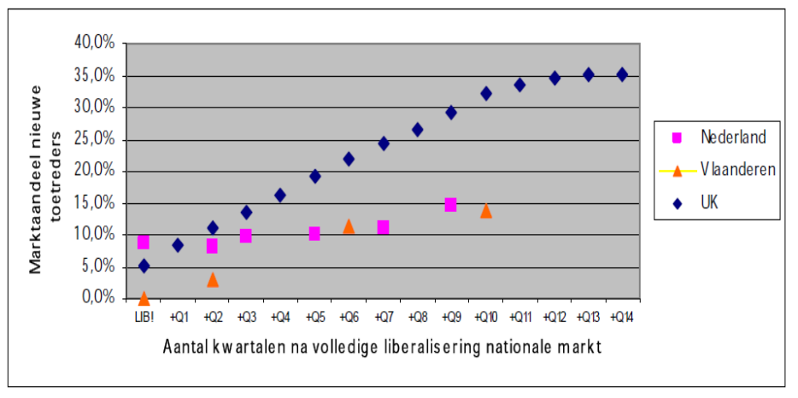Figure 7; Cumulative market share of new entrants in the electricity market
Source: DTe
Unfortunately, there is not enough clear data to draw the graph on the number of new firms as previously done for New Zealand. Though, the DTe does state that the independent players in the Dutch electricity market had dropped from 37 firms in 2005 to only 22 firms in 2007. This drop in firms was mostly due to horizontal integration within the existing firms leading to takeovers. Figure 5 of the case study analysis of New Zealand illustrates clear evidence showing a sharp decrease in the number of new firms after liberalization of the market. From the figure above, it is clear that despite of the new entry in the industry, these firms experience difficulties to manage a great market share due to the high concentration of incumbent firms that are dominating the market.
Furthermore, during the implementation of the ownership split, both nations has transformed from a state monopoly to an oligopoly where only a few big players are dominating the entire market. The initial intention of the state was to embrace a new market structure characterised with perfect competition where efficiency is the key objective. Another aspect that is clearly present is the prevalence of vertical and the earlier mentioned horizontal integration. In the short-run, both The Netherlands and New Zealand faced a major takeover wave. Many small firms are taken over by larger dominant firms, as these new firms cannot compete against the large players. In the Dutch case it is primarily international firms that take over Dutch domestic firms to increase efficiency. For New Zealand in contrast, these include mainly domestic takeovers. The main objectives of such actions are often to increase quality and reliability of the networks and to gain price efficiency for consumers.

Currently, New Zealand has introduced the Commerce act, which will lead to more state control over the networks. As The Netherlands is facing more international takeovers, control over the supply and the maintenance of the networks is limited. This will become a problem when The Netherlands will face a power failure, like what has occurred in New Zealand in 1998 and this would consequently lead to large dependence on other countries for the electricity supply to the Dutch. However, the paradox here is that New Zealand did not have foreign networks distributing to their country, therefore during the power failure, New Zealand was forced to import electricity through the port from different countries which left the a whole city for 5 weeks of electricity outage. Here, in both cases negative and positive outcomes of takeovers can be enlightened, but the question is which has a higher weight?
4.3.2 Entry Barriers
The entry barriers that exist in the Dutch electricity industry are rather identical with the entry barriers existing in New Zealand. Both countries underwent similar reforms that initially should have caused more new entry into this market. Though both nations experienced a satisfying number of potential entrants in the short run, these firms tend to exit the market easily or are exposed to takeovers by larger firms. As explained in the case study analysis of New Zealand, the barriers are mainly due to the size, capital availability and the extent of vertical integration of incumbent firms. An unpredictable market, such as the electricity market, is characterised with high entry costs and with high exits costs. Potential new firms have to obtain a large sum of capital to ensure success in an industry where the concentration of firms is high. One of the reasons for high exit costs is associated with tendency of firms to be highly vertically integrated. After the enforcement of the ownership split, all firms entering the industry have equal access to the national networks. However, large firms also having access to the national networks benefit from economies of scale and therefore can offer lower prices to consumers. The smaller firm who just enters the market does not have these advantages, and therefore will face difficulties competing against the big firms. In addition, switching costs are experienced as high for switching of energy companies within The Netherlands as well as in New Zealand. Consequently, consumers are not willing to take the effort of switching. A potential strategy for the new entrants could be to largely invest in R&D and engage in innovative activities. As a result, the firms can introduce an innovative product in the market, and gain more consumers by for instance offering inexpensive environmentally friendly products.
However when firms start off small and book progress in their innovative activities, these firms are likely to be taken over by larger firms. This action has its positive and negative effects. Smaller firms are much more efficient in innovating as these firms can focus on core innovative activities within the firm. Therefore the product/process innovation tends to generate much more success in the market. However, large R&D investments are a necessary condition to continue with successful innovation. As a result, large firms take over these activities. The entries and subsequently exits of these small firms are therefore very efficient. However this action does have its contribution towards reaching the objectives of market liberalization.
The five entry barriers identified for New Zealand, for instance the uncertainty for fuel supply, do not all hold for The Netherlands. In a country like The Netherlands, the fuel supply is more certain since The Netherlands borders to large countries supplying electricity to smaller countries. Conversely, New Zealand consists of two islands which is nationally dependent, implying that the investment in transmission cannot be a possible entry barrier of The Netherlands whereas it can before New Zealand. Another factor which differs with respect to entry barriers is that both nations face limited legal actions taken towards collusive behaviour of large firms. The state regulators came in force in late 2003 in New Zealand. Prior to this act, New Zealand did not have any regulators in the market to ensure laws and regulations against collusive behaviour. The Netherlands however, had supervising committees called de DTe from the very beginning of the liberalization process. Despite of this regulatory difference between the two countries, the outcomes were largely similar. The Netherlands is still not a highly supervised and regulated market, as regulations had to be minimized as much as possible. In the long run, it can be observed that New Zealand implemented the Commerce Act with many amendments that eventually will lead to New Zealand’s initial regulated electricity market. The question is; Will The Netherlands face the same outcome?
4.3.3 Electricity prices
The case study analysis and the figures shown on the current price situation in The Netherlands presents evidence that New Zealand and The Netherlands experienced the same trend with respect to the developments of electricity prices. The prices of New Zealand and well as those in The Netherlands underwent an upward sloping trend directly after the ownership split
The Netherlands is one of the European countries with the highest electricity prices. The reason why Dutch electricity prices are extremely high is because of the high tax percentage levied on consumers. The enforcement of the ownership split would nevertheless have had a minor impact on the Dutch electricity prices as more than half of the electricity bill consists of governmental taxes. Gaining the benefits of more efficient price formation would be almost an impossible task to execute as a result of the fixed tax percentage levied by the Dutch national government. The case study analysis of New Zealand showed that prices tend to initially fall in the short run but not in the long-run due to the increase of the price-cost margins of networks as a result of oligopolistic market power. The tax percentage of New Zealand electricity prices is much lower than that of The Netherlands. The remaining question is whether this was an effective move that benefited the community?
4.3.4 Summary Case study Comparison NZ vs. NL
- The degree of competition: Price levels did not decrease following liberalisation. In fact they increased for the end-consumers.
- Generation: There was a lack of competition in the generation market. The market only consisted of a few big players.
- Retail: the retail business had no power for survival without integrating the business activities.
- Economies of scale: The benefits of economies of scale were gained when network operators merged and consolidated their activities.
- Entry barriers: The barriers to enter the dynamic electricity market are extremely high.
The final figure is based on a comparative practical example can be used as a predictive tool for the long-run consequences that The Netherlands will most likely face in the electricity industry.
Action Effects on Desired state Actual State Accomplished
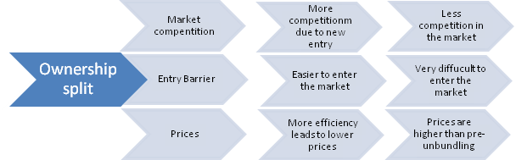 NO
NO
NO
Figure 8: Causal relationship of an ownership split
5 Conclusion
The liberalization of the electricity industry is globally taking place with the aim to enhance competition, resulting in the freedom of consumers to choose from competing suppliers. The objective of this paper is to predict long run consequences of liberalisation, particularly after the enforcement of an ownership split in the Dutch electricity market. The methodology that is used is based on a case study analysis of the New Zealand’s electricity market. In the early 90’s, this market underwent similar reform developments and is currently one of the most deregulated electricity markets worldwide.
Throughout this paper, there is an emphasis on the three indicators of market structure and market behaviour. These independent variables are the degree of market competition, entry barriers in the industry and the development of prices.
After conducting the case study analysis of New Zealand and the case study comparison of New Zealand versus The Netherlands, evidence has shown that the market structure has evolved from a state monopoly to an oligopoly for both nations. The main objective for the ownership split is to increase the number of new entry into the electricity market and enhance fair competition within the generation, distribution and the retail of electricity resulting in lower electricity prices for consumers. However, the case study has revealed that the retail business has no power for separate survival basis. The Netherlands and New Zealand both have witnessed retail integrated with stable asset-backed distribution to retail integrated with asset-backed generation. This was not foreseen at the time of implementation of the ownership split regulation and an industry that is currently characterised by an oligopoly was certainly not included in the agenda.
The electricity prices however, faced in both countries an initial decrease. Despite of the fall in prices in the short run, it did not have a continuous character in the long-run. The reason for can be explained by the market power of dominant firms, resulting in unfair competition and inefficiencies that have led towards high electricity prices in the market. The Netherlands is currently facing an increase of electricity prices. As mentioned earlier, one of the objectives for the government to enforce an ownership split to obtain lower prices for consumers. However for the Dutch case this is an extraordinary pretentious goal.

Since Dutch electricity prices are determined for more than half by fixed governmental taxes, would it then not be ineffective to enforce an ownership split for that small percentage of generation cost and distribution costs than determines the other minor half of the prices? Yes, since it would have a minor impact on the electricity bill consumers have to pay.
Moreover, in theory an ownership split is likely to result in lower entry barriers and consequently should enhance fair competition in the market. The electricity industry is compounded of two and sometimes three related businesses. The government had its doubts by leaving both the natural monopoly and the potentially competitive businesses in one single entity, because it would lead to competition constraining activities such as charging monopoly rents for use of the networks of the existing firm or completely restrict competitor access to their lines. The enforcement of an ownership split in New Zealand did not have its contribution to limit collusive behaviour of incumbent firms. Therefore entry barriers are observed as high resulting in a long-run trend of decreasing number of new entry in the market. Though new firms enter the market, these firms are likely to be taken over by other dominating firms. The early stages of this long-run trend are currently observable in The Netherlands as the country is facing a takeover wave. Takeovers can be beneficial for the economy as small firms can engage in innovative activities in which large firms are less efficient in. Subsequently, large firms take over these small firms’ innovation since large firms have access to large amount of capital that can be further invested in the innovation branch. Therefore, new entry is of crucial importance in the short-run but these firms are likely to be taken over in the long-run. This phenomenon occurred in both nations but does not necessary have a negative impact. Only the least efficient firms exit the market and the efficient, which are often innovative firms, have an indirect contribution to the economy.
Furthermore, there exists evidence that the operational cost reduction in distribution of electricity is attributable to unbundling. This is mainly obtained by the exploitation of economies of scale. However this has a minor impact on the retail prices consumers have to pay. Electricity firms still maintain high prices for electricity. This means that an ownership split does have a positive effect on cost reduction, and short-run contribution to the economy. To increase competition and decrease entry barriers and prices in the market, the ownership split may not be right policy as the long-run desired outcomes will not be as theory predicts. Indeed, if this policy intends to decrease operational cost, the ownership split is effective, but this objective could also be reached with a competent regulator in the industry.
The solution imposed by the government to enforce an ownership split was to solve a problem which was of theoretical nature and certainly not compulsory, as in practice after the liberalisation there were no problems to be detected. If it is not broke, don’t fix it! Electricity is a primary good and therefore regulators and state control is of necessary condition to protect this industry for collusive behaviour of electricity firms.
The desired long run effects that should have resulted from the reforms in the market are likely to not emerge at all. The ideology that the reforms in The Netherlands will have the positive impact in the short run as well as the long-run has no evidential background. This ought to be the reason why New Zealand is re-transforming its energy economy to its pre-unbundling situation. The true answer whether The Netherlands will experience the same resort as New Zealand lays in the future, but clear evidence that is revealed in this paper indicates that the predictive answer will be related to the current re-transformation of the electricity sector in New Zealand.
I encourage further research in the field of market failures after liberalization in a market such as that of electricity. During this research, several other case studies in the field of electricity market liberalization were found. Examples of these are in the State of California, Australia, and the United Kingdom. However these studies were beyond the research of this single-case study in this paper.

Appendix
Appendix A: Entity Composition in the New Zealand’s electricity industry
Source: Paul Nillesen PriceWaterhouse Coopers and Michael Politt University of Cambrigd, 2008.

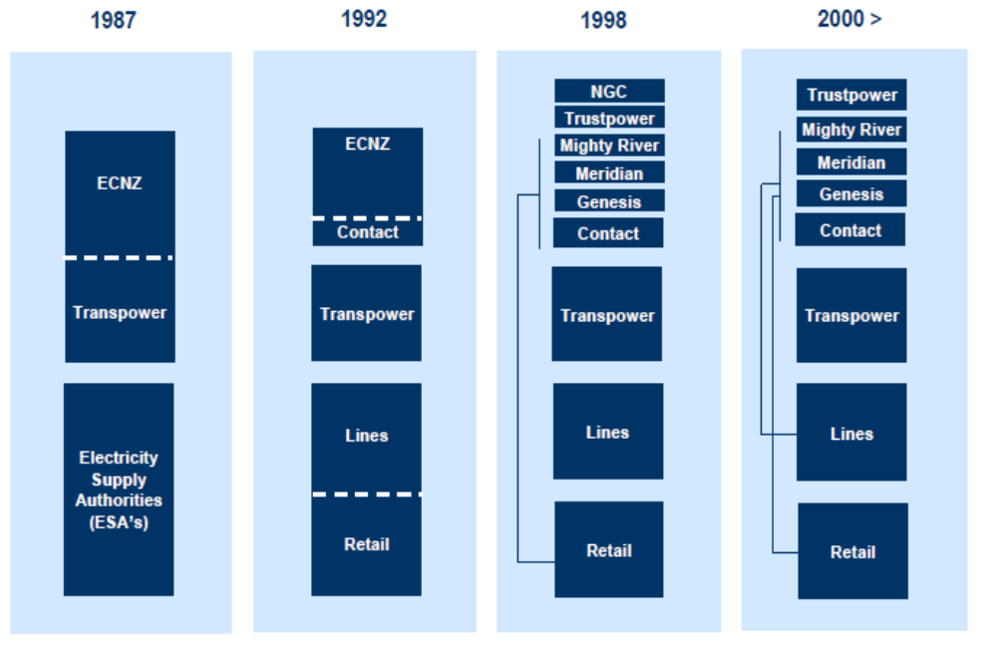

Generation

Distribution

Lines/Retail

Appendix B: Timeline of Reforms in New Zealand
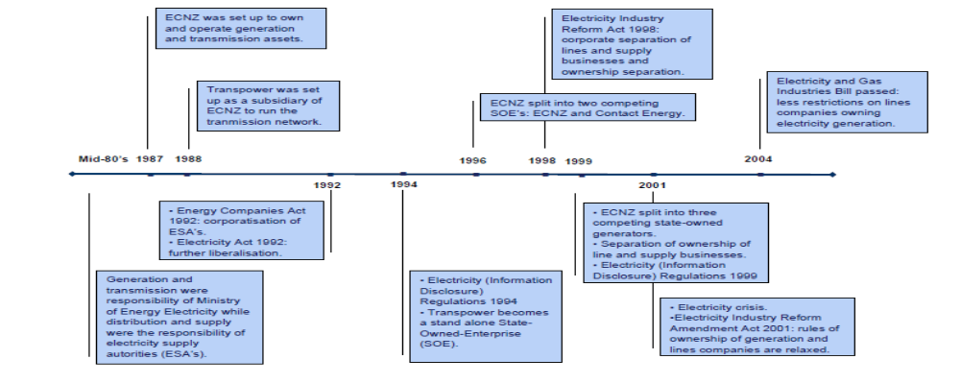Source: Paul Nillesen PwC and Michael Pollitt, 2008

Appendix C: Data to construct graph in figure 5
Source: Annual Reports and Retails Registry Statistics Commission 2208; Nillesen and Politt (2008)
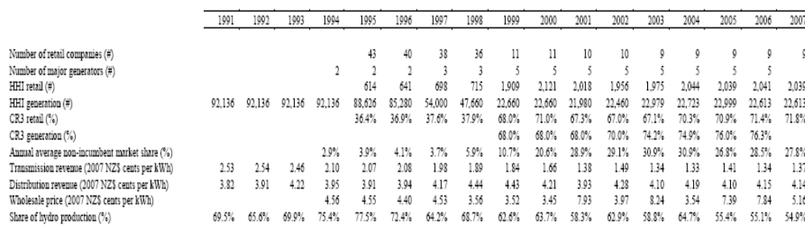

Appendix D: Price-cost margins over time in New Zealand
Source: Nillesen, P., Pollitt, M., August 2008;

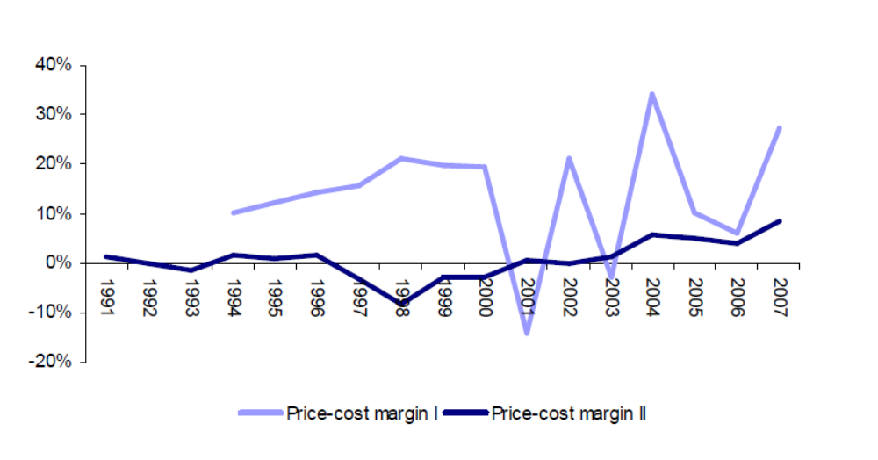

Appendix E: Operational cost
Source: Nillesen, P., Pollitt, M., August 2008;

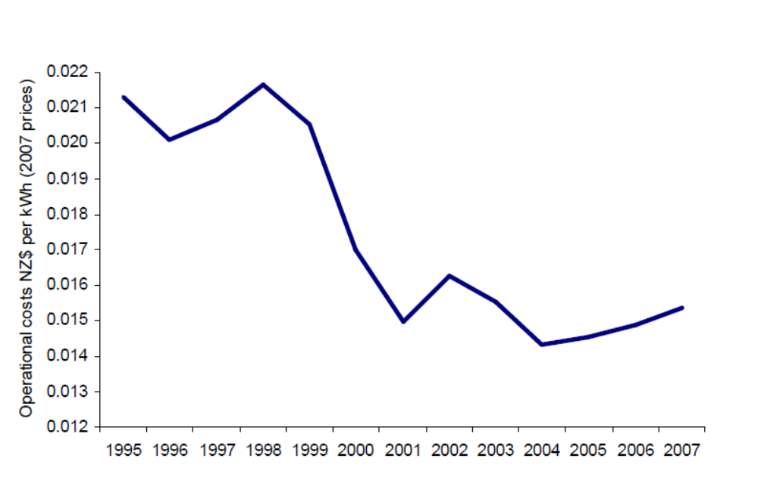

Appendix F: Spot prices and hedge prices to estimated long-run marginal cost of generation for the period 1994 – 2004.
Source: Murray and Stevenson, 2004
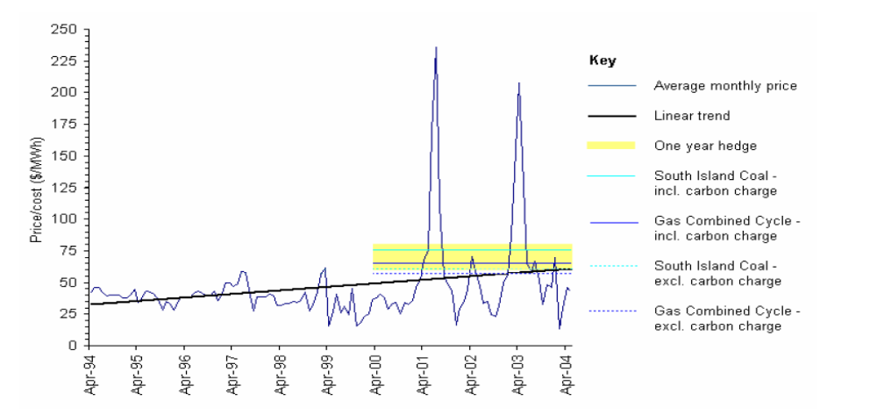

References
Papers:

Belmans., R., Roy van., P., September 2001, Hoe de liberalisering fout lief, Tekst voor VILv-blad

Aalbers., R.F.T., Baarsma., B.E., 2005, Splitsen energiebedrijven vermindert concurrentie, SEO Economisch Onderzoek, cluster mededingen en regulering p356-357

Bushnell., J.B., Mansur., E.T., Saravia., C., 2005, Vertical Arrangements, Market Structure, and Competition: An Analysis of Restructured U.S. Electricity Markets, American Economic Review, Vol 98, Issue 1, 2008

Coevering van de., C., Werff van de., B., Marktwerking in Nederlandse netwerksectoren: leidt liberalisering tot grotere concurrentie? December 2001, DNB

Damme van., E., 2005, Liberalizing the Dutch Electricity Market: 1998-2004; Tilburg University, Tilburg Law and Economic Center in its series Discussion Paper with number 09

Goto., M., Karolyi., G.A., July 2, 2004, Understanding Electricity Price Volatility Within and Across Markets, Dice Center Working Paper No. 2004-12

Groenewegen., J., 2005, Designing Market Institutions; The case of the Dutch Electricity Sector ; To unbundled or not to unbundled network ownership, International Society for New Institutional Economics, Paper 05

Hodkinson., P., Hodkinson., H., 2001, The Strengths and Limitations of Case Study Research, University of Leeds, Paper presented to the Learning and Skills Development Agency conference Making an Impact on Policy and Practice

Hogan., W.W., 1998, Transmission Investment and Competitive Electricity Markets, Hogan., W.W., 1998, Transmission Investment and Competitive Electricity Markets, Center for Business and Government John F. Kennedy School of Government Harvard University Cambridge, Massachusetts 02138

Klooster., J.P.G.N., Schillemans., R.A.A., Warringa G.E.A., September 2005, Dleft, Vrije stroom, vieze stroom, weg stroom? Effecten liberalisering elektriciteitsmarkt Notitie voor de Bezinningsgroep Energie; CE, oplossingen voor milieu, economie and technologie

Murray, K., Stevenson, T. , 30 August 2004, Analysis of the state of competition and investment and entry barriers to New Zealand’s wholesale and retail electricity markets, Report Prepared for the Electricity Commission

Nillesen, P., Pollitt, M., August 2008; Ownership unbundling in electricity distribution: empircal evidence from New Zealand; Faculty of Economics, University of Cambridge in its series Cambridge Working Papers in Economics No. 0836

Tamaschke, R., Docwra, G., Stillman, T.R., 2005. Measuring market power in electricity generation: A long-term perspective using a programming model by; Energy Economics 27 (2005) 317– 335

Other Sources

- http://www.tegenstroom.nl/node/101

- http://www.energieprijsvergelijkers.nl/Default.aspx?P=OPT

- http://www.eprg.group.cam.ac.uk/wpcontent/uploads/2009/03/nottinghambsownershipunbundling.pdf

- http://www.europeanenergyforum.eu/archives/european-energy-forum/electricity-matters/towards-a-pan-european-electricity-market

- http://www.europarl.europa.eu/sides/getDoc.do?language=NL&type=IM-PRESS&reference=20080505IPR28142

- http://www.nmadte.nl/images/Marktmonitor_kleinverbruikersmarkt_2008_Def_tcm7-123016.pdf

- http://www.electricitycommission.govt.nz/consumer/prices
- http://en.wikipedia.org/wiki/1998_Auckland_power_crisis
- http://www.ontariotenants.ca/electricity/articles/1998/ts-98c16.phtml
- http://www.socialresearchmethods.net/kb/dedind.php
- http://www.energiewereld.nl/energieaanbieders/
- http://zakelijk.nuon.nl/zakelijk/klantenservice/tarieven/opbouw.jsp
- http://zakelijk.nuon.nl/zakelijk/over_energie/prijsontwikkeling/tarieven-mkb.jsp

Books

- Frank., R.H., Microeconomics and behaviour, 6th edition

- George., A.L., Bennett., A Case Studies and Theory Development in the Social Sciences

http://www.europeanenergyforum.eu/archives/european-energy-forum/electricity-matters/towards-a-pan-european-electricity-market
http://www.europarl.europa.eu/sides/getDoc.do?language=NL&type=IM-PRESS&reference=20080505IPR28142
DTe is part of the Nederlandse Mededingingsautoriteit (NMA) that monitors the service of the network owners, determine tariffs and condition for the transport of electricity and provides consultancy on the efficient supply of electricity. At the end the DTe reports directly to the Ministry of Economic Affairs.
Microeconomics and behaviour, R.H. Frank 6th edition, p. 370
http://zakelijk.nuon.nl/zakelijk/klantenservice/tarieven/opbouw.jsp
http://zakelijk.nuon.nl/zakelijk/over_energie/prijsontwikkeling/tarieven-mkb.jsp
http://www.energiewereld.nl/energieaanbieders/
CBS is Statistics Netherlands which is responsible for collecting and processing data in order to publish statistics to be used in practice, by policymakers and for scientific research
http://www.socialresearchmethods.net/kb/dedind.php
Cited from Daniel Kalderimis definition in the paper: Pure Ideology: The "Ownership Split" of power companies in the 1998 electricity reforms
http://en.wikipedia.org/wiki/1998_Auckland_power_crisis
http://www.ontariotenants.ca/electricity/articles/1998/ts-98c16.phtml
http://www.electricitycommission.govt.nz/consumer/prices
K. International Energy Comparisons: Energy Data File June 2008
http://www.nma-dte.nl/images/Marktmonitor_kleinverbruikersmarkt_2008_Def_tcm7-123016.pdf

