ERASMUS UNIVERSITEIT ROTTERDAM
Faculteit der Economische Wetenschappen

The willingness to pay for environmentally friendly products

A journey of a thousand miles begins with the first step - The way of Lao-tzu

Supervisor: Drs. Nuno Camacho
Name: Richard Peters
Studentnumber: 290834
E-mail address: r_a_peters@hotmail.com
Thesis: Master thesis
Date: 29 October 2009
Mob. nr: 06-26686849
Foreword Ode to sustainability

Are we human enough to sustain upon this earth?
Is it all the fighting against pollution eventually worth?

Sustainable entrepreneurship is what really counts
Momentarily implemented on several accounts

The future lies in sustainability, please bring order and stability
For all that you do during your life, all those days
are absorbed in an ecological footprint in multiple ways

The solution is there, so pick it up
Get to the front, without a stop
Shout it all, and make it loud
So that nature will be proud

We are the resistance against disorder
Harmoniously intertwine in our reality
When you see, what we see
When you feel, what we feel
When you know, what must be known
You will rise and we fight side by side

From the cradle to the grave
From the end to the beginning
Is it a life cycle approach
In which corporations are spinning

Create what you can produce
Recycle products for reuse
This is the start of a new age
In which nature comes with rage

Awareness for this mighty beast
For else it will surely feast
Upon thy ignorance and bless
And takeaway all that you possess
Executive summary
Times are changing and companies need to adjust. The era in which companies could decide to go or not to go for environmentally friendly products (EFP’s) is over. It is now a question of when and companies are realizing that sustainability is gaining momentum. A major problem for many companies at this stage is understanding their customers in relation to environmentally friendly behavior. They need to find out what the drivers are of consumers’ willingness to pay for environmentally friendly products (WTP-EFP).

This study provides the answer to this problem with the use of a conceptual framework based on the theory of planned behavior. In addition to the current literature, I add the variable guilt as a mediating variable and claim that guilt influences the direct effect of personal believes and social pressure on WTP-EFP. Subsequently I insert the variable cultural background as a moderator. I expect that people with an Asian cultural background in comparison to people with a Dutch cultural background perceive guilt in a different way.

This exploratory research is tested with the use of ordered probit regression and binary logistic regression. The adjusted Sobel test is used for measuring the mediating effect of guilt. With the aid of an online survey data of 156 respondents is collected.

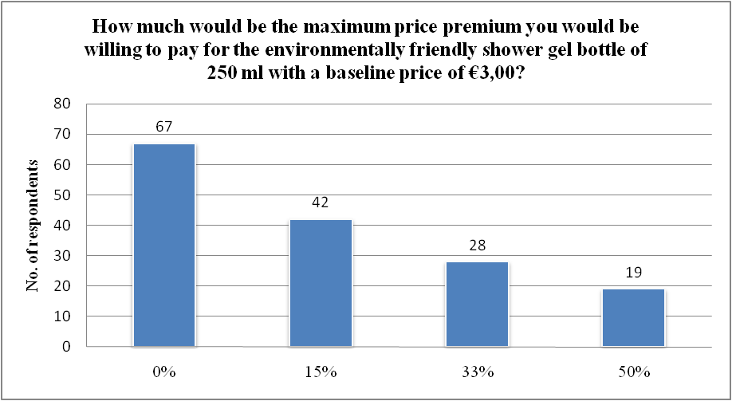For testing the conceptual model I used as an example the product shower gel. I found that 36% of the respondents would care to look for an environmentally friendly variant of the shower gel when imagining that they were buying a shower gel today. 57% of the respondents is willing to pay some price premium for the environmentally friendly variant of the shower gel. The figure on the left illustrates the distribution among the 156 respondents.

As can be seen companies who charge a price premium of more than 15% for environmentally friendly variants of products will lose a large amount of consumers when their competitors keep their prices fixed.
With the output of the ordered probit model I am able to conclude that environmental consciousness, environmental involvement, environmental importance, feelings of guilt, cultural background and gender are the drivers of consumers’ willingness to pay more for environmentally friendly products. The binary logistic regression model showed that there are important differences between respondents’ WTP-EFP and willingness to look for an environmentally friendly certified shower gel. The Sobel test provided the details about the non-significant mediating effect of guilt between environmental attitude, social pressure and WTP-EFP.

With the aim of understanding why people are or are not WTP-EFP I found that; a) a positive environmental attitude leads to a higher WTP-EFP, b) people who experience feelings of guilt are willing to pay a higher price for an EFP, c) people with an Asian cultural background have a higher WTP-EFP and having an Asian cultural background negatively influences the effect of personal beliefs on guilt and d) woman are willing to pay more for an EFP.

From the managerial and policy implications it becomes clear that almost one third of the Dutch students and high educated consumers experience feelings of guilt and as a consequence do not want to buy products that make them feel guilty and are searching for sustainable substitutes. Differences in cultural background show managers the need to distinguish cultural groups and target them separately with a proper price discrimination strategy and diverse persuasive messages.

Concerning the difference between WTP-EFP and willingness to look for an EFP I found that managers should increase the attention of customer groups who by default will not search for EFP’s in the store, at the store level. This can be achieved with the use of visual marketing techniques aimed at attracting consumers’ attention to these EFP’s. I also found that managers need to invest in informative marketing and education to increase the search for EFP’s.

I conclude with three crucial take aways in order to give companies some tools to understand sustainable entrepreneurship; a) long term economics, in which I explain that managers need to break free from their competitive myopia by adjusting their vision, b) competitive pricing, where I make clear that consumers are price sensitive and companies need to price products sensibly and c) consumer needs, in which I clarify that companies need to communicate to their target market that they are environmentally friendly in order to create brand awareness.

Table of contents

Chapter 1 Introduction 1
1.1 Social and scientific relevance 1
1.2 Goal 1
1.3 Method 1
1.4 Research question 1
1.5 Sub questions and classification 1
1.6 Limitations 1
Chapter 2 Theoretical and conceptual framework 1
2.1 Introduction 1
2.2 What is an environmentally friendly product? 1
2.3 What is willingness to pay for an environmentally friendly product? 1
2.4 The conceptual framework 1
2.5 Intention variable WTP-EFP 1
2.6 Environmental attitude variables 1
2.7 Social norm variable 1
2.8 Perceived behavioral control variables 1
2.9 Mediating guilt variable 1
2.10 Cultural background variable 1
2.11 Control variables 1
2.12 Concluding summary 1
Chapter 3 Data and research method 1
3.1 Introduction 1
3.2 Measures 1
3.3 Data collection 1
3.4 Research method 1
3.5 Concluding summary 1
Chapter 4 Empirical results 1
4.1 Introduction 1
4.2 Descriptive statistics 1
4.3 Ordered probit model performance and parameter estimates 1

4.4 Binary logistic model performance and coefficients 1
4.5 Sobel test for the mediator guilt 1
4.7 Concluding summary 1
Chapter 5 Discussion and implications 1
5.1 Introduction 1
5.2 Discussion of general findings 1
5.3 Managerial and policy implications 1
5.4 Further research 1
5.5 Concluding summary 1
Acknowledgements 1
References 1
Appendixes 1
Appendix 1 Maslow’s Hierarchy of Needs 1
Appendix 2 Scree Plot of Factor Analysis for Environmental Attitude 1
Appendix 3 Table 1 Measures 1
Appendix 4 Table 2 Descriptive Statistics 1
Appendix 5 Histograms of DV’s 1
Appendix 6 Pie chart for yearly household income 1
Appendix 7 Descriptive statistics for estimated cell probability 1
Appendix 8 Table with definitions for the variables 1
Appendix 9 Output Ordered Probit model 1
Appendix 10 Output Binary Logistic model 1
Appendix 11 Sobel Test Output Spreadsheet 1
Appendix 12 Environmental Behavior Questionnaire 1

Chapter 1 Introduction

1.1 Social and scientific relevance
The primary reason for writing the master thesis about environmentally friendly products is the impact this subject has on today’s society. It is an issue that affects people all over the world. It also affects me during my daily life, when I walk around in the supermarket searching products for breakfast or dinner. During these strolls around the marketplace I wonder why people choose certain products above others, what their motivation is to buy friendly or unfriendly environmental products and how this influences the amount of money they are willing to spend in the supermarket?

For my bachelor thesis I wrote about sustainable entrepreneurship in small industrial companies. I followed an internship of 6 months and learned a lot about entrepreneurship and sustainability. During this period I came to realize that CEO’s of small industrial companies where not willing to take the risk to start producing environmentally friendly products, because of the higher costs which consumers in turn were not willing to pay. In their viewpoint, consumers only look at their spending and do not involve sustainable and social factors to their respective choices. Academic literature proves otherwise, because already in 1989, 67 percent of Americans stated that they were willing to pay 5-10 percent more for ecologically friendly products (Coddington, 1990). In 1991, Suchard and Polonsky, provide research that environmentally conscious individuals were willing to pay 15-20 percent more for environmentally friendly products. In 2003, a survey was conducted among 1600 Pennsylvania and Tennessee residents and found that approximately 35% were willing to pay some positive ‘premium’ for environmentally certified wood products. The authors find that the estimated market premiums for cheap to expensive (a $29 shelf, a $200 chair and an $800 table) wood products ranges between 12.9%, 8.5%, and 2.8%, respectively. (Jensen and Jakus, 2003). In more recent literature willingness to pay a premium of 15% is found for environmentally friendly variants of products like clothes detergent, automobiles, wood furniture and computer printer paper (GFK Roper Yale Survey, 2008).

With regard to willingness to pay (WTP) and environmentally friendly products (EFP), the thesis will focus on willingness to pay for environmentally friendly products (WTP-EFP).

Besides whether people are WTP-EFP, many scientists fear that, if measures are not taken to contain resource depletion, the acceleration of human activity will have serious negative consequences in our planet. When consumption continues to grow and the environment endures being polluted, climate change and health problems are only the beginning of our concerns (Hart 1995).

The fear for the destruction of our planet is used nowadays by companies, politicians and scientists to address the severity of our consumption behavior. One only needs to open a newspaper, surf on the internet or put on the television in order to receive information about pollution and climate change. Movies like An Inconvenient Truth, Planet Earth, The Eleventh Hour and Home are strong examples of emotionally altered messages that are made to change absent minded people into active participants that will consume environmentally friendly products.

When I look at the concept of environmentally friendliness from this perspective, I believe that feelings are a relevant factor in the decision process of buying environmentally friendly or environmentally harming products. The feeling of guilt is salient in this research and I expect consumers to feel guilty due to a sense of obligation towards environmental friendliness and due to the prevailing moral standards concerning environmental protection imposed by the society.

However when dealing with the variable guilt it is important to keep cultural differences in mind. Guilt is perceived quite different across cultures and no one, to the best of my knowledge, has considered the combined effect of culture and guilt on WTP-EFP.

As a finalizing remark I would like to refer to Adam Werbach, the author of the book “Strategy for Sustainability”, whom provides the link between "green" sustainability and economic sustainability of companies. He argues that to bet in environmentally friendly production processes is not anymore a question of being "philantropic" or "responsible" it is a question of being economically sustainable, of guaranteeing enduring profitability for the company.

Contribution
The first contribution I make to the literature is using an integrated model grounded on strong psychological theories to study the drivers of consumers’ WTP-EFP. Ajzen (1991, 2002) presents the theory of planned behavior which I use for the foundation of the conceptual framework. My integrated model is a combination of previous conceptual frameworks (e.g. Laroche et al. (2001) and Vlosky et al. (1999)) and the theory of planned behavior. The models of Laroche et al. (2001) and My H. Bui (2005) mainly concentrate on Values, Knowledge, Needs & Motivations, Attitudes and Demographics. The model of Vlosky et al. (1999) focuses on the positive relationships between environmental consciousness, importance of certification, involvement in certification and willingness to pay a premium for environmentally products.

My second contribution is enriching this cognitive-based model with an emotional component by exploiting the role of guilt. In the literature about environmentally friendly products, however, the notion of guilt is unilluminated. This is in contrast with the literature about charity donations, where guilt is distinguished as an important driver (Andreoni, 1990). One important contribution of my study is to research to what extent (and to which consumers) the driver guilt has a significant mediating effect on the WTP-EFP.

The third contribution I make is considering the moderating effect of culture. Cultural differences are known to effect the way a person evaluates a situation (e.g. Hofstede 2001, p. 210). In this study I assume that respondents with an Asian cultural background will perceive guilt in a different way than respondents with a Dutch cultural background.

1.2 Goal
The goal of this thesis is to measure how much consumers are willing to pay more for environmentally friendly products and what the underlying factors are that determine the WTP-EFP.

1.3 Method
The data for the research is gathered with the use of an internet survey. The questionnaire consists of 48 questions concerning the respondents’ environmental behavior. The respondents were surveyed about their environmental consciousness, environmental involvement, environmental importance, social pressure, feelings of guilt, cultural background, environmental skills, income level, age, gender and level of education.
After the online data collection I use the method of ordered probit regression and binary logistic regression for analyzing the data. By testing my assumed hypotheses I can measure whether the theory resembles the reality and previous literature. The moderating effects are measured by multiplying the specific independent variable with the effect of the moderating variable. For measuring the mediating effect of guilt I use the adjusted Sobel test for discrete response scales. The Sobel test is used to measure whether the influence of an independent variable to a dependent variable is carried by the mediator.

1.4 Research question
What are the drivers of consumers’ willingness to pay more for environmentally friendly products? That is, what are the underlying factors that determine WTP-EFP?

1.5 Sub questions and classification
In order to answer the research question it is important to illustrate the definitions of all terms stated in the research question. The first part of chapter 2 contains these definitions using academic literature and provides a deeper understanding of the terms used. The following sub questions are stated:
- What is an environmentally friendly product?
- What is willingness to pay for an environmentally friendly product?

In the second part of chapter 2 the conceptual framework and the research approach that is needed to test the theory proposed in the conceptual framework is described. This model is used to explain the relationships between the willingness to pay for environmentally friendly products and the underlying factors that determine the willingness to pay. The relevant topics in this area are:
- The conceptual framework
- Intention variable
- Environmental attitude variables
- Social norm variable
- Perceived behavioral control variables
- Mediating guilt variable
- Cultural background variable
- Control variables

After the explanation of the conceptual framework and variables the research method is described in the third chapter. This chapter contains the foundation for the measures that are chosen for each variable and includes the data collection and research method. The classification is in the following manner:
- Measures
- Data collection
- Research method

In chapter four the empirical results are discussed. This chapter provides the results from analyzing the data and answers whether the hypotheses are valid. Chapter five will provide a discussion of general findings and the managerial and policy implications. The thesis will be concluded in chapter six with a conclusion and future research proposal.

1.6 Limitations
The first limitation of my research is that I identify the intended action consumers will make, this means that there can still be a big difference between the actual behavior of the participants in real life and what the participant is willing to do (Hume 1991).

The second limitation is that I could have studied other emotions rather than only measuring the effect of guilt. For instance shame and anticipated regret can also be emotions that influence the WTP-EFP. Additionally I could have compared other cultural backgrounds and their effect on guilt and WTP-EFP. A good example would be the cultural difference between North and South European countries.

The third limitation of my research is that I use an English questionnaire while having Dutch and Asian respondents. I realized during the process of collecting the data that people with a lower education were not able to answer the questionnaire meaning that the survey respondents are mainly higher educated than average or students.

Chapter 2 Theoretical and conceptual framework

2.1 Introduction
In this chapter, I review and explain the theories I used to build the conceptual framework of my thesis. Specifically, in this chapter I clarify the definition of ‘willingness to pay for environmentally friendly products’ and the theoretical relationships between several underlying factors and consumers’ willingness to pay.

2.2 What is an environmentally friendly product?
In the past few years an increasing number of consumers became aware about the impact of the products they purchase on the environment. In fact, soon, the environment might even be considered one of the most important subjects of this century (Costanza 1996). This is due to the fact that, until recently, humanity only produced products in the sanctuary of welfare and depleted natural resources with the grace of the gods.

Thomas Malthus created a dystopian in 1798 where he warned the world that:
“The power of population is indefinitely greater than the power in the earth to produce subsistence for man. Population, when unchecked, increases in a geometrical ratio. Subsistence increases only in an arithmetical ratio. A slight acquaintance with numbers will show the immensity of the first power in comparison with the second” (Malthus 1798, p. 13)

This citation refers to the exponential growth of the population versus the linear growth of the food supply, resulting in possible starvation. Malthus tried to forecast that increased population growth and consumption would lead the world to disastrous consequences. Fortunately humanity did not know that technology would ensure equilibrium between these powers. However, we should all keep in mind that when the technological progress decreases or stops, we might be in the same Malthusian world again.

Change is needed and there are several factors that are fundamental for a successful change. The first important factor is awareness. With the mass media covering many topics about sustainability, ‘green’ consumerism and environmentally friendly products, the environment can regain its strength when the majority of the public understands the perils of the situation we now face. In fact, the concept of environmentally friendliness of consumption products is, to a large extent, integrated in the more general notion of sustainability. In fact, reliance on environmentally friendly products (and production processes) is a very important necessary ingredient for our world to become more sustainable. Thus, it is not surprising that many sectors of society have been increasingly voicing their concerns about the sustainability of modern consumption societies.

In 1987, for example, The Brundtland Commission voiced some of these concerns in a report called “Our Common Future.” In that report, scientists and practitioners explain the impact of human activity on the environment and bring the term sustainable development to the surface. Sustainable development is defined as (economic) “development that meets the needs of the present without compromising the ability of future generations to meet their own needs” (WCED 1987). However, this definition only covers the human aspect of sustainable development, ignoring the impact that different development choices, today, might have on the environment that surrounds us. Therefore a stronger definition, one that also refers to the environment, is needed.

A second definition, from Robert Goodland (1995), strengthens the Brundtland Commission’s definition by focusing on environmental sustainability which is the “maintenance of natural capital” (Goodland 1995, p. 10). Environmental sustainability is all about the natural environment; it questions how to keep the environment healthy and in equilibrium. There is a source side and a sink side. The source side deals with issues surrounding sustainable consumption, like “keeping harvest rates of renewables within regeneration rates” (Goodland 1995, p. 4). The sink side manages the sustainable production and is about “holding waste emissions within the assimilative capacity of the environment without impairing it” (Goodland 1995, p. 4). This definition adds a strong dimension to the concept of environmental sustainability and environmentally friendliness. Specifically, it explicitly embodies these concepts with a naturally-determined capacity constraint. This constraint suggests that the natural world can only carry a certain amount of waste, and that we, as responsible rational beings of the planet, need to guarantee that we allow enough time for the environment to regenerate itself before the next wave of waste is leashed upon it.

Finally, a third definition, taken from the Webster’s New Millennium Dictionary (2009), defends that environmentally friendly means “having minimal impact on the natural environment; also, using as well as maintaining natural materials”. When combining these three definitions (The Brundtland Commission, R. Goodland and the Webster dictionary), environmentally friendly - in a broad sense - can be defined as:

any human activity (e.g. production or consumption) which is carried in a manner that guarantees (a) minimal impact on the capacity of the natural environment to carry waste and (b) the maintenance of Earth’s natural capital, (c) without compromising the ability of future generations to meet their own needs.

Yet, to define an environmentally friendly product, I still need to clarify the definition I use of products. Products refer, in marketing terms, to the goods and services that are offered in the market in order to satisfy customer needs.

Ultimately it can be stated that for the remainder of the thesis an environmentally friendly product (EFP) is defined as:

a good or service that satisfies customer needs with minimal impact on the carrying capacity of the natural environment while maintaining Earth’s natural capital, without compromising the ability of future generations to meet their own needs.

In my empirical study, I operationalize this definition by applying it on the product shower gel, the product I use to test my hypotheses. The product used to test the conceptual framework influences the outcome of the model. Therefore it is highly relevant to find a suitable product that has minimal disrupting impact on the model performance. The main reason for choosing shower gel is that everybody can directly imagine the product and understands what the function is. Subsequently, shower gel is a product that is used every day by millions of people around the world which will improve the probability that the respondents in my research know the product and can provide the necessary answers to the survey questions. The shower gel is not branded, to avoid brand signaling influences and possible price premiums. Specifically, I need two variants of the shower gel:
- The standard shower gel meets the minimum required safety standards for production and guarantees that no dangerous chemicals for humans are used. The average price of a 250ml bottle of shower gel in the Dutch market is €3,00.
- The environmentally friendly shower gel meets the minimum legally required safety standards plus it uses renewable biological ingredients. It is assured that no dangerous chemicals for humans are used and environmental certification guarantees minimal impact on the environment and that all processes are certified as environmentally safe (ISO 14001).

2.3 What is willingness to pay for an environmentally friendly product?
Willingness to pay (WTP) is directly related to the economic value theory. It is derived from the consumer perceptions of a product and is shaped by the need for the product (Pearce and Moran, 1994. p. 17). Willingness to pay is defined by Hanemann (1991, p. 635) as “the maximum amount of money an individual would be willing to pay to secure the change”. Auger et al. (2003) argue that the difference in willingness to pay among bundles of product features reflect “the utility that a consumer derives from the presence or absence of specific features” (Auger et al. 2003, p. 294).

Willingness to pay a premium takes place when an individual perceives added value in terms of utility due to, for example, better performance of a new product in comparison with an old product. Rao and Bergen (1992) clarify that price premiums can be seen as the “excess price individual’s are willing to pay on top of the ‘fair’ price that is justified by the ‘true’ value of the product” (p. 412). Willingness to pay can be measured with the contingent valuation method, which relies on imagined markets to survey people about how much they value certain nonmarket goods (Ajzen and Driver 1992, p. 298).

In fact, according to Ajzen and Driver (1992) willingness to pay consists of several factors. In order to formulate a price for a hypothetical product, or agree on a hypothetical price, two factors are important: (a) availability of information and (b) participant’s knowledge and skills. Availability of information is important because respondents need to know what the advantages, disadvantages, costs and benefits of the product are for its stakeholders. The second relevant factor of willingness to pay is that participants need to have sufficient skills to evaluate how reasonable a stated price is. Since many respondents are not used to making abstract judgments and information is lacking most of the time, respondents have no choice than to “rely on intuitive heuristics or rules of thumb” (Ajzen and Driver 1992, p. 299).

When applying the theory above to understand the willingness to pay for environmentally friendly products we can expect respondents to base their judgments about the product on their knowledge, skills, available information, intuitive heuristics and/or rules of thumb. Hence, it is important to select a product for which most respondents have enough knowledge and experience with and to provide some extra information (e.g. anchor price) to guarantee that respondents make comparable judgments. In this way, the respondents’ judgment will provide us with a measure of their willingness to pay for an environmentally friendly product (WTP-EFP), which can be defined as:
the maximum (excess) price a person would be willing to contribute in order to equalize the utility derived from the EFP with the utility of a non-environmentally friendly substitute.

2.4 The conceptual framework
I will now build up a conceptual framework to answer my focal research question: why consumers are willing to pay for environmentally friendly products. The first important step is to know which underlying factors determine this willingness to pay. In order to identify these underlying factors, I rely on established psychological theories that can be used to explain consumer behavior. In particular, I focus on three kinds of salient beliefs set forth in the theory of planned behavior from Icek Ajzen (1991, 2002): (a) behavioral beliefs, (b) normative beliefs and (c) control beliefs.

The theory of planned behavior is an extension of the theory of reasoned action (Ajzen and Fishbein 1980; Fishbein and Ajzen 1975) and it incorporates the possibility of dealing with behaviors over which people have “incomplete volitional control” (Ajzen 1991, p. 181). The theory of planned behavior is often used to explain human behavior and provides a functional conceptual framework for dealing with the complications that occur in human social behavior.

According to Ajzen (1991) the core assumption of the model is that a person’s behavior is determined by the intention to perform the behavior and that this behavioral intention is specified by the attitudes toward the behavior, subjective norms regarding the behavior and the perceived behavioral control.

In addition, to Ajzen’s (1991) cognitive framework I add an emotional antecedent - the variable guilt – as a key mediating variable in my conceptual framework. According to me guilt influences the direct effect of social pressure and environmental attitudes on the intention to perform the focal behavior of interest, which in my thesis is the WTP-EFP. The reason for this effect comes forth from the expectation that consumers feel guilty when not acting in an environmentally friendly manner because of a sense of obligation towards environmental friendliness and due to the prevailing moral standards concerning environmental protection. As discussed in the first chapter movies like An Inconvenient Truth, Planet Earth, The Eleventh Hour and Home are mounting social pressure and increased personal awareness for the impact of our behavior on the environment.

Besides adding the variable guilt as a mediator I also include another overlooked factor in extant literature - the role of cultural background as an important moderator of the predicted relationships. Specifically, I assume that the formation of guilt due to the violation of personal beliefs or social pressure from respected referents will be different for people with a different cultural background. In my study I will examine whether respondents with an Asian background perceive guilt in a different way than respondents with a Dutch cultural background. Subsequently I also include cultural background as a direct effect, meaning that people from certain cultures will be more willing to pay for EFP’s than people from other cultures. Inclusion of cultural background in my framework enriches our understanding of WTP-EFP as it provides us a deeper understanding of the effect of cultural differences on the perception of guilt.

In order to clarify the theoretical parts I will provide an example for every salient belief mentioned earlier. The attitudes toward the behavior are based upon behavioral beliefs, meaning the beliefs people have about certain attributes of an object or outcome. The beliefs are formed when consumers perform or intent to perform a given behavior. This will lead to the formation of positive or negative attitudes toward the behavior, due to the attributes already being valued positively or negatively. Assume for example that a consumer believes that buying EFP’s will protect the environment from being harmed. The consumer perceives the protection of the environment as a positive attribute and therefore will form a positive attitude toward performing the behavior of buying EFP’s.

The subjective norms are linked to the normative beliefs which are “concerned with the likelihood that important referent individuals or groups approve or disapprove of performing a given behavior” (Ajzen 1991, p. 195). In this case, a consumer’s environment influences the decision to perform a given behavior. Take for example the case of a good friend who disapproves one’s decision to use a highly pollutant vehicle. Due to the disapproval and the consumer finding the opinion of his/her friend important, he/she may decide not to buy (or use) such highly pollutant vehicle and will go for a suitable alternative.
The perceived behavioral control is determined by control beliefs that “refer to people’s perception of their ability (resources and opportunities) to perform a given behavior” (Ajzen 1991, p. 196). For instance, a consumer who is willing to pay for EFP’s, but thinks he/she does not have enough income to purchase the products, will perceive the intention to perform the behavior of buying EFP’s as inappropriate. In the end, the consumer will not buy the product, because of their perceived inability to perform the behavior.

The next step in forming the conceptual framework is to combine the theory of planned behavior with the factors that determine WTP-EFP.

Given that the focal behavior relates to paying a (premium) price for goods that are environmentally friendly, the attitude towards the behavior will be formed by the environmental attitudes of the consumer. I identified three environmental attitudes that will compose the behavioral beliefs’ component of my model: environmental consciousness, environmental involvement and environmental importance.

The subjective norm, when dealing with EFP’s, is reflected in a possible feeling of social pressure among consumers that fail to show interest in environmentally friendly consumption behavior. Hence, the normative belief that precedes the subjective norm embodied in social pressure is constituted from social pressure by individuals or groups whom the consumer respects and who disapprove the failure of a person to engage in environmentally friendly consumer behavior (e.g. Ajzen 1991).

The perceived behavioral control explains whether an individual has the ability to perform the behavior of paying a price premium in order to buy EFP’s. The two most striking restrictions to the ability of a consumer to pay for EFP’s are: (a) budget constrains and (b) knowledge and skills. I thus capture perceived behavioral control using the following control-related variables: income and skills.

Last, but not least there are three control variables left. I hypothesize that age, gender and education will affect WTP-EFP.

Figure 1: Conceptual Framework
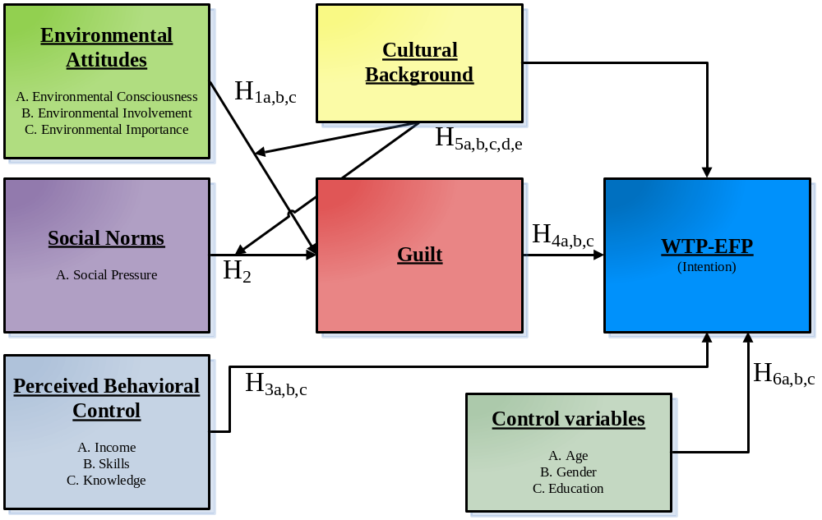

In sum, the conceptual framework in figure 1 is designed by the author of this thesis and is based upon the theory of planned behavior and several conceptual models concerning WTP-EFP and consumer behavior (Webster 1975; Vlosky et al. 1999; Laroche et al. 2001; Auger et al. 2003; Cornelissen et al. 2008 and Diepen et al. 2009). In the subsequent paragraphs the input, mediating, moderating and output variables of the conceptual framework will be explained together with the formulation of the model hypotheses.

2.5 Intention variable WTP-EFP
The intention variable is the outcome variable of the model, which is WTP-EFP. “Intention is defined as a course of action one intends to follow” (Bui 2005). According to Ajzen’s (1991) theory of planned behavior the core assumption of the model is that a person’s behavior is determined by the intention to perform the behavior. A general rule of the theory is that “the stronger the intention to engage in a behavior, the more likely should be its performance” (Ajzen 1991, p. 181). Therefore I assume that the strength of the intention to perform the behavior is a strong predictor for the actual behavior. Applying this to the conceptual framework provides that the intention is WTP-EFP and the behavior is the purchasing of environmentally friendly products. So, I assume that WTP-EFP is a strong predictor for purchasing environmentally friendly products.
However this WTP-EFP is specified by the environmental attitude toward the behavior, subjective norm regarding the behavior, the perceived behavioral control, feelings of guilt, cultural background and several control variables.

2.6 Environmental attitude variables
Three behavioral belief constructs are likely to have a vital role in determining a consumer’s intention, or WTP-EFP: (a) an individual’s environmental consciousness, (b) environmental involvement and (c) environmental importance. The environmental attitude, therefore, refers to the individual’s associations between the product feature ‘environmentally friendliness’ and her or his behavioral beliefs at an environmental level. When the attribute environmentally friendly is valued positively enough by the individual, such valuation will lead to a positive attitude toward EFP’s and a higher willingness to buy such products, even if a price premium is charged for them. Corroborating this causal mechanism, in the past, several studies have indeed found that there are positive correlations between environmental concern (i.e. attitude) and environmentally friendly behaviors (Van Lierre and Dunlap 1981; Simmons and Widmar 1990; Schlegelmilch et al. 1996; Roberts and Bacon 1997). I will now provide some details on the role of each of these three constructs in the model.

Environmental consciousness
Environmental consciousness is a person’s awareness about the environmental impact of his/her consumer behavior. The variable environmental consciousness is measured by the consumers’ consideration of the environmental impact of his/her consumer behavior (e.g. Webster 1975). It is shown by prior literature that people who consider the environmental impact of their consumer behavior (and have knowledge about the environment) are more environmental conscious (Minton and Rose 1997). I expect that more environmentally conscious consumers will have a greater WTP-EFP. So, I hypothesize the following:

Hypothesis 1a (H1a): Environmental consciousness will have a positive effect on the willingness to pay for environmentally friendly products.

Environmental involvement
More than only being conscious about the need to protect the environment, some consumers are more active than others in their efforts to actually do so. Hence, environmental involvement consists of consumer willingness and active engagement in multiple behaviors aimed at environmental protection (Suchard and Polonski, 1991). In other words, environmental involvement is a “willingness to forgo comfort and quality life style for the betterment of society and the environment” (Bui 2005, p. 21) or, in a reversed definition, the perceived inconvenience of behaving in an environmentally friendly manner (Laroche et al. 2001). Hence, people who are willing to protect the environment and forgo comfort and quality for the betterment of society and the environment will have a higher environmental involvement. I expect environmentally involved consumers to show a greater WTP-EFP. Thus, I hypothesize:

Hypothesis 1b (H1b): Environmental involvement will have a positive effect on the willingness to pay for environmentally friendly products.

Environmental importance
Environmental importance refers to the perceived environmental importance and the values individuals hold regarding to the environment. Environmental values are important, because they influence the intention to perform a certain behavior. In order to have the intention for WTP-EFP it is vital that consumers actually value protecting the environment. Perceived environmental importance is defined in Amyx et al. (1994) as “the degree to which one expresses concern about ecological issues” (cited in Laroche et al. 2001, p. 506). Perceived environmental importance determines the way a consumer observes environmental behavior as important towards him/herself and the society. For this variable I assume that when a consumer values protecting the environment and perceives environmental behavior as important he/she will have a higher environmental importance. Having environmental importance will result in a greater WTP-EFP. I hypothesize:

Hypothesis 1c (H1c): Environmental importance will have a positive effect on the willingness to pay for environmentally friendly products.

2.7 Social norm variable
The social norm variable that is relevant in this framework is social pressure. As said earlier, the subjective norm when dealing with EFP’s is that people should feel social pressure when not showing interest in environmental behavior.

Social Pressure
Social pressure, in the case of WTP-EFP, stems from the approval or disapproval for not behaving in an environmentally friendly manner by individuals or groups whom the consumer respects. The reason for using social pressure as a social norm variable comes forth from the fact that the environment people live in has a big influence on how they perceive the world (e.g. Griskevicius et al. 2008). The social norms people have are established by their environment, especially when the environment consists of respected referents. Even economists, who used to have a more self-centered view of human behavior, are now actively incorporating social norms and influences in economic agents’ decisions (e.g. Becker and Murphy 2000)

The assumption for this variable is that people will feel social pressure when they do not show interest in environmentally friendly behavior, while important referents disapprove their behavior. Subsequently, the current media pressure supporting and protecting green behaviors is also a form of social pressure, because the media is respected and can be seen as a group of people. The social pressure that constitutes from this disapproval and huge media involvement will cause the consumer to change his/her behavior in order to please the referents that view environmentally friendliness as important and whom the consumer respects. Subsequently it is hypothesized that the higher the social pressure the greater the WTP-EFP becomes. I hypothesize:

Hypothesis 2 (H2): Social pressure will have a positive effect on the willingness to pay for environmentally friendly products.

2.8 Perceived behavioral control variables
Perceived behavioral control refers to whether an individual has the ability in terms of resources and opportunities to perform the behavior of buying EFP’s. Perceived behavioral control refers to the capability of a person to perform a certain behavior either directly or, indirectly, due to that person’s beliefs about her or his ability to actually perform the focal behavior (Ajzen, 2002, p. 668). Given that behavior is strongly linked to intention, the variables of perceived behavioral control will certainly predict a consumer’s intention to perform a given behavior.

This means that when an individual believes she or he possesses a high ability and anticipates small barriers to the performance of a certain behavior, the greater her or his perceived control over the intention to perform that behavior (Ajzen 1991). I identify three perceived behavioral control variables when dealing with EFP’s: (a) income and (b) skills.

Income
Income is the most important perceived behavioral control variable because, in general, environmentally friendly products are priced higher. In fact, my focal research question concerns which consumers are willing to pay for products which are environmentally friendly, which suggests that income is probably the strongest constraint to the performance of such behavior.

In fact, a consumer needs to have a high enough income to be able to purchase environmentally friendly products. Referring to Maslow’s Hierarchy of Needs, people will first fulfill their basic needs (which consist of physiological needs) and, only then, be worried with higher-level needs. Whether a product is environmentally friendly is not processed in the decision making for the first needs. According to Borden and Francis (1978, cited in Kollmuss & Agyeman, 2002, p. 245), “people who have satisfied their personal needs are more likely to act ecologically because they have more resources (time, money, energy) to care about bigger, less personal social and pro-environmental issues.”
I expect people with a higher income to have more resources available and, therefore, to have a greater perceived behavioral control over the behavior of buying environmentally friendly products. Consequently, I hypothesize:

Hypothesis 3a (H3a): People with higher levels of income will have a greater willingness to pay for environmentally friendly products.

Skills
Skills are a relevant determinant of WTP because consumers need to be able to make trade-offs between products, judge the environmental impact of their behavior and evaluate the reasonableness of product prices. A consumer that is not knowledgeable about how certain consumption behavior is capable of harming the environment will certainly not be willing (or capable, e.g. if she or he is not even aware about the existence of such options) to pay more for an EFP. The variable skills consists of two elements. One element about skills and the other about knowledge. ‘Knowledge’ refers to the level of knowledge people think they have about environmental topics. ‘Skills’ refer to the consumer’s ability to identify and judge the difference between environmentally-friendly and non-environmentally-friendly products. Skills are somehow intertwined with the term ecoliteracy (Laroche et al. 1996). “Ecoliteracy is a measure for the respondent’s ability to identify or define a number of ecologically-related symbols, concepts and behaviors” (Laroche et al. 2001, p. 505). Laroche et al. (1996) found that there is a correlation between ecoliteracy and some attitudes and behavior toward the environment. I expect that when consumers have the skills necessary to understand the information conveyed on EFP’s, they will have a greater perceived behavioral control over the intention to engage in environmentally-friendly consumption behavior. Therefore, I hypothesize:

Hypothesis 3b (H3b): People with skills to understand the information conveyed on environmentally friendly products will have a greater willingness to pay for environmentally friendly products.

For the element ‘knowledge’ I assume that people who are knowledgeable about environmental topics will have a greater perceived behavioral control over the intention to engage in environmentally-friendly consumption behavior. I hypothesize:

Hypothesis 3c (H3c): People who think that they are knowledgeable about environmental topics will have a greater willingness to pay for environmentally friendly products.

2.9 Mediating guilt variable
Guilt is a cognitive or emotional reaction that occurs when a person becomes aware about his/her violation of a moral standard or obligation. In the context of charity donations, for example, Diepen et al. (2009, p. 124) state that “people may feel guilty if they do not make a donation, because of their sense of obligation and moral standards.” When applying the same reasoning to the topic of environmentally friendly products, I expect consumers to feel guilty due to a sense of obligation towards environmental friendliness and due to the prevailing moral standards concerning environmental protection.

The role of the mediating variable guilt is twofold, which is illustrated in my conceptual framework. On the one hand, guilt influences the direct effect of environmental attitudes consumers have towards the intention to perform the behavior, which is expressed by WTP-EFP. This signifies that individuals who have a positive environmental attitude might have feelings of guilt when not acting in an environmentally friendly manner. An important note is that considering the environmental impact of consumer behavior, willingness to protect the environment and value protecting the environment are personal beliefs (moral standards) that can be violated. The personal beliefs in the conceptual model refer to the environmental attitudes which consists of environmental consciousness, environmental involvement and environmental importance.

The key assumption here is that people who have a positive attitude towards the environment will feel guilty when they violate their personal beliefs. Given this assumption, I therefore hypothesize:

Hypothesis 4a (H4a): Feelings of guilt stem from the violation of personal beliefs.

On the other hand, guilt mediates the direct effect between social pressure and WTP-EFP. This indicates that individuals can have possible feelings of guilt when they do not act according to the opinion of respected referents. Moral standards are often a form of social pressure, in the sense that, frequently, it is through the reactions of important others that the consumer becomes aware of his/her violation.

Guilt is a negative state because, as argued by Burnett and Dale (1994), the violation of one’s socially imposed standards normally leads to a lowering of one’s self-esteem. This lowering of self-esteem can, in itself, become a “behavioral motivation in the sense that people who feel guilty will try to alleviate their guilt by engaging in compliant and altruistic behavior” (Diepen et al., 2009, p. 125).

In order to test the significance of the driver guilt, it is assumed that, often, people who experience feelings of guilt for not acting environmentally friendly feel guilty because of extensive social pressure from important referent groups that view environmentally friendliness as important. Thus, I hypothesize:

Hypothesis 4b (H4b): Feelings of guilt stem from social pressure to behave in an environmentally-friendly manner.

Therefore, I interpret guilt not only as a consequence of one’s violation of personal moral beliefs but also as an important manifestation of social pressure and I will try to uncover the extent of its influence in the WTP-EFP. In both cases (self-caused or social-caused feeling of guilt), the greater the feeling of guilt, the greater the consumer’s WTP-EFP becomes. Thus:
Hypothesis 4c (H4c): Guilt will have a positive effect on the willingness to pay for environmentally friendly products.

2.10 Cultural background variable
The reason for modeling cultural background as a moderator is because culture influences the way people perceive the world. Cultural differences are known to affect the way a person evaluates a situation (e.g. Hofstede 2001, p. 210). Therefore it is important to know what culture is. Culture is defined by Kluckhohn (1951, p. 86) as:

Culture consists in patterned ways of thinking, feeling and reacting, acquired and transmitted mainly by symbols, constituting the distinctive achievements of human groups, including their embodiments in artifacts; the essential core of culture consists of traditional (i.e. historically derived and selected) ideas and especially their attached values.

Cultural background refers to the respondents’ specific culture. Cultural background consists of the country of origin of the respondent, the country of origin of the parents of the respondent and the respondent’s classification of his or her cultural background. Eventually the difference between cultures provides the reason for the difference in how the respondent will perceive guilt due to social pressure or violation of personal beliefs. Cultural background provides the means for measuring the effect of cultural differences on the perception of guilt.

The respondents that are used in the data set have a cultural background that can be traced back to two geographical areas. The first area is the Netherlands and the second area contains Asian countries. I assume that the formation of guilt due to the violation of personal beliefs or social pressure from respected referents will be different for people with a different cultural background. That is, as I explain in greater detail below, cultural differences between respondents with an Asian versus a Western (i.e. Dutch) background will lead to different perceptions and roles of guilt as an antecedent of WTP-EFP.

In order to link different cultural backgrounds with deviating perceptions of guilt I build on established research on cultural differences. Specifically, I rely on two of the five cultural dimensions of Hofstede (2001) in order to explain my view on how respondents are assumed to perceive guilt: Individualism and Masculinity. I use these dimensions because of the strong differences between individualism and collectivism among Dutch and Asian people and the role of masculinity and femininity when dealing with environmental attitude and social norms. I do not use the dimensions Power Distance and Uncertainty Avoidance because these are not logically related to WTP-EFP. Subsequently, Long-term versus Short-term Orientation is not used due to the small diversity in orientation between the Netherlands and several Asian countries.

The first dimension I use is Individualism, this dimension “describes the relationship between the individual and the collectivity that prevails in a given society” (Hofstede 2001, p. 209). Hofstede argues that individualistic cultures are “intended by their constituents to be means to specific ends” and that collectivistic cultures “result from mutual sympathy, habit or common beliefs and are ‘willed’ for their intrinsic value to their members” (Heberle 1968, p. 100). Adding this together with the individualism index scores provides the following insight; “Chinese culture countries score considerably lower on individualism than do those of the western world” (Hofstede 2001, p. 210). This implies that a western country like the Netherlands is an individualistic oriented culture in which individuals are only motivated by self oriented means that lead to the desired end state. Due to this difference having a Dutch cultural background will positively influence the effect of personal beliefs on guilt. Having an Asian cultural background, implicating a collectivistic culture, will negatively influence the effect of personal believes on guilt, because personal believes are less relevant than social norms. The opposite holds for social pressure, meaning that having an Asian cultural background will positively influence the effect of social pressure on guilt and having a Dutch cultural background will negatively influence the effect of social pressure on guilt.

The second dimension I use is masculinity, with its opposite pole femininity. This dimension refers to the biological differences between the sexes in the area of emotional and social roles of gender (Hofstede 2001, p. 279). Universally, “women attach more importance to social goals such as relationships, helping others and the physical environment” and “men attach more importance to ego goals such as careers and money” (Hofstede 2001, p. 279). So, masculinity is about ego enhancement and femininity is about relationship enhancement. When analyzing the statistics of the IBM study (Hofstede 2001) I find that the Dutch culture is strongly feminine and Asian countries are slightly more feminine than masculine. This means that Dutch people greatly value relationships, helping others and their physical environment. For Asian countries the effect of this dimension is limited due to the small difference between masculinity and femininity. This feminine culture in which relationship enhancement and helping each other is essential reverses the effect of social pressure on guilt when dealing with an individualistic cultural background. Thus, for the respondents with a Dutch cultural background the previously modeled negative effect of social pressure on guilt is reversed in a positive effect, because the Dutch culture is strongly feminine.

In sum, I expect feelings of guilt to stem mainly from the violation of personal beliefs for people from an individualistic culture (Dutch sample), but to stem more from social pressure to behave in an environmentally-friendly manner for people from a collectivistic culture (Asian sample):

Hypothesis 5a (H5a): An Asian cultural background will negatively change the effect of personal believes on guilt.
Hypothesis 5b (H5b): A Dutch cultural background will positively change the effect of personal believes on guilt.
Hypothesis 5c (H5c): An Asian cultural background will positively change the effect of social pressure on guilt.
Hypothesis 5d (H5d): A Dutch cultural background will positively change the effect of social pressure on guilt.

In addition to the moderating effects of cultural background I also introduce a direct effect between cultural background and WTP-EFP. I use the Individualism dimension again of Hofstede (2001) for the proper reasoning. Asian countries are in general collectivistic, which implies that people with an Asian cultural background have mutual sympathy, habits or common beliefs and are willing to enhance their intrinsic value in order to be of higher value to their members (e.g. Heberle 1968). This willingness to enhance their intrinsic value in order to be of higher value to the rest of the members of a society is essential when dealing with sustainability, because sustainability needs to be done by all members for the whole society. Due to the collectivistic thoughts of people with an Asian cultural background, they are willing to pay more for environmentally friendly products, because they reason that it is beneficial for the whole society to be environmentally friendly. I hypothesize:

Hypothesis 5e (H5e): An Asian cultural background will have a positive effect on willingness to pay for environmentally friendly products.

2.11 Control variables
The control variables of this model are age, gender and education. I hypothesize that the affect of age and education will be limited in this research and that both variables can influence WTP-EFP. For the variable gender it is hypothesized that being female has a positive effect on WTP-EFP.

Age
Age can determine the way people perceive environmentally friendly products. In the literature there is not yet a conclusive relationship found between age and environmentally responsible consumers. Some authors claim that the demographic profile is mainly young and/or middle age and others suggest that ‘green’ consumers are mostly older than the average (Bui 2005). I believe that age is important for the way a person perceives the world, because the older people get the more value they attach to the things that matter to them. Age when dealing with feelings of guilt is quite a different story because guilt needs the formation of moral standards or obligation. Young people are subjected to change their opinion more often than elderly people, because they have not yet formed their moral standards and obligation. Manipulating or influencing their environmental behavior is therefore easier than in the case with higher aged individuals. Subsequently, people with a higher age will be less influenced by social pressure because their habits are often fixed and not subjected to change.
I assume that age will influence WTP-EFP for varying reasons and the direction of the effect remains inconclusive. I hypothesize:

Hypothesis 6a (H6a): Age will have an effect on the willingness to pay for environmentally friendly products.

Gender
Gender in regards to the environment is an interesting issue. Generally, females are identified as being more environmentally concerned than males (Laroche et al. 2001, Webster 1975). I believe that the reason for this difference constitutes from the fact that women are more emotional than man and that emotions play an important role when dealing with WTP-EFP. Women are prepared to pay more for environmentally friendly products, because they value the environment more and have a higher tendency to protect it. So, in line with this previous research I assume that being female will have a positive effect on WTP-EFP.

Hypothesis 6b (H6b): Being female will have a positive effect on the willingness to pay for environmentally friendly products.
Education
Education is linked to environmentally friendly attitudes and behaviors. Most studies in the field of education and behaviors of environmentally friendly consumers found positive correlations (e.g. Schwartz and Miller 1991; Newell and Green 1997). However, there is no literature found about the influence of the level of education on the effect of guilt on WTP-EFP. There is one study that refers to the affect of parental education on guilt and shame, but did not find any relationship (Tangney 1990).

I expect that the level of education will influence the way a person evaluates her or his moral standards or obligation. A person that has a higher level of education will have a greater understanding of the environmental impact of products and will place a higher value to his or her violation of moral standards or obligations. So, the level of education will affect WTP-EFP for different reasons, because the level of education provides the means to understand and evaluate the situation at hand. However, this does not provide an indication of the direction of the effect. Thus, I hypothesize:

Hypothesis 6c (H6c): The level of education will have an effect on the willingness to pay for environmentally friendly products.

2.12 Concluding summary
Chapter 2 provides the theoretical foundation of the thesis. At the end of this chapter it can be concluded that guilt and cultural background are two influential variables that will contribute to the current literature about WTP-EFP. I define an environmentally friendly product as:
a good or service that satisfies customer needs with minimal impact on the carrying capacity of the natural environment while maintaining Earth’s natural capital, without compromising the ability of future generations to meet their own needs.
The definition I use for WTP-EFP is:
the maximum (excess) price a person would be willing to contribute in order to equalize the utility derived from the EFP with the utility of a non-environmentally friendly substitute.

The conceptual framework (Figure 1) is based on the theory of planned behavior. The core assumption of the model is that a person’s behavior is determined by the intention to perform the behavior and that this behavioral intention is specified by the attitudes toward the behavior, subjective norms regarding the behavior and the perceived behavioral control. The attitudes toward the behavior are based upon behavioral beliefs, meaning the beliefs people have about certain attributes of an object or outcome. The subjective norms are linked to the normative beliefs and the perceived behavioral control is determined by control beliefs. The intention that is measured is the WTP-EFP by using an environmentally friendly and non environmentally friendly variant of shower gel.

In addition, I add the variable guilt to the conceptual framework as a mediating variable and claim that guilt influences the direct effect of social pressure and personal believes on the intention to perform the behavior. Subsequently I insert the variable cultural background as a moderator. I assume that the formation of guilt due to the violation of personal believes or social pressure from respected referents will be different for people with a different cultural background. Meaning in this study that respondents with an Asian cultural background will perceive guilt in a different way than respondents with a Dutch cultural background. Last, but not least I assume that being female will have a positive effect on WTP-EFP and that age and education will influence WTP-EFP.

Chapter 3 Data and research method

3.1 Introduction
This chapter describes my measures, data collection and research method. I explain how to measure the variables in the conceptual framework using constructs from previous literature and developing new constructs for additional variables. These constructs consist of questions that need to be answered by the respondents and which are essential for measuring the effect of the independent variables on the dependent variable.

3.2 Measures
This paragraph explains the measures for WTP-EFP and the independent variables in my model. Following the logic of the theory of planned behavior and my conceptual framework, several independent variables are measured by the online questionnaire, including environmental attitude, social norm, perceived behavioral control, guilt, cultural background and demographic control variables. Guilt and cultural background have a salient role because of their respective mediating and moderating effects on the dependent variable. Before launching the actual survey online I ran a pilot study and used an iterative procedure to purify my scale (Churchill 1979). The iteration resulted in adjusting the wording of several questions and reordering some of the constructs.

Dependent variable WTP-EFP
The dependent variable WTP-EFP is measured by asking respondents to answer a 6-point discrete response scale question about their willingness to pay for an environmentally friendly product. In the introduction of the survey respondents are told that a normal shower gel (non EFP) costs €3,00. This establishes an anchor (€3,00) for the price of a “base” shower gel. Afterwards they are required to indicate how much would they be willing to pay for a gel that is similar in all features, except in the fact that it has been certified as an EFP. The options in the response scale were: 1 = ‘Less than €3,00’; 2 = ‘€3,00’; 3 = ‘More than €3,00 but less than €3,50’; 4 = ‘More than €3,50 but less than €4,00’; 5 = ‘More than €4,00 but less than €4,50’ and 6 = ‘More than €4,50’. After observing the response distribution, and in order to facilitate the analyses, I converted this 6-point response scale into a 4-point response scale with values 0 = ‘€3,00 or less’; 1 = ‘More than €3,00 but less than €3,50’; 2 = ‘More than €3,50 but less than €4,00’ and 3 = ‘More than €4,00’. The reason for using a discrete rather than a continuous response scale is threefold; a) convenience, it avoids respondents having to ponder about the answer for too long, b) focus, the discrete response scale gives some hints and anchors that avoid too much variation or heterogeneity in the responses and c) avoiding the possibility that respondents give overly-dispersed answers.

Besides this main question two additional questions are asked in order to find out whether people would be willing to pay a price premium for an environmentally friendly product and whether they care to look for an environmentally friendly product when buying a product today. These questions provide me two additional (binary) measures of consumer interest and motivation to buy an EFP (i.e. they are measured as Yes=1 and No=0). The product that I use to test the theory is an environmentally friendly and non environmentally variant of shower gel as explained in paragraph 2.2. The survey contains a brief product message for the environmental and non environmental variant of the shower gel in order to be sure that the respondent understands the meaning and implication of two variants (see p. 1 of appendix 12).

Environmental attitude variables
I define three variables in order to measure the personal beliefs of the respondents concerning their behavioral beliefs that determine their attitude towards the behavior of interest (willingness to pay/purchase an EFP). For measuring the environmental attitude variables I used 19 items in the form of questions that the respondent needed to fill out in the survey. Due to the number of items I first purified the scale, in line with the general ideas of Churchill (1979), in a way that maintains the validity and multidimensionality of the construct but, at the same time, guarantees parsimony and reduced respondent burden. This resulted in deleting 4 of the 19 items. Secondly, I used factor analysis on the remaining 15 items to see whether the items actually loaded in different dimensions in order to test whether the items are actually tapping different constructs as claimed by previous research. Factor analysis measures “whether the correlations between the set of observed items for each environmental attitude construct stem from their relationship to one or more latent variables” (Field 2005, p. 731). Three latent variables are derived from the factor analysis, which is in line with the theoretical framework. Using the scree plot (see appendix 2) it can be seen that the cut-off point for selecting the factors is at the third factor, because of the point of inflexion. The final step in determining the internal consistency is recalculating the Cronbach Alpha’s for each construct with loaded items. The factor loadings and Cronbach Alpha’s can be found in table 1 (see appendix 3). This method is also applied to the variables skills and guilt.

Environmental consciousness
In order to measure environmental consciousness I use the Environmental Consciousness scale from Vlosky et al. (1999). I changed the wording of two items to clarify their meaning due to recommendations from the pilot study. I also adapted the 5-point likert scale to make the response scale consistent throughout the survey and reduce response complexity (Swain et al. 2008). The scale now ranges from strongly disagree (1) to strongly agree (5). In addition I added another scale of Vlosky et al. (1999) named involvement in certification. I put this scale under the environmental consciousness variable because the items in the scale are directed at the respondents environmental consciousness instead of involvement. This implication is confirmed by the factor analysis that I did when testing whether the items are actually tapping different constructs. I used the same 5-point Likert scale as the original construct which ranges from strongly disagree (1) to strongly agree (5). I removed certified wood in the first and second question, because these words do not apply to the current survey. The internal validity of the scale is not compromised due to this small modification, because the essence of the questions remains unchanged. The scale has a Cronbach Alpha of 0,73.

Environmental involvement
I measured environmental involvement by adapting the Inconvenience of being environmentally friendly scale from Laroche et al. (2001). I changed the 9-point likert scale into a 5-point Likert scale ranging from strongly disagree (1) to strongly agree (5). I reworded reversed or negatively worded items into non-reversed and/or positively worded questions in order to reduce one more common source of misresponse (Swain et al. 2008). My objective, by merely rewording items, is to guarantee better psychometric properties without changing item meanings. The scale has a Cronbach Alpha of 0,72.

Environmental importance
Recall that environmental importance determines the way a consumer observes environmental behavior as important towards him/herself and the society. This construct is measured by asking respondents to value general environmental beliefs on a 5-point Likert scale ranging from strongly disagree (1) to strongly agree (5). The questions are adapted from the revised New Ecological Paradigm (NEP) scale by Dunlap et al. (2000). From each central aspect I used 1 item for the environmental importance construct. The response format used is a 5-point Likert scale that ranges from strongly disagree (1) to strongly agree (5). No changes are made in the wording of the questions. The observed Cronbach Alpha is 0,68. This is acceptable because of the diversity of the questions (Kline 1999).

Personal Beliefs
Personal beliefs is a variable I needed to create in order to test several of the hypotheses. Personal beliefs represents the environmental attitude which consists out of environmental consciousness, environmental involvement and environmental importance. Personal believes is a summated scale variable created by using the following formula: 0.333 * summated scale of environmental consciousness + 0.333 * summated scale of environmental involvement + 0.333 * summated scale of environmental importance.

Social Norm variable
Social pressure
With this variable I measure whether people feel social pressure when showing or not showing interest in environmental behavior. Social pressure is measured by asking the respondents to think of a situation in which they behave environmentally friendly and subsequently ask on a 5-point Likert scale ranging from very unlikely (1) to very likely (5) whether important people around them think they should engage in the proposed activity and if they would approve or disapprove their engaging in the activity on a 5-point Likert scale ranging from strongly disapprove (1) to strongly approve (5). This method of measurement is derived from the suggestions of Ajzen (1991) and Ajzen and Fishbein (1980). “A global measure of social norm is usually obtained by asking respondents to rate the extent to which ‘important others’ would approve or disapprove of their performing a given behavior” (Ajzen 1991, p. 195). For calculating the reliability of this construct I used the Spearman-Brown correlation measure. The reason for using the Spearman-Brown correlation is that one can calculate the reliability of a construct measured by two items, while the Pearson correlation only provides the correlation between the items. The observed reliability is 0,57. This means that the scale is slightly unreliable (057 < 0,6), but still manageable.

Perceived behavioral control variables
Three variables are characterized to be of importance for perceived behavioral control when dealing with environmentally friendly behavior.

Income
This variable is measured by asking respondents about their total yearly household income, including all earners in their household (after tax). The scale used ranges from less than 10.000 (1) to 90.000 or more (8). The higher the stated income, the higher the perceived behavioral control to perform the behavior.

Skills
With the term ‘skills’ I refer to the consumer’s ability to identify and judge the difference between environmentally-friendly and non-environmentally-friendly products. In order to measure the respondents ability, I needed to develop a new scale. The scale contained 3 questions on a 5-point Likert scale ranging from strongly disagree (1) to strongly agree (5) in which respondents are asked whether they find it easy to identify EFP’s and whether they understand the meaning of environmentally friendly products and certified environmental labels. Due to low consistency one item of the three items is deleted. With two items left to measure this construct, I calculated the reliability using the Spearman-Brown correlation. The observed score is 0,61.

Knowledge
Knowledge is measured by asking respondents on a 5-point Likert scale ranging from know nothing about (1) to know a great deal about (5) how much they think they know about environment issues. This measure is developed by Bohlen et al. (1993) and originally used 10 issues. In my version I eliminated 4 issues due to their essence being already captured by another issue and of the lower relevance to the current subject. My final scale has a Cronbach Alpha of 0,87.

Guilt variable
Finding existing constructs for the variable guilt in relation to WTP-EFP proved to be a difficult task, because the existing scales are on the one hand specifically focused on one environmental element such as driving in an automobile (Kaiser and Shimoda 1999) and on the other hand too general and large (Harder and Zalma 1990).

Eventually I have chosen to use the Kals’ Guilt Scale (Kals, 1993). In the Kals’Guilt Scale the questions are insinuating that the respondent is not environmentally friendly while this is not always the case. I changed this insinuation into a more hypothetical question suggesting the possibility that one might behave environmentally harming. In order to create these less direct questions I needed to adapt the wording of the 3 items without distorting their meaning. To be consistent with the response options for the other responsibility related measures, the original 6-point Likert scale is changed to a 5-point Likert scale ranging from strongly disagree (1) to strongly agree (5).

Due to the fact that the Kals’Guilt Scale of three items does not measure all of the stated hypotheses about guilt I needed to extend the construct. I developed another scale consisting of four questions about situational guilt feelings when behaving in an environmentally harming manner. Due to limited resources and time I could not fully adhere to all the necessary steps in scale construction paradigms like Churchill (1979) or Rossiter (2002) recommend. The inspiration for formulating the additional questions comes from the papers of Kugler and Jones (1992), Baumeister et al. (1994) and Diepen et al. (2009). Kugler and Jones (1992) discuss four guilt inventories and four guilt scales that were not applicable for measuring guilt in combination with WTP-EFP. Baumeister et al. (1994) provide a discussion about an interpersonal approach of guilt and Diepen et al. (2009) presents the use of guilt in the context of charity donations. The way of measurement for guilt is appropriate, ‘looks right’ and behaves as expected, therefore according to Churchill (1979) the measure fulfills the necessary conditions to obtain content and construct validity. The items for the construct guilt are based on a 5-point Likert scale ranging from strongly disagree (1) to strongly agree (5). Factor analysis resulted in one latent variable. The Cronbach Alpha of this scale is 0,83 which confirms that the scale has a proper internal validity.

Cultural background variable
Cultural background is measured by asking respondents to fill in their country of origin, country of origin of their parents and specify how they would best describe their cultural background. From the answers to these questions I can derive a binary scale for cultural background measured with 1 for an Asian cultural background and 0 for a Dutch cultural background. The reason for asking for the cultural background of the respondents parents is due to the fact that in the Netherlands many Asians are sons of immigrants or second generation immigrants. In order to control social desirable answers I asked people in the beginning of the survey to be open and honest in their responding and I reassured them that their individual answers will never be used for any purpose other than my academic research. Due to time-constraints and the size of the survey I was not able to use more elaborate instruments like Schwartz´s value scale (Schwarz 1992). I therefore needed to assume that upbringing, family transfer and the respondent’s own perception are the main traits of the mainstream culture of the respondent. I admit that second generation immigrants have, at least in part, been acculturated when compared with their parents (in the sense that they may follow social norms and values that are closer to the mainstream Dutch values than the values of their parents or ancestors). However, this means that my test for the effect of culture will be a conservative one. In fact, if I had the resources to survey people from different countries, I expect the effects of culture to have been amplified.

Control variables
The control variables are measured straightforwardly. Gender is measured by asking respondents to fill in their gender. Age is measured by asking respondents to fill in their age. Education is measured by asking respondents what the highest level of education is that they have completed, ranging from less than high school (1) to doctoral degree or more (6).

3.3 Data collection
The data is collected with the use of an online survey (see appendix 12). The distribution of the online survey is done via an internet link. Respondents need to click on the internet link in order to open the survey and fill in the questions. When a question on a page of the survey is not answered the respondent cannot continue before the question is answered. I have chosen for this approach in order to minimize the possibility of missing answers.

The number of respondents that filled out the survey is 198. The data used for the research consists of 156 respondents, because there were 42 partially completed surveys. Only completed surveys are taken into account, because partially completed surveys might indicate that the respondent was not motivated to fill in the questionnaire. I asked several respondents whom did not fully complete the survey what the reason for dropping out was. They answered that they did not understand some of the questions or that it took too much time to fill it in.
In the beginning of the data collection process a wide range of people from all social classes was approached via an email invitation. Due to the questionnaire being in English lower educated respondents were unable to answer the survey questions. Several people refused to fill in the questionnaire when asked. This phenomenon of the data collection has lead to a limitation in my research, because most respondents have a higher education than average and many respondents are students or recently graduated. The process of collecting all necessary data has taken approximately two months.

3.4 Research method
The research method can be best described by exploratory research because as far as I know, no study ever investigated guilt and cultural factors that influence consumers’ willingness to pay a higher price for environmentally friendly products. In order to strengthen my assumptions I used desk research to create my theoretical and conceptual framework. After formulating all the essential hypotheses I needed field research to find data supporting my assumptions. I did not spend money on collecting the data, only a lot of effort and time.

For the analyses of the primary research I use two methods to answer the research question what the drivers are of consumers’ willingness to pay for environmentally friendly products. The first and most important method is ordered probit regression and the second method is binary logistic regression. The Sobel test is needed to model the mediating effect of guilt on WTP-EFP.

The reason for using two models is due to the scale of the dependent variables. The main dependent variable which measures WTP-EFP is measured by using a discrete response scale, also known as an ordinal scale. The second dependent variable is scaled dichotomous and can be analyzed with the binary logistic regression model. This dichotomous variable measures the consumers’ willingness to look for an environmentally friendly certified shower gel.

Ordered Probit Model
I have chosen to use the ordered probit model because the model takes into account that the difference between each option in a given scale are not equally set apart and the model estimates the parameters of the underlying distribution and not the response itself (e.g. Daykin and Moffatt 2002). So, when dealing with an ordinal scale one must keep in mind that “there is a latent continuous metric underlying the ordinal responses observed by the analyst” (Jackman 2000, p. 2). According to Franses and Paap (2001, p. 113) “an ordered regression model starts off with an unobserved (latent) variable y_{i}*. In an easy model this latent variable correlates with a single explanatory variable X_{i}”, which leads to equation (1):

y_{i}* = β₁*X_{i} + ε_{i} (β is a vector of parameters not containing an intercept) (1)

For measuring WTP-EFP I need a more complex model with a large number of explanatory
variables (X_{ki}), which leads to the more complex equation (2):

y_{i}* = β₁*X_{1i} + β₂*X_{2i} + … + β_{n}*X_{ki} + ε_{i} (2)

yi* is the underlying latent variable reflecting the respondent i’s response to the question what the maximum amount of money he or she is willing to pay for the environmentally friendly shower gel variant. β is a vector of parameters not containing an intercept. The individual’s i personal characteristics, feelings and attitudes can be summarized by a vector X_{i}. Thus, the last element of X_{i}, can for example be the level of environmental consciousness of an individual or an individual’s feelings of guilt due to his or her environmentally harming behavior. ε_{i} is the residual term, which is independently and identically distributed (across respondents) according to a normal distribution with mean 0 and a variance of 1.

The idea behind probit regression is that “the latent variable yi* gets mapped onto a multinomial variable, while preserving the fact that yi* is a continuous variable that depends linearly on an explanatory variable” (Franses and Paap 2001, p. 114). By creating more categories one can make sure that this latent variable gets mapped onto an ordered categorical variable (Yi). This is done in equation (3) explained in detail in Franses and Paap (2001, p. 114) as follows:

Y_{i} = 1 if α₀ < y_{i}* ≤ α₁
(…)
Y_{i} = j if α_{j-1} < y_{i}* ≤ α_{j} for j = 2,…, J-1 (3)
(…)
Y_{i} = J if α_{J-1} < y_{i}* ≤ α_{J}

The α0 to αJ are unobserved thresholds. The thresholds refer to the distinction between the ordinal categories. The above equations provide the condition that is needed for an individual i to get assigned to category j with j = 1,…,J.

When applying the above knowledge into the WTP-EFP model without guilt as a mediator equation (4) follows (I call this model M1-NGuilt):

WTP-EFPi = β1*PBi + β2*SPi + β3*INCOMEi + β4*SKILLSi + β5*KNOWLEDGEi + β6*GENDERi + β7*EDUi + β8*AGEi + β9*(CBi*PBi) + (4)
β10*(CBi*SPi) + εi
A small table with definitions of the variables can be found in appendix 8. When guilt is introduced in the WTP-EFP model Personal Beliefs (PB) and Social Pressure (SP) are removed and the interaction between guilt and cultural background is instituted (I call this model M2-Guilt). This model is reflected in equation (5):

WTP-EFPi = β1*GUILTi + β2*INCOMEi + β3*SKILLSi + β4*KNOWLEDGEi (5) + β5*GENDERi + β6*EDUi + β7*AGEi + β9*(CBi*GUILTi) + εi

Binary Logistic Model
Explaining binary logistic regression to its full extent is less important in this paper, therefore the following paragraph is shortened to the most basic elements needed to understand the model. The dependent variable whether an individual is willing to look for an environmentally friendly certified shower gel is measured using a binary scale with 1 for Yes and 0 for No. With the use of logistic regression I predict the probability of Y occurring given known values of X_{i}. Equation (6) illustrates the model (Train 2003):

P(Y) = 1 / (1 + e(β0 + β1*Xi + β2*Xi + … + βn*Xki)) (6)

Y = 1 reflects that the individual is willing to look for an environmentally friendly certified shower gel and Y = 0 means that the individual is not willing to look for an environmentally friendly certified shower gel. P(Y) is the probability of Y occurring and since this is a binary logistic model 1 – P (Y) is the probability of Y not occurring. X_{ki} is the ith participant’s score on the kth predictor variable. β₀ is the intercept and β_{k} is the gradient of the line referring to variable k. ε_{i} is the residual term. The residuals are assumed to be independently and identically distributed across respondents according to an extreme value distribution, an assumption that guarantees that I indeed obtain the Logit model (Train 2003).

This logistic regression equation is based on the principle that it expresses the multiple linear regression equation in logarithmic terms and thus overcomes the problem of violating the assumption of linearity (Field 2005).

Sobel Test
For testing whether the mediating effect of guilt on WTP-EFP is significant the Sobel test is needed. According to MacKinnon and Dwyer (1993) there is a problem when making a mediation analysis while not having a continuous outcome variable, which is the case with both my dependent variables. Therefore, I need to use their adapted Sobel test when using binary logistic regression which takes into account that the outcomes are dichotomous meaning that the coefficients result in different scales. Figures 2 and 3 illustrate the difference between the original and modified Sobel test.
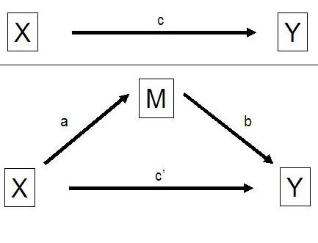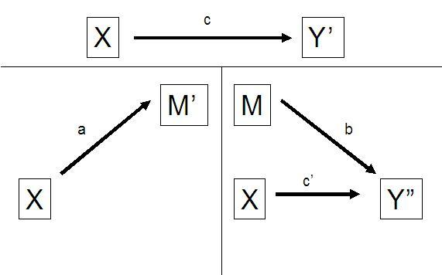
Figure 2 Original Sobel test Figure 3 Modified Sobel test

The main difference between the two figures are the primes added to M and Y to show that the scale of M’ or Y” is different from the scale of M and Y’. There are several steps needed to make the coefficients, variances and standard errors comparable to the original Sobel test. This is explained in the paper of MacKinnon and Dwyer (1993).

In order to have a mediating effect the variable guilt needs to comply to four conditions according to Baron and Kenny (1986) and Judd and Kenny (1981). Therefore the following equations which need to be significantly correlated are developed:

a) Y’= cX+E1 WTP-EFPi = β1*ECi + β2*EINVi + β3*EIMPi + β4*SPi + E1 (7)

b) M’= aX+E2 GUILTi = β1*ECi + β2*EINVi + β3*EIMPi + β4*SPi + E2 (8)

c) Y”= bM+c’X+E3 WTP-EFPi = β1*ECi + β2*EINVi + β3*EIMPi + β4*SPi (9)
+β5*GUILTi + E3

Equation 7 shows that the initial variables environmental consciousness, environmental involvement, environmental importance and social pressure are correlated with the outcome variable WTP-EFP. Equation 8 provides the condition that the initial variables are correlated with the mediator guilt. Equation 9 demonstrates that the mediator guilt affects the WTP-EFP variable when the initial variables are controlled for. Meaning that in order to measure the effect of the mediator guilt on the outcome variable one needs to take the causal effect of the initial variables into account because the mediator and the outcome may be correlated because they are both caused by the initial variables. For determining whether there is full mediation it is important to check whether the parameters βeta 1 to βeta 4 become not significant when the variable guilt is included. When this is the case it illustrates that the mediator mediates the original relationship between the WTP-EFP and initial variables, because it reduces the effect of the independent variables on the dependent variable. The effect can be diminished to zero, when the mediator is very strong.

In order to calculate the Sobel test I decided to recode the discrete response scale of the dependent variable (about the height of the respondents’ WTP-EFP) into a dichotomous scale. This is important in order to use the binary logistic regression model, because there is no literature as far as I know that explains the Sobel test for an ordinal scaled variable. By using the website of Nathaniel R. Herr and Kristopher Preacher I was able to calculate whether the mediator guilt significantly carries the influence of the independent variables environmental consciousness, environmental involvement, environmental importance and social pressure to the dependent variable WTP-EFP.

3.5 Concluding summary
This exploratory research is tested with the use of ordered probit regression and binary logistic regression. The adjusted Sobel test is used for measuring the mediating effect of guilt. With the aid of an online survey data of 156 respondents is collected. Cronbach Alpha is used to test the internal validity of the constructs and to see whether the items measure the same. Factor analysis provided reassurance that all items loaded to each predetermined latent variable in the conceptual framework. Table 1 in appendix 3 represents the summary of the constructs together with the items, sources, factor loadings and Cronbach Alpha’s.

Chapter 4 Empirical results

4.1 Introduction
In Chapter 4 I will present the estimates of the models discussed in Chapter 3 and use them to test the hypotheses I advanced in previous theoretical chapters. I used the statistical program SPSS to obtain these estimates. I then used these results to create the necessary tables, graphs and figures needed for a deep analysis of the collected data. Before this in-depth analysis, I start by presenting and explaining the descriptive statistics of my data. Next, I will indeed proceed by discussing parameter estimates and performance of the ordered probit and binary logistic model. I then turn to the mediation analysis, which I pursue by implementing the modified Sobel test discussed in Chapter 3. The chapter finishes with a concluding summary.

4.2 Descriptive statistics
The descriptive statistics table (see appendix 4) shows the minimum and maximum scores for each response item and construct for the 156 respondents (N = 156). It also indicates the equivalent mean and standard deviation. The results of the descriptive statistics provide a summary of the respondents answers, indicating their respective choices. The results for the constructs which are bold are derived by aggregating the answers of each respondent for each construct item and divide the total by the number of items.

As can be seen from the histograms (see appendix 5) 36% of the respondents would care to look for an environmentally friendly variant of the shower gel when imagining that they were buying a shower gel today. 57% of the respondents is willing to pay some price premium for the environmentally friendly variant of the shower gel when choosing between two identical bottles of shower gel where only one was certified as environmentally friendly. 43% of the respondents are not willing to pay more according to the response on the question about the height of the respondents WTP-EFP based on the 6-point discrete response scale. From the 57% of the respondents who are willing to pay a price premium for EFP’s, 47% are willing to pay a premium between €0,01 and €0,50; 32% is willing to pay a price premium between €0,51 and €1,00; and 21% of the respondents is willing to pay a price premium between €1,01 and €1,50.

The interpretation of the descriptive statistics table (see appendix 4) for the questions with a 5-point Likert scale is that the mean resembles the average response on the question or item. For example, the average response to the question “I believe that environmental information on packaging is important” is 3,92. A score of 1 indicates the response ‘strongly disagree’ and 5 resembles the response ‘strongly agree’. Thus, the average score of 3,92 indicates that on average the 156 respondents agree to the question that environmental information on 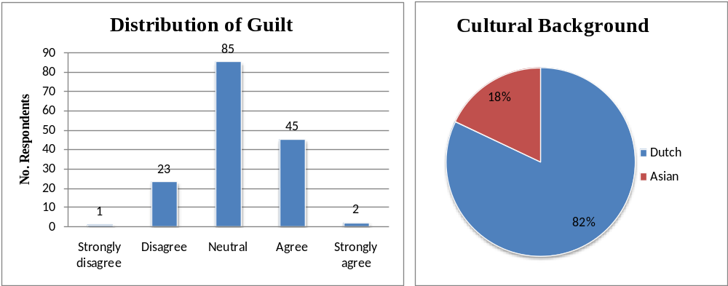packaging is important.
Figure 4 – Histogram of guilt distribution | Figure 5 – Pie chart of cultural background distribution

Figure 4 above represents the distribution of the construct guilt for the 156 respondents. The histogram indicates that the majority of the respondents (54,5%) do not know whether they experience feelings of guilt in combination with environmentally friendly behavior. 15,4% of the respondents do not experience feelings of guilt when they would behave environmentally unfriendly and 30,1% of the respondents experiences feelings of guilt when they would behave in an environmentally harming manner. This last result signifies that guilt is a variable that can have important implications regarding to environmentally friendly behavior, because “people who feel guilty will try to alleviate their guilt by engaging in compliant and altruistic behavior” (Diepen et al. 2009, p. 125).

Figure 5 depicts the distribution of cultural background for the 156 respondents. As can be seen 18% of the respondents have an Asian cultural background. In comparison to the 82% of the respondents with a Dutch cultural background, hence, the sample size for respondents with an Asian cultural background is low.

Regarding the demographic profile of the respondents in my sample, 50% of the respondents are male and the average age of the respondents is 29,5 years old. Moreover, there are only respondents included from the age of 18. The reason for incorporating only adults in the data is due to the fact that children in most cases do not purchase shower gel products on their own. The mean level of completed education is 4, indicating that the respondents on average possess a bachelor’s degree. In comparison with the average height of education of the Dutch population it can be concluded that the research data contains a bias concerning having more highly educated people than the average of the Dutch population.

The distribution of the household income level of the respondents (see appendix 6) shows that 43% of the respondents have a yearly household income of less than €20.000. This indicates that the distribution is skewed to lower income which is explanatory due to the relatively high number of students who filled out the questionnaire. The reason for the high number of students is because of time and budget constraints. The average household income of the Dutch population is €33.500. As can be seen in the pie chart 35% of the respondents in the data set have a higher income than the average Dutch population, meaning that another bias is that I have students with a low income and high educated people with a high income.

The descriptive statistics table for estimated cell probability in appendix 7 indicates the different "thickness" of each category, meaning the unequal distance between them as demonstrated by the minimum and the maximum of each category. This observation supports the decision in favor of the ordered probit model.

4.3 Ordered probit model performance and parameter estimates
The parameter estimates are obtained with the Maximum Likelihood estimation method for ordered probit models. Due to the mediating effect of guilt I need to estimate two models. The first model is without the mediator guilt and with a summated scale for personal beliefs and social pressure (equation 4 M1-NGuilt). The second analysis is with guilt as a mediator and without the summated scale for personal beliefs and social pressure (equation 5 M2-Guilt).

M1-NGuilt - Ordered Probit regression with Personal Beliefs and Social Pressure
The output of my first model can be found in appendix 9 under output analysis 1. The Model Fit information illustrates data indicating that the final fit with 11 degrees of freedom is highly significant (p < 0.016). The Chi-Square shows the improvement made to the model by adding all the 11 variables. The lower value of -2 Log Likelihood (376,15 < 399,67) indicates that the model is predicting the outcome variable more accurately.

The R-squared in general reflects the amount of variance of the dependent variable explained by the independent variables. The Pseudo R-Square statistics have been proposed in a way to have a similar interpretation, so for the sake of completeness I report them here. However they should be interpreted with caution because they do not mean exactly the same. A high value close to 1 is desirable as a positive value indicates that as the predictor variable increases, so does the likelihood of the event occurring. The Cox and Snell, Nagelkerke and McFadden pseudo R-squareds are.140, .152 and .059, respectively.

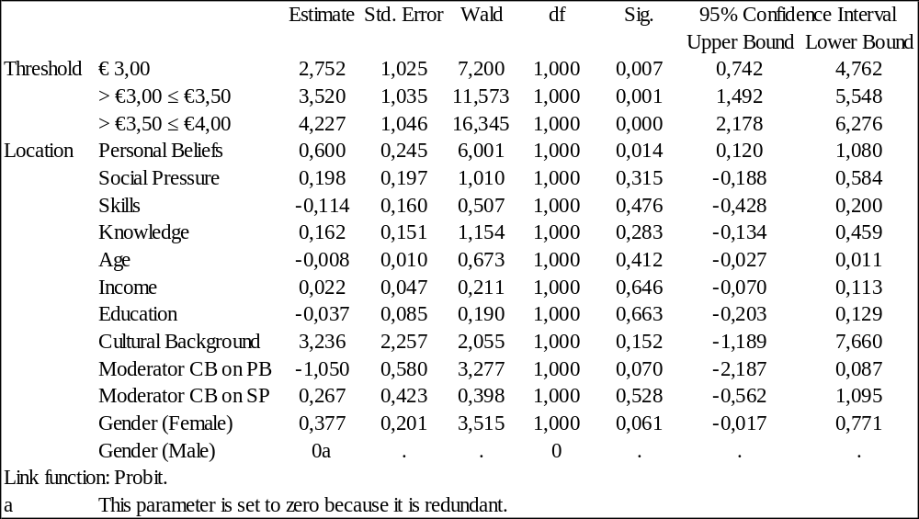Figure 6 Parameter Estimates M1-NGuilt (Ordered Probit Model)

Figure 6 above illustrates the parameter estimates of the first ordered probit model (M1-NGuilt). The parameter estimates of the dependent variable (thresholds) are significant, meaning that the use of the ordered probit model is justified because there is a distinction between the categories. The variables Personal Beliefs, Gender and the moderator cultural background on personal beliefs are significant. The moderator cultural background (measured with 1 for an Asian cultural background and 0 for a Dutch cultural background) on personal beliefs indicates with -1,05 the highest value of the significant estimates. The other variables are not significant, meaning that they do not influence WTP-EFP in a significant manner. Due to the exploratory character of this research, and a relatively low sample size especially for Asian background, a significance level up to 0,10 is acceptable.

The results of the parameter estimates indicate that respondents that scored higher on personal beliefs (i.e. environmental involvement, consciousness and importance) tend to have a higher WTP-EFP, which is indeed what one would expect to find. Yet, interestingly, the strength of this result is not universal. For respondents with an Asian cultural background this relationship is significantly weaker. Women also show a higher WTP-EFP.

When testing the hypotheses it can be stated that Environmental attitudes consisting of environmental consciousness, environmental involvement and environmental importance tested with the term personal beliefs (PB) has a statistically significant positive effect (β = 0,6 and p = 0,014). This means that hypotheses H1a, H1b and H1c cannot be rejected, with a significance level of 0,1.

Regarding hypothesis H5a it can be concluded that an Asian cultural background (CB) moderates the effect of personal beliefs on guilt in a significantly negative manner (β = -1,05 and p = 0,07). Since the CB moderator takes only two values, this finding also indicates that hypothesis H5b - which implied a positive effect of having a Dutch cultural background on the relationship between Personal Beliefs and Guilt - is significant and positive. Therefore I do not reject hypothesis H5a and H5b.

The control variable gender also has a significant positive effect (β = 0,38 and p = 0,061) when being female, indicating that hypothesis H6b is not rejected.

M2-Guilt - Ordered Probit regression with guilt
The output of the second analysis can be found in appendix 9 under output analysis 2. The Model Fit information indicates that the final fit with 9 degrees of freedom is significant (p < 0.04). The Chi-Square shows the improvement made to the model by adding all the 9 variables. The lower value of -2 Log Likelihood (381,76 < 399,67) indicates that the model is predicting the outcome variable more accurately. The Cox and Snell, Nagelkerke and McFadden equivalents are with .109, .118 and .045 respectively, in the positive direction, indicating significant effects of the inserted variables.

Figure 5 below illustrates the parameter estimates of the second analysis for the ordered probit model. The parameter estimates of the dependent variable are all significant, indicating that the confidence intervals do not overlap a lot and that there is a distinction between the categories. Gender, guilt, cultural background and the moderating effect of cultural background on guilt are significant. Cultural background has with 3,792 the highest value of the estimates. This is in accordance with its highest Wald statistic (7,525). The other variables are not significant.
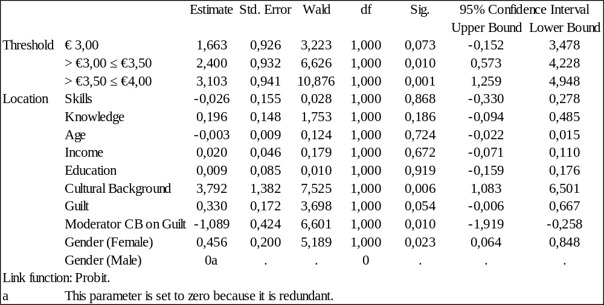Figure 7 Parameter Estimates Analysis 2 Ordered Probit Model

The parameter estimates indicate that the variable guilt is significantly positively related with WTP-EFP, that is, in general, the more guilty someone would feel by behaving in a non-environmentally-friendly manner, the more that person would be willing to pay for an EFP. Regarding the direct effect of the variable cultural background I have found that respondents with an Asian cultural background tend to have a higher WTP-EFP. However, when combining guilt with cultural background, the significant positive effect of guilt on WTP-EFP is not universal because for respondents with an Asian cultural background this relationship is significantly weaker. This results in guilt actually reducing the WTP of people with an Asian cultural background, because the parameter estimate of the moderator CB on guilt of -1,089 is bigger, in absolute terms, than the parameter estimate of guilt of 0,33. A possible reason for this phenomenon is that people with an Asian cultural background experience feelings of guilt through the violation of personal believes instead of extensive social pressure from important referents. This implies that due to the collectivistic culture feeling guilty through the violation of personal believes does not form a reason to be willing to pay more for an EFP as the individual is of less importance than the society as a whole. Similar to the model without guilt, women show a higher WTP-EFP.

When testing the hypotheses it can be stated that the mediating variable guilt has a significant positive effect (β = 0,33 and p = 0,054) on WTP-EFP. This indicates that hypothesis 4c is not rejected. Cultural background has a strong significant positive (β = 3,79 and p = 0,006) direct effect on WTP-EFP. Thus, it can be concluded that hypothesis 5e is not rejected.

The social norm social pressure has a non-significant effect. Meaning that with the current data hypothesis 2 is rejected. However, this does not mean that the variable has no influence on WTP-EFP. The hypotheses 5c and d which are related to social pressure and cultural background are also not significant and as a consequence rejected.

The variables of perceived behavioral control; income, skills and knowledge, do not have significant effects, indicating that hypotheses 3a, b and c are rejected. The effects of the control variables age and education are both non-significant, meaning that hypotheses 6a and c are rejected. Gender on the other hand provides a significant positive effect for being female, indicating that hypothesis 6b is not rejected.

From analyzing the hypotheses I am able to conclude what the drivers are of consumers’ willingness to pay more for environmentally friendly products. I believe that environmental consciousness, environmental involvement, environmental importance, feelings of guilt, cultural background and gender are extremely important underlying factors that determine WTP-EFP. Social norms, perceived behavioral control and the control variables age and education might influence WTP-EFP but not in a significantly tested manner.

4.4 Binary logistic model performance and coefficients
After analyzing the output of the ordered probit model I shortly introduce the output of the binary logistic regression model to show that there are differences between the behavior of willing to pay more and willing to look for an environmentally friendly shower gel variant.

M3-WTSearch-NGuilt - Binary logistic model with personal beliefs and social pressure
For the binary logistic model I need the same analyses as for the ordered probit model, but then with a different dependent variable. The output of these analyses can be found in appendix 10 under output analysis 3 and 4. The classification table (a,b) with step 0 shows the model before entering the independent variables. The overall percentage of 64,1% means that the model correctly classifies 64,1% of the respondents as willing or not willing to look for an environmentally friendly certified shower gel. The next part of the output named variables in the equation is a summary of the model. In step 0 only the constant is included which has a value (β0) of -0,58. After entering the independent variables in the model it can be seen from the Omnibus test of model coefficients that overall the model is predicting willingness to look for an environmentally friendly certified shower gel significantly better (p < 0,003) than with only the constant included (Field, 2005). Evidence for this better performance is illustrated in the classification table (a) with Step 1. This table shows that the overall percentage of correctly classifying has increased by 7,7 percentage points from 64,1% to 71,8% due to entering the independent variables in the model.

The next part of the output called variables in the equation is essential because it provides us the estimates for the coefficients for the independent variables of the model (Field, 2005). From the figure it becomes clear that personal beliefs is the only significant variable. This represents that respondents who scored higher on personal beliefs (i.e. environmental involvement, consciousness and importance) tend to have a higher willingness to look for an environmentally friendly certified shower gel.

In comparison to analysis 1 with the ordered probit model outcome there are two main differences. The first difference is that being female does not influence the likelihood of looking for an EFP, while it does positively influence the height of WTP-EFP. The second difference is that there is no difference in personal believes between having an Asian or a Dutch cultural background, while this is the case with the ordered probit model with WTP-EFP.

M4-WTSearch-Guilt - Binary Logistic regression with guilt
In the fourth analysis in which personal beliefs and social pressure are replaced for guilt, the overall model is significantly (p < 0,027) predicting willingness to look for an environmentally friendly certified shower gel better after entering the independent variables than with only the constant included (Field, 2005). The classification table (a) with Step 1 (see appendix 10) illustrates that the overall percentage of correctly classifying has slightly increased by 1,9 percentage points from 64,1% to 66%.

From the figure variables in the equation it becomes clear that knowledge, age and guilt are significant. The results imply that knowledge is significantly positively related with willingness to look for an environmentally friendly certified shower gel. Respondents with a higher age tend to have a higher willingness to look for an environmentally friendly certified shower gel. However the β-value is close to 0, indicating that the effect is minimal. The variable guilt is also significantly positively related with willingness to look for an environmentally friendly certified shower gel.

In comparison to analysis 2 with the ordered probit model outcome there are two main differences. First, the variable knowledge has a significant positive effect on the likelihood to look for an EFP. This is interesting, because knowledge apparently provides respondents with the incentive to be willing to look for an EFP, but does not turn this incentive into a higher WTP-EFP. An explanation for this might be that respondents who are knowledgeable about environmental topics are not willing to pay more for an EFP because they think that the price should be equal to a non EFP. Second, the variable cultural background is not significantly related to willingness to look for an EFP. This indicates that having an Asian cultural background does not influence whether the respondent is willing to look for an EFP, while it does positively relates to the height of the respondents WTP-EFP.

4.5 Sobel test for the mediator guilt
In paragraph 3.4 I explained the basic Sobel test conditions and the adjustments made in order to test mediation with dichotomous variables. Eventually I used the website of Nathaniel R. Herr and Kristopher Preacher to be able to calculate whether the mediator guilt significantly carries the influence of the independent variables environmental consciousness, environmental involvement, environmental importance and social pressure to the dependent variable WTP-EFP. I also tested the mediating effect of guilt when using the variable personal beliefs. I needed to calculate the Sobel test separately for each independent variable in order to calculate the mediating effect of guilt for each variable. The spreadsheet with calculations and the output of the adjusted Sobel test can be found in appendix 11. As can be seen the spreadsheet clearly describes the steps needed in order to calculate the Sobel test for dichotomous variables:
- The standard deviations are calculated for the X, M and Y variables, which are respectively the independent, mediating and dependent variables. This is done by running descriptive statistics on these variables.
- The covariance between X and M is calculated. This is done by running a correlation analysis with “covariance matrix” between X and M.
- The initial coefficients of a, b, c and c’ are calculated. These are derived by running the binary logistic regressions for the equations 7, 8 and 9 (see chapter 3).
- The final step for calculating the Sobel test statistics is to adjust the variances of Y’, M’ and Y”, the coefficients and standard errors of a, b, c and c’ with the use of the formula’s.

The Sobel test value can be compared to a z-score table and in that way one is able to check the significance. With the website of Kristopher Preacher I was able to calculate p-values for each Sobel test statistic. This resulted in the following output of figure 8:
Figure 8 Sobel Test statistics
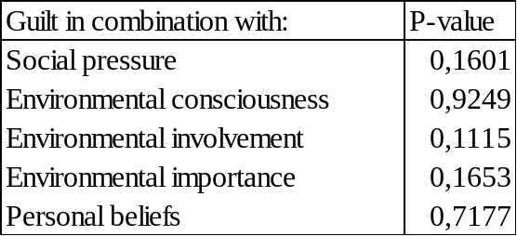The P-values indicate that the mediator guilt does not significantly mediate the effect of environmental consciousness, environmental involvement, environmental importance, social pressure and personal beliefs. Although the effects are not significant, guilt does partly mediate the effect of the variables social pressure, environmental involvement and environmental importance on the WTP-EFP. This is concluded from the P-values that are relatively close to the significance level of 10%. Environmental consciousness has a very strong direct effect on WTP-EFP which is not mediated at all by guilt. Further research is perhaps able to provide a better insight in the mediating relationship of guilt between environmental attitude, social pressure and WTP-EFP.

Due to the non-significant Sobel test statistics it cannot be confirmed that feelings of guilt stem from the violation of personal beliefs and/or social pressure to behave in an environmentally friendly manner, meaning that hypotheses 4a and b are rejected.

4.7 Concluding summary
The descriptive statistics show that 36% of the respondents would care to look for an environmentally friendly variant of the shower gel when imagining that they were buying a shower gel today. 57% of the respondents is willing to pay some price premium for the environmentally friendly variant of the shower gel when choosing between two identical bottles of shower gel where only one was certified as environmentally friendly. From the 57% of the respondents who are willing to pay a price premium for EFP’s, 47% are willing to pay a premium between €0,01 and €0,50; 32% is willing to pay a price premium between €0,51 and €1,00; and 21% of the respondents is willing to pay a price premium between €1,01 and €1,50. In addition it is shown that 30,1% of the respondents experiences feelings of guilt when they would behave environmentally unfriendly and 18% of the respondents has an Asian cultural background.

With the use of the ordered probit model I was able to find significant relationships between WTP-EFP and the independent variables environmental consciousness, environmental involvement, environmental importance, feelings of guilt, cultural background and gender. The binary logistic regression model showed that there are important differences between respondents’ WTP-EFP and willingness to look for an environmentally friendly certified shower gel. The Sobel test provided the details about the non-significant mediating effect of guilt between environmental attitude, social pressure and WTP-EFP when using a dichotomous scaled output variable.

At the end of this chapter I am able to conclude that environmental consciousness, environmental involvement, environmental importance, feelings of guilt, cultural background and gender are the drivers of consumers’ willingness to pay more for environmentally friendly products.

Chapter 5 Discussion and implications

5.1 Introduction
In this chapter I discuss what the general findings represent and how these are supposed to be interpreted taking the limitations into account. I also provide some important managerial and policy implications concerning long term economics, competitive pricing and consumer needs concerning environmentally friendly products that can help managers to understand the necessity and luxury of going for sustainable entrepreneurship.

5.2 Discussion of general findings
The goal of the present paper is to determine the underlying factors of WTP-EFP and measure why consumers are willing to pay more for environmentally friendly products. With the use of an online survey I gathered data for 156 respondents. Due to the research limitations (see paragraph 1.6) I assume that the respondents either with a Dutch or Asian cultural background are representative for two large, but culturally distinct, demographic profiles in The Netherlands. To be precise, these are students and highly educated people. The results indicate that 57% of the Dutch students and high educated people are willing to pay more for an environmentally friendly shower gel product. A study by PricewaterhouseCoopers (2009) about “making sustainability your business” found that 40% of the general group of Dutch consumers are willing to pay more for lifestyle of health and sustainability (LOHAS) products. The difference in percentage points might indicate that higher educated people and students have in general a higher WTP-EFP. This can be explained by their higher level of knowledge, awareness and/or income. However, further research is needed to provide better insight in this phenomenon.

From the 57% of the Dutch students and high educated people, almost half is willing to pay a price premium of 15%. One third is willing to pay a price premium of up to 33% and approximately one sixth goes for a price premium with a limit of 50%. These results indicate that companies who charge a price premium of more than 15% for environmentally friendly variants of products will lose a large amount of consumers when their competitors keep their prices fixed. In for example the current market this can be seen when walking through a Dutch supermarket. Many environmentally friendly products are priced 20% to 50% higher than their competitive substitutes and are - in light of the current research - pricing themselves out of the market for the majority of the Dutch students and high educated consumers.

With the aim of understanding why people are or are not WTP-EFP I found that environmental consciousness, environmental involvement and environmental importance play a vital role in whether a consumer is willing to pay more for an EFP. These variables form together the consumers’ environmental attitude and imply that a positive environmental attitude leads to a higher WTP-EFP. Similar conclusions are drawn in previous literature by Minton and Rose (1997), Suchard and Polonski (1991) and Laroche et al. (2001). Increasing awareness for the environment, helping people to actively support the environment and educating (future) consumers about environmental values can have a positive effect on consumers’ WTP-EFP.

My analyses confirm the expected association between feelings of guilt and WTP-EFP. People who experience feelings of guilt due to the violation of their personal beliefs or because of extensive social pressure from important referent groups (that view environmentally friendliness as important) are willing to pay a higher price for an EFP. The reason for the higher WTP-EFP is that a guilty person needs to increase his or her self-esteem and will try to cope with his or her guilt by engaging in environmentally friendly behavior which can result in willing to pay a higher price for an EFP. However, these results should be interpreted cautiously because I could not fully adhere to all the necessary steps in scale construction paradigms due to limitations in resources and time.

My statistical results support several of my views regarding cultural background. The direct effect of cultural background is confirmed, which indicates that people with an Asian cultural background have a higher WTP-EFP. I believe that the reason for this result comes from their collectivistic culture in which the intrinsic value of the society is considered to be greater than the sum of the intrinsic values of all individuals. Regarding this collectivism the expected negative association between personal believes and guilt when having an Asian cultural background in comparison with a Dutch cultural background is also verified. Meaning that having an Asian cultural background negatively influences the effect of personal beliefs on guilt. The influence of this effect on WTP-EFP remains unclear, because the moderating effect of social pressure on guilt is not significant. Further research concerning cultural background, guilt and WTP-EFP is needed in order to identify these relationships.

The final driver of interest is gender. Gender provides additional support for the fact that being female has a positive effect on WTP-EFP. Implying that women are willing to pay more for EFP and that the possible reason for this higher WTP is because they value the environment more and have a higher tendency to protect it.

Income, age and education are not significantly related to WTP-EFP possibly because there is not enough variation in the data to provide significant correlation. The respondents are divided into two main groups: young high educated students with low income or middle aged high educated people with a high income. The results indicate that income, age and education do not significantly influence an individual’s WTP-EFP.

Social pressure, skills and knowledge are also not significant. However, when leaving the variable personal believes out of the ordered probit model social pressure turns out to have a significant positive effect on WTP-EFP, which indicates that environmental consciousness is a very strong predictor for WTP-EFP and influences the model performance. A similar conclusion can be drawn for the variable knowledge when leaving cultural background out in the ordered probit model with guilt. Nevertheless considering the current results I conclude that social pressure, skills and knowledge do not significantly influence an individual’s WTP-EFP.

5.3 Managerial and policy implications
After discussing the general findings, this section provides the answer to what these results mean to managers and policy makers. I start with explaining the managerial and policy implications of guilt and cultural background in relation to WTP-EFP. Then I discuss two managerial implications regarding the difference between willingness to look and willingness to pay for an EFP. As a final point I end by formulating three take aways for managers and policy makers in which I provide insight in the current market situation and give some tools to understand sustainable entrepreneurship.

Guilt and Cultural Background
The variable guilt has only recently been introduced in the literature about environmentally friendly behavior (Bamberg 2006) and is currently unilluminated in the literature about WTP-EFP. The managerial implication that is most important concerning feelings of guilt is that “people who feel guilty will try to alleviate their guilt by engaging in compliant and altruistic behavior” (Diepen et al. 2009, p. 125). This results in consumers who do not want to buy products that make them feel guilty and are searching for sustainable substitutes. In the current study this would mean that almost one third of the Dutch students and high educated consumers experience feelings of guilt and, as a consequence, are willing to pay more for an EFP. So, from a managerial perspective it is relevant to find out who these consumers are and whether these consumers can be targeted with premium priced environmentally friendly products.

A comparable suggestion holds for people with an Asian cultural background, because according to the research, people with an Asian cultural background have a higher WTP-EFP. When managers can distinct cultural groups and target them separately with a proper price discrimination strategy, they can earn back the additional investments that are needed to become certified as environmentally friendly. Additionally, managers need to invest at the store level in more persuasive messages to stimulate WTP-EFP. For example, managers can make guilt-inducing messages in Western-dominated neighborhoods and non-guilt inducing but, for instance, reward/praising messages for good behavior in Asian-dominated neighborhoods. This idea is also possible in features sent by direct mail to different consumers, or in websites that morph to each consumer, where there is an even greater opportunity to target messages and marketing.

In order to let this succeed, the role of policy makers should be to make sure that companies are not using environmentally friendliness as an unconscious marketing tool, but that they are truly acting environmentally friendly.

WTP-EFP versus Willingness to look for an EFP
In chapter 4 I showed the differences between the willingness to look for an EFP model and WTP-EFP model. In sum, the differences are:
- Being a woman does not influence the likelihood of looking for an EFP, while being a woman does positively influence the height of WTP-EFP.
- Knowledge has a significant positive effect on the likelihood to look for an EFP, while there is no significant effect when analyzing the WTP-EFP model.
- Cultural background is not significantly related to willingness to look for an EFP, while it does positively relate to the height of the respondents WTP-EFP.
- There is no difference in personal believes between having an Asian or a Dutch cultural background when analyzing willingness to look for an EFP, while this is the case with WTP-EFP.
Two managerial implications are essential regarding these differences. First, these differences show that some cultural groups or groups defined by gender (e.g. people with an Asian cultural background and woman) are not willing to look for an EFP while they are willing to pay more. This indicates that managers should raise attention of these customer groups in the store, at the store level, because by default these consumers (e.g. consumers with an Asian cultural background) will not search for these products. This can be done, for example, by using visual marketing techniques aimed at attracting consumers’ attention to these EFP’s (see e.g. Lans et al. 2008). In fact, if you can grab the attention of these consumers, they will probably buy the EFP and even pay a price premium. Second, managers can invest in informative marketing and education (to increase knowledge) to increase the search for EFP’s. Subsequently they need to inform people who are knowledgeable about environmental topics that, in order to become a sustainable company, large investments are needed that need to be earned back in time to ensure continuity. This might provide the vital incentive for knowledgeable people to be willing to pay more for an EFP besides only willing to look for an EFP.

Three take aways
1. Long term economics
The first take away is that managers need to break free from their competitive myopia. Sustainable entrepreneurship needs to be fed by “entrepreneurial imagination and willingness to make risky long-term competitive investments” (Hayes and Abernathy 2007, p. 139) that will earn themselves back as an outcome of processes instead of a goal on itself (Heertje 2006). Nowadays, according to Hayes and Abernathy (2007), business is almost like banking, because managers are focused on the return on investments and ensuring cash flow generating activities. There is so much more to economics and business than this financially focused world in which prosperity is separated from welfare, leading to a separation between what can be measured in terms of the allocation of scarcity, like money and goods and what cannot be measured like sustainability, living in a healthy environment and happiness (Heertje 2006). According to Heertje (2006) this separation in fact does not even logically exist, because the means and ends of welfare require the use of scarce resources such as clean air and free space on the freeway, meaning that prosperity and welfare have a similar definition. When readjusting the quantitative approach into a qualitative approach to life it becomes clear that nature plays a vital role in our survival during the current crisis of existence. For managers this implies that “the key to long-term success - even survival – in business is what it has always been: to invest, to innovate, to lead and to create value where none existed before” (Hayes and Abernathy 2007, p. 149). This managerial vision, or goal, is consistent with ‘being environmentally friendly’, defined by any human activity (e.g. production or consumption) which is carried in a manner that guarantees (a) minimal impact on the capacity of the natural environment to carry waste and (b) the maintenance of Earth’s natural capital, (c) without compromising the ability of future generations to meet their own needs. The role of policy makers is to make sure that companies follow the guidelines and become sustainable.

2. Competitive pricing
During the past several years the number of environmentally friendly products has increased enormously. The market potential for these products is increasing as well. According to a recent study among Americans it is claimed that the majority of the Americans find it important that a product is environmentally friendly (GFK Roper Yale Survey 2008). Subsequently, an even more relevant, a recent study found that “one third of the Dutch consumers pay attention to the sustainability of a product when purchasing” (PriceWaterhouseCoopers 2009, p. 5). These positive findings, in combination with the antecedents of willingness to pay a price premium I highlighted throughout my thesis, provide managers the means to start securing their future business by becoming environmentally friendly. However, managers should be warned that in the current market while momentum for sustainability is gathered, one needs to remain competitive with their pricing.

The thousands of environmentally friendly products that are currently in the market can be divided in several categories. The most common category of products is the environmentally friendly variant of an ordinary product that is already in the market. When applied properly, the points of parity are met, meaning that the new product has the same attributes as the original product. The additional value is then the point of difference, indicating the new attribute, which is that the product is environmentally friendly. In my study 57% of the Dutch students and higher educated consumers are willing to pay a price premium up to 15% for this added value. Given this information it is of crucial importance that managers make the right decision concerning the pricing strategy of their products, because they otherwise price themselves out of the market, which is currently at stake. For example, an organic pizza is priced 40% higher than the original pizza’s of the same brand (Organic pizza €2,69 and same original pizza €1,93) or an environmentally friendly cucumber is priced 50% higher than its non-environmentally friendly counterpart (environmentally friendly cucumber €1,20 and ordinary cucumber €0,80).

In order to solve the pricing issue companies need to invest in cost-cutting technologies and price products more sensibly, exploit communication and marketing opportunities and lobby for subsidies or lower taxes to compensate for the difference between the margin they need to charge to be profitable, and the margin consumers are willing to pay.

With product prices that have a maximum premium of 15%, more consumers are willing to pay for the product, which can create economies of scale. Meaning that when demand increases, the constant costs of the product drops due to the higher quantity by which the constant costs are divided. This leads to a bigger margin in which the investment of becoming sustainable can be earned back. When thinking in this long term way, profit becomes an outcome of processes instead of a goal on itself.

3. Consumer needs
Consumers are increasingly aware of sustainability and they demand sustainable products. The increase in the demand provides more room for sustainable entrepreneurs to gain momentum in the market and accumulate market share. However, managers need to keep in mind that the majority of the consumers is not willing to pay a large price premium because of a product being environmentally friendly. Environmentally friendliness is not something special, but something that should be naturally associated with products. For example, a consumer is not willing to pay more money when going to a restaurant that says on the menu that the food is arsenic free, because it is supposed to be arsenic free.

At this point a question arises on how to remain competitive when consumers are not willing to pay more money and not environmentally friendly competitors have lower investment costs. The answer to this question is twofold. First of all, many leading world governments have signed the Kyoto protocol in 1997 and will sign the ‘Copenhagen protocol’ in December 2009. They will be signing for a reduction of the impact of human activity on our planet. The regulation that follows from this protocol will be translated back through these governments, to all the companies that fall under the government policy. This government policy will force non sustainable companies to make similar or even higher investments in order to execute the compulsory regulations.
Secondly, and more presently, companies who are environmentally friendly need to communicate that they are environmentally friendly to their target market in order to create awareness for their brand. Academic research provides evidence that for example investments in environmentally friendliness lead to increase in purchase likelihood, profitability and consumer loyalty when the decision of firms to offer EFP's as a Corporate Social Responsibility is well linked to a correct brand positioning and overall firm strategy (Du et al. 2007).

5.4 Further research
In this section I illustrate shortly some unilluminated issues concerning research about WTP-EFP which can provide new insights. I think that besides researching differences in WTP-EFP between Asian and Dutch cultural backgrounds, other cultural backgrounds need to be explored. For example, examine the difference in WTP-EFP between Northern European and Southern European cultural backgrounds.

Concerning emotions it would be interesting to test whether other emotions besides feeling guilty have interesting implications on WTP-EFP. Emotions like pride for acting environmentally friendly or having a warm glow feeling when doing something good for the environment are interesting to delve into.

Regarding intention versus actual behavior there is also more research needed. Many academics write about the intentions of consumers, but few write about actual consumer behavior. In many cases consumers talk the talk, but do not walk the walk. Meaning that consumers intent to purchase environmentally friendly products but leave the shop without them. It would be fascinating to find out why consumers stumble when it comes down to walk the talk.

5.5 Concluding summary
From the discussion of general findings I can conclude that the results indicate that companies who charge a price premium of more than 15% for environmentally friendly variants of products will lose a large amount of consumers when their competitors keep their prices fixed. Many environmentally friendly products are - in light of the current research - priced out of the market for the majority of the Dutch students and high educated consumers.

With the aim of understanding why people are or are not WTP-EFP I found that a positive environmental attitude leads to a higher WTP-EFP. My analyses confirm that people who experience feelings of guilt are willing to pay a higher price for an EFP. My statistical results support several of my views regarding cultural background. People with an Asian cultural background have a higher WTP-EFP. I also found that having an Asian cultural background negatively influences the effect of personal beliefs on guilt. The final driver of interest is gender and implies that woman are willing to pay more for an EFP.

From the managerial and policy implications it becomes clear that almost one third of the Dutch students and high educated consumers experience feelings of guilt and as a consequence do not want to buy products that make them feel guilty and are searching for sustainable substitutes. Differences in cultural background show managers the need to distinct cultural groups and target them separately with a proper price discrimination strategy and diverse persuasive messages.

Concerning the difference between WTP-EFP and willingness to look for an EFP I found that managers should increase the attention of customer groups who by default will not search for EFP’s in the store, at the store level. This can be achieved with the use of visual marketing techniques aimed at attracting consumers’ attention to these EFP’s. An additional managerial implication is that managers need to invest in informative marketing and education to increase the search for EFP’s. Subsequently they need to inform people who are knowledgeable about environmental topics that the price premiums are necessary to ensure continuity of their business.

I conclude the managerial and policy implications with three crucial take aways in order to give some tools to understand sustainable entrepreneurship; a) long term economics, in which I explain that competitive myopia is not going to solve the current crisis of existence, b) competitive pricing, where I make clear that consumers are price sensitive and companies need to price products sensibly and c) consumer needs, in which I clarify that companies need to communicate to their target market that they are environmentally friendly in order to create brand awareness.

I end by asking academics to begin with research about other cultural backgrounds, other emotions and the difference between intention and actual behavior in order to understand why consumers stumble when it comes down to walk the talk.

Acknowledgements
After studying the subject of WTP-EFP for endless hours, days and weeks I can finally write my words of gratitude. Besides my intrinsic motivation to graduate and learn about the field of sustainability there is one person in particular who gave me the motivation to keep on going. This is my supervisor Drs. Nuno Camacho, who actively supported me with his positive reviews during the whole thesis process and who excellently shaped my chaotic thoughts. Hereby I would like to thank Drs. Nuno Camacho for his endless support.

During the time consuming moments of writing my thesis I came to realize that I am able to write this thesis only because of my environment. For that reason I am grateful to my family and friends for making it possible for me to graduate. Their continuous encouragement and insights concerning environmentally friendly behavior were of great assistance. At last I would like to thank Irene for her unconditional love and the fact that she endures all my talking about sustainability.

Kind regards,

Richard Peters

References

- Ajzen, I. (1991), “The theory of planned behavior,” Organizational Behavior and Human Decision Processes, 50, 179-211.
- Ajzen, I. (2002), “Perceived Behavioral Control, Self-Efficacy, Locus of Control, and the Theory of Planned Behavior,” Journal of Applied Social Psychology, 32, 665-683.
- Ajzen, I. and B. L. Driver (1992), “Contingent Value Measurement On the Nature and Meaning of Willingness to Pay,” Journal of consumer psychology, 4, 297-316.
- Ajzen, I. and M. Fishbein (1980), Understanding Attitudes and Predicting Social Behavior. Prentice-Hall, Englewood Cliffs, NJ.
- Amyx, D. A., P. F. de Jong, Chakraborty G. Lin and J. L. Wiener (1994), “Influencers of purchase intentions for ecologically safe products: an exploratory study,” Winter Educators’ Conference Proceedings of the American Marketing Association, 5, 341-347.
- Andreoni, James (1990), “Impure Altruism and Donations to Public Goods: A Theory of Warm-Glow Giving,” The Economic Journal, 100 (401), 464–77.
- Auger, Pat; Burke, Paul; Devinney, Timpthy M.; Louviere, Jordan J. (2003), “What will consumers pay for social product features?,” Journal of Business Ethics, 42, 281-304.
- Bamberg, Sebastian and Guido Möser (2007), “Twenty years after Hines, Hungerford, and Tomera: A new meta-analysis of psycho-social determinants of pro-environmental behaviour,” Journal of Environmental Psychology, 27, 14-25.
- Baron, R. M., & Kenny, D. A. (1986), “The moderator-mediator variable distinction in social psychological research: Conceptual, strategic and statistical considerations”, Journal of Personality and Social Psychology, 51, 1173-1182.
- Baumeister, Roy F., Arlene M. Stillwell and Todd F. Heatherton (1994), “Guilt: An interpersonal Approach,” Psychological Bulletin, 115 (2), 243-267.
- Becker and Murphy (2000), Social Economics: Market Behavior in a Social Environment. Cambridge, Mass. Belknap Press of Harvard University Press.
- Bohlen, Greg, Bodo B. Schlegelmilch and Adamantios Diamtopoulos (1993), “Measuring Ecological Concern: A Multi-construct Perspective,” Journal of Marketing Management, 9, 415-430.
- Borden, D. & Francis, J.L. (1978), “Who cares about ecology? Personality and sex difference in environmental concern,” Journal of Personality, 46, 190–203.
- Bui, My H. (2005), “Environmental marketing: A model of consumer behavior,” Proceedings of the annual meeting of the association of collegiate Marketing Educators (2005).
- Burnett, Melissa S. and Dale A. Lunsford (1994), “Conceptualizing Guilt in the Consumer Decision-Making Process,” Journal of Consumer Marketing, 11 (3), 33–43.
- Churchill, Gilbert A. (1979), “A Paradigm for Developing Better Measures of Marketing Constructs,” Journal of Marketing Research, XVI (February), 64-73.
- Coddington, W. (1990), “It’s no fad: environmentalism is now a fact of corporate life,” Marketing News, 15 (October), 7.
- Cornelissen, Gert, Mario Pandelaere, Luk Warlop and Siegfried Dewitte (2008), “Positive cueing: Promoting sustainable consumer behavior by cueing common environmental behaviors as environmental,” International Journal of Research in marketing, 25, 46-55.
- Costanza, Robert (1996), “Introduction: Ecological Economics and sustainability,” Ecological Applications, 6 (4), 975.
- Daykin, Anne R. and Peter G. Moffatt (2002), “Analyzing Ordered Responses: A Review of the Ordered Probit Model”, Understanding Statistics, 3, 157-166.
- Diepen, Merel van, Bas Donkers and Philip Hans Franses (2009), “Dynamic and Competitive Effects of Direct Mailings: A Charitable Giving Application,” Journal of Marketing Research, XLVI (February), 120-133.
- Du, Shuili, C.B. Bhattacharya and Sankar Sen (2007), “Reaping relational rewards from corporate social responsibility: The role of competitive positioning,” International Journal of Research in Marketing, 24, 224-241.
- Dunlap, R. E., Van Liere, K. D., Mertig, A. G. & Jones, R. E. (2000), “Measuring endorsement of the new ecological paradigm: a revised NEP scale,” Journal of Social Issues, 56 (3), 425–442.
- Field, Andy (2005), Discovering Statistics Using SPSS. London: Sage Publications.
- Fishbein, M., and I. Ajzen (1975), Belief, attitude, intention, and behavior: An introduction to theory and research. Reading, MA: Addison-Wesley.
- Franses, Philip Hans and Richard Paap (2001), Quantitative Models in Marketing Research. New York: Cambridge University Press.
- Freeman (1984), Strategic management: A stakeholder approach. Boston: Pitman.
- Goodland, Robert (1995), “The Concept of Environmental Sustainability,” Annual review of ecology and systematics, 26, 1-24.
- GfK Roper Yale Survey on Environmental Issues (2008), (accessed June 6, 2009), [available at http://environment.research.yale.edu/documents/downloads/a-g/GfK-Roper-Yale-Survey.pdf]
- Griskevicius, Vladas, Noah J. Goldstein, Robert B. Cialdini (2008), “A Room with a Viewpoint: Using Social Norms to Motivate Environmental Conservation in Hotels,” Journal of consumer research, 35 (August).
- Hanemann, W. Michael (1991), “Willingness to Pay and Willingness to Accept: How Much Can They Differ?” The American Economic Review, 81 (June), 635-647.
- Harder, David H and Alysa Zalma (1990), “Two Promising Shame and Guilt Scales: A Construct Validity Comparison”, Journal of personality assessment, 55 (3&4), 729-745.
- Hart, Stuart L. (1995), “A natural-Resource-Based View of the Firm,” Academy of Management Review, 20 (4), 986-1014
- Hayes, Robert H. and William J. Abernathy (2007), “Managing our way to economic decline,” Harvard Business Review, (July – August), 138-149.
- Heberle, R. (1968), “Tönnies, Ferdinand” In International encyclopedia of the social sciences, D. L. Sills, ed. New York: Macmillan. 16, 98-103.
- Heertje, A. (2006), Echte economie: een verhandeling over schaarste en welvaart en over het geloof in leermeesters en lernen. Nijmegen: Thijmgenootschap.
- Hofstede, G. (2001), Culture’s consequences: Comparing values, behaviors, institutions and organizations across nations. Thousand Oaks, CA: Sage.
- Hume, S. (1991), “Consumer double talk makes companies wary,” Advertising Age, 62 (46), GR4.
- Jackman, Simon (2000), “Models for Ordered Outcomes”, Political Science 200C, (Spring), 1-20.
- Jensen, Kimberly L. and Paul M. Jakus (2003), “Consumers’ Willingness to Pay for Eco-Certified Wood Products,” (accessed October 22, 2009), [available at http://ageconsearch.umn.edu/bitstream/22159/1/sp03je01.pdf].
- Judd, C. M., & Kenny, D. A. (1981), “Process analysis: Estimating mediation in treatment evaluations,” Evaluation Review, 5, 602-619.
- Kaiser, Florian G. and Todd A. Shimoda (1999), “Responsibility as a Predictor of Ecological Bahaviour,” Journal of Environmental Psychology, 19, 243-253.
- Kals, E. (1993), “Ökologisch relevante Verbotsforderungen, Engagement- und Verzichtsbereitschaften am Beispiel der Luftqualität [Ecologically relevant acceptances of governmental prohibition and readiness to adopt behaviors related to pollution]. Ph. D. thesis, Universität Trier, Germany.
- Kline, P. (1999). The handbook of psychological testing. London: Routledge.
- Kluckhohn, C. (1951), “The study of culture”. In D. Lerner & H.D. Lasswell (Eds.), The Policy Sciences (86-101). Stanford, CA: Stanford University Press.
- Kollmuss, A., & Agyeman, J. (2002), “Mind the Gap: Why do people act environmentally and what are the barriers to pro-environmental behavior?,” Environmental Education Research, 8 (3), 239-260.
- Kugler, Karen and Warren H. Jones (1992), “On Conceptualizing and Assesing Guilt,” Journal of Personality and Social Psychology, 62 (2), 318-327.
- Lans, Ralf van der, Rik Pieters and Michel Wedel (2008), “Eye-Movement Analysis of Search Effectiveness,” Journal of the American Statistical Association, 103, 452-461.
- Laroche, Michel; Bergeron, Jasmine; and Barbaro-Forleo, Guido (2001), “Targetting consumers who are willing to pay more for environmentally friendly products,” Journal of Consumer Marketing, 18 (6), 503-521.
- MacKinnon, D. P., & Dwyer, J. H. (1993), “Estimating mediated effects in prevention studies,” Evaluation Review, 17, 144-158.
- Madeleine E. Pullman, William L. Moore, Don G. Wardell (2001), “A comparison of quality function deployment and conjoint analysis in new product design,” The Journal of Product Innovation Management, 19, 354-364.
- Malthus T.R. (1798), An essay on the principle of population. Chapter 1, p13 in Oxford World's Classics reprint.
- Minton, Ann P. and Randall L. Rose (1997), “The effects of Environmental Concern on Environmentally Friendly Consumer Behavior: An Exploratory Study,” Journal of Business Research, 40, 37-48.
- Newell, S. J. and Green, C.L. (1997), “Racial differences in consumer environmental concern,” The Journal of Consumer Affairs, 31 (1), 53-69.
- Pearce D. and D. Moran (1994), “The Economic Value of Biodiversity,” in Earthscan Publications, The World Conservation Union (IUCN), ed. London.
- Philip Kotler, Gary Armstrong, John Saunders and Veronica Wong (1999), Principles of Marketing. Prentice Hall: Europe.
- PriceWaterhouseCoopers (2009), “Make sustainability your business,” Publication by PricewaterhouseCoopers Advisory N.V. Amsterdam.
- Rao, A.R. and M.E. Bergen (1992), "Price premium variations as a consequence of buyers’ lack of information," Journal of Consumer Research, 19, 412-23.
- Roberts, J.A. and D.R. Bacon (1997), “Exploring the subtle relationship between environmental concern and ecologically conscious consumer behavior,” Journal of Business Research, 40 (1), 79 – 89.
- Rossiter, John R. (2002), “The C-OAR-SE procedure for scale development in marketing,” International Journal of Research in Marketing, 19, 305-335.
- Schlegelmilch, Bodo, Greg Bohlen and Adamantios Diamantopoulos (1996), “The link between green purchasing decisions and measures of environmental consciousness,” European Journal of Marketing, 30 (5), 35 – 55.
- Schwartz, J. and T. Miller (1991), “The earth’s best friends,” American Demographics, 13 (February), 26 – 33.
- Schwartz, S. H. (1992), “Universals in the content and structure of values: Theoretical advances and empirical tests in 20 countries,” Advances in experimental social psychology, 25, 1-65.
- Simmons, D., & R. Widmar (1990), “Motivations and barriers to recycling: Toward a strategy for public education,” The Journal of Environmental Education, 22, 13 – 18.
- Suchard, H.T., and M.J. Polonski (1991), “A theory of environmental buyer behaviour and its validity: the environmental action-behaviour model,” in Gilly, M.C. et al. (Eds), AMA Summer Educators’ Conference Proceedings, American Marketing Association, Chicago, IL, 2, 187-201.
- Swain, Scott D., Danny Weathers and Ronald W. Niedrich (2008), “Assessing Three Sources of Misresponse to Reversed Likert Items,” Journal of Marketing Research, XLV (February), 116-131.
- Tangney, June Price (1990), “Assessing Individual Differences in Proneness to Shame and Guilt: Development of the Self-Conscious Affect and Attribution Inventory,” Journal of Personality and Social Psychology, 59 (1), 102-111.
- Train, Kenneth E. (2003), Discrete Choice Methods with simulation. New York: Cambridge university press.
- Van Liere, K. and Dunlap, R. (1981), “The social bases of environmental concern: a review of hypotheses, explanations, and empirical evidence,” Public Opinion Quarterly, 44 (2) 181 – 97.
- Vlosky, Richard P., Lucie K. Ozanne and Rénee J. Fontenot (1999), “A conceptual model of US consumer willingness-to-pay for environmentally certified wood products,” Journal of Consumer Marketing, 16 (2), 122-136.
- Webster, Frederick E., Jr. (1975), “Determining the Characteristics of the socially conscious consumer,” Journal of consumer research, 2 (December), 188-196.
- Webster's New Millennium Dictionary of English Copyright © 2003-2009 Dictionary.com, LLC, (accessed June 5, 2009), [available at http://dictionary. reference.com/browse/nature-friendly]
- WCED, World Commission on environment and development (1987), Our common future. New York: Oxford University Press.

Appendixes

Appendix 1 Maslow’s Hierarchy of Needs
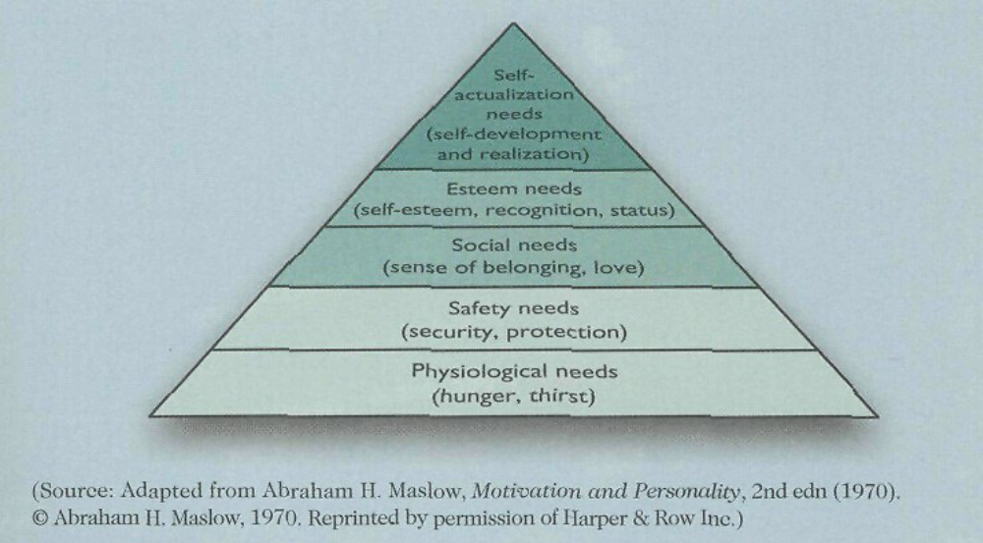

Appendix 2 Scree Plot of Factor Analysis for Environmental Attitude
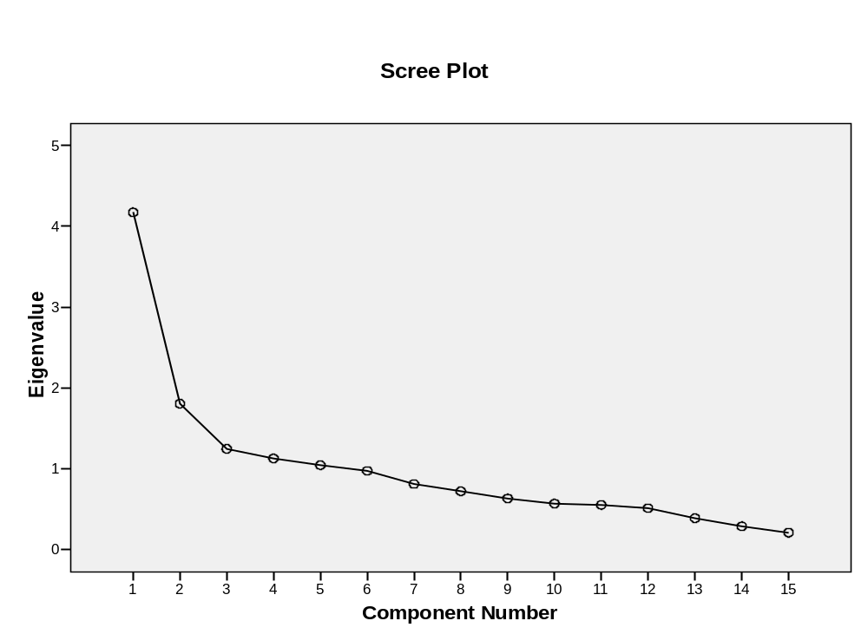
The component number stands for the number of factors.

Appendix 3 Table 1 Measures
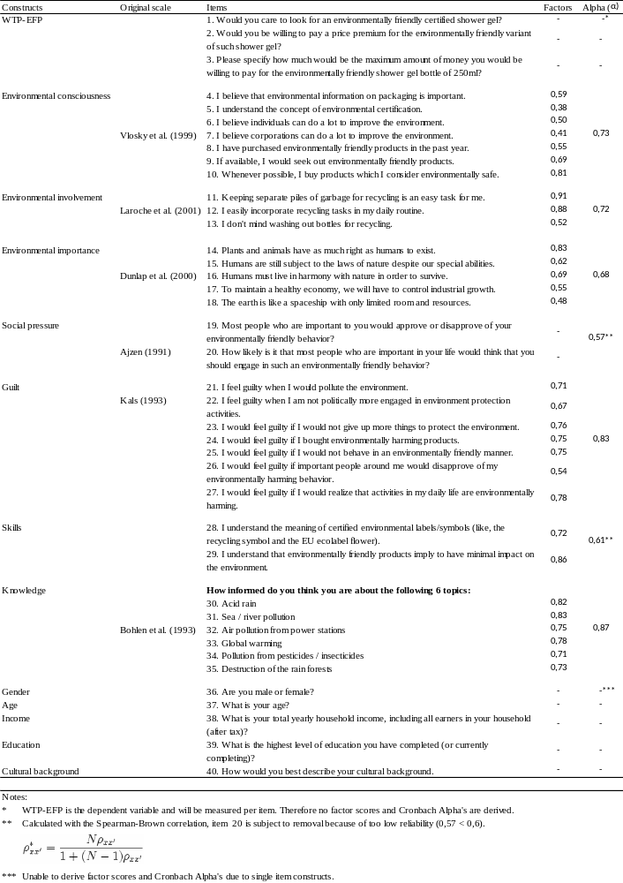

Appendix 4 Table 2 Descriptive Statistics
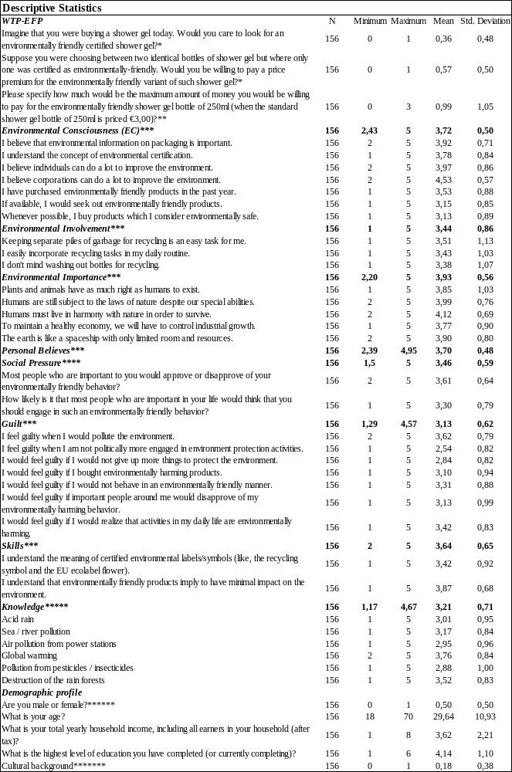

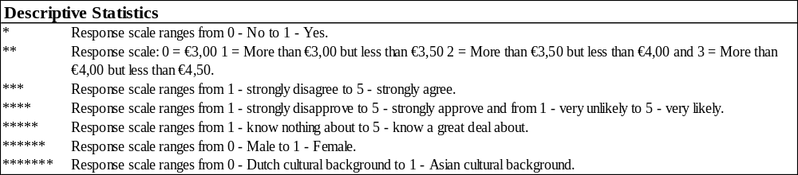

Appendix 5 Histograms of DV’s

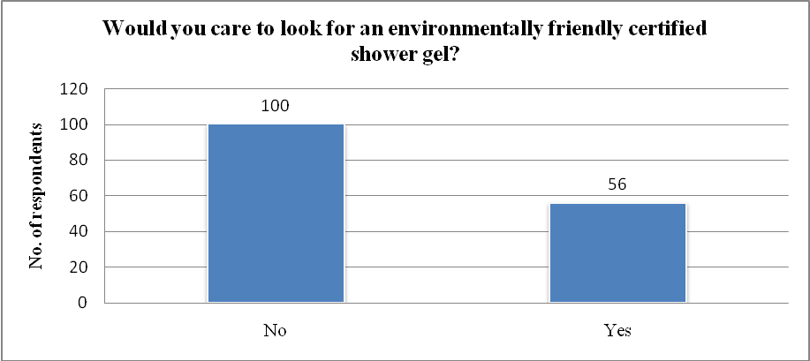

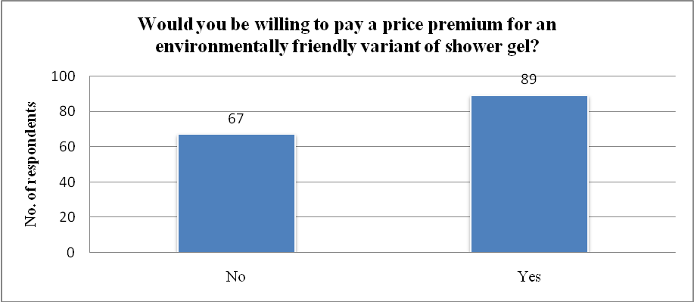
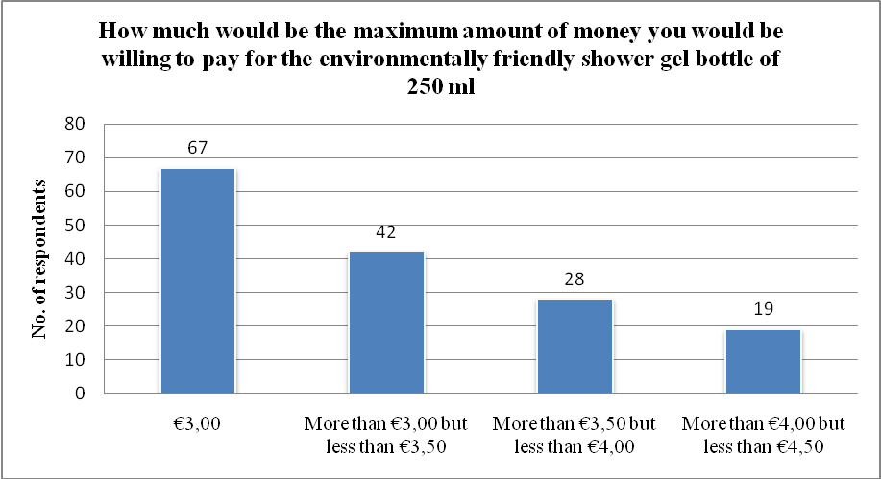

Appendix 6 Pie chart for yearly household income

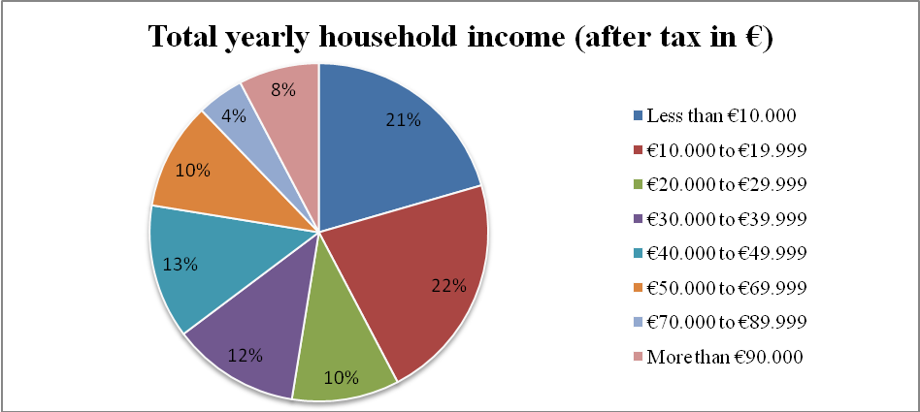

Appendix 7 Descriptive statistics for estimated cell probability
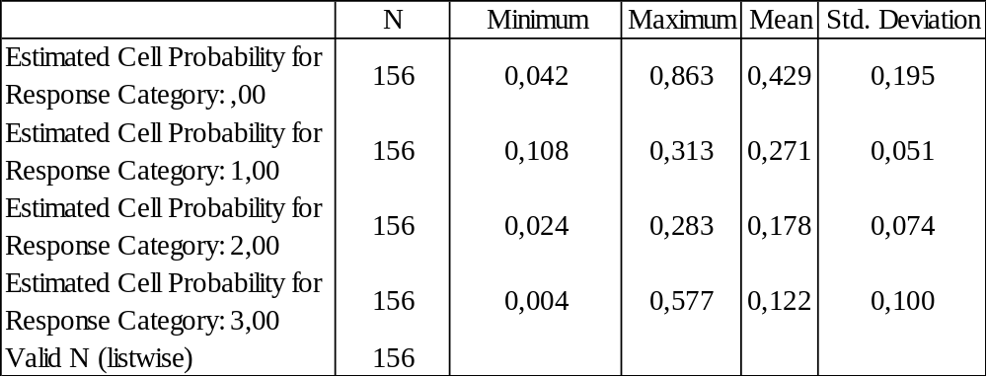

Appendix 8 Table with definitions for the variables
WTP-EFP | Willingness to pay for environmentally friendly products
EC | Environmental consciousness
EINV | Environmental involvement
EIMP | Environmental importance
PB | Personal believes
SP | Social pressure
EDU | Education
CB | Cultural background

Appendix 9 Output Ordered Probit model

Output M1-NGuilt
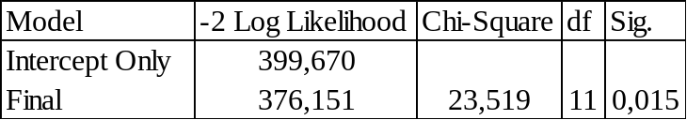Model Fitting Information Pseudo R-Square
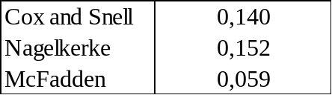

Output M2-Guilt
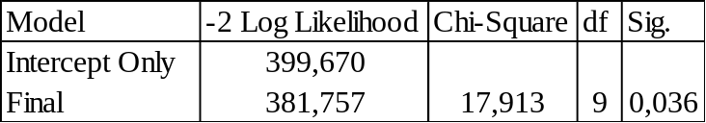Model Fitting Information Pseudo R-Square
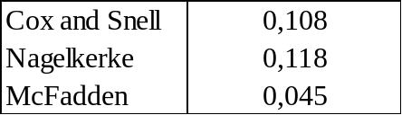

Appendix 10 Output Binary Logistic model

Output M3-WTSearch-NGuilt
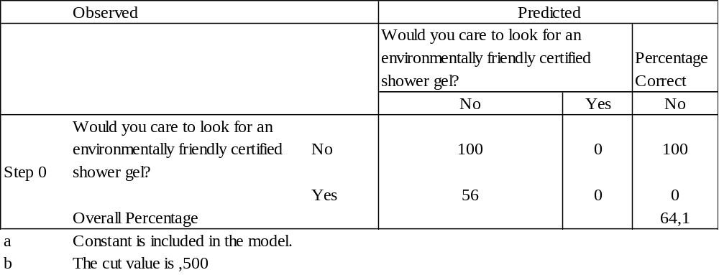Classification Table (a,b) Step 0

Variables in the Equation

Omnibus Tests of Model Coefficients
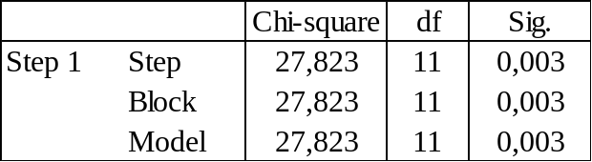

Variables in the equation
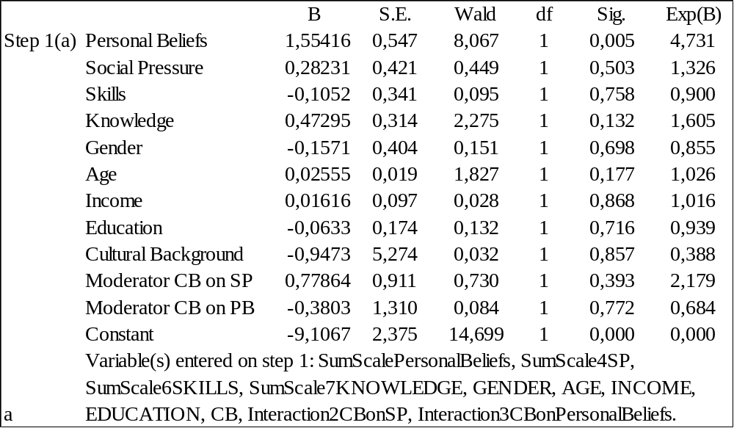

Classification Table (a) Step 1
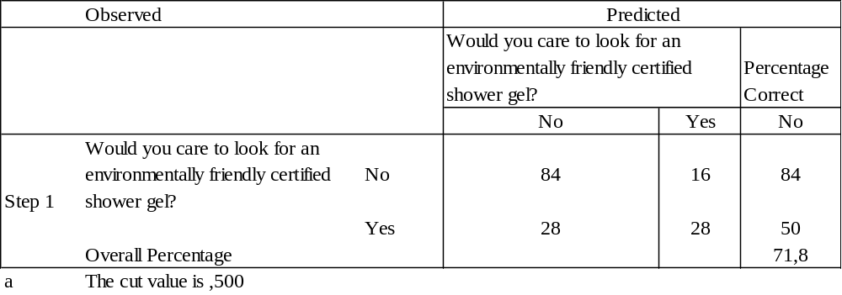

Output M4-WTSearch-Guilt

Omnibus Tests of Model Coefficients
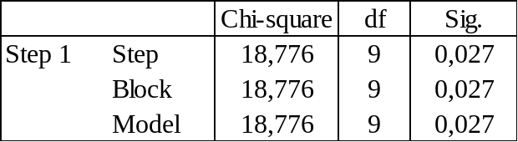

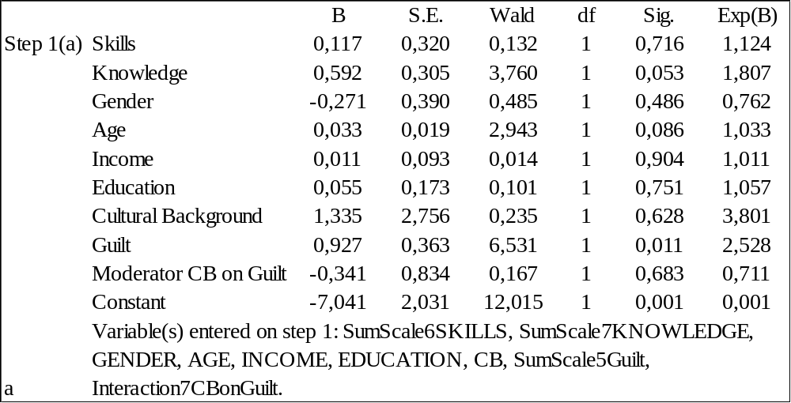Variables in the equation

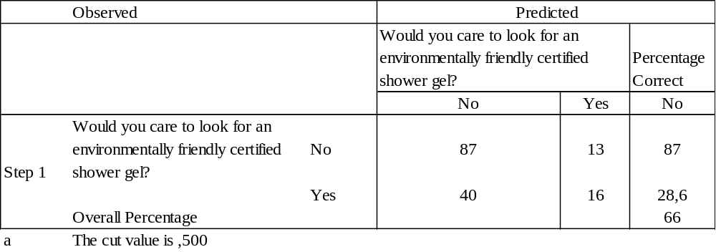 Classification Table (a) Step 1

Appendix 11 Sobel Test Output Spreadsheet

Sobel test output for mediator Guilt and Social Pressure
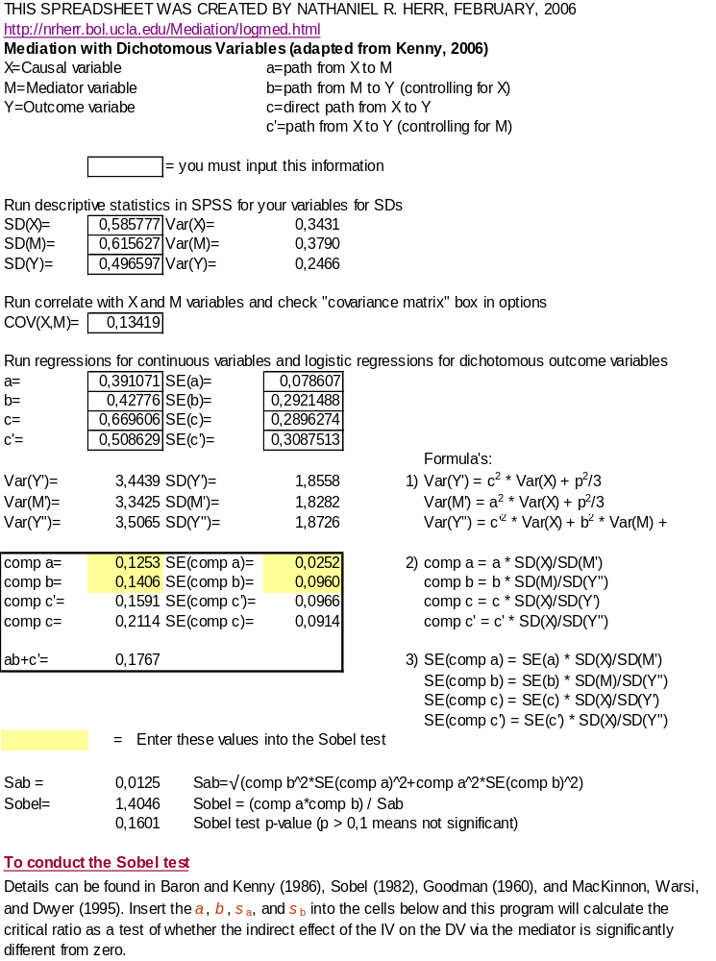

Appendix 12 Environmental Behavior Questionnaire
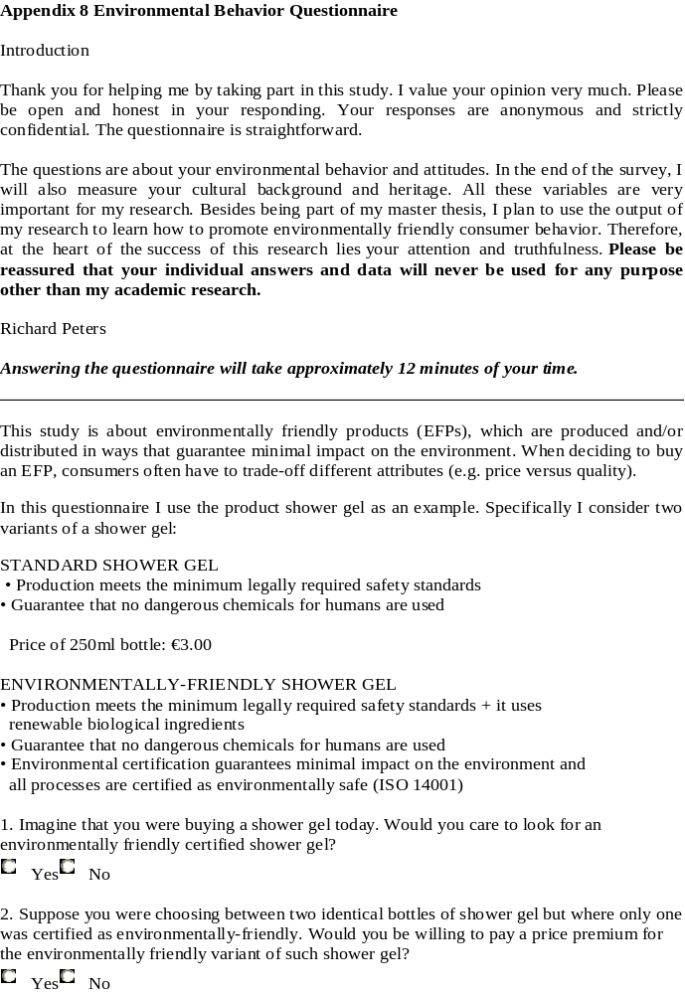
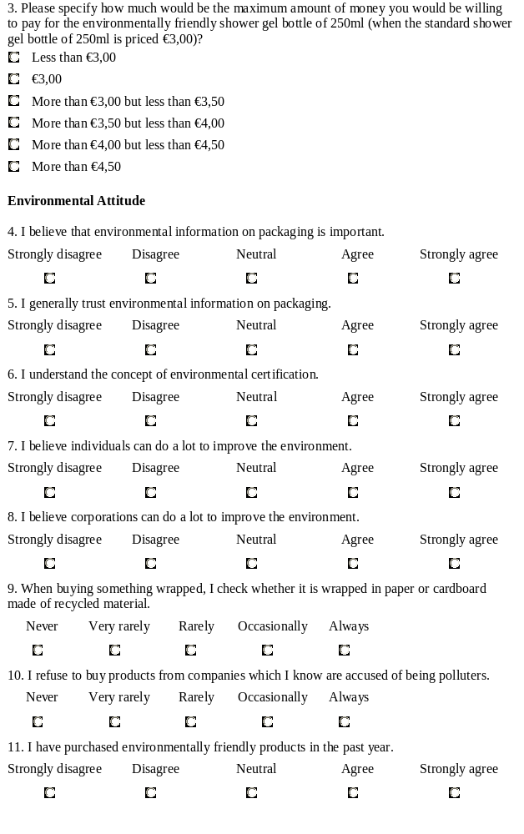
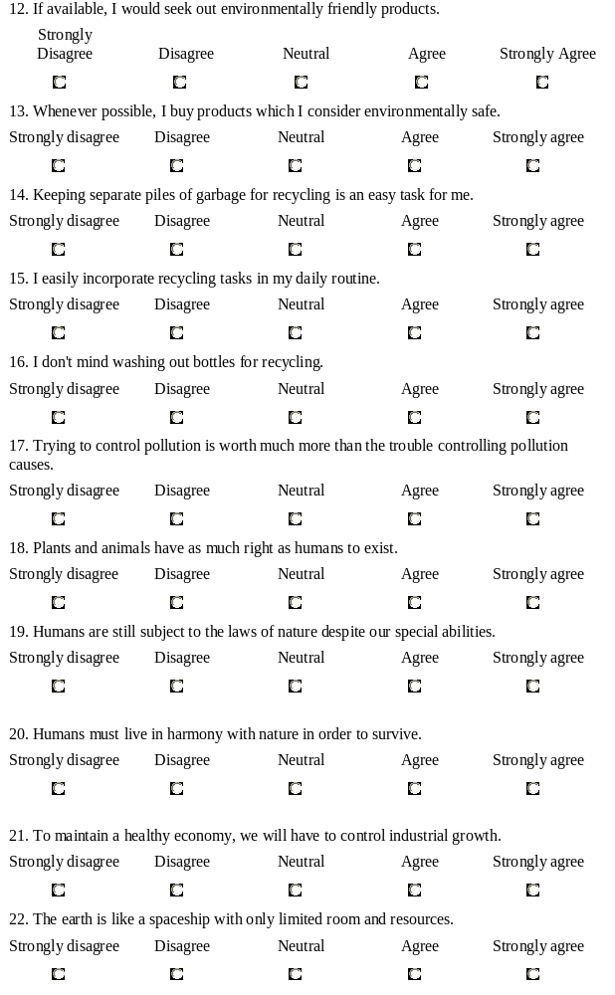
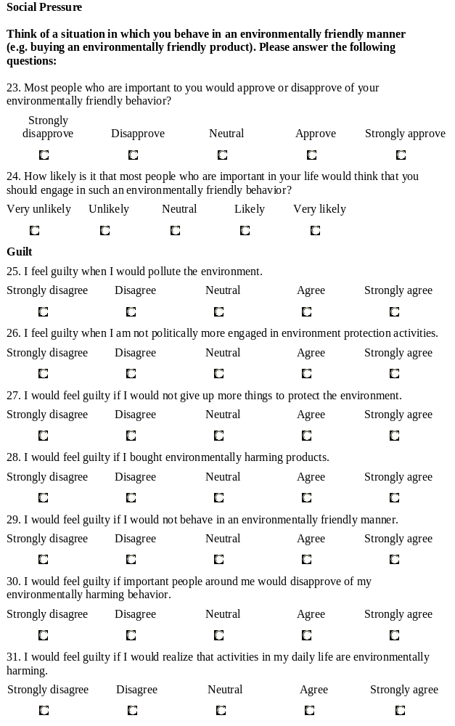
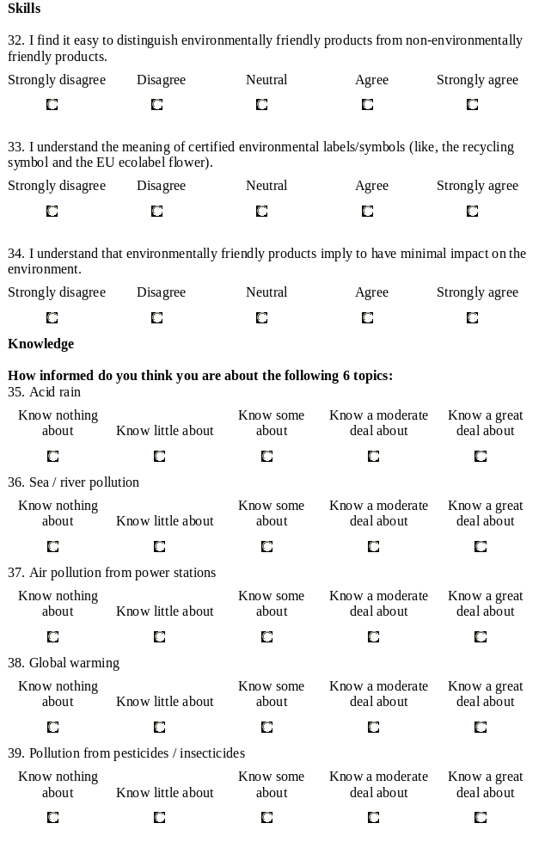


Human activity refers to the things that people do or cause to happen. In this case the increase in consumption and manufacturing are most relevant.
McKinsey Quarterly video: When sustainability means more than ‘green’ http://www.mckinseyquarterly.com/Video?vid=314 date: 06-07-2009.
The Brundtland commission was founded in 1983 by the United Nations and named after the Norwegian politician Gro Harlem Brundtland. She was the Chair of the World Commission on Environment and Development. The goal of the commission is to create awareness concerning sustainable development.
Freeman (1984) defines stakeholders as “any group or individual who is affected by or can affect the achievement of an organization’s objectives”.
Volitional control as “being able to decide at will to perform or not to perform the behavior in question” (Ajzen 1991, p. 182).
People who perceive inconvenience due to behaving in an environmentally friendly manner will have a lower environmental involvement.
This behavioral motivation will only occur when preceding human needs in the Maslow’s Hierarchy of needs are fulfilled (see appendix 1 for the model). In particular, a guilty person needs to increase his/her self-esteem but that should only be a priority for an individual when the physiological, safety and social needs are already taken care of, otherwise self-esteem will not be a strong motivator for such individuals (Kotler et al. 1999).
Cronbach Alpha is used to measure internal reliability. It measures the extent to which a set of item responses correlate highly with each other, meaning that they measure a single construct. According to Kline (1999) the generally accepted value of Cronbach’s Alpha is .8 for cognitive tests, .7 for ability tests and when dealing with psychological constructs, a value below .7 can be expected because of the diversity of the constructs being measured.
The reason that β is a vector of parameters not containing an intercept is because it is not possible to identify all parameters, thresholds and intercepts. Some identification needs to be imposed and a common restriction is to set the intercept to zero and the variance of the errors to one, allowing estimation of all other beta parameters and all thresholds (Jackman 2000).
Website of David Kenny explaining mediation. http://davidakenny.net/cm/mediate.htm date: 30-09-2009.
Website of Nathaniel R. Herr explaining mediation with dichotomous outcomes. http://nrherr.bol.ucla.edu/Mediation/logmed.html date: 30-09-2009.
Website of Nathaniel R. Herr explaining mediation with dichotomous outcomes. http://nrherr.bol.ucla.edu/Mediation/logmed.html date: 30-09-2009.
Website of Kristopher Preacher in order to run a Sobel test. http://www.people.ku.edu/~preacher/sobel/sobel.htm date: 30-09-2009
This information is derived from the website of the CBS: http://statline.cbs.nl/StatWeb/publication/?DM=SLNL&PA=70843ned&D1=a&D2=0&D3=0&D4=a&HDR=G1,G2,G3&STB=T&VW=T datum: 10-09-2009
In statistics it is of crucial importance to keep in mind that one can never truly accept or reject a hypothesis. The reason for this fact is that on one hand “a non-significant result does not tell us that the effect is 0, but implies that the effect is not big enough to be anything other than chance” (Field 2005, p.28). On the other hand “a significant test statistic is based on probabilistic reasoning, which severely limits what we can conclude” (Field 2005, p. 28), implying that we can only confirm that the effect is statistically significant.
Website of Nathaniel R. Herr explaining mediation with dichotomous outcomes. http://nrherr.bol.ucla.edu/Mediation/logmed.html date: 30-09-2009.
Website of Kristopher Preacher in order to run a Sobel test. http://www.people.ku.edu/~preacher/sobel/sobel.htm date: 30-09-2009
Respondents with an Asian cultural background are included because these respondents live in the Netherlands and are therefore residents of the Netherlands.
Price check in the Albert Hein supermarket at September 7th 2009

