The location choice of privately owned health care facilities

Lenneke Wester
Studentnumber: 268276

Erasmus University Rotterdam
Master Economics and Business
Master programme Urban, Port and Transport Economics
December 2009

Thesis committee:
Supervisor: | Drs. A.H.J. Otgaar
Reader: | Mr. Dr. P.A. van Reeven

Abstract
Cities are interested in attracting health facilities to their municipality for promotion and economic reasons. In this thesis, the factors that are of influence on the location behaviour of privately owned health care facilities are studied. The scope of the research is the Dutch situation, where there are two types of privately owned health care facilities: the independent treatment centre and the private clinic.

The research question of this thesis is:
What are the most important factors that influence the location decision of privately owned health care facilities in the Netherlands?

From economic location theories, medical geography and studies in the United States it is concluded that factors of influence are the location and size of the demand market, the location and quality of the labour pool, accessibility, land prices or rent prices, behavioural factors, behaviour and quality of other firms and government facilities.

These factors are tested for the Dutch situation by using statistical data, GoogleMaps photos and survey responses. Privately owned health care facilities in the Netherlands are located in high dense, urbanised areas, in neighbourhoods with a lower housing value than average and they find accessibility very important. From the empirics it is concluded that the demand market, accessibility, land prices and agglomeration economies of urbanisation are the most important factors for privately owned health care facilities in their location choices.

Voorwoord

“Achteraf en aan de buitenkant ziet wetenschappelijk onderzoek
er netjes en gestructureerd uit. Welhaast gelikt.“
(Patrick van der Duin, 2009, Prettige Chaos, TU Delta.32)

Het was niet makkelijk. Hoewel ik houd van meerdere ballen in de lucht houden, bleek het met deze bowlingbal niet goed mogelijk te zijn. Vandaar dat de planning die eerst zes maanden besloeg enigszins is uitgelopen. Maar in die tijd heb ik mee mogen werken aan een onderzoek bij Euricur, heb ik extra colleges bij kunnen wonen en ben ik meer en meer betrokken geraakt bij onze vakgroep. Ik wil dan ook al mijn collega’s van RHV bedanken voor alle support en collegialiteit tijdens het schrijven van deze scriptie.

Mijn bijzondere dank gaat uit naar Alexander Otgaar, die mij met raad en daad heeft bijgestaan en waar altijd de deur van open stond. Naast voor advies, ook altijd voor kopjes koffie! Ook Peran van Reeven wil ik hier bedanken. Hij heeft mij tips gegeven wat betreft het statistische deel van mijn onderzoek en heeft de moed gehad het hele verhaal nu nog eens te lezen.

Natuurlijk zijn al mijn vrienden en familie bij deze mijn eeuwige dank verschuldigd. Jullie hebben vaak genoeg mijn geklaag aan moeten horen en aanmoedigende schouderklopjes moeten uitdelen. Ik zal me inhouden voor de volgende scriptie. Bijzondere dank voor Carlijn, Emilie, Mariska, Linda, Femke, Emma, Mathieu, Suerd en Heidi. Jullie weten wel waarom. Als ik gouden letters kon printen, dan zou ik het doen voor Kirsten Henken, zonder wie ik de laatste hordes maar moeilijk had kunnen nemen.

Mama, papa en Karlijn: het was niet makkelijk voor ons dit anderhalf jaar. We hebben elkaar gesteund en zijn dichtbij elkaar gebleven. Jullie hebben me vaak er weer bovenop geholpen als ik het niet meer zag zitten. Dit werk is er dankzij jullie. Dank!

Index
Abstract ii
Voorwoord iii
Index iv
1 Introduction 3
1.1 Health trend 3
1.2 Central research question 3
2 Research on location behaviour 3
2.1 Location theories 3
2.2 Location factors for the medical sector 3
2.3 The health care system in the Netherlands 3
2.4 Conclusion 3
3 Research framework 3
3.1 Factors put into expectations 3
3.2 Method of testing expectations 3
3.3 Conclusion 3
4 The factors tested for the Dutch privately owned health care facilities 3
4.1 Density of the population 3
4.2 High quality labour market 3
4.3 High quality environments 3
4.4 Accessibility 3
4.5 Clusters 3
4.6 Conclusion 3
5 Discussion of the analysis 3
6 Conclusion and remarks 3
6.1 Conclusion of the research 3
6.2 Remarks on the study and suggestions for further research 3
7 Bibliography 3
Appendices 68

Introduction

Health trend
On a regular night, watching television while sitting on the couch, one starts to feel guilty doing nothing. The television proclaims in commercials how we should have an active life, should eat healthy products and relax with sauna treatments. Also when reading magazines or walking through the supermarket you encounter this trend. Health and living a healthy life is something that is very important in everyday life nowadays. This trend can be explained by two social movements. On the one hand, the broader meaning of the term ‘health’ implies that it is used more often. In the Western world welfare standards are high, which reflects on our view on health. Health nowadays is not only seen as the ‘absence of illness’, but also as ‘feeling good’ and even ‘being happy about yourself’. This indicates that the term ‘health’ no longer just includes ones physical condition, but also includes feelings and state of mind. On the other hand, people are more often confronted with health problems that come with age. The life expectancy rate in the Netherlands is increasing. The baby-boom generation is getting grey and therefore a large part of the population is faced with health issues because of increasing age. These two social issues make that a large part of the population is concerned about their health, in the broader sense of the word.

This health trend is being picked up by cities as well. Naturally, the first reason to include health in city policy is to promote healthy citizens. This is not only individually done: the Healthy Cities network from the World Health Organisation (WHO, 2009) unifies cities around the world to create healthy environments for their inhabitants. There are however, two other reasons to have a focus on health.

Firstly, health is used to boost the image of cities. Cities see a competitive advantage in claiming to be a ‘healthy city’: a city where people and the environment are healthy. A Dutch example is the city of Nijmegen. The term ‘health’ was used in their marketing efforts (Van Ginniken, 2007). In 2007, the city called itself ‘City of Health’ for one year and organised activities around this theme. The city even had special signs placed (Figure 1.1).
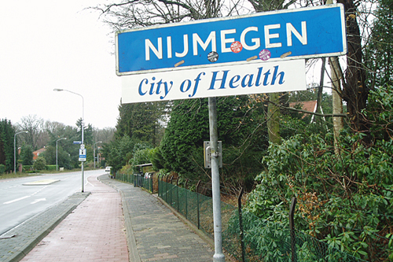
Figure 1.1: Nijmegen City of Health (sign from 2007)
(Source: http://www.placemarketing.nl)
Nijmegen used the term ‘health’ not only as an indicator of the existence of care and cure facilities in the city, but also for the three hospitals within its borders and for the various sports events the city organises.

Some cities are creating this image of health by focussing on health companies in their region. In Valkenburg, for instance, there is an emphasis on ‘wellness’ (Gemeente Valkenburg aan de Geul, 2007a). The region wants to be recognised as a region of cure, care and relaxation. Next to the spa ‘Thermae 2000’ (Thermae 2000, 2009), the Orbis medical centre in Sittard is used in this campaign (Gemeente Valkenburg aan de Geul, 2007b). Another example is Heerenveen, that wants to be perceived as ‘Sport City’. Heereveen clearly has a focus on ‘living an active life’. Besides having a large ice skating hall and football club, Heerenveen has a special ‘Sports Health Centre’ as well.

Secondly, health is an important economic sector for cities. Care facilities, especially hospitals, have an important influence on their surroundings. There are direct positive externalities from hospitals, for example the improvement in the health of people or the knowledge creation by academic teachings in the hospital. Moreover, hospitals can have a large multiplier effect on the economy of the region they are located in. On the one hand, they have many employees, who spend their money on other consumer goods whereof others have jobs. On the other hand, the hospital itself needs supplies and services and by buying those items locally, it supports local companies. The American Hospital Association states that the existence of a hospital has a positive effect on the attractiveness of a community and that in the United States, each hospital job supports almost two additional jobs (AHA, 2008).

This economic attractiveness is acknowledged by cities. For example, the city of Rotterdam states that it wants to attract health companies to ensure the formation of a ‘health cluster’ (Bestuursdienst gemeente Rotterdam, 2009). Next to care facilities, medical clusters typically contain pharmaceutical companies, medical and biomedical research companies, and medical instrument companies (Van den Berg et al., 2001). Rotterdam plans to attract these companies by developing new ‘health science parks’ (like ‘Science Port Holland’). The city expects that this health cluster will give the city employment possibilities and, as a result, economic growth.

In sum, the presence of health care facilities is interesting for cities for marketing and image boosting as well as for economic growth. For cities, it is therefore interesting to know how these facilities can be attracted to their municipality. This knowledge can be obtained by researching the present locations of these facilities, to find out where and why they are located on a specific place. In other words: one would like to know more about the factors that influence the location behaviour of these health care facilities. In this thesis, this issue will be addressed.

Overall, there are two forms of health care facilities: (semi-)publicly owned health facilities and privately owned health care facilities. The (semi-)publicly owned facilities are not very free in their location choice. Their location is often historically determined and appointed by the government. Most of the facilities are large, so relocation is very expensive. Next to the costs, they are also bound by strict government regulations. Therefore, their location choices cannot be seen as ‘free’. Privately owned health care facilities, however, are often smaller and have far less regulations. It is easier for them to move or relocate: they are more footloose. These facilities are therefore a valuable study object.

In the Netherlands, semi-publicly owned health facilities and privately owned health facilities exist. The existence of privately owned health care facilities has undergone some interesting developments in recent years: it is only allowed to open one legally since a few decades. Therefore, location choices have only been made recently and it is very likely that in the future, these facilities might relocate or start up in a new location. The Dutch situation is consequently an interesting field to research these location choices.

Central research question
We can conclude from section 1.1 that it is interesting to know more about the location behaviour of privately owned health care facilities. This is studied in the present thesis, with a focus on the factors that influence the location choices of the facilities. The central research question is:

What are the most important factors that influence the location decision of privately owned health care facilities in the Netherlands?

There are multiple factors that can influence location decisions. In this research, the most important factors are determined in two stages. In the first stage, literature will be studied. Economic location theories and literature on location behaviour are studied to define factors that influence location behaviour in general. Moreover, we will have a look on what is already researched about the location choices of privately owned health care facilities, in general and for the Netherlands specifically. The sub-questions for this stage are:
- Based on economic location theory: what are the most important factors that influence the location decision of firms and public organisations?
- What is already known about the factors that determine location decisions of privately owned health facilities?
- What is already known about the location behaviour of the Dutch privately owned health care facilities?

In the second stage, the distinguished factors are tested on the location behaviour of privately owned health facilities in the Netherlands. Data is collected on the locations and the location choices of the facilities. This data comes from statistical databanks, from actually looking at the location of facilities and from asking the facilities themselves through a survey. These different kinds of research are used to see if the factors from theory are indeed important for the location decision of privately owned health care facilities in the Netherlands. The sub question for this stage is:
- Based on location data, are the factors from theory of important influence for privately owned health care facilities in the Netherlands?

In chapter 2, an overview is presented of the literature on location decisions in general and for health centres in particular. We will also have a look at the Dutch health care system in this chapter. In chapter 3, the research framework is set up and the methods of this study are explained in more detail. This research is presented and analysed in chapter 4. The findings of the research will be discussed in chapter 5, and then we will draw our conclusions in chapter 6. Moreover, in this chapter we can find some final remarks on this thesis and suggestions for further research.

Research on location behaviour
In this chapter, literature is studied in order to find factors that are of influence to location choices. There is a substantial amount of economic theory on the subject, which is called ‘location theory’. In section 2.1, we review the most important research on the matter and we see what factors are of influence on location choice according to location theory. In addition, in section 2.2 the research on location behaviour of medical facilities in particular will be presented. Section 2.3 presents information on the health care system in the Netherlands. In the end of the chapter (section 2.4) the conclusion from the literature is given. Here, we find the factors of influence of location choices for privately owned health care centres in the Netherlands, distilled from the literature.

Location theories
Over a period of 150 years, location choices of firms have been studied and a substantial amount of literature has been published on the matter. In this section, we have a look at the most important theories. We will start with the classical location theories (2.1.1). In section 2.1.2 the critiques on the classical theories by behavioural economists is presented. Section 2.1.3 covers literature on agglomeration economies or clusters. In the first three sections, the literature is mostly about private firms. To learn more about the context of privately owned health care facilities, we examine in section 2.1.4 what factors are important in the location choices of public institutions. In the following section, we will elaborate on the development in present times and we will answer the question as to whether location choice and location factors are still of importance these days (2.1.5).

Classical location theories
In economic theory, location (or space) was introduced in the beginning of the 1800s. In that time, modern economic location theory started with the theory of Von Thünen. In 1826, he introduced location into the decision model on how to use agricultural land. Von Thünen put the market (or town) in the centre of his model. Around it, agricultural land would be developed. He regarded the land as uniformly distributed, of the same quality everywhere and with linear returns to scale. He stated that for every piece of land, the distance to the market determines the rent prices for which farmers are willing to grow their crops there. The distance, or in fact the transportation costs to the market, determine what price the farmer can pay for the land and still make a profit. This means that the further away from the market, the higher the transport costs, and so the less farmers are willing to pay for the land (McCann, 2001; McCann and Sheppard, 2003). From the theory of Von Thünen we learn that the location of the demand market and the transportation costs, as well as the land prices are important factors in location choice.

Another classical location theory is the theory of Weber from 1909. In the time he lived, the industrial revolution was taking place. The quality of the land had a far less important role in the location choices of firms than it had for agricultural firms. The manufacturing firms were more free in their location choice. His theory was more fitting to this footloose manufacturing industry. He assumed that a firm wants to maximise its profits. He stated that the location choice of firms is influenced by the location of the suppliers and the market, and the distance and transport costs from and to these locations. He put the firm in a triangle, where two corners are locations of resources (suppliers) and one corner is the marketplace. He showed that when transport costs are lower, the firms will move further away from this corner and towards the other corners, to minimise transport costs and maximise profits (McCann, 2001). We learn from the theory of Weber that transport costs and distance to suppliers and the marketplace are factors that influence the location choice of firms.

These theories consider location choice as a one-firm decision: no other players are active on the market. In 1929, Hotelling developed a model on how firms behave when they are competitors for space (McCann, 2001). The theory assumes a two-dimensional world where there are two homogeneous firms, seeking to maximise their profits in a linear economy. The firms have evenly distributed costumers and transport costs increase linearly when the distance increases. The firms are driven by acquiring access to the largest part of the market share. When both firms wish to serve the largest demand market, they will both locate in the middle of the two-dimensional space. Here lies the equilibrium: one firms serves the left part of the market, the other firm serves the right part of the market (McCann and Folta, 2008).

Hotelling compares this to a beach where two lemonade sellers (A and B) want to locate their stall. Both sellers want to serve the largest part of the market what results in that they are located in the middle of the beach next to each other. Seller A will serve the left side of the beach and seller B will serve the right side of the beach (see Figure 2.1).
BEACH
A
B
Market of A
Market of B
Transport costs
of clients
Figure 2.1: Lemonade stalls on the beach – the theory of Hotelling

From the theory of Hotelling we learn that the behaviour of other players in the market can influence the location choice of a firm. Moreover, transport costs play a role in his theory.

Behavioural economics
The classical theories are all based on the assumption that ‘rational’ firms will base their decisions on the aim of maximising profits. They state that all the information that is needed to make the right decision is for every firm fully available. Behavioural economists criticise these assumptions.

Behavioural economists state that, apart from maximising profits, other goals may play a role in the decisions of firms. For example, the continuity of the firm or the minimising of costs can also be important. Moreover, they state that firms do not have enough information to make the right decision. That amount of information gathered may differ per firm. Roughly, one can divide the critique of the behavioural economists into three themes: firms have bounded rationality, there may be conflicting goals and the relocation costs should be taken into consideration (McCann, 2001).

First we elaborate on bounded rationality. This term is mentioned by Simon in his article of 1957, where he elaborated on the ‘economic man’. This economic man, the basis of classical economic theories, is thought to make decisions in a fully rational way, by using all information that is available. In this way, he is able to optimise all his preferences. Simon states that this economic man does not exist in real life. In practice, people make decisions only partly based on ratio, and for the most part the decisions are irrational or emotional (Simon, 1957). For firms, this is also true: not all information can be obtained and so it is complemented with emotional and intuitive information. For location choices, this is very likely to occur, because especially the information on space and location is scarce (McCann, 2001).

An example of this bounded rationality we can find in marketing theory: the theory on sets of possibilities where people choose from. It states that one uses only certain sets of choice options when making a decision. We take the example that John wants to buy a new car. John might know ten brands of cars of all the car brands in the world, this is the so called ‘awareness set’. Of these ten, John can probably think of seven when a decision on buying a car must be made. These seven brands is the ‘evoked set’. Probably, about four of them will be discarded immediately, because they do not fulfil John’s needs. For example, Porsche is thrown out because it is too expensive. The set of three brands that remain is the ‘consideration set’. From this three the one car is chosen (Sheth and Krishnan, 2003).

This theory can be translated to location choices. There are numerous places one can locate, but location decision makers will probably not know all of them. From the awareness set, there will be some locations directly unsuitable because they do not meet demands of the firm. For example, the location is too far away or the location is thought to be in a unsafe environment. The evoked set is not consciously put together: the choices are coloured by emotions. Next, the locations in the evoked set are tested and evaluated so that a choice is made. In this example one can see that information is not only insufficient, but the information one is looking for will also be coloured by the demands and wishes of the firm.

The second critique of behavioural economists deals with conflicting goals within one firm. Different conflicting goals might exist: for example, employees and management may have different goals they are after. It is likely that when a firm is making less profit in a certain year, the employees want to keep their jobs while the management may want to cut costs by firing employees. Another example is that conflicting goals often exists between the owners of a firm and the management of a firm, when ownership and decision making tasks are separated. These examples are likely to result in complex systems of decision making and the pursuit of different goals within one firm (McCann, 2001).

The third critique of behavioural economics is about relocation costs. The classical theories say little about relocation costs; they imply that moving will not cost a firm anything. Of course, this is not true in reality. Next to the obvious costs of moving all inventory to another place, there are also costs like searching for a new office building, finding new personnel or breaking down and building up machines. This means that the new location should be substantially better to make a firm move (McCann, 2001).

These critiques show us that the choices of firms are not based on ‘hard’ factors alone and they are based on partial information. It must be taken into account that conflicting goals and bounded rationality lead to less-optimal location choices from a theoretical point of view.

Research from the behavioural economist Alchian (1950) shows us how bounded rationality can influence a firm’s behaviour. His theory is about adaptive and adoptive environments. The adoptive environment is an environment of which no firm has more information than another firm. When firms locate there, it depends on the fit of the firm in the environment if they are successful of not. This can only be evaluated ex post: it is a ‘survival of the fittest’- situation. The adaptive environment theory states that large firms are more capable in finding information about a location and therefore they have an advantage over other firms. They are better equipped to make a more ‘rational’ decision. Small firms follow these large firms to these locations, because they anticipate on the fact that the large firms knows what they are doing. In this environment clustering takes place: smaller firms are located on the same location as larger firms. This theory teaches us that firms act on the location choice of others.

Agglomeration Economies
We have seen that bounded rationality may lead to clustering, because the disadvantage of information shortage can be evaded. In economic theory, more reasons for clustering can be found. The advantages of clustering are called ‘agglomeration economies’ and they can be seen as factors that are of influence for location choices.

In 1890, Marshall described reasons why agglomeration takes place. Firstly, he stated that lowering information costs is the key reason to agglomerate. Next to this, he distinguished three different endogenous advantages of agglomeration: access to a large skilled labour pool, access to specialised inputs and access to technological spill-overs (McCann and Folta, 2008). The large skilled labour pool is accessed because agglomerations attract job seekers and firms can tap into eachothers personnel databases. Also job hopping is easier for employees, because the physical closeness of other firms. Specialised inputs are obtained because the agglomeration provides a large demand market for suppliers. Very specialised suppliers are willing to supply this market and firms can work together in getting, for example, bulk discounts. Lastly, technology spill-overs are accessed because the proximity of the firms allows easy sharing of knowledge, like during lunch breaks or short visits. We can learn from his theory that skilled labour, access to specialised inputs and knowledge sharing are important factors for firms’ location behaviour.

The theories of Ohlin and Hoover show that the exact nature of the advantages of clustering may differ per location and per firm (Hoover, 1937; cited by McCann, 2001). They divide agglomeration economies in three types: internal returns to scale, economies of localisation and economies of urbanisation. The first type of agglomeration economies is the internal returns to scale, that can also be seen as firm specific advantages. Regularly, there is at least one large firm located in a cluster. The investments of such a firm benefits the firm itself, and because of the size of the firm, the firm can generate economies of scale. In that matter these agglomeration economies are internal, and not external like the types that Marshall distinguished. It is location specific, because these investment are done in one place.

The second type of advantages is economies of localisation. These advantages cover a range of firms that belong to a specific industrial sector and that are located on the same location. One can think of the medical cluster that Rotterdam aims to develop (McCann, 2001). The agglomeration economies that Marshall mentions come back in economies of localisation. Because the sector-firms are located together, they can benefit from a large skilled labour pool, access to specialised inputs and from knowledge sharing.

The third type is economies of urbanisation. These economies cover the advantages that benefit firms that are in several sectors. The cluster with all same-sector firms will need employees and together they need things like health care, legal advice and retail services. Because of the existence of the cluster, other sectors may benefit as well: those advantages are called economies of urbanisation (McCann, 2001). This type has a close relation with the view of Van den Berg, Braun and Van Winden (2001), which see a cluster as a local network society. In this view, the cluster is more than the same-sector firms; it includes the other-sector firms (in the network) that benefit from economies of urbanisation.

According to Henderson (cited by Barrios et al., 2006), different firms are attracted by the different types of economies. Mature firms are attracted by economies of localisation, while modern and business service firms are more attracted by economies of urbanisation.

These theories on different agglomeration economies teach us that firms might benefit from investments they do themselves, from the fact that other same-sector firms are located nearby and from the fact that a cluster of some other sector is located nearby.

Porter (2000) has also given his view on agglomeration economies. He states that the connections between firms are vital for competition, productivity growth, formation of new business and for innovation. He gives some specific advantages for these firms to locate near each other:
- Access to specialized inputs and employees;
- Easy access to information;
- Complementarities between the firms;
- Access to institutions and public goods;
- Advantage in incentives and performance measurements.
In these advantages, we see the agglomeration economies that Marshall mentioned, but also some new ones. Porter breaks down knowledge sharing into information access, complementarities between firms and incentive advantages. However, this covers more than only knowledge sharing. Porter distinguished that the closeness of other companies speeds up the process of productivity growth and innovation because of the pressure in a cluster. Not only because there is competition, but also because firms want to look good for their neighbours. Next to this, Porter adds that access to institutions and public goods is important, in other words: the amenities and government are also of influence to the cluster agglomeration economies. From the theory of Porter we can learn that firms are attracted by the existence of other firms (for both rivalry and complementarity reasons), by the closeness of inputs and employees and the access to facilities supplied by the government.

Location theories of the public sector
In the former sections we saw theories about the location choices of firms. In this thesis we are dealing with private health care facilities, and one could expect that these centres behave like private firms. Because their ownership is private, profit maximalisation or costs reductions is likely to be more important than targeting socially inspired goals. However, private health centres sell a special product or service: care. In the last decades, care has typically been a product to achieve a social aim: to make people healthy. Historically this has been a service that was provided by the government. To understand this public context of health care, it is interesting to shortly review theories on public location choice.

The theories about location choice of firms and agglomeration economies partly cover the choices of public entities, too. Private and public sector have the same objective of maximising a form of utility when considering location. However, they have different owners and therefore, there are different deliberations in location decisions (Revelle, Marks and Liebman, 1970). In this section we will look at some theories about location choice of public institutions. Public location theories are shortly reviewed to extract factors that influence location choices of private health facilities.

Public facilities come in many shapes and forms: they go from waste facilities to police stations. In 1974, Austin introduced a distinction between three different forms of public facilities with the use of the individual place utility function. This place utility function explains how people experience the facility when considering its location. The higher the utility, the more positive stance people have towards the facility. The three forms of public facilities according to Austin are site-noxious facilities, site-neutral facilities and site-preferred facilities. The site-noxious facilities cause a negative place utility when people are located close to the facility, but this becomes positive with increasing distance (for example, a waste dump). With site-neutral facilities there is an equal effect on place utility at all distances from the facility (for example, a fire station). For site-preferred facilities, there is a positive place utility close to the facility, but when moving further away from people, the place utility drops (for example, a school) (De Verteuil, 2000).

For health care, it can differ what kind of place utility a facility has. For general practitioners and primary care facilities (the places where a patient first has contact with the health system), it can be argued that it is a site-preferred facility: the more near, the higher individual place utility it has. For larger hospitals, it is likely that there is a more site-neutral approach, within certain boundaries. If a hospital is around the corner or 15 minutes away might not be seen by patients as a change in utility. However, when you have to travel more than an hour to the hospital, this might reduce the utility of the hospital. We learn from this theory that for health facilities, the overall place utility is likely to be site preferred, or at least site-neutral. The smaller distance to patients, the more positive they feel about the facility. Consequently, it is likely that privately owned health care facilities are located close to their (potential) patients.

The themes equity and efficiency are key elements in public location theory (DeVerteuil, 2000). Efficiency based models focus on how to locate the facilities so that they are most efficient. The optimum of those models lies in a centralised system of larger facilities. In this way, all consumers are reached with minimum effort and economics of scale can be enjoyed. An example of a public facility that uses this approach is a hospital.

Equity based models state the optimum is reached when a socially determined criterion (like safety or good health) is maximised, by using surrogates for this social criterion. The equity approach will result in a large number of easy accessible facilities that are more scattered and of a smaller scale (DeVerteuil, 2000). One can see this approach in the more small scale health care centres where general practitioners are located.

We can learn from these theories that the location of the demand market is important for the location choice of public facilities. Both equity and efficiency play a role in the location choice of public facilities. It may depend on the function and type of the facility which one of the two is more important. Next to this, it is important that the location choice will maximise a social criterion (in the case of health care facilities: good public health). For privately owned health care facilities, it is likely that the maximalisation of a social criterion is not the goal. The demand market may play a role, although it would be likely that the efficiency approach will have the largest influence.

Is location still important?
We have observed several theories on location choice. These theories all have the assumption that a location can give firms or institution a competitive advantage compared to other locations. However, it can be questioned if location still plays such a big role in firms nowadays. In this section, we see that researchers agree that this is still the case, despite of developments in the world.

In the second half of the 20th century, the globalisation-process took off and the service industry became the most important sector in Western economies. These service firms have the possibility to be less concerned with the characteristics of a location; it is the service they offer that matters and that can be done on various locations. However, not only service firms are more footloose. Transport costs have decreased substantially, which made it possible for firms to locate production further away from the demand market. In addition, information and communication technologies allow easier communication with other parts of the world. This decreases the need to be in the proximity of clients or colleagues. These factors facilitate the freedom of location choice for industrial firms as well. Praamsma (2004) supports this by stating that there is an increasing freedom of location choice, and that spatial context is less important as it used to be. He notices that firms are very footloose in their location choice. They are increasingly involved in place making: it does not matter where they are located, they will change the environment so, that it is to their wishes.

However, this does not explain the fact that firms can still be observed clustering together. Apparently, there are still characteristics of a location that are of influence to the competitive advantage of firms (Enwright, 1998). Van den Berg, Braun and Van Winden (2001) do not agree with the view of Praamsma (2004) that location is less important for firms because they perform place making. They emphasise the existence of network societies: the connected complexes that results from cooperation between different firms and institutions. In their eyes, this is the leading organisational principle nowadays. These networks have different spatial dimensions. One form of a network society is the cluster. The formation of clusters shows that location is likely to still be an important factor for firms.

Another research that illustrates that location characteristics are important to firms is the yearly study of Cushman and Wakefield (2008). Annually, this firm performs a survey on location behaviour, the so called European Cities Monitor. They asked CEO’s of multinational companies what factors are important to them in their firm’s location decision. For 2007 and 2008, the essential factors are shown in Table 2.1.

Factor | 2008 (%) | 2007 (%)
Availability of qualified staff | 60 | 62
Easy access to markets, customers or clients | 59 | 58
The quality of telecommunications | 54 | 55
Transport links with other cities and internationally | 53 | 52
Cost of staff | 40 | 36
The climate governments create for business through tax policies or financial incentives | 27 | 27
Languages spoken | 27 | 29
Value for money of office space | 26 | 26
Ease of travelling around within the city | 25 | 24
Availability of office space | 24 | 26
The quality of life for employees | 21 | 21
Freedom from pollution | 18 | 16
Table 2.1: The ‘absolutely essential’ responses of CEO’s in Europe (Cushman & Wakefield, 2008)

This research of Cushman and Wakefield demonstrates that the factors from theory are indeed of essential importance to firms in choosing their location nowadays. For example, 60% of the CEOs find the quality and availability of the labour pool an important factor in choosing the location of the firm. The easy access to demand markets is in both years on the second place in the survey results. But also telecom and transport links – very much location-bounded factors – are important to the CEO’s. This study is an indicator that location characteristics still have an important influence on location choice.

Summary
In section 2.1 we have encountered several factors that, in theory, can influence location choices of firms and public facilities. From the classical economic location theories we learned that the location of the demand market, the price of the land and transportation costs are important issues in location decisions. We have also seen that firms are influenced by other firms in their location choices because of the willingness to have the largest market share.

In behavioural economics we saw that not only rationality is used to make a location decision. Bounded rationality, conflicting goals and relocation costs play a role, too. Information asymmetry can be one of the causes of firms to be influenced by each other location choices. A large firms is, because of this asymmetry, often followed by small firms in locating on a certain spot and consequently clusters are formed.

From agglomeration economies we could distil other factors that are important for clustering: access to a labour pool, proximity to other companies to enjoy knowledge spill-overs, access to specialised inputs, access to amenities and the attraction of the demand market. Public facility theory gave us information on equity and efficiency approaches to the location choice of institutions. Moreover, we have examined the different place utility functions of public facilities. Health care facilities are thought to be site-preferred or at least site-neutral institutions.

Location factors for the medical sector
The factors that we found in section 2.1 are general factors, applicable to firms in general and/or public institutions. Because this research is about health care facilities, we would like to know if these factors are also of influence in the medical sector specifically. In section 2.2 this is studied. In section 2.2.1 we look into the general field of medical geography and in section 2.2.2, former exploration about private health centres is presented.

Medical geography
Research on the location choices of care facilities specifically is done in the field of ‘medical geography’. Medical geography is active in studying two fields: on the one hand the location behaviour and geography of health care, and on the other hand it studies the geography of illness and death (Litva and Eyels, 1995). For this thesis we only look are the first field of research: geography of health care.

Geography of health care performs studies on locations of health care facilities, accessibility of these facilities, the utilisation rates of them, and the individual patient behaviour patterns (Litva and Eyles, 1995). A lot of different health care facilities are included in this field of study. For instance, primary health centres (the first place people can go with health problems) and preventive clinics may be studied, which show different location behaviour and have a different consumer/client group than secondary care in hospitals (the care that people receive when they are referred by primary care).

A primary distinction is visible between the different kinds of facilities in whether they are located based on an equity or an efficient approach. Primary health care is meant to reach as much people as possible. As been proven by researchers, the use of primary health centres is an important determinant of public health (Field and Briggs, 2001). For these centres, it is important that they are very accessible. Here one can expect the equity approach. Secondary health care is more efficiency oriented. Hospitals are rather large and are located in central locations, and there are far less hospitals than general practitioner practices.

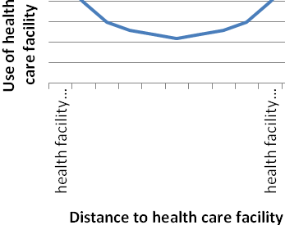
Figure 2.2: Use of a health facility set off against distance to the health facility: a U-shaped form
However, accessibility does not fully depend on distance alone. The use-distance ratio shows a more U-shaped form as can be seen in Figure 2.2: the further the centre moves away, the lesser use in the beginning, but when moving beyond a certain point, usage starts to go up again. This is supported by various studies that found that, next to distance, gender, age, social and employment conditions and access to a car are all important in determining the accessibility of primary health centres (Field and Briggs, 2001). It is argued, however, that aerial distance from the dependent primary health care centre is still an objective measure of accessibility, although it is a crude and short-sighted one (Kohli et al., 1995).

In the last decades, views on health and the way people perceive and receive health has changed (Parr, 2003). One can think of the mixed offer of public and private services, which is related to the topic of this thesis. But there is also an increased use of telephone and internet support and phenomenons like automatically working pharmacies. These developments indicate that also health care facilities are less restrained to their locations as they used to be. However, research shows that although things are changing, accessibility still plays a big role in the utilisation rates of health centres (Kohli et al., 1995). Also in preventive health care facilities, this is a very important factor of demand. Studies have shown that healthy people are willing to travel shorter distances than ill people for health care (Verter and Lapierre, 2002). Moreover, more place-marketing techniques are introduced in health care, which is an indication that location is thought to give a comparative advantage for the facility (Parr, 2003).

From these insights we learn that care facilities might be efficiency or equity oriented, accessibility is in both cases an important factor. However, this does not have to mean that facilities need to be close to the people it wants to reach: the use-distance ratio is more in a U-shaped form. In addition, differences are expected in importance of accessibility between different kinds of care facilities. It is important to keep in mind that healthy people are willing to travel a shorter distance than ill people.

Privately owned health care facilities in the United States of America
In the United States, there has been a longer history with private health centres than in Europe. In this section we use research from the United States to distil factors of influence to their location choices. American health facilities comprise three kinds of ownership: government owned hospitals that are not-for-profit, private hospitals that are not-for-profit, and private hospitals that are for-profit. In 2000, 17% of the hospitals were private for-profit hospitals, 59% were private not-for-profit and the rest was operated by governments, mostly local government (Sloan, Picone, Taylor jr. and Chou, 2000).

McClellan and Staiger (1999) studied the hospital quality of not-for-profit and for-profit hospitals in the United States. They measured this quality by looking at mortality rates and rehospitalisation after complications. Their aggregate outcome was that for-profit hospitals have an overall lower quality than not-for-profit-hospitals. However, in their case studies, higher quality was found in for-profit hospitals than in not-for-profit hospitals. While the quality of hospitals is irrelevant for our study, the explanation of the authors for the difference in outcome is very interesting. They suggest that location is a very important factor for the differences in the outcomes. For-profit hospitals are likely to locate at places where overall quality is low: in this way it is easy for them to offer better care than the competitors and draw costumers to the hospital. Moreover, lower quality hospitals are an easy takeover target and the margins for care are higher because the quality demanded by the market is less high (McClellan and Staiger, 1999). This means that locally, the for-profit hospitals offer better care than their competitors. However, when we zoom out and look at quality differences on a larger scale, they offer lower quality care than others. From this study can be concluded that the quality of other hospitals or care facilities in the neighbourhood is likely to have an influence on the location behaviour of private health care facilities.

In addition, Norton and Staiger (1994) studied hospitals in America. They saw that location characteristics differ dramatically by hospital ownership and services. They state that for-profit hospitals are found in areas where more people are insured, where more children are born, and where people get higher wages. Sloan et al. (2000) find the same results. They state that for-profit hospitals tend to locate in places where they can make more money.

It seems that in the United States, the for-profit (privately owned) hospitals tend to locate in places where the highest benefits can be obtained. They offer acceptable quality of services with high margins. Moreover, they will locate in places where people are medically insured or otherwise are able to pay for care. They seem less interested with equity and more with efficiency.

The health care system in the Netherlands
In the sections 2.1 and 2.2 we have gathered some factors that are of influence to the location choice of private health care facilities. In the coming chapters, we will test this on the practice in the Netherlands. But first, in section 2.3 the present system of Dutch health care is examined. In section 2.3.1 one can find out more about the history of the Dutch private health care facilities. The last part (2.3.2) covers more information on the specific area of privately owned health care facilities.

Present situation of the Dutch health care system
Different kinds of health care facilities are existent in the Netherlands. Within these health care facilities we can distinguish hospital care, first line care (primary health care), nursing care, care for the disabled, mental care, and pharmaceutical care (RIVM, 2009a). Hospital care consists of academic and general hospitals, categorical hospitals and independent treatment centres (RIVM, 2009b). This system is showed in Figure 2.3. Since 1 January 2006 the terms general hospital, categorical hospital and independent treatment centre have been renamed to the general term ‘institute for specialist medical care’. However, the separate terms are still unofficially in use to explain the differences between the hospitals.

Hospital care
Primary care
Nursing care
Care for the disabled
Mental care
Pharmaceuticals
Academic hospitals
General hospitals
Categorical hospitals

Independent treatment centres
Private clinic
Institutes for specialist medical care
Figure 2.3: System of health care facilities in the Netherlands

Before explaining the different types of care institution, we will have a quick look at the finance system of the Dutch health care system. Since 2005, the Netherlands knows a system of Diagnosis Treatment Combinations (DTC; in Dutch: ‘diagnose-behandeling combinaties’). In this DTC-system, the care facilities are paid per combination of diagnosis and the treatment that follows (DBC Onderhoud, 2009a). The DTCs have different prices. For the largest part (95% of the DTCs) these prices are fixed and set by the government (Rijnland zorggroep, 2007). These DTCs are in the so called ‘A-segment’ of care. The rest of the DTCs are divided into the ‘B-segment’ and ‘C-segment’. The prices of the DTCs in the B-segment are set through negotiations between care providers and health insurers. The prices in the C-segment are the most free: care providers may set them in negotiation with the patient. The downside is that care in this segment is usually not covered by health insurers. These three segments play an important role in setting the types of hospital care providers apart from eachother.

General and academic hospitals are very government oriented. Most of the hospitals are not directly managed by the government, but indirectly the government holds ownership: they are generally not managed by the government directly, but indirectly the government is very much involved. In these hospitals, the core business is the care in the A-segment. Categorical hospitals, also hospitals where the government is involved, deliver care to special groups of patients (like diabetics and asthmatics). The normal combinations of diagnosis and treatment may not always fit these patients, because the care provided is usually chronical and the treatment is often therapeutical. In these hospitals, the DTC-model has a deviated form (DTC Onderhoud, 2009b). Independent treatment centres deliver care in the B-segment, and sometimes in the A-segment. Private clinics only offer care in the C-segment. Most of the time, the treatments of private clinics are therefore not covered by health insurers.

History of the Dutch privately owned health care facilities
Since private health care facilities are a new phenomenon in the Netherlands, it is interesting to know more about the history of this development. We will see that history is also a factor that may have influenced decision choices.

Health care in the Netherlands was originally provided by private institutions and private doctors. This lasted until the second half of the 19th century. It was only then that the government interfered in health care and that public hospitals emerged. This soon resulted in a monopoly for the government on health care facilities and a prohibition of private centres. This lasted for more than a century. Since the end of the second world war (1945), few private clinics started up, but the Dutch government was very critical towards them. Since it was not allowed to start a private clinic, the owners were even prosecuted. However, in the 1970s the government was forced to privatise some of its activities, because she was considered to be too controlling. This resulted in more room for private initiatives in healthcare (Hermans, 2004).

These private initiatives had a unusual position: on the one hand they were private companies with entrepreneurial ambitions, on the other hand they were executing a public task by delivering health care that was arranged in the constitution (art. 22 Dutch Constitution) (Hermans, 2004). Probably because of this uncommon position, the government had a love-hate relationship with private health initiatives. This was illustrated by the fact that the gained freedom in the 1970s was taken back in the 1990s when the Minister of Health prohibited private clinics again (Knoors, Vrijland and Zenderen, 2000).

However, in the end of the 1990s, it was acknowledged that private clinics could contribute to the solution to problems in health care, including the increasing amount of waiting lists of patients waiting for the possibility of an operation (Hermans, 2004). It was considered to be a fast and cheap way to increase capacity of the existing health care system. In 1998, the ‘independent treatment clinic’ (ITC; in Dutch: ‘Zelfstandige behandelkliniek’) was created by law. Private health centres were allowed to apply for a permit to perform treatments. But still, the ITC needed a permit to settle somewhere and they were obliged to have a link with a hospital (Hermans 2004). In 2003, regulations for starting an ITC were loosened, for example by allowing ITCs to locate in places of their choice (College Bouw, 2003).

Even though the law-system has not been advantageous for private clinics, they still exist. Private clinics and independent health clinics are nowadays seen as the frontrunners in the introduction of a more market-like approach in the Dutch health care system. A more business-like way of working is thought to solve a lot of problems in the system, like the bureaucracy in health care and the previously mentioned waiting lists.

Privately owned health care facilities in the Netherlands
We have seen the different forms of hospital care in the Netherlands and the history of the independent treatment centre and the private clinic. In this section we focus more on the present characteristics of these Dutch privately owned health care facilities.

Since 2006, the creation of ITCs is controlled by the WTZi-law. This law aims to minimise the interference of the government (Hermans, 2004). According to this law, an ITC is an institution or health cooperation between two or more medical specialists that has a licence as meant in this law. The ITC can offer care with or without stay, however, patients need to be able to leave the centre within 24 hours: the medical treatment should be planable and non-urgent. In these things the ITC is very similar to a private clinic. There are some differences, though. An ITC has three organisational elements: it must be an organisation of multiple medical specialists, the centre must offer medical specialist care without the intention of making profit and patients must be able to refund the costs through their health insurance companies (Orde van Medisch Specialisten, 2004). An ITC is able to negotiate about the prices of care with the insurers (B-segment) and they have a customer-oriented focus. For these reasons, the ITC stands model for the way the government would like the health sector to operate: more flexible and cost-efficient (Kamerstuk 24-06-2003, 28600 XVI). All other privately owned health care facilities (where the government does not hold indirect ownership) are known as private clinics. The term includes a variety of health care facilities. Private clinics are not obliged to hire a medical specialist, and may provide care that is not covered by health insurance (C-segment). Moreover, the private clinic is allowed to make profit.

It is an important difference that private clinics are for-profit facilities, and that ITCs are not-for-profit facilities. We will treat them the same in this study, however. They both stand model for the way the government wants that health care is operated in the future. They are both more business-like organisations than other hospitals and care providers.

Homberg, Heijmans and Huisman (2006) studied the marketing behaviour of the ITCs in the Netherlands. They saw a steep growth in the creation and permit-applicants for ITCs. In January 2004, 51 ITCs had applied for a permit, which increased to 113 permit applications in November 2005. ITCs are mostly located in and around the largest cities in the Netherlands: Amsterdam, Rotterdam, The Hague, and Utrecht. Most of the ITCs are small companies: in November 2005, 18% of the ITCs only had a maximum of 1,0 FTE of medical specialists working for them, 52% had 1 to 2 FTE, 15% between 2 and 3 FTE, and 15% over 3 FTE. (Homberg et al., 2006).

The data of the Netherlands Health Care Inspectorate of April 2009 show that there are 199 privately owned health care facilities at the moment. This is made up by 78 private clinics and 119 ITCs; 2 privately owned health care facilities have both registrations. One can see this in Figure 2.4.
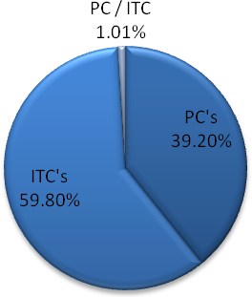
  private clinics | 78
  ITCs | 119
  private clinic & ITC | 2
  Total | 199
Figure 2.4: The amount of private clinics and ITCs in the Netherlands (IGZ website, 2009b)

There is a broad line of care that is offered by privately owned health care facilities. Knoors et al. (2000) and Homberg et al. (2006) mention the most common kinds of privately owned health care facilities in the Netherlands. They state that the most popular fields of work for private centres are plastic surgery, eye related health care, dermatology, general practice, orthopaedics, cardiology, and gynaecology. However, in the last years the most popular areas have shifted. The current field of practice are shown in Figure 2.5.

The figure shows that plastic surgery is the most popular kind of privately owned health care facility. The second largest part is the ‘specific’ care: this is a group of various different centres that offer specific care that does not fall into other categories. One can think of facilities offering dental care, oxygen treatments or circumcisions. The ‘general practice’-centres are centres where multiple kinds of care are offered, for example a centre where plastic surgery and eye related health care are both performed.

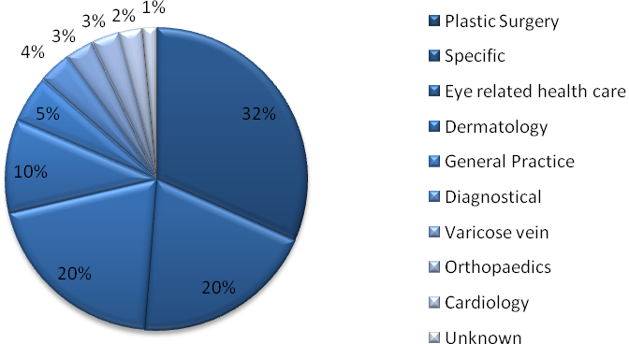
Figure 2.5: Types of ITCs and private clinics (empirics: see appendix A)

The RIVM, the Dutch National Institute for Public Health and the Environment, is concerned with researching public health issues for the government. They continuously monitor the locations of the different care providers in the Netherlands. In Figure 2.6, the maps with the locations of academic and general hospitals and the map of independent treatment centres are depicted.

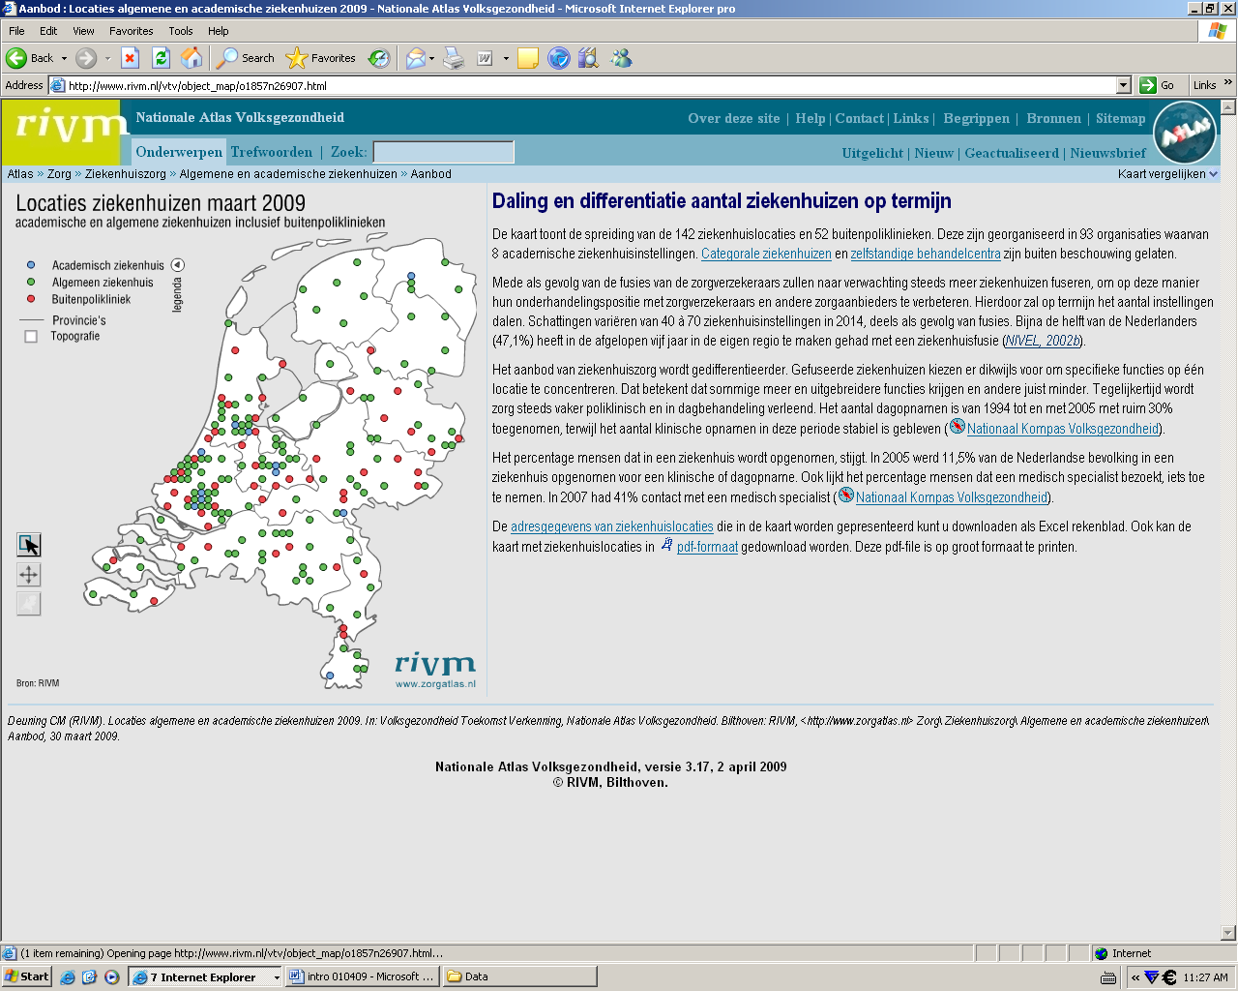 | 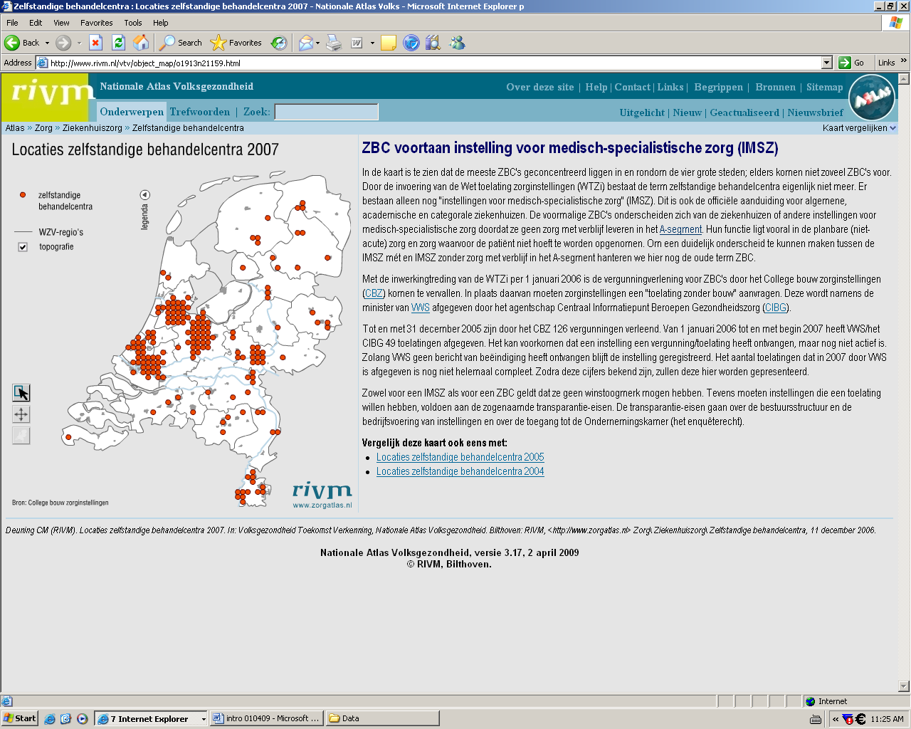
Figure 2.6: Different locations for general and academic hospitals (left image) and independent treatment centres (right picture). NB: The years of the pictures differ: the left picture is from march 2009, the right picture is from 2007 (RIVM, 2009d)

Looking at the maps, the map for academic and private hospitals gives a very different picture than the map with the independent treatment centres. General and academic hospitals seem to be located more scattered over the Netherlands, the ITCs are more agglomerated in the places with the most inhabitants. It gives an indication of the different location choices these facilities make.

Conclusion
In this chapter we have seen various theories that provided us with factors that might be of influence on the location choices of private health care facilities. In this section an overview is given of the factors that are mentioned most often.
- Demand market. In almost all theories it comes forward that the location of the demand market is important for the location choice: in classical economic location theory of firms, theory on agglomeration economies and in medical geography, this is mentioned. The public theory on efficiency or equity driven location choices also puts an emphasis on the location of the demand market.
- Labour pool. The location of factor inputs are decisive in location choices. Since labour is the most important factor input for private health facilities, the quality and the availability of the labour pool is theoretically very important in the location choice. Furthermore, in agglomeration economies, the access to a skilled labour pool is one of the advantages of locating in near other companies.
- Accessibility. Accessibility is often mentioned in the discussed theories. Agglomeration economies state that accessibility is improved when firms are located in a cluster. In public location theory and in medical geography, accessibility has a vital role. One can see the transport costs that are mentioned in the classical theories as being the transport costs of the clients: health centres do not deliver their services, but patients have to come to the facility to receive care. Moreover, it should be taken into account that ill people are willing to travel further for health care than healthy people.
- Land prices / Rent. In the classical theories we have seen that land prices play role in location behaviour. Moreover, the research from privately owned health care facilities in the United States showed us that in order to maximise profit, facilities are also concerned with lower costs: consequently, land prices play a role.
- Behavioural factors. Not only hard factors play a role; because of information biases and conflicting goals, people cannot make a fully rational choice. Moreover, the theories on bounded rationality demonstrated that emotions play a role in decisions. The location choices of privately owned health care facilities may be influenced by personal factors, too.
- Behaviour and quality of other firms. Location choice can be influenced by the behaviour of other firms. The classical theory of Hotelling showed us that firms react on each other’s movements. Moreover, the adaptive theory of Alchian showed that small firms move to places where large firms are located. Due to agglomeration economies, firms are likely to move close together. Moreover, the studies from the United States of America found that for the location choice of privately owned health care facilities, the quality of the other centres at the location is also important.
- Government facilities. We have seen in the agglomeration economies theory of Porter that the access to amenities is important for firms. Moreover, in the survey results of Cushman & Wakefield it came forward as an essential factor for multiple CEO’s.

Next to all factors we found, we also had a look at the Dutch health care system. In section 2.3 we put the private health care facilities in their Dutch context and we saw why these facilities are different from other hospitals. Privately owned health care facilities in the Netherlands are more business-oriented and customer-focused than other hospitals. They offer various types of care, and only the non-urgent, planable treatments. They are located on more central locations; other hospitals can be found more scattered in the Netherlands.

In section 2.3 it was explained that the 199 privately owned health care facilities in the Netherlands stand out from other hospital care providers: they are more free to operate. They can offer care for prices in which they can negotiate with care insurers and patients. They offer care that is not urgent and planable. Patients cannot stay longer than 24 hours within a facility. Within the field of private health care facilities we can make a distinction between ITCs and private clinics, of which the private clinics are more free and work for-profit, while the ITCs must have medical specialists working in the centre, they have to apply for a government permit and they offer non-profit care. We have seen that an important difference is that private clinics are for-profit facilities, and that ITCs are not-for-profit facilities. However, we treat them the same way in testing their location behaviour, because they are both more business-like organisations than other hospitals and care providers. Privately owned health care facilities work in various fields of care and they are located in more central places than academic and general hospitals.

Research framework
The factors we found in the previous chapter cannot be directly be tested on the Dutch situation. In this chapter, the factors are translated from the theory into expectations (see section 3.1) that we shall test in chapter 4. Furthermore, the methods that are used to test these expectations are presented in section 3.2.

Factors put into expectations
The closeness of the demand market is mentioned by several theories as being important for firms to locate somewhere. The demand market for privately owned health care facilities is patients, so in other words: the facilities would like to be close to people. Moreover, we have seen that the location of the inputs in important and the most important input for health care centres is labour. Again, this means that privately owned health care facilities are likely to be located near people. Our first expectation is therefore:
Privately owned health care facilities are located in densely inhabited areas.

Next to this, it is expected that the location of a high quality labour force is important for privately owned health care facilities. Health care centres need doctors and assistants that are trained in health care, in other words: they need high-skilled employees. The second expectation is therefore:
Privately owned health care facilities are located near a high quality labour market

The direct physical environment of the location might be important for three different reasons. First, doctors will most of the time live nearby the clinic, or even have a clinic next to their homes. Here bounded rationality plays a role: more personal factors may be important in the location choice. For them, a nice living environment is important. So green areas, nice housing, schools for their children: it all matters in their personal location choice and therefore location choice of the clinic. Secondly, a healthy environment is important for their patients. That might differ per health centre though: one can imagine that surgical procedures might not require a nice environment outside the operation room. However, some procedures are helped by a healthy environment. You can think of orthopaedics where outside movement may be encouraged or dermatology where sun is of good influence on the healing process. In line with this, the environment may be important in marketing. Health centres might like to market themselves as ‘wellness’ centres, as centres where you get healthy again. In this view, the environment can be a part of their image and marketing. The third reason is more derived: a nice environment may attract skilled labour to the area. Indirectly through the labour pool factor, this also might be of influence. These are three reasons why a quality environment can be important. The third expectation is therefore:
Privately owned health care facilities are located in high quality environments

The fourth expectation deals with accessibility. We have seen in both location theories as in medical geography that accessibility plays an important role in location choice. Moreover, it is shown that usage factors of health facilities tend to go up when the centre is better accessible. Our forth expectation is:
Privately owned health care facilities are located in well accessible locations

Various theories stated that firms react on each other’s movements or location choices. In general, this may lead to clustering. The reason for clustering may lie in the differences in information on a location and therefore hospitals may be followed by smaller health care providers. Other reasons can be obtained from the theory of agglomeration economies. Private health care facilities may tend to cluster because of these advantages. We have seen on the maps in Figure 2.6 (section 2.3.2) that indeed ITCs are more clustered than general and academic hospitals. Our fifth expectation is:
Privately owned health care facilities are located in health clusters

When we compare these expectations to the conclusion from section 2.4, there are a few factors that we found that are not directly covered by these expectation. First of all, the land prices; they will be included in the expectation of the quality of the environment. A high quality environment is likely to have higher land prices or rents. If this expectation is met, it will indicate that for privately owned health care facilities, land prices are less important than quality of the environment. Secondly, the facilities of the government are left out of the tested expectations. It is very hard to make this factor explicit and therefore it is not easy to test. Moreover, most of the governmental legal facilities are set by the national government and will therefore not influence the regional attractiveness. Thirdly, the quality of other centres is left out, because for one, it is not easy to get information on this issues (both on availability and on how to decide what is high quality) and secondly, in the Netherlands the quality will not differ that much between regions as in the United States. There is a strict governmental check on health providers, so that they all perform following certain norms. The lack of quality differences will make sure that it is likely to not play a role in the location choices of health centres in the Netherlands.

Method of testing expectations
In this section it is explained what methodology is used to test if the expectations are right. First there is general explanation about the data collection for this research (3.2.1). In the following sections, the method per expectation will be presented.

Data collection in general
In the Netherlands, the Health Care Inspectorate is the government’s ‘watchdog’ for all health centres in the Netherlands. They ensure all health workers and companies comply with Dutch laws and regulations (IGZ, 2009a). They also watch over private clinics and independent health centres. The basis of all the findings from this thesis is a list of all ITCs and private clinics of this Health Care Inspectorate (IGZ, 2009b). The list is constructed from permit applications, observations of the Health Care Inspectorate itself, and from information provided by the facilities. The Health Care Inspectorate acknowledges that the list is not fully up to date because of the constant coming and going of the facilities. However, it tries to stay as up-to-date as possible. During the process of the research for this thesis, errors and changes have been identified and corrected, by looking at the websites of the different privately owned health care facilities. The resulting list is an up-to-date overview of the number of facilities and their locations.

The list is complemented with characteristics of the locations based on data from the database of the Dutch Statistics Agency: Statline (CBS, 2009c). Also other information sources were used. Important sources were satellite pictures from Google maps (Google, 2009). Moreover, information websites of the different health centres were examined. The list with all the information can be found in appendix A. How the different numbers were gathered is explained in the following sections.

Next to this data from databases and satellite pictures, a survey was used to illustrate the findings. This survey included nine questions about the location of private health clinics. The survey question form is included in appendix D. All 199 facilities from the list received this survey, and 13 of them returned the filled-in form. This number is too small to get significant results, consequently the results were used as a mere illustration only.

Expectation 1: Density of the population
Expectation 1 is tested quite straightforward. The Dutch Statistic Agency (CBS) provides numbers on the density of inhabitation of certain areas on neighbourhood level, by looking at the same postal codes. The website of Jaap, a Dutch broker, uses the data from the CBS on their website to make a clear overview of every neighbourhood in the Netherlands. Because of the clear presentation, the information from the CBS was obtained via this website (Jaap, 2009).

The density of the population per neighbourhood is calculated by dividing the number of inhabitants in that neighbourhood by the squared kilometres of the neighbourhood. The results per facility are compared to the average of all municipalities in the Netherlands. Categories of density are used to see if the private facilities are located in more densely inhabited areas than average. The categories are:

- < 400 addresses per km²
- 400-800 addresses per km²
- 800-1200 addresses per km²
- 1200-1600 addresses per km²
- 1600-2000 addresses per km²
- 2000-2400 addresses per km²
- 2400-2800 addresses per km²
- > 2800 addresses per km²

We also test whether privately owned health care facilities are mostly located in cities, as can be the case when economies of urbanisation play a role (see section 2.1.3). In the Netherlands, there is not a formal definition of a ‘city’. In Dutch law, the term ‘city’ was removed in the 19th century. From then on, only municipalities existed. The term city now has a more vague definition in people’s minds. However, the CBS uses a scale of urbanisation to see if a municipality has urban features. This scale ranges from ‘not urban’ to ‘very strong urban area’ in five steps (CBS, 2009b). The scale is measured via the density of addresses. The density of an address is measured by the amount of addresses within a circle of one kilometre from the address. For the average density of addresses of a municipality, first the density is measured for every single address, and then the average of all addresses in the municipality is calculated.

The scale of urbanisation is made up of five steps of density of addresses:
- Not urban: average density of less than 500 addresses per km²
- Slightly urban area: average density of 500 to 1000 addresses per km²
- Mediocre urban area: average density of 100 to 1500 addresses per km²
- Strong urban area: average density of 1500 to 2500 addresses per km²
- Very strong urban area: average density of 2500 addresses or more per km²

We test the data on the fact if privately owned health care facilities are more often located in urban areas compared to the average of all municipalities. Lastly, we also used the survey to illustrate our findings for this expectation.

Expectation 2: High quality labour market
This expectation is harder to test. Logically, education levels would be used as a proxy to quality. Although there are numbers on how many people graduated in what level in a certain region, this does not tell us anything on the education level of the people living there. For example: most students that graduate from the top level of high school, will move away to study at university in another city or town.

In the Netherlands, there are thirteen cities where a university is located. To use these cities to test if privately owned health care facilities are located nearby educational centres would generate biased results. There are more aspects about these cities that attract firms, other than the university. Next to this, it is not certain if theoretical education (like in universities) is the kind of quality that the privately owned health care facilities are looking for. It could be that they need more people that are more skilled in nursery and therefore you need a more practical education. In the Netherlands, this education is offered on a HBO-school; in the Netherlands one can find 39 of them (CBS, 2009c). These schools are even more divided, because they have different business units. For example, the InHolland HBO-school is active in nine places in the Netherlands (INHolland, 2009). This means these schools are scattered over the Netherlands and the chances are that most of the ITC’s and private clinics are located near them, just because there are so many of them.

Because of the fact that it is hard to test the existence of quality of the labour pool in regions in the Netherland statistically, this is not tested using ‘hard’ data or proxies. The survey was used to fill up this gap. The results are used to illustrate what the respondents think about this issue.

Expectation 3: High quality environments
To test the quality of the physical environment different data was used. First, the proxy of a ‘green’ environment was used to indicate the quality of the environment. To do this, typologies of physical environments were made. Those were tested by using Google Maps.

The four typologies in locations that were made, are:
Inner city: the location is in a large town or city in the inner compartments of the city – there is a high density in houses and buildings.
Village/Suburb: the location is in the suburbs of a city or in a village – there is a lesser density in houses and buildings.
Nature/Forest: the location is within a forest or another nature-like site – there a no or few buildings near the location.
Industrial park: the location is in a business or industrial park – there are no or few houses, but there are office buildings and factories.

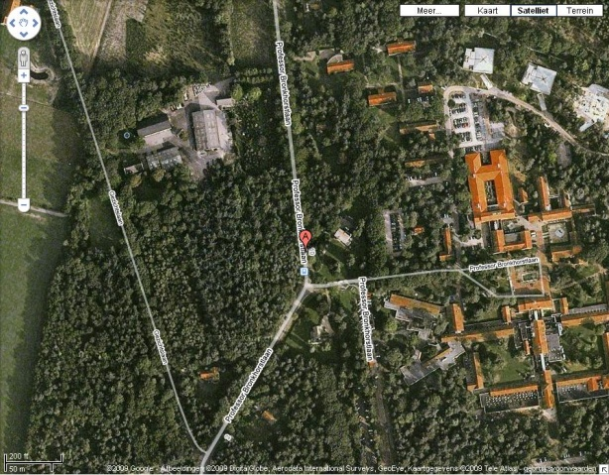
Figure 3.1: The location or the Bergman Beauty Clinic in Bilthoven
By using satellite pictures from GoogleMaps, the locations of the privately owned health care facilities were divided over the different typologies. For example, in Figure 3.1 one can find a picture of the location of the Bergman Beauty Clinic, a privately owned health care facility that is specialised in plastic surgery. This facility is located in an area near Bilthoven where there are no houses or buildings nearby, other than the cluster of health centres that can be seen (the red roofs). The location of the centre falls therefore in the category ‘Nature/Forest’.

Another example is the location of the ‘Stichting AnnaTommie’ in Rijswijk (see Figure 3.2). This facility is located on an industrial and/or commercial site. One might already have a suspicion by looking at the satellite picture, but this can be even more clear when we look at the ‘map’ function of Google Maps. As you can see, the centre is located in the darker grey area, that in Google Maps means ‘industrial or business park’. Therefore, the location of this centre is categorised to be on an ‘Industrial’ location.

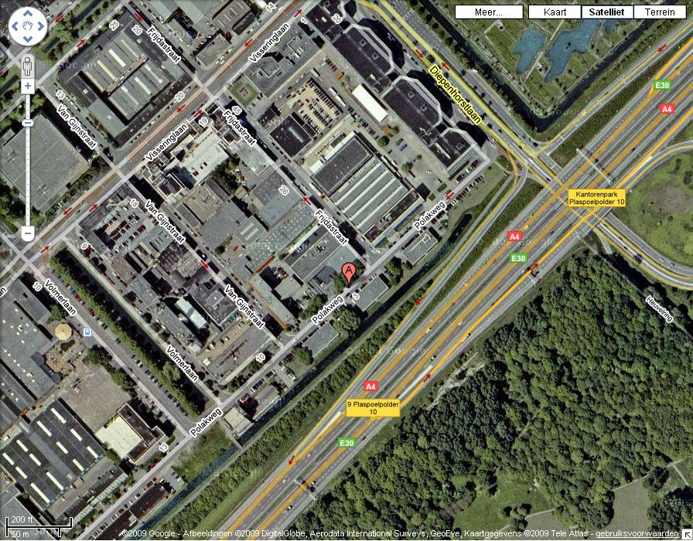 | 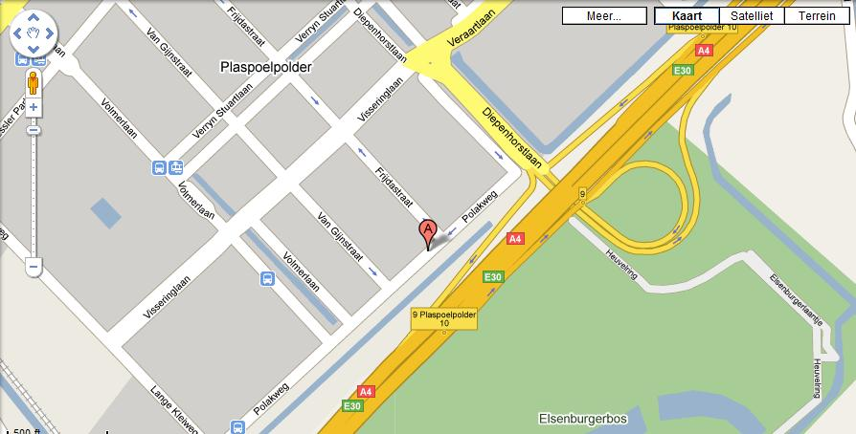
Figure 3.2: The location of Stichting Kliniek AnnaTommie in Rijswijk on a satellite picture (left) and on the ‘map’-function of Google Maps (right)

In Figure 3.3 we find an example of an inner city location in Amsterdam. The location is in the central area of Amsterdam, a large city. Furthermore, it is clear from the photo that the clinic is located in a high dense residential area. In Figure 3.4 one can see an example of a village/suburban location in Rosmalen. This area is less dense inhabited (less dwellings) and even shows some green areas.

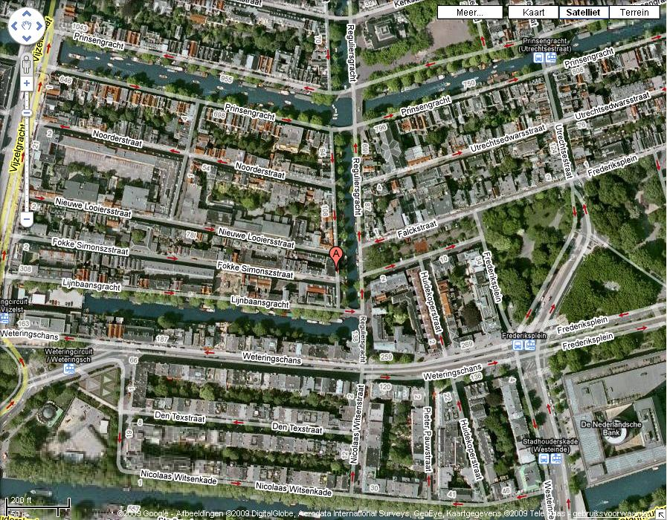 | 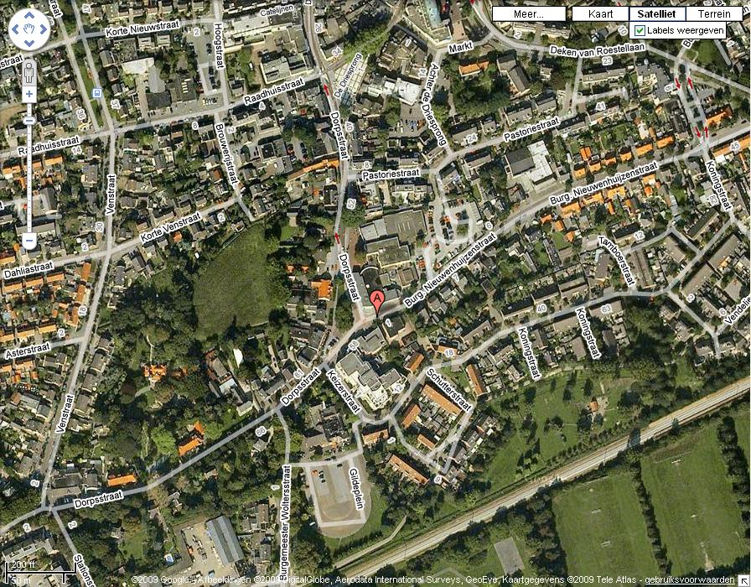
Figure 3.3: Groepspraktijk Van Eendenburg/Nanninga: an example of a privately owned health care facility that is located in a inner city location | Figure 3.4: Polikliniek voor Flebologie en Proktologie Drs. Wetzels Rosmalen: an example of a privately owned health care facility that is located in a village/suburb location

Next to this GoogleMaps method, the survey included a question to see if clinics themselves categorise their environment in the same typology.

Secondly, the housing prices were used as a proxy to quality of the environment. Housing prices are a suitable proxy for the attractiveness of neighbourhoods: when prices are high, it means that the neighbourhood is attractive to live in. The average housing prices per neighbourhood were obtained from the CBS through the website of Jaap (Jaap, 2009). The average housing value was calculated by the CBS based on the average WOZ-value in the neighbourhood on 1 January 2009 (CBS, 2009a). The housing values were divided into 11 categories, with a € 25.000 interval. The categories are:

- < € 175.000
- € 175.000 - € 200.000
- € 200.000 - € 225.000
- € 225.000 - € 250.000
- € 250.000 - € 275.000
- € 275.000 - € 300.000
- € 300.000 - € 325.000
- € 325.000 - € 350.000
- € 350.000 - € 375.000
- € 375.000 - € 400.000
- > € 400.000

These housing values of the neighbourhoods of privately owned health care centres were compared to the average housing prices of all municipalities of the Netherlands on 1 January 2009 (CBS, 2009c).

Expectation 4: Accessibility
The accessibility of a place can be measured in different ways. This can involve a study about the users of a place and their travel behaviour. The accessibility then can be measured with this model: Accessibility = ∑_{j} Opportunities * f ( C_{ij} ), where i is the index of origin zones, j is the index is destination zones and f ( C_{ij} ) is a function of generalised travel costs (Hansen, 1959). However, to obtain information about the travel behaviour of users of privately owned health care facilities is hard and takes a lot of time. In this thesis this information is therefore not included.

De Bok, Blijie and Sanders (2003) have a different way of measuring accessibility. They used surrogates for measuring accessibility in two separate studies. One focused on the clients of firms and their possibilities and willingness to travel to a firm. The other method focused on the location of the firm itself. The researchers used a system where firms would get categorised for being in an accessible location. To measure this, firms would get categorised in an α-location when the distance to intercity station was less than 800 metres, they would be categorised β when the distance to a train station was less than 800 metres and when the distance to an onramp was less than 5000 metres, they would fall in the category γ when the distance to an onramp was less than 2000 metres and the rest of the locations was category ς.

In this thesis, a similar method is used as the last method of De Bok, Blijie and Sanders (2003). Satellite photos by GoogleMaps were used to see whether a place was well accessible. A similar point-system was developed, where the most points were given to the most accessible location. On the photos, one can distinguish multiple ways of transport, being onramps, train stations, metro stops, tram stops and bus stops. In an area of 150 metres around the location, points are given for every public transport facility. The highest score is for the fastest mode of public transport: three points for every train station, for every metro station two points, and for every bus or tram stop one point. Moreover, in an area of 300 metres the location scores points with the existence of an highway exit (A or N road), this scores three points. In the area between 150 and 300 metres, the location can get half the score for the public transport modes.

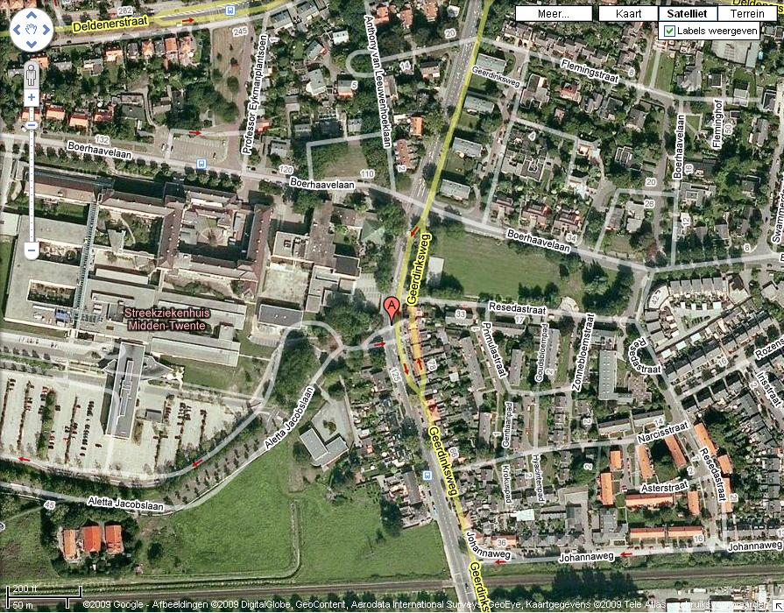 | 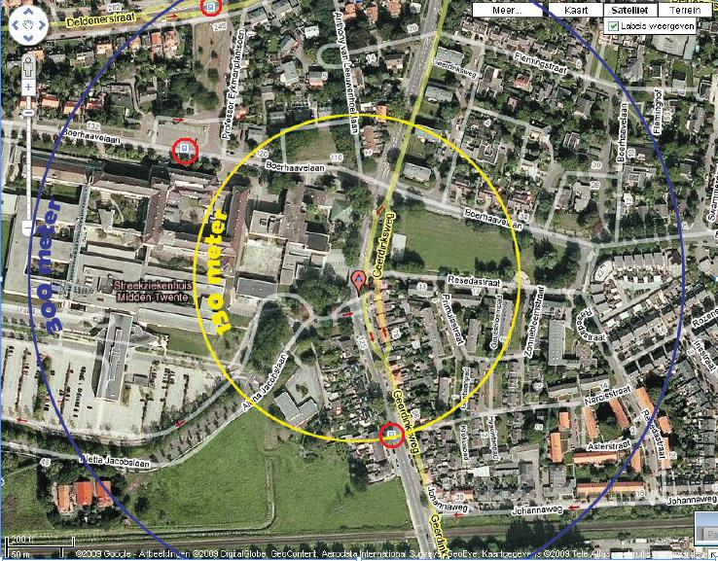
Figure 3.5: GoogleMaps satellite photo of private clinic Cosmea | Figure 3.6: GoogleMaps satellite photo of private clinic Cosmea with accessibility circles and red circles that indicate bus stations

For instance, the private clinic ‘Cosmea’ is located at the place that is shown in Figure 3.5. When the circles from 150 and 300 metres are put over this picture (in the same scale), one can see how many public transport points and highway exits fall into these circles in Figure 3.6. Within the red circles, three bus stations are situated. One falls within the 150 metres-zone, so that one gets one point. The other two fall out of the 150 metres, within the 300 metre line: they receive half a point. In total, the ‘Cosmea’ clinic scores two points in accessibility. This method is repeated for all locations of the privately owned health care facilities. When all points are found, it is evaluated if the facilities are located in highly accessible locations. It is also tested whether this was different for the various types specialisms.

Expectation 5: Clusters
A cluster can be seen as a network organisation that is located on a specific location, as we have learned from section 2.1.3. A proxy for the fact if a health centre is located in a cluster is to look at co-siting. Co-siting can be seen as the phenomenon that firms are located very near to each other on the same site. This is a less broad definition than for a health cluster.

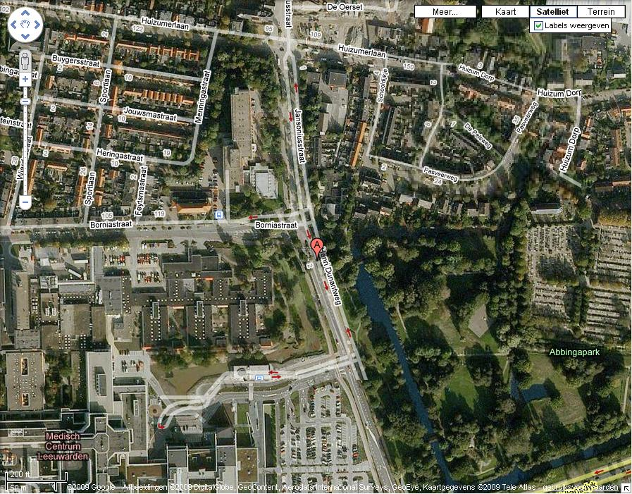
Figure 3.7: Location of Centrum voor Esthetische Chirurgie, Leeuwarden
From the satellite images of GoogleMaps one can distinguish if private health centres are co-sited on a specific site (bordered by the picture of GoogleMaps, which is an area of about two km²). Per picture it is checked if the facility is located near other health care (related) companies or hospitals. For example, the Centre for Aesthetic Surgery in Leeuwarden is located near the Leeuwarden Hospital as we can see in Figure 3.7. On the bottom left, one can distinguish the location of the hospital in Leeuwarden. It is about 300 metres from which the private clinic is located. This was checked for all the private health care facilities in the Netherlands.

Next to this, the addresses of the private health centres are compared with each other. For example, in Bilthoven, several private health centres are located on the same street, as can be seen in Table 3.1.
Alant Vrouw | Prof. Bronkhorstlaan 10 | 3723 MB | BILTHOVEN
Bergman Beauty Clinics | Prof. Bronkhorstlaan 10 W | 3723 MB | BILTHOVEN
Diabetes Centrum Bilthoven (Mesos) | Prof. Bronkhorstlaan 12 | 3723 MB | BILTHOVEN
Euroclinics - Internistenpraktijk Berg en Bosch | Prof. Bronkhorstlaan 10A | 3723 MB | BILTHOVEN
Kliniek voor preventieve geneeskunde  Berg & Bosch | Prof. Bronkhorstlaan 10 F | 3723 MB | BILTHOVEN
Stichting Medisch Centrum Bilthoven (SMCB) | Prof. Bronkhorstlaan 10 | 3723 MB | BILTHOVEN
Table 3.1: The addresses of several clinics in Bilthoven
This results in a list with information on whether a privately owned health care facility is co-siting with other health companies and if so, if a general or academic hospital is nearby. The general and academic hospitals are specifically taken into account because historically, ITCs had to be related to these hospitals. Although this requirement has been abolished in 2003, the locations of the ITCs that situated themselves somewhere before 2003 might still be affected by this former condition and less influenced by the willingness to co-site. Next to this, behavioural theory (see section 2.1.2) showed us that small firms may copy the location behaviour of large firms and consequently they end up on the same location. Here, hospitals can be seen as large firms, while the ITCs and private clinics are small firms.

With the list of the facilities that are co-sited, we test if the privately owned health care facilities are significantly more often co-sited or not. We also test whether this has something to do with the different types of location distinguished for expectation 3 (see section 3.2.4).

Conclusion
These different expectations can be put into a picture. All the factors mentioned in these expectations have, according to theory, an important influence on the location of private healthcare facilities. The methods that are used to test these expectations, sometimes use proxies for the different factors. In drawing, this research framework looks like shown in Figure 3.8.

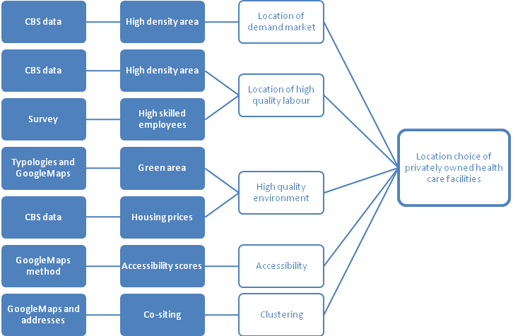
Figure 3.8: The factors that are tested and expected to be of influence to location choices

The factors tested for the Dutch privately owned health care facilities
The expectations that were presented in chapter 3 are analysed in this chapter. We statistically test what factors, that we found in the theory, are of influence on the location choice of privately owned health care facilities in the Netherlands. All the statistical tests are performed in the computer programme SPSS. The findings of the research is presented and our first conclusions will be drawn. A significance level of 0,05 is used for all statistical tests. In every section, the results per expectation are shown.

Density of the population
In the first section of this chapter we test whether our first expectation is met in practice. The first expectation is that privately owned health care facilities are located in densely inhabited areas. The data analysis is presented and the results from the survey are showed.

Data results and analysis
The density of the neighbourhoods of the privately owned health care facilities in the Netherlands and the average density of all municipalities are depicted in Figure 4.1.
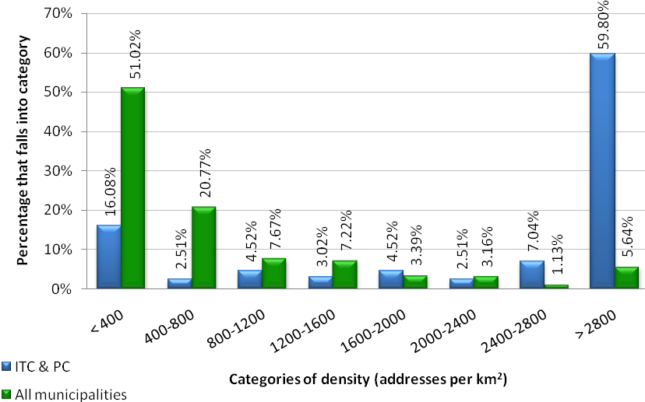
Figure 4.1: Frequency graph of the density of the population of the neighbourhoods where the ITC’s and private clinics are located (numbers in appendix B)

The green columns stand for the percentage of all municipalities in the Netherlands that fall into one density category. The blue columns show the percentage of the neighbourhoods of the privately owned health care facilities that fall into a density category. One can see that 51% of the municipalities have an average density of the population that falls between zero and 400 addresses per squared kilometre. For the neighbourhoods of the ITCs and private clinics, this is a very different picture. 59,8% of the neighbourhoods have a density of the population that is above 2800 addresses per squared kilometre. From the graph it looks like private health centres are indeed located in more densely inhabited neighbourhoods than average.

To know for sure, a statistical test of the difference is performed. It is tested if the centres and clinics are located in municipalities that are significantly denser populated than the average of all municipalities. To know what test to use, it is checked whether the groups of numbers have normally distributed values. A Kolmogorov-Smirnov test is conducted, of which the results are presented in Table 4.1.

 | Statistic | Degrees of freedom | p-value
Density of neighbourhood of private health care facility | 0,129 | 193 | 0,000
Average density of all municipalities | 0,218 | 443 | 0,000
Table 4.1: Kolmogorov-Smirnov test of normality for density per neighbourhood/municipality (performed in SPSS)

One can see that for both groups, the significance is 0,00, which is lower than our significance level of 0,05. This means that the values for density are for both groups not normally distributed and we are only allowed to perform non-parametrical tests.

We now perform a Mann-Whitney test to see if the density of the neighbourhoods of the privately owned health care facilities are different than the average densities of all municipalities of the Netherlands. The Mann-Whitney tool tests whether two groups of values come from the same population, in other words: to test if the two groups are significantly the same or not. The test will not look at the actual numbers, but will rank the different values. For example, the density of 2400 addresses per km² will rank higher than a density of 2300 per km². After ranking, the Mann-Whitney tool researches from which group which ranking comes from. If the two groups are very much the same, the chance that the ranking comes from group X (here: density of neighbourhoods of privately owned health care facilities) or from group Y (here: density for all municipalities) on every rank is the same. The ranking will look like this: 1=X, 2=Y, 3=X, 4=Y, 5=X, 6=Y, and so on. However, when the two groups are dissimilar, the ranking will look different: in the most extreme case like this: 1=X, 2=X, 3=X, 4=X (...), 200=Y, 201=Y, 202=Y, 203=Y, etcetera. The Mann-Whitney test looks at the difference in ranking for the different groups and calculates if this difference is statistically significant.

The Mann-Whitney test first ranks all the different values and sums up the rank values. In Table 4.2 one can find the rank sums of both the groups.

 | N | Mean Rank | Sum of Ranks
Density of neighbourhood of private health care facility | 193 | 453,64 | 87552,00
Average density of all municipalities | 443 | 259,63 | 115014,00
Total | 636
Table 4.2: The rank sums from the Mann-Whitney test (performed in SPSS)

One can see that the mean rank for the neighbourhood of the privately owned health care facilities (453,64) is higher than the mean rank of the density of all municipalities (259,63). This is consistent with the conclusion from Figure 4.1. Next, it is tested if this difference is significant. The result from this can be seen in Table 4.3.

 | density_cl
Mann-Whitney U | 16668,000
Wilcoxon W | 115014,000
Z | -12,243
Asymp. Sig. (2-tailed) | 0,000
Table 4.3: Test Statistics for the Mann-Whitney test on the population density of neighbourhoods/municipalities (performed in SPSS)

One can see that the ranking differences (Mann-Whitney U) is large (16.668). The difference between the two groups is significant: the p-value is 0,00, which is lower than 0,05 (which is the significance level) and therefore we can assume that the two groups of values are statistically different from each other. Because the mean ranks from Table 4.2 showed us that the density of the neighbourhood of the population is ranked on average higher than the average density of all municipalities, it is concluded from the Mann-Whitney test that the private health care facilities are located in significantly more dense inhabited areas than average. The first expectation is therefore met: privately owned health care facilities are located in densely inhabited areas.

We also perform a second test: the fact that the facilities are located in denser populated areas may mean that they are located in cities. When we apply the scale from the CBS on the values of density for all the municipalities, and on the values for municipalities of the location of privately owned health centres we can make the graph that is shown in Figure 4.2.

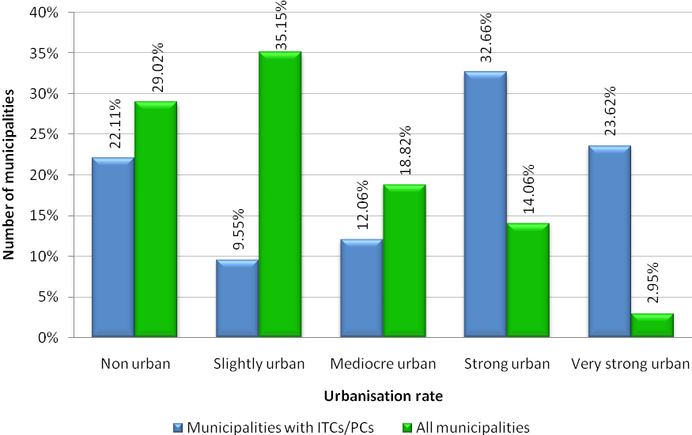
Figure 4.2: Scale of urbanisation for municipalities where privately owned health centres are located (blue) and for all municipalities (green) (numbers in appendix B)

From these graph we might already conclude that privately owned health centres tend to locate in very strong and strong urban areas. For all municipalities, there is a high percentage that is non urban or slightly urban (in total 64%). On the other hand, privately owned health care facilities are for 57% located in strong to very strong urban municipalities. These numbers represent ordinal variables and consequently a Sign test must be used to examine whether this difference is significant. The Sign test shows us whether the two groups have the same median or not. When the p-value is lower than the significance level (0,05), than there is a significant difference between the two groups. First, we have a look at the descriptive statistics (Table 4.4). For the test, the categories were rated from one to five, where the number one stands for non urban areas and five stand for very strong urban areas.

 | N | Mean | Std. Deviation | Minimum | Maximum
Urbanisation rate for all municipalities | 443 | 1,8713 | 1,25636 | 1,00 | 5,00
Urbanisation rate for municipalities with ITC/PC | 199 | 3,2613 | 1,48122 | 1,00 | 5,00
Table 4.4: Descriptive statistics for the scale of urbanisation for all municipalities and the municipalities where privately owned health care facilities are located (performed in SPSS)

In Table 4.4 one can see that the mean for the municipalities where privately owned health centres are located (3,26) is higher than the mean for all municipalities (1,87). To see if this difference is significant, first we have a look at the different frequencies. These results are shown in Table 4.5.
 |  | N
Urban_cl_mun - Urban_all_mun | Negative Differences (Urban_cl_mun < Urban_all_mun) | 29
 | Positive Differences (Urban_cl_mun > Urban_all_mun) | 125
 | Ties (Urban_cl_mun = Urban_all_mun) | 45
 | Total | 199
Table 4.5: Frequencies for the scale of urbanisation for all municipalities and the municipalities where ITCs and private clinics are located (performed in SPSS)

One can see that there are much more positive differences (that the municipalities where the private centres are locates are more urbanised than all municipalities) than that there are negative differences. These numbers correspond with what we saw in Figure 4.2. The final Sign test is shown in Table 4.6.

 | Urban_cl_mun - Urban_all_mun
Z | -7,655
Asymp. Sig. (2-tailed) | 0,000
Table 4.6: Test results for the sign test for the scale of urbanisation (performed in SPSS)

One can see in the last output in Table 4.6 that the difference is a significant difference, because the p-value is 0,00 and this is lower than the significance level of 0,05. We can conclude from the Sign-test that the private health clinics are located in more urbanised areas than average.

From these two data results and tests we can conclude that the privately owned health care facilities in the Netherlands are located in densely inhabited areas, that are more urbanised than average.

Answers from the survey
The expectation that centres are located in densely inhabited areas was a proxy for being near a large demand market. When we look at the answers that were given on the survey forms (see Table 4.7), it gives insight in the reasons why the centres are located in the dense inhabited areas. The opinions on the importance of the location of the demand market are quite scattered. All centres are divided over the categories. Only two centres qualify that the location of the demand market is very important in their location choice.

 | not important | little important | mediocre important | quite important | very important
Close to demand market | 3 | 2 | 4 | 2 | 2
Table 4.7: The weighing of factors of influence to location choices as answered in the survey, focused on the closeness of the demand market

The facilities were also asked in the survey about the three most important advantages of the location they are situated at the moment (see Table 4.8). Two of the centres indicate that the closeness to the demand market is one of these advantages of the location of the centre.

Advantages of current location | Number of answers given
Good accessibility by car | 13
Parking possibilities | 13
Good accessibility by public transport | 9
The building itself | 8
Close to demand market | 2
Close to hospital | 2
Nice living environment | 2
Cheap (land, rent) | 1
Close to other health facilities | 1
Table 4.8: The three most important advantages of the current location of privately owned health care facilities. NB: the numbers do not add up to 39; this is because some centres filled this in for more than one location and one centre answered more than three advantages.

High quality labour market
The second expectation is that privately owned health care facilities are located near a high quality labour market. Because this is hard to test with number-data (as has been explained in section 3.2.3), we will use the survey to give an indication on the importance of this factor.

Answers from the survey
The reason of locating near the labour market is only very important to one respondent (see Table 4.9). The rest of the centres find locating near (potential) employees less important. On average, they give it mediocre importance. None of the centres listed the quality of the labour market as one of the advantages of the location. The answers indicate that locating near a quality labour market is mediocre important for the privately owned health care facilities.

 | not important | little important | mediocre important | quite important | very important
Close to homes of (potential) staff | 1 | 3 | 7 | 1 | 1
Table 4.9: The weighing of factors of influence to location choices as answered in the survey, focused on the closeness of the labour market

High quality environments
The third expectation that we distilled from the theoretical background is that privately owned health care facilities are located in high quality environments. Section 4.3.1 includes data results and analysis of two types of proxies. The first proxy is that of the greenness of the area by using the location typologies from section 3.2.4: inner city, village/suburb, industrial and nature/forest. The second proxy is the average price of housing in the neighbourhood of the privately owned facilities. In section 4.3.2 the answers from the survey are presented.

Data results and analysis
The GoogleMaps method was used to distinguish the type of environments for all privately owned health care centres. The results are shown in Figure 4.3. Consistent with the findings about the density of the area, most of the private facilities are located in the inner city or a village/suburban area: the most densely inhabited areas of the four typologies. About 20% is located in an industrial area and 10% is located in nature/forest-like surroundings.

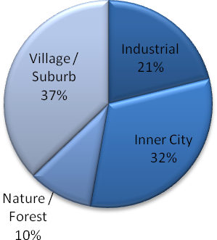
Figure 4.3: The division of the privately owned health care facilities in the different location typologies (numbers in appendix B)
It is interesting to see the difference between the industrial locations and the nature/forest locations. It was expected that the facilities would locate in a green area. Although the high percentage of the locations in inner cities and village/suburbs is understandable from the results of the first expectation, it is remarkable that even the industrial locations are more popular than the nature locations. Apparently the quality (or in this case greenness) of the environment is less important than expected.

However, these effects might differ per work area of private health centres. To test this, the results from the GoogleMaps method were set against the work areas of the different health centres. This result is shown in Figure 4.4.

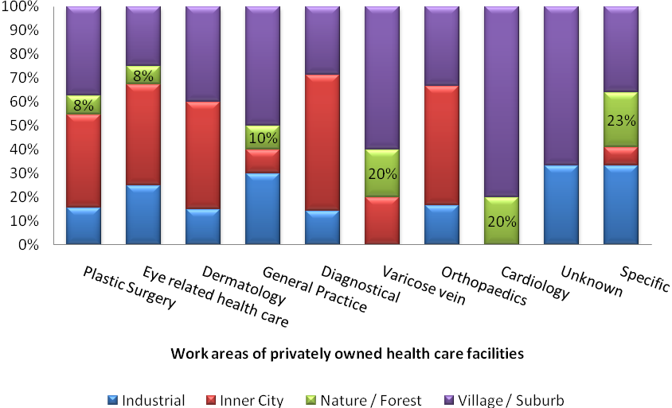
Figure 4.4: The location typology per work areas of privately owned health care facilities (numbers in appendix B)

We can see here, that for the nature/forest-environment, there is not one specific type of ITC or private clinic that has a clear preference for this environment. While plastic surgery and eye related health care facilities are best represented in absolute numbers, only 8% of the facility types are located in this environment. For cardiology and varicose vein facilities, 20% of the facilities are located in the nature/forest environment. For these two specialism types, this environment is most popular if compared to other specialism types. However, for both types, it is not the most preferred environment overall.

Average housing prices per neighbourhood were also used as a proxy for the quality of the environment. The average housing prices of the neighbourhoods of the privately owned health care clinics was compared to the average housing prices of all municipalities in the Netherlands. The results are depicted in Figure 4.5.
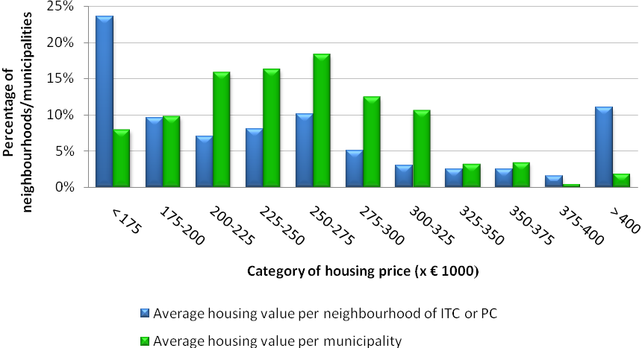
Figure 4.5: Average housing prices of neighbourhoods where privately owned health care facilities are located and all municipalities in the Netherlands in percentages (numbers in appendix B)

The graph shows a different picture than expected: in the lower housing values, the neighbourhoods of the privately owned health care facilities are more prevalent. Moreover, we see that private health centres are also more prevalent in the higher values (> € 400.000). The differences in average housing prices is for privately owned health care facilities rather large.

With a statistical test, we will see whether there is a significant difference between the two sets of housing values. First, a normality test was performed. From the Kolmogorov-Smirnov test can be concluded that both the groups are not normally distributed (see Table 4.10), because the p-value is 0,00; thus lower than the significance level of 0,05.

 | Statistic | Degrees of freedom | p-value
Housing prices neighbourhood ITCs and private clinics | 0,152 | 166 | 0,000
Housing prices all municipalities | 0,069 | 443 | 0,000
Table 4.10: Kolmogorov-Smirnov test for housing prices of the neighbourhoods of privately owned health facilities and of the housing prices of all municipalities in the Netherlands (performed in SPSS)

Because the groups do not have normally distributed values only a non-parametric test can be conducted. To see if the groups are different from eachother, a Mann-Whitney test is performed. How this test works has been explained in section 4.1. The results from the test are depicted in Table 4.11 and Table 4.12.

 | N | Mean Rank | Sum of Ranks
Housing prices neighbourhood ITCs and private clinics | 166 | 275,89 | 45.797,00
Housing prices all municipalities | 443 | 315,91 | 139.948,00
Total | 636
Table 4.11: The rank sums from the Mann-Whitney test (performed in SPSS)

One can see from Table 4.11 that the mean rank for the housing prices for all municipalities (315,91) is higher than for the neighbourhood of the facilities (275,89). This is not very surprising when we compare this to Figure 4.5. The fact that about 10% of the health care facilities is located in higher-prices environment does not tilt the average high enough to rank above all municipalities. To see if this difference is significant, we will look at the final outcome of the Mann-Whitney test, which can be found in Table 4.12.

 | Housing prices neighbourhood ITCs and private clinics
Mann-Whitney U | 31.936,000
Wilcoxon W | 45.797,000
Z | -2,500
Asymp. Sig. (2-tailed) | 0,012
Table 4.12: Test Statistics for the Mann-Whitney test on the housing prices of neighbourhoods/municipalities (performed in SPSS)

The difference in ranking is large (Mann-Whitney U: 31.936) and this difference is statistically significant. The p-value is 0,012 which is smaller than the significance level (0,05). We can conclude from this test that there is a significant difference in housing prices between the neighbourhoods of privately owned health care facilities and the overall of municipalities in the Netherlands. The privately owned health care centres are located in less valuable neighbourhoods.

Answers from the survey
The survey answers showed that the division over the four location typologies that was performed with the GoogleMaps method was accurate. The facilities had the opportunity to state in which typology they thought they were located. For all 13 centres this was the same for what was found from the GoogleMaps method. There were also two facilities that indicated that the nice living environment was one of the advantages of the location it was in, as can be found in Table 4.13.

Advantages of current location | Number of answers given
Good accessibility by car | 13
Parking possibilities | 13
Good accessibility by public transport | 9
The building itself | 8
Close to demand market | 2
Close to hospital | 2
Nice living environment | 2
Cheap (land, rent) | 1
Close to other health facilities | 1
Table 4.13: The three most important advantages of the current location of privately owned health care facilities. NB: the numbers do not add up to 39; this is because some centres filled this in for more than one location and one centre answered more than three advantages.

One of those centres indicated that a healthy environment for its patients was very important in the location choice. This centre was located in a village/suburb environment. Eleven of the centres found this less important, however five of them indicated that a healthy environment for their patients was quite important in the location choice (see Table 4.14). Those centres were located on all different typologies.

 | not important | little important | mediocre important | quite important | very important
Healthy environment for patients | 1 | 2 | 3 | 5 | 2
Nice living environment | 0 | 2 | 5 | 5 | 1
Cheap (land, rent) | 0 | 2 | 5 | 5 | 1
Table 4.14: The weighing of factors of influence to location choices as answered in the survey, focused on the quality of the environment

One of the centres, located in a industrial environment, stated in the survey that a disadvantage of the location is the look and feel of the neighbouring buildings.

For average housing prices, the following answers were given in the survey (see Table 4.13 and Table 4.14). Only one centre found cheap housing prices very important in the location choice (it was located on industrial, the cheapest, grounds), and five found it quite important (they were located in inner city locations and village/suburb locations). None of the centres indicated it was not important at all. This indicates that although a nice environment is also important, cheap housing is likely to be more important.

Accessibility
Expectation four is that privately owned health care facilities are located in well accessible locations. To test this, all locations of the ITCs and private clinics are given scores for accessibility. Here, the data results are presented and analysed in section 4.4.1. In section 4.4.2 the answers from the survey are presented.

Data results and analysis
The accessibility scores were collected for all privately owned health care centres in the Netherlands. The results are depicted in Figure 4.6.
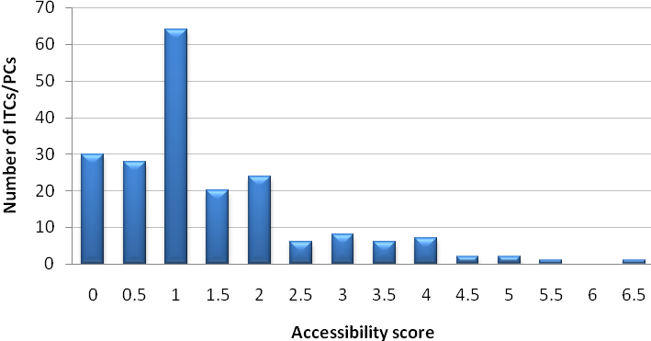
Figure 4.6: Accessibility scores for location of privately owned health care facilities (numbers in appendix B)

The graph indicates that accessibility scores are not very high for private health centres. The median score of all clinics is a score of one point. There are 30 centres that have an accessibility score of zero. However, this method has a strict point-system. When compared to the study of De Bok, Blijie and Sanders (2003), this method is more than twice as strict when giving points to the location of the privately owned health care facilities.

Several reference accessibility scores were calculated to give more insight in how the scores for the different facilities should be considered. For example, the central station of Rotterdam scored a 7 on accessibility. This is a high score compared to the facilities, which is expected because the station is a regional hub in the Dutch public transport network. However, when the Amsterdam Arena football stadium is scored (it scored 0 points), the flaw in the scoring system is clear. The football stadium is so large, that the circle of 150 metres covers the stadium alone. When the central point is shifted to the nearby shopping street, the score becomes higher (3 points). However, both the stadium as the shopping street are known to be very accessible and one would expect a higher score. This is an indication that the scope of the scoring system is indeed too small. The idea that the health facilities are not that accessible is likely to be a too negative solution from this method. From the dataset in this paragraph it is not very clear if private health centres are located in very well accessible locations.

As discussed in the theory, it could differ per type of centre if accessibility is important. When we set the accessibility scores against the different types of health centres, one can have insight in if this is the case. The results are presented in Figure 4.7. In the graph it can be seen that eye-related health care facilities may be located on a more accessible location than other clinics. The higher the accessibility scores are, there is more of the green colour (indicating eye-related health centres) in the graph. Dermatology and varicose vein clinics seem to be in less accessible locations.

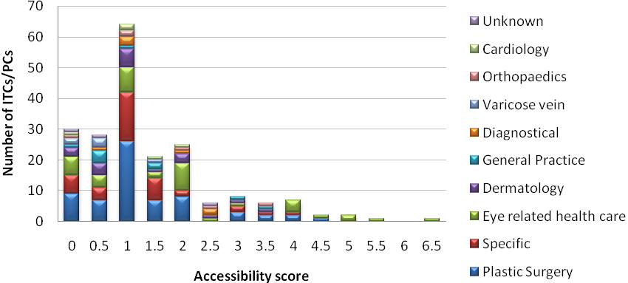
Figure 4.7: Accessibility scores per specialism (numbers is appendix B)

To examine if this first impression is right, it is tested whether the average accessibility of these types of privately owned health care facilities are different than the average of all facilities. A Sign-test was used because the scores are ordinal variables.

 | N | Mean | Std. Deviation | Minimum | Maximum
Accessibility eye-related health care facilities | 38 | 1,9474 | 1,72732 | 0,00 | 6,50
Accessibility other health care facilities | 163 | 1,2546 | 1,00978 | 0,00 | 4,50
Table 4.15: Descriptive statistics of the accessibility of eye-related health care facilities and all other private health care facilities (performed in SPSS)

From the descriptive statistics (see Table 4.15) we can see that indeed the mean of the accessibility scores of the eye-related health care centres is higher than average. The Sign-test shows if this is a significant difference.

 |  | N
other_access - eye_rel_access | Negative Differences (other_access < eye_rel_access) | 20
 | Positive Differences (other_access > eye_rel_access) | 14
 | Ties (other_access = eye_rel_access) | 4
 | Total | 38
Table 4.16: Frequencies of the accessibility of eye-related health care facilities and all other private health care facilities (performed in SPSS)

The frequency count is given in Table 4.16. From this table we may conclude that the differences between the two groups of accessibility scores is not that large. For the final test we can look at Table 4.17, to see if the difference is significant.

 | other_access - eye_rel_access
Z | -0,857
Asymp. Sig. (2-tailed) | 0,391
Table 4.17: Test results of the sign test for the accessibility of eye-related health care facilities compared to all other private health care facilities (performed in SPSS)

The results from the Sign test in Table 4.17 shows that here is no significant difference between the accessibility scores of eye-related health care centres and the overall average; the p-value of 0,391 is higher than the significance level of 0,05. The eye-related health care facilities are not located on more accessible locations.

The same Sign test is repeated for the dermatological and varicose vein health centres. The centres are tested together, because otherwise the numbers are too low and we cannot test them at all. Because we expect the same results from both, it is allowed to do so.

 | N | Mean | Std. Deviation | Minimum | Maximum
Accessibility dermatology and varicose vein health care facilities | 22 | 1,1136 | 1,01103 | 0,00 | 3,50
Accessibility other health care facilities | 179 | 1,4190 | 1,22492 | 0,00 | 6,50
Table 4.18: Descriptive statistics of the accessibility of dermatology and varicose vein health care facilities and all other private health care facilities (performed in SPSS)

In Table 4.18 we can find the descriptive statistics for the dermatological and varicose vein centres, compared to the accessibility scores for the other facilities. We can see that indeed the mean for the other facilities is higher than the for the accessibility scores of the facilities who work in the area of dermatology and varicose vein.
 |  | N
other_access - derma_vari_access | Negative Differences(other2_access < derma_vari_access) | 5
 | Positive Differences(other2_access > derma_vari_access) | 17
 | Ties(other2_access = derma_vari_access) | 0
 | Total | 22
Table 4.19: Frequencies of the accessibility of dermatology and varicose vein health care facilities and all other private health care facilities (performed in SPSS)

The frequency table (Table 4.19) also shows that there is more often a positive difference between the two groups. For the final results of the Sign-test we look in Table 4.20.

 | other_access - derma_vari_access
Asymp. Sig. (2-tailed) | 0,017
Table 4.20: Test results of the sign test for the accessibility of dermatology and varicose vein health care facilities compared to all other private health care facilities (performed in SPSS)

The results from the Sign test show that there is a significant difference between the accessibility scores of dermatology and varicose vein centres on the one hand and the other facilities on the other hand. The p-value of 0,017 is lower than the significance level of 0,05. Because the mean (Table 4.18) and the frequency table (Table 4.19) showed us that the dermatology and varicose vein centres are located on less accessible locations, together with the Sign-test results we can conclude that they are indeed on significant less accessible locations than other facilities.

Answers from the survey
It was very clear from the survey that the privately owned health care facilities found accessibility very important, one can find the results in Table 4.21. Almost all centres mentioned the good accessibility by car as very important in their location choice, only two indicated it as quite important.

 | not important | little important | mediocre important | quite important | very important
Good accessibility by car | 0 | 0 | 0 | 2 | 11
Good accessibility by public transport | 0 | 1 | 1 | 4 | 7
Parking possibilities | 0 | 0 | 0 | 3 | 10
Table 4.21: The weighing of factors of influence to location choices as answered in the survey, focused on accessibility

Moreover, the good accessibility by car was mentioned as one of the three advantages for all locations, just like the good parking possibilities. Good accessibility by public transport was mentioned as an advantages by nine of the facilities (see Table 4.22). Although the survey is only an indication, it is a very strong signal that accessibility is the most important factor in location choice of private health facilities.

Advantages of current location | Number of answers given
Good accessibility by car | 13
Parking possibilities | 13
Good accessibility by public transport | 9
The building itself | 8
Close to demand market | 2
Close to hospital | 2
Nice living environment | 2
Cheap (land, rent) | 1
Close to other health facilities | 1
Table 4.22: The three most important advantages of the current location of privately owned health care facilities. NB: the numbers do not add up to 39; this is because some centres filled this in for more than one location and one centre answered more than three advantages.

Clusters
The fifth and last expectation is that privately owned health care facilities are located in clusters, where we use the proxy of co-siting. We first look at the data results and analysis to see if the facilities are co-siting with are health-related institutions. The second part presents the answers from the survey.

Data results and analysis
The findings of co-siting of the privately owned health care facilities resulted in the following numbers, depicted in Figure 4.8:

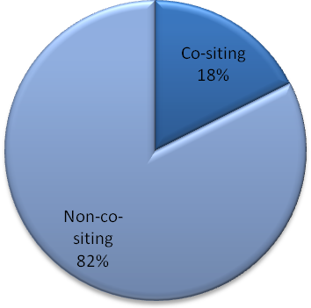 | 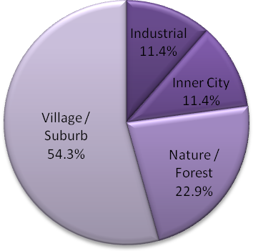
Figure 4.8: The percentage of privately owned health care facilities that are co-sited (numbers in appendix B) | Figure 4.9: The physical envrionment of the health care facilities that are co-sited (numbers in appendix B)

Most of the privately owned health care facilties, in fact 82%, are not co-sited. This is remarkable, since it was expected that most of them would be co-sited and thus in a cluster. This means that our fifth expectation is not met.

Next, the results from the co-siting were compared to the different typologies of the health centres. The 18% of the facilties that are located on a co-site, are divided in their location types. The results can be found in Figure 4.9. One can see that a large part of the co-siting facilities are located in the nature/forest areas.

In 25 of the 35 co-sites, there is a hospital present. Most of the co-sites are populated by private clinics in absolute numbers. Percentagewise, the part of co-sited private clinics that is located near a hospital is larger than for independent treatment centres. The numbers are presented in Table 4.23.

Number of ITCs that are co-sited: | ITC near hospital | Number of private clinics that are co-sited: | Private clinic near hospital
13 | 7 | 22 | 17
 | Percentage of co-sited ITCs |  | Percentage of co-sited private cinics
 | 54% |  | 77%
Table 4.23: The amount of independent health centres and private clinics in clusters and near hospitals

Answers from the survey
In the survey, one centre found it very important to be close to a hospital, and ten of the centres found it quite important (see Table 4.24). This indicates that the ties of the privately owned health care centres to the hospitals is very strong. The largest part of the private health facilities find it less important to be located near other health organisations. One found it very important, four found it quite important and seven of them found it mediocre important.

 | not important | little important | mediocre important | quite important | very important
Close to other health facilities | 0 | 1 | 7 | 4 | 1
Close to hospital | 1 | 0 | 1 | 10 | 1
Table 4.24: The weighing of factors of influence to location choices as answered in the survey, focused on clustering

In Table 4.25 we find the answers on the question which three factors are found to be advantages of the current location. Only one mentioned the closeness of other health facilities as an advantage. Two of the facilities indicated that closeness to a hospital was one of the advantages of the current location.

Advantages of current location | Number of answers given
Good accessibility by car | 13
Parking possibilities | 13
Good accessibility by public transport | 9
The building itself | 8
Close to demand market | 2
Close to hospital | 2
Nice living environment | 2
Cheap (land, rent) | 1
Close to other health facilities | 1
Table 4.25: The three most important advantages of the current location of privately owned health care facilities. NB: the numbers do not add up to 39; this is because some centres filled this in for more than one location and one centre answered more than three advantages.

Conclusion
In this chapter we tested whether our expectations would be met. The first expectation is met very convincingly: privately owned health care facilities are located in densely inhabited areas. The second expectation that covers the high quality of the labour market, is not met. The survey does not illustrate that the quality of the labour market is very decisive in the location choice of the facilities. The third expectation deals with the quality of the environment. The facilities are not located in green areas and they are often not located in neighbourhoods with high housing values. This expectation is neither met. The fourth expectation deals with the accessibility of the facilities. From the statistical data it is not very clear if they are located on accessible locations. However, the survey shows that accessibility is very important for the centres. The testing of the fifth expectation showed us that privately owned health care facilities are not often co-sited. When they are located on a co-site with other health-related institutions, they are mostly located in nature/forest environments and often there is a hospital located on the site.

Discussion of the analysis
In this chapter is explained what the results of the analysis mean for the location choices of privately owned health care facilities in the Netherlands. We will translate the expectations back to the factors of influence. The results are connected to the theory where possible.

The first expectation was that privately owned health care facilities are located in densely inhabited areas. From the research can be concluded that the privately owned health care facilities are located on locations where the density of the population is higher than average. The density of the population was a proxy both for the closeness of the demand market as the location of the labour market. The conclusion is that privately owned health care facilities are indeed located close to these markets. This corresponds with the theories we have seen in chapter 2. The classical location theories (section 2.1.1) state that firms will locate near the demand market and the agglomeration economies (section 2.1.3) give special attention to the demand market that is attracted by a cluster. Next to this, we saw from the research from the United States of America (section 2.2.2) that for-profit private health centres tend to locate near large demand markets, in order to make profit.

The private health centres are located mostly in urbanised areas. This is an indication that the facilities are attracted by the economies of urbanisation as described by Ohlin and Hoover (see section 2.1.3). Private health care may be seen as a secondary need of the participants in a cluster. These participants make sure that there are indirect spill-over effects for a health firm from other clusters in a city region.

That the facilities are located in densely inhabited area also indicates that the centres are located near a labour market, the main input for health care centres. In a dense inhabited area, the health centres have a higher chance to find a lot of labour inputs that fits them. This is also mentioned in the classical economic theories, where location of input factors play an important role (section 2.1.1). It is questionable if this is the case, however. From the research on the second expectation, it is concluded that the labour market location may not be very important to the privately owned health care facilities in the Netherlands.

The second expectation was that privately owned health care facilities are located near a high quality labour market. The results from the survey do not say much about the need to locate near a quality labour market. There is a weak indication from the survey that it seems not to be of much importance to the private health facilities. This might have something to do with the fact that in the Netherlands, infrastructure is good and therefore there is less need to be very close to the skilled labour market. Employees can travel fairly easy from their living area to the private health facility.

The third expectation was that privately owned health care facilities are located in high quality environments. There were two proxies used: the location in a green environment (nature/forest environment) and the housing prices. The greenness of the physical environment is not very important to privately owned health care facilities. In the survey, the facilities mentioned that the quality of the environment was of mediocre important to the facilities on average. Most of the facilities are located in inner city or village/suburban areas, which is consistent with the findings of the first expectation. It is remarkable that there are many more centres located in industrial areas than in nature/forest areas. This is most likely influenced by the lower housing prices in the industrial area: it is probable that the facilities find low land prices and rent more important to greenness of the environment.

Housing prices were compared as a proxy for the quality of the environment. The privately owned health care facilities were located (on average) in lower priced neighbourhoods that the average of the Netherlands. This is quite surprising and definitely against the third expectation. It is likely that the price of the land, that in classical theories is of influence on the location choice, plays a bigger role than the quality of the environment.

When private health care facilities are located in a more nature and forest environment, this also influences the amount of co-sited facilities. The endogenous advantages of a cluster or agglomeration are then more prominent and the facilities will locate together. Of all the private facilities that are co-sited with other health firms, 54% is located in a nature/forest environment.

Expectation four was that privately owned health care facilities are located in well accessible locations. The data showed no clear results in that respect. The method that was used via the GoogleMaps method was too strict to tell us anything about the scores of accessibility. However, it was possible to compare the accessibility scores of the facilities on different work areas. It was concluded that dermatology centres and varicose vein specialist centres were less accessible than other facilities. It is likely that for these specialisms, people are willing to travel further. It may be an indication that people who are in need of this type of care are feeling more ill than the patients of other facilities. We have seen in medical geography (section 2.2.1) that ill people are willing to travel further than healthy people.

From the data it was not very clear, but the survey results show that accessibility is very important. When one takes into account that the scope of the data analysis and point system was strict and the theory of public and private health care facilities state that accessibility is of huge importance, it can be concluded that accessibility is for private health care facilities in the Netherlands a very important factor in their location decision.

The last expectation was that privately owned health care facilities are located in clusters. The data research showed that the largest part of the facilities was not located on the same site as other health(-related) companies. This is different than we expected from the agglomeration economies theories. It must be taken into account that co-siting may be a too strict proxy to test for clustering. It is likely that the health cluster are more spread out than only one site. Nevertheless, the fact that the largest part of the facilities are not on co-sited is not surprising when the agglomeration economies of urbanisation are thought to be of greater influence. It was remarkable that a large percentage of the co-sites of health facilities was located in a nature/forest area. In these areas, the dense clusters are important to make sure agglomeration economies are accessed. In this case, firms enjoy the economies of localisation.

In most of the co-sites that do exist there is a hospital present. It is not very likely this is only historically grown: there are more private clinics than ITCs located near a hospital. This may indicate that the hospital behaves as the large firm in the adaptive theory of Alchian (McCann, 2001; see section 2.1.3). According to the theory of Alchian, it means that the clusters are located in a adaptive environments and the large hospital attracts other firms to evade information assymmetries.

Conclusion and remarks
In this chapter the conclusions of the research are presented in section 6.1. After this, in section 6.2 one can read some remarks on this research and suggestions for further research are done.

Conclusion of the research
In this research we aimed to answer the following research question:
What are the most important factors that influence the location decision of privately owned health care facilities in the Netherlands?
We will answer this question through the sub questions we have defined in chapter 1.

- Based on economic location theory: what are the most important factors that influence the location decision of firms and public organisations?
In economic and location theory various factors of influence were distilled. We found that the location of the demand market, the location of a high quality labour pool, accessibility, behavioural factors, the behaviour and quality of other firms, land prices and access to governmental facilities were of the largest influence on the location choices of privately owned health care facilities.

- What is already known about the factors that determine location decisions of privately owned health facilities?
Medical geography studies the geography of health care. Theories in this field of research show that accessibility is the most important factor that influences location choices. Moreover, the efficiency or the equity approach can influence location choices for different types of health care. Former research on locations of private health centres in the USA showed that these centres are lead by the goal to make profit, so they will locate in places where large profits can be made.

- What is already known about the location behaviour of the Dutch privately owned health care facilities?
There are various types of hospitals in the Netherlands. The two forms of privately owned hospitals in the Netherlands are independent treatment centres and private clinics. On these two forms of hospitals this research was focused. These privately owned health care facilities are active in diverse fields of medical specialisms. They offer non-urgent and planable care for prices that can be negotiated with the patient or its insurer.

From studies by the RIVM it follows that independent treatment centres are more centrally located near large cities in the Netherlands than general hospitals. About the location choices of private clinics no research is available.

- Based on location data, are the factors from theory of important influence for privately owned health care facilities in the Netherlands?
The factors that were thought to be of influence according to the theories we found in chapter 2 were translated into expectation that were tested in chapter 4. The factors that were tested are the location of the demand market and the location of the high quality labour market, the quality of the environment, the accessibility of the centres and clustering.

What are the most important factors that influence the location decision of privately owned health care facilities in the Netherlands?
From the tests it was concluded that privately owned health care centres are located most often in urbanised areas. The location of the demand market is of importance. Moreover, it is likely that the facilities are located in cities because of accessibility and agglomeration economies of urbanisation. They tend to locate in neighbourhoods where housing prices are lower than average. Although the quality of environment plays a role in the location choices, housing prices are more important. The facilities are located in less valuable neighbourhoods than average in the Netherlands.

Remarks on the study and suggestions for further research
This research is a first step to look at the location decisions of private health care facilities in the Netherlands. There are a few remarks on this research. Moreover, these remarks lead to suggestions of further research. These items will be presented in this section.

First of all, the lists, both of independent treatment centres and private clinics, that were used in this study was not completely reliable. This list was chosen based on the source, but later on in the research it became clear that this list was not completely accurate. When asked, the Netherlands Health Care Inspectorate (IGZ) explained how the list was formed. One can read the response of the IGZ in the email in appendix D. In the course of the research for this thesis the list was changed and corrected as much as possible, but there will still be errors. For example, there might be private health facilities that are not on this list but do exist. It is recommended for later research to have a more reliable dataset to begin with.

Secondly, to say something about the location choices of health facilities in general, one cannot stop after looking at the Netherlands. The Netherlands is a small country with a lot of inhabitants and fairly well organised infrastructure. It is likely that the location decision in the Netherlands is based on other factors than in other countries. Moreover, the absolute amount of privately owned health care facilities in the Netherlands is not that high. In line with this is a comment of Knoors, Vrijland and Zenderen (2000). They state that while the dogmatic meaning of private clinics and ITC’s is big, the amount is not that much in comparison with regular health care in the Netherlands: in 2000, there were 6000 medical specialists employed by the regular hospitals, and only 110 specialists were employed by private actors (Knoors et al., 2000). It is recommended to look at other case studies in other countries to test this in the future.

Thirdly, it would have been very interesting to use more survey data. The survey results were now used as a mere illustration to the results from the dataset. The first intention was to talk to a few decision makers of health facilities in-depth about their thoughts about the location choices they made and could make in the future. However, there was not much interest for this and because of time considerations, it was decided to go with a survey instead. This survey did not result in a lot of feedback (13 of the 199 responded). This is a shame, because now the number data findings could not well be supported by the survey. A larger response could have given us more insights in why the centres were located on the different places, which was especially interesting for the labour market location. In future research, it is recommended to use in-depth interviews or a survey with a larger response.

Fouthly, and in addition to the third point, there is a remark on personal factors that play a role in location decision making. In this research ‘hard’ data was used (numbers, locations and pictures) to tell something about the factors that are of influence to location choices. However, this is not enough to fully understand how and especially why these location choices are made.

As we have seen in behavioural economic theory, the location decision makers might have personal or emotional factors that will influence their choice. For example, doctors might like the place they live in, and want to start a facility in that place. There are various reasons that can differ from person to person. The decision makers will have own considerations and probably private factors that influence the location choice. Although they cannot be measured easily, they should be taken into account. In-depth interviews give the opportunity to look more into these factors as well.

The last remark is about the method of research that is used in this study. The method of using GoogleMaps for location research is a new phenomenon. It is a convenient and easy way to look at characteristics of locations and may be used for further research as well. In this research, a certain scale was used for all the pictures. For further research it is recommended to try other scales and other tests, to see if other results can be found. That this can be interesting has become clear for the expectations on accessibility and on clustering. For example, by testing for co-siting for a larger scale, it may be that there are more clusters visible. In that case, other conclusions may be taken.

Bibliography
Alchian, A., 1950, Uncertainty, Evolution and Economic Theory, Journal of Political Economy, Volume 58, Pages 211-21
American Hospital Association, 2008, Beyond Health Care: The Economic Contributions of Hospitals, Trendwatch, April, Pages 1-8
Babbie, E., 2004, The practice of social research, 10th ed., Belmont, CA: Thomson Wedworth
Barrios, S., Gorg, H. and Strobl, E., 2006, Multinationals’ location choice, agglomeration economies and public incentives, International Regional Science Review, Volume 29, Number 1, Pages 81-107
Bartik, T., 2005, Solving the problem of Economic Development Incentives, Growth and Change, Volume 36, Number 2, Pages 139-166
Begg, I., 1999, Cities and Competitiveness, Urban Studies, Volume 36, Numbers 5-6, Pages 795-809
Bestuursdienst gemeente Rotterdam, 2009, website Doelstellingen Pijler: Economie, http://www.rotterdam.nl/smartsite2116998.dws (5 March 2009)
CBS, 2009a, website CBS in uw buurt: http://www.cbsinuwbuurt.nl (8 September 2009)
CBS, 2009b, website CBS Begrippen: http://www.cbs.nl/nl-NL/menu/methoden/begrippen/default.htm?ConceptID=658 (10 October 2009)
CBS, 2009c, website Statline: http://statline.cbs.nl/statweb/ (Accessed on various occasions in the period January - September 2009)
College bouw, 2003, Signaleringsrapport College Bouw Ziekenhuisvoorzieningen 'Het zelfstandig behandelcentrum: van noodzakelijk kwaad tot nuttig goed?', February 2003, online available: http://www.bouwcollege.nl/Pdf/CBZ%20Website/Publicaties/Uitvoeringstoetsen/Ziekenhuizen/ut549.pdf (July 2009)
Cushman & Wakefield, European cities monitor 2008, October 2008, online available: http://www.cushwake.com/cwglobal/jsp/kcReportDetail.jsp?Country=GLOBAL&Language=EN&catId=100003&pId=c17500010p (July 2009)
DBC onderhoud, 2009a, website DBC Onderhoud: Over de DBC systematiek, http://www.dbconderhoud.nl/Over-de-DBC-systematiek (13 November2009)
DBC onderhoud, 2009b, website DBC Onderhoud: Categorale Instelling, http://www.dbconderhoud.nl/Over-de-DBC-systematiek/Wie-werken-met-de-DBC-systematiek/Categorale-instelling (13 November2009)
De Bok, M., Blijie, B. and Sanders, F., 2003, The influence of the transportation system on land use: A disaggregated analysis of the migration patterns of firms on the office market and the accessibility of locations, Paper for the Colloquium Vervoersplanologisch Speurwerk
DeVerteuil, G., 2000, Reconsidering the legacy of urban public facility location theory in human geography, Progress in Human Geography, Volume 24, Number 1, Pages 47-69
Enright, M. J., 1998, The globalization of competition and the localization of competitive advantage: policies towards clustering, Paper presented at the Workshop on the Globalization of Multinational Enterprise Activity and Economic Development, University of Strathclyde, Glasgow, Scotland, May 15-16
Field, K.S. and Briggs, D.J., 2001, Socio-economic and locational determinants of accessibility and utilization of primary health care, Health and Social Care in the Community, Volume 9, Number 5, Pages 294-308
Fujita, M. and Thisse, J., 1996, Economies of Agglomeration, Journal of the Japanese and International Economies, Volume 10, Pages 339-378
Gemeente Rotterdam, 2009, Rotterdam Economisch Uitvoeringsprogramma 2006-2009, online available: http://www.rotterdam.nl/smartsite2116990.dws (12 January 2009)
Gemeente Valkenburg aan de Geul, 2007a, website Global Wellness Valkenburg, http://www.globalwellnessvalkenburg.nl/ (10 February 2009)
Gemeente Valkenburg aan de Geul, 2007b, website Global Wellness Valkenburg ondernemers, http://www.globalwellnessvalkenburg.nl/ondernemers/helendehellingen.htm (10 February 2009)
Google, 2009, website Google Maps: http://www.maps.google.com (Accessed on various dates during January - September 2009)
Gupta, B., Pal, D. and Sarkar, J., 1997, Spatial Cournot competition and agglomeration in a model of location choice, Regional Science and Urban Economics, Volume 27, Pages 261-282
Hansen, W.H., 1959, How accessibility shapes land use, Journal of the American Institute of Planners Volume 15, Pages 73-76
Hermans, H.E.G.M., 2004, Privéklinieken, ZBC’s, markt en winstoogmerk, Tijdschrift voor Gezondheidsrecht, Volume 28, Pages 414-428
Homberg, J., Heijmans, C. and Huisman, R., 2006, Merkbeleid bij ZBC’s: koplopers in marketing?, ZM Magazine, Volume 9, Pages 6-10
Hoover, E. M., 1937, Location theory and the shoe and leather industries, Cambridge, MA: Harvard University Press
IGZ, 2009a, Toezicht op zelfstandige behandelcentra April 2009 and Toezicht op private klinieken April 2009, address lists of ITCs and private clinics in the Netherlands, online available: http://www.igz.nl/burgersloket1/ietsweten/kwaliteit_zorgaanbieders/particuliere_klinieken online (20 May 2009)
IGZ, 2009b, http://www.igz.nl/ (July 2009)
INHolland, 2009, website Hogeschool INHolland Organisatie: http://www.inholland.nl/Over+INHOLLAND/Organisatie/frontpage.htm
Jaap, 2009, website Jaap.nl: http://www.jaap.nl/buurten (September 2009)
Kamerstuk 24-06-2003, 28600 XVI, nr. 132, kenmerk CZ/IZ/2386811, Regeling houdende wijziging van enkele regelingen op grond van de Wet ziekenhuisvoorzieningen inzake zelfstandige behandelcentra
Kohli, S., Sahlen, K., Sivertun, A., Lofman, O., Trell, E. and Wigertz, O., 1995, Distance from the Primary Health Center: A GIS Method to Study Geographical Access to Health Care, Journal of Medical Systems, Volume 19, Number 6, Pages 425-436
Knoors, E.G.M., Vrijland, E.L. and Zenderen, L.A.M., 2000, Van gedogen naar mogen: de regelgeving voor proveklinieken en zelfstandige behandelcentra, Tijdschrift voor Gezondheidsrecht, Volume 24, Pages 482-497
Litva, A. and Eyles, J., 1995, Coming out: exposing social theory in medical geography, Health & Place, Volume 1, Number 1, Pages 5-14
McCann, P., 2001, Urban and Regional Economics, New York: Oxford University Press
McCann, B. and Folta, T., 2008, Location Matters: Where we have been and where we might go in agglomeration research, Journal of Management, Volume 34, Pages 532-565
McClellan, M. and Staiger, D., 1999, Comparing hospital quality at for-profit and not-for-profit hospitals, NBER Working Paper Series, no. 7324
Norton, E. and Staiger, D., 1994, How hospital ownership affects access for the uninsured, The RAND Journal of Economics, Volume 35, Number 1, pages 171-185
Orde van Medisch Specialisten, 2004, Zelfstandige Behandelcentra (ZBC's), online available http://orde.artsennet.nl/discussie/Artikel/Zelfstandige-Behandelcentra-ZBCs.htm (January 2009)
Parker, Barett R. and Srinivasan, V., 1976, A Consumer Preference Approach to the Planning of Rural Primary Health-Care facilities, Operations Research, Volume 24, Number 5, Pages 991-1025
Parr, H., 2003, Medical Geography: care and caring, Progress in Human Geography, Volume 27, Number 2, Pages 212-221
Penchansky R. and Thomas, J.W., 1981, The Concept of Access: Definition and Relationship to Consumer Satisfaction, Medical Care, Volume 19, Number 2, pp. 127-140
Porter, M., 2000, Location, Competition, and Economic Development: Local Clusters in a Global Economy, Economic Development Quarterly, Volume 14, Number 1, Pages 15-34
Praamsma, J.M., 2004, De (on) voorspelbaarheid van ruimtelijk handelen, Geografie, januari 2004, Pages 30-35
Revelle, C., Marks, D. and Liebman, J.C., 1970, An analysis of Private and Public Sector Location Models, Management Science, Volume 16, Number 11, Pages 692-707
Rijnland zorggroep, 2007, website Rijnland Ziekenhuis Behandelkosten en DBC's, http://www.rijnland.nl/nl/p466d6dee98c4b/Behandelkosten-en-DBC's.html (10 November 2009)
RIVM, 2009a, website RIVM Nationale Atlas Volksgezondheid - Zorg: http://www.rivm.nl/vtv/object_class/atl_zorg.html (January 2009)
RIVM, 2009b, website RIVM Nationale Atlas Volksgezondheid - Zorg - Ziekenhuisszorg: http://www.rivm.nl/vtv/object_class/atl_ziekenhuis.html (January 2009)
RIVM, 2009c: website RIVM Nationale Atlas Volksgezondheid - Zorg - Ziekenhuiszorg - Particuliere klinieken: http://www.rivm.nl/vtv/object_map/o1913n21159.html (January 2009)
RIVM, 2009d, website RIVM Nationale Atlas Volksgezondheid: http://www.rivm.nl/vtv/object_document/o4235n21143.html (January 2009)
Schneider, J.B., 1967, Measuring the Locational Efficiency of the Urban Hospital, Health Services Research, Volume 2, Number 2, Pages 154-169
Sheth, J.N. and Krishnan, B.C., 2003, Consumer Behaviour, Chapter in: Calhoen, J.W., Marketing Best Practices, Mason: Thomson South Western
Simon, H., 1957, A Behavioral Model of Rational Choice, in Models of Man, Social and Rational: Mathematical Essays on Rational Human Behavior in a Social Setting, New York: Wiley
Sloan, F., Picone, G., Taylor jr., D. and Chou, S.,2000. Hospital ownership and cost and quality of care: is there a dime’s worth of difference?, Journal of Health Economics, Volume 20, pages 1-21
Thermae 2000, 2009, website Thermae 2000 World of Wellness Informatie: http://www.thermae.nl/informatie/ (12 February 2009)
Teitz, M.B. 1968: Toward a theory of public facility location, Papers of the Regional Science Association, 21, 35-51.
Van den Berg, L., Braun, E. and Van Winden, W., 2001, Growth Clusters in European Cities: An Integral Approach, Urban Studies, Volume 38, Number 1, Pages 185-205
Van Ginniken, J., 2007, Bordjes ‘City of Health’ verdwijnen, De Gelderlander, 6 December 2007
Verter, V. and Lapierre, S.D., 2002, Location of Preventive Health Care Facilities, Annals of Operations Research, Volume 110, Pages 123-132
WHO, 2009, website Healthy Cities and urban governance: http://www.euro.who.int/healthy-cities (6 January 2009)

‘Kliniek Sportstad’, a part of a new developed ‘SportsCity Heerenveen’, including a health boulevard; http://www.sportstadheerenveen.nl/ (5 March 2009)
See the email from Dienstpostbus IGZ Loket Utrecht, dd. 14 July 2009 (in Appendix C)

