ERASMUS UNIVERSITY ROTTERDAM
Erasmus School of Economics
Master Urban, Port and Transport Economics
Master Thesis, December 2009

OIL PRICE INFLUENCE ON EU IMPORT, INWARD CONTAINER TRANSPORT AND TRADE BALANCE WITH CHINA

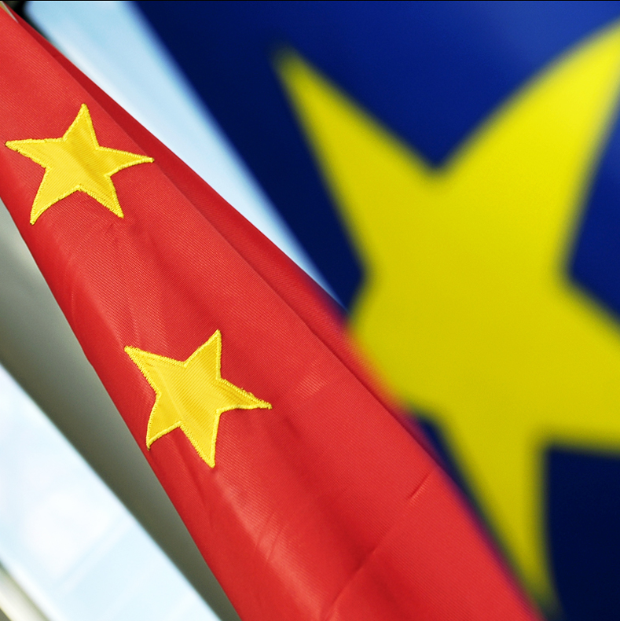

Name student: Cam Hoan Luu
Exam number: 266930
Supervisor: Mr. M. Nijdam MSc
E-mail address: camhoanluu@hotmail.com

Table of contents

Table of contents 2
Preface 4
Summary 5
1 Introduction 7
2 The first oil crisis in the 21st century 13
2.1 Oil crisis in 2008 13
2.2 Oil price increase 15
2.3 Oil price decrease 17
3 The theory 19
3.1.1 Foreign enterprises sourcing manufacturing activities from China 19
3.1.2 China’s driving factors as manufacturing sourcing destination 22
3.2 Global supply chain stimulated sourcing to China 24
3.3.1 High oil price implications on economy growth 25
3.3.2 Maritime container transport costs 27
3.4 High oil effect on China’s export of manufactured goods is minimal 34
4 EU-China ‘real’ trade in goods development in 2000-2008 37
4.1.1 EU external trade with China in total goods 37
4.1.2 Manufactured goods 41
4.2 Distorted EU-China trade deficit 44
4.2.1 EU FDI (off shoring) in China 45
4.2.2 EU FIE in China’s export 46
4.2.3 EU International (out) sourcing 47
5 Transportation between the EU and China 50
5.1.1 Maritime transportation 50
5.1.2 EU-China trade in goods by sea 51
5.2.1 Container transport 54
5.2.2 EU and Chinese container port traffic 59
5.2.3 Chinese trade export value versus container export volume 61
5.2.4 Freight rates on main routes 62
5.2.5 After the oil crisis in 2008 63
5.3.1 Port of Rotterdam – The Gateway for EU-China trade 64
5.3.2 Rotterdam effect and Global factory effect 66
6 Oil price relation with imported goods and inward container transport 70
6.1 EU-Asia freight rate 70
6.2.1 EU imported total goods and manufactured goods 71
6.2.2 EU imported manufactured goods in 3 product groups 72
6.2.3 EU imported manufactured goods in 7 specific product groups 74
6.2.4 EU imported manufactured goods in 7 detailed product groups 75
6.3.1 EU inward container transport (2005-2008 1st half year) 76
6.3.2 Port of Rotterdam inward container transport (2000-2008) 76
6.4 Exchange rate effect on oil price and import of Chinese goods 78
7 The future expectations 79
8 Conclusion 83
9 References 86

List of abbreviations
BAF Bunker Adjustment Factor
Bln. Billion
EU European Union 27
FDI Foreign Direct Investment
FIE Foreign Invested Enterprise
GDP Gross Domestic Product
IEA International Energy Agency
ICT Information and Communication Technology
Mln. Million
nes not elsewhere specified
POR Port of Rotterdam
R&D Research and Development
SEZ Special Economic Zone
SITC Standard International Trade Classification
TEU Twenty feet Equivalent Unit
Tln. Trillion
y-o-y year-on-year
US United States of America
WTO World Trade Organization

Preface

As the last part of my master study Urban, Port and Transport Economics at Erasmus University, I did a research on the oil price influence on EU import, inward container transport and trade balance with China. Writing this research thesis is like the story ‘Journey to the West’ with increasing hindrances to the final stage.
Therefore I want to acknowledge several people for their contribution towards my research. First of all, I would like to thank my supervisor Mr. M. Nijdam Msc for the insightful conversations and helpful advices, guidance and comment during the research.
Secondly, I would like to thank my ‘chiefs’ mr. R.R. L Hunte and Imro Davids, Transportation Researchers at RET N.V. Despite their busy time schedules, they were willing to check my writings. Furthermore, I want to thank all my fellow students and friends for their support and knowledge sharing.
In addition, I would like to thank the following persons for their professional advices and statistic data sharing: Henny Gillet, Business Information Analist at Havenbedrijf Rotterdam N.V.; Jacqueline van de Wetering, Senior Vice President Business Department at Evergreen Shipping Agency (Netherlands) B.V.; Charles de Trenck at Transport Trackers; Tanya Petridou and Mushtaq Hussain at ESTAT.
Finally, I want to thank my parents, my sisters and especially my brothers for supporting me during this thesis period. Last but not least, I want to thank my auntie Anh and her family for their support and encouragement, which persuade me to come back to the Netherlands to complete my study.

Zwijndrecht, December 2009

Cam Hoan Luu

Summary

Oil is an important fundamental component in the global and maritime transport trade. Higher oil prices during the first oil crisis in the 21st century leads to higher maritime transport costs. The main objective of this thesis is to research if oil prices has a significant influence on EU import and inward container transport from China and if there can be found significant consequences in EU trade balance with China.
This objective is translated into a main research question:
Could oil prices influence EU import, inward container transport and trade balance with China?
In order to get an answer to this question I investigate the oil influence on EU import, inward container transport and trade balance with China for the period 2000-June 2009. Since 2000 we have experienced a global oil crisis with increasing oil prices and a following global credit crisis with decreasing oil prices. Growing global oil demand, particularly boosted by emerging countries such as China leads to oil price surges, which peaked at $132,35 on 3 July 2008. Implications during oil crisis are higher transport costs, inflations and food crisis. However, the turning point is the credit crunch global breakout, which is followed by a lower global demand for goods and lesser transportation. This leads to a nose-dive in oil prices to $33,73 in 26 December 2008.
Growing EU-China trade is boosted by increasing EU firms demand for Chinese goods by sourcing out manufacturing activities to China. China has become EU’s factory due to its comparative advantages in manufacturing, progress in global containerization and ability to put more labour in production to offset higher energy costs. High oil prices during oil crisis forced shipping lines to adjust their vessel speed and fleet management by employing more ships and at the same time solve TEU capacity oversupply. Additionally, shipping lines add more BAF and oil related surcharges, which increase total freight rates and transport costs.
EU-China trade has become more important, which account for around 1/3 of world merchandise trade in 2007. Since 2006, is China EU’s largest supplier of (manufactured) goods, while EU is China’s largest export market. In 2000-2008, EU import growth of Chinese goods still increase particularly manufactured goods (95,9%), where as transport costs surge significantly. EU export growth is lesser, which results into widening trade deficits with China. However, EU trade deficit in goods is distorted by hidden EU firm’s participation via off shoring. Sourcing remain mainly within EU, but EU firms sourcing production to China increase. China’s real net added value in EU import is much lesser.
Imbalanced EU-China trade leads to high share of EU empty container transport (52,7%) and POR (42,3%) back to China. The result is higher freight rate in westbound direction to cover up return costs of empty containers in eastbound direction. EU total imported goods average value/ton is higher than exported goods, respectively €2.363 and €1.853. In top 20 world container ports for the period 2003-2008, Chinese ports growth is higher than EU ports. We explain that China as world factory has net advantage, which replace all across global sea transportation.
I research the relation between oil price and EU imported Chinese goods and inward container transport. Despite higher transport costs EU and POR inward container transport in TEU still grows at a lower pace. Empty share in inward container transport declines significantly. However, imported goods measured in value increase while in quantity declines. Stronger euro against dollar and yuan slightly reduce oil price influence on transport costs and EU imported goods from China. Oil price has a positive relation with Asia-EU freight rate (R²= 0,5), total goods in value (R²= 0,69), EU total inward container transport in TEU (R²= 0,55), POR total inward container transport in TEU (R²= 0,80), dollar depreciation against euro (R²= 0,72). Yuan depreciation against Euro has a positive relation with EU imported total Chinese goods (R²= 0,46).
Oil price has a positive, but no negative causal correlation with EU imported goods from China. Higher oil prices and transport costs should diminish EU imported goods, but China’s competitive production stimulates its export and eventually higher oil prices than in the origin. Additionally, shipping lines flexible reaction to oil prices leads to downward pressure on transport costs. After all, China’s currency policy keeps Chinese goods artificially cheaper.
Future outlook for EU-China trade and maritime transportation is positive with an expected modest oil price increase to $100 in 2020. Enterprises in manufacturing and shipping lines can gradually adjust their production and transportation strategies to growing oil prices. China’s shift to green and more high tech goods in the value chain will heighten export goods value, which is lesser venerable for transport costs increase. More EU firms shift high value production to China due to promising huge domestic market will keep EU export growth relative lower and even heighten future trade deficits with China. Moreover, vessel and TEU capacity oversupply based on order book up to 2011 keep freight rate temporary low.

1 Introduction

Asian economies fast recovery in the ongoing global credit crisis and higher expected economic growth signal an accelerated global economic power shift eastwards. In continuation of my Bachelor Thesis “How China and India can preserve high economic growth to become eventually the largest Asian economy in 2050” I change the focus and do further research on the trade and transport relation between China and the EU. According to WTO report the EU merchandise trade economy is the largest and China third largest in the world in 2008. Therefore, it is interesting to investigate whether merchandise trade and related maritime transportation between EU and China would be affected by growing oil prices. As the “World’s factory” China’s economy is strongly based on the export of mainly (low value) manufactured goods. The issue is will this economic structure remain the same, when transport costs increase due to the rising oil prices like in the oil crisis in 2008?
The growing merchandise trade between EU and China is possible due to the ongoing globalization process with driving factors such as relocation of manufacturing activities, progressive developments of supply chain and particularly lower transport costs. EU growing imported Chinese goods is partly boosted by sourcing out and relocating work processes to China. China’s economic growth has a ‘hidden’ positive effect on the EU economy. The relocation of European production to China creates economic loss such as European labour, but it still generates profits for the European enterprises. EU huge trade deficit with China generate high share of empty container transport back to China. The port of Rotterdam (POR) is EU’s ‘gateway’ for inward Chinese sea transport (westbound), but it also has an important function in empty container transport issue (eastbound).
Rising oil prices prevail as key factor in the energy mix used in transport costs. Since March 2007, oil prices surged to the record high of $ 143,95 on 3 July 2008. This leads to higher freight rate and oil surcharges in transport costs, which become a larger component of transaction costs. This can harm EU-China trade. However, transport costs are also determined by factors, like geography, trade volumes, economies of scale, infrastructure and administrative processes. According to some trade observers, higher oil price could hinder globalization process and eventually change global trade. This implies that China’s comparative advantage in massive manufacture production diminishes. This would affect EU and global manufacture plant location decisions, current global trade flows and related transportation strategies.
In 2000-2008, EU trade with China has been more than tripled in value. In 2008, EU imported Chinese goods had a total worth of € 248 Bln. In the same year China was the largest source of EU imported manufactured goods, where as in 2000 Chinese import was just €75 Bln. On the other hand, China is now the fastest growing export market for Europe. In the same period, EU export to China also tripled. In 2008, EU exported goods for €78 Bln. to China compared with €26 Bln. in 2000. In 2008, Europe’s trade deficit with China was €169 Bln. this is around €19 Mln. every hour. This growing deficit remains a sensitive political issue. The general perception is that the EU-China trade is growing due to much larger EU import than export, which is creating unemployment in Europe. However, the EU trade deficit with China is to some extent distorted.
Increasing oil prices result in higher transport costs and ultimately in higher Chinese consumer prices. The issue is whether European companies change their relocation strategy as transport costs exceed the benefit of lower sourcing costs from China. EU import of Chinese goods and related sea transportation (westbound) diminish if EU companies indeed reverse the relocation trend. However, the turning point for transport costs was when the ongoing credit crunch emerged and oil prices plunged. The nose-dive in oil prices are mainly caused by decreasing global oil demand as a consequence of the grim world economy expectations, lower consumer confidence, but the oil problem remains. According to IAE oil supply would unavoidable decline and predicts eventually a higher oil price than the current record price of $143,95 per barrel oil in the future. Moreover, recent oil prices bounce back to around $75 in December 2009. After all, China’s clean energy policy and shift to more green production could heighten future EU imports.

The Research Question
The topic of my master thesis research is what the influence of oil prices has on merchandise trade, maritime container transport and trade balance between EU and China. The main objective of my thesis is to research if oil prices has a significant influence on EU import and inward container transport from China and if there can be found significant consequences in EU trade balance with China. The research question can therefore be formulated as follows:

COULD OIL PRICES INFLUENCE EU IMPORT, INWARD CONTAINER TRANSPORT AND TRADE BALANCE WITH CHINA?

In order to come to a structured and clear answer to this research question, I divide the research question into five sub questions. Some of these sub questions are further divided into sub-sub questions. I will analyze and reply each sub question step by step by using data from statistic and literature sources to find the answer on the research question. The sub questions and sub-sub questions are formulated as follows:

1 - What is the cause behind the extreme high oil prices during the first ‘oil crisis’ in the
21st century?
2 - What is the impact of (high) oil price on EU sourcing out work processes to China?
2.1 Why are EU enterprises sourcing their manufacturing activities from China?
2.2 How could global supply chain facilitated outsourcing to China?
2.3 What are the implications of high oil price for global trade and transport (costs)?
2.4 What is the impact of (high) oil prices on China’s export of goods?
3 - What is the ‘real’ EU-China trade development in 2000-2008?
4 - What are the implications of growing (imbalanced) EU-China trade and increasing
oil prices on the maritime container transport?
5 - Can oil prices influence EU’s import of Chinese manufactured goods and inward
container transport?
6 - What is the future oil price influence on China’s manufacturing development in
EU-China trade and transportation?
The Research Process and Methodology
My research process consists of a literature and a practical research part. I intensively collect the necessary data or required knowledge for the theory part from (study) books, journals, working papers, yearbooks, internet articles and newsletter reports. Additionally, I use gathered knowledge of the past years during Bachelor of Science in Economics and Business and Master Urban, Port and Transport Economics at the Erasmus University Rotterdam. For the research part, I mainly use EUROSTAT statistic database and yearbooks. Moreover, I complement data from UNCTAD, CBS, MOFCOM etc.
In order to provide a structured research, I firstly reflect the cause of high oil price increase, which leads to the oil crisis in 2008. Then I will describe the theory from researchers on sourcing out manufacturing processes to China and the impact of oil prices on the global trade and maritime container transport. Afterwards, I will analyze the merchandise trade and transportation between EU and China. Next, I will explore the oil price impact on EU imported goods from China and inward container transport. In the end I will give the future expectations of oil price effect and china manufacturing development on EU-China trade.
Methodology
In my thesis I use data from EU27 and China excluding Hong Kong. All oil prices are indicated in US$ per barrel. We focus from EU producers and importers point of view in demand for Chinese goods. In the theory part the starting-point is higher oil prices. When analyzing traded goods in Chapter 4, I break traded goods down by using the first digit (section) of the Standard International Trade Classification (SITC). We divide manufactured goods into 3 subgroups: Chemicals (SITC 5), Machinery and transportation equipment (SITC 7) and Other manufactured goods (SITC 6 and SITC 8). In order to research whether higher transport costs influence European companies’ relocation strategy to China, we use FDI outflows and stock. In Chapter 5, transported goods by sea are divided by NSTR. POR container transport is indicated by Container unit and TEU. Because of no available specific freight rate data between China and EU, we use Asia-EU to indicate the trend in freight rates.
In chapter 6, we research the oil price relation with EU imported goods (whether trade pattern change) and inward sea container transport from China (whether maritime transport change). We use detailed EUROSTAT data such as quarterly and monthly numbers. Additionally, we explore whether the oil price influence specific manufactured goods in value such as textile, footwear, toys, monitors etc. We use the average crude oil price of the three oil spot prices (from January 2000 - June 2009) to determine the oil price, due to the intercontinental EU-China sea transportation. Actually we have to use bunker price since shipping lines use bunker oil to fuel vessels, but the oil price and bunker price development are not always similar. We use time series index figures to illustrate the historical development of oil and imported Chinese goods. We compare the oil price with imported goods and inward transport by three basic (index) years: 1) 2000, when average monthly oil price is $25,21. 2) 2007, when oil price doubled to $53,40 and the start of extreme high oil price period. 3) July 2008, when oil price peaked $132,55 and declined to $41,53 in December. We use the linear regression R² to compare the connection of oil price on several different EU imported goods and inward transport.

The Theoretical Framework
To have a better understanding and insight into the oil crisis and the consequences of it, a few restrictions will be made. First, regarding to oil crisis I refer the period of high oil prices January 2007-July 2008. After oil crisis is the period, when oil price peaked $ 143,95 on 3 July 2008 until June 2009. Second, I mainly focus on the traded total and manufactured goods between EU-China in 2000-2008. Moreover, I subdivide manufactured goods in Chemicals, Machinery and transport, and the other manufactured goods. Third, I mainly focus on maritime container shipment, because high share manufactured products are transported in containers by sea. I use freight rate as indication for transport costs development. Fourth, due to higher EU import growth than export growth, I mainly focus on oil influence in EU import of the EU-China trade balance. Transport costs are the only transaction cost in merchandise trade and there is no tariffs and quota on EU import. Future oil effects expectation on EU-China trade are mainly based on oil alternatives in the energy mix and China’s shift to green production development.

The Structure of the Research
In order to provide a structured thorough analysis of the research, I divide my thesis into seven parts in the form of Chapters. In Chapter 2, the causes and consequences of oil price development in the oil crisis will be commented. In Chapter 3, I will give the theory related to manufacturing sourcing, oil prices affect on trade and sea container transportation. In Chapter 4, the EU-China merchandise trade will be analyzed. In Chapter 5, the implications of growing imbalanced EU-China trade and expensive oil on maritime container transport will be described. In Chapter 6, I represent oil influence on EU import of total and manufactured products and westbound container transport from China. In Chapter 7, I give the future expectations of oil prices and alternative energy related China manufacturing on EU-China trade. Chapter 8 will be the conclusion part of my thesis.

2 The first oil crisis in the 21st century

Crude oil is an important fundamental component in the national and global economy. As the most important energy source, petroleum/oil can be used to generate electricity. Oil is needed as raw material to produce synthetic materials, such as plastic. After all, crude oil is necessary to refine as fuel for the transportation means such as cars, air planes and vessels. Therefore, oil is very important for the functioning of the economy. This explains policy makers, producers and consumers concern on the oil price development. The oil price altitude has directly impact in the manufacturing and transport sector such as production and transport costs. Indirectly economic influences are inflation, wages, consumer prices of goods, car sales, exchange rates, stock prices and many more. Rising oil prices and economic growth have a correlation effect, but in reality the adjustment of economic growth has some time lag after an oil price change.

2.1 Oil crisis in 2008
In previous two oil crises, high oil prices deteriorated the global economy. The oil crisis in 1973 was the first that influenced the whole global economy. Arabic oil exporting countries cut oil supply as a politic action against western countries. Oil prices increased with 70%, while oil production reduced with 5% every month. After a half year oil prices increased 4-fold. Increasing oil prices had a big impact on the global economy, which ultimately lead to stagflation. The second oil crisis was in 1979, where crude oil price increased exponentially due to the conflict between Iran and Iraq. Iran limited the oil export with 2 to 2,5 Mln. barrels per day between November 1978 and June 1979. In 1980, global oil production was even 10% lower than in 1979. These events heightened the oil price from $14 in 1978 to $35 in 1981. After 26 years, Iran production is still only two-third of former level. Iraq oil production remains about 1,5 Mln. barrels under its peak before the Iraq-Iran war. The cause of both oil crises is the result of political, bureaucratic and business that gains from the government limitations on oil market (Glasner, 1985).
The first oil crisis in the 21st century differs from the previous two oil crises from the 20th century. The origin of the oil crisis in 2008 is not just caused by political confrontation in Middle East, but from a broader economical global context where emerging countries also play an important role. Moreover, EU import of cheap Chinese goods limited inflation pressure.
Recently, there are many bleak empirical reports about the Peak oil in the future. The combination of expected oil exhaustion and larger global demand by emerging countries resulted in higher oil prices during the recent ‘oil crisis’ in 2008. Between early 2003 and mid-2008, oil prices increased by 320% in dollars. Oil price increased in January 2007 from $54 to $96 in December 2007. Beginning 2008, oil passed the $100 threshold due to low supply growth combined with a tight spare capacity. This is a considerable growth compared with just $11 in 1998. The prior record oil price was in April 1980 at $102,81 adjusted by inflation. Even discovery of new oil reserves do not diminish the oil price. Brent oil spot price fell under $90 in mid January and begins February 2008, but it reverse and peaked at the record high of $143,95 in July 3 2008, see Figure 2.1. However, since the worldwide breakout of the ongoing ‘credit crunch’ oil price plunged with 76,6% from the oil price peak to $33,73 in December 26 2008. This nose-dive is just in a period of five months!
Figure 2.1: Europe Brent Crude Oil daily Spot Price FOB ($ per barrel)
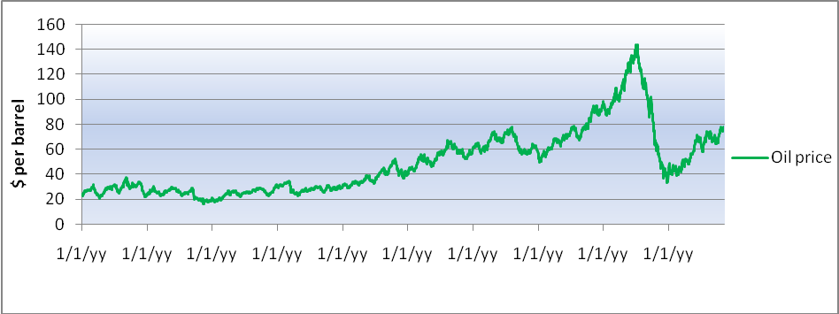
Source: Own elaboration based on US Energy Information Administration data (2009)

2.2 Oil price increase

Several main factors caused oil prices increase and the ‘suddenly’ surge in 2007-2008 oil crisis period. First, the main driver is the fastest growth of world economy and trade in decades. This economic expansion leads to a substantial increase in oil demand.The economic prosperity is proportional with energy consumption (GDP-oil correlation theory). Second, higher traffic volumes and particularly road traffic volumes are strongly coupled to GDP (Tapio, 2005). Third, is extra global oil demand by emerging countries. Dynamic economic growth of emerging countries pushed their appetite for oil, which resulted in larger global oil demand. Higher world increase in oil demand is related to China by 1/4 in 1995-2004 and even 1/3 in 2004 (Bénassy-Quéré et al. 2007). China’s expected share in world oil demand increased from 7% in 2005 to 12% in 2025.
The uncertainty in oil supply drove the oil price further up. First, the combination of low oil production by Organization of the Petroleum Exporting Countries (OPEC), Russian Federation oil production reduction, refining capacity shortages, fluctuation in strategic oil stock levels affected the global oil supply. Second, delays in completing oil projects, outdated pipelines and weather-related disruptions provided lesser oil supply. Slow oil production reaction, while cheap oil reserves diminish forced oil producers to remote areas to acquire oil. These large investments by oil companies heighten oil prices. Third, geopolitical instability and conflicts in oil exporting countries leads to production shortfalls. For example, attacks to oil installations in Nigeria and Iraq or friction between Venezuela and USA about compensation of oil nationalization projects.
Oil exporting countries increased oil prices to compensate the weaker dollar against euro (-10%) and other foreign currencies. Oil exporting countries’ currencies are pegged to the dollar. However, the Central Bank of the United Arab Emirates considers coupling its currencies to a more varied basket of foreign currencies. Notable, as shown in Figure 2.2, the relationship between dollar and oil price development can change from positive to negative. The oil crisis was disastrous for oil importing countries, but oil exporting countries were the biggest beneficiaries. Their trade balance surplus was rising in periods of oil crisis.
Oil prices increase can be seen as a wealth transfer from an oil importing country to an oil exporting country (Krugman, 1980 and Golub, 1983).
According to some analysts higher oil demand was partly the result of speculative investors who used crude oil as an alternative investment for the weaker dollar, while banks and hedge funds treat oil as assets. Moreover, speculators gamble on oil exhaustion combined with larger global demand in the near future. Oil price surge was just the result of demand and supply in the market mechanism, because there is no suitable substitute for crude oil in the short term
The consequences of high oil prices have deep impact on the global economy. Firstly, higher fuel price generate a burden for the whole transport sector. For example, French truckers protested their displeasure against higher fuel prices and organized strikes by blocking the national highways, which delayed transportations within Europe and leads to significant economic losses. The aviation sector suffers under the high kerosene prices and higher bunker price in the maritime transport leads to higher freight rate. Higher transport costs eventually passed to the end consumers. However, increasing transport costs forced transport companies to higher efficiency. Secondly, oil price increase leads to higher prices for other commodities, which in turn enhance the inflation trend worldwide. In early 2003- mid 2008, internationally traded food prices increased with 138%. The problems were catastrophic, especially for the vulnerable developing countries, which resulted in food crisis. Another factor that drove the food prices was that agricultural products were used to create bio oil as alternative for crude oil.
On the contrary, high oil costs forced users to change their usual oil consumption. Governments and manufacturers have more financial incentives to invest in alternative energy sources to reduce oil dependency. Investments in sustainable energy or energy efficient technology are more profitable. Citizens are encouraged to reduce their private energy use or buy sustainable products. Motorists consider traveling by public transport or bike. Potential car users rather purchase economical hybrid or electric cars than oil devouring SUVs.

2.3 Oil price decrease

Many empirical studies which forecasted future oil prices increase over the $200 threshold were entirely wrong, because they did not include oil price decline in late 2008. The main reason for the nose-dive in oil prices was the credit crunch, which started with the financial crisis in the USA. The collapse of Lehmann Brothers on 15th September 2008 caused a financial tsunami to the rest of the international financial world. The ripple effect from the global financial sector spread to other sectors in the global economy due to the banks central financial function in the economy. This resulted in investments decline due to lesser available loans by banks and global massive lay-offs. The transport sector suffers seriously under the credit crunch when global demand for goods declined. This in turn leads to lesser transported goods volume and even more unemployment in the POR.
The forecasted world economic growth for 2009 by the World Bank on December 9 2008 was very grim. The global GDP growth will be falling from 2.5% in 2008 to 0.9% in 2009. Moreover, world trade will contract by 2.1% in 2009 which imply the first reduction since 1982. All countries expect lower exports, which resulted in rapid slowdown of global demand and reduced accessibility of export credits. These gloomy forecasts caused the big decline in demand for oil, which resulted in the plunging oil prices with 76,6%. The falling oil prices and (food prices) imply the end of the most significant commodity price boom in decades.
We can outline the oil price development as shown in Figure 2.3. The oil price reached its peak on 3 July 2008 at $ 143,95. After the collapse of Lehmann Brothers oil price was $102,51. It decline and reverse to $102,09 on 24 September and started to make a deep fall after the global breakout of the credit crunch and end up to the lowest point of $ 33,73 on 26 December 2008. It is interesting to compare the ‘oil crisis’ and the ‘credit crunch’ with their own extreme oil price developments. On the one hand, oil prices increased during the oil crisis where demand for oil is larger than the supply. Oil companies made large investments to increase oil production. The expected higher economic growth before global crisis forced Governments to implement several inflation measures. On the other hand, with the ongoing credit crisis oil prices fell to $33,73, where demand for oil is smaller than the supply of oil. Oil exporting countries cut their oil production to avoid oversupply on the international petroleum market. Despite, the attempt of OPEC and Russia in oil supply cutting to prevent
falling oil prices, it further declined. Meanwhile, several major industry countries like the USA and Germany were in recession with growing unemployment rates. The inflation rates declined worldwide and eventually lead to deflation fear. The recent recession has similarities with the Japanese economic problems in the 1990s, which was a combination of high oil prices, problems in the banking sector and decline in consumer confidence (Blanchard, 2000).
Figure 2.3: Oil price development January 2007- November 2009
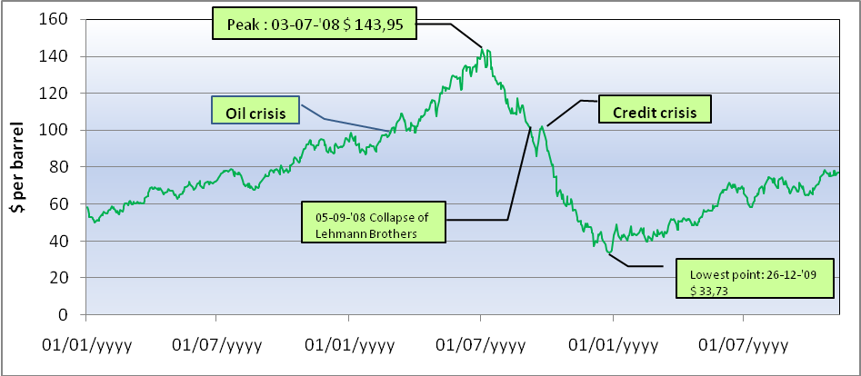
Source: Own elaboration based on US Energy Information Administration data (2009)

Fortunately, actual GDP numbers for the main economies from the 3rd quarter 2009 are not that terrific as expected. While developed economies in Europe and US still suffer from the credit crunch, Asian emerging economies already generate positive GDP growth rates. China’s expected domestic demand growth of 8,4% in 2009, has positive influence on countries, which supply products and raw materials to China. China’s economy and better than expected global economic growth has driven the oil price gradually from the lowest point of $33,73 last year to around $75 begin November 2009. Additionally, a weaker dollar keeps the oil price high despite a slump in American consumption and constructs cheaper oil for investors holding the stronger euro. It looks as though the whole oil crisis cycle tend to resume, where higher demand from China partly boost the oil price.

3 The theory

In this chapter we report empirical theoretical information over rising oil prices impact on global sourcing, merchandise trade and maritime container transport. Oil price issues analysis should be thorough and reflect the global and multidimensional nature of the problem, which is only complete if it is inclusive other closely related factors that could compensate or strengthen oil effects. This include efficiency gains and initiatives aimed at lowering trade transaction costs, technology improvements, energy security, environmental sustainability, climate change mitigation etc. Therefore, we describe in the first part the globalization process and the reasons which attract foreign companies to source their manufacturing process to China. Then we focus on the progressive developments in the global supply chain, which facilitated relocation to China. In the third part we outline the macroeconomic impact of high oil prices on economy growth and transport costs. Finally, we explain the minimal effect of oil prices on Chinese export of manufactured goods.

3.1.1 Foreign enterprises sourcing manufacturing activities from China
As mentioned in the introduction EU-China trade in goods is growing. Besides lower import prices, another driving force is that many European enterprises relocated or outsourced their manufacturing activities to China and export or import their products back to Europe.
According to Buckley there are some driving factors to globalization and the global factory (Buckley, 2008). On the demand side, producers are capable to substitute or compete with products more easily. Additionally, consumers are eager to switch between products, mainly when prices decline for some sort of products. This leads to pressures on the producers to tie up with consumers by branding. On the supply side, innovation in mass production of standardized goods enables possibilities for economies of scale. More important is easier access to low labour cost. Additionally, the need for flexibility to satisfy consumer demand and downward pressure on product prices through competition encourage more off shoring and outsourcing. Offshoring is the involvement of the externalization option together with the ‘make abroad’ location decision (Buckley and Casson, 1976). Outsourcing is the involvement of the utilizing ‘buy’ rather than ‘make’ in the Coasean ‘externalize’ or ‘internalize’ decision (Coase, 1937). In Table 3.1, we made the following distinction in sourcing out work processes.
Table 3.1: Sourcing out work processes to location and property
 | EU (intra) | China
Contract out | National outsourcing (nearshoring) | International outsourcing
In own control/management | Domestic investment | (FDI) offshoring

Production off shoring is a trend in manufacturing industries, but also in emerging economies such as Singapore and Taiwan (Vereecke, 2006). Expensive labour enforced labour intensive manufacturing enterprises in the industrialized countries to reconsider about reduce or even close down their factories and shift manufacturing activities to low wage countries. Production costs is an important factor in plant location choice, but other factors such as quality, flexibility, transportation and energy costs, innovation and fast delivery are also important to determinate the optimal manufacturing network. After all, enterprises offshoring to China to profit the market entrance, lower transaction costs and economy of scale possibility.
Low labour costs reduce individual product and product family design costs and the need for new design of assembly and automation, by adding more labour input the assembly process. Overseas outsourced direct labour costs are not a production restriction for many types of products. According to Mold Making Technology, off shore tooling buyers concentrate on initial purchase costs, which are often lesser than half of the domestic prices. These extremely low prices are the results of the extremely low labour costs in Southeast Asian countries and particularly China. More foreign enterprises remove to China to supply parts or make complete products, because individual components and parts prices are lower in China (Bergmann et al. 2004). The part-sourcing trend is also strengthened by US vehicle enterprises sourcing billions in Chinese parts (Shenkar, 2004). Additionally, enterprises buy components at expected savings up to 25% (Bergmann et al. 2004).
The disadvantage of offshoring is higher transport costs by growing distance between production and consumers markets. Moreover, close down of factories in industrialized countries create unemployment. However, according to Gorter et al. offshoring contribution to EU (transition) unemployment is minimal (Gorter et al. 2005). For instance, it is important is that the labour force in the Netherlands is able to adapt newer international specialization, particularly low skilled employees. They have to compete indirectly with low skilled employees in the relocation countries. The loss of unemployment in the manufacturing sector (21.000 jobs in the example) is minimal due to the dynamic of the Dutch labour force. Researches states an annually 856.000 job loss has been offset against a 939.000 job creation of a total labour force of six million in 1991-1997 periods. In 2003, 1% of all mass layoffs in the USA have been caused by ‘overseas relocation’ (Kierkegaard, 2004). The advantage of offshoring remains lower consumer prices of goods and higher productivity for the producers. After all, the Netherlands can import cheaper products and export products at a better price in the international market. This explains the growing Dutch deficit with Asian economies and increasing Dutch surplus in the EU-intra trade.
Main outsourcing benefit for western enterprises is lower direct labour costs, this leads to lower production costs and more profits. For example, in 2002 Chinese factory labour costs (inclusive labour and employer contributions to benefits) was $ 0,64 per hour, while US factory labour costs was $21,11. This is almost 33 times higher than in China (Coy, 2004).
Other advantages of production outsourcing are first, Wu et al. state that enterprises consider to outsourcing, because they can buy components, sub-assemblies, finished products or services from suppliers when own production is limited (Wu et al. 2005). Another reason to outsourcing is when enterprises lack the needed technology, but attempts the business opportunities. Heizer (1996) examined 11 industries on their outsourcing expenses and states that average ratio between outsourcing expenses and revenue was an unexpected high 54%. Second, Quinn and Hilmer (1994) suggest that outsourcing adds value to a company chain activity. Third, outsourcing facilitates an organization to organize its own resources and resources of its external agent who has the necessary expertise and particular resources or technologies to do all the tasks (Wu et al. 2003). Fourth, efficient use of outsourcing enables an organization focus on a few strategically important tasks and improvement of its core abilities (Venkatraman 1989, Kotable 1990, Quinn 1992, Dess et al. 1995). Fifth, low cost outsourcing enable enterprises to develop and manufacture products cheaper without waste in time and effort in product platforms and families developments (Marion et al. 2006). Outsourcing improve the enterprise performance through higher product quality, lower inventory level, lower production cost, removal of production bottleneck and punctual delivery. According to Walker and Weber (1984) sourcing decisions depend more on differences in production costs than in transaction costs.
Outsourcing provides a company substantial benefits, however companies has to make appropriate decision and deliberation on long-term performance to sustain its competitiveness. Abundant outsourcing leads to overdependence on suppliers, which could diminish a company’s R&D activities and abilities (Wu, 2003), lesser motivation for new technological breakthrough (Kotable, 1992) and core technologies loss by lack of intellectual property right protection (Teece, 1987). Supplier could acquire much access to critical production knowledge during the process, which can simply enter the same market and become a serious rival (Prahalad,1990). All these possibilities could result in declined competitive advantage and market share.

3.1.2 China’s driving factors as manufacturing sourcing destination

The combination of several factors contribute to the success of China as manufacturing sourcing destination, which contribute to the impressive economic and export growth (Gerard Adams et al. 2004).The main factor is low wages, but wages increased rapidly in recent years, especially for skilled workers in export-intensive Chinese provinces. The abundant of rural unskilled and gradually more mobile labour supply offset increasing wages. Other factors are high FDI inflows, which leads to China’s production shift, support in export oriented policy, WTO membership, huge domestic market, agglomeration effect; and appropriate exchange rates and trade policies (Lai, 2004).
First, higher FDI and more private enterprises facilitated the shift of Chinese export production toward high tech products. FDI in China add new production technology, heighten world market specifications and advanced management skills. The composition of China’s exported goods reflects this in the global economy (Adams and Ichimura, 1998; Vernon, 1966). China’s export of manufactured mass production goods grows 6.9%, while high technology goods exports grow 15% per year. Chinese production shift toward high tech products leads to more competition with other Asian export countries. But, it also creates joint relationship (outsourcing) with East Asian countries. Foreign investment projects transfer technology and knowhow by joint ventures with Chinese partners. The result is that Chinese manufacture production is more capable to meet world requirements for product quality and design, which attract more outsourcing. Moreover, foreign enterprises add their Chinese process into their value chain that expands into the global economy (Ng and Yeats, 2003).
Second, support in export oriented policy by lower tax or export subsidies (such as in SEZ) give export oriented enterprises a competitive edge on international market. There is strong evidence that production subsidies stimulate Chinese firms export performances (Girma et al. 2008). However, it does not help the Chinese firms enter the export market.
Third, China’s membership in WTO reduced trade barriers, which reduced import tariff for products to western economies for outsourcing enterprises. However, China’s lower costs or under pricing according to EU competitors leads to many disputes at the WTO. This resulted in textile quota, shoes tariffs to protect EU industries. This in turn challenges China to retaliate with quotas at other sector where the EU excels.
Fourth, entrance to China’s huge domestic market attracts many foreign enterprises. The benefit is low cost export platforms combined with growing local sales. Manufacture production in or near to the consumer market save transaction costs (Gorter et al, 2005). Moreover, this combination enables lower production costs by economies of scale.
Fifth, appropriate exchange rate policy hold the yuan artificially low to stimulate exports. This reduces the unit value per manufactured product. Even a slow appreciating yuan by 20% against the dollar in July 2005-late 2008 does not diminish China’s export competitiveness. However, to stimulate export after plunged exports to EU and US the yuan depreciated again since late 2008.
Sixth, the agglomeration of all manufacturing processes in China generates a growing spillover effect. Located firms not only profit from the vicinity of suppliers and customers, but these suppliers and customers also profit from the vicinity from the new firm (Gorter et al. 2005). Moreover, enterprises contribute to the local knowledge labour supply, by which other enterprises can profit. The New Economic Geography illustrates ‘forward and backward linkages’ (Fujita et al, 1999). The concentration of firms reduce cost prices, because suppliers hardly charge trade costs and those firms sell more because they do not charge trade costs as well.
After all, China signed many mutual trade pacts and currency swaps with resource rich developing countries like Africa and Latin America region. This leads to lower cost prices and Chinese export prices than competitors. China has less strict laws on environment and conditions of employment compared to developed economies. This attracts foreign companies, which aim to save these costs. The combination of longer labour time and continuously (newer) machines use heighten the manufacturing productivity per worker. The vicious circle of more FDI inflows, production, exports and production shift in value chain just strengthen China as sourcing destination and World’s factory in the future.

3.2 Global supply chain stimulated sourcing to China

Reduced delivering costs enable sourcing from China to the world markets. The development in maritime container transportation, ICT and coordination leads to lower delivering costs. The progress in containerization enable enterprises to optimize comparative advantages in global production, while efficient distribution systems interaction can combine spatially various supply and demand relationships (Notteboom, T and Rodrigue J.P, 2008). In most developed areas, containers take a high share in import and export of maritime cargo. It is expected that the worldwide extent of containerization could reach 75%. Container shipping improved the scale and scope of global freight distribution. Higher velocity in freight distribution enlarged new global markets trade opportunities, due to reduction in time and costs. Containerization mainly improved the transshipment efficiency (Rodrigue, 1999). Containerization enlarges international markets by enhancing the reliability, flexibility and lower costs of freight distribution. The convergence of these factors creates a global supply chain, based on the ‘just in time’ theory.
ICT improvements, such as e-commerce, made global operations more manageable and cheaper at a distance. Global enterprises operate to ‘fine slice’ their activities and allocate each ‘stage’ of activity to the most optimal location. Additionally, they can control without owning the whole supply chain. These technological and managerial drivers are possible due to more openness in China. Moreover, progress in ICT and global coordination of logistics leads to lower transport costs. This stimulates Western enterprises to enhance their outsourcing of non-core processes. Especially, for products with standard manufacturing interfaces. This resulted in the development of new business strategies by companies to deal with goal-oriented activities, which depend heavily on outsourcing (Mowshowitz, 1994).
The concept of ‘global factory’ where multinational enterprises are changing into a model of differentiated networks was introduced in Buckley (2004) and further developed in Buckley and Ghauri (2004). The aim is to select location and ownership policies to maximize profits, without the involvement of internalizing their activities. This process leads to the outsourcing or off shoring activities. The global factory enables new opportunities for new locations to enter international business. Brand-owning MNE’s are subcontracting production and service activities with emerging countries. Every internalized activity will subject to ‘the market test’ and this result into a differentiated network, which is called ‘the global factory’. The global factory is the result from managerial decisions on insourcing versus outsourcing (the so called make-or-buy decision) and the location decisions, which are geographically unrestrained.
As illustrated in Figure 3.1, the global supply chain is divided into three parts. The original equipment manufacturers control the brand and carry out design, engineering and R&D for the product. They are customers for contract manufacturers, who execute manufacturing services for original equipment manufacturers. In this model production network, contract manufacturers need own capabilities such as the mix of product and new product flexibilities, while at the same time undertake manufacturing activities at low costs with mass production processes. Flexibility is important to satisfy consumer’s product differentiation needs and low cost for global efficiency is crucial (Wilson and Guzman, 2005). The third part of the chain is warehousing, distribution and adaption done by a ‘hub and spoke’ principle in order to realize local market adaption through a mix of ownership and location policies.

3.3.1 High oil price implications on economy growth

Given wages, an increase in the oil price will increase production costs, which will force firms to increase prices (Blanchard, 2000). A rising oil price reduces output not only in the short run, but also in the medium run.
According to Akira Maeda there is a negative oil price-GDP relationship (Maeda, 2007). Higher oil prices can deteriorate a domestic economy by raising production costs for the corporations. As shown in Figure 3.2, we see that when oil price increase with $10 then the GDP will decrease 0,3% in the USA, Japan and the whole OECD as one unity. Euro zone GDP decline is 0,6%, because Euro zone countries are mainly dependent on foreign oil. China’s growing oil demands in current years, GDP reduced more than 0,5%. The changed oil prices and GDP leads to long term changes in the global trade structure. Exchange rates fluctuations also create changes in trade structure.
Komine argues that rising oil prices leads to a ‘trilemma’ of 1- a balance of payment deficit (oil deficit), 2- an increase in goods prices (oil inflation) and 3- economic recession (oil deflation) (Komine 1982: 139). Yoshitomi suggests that higher oil prices leads to ‘currency transfer’ and ‘real transfer’ problems for oil importing countries. Rising oil prices have a negative impact on the Japanese economy on 1) income transfer to oil exporting countries, 2) pressure on business revenues until prices change, 3) pressure on real incomes leads to restrained personal consumption, 4) lower export to countries with low overall energy efficiency (Cabinet Office 2005: 28).
China is a net oil importing country since 1996, which make it vulnerable to high oil price. This is getting worse in the future due to growing demand. After the second oil crisis developed countries established energy saving and anti-oil policies, which end the oil price-real GDP elasticity decline since late 1980’s, see Figure 3.3. Developed countries expanded some economic structures to resist oil price increases over the past decades. On the contrary, Chinese economic structure is rapidly become oil price vulnerable. The fast economic development and changes in trade structure reflect this development.
Oil prices have lesser influence on the economy (Aquiar and Wen, 2006). The general theory forecasts that a permanent increase of oil prices leads to a direct, permanent plunge in economy output. But, empirical researches prove that output makes rather a U-shaped transitional path after a permanent oil shock. After the oil shock in 1973, the US economy recovered due to the multiplier-accelerator effects in less than three years during increasing oil price period. Like the current oil crisis, global economy, particularly Asian economy recovers very fast. According to Aguiar-Conraria and Wen an exogenous oil shock is an innovation which could have a permanent impact on the oil price. Other factors, by demand-side effects influence oil price, have a transitory impact on the oil price. After 2004, the surge in oil prices provide fears like large oil price shocks in 1973and 1979, which resulted in an economic downturn combine with rising inflation (Roeger, 2005). However, the current oil share in total output is much smaller than 30 years ago. Moreover, inflation can be controlled by monetary policy, in case of oil supply shocks. Recent oil price increase still causes an unpleasant supply shock with serious macroeconomic consequences. Although monetary policy could weaken the long run affect of higher oil prices. Studies have shown that policy may have some influence to balance the economy. After a period of two years there could be substitution between inflation and GDP.

3.3.2 Maritime container transport costs

In the Geography of trade a country competitiveness is determined by product supply and demand, and product supply ability to the market. Other relevant aspects are geographical factors and transport costs. Transport costs are determined by factors, like geography, trade volumes, economies of scale, infrastructure and administrative processes. In the transportation energy mix oil prevail as a key cost factor. Higher oil prices since 2007 let the concern grows over potential implications for transport costs and global trade. Oil price shocks significantly have influence on the trade share (Bridgman, 2008). Some trade observers hint that higher oil prices harm globalization and eventually global trade patterns. The peak oil results in peak globalization, which leads to shorter supply chain for most goods and production relocation closer to consumer market (Curtis, 2009). China’s main comparative advantages such as low production costs and labour abundance could diminish, which affect China as the global plant, transportation strategies and current global trade flows. Transport costs are an important factor in the determination of the volume, structure and patterns of trade, comparative advantages and trade competitiveness of a country. But, the long term effect of persistent higher oil prices on transport and trade are not entirely clear.
According to Rubin and Tal, higher energy prices exceptionally influence transport, where transport costs of goods exceeds tariff costs could create the largest obstacle to global trade (Rubin, J. and Tal, B , 2008). Thus, higher global transport costs could equalize all free trade efforts by tariff cutting in last three decades. This implies a major decline of global trade growth and essential realignment of global trade patterns. Higher transport rates caused by higher fuel prices should diminish logistics service demand, but sea freight volumes still growing modestly. For instance NOL/APL and NYK global container shipping companies reported strong demand in most areas of their trade. Some main shippers consider adjusting their inventory policy to mirror higher transport costs. Shippers tend to absorb some higher logistic costs in markets with sufficient demand. According to Goldman Sachs much higher fuel prices in the next decade will not reduce demand for freight transport. Rising fuel prices impact in maritime transport costs is really important, because an estimated of more than 80% of global merchandise trade in volume is sea transportation. Increasing oil prices affect ship bunker costs, carriers’ operating costs and management strategies.
Increasing oil prices, at the end of 2007 leads to bunker price increase with 73% in Rotterdam, 79% in Los Angeles and 76% in Singapore compared to late 2006. Fuel costs form a burden for the shipping sector and global trade through its significant share of the total operating costs for shipping companies. In November 2007, Lloyd suggests that fuel take 63% of the operating costs of an 8.000 TEU container ship. UNCTAD estimate that fuel costs was 40% of the total operating costs for a small 3.000 deadweight general cargo ship. Increasing fuel costs provide changes in logistic policies based on network optimization and dramatic supply chains re-evaluation. Shipping lines pool equipments and loads, move full container loads and truck loads and choose alternative transportation modes, while trying to optimize inventory by searching the best combination of warehouse and distribution locations. Shippers aim to load fully containers and use more cross-docking and intermodal rail. Moreover, these strategies aim to gain higher efficiency and long-term sustainability of their distribution networks. High oil prices forced shipping lines to reduce vessel service speeds to save fuel. Lower service speeds required more ships on the same route, which also solves overcapacity problems, while at the same time causes lesser fleet productivity. This is to solve the capacity constraints and congestion at ports.
Higher oil price forced shipping industry invests in more fuel-efficient technologies (hull design, propulsion, engines) and alternative energy sources. For instance, wind energy with giant kites. Depending on wind circumstances this SkySails system can diminish a vessels fuel costs by 10% to a yearly average of 35%. Under optimal circumstances fuel usage can temporary diminished up to 50%.
Fuel costs is not the only determinant of trade costs, because direct maritime transport costs freight rate is just a small part of total trade transaction costs. Even maritime freight rate alone is determined by more factors, such as trade imbalances, economy of scales, levels of competition, port infrastructure, private sector participation in port operations, the type and value of the cargo traded. According to Wilmsmeier and Hoffmann maritime freight rate depends on: distance, liner shipping connectivity, containerized goods trade balance, port infrastructure endowments, country general level of development, vessel charter rates and fuel prices (Wilmsmeier and Hoffmann, 2008). Freight rate reduce by; 1- shorter distance, 2- improved liner shipping connectivity (more access to regular and frequent transport service and more competition in service supply), 3- shorter transit time, especially for transshipment, 4- positive trade balance (no cover for returning empty container cost to its origin), 5- improved port infrastructure, particularly in importing country (berth length and storage capacity), 6- higher country development (more ICT use, higher education and fewer accidents), 7-rich country (improve country’s trade competitiveness), 8- lower service speed due to fuel savings, but this leads to longer transit time. Additionally, if more liner shipping companies provide direct services instead of transshipment between countries freight rate reduce more. Transport costs between ‘richer’ countries are lower. This creates a vicious circle, where higher trade volumes and economic development stimulate transport costs reduction which in turn stimulates to promote trade and development.
Recent freight rate increase is also caused by other factors than higher oil price such as booming trade and supply side constraints (port congestion and capacity scarcity). Moreover, there is a differently development between oil price and freight rate. When oil prices reached a record high in mid-2006, freight rate declined drastically compared with its previous peak in the beginning of 2004. Freight rate varied from oil prices due to short-lived oil price increase, time lag influence freight rate adjustments (terms of contract between shipper and carrier), ability of carriers to absorb extra costs by booming volumes or operational measures (sailing speed reduction) and vessel and TEU supply capacity surplus.
Container shipping due to commercial speed requirements is the biggest bunker fuel consumer in maritime transportation. Figure 3.4, shows different development of average freight rates on the three major East-West shipping routes compared to bunker fuel prices. Differences in the development of (bunker) oil prices and transport costs are mainly the result of nonfuel related factors that determine maritime transport costs. These consist of geography, time, trade volumes and imbalances, economies of scale, the type and value of the products traded, insurance and crewing costs, quality of infrastructure, levels of competition and private sector participation in port operations.
Transport costs and connectivity affect global trade patterns. A 2006 UNCTAD study based on trade data claims a positive correlation (+0.24) between the share of containerizable products in bilateral trade flows and distance between trading partners. Containerizable goods are mainly manufactured goods, which (likely) have higher value per volume ratio than bulk cargoes. This implicates that higher transport costs are less relevance to manufactured products than for bulk cargo. On the one hand, resource importers rather source from providers around. For example, oil from South America or Mexico would rather be exported to countries in the American region, while oil in Asian countries would rather be exported to other Asian countries, as transport costs are lower. On the other hand, manufactured products tend to shipped over longer distances, because they are more frequently sourced globally. Thus, the impact of increasing oil prices and higher transport costs depends on the sort of good is transported.
According to a Drewry study, outsourcing decision factors such as differences in labour and production costs, tariff regimes, supply chain responsiveness and agility are more important than lower transport costs. In the growing luxury (fashion) clothing sector, short production cycles with rapid delivery times and agile supply chains are significantly important. But, it is doubtful whether higher transport costs reduce offshoring locations competitive advantage if new low cost offshore locations in the clothing and textile manufacturing sector arise such as Vietnam. Thus, higher transport costs will not reverse manufacturing activities to the EU. However, in practice China flooded other developing markets by ‘dumping’ Chinese products like in Vietnam and Africa. The aim of this strategy is preventing or pushing potential competitive emerging countries out of the market before they can set up firms in the future.
Reorganization of global production and trading patterns with redefined comparative advantages due to higher oil prices may not be feasible or economic practicable.
“ It would be difficult to reverse the geographical concentration of production given the magnitude of the scale economies that firms achieve. When a manufacturing plant is relocated to another country or its output is replaced by imports, many of the upper links in the supply chain also transfer to the foreign country as new overseas vendors are found”.

Global production networks rely greatly on clusters and linkages created within a geographical region, particularly for intermediate products. Reverse the outsourcing or production plant involve relocating related trade partnerships (sources of raw materials, producers, carriers, assembly etc.). The removing costs for production plants and associated clusters could be substantial and even erode the potential comparative advantages found in the new locations. However, a decline in globalization could be possible when rising oil price create very large transport costs increase, particularly for higher value products.
When oil prices increase companies consider first the less drastic and more cost effective transport cost reduction strategies (reduce handling factor measures), before reverse sourcing manufacturing activities. They consider whether higher oil price and transport costs do not drastically and permanently disturb the trade-off balance between on the one hand ‘transportation, production, distribution’ and on the other hand ‘reliability, speed and service quality’.
Global warming issue realize savings opportunities in transport costs. Increasing oil prices and transport costs may be compensated by savings that could be obtained by full-year operation of the Northern Sea Route (NSR). Shorter shipping lanes diminish transport costs and simultaneously benefit globalization and generate more competition with existing routes like the Panama and Suez canals. Considering canal fees, fuel costs and other related factors that determine freight rates, the new trade routes reduce costs for a single trip by a large containership to the extent of 20%. This is yearly shipping business savings in billions of US dollars.
The NSR shortened the route from North Asia (ports of China) to Northwestern Europe (POR) by aproximately 2.500 nauticalm miles (nm) Verny and Grigentin (2009), see Figure 3.5. Transit times reduce with about 10 days, which is 1/3 of transit time by the Royal route. But, there is no stopovers over aproximately 2.500 nm. of Siberian coast between the Bering strait and the port of Murmansk. Moreover, due seasonal influence vessels have to sail at lower speed in winter. Transport cost of a container via the NSR is not too expensive, but liners operational costs could be relative high. Suitible container vessels for this route create higher operating cost. The cost of one TEU is around twice as high on the NSR as on the Royal Road. Thus, the NSR is an alternative (particularly in summer) to the Royal Road if bunker prices increase forcing container vessel to reduce (commercial) speed.
Bunker prices continuously fluctuate due to market forces and crude oil prices (Notteboom and Vernimmen, 2008). In recent years bunker oil prices increased approximately at the same pace as crude oil price. Bunker prices quadrupled between 2001-2007 periods, especially the last 3 years. Higher bunker price leads to upward effect on shipping costs, which can be compensated by higher freight rates. For liner shipping activities, particularly container shipping, fuel is a considerable expense. Rising bunker prices is only partially compensated by surcharges to freight rates via ‘Bunker Adjustment Factor’ (BAF). All freight rates in container transport are exclusive BAF. The BAF is adjusted in response to fluctuations in bunker oil prices and $ exchange rate. If bunker price is lower than €140 per ton, the surcharges will be drawn.
The member lines of Far Eastern Freight Conference (FEFC) inform shippers that the BAF appropriate for January 2008 will be around $482 per TEU to or from the Mediterranean and West Coast European Region. This is more than 1/3 of the freight rate on the leading west bound leg. Additionally, environmental concerns resulted in strict emission standards and leads to a gradual shift from heavy fuel to bunkers with low sulphur content. The setting up of Sulphur Emission Control Area (SECA) throughout EU has some shipping lines impose a new sort of surcharge, namely ‘low sulphur surcharge’ which range between $5-$10 per TEU.
Rising bunker costs forced shipping lines to keep a tighter control on fuel consumption such as: 1) use of (lower quality) cheaper bunker fuel, 2) better fuel efficiency ship design, 3) sound fleet commercial speed and scale of vessels. As shown in Figure 3.6, increase in service speed with just a couple of knots leads to an impressive increase in fuel consumption. For instance, bunker prices at $450 per ton implies a daily cost increase of $36.000, if service speed increase from 23 to 26 knot for an 8.000 TEU ship. For a 12.500-13.000 TEU container ship which will be the ‘workhorse’ on the Far East-EU main container trade lane, the daily costs increase to $51.750. Many shipping lines focus to large post-Panamax container vessels due to higher future demand and savings by economy of scale. The capacity of 7.500 plus TEU ships will triple and vessel units increase from 147 to 399 in 4 years . Furthermore, 10.000 plus TEU ships will increase from 2 to 91in the period 2007-2011. Scale increase in vessel size leads to lower bunker costs per slot at given commercial speed. At commercial speed of 22 knots, bunker cost per day of a 5.000 TEU ship is $ 8,7 per TEU slot, while for a 12.000 TEU ship is just $5,4 per TEU slot. This is a cost saving of around 39%. Higher commercial speed generates larger cost differences. If vessel speed is 24 knots, the costs increase to 41%, while at 18 knots costs will decrease to 34%.
Several shipping lines added an extra vessel to a number of Asia-EU loops due to rising bunker costs and overcome delays by port congestion. Dynaliners reports that shipping lines stated that their clients will agree to inferior transit times in exchange for better schedule integrity, resulting from extra buffer allowance. The number of two-way services on the Far East-North Europe trade route increased, but carriers are targeting on a lower number port of calls. On the other hand, the average number of ships per service is rising and this goes together with a significant growth in average vessel size (+30%).
More vessels have higher impact than port call lessening on potential vessel speed reductions. Some conclusion can be made. First, when bunker price is $450 per ton (2007) container ships sailing at 24 knots leads to total bunker costs of nearly 60% of total ship costs and up to 40% of total costs. When bunker price is $ 250 per ton (2005) container ships sailing at the same speed leads to bunker costs of 44% of total ship costs and up to 28% of total costs. Second, the deployment of a 9.500 TEU ship sailing at lower speeds needs 9 vessels, while only 8 smaller ships are required to supply the same weekly call. Scale enlargement in vessel size force shipping lines to increase the number of ships per loop or to diminish the number of port calls. Third, rising bunker costs put economies of scale in vessel size in a new point of view. When bunker costs was $250 per ton in 2005, the cost of transporting one TEU on the North Europe-East Asia trade route with a 4.000 TEU vessel sailing at 22 knots was approximately the same cost for using a 9.500 TEU ship in 2007 at $450 per ton.
Figure 3.7 shows the relationship between bunker price per ton and total liner service costs and Figure 3.8 illustrates the relationship between bunker price per ton and costs per transported TEU. It is more attractive for shipping lines to shift from 8 to 9 vessels and reduce speed from 23 to 20 knots, when the bunker price is higher than about $150 per ton. Changes in the number of ports call have only a small impact on the total costs per TEU shipped and do not change the $150 per ton mark. Carriers still save costs by raising the number of port calls from 8 to 10, while raising the number of ships from 8 to 9 as long as the fuel price is above $200 per ton.

3.4 High oil effect on China’s export of manufactured goods is minimal

The oil price increase in recent years was partly caused by China’s economic growth which leads to higher oil demand (Roeger, 2005). China transformed from oil exporting to a net oil importing country. Oil price increase should have a negative effect on China’s export because it actually leads to higher production costs according to Blanchard. Figure 3.9, shows that increasing oil prices do not deteriorate China’s export of manufactured goods. In 1992-2005, there is even a positive correlation between Chinese manufactured goods export and the real WTI crude oil price of 0,85 (Faria et al, 2009). The correlations between Chinese manufactured goods export and nominal oil price is 0,91.
According to Faria et al. the positive correlation between Chinese manufactured goods export and oil price increase could be explained by China’s ability to replace oil input with its large labour surplus in the production function. This means that China is more capable than its competitors to replace oil with labour in its production. The consequence is an increase in China’s total labour productivity. This in turn leads to more export, partially at the cost of other countries exports and much higher oil prices due to more oil demand for increased production and transport. Thus, the most important cause of the surge of Chinese exports is its outstanding competiveness. This is the same what Rodrik declared (Rodrik, 2006):
“ [China’s] export bundle is that of a country with an income-per-capita level three times higher than China’s. China has somehow managed to latch on to advanced, high-productivity products that one would not normally expect a poor, labor abundant country like China to produce, let alone export”

Another possible explanation for increases in oil prices and China’s exports could be the fact that China’s exports are relatively not energy intensive. This implies that oil is not a significant input in the production. This may explain higher oil prices lesser impact on the Chinese production costs and export compared to competitor countries.
Moreover, the coefficient on the oil price is small, namely 0,063 or 0,068. Empirical evidence shows on condition that higher costs due to oil price increase are more than compensated by the competitive gains of Chinese exports of manufactured goods. However, there is a negative correlation of real exchange rate on exports varying between -0,328 to -0,251. This means that the appreciation of the Chinese Yuan has a negative effect on the exports.
Oil price fluctuations have different implications for countries depending on their exchange rate regime, because crude oil is traded in US dollars (Bénassy-Quéré et al. 2007). For example, growing oil prices in 2002-2004 was moderately reduced in the EU due to the appreciation of the euro. From December 2001- November 2004, oil price grew with 127% in dollars and just 83% in euro. This is the result of dollar depreciation by 44% vis-à-vis the euro. On the contrary, the EU did not gain from the oil price decline, when the dollar appreciated in 1980-1985.
The dollar depreciation against euro has a positive impact on Chinese export and higher Chinese export let the demand for oil rise. This is the effect of the fixed peg between the yuan against the dollar. China’s emerge as a major player on the oil and foreign exchange markets, could theoretically change the relation between the price of oil and dollar. Since late 1990s, China has been the second largest country (after Japan) holding official reserves in (mainly dollar) foreign currencies. While China declared it has a managed floating system against a basket of foreign currencies (instead of dollars) after July 2005. OPEC and China invest their received dollars from export in American assets such as US treasuries to keep the dollar’s value high (pegging). But in contradistinction to OPEC, China is a net oil importing country. Therefore, this symmetry between China and OPEC could influence the relationship between the oil price and dollar.
The impact of €/$ exchange rate on the Chinese total demand goes via the Chinese monetary mechanism. Due to these interventions a depreciation of the dollar vis-à-vis the euro leads to monetary growth that increase Chinese productivity and export. In the long run, monetary growth should direct a price increase, with nor real effect. But, partly due to particular Chinese labour market, such inflation does not exist. It has more impact on the asset prices.
According to IEA numbers (IAE, 2005a, b), Chinese oil intensity of output is more than double of the US and EU output. These differences are highly distorted by the method how output is valued. Because the Yuan is undervalued the use of the PPP exchange rate is more suitable. As shown in Figure 3.10, Chinese oil intensity appears much lower if it is depicted in PPP exchange rate.
The status quo could reinforce the pattern of a growing oil price with a depreciating dollar like in the period 2002-2004. On the contrary, when Chinese policy has been successfully move to a managed float of fixed basket, this relationship could be undermined or even reverse to the conventional, positive relationship between the oil price and the dollar. This policy also affects the EU, because a negative relationship between the oil price and the dollar will be likely stabilize the oil price for the EU region.

4 EU-China ‘real’ trade in goods development in 2000-2008

In this chapter we analyze whether growing oil prices affect the EU-China merchandise trade and trade balance. Additionally, we raise the statistic data distortion of EU’s trade deficit with China. In the first part we give the import and export numbers and the composition for manufactured goods to get a better impression about the EU-China trade in goods for 2000-2008. In the second part we depict EU and FIE contribution in China’s export.

4.1.1 EU external trade with China in total goods

Globalization becomes clearly visible if it is shown by actual rising global trade numbers. World Development Indicators stated that trade growth is on average nearly double so fast as GDP in 2000-2007. Exported manufactured goods and manufacturing production are the groups that have the highest annual increase percentages. Global trade was expected to account for approximately US$ 16 Tln. in 2007, equal to 31% of world GDP. In 2008, merchandise trade measured in volumes grew just by 2% due to global credit crisis, but it is still higher than the global GDP growth of 1,7%. This 2% merchandise trade growth is rather low compared with 6% increase in 2007 and the average of 5,7% during the 1998-2008 period. Table 4.2, shows that China’s GDP and trade growth in 2000-2008 is tremendously compared with the EU and world numbers. This is partly the result of China’s WTO membership since 2001. China’s exports almost quadrupled where as imports have more than tripled. In 2007, China’s merchandise export to Europe is $264 Bln. (21,7%), while export to Asia is the largest at $521 Bln (42,8%).
EU and China are among the main players in the world merchandise trade. In 2007, EU is the world’s largest export economy accounting for 17,4% of world export in goods and second largest importer with 19,1% of world import in goods. China takes the second place with 12,5% of world export in goods and third place at 9,3% of world import in goods. In 2000-2007, EU export percentage increased from 17,5% in 2000 to 19,2% in 2003 and end to 17,4% in 2007. EU import percentages remain around 19%. China’s share in global export rate more than doubled from 5,6% in 2000 to 12,5% in 2007, while Chinese import almost doubled from 4,7% in 2000 to 9,3 % in 2007.
As illustrated in Figure 4.1, we see a slightly increase of EU export percentage in world trade of goods till 2003 before the blue line declined. Compared with Figure 4.2 we see a constant trend of EU in global import share. In both figures we observe that China is the only country which export and import percentages are continuously raising, while Canada, Japan and USA declined. In 2007, EU and China combined take almost 1/3 of global trade in export and import of goods, respectively 29,9% and 28,4%.
We focus on the two main partners of the EU-extra trade, the US with 15,2% and China 11,4% of total EU-extra trade in 2008 (see Table 4.6). We notice a deep fall of US share, while Chinese share surge in EU export, see Figure 4.3. In 2000, US share account for 28% of EU-extra export and declines to 19.1% in 2008, but US still remain the largest EU-extra export destination. On the contrary, China’s share of EU-extra export doubled from 3% in 2000 to 6% in 2008, but it remains EU extra fourth largest export destination in 2008.
Considering the EU-extra import trade, China’s share more than doubled from 7,5% in 2000 to 16% in 2008. China surpasses the US in 2006 as EU largest supplier of imported goods, see Figure 4.4. The EU is also China’s largest export market. On the contrary, the US which was EU’s main supplier in 2000 fell from 20,8% to second place with 12% in 2008. So, the importance of EU-China trade is growing.
Figure 4.5: EU trade in total goods with China and growing EU trade deficit
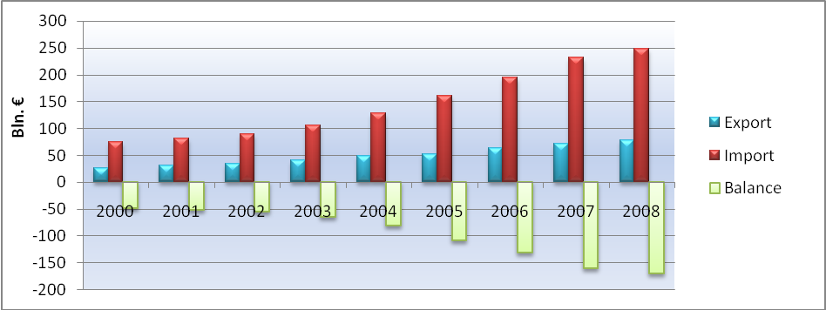
Source: Own elaboration based on Eurostat data (2009)
Buoyant economy growth provides a gradual rise in EU export to China in 2000-2008, see Figure 4.5. EU export tripled from €25,9 Bln. to €78,4 Bln. However, EU import growth from China was much higher, which more than tripled from €74,6 Bln. to €247,62 Bln. This unbalanced development result into a growing EU-China bilateral trade deficit in goods. Moreover, EU-China bilateral trade deficit remain a big share in total EU-extra trade deficit in this period, see Figure 4.6. Since 2000, is EU-China bilateral trade deficit in total goods the largest, which increased from €48,8 Bln. to €169.2 Bln. in 2008. This implies that bilateral trade deficit in total goods with China takes 69,9% of EU-extra total deficit of €242,1 Bln. in 2008. However, in 2008 EU largest bilateral trade surplus in goods was with the US at €63,1 Bln. Notable, EU export to China is lower, because many EU firms remove to China to shorten the distance between production and consumer market. This leads to the ‘hidden’ transfer of EU export numbers to domestic production in China. Thus, while EU firms still generate profit by selling their goods in China it is not recorded at the account of EU-China trade.
When we distinguish EU-extra trade in total and manufactured goods, then we find a pattern. In 2000-2008, EU export consists for a great part of manufactured goods, which has an average 86% of total EU exports. EU average manufactured goods of total imported goods are 66,5%. Additionally, the rate decline from 69,8% to 59%. In Figure 4.7, we see that manufactured share of exported goods is higher than in the imported goods of the EU-extra trade. Manufactured goods share decline in EU import implies that primary goods share increase. This can be explained by the fast energy products import growth. However, around two third of the imports are still manufactured products.
We take a closer look at the composition of the total EU export in 2008. Machinery and transport (SITC 7) is the largest group with 43,5% of EU total export, see Figure 4.8. The Other manufactured goods (SITC 6 +SITC 8) are 24,2% and Chemical products are 15,7%. Total manufactured goods are 83,4% in 2008. As shown in Figure 4.9, the largest group of imported goods in total EU extra trade is Mineral fuels, lubricants and related materials (SITC 3) 28,6%, second is Machinery and transport at 26,7%. The Other manufactured goods is 24,2% and Chemical products just 8,2%. Total imported manufactured goods share is 59%. This illustrates the importance of energy goods in EU import.
In regard to the high share of mineral fuels (SITC 3) in the EU-extra import we give a few notes. In 1999-2007, EU trade surplus in manufactured goods have grown nearly threefold. Trade in Machinery and transport is the sector, where EU has an obvious comparative advantage in international trade. However, EU has a structural trade deficit in energy goods, which reached a record high of €280,9 Bln. in 2006. Three quarters of imported energy goods are petroleum products, mainly crude oil. The composition of EU import change due to higher growth of primary goods share. The growing EU trade deficit in the energy sector generate together with the EU trade deficit with China in manufactured goods a significant part of the total EU-extra trade deficit. The unit value index for EU imports of energy products, which indicate price changes, more than doubled between 2004 and 2008. Petroleum products (SITC33), with a total value of €405 Bln. was the most traded product group during 2008. Petroleum products increased from 9% share of total imports in 1999 to 18% in 2007. Part of this fast growth is the relative importance of fuel imports and the higher value attributed by increasing prices for these products. EU has become more dependent on fuel and energy imports, which resulted in increasing trade deficit of this product group in international trade.
As shown in Figure 4.10, EU-extra trade deficit indicated in energy and petroleum goods fastly increase since 2004. Moreover, petroleum goods have a major part in EU-extra energy goods trade. In 2008, trade deficit in energy goods is €377 Bln. and petroleum goods is €263,8 Bln. (70% of energy goods). In Figure 4.11, we see the higher development of oil price than trade in energy and petroleum goods.
Figure 4.12, shows the composition of EU total merchandise export to China by SITC in 2008. The largest product group is Machinery and transport with 60,2%, second is Other manufactured goods at 18,5% and third is Chemicals at 11%. EU total manufactured goods percentage of total export to China is 89,5%. As illustrated in Figure 4.13, Other manufactured goods is the largest product group in EU total import from China with 46,6%. Followed by Machinery and transport at 46,4% and Chemicals with 3,8%. In 2008, the aggregated manufactured share is 96,8% of imported goods from China. All these numbers strongly affirm that manufactured goods generate a substantial share of total EU-China trade in goods.

4.1.2 Manufactured goods

In 2001 China surpassed the USA as EU biggest supplier in the Other manufactured goods product group. In 2007, China’s share is 29% of EU imported other manufactured goods. However, the USA remains the main export destination for the EU with 19%. China is already the largest supplier of manufactured products, such as Articles of apparel and clothing accessories to EU. Additionally, China expands its share as major supplier for three of the six main EU imported goods: Office machinery and computers, Electrical machinery and equipment and Telecommunications, audio, TV, video. All these gains is at the cost of the US and Japanese market share in EU import.
As shown in Figure 4.14, EU imported manufactured goods from China grows much faster than the EU export to China. In 2000, EU export to China was €23,2 Bln. and it nearly tripled to €69,4 Bln. in 2008. Although, EU import from China in value is three times higher than the export in 2000 it could even increased 3,4-fold from €70,6 Bln. to €239,3 Bln. This high imbalanced growth trend results in an ever increasing EU trade deficit from €47,4 Bln in 2000 to €169,9 Bln in 2008. This is an increase of 3,6-fold.
Figure 4.14: Manufactured goods with China (x Bln €)
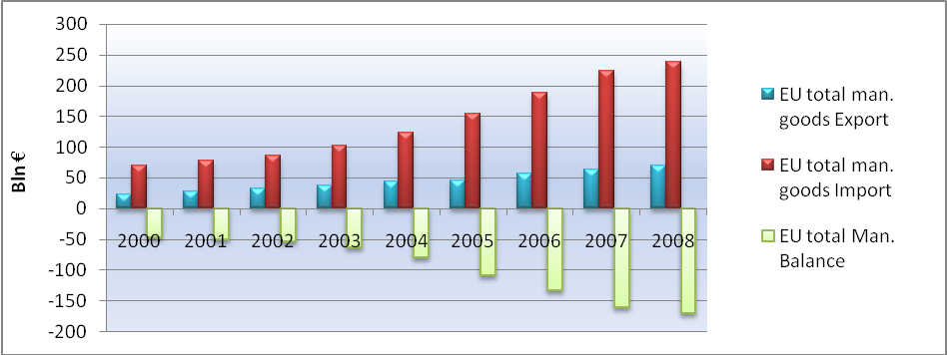
Source: Own elaboration based on Eurostat data (2009)
In Figure 4.15, we see manufactured goods share of EU export and import in total goods business with China for 2000-2008. In 2000, the export share of manufactured goods to China was 89,8%, increased to 92,3% in 2003 and fall back to 88.5% in 2008. The average manufactured goods portion in the EU export was 90,3%. The EU import share of manufactured goods from China was even higher. Since 2000, it has been rising gradually from 94,6% to 96,6% in 2008. The average share of Chinese manufactured goods of total EU import from China was 95,9%. Thus, manufactured goods dominate the total EU-China merchandise trade.
We focus on the composition of manufactured goods divided in three product groups. We calculate the average of each product group value for the period 2000-2008 to determine its extent of importance in the EU-China trade.
Chemicals (SITC Section 5) consist of products such as organic chemicals, inorganic chemicals, plastics and pharmaceutical products. The most important traded chemical products are pharmaceutical products and organic chemicals. Since 2000, trade in chemical products has been grown gradually, see Figure 4.16. The EU has a trade deficit in chemicals products with China in the period 2000-2008, except 2004 and 2005 where it has a small trade surplus of respectively €371,4 Mln. and €2,1 Mln.. Chemicals average export share is 10,7% of Manufactured goods and 9,6% of total trade export to China, see Figure 4.17. Chemicals average import share is 3,7% of manufactured goods and 3,5% of total import trade from China. This indicates a relative small portion of chemicals in the EU-China trade. In 2008, EU Chemicals products export to China is €8,5 Bln. (12,3% of manufactured goods and 10,8% of total goods). EU Chemical product import from China is €9,3 Bln. (3,9% of manufactured goods and 3,7% of total goods). The deficit was just €783 Mln, but a huge increase of 482,1% compared with 2007.
Machinery and transport (SITC Section 7) consists of power generating and industrial machinery, computers, electric and electronic parts and equipment, road vehicles and parts, ships, airplanes and railway equipment. The most exported goods are road vehicles, industrial machinery and electrical machinery, while most imports are electrical machinery, IT products and telecommunications equipment. In EU-China export trade Machinery and transport is the most valuable product group. It almost tripled from €16,5 Bln. in 2000 to €46,6 Bln. in 2008, see Figure 4.18. However, import increased more than 4-fold from €27,7 Bln. to €114,7 Bln in the same period. EU deficit with China in Machinery and transport increased 6-fold from €11,2 Bln into €68,1 Bln.
Machinery and transport average export share is 68,7% of total manufactured goods and 62,1% of total trade export to China. Machinery and transport average import share is 46,3% of manufactured goods and 44,4% of total imported goods from China. This indicates that approximately two third of EU export to China is at the account of Machinery and transport product group. It also implicates that almost half of Chinese import are machinery and transport goods. In 2008, EU Machinery and transport export to China is €46,6 Bln. (67,1% of manufactured goods and 59,4% of total goods). EU machinery and transport import from China is €114,7 Bln. (47,9% of manufactured goods and 46,3% of total goods). The trade deficit is €68,1 Bln. an increase of 5,3% compared with 2007.
Other manufactured products (SITC Sections 6 and 8) is a group with manufactured goods which vary from basic semi-manufactured products like leather, rubber, wood, paper, textiles, metals, building fixtures and fittings to more labour-intensive products such as clothes, shoes and accessories, scientific instruments, clocks, watches and cameras. The trade composition, in terms of products is different to some extent. EU exports more semi-manufactured goods like metals and metal products, while EU imports consist of manufactured products which are more relevant to end products like clothing.
The development of ‘Other manufactured goods’ trade between EU and China rises also gradually. This is the product group where the EU has the most unbalanced trade with China in 2000-2008, see Figure 4.19. The major part of EU merchandise trade deficit with China has been created in this product group. EU export to China was €4,3 Bln in 2000 and €14,3 Bln in 2008. EU import from China was €40 Bln and increased to €115,3 Bln in 2008. Although the export increase was 3,3-fold versus import increase of 2,8-fold, the deficit grew 2,9-fold from €35,8 Bln to €101 Bln. Other manufactured goods average export rate for EU is 20,6% of manufactured goods and 18,6% of total goods. Other manufactured goods average share of EU import from China is 50,1% for manufactured goods and 48,% for total goods. This reflects that about half of the imported Chinese goods are classified under other manufactured goods.
In 2008, EU other manufactured products export to China is €14,3 Bln (20,6% of manufactured goods and 18,3% of total goods). EU import of other manufactured goods from China is €115,3 Bln (48,2% of manufactured goods and 46,5% of total goods). EU other manufactured goods deficit is €101 Bln, an increase of 5,2% compared to prior year.
In 2008, the composition of EU trade deficit with China in manufactured products is as follows: Chemicals €0,8 Bln. (0,46%), Machinery and transport €68,1Bln (40,09%) and Other manufactured products €101 Bln. (59,45%), which generate a total trade deficit of €169,9 Bln. Remarkable, in 2008 EU manufactured goods trade deficit with China is larger than the deficit of total goods, respectively €169,9 Bln and €169,4 Bln. This can be explained by EU trade surplus in primary goods such as ‘Beverages and Tobacco’ (SITC 1), ‘Crude material’ (SITC2), ‘Animal and vegetable oils’ (SITC4) and ‘Products n.e.s.’ (SITC 9) which offset slightly the generated trade deficit in total goods with China. This is a ‘win-win’ situation of the globalization process based on comparative advantages, where EU produce and generate trade surplus in the primary goods and China in manufactured goods.

4.2 Distorted EU-China trade deficit

The unbalanced EU-China trade is growing, but a great share of Chinese import in goods statistic numbers is distorted. EU companies which off shore parts of their manufacturing activities to China and export their products back are not recorded in the EU-China trade numbers. Hence, we describe European companies removing trend to China by using EU FDI in China. In the following part we investigate EU firms ‘participation’ in the European trade deficit by the EU FIE share in China, which distort a substantial part of the total China export. After all, we highlight the growing share of EU enterprises which are outsourcing to China.
The rise in demand for Chinese imported goods and increasing trade deficit can partly explained by the increasing extent of European companies that contract out their work processes to China. We distinguish European enterprises contract out process in:
1) Off shoring: EU companies invest in China by using FDI, there is EU participation in
the import of goods from China and distortion in statistic numbers
2) Out sourcing: EU companies just buys imported goods from China, thus there is no EU
participation in the import of goods from China and no distortion in
statistic numbers
When determining the extent of EU companies removing to China, we use EU FDI flows and stocks (more information about the real investment in a country) as a rough indication to survey this. When products manufactured by EU enterprises in China have been transported back to Europe it heightens EU import of goods from China statistic number. In this part we consider that EU companies which are investing in China with the only aim to produce for the EU market.

4.2.1 EU FDI (off shoring) in China

In 2004-2007, EU FDI out flows as well as stocks into China has been increasing, see Figure 4.20. FDI outflow increases with 84% from €3,9 Bln. to €7,1 Bln. FDI stocks increase with 80,2% from €21,3 Bln. to €38,4 Bln. Despite a fall of EU FDI investment flows in Asia in 2006, investment in China’s is still growing. China’s share of EU investment in Asia has also increased, except for EU FDI flow in 2007. EU flows in China’s share of total EU-extra is declining, while EU stocks in China’s share of EU-extra are growing. FDI percentages in flows and stocks of China in the total EU-extra are rather very low. So the perception that many EU enterprises relocate their manufacturing process to China is not properly true.
In 2007, China is the 4th largest recipient of EU investment in Asia. In 2006 Manufacturing is the key activity of EU investment in China with a worth of €15,2 Bln. This is 47% of EU FDI in stocks. When measured in FDI flows then China manufacturing sector received 43,4% in 2005 and 36% in 2006 of the total FDI flows. While the FDI outflow grows with 8,8%, the whole manufacturing contract with -9,9% in 2006. Only total machinery, computers, RTV, communication has positive growth. EU invests mainly in petroleum, chemical, rubber, plastic products activity. The global economic crisis in 2008 has implications for EU FDI flows in China which was €5 Bln, this is proper modest despite its growing importance in trade of goods. EU FDI outflows in China decreased with 87% in the provisional results for 2008. This is much larger than the FDI decrease of 28% in the total EU-extra outflows.
As shown in Figure 4.21, realized EU FDI in China is rising since 2002 and decreased in 2007. The EU share in total realized FDI in China in value is also declining from 11% in 2000 to 4,6 % in 2007. On the contrary, EU investment projects numbers in shares of China’s total is growing since 2002 which peaked in 2005. Thus based on the number of projects EU companies are still willing to relocate to China, but measured in FDI value it is declining. The actual EU investment is $ 5.194 Bln. which is the number 4 in the top 5 countries/region investing in China in 2005. EU Accumulative FDI in China is $47,3 Bln. also 4th place. However, the main FDI is from China’s Asian neighbours such as Hong Kong $259,5 Bln.
In periods of historical high oil prices China’s comparative advantages diminish due to higher transport costs. The question is whether China’s attractiveness as investment destination for EU companies has been affected in periods of gradually rising oil prices (From January 2002 - December 2007 it increased 4,6-fold from $19,15 to $89,43). We conclude that oil price has influenced the number of EU investment projects in China, which declined since 2005.

4.2.2 EU FIE in China’s export

We determine EU company’s participation in the EU-China trade by using EU FIE share in China’s export. The FIE generate an important part of Chinese industrial output and simultaneously technical progress. As illustrated in Figure 4.22, EU share in China export is gradually rising from 6,9% in 2000 to 11,7% in 2007. Moreover, total FIE take also a substantial part in China’s export. It grew from 47,9% to 57,1%. Thus more than half of China’s export was generated by foreign enterprises in 2007.
In 2007, China’s export is $1.218,2 Bln. and according to WTO 21% or $255,8 Bln. (Eurostat: €232,6 Bln.) were exports to the EU. This implies that 11,7% or around $30 Bln. (€27,2 Bln.) are generated by European companies and 57,1% or around $146 Bln.(€132,8 Bln.) by FIE. In 2007, EU trade deficit with China is €160,7 Bln. This implies that trade deficit could be around one fifth lower at €133,5 Bln. without the ‘participation’ of European enterprises.
As indicated in the former theory part, China’s higher export numbers to Europe is partly replaced or at the expense of other (Asian) countries, for instance Taiwan and Japan. As shown in Figure 4.23, EU’s import countries shares except China declined in the period 2000-2007. Asian countries with the largest loss is Taiwan, which fell from €92,1 Bln. (9,3%) to €78,4Bln. (5,5%). In Figure 4.24, we see Japan as the only country with a declining share of FIE in China’s export participation, but the value of Japanese FIE tripled. The other 4 foreign countries shares in China’s export grow until 2005. The only exception is the EU which grows further.
Hong Kong, Taiwan and Japan are main Asian investors in China, with a combined FIE share of 18,4% in China’s export. They concentrate on products design or producing high value electric parts and relocate their low skilled manufacturing activities such as products assemblage to China. This can explain the growing exports of Asian countries to China. Thus, when we look at the net added value by China in the end production it will subtract a great part from China’s gross trade surplus or profit with the EU. This can be explained through China’s use of many imported manufactured parts from other Asian countries in the end production.
Let’s take a mp3 player as a simple example. This mp3 player is designed in the US and the needed chip is from Japan, display part is imported from Taiwan, electronic semiconductor from Hong Kong and the assemblage is in China. The European importer pays the total cost price of $100, of which $40 is design costs and profit for US company, $30 is for Japan, $10 is for Taiwan, $10 for Hong Kong, Chinese net added value is just $10. But, in the European statistic the import of one mp3 player is recorded as imported good from China for $100. Thus, the large EU trade deficit with China is distorted by this sort construction of manufactured goods by FIE in China.

4.2.3 EU International (out) sourcing

Growing outsourcing of EU companies is another factor that boosts EU demand for Chinese manufactured goods. We use two international sourcing survey as indication of EU12 companies sourcing internationally within EU-27 and China. It indicates the trend of EU companies, which are willing to replace more sourcing activities (from within EU27) to China.
In 2000-2006, around 46% of EU12 companies outsourced their support business functions and around 43% of their core functions. Enterprises outsource for 49,2% ‘Distributions and logistics’ and 43,2% ‘other functions’. Enterprises in the EU countries source averaged 55,3% of their core and 66,5% of support functions internationally within the EU27. This is much more than sourcing outside the EU. EU companies outsource 18,8% of their core and 9,4% of support functions to China. 16% of the surveyed companies relocated certain business functions abroad due to lower costs, new market opportunities and other efficiency gains.
4% of enterprises with no international sourcing are willing to plan international sourcing for the period 2007-2009. The percentage of manufacturing enterprises is higher than enterprises in other sectors, respectively around 6% and 2%. Enterprises remain with their preference to source averaged 44% of their manufacturing activities internationally and 50,8% in other sectors within the EU27. Manufacturing enterprises are more willing to source to China with an average of 21,3% than enterprises in other sectors at 10%. Enterprises want to source more of their core business activities outside the EU, while support functions sourcing remain within the EU27. Enterprises willing to plan sourcing their core business within the EU27 is averaged 44,5% and support business 52,1%. This is a decline of 10,9% and 14,4% compared to the former survey for the period 2000-2006. On the other hand, enterprises willing to plan sourcing their core business to China increased with 4% for core business function at 22,8%, but remain the same for support business function at 9,4%. The overall trend seems that enterprises are more willing to move sourcing from intra-EU27 international to non-EU destinations. Thus, the supposed perception that more EU companies source their production to China is slightly true, but sourcing remains mainly within EU27.
Most firms mention that international sourcing has mainly a positive effect on competitiveness, reduction in costs other than labour costs and access to new markets, see Figure 4.25. In-house know how, logistics, access to specialized knowledge or technology and improved quality or introduction of new goods has lesser positive effect. On the contrary, only 4% of firms indicate that international outsourcing has a negative impact on competitiveness. Therefore, the ‘positive-negative impact’ balance was 58% in favour of positive effect. This is the same for reduction of costs other than labour costs and access to new market, with respectively 44% and 43% positive effect. But, logistics has been considered rather negative with 13% than positive at 26%. In Figure 4.25, the number of firms in all countries reflected that international outsourcing diminish labour costs far exceeded those which think the opposite.
The reduction of labour costs and access to new markets are the dominant motives for firms which want international sourcing. As shown in Figure 4.26, more than 40% of EU firms regard lower labour costs and entrance to new markets as the most important reasons for sourcing. Reduction of other costs than labour costs, following strategic decisions by market leader accounted for more than 25%. Reflecting the behaviour or example from competitors or customers scores slightly 15% following by improved quality or introduction of new products and tax or financial motivations with around 12%.
Thus, EU firms investing in China by FDI outflows, take the comparative advantages of China as sourcing destination to export their products from China back to EU. This has influence in the westbound container transport. But, when the motive is to tap the Chinese domestic market, then this will influence the eastbound container transport, which replaces some EU export numbers to China. The increase in EU firms manufacturing sourcing plans to China in 2007-2009 survey compared to 2000-2006 survey, indicates higher EU sourcing willingness, while oil price is increasing in that time.

5 Transportation between the EU and China

In this chapter we reflect the implications of growing imbalanced EU-China trade and higher oil prices on maritime transportation between the EU and China. First, we describe the effect of more traded goods on maritime transportation. Second, we focus on the sea container transportation. After all, we explain the function of POR in EU-China trade in the last part.

5.1.1 Maritime transportation

In 2007, dynamic growth in emerging and transition countries caused 4,8% increase in international maritime trade. Together with positive trade development, shipping services demand grew with 4,7% to a total of 32.932 Bln. ton-miles. Maritime transport is the fundamental in international trade, which account for over 80% of global merchandise trade by volume. In the last three decades yearly world seaborne trade growth is 3.1% on average. At this pace, global estimated seaborne trade would be rising by 44% in 2020 and even doubled by 2031, this is 11.5 Bln. tonnes and 16.04 Bln. tonnes respectively.
The growing EU-China trade and rising EU-intra trade resulted in a substantial growth in cargo transport. Many products are imported by sea via transshipment in main European seaports, before transportation is possible to their final destination within Europe. In 2007, EU-extra transport was 59,9% of EU total seaborne transport. This is more than twice the EU-intra transport of 28,1%, see Figure 5.1.
In EU’s 27 main ports, bulk cargo has the largest share of seaborne goods in inwards and outwards handling with 63,7% of total 3,8 Bln. tonnes handled, see Figure 5.2. From the total bulk cargo 39% is liquid bulk (liquefied natural gas, oil and chemicals) and 24,7% is dry bulk (iron ore, coal and grain). The third largest group is large freight containers taking 17,9% of total gross weight. Roll-on-roll-off units is 11,8% and other cargo is 6,6%.
In the last quarter of 2008, China ranked as EU’s fifth largest international trade partner country in maritime transport of goods handling with 17,7 Mln. tonnes and an annual growth rate of -7,9%. This has been worsened compared with the 20,7 Mln. tonnes and -4,7% in 3rd quarter of 2008. (Notable, these numbers are without Italian ports.) After South Africa this is the largest fall of annual growth percentage in the top 10 EU27-extra partner countries. The growth rate decline on the same quarter in 2007 is even -14,2%. This is worser than -11,2% in the 3rd quarter of 2008. Thus, the global crisis has been largely effect the EU-China maritime transport.
China fall one place compared to prior quarter and takes the fourth place at 10 Mln. tonnes in EU-extra top 20 maritime transport of inwards trades by gross weight of goods in EU IT main ports during the 4th quarter 2008. The yearly growth rate is 4,1%, which is lower than 11% in the previous quarter. In outward maritime transport trade, China remains at the second spot with 4,4 Mln. tonnes, which is also lower than the 5,3 Mln. tonnes in the prior quarter. Trade in both directions is in large containers.

5.1.2 EU-China trade in goods by sea

We focus at the EU-China merchandise trade in value divided according to NSTR and transported by sea. The aim is to investigate the importance of maritime transport of goods in the EU-China trade in value and whether difference in trend appeared.
The trend is the same as described in former chapter, where EU imports growth from China is much faster than EU export to China. This result in a gradually larger EU trade deficit, see Figure 5.3. In 2008, EU export to China is €49 Bln. where as import is €151 Bln. and trade deficit is €101,9 Bln. Maritime transportation share in total traded goods (in SITC) is 62,6% for export, 61% for imports and 60,2% in the trade deficit. In Figure 5.4, China’s share in EU-extra trade by sea is growing faster. The increase in export of goods in value is from 3,7% in 2000 to 8% in 2008, while import increase is from 11,1% to 18,3%. Notable, China’s import share of total EU-extra is higher at 18,8% in 2007.
EU-China trade in total goods expressed in tons quantity carried by sea has also a growing trend, see Figure 5.5. However, EU import quantity of Chinese goods reached its peak in 2007 at 68,2 Mln. tons with also a lowest point of a negative EU net at 47,5 Mln. tons, while EU export quantity of goods grows further to 24,5 Mln. tons 2008. As shown in Figure 5.6, China’s percentages of total EU-extra trade in tons are lower compared with total Extra trade in value. Additionally, China’s import share in trade quantity is lower than export share, this is the opposite of former figure. Thus, in EU external trade is Chinese goods transport in quantity lesser important than other countries, particularly Chinese import. This could be explained by the relative larger difference in the Export/Import ratio of the total EU-extra external trade in tons than in value. For example, in 2008 Export/Import ratio is 43/57 for EU-extra trade in value, where as Export/Import ratio is 24/76 for EU extra trade in quantity. This make Chinese imported goods share much lesser. Higher EU import could also be caused by relatively more energy goods import like petroleum goods.
When we consider value per ton of Chinese goods, there is no smooth trend, see Figure 5.7. In 2000-2008, the exported value per ton is €1.758 in 2000 and increased to €2.005 in 2008, while the imported value per ton declined from €2.610 in 2000 to €2.554 in 2008. It is remarkable that total imported Chinese goods have a higher average value per ton than the average EU exported goods, respectively €2.363 and €1.853. As illustrated in Figure 5.8, the index trend of exported goods value per ton increased, while imported goods decreased up to 2007.
When looking at manufactured goods classified as (NSTR) 8 and 9, which consist of Chemical goods and Machinery, transport equipment, manufactured articles and miscellaneous articles, the pattern is approximately the same as manufactured goods in (SITC), see Figure 5.9. The average share of manufactured goods in total goods in NSTR transported by sea is 81,3% for export and 91,2% for import. This is lower than the average percentages of 90,3% and 95,9% in SITC. This implies that higher value manufactured goods could be more transported by air. In 2008, EU manufactured goods export transported by sea in value, to China is €39,3 Bln. where as import is €133,4 Bln. and the trade deficit is €94 Bln. Maritime transportation share in manufactured goods (in SITC) is 56,6% for export and 55,7% for imports.
The Chinese share of imported manufactured goods in EU-extra trade increases much faster than exported manufactured goods to China, see Figure 5.10. The average exported manufactured goods is 6,8% and for total goods 6,3%. However, China’s average import share of manufactured goods in total EU-extra is almost twice as much than total goods, respectively 27,8% and 15,1%. This confirms the greater importance of Chinese manufactured goods in the EU-extra import trade by sea.
As shown in Figure 5.11, EU exported manufactured goods in quantity increased gradually to €15,2 Bln. in 2008, while EU import of €33 Bln. was more than doubled, but it peaked in 2007 at €33,4 Bln. China’s share in EU-extra trade increases in export as well as import. Remarkable, again is that imported Chinese manufactured goods in quantity percentage in the EU-extra trade is 27,1% vis-à-vis 36,8% in value. Like total goods it shows that the Chinese goods in value is higher than quantity percentage in EU-extra trade. In 2000-2008, manufactured goods share in total goods quantity is growing for EU export from 37% to 62,1%, while import increase a little slower from 49,8% to 55,9%.
EU export average percentage of manufactured goods quantity to China of EU-extra trade is 8,5% and total goods 4,5%. The China share of imported manufactured goods of EU-extra trade was much higher for manufactured goods 18,9% in contrast to total goods 3,1%. As shown in Figure 5.12, the export percentage has a gradual growth, while import percentage increased a little faster in 2002-2005.
EU-China manufactured goods trade in value/ton differ from total goods trade. Except the value/ton is around one and a half time higher than total goods, export value for manufactured goods is decreasing since 2000 up to 2005, see Figure 5.13. EU import value is higher, but also declined in 2000-2004. The exported value/ton in 2000-2008 is €3.856 and declined to €2.588, while the imported value/ton is €4.826 and fell to €4.033. This implies that more low valued manufactured were traded. China’s membership in the WTO since 2001could be the reason behind this fall in value/ton. When we focus at the value/ton index, EU export decrease to the lowest point of 61 in 2005 and EU import falls to 71 in 2004, see Figure 5.14.
Remarkable is the much lower average value/ton for EU exported manufactured goods of €2.931 than for imported manufactured goods of €4.039. When we distinguish manufactured goods in Chemicals (NSTR 8) and Machinery etc. (NSTR 9), then we see the value/ton change dramatically. Average export value/ton in Chemicals is €695 and import value/ton €1.868, whereas average export value /ton in Machinery is €6.494 and value/ton import €4.289. Thus, the much lower value/ton in Chemicals drag down the average EU export of manufactured goods value/ton to China. This drag down effect by chemicals in EU export is shown in Figure 5.15. The import value/ton trend of Machinery is closely related to the manufactured goods, see Figure 5.16. The average index gives a good illustration of this drag down effect of chemicals. EU export in Chemicals has the lowest and export in Machinery the highest average index number. EU export in Machinery is the only one with an index higher than 100 in the whole period, with exception in 2002.

5.2.1 Container transport

Despite bulk trade, tanker and dry cargo dominate world trade by sea, growing containerized trade, is at the heart of globalized production and merchandise trade. In 2006, exported manufactured goods is $ 8,2 Tln, which is more than 70% of total world exports with a worth of $ 11,5 Tln.. Moreover, manufactured goods represent practically the major part of total goods in EU-China trade, especially for China’s export in value with 96,6% and 88,3% by sea in 2008. We focus on container transport, because of manufactured goods high share in container shipment.
In recent years the perception of maritime transport changes from transportation of high-volume in low value goods (iron ore and coal) to low-volume in high value goods (manufactured products). WTO states that manufactured goods take over 70% of world merchandise trade by value. Traded manufactured goods consist of consumption products, intermediate products, parts and semi-finished products that extended due to intra-company trade, international outsourcing and globalization. Many merchandise trade is carried in containers and the expected growth in the near future need a doubling of container handling capacity. Container shipping sector invest more in larger containerships to heighten profit by economy of scale and costs reduction.
Most containerized freight consists of manufactured products and high value bulk commodities (time- and temperature-sensitive cargo). Since 1990, the estimated increase of container trade in TEUs is 5-fold. This is a yearly average growth of 9.8%. In 2007, global container trade is about 143 Mln. TEUs; this is a 10.8% increase over 2006. If measured in tonnage it is 1.24 Bln. tons, see Figure 5.17. This is about 1/4 of total dry cargo loaded. Globalization leads to more trade in intermediate goods, consumption and production levels growth and extended containersizable cargo base (more agricultural cargo carried in containers). Containerized trade is expected to grow drastically and take a greater part of world dry cargo.
Container transport in EU main ports has been more important. The handling of goods indicated as gross weight in EU main ports by large freight containers increased from 16% in 2005 to 17,9% in 2007 of total cargo. Additionally, containers take a major share of total traffic in EU main ports, rising from 61,2% in 2005 to 61,6% in 2007. Container vessels units in EU main ports have been increased in y-o-y growth rate, in 2006 it is 5,1% and in 2007 it is 7%. However, measured in gross tonnage the y-o-y growth rate declined from 12,7% and 8,5%. After all, in each category the y-o-y container vessels growth rates are higher than the total of all vessel types.
Drewry Shipping Consultants predicts that container trade will be doubled by 2016 to 287 Mln. TEUs and even exceeding 371 Mln. TEUs in 2020. Higher trade volumes would have consequences for global container fleet and port handling capacity, plus intermodal and hinterland connections. Stimulated by container trade growth, port container handling activity has also increased.
In Figure 5.18, we see a given trade movement (import and export) goes through more than two port moves. Transshipments part in total port throughput has been increased from 10% in 1980 to 27% in 2007. Thus, container port throughput is more than three times the volume of trade. A big concern for liner carriers is the imbalances and their implications of empty containers. The larger the imbalance, the higher the empty container rate and the more significant the costs are from related operational challenges (repositioning empty containers and empty mileage). Terminals, which already have pressure to handle increased imported containers number, will heighten space demand. In 2007 EU’s y-o-y empty containers growth rate handled in main ports is higher than growth rates of loaded and total containers, respectively 18% ;11,1% and 12,5%. However, y-o-y growth rates in 2006 is lower, respectively 4,7%; 7,9% and 7,2%. Empty containers still form slightly more than 1/5 of total handled containers in European main ports.
Containerized trade is transported crossways through three major sea routes along the East-West axis, see Figure 5.19. These routes are 1) Transpacific, which connects Asia and North America; 2) Transatlantic, which connects Europe and North America; and 3) Asia-Europe route, which connects Asia and Europe. We only focus on the Asia-Europe route. In 2007, Asia-Europe route surpassed the Transpacific route as largest containerized trading lane. This is mainly the result of growing EU-China trade in goods transported by sea. In 2008, 21,6 Mln. TEU in Asia-Europe route represents 30% of container sizable cargo transport on global shipping lanes (Global insight, 2008) (Verny and Grigentin, 2009, page 109).
In 2007, global fleet supply of fully cellular containerships continued to increase significantly. Beginning 2008, global fleet consists of 4.276 vessels with a total capacity of 10.76 Mln. TEU. This implies an increase of 9.5% in vessels units and 14% in TEU capacity over 2007. Vessel sizes also increased 4,1% with average carrying capacity per vessel rising from 2.417 TEUs in January 2007 to 2.516 TEUs in January 2008. The average vessel size of new cellular containerships that came into service in 2007 is 3.291 TEU. In May 2008, global containership fleet achieved about 13.3 Mln. TEUs of which 11.3 Mln. TEUs were fully cellular containerships.
In 2005, UNCTAD states that global cargo costs represent 5.9% of global imports value, an increase of 5.1% against 2004. Higher transport costs continued to be relevant for developing countries. The cost proportion of transport is 7.7% of import value for developing countries. UNCTAD’s Review of Maritime Transport 2007 reports that growing world demand caused by higher demand in Asia leads to an increase to 7.4 Bln. tons in 2006 (4.3%) in international maritime trade. Total world transported merchandise trade accounted for 8% growth in 2006. This is the doubled GDP growth rate for the same year.
Container shipping supply and demand growth is shown in Figure 5.20 as a comparison of the yearly change in containerized trade in TEU and container carrying capacity of the world fleet y-o-y growth in TEU. Since 2006, fleet growth exceeds containerized trade growth. In 2008 (forecasted), fleet supply growth with 13,1% is 4,1% higher than 9% containerized trade demand growth, this results into a downward pressure on container shipping freight rates.
The liner shipping market takes about 1/4 of total international freight volume carried by sea, which transport mostly consumer manufactured goods. Strong Asia to Europe cargo demand growth compensated lesser US demand for Asian products in 2007. Higher carrier’s operation efficiency as reaction to higher fuel costs solved overcapacity problem by using more ships on the same schedule. The appreciated Euro is likely to strengthen the increase of outsourcing to Asia. The development of more and larger container gives an extra downward pressure on container shipping freight rates.
In the last two decades, world container trade in tonnes has been increased with an estimated 10.8%, to a total of 143 Mln. TEU in 2007. The share of containerized cargo in the global total cargo increased from an estimated 7.4% in 1985 to 24% in 2006. The progress along the main container trade routes reflects this trend. Asia-Europe route had a total of 27.7 Mln. TEUs. Freight flows on the main leg from Asia to Europe was about an estimated 17.7 Mln. TEUs, which is an increase of 15.5% over 2006. The eastbound transport increased with 9%, achieving 10 Mln. TEUs. This means about a 6.4:3.6 ratio. Figure 5.21 shows that in 2007 Asia-Europe route ranks as the most important major trade route. Market share of trade in imports and exports of the three main regions illustrate that Far East trade counting for about 42.4% of the containerized trade, Europe 32.6% and North America 25%. This indicates also the large trade deficit in goods between EU and US with Asia.
We focus at the EU-China container transport in EU main ports quarterly output in the period 2005-2007. Total EU inward container transport from China has an upwards trend and reached its peak in 2007 3rd quarter, but due to seasonal influences there are fluctuations, see Figure 5.22. Total EU outward container transport to China displays a similar trend only at lower TEU volumes. In 2005 1st quarter, EU inward container transport is 899.238 TEU and in 2007 4th quarter 1,7 Mln. TEU, this is an increase of 88%. EU outward container transport is 536.047 TEU and 1 Mln. TEU, an increase of 93,3%. There is a net inward transport of 654.525 TEU, an increase of 80,2% in the last quarter of 2007. The annually total container transport has a gradually increase of y-o-y rate. Inward container transport is 19,5% in 2006 and 28,4% in 2007, while outwards container transport is higher 27,5% and 31,9%.
European trade deficit in goods with China has large consequences in the container transport. This results in a continually growing empty container problem, which is obviously depicted here. EU empty container outward line has been growing higher, while empty container inward line remains constantly very low. In 2005 1st quarter inward empty container transport is 23.759 TEU and decreased with -14,2% to 20.374 TEU in the 1st quarter 2007. Outward empty container transport is 216.619 TEU and increased with 107% to 448.312 TEU. This means that in 2007 1st quarter EU transported net 427.938 TEU empty containers to China, a 121.9% increase compared to 2005 1st quarter of net 192.860 TEU empty containers. When we look at the empty container share of the total container transport, we see that there is an upward trend for the outward direction to China and a slightly downwards path of empty containers inward share, see Figure 5.23. The average share of empty inward transported containers is 2.1% and for empty outward containers 46,9%. In the last three quarters of 2007, empty container is even more than half (50,3%;57,1 and 56,4%) of total outward containers transported to China. Empty container inward transport annually growth rate is 19,8% in 2006, but declined with -26,3% in 2007. Outward growth rate is higher, namely 30,3% and 55%. In 2007, the y-o-y rate indicated as empty containers of total transported containers is more divergent, the inward rate is -42,6% and outward rate 17,6%. Thus, it is evidently that the ongoing empty containers problem as the consequence of growing trade deficit in goods with China has been worsened in the container shipping sector.
As shown in Figure 5.24, China’s share of EU inward total container transport is rising continuously, this is also similar for China share of outward total container transport though at lower percentages. Chinese part of EU total transport inward empty container transport is very low (between 1%-2%), where as outward empty containers is rather high (between 11,4%-21,5%) in EU total empty container transport. The annually trend of China share in EU total container transport, is rising for empty containers as well as total container, with the exception of inward decline of empty container transport in 2007. When focused on yearly growth rates, China share of EU total inward total container transport increased from 11,4% in 2006 to 15,3% in 2007, while outward total container transport declined from 20% to 17,9%. In 2007, China’s share growth of EU total empty container transport is lower in outward transport and even negative in inward transport compared to previous year. Remarkable, these percentages are really high, when EU ‘total containers transport’ implies that it is also inclusive all container transport within the EU (Intra-EU economy effect). When we could use EU-extra data, (no available EU-extra statistic data), then we could see Chinese percentages change dramatically.

5.2.2 EU and Chinese container port traffic

China significantly increased its share in world trade, see Figure 5.25. It grows from 3% of world port moves in 1995 to 24% in 2008. China’s incredible container growth is mainly created by developed countries growing demand for in China produced manufactured products. Thus, a decline or increase in import volumes in Europe, North America and many other countries leads to the decline or increase in container export from China.
The growing world container fleet is a positive sign for the prospects of ports. According to some analysts there is a surplus of ordering due to favourable lending and a very optimistic expectation of world trade (before financial crisis). However, high oil prices forced shipping liners to employ new vessels on existing routes at a slower speed to maintain the regular schedules. More ships do not automatically imply that more freight volumes are transported. However, world container port throughput increase, which leads to more port revenues.
In (provisional) 2007, world container port throughput rise with an estimated 11.7% worth of 485 Mln. TEUs.. Chinese ports take about 28.4% of total world container port throughput. Container port throughput growth rate in China grows from about 21.7 % in 2005 to 24.47 % in 2006 with a 84 Mln. TEU. Preliminary figures for 2007 of Chinese port throughput are approximately 101 Mln. TEU. (20,8%). This is excluding Hong Kong and Taiwan. When we combine all Chinese ports (inclusive Hong Kong and Taiwan), then we have a total port throughput is 139.1 Mln. TEUs. This is 28.4% of world container port throughput. In 2007 Chinese ports grow on average 17.3% over the prior year. When comparing with EU (main) ports total throughput which is 83 Mln. TEU, the EU share is 17,1% of total world container port throughput.
The world’s top 20 container ports have a throughput of 247 Mln. TEU in 2008. This is an 4,9% increase over 2007. From these 20 container ports, 11 are from Asia and 4 are located in Europe. Eight container ports are from China (including Hong Kong and Taiwan). In 2008 the growth in top 20 ports throughput is much lower compared with 2007. Only Hong Kong, Tianjin and Bremen have slightly higher growth percentage than in 2007. This implies the larger implications of worse economic development in the form of lesser demand for goods in the 2nd half of 2008.
In Figure 5.26, we see the difference whether we consider total Chinese ports (inclusive Hong Kong and Khaohsiung port) or Chinese ports separately. The fact remains the same that even China without Hong Kong and Khaohsiung port has a higher container throughput. China’s container throughput increased 2,6-fold from 34,7 Mln. TEUs in 2003 to 90 Mln. TEU in 2008. The increase of European ports are lower by 58,4% from 21,9 Mln TEU to 34,7 Mln. TEU. In Figure 5.27, all three Chinese lines illustrate an upwards trend and gaining higher share of the total top 20 port container throughput, where as the EU line has a slightly downward trend. China exclusive Hong Kong and Taiwan increased from 24,1% to 36,4%, while EU declined from 15,2% to 14%. All Chinese ports, including Hong Kong and Taiwan, even have an aggregated share of 50,2% in 2008.
The big increase of Chinese port container throughput can also be driven by China as the ‘Global factory’ effect. More manufactured goods parts export from other Asian countries to China for product assemblage leads to more container transport, which boost container throughput. Additionally, all these manufactured goods (parts) suppliers have to transport over sea, because they are separated by water. Most Chinese factories are located at the east coast. In Europe, most countries are connected with each other sharing one mainland, without separation by water. So, there is more alternative mode for maritime container transport such as container transport by rails or roadway. Additionally, growing EU-China trade leads to more port calls in Asian ports by shipping lines (Notteboom and Vernimmen, 2008).
The question remains: Why are intercontinental container shipping still growing, where as oil prices and transport costs are increasing too? According to R. Smith 2008 there is properly no good substitution for shipping in global transport of (container) cargo at these scales. Moreover, container shipping remains the cheapest transport compared to other multi model alternatives as depicted by Verny and Grigentin. Therefore, global seaborne trade grows faster than GDP even in periods of growing oil prices and transport costs. Maritime container transport growth is driven by global and regional GDP growth, which can be factored by the continuing and growing dislocation between location of resources, the location of manufacturing bases and the location of key areas of consumption in the developed world.

5.2.3 Chinese trade export value versus container export volume

Since 2007, Asian container trade export volumes have been slowed down to low single digit growth, but export trade value against container transport volume has been shifted up. Asian goods export value data in regard to container export volume growth, shows a dissimilar pattern, which product exports value is growing faster than products volume. China export data shows the trend even more obviously. The value-volume differential growth in China’s May trade shows a development like inflation with Chinese characteristics, due to low real rate states and high commodities in recent years.
To examine the growth pattern of EU container transport and imported Chinese goods, we use Chinese manufactured and total goods transported by sea according to NSTR (SITC) and the loaded inward container transport from China. In 2006, the 16,5% (22%) growth of imported manufactured Chinese goods value by sea is lower than inward loaded container transport of 19,5%. In brackets is the growth percentage in SITC, which is higher than container transport growth, see Figure 5.28. In 2007 the y-o-y rate of manufactured goods is 23,5% (19,2%) which is still lower than container transport growth of 29,8%. This implies that container transport growth from China to EU is higher than the imported Chinese goods value growth. This is different compared to China global trade pattern with other economies.
In 2008, higher wages, input, production and environmental costs would affect China volume growth. However, China will not lose its export competitiveness in global trade, but profits decline. Chinese Government planned to slow down the production of low value end products, but it was faster realized than thought. China’s (input) costs increased due to higher fuel costs, which represent 1/3 of transport costs, while demand in volume from developed countries is falling down more rapidly measured in conventional terms like store sales. Although, fuel prices were high during the 1st half of 2008, EU import of Chinese goods in value is still rising, while inward containers transport from China declined. This could indicate that Chinese firms absorb the higher total costs with lower profits.
Europe inward container transport volume, with a long term-term growth of 15% and approximately 19% in 2007, decreased rapidly and is generating a preliminary 10% growth in 2008. A sort of inflation is still growing, where input, production and transport costs are rising.

5.2.4 Freight rates on main routes

According to Far Eastern Freight Conference (FEFC), a group of 16 shipping lines with about 2/3 container ships capacity on the Asia-Europe route, there is an increase in bi-directional volumes of traffic in 2007. In 1st quarter of 2007, 2.12 Mln. TEUs are shipped to the west. In July 2007, the FEFC raised cargo costs per TEU with $300 for goods from Asia to Europe, due to higher demand for Asian goods. This is a 19% increase on the first quarter’s average price of $1.550, the largest quarterly price increase in the prior decade. However, there is a 15% reduction in rates for the 1st quarter of 2006. In the 1st quarter of 2007, trade from Europe to Asia increased with 9,6% over the previous year to 815.173 TEUs.
Figure 5.29, illustrates the trend in freight rates to and from Asia in 2004-2007. During this period freight rates remain almost constant except on the Asia-EU route, which decreased 15% in the 1st quarter of 2006 and recovered later. Cargo freight rates from EU-Asia diverged between 51% and 58% of the cost of shipping in the reverse direction.
NOL reports that its overall average container freight rate, across all trades, had grown 16% to $2.934 per FEU compared to the same period last year. Average rates in Europe are $3.216 per FEU an increase of 25% over 2007. In Asia it is $2.014, up 24% over 2007. Asia-EU route was the most significant gaining route. Ending 2007, the level of all-in freight rates of EU-Asia and Asia-EU containerized routes are both higher than the end of 2006 levels. Despite the appreciation of the Euro against most major currencies freight rate increased with 14.3% in the 4th quarter of 2007 compared with the same period the year before. However, the rise of Asia-EU route is even larger by an increase of 32.9% in the same period. This stresses the higher purchasing power of Euro. From 2nd quarter 2007, there is a trend that the EU-Asia route freight rate is growing, whereas the opposite Asia-EU route is falling after 4th quarter in 2007 despite the higher purchasing power of the Euro, see Figure 5.30. In 2006-2nd half 2008, average EU-Asia freight rate is $841 and Asia-EU is $1.703. EU-Asia is 49,4% of Asia-EU freight rate. Higher Asia-EU freight rate has to cover up the eastbound operation costs. Notable, freight rate in the direction from Asia to EU and USA is much higher than the opposite, because of higher EU and US consumer demand for Asian goods.

5.2.5 After the oil crisis in 2008

In 2006-2007, freight rates increased due to tight container capacity supply. Relative lower growth of 3-4% in global demand in total 2008, results in at least 10% over capacity of approximately 1,2 Mln. containers TEU (total core fleet is 12,3 Mln. TEU at the end of 2008). This in turn leads to more downward pressure on freight rates. The direct impact of falling freight rates is varied for the developing countries, such as China. Lower freight costs lead ultimately to lower consumer prices for Chinese manufactured goods on the European market. Chinese exporters of manufactured goods and importers of the needed commodities such as raw material or crude oil for the production benefit due to lower freight costs and reduction on inflationary pressures. For most commodities shipped in bulk cargo (raw materials), freight rates (BDI) account for an high share of the products final cost price. Shipments with lower value to weight ratios are more sensitive for differences in transport costs.
On the contrary, freight rate share for manufactured goods is rather low. Sea transportations with higher value to weight ratios are less sensitive to variations in transport costs. Because of EU-China trade is dominated with manufactured goods, declining shipping rates stimulate their trade under normal conditions. But, lesser demand for shipping services reflects the effects of the global financial crisis and weak European demand for Chinese goods. Especially, for typically raw material exporting countries, which deliver raw materials to China are suffering.

5.3.1 Port of Rotterdam – The Gateway for EU-China trade

In EU-China trade, POR is a very important sea transportation link with her function as the hub for the EU-intra transport. POR plays a major role in the international maritime cargo handling, as well as crude oil within the EU. Furthermore it is Europe’s largest container transshipment port measured in container through put and ranked the 9th position of top 20 world ports in 2008. High oil prices also have significant implications on the Rotterdam container throughput. Because of more available data, we can show more precisely the oil affect on the container transport on a smaller scale.
POR is an ideal European port for container transshipment of Chinese import by its natural deep sea port and Dutch inland waterway network that can reach into the heart of Europe. Transport process is almost 353,6 Mln. tonnes in 2006, this is 9% of EU total. The port is for most shipping lines the first port of call in westbound container transport (Notteboom, 2008).
In 2004, cargo transshipment increased substantially, where growing container transport was the greatest driver. Container trade with China grew substantially in recent years. Containers share in total Rotterdam cargo shipment is growing, which is 23% in 2004. The transshipment of goods grew by an average of 2,2% annually in 1998-2004. About 55% of the growth rate was generated by container shipping, with an average yearly growth of 5,8%, see Figure 5.31. As shown in the figure container growth is the highest goods transshipment in 2004. In 2004, total transshipment of goods grows 8% on previous year.
More than 16% of total container traffic was with China including Hong Kong in 2004. The average growth percentage of containers with China was more than 17% annually. In the 2nd half of 2001 and first few months in 2002 growth rate was around zero, mainly due to slowdown in world trade expansion. Business with China grew since then. In 2004 growth rate was even 38% y-o-y. Container traffic increase with China is strongly related to the surge in growth of Chinese economy. As illustrated in Figure 5.32, the share of China in total container transport is very close to total POR container transport y-o-y percentage change. Thus, if container transport with China decreases it will harm the total of Rotterdam port transport, inclusive its hinterlands transport. More Chinese trade leads to more container transport, which implies more transshipment in Rotterdam. This in turn creates more revenue for the POR, such as port charges, ship fueling in the port and port employment in Rotterdam.
Rotterdam is the largest container port in the EU for years. However, Hamburg and Antwerp are catching up, see Figure 5.33. Growth rates are changing from double digits percentage in 2007 to negative in 2008. In 2008, Rotterdam port container growth was -0,1%, Hamburg even-1,5% and Antwerp 6%. As long as only Asian ports are above the port of Rotterdam, there is no threat for the POR competitive position in the EU. This because most Chinese imports goes via transshipment in Rotterdam.
Notable, is that inward container transport of goods is higher than outward in the Netherlands and the share of unloaded goods in total reached even 75%. The Netherlands runs a large deficit of €37 Bln. in the statistics with China, but this has been caused by the so called Rotterdam effect.
We focus at the number of total and empty transported containers between POR and China. Total inward containers from China has been increased from 2000-2008, where as the inward empty container is constant, see Figure 5.34. The total inward container transport in ‘container unit’ increase is 4,7-fold from 157.478 in 2000 to 743.196 containers in 2008. Inward empty containers grows 2,1-fold from 7.765 to 16.377 containers. Total outward containers to China increased at a lower level together with a rising outward empty containers. Total outward container transport increased 7,2-fold from 81.113 to 581.544 containers. Empty outward containers grew 12,7-fold from 18.993 to 240.666 containers. This implies that empty percentage is 2,2% of the total inward container transport, while 41,4% of total outward containers to China is empty in 2008. As shown in Figure 5.35, all three containers transport has been growing, particularly in 2007, but the increase has been much flatter in 2008. This could be the global crisis impact in late 2008. Since 2000, total containers transport of POR with China have been grown 5,6 times from 238.591 to 1.324.740 containers and empty containers even 9,6-fold from 26.758 to 257.043. The empty percentage is 19,4% in 2008. Thus, roughly one fifth of the total transported containers is empty.
The trend is the same if container transport is indicated in ‘container TEU’ see Figure 5.36. The total inward container transport increase in TEU was 5-fold from 239.014 in 2000 to 1.190.703 containers TEU in 2008. Inward empty containers grows 2,2-fold from 12.058 to 26.401 containers TEU. Total outward container transport increased 7,3-fold from 129.341 to 945.846 containers TEU. Empty outward containers grew 12,3-fold from 32.463 to 400.363 containers TEU. The result of container transport increase measured in container TEU is higher than in container unit, except the outward of empty container. As illustrated in Figure 5.37, empty containers share in outward container transport in TEU is rising from 25,1% to 42,3%, while empty percentage of inward container transport is decreasing from 5% to 2,2% in 2000-2008. This great percentage difference in empty container TEU can also explain higher freight rate in the direction Asia-EU than EU-Asia.

5.3.2 Rotterdam effect and Global factory effect

EU imbalance trade in goods with China leads to higher empty container transport from EU and POR to China. In my opinion, the EU-China empty container transport problem has a positive total net effect on global maritime transportation. China as ‘the Global factory’ act as a sort of hub for all EU (empty) container transport. We explain the ‘Global factory’ effect on container transport with the use of a simple example with 2 scenarios. In this example, we suppose that POR is the only transshipment port in the trade between China and the world.
Scenario 1 is the current situation where China is the ‘Global factory’ which produce together with 4 foreign enterprises 5 different product x for the global market. Enterprises from the US, Japan, Germany and France relocated their manufacture activities to the ‘Global factory’ hub in Shenzhen. Scenario 2 is the former situation where 5 different countries manufacture product x for the global market. The US, Japan, Germany and France produce product x in their own country, hence they do not import product x from China. To create product x each enterprise needs to import raw materials from Africa and Australia and special manufacture parts from Taiwan. Other manufactured goods parts from Hong Kong, South Korea and Japan the other 4 foreign countries can produce themselves.
In scenario 1 there is 1 big container vessel from China to POR loaded with 5 different sort of product x, see Figure 5.38. China has to import raw materials from Africa and Australia and the needed manufacture parts from the surrounding Asian countries. The wider lines mean the higher quantity, which leads to lower prices due to quantity discount by economy of scale effect. The high inward container transport of Rotterdam will be further distributed within the EU. Before the big container ship sails back from Rotterdam to China, it first has to gather all the empty containers in the EU (Rotterdam effect) by smaller container vessels. This explains the higher empty container units from the POR to China. Additionally, the spillover effect of a factory hub will provide more production advantages. For example, concentration of (raw material) suppliers which means transaction costs and lower prices for producers. Furthermore, an empty container is lighter in weight, thus 1 big container vessel carrying many empty containers need lesser fuel to drive the vessel. Disadvantage is high dependency on China supply.
In scenario 2, Germany and France produce product x themselves. Thus, they do not need to import it from China and there is also no empty containers back to the port of Rotterdam, see Figure 5.39. Therefore Chinese imported product x and the number of empty outward container transport share reduce. Because each producer needs raw materials and manufacture parts, they have to import it separately from Africa, Australia and Taiwan. This implies more net maritime transportation. The result will be more waste in transit time, fuel and operating costs etc. China export diminishes due to no export to the US and Japan and lesser demand in the whole EU market. This will also means lower empty container transport share from EU to China.
We see the increase of inward sea transportation of raw materials from Africa and Australia and manufacture parts from Taiwan to the POR. Moreover, product x from Japan and the US emerged too. US and Japan sea transport grows due to raw material import and emerged export markets. In the end the volume of maritime transport traffic in the whole world and particularly in the POR is much higher in scenario 2 than in scenario 1. On the contrary, Chinese manufactured goods transport to the US and Japan disappeared and also empty container transport from the US to China. This implies lesser net Chinese global container transport.
In scenario 1, we see that total EU import from China replace all the EU needed raw materials imports from Africa and Australia and manufacture goods part from Taiwan. Additionally, it substitute import from the US and Japan (see chapter 4). In the statistics import of these 5 different sorts of product x is at the account of China, but the profit is generated by the American, German, French and Japanese enterprises located in China. Additionally, part suppliers from Hong Kong and South Korea take a part of China export profit. Thus, ‘Global factory’ effect creates some distortion in China’s export statistic data. This is the same as the ‘Rotterdam’ effect in the EU trade.

Figure 5.38: Port of Rotterdam import product x from China as the ‘Global factory’
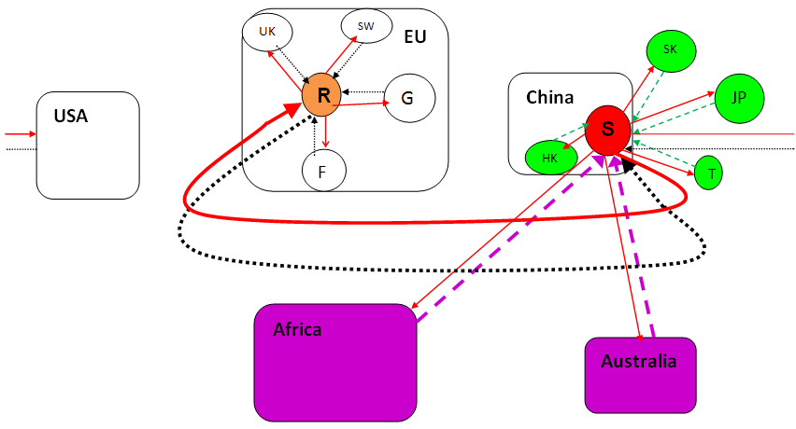
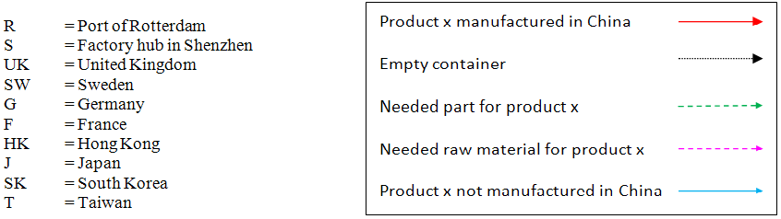
Figure 5.39: Port of Rotterdam import product x from 5 different production countries
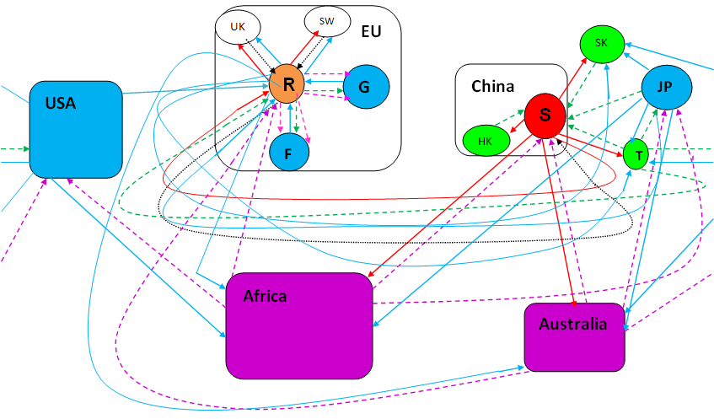
Source: Own elaboration
To conclude, the advantage of China as ‘Global factory’ is that the EU can import 1 big container vessel loaded with 5 different products x from China and transport 1 big container ship with high share of empty containers via Rotterdam back to China. Plus, EU does not have to import raw materials and manufactured parts. In scenario 2 EU countries except Germany and France, can remain to buy these 5 different product x, but the maritime transport has grown much more than in scenario 1. Additionally, EU producer countries Germany and France have to import raw materials and manufactured parts separately. In the end result, total cost is definitely higher due to extra production costs (higher wages) and transport costs (raw materials). So, it is better to send one big behemoth container vessel to China with high share empty containers, than spreading smaller (container) vessels around the world.
POR is important in the EU outward container transport to China. In 2005-2008 1st half year, Rotterdam share in EU outward total loaded container transport to China was 25,3% and for total containers 21%. Empty containers is 16,3% of EU total. In EU inward container transport with China, POR is more important in empty container handling with 31,1% of EU total. Loaded inward container transport Rotterdam has 18,1% and for total container transport 18,3% of EU total. The high difference in empty container share of inward and outward transport in Rotterdam could be explained by higher container handling costs in the port of Rotterdam than other ports. However, in TEU units outward empty container transport is higher than inward. Furthermore, POR is the main first port of call for shipping lines in westbound container transport (Notteboom and Vernimmen, 2008). When the loaded container is at the destination somewhere in Eastern Europe, it is easier and more economical to sail back from there or surrounding transshipment ports instead of back to Rotterdam and then to China. After all, port of Antwerp is the main last port of call for shipping lines in eastbound return cargo.

6 Oil price relation with imported goods and inward container transport

In this chapter we analyze the (monthly) oil price relation with EU imported Chinese goods and inward sea container transport. Maritime transport costs are determined by more factors, than just freight rate. In high oil price periods, shipping lines add BAF and oil related charges to freight rate to compensate higher bunker prices. Hence, it is not accurate just compute freight rate as maritime transport costs. Therefore, we focus on directly comparison between the relation oil price and EU imported Chinese goods to find the aggregated oil influence.

6.1 EU-Asia freight rate
We test the relation between oil prices and freight rate. Although, we only have freight rate for EU-Asia and Asia-EU the result reflect a rough development for EU-China sea transport. In 2006-1st half of 2008, freight rate in Asia-EU direction declines, while EU-Asia increase, see Figure 6.1. However, freight rate value for Asia-EU route is still much higher than EU-Asia, respectively $1.899 and $1.061. The oil correlation with freight rate is R² = 0,5 for Asia-EU and R² = 0,92 for EU-Asia. This indicates that other factors such as the imbalanced trade between Asia and EU has more influence on Asia-EU freight rate. Notable, freight rate is exclusive BAF and oil related surcharges.

6.2.1 EU imported total goods and manufactured goods

Figure 6.2, shows the oil price index development on the world market against EU import of total and manufactured goods in value index from China. We see that trend lines of total goods and manufactured goods are almost the same, where the manufactured goods line is a little bit higher. The slope of Manufactured goods trend line is 3,07 and for Total goods is 2,96. This is higher than the slope of oil trend line which is 2,45. In March 2008- September 2008, index of oil is permanent higher than the total and manufactured goods index. To keep the following figures arranged we do not display the black lines in the figures, but only show the R² and the slopes in the matching tables.

Figure 6.2: EU total goods and manufactured goods import in value (2000 = 100)
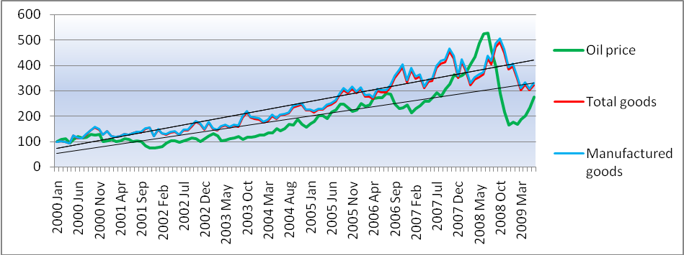
Source: Own elaboration based on Eurostat data (2009)

In Figure 6.3, we see the oil price index against total and manufactured goods index from China in quantity of 100 kg. We observe a much higher increase of manufactured goods and a slightly decline of total goods against oil price index line. The slope of the trend lines are respectively, 4,47 and 2,38 against 2,45. Thus, manufactured goods growth is much higher than oil price increase, where as total goods growth is a little bit lesser. Both indexes have a downward result after the surge of oil prices in beginning 2008.
As illustrated in Figure 6.4, we see the trend change dramatically, when index year is 2007. From January 2007, monthly oil prices rise from $53,40 to the record of $132,55 in July 2008. It is obviously that since then the index of total goods and manufactured goods in value do not rise that much. It is difficult to determine the trend line in this period, because of the high ups and downs of the oil rises. The reliability is very low R²=0,0055 and the slope -0,42. Total and manufactured goods are rather constant with a slope of -0.05 and -0.03. The maximum index for total goods is 129 in October 2008 and for manufactured goods 130. In Figure 6.5 the trend for total and manufactured goods highest index is ‘only’ 108 and for manufactured goods 113 on 2007 August. The lowest point is 49 for total goods and 48 for manufactured goods in March 2009.
If higher oil prices leads to fewer imported total and manufactured goods, then the ‘simple’ opposite reaction should be lower prices leads automatically to more imported goods from China. In Figure 6.6 it is clear that this is not the case. Actually it increases until 2008 October before it plunges due to lesser demand in the EU by the global Credit crisis in late 2008. However, there is some seasonal influence. In Figure 6.7 we see that only in September and October were above 100 index. Oil price decline has a larger connection on the import in quantity, especially for total goods. Oil prices changes have lesser connection on imported manufactured goods.
When we compare oil price connection on total goods in value the linear regression R²= 0,687 and manufactured goods is R²= 0,685. This implies that oil price can explain for 0,69 out of 1 on the EU imported total goods from China. The impact of oil price on total goods in quantity is R²=0,65 and for manufactured goods R²=0,682. Here, we see higher connection between oil price and total goods in value than manufactured goods, but lower connection of oil and total goods in quantity than manufactured goods.

6.2.2 EU imported manufactured goods in 3 product groups

We break manufactured goods in value down into Chemicals, Machinery and transport and Other manufactured goods. In Figure 6.8, we see that the Machinery and transport group has the highest trend slope compared to oil prices with a slope of 4,28 against 2,45. On the contrary, Chemicals and Other manufactured goods remain under the oil trend line, respectively 2,18 and 2,37. After 2007, where oil prices rose the trend pattern of the three product groups do not change that much. The only change is the ever greater contrast in peaks and dips. But, in late 2008 when oil price plunged, all three product groups also decrease.
As shown in Figure 6.9, Other manufactured goods in quantity has the highest slope of 5,31 with a steep increase in January 2006-August 2007. The trend line of Machinery and transport is also steeper than oil price. Further in September 2004-December 2005, there is a lot of fluctuations. Since October 2007, when oil prices break through the $82,15 threshold, the increase of Other manufactured goods and Machinery and transport has been stopped. Chemicals growth is even earlier ended at the oil price of $73,67. Thus, EU import of goods from China in value has been still growing in periods with increasing oil prices, but imported goods in quantity are negatively affected. Notable, inflation or China’s shift into higher tech production could be a factor in value increase while at the same time quantity decrease of EU imported goods.
In Figure 6.10, Chemicals has the highest trend line slope and Other manufactured goods even declines due to oil price increase, but the reliability of the R² are very low. The highest index of all three product groups is around the 132-135, which are rather low compared with the maximum index of 248 for oil. When expressed in quantity all 3 product groups have a declining slope, with higher R² than in value. Other manufactured goods suffered the most, even in the period of falling oil prices there are no improvement, see Figure 6.11.
As depicted in Figure 6.12, all 3 product groups increased in the first few months when oil price plunged after August 2008, before falling together with the lower oil price. Machinery and transport goods in value do not have much connection with oil prices. Other manufactured goods also suffered the most with a slope of -4,21. If we focus on the quantity the Other manufactured goods begins with the highest, but also ends as the lowest product group, see Figure 6.13.
When we compare the oil correlation with each product group in value individually, then the reliability of linear regression line of oil price with Chemicals is the highest with a R² of 0,71. Chemicals in quantity also has the highest linear R² of 0,70. Remarkable is that only Other manufactured goods has a higher quantity R² than value R², respectively 0,67 and 0,66.
Thus, we conclude that imported manufactured goods measured in value are lesser affected (still increase) than measured in quantity in periods of high oil prices. However, imported manufactured goods measured in value have more connection with oil price than measured in quantity. Several factors could create this import decline of manufactured goods in quantity, while the value is still increasing. For example, higher value of goods, inflation, lower profits for EU importer of low value manufactured goods, product technical advancement (1-flat screen televisions are much lighter in weight, but have a higher value, 2 -more compact design like smaller electronic mp3 players).

6.2.3 EU imported manufactured goods in 7 specific product groups

To keep the research arranged, we just compare the value of the specific and detailed goods.
Figure 6.14, shows the trend lines of product groups Plastics (SITC 57), Leather (SITC 61) , Telecommunication (SITC 76) and Road vehicles (SITC 78) in value. Plastics and Leather do not have any pattern, while Telecommunication and Road vehicles are gradually growing. Leather tends to have some opposite development against higher oil prices. In Figure 6.15, we see that all three product groups of Apparel (SITC 84), Footwear (SITC 85) and miscellaneous goods (SITC 89) do not exceed oil price increase. Furthermore, these three products have seasonal trends where the difference in peaks and dips are growing. When we focus on the slopes of the trend lines, then Road vehicles has the highest slope 6,26 and Leather the lowest with 1,15 (R² is just 0,39).
As demonstrated in Figures 6.16 and 6.17, only Road vehicles, Apparel and Miscellaneous goods have a slightly increase against the oil development. The rest and especially leather have a bad performance compared to oil price. In Figures 6.18 and 6.19 we see that Miscellaneous manufactured goods and Telecommunication have reached higher than 100 index points until the end of 2008. The decline in 2009 could be caused by the weaker EU demand during the Global crisis. Plastics and Leather fell in August and also have higher than 100 index points for a few months.
We explore the impact of high oil price surge on these manufactured goods since 2007 up to the peak in July 2008. Oil price trend line has a slope of 7,86 with a R² of 0,94 and only ‘Road vehicles’ trend line has a relative high slope of 2,54 with a R² of 0,52, see Table 6.4 last column. Oil prices has the most connection with Road vehicles based on R² of the linear trend lines and the least with Leather products, respectively 0,78 and 0,40. This implies that higher oil prices go together with more import of road vehicles from China.

6.2.4 EU imported manufactured goods in 7 detailed product groups

In Figure 6.20 it is very obviously that the trend line increase of Monitors and Motor cars are tremendously compared with oil price. The slope of Monitors is 58,87 and for Motor cars it is even 95,64, the highest of these 7 products. However, this is the result of very low import from China in the beginning of 2000. At that time China was above all exporting low value manufactured goods, which changed due to its gradual progress to high tech production. Higher oil price in 2008 tend to have negative implications for these two products, especially for Monitors. In Figure 6.21, we see that all 4 products have strong seasonal fluctuations. Tennis shoes have a stable trend and seem to have nothing common with oil price changes. The slope of Tennis shoes is also just 0,09.
As shown in Figure 6.22, Motor cars remain closely related with the oil price progress, where as the trend of Monitors has been downwards. The slope (-0,77) and R² (0,007) of Motor cars is also closer to oil price (-0,42) and (0,006) than Monitors (-1,46) and (0,41). Polymere shows more an opposite trend after the oil peak. In Figure 6.23, Toys is the only product which remain higher than 100 index number. After all, these 4 products do not have large change vis-a-vis oil price development.
In Figure 6.24, Polymere and Monitors perform better than oil price and Motor cars. Here it confirms again the complementation effect of oil price and Motor cars. In Figure 6.25, Toys performs the best, but has the lowest slope of -7,51. Tennis shoes is the only product with a positive slope, but the R² is the lowest at 0,0032. When we focus on the high oil price period 2007 till the oil peak, then Motor cars and Polymere are the only products which have relative high R² and a positive slope. It is not surprising that Motor cars have the highest linear relationship of R² = 0.76 with oil price, see Scatter diagram 4. Tennis shoes has hardly any connection with oil price, R² = 0,0002.

6.3.1 EU inward container transport (2005-2008 1st half year)

EU inward total and loaded container transport from China increased until the 3rd quarter 2007, see Figure 6.26. At that time the oil price is $73,57. It is not sure whether it is the implication of high oil prices or seasonal influences due to the limited EU data. In the former two years it is also peaked in the 3rd quarter and declined one or two quarters before it rise again. The slope of loaded and total container transport trend line is lower, respectively 7,68 (R² = 0,88) and 7,42 (R² = 0,88) than the oil price increase 8,66 (R² = 0,7). The EU inward loaded and total container transport lines from China are practically the same. This implies the high occupation degree of loaded container in the total EU inward container transport from China. Empty inward container transport peaked in 2006 2nd quarter at $68,30 and 2007 4th quarter at $87,62. The empty inward container transport has a negative trend line with a slope of -1,96 (R² = 0,13). This means that the higher oil price, the higher possible loss to transport an empty container from China to EU. So, shipping lines would be filling that empty container with ‘something’. For example, empty containers freight rate is lower than loaded containers. Shipping lines can reduce empty container freight rate. However, they have to compensate more via loaded freight rate to cover the return voyage costs.
When we consider the oil price connection with the EU inward container transport, then loaded and total container transport have equal linear R², namely 0,55. Empty container transport has a negative and low R² = 0,08.

6.3.2 Port of Rotterdam inward container transport (2000-2008)

Now we explore whether the oil price has much connection on inward container transport in Container unit from China to the POR. In Figure 6.27, we see that the increase of loaded and total inward container transport from China is higher than the increase of oil price. The linear trend line slope is 14,3 for loaded containers (R² = 0,95) and 13,9 for total containers (R² = 0,95). The reliability of these trend lines is very high. The slope of oil price increase is 8.1 (R² = 0,74). Empty containers has a lower slope of 5,4 (R² = 0,32). The loaded and total inward container transport has a first peak in 2007 3rd quarter, falling to 2008 1st quarter. The inward container transport grows further, while the oil price grows further until the second peak in 2008 3rd quarter. Empty containers reached its peak with an oil price of $42,73 in the last quarter of 2004. Afterwards, it is too expensive to transport an empty container from China to Rotterdam. When we compare the oil price against inward container transport unit, then loaded container transport has the highest linear R², which is 0,81.
As written above, when we compare the oil price trend slope of 6,67 for period (2000-2007) and 8,01 for period (2000-2008), then the latter is higher, but with a lower R² 0,74 against R² 0,81.
As illustrated in Figure 6.29, inward container transport increase in TEU is slightly higher than container transport measured in Container unit. In the last quarter of 2007 and the 1st quarter of 2008, inward loaded and total containers in TEU declined, while oil prices are continuing to rise. In the 2nd and 3rd quarter of 2008 both rise again before falling in the last quarter of 2008. Oil price reached its peak in the second quarter. The linear trend lines are indeed higher with a slope of 15,71 (R² = 0,95) for loaded and 15,25 (R² = 0,95) for total containers. In Figure 6.30, we see it more apparent that loaded and total container transport growth suffers from the rising oil prices, but there is still increase.
Figure 6.27: Port of Rotterdam inward container transport in ‘Container unit’ (2000 = 100)
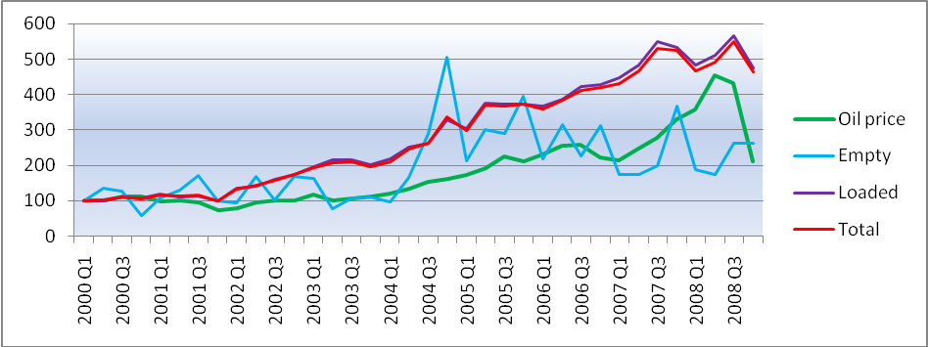
Source: Own elaboration based on Eurostat data (2009)

In Figure 6.31, we see the comparison of the POR with total EU inward container transport for the period 2005-2008 1st half year. We see more fluctuations of empty containers in Rotterdam. There are more declines in EU empty container transport than in the POR. The increase of EU loaded and total inward container transport is higher than the increase in the POR in periods of extreme high oil prices.
We conclude that EU inward container transport has more connection with oil prices, than EU import from China. In the whole period imported manufacture goods from China in value still increase, while in quantity declined. It could be possible that Chinese manufactured goods worth has been increased and products have been lighter in weight. During extreme high oil prices period 2007- July 2008, EU import increase of Chinese manufactured goods indeed suffer. Imported manufactured goods in value remain constant, where as in quantity decrease. After the oil peak in July 2008, manufactured goods in quantity diminished. Imported manufactured goods in value still increase in the 3rd quarter, but declined in the 4th quarter of 2008. The EU and POR inward container transport still increase even in the extreme high oil price period, but at a slower pace. Especially, empty inward container transport reduced significantly. As analyzed in chapter 4, EU trade deficit with China in total goods as well as manufactured goods still growing for 2000-2008. This implies that the EU export of goods to China is much more affected by higher oil prices.

6.4 Exchange rate effect on oil price and import of Chinese goods

The exchange rate between the euro and dollar can reduce some impact of high oil prices on EU imported Chinese goods is. When oil prices increased, which are noted in dollars, the effect is relative lesser harmful for the EU importers and shipping lines. This could be explained by the weaker dollar against the euro. This means a relative lesser impact on the transport costs than in the scenario, when the dollar was appreciated vis-à-vis the euro (lesser BAF by shipping lines as fuel and exchange rate risk compensation). The correlation between dollar and oil price is R² = 0,72. Thus, as long as the oil price increase and together with a weaker dollar, transportation costs increase is lesser painful for the European importer due to its higher buying-power. After all, dollar depreciation was one of the factors that lead to record high oil prices in 2008.
Additionally, the yuan or CNY also depreciated vis-à-vis the euro during high oil price period. The undervalued Chinese currency monetary policy, aimed to protect Chinese exporters global competitive position. Since 2005, the CNY is not more pegged to the $, but it still remains closer to the $ than €. Moreover, in late 2008 it was re-pegged against the dollar. This means relative cheaper Chinese products for the European importer compared to European or other international products. As shown in Figure 6.32, it seems that since 2002 the $ and CNY developments mirror the oil price fluctuation. After May 2006, the $ depreciated more than the CNY against the €. The depreciation of the American and Chinese currency functions so to speak as an offset mechanism for higher transport costs during periods of extreme high oil prices. In Figure 6.33, we see it more obviously that currency depreciation goes further in the period 2007- July 2008. This can also explain the restraining influence of the stronger € on the exported European goods to China. For Chinese importers European goods get more expensive compared to Chinese goods. The connection between depreciation of the CNY and EU imported Chinese goods is rather low. Imported total goods has a R² = 0,459 and manufactured goods R² = 0,46.

7 The future expectations

IEA predicts that oil price will increase to $100 in 2020. Future oil price influence on EU-China trade and container maritime transportation depends on the pace and duration of oil price increase. Gradual oil price increase enable enterprises and shipping lines to adapt their strategies, while oil price shocks provide dramatic consequences. Other factors are: 1-possibility of profitable alternative energy substitution for oil; 2- transport costs share in total production costs; 3- feasibility of reverse manufacturing from China to EU in costs reduction. Can transport cost savings offset production costs increase compared to China? 4- value, weight, handling requirements of traded and transported (manufactured) goodThe issue is which economy can transform to higher oil efficiency production. Additionally, are shipping lines continuing to invest in newer fuel efficient or alternative fuel technology for container transport and can shipping lines gain more improvements in sound fleet management to diminish transport costs.
During global recession, western countries use their stimulus on banking and reduced their green investments, while China spent its stimulus on infrastructure modernizing and environment initiatives to meet their future energy demand. China investments in clean energy are to secure national security, which reduce dependency of imported oil. However, the aggregated oil demand still increases. After all, to secure sufficient energy supply China signed long term oil supply contracts with oil exporting countries, when oil prices are very low.
China’s clean energy policy aim to be the global leader in clean energy production and diminish coal dependency (reduce carbon emissions by 2020), while simultaneously export its clean-energy technologies. China invest and supported by FDI in clean energy (Clean Development Mechanism) large amounts in renewable energy, such as nuclear plants, solar and wind farms, hydro electric dams, ‘green transport’, ‘clean coal’ and super efficient electric grids. This transforms China into a dominant global low-carbon economy in coming decades. China is already the world’s largest producer of solar panels, wind turbines and start mass production of electric cars. The most optimistic forecast for alternative energy is from De Ridder. He suggests that solar energy production would be almost for free within two decades, due to similar growth development as in the ICT of the last decade.
China’s agglomeration effect strengthened as the largest recipient of FDI in manufacturing. Many lending and investment projects in resource rich developing countries reduce China’s future input and production costs. In 2010, ASEAN-China free trade agreement leads to more Asian-intra trade and diminish transaction costs. However, the implications for EU future trade with the Asian region are less than 1,5% (Lee et al, 2009). The issue is whether China has the ability to keep its cutting edge in low cost massive production with an aging labour force and progress in environment (carbon tax plans) and working laws.
The exchange rate is another important factor that can influence future oil price as well as EU import of Chinese goods. The expected appreciation of the yuan against falling dollar dominance in global trade cause larger implications for EU-China trade than just oil price in the transport costs. Additionally, oil exporting countries plan to base oil price on a varied basket of currencies.
EU and particularly the Netherlands as ‘the gateway’ of Europe in maritime transportation has been more focused as consuming market for Chinese firms, by setting up Chinese centre’s. For example, the ‘European China Centre’ (ECC) in Rotterdam stimulates more trade and job creation. The future statistic import values may increase much more due to the ‘hidden’ statistic effects. EU import growth diminish, due to more Chinese (final assemblage) manufacturing production in Europe to bypass import tariff, textile quota and satisfy European demand of exclusive Italian high quality materials. EU export growth decline, due to more FDI flows to China. EU largest exported manufactured group is Machinery and transport, but European luxury vehicle makers are launching more production facilities in China to gain its growing car market (world’s largest in 2009).
China’s ongoing shift to green and high tech goods in value chain production, leads to higher EU import value and less vulnerability for possible transport costs increase. But, low tech products import decline if it is not profitable. China aim is to transform from just a manufacturing hub to a knowledge economy by adding the ‘core functions’ part in the ‘world factory’ concept. Government policy establishes financial incentive to attract more human capital. The global crisis pulled unexpectedly more brain gain and at the same time a reverse of brain drain (sea turtles ‘hai gui’). After all, the abundant of annually millions new graduates will keep high skill wages low.
Transport sector account for 97% of boost in oil use in 2008-2030. Future freight rate increase with expected higher oil prices, but it can be reduced by improvements in driving factors such as 1- more competition in liner services, 2- shorter transit times by generating reductions in future operating costs of the Northern Sea Route, 3- improved port infrastructure in Europe (Maashaven II), 4- higher development level of China using the newest ICT in Yangshan deep water port, 5- improvement in China’s competitiveness, 6- more direct services between EU and China by reducing transshipments in intermediate ports. After all, newer oil efficiency technology in vessel design (hybrid) and improvement in sound fleet management reduce shipping lines oil consumption.
In the near future China focuses more on the international supply chain, where value is added, particularly in warehousing. China potential shift to own more ships provide more control on its increasing traded cargo. Container transport is gradually recovering. The overcapacity based on shipping lines’ order book of AXS-Alphaliner leads to temporary relative low freight rates for coming years.
Could future higher oil prices end EU sourcing to China? We explain this with the use of next example for a Dutch company. China has a unique economy model, which enable it to compete with low prices due to the combination of several factors. The aggregate of positive driving factors generate a sort of multiplier effect, while simultaneously a sort of inverse multiplier effect diminishes the production costs. As shown in Table 7.1, this ‘multiplier’ effect enables China to produce 1 product x at a lower price. The assumption is that product x requires mainly manual work and all countries use the same type machine. Moreover, the dollar depreciates against the euro.
In this example, raw material price for 1 product x is lower, because Chinese firms buy resources in large quantities from Africa (economy of scale). Neighbouring Asian part supplier’s shorter distance and large import quantity (economy of scale) reduce electronic parts price. Lower wages and longer labour hours in China diminish labour costs per product x. National large investment in clean energy reduce oil input in energy costs. Government subsidies for (foreign invested) companies such as accommodation subsidy reduce cost price. The limited or missing laws related to environment (planned carbon tax in China) and labour rights generate no or minimal extra costs. General tax rate level in China is lower compared to other countries. China stimulates export oriented enterprises with Export rebates, which diminish export prices. Manufacturing plants clustering in SEZ generates agglomeration and spillover effects, which leads to lower transaction costs for other parts. China’s monetary policy stimulates Chinese exports by holding the Yuan artificially lower. The Yuan re-pegging against the dollar since late 2008, reduce the cost price of product x on the international market. Even adding freight rate and oil price related surcharges, the Chinese consumer price of product x on the Dutch market is still the lowest. Thus, China’s aim to higher oil efficiency gains some advantage in the product price on the international market. However, it still depends on transport costs in total production costs, which can create higher total production costs for the Dutch company. If higher oil prices leads to transport costs increase and let Chinese total production costs exceed Poland, the Dutch firm can stop sourcing and EU import reduce from China. However, removing manufacturing and clusters to Poland leads to loss of created linkages with suppliers and trade partnerships. Additionally, it is costly and erodes potential comparative advantages in China (market share).
Table 7.1: 1 product x with fictional prices and surcharges
 | China | Poland | USA | India
Raw material | 5,00 | 6,00 | 6,00 | 6,00
Electronic parts from other Asian countries | 3,00 | 4,00 | 4,00 | 4,00
Wage | 2,00 | 4,00 | 8,00 | 1,50
Oil efficiency by production (energy costs) | 1,20 | 1,30 | 1,00 | 2,00
Government subsidy | -1,00 | - | - | -1,00
Environmental surcharges | - | 1,00 | 0,75 | -
Labour surcharges | - | 0,50 | 0,75 | 0,20
Tax | 0,20 | 0,40 | 0,60 | 0,20
Export rebates | -0,10 | - | - | -0,05
Agglomeration effect (transaction costs) other parts | 2,00 | 3,00 | 3,50 | 3,00
Exchange rates | -0,50 | - | -0,50 | -0,25
Production costs without transport costs | 11,80 | 20,20 | 24,10 | 15,60
Freight rate | 1,00 | 0,20 | 0,70 | 0,90
Oil related surcharges | 0,25 | 0,05 | 0,25 | 0,25
Total production costs + transport costs in the Netherlands | 13,05 | 20,45 | 25,05 | 16,75
Source: Own elaboration
Note: There are no EU import tariffs or quota

8 Conclusion

The oil crisis in 2008 differs with prior oil crises, because it was mainly caused by higher global demand, particularly by emerging countries. Oil consequences are limited compared to prior oil crises, since many developed countries have established economic structure to resist higher oil prices. Inflation can be controlled by monetary policy. China’s GDP has become more vulnerable for high oil prices than Europe, but EU imported Chinese manufactured goods still increase.
EU enterprises source their manufacturing activities to China mainly due to low production costs, growing agglomeration effect and growing domestic market. Progress in supply chain stimulates more outsourcing. Shipping lines are flexible in regard to higher oil prices. In periods of high oil prices fuel costs generate significant costs for shipping lines. The reaction is lower vessel speed and sound fleet management of using vessel and TEU capacity oversupply. Additionally, shipping lines add BAF and oil related surcharges on growing freight rates to compensate higher fuel prices, which results in higher maritime transport costs. However, freight rate (small part of transport costs) is determined by more factors such as shipping lines connectivity, port infrastructure etc. Reverse in EU off shoring to China is not profitable, if transport costs reductions cannot off set China’s lower production costs. Chinese manufactured goods better export performance, while oil prices increase is the result of China’s capability to use more cheap labour in production. On its turn, higher Chinese export (at the cost of other countries) leads to more oil demand and higher oil price.
In 2000-2008, EU import growth is higher than EU export growth in EU-China trade, this leads to a growing EU-China trade deficit, particularly in manufactured goods. EU average imported manufactured goods share is 95,9% of total goods. Other manufactured goods are the largest and most unbalanced product group with 48% of total goods. EU average exported manufactured goods is 90,3% of total goods. The largest product and most valuable group is Machinery and transport with 62,1% of total goods. However, EU higher import is distorted by ‘hidden’ participation of EU enterprises manufacturing in China, which export their products back to Europe. Moreover, China’s export replaces other countries by using their manufacturing parts. China’s share in total EU-extra FDI outflows and stocks are rather low. Sourcing remains mainly within EU, but more EU firms want to source manufacturing production to China. China’s real net added value is much lower, where as EU and FIE share in China’s export is rising.
EU-China merchandise trade deficit leads to imbalance in EU-China maritime container transport. The result is high empty containers share of 52,7% in EU (2007) and 42,3% in POR (2008) eastbound transport, which implies oil inefficiency. More trade leads to higher freight rate, but due to imbalanced trade westbound freight rate also has to cover up eastbound (empty) container freight rate. In 2006-2nd half 2008, average freight rate for EU-Asia is $841 and Asia-EU is $1.703. Moreover, empty container freight rate is cheaper. EU total imported goods have a higher average value/ton than exported goods, respectively €2.363 and €1.853. If consider just manufactured goods it is even higher, respectively €4.039 and €2.931. We use the Global factory effect model to explain the net advantage of China as World factory in maritime container transport, which actually replace all across global sea transportation.
During high oil prices period, EU imported goods from China in value still increase, while in quantity it declines. EU import in value increase due to China’s shift to more high tech production, which is less sensitive for higher freight rates and transport costs. Other manufactured goods suffer the most in value and in quantity. Inward total and loaded container transport in EU and POR still increase at a slower pace, while empty container share significantly decline. A stronger euro against dollar and yuan offset slightly rising oil price influence on transport costs and make Chinese goods export relative cheaper for European importers. This also restrains EU export to China, which result into a growing EU trade deficit. Oil price has a positive relation with freight rate in Asia-EU route (R²= 0,5) and EU-Asia (R²= 0,92), EU imported total and manufactured goods in value (R²= 0,69), EU imported Chemicals (R²= 0,71), Machinery and transport (R²= 0,66) and Other manufactured goods (R²= 0,66), EU total inward container transport in TEU (R²= 0,55), POR total inward container transport in TEU (R²= 0,80), dollar depreciation against euro (R²= 0,72). Yuan depreciation against euro has a positive relation with EU imported Chinese total and manufactured goods (R²= 0,46).
Oil price has a positive, but no negative causal correlation with EU imported Chinese goods. Higher oil prices leads to higher transport costs. This should diminish EU import of Chinese goods, but more EU import of Chinese goods due to China’s unique competitiveness in export drives further oil demand. This leads to higher oil prices than in the origin. Additionally, shipping lines reaction by using economy of scale in larger and extra ships and reduced vessel speed leads to downward pressure on total transport costs per TEU. Moreover, China’s currency policy keeps Chinese imported goods artificially cheaper. Without these two measures EU import could decline. Thus, higher oil prices do not reduce EU import of Chinese manufactured goods in value. Furthermore, inward container transport in EU and POR still increases. Therefore, oil price increase does not diminish EU-China trade. EU trade deficit with China still grows, because EU export growth is lower than EU import growth from China.
In short, oil price increase influence on EU import, inward container transport and trade balance with China is minimal, because:
- Shippers absorb higher logistic costs in markets with sufficient demand
- EU import of Chinese goods is mainly manufactured goods, which are less vulnerable for
higher transport costs
- China’s ongoing shift to higher value chain production
- Depreciated dollar and yuan against the euro, which offset higher transport costs
- Other outsourcing factors (demand for Chinese goods) are more important than lower
transport costs such as, supply chain agility, labour and production costs
- Reverse sourcing back to EU is not feasible or economic practicable
- Freight rate (direct sea transport costs) is just a ‘small’ part of total trade transaction costs
- EU-China freight rate is also determined by factors such as, economy of scale, level of competition, port infrastructures, type and value of traded cargo (mainly manufactured goods)
- There is still no profitable substitution for container shipping at this large scale

The expected oil influence for EU-China trade in the future depends on the development of profitable oil substitutes. Western investment in alternative energy sources diminished, while investment in China increases. China’s shift to high tech and green product manufacturing will heighten China’s future merchandise export value, which is less sensitive for higher transport costs. EU export growth to China will remain lower than import growth, when EU firms are still relocating their manufacturing functions to China to gain the growing consumer market. When China is more active in global supply chain, then it will cause some downward pressure on Asia-EU freight rate. Up to 2020, freight rates and maritime transport costs remain rather low due to expected modest oil price increase to $100 and the contemporary oversupply in vessel and TEU capacity.
Further research is needed to analyze the full influence of oil price on EU import and inward container transportation from China. Relatively few suitable EU 27 statistic data with regard to China hinder a thorough research.

9 References

Journals:
Aguiar-Conraria, L. and Wen, Y. (2006), “Understanding the Large negative Impact of Oil Shocks,” Journal of Money, Credit and Banking, Vol. 39, No.4 (June 2007), The Ohio State University.
Bénassy-Quéré, A; Mignon, V and Penot, A. (2007), “China and the relationship between the oil price and the dollar,” Energy Policy, Vol. 35, 5.795-5.805 (2007), Elsevier Ltd.
Bridgman, B. (2008), “Energy prices and the expansion of world trade,” Review of Economic Dynamics, Vol. 11, 904-916 (2008), Elsevier Inc.
Buckley, P.J. (2008), “The impact of the global factory on economic development,” Journal of World business, Vol. 44, (2009) 131-143, Elsevier Inc.
Curtis, F. (2009), “Peak globalization: Climate change, oil depletion and global trade,” Ecological Economics, doi: 10.1016/j.ecolecon.2009.08.020 (2009), Elsevier B.V.
Faria, J.R; Mollick, A.V; Albuquerque, P.H. and León-Ledesma, M.A. (2009), “ The effect of oil price on China’s exports,” China Economic Review, Vol. 20, (2009) 793-805, Elsevier Inc.
Hamilton, J.D. and Herrera, A.M. (2004), “Oil Shocks and Aggregate Macroeconomic Behavior: The Role of Monetary Policy,” Journal of Money, Credit, and Banking, Vol. 36, No. 2 (April 2004), The Ohio State University.
Lee, H; Owen, R.F. and Van der Mensbrugghe, D (2009), “Regional integration in Asia and its effects on the EU and North America” Journal of Asian Economics, Vol. 20, 240-254, Elsevier Inc.
Maeda, A. (2008), “On the Oil Price–GDP Relationship,” The Japanese Economy, Vol. 35, no. 1, Spring 2008, pp. 99–127, M.E. Sharpe, Inc.
Marion, T.J; Thevenot, H.J. and Simpson, T.W. (2006), “A cost-based methodology for evaluating product platform commonality sourcing with two examples,” International Journal of Production Research, Vol. 45, No. 22 (15 November 2007), 5285-5308, Taylor & Francis Group Ltd.
Notteboom, T and Rodrigue, J.P. (2008), “Containerization, Box Logistics and Global Supply Chains: The Integration of Ports and Liner Shipping Networks,” Maritime Economics & Logistics, Vol. 10, 152-174 (2008), Palgrave Macmillan Ltd.
Notteboom, T and Vernimmen, B. (2008), “The effect of high fuel costs on liner service configuration in container shipping,” Journal of Transport Geography, Vol. 17, 325-337 (2009), Elsevier Ltd.
Roeger, W. (2005), “International oil price changes: impact of oil prices on growth and inflation in the EU/OECD,” International Economics and Economic Policy, Vol. 2, 15-32, (2005), Springer-Verlag.
Verny, J and Grigentin, C. (2009), “Container shipping on the Northern Sea Route,” International Journal of Production Economics, Vol. 122, 107-117, (2009), Elsevier B.V.
Wilmsmeier, G and Hoffmann, J. (2008), “Liner Shipping Connectivity and Port Infrastructure as Determinants of Freight Rates in the Caribbean,” Maritime Economics & Logistics, Vol. 10, 130-151 (2008), Palgrave Macmillan Ltd.
Wu, F; Li, H.Z; Chu, L.K. and Sculli, D. (2005), “An outsourcing decision model for sustaining long-term performance,” International Journal of Production Research, Vol. 43, No. 12 (15 June 2005), 2513-2535, Taylor & Francis Group Ltd.

Working Paper:
Gerard Adams, F; Gangnes, B. and Shachmurove, Y. (2004), “Why is China So Competitive? Measuring and Explaining China’s Competitiveness,” Working Paper, No. 04-6, Northeastern University, University of Hawaii at Manoa and City University of New York.
Girma, S; Gong, Y; Yu, Z and Görg, H. (2008), “Can production subsidies explain China’s export performance? - Evidence from firm level data,” Working Paper, No. 1442/ August 2008, Kiel Institute for the World Economy.
Vereecke, A. (2006), “Do not forget the strategic architecture of your manufacturing network while off shoring,” Working Paper, No. 2006/12, Vlerick Leuven Gent Management School.

Document:
Gorter, J; Tang, P. and Toet, M. (2005), “Verplaatsing vanuit Nederland: Motieven, gevolgen en beleid,” CPB Document, No. 76, February 2005

Books:
Blanchard, O (2000), Macro Economics, Second Edition
Glasner, D (1985), Politics Prices and Petroleum: The Political Economy of Energy, Pacific Institute for Public Policy Research

Data:
EUROSTAT:
Data in focus 22/2009
External and intra-European Union trade, Data 2002- 07
European Economic Statistics, 2008 edition
Europe in figures, Eurostat yearbook 2008
Newsrelease, 72/2009 - EU27 deficit in trade in goods with China of 170 bn euro in 2008, 18 May 2009
Panorama of transport, Edition 2007
Panorama of transport, Edition 2009
Statistics in focus 77/2009- EU investment in Asia grew in 2007

UNCTAD Review of Maritime Transport 2007
UNCTAD Review of Maritime Transport 2008
UNCTAD Transport Newsletter, NO. 39 Second Quarter 2008
Transport Trackers, Peak Bikes’ Never Came..., by Wayne Thompson, 2 December 2009
Transport Trackers, Shipping Roadmap Guidelines, by De Trenck –, May 2009
Transport Trackers, We Transport trackers – China Ports in Storm (… an effect not a cause) 16 April 2009
International Energy Agency – World Energy Outlook, executive summary 2009
World Trade Organization, International Trade statistics 2008
World Trade Report 2009, The trade situation in 2008-09

Websites:
China as an Innovator, Not Just an Imitator, by Anil K. Gupta and Haiyan Wang (Business Week) March 9, 2009
http://www.businessweek.com/globalbiz/content/mar2009/gb2009039_914844.htm
China Gains Key Assets In Spate of Purchases, by Ariana Eunjung Cha (The Washington Post), March 17, 2009
http://www.washingtonpost.com/wp-dyn/content/article/2009/03/16/AR2009031603293.html
China goes on the road to lure ‘sea turtles’ home, by Wanfeng Zhou (Reuters), Dec 17 2008
http://www.reuters.com/article/ousiv/idUSTRE4BH02220081218
China makes renewable power play to be world's first green superpower, by Jonathan Watts (Guardian.co.uk) 10 June 2009
http://www.guardian.co.uk/environment/cif-green/2009/jun/10/china-clean-energy
China to Lend Africa $10 Billion, by Shereen El Gazzar (The Wall street Journal), November 9, 2009
http://online.wsj.com/article/SB125767207323136609.html
China’s currency: A yuan-sided argument (The Economist print edition) Nov 18th 2009
http://www.economist.com/businessfinance/displayStory.cfm?story_id=14901104&source=most_commented
China’s Route Forward, by Keith Bradsher (The New York Times) January 22, 2009
http://www.nytimes.com/2009/01/23/business/worldbusiness/23yuan.html
China’s University Students Rattled by Prospect of Post-graduate Unemployment, by Wen, W; Jia, H and Wang, X. (www.echinacities.com), Feb 6, 2009
http://www.echinacities.com/main/ChinaMedia/ChinaMediaInfo.aspx?n=1543
Clean Development Mechanism in China
http://cdm.ccchina.gov.cn/english/
Crude Oil and U.S. Dollar Inverse Relationship? by Richard Shaw (The Market Oracle), Dec 17, 2008
http://www.marketoracle.co.uk/Article7829.html
Domestic Demand in China Helps Fuel the Region's Resurgence but Some Countries Still Struggling, Says World Bank's East Asia and Pacific (The World Bank) November 3, 2009
http://web.worldbank.org/WBSITE/EXTERNAL/NEWS/0,,contentMDK:22377507~menuPK:34463~pagePK:34370~piPK:34424~theSitePK:4607,00.html

Economic power shift from West to East is poised to gather pace, by Sean O'Grady (The Independent), 30 November 2009
http://www.independent.co.uk/news/business/news/economic-power-shift-from-west-to-east-is-poised-to-gather-pace-1831255.html
Energieprobleem? Hoezo, energieprobleem?, by Mark Litjens (KAS magazine) 6 - 2009
http://www.algemene-energieraad.nl/Include/ElectosFileStreaming.asp?FileId=484
Everything you know about China is wrong, by Rana Foroohar (Newsweek), Oct 17, 2009
http://www.newsweek.com/id/218290/output/print
Het Financiële Dagblad: dossier olieprijs
http://www.fd.nl/nieuws/dossiers/467248/9306583/
Historic commodity price boom ends with slowing global growth (The World Bank), December 9, 2008
http://econ.worldbank.org/WBSITE/EXTERNAL/EXTDEC/0,,contentMDK:22004555~pagePK:64165401~piPK:64165026~theSitePK:469372,00.html
Interim Report of the ITF, Interim Report on Crude Oil: Interagency Task Force on Commodity Markets, July 2008
http://www.cftc.gov/stellent/groups/public/@newsroom/documents/file/itfinterimreportoncrudeoil0708.pdf
Invest in China - An overview of China’s absorption of foreign direct investment in 2005, 2006-09-06
http://www.fdi.gov.cn/pub/FDI_EN/Statistics/AnnualStatisticsData/AnnualFDIData/FDIStatistics2005/t20060906_61535.htm
Lage dollarkoers doet olielanden pijn (het financieele dagblad)
http://www.fd.nl/artikel/8096775/lage-dollarkoers-doet-olielanden-pijn
Minder uitstoot van CO2 door crisis (energie raad), 10 november 2009
http://www.algemene-energieraad.nl/newsitem.asp?pageid=17096
Oil Hits $100 a Barrel for the First Time, by Clifford Krauss (The New York Times), January 2, 2008
http://www.nytimes.com/2008/01/02/business/02cnd-oil.html?hp
Oil settles near $78 as China's economy rebounds, by Chris Kahn (Business Week) November 11, 2009
http://www.businessweek.com/ap/financialnews/D9BTIQ700.htm
OPEC ready to cut oil output as prices dive (China Daily), 2008-12-16
http://www.chinadaily.com.cn/world/2008-12/16/content_7309435.htm
South-East Asian summitry: Distant dreams (The economist print version), Oct 29th 2009
http://www.economist.com/world/asia/displayStory.cfm?story_id=14745120
Steel Selection-Closing the Gap with Offshore Tooling, By Tom Schade (moldmakingtechnology)
http://www.moldmakingtechnology.com/articles/100302.html
Threat of Overheating in China, by Bloomberg News (Business Week) December 11, 2009
http://www.businessweek.com/globalbiz/content/dec2009/gb20091211_486042.htm
UNCTAD/PRESS/PR/2008/044 - 04/11/08
http://www.unctad.org/Templates/Webflyer.asp?docID=10755&intItemID=2068&lang=1
Venezuela threatens to cut US oil (BBC News), 11 February 2008
http://news.bbc.co.uk/2/hi/americas/7238214.stm
Wall Street in crisis na val zakenbanken, Freek Staps (NRC Handelsblad), 15 september 2008
http://www.nrc.nl/economie/article1983919.ece/Einde_Lehman_in_zicht,_Merrill_overgenomen
Worlds Yard, Guest Comment 4 July 2008
http://download.hellenicshippingnews.com/pdf/worldyards/75001-Inflation%20-%20Deflation%20and%20the%20Container%20Trade%20Slowdown.pdf
World Trade Organization - WORLD TRADE 2008, PROSPECTS FOR 2009 PRESS/554,23 March 2009
http://www.wto.org/english/news_e/pres09_e/pr554_e.htm#table
WTRG Economics: Oil Price History and Analysis
http://wtrg.com/prices.htm

Reply and statistic data by email:
Eurostat
Evergreen Shipping Agency (Netherlands) B.V.
Havenbedrijf Rotterdam N.V.
Maersk
Transport Trackers

Scatter diagram 1: EU imported total and manufactured goods from China in value and quantity
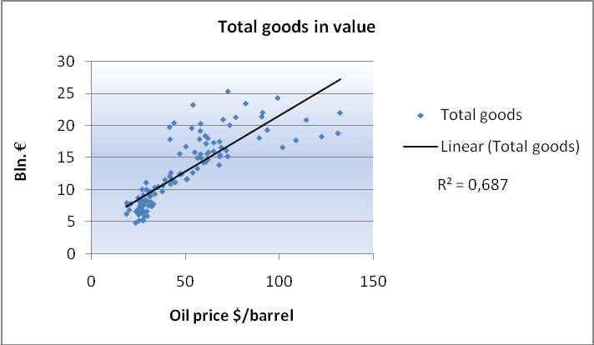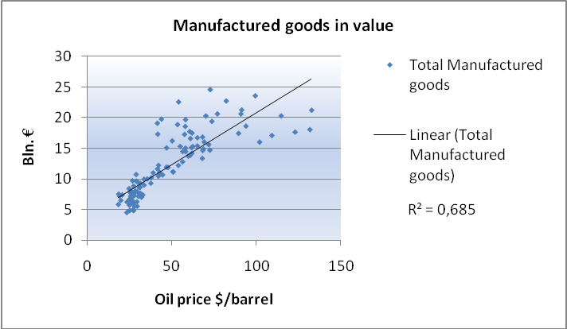
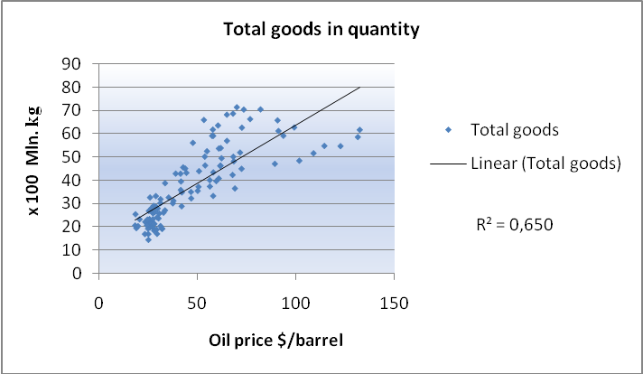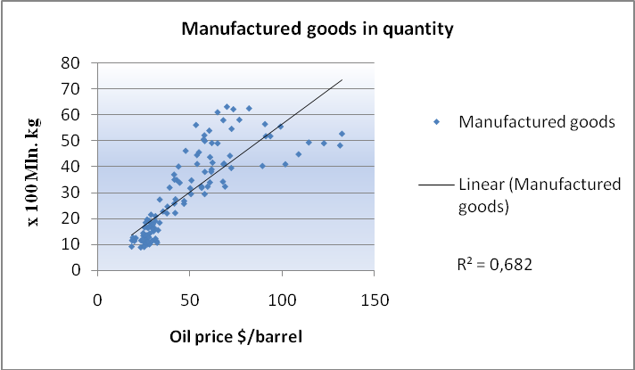
Source: Own elaboration based on Eurostat data (2009)
Scatter diagram 2: EU imported Chemicals, Machinery and transport, and Other manufactured goods in value and quantity
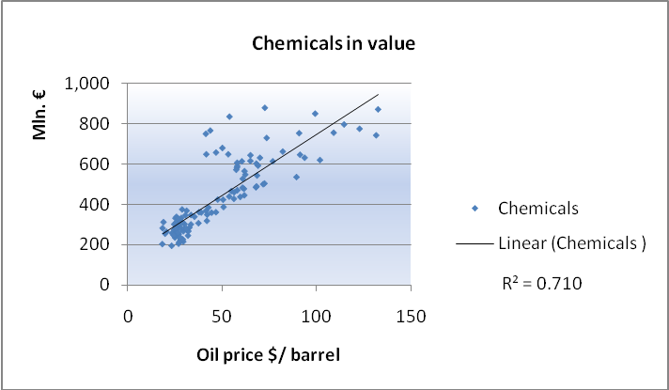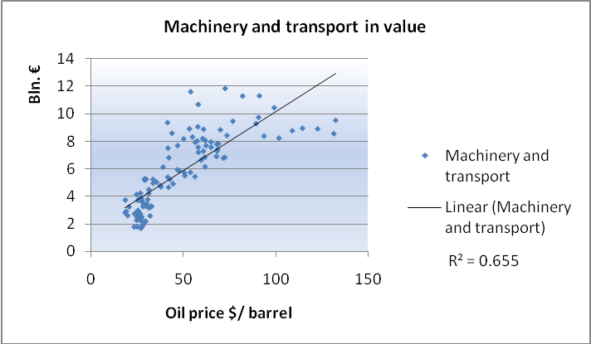
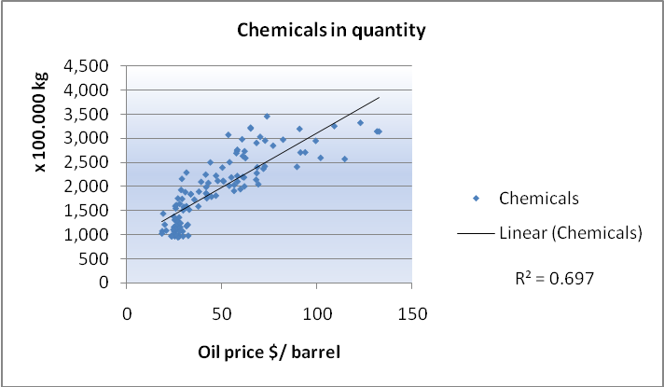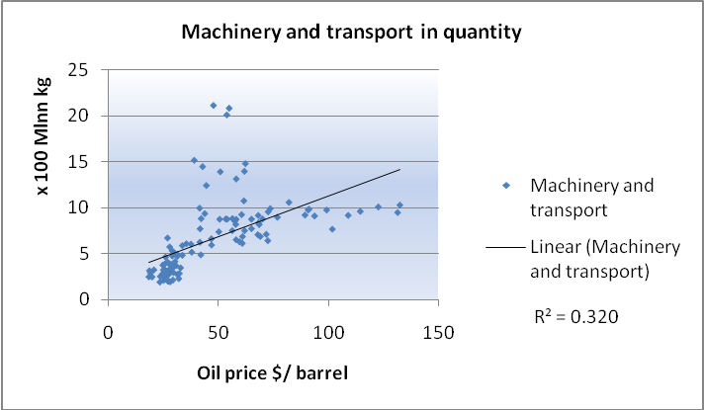
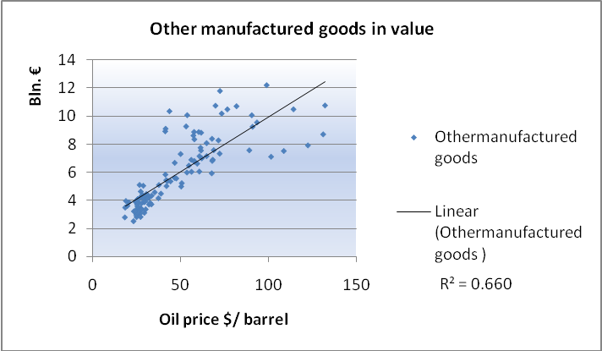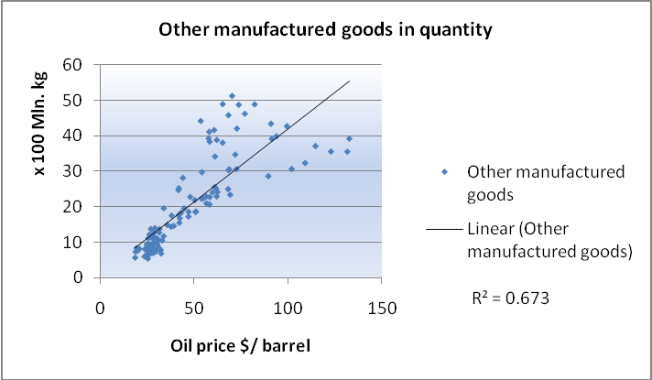 Source: Own elaboration based on Eurostat data (2009)

Scatter diagram 3: EU imported specific manufactured goods in value
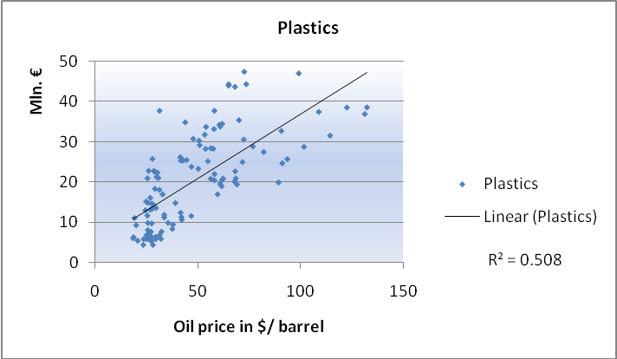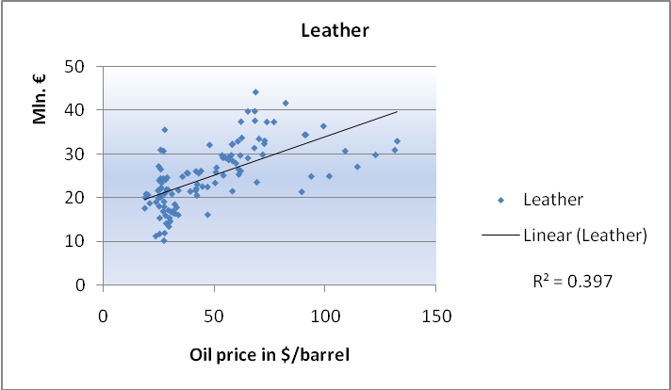
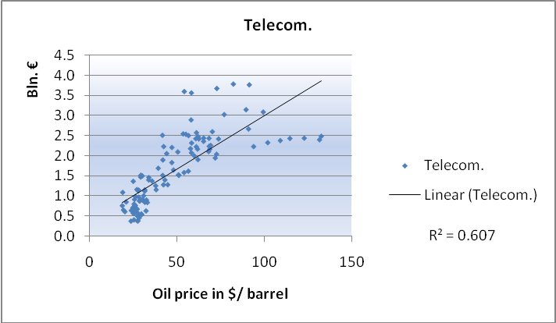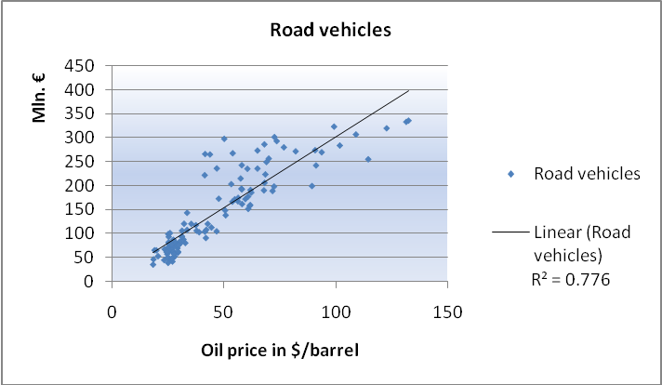
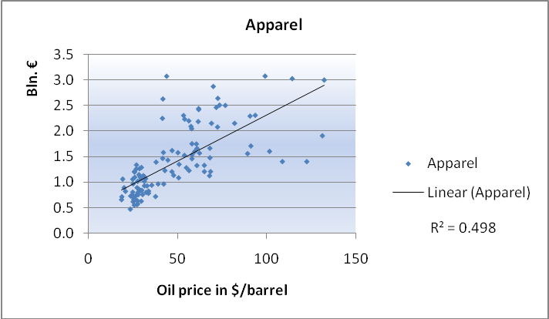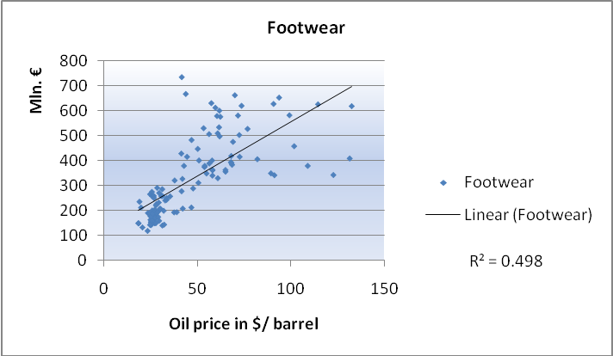
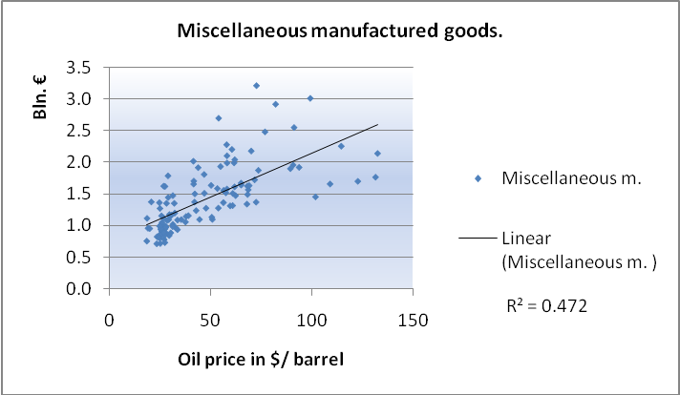
Source: Own elaboration based on Eurostat data (2009)
Scatter diagram 4: EU imported detailed manufactured goods in value
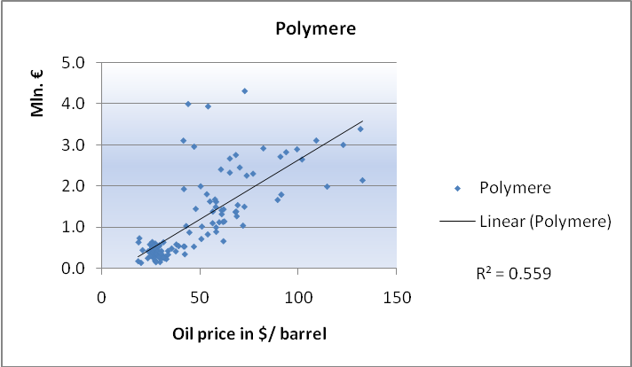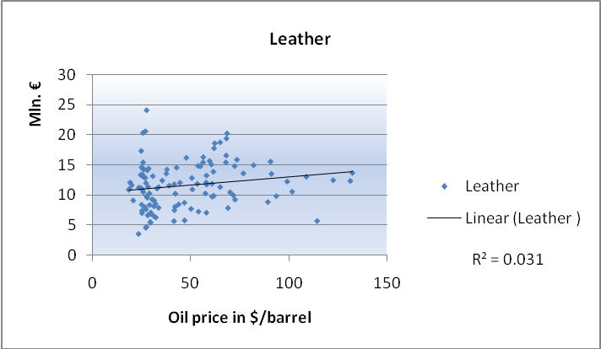
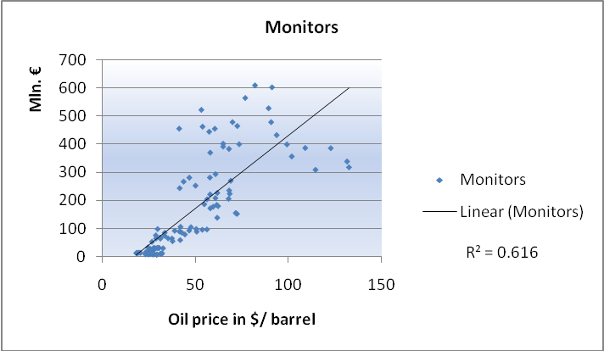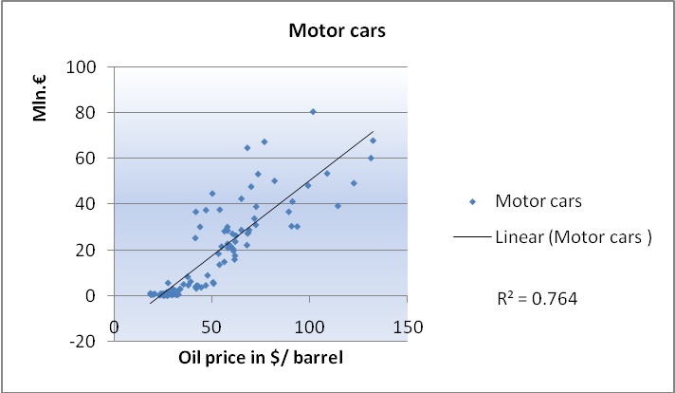
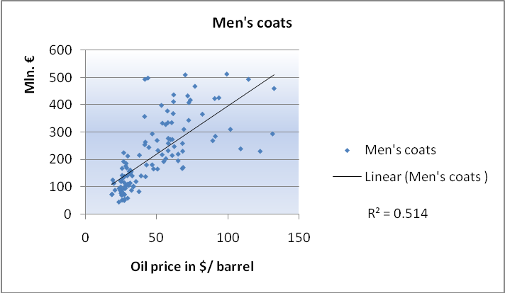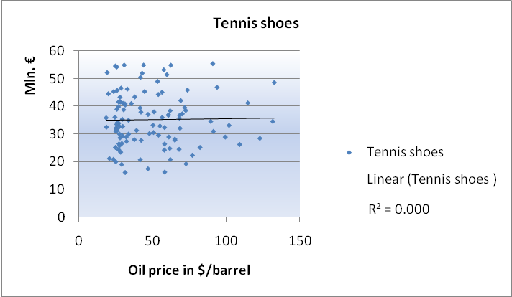
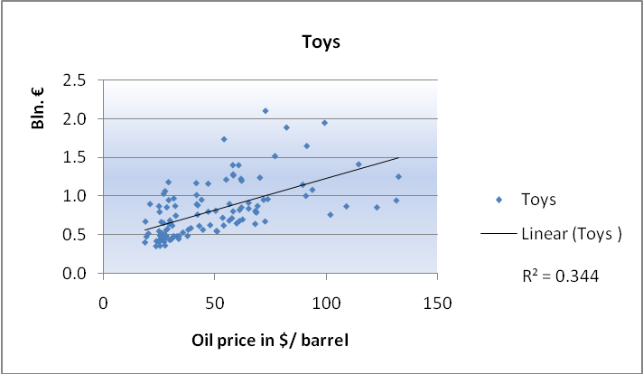
Source: Own elaboration based on Eurostat data (2009)
Scatter diagram 5: EU inward container transport from China in ‘TEU’
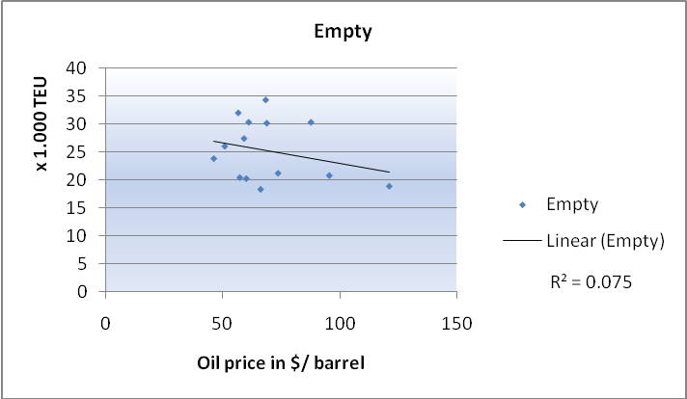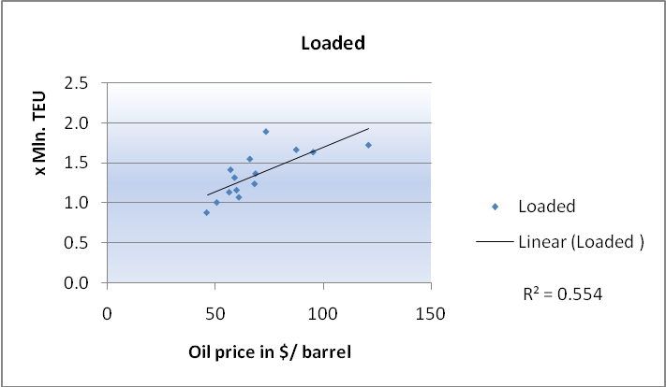
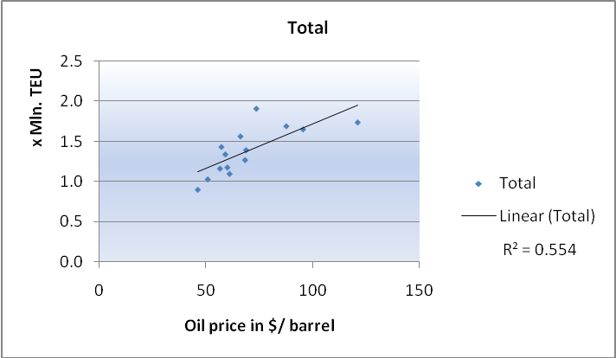
Source: Own elaboration based on Eurostat data (2009)
Scatter diagram 6A: Port of Rotterdam inward container transport from China in ‘Container unit’
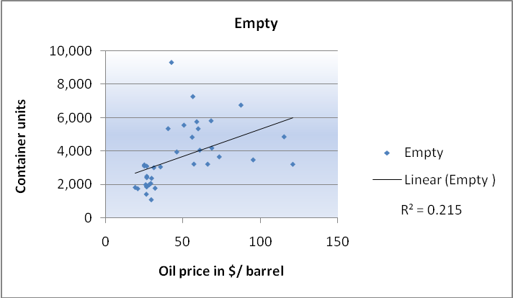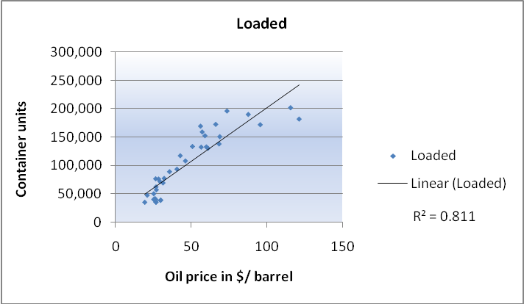
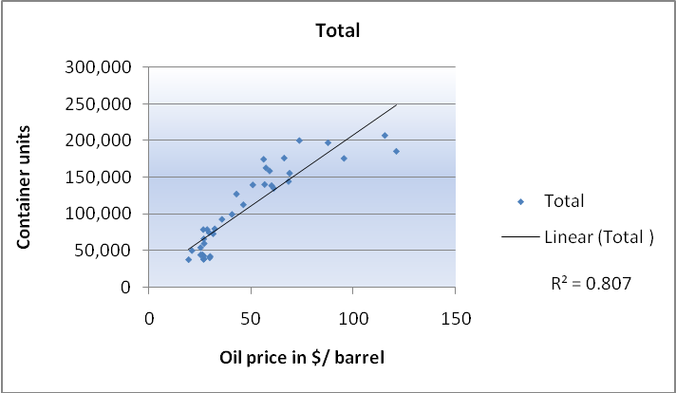
Source: Own elaboration based on Eurostat data (2009)
Scatter diagram 6B: Port of Rotterdam inward container transport from China in ‘TEU’
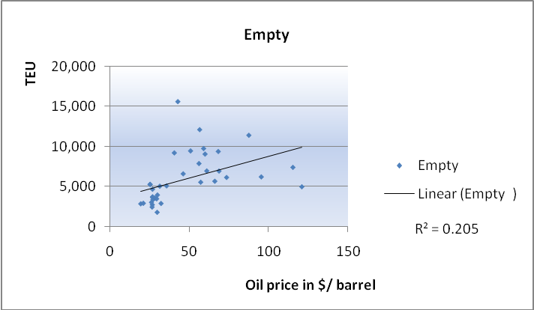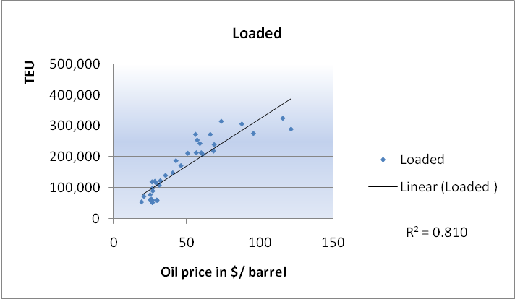
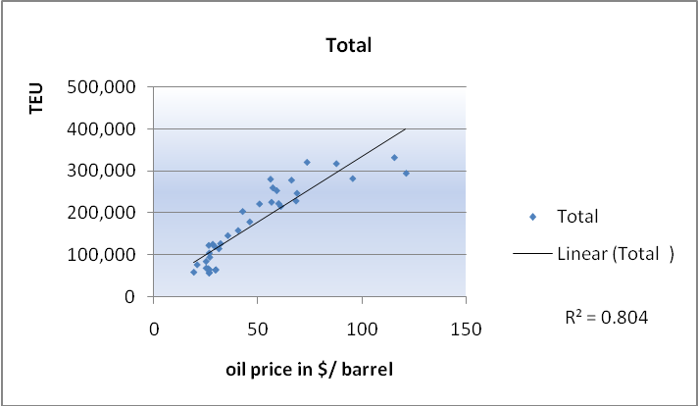
Source: Own elaboration based on Eurostat data (2009)
Scatter diagram 7: $ depreciation against € vs Oil price development
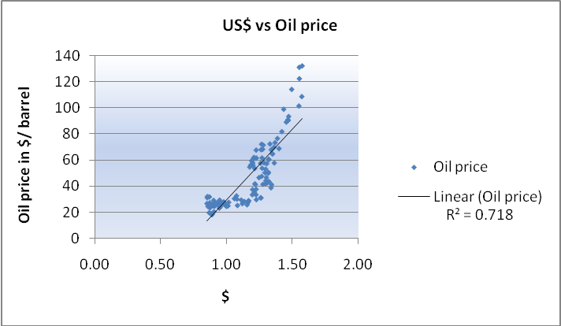
Scatter diagram 8: CNY depreciation against € vs EU imported total goods and manufactured goods from China
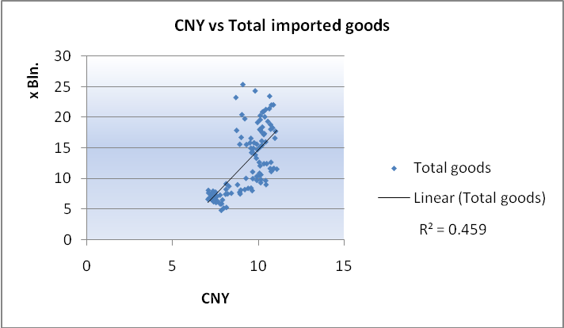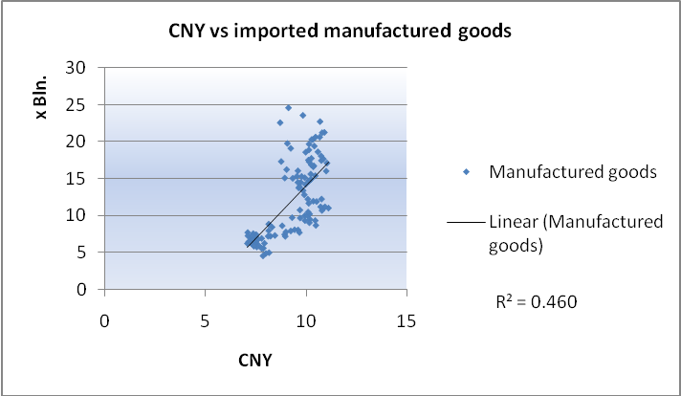
Source: Own elaboration based on Eurostat data (2009)

ERASMUS UNIVERSITY ROTTERDAM
Erasmus School of Economics
Master Urban, Port and Transport Economics
Master Thesis, December 2009

OIL PRICE INFLUENCE ON EU IMPORT, INWARD CONTAINER TRANSPORT AND TRADE BALANCE WITH CHINA

APPENDICES



Name student: Cam Hoan Luu
Exam number: 266930
Supervisor: Mr. M. Nijdam MSc
E-mail address: camhoanluu@hotmail.com

Table of contents
Appendix: Figures Error! Bookmark not defined.
Figure 2.2: 18 year monthly chart comparing US $ to West Texas Intermediate Crude Error! Bookmark not defined.
Figure 3.1: The Global Factory – Globally distributed operations Error! Bookmark not defined.
Figure 3.2 : Change in GDP due to rising oil prices with $10 by countries Error! Bookmark not defined.
Figure 3.3: International oil price – Real GDP elasticity (x40) Error! Bookmark not defined.
Figure 3.4: Fuel costs and container freight rates Error! Bookmark not defined.
Figure 3.5: The Northern Sea Route versus the Royal Route Error! Bookmark not defined.
Figure 3.6: Daily fuel consumption for four types of container ships at different service speeds Error! Bookmark not defined.
Figure 3.7: Total liner service costs as a function of the bunker price Error! Bookmark not defined.
Figure 3.8: Total costs per TEU transported as a function of the bunker price Error! Bookmark not defined.
Figure 3.9: Chinese manufactured export in US$ Bln. and real price of oil in US$ Error! Bookmark not defined.
Figure 3.10: Oil intensities on 2003 Error! Bookmark not defined.
Figure 4.1: Export % in world trade of goods Error! Bookmark not defined.
Figure 4.2: Import % in world trade of goods Error! Bookmark not defined.
Figure 4.3: EU main trading partners export % Error! Bookmark not defined.
Figure 4.4: EU main trading partners import % Error! Bookmark not defined.
Figure 4.6: EU Trade Balance with China and the US Error! Bookmark not defined.
Figure 4.7: Manufactured goods % of EU total goods in export and import Error! Bookmark not defined.
Figure 4.8: Total EU-extra export by product (SITC) 2008 Error! Bookmark not defined.
Figure 4.9: Total EU-extra import by product (SITC) 2008 Error! Bookmark not defined.
Figure 4.10: EU trade in Energy goods SITC 3 and Petroleum goods SITC 33 Error! Bookmark not defined.
Figure 4.11: Oil price vs Energy goods and Petroleum goods Index (2000 = 100) Error! Bookmark not defined.
Figure 4.12: EU total export to China by product (SITC) in 2008 Error! Bookmark not defined.
Figure 4.13: Total EU Import from China by product (SITC) 2008 Error! Bookmark not defined.
Figure 4.15: Manufactured goods % of EU-China trade Error! Bookmark not defined.
Figure 4.16 : EU trade with China in ‘Chemicals’ (Bln. €) Error! Bookmark not defined.
Figure 4.17: EU average exported manufactured goods % to China (2000-2008) Error! Bookmark not defined.
Figure 4.18 : EU trade with China in ‘Machinery and vehicles’ (x Bln €) Error! Bookmark not defined.
Figure 4.19 : EU trade in ‘Other manufactured goods’ with China (x Bln €) Error! Bookmark not defined.
Figure 4.20: EU FDI flows and stocks in China (x Bln. €) Error! Bookmark not defined.
Figure 4.21: EU realized FDI in China in value (x Bln. $) Error! Bookmark not defined.
Figure 4.22: EU and total FIE percentages of China export (x Bln. $) Error! Bookmark not defined.
Figure 4.23: EU import shares from main Asian countries and US in EU-extra import Error! Bookmark not defined.
Figure 4.24: Main FIE shares in China’s export Error! Bookmark not defined.
Figure 4.25: Firms reporting positive impact and balance of positive - negative impact Error! Bookmark not defined.
Figure 4.26: Motivation factors for international sourcing % in total number Error! Bookmark not defined.
Figure 5.1: International Seaborne transport of goods 2007 Error! Bookmark not defined.
Figure 5.2: % of gross weight of seaborne goods handled by type of cargo in main ports in 2007 Error! Bookmark not defined.
Figure 5.3: EU-China trade in ‘total goods’ in value by sea (NSTR) (x Bln €) Error! Bookmark not defined.
Figure 5.4: China percentage of EU-extra trade in ‘total goods’ value (€) by sea Error! Bookmark not defined.
Figure 5.5: EU-China trade in ‘total goods’ in quantity by sea (x Mln. tons) Error! Bookmark not defined.
Figure 5.6: China percentage of EU-extra trade in ‘total goods’ in quantity (tons) by sea Error! Bookmark not defined.
Figure 5.7: Value of ‘total goods’ between EU-China in € per ton Error! Bookmark not defined.
Figure 5.8: Value per ton of ‘total goods’ between EU-China (Index=year 2000) Error! Bookmark not defined.
Figure 5.9: EU-China trade in ‘manufactured goods’ classified by NSTR in value by sea (x Bln.€) Error! Bookmark not defined.
Figure 5.10: China percentage of EU-extra trade in ‘manufactured goods’ value (€) by sea Error! Bookmark not defined.
Figure 5.11: EU-China trade in ‘manufactured goods’ in quantity by sea (x Mln. tons) (NSTR) Error! Bookmark not defined.
Figure 5.12: China percentage of EU-extra trade in ‘manufactured’ goods quantity (tons) by sea Error! Bookmark not defined.
Figure 5.13: Value of ‘manufactured goods’ between EU-China in € per ton Error! Bookmark not defined.
Figure 5.14: Value per ton of ‘manufactured goods’ between EU-China (Index=year 2000) Error! Bookmark not defined.
Figure 5.15: EU export value per ton for ‘manufactured goods’ and ‘total goods’ Error! Bookmark not defined.
Figure 5.16: EU import value per ton for ‘manufactured goods’ and ‘total goods’ Error! Bookmark not defined.
Figure 5.17: International containerized trade growth, 1986-2008 (x Mln. tons) Error! Bookmark not defined.
Figure 5.18: International container port traffic 1980-2007 Error! Bookmark not defined.
Figure 5.19: Major maritime trade routes: container traffic, 2007 (Mln. of TEUs) Error! Bookmark not defined.
Figure 5.20: Containerized trade versus container carrying fleet growth percentage Error! Bookmark not defined.
Figure 5.21: Estimated cargo flows on major trade routes (x Mln. TEU) Error! Bookmark not defined.
Figure 5.22: EU-China empty and total transported containers(x1.000 TEU) main ports, quarter Error! Bookmark not defined.
Figure 5.23: EU-China empty containers % of total containers transport in main ports, quarter Error! Bookmark not defined.
Figure 5.24: China % of EU total empty and total container transport in main ports, quarterly Error! Bookmark not defined.
Figure 5.25 : China Ports Growing % of World Port Moves, 1995-2008 Error! Bookmark not defined.
Figure 5.26: Total EU and China ports in top 20 world container ports (2003-2008) Error! Bookmark not defined.
Figure 5.27: Total EU and China ports percentage in top 20 world container ports Error! Bookmark not defined.
Figure 5.28: Difference in imported goods growth in NSTR and SITC versus inward container Error! Bookmark not defined.
Figure 5.29: Freight rates to and from Asia (2004-2007) Error! Bookmark not defined.
Figure 5.30: Freight rates (market averages) in $ per TEU on the three major liner trade routes Error! Bookmark not defined.
Figure 5.31: Development in goods transhipment in the port of Rotterdam (weight) Error! Bookmark not defined.
Figure 5.32: Development of container transhipment in the port of Rotterdam Error! Bookmark not defined.
Figure 5.33: Rotterdam's main competitors in the transhipment of goods Error! Bookmark not defined.
Figure 5.34: Yearly transport between Port of Rotterdam and China in ‘containers unit’ (x1000) Error! Bookmark not defined.
Figure 5.35: Total number of transported containers between Rotterdam and China, per year Error! Bookmark not defined.
Figure 5.36: Yearly container transport between Rotterdam and China in TEU (x 1.000) Error! Bookmark not defined.
Figure 5.37: Empty container % of total transported containers between Rotterdam and China Error! Bookmark not defined.
Figure 6.1: EU-Asia and Asia-EU freight rate (2006 = 100) Error! Bookmark not defined.
Figure 6.3: EU total goods and manufactured goods import in quantity (2000 = 100) Error! Bookmark not defined.
Figure 6.4: EU total goods and manufactured goods import in value (2007 = 100) Error! Bookmark not defined.
Figure 6.5: EU total goods and manufactured goods import in quantity (2007 = 100) Error! Bookmark not defined.
Figure 6.6: EU total goods and manufactured goods import in value (2008 July = 100) Error! Bookmark not defined.
Figure 6.7: EU total goods and manufactured goods import in quantity (2008 July = 100) Error! Bookmark not defined.
Figure 6.8: EU imported Chemicals, Machinery and transport and Other man. goods in value Error! Bookmark not defined.
Figure 6.9: EU imported Chemicals, Machinery and transport and Other man. goods in quantity Error! Bookmark not defined.
Figure 6.10: EU imported manufactured goods in value (2007 = 100) Error! Bookmark not defined.
Figure 6.11: EU imported manufactured goods in quantity (2007 = 100) Error! Bookmark not defined.
Figure 6.12: EU imported manufactured goods in value (2008 July = 100) Error! Bookmark not defined.
Figure 6.13: EU imported manufactured goods in quantity (2008 July = 100) Error! Bookmark not defined.
Figure 6.14: EU imported manufactured goods divided in specific groups (2000 = 100) Error! Bookmark not defined.
Figure 6.15: EU imported manufactured goods divided in specific groups (2000 = 100) Error! Bookmark not defined.
Figure 6.16: EU imported manufactured goods (2007 = 100) Error! Bookmark not defined.
Figure 6.17: EU imported manufactured goods (2007 = 100) Error! Bookmark not defined.
Figure 6.18: EU imported manufactured goods (2008 July = 100) Error! Bookmark not defined.
Figure 6.19: EU imported manufactured goods (2008 July = 100) Error! Bookmark not defined.
Figure 6.20: EU imported manufactured goods divided in detailed groups (2000 = 100) Error! Bookmark not defined.
Figure 6.21: EU imported manufactured goods (2000 = 100) Error! Bookmark not defined.
Figure 6.22: EU imported manufactured goods (2007 = 100) Error! Bookmark not defined.
Figure 6.23: EU imported manufactured goods (2007 = 100) Error! Bookmark not defined.
Figure 6.24: EU imported manufactured goods (2008 July = 100) Error! Bookmark not defined.
Figure 6.25: EU imported manufactured goods (2008 July = 100) Error! Bookmark not defined.
Figure 6.26: EU inward container transport from China in TEU (2005 = 100) Error! Bookmark not defined.
Figure 6.28: Port of Rotterdam inward container transport in ‘Container unit’ (2007 = 100) Error! Bookmark not defined.
Figure 6.29: Port of Rotterdam inward container transport in ‘TEU’ (2000 = 100) Error! Bookmark not defined.
Figure 6.30: Port of Rotterdam inward container transport in TEU (2007 = 100) Error! Bookmark not defined.
Figure 6.31: EU vs POR inward container transport (2005 = 100) Error! Bookmark not defined.
Figure 6.32: Oil price vs Exchange rates and EU imported goods (2000 = 100) Error! Bookmark not defined.
Figure 6.33: Oil price vs Exchange rates and EU imported goods (2007 = 100) Error! Bookmark not defined.

Appendix: Tables Error! Bookmark not defined.
Table 1.1: Average monthly oil price in $ (2000-2009) Error! Bookmark not defined.
Table 3.2: Growth of Exports 1995-2001 by merchandise class Error! Bookmark not defined.
Table 3.3: Multimodal alternatives between Shanghai and Hamburg port/Frankfurt airport Error! Bookmark not defined.
Table 3.4: Breakdown of the cellular containership fleet for selected dates Error! Bookmark not defined.
Table 3.5: Key indicators of the Far East–North Europe container trade Error! Bookmark not defined.
Table 3.6: Cost comparison for different vessel sizes, bunker costs and vessel speed-cost Error! Bookmark not defined.
Table 4.1: Growth in the volume of world merchandise exports and production, 2000-2007 Error! Bookmark not defined.
Table 4.2: World, EU and China GDP and merchandise trade growth in annual % change Error! Bookmark not defined.
Table 4.3: Export percentage of world trade in goods Error! Bookmark not defined.
Table 4.4: Import percentage of world trade in goods Error! Bookmark not defined.
Table 4.5: EU-extra trade in goods by main partners (x Bln. €) Error! Bookmark not defined.
Table 4.6: EU trade in total goods with the US and China (x Bln. €) Error! Bookmark not defined.
Table 4.7: Manufactured goods as share of total EU-extra export trade (x Bln. €) Error! Bookmark not defined.
Table 4.8: Manufactured goods as share of total EU-extra import trade (x Bln. €) Error! Bookmark not defined.
Table 4.9: EU-extra trade in ‘energy goods’ and index (2000 = 100) Error! Bookmark not defined.
Table 4.10: EU-extra trade in ‘petroleum goods’ and index (2000 = 100) Error! Bookmark not defined.
Table 4.11: EU ‘total manufactured goods’ trade with China in € Error! Bookmark not defined.
Table 4.12: Manufactured goods as EU export share to China (x Bln. €) Error! Bookmark not defined.
Table 4.13: Manufactured goods as EU import share from China (x Bln. €) Error! Bookmark not defined.
Table 4.14: Product group exported percentage in manufactured goods and total trade Error! Bookmark not defined.
Table 4.15: Product group imported percentage in total manufactured goods and total trade Error! Bookmark not defined.
Table 4.16: EU-China trade in ‘Chemicals’ with China in € Error! Bookmark not defined.
Table 4.17: EU-China trade in ‘Machinery and transport’ with China in € Error! Bookmark not defined.
Table 4.18: EU-China trade in ‘Other manufactured goods’ with China in € Error! Bookmark not defined.
Table 4.19: EU FDI flows with China (x Mln. €) Error! Bookmark not defined.
Table 4.20: EU FDI flow in China manufacturing activities 2005-2006 (x Mln. €) Error! Bookmark not defined.
Table 4.21: EU investment in China in US $ Error! Bookmark not defined.
Table 4.22: EU and total FIE share of China Exports (x Bln. $) Error! Bookmark not defined.
Table 4.23: EU importers (x Bln. €) and China’s export FIE participation (x Bln. $) Error! Bookmark not defined.
Table 4.24: EU importers EU-extra % and China’s export % of FIE Error! Bookmark not defined.
Table 4.25: Asian countries export to China Error! Bookmark not defined.
Table 4.26: EU enterprises with international sourcing by Intra-EU27 and China Error! Bookmark not defined.
Table 4.27: EU enterprises without international sourcing but plan to do it by sectors Error! Bookmark not defined.
Table 4.28: EU enterprises without international sourcing but plan to do it by function Error! Bookmark not defined.
Table 5.1: Maritime transport EU 27- extra with China by gross weight of goods handled Error! Bookmark not defined.
Table 5.2: EU27-extra maritime transport trades with China * by gross weight of goods handled Error! Bookmark not defined.
Table 5.3: EU-China trade in ‘total goods’ in value (€) by sea (NSTR) and percentage Error! Bookmark not defined.
Table 5.4: EU-China trade in ‘total goods’ in quantity (tons) by sea and percentage Error! Bookmark not defined.
Table 5.5: Value per ton of ‘total goods’ between EU-China and index year 2000 = 100 Error! Bookmark not defined.
Table 5.6: EU-China trade in ‘manufactured goods’ in value (x Bln. €) by sea and percentages Error! Bookmark not defined.
Table 5.7: EU-China trade in ‘manufactured goods’ in quantity(x Mln. tons) by sea Error! Bookmark not defined.
Table 5.8: Value per ton of ‘manufactured goods’ and ‘total goods’ between EU-China Error! Bookmark not defined.
Table 5.9: Average value €/ton in EU-China trade by index 2000 = 100 Error! Bookmark not defined.
Table 5.10: EU Gross weight of goods handled in main ports by large freight containers Error! Bookmark not defined.
Table 5.11: EU Gross weight of goods transported to/from main ports by containers Error! Bookmark not defined.
Table 5.12: EU number and gross tonnage (x1.000) of container vessels year-on-year growth rate Error! Bookmark not defined.
Table 5.13: EU volume (in TEU) of containers handled in main ports by loading status Error! Bookmark not defined.
Table 5.14: Long-term trends in cellular containership fleet* Error! Bookmark not defined.
Table 5.15: Growth of demand and supply in container shipping, 2002-2008* Error! Bookmark not defined.
Table 5.16: Estimated cargo flows on major trade routes Error! Bookmark not defined.
Table 5.17: EU-China empty and total transported containers (TEU), quarterly Error! Bookmark not defined.
Table 5.18: EU-China empty and total transported containers (TEU), annually Error! Bookmark not defined.
Table 5.19: China % of EU total empty and total container transport in main ports, quarterly Error! Bookmark not defined.
Table 5.20: China % of EU total empty and total transported containers (TEU), annually Error! Bookmark not defined.
Table 5.21: Top 20 Container ports (x 1.000 TEUs) and percentage change in 2007 and 2008 Error! Bookmark not defined.
Table 5.22: Total EU and China ports (x 1000 TEU) in top 20 world container ports Error! Bookmark not defined.
Table 5.23: Total EU and China ports percentage in top 20 world container ports Error! Bookmark not defined.
Table 5.24: EU imported Chinese goods vs. inward loaded container transport from China Error! Bookmark not defined.
Table 5.25: Freight rates (market averages) per TEU on the three major liner trade routes Error! Bookmark not defined.
Table 5.26: Yearly container transport between Rotterdam Port and China in ‘Container unit Error! Bookmark not defined.
Table 5.27: Yearly containers transport between Rotterdam Port and China in ‘TEU’ Error! Bookmark not defined.
Table 5.28: Growth percentage and Increase factor in Containers unit and TEU from 2000-2008 Error! Bookmark not defined.
Table 5.29: Port of Rotterdam share of EU total container transport with China (2005-2008 ½) Error! Bookmark not defined.
Table 6.1: Average quarterly oil price and EU-Asia freight rate Error! Bookmark not defined.
Table 6.2: Time serie trend lines of Oil price, Total goods and Manufactured goods Error! Bookmark not defined.
Table 6.3: Time serie trend lines for Chemicals, Machinery and Transport, Other Man. goods Error! Bookmark not defined.
Table 6.4: Time serie trend lines for ‘specific manufactured goods’ Error! Bookmark not defined.
Table 6.5: Time serie trend lines for ‘detailed manufactured goods’ Error! Bookmark not defined.
Table 6.6: Time serie trend line of Port of Rotterdam inward container transport from China Error! Bookmark not defined.

Scatter diagram Error! Bookmark not defined.
Scatter diagram 1: EU imported total and man. goods from China in value and quantity Error! Bookmark not defined.
Scatter diagram 2: EU imported Chemicals, Machinery and transport, and Other man. goods Error! Bookmark not defined.
Scatter diagram 3: EU imported specific manufactured goods in value Error! Bookmark not defined.
Scatter diagram 4: EU imported detailed manufactured goods in value Error! Bookmark not defined.
Scatter diagram 5: EU inward container transport from China in ‘TEU’ Error! Bookmark not defined.
Scatter diagram 6A: Port of Rotterdam inward container transport from China in ‘Container unit’ Error! Bookmark not defined.
Scatter diagram 6B: Port of Rotterdam inward container transport from China in ‘TEU’ Error! Bookmark not defined.
Scatter diagram 7: $ depreciation against € vs Oil price development Error! Bookmark not defined.
Scatter diagram 8: CNY depreciation against € vs EU imported total goods and man. goods Error! Bookmark not defined.

Appendix: Figures

Figure 2.2: 18 year monthly chart comparing US $ to West Texas Intermediate Crude
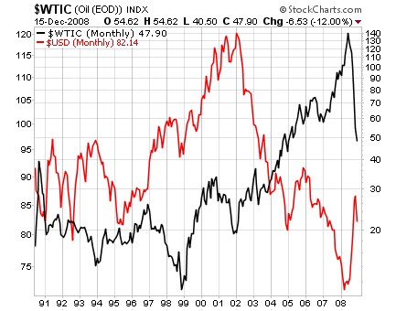
Source: StockCharts.com

Figure 3.1: The Global Factory – Globally distributed operations
Source: Buckley 2008

Figure 3.2 : Change in GDP due to rising oil prices with $10 by countries
Source: Maeda, A (2008)
Note: under the same condition as in the IAE Study with two scenarios

Figure 3.3: International oil price – Real GDP elasticity (x40)
Source: Maeda, A (2008)

Figure 3.4: Fuel costs and container freight rates
US$ per TEU (freight rates) and US$ per ton (bunker prices)
Source: UNCTAD
Figure 3.5: The Northern Sea Route versus the Royal Route
Source: Verny and Grigentin (2009)

Figure 3.6: Daily fuel consumption for four types of container ships at different service speeds
Source: own representation based on AXS-Alphaliner data - Notteboom and Vernimmen (2008)

Figure 3.7: Total liner service costs as a function of the bunker price. Roundtrip of 23.200 nm
and 10 ports of call
Source: Notteboom and Vernimmen (2008)
Figure 3.8: Total costs per TEU transported as a function of the bunker price. Roundtrip of
23.200 nm
Source: Notteboom and Vernimmen (2008)

Figure 3.9: Chinese manufactured export in US$ Bln. and real price of oil in US$
Export manufactured exports
Real price of oil in US$
Source: Faria et al (2009)

Figure 3.10: Oil intensities on 2003 (oil supply in tonnes of oil equivalent/GDP in dollars, using
two alternative exchange rates).
Source: International Energy Agency - (Bénassy-Quéré et al. 2007)
Figure 4.1: Export % in world trade of goods
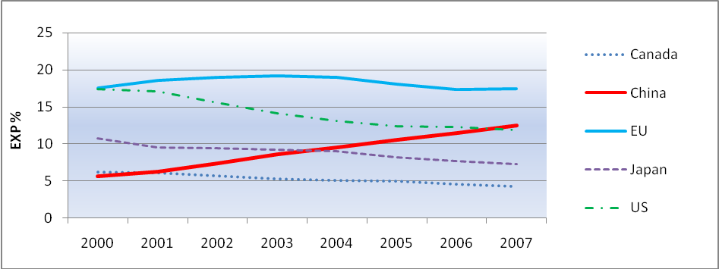
Source: Own elaboration based on Eurostat data (2009)

Figure 4.2: Import % in world trade of goods
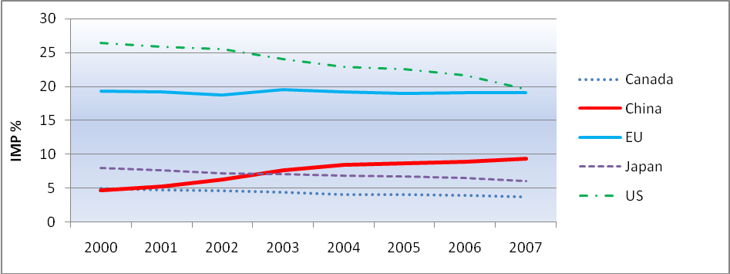
Source: Own elaboration based on Eurostat data (2009)

Figure 4.3: EU main trading partners export %
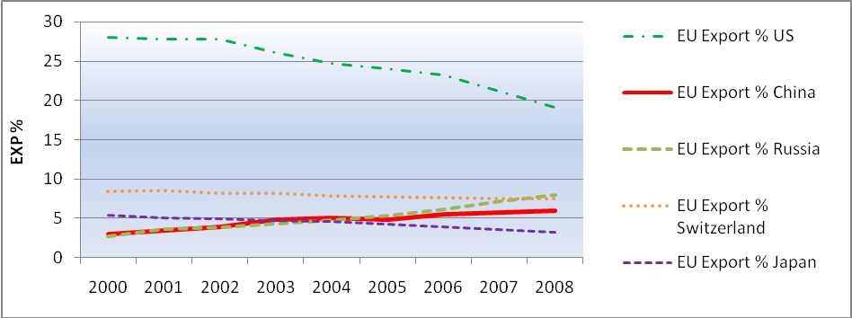
Source: Own elaboration based on Eurostat data (2009)
Figure 4.4: EU main trading partners import %
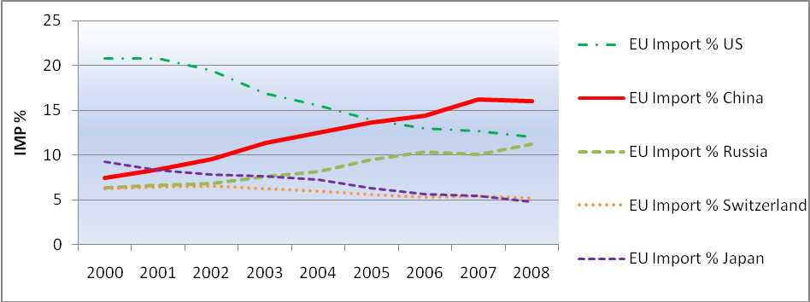
Source: Own elaboration based on Eurostat data (2009)

Figure 4.6: EU Trade Balance with China and the US
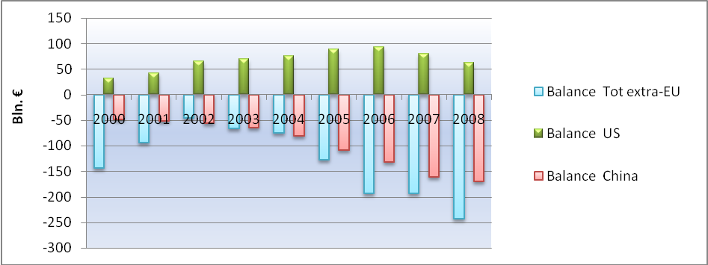
Source: Own elaboration based on Eurostat data (2009)

Figure 4.7: Manufactured goods % of EU total goods in export and import
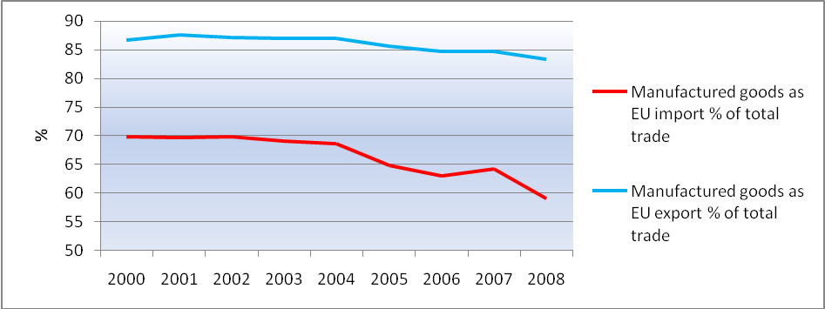
Source: Own elaboration based on Eurostat data (2009)
Figure 4.8: Total EU-extra export by product (SITC) 2008
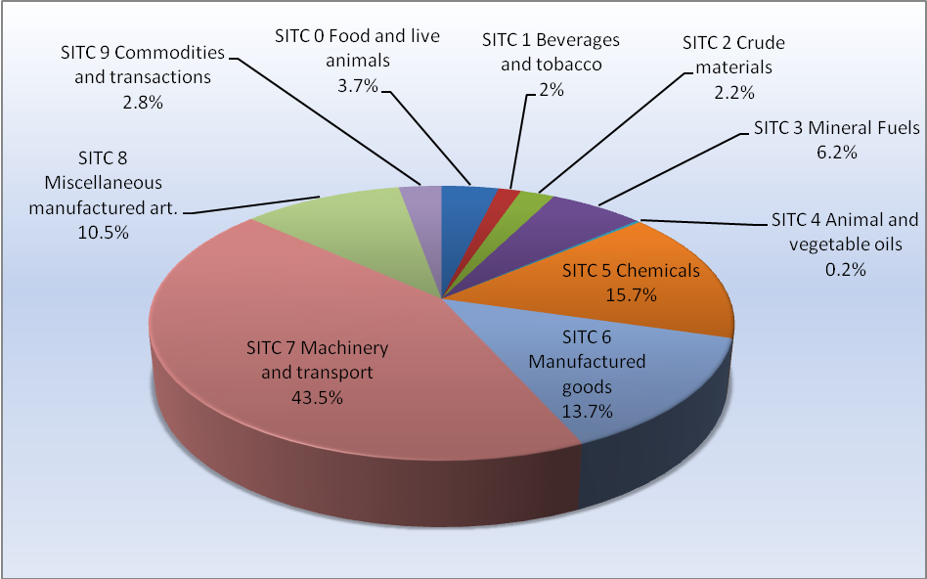
Source: Own elaboration based on Eurostat data (2009)

Figure 4.9: Total EU-extra import by product (SITC) 2008
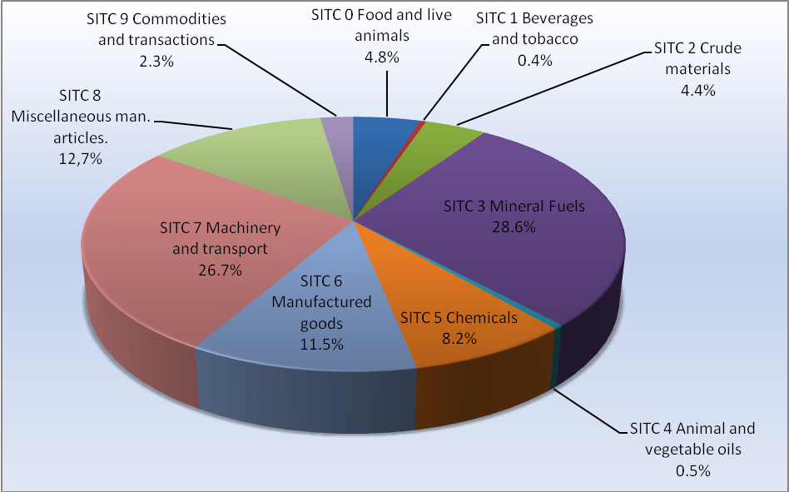
Source: Own elaboration based on Eurostat data (2009)
Figure 4.10: EU trade in Energy goods SITC 3 and Petroleum goods SITC 33
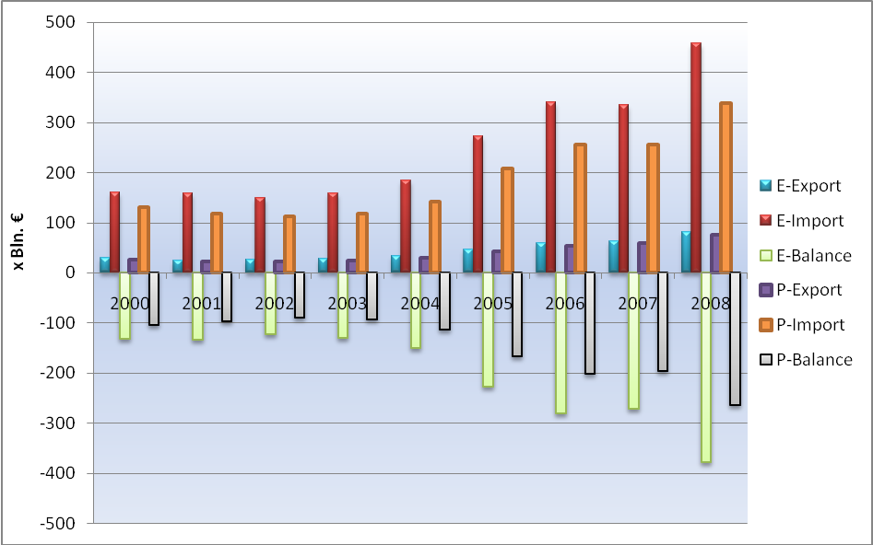
Source: Own elaboration based on Eurostat data (2009)

Figure 4.11: Oil price vs Energy goods and Petroleum goods Index (2000 = 100)
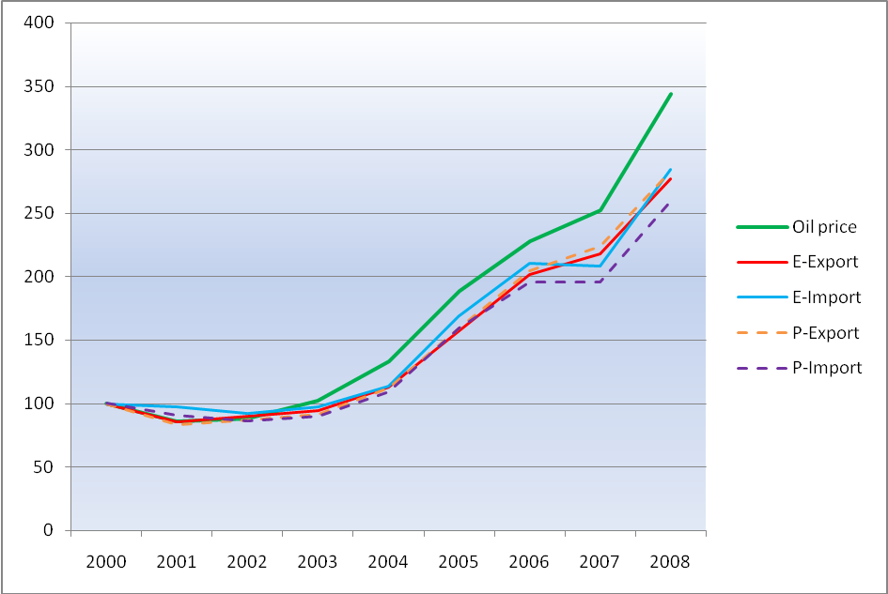
Source: Own elaboration based on Eurostat data (2009)
Figure 4.12: EU total export to China by product (SITC) in 2008
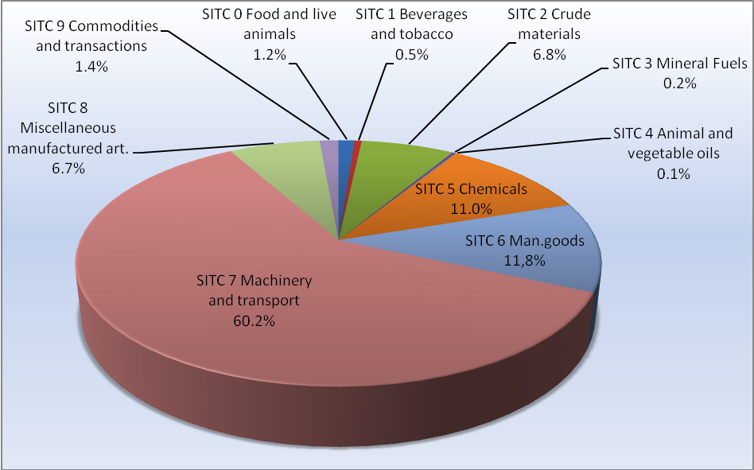
Source: Own elaboration based on Eurostat data (2009)

Figure 4.13: Total EU Import from China by product (SITC) 2008
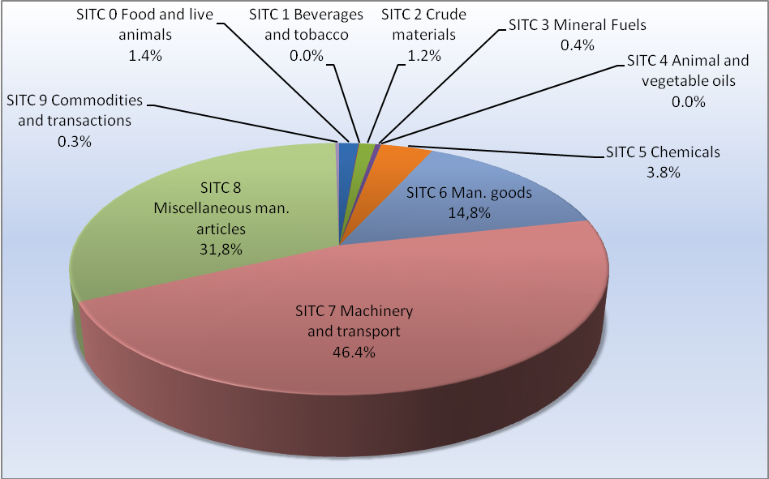
Source: Own elaboration based on Eurostat data (2009)
Figure 4.15: Manufactured goods % of EU-China trade
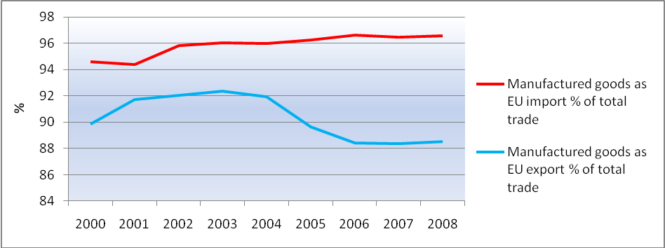
Source: Own elaboration based on Eurostat data (2009)

Figure 4.16 : EU trade with China in ‘Chemicals’ (Bln. €)
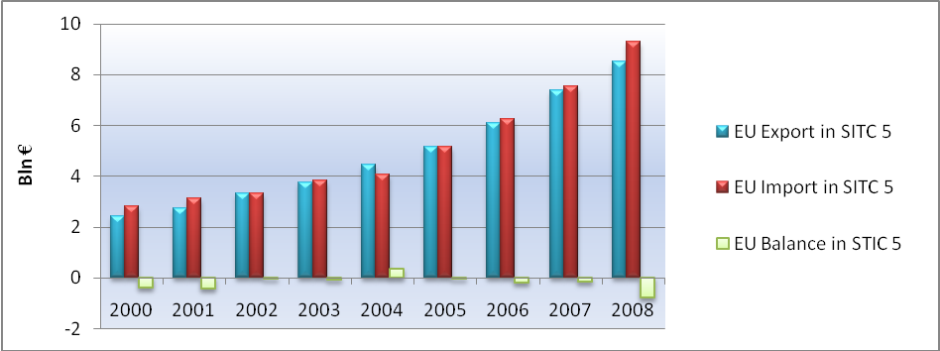
Source: Own elaboration based on Eurostat data (2009)

Figure 4.17A: EU average exported manufactured goods % to China (2000-2008)
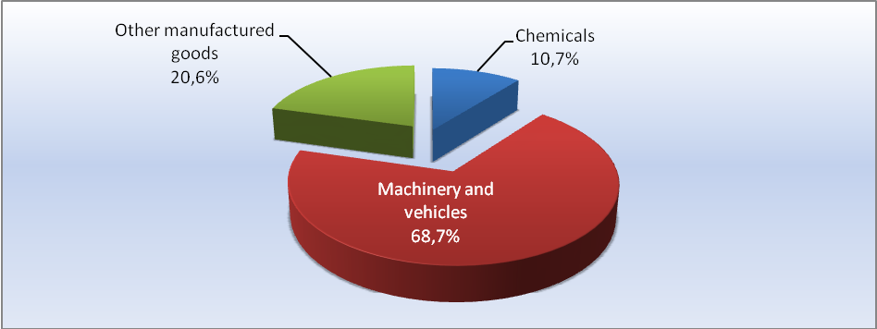
Source: Own elaboration based on Eurostat data (2009)
Figure 4.17B: EU average exported total goods % with China (2000-2008)
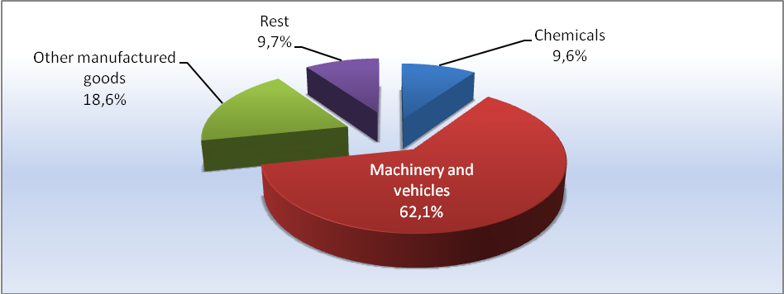
Source: Own elaboration based on Eurostat data (2009)

Figure 4.17C: EU average imported manufactured goods % from China (2000-2008)
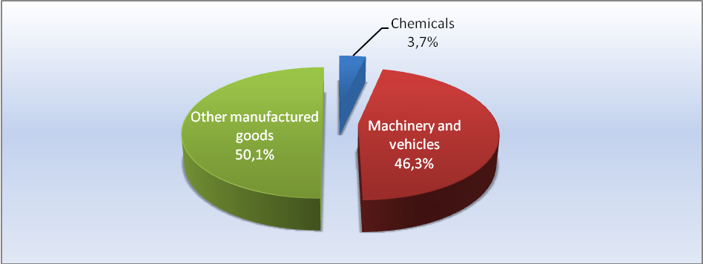
Source: Own elaboration based on Eurostat data (2009)

Figure 4.17D: EU average imported total goods % from China (2000-2008)
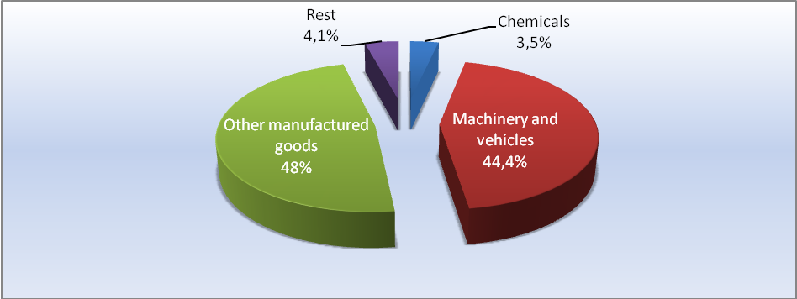
Source: Own elaboration based on Eurostat data (2009)
Figure 4.18 : EU trade with China in ‘Machinery and vehicles’ (x Bln €)
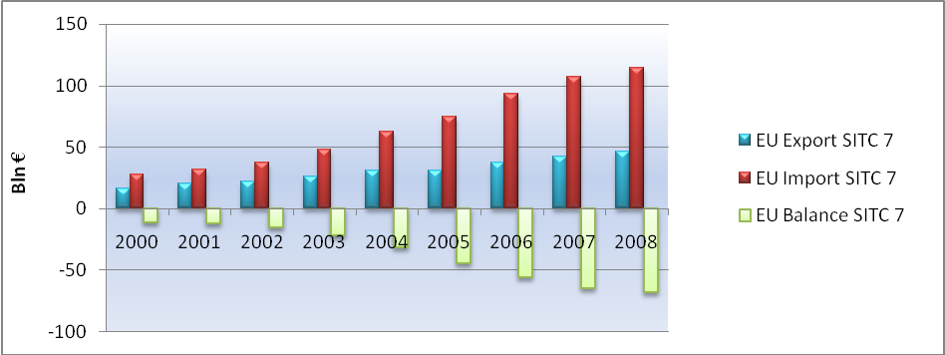
Source: Own elaboration based on Eurostat data (2009)

Figure 4.19 : EU trade in ‘Other manufactured goods’ with China (x Bln €)
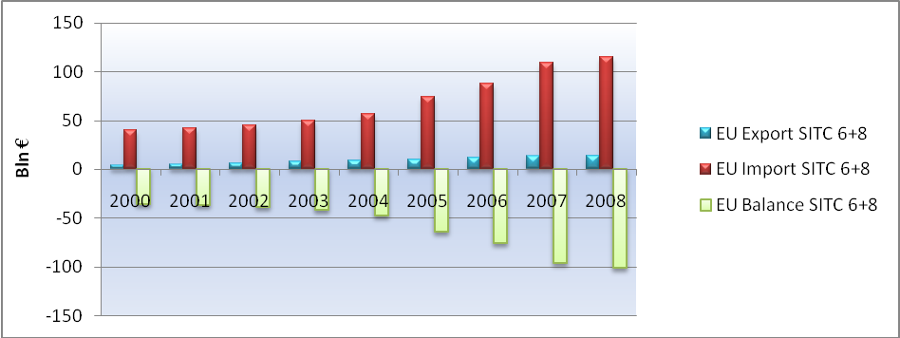
Source: Own elaboration based on Eurostat data (2009)

Figure 4.20: EU FDI flows and stocks in China (x Bln. €)
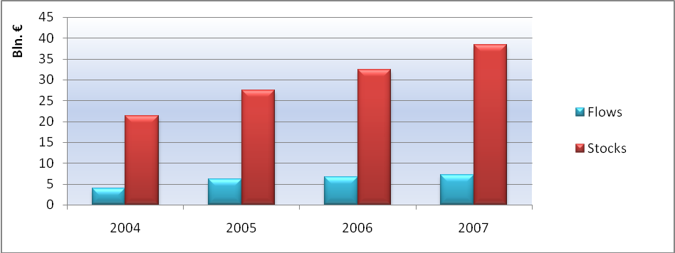
Source : Own elaboration based on Eurostat data (2009)
Figure 4.21: EU realized FDI in China in value (x Bln. $)
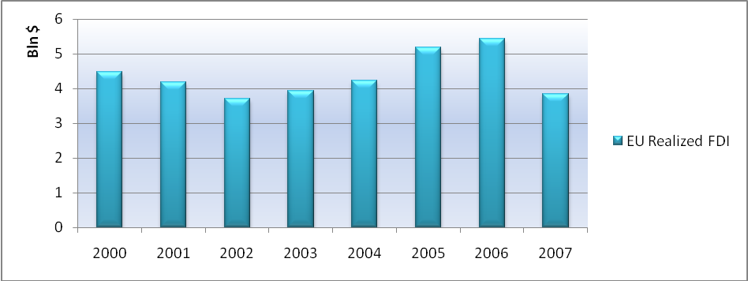
Source: Own elaboration based on MOFCOM FDI statistics data (2009)

Figure 4.22: EU and total FIE percentages of China export (x Bln. $)
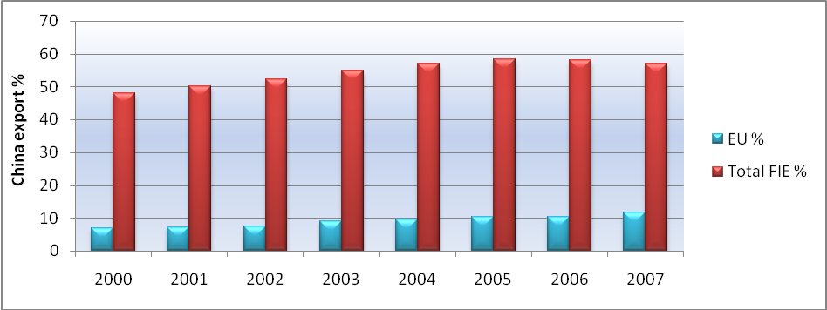
Source: Own elaboration based on www.fdi.gvn.cn data (2009)

Figure 4.23: EU import shares from main Asian countries and US in EU-extra import
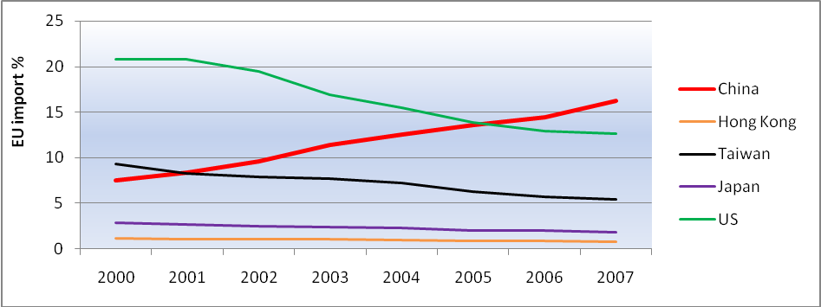
Source: Own elaboration based on Eurostat data (2009)
Figure 4.24: Main FIE shares in China’s export
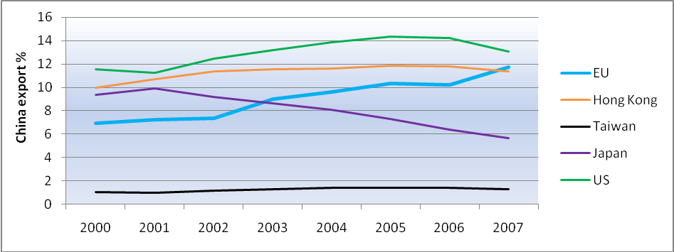
Source: Own elaboration based on www.fdi.gvn.cn data (2009)

Figure 4.25: Firms reporting positive impact and balance of positive - negative impact by
motivation factor. Share in total nr. of firms engaged in international sourcing (%)
Source: Eurostat (iss_imp) - Statistics in Focus 73/2009

Figure 4.26: Motivation factors for international sourcing % in total number of frims with plans
for international sourcing that considered motivation factors to very important (%)
Source: Eurostat (iss_plan, iss_econ) – Statistics in Focus 74/2009
Figure 5.1: International Seaborne transport of goods 2007
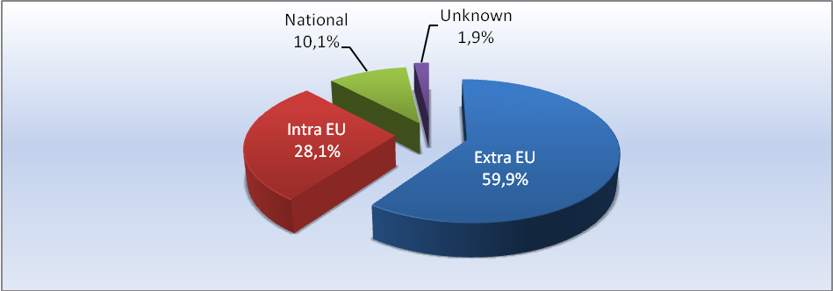
Source: Own elaboration based on Eurostat data (2009)
* Data based on the total of goods transported by ‘main’ ports

Figure 5.2: % of gross weight of seaborne goods handled by type of cargo in main ports in 2007
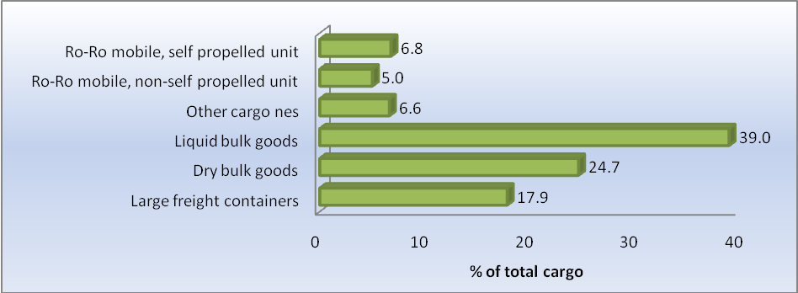
Source: Own elaboration based on Eurostat data (2009)

Figure 5.3: EU-China trade in ‘total goods’ in value by sea (NSTR) (x Bln €)
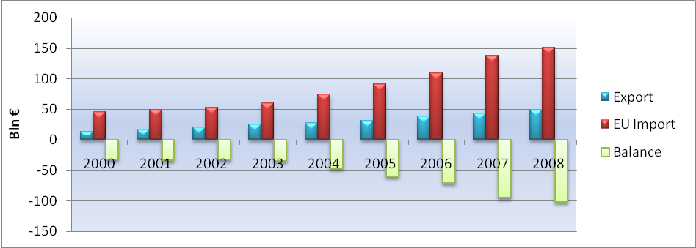
Source: Own elaboration based on Eurostat data (2009)
Figure 5.4: China percentage of EU-extra trade in ‘total goods’ value (€) by sea
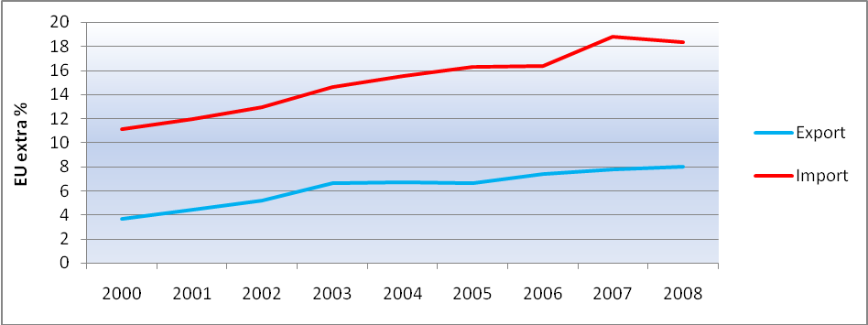
Source: Own elaboration based on Eurostat data (2009)

Figure 5.5: EU-China trade in ‘total goods’ in quantity by sea (x Mln. tons)
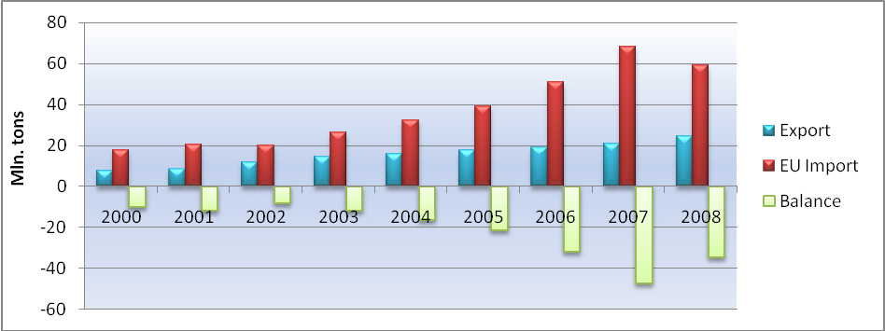
Source: Own elaboration based on Eurostat data (2009)

Figure 5.6: China percentage of EU-extra trade in ‘total goods’ in quantity (tons) by sea
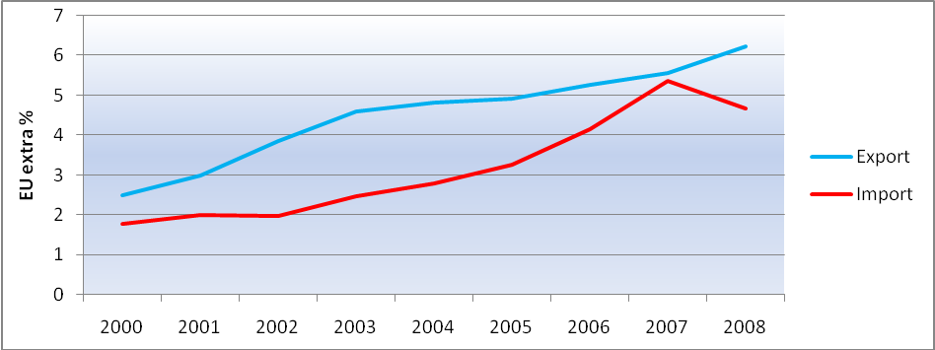
Source: Own elaboration based on Eurostat data (2009)
Figure 5.7: Value of ‘total goods’ between EU-China in € per ton
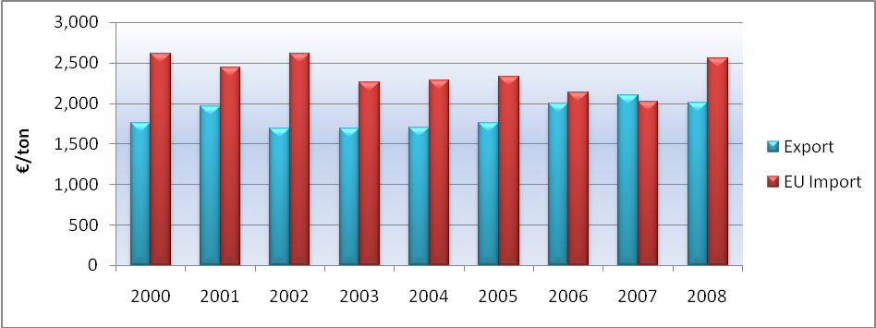
Source: Own elaboration based on Eurostat data (2009)

Figure 5.8: Value per ton of ‘total goods’ between EU-China (Index=year 2000)
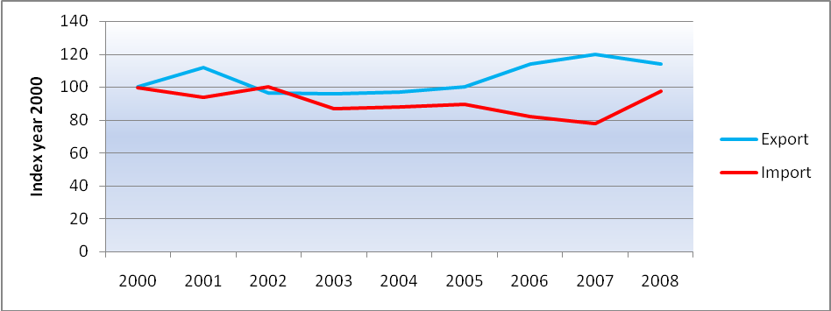
Source: Own elaboration based on Eurostat data (2009)

Figure 5.9: EU-China trade in ‘manufactured goods’ classified by NSTR in value by sea (x Bln.€)
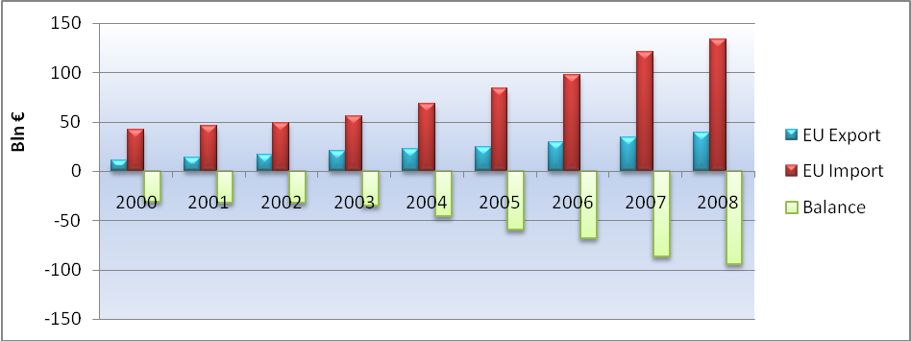
Source: Own elaboration based on Eurostat data (2009)
Figure 5.10: China percentage of EU-extra trade in ‘manufactured goods’ value (€) by sea
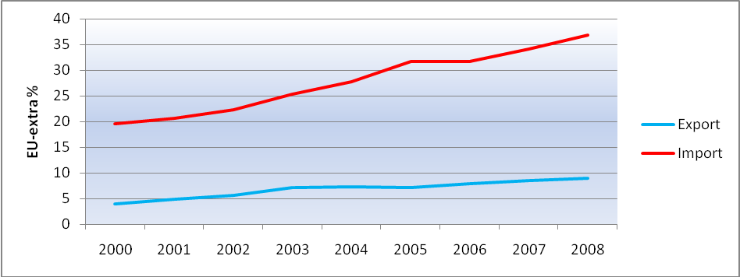
Source: Own elaboration based on Eurostat data (2009)

Figure 5.11: EU-China trade in ‘manufactured goods’ in quantity by sea (x Mln. tons) (NSTR)
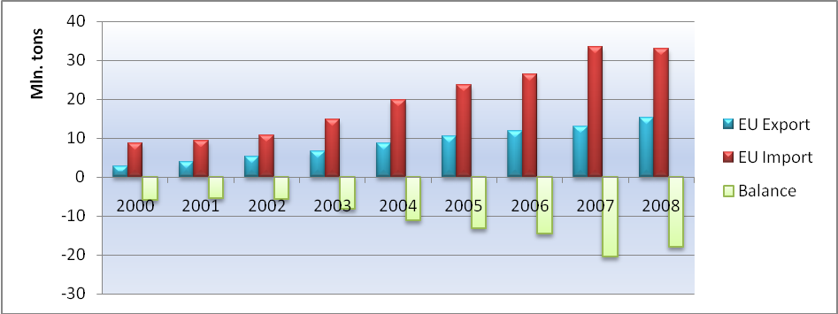
Source: Own elaboration based on Eurostat data (2009)

Figure 5.12: China percentage of EU-extra trade in ‘manufactured’ goods quantity (tons) by sea
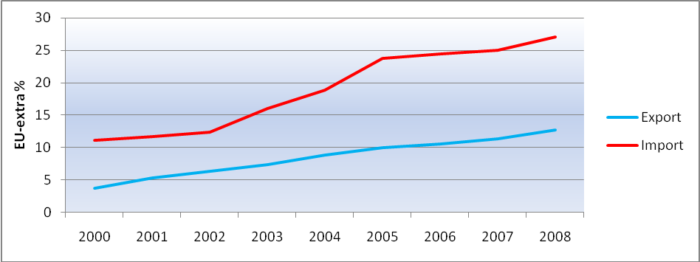
Source: Own elaboration based on Eurostat data (2009)
Figure 5.13: Value of ‘manufactured goods’ between EU-China in € per ton
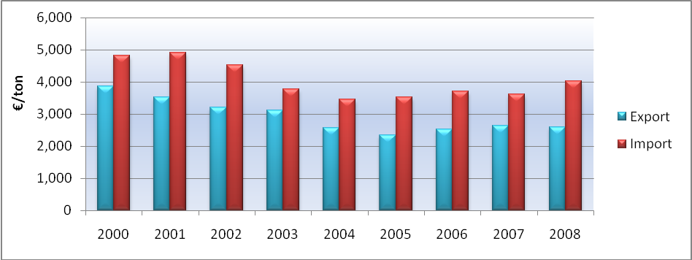
Source: Own elaboration based on Eurostat data (2009)

Figure 5.14: Value per ton of ‘manufactured goods’ between EU-China (Index=year 2000)
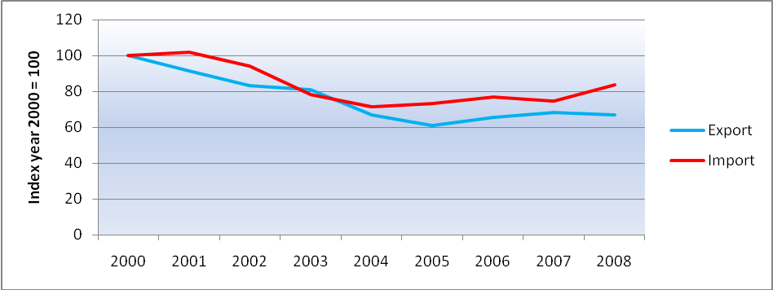
Source: Own elaboration based on Eurostat data (2009)

Figure 5.15: EU export value per ton for ‘manufactured goods’ and ‘total goods’
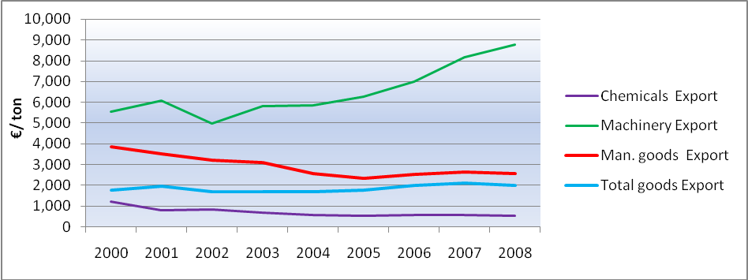
Source: Own elaboration based on Eurostat data (2009)
Figure 5.16: EU import value per ton for ‘manufactured goods’ and ‘total goods’
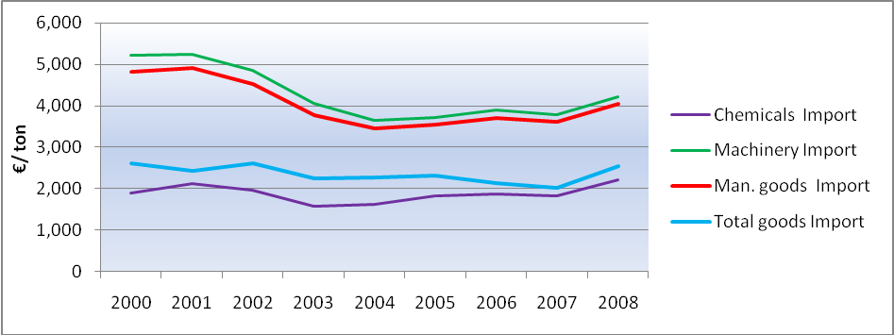
Source: Own elaboration based on Eurostat data (2009)

Figure 5.17: International containerized trade growth, 1986-2008 (x Mln. tons)
Source: Clarkson Research Services, Shipping Review Database, Spring 2008: 101

Figure 5.18: International container port traffic 1980-2007
Source: UNCTAD based on data provided by Drewry Shipping Consultants in the Drewry Annual Container Market Review and Forecast 2006/2007, September 2006
Figure 5.19: Major maritime trade routes: container traffic, 2007 (Mln. of TEUs)
Source: UNCTAD secretariat

Figure 5.20: Containerized trade versus container carrying fleet growth percentage
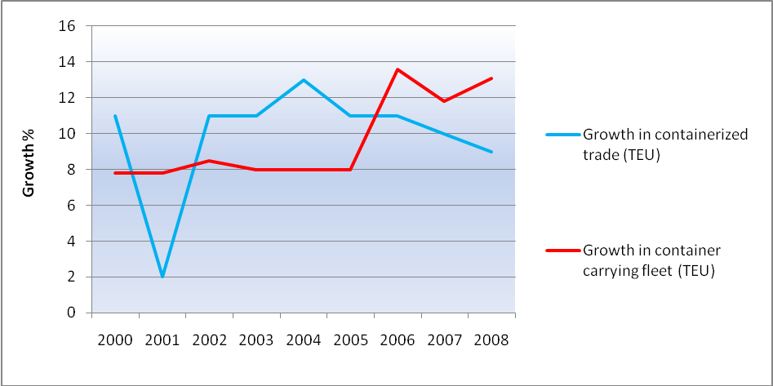
Source: Own elaboration based on Compiled by the UNCTAD secretariat on the basis of data from Clarkson
Container Intelligence Monthly, various issues data (2009)
Figure 5.21: Estimated cargo flows on major trade routes (x Mln. TEU)
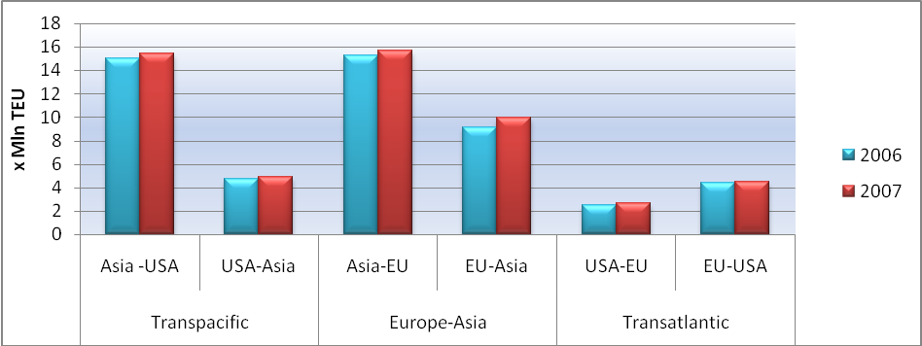
Source: Own elaboration based on Compiled by UNCTAD secretariat from Containerisation International data (2009)

Figure 5.22: EU-China empty and total transported containers(x1.000 TEU) main ports, quarter
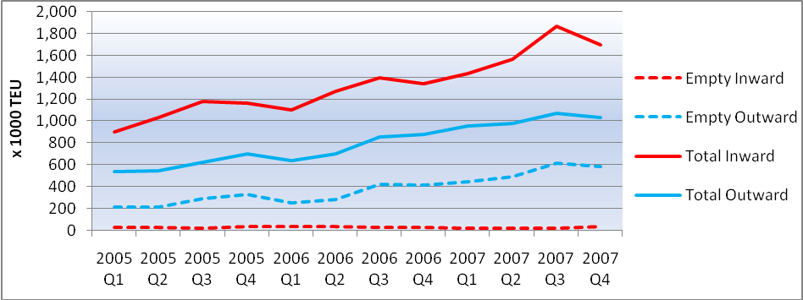
Source: Own elaboration based on Eurostat data (2009)

Figure 5.23: EU-China empty containers % of total containers transport in main ports, quarter
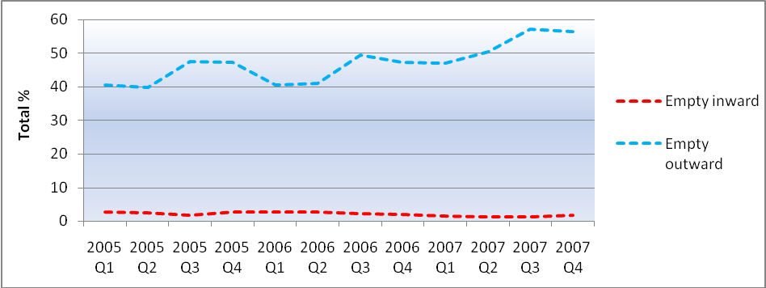
Source: Own elaboration based on Eurostat data (2009)
Figure 5.24: China % of EU total empty and total container transport in main ports, quarterly
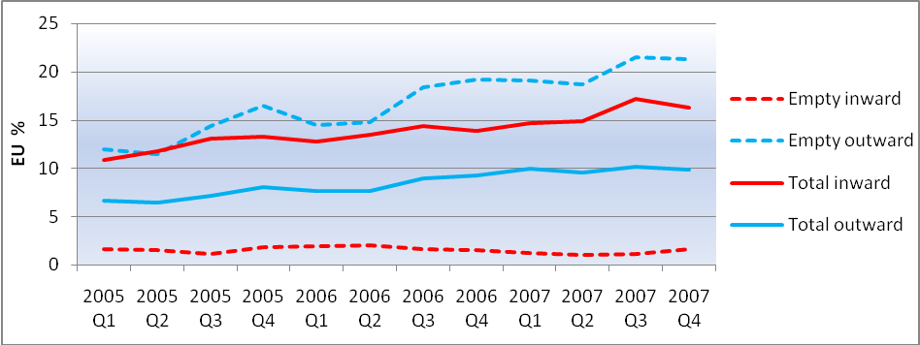
Source: Own elaboration based on Eurostat data (2009)

Figure 5.25 : China Ports Growing % of World Port Moves, 1995-2008
Source: Transport trackers (2009)

Figure 5.26: Total EU and China ports in top 20 world container ports (2003-2008)
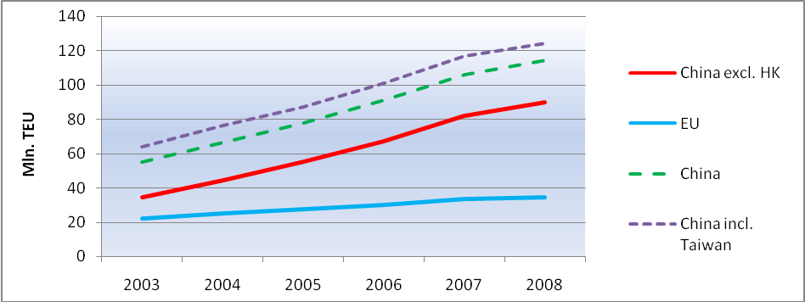
Source: Own elaboration based on Other Port Authorities data (2009)
Figure 5.27: Total EU and China ports percentage in top 20 world container ports
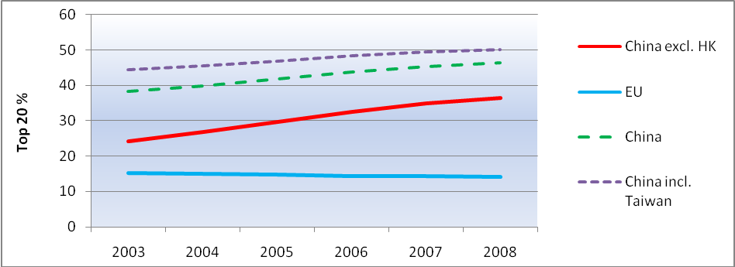
Source: Own elaboration based on Other Port Authorities data (2009)

Figure 5.28: Difference in imported goods growth in NSTR and SITC versus inward container
Transport y-o-y growth rate
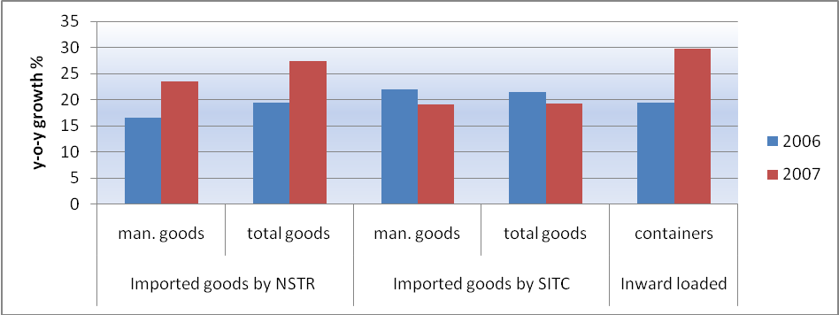
Source: Own elaboration based on Eurostat data (2009)

Figure 5.29: Freight rates to and from Asia (2004-2007)
Source: www.ci-online.co.uk.
Figure 5.30: Freight rates (market averages) in $ per TEU on the three major liner trade routes
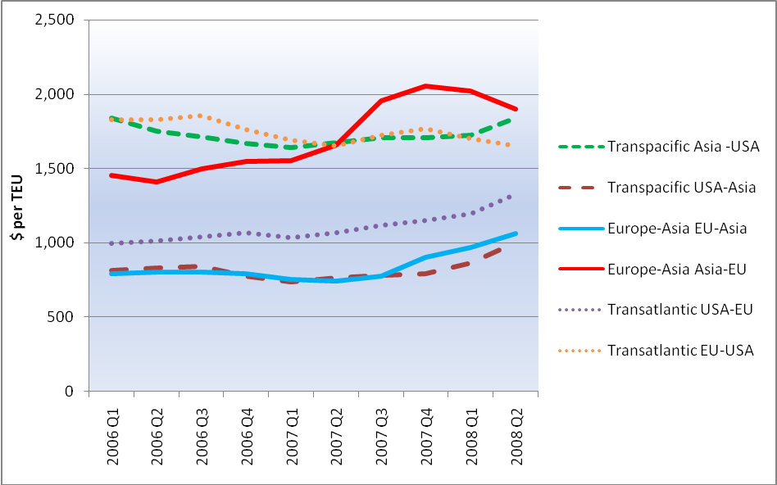
Source: Own elaboration based on UNCTAD secretariat based upon Containerisation International Online, Error! Hyperlink reference not valid. (2009)

Figure 5.31: Development in goods transhipment in the port of Rotterdam (weight)
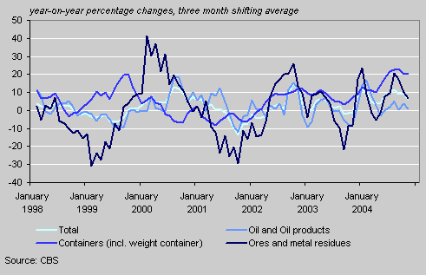

Figure 5.32: Development of container transhipment in the port of Rotterdam (incl. weight container)
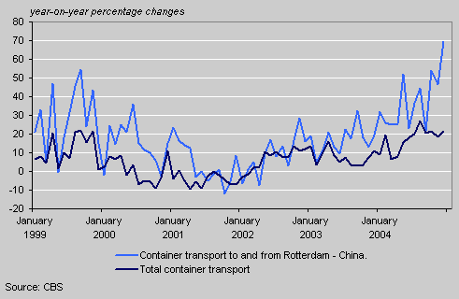

Figure 5.33: Rotterdam's main competitors in the transhipment of goods
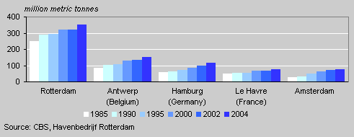
Figure 5.34: Yearly transport between Port of Rotterdam and China in ‘containers unit’ (x1000)
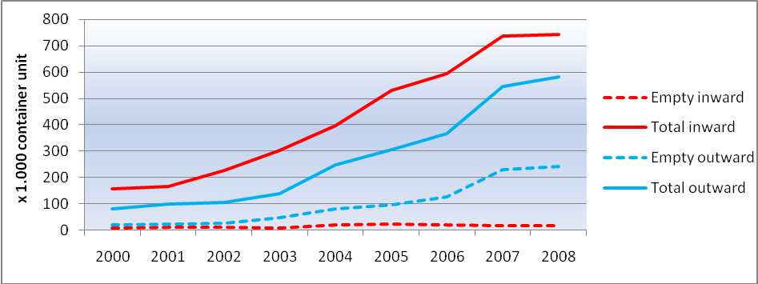
Source: Own elaboration based on CBS/ HbR. N.V. data (2009)
Figure 5.35: Total number of transported containers between Rotterdam and China, per year
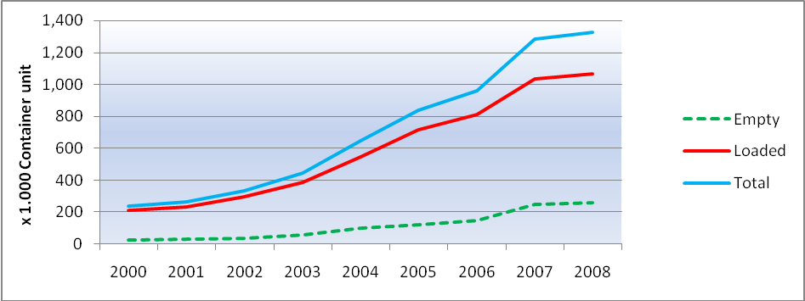
Source: Own elaboration based on CBS/ HbR. N.V. data (2009)

Figure 5.36: Yearly container transport between Rotterdam and China in TEU (x 1.000)
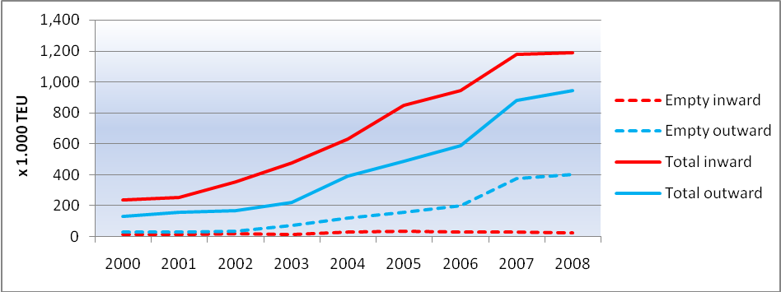
Source: Own elaboration based on Eurostat data (2009)

Figure 5.37: Empty container % of total transported containers between Rotterdam and China
in TEU
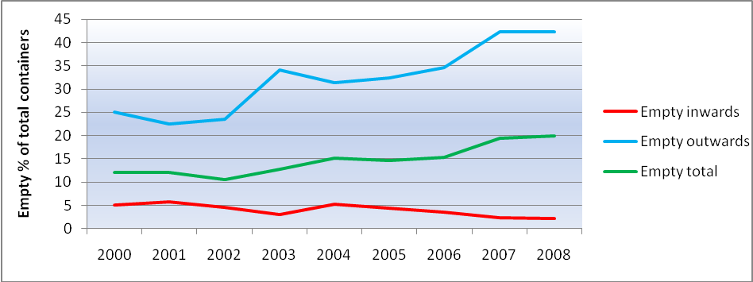
Source: Own elaboration based on Eurostat data (2009)
Figure 6.1: EU-Asia and Asia-EU freight rate (2006 = 100)
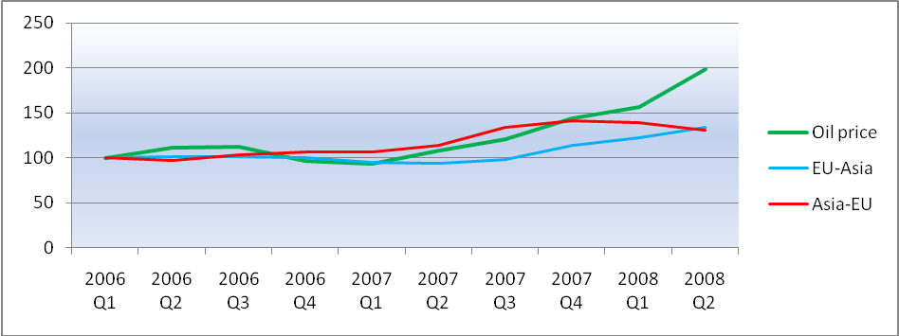
Source: Own elaboration based on UNCTAD secretariat based upon Containerisation International Online, www.ci-online.co.uk. data

Oil price- http://www.indexmundi.com/commodities/?commodity=crude-oil&months=120 (2009)
* average crude oil price of the three oil spot prices, namely Dated Brent, West Texas Intermediate and the Dubai Fateh in US$ per barrel

Figure 6.3: EU total goods and manufactured goods import in quantity (2000 = 100)
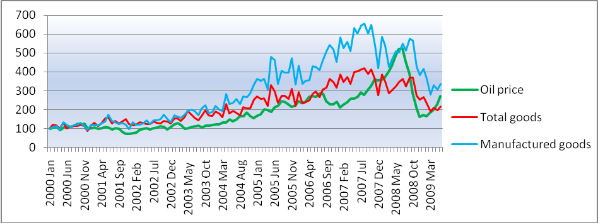
Source: Own elaboration based on Eurostat data (2009)
Figure 6.4: EU total goods and manufactured goods import in value (2007 = 100)
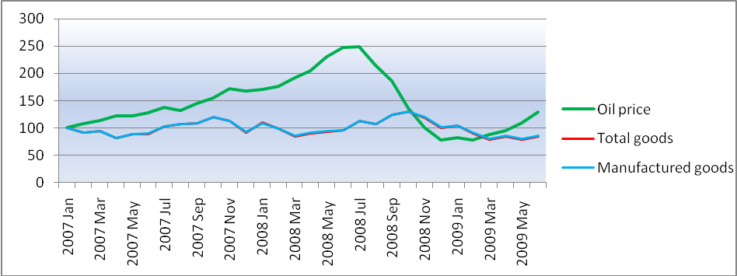
Source: Own elaboration based on Eurostat data (2009)
Figure 6.5: EU total goods and manufactured goods import in quantity (2007 = 100)
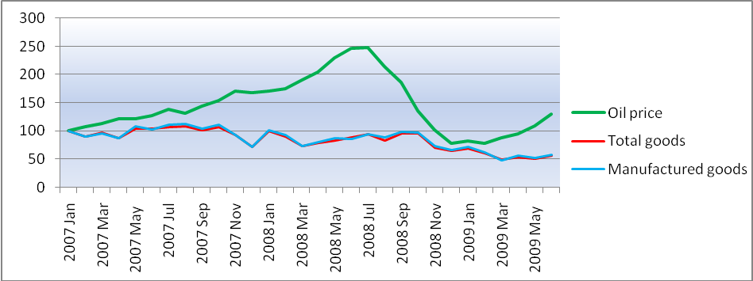
Source: Own elaboration based on Eurostat data (2009)

Figure 6.6: EU total goods and manufactured goods import in value (2008 July = 100)
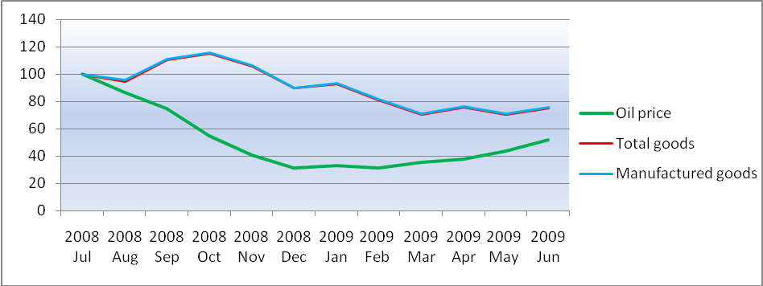
Source: Own elaboration based on Eurostat data (2009)

Figure 6.7: EU total goods and manufactured goods import in quantity (2008 July = 100)
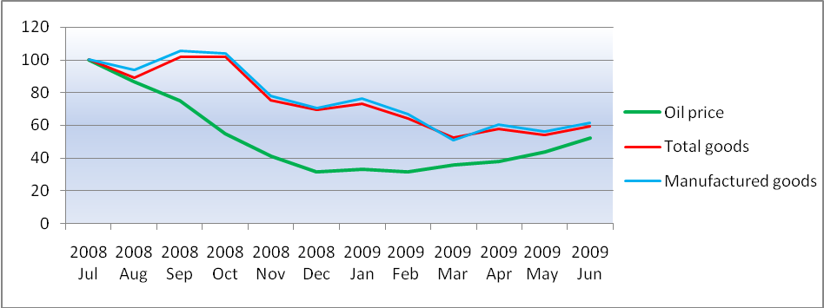
Source: Own elaboration based on Eurostat data (2009)
Figure 6.8: EU imported Chemicals, Machinery and transport and Other manufactured goods in value
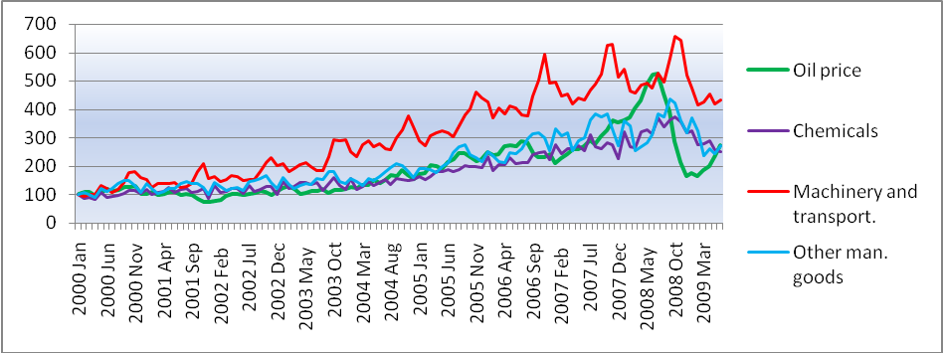
Source: Own elaboration based on Eurostat data (2009)

Figure 6.9: EU imported Chemicals, Machinery and transport and Other man. goods in quantity
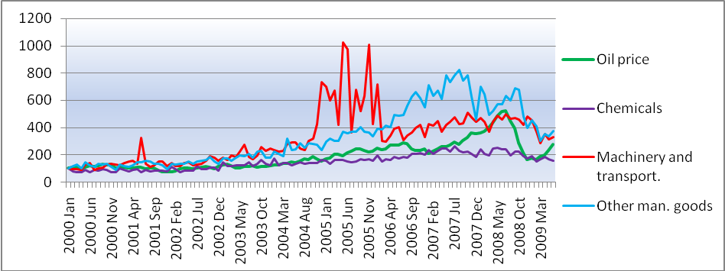
Source: Own elaboration based on Eurostat data (2009)

Figure 6.10: EU imported manufactured goods in value (2007 = 100)
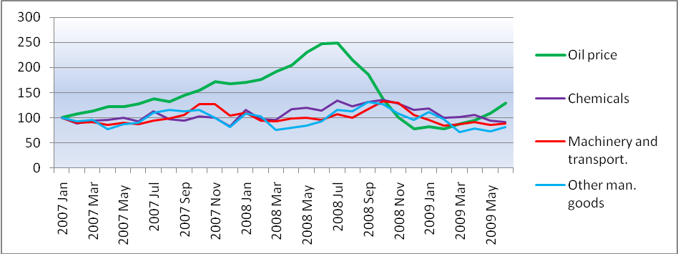
Source: Own elaboration based on Eurostat data (2009)
Figure 6.11: EU imported manufactured goods in quantity (2007 = 100)
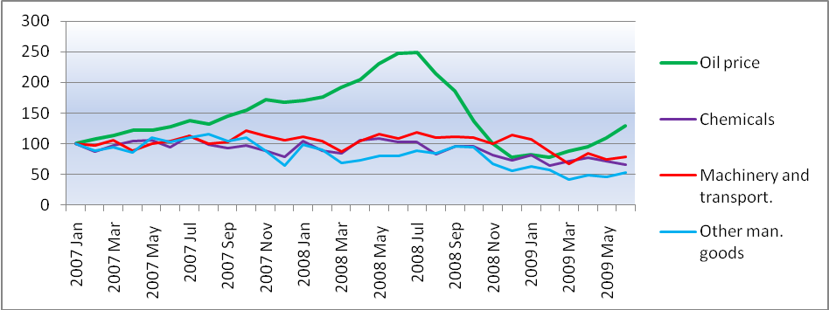
Source: Own elaboration based on Eurostat data (2009)

Figure 6.12: EU imported manufactured goods in value (2008 July = 100)
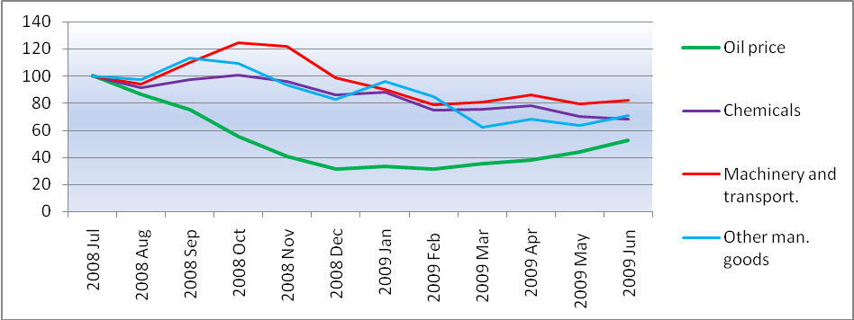
Source: Own elaboration based on Eurostat data (2009)

Figure 6.13: EU imported manufactured goods in quantity (2008 July = 100)
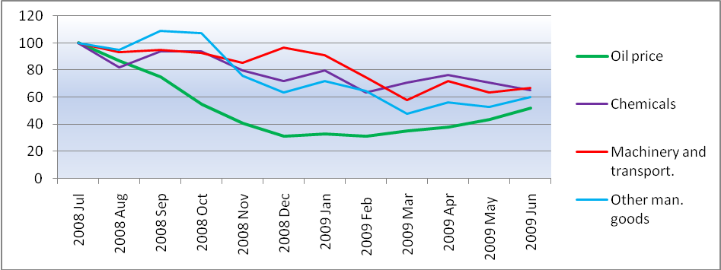
Source: Own elaboration based on Eurostat data (2009)
Figure 6.14: EU imported manufactured goods divided in specific groups (2000 = 100)
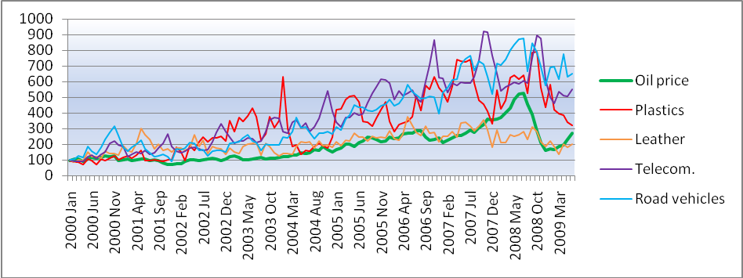
Source: Own elaboration based on Eurostat data (2009)

Figure 6.15: EU imported manufactured goods divided in specific groups (2000 = 100)
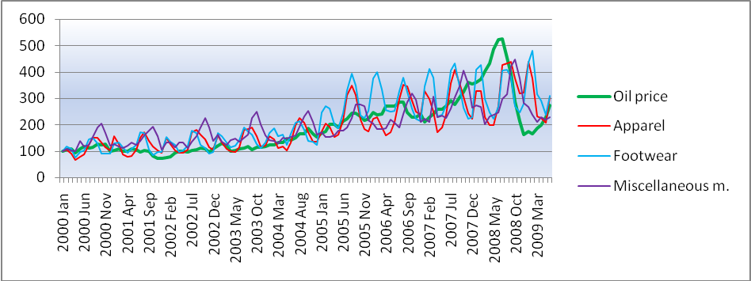
Source: Own elaboration based on Eurostat data (2009)

Figure 6.16: EU imported manufactured goods (2007 = 100)
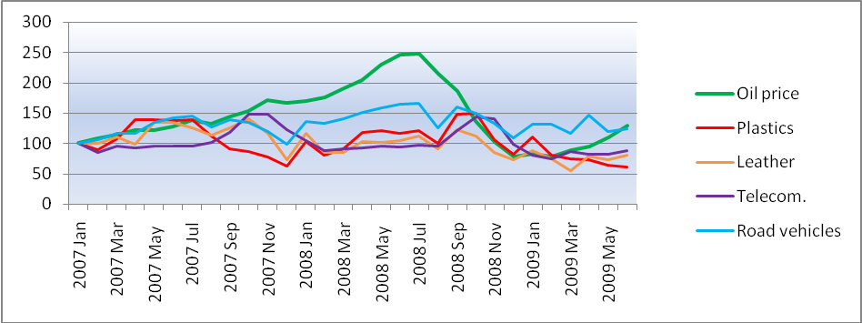
Source: Own elaboration based on Eurostat data (2009)
Figure 6.17: EU imported manufactured goods (2007 = 100)
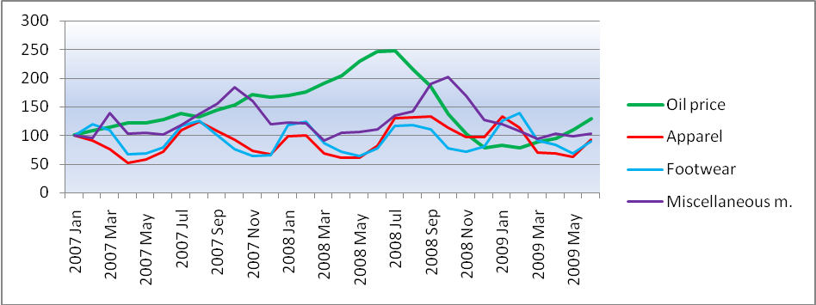
Source: Own elaboration based on Eurostat data (2009)

Figure 6.18: EU imported manufactured goods (2008 July = 100)
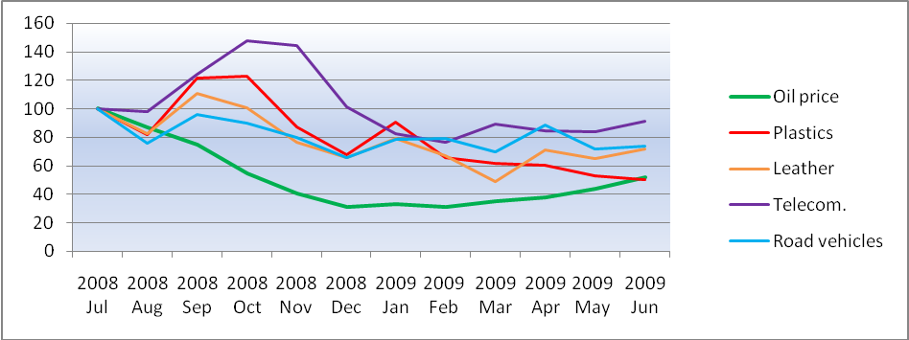
Source: Own elaboration based on Eurostat data (2009)

Figure 6.19: EU imported manufactured goods (2008 July = 100)
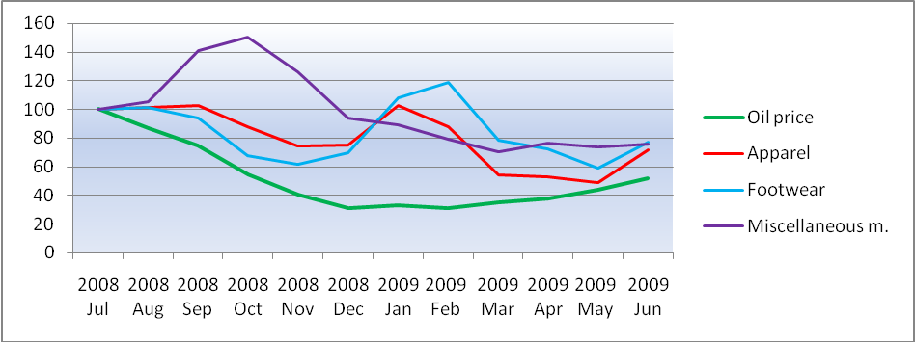
Source: Own elaboration based on Eurostat data (2009)
Figure 6.20: EU imported manufactured goods divided in detailed groups (2000 = 100)
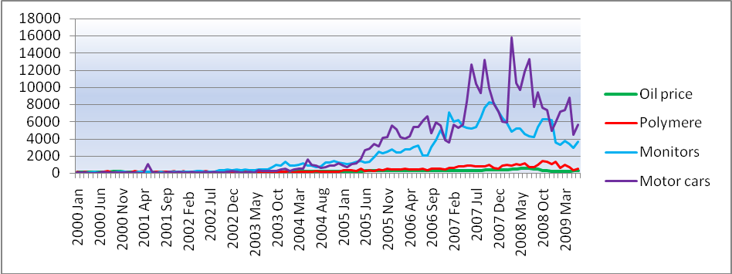
Source: Own elaboration based on Eurostat data (2009)

Figure 6.21: EU imported manufactured goods (2000 = 100)
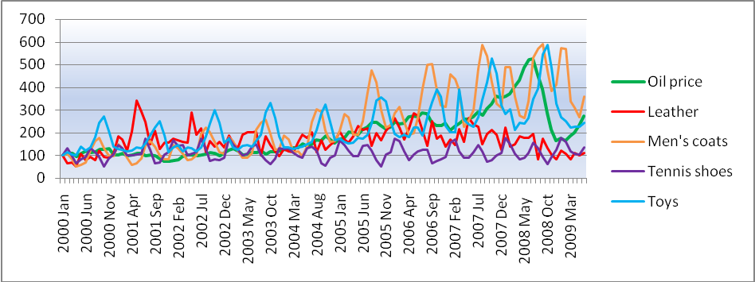
Source: Own elaboration based on Eurostat data (2009)

Figure 6.22: EU imported manufactured goods (2007 = 100)
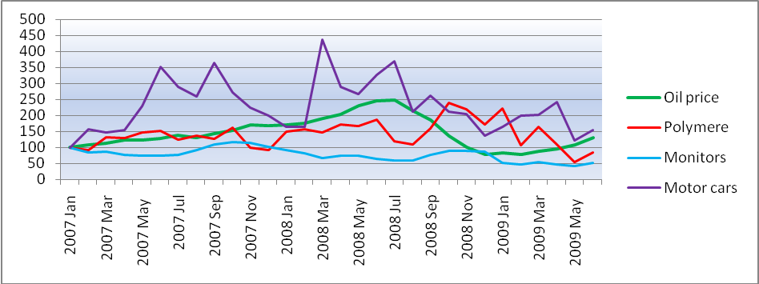
Source: Own elaboration based on Eurostat data (2009)
Figure 6.23: EU imported manufactured goods (2007 = 100)
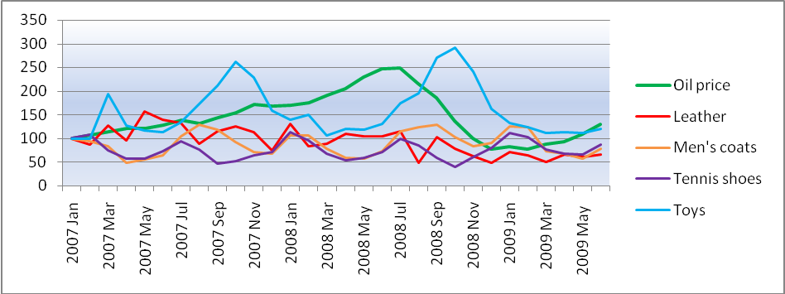
Source: Own elaboration based on Eurostat data (2009)

Figure 6.24: EU imported manufactured goods (2008 July = 100)
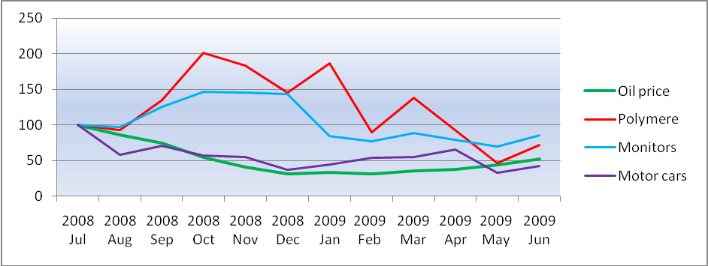
Source: Own elaboration based on Eurostat data (2009)

Figure 6.25: EU imported manufactured goods (2008 July = 100)
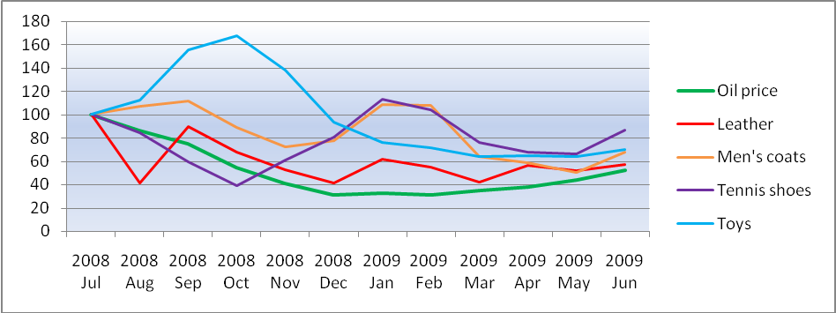
Source: Own elaboration based on Eurostat data (2009)
Figure 6.26: EU inward container transport from China in TEU (2005 = 100)
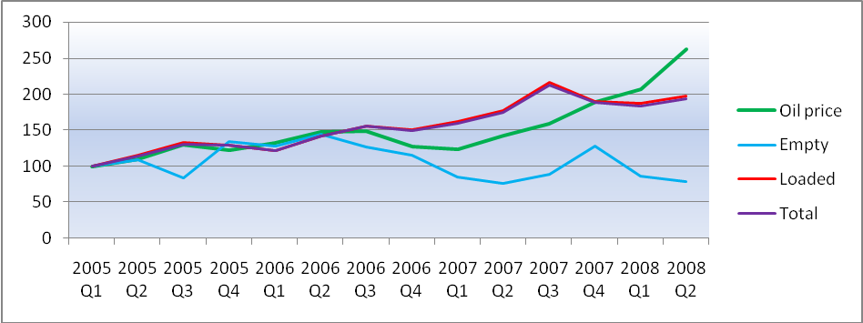
Source: Own elaboration based on Eurostat data (2009)

Figure 6.28: Port of Rotterdam inward container transport in ‘Container unit’ (2007 = 100)
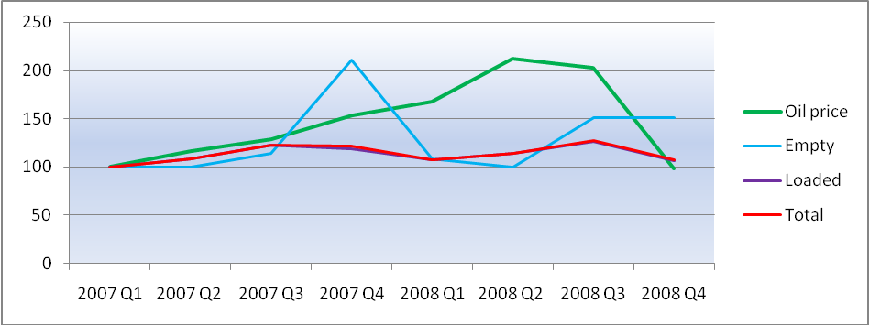
Source: Own elaboration based on Eurostat data (2009)

Figure 6.29: Port of Rotterdam inward container transport in ‘TEU’ (2000 = 100)
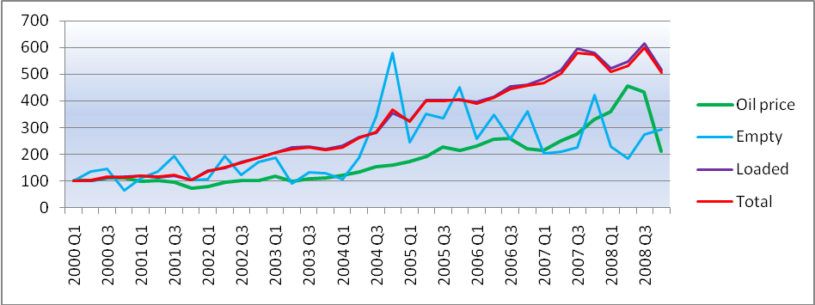
Source: Own elaboration based on Eurostat data (2009)
Figure 6.30: Port of Rotterdam inward container transport in TEU (2007 = 100)
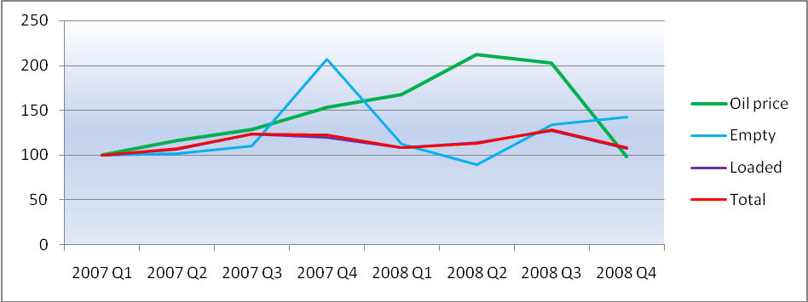
Source: Own elaboration based on Eurostat data (2009)

Figure 6.31: EU vs POR inward container transport (2005 = 100)
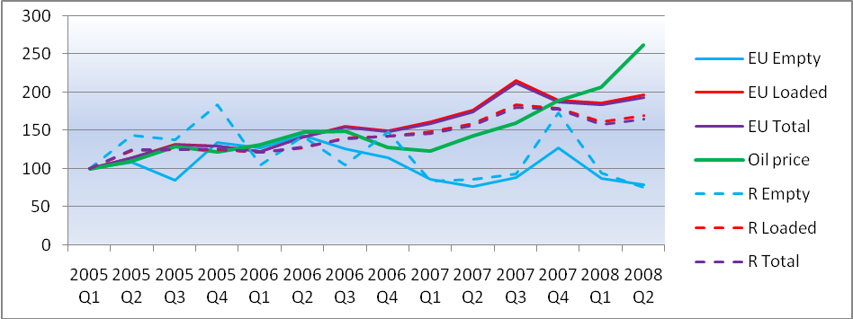
Source: Own elaboration based on Eurostat data (2009)

Figure 6.32: Oil price vs Exchange rates and EU imported goods (2000 = 100)
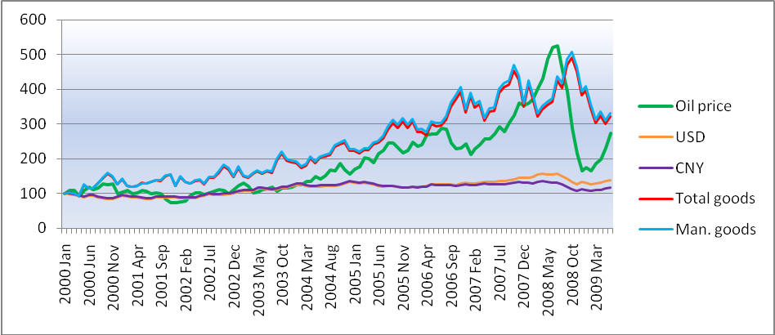
Source: Own elaboration based on Eurostat data (2009)
Figure 6.33: Oil price vs Exchange rates and EU imported goods (2007 = 100)
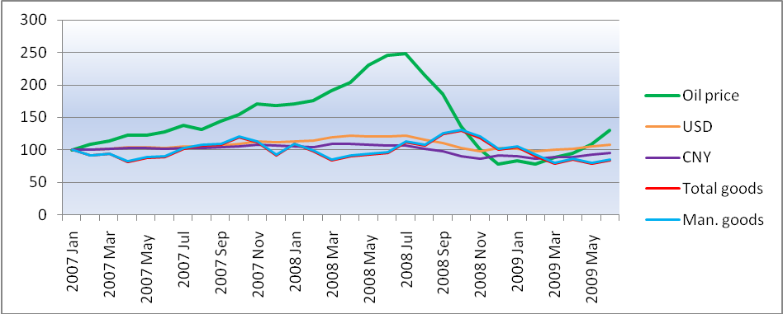
Source: Own elaboration based on Eurostat data (2009)

Appendix: Tables

Table 1.1: Average monthly oil price in $ (2000-2009)
 | 2000 | 2001 | 2002 | 2003 | 2004 | 2005 | 2006 | 2007 | 2008 | 2009
Jan | 25,21 | 25,95 | 19,15 | 30,77 | 31,40 | 42,89 | 62,36 | 53,40 | 90,82 | 43,91
Feb | 27,15 | 27,24 | 19,98 | 32,88 | 31,32 | 44,56 | 59,71 | 57,58 | 93,75 | 41,76
Mrt | 27,49 | 25,02 | 23,64 | 30,36 | 33,67 | 50,93 | 60,93 | 60,60 | 101,84 | 46,95
Apr | 23,45 | 25,66 | 25,43 | 25,49 | 33,71 | 50,64 | 68,00 | 65,10 | 109,05 | 50,28
Mei | 27,23 | 27,55 | 25,69 | 26,06 | 37,63 | 47,81 | 68,61 | 65,10 | 122,77 | 58,10
Jun | 29,62 | 26,97 | 24,49 | 27,91 | 35,54 | 53,89 | 68,29 | 68,19 | 131,52 | 69,13
Jul | 28,16 | 24,80 | 25,75 | 28,59 | 37,93 | 56,37 | 72,51 | 73,67 | 132,55 | 64,65
Aug | 29,41 | 25,81 | 26,78 | 29,68 | 42,08 | 61,87 | 71,81 | 70,13 | 114,57 | 71,63
Sep | 32,08 | 25,03 | 28,28 | 26,88 | 41,65 | 61,65 | 61,97 | 76,91 | 99,29 | -
Okt | 31,40 | 20,73 | 27,53 | 29,01 | 46,87 | 58,19 | 57,95 | 82,15 | 72,69 | -
Nov | 32,33 | 18,69 | 24,79 | 29,12 | 42,23 | 54,98 | 58,13 | 91,27 | 54,04 | -
Dec | 25,28 | 18,52 | 27,89 | 29,95 | 39,09 | 56,47 | 61,00 | 89,43 | 41,53 | -
Source: Own elaboration based on http://www.indexmundi.com/commodities/?commodity=crude-oil&months=120 data (2009)

Table 3.2: Growth of Exports 1995-2001 by merchandise class
Source: United Nations Comtrade - (Gerard Adams et al. 2004)

Table 3.3: Multimodal alternatives between Shanghai and Hamburg port/Frankfurt airport
Source: Verny and Grigentin (2009)
Note: CS = Containership.
ª = Based on a weekly service frequency

Table 3.4: Breakdown of the cellular containership fleet for selected dates
Source: AXS-Alphaliner - Notteboom and Vernimmen (2008)
Note : ª = Based on order book as at 1st December 2007

Table 3.5: Key indicators of the Far East–North Europe container trade
Source: Own calculations based on AXS-Alphaliner data - Notteboom and Vernimmen (2008)

Table 3.6: Cost comparison for different vessel sizes, bunker costs and vessel speed-cost in USD
per TEU transported (port-to-port basis)
Source: Cost model results – Notteboom and Vernimmen (2008)
Note: The bold values are not a feasible option

Table 4.1: Growth in the volume of world merchandise exports and production, 2000-2007
 | 2000-07 | 2005 | 2006 | 2007
World merchandise exports | 5,5 | 6,5 | 8,5 | 6,0
Agricultural products | 4,0 | 6,0 | 6,0 | 4,5
Fuels and mining products | 3,5 | 3,5 | 3,5 | 3,0
Manufactures | 6,5 | 7,5 | 10,0 | 7,5
World merchandise production | 3,0 | 3,0 | 3,0 | 4,0
Agriculture | 2,5 | 2,0 | 1,5 | 2,5
Mining | 1,5 | 1,5 | 1,0 | 0,0
Manufacturing | 3,0 | 4,0 | 4,0 | 5,0
World GDP | 3,0 | 3,0 | 3,5 | 3,5
Source: Own elaboration based on International Trade Statistics 2008, WTO data (2009)

Table 4.2: World, EU and China GDP and merchandise trade growth in annual % change at
constant prices
 | GDP |  |  | Exports |  |  |  | Imports
 | 2006 | 2007 | 2008 | 2000-07 | 2006 | 2007 | 2008 | 2000-07 | 2006 | 2007 | 2008
World | 3,7 | 3,5 | 1,7 | 5,5 | 8,5 | 6,0 | 2,0 | 5,5 | 8,0 | 6,0 | 2,0
EU 27 | 3,0 | 2,8 | 7,5 | 4,0 | 7,5 | 3,5 | 0,0 | 3,5 | 7,0 | 3,5 | -1,0
China | 11,6 | 11,9 | 9,0 | 22,5 | 22,0 | 19,5 | 8,5 | 18,0 | 16,5 | 13,5 | 4,0
Source: Own presentation based on WTO Secretariat data (2009)
Note: Due to differences between data we take the most actual number
Table 4.3: Export percentage of world trade in goods
 | Canada | China | EU | Japan | US | EU and China
2000 | 6,2 | 5,6 | 17,5 | 10,7 | 17,4 | 23,1
2001 | 6,1 | 6,2 | 18,6 | 9,5 | 17,1 | 24,8
2002 | 5,7 | 7,3 | 19,0 | 9,4 | 15,6 | 26,3
2003 | 5,3 | 8,6 | 19,2 | 9,2 | 14,1 | 27,8
2004 | 5,1 | 9,5 | 19,0 | 9,0 | 13,1 | 28,5
2005 | 5,0 | 10,5 | 18,0 | 8,2 | 12,4 | 28,5
2006 | 4,6 | 11,5 | 17,3 | 7,7 | 12,3 | 28,8
2007 | 4,3 | 12,5 | 17,4 | 7,3 | 11,9 | 29,9
Source: Own elaboration based on Eurostat data (2009)

Table 4.4: Import percentage of world trade in goods
 | Canada | China | EU | Japan | US | EU and China
2000 | 5,0 | 4,7 | 19,3 | 8,0 | 26,4 | 24,0
2001 | 4,8 | 5,3 | 19,2 | 7,6 | 25,8 | 24,5
2002 | 4,7 | 6,3 | 18,8 | 7,2 | 25,5 | 25,1
2003 | 4,4 | 7,6 | 19,5 | 7,1 | 24,0 | 27,1
2004 | 4,1 | 8,4 | 19,2 | 6,8 | 22,9 | 27,6
2005 | 4,1 | 8,6 | 19,0 | 6,7 | 22,5 | 27,6
2006 | 3,9 | 8,9 | 19,1 | 6,5 | 21,6 | 28,0
2007 | 3,7 | 9,3 | 19,1 | 6,0 | 19,6 | 28,4
Source: Own elaboration based on Eurostat data (2009)

Table 4.5: EU-extra trade in goods by main partners (x Bln. €)
 | EU Export % |  |  |  |  | EU Import %
 | US | China | Russia | Switzerland | Japan | US | China | Russia | Switzerland | Japan
2000 | 28,0 | 3,0 | 2,7 | 8,5 | 5,4 | 20,8 | 7,5 | 6,4 | 6,3 | 9,3
2001 | 27,8 | 3,5 | 3,6 | 8,6 | 5,1 | 20,8 | 8,4 | 6,7 | 6,5 | 8,3
2002 | 27,8 | 3,9 | 3,9 | 8,2 | 4,9 | 19,5 | 9,6 | 6,9 | 6,6 | 7,9
2003 | 26,1 | 4,8 | 4,3 | 8,2 | 4,7 | 16,9 | 11,4 | 7,6 | 6,3 | 7,7
2004 | 24,7 | 5,1 | 4,8 | 7,9 | 4,6 | 15,5 | 12,5 | 8,2 | 6,0 | 7,3
2005 | 24,0 | 4,9 | 5,4 | 7,8 | 4,2 | 13,9 | 13,6 | 9,5 | 5,6 | 6,3
2006 | 23,2 | 5,5 | 6,2 | 7,6 | 3,9 | 13,0 | 14,4 | 10,4 | 5,3 | 5,7
2007 | 21,1 | 5,8 | 7,2 | 7,5 | 3,5 | 12,7 | 16,2 | 10,1 | 5,4 | 5,5
2008 | 19,1 | 6,0 | 8,0 | 7,5 | 3,2 | 12,0 | 16,0 | 11,2 | 5,2 | 4,8
Source: Own elaboration based on Eurostat data (2009)
Table 4.6: EU trade in total goods with the US and China (x Bln. €)
 | Export |  |  | Import |  |  | Balance
 | Tot. EU extra | US | China | Tot EU extra | US | China | Tot EU extra | US | China
2000 | 849,74 | 238,20 | 25,86 | 992,70 | 206,28 | 74,63 | -142,96 | 31,92 | -48,77
2001 | 884,71 | 245,59 | 30,66 | 979,14 | 203,30 | 82,00 | -94,43 | 42,29 | -51,34
2002 | 891,90 | 247,93 | 35,10 | 936,97 | 182,62 | 90,15 | -45,07 | 65,31 | -55,05
2003 | 869,24 | 227,28 | 41,47 | 935,27 | 158,12 | 106,22 | -66,03 | 69,16 | -64,75
2004 | 952,95 | 235,50 | 48,38 | 1027,52 | 159,38 | 128,69 | -74,57 | 76,12 | -80,31
2005 | 1052,72 | 252,68 | 51,83 | 1179,57 | 163,51 | 160,33 | -126,85 | 89,17 | -108,50
2006 | 1159,29 | 268,99 | 63,78 | 1351,73 | 175,22 | 194,83 | -192,44 | 93,77 | -131,05
2007 | 1241,57 | 261,43 | 71,91 | 1434,05 | 181,63 | 232,59 | -192,48 | 79,80 | -160,68
2008 | 1308,60 | 249,42 | 78,42 | 1550,69 | 186,34 | 247,62 | -242,09 | 63,08 | -169,20
Source: Own elaboration based on Eurostat data (2009)

Table 4.7: Manufactured goods as share of total EU-extra export trade (x Bln. €)
 | EU extra Export
 | SITC 5 | SITC 6 | SITC 7 | SITC 8 | Man. goods | Man. goods as EU export % of total trade
2000 | 118,9 | 121,2 | 393,5 | 102,9 | 736 | 86,7
2001 | 130,2 | 123,4 | 412,0 | 109,3 | 775 | 87,6
2002 | 141,1 | 124,9 | 401,5 | 109,8 | 777 | 87,2
2003 | 141,1 | 119,6 | 391,6 | 104,3 | 757 | 87,0
2004 | 152,6 | 134,1 | 430,1 | 112,1 | 829 | 87,0
2005 | 164,9 | 147,9 | 470,3 | 118,0 | 901 | 85,6
2006 | 184,6 | 164,6 | 504,1 | 129,0 | 982 | 84,7
2007 | 197,7 | 176,5 | 543,1 | 133,3 | 1.051 | 84,7
2008 | 205,2 | 179,7 | 569,2 | 137,0 | 1.091 | 83,3
Source: Own elaboration based on Eurostat data (2009)

Table 4.8: Manufactured goods as share of total EU-extra import trade (x Bln. €)
 | EU extra Import
 | SITC 5 | SITC 6 | SITC 7 | SITC 8 | Man. goods | Man. goods as EU import % of total trade
2000 | 70,5 | 111,1 | 371,5 | 139,4 | 693 | 69,8
2001 | 76,9 | 110,4 | 352,0 | 143,2 | 682 | 69,7
2002 | 80,8 | 102,7 | 329,1 | 141,5 | 654 | 69,8
2003 | 80,5 | 99,4 | 326,7 | 139,1 | 646 | 69,0
2004 | 88,6 | 115,6 | 354,6 | 146,9 | 706 | 68,7
2005 | 96,4 | 128,2 | 378,7 | 162,1 | 765 | 64,9
2006 | 109,0 | 160,6 | 402,6 | 180,2 | 852 | 63,1
2007 | 120,6 | 188,8 | 418,2 | 193,1 | 921 | 64,2
2008 | 126,9 | 177,9 | 414,2 | 196,6 | 916 | 59,0
Source: Own elaboration based on Eurostat data (2009)

Table 4.9: EU-extra trade in ‘energy goods’ and index (2000 = 100)
 | Oil price | Export | Import | Balance | Oil price | Export | Import | Balance
2000 | 28,23 | 29.116.465.837 | 161.116.052.138 | -131.999.586.301 | 100 | 100 | 100 | 100
2001 | 24,33 | 24.927.678.547 | 157.768.557.243 | -132.840.878.696 | 86 | 86 | 98 | 101
2002 | 24,95 | 26.172.914.003 | 149.111.816.880 | -122.938.902.877 | 88 | 90 | 93 | 93
2003 | 28,89 | 27.409.480.440 | 157.846.478.435 | -130.436.997.995 | 102 | 94 | 98 | 99
2004 | 37,76 | 32.935.002.445 | 183.437.177.898 | -150.502.175.453 | 134 | 113 | 114 | 114
2005 | 53,35 | 45.871.079.569 | 272.576.207.271 | -226.705.127.702 | 189 | 158 | 169 | 172
2006 | 64,27 | 58.688.612.805 | 339.627.041.228 | -280.938.428.423 | 228 | 202 | 211 | 213
2007 | 71,13 | 63.510.372.884 | 335.013.240.879 | -271.502.867.995 | 252 | 218 | 208 | 206
2008 | 97,04 | 80.719.779.713 | 457.887.054.384 | -377.167.274.671 | 344 | 277 | 284 | 286
Source: Own elaboration based on Eurostat data (2009)
Table 4.10: EU-extra trade in ‘petroleum goods’ and index (2000 = 100)
 | Oil price | Export | Import | Balance | Oil price | Export | Import | Balance
2000 | 28,23 | 26.313.503.068 | 130.305.586.791 | -103.992.083.723 | 100 | 100 | 100 | 100
2001 | 24,33 | 21.949.744.056 | 118.481.468.466 | -96.531.724.410 | 86 | 83 | 91 | 93
2002 | 24,95 | 22.910.918.322 | 112.358.610.856 | -89.447.692.534 | 88 | 87 | 86 | 86
2003 | 28,89 | 24.068.915.397 | 117.412.035.506 | -93.343.120.109 | 102 | 91 | 90 | 90
2004 | 37,76 | 29.505.014.392 | 142.034.603.429 | -112.529.589.037 | 134 | 112 | 109 | 108
2005 | 53,35 | 42.040.260.093 | 208.098.076.813 | -166.057.816.720 | 189 | 160 | 160 | 160
2006 | 64,27 | 53.948.723.743 | 254.986.981.679 | -201.038.257.936 | 228 | 205 | 196 | 193
2007 | 71,13 | 58.905.122.344 | 255.582.342.575 | -196.677.220.231 | 252 | 224 | 196 | 189
2008 | 97,04 | 74.506.092.392 | 338.281.982.842 | -263.775.890.450 | 344 | 283 | 260 | 254
Source: Own elaboration based on Eurostat data (2009)
Table 4.11: EU ‘total manufactured goods’ trade with China in €
 | EU total man. goods Export | EU total man. goods Import | EU total Man. Balance
2000 | 23.234.393.509 | 70.610.611.978 | -47.376.218.469
2001 | 28.122.175.035 | 77.388.833.145 | -49.266.658.110
2002 | 32.305.295.496 | 86.361.925.979 | -54.056.630.483
2003 | 38.297.129.302 | 102.020.459.158 | -63.723.329.856
2004 | 44.455.721.239 | 123.525.223.864 | -79.069.502.625
2005 | 46.450.253.377 | 154.310.434.298 | -107.860.180.921
2006 | 56.369.452.101 | 188.260.784.538 | -131.891.332.437
2007 | 63.503.140.385 | 224.340.318.438 | -160.837.178.053
2008 | 69.433.060.750 | 239.342.424.843 | -169.909.364.093
Source: Own elaboration based on Eurostat data (2009)
Table 4.12: Manufactured goods as EU export share to China (x Bln. €)
 | EU Export to China
 | SITC 5 | SITC 6 | SITC 7 | SITC 8 | Man. goods | Man. goods as EU export % of total trade
2000 | 2,4 | 2,9 | 16,5 | 1,4 | 23,2 | 89,8
2001 | 2,7 | 3,4 | 20,1 | 1,9 | 28,1 | 91,7
2002 | 3,3 | 4,3 | 22,4 | 2,3 | 32,3 | 92,0
2003 | 3,8 | 5,5 | 26,4 | 2,6 | 38,3 | 92,3
2004 | 4,4 | 6,0 | 30,8 | 3,2 | 44,5 | 91,9
2005 | 5,2 | 7,0 | 31,0 | 3,2 | 46,5 | 89,6
2006 | 6,1 | 8,5 | 37,8 | 3,9 | 56,4 | 88,4
2007 | 7,4 | 9,0 | 42,6 | 4,5 | 63,5 | 88,3
2008 | 8,5 | 9,2 | 46,6 | 5,2 | 69,4 | 88,5
Source: Own elaboration based on Eurostat data (2009)
Table 4.13: Manufactured goods as EU import share from China (x Bln. €)
 | EU Import from China
 | SITC 5 | SITC 6 | SITC 7 | SITC 8 | Man. goods | Man. goods as EU import % of total trade
2000 | 2,8 | 8,9 | 27,7 | 31,2 | 70,6 | 94,6
2001 | 3,1 | 9,5 | 32,1 | 32,7 | 77,4 | 94,4
2002 | 3,3 | 10,1 | 37,6 | 35,3 | 86,4 | 95,8
2003 | 3,8 | 11,3 | 48,4 | 38,5 | 102,0 | 96,0
2004 | 4,1 | 14,5 | 62,6 | 42,4 | 123,5 | 96,0
2005 | 5,2 | 19,0 | 75,1 | 55,1 | 154,3 | 96,2
2006 | 6,3 | 26,1 | 93,8 | 62,2 | 188,3 | 96,6
2007 | 7,5 | 36,6 | 107,3 | 72,9 | 224,3 | 96,5
2008 | 9,3 | 36,7 | 114,7 | 78,7 | 239,3 | 96,6
Source: Own elaboration based on Eurostat data (2009)

Table 4.14: Product group exported percentage in manufactured goods and total trade
 | EU exported man. goods to China |  |  | EU exported total goods to China
 | SITC 5 % | SITC 7 % | SITC 6 +8 % | SITC 5 % | SITC 7 % | SITC 6 +8 %
2000 | 10,4 | 71,1 | 18,4 | 9,4 | 63,9 | 16,6
2001 | 9,7 | 71,6 | 18,7 | 8,9 | 65,6 | 17,2
2002 | 10,2 | 69,4 | 20,3 | 9,4 | 63,9 | 18,7
2003 | 9,8 | 68,9 | 21,3 | 9,1 | 63,6 | 19,7
2004 | 10,0 | 69,3 | 20,7 | 9,2 | 63,7 | 19,0
2005 | 11,2 | 66,7 | 22,1 | 10,0 | 59,8 | 19,8
2006 | 10,8 | 67,1 | 22,1 | 9,6 | 59,3 | 19,5
2007 | 11,6 | 67,1 | 21,3 | 10,3 | 59,3 | 18,8
2008 | 12,3 | 67,1 | 20,6 | 10,8 | 59,4 | 18,3
Source: Own elaboration based on Eurostat data (2009)

Table 4.15: Product group imported percentage in total manufactured goods and total trade
 | EU imported man. goods from China |  |  | EU imported total goods from China
 | SITC 5 % | SITC 7 % | SITC 6 +8 % | SITC 5 % | SITC 7 % | SITC 6 +8 %
2000 | 4,0 | 39,3 | 56,7 | 3,8 | 37,2 | 53,7
2001 | 4,1 | 41,5 | 54,5 | 3,8 | 39,1 | 51,4
2002 | 3,9 | 43,5 | 52,6 | 3,7 | 41,7 | 50,4
2003 | 3,8 | 47,4 | 48,8 | 3,6 | 45,5 | 46,9
2004 | 3,3 | 50,7 | 46,0 | 3,2 | 48,6 | 44,2
2005 | 3,4 | 48,7 | 48,0 | 3,2 | 46,8 | 46,2
2006 | 3,3 | 49,8 | 46,9 | 3,2 | 48,1 | 45,3
2007 | 3,4 | 47,8 | 48,8 | 3,2 | 46,1 | 47,1
2008 | 3,9 | 47,9 | 48,2 | 3,7 | 46,3 | 46,5
Source: Own elaboration based on Eurostat data (2009)
Table 4.16: EU-China trade in ‘Chemicals’ with China in €
 | EU Export in SITC 5 | EU Import in SITC 5 | EU Balance in STIC 5
2000 | 2.420.754.638 | 2.805.471.502 | -384.716.864
2001 | 2.733.436.410 | 3.142.200.641 | -408.764.231
2002 | 3.307.935.353 | 3.340.370.694 | -32.435.341
2003 | 3.759.982.962 | 3.829.420.833 | -69.437.871
2004 | 4.446.685.777 | 4.075.328.004 | 371.357.773
2005 | 5.180.132.030 | 5.178.023.543 | 2.108.487
2006 | 6.097.776.997 | 6.268.365.746 | -170.588.749
2007 | 7.369.828.867 | 7.532.232.213 | -162.403.346
2008 | 8.505.992.698 | 9.288.967.825 | -782.975.127
Source: Own elaboration based on Eurostat data (2009)

Table 4.17: EU-China trade in ‘Machinery and transport’ with China in €
 | EU Export SITC 7 | EU Import SITC 7 | EU Balance SITC 7
2000 | 16.528.342.841 | 27.739.342.442 | -11.210.999.601
2001 | 20.125.110.482 | 32.098.622.851 | -11.973.512.369
2002 | 22.435.609.958 | 37.567.495.866 | -15.131.885.908
2003 | 26.381.713.648 | 48.366.797.890 | -21.985.084.242
2004 | 30.801.216.829 | 62.598.482.187 | -31.797.265.358
2005 | 31.002.379.798 | 75.081.334.352 | -44.078.954.554
2006 | 37.817.792.309 | 93.754.259.275 | -55.936.466.966
2007 | 42.636.728.902 | 107.304.573.422 | -64.667.844.520
2008 | 46.591.719.417 | 114.705.403.612 | -68.113.684.195
Source: Own elaboration based on Eurostat data (2009)

Table 4.18: EU-China trade in ‘Other manufactured goods’ with China in €
 | EU Export SITC 6+8 | EU Import SITC 6+8 | EU Balance SITC 6+8
2000 | 4.285.296.030 | 40.065.798.034 | -35.780.502.004
2001 | 5.263.628.143 | 42.148.009.653 | -36.884.381.510
2002 | 6.561.750.185 | 45.454.059.419 | -38.892.309.234
2003 | 8.155.432.692 | 49.824.240.435 | -41.668.807.743
2004 | 9.207.818.633 | 56.851.413.673 | -47.643.595.040
2005 | 10.267.741.549 | 74.051.076.403 | -63.783.334.854
2006 | 12.453.882.795 | 88.238.159.517 | -75.784.276.722
2007 | 13.496.582.616 | 109.503.512.803 | -96.006.930.187
2008 | 14.335.348.635 | 115.348.053.406 | -101.012.704.771
Source: Own elaboration based on Eurostat data (2009)
Table 4.19: EU FDI flows with China (x Mln. €)
 | China |  | Asia |  | EU-extra |  | Asia % |  | EU-extra %
 | Flows | Stocks | Flows | Stocks | Flows | Stocks | Flows | Stocks | Flows | Stocks
2004 | 3.868 | 21.337 | 35.525 | 317.378 | 142.278 | 2.023.578 | 10,9 | 6,7 | 2,7 | 1,05
2005 | 6.137 | 27.514 | 42.630 | 369.246 | 239.454 | 2.426.226 | 14,4 | 7,5 | 2,6 | 1,13
2006 | 6.677 | 32.329 | 32.071 | 377.534 | 317.472 | 2.737.692 | 20,8 | 8,6 | 2,1 | 1,18
2007 | 7.118 | 38.444 | 57.766 | 414.978 | 484.197 | 3.134.903 | 12,3 | 9,3 | 1,5 | 1,23
2008* | 4.460 |  |  |  | 354.187 |  |  |  | 1,3
Source: Own elaboration based on Eurostat data (2009)
* Provisional data

Table 4.20: EU FDI flow in China manufacturing activities 2005-2006 (x Mln. €)
Item nr. | Product | 2005 | 2006 | Growth %
9999 | TOTAL | 6137 | 6677 | 8,8
3995 | Manufacturing | 2666 | 2402 | -9,9
1605 | Food products | 282 | 33 | -88,3
2295 | TOTAL textiles + wood activities | 87 | 80 | -8,0
1805 | Textiles and wearing apparel | 13 | 49 | 276,9
2205 | Wood, publishing and printing | 74 | 32 | -56,8
2595 | TOTAL petroleum,chemical,rubber,plastic products | 668 | 588 | -12,0
2300 | Refined petroleum prod. and other treatments | -2 | 188 | -9500,0
2400 | Manufacture of chemicals & chemicals products | 559 | 257 | -54,0
2500 | Rubber and plastic products | 115 | 144 | 25,2
2995 | TOTAL metal and mechanical products | 511 | 456 | -10,8
2805 | Metal products | 188 | 153 | -18,6
2900 | Mechanical products | 322 | 303 | -5,9
3295 | TOTAL machinery, computers, RTV, communication | 131 | 402 | 206,9
3000 | Office machinery and computers | -2 | 119 | -6050,0
3200 | Radio,TV,communication equipments | 134 | 282 | 110,4
3595 | TOTAL vehicles + other transport equipment | 386 | 349 | -9,6
3400 | Motor vehicles |  | 344
3500 | Other transport equipment |  | 5
Source: Own elaboration based on Eurostat data (2009) send by gmail

Table 4.21: EU investment in China in US $
 | Nr of Project |  |  | Realized FDI Value
 | EU | National Total | Share % | EU | National Total | Share %
2000 | 1.130 | 22.347 | 5,1 | 4.479.460.000 | 40.714.810.000 | 11,0
2001 | 1.214 | 26.140 | 4,6 | 4.182.700.000 | 46.877.590.000 | 8,9
2002 | 1.486 | 34.171 | 4,3 | 3.709.820.000 | 52.742.860.000 | 7,0
2003 | 2.074 | 41.081 | 5,0 | 3.930.310.000 | 53.504.670.000 | 7,3
2004 | 2.423 | 43.664 | 5,5 | 4.239.040.000 | 60.629.980.000 | 7,0
2005 | 2.846 | 44.019 | 6,5 | 5.193.780.000 | 72.405.690.000 | 7,2
2006 | 2.619 | 41.496 | 6,3 | 5.439.470.000 | 72.715.000.000 | 7,5
2007 | 2.384 | 37.892 | 6,3 | 3.838.380.000 | 83.520.890.000 | 4,6
Source: Own elaboration based on MOFCOM FDI Statistics data (2009)
Table 4.22: EU and total FIE share of China Exports (x Bln. $)
 | EU | Total FIE | Total | EU % | Total FIE %
2000 | 17,3 | 119,4 | 249,2 | 6,9 | 47,9
2001 | 19,3 | 133,2 | 266,2 | 7,2 | 50,1
2002 | 23,9 | 169,9 | 325,6 | 7,4 | 52,2
2003 | 39,5 | 240,3 | 438,4 | 9,0 | 54,8
2004 | 57,2 | 338,6 | 593,4 | 9,6 | 57,1
2005 | 78,8 | 444,2 | 762,0 | 10,3 | 58,3
2006 | 99,3 | 563,8 | 969,1 | 10,2 | 58,2
2007 | 143,0 | 695,9 | 1218,2 | 11,7 | 57,1
Source: Own elaboration based on www.fdi.gov.cn data (2009)

Table 4.23: EU importers (x Bln. €) and China’s export FIE participation (x Bln. $)
 | EU main import countries (x Bln.€) |  |  |  |  | China export main FIE by countries (x Bln $)
 | China | Hong Kong | Taiwan | Japan | US | EU | Hong Kong | Taiwan | Japan | US
2000 | 74,6 | 12,0 | 92,1 | 28,4 | 206,3 | 17,3 | 24,8 | 2,5 | 23,3 | 28,8
2001 | 82,0 | 10,7 | 81,1 | 26,1 | 203,3 | 19,3 | 28,5 | 2,6 | 26,4 | 29,9
2002 | 90,2 | 10,2 | 73,7 | 23,5 | 182,6 | 23,9 | 37,0 | 3,8 | 30,0 | 40,5
2003 | 106,2 | 10,0 | 72,4 | 22,6 | 158,1 | 39,5 | 50,6 | 5,7 | 38,0 | 57,7
2004 | 128,7 | 10,0 | 74,7 | 23,9 | 159,4 | 57,2 | 69,2 | 8,4 | 48,0 | 82,3
2005 | 160,3 | 10,7 | 74,1 | 24,1 | 163,5 | 78,8 | 90,5 | 10,9 | 55,9 | 109,2
2006 | 194,8 | 12,2 | 77,3 | 26,7 | 175,2 | 99,3 | 114,5 | 13,9 | 61,9 | 137,5
2007 | 232,6 | 10,9 | 78,4 | 26,0 | 181,6 | 143,0 | 138,5 | 15,7 | 69,1 | 159,0
Source: Own elaboration based on Eurostat and www.fdi.gov.cn data (2009)
Table 4.24: EU importers EU-extra % and China’s export % of FIE
 | EU main import countries % of EU-extra |  |  |  |  | FIE by countries % of China export
 | China | Hong Kong | Taiwan | Japan | US | EU | Hong Kong | Taiwan | Japan | US
2000 | 7,5 | 1,2 | 9,3 | 2,9 | 20,8 | 6,9 | 9,9 | 1,0 | 9,4 | 11,6
2001 | 8,4 | 1,1 | 8,3 | 2,7 | 20,8 | 7,2 | 10,7 | 1,0 | 9,9 | 11,2
2002 | 9,6 | 1,1 | 7,9 | 2,5 | 19,5 | 7,4 | 11,4 | 1,2 | 9,2 | 12,4
2003 | 11,4 | 1,1 | 7,7 | 2,4 | 16,9 | 9,0 | 11,5 | 1,3 | 8,7 | 13,2
2004 | 12,5 | 1,0 | 7,3 | 2,3 | 15,5 | 9,6 | 11,7 | 1,4 | 8,1 | 13,9
2005 | 13,6 | 0,9 | 6,3 | 2,0 | 13,9 | 10,3 | 11,9 | 1,4 | 7,3 | 14,3
2006 | 14,4 | 0,9 | 5,7 | 2,0 | 13,0 | 10,2 | 11,8 | 1,4 | 6,4 | 14,2
2007 | 16,2 | 0,8 | 5,5 | 1,8 | 12,7 | 11,7 | 11,4 | 1,3 | 5,7 | 13,1
Source: Own elaboration based on Eurostat and www.fdi.gov.cn data (2009)
Table 4.25: Asian countries export to China
 | Hong Kong | Japan | South Korea
2000 | 75,6 | 32,9 | 20,0
2001 | 78,3 | 34,6 | 20,3
2002 | 83,3 | 42,3 | 25,1
2003 | 84,4 | 50,8 | 31,0
2004 | 91,8 | 59,4 | 40,0
2005 | 104,7 | 64,3 | 49,8
2006 | 118,1 | 73,6 | 50,2
2007 | 122,5 | 79,8 | 69,0
Source: Own elaboration based on Eurostat External and intra-European trade Statistical year book Data 1958-2007 data (2009)
Table 4.26: EU enterprises with international sourcing by Intra-EU27 and China
 | Intra-EU 27 |  | China
 | Core | Support | Core | Support
CZ Czech Republic | 58,3 | 80,5 | 14,2 | 2,3
DK Denmark | 53,2 | 60,8 | 29,4 | 10,7
DE Germany | 56,4 | 54,1 | 28,1 | 26,0
IE Ireland | 59,4 | 69,1 | 22,1 | 7,7
IT Italy | 53,6 | 60,2 | 20,1 | 9,2
NL Netherlands | 58,0 | 68,1 | 12,9 | 4,1
PT Portugal | 50,9 | 80,6 | - | -
SI Slovenia | 24,1 | 41,6 | 9,3 | 7,1
FI Finland | 58,0 | 69,8 | 25,6 | 8,9
SE Sweden | 72,9 | 83,5 | 17,8 | 10,1
UK United Kingdom | 52,7 | 58,0 | 15,6 | 11,2
NO Norway | 66,3 | 72,1 | 11,6 | 5,6
Average % | 55,3 | 66,5 | 18,8 | 9,4
Source: Own elaboration based on Eurostat Statistics in focus 73/2009 – Features of International Sourcing in Europe in 2001-2006 data (2009)

Table 4.27: EU enterprises without international sourcing but plan to do it by sectors
 | Manufacturing |  | Other sectors
 | Intra-EU27 | China | Intra-EU27 | China
CZ Czech Republic | 51,2 | 20,9 | 63,0 | 11,1
DK Denmark | 58,1 | 22,1 | 53,5 | 16,3
DE Germany | 47,9 | 25,4 | 57,9 | 9,6
IT Italy | 37,9 | 31,8 | 67,9 | 16,7
NL Netherlands | 26,7 | 20,0 | 50,0 | -
PT Portugal | 27,3 | - | 46,5 | -
SI Slovenia | 27,7 | 14,9 | 0,0 | 0,0
FI Finland | 54,8 | 19,4 | 55,8 | 13,5
SE Sweden | 56,2 | 16,5 | 60,6 | 7,1
NO Norway | 52,6 | 21,1 | 52,9 | 5,9
Average % | 44,0 | 21,3 | 50,8 | 10,0
Source: Own elaboration based on Eurostat Statistics in focus 74/2009 – Plans for International Sourcing in Europe in 2007-2009 data (2009)
Table 4.28: EU enterprises without international sourcing but plan to do it by function
 | Core business function |  | Support business function
 | Intra-EU27 | China | Intra-EU27 | China
CZ Czech Republic | 46,7 | 26,7 | 63,4 | 7,3
DK Denmark | 58,3 | 22,2 | 56,0 | 15,5
DE Germany | 49,2 | 26,2 | 50,9 | 18,0
IT Italy | 42,8 | 28,6 | 40,4 | 22,3
NL Netherlands | 41,6 | 19,5 | 30,9 | 5,3
PT Portugal | 38,1 | 17,9 | 58,3 | 0,0
SI Slovenia | 15,8 | 18,4 | 37,5 | 12,5
FI Finland | 55,3 | 21,1 | 59,5 | 8,1
SE Sweden | 52,9 | 15,7 | 68,5 | 4,5
NO Norway | 43,8 | 31,3 | 56,0 | 0,0
Average % | 44,5 | 22,8 | 52,1 | 9,4
Source: Own elaboration based on Eurostat Statistics in focus 74/2009 – Plans for International Sourcing in Europe in 2007-2009 data (2009)
Table 5.1: Maritime transport EU 27- extra with China by gross weight of goods handled
(inwards and outwards) in EU 27 IT main ports* during the 4th quarter 2008
2007 | 2008 |  |  | 2008
Q4 | Q1 | Q2 | Q3 | Q4
Gross weight of goods (in Mln. tonnes) |  |  |  | Gross weight | Growth rate | Growth rate on | Annual
 |  |  |  | of goods (in Mln. tonnes) | on previous Q | same Q of prev. year | growth rate
20,7 | 19,8 | 20,6 | 21,1 | 17,7 | -16,0% | -14,1% | -7,9%
Source: Own elaboration based on Eurostat Data in focus 22/2009 and 41/2009 data (2009)
* Excluding the French port of Le Havre and the Dutch port of Amsterdam

Table 5.2: EU27-extra maritime transport trades with China * by gross weight of goods handled
in EU27 –IT main ports** during the 4th quarter 2008
2007 | 2008 |  |  | 2008
Q4 | Q1 | Q2 | Q3 | Q4
Gross weight of goods (in Mln. tonnes) |  |  |  | Gross weight | Growth rate | Growth rate on | Annual
 |  |  |  | of goods (in Mln. tonnes) | on previous Q | same Q of prev. year | growth rate
from EU-extra ports to EU -IT main ports (inwards)
10,8 | 10,7 | 11,7 | 11,6 | 10,0 | -13,6% | -7,7% | 4,1%
from EU-27 IT main ports to EU-extra 27 ports (outwards)
4,9 | 4,9 | 5,5 | 5,2 | 4,4 | -15,8% | -9,1% | 4,0%
Source: Own elaboration based on Eurostat Data in focus 22/2009 data (2009)
* The concept of maritime transport trade is defined using the following three variables:
1. Direction: “inward” transport is distinguished from “outward” transport
2. Partner geographical area: usually this corresponds to one country, with the exception of countries of such a size and/or geographical position that the location of individual ports may be quite different and may have a strong impact on the maritime route followed. For example the ports of the USA are grouped in two geographical areas: "East coast" (including Atlantic, Gulf of Mexico, Great Lakes and Puerto Rico) and "West coast" (Pacific);
3. Type of cargo: the following thirteen cargo types are used in Table 4: liquefied gas, crude oil, oil products, other liquid bulk goods, ores, coal, agricultural products, other dry bulk goods, large containers, Ro-Ro mobile units, forestry products, iron/steel products and other general cargo. The first four types constitute "liquid bulk", the subsequent four types "dry bulk", and the last three types "other general cargo not elsewhere specified", as presented in Tables 2 and 6.

** Excluding the French port of Le Havre and the Dutch port of Amsterdam

Table 5.3: EU-China trade in ‘total goods’ in value (€) by sea (NSTR) and percentage
 | EU-China in € |  |  | China % of EU extra
 | Export | EU Import | Balance | Export | Import
2000 | 13.409.868.647 | 45.911.883.226 | -32.502.014.579 | 3,7 | 11,1
2001 | 16.625.825.016 | 49.712.249.303 | -33.086.424.287 | 4,4 | 11,9
2002 | 19.899.156.570 | 52.515.380.942 | -32.616.224.372 | 5,2 | 12,9
2003 | 24.813.315.268 | 60.073.022.917 | -35.259.707.649 | 6,6 | 14,6
2004 | 27.316.649.057 | 74.086.067.009 | -46.769.417.952 | 6,7 | 15,5
2005 | 30.947.831.470 | 90.961.251.259 | -60.013.419.789 | 6,7 | 16,3
2006 | 38.165.713.127 | 108.572.356.703 | -70.406.643.576 | 7,4 | 16,4
2007 | 43.637.166.626 | 138.259.720.636 | -94.622.554.010 | 7,8 | 18,8
2008 | 49.055.527.150 | 150.966.247.654 | -101.910.720.504 | 8,0 | 18,3
Source: Own elaboration based on Eurostat data (2009)

Table 5.4: EU-China trade in ‘total goods’ in quantity (tons) by sea and percentage
 | EU-China in tons |  |  | China % of EU extra
 | Export | EU Import | Balance | Export | Import
2000 | 7.627.322 | 17.588.847 | -9.961.525 | 2,5 | 1,8
2001 | 8.450.826 | 20.324.902 | -11.874.076 | 3,0 | 2,0
2002 | 11.763.195 | 20.061.792 | -8.298.597 | 3,9 | 2,0
2003 | 14.724.182 | 26.573.822 | -11.849.640 | 4,6 | 2,5
2004 | 16.051.993 | 32.378.061 | -16.326.068 | 4,8 | 2,8
2005 | 17.572.352 | 39.011.071 | -21.438.719 | 4,9 | 3,3
2006 | 19.104.089 | 50.808.482 | -31.704.393 | 5,3 | 4,1
2007 | 20.736.255 | 68.219.849 | -47.483.594 | 5,6 | 5,4
2008 | 24.462.311 | 59.120.485 | -34.658.174 | 6,2 | 4,7
Source: Own elaboration based on Eurostat data (2009)

Table 5.5: Value per ton of ‘total goods’ between EU-China and index year 2000 = 100
 | EU-China €/ton |  | €/ton 2000 = 100
 | Export | EU Import | Export | Import
2000 | 1.758 | 2.610 | 100 | 100
2001 | 1.967 | 2.446 | 112 | 94
2002 | 1.692 | 2.618 | 96 | 100
2003 | 1.685 | 2.261 | 96 | 87
2004 | 1.702 | 2.288 | 97 | 88
2005 | 1.761 | 2.332 | 100 | 89
2006 | 1.998 | 2.137 | 114 | 82
2007 | 2.104 | 2.027 | 120 | 78
2008 | 2.005 | 2.554 | 114 | 98
Source: Own elaboration based on Eurostat data (2009)
Table 5.6: EU-China trade in ‘manufactured goods’ in value (x Bln. €) by sea and percentages
of EU-extra and manufactured goods percentage of total goods (NSTR)
 | EU-China in € |  |  | China % of EU-extra |  | Man. Goods % of Total goods
 | Export | EU Import | Balance | Export | Import | Export | Import
2000 | 10.887.585.361 | 42.293.876.551 | -31.406.291.190 | 3,9 | 19,6 | 81,2 | 92,1
2001 | 14.028.512.548 | 45.728.684.860 | -31.700.172.312 | 4,9 | 20,7 | 84,4 | 92,0
2002 | 16.664.525.693 | 48.967.094.684 | -32.302.568.991 | 5,7 | 22,3 | 83,7 | 93,2
2003 | 20.691.052.186 | 56.050.432.991 | -35.359.380.805 | 7,1 | 25,4 | 83,4 | 93,3
2004 | 22.620.508.934 | 68.465.634.876 | -45.845.125.942 | 7,3 | 27,8 | 82,8 | 92,4
2005 | 24.629.782.248 | 83.750.366.626 | -59.120.584.378 | 7,1 | 31,7 | 79,6 | 92,1
2006 | 29.695.482.362 | 97.575.340.906 | -67.879.858.544 | 7,9 | 31,7 | 77,8 | 89,9
2007 | 34.458.901.783 | 120.488.749.750 | -86.029.847.967 | 8,5 | 34,1 | 79,0 | 87,1
2008 | 39.321.578.810 | 133.355.899.949 | -94.034.321.139 | 9,0 | 36,8 | 80,2 | 88,3
Source: Own elaboration based on Eurostat data (2009)

Table 5.7: EU-China trade in ‘manufactured goods’ in quantity(x Mln. tons) by sea and
percentages of EU-extra and manufactured goods percentage of total goods (NSTR)
 | EU-China in tons |  |  | China % of EU-extra |  | Man. goods % of Total goods
 | Export | EU Import | Balance | Export | Import | Export | Import
2000 | 2.823.376 | 8.763.859 | -5.940.483 | 3,8 | 11,1 | 37,0 | 49,8
2001 | 3.986.189 | 9.319.372 | -5.333.183 | 5,4 | 11,6 | 47,2 | 45,9
2002 | 5.195.751 | 10.808.517 | -5.612.766 | 6,3 | 12,4 | 44,2 | 53,9
2003 | 6.640.574 | 14.886.579 | -8.246.005 | 7,3 | 16,0 | 45,1 | 56,0
2004 | 8.774.129 | 19.850.613 | -11.076.484 | 8,8 | 18,9 | 54,7 | 61,3
2005 | 10.470.457 | 23.718.145 | -13.247.688 | 10,0 | 23,8 | 59,6 | 60,8
2006 | 11.754.446 | 26.333.225 | -14.578.779 | 10,6 | 24,4 | 61,5 | 51,8
2007 | 13.070.115 | 33.393.115 | -20.323.000 | 11,3 | 25,1 | 63,0 | 48,9
2008 | 15.191.718 | 33.070.113 | -17.878.395 | 12,7 | 27,1 | 62,1 | 55,9
Source: Own elaboration based on Eurostat data (2009)

Table 5.8: Value per ton of ‘manufactured goods’ and ‘total goods’ between EU-China
 | Chemicals |  | Machinery |  | Man. goods |  | Total goods
 | Export | Import | Export | Import | Export | Import | Export | Import
2000 | 1.225 | 1.878 | 5.546 | 5.218 | 3.856 | 4.826 | 1.758 | 2.610
2001 | 778 | 2.120 | 6.079 | 5.244 | 3.519 | 4.907 | 1.967 | 2.446
2002 | 827 | 1.951 | 4.986 | 4.844 | 3.207 | 4.530 | 1.692 | 2.618
2003 | 686 | 1.565 | 5.803 | 4.047 | 3.116 | 3.765 | 1.685 | 2.261
2004 | 562 | 1.604 | 5.855 | 3.640 | 2.578 | 3.449 | 1.702 | 2.288
2005 | 530 | 1.806 | 6.256 | 3.702 | 2.352 | 3.531 | 1.761 | 2.332
2006 | 562 | 1.863 | 6.991 | 3.897 | 2.526 | 3.705 | 1.998 | 2.137
2007 | 561 | 1.821 | 8.170 | 3.787 | 2.636 | 3.608 | 2.104 | 2.027
2008 | 521 | 2.201 | 8.761 | 4.220 | 2.588 | 4.033 | 2.005 | 2.554
Average | 695 | 1.868 | 6.494 | 4.289 | 2.931 | 4.039 | 1.852 | 2.364
Source: Own elaboration based on Eurostat data (2009)
Table 5.9: Average value €/ton in EU-China trade by index 2000 = 100
 | Chemicals |  | Machinery |  | Man. goods |  | Total goods
 | Export | Import | Export | Import | Export | Import | Export | Import
2000 | 100 | 100 | 100 | 100 | 100 | 100 | 100 | 100
2001 | 64 | 113 | 110 | 100 | 91 | 102 | 112 | 94
2002 | 68 | 104 | 90 | 93 | 83 | 94 | 96 | 100
2003 | 56 | 83 | 105 | 78 | 81 | 78 | 96 | 87
2004 | 46 | 85 | 106 | 70 | 67 | 71 | 97 | 88
2005 | 43 | 96 | 113 | 71 | 61 | 73 | 100 | 89
2006 | 46 | 99 | 126 | 75 | 66 | 77 | 114 | 82
2007 | 46 | 97 | 147 | 73 | 68 | 75 | 120 | 78
2008 | 43 | 117 | 158 | 81 | 67 | 84 | 114 | 98
Average | 57 | 99 | 117 | 82 | 76 | 84 | 105 | 91
Source: Own elaboration based on Eurostat data (2009)
Table 5.10: EU Gross weight of goods handled in main ports by large freight containers
 | Containers | Total cargo | Container % of Total cargo
2005 | 574.809 | 3.599.277 | 16,0
2006 | 618.156 | 3.709.903 | 16,7
2007 | 680.008 | 3.805.311 | 17,9
Source: Own elaboration based on Eurostat data (2009)
Table 5.11: EU Gross weight of goods transported to/from main ports by containers
 | Containers | Total traffic | Container % of Total traffic
2005 | 1.781.391 | 2.910.166 | 61,2
2006 | 1.835.782 | 3.000.312 | 61,2
2007 | 1.894.646 | 3.075.780 | 61,6
Source: Own elaboration based on Eurostat data (2009)
Table 5.12: EU number and gross tonnage (x1.000) of container vessels year-on-year growth rate
in main ports*
 | Container |  | Total |  | Cont. growth % |  | Total growth %
 | Number | Grt | Number | Grt | Number | Grt | Number | Grt
2005 | 90.916 | 1.604.465 | 2.026.204 | 13.380.280
2006 | 95.595 | 1.808.548 | 2.075.116 | 13.830.171 | 5,1 | 12,7 | 2,4 | 3,4
2007 | 102.252 | 1.962.063 | 2.119.996 | 14.793.656 | 7,0 | 8,5 | 2,2 | 7,0
Source: Own elaboration based on Eurostat data (2009)
* (based on inwards declarations)

Table 5.13: EU volume (in TEU) of containers handled in main ports by loading status and
Year-on-year growth rates
 | Empty | growth % | Loaded | growth % | Total | growth % | Empty % | Loaded %
2005 | 14.455.399 |  | 54.383.602 |  | 68.839.001 |  | 21,0 | 79,0
2006 | 15.132.263 | 4,7 | 58.664.476 | 7,9 | 73.796.739 | 7,2 | 20,5 | 79,5
2007 | 17.851.347 | 18,0 | 65.198.114 | 11,1 | 83.049.461 | 12,5 | 21,5 | 78,5
Source: Own elaboration based on Eurostat data (2009)
Table 5.14: Long-term trends in cellular containership fleet*
World total | 1987 | 1997 | 2006 | 2007 | 2008 | Growth % 2008/2007
Number of vessels | 1.052 | 1.954 | 3.494 | 3.904 | 4.276 | 9,53
TEU capacity | 1.215.215 | 3.089.682 | 8.120.465 | 9.436.377 | 10.760.173 | 14,03
Average vessel size | 1.155 | 1.581 | 2.324 | 2.417 | 2.516 | 4,10
Source: Own elaboration based on Compiled by the UNCTAD secretariat on the basis of data supplied by
Lloyd’s register –Fairplay data (2009)
* Vessels of 100 GT and above. Beginning of year figures, except 1987, which are mid-year figures.

Table 5.15: Growth of demand and supply in container shipping, 2002-2008* (annual growth%)
 | 2000 | 2001 | 2002 | 2003 | 2004 | 2005 | 2006 | 2007 | 2008
Growth in containerized trade (TEU) | 11,0 | 2,0 | 11,0 | 11,0 | 13,0 | 11,0 | 11,0 | 10,0 | 9,0
Growth in container carrying fleet (TEU) | 7,8 | 7,8 | 8,5 | 8,0 | 8,0 | 8,0 | 13,6 | 11,8 | 13,1
Balance | 3,2 | -5,8 | 2,5 | 3,0 | 5,0 | 3,0 | -2,6 | -1,8 | -4,1
Source: Own elaboration based on Compiled by the UNCTAD secretariat on the basis of data from Clarkson
Container Intelligence data (2009)
Monthly, various issues.
* Total container carrying fleet, including multi-purpose and other vessels with some container carrying
capacity. 2008 data: forecast.

Table 5.16: Estimated cargo flows on major trade routes (x Mln. TEUs and percentage change)
 | Transpacific |  | Europe-Asia |  | Transatlantic
 | Asia -USA | USA-Asia | EU-Asia | Asia-EU | USA-EU | EU-USA
2006 | 15,0 | 4,7 | 15,3 | 9,1 | 2,5 | 4,4
2007 | 15,4 | 4,9 | 15,7 | 10,0 | 2,7 | 4,5
Change % | 2,8 | 3,0 | 15,5 | 9,0 | 7,3 | 1,6
Source: Own elaboration based on Compiled by UNCTAD secretariat from Containerisation International data (2009)

Table 5.17: EU-China empty and total transported containers (TEU), quarterly
 | Empty containers |  |  | Total containers |  |  | Empty cont. %
 | Inward | Outward | Net | Inward | Outward | Net | Inward | Outward
2005 Q1 | 23.759 | 216.619 | -192.860 | 899.238 | 536.047 | 363.191 | 2,6 | 40,4
2005 Q2 | 25.973 | 217.024 | -191.051 | 1.028.718 | 546.855 | 481.863 | 2,5 | 39,7
2005 Q3 | 20.173 | 294.877 | -274.704 | 1.176.412 | 622.436 | 553.976 | 1,7 | 47,4
2005 Q4 | 31.952 | 329.677 | -297.725 | 1.162.476 | 699.177 | 463.299 | 2,7 | 47,2
2006 Q1 | 30.281 | 256.850 | -226.569 | 1.097.118 | 636.106 | 461.012 | 2,8 | 40,4
2006 Q2 | 34.268 | 283.993 | -249.725 | 1.268.979 | 695.762 | 573.217 | 2,7 | 40,8
2006 Q3 | 30.112 | 421.602 | -391.490 | 1.392.798 | 852.081 | 540.717 | 2,2 | 49,5
2006 Q4 | 27.351 | 416.896 | -389.545 | 1.339.921 | 881.788 | 458.133 | 2,0 | 47,3
2007 Q1 | 20.374 | 448.312 | -427.938 | 1.431.787 | 954.478 | 477.309 | 1,4 | 47,0
2007 Q2 | 18.251 | 492.468 | -474.217 | 1.563.940 | 979.565 | 584.375 | 1,2 | 50,3
2007 Q3 | 21.012 | 613.053 | -592.041 | 1.863.006 | 1.073.167 | 789.839 | 1,1 | 57,1
2007 Q4 | 30.270 | 584.785 | -554.515 | 1.690.649 | 1.036.124 | 654.525 | 1,8 | 56,4
Source: Own elaboration based on Eurostat data (2009)
Table 5.18: EU-China empty and total transported containers (TEU), annually
 | Empty containers |  | Total containers |  | Empty % of total containers
 | Inward | Outward | Inward | Outward | Inward | Outward
2005 | 101.857 | 1.058.197 | 4.266.844 | 2.404.515 | 2,4 | 44,0
2006 | 122.012 | 1.379.341 | 5.098.816 | 3.065.737 | 2,4 | 45,0
2007 | 89.907 | 2.138.618 | 6.549.382 | 4.043.334 | 1,4 | 52,9
 | Year-on-year growth rates
2006 | 19,8 | 30,3 | 19,5 | 27,5 | 0,2 | 2,2
2007 | -26,3 | 55,0 | 28,4 | 31,9 | -42,6 | 17,6
Source: Own elaboration based on Eurostat data (2009)

Table 5.19: China % of EU total empty and total container transport in main ports, quarterly
 | Empty containers |  | Total containers
 | Inward | Outward | Inward | Outward
2005 Q1 | 1,6 | 11,9 | 10,9 | 6,6
2005 Q2 | 1,6 | 11,4 | 11,8 | 6,4
2005 Q3 | 1,1 | 14,4 | 13,1 | 7,1
2005 Q4 | 1,8 | 16,5 | 13,3 | 8,0
2006 Q1 | 1,9 | 14,5 | 12,8 | 7,6
2006 Q2 | 2,0 | 14,8 | 13,5 | 7,6
2006 Q3 | 1,6 | 18,4 | 14,4 | 9,0
2006 Q4 | 1,5 | 19,2 | 13,9 | 9,3
2007 Q1 | 1,2 | 19,1 | 14,7 | 10,0
2007 Q2 | 1,0 | 18,7 | 14,9 | 9,6
2007 Q3 | 1,1 | 21,5 | 17,2 | 10,2
2007 Q4 | 1,6 | 21,3 | 16,3 | 9,9
Source: Own elaboration based on Eurostat data (2009)

Table 5.20: China % of EU total empty and total transported containers (TEU), annually
 | Empty containers |  | Total containers
 | Inward | Outward | Inward | Outward
2005 | 1,5 | 13,6 | 12,3 | 7,0
2006 | 1,7 | 16,9 | 13,7 | 8,4
2007 | 1,2 | 20,2 | 15,8 | 9,9
 | Year-on-year growth rates
2006 | 13,3 | 24,3 | 11,4 | 20,0
2007 | -29,4 | 19,5 | 15,3 | 17,9
Source: Own elaboration based on Eurostat data (2009)

Table 5.21: Top 20 Container ports (x 1.000 TEUs) and percentage change in 2007 and 2008
Port | Country | 2003 | 2004 | 2005 | 2006 | 2007 | 2008 | % '07 | % '08
Singapore | Singapore | 18.411 | 21.329 | 23.192 | 24.792 | 27.932 | 29.918 | 12,7 | 7,1
Shanghai¹ | China | 11.280 | 14.558 | 18.084 | 21.719 | 26.150 | 28.010 | 20,4 | 7,1
Hong Kong ¹ | China | 20.449 | 21.984 | 22.602 | 23.539 | 23.998 | 24.494 | 1,9 | 2,1
Shenzhen | China | 10.650 | 13.655 | 16.197 | 18.469 | 21.099 | 21.420 | 14,2 | 1,5
Busan | South Korea | 10.286 | 11.492 | 11.843 | 12.039 | 13.261 | 13.425 | 10,2 | 1,2
Dubai Ports | UAE | 5.152 | 6.429 | 7.619 | 8.923 | 10.653 | 11.827 | 19,4 | 11,0
Guangzhou | China | 2.770 | 3.304 | 4.685 | 6.600 | 9.200 | 11.200 | 39,4 | 21,7
Zhoushan/Ningbo* | China | 2.750 | 4.005 | 5.208 | 7.068 | 9.360 | 10.900 | 32,4 | 16,5
Rotterdam | Netherlands | 7.144 | 8.292 | 9.288 | 9.653 | 10.791 | 10.784 | 11,8 | -0,1
Qingdao | China | 4.240 | 5.139 | 6.307 | 7.702 | 9.462 | 10.020 | 22,9 | 5,9
Hamburg | Germany | 6.138 | 7.003 | 8.088 | 8.862 | 9.890 | 9.737 | 11,6 | -1,5
Khaohsiung | Taiwan | 8.843 | 9.714 | 9.471 | 9.775 | 10.257 | 9.677 | 4,9 | -5,7
Antwerp | Belgium | 5.445 | 6.064 | 6.488 | 7.018 | 8.176 | 8.663 | 16,5 | 6,0
Tianjin | China | 3.000 | 3.814 | 4.801 | 5.950 | 7.103 | 8.500 | 19,4 | 19,7
Los Angeles | USA | 7.351 | 7.273 | 7.485 | 8.470 | 8.355 | 8.081 | -1,4 | -3,3
Port Klang | Malaysia | 4.841 | 5.244 | 5.716 | 6.326 | 7.119 | 7.970 | 12,5 | 12,0
Long Beach | USA | 4.658 | 5.780 | 6.710 | 7.290 | 7.312 | 6.488 | 0,3 | -11,3
Tanjung Pelepas | Malaysia | 3.487 | 4.020 | 4.177 | 4.770 | 5.500 | 5.600 | 15,3 | 1,8
Bremen | Germany | 3.191 | 3.469 | 3.735 | 4.450 | 4.912 | 5.529 | 10,4 | 12,6
New York/N. Jersy | USA | 4.068 | 4.478 | 4.785 | 5.093 | 5.299 | 5.236 | 4,0 | -1,2
Total top 20 Ports | World | 144.154 | 167.046 | 186.481 | 208.508 | 235.829 | 247.479 | 13,1 | 4,9
Source: Own elaboration based on Other Port Authorities data (2009)
¹ Including river trade
* Ports combined in 2006

Table 5.22: Total EU and China ports (x 1000 TEU) in top 20 world container ports (2003-2008)
 | 2003 | 2004 | 2005 | 2006 | 2007 | 2008
China excl. HK | 34.690 | 44.475 | 55.282 | 67.508 | 82.374 | 90.050
EU | 21.918 | 24.828 | 27.599 | 29.983 | 33.769 | 34.713
China | 55.139 | 66.459 | 77.884 | 91.047 | 106.372 | 114.544
China incl. Taiwan | 63.982 | 76.173 | 87.355 | 100.822 | 116.629 | 124.221
Source: Own elaboration based on Other Port Authorities data (2009)

Table 5.23: Total EU and China ports percentage in top 20 world container ports (2003-2008)
 | 2003 | 2004 | 2005 | 2006 | 2007 | 2008
China excl. HK | 24,1 | 26,6 | 29,6 | 32,4 | 34,9 | 36,4
EU | 15,2 | 14,9 | 14,8 | 14,4 | 14,3 | 14,0
China | 38,3 | 39,8 | 41,8 | 43,7 | 45,1 | 46,3
China incl. Taiwan | 44,4 | 45,6 | 46,8 | 48,4 | 49,5 | 50,2
Source: Own elaboration based on Other Port Authorities data (2009)

Table 5.24: EU imported Chinese goods (in €) versus inward loaded container transport from
China (in TEU)
 | Imported goods by NSTR |  | Imported goods by SITC |  | Inward loaded
 | man. goods | total goods | man. goods | total goods | containers
2005 | 83.750.366.626 | 90.961.251.259 | 154.310.434.298 | 160.327.044.852 | 4.164.987
2006 | 97.575.340.906 | 108.572.356.703 | 188.260.784.538 | 194.830.738.622 | 4.976.804
2007 | 120.488.749.750 | 138.259.720.636 | 224.340.318.438 | 232.535.525.663 | 6.459.475
 | Year-on-year growth rate
2006 | 16,5 | 19,4 | 22,0 | 21,5 | 19,5
2007 | 23,5 | 27,3 | 19,2 | 19,4 | 29,8
Source: Own elaboration based on Eurostat data (2009)

Table 5.25: Freight rates (market averages) per TEU on the three major liner trade routes
($ per TEU and percentage change)
 | Transpacific |  | Europe-Asia |  | Transatlantic
 | Asia-USA | USA-Asia | EU-Asia | Asia-EU | USA-EU | EU-USA
2006 Q1 | 1.836 | 815 | 793 | 1.454 | 995 | 1.829
Change % | -2 | -1 | -4 | -15 | -1 | 1
2006 Q2 | 1.753 | 828 | 804 | 1.408 | 1.010 | 1.829
Change % | -5 | 2 | 1 | -3 | 2 | 0
2006 Q3 | 1.715 | 839 | 806 | 1.494 | 1.041 | 1.854
Change % | -2 | 1 | 0 | 6 | 3 | 1
2006 Q4 | 1.671 | 777 | 792 | 1.545 | 1.066 | 1.762
Change % | -3 | -7 | -2 | 3 | 2 | -5
2007 Q1 | 1.643 | 737 | 755 | 1.549 | 1.032 | 1.692
Change % | -2 | -5 | -5 | 0 | -3 | -4
2007 Q2 | 1.675 | 765 | 744 | 1.658 | 1.067 | 1.653
Change % | 2 | 4 | -1 | 7 | 3 | -2
2007 Q3 | 1.707 | 780 | 777 | 1.952 | 1.115 | 1.725
Change % | 2 | 2 | 4 | 18 | 4 | 4
2007 Q4 | 1.707 | 794 | 905 | 2.054 | 1.147 | 1.766
Change % | 0 | 2 | 16 | 5 | 3 | 2
2008 Q1 | 1.725 | 861 | 968 | 2.021 | 1.193 | 1.700
Change % | 1 | 8 | 7 | -2 | 4 | -4
2008 Q2 | 1.837 | 999 | 1.061 | 1.899 | 1.326 | 1.652
Change % | 6 | 16 | 10 | -6 | 11 | -3
Source: Own elaboration based on UNCTAD secretariat based upon Containerisation International Online, www.ci-online.co.uk. data (2009)
Notes: The freight rates shown are all-in, that is they include currency adjustment factors and bunker adjustment factors, plus terminal handling charges where gate/gate rates have been agreed, and inland haulage where container yard/container yard rates have been agreed. All rates are average rates of all commodities carried by major carriers. Rates to and from the United States refer to the average for all three coasts.

Table 5.26: Yearly container transport between Rotterdam Port and China in ‘Container unit’*
 | Inward |  |  | Outward |  |  | Total
 | Empty | Loaded | Total | Empty | Loaded | Total | Empty | Loaded | Total
2000 | 7.765 | 149.713 | 157.478 | 18.993 | 62.120 | 81.113 | 26.758 | 211.833 | 238.591
2001 | 9.360 | 158.003 | 167.363 | 23.322 | 74.844 | 98.166 | 32.682 | 232.847 | 265.529
2002 | 9.803 | 218.610 | 228.413 | 26.261 | 80.333 | 106.594 | 36.064 | 298.943 | 335.007
2003 | 8.440 | 295.439 | 303.879 | 47.190 | 92.877 | 140.067 | 55.630 | 388.316 | 443.946
2004 | 19.502 | 378.784 | 398.286 | 78.335 | 168.794 | 247.129 | 97.837 | 547.578 | 645.415
2005 | 22.134 | 508.682 | 530.816 | 96.390 | 207.829 | 304.219 | 118.524 | 716.511 | 835.035
2006 | 19.825 | 573.565 | 593.390 | 126.006 | 240.395 | 366.401 | 145.831 | 813.960 | 959.791
2007 | 16.853 | 719.847 | 736.700 | 228.300 | 318.029 | 546.329 | 245.153 | 1.037.876 | 1.283.029
2008 | 16.377 | 726.819 | 743.196 | 240.666 | 340.878 | 581.544 | 257.043 | 1.067.697 | 1.324.740
Source: Own elaboration based on CBS/ HbR. N.V. data (2009)
* Container unit consist of 20-ft, 30-ft, 40-ft and 45-ft containers.

Table 5.27: Yearly containers transport between Rotterdam Port and China in ‘TEU’
 | Empty containers |  |  |  | Loaded Containers
 | inw | out | Net | Total | inw | out | Net | Total
2000 | 12.058 | 32.463 | 20.405 | 44.521 | 226.956 | 96.878 | -130.078 | 323.834
2001 | 14.682 | 34.650 | 19.968 | 49.332 | 241.235 | 119.201 | -122.034 | 360.436
2002 | 16.099 | 38.899 | 22.800 | 54.998 | 340.153 | 125.711 | -214.442 | 465.864
2003 | 14.407 | 75.320 | 60.913 | 89.727 | 465.923 | 144.815 | -321.108 | 610.738
2004 | 32.768 | 122.729 | 89.961 | 155.497 | 600.186 | 268.321 | -331.865 | 868.507
2005 | 37.210 | 158.845 | 121.635 | 196.055 | 810.861 | 330.596 | -480.265 | 1.141.457
2006 | 32.996 | 203.148 | 170.152 | 236.144 | 911.738 | 383.149 | -528.589 | 1.294.887
2007 | 28.705 | 373.801 | 345.096 | 402.506 | 1.149.280 | 508.421 | -640.859 | 1.657.701
2008 | 26.401 | 400.363 | 373.962 | 426.764 | 1.164.302 | 545.483 | -618.819 | 1.709.785

 | Total containers |  |  |  | Empty cont.% of total containers
 | in | out | Net | Total | inward | outward | Total
2000 | 239.014 | 129.341 | -109.673 | 368.355 | 5,0 | 25,1 | 12,1
2001 | 255.917 | 153.851 | -102.066 | 409.768 | 5,7 | 22,5 | 12,0
2002 | 356.252 | 164.610 | -191.642 | 520.862 | 4,5 | 23,6 | 10,6
2003 | 480.330 | 220.135 | -260.195 | 700.465 | 3,0 | 34,2 | 12,8
2004 | 632.954 | 391.050 | -241.904 | 1.024.004 | 5,2 | 31,4 | 15,2
2005 | 848.071 | 489.441 | -358.630 | 1.337.512 | 4,4 | 32,5 | 14,7
2006 | 944.734 | 586.297 | -358.437 | 1.531.031 | 3,5 | 34,6 | 15,4
2007 | 1.177.985 | 882.222 | -295.763 | 2.060.207 | 2,4 | 42,4 | 19,5
2008 | 1.190.703 | 945.846 | -244.857 | 2.136.549 | 2,2 | 42,3 | 20,0
Source: Own elaboration based on Eurostat data (2009)

Table 5.28: Growth percentage and Increase factor in Containers unit and TEU from 2000-2008
 | Inward in container unit |  |  | Outward in container unit
 | Empty | Loaded | Total | Empty | Loaded | Total
2000 | 7.765 | 149.713 | 157.478 | 18.993 | 62.120 | 81.113
2008 | 16.377 | 726.819 | 743.196 | 240.666 | 340.878 | 581.544
Growth % | 111 | 385 | 372 | 1.167 | 449 | 617
Increase | 2,1 | 4,9 | 4,7 | 12,7 | 5,5 | 7,2
 | Inward in container TEU |  |  | Outward in container TEU
 | Empty | Loaded | Total | Empty | Loaded | Total
2000 | 12.058 | 226.956 | 239.014 | 32.463 | 96.878 | 129.341
2008 | 26.401 | 1.164.302 | 1.190.703 | 400.363 | 545.483 | 945.846
Growth % | 119 | 413 | 398 | 1.133 | 463 | 631
Increase | 2,2 | 5,1 | 5,0 | 12,3 | 5,6 | 7,3
Source: Own elaboration based on CBS/ HbR. N.V. and Eurostat data (2009)
Table 5.29: Port of Rotterdam share of EU total container transport with China (2005-2008 ½)
 | Inward |  |  | Outward
 | Empty | Loaded | Total | Empty | Loaded | Total
Rotterdam | 110.057 | 3.437.919 | 3.547.976 | 910.824 | 1.511.761 | 2.422.585
EU | 353.439 | 18.996.450 | 19.349.889 | 5.575.103 | 5.981.633 | 11.556.736
R'dam % | 31,1 | 18,1 | 18,3 | 16,3 | 25,3 | 21,0
Source: Own elaboration based on Eurostat data (2009)
Table 6.1: Average quarterly oil price and EU-Asia freight rate
 | Oil price | EU-Asia | Asia-EU
2006 Q1 | 61,00 | 793 | 1.454
2006 Q2 | 68,30 | 804 | 1.408
2006 Q3 | 68,76 | 806 | 1.494
2006 Q4 | 59,03 | 792 | 1.545
2007 Q1 | 57,19 | 755 | 1.549
2007 Q2 | 66,13 | 744 | 1.658
2007 Q3 | 73,57 | 777 | 1.952
2007 Q4 | 87,62 | 905 | 2.054
2008 Q1 | 95,47 | 968 | 2.021
2008 Q2 | 121,11 | 1.061 | 1.899
Source: Own elaboration based on UNCTAD secretariat based upon Containerisation International Online, www.ci-online.co.uk. data
Table 6.2: Time serie trend lines of Oil price, Total goods and Manufactured goods
 | 2000 = 100 |  |  |  | 2007 = 100 |  |  |  | 2008 July = 100
 | In value |  | In quantity |  | In value |  | In quantity |  | In value |  | In quantity
 | R² | Slope | R² | Slope | R² | Slope | R² | Slope | R² | Slope | R² | Slope
Oil price | 0,630 | 2,45 | 0,63 | 2,45 | 0,0055 | -0,42 | 0,01 | -0,42 | 0,50 | -4,52 | 0,50 | -4,52
Total goods | 0,870 | 2,96 | 0,70 | 2,38 | 0,0010 | -0,05 | 0,63 | -1,63 | 0,69 | -3,58 | 0,81 | -4,71
Man. goods | 0,871 | 3,07 | 0,75 | 4,47 | 0,0004 | -0,03 | 0,58 | -1,61 | 0,68 | -3,60 | 0,80 | -4,79
Source: Own elaboration based on Eurostat data (2009)
Table 6.3: Time serie trend lines for Chemicals, Machinery and Transport, Other Man. goods
 | 2000 = 100 |  |  |  | 2007 = 100 |  |  |  | 2008 July = 100
 | In value |  | In quantity |  | In value |  | In quantity |  | In value |  | In quantity
 | R² | Slope | R² | Slope | R² | Slope | R² | Slope | R² | Slope | R² | Slope
Oil price | 0,63 | 2,45 | 0,63 | 2,45 | 0,006 | -0,42 | 0,01 | -0,42 | 0,50 | -4,52 | 0,50 | -4,52
Chemicals | 0,86 | 2,18 | 0,80 | 1,45 | 0,145 | 0,63 | 0,43 | -0,97 | 0,85 | -3,06 | 0,67 | -2,68
Machinery | 0,88 | 4,28 | 0,42 | 3,82 | 0,001 | 0,05 | 0,13 | -0,53 | 0,45 | -2,96 | 0,75 | -3,54
Other man. | 0,79 | 2,37 | 0,71 | 5,31 | 0,007 | -0,16 | 0,61 | -1,87 | 0,73 | -4,21 | 0,76 | -5,29
Source: Own elaboration based on Eurostat data (2009)
Table 6.4: Time serie trend lines for ‘specific manufactured goods’
 | 2000 = 100 |  | 2007 = 100 |  | 2008 July = 100 |  | 2007 =100 till peak
 | R² | Slope | R² | Slope | R² | Slope | R² | Slope
Oil price | 0,63 | 2,45 | 0,006 | -0,42 | 0,50 | -4,52 | 0,939 | 7,86
Plastics | 0,66 | 4,22 | 0,123 | -1,04 | 0,64 | -5,54 | 0,018 | -0,02
Leather | 0,39 | 1,15 | 0,339 | -1,53 | 0,53 | -3,54 | 0,068 | -0,84
Telecom. | 0,80 | 5,75 | 0,024 | -0,36 | 0,29 | -3,58 | 0,003 | 0,18
Road veh. | 0,84 | 6,26 | 0,057 | 0,49 | 0,30 | -1,59 | 0,519 | 2,54
Apparel | 0,63 | 2,25 | 0,032 | 0,51 | 0,59 | -4,31 | 0,004 | 0,26
Footwear | 0,66 | 2,55 | 0,001 | -0,06 | 0,11 | -1,84 | 0,023 | -0,62
Miscallaneous. | 0,58 | 1,67 | 0,002 | 0,14 | 0,51 | -5,37 | 0,007 | 0,01
Source: Own elaboration based on Eurostat data (2009)
Table 6.5: Time serie trend lines for ‘detailed manufactured goods’
 | 2000 = 100 |  | 2007 = 100 |  | 2008 July = 100 |  | 2007 =100 till peak
 | R² | Slope | R² | Slope | R² | Slope | R² | Slope
Oil price | 0,63 | 2,45 | 0,006 | -0,417 | 0,495 | -4,52 | 0,9387 | 7,86
Polymere | 0,69 | 8,39 | 0,023 | 0,721 | 0,163 | -5,52 | 0,2468 | 2,44
Leather | 0,02 | 0,22 | 0,485 | -2,344 | 0,240 | -2,48 | 0,0321 | -0,69
Monitors | 0,72 | 58,87 | 0,409 | -1,464 | 0,320 | -4,53 | 0,1075 | -0,96
Motor cars | 0,69 | 95,64 | 0,007 | -0,774 | 0,409 | -3,14 | 0,2992 | 8,91
Men's coats | 0,67 | 3,60 | 0,005 | 0,199 | 0,495 | -4,30 | 0,0001 | -0,05
Tennis shoes | 0,01 | 0,09 | 0,000 | -0,004 | 0,003 | 0,33 | 0,0137 | -0,43
Toys, games | 0,40 | 1,93 | 0,003 | 0,320 | 0,519 | -7,51 | 0,0096 | 0,80
Source: Own elaboration based on Eurostat data (2009)

Table 6.6: Time serie trend line of Port of Rotterdam inward container transport from China
 | 2000 = 100 |  |  |  | 2007 = 100
 | Container unit |  | TEU |  | Container unit |  | TEU
 | Slope | R² | Slope | R² | Slope | R² | Slope | R²
Oil price | 8,05 | 0,74 | 8,05 | 0,74 | 8,11 | 0,20 | 8,11 | 0,20
Empty | 5,42 | 0,32 | 6,38 | 0,33 | 5,53 | 0,12 | 3,54 | 0,05
Loaded | 14,30 | 0,95 | 15,71 | 0,95 | 1,17 | 0,10 | 1,33 | 0,12
Total | 13,87 | 0,95 | 15,25 | 0,95 | 1,25 | 0,11 | 1,38 | 0,12
Source: Own elaboration based on Eurostat data (2009)

Economic power shift from West to East is poised to gather pace, by Sean O'Grady (The Independent), 30 November 2009
World Trade Report 2009
UNCTAD Transport Newsletter NO.39 Second Quarter 2008
EUROSTAT Newsrelease, 72/2009 - 18 May 2009 - EU27 deficit in trade in goods with China of 170 bn euro in 2008
See Table 1.1
http://www.groupeconomics.allianz.com/images_deutsch/pdf_downloads/saobj_1193254_juli06_e_spezialthema__lpreis-1.pdf
http://wtrg.com/prices.htm
The World Bank - Historic commodity price boom ends with slowing global growth, December 9, 2008
Oil Hits $100 a Barrel for the First Time, by Clifford Krauss (The New York Times), January 2, 2008
Interim Report of the ITF, Interim Report on Crude Oil: Interagency Task Force on Commodity Markets, July 2008
OPEC (2004); consistently, IMF (2005a) expects China to reach 12% of world demand in 2020 and 13.5% by 2030.
Venezuela threatens to cut US oil (BBC News), 11 February 2008
Lage dollarkoers doet olielanden pijn (het financieele dagblad)
Crude Oil and U.S. Dollar Inverse Relationship? by, Richard Shaw (The Market Oracle), Dec 17, 2008
Historic commodity price boom ends with slowing global growth (The World Bank), December 9, 2008
‘Peak Bikes’ Never Came... by, Wayne Thompson (Transport Trackers), 2 December 2009
Wall Street in crisis na val zakenbanken, Freek Staps (NRC Handelsblad), 15 september 2008
Historic commodity price boom ends with slowing global growth (The World Bank), December 9, 2008
OPEC ready to cut oil output as prices dive (China Daily), 2008-12-16
Domestic Demand in China Helps Fuel the Region's Resurgence but Some Countries Still Struggling, Says World Bank's East Asia and Pacific (The World Bank) November 3, 2009
Oil settles near $78 as China’s economy rebounds, by Chris Kahn (Business Week), November 11 2009
UNCTAD Transport Newsletter, NO. 39 Second Quarter 2008
Steel Selection-Closing the Gap with Offshore Tooling, By Tom Schade (mold making technology)
See also Zhang and van Witteloostuijn (2004). Chuang and Hsu (2004) find that the presence of foreign ownership has a positive and significant effect on domestic firms’ productivity. Feenstra and Hanson (2005) observe that export oriented MNEs in China tend to split factory ownership and input control with local managers, generally with foreign factory ownership and Chinese control over input purchases.
See Table 3.2
UNCTAD Transport Newsletter NO.39 Second Quarter 2008
See for example, D. Hummels, Towards a Geography of Trade Costs, University of Chicago, January 1999 and Transportation Costs and International Trade in the Second Era of Globalization, Journal of Economic Perspectives, volume 21, Number 3, 2007 (pages 131-154); J. Korinek, Clarifying Trade Costs in Maritime Transport, Working Party of the Trade Committee, OECD, 25 April 2008 (TAD/TC/WP(2008)10) and N. Limão and A J. Venables, Infrastructure, Geographical Disadvantage, Transport Costs and Trade, Journal of Economic Literature, December 2000. See also UNCTAD Transport Newsletter No. 38, March 2008, on The modal split of international goods transport; and No. 33, September 2006, on Trade, Liner Shipping Supply, and Maritime Freight Rates.
Transport Intelligence Briefing. 28 May 2008
UNCTAD estimate based on international seaborne trade data for 2007 and global trade data supplied by Global Insight in 2007. It should be noted that this share amounts to 90 per cent of world merchandise trade when intra-European trade is excluded.
Based on data on world bunker prices, monthly averages in $/tonne published on Containerisation International, ci-online, http://www.ci-online.co.uk.
Dynamar BV Transport and Shipping Information, Dynaliners. Weekly News Summary, Analysis and Commentary on Liner Shipping, 47/2007. 23 November 2007: 6.
See World Shipping Council (WSC), Record Fuel Prices Places Stress on Ocean Shipping, 2 May, 2008.
DiBenedetto B. The Journal of Commerce Online. Fuel burn: Rising energy costs are spurring companies to reevaluate supply chains. 18 June 2008.
UNCTAD Review of Maritime Transport 2008
http://www.skysails.info/index.php?L=1.
Transport Newsletter No. 31. Ports and international transport costs. March 2006; and Transport Newsletter No. 24. Recent trends in liner shipping freight rates. June 2004.
Based on data obtained from Containerisation International, ci-online, www.ci-online.co.uk.
See for example D. Hummels, Transportation Costs and International Trade in the Second Era of Globalization, Journal of Economic Perspectives, Vol 21, 3(2007) 131-154. See also UNCTAD Transport Newsletter No. 31, March 2006, on Ports and International Transport Costs; and Transport Newsletter No. 24, June 2004, on Recent Trends in Liner Shipping Freight Rates.
Transport Newsletter No. 38. The modal split of international goods transport. March 2008; and Transport Newsletter No. 33. Trade, liner shipping supply, and maritime freight rates. September 2006.
Drewry, China’s Apparel Supply Chains, London, 2007, www.drewry.co.uk
Drewry Supply Chain Advisors, China’s Apparel Supply Chains Will They Become Uncompetitive?, November 2007.
China Loses its Competitive Edge in Clothing, juste-style.com, 22 July 2008.
Professor Alan McKinnon, The Potential of Economic Incentives to Reduce CO2 Emissions from Goods Transport, Logistics Research Centre, Heriot-Watt University, Edinburg, UK, May 2008
Dynamar, Dynaliners Trades Review (2008): 20.
Professor Alan McKinnon, The Potential of Economic Incentives to Reduce CO2 Emissions from Goods Transport, Logistics Research Centre, Heriot-Watt University, Edinburg, UK, May 2008.
Ibid.
See Table 3.3
See Table 3.4
See Table 3.5
See Table 3.6
This situation has become stronger in September of 2006 as reported in The Wall Street Journal (2006): “China, the world’s second biggest oil consumer, imported a record volume of crude last month, underscoring that petroleum demand here and in other developing economies, such as India and the Middle East, continues to rise despite lofty petroleum prices.” Further, the run-up of oil towards the $ 145 level in the summer of 2008 has provided additional evidence that China may influence oil prices when they decline as well. For example, the Chinese government raised its base price for gasoline by 17% and diesel by 18% in June of 2008. This caused global oil traders to quickly conclude that (the Chinese action) “could diminish the country’s voracious appetite for fuel. Benchmark crude oil on the New York Mercantile Exchange fell $ 4.75 a barrel, or 3.5%, to $131.93 as reported in The Wall Street Journal (2008).
Rodrik, 2006, p. 4
Source: IMF (2005b)
See Table 4.1
See Table 4.2
World Trade Organization - WORLD TRADE 2008, PROSPECTS FOR 2009 PRESS/554,23 March 2009
International Trade Statistics 2008, WTO
See Table 4.3
See Table 4.4
See Table 4.5
See Table 4.6
See Table 4.7
See Table 4.8
EUROSTAT, External and intra-European Union trade - Data2002-07, p.19
EUROSTAT, Statistics in focus 64/2009
EUROSTAT, Europe in figures 2008 p.361
See Table 4.9
See Table 4.10
See Table 4.11
See Table 4.12
See Table 4.13
See Table 4.14 and 4.15
EUROSTAT Pocketbook, External and intra-European Union trade Data 2002-07 P. 27
See Table 4.16
See Table 4.17
See Table 4.18
EU27 FDI EUROSTAT Data start in 2004 and activity break down vis-à-vis China is available since 2005
See Table 4.19
EUROSTAT Statistics in focus 77/2009 - EU investment in Asia grew in 2007
See Table 4.20
EUROSTAT News release 68/2009 – 14 May 2009 ‘EU27 Foreign Direct Investment
See Table 4.21
Invest In China - An overview of China’s absorption of foreign direct investment in 2005, 2006-09-06
Investopedia explains Foreign Invested Enterprise – (FIE) Setting up an FIE is a common method of creating an operation in Asian countries, especially in China. In China, any one of a number of legal entities can be considered FIEs including equity joint ventures (EJV), cooperative joint ventures (CJV), wholly-owned foreign enterprises (WFOE) and foreign-invested companies limited by shares (FCLS). http://www.investopedia.com/terms/f/fie.asp
See Table 4.22
See Table 4.23 and 4.24
See Table 4.25
EUROSTAT Statistics in focus 73/2009 – Features of International Sourcing in Europe in 2001-2006
See Table 4.26
EUROSTAT Statistics in focus 74/2009 – Plans for International Sourcing in Europe in 2007-2009
See Table 4.27
See Table 4.28
UNCTAD/PRESS/PR/2008/044 - 04/11/08
EUROSTAT Panorama of transport, Edition 2007
See Table 5.1
EUROSTAT Data in focus 22/2009 - Maritime transport of goods – 3rd quarter 2008
See Table 5.2
See Table 5.3
See Table 5.4
See Table 5.5
See Table 5.6
See Table 5.7
See Table 5.8
See Table 5.9
World Trade Organization (WTO), Statistics Database, Merchandise Trade by Commodity, 2006 (www.wto.org).
UNCTAD estimates based on data supplied by Drewry Shipping Consultants in 2007 as well as on information published in Drewry, Container Market Review 2006/2007
See Table 5.10
See Table 5.11
See Table 5.12
Drewry Shipping Consultants, 2007
‘Global Maritime trade: The challenges of growth & scale in Europe’ presentation to the TOC 2007 Europe conference – June 20, 2007
See Table 5.13
See Table 5.14
See Table 5.15
See Table 5.16
See Table 5.17
See Table 5.18
See Table 5.19
See Table 5.20
Transport trackers – China Ports in Storm (… an effect not a cause) 16 April 2009
UNCTAD 2008, page 91
EUROSTAT 2009, database
See Table 5.21
See Table 5.22
See Table 5.23
Russell Smith, Ports & Maritime Trade Outlook 29 April 2008
See Table 3.3
www.download.hellenicshippingnews.com - Worlds Yard, Guest Comment 4 July 2008.
See Table 5.24
UNCTAD 2007, Page 117
See Table 5.25
UNCTAD/PRESS/PR/2008/044 - 04/11/08
Panorama of Transport – Eurostat 2009 edition page 93
http://www.cbs.nl/en-GB/menu/themas/dossiers/conjunctuur/publicaties/artikelen/archief/2005/2005-06-27-f.htm
See Table 5.21
Chairman of Economic Development Board Rotterdam radio interview 24-10-09
Dutch imports and therefore the trade deficit are over-estimated because of the “Rotterdam effect” where goods destined for the rest of the EU arrive and are recorded in harmonised EU external trade statistics in Dutch ports. This then has a positive effect on the external trade balances with China of those Member States to which the goods are re-exported as these shipments would be recorded as intra-EU trade with the Netherlands rather than extra-EU trade with China. To a lesser extent, Belgian trade figures are similarly over-estimated.
See Table 5.26
See Table 5.27
See Table 5.28
See Table 5.29
See Table 1.1
See Table 6.1
See Table 6.2
See Scatter diagram 1
See Table 6.3
See Scatter diagram 2
See Table 6.4
See Scatter diagram 3
See Table 6.5
Source: Jacqueline van de Wetering, Senior Vice President Business Department - Evergreen Shipping Agency (Netherlands) B.V. by email
See Scatter diagram 5
See Scatter diagram 6A
See Table 6.6
See Scatter diagram 7
See Scatter diagram 8
Minder uitstoot van CO2 door crisis (energie raad), 10 november 2009
Ibid
China’s Route Forward, by Keith Bradsher (The New York Times), January 22 2009
China Gains Key Assets In Spate of Purchases, by Ariana Eunjung Cha (The Washington Post), March 17, 2009
http://cdm.ccchina.gov.cn/english/
China makes renewable power play to be world’s first green superpower, by Watts, J (Guardian.co.uk), 10 June 2009
Energieprobleem? Hoezo, energieprobleem?, by Litjens, M (KAS magazine) 6 - 2009
China to Lend Africa $10 Billion, by El Gazzar, S (The Wall street Journal), November 9, 2009
South-East Asian summitry: Distant dreams (The economist print version), Oct 29th 2009
China’s currency: A yuan-sided argument (The Economist print edition) Nov 18th 2009
Source: Chinese entrepreneur of an import/export company in the Netherlands
Threat of Overheating in China, by Bloomberg News (Business Week) December 11, 2009
China as an Innovator, Not Just an Imitator, by Gupta, A and Wang, H (Business Week), March 9 2009
China goes on the road to lure ‘sea turtles’ home, by Zhou, W (Reuters), Dec 17 2008
China’s University Students Rattled by Prospect of Post-graduate Unemployment, by Wen et al. (www.echinacities.com), Feb 6, 2009
International Energy Agency – World Energy Outlook, executive summary 2009
Source: National Geographic Channel: Mega structures – Deep Ocean Port
Shipping Roadmap Guidelines, by De Trenck – Transport Trackers, May 2009

