
Graduate School of Development Studies

Public Health Expenditure, Skill Birth Attendance and Infant Mortality in Indonesia:
What Does Provincial Data Say?

A Research Paper presented by:
Benny Alamsyah
(Indonesia)
in partial fulfilment of the requirements for obtaining the degree of
MASTERS OF ARTS IN DEVELOPMENT STUDIES
Specialisation:
Economics of Development
(ECD)
Members of the examining committee:
Dr. Robert A. Sparrow (supervisor)
Prof. Dr. Arjun S. Bedi (reader)
The Hague, the Netherlands
Augustus, 2009
Disclaimer:
This document represents part of the author’s study programme while at the Institute of Social Studies. The views stated therein are those of the author and not necessarily those of the Institute.
Research papers are not made available for circulation outside of the Institute.

Inquiries:
Postal address: Institute of Social Studies
P.O. Box 29776
2502 LT The Hague
The Netherlands
Location: Kortenaerkade 12
2518 AX The Hague
The Netherlands
Telephone: +31 70 426 0460
Fax: +31 70 426 0799

Contents
List of Tables iii
List of Figures iii
List of Acronyms iii
Abstract iii
Chapter 1 Introduction 3
Chapter 2 Indonesia’s Health Profile 3
2.1 Indonesia’s Health System, Infrastructure, and Health Workforce 3
2.1.1 Indonesia’s Health System 3
2.1.2 Infrastructure 3
2.1.3 Health Workforce 3
2.2 Maternal Care Service 3
2.3 Indonesia’s Child Health Status 3
2.4 Public Expenditure on Health 3
Chapter 3 Literature Review 3
3.1 Public Health Expenditure and Infant Mortality 3
3.2 The Role of Skilled Birth Attendance on Infant Survival 3
Chapter 4 Methodology 3
4.1 Infant Mortality Rate: Definition and Estimation Approaches 3
4.2 Data 3
4.3 Econometrics Model 3
Chapter 5 Results 3
5.1 Descriptive Analysis 3
5.2 Impact of Public Health Spending on Infant Mortality 3
5.3 Impact of Public Health Spending on Skilled Birth Attendance 3
5.4 Impact of Skilled Birth Attendance on Infant Mortality 3
Chapter 6 Conclusions and Policy Recommendations 3
References 3

List of Tables
Table 2.1 A List of the Main Puskesmas Activities 3
Table 2.2 Number of General Hospital by Ownership 2003-2007 3
Table 2.3 Number of Beds in General Hospital by Ownership 2003-2007 3
Table 2.4 Total Number and Ratio of General Practioner in Indonesia by Region 1996-2006 3
Table 2.5 Total Number and Ratio of Midwives in Indonesia by Region, 1996-2006 3
Table 2.6 Trends in Indonesia Public Health Expenditures, 2001-2007 3
Table 2.7 Public Health Expenditures by Level of Government, 2001-2005 3
Table 2.8 Levels and Shares of Health Expenditures at Different Levels of Government, 2001-2005 3
Table 4.1 Definitions and Sources of The Variables Used in The Analysis 3
Table 4.2 Descriptive Statistics 3
Table 5.1 Impact of Total Public Health Spending on Infant Mortality 3
Table 5.2 Impact of Public Health Spending on Skilled Birth Attendance 3
Table 5.3 Impact of Skilled Birth Attendance on Infant Mortality 3

List of Figures
Figure 2.1 Organizational Structure of Indonesia’s Health System 3
Figure 2.2 Number of Puskesmas and Puskesmas with Beds, 2003-2007 3
Figure 2.3 Ratio of Puskesmas to 100,000 populations, 2003-2007 3
Figure 2.4 Type of Delivery Assistance, 2006 3
Figure 2.5 Trends in Location of Births in Indonesia, by Type of Provider and Presence of Skilled Attendant 3
Figure 2.6 Antenatal Care: K1 and K4 Coverage, 2001-2006 3
Figure 2.7 Causes of Infant Deaths in Indonesia, 2005 3
Figure 3.1 Conceptual Frameworks for Skilled Attendance at Delivery on Infant Survival 3
Figure 5.1 Pattern of Relationship between Infant Mortality Rates and Per Capita Total Public Health Expenditure, 2001-2006 3
Figure 5.2 Pattern of Relationship between Infant Mortality Rates and Skilled Birth Attendance, 2001-2006 3
Figure 5.3 Pattern of Relationship between Skilled Birth Attendances and Per Capita Total Public Health Expenditure, 2001-2006 3

List of Acronyms
2SLS two-stage least square
APBN Anggaran Pendapatan dan Belanja Negara (state budget)
Bides Bidan di Desa (village midwives)
BUMN Badan Usaha Milik Negara (state-owned enterprise)
DAK Dana Alokasi Khusus (specific purpose grant)
DAU Dana Alokasi Umum (general purpose grant)
Dinkes Dinas Kesehatan Provinsi (Provincial Health Office)
DPT diphtheria, pertussis and tetanus (vaccine)
GDP Gross Domestic Product
GLS general least square
IDHS Indonesian Demographic and Health Survey
IMR Infant Mortality Rate
Inpres Instruksi Presiden (Presidential Instruction)
IV Instrumental Variable
KKI Konsil Kesehatan Indonesia (Indonesian Medical Council)
MoF Ministry of Finance
MoH Ministry of Health (Departemen Kesehatan – Depkes)
NFHS National Family Health Survey
OLS Ordinary Least Square
Podes potensi desa (village potency)
Polindes Pondok Bersalin Desa (village midwife clinic)
PPP purchasing power parity
PTT Pegawai Tidak Tetap (non-permanent employee)
Puskesmas Pusat Kesehatan Masyarakat (health centre)
Pusling Puskesmas Keliling (mobile health care clinic)
PUSTU Puskesmas Pembantu (sub health centre)
Susenas Survei Sosial Ekonomi Nasional (National Socioeconomic Survey)
UNICEF United Nations Children’s Fund
WHO World Health Organization

Abstract
The research aims to investigate the relationships between public health expenditure and infant mortality using the utilization of skilled birth attendance as an intermediate channel. Using Indonesia’s data from 2001 to 2006, the fixed effect estimation suggests no effect of per capita total health expenditure on infant mortality once the utilization of skilled birth attendance is not included in the model. However, introducing an interaction variable between per capita public health expenditure and skilled birth attendance, employing lagged skilled birth attendance and controlling for socio-economic variables, a statistically significant result emerge. The regression results also shows that socio-economic variables namely proportion of households having their own house and mother’s education are associated with reduction of infant mortality. This paper does not find any statistical evidence to support that the presence of skilled birth attendant at delivery affects infant mortality.
This study finds that per capita public health expenditure and puskesmas coverage statistically significant affect the utilization of skilled birth attendance. An important new result is that the effect of public health spending seems to be more effective to increase the utilization of skilled birth attendance and reduce infant mortality in the areas with less access to skilled birth attendance and puskesmas.

Relevance to Development Studies
Infant mortality is a commonly used measure of average population health and development. It mainly determined by socioeconomic factors and government’s ability to provide health care services to its people. This research examines the importance of governments expenditure on utilization of health care services and to what extend it can be translated to reduction of infant mortality.
Keywords
Public health expenditure, skilled birth attendance, infant mortality, Susenas, Indonesia

Introduction
Infant mortality still remains a serious health challenge in Indonesia. Although significant improvement has been made in reducing infant deaths, the speed of declining appears to have slowed since 2002 (World Bank, 2009). According to The Indonesian Demographic and Health Survey (IDHS) data, infant mortality rate (IMR) decreased from 46 per 1,000 live births in 1997 to 34 per live births in 2007. In addition, significant disparities in the IMR exist across provinces and socio-economic groups. Indonesia’s IMR is also above the East Asian average and underperform compared to its closely neighbors. The World Health Statistics 2008 shows that Indonesia’s IMR is still higher than Malaysia (10), Thailand (20), and Vietnam (18).
Protecting and providing maternal healthcare services for the poor and vulnerable groups in rural and remote areas, as well as in pockets of poverty in urban areas will be essential in combating infant mortality. One of these services is the presence of skilled birth attendants at delivery. The presence of skilled birth attendants at delivery is an important factor in preventing infant mortality since they are able to recognize the complications of unborn babies and provide appropriate interventions. They also perform assessment on the babies in the immediate post-birth period and intensive treatments for sick newborn when needed. As a result, the risk of infant deaths can be decreased (WHO, 2004).
However, the utilization of skilled birth attendance requires a functioning health system including well-trained midwives, financial support, adequate facilities, and community partnership. The role of government is needed in supporting the health system specifically in the improvement of skilled birth attendance. In the common practice, it is reflected by public health spending. Meanwhile, the role of community is essential for its usefulness in spreading the information on the best practice of maternal care including the necessary of skilled birth attendance in the delivery process. Focusing on the role of the government, the utilization of skilled birth attendance could be increased if government, for example, improves health services coverage, reduces user fees, or increases the number of health facilities. These interventions do not only need resource allocation from government’s budget but also require an effective government to manage this resource and deliver health services to the community. A lower level of government is expected to be more effective since it is closer to the community and well inform on the needs of local people. It brings to idea of decentralization where, in the scoop of health care, the lower level of government is better to have a responsibility in delivering health services rather than the central government for its intense interaction with the local people.
Decentralization has been implemented in Indonesia in 2001. Under decentralization, responsibility for health care provision was delegated to district governments. It was also followed by transfer of a quarter million-health workers (Rokx et al., 2009). It then might affect the public health care supply. Focusing on the utilization of skilled birth attendance, Susenas data confirm that a skilled medical staff such as a doctor, midwife or nurse attended about 64 percent of live births in 2001. This percentage increases to 72 percent in 2006. At the same time, the public spending trend shows that the majority of health expenditure was spent in district government. Districts spent 4.4 billion rupiah in 2001 and became 9.9 billion rupiah in 2005.
Regarding these trends, it is interesting to investigate the possible impact of improvement in public health spending and health care provision on child health status. More specific, it is essential to explore not only a causal relationship between public health spending and infant mortality but also the intermediate link between them. Understanding the role of public health expenditure especially for district level is an important point for policymaking. If spending is closely associated with health service utilization and affects infant mortality, district governments should make interventions in health supply, for instance increase the number of midwives or build new health service centres (Puskesmas). These might increase the accessibility and quality of health care especially for the poor and the people living in remote and rural areas.
The possible impact of public health spending on infant mortality is a debatable topic among health economists. There is likely to be on-going discussion on the possible consequences of investment in health through public health expenditure. In fact, there is no clear answer about this relationship. Several studies do not find a positive relationship between public health spending on infant mortality; in contrast, other researches do.
Most of the literature that examines the link between public health expenditure and infant mortality utilizes cross-countries data. A study by Filmer and Pritchett (1999) shows a small coefficient and not statistically significant for the impact of public health expenditure on infant and child mortality. The more influence factor is socio-economic characteristics of each country in analysis. In contrast, studies by Gupta et al (2002) and Rajkumar and Swaroop (2008) have different conclusion. They found that the increasing of public spending on health is associated with the reduction on mortality rates for infants. In addition, Rajkumar and Swaroop indicate the important of good governance for the improvement in development outcomes as well. However, these studies may suffer from inherent unobserved heterogeneity on both public spending and health outcomes. It also typically prone to measurement error, due to inconsistencies between countries in data quality, collection method and underlying data sources as well (Kruse et al., forthcoming). It then calls for an alternative data source that is sub-national data set.
There are some relevant works analyze in sub-national expenditure. Crémieux et al. (1999) apply the homogenous data of Canadian provinces over the period of 1978-1992 and confirm that lower health care spending is significantly associated with higher infant mortality rate. In Indian context, Bhalotra (2007) focuses on 15 states and finds a small coefficient with negative significant effect appears in the third lag of public health expenditures on child mortality for rural households. Study of Pradipta (2003) also found that provincial health expenditure has a negative significant effect on infant mortality in Indonesia.
Although the causal relationship between public health spending and infant mortality has become a major interest of many researchers in the last ten years, the role of health services utilization as intermediate link between public spending and infant mortality has not been adequately assessed in the health policy research literature. For example, none of the paper reviewed so far examines this indirect link. Addressing this absence, this study aims to investigate the function of skilled birth attendant at delivery on infant mortality as well as examine the causal relationships between public health spending and infant mortality.
This paper contributes to the literature on public finance and health economics by analyzing the relationship between public health spending and infant mortality using skilled birth attendance. In particular, it investigates the extent to which public health spending results in a decrease in infant mortality and whether skilled birth attendance has positive contribution to this decline. The study based on budget data combined with Indonesian household survey (Susenas) data for district level in Indonesia. A panel data constructed by spending data from 2001 to 2004 linked with the Susenas data for 2001 to 2006. However, in order to simplify the analysis, these data aggregated into province level. It also aims to make infant mortality rate more feasible to be calculated since data for this variable are not available. Infant mortality rate is estimated by indirect method using QFIVE software developed by United Nations. Moreover, this study also uses data from Ministry of Health namely puskesmas coverage per 100,000 inhabitants. Only those provinces for which have complete data are included in the analysis. The balanced panel contains data from 25 provinces. This panel is estimated using fixed effect regression method.
This study at least has three features that fit for the proposed analysis. First, this study focuses on a specific country with one data source and one definition. Consequently, it gives more robust result. Second, this study uses panel data analysis. Combining time series of cross-section observations, panel data have several advantages. It gives more informative data, more variability, less collinearity among variables, more degrees of freedom and more efficiency, and can eliminate unobserved heterogeneity across individuals as well (Gujarati, 2003). Third, by studying the repeated cross section of observations, panel data are better suited to study the dynamics of change as intended this paper.
This paper finds no effect of per capita total health expenditure on infant mortality once the utilization of skilled birth attendance is not included in the model. However, introducing an interaction variable between per capita public health expenditure and skilled birth attendance, employing lagged skilled birth attendance and controlling for socio-economic variables, a statistically significant result emerge. The regression result also shows that socio-economic variables namely proportion of households having their own house and mother’s education are associated with reduction of infant mortality. However, this paper does not find any statistical evidence to support that the presence of skilled birth attendant at delivery affects infant mortality.
This analysis does find a significant impact of per capita public health spending on the utilization of skilled birth attendance when it includes interaction variable between public health expenditure and puskesmas coverage. An important new result is that the effect of public health spending seems to be more effective to increase the utilization of skilled birth attendance and reduce infant mortality in the areas that fall behind in skilled birth attendance and puskesmas. In addition, number of puskesmas for 100,000 populations also has a significant impact on the utilization of skilled birth attendance.
The remains of this paper are organized as follows. Chapter 2 describes the overview of Indonesia’s health system, child health status and trend of government spending on health in Indonesia during the period of analysis. Chapter 3 provides the literature related to the public health spending, skilled birth attendance and infant mortality while chapter 4 focus on the data and issues related to specification and estimation methods. Chapter 5 presents the main findings and discusses their interpretation. Chapter 6 summarizes the conclusions and suggests some recommendations.

Indonesia’s Health Profile
This chapter provides some information about the current condition of development on Indonesia health sector. This chapter first discusses the Indonesia’s health system and development of infrastructures and human resources for health especially after decentralization era. The second part of this chapter next describes the progress of maternal care services in Indonesia while the third part presents Indonesia’s health status at glance. To fit objective of the study, this paper limits the discussion about the Indonesia’s health status on the child health issues. Finally, the trend of public expenditure on health will be illustrated in the last section of this chapter.

Indonesia’s Health System, Infrastructure, and Health Workforce

2.1.1 Indonesia’s Health System
The Indonesia’s health system is a combination between private and public health service providers. In the 1990s, the government of Indonesia introduced partnership and community empowerment principles to encourage the role of private sector in delivering health services. This led to rapid growth in number of private hospitals, clinics, and emergency-trained midwives which are expected to support themselves by charging fees for services (Rokx et al., 2009).
Figure 2.1 Organizational Structure of Indonesia’s Health System
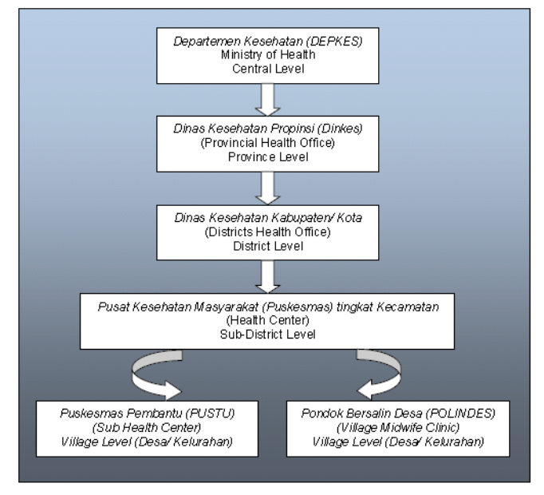
Source: WHO as cited in Erlina, 2007.
Meanwhile, the provision of public health is the responsibility of the Ministry of Health (MoH) and sub-national governments. Thus, it mainly related to government’s structures and administration. These public sector actors deliver not only inpatient but also outpatient services, and perform promotive and preventive health activities. Figure 2.1 presents the complete structure of Indonesia’s health system.
The MoH has overall duties for national health policy as the highest level of Indonesia’s health system. It sets national health programs and provides guidance and supervision for the entire health system to ensure the health care quality. For instances, the MoH controls for the minimum health service standards on districts and municipalities as well as manages the accreditation and licence for private health service providers. Moreover, it regulates the standard requirements of health educational institution and professionalism certification for health workers. The MoH also remains responsible to allocate the doctors and midwives to the sub national region as non-permanent health employee or Pegawai Tidak Tetap (PTT).
Province is the second level of Indonesia’s health system. Each province in Indonesia has its own hospitals. These hospitals are part of government structure and financed by provincial budged and user fees. In contrast, local hospital does not exist in every district since the district governments face limited human resources and fiscal burden. The health services then provided at kecamatan (sub-district) level. Each sub-district has at least one puskesmas (health centre) headed by a doctor. Puskesmas mainly provide eighteen services. The full list of these services can be seen in table 2.1.
Table 2.1 A List of the Main Puskesmas Activities
No | Main Activities
1. | Women's and child health
2. | Family planning
3. | Nutrition
4. | Environmental health
5. | Surveillance, prevention and elimination of disease as well as immunization
6. | Public health education
7. | Treatment, including emergency treatment due to accidents
8. | Health in school
9. | Public healthcare
10. | Dental and oral health
11. | Mental health
12. | Optometry
13. | Geriatric health
14. | Exercise and sport
15. | Development of traditional medicine
16. | Occupational health and safety
17. | Basic laboratories
18. | Information gathering and reporting for the health information system
Source: Smeru Research Institute, 2004
Four smaller health care units usually support a puskesmas. They are secondary health service (pustu), village midwives (bides), village maternity houses (polindes) and mobile healthcare clinics (pusling). These four support units operate to increase service coverage based on working area and the population density. They work under head of puskesmas commands and use puskesmas’s facilities and medications.
A pustu is located at village or kelurahan level. It serves one or two villages based on population density. In Java and Bali, a pustu is targeted to cover 6,000 residents while it only covers 2,500 residents in outside Java. It staffed by one midwife and one nurse who are assisted by two administration staff. Meanwhile, in order to improve maternal and child health, due to the bides (bidan di desa) program, midwives are being deployed to the village. Polindes are established and managed by the community with the financial support of the government. It serves as a place to assist women giving birth and a home for midwife. However, in many cases polindes also gives a primary health service to the local communities. Pusling is a car or motorboat being used as mobile health clinics to serve communities in remote areas. It is staffed by one doctor or nurse, one midwife and one sanitarian with a working area equivalent to a puskesmas working area.
There is a significant change in the roles and responsibilities of various level of government since decentralization policy has been implemented in 2001. More specific, health financing, human resources for health and service provision have been affected. Under decentralization, responsibility for health care provision was delegated to local governments at district level. It also followed by transfer of a quarter million health worker (Rokx et al., 2009). The employment, deployment and payment affairs then become the responsibility of district government. Moreover, decentralization brings boarder discretion to district government to finance their health programs and plans that closely based on the local needs. There is an increasing trend of public health expenditure in district level although it still financed by intergovernmental fiscal transfers for instance general purposes grant or Dana Alokasi Umum (DAU) and specific purposes grant or Dana Alokasi Khusus (DAK). In contrast, province- level health offices have mainly been responsible for training and coordination efforts as well as managing of provincial hospitals (Rokx et al., 2009).

2.1.2 Infrastructure
Indonesia experienced massive growth of public health infrastructure in the 1970s and 1980s. At the time, the central government funded the construction of health centers and other primary health care network through the Inpres (Presidential Instruction) program and Anggaran Pendapatan dan Belanja Negara or APBN (the State Budget). After decentralization, the construction of health centers is mainly financed by the special allocation fund for health sector (Dana Alokasi Khusus/DAK Kesehatan) that transferred directly to district governments.

There were 8,234 puskesmas in 2007 and 2,683 units of them were puskesmas with beds (MoH, 2007). During 2003-2007, numbers of puskesmas were slightly increased with the highest increased (4.51 %) in 2006. Number of puskesmas with beds also tended to increase during that time. The most increase occurred in 2006 (20.22 %) and 2007 (7.45 %). Progress in number of puskesmas and puskesmas with beds in Indonesia during 2003-2007 is described in figure 2.2.
Figure 2.2 Number of Puskesmas and Puskesmas with Beds, 2003-2007
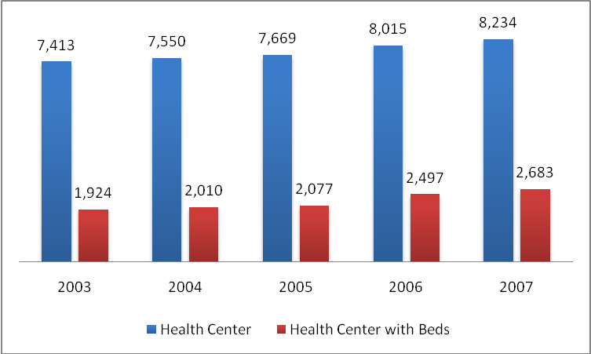
Source: MoH, 2008a
In addition, during 2003-2007, ratios of puskesmas to 100,000 populations ranged from 3.46 to 3.61. It means that every 3-4 puskesmas served to 100,000 populations. It is considered sufficient to meet the established standard of one puskesmas per 30,000 people. However, the distributions of puskesmas are not equal among provinces. The availability of them also not based on needs assessments (Rokx et al., 2009).
Figure 2.3 Ratio of Puskesmas to 100,000 populations, 2003-2007
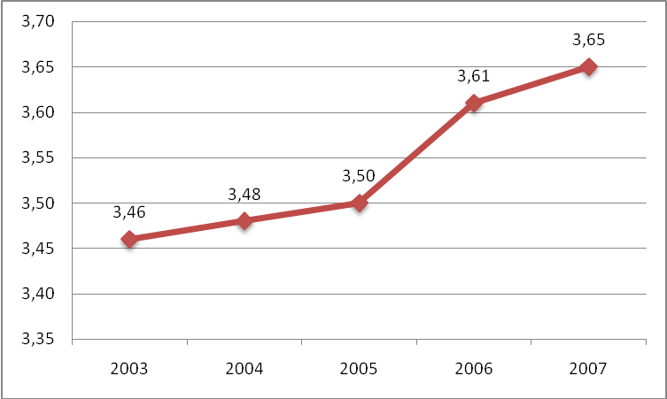
Source: MoH, 2008a
The number of general hospitals and hospital beds has grown slowly and has barely kept up with population growth. In 2003, there were 353 general hospitals and about 52,600 beds under the MoH, plus provinces and districts. In 2007, these numbers rose to 401 general hospitals and about 59,500 beds. These numbers do not include hospitals belonging to the armed forces, the police, or other ministries and state-owned enterprises, which, although affiliated with state agencies, function more like private institutions. The full information about number of general hospital and its beds by ownership is presented in table 2.2 and table 2.3.
Table 2.2 Number of General Hospital by Ownership 2003-2007
Ownership | Total General Hospital
Ownership | 2003 | 2004 | 2005 | 2006 | 2007
Ministry of health | 14 | 13 | 13 | 13 | 13
Province | 45 | 43 | 43 | 43 | 43
District/ Municipal | 294 | 305 | 322 | 334 | 345
MoH and Local Governments | 353 | 361 | 378 | 390 | 401
Armed Forces/ Police | 110 | 110 | 110 | 110 | 110
Other Ministry/ State-owned enterprises (BUMN) | 71 | 71 | 71 | 71 | 71
Government | 534 | 542 | 559 | 571 | 582
Private | 432 | 434 | 436 | 441 | 451
Total General Hospital | 966 | 976 | 995 | 1012 | 1033
Source: MoH, 2008a
The slow expansion in public hospitals and beds has been partly offset by an increase in private hospitals. In 2003, there were 432 private hospitals with about 42,300 beds. It was increasing in 2007 to 451 hospitals with around 45,000 beds. It was around 37 percent of the total beds in general hospitals.
Table 2.3 Number of Beds in General Hospital by Ownership 2003-2007
Ownership | Total General Hospital
Ownership | 2003 | 2004 | 2005 | 2006 | 2007
Ministry of health | 8.858 | 8.505 | 8.483 | 8.784 | 8.777
Province | 12.958 | 12.391 | 12.902 | 12.834 | 13.182
District/ Municipal | 30.803 | 31.959 | 33.896 | 35.375 | 37.575
Moh and Local Governments | 52.619 | 52.855 | 55.281 | 56.993 | 59.534
Armed Forces/ Police | 10.718 | 10.761 | 10.814 | 10.842 | 10.836
Other Ministry/ State-owned enterprises (BUMN) | 6.758 | 6.537 | 6.827 | 6.880 | 6.851
Government | 70.095 | 70.153 | 72.922 | 74.715 | 77.221
Private | 42.284 | 42.487 | 43.364 | 43.789 | 45.074
Total Beds in General Hospital | 112.379 | 112.640 | 116.286 | 118.504 | 122.295
Source: MoH, 2008a

2.1.3 Health Workforce
According to Indonesian Medical Council (KKI), as of July 2007, a total of 72,249 doctors, including 15, 499 specialists, were registered nationally (World Bank, 2009). It means that there were 25 doctors per 100,000 inhabitants. One should be noted that this number might include non-practicing doctors; therefore, it may be overestimate of the number of available doctors. In contrast, the Podes (potensi desa), census data that is gathered by interviewing desa (village) and kelurahan heads, reported the total number of medical doctors at almost 40,000 in 2006. It means that Indonesia has more than 18 medical doctors for every 100,000 populations. It increased by 6 percent compared to 1996 data (table 2.4).
Table 2.4 Total Number and Ratio of General Practioner in Indonesia by Region 1996-2006
Region |  | Level |  |  | Ratio per 100,000 Population
 |  | 1996 | 2006 | % Change | 1996 | 2006 | % Change
Java/ Bali |  | 19,635 | 23,944 | 21.95 | 16.20 | 18.50 | 14.20
 | Urban | 16,141 | 20,896 | 29.46 | 39.00 | 34.10 | -12.56
 | Rural | 3,494 | 3,048 | -12.76 | 4.40 | 4.50 | 2.27
Outside Java/ Bali |  | 11,908 | 15,740 | 32.18 | 14.80 | 18.10 | 22.30
 | Urban | 7,738 | 11,187 | 44.57 | 43.20 | 40.90 | -5.32
 | Rural | 3,638 | 3,141 | -13.66 | 7.10 | 8.30 | 16.90
 | Remote | 532 | 1,412 | 165.41 | 4.70 | 6.60 | 40.43
Total |  | 31,543 | 39,684 | 25.81 | 17.30 | 18.40 | 6.36
Sources: World Bank, 2009

Both total numbers of general practioner and its ratio per 100,000 populations has improved over time, but inequalities in distribution between provinces, between urban and rural area, and between Java/ Bali and outside Java/ Bali have not (World Bank, 2009). As can be seen in table 2.4, urban areas in all regions have more doctors than in rural and remote areas. Urban areas served by more doctors per 100,000 populations at ratio at least five times greater than in rural and remote areas. The data also shows that the number of doctors in both 1996 and 2006 was much higher in Java/ Bali than outside Java/ Bali.
According to PODES, Indonesia had almost 80,000 midwives in 2006. It means there was about 50 midwives per 100,000 populations or about one per village (World Bank, 2009). The ratio for midwives has improved significantly
over time, from 42 midwives per 100,000 in 1996 to 49 midwives per 100,000 in 2006, an increase of 17 percent (table2.5). However, for number of midwife rural areas show higher ratios than urban. This mainly happens because of “Bidan di Desa” (Bides) or midwife in the village programme that launched by the government in 1989. Moreover, the total number of midwives in Java/ Bali did not change over time, but in there is a tendency that midwives are moving back to urban areas. On the other hand, there is a significant increase in outside Java/ Bali region. The ratio of midwives to population increases from 46 in 1996 to 53 in 2006, while the absolute number of midwives in remote areas increases twice from 1996.
Table 2.5 Total Number and Ratio of Midwives in Indonesia by Region, 1996-2006
Region |  | Level |  |  | Ratio per 100,000 Population
 |  | 1996 | 2006 | % Change | 1996 | 2006 | % Change
Java/ Bali |  | 33,436 | 33,755 | -0.18 | 27.50 | 26.10 | -5.09
 | Urban | 9,874 | 15,388 | 55.84 | 23.80 | 25.10 | 5.46
 | Rural | 23,562 | 18,367 | -22.05 | 29.50 | 27.10 | -8.14
Outside Java/ Bali |  | 37,579 | 45,906 | 22.16 | 46.80 | 52.80 | 12.82
 | Urban | 8,084 | 12,421 | 53.65 | 45.10 | 45.40 | 0.67
 | Rural | 23,487 | 20,957 | -10.77 | 46.00 | 55.10 | 19.78
 | Remote | 6,008 | 12,528 | 108.52 | 53.40 | 58.10 | 0.09
Total |  | 71,015 | 79,661 | 12.17 | 41.70 | 48.60 | 16.55
Sources: World Bank, 2009

Maternal Care Service
Adequate infrastructure and availability of health worker supply are essential factors that determine utilization of two maternal care services namely skilled birth attendant at delivery and antenatal care in Indonesia. In general, Indonesia has made progress in the utilization of maternal care. In 2006, 72.41% of delivery babies had helped by skilled birth attendances. Among this number, midwife is the most health workforce helps in the delivery process (60.73%). Doctor 10.79% and nurse 0.89% followed it. From the non-health workforce, traditional birth attendant accounted for 25.30% in baby born process. The other 2% was reported for helps from other family members (figure 2.4).
Figure 2.4 Type of Delivery Assistance, 2006
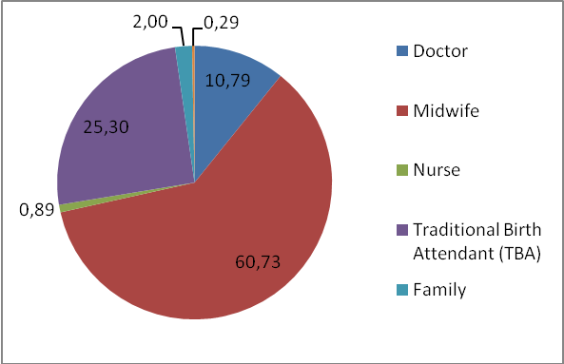
Source: Author calculations based on Susenas Data, 2006
In addition, there is a positive trend of women to deliver their babies in a health facility instead of at home. Figure 2.5 illustrates trends in location of births by type of provider and presence of skilled birth attendant in Indonesia. The percent of live births attended by a health professional increased nearly 100% from 1986 to 2002. It increased from 35% (1986–1989) to 69% (2000–2002) of live births. Home births attended by a health professional increased from 14% in 1986–1989 to 32% in 2000–2002, while health facility births increased from 20% to 37% over the same period. There is also increasing trend of delivery occurred in private facilities.

Figure 2.5 Trends in Location of Births in Indonesia, by Type of Provider and Presence of Skilled Attendant
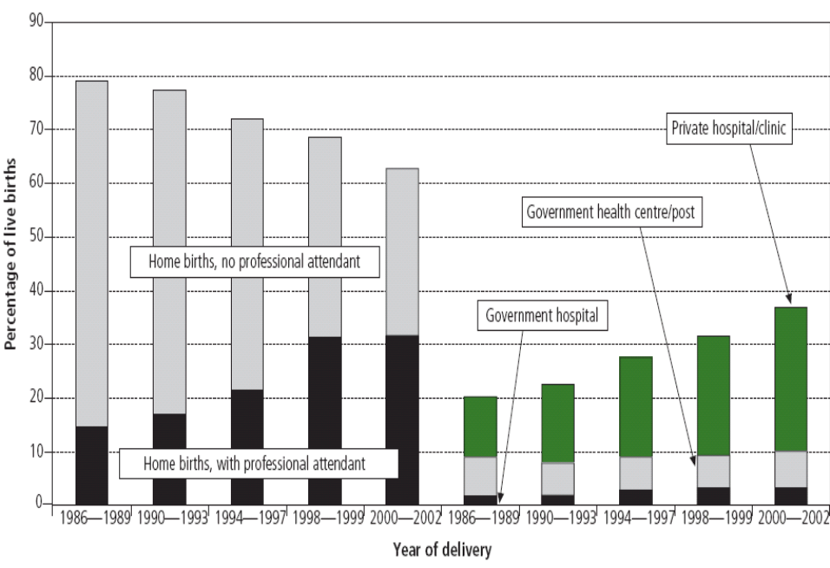
Source: IDHS Reference 15 as cited in Hatt et al., 2006
Other indicator of maternal health services is the antenatal care. Antenatal care is a service for mother during her pregnancy provided by professional health workforce (obstetric and gynaecologic specialist, physician, midwife and nurse). This service covers weighing and blood pressure measurement, fundus uteri height, Tetanus Toxoid (TT) immunization, and zinc supplement. Antenatal care can be reflected from K1 and K4 coverage (MoH, 2008a). K1 coverage represents the number of pregnant women who made the first visit to get antenatal care. While K4 expresses the number of pregnant women who accomplished the standardized antenatal care by taking at least four visits: once at the first three months, once at the second three months, and twice at the third three months.
Figure 2.6 displays the percentage of K1 and K4 coverage from 2001-2006. The differences in the percentage between K1 and K4 imply the decreasing in number of visit to get antenatal care. It is because the first three months usually is the essential time for the growth of a baby. In 2001, there was a high number of pregnant women took their first visit for antenatal care (K1). However, the percentage of K1 decreased for the next two years, from 93.03% in 2001 felt to 88.56% and 87.73% in 2002 and 2003 respectively. Then, it steadily increased in 2004 to 2006. For K4, there was also a decreasing in percentage from 2001 to 2002 as much as 4.37%. In the next following years, percentage of K4 increased and reached the highest point during the last six years at 79.63% in 2006. The increasing in K1 and K4 indicates the improvement in maternal health services
Figure 2.6 Antenatal Care: K1 and K4 Coverage, 2001-2006
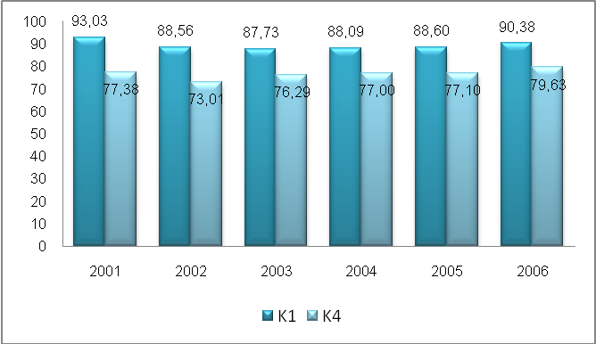
Source: MoH, 2008a

Indonesia’s Child Health Status
Health conditions of the Indonesian population have improved dramatically over the years. Infant mortality rate decreased from 46 per 1,000 live births in 1997 to 34 per 1,000 live births in 2007 (MoH, 2008a). The same pattern is found in declining of under-five mortality rate. The Indonesian Demographic and Health Survey (IDHS) data confirm that under-five mortality rate fell down from 97 per 1,000 live births in 1991 to 44 per 1,000 live births in 2007.
Mortality in early childhood is related to neonatal and post-neonatal factors (MoH, 2008a). Neonatal mortality defines as the death of infants occurred in the months after the baby born. It caused by several reasons associated with child condition obtained from conception or during pregnancy. Meanwhile, post-neonatal death is infant mortality that happened between the age of one month and the age of one year. It influenced by the external environments for example house condition and access to sanitation or safe water.
Statistics shows that in 2005 both neonatal and pneumonia are the main causes of infant mortality. They contributed to 68 percent of infant deaths. In addition, 9 percent of infant deaths are caused by diarrhea. It suspects that poor sanitation and clean water contributes to high degree of diarrhea. Surprisingly, only 1.7 percent of infant deaths occurred because of malnutrition. It seems that Indonesia has made substantial progress in child nutrition in order to reduce infant mortality.

Figure 2.7 Causes of Infant Deaths in Indonesia, 2005
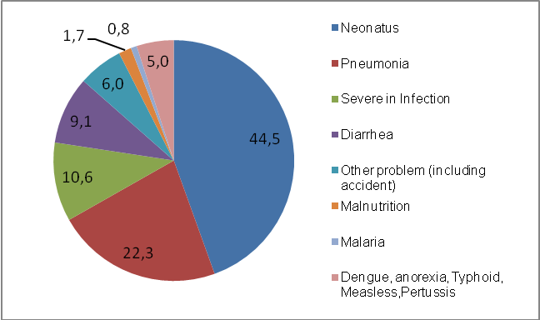
Source: MoH, 2008b
Although significant progress in reducing child mortality has been achieved, Indonesia is still facing several problems. Firstly, there is a geographical disparity among provinces. The Indonesia’s Health Profile 2007 confirmed this problem. It reported that the lowest IMR with 19 deaths per 1,000 live births was achieved by Yogyakarta, while the highest IMR performed by West Sulawesi with 74 infant deaths for every 1,000 live births. This condition implies that the IMR in West Sulawesi is four times higher than Yogyakarta. On the other hand, the high rate of under-five mortality rate appeared dominantly in east region of Indonesia. They were West Sulawesi (96), Maluku (93) and West Nusa Tenggara (92). Their performances were far below Yogyakarta (22), Central Java (32) and Central Kalimantan (34).
The second problem is significant disparities emerged across socio-economic groups (World Bank, 2007, 2008). The IDHS data for 2002-2003 showed that under-five mortality rate as high as 77 per 1,000 live births among the poorest households compared to about 22 per 1,000 among the wealthiest households. It means that the children who live in the poor households face higher probability to be dying than those in rich households.
Thirdly, Indonesia’s performance is still below its closely neighbour countries in South East Asia. According to World Health Statistics 2008, Indonesia’s IMR is still higher than Malaysia (10), Thailand (20) and Vietnam (18). For under-five mortality rate, again Indonesia performed poorly compare to Thailand (8), Malaysia (12) or Vietnam (17).

2.4 Public Expenditure on Health
Public health expenditure in Indonesia has risen substantially since 2001. It was doubling from 9.3 trillion rupiah in 2001 to 22. 2 trillion rupiah in 2005 (table 2.6). In addition, budget allocation for 2006 showed that public health expenditure increase 63 percent compared with 2005. It was projected become 39 trillion rupiah in 2007 and 39.7 trillion rupiah in 2008.
Table 2.6 Trends in Indonesia Public Health Expenditures, 2001-2007
 | 2001 | 2002 | 2003 | 2004 | 2005 | 2006* | 2007** | 2008***
National nominal health expenditures | 9,3 | 11,0 | 16,0 | 16,7 | 19,1 | 31,2 | 39,0 | 39,7
National health expenditures at constant prices (100=2000) | 8,3 | 8,8 | 12,1 | 11,8 | 12,2 | 18,0 | 20,9 | 20,3
Annual growth real national health expenditures (%) | 42,8 | 19,0 | 45,8 | 4,1 | 14,4 | 63,3 | 24,9 | 1,8
Public health expenditures as % of national total public expenditure (%) | 2,6 | 3,2 | 3,9 | 3,6 | 3,5 | 4,4 | 4,8 | 4,4
National public health expenditure as % of GDP (%) | 0,5 | 0,6 | 0,8 | 0,7 | 0,7 | 0,9 | 1,1 | 1,1
Total national public expenditure at current prices | 355,2 | 339,6 | 411,2 | 459,8 | 547,2 | 714,7 | 812,0 | 891,8
Total national public expenditure at constant prices (2000=100) | 318,6 | 272,2 | 309,3 | 325,6 | 350,8 | 412,0 | 435,0 | 455,4
Source: World Bank 2008
Public health expenditure has also increased relative to overall national expenditure, from 2.6 percent in 2001 to 3.5 percent in 2005. However, health expenditure as a share of GDP remains low. It only increased from 0.5 percent to 0.7 percent over the same period. The share was estimated to 0.9 percent in 2006 and 1.1percent in 2007.
Over the period 2001 to 2005, the average annual rate of health spending growth was 29 percent for all level of government. More specific, it was 41 percent for central government, 23 percent for provincial government, and 24 percent for district spending (World Bank, 2008). Furthermore, the majority of health expenditure was spent by the district level (table 2.7). Districts spent 4.4 billion in 2001 and it became 9.9 in 2005. In 2005 district contributed for 52 percent of total expenditure while provinces and central contributed for 17 and 31 percent. This trend has remained consistent until 2006. In 2006 central level share of health expenditure started to increase. In 2006 and 2007, share of districts and central were relatively the same. The increase amount of health expenditure in central government is caused by the increase in social spending or the Askeskin health insurance program for the poor that is classified as central level expenditure (World Bank, 2008).
Table 2.7 Public Health Expenditures by Level of Government, 2001-2005
Level of Gov. | 2001 |  | 2002 |  | 2003 |  | 2004 |  | 2005
Level of Gov. | Nominal | % | Nominal | % | Nominal | % | Nominal | % | Nominal | %
Central | 3,119 | 34 | 2,907 | 26 | 5,752 | 36 | 5,595 | 33 | 5,837 | 31
Province | 1,745 | 19 | 2,372 | 22 | 2,821 | 18 | 3,000 | 18 | 3,316 | 17
District | 4,387 | 47 | 5,725 | 52 | 7,473 | 47 | 8,108 | 49 | 9,948 | 52
Total | 9,250 | 100 | 11,004 | 100 | 16,045 | 100 | 16,703 | 100 | 19,101 | 100
Source: World Bank 2008
Before 2005, Indonesia used the traditional classification of “routine” and “development” expenditure. Development expenditure is defined as expenditure creating future benefits. It is government investments, for instance construction or upgrading of health facilities. On other hand, routine expenditure consists of recurrent items, mainly salaries and allowances. In 2005, Indonesia introduced a unified budgeting system and the “routine” and “development” classification no longer being used (World Bank, 2008). Instead, the new budget categorizes between :(i) discretionary spending (similar to what was previously called “development”); (ii) non-discretionary spending (part of what used to be labelled “routine”); and (iii) an economic classification that includes personnel, material, social assistance and capital. These sub-classifications are used to be called “routine”.
Using the “routine” and “development classification, it confirms that routine expenditure remained constant during period 2001 to 2005. A small decrease at central and provincial level was compensated by an increase at district level (table 2.8). In contrast, there was an increase in development expenditure. Development expenditure increased significantly from 2001 to 2004 at all level of governments. There was an increase of about 15 percent per annum during that time. Meanwhile, there was significant increase of health expenditure at district level. In 2005, it was account for 40 percent of total district’s health expenditure.
The increase in development expenditure at district level after 2001 was probably a result of decentralization (World Bank, 2008). This comes from increased purchasing and procurements executed by district governments since most of functions of healthcare provision became their responsibilities. Moreover, introduction of DAK for health sector that mainly used for infrastructure construction contributed to increase of development spending.
Table 2.8 Levels and Shares of Health Expenditures at Different Levels of Government, 2001-2005
 | 2001 |  | 2002 |  | 2003 |  | 2004 |  | 2005
 | Nom. | % | Nom. | % | Nom. | % | Nom. | % | Nom. | %
Central government | 3,1 | 34 | 2,9 | 26 | 5,8 | 36 | 5,6 | 34 | 5,8 | 31
Development | 2,3 | 74 | 2,4 | 84 | 5,3 | 92 | 5,0 | 89 | - | -
Routine | 0,8 | 26 | 0,5 | 16 | 0,5 | 8 | 0,6 | 11 | - | -
Provincial government | 1,7 | 19 | 2,4 | 22 | 2,8 | 18 | 3,0 | 18 | 3,3 | 17
Development | 0,6 | 33 | 0,9 | 39 | 1,5 | 52 | 1,8 | 60 | 1,8 | 54
Routine | 1,2 | 67 | 1,4 | 61 | 1,4 | 48 | 1,2 | 40 | 1,5 | 46
District government | 4,4 | 47 | 5,7 | 52 | 7,5 | 47 | 8,1 | 48 | 9,9 | 52
Development | 1,2 | 28 | 1,5 | 26 | 2,9 | 39 | 3,1 | 38 | 4,0 | 40
Routine | 3,2 | 72 | 4,2 | 74 | 4,6 | 61 | 5,0 | 62 | 6,0 | 60
Total National Expenditures | 9,3 | 100 | 11,0 | 100 | 16,0 | 100 | 16,7 | 100 | 19,1 | 100
Total Development | 4,1 | 44 | 4,8 | 44 | 9,7 | 61 | 9,9 | 59 | 5,8 | 30
Total Routine | 5,2 | 56 | 6,1 | 56 | 6,5 | 39 | 6,8 | 42 | 7,5 | 39
Source: World Bank 2008

Literature Review
This chapter briefly highlights the literature associated with infant mortality with emphasize on its relationship with public health spending and skilled birth attendance. The first subchapter presents previous studies that examine how government’s investment on health through its public spending affect infant mortality rate. This subchapter discuss model, methodology and empirical findings of these studies. The second subchapter aims to provide conceptual framework for skilled birth attendance on infant survival. It also followed by presentation of several studies that have been carried out to examine the role of skilled birth attendance on infant mortality.

Public Health Expenditure and Infant Mortality
The possible impact of public health spending on infant mortality is a debatable topic among health economists. There is likely to be on-going discussion on the possible consequences of investment in health through public health expenditure. In fact, there is no clear answer about this relationship. Several studies do not find a positive relationship between public health spending on infant mortality; in contrast, other researches do.
A number of cross-country studies of the relationship between spending and health outcomes have been carried out over the last ten years. Using cross-national data, Filmer and Pritchett (1999) find that the impact public health expenditure on infant and child (under 5 years old) mortality is relatively small across countries and insignificant at conventional level of significance. Their estimation is based on aggregate ‘health productions function’ that assumes that health outcomes depend on countries’ income, knowledge, and social capability. The model is
ln(M_{i}) =β₁ ln (GDP_{i}/N_{i}) + β₂ ln (H_{i}/GDP_{i}) + β₃ ln X_{i} + ε_{i}
where M denotes the (natural) log of child or infant mortality; GDP/N is the log of mean per capita income; H/GDP is the log of the share public spending as a fraction of GDP, and X is a set of socio-economic variables. These variables are the level of female education, income inequality, percentage people that live in urban area, predominantly muslim, etno-linguistic fractionalization, access to safe water, dummy tropical country, dummy oil exporter, years independent, and defense spending as a share of GDP.
The model estimates using OLS method and Instrumental Variables (IV). The reason is to take into account not only for possible endogeneity between infant or child mortality and public health spending but also for measurement error in health spending. Filmer and Pritchett use the average public sector health care spending as a share of GDP and the average defense spending as a share of GDP of a country’s geographic neighbours as instruments of their IV estimation. However, both OLS and IV estimation shows insignificant results. Therefore, they do not have enough statistical evidence to conclude that public health spending affects infant and child mortality. They conclude that public health spending is not a powerful determinant of infant mortality because 95 % of cross-national differences can be explained by socio-economic characteristics of each country, for examples inequality of income distribution, female education, level of ethnic fragmentation, and predominantly religion.
Study of Gupta et al. (2002) found that public health spending is associated with reduction in child mortality. They use cross-sectional data for 50 countries and employ the following equation to evaluate the impact of public spending on health care.
Y_{i} = f (X_{1i}, X₂₁, Z_{i})
where Y_{i} is a social indicator reflecting health status for a country i. Two indicators are used: infant and child mortality rates. X_{1i} is public health spending as percentage of GDP, while X_{2i} is primary health care spending as percentage of total health care spending. Z_{i} is a vector of socio-economic variables including adult illiteracy rate, income per capita in PPP term, urbanization (percent of population), and access to sanitation. This equation estimates in log-log regressions using OLS (correcting for heteroskedasticity) and two-stage least square (2SLS).
The results are as follows. First, total health spending is found statistically significant both when they utilize OLS and 2SLS but the share of primary health care spending as percentage of total health care spending is not. The coefficient of estimations suggest that increasing the share of total public spending in GDP by 1 percentage point will decrease either child or child mortality rates by about 3 deaths per 1000 live births. Therefore, one can conclude that public health spending is an important element in determine infant or child mortality rates. Second, almost all control variables are found statistically significant affect mortality rates and have signs as expected, except for access to sanitation. Adult illiteracy rate and per capita income variables show consistent results in all regressions, while urbanization variable is only statistically significant for OLS regression.
Moreover, Rajkumar and Swaroop (2008) provide further explanation that helps to understand why public spending often does not yield the expected improvement in outcomes. They argue that the differences in the effectiveness of public health spending across countries are the source of incoherent impact of public spending on certain outcomes. The effectiveness of public health spending itself can be largely explained by the quality of governance. Therefore, one can conclude that the positive link between public spending and development outcomes will emerge only if the good governance establish.
In their study, Rajkumar and Swaroop use cross-sectional data for 91 countries over three years: 1990, 1997, and 2003. Like Filmer and Pritchett (1999), their key spending variable is total public health. On governance, they use two measures to interact with public health spending in order to assess the impact of health spending on under 5 mortality. These measures are corruption and bureaucratic quality. Corruption is measured on a scale of 0 to 6, and bureaucratic quality ranges from 1 to 4. In addition, they also utilize several control variables. They include per capita GDP in PPP adjusted 2000, predominantly muslim, etno-linguistic fractionalization, female education, income inequality, access to safe water, degree of urbanization, and percentage of population aged under 5. The estimations used in this paper are OLS and 2SLS.
The regression results show that governance is the key determinant of public health spending effectiveness. More specific, 1 percentage point increase in the share of public health spending in GDP declines the under-5 mortality rate by 0.32 % in countries with good governance as measured by a corruption index. Similarly, it reduces 0.20 % the under-5 mortality in countries with average governance. In fact, it has no impact in countries with weak governance. The same result is attained when spending variables is interacted with the quality of bureaucracy. It has a negative coefficient which is statistically significant all level of significance. These results confirm that rich countries have lower child mortality, and the sign of relationship between public health spending and child mortality is negative. It also suggests that the effectiveness of public health spending is positively related with the level of governance.
Although the cross-country analysis could explain the possible link between public health spending and health outcomes, several concerns have been raised. First, they suffer from the inherent unobserved heterogeneity, for example historic and institutional factors, that affect both public spending and health outcomes. This has made cross-country analysis of public health spending less than optimal to determine the impact of health spending on health outcomes. More precisely, unobserved heterogeneity would lead to omitted variable biased. Second, the quality and comparability of the data themselves have been questioned. The data come from various sources with different data collection and treatment. Moreover, variable definition may not be uniform across countries. For instance, the definition of “total public health spending” may be different between Indonesia and Kenya. As a result, measurement error typically exists in cross-country analysis.
Analyzing relationship between public health spending and infant mortality in sub national context may reduce possibility of omitted variable bias since the sub national governments have the same institutional setting, and often share data collection tools (Kruse et al., forthcoming). In other word, the use of homogenous data might yield a more precise estimate of the relationship between infant mortality and public health spending. Cremieux et al.(1999) examined the impact of private and public health spending on health outcomes using Canadian provinces data over period 1978-1992. They argue that inherent heterogeneity associated with cross-country studies is the reason why previous studies found an insignificant relationship between mortality rates and public health spending. Therefore, using provincial data will limit both specification bias and data heterogeneity. It will lead to a more robust result.
Cremieux et al. take five groups of independent variables that expected to explain the variation in infant mortality rates as well as life expectancies at birth by sex. First group consist of health and economic variables including health spending per capita, GDP per capita, and number of physicians per capita. Second group captures socio-demographic aspects using number of graduates per capita, poverty rate, and population density. Third group draws lifestyle variables including percentage of smokers and alcohol consumption per capita, while fourth group represents nutritional variables including spending on meat and fat. The last group is provincial variables consist of ten provinces in Canada. The model is an aggregate function that examines these four determinants of health outcomes based on a general least squares estimation with provincial fixed effects. A GLS method correcting for both autocorrelation and heteroskedasticity in panel data that suspected to exist. Moreover, provincial variables are introduced to control systematic time invariant differences among provinces. The regressions are conducted not only in level but also in log variables.
The regression results confirm that lower health care spending in Canada is statistically significant associated with reduction in life expectancies and higher infant mortality rates. More specific, a 10 % reduction in health care spending will increase infant mortality by 0.5 % for male and 0.4 % for female. Similarly, a 10 % decrease in health care spending is associated with lower life expectancies by 6 months for men and 3 months for women. Cremieux et al. also found that even though the lifestyles and nutrition data are excluded, the results are still the same. Therefore, they conclude that the previous studies’ failure to find a significant relationship between health spending and health outcomes more caused by data heterogeneity inherently from cross-country studies rather than specification bias.
In Indian context, Bhalotra (2007) investigate the impact of variations in state health expenditure on infant mortality. She use the micro-data from the second round of the National Family Health Survey of India (NFHS-2) that informs complete fertility histories for ever-married women aged 15-49 in 1998-1999 including the time and incidence of child deaths. These data are used to construct individual-level indicators of infant mortality. These micro-data then are merged by state and year of birth with a panel data on health expenditure and other relevant variables for the 15 Indian states. Bhalotra runs the baseline model as follows.
Subscripts s and t indicate state and year and i and m indicate the individual child and mother respectively, ln denotes logarithm. M* is a latent variable measuring the probability of infant death, H is per capita real health expenditure, Y is per capita real net domestic product and β is the parameter of interest. X is a vector of variables observed at the child or mother level, Z is a vector of state- level controls and R^{f} and R^{d} are vectors of positive and negative state-specific rainfall shocks (superscripts f and d denote “flood” and “drought” respectively). α_{s} and α_{t} are state and year fixed effects and u_{st} are state-specific trends. The baseline model is estimated as a probit. Moreover, the model also adjusts for conditional heteroskedasticity and for conditional autocorrelation within states.

In addition, to gain at least an indicative sense of the state-specific relationships, Bhalotra also estimates simple linear model for each state using the time series (T = 28):
The results from baseline model show that health spending has no effects on infant mortality, while the state-specific model reveals that health expenditure has a significant negative effect only in three of 15 states in India. However, when Bhalotra restricts the sample to rural households, allows a distributed lag, and includes state-specific trends in the model, a significant impact of health expenditure emerges in the third lag of health expenditure. A possible explanation is that health expenditure is endogenous, and that this endogeneity is being limited by factoring out state-specific trends and by lagging health expenditure. In addition, Bhalotra also examines the differences in the impact of health expenditure by social group. She found that the impact is greater for rural and scheduled tribe households than for urban or higher-caste households.
There is a relevant recent work for Indonesia (Pradipta, 2003). The paper analyzes the link between total public health spending in provincial level and infant mortality rate in Indonesia while control for income per capita, public health expenditure, DPT1 Immunization, access to safe water, and adult illiteracy rate. The study uses a balance panel of 26 provinces in Indonesia over period 1997 to 2000 with fixed effect estimation.
The results show that public health expenditure is significantly affect infant mortality with negative sign as expected. The author concludes that public health expenditure in provincial level affects the reduction of infant mortality rate in Indonesia. The results also shows that all control variables are significant with expected sign accept for access to safe water that is also significant but with positive sign. One possible explanation is that reducing in infant mortality efforts in Indonesia did not followed by increasing access to safe water to the people.
To summary the discussion so far, at least two aspects need to be highlighted. First, there is no clear answer about the relationship between public health spending and infant mortality. The differences in findings are mainly caused by the quality of data and methods being used. There is a possibility of unobserved heterogeneity that make the estimation less than optimal setting to determine the impact of health care spending on infant mortality. However, using more homogenous data and utilizing panel data analysis can solve this problem. Second, none of the paper reviewed before examine indirect link or channel between public health expenditure and infant mortality. It is then become interesting to investigate the role of maternal care namely skilled birth attendant at delivery as channel for infant mortality reduction.
Addressing these two aspects, this paper aims to examine the direct effect of public health spending on infant mortality through the utilization of skilled birth attendance in Indonesia. In particular, it investigates the extent to which public health spending results in a decrease in infant mortality and whether skilled birth attendance has positive contribution to this decline. Using district data that aggregate to province level from 2001 to 2006, this study has better quality of spending data in the sub-national level since 60% of public health spending is spent by district governments as the effect of decentralization. The different condition experienced by the study of Pradibta (2003) that used pre-decentralization data from 1997 to 2000 to analyze the impact of province’s public health spending on infant mortality. Since public health spending before 2001 mainly occurs at central level, data used by this study might not be adequate to analyze the impact of public health spending on infant mortality in the province level. Moreover, Pradibta also failed taking into account population in his analysis since he use total health expenditure instead of per capita public health expenditure as a variable.

The Role of Skilled Birth Attendance on Infant Survival
The presence of skilled birth attendants at delivery is an important factor in preventing infant mortality. Skilled birth attendants at delivery, for example, are able to recognize the complications of unborn babies and provide appropriate interventions. They also perform assessment on the babies in the immediate post-birth period and intensive treatments for sick newborn when needed. Therefore, the risk of infant deaths can be reduced.
Several aspects determine the utilization of skilled birth attendance and provide a conceptual framework concerning its role on infant survival (figure 3.1). First, the utilization of skilled birth attendance is mainly associated with government’s policy context and socio-cultural attributes. The government, for instances, can provide intensive maternal care or increase the number of midwives to serve the community especially in rural areas in order to reduce infant mortality. On the other hand, the difference on socio-cultural attributes could diminish demand for skilled birth attendance. For examples, the preferences of people with skilled birth attendance at delivery are varies across religion, income groups or geographical locations.
Second, the degree of skilled birth attendance utilization is also affected by its inputs. For the skilled attendance to function effectively, at least the following must be in place. First, it needs high human resources competencies. The skilled attendants must have knowledge and personal attributes including life-saving skills to provide a good quality care. Second, it requires financial resources, for examples to ensure availability of all essential drugs, supplies and equipment. The financial resources itself can be come from either public expenditure or user fees. Third, the adequate infrastructure and transportation are needed to ensure the provision of effective care especially in an emergency. Fourth, interactions, communications and partnerships should exist between the health services and communities. This community empowerment aims to guarantee the quality of service delivery.

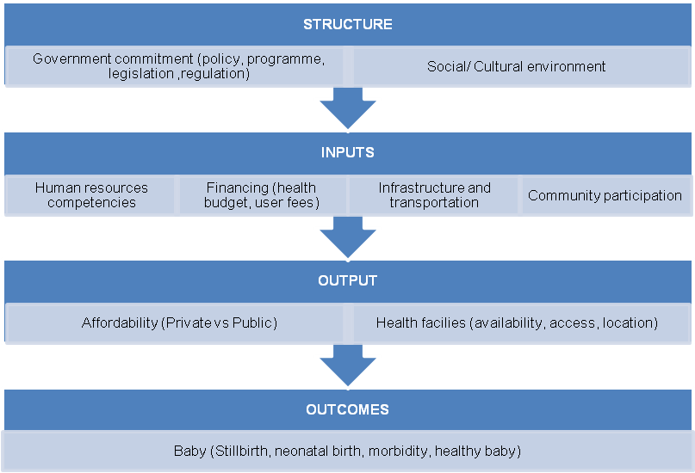Figure 3.1 Conceptual Frameworks for Skilled Attendance at Delivery on Infant Survival
Source: Graham et al., 2001 edited by author.
The last aspect that determines the utilization of skilled birth attendance is the affordability and health facility characteristics. The skilled birth attendance can be found both in private and public health provider. The users can choose based on their preferences. The users’ preferences are mainly affected by the price they are paid for services and quality of services that they received. In fact, public facilities tend to deliver services of lower quality than private facilities, but at a much lower price. On the other hand, the health facilities attributes also affect the utilization of skilled birth attendance. The availability and accessibility of health facilities by taking into account the location, distance from residence, transport time and cost are also important.
Some studies have been carried out to examine the impact of skilled birth attendance on infant survival. Panis and Lillard (1994), for example, examine the relationship of prenatal care and institutional delivery on child survival rate in Malaysia during period 1950-1988. Using probit estimation, they found that the children who delivered in a clinic or hospital are having higher probability to survive than those who do not. Then, they conclude that institutional delivery is strongly associated with child survival. Moreover, they also found that higher income would lead to the increase of demand for institutional delivery.
McGuire (2006) analyses the cross-section data for 94 developing countries in 1990 and confirms the same result. He demonstrates that the share of birth attended by trained personnel is strongly associated with decrease in under-5 mortality rates, while control for per capita GDP, female schooling, income inequality, ethnolinguistic fractionalization, and predominantly muslim. In contrast, this study also finds that health public health spending not associated with under-5 mortality reduction. These findings suggest that having a high degree of public health financing is insufficient to reduce child mortality if it is not followed by improvement in maternal and infant health care services.
However, the contradictory result is obtained by Hatt et al.(2009). They used four Indonesian Demographic and Health Survey (DHS) conducted in 1991, 1994, 1997, and 2002/2003 to examine the effect of skilled birth attendance, including place and type of providers, on improved infant survival between 1986 and 2002. They pooled these four surveys become cross-sectional dataset and investigated live birth occurring during the 5 years before each survey conducted. The multivariate logistic results show that first-day mortality did not decrease significantly between 1986 and 2002 as early neonatal mortality rates did. The results also confirm that decrease in early neonatal mortality is not statistically significant associated with professional attendance at home birth and private providers, while public facilities are statistically significant at 5% level of confidence. On the other hand, fertility factors such as birth interval and mother’s age at delivery are significantly affecting infant mortality. This paper concludes that although early neonatal mortality in Indonesia decreased by an impressive amount between 1986 and 2002, they are unable to provide an empirical finding that the increased skilled birth attendance contributed to this decrease. These findings finally suggest three policy recommendations. First, it is important to increase the midwife’s skills for immediate newborn through specific trainings. Second, the improvement in midwife’s competencies should also be complemented with increasing in public health facilities. Third, since fertility factors are the main determinant of infant deaths, the policy supports for family planning programme should be continued.

Methodology

Infant Mortality Rate: Definition and Estimation Approaches
Infant mortality rate (IMR) is the number of deaths occurring in the first year of life per 1,000 live births. It measures the probability of a child born in a specific year will die before reaching the age of one (O’Donnel et al., 2008). The IMR are estimated using two approaches including a direct and indirect method. Choice of methods used to estimate the IMR depends on availability and reliability of data source on infant deaths.
Reliable data to estimate infant mortality rates mainly come from two data sources. The first is a vital registration system. It is a preferred source of data on infant mortality because it records all information about live births and deaths on prospective basis where a live birth or death is directly reported after it occurs. This makes vital registration system always inform statistical records of live births and deaths based on the actual condition of the population. As a result, it will provide more reliable and accurate data on infant mortality. However, an accurate vital registration system have not yet established for large part of the world, especially in developing countries. Then, it calls for an alternative source in order to estimate the IMR.
The alternative source of data on infant mortality is household surveys. In the surveys, the women of fertility age are asked to answer some questions about births and deaths of children born to them. From this information, the fertility histories then can be constructed. There are two types of the fertility histories. They are a complete or truncated fertility history and incomplete or summary fertility history (O’Donnel et al., 2008). A complete fertility history uncovers the dates of births, survival status and date or age at death of all children born to the interviewed woman. On the other hand, an incomplete fertility history reveals only the number of children ever born and the number still alive or the number who have died.
In order to estimate infant mortality rate, a direct method requires data for each child’s date of birth, survival status, and date or age at death. This information can be found both in vital registration systems and in household surveys with complete fertility histories. In contrast, an indirect method requires less data that can be found in household surveys that do not collect detailed fertility histories. The only information required are: the number of children ever born, the number of children surviving (or dead), and the total number of women classified by five year age groups.
The indirect approach uses the Brass method, after William Brass who developed a procedure to convert the proportion of death among children ever born reported by women in the age groups into estimates of the probability of dying before a certain age. Brass’s method assumes that the age of the mother can function as a proxy for the age of her children and therefore for how long they have been exposed to the risk of dying (UNICEF, WHO, The World Bank and UN Population Division, 2007). The procedures to calculate infant mortality rate using the indirect method can be explained as follows.
Step 1. Calculation of average parity per woman
Average parity per woman is the average number of children ever born by women in a given five-year age group. It is calculated as
P(i) = CEB(i)/FP(i) (1)
where P (i) is the average parity of women of age group i, CEB (i) is the total number of children ever born by these women, and FP (i) is the total number of women in the age groups. Although parity values are needed only for age groups 15-19, 20-24, and 25-29, that are P(1), P(2) and P(3), it is important to calculating the whole set up to age group 45-49 in order to check the quality of the basic data (United Nations, 1990).
Step 2. Calculation of the proportion dead among children ever born
The proportion dead among children ever born is given by ratio of the total number of dead children to the total number of children ever born for each age group. Therefore,
D(i) =CD(i)/CEB(i) (2)
Where D(i) is the proportion of children dead for women of age group i, CD(i) is the number of children dead reported by those women, and CEB (i) is the total number of children ever born by those women.
Step 3. Calculation of the multipliers, k(i)
The Brass method assumes that ages of mothers and ages of their children are associated. However, these connections are not exact and depend on the nature of reproductive histories in a particular group of women who are reporting their birth. This makes adjustment factors, k (i) are needed to adjust for the particular reproductive histories of a group of women. The adjustment factor in Brass’s approach depends on P(1)/P(2), which is an index of the earliness of fertility.
The multiplier equation is
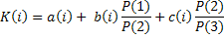 (3)
The equation (3) shows that multiplier factor k(i) is determined by the parity ratios P(1)/ P(2) and P(2)/P(3) and three coefficient a(i), b(i), and c(i). These coefficients were estimated by regression analysis of simulated model cases. One common approach is using the four regional families of the Coale-Demeny model life tables.
Step 4. Calculation of the probability of dying by age x, q(x)
As D(i) and k(i) have been calculated for each age group i, the estimates of q(i) are obtained as their product.
q(x) = k (i) D(i) (4)
However, the indirect method has several limitations. First, since model life tables required to adjust the data for the age pattern of mortality in the general population are mainly derived from European experiences, they might not fit the population pattern in other countries. Choosing an appropriate life table to a specific population is important to generating accurate estimates (Ahmad et al., 2000). Second, the Brass method assumption that fertility and child mortality have remained constant in the recent past has been questioned. If, for example, fertility has been changing, the ratios of average parities and age pattern of childbearing will be affected. It will lead to bias results, over or under estimate of child mortality (United Nations 1983, Preston et al. 2001).
In this paper, data to estimate province’s infant mortality rates come from Indonesia’s socio-economic household survey (Susenas) data from 2001 to 2006. Susenas data provides information about: (i) the number of children ever born, (ii) the number of children surviving, and (iii) the total number of women classified by five-year age groups. Based on this data, infant mortality rates are calculated using the United Nation’s software, QFIVE. Coaled-Demeny West table have been chosen to adjust for age pattern of mortality. This is based on argument that this life table is suit on mortality pattern in Indonesia (Bos and Saadah 1999). This life table also become main reference of Statistics Indonesia when calculate infant mortality rates. One should be noted that since the study period of this paper only six years, the fertility patterns across provinces are likely remain constant. This study period is too short for any meaningful changes in fertility to materialize. As a result, infant mortality rates are reliable to be used for the further analysis.

Data
The empirical analysis in this paper uses a balanced panel of 25 Indonesian Provinces during the period 2001-2006, for which complete data can be found from three sources. The first is Indonesia’s socio-economic household survey (Susenas), which provides information on household characteristics and the presence of skilled birth attendant at delivery. The Susenas data also contains information that can be used to calculate infant mortality rates with the indirect method. The Susenas data for this paper are available from 2001 to 2006.
The second source is the Ministry of Finance (MoF) data. It records district expenditure that can be broken down by sector, including health. It is then divided into two types of health expenditure, routine and development expenditure. Since the Indonesian government changed the financial report format for provincial and district level spending according to Government Regulation Number 24 year 2005 about Governmental Accounting Standard, time consistent data for public expenditure on health are available only for 2001 to 2004.
The last source is Ministry of Health (MoH) data on the ratio of puskesmas per 100,000 inhabitants as proxy for health care supply provided by government. This data are available for every province from 2001 to 1006. This information is taken from various years of Indonesia Health Profile published by the MoH.
This study combines these three data sources to construct a panel data set. In order to simplify the analysis, these data aggregated into province level. It also aims to make infant mortality rates feasible to be calculated. Four provinces are excluded from analysis since they do not have complete data namely Nanggroe Aceh Darussalam, North Maluku, Maluku, Papua, and DKI Jakarta. A balance panel then consist of 25 Indonesia provinces during the period 2001-2006. Table 4.1 lists the variables with their definitions and sources while table 4.2 presents descriptive statistics of province panel.
Table 4.1 Definitions and Sources of The Variables Used in The Analysis
Variable | Definition | Source
Infant Mortality Rate (IMR) | The total number of deaths to children under the age of one year for every 1,000 live births. | Own calculation using Susenas data and QFIVE software
Public health expenditure | Per capita public health expenditure. | Ministry of Finance
Development health expenditure | Per capita development health expenditure. | Ministry of Finance
Routine health expenditure | Per capita routine health expenditure. | Ministry of Finance
Skilled birth attendance | The proportion of child born last year that helped by a trained health professional (doctor, midwife or nurse). | Susenas
Rural population | The fraction of population living in rural area. | Susenas
Mother's education 1 | Primary education highest attended by women that ever gave birth. | Susenas
Mother's education 2 | Junior secondary education highest attended by women that ever gave birth. | Susenas
Mother's education 3 | Senior secondary education highest attended by women that ever gave birth. | Susenas
Mother's education 4 | Higher education highest attended by women that ever gave birth. | Susenas
Own house | The fraction of population having its own house. | Susenas
Access to sanitation | The proportion of households with closed sewage disposal. | Susenas
Households size | average number of members of a household. | Susenas
Puskesmas coverage | The ratio of puskesmas per 100,000 inhabitants. | Ministry of Health

Table 4.2 Descriptive Statistics
Variable | Number of observations | Mean | Std. Dev. | Min | Max
Year | 150 | 2003.5 | 1.71 | 2001 | 2006
Per capita public health expenditure | 100 | 32535.74 | 15245.15 | 9378.90 | 118512.90
Per capita development health expenditure | 100 | 11631.12 | 11377.15 | 1338.03 | 91781.22
Per capita routine health expenditure | 100 | 21045.61 | 6354.81 | 7895.78 | 38912.55
ln IMR | 150 | 3.61 | 0.43 | 2.08 | 4.83
Skilled birth attendance | 150 | 0.71 | 0.14 | 0.36 | 0.97
Rural population | 150 | 0.63 | 0.12 | 0.40 | 0.84
Mother's education 1 | 150 | 0.65 | 0.11 | 0.41 | 0.89
Mother's education 2 | 150 | 0.16 | 0.05 | 0.05 | 0.27
Mother's education 3 | 150 | 0.15 | 0.05 | 0.05 | 0.28
Mother's education 4 | 150 | 0.04 | 0.02 | 0.02 | 0.11
Own house | 150 | 0.83 | 0.57 | 0.70 | 0.92
Access to sanitation | 125 | 0.37 | 0.12 | 0.12 | 0.66
Household size | 150 | 4.78 | 0.35 | 4.07 | 5.65
Puskesmas coverage | 150 | 4.48 | 1.58 | 1.88 | 8.61
Source: author analysis of panel data

Econometrics Model
This paper first estimates a regression model examining the effect of public health spending on infant mortality, and then it explores the relationship between the public health spending on skilled birth attendance. Finally, this study will investigate whether infant mortality is affected by skilled birth attendance. This paper introduces a fixed effect parameter in order to capture unobserved heterogeneity associated with the provinces and a time specific effects.
Representing the provinces by the subscript i and the year of observations available by the subscript t, the relationship between IMR and public health spending is specified as
H_{it} = β₀ + β₁ S_{it} + β₂ X_{it} + α_{i} + δ_{t} + ε_{it} (1)
where H is log infant mortality and S is per capita total public health expenditure. X is a set of control variables, which include average house ownership in the province as proxy of average province welfare, the fraction of population living in rural area, the proportion of households with a closed sewage disposal system, and mother’s level of education. This model also controls for the ratio of puskesmas per 100,000 inhabitants as proxy of health care supply provided by government.
Time specific effects, represented in δ_{t}, are captured by a dummy variables for each year. This term incorporates average trends associated with economic development, for instance technological progress. The province fixed effect α_{i}, captures all unobserved, time invariant factors that might affect infant mortality rates, for examples geographical features and wide variations on cultural perspectives on how to care for newborn children.
The second model investigates the role of public health spending on skilled birth attendance. This model also examines role of the intermediate effect on utilization of skilled birth attendance as transmission channel through which public health spending may affect infant mortality rate. The model is
U_{it} = β₀ + β₁ S_{it} + β₂ X_{it} + α_{i} + δ_{t} + ε_{it} (2)
where U is utilization of skilled birth attendance, and X are control variables including average house ownership in the province, the fraction of population living in rural area, household size, mother’s education and puskesmas coverage.
Finally, in order to identify the effect of skilled birth attendance on infant mortality, this paper is examining the following model:
H_{it} = β₀ + β₁ U_{it} + β₂ X_{it} + α_{i} + δ_{t} + ε_{it} (3)
where the control variables X are the same as in equation (1).
One should be noted that fixed effect approach assume that both of time invariant unobserved effect and idiosyncratic error (usually called the composite error) are uncorrelated with each explanatory variable. Under fixed effect model means that it only controls for time invariant unobserved heterogeneity. Equally, any explanatory variable that is constant over time is swept away by fixed effect transformation, but the idiosyncratic error is not. This condition makes the idiosyncratic errors are potentially become sources of bias. Therefore, it needs a strict exogeneity assumption on the explanatory variables that is the idiosyncratic error should be uncorrelated with each explanatory variable across all time periods. The other assumptions needed are that the idiosyncratic errors are homoskedastic and serially uncorrelated across time. These assumptions are hold in this paper.

Results

Descriptive Analysis
The correlation between infant mortality, public health expenditure and skilled birth attendant at delivery from province panel data set are present in figure 5.1 to figure 5.3.
Figure 5.1 Pattern of Relationship between Infant Mortality Rates and Per Capita Total Public Health Expenditure, 2001-2006
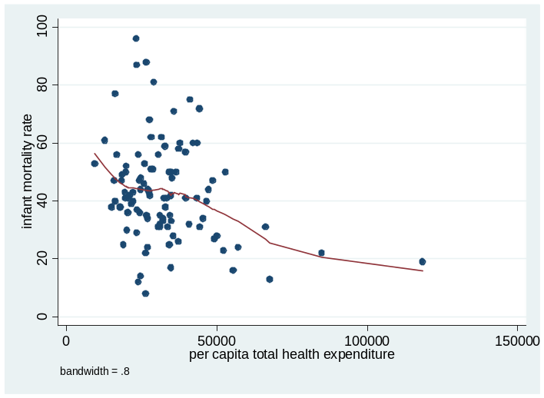
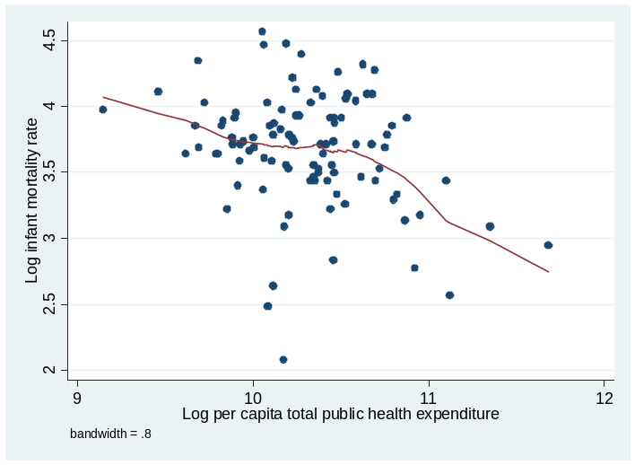

Source: author analysis from panel data

As seen in figure 5.1, there is a negative correlation between per capita public total health expenditure and infant mortality rate both in level and log-log form. Numerically, the coefficient of correlation between public health expenditure and infant mortality rate is – 0.2777 and statistically significant. The association remains unchanged when log-log form is examined (the coefficient correlation -0.2743). One should be noted, this patterns do not imply causal relationship. It could be driven by confounding trends.

Figure 5.2 Pattern of Relationship between Infant Mortality Rates and Skilled Birth Attendance, 2001-2006
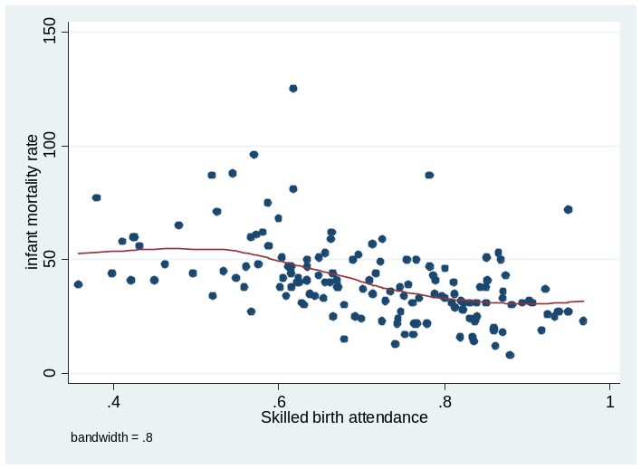
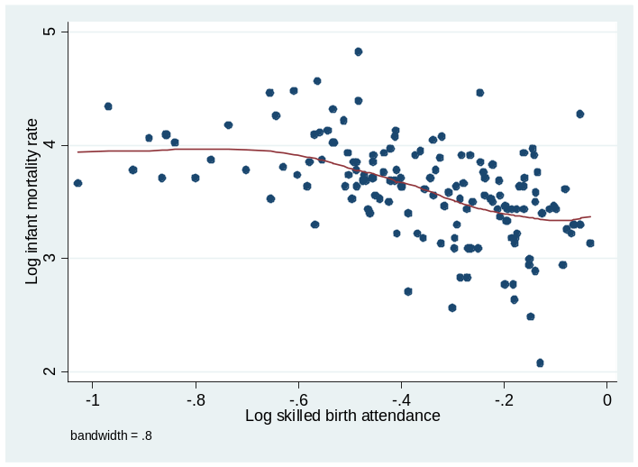

Source: author analysis from panel data
Table 5.2 presents the relationship between infant mortality rate and skilled birth attendant at delivery both in level and log-log form. It shows a clear pattern of negative relationship between these two variables. Statistical examination using simple correlation provides support of this argument. The degree of association is -0.4979. The log-to-log association is resulted in slightly increase negative correlation (-0.5120).
In addition, there is a positive correlation between skilled birth attendant present at delivery and per capita total public health expenditure (figure 5.3). In level, the degree of association is +0.1813 and statistically significant. However, it slightly decreases when the log-to-log association is utilized (+ 0. 1574).

Figure 5.3 Pattern of Relationship between Skilled Birth Attendances and Per Capita Total Public Health Expenditure, 2001-2006
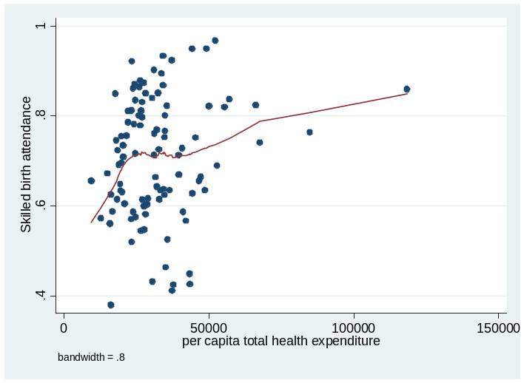
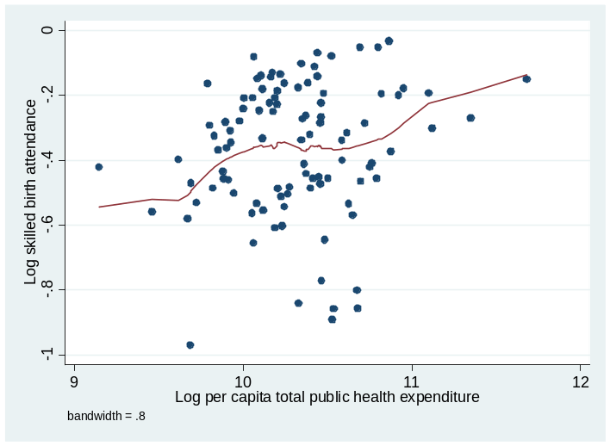

Source: author analysis from panel data

Impact of Public Health Spending on Infant Mortality
Table 5.1 presents the results of fixed effect analysis of public spending impact on infant mortality. In general, all coefficients have the expected sign except for puskesmas coverage. However, almost all variables are statistically not significant. There are two specification presented, (1) Baseline specification using per capita total public health expenditure; and (2) Specification with per capita development and routine expenditure. These two specifications control for province and time effects.
Specification 1 shows that per capita public health spending is not statistically associated with reduction in infant mortality rate. One possible explanation is that public health spending takes time to affect infant mortality rate. The spending on health at current year probably will have significant effect in the coming years. In other word, it suggests a lag structure in order to investigate the spending impact. However, using the lag structure is also problematic. This study does not have enough observations to employ more than two lags since it only had four years data for public health expenditure. In fact, Bhalotra (2007) needs three lags in 19 years data to conclude that public health spending has strong effects in combating infant mortality. This study does try to use lag structure, but it seems do not change the results. Therefore, the best option for this study is to keep on estimation in level.
The same situation also faced by specification 2 when total public spending divided into per capita development and routine expenditure. These two forms of expenditure have a negative sign as expected but statistically insignificant. Therefore, there is no enough statistical evidence to argue that these variables affect infant mortality rate. Meanwhile, both in specification 1 and 2, the proportion of population that having its own house and proportion of mothers with higher education level completed compared to that with primary education highest completed show a significant result. These findings then support the arguments that wealth and mother’s education factors determine the utilization of skilled birth attendance.
Table 5.1 Impact of Total Public Health Spending on Infant Mortality

Variable |  | Specification 1 |  | Specification 2
 |  | Coefficient | Robust Std. Error | Coefficient | Robust Std. Error
Total health expenditure |  | -0.00000314 | -0.00000315
Development health expenditure |  |  |  | -0.00000423 | 0.00000365
Routine health expenditure |  |  |  | -0.000000259 | 0.00000911
Own house |  | -4.697 | 2.438* | -4.444 | 2.430*
Access to sanitation |  | -0.969 | 1.437 | -1.070 | 1.470
Puskesmas coverage |  | 0.076 | 0.088 | 0.071 | 0.089
Rural population |  | 3.239 | 3.070 | 3.509 | 3.090
Mother's education (reference: primary school)
 | Junior secondary | -4.224 | 3.184 | -4.309 | 3.178
 | Senior secondary | -1.716 | 3.889 | -1.602 | 3.877
 | Higher education | -11.244 | 4.641** | -10.736 | 4.225**
Constant |  | 6.997 | 3.368 | 6.612 | 3.306
Observations |  | 100 |  | 100
Number of provinces |  | 25 |  | 25
R² (within) |  | 0.4489 |  | 0.4502
Statistical significance: * at 10%, ** at 5%, and *** at 1% level of significance. Both specifications controls for province and time specific effects.

Impact of Public Health Spending on Skilled Birth Attendance
Table 5.2 presents the link between public health spending and the presence of skilled birth attendant at delivery. There are two specification presented: (1) specification with per capita total public expenditure, and (2) specification with per capita routine and development expenditures. The result shows that a 1-rupiah increase in per capita total public health spending is associated with 0.00000509 increases in the presence of skilled birth attendant at delivery. It also can be interpreted as a 10 % increase in average of per capita public health spending will increase the utilization of skilled birth attendance by 0.016. This result is statistically significant at 1% level of significance and implies that investment of district governments on health sector will increase as the utilization of skilled birth attendance increase.
Table 5.2 Impact of Public Health Spending on Skilled Birth Attendance
Variable |  | Specification 1 |  | Specification 2
 |  | Coefficient | Robust Std. Error | Coefficient | Robust Std. Error
Total health expenditure |  | 0.00000509 | 0.0000018***
Development health expenditure |  |  |  | 0.00000525 | 0.00000230**
Routine health expenditure |  |  |  | 0.00000327 | 0.00000452
Own house |  | 0.064 | 0.394 | -0.146 | 0.394
Household size |  | 0.038 | 0.080 | 0.034 | 0.078
Rural population |  | -0.657 | 0.576 | -0.887 | 0.637
Mother's education (reference: primary school)
 | Junior secondary | 0.569 | 0.413 | 0.624 | 0.428
 | Senior secondary | -0.858 | 0.440 | -0.954 | 0.440**
 | Higher education | 0.095 | 0.716 | 0.206 | 0.634
Puskesmas coverage |  | 0.729 | 0.021* | 0.047 | 0.028
Total health expenditure x puskesmas coverage |  | -0.000000836 | 0.000000336**
Development expenditure x puskesmas coverage |  |  |  | -0.000000760 | 0.000000427*
Routine expenditure x puskesmas coverage |  |  |  | -0.000000919 | 0.000000892
Constant |  | 0.729 | 0.579 | 1.110 | 0.696
Observations |  | 100 |  | 100
Number of provinces |  | 25 |  | 25
R² (within) |  | 0.4631 |  | 0.4891
Statistical significance: * at 10%, ** at 5%, and *** at 1% level of significance. Both specifications controls for province and time specific effects.
In addition, this estimation also demonstrates two interesting results. First, puskesmas coverage is statistically significant at 10% level of significance. It suggests that increasing number of puskesmas will improve the access of skilled birth attendant service. A one unit increase in puskesmas per 100,000 population is associated with 0.729 increase in the presence of skilled birth attendant at delivery. Second, the estimation result also reveals that the interaction term between per capita public expenditure and puskesmas coverage is statistically significant at 10% level of significant. It confirms that public health spending is less effective in the presence of more puskesmas. The marginal increase of public health spending is more effective if the health infrastructures are bad. This means that increasing of public health spending is relatively benefit for those people that live in the less developed areas or in the areas where the access to puskesmas is low.
However, when total public health expenditure separated into development and routine expenditure, only development expenditure that statistically significant. This implies that the impact of total public spending on utilization of skill birth attendance mainly driven by development expenditure. It is statistically significant at 5 % of level of significance. The interaction between per capita development expenditure and puskesmas coverage is also statistically significant at 10% level of significance. This finding confirms that per capita development expenditure is more effective in the less developed areas.

5.4 Impact of Skilled Birth Attendance on Infant Mortality
Table 5.4 depicts the regression results of three specifications that examine the association between skilled birth attendance and infant mortality. Since infant mortality represents number of infant who died one year before, it is relevant to relate this variable with last year skilled birth attendance. Thus, for skilled birth attendance variable, these three specifications use lagged one-year skilled birth attendant at delivery.
Specification 1 serves as a baseline model that aims to examine a direct effect of skilled birth attendance on infant mortality while controls for fraction of population having its own house, fraction of population living in rural area, proportion of households with closed sewage system, puskesmas coverage, and mother’s education. The results show that although the expected signs are confirmed, only mothers highest completed junior secondary school compare to that with primary education highest completed that statistically significant at 10 % level of significance. This finding suggests that mother’s education plays an important role in combating infant mortality. Meanwhile, the presence of skilled birth attendant at delivery is not statistically significant affect infant mortality. There is no sufficient statistical evidence to conclude that skilled birth attendance affects infant mortality rate.
On the other hand, specification 2 treats infant mortality rate as a function of skilled birth attendance and public health spending. By introducing per capita total public health spending, this specification will give not only the effect of public health spending on infant mortality rate that works through utilization of skilled birth attendance but also the direct effect of public health spending. The result confirms, again, that the use of skilled birth attendance is not statistically associated with reduction of infant mortality rate. However, in this specification R² is increasing significantly, as per capita public health expenditure includes in the model. This proves that public health spending is an important aspect that determines the reduction of infant mortality. Moreover, in this specification mother’s highest completed junior secondary school compare to that with primary education highest completed shows also a statistically significant result. It is statistically significant at 1% level of significance.
Table 5.3 Impact of Skilled Birth Attendance on Infant Mortality
Variable |  | Specification 1 |  | Specification 2 |  | Specification 3
 |  | Coeff. | Robust Std. Error | Coeff. | Robust Std. Error | Coeff. | Robust Std. Error
Lagged skilled birth attendance |  | -1.635 | 1.063 | -1.026 | 1.247 | -3.240 | 1.913
Total health expenditure |  |  |  | -0.00000422 | 0.00000750 | -0.0000553 | 0.0000276*
Total health expenditure x skilled birth attendance |  |  |  |  |  | 0.0000748 | 0.0000426*
Own house |  | -1.529 | 3.870 | -6.550 | 3.926 | -6.676 | 3.621*
Access to sanitation |  | -0.609 | 1.453 | -1.681 | 2.052 | -1.538 | 2.053
Puskesmas coverage |  | -0.007 | 0.047 | 0.835 | 0.140 | 0.128 | 0.138
Rural population |  | 0.880 | 4.413 | -2.712 | 5.255 | -6.102 | 6.402
Mother's education (reference: primary school)
 | Junior secondary | -6.115 | 3.018* | -9.028 | 3.137*** | -8.379 | 3.009***
 | Senior secondary | 4.313 | 3.522 | -1.518 | 4.136 | -3.410 | 4.392
 | Higher education | -9.751 | 8.052 | -16.283 | 14.773 | -15.169 | 14.296
Constant |  | 6.061 | 4.721 | 14.435 | 6.370 | 18.076 | 7.159
Observations |  | 100 |  | 75 |  | 75
Number of provinces |  | 25 |  | 25 |  | 25
R² (within) |  | 0.2611 |  | 0.5071 |  | 0.5344
Statistical significance: * at 10%, ** at 5%, and *** at 1% level of significance. Both specifications controls for province and time specific effects.
Specification 3 introduces interaction variable between per capita total health expenditure and skilled birth attendance. The regression result reveals that lagged skilled attendance is not statistically associated with infant mortality. However, this specification gives a statistically significant result for per capita total public health spending. It is statistically significant at 10 % level of significance. According to this result, a 10 % increase in average per capita public health expenditure will reduce infant mortality rate by 0.179 %. In addition, the interaction variable between per capita total public health expenditure and skilled birth attendance shows an interesting finding. It informs that increasing per capita total public health expenditure is less effective to reduce infant mortality in the area where the supply of skilled birth attendance is high. In other word, the marginal increase of per capita total public health spending is higher in the area where the access to skilled birth attendance is low. This finding contradicts with previous study conducted by Hall et. Al (2009) that essentially argued that public health spending is going to be more effective in areas with a relatively large supply of maternity care.

Conclusions and Policy Recommendations
Using fixed effect analysis, this paper has identified a significant impact of per capita total health expenditure on infant mortality in Indonesia. This paper is unable to identify a direct effect of spending on infant mortality without taking into account the utilization of skilled birth attendance. The regression results suggest that introducing an interaction variable between per capita total health expenditure and skilled birth attendance, employing lagged skilled birth attendance, and controlling for socio-economic variables produce a statistically significant result. The result reveals that a 10 percent increase in average per capita total public health expenditure will reduce infant mortality rate by 0.179 percent. The regression result also shows that socio-economic variables including proportion of households having their own house as a proxy of wealth and mother’s education also associated with reduction of infant mortality. However, this paper does not find any statistical evidence to support that the presence of skilled birth attendant at delivery affects infant mortality.
This study does find a significant impact of per capita public health spending on the utilization of skilled birth attendance when it includes interaction variable between public health expenditure and puskesmas coverage. The regression result shows that a 10 percent increase in average of per capita public health spending will increase the utilization of skilled birth attendance by 0.016. In addition, number of puskesmas for 100,000 populations also has a significant impact on the utilization of skilled birth attendance.
An important new result is that the effect of public health spending seems to be more effective to increase the utilization of skilled birth attendance in the areas that access to puskesmas are low. In this context, the estimates imply that marginal increases of public health spending will be greater in the rural or remote areas than in more developed areas. Furthermore, this study found that public health expenditure have less impact on combating infant mortality when supply of skilled birth attendant is relatively high. Equally, increasing the utilization of skilled birth attendance is going to be more effective to reduce infant mortality in the areas with relatively low public health budget.
Findings of the paper offer some suggestions for evidence-based policy that will help to increase the utilization of skilled birth attendance and reduce infant mortality. First, the government should put priority to increase health budget allocation for rural and remote areas in order to increase the utilization of skilled birth attendance. It can be done, for instance, by implementing free delivery policy for pregnant women or by providing incentive for midwives who serve in the villages or remote areas. Second, increasing on maternal services coverage, through additional puskesmas especially in remote areas, are basic requirement to increase the utilization of skilled birth attendance. Third, the government’s policies should concern with the effort of providing more education to woman. These policies should also integrate with income distribution policy particularly among the poor.

References
Ahmad, O.B., A.D. Lopez and M. Inoue (2000) “The decline in child mortality: a reappraisal”, Bulletin World Health Organization 78(10):1175-1191.
Bhalotra, S. (2007) "Spending to Save? State Health Expenditure and Infant Mortality in India", Health Economics 16(9): 911-928.
Bos, E. and F. Saadah (1999) Indonesia: Childhood Mortality Trends, The World Bank Watching Brief July 1999 Issue 4. Available at http://siteresources.worldbank.org/INTINDONESIA/Resources/Human/childmort.pdf (Accessed on 26 August 2009)
Crémieux, P.Y., P. Ouellette and C. Pilon (1999) “Health Care Spending as Determinants of Health Outcomes”, Health Economics 8: 627–639.
Erlina, E. (2007) “Health Care Service Provision in Indonesia: Does It Reach the Poor?” MA Research Paper, Institute of Social Studies (ISS), The Hague
Filmer, D. and L. Pritchett (1999) “The impact of public spending on health: Does money matter?” Social Science and Medicine 49(1): 1309–1323.
Graham, W., J.S. Bell and C. Bullaugh (2001) “Can skilled attendance at delivery reduces maternal mortality in developing countries?” in V. de Brouwere and W. van Lerberghe (eds) Save Motherhood Strategies: A Review of the Evidence, Studies in Health Services Organization and Policy, 17, 2001. Antwerp: ITG Press.
Gujarati, D.N. (2003) Basic Econometrics. New York: McGraw-Hill Co. 4th edition.
Gupta, S., M. Verhoeven and T. Tiongson (2002) “The effectiveness of government spending on education and health care in developing and transition economies”, European Journal of Political Economy 18: 717–737.
Hatt, L., C. Stanton, K. Makowiecka, A. Adisasmita, E. Achadi, C. Ronsmans (2007) “Did the Strategy of Skilled Attendance at Birth Reach the Poor in Indonesia? Bulletin of the World Health Organization 85:774-782.
Hatt, L., C. Stanton, C. Ronsmans, K. Makowiecka and A. Adisasmita (2009) “Did Professional Attendance at Home Births Improve Early Neonatal Survival in Indonesia?” Health Policy and Planning 24:270-278.
Hong, R. and M. Ruiz-Beltran (2007) “Impact Prenatal Care on Infant Survival in Bangladesh”, Maternal and Child Journal 11(2): 199-206.
Kruse, I., M. Pradhan and R. Sparrow (forthcoming) Health Spending and Decentralization in Indonesia.
Mcquire, J.W. (2006) “Basic Health Care Provision and Under-5 Mortality: A Cross-National Study of Developing Countries”, World Development 34(3):405-425.
Ministry of Health (2007) Indonesia Health Profile 2005, Jakarta: MoH
Ministry of Health (2008a) Indonesia Health Profile 2007, Jakarta: MoH
Ministry of Health (2008b) Indonesia Health Profile 2006, Jakarta: MoH
Nixon, J. and P. Ulmann (2006) “The Relationship between Health Care Expenditure and Health Outcomes: Evidence and Caveats for a Causal Link”, European Journal of Health Economy 7: 7-18.
O’Donnell, O., E. Van Dooslaer, A. Wagstaff and M. Lindelow (2008) Analyzing Health Equity Using Household Survey Data: A Guide to Techniques and Their Implementation. Washington DC: World Bank.
Panis, C.W.A. and L.A. Lillard (1994) “Health Inputs and Child Mortality: Malaysia”, Journal of Health Economics 13: 455-489.
Poerwanto, S., M. Stevenson and N. de Klerk (2003) “Infant Mortality and Family Welfare: Policy Implications for Indonesia”, Journal Epidemiology Community Health 57: 493-498.
Preston, S.H., P. Heuveline and M. Guillot (2001) Demography: Measuring and Modeling Population Processes. Oxford: Blackwell Publishers Ltd.
Pyndick, R.S. and D.L. Rubenfeld (1998) Econometric Models and Economic Forecast. Singapore: McGraw-Hill Co. 4th edition.
Rajkumar, A.S. and V. Swaroop (2008) “Public spending and outcomes: Does governance matter?” Journal of Development Economics 86: 96–111.
Rokx, C., G. Cchieber, P. Harimurti, A. Tandon and A. Somanathan (2009) Health Financing in Indonesia: A Reform Road Map, Jakarta: World Bank.
Smeru Research Institute (2004) Basic Health Services in the Era of Regional Autonomy. Smeru News No.09: Jan-Mar/2004. Available at http://www.smeru.or.id/newslet/2004/ news09. pdf (Accessed on 26 August 2009)
UNICEF, WHO, The World Bank and UN Population Division (2007) Levels and Trends of Child Mortality in 2006. Estimates developed by the Inter-agency Group for Child Mortality Estimation’, New York. Available at http://www.childinfo.org/files/ infant_child_ mortality_2006.pdf (Accessed on 26 August 2009)
United Nations (1983) Manual X: Indirect Techniques for Demographic Estimation, New York: United Nations.
United Nations (1990) QFIVE-United Nations Program for Child Mortality Estimation: A Micro Computer Program to Accompany The Step-by-step Guide to Estimation of Child Mortality, New York: United Nations.
World Bank (2007) "Spending for Development: Making the Most of Indonesia's New Opportunities", Indonesia Public Expenditure Review 2007. Jakarta: World Bank.
World Bank (2008) "Investing in Indonesia’s Health: Challenges and Opportunities for Future Public Spending”, Indonesia Public Expenditure Review 2008. Jakarta: World Bank.
World Bank (2009) Doctors, Midwives and Nurses: Current Stock, Increasing Needs, Future Challenges and Options, Jakarta: World Bank.
World Health Organization (2004) Making Pregnancy Safer: the Critical Role of the Skilled Birth Attendant, Geneva: Department of Reproductive Health and Research, WHO.
World Health Organization (2008) World Health Statistics 2008. Available at http://www.who.int/whosis/whostat/EN_WHS08_Full.pdf (Accessed on 26 August 2009).

