An analysis of a Brazil - EU Free Trade Agreement

Abstract:

In this paper, the potential economic impact of a free trade agreement between Brazil and the EU is investigated. In order to come to conclusions the GSIM model is applied to quantify two different scenarios. The scenarios describe a reduction of bilateral import tariffs by 60% (limited FTA) and by 100% (ambitious FTA). The simulations analyse the effects of liberalization for the economy as a whole and partial effects for the livestock and meat products sector and the motor vehicles sector. A general conclusion is that deeper integration is accompanied with larger welfare, trade, price, output and third country effects. Results indicate that the FTA will bring positive net welfare effects for Brazil in both scenarios. Producer and consumer surplus, trade and output increase while tariff revenue declines. Although tariff revenue declines, the net welfare effect is positive for the economy as a whole, but within the economy there are winners and losers. The partial effects show that the motor vehicles sector only experiences modest improvement while the livestock and meat products sector is a big winner of liberalization. On the other hand the EU is expected to experience positive net welfare effects in the motor vehicles sector in both scenarios while negative net welfare is expected for overall economy wide trade and the livestock and meat products sector under the ambitious FTA. In overall economy wide trade the increase of consumer and producer surplus is totally offset by the fall in tariff revenues. In the livestock and meat products sector fierce competition results in a decline in producer prices and producer surplus. Although the motor vehicles sector is a winner of liberalization, consumers will face increased prices and can be considered as the losers. These opposite effects create conflicting interests resulting in difficult negotiation positions. Negotiation may lead to the adoption of a different tariff reduction than under a limited or ambitious FTA. Besides these changes, third country effects are expected for all other countries in the form of trade diversion and a decline of welfare.

Tieme Kamphuis
262248
Master thesis
Economics & Business Economics
03-02-2010
Introduction

This paper addresses the potential economic effects of a free trade agreement between Brazil and the EU in terms of welfare, trade, price and output. Trade is a very complex subject and many theories and empirical studies about trade and trade in relation to economic growth have been produced. Some observers have argued a positive relationship, while others argue that there are no gains from higher openness. Different empirical methods like cross-country comparisons and time-series analyses have been used to come to the different conclusions in the large body of literature on this subject.

There is theoretical support for effects of trade policy as well; according to the Heckscher-Ohlin-Samuelson model, the Gravity model of trade and the Ricardian theory of trade, we would expect a system of open economies to be more efficient than a system in which the same economies are all closed. Nonetheless, pressures exist for governments to protect their own industries by raising import tariffs or by other protective measures favouring home production. In some parts of the world trade policy is focused on promoting certain industries, which may yield more benefits than others (e.g. in terms of employment or the rate of technological innovation).

Next to the different theories and empirical studies, ideas on trade policy and development also differ through time. Until the 1970s development strategies were mainly focused on import substitution in manufacturing. It was supposed to lead to industrialization and thereby to economic growth. The case of Latin America (where this strategy failed in the 1980s) raised the question whether free trade might be the key to growth (see Frankel and Romer (1999), Rodríguez and Rodrik (1999), Dollar and Kraay (2003)). In the meantime the East Asian economies that were based on export promotion and thus trade openness experienced much higher levels of economic growth (see Edwards (1998), Yanikkaya (2002), Kamrul Hassan (2005)). These developments made trade liberalization the new number one strategy to use. Brazil is one of the countries that changed from an import substitution industrialization strategy to a trade liberalization strategy (see Ernst (2005)) and a potential FTA with the EU is one of the policy tools to engage in export driven growth.

The structure of this paper is based on the following research question: Does economic growth in Brazil increase with the establishment of an FTA between Brazil and the EU and what major trade effects occur? In order to be able to answer this question correctly I look at the following issues:

- What other research has been done on this topic?
- What model shall be used and why?
- Which scenarios shall be used to model the effects of a Brazil - EU FTA?
- What are the main effects of the FTA in terms of welfare, trade, price and output and what economic mechanisms are at work?

The chapter that follows gives a short overview of existing literature on the topic FTA and potential economic impacts. Chapter III gives a historical overview of Brazil and the EU regarding trade and developments in trade policy while Chapter IV will focus on the role of the WTO given the friction between bilateral and multilateral efforts towards free trade. Chapter V explains the methodology and the model used. Chapter VI focuses on the implementation of the model and results analysis in the case of Brazil and the EU and chapter VII concludes.

Chapter II: Literature review

Globalization has been a well-known phenomenon in the last two decades and its importance has continuously grown (see Kolodko (2006), Stiglitz (2002), Ghai (1997), Dreher (2002), Crafts (2000), Feenstra (2007)). With the recent developments it becomes clear that the effects of globalization are far-reaching. Growing integration of economies and societies around the world is evident via multilateral (e.g. WTO, OECD) and bilateral (e.g. FTA’s) efforts.

FTA’s meet the increasing needs of a market economy opening up to the world (see Grinols and Silva (2003), Maggi and Rodriquez-Clare (2005), Victorio and Rungswang (2008), Trakman (2008), Saggi and Yildiz (2004), Ethier (2002)). An FTA means that two countries or regions agree upon eliminating some or all (non-tariff) barriers to trade and investment, whereby some barriers are dropped immediately while others are being phased out over periods of several years.

When an FTA is signed and becomes active, trade effects occur. We distinguish two main effects: trade creation and trade diversion (see Viner (1950), Shujiro and Misa (2007), Nugent and Abdel-Latif (1994), Mansfield and Pevehouse (2005), Eicher (2008), Kreinin (1959), Robinson and Thierfelder (1999), Waschik (2005)). Trade creation means that there is additional trade between countries that would not have existed without the FTA while trade diversion is a phenomenon that describes the shift of trade from a more efficient supplier outside the FTA towards a less efficient supplier within the FTA (imports from the rest of the world decrease). Combining trade creation and trade diversion results in a net positive or net negative welfare effect.

Besides trade effects the establishment of an FTA creates environmental (pollution of air, water and land), social (effects on poverty, employment, health, equality and education) and third country effects. Third country effects are witnessed if a country’s export decreases because of the signing of an FTA between two other countries. This is especially the case if there are significant similarities in export products between the third country and the countries involved in the FTA. Furthermore, conflicting interests between countries signing the FTA could arise. Whereas developed countries are mainly interested in services and goods, developing countries seek better market access in the agricultural sector.

The greater part of the FTA studies conducted feasibility studies. They examine the effects of a potential FTA between two countries or regions. In most studies a clear distinction is made in the degree of liberalization. While a basic degree of integration (lowering tariffs) is characterized by improved market access and an expansion of trade between partners, deep(er) integration aims at the creation of a common marketplace across countries, harmonisation of market institutions, financial investment, administrative and contract law, regulation of labour markets etc. Deep integration is expected to increase trade, growth and productivity (Evans, Kaplinsky and Robinson, 2006).

Several techniques like PE, CGE, IMMPA, SMART and GTAP have been applied to various cases between neighbouring countries, countries across the world, rich and developing countries, developing countries and even to specific sectors within a country. Despite the different viewpoints and cases described in the various papers covering this topic, they provide more or less the same conclusion. The general opinion is that an FTA brings significant positive economic effects to the countries (create welfare, trade, investment, efficiency, larger and more attractive markets etc.). That is if countries have similar levels of development. These FTA’s are able to provide import competition in domestic markets and export opportunities abroad to maximize the benefits. FTA’s between countries with different levels of development could harm the economic development process. Developing countries are expected to implement broad and deep liberalisation in market access (in goods and services etc.) while their gain of improved market access will be rather limited. Often this is caused by restrictive rules of origin, non-tariff measures, supply side constraints and exclusion from the FTA’s of reduction or elimination of subsidies in agriculture in rich countries. Moreover, the stronger country is in a position to sell and therefore is likely to gain more benefits. The weaker partner, on the other hand, will not be able to exploit the increased market access.

To form a successful FTA it is important to focus on possible negative effects while negotiating. While people in overall will benefit from an FTA it is important to realize that not every single person will benefit from the signing of an FTA. Within each country there are winners and losers. Besides this, special attention has to be paid to trade creation and diversion, effects on third countries, conflicting interests between countries, social and environmental effects. If those factors are taken into account an FTA is bound to be successful for the countries signing the FTA. An FTA can open domestic markets for competition (lowering prices for consumers and shifting factors of production to more efficient use) and enhance economic liberalization and integration. Third countries however will likely suffer in welfare (e.g. decreasing exports) from the signing of an FTA.

It is obvious that FTA´s can have negative and positive effects. The extensive literature using all kinds of methodologies has produced different outcomes regarding the effects of an FTA (see Estevadeordal (2003), Hur (2001), Jang (2007), Baier and Bergstrand (2006)). An overview of some important FTA studies on effects presents the following picture.

- Welfare, productivity and trade flows

A study by the Japan – Chile free trade agreement study group under the chairmanship of Shintaro Oishi (2001) concludes that an FTA between Japan and Chile will promote bilateral trade and mutual investment flows. Based on the use of an econometric model an FTA will increase trade (as result of the abolition of tariffs) and projects trade-creation with higher productivity incorporated.

Taeko Yasutake (2004) uses a Computable General Equilibrium Model (CGE) to analyze the effects of a possible Philippines - Japan FTA. From a Philippine viewpoint, an abolishment of tariffs on imports from Japan results in an increase of total imports from Japan. Sectors like agriculture experience a large increase in import while other sectors like industry experience a slight increase. Despite of the fact that some households’ income will decline, an increase in total welfare for all households (measured in Compensated and Equivalent Variation) is expected. Nonetheless, inequality remains an important negative factor with richer households better equipped to benefit from the cheaper consumer goods. Yasutake (2004) concludes that the Philippine economy benefits from an FTA with Japan, mainly because of an increase in consumer welfare. In the future, welfare can increase if liberalization of foreign investment is included in the agreement.

In “Trade Sustainability Impact Assessment for the FTA between the EU and Ukraine within the Enhanced Agreement” ECORYS Netherlands BV and CASE Ukraine (2007) present the findings of the study they conducted on the expected economic, social and environmental impacts of the FTA between the EU and Ukraine. In order to do so they use a CGE model (Harrison-Rutherford-Tarr (1996) Multi-Region Trade model) in combination with data from the GTAP version 6 database and the State Statistics Committee of Ukraine. Besides this general model, an in-depth analysis of 38 sectors is made to come to detailed conclusions. The paper examines two possible FTA scenarios: an extended (deep) FTA and a limited FTA.

After applying the CGE model the researchers conclude that both the extended and the limited version of the FTA provide significant positive economic impacts to the EU and Ukraine. Nevertheless an extended FTA will yield the most benefits (economic, social and environmental). An extended FTA will cut tariffs deeper than a limited FTA allowing more trade (in services and FDI etc.). The EU and the Ukraine will experience positive economic impacts like increases in employment, reduction in prices relative to wages, increase in production and increase of the GDP per capita. Furthermore results predict additional economic growth for Ukraine although some sectors will lose.

In another study ECORYS Netherlands BV and partners (2009) perform a trade sustainability impact assessment on an EU-ASEAN FTA. Again the focus is on the potential economic, social and environmental effects. To represent different degrees of liberalization they construct 3 possible scenarios. They focus on a limited FTA, an extended/ambitious FTA and an extended+/ambitious+ FTA.

These scenarios differ in terms of tariff reduction, services liberalization and removal of non-tariff barriers. The impacts of these scenarios are determined with the use of a standard multi-region computable general equilibrium model (CGE) based on the Francois, Van Meijl, and Van Tongeren model (see Francois, Van Meijl and Van Tongeren (2005)). Furthermore data is extracted from Version 7.5 of the GTAP dataset. The outcomes (at sector and overall level) are further analyzed with the help of causal chain analysis, secondary data analysis and literature review, expert interviews and consultations to get a better and more specified understanding of the direct and indirect impacts of the FTA at macro, meso and micro level. In order to do so the researchers concentrate on fields like competition policy, intellectual property rights, financial services etc. and on specific sectors (32 in total) like agriculture, fishing, mining and textiles.

The report concludes that the EU - ASEAN FTA will likely have positive welfare effects for all countries involved. GDP, income, trade and employment are expected to increase significantly for ASEAN and small but positive for the EU. This can be accomplished if non-tariff barriers are removed, tariffs are declined and services are liberalized. Although welfare effects are positive in general, there will still be some sectors and groups in society that are unable to gain and may lose. Comparative advantages between countries shift production from one country to another resulting in winners and losers among communities.

Another study on EU FTA’s has been performed by Francois, McQueen and Wignaraja (2005). The paper is based on the Global Trade Analysis Project (GTAP) computable equilibrium model which estimates the effects of the FTA’s. The authors examine 29 regions and 24 sectors and simulate 2 policy scenarios. The first scenario describes the actual EU – Developing country FTA and the second one a full EU - Developing country FTA.

They apply the model to five different EU FTA’s and the customs union agreement in industrial products with Turkey. South Africa, Mexico, Chile and Egypt are the FTA’s already in force while the fifth FTA (Mercosur) is being negotiated. Goal is to identify the main factors and their economic effects. The results show that potential gains from an FTA are lost because of EU restrictions in product coverage and in rules of origin. These restrictions hinder full liberalization and negatively affect trade in agricultural goods and labor-intensive manufactures. Deeper integration is needed to fully benefit from trade liberalization and this in only achieved in the case of Mexico, Chile and Turkey. Nevertheless Mercosur and South-Africa will also benefit from the FTA in terms of trade and welfare. Egypt is still liable to domestic distortions hindering trade liberalization resulting in a significant loss for the Egyptian economy. Furthermore they conclude that bilateral negotiations are costly while multilateral agreements can be more efficient and competitive, leading to greater net effects of trade liberalization.

While most studies concentrate on the net economic effects on countries as a whole the ‘Australia – China Free Trade Agreement’ paper of The Royal Australian Institute of Architects (RAIA) (2005) focuses on one specific sector. The RAIA (2005) tries to examine the economic effects of an FTA on their sector. The investigation is a difficult one because of a lack of data on import/export of architectural services between the countries. Furthermore significant barriers like ownership restrictions, joint venture provisions, licensing provisions and protections of intellectual property rights remain in place. Nevertheless the RAIA (2005) is convinced that an FTA can have a positive influence on the architectural sector if the FTA is structured to be “an overall net positive for Australian architecture with the potential to further open a rapidly developing and sophisticated building and construction sector to Australian architecture professionals.” To reach this goal an FTA should aim at resolving minimum capital requirements, restrictions on wholly foreign-owned enterprises, license and market access restrictions, intellectual property rights etc. This could enhance economic development within this sector in both China and Australia. China’s building and construction growth pattern will be supported because of more liberal access to the Chinese architectural market and Australian architects will add more to Australian export earnings.

- Investment

Jackson (2006) bases her paper on two fundamental questions regarding the change in trade relationship because of the implementation of an FTA: What impact do cross-regional free trade agreements have on Foreign Direct Investment (FDI) and what role do they play in increasing trade?

Jackson (2006) focuses on the Mexico - Japan FTA to answer these questions. This FTA was implemented on April 1, 2005 and included free trans-border flows of goods, persons, services, and capital between the two countries. Tariffs were eliminated or reduced and quota restrictions were loosened. She concludes that FDI and trade flows increase. Although these findings are positive they are not yet conclusive. The Mexico - Japan FTA has been operative for only a short period of time and this time span is too short to draw any definitive conclusions. Furthermore she states that the increase in trade and FDI could be the result of other factors (physical infrastructure, business environment and an efficient transportation system) rather than the signing of the agreement.

ECORYS Netherlands BV and partners (2009) dedicate a part of their study to make an analysis of changes on investment because of the establishment of an EU - ASEAN FTA. The report concludes that investment and the reallocation of capital are of significant importance to increase efficiency. To gain from the benefits of investment, the investment climate has to be improved. It is still subject to non-tariff barriers (e.g. ownership restrictions and intellectual property rights) that hamper further liberalization. Reforms are needed to remove these restrictions. If integration within ASEAN improves, FDI will increase. This enables foreign investors to trade more easily within ASEAN and besides this investment from within ASEAN increases. At sector level removal of trade barriers in the motor vehicle and parts sector is expected to increase FDI while removal of ownership restrictions improves the financial services potential for investment. If the ASEAN is able to implement these recommendations they can expect overall investments to increase.

- Social and environmental impacts

ECORYS Netherlands BV and CASE Ukraine (2007) dedicate a part of their study to examine the social impacts of an FTA. They find some evidence for social impacts in general and at sector level. In general poverty is expected to decline while living standards, health, working conditions and wages increase. Again this is an overall impact because the social situation of certain groups could be affected negatively. These social differences are seen in Ukraine where the agriculture, fisheries and forestry sector, located in the western parts of Ukraine, suffer a decrease in employment and output. While on the other hand, the eastern part of Ukraine experiences an increase in production (chemicals, rubber, ferrous metals and coal production). Although wages are expected to increase in general this contrast may result in further geographic income disparities. In contradiction to the generally positive economic and social impacts of the FTA, environmental impacts will be negative. Air, water and land quality are most likely to deteriorate.

The report of ECORYS Netherlands BV and partners (2009) examines social impacts at the sector level and it focuses on several sectors (cereals and grains, textile, clothing and footwear, motor vehicles and parts, financial services and fisheries). Within the EU - ASEAN FTA, the EU is likely to experience an increase in unemployment and poverty in the textiles, clothing and footwear sector in certain regions while all other sectors will not experience significant changes. On the other hand ASEAN is subject to both positive and negative effects at the sector level. Poverty is likely to increase in the cereals and grains sector and employment in the financial sector will decrease in some countries. In contradiction to these negative effects employment increases and poverty declines in the textiles, clothing and footwear, motor vehicles and parts and fisheries sector. In general, employment across ASEAN is expected to increase (both skilled and unskilled). Besides these internal effects, third countries will experience negative economic effects (trade diversion) but these will be rather limited. In contradiction to the in general positive economic effects, pressure on the environment and natural recourses will increase.

- Conflicting interests

Achterbosch, Kuiper and Roza (2008) examine an EU - India FTA. Their report describes a possible FTA between a developing country and a high income partner and was made while negotiations were underway. Main goal is to explore the effects on trade with special attention to agricultural markets. A global economy wide model (CGE) is used in combination with a recent GTAP database (GTAP-ARG (2005)) to implement the diverse data. The report describes the scenarios of non-agricultural liberalization, full trade liberalization, non-agricultural liberalization when a DOHA agreement is in place and full trade liberalization when a DOHA agreement is in place.

Furthermore the writers tested different degrees of liberalization taking steps of 10 percent. All these scenarios should make it possible to determine the optimal liberalization policy. Nevertheless it becomes clear that a simple solution for the liberalization process is not straightforward. The EU - India FTA is a very complex case because of conflicting interests. Each of all 4 scenarios gives different outcomes regarding welfare gains for both the EU and India. While full liberalization of agriculture in India would be optimal for Europe, agriculture in India is heavily protected (India’s policy goal is self-sufficiency) and can be seen as a closed sector. An FTA will increase competition with possible trade diversion harming producers in India as a result. That is why India’s attention is on tariff reduction on industrial goods while the EU is merely interested in agriculture and services. Besides India is not well integrated in the global markets which makes an FTA even harder to establish. The writers state that an FTA can harm India more than it will bring India if it solely focuses on tariff reduction. The EU will strengthen its position on the Indian market becoming a threat for domestic producers. For India to gain from an FTA deeper economic integration is needed.

- Trade creation and diversion

The Ministry of Foreign Trade and Tourism of Peru and the Ministry of Commerce of the People’s Republic of China (2007) prepared the report “Peru - China free trade agreement: joint feasibility study”. It focuses on the establishment of a bilateral FTA and uses several methods and techniques to explore opportunities and challenges. It applies two CGE models and two Partial Equilibrium models. They combine the GTAP and SMART model for Peru and the IMMPA (Integrated Macroeconomic Model for Poverty Analysis) and PE (also takes non-tariff barriers into account) model for China. They expect positive effects for both countries if tariffs are eliminated and non-tariff measures do not hinder bilateral trade. If FTA negotiations can take care of this, bilateral trade is likely to increase. This again will trigger growth of GDP and welfare. Furthermore the PE models assume some trade creation and trade diversion for both Peru and China. This can be of negative influence on particular industrial sectors. Negotiations have to focus on this subject to minimize their negative effects. In short, an FTA will benefit both countries and their people.

Cadario (2003) describes the Free Trade Agreement of the Americas (FTAA) and its possible impacts. Goal of the FTAA is to eliminate barriers and stimulate trade and investment flows. The FTAA includes 34 countries but the paper focuses on Brazil being the largest member of the FTAA. Cadario (2003) uses comparative static analysis to estimate base impacts. Furthermore she examines trade diversion and trade creation for specific important products being traded between Brazil and the US. Results show that the effects of trade diversion will be limited to countries that are not FTAA members and that Brazil will experience trade expansion. She concludes that there are significant benefits from the FTAA for Brazil and other Latin American countries that are in the process of development. As a result of elimination of tariffs the US will increase imports from Brazil in favour of their consumers. Furthermore Brazilian producers will be able to export more to the US harming US producers who will suffer losses because of greater competition in raw materials, intermediate inputs and final goods. Besides these positive findings for Brazil Cadario (2003) makes a critical remark regarding the creation of the FTAA. Conflicts could arise during the process of accomplishing the FTAA. There are 34 countries involved each having its own preferences and interests. Good and solid negotiation is needed to satisfy each country and this could take a while.

- Third country effects

In contradiction with the papers reviewed above, Choi and Schott (2001) dedicate a chapter in their book ‘Free trade between Korea and the United States?’ to the impacts on third parties of an FTA between two countries. The United States and Korea are both among the largest trading countries of the world. An FTA between the two countries could have significant effects on other countries. Trade diversion comes into play when the FTA is established. Exports between the United States and Korea will increase with decreasing imports from third parties as result. Trade diversion is thus a threat to third countries that will experience decreasing export to the United States and Korea. With the help of gravity model analysis Choi and Schott (2001) find a strong possibility of trade diversion. Countries that have the strongest similarity of export commodities in comparison to that of the other FTA partner country are likely to suffer most from an FTA. With the help of the ESI (Export Similarity Index) those countries are identified by the writers. Japan would be one of the countries that are negatively affected by the creation of a Korean - US FTA. Japan should consider creating its own FTA with respectively the United States and Korea to counter these effects.

In “Trade Sustainability Impact Assessment for the FTA between the EU and the Republic of India” ECORYS Netherlands BV, CUTS and CENTAD (2009) examine the potential economic, social and environmental impacts of an EU - India FTA. The techniques used in the paper are: computable equilibrium modeling, gravity modeling and poverty analysis complemented with causal chain analysis and stakeholder consultation for qualitative analysis. The writers test three scenarios (a limited FTA, an extended FTA and an extended FTA plus). Results indicate that the extended FTA is expected to bring the most economic, social and environmental benefits (welfare, production, trade, wages, health, productivity, employment and poverty).

Although these impacts are positive, other countries not included in the FTA will experience third country effects. Neighbouring countries like Bangladesh, Pakistan and Sri Lanka will only be subject to very small negative third country effects because of the FTA. They will experience a minor decrease in welfare because their export volumes are limited and some of India’s neighbouring countries already enjoy preferential treatment (GSP). Although third country effects are limited these countries will lose in the textile sector. India and its neighbouring countries have more or less the same structure of exports regarding textiles. Because the FTA provides India with a relatively better market position (better market access) as opposed to the neighbouring countries, India becomes more competitive which results in a decline of market share of the neighbouring countries. Negative third country effects increase when integration is deepened.

- Summary

Name and year | FTA and characteristics | Effects | Remarks
Shintaro Oishi (2001) | - Japan - Chile FTA.  - Abolishment of tariffs. | - Bilateral trade and mutual investment flows increase.  - Trade creation is projected with higher productivity incorporated.
Taeko Yasutake (2004) | - Filippines - Japan FTA.  - Abolishment of tariffs on import. | - Philippine imports from Japan increase.  - Philippine consumer welfare increases. | - Inequality remains a negative factor.  - Some households’ income will decline.
ECORYS Netherlands BV and CASE Ukraine (2007) | - EU - Ukraine FTA.  - Cut in tariffs. | - Positive economic effects: increases in employment, production and GDP per capita.  - Social impacts: poverty reduction and an increase in living standards.  - Environmental impacts will be negative. Air, water and land quality are most likely to deteriorate. | - An extended FTA will yield more benefits than a limited FTA.
ECORYS Netherlands BV and partners (2009) | - EU - ASEAN FTA. | - Positive economic effects: welfare will increase.  - Social impacts: some groups and sectors will lose.  - Environmental impacts: negative, more pressure on natural resources and environment. | - Negative but rather limited third country effects.
Francois, McQueen and Wignaraja (2005) | - EU - South Africa.  - EU - Mexico.  - EU - Chile.  - EU - Egypt.  - EU - Mercosur.  - EU - Turkey. | - Deep integration is achieved in Mexico, Chile and Turkey resulting in an increase in trade and welfare.  - Mercosur and South-Africa are also subject to welfare gains because of the agreement.  - Egypt economy faces a loss because of domestic distortions hindering trade liberalization. | - Potential gains are lost from an FTA because of EU restrictions in product coverage and in rules of origin. These restrictions hinder full liberalization and negatively affect trade in agricultural goods and labor-intensive manufactures.
RAIA (2005) | - Australia - China FTA.  - FTA is focused on the architectural sector. | - Economic development within this sector in both China and Australia.  - China’s building and construction growth pattern will be supported because of more liberal access to the Chinese architectural market and Australian architects will add more to Australian export earnings. | - Significant barriers like ownership restrictions, joint venture provisions, licensing provisions and protections of intellectual property rights remain in place.
Jackson (2006) | - Mexico - Japan FTA.  - Tariffs were eliminated or reduced.  - Quota restrictions were loosened. | - FDI and trade flows increase. | - Effects are not yet conclusive because of the short period the FTA has been in operative. Effects could be the results of other factors rather than the signing of the FTA.
Achterbosch, Kuiper and Roza (2008) | - EU - India FTA.  - Tariff reduction.  - Conflicting interests make the FTA a complex one. | - Full liberalization of agriculture and services would be optimal for Europe.  - Trade diversion will harm producers in India. | - India could be harmed if the FTA solely focuses on tariff reduction in agriculture and services.
The Ministry of Foreign Trade and Tourism of Peru and the Ministry of Commerce of the People’s Republic of China (2007) | - Peru - China FTA.  - Tariffs are eliminated  - Non-tariff does not hinder bilateral trade. | - Bilateral trade, GDP and welfare will increase.  - Trade creation and diversion is expected for both Peru and China. | - Trade creation and diversion can be of negative influence on particular industrial sectors.  - Negotiations have to focus on this subject to minimize their negative effects.
Cadario (2003) | - FTAA.  - Elimination of trade barriers like tariffs. | - Brazil will experience trade expansion while effects of trade diversion will be limited to countries that are not FTAA member.  - US producers are likely to suffer losses because of increased competition but positive economic effects are expected for Brazil and other Latin American countries that are in the process of development. | - Conflicts could arise during the process of accomplishing the FTAA. There are 34 countries involved each having its own preferences and interests. Good and solid negotiation is needed to satisfy each country and this could take a while.
Choi and Schott (2001) | - US - Korea. | - Trade diversion will be of significant negative effect on third countries (decreasing exports of third countries are the result). | - Choi and Schott investigate the impacts on third parties of an FTA between two countries.  - Countries that have the strongest similarity of export commodities in comparison to that of the other FTA partner country are likely to suffer most from an FTA.
ECORYS NETHERLANDS BV, CUTS and CENTAD (2009) | - EU - India FTA. | - Positive economic effects in the field of welfare, trade, production and productivity. Third country effects are witnessed.  - Social effects: poverty will decline in and health will improve in India while the EU will remain at same level. Wages and employment will increase in India.  - Environmental effects: Atmosphere, land and water quality are affected slightly negative in India. No significant effects are witnessed regarding the environment in the EU. | - Although third country effects are present they are rather limited because of the insignificant export volume of neighbouring countries and preferential treatment.

Considering all the possible effects an FTA can have it is interesting to examine a case between an emerging economic power like Brazil and an established economic power like the EU. I will take a look at a Brazil - EU FTA to see what kind of effects can be found.

Chapter III: Historical overview of Brazil and the European Union

Brazil: History of trade and trade-policy
Before World War II trade policies of Brazil were merely focused on creating revenue or used to serve special groups like the coffee producers (see CIA World Factbook (1997)). Trade policies did not take creation of economic growth into account. Exports of Brazil in this period were heavily dominated by three crops (coffee, cotton and cacao). They accounted for 80 percent of the country’s exports. Besides that, these products could fail due to bad weather or disease; moreover there was the problem that more than 50 percent of Brazil’s exports were directed to the USA. These conditions were not in favour of Brazil’s external vulnerability.
After World War II protectionist policies of Brazil arose. Sectors vulnerable for renewed import demanded state-led, autarkic policies. The Brazilian government implemented some development plans to decrease this vulnerability and promoting industrialization became more and more the goal of its trade policies. Emphasis was put on the production of other export products than the three main crops (especially comparatively high-tech products) and on products which would have been imported if not produced (import-substitution). Special attention was given to industries that were considered to be important for growth like steel, aluminium, heavy machinery and chemical industries. All these measures contributed to the diversification of the Brazilian economy. Besides that, especially the import substitution stimulated domestic production (see Abreu, Bevilaqua and Pinho (1996)).

To enhance the effectiveness of the new policies the government decided to protect the new manufacturing industries by introducing all kinds of import restrictions and tariffs (Tariff Law of 1957). In spite of all these developments Brazil encountered a slight fall in growth in the early 1960s caused by political problems. The military regime was not able to take away obstacles hampering growth. Finally these problems were overcome by reforms based on export promotion, reducing inflation and solving balance-of-payments problems (see Randall (1997)). The national currency (Cruzeiro) devaluated to solve the balance-of-payments problem. Imports became more expensive and exports cheaper creating a trade balance surplus. This improvement continued when in 1967 a big tariff cut on exports triggered new economic growth and improved trade openness and higher subsequent levels of disposable incomes for households. Not only exports increased, imports did too. This was mainly caused by the new economic growth rather than by the tariff cuts themselves. Argentina also became a large trading partner and the dependence on Brazil-US trade decreased which was important in decreasing external vulnerability.

The rise in oil prices in 1973 hampered Brazilian trade openness development. Brazil, being a major importer of oil, saw a significant deterioration of its trade balance. Policymakers decided that imports had to be restricted. The second half of the 1970s ‘II Plano Nacional de Desevolvimento Economico’ (National Development Plan II) was developed. It was based on renewed import substitution (different strategies than in the former period) through State enterprise and private investments. This policy was very protectionist. The main objective was to enhance and to modify the comparative advantages of the country by changing the allocation of domestic resources in the economy. The aim was to increase self-sufficiency in different sectors. The main components were promoting import substitution of basic industrial inputs like steel and aluminium and promoting exports. The expected economic growth through the domestic market was not achieved because some important factors to succeed were neglected. Natural resources and allocation of abundant labour were not taken into account and no selection was made of the sectors that were to be protected. As a result comparative advantage in favour of the utilization of intensive goods in capital was not accomplished. Although this was not accomplished, the strategy was effective in promoting overall growth. A negative aspect was that in spite of import-substitution being a policy goal imports increased resulting in an even higher current account deficit. This was financed with foreign debt and Brazil counted on the large trade surpluses to cope with this problem. This attitude resulted in continuing high growth rates despite of the world recession (oil shock).

The traditional industries (food industries, clothing etc.) declined while industries like transport equipment, machinery and chemical industries expanded. Agricultural exports became less important than industrial export. Still Brazil remained the world’s largest grower and exporter of coffee, but the share of coffee in total exports dropped with more than 50 percent. The period 1945-1980 is characterized by import-substitution industrialization and because of this the Brazilian economy experienced rapid growth with industry performing as the engine. There was a significant increase in exports of manufactured goods and also an increase in imports of capital goods, basic and semi-processed inputs. This rise in imports was created by the modernization of industry and the rapid growth.

A second oil shock in 1979 almost doubled the price of oil (see Roberts (2005)). Brazil experienced the negative effects of this in the lowered terms of trade. In this period it became clear that past policies could not trigger a new cycle of economic growth. In combination with the fact that emphasis was more and more on international competitiveness and open trade to gain comparative advantages, change was needed in order to achieve new economic growth. A trade liberalization reform was established and new policies (focus is on trade policy solely) were created. The aim of the trade policy was to create a trade surplus (difference between export-value and import-value) in order to further reduce Brazil’s external vulnerability. Current account improvement because of trade balance surplus meant that Brazil could better deal with its foreign debt. To establish this, a package of import and exchange controls was implemented.

Formal import programs were created. These were agreements between importing firms and the Department of Foreign Trade. The consequence was that imports became a political and administrative matter rather than an economical one. Also exporters were subsidized (basically this was still an influence of the protectionist import replacing policy of the 1970s that dominated incentives to promote export). These implementations evoked a steep rise in inflation and import restrictions were relaxed which created some trade liberalization. Import liberalization was expected to reduce inflation a little. This was not the case. In reaction the Brazilian government introduced a plan that was based on freezing the prices trying to counter the inflation and finally wipe out inflation (known as The Cruzado Plan). The more open trade regime would force the domestic firms to adopt more efficient production techniques. Nonetheless, it would stimulate better allocation of national resources (can trigger GDP growth) because of comparative advantages and thereby increase international competitiveness.

In line with this is the privatization of state-owned enterprises in Brazil that also enhances competitiveness and economic efficiency. These measures did not create any economic growth. In this ‘lost decade’ inflation was so high that the primary goal of the government was internal stabilization, and trade policy reform came only in second place. Although the 1990s are connected with the ‘lost decade’ they accounted for some important changes. In this period a lot of economic reforms were implemented with trade liberalization being one of the major reforms. Trade liberalization enhances the openness of a country and should thereby increase efficiency.

After the 1990s more openness to world markets and deregulation came into play. This was all started by Fernando Collor de Mello when he became the new president of Brazil. Imports were further liberalized by simplifying import licences and reduction of import tariffs. Between 1991 and 1994 Brazilian trade protection was lowered heavily, making Brazil a much more open country than before. What has Brazil done to become more open? The tariffs for Brazilian imports were created in 1957 and until 1990 no major changes in tariffs occurred. But in 1990 the first big tariff reform took take place. This meant that redundant tariffs were eliminated (quantitative controls were eliminated and prohibited import products were permitted again). Also all special import programs that created a difference between legal tariff and tariff effectively applied were abolished. Protection for domestic firms decreased because of these new implementations. Still the most protected types in the past like transportation materials, clothing etc. remained subject to relatively high protection (see Colistete (2009)).

In the 1990s Brazil took liberalization again a step further by signing an agreement (The treaty of Asuncion) with the governments of Argentina, Paraguay and Uruguay. With this agreement these countries formed Mercosur. In the period 1991-1994 tariffs on intra-regional trade were reduced, besides this the four countries made an agreement on a common external tariff called CET (with a maximum tariff of 20%). Forming the CET was another feature of trade liberalization because of the agreement with three other countries sudden change in tariffs was not possible anymore. From now on protectionist measures could hardly influence tariffs. Exceptions were still there, mainly country specific, in the case of Brazil protectionist measures remained for clothing and some other products.

Brazil’s economic reform has led to a more open trade and investment regime. Deregulation of state monopolies and prices, investment liberalization and privatization have produced a more market-driven, decentralized environment. These changes strengthened Brazil’s economy and made it more resistant to external shocks like financial crises (financial crisis of late 1998 resulting in floating of the Real). Since 1996 the economy has grown significantly and inflation is in line with the target the government has set (8%). Furthermore a large internal market and better access to other Mercosur countries made Brazil an interesting country for FDI. In this period Brazil experienced a significant increase in FDI. Because some sectors like the automotive, transport, energy and telecommunication sector (see Lorenzo (2006), Maag (2005)) are still subject to free trade restrictions Brazil’s main objective is deeper integration in South America and completion of Mercosur.

Brazil’s future trade policy developments are all based on the process of globalization. Brazil will try to attain deeper global economic integration with the use of the multilateral trading system. For this process to succeed Brazil will aim at further deregulation and privatization of the Brazilian economy. Besides this better and improved access of Brazilian products in foreign countries is on the trade policy agenda. This will mainly involve agricultural product access in developed countries. These products are still subject to discriminatory practises. In line with these goals is the focus on Mercosur. Mercosur has to expand with several sectors that are not yet under the principle of free trade. Furthermore Brazil should examine the possibility to sign several FTA’s.

Chapter III.II The EU: History of trade and trade-policy

On 25 March 1957 Belgium, France, West-Germany, the Netherlands, Luxembourg and Italy sign the Treaty of Rome. The six participating countries had established the European Coal and Steel Community (ECSC) in 1951 but with the signing of the Treaty of Rome the establishment of the European Economic Community (EEC) and the European Atomic Energy Community (EURATOM) became possible. The EEC is set up officially on 1 January 1958, the date on which the Treaty of Rome becomes effective.

The Treaty of Rome was particularly an economic treaty. The objective of the Member States is removing trade- and price-barriers between the countries, resulting in the creation of a common market. The participating countries applied a common tariff for products coming from third countries and they adopted a Common Agricultural Policy (CAP) that enabled a free market of agricultural products inside the EEC. The treaty forms the basis of European integration and in 1967 the ECSC is merged with the EEC and EURATOM to form the “European Communities” (EC).

To succeed the EC began to eliminate trade restrictions of individual member states and integration led to the adoption of common policies that replaced national ones. As a result import and export-related policies were gradually harmonized with the creation of a common external tariff, while goods that enter the area are subject to the same custom duties, quotas, other non-tariff barriers and the Common Customs Tariff (CCT) This common external trade policy is known as the Common Commercial Policy (CCP) and it focuses on an open European economy (lowering of custom barriers and progressive abolition of restrictions on international trade) and being competitive throughout the world. Besides this, traditional sectors (telecommunication and financial services markets) were subject to structural change. Liberalization and deregulation triggered significant growth. In the following years more countries join the EC like Denmark, Ireland and the United Kingdom in 1973, Greece in 1981 and Spain and Portugal in 1986.

In 1992, the treaty of Maastricht is signed, becoming effective in 1993 and changes the name of the community in European Union. The political range of the European Economic Community (EEC) increased as a result of the establishment of the European Union. This increase was primarily the case in the field of foreign and security policy. Deeper economic integration is characterized by the creation of a Central European Bank and a common currency, the Euro. In the short period after the foundation of the EU the internal market process became the most important feature of the EU trade policy. The core activity of the EU was the establishment of a common single market. This common single market had to include a customs union, a common trade policy, a single currency and a common agricultural policy. Besides internal policy integration the objective was trade liberalization.

The importance of a common single market is underlined by the Cecchini report (1988). This important study examines the benefits and costs of creating a single market in Europe. The report states that maintaining a fragmented Europe as opposed to a single market results in three barriers to trade: a physical, a technical and a fiscal barrier. The study concludes that the failure to establish a common single market will harm European industry. Opportunities for growth, job creation, economies of scale, increased effectiveness, consumer choice, healthier competition, stable prices and profitability will all be lost. The creation of a single market will have a positive effect on economic performance and employment.

From 1996 the EU experienced an average growth rate of 2.5 percent per year. This growth was accompanied with a trade policy based on the EU’s Market Access Strategy. Focal point of this strategy is competitiveness and economic reform (especially aimed at increasing market access). It provides more insights in third country markets to exporters and aims at eliminating global trade barriers. To implement this strategy the EU uses the WTO dispute settlement mechanism in combination with bilateral agreements. Competitive markets and opening up to international trade lead to innovation, education, research and development while transparent markets create economies of scale and efficient use of resources. These policies should benefit all consumers within the EU. With the Market Access Strategy the EU pays special attention to product regulations and standards. These issues had to be solved during trade agreement negotiations as well as for trade within the EU.

The MFN principle, the EU´s Generalized System of Preferences and the establishment of trade agreements (multilateral, bilateral and regional) led to an open European market in which the average tariffs declined gradually, especially for industrial products. On the other hand the CAP continued to determine access to the agricultural market. The CAP protects the needs and interests of the EU in the agricultural sectors. It is developed to “protect European domestic agricultural industries and aims at providing farmers with a reasonable standard of living, consumers with quality food at fair prices and preserving rural heritage at self-sufficiency”. Although WTO members and preferential trading partners are liable to reduced tariffs regarding the agricultural market, access remains somewhat difficult due to the application of high tariffs in agriculture in general. Furthermore the EU continued to apply high tariffs on clothing and textiles to protect domestic industries.

With the increasing economic growth the EU started to realize that in order to maintain these growth levels further and broader liberalization was needed especially in the services sector. Telecommunication services and infrastructure were liberalized and exposed to competition. Other subjects of attention were further liberalization of agriculture, non/agricultural tariffs, investment and TRIPS all with the goal to contribute to economic growth.

In the following years (2000 – 2005) the EU deepened existing agreements while concluding some new trade agreements (regional, multilateral and bilateral). The EU used free trade agreements in order to bring about further integration within Europe. This included an agreement with the Western Balkans to abolish remaining tariff ceilings for all industrial products. Furthermore it improved preferences for least-developed countries (LDC’s) granting them expanded market access. The EU enhanced its GSP scheme providing duty free access to all products from LDC’s. The enhancement of free trade in this period is contradicted by the case of the Multi-Fiber Agreement (MFA), also known as the Agreement on Textile and Clothing. This agreement had been in place since 1974 and regulated the world trade of textile. The export of textiles from developing countries to developed countries was subject to quotas. With developing countries having a comparative advantage in textiles (labour-intensive and cheap labour costs), the quotas enabled developed countries to protect their domestic textile industries. With the expiration date of the agreement set at 1 January 2005 the EU feared a textile war.

Since 2005 the textile industry has been under the supervision of the WTO and although the MFA ended and textile import from developing countries grew, significant trade barriers remained on textiles. Especially China formed a huge threat to the textile sector in the EU. In order to protect the EU textile industry the EU applied the WTO safeguard provision to China. In a mutual agreement (June 2005) the EU and China resumed import quotas. The goal of the agreement (expiring at the end of 2007) was to enable a sound transition from a situation of protection of the textile industry to a situation of free global trade in textiles.

These ever increasing agreements have led to a situation in which most industrial products (except clothing, textiles and agricultural products which remained relatively protected) are now in free circulation within the EU and between the EU and their partners. These developments make trade one of the most important economic factors for both consumers and producers within the EU. The EU continued to enlarge competitive practises and domestic industries were forced to innovate and reform in order to become competitive. In line with this process of internal integration the EU focused on increasing competition in the services sector. Although the services sector accounts for two-thirds of all economic activity and employment in the EU it is still subject to significant internal market barriers hampering integration of services. To trigger economic growth and increase employment and welfare in this field and in general (more than 75% of the growth rate of the last ten years can be attributed to services) it is an absolute must to increase market access.

To implement the principle of free trade in the services sector the Services Directive was passed in February 2006 by the European Parliament. The goal of the Services Directive is to remove obstacles (anticompetitive regulations and national regulations like quantitative restrictions, residence requirements, professional qualification, country-specific technical standards etc.) that hinder cross-border services provision. In order to do so the Services Directive provides a legal framework in which rules and principles regarding services are transparent (administrative measures are simple, regulation is relevant, no discrimination between domestic and foreign companies). The Copenhagen Economics Report (2005), which describes the economy wide effects of reducing barriers under the Services Directive, concludes that reducing barriers to services provision, increases competition, reduces costs and increases productivity. Furthermore it will lower prices and increase wages, output and employment. According to the report welfare in all Member States will increase.

In today’s globalized world most strong economies are very well integrated and competitive. Europe’s future trade policy will have to focus on openness and being more competitive in order to pursue sustainable growth. Trade is the key factor in achieving these goals. Europe will aim at deeper liberalization of trade in order to grow while on the other hand it will counter protectionism. Especially in the services and agricultural sector, which have been more protected than other sectors, much improvement can be made. Furthermore the investment climate can be improved (more regulation, transparency etc.) to trigger increased investment flows that can create significant economic growth.

Chapter IV: The GATT and the WTO

From both the trade-policy developments of Brazil and the EU it becomes clear that they are aimed at increasing openness to trigger economic growth, raise living standards and increase employment. In order to reach these goals it is important that the right conditions (transparent rights and obligations) are created within a framework of international rules regarding trade. To ensure that trade would be fair and safe The General Agreement on Tariffs and Trade (GATT) was first signed in 1947 and taken in effect on January 1, 1948 by 23 countries. The GATT was the first step towards the creation of an International Trade Organization (ITO). It aimed at reducing trade barriers by abolition of quotas, regulating and reducing tariffs on traded goods and by provision of a common mechanism for resolving trade disputes. It was designed to provide an international forum that encouraged free trade between member states and proved to be the most effective instrument of world trade liberalization. However when it became clear that the ITO would not materialize, the GATT remained the main multilateral vehicle to discuss and promote.

The GATT used ‘negotiation’ in order to liberalize trade. Since the founding of the GATT negotiation rounds have taken place in which the participating countries make agreements concerning a further liberalization of global trade. During these negotiations the focus has been on lowering tariffs. Besides this, other trade-related subjects that form obstacles to trade like subsidies, dumping and non-tariff measures were discussed with the goal to eliminate them. Initially these negotiation rounds would take short time periods to come to conclusions. Later the rounds would take up several years.
Since the founding of the GATT, eight rounds of GATT negotiations have taken place (see table 1) of which the Uruguay Round (1986 – 1994) was so far the most important one. The goal of each negotiation is to work out tariff reductions. Besides tariff reductions the Uruguay Round discussed trade in services, trade-related investment measures (TRIMS), intellectual property rights, rules of origin, dumping, subsidies, safeguards and dispute settlement procedures and implemented them into the GATT. Negotiations in Uruguay resulted in tariff reductions on industrial goods by an average of 40 percent, new agreements on trade in services and reduced agricultural subsidies. Besides these measures, the World Trade Organization was established (January 1, 1995) as a new administrative institution and successor of the GATT to monitor and regulate world trade.
Figure IV.I Duration of GATT/WTO rounds and # of countries
By the time the GATT was replaced by the World Trade Organization (WTO) it included 125 nations and covered around 90 percent of world trade. The GATT was an ad hoc and temporary organization. The WTO on the other hand, being an international organization, has a firm legal base because it has been ratified by the parliaments of its members. The WTO includes the provisions of the GATT and the agreements that are made during the different GATT rounds. Countries that wish to become member of the WTO have to accept all these GATT-regulations (38 Articles) because the GATT articles became a component of the WTO Agreement.
The WTO regulates the rules of the game of trade between countries. WTO-members stipulate those rules in agreements with the aim to stimulate trade. It played a major role in the expansion of trade from 1995 onwards. All countries that are member of the WTO are obliged to respect and to comply with the agreed rules. The key fundamental objective of the rules is to eliminate/reduce restrictions on international trade. The basic principles that are drawn up to achieve this goal essentially correspond with the rules of the original GATT. The WTO has been based on these principles that constitute the foundation of the multilateral trading system. These core principles are:

- Tariff preference. Article XI of the GATT (General Elimination of Quantitative Restrictions) states that the WTO prefers tariffs, to other forms of import-restricting measures, e.g. maxima (quota) for imports, import and export licenses. Tariffs are, as it happens, trade barriers that are predictable for exporters. They are fixed and thus give certainty, grow faith and are less economically disturbing than volume-based measures. Moreover the WTO structurally aims at lowering these tariffs by means of negotiation. Exceptions to this article are Article XI:2 (a) that allows quantitative restriction to prevent critical shortages in products that are of significant importance to the export country, Article XI:2 (b) that is about prohibition and restriction on import and export (In order to be able to apply standards and regulations to products in international trade, prohibitions and restrictions on import and export are necessary. They involve the quotation, classification or marketing of products) and Article XI:2 (c) that enables the government to apply restrictions on import in agricultural products.
- The Most-Favoured-Nation principle (MFN) (stipulated in Articles I, XIII and XVII of GATT) describes the situation in which the most favourable trade conditions which are granted to one country, are automatically also granted to all other trade partners who have the MFN status. Each member has to open its market to every other member without discriminating between members. Thus a tariff-reduction agreed with member A automatically applies to member B. Members of the GATT have to apply the MFN principle to each other but exceptions are possible. Developing countries can be favoured and free trade areas between groups of countries are permitted. The Tokyo round adopted the Enabling clause in 1979 to create a lasting exemption to the MFN principle. The clause provided a legal basis for extending the Generalized System of Preferences (GSP). A system that enables countries to differentiate between certain groups of trading partners granting developing countries and least developed countries lower tariffs than developed countries. Other exceptions are described in GATT Article XXIV (Regional Integration) and GATT Article XXXV (Non-Application of The Agreements between Specific Contracting Parties). Article XXIV exclude custom unions and FTA’s from the MFN principle. It allows preferential trade agreements (PTA’s) and thereby an exception to multilateral trade liberalization. Provided, however, that these agreements do not increase existing levels of trade restrictions The agreements must not effect nonmember countries negatively and must lead to significant liberalization. Article XXXV contains a clause which permits countries to withdraw from the MFN-principle regarding a specific country if certain criteria are met. In line with this is Article XXV:5 which states that it is possible to get a written statement which implies an exemption from the MFN.
- The National Treatment Principle (NTP) (Article III of GATT) states that once goods of a WTO-member are imported into another member state, they must be treated in the same manner as internal products. This means that those imports are subject to the same tax as similar internal products and cannot be charged a higher tariff. The purpose of this principle is to deal with non-tariff barriers to trade, such as technical standards and security standards, which create disadvantages for imported goods. Exceptions to the NTP principle are Government Procurement (Article III:8 (a)) and domestic subsidies (Article III:8 (b)). Article III:8 (a) concerns products purchased for government purposes and not intended to be used commercially while Article III:8 (b) states that subsidies given to domestic producers only, are allowed.

The MFN principle and the NTP are two major components of the non-discrimination principle of the WTO. General exceptions to the rule of non-discrimination are documented in Article XIV of the GATT and apply to article XII and XVIII of GATT. Article XII (Restrictions to Safeguard the Balance of Payments) provides member states with emergency trade measures (restrict quantity of import) to preserve their balance-of-payments and external financial position. Article XVIII (Governmental Assistance to Economic Development) applies to developing countries. The protection of their vulnerable economic position (e.g. infant industries and balance-of-payments) is the goal of article XVIII. It enables those countries to deviate from the non-discrimination principle under GATT-ruling and impose quantitative restrictions to protect and enhance their economic development. Furthermore exceptions in favour of protection of public morals, life and health et cetera. are documented in Article XX while security exceptions are documented in Article XXI.

Although there are many similarities between the GATT and the WTO there are also a few differences. In contradiction to the GATT the WTO has a stronger enforcement mechanism (Dispute Settlement Body). Dishonest trade practices like export subsidies and dumping are not permitted. Countries can file a complaint at the WTO if other countries do not act conform these rules and thus harm trade. If there is question of dishonest practices, the WTO can permit a country to take retaliatory measures to compensate damage. Furthermore the WTO includes a broader package of rules concerning trade in goods, trade in services, subsidies, protection of intellectual property and technical trade barriers. It provides a framework for negotiating and formalizing trade agreements and basically concerns the trade in goods (GATT) and extended GATT coverage with relatively new subjects such as the trade in services (GATS) and the trade in ideas (TRIPS).

Chapter IV.II Brazil and the WTO

Brazil has been rather active in negotiations about world trade in the last 60 years. It was one of the 23 countries that founded the GATT in 1947. During the early years of the GATT Brazil allowed quantitative restrictions based on balance of payments difficulties. During the Tokyo round (1973 – 1979) Brazil clashed with developed countries such as the US regarding tariff reductions. Opposing interests forced both parties to make concessions. Brazil tried to protect its own industries and finally made a list of 200 products in which tariff reductions were implemented. On the other hand Brazil expected concessions from developed countries regarding products in which it had a significant comparative advantage like orange, beverages and processed meat. Despite the reluctant attitude of the developing countries (including Brazil) towards tariff reductions, tariffs were reduced and the result of the Tokyo round favoured the developed countries. Tariff reductions on products favoured by developed countries were higher (33%) than those on products favoured by developing countries (28%).

In the period 1980 – 1994 Brazil used the GATT mainly for its dispute settlements. It was involved in many cases as complainant trying to protect its own industries. This Brazilian policy was natural for a country that experienced rapid growth with a strategy of import substitution in combination with protectionism in the 1970s. During this period there were opposite interests between developing and developed countries. Developed countries (especially the US) focused on including services; intellectual property rights (TRIPS), investment and trade (TRIMS) and high technology products into the negotiations. Developing countries like Brazil were afraid that these new issues might only favour developed countries and that it might divert attention from pending negotiations on market access (especially market access of textiles and agricultural goods which were very important for developing countries). Furthermore developing countries feared their lack of negotiation experience and analytical skills dealing with these new issues. Besides this, international labour mobility, access to technology and regulation of the activities of multinationals, all subjects of great importance to developing countries, were not included into the agenda of the Uruguay round.

As some kind of compromise the Uruguay round dealt with TRIPS and TRIMS while negotiations on services were postponed. This compromise was partly a concession by Brazil because of its weakened bargaining position due to the country’s growing financial vulnerability since the end of the 1970s. Furthermore Brazil became aware that a more flexible stance on the new issues and liberalization of agriculture could bring renewed economic growth. The Uruguay round resulted in some positive outcomes for developing countries like transformation of nontariff barriers in tariff protection (especially agriculture) and increased access to markets in the developed countries (in the case of Brazil especially for tropical products like orange juice).

Negotiations resulted in an average tariff cut on industrial products of 32 percent overall (38% in developed countries and 25% in developing countries). Again developed countries benefitted more from the negotiations than developing countries with tariff cuts on industrial products being more significant than on agricultural products. Nevertheless the Brazilian government implemented a program of liberal reform in which tariffs cuts were increased and non-tariff barriers were abolished. Although tariffs decreased significantly, Brazil’s most important export products like orange juice faced a more modest tariff cut (20% in the EC and 15% in the US and Japan). Nevertheless the process of trade liberalization was set in motion and was expected to increase competitiveness of domestic industry and trigger economic growth.
During the 1990s, a time characterized by liberalized international trade relations (creation of the WTO), Latin American countries changed from a policy of ‘import substitution industrialization’ to more export orientated trade liberalizing alternatives. Although Brazil has experienced a financial crisis, a policy of high protectionism in combination with rapid economic growth is not likely to return. With Fernando Collor de Mello winning the Brazilian presidential election (1989), Brazil focused among other things on trade and capital liberalization, the increase of domestic production efficiency and the implementation of the trade agreements negotiated at the beginning of the 1990s, namely the Uruguay Round and Mercosur.
Although Brazil gradually moved towards more liberal economic policies a big step had been taken to be more open to the world. Integration into the global economy became the main goal of the Brazilian government. The WTO multilateral trading system is very important for Brazil in order to reach these economic development goals because it grants Brazil the tools to access markets for import and export. Besides this, Brazil grants at least MFN treatment to all its trading partners and it negotiates better market access conditions for Brazilian products.

The following period (1994 - 1998) was characterized by negotiations on financial services and basic telecommunications. In the case of financial services Brazil did not change much as it left market access, consumption abroad and cross border supply of financial services more or less the same. No commitments were made in this field whereas the area of telecommunications showed more improvement. Telecommunications became subject to more rules like competitive safeguards, interconnection, allocation and use of scarce resources and independent regulation, which ensured more safety.

In this same period Brazil was involved in many cases under the WTO dispute settlement mechanism. It included a case against the US concerning environmental standards related to gasoline, import of poultry products by the EC and a case against Canada concerning measures affecting the export of civilian aircraft (see Raghavan (1996), Barral (1997), WTO Appellate Body (2000)). Besides these cases several cases against Brazil were filed. Canada filed a complaint about the Brazilian export financing system while Japan filed a complaint on automotive investment (see Raghavan (1996)). Brazil acted as complainant, defendant or third party in a total of 16 cases in this period.
The most important case started with a complaint filed by Canada regarding Embraer which opened the eyes of the media, the private sector and Brazilian politics. Embraer was a producer of medium-size civil aircrafts and of great importance for Brazilian industrial policy. Canada however complained that the subsidy that Brazil gave the Brazilian aircraft manufacturer Embraer harmed Canadian aircraft manufacturer Bombardier. In defense the Brazilian government started its own case against Canada on behalf of Embraer. Both Canada and Brazil were found guilty of violation of the subsidy agreement of the WTO (see Doh (2003)).
Not so much the outcome of the case was important but the changed approach of the government towards WTO dispute settlements. It stimulated the government, the private sector and civil society to coordinate and to become more involved. From now on the Brazilian government would be very active in the use of dispute settlements to protect the interests of Brazil and in particular the interests of Brazilian industries and sectors. Within the government Brazil created a specialized WTO dispute settlement unit (full of legal and technical expertise regarding dispute settlements) as Brazil acknowledged the power of the WTO in increasing involvement in trade policy. These developments made Brazil one of the most successful users of the dispute settlement system.

Before opening up, Brazilian industry primarily targeted the huge internal market. Brazilian industry devoted little attention to foreign trade. It approached GATT/WTO cases without the use of a special dispute settlement unit and without support of private law firms. Nonetheless, the Brazilian structure regarding exports made the country one of the most successful users of the dispute settlement system later on. This is based on three characteristics of Brazil including The Ministry of Foreign Affairs, large individual businesses and well-funded and well-staffed trade associations and well-educated, internationally networked and hard-working Brazilian elites in the public and private sector with respect to international business.

The Ministry of Foreign Affairs has significant expertise in international economic affairs because of its long term experience in this field. Furthermore it has relative autonomy, professionalism and an unified institutional structure. Combined with the fact that the Ministry can easily adjust to outside developments makes it a key government body regarding international trade and economic policy.

Within Brazil there was a close relationship between the government, trade associations and companies because individuals who built trade policy careers and developed expertise often changed jobs within the three categories. As a result of this close relationship, trade associations and large individual businesses fund external lawyers and economic consultants. These people assist the Brazilian government in trade disputes and provide the government with better positions in trade negotiations. Because of this funding Brazil has an advantage on most countries with less or no funding at all.

Brazilian elites consisting of lawyers, economists, consultants etc. are very influential. Most of them have studied abroad in the EU or the US and have gained a lot of knowledge and experience due to internships. Internships at the WTO, UNCTAD, the World Bank or other important economic bodies made them acquainted with international trade.

Besides these characteristics Brazil created an inter-ministerial body that focused on trade. This Chamber of Foreign Trade (CAMEX) has bundled all the existing expertise throughout the different ministries and has to adopt, coordinate and implement foreign trade policy. CAMEX instructs the Ministry of Foreign Affairs and makes trade policy more transparent for the government as a whole.

The WTO has brought Brazil much success. Brazil is known as frequent user of the dispute settlement system. With a participation rate of 23 percent (involved in 86 of 369 cases by December 31 2007) Brazil is ranked 4th in the world regarding the use of the dispute settlement system. After the US, EU and Canada it participated in the largest number of cases. It has won strategically important cases against the world’s leading powers. It made Brazil a leader of the developing countries in trade negotiations.

This development is underlined by the establishment of the Group of Twenty (G-20) in 1999 in which Brazil is a key player. The G-20 consists of a group of important developed and developing countries that discuss important issues of the global economy such as the functioning of the financial system, economic development and dealing with financial crisis etc. Its goal is to provide a platform where developing countries are brought together with industrialized countries in global economic debate and governance in order to support economic growth and development throughout the world. The G-20 nations deal with a wide range of issues like growth-policy, fiscal policy and organizing the financial system. The G20 seeks balance between the interests of trade liberalization on the one hand and the goals of its members with regard to development on the other hand.

In order to protect its interests the developing countries formed a coalition that had to be taken into account in the negotiations. As counterpart of the developed countries (especially the US and the EU)) Brazil and the other developing countries focused on defending their agricultural interests (achieve agricultural trade policy reform) in international trade talks. Furthermore Brazil became a member of the G-4 (EU, US, India and Brazil) for trade negotiations in the DOHA round. This development of Brazil, India and the G-20 provided the US and the EU with some serious new ‘partners’ in the international trade negotiation process.

Especially for countries with limited bargaining power like Brazil the WTO provides the instruments to negotiate continuous trade liberalization. It offsets power asymmetries in international trade relations due to the use of ‘rule of law’ (dispute settlement system). Brazil will have to focus on liberalization of agriculture rather than on industrial products to which developed countries attach great importance.

Chapter IV.III The EU and the WTO

The EU supports the view that global economic integration creates growth and development. That’s why the EU strives to a policy targeted on promotion of world trade within a multilateral scheme of rules. This is in line with the objectives of the WTO with respect to trade liberalization and the promotion of free trade. The WTO provides multilateral rules important for the EU as a whole in binding all member states and forming a general external European policy. The EU focuses on cooperation between the member states and forming a bloc (gradual harmonization of European policies) towards the rest of the world by using the EU´s external policies.

The CCP establishes homogeneous principles between all member states. These principles include: changes in tariff rates, the conclusion of tariff and trade agreements with non-member countries, uniformity in measures regarding trade liberalization, export policy and instruments to protect trade, for example subsidies and measures to prevent dumping. Due to the Common External Tariff for example, it makes no difference whether a product enters the EU via a port in France, The Netherlands or Spain. The product will be subject to the same tariff rate.

The WTO and its multilateral trading system provide a system of global rules to ensure that trade between countries is fair and open and trade barriers can be eliminated in a stable and sustainable manner. Within the WTO all 27 members of the EU are individual members but they act as one single body making Europe one of the most important members. The European Commission negotiates trade on behalf of all 27 EU countries. Its goal is to protect European business and industries against unfair practices by trading partners. If certain products are expected to be subject to dumping or subsidizing, the EU could choose to increase import duties or limit import of those products to counter these practices.

The EU is one of the most frequent users of the WTO provisions. In order to be more open to the world and competitive throughout the world the EU uses several policy instruments in line with WTO acquirements. Besides negotiation (gradual reduction of tariffs) the EU focuses on dispute settlement, trade barriers regulation, anti-dumping, anti-subsidy and safeguards.

The EU has been active in many dispute settlement cases as defendant, complainant and third party. The European Commission plays an important role in the initiation of a trade dispute case. The Commission is influenced by government preferences of individual member states (business interests claiming action) but it acts on what is best for the EU as a whole. In line with this directive the European Commission makes a selection out of all the submitted cases regarding trade-barriers that are actionable according to WTO-rules. Only cases of significant importance (threat to European industries) will result in an actual trade dispute at the WTO. To achieve this, the European Commission also needs support of a qualified majority of the member governments (Council of Ministers) to eventually impose sanctions. By filing a complaint unnecessary obstacles to free trade can be eliminated. In most cases the EU focused on anti-dumping and anti-subsidy measures and countering technical barriers to trade (certification, product regulations, discriminatory taxes etc.). These factors hamper trade and are intended to protect the domestic market or provide food security, quality of work, safety etc.

The objective of the EU to stimulate free trade remains a red line through all trade negotiating rounds. During the Uruguay round the EU committed itself to widespread tariff reductions for manufactures (average rate declined with 38%). On the other hand high tariffs and other import barriers remain (to protect European industries) on products that are considered susceptible (textiles and clothing).

Again the DOHA round has been of great importance to the EU. It main objective was to trigger economic growth by creating improved market access with the use of the multilateral trading system. For both developed and developing countries improved market access for their products was a tool to increase global economic growth and integration. This included tariff reductions in sectors such as agriculture, services and non-agricultural products. To create an environment in which this could take place the EU aimed at the establishment of a transparent and predictable, non-discriminatory framework. Technical barriers to trade, subsidies, dumping etc should be countered to reach this goal.

In achieving faster and more comprehensive trade liberalization the EU makes use of FTA’s. It has set up different trade agreements with focus on developing countries in recent years. The establishment of economic partnership agreements (EPA's) is in line with this development. In 2008 the EU signed an EPA with the Caribbean while negotiations with four African and Pacific regions are underway. Goal of these agreements is to build regional markets and to diversify the economy of developing countries which enable them to benefit more from openness to the global economy. To strengthen the effects of the EPA’s the EU has set up a generalized system of preferences (GSP). This system grants access to the EU market in the form of reduced tariffs for mainly non-agricultural products from 176 developing countries. Higher openness and more trade is the result and this is linked to economic growth and creation of jobs.

With global economic integration as major contributor to economic growth the EU recognizes FDI as a significant factor in this process. FDI flourishes in a stable environment with low risk for investment and legal certainty for investors. A set of international rules can provide such an environment and thus increase FDI. With this in mind the EU negotiates investment rules in their preferential trade agreements. During the DOHA round the EU negotiated FDI in order to establish a multilateral framework in which FDI could flourish with the help of more stable conditions.

Nowadays being one of the leading economic powers of the world the EU is an important market for most WTO members. It is one of the key players within the WTO and in order to be able to offer the benefits from trade to all its members it is of crucial importance that the EU supports the rule-based multilateral trading system. The credibility of the system is very important for the functioning of the multilateral trading system and therefore the implementation of the agreements should be clear and correct. The EU puts a lot of effort in resolving possible problems.

Chapter V GSIM and data
Methodology

The establishment of an FTA has very complex trade and growth effects due to the interdependencies between countries. In order to analyze these effects I use the Global Simulation Model (GSIM) developed by Francois and Hall (2003). It is a multi-region, bilateral trade, partial equilibrium model with Armington-type product differentiation. This model is designed to analyze trade policy (e.g. changes in tariffs, export subsidies, production subsidies etc.) The model is able to determine the effects of trade policies (implemented at regional, unilateral and global levels) on welfare.

The model estimates the effects of trade liberalization which are divided in bilateral trade effects, welfare effects (producer surplus, consumer surplus and change in tariff revenue), price and output changes. Furthermore third country effects are identified (trade diversion and trade creation). In order to analyze trade policy changes the model requires input. This input consists of bilateral trade at world prices, initial bilateral import tariffs, composite demand elasticity, industry supply elasticity and substitution elasticity. Furthermore the model enables the analysis of effects of export and production subsidies on welfare by providing a matrix in which data on initial bilateral export and production subsidies can be submitted. To obtain equilibrium prices the model has to satisfy the requirement that global imports must equal exports (global market clearing condition). These equilibrium prices are than used to determine national results for different simulated scenarios.

There are a few reasons to use GSIM as a tool for trade-policy analysis. Firstly, the framework offers transparency which is translated into disaggregation of welfare effects. The model makes a clear distinction between producer, consumer and national effects. This disaggregated sector specific analysis is an advantage of GSIM compared with global general equilibrium models. Global equilibrium models provide estimates at aggregate levels and are known to become too complex when used for multiple regions and sectors. The partial equilibrium nature of GSIM on the other hand enables the model to focus on specific individual countries and/or sectors of interest and to maintain a global scope at the same time. Secondly, the model provides the tools to analyze simultaneous policy changes. A wide range of policy changes such as changes in taxes or subsidies, domestic production and tariff rates can be incorporated in the model. Thirdly, the model requires a minimum of data, parameter and computational requirements and is therefore relatively user-friendly.

Chapter V.II Model equations

The mathematical structure of the model is based on export supply and import demand equations. The model is described with a set of equations to derive at the market clearing conditions in order to determine the impacts on welfare. The structure described below is a reflection of the mathematical structure of GSIM formulated in the paper “Global Simulation Analysis of Industry-level Trade Policy” by Francois and Hall (2003).

To resolve the influence of price changes on demand the model includes own- and cross-price elasticity’s. To arrive at the equations for the own- and cross-price elasticity’s we look at exporting regions (r,s), importing regions (v,w) and industry designation (i). GSIM assumes that within each importing country v, import demand within product category i of goods from country r is a function of industry prices and total expenditure on the category. This assumption is described by equation 1 (the demand expenditure share (at internal prices)) and equation 2 (the export quantity share).
(1)

The demand expenditure share is a function of quantity of imports (M) and the power of the tariff (T).

(2)

Combining equation 1 and 2 results in equation 3:

(3)

Equation 3 describes the demand for imports, M, of commodity i in country v from country r which is a function of the internal price of the commodity from country r within country v, the external price of the commodity from other sources and the aggregate expenditure on imports of commodity i in country v. Where Y(i,v) is total expenditure on imports of i in country v, P(i,v),r is the internal price for goods from region r within country v, and P(i,v),s r is the price of other varieties. In demand theory, this results from the assumption of weakly separability.

By differentiating equation 3, applying the Slutsky decomposition of partial demand, and taking advantage of the zero homogeneity property of Hicksian demand Francois and Hall (2003) derive equation 4 and 5 (see Francois and Hall 1997):

(4)

(5)

Equation 4 defines the cross-price elasticity and equation 5 the own- price demand elasticity. Within these equations θ (i,v ),s is expenditure share, and Em,v is the composite demand elasticity in importing region v.

Having defined own-price and cross-price elasticity’s, we next need to define demand for national product varieties. In addition, we will need national supply functions if we are to specify full market clearing. Defining Pi,r * as the export price received by exporter r on world markets, and P(i,v),r as the internal price for the same good, we can link the two prices as follows:

(6)

In equation (6), T =1+ t is the power of the tariff (the proportional price markup achieved by the tariff t.) We will define export supply to world markets as being a function of the world price P*.

(7)

Differentiating equations (3), (6) and (7) and manipulating the results, we can derive the following:

(8)

(9)
(10)

where ^ denotes a proportional change, so that

From the system of equations above, we need to make further substitutions to arrive at a workable model defined in terms of world prices. In particular we can substitute equations (8), (4), and (5) into (10), and sum over import markets. This yields equation (11).
(11)
We can then set equation (11) equal to the modified version of equation (9). This yields our global market clearing condition for each export variety.
(12)

For any set of R trading countries, we can use equation (12) to define S<R global market clearing conditions (where we have R exporters). If we also model domestic production, we will have exactly R=S market clearing conditions.
Chapter V.III Model specifications

The specifications of the GSIM framework are based upon several assumptions. The first assumption is known as the Armington assumption (1969) which states that products from different sources (e.g. countries) are not homogenous. GSIM differentiates between imports from different sources and treats them as imperfect substitutes based on this national product differentiation. This product heterogeneity is driven by the fact that policies (tariff changes etc.) are often imposed bilaterally. These bilateral policies result in tariffs that differ from country to country. Tariffs determine the relative price of goods and the elasticity of substitution (Armington elasticity) the extent to which import changes by source. The effect of the Armington elasticity on global (allocative efficiency) gains is limited but the effects on distribution are substantial. The second assumption is that GSIM keeps the substitution elasticity constant and equal across products from different sources. This assumption reduces the influence of market share on elasticity’s to zero and makes sure that elasticity’s are equal between any pair of products in the same market. Besides these two important assumptions the framework assumes constant elasticity of demand in aggregate and constant import supply elasticity.

In this thesis a 6x6 GSIM is used to estimate the effects of trade policy changes (establishment of an FTA between Brazil and the EU). The model includes the following world regions and countries: Brazil, the EU27, Russia-China (one block), the Americas, Argentina and the rest of the world (ROW). The members of the EU are treated as one country while Russia and China will be treated as one bloc of emerging economic world powers called RC. Furthermore the Americas consists of all members of NAFTA and all Latin-American countries except Brazil and Argentina.

The analysis will be carried out for overall economy wide trade and for sectors that are among the most important in world trade: the livestock and meat products sector and the motor vehicles sector. To perform this analysis the initial bilateral trade matrix at world prices, the initial matrix of bilateral import tariffs in ad valorem form, the final matrix of bilateral import tariffs in ad valorem form and the elasticity's (composite demand, industry supply and substitution) are filled in with data from GTAP.

GSIM is then used to simulate two different scenarios: a limited FTA and an ambitious FTA. The limited FTA is based on the establishment of an FTA in which a 60 percent reduction of import tariffs is applied while the ambitious FTA includes a 100 percent reduction of import tariffs. These hypothetical new trade agreements (alternative tariffs) will result in new estimates regarding trade and welfare.
Chapter V.IV Limitations

Although the model has significant advantages over other models it also has its limitations. Firstly, GSIM is a partial equilibrium model that implies that it assesses just a part of the total economy. The model does not take intersectoral linkages into account which prevents the effects of resource re-allocation among sectors to be part of the results. Changes in the rest of the economy are assumed to be of no influence on the production/consumption decisions in the specific sector or in relation to the specific product. This assumption implies that although GSIM provides results regarding the effects of trade liberalization, it might be incomplete (overestimated or underestimated) because many other economic factors not taken onto consideration could be of significant influence.

Secondly, GSIM is a static model which means that the model compares two situations at a given time. The model does not incorporate the transition period which might have dynamic economic effects like changes in the market, costs of adjustment or the influence of uncertainty. When included, these dynamic effects will affect the results modestly, but it is unlikely that it will lead to reversed conclusions. Thirdly, the efficient use of elasticity’s is somewhat limited. The model is based on the representative agent assumption regarding the responsiveness to price changes. The responsiveness to price changes is considered to be the same across different income groups and geographic locations within the framework used in the model. The model is not able to differentiate between these groups which might have a totally different response to trade policy changes within a country. Fourthly, with regard to welfare responses it is assumed that there are full price transmissions. In reality changes in equal border prices are not completely transmitted to the level of producers and households. As a consequence actual responses to reforms may differ from what is expected by GSIM.

Besides these general limitations this paper is subject to a specific limitation. Data on bilateral export and domestic production subsidies are scarce. These data are not included into the model which makes it impossible to measure trade distortions. As a consequence trade changes are overstated because the model only includes changes in the simple average of ad valorem tariffs while ignoring non-tariff barriers and specific tariffs.

Chapter V.V Data

In order to use GSIM data are needed on ad valorem equivalents of trade barriers, bilateral trade, domestic production and absorption (also known as trade with self) and estimates of elasticity’s of composite demand, supply and substitution. Furthermore if data are available on subsidies these data can be included in GSIM.

Trade data and initial bilateral import tariffs are obtained from the World Integrated Trade System database (WITS) developed by the World Bank together with the United Nations Conference on Trade (UNCTAD). WITS is designed to integrate various databases concerning trade and to provide easy admission to governments, regional and international organizations (e.g. United Nation Statistical Division (UNSD) and the WTO). TRAINS, COMTRADE. Integrated Database and Consolidated Tariff Schedule are four large databases accessible through WITS that contain information on trade, tariffs and non-tariff measures.

Furthermore data are obtained from the Global Trade Analysis Project (GTAP) version 7 with base year 2004. It provides trade flows, bilateral tariffs, output values, trade values, trade policy (including tariff equivalence if import policies are not simple tariffs), elasticity of demand and import substitution elasticity.

The databases provide bilateral trade data on the EU27, Brazil, Argentina, NAFTA, Latin America, Russia, China and the Rest of the World. The trade matrix at world prices of economy wide trade and the specific sectors of livestock and meat products sector and motor vehicles can be filled in with the data from GTAP. To obtain the exact volume of trade of the trade blocs (RC, ROW, The Americas and the EU27) some extra calculations are needed. These blocs include trade of several regions or countries and these numbers have to be added together to get the right amount of trade of the specific trade blocs. Table V.I shows the computed data for economy wide trade.

Table V.I Economy wide trade

All goods and services: value of exports, c.i.f. (including charges and freight), millions of dollars
 | Destination country
Source Country |  | EU27 | Brazil | Argentina | The Americas | RC | ROW
Source Country | EU27 | 2.619.473 | 27.642 | 7.392 | 490.965 | 168.639 | 870.686
Source Country | Brazil | 36.881 | 0 | 7.806 | 45.223 | 10.873 | 30.198
Source Country | Argentina | 10.368 | 5.751 | 0 | 14.351 | 3.310 | 10.076
Source Country | The Americas | 400.988 | 23.948 | 7.282 | 917.691 | 82.753 | 444.448
Source Country | RC | 293.010 | 5.388 | 1.235 | 260.214 | 20.128 | 392.235
Source Country | ROW | 917.774 | 23.569 | 4.175 | 680.692 | 484.984 | 1.455.096

Besides this, value added shares, value of gross output and value of exports (including charges and freight) from several important sectors within each country are gathered from the database. These sectors include grains and crops, livestock and meat products, mining and extraction, sugar, processed food, textiles and clothing, motor vehicles, other transport equipment, other manufacturing, commercial services and public services and utils. Table V.II shows the value of gross output per sector.

Table V.II Value of gross output

Value of gross output, millions of dollars
 | EU27 | Brazil | Argentina | The Americas | RC | ROW
Grains and Crops | 269.259 | 48.743 | 14.620 | 232.926 | 230.230 | 619.243
Livestock and Meat Products | 307.553 | 35.795 | 10.038 | 350.239 | 168.234 | 321.001
Mining and Extraction | 203.651 | 32.831 | 12.105 | 408.606 | 349.724 | 859.900
Sugar | 34.175 | 9.591 | 368 | 32.979 | 4.441 | 59.692
Processed Food | 1.220.670 | 56.756 | 20.288 | 728.958 | 170.798 | 787.899
Textiles and Clothing | 508.953 | 20.749 | 3.619 | 294.136 | 247.038 | 448.817
Motor Vehicles | 955.135 | 24.388 | 4.314 | 655.605 | 121.670 | 611.618
Other Transport Equipment | 210.984 | 18.902 | 654 | 253.497 | 46.123 | 132.476
Other Manufacturing | 6.003.823 | 261.833 | 45.188 | 4.670.664 | 2.056.896 | 5.146.814
Commercial Services | 11.259.368 | 383.573 | 89.007 | 10.816.832 | 1.676.791 | 8.572.826
Public Services and Utils | 3.629.724 | 201.113 | 48.349 | 6.343.190 | 614.421 | 3.772.731

Furthermore, GTAP provides the composite demand elasticity for the livestock and meat products sector (-3,0) and the motor vehicles sector (-2.8). The elasticity of substitution is 7,2 for the livestock and meat products sector and 5,6 for the motor vehicles sector. Data on the composite demand elasticity and substitution elasticity of economy wide trade are not included. To retrieve these elasticity's a calculation is made based on the elasticity’s of the eleven individual sectors in combination with total gross output per sector worldwide. This calculation provides a (weighted) composite demand elasticity of economy wide trade of -2.5 and a (weighted) substitution elasticity of economy wide trade of 5,2. Due to scarce data it is difficult to retrieve the elasticity of industry supply. The industry supply elasticity is adopted from Francois and Hall (2003) and will be 1,5 for economy wide trade, the livestock and meat products sector and the motor vehicles sector.

As in the trade volume calculations, some calculations have to be made to get the exact initial bilateral import tariffs regarding the trade blocs. Tariffs have to be weighted with respect to trade flow volumes (import weighted average method).

Chapter VI Results and Analysis

The focus of the analysis will be on potential economic effects of tariff reforms implemented in an FTA between the EU and Brazil. Although GSIM is able to provide us with these effects, the outcomes have to be valued the right way. Limitations of the model, being a partial equilibrium model, must be kept in mind. If done so the model will provide useful insights regarding a Brazil - EU FTA and its potential economic effects.

GSIM provides results regarding welfare, trade, price and output changes. Welfare is determined by the net result of changes in consumer surplus, producer surplus, government revenues and subsidies. Output is also known as economy wide production (GDP). Table VI.I shows the GDP (retrieved from GTAP 7) of the countries and trade blocs needed for this analysis.

Table VI.I GDP by region
GDP, millions of dollars
EU27 | 34.795.308
Brazil | 1.627.269
Argentina | 372.715
The Americas | 36.242.663
RC | 8.022.651
ROW | 31.935.712

This paper uses an aggregation of the six regions to determine these economic effects in the case of economy wide trade with special focus on the livestock and meat products sector and the motor vehicles sector. Besides the overall effects and the sector specific effects GSIM allows us to look at third country effects. The effects are analyzed in the case of the limited FTA and the ambitious FTA. The ambitious FTA is assumed to be a full liberalization of trade among Brazil and the EU which implies a reciprocal tariff cut of 100 (zero import tariffs). The limited FTA is based on a 60 percent reduction of import tariffs.

Chapter VI.II Economy wide trade

Economy wide trade is taken from the GTAP database and is defined as value of exports, c.i.f. (including charges and freight) in millions of dollars of all goods and services. The total of goods and services includes 11 individual sectors (grains and crops, livestock and meat products, mining and extraction, sugar, processed food, textiles and clothing, other transport equipment, other manufacturing, public services and utils, motor vehicles and commercial services).

Brazil applies an initial import tariff of 11.4 percent regarding products imported from the EU27, while the EU27 applies a 14.2 percent initial import tariff for products imported from Brazil. These tariffs will be set at 0 percent when applying the ambitious FTA. In the case of the limited FTA the final import tariffs will be 4.6 percent for Brazil and 5.7 percent for the EU27. Furthermore economy wide trade is subject to a composite demand elasticity of -2.5, a substitution elasticity of 5.2 and an industry supply elasticity of 1.5. The GSIM results are summarized in Table VI.II below.

Table VI.II Summary of welfare, trade, price and output effects in economy wide trade

 | Scenario 1: 60% tariff reduction
Variable |  |  | Unit/value | EU27 | Brazil | Argentina | The Americas | RC | ROW
Welfare
Producer surplus |  | A | Mln US$ | 739 | 2211 | -46 | -105 | -35 | -124
Consumer surplus |  | B | Mln US$ | 2111 | 1950 | -132 | -771 | -199 | -628
Tariff revenue |  | C | Mln US$ | -2509 | -1783 | 22 | -78 | -23 | -204
Change in subsidy payments |  | D | Mln US$ | 0 | 0 | 0 | 0 | 0 | 0
Net welfare effect |  | A+B+C+D=E | Mln US$ | 340 | 2377 | -156 | -954 | -257 | -956
Other
Exports |  | Value | Mln US$ | 1846 | 5513 | -115 | -263 | -89 | -311
Imports |  | Value | Mln US$ | 4898 | 4124 | -227 | -1140 | -291 | -782
Trade balance |  | Value | Mln US$ | -3052 | +1389 | +112 | +878 | +202 | +471
Change in output |  | Percent | % | 0 | 2,5 | -0,2 | 0 | 0 | 0
Change in overall consumer prices |  | Percent | % | -0,05 | -2 | 0,4 | 0,03 | 0,02 | 0,02
Producer price for home good |  | Percent | % | 0,02 | 1,7 | -0,1 | -0,01 | 0 | 0
Market price for home good |  | Percent | % | 0,02 | 1,7 | -0,1 | -0,01 | 0 | 0
 | Scenario 2: 100% tariff reduction
Variable |  |  |  | EU27 | Brazil | Argentina | The Americas | RC | ROW
Welfare
Producer surplus |  | A | Mln US$ | 1221 | 3757 | -77 | -174 | -60 | -208
Consumer surplus |  | B | Mln US$ | 3573 | 3304 | -223 | -1299 | -335 | -1054
Tariff revenue |  | C | Mln US$ | -5322 | -3527 | 37 | -134 | -39 | -350
Change in subsidy payments |  | D | Mln US$ | 0 | 0 | 0 | 0 | 0 | 0
Net welfare effect |  | A+B+C+D=E | Mln US$ | -529 | 3534 | -263 | -1607 | -433 | -1612
Other
Exports |  | Value | Mln US$ | 3051 | 9354 | -192 | -436 | -149 | -520
Imports |  | Value | Mln US$ | 8491 | 6875 | -393 | -1995 | -507 | -1363
Trade balance |  | Value | Mln US$ | -5440 | +2479 | +202 | +1559 | +358 | +842
Change in output |  | Percent | % | 0 | 4,2 | -0,3 | 0 | 0 | 0
Change in overall consumer prices |  | Percent | % | -0,08 | -3,4 | 0,7 | 0,05 | 0,04 | 0,03
Producer price for home good |  | Percent | % | 0,03 | 2,8 | -0,2 | -0,01 | -0,01 | -0,01
Market price for home good |  | Percent | % | 0,03 | 2,8 | -0,2 | -0,01 | -0,01 | -0,01

The limited FTA generates an increase of US$ 2211 million in Brazilian producer surplus while the EU27 producers experience an increase of US$ 739 million. Besides an increase in producer surplus, consumers in Brazil and the EU27 benefit as well. Consumer surplus is expected to increase with US$ 1950 million in Brazil and with US$ 2111 million in the EU27. While producer and consumer surplus increase, both Brazil (-1783 million USD) and the EU27 (-2509 million USD) suffer a loss in tariff revenues because of the reduced tariffs on imports. In contrast with Brazil and the EU27, Argentina, the Americas, RC and the ROW are negatively affected by the establishment of the Brazil - EU FTA. Demand for their products and thus exports will decrease which translates into a drop in prices and a loss in producer surplus (see table VI.II). Besides this a decline in consumer surplus is expected. Combining consumer surplus, producer surplus and tariff revenue results in a net welfare effect. Figure VI.I shows the welfare changes in the case of economy wide trade under 60 percent tariff reduction.
Figure VI.I Welfare change in overall economy wide trade in scenario 1 (million US$)
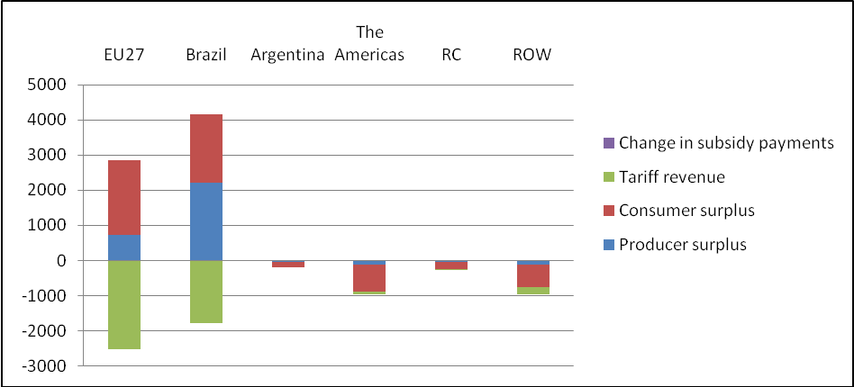

Scenario 1 shows a positive value of US$ 340 million for the EU27, which is in line with the expected increase in welfare because of free trade. Net welfare increases for the EU27 but not significantly (less than 0,01% of GDP). Brazil’s net welfare is expected to increase with US$ 2377 million under the limited FTA. Although the absolute increase of welfare is larger for Brazil than for the EU27 the welfare change again is negligible (0,2% of GDP). All third countries show a loss in net welfare.

The ambitious FTA produces the same results as the limited FTA regarding producer surplus, consumer surplus and tariff revenue. When import tariffs are set at 0 percent the producer surplus increases even more (3757 million USD for Brazil and 1221 million USD for the EU27) while losses for producers in third countries are larger in scenario 2. The same tendency is seen regarding consumer surplus and tariff revenue (see table VI.II). Figure VI.II shows the welfare changes in the case of economy wide trade under 100 percent tariff reduction.
Figure VI.II Welfare change in overall economy wide trade in scenario 2 (million US$)
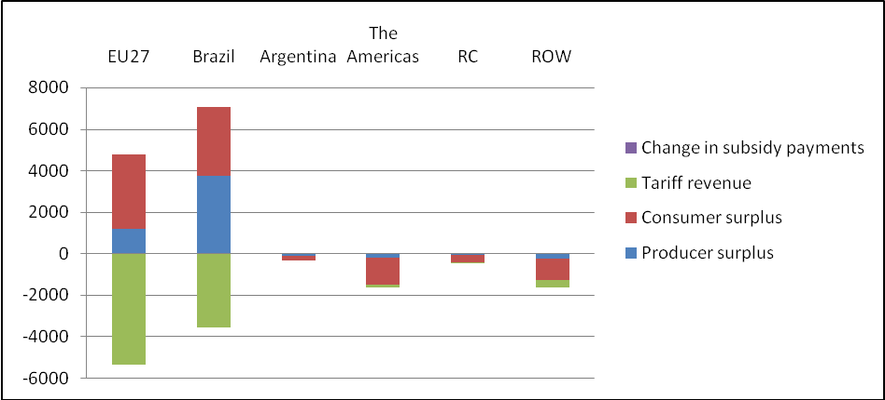

A tariff cut of 100 percent results in an even larger net welfare increase in Brazil (3534 million USD as opposed to 2377 million USD in scenario 1). However, scenario 2 provides an interesting value regarding net welfare of the EU27. While net welfare is expected to increase, the net welfare for the EU27 is negative (-529 million USD) in the case of the ambitious FTA. The increase of consumer and producer surplus is totally offset by the fall in tariff revenues. Argentina, the Americas, RC and the ROW all suffer a somewhat larger loss in net welfare in scenario 2 compared with scenario 1.

As postulated in the scenarios, import tariffs decline and trade between Brazil and the EU27 is expected to increase substantially. Brazilian exports to EU27 will increase by 30 percent in scenario 1 while the value of exports of the EU27 to Brazil will increase by 26 percent. A more elaborate and detailed description of the changes in trade is provided in the tables in Annex 2 to this paper. These provide estimates of changes in exports and imports in overall economy wide trade, the livestock and meat products sector and the motor vehicles sector with all two scenarios. The focus here is on the basic pattern that emerges from these tables.
Figure VI.III Trade: change in value of exports in overall economy wide trade in scenario 1 (million US$)
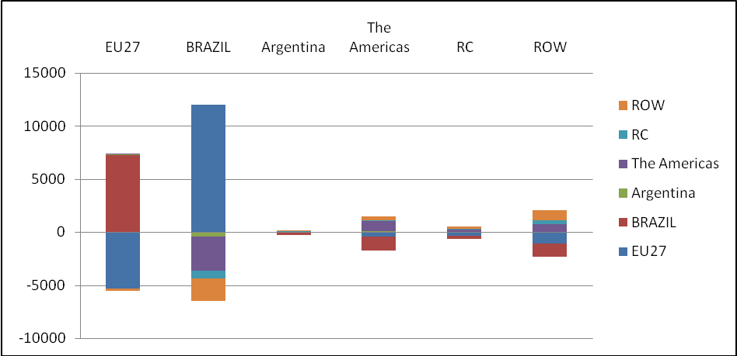

The increase in trade is more significant in the case of the ambitious FTA. Brazilian exports to EU27 will increase by 51 percent in scenario 2 and the same tendency is seen in the case of the EU27 with their value of exports to Brazil increasing by 44 percent (see Annex 2).

Figure VI.IV Trade: change in value of exports in overall economy wide trade in scenario 2 (million US$)

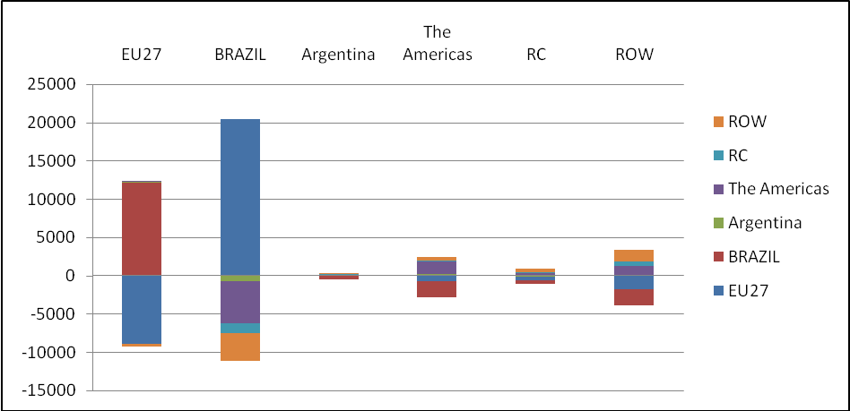

This significant increase in trade between both regions is likely to create third country effects in the form of trade diversion. Especially important trading partners like Argentina and the Americas and countries with similar production are subject to these third country effects. In both scenarios Argentina, the Americas, RC and the ROW are subject to trade diversion. Again results are more noteworthy in scenario 2 which shows a decrease in exports of 8 percent (Argentina) and 9 percent (The Americas, RC and ROW) to Brazil. Total export of third countries to EU27 remains relatively unaffected.

Besides welfare and trade effects, changes in price and output are witnessed. The limited and the ambitious FTA increase the import demand of both Brazil and the EU27. This increase in demand results in higher prices for exporters (producer price for home good). Brazil experiences an increase of 1,7 percent (scenario 1) and 2,8 percent (scenario 2). The EU27 is subject to just a slight increase of 0,02 percent in scenario 1 and 0,03 percent in scenario 2. These higher prices for producers imply an increase in producer surplus. Besides the producers, consumers are also able to benefit from the FTA. Brazilian consumers enjoy a fall in consumer prices by 2 percent in scenario 1 and 3,4 percent in scenario 2. The EU27 sees consumer prices drop by almost 0,1 percent in both scenario 1 and scenario 2. This again results in an increase in consumer surplus in both scenarios. With respect to output changes the expectation is that Brazil’s production (GDP) will increase by 4.2 percent in scenario 2 and by 2,5 percent in scenario 1. In both scenarios the GDP of the EU27 does not change. As for the other countries, the only output changes witnessed are those of Argentina but these changes are not evident. Argentina produces less in both scenarios (-0,2% in scenario 1 and -0,3% in scenario 2). The Americas, RC and ROW experience no output changes.

The outcomes of the GSIM simulations have clarified the possible impacts of a Brazil - EU FTA. On the whole the FTA is expected to have positive net welfare effects under both scenarios for Brazil and under scenario 1 for the EU. However, comparing both scenarios, it becomes clear that the ambitious FTA yields the most benefits for producers, consumers and countries. Producer surplus, consumer surplus, output, trade and net welfare increase more significantly if liberalization deepens. In order to establish the FTA, negotiations between Brazil and the EU are required. These negotiations will be difficult because both Brazil and the EU will focus on their own interests. Based on this economic impact analysis Brazil should aim at an ambitious FTA (generates the most benefits for Brazil) while the EU should aim at a limited FTA. Both Brazil and the EU have to make concessions to eventually make the FTA work. This could mean that negotiations lead to an outcome that neither the limited FTA nor the ambitious FTA will serve one of the parties best. Concessions can lead to the adoption of a reduction of tariff rates other than 60 percent or 100 percent. The outcomes regarding third countries are negative in both scenarios. These countries experience a decrease in welfare with welfare taking a more significant blow in scenario 2.

Chapter VI.III Livestock and meat products sector

The livestock and meat products sector is part of Brazil’s important agribusiness sector. The agribusiness sector accounts for 25 percent of total GDP. The livestock and meat products sector is an important factor in this production growth. Production of meat has grown constantly the past 5 years (annual growth rate of 4%). Continuous efforts of the companies within the livestock and meat products sector to innovate and increase efficiency, cheap feed inputs and an abundance of pastureland have made the sector to a success. The sector is characterized by mergers, acquisitions and product diversification. Mergers and acquisitions create large powerful meat producers that operate internationally and produce a variety of products like poultry, dairy and pork products (product diversification). Although Brazilians consume almost three quarters of their own meat production, export of meat has grown significantly over the last ten years (increase of 21% per year). This development makes Brazil the world’s leading exporter of meat since 2005 with a 24 percent global market export share in beef, 35 percent in poultry and 13 percent in pork.

As in Brazil the meat sector plays an important role in the agricultural sector of the EU. The meat sector accounts for 25 percent of the total value of agricultural production. The sector is very diverse with specialized meat production concentrated in different areas across the EU. Ireland produces a significant part of total beef production, sheep rearing is mainly concentrated in the UK and Spain while pig rearing is concentrated in Belgium, France, Spain, Germany and the Netherlands. The total meat production of the EU accounts for 16 percent of total global meat production. Besides this significant production the EU is a major player in world meat trade (12,8% net share of total world trade in meat). Although the EU is self-sufficient in most types of meat some import of meat (sheep and goat) is needed. Major third country suppliers are Brazil and Argentina.

The CAP regarding the livestock and meat products sector has been focused on improving product quality and creating an environment in which producers are confident about their future income. In order to achieve this goal the EU used border protection, intervention buying (the buying of surplus beef from the market) and export subsidy (export refund) to stabilize the EU internal market price. These protectionist measures were liberalized with the establishment of the WTO. Under WTO ruling export refund decreased, domestic market support (intervention buying) declined, market access increased and tariff cuts were applied. These developments led to increased competition from imported products and the gap between the internal market price for beef and world prices narrowed. As a result of this, high export subsidies to make EU beef more competitive have been less necessary.

Although some efforts to liberalize the livestock and meat products sector of the EU have taken place the sector remains subject to significant border protection in the form of high import tariffs. The EU27 applies a 79,8 percent initial import tariff regarding meat products imported from Brazil while Brazil applies an initial import tariff of only 6.6 percent regarding meat products imported from the EU27. These tariffs will be set at 0 percent when applying the ambitious FTA. In the case of the limited FTA the final import tariffs will be 2,7 percent for Brazil and 31,9 percent for the EU27. Furthermore the livestock and meat products sector is subject to a composite demand elasticity of -3.0, a substitution elasticity of 7.2 and an industry supply elasticity of 1.5. The GSIM results are summarized in Table VI.III below.
Table VI.III Summary of welfare, trade, price and output effects in the livestock and meat products sector

 | Scenario 1: 60% tariff reduction
Variable |  |  | Unit/value | EU27 | Brazil | Argentina | The Americas | RC | ROW
Welfare
Producer surplus |  | A | Mln US$ | -549 | 904 | -15 | 27 | -2 | -27
Consumer surplus |  | B | Mln US$ | 1860 | 3 | -6 | -80 | -92 | -262
Tariff revenue |  | C | Mln US$ | -138 | -2 | 0,4 | -24 | -41 | -9
Change in subsidy payments |  | D | Mln US$ | 0 | 0 | 0 | 0 | 0 | 0
Net welfare effect |  | A+B+C+D=E | Mln US$ | 1173 | 905 | -20 | -77 | -134 | -298
Other
Exports |  | Value | Mln US$ | -1374 | 2231 | -37 | 66 | -4 | -68
Imports |  | Value | Mln US$ | 2013 | 6 | -14 | -192 | -218 | -780
Trade balance |  | Value | Mln US$ | -3387 | +2225 | -23 | +258 | +214 | +713
Change in output |  | Percent | % | -1,6 | 13,2 | -1 | 0,2 | -0,1 | -0,2
Change in overall consumer prices |  | Percent | % | -3,2 | -1,1 | 4,3 | 0,4 | 1 | 0,6
Producer price for home good |  | Percent | % | -1,1 | 8,8 | -0,7 | 0,1 | -0,04 | -0,1
Market price for home good |  | Percent | % | -1,1 | 8,8 | -0,7 | 0,1 | -0,04 | -0,1
 | Scenario 2: 100% tariff reduction
Variable |  |  |  | EU27 | Brazil | Argentina | The Americas | RC | ROW
Welfare
Producer surplus |  | A | Mln US$ | -966 | 1677 | -26 | 47 | -3 | -48
Consumer surplus |  | B | Mln US$ | 3413 | 5 | -11 | -142 | -165 | -467
Tariff revenue |  | C | Mln US$ | -3241 | -4 | 1 | -48 | -86 | -74
Change in subsidy payments |  | D | Mln US$ | 0 | 0 | 0 | 0 | 0 | 0
Net welfare effect |  | A+B+C+D=E | Mln US$ | -794 | 1678 | -36 | -142 | -254 | -589
Other
Exports |  | Value | Mln US$ | -2422 | 4104 | -64 | 118 | -8 | -120
Imports |  | Value | Mln US$ | 4185 | 10 | -28 | -408 | -473 | -1677
Trade balance |  | Value | Mln US$ | -6607 | +4094 | -36 | +526 | +466 | +1557
Change in output |  | Percent | % | -2,9 | 23,4 | -1,8 | 0,3 | -0,1 | -0,3
Change in overall consumer prices |  | Percent | % | -5,7 | -1,9 | 7,6 | 0,8 | 1,7 | 1
Producer price for home good |  | Percent | % | -2 | 15,6 | -1,2 | 0,2 | -0,07 | -0,2
Market price for home good |  | Percent | % | -2 | 15,6 | -1,2 | 0,2 | -0,07 | -0,2

The net welfare effect for Brazil is positive in both scenarios (905 million USD in scenario 1 and 1678 million USD in scenario 2). Although Brazil loses tariff revenue this is not in proportion with the total gain in producer and consumer surplus. The position of the EU27 is somewhat more complex. The EU27 loses tariff revenue and producer surplus but increases consumer surplus in both scenarios. Nevertheless the gain in consumer surplus is only large enough in scenario 1 to create a positive net welfare effect (1173 million USD). In scenario 2 the losses in tariff revenue and producer surplus are too significant to be totally offset by the consumer surplus increase. Scenario 2 is expected to create a loss in net welfare of US$ 794 million. The net welfare of all other countries in the world is likely to be negatively affected by the FTA. For an overview of welfare changes in both scenarios see Figure VI.V and Figure VI.VI below.
Figure VI.V Welfare change in the livestock and meat products sector in scenario 1 (million US$)
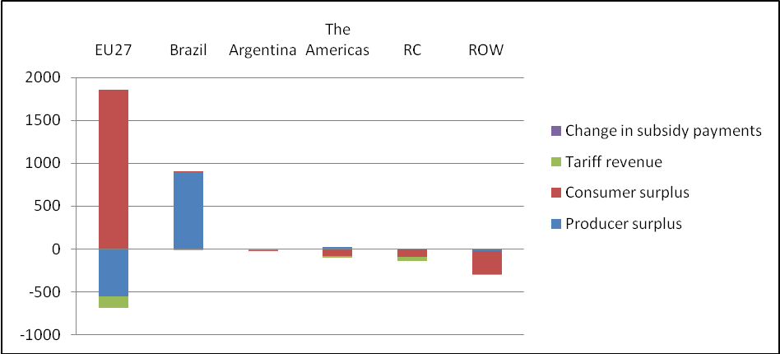
Figure VI.VI Welfare change in the livestock and meat products sector in scenario 2 (million US$)
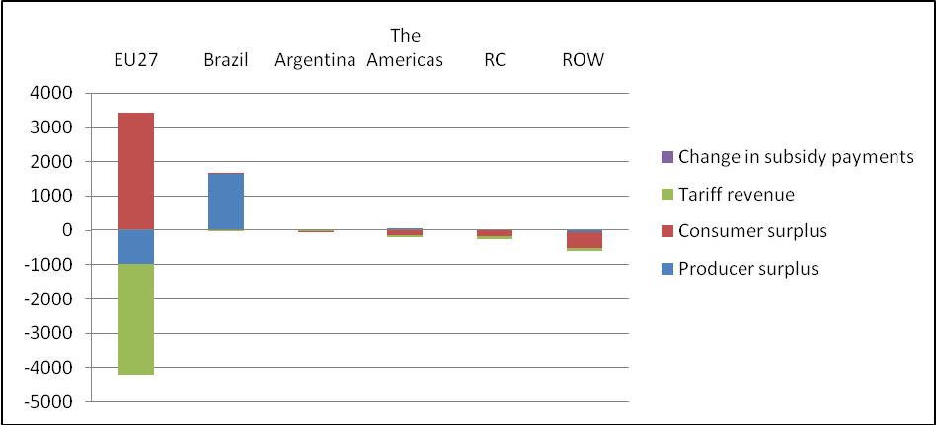

On the consumer side both regions experience positive effects in both scenarios. Increased competition favours consumers and prices drop with 1,1 percent (scenario 1) and 1,9 percent (scenario 2) in Brazil and with 3,2 percent (scenario 1) and 5,7 percent (scenario 2) in the EU27. Especially consumers in the EU27 benefit from the liberalization of trade. This is confirmed by the steep rise of the consumer surplus with US$ 1860 million in scenario 1 and US$ 3413 million in scenario 2. Although consumer surplus in Brazil rises, the amount (respectively 3 million USD and 5 million USD) is insignificant.

Where producer surplus is concerned, Brazil and the EU27 show opposite results. Better market access to EU27 provides Brazilian producers with a larger market for their products. Demand for their products increases resulting in higher prices. The prices for Brazilian goods increase by 8,8 percent under the limited FTA and by 15,6 percent under the ambitious FTA. As a result of the higher prices the producer surplus increases with US$ 904 million (scenario 1) and US$ 1677 million (scenario 2). The fierce competition of Brazilian producers decreases the demand for the EU27 products and as a consequence the EU27 experiences a small decrease in producer prices (-1,1% and -2%). Producer surplus decreases with US$ 549 million in scenario 1 and US$ 966 million in scenario 2.

As expected the tariff revenue declines with a reduction of tariffs. Both regions have to cope with a decline in revenues in both scenarios. However in the case of Brazil this loss is insignificant because applied tariffs were already very small. In contradiction to Brazil, the EU27 applied significant import tariffs and as a consequence the loss in tariff revenue (138 million USD in scenario 1 and 3241 million USD in scenario 2) has a big negative impact on net welfare. A reduction of import tariffs (60% and 100%) is likely to increase trade between the two regions. The GSIM simulations confirm these expectations with value of exports of both countries increasing in scenario 1 and scenario 2. Brazil shows a staggering increase of 132 percent (5630 million USD) in scenario 1 and 234 percent (10556 million USD) in scenario 2 (see Annex 2). This is not really surprising considering the facts that Brazil is among the top producers and exporters in the livestock and meat products sector and that the EU27 applied very high import tariffs to protect its domestic industry. The EU27 experiences an increase of 30 percent in the limited FTA and of 50 percent in the ambitious FTA. The value of exports from the EU27 to Brazil increases with US$ 14 million (limited FTA) and US$ 23 million (ambitious FTA) (see Annex 2). Figure VI.VII (scenario 1) and VI.VIII (scenario 2) show the changes in value of exports.

Figure VI.VII Trade: change in value of exports in the livestock and meat products sector in scenario 1 (million US$)

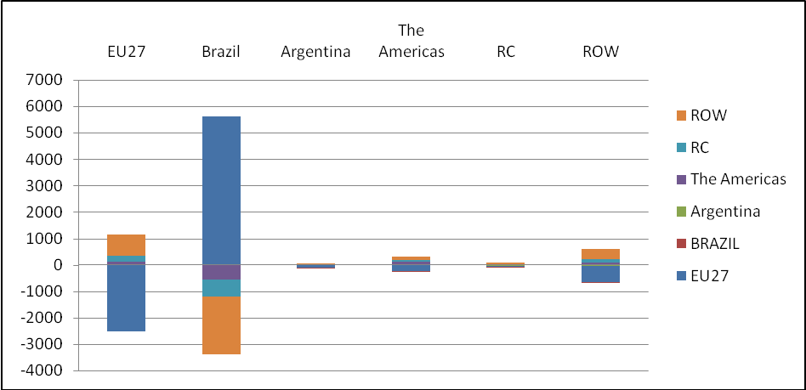

Figure VI.VIII Trade: change in value of exports in the livestock and meat products sector in scenario 2 (million US$)

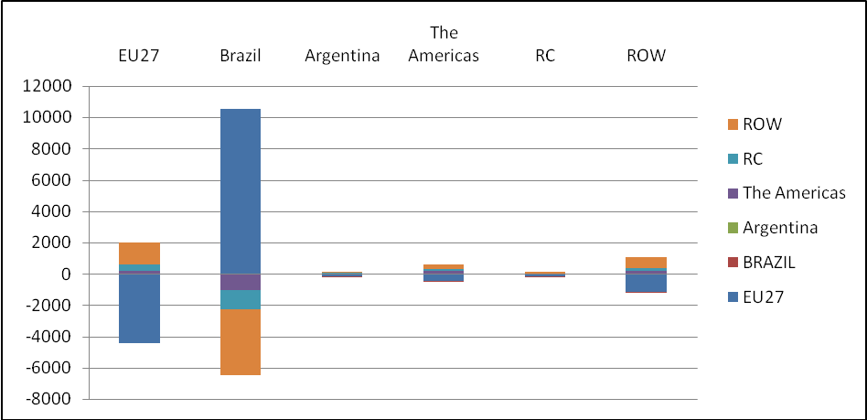

The establishment of the Brazil - EU FTA will lead to trade diversion and trade creation. All countries outside the FTA will suffer from a decrease in value of exports to EU27 and Brazil. These third countries will partly offset the decrease in value of exports to Brazil and the EU27 by increasing their value of exports to other regions in the world. Especially Argentina is very active. Argentina’s exports and imports to and from the Americas, RC and the ROW will be higher.

With the drop in tariffs Brazilian producers in the meat and livestock sector will become significant competitors for European producers. Brazil has some of the largest internationally operating producers and their influence is seen in the expected output change. With the decline of the import tariffs of the EU27, the market access for Brazilian producers into the EU27 market improves. In scenario 1 Brazil increases its output with 13,2 percent and in scenario 2 with 23,4 percent. The EU27 on the other hand experiences more competition and some of its output might be replaced by relative cheap imports (in some meat sectors the EU27 is not self-sufficient). These changes are translated in a decline of output of 1,6 percent in scenario 1 and 2,9 percent in scenario 2. No significant changes in output for the Americas, RC and the ROW are witnessed while Argentina faces a decline in both scenarios.

The GSIM simulations regarding the livestock and meat products sector show that Brazil will experience an increase in net welfare under both scenarios. Deeper liberalization in the form of the ambitious FTA is desirable for Brazil because that scenario yields the most benefits in terms of welfare, trade and output. Producer surplus, consumer surplus, output, trade and net welfare increase more significantly than in the case of a limited FTA. The EU sees its net welfare increase under a limited FTA while it will decrease under an ambitious FTA. The EU has strongly protected its livestock and meat products sector and with the decline of import tariffs the sector becomes subject to fierce competition. During negotiations Brazil will aim at full liberalization (0% import tariffs) while the EU will seek a particular import tariff that increases net welfare while protecting domestic industry.

Chapter VI.IV Motor vehicles sector

The Brazilian industry is very diverse and motor vehicles are among the major export products of Brazil. Besides this the sector played an important role in the process of liberalization. This began with the creation of Mercosur in 1991 which stimulated, modernized and restructured the domestic industry resulting in an increase in production and exports (Argentina and other Mercosur members are major export destinations). During the 1990s another boost was given to the motor vehicles sector when the market opened up for imports. This development led to an increased attractiveness for investment. Big foreign producers like Nissan, Renault, Hyundai, Honda et cetera settled in Brazil and opened factories. This development continued over the years and the motor vehicles industry became one of the main economic activities of Brazil. Brazil entered the top five of major auto producers in the world and besides production for own consumption the export of motor vehicles increased significantly (it now accounts for 10% of total Brazilian value of exports).

Within the EU, the motor vehicles sector is a key industry with a number one ranking in the list of largest automotive regions of the world. The market is characterized by a series of mergers and acquisitions creating some large manufacturers (DaimlerChrysler, Volkswagen, BMW, Ford Europe, General Motors (GM) Europe, Renault, Fiat and Porsche). The sector employs a substantial number of people and shows a rising output over the last years. In the same period exports (mainly to members of NAFTA) exceeded imports creating a trade balance surplus.

The motor vehicles sector of the EU is efficient and innovative. This is the result of the fierce competition that comes along with the modest import tariffs the EU27 applies to the rest of the world. Products imported from Brazil are only subject to an initial import tariff of 1,1 percent. Brazil applies an initial import tariff of 17.8 percent for products imported from the EU27. Tariffs will be set at 0 percent when applying the ambitious FTA. In the case of the limited FTA the final import tariffs will be 7,1 percent for Brazil and 0,4 percent for the EU27. Furthermore the transport vehicles sector is characterized by a composite demand elasticity of -2.8, a substitution elasticity of 5.6 and an industry supply elasticity of 1.5. The GSIM results are summarized in Table VI.IV below.

Table VI.IV Summary of welfare, trade, price and output effects in the motor vehicles sector

 | Scenario 1: 60% tariff reduction
Variable |  |  | Unit/value | EU27 | Brazil | Argentina | The Americas | RC | ROW
Welfare
Producer surplus |  | A | Mln US$ | 148 | 7 | -16 | -11 | 0.2 | -6
Consumer surplus |  | B | Mln US$ | -94 | 238 | -2 | -1 | -4 | -20
Tariff revenue |  | C | Mln US$ | -5 | -194 | 0,1 | -2 | -1 | -1
Change in subsidy payments |  | D | Mln US$ | 0 | 0 | 0 | 0 | 0 | 0
Net welfare effect |  | A+B+C+D=E | Mln US$ | 49 | 51 | -17 | -14 | -5 | -28
Other
Exports |  | Value | Mln US$ | 369 | 18 | -39 | -28 | 1 | -16
Imports |  | Value | Mln US$ | -164 | 514 | -3 | -1 | -6 | -36
Trade balance |  | Value | Mln US$ | +534 | -496 | -36 | -28 | +7 | +20
Change in output |  | Percent | % | 0 | 0,1 | -1 | 0 | 0 | 0
Change in overall consumer prices |  | Percent | % | 0,02 | -4,2 | 0,05 | 0 | 0,01 | 0,01
Producer price for home good |  | Percent | % | 0,03 | 0,07 | -0,7 | -0,01 | 0 | 0
Market price for home good |  | Percent | % | 0,03 | 0,07 | -0,7 | -0,01 | 0 | 0
 | Scenario 2: 100% tariff reduction
Variable |  |  |  | EU27 | Brazil | Argentina | The Americas | RC | ROW
Welfare
Producer surplus |  | A | Mln US$ | 246 | 12 | -26 | -19 | 0,4 | -11
Consumer surplus |  | B | Mln US$ | -157 | 411 | -3 | -2 | -7 | -34
Tariff revenue |  | C | Mln US$ | -9 | -419 | 0,2 | -3 | -2 | -2
Change in subsidy payments |  | D | Mln US$ | 0 | 0 | 0 | 0 | 0 | 0
Net welfare effect |  | A+B+C+D=E | Mln US$ | 81 | 5 | -29 | -24 | -9 | -46
Other
Exports |  | Value | Mln US$ | 616 | 31 | -66 | -47 | 1 | -27
Imports |  | Value | Mln US$ | -274 | 858 | -5 | -2 | -10 | -60
Trade balance |  | Value | Mln US$ | +890 | -828 | -60 | -46 | +11 | +33
Change in output |  | Percent | % | 0,1 | 0,2 | -1,6 | 0 | 0 | 0
Change in overall consumer prices |  | Percent | % | 0,04 | -6,9 | 0,08 | 0 | 0,02 | 0,02
Producer price for home good |  | Percent | % | 0,05 | 0,1 | -1,1 | -0,01 | 0 | 0
Market price for home good |  | Percent | % | 0,05 | 0,1 | -1,1 | -0,01 | 0 | 0

The net welfare effect is positive for both Brazil and the EU27. In Brazil both producer and consumer surplus are positively related with the establishment of the FTA, but especially in scenario 2 these effects are largely offset by a decrease in tariff revenue. Still the limited FTA will provide Brazil with a positive net welfare of US$ 51 million and the ambitious FTA with a positive net welfare effect of US$ 5 million. In contrast with the Brazilian consumers, the consumers in the EU27 will be negatively affected by the FTA. Although consumer surplus will decrease, net welfare is expected to increase with US$ 49 million in scenario 1 and US$ 81 million in scenario 2. This is caused by the fact that the EU27 is not harmed by a large decrease in tariff revenue (tariff rates applied were already small). All countries outside the FTA suffer a loss in welfare. Figure VI.IX (limited FTA) and Figure VI.X (ambitious FTA) show the welfare changes in the motor vehicles sector.

Figure VI.IX Welfare change in the motor vehicles sector in scenario 1 (million US$)

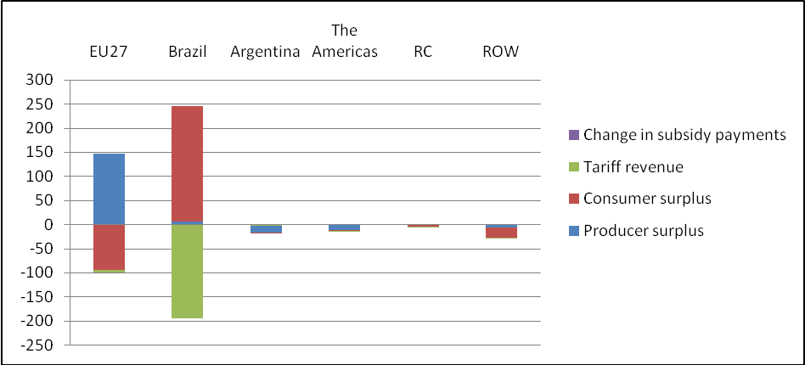
Figure VI.X Welfare change in the motor vehicles sector in scenario 2 (million US$)
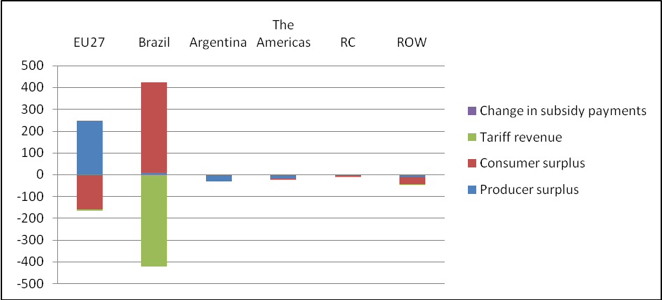

An analysis of the producer surplus and the consumer surplus provides some interesting results. As a result of increased demand, the prices for exporters (in Brazil as well as in the EU27) increase under both the limited and the ambitious FTA. As a consequence producer surplus also rises (see Table VI.IV). On the consumer side of the economy, Brazil experiences a steep rise in consumer surplus (238 million USD and 411 million USD) due to significant price changes. Better market access in Brazil increases competition and consumer prices fall by 4,2 percent in scenario 1 and 6,9 percent in scenario 2. This is in favour of the Brazilian consumers and companies that will be able to buy cheaper products. A positive side effect is that cheaper prices in the motor vehicles sector, being one of Brazil’s main economic activities, translate through to many sectors in the Brazilian economy. The EU27 sees opposite effects, a slight increase in consumer prices in both scenarios lead to a decrease in consumer surplus of US$ 94 million in scenario 1 and US$ 157 million in scenario 2. Products will be more expensive harming consumers.

Third country effects show a decrease in producer surplus for Argentina, the Americas and the ROW in both scenarios. Demand for their products decreases, total export quantity declines and producer prices drop in both scenarios. The only exception is RC with an insignificant increase in producer surplus of US$ 0,2 million in scenario 1 and US$ 0,4 million in scenario 2. RC is not affected negatively by the Brazil - EU FTA because it is not a major trading partner of Brazil unlike the Americas and Argentina. Besides a fall in producer surplus, consumer surplus is also negatively affected. Argentina, the Americas, RC and the ROW see consumer prices rise resulting in a decrease in consumer surplus.

As for tariff revenue, it is expected to be negative for Brazil, the EU27, the Americas, RC and the ROW in both scenarios. Brazil will experience a much larger decrease in tariff revenue than the EU27 which is in line with the much higher initial import tariff. Argentina is the only country with a minor but positive revenue change (0,1 million USD in scenario 1 and 0,2 million USD in scenario 2). Total value of imports of Argentina declines, for the greater part due to a drop of imports from Brazil. Still tariff revenue of Argentina rises. Imports from Brazil are subject to an applied import tariff of 0 percent due to Mercosur. The increase in tariff revenue can be explained by the rise in imports from the Americas and the ROW (applied import tariffs of 11% and 19% respectively).

Liberalization of trade by decreasing import tariffs leads to an increase in trade in both scenarios. However, the percentage change of trade differs significantly between Brazil and the EU27. Brazil exports 3 percent more to EU27 in scenario 1 and 6 percent more in scenario 2. The EU27 exports to Brazil increase by 39 percent in scenario 1 and by 65 percent in scenario 2. Furthermore the quantities exported from the EU27 to Brazil are much more significant than the quantities exported from Brazil to the EU27. On the import side the EU27 experiences a decline in imports while Brazil increases its imports in both scenarios (see Annex 2). Figure VI.XI (scenario 1) and VI.XII (scenario 2) show the changes in value of exports.
Figure VI.XI Trade: change in value of exports in the motor vehicles sector in scenario 1 (million US$)

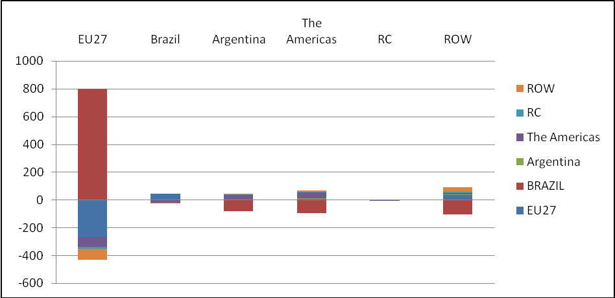

Figure VI.XII Trade: change in value of exports in the motor vehicles sector in scenario 2 (million US$)

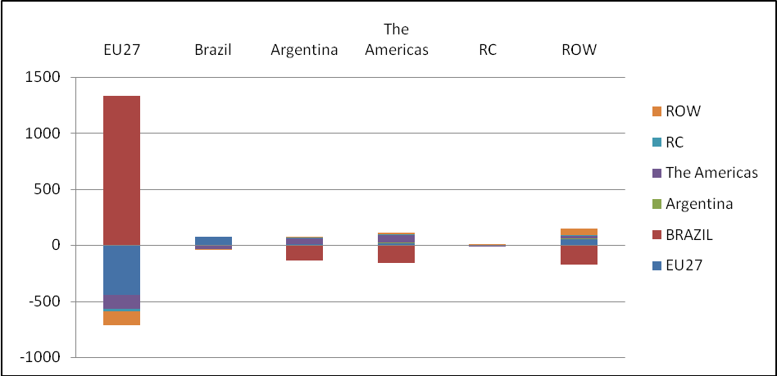

These differences can be explained by the fact that the EU27 has a comparative advantage in motor vehicles. The EU27 motor vehicles sector was already very open (very small import tariffs) while Brazil applied significant import tariffs. Opening up of the Brazilian market increases opportunities for the EU27 businesses to export their product. Increasing exports and decreasing imports give a positive boost to the trade balance of the EU27 while the trade balance of Brazil deteriorates. The Americas, RC and the ROW will be affected negatively (trade diversion). Their trade to Brazil decreases in scenario 1 and even more in scenario 2. Even Argentina, a member of Mercosur just like Brazil, will be harmed. Between Brazil and Argentina no import tariff is applied (Mercosur ruling) but still the value of exports of Argentina to Brazil declines with 8 percent in scenario 1 and 13 percent in scenario 2 (see Annex 2). Argentina makes up for this loss in value of exports partly by exporting more to EU27, the Americas, RC and the ROW. Still the total amount of export decreases in both scenarios because Brazil is one of the major export destinations of Argentina (see Annex 2). Trade of Argentina, the Americas, RC and the ROW with the EU27 will not change significantly in both scenarios. Output does not change significantly in both scenarios with the exception of Argentina. Argentina shows a decrease in output of 1 percent in scenario 1 and 1,6 percent in scenario 2.

Overall an FTA is expected to have positive economic effects for the motor vehicles sector of both Brazil and the EU. The EU will benefit from increased exports while Brazil experiences positive economic effects from a decrease in prices. Besides this difference, it is obvious that the ambitious FTA yields the most benefits for the EU while the limited version is most beneficial for Brazil. This is a complex situation which will cause a lot of difficulties during negotiations. Brazil will aim for an applied import tariff reduction of 60 percent while the EU will negotiate for deep liberalization with tariffs set at 0 percent. It is clear that the establishment of a Brazil - EU FTA regarding the motor vehicles sector is in the best interest of both parties but the tariff rate to be applied is subject to discussion.

Chapter VI.V Sensitivity analysis

The results GSIM provides are driven by several parameters, assumptions and variables like Armington elasticity’s. These variables could be subject to uncertainty and to check if results are robust the model is run with different values. The sensitiveness of the results to changes in parameters is measured by changing the values of industry supply, composite demand and substitution elasticity.

In order to check the robustness of the results the industry supply and substitution elasticity are doubled while the composite demand elasticity is cut in half. These changes are applied to both scenarios. A cut in demand elasticity represents a situation in which demand is less sensitive to price changes. A doubling of the substitution elasticity means that buyers are more willing to substitute between products from different countries as the relative prices change.

In general some changes in results are witnessed when industry supply, composite demand and substitution elasticity are varied. However these changes are small and insignificant and do not change the direction of the results.

Chapter VII Conclusions

In this paper the partial equilibrium model GSIM is used to estimate the welfare, trade, price and output effects of a limited and an ambitious FTA between Brazil and the EU. Two simulations of tariff reduction (60% and 100%) are applied to economy wide trade, the livestock and meat products sector and the motor vehicles sector. Sensitivity analysis shows that expected estimates are robust and, with limitations of the model and data kept in mind, the model provides useful insights regarding the expected economic effects of a Brazil - EU FTA.

The GSIM analysis has clarified the advantages and disadvantages of the Brazil - EU FTA. With respect to economy wide trade Brazil will experience a rise in net welfare with the ambitious FTA leading to larger welfare gains than the limited FTA. Brazil will experience a rise in consumer and producer surplus which is big enough to compensate for the loss in tariff revenue. The economic impact of the Brazil - EU FTA on the EU is a very interesting one. Liberalization of trade is often accompanied by an increase in net welfare. Although the limited FTA provides the EU with a rise in consumer surplus, producer surplus and net welfare, deeper integration in the form of an ambitious FTA turns out to be negatively related with net welfare. Under the ambitious FTA consumer surplus and producer surplus rise even more than under the limited FTA, but these effects are totally undone by a much larger loss in tariff revenue. This can be explained by the fact that the EU has been protecting its domestic industries where needed. A reciprocal tariff cut of 100% will result in the loss of all tariff revenues regarding these sectors. In terms of welfare third countries like Argentina, the Americas, RC and the ROW are negatively affected by the establishment of the Brazil - EU FTA. Trade diversion will shift trade away from these countries. Demand for their products and thus exports will decrease which translates into a drop in prices and a loss in producer surplus. Besides this a decline in consumer surplus is expected. Especially the Americas, being one of the major trading partners of Brazil and the EU, will be harmed. Again decrease in welfare is more significant in scenario 2.

The sectoral impacts of the Brazil – EU FTA are very much in line with economy wide trade results. For the livestock and meat products sector in Brazil net welfare is expected to increase in both scenarios and will be the largest in the ambitious FTA, where the integration is most far-reaching. The livestock and meat products sector is part of Brazil’s important agribusiness sector. The sector has produced large powerful meat producers by mergers and acquisitions which can compete internationally. With reduction of tariffs, the EU27 market will be more open to Brazilian exports. Demand for Brazilian products will increase and prices for exporters will rise which results in a significant increase of Brazilian producer surplus. Consumer surplus shows a slight increase due to increased competition and tariff revenue will decline because of reduced tariffs. In contradiction to Brazil the EU will suffer a loss in net welfare under the ambitious FTA. The CAP regarding the livestock and meat products sector resulted in protectionist measures and significant border protection in the form of high import tariffs. Increased competition because of trade liberalization makes demand for domestic products decline. Prices will drop and producers within the European livestock and meat products sector will be among the losers (producer surplus declines) of the establishment of the Brazil - EU FTA. While producers lose consumers within the EU win. Consumer surplus will increase because increased competition from Brazilian products makes prices drop. Although the European consumers are the big winners of the FTA the net welfare decreases under the ambitious FTA due to significant tariff revenue losses.

Unlike economy wide trade and the livestock and meat products sector, the motor vehicles sector shows positive net welfare values for both Brazil and the EU under both the limited and the ambitious FTA. Compared with the EU, the Brazilian motor vehicles sector is significantly protected. With the establishment of the FTA, applied import tariffs will drop. Competition of European motor vehicles on the Brazilian market will enlarge because of improved access. With a larger supply of products, prices for consumers will drop resulting in an increase in Brazilian consumer surplus. In contradiction to Brazil the consumer surplus in the EU declines because of a rise in prices. While Brazil benefits from a decrease in consumer prices, the EU mainly benefits from increased exports. The tariff reduction in a significantly protected market like the Brazilian motor vehicles market provides the EU with a lucrative new market to sell their products. As a result of increased demand, the prices for exporters and producer surplus increase in the EU under both the limited and the ambitious FTA. Third country net welfare is expected to decrease. Trade diversion results in a decrease in demand for their products, total value of exports declines and producer prices drop in both scenarios. Besides a fall in producer surplus, consumer surplus is also negatively affected. Argentina, the Americas, RC and the ROW see consumer prices rise resulting in a decrease in consumer surplus.
Most of the changes in net welfare after liberalization can be expected in those sectors where protection is strong. The protection in the livestock and meat products sector is more significant than the protection in the motor vehicles sector. As a result the absolute value of net welfare change of the livestock and meat products sector is larger than that of the motor vehicles sector.

As assumed, liberalization of trade leads to an increase in the quantity traded between Brazil and the EU. Overall economy wide trade between Brazil and the EU will expand in both scenarios and trade increases with the degree of liberalization. This trade creation is accompanied by trade diversion effects. Argentina, the Americas, RC and the ROW will suffer from a decrease in exports to Brazil and the EU. Besides these trade effects, Brazil’s GDP increases in both scenarios while no change in output is witnessed for the EU.

In the livestock and meat products sector Brazil shows a staggering increase in value of exports to the EU in scenario 1 and 2. As one of the top producers and exporters Brazil manages to make good use of the better market access to the EU. Value of exports from the EU to Brazil also increases but insignificantly. With better market access Brazilian producers in the meat and livestock sector will become significant competitors for European producers. More potential customers increase demand and to be able to meet this demand Brazil increases output in both scenarios. Because prices of imports drop, the EU will replace some domestic production by relative cheaper imports leading to a decline in domestic output of the EU, with gains for EU consumers.

In the motor vehicles sector an increase in trade is witnessed in both scenarios. As opposed to the livestock and meat products sector the increase in export volumes from Brazil to the EU is very small while the increase in volumes exported from the EU to Brazil is much more significant in both scenarios. The liberalization of the Brazilian motor vehicles sector, which has been rather protected, provides opportunities for European industry to increase export and improve market access. Trade diversion effects are observed particularly in changes in trade to Brazil. Argentina, the Americas, RC and the ROW experience a decrease in exports to Brazil in both scenarios. Their exports to the EU do not change significantly because the motor vehicles sector in the EU already was relatively open.

Interpretation of the results makes it evident that establishing a Brazil - EU FTA will be a difficult task because of conflicting interests. The EU will aim at the implementation of a limited FTA in the case of economy wide trade while Brazil will aim at full liberalization (ambitious FTA). At the sector level the same problem arises as Brazil will try to fully liberalize trade in the livestock and meat products sector. On the other hand, the EU will try to protect its domestic industry to a certain level and will negotiate the implementation of the limited FTA. It is clear from the GSIM simulations that reduction of tariffs in the motor vehicles sector are favourable for both Brazil and the EU. Net welfare in the EU will increase because of an increase in exports while Brazil will gain from a decline in prices. Although both regions gain, conflicts in negotiations are inevitable because Brazil will experience a larger net welfare increase under the limited FTA than under the ambitious FTA while the EU gains more under the ambitious FTA. Conflicting interests will lead to a situation in which both parties will have to make concessions in order to establish the FTA and to make it work. Further analysis of the influence of tariff reductions may lead to the adoption of a different tariff reduction than 60 percent or 100 percent.

Chapter VIII Annex 1: References

Japan-Chile free trade agreement study group “Study report on the Japan – Chile free trade agreement”, Japan external trade organization (JETRO) (2001)

Yasutake, T. (2004), ”Philippines – Japan free trade agreement: Analyzing its potential impact using a Computable General Equilibrium Model”, University of the Philippines (2004)

Jackson, S.D. (2006), ”Cross-regional trade cooperation: the Mexico – Japan free trade agreement”, Seventh meeting of the Latin American and Caribbean studies network on Asia Pacific (REDEALAP)

Achterbosch, T. Kuiper, M. and Roza, P. (2008), “EU – India free trade agreement: A quantitative assessment”, LEI Wageningen UR, The Hague

Francois, J.F. McQueen, M. and Wignaraja, G. (2005), “EU – Developing country FTA’s: Overview and Analysis”

“Peru - China free trade agreement: joint feasibility study”, Report prepared by the Ministry of Foreign Trade and Tourism of Peru and the Ministry of Commerce of the People’s Republic of China, Ministerio de Comercio Exterior y Turismo (2007)

“Trade Sustainability Impact Assessment for the FTA between the EU and the Republic of India”, Report prepared by ECORYS Netherlands BV, CUTS and CENTAD (2009)

“Trade Sustainability Impact Assessment for the FTA between the EU and Ukraine within the Enhanced Agreement”, Report prepared by ECORYS Netherlands BV and CASE Ukraine (2007)

“Trade Sustainability Impact Assessment of the FTA between the EU and ASEAN - Final Report”, Report prepared by ECORYS Netherlands BV and partners (2009)

Cadario, M.E. (2003), “A free trade agreement of the Americas: A case study of Brazil”, Department of Economics

Choi, I. and Schott, J.J. (2001), “Free trade between Korea and the United States?”, Policy analysis in International Economics 62

“Australia – China Free Trade Agreement”, paper of The Royal Australian Institute of Architects, Submission to the Department of foreign Affairs and Trade (2005)

Kolodko, G.W. (2006), “Globalization and Its Impact on Economic Development”, TIGER Working Paper Series No. 81, Warsaw

Stiglitz, J.E. (2002), “Globalization and Its Discontents”, New York : W.W. Norton

Ghai, D. (1997), “Economic Globalization, Institutional Change and Human Security”, United Nations Research Institute for Social Development

Dreher, A. (2002), ”Does Globalization Affect Growth?”, University of Mannheim, Lehrstuhl für Volkswirtschaftslehre, L7, 3-5, D-68131 Mannheim, Germany, JEL-Codes: H77, O57, F43

Crafts, N. (2000), “Globalization and Growth in The Twentieth Century”, IMF Working Paper, JEL Classification Numbers N10, F43, O10

Feenstra, R.C. (2007), “Globalization and Its Impact on Labor”, Global Economy Lecture,
Vienna Institute for International Economic Studies, University of California, Davis and NBER

Grinols, E.L. and Silva, P. (2003), “An Enhancement of Modern Free Trade Area Theory”, JEL classification numbers: D6, F15

Maggi, G. and Rodriquez-Clare, A. (2005), “A Political-Economy Theory of Trade Agreements”, NBER Working Paper No. 11716

Victorio, A.G. and Rungswang, M. (2008), “The Effect of a Free -Trade Agreement upon
Agricultural Imports”, International Journal of Social Sciences 3;4
Trakman, L.E. (2008), “The Proliferation of Free Trade Agreements: Bane or Beauty?”, Journal of World Trade, vol. 42
Saggi, K. and Yildiz, H.M. (2004), “Bilateral trade agreements and the feasibility of
multilateral free trade”, JEL Classifications:F13, F12

Ethier, W.J. (2002), “The Theory of Trade Policy and Trade Agreements: A Critique”, Department of Economics, University of Pennsylvania
Shujiro, U. and Misa, O. (2007), ”The Impacts of Free Trade Agreements on Trade Flows: An Application of the Gravity Model Approach”, Research Institute of Economy, Trade and Industry (RIETI), Discussion papers with number 07052
Nugent, J.B. and Abdel-Latif, A.M. (1994), “Countertrade as Trade Creation and Trade Diversion: Theory and Case Study Illustration”, Contemporary Economic Policy, 12, pp. 1-11
Mansfield, E. and Pevehouse, J. (2005), "Trade Diversion, Trade Creation, and International Conflict", Paper presented at the annual meeting of the International Studies Association, Hilton Hawaiian Village, Honolulu, Hawaii
Eicher, T. (2008), ”Trade Creation and Diversion Revisited: Accounting for Model Uncertainty and Natural Trading Partner Effects”, University of Washington - Department of Economics; CESifo (Center for Economic Studies and Ifo Institute for Economic Research), IMF Working Paper No. 08/66

Kreinin, M.E. (1959), “On the "Trade-Diversion" Effect of Trade-Preference Areas”, The Journal of Political Economy, Vol. 67, No. 4, pp. 398-401, Published by: The University of Chicago Press (1959)

Viner, J. (1950), “The Customs Union Issue”, Carnegie Endowment for International Peace, New York

Robinson, S. and Thierfelder, K. (1999), “Trade Liberalization and Regional Integration:
The Search for Large Numbers”, International Food Policy Research Institute, U.S. Naval Academy

Waschik, R. (2005), “Trade Creation, Trade Diversion, and Non-Members of Free Trade Areas”, La Trobe University, Department of Economics and Finance, Victoria, Australia

Frankel, J. and Romer, D. (1999), “Does trade cause growth?”, American Economic Review, vol.89, issue 3, pages 379 - 399

Rodríguez, F. and Rodrik, D. (1999), “Trade policy and Economic Growth: A Skeptic’s Guide to the Cross-National Evidence”, University of Maryland and Harvard University, Department of Economics

Dollar, D. and Kraay, A. (2003), “Institutions, trade, and growth: Revisiting the
evidence”, World Bank Policy Research Paper 3004

Edwards, S. (1998), “Openness, Productivity and Growth: What Do We Really Know?”, Economic Journal, Vol. 108, no. 447: 383-398

Yanikkaya, H. (2002), “Trade openness and economic growth: a cross-country empirical investigation”, Journal of Development Economics 72, 57– 89

Kamrul Hassan, A.F.M. (2005), “Trade Openness and Economic Growth: Search for a Causal Relationship”, South Asian Journal of Management

Ernst, C. (2005), “Trade liberalization, export orientation and employment in Argentina, Brazil and Mexico”, Employment Strategy Papers

Estevadeordal, A. (2003), “The impact of Free Trade Agreements on the Pattern of Trade”, Integration, trade and hemispheric issues division, Integration and regional programs department

Hur, J. (2001), “Effects of Regional Free Trade Agreements on Industrial
Structure: An Extension of Krugman’s Economic Geography Model (1991)”, Department of Economics, Working Paper No. 0113

Jang, Y. J. (2007), “The Impact of Free Trade Agreements on Foreign Direct Investment”Indiana University, Department of Economics

Baier, S. L. and Bergstrand, J. H. (2006), “Estimating the effects of free trade agreements on international trade flows using matching econometrics”
CIA World Factbook (1997), “Brazil The Coffee Economy, 1840-1930”, The Library of Congress Country Studies
Abreu, M. P. Bevilaqua, A. S. and Pinho, D. M. (1996), “Import Substitution and Growth in Brazil, 1890s-1970s”, Working Paper Series, Discussion paper no. 366
Roberts, M. (2005), “Oil Price Shock”
Colistete, R.P. (2009), “Revisiting Import-Substituting Industrialization in Brazil: Productivity Growth and Technological Learning in the Post-War Years”, Department of Economics, Universidade de São Paulo – USP, Prepared for the Conference on “Latin America, Globalization, and Economic History”

Lorenzo, A. (2006), “Obstacles to Total Economic Integration in Regional Trade Blocs: The Case of Mercosur”, Pace University

Maag, I. (2005), “Brazil’s Foreign Economic Policy: South – South, North – South or both?”, FES Briefing Paper

Randall, L. (1997), “The Political Economy of Latin America in the Postwar Period”, University of Texas Press, Austin, 329 pp

Francois, J. Meijl, H. and van Tongeren, F. (2005), “Trade Liberalization in the Doha Development Round”, Economic Policy April: 349-391
Evans, D. Kaplinsky, R. and Robinson, S. (2006), “Deep and shallow integration in Asia: Towards a holistic account”, IDS Bulletin 37.1:12-22, Brighton: IDS
Raghavan, C. (1996), “WTO adopts ruling against US on gasoline rules”
Barral, W. (2007), “The Brazilian Experience in Dispute Settlement”, ECLAC, Project Documents Collection
WTO Appellate Body (2000), “Canada – Measures affecting the export of civilian aircraft”, Report of the Appellate Body
Raghavan, C. (1996), “Japan, Brazil consult over Automobile Policy”
Doh, J.P. (2003), ”The Bombardier-Embraer Dispute and its Implications for Western Hemisphere Integration”, Policy papers of the Americas, Volume XIV, study 12
Francois, J. and Hall, H.K. (2003), “Global Simulation Analysis of Industry-Level Trade Policy”
Cecchini, L. (1988), “Cecchini Report”, Commission of the European Communities
Copenhagen Economics (2005), “Economic Assessment of the Barriers to the Internal Market for Services”
Internet-sources
http://www.photius.com/countries/brazil/economy/brazil_economy_the_coffee_economy_~215.html
http://www.marxist.com/oil-price-shock121005.htm
www.wto.org
www.imf.org
www.worldbank.org
www.un.org
www.economist.com
www.undp.org
http://unstats.un.org

Chapter IX Annex 2: Tables overview modeling results
Economy wide trade
Table IX.I Trade: change in value of exports in overall economy wide trade in scenario 1 (million US$)
Origin | Destination
Origin |  | EU27 | Brazil | Argentina | The Americas | RC | ROW | Export total
Origin | EU27 | -5334 | 7276 | 81 | 49 | -15 | -211 | 1846
Origin | Brazil | 12026 | 0,0 | -460 | -3166 | -763 | -2124 | 5513
Origin | Argentina | 32 | -287 | 0 | 75 | 17 | 49 | -115
Origin | The Americas | -428 | -1296 | 87 | 979 | 73 | 323 | -263
Origin | RC | -337 | -292 | 15 | 257 | 16 | 253 | -89
Origin | ROW | -1061 | -1277 | 50 | 667 | 383 | 929 | -311
Origin | Import Total | 4898 | 4124 | -227 | -1140 | -291 | -782
Table IX.II Trade: percent change in overall economy wide trade in scenario 1
Origin | Destination
Origin |  | EU27 | Brazil | Argentina | The Americas | RC | ROW
Origin | EU27 | -0,2 | 26 | 1 | 0 | 0 | 0
Origin | Brazil | 30 | 0 | -7 | -9 | -9 | -9
Origin | Argentina | 0,4 | -5 | 0 | 0,6 | 0,6 | 0,6
Origin | The Americas | -0,1 | -5 | 1 | 0,1 | 0,1 | 0,1
Origin | RC | -0,1 | -5 | 1 | 0,1 | 0,1 | 0,1
Origin | ROW | -0,1 | -5 | 1 | 0,1 | 0,1 | 0,1
Table IX.III Trade: change in value of exports in overall economy wide trade in scenario 2 (million US$)
Origin | Destination
Origin |  | EU27 | Brazil | Argentina | The Americas | RC | ROW | Export total
Origin | EU27 | -8951 | 12130 | 137 | 93 | -22 | -337 | 3051
Origin | Brazil | 20484 | 0,0 | -786 | -5410 | -1304 | -3630 | 9354
Origin | Argentina | 53 | -478 | 0,0 | 125 | 28 | 82 | -192
Origin | The Americas | -728 | -2160 | 147 | 1644 | 122 | 540 | -436
Origin | RC | -570 | -487 | 25 | 432 | 27 | 425 | -149
Origin | ROW | -1797 | -2129 | 84 | 1122 | 643 | 1558 | -520
Origin | Import total | 8491 | 6875 | -393 | -1995 | -507 | -1363

Table IX.IV Trade: percent change in overall economy wide trade in scenario 2
Origin | Destination
Origin |  | EU27 | Brazil | Argentina | The Americas | RC | ROW
Origin | EU27 | -0,4 | 44 | 2 | 0 | 0 | -0,1
Origin | Brazil | 51 | 0 | -13 | -14 | -14 | -14
Origin | Argentina | 0,7 | -8 | 0 | 1 | 1 | 1
Origin | The Americas | -0,2 | -9 | 2 | 0,2 | 0,2 | 0,1
Origin | RC | -0,2 | -9 | 2 | 0,2 | 0,1 | 0,1
Origin | ROW | -0,2 | -9 | 2 | 0,2 | 0,1 | 0,1

Livestock and meat products sector
Table IX.V Trade: change in value of exports in the livestock and meat products sector in scenario 1 (million US$)
Origin | Destination
Origin |  | EU27 | Brazil | Argentina | The Americas | RC | ROW | Export total
Origin | EU27 | -2506 | 14 | 4 | 99 | 214 | 801 | -1374
Origin | Brazil | 5630 | 0 | -26 | -526 | -648 | -2199 | 2231
Origin | Argentina | -102 | -0,1 | 0 | 17 | 21 | 28 | -37
Origin | The Americas | -248 | -6 | 6 | 114 | 63 | 138 | 66
Origin | RC | -91 | -0,3 | 0,6 | 12 | 5 | 69 | -4
Origin | ROW | -670 | -0,9 | 1,6 | 93 | 127 | 382 | -68
Origin | Import total | 2013 | 6 | -14 | -192 | -218 | -780
Table IX.VI Trade: percent change in the livestock and meat products sector in scenario 1
Origin | Destination
Origin |  | EU27 | Brazil | Argentina | The Americas | RC | ROW
Origin | EU27 | -6 | 30 | 26 | 10 | 12 | 10
Origin | Brazil | 132 | 0 | -46 | -62 | -60 | -61
Origin | Argentina | -8 | 0,3 | 0 | 7 | 9 | 7
Origin | The Americas | -14 | -6 | 17 | 1 | 3 | 2
Origin | RC | -13 | -4 | 18 | 2 | 4 | 3
Origin | ROW | -13 | -4 | 19 | 3 | 5 | 3

Table IX.VII Trade: change in value of exports in the livestock and meat products sector, scenario 2 (million US$)
Origin | Destination
Origin |  | EU27 | Brazil | Argentina | The Americas | RC | ROW | Export total
Origin | EU27 | -4405 | 23 | 7 | 174 | 375 | 1405 | -2422
Origin | Brazil | 10556 | 0 | -49 | -998 | -1230 | -4175 | 4104
Origin | Argentina | -180 | -0,1 | 0 | 29 | 38 | 49 | -64
Origin | The Americas | -440 | -10 | 10 | 201 | 112 | 245 | 118
Origin | RC | -161 | -0,4 | 1 | 21 | 9 | 123 | -8
Origin | ROW | -1185 | -2 | 3 | 164 | 224 | 676 | -120
Origin | Import Total | 4185 | 10 | -28 | -408 | -473 | -1677
Table IX.VIII Trade: percent change in the livestock and meat products sector in scenario 2
Origin | Destination
Origin |  | EU27 | Brazil | Argentina | The Americas | RC | ROW
Origin | EU27 | -10 | 50 | 46 | 17 | 21 | 18
Origin | Brazil | 234 | 0 | -81 | -110 | -106 | -109
Origin | Argentina | -15 | 1 | 0 | 12 | 16 | 13
Origin | The Americas | -25 | -10 | 30 | 2 | 6 | 3
Origin | RC | -23 | -7 | 32 | 4 | 8 | 5
Origin | ROW | -22 | -7 | 33 | 5 | 9 | 6

Motor vehicles sector
Table IX.IX Trade: change in value of exports in the motor vehicles sector in scenario 1 (million US$)
Origin | Destination
Origin |  | EU27 | Brazil | Argentina | The Americas | RC | ROW | Export total
Origin | EU27 | -267 | 780 | -0,1 | -73 | -13 | -78 | 369
Origin | Brazil | 45 | 0 | -3,8 | -18 | -0,7 | -4 | 18
Origin | Argentina | 6 | -83 | 0 | 33 | 0,2 | 4 | -39
Origin | The Americas | 12 | -95 | 0,5 | 46 | 1 | 7 | -28
Origin | RC | 2 | -3 | 0,0 | -0,3 | 0 | 2 | 1
Origin | ROW | 37 | -105 | 0,3 | 11 | 7 | 33 | -16
Origin | Import total | -164 | 514 | -3,0 | -1 | -6 | -36

Table IX.X Trade: percent change in the motor vehicles sector in scenario 1
Origin | Destination
Origin |  | EU27 | Brazil | Argentina | The Americas | RC | ROW
Origin | EU27 | -0,1 | 39 | 0 | -0,2 | -0,1 | -0,1
Origin | Brazil | 3 | 0 | -0,2 | -0,4 | -0,3 | -0,3
Origin | Argentina | 4 | -8 | 0 | 4 | 4 | 4
Origin | The Americas | 0,1 | -12 | 0,2 | 0 | 0,1 | 0,1
Origin | RC | 0,1 | -12 | 0,1 | 0 | 0 | 0
Origin | ROW | 0,1 | -12 | 0,1 | 0 | 0 | 0
Table IX.XI Trade: change in value of exports in the motor vehicles sector in scenario 2 (million US$)
Origin | Destination
Origin |  | EU27 | Brazil | Argentina | The Americas | RC | ROW | Export total
Origin | EU27 | -444 | 1334 | -0,1 | -122 | -22 | -130 | 616
Origin | Brazil | 75 | 0 | -6,4 | -30 | -1 | -7 | 31
Origin | Argentina | 10 | -137 | 0 | 54 | 0,4 | 7 | -66
Origin | The Americas | 20 | -159 | 0,9 | 77 | 2 | 11 | -47
Origin | RC | 3 | -4 | 0 | -0,6 | 0 | 3 | 1
Origin | ROW | 62 | -175 | 0,5 | 19 | 11 | 55 | -27
Origin | Import total | -274 | 858 | -5,1 | -2 | -10 | -60
Table IX.XII Trade: percent change in the motor vehicles sector in scenario 2
Origin | Destination
Origin |  | EU27 | Brazil | Argentina | The Americas | RC | ROW
Origin | EU27 | -0,2 | 65 | -0,1 | -0,3 | -0,2 | -0,2
Origin | Brazil | 6 | 0 | -0,4 | -0,6 | -0,6 | -0,6
Origin | Argentina | 6 | -13 | 0 | 6 | 6 | 6
Origin | The Americas | 0,2 | -19 | 0,3 | 0,1 | 0,1 | 0,1
Origin | RC | 0,1 | -19 | 0,2 | 0 | 0 | 0
Origin | ROW | 0,1 | -19 | 0,2 | 0 | 0,1 | 0,1

According to Heckscher-Ohlin-Samuelson scarce factors of production favour autarky whereas abundant factors benefit from trade
The G-20 consists of Argentina, Australia, Brazil, Canada, China, France, Germany, India, Indonesia, Italy, Japan, Mexico, Russia, Saudi Arabia, South Africa, South Korea, Turkey, United Kingdom, United States and the European Union.

