
Graduate School of Development Studies

Knowledge(s) and Social Movements:

Escuela Mesoamericana de los Movimientos Sociales

A Research Paper presented by:
Tania Marlene Durán Eyre
(El Salvador)
in partial fulfillment of the requirements for obtaining the degree of
MASTERS OF ARTS IN DEVELOPMENT STUDIES
Specialization:
Politics of Alternative Development
(PAD)
Members of the examining committee:
Dr Rosalba Icaza [Supervisor]
Dr Kees Biekart [Reader]
The Hague, The Netherlands
May, 2010

Disclaimer:
This document represents part of the author’s study programme while at the Institute of Social Studies. The views stated therein are those of the author and not necessarily those of the Institute.
Research papers are not made available for circulation outside of the Institute.

Inquiries:
Postal address: Institute of Social Studies
P.O. Box 29776
2502 LT The Hague
The Netherlands
Location: Kortenaerkade 12
2518 AX The Hague
The Netherlands
Telephone: +31 70 426 0460
Fax: +31 70 426 0799

Acknowledgements
I would like to honor all the courageous and wonderful people engaged in popular and social movements. To the people that struggle for keeping their history alive, including experiences of suffering, joy, frustrations and hopes. To the people that have not opted to forget, but to reflect and to learn from these experiences in order to create knowledge to contribute to a world that ceases to be a dream, but becomes an urgent task to shape collectively. To the ones that share their knowledges, the ones that continue struggling in the midst of repression, teaching that solidarity, justice, dignity, peace and happiness are possible and urgent. To the ones that inspire to confront fears and suffering and turn them into a collective light of hope. To the ones that without even realizing are contributing to the healing process of our world.

I consider this research paper a result of an inherently collective process. I would like to give my deepest thanks to all the people that have supported me in this process. My deepest gratitude to the people from the movements, Alforja and EMMS for sharing their valuable time, insights and knowledges with me and for allowing me to learn from you.

To my wonderful husband, Dylancito, for everything that you give me, and for being there for me all the time. Te amo mucho! (KTF)
To my parents, Betty and Raúl for being an example of commitment to social justice. To my sister and brothers: Natalia, Julius, Jesse for all your love. To my parents and brother-in-law John, Lucyann and Ian for all the love you share with me.
To Ana Bickel for being so generous and giving me the opportunity to learn from your experiences with Alforja.
To Rosalba for being the best supervisor and supporting me not just academically, but emotionally. I can’t thank you enough for your guidance and friendship. To my second reader Kees many thanks for your insights, guidance and patience. To my convenor Rachel for your support throughout the whole process.
To my wonderful ISS friends: Tinyu, Tara, Stefi, Meghan, Princess, Susana, Larissa, Jessica, Ana María, to the Other Knowledges Group.
To great professors that I will always remember: Rolando, Nahda, ThanhDam, Helen, Mohammed, Dubravka, Des, Howard.
To Arturo Escobar, Maribel Casas-Cortes, Alfonso Torres for sharing your experience and knowledges working alongside with social movements.
To Hivos for the support and patience in this learning process.
Contents
List of acronysm v
Abstract vi
Preface vii

Chapter 1 Introduction 1
1.1 Research Argument, Objective and Questions 3
1.2 Justification 4
1.3 Scope and Limitations 5
1.4 Ethical Concerns 5
1.5 Methodology 6
1.6 Structure of Research 8

Chapter 2 Case Study:
Escuela Mesoamericana de los Movimientos Sociales (EMMS) 10
2.1 Popular Education 10
2.2 Alforja Popular Education Network 11
2.3 Situating La Escuela Mesoamericana de los Movimientos Sociales 12
2.3.1 The Subjects: Knowledge by Whom? 15
2.3.2 The Purposes: Knowledge for What? 16
2.3.3 The Contents: Knowledge about What? 16

Chapter 3 Theoretical Framework 18
3.1 Knowledge-Practices Approach in Social Movement Studies 18
3.2 The Politics of Knowledge 21
3.2.1 Problematizing Dominant Conceptions of Knowledge 22
3.2.2 Power-Knowledge Regimes 23
3.2.3 Knowledge and Decoloniality 26

Chapter 4
Analysis: EMMS’ Knowledge-Practices: Alternative to what? 30
4.1 Reflecting on EMMS's Knowledges-Practices 30
4.1.1 Concrete lived experiences as sources of knowledge 30
4.1.2 An Ecology of Knowledges in Practice? 34
4.1.3 Attention to power relations in the construction of knowledge 40
4.2 Challenges of the EMMS 42

Chapter 5 Drawing Conclusions 45
5.1 Socio-Political Implications 45
5.1.1 Ecologies of knowledges on the ground 45
5.1.2 Micro-politics and macro-politics of knowledge 46
5.1.3 Implications for academia and conventional social sciences 47
5.2 Final Reflections 49

References 52
Appendices 56

List of Acronyms

CEAAL --Consejo de Educación de Adultos de América Latina (Latin American Counsil of Adult Education)

EMMS --Escuela Mesomericana de los Movimientos Sociales (Mesoamerican School of Social Movements)
LA --Latin America
MA --Mesoamerica
KPP --Knowledge-Practice Approach
PE --Popular Education
Abstract
This research argues that social movements themselves, besides engaging in social struggles, are also challenging dominant knowledge frameworks through their knowledge creation practices. In so doing, they make visible alternative epistemologies with important socio-political implications. The research engages with the experience of the ‘Escuela Mesoamericana de los Movimientos Sociales’ (EMMS), which brings together diverse social movements, popular educators, and academics with the purpose of creating collective knowledge for political action and social transformation. Based on an approach which engages with social movements as knowledge producers, it reflects on how the knowledges and practices of EMMS are visibilizing alternative ways of knowing and acting.

Relevance to Development Studies
Development is a contested term and concept emerging out of western modern epistemology (Escobar, 2007, Santos et al., 2007, Walsh, 2004, Mignolo, 2003). Since there are diverse ways of knowing and understanding the world, development needs to be conscious that it reflects one paradigm of social change among many others. This research aims to contribute to a set of literature and thinking that seeks to promote epistemic diversity, in this case, through the intersections between social movements, popular education and knowledge production.

Keywords
Politics of knowledge, epistemic justice, social transformation, social movements, Popular Education, Mesoamerica, Decoloniality, epistemic diversity

Preface
Situating Myself- Who and What For
Taking into consideration that we always speak from a particular location within power relations (Grosfoguel 2007; Walsh 2004), and our background and experiences always influence our knowledge production, I start by situating myself in approaching this research paper, not just in terms of categories, (mestiza, women, middle class, from the ‘South’, studying in the “North”), but in terms of lived experiences that influence this research.

When I was 16 years old I decided to join a youth movement struggling for the recognition of the youth sector as a political subject, for ending its criminalization, promoting policies to support the needs of quality education and jobs. It was through this experience when I first participated in Popular Education initiatives in which feelings of cooperation, collective knowledge, and empowerment were prevalent while engaging in critical reflexion and political action. Later in life, I moved to United States where I joined the Immigrant Rights Movement. After the massive protests and political direct actions across the country came a backlash of increased detentions and deportations, police repression, as well as family separations.

The purpose of engaging in this research is personal. Through the experiences of being part of social movements and the repression that is usually involved, I developed feelings of extreme frustration, anger and gradual hopelessness while internalizing the T.I.N.A. discourse “there is no alternative”. My participation in these actions, in popular education, and my approach to contribute to changing situations of domination only from a place of resistance (‘being against the system’) have brought me to the point where resistance becomes exhausting and frustrating. What it is left is the hope of imagining and exploring alternative ways of understanding the world and aiming to transform it.

I wanted to take this opportunity to reflect more on the intersection between Popular Education as an alternative way of knowing and dialogues among diverse social movements. That is how I came across the “Escuela Mesoamericana de los Movimientos Sociales”, a space that brings together diverse social movements to create collective knowledge based on lived experiences of struggle. Using Popular Education methods and dialogues among different knowledges they search for alternatives for social transformation.

Introduction
The increased and unbearable levels of poverty, exclusion, inequality, violence and repression as well as the climatic catastrophes that we are experiencing in most of the world are urgently calling for new paradigms of social transformation. The changes in Latin America as well as in the world’s political scene such as: the historical experiences of so-called soviet socialism, the hegemony of neoliberalism in the region, the rise of leftist governments, the rise alternative cultural and popular movements pose formidable challenges to our ways of interpreting and acting on the world (Torres, 2009a). These challenges to our ways of thinking are accompanied by the proliferation of resistance actions on many levels and in many places: counter-hegemonic academia, social movements, and alternative education collectives, to name a few.

For Santos, the most disconcerting problem that social sciences are facing can be formulated as follows: ‘[I]f at the beginning of the XXI century, we live in a world where there is so much to be criticized, why it has become so difficult to produce a critical theory’ (2006a: 17-18). By critical theory Santos means one that does not reduce ‘reality’ to what exists. ‘Reality’, no matter how we conceive it, is considered by critical theories as a field of possibilities. Critical analysis does not just rest in inquiring “why the world is the way it is”, but “can it be otherwise?” Discomfort, indignation, nonconformity in face of what exists can be sources of inspiration to theorize about a way to overcome this state of things (Santos, 2006a).

According to Pontual (2008), in the context of Latin America, social movements have been major political protagonists of the most substantive historical changes in the region over the last decades. During the period of military dictatorships in the 70’s and 80’s, they emerged as actors resisting the bloody repression; in the 90’s they led different forms of resistance against neoliberal policies; and at the beginning of the XXI century, they raised the need for democratizing democracy and creating alternatives to neoliberalism. Also, social movements have enabled in a more visible way, the affirmation of identities that have been historically discriminated against such as indigenous people, women, youth, afro-descendants, people with diverse sexual orientations and many other faces and voices that have been made silent. Recently, it has become an increasing priority for many social movements in Latin America to produce knowledge in a more autonomous, and collaborative way in order to support their struggles in a more strategic and reflective manner.

As it relates to alternative education collectives such as Popular Education (PE) have been critical in supporting mobilizations and collective actions in Latin-America for the last 50 years. According to Torres (2009a), due to the challenges mentioned above, various Latin-American Popular Education collectives, such as CEAAL and Alforja network, have expressed a great concern with redefining or replacing the political and theoretical assumptions of the foundational discourse of Popular Education. As stated by Torres (2009a), these PE networks and collectives are concerned and searching intentionally for alternative paradigms, alternative ways of understanding these emergent realities. This concern is based on the recognition of the crisis and exhaustion of the critical theoretical underpinnings that have guided the thinking and action of the social left in the region and many parts of the world, in particular Marxism in its orthodox version. Marxism, in its different currents, was the main theoretical source that supported the alternative movements and discourses in Latin America throughout the XX century, including some currents within Popular Education. Historical materialism provided the main interpretative framework and categories of analysis. According to Torres (2009a), there has been a growing recognition of the limitations of these types of paradigms to explain the recent social, political, and cultural changes. The other face of the critique of these conceptual frameworks has to do with the need to incorporate and to build alternative ways of interpreting the world; especially, when neoliberalism has become a ‘dominant paradigm’ which is able to co-opt critical categories for its hegemonic project. In this sense, Torres understands emancipatory paradigms as ‘a set of political, theoretical, and ethical approaches which are alternative to the hegemonic thinking and models’ (2009a).
As stated by Pontual,
“In its almost half century of existence, and due to the important political changes at the end of the 80s, Popular Education is questioning the conceptions of social transformation and political action that have inspired it. In this context, it is relevant to ask what continues to be valid, what has changed, what needs to be re-thought within Popular Education?” (Torres, 2009a:5)

Social movements in Mesoamerica have historically relied on conventional paradigms of social change which are based largely on theory and abstraction, many times without consideration of context. This research argues that this situation has helped to make invisible other paradigms that have grown out of reflections on concrete social struggles. With this context in mind, I will analyse the experience of La Escuela Mesoamericana de los Movimientos Sociales (EMMS) facilitated by Alforja network. This space brings together diverse social movements, popular educators, and academics for the purpose of creating collective knowledge for political action and social transformation. In this, I will reflect on how the knowledge creation practices of EMMS are visibilizing alternative ways of knowing and acting.

Research Argument, Objectives and Questions
In order to analyse the experience of the EMMS, I depart by making explicit main assumptions in which the research argument rests, which will be elaborated in more detail in the theoretical framework (chapter 3):
First, I start from a conception of knowledge as a social practice, which is concrete, embodied and situated as opposed to abstract; and with the premise that diverse knowledges exist.
Second, knowledge production is political. It can either contribute to exercise disciplinary power and justify dominant oppressive systems; or it can help to deconstruct, de-normalize and challenge them.
Third, there are hegemonic ways of interpreting the world that contribute to make invisible and to delegitimize alternatives for social transformation and political action and this leads to a waste of social experience. Legitimate knowledge production has been conventionally seen as coming exclusively from academics and scientists but rarely from the experience of social and collective action.
With the consideration of these assumptions, this research argues that social movements, and in this case EMMS, besides engaging in social struggles, are also providing alternative knowledge practices in contrast with dominant knowledge frameworks.

Research Objective
The central objective of this research is to analyze the EMMS’ knowledge practices as an alternative space for knowledge creation in contrast with mainstream public/private education initiatives available to social movements which tend to be based on dominant paradigms of knowledge production and focus on more managerial skills. In order to grasp this alternative nature, this research focuses at EMMS knowledges and practices, engaging with the social movements, and other participants involved in the experience, as knowledge producers (as opposed to just mere ‘data givers’). The approach I used is called Knowledges-Practices approach in social movement studies (Casas-Cortes et al. 2008).This approach focuses on social movements’ knowledge-production in their own right. I elaborate more this approach in the methodology section and in the theoretical framework in chapter 2.

Research Questions
Main research question:
How is it possible to understand the knowledge practices of the Escuela Mesoamericana as alternative to dominant knowledge frameworks?
- What are the purposes, contents and actors involved in the EMMS? (Chapter 2)
- Why the knowledge practices of the EMMS can be understood as an alternative space in contrast with dominant knowledge frameworks? (Chapter 3)
- How do the knowledge practices of the EMMS contribute to build alternative ways of knowledge construction in contrast with hegemonic knowledge frameworks? And what are their challenges? (Chapter 4)
- What socio-political implications can be derived from this alternative space of knowledge production? (Chapter 5)

Justification
In this section, I provide some theoretical, practical and socio-political reasons why I consider this topic relevant.

First at all, the EMMS was chosen as a case for this research for reasons including: their vast experience using Popular Education in building knowledge; their stated purpose of bringing into dialogue diverse movements to engage in struggles of social transformation; and their regional focus.

At the academic level, this research aims to contribute to a set of literature and thinking that seeks to promote epistemic justice, that is, to make visible other systems of knowledges that have been traditionally marginalized. This is explored in this research by focusing on the intersections between social movements and knowledge production based on popular education. In this moment of paradigmatic transition (Santos 2006a), according to Hoetmer (2009), one of the main tasks for activist and academic researchers committed to social transformation is (re) evaluate the analytical concepts, theories of change and methodologies that we use to analyze, criticize, explain and change society. For Hoetmer, we require of analysis, interpretations and theorizations of social transformation path that are present in the actions, concepts, imaginaries and political proposals of current social movements. Engaging in the study of social movements research as subjects who produce knowledge in their own right, can provide some political insights derived from their knowledges (Casas-Cortes et al. 2008; Zibechi 2007; Walsh 2007; Eyerman and Jamison 1991; Parra 2005; Goldar 2008).

At the practical level, in the last decade NGOs, academic programs and development research organizations have engaged in ‘capacity-building’ projects targeting social movement members and community organizations. Most of these initiatives, I argue, rest on conventional ways of thinking about knowledge production and about who produces valid knowledge. They start from the assumptions that the only legitimate site of knowledge production lies within academia and through modern science; and members of grassroots organizations, social and popular movements are ‘lacking the necessary skills to claim their rights’, therefore, someone with ‘more’ knowledge needs to ‘empower them’. Many of these projects do not recognize the political nature of every process of knowledge production and its relationship with power relations. In chapter 3, I will explore more these assumptions that can impede us to engage in transformative processes of knowledge sharing.

At a socio-political level, these conventional ways of thinking about knowledge and power invisibilize, either consciously or unconsciously, other subjects and processes of knowledge production. Besides the ethical implications of this situation, it has also as an effect the vast social and political waste (Santos 2006b) that alternative ways of thinking, learning and doing can provide by increasing the range of alternatives available in order to overcome systems of domination and oppressive structures.

Scope and Limitations
The scope of this research is the ‘process’ of the EMMS, through the revision of the minutes of the experience and the interviews that I engaged in with the people that participated. Due to the time constraints, I focused my interviews on participants of the EMMS that are members of social movements only from El Salvador. I focus essentially on their perspectives specifically as it relates to the EMMS, as a space that engaged with movements from the whole region as well as its contributions to their respective movement. Even though, I do not look at all the movements that participated, the reflections of the people I talked to were informed by the contributions of the rest of the participants from the region and not just from El Salvador.
Some of the limitations I encountered in setting the meetings were the fact that activists are over-stretched with family, movement and work related activities, and it was not possible to meet all the participants from El Salvador that participated. However, through the detailed minutes of the Escuela it was possible to explore the perspectives, not just of the movements from El Salvador, but the whole region.

Ethical Concerns
One important ethical consideration of this research is guaranteeing confidentiality about disclosing detailed information about the members participating in the movements, due to security reasons.
On another note, I think of the movement members and regional networks as agents, as knowledge producers, as compañeros/as (not as ‘data givers’ or ‘objects of study’). It is not my intention to theorize “about them” just from an academic standpoint. I am approaching this research as a way to learn with them, and to share reflections and experiences, making explicit the lenses I am using to analyze the experience of the EMMS. Moreover, the aim is not to speak on behalf of Alforja or the people I engaged with through the research process. Their knowledge, ideas, concepts are mediated by my interpretation; no matter how much I aim to be accurate. Every exercise of knowledge production, every occasion when someone seems to speak on behalf of someone else, no matter how good the intentions are, needs to be questioned (Mills, 2003).

Methodology
In order to be consistent with my argument and ontological/ethical stances of looking social movements as knowledge producers; I decided to engage in research about alternative methodologies that address this concern as well as the recognition of the political aspects involved in research. My experience with the dominant research methods in academia seemed to be disconnected with what I wanted to learn in order to engage in the reflection and be more prepared for activism. For me, research is personal and political (Foley and Valenzuela, 2005:218), connected to self-organization dynamics. Every act of knowledge production (research included) is a political practice, even we are not aware of it, as I will explain more through the theoretical framework in chapter 3.
The main approach I am using in engaging in social movements research is called Knowledges-Practices in social movement studies (Casas-Cortes et al., 2008). This position engages in academic research with social movements with the primary concern of learning from their knowledge and their own terms. This framework challenges conventional approaches such as resource mobilization and rational choice which focus on assessing the effectiveness and therefore focusing on instrumental aspects of social movements (Alvarez et al., 1998, Escobar, 1992, Eyerman and Jamison, 1991, Centro de Estudos Sociais, 2001). The purpose of this research is not judging and evaluating the effectiveness of Alforja or the Escuela Mesoamericana. My intention was to engage in a dialogue and learn from their experiences, motivations, frustrations, knowledges, and worldviews and how they engage in transformative change, at the individual and collective levels.

This research used mixed qualitative methods to gather and interpret the empirical materials, including: document analysis and in depth semi-structured interviews.

Document/text analysis
Due to the focus of the research which is reflecting on the ‘process’, specific practices and activities implemented at the EMMS, the minutes of the three meetings/workshops comprise an important basis of the analysis. The minutes of the EMMS were written by Alforja and approved by the members from the movements that participated in the process. The goal was to identify concrete practices and analysis made by the movement participants at the three meetings of EMMS. Since one of the main objectives is to learn from the analysis and theoretical production of the movements and participants involved, interacting with these documents required an exploration using a process of ‘immanent reading’. This is a method of reading that defers from mainstream approaches to social movements research in which ‘case studies’ are incorporated into pre-determined theoretical and conceptual frameworks of how collective action is/should be organized. My intention, through immanent reading, was to work with the network and movements engaging with their own terms and to use their materials as sources (Casas-Cortés, forthcoming).
It is important to make explicit that the communal reflections and results of the different activities at the EMMS were deliberately not attributed to individuals in most cases. This is especially the case for instances where participatory methods were used. Due to this, in the analysis chapter, quotes are not attached to specific individuals but seen as created through the interaction of the group. These are cited as “EMMS participant, Module X in Alforja 2008: page#”.

This method was combined with semi-structure interviews explained as follows.

Semi-structured Interviews
With the intention to learn about perceptions from the movement participants about the role of the EMMS in supporting their struggles, part of the research methodology included semi-structured interviews. Informed partly by Santos’ methodology used in the research project Reinventing Social Emancipation, the purpose of these conversations was ‘not only to collect their views and evaluations about their own social practice, but also to glimpse at their wisdom about the world, society and nature, past and future’ (Centro de Estudos Sociais, 2001). All the interviews were done in Spanish and all the narratives presented in this research are my own translations. I elaborated the design of the guiding questions for the semi-structure interviews with people from Alforja in charge of facilitating the EMMS. At times, the interviews became ‘conversations’ or dialogues about common experiences in social movements and popular education and I tried to make explicit my assumptions, as much as possible. The interviews included: social movements members and popular educators participating in EMMS, and academics working alongside social movements in Latin America. There was an attempt, “within the interview, or rather, within a series of in-depth semi-structured interviews as ‘conversations’ to actually co-construct a mutual understanding by means of sharing experiences and meaning” (Bishop, 2005: 126).

Research Path
A relevant aspect to highlight and make explicit as far as the research trajectory is the way in which the original purpose of the research has changed. I started with the objective to explore how the EMMS used Popular Education in order to strengthen social movements. After the fieldwork and through engagement with diverse literature, my views about Popular Education and its relation to knowledge and social movements changed. Throughout the process, I was constantly challenged to review my views and assumptions about my epistemological and methodological readings of the world, and my conceptions about knowledge-production and social transformation. Through the research, I realized that EMMS was not just engaging in Popular Education, but was contributing to alternative ways of knowledge production by bringing together diverse movements in an exercise of collective reflection. Only looking at how the EMMS used Popular Education, without embedding it in the wider context of the politics of knowledge (addressed in the theoretical framework), seemed too narrow. That it is why, I decided to focus on how the EMMS provides alternative ways of knowing by combining dialogues among diverse movements and Popular Education.

Structure of the Research
In order to explore the alternative aspects of the EMMS’ knowledge-practices and to develop the emerged from the research process, I have structure the paper as follows:
I start by situating myself as an activist /researcher in the preface. In chapter 2, I provide a description of the EMMS, including its purposes, actors, and contents. Since the EMMS is based on Popular Education, I provide a brief background and discussion of the ways in which it has been conceptualized. Furthermore, I include a description of the Alforja network which was involved in organizing and facilitating the experience of EMMS.
In chapter 3, I engage with key literature relevant to the main argument and my methodological choice of a knowledges-practice approach. This chapter will set the broader perspective from which I understand EMMS as an alternative space of knowledge creation. I develop the theoretical framework by focusing on two main themes: knowledge-practice approach in social movements studies and the politics of knowledge. This chapter will be used for the conceptualization and analysis of the EMMS case in the following chapter.
In chapter 4, I review and analyze the knowledges-practices and challenges involved in the EMMS, highlighting the ways in which it contributes in providing alternative epistemologies.
In chapter 5, I reflect on some of the social- political implications that can be derived from the analysis on the experience of la EMMS in conjunction with the concepts addressed in the theoretical framework. Finally, I provide some final reflections; identify considerations and inquiries as it relates to the main research objectives and research questions.

Case Study: Escuela Mesoamericana de los Movimientos Sociales (EMMS)

This section aims to situate the experience of the Escuela Mesoamericana de Movimientos Sociales (EMMS) which was facilitated by Alforja network and based on an alternative methodology, called Popular Education. I start by providing a background of Popular Education and its relation to knowledge production. Then, based on the revision of Alforja’s documents and interviews, I provide a description of Alforja network. Finally, I describe the EMMS in terms of its purpose, its contents and the actors that participated.

Popular Education
Popular Education has been conceptualized in different ways according to the different context, and different groups. In this section I provide some background about PE; however, the research will focus on Popular Education as conceptualized and based on the concrete practices described by Alforja and EMMS.

Popular Education (along with the Theology and Philosophy of Liberation, participatory communication, and participatory action research), is part of and contributes to a Latin-American tradition of resistance as well as a current of theories and practices which are intentionally oriented towards the transformation of unjust structures and the construction of alternatives to hegemonic models. PE as part of this critical current has been strongly related to the struggles and social movements in Latin America from an emancipatory perspective. Its central aim is to contribute to share knowledge for the construction of more just societies with a preference for the marginalized and oppressed sectors through a radical criticism (ethical and political) of the current social order (Torres, 2009b).As conceived by Torres (2009a), popular education’s concern with knowledge -from the classical slogan of ‘seeing-reflecting-acting’ to the latest practices- has had as objective working towards transformative practices of reality.

According to Cecilia Díaz, member of the knowledge sharing committee of the Alforja network, in her presentation at the I Mesoamerican Forum of Social Movements (Alforja, 2007: 61-64), Popular Education is understood and assumed in many different ways due to the fact that in each country and context there are different social, economic, cultural and political realities. It has specific fields of action, such as: literacy, human rights, citizenship education, gender, popular communication, etc. It has been understood as an instrument, methodology, a political option, educative practice, knowledge community, cultural-political-pedagogical action, as cultural movement and also as an epistemology.
According to Diaz, Popular Education can be seen as social, educative and intellectual field always under construction as it relates to its basis, practices, and language. It is also referred to it as a pedagogic movement. As a pedagogic current, it is born in Latin America around the contributions of the Brazilian educator, Paulo Freire, whose famous book Pedagogy of the Oppressed has influenced many social movements and alternative education initiatives throughout the region, such as the Landless Movement, in Brazil; Emancipatory movements in Central America, among others. His philosophical contributions in education were linked to the demystification of reality for social transformation. One of his most important contributions was his conceptualization of concientização (consciousness), as found in the preface of Pedagogy or the Oppressed “[t]he term concientização refers to learning to perceive social, political, and economic contradictions, and to take action against the oppressive elements of reality”(Freire 2006: 35).

Usually, PE is identified with a series of social and emancipatory practices developed with a plurality of social actors, within a diversity of fields as ethical and political options with the marginalized and popular sectors of society. According to Torres (2009a), from a PE perspective, talking of emancipatory paradigms implies three dimensions: a) knowledges and interpretations of reality; b) a political and ethical dimension (positioning yourself within that reality); and c) practical dimension (influencing individual and collective actions).

Some of the main education models to which PE aims to overcome can be explained with the ‘banking concept of education’ elaborated by Freire (2006: 71-86). It can be summarized as the idea that dominant education models are based on hierarchic relations between teacher and students. It is based on the assumption that students are passive depositaries whose role is just to listen and store information, as they are considered to be ignorant. The teacher’s role is to ‘deposit’ information; he/she makes all the decisions and narrates the material. Some effects of such models can promote passivity of students and manipulation as opposed to autonomous thinking.

Diaz identified some of the main principles assumed by Popular Education discourse as a cultural-pedagogical-political action: It has a critical view and action towards the unjust character of society and about the role that education in general plays. It aims to promote more horizontal processes of education. It makes explicit the preference for the excluded sectors of society.

Alforja Popular Education Network
The EMMS was born, through a consultation with social movements in the region, as one of the initiatives of the Alforja Network of Popular Education in collaboration with the CEAAL (Latin American Counsel of Adult Education). The EMMS was organized and facilitated by popular educators from Alforja.

Alforja is a network of six Popular Education centers in the Mesoamerican region. It includes civil society organizations from Guatemala (SERJUS), Costa Rica (CEP), Nicaragua (CANTERA), El Salvador (FUNPROCOOP), Honduras (CENCOP), Panama (CEASPA) and Mexico (IMDEC). In its first stages, Alforja played an important role in contributing to the construction of the current of Popular Education in Latin America. Currently, Alforja, through the analysis of the Mesoamerican regional context and through Popular Education, engages in training processes specifically supporting social movements. It has supported social movements in Mesoamerica such as: movements against “Free trade”, anti-mining, anti-dam construction, anti-privatization of basic social services, as well as women’s, peasants, youth and indigenous movements, marginalized urban settlers, among others.

Alforja emphasizes the role of reflection and the strategies of organizing through Popular Education. The Alforja network has contributed to education processes of social movements and organizations with the objective of transforming society at a fundamental level. It also coordinates activities such as participatory action research, documentation, and production of materials for political action of social movements and popular organizations at the local, national and regional levels. Twenty-five years of experience with theory and practice have enabled Alforja to develop processes of political and methodological training. These processes are based on the principles of Popular Education to address themes such as: power relations, power at the local level, gender equality, political participation, social movements, socioeconomic and environmental vulnerability, the impact of neoliberal globalization, and strategies for political action (Alforja’s website).

The network is organized into five working committees: coordinating, knowledge sharing, culture and gender, sistematización, and food sovereignty. Historically, Alforja has received the support of different solidarity organizations for the implementation of their initiatives. Currently, it is supported financially by organizations such as CCFD- Terre Solidaire and Ayuda Obrera Suiza.

Situating La Escuela Mesoamericana de los Movimientos Sociales

In this section I provide a description of the EMMS, including how it was born, subjects involved, its purposes, and its contents. The EMMS can be describe as a space that brings into dialogue diverse social movements from the Mesoamerican region to share strategies and perspectives as it relates to social transformation. It was facilitated utilizing as a foundation Popular Education and it also brought academics with the aim of engaging in a collective production of knowledge based on the concrete experiences of struggles of the movements.
As stated in the minutes of module I of the EMMS, the purpose of this initiative is to connect people from the different Mesoamerican movements through a space of political education in order to strengthen them to make meaningful changes in the region. The goal is to have a regional space in which to know each other, debate, interpret reality from each other’s perspective, analyze mistakes and successes as well as the opportunities to improve within the movements. The space is implemented using Popular Education methods, as it aims to create collective knowledge. In addition, due to the political nature of Popular Education, it can lead to the transformation and consciousness raising of members of many diverse movements (Alforja, 2008b).

The Escuela Mesoamericana is born out of the regional forum, I Encuentro Mesoamericano: De Movimientos Sociales y Populares. Esperanzas, Deseos y Sueños que Obligan el Presente (2007:3). This forum took place in October of 2007 in Honduras and it was organized by the Alforja Network of Popular Education and by CEAAL. The participants of the forum were member from diverse movements from the region that have been working alongside with the different popular education centers members of the Alforja network. At the Forum members of Alforja Network and CEAAL presented a proposal to the rest of the participants on the issue of strategic critical education for the Mesoamerican social movements. The purpose was ‘to contribute to the construction of new ways of doing politics and to generate regional wills for articulation and transformative collective action, starting from the accumulated experiences of the Mesoamerican social and popular movements (Alforja, 2007).
Among some of the challenges discussed at the forum were the need to analyze the recent political experience of the popular and social movements and, through Popular Education, to contribute to the articulation and strengthening the everyday and strategic work of the different movements. The discussion also included the need to exchange reflections and popular political action experiences, ‘to debate about what we have learned as movements to position ourselves in national and regional dynamics having as an objective to build a regional education proposal directed to the movements from the different countries in Mesoamerica’ (Alforja, 2007:3).

Figure 1
EMMS and Alforja Network of Popular Education

Representatives from different movements
Facilitated by:
Source: Own construction

It was stated that, as a politico-pedagogical core, the EMMS aimed to support in the ‘construction of social and political powers in the social movements’ (Alforja, 2007), understanding as social and political powers the strategic and tactical capacities, the social strength, and a holistic vision of life. The logic of this idea, according to minutes, is the reflection, organization, action, and passion involved in the education process.

In the presentation at the Mesoamerican forum, which I referred to above, it was stated that conceiving the EMMS just as ‘events’ was too limited. It has to be thought as a process that is triggered through the events (meetings/modules) and continues at the national and regional levels through various activities such as: inter-workshop activities, national forums, face-to-face events. As far as the face-to-face events, the EMMS was organized in three modules or workshops during 2008, each one with a specific focus:
- “Experiences of Resistance and Movement’s Political Horizon”, in May;
- “Social Movements: Ways of Understanding and Transforming the World” in July;
- “Social movements’ organizing and strategies” in October.

Figure 2: Minutes cover from Module II:
Social Movements: Ways of Understanding and Transforming the World”
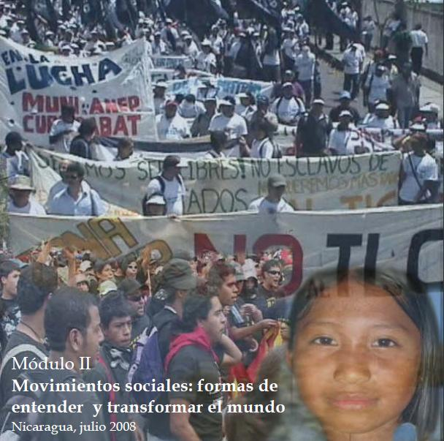
Source: Alforja

2.3.1 The Subjects: Knowledge by Whom?
One of the main characteristics of the EMMS is that it included plural actors which can be located in three main groups, whose members sometimes overlap: social/popular movement members, popular educators and academics. The social movements were very diverse and included members from 44 different social movements and grassroots organizations from Mexico, Guatemala, Honduras, El Salvador, Costa Rica, and Panama. It included, among others, the following movements: peasant, women, indigenous, migrants, youth, students, anti-neoliberal policies, anti-mining, and informal workers, environmental movements, among others. It was facilitated by three popular educators from the Alforja network. Most of the popular educators involved in the organizing and facilitation of the EMMS are also part of social movements from the region.

The academics and speakers that came as guest presenters were selected on the basis of having wide knowledge and experience in the specific topic they were going to cover, in order to ensure the necessary depth. Additionally, they were considered to be experienced people whose testimony and analysis could contribute to build regional horizons from the topics of concern to social movements. According to the facilitators of the EMMS, the main contribution from the participation of the presenters came not only from their analysis, but also from their experiences. It was expected that they share with the group what they have learned, their mistakes, their interpretation of the current reality and about the challenges that movements are facing from their perspective. It is understood that they are people whose experiences are linked to a specific social movement and their knowledges are also from the collective of which they are a part.

Figure 3: EMMS Participants
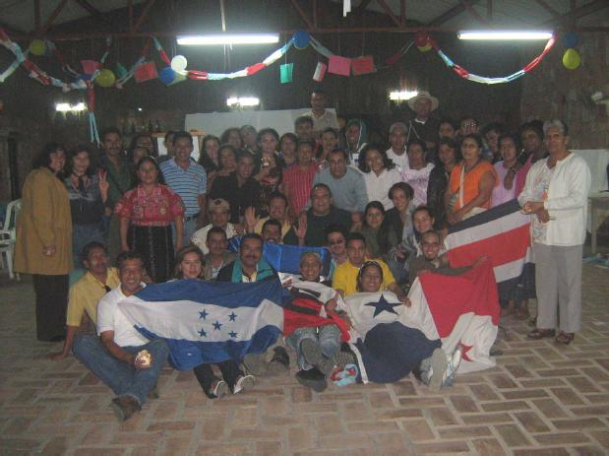

2.3.2 The Purposes: Knowledge for What?
The purpose of this initiative is to connect people from the different Mesoamerican movements through a space of critical education in order to strengthen them to make meaningful changes in the region. The goal was to have a regional space in which to know each other, debate, interpret reality from each other’s perspective, analyze mistakes and successes as well as the opportunities to improve within the movements. The initiative was implemented using Popular Education, as it aims to create collective, and more horizontal knowledge sharing processes. The EMMS aimed to address the need to create knowledge which is relevant to the realities of the participants and to promote a space for reflections about the diverse experiences of the movements within these contexts. As opposed to importing de-contextualized theories that do not resonate with the realities participants are aiming to transform. Specifically, the EMMS, according to the minutes of the forum (Alforja, 2007: 68) aimed to:
- constitute a space to exchange and create organization and action strategies from the diversity of the social/popular movements;
- to build new political sensitivities that encourage in the struggle against all kinds of inequalities and discriminations through the reflection and systematic revision of the movements’ experiences;
- to strengthen strategic leadership at the local, national, and regional levels.

2.3.2 The Contents: Knowledge about What?
In this section I include some of the contents and issues discussed throughout the modules with the intention of providing a general idea about the types of issues that were addressed. Among some of the topics according to the minutes of EMMS (Alforja, 2008b, Alforja, 2008c, Alforja, 2008d) and the interviews were: Current conceptualization of ‘political subject’ beyond Marxist notion of the proletariat and including the wide variety of social emancipatory movements; definition of social movements and popular movements; relation of movements with leftist governments; conceptualizations of leadership (beyond individualist notions); notions of power and its role within social movements; reflections of how to promote unity in diversity; gender analysis; collective construction of historical memory from the movements perspectives, among others.

There were previous consultations and through the education initiatives of the popular education centers members of Alforja network at the national level it was possible to identify with the different movements relevant topics to address. According to the interviews, the purpose was to focus on topics that were based on the needs of the movements consulted.

Conclusions:
EMMS is a space that brings together diverse movements with the aim producing collective knowledge through Popular Education and it was facilitated by Alforja. In this section I provided a background about Popular Education, emphasizing that it has been conceptualized and practiced in many ways according to the particular groups and context. I will be adopting the conceptualization of PE as used by Alforja at EMMS. Then, I described the Alforja Network of Popular Education. Finally, I described the purposes, contents and subjects of EMMS’ experience.

Some initial questions emerged and motivated the reflection about the case of EMMS (chapter 4), for example: why is relevant from their perspective to put into dialogue different actors and different worldviews? Why is so important for the EMMS the ways in which we share knowledge about their context and how they do it? What implications can emerge from bringing together diverse movements to build collective knowledge?

Theoretical Framework
In this chapter I will develop the theoretical framework with the intention to set a broader perspective from which I understand the EMMS as an alternative space of knowledge production. In the first part of this chapter, I will start by providing a critical review about different approaches used in social movement studies. I will elaborate on the knowledge-practices approach which serves as an epistemological position for this research as it relates to the engagement on social movement studies. The second part of this section will deal with the issue of Politics of Knowledge. The intention is to address critically dominant knowledge frameworks by drawing on key literature from feminist and critical theories. Also, by addressing the relation between power and knowledge and using theories of Decoloniality, I will discuss the political implications of hegemonic systems of knowledge. Throughout this section, I provide a wider theoretical justification for the relevancy of engaging in the struggle of epistemic justice by making explicit the claim that multiple systems of knowledge exist beyond the dominant ones.

Knowledge-Practice Framework in Social Movement Studies
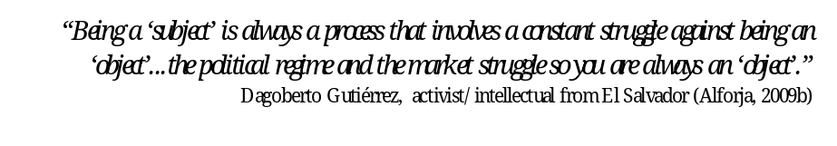
In this section based on the work of Casas-Cortes at al. (2008), I summarize the Knowledge-Practice approach in the study social movements that I am using in this research. Also, I provide some reasons why I focus on this approach and not others such as structuralist-rationalist or culturalist approaches.

Despite the fact that knowledge production has been one of the main activities carried out by many grassroots organizations, collectives and social movements’ members for a long time; conventional social movement studies have not always recognized such knowledge production practices. This is mainly due to the theoretical assumptions and methodologies adopted in these approaches (Casas-Cortes et al., 2008, Kurzman, 2008). As Casas-Cortés et al. argue, this lack of recognition “has made it difficult for social movement theorists to grasp the actual political effects of many movements...including not only immediate strategic objectives for social or political change, but the very rethinking of democracy; the generation of expertise and new paradigms of being, as well as different modes of analysis of relevant political and social conjunctures”(2008:20).
As Santos (2009) argues in his article on Reinventing Social Emancipation, “we do not need alternatives, but alternative thinking about the alternatives, because many alternatives already exist but they are not recognized as such; they are marginalized, invisibilized; they are excluded as well as wasted”. This is a call to move beyond conventional ways of engaging in social movement research to open the possibilities for visibilizing alternatives posed by other spaces of knowledge production such as EMMS. According to Casas-Cortes at al. (2008), in recent years, a few academics and activists, working at the ‘edge of the field’ of social movement studies and building on interdisciplinary approaches, have begun more explicitly to link social movements with knowledge production.

In these sense, Casas-Cortes at al. argues that knowledge-practices are an important component of the creative and everyday practices of social movements. These knowledges take the form of stories, experiences, narratives, ideas, but also of theories, critical context analysis, political analysis, and concepts. And their creation, modification and diverse enactments are they called “knowledge-practices”. They use the hyphenated term in order to go beyond abstract conventional connotations of knowledge. They argue for a conception of knowledge which is situated, concrete, embodied, and lived as well as plural. For Casas-Cortes at al. social movements prolifically generate knowledges which are politically crucial, because both the inextricable relationship between knowledge and power and because of the unique location of these practices, which question dominant structures. In this sense, ‘social movements can be understood in and of themselves as spaces for the production of situated knowledges of the political’ (Casas-Cortes at al. 2008:51), understanding the political beyond the realm of state and party institutions.

The Knowledge-Practices approach builds on the ‘culturalist turn’ in the study of social movements and their critiques to positivist and structuralist approaches which, according to Casas-Cortes et al. have become prevalent within the disciplinary field of social studies. I provide a brief characterization of the Structuralist-Rationalist and the Culturalist approach in what follows:
The structuralist rationalism approach was mostly prevalent within academics in the Anglo-Saxon tradition since the 1970s (Kurzman, 2008, Escobar, 1992, Canel, 1997). Theories such as rational choice, resource mobilization and political opportunities can be catalogued within this perspective (Tarrow, 1998, Kurzman, 2008, Casas-Cortes et al., 2008). Academics promoting the rational choice theory were interested according to Tarrow (1998), in addressing the problem of ‘how collective action is even possible among individuals guided by narrow self-interest’. Tarrow mentions as one of the most influential works within this theory the book The Logic of Collective Action by Mancur Olson. Olson assumed that in large groups some members are the ones who have enough interest to take the initiative while others rather to ‘free-ride’ on the efforts of others. Olson argued, that ‘rational people guided by individual interest might well avoid taking action when they see others are willing to take it for them’ (Tarrow, 1998). By the early 1980s the resource mobilization theory had become dominant. Tarrow (1998) mentions two sociologist, McCarthy and Zald, who proposed to address the ‘free-ride’ paradox, focusing on the resources available to collective actors in (post)industrial societies such as personal resources, external financial support, professional movement organizations. Canel (1997) points out that resource mobilization theory made social movements the object of analysis and interprets them as ‘conflicts over the allocation of goods in the political market’. According to Tarrow (1998), Tilly and his book From Mobilization to Revolution put forward the concept of political opportunity for the analysis of collective action. This theory linked collective action to the state; and it emphasized a set of conditions for mobilization such as opportunity (threat to challengers) and facilitation (repression by authorities). Tarrow warns that the term ‘political opportunities structure’ should not be understood as a simple formula, but as a set of clues to predict when ‘contentious politics’ will emerge, ‘setting in motion a chain of causation that may ultimately lead to sustained interaction with authorities and thence to social movements’(Tarrow, 1998).

As far as the Culturalist approach, and as a way to challenge the ‘overly structural and macro-political orientation’ (Casas-Cortes et al. 2008:22) of the dominant theories of resource mobilization and political opportunities various authors associated with this ‘cultural turn’ such as Melucci, Polletta, Touraine, Laclau and Mouffe, Benford and Snow, among others, argue for the need to emphasize the cultural aspects within social movements such as identity, ideology, narratives, and framing process. Their focus is mainly on social actors and collective action, as opposed to structures (Escobar, 1992). A review on the work of these authors is beyond the scope of this research. Therefore, I concentrate on the general category of ‘culturalist approach’.

Some limitations of conventional approaches:
As Casas-Cortés et al. point out this approaches have been influenced by strict and narrow definitions of what constitute the object of study as well as conceptualizations of the political being reduced to ‘a fixed and pre-determined politico-institutional sphere’(2008). And this conceptual boundaries within science and politics as led too often to treat social movements as objects whose ‘life cycle’ has to be explained by the distanced objective researcher. The use of these pre-fixed categories such as ‘political opportunities’ is based on the assumption that these structural conditions (political opportunities and facilitation) determine collective action. This approach can be limiting as it usually recognizes just the most visible parts of collective action such as protests and demonstrations, often premised by the notion that the only goal of a movement is mobilization. This not take into consideration that ‘even when movements fail to at their stated goals, their ideas, discourse, and methods may survive and flourish’(Kurzman, 2008). The structuralist and rationalist approaches are based on fix notions of human nature, resting on an assumption that sees human beings as rational and self-interest individuals which provides a relative narrow space in order to explore the worldviews of movement members(Kurzman, 2008). It also limits the possibility to grasp the complexity, contradictions, and changes in social movements. It assumes a fix idea of collective behaviour and it claims having the capacity to predict it.

Even though the Knowledge-Practices framework follows the culturalist approach, Casas et al. argue that some of their limitations are that they do not problematize the subject-object divide in social movement studies and its implications. Also, cultural aspects are usually seen as instrumental just to mobilization. For Casas-Cortes both approaches (structuralist-rationalist and culturalist) tend to focus on causes and effects, categories and mechanisms involved social movements which are just meant to be explained by detached theories.

Among some of the reasons for adopting this particular knowledge-practice framework are that the approach of knowledge-practices offers me some insights to explore the ways that different movement members make sense of the world, not just through their reflections but through their practices. As this approach does not aim to generalized and universalize movements or to but to engage with movements in their own terms, it can provide some opportunities to reflect on the socio-political implications derived from the knowledges practices of the EMMS and diverse movement members involved in the experience.

Taking into consideration that knowledge-practices are “forged in fields of power, to claim social movements as knowledge-makers has political significance” (Casas-Cortes et al. 200:46). The theoretical practices of social movements, and in this case of EMMS, emerge in relation to the ontological regimes that they are aim to transform. In this sense, the following section deals with the political aspect of knowledge production and provides a theoretical context in which the EMMS is embedded.

The Politics of Knowledge
The purposes of this section are to engage in a critical discussion about dominant knowledge frameworks and also to elaborate on the assumptions in which the main argument rests, which is that social movements, and in this case EMMS provide alternative knowledge frameworks. This section helps to address main first research sub-question: Why the knowledge practices of the EMMS can be understood as an alternative space in contrast with dominant knowledge frameworks?
This theoretical framework will help me to analyse, in chapter 4, some of the alternative aspects of la EMMS knowledge-practices and put into dialogue these concepts with the concepts provided by the EM as it relate to knowledge construction.

3.2.1 Problematizing Dominant Conceptions of Knowledge
I start from a conception of knowledge as a social practice and with the premise that diverse knowledges exist; knowledge is concrete, situated embodied as opposed to abstract; detached. Also, with the premise that the social experience of the world is much wider and diverse than the modern scientific or philosophical western tradition considers important.

As a starting point, it is important to distinguish between the positivist tradition from the critical tradition in producing knowledge about society. The positivist tradition is based on the assumption that producing knowledge is about representing the world as it is, it assumes that scientist is the subject of knowledge and that their task it to represent the ‘object’ of knowledge, the ‘fact’, ‘the truth’. It is based on ideas of detachment and neutrality (for instance, just as a scientist has to study nature). It assumes that the scientist is able to transcend society and that it is possible to position his/herself outside of it, in order to study it. For the critical tradition, society cannot be studied as an object, due to the fact that society is made of human beings, so it is difficult to establish this type of neutrality. Moreover, it is not about representing things as they are, but questioning ‘why the world is as it is’ as well as ‘can it be otherwise’. It has to do with questioning and not with representing.

Knowledge as material, situated and embodied
Feminist theorists among other critical theorist have challenged the conventional view of modern scientific knowledge as abstract, universal, neutral, apolitical. By criticizing its core assumptions, they have provided some of the most powerful resources to question the way in which the modern scientific knowledge has excluded other subjects such as women. For Haraway (1988), knowledge is not abstract, but embodied in people, material and situated. She opposes to the various forms of universal, objective and un-located knowledge claims. Even knowledge that claims universality belongs to a locality, a concrete context (Escobar 2007; Santos et al. 2007). For Haraway, “objectivity turns out to be about particular and specific embodiedment and not about the false vision promising transcendence of all limits and responsibility” (1988: 582-583). Every observation that claims to be objective is always mediated by our interpretations. Haraway argues for a conception of knowledge considered as partial and not universal.

Knowledge as a social practice
Santos et al. conceive the production of knowledge as “...a social practice and what distinguishes it from other social practices is the thinking and reflecting on actors, actions, and their consequences in the context where they take place. Every form of knowledge thus involves self-reflexivity, which productively reshapes the context of practices into the motive and engine of actions that do not simply repeat their contexts” (2007: xivii). For Santos there is no essential or ultimate way of describing, classifying, interpreting the world and the very action of knowing is an intervention in the world. In these sense, different ways of knowing will have different effects in the world. This notion expands our conventional ways to refer to knowledge production; and therefore, it allows seeing other actors, processes, motivations that co-exist in producing knowledges, as in the case of the various movements involved in the experience of EM. This can make visible alternatives and influence our ways of interpreting, being and acting upon the world.

Epistemic diversity: The plurality of knowledge
Conceptions of knowledge, what is counted as knowledge, what it means knowing something, how knowledge is produced are very diverse and depend on different cosmologies and frameworks (Santos et al. 2007: xxi)(Santos et al., 2007). Different communities have different ways to view the world, which do not necessarily follow Eurocentric distinctions. By epistemological diversity, Santos et al. (2007) mean the different knowledge systems that inform practices of diverse social groups across the world. This goes beyond dominant epistemologies such as Eurocentric modern science which is assumed to be the only valid form of rationality and knowledge (Santos, 2006b). This allows to us to recognize that, “the understanding of the world far exceeds the Western understanding of the world” (Santos 2006b:14). In this sense, there are very different notions of human rights, justice, time and nature according to different knowledges. In the following sections, I will address some of the mechanisms by which some knowledges have become hegemonic drawing on key literature from the theories on Decoloniality. One important aspect to consider is the question of relativism, for Santos the point is not to ascribe validity to all types of knowledge, but instead to allow for a “pragmatic discussion of alternative criteria of validity, which does not straight forwardly disqualify whatever does not fit within the epistemological cannon of modern science” (Santos et al. 2007: xliv). The validity among the different types of knowledges depends on each specific situation and context.

After engaging in the discussion questioning conceptions of knowledge as objective, detach, abstract, de-contextualized, this research adopts the situated, embodied, concrete, plural aspects of knowledge conceived as a social practice. Building on the previous discussion, the following section will explore the relationship between knowledge and power as well as the implications of perpetuating hegemonic knowledge systems.

3.2.2 Power-knowledge regimes
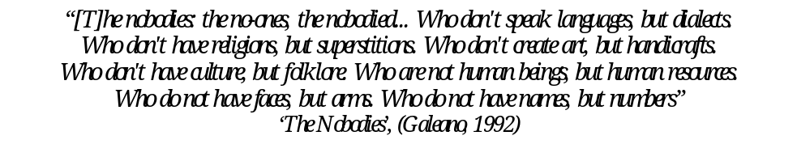
What are the processes and institutional practices by which some statements are qualified as knowledge or facts and others not? Why it is that social sciences and modern epistemologies, with its institutions such as academia, have been conventionally perceived to have the legitimate monopoly of knowledge creation? All these questions are crucial as starting points, in this endeavour of exploring the intersections between knowledge and power.

In this section I elaborate on the claim that: Since knowledge production is a social practice embedded in power relations, knowledge is political as opposed to neutral and independent. It can either contribute to exercise disciplinary power and justify dominant oppressive systems; or it can help to deconstruct, de-normalize and challenge them. Additionally, I expand on the assumption that legitimate knowledge production has been conventionally seen as coming exclusively from academics and scientists but rarely from the experience of social and collective action. This is relevant in order to study alternative spaces of knowledge construction such as the EMMS and the politics involved in knowledge production. I use Michel Foucault’s analysis found in Power/Knowledge: Selected Interviews and Other Writings 1972-1977 (Foucault, 1980) and in a debate between Foucault and Chomsky (1971). Also, I use various interpretations of Foucault’s concepts based on the work of Mills (2003) and Sawicki (1991).

Foucault questioned the notion that knowledge is the product of rational, objective, un-interested, and neutral individuals. The classical European view of knowledge is focused on sciences and scientists as the most important and only producers of proper and factual knowledge. The conventional view of knowledge, particularly this scientific knowledge, is that it is produced by individual and isolated geniuses such as Einstein and Kant. They are categorized as being exceptional and unconventional people who were able to transcend the conventional ideas of their times by formulating completely new ideas and theoretical perspectives and bringing about changes or paradigms (Mills, 2003:67). The human scientist was not seen as part of that world, but external to it.

Since knowledge is a social practice it is not exempt from relations of power. In this sense, Foucault conceptualizes knowledge as being a combination of power relations and information-seeking that is why he uses the term power-knowledge (Mills, 2003). Power-knowledge regimes refer to the complex, interwoven and continuous processes of defining ‘reality’ through specific knowledge which is based on socially embedded practices that have material effects on that reality. Knowledge is not produced by individual subjects of knowledge, but by power-knowledges regimes. According to Mills (2003:70), for Foucault power/knowledge regimes determine what will be known (dominant paradigms or worldviews).

The concept of power-knowledge regimes, as institutionalized practice, help us to see how dominant institutions produce dominant discourses which become widely accepted and considered ‘normal’, ‘true’, ‘factual’. If people accept something as normal (i.e. the discourse of development, hierarchies based on cultures, knowledges, ‘race’, gender, ethnicity, etc.), there is no need to use coercion. This is what Foucault calls ‘normalizing power’ which is a type of power that it is dispersed and exercised through culturally and socially accepted practices. Our knowledge of the world, as well as our conceptions of ‘truth’ and ‘reality’ both allow or limit our actions in the world (Casas-Cortes et al. 2008: 47). This is important to realize that social struggle cannot be separated from epistemic struggle as it is the case with the EMMS’ actors who engage intentionally in the production of diverse knowledges.

The importance of Foucault’s statement that ‘it is not possible for power to be exercised without knowledge, it is impossible for knowledge not to engender power’(Mills, 2003:69) rests in that it shows how knowledge is an integral part of power struggles and emphasizes that in producing knowledge one is making a claim for power. Moreover, Foucault suggests the importance of providing alternative types to the ones information provided by dominant institutions, he considered that the production of knowledge could play an important role; and it is in the spaces of struggles between these different power-knowledge regimes that political spaces for resistance appear (Mills, 2003). In this sense we can consider la EMMS as an alternative power-knowledge regimes as it is formed by social movements challenging structures of domination.

The notion of power/knowledge regimes rests on a definition of power that challenges traditional ways of conceiving it. Sawicki (1991:20) reviews Foucault’s critique on the conventional definitions of power (as found in Marxism and Liberalism, for example). Conventional models characterize power as: something that is possessed and located in the law, state, economy; that flows from a centralized place in a top-down manner; and that is mainly exercised through repression (destructive/coercive) by institutions such as government and police. In contrast, Foucault’s conceptualization of power goes beyond states, law, and class. For him power is exercised in every human and social encounter. Rather than conceptualizing power as being possessed; it is considered dispersed, from bottom-up (in daily life and through institutional practices); and power is not just repressive, but it is also “productive” (of effects, identities, subjectivities, practices). According to Foucault, there are a variety of power relations in the society exercised at the micro-level that make possible the centralized and repressive forms of power (Sawicki, 1991, Foucault and Chomsky, 1971). In this sense, power is also exerted by other institutions, usually less associated with ‘political power’ and that seem independent and neutral. To illustrate this point, Foucault gives the example of the university and the whole education system which is suppose to distribute knowledge, but maintains perceived power in the hands of a certain class or groups and excludes others. For him an urgent political task in society is to criticize the way institutions that appear to be neutral and independent work, so the political violence that has exercised through them is uncovered (Foucault and Chomsky, 1971), and therefore opens the possibility for alternatives.

Concluding remarks:
For the purpose of emphasis and building on the theories explained above, I highlight some concepts that will help in the analysis chapter. First, Foucault’s concept of power allows me to identify forms of power that are not visible in traditional theories (such as revolutionary theories that see power as something you take through the state). In this sense, I would like to explore what conception of power is carried out by EMMS in their social struggles. Second, The concept of power/knowledge regimes allows me to explain why subjects such as social movement actors and their knowledges have been conventionally seen as mere objects. Third, as it is suggested knowledge production is a site of contestation. It can be used on the one hand for disciplining and normalizing purposes (disciplinary power), and therefore the reproduction of power relations; and on the other, as a critical and transformative tool by challenging the status-quo and making visible alternatives. In what follows, I analyse the EMMS’ knowledge production practices keeping in mind the wider context of the politics of knowledge, which is the regimes of power/knowledge in which they are inserted.

3.2.3 Knowledge and Decoloniality
In this section, I expand on the claim, part of the main argument, that: there are hegemonic ways of interpreting the world that make invisible and delegitimize alternatives for social transformation and political action and this leads to a waste of social experience. Also, on the notion of ‘epistemic justice', I explore how some ways of knowledge production and worldviews become dominant and others excluded; and on some possibilities to look for alternatives.

Decolonial thinking can be seen as an approach that sees “Modernity” as a dominant and hegemonic system of representation, as a mode of knowledge that does not recognize ‘the other’ as valuable, marginalizing and excluding by claiming universality for itself. This approach aims to question the totality of Modernity as a system of knowledge that actively produces exclusion (Santos 2006b; Escobar, 2007).Around the world diverse social struggles are being conducted against structures of domination and oppressive conditions, of capitalism for instance. From a Decolonial perspective, these struggles are also questioning the knowledge frameworks, the way we understand the world, that keep them silenced and invisible. For Santos (2006b:14) “[t]here is no global social justice without global cognitive justice”, meaning that, they are also struggles in knowledge (epistemic struggles). Talking of justice also implies questioning the imposition of dominant ways of knowing and excluding, discrediting, delegitimizing others ways of knowing. Under this approach, all the ideas we use to think about the world: Liberalism, Marxism, conservative traditions come from a paradigm of knowledge that comes from the European modernity (Escobar 2007).

For Escobar (2007) knowledge sits in places; and in this sense, modernity is not an abstract and universal way of seeing the world, but it is located in a specific context, that is a local European history. Some theorists such as the ones from the Modernity/Coloniality project, locate the roots of modernity with the conquest of America, other European theorist locate in the Industrial Revolution or the Enlightment. According to Escobar, modernity can be seen as a hegemonic representation and way of knowing the world that claims universality for itself. It is not reduced to the West since modernity is everywhere. For Escobar, modernity “has enacted a totalizing project” (2007:4), although has not been able to destroy other worldviews. For him this is the problem, the totalitarianism of modernity that does not accept other projects along with them. The M/C research project goes beyond questioning capitalism, centred in the economy; and focuses on questioning modernity (which includes capitalism). For the M/C research project, modernity has historically come with colonialism(Escobar, 2007). For Escobar, all the discourses of progress, development, modernization, universality are concealing the historical processes of domination, coloniality and exploitation that have come with it. Behind these universalistic ideas there are projects of domination, imposition and expansion. That is why it is called Modernity/Coloniality; we cannot see one side without looking at the other.

Escobar poses as a question who is ‘the other’ that Modernity did not include in this ‘universal subject’. The others of modernity are fighting in the streets, questioning from outside, from beyond the system this closed view of modernization, progress, from beyond this normative frame of modernity (Escobar 2007). In this sense, there is a relation between social struggles and epistemic struggles. As Santos (2006b:13) argues,
‘Neo-liberal globalization is presided over by techno-scientific knowledge, and owes its hegemony to the credible way in which it discredits all rival knowledges, by suggesting that they are not comparable, in terms of efficiency and coherence, to the scientificity of the market laws. Since neo-liberal globalization is hegemonic, no wonder that it anchors itself in the knowledge, no less hegemonic, of Western-based modern science’.

In order to address this relation between social and epistemic struggles, I will use the concept the sociology of absences, which “consist of an inquiry that aims to explain that what does not exist is in fact actively produced as non-existent, that is- as non-credible alternative to what exists’ (Santos 2006b:15). The process of sociology of absences helps us to understand how different rationalities, knowledges, practices and actors have become invisible, non-credible, disqualified and actively ignored by the hegemonic rationality and knowledge (Walsh 2007). This concept has profound implications: As Santos suggests, “[t]he social production of these absences results in a waste of social experience...to be made present means to be considered alternatives to hegemonic experience, to have their credibility discussed and argued for”(2006b:18). Furthermore, for Santos (2006:66-67), social science, as we know it, is not useful to counter the waste of social experience, to make visible the alternative initiatives and alternative movements knowledge-practices and to legitimize them. Since for him this science is responsible for hiding and delegitimizing alternatives, it is not enough to propose other social science, but to propose a different model of rationality. He argues that without critiquing the dominant western rationality model, all the proposals no matter how alternative they are (in this case the EMMS knowledge-practices), will tend to reproduce the same discrediting and invisibilizing effect.

Santos (2006a: 13-18) (2006a) distinguishes, in an schematic way, different logics or ways of producing the non-existent. These logics are manifestations of the same rational dominant monoculture. For the purposes of this research, I focus on the following three aspects:
1) The monoculture of knowledge and rigour of knowledge: It consists in turning modern science as the exclusive canons of production of knowledge. It becomes as the only criteria of ‘truth’. In this way other knowledges and cultures are delegitimized and invisibilized (epistemicide). The other is seen as ‘ignorant’. 2) The monoculture of linear time: It sees time as linear, and history as having just one direction and meaning. It conceives history as progress and evolution. Notions such as Development and Modernization are based on these ideas. The core countries of the world system, along with its dominant knowledges and institutions, are seen as being ahead and the others as following this linear progress. The other is characterized as ‘backward’, ‘pre-modern’, ‘under-developed’. 3) The monoculture of naturalization of differences: this logic classifies populations according to categories that make hierarchies seen as natural. The idea and construction of race and gender are some of the most prevalent examples. The relation of domination is seen as a consequence of this hierarchy and not as the cause. In this sense, the ‘other’ is seen as naturally inferior.

These logics of universal modernity show the exercise of coloniality and its multiple dimensions including: coloniality of power (Quijano, 2000), knolwedge(Lander, 2000), being, nature(Walsh, 2007) and gender (Lugones, 2008). The articulation of these dimensions contributes to maintain the colonial difference and subalternization (Walsh, 2007). Rivera-Cusicanqui (2006) refers to the term ‘internal colonialism’ to reflect how hegemonic ways of thinking, acting can operate, when we reproduce this internal coloniality in our struggles for liberation. These conditions of coloniality, I argue, provide justification for exploring Decolonial options in order to make visible alternative ways of power/being/ knowing, and conceptions of nature. This supports my argument of the how EMMS provides alternative ways of knowing and being as well as to analyse how they negotiate with the internal colonialism.

In relation to decolonizing knowledge and power, it resonates with Santo’s argument that ‘there is no global social justice without global epistemic justice’ Santos (2006b: 14). Within this context, Santos et al. (2007) suggests the notion of promoting an ‘Ecology of Knowledges’ as opposed to the hegemonic ‘monocultures’. Santos, refers to the ecology of knowledges as ‘an invitation to the promotion of non-relativist dialogues among knowledges granting “equality of opportunities to the different kinds of knowledge engaged in ever broader epistemological disputes aimed both at maximizing their respective contributions to build more a democratic and just society and at decolonizing knowledge and power” (Santos et al. 2007: xx). Questioning the hegemonic aspects of modernity does not mean to discredit it or reject it (Santos 2006b:20). The epistemic struggle has the task of humbling the universalist knowledges. The critique is about recognizing the imcompleteness of all knowledges as a condition for the possibility of dialogue among knowledges (Santos, 2006b). EMMS intentionally puts into dialogue different knowledges (Mayas, Feminisms, Socialisms, etc.). I argue it can be seen as an experiment of ecology of knowledge in practice. In this sense, I will like to analyze the how of the process as well as some of its challenges.

Concluding remarks:
In this previous section we discuss the processes, by which hegemonic ways of interpreting the world (modern scientific knowledge/rationality) can contribute to make invisible and to delegitimize alternatives for social transformation and political action leading to a waste of social experience. One way of exercising coloniality of knowledge and power, intentionally or unintentionally, can be by an a priori marginalization or de-legitimization of alternatives or by automatically qualify them as viable just for their own context, and not for the rest of society (Walsh 2004).

Analysis: EMMS Knowledge-Practices: Alternative to what?
Building on the situated, plural, embodied and political aspects of knowledge production, addressed in the previous section, this chapter aims to deal with the research sub-question: How do the knowledge practices of the EMMS contribute to build alternative ways of knowledge construction in contrast with hegemonic knowledge frameworks? And what are their challenges?
Based on a document review of the EMMS minutes and based on the interviews, I will analyze the knowledge-practices of the EMMS by concentrating on the “knowledge how” or “process” in which some of the activities were based (Casas-Cortés at al. 2008:34). Since the experience itself is vast and rich and as a way to operationalize the knowledge-practice approach, I highlight three main sets of knowledge-practices: a) starting from concrete participants’ experiences; b) Intentional collective creation of knowledge; and c) focus on power relations in the construction of knowledge. Throughout the section I will put into dialogue the categories, concepts from the theoretical framework with the ones coming from the EMMS. I include in the analysis: characteristics of the process, (based on the interviews and EMMS documents); some illustrative methods; epistemological reasons behind the choice in the approaches; and I try to highlight the alternative aspects in contrast with dominant epistemologies throughout the analysis. The second part of this chapter will address some of the challenges of the EMMS as it relates to the process. Additionally, it will provide a discussion of some of the external challenges or risks based on the interviews. Intention of this research is not to judge or assess the effectiveness of the EMMS. The purpose is to reflect on the alternative components of the knowledge production coming out from this experience taking into consideration that this is mediated by my interpretation and reflections from where I am situated looking at the experience.

Reflecting on EMMS’ Knowledge-Practices

4.1.1 Concrete lived experiences as sources of knowledge
This section focuses on the process of knowledge production followed at the EMMS as well as the reasons behind these practices. Emphasis is placed on the ways in which concrete lived experiences of participants were seen at the EMMS. Furthermore, I will address the possible epistemological foundations of these practices in contrast with dominant knowledge frameworks.
EMMS utilizes the concept of ‘praxis’ as conceptualized by Freire (2006), as a combination of reflection and action; theory and practice. The process of knowledge creation is seen as a spiral and not as a linear closed process. It starts with concrete, lived experiences of struggles and the daily life experiences of the participants (practice); it moves to critical collective reflection (theory); and then, it focuses on ways to make it applicable in the practices of the participants within their context (daily life, movement, country).
Figure 4: Agenda from Module I and II of the EMMS
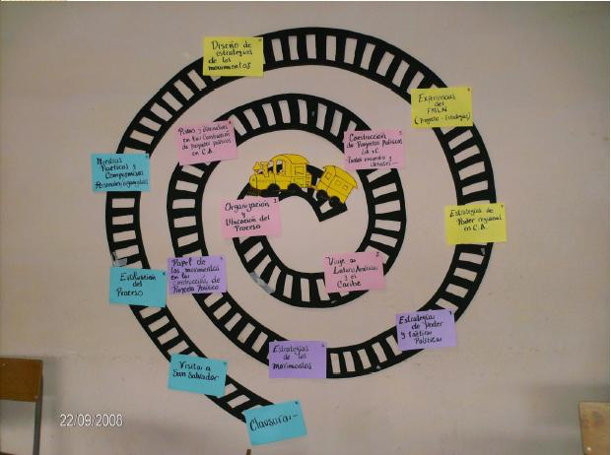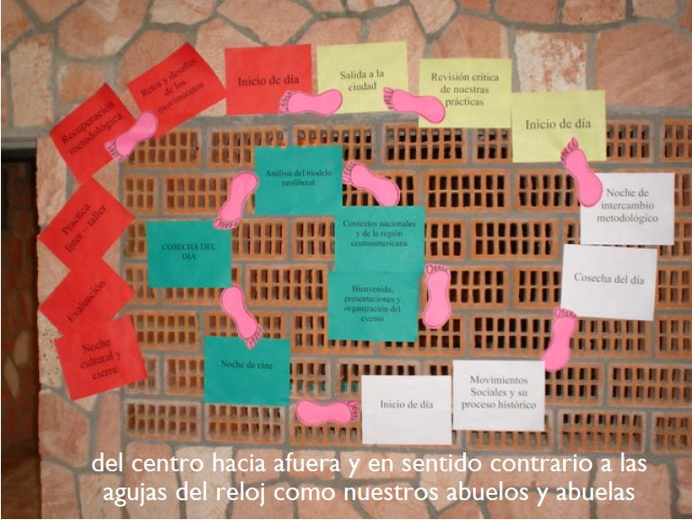
Source: Alforja
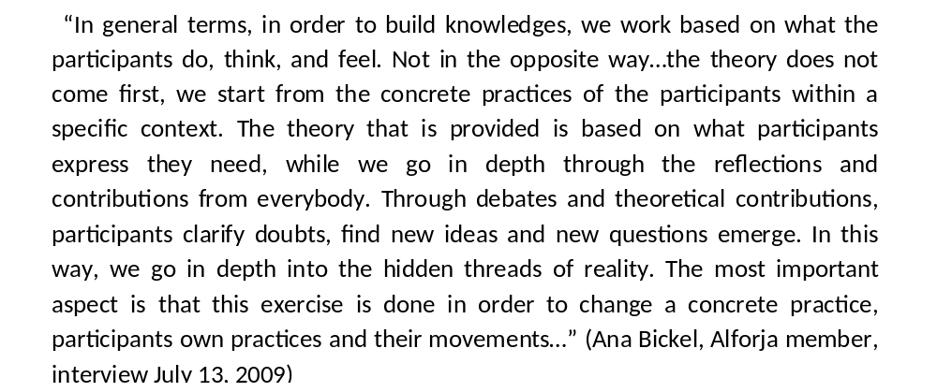
As explained by Ana, a facilitator of EMMS, when asked about the process:

Theory is used to aid in the reflection of those direct experiences and to guide in the elaboration of ways of intervening in the transformative goals for which the movements strive. This is done to review and reflect critically on their practices and experiences contrasting with: their movements’ idearios of transformation, with their motivations and frustrations, with their strengths (or capacities) and with the context in which they act. After the theoretical reflection, the participants focus on how these theories can find their application within their practices; establishing concrete commitments/responsibilities with the purpose of transforming the practices themselves. An important aspect of the knowledge construction process, under PE, is the need to link it with concrete organizing processes and struggles. Dominant ways of knowing tend to see theory separate from practice or practice is placed lower in the hierarchy in an instrumental way only with the function to ‘test’ the theory. Within dominant social sciences, for example, the knowledge process usually starts from abstract theories not form concrete experiences.

From this spiral process of knowledge production, I consider important to highlight the attention that is given to the lived experiences of participants. Concrete life experiences are considered a source of knowledge and reflection. It also includes experiences with suffering and hope. However, it seems not enough just talking about these experiences but reflecting on them critically and collectively. The purpose is not simply to objectify them just as an academic exercise, but to draw lessons in order to improve political action. As found in the minutes for the first module (Alforja 2008c: 25-30), one activity at the EMMS, called “The Gallery” can illustrate the emphasis on direct and concrete experiences. The participants formed groups based on their types of struggles and movements. They focused the discussion on the different organizing strategies used in the past. Also, they discussed about the type of relations within the movements, with other movements, the state, and political parties. The result of the reflective work was done using images and was placed in a gallery as shown in the images below.

Figure 5: Images from the group presentations
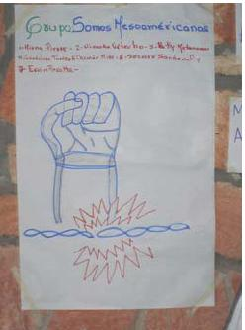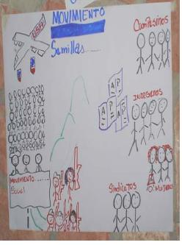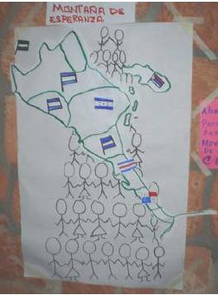
Source: Minutes EMMS Module I (in Alforja 2008c:26-30).

The attention to the direct lived experience of struggle is strongly linked to the notion of prácticas-senti-pensantes which is a concept commonly used in PE. It involves the permanent and intentional articulation of experiences, emotions, reasoning (or cognition), spiritualities, imagination and the perceptions of the contexts that they aim to transform. In other words, the practice of knowledge is conceived and carried out by subjects in a more holistic manner including not just what they think, but also what they do, dream, wish, suffer, know and the context in which they act. This resonates with the conception of knowledge as situated and embodied used by Haraway (2008), which contrasts with the dominant notion of knowledge as abstract and de-contextualized where the knower is concealed from the process. The intention is to listen to each other’s stories and look at how they connect or contrast with each other. Story-telling and the use of oral tradition are very important in the process.

The notion of práctica-senti-pensante contrasts with modernist or Cartesian epistemologies which conceive reality and its approach from mutually exclusive binaries such as: nature/human beings; mind/body; reality/thought; reasons/emotions; theory/practices; subject/object. Through a PE epistemology these boundaries tend to blur to a certain extent. Moreover, conventional approaches to knowledge tend to focus on only cognitive aspects, ignoring emotional and imaginary aspects since these are considered not to be sources of knowledge, or to be an obstacle to create knowledge. Experiences are usually not considered since it is assumed that they are not relevant in knowledge production. From this PE perspective, the experiential-epistemic assumption is that we approach knowledge from the world- from experience but also from cosmology and the existential philosophy that makes meaning of these experiences. In contrast with western-modern perspectives that assume that we approach the world from knowledge (reason) (Walsh 2007: 107).

Among some of the methods used for the purpose of knowing in a more holistic manner we can mention:
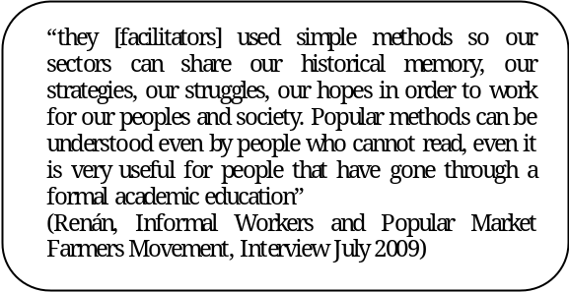
The use of art including: relevant poem interpretations, protest songs, skits, drawing, and videos. These activities are usually accompanied by a collective critical analysis in which participants reflect on how they felt and thought about the activity and how it connects with the issue they are discussing.
The use of ‘experiential metaphors’ related to the daily life experiences of the participants is prevalent with the purpose to serve as symbols that everyone can relate to and use for reflection. One concrete example during the EMMS, was engaging with the definition of ‘social movements’ through a musical exercise and dancing individually and collectively with a song relating to collective work. After the exercise, there was an analysis about how this can be compared to the way they perceive social movements.

Attention to direct experiences and perceptions can allow discussing issues that are tailored to the concrete needs of the participants involved. This moves away from education practices in which theories seem disconnected and not relevant to the knowledge sharing needed for political action.

4.1.2 An Ecology of Knowledges in Practice?

EMMS’ stated objective was to contribute to knowledge with and from social movements. The purpose of PE is to promote the collective production of knowledge for more horizontal and democratic processes. These practices are premised on the belief that there is not absolute ignorance or absolute knowledge (Freire 2006), similar to the notion of incompleteness of knowledges in Santos et al. (2007). Everybody learns, everybody teaches. The need for facilitators is justified by the need of having people in charge of ensuring that the dialogue continues and to check for imbalances in power relations within the knowledge sharing process. Dominant models of education, prevalent in academia and in ‘capacity-building’ projects, at their worst tend to assume a linear way of transmitting information and the absolute ignorance of the ‘beneficiaries’ and the absolute expertise of the persons in charge of ‘educating’ or ‘empowering’. At its best dominant models of education put the ‘beneficiaries’ knowledges into a preordained hierarchy.

The following quote by José reflects this notion of incomplete knowledges and collective reflection:

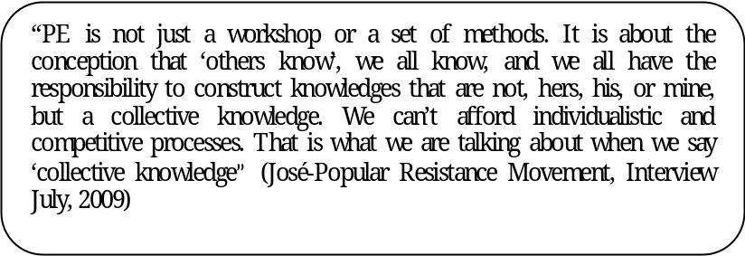
Figure 6: Group work Module II EMMS
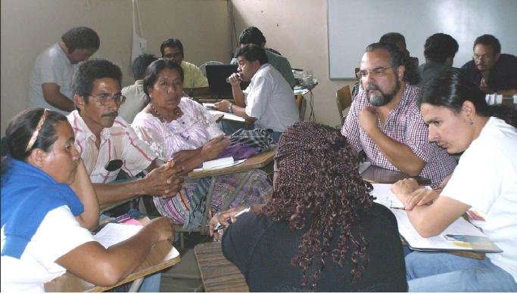

The practice of dialogue is central to the activities of the EMMS by bringing together the empirical and diverse knowledges of the movement and grassroots organization participants as well as the knowledge of academics. According to Freire, "dialogue characterizes an epistemological relationship…in this sense, dialogue is a way of knowing and…it should never be viewed as a mere tactic to involve participants in a particular task” (2006:17). Since PE starts from ‘where participants are’ it also includes their knowledges and subjectivities. One of the most innovative initiatives of the Escuela was the intentional process of bringing into dialogue paradigms and worldviews such as: feminisms, Mayas, socialisms, and youth voices, among others. This can be seen as an exercise of ‘ecology of knowledges’ in practice (Santos et al. 2007).

Based on the minutes of module II (Alforja 2008d:41-77), this practice of dialogue of knowledges, included, for example, one activity in which there were presentations focusing on contributions towards thinking about social transformation coming from: feminisms, Maya cosmologies, socialisms, youth perspectives, and other ways of conceiving spiritualities. The presentations aimed to highlight some of the meanings, worldviews and reflections that guide their movement’s action, and then the rest of the participants would ask questions and provide comments. These discussions were followed by a group exercise named possible scenarios, contributions towards a ‘political project’ (Alforja 2008d: 78-86) with the purpose to engage in a discussion to envision alternative systems.

As stated in the EMMS minutes,
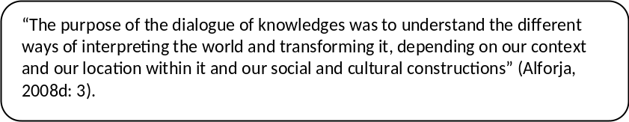

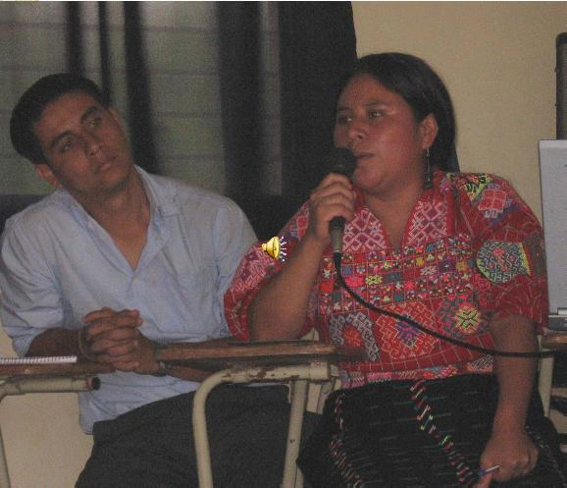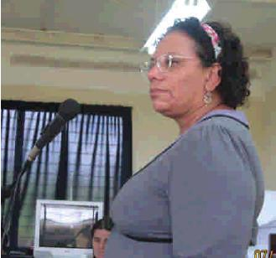
Source: Minutes EMMS module II (in Alforja 2008d)

The opportunity of bringing in to dialogue diverse paradigms made visible for the participants other identities, oppressions, reflections and knowledges that have been traditionally marginalized within the movements. The initiative of sharing different conceptions, worldviews and paradigms exposed the participants to a wide variety of analysis important not just for social but also personal transformation. The following image was part of the presentation from the youth movement and their struggles:

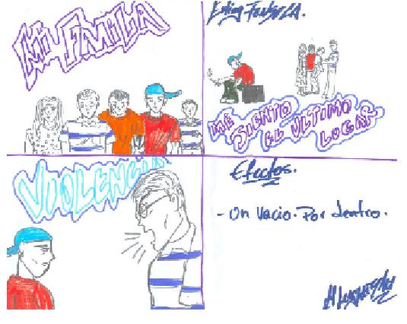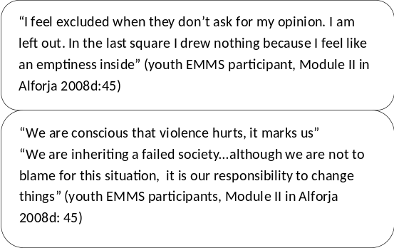

The following narratives from the interviews illustrate some of the effects that this experience of bringing together different struggles had on some of the participants interviewed:

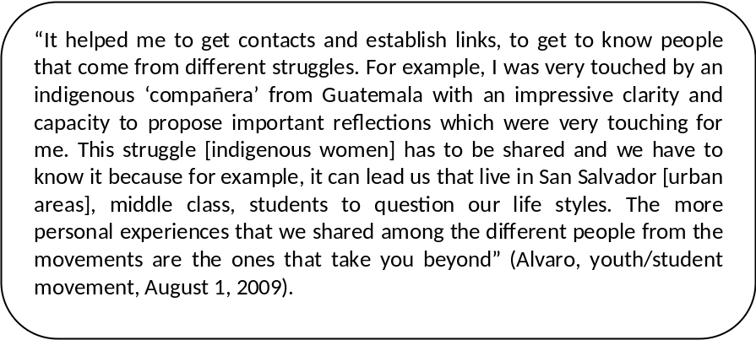
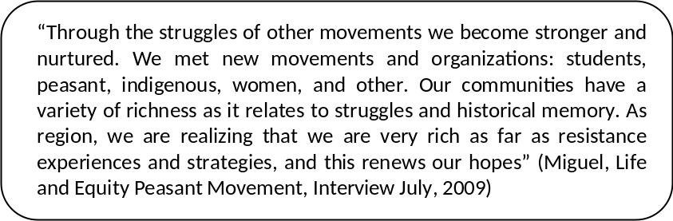
Dialogues are usually centred on an inquiry-based method in which there are some generative questions that aid in starting the discussion. It is not about asking questions to ‘lead’ the participants to a certain answer. The facilitator can make his/her opinions explicit in a way that generates discussion. Some of the methods used to promote a collective production of knowledge were: small group dialogues, combining groups formed by different movements as well as by country or region. The guiding questions were used to initiate the dialogues, plenary sessions, games for analysis, energizing icebreakers, among others. Additionally, throughout the EMMS events, participants would have encounters of spiritualities or moments in which they would share their diverse ways of spiritual practices and its meanings. In this sense, the interaction was not limited just to story-telling and presentations, but also sharing practices.

Figure 7: Encounter of Spiritualities at EMMS Module II
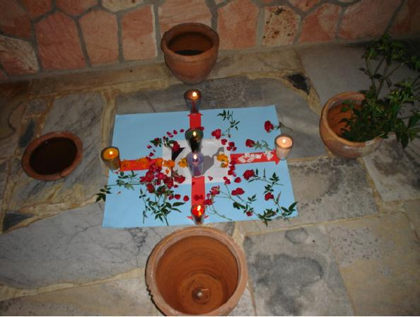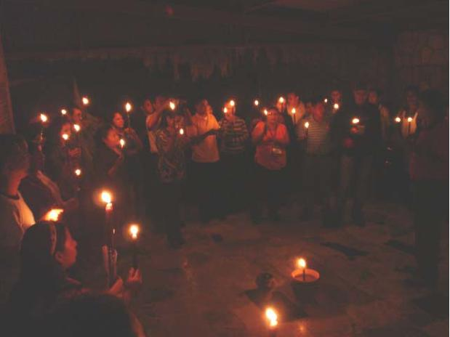

It can be said that knowledge produced at EMMS is seen as a common good, for purposes of political action and collective reflection in order to promote individual and social change. It is not meant to be objectified, privatized or patented for the purpose of being consumed. These are some of the practices promoted by neoliberal projects as it relates to biodiversity and local knowledges to which the movements are strongly opposing. There seems to be a conception of dialogue as a collective way of knowing as opposed to a debate in which the purpose is to ‘win’ the argument. There are some attitudes that are usually promoted, such as paying attention to ‘silences’ which sometimes can mean an autonomous decision of active listening or a sign of not being comfortable to speak. The dominant competitive ways of approaching discussions can be informed by the notion of knowledge questioned by Foucault (in Mills 2003), through his concept of power-knowledge regimes, which is seen as produced by individual and isolated geniuses and not as a social practice (Santos et al. 2007).

Collective construction of knowledge aims to address social fragmentation and overcome dogmatisms. Also, it can contribute to establishing relationships based on friendships in contrast with instrumentalized and utilitarian alliance to advance the different movement claims. The dialogue of knowledges can contribute to the construction of plural alternatives as opposed to universal ones. This dialogue of knowledges is particularly relevant, due to previous experiences of dogmatism and traditional orthodox Marxism that was prevalent during the 70s and 80s. This was the dominant framework for social change, in which a conception of power as something to be taken mostly through the state prevailed. Also, there was the notion that after achieving communism everything else was going to come automatically such as overthrowing patriarchy, discrimination, and other oppressions. The way in which indigenous, women, youth, LGBTQ voices were made invisible or non-existent within the movements by prevalent Marxist paradigms can be seen as an example of the notion of sociology of absences by Santos et al. (2006b). One concept coming out of the EMMS was ‘Unity with Diversity’; to make explicit the value of differences and their rejection to the notion of inclusion which implies that someone includes others under one way of thinking. They use the notion of articulation or interrelation to imply that diversity in subjectivities and worldviews is strength.

Out of the dialogues of knowledges, alternative paradigms were made visible. For example, the reflections from the indigenous movements showed alternative ways of thinking about nature, going beyond the dichotomy between humans/nature, prevalent in the Catersian epistemology. From these perspectives, water, plants, animals, humans are interconnected. Nature is everywhere and whatever we do to it, we do to ourselves. The notion of the ‘Buen Vivir’, promoted by Andean communities as well as other indigenous cultures, seemed to become more prevalent and embraced in the Mesoamerican context, due to the common experiences of exploitation of land, water by multinational corporations. Buen vivir can be understood as an alternative paradigm and ontology to the paradigm of development and modernization which focuses on the notions of harmony with nature and the simplicity of life (Davalos, 2009).

Conventionally, it is assumed that engaging in dialogues means relativism, accepting what everybody thinks or that people do not have clear issues to talk about. The practice of dialogue combined with posing critical questions can provide a more systematic and cooperative way of engaging in discussions. Dialogue is not based on a zero-sum game assumption in which one wins and other looses. Since the stated purpose is not to ‘compete’, but to make an effort to try to understand other’s reasons to think the way they do. When challenges (nudos) are indentified or when disagreeing it is an opportunity to go in-depth on those issues, since contradictions can be seen as sources of critical reflection.
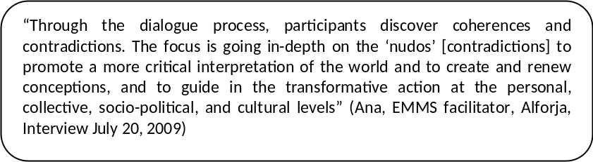

This knowledge-practice seems to be based on the assumption that knowledge is situated and that we speak from particular locations within power relations that might not allow us to see certain things and not others. There is an intentional emphasis in providing a respectful environment, valuing everybody’s ideas not just the ideas of the dominant voices (which usually coincide with being higher up in the hierarchies: white or mestizos, formal education, urban, men, etc.), where people can feel comfortable to express their opinions. Interventions such as ‘there are no absolute truths’, ‘reality is not always certain’, ‘from where I see the situation’, ‘we need to learn to be comfortable with the idea that life is complex’, ‘people are not clean categories, but multiple contradictions exist within the same person’, reflect some of the assumptions that knowledge is partial and depends on who speaks (situated) and it recognizes the complexity of reality.

4.1.3 Attention to power relations in the construction of knowledge
The recognition of power relations at the micro-level and in the spaces of knowledge creation can be seen as a way to overcome practices within dominant ‘banking’ (Freire 2006) models of education based on hierarchical and authoritarian relations. Conventional “capacity building” practices do not usually problematize the relations of power at the micro-level and the connection that it has with the macro-level. Within dominant frameworks of knowledge sharing, there seems to be a normalization of the hierarchies such as: teacher/students, practitioner/community member; academic/social movement member; North/South; hierarchies based on gender, ethnicity, ‘race’, among others.

Based on the interviews and on the minutes of the EMMS’ workshops, there seems to be an emphasis on reflecting about power relations at the micro-level. In the module I of EMMS there was a full day dedicated to the reflection on power relations within the movements. Since one of the major challenges within the movements has been the marginalization of certain voices such as indigenous, women, youth, among others and seeing them as subaltern or non-existent, as explained by Santos and his concept of the sociology of absences. The prevalent conception of power at the EMMS resonates with Foucault’s conception of power as relational (Sawicki, 1991). This contrasts with prevalent conceptions within movements in the past that talk about ‘taking power from state’ within a Marxist framework.

The practice of self-criticism is also a key element in this process of knowledge production at the EMMS as it relates to how participants play a role in reproducing unequal power relations in their daily lives. Practices such as these can help to promote more awareness and make explicit how participants’ take responsibility for perpetuating or changing power relations at the micro-level as well as it relations with the macro-level. This is vital because one of the major challenges among social movements in the region is the reproduction of systems of dominations. In order to explore the relations of power within the movements one of the exercises used at the EMMS, was Looking in the Mirrors: Practice to Generate Counter-Power (Alforja 2008c:37-40). Working in groups they used the following guiding questions for their dialogues:
- How are power relations within our movements: between leaders and the rest of the members, between men and women, youth and adults, etc? How do we relate with the rest of the community? With other movements? With political parties?
- How do we see power relations within this space of EMMS?
The important thing was to not focus on others but to talk about themselves and their movements. Then the groups shared their reflections with the rest of the participants. The aim was to promote a safe and supportive environment to enable participants to be explicit about their challenges.

The following are statements from some of the participants that emerged from the activity while sharing the results of the group discussion:
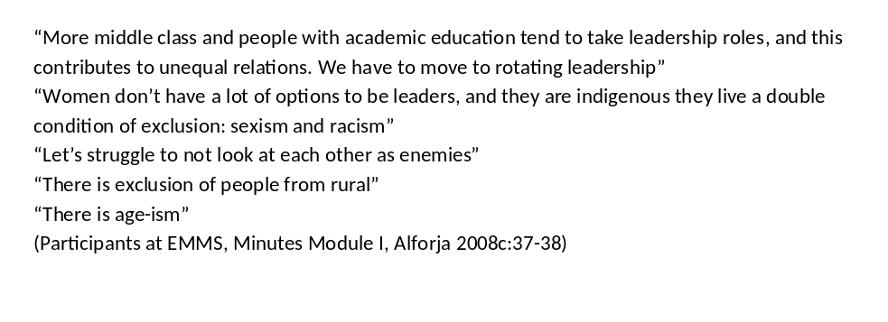
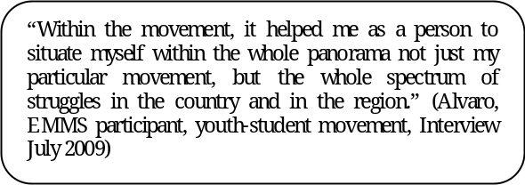
One of the prevalent ideas of the EMMS was the importance of combining personal as well as
collective transformation. Since for them, power relations at the micro level justify and are functional to the relations at the systemic level. It seems that this personal and collective transformation is conceptualized as an interactive process in which the personal is influenced by the collective and vice-versa.

Discussing in an open manner about participants’ roles in power relations in a diverse environment can promote the capacity for self-generation and self-reflection. It can make explicit the situations in which, without realizing, people are oppressing at the same time they are talking about liberation. The following statements gathered at the EMMS show some reactions towards this exercise:
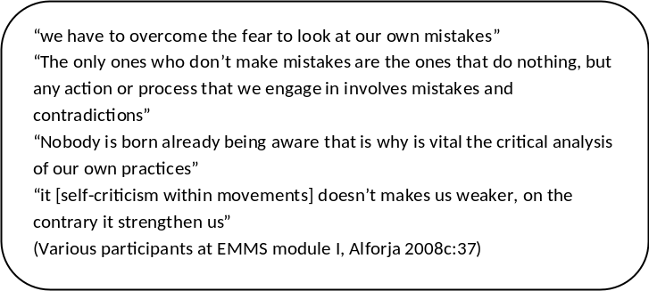

There was also an attempt to incorporate this focus on power relations throughout the events. For example, while cooking together, there was an emphasis on equal distribution of tasks based on gender.

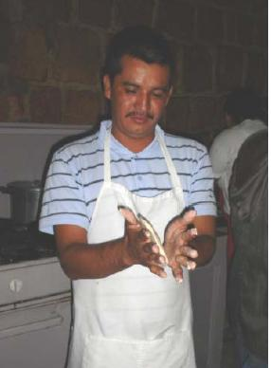
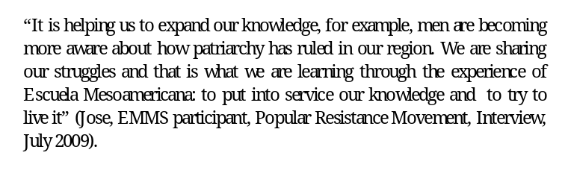

Challenges of the EMMS
Since it is important, besides engaging a discussion about the alternative aspects of the knowledge-practices of the EMMS, to reflect on what are some of the challenges that they face. In this analysis section I include some dilemmas derived from the analysis of the experience as well as external risks that I consider relevant to discuss for the purposes of this research

An important challenge is the consistency between thinking and acting. This means, being congruent with the values and discourses around PE and the practices and actions on the ground. Even with the PE methods (i.e. small group dialogues) how to prevent that people tend to dominate and not have sensitivity about supremacist behaviors, how to make explicit and acknowledge oppressive assumptions within the EMMS. As pointed out by one participant during the evaluation of EMMS Module II,
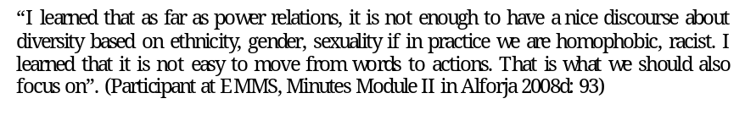
As it relates particularly to the experience of bringing diverse movements to share worldviews, analysis, strategies, one major challenge can be dealing with balance. On the one hand, the need of overcoming dogmatisms and not universalizing or imposing worldviews as it relates to political proposals; and on the other, the need for formulating concrete regional strategies to counter-immediate threats (repression, land displacements, etc.). The following is an example of one of the urgent issues expressed by some of the movement members which whom I talked,
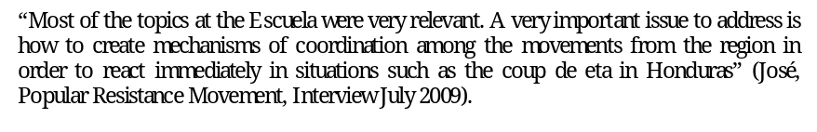
Other important challenge or dilemma relates to need that the EMMS is trying to address which is finding the links that can promote unity among the different movements. The notion of unity promoted by the EMMS according to one of its facilitators,
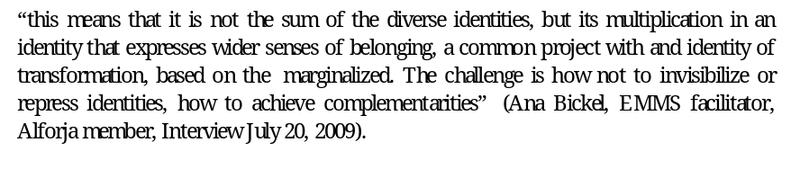
Hierarchies among knowledges are always present (i.e. socialism over Mayan philosophies), internal coloniality of power/knowledge persist. The challenge is on the one hand, how to negotiate the priorities for coordinating efforts; and on the other, to give every paradigm equal opportunity do be discussed within a specific situation and context recognizing the internal coloniality of knowledge and power that exist. This is a dilemma which relates to the notion of ecology of knowledges and relativism addressed by Santos et al. (2007).

Traditionally, one of the main discourses around the role of popular educators has been ‘to awaken the critical consciousness and of the popular sectors’. This perpetuates old dichotomies between the ‘emancipated’ and the ‘non-emancipated’ people. The process of promoting consciousness is based on a linear conception of time, in which the ‘emancipated’ are ahead and the others behind, therefore the mission is to bring them to this level. The challenge is how to recognize that there are ‘other’ ways of knowing and to promote collective awakening of critical consciousness in order to overcome vanguardist thinking of some people ‘emancipating’, ‘empowering’ others. It is not about bringing ‘people’ from point A (ignorance) to point B (awareness/development) by an ‘enlighten vanguard’. This just keeps reproducing practices of domination. (Alforja, 2008a, Esteva et al., Walsh, 2007). EMMS is engaging in alternative process to dominant ways of knowing. However, even within this process, characteristics of dominant knowledge frameworks persist (dichotomizing, universalizing, hierarchies, etc.) and are reproduced to a certain extent. The challenge is to identify when, why, and how this occurs impeding alternative ways of knowing and acting (Torres, 2009c).

Knowledge at What Risks?
The most salient frustration among the movements participating in the research, was the persecution and assassinations of compañeros/as, threats to people with some levels of leadership. The socio-political environment in the region was and continues to be very unstable and violent. During the ‘fieldwork’ period, the coup d'état in Honduras reminded many of us of the civil wars and of the various violent coups during the 70’s and 80’s as well as its effects in our country and the region in general.
Personally, this research experience exposed me even more to the violent environment to which many of the activists are subjected. A few days before I got to El Salvador, one activist member of the anti-mining movement was found tortured and dead due to his involvement in the movement opposing to mining corporations. This is a sad reality with which many members aiming to stop multi-national corporations and to transform the society have to live. According the interviews, one important challenge was, beside the focus on creating alternatives, the need for thinking about immediate reaction mechanisms as networks of movements in situations such as the coup d’état in Honduras, as stated by a member of Popular Resistance Movement (MPR),
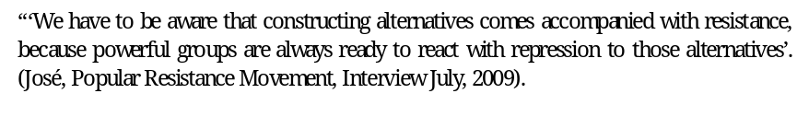
This shows that is not easy just focusing on creating alternatives, or to move from ‘protest to proposals’, since repression always exists, resistance continues.

Another important challenge of the EMMS is the lack of economic resources to continuing implementing it in the future. The EMMS was implemented just once, through their three modules in 2008. However, since then it has not been possible to mobilize resources to continue it in 2009 and 2010. One possible factor, among other factors, can be its alternative nature and its clear political positioning against capitalism, neoliberalism, patriarchy, racism, among other oppressions. Another reason can be the fact that some solidarity organizations focus on distinct specific movements, and not so much on strengthening connections among diverse movements.

Drawing Conclusions
Considering the following aspects: valuing participants experiences, subjectivities, knowledges; engaging in diverse collectives; and attention to the ethics and political aspects in knowledge construction can provide some of the most fertile spaces for ideas (Rivera 2008). Due to the space of this research, I focus on just a few reflections that, I consider, can be derived from the rich experience of the EMMS based on the combination of conversations, minutes from EMMS, theories, and personal reflections.

Building on the analysis of the EMMS, in the previous chapter and drawing ideas from the theoretical framework, this section will discuss some of the socio-political implications that I identify as a result of engaging in the research process such as: 1) what can be involved in engaging in a practice of ecologie of knowledges. 2) What is the relationship between micro and macro-politics of knowledge. 3) What are some implications for the role of conventional social science and academia. In the second part of this chapter, I will provide a brief summary of the research paper; I will address the research objective and main questions and provide some final reflections from the research process.

Socio-Political Implications
5.1.1 What does it mean for ecologies of knowledges on the ground?

It is important to recognize, moving forward, even when engaging intentionally with ecologies of knowledges; hierarchies can persist among perspectives. This is relevant in order to focus on finding ways on the ground to address these hierarchies that can invisibilize others. Dialogue between knowledges is not just about fitting other discourses within our rationality, logics, and pre-fixed frameworks; but an attitude of incompleteness and openness to try to understand other logics and rationalities. One of the main ideas that came out of the EMMS is the value of partial knowledges and their incompleteness ‘the paradigm is that there is no one universal paradigm’ (Alforja, 2008a), therefore dialogue and connecting with others is important. It contrasts with universalist and dogmatic ways of thinking.

Despite its challenges, an implication of the EMMS experience, and their approach to Popular Education through ecology of knowledges, is that it helps to visibilize other ways of thinking about the world, concepts, and theoretical collective analysis for example concepts that came out of the experience were the notion of Buen Vivir, the difference between social and popular movements, conceptions of power, history as a source of resistance, collective critical context analysis, among others.

Another consideration is the issue of representation, as movements are not blocks of consistent perspectives (indigenous, movements, youth, etc.) but contain differences within them. People are not distinct categories but multiple dominations, identities, and contradictions co-exist. It the case of a person facing multiple oppressions it can be difficult to prioritize one of them, for example a person differently able, women, sweatshop worker, indigenous. In this sense, when engaging in ecologies of knowledges, it is important not to essentialize and homogenize personal identities under the umbrellas of distinct movements. For example, in the attempt to bring the ‘voice of indigenous peoples’ just focusing on Maya philosophies, it can obscure the diversity and complexity that exist within. Other indigenous ethnic groups from the region such as Pipiles, Toltecas, for instance, can be excluded. Something similar can be said about ‘Feminist voices’.

5.1.2 Micro-politics and Macro-politics of Knowledge:

Based on the experience of the EMMS and on Foucault’s concept of disciplinary or normalizing power (Sawicki 1991), it is possible to recognize that our ways of knowing and acting at the micro-level can play a role in reproducing or challenging the dominant systems at the macro-level. Since education and knowledge sharing practices can contribute to normalize values, ideas, analysis. For this reason attention to the methods of constructing knowledge is fundamental. The summary of the discussion about power relations at the EMMS Module II, speaks to this point of micro and macro politics of knowledge:
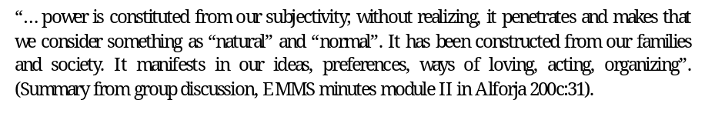
In this sense, dominant ways of knowing, based on ‘banking’, authoritarian and vertical models, can contribute to normalize values such as individualism, competition, selfishness, and hierarchical relations. This can translate into isolation and exclusion as well as passivity, dependence, paternalism by impeding critical thinking. All these values, when internalized are functional to maintaining hegemonic oppressive systems which normalizes intertwined hierarchies such as based on: gender, ethnicity, ‘race’, class, spirituality, age, epistemologies, languages, among others. As addressed in the theoretical framework, if people accept something as ‘normal’ there is no need for coercion.

In similar manner, alternative ways of knowing, based on more horizontal, democratic, collective and holistic ways of knowing that make explicit power relations and coloniality can contribute to promote values such as cooperation, recognition of interconnection, valuing differences ( including experiences and knowledges), critical thinking, autonomy, recovering of social fabric. In this way, making visible other ways of knowing and being could play a role in challenging the oppressive relations at the systemic level. As stated at the EMMS, ‘modeling in the present other possible worlds and not just hope for them in the future’ (Alforja 2008c); moving from just resisting to transforming at the individual and collective level.

The emphasis on the micro-politics of knowledge, specifically in producing alternative ways of knowing and being constitute knowledge-practice in that “it stemmed from the belief that contemporary subjects learn how to behave and be in the world through embodied micro-political practices” (Casas-Cortes et al 2008: 36). Attention to power relations at the micro-level involves critical thinking and self-reflection, that is, “going back to our own steps, to our own history, to our own experiences and views, going back to ourselves in order to see how we have been constituted. This can make it possible to think-be-make- ourselves otherwise, if it is necessary” (Parra 2005: 73).

Implications for academia and conventional social sciences
Engaging with diverse social movements as knowledge producers has very profound implications for rethinking the role of committed academics. The argument made by feminist and critical theorists that focuses on the idea that knowledge is political as well as the notion of power-knowledge regimes are relevant for this section. Knowledge claims can be used either for disciplinary and normalizing purposes or to de-mystify and deconstruct oppressive systems of power. This opposes the assumption of a detached and neutral knowledge.

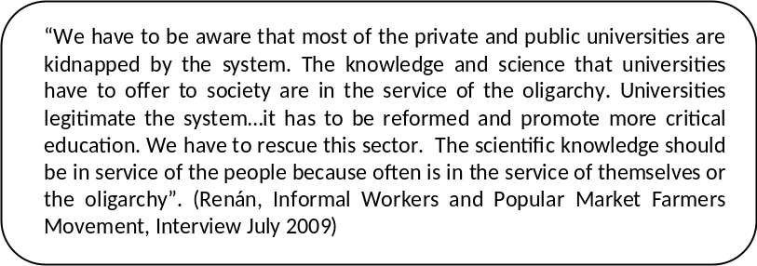

EMMS is not just bringing together diverse actors coming from the diverse movements and sectors, including academics. There is an emphasis on the process and on addressing critically the assumptions that we have while engaging in knowledge sharing. Furthermore, there is a political and ethical positioning towards the question “knowledge for what”.
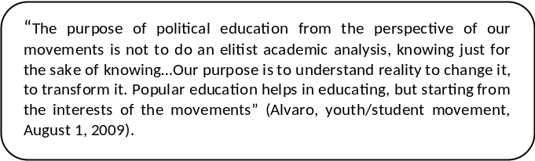

The perceived legitimacy of the monopoly of knowledge of conventional modern science is strongly questioned as well as its claims of detachment, neutrality, and universality that obscure its political nature.
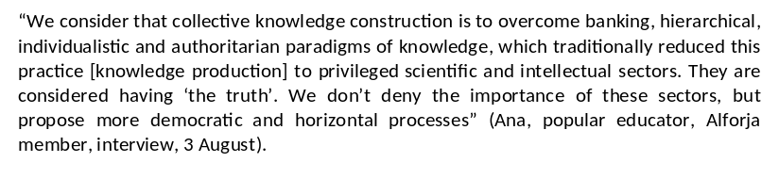
Arturo Escobar, an academic working alongside social movements in Latin America echoes this assertion and suggests the need to transform academia itself, if it is to play a role in social transformation. In his words,
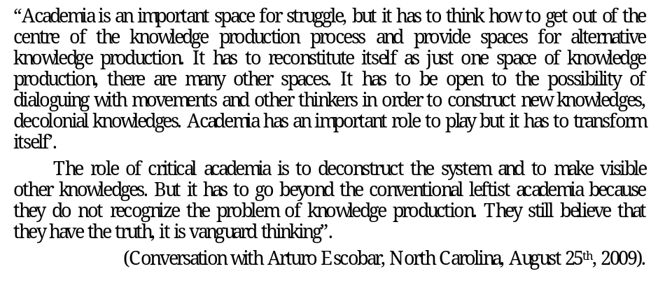
Moreover, I argue, it is not enough to make visible other systems of knowledge; it is also important to recognize the perceived ‘power of naming’ of academia. Even when talking about de-coloniality and emancipation it is important to challenge the ways in which the dominant power-knowledge regimes tend to name new ‘gurus’ or ‘academic heroes’ and exclude the collective theoretical production coming from experiences of struggle. In this sense, it is important to be conscious that even theories of de-coloniality or the “the personal is the political” in feminist theories have their roots in concrete experience of collective analysis of oppression such as Andean indigenous movements (Rivera-Cusicanqui 2006) and the Blackclubwomen’s Movement and women’s consciousness-raising collectives (Malo 2004: 22) respectively.

Final Reflections
This research has attempted to address the main research question how the EMMS’ knowledge-practices can be understood as alternative to dominant knowledge frameworks? This question rest on the argument that social movements themselves, and in this case Escuela Mesoamericana de los Movimientos Sociales (EMMS), besides engaging in social struggles, are providing alternative ways of knowing in contrasts with dominant knowledge frameworks through their knowledge creation practices. In so doing, they make visible alternative epistemologies with important political and social implications.

In order to expand on this argument and to address the main question, we started, in chapter 2, by describing the EMMS as a space, based on Popular Education, which brings together actors from diverse movements to engage in a collective construction of knowledge in order to analyze their contexts for the purpose of engaging in exploring alternatives for social transformation. I started by providing a background about Popular Education and Alforja network which facilitating the EMMS. Then, I situated the experience of the EMMS based on their actors, contents and purposes. Some initial questions emerged from the case itself that motivated the analysis of this experience: why is relevant from their perspective to put into dialogue different actors and different worldviews? Why is so important for the EMMS the ways in which they share knowledge about their context and how they do it? What implications can emerge from bringing together diverse movements to build collective knowledge?

In chapter 3, in order to address the sub-question: Why the knowledge practices of the EMMS can be understood as an alternative space in contrast with dominant knowledge frameworks? I provided the theoretical framework from which I looked at the EMMS as an alternative space of knowledge. Based on the claim that legitimate knowledge production has been conventionally seen as coming exclusively from academics and scientists but rarely from the experience of social and collective action, I elaborated on the approach of knowledge-practice (K-P) that engages in social movements’ studies as knowledge producers which is the basis for my analysis. The KP approach, which was built through the research process, can be seen as an epistemological position which I operationalize in the analysis section. Additionally, in the theoretical framework, drawing from feminist, critical theories I elaborate on the main assumptions in which the argument rest, these are that knowledge is situated, embodied, concrete, plural and political. Using the concept of power-knowledge regimes and theories on Decoloniality, I also expand on the claim that there are hegemonic systems of knowledge that contribute to the perpetuation of marginalizing other knowledges such as those of the actors involved in the EMMS. Furthermore, this chapter served two purposes, to provide some analytical tools to use in the analysis of the EMMS and to engage in a theoretical discussion about the wider context of the politics of knowledge in which the EMMS is embedded.

In chapter 4, the analysis section, intended to address the main question on How do the knowledge-practices of the EMMS contribute to provide alternative ways of knowledge construction in contrast with hegemonic knowledge frameworks? I focus on the process, and methods utilized at the EMMS. Since the ‘process’ (how) can be seen as an example of knowledge-practice in which the activities of the EMMS were based, drawing from Popular Education methods. Due to the scope of the research, I focused the analysis on three alternative knowledge-practices: 1) starting from lived experiences; 2) intentional collective construction of knowledge; and 3) attention to power relations in the construction of knowledge. Through the analysis, I address the rationale behind these practices; based on the interviews and Alforja documents. Furthermore, I contrast explicitly how they are alternative to dominant knowledge frameworks. At the end of the section, I discussed some of the challenges of the EMMS as it relates to their process of knowledge creation as well as external risks they face, according to the interviews.

The knowledge practices of the EMMS reflect their situated, embodied, plural and political conception of knowledge. They are based on concrete reflections on lived experiences within a diverse space where different worldviews are made explicit and a certain extent make visible different paradigms of social transformation beyond Marxist frameworks. Among some of the alternative aspects of the EMMS practices we can mention their conception of knowledge as a common good which is create collectively as opposed to individual exercise. The value of incompleteness, recognition of power relations at the micro-level is seen as a condition to engage in dialogues among diverse knowledges. Additionally, the value of direct experiences of struggle is based on the belief that they can be seen as source of knowledge and not as an obstacle to the knowledge creation process, as can be seen within dominant frameworks. Based on the EMMS knowledge-practices, the act of knowing involves a holistic approach in which there is no separation between reason, emotions, and imagination; contrary to a modern Cartesian epistemology based on the assumption of dichotomizing mind and body.

In chapter 5, based on the analysis, theoretical framework and personal reflections, I identify socio-political implications that emerged out of the experience of the EMMS, such as: lessons for engaging in dialogues between knowledges; the relationship between micro and macro-politics of knowledge; and finally, implications for academics engaged with critical theories. Within this, it is important to consider that EMMS encounters challenges at every step while engaging in these practices, since “normally, in many social settings, one is not supported to think and live in ways geared towards equal participation, anti-authoritarianism, radical diversity, non-supremacist behavior, and ultimately, democratic collective action” (Casas-Cortes et al 2008: 35). Despite these challenges, they continue to push forward, “making the road by walking” (Freire & Horton, 1990) in a reflective and self critical manner.

Personally, I have been constantly challenged by this process especially about my assumptions towards social change, the ‘what for’ of engaging in research, and my role in perpetuating or challenging oppressive systems at the micro-level. As stated by (Casas-Cortes et al., 2008), looking at social movements as knowledge producers in their own right has important implications for research such as blurring the boundaries between the ‘subject’ and the ‘object’ of study. This has meant a constant questioning of my role as a researcher, and the ‘what for’ of the research process.

I used to think that it was just a matter of learning the ‘right’ type of knowledge to direct our political actions; however, I am realizing that it is not just that. It also has to do with being aware of the systems of knowledge/power in which we are immersed and we can contribute to perpetuate or challenge. The path towards decolonizing power and knowledge requires that we are conscious that knowledge has value, colour, gender, place of origin, and for this reason the place from where we think and create knowledge matters (Walsh 2004). In this sense, considering that knowledge it cannot be neutral or objective, it is important the we ask questions such as knowledge by who? Knowledge for what? Knowledge how? If we see learning as complex, process of questions, and temporary reflections, and reject the notion that knowledge can be fixed and complete, it can be an invitation to be humble and to expect contradictions as part of the process. In the spirit of this research, I would make a modest call for recognizing more and other spaces and processes of alternative knowledge creation based on the values of the world for which we are aspiring. The words of a huichol marakame (or shaman) seem appropriate:
“Joining the moments in one heart, a heart that belongs to everybody, will make us all wise, a little bit more to face whatever comes. Only among all, can we know all”
(Quoted by Vera 1997),

References
Alforja (2007) I Encuentro Mesoamericano: De Movimientos Sociales y Populares. Esperanzas, Deseos y Sueños que Obligan el Presente. Tegucigalpa, Red Alforja and CEAAL.
Alforja (2008a) Encuentro de Educadores y Educadoras Populares Mesoamericanos/as. Tegucigalpa, Honduras.
Alforja (2008b) Escuela Mesoamericana de los Movimientos Sociales: Consechando un Mundo Mejor.
Alforja(2008c) Memoria Módulo I: Experiencia de resistencias y horizonte político de los movimientos. Escuela Mesoamericana. Tegucigalpa, Honduras.
Alforja (2008d) Memoria Módulo II: Movimientos sociales. formas de entender y transformar el mundo. Escuela Mesoamericana. Nicaragua.
Alforja (2008e) Memoria Módulo III: Organización y estrategias de los movimientos sociales. Escuela Mesoamericana. Chalatenango, El Salvador.
Alforja (2008f) Red Alforja website.
Alforja (2009a) Estrategias del Imperialismo y Formación Política. Intercambio de Educadores Populares de Mesoamérica., El Salvador.
Alforja (2009b) Video documentary: Mesoamerica en movimiento. http://www.redalforja.net/
Alforja & Colectivo Arbol (2008) La Sistematización Participativa para descubrir los sentidos y aprender de nuestras experiencias. Multiversidad – Uruguay.
Alvarez, S., Dagnino, E. & Escobar, A. (Eds.) (1998) Cultures of Politics/ Politics of Cultures: Re-visioning Latin American Social Movements Boulder, CO, Westview Press.
Aparicio, J.R.& Blaser, M.(2008) The "Lettered City" and the Insurrection of Subjugated Knowledges in Latin America. Anthropological Quarterly, 81, 59-94.
Campana, A. & Hoetmer, R. (2007) Presentación. Autonomías y Emancipaciones: América Latina en Movimiento. Lima, Fondo Editorial de la Facultad de Ciencias Sociales • Unidad de Post Grado • UNMSM.
Canel, E. (1997) New Social Movement Theory and Resources Mobilization Theory: The Need for Integration. In Kaufman, M. & Alfonso, H. D. (Eds.) Community Power and Grassroots Democracy: The Transformation of Social Life. London, Zed Books. IDRC.
Casas-Cortés, M. I. (forthcoming) Social Movements as Sites of Knowledge Production: Precarious Work, the Fate of Care and Activist Research in a Globalizing Spain. Department of Anthropology. unpublished doctoral dissertation, University of North Carolina at Chapel Hill.
Casas-Cortés, M. I., Osterweil, M. & Powell, D. (2008) Blurring Boundaries: Recognizing Knowledge-Practices in the Study of Social Movements. Anthropology Quarterly, 81, 17-58.
Ellacuría S.I., Ignacio. (2003) Filosofía ¿para qué? San Salvador: UCA Editores.
Centro de Estudios Sociais (2001) Reinventing Social Emancipation: Voices of the World. Coimbra.
Davalos, P. (2009) Reflections on Sumak Kawsay (good living) and theories of development. ALAI, América Latina en Movimiento.
Denzin, N. K. & Lincoln, Y. S. (Eds.) (2005) The Sage Handbook of Qualitative Research. Third Edition, Thousand Oaks•London•New Delhi, Sage Publications.
Escobar, A. (1992) Imagining a Post-Development Era? Critical thought, Development and Social Movements. Social Text, 31/32, 20-56.
Escobar, A. (1995) Encountering development : The making and unmaking of the Third World, Princeton, NJ, Princeton University Press.
Escobar, A. (2001) Culture sits in places: reflections on globalism and subaltern strategies of localization. Political Geography, 20, 139–174.
Escobar, A. (2007a) Worlds and Knowledges Otherwise. Cultural Studies, 21, 179- 210.
Escobar, M. R. (2007b) Universidad, conocimiento y subjetividad. Relaciones de saber/poder en la academia contemporánea. Universidad Central de Colombia-Revista Nómadas, 27, 48-61.
Esteva, G., Prakash, M. S. & Stuchul, D. From a Pedagogy for Liberation to Liberation from Pedagogy.
Eyerman, R. & Jamison, A. (1991) Social Movements: A Cognitive Approach., Cambridge, Polity Press.
Foley, D. & Valenzuela, A. (2005) Critical Ethnography. The Politics of Collaboration. In Denzin, N. & Lincoln, Y. (Eds.) The Sage Handbook or Qualitative Research. Third Edition. Third ed. Thousand Oaks•London•New Delhi, Sage Publications.
Fontana, A. & Frey, J. (2005) The Interview: From Neutral Stance to Political Involvement. In Denzin, N. & Lincoln, Y. (Eds.) The Sage Handbook or Qualitative Research. Third Edition. Third ed. Thousand Oaks•London•New Delhi, Sage Publications.
Foucault, M. (1980) Power/Knowledge: Selected Interviews and Other Writings 1972-1977, New York, Pantheon Books.
Foucault, M. & Chomsky, N. (1971) Debate: 'Human Nature: Justice Vs. Power'.
Freire, P. (1974) Education for Critical Consciousness, New York, Continuum.
Freire, P. (2006) Pedagogy of the Oppressed, New York, The Continuum International Publishing Group Inc.
Freire, P. & Horton, M. (1990) We Make the Road by Walking: Conversations on Education and Social Change, Philadelphia, Temple University Press.
Galeano, E. (1992) The Nobodies. The Book of Embraces. New York, W. W. Norton & Company.
Goldar, M. R. (2008) Educación Popular y Movimientos Sociales en el Actual Contexto de Latinoamérica y el Caribe. La Piragua, Revista Latinoamericana de Educación y Política, No. 27.
Grosfoguel, R. (2007) Interview by Angélica Montes and Hugo Busso. Paris.
Haraway, D. (1988) Situated Knowledges: The Science Question in Feminism and the Priviledge of Partial Perspective. Feminist Studies, 14, 575-599.
Hoetmer, R. (Ed.) (2009) Repensar la política desde América Latina. Cultura, Estado y movimientos sociales., Lima, Fondo Editorial de la Facultad de Ciencias Sociales • Unidad de Posgrado • UNMSM.
Kouritzin, S., Piquemal, N. & Norman, R. (Eds.) (2009) Qualitative Research: Challenging the Orthodoxies in Standard Academic Discourse (s) New York, Routledge.
Kurzman, C. (2008) Introduction: Meaning-Making in Social Movements. Anthropological Quarterly, 81, 5-15.
Lander, E. (2000) Ciencias sociales:saberes coloniales y eurocéntricos. IN (COMP.), E. L. (Ed.) La colonialidad del saber: eurocentrismo y ciencias sociales. Perspectivas latinoamericanas. Buenos Aires, CLACSO.
Lugones, M. (2008) The Coloniality of Gender. Worlds and Knowledges Otherwise. A web dossier.
Malo, M. (2004) Prólogo. Nociones Comunes: Experiencias y Ensayos entre Investigación y Militancia. Madrid, Traficantes de Sueños Utiles.
Mignolo, W. (2003) Globalization and the Geopolitics of Knowledge. The Role of the Humanities in the Corporate University. Nepantla: Views from South, 4, 97-119.
Mills, S. (2003) Power/Knowledge. IN MILLS, S. (Ed.) Michel Foucault. London, Routledge.
Parra, M. (2005) La Construcción de los Movimientos Sociales como Sujetos de Estudio en América Latina. Athenea Digital, Num. 8, 72-94.
Pontual, P. (2008) Movimientos Sociales, Tema Vital para la Educación Popular. La Piragua, Revista Latinoamericana de Educación y Política.
Quijano, A. (2000) Colonialidad del poder, eurocentrismo y América Latina. IN (COMP.), E. L. (Ed.) La colonialidad del saber: eurocentrismo y ciencias sociales. Perspectivas Latinoamericanas. Buenos Aires, CLACSO, Consejo Latinoamericano de Ciencias Sociales.
Rivera-Cusican qui, S. (2006) Chhixinakax utxiwa. Una Reflexión sobre Prácticas y Discurso Decolonizadores. Mario Yupi (comp.). Modernidad y pensamiento descolonizador. Memoria del Seminario Internacional. La Paz, U-PIEB – IFEA.
Rivera-Cusican qui, S. (2008) Interview by Colectivo Zoom. Lima, Facultad de CCSS de la Universidad Nacional Mayor de San Marcos.
Santos, B. D. S. (2006a) Conocer desde el Sur. Para una cultura política emancipatoria, Lima, Programa de Estudios sobre Democracia y Transformación Global.
Santos, B. D. S. (2006b) The World Social Forum as epistemology from the South. The Rise of the Global Left: The World Social Forum and Beyond. London and New York, Zed Books.
Santos, B. D. S. (2006c) La Universidad Popular del Siglo XXI, Lima, Programa de Estudios sobre Democracia y Transformación Global. UNMSM.
Santos, B. D. S. (2009) Reinventando la Emancipación Social (Reinventing Social Emancipation). Cuadernos de Pensamiento Critico Latinoamericano-CLACSO, No. 18.
Santos, B. D. S., NUNES, J. A. & MENESES, M. P. (2007) Opening Up the Canon of Knowledge and the Recognition of Difference. IN SANTOS, B. D. S. (Ed.) Another Knowledge is Possible London and New York, Verso.
Sawicki, J. (1991) Foucault and Feminism: Toward a Politics of Difference. IN SAWICKI, J. (Ed.) Disciplining Foucault. Feminism, Power, and the Body. New York and London, Routledge.
Social Movements Working Group (n.d.) <http://www.unc.edu/smwg/about/>.
Tarrow, S. (1998) Contentious Politics and Social Movements. Power in Movement: Social Movements and Contentious Politics. Cambridge, Cambridge University Press
Torres, A. (2009a) Educación Popular y Nuevos Paradigmas. La Piragua- Revista Latinoamericana de Educación y Política,, No. 28 I, 5-27.
Torres, A. (2009b) Educación Popular y Paradigmas Emancipadores. La Piragua- Revista Latinoamericana de Educación y Política,, No. 30 III, 11-32.
Torres, A. (2009c) La sistematización de experiencias: Aporte de la Educación Popular para una nueva universidad. Revista Diálogo de Saberes, No. 2, 31-37.
Tuhiwai-Smith, L. (1999) Decolonizing Methodologies. Research and Indigenous Peoples, London & New York Zed Books.
Walsh, C. (2004) Geopolíticas del Conocimiento, Interculturalidad y Descolonialización. Boletín ICCI-ARY Rimay, No. 60.
Walsh, C. (2007) ¿Son Posibles unas Ciencias Sociales/Culturales Otras? Reflexiones en Torno a las Epistemologías Decoloniales. Nómadas-Universidad Central Colombia, 26, 102-113.
Yehia, E. (2007) Descolonización del conocimiento y la práctica: un encuentro dialógico entre el programa de investigación sobre modernidad /colonialidad/decolonialidad latinoamericanas y la teoría actor-red. Tabula Rasa, 6, 85-115.
Vera, R. (1997) La Noche Estrellada. La formación de constelaciones de saber. Revista Chiapas. http://www.revistachiapas.org/ch5vera.html
Zibechi, R. (2003) Los movimientos sociales latinoamericanos: tendencias y desafíos. CLACSO: Observatorio Social de América Latina, No. 9, 185-188.
Zibechi, R. (2007) Autonomías y Emancipaciones: América Latina en Movimiento, Lima, Fondo Editorial de la Facultad de Ciencias Sociales • Unidad de Post Grado • UNMSM.

Appendices
Appendix 1 – List of Interview Participants

a) Social Movement’s Members from El Salvador Participating in the EMMS (El Salvador)
- Renán-Movimiento de Mercados y Trabajadores Informales- Informal Workers and Popular Market Farmers Movement (July, 2009)
- Miguel-Movimiento Vida y Equidad Campesina-Life and Equity Peasants Movement (July, 2009)
- José-Popular Resistance Movement: Against free trade, megaprojects (dams and mining) (July, 2009)
- Alvaro- Colectivo Utopía- Youth and student movement (August 1, 2009)

c) Members of Social Movements outside Escuela Mesoamericana
- Remberto-Movement against Mega-Projects and mining (July 26, 2009)
- Pablo-Patria-Exacta Movement: Movement of artists, practitioners, and committed professionals working alongside popular movements and grassroots organizations (July 24, 2009)

- Ana Bickel- Popular educator from Alforja and Coordination Committee of the EMMS

Three face to face conversations: July 13, July 20, August 3, 2009.

Email communication (September 2009-February 2010)

d) Academics working alongside Social Movements in Latin America
- Arturo Escobar (August 25th, 2009) - UNC Chapel Hill
- Rafael Paes- (July 14, 2009) Sociologist and researcher on social movements at the National University of El Salvador -
- Alfonso Torres (February, 2010)- is a Colombian sociologist and historian. He teaches at the National Pedagogical University of Colombia (Universidad Pedagógica Nacional de Colombia), specializing on theory, methods and techniques of social research. He is author of numerous books, chiefly dealing with the various expressions of popular education in his country.

Appendix 2 – Guiding questions for EMMS Participants Interviews (Spanish)
Escuela Mesoamericana de Educación Popular
Entrevista-participantes
- ¿Cuál es el nombre, las acciones o banderas de lucha de su movimiento? ¿Como nació la iniciativa de formar su movimiento?
- ¿Cree es usted que es necesario hacer la distinción entre movimiento social y movimiento popular? Si es así, ¿cuál es la diferencia entre ambos?
- ¿Qué es la Educación Popular para usted? ¿Qué cree usted que aporta la Educación Popular a la formación política? ¿Cambió algo el hecho de haber participado en un proceso de Educación Popular?
- ¿Cómo multiplicaron los conocimientos con el movimiento? ¿cuáles fueron algunos obstáculos o retos?
- ¿En qué aportó la Escuela Mesoamericana a nivel personal y a su contribución a nivel de movimiento?
- ¿Qué expectativas tenían? ¿Cuáles se cumplieron y cuáles no?
- ¿Qué temas recomendaría abordar a través de la Escuela regional?
- ¿Quiénes cree deberían ser los participantes de la escuela y cómo se podría asegurar su participación?
- ¿Se dan estos temas a nivel nacional o en los procesos de formación de su movimiento? Si no, ¿por qué?
- ¿Cuál es el valor agregado de hacer una Escuela Regional de formación para movimientos sociales/populares?
- En su opinión, ¿existe un Movimiento Mesoamericano? ¿Cómo se llamaría el movimiento? ¿Qué acciones podría llevar a cabo? ¿Cómo se podría fortalecer este espacio? ¿Cree que una escuela regional de los movimientos podría favorecer la construcción de un movimiento regional? ¿por qué?
- ¿Qué dificultades, retos o necesidades tienen como movimiento?
- Desde la situación actual de su movimiento, ¿qué aporte cree que la Escuela Mesoamericana podría seguir dando?
- ¿Tiene interés en seguir participando?
- ¿Qué otro movimiento de su país que cree que debería incluirse en la Escuela?
- ¿Cuál cree usted que debe ser el papel de las ONG y cooperación internacional en apoyo a los movimientos sociales?
- ¿Cuál cree usted que debe ser el papel de la academia en apoyo a los movimientos sociales y a procesos de transformación social?

Appendix 3 – Guiding questions for EMMS Popular Educators (Spanish)
Escuela Mesoamericana de Educación Popular
Entrevista-facilitadores/as
- ¿Cuál es su experiencia en procesos de Educación Popular? ¿Es parte de algún movimiento social/popular específico?
- ¿Qué es la Educación Popular para usted? ¿Qué cree usted que aporta la Educación Popular a la formación política?
- ¿En qué cree que ha cambiado la educación popular en los últimos años, en el contexto de la globalización neoliberal (90´s) y de la crisis de dicho paradigma (2000´s)? ¿En qué cree que debe cambiar para la EP para adaptarse a las necesidades de los movimientos de la región?
- ¿Cómo nació la idea de realizar la Escuela Mesoamericana?
- ¿Cómo se seleccionaron los temas a abordar en la Escuela Mesoamericana? ¿Qué temas recomendaría abordar a través de la Escuela regional en el futuro?
- ¿Qué metodologías se usaron? ¿Qué aportaron estas metodologías a la experiencia en la Escuela?
- ¿Cómo se hizo la selección de los participantes de la Escuela y qué criterios se tomaron en cuenta?
- ¿Quiénes cree deberían ser los participantes de la escuela y cómo se podría asegurar su participación? ¿Qué otro movimiento de su país que cree que debería incluirse en la Escuela?
- ¿Cómo se multiplicaron los conocimientos con los movimientos? ¿cuáles fueron algunos obstáculos o retos?
- ¿En qué aportó la Escuela Mesoamericana a nivel personal y a su contribución a nivel de movimiento?
- ¿Qué expectativas tenían? ¿Cuáles se cumplieron y cuáles no?
- ¿Se dan estos temas a nivel nacional o en los procesos de formación de los movimientos? Si no, ¿por qué?
- ¿Cuál es el valor agregado de hacer una Escuela Regional de formación para movimientos sociales/populares?
- En su opinión, ¿existe un Movimiento Mesoamericano? ¿Cómo se llamaría el movimiento? ¿Qué acciones podría llevar a cabo? ¿Cómo se podría fortalecer este espacio? ¿Cree que una escuela regional de los movimientos podría favorecer la construcción de un movimiento regional? ¿por qué?
- ¿Qué dificultades, retos o necesidades ve usted que tienen los diferentes movimientos en la región?
- Desde la situación actual de los movimientos, ¿qué aporte cree que la Escuela Mesoamericana podría seguir dando?
- ¿Cuál debería ser papel de los/as educadores/as populares en el apoyo a los movimientos?
- ¿Cuál cree usted que debe ser el papel de las ONG y cooperación internacional en apoyo a los movimientos sociales?
- ¿Cuál cree usted que debe ser el papel de la academia en apoyo a los movimientos sociales/populares o a procesos de transformación social?
Appendix 4 – Structure of Modules of the Escuela Mesoamericana
- First workshop/module-
‘Experiences of Resistance and Movement’s Political Horizon’ (Alforja, 2008b)-
The purpose was to look at the history from the perspective of building power: power relations, powers already built, potentialities to transform and resist of the Mesoamerican peoples from the diverse worldviews of sectors and movements (women, indigenous, peasants, youth, etc.).
Before the event: participants prepared about the main milestones in the history of their movements to provide a presentation during the workshop.
During the workshop: The aim was to generate a dialogue around the experiences and perspectives of the various movements. Including the analysis of the powers involved and powers already conquered (including reasons and emotions), as well as the capacities to transform and to resist of the peoples (conditions, opportunities, viabilities).

- Second workshop/module-
‘Social Movements: Ways of Understanding and Transforming the World’ (Alforja, 2008c)-
The purpose was to create a space where different ways of understanding, viewing and interpreting the world can dialogue. Through feminisms, Mayan worldviews (cosmoviews), and socialisms formulate perspectives that contribute and enrich their ways of understanding and transforming the world.
Before the event: the members of each movement reflected about the meanings that motivate their movements (thinking, organization, action).
During the workshop: reflections about conceptions of the world and how the struggles manifest those conceptions; going in depth among all the participants about the construction of broader collective visions; building a regional working vision from the movements’ perspectives.

- Third workshop/module-
‘Social movements’ organizing and strategies’(Alforja, 2008d)-
The purpose was to review critically participant’s lives and strategies for struggle, as individuals and movements for liberation. Look for clues that feed us and strengthen us in order to improve our actions.

Before the event: participants involved with readings about Latin-American experiences of organization and search for social transformation. Participants promoted national forums or dialogues for national articulation.
During the workshop: aiming at the creation of national and regional strategies for articulation and struggle from the movements. Discussion about Popular Education and its contributions in two main fields: first, in generating ethical, political and pedagogical action; second, in the construction of the ‘political subject’ from the participants’ experiences. Additionally, it included the design of strategies for action.

Each event started with the central ideas from the previous day and there were critical reflections about the methodologies used.

At the end of the EM Alforja produced a series of materials in order to share with other movement members and collectives and also to continue the process of discussion. Among the products they developed: texts, videos, sistematizaciones, and methodological guides, guides for analysis and discussions, guiding reflections and lines of action, tools to facilitate addressing certain specific issues (power relations, context analysis, etc.), complimentary readings, and minutes from the workshops, sharing through community radio.
Appendix 5- Illustrative Popular Education method from the Escuela Mesoamericana
Objective: Defining Collectively ‘Social Movement’ (Module I p. 21) (Alforja, 2008b)
First exercise: Rhythm, music and movement.
- Instructions for the first exercise :
‘Ana [the facilitator] asked us to get all together in the middle of the room. From there we started moving freely with the rhythm of the music. Then, she said we had to form partners and little by little bigger groups. She would cheer saying: “with more strength”. And like this, we continued singing, dancing and getting together. In reality, we formed two or three groups that had their own rhythm and synchrony’.

- Collective analysis:
‘After the exercise was over, Ana asked us and as a group we answered:
*What did we do? Relaxed, moved, enjoyed, joined, listened to each other, opened up to give spaces, overcome shyness. At the beginning they were individual rhythms at the end we formed a collective with a more group rhythm.
*What could have given us more strength? The integration of the whole group
*How the exercise relate to the movements? It’s an example to get together. The movement starts with an unease or desire that I feel and I look for people that might feel the same, then we form the group, alliances or block towards the same direction. It was the same music danced according to each person, then starting from the individual attitudes, that challenge was to overcome shyness and individuality, being dynamic and creative. It is hard to convince other to do things. Needs are address collectively; we would have to join despite of differences. There is a need to move from the individual to the commons in order to have more strength; but it is difficult to get motivated to get in. Although it can happen that someone gets in already very convinced and with his/her strength encourage me more’.

- Expanding theoretically (collectively)
Synthesis of discussion:
‘The word movement it is not coincidental. It is used because it means moving, action. Movement doesn’t usually goes on the same direction. It is oscillating, comes and goes in several directions and it is difficult to predict the direction it can take. If we compare it with the body, there are members that don’t adapt easily to the movement: some parts go in one direction and other parts towards other directions. So, the objective is to harmonize with the rhythm (music) the different parts of the body. The same can happen with movements. The song is the same; it is the same context, the same difficulties. But the ways we move are different. Our intention is being able to find a collective rhythm. With the exercise we were able to connect to certain extent. Why? Movements are complex and their direction does not depend on one intention. Will is not enough; we have to involve abilities, attitudes, and knowledges in order to find the rhythm. Movements have to do with something external such as the rhythm; but the internal component is how we respond to that rhythm’

The Mesoamerican region includes the Southwest part of Mexico and Central America. The people from this region are descendant of Mayas, Chibchas, Africans, and Europeans. It is very diverse and some of the languages spoken are Spanish, Maya, Garifuna, Mayanga, Kuna, and Creole.
English translation: The Mesoamerican School of Social Movements. From now on I will refer to it as either Escuela Mesoamericana or EMMS.
For more on alternative research methodologies see Casas-Cortes et al. (2008), Denzin and Lincol (2005); Kouritzin et al. (2009), Tuhiwai (1999), Centro De Estudos Sociais(2001), Wang (2008).
See appendix for a list of all the documents reviewed.
My deepest gratitude to Maribel Casas-Cortés for sharing with me methodologies to engage with social movements as knowledge-producers
Please see list of movement participants, academics, and popular educators in the appendix 1.
Activist is a contested term in various social movement circles in Latin America as it highlights the ‘action’ and conceals the ‘reflection’ involved in social struggles. This also resonates with Freire’s (2006) notion of praxis, which involves ‘action/word’ and ‘reflection/work’. For Freire, sacrificing action turns into verbalism, and sacrificing reflection turns into activism. From now on I use the term ‘social movement member/participant’.
http://www.redalforja.net
‘Sistematizaciones’ can be understood as a critical and in depth reflection based on a particular experience, i.e. struggle, political action, gathering, etc. (Alforja 2008, Colectivo Arbol 2008).
English translation: Mesoamerican Forum: From Social and Popular Movements. Hopes, Desires and Dreams that the Present Time Demands
See appendix 4 for a brief description of each module.
All pictures are from the minutes of the EMMS, unless stated otherwise.
My own translation.
Mignolo (2003) focuses on underlying the historical trajectories of the University and its role in justifying the hegemonic systems going from the Reinassance university in the service of the Crown and the church; the Kantian-Humboldtian university in the service of the emerging nation-states; and the corporate university in the context of neoliberal developments which expanded a set of values over the state university (i.e. commodification of knowledge).
Ideario can be understood as the set of principles, ideas or conceptions.
Prácticas senti-pensantes it can be translated as ‘felt-thought-practices’.
See appendix 5 for a description and analysis done by the participants
Instead of Unity in Diversity: Working together despite of differences.
Buen Vivir: Good Living. For an English article on this notion see DAVALOS, P. (2009) Reflections on Sumak Kawsay (good living) and theories of development. ALAI, América Latina en Movimiento.
I use the term ‘race’ to highlight the socially constructed nature of the term
The Blackclubwomen’s Movement was constituted by associations of mutual support, formed exclusively by women, who give emotional and practical support to recent recently freed women from slavery (Malo 2004: 22).
Own translation from “Juntar los momentos en un solo corazón, un corazón de todos, nos hará sabios, un poquito más para enfrentar lo que venga. Sólo entre todos sabemos todo”
In order to be more precise the term ‘Cosmovisión’ goes beyond paradigms whose scope is limited to the world. The cosmos and humans relationship to it are fundamental components within Mayan philosophy.

