Academic year 2009-2010
Erasmus University Rotterdam
Department of applied economics
Bachelor Thesis: Entrepreneurship and Organization

Jasper Veel
315627jv

315627jv@student.eur.nl
0628061362

Reader: Marcus Dejardin

Opportunity and necessity entrepreneurship, what else?

Table of contents
1 Introduction 3
2 Place in the literature 5
3 Literature Review 7
3.1 Brockhaus and Horwitz, 1986 7
3.2 Verheul, Wennekers, Audretsch and Thurik, 2002 8
3.3 Hessels, Gelderen and Thurik, 2008 10
3.4 Thurik, Carree, Stel and Audretsch, 2008 12
4 Analytical Review 13
5 Discussion 15
5.1 Definition problem 15
5.2 Overlap between the two concepts 16
5.3 Environmental Characteristics and necessarily facilities 18
5.4 Valuing problem 19
6 Conclusion 22
7 References 26

1 Introduction

The existence of small business became more important in the last few decades. Small firms drove innovation and economic growth. Governments adapt policies in order to increase entrepreneurial activity within their country.
The importance of small business led to a increase of related studies and institutions to understand and monitor entrepreneurial activity. The GEM (Global Entrepreneurship monitor) is an example of such an institution. The GEM is a non-profit academic research consortium, with the goal to provide high-quality international research data widely available. A lot of research focuses on the reasons why people turn into entrepreneurs. The GEM introduced two main concepts to describe the main reasons.
The GEM uses the concepts of necessity and opportunity entrepreneurship to explain why people become self-employed.
Opportunity entrepreneurship is the concept where someone becomes self-employed due to opportunities available being self-employed. These opportunities as being self-employed could come from economic and non-economic factors. The possible access to high(er) financial rewards is an example of an opportunity which can be obtained when becoming an entrepreneur.
Necessity entrepreneurship is the concept were a inconvenient initial situation leads to the decision to become self-employed. This could be the case if the current situation as an employer has bad future sights or insufficient financial rewards.
The GEM made a distinction between opportunity and necessity entrepreneurship by asking people the question whether they were starting and growing their business to take advantage of a unique business opportunity or was it the best option available. (GEM report 2001)

This essay describes the two concepts of opportunity and necessity entrepreneurship and tries to discuss these concepts.

The literature review part is used to explain the main concepts. Furthermore some other concepts or reasons to become an entrepreneur will be pointed out. The papers used in this part are benchmarks in the research for entrepreneurial motivations. An analytical review is done on the literature review. This review leads us to some points which need further discussion.
The discussion part of this essay states papers that bring in critical notes towards the papers pointed out in the literature review or come up with different and additional ideas. Comparing the discussion part with the literature review gives us insight in the development concerning the research for entrepreneurial motivations.

The study question for this essay is: “Are the concepts of necessity and opportunity entrepreneurship sufficient to explain all motivations to become self-employed?”

The literature review and the discussion part lead us to the conclusion where the study question is answered. We come up with a revision of the initial concepts and identify the reasons for entrepreneurship in a more precise manner. This is done according to the findings in both the review and discussion part.
There is a need to distinguish the reasons for entrepreneurship in a summarizing concept. Entrepreneurship has a positive impact on the performance rate of the economy, especially on those of the richer countries (Stel, van et al. 2005) By understanding the motivations to become an entrepreneur, government can introduce policies which drive entrepreneurship. Summarizing concepts make it easy for governments to apply policies. Focusing on the main (group of) motivations will lead to decent policies to increase entrepreneurial activity and finally to economic growth.

2 Place in the literature

The existence of small business is increasingly important in the last years. Different studies show the positive effect of entrepreneurial activity on the overall economic performance. Entrepreneurship drives innovation and competition. (Stel, van et al 2005) Governments and non-profit organizations try to imply policies and create facilities for people to support them in their entrepreneurial process. The understanding of reasons and motivations of entrepreneurship helps them to adapt more effective policies.

The function of entrepreneurs within an economic system is discussed in a lot of studies.
This study focuses however on the motivations for entrepreneurship. Why do people start a business and what are the main factors that play a role in this process?

A lot of literature can be found on the reasons for entrepreneurship.
Knight (1921) adopted the idea that people choose between 3 different states, unemployment, employment and self-employment. Different factors of the person itself and environmental and economical factors made the person decide whether to become unemployed, employed or self-employed. (Knight 1921). This general study led finally to studies who focused primarily on the reasons for entrepreneurship.
Studies describe the different drivers for people to become self-employed. (Kolvereid 1996; Shane et al. 2003; Hessels et al. 2003). Kolvereid (1996) described 11 different classes of reasons why people would choose to be self-employed or work as an organizational employer. Some classes were clear reasons to choose for self-employment. Authority, Autonomy, Challenge and Self-realization are motivations to choose for self-employment.
Shane et al. (2003) focuses on characteristics of entrepreneurs. Entrepreneurs are in general risk-lovers, looking for challenges and are looking for independence.
Hessels et al. (2003) focus on the independence motive, the looking for wealth motive and the necessity motive.
Besides the characteristics of the entrepreneur, the environment plays an important role. The environment is critical in the decision of becoming an entrepreneur. (Grilo et al. 2005) The environment is also something that the government can influence. Influencing the environment could lead to more start up activity (Grilo et al. 2005). The environment of the entrepreneur is a driver of entrepreneurship if it offers a lot of unique business opportunities and offers facilities which make entrepreneurship possible.

Necessity entrepreneurship is also explained with the unemployment push or refugee effect (Thurik et al. 2008). Unemployment or bad future perspectives in the initial situation will entail someone to become an entrepreneur. The bad initial situation pushes towards life as an entrepreneur.
Opportunity entrepreneurship is explained with the entrepreneurial effect (Thurik et al. 2008). A thriving economy brings in a lot of opportunities for entrepreneurs. These opportunities could lead to the entry of both unemployed and employed as entrepreneurs.

The concepts of necessity and opportunity entrepreneurship are often replaced by the terms pull and push factors. There is however a big differences. The GEM sees opportunity entrepreneurship as a chasing a unique business opportunity, whereas necessity entrepreneurship is seen as the best available option. Pull and push factors stand for a broader concept. All factors that attract people towards entrepreneurship are seen as pull factors. Factors that drive people away from their initial situation are seen as push factors, mostly associated with job dissatisfaction.

The development of the research towards the reasons for entrepreneurship led us to some basic concepts according entrepreneurship. It is clear that this research will continue in the coming years. Discussions on existing models/concepts and new research methods will probably give us more, more complex, more specific and better models in the future.

3 Literature Review

3.1 Brockhaus and Horwitz, 1986

Brockhaus and Horwitz (1986) focuses on the psychology of the entrepreneur. Research is done to define the common characteristics of the entrepreneur. What makes an entrepreneur different form an employer?
The study discusses previous literature which tried to distinguish the common characteristics. A Neil Churchill (1992) study shows 11 characteristics that are important. Some of these characteristics are most important in the early stage of the business set-up. However these characteristics are not important anymore in the stage of business growth. This study reveals that it is virtually impossible to come up with a list of characteristics which typifies the entrepreneur.
The studies on this topic revealed the following common characteristics of entrepreneurs which are important in the early stages of the business set-up.
- Risk-taking propensity. The common entrepreneur is likely to accept a certain risk. There is always a risk of business failure which has to be taken into account.
- Locus-of-control. Someone with high locus-of-control is certain that his behavior has an effect on the outcome of an action. People who become an entrepreneur think that their behavior effects the performance of the business.
- Problem-solving style in innovativeness. The common entrepreneur has a high believe in his own abilities. He is able to cope with difficulties and tries to solve problems.
- Values. The entrepreneur is a concrete thinker. He is concerned with immediate problems and operations of the business.

These characteristics could be important in the early stages of entrepreneurship. It is however hard to tell which characteristics are important to become a successful entrepreneur in the long run.

Importance of this chapter in the literature review:

If it is possible to distinguish the common entrepreneur, it will be possible to clarify what drives him. The common characteristics of an entrepreneur could help us to understand the motivations and drivers to start a business.

3.2 Verheul, Wennekers, Audretsch and Thurik, 2002

Verheul, Wennekers, Audretsch and Thurik (2002) describe entrepreneurship in all its concepts. It starts with the factors that drive people in their occupational choice. People could work as an employer or can decide to start their own business. It takes into account economic, psychology and sociology factors. A decision framework is introduced to show how people come to the final decision to become an entrepreneur. (Figure 1)

Figure 1, Framework of determinants of entrepreneurship Source: Verheul et al. (2002)
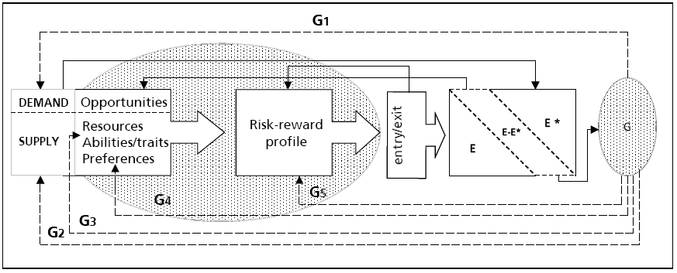

The arrows with the notations G1,G2,….,G5 note all the place in the decision framework where the government can influence the final decision.

Factors that influence the demand and supply side of entrepreneurs are discussed. The final number of entrepreneurs is also influenced by policies enhanced by different government. The policy framework discussed in this paper shows us this stage in the decision process.

A distinction is made between the supply side and the demand side of entrepreneurship. The supply side consist of the labor market perspectives. Bad perspectives on this labor market will lead to a big number of people who want to become an entrepreneur. The supply side of entrepreneurs is mainly influenced by demographic and personal characteristics.

The demand side of entrepreneurship consist of the market perspectives as being an entrepreneur. This demand side consist of the opportunities that lie on the market. Big markets with a lot of potential for new products will attract more entrepreneurs. The demand side is heavenly influenced by technological and government factors. These factors could make new products or new entries more easy or harder.

The final choice whether or not to become an entrepreneur is based on macro(environmental) and micro(individual) factors. The OECD Economic Outlook(2000) argues that this occupational choice depends on skills and conditions. Skills consist out of external factors; access to resources and finance, taxation and social security. Conditions are the personal characteristics of the individual; ability, preferences and values.

The occupational choice is to compare the opportunities and personal capabilities. The possible economic and non-economic rewards have to be compared. A personal risk-reward profile combines these opportunities and capabilities and leads to an exit or entry as an entrepreneur.

The next step in the framework is to compare the actual amount of entrepreneurs with the optimal amount of entrepreneurs. This lack or surplus of entrepreneurs leads to the actual exit or entry of entrepreneurs. This part in the framework is influenced by government intervention. The government can apply policies in order to control the actual amount of entrepreneurs.

Importance of this paper in the literature review:

This paper gives a total framework about how people come towards the choice to become an entrepreneur. The reasons for entrepreneurship are divided into a supply and demand side. The opportunities and capabilities of the entrepreneur are combined with his risk profile and the actual amount of entrepreneurs in the market. Finally the government intervention is taken into account and clearly has an effect on the final decision of the entrepreneur. The government could influence the supply side, demand side and the risk profile.

3.3 Hessels, Gelderen and Thurik, 2008

A review of Hessels, Gelderen and Thurik (2008) is given in order to explain the several motives for people to become self-employed.

The paper investigates whether various start-up motivations and a country’s level of social security can explain the prevalence of entrepreneurial aspirations.

Several studies show a positive relation between entrepreneurship and economic performance. Entrepreneurship drives innovation, employment and economic growth.

Entrepreneurs start a business due to individual motivations. These motivations finally have an effect on the economy as a whole. The knowledge of personal motivations could help policy makers to come up with the right policies to foster entrepreneurship.

The paper furthermore tries to give an answer to the question how social security affects entrepreneurship.

Three different types of studies according to entrepreneurship motives are recognized.
- Motives are divided into two categories. Pull and push motives, which are sometimes used as replacements for opportunity and necessity entrepreneurship. Autonomy, status and income are seen as pull motives. The search for these factors drives people towards self-employment. Unemployment is mentioned as a push factor. High levels of unemployment drives people towards becoming self-employed. (This relationship is discussed in detail later: Thurik, Carre, Stel and Audretsch (2008))
- Cost benefit studies. Studies link the material and immaterial risks and gains to explain the motives to start a business. The expected value of all these factors combined decides whether or not people become self-employed.
- The last type of studies on the motives for entrepreneurship focuses on the psychology of entrepreneurs. Fundamental factors in this studies are the need for power and achievement.

Different studies link the initial motives with the business aspirations. Entrepreneurs who started a business in order to gain financial rewards and independence stand positive towards ambitions to grow.
Entrepreneurs who started a business with the motives to be in control and create well-being for the employers stand negative towards ambitions to grow.

The study also focuses on the role of social security on the entrepreneurial aspirations, using data from the GEM is used for the year 2005 to do a cross-country analysis.

An empirical study is done using data from the GEM. Entrepreneurial aspirations are taken as dependent variables. Entrepreneurial motivations are taken as independent variables. The motives to become an entrepreneur are divided in 3 categories. The necessity motive, the independence motive and the search for economic welfare.
The study clearly shows that these 3 different types of motives don’t catch all possible motives to become an entrepreneur.
The study shows that different motives to start a business finally lead to different aspirations within the business. People who are looking for financial gains have the incentive to look for job growth and export orientation to achieve their personal goals.
People who are looking for independence do not have a strong focus on growth. Their business does not have to grow to for fill their need for independence.
Finally the study concludes that high levels of social security have a negative impact on the entrepreneurship in general and a decline of ambitious entrepreneurs who look for job growth and innovation.

Importance of this paper in the literature review:

This paper provides a background with different divisions in motives for entrepreneurship. It states both the push and pull motives; Cost benefit studies and the psychology of the entrepreneur are mentioned as additional and/or alternative approaches.
The study gives a relationship between motives and aspirations.
High-levels of social security have a negative impact on the entrepreneurial activity. The motivation to become an entrepreneurs is clearly weakened due to an existing social security system.

3.4 Thurik, Carree, Stel and Audretsch, 2008

Literature on the relationship between unemployment shows the refugee effect. (Evans et all 1990; Blanchflower et al. 1994). Entrepreneurship activity increases when there is high unemployment. The opportunity costs of starting a business are decreased. People don’t have to give up their job in order to start a business. This refugee effect is a push factor.
Thurik, Carre, Stel and Audretsch (2008) suggest, in line with earlier research, that there is also a contradictory effect. Lower rates of human capital, lower personal wealth and a stagnating economy could influence the entrepreneurial activity in a negative way. Market factors are an important for the decision to become an entrepreneur. This are pull factors. Evidence for both relations is found. It is likely that these two effects work at the same time. In that case there are push and pull factors working at the same time.

Thurik, Caree, Stel and Audretsch (2008) show a negative effect of entrepreneurial activity on the unemployment level. This is caused by the overall increasing economic performance (Stel, van et al. 2005) and the hiring of employees by new firms (Pfeiffer et al. 2000). This is called the entrepreneurial effect.

Thurik, Carree, Stel and Audretsch (2008) finds both a positive and negative relation between the unemployment level and self-employment. The effect of self-employment on unemployment and the effect in the opposite way clearly work at the same time.
Both effects act in long time lags. Unemployment and self-employment levels don’t adjust directly.
The refugee effect according is quite small in comparison to the entrepreneurial effect. The effect of self-employment rates on the unemployment level is the dominant one. In general high entrepreneurial activity would lead to lower unemployment rates.

Importance of this paper in the literature review:

Evidence is found on the existence of both the entrepreneurial and the refugee effect. This paper is the first one that shows that both the effects exactly happen at the same time. This study is in line with earlier research on both the effects. The value of this paper is that it links the two effects. This study provides us with the knowledge that pull and push factors are active at the same time.

4 Analytical Review

The literature review provides us with different research towards the reasons to become an entrepreneur. Some studies provide us with economic reasons only (Thurik et. al 2008) where others give us psychological factors. (Brockhaus & Horwitz 1986).
These studies support the idea that different factors from different fields of study are acting at the same time. Economic, psychology and sociological factors are important.

How is this related with our initial division between necessity and opportunity entrepreneurship?

Necessity entrepreneurships is clearly driven by economic factors. There is a need to become an entrepreneur. The future sights or current financial rewards are not sufficient. Thurik (2008) studies the relation between unemployment and the entrepreneurial activity. The refugee effect described in the study could be seen as necessity entrepreneurship.

For opportunity entrepreneurship it is harder to state which type of motivations are involved. If the narrow definition is taken where opportunity entrepreneurship involves the market opportunities, it is clearly driven by economic factors alone. In that case all psychology and sociological factors that could drive entrepreneurship are not caught in the model.
In this case where both opportunity and necessity entrepreneurship are purely economic based, there is an overlap between the two concepts. Thurik (2008) describes the refugee and entrepreneurial effect which act at the same time.
The broader definition of opportunity entrepreneurship includes all possible benefits that can be found when becoming an entrepreneur compared to the initial situation. In that case factors like status, authority, autonomy and self-realization could be part of the concept of opportunity entrepreneurship. Not only chasing a unique business opportunity is taken into account. Someone sees the opportunity to realize more status, authority or autonomy when he becomes an entrepreneur.

As discussed in the literature part of this study, there is a big difference between the narrow and broad definition of opportunity and necessity entrepreneurship. The introduction of the definition of pull and push factors as replacements for opportunity and necessity entrepreneurship is the source of this difference.

Pull factors could be compared with the broader definition of opportunity entrepreneurship. Every possible positive effect of becoming an entrepreneur could be defined as a pull factor, both economic and psychological factors. Not only the existence of a unique business opportunity is a reason for entrepreneurship.

Verheul et al. (2002) provide us with different division of motives. The motives are divided in a demand and supply side of entrepreneurship. The demand side takes the market perspectives into account. The supply side of entrepreneurship consists out of the labor market perspectives. Like the concept of necessity and opportunity entrepreneurship this division seems purely based on economic motives.
The concept however takes into account the existence of a risk profile. The possible risks, benefits and losses are compared with the help of the risk profile. This risk profile could decide whether demand or supply side motives are most important in the decision to become an entrepreneur. Someone with high acceptance of risk is willing to become an entrepreneur if there is just a small chance for higher financial rewards.
This study also provides us with the idea that two types of motivations are active at the same time. The personal risk profile finally decides which factor is dominant.

This review leaves us with the idea that a division in necessity and opportunity entrepreneurship is not sufficient. There is an overlap between the two concepts and, according to the definition, a lot of factors are not included in the model.

The discussion part is used to develop some remarks on the concepts of opportunity and necessity entrepreneurship.
The discussion part is divided in four different parts:

- Definition problem
- Overlap between the two concepts
- Environmental characteristics and necessarily facilities
- Valuing problems

5 Discussion

5.1 Definition problem

The concepts of opportunity and necessity entrepreneurship are often replaced by pull and push factors. Pull factors are the factors the attract people towards a new situation. Push factors are the factors that push people away from their current situation. Unpleasant factors in their current situation as an employer could force people towards a life as an entrepreneur.
The GEM defines opportunity entrepreneurship as the existence of a unique business opportunity. This business opportunity is the driver for entrepreneurship. This is mainly an economic reason.
Factors that are attached to entrepreneurship; autonomy, independence and self-realization are not taken into account.
The GEM uses “necessity entrepreneurship” as the best possible option available. This suggest that people who are a necessity entrepreneur were not planning or don’t want to be an entrepreneur. Just being the best available option suggests that they are looking for a better situation.
Stating necessity and opportunity entrepreneurship as just chasing a unique business opportunity or the best option available, is not sufficient to capture all reasons for entrepreneurship in this simple model. Push factors have to be characterized by personal or external factor that often have negative connotations. Pull factors have to be seen as all positive factors that could attract people towards a life as an entrepreneur. (Kirkwood 2009; Schjoedt and Shaver 2007). Job (dis)statifaction, autonomy and independence are also important factors that drive entrepreneurship.
In order to make the concept of opportunity and necessity entrepreneurship a decent one to apply policies it is necessary to change the concept. A change to a pull-push motivation concept which captures all factors that drive entrepreneurship will be more exhaustive.
In this case it is important to see that business ventures that are driven by push factors are in general less successful than the ones driven by pull factors (Amit and Muller 1995). In order to increase the entrepreneurial activity in a country there is no need to strengthen the push factors. People who start a business due to dissatisfaction in their current job or possible unemployment or likely to be unsuccessful and will not drive economic growth economic growth.

5.2 Overlap between the two concepts

The existence of the refugee and the entrepreneurial effect at the same time already supported the idea of mixed motivations or the overlap of the two concepts. People are not always a complete opportunity entrepreneur, only driven by the unique business opportunities on the market, or a complete necessity entrepreneur. (Block and Sandner 2009 ;Verheul et al. 2010)
The mixed motivations of an entrepreneur consist out of pull and push motives. The pull motives are seen as the positive factors faced with as an entrepreneur. Not only the possible financial rewards but also autonomy and independence. The push factors are mainly seen as unemployment or bad future sights in their current position. Studies show also family pressure and autonomy as push factors (Giacomin et al. 2007). Where autonomy is explained as not wanting to be bossed around.
Verheul et. al (2010) had a 12 % share of entrepreneurs with mixed motives, where in southern Europe this share is 16 %. Figure 2 shows a table with the shares of people with mixed motives. The counties are categorized according to their institutional system.
Figure 2, Categorization of national institutional systems
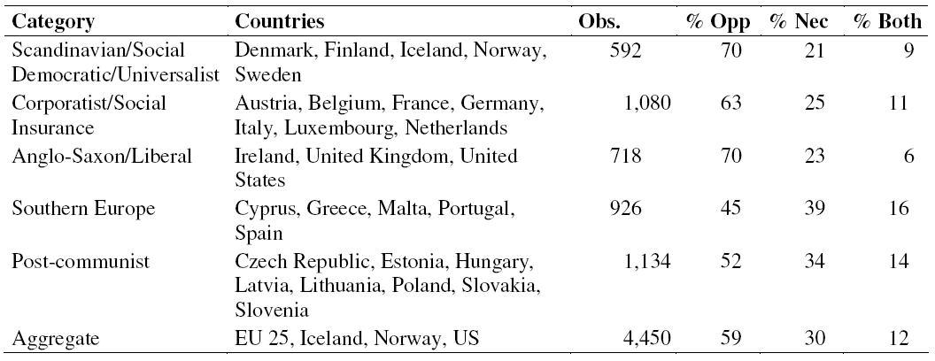
Source: Verheul et al. (2010)
Figure 3 shows the three motivation types and “never considered”. Especially the variables where an e and f are placed behind are important for this paper. These variables show a significant difference between opportunity and mixed motives and necessity and mixed motives. People who start a business with mixed motives have different characteristics and motives than the people who are primarily opportunity or necessity entrepreneur.
Figure 3, Average of the variables for the three motivation types and “never considered”
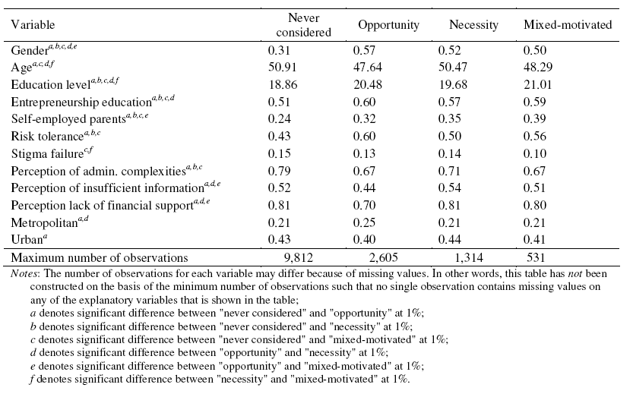
Source: Verheul et al (2010)
The mixed motivation group is clearly different form opportunity and necessity entrepreneurs. They show different characteristics and different motivations. The concepts of necessity and opportunity entrepreneurship is not sufficient to explain the start-ups from people with mixed motivations.
There is also a counter argument for the division in 3 different sectors. If the model is used for policies making only a model with only the necessity and opportunity entrepreneurs could be sufficient. As long as the policy makers focus on both groups the will also adapt policies that favor the entrepreneurs with mixed motives.

5.3 Environmental Characteristics and necessarily facilities

Thornton (1999) distinguishes the existing literature on entrepreneurship between the supply and demand school. Where the supply side focuses on the individual characteristics of the entrepreneurs, the demand side focuses on the push and pull factors of the market.

Thornton (1999) states that the literature at that time was always focused on different subsectors of entrepreneurship. Thornton (1999) supports studies that investigate entrepreneurship as a whole.
Using sociological frameworks, the individual, organizational, market, and environmental characteristics can be investigated. These characteristics give us an explanation how, why and where new firms are created.
This study states 4 different sectors which are important for entrepreneurs. Instead of having 2 sectors with internal (individual) and external factors there are 4. The organizational, market and environmental factors give a total overview of the external factors that drive entrepreneurship motivation. A lot of different factors play a role in the formation of the environment of the entrepreneur. To divide this into 3 sectors makes it more easy to compare factors that shape the environment.
The effect of venture capitalists and acquisition markets is discussed. Venture capitalists are main drivers for entrepreneurship. They supply the financing of entrepreneurs and make business formations possible. These venture capitalists also provide a first stage of selection. Business ideas with bad future sights will not get any financing.
Acquisition markets and IPO’s (Initial public stock offering) are the main mechanism for entrepreneurs and venture capitalists to turn their ideas into liquidity.
The existence of venture capitalists and acquisition markets are important for creating entrepreneurs, they facilitate new start-ups.
The psychological characteristics and the existence of acquisition markets are addition to the original division of necessity and opportunity entrepreneurship. The choices of becoming an entrepreneur is not only depending on the opportunities or needs to become self-employed. If there are no institutions to support your idea you are stuck, even if you come up with the best business idea possible.
The characteristics of the (future) entrepreneur limit the option of becoming an entrepreneur. With no knowledge or no willing to take risk it is impossible to become an entrepreneur.
This discussion supports the idea that the initial concept has to add a “possibility” feature. The concept is useless if only motivations are taken into account but necessarily facilities are not present.

5.4 Valuing problem

Verheul et al. (2002) provided us with the introduction of a risk profile. In stage of the determination process to become an entrepreneur, people value different factors and risks. It could seem obvious that people are willing to lose some security to get high financial rewards. However someone who values security more than financial rewards could decide to stay active as an employee.
The initial concept of necessity and opportunity entrepreneurship doesn’t include a weighing factor. As long as potential entrepreneurs are not willing to lose the characteristics that are present when working as an employee they will not become an entrepreneur. Even if they see opportunities in the market and all necessary facilities are present. The introduction of a personal risk profile will make it possible to weigh different factors and opportunities which are taken into account when making the decision whether or not to become an entrepreneur.
The consequences of a failing business could influence the future of someone’s future. The loss of financial rewards but also loss of self confidence and other emotional factors could influence his future. (Brockhaus 1980)
Verheul et al. (2002) introduced the risk profile to make the decision depending on the factors introduced in the demand and supply side. Personal characteristics, demographic factors and financial rewards are taken into account. The model compares all these factors to come to final decision. An introduction of such a risk-profile to the initial concept of necessity and opportunity entrepreneurship will make it more complete. Comparing pull and push actors with a risk or preferences profile makes it possible to see which factors are finally most important for the entrepreneurship decision.
If governments try to apply policies for certain groups of potential entrepreneurs this risk or preferences profile will be a decent addition to the model. The risk profile tells them which factors are most important in this group and if they are willing to lose some common factors when being an employee. The risk profile makes it possible to apply some more specific policies.
Education could change the perception and desirability of someone to become an entrepreneur. Knowing what entrepreneurship is about and knowing about the possible risks and opportunities increases the desirability to become an entrepreneur. (Peterman & Kennedy 2003)
Instead of creating facilities and opportunities for people to motivate them to become an entrepreneur, it is also possible to change the risk and preferences profile.
Douglas & Shepherd (2000) see the decision process as a utility maximizing process. Taking into account all possible factors that given a negative or positive utility and their combined expected value. If the expected value for their entrepreneurial option is higher than for their best employment option people will become an entrepreneur. This process takes into account the personal preferences and risks and both pull and push factors. Someone with a low risk taking propensity will lose a lot of utility if job security is lost by becoming an entrepreneur.
The Douglas and Shepherd study (2000) is very complex. It takes into account all economic, social and psychological factors and combines this with personal preferences and risks and statistic possibilities on some occurrences. This study has however one big shortcoming, it is not very suitable for policy making. There is no separation is different groups of motivations, which makes it hard to indentify different motivations and to create policies for them.

6 Conclusion

The GEM introduced the concept of opportunity and necessity entrepreneurship in their 2001 Global Report. The idea of this paper is to investigate the validation of these concepts with the help of a literature study.

The study question answered in the conclusion is: “: “Are the concepts of necessity and opportunity entrepreneurship sufficient to explain all motivations to become self-employed?”

The four papers in the literature review and the analytical review part of these papers gave us already the clue that these concepts as defined by the GEM are not sufficient to explain all motivations to drive entrepreneurship.
The discussion part leaves us with the four main missing points in the initial concept of opportunity and necessity entrepreneurship. The definition, overlap between the concepts, environmental characteristics and facilities and finally the valuing problem are the missing parts in the initial concept.
The questions formulated by the GEM to come to necessity and opportunity entrepreneurship are not sufficient. Verheul et al. (2010) showed us that also people with mixed motives have a share. This share is a combination of opportunity and necessity entrepreneurship. The two concepts are however a simple and efficient way to make a distinction in two reasons for entrepreneurship. Chasing a unique business opportunity or just the best option available are not the only factors that are important in this decision. A distinction between pull and push factors is more relevant. Push factors are the factors that drive people away from their current situation, mainly unpleasant factors. Pull factors attract people towards a life as an entrepreneur. These are mainly positive factors that can be obtained by becoming an entrepreneur.

The concepts of pull and push factors show an overlap. Thurik (2008) explains the refugee and entrepreneurial effect that happen at the same time. Another Thurik (2010) study describes the existence of a group of entrepreneurs who decided to become an entrepreneur due to mixed motives, both pull and push. These studies show that a concept with two separated groups of entrepreneurial motivations is not sufficient. There exists an overlap between the concepts.

To become an entrepreneur some facilities are necessary. The market has to support entrepreneurs with for example access to capital. Acquisition markets and venture capitalists facilitate such access. Without acquisition markets and venture capitalist it is virtually impossible to start a business, even if someone comes up with the best business idea ever. The characteristics of the entrepreneur also limit options available. The lack of knowledge of willingness to take risk limits the changes and opportunities of an entrepreneur.
An introduction of a “possibility test” to the initial concept could test if all necessary facilities are present to support entrepreneurs: acquisition markets, venture capitalist and knowledge.

Every possible future entrepreneur has a certain profile, everybody has different preferences. These preferences make that some people are more willing to take some risk or willing to lose some security in their current situation as an employee.
Some people value their security in their current situation most. This personal profile is very important in the decision towards becoming an entrepreneur. To introduce a personal risk/preferences profile in the concepts of pull and push factors will help policy makers to understand the decision process better. Policy makers could adapt policies that change or create pull and push factors and the personal profile.
Education and providing knowledge and experience concerning entrepreneurship could help to change someone’s personal profile. It could make policies regarding opportunities on the market more effective.

Figure 4 shows the concept that I propose after my study on reasons for entrepreneurship. The concept consists out of pull and push factors with their overlap. The introduction of a possibility test and the personal preference/risk profile help to describe the context where entrepreneurship takes place.

Figure 4
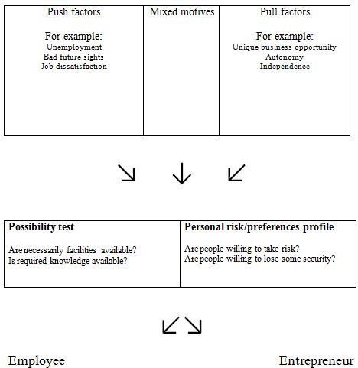

The process of the decision to become an entrepreneur is divided in 2 phases. The final decision of this concept is whether to become an entrepreneur or to stay active as an employer.
The first part of the concept is about the motivations. Divided in 3 different categories; pull factors, push factors and mixed motives. Pull and push factors are defined as the broad definition of opportunity and necessity entrepreneurship. Which includes all positive and negative factors related with entrepreneurship and the initial situation as an employee.
The factors in the first part are combined using a utility function. The weights and values given to the factors depend on the personal preference profile which is introduced in the second part of the scheme. Attitudes towards risk and security create this personal profile and define the value of the factors in the utility function.
The second part of the scheme also has a possibility test. This test introduces the existence of necessary facilities to the decision scheme. The accessibility of capital and education are needed to start a (successful) business. To combine all factors in a utility model and to check if the necessary facilities are present it is possible to make the decision whether or not to become an entrepreneur. The understanding of this decision scheme is useful when creating the right circumstances to support entrepreneurship.

7 References

Amit, R. and Muller, E. (1995), Push and pull entrepreneurship (two types based on motivation) , Journal of Small Business and Entrepreneurship, Vol. 12 No. 4, pp. 64-80.
Block, J.H. and P. Sandner, 2009, Necessity and opportunity entrepreneurs and their duration in self-employment: evidence from German micro data, Journal of Industry, Competition and Trade, forthcoming.
Brockhaus, Robert H., 1980, Risk taking propensity of entrepreneurs, The academy of management journal, Vol 23, No. 3 pp 509-520
Brockhaus. Robert H. and Horwitz. Pamela S. 1986. The psychology of the entrepreneur. The art and science of entrepreneurship (1986) 25-48, in Kreuger. Norris F. Entrepreneurship: critical perspectives on business and management, Volume 2. Routledge London.
Churchill, N. C, 1992, "Research issues in entrepreneurship", in D.L. Sexton, J. Kasarda (Eds),PWS Kent, Boston, .
Douglas, E. J., and Shepherd, D.A. (2000) Entrepreneurship as a utility maximizing response. Journal of Business Venturing 15(3): 231-252.
Giacomin, O., Guyot, J-L., Janssen, F. and O. Lohest, 2007, Novice creators: personal identity and push pull dynamics, CRECIS Working Paper 07/2007, Center for Research in Change, Innovation and Strategy, Louvain School of Management, downloadable through www.crecis.be.
Grilo, I. and Thurik, R., 2005, Entrepreneurial Engagement levels in the Europian Union, International Journal of entrepreneurship education 3 (2), 143-168
Hessels. J., Gelderen. M. van, Thurik, R.,2008, Entrepreneurial aspirations, motivations and drivers, Small Business Economics 31:323-339
Hessels. J., Gelderen. M. van, Thurik. R., 2008, Drivers of entrepreneurial aspirations at the country level: the role of start-up motivations and social security. International Entrepreneurship Management Journal. 4:401-417
Kirkwood, Jodyanne. (2009), Motivational factors in a push-pull theory on entrepreneurship, Gender in Management, Vol. 24, Issue 25, pp346-364
Knight, Frank H., 1921, Risk Uncertainty and Profit, New York: Houghton Mifflin
Kolvereid. L., 1996, Organizational employment Versus Self-Employment: reasons for career choice intentions”, Entrepreneurship Theory and practice, 20(3), 23-31
OECD, 2000, OECD Employment Outlook, OECD, Paris
Peterman, Nicole E., Kennedy, Jessica. Enterprise education: influencing students’ perceptions of entrepreneurship. Entrepreneurship: Theory and practice, Vol. 28, Issue 2, p129-144
Pfeiffer. F. and Reize. F., 2000, Business Start-ups by the Unemployed – an Econometric analysis based on firm data. Labour Economics 7(5) 629-663
Reynolds, Paul D., Camp, Michael S., Bygrave, William D., Autio, Erkko., Hay, Michael., Global Entrepreneurship monitor summary report 2001
Schjoedt, L. and Shaver, K.G. (2007), Deciding on an entrepreneurial career: a test of the pull and push hypotheses using the panel study of entrepreneurial dynamics data, Entrepreneurship Theory & Practice, Vol. 31 No. 5, pp. 733-52.
Shane, S., Locke, E., & Collins, C. J. ,2003. Entrepreneurial motivation. Human Resource Management Review, 13(2), 257–280
Stel. A. van, Carree. M., Thurik. R., 2005, The effect of Entrepreneurial Activity on the national economic growth. Small Business Economics 24(3) 311-321
Thornton, Patricia H. ,1999, The sociology of entrepreneurship. Annual Reviews Sociology 25:19-46
Thurik, A. R., Carree, M. A., van Stel, A. J. & Audretsch, D. B. (2008). Does self-employment reduce unemployment? Journal of Business Venturing (in press).
Verheul, I., S. Wennekers, D. Audretsch and A.R. Thurik, 2002, An eclectic theory of entrepreneurship, in D.B. Audretsch, A.R. Thurik, I. Verheul and A.R.M. Wennekers (eds.) Entrepreneurship: Determinants and Policy in a European-US Comparison, Boston/ Dordrecht: Kluwer Academic Publishers.
Verheul, Ingrid., Thurik, Roy., Hessels, Jolanda., Zwan, Peter van der. Factors influencing the entrepreneurial engagement of opportunity and necessity entrepreneurs. 2010

