The significance of a Max Havelaar label on a Tony’s Chocolonely chocolate bar
ERASMUS UNIVERSITY ROTTERDAM
Erasmus School of Economics
Department of Economics
Supervisor: Prof.dr Ph.H.B.F. Franses
Name: Eline Kim ‘t Hart
Exam number: 314024
E-mail address: kimhart89@gmail.com

Abstract

Tony’s Factory strives to employ the most efficient possible supply chain in order to give the relevant farmer the greatest possible proportion of the fair trade premium. However, to achieve this, Tony’s Factory may have to end its liaison with Max Havelaar. This implies that Tony’s Chocolonely would not have the Max Havelaar label anymore on its package. This research paper will examine what implications this would have on the consumer’s purchasing behavior. A questionnaire and an experiment will be conducted to investigate the consumer’s stated and behavioral preferences. The research reveals that the Max Havelaar label on a chocolate bar does indeed have a significant influence on the consumer’s consumption behavior. It can be concluded that Tony’s Factory should not underestimate the added value of the Max Havelaar label on its packaging.

Tabel of Contents

- Introduction ……………………………………………………………………………………………………………..4
1.1 Background Information ………………………………………………………………………..4
  - Short Overview …………………...…………………………………………………………………..4
- Research Description………………………………………………………………………………………………..4
2.1. Problem Statement…………………………………………………………………………………4
2.2. Research Question……………………………………………………………………………….....5
2.3. Purpose of Research Question………………………………………………………………..5
- Related Literature…………………………………………………………………………………………………….5
- Research Methodology...................................................................................................................................6
4.1. Experiment……………………………………………………………………………………………...6
4.2. Questionnaire………………………………………………………………………………………....7
4.3. Data Collection………………………………………………………………………………………..8
- Representativeness& Validity………………………………………………...………………………………10
5.1. Representativeness……………………………………………………………………………....10
5.2. Validity……………………………………………………………………………………………….…11
5.3. Reliability……………………………………………………………………………………………...11
- Data Analysis ………………………………………………………………………………………………………….12
6.1. Questionnaire Results…..………………………………………………………………………12
6.2. Experiment Results……………………….………………………………………………………13
- Conclusion…………………………………………………………………………………………………………........16
- Management Implications ……………………………………………………………………………………...17
- Sources ……………………………………………………………………………….………………………………….18
- Appendix………………………………………………………………………………………………………………...19

1. Introduction
1.1 Background Information
Tony’s Factory is a commercial company with an ambitious goal: to produce fair chocolate. Its aim is to evoke critical questions, find answers and at the same time pressure the industry to change. In 2008, Tony‘s Factory initiated a research project ‘Tony in Africa’ to investigate an alternative supply chain for the cacao industry. The current system, segregation, focuses on the traceability of cacao from farmer to end-product. As it is extremely difficult to trace the cacao beans, it is a very expensive process. Therefore, the foremost disadvantage of the segregation system is that too much money gets lost within the supply chain.
The aim of ‘Tony’s in Africa’ is to develop a more efficient supply chain so that more money could be invested in farmer co-operations. The research project uncovered the ‘Book and Claim supply chain’, a technique that partially gives up the segregation of the supply chain so that more money is available for the farmer. However, this has as consequence that the origin of the cacao is to some extent unknown. Therefore, there is a possibility that the cacao in the chocolate bar originates from a normal plantation instead of a Fairtrade certified plantation. However, the extra money paid for the chocolate bar will go directly to the Fairtrade certified farmer. This Book & Claim bonus is intended for strengthening the farmer co-operations so that these eventually become “bankable”.

1.2. Short Overview
This research paper will first discuss the current problem Tony’s Factory is facing and state the research question that will be studied. It will also study related literature to the customer’s view of Fairtrade products and the importance of labeling organizations. Then, it will investigate the research question by executing an experiment and interviewing consumers in diverse distribution channels and in different cities. Thereafter, the relevant results will be interpreted and discussed. As conclusion, several recommendations will be given to Tony’s Factory and the Fairtrade industry in general.

2. Research Description
2.1 Problem Statement
The main problem Tony’s Factory is currently facing is the reticent behavior of Max Havelaar, the Fairtrade labeling organization. Max Havelaar does not want Tony’s Factory to initiate a Book & Claim pilot as it does not fully support this supply chain method. Max Havelaar, in accordance with Flo, is much more in favor of the Mass Balance technique. Mass Balance is another supply chain method in which a certain percentage of the product is traceable to the Fairtrade certified farmer and the rest is considered to be “normal chocolate”.

Tony’s Factory is currently facing a dilemma: Should it continue with Max Havelaar and switch to a Mass Balance technique, a supply chain system it cannot fully comply with? Or should Tony’s Factory split with Max Havelaar and introduce the Book & Claim pilot, a supply chain system it fully supports?
2.2 Research Question
If Tony’s Factory decides to end its liaison with Max Havelaar, it will most likely affect the relationship with investors, suppliers, retailers and consumers. This research will focus on the latter stakeholder and investigate the importance of a Max Havelaar label on a Fairtrade product. The research question is formulated as follows:

How important is the Max Havelaar label on a Tony’s Chocolonely bar for consumption decisions?

2.3. Purpose of Research Question
The main purpose of this research is to provide insight into the possible reaction of consumers, if Tony’s Factory decides to split with labeling organization Max Havelaar. The results of this study will give Tony’s Factory an enhanced view of the added value of the Max Havelaar label on their products. Therefore, Tony’s Factory will be able to make a better-informed decision concerning their liaison with Max Havelaar.

Furthermore, the results of this study could be useful for other labeling organizations and Fairtrade companies. The research will give a general idea of the importance of a recognized label on a product.

3. Related Literature
Hamers et al., (2010) researched the consumer profile of the Fairtrade industry. Fairtrade products mainly attract the elderly age group: pensioned households have a spending-share of 32%. Furthermore, in the big cities and their suburbs there is an over-representation for Fairtrade products (54,5% of the total spending share). Finally, higher social classes tend to have a higher spending-share of the Fairtrade products (57.5%).

Verhoef and van Doorn (2009) have studied the consumer’s attitude towards Fairtrade products in the Netherlands. They found that the average Dutch consumer is not prepared to pay significantly more for a product with a Fairtrade claim. Even though consumers perceive Fairtrade products to be healthier and more socially-correct, they are convinced that the quality of these products is lower than products without Fairtrade claim. Verhoef and van Doorn presume that the low willingness to pay more for sustainable food can be a feasible explanation for the low market share of Fairtrade products in the food industry.

Schreuder Goedheijt (2010) researched how the consumer’s perception of the Fairtrade industry would be affected by the change from a segregation system to a ‘ book and claim’ system. The consumer study found that the choice of system and the uncertainty about the relative effectiveness have no significant effect on the brand valuation of Fairtrade. The choice of system also does not significantly affect the extent to which consumers perceive Fairtrade as a social responsible brand. However, uncertainty about the effectiveness of the relative system does have a significant negative influence on the social responsible image.

The consumer study also found that when people buy Fairtrade products, they attach much more value to the knowledge that farmers receive a fair price than to the knowledge about the origin of their cacao (4.8 compared to 2.6 on a scale of 7). CREM concluded that the choice of system, segregation or book and claim, should therefore not lead to major problems concerning brand valuation and social responsible image. However, the researchers did notify that the introduction of a book and claim system could lead to uncertainty about the Fairtrade industry which in turn could lead to a deteriorated social responsible image.

4. Research Methodology
In order to analyze the research question, the importance of the Max Havelaar label on a Tony’s Chocolonely bar for consumption decisions, a descriptive research method has been chosen. In particular, a cross-sectional research design has been carried out. To obtain the information needed, a questionnaire and an experiment have been conducted. Both the questionnaire and the experiment have been executed in three different Dutch cities and three diverse distribution channels.

4.1. Experiment
In order to gain a valid impression of the consumer’s behavior towards the Max Havelaar label, it seems most efficient to conduct an experiment. Experimental research is considered to be the most scientifically valid research; it has the advantage of being able to isolate extraneous factors and relate the observed effects to the variations in the treatments. For these reasons it is preferable to perform experimental research. If we would solely conduct a questionnaire, people might be inclined to give ‘socially desirable’ answers towards questions concerning Fairtrade products. The results of the questionnaire would not represent the reality and thus would be considered invalid.

The test suspects cannot suspect that the experiment concerns the significance of the Max Havelaar label. Therefore, test four aspects of a chocolate bar will be tested: brand (Tony Chocolonely or Cote d’Or) taste (milk or pure), price (high or low) and label (yes or no). In total there are 16 choices (see Appendix 3.1). Test subjects will have to choose 8 times between two randomly chosen chocolate-tablets, shown on ‘real-life photos’ (see Appendix 3.2). The test- subjects will be able to see the brand, the label (or no label), and the flavor of the chocolate bar on the wrapping. The price-tag will be attached to the picture. Each time the test subject picks his preferable chocolate bar from the two bars offered, the experimenter will note which chocolate bar with which specific characteristics has been chosen. Using this data, it can be evaluated if the Max Havelaar label plays a significant role in consumer behavior.

4.2. Questionnaire
In order to gain further insight into the knowledge and consumption behavior of consumers, a questionnaire will be conducted. The survey research will be done after the experimental research so that the experiment remains as neutral as possible. About two- thirds of the questionnaire tests the knowledge of the test-subject on the research topic. Thus, these questions are not exposed to social-desirable answers. Although the questionnaire further consists of consumer behavioral questions, sensitive information is not being asked. However, it is important to be aware for bias; the test-subjects should not suspect that the research is being done for Tony Chocolonely. In this way it is possible to curtail the bias in the answers.

4.2.1 Guidelines for Questionnaire
The following three guidelines are used to develop the questionnaire: i. It should convert the required information in a set of answerable questions. ii. It should stimulate the respondent to collaborate. iii. It should minimize response errors (Malhotra and Birks, 2005).

In order to increase the willingness to respond, the questionnaire is narrowed down to five relatively short questions. The effort of providing information is low seeing as the questionnaire is limited to closed and aided questions. By solely giving the most important alternatives for the multiple choice questions, the range of answers is manageable. To prevent non-response and missing answers, respondents can fill in a missing alternative for several questions. Further, respondents will be informed that the survey is meant for research purposes only.

4.2.2. Purpose of Questions
In this section, the purpose of the questions in the questionnaire will be discussed. The full questionnaire can be found in Appendix 4.

1. How well do you know the following brands?
This question discloses valuable information for Tony’s Factory as it gives better insight into the strength of their brand recognition.
2. Do you know which brands have a certification mark, and if so, which certification mark?
By asking this question, the knowledge of the consumer concerning the Fairtrade certification mark can be tested. Further, this question builds on the experiment. It provides more information of how important the Fairtrade label is for the consumer.
3. What does the Max Havelaar label purport, according to you?
This is one of the key questions of the study. It gives an idea of what the Max Havelaar label signals to the consumers and how the consumers perceive it.
4. How often do you buy Tony’s Chocolonely?
This question adds on to question 1. The actual buyers of Tony’s Chocolonely are exposed by this question and thus it verifies the target group of Tony’s Factory.
5. Why do you purchase Tony’s Chocolonely?
This question also discloses valuable information for Tony’s Factory as it reveals how the chocolate bar is positioned in the market. It furthers verifies if the marketing strategy of Tony’s Chocolonely is in line with the consumer’s preferences.

4.3 Data Collection
3.1. Chosen Cities
The experiment and questionnaire have been conducted in three notably different cities so that a wide range of Tony’s consumers can be reached.

In Groningen the aim is to reach the target group of Tony’s Chocolonely: students and yuppies. This city has been chosen for the experiment as the age-groups 20-25 and 25-45 are over-represented (relatively 15.1% and 32.5%). Further, 58.3% of the private households are a one-person household, which implies the income does not have to be shared between partner and children. Finally, the young affluent persons in Groningen are relatively high-educated as 72.26% of the students are HBO/university students. (See Chart 1)

Earlier research (Hamers et al., 2010) reveals that elderly households have a significant high spending-share of the Fairtrade products. Further, the research notes that the spending-share of Fairtrade products is overrepresented in big cities. For this reason, it would be noteworthy to execute the experiment in a relative ‘gray’ city. By doing this, the probability is higher to reach the ‘standard’ Fairtrade buyer: the well-off, pensioned, urban household. In Maastricht, 18.0% of the people are over 65 years old, which is far above the national average of 15.3%. Further, it has a relatively high ‘gray pressure ’of 28.5%. (See Chart 1)

For this research it is also interesting to target the ‘average Dutch family’: average spendable wage, average household and average accommodation. The CBS statistics (2007) confirms that Amersfoort is a typical Dutch city. The average spendable wage per person in Amersfoort is slightly above the national average (relatively €13.900 compared to €13300). Further, the average private household size of 2.28 is comparable to the national average of 2.25.Finally, the average housing-value of Amersfoort, € 229000, is only to some extent above the national average, €216000. (See Chart 1)

4.3.2. Chosen Distribution Channels
This research strives to reach three diverse types of consumer behavior: quality-conscious, price-conscious and environmentally conscious. Therefore, three different distribution channels have been chosen: Albert Heijn, Jumbo and the Wereldwinkels.

The shopper’s profile of the Albert Heijn consists primarily out of young one-person households with a relative high income. The shoppers at Albert Heijn are relatively more quality-conscious than the shoppers at the Jumbo. The customers prize the freshness, quality and cleanness of the supermarket (See Appendix 2.1b). The supermarket is positioned as relatively price disadvantageous; the customer-value for the price level and the special offers is below average. (See Appendix 2.1.a)

Jumbo’s shopper’s profile consists especially out of large households with an average income (See Appendix 2.1c). The shoppers at the Jumbo are in general more price-conscious than the shoppers at the Albert Heijn. The Jumbo can be found in the top 5 of most price-advantageous supermarkets (See Appendix 2.1b). Further, Jumbo is recognized for its large assortment of Fairtrade products. The chain has on average the most fair products on its shelves.

The Wereldwinkel (‘World Shop’) is a democratic volunteer movement that brings fair trade to the public through the sale of Fairtrade products, education and events. In the Wereldwinkels it is possible to buy Fairtrade food products, arts and crafts and cosmetics. The Werelwinkels primarily sell products with the Max Havelaar certification label. The consumers of the Wereldwinkel are generally environment and Fairtrade-conscious. These persons deliberately go to this shop to buy Fairtrade products. Therefore, these persons usually are well-informed about the essence of fair trade and Max Havelaar. For this reason, it could be interesting to include these consumers in the research.

The experiment and survey will deliberately be conducted in front of the aisle of Tony’s chocolate bars so that a majority of Tony’s consumers can be reached.

5. Representativeness & Validity
5.1 Representativeness
The population of the research is defined as the consumers in the Netherlands. On basis of question four in the questionnaire, the population is divided into two subpopulations: buyers of Tony’s Chocolonely and non-buyers of Tony’s Chocolonely. By identifying the actual buyers of Tony’s Chocolonely among the respondents, the relevance of the results is enhanced for Tony’s Factory.

Due to the focus on the consumers of Tony’s Chocolonely and the Fairtrade consumers, the respondents are not selected entirely random. Non-proportionate quota sampling is one of the techniques that have been employed for this research. It is important that two sub-groups in the field of study are well-covered: Fairtrade consumers and Tony’s Chocolonely consumers. In Groningen, the target age-group of Tony’s Chocolonely (20-35) is especially focused upon. In Maastricht, the Fairtrade customers (women over the 50) are the focal point of the research. Another sampling technique is used in Amersfoort. Here, the aim is to get an overall view of the consumer behavior of the average Dutch person. Thus, in this city the heterogeneity (diversity) sampling technique is employed. The objective is to seek a wide range of views.

As this is a small scale study and the population is very large, the difference between the sampling frame and the population is relatively high. This is due to the fact that Dutch consumers (population) coming from other cities or shopping at other distribution channels, are less likely to be part of the sample (sample frame). As we employ non-probability sampling techniques, the extent to which the sampling frame differs from the population remains unknown. However, as the sample is regarded to be sufficiently random, the difference between the sampling frame and the population is not considered to be compromising the representativeness of this sample.
5.2 Validity
Due to the execution of an experiment and a questionnaire, the content validity of the research has been met. The measurement tools used for this research reveal the specific domain of content intended to investigate. The answers of the questionnaire give an idea of what the Max Havelaar label signals to consumers. The post-evaluation of the experiment infers the importance of the Max Havelaar label for consumption decisions.
The criterion validity is realized through the different aspects of the experiment: the chocolate bars do not only differ in label, but also in price, taste and brand. Therefore, consumers do not suspect that the research primarily examines the behavior towards the Max Havelaar label. For this reason, social desirable behavior is curtailed and thus the measurement corresponds with actual behavior. The behavioral criterion is successfully taken into account to validate the measures directly (Babbie, 2007).

The measures of the research are primarily intended for Tony’s Chocolonely. Thus for the key purpose, the research recognizes the construct validity. As conclusion, the results are generalized for other chocolate brands and certification labeling organizations. Hereby, some doubt may be casted on the construct-validity of the research.

These three criteria ensure that we indeed measure what we are supposed to measure.
5.3. Reliability
As the experiment is easy to understand and simple questions have been asked, it can be assumed that when doing the research again, the same results would be obtained. Post-research, no systematic errors can be found. This makes the data reliable.

6. Data Analysis
6.1. Questionnaire Results
6.1.1 Data Analysis
The variables used in the questionnaire are of nominal and ordinal scale. For the nominal variables, cross-tables analyses are conducted with the respective histograms, to obtain descriptive statistics. The variables with an ordinal measurement scale will be treated as quantitative variables so that paired sample t-tests can be executed. As the sample size is relatively small compared to similar studies, a significance level of 0.10 will be employed for all tests.

6.1.2 Results
The questionnaire illustrates that Tony’s Chocolonely has a relatively low brand recognition compared to its main competitor Toblerone. Solely 14.8% of the test-subjects know Tony’s Chocolonely ‘well’ to ‘really well’ (see Chart 1). This percentage is more than four times as high for Toblerone (67.5%). The statistics of brand recognition are fairly comparable to the statistics of purchasing behavior. 13.9% of the people buy Tony’s Chocolonely just as often, or more than other chocolate brands. It should be noted, that 62.4% of these ‘frequent’ buyers are Wereldwinkel customers.
The target group of Tony’s Chocolonely has been confirmed by this research project: 33.8% of these buyers belong to the age-group of 20-35 (see Chart 2). The main reason why people buy Tony’s Chocolonely differs between distribution channels (see Chart 3). The purchasers of Tony’s Chocolonely in supermarkets particularly buy the product because it is 100% slave-free (32.6%) and due to its appealing packaging (26.5%). The purchasers of Tony’s Chocolonely in Wereldwinkels primarily buy the product because it is Max Havelaar certified (29.2%). This could imply that Tony’s Chocolonely is primarily associated with slave-free in the supermarkets and Tony’s Chocolonely in the wereldwinkel is associated with the Max Havelaar label.

According to Chart 4, consumers are fairly well-informed about the essence of the Max Havelaar label. 48.2% of the consumers know that the Max Havelaar label implies that the farmer receives a fair price for the cacao beans. This thought corresponds with the Max Havelaar statement on its website: “The Mark indicates that the product has been certified to give a better deal to the producers involved.” Further, 19.9% of the consumers believe that the Max Havelaar label entails that the supply chain of the cacao bean is traceable. This is remarkable information for Max Havelaar as currently they assume that more than 50% of the consumers relate Max Havelaar with the traceability of the supply chain. Due to this supposition, Max Havelaar does not want to implement the ‘Book and Claim’ pilot as it partially gives up the traceability of the supply chain.

Although the Dutch consumer is apparently well-informed about the essence of the Max Havelaar label, it is relatively unaware about which brands own this certification mark. In the supermarkets, solely 22.4% of the consumers could name one or more of the certification marks on the diverse chocolate bars. This statistic is notably higher in the Wereldwinkels: 51.9% of the consumers are aware of which certification marks belong to which chocolate bar. Chart 4 demonstrates that, in comparison to the other three brands, consumers are most aware of the Max Havelaar label on the Tony’s Chocolonely chocolate bar. This is a peculiar result, as the brand recognition of Tony’s Chocolonely is considerably lower than the other three brands.

Table 2 shows that the consumer’s awareness of the Max Havelaar label on the Tony’s Chocolonely chocolate bar has a significant, positive influence on the consumer’s purchasing behavior of Tony’s Chocolonely (sign. = 0.03). This result implies that consumers who are aware of the Max Havelaar label on Tony’s Chocolonely are more willing to buy the product. Table 3 verifies the latter statement, as it demonstrates that there is a positive, significant correlation between the awareness of the Max Havelaar label and the purchasing behavior of Tony’s Chocolonely. These findings are particularly in line with the main purchasing reason of Wereldwinkel customers. As stated earlier, 29.2% of the Wereldwinkel customers buy Tony’s Chocolonely due to its Max Havelaar label.

The relevant answers given in the questionnaire and discussed above, provide a better understanding of who the consumers of Tony’s Chocolonely are, the reasons for purchasing Tony’s Chocolonely and the significance of the Max Havelaar label on Tony’s Chocolonely.

6.2 Experiment Results
6.2.1 Data Analysis
This experiment consists of a dichotomous output (choice 1/choice 2) that is thought to be influenced by several independent variables (brand, taste, price, Max Havelaar label). As the outcome must lie between 0 and 1, it involves a non-linear relationship. A linear function would violate this condition and so different modeling assumptions are required. By applying a logit transformation, the relationship can be linearised. The underlying distribution of a logit model is the logistic distribution.
All the aspects of the chocolate bar (brand, taste, price, Max Havelaar label) have been transformed into dummy variables. Further, per test-subject, the age, gender, and place of experiment (city and distribution channel) have been noted .These factors are all also transformed into dummy-variables.

6.2.2 Hypothesis:
Based on the research question, stated in the introduction, the following hypothesis has been deduced:
H₀: The Max Havelaar label on a chocolate bar does NOT have a significant influence on the consumer’s consumption choice.
H_{a} The Max Havelaar label on a chocolate bar does have a significant influence on the consumer’s consumption choice.

6.2.3 Assumptions:
First, the assumptions of the logit regression model are tested. A goodness-of-fit test is conducted to ascertain that the observed frequency distribution corresponds with the theoretical distribution. If the chi-square goodness-of-fit test is not significant, it implies that the logit model fits the data. As the null hypothesis is accepted for all of the following tests, it can be established that there is no significant difference between the observed and expected number of positive choices. Thus, the logit model is well-fitted for the data.

Further, the observations should be independent. However, the experiment fails to meet this assumption as every case is related to seven other cases (the same person chooses eight times between two chocolate bars). Therefore the independency assumption is not valid. This could have negative consequences for the reliability and validity of the results.

6.2.4 Results:
Table 4 depicts the influence of the brand, taste, price and label of the chocolate bar on the consumer’s consumption choice. The table reveals that the price has the biggest negative impact on the choice of the consumer. This implies that price plays the most important role in deciding which chocolate bar to consume. This further implies that if the price rises, the consumer is enticed to choose the other chocolate bar. Taste is the second most important aspect in the consumer’s choice between chocolate bars. Amongst the test-subjects, there is a considerable preference for milk chocolate.

After price and taste, the Max Havelaar label has the third biggest, positive impact on the choice of the consumer. The H₀-hypothesis should be rejected: the Max Havelaar label on a chocolate bar has a significant influence on the consumer’s consumption choice. If a chocolate bar has a Max Havelaar label, the consumers are significantly more inclined to choose this chocolate bar. The brand of the chocolate bar has relatively the smallest impact on the consumer’s choice. The statistics entail that the consumer has a light preference for Cote d’Or chocolate instead of Tony’s Chocolonely.

As the experiment has been executed in different cities and diverse distribution channels, it is possible to incorporate these factors into the model (Table 5). It appears that the influence of the chocolate bar aspects (brand, taste, price, label) on the consumer’s choice do not considerably change when the place of experiment and demographic parameters are included. Table 5 further depicts that the distribution channel and city where the experiment has been executed, do not have a noteworthy influence on the outcome. The age and gender of the test subjects are also non-significant factors in the model.

In order to gain more detailed insight into the consumption behavior of the consumers, the interaction effect between the independent variables can be analysed. By multiplying the dummy-coded distribution channels, cities and age times the dummy-coded aspects of the chocolate bars, the specific contrasts can be found. For each variable, one category functions as base, with which the other categories of the variable are compared. The significant outcomes of this particular data analysis can be found in table 6 (Appendix 5.2).

Table 6 verifies earlier observations that in general the consumer prefers Cote d’Or over Tony’s Chocolonely. However, in Groningen, the consumer shows a clear preference for Tony’s Chocolonely. This outcome could be explained by the research done earlier: the target group of Tony’s Chocolonely (18-34) is over-represented in Groningen. The consumers belonging to age-group 18-34, indeed demonstrate a slight preference for the brand Tony’s Chocolonely. It should further be noted that compared to other age groups, consumers over 65 years old prefer Cote d’Or more strongly over Tony’s Chocolonely.

Table 6 further depicts that test-subjects at the Wereldwinkel incorporate the Max Havelaar label significantly more in their consumption choice than test-subjects at the Albert Heijn. Remarkable are the outcomes for the different age-categories. Youngsters between 18 and 34 give relatively less importance to the Max Havelaar label in their consumption choice. This could perhaps be explained by their low awareness of and concern in the label. On the contrary, the Max Havelaar label is significantly influential in the consumption decision of the consumers over 65 years old.

7. Conclusions
From the questionnaire and the experiment it can be deduced that the Max Havelaar label on a chocolate bar has a significant influence on the consumer’s consumption choice. Thus the H₀-hypothesis can be rejected. Especially consumers above the 65 years old show a strong preference for Max Havelaar labeled chocolate bars. This result is in accordance with the research done by Hamers et al. (2010) which suggests that Fairtrade products mainly attract the elderly age group. The experiment also demonstrates that especially Wereldwinkel customers are attracted by the Max Havelaar label on a chocolate bar. This experiment outcome is in line with the results of the questionnaire which state that Wereldwinkel customers primarily purchase Tony’s Chocolonely due to the Max Havelaar label.

Especially for Tony’s Chocolonely the Max Havelaar label appears important; 41.48% of the test-subjects are aware of the Max Havelaar label on the brand whereas only 14.8% of the test-subjects recognize the brand ‘well’ to ‘very well’. Further, the main two reasons why customers buy Tony’s Chocolonely is due to its Max Havelaar label and because it is slave-free. The questionnaire results reveal that consumers who are aware of the Max Havelaar label on Tony’s Chocolonely are more willing to buy the product. However, it should be noted that compared to other age-groups, the target age-group of Tony’s Chocolonely (18-35) gives significantly less importance to the Max Havelaar label in their consumption choice. Still, the customers at the main distribution channel of Tony’s Chocolonely, the Wereldwinkel, give significantly more importance to the Max Havelaar label compared to other distribution channels. Based on these observations, it can be concluded that the Max Havelaar label has a considerable added value for Tony’s Factory.

As a general conclusion of this research, it could be stated that certification labels perhaps have a bigger influence on the consumer’s behavior than previously thought. Consumers are not willing to pay more for a product with certification label, nor are they willing to diverge from their preferred taste. However, the certification label on a chocolate bar does appear to be, in general, more important than the brand.

8. Management Implications
Based on the survey and experiment, several extra remarks can be made. Since the brand ‘Tony’s Chocolonely’ is relatively unknown, the Max Havelaar label could provide recognition for the consumer. 48.2% of the consumers know what the Max Havelaar label is and implies. Further, chart 5 demonstrates that 12-16% of the consumers believe that the Max Havelaar label signals a good quality product and a trustworthy producer. Thus, if a consumer does not know Tony’s Chocolonely, it could be persuaded by the Max Havelaar label to buy the product.

This research concludes that the Max Havelaar label is considerably important for Tony’s Chocolonely. Tony’s Factory should not underestimate the power of the label on the product. If Tony’s Factory ends its liaison with Max Havelaar, it could have negative consequences for the sales of Tony’s Chocolonely, especially at the Wereldwinkel. Tony’s Factory could lose a substantial amount of customers, specifically consumers over 65 years old, as the endorsement and recognition of the Max Havelaar label has vanished. From a marketing/sales point of view, I would advise Tony’s Factory to retain its liaison with Max Havelaar.

9. Sources
Babbie, Earl (2007). The Practice of Social Research. Thomson

Doorn, Jenny and Verhoef, Peter ( 2009). WTP for organic, fair trade and nutrient food claims: differences between utilitarian and hedonic products. Working Document, Rijksuniversiteit Groningen.

GfK Customerscan. Retailer Data. Quarter 1, 2010. Raw Data. Friesalnd Cambina, Amersfoort

Hamers, Sabine., Mathijssen Bart., Derikx, Hans., van Oirschot, Jolanda. (2010). Fairtrade producten in de boodschappentas in 2009? (Projectnummer: 14211) Retrieved from: Nationale Commissie van Internationale Samenwerking en Duurzame Ontwikkeling. http://www.ncdo.nl/docs/uploads/48_rapport_onderzoek.pdf

Malhotra Naresh K., Birks, David F. (2005). Marketing Research: An Applied Approach. Prentice Hall, Essex, England.

Schreuder Goedheijt, Martijn. (2010). “From Segregation to Book & Claim”. Working Document, Rijksuniversiteit Groningen.

10. Appendix
1.1. CBS Statistics 2007
 | Age (%) |  |  |  |  |  | Average Household | Average Housing Value (€) | Average Spendable Wage (€) | Average HBO/WO students (%)
 | 0-20 | 20-25 | 25-45 | 45-65 | 65-  80 | >  80
Netherlands | 23.8 | 6.0 | 27.5 | 27.6 | 11.2 | 3.8 | 2.25 | 216000 | 13300 | 29.14
Groningen | 19.6 | 15.1 | 32.5 | 21.5 | 7.90 | 3.40 | 1.70 | 149000 | 12300 | 72.28
Maastricht | 19.0 | 15.9 | 26.4 | 27.6 | 13.2 | 4.7 | 1.90 | 189000 | 12400 | 64.59
Amersfoort | 26.6 | 5.4 | 31.5 | 24.7 | 8.4 | 3.4 | 2.28 | 229000 | 13900 | 53.37

2.1. GfK Customer Scan, quarter 1 2010
a. Positioning scheme of grocery stores in the Netherlands
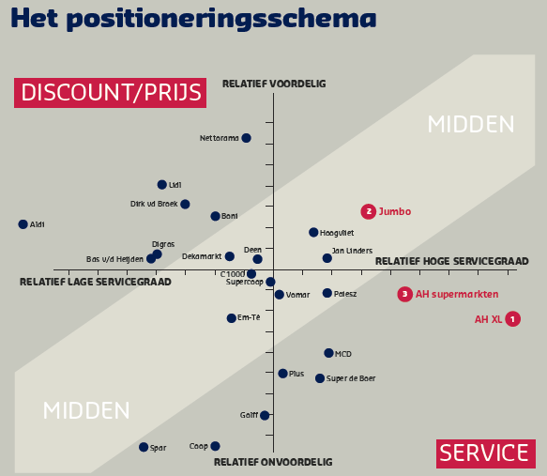

b. Top 5 supermarkets with best service & Top 5 price-advantageous supermarkets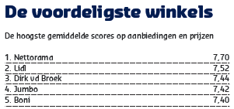
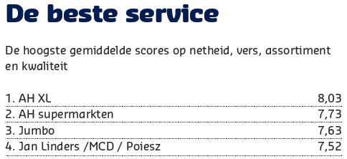
c. Household-sizes Albert Heijn and Jumbo
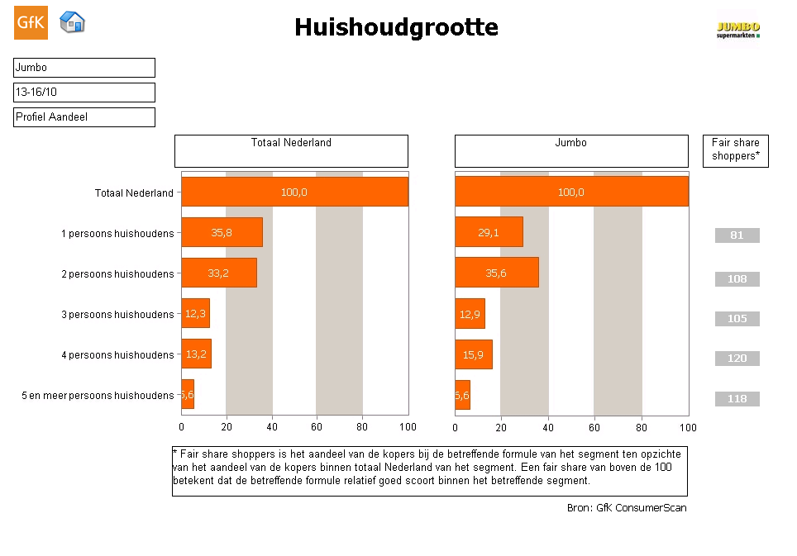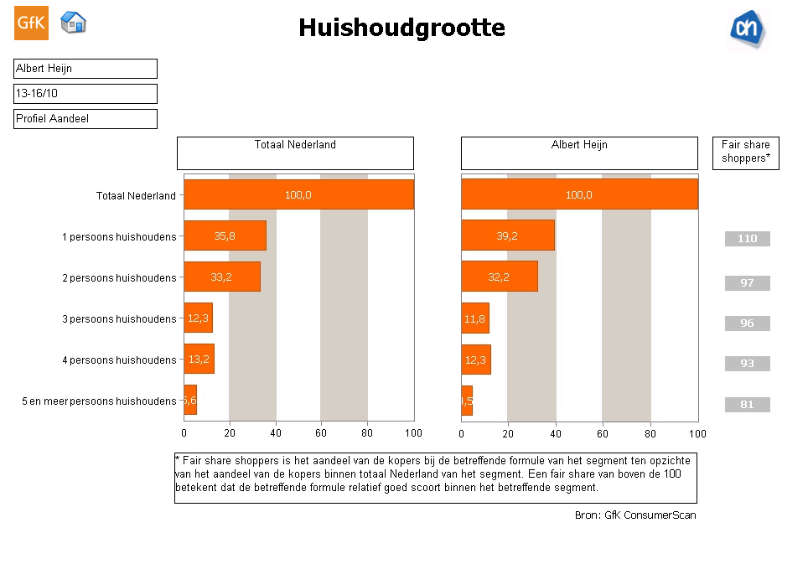

3.1 Experiment Possibilities
Tony, Pure, Low, Label Cote d’Or, Pure, Low, Label
Tony, Pure, Low, No Label Cote d’Or, Pure, Low, No Label
Tony, Pure, High, Label Cote d’Or, Pure, High, Label
Tony, Pure, High, No Label Cote d’Or, Pure, High, No Label
Tony, Milk, High, Label Cote d’Or, Milk, High, Label
Tony, Milk, High, No Label Cote d’Or, Milk, High, No Label
Tony, Milk, Low, Label Cote d’Or, Milk, Low, Label
Tony, Milk, Low, No Label Cote d’Or, Milk, Low, No Label

3.2 Experiment Possibilities
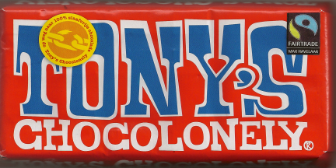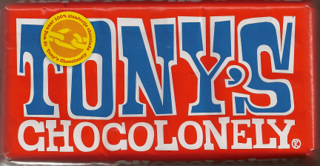

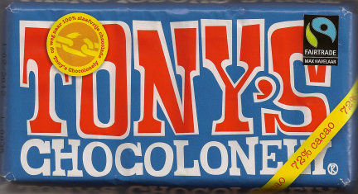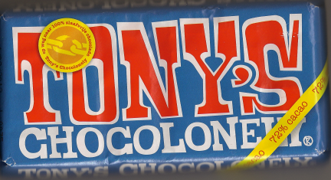

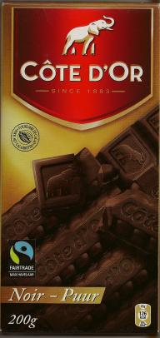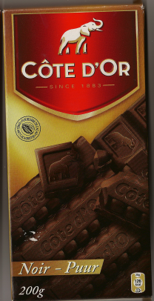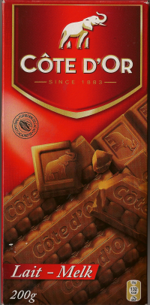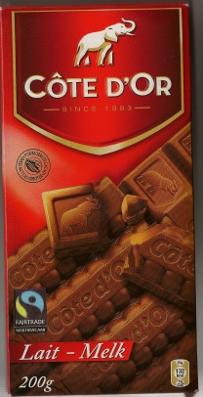

4: Questionnaire

- How well do you know the following brands?
Very Bad Bad Mediocre Well Very Well
  - Cote D’ Or
  - Verkade
  - Tony’s Chocolonely
  - Toblerone

- Are you aware of the certification marks of the following brands? If so, which certification mark do the following brands have?
  - Cote D’ Or ………………………………………………
  - Verkade ………………………………………………
  - Tony’s Chocolonely ………………………………………………
  - Toblerone ………………………………………………

- Wat does the Max Havelaar label purport according to you? (multiple answers are possible)
  - Good Quality Chocolate
  - Trustworthy Producer
  - The cacao beans are traceable to its origin, the certified farmers
  - The product has been traded under fair trading conditions
  - Biologic Product
  - Other, namely …

- How often do you buy Tony’s Chocolonely?
  - More often than other chocolate brands
  - Just as often as other chocolate brands
  - Less often than other chocolate brands
  - Never (skip question 5)

- Why do you purchase Tony’s Chocolonely? (Multiple answers are possible)
  - Good Quality chocolate
  - Max Havelaar Certified Fairtrade chocolate
  - 100% slave free chocolate
  - Packaging appeals to me
  - Delicious Chocolate
  - Other, namely ...

5. Data Analysis
5.1. Questionnaire
5.1.1. Chart 1: Brand Recognition
Tony’s Chocolonely
Very Well
Well
Mediocre
Very Bad

% Percentage
40
30
20
10
0
Brand Recognition
Bad

5.1.2. Chart 2: Buyer’s Profile
Tony’s Chocolonely
>65
50-65
35-50
<20

40
30
20
10
0
Buyer’s Profile
20-35

% Percentage

5.1.3. Chart 3: Reasons for Purchase
Wereldwinkel
Reasons for Purchase
% Percentage
Quality
Max Havelaar
100% Slavefree
Package
Taste
10
20
30

Reasons for Purchase
Supermarket
% Percentage
Quality
Max Havelaar
100% Slavefree
Package
Taste
40
30
20
10

5.1.4. Awareness of Certification Marks
a. Chart 4: Awareness of Max Havelaar Label on diverse Chocolate Brands
% Percentage
Awareness of Certification label on Chocolate bar
b. Table 1: Crosstable Awareness * Chocolatebar
 |  | Chocolatebar |  |  |  | Total
 |  | Cote d'Or | Verkade | Tony's Chocolonely | Toblerone | Total
Awareness | Not Aware | 98 | 94 | 79 | 109 | 380
Awareness | Aware | 37 | 41 | 56 | 26 | 160
Total |  | 135 | 135 | 135 | 135 | 540

c. Table 2: Influence of Awareness on Purchase Behavior
H0 = Awareness of Max Havelaar label has no influence on Purchase Behavior
Ha= Awareness of Max Havelaar label has influence on Purchase Behavior
 | Unstandardized  Coefficients (B) | t | Sig.
(Constant) | 1.297 | 5.507 | .000
Awareness | .472 | 3.027 | .003
Dependent Variable: Purchase Behavior

d. Table 3: Correlation between Awareness and Purchase Behavior
H0 = Awareness of Max Havelaar label is not correlated to Purchase Behavior
Ha= Awareness of Max Havelaar label is correlated to Purchase Behavior
 | N | Correlation | Sig.
Knowledge & PurchaseBehaviour | 135 | .264 | .002
5.1.4. Chart 5: Signal of a Max Havelaar Label
Signal Max Havelaar Label
Biologic Product
Fair Conditions
Traceability
Trustworthy
Quality
%
Percen
tage
60.0%
45.0%
30.0%
15.0%
0.0%
5.2 Experiment
5.2.1.SPSS Analysis
i. Table 4: General

 | Parameter | Estimate | Significance
LOGIT | Tony’s | -,105 | ,043
LOGIT | Pure | -,904 | ,000
LOGIT | €1.43 | -1,125 | ,000
LOGIT | Max Havelaar Label | ,836 | ,000
LOGIT | Intercept | 0,573 | ,000

 |  | Chi-Square | df | Significance
LOGIT | Pearson Goodness-of-Fit Test | 1081,704 | 1075 | ,437

ii. Table 5: Logit Analysis with factors

 | Parameter | Estimate | Significance
LOGIT | Tonys (2) | -,107 | ,042
LOGIT | Pure (2) | -,913 | ,000
LOGIT | €1.43 (2) | -1,141 | ,000
LOGIT | Max Havelaar Label (2) | ,832 | ,000
LOGIT | Albert Heijn | -0.31 | ,852
LOGIT | Jumbo | -,095 | ,561
LOGIT | Groningen | 0,006 | ,977
LOGIT | Maastricht | 0,019 | ,908
LOGIT | 18-34 | -0,20 | ,890
LOGIT | 35-49 | 0,097 | ,480
LOGIT | 50-64 | 0,076 | 0,571
LOGIT | Man | 0,169 | ,209
LOGIT | Intercept | 0,503 | 0,021

 |  | Chi-Square | df | Significance
LOGIT | Pearson Goodness-of-Fit Test | 1082,211 | 1067 | ,366

ii. Table 6: Logit Analysis with Interaction Effect

 | Parameter | Estimate | Significance
LOGIT | Tony’s | -,155 | 0,081
LOGIT | Pure | -,251 | ,001
LOGIT | €1.43 | -,975 | ,023
LOGIT | Max Havelaar Label | ,372 | ,051
LOGIT | Wereldwinkel*Max Havelaar label | ,692 | ,030
LOGIT | Groningen* Tonys | 0,381 | ,078
LOGIT | Age 18-34 * Tonys | 0,184 | ,063
LOGIT | Age 18-34 * Label | -,208 | ,057
LOGIT | Age > 65* Tonys | -513 | ,032
LOGIT | Age > 65 * Label | ,160 | ,089
LOGIT | Intercept | ,417 | ,397

 |  | Chi-Square | df | Significance
LOGIT | Pearson Goodness-of-Fit Test | 938,233 | 1040 | 0,989

A specialized bureau for sustainable development projects
P. Kotler and K.L. Keller. Marketing Management 12e. Pearson Education LTD. Australia PTY.
Yuppies: affluent, young professional persons (Collins English Dictionary – Complete and Unabridged © HarperCollins Publishers 2003)
CBS Statistieken (2007). Regionale Kerncijfers Nederland..
CBS Statistieken( 2007). Regionale Kerncijfers Nederland.
CBS Statistieken (2007). Regionale Kerncijfers Nederland..
GfK Customerscan. Retailer Data. Quarter 1, 2010. Raw Data. Friesalnd Cambina, Amersfoort
GfK Customerscan. Retailer Data. Quarter 1, 2010. Raw Data. Friesalnd Cambina, Amersfoort
Solidaridad Jaarverslag 2009.
Schreuder Goedheijt (2010), Hamers et al. (2010)

