MSc Programme in Urban
Management and Development

Rotterdam, the Netherlands
July 2025

Anchored in Place: Exploring the Influence of Place
Attachment on Flood Preparedness among FemaleHeaded Households in Mathare, Nairobi



Name: Beatrice Anne Soriano Garrovillas
Supervisor: Dr. Maartje van Eerd
Specialisation: Urban Housing and Land Justice (UHLJ)
Report number: 1950
UMD2024-25

Abstract
As climate change increases in intensity and frequency, weather-related disasters such as floods are continually exacerbating the risk exposure of urban informal settlements across the Global South. In Kenya, these low-income communities are characterized by tenure insecurity, inadequate infrastructure and fragmented services. Mathare, one of the city’s oldest and second largest informal settlements, is highly concentrated with female-headed households (FHH) who face disproportionate inequalities due to combined socio-economic and gender-based vulnerabilities.

This study delves into how FHHs in Mathare experience, perceive and prepare for flooding events through the theoretical lens of place attachment at the household-level. Through different qualitative methods conducted with FHHs and key informants of the community at large, four place attachment dimensions, namely physical, social, psychological, and temporal, are explored relative to flood preparedness measures adapted from the Protective Action Decision Model (PDAM) and in consideration of FHHs’ socio-economic responsibilities in a flood-prone informal settlement like Mathare.

Empirical findings reveal that social and psychological attachments of FHHs, manifest through their strong connections with self-help micro-saving groups or ‘chamas’, CBOs, neighbours, religious groups and other FHHs in the community, serves as both a protective resource and barriers to mobility. While they can depend on others for financial stability, physical support and sharing social responsibilities during floods, it also poses more risks as they refuse to relocate for fear of losing connection to their own identity and familiar surroundings. Physical attachment is less evident within the physical structures of their homes as renters but is illustrated through the importance they uphold for specific places that provide them increased protection during floods and socio-economic stability as well as proximity to services and amenities such as hospitals, schools, and CBO halls. Temporal attachment is complicated by the familial and intergeneration ties of FHHs, wherein their decision to stay or leave is split between wanting to be part of the change in Mathare and seeking upward mobility beyond the informal settlement. Experiences from last year has changed what many FHHs prioritize, with most of them relocating to safer, yet more expensive, areas of Mathare where they could keep their families protected and deep-seated connections within reach. Informal stakeholders, such as NGOs, CBOs and other neighbours, were consistently perceived as more trustworthy and responsive when it comes to warnings and provision of aid by FHHs in comparison with formal authorities. Finally, these findings underscore that flood preparedness at the household level is complex, shaped by weak institutional frameworks, where FHHs must balance caregiving responsibilities, deep-rooted emotional bonds to their homes, and heavy dependency on their social networks.

Keywords
Female-headed households, Flood Preparedness, Place Attachment, Protective Action
Decision Model, Mathare Informal Settlement, Household-level strategies

Acknowledgements
Before anything else, I would like to extend my deepest gratitude to my family. My parents who had provided and given me their unwavering support through anything and everything I have dreamt of, and to my sister who have been an amazing sounding board in all the crazy ideas I come up with. Being away from all of you was both freeing and lonely, but I have never questioned your love and support all the way here.

To all the shoulders I could rely on in Nairobi for a whole month, Abhishek, Boris, Dakota, Sarah and Vasiliki. I would not have survived the gruelling work and unexpected realities of Africa by myself. We each shared special moments individually and together, and I would not trade it for the world. From the animals of the Nairobi National Park, the nyama choma and ugali we shared on the same plate, our little ‘vibey’ paradise in Mombasa, and every meal and moment we had together, I knew I was in the right company from the beginning. Asante sana!

My deepest gratitude goes to my supervisor, Dr. Maartje van Eerd, your unwavering support, guidance and advice, made this experience truly invaluable. It has been an honour and privilege to have been supervised by such an esteemed academic. To our Nairobi Thesis Atelier supervisors, Dr. Jan Fransen and Dr. Pamela Duran Diaz, thank you for sharing the heavy load and responsibility of researching in a whole new world with all of us. Your unending passion for the city we all grew to adore and appreciate is one of the reasons why this thesis was even possible. To our other professors in UHLJ, Dr. Alonso Ayala, Dr. Bahar Sakizlioglu, Carolina Lunetta, Charmae Wissink-Nercua, and Ore Fika. I am grateful for all your teachings, I will be carrying them with me, in life and in my career.

To my friends at IHS, thank you for your unending support both before, during and after our time in the Netherlands. It has been an honour and a privilege to have met such an esteemed set of people. Whether near or far, please know that there will always be a little Bea you could call whenever and wherever you are. Thank you, thank you, thank you.

To my Civic Club members, I would not have been able to take this leap without your constant encouragement and support in all that I wanted to do. The person I was four years ago would not have been the same if not for this quirky little group. I am truly lucky to have you all by my side, albeit almost 6,000 km away. Thank you.

Finally, to the women who openly trusted, confided and collaborated with me, you welcomed me into your homes and lives wholeheartedly. Without an ounce of doubt, I know that Mathare will thrive because of the compassion, commitment and love you have for your community and each other. I am truly indebted to you all for everything. To my community research partner, Pauline, your continuous care and support is what pushed me beyond what I thought I could achieve in my little time in Mathare. To Nuvoni Research Institute, Slum Dwellers International (SDI) Kenya, and Ghetto Foundation, especially to Mike, Stephen, and MC, thank you for helping us navigate researching Mathare. It would not have been possible if not for your openness and welcoming nature. Asante sana!

Table of contents

Abstract i
Keywords i
Acknowledgements ii
Table of contents iii
List of Figures v
List of Tables v
Abbreviations vi
1. Introduction 1
1.1 Background 1
1.2 Problem Statement 2
1.3 Research Objective 2
1.4 Research Questions 2
1.5 Academic and societal relevance 3
1.5.1 Academic Relevance 3
1.5.2 Societal Relevance 3
1.6 Scope and Limitation 3
2. Literature review / Theory 4
2.1 Place Attachment Theory 4
2.1.1 Physical Attachment 4
2.1.2 Social Attachment 5
2.1.3 Psychological Attachment 5
2.1.4 Temporal Attachment 5
2.2 Flood Preparedness in the Context of Climate Change 6
2.2.1 Protective Action Decision Model (PADM) 7
2.3 Female-headed Households: Definition and Typologies 7
2.3.1 Female-Headed Households: How their Responsibilities Differ from Traditional Family Roles 8
2.4 Conceptual Framework 9
3. Research Design and Methodology 10
3.1 Research Strategy 10
3.2 Justification for Mathare Selection 10
3.3 Data Collection Methods 11
3.4 Target Population and Sampling Techniques 12
3.5 Data Analysis Strategy 13
3.6 Operationalization of the Variables 14
3.7 Reliability and Validity 15
3.8 Challenges and Limitations 16
4. Results, analysis and discussion 17
4.1 Case Study: Mathare Informal Settlement 17
4.2 Household Population Breakdown 18
4.3 Socio-demographic Profile of Interviewees 19
4.3.1 Age groups 19
4.3.2 Level of Educational Attainment 19
4.3.3 Length of Residence in Mathare 20
4.4 Place Attachment Exhibited by Female-Headed Households 20
4.4.1 Physical Attachment 20
4.3.2 Social Attachment 21
4.3.3 Psychological Attachment 22
4.3.4 Temporal Attachment 24
4.4 Types of Flood Preparedness Measures Employed by FHHs 25
4.4.1 Pre-decision Processes 25
4.4.2 Protective Action Decisions and Behaviours 26
4.5 Social and Economic Responsibilities of FHHs 29
4.5.1 Social Responsibilities of FHHs 29
4.5.2 Economic Responsibilities of FHHs 31
5. Conclusions 33
5.1 Place attachment as exhibited by FHHs in Mathare 33
5.2 Flood preparedness measures commonly employed by FHHs in Mathare 33
5.3 Social and Economic Responsibilities of FHHs in Mathare 34
5.4 To what extent does place attachment and belonging in a FHH influence their adoption of flood preparedness measures in Mathare? 34
5.5 Recommendations 35
5.6 Further Research 35
Bibliography 37
Appendix 1: IHS copyright form 43

List of Figures
Figure 1. Protective Action Decision Model. ............................................................................ 7
Figure 2. Conceptual Framework. ............................................................................................. 9
Figure 3. Triangulation of methods. ........................................................................................ 11
Figure 4. Mathare Valley map. ................................................................................................ 18
Figure 5. Mathare household headship by age and sex. ......................................................... 18
Figure 6. Reasons for staying/residing in Mathare. ................................................................. 20
Figure 7. Place attachment and its influence on how FHHs react to floods. ........................... 35

List of Tables
Table 1. Data collection methods and types of data collected. ................................................ 12
Table 2. Sample Selection. ....................................................................................................... 13
Table 3. Operationalization of Variables. ................................................................................ 14
Table 4. Age groups of participants. ........................................................................................ 19
Table 5. Level of educational attainment. ................................................................................ 20
Table 6. Trust Ranking for Community Actors. ...................................................................... 26
Table 7. Household size of respondents .................................................................................. 30
Table 8. Primary occupation and sector of work of respondents. ............................................ 31

Abbreviations

Abbreviation | Full form
IHS | Institute for Housing and Urban Development Studies
UNDRR | United Nations Office for Disaster Risk Reduction
ILO | International Labour Organization
GFDRR | Global Facility for Disaster Reduction and Recovery
DRR | Disaster Risk Reduction
NGO | Non-governmental organization
FHH | Female-headed household
MHH | Male-headed household
CBO | Community-based organization
PA | Place attachment theory
SDI | Slum Dwellers International (Kenya)
PADM | Protective Action Decision Model
RCK | Red Cross Kenya
UNDRR | United Nations Office of Disaster Risk Reduction

1. Introduction

1.1 Background
Climate change has emerged as one of the most pressing global issues of the 21st century. Increases in and frequency of extreme weather events due to climate change have resulted in unequal losses and damages of places, nature and people’s livelihoods (IPCC, 2023). In comparison to other extreme weather events, floods are considered among the most frequent and damaging. Between 2000 and 2019, UNDRR reported floods accounted for about 44% of all recorded weather-related disasters globally, impacting about 1.6 billion people and over 650 billion US dollars in damages (UNDRR, 2020). However, these impacts are skewed and rarely equally distributed, particularly in areas of the Global South (IPCC, 2023). Kenya is no exception as the country experienced at least 17 major floods, each disaster having reported impacts to at least 70,000 people since the 1960s (Owuor & Mwiturubani, 2023). Urban areas, like the capital city Nairobi, are majorly affected as heavy rainfalls overwhelm underdeveloped drainage systems and tenuous infrastructure, as evident during the March-May 2024 floods. Scientists have attributed these extreme weather events to both natural and human-induced climate change, emphasizing that these events could become more frequent in the future (WMO, 2025). As such, escalating flood risks places urban cities like Nairobi at the forefront of exacerbating impacts of climate change and development of locally sensitive preparedness measures.

In Kenya, over 50% of its population reside in densely populated informal settlements and roughly 60% of the country’s urban families live in areas characterized as ‘slums’ (Ren et al., 2020). Leaving majority of its residents disproportionately affected by floods as they lack proper infrastructure, amenities and services. A prime example of this is Mathare, Nairobi’s oldest and second largest informal settlement, where approximately 70,000 individuals call the riparian areas of Mathare River their home (Owuor & Mwiturubani, 2023). However, these flood-prone areas are proliferated with rapid urbanization, no building regulation enforcement and substandard housing, leaving residents at an increased environmental and health risks they are ill-equipped to withstand (Owuor & Mwiturubani, 2023; Kimeu, 2024). Female-headed households (FHHs) standout as a particularly vulnerable group in Mathare. These households, wherein a woman is the sole income-earner and decision-maker of the family, often have constrained protection channels against natural disasters having very limited economic resources, lower educational levels and social support, and endure deep-seated gender inequalities. Thus, they unable to immediately rebuild or reinforce their homes after a flood and rely on fragile household adaptation strategies (Saad et al., 2022; Alston, 2015; Flatø et al., 2017). However, scholars also argue that the same socio-cultural constraints that force FHHs to remain in place after climate disasters can also develop positive transformations rooted in place attachment (Khalil & Jacobs, 2021).

Place attachment, or the affective bond or link that an individual may develop with a place, profoundly shapes household-level preparedness behaviour (Han, 2025; Scanell & Gifford, 2009; Hidalgo & Hernandez, 2001). A study on German flood-prone regions found that areas with high environmental threats and disaster risks have higher place attachment, contributing
1
to an increased adoption of household-level flood preparedness measures and collective capacity building. However, such attachments may result in increased vulnerability as individuals underestimate warning signs, delay evacuations and willingly stay due to emotional connections to their homes (Han, 2025). This sense of security often leads to complacency and reluctance towards household-level flood preparedness strategies in vulnerable communities facing weather-related disasters (Swapan & Sadeque, 2021). As such, FHHs living in floodprone informal settlements are confronted with a unique challenge on how to balance both the constraints of residing in areas with limited resources and their emotional ties to a place.

1.2 Problem Statement
Numerous studies have tried to define and explore how emotional connections to a place could drive household decisions relative to flood protection (Han, 2025, Ehsan et al., 2022, Lie et al., 2023, van Valkengoed & Steg, 2019). These studies provided insights around risk perception, decision motivations and coping mechanisms of communities, but did not correlate how place attachment at the household-level could play a role in climate response decisions. Despite its complexity, the interplay of place attachment of FHHs relative to their socio-economic realities and flood preparedness mechanisms at the household-level has not received much focus in academia (Holley et al., 2022; Swapan & Sadeque, 2021; Devine-Wright & Quinn, 2020). Mathare is one of Nairobi’s oldest and second most densely populated informal settlement and has a large concentration of FHHs, accounting for about 45.4% of its total household population. The devastating floods from March to May 2024 further exposed the vulnerabilities of women and children, with fatalities estimated to be at least 120 residents in the city and displaced more than 55,000 households across Kenya (Kimeu, 2024; Rukanga, 2024). To bridge these gaps, this thesis will unpack four dimensions of place attachment, namely physical, social, psychological, and temporal, and how it could influence FHHs’ householdlevel preparation and everyday resilience to floods, despite the precarity of their socioeconomic realities in Mathare, Nairobi.

1.3 Research Objective
The main objective of this research is to make deductions on the extent in which FHHs’ place attachment and socio-economic responsibilities affect their adoption of flood preparedness strategies at the household-level in Mathare, Nairobi.

1.4 Research Questions
The main research question of this study is: To what extent does place attachment (physical, social, psychological, temporal) and belonging in a female-headed household influence their adoption of flood preparedness measures in Mathare, Nairobi?

Further, the sub-questions employed for this research are as follows:
- How is place attachment (physical, social, psychological, temporal) exhibited by FHHs in Mathare?
- What types of flood preparedness measures are commonly employed by FHHs Mathare?
- How do social and economic responsibilities of FHHs in Mathare affect their place attachment and flood preparedness measures?

1.5 Academic and societal relevance

1.5.1 Academic Relevance
This research contributes to the interdisciplinary discourse on gendered vulnerability, urban informality, and climate adaptation by delving into the intricate dynamics of place attachment, flood preparedness and the socio-economic realities of FHHs in an informal settlement. This study also confronts dominant narratives that frequently overlook how gendered socioeconomic responsibilities and their enduring emotional bonds to specific places determine their capacity to floods at the household level.

1.5.2 Societal Relevance
Many residents were displaced by government-led evictions and demolitions 30m of the Mathare River immediately after the floods, citing flood risks and landslides. A Special Planning Area (SPA) is now being proposed in Mathare by different stakeholders and NGOs in support of better slum upgrading policies and participatory planning mechanisms. to flood preparedness regulations that are context-specific and leverages the roles FHHs play in transforming their communities, along with government officials and urban professionals (planners, architects, and urban designers).

1.6 Scope and Limitation
The scope of this thesis focuses on FHHs residing in an urban informal settlement, Mathare, and examines how their decisions to utilize flood preparedness measures at the householdlevels could be influenced by four dimensions of place attachment (physical, social, psychological, and temporal). Other types of attachment such as cultural, political attachment and economic, while touched upon as it relates to the chosen dimensions, were not explicitly explored as a sub-dimension and is a limitation. The research is also geographically limited to the informal settlement of Mathare, chosen for their high exposure of floods in recent years and its high concentration of FHHs at about 45.4% of the total households.

The study has several limitations: (1) informal nature of Mathare presented unexpected logistical, financial and administrative challenges in accessing a fully representative sample; (2) due to safety concerns, some areas were restrictive, and engagement was reduced; (3) analytical comparisons with other household types or vulnerable groups is confined as the study is focused on FHHs; and lastly, (4) generalizability of the findings to other informal settlements beyond Mathare may not be comparable due to differences in socio-economic conditions, governance structures, and other contextual nuances.

2. Literature review / Theory
This chapter reviews the theoretical foundation and definitions of the four dimensions of place attachment (physical, social, psychological, and temporal), household-level flood preparedness measures and the PDAM model as well as the social and economic responsibilities of FHHs within the scope of the study.

2.1 Place Attachment Theory
The idea of ‘place’ pertains to different dimensions and characteristics of a given location, such as when looking at physical or material aspects (Altman & Low, 1992), social relations amongst community members or between individuals with shared beliefs or values (Altman & Low, 1992), and emotional aspects from collective feelings of belonging in group settings (Sarason, 1974; Altman & Low, 1992). Places are dynamic; politicised for what it provides and continuously molded by overlapping narratives, ideals and interests of different people (Sarason, 1974; Altman & Low, 1992). In this research, the concept of place attachment is derived from three theorists, defined as ‘the effective bond or link between people and place’ in four dimensions: physical, social, psychological and temporal attachments. Underscoring how place-space bonds may positively dictate their social life, environmental outcomes, and their definitions of specific places over time (Hidalgo & Hernandaz, 2001; William & Vaske, 2003; Scannell & Gifford, 2009). On the contrary, Manzo (2014) made emphasis of feminist bodies of research contending that places can embody negative implications relative to gender dynamics and vulnerabilities (Manzo, 2014). Additionally, place attachment is far more complex than its positive outlooks, especially in marginalized communities where unequal power dynamics, stigma and conflict are more prevalent (Manzo, 2014).

2.1.1 Physical Attachment
Physical attachment or ‘functional place dependence’ is determined by socio-economic outcomes people have in certain places, and where they achieve agency and autonomy for their daily objectives (Williams and Vaske, 2003). Losing access to health clinics, public transportation, schools, police stations, and shorter traveling time to economic opportunities were attributed as the main reasons for refusing relocation by about 65% of affected residents after a major flood in two South African informal settlements. The same study also stressed that economic disadvantages were found to be largest contributing factor to physical attachment, highlighting if no better alternative exists for economic stability and affordable housing, people are willing to stay in flood-prone areas (Williams-Bruinders & de Wit, 2015). In another South Africa-based study, scholars concluded that in the context of climate change FHHs have restricted mobility, depend heavily on their immediate surroundings and local environmental for their daily survival, income and food across formal and informal industries. This factor, therefore, makes them more vulnerable to rainfall variability and flood risks against MHHs due to limited access to alternative resources or social connections (Flatø, Muttarak & Pelser, 2016). In conclusion, physical attachment can both increase preparedness when the needs of an individual are fulfilled but may also create complexities when other externalities become severe.

2.1.2 Social Attachment
Bonds made with others, such as with neighbours, family, religious and community groups characterize social attachment; they manifest through well-integrated social networks and sense of community or belonging as one settles in a place (Manzo & Perkins, 2006). Neighbours who have developed strong connections typically invest significant time and effort to improve the well-being of their community, from willingly helping neighbours, participating in communal activities, and supporting revitalization efforts (Brown & Perkins, 2003; Manzo & Perkins, 2006). Social cohesion built from these connections could then encourage others to extend help and support during post-disaster recovery. As Aldrich (2012) discusses in their study after the 2011 Tohoku, Japan tsunami, residents with strong community ties and social capital immediately pooled resources, returned to affected areas to help rebuild, and organized search parties despite being victims themselves (Aldrich, 2012). However, these bonds could become faulty when gender vulnerabilities and informality for FHHs are factored in as avenues and mechanisms to protect themselves are typically lacking. A study by Flatø, Muttarak and Pelser (2016) found that FHHs are more vulnerable even after controlling for socio-economic characteristics, not only for their precarious economic status, but also their limited access to familial support and protective social networks during crises. Other pressing issues such as lack of legal protection, secure tenure and access to community decision-making platforms or formal credit markets also weakens their social attachment to a place as they feel inferior in areas where men tend to hold more institutional powers (Flatø, Muttarak & Pelser, 2016).

2.1.3 Psychological Attachment
According to Scannell and Gifford (2009), affective, cognitive and behaviour encompasses the psychological attachment, wherein occurrences in a certain location becomes an extension of self in the process (Scannell & Gifford, 2009). Affective functions are the feelings of comfort and sense of pride, cognitive functions develops when a person identified themselves to a place from personal memories, and behavioural patterns are repeated intentions or the need to be within proximity of a place (Scannell & Gifford, 2009). Manzo and Perkins (2006) also reiterate that these connections are heavily dependent on emotional experiences, where one can feel safe, connected and empowered in the areas they frequent (Manzo & Perkins, 2006). These attachments could then motivate them to stay, protect and care for the areas that are meaningful to them. In a study of flood-prone areas in Taipei, strong correlations were found in how residents support physical and structural improvements, such as building flood defenses in their homes or neighbourhoods, if they are highly emotionally attached to where they are over finding a new place to live in. However, satisfaction and affinity for their communities also made them less likely to relocate or evacuate for safety even when flood threats are recurring, further undermining their risks and urgency for preparedness (Lee & Lin, 2022).

2.1.4 Temporal Attachment
Temporal attachment involves historical symbolism made from memories and meanings a person associates with certain locations. Length of residence, intergenerational connections of where your family or oneself resided, and repetitive routines could inform this attachment to a site (Low & Altman, 1992). Stokols and Schumaker (1981) have also argued that “endurance and frequency” are two integral factors that contribute to this (Stokols & Schumaker, 1981). Other theorists such as Hummon (1992) and Gerson et al., (1977) also reiterated this notion wherein community attachment is cultivated through long-term residence and experiencing important events within your social circle, creating positive associations with the people you share these memories with and the location of where it happens (Hummon, 1992; Garson et al., 1977). In a study amongst residents who have occupied the same land for multiple generations in New Brunswick, Canada, noted feelings of betrayal when floods extended past the season 3-4 days. Coping mechanisms against floods that were passed down across generations became inadequate, illustrating the fragility of temporal bonds during natural disasters (Grogan & Woodhall-Melnik, 2019). In another context, residents who were forcibly relocated during the 2011 Queensland floods showed signs of grief responses identical to losing a family member when their homes were destroyed. Consequently, shorter tenured or new residents displayed weaker bonds to place and were more likely to permanently relocate after a disaster, whereas long-term residents experienced profound grief due to “the destruction of a lifetime of memories” and disruption to their sense of continuity in a place (Devine-Wright & Quinn, 2023).

2.2 Flood Preparedness in the Context of Climate Change
Household-level flood preparedness measures manifests in a multitude of interconnected factors which determine how individual households may prepare, respond and recover from flooding events. The Sendai Framework for DRR (2017) defines ‘preparedness’ as a set of short- to medium-term actions undertaken by individuals, communities and governments for rapid response and recovery if a natural disaster were to occur. It aims to build the needed capacity before an event rather than focusing on large systemic changes in communities. For flooding, these mechanisms may include contingency planning, emergency drills and evacuation plans, educational and awareness campaigns with the public, and installing early warning systems (UNDRR, 2017).

The ability of a household to recover post-disaster is largely determined by the types of mechanism that are readily available to absorb both environmental and economic shocks. These mechanisms may include to access different financial channels, government aid, relocation to safer areas, or pursuing employment elsewhere (UNDRR, 2017; IPCC, 2023). The GFDRR report on Gender Dimensions of Disaster Risk and Resilience (2021) found FHHs to be overrepresented in populations who have high exposures to both natural disasters and residing in fragile structures. This factor makes them more susceptible to disaster impacts globally, causing them to become more economically disadvantaged with compounded vulnerabilities during flooding events (GFDRR, 2021). Scholars maintain three widely observed dynamics with FHHs relative to natural disasters in urban informal settlements: (1) the poor endure increased disaster risks and threats; (2) women are overrepresented among informal populations; and, (3) FHHs are asset- and economically-marginalized. However, scholars on that climate change and post-disaster recovery offers a “window of opportunity” in challenging the status quo of gender inequalities and shifting power dynamics toward women leadership and agency (GFDRR, 2021; Le Masson et al., 2015).

2.2.1 Protective Action Decision Model (PADM)
To better understand these dynamics, this thesis employed and adapted the Protective Action Decision Model (PADM), a framework developed by Lindell and Perry (1992; 2003; 2012) (see Figure 1). PADM is a multi-stage model that explains how people receive and process risk information to natural disasters based on pre-decision processes: how individuals interpret warning signals, environmental and social cues which then informs how individuals form protective actions and behaviors and whether to act on it or not (Lindell & Perry, 1992; 2003; 2012). The following definitions were considered to test how FHHs react, respond and adapt to floods:
- Environmental cues are signals that present itself through sight, sound or smell which could indicate imminent danger or risk and may demand some form of protective actions from individuals (Lindell & Perry, 1992; 2003; 2012).
- Social cues refer to how individuals depend on other people’s behaviour or reactions when faced with impending threat. These typically involve informal signals derived from observing how others react or respond to a given situation (Lindell & Perry, 1992; 2003; 2012).
- Warning components refer to the importance of well-built warning systems, including the source, channels, and contents, provided by formally or informal networks. If done correctly, these warnings trigger recipients to either proactively or reactively respond to floods (Lindell & Perry, 1992; 2003; 2012).
- Protective Action Decisions and Behaviours refers to whether an individual takes protective action and decisions against flooding after obtaining social and environment cues, warning signals (Lindell & Perry, 1992; 2003; 2012).
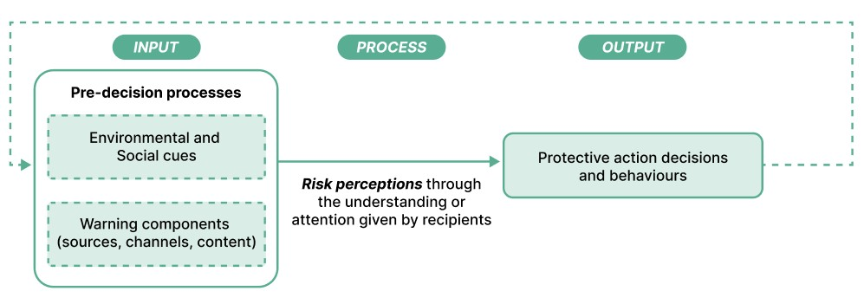
Figure 1. Protective Action Decision Model (Adapted from Lindell & Perry, 1992).

2.3 Female-headed Households: Definition and Typologies
As defined by the ILO (UN-ESCWA, n.d.), FHHs results from two phenomena where: (1) no adult men (i.e., 18 years old or over) are present due to divorce, separation, migration, nonmarriage, or widowhood; or (2) a male is present but cannot provide financially due to illness, disability, old age, alcoholism and other incapacities except unemployment (UN-ESCWA, n.d.). Household headships are classified into two categories: de facto or ‘real’ and de jure or ‘perceived’. De facto heads are individuals in a household who take on the financial, welfare and decision-making responsibilities. While de jure heads, traditionally recognized as male breadwinners, are individuals who are socially accepted by its members as the head of the household (UN-ESCWA, n.d.).

For this study, FHHs is further defined through two interlinked dimensions over the absence of a husband or partner as defined by Clark (1984) in their study of Kenyan matrifocal context:
- Having primary economic responsibility and autonomy: where the female head has primary economic autonomy in the provision, management and distribution of resources, household income, and assets of the family unit (Clark, 1984).
- Social and cultural embeddedness: recognition that FHHs do not exist in isolation but are deeply rooted in the social, cultural and relational fabrics of the community. FHHs are influenced by and integrated with their social relationships, roles, kinship ties and existing community structures (Clark, 1984).

These overlapping distinctions are critical in understanding how household-level flood preparedness decisions are made, as women and FHHs in certain contexts are not only excluded from formal recognition by governments but are also positioned as disproportionately poorer and more vulnerable against weather-related disasters (Saad et al., 2022; UN-ESCWA, n.d.).

2.3.1 Female-Headed Households: How their Responsibilities Differ from Traditional Family Roles
Traditional family units based on the male-breadwinner model divide homecare responsibilities where women take on domestic tasks and caring for children while men are focused on incomegenerating and other external activities. However, these disparate concepts become hazy as FHHs combine them into a single role, making difficult trade-offs between financial stability and caregiving obligations (Clark, 1984). In a study of 103 low- and middle-income countries, scholars found FHHs tend to take on responsibilities beyond the typical female caring roles, without any practical means of support or partners to share obligations with. Resorting to precarious and informal forms of employment, short-term coping methods, and heavy reliance on their social connections for their survival (Saad et al., 2022). These factors, however, exacerbate their conditions by their inability to sustain upward mobility and intergenerational cycles of vulnerability (Saad et al., 2022; GFDRR, 2021; Erman et al., 2019).

The most critical distinction between FHHs from traditional family structures lies in who take on financial duties. When economic provision was majorly held by male breadwinners, female partners then lack the agency or autonomy to make decisions, perpetuating uneven power dynamics (Hiwarhkheda & Sharma, 2024). FHHs challenge this by simultaneously adopting both roles, which scholars refer as the ‘double burden’, as they maintain paid and unpaid work inside and outside of the home. As a result, the levels of food security, access to education or healthcare, and capacity to bounce back against economic and environmental shocks are significantly reduced and manifest in families wherein women are the sole income earners (Mitra & De, 2024; Braga & Costa, 2022; Wanasinghe & Tennakoon, 2019; Kazi et al., 1988).

2.4 Conceptual Framework
This study probes into how four dimensions of place attachment influence their response to floods at the household level, relative to the economic and social responsibilities that female headships have. Drawing on the literature and theories discussed, this framework situates place attachment as the independent variable, broken down into four inter-related dimensions: physical, social, psychological, and temporal. Employing flood preparedness as the dependent variable, complemented by pre-decision processes: environmental cues, social cues, and warning components which dictate their protective action decisions and behaviours. Finally, as the moderating variable, the economic and caregiving responsibilities of FHHs will underscore how this may further hinder or facilitate their capacities to take proactive or reactive mechanisms against floods (see Figure 1).
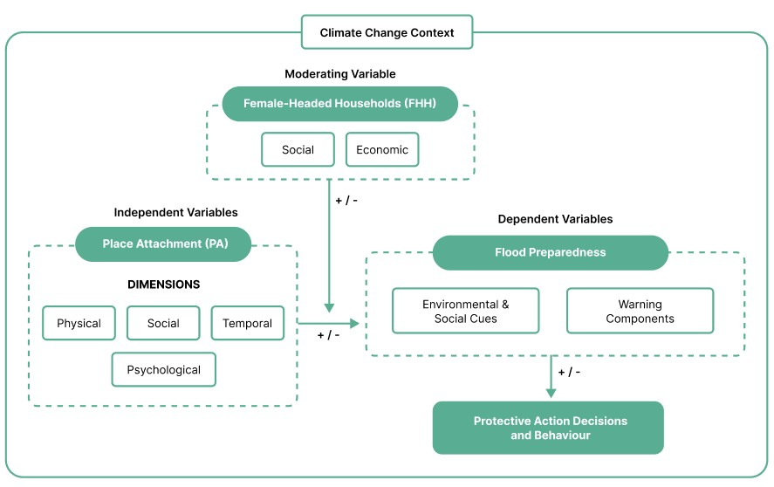
Figure 2. Conceptual Framework (Author, 2025).

3. Research Design and Methodology
This chapter outlines the research design, strategies and methodology utilized for field work in Mathare, followed by discussions on the sample, data collection methods, operationalization, validity and reliability as well as challenges and limitations. Finally, how the data collected will be analyzed and prepared closes this chapter.

3.1 Research Strategy
An explanatory case study strategy was adopted to delve deeper into how gender dynamics and place attachment influence flood preparedness of FHHs in Mathare. Such studies centres around investigating how complex, socially embedded phenomena occur and how outcomes are produced within a given community. Utilizing it allows researchers to holistically focus on real-life contexts and experiences of individuals directly involved instead of broad generalizations (van Thiel, 2021; Rowley, 2002).

The study employed qualitative field methods, namely in-depth semi-structured interviews complemented by direct observations, to investigate the intersection of gender dynamics, the four dimensions of place attachment, and flood preparedness measures of FHHs in an informal urban environment. FHHs with different roles in the community were also included, such as individuals who are part of self-help micro-savings groups or ‘chamas’, CBOs and first responders after March-May floods (Red Cross Kenya (RCK) and local disaster and community response team). Key informants include representatives from the government, Women’s Enterprise Fund (WEF), and Kenyan slum federation. On-the-ground investigations complemented the interviews to encapsulate housing conditions, any existing informal or formal adaptive mechanisms, and environmental contexts at the household levels. Participants were selected purposively and through snowball sampling, ensuring that variations exist between participants in age, village wards, flood exposure (i.e., direct or indirect), and location within the riparian zone to lower selection bias and gather diverse perspectives.

3.2 Justification for Mathare Selection
Mathare, one of Nairobi’s oldest and second largest informal settlements, was selected as a case study due to its high exposure to flooding events in recent years. Between March to May 2024 rainy season, colloquially known as ‘masika’, Mathare saw what was widely reported as the one of the most relentless and catastrophic floods in years (Kimeu, 2024). The overflow of Mathare River, which runs along the centre of the whole informal settlement, caused more than 120 fatalities, devastating losses in property and livelihoods, displaced over 23,000 households with majorly women and children impacted (Kimeu, 2024). The low-lying, sloping terrain of the riparian areas and the Mathare Valley coupled with government-led evictions immediately after the floods exacerbated the severity of the situation.

The aftermath of this flood continues to impact their daily lives a year later, making Mathare a relevant and timely setting to examine at the household levels. SDI Kenya (2021) estimates that about 45.4% of the total households are led by women in Mathare (SDI, 2021). Despite being a significant demographic, there remains a notable research gap in how women within the community have experienced, perceive and prepare for flooding events as previous literature centred around a more generalized notion of community-level adaptive responses.

3.3 Data Collection Methods
Fieldwork was completed over a four-week period in May, the study employed two qualitative methods to explore the discourse of gender dynamics, place attachment and flood preparedness among FHHs. Due to very limited secondary data sources from public entities, the study relied mainly on primary data collected through semi-structured interviews, direct observations (photographs and fieldnotes) and a FGD with secondary data acquired from SDI Kenya (2021) for Mathare. Guided by the theoretical framework outlined in Chapter 2, multiple interview guides were developed for all methods. Three pilot interviews were done to finalize questions, and ensure wording was appropriate and culturally sensitive, and a validation workshop was done at the end to confirm findings with previous respondents. Each method was utilized by the researcher to capture different results and to triangulate findings (see Figure 3, Tables 1 and 2).
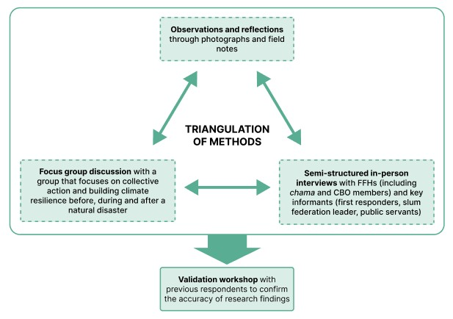
Figure 3. Triangulation of methods (Author, 2025).

Table 1. Data collection methods and types of data collected.
Qualitative Method | Participants involved | Type of data collected
Face-to-face interview | 16 FHHs, 7 key •  informants (N = 23) | FHH: personal insights, feelings and experiences on their flood preparedness strategies and their homes at the household level
 | • | Key informants: specialized  understanding at the socio-political and environmental level
Focus group discussion | FHHs (N = 10) • | Helped to unpack shared collective experiences, actions and responses at the community and neighbourhood levels
 | • | How informal community systems enable or hinder FHHs before, during or after a flood
Observations and reflections | FHHs and community • | Photographs and fieldnotes to capture grounded and contextually rich information about Mathare
Validation Workshop | Previous FHHs and •  key informants interviewed (N = 14) | To discuss findings

Interviews were conducted with 16 FHHs and 7 key informants from different stakeholder groups, including chamas, public servants, CBOs, a slum federation and an NGO, as shown in Tables 1 and 2. Additionally, a FGD was conducted with 10 members of a group that focuses on building climate resilience and collective action before, during and after a natural disaster. They were chosen through purposive sampling to specifically select individuals who have relevant knowledge, experience or expertise on a given subject (van Thiel, 2021). All 10 participants resided along the riparian areas and were forcibly relocated due to the 2024 floods and government-led evictions that followed 48 hours after. A validation workshop with 14 former respondents was also done to share, corroborate and discuss findings at the end of fieldwork in Mathare.

3.4 Target Population and Sampling Techniques
Snowball sampling was utilized to secure the right participants through a community research partner, ensuring they fit the criteria outlined in the study. While this could pose selection bias, deliberate decisions were made to variably select people from the 4 wards, age groups, flood exposure, and proximity to the riparian areas affected. This factor not only lowered the possibility of selection bias but also allowed for better understanding of a population that is otherwise scattered. The number of interviews conducted depended on the saturation point of information being received, which meant that data had become redundant, and no new insights were found (van Thiel, 2021).

Table 2. Sample Selection.
Semi-structured Interview Respondents | No. of participants
Female-headed Households (n = 10) + chama members (n = 2) +  CBO members (n = 4): N = 16  - From two different chamas (n = 2)  - From different CBOs included 2 heads and 2 members (n = 4):  - Ghetto Foundation, Mathare River Adaptation, Mathare Teenage Mothers (Ghetto Gals), Mathare Slums Community  Associations (MaSCA), Mto Wangu (My River) Initiative | 16
First responders: Red Cross Kenya (NGO); Disaster and Community Response Team (local response team) | 2
Slum Federation leader (Muungano Wa Wanavijiji): 1 national leader | 1
Government: 1 National Planner, 1 Environmental Specialist from the Nairobi City County and 1 Nairobi County Health Department officer | 3
Government agency: Women’s Enterprise Fund (WEF) | 1
Focus group discussion participants | No. of attendees
Group that focuses specifically on collective action and building climate resilience before, during and after the flood | 10 members
Total | 23 individual semi-structured interviews  1 group interview

3.5 Data Analysis Strategy
This research adopted a thematic analysis to interpret and analyse the data. This step-by-step methodological framework allows for an expansive amount of data to be synthesized through patterns, key themes, recurring topics and relationships against a set of variables. Involving a step-by-step framework that builds on each other (Naeem et al., 2023). The first step entailed familiarizing with the raw data, transcripts and field work notes collected in Mathare and secondary data sourced externally. While all interviews were conducted in English, transcriptions were done manually to ensure flow, clarity and any translations from the community research partner in Swahili were captured. After, a long process of coding and recoding was done, primarily finding themes deductively based on the conceptual framework and operationalization table. However, because of the nature of how the interviews were conducted, inductive coding was also incorporated to highlight any new themes that emerged. Finally, these themes were interpreted in relation to the research questions of the study using ATLAS.ti.

3.6 Operationalization of the Variables
Table 3 below outlines how the concepts are operationalized as defined in the conceptual framework of this study, including the variables, indicators and through which method the data was collected.

Table 3. Operationalization of Variables.
Variables | Sub-variables | Indicators | Sub-indicators | Data Source and Collection Method
Independent Variable
Place attachment | Physical dimension | Efforts or  improvements to their dwellings or surrounding | - Repairs and improvements - Use of durable or non-durable  materials | Semi-structured  interviews with FHHs and informant groups
Place attachment | Physical dimension | Proximity to services, amenities, and employment | Access to water sources, schools,  hospital, markets and jobs from their homes | Semi-structured  interviews with FHHs and informant groups
Place attachment | Social dimension | Sense of belonging  with others in the community | - Feeling acknowledged or accepted as part of a group  - Membership in community groups and activities | Semi-structured  interviews with FHHs and informant groups
Place attachment | Social dimension | Willingness or motivation to engage in collective action | - Interests in informal community planning  - Participation in collective action | Semi-structured  interviews with FHHs and informant groups
Place attachment | Social dimension | Receiving support through social networks | Dependence on family members or friends | Semi-structured  interviews with FHHs and informant groups
Place attachment | Psychological dimension | Sense of identity | - Self-identification with Mathare - Reluctant to leave due to loss of identity | Semi-structured  interviews with FHHs and informant groups
Place attachment | Psychological dimension | Sense of pride | Positive (pride) or negative feelings towards oneself or community | Semi-structured  interviews with FHHs and informant groups
Place attachment | Psychological dimension | Sense of safety or security | Comparisons to less secure living conditions or other locations in the past | Semi-structured  interviews with FHHs and informant groups
Place attachment | Temporal dimension | Major life events tied to the place | Milestones or important life stages occurring in place | Semi-structured  interviews with FHHs and informant groups
Place attachment | Temporal dimension | Familial or intergenerational connections | Residential continuity across generations | Semi-structured  interviews with FHHs and informant groups
Place attachment | Temporal dimension | Affection (or lack of) towards changes in the place over their time | Connection or disconnection with changes over the years | Semi-structured  interviews with FHHs and informant groups
 |  | Stability of residence | - Intentions to stay or leave in the future - Number of years lived in the same house or neighbourhood  - References to the home as 'permanent' or 'temporary' place
Dependent Variable
Flood preparedness | Pre-decision processes | Environmental and social cues | Observations made on:  - Changes in weather or environmental patterns  - Neighbour or community actions | Semi-structured interviews with FHHs and key informant groups
Flood preparedness | Pre-decision processes | Warning components (sources, channels, content) | Who the warning came from:  - Neighbours,  - Local government officials  - Village chiefs, leaders, elders  - Chama  - NGOs  - Media outlets
Flood preparedness | Pre-decision processes | Warning components (sources, channels, content) | How the warning was delivered:  - SMS  - Word-of-mouth  - Newspapers or radio  - Social media  - Community meetings  - Other sources
Flood preparedness | Pre-decision processes | Warning components (sources, channels, content) | What the warnings entailed:  - Timing  - Severity of floods
Flood preparedness | Protective  Action  Decisions and  Behaviours | Types of actions undertaken by FHHs | Short- or long-term actions (or inactions) of households
Moderating Variable
Femaleheaded households (FHHs) | Social responsibilitie  s | Caregiving and social obligations | Household size:  - Number of adults and minors | Questionnaire and semi-structured interviews with FHHs and key informants
Femaleheaded households (FHHs) | Social responsibilitie  s | Caregiving and social obligations | Social responsibilities:  - Taking care of dependents (elderly parents or children)
Femaleheaded households (FHHs) | Economic  responsibilitie  s | Income generation and financial decision-making | Economic stability:  - Principal earner or not  - Daily average income of household  - Primary occupation or sector of work - Reliance on other income-generating activities  - Ability to respond to financial shocks

3.7 Reliability and Validity
Internal validity, or keeping the credibility of the research process, was addressed by developing and using different interview guides for each stakeholder (Van Thiel, 2021). This allowed for consistency of questions across participants, supporting flexibility when certain themse were mentioned. Field notes and reflection journals were kept throughout fieldwork in Kenya to ensure that the research remains contextually-grounded to Mathare. As a qualitative study and small sample size, analytical generalizability is very limited (Van Thiel, 2021). Instead, external validity was considered for transferability or how these findings could be reflected beyond Mathare. To address this, methodological triangulation was utilized by complementing the interviews with field observations, FGD and validation workshop. Simultaneously, reliability was maintained by conducting three pilot interviews ahead of fieldwork, reviewing guides with the local guide, reflexive debriefing after each interview.

3.8 Challenges and Limitations
Conducting fieldwork in Mathare presented several methodological challenges and limitations:
- Safety and security with environmental conditions in the area limited access and mobility. Some areas were more difficult to reach, and fieldwork could only be conducted during the day with a local partner. To address this, purposive sampling was done to specifically target FHHs from different wards, age groups and flood exposure.
- Demographic data in Mathare was very difficult to acquire from official channels and the latest data available was from 2021-2022. As such, it may not fully encapsulate the current numbers of FHHs and relocations that occurred after the floods, governmentled evictions, informal housing arrangements, and the COVID-19 pandemic make this even more difficult to confirm.
- Time, financial and logistical constraints also prevented long-term engagements with participants and combined with purposive and snowball sampling poses referral bias and limitations on generalizability (van Thiel, 2021). To counter this, a validation workshop was conducted with previous participants to review accuracy and receive feedback on findings.
- My community research partner was an established advocate in the women empowerment sphere in Mathare which could introduce selection bias. Any connections from her may also be individuals active in the same arena, share similar beliefs or try aligning answers based on her viewpoints. To address this, open-ended and non-leading questions were used, and when possible, interviews were conducted in private.
- Finally, as a North American student researcher, coming to Mathare meant that my positionality, identity and perceived socio-economic status possibly influenced the research process and their interactions with me. Consequently, my interviews with FHHs carried emotional weight for all participants including myself as some stories touched on topics of trauma, relationship abuse, and gender-based violence. To address this, I made sure that informed consent and confidentiality was clear from the beginning, and participants were encouraged to set boundaries and decline any questions when necessary.

4. Results, analysis and discussion
This chapter presents the main findings and analyses of the study by discussing each research sub-questions by discussing data collected from interviews, FGD and field observations in Mathare.

4.1 Case Study: Mathare Informal Settlement
Mathare is the oldest and second largest urban informal settlement, located in the Eastlands of Nairobi, Kenya. Covering over 157 hectares of land and bordered by the Meru-Nairobi Highway and Mathare North Road to the north, Juja Road to the south, Huruma road to the east and Pangani area to the west. From both ends of the settlement, a highly polluted Mathare River weaves along the centre. The settlement consists of 13 villages and 4 wards (see Figure
4).

Due to weak presence of formal institutions in Mathare, CBOs, NGOs, women’s and religious groups as well as other grassroot initiatives has emerged as the main provider of services. These informal governance systems, including over 3,000 CBOs, play a crucial role in supporting residents particularly youth and women. CBOs, many of which are community-led and selforganized by residents, work alongside NGOs and assume roles that are traditionally expected from government entities and agencies. They tailor their objectives based prevalent and ongoing issues while also remaining flexible during disasters (Fransen et al., 2024). NGOs also act as intermediaries in the provision of vital services, such as building and managing low-cost private schools due to the low number of publicly funded schools, distributing school supplies to children, as well as running medical drives and feeding programs weekly or after disasters.

FHHs also rely on chamas for both financial support and as a social safety net. By pooling savings together, women are guaranteed diverse avenues to pay for their children’s school fees, buy household items or goods, run their businesses and generate enough money to make smallscale personal and community investments (Thelwell, 2024; Omukiti, 2023). These groups also partake in informal forms of governance, such as provision of educational and awareness workshops, feeding programs for children, early warning systems for fires or floods, emergency assistance and community advocacy. Study on their presence and role in increasing female empowerment in Kenyan informal settlements found that women belonged in at least one chama, or even more (Omukiti, 2023).

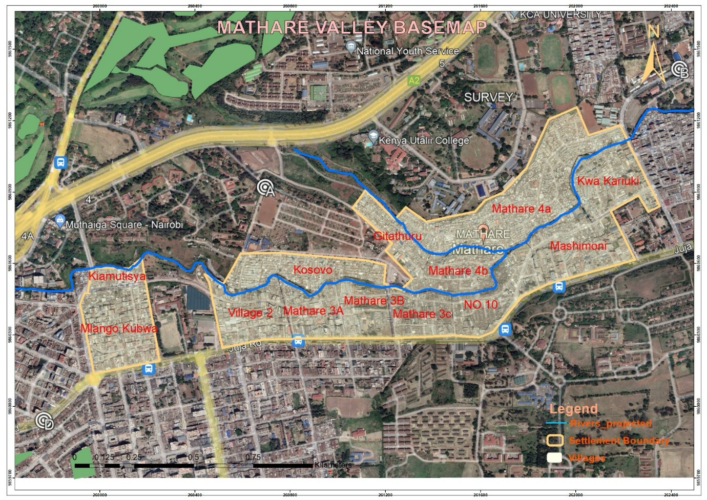
Figure 4. Mathare Valley map (Nuvoni Centre for Innovation Research, n.d.).

4.2 Household Population Breakdown
There are about 61,367 total households in Mathare, of which 27,861 households or 45.4% have female headships, 24,608 households or 40.1% have male headships, and 8,898 or 14.5% have both parents present (SDI Kenya, 2021). In both genders, ages between 25-30 make up the largest proportion at 20.41% and 10.58% for men and women, respectively. Interestingly, male-headed households (MHHs) have a higher proportion of older heads of household from ages 31 to 45 compared to women.
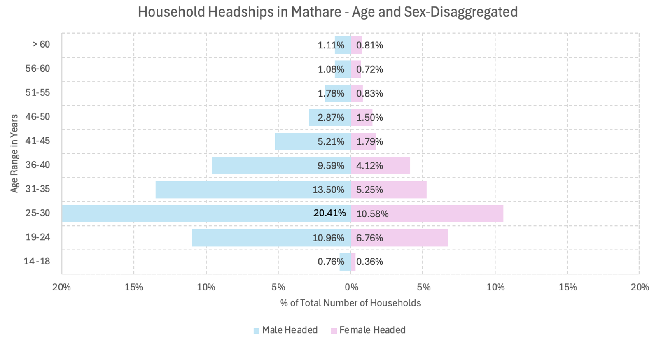
Figure 5. Mathare household headship by age and sex (SDI Kenya, 2021).
In the same survey, MHHs were identified to occupy between 0 to 6 rooms, while FHHs were lower at 0 to 4 rooms. A large majority of residents are renters at 92.8%, while 5.6% are structure owners. Like other settlements, absentee structure owners or individuals who own substandard housing but do not reside in them, are prevalent in Mathare. Majority of the household expenditure were allocated on rent, food, and other daily necessities such as water, sanitation, education and health-related needs. Currently, water is only being supplied every weekend, and waste disposal collection are done by private entities.

4.3 Socio-demographic Profile of Interviewees
Interviewees included 10 FHHs, 2 chama members, and 4 members of CBOs (N = 16). Respondents were asked about their age, level of educational attainment, current tenure status, and length of residency in Mathare. This socio-demographic profiles excludes the first responders, slum federation leader, government employees, WEF representative and the FGD participants.

4.3.1 Age groups
Respondent ages ranged from 22 to 50 years of age, with the largest age group between 25-30 years old at 6 interviewees (see Table 4). While a very small representative, this mirrors data from 2021 that also identified the same age group as the largest proportion in Mathare (SDI Kenya, 2021). Followed by ages 19-25, which also parallels 2021 data, highlights how early some women shoulder caregiving responsibilities, socio-economics stability, and capacity to protect themselves from financial and environmental shocks in the informal settlement.

Table 4. Age groups of participants (N = 16).
Age group | Frequency | Percentage (%)
19 – 24 | 5 | 31.25
25 – 30 | 6 | 37.5
36 – 40 | 2 | 12.5
41 – 45 | 1 | 6.25
46 – 50 | 2 | 12.5
Total | 16 | 100

4.3.2 Level of Educational Attainment
Out of the 16 respondents, the largest group obtained secondary level of education (n = 7) followed by college degree holders (n = 6) (see Table 5). However, some FHHs noted leaving school prematurely due to early pregnancy, while college-educated FHHs cited multiple reasons for staying: limited job opportunities, high costs of living outside Mathare, and the financial burden of supporting dependents. When overlapping this with the age group data, the two individuals whose highest level of educational attainment is at the primary level were the oldest of the group (i.e., FHH2, 50 years old and FHH6, 47 years old).

Table 5. Level of educational attainment (N = 16).
Educational level | Frequency | Percentage (%)
Primary school | 2 | 12.5
Secondary school | 7 | 43.75
Vocational Level | 1 | 6.25
College | 6 | 37.5
Total | 16 | 100

4.3.3 Length of Residence in Mathare
Of the 16 respondents, 15 were born and raised in Mathare and 1 FHH who moved when they were young and eventually stayed. Because of this, their length of stay was akin to their ages, ranging from 22 to 50 years, which could suggest long-term and deep-seated connections to each other, their surroundings and Mathare.

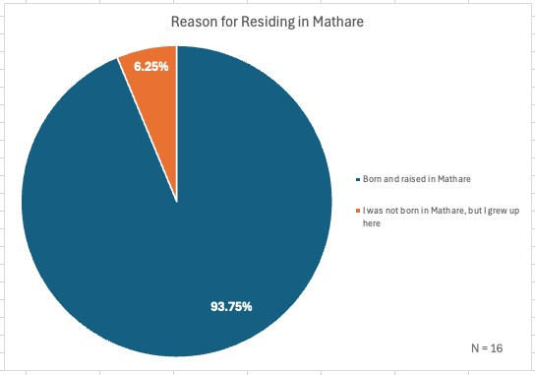
Figure 6. Reasons for staying/residing in Mathare (N = 16).

4.4 Place Attachment Exhibited by Female-Headed Households
The lived experiences of FHHs are multi-faceted and complex. We apply a critical lens to further unpack how four dimensions of place attachment play out in the lived realities of FHHs in the next sub-sections.

4.4.1 Physical Attachment
All respondents interviewed are renters and unable to alter or make any structural improvement to their homes, with some expressing fear of eviction if any personal changes were made. For FHHs in Mathare, their physical attachment is exhibited in the functions that their environment could provide, instead of physical structures or buildings in their neighbourhood. Multiple respondents, when asked about landmarks or particular memories attached to certain areas, talked more about the services which became available in recent years, such as the schools they or their children attended, church they go to weekly, NGO buildings such as Mission of Hope or SHOFCO, CBO halls, hospital, and the river. In the absence of having control over what they could do within their homes and stable tenure, these places function as a means for them to have social connections and access services every day; offering some sense of stability and growing emotional and social attachments instead. As one respondent shared:

“Where I stay, I have all the amenities…the church is near me, the school is even nearer. Where I stay is also cheaper compared to other areas. Even the food...they come here to buy. Also for small businesses who operate here, there’s no harassment from county officials compared to other areas.”
(FHH10, 43 years old)

This excerpt exhibits how FHHs place more importance on socio-economic trade-offs, proximity to resources, safety and if risks are low, in lieu of having very little agency over their immediate surroundings (FHH1-4, FHH7-9, CBO2 and 3).

Moreover, natural disasters particularly the floods from 2024 and the government-led evictions intensified awareness on their limited capacity against shocks and the precarity of their tenure status. All FHHs, including interviewees from the FGD, had to relocate involuntarily after the flood, citing this as a reason for their disconnections to their physical surrounding and ‘home’. With CBO1 (27 years old), who moved and is still staying with her mother, “Some time ago, I was very attached to this place, but now because of what I experienced, I’m no longer attached to this place, and I know it’s not only me…the experiences we have are not good and now our emotions are split. Our attachment is no longer there.” With another FHH9 (23 years old) echoing: “the floods caused everyone trauma and damage...we saw everyone losing everything…their houses, our family, friends, neighbours…it caused damage to us both physically and emotionally. I don’t know how we could get attached to this place anymore.” This statement encompasses what few FHHs shared, despite previously having meaningful connections and sense of autonomy in Mathare, the uncertainty and insecure tenure within the settlements, coupled with failed resettlement attempts by the government and the floods, has shifted the meaning and connections to their physical surroundings.

4.3.2 Social Attachment
Among the FHHs, social attachment was expressed very strongly through repeated references of: “unity,” “togetherness,” “collectivity,” and “love for community.” Multiple inferences were also made on how their capacity to survive in Mathare could be attributed to robust social networks. From the multiple local groups they belong to, church they frequent on Sundays, to the neighbours who care for their children while they work are all integral to their lived experiences as FHHs and sense of belonging to the community. Participants like FHH4 (24 years old), FHH7 (26 years old), FHH8 (22 years old) all stated similar sentiments: “Home is where we are not judged. It is where we work for a common goal together and for everyone” (FHH4). This captures their deep-rooted belief that what defines a ‘home’ is more than just its physical structure, but it’s also built on the social dimensions of trust, inclusion felt from belonging in a community and having a shared goal with others.

These same values were echoed when experiences of emergencies and natural disasters in recent years were discussed. As FHH7 (24 years old) expressed: “My neighbours’ problems are also my problem, and my problem is also everyone else’s.” With another FHH2 (50 years old) reiterating similar statements: “For me as the head of the household, we must be together as one. One family with your neighbors…that chama, it’s like my mother and my father… Without each other, I don’t think I could do it by myself”. These statements speak volumes about the emotional significance of the bonds they develop and nurture in their groups, such as chamas and CBOs. While only 2 chama members were specifically interviewed for the study, all 16 FHH respondents belonged to multiple groups. Many FHHs conveyed that despite initially joining to mainly fulfill financial inadequacies, they have grown to rely on other members for emotional support and social connections outside of their own families (FHH2, 4, 6, Chama2, CBO1-4). FHH9 (23 years old), for example, was not a member prior to the floods, however seeing the role they played in the community served as catalyst to joining one. This highlights how shared experiences of vulnerability could motivate FHHs in seeking better economic and social safety nets within their immediate communities.

Moreover, their significance is particularly intense for FHHs as they draw strength and support to carry the heavy load of responsibilities from others in the community. For instance, FHH2 (50 years old) also emphasized that “without a chama for heads of households like me, you are nobody.” In informal settlements like Mathare, where formal support systems are lacking and everyday lived experiences are unpredictable, FHHs find stability and emotional support during crises in others. They have built their own safety nets to resist and respond to difficult circumstances such as the floods, with FHH2 also citing: “Even before the flood from last year, we realized coming together is the only way we could improve our community.” For many FHHs, their place is not just where they reside, but it is also where they feel supported, accepted and valued. Social cohesion and belonging in the community are what makes Mathare feel like ‘home’ for them (FHH4, 7, 8, 10, Chama2).

4.3.3 Psychological Attachment
Psychological attachment among the respondents emerged strongly in their anecdotes about their sense of security, pride and identity. For several FHHs, the idea of security is not built on formal systems but rather informally, believing that residents have a moral obligation and responsibility to provide protection and maintain a sense of safety for each other. As FHH2 (50 years old) outlines in her statement: “In Mathare, the residents, ourselves, we are the ones who keep ourselves and each other safe and secure..,as a community, we feel that it is our responsibility to sit together and talk [to children who use drugs, don’t go to school and steal], and help them. We don’t have police in Mathare. Police do not come here or give us any security. Security starts with you as a community.”
For emotional bonds to transpire, strong social networks and the desire to collectively work on something together must first be established between different actors, which becomes their motivation to improve their communities. As reported by FHH2 and others, participants defined safety as something they could actively work towards even when acknowledging Mathare has limited institutional assistance. The Red Cross representative (30 years old), who was born and raised in Mathare, also mentioned seeking training and working as a Children Protection Officer as soon as she was able, citing that “if not me or anyone in Mathare, who will do it for these children?”

For many of these women, their ability to navigate the stresses weak institutional governance in their communities meant coming forward to collectively act and adapt even in isolation. Nonetheless, some respondents also highlighted instances of violence, police brutality, theft, political upheaval during election season, fires, gender-based violence and floods as a source of worry and dissatisfaction for living in an informal settlement (FHH2, 6, 7, 8, RCK).

Consequently, another key aspect of psychological attachment is the sense of pride respondents feel in their ability to endure adversities. Unlike temporal attachment where some sense of ideation harbors attachment to a place, their pride is instead built on acknowledging their ability to withstand hardships through mutual support. A CBO member explains:

“For me growing up in Mathare, I was really looking up to getting a better life, moving away from Mathare…but growing up in this place is one of the best things that ever happened to me. Mathare has really shaped me to what I am today. For me, I'm not ashamed to grow up in Mathare and to live in Mathare. Actually, the hardships have really hardened me. They are the ones that have made me into superwoman…because we have endured hardships like for me I lost my parents, so I had to learn how to survive at a very young age. I was once into drugs, and it was not my choice, it's peer pressure and lack of school fees…I can proudly say I'm proud to be in Mathare, grown from Mathare. As much as I am really looking forward to going to a better place in future, I don't regret growing up in Mathare.”
(CBO4, 28 years old)

Emotional bonds to a place is not only limited to positive feelings but could also be realized after overcoming experiences that are less desirable. This then becomes a meaningful narrative of resilience and growth which some associating it to their sense of identity and pride of living in Mathare. This relates to what FHH1 (25 years old) emphasized when asked how much of her identity pertains to her being a Mathare resident: “It has been my home, and it will always be my home. Even if I go away, it will always be my home.” From this, we could infer that Mathare remains a symbolic and central point of not just their self-identity but also how they define ‘home’. Despite imagining living somewhere else, they felt that Mathare is an integral part of how the respondents saw themselves. This reflects a deep yet complex psychological and temporal attachment to places that FHHs navigate even under conditions of uncertainty.

4.3.4 Temporal Attachment
For many FHHs in Mathare, temporal attachment is multi-faceted and dynamic. Their longterm residence, familial and intergenerational connections, shared lived experiences and deepseated social fabric has created for them a strong sense of continuity and belonging. However, these do not always entail intentions to stay or satisfaction with the place. For example, FHH3 frankly discussed their desires for obtaining a better socio-economic standing outside of Mathare, even if their family history spanned decades in the informal settlements:

“Life is tight here. Our parents brought us up here because they’re not educated and had no knowledge. They did not know to invest or about anything else…so, don’t be stagnant just because you were brought up here… for me, now and as long as I am alive, I’m fighting for that. That mentality, one day I’ll shift and move away.”
(FHH3, 40 years old)

The dynamic nature of temporal attachment may materialize negative notions if a given place does not fulfill the aspirations for an individual over time, increasing motivations to find better opportunities elsewhere. Contrarily, some respondents cited wanting to be part of the change and improvements they did not experience growing up in an informal settlement. As expressed by FHH1 and CBO4:

“Everyone’s dream is to be somewhere better. It has crossed my mind to move but still I want to bring change. Everyone here is the same, because we don’t have a choice, we want to bring change in Mathare.”
(FHH1, 25 years old, Mathare 3B)

“One of the things that made me stay in Mathare…I want to be part of the change in Mathare. It is one of the things that has really kept me here. I don't want to go, come back and find change in my home in Mathare without me. I want to be a part of the change from the roots to every part of it. So that's why I'm here and part of the groups…every day I do something for the change I want to see here.”
(CBO4, 28 years old)

For these women, their attachment goes beyond the duration of residing in Mathare, but they also feel equally obligated to their community and the people they grew up with. In addition, some respondents expressed satisfaction in the infrastructural and service improvements such as the new hospital, more public schools, public toilets, and paved roads as well as urban farming and clean-up projects of CBOs along the river. Citing these signs of progress as reasons for their growing sense of pride and security for the future of Mathare and increased hope that these transformations could change the trajectory for the next generations, especially for their children. This coincides with the psychological and physical dimensions, as they report feeling “happier over time (FHH7, 26 years old)” and “pride (FHH2, 50 years old)” over the improvements from the last decade. Despite mentions of discontent with the drainage and garbage disposal systems in some areas, more women saw Mathare as a place that has potential to evolve so long as they continuously invest and nurture it together, which parallels the social dimensions of place attachment.

4.4 Types of Flood Preparedness Measures Employed by FHHs

4.4.1 Pre-decision Processes
FHHs in Mathare often look at a combination of environmental and social cues and warning components to determine the scope, extent and urgency needed to protect themselves before a flood occurs.

Environmental and Social cues
FHHs relied heavily on social cues compared to environmental signs before last year’s floods. Multiple women described the behaviour of others around them, including running with their family and household items (FHH2, 5, 6, 8, CBO4), hearing people scream verbal warnings (FHH2, 3), seeking shelter in the upper areas (CBO4, FGD), and seeing others leading others to safety (FHH6, 7) triggered them to react as the flood waters came up to the riparian areas. Due to the flood occurring in the middle of the night, many FHHs were unable to rely on environmental cues as visible signs such as rising waters or extreme changes in the weather were more difficult to observe and many were caught by surprise. Interestingly, FHHs also mentioned willingly returning the following morning to assist others to safety after guaranteeing the safety of their own families. This highlights the trust FHHs place on social cues they receive from informal community networks in Mathare, their obligation and willingness to help even under immense pressure.

Warnings Components
When asked to rank the level of trust FHHs have in relation to different community actors and delivery of warnings or advice to prepare for floods, NGOs (n = 7) had the highest number of first-place ranking followed by CBOs (n = 5) (see Table 6). Interestingly, community-based stakeholders such as neighbours, CBOs and chamas were all ranked highly, showing great levels of trust and responsiveness at the local level by FHHs. In contrast, government officials and local leaders occupied the lower rankings, indicating a perceived lack of timely and ample assistance with FHH9 (23 years old) citing, “they always come too late, when they arrive it’s already solved.” These rankings reveal not only which actors they believe are effective and present during last year’s flood, but also who they could turn to in times of need.

Table 6. Trust Ranking for Community Actors (N = 16).
Actors | Rank 1 | Rank 2 | Rank 3 | Rank 4 | Rank 5
Government officials | 1 | 0 | 9 | 14 | 14
Local Leaders  (village chiefs and elders) | 0 | 0 | 4 | 2 | 2
Neighbours | 3 | 4 | 3 | 0 | 0
NGOs | 7 | 5 | 0 | 0 | 0
CBOs / Chamas | 5 | 7 | 0 | 0 | 0
Total |  |  | 16

A colour-coded hazard system was established by RCK along the riverbanks to signify different water levels and warn residents about imminent danger. However, both the local response team and RCK representatives stated that it was more difficult to reach FHHs compared to other groups as they prioritize income-generating activities over sensitization workshops or educational flood campaigns. Door-to-door programs were also deemed ineffective as they juggle multiple informal jobs and responsibilities during the day, and therefore, regularly absent from their homes. RCK representative cited: “When we try to look for those affected last year, the women maybe because they were looking for money…we couldn’t locate them. So maybe 30% were helped, but the remaining 70% we couldn’t give them anything.”

Flood-related warnings are mainly received by FHHs through informal channels, including word-of-mouth from neighbours, CBOs, NGOs, or chamas, social media like WhatsApp and Facebook, and occasionally through local weather forecasts or radio. They were were deemed more accessible and up to date than formal government alerts, with CBO1 (27 years old) stating that “there is no official Mathare-wide alert system that is locally managed until now, so we listen to Red Cross, news, and word-of-mouth from neighbours.” This highlights that when formal warning systems fail, FHHs and other residents adapt to build informal systems, ensuring timely updates are received by each other.

4.4.2 Protective Action Decisions and Behaviours
The heavy and continuous rainfall which led to the 2024 floods occurred for 3 consecutive days, with the most severe development happening in the middle of the night. Several FHHs cited not being able to prepare as they were woken up around 11pm when water entered their homes, only able to bring “clothes on their backs (FHH6, FHH10)”, with another citing, “I did not realize we did not have shoes until the morning (FHH2)” as everything was swept away. The urgency of the situation deprives FHHs the capacity to make deliberate or calculative decisions, which leads to more reactive strategies than planned actions even when they detect social and environmental cues.

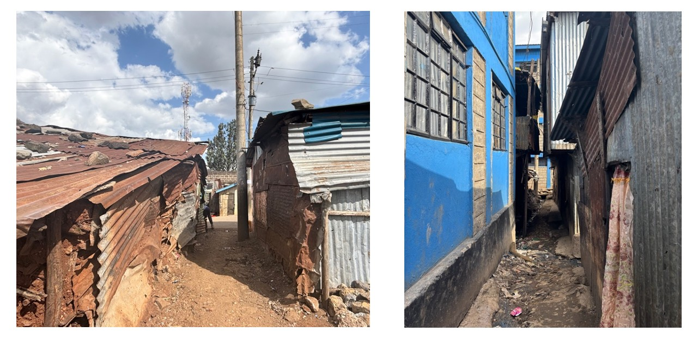
Photographs 1 and 2. House near the river made from clay and iron sheets sinking (left). Drainage line, also used as a pathway, with houses that have been built loosely on top of each other. These types of housing became more prevalent after the flood to cater to the resettled and were being rented out at a higher price (right).

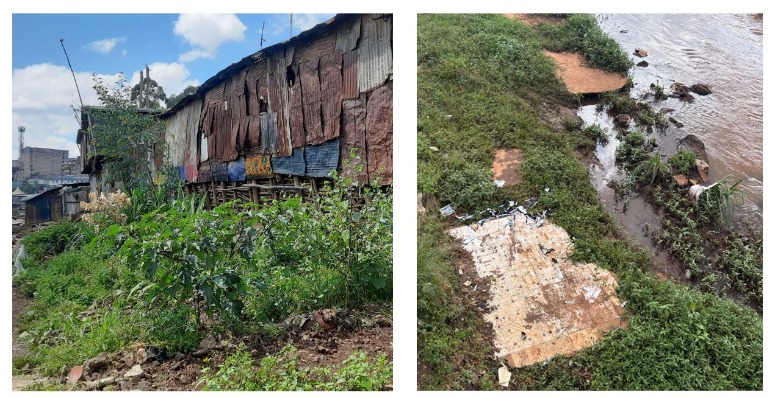 Photographs 3 and 4. Urban farming near the river (left). Foundational structures from demolished homes, showing the proximity of houses along the riparian areas (right).

Houses along the river, while cheaper and affordable for FHHs, were typically made with nondurable materials such as iron sheets or clay. Highlighting both their tenure insecurity and precarity of their living situations especially during a flood, with many citing “trauma (CBO3, 4, FHH4, 9, Chama1)” and “fear (FHH2, 6, 7, RCK)” of living again near the river. Householdlevel protective decisions ranged from different actions, determined by their caregiving responsibilities, financial constraints, and financial ties to the place. These actions include rainwater harvesting, keeping items in waterproof bags and a safe area, and diversifying their income-generating activities.

Such decisions are rarely made in isolation; they reflect a deep-seated obligation to protect dependents, especially children and elderly family members. The urgency of care and the absence of alternative support systems often push FHHs to prioritize immediate safety over long-term planning. In some cases, women chose not to evacuate during flooding because they lacked safe options, feared losing possessions, or even past traumatic experiences from displacement with RCK emphasizing that some FHHs wanted to “wait it out (RCK)”. These behaviors are not simply reactive but represent a form of calculated risk management, grounded in their lived realities and constrained decision-making power.

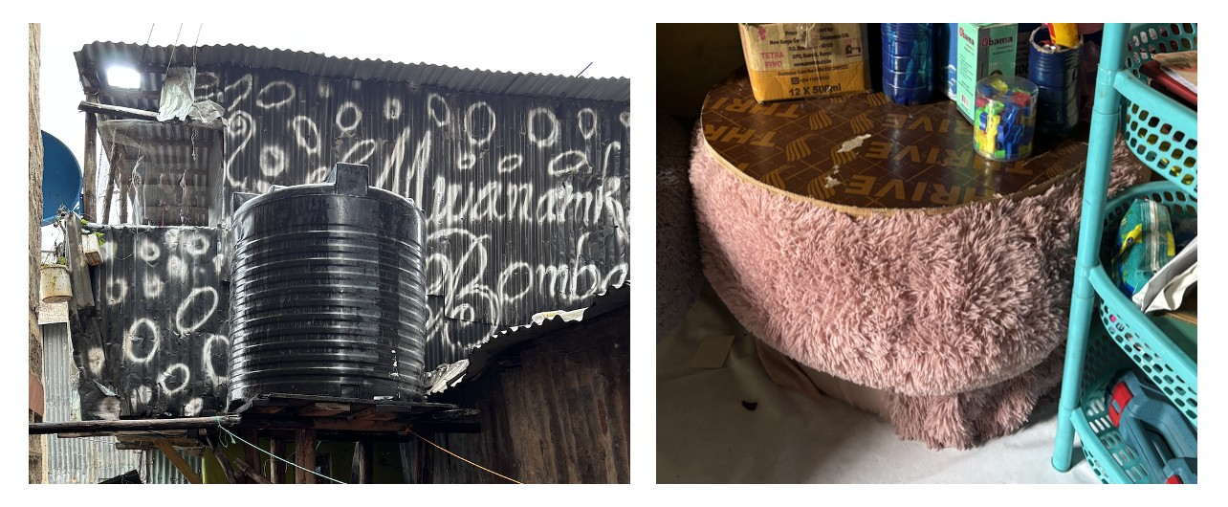
Photographs 5 and 6. Rainwater harvesting in homes (left); tyres that have been repurposed as furniture and sold by a CBO (right).

At the community level, many CBOs partook and collaborated with each other to better improve the areas along the river. This included transforming a former landfill into a community park, with a playground, gazebo for recreational classes, and planting trees and urban farming for better structural integrity of the riparian areas. These groups also work together to conduct weekly clean-ups along the river, awareness campaigns and feeding programs to get the youth involved. FHH7 (26 years old), whose CBO led the movement to build the community park, reiterated the importance of starting with the youth: “I joined the CBO because we have the same goals, coming together and looking to make a change together, it makes me feel more motivated to help them while they are still young.” They also used this opportunity as a means to reclaim the land back from the government, hoping that through their collective efforts they would be able to gain agency again from what they lost in the floods and evictions.

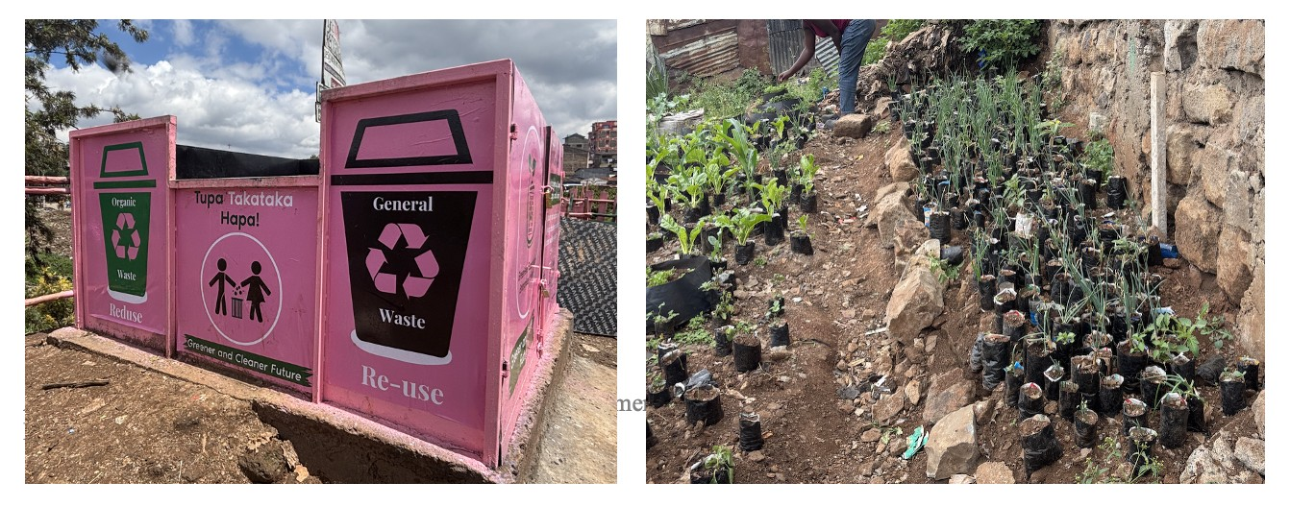
Photographs 7 and 8. Waste segregation bins where CBOs sort and sell recycled items. The money goes to a weekly youth feeding program (left). Urban farming along the riparian areas as a way for FHHs to reclaim the land after government-led evictions (right).

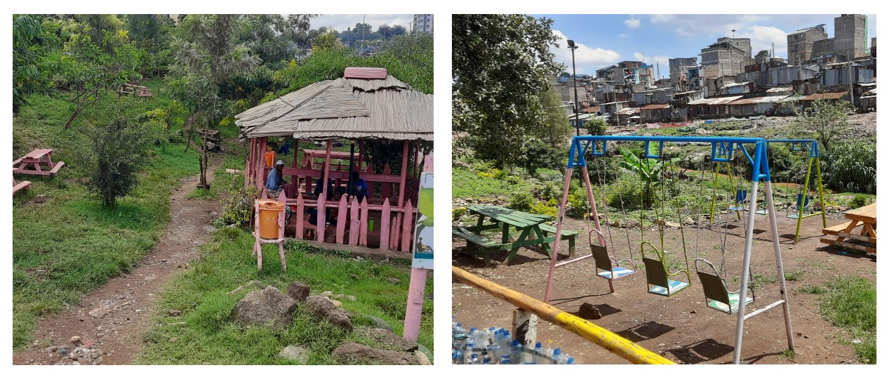 Photographs 9 and 10. Former landfill that was cleaned up and turned into Mathare Community Park by multiple CBOs (left). Park playground and sitting area (right).

4.5 Social and Economic Responsibilities of FHHs

4.5.1 Social Responsibilities of FHHs

Household size
Out of the total number of households Mathare, average household size was 4 members (SDI Kenya, 2021). From the respondents (N = 16), the largest proportion reported having at least 3 members in the same dwelling, with household size ranging from 1 to 6 members. Household configurations varied with some living with their elderly parents, nephews or nieces, adult siblings or neighbours’ children. The largest household size was made up of 3 adults and 3 children, with the female headship being a 22-year-old, chama member.

Table 7. Household size of respondents (N = 16).
Total Household Size (Adults + Minors) | Frequency | Percentage (%)
1 | 1 | 6.25
3 | 7 | 43.75
4 | 5 | 31.25
5 | 2 | 12.5
6 | 1 | 6.25
Total | 16 | 100

As the main caretaker of the home, social responsibilities of these women change depending on the number of members that rely on them socio-economically. Their time, attention and efforts need to be optimized and when compounded with considerations of their housing situations, FHHs have conflicting priorities making caregiving more physically and mentally exhausting. This was cited by Chama2 (38 years old): “Other women in my chama also take care of others, even not their family…sometimes you would see 6 or 10 in one room because the river is the cheapest, so a lot more people are affected. But we don’t really have another choice.”

Social Responsibilities
FHHs in Mathare shoulder social responsibilities daily that shape their capacity to survive and thrive in the informal settlements. Respondents noted having caregiving obligations beyond their own children or elderly family members, especially during the floods from last year. However, the burden of decision-making and caring for the home is endured typically in isolation, with FHH6 (47 years old) alluding that “if you are a single mother, it is very hard because you are the only one working for your family. I cry silently to not show them…you just have to keep working…there are many challenges, but I can only keep trying.” In parallel, CBO3 (26 years old) echoed this sentiment: “they don’t see you the same without a husband, but you can’t just leave your children or your responsibilities.”

As sole caregivers, these women must protect not only the household structure and their personal belongings but also ensure that their children are fed, clothed, and kept safe, often in overcrowded and unpredictable circumstances. Last year’s floods resulted in the loss of school uniforms, books, and supplies, which made it difficult for students to return immediately as most schools were used as temporary shelters. FHHs also reported that their children felt ashamed and stigmatized, especially when classmates identified them as displaced or being part of a single-parent household. FHH6 (24 years old) shared that her daughter was reluctant to attend school because, “everyone would know that we had to run from the flood and live near the river.” These experiences highlight the emotional and social burdens FHHs must endure, balancing the needs of their children while also maintaining continuity in their daily lives after the flood.

4.5.2 Economic Responsibilities of FHHs
All respondent identified as the principal earner of their households, which suggest a high level of economic responsibility and self-reliance to earn a livable wage for themselves and their dependents. Of the 16 FHHs, 7 of the respondents reported having a small business, which include selling secondhand clothing, vegetables and food items at the market, and house décor (see Table 8). Because of the unpredictability of the number of customers of they have daily, several FHHs are part of multiple table-banking groups with neighbours, chamas, and churchmates and work casually to supplement their daily income. 1 FHH who reported as unemployed referred to their chama as their current source of daily income.

Table 8. Primary occupation and sector of work of respondents (N = 16).
Primary Occupation / Sector of Work | Frequency | Percentage (%)
Small Business | 7 | 43.75
Casual work | 3 | 18.75
Housework | 2 | 12.5
Unemployed | 1 | 6.25
Student | 1 | 6.25
Other | 2 | 12.5
Total | 16 | 100

Respondents from the informal and domestic work sectors cited inconsistent and very low daily income averages, ranging from KSH 0 to 800 (EUR 5.25). The highest income earner noted having a monthly average of about KSH 10,000 (EUR 65.60) from her catering business but also highlighted that it is irregular and seasonal-based, which averages to about 12 days of income. Despite identifying as their household’s primary earner, these findings suggest a high degree of financial insecurity and the precarity of their economic situation, with FHH6 noting that they are “one emergency or sickness away from living outside.”

FHHs in Mathare shoulder extensive economic responsibilities that extend beyond immediate caregiving roles. Many women are also sole income earners for their elderly parents and extended kin, with RCK representative explaining, “It’s so hard for me because you have four kids, you have your parents and other siblings that are depending on you, it’s so, so, so, difficult…we all need to survive from hand to mouth.”

This precarity is also evident in their tenure status as all FHHs identified as renters. Their monthly lease ranges from KSH 2,500 to 5,500, equating to about 50% of their monthly income allocated to housing. This may also increase depending on the ward, proximity to street and upper areas, material of the home, and number of rooms. Before the floods and governmentled evictions from last year, respondents who used to live along the riparian zone stated that their monthly rent was between KSH 1,500 to 2,500.

These financial burdens are exacerbated by housing insecurity and price shocks, particularly following disasters. Multiple FHHs stated that immediately after the floods, rent in safer, elevated areas rose sharply, making previously affordable housing inaccessible for many (FHH1-4, 6, 9, 10). Despite these constraints, some FHHs chose to pay higher rents to live in safer locations, prioritizing security over affordability. “Let me pay more and be safe… Now even if the rain is raining, I feel more comfortable, and I don’t feel any fear anymore because I know where I am and it cannot come here (RCK).” These economic decisions, balancing caregiving, rent, and safety, highlight the compounded pressures faced by FHHs and the difficult trade-offs they must make to protect their families in an increasingly unstable environment.

5. Conclusions
This chapter outlines the contributions of this study relative to the broader academic discourses around place attachment, flood preparedness and socio-economic responsibilities of FHHs by answering the research questions. As a close, future research recommendations are also outlined.

5.1 Place attachment as exhibited by FHHs in Mathare
Findings show that their attachment is less connected to ownership or physical permanence, but is rather heavily embedded in their social networks, routines and adaptation againts to adversities.
- Physical attachment: due to inability to make personal alterations as tenants, this bond instead manifests through the socio-economic trade-offs FHHs make to remain close to essential services, reliable social networks, and employment opportunities, eventually accepting higher environmental risks, as argued by Williams-Bruinders & de Wit (2015). Their decisions to stay is also constrained by their familiarity and limited agency, rather than preferences as defined by Flatø, Muttarak & Pelser (2016).
- Social attachment: because of weak governance structures in Mathare, FHHs have learned to adapt with others through community-based groups. With limited formal social safety nets, these connections provide financial and practical supports with or without natural disasters, and a central reason for remaining in place by some FHHs. This aligns with Manzo and Perkins (2006) arguments that well-integrated individuals are motivated to care for and improve the places they feel most connected with (Manzo & Perkins, 2006).
- Psychological Attachment: FHHs characterized Mathare through their pride, identity and feelings of safety. Despite residing in flood-prone areas, they see their capacity in withstanding and adapting to their everyday circumstances as a positive outcome, which parallels viewpoints made by Scannell and Gifford (2009) and Manzo and Perkins (2006).
- Temporal Attachment: long-standing history and residence with Mathare has tied FHHs temporally in place. Contrarily to Giuliani’s (2003) that longer residence to a place lead to stronger temporal attachments, findings show that this is not agedependent as both young and older FHHs have split between desires to leave or stay in place.

5.2 Flood preparedness measures commonly employed by FHHs in Mathare
FHHS in Mathare typically employed preparedness measures that are low-cost, informal and reactive due to limited economic capacities, institutional support and overlapping socioeconomic responsibilities. At the household level, they place important documents in waterproof bags, identifying safe areas in the neighbourhood, and diversification of employment. However, many still rely on collective preparedness measures through trusted informal channels, such as chamas and word-of-mouth signals (Satterthwaite et al., 2020). These groups replace formal adaptive mechanisms, filing the gaps and enabling flood preparedness measures by having a shared objective and coordinated localized responses, further reinforcing their social and psychological attachments (Aldrich, 2012; Manzo & Perkins, 2006).

5.3 Social and Economic Responsibilities of FHHs in Mathare
As sole caregivers, FHHs in Mathare prioritized daily survival, caring for dependents and income-generating activities, over anticipatory preparedness, with limited financial means at their disposal to invest in long-term protective measures at the household level. These social responsibilities then equate to deeper social and psychological attachments to place by fostering collective resilience networks through community-based groups. Scarce economic avenues have to some extent forced FHHs to remain in place, where their social fabrics, comfort zones and familiarity with Mathare outweigh the potential of upward mobility from relocating, even when flood risks are evident (Manzo & Perkins, 2006).

5.4 To what extent does place attachment and belonging in a FHH influence their adoption of flood preparedness measures in Mathare?
Empirical findings from this research surmises that while attachment may strengthen community-based resilience, it could also hinder in adopting preparedness actions at the household levels. In Mathare, women’s identities as caregivers and community members deeply tie them to the many social roles and obligations they obtain through their social networks, creating a strong social, physical and psychological attachment to place, which aligns with arguments by Manzo and Perkins (2006), who emphasize that social connections are central to place-based behaviours and willingness to improve, remain and care for a place (Manzo & Perkins, 2006). FHHs interviewed felt pride, safe and self-identified with Mathare even after the traumatic 2024 floods that displaced them from the riparian areas. However, these same emotional bonds have also led them to refuse relocation, delay evacuation even with obvious social cues, and resources that are available (Swapan & Sadeque, 2021). Contrary to Giuliani’s (2003) reasoning that older individuals tend to become more temporally attached as they age in place, the study found no clear distinction in their attachment levels or preparedness actions when comparing older and younger FHHs in Mathare. Nonetheless, this could suggest that in flood-prone areas that have scarce resources, their behaviours and actions may be shaped more by daily survival pressures and shared caregiving responsibilities than their length of residence (see Figure 7).
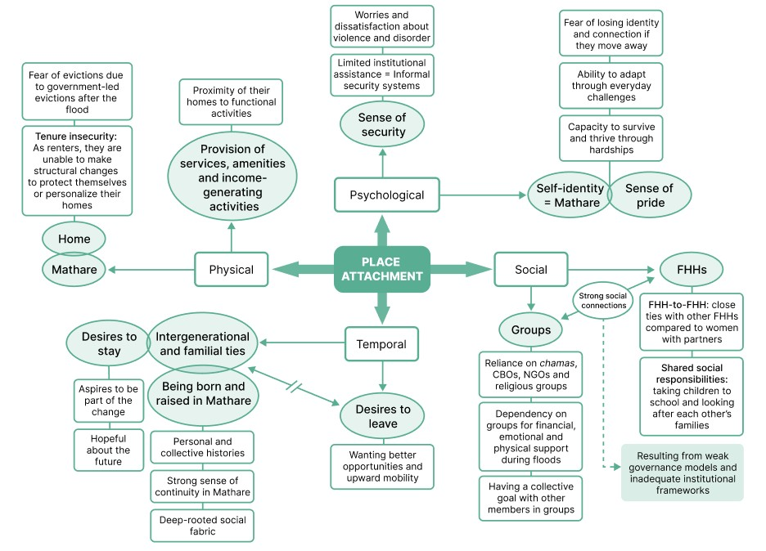
Figure 7. Place attachment and its influence on how FHHs react to floods (Author, 2025).

5.5 Recommendations
Based on the findings, two main recommendations emerge:
- Findings demonstrate the importance of informal social networks through collective groups such as chamas, CBOs, and other grass-roots initiatives for FHHs in Mathare. As such, policymakers should leverage on these pre-existing connections to invest in collective preparedness mechanisms or platforms for the community at large that may be physically or financially unfeasible for individual FHHs.
- “Information is power!” this was a recurring shared sentiment among residents during fieldwork in Mathare. This expression reflects their strong local awareness on the value of receiving timely and relevant knowledge when responding to risks, and the importance of easily accessible methods for information sharing between different stakeholders. Dissemination of relevant, crucial and actionable information should be done concisely in a format and language easily understood by the residents especially during disasters.

5.6 Further Research
Future research may also explore how emotional bonds to place and flood preparedness could differ across different types of households in informal settlements, including male-headed, multi-generational, or nuclear families, as well as different demographic conditions (such as age, emplolyment strategies, group dynamics) which can elicit better understanding on the roles gender and family headship dynamics play in shaping adaptive behaviours during natural disasters. Male-heads with children but have no partners were also noted to have been stigmatized during floods of last year, possibly even more so than FHHs, as they are deemed to be less socially accepted in community. Looking into this perspective will not only broaden the understanding of gender vulnerabilities in the context of climate change but also challenge assumptions that only FHHs are disproportionately affected during natural disasters.

Bibliography
Ackerl, T., Weldemariam, L. F., Nyasimi, M., & Ayanlade, A. (2023). Climate change risk, resilience, and adaptation among rural farmers in east africa: A literature review. Regional Sustainability, 4(2), 185–193. doi:10.1016/j.regsus.2023.05.004

Agarwal, S., & Arshad, M. (2024). Sociological Insights: Rethinking decision-making in evolving patriarchal family structures. International Journal of Social Science and Human Research, 7(01). https://doi.org/10.47191/ijsshr/v7-i01-112

Aldrich, D. P. (2012).‘Social Capital in Post Disaster Recovery: Towards a Resilient and Compassionate East Asian Community’, in Sawada, Y. and S. Oum (eds.), Economic and Welfare Impacts of Disasters in East Asia and Policy Responses (pp.157-178). ERIA Research Project Report 2011-8, Jakarta: ERIA.

Alston, M. (2015). Women and climate change in Bangladesh. Routledge.

Altman, I., & Low, S.M. (1992). Place attachment. In: Altman, I., Low, S.M. (Eds.), Human Behaviour and Environment, (vol. 12). Springer, Plenum Press, New York and London.

Braga, C., & Costa, L. (2022). Time use and food insecurity in female-headed households in Brazil. Revista Brasileira De Estudos De População, 39, 1–23.
https://doi.org/10.20947/s0102-3098a0200

Bryan, E., Ringler, C., Okoba, B., Roncoli, C., Silvestri, S., & Herrero, M. (2013). Adapting agriculture to climate change in kenya: Household strategies and determinants.
Journal of Environmental Management, 114, 26–35.
doi:10.1016/j.jenvman.2012.10.036

Brown, B.B., & Perkins, D.D. (1992). Disruptions in place attachment. In: Altman, I., Low, S.M. (Eds.), Place Attachment. Human Behavior and Environment, Advances in Theory and Research, (vol. 12). Springer, Boston, MA.

Devine-Wright, P., Quinn, T., Environment Agency, Kipling, K., & Bailey, P. (2023, January). Place attachment, flood risk and adaptation. (University of Exeter), FCERM Research & Development Programme. Retrieved from
https://assets.publishing.service.gov.uk/media/6388d459e90e071e009bdd7a/FRS1719
2_Working_together_to_adapt_to_a_changing_climate_flood_and_coast__place_attachment__flood_risk_and_adaptation.pdf

Dixon, J., & Durrheim, K. (2000). Displacing place-identity: a discursive approach to locating self and other. Br. J. Soc. Psychol. 39 (1), 27–44.

Ehsan, S., Begum, R. A., Abdul Maulud, K. N., & Mia, M. S. (2022). Assessing household perception, autonomous adaptation and economic value of adaptation benefits: Evidence from west coast of peninsular malaysia. Advances in Climate Change Research, 13(5), 738–758. doi:10.1016/j.accre.2022.06.002

Erman, A, Tariverdi, M, Xiaomeng, M O, Rose, C, Vincent, C, Malgioglio, S, Rentschler, J,
Hallegatte, S, and Yoshida, N. (2019). Wading Out the Storm the Role of Poverty in Exposure, Vulnerability and Resilience to Floods in Dar Es Salaam. World Bank: Washington, DC. http://hdl.handle.net/10986/32269.

Flatø, M., Muttarak, R., & Pelser, A. (2017).Women, weather, and woes: The triangular dynamics of female-headed households, economic vulnerability, and climate variability in South Africa. World Development, 90, 41–62.
doi:10.1016/j.worlddev.2016.08.015

Gebre, G. G., Amekawa, Y., Fikadu, A. A., & Rahut, D. B. (2023). Farmers' use of climate change adaptation strategies and their impacts on food security in Kenya. Climate risk management, 40, 100495. https://doi.org/10.1016/j.crm.2023.100495

Gerson, K.; Stueve, C.; Fischer, C. (1977). Attachment to place. In C. Fischer, ed. Networks and Places. NY: The Free Press.

Giuliani, M.V. (2003). Theory of attachment and place attachment. In: Bonnes, M., Lee, T., Bonaiuto, M. (Eds.), Psychological Theories for Environmental Issues (pp. 137–170). Ashgate, Aldershot, UK.

Han, S. (2025). Anchored in place, driven by risk: How place attachment amplifies the household flood adaptation. Applied Geography, 177, 103547.
doi:10.1016/j.apgeog.2025.103547

Hay, R. (1998). Sense of place in developmental context. J. Environ. Psychol. 18 (1), 5–29.

Holley, J. R., McComas, K. A., Lambert, C. E., Snider, N. P., & Tucker, G. K. (2022). Responding to flood risk in Louisiana: the roles of place attachment, emotions, and location. Natural Hazards, 113(1), 615–640. https://doi.org/10.1007/s11069-02205316-9

Hiwarkhedka, N. S. M., & Sharma, N. D. A. (2024). Patriarchal dominance in English literature. International Research Journal on Advanced Engineering and Management, 2(04), 1228–1231. https://doi.org/10.47392/irjaem.2024.0165

Howard, B.C., Awuni, C.A., Agyei-Mensah, S., Bryant, L., Collins, A., Yidana, S., Yiran, G., Buytaert, W. (2024). Household-specific barriers to citizen-led flood risk adaptation.
npj Clim. Action 3, 112 . https://doi.org/10.1038/s44168-024-00198-y

Hummon, D.M. (1992). Community Attachment: Local Sentiment And Sense Of Place. In I.

Altman; Low, S.M., eds. Place Attachment (pp. 253-278). NY: Plenum Press.

IPCC. (2007). Climate Change 2007: The Physical Science Basis. Contribution of Working Group I to the Fourth Assessment Report of the Intergovernmental Panel on Climate
Change [Solomon, S., D. Qin, M. Manning, Z. Chen, M. Marquis, K.B. Averyt, M.Tignor and H.L. Miller (eds.)]. Cambridge University Press, Cambridge, United Kingdom and New York, NY, USA.

IPCC. (2023). Summary for Policymakers. In: Climate Change 2023: Synthesis Report.
Contribution of Working Groups I, II and III to the Sixth Assessment Report of the Intergovernmental Panel on Climate Change [Core Writing Team, H. Lee and J.
Romero (eds.)]. IPCC, Geneva, Switzerland, pp. 1-34, doi: 10.59327/IPCC/AR6-
9789291691647.001

Kazi, S., Raza, B., & Aziz, N. (1988). Households Headed by Women: Income, Employment and Household Organization [with Comments]. The Pakistan Development Review, 27(4), 781–790. http://www.jstor.org/stable/41239064

Kimeu, C. (2024, September 19). ‘I’ve only the clothes on my back’: lives swept away by floods in Kenya. The Guardian. https://www.theguardian.com

KNBS and ICF. (2023). Kenya Demographic and Health Survey 2022. Nairobi, Kenya, and Rockville, Maryland, USA: KNBS and ICF. Retrieved from
https://www.knbs.or.ke/wp-content/uploads/2023/08/Kenya-Demographic-andHealth-Survey-KDHS-2022-Summary-Report.pdf

Lee, Y.-J., & Lin, S.-Y. (2022). Effects of Perceptions of Climate Change and Flood Risk on Coping Behavior: A Case Study of Taipei, Taiwan. Sustainability, 14(1), 289.
https://doi.org/10.3390/su14010289

Le Masson, V., Lim, S., Budimir, M., & Podboj, J. (2016, November). Disasters and violence against women and girls: Can disasters shake social norms and power relations? Overseas Development Institute. Retrieved from https://media.odi.org/documents/11113.pdf

Lie, L. B., de Korte, L., & Pursiainen, C. H. (2023). “here, i will stay until i die”—exploring the relationship between place attachment, risk perception, and coping behavior in two small norwegian communities. Regional Environmental Change, 23(3), 115.

Lindell, M. K., & Perry, R. W. (1992). Behavioral foundations of community emergency planning. Hemisphere Publishing Corp.

Lindell, M. K., & Perry, R. W. (2003). Communicating environmental risk in multiethnic communities. Sage publications.

Lindell, M. K., & Perry, R. W. (2012). The protective action decision model: theoretical modifications and additional evidence. Risk analysis : an official publication of the
Society for Risk Analysis, 32(4), 616–632. https://doi.org/10.1111/j.1539-
6924.2011.01647.x

Manzo, L. (2014). Exploring the shadow side: Place attachment in the context of stigma, displacement and social housing. In L.C. Manzo and P. Devine-Wright (eds) Place attachment: Advances in theory, methods and applications (pp. 178–190). London: Routledge.

Mitra, N., & De, K. (2024). A study on Financial Independence and Financial DecisionMaking Autonomy of Women. Asian Journal of Management, 261–265.
https://doi.org/10.52711/2321-5763.2024.00041

Musafiri, C. M., Kiboi, M., Macharia, J., Ng'etich, O. K., Kosgei, D. K., Mulianga, B., . . .
Ngetich, F. K. (2022). Smallholders’ adaptation to climate change in western kenya: Considering socioeconomic, institutional and biophysical determinants.
Environmental Challenges, 7, 100489. doi:10.1016/j.envc.2022.100489
Ngigi, M. W., Mueller, U., & Birner, R. (2017). Gender differences in climate change adaptation strategies and participation in group-based approaches: An intra-household analysis from rural kenya. Ecological Economics, 138, 99–108.
doi:10.1016/j.ecolecon.2017.03.019

Naeem, Muhammad, Wilson Ozuem, Kerry Howell, and Silvia Ranfagni. (2023). ‘A Step-byStep Process of Thematic Analysis to Develop a Conceptual Model in Qualitative Research’. International Journal of Qualitative Methods 22:16094069231205789.
doi: 10.1177/16094069231205789.

Nyandoro, E., & Simiyu, M. (2023, July 3). KDHS 2022: Women headed households have increased over the last eight years. Daily Nation Africa. Retrieved from https://nation.africa

Omukiti F. (2023) The Role of Women Self Help Groups (Chama) in Empowering Rural Women in Kenya ISSN: 2758-0970 The Paris Conference on Arts & Humanities 2023
Official Conference Proceedings (pp. 91-104) https://doi.org/10.22492/issn.27580970.2023.8

Owuor, M. O., & Mwiturubani, D. A. (2021). Nexus between flooding impacts and coping strategies in nairobi’s settlements. International Journal of Disaster Risk Reduction, 64, 102480. doi:10.1016/j.ijdrr.2021.102480

Proshansky, H. M. (1978). The city and self-identity. Environment and Behavior,10(1), 147– 170.

Quandt, Amy & Kimathi, Y. (2016). Adapting livelihoods to floods and droughts in arid Kenya: Local perspectives and insights. African Journal of Rural Development. 1.
2016-51

Ren, H., Guo, W., Zhang, Z., Kisovi, L. M., & Das, P. (2020). Population Density and Spatial Patterns of Informal Settlements in Nairobi, Kenya. Sustainability, 12(18), 7717.
https://doi.org/10.3390/su12187717

Rowley, J. (2002). Using case studies in research. Management Research News, 25(1), 16-
27. https://doi.org/10.1108/01409170210782990

Rukanga, B. B. (2024, April 30). Kenya floods: What a deluge reveals about Nairobi’s vulnerability. https://www.bbc.com/news/world-africa-68898731

Saad, G. E., Ghattas, H., Wendt, A., Hellwig, F., DeJong, J., Boerma, T., Victora, C., & Barros, A. J. (2022). Paving the way to understanding female-headed households:
Variation in household composition across 103 low- and middle-income countries. Journal of global health, 12, 04038. https://doi.org/10.7189/jogh.12.04038 Scannell, L., & Gifford, R. (2009). Defining place attachment: A tripartite organizing framework. Journal of Environmental Psychology, 30(1), 1– 10. https://doi.org/10.1016/j.jenvp.2009.09.006

Swapan, M. S. H., & Sadeque, S. (2021). Place attachment in natural hazard-prone areas and decision to relocate: Research review and agenda for developing countries.
International Journal of Disaster Risk Reduction, 52, 101937.
doi:10.1016/j.ijdrr.2020.101937

Sarason, S. (1974). The psychological sense of community: Prospects for a community psychology. San Francisco: Jossey-Bass.

Stokols, D., & Shumaker, S. A. (1981). People in places: a transactional view of settings. In J. Harvey (Ed.), Cognition, social behavior and environment (pp. 441-488). Hillsdale, NJ: Erlbaum.

Thelwell, K. (2024, May 31). How chamas in Kenya fight poverty. Retrieved from https://borgenproject.org/how-chamas-in-kenya-fight-poverty/

Tuan, Y.F. (1980). Rootedness versus sense of place. Landscape 24, 3–8.

van Valkengoed, A. M., & Steg, L. (2019). Meta-analyses of factors motivating climate change adaptation behaviour. Nature climate change, 9(2), 158–163.

United Nations Office for Disaster Risk Reduction (UNDRR). (2017). The Sendai Framework Terminology on Disaster Risk Reduction. "Preparedness".
https://www.undrr.org/terminology/preparedness.

UN-ESCWA. (n.d.). Woman-headed household. Retrieved from https://www.unescwa.org/sd-glossary/woman-headed-
household#:~:text=Women%2Dheaded%20households%20are%20households,similar %20incapacity%20(but%20not%20because

UNDRR. (2020). The human cost of disasters: An overview of the last 20 years (2000-2019) (tech. rep.). CRED and UNDRR.

Van Thiel, S. (2021). Research methods in public administration and public management: An Introduction. Routledge Masters in Public Management.

Wanasinghe, Y., & Tennakoon, S. (2019). Meeting the basic needs of the family: the changing economic role of wives and daughters in the villages of the north central province of Sri Lanka. Vidyodaya Journal of Humanities and Social Sciences, 2.
https://doi.org/10.31357/fhss/vjhss.v02i00.4057

Ware, J., & Pearce, O. (2024, December). Counting the Cost 2024: A year of climate breakdown. Christian Aid. Retrieved from https://reliefweb.int/report/world/countingcost-2024-year-climate-breakdown

Williams-Bruinders, L., & de Wit, A. (2015). Connecting sense of place and climate change:
adaptation amongst the vulnerable poor in Port Elizabeth, South Africa,. Environmental Economics, 6(4), 76-82

Woodhall-Melnik, J., & Grogan, C. (2019). Investigating Mental Health and Social Capital in Communities that Experienced Residential Displacement as a Result of the Saint John River flood of 2018. (Institute for Catastrophic Loss Reduction). Retrieved from https://www.unb.ca/initiatives/_assets/documents/ucsi/iclr-report.pdf

World Meteorological Organization (WMO). (2025). State of Global Climate 2024 (ISBN 978-92-63-11368-5).

Appendix 1: IHS copyright form

In order to allow the IHS Research Committee to select and publish the best UMD theses, we kindly ask you to fill out and sign this copyright form and make it an annex to your final thesis.

Criteria for publishing:
- An abstract of 400 words should be included in the thesis.
- The number of words should not exceed 12,000.
- The thesis should be edited.

By signing this form you are indicating that you are the sole author(s) of the work and that you have the right to transfer copyright to IHS, except for items cited or quoted in your work that are clearly indicated.
----------------------------------------------------------------------------
I grant IHS, or its successors, all copyrights to the work listed above, so that IHS may publish the work in The IHS thesis series, on the IHS web site, in an electronic publication or in any other medium. IHS is granted the right to approve reprinting.

The author(s) retain the rights to create derivative works and to distribute the work cited above within the institution that employs the author.

Please note that IHS copyrighted material from The IHS Thesis series may be reproduced, up to ten copies for educational (excluding course packs purchased by students), noncommercial purposes, providing full acknowledgements and a copyright notice appears on all reproductions.

Thank you for your contribution to IHS.

Date: 30 July 2025

Your Name: Beatrice Anne Soriano Garrovillas

Your Signature:




