MSc Programme in Urban
Management and Development

Rotterdam, the Netherlands
July 2025



Uncovering the Impact of Growing Vacant Housing on the Urban Areas in Busan, South Korea

Name: Youvin Park
Supervisor: Anitra Baliga
Specialisation: Strategic Urban Planning & Policies
Report number: 670564
UMD 2024-2025

0

Abstract
This study explores the spatial and temporal dynamics of vacant housing (VH) in Busan and its impact on urban decline, with a particular focus on resident dissatisfaction. Using KOSIS (Korean Statistics Information Service) data and QGIS mapping from 2000 to 2023, the analysis reveals a steady increase in the vacancy rate, especially after 2010. It tends to be concentrated in old city center districts, such as Jung-gu, Seo-gu, Dong-gu, Yeongdo-gu, Busanjin-gu, and Nam-gu. The growth of aged vacant houses and the dominance of apartmenttype vacancies were also observed through the investigation, and included in the analysis as well.
To evaluate the impact of VH on urban decline, the study applied Mixed-Effects and FixedEffects regression models using resident dissatisfaction indicators—pedestrian environment, safety, housing conditions, and moving-out intention—as dependent variables. Individual and district-level control variables were included for each regression model to account for demographic and socioeconomic factors. The results indicate that the vacant housing rate (VHR) shows a negative association with certain dissatisfaction indicators, implying that residents have become accustomed to the presence of vacant houses, that individuals in poorer housing conditions have relocated, or that regeneration initiatives have had a mitigating effect. Moreover, the vacant housing aging rate (VHAR) has a noticeable moderating effect by strengthening the association between vacancy and housing dissatisfaction. It suggests that long-term vacancies may intensify negative perceptions of the urban environment.
These findings demonstrate that vacant housing not only reflects but also contributes to urban decline in Busan. Moreover, the age of vacant properties partially but significantly conditions their impact. Thus, this study highlights the importance of tailored urban policies that address both the scale and duration of vacancy and calls for future research on sustainable reuse strategies and the long-term social implications of VH.

Keywords
Vacant Housing, Aged Vacant Housing, Urban Decline, QGIS, Mixed-Effects Regression,
Fixed-Effects Regression

Acknowledgements
First and foremost, I would like to express my sincere gratitude to my academic advisor, Anitra Baliga, for her steady and solid guidance and support throughout this research. Her insightful feedback and patient mentorship have been invaluable to both the development of this thesis and my personal growth as a researcher.
I would also like to thank the faculty for providing the academic environment and the resources necessary to complete this study. Special thanks to my friend Tony for helping me gain the knowledge on quantitative research. Additionally, my appreciation goes to my friends as well who offered both intellectual input and emotional support, especially during moments of selfdoubt. Your presence made this journey more manageable and meaningful. Importantly, to my family, I highly appreciate your endless love, support, and encouragement during this journey. I cannot omit to mention them since it has been a source of strength throughout my studies.
Lastly, I am deeply grateful to the BDI (Busan Development Institute) and the citizens of Busan. Their clear and honest responses on the survey proved invaluable to this study, and the excellent organization of the data load was remarkably rich, practical, and insightful. This thesis would not have been possible without this great data and information.

Foreword
While participating in new housing design projects in South Korea, I paradoxically developed a deep interest in the issues of vacant housing and urban decline. Engaged in the creation of new residential spaces, I began to question whether the current housing supply truly aligns with demand in the context of a steadily shrinking population. This naturally led to a broader consideration of vacant, aged housing stock in the old city centers. As many cities experience cycles of growth and decline, the rapid decline in the situation of South Korean cities may be seen as a natural process. However, the author became increasingly concerned with how existing vacant homes actually impact resident’s quality of life and contribute to urban deterioration, and whether these vacant properties are merely regarded as social nuisances. These questions ultimately motivated me to undertake a focused study on vacant housing.
Busan is not the city where I was born or raised. However, as a city well known for tourism and leisure, I had visited it several times. Contrary to its reputation, I found the city center and residential areas to be rather empty and desolate. These impressions led me to question what might be happening in Busan city, and if it is indeed experiencing decline, what factors are contributing to these urban dynamics.
Lastly, I must acknowledge the value of South Korea’s well-organized public data platforms. Institutions such as KOSIS and regional research centers provide detailed and extensive, highquality datasets, and I have long hoped to actively incorporate these resources into my own research projects. Through this study, I am grateful for the opportunity to utilize meticulously curated data—built upon the efforts of many—for academic purposes and to explore a topic of pressing social relevance. I hope that in the future, more datasets across various subjects and sectors in Korea will continue to be made accessible and used for wholesome and meaningful purposes.

Table of contents

Abstract 2
Keywords 2
Acknowledgements 3
Foreword 4
Table of contents 5
List of Figures 7
List of Tables 7
List of Graphs 7
Abbreviations 8
1. Introduction 8
1.1 Growing of the vacant housing, declining of the city 8
1.2 Research gap 9
1.3 Research questions 10
2. Literature Review and Hypothesis 12
2.1 Different perspectives on the impact of vacant housing 12
2.2 The relationship between urban decline and vacant housing 13
2.3 Urban decline and the citizen dissatisfaction 15
2.4 Conceptual framework 17
3. Methodology 18
3.1 Research design and the data description 18
3.2 Regression modelling approach 20
3.3 Limitation 20
4. Results and the Data Analysis 22
4.1 Vacant housing in Busan: growth, patterns, and shifts 22
4.2 Relationship between vacant housing and the urban environment dissatisfaction level 27
4.3 Relationship between vacant housing and the urban environment dissatisfaction level
with the moderating effect 30
4.4 The moderating effect 33
5. Discussion 34
5.1 Urban development strategies and the vacant housing policies 34
6. Conclusions 38
6.1 Key findings 38
6.2 Conclusion 38
Bibliography 40
Annex 1: Operationalisation table 45
Annex 2: Statistics of vacant housing in Busan 47
Annex 3: Survey data 49
Annex 4: Statistics of Busan 50
Appendix 1: IHS copyright form 51

List of Figures
Figure 1. The words cloud from the online articles (Author’s own source, 2025) .............................................................. 8
Figure 2. Collapsed unauthorized house in a redevelopment zone in Seo-gu, Busan (Culture daily news, 11.2024) ....... 8
Figure 3. Definition of vacant houses in different countries (Lee, 2018; Lee, 2021) ......................................................... 13
Figure 4. The circular structure of urban decline and the vacant housing problem (Author’s own source, 2025; referred - Kim, 2019; Seong et al., 2017; Yang, 2022) ............................................................................................................... 14
Figure 5. The relationship between Urban shrinkage, Urban Decline and Vacant Housing (Author’s own source; Based on Seong et al., 2017; Weaver et al., 2016) .................................................................................................................. 15 Figure 6. Conceptual framework (Author’s own source, 2025) ......................................................................................... 17
Figure 7. Empty houses in Dong-gu (old city center) district (KNN, 21.11.2024) ............................................................. 22
Figure 8. Empty houses near elementary school in Yeongdo-gu, Busan (Jeong, 2024) .................................................... 22
Figure 9. Changes vacant housing rate in each district over time (Author’s own source – QGIS used, 2025) .............. 23
Figure 10. Changes in the most prevalent vacant housing types in each district over time (Author’s own source – QGIS
used, 2025) ..................................................................................................................................................................... 25
Figure 11. Changes in the aging rate of vacant housing in each district over time (Author’s own source – QGIS used, 2025) ............................................................................................................................................................................... 26
Figure 12. A barrier installed to block entry to an empty house in Haeundae-gu, Busan (Cho, 2024) ........................... 35
Figure 13. Painting project for the abandoned houses in Busan (Choi, 2025) .................................................................. 35
Figure 14. 2024 Busan City Emergency Economic Countermeasures Meeting (Busan City, 2024) ................................ 37
Figure 15. Busan City Vacant House Inspection and Status Investigation (Choi, 2025) .................................................. 37 Figure 16. Busan Map and the names of the 16 districts (Author’s own source, 2025) ................................................... 47

List of Tables
Table 1. Explanation of the variables for the regression (Author’s own source, 2025) .................................................... 18
Table 2. Definition of vacant housing in Korea (Lee, 2018; Lee, 2021) ............................................................................. 21
Table 3. Descriptive statistics (Author’s own source, 2025) ............................................................................................... 27
Table 4. Mixed-Effects Regression Results (Author’s own source, 2025) ......................................................................... 28
Table 5. Fixed-Effects Regression Results (Author’s own source, 2025) ........................................................................... 29
Table 6. Mixed-Effects Regression Results with the moderating effect (Author’s own source, 2025) ............................ 30
Table 7. Fixed-Effects Regression Results with the moderating effect (Author’s own source, 2025) ............................. 31
Table 8. Concept of maintenance plan (Busan City, 2022) ................................................................................................. 34
Table 9. Direction of the plan (Busan City, 2019) ............................................................................................................... 34
Table 10. New promotion strategy (Busan City, 2024) ....................................................................................................... 34
Table 11. Flow of urban development and empty house policy (Author’s own source, 2025) ......................................... 35
Table 12. Operationalization table (Author’s own source, 2025) ....................................................................................... 45
Table 13. The numbers of Empty Houses in Busan (Author’s own source – based on KOSIS, 2025) ............................ 47
Table 14. Urban environment dissatisfaction questions and responses distribution (BDI, 2015-2018) .......................... 49
Table 15. Statistics of Busan – Control variables (KOSIS, 2015-2018) ............................................................................. 50

List of Graphs
Graph 1. Changes in the population and the numbers of housing in Busan (KOSIS, 2024) ........................................... 23
Graph 2. Changes in the numbers of the VH in Busan (Author’s own source – KOSIS, 2025) ...................................... 23

Abbreviations
Abbreviation | Full form
VH | Vacant Housing
KOSIS | Korean Statistics Information Service
BDI | Busan Development Institute
LX | Korea Land and Geospatial Informatix Corporation
URIS | Urban Regeneration Information System
MOLIT | Ministry of Land, Infrastructure and Transport
NGII | National Geographic Information Institute
KOSTAT | Statistics Korea
GWR | Geographical Weighted Regression model
MEM | Mixed-Effects Model
FEM | Fixed-Effects Model
IV | Independent Variable
DV | Dependent Variable
VHR | Vacant Housing Rate
VHAR | Vacant Housing Aging Rate

Introduction

Growing of the vacant housing, declining of the city
Busan, the second-largest city in South Korea, has undergone gradual urban and social transformations. Industrial recession, regional emigration, an aging population, and declining cities and centers have been highlighted (Yun et al., 2023), and housing issues, especially the vacant housing phenomenon, have been exacerbated (Min, 2024). Since the late 2010s, some researchers have started to focus on the vacant housing (VH) issues in small- and medium-sized cities in South Korea. Nowadays, it has become a significant urban issue, as highlighted by the media, which has been spreading and may have a negative impact on the surroundings since the early 2020s. The number of vacant housing units in Busan was recorded at 114,245 in 2023, which accounts for 8.6% of the total housing units, while the average vacant housing ratio (VHR) was 7.6%. It is one of the highest numbers and the ratio of the cities across the country (KOSIS, 2024). Moreover, according to some researchers, they have affected adjacent houses and spread like a “contagious virus,” increasing the likelihood of further regional decline (Cho, 2024).
Why is the increase of VH in a city undesirable, then? Kelling and Wilson (1982) introduced the “Broken Windows Theory,” which posits that if a window in a building is broken and left unrepaired, the rest of the windows will soon be broken. Related to this, Lee (2019) demonstrated that the probability of VH occurrence increases when nearby vacancies exist. Spelman (1993) found that 86% of vacant houses are poorly managed and could attract illicit activities, describing them as “magnets for crime” in the US. In South Korea, the “Kim Gil-tae case” in 2010 brought attention to the VH issue (Lee, 2020). It was a criminal caught hiding in a VH cluster in Busan after committing a heavy crime, which raised concerns regarding the correlation between VH and social safety. In response, Busan has taken preventive measures by installing security facilities and strengthening local police patrols in areas with empty housing (Cho, 2022). On the other hand, some academics view vacant houses as local assets (Caramaschi & Chiodelli, 2023), and this school of thought has been discussed for application in Busan in the late 2010s. In response to the growing VH issue, the government has been addressing it since the early 2010s, and the media has been highlighting this issue more frequently to raise citizen’s awareness since the early 2020s (Kim, 2020).
Figure 1. The words cloud from the online articles (Author’s own source, 2025)
Figure 2. Collapsed unauthorized house in a redevelopment zone in Seo-gu, Busan (Culture daily news, 11.2024)
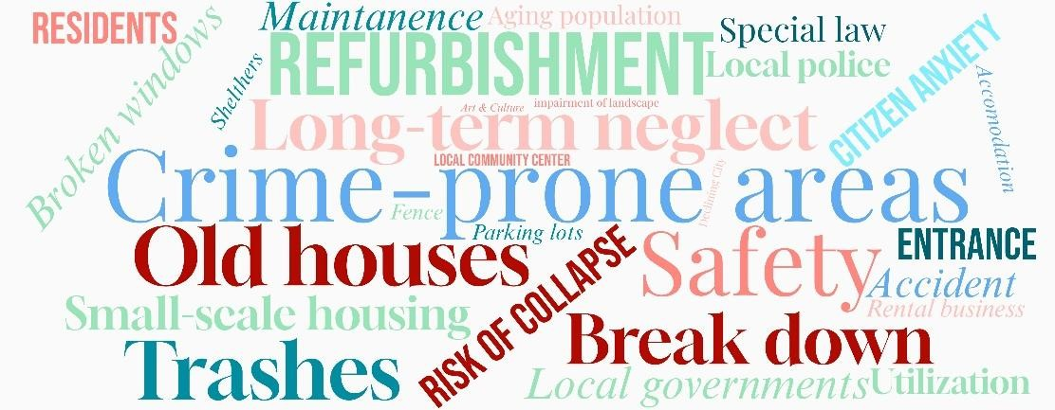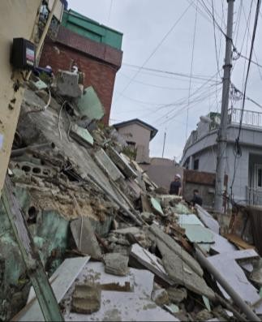

More importantly, another urgent issue in Busan is “Urban Decline”. As of 2016, Busan Metropolitan City was identified as having the highest urban decline index in South Korea, and this trend was projected to worsen over time (Kim, 2020). According to the Urban Regeneration Information System as of 2023, the urban decline status of Busan was approximately 87.4%, and 180 out of 206 regions met the criteria for areas requiring revitalization, which is comprehensively calculated based on the population changes, available jobs, and ratio of old buildings in the city, etc. (URIS, 2025). Furthermore, Lee et al. (2022) demonstrated that the three districts in Busan, mainly the old city center areas, are classified as having a risk of regional extinction. It could be rightfully assumed that the high vacancy rate might be related to the current urban decline, as this situation negatively influences resident’s anxiety and community vitality (Silverman et al., 2013). Thus, VH and urban decline are assumed to be associated, and this research is going to investigate about this relationship.
This study is focused on Busan for three primary reasons. Firstly, Busan has the most vacant houses and the highest vacancy rate across South Korea since the 2010s. According to KOSIS (2025), there are 113,410 vacant units in the city, with a vacancy rate of 8.9% as of 2020. Among them, 22,120 houses had remained unoccupied for over a year. Additionally, Busan presents unique VH types, including “unauthorized” residences, which emerged under historical circumstances and have remained abandoned over time. These are often viewed as a negative sign among the local people of Busan, and they perceive the issue as a trigger for crime, undervalued housing, and tax waste (Lee, 2020). It is meaningful to explore various types of VH in Busan with its historical context.
Secondly, urban decline is an ongoing and urgent topic associated with diverse phenomena in Busan. In particular, urban decline has been accelerating due to factors such as industrial stagnation and population outflows driven by suburban development in Busan (Kim, 2020). Experts consider the increase in VH to be closely interrelated with these phenomena. Moreover, reliable and accessible data on VH and socio-demographic factors contributing to the declining situation are available, providing a strong foundation for researching this issue.
Lastly, the Busan case contributes to a unique VH case by suggesting different declining tendencies and housing types than in the other cities. Weaver et al. (2016) demonstrate that the declining trend is concentrated in the Sun Belt area (the southern part) of the US. The forces, mainly deindustrialization and suburbanization, bring risks through their effects on social and political institutions (Rieniets, 2009). Especially after the Great Recession, a historically high number of foreclosures led to an accumulation of vacant properties, and long-term vacancies increased in the outskirts of a strong-growth city (Wang & Immergluck, 2019). In the case of the UK, industrial changes and economic downturns led to urban decline, primarily affecting metropolitan areas clustered in the middle and north of the country (Cunningham-Sabot & Fol, 2009). However, the Busan case shares a similar background with the US and UK, such as industrial recession and suburbanization, while it is associated with the Korean contextual issues, for example, low birthrate, population outflow (Huh et al., 2024), the changes in housing preferences (Kim, 2020), and housing market instability. For these reasons, the Busan case demonstrates its urban historical and contextual uniqueness, which contributes to an international housing phenomenon case study.

Research gap
Research on the VH phenomenon in South Korea began in the mid-to-late 1990s, initially focusing on rural areas impacted by rapid urbanization (Kim, 2018). By the 2010s, attention started to shed light on idle spaces in cities. With the growing interest in vacant housing, research on urban decline and residential community experiments was promoted. In particular, figuring out the exact number of vacant houses and how to utilize them at the government level was the most important topic (Kim & Nam, 2016). Relatively, the urban decline concept, which is defined as the result of constant shrinking phenomena in population, economic activities, and urban structure, is intricately connected to the VH issue. Systematically, such as residential property disinvestment, changes in occupied housing (Hollander, 2011), and the outflow of economically affordable citizens, are partially considered indicators of urban decline (Schilling & Mallach, 2012; Weaver et al., 2016).
However, there still remains a gap in understanding the empirical impacts of VH on urban environments, particularly regarding urban decline (Jeong et al., 2022). Several previous studies have viewed some socio-economic shrinkage as a primary driver of VH increase. As a result, the academic focus has mainly concentrated on determining the factors that cause vacant houses (Lee, 2020). Conversely, the impact of the VH on the urban environment, particularly regarding urban decline, has not been discussed extensively. Given the professional view that these two topics are interrelated, figuring out the relationship between the rise in VH and urban decline will help us better understand the complexity and current status of the phenomenon.
Moreover, as the VH phenomenon became an important issue in the mid-2010s, development strategies and VH policies have been developed together (Jeong et al., 2022). Busan was the first metropolitan autonomous body to enact the “Vacant House Maintenance Support Ordinance” in 2013 (Kim, 2020), and nationwide, 15 basic autonomous bodies began enacting ordinances in earnest starting in 2015 (Jeong et al., 2022). Regarding to this situation, the academics have been focused on assessing policies to improve them (Kim et al., 2022). Based on the critical voices on the current VH dealing approaches figured in many studies, there is a lack of understanding of the relationship between growing vacant houses and their impact on the urban environment. Additionally, since the critical opinions are related to planning and policies, they may not resolve the very foundational part of the issue. Thus, this study aims to fill this research gap through a quantitative investigation that focuses on the impacts of vacant housing on urban decline using several proxies, and a discussion on urban development strategies. Examining the situation offers valuable opportunities to explore the multifaceted nature of vacant housing within the urban historical and social context.

Research questions
Based on the context, this thesis aims to figure out:
- How does the vacant housing situation impact the urban decline in Busan?
To answer the main question, the following sub-questions are explored:
- What are the spatial and typological characteristics of vacant housing in Busan, and how have these changed over time?

- How are the vacant housing rates related to resident’s dissatisfaction levels across the pedestrian environment, housing satisfaction, social safety, and moving-out intention in Busan?

- Does the ageing rate of vacant housing moderate the relationship between vacancy levels and urban dissatisfaction indicators?
This study offers a timely and academically significant contribution to the growing discourse on vacant housing and urban decline, through a comprehensive analysis by empirical and theoretical insights. The spatial and typological patterns of vacancy that haven’t been detailed before is identified. Particularly through the lens of citizen dissatisfaction—an increasingly recognized proxy for measuring urban distress (Silverman et al., 2013), it demonstrates how vacant housing rates relate to resident’s dissatisfaction for observing the impact on urban decline. Given the urgency of the issue in South Korea, particularly in Busan (Min, 2024; Busan City, 2024), this research addresses a critical gap by empirically examining the relationship between VH prevalence and urban decline indicators. Furthermore, since many vacant houses are old in several districts in Busan (KOSIS, 2024), the ageing rate of vacant housing was added as a moderating variable to take a glance at a temporal dimension to the understanding of urban decline. By contextualizing this relationship within urban development strategies and policies, the study not only deepens theoretical understanding but also enhances the practical relevance of its findings through the extended discussions. The research questions are essential to the academic discourse on the relationship between urban vacancy and decline, offering practical implications that will eventually inform urban planning and regeneration strategies, particularly in aging cities like Busan. Ultimately, this research serves as a valuable case study that advances both academic inquiry and practical application in urban resilience.

Literature Review and Hypothesis

Different perspectives on the impact of vacant housing
From a market logic perspective, vacant houses are merely a byproduct of competition and change (Ji, 2019). However, if they left unaddressed, they can contribute to making more vacancies over time (Newman et al., 2016). Housing vacancy occurs when an owner neglects to fulfil at least one of the fundamental duties of property ownership; such as maintenance, taxes, and occupancy and further (Mallach, 2005; Weaver et al., 2016). They can exacerbate various urban issues, potentially even threatening the stability of entire neighborhoods (Silverman et al., 2013).
Most long-term vacant houses produce quality-of-life issues such as uncomfortable living conditions (Morckel, 2013), crime increase (Schilling, 2022), landscape deterioration, disaster risk and strong clustering/spreading effect (Kim & Nam, 2016; Morckel, 2014). A study focused on Baltimore in the U.S., demonstrated that short-term vacant houses had a negative impact on property values on the same block and nearby, but long-term vacant houses had the same impact over relatively long distances (Han, 2014). High vacancy rates depress rental prices (Glock & Häußermann, 2004) and reduce property tax revenues, negatively impacting local economy and infrastructure management (Accordino & Johnson, 2000; Han, 2014). In the low-rise housing areas with a high density in Busan, the vacancies can disrupt neighborhoods, affect resident’s daily activities, and increase exposure to neglected spaces (Benediktsson, 2014; Wallace, 2015; Wickes et al., 2013). As these areas continue to experience a serious aging phenomenon, the adverse effects are expected to intensify over time. Moreover, neighborhood stigma can shape resident’s perceptions of their community and selfidentity, further accelerating urban decline (Gourlay, 2007).
Ji (2021) demonstrated that the increase in the density of vacant houses has a significant spatial spillover effect. It influences the rise in the average VH numbers in neighbouring areas, through Spatial Lag Mode (SLM) analysis. Similarly, Lim & Kim (2019) demonstrated that the VH occurs in clusters, meaning that the large number of vacant houses could be contagious in the residential areas and impact the urban structure in Busan. Beyond that, it could be an indicator of the severity of urban decline. Lee et al. (2021) analyzed the housing prices in the Gyeongsangnam-do region, which includes Busan. The result shows that an increase in VH significantly decreases the prices of nearby apartments, with an estimated reduction of approximately 29.65 million won (approx. 18,800 euros, as of Mar 2025), and it could affect the regional housing situation and decline.
On the other hand, some scholars claim that VH can be seen as “potential assets” for neighborhoods. Kim et al. (2016) conceptualize the VH as “assets for comprehensive urban regeneration,” suggesting that they can be repurposed into community spaces that enhance safety, reduce social inequality, and strengthen local communities. Nam et al. (2016) highlight the economic and environmental benefits of repurposing empty houses. It can save the development expenses, energy consumption and the resources associated with redevelopment, thereby promoting sustainability. Therefore, existing vacant houses should not be viewed solely as urban fungus but also as local resources with latent value. Previous studies have mainly touched on the academic areas of general causes of VH, exploration of repurposing strategies, and case studies with comparative analysis. Discussing the impact of VH connected with the urban decline will contribute to filling the research gap and understand the circular situation of the urban phenomenon.

The relationship between urban decline and vacant housing
According to the urban life cycle model, a city’s development typically progresses through five stages: growth, maintenance, aging, decline, and slumization (Metzger, 2000). VH is often a direct consequence of reduced investment in the built environment during the decline phase (Kim et al., 2017). Although VH can emerge from the complex and interrelated factors, a fundamental cause lies in urban decline itself—characterized by reduced housing demand, growing disparities with surrounding areas, and the physical deterioration of the built environment (Sung, 2019). This process can initiate a vicious cycle in which generation of VH lead to the deteriorated living condition and residential satisfaction, further accelerating decrease on housing asset and out-migration, which impact the urban decline again (Schilling, 2002).

Figure 3. Definition of vacant houses in different countries (Lee, 2018; Lee, 2021)
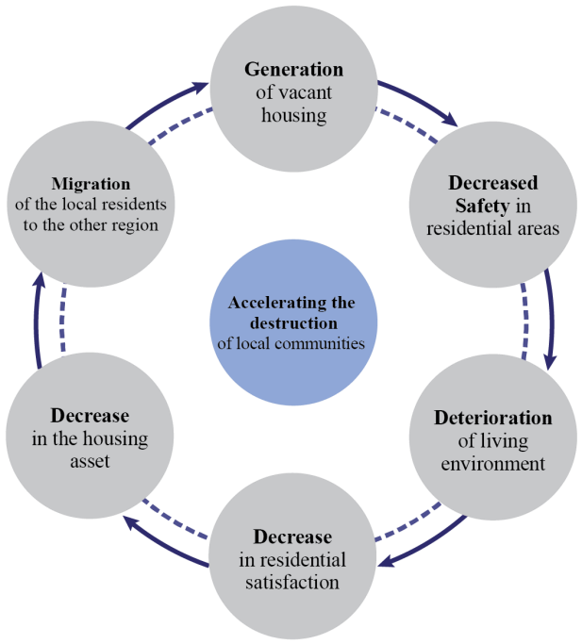
The prevalence of VH is not only a symptom, but also an active driver of urban decline (Park, 2016). To break this cycle, a precise understanding of the causes and consequences of VH, along with a detailed analysis of its spatial patterns and influencing factors in the neighborhood level is important (Park, 2016; Morckel, 2013). Many previous studies have considered demographic changes as key factors for the creation of VH. Kim (2020) adopted the aging index, population growth rate, proportion of workers, and old/new housing as independent variables that affect the VH creation. Min (2024) set the net migration rate of the fertile female population, the proportion of new houses, and the real house price index as independent variables, while Lee (2019) focused on more technical elements, such as the relationship between the proportion of old houses, adjacent 4-meter-wide roads, the zoning areas, and the existence of vacant houses in the adjacent areas with the occurrence of the new VH.
On the other hand, several studies have considered vacant houses as a factor affecting cities. Kim et al. (2017) considered the occurrence of VH and the spatial distribution as one of the urban decline indicator phenomena in Gwangju city, and they analyzed the correlation between the two themes using the 10 urban decline diagnostic indicators. The result shows that the influence of physical and environmental indicators was more substantial in the old city center, while the contribution of demographic and social indicators was relatively higher in the areas outside the old city center. Lim & Kim (2019) examined urban decay through the distribution of vacant houses in Busanjin-gu. It showed that the vacant houses tend to occur in clusters in neighbouring areas, suggesting that this may be a key indicator of the severity of decline. Urban decline is typically linked to both a significant and long-term loss of population and a drop in the wealth base of a region (Weaver et al., 2016). It usually results in a dysfunctional mismatch between the built environment and the population size of the impacted region. Previous studies have predominantly examined the related phenomenal factors of VH, the distribution of VH, and spatial repurposing types. This study builds upon existing research by analyzing the impact of vacant housing on urban decline.
Figure 4. The circular structure of urban decline and the vacant housing problem (Author’s own source, 2025; referred - Kim, 2019; Seong et al., 2017; Yang, 2022)
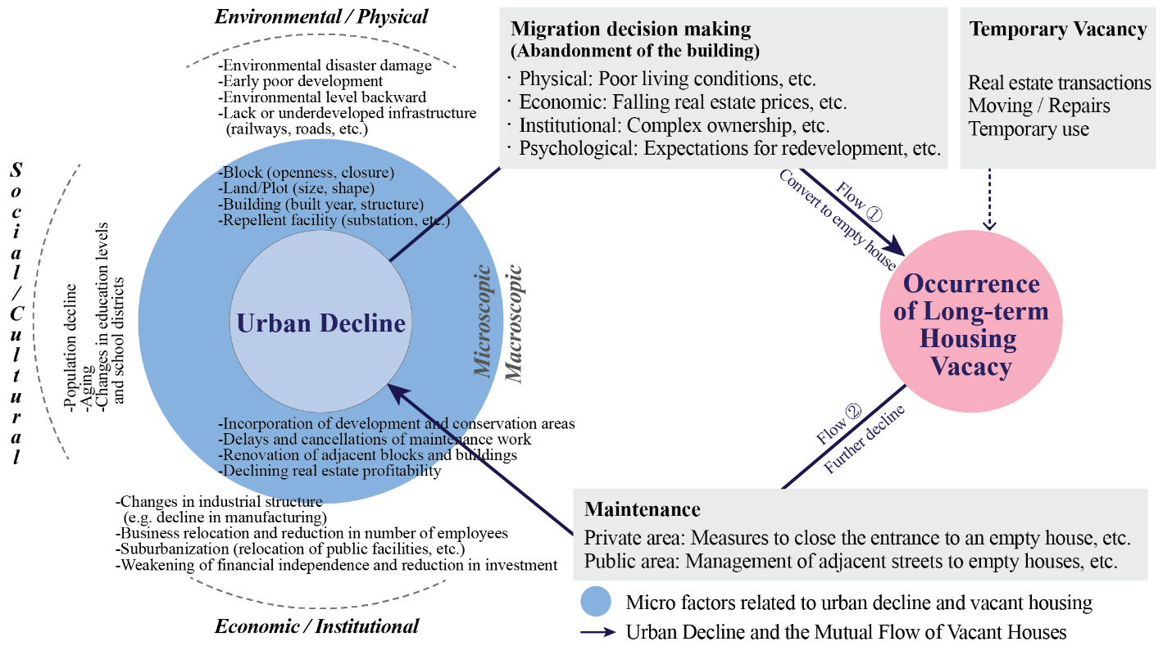
Seong et al. (2017) suggested the circular model of urban decline and the occurrence of VH. They stated that declining city demand resulting from industrial shifts, associated with reduced development following environmental aging, contributes to the emergence of vacant houses. Similarly, Lee (2022) argued that the prevalence of VH is closely linked to broader patterns of urban decline. The failure of urban decline management in a region can precipitate the emergence of more vacant houses, then it worsens the urban decline phenomenon again - thereby establishing a vicious cycle (Jeon & Kim, 2020; Kim et al., 2018; Kim & Lee, 2016; Lee & Lee, 2022; Morckel, 2014; Park, 2019; Yoo & Kwon, 2019). Once this circulation is formulated, it becomes increasingly difficult to break as time passes. In this perspective, as urban decline and the occurrence of VH are linked, finding out the “root” of the issue is challenging.

Urban decline and the citizen dissatisfaction
Urban decline generally refers to the steady population and economic downturn of cities, which can lead to an oversupply of housing and infrastructure that was previously deemed adequate (Park, 2025). It can be seen to be similar to urban shrinkage - however, urban decline might be more severe, persistent, and widespread beyond shrinking (Weaver et al., 2016). Even though the declining phenomenon after the end of urban growth may be a natural part of the urban lifecycle, it often has a bad reputation since it contributes to a wide range of social, economic, and fiscal challenges (Hollander, 2011). To be more specific, rapid demographic changes, including macroeconomic shifts, an increasingly elderly population, and a declining rural population can trigger urban decline through avoidance of old towns, migration to nearby new cities or far away further accelerating urban decline and potentially pushing some regions into the extinction stage (Lee, 2021). Following this theory, many small and medium-sized cities in Korea are facing the crisis of regional extinction.
On the other hand, some academics even argue that urban shrinkage should be viewed as a positive concept, unlike urban decline. For example, countries such as the US and Germany, which have already experienced de-urbanization, do not regard urban shrinkage as the opposite of growth (Son & Jang, 2020). Rather, they are focusing on planning regions to be more compact and efficient through the concepts of ‘smart decline’ and ‘creative shrinkage’ (Lee & Han, 2014; Son & Jang, 2020; Hiroshi, 2013). On the other hand, urban decline is a negative concept that is accompanied by distress, disadvantage, and highly persistent deterioration (Glaeser & Gyourko, 2005). It can occur in all types of human settlements, regardless of whether they are expanding, stable, or experiencing shrinkage (Weaver et al., 2016). The rapid and persistent population loss often reduces the wealth base in an area by decreasing taxes and the value of housing, and it typically creates a dysfunctional mismatch between the size of the affected area’s population and the built environment. Furthermore, it becomes increasingly vulnerable to long-term issues of concentrated poverty, neighborhood disinvestment, property abandonment, and chronic vacancy. Synthesizing these theories, urban decline can be seen as an atypical increase in concentrated disadvantage, while shrinkage has the potential to be incorporated into a future-oriented concept.
Figure 5. The relationship between Urban shrinkage, Urban Decline and Vacant Housing (Author’s own source; Based on Seong et al., 2017; Weaver et al., 2016)


Urban

Shrinkage

Urban
Decline

Vacant

Housing

Mallach et al. (2017) claimed that the studies on urban decline have not been conducted in a “multidisciplinary manner”. Then, how can urban decline be measured? It is widely understood to manifest across multiple aspects, including demographic and socio-economic factors, industrial transformation, and built environment indicators (Hwang & Woo, 2020). Prior studies have focused on deriving standardized indicators of urban decline that can be applied broadly in Korea, including underdeveloped cities, small and medium-sized cities, and district levels. These studies have typically aimed to establish universally applicable indices of decline or develop methodologies for calculating indicator weights (Jo, 2014; Jo et al., 2010; Kim et al., 2008; Kim & Park, 2009; Nam & Seo, 2018; Park et al., 2021).
In the context of U.S. cities, Weaver et al. (2016) categorized urban decline by distinguishing between “distress,” defined as community vulnerability to detrimental change, and “disadvantage,” which refers to qualities or achievements unusually difficult. Indicators of disadvantage generally include socio-demographic variables such as poverty levels, unemployment rates, single-parent households, and racial or ethnic composition. Similarly, Glaeser and Gyourko (2001) argued that declining cities tend to attract people with lower capital levels in US. In another study focused on Leipzig, they incorporated a range of factors in assessing urban decline, including environmental indicators, urban structure variables such as built-up area, green space related to social infrastructure, and residential environment factors such as noise, pollution, and commuting accessibility to workplaces (Banzhaf et al., 2007). From a slightly different perspective, some studies have emphasized “People on the street, especially pedestrian flow” as a key factor for assessing urban vitality and decline (Kim et al., 2025; Mehta, 2011; Montgomery, 1998). These studies suggest that the measured number of individuals engaging in social activities, for example speaking, eating, and window shopping, within the area is critical for evaluating urban vitality, which stands in contrast to urban decline (Kim et al., 2025; Mehta, 2011). Furthermore, additional indicators such as residential population, increased commercial usage (e.g., through repurposing or densification), and public transportation accessibility are also considered relevant in assessing levels of urban vitality (Kim et al., 2025).
Kwon et al. (2019) further demonstrated that urban decline has a direct impact on resident’s satisfaction with life and their residential environment, depending on the city size. As a result, aging and vacancy of housing, buildings, and infrastructure reduce the satisfaction with the residential environment. Related to this, several Korean cities evaluate urban decline with population changes (social indicator), the total number of businesses (economic indicator), and the proportion of buildings older than 20 years (environmental indicator), typically based on panel data (URIS, 2025). While many studies employ quantitative approach, some have developed composite urban decline indices such as Analytic Hierarchy Process (AHP) method based on expert surveys (Chea, 2013; CNU R&DB Foundation, 2018; Jo et al., 2010; Kwon, 2017), incorporating social impact assessment items to reflect opinions of the residents during the urban regeneration process (Choi & Yoo, 2012; Park et al., 2021), or using metrics such as population growth rate and urban area expansion rate as proxies for measuring decline (Jo, 2014).
Based on previous findings, this study adopts citizen’s dissatisfaction levels with the urban environment as a set of proxies to explore the relationship between vacant housing and urban decline. The selected dependent variables include Pedestrian Environment Dissatisfaction (Huang et al., 2020;
Kim et al., 2025; Mehta, 2011; Montgomery, 1988), Safety Anxiety (Nasab & Bin, 2023), Housing Dissatisfaction (Kwon et al., 2019), and Moving-Out Intention. To capture potential moderating effects, the Vacant Housing Aging Rate (VHAR) was included as a key explanatory variable, since it is a branch issue in Busan (Eom & Woo, 2016; Park, 2021; URIS, 2025).

Conceptual framework
The formulated conceptual framework depicts the relationship between the two main concepts in the Busan context based on the previous academic findings. Figure 6 explicitly explains how vacant housing (independent variable, IV) influences the resident’s dissatisfaction and their living condition, which contributes to the urban decline (dependent variables, DV). The four indicators explaining urban decline are chosen as pedestrian environment dissatisfaction, residential environment dissatisfaction, social safety anxiety, and moving-out intention, based on a literature review. The moderator variable, which may affect the strength and direction of the relationship between the Vacant Housing Rate (IV) and the Dissatisfaction Level (DV), is selected as the Vacant Housing Ageing Rate after a thorough review of previous studies.

Figure 6. Conceptual framework (Author’s own source, 2025)
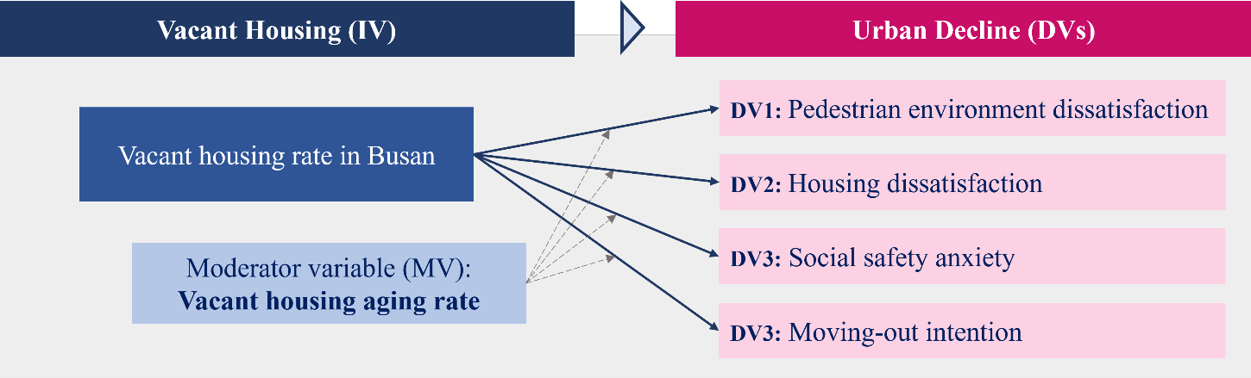

Methodology

Research design and the data description
This study mainly employs quantitative research to address research questions. The data were primarily collected from official government platforms, including the Korean Statistical Information Service (KOSIS), the Busan Development Institute (BDI) archive, the Ministry of Land, Infrastructure and Transport (MOLIT), the National Geographic Information Institute (NGII), and the official Busan Metropolitan City website (see Abbreviation Table, p.7).
First, a GIS method was employed to illustrate and analyze the VH situation in a spatial context. QGIS (version 3.42.1) was useful for clearly visualizing the evolution and aging of vacant houses, as well as changes in VH types in the districts over time (Mun & Kim, 2018). Vacant housing number data were available from 2000 to 2023, while data on the types and aging of VH were available from 2010 to 2023. These statistical and geospatial datasets were obtained from NGII and KOSIS. Analyzing the VH spatial patterns and their influencing factors at the district level through an illustration is important for a precise understanding of the causes and consequences (Park, 2016; Morckel, 2013). It allows readers to understand the issue intuitively and be aware of its seriousness.
Secondly, Stata MP 18 was used for the data analysis, specifically to estimate the relationship between VH and citizen’s dissatisfaction with urban conditions through regression modeling. Two complementary regression models were employed to capture both the overall and within-district dynamics of this relationship. Citizen dissatisfaction indicators—scored on a scale from 0 to 10— were organized as proxies for explaining urban decline. These indicators, including perceived dissatisfaction with Pedestrian Environment, Safety Anxiety, Housing condition, and Moving-out Intention, were sourced from the BDI archive. The citizen’s dissatisfaction level chosen in this study is important since it reflects the urban declining conditions in simple numbers (Glaeser et al., 2016). They are directly linked to daily lives and housing experiences, as well as the intention to move to another city, which may influence population and economic changes, which can explain urban decline (Kwon et al., 2019). According to Glaeser et al. (2016), the cities that have declined seem to have had unhappy and dissatisfied citizens in the past. Moreover, a high awareness of residential and land vacancy tends to increase overall urban dissatisfaction and the intention to relocate, potentially influencing relocation indirectly by diminishing satisfaction with consumption, leisure, and the broader urban environment (Fu, 2025). Regarding this, using the citizen’s dissatisfaction survey data is fruitful and relevant to urban decline, and to eventually answer the main research question.
For the regression analysis, there is one independent variable (Vacant Housing Rate), one moderating variable (Aging Vacant Housing Rate), four dependent variables (Pedestrian Dissatisfaction, Safety Anxiety, Housing Dissatisfaction, and Moving-out Intention), and ten control variables in each of the 14 models. The dataset comprises individual-level responses collected between 2015 and 2018, with each dependent variable supported by over 60,000 observations.

Table 1. Explanation of the variables for the regression (Author’s own source, 2025)
Variable | Variable Name | Definition / Time Period
Independent Variable | Vacant Housing Rate  (VHR) | • Vacancy rate in the 16 districts in Busan. • Time: 2000 - 2023.
Dependent  Variables | Pedestrian  Dissatisfaction | - The score is the gross of the two components.  - Time: 2016 – 2018
Dependent  Variables | Safety Anxiety | - The score is the gross of the two components.  - Time: 2018
Dependent  Variables | Housing  Dissatisfaction | - Dissatisfaction level on one’s housing  - Time: 2015 – 2017
Dependent  Variables | Moving-out Intention | - Willingness to move from Busan to another city  - Time: 2015 – 2017
Moderating Variable | Vacant Housing  Ageing Rate (VHAR) | - Rate of the aged vacant houses, which built longer than 20 years ago (Busan City, 2022), in the 16 districts in Busan.  - Time: 2010 – 2023.
Control  Variables | Age | The age of the respondents
Control  Variables | Gender | Gender of the respondents
Control  Variables | Income | Average monthly household income in the scale of 1-8.
Control  Variables | District code | Classification of the 16 districts
Control  Variables | Year | Responded time
Control  Variables | Elderly Population Rate | Population Aging rate
Control  Variables | Net-moving Rate | The pure number of the movers
Control  Variables | Land Price Fluctuation | The increase in the land price index at a given point in time compared to the base point in time
Additionally, the analysis incorporates a range of control variables at both the individual and regional levels that may influence the results: respondent’s Age, Income (Choi et al., 2018; Glaeser & Gyourko, 2001; Park et al., 2021), and Gender, as well as district-level indicators such as Aging population (Jang et al., 2016; Park et al., 2021), Net-migration rate (Jo, 2014; URIS, 2025), and Land price fluctuation (Kim & Park, 2012). These variables were selected based on their relevance in prior studies examining urban decline and socio-spatial dynamics. While the independent, dependent and the moderating variables remain consistent across both regression models, the set of control variables differs by model type. For the Mixed-Effects model, individual-level characteristics: age, gender, income, district of residence, and survey year are used as controls to account for within- and betweendistrict variation. In contrast, the Fixed-Effects model incorporates objective district-level statistics, including the elderly population rate, birth rate, net-moving rate, and fluctuations in land prices, to account for structural changes over time within districts. Using model-specific controls reduces omitted variable bias by addressing relevant confounders at each analysis level (Torres-Reyna, 2007). This approach enhances the robustness of findings and allows for more precise, context-sensitive policy insights into the relationship between VH and urban dissatisfaction (McNeish & Kelly, 2019).
The dissatisfaction level dataset used for the regression modelling has an excellent quality. It includes clearly recorded responses along with detailed demographic information, such as age, income, and residential location. Organized at the micro level, the data features a large sample size (over 30,000 responses for each indicator), minimal skewness, and strong reliability, having been sourced from a trustful local development research institution (BDI, 2022). The survey dataset has been rarely employed in urban studies and housing fields in South Korea, offering an opportunity to gain new insights. Moreover, objective statistical data, such as VH counts, housing types, demographic changes, and land-related indicators, are precise and economically relevant.

Regression modelling approach
In this study, a four-step regression strategy is employed to investigate the impact of VH and urban dissatisfaction. The analysis draws on multi-year, individual-level survey data. It focuses on the four dependent variables: perceived dissatisfaction with the Pedestrian Environment, Safety Anxiety, Housing Dissatisfaction, and Moving-out intention. The first two steps involve Mixed-Effects Models (MEM) and Fixed-Effects Models (FEM) without moderation, while the third and fourth steps re-estimate these models with a moderating variable, the Vacant Housing Aging Rate (VHAR), through an interaction term Vacant Housing Rate (VHR)×Vacant Housing Aging Rate (VHAR). This framework enables the analysis to capture both individual and district-level variation, offering distinct analytical insights at each step.
According to McNeish & Kelly (2019), it is essential to account for clustering in the analysis when working with cross-sectional, panel, or nested data structures. Ignoring this structure can violate the independence assumption underlying many statistical models, leading to biased standard errors and invalid inferences (Liang & Zeger, 1986; Maas & Hox, 2005; McNeish & Kelly, 2019; Raudenbush & Bryk, 2002; Wooldridge, 2003). To address such complexities, Mixed-Effects Models (MEMs) and Fixed-Effects Models (FEMs) are commonly employed (McNeish & Kelly, 2019). MEMs handle clustering by incorporating random effects and modelling individual outcomes while allowing for district-level variability. In this framework, fixed effects represent the average effect across all clusters, while random effects capture deviations from that average (Laird & Ware, 1982; McNeish & Kelly, 2019). This approach is well-suited to the present study, which analyzes how VHR influence citizen dissatisfaction levels, accounting for the hierarchical structure of individuals nested within 16 districts in Busan over a three-year period (2016–2018). In contrast, FEMs address unobserved heterogeneity by introducing fixed effects—typically through dummy variables—allowing for cluster-specific intercepts without assuming a random distribution (Gardiner et al., 2009). This method isolates within-district variation over time and controls for unobserved, time-invariant characteristics such as historical development patterns or institutional settings (Breuer & Haan, 2024).
Accordingly, the first analysis step applies Mixed-Effects Regression (without moderation), using the mixed command in Stata. The second step employs Fixed-Effects Regression, selected based on the Hausman test, to control for stable district-level characteristics. In both models, interaction term is included in the moderated versions (Models 1.2-4.2) to test conditional effects. Robust standard errors are used to correct for potential heteroskedasticity.
Altogether, the 14 models were constructed to capture both general trends and localized dynamics in this study. MEMs offer insights into broader patterns while accounting for between-district heterogeneity, whereas FEMs enhance causal inference by focusing on within-district temporal changes. The inclusion of the moderating variable (VHAR) adds depth to the analysis, and it highlights the impact of vacancy on dissatisfaction is not uniform but conditioned by the aging of the housing stock.

Limitation
Several limitations should be acknowledged about the data sources and methodological design of this study. First, the safety dissatisfaction variable is available only for the year 2018, which restricts temporal comparison and limits the robustness of longitudinal analysis for the outcome. Second, although multi-year data on VH is available, the environmental satisfaction survey data provided by BDI lacked consistent respondent information across multiple years. While the overall quality and quantity of the data are highly sufficient, the well-organized structure of KOSIS datasets highlights some of the inconsistencies and shortcomings in the city-level survey data. Third, the definition of VH data in this study does not align with the one recently established in June 2023 by three Korean ministries—the Ministry of Land, Infrastructure and Transport; the Ministry of Agriculture, Food, and Rural Affairs; and the Ministry of Maritime Affairs and Fisheries—which classifies vacant houses as those unoccupied for more than one year (MOLIT, 2023). The data on this newly incorporated definition of VH is not available yet, and it was adopted after the period covered (2015~2018) by this study, and most official data does not reflect this recent public regulative change. As a result, this thesis relies on the annual data reported by KOSIS (2024), which are based on longterm unoccupied housing observed on November 1st of each year. Lastly, it is essential to note that definitions of “vacant housing” vary across countries and even among Korean municipalities prior to 2023, which introduces potential inconsistencies in the comparability and interpretation of vacancy trends across regions. For these reasons, the Busan VH case demonstrates its urban historical and contextual uniqueness.

Table 2. Definition of vacant housing in Korea (Lee, 2018; Lee, 2021)
Country | Definition of Vacant Housing | Regulation Law
South  Korea | Housing not occupied or used for more than one year.  Exceptions) Public rental housing, unsold homes that have not been approved for use for 5 years, etc. | Article 2, Paragraph 1, Item 1 of the “Special Act on the Maintenance of Vacant and Small-scale Houses”,  Article 2 of the “Enforcement Decree of the Special Act on the Maintenance of  Vacant and Small-scale Houses”

Results and the Data Analysis

Vacant housing in Busan: growth, patterns, and shifts
Busan is a port city located in the southeastern part of South Korea, close to Japan. As of January 2025, the total population is 3,263,891, and the area of the city is 771.31km² (KOSIS, 2025), which is larger than Seoul, 605.2 km², (KOSIS, 2023) and smaller than Berlin’s 891 km² (Reuter & Erb, 2025. Graph 1 shows a constant growth of the housing supply in Busan, while the total population is shrinking gradually. Eventually, the total number of houses reached 1,329,355 in 2023. Since 2000, the common family structure in South Korea has shifted from large families to nuclear families as the economy developed. Accordingly, housing types and policies have focused on supplying houses for 3-4 people (Yun, 2018). In the 2010s, as demand for single-person households increased, the need for mass housing supply for family sizes gradually decreased, and a strategy according to various demand classes became necessary (Yun, 2018). The size of housing became smaller, but the quantity has increased. Accordingly, in response to the growing proportion of apartments for a single person— the largest demographic among housing demand groups—a substantial number of housing units were supplied in South Korea. However, these units were often uniform in design and tailored to the convenience of suppliers, resulting in limited consumer choice. Consequently, some houses or apartments failed to align with the evolving preferences of demand, which led to prolonged vacancies in some cases. Moreover, the sudden surge in housing supply, coupled with ongoing demographic shifts such as population decline and rapid aging, is expected to have further contributed to the increase in the number of vacant homes.

Figure 7. Empty houses in Dong-gu (old city center) district (KNN, 21.11.2024) Figure 8. Empty houses near elementary school in Yeongdo-gu, Busan (Jeong, 2024)
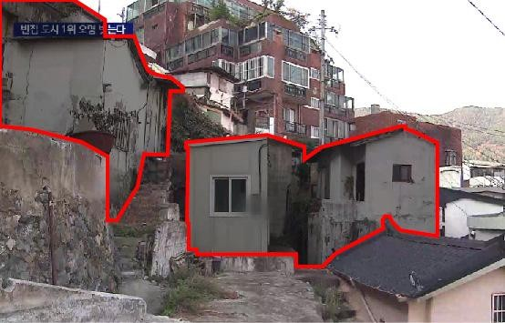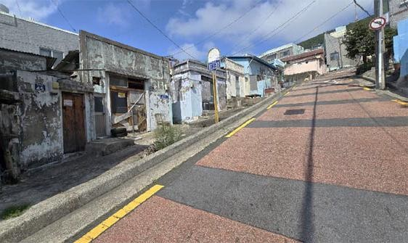

Graph 2 illustrates the changes in both the number and rate of VH units in Busan. The data indicate a consistent growing trend in vacancy, except for the period between 2005 and 2010. The vacancy rate follows a similar path; there was a drop in the vacant housing rate (VHR) from 5.55% to 3.97% between 2005 and 2010. Eventually, it reached 8.6% in 2023 as the number of housing units per household in Busan surpassed 100% in 2008 and reached 102.9% by 2023. Given this oversupply, the vacant housing prevalence is expected to continue rising, with little indication of decline in the near future.

Graph 1 | Graph 2

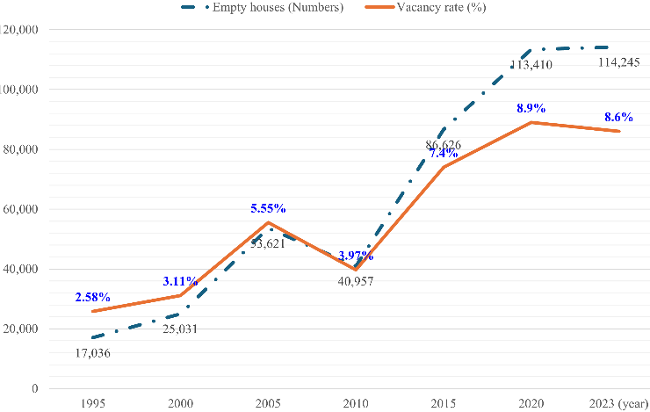
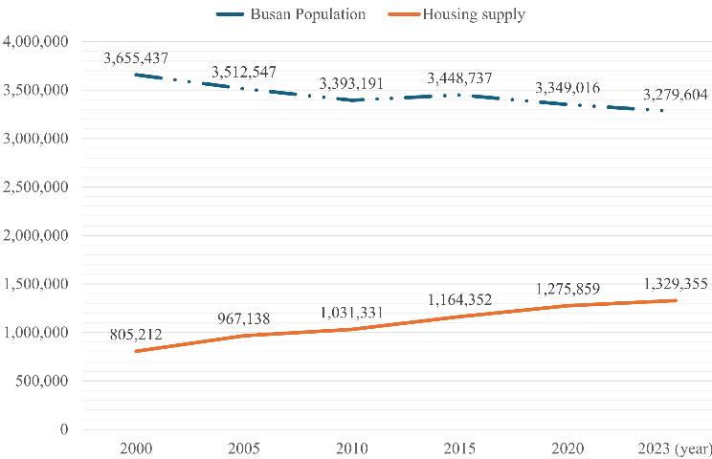
Graph 1. Changes in the population and the numbers of housing in Busan (KOSIS, 2024) Graph 2. Changes in the numbers of the VH in Busan (Author’s own source – KOSIS, 2025)

Figure 9. Changes vacant housing rate in each district over time (Author’s own source – QGIS used, 2025)
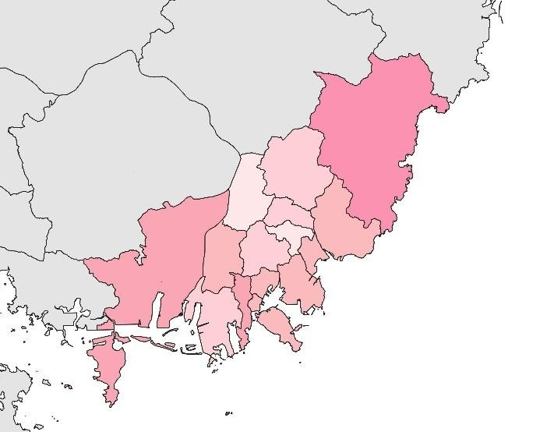 | 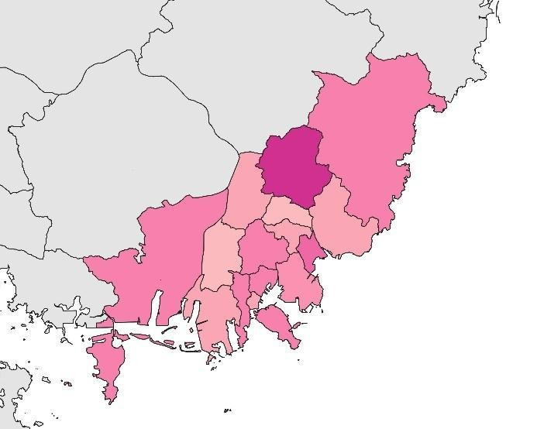
2000 | 2005
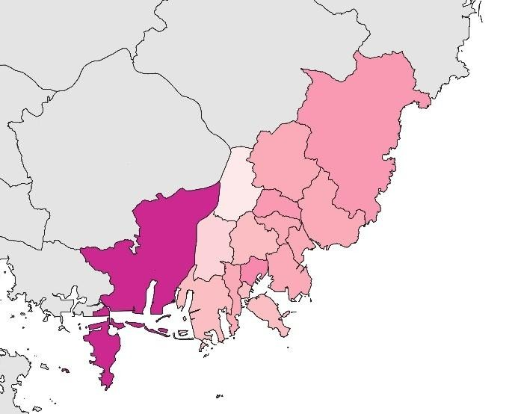 | 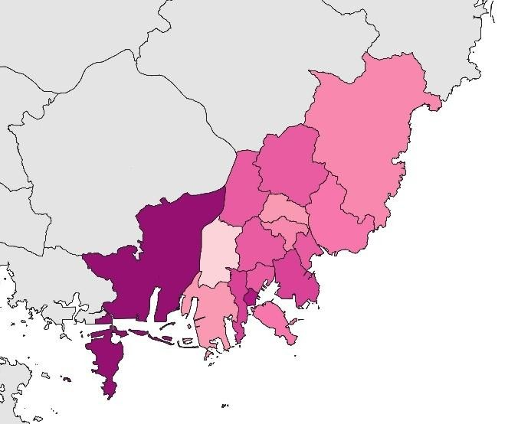
2010 | 2015

0 – 16.2 %
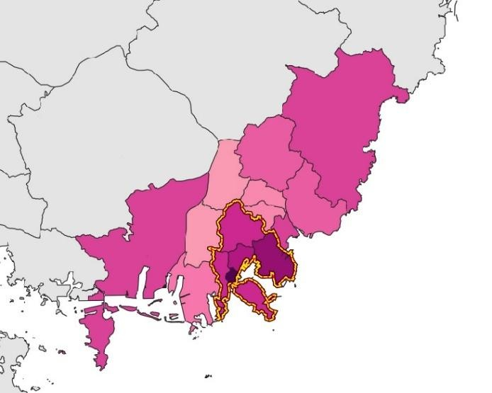 | 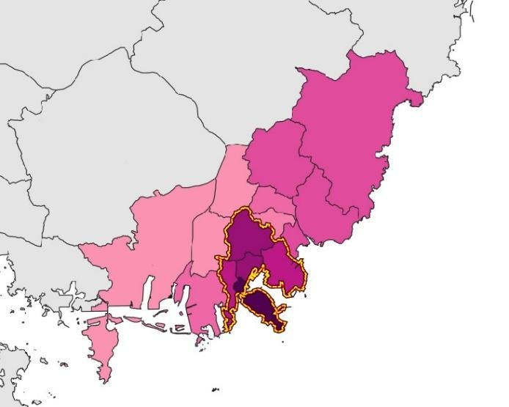
2020 | 2023
0 – 16.2 %
Figure 9 depicts the progression of the VHR in Busan from 2000 to 2023. The map was generated using QGIS (version 3.42.1), based on data from KOSIS (2025). The results reveal a steady increase in vacancy rates across the city over time. Notably, in 2010, most districts displayed relatively light color intensities, indicating lower vacancy levels, except for Gangseo-gu, which already exhibited higher rates. However, following this period, vacancy rates rose markedly, reaching their highest level in 2020. Although a slight decline is observed in several districts by 2023, vacancy rates in the old city center areas (highlighted on the maps for 2020 and 2023) have continued to rise consistently since 2015.
From the 1970s to the early 2000s, Busan’s economy was predominantly driven by heavy industry and manufacturing, accompanied by a continuous influx of population (Kim, 2020). As a result, the VHR remained relatively low across all districts, at or below 4%, except for Gijang-gun, which recorded a slightly higher rate of 5.6%. Between 2005 and 2010, the overall vacancy rate declined slightly, although districts such as Geumjeong-gu and Gangseo-gu experienced localized increases in vacancy rates. Since 2015, however, VHR has risen rapidly and relatively uniformly across the city, with particularly high concentrations observed in the six historic core districts—Jung-gu, Seogu, Dong-gu, Yeongdo-gu, Busanjin-gu, and Nam-gu. By 2023, the total number of VH in Busan had surpassed 114,000, with Busanjin-gu, Nam-gu, and Haeundae-gu each reporting over 10,000 vacant houses. In the six aforementioned inner-city districts, the VHR exceeded 10%, remarkably higher than the citywide average. Other districts also recorded elevated rates, averaging over 8% (see Annex 2). These trends suggest a continued increase in both the number and proportion of vacant houses, with little indication of a significant decline in the near future. Supporting these observations, Lee et al. (2021) investigated the relationship between rising VH rates and housing prices in the Gyeongsangnam-do region, which includes Busan. Their analysis found that a rise in VH is associated with a significant decrease in nearby apartment prices, by an estimated 29.65 million KRW. It suggests that a surge in VH may negatively affect local housing markets, liveability, and the broader urban economy.
A notable VH characteristic in Busan is the prevalence of unauthorized houses constructed before and after the Korean War in 1950. Many of these dwellings were built by war refugees and post-war job seekers who settled in the hilly areas, forming informal housing communities. Given this, Busan has features such as abnormal dwellings that were created due to historical events in the 1960s and 1970s (Kim, 2020). Today, these unauthorized houses account for more than 60% of the city center’s residential stock (Busan City, 2024). These are often located in steep areas with narrow access roads, making them highly vulnerable to vacating. Moreover, once it becomes empty, it is challenging to demolish and requires greater effort to refurbish. Based on the data, the types of vacant houses currently present in Busan can be categorized as follows:
Types of empty houses in Busan
- Houses that are not aged
  - Unsold apartments / houses
  - General houses (single- and multi-family housing, apartments, townhouses etc.)
- Old houses: older than 20 years old (“Busan city urban and residential environment improvement ordinance partial amendment”, 2022)
  - Apartments
  - Single- and multi-family houses
  - Unauthorized (illegally built) houses

According to Sung (2019), 10 out of 16 districts in Busan have a combination of high vacancy rates of single-family houses, apartments, and old houses, resulting in stagnant annual population and housing growth. In addition, the two districts of Busan (Dong-gu and Yeongdo-gu) have the highest vacancy rates for single-family houses, and old houses are creating the most serious urban problems.

Figure 10. Changes in the most prevalent vacant housing types in each district over time (Author’s own source – QGIS used, 2025)
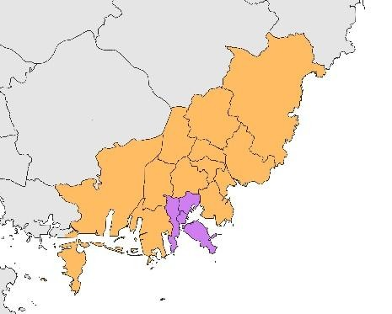 | 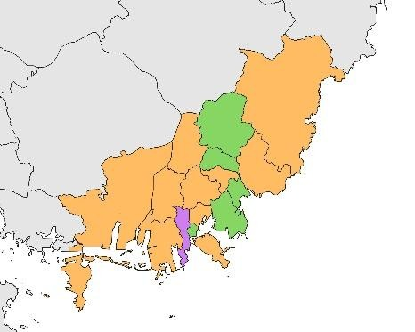 |  | 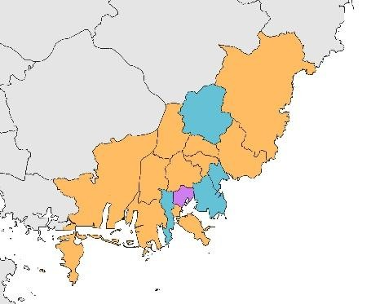
2010 | 2015 |  | 2018
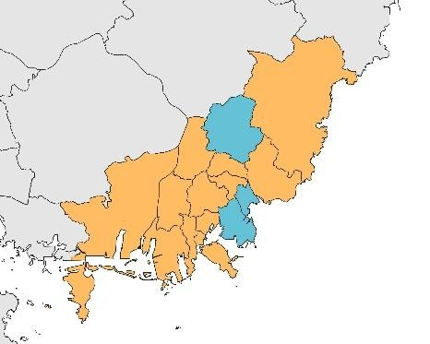 |  |  | 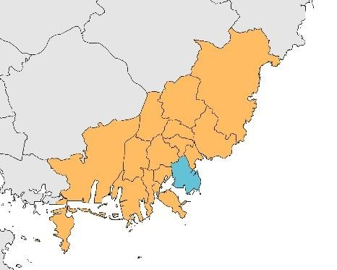
2020 |  |  | 2023

 | Single-family houses |  | Apartments |  | Townhouses |  | Multi-family houses
Homes in non-
Residential buildings
Figure 10 illustrates the most prevalent housing types among the vacant houses by district in Busan. Between 2010 and 2023, the composition of the old city center’s VH underwent a notable shift, transitioning from predominantly single-family homes to multi-family dwellings and apartments. Unlike these concentrated patterns, vacant apartments appear to be dispersed across the entire city. Interestingly, “townhouse” residences briefly emerged as the most common type of vacancy in 2015, although this trend did not continue for long. According to media reports and real estate news, the City of Busan began supplying a significant number of newly built townhouses starting in 2022, despite the earlier spike in townhouse vacancies observed in 2015. Overall, we can see that the most prevalent type of vacant housing in Busan is apartments. “Apartment” is the most common and preferred housing type in South Korea (Hong & Lim, 2018), accommodating over 52% of the total population (NGII, 2020). Thus, it is not a surprising result that apartment types are the most common vacancy type rather than in other residences in Busan, and probably across the country.

Figure 11. Changes in the aging rate of vacant housing in each district over time (Author’s own source – QGIS used, 2025)
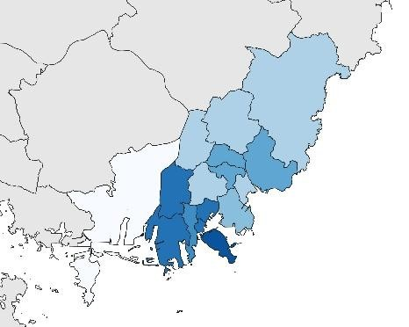 | 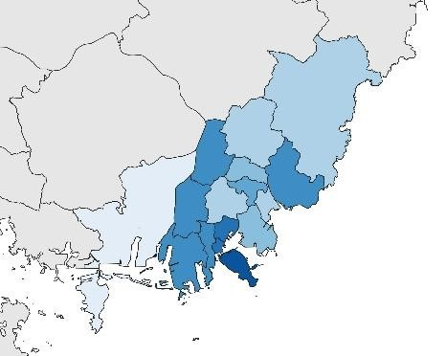 | 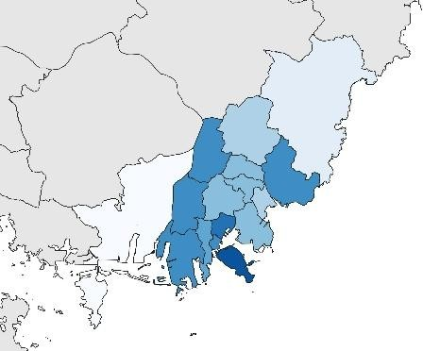
2015 | 2016 | 2017
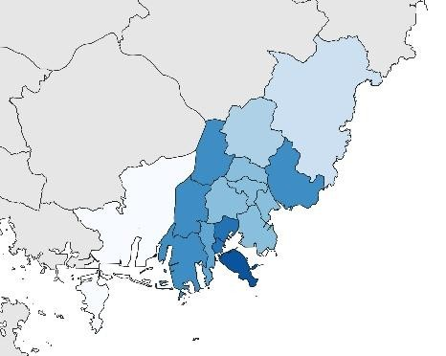 | 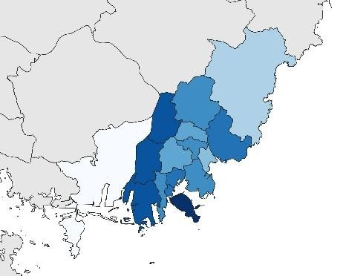 | 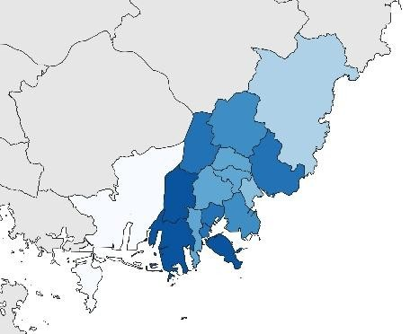
2018 | 2020 | 2023

0 - 100%
Figure 11 illustrates the changes in the rate of aged vacant housing (VHAR) in Busan. According to Busan City (2022), aged housing is defined as buildings that was constructed more than 20 years ago. Based on statistical data from KOSIS (2024), the concentration of VHAR was initially centered in the old city center districts in 2015. Over time, this pattern expanded to adjacent districts, including Saha-gu, Sasang-gu, Buk-gu, Geumjeong-gu, and Haeundae-gu. Notably, by 2023, the rate in these five districts was around 80%. In contrast, the districts with the lowest proportions of aged vacant housing are Gangseo-gu and Gijang-gun. However, as shown in Figure 9, these areas appear to have a relatively high overall vacancy rate, yet most of the vacant units consist of apartments built within the past two decades.

Relationship between vacant housing and the urban environment dissatisfaction level
Table 3 presents the descriptive statistics for the key variables used in the analysis, including the independent, dependent, moderating, and control variables. The Vacant Housing Rate (VHR), the primary independent variable, averaged 8.32% across Busan’s 16 districts during 2015, 2017, and 2018. The Vacant Housing Aging Rate (VHAR), used as a moderating variable, had a mean of 4.30% during the same period.
Among the four indicators of urban dissatisfaction, used as proxies for urban decline, Safety Anxiety recorded the highest mean score (M=6.592), while Moving-out Intention was the lowest (M=4.522). Although concerns over safety and environmental quality are prominent, the intention to relocate is relatively weaker. The analysis includes 244,268 individual-level survey responses. Respondent’s average age was 50.62 years, higher than Busan’s general population average of 43.6 years in 2018 (KOSIS, 2024), indicating greater participation among older residents. The mean income score was 3.438, corresponding to the city’s average household income of 3–4 million KRW during the study period (Busan City, 2025).
At the district level, the eight control variables capture socio-demographic and economic conditions. The average aging rate across the selected years (in 2015, 2016, and 2018) was 16.77%, exceeding the national average by 2.45 percentage points (KOSTAT, 2018). Based on the UN threshold of 14% (WHO, 2020), Busan qualified as an “aged society” by 2018 and became a “super-aged society” in 2022, with an aging rate of over 21.3% (Kwak, 2024). The net-moving rate was –0.367, it indicates the population outflow in most districts. Lastly, land price fluctuation averaged 0.397, indicating modest variation in land values during the observation period. Table 3. Descriptive statistics (Author’s own source, 2025)
 | Mean | Median | S.D. | Min. | Max. | Obvs.*
Vacant Housing Rate (%) | 8.322 | 8.067 | 2.615 | 2.429 | 15.192 | 48
Vacant Housing Aging Rate (%) | 4.304 | 3.729 | 2.376 | 0.456 | 10.854 | 48
Pedestrian  Dissatisfaction | 5.798 | 6 | 0.006 | 2 | 10 | 69,071
Safety Anxiety | 6.492 | 6 | 0.008 | 2 | 10 | 33,497
Housing  Dissatisfaction | 5.209 | 6 | 0.007 | 2 | 10 | 70,850
Moving-out  Intention | 4.522 | 6 | 0.007 | 2 | 10 | 70,850
Age | 50.622 | 52 | 17.958 | 15 | 104 | 244,268  (TR*)
Income | 3.438 | 3 | 0.004 | 1 | 8 | 244,268  (TR*)
Aging Rate | 16.765 | 16.061 | 3.701 | 10.78 | 24.218 | 48
Net-Moving Rate | -0.367 | -1.432 | 2.818 | -2.794 | 13.979 | 48
Land Price  Fluctuation | 0.397 | 0.394 | 0.140 | 0.178 | 0.725 | 48
Obvs*: Observations
TR*: Total Responses

For the primary analysis, the four models were generated using by the Mixed-Effects Regression. Each models use the same independent, moderating and control variables, but the different dependent (dissatisfaction level) variables observed in the year of 2015 - 2018.
1. Mixed-Effects Regression
Yij = β0 + β1Xij + Cijγ + uj + ϵij
Y_{ij} denotes the dissatisfaction level for individual i in district j, and X_{ij} represents the VHR as the main independent variable. The term X_{ij} captures a vector of individual-level control variables including age, gender, income, and survey year, with associated coefficients β. The model incorporates a random intercept u_{j} to account for unobserved heterogeneity at the district level, assuming that districts differ in their baseline levels of dissatisfaction. The residual term ϵ_{ij} represents individual-level random error.

Table 4. Mixed-Effects Regression Results (Author’s own source, 2025)
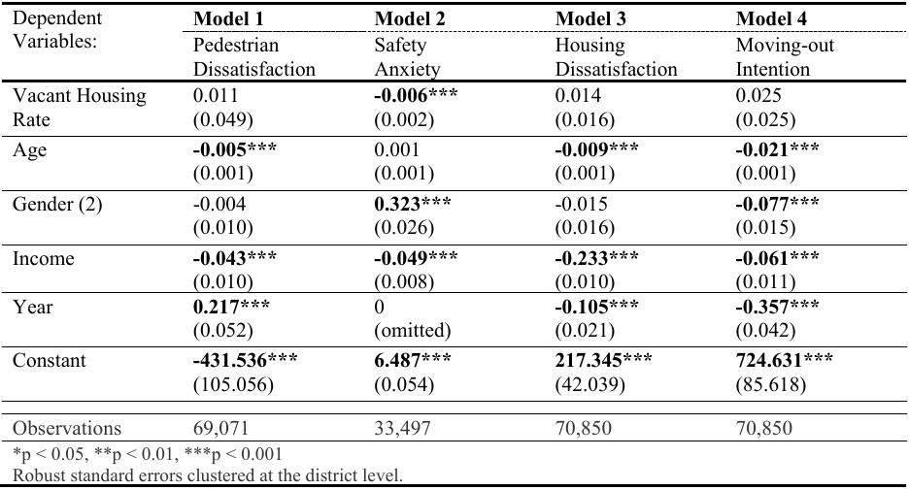
In Table 4, the Vacant Housing Rate (VHR) exhibits a negative relationship and statistical significance with safety anxiety in Model 2, while the other models display positive but statistically insignificance. It indicates that when the VHR increases at 1%, it is associated with a 0.006-unit decrease in safety anxiety level. This finding appears counterintuitive, it may reflect the effects of enhanced surveillance, targeted redevelopment efforts, or increased institutional presence in areas with high vacancy. Since this model does not account for district-level variation, the findings should be viewed as general trends rather than location-specific outcomes.
The significantly negative relationships of Age variable suggests that older citizens are either more accustomed to their surroundings or less concerned with environmental changes in their neighborhoods. According to the Gender variable result, women are more anxious about safety than men, which is consistent with existing literature on urban fear and perceived vulnerability (Sutton & Farrall, 2005). However, they are less likely to relocate to another city, even though they feel anxious about the urban environment, in the Model 4. This result may reflect a stronger sense of residential stability or limitations related to family obligations or financial factors of women.
Remarkably, through the Income variable, the results suggest that individuals with higher incomes tend to be more satisfied with the urban environment, likely due to their better living conditions. Based on the findings, considering income disparities in urban planning, and suggesting that the social-mix strategies could be beneficial in mitigating spatial inequality, particularly in the context of new development initiatives. For the Year variable, the pedestrian dissatisfaction increased between 2017 and 2018, while both housing dissatisfaction and moving-out intention decreased between 2015 and 2017. The decline in moving-out intention can be assumed to be related to the early impacts of newly introduced VH initiatives, which may have begun to positively influence resident’s daily lives. As a result, housing dissatisfaction has also decreased. It could be attributed to improvements in housing conditions—such as affordability, quality, or maintenance—or to more optimistic public perceptions of the city’s development periphery during that time. Ultimately, the VHR shows a statistically significant relationship only with housing dissatisfaction. This suggests that VHR does influence urban decline; however, its impact appears limited, as it is only significant for one indicator, while its effects on the others are not statistically robust.
2. Fixed-Effects Model
A Hausman test was conducted to determine the most appropriate model between fixed effects and random effects. The results (p<0.001) indicate that the differences in coefficients are systematic, suggesting that the fixed-effects model is suitable for the analysis. It implies that unobserved districtlevel characteristics are correlated with the explanatory variables, and therefore, the fixed-effects specification provides more reliable estimates. Yet, since one DV (Safety Anxiety), has a single year data, it is excluded from the panel data regression.
Y_{it} = β₀ + β₁ X_{it} + C_{it}β + α_{i} + ε_{it}
Where Y_{it} represents the dependent variable(s) for district i at time t; X_{it} is the independent variable capturing the VHR; C_{it} denotes a vector of four time-varying control variables (aging rate, net moving rate, and etc.); α_{i} accounts for all time-invariant unobserved heterogeneity across districts (Yan et al., 2022); and ε_{it} is the idiosyncratic error term. By focusing on intra-district changes over time, this model enables a more robust estimation of the effects of VH, free from the confounding influence of district-level characteristics that do not vary across time.

Table 5. Fixed-Effects Regression Results (Author’s own source, 2025)
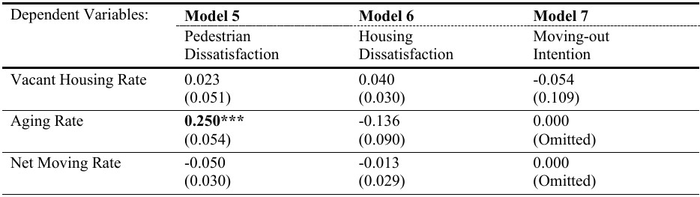
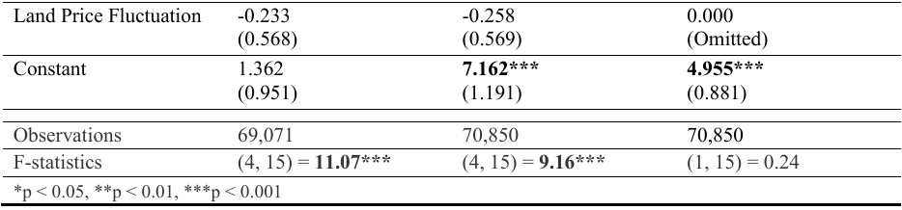
Table 5 presents the results of the Fixed-Effects Regression models without the moderating effect. In Models 5 and 6, the VHR shows positive and negative associations with the three DVs, however, all the results show the limited direct influence in this specification. Notably, the Aging Rate in Model 5, increase of one percentage of ageing rate is associated with a 0.25-unit increase in pedestrian environment dissatisfaction. Overall, the VHR has a limited influence on urban decline, while the increase of aged people is less likely to be satisfied with the pedestrian environment in Busan.

Relationship between vacant housing and the urban environment dissatisfaction

level with the moderating effect
Mixed-Effects Regression with a moderating effect
yij = β₀ + β₁x1ij + β₂x2ij + + βₖxkij + uⱼ + εij
To examine the effect of vacant housing aging rate (VHAR), a moderator and the interaction term (Vacant Housing Rate × Vacant Housing Aging Rate) was added in the analysis. The Mixed-Effects Regression model accounts for the nested structure of the data, where individuals (i) are nested within districts (j). It estimates both fixed effects (e.g., VHR, VHAR, and controls like age, gender, income) and random effects (district-level intercepts), allowing for variation across 16 districts in Busan. The interaction term tests if the effect of vacant housing differs based on the aged vacant housing rate. Additionally, robust standard errors help mitigate heteroskedasticity.

Table 6. Mixed-Effects Regression Results with the moderating effect (Author’s own source, 2025)
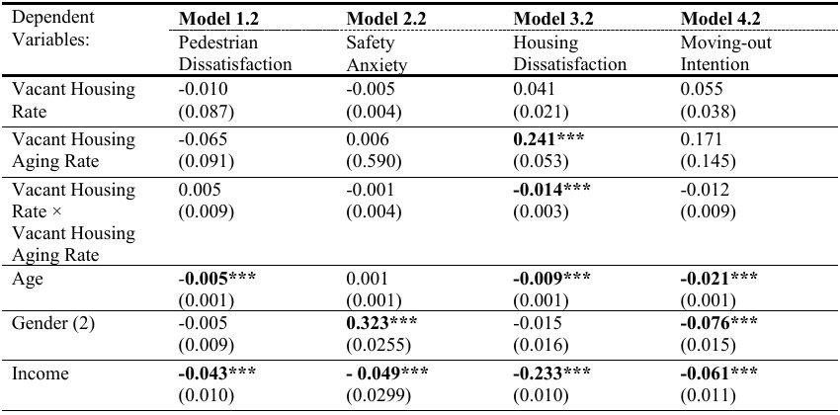
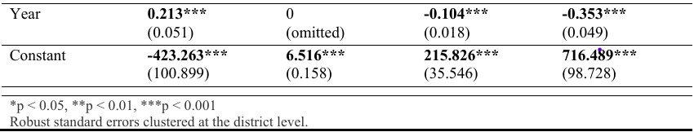
Table 6 presents the results of four mixed-effects regression models, extending Models 1–4 (Table 3) by including the Vacant Housing Aging Rate (VHAR) as a moderating variable and the interaction term VHR×VHAR. VHAR shows a statistically significant and positive relationship with Housing Dissatisfaction, indicating that a 1% increase in VHAR corresponds to a 0.24-unit increase in dissatisfaction. This suggests that areas with a higher proportion of aged vacant housing may experience greater resident concern due to perceived neighborhood decline. The interaction term is significant with the Housing Dissatisfaction (Model 3.2) with a negative coefficient value at -0.014, indicating a moderating effect. The interaction implies that the effect of vacancy is weaker in districts with older vacant housing and stronger in areas with newer vacancies which could be counteractive. This suggests that residents are more reactive to newly generative vacancies, while long-standing vacant houses may be perceived as a part of the existing urban area.
For the control variables, older people tend to report more satisfaction in pedestrian and housing condition, and moving-out intention too. For Gender, female respondents report higher safety concerns (+0.323) but lower moving-out intentions (-0.076), suggesting stronger residential attachment despite increased perceived insecurity. Additionally, higher-income respondents reporting lower dissatisfaction, most noticeably in housing dissatisfaction. Lastly, the Year variable is significant in Models 1.2, 3.2, and 4.2, indicating that pedestrian dissatisfaction rose in 2018 compared to 2017, while housing satisfaction and residential stability were higher in 2017 than in 2015—possibly reflecting changing demographic dynamics and aging-related immobility.
Fixed-Effects Regression with a moderating effect
Yit = β0 + β1Xit + β2Zit + β3(Xit × Zit) + αi + εit
This model allows for assessing the impact of VH on urban environmental dissatisfaction while also accounting for potential moderation by the VHAR. In this model, the dependent variable (Y_{it}) is environmental dissatisfaction, and the VHR is included as the main independent variable. To explore whether the effect of vacancy differs based on the condition of housing unit, an interaction term (X_{it} × Z_{it}) between the VHR (X_{it)} and the VHAR (Z_{it}) is incorporated. Additionally, district-level control variables—the aging rate, net moving rate, and land price fluctuation—are included to account for other socio-demographic and economic influences on dissatisfaction levels. This model effectively controls for all time-invariant characteristics specific to each district, thereby isolating the effects of the time-varying predictors.

Table 7. Fixed-Effects Regression Results with the moderating effect (Author’s own source, 2025)
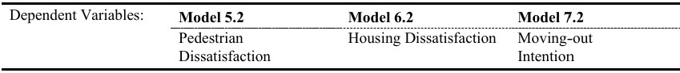
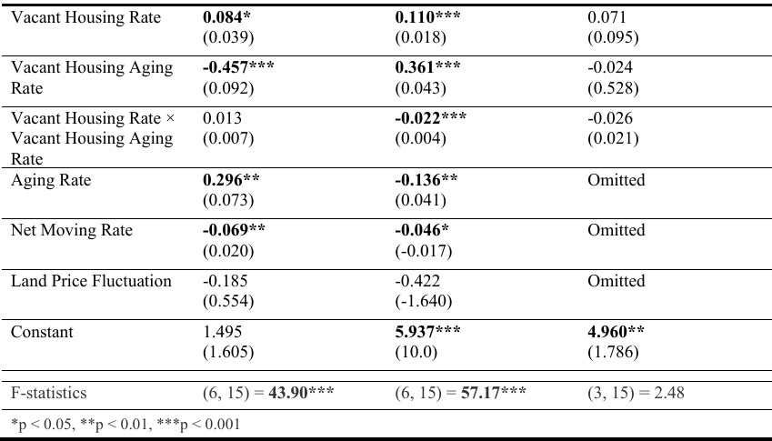
In Table 7, VHR shows a positive and statistically significant in the Models 5.2 & 6.2. When VHR increases one percent, it is associated with a 0.084-unit rise in pedestrian dissatisfaction and a 0.110unit rise in housing dissatisfaction. VHAR exhibits contrasting effects that it is negatively associated with pedestrian dissatisfaction (-0.457) and positively with housing dissatisfaction (+0.361). These findings suggest that districts with higher VHAR may have implemented interventions improving walkability—e.g., regular surveillance, patrols, or public space design—while still facing deteriorating residential conditions. For instance, Yeongdo-gu, Jung-gu, and Dong-gu, districts with the highest VHAR in 2015 and 2017, may exemplify this pattern (see Figure 11). Notably, the interaction term (VHR×VHAR) indicates that the impact of VHR on housing dissatisfaction weakens as VHAR increases in Model 6.2. While VHR alone has a significant positive effect on housing dissatisfaction, the moderating effect implies that long-standing vacancy may be perceived as less disruptive than newer vacant houses. The moderation by VHAR is most evident in housing dissatisfaction, since the interaction is not statistically significant in Models 5.2 and 7.2.
Among the control variables, higher pedestrian dissatisfaction and lower housing dissatisfaction are reported as the aging rate grows. Assuming that when the older population grows, they find it harder to walk in the city center and residential areas, but feel more attached to their home. The Net-Moving Rate growth is related to the lower pedestrian and housing dissatisfaction. From a broader perspective, the negative association may also reflect a dynamic selection process: individuals dissatisfied with their current living conditions are more likely to move out, whereas those choosing to move into a district are generally more satisfied with its overall environment (Glaeser et al., 2016). Land Price Fluctuation shows no significant effects, implying that short-term price changes have limited influence on perceptions of walkability or housing quality. Overall, these findings underscore the importance of considering both the prevalence and age of vacant housing, alongside demographic and mobility patterns, in evaluating urban dissatisfaction.

The moderating effect
In the Mixed-Effects results (Models 1.2–4.2), the interaction term shows a significant negative effect with Housing Dissatisfaction (Model 3.2), and it indicates that the impact of vacancy weakens as vacant houses age. It possibly suggests that the recent vacant houses may contribute more to dissatisfaction than long-term vacancies. Although the interaction terms with the pedestrian dissatisfaction and the moving-out intention (in Models 1.2 & 4.2) are not statistically significant, they still alter the direction and weight of VHR’s effect, implying structural influence. For Safety Anxiety (Model 2.2), the previously significant negative effect of VHR disappears when VHAR is introduced, which indicates a possible suppressing effect. In the Fixed-Effects model (Table 7), the interaction term in Model 6.2 has a significantly negative value, reinforcing that the influences of vacancy on housing dissatisfaction are conditioned by the age of the VH. Compared to Table 5, where VHR has a weak, non-significant effect, Table 7 highlights a nuanced dynamic: VHR becomes statistically significant with the moderator (VHAR), but its effect diminishes with higher VHAR in housing dissatisfaction level. It suggests that when the old vacant housing rate increases, citizen are likely to be more satisfied with their housing environment, although the vacant houses appear more in their areas. It implies that people living in areas with many old vacant houses are more satisfied with their housing conditions or are likely to receive more residential benefits from the government, as the area is targeted for urgent urban regeneration.
Overall, the findings proves that VHAR moderates the impact of VHR on citizen’s dissatisfaction levels. Beyond that, the old vacant housing rate affects urban decline in a holistic view. This result highlights the need for vacancy initiatives that are tailored to the age of the buildings and that consider the temporal dimension of vacancy in urban planning.

Discussion

Urban development strategies and the vacant housing policies
As shown in prior studies, vacant housing (VH) impacts the built environment, resident’s quality of life, and urban decline. VH is now widely recognized as one of Busan’s most urgent urban issues, drawing attention from the municipality, public institutions, residents, and media. Its effects range from short-term interventions to long-term planning implications. In response, there is growing advocacy in South Korea for “rightsizing” cities—addressing urban shrinkage by analyzing the causes and spatial patterns of decline (Yun et al., 2023). This shift challenges the country’s prevailing growth-oriented planning paradigm (Son & Jang, 2020). Reflecting this change, Busan launched the ‘2035 Urban Regeneration Strategic Plan’ in August 2024, emphasizing resident-centered renewal post-COVID-19 (Park, 2024).

Table 8. Concept of maintenance plan (Busan City, 2022)
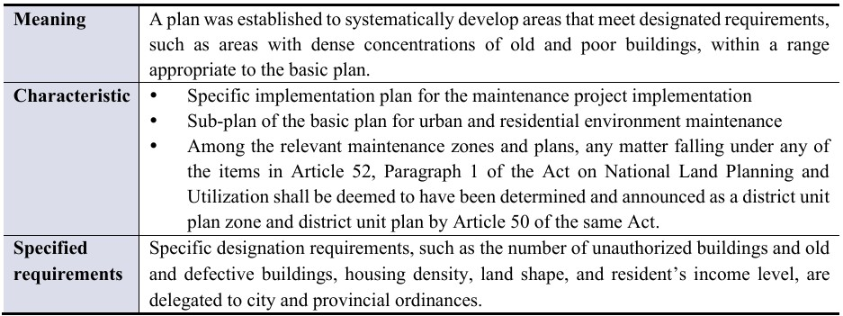
Changes to the 2030 Urban and Residential Environment Improvement Basic Plan

Table 9. Direction of the plan (Busan City, 2019)
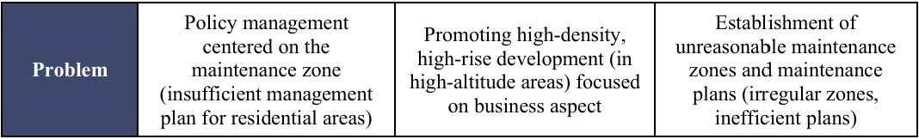

Table 10. New promotion strategy (Busan City, 2024)
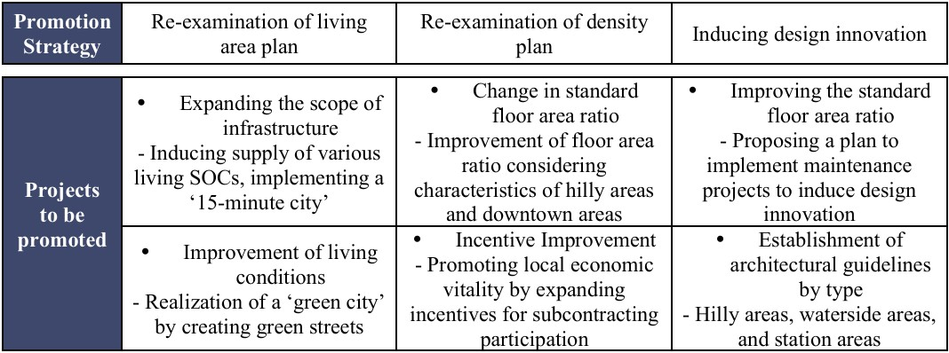
Tables 9 and 10 indicate that Busan’s urban and housing environment master plans have undergone significant revisions over the past five years. Between 2019 and 2024, the number of VH cases rose steadily, coinciding with the COVID-19 pandemic. Although the vacancy rate slightly declined by approximately 0.3% between 2020 and 2023, this reduction is more likely attributable to construction delays than to active demolition or reuse efforts (Park, 2020). Since 2022, the term “vacant housing pandemic” has entered public discourse, with worsening conditions drawing increased media attention. In response, the city has adopted more proactive measures, including a policy meeting for the “Busan-type Vacant Housing Management Innovation Plan” (Busan City, 2024), ordinance revisions, and new initiatives from 2024 onward.
A key change in the 2024 revised plan concretizes the “compact city” concept. While the 2019 plan acknowledged the mismatch of high-rise, high-density oriented redevelopment in Busan, it lacked actionable strategies. Proposals such as omitting certain redevelopment zones and adjusting floor area ratios (FAR) remained vague. The updated 2024 plan, however, introduces locally tailored FAR adjustments—particularly targeting hillside areas and the old city center, where vacancy and housing deterioration are most concentrated (Figures 9&11). Though the direction of FAR adjustments remains unspecified, the plan emphasizes design innovation and updated architectural guidelines, suggesting a more context-sensitive approach. Additionally, the plan links urban decline to walkability, proposing improvements to neighborhood streets as part of its “design innovation” strategy. Accordingly, Busan has started initiatives such as installing entry-blocking panels and murals in highly vacant areas to enhance the pedestrian environment (Cho, 2024).

Figure 12. A barrier installed to block entry to an empty house in Haeundae-gu, Busan (Cho, 2024) Figure 13. Painting project for the abandoned houses in Busan (Choi, 2025)
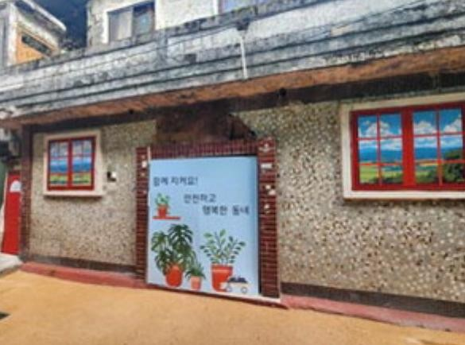

There are three urban areas maintenance classification, 1) Residential environment improvement project, 2) Redevelopment project, 3) Reconstruction project in Busan (Busan City, 2024). Among the major categories of urban renewal projects, VH initiatives in Busan are primarily under “residential environment improvement projects.” In contrast, redevelopment and reconstruction projects focus on demolishing entire buildings within a designated area to construct new residential, commercial, or industrial facilities. Given that the areas with low residential demands have many vacant houses, the city currently prioritizes demolishing deteriorated vacant houses or repairing them for reuse as the primary goal of the strategy.

Table 11. Flow of urban development and empty house policy (Author’s own source, 2025)
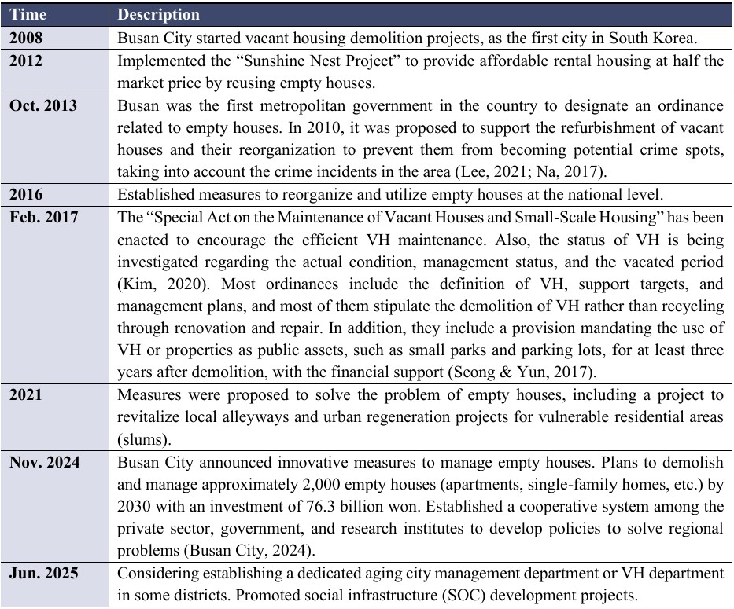
VH management in South Korea began in rural areas in 2001 with the revision of the Rural Improvement Act. Subsequent amendments to the Building Act, Urban and Residential Environment Improvement Act, and the Special Act on Urban Regeneration introduced introductory provisions for VH demolition and financial support, yet lacked detailed implementation frameworks (Lee, 2020). As VH emerged as a national concern, the government introduced more comprehensive measures, notably the 2017 Special Act on the Maintenance and Improvement of Vacant Houses and SmallScale Housing. This law established a legal foundation for VH management in urban areas by streamlining redevelopment procedures, easing building regulations, and introducing monitoring systems (Sung, 2019).
Busan, one of the cities most affected by VH, took early action. In 2008, the city launched Korea’s first demolition program for abandoned houses, and in 2012, began the “Sunshine Nest Project”, which renovates deteriorated houses for affordable rental housing in partnership with private owners. This initiative aims to prevent crime, reduce urban blight, and support low-income households. Other projects include converting cleared lots into gardens and parking areas, implementing crime prevention programs, and the “Green Zone” relocation initiative. However, the number of reused houses remains insufficient relative to the pace of VH growth, and there were only a few rental operator applicants due to the expensive renovation costs, which is a burden (Kim, 2012).
Initially, VH policies were limited and integrated into broader regeneration strategies, but they eventually became a core issue in urban planning (Lee, 2020). In November 2024, Busan announced plans to purchase and reserve old and abandoned houses, monitor new vacancy appearances, and develop a Busan-specific housing model for hilly areas. Under the expanded “Sunshine Nest Project”, the city aims to renovate or demolish 2,000 vacant houses by 2030 (Busan City, 2024; Lee, 2024). However, the legal and administrative barriers still exist. Many long-vacant houses remain untouched due to ambiguous ownership and potential legal disputes. The 2017 Special Act empowers local governments to forcibly demolish hazardous vacant houses if the owners do not provide valid reasons for non-compliance (Kwon, 2025). In May 2025, Busan’s Dong-gu district conducted the first such demolition, potentially setting a precedent for other districts.

Figure 14. 2024 Busan City Emergency Economic Countermeasures Meeting (Busan City, 2024) Figure 15. Busan City Vacant House Inspection and Status Investigation (Choi, 2025)
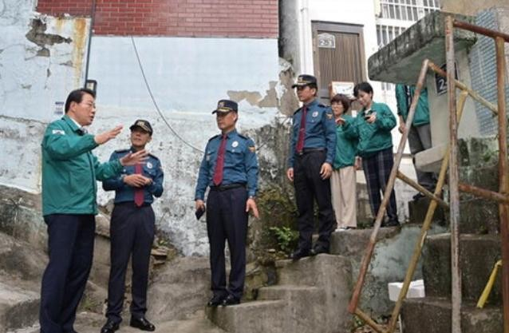

Vacant housing continues to shape Busan’s social, economic, and spatial dynamics. The city now adopts a dual strategy: mitigating existing vacancies through demolition and reuse, and preventing future occurrences. However, effective VH management requires more than physical interventions— it demands sustained monitoring and policy innovation. Future research should investigate VH sustainable reuse models, vacancy typologies, and their broader implications for neighborhood vitality and urban resilience.

Conclusions

Key findings
This study is conducted to investigate the current vacant housing (VH) situation in the 16 districts of Busan, and to empirically examine the relationship between VH situation and urban decline using citizen’s dissatisfaction levels with the urban environment as proxies for measuring.
The findings indicate a consistent increase in the vacant housing rate (VHR) across nearly all districts in Busan since 2010. Notably, the six old-city districts (see Annex 2)—Jung-gu, Seo-gu, Dong-gu, Yeongdo-gu, Busanjin-gu, and Nam-gu—exhibit both the highest levels and the most rapid growth in vacancy. In terms of housing types, apartments and multi-family houses constitute the highest proportion of vacant units across most districts. However, in several inner-city areas, particularly those historically settled by refugees after the war in the 1950s and characterized by hillside informal housing, single-family and multi-family housing types account for the largest share of vacancies. The rate of old vacant houses (VHAR), defined as dwellings over 20 years old, has shown an upward trend. This is especially pronounced in the old city center and the surrounding five districts, Saha-gu, Sasang-gu, Buk-gu, Geumjeong-gu, and Haeundae-gu, where the housing conditions are deteriorating rapidly. Since the VHAR grows quickly, the possible impact on urban decline is considered in the regression analysis.
Among the regression models analysis, the VHR demonstrated effects on Safety Anxiety (Model 2), Pedestrian Dissatisfaction (Model 5.2), and Housing Dissatisfaction (Model 6.2). For the safety anxiety (Model 2), the result appears counterintuitive by raising in VHR is associated with the decrease in it. However, it may reflect the urban improvement initiatives positively worked, such as the demolition of deteriorated housing complexes and urban improvement projects, implemented by Busan City since 2008 (Kim, 2020). In contrast, the result with the moderating effect (Models 5.2 & 6.2) show that increases in VHR are associated with higher levels of pedestrian and housing dissatisfaction, respectively. Particularly, there is a significant association with the growth of VHR with the housing dissatisfaction (Model 6.2). This highlights the need to consider not only the presence of vacancy but also its broader implications for urban quality of life.
Remarkably, the inclusion of the interaction term (Vacant Housing Rate (VHR) × Vacant Housing Aging Rate (VHAR)) reveals that the impacts of VHR on dissatisfaction weaken as VHAR increases (Models 3.2 & 6.2), particularly on Housing Dissatisfaction. It suggests that newer vacant houses tend to be negatively related to the housing dissatisfaction level more than older ones, which may be perceived as a background within the urban environment, or are more likely to be already repurposed or managed. The comparison with the baseline models (Tables 4 & 5), where no interaction term is included, further emphasizes this dynamic: the effect of VHR becomes stronger and significant only when VHAR is considered, which confirms the conditional nature of the relationship. Even where the interaction terms are not statistically significant, the inclusion of VHAR still alters the direction and weight of VHR’s effect. It reflects its structural influence on the models.

Conclusion
Finally, the vacant housing significantly contributes to resident’s overall dissatisfaction in Busan, reflecting broader patterns of urban decline. The findings emphasize the factors influencing citizen dissatisfaction, with the VHAR moderating the relationship between VHR and dissatisfaction levels, providing valuable sources for measuring urban decline. These analytical facts do not perfectly explain the degree of urban decline, yet they reveal a strong correlation between VH and declining situations. A more adequate interpretation is that rising VHR could negatively impact urban decline by influencing higher dissatisfaction levels with urban environments, while positively stimulating urban regeneration efforts. Furthermore, higher proportions of aged vacant housing appear to intensify urban decline by raising discomfort among residents. Thus, VH influences urban decline through multiple pathways, and its temporal dimension (i.e., housing age) critically shapes this relationship in the context of Busan.
This insight is essential for developing context-sensitive urban regeneration strategies. In response, Busan City has implemented various measures, including the enactment and revision of ordinances, the initiation of new regenerative plans such as the “Sunshine Nest Project”, and the establishment of dedicated public agencies to mitigate the negative impacts of VH. Despite these efforts, scholars and practitioners have pointed out that current policies often overlook the fundamental drivers of vacancy, for example, youth outmigration (Min, 2023), limited quality employment opportunities (Kim, 2020), housing oversupply, and a limited long-term vision of new regeneration plans (Jeong et al., 2022). To address these challenges, future research should examine ways to address the root causes of housing vacancy, the vacancy typologies, and sustainable VH reuse models, as well as their broader implications for neighborhood vitality and urban resilience. (11,662 words)

Bibliography
KOSIS. (2025). Retrieved from Korean Statistics Information Service (KOSIS):
https://kosis.kr/search/search.do
Banzhaf, E., Kindler, A. & Haase, D. (2007). Monitoring, Mapping and Modelling Urban Decline: A Multi-Scale Approach for Leipzig, Germany. EARSeL eProceedings, 6, 101-114.
Breuer, M. & Haan, E. (2024, 02). Using and Interpreting Fixed Effects Models. Journal of Economic Literature.
Caramaschia, S. & Chiodellib, F. (2023). Reconceptualising Housing Emptiness Beyond Vacancy and Abandonmnet. International Journal of Housing Policy, 23(3), 588-611. doi:10.1080/19491247.2022.2074268
Ceranic, B., Markwell, G. & Dean, A. (2017). 'Too many Empty Homes, Too many Homeless' - A Novel Design and Procurement Framework for Transforming Empty Homes through Sustainable Solutions. Energy Procedia, 111, 558-567.
Cho, J. (2022). Analysis of local government's vacant house management policy capacity and implications. Korea Research Institute for Human Settlements (KRIHS). Retrieved 02 17, 2025, from https://www.krihs.re.kr/
Cho, M. (2024, 01 04). Yeongdo-gu, the 'empty house island', faces difficulties in demolition. Retrieved from Gwangju MBC Official News: https://kjmbc.co.kr/NewsArticle/1407403
Cho, S. (2024, 10 06). Busan Dong-gu and Dongbu Police Station Join Hands to Address Vacant
Houses. Retrieved from Kookje Newspaper:
https://www.kookje.co.kr/news2011/asp/newsbody.asp?code=0300&key=20241007.220010 01090&kid=k29953
Cho, S. (2024, 10 21). Busan, build a crime prevention screen in an empty house and make plans to turn it into a lodging facility. Retrieved from kookje Newspaper: https://www.kookje.co.kr/news2011/asp/newsbody.asp?code=0300&key=20241022.220080 04791&kid=k29953
Cho, S. (2024, 10 27). The Empty House Maintenance Model Extends to the "Small
Accommodations". Retrieved from Kookje News:
https://www.kookje.co.kr/news2011/asp/newsbody.asp?code=0300&key=20241028.220010 07174
Choi, Y. (2010). Analysis of Factors Affecting the Promotion of Busan City Housing Redevelopment Projects.
Choi, Y. (2025, 05 15). Haeundae-gu Urban Regeneration Support Center, Re-painted Abandoned
Empty Houses. Retrieved from Kookje Newspaper: https://n.news.naver.com/mnews/article/658/0000107274
Cunningham-Sabot, E. & Fol, S. (2009). Shrinking Cities in France and Great Britain: A Silent Process? The future of shrinking cities: Problems, patterns and strategies of urban transformation in a global context.
Fu et al. (2025). How do remaining residents react to urban vacancy in shrinking city: A KAP model analysis of Yichun, China. Cities, 166. doi:10.1016/j.cities.2025.106244
Gardiner, J. C., Luo, Z., & Roman, L. A. (2009). Fixed effects, random effects and GEE: What are the differences? Statistics in medicine, 28(2), 221-239.
Glaeser, E. & Gyourko, J. (2001). Urban Decline and Durable Housing. National Bureau of Economic Research(8598).
Glaeser, E., Gottlieb, J. & Ziv, O. (2014). Unhappy Cities. (20291). doi:10.3386/w20291
Glock, B., & Häußermann, H. (2004). New trends in urban development and public policy in eastern Germany: dealing with the vacant housing problem at the local level. International Journal of Urban and Regional Research, 28(4), 919-929.
Gourlay, G. (n.d.). It’s got a bad name and it sticks…’Approaching stigma as a distinct focus of neighbourhood regeneration initiatives. In EURA Conference,‘The Vital City, (pp. pp. 12-14). Gwak, R. (2024, 01 04). The fastest-aging local government is Busan. Retrieved from Chosun Media:
https://www.chosun.com/national/labor/2024/01/04/AHND7HYNE5DIPEHEHVFMBQDH OY/
Han, H. (2014). The Impact of Abandoned Properties on Nearby Property Values. Housing Policy Debate, 24(2), 311-334.
Hollander, J. (2011). Sunburnt Cities. Taylor & Francis. Retrieved from VitalSource Bookshelf
Hong, S. & Lim, S. (2018). A study on the Change of the Housing Culture Koreans through the Firstgeneration Apartment in Korea. Asia-pacific Journal of Multimedia Services Convergent with Art, Humanities and Sociology, 8(4), 985-998. doi:10.21742/AJMAHS.2018.04.86
Huh, U., Lee, C. & Kim, C. (2024, 06). A Study on the Urban Types and Characteristics according to the Risk of Local Extinction. (Korea) National Land Research, 121, 73-90. doi:10.15793/kspr.2024.121.005
Hwang, U. & Woo, M. (2020). Analysis of Inter-Relationships between Urban Decline and Urban Sprawl in City-Regions of South Korea. Sustainability, 12(4). doi:10.3390/su12041656
Jeong, Y., Jeon, D. & Jeong, M. (2022). Analysis of local government vacant house ordinances for vacant house maintenance. Humanities and Social Sciences Research, 30(3), 495-520. doi:https://doi.org/10.22924/jhss.30.3.202208.020
Ji, J. (2021, 08). A Study on the Distribution and Characteristics of Empty House by Region Using Spatial Information. doi:[UCI]I804:21010-200000510267
Kasai, T. (2020, 12 09). Preparing for population ageing in the Western Pacific Region. Retrieved from World Health Organization :
https://www.who.int/westernpacific/newsroom/commentaries/detail/preparing-forpopulation-ageing-in-the-western-pacificregion#:~:text=A%20population%20is%20considered%20to,24%20years%20for%20Japan %20(Fig.
Kelling, L. & Wilson, Q. (1982).
Kim, G. M. (2018). Urban vacant land typology: A tool for managing urban vacant land. Sustainable Cities and Society, 36, 144-156.
Kim, G., Miller, P. A., & Nowak, D. J. (2018). Urban vacant land typology: A tool for managing urban vacant land. Sustainable Cities and Society, 36, 144-156. doi:10.1016/j.scs.2019.101562
Kim, H. (2018). The Characteristics of Empty Houses Re-use Programs and Opterational Types.
Kim, H., Choi, H., Lee, M., & Jang, M. (2017). Spatial distribution of empty deserted houses and its implications on the urban decline and regeneration. Journal of the Korean association of regional geographers, 23(1), 118-135.
Kim, H., Seong, E. & Yeo, K. (2020, 12). Exploring Predominant Neighborhood Factors for Proactive Management of Vacant Houses, Focused on Busan Metropolitan City. Journal of the Korean Urban Design Institute, 21(6), 137-150. doi:10.38195/judik.2020.12.21.6.137
Kim, J. & Nam, J. (2016, 3). A study on the distribution status and management system of empty houses in urban declining areas. Korea Regional Science Association (KRSA), 32(1), 105-122.
Kim, J. (2020). Analysis of spatial characteristics of vacant housing occurrence - Focused on the Busan Metropolitan City.
Kim, M., Park, Y., Lee, J., Kim, H. & Kim, J. (2025). Quantifying perceived decline through deep learning predictions and analyzing association with objective measures: A case study of Seoul, S. Korea. Cities, 159.
Kim, Y., Kim, S., An, P. & Cho, H. (2022, 2). A Study on the Problems and Improvement Plans of the Rural Vacant House Policy. Journal of the Korean Institute of Rural Architecture, 24(1).
doi: http://dx.doi.org/10.14577/kirua.2022.24.1.19
Kwon, K. (2025, 05 13). Busan Dong-gu, a ‘population extinction risk area’, first official demolition of ‘empty house’ with unclear owner. Retrieved from Kyunghyang News paper: https://www.khan.co.kr/article/202505131411001
Kwon, O., Kang, E. & Ma, K. (2019). A Study on the Impact of the Urban Decline on the Subjective Well-being of Residents. Korea Regional Science Association (KRSA), 33-47. doi:10.22669/krsa.2019.35.2.033
Lee, D. (2019). A Study on the Factors Contributing to Emerging Vacant houses and Countermeasures accounting to the Neigborhood Characteristics. Journal of the Korean Urban Geography Society, 22(2), 127-142. doi:10.21189/JKUGS.22.2.10
Lee, D. (2024, 11 21). Local government announces a Busan-style vacant house maintenance innovation plan. Retrieved from Busan Daily:
https://www.busan.com/view/busan/view.php?code=2024112118162237492
Lee, J. & Kim, E. (2022). Analysis of the effect of urban development projects on reducing empty houses. Social Economy and Policy Research, 12(3), 119-147. doi:10.22340/seps.2022.08.12.3.119
Lee, J. (2021). Study on the development of urban decline indicators and regeneration plans for vacant housing management areas.
Lee, J. (2021). Study on the Development of Urban Decline Indicators and Regeneration Plans for Vacant Housing Management Areas, Focused on Daegu-si.
Lee, M., Kim, S. & Kim, U. (2023, 06). Analysis of the typology and characteristics of regions in danger of extinction. (Korea) Urban Studies(23), 93-137. doi:10.34165/u rba n r.2023..23.93 Lee, S. (2020). A Study on Factors for Resolving Urban Vacancy and Policy Implications.
Lee, S. (2020). A study on factors for resolving urban vacant housing shortages and policy implications.
Lee, S. (2024, 10 28). Fear of Empty Houses at Risk of Collapse, Despite Demolition Requests.
Retrieved from Culture Daily:
https://www.munhwa.com/news/view.html?no=2024102801071327093001
Lee, S., Joo, H, Kim, K. & Kim, D. (2021). Effect of an Increase in Local Vacant Houses on Housing Sales. Journal of the Korean Society of Housing Environment, 19(4), 13-24. doi: https://doi.org/10.22313/reik.2021.19.4.13
Lim, H. & Kim, C. (2019). Spatial Analysis of Urban Decline and the Policy Improvement Direction - Focused on Busanjin-gu, Busan, South Korea. National Land Planning, 54(1), 186-198. doi:10.17208/jkpa.2019.02.54.1.186
Lim, Y. (2023). Market and real estate policy research on revitalizing housing maintenance projects - Analysis of the time required for each stage of Busan city redevelopment project.
Mallach, A., Haase, A. & Hattori, K. (2017). The shrinking city in comparative perspective: Contrasting dynamics and responses to urban shrinkage. Cities, 69, 102-108. doi:10.1016/j.cities.2016.09.008
McNeish, D. & Kelly, K. (2019). Fixed Effects Models Versus Mixed Effects Models for Clustered
Data: Reviewing the Approaches, Disentangling the Differences, and Making Recommendations. Psychological Methods, 24(1), 20-35. doi:10.1037/met0000182
Metzger, J. T. (2000). Planned abandonment: The neighborhood life‐cycle theory and national urban policy.
Min, D. (2024). A study on the Environmental Factors Causing Vacant Housing.
MOLIT. (2023). Definition of the Vacant Housing (Updated). Retrieved from Ministry of Land, Infrastructure and Transport: https://www.molit.go.kr/portal.do
Morckel, V. (2013). Empty Neighborhoods: Using Constructs to Predict the Probability of Housing
Abandonment. Housing Policy Debate, 23(3), 469–496. Retrieved from 10.1080/10511482.2013.788051
Mun, D. & Kim, J. (2018). A Study on the Flow Changes around Building Construction Area Using a GIS Data. Korean Journal of Remote Sensing, 34(6-1), 879-891. doi:10.7780/kjrs.2018.34.6.1.4
Nasab, H. & Bin, N. (2023). Identifying and Analyzing Factors Influencing Urban Decline, Case study: The border City of Zabol. Management Strategies and Engineering Sciences, 5(4), 6268.
Nest Sunshine (Abandoned Houses) Projects. (2025, 03 15). Retrieved from Busan Metropolitan City: https://www.busan.go.kr/depart/ahnestsunshine01
Newman, G, D., Bowman, A, O,. Jung, Lee., & Kim, B. (2016). A current inventory of vacant urban land in America. Journal of Urban Design,, 21(3), 302–319. doi:10.1080/13574809.2016.1167589
NGII. (2020). Retrieved from National Geographic Information Institute:
https://www.ngii.go.kr/eng/main.do
Park et al. (2021). Analysis of Urban Decline Patterns Based on Spatial Hierarchy Considering
Regional Characteristics - Focusing on Ulsan Metropolitan City. Journal of the Korean Society of Surveying, Geodesy, Photogrammetry and Cartography, 39(6), 571-585. doi:10.7848/ksgpc.2021.39.6.571
Park, C. (2025). A Study on the Regional Characteristics of Densely Populated Areas of Empty Houses, Targeting Gwangju Metropolitan City.
Park, M. (2020, 01 06). COVID-19 pandemic, Housing and Industrial Complex Supply Disrupted with the Land Compensation troubles. Retrieved from Chosun Biz:
https://biz.chosun.com/real_estate/real_estate_general/2025/01/06/BCSTUE6RMBGOHCZ IU6CDYQ3QAA/?utm_source=naver&utm_medium=original&utm_campaign=biz
Park, S. (2016). A Tentitive Approach for Establishing the Vacant Housing Information Management System of Urban Regenerative Project. Journal of the Korean Society for Intellectual Information Science, 18(2), 103-116.
Park, Y. (2024, 08 20). Busan City, 2035 Urban Regeneration Strategy Service Launched to Improve
Living Conditions in Declining Areas. Retrieved from TV Seoul: http://www.tvseoul.kr/news/article.html?no=62235
Pyo, J. (2024, 11 21). The number one city with the empty houses, Started to promote the Busan-type special measures. Retrieved from KNN: https://news.knn.co.kr/news/article/165553
Reuter, R, L., & Erb, H, J. (2025, 05 20). Berlin. Retrieved from Britannica:
https://www.britannica.com/place/Berlin
Rieniets, T. (2009). Shrinking Cities: Causes and Effects of Urban Population Losses in the Twentieth Century. Nature and Culture, 4(3), 231-254. doi:10.3167/nc.2009.040302
S, L. (2024, 11 22). 2,000 Vacant Houses, Busan's New Assets: A Major Transformation Expected by 2030 . Retrieved from Munhwa Daily News: https://n.news.naver.com/mnews/article/021/0002673453
Schilling, J. (2022). Beyond Brownfields Redevelopment: A Policy Framework for Regional Land Recycling Planning. JCULP5.
Seong, Y. & Yoon, J. (2017). Developing and Implementing a Strategic Management Plan for Vacant and Abandoned Houses. Research Report (Policy), Architectural and Urban Research Institute (South Korea). Retrieved 02 13, 2025
Silverman, R, M. Yin, L. & Patterson, K, L. (2013). Dawn of the Dead City: An Exploratory Analysis of Vacant Addresses in Buffalo, NY 2008-2010. Journal of Urban Affairs, 35(2), 131-152. doi:10.1111/j.1467-9906.2012.00627.x
Son, C. & Jang, H. (2020). A study on the Urban Management Policy Oriented toward Reduction for Urban-Rural Coexistence. Korean Society for Community Sociology.
Spelman, W. (1993). Abandoned buildings: Magnets for crime? Journal of criminal justice, 21(5), 481-495.
Stiratelli, R., Laird, N. & Ware, L. (1984). Random-Effects Models for Serial Observations with Binary Response. International Biometric Society, 40(4), 961-971. doi:10.2307/2531147
Sung, C. (2019). A Study on the Classification and Characteristics of Vacant Houses by Region in Busan, Ulsan and Gyeongsangnam-do. Journal of Korean Society of Residential Environmental Studies, 17(2), 109-122.
Sutton, R. & Farrall, S. (2005). Gender, Socially Desirable Responding and the Fear of Crime. British Journal of Criminology, 45, 212-224.
Torres-Reyna, O. (2007). Panel Data Analysis Fixed and Random Effects using Stata. Princeton Education. Retrieved from Princeton Education: https://www.princeton.edu/~otorres/
Urban Planning Department of Busan. (2024, 03 05). Urban (Re)development Project Types. Retrieved from Busan Metropolitan City: https://www.busan.go.kr/depart/ahcityguide02
URIS. (2025). Urban Regeneration Information System. Retrieved from
https://www.city.go.kr/portal/policyInfo/urban/contents11/link.do
Wallace, D., & Schalliol, D. (2015). Testing the temporal nature of social disorder through abandoned buildings and interstitial spaces. Social Science Research(54), 177-194.
Wang, K. & Immergluck, D. (2019). Housing Vacancy and Urban Growth: Explaining Changes in long-term Vacancy after the US Foreclosure Crisis. Journal of Housing and the Built Environment, 34, 511-532. doi:10.1007/s10901-018-9636-z
Weaver, R. (2016). Shrinking Cities. Taylor & Francis. Retrieved from VitalSource Bookshelf
Yan, X., Yuo H. & Lai, Y. (2022). ATwo-WayFixed Effects Estimation on the Impact of Industrial Land Supply on Environmental Pollution in Urban China. Environmental Research and Public Health(19). doi:10.3390/ijerph192214890
Yun, B., Lee, S., Lee, N., Kwon, Y. & Park, M. (2023). A study on City-size Optimization Plans for Local Small and Medium-sized Cities. National Lnad Research, 119, 121-141. Yun, I. (2018). A Study on the Lifestyle and Preference of Single-person Households.

Annex 1: Operationalisation table
Table 12. Operationalization table (Author’s own source, 2025)
Concept Variable Variable Name Indicator |  |  |  |  | Formula | Data description | Data source
Vacant Housing | Independent  Variable | Vacant Housing Rate (VHR) |  | - Changes in the rate of vacant housing in Busan | The vacant houses / Total number of houses x 100 (%) | - Secondary data  - Continuous data  - Time: 2000-2023 | - GIS  database  - MOLIT  - KOSIS
Vacant Housing | - | Vacant Housing Types |  | - The changes of the most prevalent vacant housing type | 5 housing types | - Secondary data  - Continuous data  - Time: 2015-2023 | - GIS  database  - MOLIT  - KOSIS
Vacant Housing | Moderating Variable | Vacant Housing Ageing Rate (VHAR) |  | - The changes in the aging rate of the vacant housing  - Old housing definition (in Busan): A building that has been completed for more than 20 years | Old vacant houses /  Total number of houses x  100 (%) | - Secondary data  - Continuous data  - Time: 2015-2023 | - GIS  database  - MOLIT  - KOSIS
Urban Decline | Dependent Variables | Urban  Living  Quality | Pedestrian  Environment  Dissatisfaction | - Near the residential area | Score 0-10 in total | - Secondary data  - Continuous data  - Time: 2017, 2018  - 69,071 responses | - BDI  Archive  - Busan City  dataset
 |  |  |  | - In the downtown area | Score 0-10 in total |  | - BDI  Archive  - Busan City  dataset
Urban Decline | Dependent Variables | Safety | Social Safety Anxiety | - Crime risk anxiety | Score 0-10 in total | - Secondary data  - Continuous data  - Time: 2018  - 33,497 responses | - BDI  Archive  - Busan City  dataset
 |  |  |  | - Overall social safety perception | Score 0-10 in total |  | - BDI  Archive  - Busan City  dataset
Urban Decline | Dependent Variables | Housing Quality | Housing  Dissatisfaction | - The dissatisfaction on one’s housing and overall housing situation | Score 0-10 | - Secondary data  - Continuous data  - Time: 2015, 2017  - 70,850 responses | - BDI  Archive  - Busan City  dataset
Urban Decline | Dependent Variables | Social  Integration | Moving-out intention | - The level of moving-out intention to the other city | Score 0-10 | - Secondary data  - Continuous data  - Time: 2015, 2017  - 70,850 responses | - BDI  Archive  - Busan City  dataset
Urban Decline | Control Variables | Age |  | - The age of the respondents | Number | - Secondary data  - Continuous data - Time: 2015, 2017, and 2018 | - BDI  Archive  - Busan City  dataset
Urban Decline | Control Variables | Gender |  | - The gender of the respondents | 1: Male / 2: Female |  | - BDI  Archive  - Busan City  dataset
Urban Decline | Control Variables | Income |  | - Average monthly household income on a scale of 1-8. | 1: Lesser than 1 million won (KRW)  2 – 7: From 2 – 7 million won (KRW)  8: Over 7 million won  (KRW) |  | - BDI  Archive  - Busan City  dataset
45

 |  | Year | - The survey conducting year | 2015, 2017, 2018
 |  | District code | - Classification of the 16 districts | (Annex 2.) | - Secondary data  - Categorical data
 |  | Elderly Population Rate | - Rate of the aged population | Elderly people (over 65 years old) / Total population x 100 (%) | - Secondary data  - Continuous data - Time: 2015, 2017, and 2018 | • | KOSIS
 |  | Net-moving Rate | - The pure number of movers | Moving in - moving out / total population x 100 (%) |  | • | KOSIS
 |  | Land Price Fluctuation | - The increase in the land price index at a given point in time compared to the base point in time | Land price index at the given point of a time / Index in the previous year x 100 (%) |  | • | KOSIS
46

Annex 2: Statistics of vacant housing in Busan

Figure 16. Busan Map and the names of the 16 districts (Author’s own source, 2025)
Code | District name
21010 | Jung-gu
21020 | Seo-gu
21030 | Dong-gu
21040 | Yeongdo-gu
21050 | Busanjin-gu
21060 | Dongrae-gu
21070 | Nam-gu
21080 | Buk-gu
21090 | Haeundae-gu
21100 | Saha-gu
21110 | Geumjeong-gu
21120 | Gangseo-gu
21130 | Yeonje-gu
21140 | Suyeong-gu
21150 | Sasang-gu
21160 | Gijang-gun
Busan (Total)
Map of Busan
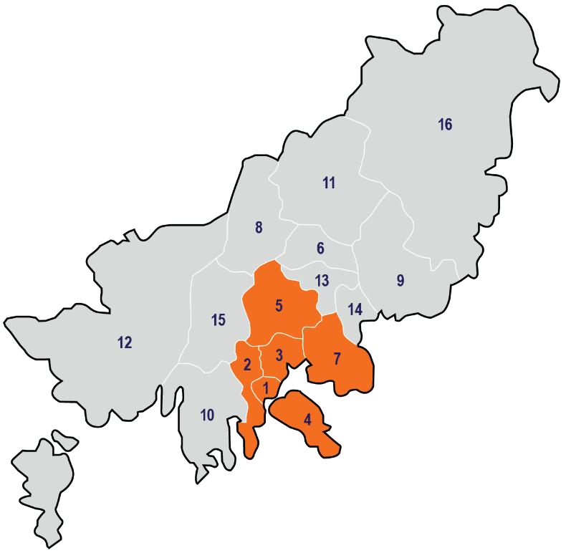
*Orange areas: The old-city center districts in Busan

Table 13. The numbers of Empty Houses in Busan (Author’s own source – based on KOSIS, 2025)
District | 1995 |  | 2000 |  | 2005
District | Number of empty houses | Vacancy rate  (%) | Number of empty houses | Vacancy rate  (%) | Number of empty houses | Vacancy rate  (%)
Busan  Gwang-yeogsi  (Total) | 17,036 | 2.58 | 25,031 | 3.11 | 53,651 | 5.55
Jung-gu | - | - | 485 | 3.70 | 739 | 4.95
Seo-gu | - | - | 1,398 | 4.44 | 2,360 | 6.49
Dong-gu | - | - | 1,013 | 3.96 | 1,820 | 6.64
Yeongdo-gu | - | - | 1,513 | 3.62 | 2,966 | 6.49
Busanjin-gu | - | - | 2,564 | 2.87 | 7,379 | 6.71
Dongrae-gu | - | - | 1,683 | 2.77 | 2,465 | 3.71
Nam-gu | - | - | 2,317 | 3.66 | 4,434 | 5.39
Buk-gu | - | - | 1,317 | 1.86 | 3,788 | 4.02
Haeundae-gu | - | - | 3,438 | 3.49 | 5,571 | 4.81
Saha-gu | - | - | 2,055 | 2.40 | 4,396 | 4.44
Geumjeong-gu | - | - | 1,432 | 2.51 | 6,278 | 9.85
Gangseo-gu | - | - | 442 | 4.03 | 678 | 6.27
Yeonje-gu | - | - | 855 | 2.00 | 2,619 | 4.85
Suyeong-gu | - | - | 15,175 | 4.00 | 3,936 | 7.87
Sasang-gu | - | - | 1,961 | 3.17 | 2,168 | 3.14
Gijang-gun | - | - | 983 | 5.51 | 1,604 | 7.00

District | 2010 |  | 2015 |  | 2020
District | Number of empty houses | Vacancy rate  (%) | Number of empty houses | Vacancy rate  (%) | Number of empty houses | Vacancy rate  (%)
Busan  Gwang-yeogsi  (Total) | 40,957 | 3.97 | 86,626 | 7.44 | 113,410 | 8.89
Jung-gu | 570 | 3.84 | 1,894 | 11.50 | 2,781 | 16.20
Seo-gu | 1,601 | 4.57 | 3,694 | 9.30 | 4,241 | 10.20
Dong-gu | 1,867 | 6.50 | 2,564 | 8.48 | 3,902 | 11.55
Yeongdo-gu | 1,639 | 3.66 | 3,446 | 7.49 | 5,087 | 10.91
Busanjin-gu | 3,519 | 3.06 | 11,077 | 8.43 | 15,483 | 10.93
Dongrae-gu | 3,870 | 5.03 | 4,397 | 5.32 | 6,145 | 6.50
Nam-gu | 4,445 | 4.85 | 9,992 | 9.98 | 13,789 | 12.74
Buk-gu | 1,603 | 1.76 | 8,458 | 8.06 | 6,176 | 5.81
Haeundae-gu | 5,761 | 4.41 | 10,075 | 7.24 | 12,221 | 8.35
Saha-gu | 3,234 | 3.12 | 5,611 | 5.08 | 8,922 | 7.58
Geumjeong-gu | 3,296 | 4.77 | 6,468 | 8.13 | 7,670 | 8.84
Gangseo-gu | 1,653 | 10.35 | 3,667 | 12.20 | 4,554 | 9.46
Yeonje-gu | 2,526 | 4.30 | 4,572 | 6.89 | 4,955 | 6.60
Suyeong-gu | 2,125 | 4.02 | 5,357 | 8.76 | 6,963 | 9.98
Sasang-gu | 1,523 | 2.16 | 1,794 | 2.43 | 4,136 | 5.39
Gijang-gun | 1,725 | 5.36 | 3,560 | 6.83 | 6,385 | 9.74

District | 2021 |  | 2022 |  | 2023
District | Number of empty houses | Vacancy rate  (%) | Number of empty houses | Vacancy rate  (%) | Number of empty houses | Vacancy rate  (%)
Busan  Gwang-yeogsi  (Total) | 101,337 | 7.90 | 110,500 | 8.45% | 114,245 | 8.59
Jung-gu | 2,648 | 15.36 | 2,727 | 15.80 | 2,979 | 15.80
Seo-gu | 3,752 | 9.03 | 4,427 | 10.21 | 4,974 | 10.21
Dong-gu | 4,336 | 12.64 | 4,120 | 11.99 | 4,896 | 11.99
Yeongdo-gu | 5,463 | 11.48 | 6,505 | 13.33 | 7,211 | 13.33
Busanjin-gu | 13,766 | 9.67 | 16,410 | 11.15 | 15,378 | 11.15
Dongrae-gu | 6,122 | 6.44 | 7,129 | 7.09 | 6,619 | 7.09
Nam-gu | 11,417 | 10.70 | 10,804 | 10.13 | 12,407 | 10.13
Buk-gu | 5,748 | 5.27 | 6,235 | 5.64 | 6,345 | 5.64
Haeundae-gu | 10,569 | 7.22 | 11,937 | 8.11 | 11,658 | 8.11
Saha-gu | 8,413 | 7.10 | 8,719 | 7.22 | 9,233 | 7.22
Geumjeong-gu | 6,795 | 7.82 | 7,118 | 8.17 | 6,827 | 8.17
Gangseo-gu | 2,603 | 5.38 | 2,630 | 5.39 | 2,444 | 5.39
Yeonje-gu | 4,916 | 6.51 | 5,193 | 6.73 | 6,072 | 6.73
Suyeong-gu | 6,200 | 8.78 | 6,355 | 8.83 | 6,476 | 8.83
Sasang-gu | 3,950 | 5.10 | 4,348 | 5.61 | 5,116 | 5.61
Gijang-gun | 4,639 | 7.12 | 5,843 | 8.47 | 5610 | 8.47

Annex 3: Survey data

Table 14. Urban environment dissatisfaction questions and responses distribution (BDI, 2015-2018)
Question | Number of Respondents
DV1. Pedestrian Dissatisfaction
Question a. How dissatisfied are you with the walking environment around your residence?
Answer:
- Very satisfied 6,071
- Somewhat satisfied 20,223
- intermediate 27,404
- Somewhat dissatisfied 11,991
- Very dissatisfied 3,382
Total sample size: | 69,071
Question b. How dissatisfied are you with the pedestrian environment in downtown Busan?
Answer:
- Very satisfied 2,784
- Somewhat satisfied 13,938
- intermediate 36,446
- Somewhat dissatisfied 12,645
- Very dissatisfied 3,258
Total sample size: | 69,071
DV2. Safety Anxiety
Question a. How anxious do you feel about the risk of crime in terms of social safety awareness?
Answer:
- Very safe 472
- Relatively safe 4,589
- Average 13,060
- Relatively unsafe 12,070
- Very unsafe 3,306
Total sample size: | 33,497
Question b. How anxious do you feel about overall safety in terms of social safety awareness?
Answer:
- Very safe 528
- Relatively safe 5,966
- Average 17,892
- Relatively unsafe 7,856
- Very unsafe 1,255
Total sample size: | 33,497
DV3. Housing Dissatisfaction
Question. How dissatisfied are you with your overall housing situation and your current housing environment?
Answer:
(2) Very satisfied 8,878
(4) Somewhat satisfied 22,699
(6) intermediate 28,913
(8) Somewhat dissatisfied 8,268
(10) Very dissatisfied 2,092
 | Total sample size: |  | 70,850
 | DV4. Moving-out Intention
 | Question. How much do you want to move out of Busan?
 |  | Answer:  (2) Not at all  (4) Not really  (6) intermediate (8) Somewhat  (10) Very much | 16156  29222  18517  4707  2248
Total sample size: |  |  | 70,850

Annex 4: Statistics of Busan

Table 15. Statistics of Busan – Control variables (KOSIS, 2015-2018)
 | 2015 | 2017 | 2018
Ageing Population Rate (%) | 20.084 | 22.075 | 23.335
Net-moving Rate (%) | -1.87 | -0.017 | -2.794
Land Price Fluctuation (%) | 0.244 | 0.368 | 0.373

Appendix 1: IHS copyright form

I grant IHS, or its successors, all copyrights to the work listed above, so that IHS may publish the work in The IHS thesis series, on the IHS web site, in an electronic publication or in any other medium. IHS is granted the right to approve reprinting.

The author(s) retain the rights to create derivative works and to distribute the work cited above within the institution that employs the author.

Please note that IHS copyrighted material from The IHS Thesis series may be reproduced, up to ten copies for educational (excluding course packs purchased by students), non-commercial purposes, providing full acknowledgements and a copyright notice appears on all reproductions.

Thank you for your contribution to IHS.

Date : 29. 07. 2025

Your Name(s) : Youvin Park

Your Signature : 



