Earnings management:
Do companies in financial distress use earnings management ?



Percy Veldhoven
Master Thesis
23 July 2010

Do companies in financial distress use earnings management ?

Abstract:
Due to the current economic circumstances, in 2009 the greatest number of Dutch bankruptcies were recorded, since the crisis of 2005. Companies are faced with decreasing gross sales and declining net profits. This might be an indicator and motivation for companies to prepare their financials applying earnings management. Resulting in the presentation of financial statements which could mislead and harm stakeholders. Certainly when a company received an unqualified auditor’s report on their financial statements and the company filed for bankruptcy the year after. This should reopen the debate regarding earnings management in relation to a company in financial distress. The thesis reviews whether it was foreseeable that a company is in financial distress and whether the company used earnings management. This is done via the research question: “Do companies in financial distress use earnings management and could this have been detected by auditors?”. The research is performed on 13 Dutch companies that filed for bankruptcy in the period from 2004 to 2009 after receiving an unqualified auditor’s report prior to the year they filed for bankruptcy. I found that companies in financial distress will overstate the revenues, accounts receivable but not the inventory and show a negative changes in cash flows from operations in comparison to the control group. And that auditors could have been able to predict this if a financial distress model was used in their assessment.

Keywords: Bankruptcy, Earnings management, Earnings manipulation, Going concern, Accruals accounting.

Rotterdam, July 2010
Erasmus University, Rotterdam
Erasmus School of Economics
Department Accounting, Auditing & Control
Author: P.R.D. Veldhoven
Thesis supervisor: Drs. R. van der Wal RA

Table of content
Abstract: II
Table of content III
Chapter 1. Introduction 1
Chapter 2. Literature review of Accounting Theory 8
2.1 Introduction 8
2.2 The Positive Accounting Theory discussed 9
2.3 Contractual arrangements 11
2.3.1 Owner/manager contracting 12
2.3.2 Debt contracting 13
2.3.3 Political costs 14
2.4 Summary 15
Chapter 3. Literature review of earnings management and going concern 16
3.1 Introduction 16
3.2 Goals and definitions of earnings management 16
3.3 Literature review on Going Concern 19
3.3.1 Introduction 19
3.3.2 Definition of going concern in the Dutch legislation 19
3.3.3 Accounting rules regarding going concern in The Netherlands 21
3.4 Summary 23
Chapter 4. Motivations and ways to apply earnings management 25
4.1 Introduction 25
4.2 Motivations for earnings management 25
4.3 Methods of applying earnings management 28
4.3.1 Premature or fictitious revenue 29
4.3.2 Aggressive capitalization and extended amortization policies 32
4.3.3 Misreported assets and liabilities 35
4.3.4 Creativity with the income statement 37
4.3.5 Cash flow reporting 39
4.4 Summary 40
Chapter 5. Literature review of models 41
5.1 Introduction 41
5.2 Literature review on models to detect earnings management 41
5.2.1 General accrual models 42
5.2.2 Specific accrual models 42
5.2.3 Accounting Choice 43
5.2.4 Discontinuities in the distribution of earnings 44
5.2.5 Research on Cash Flow 45
5.3 Real earnings management 45
5.4 Literature review on analysis of models to detect the use of earnings management 47
5.5 Literature review on accrual models to detect the use of earnings management 47
5.6 Literature review on models used to detect financial distress 51
5.7 Literature review on combined research 53
5.8 Summary 58
Chapter 6. Research design 59
6.1 Introduction 59
6.2 Hypotheses 59
6.3 Scope of empirical research and model used 61
6.4 Selection criteria and selection 65
6.5 Summary 66
Chapter 7. Empirical research 67
7.1 Introduction 67
7.2 Gathering of data 67
7.3 Analysis of data 68
7.4 Summary 77
Chapter 8. Conclusion 80
Appendix V
Annex I Selection bankrupt companies V
Annex II Selection control companies VI
References VII

Introduction
In this thesis a research will be performed regarding the use of earnings management in relation to companies who filed for bankruptcy within a year after they had received an unqualified auditor’s report. In this introduction chapter the research question will be defined, as well as an outline will be given of the thesis and how the research will be performed. To get a general idea how earnings management is used by companies an example will be presented.
Econcern N.V.
In June 2009, Econcern N.V. was declared bankrupt. The company cited, as reasons for the bankruptcy, the economic downturn, and a lack of financial support from both the financial institutions and government. In September 2009, after further investigation, it became evident that Econcern N.V had misstated its profits for the fiscal years 2006 and 2007. The financial statements in question were audited by PricewaterhouseCoopers Accountants N.V. For the fiscal years up to and including 2007, the CPA auditors had issued an unqualified audit report, relinquishing any apprehension or question regarding the going concern nature of Econcern N.V.
The audited Profit and Loss statement for the year 2007 showed € 443 million in sales and a profit of almost € 86 million. As expressed in the Econcern N.V bankruptcy report, management adjusted the 2007 consolidated sales and profit downward by € 224 million and € 55 million respectively. The 2008 financials were not yet audited at the time of the bankruptcy filing. However, the bankruptcy report does indicate that the 2008 sales had been adjusted downward by the board of directors from € 326 million to € 313 million.As a result the 2008 profit of € 130 million had to be restated as a loss of € 237 million. The primary reason for the board of directors of Econcern N.V. to misstate the accounts was that they had the pressure and desire to meet the credit requirements set by the banking industry.
Besides Econcern N.V. there are other companies by whom the use of earnings management has been detected. However, the motivation for those companies to employ earnings management is different.
The above mentioned example is an illustrations of a company who has utilized earnings management principles, or at least misrepresent their respective financial health and conditions.
A substantial amount of research has been conducted into the objectives for using earnings management For instance the Arnedo et al, (2008) study discusses some of these objectives and motivations. According to the mentioned report, earnings management can be utilized with the following motivation:
- In case of an Initial Public Offering (IPO), in order to present a permanent revenue growth;
- For personal benefits or with the intent to mislead investors.
The authors find that the use of earnings management by managers is possible due a lacking or failing monitoring and control systems in those companies.
The possible lack of control systems could be a reason why auditors have not been able to detect the use of earnings management in these case. The question then comes to mind whether auditors detect the use of earnings management in the case a company is in financial distress and would he be able to predict the possible bankruptcy of a company.
In relation to the use of earnings management by companies that are in financial distress The Argenti (1976) report discusses the correlation between the use of earnings management and the state of financial distress of companies. Based on its findings it becomes clear that especially companies in financial distress may be persuaded to use earnings management.
The effectiveness of the prediction of an auditor of possible bankruptcy of a company is discussed in the study of Kuruppu et al. (2003). In this study the effectiveness of the statistical corporate liquidation model is compared against previous bankruptcy prediction models and going concern judgements by auditors. The conclusion of the study was that the use of a model would have been yielded better results than the mere judgement of the auditor.
The before mentioned studies indicate that companies in financial distress will most probably use earnings management and the judgement of the auditor regarding the going concern of a company is outperformed by statistical models. Which leaves a question whether the annual accounts of companies give the real presentation of the current financial situation of a company as in 2009, the greatest number of Dutch bankruptcies were recorded, since the crisis of 2005. Due to the current economic decline, companies are faced with decreasing gross sales and declining net profits. This might be an indicator that companies are preparing financials using earnings management. They might do so in order to present financial statements which play to the expectations of investors and the banking industry, but do not depict the actuate financial position. Based on these incorrect financial statements, decision makers and stakeholders may be mislead in the management and determinations regarding their portfolio. This may lead to incorrect investment decisions, and eventually to an increase in costs for all stakeholders such as: investors, shareholders, trade creditors, personnel, and trade debtors. Based on the before mentioned, the debate regarding earnings management in relation to a company in financial distress, should be reopened but with a much wider view point.
Ample research has been conducted into the question whether companies are using earnings management, and if so by what motivation. The more specific question, whether earnings management is used when companies are in financial distress, has been researched significantly too. However, up to my knowledge, research into the financial management of companies who received an unqualified audit report and still filed for bankruptcy shortly thereafter, has only rarely been conducted. The question whether earnings management had been used, and if so intentionally or not, has only received marginal attention.
A good example of such an enterprise which received an unqualified audit report and still filed for bankruptcy shortly thereafter is Econcern N.V. In 2008, the company received their unqualified audit report on the financials of the previous fiscal year 2007. However, within a year after issuance of the receiving accountant’s report Econcern N.V. was unable to fulfil its obligations which inevitably lead to the filing for bankruptcy. Later it became clear that sales intentionally were overstated, and had to be adjusted. The auditor seemed to have noticed the revenue overstatement or at least did not adjusted the revenue overstatement, and did not use a going concern qualification in his report.
The general goal of this thesis will be perform a combined research on the two previously mentioned research efforts. Meaning to research the use of earnings management by companies in the year prior to the year the company filed for bankruptcy and the fact that auditors didn’t detect that a company is in financial distress and did not issue a qualified auditor’s report regarding any going concern assumptions.
Based on this, the research question for this thesis will be:
Do companies in financial distress use earnings management and could this have been detected by auditors?
In order to be able to answer the research question, several general subjects will need to be discussed. The general topics that will be discussed are:
- The accounting theory that gives insight into both the managers-stakeholders relation, and into the motivations managers have in achieving financial goals set internally and by shareholders;
- How is going concern is defined, and who is the key-player deciding which companies qualify as financial distressed and who do not ?
- How is earnings management defined in previously reviewed literature studies, and are they relevant ?
- What types of earnings management are there and what are the different motivations to use earnings management ?
In literature models of detecting earnings management are discussed. Not all are suitable to be utilized when companies are in financial distress. In this thesis the utilized model of detecting earnings management will be applied to Dutch non listed companies, using local GAAP, who filed bankruptcy after having received an unqualified audit report the previous year. The decision to only investigate Dutch non listed companies lies in the fact that most countries have their own going concern legislation as well as their own GAAP. It would have been outside the scope of this thesis to discuss different legislative systems and the relation to and between IFRS and local GAAP, as the scope is to merely investigate the process of utilizing earnings management while an unqualified audit report was issued before filing for bankruptcy. To more specifically answer the research question, I have identified the following sub questions:
- What general inside can be obtained by the positive accounting theory regarding the shareholders and manager relation in particular?
- What definitions of going concern and earnings management have been discussed in literature?
- What are motivations of utilizing earnings management in general and in what ways can earnings be managed, especially by companies in financial distress?
- What methodologies are there to detect earnings management in general and in the case of financial distress, what research has been conducted on the usage of earnings management and/or going concern issues?
- What are the findings after performing the empirical research?
Sub-question 1
In the second chapter I will give a literature overview on the positive accounting theory. In this theory the relation between shareholders and managers is discussed. In particular, the different motivations for manager decisions regarding the use of earnings management. Part of this motivation will be the asymmetry in available strategic information company officers have and on the other hand the information that is given to the share and stakeholders.

Sub-question 2
The third chapter will contain a literature review of going concern principles and how they are differently defined in Dutch legislation and Dutch GAAP. Also will be discussed definitions of earnings management. The review pertaining to the going concern principle, will focus on what is considered a general definition of going concern. I will further discuss which body has been given the responsibility to define and going concern qualification and communicate those to company residing in the Netherlands. Literature cites quite a few different definitions of earnings management. In this chapter the most common ones will be discussed. Based on the literature review performed in this chapter, an insight into going concern and earnings management will have been be given, and the definitions for use in this thesis will be presented.
Sub-question 3
In this fourth chapter I will review actual motivations for managers to apply earnings management as they have been debated in current literature. I will as well give a discourse of the techniques used in applying earnings management. The aim is to give inside into the general application of earnings management, and how financials generally are affected. This information to be discussed in this chapter is intended to give even further inside into motivations managers have for applying earnings management. As well as how the goals distilled from the fore mentioned motivations, can be achieved. It will also give a more defined understanding of the modus operandi of companies that have going concern issues and how they will try to achieve their goals.
Sub-question 4
In the fifth chapter the methodology for the empirical research will be outlined. Based on the general outline regarding earnings management and several general models of detecting earnings management in addition to several more specific models describing companies in financial distress. In this chapter the different methods for empirical research will be discussed. I will conclude the overview with a defined method of empirical research to be used in this thesis.
The sixth chapter will deal predominately with research design. It will incorporate the selected model for detect earnings management by companies in financial distress. Research criteria will be set, and a selection out of companies which have filed for bankruptcy, will be made. The annual financial statements of the years prior, and after filing for bankruptcy will be analysed. As stated previously, only companies adhering to Dutch GAAP will be selected.
Sub-question 6
The conclusion of this thesis will be discussed in the last chapter. In it, a summary of the general outline of the chapters will be given, concluding with the research findings.
Research Justification
In the introduction an example was given of a company who filed for bankruptcy or had to restate the financial statements. Very little research has been conducted into whether or not earnings management had been utilized by companies who filed for bankruptcy after receiving an unqualified audit report the preceding year. In this thesis, I will research this and give inside into this matter, also enabling stakeholders to value financial statements of themselves. I will also consider if we could have known these companies to be in financial distress, and if it was foreseeable that they were about to file for bankruptcy.
Scheme thesis
The structure of the thesis can be presented as in below mentioned scheme:
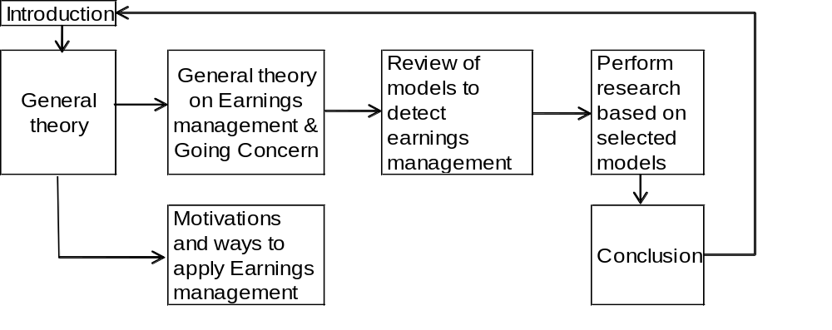

Literature review of Accounting Theory

Introduction
Deegan & Unerman (2006) discuss in their book different accounting theories that have been researched in past years.
The discussed theories are:
- the Inductive Accounting Theory;
- the Prescriptive (normative) Accounting Theory; and,
- the Predictive (positive) Accounting Theory.
Each of the three mentioned theories pertains to the same rational, but highlight a different perspective on how individuals will act. The first is empirical, the second is prescriptive, and the third is prognostic. Each of the theories will be discussed briefly.
The Inductive Accounting Theory has been developed based on observations of actions taken by individuals. Individual actions have been translated into the foundation of this theory. The aim of the Prescriptive Accounting Theory, was to develop a set of rules on how an individual should act. The Positive Accounting Theory (PAT) has been developed with the goal to explain and predict individual behaviour.
In the first chapter the example of Econcern N.V. has been given. The managers had certain motivations to act the way they did. The scope of the thesis question will only allow for a detailed review of PAT. The Inductive Accounting Theory would have used the fact of earnings management as its basis and would, therefore, not help to explain why earnings management is used.
The Prescriptive Accounting Theory would have given a set of rules on how managers should act, and henceforth, would not give inside into why and when earnings management would be used.
The PAT tries to explain why earnings management is used and predicts certain managerial behaviour. The presented literature review in this chapter will give inside into PAT from a theoretical point of view.
In paragraph 2.2 the Positive Accounting Theory will be discussed. In paragraph 2.3 an overview of the different types of contracts that are discussed in the Positive Accounting Theory will be given. In the last paragraph a summary will be given of this chapter.

The Positive Accounting Theory discussed
In their book, Deegan & Unerman (2006) present the research performed on the PAT. They used the PAT definition as defined by Watts & Zimmerman:
“PAT is concerned with explaining accounting practice. It is designed to explain and predict which firms will and which firms will not use a particular method.... but is says nothing as to which method a firm should use”
In general what becomes clear from this definitions is that the PAT tries to explain and predict the behaviour of managers over time. It does not prescribe a certain accounting method. This general outline gives a good basis for explaining why managers will make certain decisions in given situations.
In order to do so, the PAT utilizes certain proven general assumptions from other theories as valid. The first of these general assumptions is the efficient market hypothesis (EMH). The EMH assumes that capital markets react in an efficient and unbiased manner to publicly available information.
The premise is that all pertinent information is available and trustworthy. If and when such is not the case, and perceived questionable information become available, the market will investigate through inquiry with the company in question.
The EMH also assumes that all information is free, and changes in accounting methods do not influence the value of the company. This assumption has been questioned by several researchers. The research performed by Kaplan and Roll (1972) confirms this. Their research shows that managers do change accounting methods and these changes are not always detected by the capital markets. This means that not all information is free and therefore the predictive abilities of the PAT is limited.
Another general PAT assumption is that all individuals are driven by self interest. Individuals will always make decision and act in an opportunistic manner aiming to increase their own wealth.
This implies that managers do not always take actions in the best interest of both the company and shareholders. This would than lead to extraordinary costs. To limit this problem the Agency Theory has been incorporated into the PAT.
The Agency Theory is defined by Jensen and Meckling (1976), as:
“A contract under which one or more shareholders (principals) engage another person (the agent) to perform some service on their behalf which involves delegating some decision-making authority to the agent”
The goal of the contract, as the agent will try to maximize his own wealth, is to minimize company costs. At the same time this could lead to potential incentive problems. With a contract in place, the actions of the agent are bound to the limitations of the contract. Identified incentive problems are: effort aversion by the agent, divert resources for his private consumption or use, differential time horizons and differential risk aversion.
Each of these problems could lead to a situation in which the objectives of the principal will not be followed and may lead to economic welfare losses of the principal. Based on the possible welfare loss of the principal, and the fact that the agents desire to increase his personal wealth, both the principal and the agent are willing to enter into a contractual arrangement limiting the actions of managers and stating the agent´s expected performance based compensation.
Based on this assumption, an agent should be willing to give all the relevant information to auditors demonstrating he is not acting in a detrimental fashion to the welfare of the principal. The principal in general relies on the competition in the capital markets. The general assumption is that the agent is expected to be trust worthy; as his financial performance is leading for his remuneration. At the same time there is an information asymmetry between the agent and principal. The agent has all information regarding company performance, and the principal does not. The agent will not always be willing divulge all pertinent company performance information, to increase remuneration.
Such contracts ensure that all parties, acting in their own self interest, are at the same time motivated towards maximizing the value of the organisation. This results in a situation that corporate control mechanisms will have to be put in place to minimize the agency costs, i.e. all costs associated with delegating decision making authority to the agent. To minimize the agency costs two perspectives on how managers will act are defined: the efficiency - and opportunistic perspective.
Within the efficiency perspective the company will try to consider what mechanisms are in place or need to be in place to try to minimize the agency costs. In relation to the financial statements would this mean that companies would voluntarily let their accounts be audited.
Within the opportunistic perspective the company tries to explain and predict certain opportunistic behaviour that could or will occur based on the contracts that have already been negotiated. It is therefore expected that the managers will use opportunistically selected accounting methods whenever it could lead to an increase of personal wealth. At the same time, it is assumed that the principal will predict the manager to be opportunistic. Principals will therefore often stipulate the accounting method to be used for particular purposes. As it is almost impossible to describe all the accounting rules to be used in all circumstances, it is possible for agents to apply other accounting methods how they see fit for none described circumstances.

Contractual arrangements
Based on the theoretical outline above, contracts between the agents, the principal and others are based on defined financial output. This will be discussed in this paragraph. But if both the efficiency- and opportunistic perspective are taken into account, in relation to the contracts, the following distinction can be made. From a efficiency perspective all the necessary mechanisms are put into place at the beginning of the contract to reduce the agency costs. From an opportunistic perspective once the contracts are finalised it is expected that agents, if a change occurs, will try to adopt such strategies in order to achieve the greatest economic benefit for themselves. The distinction between the two perspectives cannot be made after the contracts are in place.
The different types of contracts that are discussed in the Positive Accounting Theory can be divided into three main groups being:
- Owner / manager contracting;
- Debt contracting; and,
- Political costs.
Each of these types will be discussed in following paragraphs.

Owner/manager contracting
Based on the assumption that the manager is a rational economic person, his actions will be, as discussed previously, self interest driven. Should he receive a fixed salary for his services, taking into account that all mechanisms to control him are put into place, will have the effect that the four identified incentive problems regarding his behaviour will be applicable. To align the interests of the principal with those of the agent, part of the salary of the agent will have to be related to his performance. The performance of a company are most of the times related to financial performance indicators such as sales, net profit and return on assets. This could result in the fact that the manager could change accounting rules or reduce expenses that influence the profit and thereby his bonus short term. These decisions could however influence the performance of the company in the long run. An example of such reduction in expenses is for instance the manager who will not (or at least) invest (less) in research and development which in the long run could harm the welfare of the owners, as without the product innovation and without new products, the revenue of the company will drop. Such items should be taken into account. At the same time if bonuses are based on financials, this could also give incentive to managers to manipulate those very financials. Managers could differ profits in a period if the maximum bonus is achieved or take additional expenses into account if bonuses cannot be achieved.
Another way to award managers for their performance is via the market based bonus scheme. In this scheme the managers are rewarded based on the change of share prices or a combination of the change in share prices and financials. Via this scheme the manager´s short term incentive can be (more) aligned with the long term goal of the owner; as the share prices represents the long term earnings ability of a company. But as becomes clear from Deegan & Unerman (2006) the market bonus schemes have both upsides and downsides. One of the downsides is that the financial markets do not value the expenses made for research and development as value increasing expenses and are therefore not represented in the share price. This may result in a cut in research and development expenses in order to influence the share price. A second downsides is that managers may not always be able to influence the share price due to changes in the overall market. A further downside is that it could be that company earnings may be viewed as less positive (more negative) in light of overall market wide movements in equity values. The advantage of the market bonus scheme is that managers with an equity interest will be more willing to disclose more information about the company and its performance and perspectives. This results in a situation of more information symmetry between the managers and the owners.

Debt contracting
Besides the contract between the manager and the shareholder, the company may engage in a contract with an external party willing to lend the company funds for their operations. As with the relation between the manager and the shareholder, the lender carries risk that of non-repayment due to manager actions. This may occur when the company uses the money for additional dividend payouts to the shareholders or investments in high risk projects. The costs related to divergent behaviour of the borrower are referred to as the agency costs of debt in the PAT. According to the PAT it is assumed that, in the absence of safeguards to protect the lender, the manager will not take those actions that are in the best interest of the lender. Due to this it is assumed that the company will have to pay higher costs of interest to compensate the lender for the high risk exposure. The company has the possibility to reduce the higher costs of interest if it is willing to engage in a debt agreement declaring that they will not use the received funds for activities such as mentioned before i.e. agreement upon certain constraints. By doing so it will reduce its interest costs and the lender risk. Examples of the debt constraints are leverage covenants, a minimum interest coverage and a minimum current ratio.
As with the manager compensation contract, the PAT assumes that the existence of debt contracts will incentive management to manipulate financials. The incentive to manipulate financials increases as the accounting based constraints approaches violation.
Deegan & Unerman (2006) reviewed whether companies manipulated financials in the presence of debt agreements. They reviewed the research performed by DeFond and Jiambalvo (2004) and Sweeney (1994) on the behaviour of managers known to have defaulted on accounting related debt covenants. The outcome of these studies was that companies will manipulate accounting accruals in the years prior to, and in the year after violating of the debt covenants. The research also shows that companies who approach violating debt covenants have a greater propensity to adopt income increasing strategies, in comparison to companies that are not approaching such violation of the debt covenants. To completely prevent that managers manipulate the financials, all accounting rules should be described in the debt contract. As this is almost impossible, as this would also lead to additional costs, managers will have some discretionary ability to manipulate the accounting figures. The auditor has the obligation to arbitrate the reasonableness of the accounting methods chosen. Econcern N.V. is a good example of the use of this ability. They manipulated the financials with the goal not to violate the debt covenants.

Political costs
The last type of agency costs identified within the PAT are the political costs. Large companies may sometimes be under the scrutiny of various groups such as the government, employee -, consumer - and environmental lobby groups. The basis for some of this attention by government and interest groups, is related to the general perception that a company generates excessive earnings and not contribute their fair share to the community. The most common example is the oil companies. To change the perception of the interest groups, these companies will produce reports such as environmental reports. Therefore, these companies have an incentive to lower their reported profits through utilizing accounting policies, and thereby avoiding attention.
When taking the EMH into account, any changes of accounting standards and subsequent reported profits, will not influence the valuation of the financial statements by the user. The user will eliminate the effect of the alternative accounting rules.
From a political and employee union point of view, an individual would have to take a lot of efforts to unravel the effect of the change of accounting standards. The personal benefits for such an individual do not out way the efforts of investigating and unravelling the change in accounting standards. Most likely such actions will not be undertaken. At the same time, the financials presented in the media, do not take into account the accounting standards and any effects of changed accounting methods.
The reported profit could lead to actions from politicians against these companies. This will also motivate managers of political sensitive companies to reduce the reported profit. When companies seek import relief they might aim to lower their reported profits as well. By showing low profits the company could influence politicians to protect their market for import.

Summary
In this chapter a theoretical overview of the PAT has been given. It gives inside on what drives a manager and the reason why managers and stakeholders are willing to engage in different types of contracts. In general, to enable that the goals of the company and the personal goals of the manager, to increase his welfare, are more in alignment. As well as to try to make sure that the manager will not harm the company is such a fashion that it would influence the value of the company. Also in this chapter an overview is given of the dilemma’s that the stakeholders are confronted with as well as the actions that can be expected from the managers. This chapter gives a general overview of the different facets of the relation between the manager and the shareholders as well as the relation between the company and outside parties. But what also becomes clear from this is that managers will take actions in such a way that his personal gain will always be prevailing.

Literature review of earnings management and going concern

Introduction
The aim of this chapter is to give inside on what earnings management is; as well as what going concern criteria are applicable and who and who bears the responsibility of defining them in the Netherlands. In paragraph 2.3 the definitions and goals will be discussed. With the goal to obtain knowledge on what earnings management is and what different kind of points of views there are regarding earnings management. In paragraph 3.3 the Dutch legislation and Dutch GAAP in respect to going concern will be discussed. It will aim to give inside on the Dutch legislation and who bares the responsibility of qualifying going concern standards. Based on this overview and understanding of these items the boundaries for the research question will be set. In paragraph 3.4 a summary will given of this chapter.

Goals and definitions of earnings management
In the literature many different goals and definitions of earnings management have been defined and discussed. In this paragraph different definitions and goals will be reviewed to be able to obtain a general overview on earnings management, and to be able to set the definition that will be used for this thesis.
Schipper (1989), Commentary on Earnings Management.
Schipper researches the relation between earnings management and the liberty managers are given to apply accrual management within specific GAAP. She states that the use of earnings management enables managers to provide more information regarding company performance. For her research she used the following definition of earnings management:
“By earnings management I really mean disclosure management in the sense of a purposeful intervention in the external financial reporting process, with the intent of
obtaining some private gain.”

Based on this definition and her research she concluded that the general goal of earnings management is to influence the importance of accounting accruals in arriving at a summary of the company’s performance. In her research she finds that the general goal of earnings management is clear to all. However, there is a quite a bit of discussion regarding the way this can be achieved as companies are confronted with different kind of contracts, i.e. owner/manager contracting, debt contracting, political costs. All these contracts are based on the financial reports, which make it more difficult to arrive at the actual company information, as the goals and objectives of each of these contracts are different as discussed in the PAT.
Schipper identifies two important disturbances that influence the actual financial information presented; these are: (i) selecting a different accounting method within the possibilities of the specific GAAP, and (ii) applying given methods in particular ways. The result is that general goals, the financial performance summary, and the concept of “true income”, are no longer useful, dues to distortions in the information. The outcome of such a situation is that the personal gain aspect will prevail above the any gained inside into the financial performance of the company. These motivations for personal gain may differ per company but the general idea will stand.
Dechow (1994). Accounting Earnings and Cash Flows as Measures of Firm Performance - the Role of Accounting Accruals.
According to Dechow the goal of earnings management is to help investors to assess the company’s performance of the before lying period through the use of basic accounting principles such as revenue recognition and matching. By having such principles, the accrual process is hypothesized to mitigate timing and matching problems so that the earnings more closely reflect the firms’ performance. Research shows that the accrual process results in earnings that are smoother than underlying cash flows, since accruals tend to be negatively related to cash flows, and earnings provide better information about future economic performance to investors than cash flows.
Healy and Wahlen (1999), A review of earnings management literature and its implications for standards setting.
Healy and Wahlen (1999) used in there article the appliance of general accepted accounting standards (GAAS) by managers, to inform stakeholders regarding the company performance, as a starting point. To be able to properly inform shareholders about the financial performance, managers have been given some leeway to exercise judgement based on their understanding of their particular business when presenting financials. This, however, gives them some room to achieve their own personal goals.
The definition that they give for earnings management is:
“Earnings management occurs when managers use judgment in financial reporting and in structuring transactions to alter financial reports to either mislead some stakeholders about the underlying economic performance of the company or to influence contractual outcomes that depend on reported accounting numbers.”
This means that the general purpose of earnings management is to inform stakeholders on the performance of the company. But at the same time takes into account that managers will try to mislead stakeholders via using earnings management to achieve their own goals.
Definition to be used in the thesis
These studies show that the use of earnings management is intended to be able to inform stakeholders on the performance of a company and give managers the possibility to reveal their private information and to communicate inside information to investors. But managers will use earnings management not to inform the stakeholders on the actual performance of the company but on how they want stakeholders to perceive how the company performed. This implies that companies will try to mislead or at least misinform stakeholders. One may conclude that the goal of companies in financial distress will be to try to show a financially solid company by not conveying a completely truthful depiction of the financial status of the company. In respect to this negative view on earnings management and the general questions of this thesis whether earnings management will be used by companies in financial distress, the definition of Healy and Whalen will be used as a basis for this thesis.

Literature review on Going Concern

Introduction
In the last years a lot of companies filed for bankruptcy, or are in financial distress due to the current economic recession. Financial distress is qualified as a situation in which one is not able or nearly not able to fulfil all its financial obligations. As this thesis is limited to Dutch non listed companies, this paragraph will only discuss the going concern definitions and criteria as they are applicable in the Netherlands. The applicable rules and regulations are the Dutch Civil Code (DCC), Dutch Bankruptcy Law and the Dutch Accounting Standards.

Definition of going concern in the Dutch legislation
In the Netherlands there are two laws that are applicable regarding the (dis)continuity of a company: (i) the Dutch Civil Code, and the (ii) Dutch Bankruptcy Law. In this paragraph both will be discussed.
Dutch Civil Code
The DCC is based on the principle of the continuity of a company. The assumption of continuity is based on and becomes clear from book 2, article 384 under 3.
It reads as follows:
“In the valuation of assets and liabilities it will be assumed that the entire business of the company to which those assets and liabilities are in service, shall continue, unless that assumption is incorrect, or its accuracy is subject to reasonable doubt, then under the Notices the explanation of the effect on capital and result is presented.”
In general, going concern is stated as being able to fulfil all the obligations the companies has. Should this not be the case it is assumed that the company will be in discontinuity and is referred to the Dutch Bankruptcy Law. But how to interpret the concept of continuity is not explicitly given. In the DCC two specific items have not been clarified:
- Whether it regards the existence of discontinuity in the short term or long term; and,
- Whether the perspectives of the management on the interpretation of continuity should be taken into account.
The DCC does however describes the following situations:
- Should a company be able to continue without any expected problems; no additional information regarding future plans need to be disclosed; and,
- Only if there is a reasonable chance or no chance at all that the company can continue, the company has to disclose the information regarding future plans and how they will be able to continue the company.

Almost all management of a company in financial distress will be convinced that they will survive the current negative situation. And will try to avoid to disclose any information regarding the current financial situation and future plans as this may give the “wrong” signal. This results in an expectation gap between what stakeholders expect based on the supplied information and the actual (financial) situation of the company. The DCC tried to solve this issue through additional regulations. Via these articles the external auditor, through his work, will have to give an interpretation of the existence of continuity, although the auditor has no legal power to enforce this. Legislation have set above mentioned general rules, but these don’t give explicitly guidance. It is the Accounting council that has given, via its principles, implementation on the qualification of continuity.

Definition of bankruptcy according to The Dutch Bankruptcy Law
The Dutch Bankruptcy Law is a specific part of the Dutch law, and is used in the case a company is facing a bankruptcy or has gone into bankruptcy. The Dutch Bankruptcy Law gives an overview on how and when a company is qualified as going into bankruptcy. In article 1 of this law the following definition for bankruptcy is given:
“The debtor, who is in the condition that he has ceased payments, is either on his own declaration or at the request of one or more of his creditors, by the court declared bankrupt”
As becomes clear from this definition, the law does not give a timeframe in which the lack of payment incapability will or has taken place. And whether the possibility exists that the company, in time, will be able to fulfil its obligations.
As no timeline for insolvency has been given, nor that further plans are to be taken into account, it is unsuitable for the analysis of going concern issues in the Netherlands.

Accounting rules regarding going concern in The Netherlands
As described by the DCC the fundamental assumption in the preparation of the financial statements is continuity. The external auditor, based on Dutch GAAP, need to give an independent valuation whether or not a company has going concern issues.
The definition of going concern given in the Dutch GAAP is:
“an entity is ordinarily viewed as continuing in business for the foreseeable future with neither the intention nor the necessity of liquidation, ceasing trading or seeking protection from creditors pursuant to laws or regulations. Accordingly, assets and liabilities are recorded on the basis that the entity will be able to realize its assets and discharge its liabilities in the normal course of business. As soon as above mentioned is not the case a company can be qualified to have financial distress.”
In this definition a timeframe is mentioned, this in contrary to the definition given in the DCC and Dutch Bankruptcy Law.
The primary rule regarding the financial statements is that the management of the company is responsible for the preparation and the assessment of the company’s ability to continue although not explicitly demanded based on the Dutch Accounting Standards. Management's assessment of the going concern assumption involves making a judgment, at a particular point in time, concerning the future outcome of events or conditions which are inherently uncertain. And if necessary the management should mention in the financial statements what caused the current position and in what way the company will be able to solve this, as to state that the going concern assumption is correct. The external auditor will have to evaluate this going concern assumption.
Auditor's Responsibility
The DCC transferred the responsibility of evaluation whether the assumption of continuity of a company is correct to the external auditor. Based on this the Dutch Accounting Standards defined the several responsibilities of an auditor. The responsibilities are to consider the appropriateness of management's use of the going concern assumption in the preparation of the financial statements and consider whether there are material uncertainties about the entity's ability to continue as a going concern that need to be disclosed. Independently of indications of discontinuity, and based only on the information available on the moment of the assessment. Based on the findings the auditor will issue one of the following audit qualifications:

- The accounts are prepared on the basis of going concern; ( an unqualified report)
- The accounts are prepared on the basis of going concern but with some concern; and,
- The accounts are prepared on the basis that a failure of the company is inevitable.
It is managements responsibility to make a specific assessment of the entity's ability to continue based on the going concern assumption, but as mentioned this is not an obligation. The management has the possibility to show and arrange a plan, modify current accounting figures via the use of earnings management to show that the current financial position of the company is good or at least will be good and the going concern assumption is more than credible.
The auditor has the responsibility to assess the going concern assumption of the management, which may be not completely correct, and at that time could find that the company has the ability to continue as going concern, but the auditor cannot guarantee this ability. This leaves a gap between what users of the audited financial statements perceive, as they base their judgement on the audited financial statements, and what the actual financial situation of the company is. The possible discussion relating to this gap falls outside the boundaries of this thesis and will not be further investigated.
The basis for this thesis will be the definition of the Accounting Standard Board as it takes aspects, such as current situation, future plans and possibilities to solve the possible negative current situation, into account.

Summary
In all definitions of earnings management, the general goal of earnings management is perceived to be that it should be used to inform stakeholders about the performance of the company. But at the same time different conflicting goals have been identified about the use of earnings management, being trying to influence contractual outcomes, personal gain and misleading stakeholders about the company’s performance. The definition of earnings management for this thesis will be the definition given by Healy and Wahlen. As managers will use earnings management to try to mislead stakeholders and not present the actual current situation of the company.
Based on the transferred responsibility the Dutch Accounting Standards Board has issued articles to qualify going concern. They state what the responsibilities are of the companies and the external auditor. According to the principles the management is responsible for the preparation of the financial statement, but is not obliged to assess whether there is a continuity problem within the companies. This is the responsibility of the external auditor. If the discontinuity has been identified the company has the possibility to devise a plan that show an avoidance of bankruptcy. The auditor has the responsibility to asses this plan and give based on the supplied information a qualification on the continuity of the company. However, the auditor cannot be held responsible for this assessment should the company go bankrupt after all. As management is not responsible to assess the continuity of a company it could give them more room to apply earnings management and alter financial transactions and mislead stakeholders about the economic situation of the company and try to avoid a qualified auditor’s report.

Motivations and ways to apply earnings management

Introduction
In this chapter the motivations to use earnings management and several techniques that are used to achieve these motivations will be discussed. In paragraph 4.2 the motivations that managers have to apply earnings management will be discussed. In paragraph 4.3 the techniques managers can use try to achieve their goals are presented. Both paragraphs will help to get a clear overview on the motivations that managers of companies in financial distress have and what techniques they will use. In paragraph 4.4 a summary will be given and the most relevant motivations and methods for companies in financial distress to apply earnings management will be presented.

Motivations for earnings management
In chapter 2 a general outline on the motivations to use earnings management based on the PAT has been presented. In this paragraph the actual motivations for managers to use earnings management will be discussed. Healy and Wahlen (1999) researched the motivations for managers to apply earnings management. The authors came to the conclusion that there are three main motivations which can be subdivided into more specific motivations. In this paragraph these identified motivations will be discussed. The motivations are:
I Capital market expectations and valuations
  - Meet expectation of earnings forecasts;
  - Reduce earnings volatility;
  - Try to increase stock prices before equity offers;
  - Signalling;

II Contract motivations
  - Management compensation contracts;
  - Reduce borrowing costs;
  - Lending contracts;
III Regulatory motivations
  - Industry regulation; and,
  - Anti-trust and other regulations.

- Management of the companies will try to meet the expectations of financial analysts with regard to the financial forecasts. Should management not meet the expectation could this have a negative effect on the stock price or stock recommendations by financial analysts. Managers may use earnings management to meet the expected financial forecasts and try to avoid the harm that may result from not meeting the expectation.
- The management of a company will try to reduce earnings volatility, in the hope to achieve a solid earnings picture and share-price. This can be achieved by forming /releasing an accrual in the years in which the earnings exceed/are below the expectations of the managers/shareholders and the financial market.
- Managers have the incentive to overstate earnings/unexpected accruals to try to increase the share price of the company prior to equity offers, initial public offers and stock financed acquisitions. This is supported by evidence of a reversal of the unexpected accruals after the initial public offerings and stock financed acquisitions.
- The management of a company will use earnings management to send a signal to (specific types of) investors. The evidence that is given, is that companies may deliberately cut certain expenses to avoid a decline in reported earnings. Or, may choose to explicitly not cut specific expenses depending on the type of investor. Another way for companies to signal is that in a bad financial year they will try to include more expenses, trying to give a signal to the investors that the next years will be better which will be confirmed with the release of the accrued expenses.
- Shareholders will use management compensation contracts. Managers will have to achieve their targets to obtain these compensations. Resulting in that mangers will use earnings management to increase the earnings and achieve their targets or delay earnings until the next year if the targets in the current year cannot be achieved or have already been achieved. Other options to achieve the targets are the reduction of expenses or even the use of accounting discretion.
- The company will overstate its earnings to improve the financial position of the company in the case a lending contract has to be renewed. With a better financial position the company will be able to negotiate better borrowing conditions on the outstanding loan.
- Almost all companies have contracts with constraints. The company will have the incentive to manage earnings to avoid violating one of the constraints. The company can achieve this via accelerating earnings or via changing accounting policies one year prior to the expected violation. In case of a violation of one of the constraints the company has the incentive to change the currently used accounting rules or increase earnings the year after the violation, to avoid another violation of one of the constraints.
- Most of the companies have additional regulations they have to obey by. E.g. banks have certain capital adequacy requirements. The monitoring is performed by the government and is based on the presented accounting numbers. The companies will manage earnings to make sure they will meet the requirements set by the regulators.
- Besides above mentioned, companies are also confronted with governmental anti-trust and other governmental regulations. Companies have incentives to apply earnings management to look less profitable and avoid an anti-trust investigation or other political consequences. In the case they look for government subsidy or import relief they will have the same incentives.

To my knowledge, the motivations of managers of a company, that is in financial distress or face bankruptcy, to use earnings management, are:
- Meet expectations of earnings forecasts in combination with signalling: with the goal to avoid that stakeholders and financial analyst would get the impression that the company is in financial distress;
- Management compensation contracts: as the managers will try to maximize their bonuses, especially in the case the company should go bankrupt; and,
- Lending contracts: a breach of the constraints of a lending contracts may “signal” the actual financial situation of the company to all relevant parties, which will not be the objective of the managers.

Methods of applying earnings management
After discussing the theoretical motivations mentioned in the Positive Accounting Theory and the research performed by Haely and Wahlen, in this paragraph the different methods on how earnings management can be applied will be presented. Mulford and Comiskey (2002) present in their book different methods to apply earnings management, these will be used as the basis for this paragraph. Also the articles of Rosner (2003), Graham (2005), Roychowdhury (2006) and Nelson et al. (2003) will be used to add additional information regarding the separate methods.
Mulford and Comiskey (2002) identified the following methods:
- Premature or fictitious revenue;
- Aggressive capitalization and extended amortization policies;
- Misreported assets and liabilities;
- Creativity with the income statement; and,
- Cash-flow reporting.
What became clear from the chapters two and three is that managers will use earnings management for their person gain and will try to mislead stakeholders. This is not different for companies that are in financial distress. This overview of methods is given to get a better inside on how earnings management is applied. Besides the above mentioned methods, the Dutch GAAP for each of these methods will be discussed. The Dutch GAAP is discussed as the research will only be performed on Dutch non listed companies.

Premature or fictitious revenue
The first and most comely used method is premature or fictitious revenue. As the first measurement that stakeholders will take a look at is the generated revenue of a company. As “It provides a preliminary indication of success and directly affects the amount of earnings reported and, correspondingly, assessments of earning power” Mulford and Comiskey (2002). Based on this, taking premature - or fictitious revenue will be one of the most important methods to manage earnings.
The difference between premature – and fictitious revenue has been characterized by Mulford and Comiskey (2002) as follows:
“In the case of premature revenue, revenue is recognized for a legitimate sale in a period prior to that called for by generally accepted accounting principles. In contrast, fictitious revenue recognition entails the recording of revenue for a nonexistent sale.”
Meaning that in the case of premature revenue the sale has been taken in the accounts of the company at the time the product was ordered but not yet shipped to, and received by, the ordering party. Most common is that, after the moment the products are shipped and delivered the revenue should be recognized. There are certain exceptions to this rule, such as the percentage of completion method.
In the case of fictitious revenue the sales are phantom sales. These are nonexistent as there is no order for any products or services. And has only one goal, that is to boost revenues to a higher level.
In both cases the revenue should not have been taken into account in the financial accounts of the company, or at least certainly, not presented as revenue in the income statement. To separate these two types of revenue recognition is difficult, as one would need to review all underlying transactions separately. As both recognitions are invalid anyway, the differentiation between these two is not necessary.
In the next section the principles regarding revenue recognition according to the Dutch GAAP (RJ) will be described to get a better understanding of what is allowed and what is not.
Regulatory rules
The general definition of revenue as used by the RJ is:
“Multiplications of the economic potential during the reporting period in the form of intake in the form of new or increase of existing assets, or differently than contribute reduction of liabilities, one and other ending in an increase of the equity, other than contributions made by the shareholders. The term revenue includes both turnovers and other advantages.” (RJ 135.102)
In RJ 135.202 and 205 the matching principle is discussed stating that all transactions should be taken into account at the moment they occur and should be represented in the period that they relate to. Meaning that revenue and the expenses, relating to the sale, should be taken into account when the transaction occurs not when the in- or outflow of cash occurs.
The definition of revenue represents the total revenue not just only the revenue resulting from the core business of the company. In RJ 270 the accounting principles regarding the revenue recognition relating to the sale of goods, the rendering of services and the use by others of entity assets yielding interest, royalties and dividends are discussed.
RJ 270.106 states that the revenue should be valued based on the fair value the company is going to receive from the counter party based on the services rendered. In RJ 270.109 it is stated that besides the explicit valuation of the revenue in general, the company is expected to value each transaction. More specific, the company should evaluate each and every component of the revenue and evaluate whether it is revenue or should be qualified as deferred revenue and reported as revenue in a next period.
If the company is in the business of the sales of goods, the revenue from the sales can only be recognized if the following conditions are satisfied:
(a) the enterprise has transferred to the buyer the significant risks and rewards of
ownership of the goods;
(b) the enterprise retains neither continuing managerial involvement to the degree
usually associated with ownership nor effective control over the goods sold;
(c) the amount of revenue can be measured reliably;
(d) it is probable that the economic benefits associated with the transaction will flow to the enterprise; and,
(e) the costs incurred or to be incurred in respect of the transaction can be measured
reliably. (RJ 270.110)
All these rules need to be fulfilled should the company want to recognise the revenue. In the case of earnings management the company will (deliberately) violate one or more of these conditions.
In RJ 270.115 the revenue recognition regarding services are discussed. The conditions are the same as the conditions mentioned in RJ 270.110 at (c), (d) and (e). The additionally mentioned condition is: the stage of completion of the transaction at the balance sheet date can be measured reliably. This means that revenue can be presented as such, all though the complete services has not yet been rendered. It will be based on the judgement of the manager leaving him a lot of room for the use of earnings management.
In the next section a few examples of techniques that could be used to apply earnings management, will be mentioned.
Techniques
There are several techniques to apply earnings management but in all cases the rules for revenue recognition will be violated or at least bend. The most common techniques for the management of revenue are:
- Premature booking of revenue;
- Recognizing of sales that should be spread out over a much longer period;
- Abuse of percentage of completion; and,
- Recognition of components of sales that are not yet realized.

Aggressive capitalization and extended amortization policies
The aggressive capitalization of expenses and extending amortization policies is another way to improve earnings. Aggressive capitalization is preformed via the capitalization of expenses as an asset and by amortizing the “assets” over a period of time. Resulting in, that expenses are spread out over a longer period of time and at a lower rate as when the expenses were stated as such in the period they occurred. This should not implicate that expenses can never be capitalized. Under certain circumstances expenses may be capitalized. If expenses are capitalized and amortized over a period that is longer than the useful life it relates to, one can talk about aggressive capitalisation of expenses. In the next section the principles regarding the capitalization of expenses will be discussed.
Regulatory Rules
The definition of expenses is: “Reductions of the economic potential during the reporting period in the form of outflow or exhaustion in the form of assets, or the arise of liabilities, resulting in the decrease of the equity, other than a repayment made to the shareholders. The term includes charges both costs and lose. The definition of expenses also includes not realised losses, ....decisions.” (RJ135.102)
The principles regarding expenses are not as detailed and prescribing as the principles of revenue recognition. But the principle discussed, gives a specific description of the expenses and it relates to the matching principle, as discussed in the previous paragraph. For expenses not relating to revenues, the RJ refers to the rules regarding the capitalization of expenses.
The criteria for capitalisation of expenses are, that the capitalized expenses will generate economic future benefit for the company and can be measured reliable (RJ 210.201). Expenses that, based on these criteria cannot be capitalized, need to be taken as an expenses in the period they occurred. As the expenses can only be capitalized into an intangible asset, the discussion will be limited to the intangible assets. There are different types of intangible assets, the internally generated, which is at the power of the manager, and the intangible assets that arose based on a transaction between parties. The discussion will be limited to the internally generated intangible assets as they can be influenced by managers.
The expenses that are incurred and could be capitalized as an intangible assets have to be allocated to one of the following two phases: the research phase or the development phase. The expenses that occur in the period relating to the research phase have to be recognized as an expenses in the profit and loss accounts. As it will be questionable whether the expenses will generate economic future benefits. If based on the research phase a product, if developed, will generate an economic future revenue, the expenses made in the development phase may, based on certain criteria, be capitalized. These criteria, as mentioned in article RJ 210.224, are that the company is able to show that it will be able to finish the development of the product up to the point the product can be sold, has the intention and the power to do so, the product will generate an economic benefit and is able to identify the expenses made on behalf of the intangible assets. This leaves room for managers to apply earnings management, as they will always try to show that all the capitalized expenses are correctly capitalized or certain expenses should be capitalized.
Not all types of expenses in the development phase may be capitalized. The following expenses may be capitalized:
- expenditure on materials and services used or consumed in generating the intangible asset;
- the salaries, wages and other employment related costs of personnel directly engaged in generating the asset;
- any expenditures that are directly attributable to generating the asset, such as fees to register a legal right and the amortisation of patents and licences that are used to generate the asset; and,
- overheads that are necessary to generate the asset and that can be allocated on a reasonable and consistent basis to the asset. (RJ 210.232).
RJ 210.233 states that certain expenses cannot be capitalized, such as selling-, administration-, general overhead- and training expenses. Besides the freedom that is given to the company regarding the capitalization of expenses, the company has additional freedom regarding the amortisation period and the impairment of the assets. In general, the amortization period of the intangible asset has a maximum of twenty years. But, at the same time, should the economic useful live be taken into account. The economic useful life of the asset has to be defined based on certain factors. These factors are mentioned in RJ 210.404. Some of these factors are the lifecycle of the product and public available information of the same kind of products, changes in the market and potential actions from competitors.
The amortisation method that should be used are defined in RJ 210.411 and 412. The article states that the method used should equal the patron that the economic benefit flows towards the company. Should this not be possible the company has the possibility to use the straight-line method, the diminishing balance method and the unit of production method.
Besides the amortisation of the intangible assets, the company must every year valuate, impair, the value of the intangible assets. The book value of the assets in the financial accounts should equal the net recoverable amount. The net recoverable amount is defined as the highest of the net selling price and the value of its use. Should the current book value of the asset be higher than the net recoverable amount the impairment loss should be recognized directly in the income statement as an expense or vice versa. These losses/gains may indicate that the useful life, amortisation method used or residual value needs to be adjusted. This leaves a lot of room for managers to apply earnings management as they are able to adjust the value of the assets by reversing the impairments applied and capitalize expenses.
Techniques
The techniques that can be used, not limitative, to apply earnings management are:
- Aggressive capitalization of costs;
- Large write-offs;
- Optimistic amortization terms; and,
- Accelerating expenses in a good year.

Misreported assets and liabilities
Besides before mentioned methods, the manager also has the possibility to misstate the assets and liabilities. Assets are defined as the receivables and the inventory. Liabilities as the accounts payable, accruals and other liabilities. In this discussion on the misreported assets there will be, up to a certain level, an overlap with the paragraph on premature or fictitious revenue. As far as an overlap exists, will the overlap not be taken into account in the discussion.
Managers have different methods to apply earnings management. For instance overstatement of assets and/or understatement of liabilities, in an effort to communicate higher earning power and a stronger financial position.
One way is to overstate receivable is not to take the necessary provisions into account. Another way is, based on Mulford and Comiskey (2002), to overstate physical quantity, increase the reported valuation or postponing write downs on the inventory.
These actions will directly influence the net presented revenue. On the other hand the company may also understate the liabilities and also achieving that the earnings of the company will rise. Which will result in a loss when the liability is settled. In the following section the rules regarding receivables an liabilities will be discussed.
Regulatory Rules
The definitions given in the RJ for receivables and other receivables are: As per balance sheet date the existing receive rights for financial resources or of other receivables. Meaning that cash will flow into the company when the receivables are paid and that the other receivables represent all ready paid invoices or a payment will be received. But in no case an additional cash out flow will take place. Resulting in that the receivables show the expected cash inflow for the period within a year. The receivable will be registered against the actual value. On the balance sheet date company should value the receivables and concider whether a provision should be taken into account on these receivables. (RJ 222.201 and 204). It is for the manager possible to understate the provision on the receivables and overstate the receivables, resulting in boosting the revenue. The other receivables regard prepayments on expenses and not material receivables that have little room for earnings management and are not further discussed. Inventory is seen as a specific short term asset and therefore discussed separately.
Inventories are described as goods which are bought and are apprehended to be sold, including ready for use products, work in progress, semi-finished products and raw materials which are intended for processing in the production process.
(RJ 220.107)
The inventories should only be taken into account as assets if it is likely that an economic benefit will be flow towards the company from these assets and the value of the assets can be measured reliable.
The inventories as such must be valued at a) historical cost or the lower net realisable value or b) at the current value being the replacement value or the lower net realisable value. (RJ 220.301). Resulting in a possible impairment loss at the balance sheet date, that should be taken into the profit and loss accounts.
The definitions given in the RJ for payables and other payables are: As per balance sheet date existing obligations of the legal person which usually via a payment is completed. Meaning that cash will flow out of the company when the payables are paid. For the other payables an invoice will be received and needs to be paid. Resulting in that the payables show the expected cash outflow for the period within a year. Besides these payables there are also the contingent liabilities and the provisions. These should be taken into account when it has become clear that it is realistic that the liability exists and it is likely that this will lead to an outflow of cash. The liabilities should be valued at fair value.
Techniques
The techniques that can be used to apply earnings management are:
- Overstating receivables;
- Understating payables and not taking contingent liabilities into account; and,
- Overstating inventory.

Creativity with the income statement
Besides the actual appliance of earnings management via the methods discussed in previous paragraphs, a company can also use other tools to present the actual financial statement in an another way to try to diffuse the perception of the user. These tools are: the reclassification of expenses and revenues and the disclosure given by the managers on the reported earnings. Although the models for the financial statements are prescribed, is there still certain room for managers to move earnings and expenses between the lines within the prescribed models. One of the lines that could be used by the managers for a reclassification is the line extraordinary gains and losses. Besides this, managers could use accounting changes to improve the presented performance of the company. This could be done by changes in accounting principle, changes in estimates and changes in reporting entities.
Besides before mentioned, a trend is noticeable that there is a change in the performance measurements on the part of the company, the banks and investors. Investors and managers don’t only take a look at the income statement anymore, but will also look at performance indicators such as Earnings Before Interest Taxes Depreciation and Amortization. But such performance indicators are non-GAAP measurements. The measures are developed by management to present investors another view on the financial income statement. Most of these indicators are just developed to improve and influence the perceived financial performance of a company.
Regulatory Rules
Up to a certain level, companies have within the boundaries of the Dutch GAAP some discretion regarding the classification of items and the use of models of the income statements. In the Dutch GAAP a special principle (RJ 270) relates to not ordinary expenses. In this principles a distinction is made between non ordinary and extraordinary expenses. The non ordinary expenses should be taken into account at the line it relates to, independent of the size. The only qualification that is given is that extraordinary expense needs to be related to the activity of the company. As what is extraordinary for one company may not be ordinary for another company (RJ 270.408). This leaves, up to a certain level, some room for discretion.
In RJ 910.1 the models are presented that can be used for the income statement and that the general outline of the models may not be changed. Although there is some room for alteration, such as adding additional lines and splitting up lines (RJ 910.7 and 910.14). This leaves some room to rearrange income and expenses.
In the Dutch GAAP a scheme of accounting policies have been defined explicitly, as well as the specific principles. The company will choice accounting principles at the beginning of the activity and apply these principles consistently for similar transactions, events or conditions. The principles can only be changed with a legitimate reason. As not all reasons for changes of the principles that could be used are explicitly mentioned, leaves this a certain level of discretion for managers to change the accounting principles and improving the presented earnings. And will the correctness of the change in accounting principles have to be judged by the external auditor.
Another way to apply earnings management is to change the used estimations. In the Dutch principles an estimation change is defined as and relates to a reconsideration of previously used estimations. This can be necessary on the basis of a change in the circumstances on which the estimations had been based or new information regarding the value has become available. Both the modification of the depreciation percentage and the modification of the depreciation method, classify as a change in estimation.
In comparison to the change of accounting policies no restrictions have been defined for changes in the estimations. But the effect on the financial statements in the current and future periods need to be disclosed. If this estimation for future periods can’t be made, should this also be disclosed (RJ145.304). As there are no restrictions on the change of the estimations, the manager has a lot of room for applying earnings management.

Techniques
Based on before mentioned there are several techniques that can be used by a manager to influence the income statement. Depending on the business activity of the company some gains and expenses such as gains on sales of subsidiaries, restructuring and other special charges can be categorized within or outside the operating income.
For the accounting policies and estimations there are also a couple of techniques that can be used:
- Change from LIFO to FIFO;
- Changes depreciation method;
- Change from percentage of completion to completed contract; and,
- Revision of estimated useful live.
These techniques could be used to recognise income increasing or decreasing policies.

Cash flow reporting
Besides the before mentioned types of earnings management that could be applied, all effecting the balance sheet or the income statement, the final part of the annual accounts in which earnings management can be applied is in the cash flow statement. A cash flow statement is obligatory for companies that qualify as middle large or large (the criteria for the company size are mentioned in RJ 315.104). The cash flow statements is seen as a key measure of a company’s ability to generate a sustainable cash flow from operations. The cash flow statement is divided in cash flows from operations, - investments - and - financing activities. The cash flow statement is the least subjected to earnings management. Resulting in an expected more trustworthy statement. However there are, up to a certain level, still possibilities to influence the cash flow statement.
Investors will, besides the EBITDA, also look at the cash generating power of the company. As in the cash flow statement the effects of accrual accounting e.g. are filtered. A manager can transfer amounts between operating cash flow and cash flow from investments. Resulting in boosting operating cash flow. The motivation for a manager to alter the cash flow statement is certainly creditable.
Regulatory Rules
The cash flow statement is regulated in RJ 360, The Cash Flow Statements, which will not be discussed completely. In RJ 360.201 it is mentioned that the cash flow statement should contain the cash flow from operating, financing and investing activities. The cash flow can be presented using two methods the direct method or the indirect method. The direct method discloses major classes of gross cash receipts and gross cash payments. In the indirect method net profit or loss is adjusted for the effects of transactions of a non-cash nature, any deferrals or accruals of past or future operating cash receipts or payments and items of income or expense associated with investing or financing cash flows (RJ 360.211 and RJ 360.212). The direct method is preferred by the RJ. Because this method provides information that may be useful in estimating future cash-flows. As the indirect method does not provide such information.
Techniques
Possible techniques for applying earnings management in the cash-flow statement are:
- Capitalize expenditures;
- Nonrecurring items that are categorized under operating cash flow;
- Reduce inventory; and,
- Postpone payments to increase accounts payable.

Summary
In this chapter an overview is given of the motivations managers may have to apply earnings management. As well as an overview of different techniques of applying earnings management and the regulations regarding these that can used by companies in financial distress are presented. Based on the overview of the motivations the most import motivations for companies in financial distress to use earnings management are: meting the expectations of earnings forecasts in combination with signalling, management compensation contracts and lending contracts.

Literature review of models

Introduction
In the literature the relation between the appliance of earnings management by companies who filed for bankruptcy the year after they received an unqualified auditor’s report in combination with the testing of the financial distress of companies has hardly been made. In the literature, models to detect earnings management have been researched, as well as for the models to predict financial distress of companies. In paragraph 5.2 and 5.3 a literature review on the different models to detect earnings management will be discussed. In paragraph 5.4 to 5.7 the effectiveness of the models to detect earnings management and financial distress and combined models will be presented. This chapter will start with the review on the models to detect earnings management.

Literature review on models to detect earnings management
In the research around earnings management several types of models to detect earnings management have been identified and discussed. In current literature, accrual earnings management is the most researched. And has been divided into four approaches to evaluate the phenomenon of earnings management.
The research of Zzhaohui et al. (2007) state that real earnings management has not been researched as much as accrual earnings management as it is expected not be to used as it would be too expensive. But, as becomes clear from their research, it is used more often than expected. Certainly after the introduction of SOX. In this chapter the current research that has been performed on models to detect accrual - and real earnings management will be discussed. The models that will be discussed are:
1. Accrual models;
a) General accrual Models;
b) Specific Accrual Models;
2. Accounting Choice;
3. Discontinuities in the distribution of earnings;
4. Research on cash flow; and,
5. Real earnings management.
First the accrual models to detect earnings management will be discussed.

General accrual models
As mentioned above there are several models to detect earnings management. The first and probably the most studied and used models to detect earnings management are the accrual models. These models focus on the accruals that are current in the financial statement of every company, more specific the models focus on the accruals that can be managed by the management of the company. The studies divide the total accruals in nondiscretionary - and discretionary accruals. The difference between these two accruals is as follows:
Non discretionary accruals can be defined as an obligatory expense that has yet to be realized but is already recorded in the financial statements.
Discretionary accruals can be defined as a non-obligatory expense that has yet to be realized but is recorded in the financial statements.
From these definitions it becomes clear that, the discretionary accruals can be management by managers and is therefore the focus of these studies. The split of the total accruals is, most of the times, done via taking an assumption regarding the expected height of the non discretionary accrual where as the discretionary accrual is calculated as a residual of the total accrual. This expected height of the non discretionary accrual is based via “the use of an estimated period during which no systematic earnings management is predicted.” (Dechow et al., 1995). The essence of this model is to stipulate what the size of the managed accruals is. Therefore in these models, researchers try to distinguish the managed from the expected accruals.

Specific accrual models
Besides the measurement of the discretionary accruals in relation to the appliance of earnings management, the use of earnings management can also be research via the use of specific accrual studies. In relation to the discretionary accrual these specific accruals studies are more specified to certain accruals, instead of as a residual of the total accruals. These models are being used by researchers when it has become clear that specific accruals are being used to manage earnings. There is a direct relation between the accrual and the explanatory variables used in the research. Via aggregate accrual models, it was possible that different components related differently to the explanatory variables, so that aggregating could result in estimation errors for parameter estimates. Using a single accrual overcomes this problem. Also, a specific accrual approach, can be applied in contexts which cause the accruals in question to be a material and a likely object of judgment and discretion. A specific setting can also provide insight on variables to control and to improve identifying the discretionary component of a given accrual. However, it is crucial that the specific accrual reliably reflects the exercise of discretion. If it is not clear which accrual is being management then the effectiveness of a specific accrual test for earnings management is reduced.

Accounting Choice
Besides the use of accrual management, managers have the possibility to apply accounting changes to manage earnings. Accounting changes regard the changes in accounting policies, valuation methods and reporting entities. In the Dutch GAAP it is captured how, when and in what cases a changes in the policies is allowed and how it should be handled with. As a company needs to disclose the before mentioned changes, it is easy to get inside in the choices the companies make as well as the use of assumptions to determine the discretionary accruals is not needed. The method “accounting choice” tries to measure earnings management through looking at the different choices managers made. In most cases accounting choices are viewed at and categorized in aggressive or conservative accounting practices. After this, these choices are related to economic consequences in the market. The advantage of this method is that it is possible to get an overview of choices firms tend to make. Also it avoids the problems of mathematical models and the deriving of proxies for discretionary accruals, that are necessarily for the accrual models.

Discontinuities in the distribution of earnings
Besides before mentioned methods of detecting earnings management, Healy and Wahlen (1999) discuss in their research the studies performed by Burgstahler and Dichev (1997) and DeGeorge et al. (1999). These studies focus on the density of the distribution of earnings after earnings management. Companies will have the incentive to report earnings above a benchmark, with an effect that the observation regarding the distribution of earnings after earnings management will be lower than it would be the case if earnings are just below the benchmark. At the same time managers of companies will try to avoid reporting losses, declines in earnings, avoid not meeting analysts’ forecasts and examine the distribution of reported earnings around these points. It is found that there is a higher than expected frequency of firms with slightly positive earnings (or earnings changes) and a lower than expected frequency of firms with slightly negative earnings (or earnings changes). This approach has several advantages as stated by Healy and Wahlen (1999). “First, the authors do not have to estimate (potentially noisy) abnormal accruals. Instead, they inspect the distribution of reported earnings for abnormal discontinuities at certain thresholds.” More specifically, one doesn’t need to attempt to measure earnings management for individual companies, using, say, discretionary accruals models, and then aggregate results across firms in similar economic circumstances to reach overall conclusions. Rather, they point to attributes of the distribution of earnings for large samples (or even populations) of companies and then assert whether these properties are consistent with earnings management. The power of their approach comes from the specificity of their predictions regarding which group of firms will manage earnings, rather than from a better measurement of discretion over earnings. “Second, the authors are able to estimate the pervasiveness of earnings management at these thresholds.” In the strength of this method lays also its weakness. “The model doesn’t capture the magnitude of the earnings management or the specific methods by which earnings management are managed” (Healy & Wahlen, 1999).

Research on Cash Flow
The last method discussed regarding accrual accounting will be the research on cash flow. Dechow (1994) researched whether it would be possible to use realized cash flows as a measurement of companies performance. The biggest problem with accrual accounting is that the managers have the possibility to use their judgement in applying accrual accounting and thereby trying to mislead the stakeholders by, for example, overstating earnings. In this lies the biggest advantage of using cash flow as a measurement of the company’s performance, as realized cash flow can’t be altered. As well as at the same time the value of a company is based on its ability to generate cash receipts in excess of disbursements. The relation between the presented earnings and the realized cash flow is a good way two measure whether companies have used earnings management to overstate their earnings. But realized cash flows have timing and matching problems that cause them to be a ‘noisy’ measurement of company’s performance. Relating to this, in the research performed by Dechow (1994), it is predicted that companies in a steady state cash flows have few timing and matching problems and it is a relatively useful measurements of firm performance. However, for firms operating in volatile environments with large changes in their working capital and investment and financing activities, cash flows will have more severe timing and matching problems. Thus, cash flows’ ability to reflect firm performance will decline as the firms’ working capital requirements and investment and financing activities increase. As well as companies with a long term operating cycle in comparison to a short term operating cycle, face the same problem. In certain situations cash flow can give a good inside on the operating performance of a company, in other situations it will provide valuable additional information in relation to the presented financial performance of the company.

Real earnings management
“Real earnings management in comparison to accrual earnings management involves the manipulation of real business activities such as research and development expenditures, capital investments, the production, sales and disposal of long term assets” Zhaohui Xu et al (2007).
Real earnings management is defined by Roychowdhury (2006) as: “departures from normal operational practices, motivated by managers’ desire to mislead at least some stakeholders into believing certain financial reporting goals have been met in the normal course of operations. These departures do not necessarily contribute to firm value, even though they enable managers to meet reporting goals.”
Real earnings management has not been researched as much in comparison to accrual management. The models that have been used in the research on real earnings management, besides questionnaires, focussed on the actual operational figures of a company. Items that would be taken into account are cash flow from operations, production costs, research and development expenses and discretionary expenses. The essence of the models is to capture the effect of earnings management on real operations.
Prior writers have suggested that the cost of earnings management differs across before mentioned methods, with real earnings management is generally considered to be more costly for companies (Roychowdhury, 2006).
On the other hand, survey evidence in the research of Graham et al. (2005) suggests that managers are much more willing to engage in real earnings management than in accruals management: 80% would decrease discretionary spending, 55% would delay a project, compared with only 28% who would draw down reserves and 8% who would change accounting assumptions. This survey evidence appears inconsistent with the higher cost assumption of real earnings management.
From the study of Graham et al. (2005) one could suspect that companies would use earnings management which is not free. It is unlikely for companies, who are in financial distress, to apply earnings management which is costly.

Literature review on analysis of models to detect the use of earnings management
Based on the research on companies who are in financial distress and that have performed earnings management, it becomes clear that certain methods of earnings management are used more than others. Arnedo et al. (2008) state in their research, based on research of others, that companies in financial distress will apply earnings management by overstating the receivables, implicating revenue overstating, and overstating inventory. These findings are confirmed by findings presented in the research by Rosner (2003). In his research he stated that the (accounts) receivable and inventory are the most used lines in the accounts for earnings management. In the same research it is stated that the liabilities will be understated. The research performed by Butler et al. (2004) show that companies in financial distress will use accruals to convey their financial distress.
Taken from Butler et al. (2004): "Several studies show that abnormal accruals are non-zero for firms with extreme performance.” (e.g., Dechow et al., 1995; Kothari et al., 2003). In particular, abnormal accruals are more negative (positive) for firms with extreme poor (good) performance. These studies show that accrual models tend to over reject the null-zero abnormal accruals. Given that financial distress is essentially a necessary condition for observing a going concern opinion (Hopwood et al., 1994) and that certain financially troubled firms have large negative accruals (DeAngelo et al., 1994), companies with going concern opinions are likely to have more extreme negative accruals. That is, going concern companies are likely to have negative accruals due to poor performance." Resulting in the fact that companies where the going concern issues is not yet detected will also have negative accruals. Based on previous findings, the relevant models to detect earnings management for my research is limited to the accrual models.

Literature review on accrual models to detect the use of earnings management
In this paragraph the accruals models to detect earnings management will be reviewed. This review will be based on the literature review performed by Dechow et al. (1995).
Dechow et al. (1995), Detecting earnings management
Dechow et al. in their research analysed the five most used models to detect earnings management via accrual studies. These models try to determine the mutation in the non discretionary accruals to be able to determine the discretionary accrual, the accrual that is managed by managers. The analysed models are the model of Healy (1985), DeAngelo model (1986), Jones model (1991), the modified Jones model and the industry model. A brief overview of the different models will be given. As well as a short explanation of the research and overview of the findings of the research performed by Dechow et al.
The Healy model
The Healy Model Healy (1985) tests for earnings management by comparing the mean total accruals (scaled by lagged total assets) across an earnings management partitioning variable. Assuming that in every period earnings management will be applied. The mean total accruals from the estimation period then represent the measure of nondiscretionary accruals.
The model is defined as:
NDAƬ = Σt TAt
T
where
NDA = estimated nondiscretionary accruals;
TA = total accruals scaled by lagged total assets;
t = 1, 2,...T is a year subscript for years included in the estimation period; and,
Ƭ = a year subscript indicating a year in the event period.
The DeAngelo Model
DeAngelo (1986) expects that the accrual management is not used in every period. Meaning that the total accruals in a period in which no earnings management is expected to have been applied, total accruals would equal the non discretionary accrual. Resulting in that the mutation in the accruals, in a period were earnings management is expected, the mutation will equal the discretionary accrual.

The model is defined as:
NDAƬ =TAƬ-1
The Jones Model
Prior models expect the non discretionary to be constant. Jones (1991) takes in her model into account the effect that non discretionary accruals can vary over a period of time due to changes in economic situations of companies. The example Dechow gives is: “consider a situation where management uses its discretion to accrue revenues at year-end when the cash has not yet been received and it is highly questionable whether the revenues have been earned. The result of this managerial discretion will be an increase in revenues and total accruals (through an increase in receivables).”
The model is defined as:
NDAƬ = α1 (1/AƬ-1) + α2 (∆REVƬ) + α3 (PPEƬ)
where
∆REVƬ = revenues in year r less revenues in year -1 scaled by total assets at t-1; PPEƬ = gross property plant and equipment in year X scaled by total assets at t-1; AƬ-1 = total assets at Ƭ-1; and,
α1,α2,α3 = firm-specific parameters.
The modified Jones Model
The adjustment of the Jones model is by Dechow et al. described as: “The modification is designed to eliminate the conjectured tendency of the Jones Model to measure discretionary accruals with error when discretion is exercised over revenues. …..... The only adjustment relative to the original Jones Model is that the change in revenues is adjusted for the change in receivables in the event period. The original Jones Model implicitly assumes that discretion is not exercised over revenue in either the estimation period or the event period.”
The model is defined as:
NDAƬ = α1 (1/AƬ-1) + α2 (∆REVƬ - ∆REVƬ) + α3 (PPEƬ)
where
∆REVƬ = net receivables in year Ƭ less net receivables in year Ƭ-1 scaled by total assets at Ƭ-1.
The Industry Model
Like the Jones Models the industry model assume a flexible non discretionary accrual but the expected changes in the non discretionary accrual are the same across all the companies within the same industry.
The model is defined as:
NDAƬ = Ɣ1 + Ɣ2 median I (TAƬ)
where
median I (TAƬ) = the median value of total accruals scaled by lagged assets for all non-sample firms in the same 2-digit SIC code.
The firm specific parameters Ɣ1, and Ɣ2 are estimated using OLS on the observations in the estimation period.
Research performed
Dechow et al. tested each of these models based on three different sets of assumptions regarding the components of accruals that are managed. These accruals that were tested are also the items that are managed by companies in financial distress. The general idea is to adjust the specific accounts for each of the assumptions with an expected amount in the year earnings management is expected to be used and reverse these same amounts the year after. At the same time it is expected that the mutations of the accruals over the lifetime of the company will add up to zero.
The three assumptions used for their research are:
  - Expense Manipulation - delayed recognition of expenses. Adjustment of accruals;
  - Revenue Manipulation - premature recognition of revenue. Adjustment of the total accrual, revenue and receivables; and,
  - Margin Manipulation - premature recognition of revenue (assuming all costs are variable). Adjustment of the total accruals, revenue and accounts receivable.
The difference between 2 and 3 lies in the fact that in situation 2 the revenue are managed without taking the relevant expenses into account in situation 3 the relevant expenses are taken into account.
The conclusions of their research are:
- All models produce reasonably well specified test for a random sample of event years;
- Should the models be used to sample extreme financial performance, all models do not perform good;
- The most relevant model to use is the Modified Jones Model; and,
- The selection of the variables used, can be selected incorrectly, resulting in incorrect assumptions and conclusions. Items that additionally have to be taken into account are cash performance - and earnings performance measurements.
Based on these conclusions the model that best be used is the Modified Jones Model. As it can be used over a sample of years. But at the same time should the conclusions regarding the wrong assumptions be taken into account, the result of the model will not presented the actual situation. But if this model is combined with the suggested cash - and earnings performance measurements (ratios), this issue would be solved.

Literature review on models used to detect financial distress
In this paragraph a literature review will be performed on models that have been studied relating to detecting and predicting financial distress or bankruptcy of companies.
In general the bankruptcy prediction models are mainly based on financial ratios. As these give the best presentation of current situation of the company. The ratios can be divided into different categories such as return of assets, liquidity ratio’s and financial statement ratio’s. Hereafter several research studies will be discussed.
Hopwood, McKeown and Matchler.(1994) A reexamination of auditor versus model accuracy within the context of the going-concern opinion decision.
In their research they compared the predictions of statistical models for bankruptcy with the prediction of auditors. And in their article they reviewed the existing bankruptcy prediction models based on the research performed by Zmeijewski (1984). In the research, the models are compared based on the financial statement data, stock return data and liquidity statistics. Their research shows that the models based on the financial statements gave the best predictions of the status of the companies. The differences between the different financial statements based models were small and they identified the following dimensions as being important:
- Return on assets;
- Leverage of the company; and,
- Liquidity financial.
The predictions of this model was compared with the prediction of the auditor’s. The outcome of this research show that the prediction of this model was not better then the predictions of the auditors and both were far from perfect.
In the article of Kuruppu et al. (2003) the relation between the assessments of auditors, relating to the going concern of a company, and the use of statistical models for the same assessment, is made. In their research they present an overview of prior studies that compared the opinion of auditors and what the statistical models would predict. In all studies the statistical models outperformed the assessment of the auditors. This gives an answer to the question that, based on this research, auditors would make the wrong assessments regarding the going concern of a company. In their research they reviewed also the variables that were used by the different models and selected the best variables, being:
- total sales/total tangible assets;
- total sales/average total assets;
- net income/average total assets;
- current assets/total assets;
- current assets/current liabilities;
- total liabilities/total assets;
- Net income/shareholders funds;
- Working capital/total sales;
- Sales/average accounts receivable;
- Sales/average working capital;
- Net income/total liabilities; and,
- Shareholders’ funds/total assets.
In the article of Hill et al. (1996) the statistical - and dynamic models to predict bankruptcy and financial distress are compared. The dynamic models allows for time varying explanatory variables to be taken into account. As situation of financial distress and bankruptcy of a company would give the model the possibility to take these items into account.
The conclusions from their research were that dynamic models:
- capture the dynamics of the change in financial status between financial distress and bankrupt firms;
- give the possibility to consider both types of status of the firms; and,
- are useful in identifying significant explanatory variables that differ between financially distressed and bankrupt firms.
Each of these studies identify specific ratios and some of them are similar. Based on the studies performed on companies in financial distress there are specific balance sheet items and relating ratios that will be more relevant than others to detect financial distress.

Literature review on combined research
Rosner, (2003), Earnings Manipulation in Failing Firms
Rosner researched whether failing firms that are facing bankruptcy are more likely to show income increasing earnings manipulation in comparison to companies that do not. And whether auditors detect the overstatements by companies that they perceived to be failing.
In his research he discusses the definition of earnings management and comes to a conclusion that the appliance of earnings management can be within the boundaries of the GAAP or needs to be described as “with the attempt to deceive”.
To perform his research he indentifies two research questions:
“Research question 1: Are failing firms more likely to engage in material income-increasing earnings manipulation than non failing firms?
Research question 2: Are the financial statements of firms that auditors perceive to be failing more likely to reflect reversals of previous income-increasing earnings manipulation than the financial statements of firms that auditors do not perceive to be failing?”
To answer these research questions he first of all classifies the selected companies into either of the following four groups: (1) stressed/bankrupt (SB), (2) non stressed/bankrupt (NSB), (3) stressed/non bankrupt (SNB), and (4) non stressed/non bankrupt (NSNB).
To answers his first research question he sets two hypotheses:
Hypothesis 1: “Bankrupt firms’ pre bankruptcy financial statements are more likely to reflect material earnings overstatement.”
He divides his hypothesis research into three sub questions relating to three different groups, being into SEC sanctioned firms, non SEC sanctioned non stressed firms and bankrupt firms’ with pre bankruptcy financial statements with non going concern opinions.
His second hypothesis is: “Bankrupt firms’ financial statements are more likely to reflect reversals of earnings management in going concern years than in non going concern years.”
He again divided his hypothesis into the same three subquestions relating the same three groups but then relating to the bankruptcy accounts.
His research was performed on 242 non SEC and 51 SEC sanctioned bankrupt firms with 293 control firms. The control firms were matched based on year size and industry using the 4 digit SIC code. Taking the financial statements of the last 5 years into account.

The proxies for his research can be divided into seven groups:
I. Receivables and inventory overstatement variables;
II. Payables and accrued expenses understatement variables;
III. Net working capital/current accruals overstatement variables;
IV. Property plant and equipment overstatement variables;
V. Sales and gross profit overstatement and cost of goods sold understatement variables;
VI. Total accruals and discretionary accruals overstatement variables (used in the earnings-management literature); and,
VII. Poor cash flow indicator variables.
Each, further divided into concrete variables. In these variables, the best variables to detect financial distress as mentioned in paragraph 5.6, have been taken into account. At the same time he uses in his research the modified Jones model to detect earnings management.
Based on his research he concludes the following relating to his hypothesis 1. He finds that the proxies of the SEC sanctioned firms and the non SEC sanctioned non stressed firms differ significantly from those of the control group. The differences between the results of the proxies of the group bankrupt firms’ with pre bankruptcy financial statements with non going concern opinions in comparison to the control group are not that significant as between the other 2 groups. He concludes based on this, that all companies use earnings management to disguise their financial distress.
He concludes based his research on hypothesis 2 that: the results represent the opposite of what is concluded at hypothesis 1. The results show significantly lower, negative/income-decreasing, manipulation proxy variables' magnitudes for receivables, inventories, net property, plant and equipment, sales, gross profit, and working capital, current, and total accruals in going concern years, which is consistent with overstatement reversals. Payables, accrued expenses, cost of goods sold, selling, general, and administrative expenses exhibit income increasing behaviour, which is the reverse of the income-decreasing behaviour exhibited in non going-concern years. Cash flows exceed accrual-based income in going concern years, in contrast with the reverse condition in non going-concern years.
Arnedo et al. (2008), Going-concern Uncertainties in Pre-bankrupt Audit Reports: New Evidence Regarding Discretionary Accruals and Wording Ambiguity Public.
In prior research the lack of a modified audit report for firms that subsequently filed for bankruptcy is seen as an audit failure related to the going-concern assumption. Arnedo et al. split this fact, into two circumstances that have rarely been studied in going concern literature, being:
- the failure to avoid the earnings overstatement that characterizes non-going concern reports; and,
- the failure to use the necessary language to maintain the relevance of the going-concern qualification.
Both items have a serious impact on the users of the financial statements.
This point of view is taken as, previous research focussed on either: (1)the going concern relation and whether an audit report did justice of the situation of the company as per the date of the audit report or (2) research on the use of earnings management by a company in the case a company went bankrupt. The combination of these two research questions has hardly been researched.
The research questions are:
Research Question 1: “Does the effect of the client’s financial status on the likelihood of receiving a GCU decrease if differences in discretionary accruals are considered in the estimation?”
Research Question 2: “Are certain audit quality characteristics associated with the issuance of a GCU? Are these characteristics more related to independence than to competence?”
Research Question 3: “Are there auditor strategies to soften the wording of the GCUs? Are these strategies associated with certain client or audit quality characteristics?”
The research was performed on 232 Public and privately owned Spanish firms who went bankrupt between 1992 and 2002. (Initially the selection was 533). Expecting that there is a negative relation in the discretionary accruals between a company with a going concern assumption and a company with a non going concern assumption.
To find answers to these three research questions, they took a uni variate approach with each of their experimental variables. The Mann-Whitney Z statistic to test for differences between the GCU and non-GCU groups and the Kruskal-Wallis to test for differences between the three different levels of wording clarity. Then estimate multivariate models to explain both the issuance of a GCU (RQ1 and RQ2) and the wording used by the auditor (RQ3).
In the models the following variables were used: client’s level of financial distress using Zmijewski’s (1984) financial condition score and, to proxy for audit quality, they used the following variables: auditor tenure, industry specialization, client relative size and auditor size.
They used the following regressions:
Reported-based logistic regression model
GC = α+β1ZMJ+ β2TEN+ β3ISP+ β4BIGN+ β5CLRS+ βiCONTROL+ε
Accrual-adjusted logistic regression model
GC = α+β1ZMJ’+ β2TEN+ β3ISP+ β4BIGN+ β5CLRS+ βiCONTROL+ε
Where ZMJ’ is the Zmijewski’s score after adjustments for the discretionary accrual. The discretionary accrual is determined via the modified Jones model.
The relevant part of the conclusion of the research was: “Using a sample of 533 bankrupt Spanish firms and taking the audit reports signed the year immediately prior to bankruptcy, we find significant differences in the discretionary accruals of GC and non-GC firms. Companies receiving a GCU present very negative values, in line with the reversal of previous earnings overstatements prompted by stricter auditors. Conversely, the lack of a GCU is consistent with slightly positive (or near zero) accruals that would be covering up upward manipulation of earnings and not reversed by the auditor.”

Summary
In this chapter a general overview of different types of models to detect earnings management have, from a theoretical point of view, been discussed. As well as several specific models that are used to detect financial distress to get a better general understanding. Based on the findings of the research performed, it becomes clear that companies will overstate the presented revenue and receivables, the expected cash flow will not be in line with the presented revenue and the liabilities will be understated. Based on the findings in this chapter companies will use accrual accounting in the case they are in financial distress and the relevant model to detect the appliance of earnings management is the modified Jones model. In this chapter the best financial ratio’s to detect financial distress have been identified and discussed.

Research design

Introduction
In previous chapters the theoretical overview on earnings management and ways to detect financial distress have been given. Presented are different definition of earnings management, going concern, the motivations for the use of earnings management as well as techniques and the regulation regarding earnings management. Based on research on earnings management and financial distress an overview has been presented of models that can be used to detect financial distress and the appliance of earnings management by companies. At the same time could the discussed models help auditors to determine whether a company has continuity issues or is facing bankruptcy. Based on the research performed by Kuruppu et al. (2003) the conclusion can be drawn that all the models they researched outperformed the assessments of the auditors. Based on this outline, I will be able to answer the research question:
Do companies in financial distress use earnings management and could this have been detected by auditors?
In this chapter the hypotheses for the research as well as the model that will be used for the research will be defined.

Hypotheses
The purpose of earnings management is to give managers the ability to inform stakeholders on the performance of a company as well as the possibility to reveal their private information and inside information to investors. But, as has become clear, managers use earnings management for their own personal gain and at the same time will try to mislead stakeholders on the performance of the company. A company in financial distress will try to show a financially solid company and not send out the true message on the current financial situation.

The motivations for managers to apply earnings management, that have been identified are:
- Meet expectations of earnings forecasts in combination with signalling: with the goal to avoid that stakeholders and financial analyst would get the impression that the company is in financial distress;
- Management compensation contracts: as the managers will try to maximize their bonuses, especially in the case the company should go bankrupt; and,
- Lending contracts: a breach of the constraints of a lending contracts may “signal” the actual financial situation of the company to all relevant parties, which will not be the objective of the managers.
Based on the research performed by, amongst others, DeAngelo et al. (1994) on companies in financial distress and the applying of earnings management, one can conclude that companies will use accrual management to apply earnings management as it is the easiest to use and the less expensive. Based on this, my first hypothesis for my research is:
Hypothesis 1: The magnitude of the use of earnings management is larger in the financial statements of a company in the year(s) prior to the bankruptcy in comparison to the financial statements of companies that did not file for bankruptcy.
Arnedo et al. (2008) state in their research that companies in financial distress will overstate receivables, revenue and inventory. This is confirmed by the research performed by Rosner (2003). They find that the (accounts) receivable and inventory are the most used lines in the accounts for applying earnings management and at the same time the liabilities will be understated. The research performed by Butler et al. (2004) show that companies in financial distress will use accruals to convey their financial distress. Butler et al. (2004) and Hopwood et al. (1994) find that, abnormal accruals are more negative for firms with extreme poor performance. Based on this my second hypothesis is:
Hypothesis 2: Companies in financial distress or facing bankruptcy will overstate revenue, receivables, inventories and understate liabilities.
The assessment whether a companies is in financial distress is mainly based on financial ratios as it gives the best presentation of current situation of the company. Hopwood, McKeown and Matchler (1994) compared the predictions of statistical models for bankruptcy with the prediction of auditors. They concluded that the predictions of the used models were not better then the predictions of the auditors and both were far from perfect. Kuruppu et al. (2003) performed the same analysis and presented an overview of prior studies that compared the opinion of auditors with what the statistical models would predict. In all studies the statistical models outperformed the assessment of the auditors. Based on the article of Kuruppu et al. (2003) my third hypothesis is:
Hypothesis 3: The used model will outperform the opinion of the auditor.
By answering these hypotheses an insight will be acquired whether companies in financial distress have applied earnings management and whether it was possible to predict this upfront. I expect to find that the bankrupt companies will have applied earnings management more in comparison to companies that did not file for bankruptcy. That the bankrupt companies have overstated revenue, receivables and inventory and understated liabilities. I also expect to find that, based on my research findings, that the opinion of the auditor would be different would he have used the research model.

Scope of empirical research and model used
Based on the literature review it becomes clear that there are a lot of different models to identify financial distress and detect whether earnings management was used, even in a situation in which a company is in financial distress. And that research, up to my knowledge, that takes both these models into account has hardly been performed.
Each of the both models, to detect earnings management and financial distress, have a specific goal in answering the hypotheses. The model of financial distress will be used to see whether it was foreseeable that the company was in financial distress prior to its bankruptcy. The model for earnings management will be used to see whether it was possible to detect the use of earnings management based on the financial distress prediction and after the company went bankrupt. Or whether earnings management had been used based on the last financial statement prior to its bankruptcy.
Findings of previous research show that companies in financial distress will overstate revenue and receivables. And the expected cash flow will not be in line with the presented revenue. Besides others, these are the most relevant findings that should be taken into account in selecting the model for my research.
The review of Dechow et al. (1995) on the models to detect earnings management show that the modified Jones is the best model to detect the appliance of earnings management in the case a company is in financial distress. In their research the limitations of the modified Jones model are identified. These limitations are that, by using the wrong assumptions the result of the research will be incorrect but it could be reduced if additional cash - and earnings performance measurements are taken into account.
Based on the literature review on the models to detect financial distress, it becomes clear that my research model, should contain certain measurements. As companies in financial distress will overstate revenue, receivable, inventory and understate liabilities, measurements relating to these items should at least be taken into account in my research model.
The literature review on the combined models shows that the research model of Rosner (2003) takes all before identified items into account. The model uses the modified Jones model and all identified proxies to detect financial distress. Based on this, the research model of Rosner will be used for my research. But limiting it to the selection criteria mentioned in the next paragraph and the group identified by Rosner as: non stressed bankrupt firms’ pre bankruptcy financial statements with non going concern opinion.
Rosner (2003) based the proxies on the fact that earnings management will “show up in the changes in the balances of certain accounts (i.e., accruals) and can be distinguished by their magnitudes. Positive total and/or discretionary accruals have been considered to signal income-increasing earnings management.” He disaggregates the total accruals and identifies additional manipulation proxy variables. He divided the proxies into six income-increasing earnings manipulation categories and one category of cash flow indicators. He constructed the variables by deflating changes in certain accounts by beginning-of-year assets and alternatively by the account's beginning-of-year balance. He tested his hypothesis on predictions relating to the existence of earnings overstatements on non going-concern opinion years relative to control firms over a five-year window prior to bankruptcy.
The proxies that have been identified and used by Rosner are:
I. Receivables and inventory overstatement variables
RECMAG = Change in receivables as a percentage of beginning-of-year assets:
(REC t – REC t-1)/A t-1, where REC = receivables, A = total assets.
RECPC = Percentage change in receivables: (REC t – REC t-1)/ REC t-1)
RECSLSPC = Difference in growth between receivables and sales: (RECPC -
LSPC), where SLSPC = percentage increase in sales ((SLS t -
SLS t-1)/SLS t-1). If RECSLSPC is positive, receivables are growing
at a faster rate than sales (considered to be a potential signal of
fraud (Schilit 1993)).
INVMAG = Change in inventory as a percentage of beginning-of-year assets:
(INV t – INV t-1)/A t-1), where INV = inventory.
INVPC = Percentage change in inventory: (INV t – INV t-1)/INV t-1
INVSLSPC = Difference in growth between inventory and sales: (INVPC -
SLSPC), where SLSPC = percentage increase in sales ((SLS t -
SLS t-1)/SLS t-1). If INVSLSPC is positive, inventory is growing at a
faster rate than sales (considered to be a potential signal of fraud
(Schilit 1993)).
II. Payables and accrued expenses understatement variables
PAYMAG = Change in payables as a percentage of beginning-of-year assets:
(PAY t – PAY t-1)/A t-1, where PAY = payables.
PAYPC = Percentage change in payables: (PAY t – PAY t-1)/PAY t-1
ACCEXPMAG = Change in accrued expenses as a percentage of beginning-of-year
assets: (ACCEXP t - ACCEXP t-1)/A t-1, where ACCEXP = accrued
expenses.
ACCEXPPC = Percentage change in accrued expenses:(ACCEXP t – ACCEXP t-1)
/ACCEXP t-1

III. Met working capital/current accruals overstatement variables
NWCACMAG = Net change in four working capital accruals as a percentage of
beginning-of-year assets: (∆REC + ∆INV - ∆PAY - ∆ACCEXP)/A t -1
CURACMAG = Net change in current accruals as a percentage of beginning of year
assets: ((∆CA - ∆CL - ∆CASH) + ∆LTDCUR)/ A t-1 where CA =
current assets, CL = current liabilities, and LTDCUR = current portion of long-term debt.
IV. Property plant and equipment overstatement variables
NPPEMAG = Change in net property plant and equipment as a percentage of
beginning-of-year assets (NPPE t - NPPE t -1)A t-1, where
NPPE = net PP&E.
NPPEPC = Percentage change in net, property, plant, and equipment:
(NPPE t – NPPE t -1)/ NPPE t -1
V. Sales and gross profit overstatement and cost of goods sold understatement variables
SLSPC = Percentage change in sales: (SLS t – SLS t -1)/ (SLS t -1)
CGSPC = Percentage change in cost of goods sold: (CGS t - CGS t -1)/
CGS t -1, where CGS = cost of goods sold.
GFPC = Percentage change in gross profit from prior period:
(GP t - GP t -1)/GP t -1 where GP = gross profit or sales
less cost of goods sold.
GPRPC = Percentage change in gross profit ratio from prior period:
(GPR t - GPR t -1)/GPR t -1, where GPR = gross profit ratio
or gross profit/sales.
VI. Total accruals and discretionary accruals overstatement variables (used in the earnings management literature)
TOTACMAG = Total accruals magnitude: ((∆CA t - ∆CL t - ∆CASH t + ∆LTDCUR)
- ∆DEPAMORT t ) /A t -1, where DEPAMORT = depreciation and
amortization expense (using the Healey 1985 and Jones 1991
definition).
TTOTACMAG = Total accruals magnitude: ((∆CA t - ∆CL t - ∆CASH t)-
∆DEPAMORT t ) / A t -1 . According to Thomas and Zhang 2000,
total accruals (magnitude) is expected to be around - 5% of
beginning of the year assets, on the average.
DAP1 = Discretionary accruals proxy: TOTACCRUALS - NDAP, where
TOTACCRUALS = (∆CA t - ∆CL t - ∆CASH t + ∆LTDCUR
∆DEPAMORT t) / A t -1. NDAP (Nondiscretionary accruals proxy) is
the fitted value for the dependent variable in a regression using a
cross sectional version of the modified Jones model.
DAP2 = Alternate discretionary accrual proxy, computed as described above
for DAP1 except that DAP2 was calculated using all the non bankrupt
firm-years as the estimation period, and all bankrupt firm-years as
the event period.
VII. Poor cash flow indicator variables
CFFO = Cash flow from operations (expected to be lower for failing firms).
CFFOSCLD = Cash flow from operations scaled by beginning of the year assets:
(CFFO t – CFFO t -1 )/A t -1
CASHCH = Net change In cash (expected to be lower for failing firms).
NILESSCFFO = Difference between scaled net income and scaled cash flows:
((NETINCOME t + DEPAMORT t )/A t -1) – (CFFO t -1/ A t -1)
(Lee, Ingram, & Howard 1999).
SGAPC = Percentage change in selling, general, and administrative
expenses:(SGA t - SGA t -1) / SGA t -1.

Besides the analysis and the comparing of the proxies between the two groups also part of the Rosner (2003) model is the Mann-Whitney U test. With the Mann-Whitney U test, p-value (two tailed), it is possible to decide whether or not the mean of two groups are equal. The test calculates the number of times that a score from the bankrupt companies precedes a score from the control group and the number of times that a score from the control companies precedes a score from the bankrupt companies. The Mann-Whitney U statistic is the smaller of these two numbers. The value should have a value between 0,0 and 0,1 not to indicate a big difference between the two groups.
The research will be performed on the company’s financial statement for the last five years prior to and the year the company filed for bankruptcy. For the control group comparable companies will be selected based on the same years, size and industry, based on the 4 digit SIC code. The minimum selection of five years is used because financial distress of companies will build up over a course of years and not, in most cases, arise in the last year. In these years prior to the bankruptcy the earnings management will have been used.

Selection criteria and selection
The data that is used for the research has been obtained from the database Reach. This database show that 28,444 companies registered their bankruptcy at the Chamber of Commerce. As the research is limited to Dutch companies the limitation was made to companies who had a registered office in the Netherlands. This limitation reduced the amount of companies to 28,213. The next selection criteria is that only these companies are selected, who prepared their financial statements based on Dutch GAAP. This reduces the selection of companies to 14,052. Based on Dutch GAAP only companies of a certain size are obligated to have an audit performed on their financial statements. Taking this criteria into account, reduces the selection of companies to 348. Based on the Dutch legislation the companies should have been audited by an external auditor, taking this criteria into account reduces the amount to 251. The models used for the research uses at least the financial statements of the last five years. The research period is limited to the period 2004 till 2009. The total accounts of companies that fulfil these criteria are 34. The research of this thesis is also limited to companies who used the Dutch GAAP and who received an unqualified auditor’s report in the year prior to their bankruptcy. This limits the final selection to 18 companies. The overview of these companies is presented in annex I. In this overview the year that the company filled their last normal audited financial statement, is presented. For a control group the same criteria, beside the fact that the company has gone bankrupt, are used. The selection is made for the same amount of companies in the same branches. The list of these companies is presented in Annex II. In the case it was necessary additional information/financial statements were also collected from the website http://company.info/.

Summary
In this chapter the research design has been presented. In the literature it is found that companies in financial distress will overstate revenue, receivables and inventory. Based on these findings on earnings management the hypotheses for the research have been defined. In this chapter the model of Rosner (2003) has been selected to be used for my actual research. This model was selected based on findings of the literature review on models relating to the detection of earnings management and financial distress. The selection criteria of the companies for the actual research have been presented. Based on these criteria the companies that filed for bankruptcy the year after they received an unqualified auditor’s report and the control group have been identified and selected.

Empirical research

Introduction
Based on the research outline presented in previous chapter, in this chapter the empirical research will be performed and the findings will be presented. In paragraph 7.2 the data gathering and the explanation of the exceptions will be given. In paragraph 7.3 the analysis of the data will be discussed and will the hypotheses be answered. In the last paragraph a summary of the findings will be presented.

Gathering of data
The gathering of the relevant data of the selected companies was not difficult in the case of the years prior to the bankruptcy. Of almost all the companies the financial statements, prior to the years they filed for bankruptcy, were available. But I am confronted with several limitations in acquiring all relevant information. Although the annual accounts of the companies were available via database Reach not all relevant specific financial information that is needed for my research was mentioned in the annual accounts. Such as the split of the receivables into other receivables, trade debtors e.g. This also applies for the payables. This additional information has also been acquired via the site http://company.info/.
To be able to perform my research the financial statements of the last five years, including the liquidation balance, of each of the companies are needed. The term of five years is strict as a company, over time, will get into a situation that they qualify as being in financial distress as well as to be able to analyse the development of the financials of the company over the years. Not all financials of all companies over a period of five years were available. If this is the case these companies are not taken into account as they would most probably disturb the results of the research. The companies that are not taken into account are mentioned in annex I. Based on this, the relating control companies of these excluded companies are also excluded from my research.

At the same time the bankruptcy balances of the researched companies are not available. For each of the companies who filed for bankruptcy, the bankruptcy records have been reviewed and in none of the records the liquidation balances are mentioned. This would limit the research, as based on the research outline the liquidations balances are used to review whether earnings management was applied. This will now be performed on the basis of the last available financial statements. This could result in less accurate findings but at the same time if differences in comparison to the control company are found it will implicate the appliance of earnings management.

Analysis of data
After the discussion on how the data has been acquired and what data will be used for the research, in this paragraph the analysis of the data will be performed.
The hypotheses of my research will be answered through the analysis of the proxies as described in chapter 6. At the same time has, based on the findings of each of the ratios the P value of the (two-tailed) Mann-Whitney been determined. These will also be taken into account with answering the hypotheses.
A way to analyse the proxies is via a graphical presentation of the results. The specific presented proxies relate to the lines in the financials that will, based on the research of Rosner (2003), be used to apply earnings management. These are overstating the revenue and receivables, inventory to reduce the cost of sales and to boost earnings and a understatement of the liabilities to reduce the expenses. And the expected mutation in the cash flow from operations in comparison to the presented revenue. The proxies, besides others, that take these items into account are:
- NWCACMAG = Net change in four working capital accruals as a percentage of beginning-of-year assets: (∆REC + ∆INV - ∆PAY - ∆ACCEXP)/A t -1; and,

- NILESSCFFO = Difference between scaled net income and scaled cash flows:
((NETINCOME t + DEPAMORT t )/A t -1) – (CFFO t -1/ A t -1).

With the proxy NWCACMAG the changes, in comparison to prior year, in the variables, receivables, inventory, payables and accrued expenses are related to the total assets of last year. Showing the net change in working capital.
With the proxy NILESSCFFO the net income corrected for depreciation and amortization is divided by last year’s total assets minus prior year’s cash flow divided by the total assets of prior year. This shows the change in this year’s net income related to last year’s cash flow.
Figure 1 and 2 show the means of NWCACMAG and NILESSCFFO for the bankrupt and control companies. The means are based on the total of the outcomes of the specific proxies for each companies for each of the years. The figure presents the mean of the percentage change of the variables over the selected period. In the case there were no changes in the used variables of the proxies in the research period, the result of the mean would be zero. As the variables over time do change the closer the mean is to zero the less likely it is that earnings management is used. In figure 1 and 2 present an overview of the findings of my research relating to above mentioned proxies.
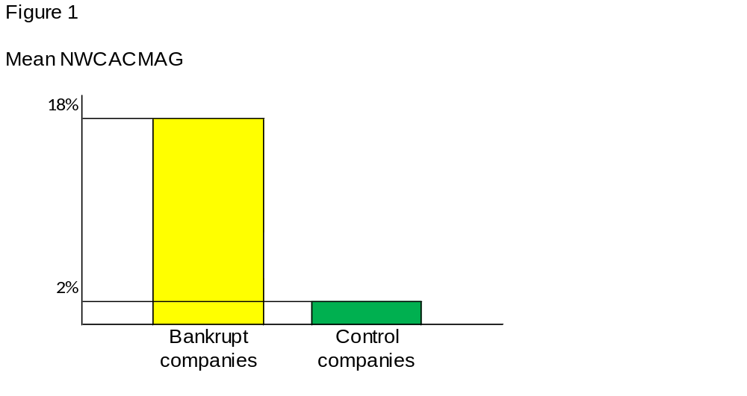

The result as presented in panel A, NWCACMAG, show that the bankrupt companies show a mean of 18%. And the control companies show a mean of 2%. This shows that the bankrupt companies will overstate receivables, inventory and understate payables and accrued expenses.
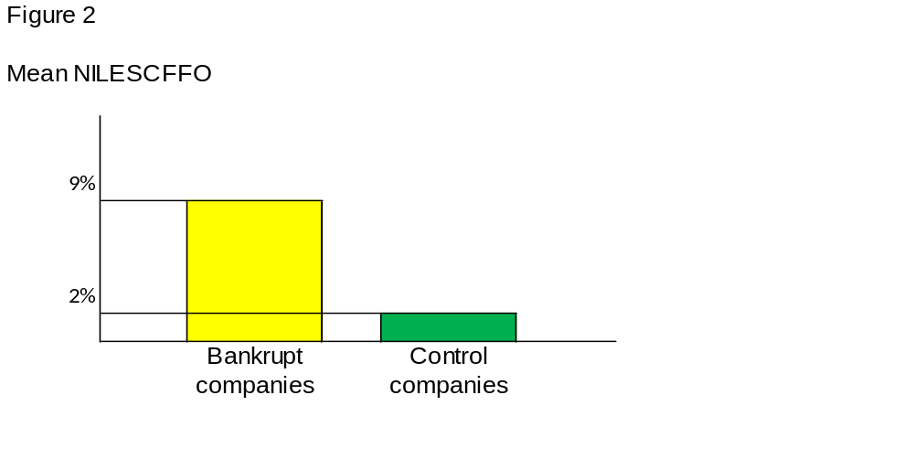The result as presented in figure 2, NILESSCFFO, show that the bankrupt companies show a mean of 9% and the control companies show a mean of 2%. This difference in the means show that the net income of bankrupt companies exceeds the expected cash flow from the presented net income.
The means of both proxies for the bankrupt companies are significantly greater than the means of the control companies which confirms my hypothesis 2.
Table 1 presents an overview of means and medians of all the proxies as described in chapter 6. This for the companies who filed for bankruptcy and the control group. I will discuss the findings per section as identified in table 1.

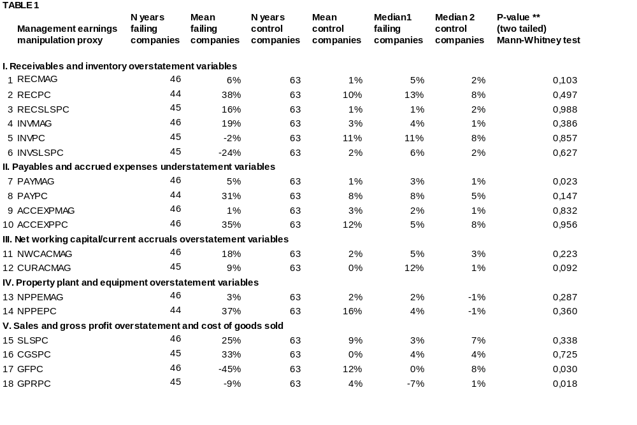
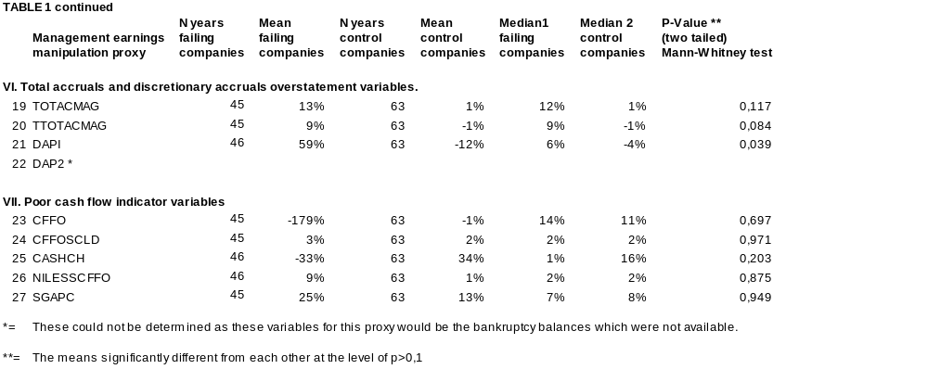

I Receivables and inventory overstatement variables
In this section the results of all the proxies relating to receivables and inventory are presented for both groups. Table 1 shows that the mean and the median of the receivables (RECPC and RECSLSPC) are significantly greater than the control company. This implicates that bankrupt companies overstated their receivables. This is confirmed by the Mann-Whitney p-value (p) of 0,497 and 0,988 respectively. The significantly high values state the number of times the mean differs from the average mean of the comparing group. The mean and median of the inventory proxy INVMAG of the bankrupt companies show that inventories increased significantly over the research period in comparison to the control group (p = 0,386). In the case of the inventory proxy in comparison to the presented sales (INVSLSPC) (p=0,627) shows that the sales are much higher than the mutation in the inventory what would indicate a overstatement of the sales. The inventory change over the years (INVPC) is -2% with the value of 11% for the control companies and a p value of 0,857. Indicating that the inventories are lower than one would expect in comparison to the control companies and are not overstated. The other proxies do not differ significantly.
II Payables and accrued expenses understatement variables
In this section the results of all the proxies relating to payables and accrued expenses are presented for both groups. Table 1 shows that the means of the accrued expenses and payables proxies (PAYPC, ACCEXPPC) for the bankrupt companies are significantly greater than the proxies values of the control company. Implicating that the accrued expenses and payables over the periods increased enormously. And confirmed by the p-values of the proxies of 0.147 and 0.956. The difference in the mean with a p-value of 0.956 show that the change in the mean is very significant. But if the accruals are compared to the total assets (PAYMAG, ACCEXPMAG) the mutation is marginal. This is expected as failing firm would understate accrued expenses to reduce the presented expenses. At the same time show the p-values of the accrued expenses (ACCEXPMAG and ACCEXPPC) a very high value and are the p-values for the payables (PAYMAG and PAYPC) very low. Implicating that the accrued expenses have been managed and the payables not.

III Net working Capital/current accruals overstatement variables
In this section the results of all the proxies relating to net working capital and current accounts are presented for both groups. Table 1 shows that the mean and the median of the net working capital (NWCACMAG) and current account mutations (CURACMAG) are significantly greater than the control company. These findings are expected for failing firms as discussed at figure 1. It is expected that these proxies would show a higher mean and median than the control companies as it is expected that companies in financial distress will overstate receivables. This is confirmed by the p-value of 0.223 for NWCACMAG. This proxies takes the receivables, inventory, payables and accrued expenses into account. Although the difference in the mean and median are significant for CURACMAG is the p-value of CURACMAG is 0.092. This is due to the fact that this proxies takes a look at the total of current assets and current liabilities and not just the receivables and payables.
IV Property, Plant and equipment overstatement variables
In this section the results of all the proxies relating to fixed assets are presented for both groups. Table 1 shows that the mean and the median of the fixed assets (NPPEPC) are significantly greater than the control company. These findings are expected as expenses will be classified as investments in fixed assets to lower the presented expenses and present a higher profit. And is confirmed by a p-value of 0.360. This is supported by my research in previous chapters.
V Sales and gross profit overstatement and cost of goods sold
In this section the results of all the proxies relating to the sales are presented for both groups. Table 1 shows that the means of the sales (SLSPC, CGSPC) are significantly greater than the control company. Showing that the bankrupt companies are overstating their sales. Which is confirmed by the high p-values of 0.338 and 0.725 as well as by previous research. But what was not expected that the change in cost of sales (CGSP) would exceed the sales. Expected would be that these would be lower than the change in the sales to show a higher gross margin and net income. But these findings are supported by the negative proxies relating to the inventory (INVPC and INVSLSPC) and the negative proxies for the gross margins proxies (GFPC and GPRPC) with the relating p-values of 0.03 and 0.018. Implicating that the means of the gross margins between the two groups is marginal.
VI Total accruals and discretionary accruals overstatement variables
In this section the results of all the proxies relating to the total accruals are presented for both groups. Table 1 shows that the means and medians of the accruals (TOTACMAG, TTOTACMAG, DAP1) are significantly greater than the control company. This is due to the fact that the percentage change in the current assets is higher than the current liabilities. Implicating that the bankrupt companies will overstate their current assets or understate their current liabilities. But the p-values state that the differences between de means are marginal. Implicating that the overstatement of the current assets and mutation in the cash are compensated by the mutation in the current liabilities. This is confirmed by previous findings and the presented p-values.
VII Poor cash flow indicator variables
In this section the results of all the proxies relating to the cash flow are presented for both groups. Table 1 shows that the means relating to the cash flow (CFFO and CASHCH) are significantly negative in comparison to the values of the control companies. This implicates that the cash flow from operations of the bankrupt companies is negative as well as the change in the actual cash position of the bankrupt companies. These proxies are for the control companies both positive, stating that these have a positive cash flow from operations. The mean of the net income in comparison to the scaled cash flow (NILESSCFFO) is also more positive for the bankrupt companies in comparison to the control companies. This implicates that the increase in net income is higher than the increase in cash. Confirming that the income is overstated. The mean proxy for the other expenses (SGAPC) are significantly higher for the bankrupt companies in comparison to the control companies. This is not expected as bankrupt companies would try to reduce the expenses. All the p-values of these proxies are significant high stating that the mean differ significant confirming the before mentioned conclusions.
The most important findings of previous research is that companies in financial distress will overstate the revenue, receivables, overstate inventory and understate the liabilities. (Rosner (2003), Arnedo et al. (2008), Butler et al. (2004)).
Based on the results of the analysis of my actual research above presented analysis the following key conclusions can be drawn:
- The companies who filed for bankruptcy have overstated the presented revenue;
- The companies who filed for bankruptcy show a negative operating cash flow in comparison to the reported revenue;
- The companies who filed for bankruptcy have overstated the receivables;
- The companies who filed for bankruptcy have not overstated the inventory and not understated the relating cost of sales.
If the relation in the changes in inventory, cost of sales and revenue are examined more closely one may conclude that the companies applied real earnings management. As with real earnings management companies will try improve sales by reducing sales prices and increase the amount of sales and thereby the revenue in total. With this the gross margin would deteriorate and the inventory would decrease. At the same time the receivables would increase. This could be concluded based on the result of the proxies. But based on the research design it is difficult to confirm this conclusion.
Based on these findings can hypothesis 1 be answered confirmative due to the fact that companies in financial distress will apply earnings management in the financial statements prior to the years they filed for bankruptcy. This can be concluded based on the fact that the cash flow of the companies is strongly negative and the receivables are overstated in comparison to the control companies.
The findings also state that companies have overstated the revenue based on the proxies SLSPC, CGSPC. But the cost of sales proxies are higher than those of the control companies but at the same the proxies regarding the inventories are also lower than the control companies which states that the inventories are not overstated. The receivables however are overstated by the bankrupt companies. Taking these last findings into account can hypothesis 2 only partly be confirmed.
All companies that were taken into account received an unqualified auditor’s report on the financial statements prior to the year they filed for bankruptcy. Implicating that there is no uncertainty regarding the continuity of these companies. The qualifications of these auditors appeared to be incorrect. Based on the results of my research it would have been possible to predict that these companies were in financial distress and that the auditors (most) probably would have altered their auditor’s report from an unqualified to a qualified report and would (most) probably have predicted that the company would file for bankruptcy if they would have used this research model for their assessment. This is based on the fact that almost all proxies differ from the control companies. Especially the cash flow proxies and the sales and receivables proxies. Hypothesis 3 can thereby also be answered affirmatively.
But these conclusions need to be interpreted carefully as my research was limited to 13 companies.

Summary
In this chapter I have presented how the data was gather and which problems I encountered in gathering the data. The amount of companies that were initially selected was 18. But due to the fact that not all necessary information for all of these companies were available, my research group had to be reduced to 13. The selected control companies have, based on this, also been reduced to 13 to align the research groups. In comparison to the previous research performed by Arnedo et al. (2008) and Rosner (2003) my research scale was limited.
For my actual research I used the research model of Rosner (2003). He identified in total 27 proxies compromised into 6 groups. The selected data that was used for my research were the financial accounts of the, at least, last four years of the companies before they filed for bankruptcy. Based on these financials the proxies were calculated for each of the years. And based on these proxies the means and medians were determent for both groups. Based on results of this proxies the Mann-Whitney U test, p-value (two tailed), were determined. These results were presented in an overview to be able to analyze the differences between the two proxies of the two groups. In the analysis the results of the proxies the p-values of the Mann-Whitney test were taken into account. As with these values it is possible to decide whether or not the mean of two groups are equal. The value should have a value between 0,0 and 0,1 not to indicate a big difference between the two groups.
Based on this analysis the conclusions can be drawn that the companies that filed for bankruptcy in comparison to the control group overstated the presented revenue, these companies show a negative cash flow from operations, overstated the receivables but not overstate the inventory and understate the cost of goods.
If these findings are compared with previous research, the findings of my research are almost equal to the results of the previous research. With the exception of the fact that in previous research the inventory was overstated to reduce the cost of sales. The results of my research do not support these findings.
In answering the hypotheses, the following answers can be found.
Hypothesis 1: The magnitude of the use of earnings management is larger in the financial statements of a company in the year(s) prior to the bankruptcy in comparison to the financial statements of companies that did not file for bankruptcy.
Based on before mentioned and the enormous differences in the proxies and the p-values between the two groups the conclusions can be drawn that the magnitude of earnings management by companies who filed for bankruptcy is larger than the magnitude of earnings management of the control companies.
Hypothesis 2: Companies in financial distress or facing bankruptcy will overstate revenue, receivables, inventories and understate liabilities.
It is found that the companies who filed for bankruptcy overstated all the items expressed in the hypothesis except for the inventory and understatement of, or at least not overstatement of the liabilities. Due to the fact that the change in the liabilities in comparison to the total assets is marginal.

Hypothesis 3: The used model will outperform the opinion of the auditor.
Based on the results of the research the conclusion can be drawn that the most important proxies, the revenue - and cash flow proxies, show a significant difference in comparison to the control group. That would indicate that these companies are in financial distress and the conclusion could even be drawn that there would be a chance that these companies were going to file for bankruptcy. If the auditor would have realized this, their audit opinion would most probably have been different. There by the model outperformed the assessment of the auditor.
Based on the total findings of my research one can state that the companies who filed for bankruptcy have applied earnings management. And based on the findings of my research it is possible to predict that the companies are in financial distress and even may fill for bankruptcy.

Conclusion
For companies to get in financial distress or even file for bankruptcy in the current economic circumstances is not uncommon. This situation could lead to the fact that managers of these companies are more willing to apply earnings management. For all different kind of reasons. At the same time more is expected from external auditors. As they audit the financial statements of these companies and state that there is no uncertainty regarding the continuity of these companies in the case of an auditor’s report with no qualification regarding the continuity. Based on this the following research question is formulated:
Do companies in financial distress use earnings management and could this have been detected by auditors?
There are different motivations for managers to use earnings management. The most important ones are: meeting expectations regarding the earnings forecasts, maximizing their personal gain and a possible breach of a constraint of lending contracts.
Earnings management can be used within the boundaries of the Dutch but also and most of the time outside the boundaries of Dutch Gaap. Dutch GAAP gives a explicit overview what is allowed and what is not.
Previous research that has been performed on detecting earnings management as well as whether financial distress can be detected via the use of models and whether these models would outperform the conclusion of auditors. But, up to my knowledge, there has hardly been any research that combined these two types of research.
Based on the research performed by Dechow the best model to detect earnings management is the modified Jones model. And the financial ratios that at least have to be taken into account to detect financial distress, not limited, are revenue and cash flow ratios. The other ratio’s will support the findings of these ratio’s. The model that combines these items is the model of Rosner (2003) and this model was used for my research.
For my research 13 companies that filed for bankruptcy after receiving a unqualified auditor’s report were selected, based on the same criteria the same amount of control companies were selected. The research period is 2004-2009.
The model determines the mean and median for 27 financial proxies for the bankrupt companies and the control group over a period of at least four years. Based on the results of these proxies the p-values of the Mann-Whitney test have been determined. These findings were compared to be able to conclude whether earnings management has been applied by the companies who filed for bankruptcy.
The findings of my research show that the bankrupt companies overstated the revenue, had a negative operating cash flow, overstated the receivables but have not overstated the inventory and not understated the relating cost of sales.
In answering the research question can this question be divided into two separate questions: do companies in financial distress use earnings management and could this have been detected by auditors.
In the comparing of the out comings of the proxies of both groups, significant differences have been identified in the means and medians and explained/confirmed by in combination with the Mann-Whitney two tailed p-values. They show that there are significant differences.
Based on these results of my research the conclusions that can be drawn that companies who filed for bankruptcy one year after receiving an unqualified auditor’s report, do use earnings management.
If one takes a look at the differences in the proxies and the confirming p-values one could come to the conclusion that if an auditor would have used this model he would most probably have altered his auditor’s report from unqualified to a qualified one. As the main findings are that the companies have a negative cash flow from operation and overstated the presented revenue and could have predicted that the companies would go bankrupt or at least concluded that they are in financial distress.
The research question can, based on this, be answered with yes twice. Companies in financial distress use earnings management and based on the research auditors could have detected it by using the selected model.
But as my research was limited to a small group of companies the answer should be read with carefully. As the selected companies don’t present a representative group.

Appendix

Annex I Selection bankrupt companies
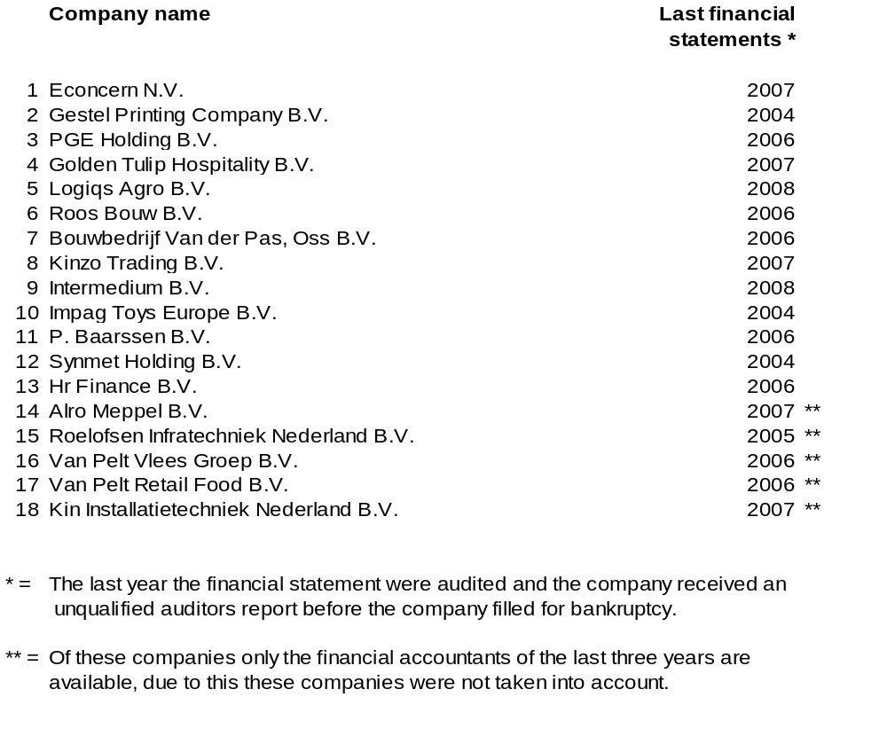

Annex II Selection control companies
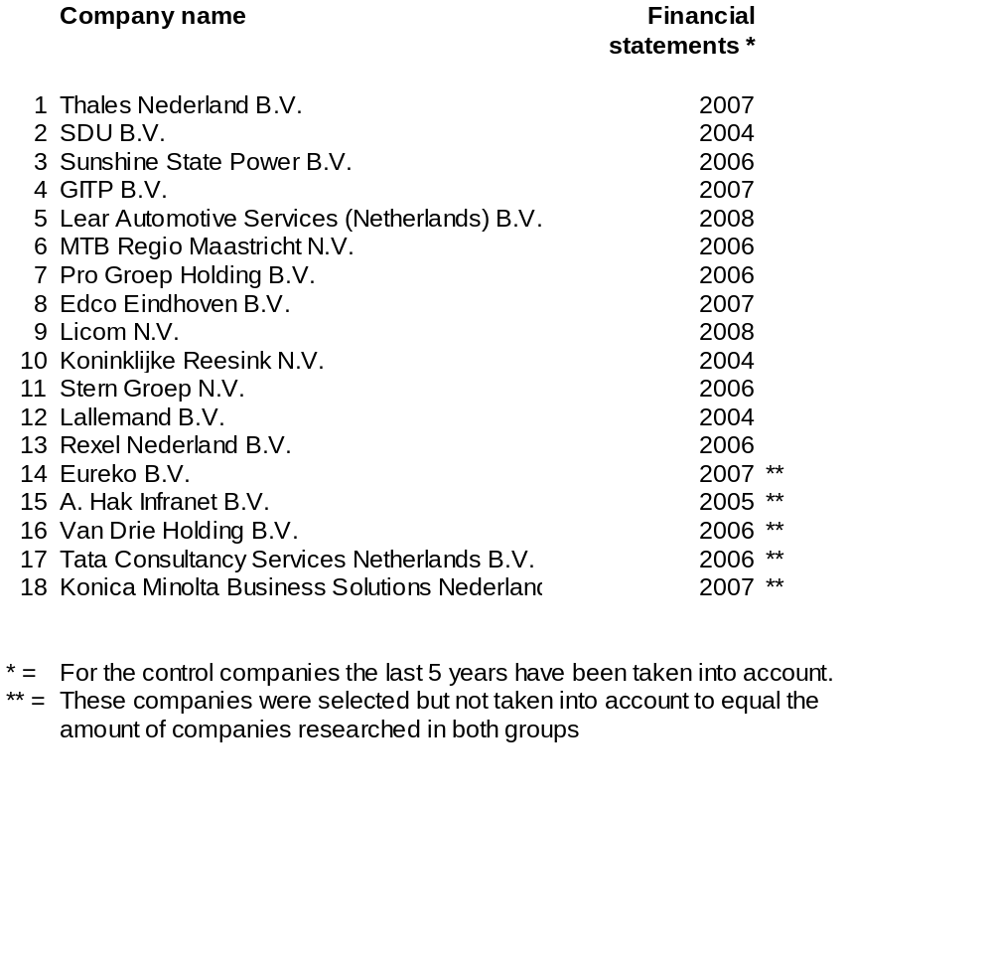

References
- Argenti, J. (1976). Corporate Collapse: The Causes and Symptoms. London: McGraw-Hill.
- Arnedo, L., Lizarraga, F. and Sánchez, S. (2008). “Going-concern Uncertainties in Pre-bankrupt Audit Reports: New Evidence Regarding Discretionary Accruals and Wording Ambiguity.” Public University of Navarra, Spain, International Journal of Auditing , 12, 25–44.
- Butler, M., Leone, A.J., Willenborg, M. (2004). “An empirical analysis of auditor reporting and its association with abnormal accruals.” Journal of Accounting and Economics, 37, 139–165.
- Dechow, P. M. (1994). “Accounting Earnings and Cash Flows as Measures of Firm Performance - the Role of Accounting Accruals.” Journal of Accounting & Economics, 18 (1), 3-42.
- Dechow, P. M., Sloan, R.G., and Sweeney A. P. (1995). “Detecting earnings management.” The Accounting Review, 70, 193-225.
- Deegan, C., and Unerman,J. (2006). Financial Accounting Theory. Berkshire: McGraw-Hill.
- Eeghen van, L.J. ( July 2004). “Discontinuities and the expectation gap.” MAB
- Haw, I., Hu, B.B., Seok, L. and Woody Hu, W. (2004). “Ultimate Ownership, Income Management, and legal and extra legal institutions.” Journal of Accounting and Economics, 42, 423-462.
- Healy, P.M. and Wahlen, J.M. (1999). “A review of earnings management literature and its implications for standards setting” American Accounting Association, 13 (4), 365-383.
- Hill, N. T., Perry, S. E., Andes, S. (1996). “Evaluating firms in financial distress: An event history analysis.” Journal of Applied Business Research, 12 (3), 60-71
- Hopwood, W., J. McKeown, and J. Matchler. (1994). “A re-examination of auditor versus model accuracy within the context of the going-concern opinion decision.” Contemporary Accounting Research, 10 (2), 409-31.
- Jeong-Bon, K. and Cheong, Y. H. (2006). “Ownership Structure, Business Group Affiliation.” Listing Status and Earnings Management, 23 (2).
- Jones, J.J. (1991). “Earnings management during import relief investigations.” Journal of accounting research, 29 (2), 193-228.
- Klein, A. (2002). “Audit Committee, Board of Directors, and Earnings management.” Journal of Accounting and Economics, 33, 375-400.
- Kuruppu, N., Laswad, F., Oyelere, P. (2003). “The efficacy of liquidation and bankruptcy prediction models for assessing going concern.” Managerial Auditing Journal, 18 (6/7), 577-590.
- Leuz C., Dhananjay N., Wysocki P.D. (2003). “Earnings Management and investor protection: an international comparison.” Journal of Financial Economics, 69, 505-527.
- Levitt A. (1998). The Numbers game.
- Lo, K. (2008). “Earnings management and earnings quality.” Journal of Accounting and Economics, 45, 350–357.
- Mulford, C.W., and Comiskey, E.E. (2002). The financial numbers game. London: detecting creative accounting practices. John Wiley & Sons, USA.
- Nelson, M.W., Elliott, J.A. and Tarpley, R.L. (2003). “How Are Earnings Managed? Examples from Auditors.” Accounting horizons, suppl., 17-35.
- Rosner, R.L. (2003). “Earnings Manipulation in Failing Firms.” Contemporary Accounting Research, 20 (2), 361-408.
- Roychowdhury, S. (2006). “Earnings management through real activities manipulation.” Journal of Accounting and Economics, 42, 335–370.
- Schipper, K. (1989). “Commentary on Earnings Management.” Accounting Horizons, 3, 91-102.
- Sloan, R. (2001). “Financial accounting and corporate governance: A discussion.” Journal of Accounting & Economics, 32, 335-347.
- Stolowy, H. & Breton G. (2004). “Accounts manipulation: a literature review and proposed conceptual framework.” Review of Accounting & Finance, 3 (1), 5-66.
- Warfiel D. T., Wild J.J., Wild K.L. (1995). “Managerial ownership, accounting choices, and in formativeness of earnings.” Journal of Accounting and Economics, 20, 61-91.
- Zhaohui Xu, R., Taylor, G.K., Dugan, M.T. (2007). “Review of real earnings management literature.” Journal of accounting literature, 26, 195-228.

The bankruptcy report of Econcern N.V. can be gathered on http://www.hvg.nl/download/faillissementverslag/Deterink/Econcern_Verslag1EN_220909.pdf
Het financiele dagblad , Econcern knoeide met cijfers, September 5th, 2009.
Healy, P.M. and Wahlen, J.M. (1999), A review of earnings management literature and its implications for standards setting, American Accounting Association, Volume 13 no. 4, pp. 365-383
This information was gathered from the site http://www.cbs.nl/NR/rdonlyres/DE13669A-EA5C-45D2-A254-0E189388450A/0/pb10n012.pdf
The bankruptcy report of Econcern N.V. can be gathered on http://www.hvg.nl/download/faillissementverslag/Deterink/Econcern_Verslag1EN_220909.pdf
Netherlands Standards on Auditing 570 Going concern
Netherlands Standards on Auditing 570 Going concern
K. Lo / Journal of Accounting and Economics 45 (2008) 350–357

