ERASMUS UNIVERSITY ROTTERDAM
Erasmus School of Economics
Department of Applied Economics
Master’s Thesis Entrepreneurship, Organisation and Strategy Economics



Polycentricity
In search of the ‘pur-fect’ region

J.W. Bruijsten
288376
Supervisor: Dr. L. van der Laan
Co-reader: G. Mingardo

Preface
The ending of my academic career is ‘crowned’ by this thesis. It is the last result of my six years at the Erasmus University. Stumbling across some problems with my initial supervisor and topic it has led me to the subject as it is now. Being absolutely pleased with this subject it has made the making of this thesis probably a lot easier. Therefore I would like to thank my supervisor, Dr. Lambert van der Laan, for bringing this subject to my attention. His guidance has helped me a lot during the construction of this thesis. Further I would like to thank Giuliano Mingardo for being not only the co-reader but more a second supervisor. His enthusiasm for the work I showed was extraordinary.
During the construction of this thesis I spend a lot of hours in the university library or in the computer labs of the economics department. Fortunately I was not alone. Special thanks goes to Salko who gives himself the credits for the fast ending of my study. Another word of thanks goes to Karsten, Sonny and Laurens who were pleasant friends during ‘work’ hours and coffee or lunch breaks. Hopefully they will end their academic career fruitfully.
Furthermore I would like to thank my girlfriend Ilse who continuously asked me about my progress so she could attend my graduation; it was a good stimulus to continue the hard work. I also want to dedicate some words to my uncle Sil, who acted as a guide in the greater part of my academic career. For me your help was inexpressible, so I hope you had joy in doing it. Last but not least I would like to thank my parents for their continuous support and always showing the right amount of interest in my achievements.

Rotterdam, August 2010
J.W. Bruijsten

Abstract

This paper uses commuting flows to investigate the development of polycentricity in the Veneto region between 1991 and 2001, which is located in the North-East of Italy. Both ingoing and outgoing commuting flows are used to measure two aspects of polycentricity at two spatial scales; the inter- and the intra-urban scale. Although commuting flows are limited to some extent it is considered an appropriate measure to analyze the urban structure of regions. It is argued that the monocentric model is being surpassed by the polycentric model. Where commuting used to be aimed at the city, it is the multi-directional aspect of commuting that the polycentric model sets forth. Furthermore, polycentricity refers to a balanced distribution of employment centers throughout a region. The results from this thesis show that only Venice can be characterized by the monocentric model. However, the polycentric model does not fully characterize the other regions in the entire Veneto region. Only between a few functional urban regions in the Veneto region there is a polycentric structure, and the same holds for the urban structure within a few functional urban regions. Hence, this thesis does not support the argument from previous studies that the Veneto region is a polycentric region.

Table of Contents
Abstract 3
List of figures and tables 5
List of abbreviations 6
Chapter 1: Introduction 7
Chapter 2: Polycentricity 9
2.1 The concept of polycentricity 9
2.2 Causes 10
2.3 Benefits and disadvantages 12
2.4 Morphological and functional polycentricity 14
2.5 Intra- and inter-urban scale 15
2.6 Evidence of PURs 16
2.7 The concept of the FUR 18
Chapter 3: Commuting flows 21
3.1 Commuting 21
3.2 In- and outgoing commuting 23
Chapter 4: Veneto 26
4.1 Veneto 26
4.2 FURs in Veneto 28
Chapter 5: Data 31
5.1 Description of data 31
5.2 Methodology 33
Chapter 6: Results 43
6.1 Morphological polycentricity 43
6.2 Functional polycentricity 50
6.3 Overview 55
6.4 Discussion 59
6.5 Limitations 62
Chapter 7: Conclusion 64
Reference list 70
Appendix 78

List of figures and tables

Figure 2.1: Two structural aspects of polycentricity 14
Figure 3.1: Types of DUS 24
Figure 4.1: Map of Veneto 248
Figure 4.2: FURs in Veneto 29
Figure 4.3: FURs in Verona. 30
Figure 4.4: Municipalities in Verona. 30
Figure 5.1: Neighborhood definitions 35
Figure 5.2: Types of FUR based on N1 and N2. 40

Table 5.1: Example of commuting pattern matrix 31
Table 5.2: Total number of persons commuting into or out of the different provinces 32
Table 5.3: Overview of the direction of N1 and N2 39
Table 5.4: Methods used to measure polycentricity 42
Table 6.1: Different systems in Veneto 50
Table 6.2: Summary of the results of the hypotheses 55
Table 6.3: Percentage of outgoing commuting to Verona, San Giovanni Lupatoto and San Martino B.A. 57
Table 6.4: Percentage of outgoing commuting from FURs with low N1 to main central city 58

List of abbreviations

CBD Central Business District
CR City Region
C zone City zone
DUS Daily Urban System
ESDP European Spatial Development Perspective
FUR Functional Urban Region
HHI Herfindahl-Hirschmann Index
ISTAT Italian National Institute for Statistics
IO Inward Openness
LISA Local Indicators of Spatial Association
LLM Local Labor Market
LLS Local Labor System
N1 Nodality 1
N2 Nodality 2
OO Outward Openness
PUR Polycentric Urban Region
SA Spatial Autocorrelation
S zone Zone surrounding city zone
TAZ Transportation Analysis Zone

Chapter 1: Introduction

‘Location, location, location’. Real estate brokers use this phrase to emphasize the importance of location. Location is also an aspect of this thesis. However, this thesis uses commuting flows to analyze where employment is located and whether this location is characterized by employment concentration. In other words, it investigates polycentricity. Spatial planning policy is primarily build on these two issues. Differences over time in the location of employment and households changed the urban spatial structure of regions. To illustrate, in medieval times merchants travelled long distances to sell their products on the market. Because of huge developments in transport and communication technologies the choice of where to locate for selling and buying has changed dramatically. Nowadays, it is possible to locate out of the city to avoid congestion and high commuting costs. It is therefore interesting for policymakers to understand the urban structure of the region. Especially in the last two decades there have been developments in the urban structure of regions. This has led to the following research question:
To what extent do commuting flows support the development of polycentricity in the Veneto region between 1991 and 2001?
The Veneto region is analyzed because several scholars argue that the (Central) Veneto region is one of the prime examples of polycentricity (Dieleman and Faludi, 1998; Musterd and Van Zelm, 2001; Meijers, 2007). However, this has not been empirically investigated which Cristaldi (2005) emphasizes. Furthermore, the Veneto region is believed to be similar to the Randstad. However, recent studies regarding polycentricity in the Randstad marked another urban structure (Cowell 2010; Van der Laan, 2010; Van Oort et al., 2010). The results of this thesis can thus show whether the Veneto region is indeed similar with the Randstad. Finally, this thesis uses the periods of 1991 and 2001 because 1) these are the most recent data and 2) because using different years can show how the urban structure has developed.
Relevance
De Goei et al. (2010, p. 3) argue that only ‘a few studies on the configuration of urban systems using flow characteristics predominantly assess the central place model versus the network model at one point time’ whereas this thesis analyzes the inter- and intra-urban configuration of urban systems at two points in time. Van Oort et al. (2010, p. 742) argue that there is a need for analyzing the configuration of urban systems as ‘a burgeoning literature suggests that the polycentric region as a spatial economic concept replaces the hierarchical, central node concept’. Furthermore, this thesis contributes to existing literature because the work-related commuting flows in Italy have rarely been analyzed (Cristaldi, 2005). It differs from the work of Cristaldi (2005) in that it uses a more recent data set, it focuses more on polycentricity and it analyzes one entire region where Cristaldi (2005) takes nine different regions throughout Italy.
The framework this thesis uses for functional polycentricity is well-suited because it ‘takes into account not only the monocentric or polycentric structure of the urban system, but also looks at its effects on commuting patterns’ (Schwanen et al., 2001, p. 177). Furthermore, Parr (2005, p. 558) argues that the ‘most important component in the overall pattern of interaction within the FUR involves commuting flows’. This thesis further takes spatial dependence into account: ‘avoiding the pitfalls from spatially correlated data is crucial to good spatial data analysis’ (Fischer, 2006, p. 20). Dominics et al. (2007) argue that their analysis also takes spatial dependence into account and thereby contributes to empirical literature. Additionally, this thesis assumes that the local indicators for spatial association (LISA) are complementary to the Herfindahl-Hirschmann Index (HHI); ‘inspecting the local Moran significance map is very useful for local policy authorities interested in identifying new industrial clusters and in testing the performance of pre-existing industrial districts’ (Dominics et al., 2007, p. 11).

Chapter 2: Polycentricity
The urban spatial structure of cities and regions is changing; it is shifting from the monocentric model to the polycentric model. Polycentricity can refer to inter- or intra-urban patterns of clustering of, for example, employment and population. The Polycentric Urban Region (PUR) corresponds with the inter-urban pattern and the Functional Urban Region (FUR) with the intra-urban pattern. This chapter will firstly define the concept of polycentricity (section 2.1), it will investigate how it came into existence (section 2.2) and it will discuss benefits and disadvantages related to polycentricity (section 2.3). Two aspects of polycentricity – morphological and functional – will be introduced (section 2.4). The inter-urban pattern will then be discussed which relates to openness (section 2.5). The inter-urban pattern refers to the PUR (section 2.6) and finally, the concept of the FUR will be defined (section 2.7)

2.1 The concept of polycentricity
In the monocentric model transport is aimed at a single city centre or Central Business District (CBD), which dominated the hierarchy between the different business centers in the city (Clark and Kuiijpers-Linde, 1994; Kloosterman and Musterd, 2001; Limtanakool et al., 2007a). Employment is concentrated in the CBD and the rest of the region is committed for residential use (Anderson and Bogart, 2001; de Goei et al., 2010). This monocentric model reflects the traditional central place model, which focuses on the hierarchy in the relations between cities. This hierarchy contains one-sided vertical relationships between different classes of places. It means that the smaller cities are dependent on the larger cities (Meijers, 2007).
Suburbanization changed the urban structure of regions which led to a period of spatial deconcentration (Bramezza, 1996). This means that the population moves to suburban municipalities. The high income groups move first to the suburbs followed by the middle class (Mieszkowski and Mills, 1993). A main characteristic of suburbanization is that the population moving to the suburbs remains oriented at the central city they have left, resulting in commuting flows from the suburbs to the central city (Bramezza, 1996).
However, over time the suburbs ‘tended to absorb an increasing share of the CBD employment’ (Romein and Verkoren, 2007, p. 4) and employment shifted to the suburbs (Clark and Kuijpers-Linde, 1994). These suburbs ‘increasingly emerged into local centers that developed their own economic activities’ (De Goei et al., 2010, p. 3). This resulted in multiple centers in one area (Kloosterman and Musterd, 2001; Riguelle et al., 2007; Cowell, 2010), which this thesis defines as polycentricity. Polycentricity reflects the network model. It emphasizes relationships between two or more independent cities, which cooperate to achieve economies of scope – i.e. economic growth achieved through, among others, knowledge exchange with nearby partners (e.g. firms or cities) - and complementarity (Batten, 1995). Commuting flows are reciprocal; they are not only directed anymore from the suburbs to the central city, but also the other way around (De Goei et al., 2010).
Firms and households are now scattered over an area. The monocentric model ‘appears to be a relic of the past’ (Shearmur et al., 2007, p. 1714). The result of this scatteration is the development of regions into polycentric regions. The corresponding commuting flows are one of the essential characteristics for identifying a polycentric region (Kloosterman and Musterd, 2001). Bailey and Turok (2001, p. 698) argue that such a region can be defined as ‘a region having two or more separate cities, with no one centre dominant, in reasonable proximity and well-connected’. Examples of these regions are predominantly present in Europe (Bailey and Turok, 2001), which include the Dutch Randstad, the Rhine-Ruhr area in Germany and the Veneto region in Italy (Meijers, 2007). For more evidence on these regions see section 2.6.

2.2 Causes
As the previous section showed there are a number of historically distinct cities present in a polycentric region. Urban regions with one dominant city, such as London or Paris (Dieleman and Faludi, 1998; Limtanakool et al., 2007a), cannot be defined or analyzed as polycentric; there must be the lack of a dominant city in a polycentric region. As firms and households are locating outside the CBD (McMillen and Smith, 2003), suburban areas emerge into local centers (De Goei et al., 2010). Romein and Verkoren (2007) argue that urban regions have become border- and centre less due to the concentration of employment in local economic centers. In other words, the locational choices of firms and households have extended spatially (Limtanakool et al., 2007a). Bertaud (2004, p. 6) states that ‘large cities are not born polycentric; they may evolve in that direction’. The causes for the emergence of a polycentric region can be grouped in three ways: ‘the increased spatial mobility and flexibility of firms, the increased spatial mobility and flexibility of households and local and regional policy’ (De Goei et al., 2010, p. 9). This section will briefly discuss the first two, as the latter is beyond the scope of this thesis:
Increased spatial mobility and flexibility of firms
The increased spatial mobility and flexibility of firms is also called the restructuring hypothesis. It means that changes in the locations of employment (Renkow and Hoover, 2000) are the main reasons for the emergence of a polycentric region. Huge developments in transport and communication technologies (Batten, 1995; Kloosterman and Lambregts, 2001; Kloosterman and Musterd, 2001), increasing congestion and better accessibility of the suburban locations (Riguelle et al., 2007; Romein and Verkoren, 2007) have caused firms to move out of the CBD. Firms that move out of the CBD distribute employment opportunities over the region (Renkow and Hoover, 2000). This and the ‘results from improvements in transportation systems and accessibility, which diminish the importance of distance’ (Patuelli et al., 2010, p. 6) are the main reasons for the development of a polycentric region, according to this hypothesis.
Increased spatial mobility and flexibility of households
The increased mobility and flexibility of households implies that the main reason for the emergence of a polycentric region lays in the residential preferences of individuals (Renkow and Hoover, 2000). This is also known as the deconcentration hypothesis. Costs of living in the city, such as congestion and crime, and also the developments in the transport and communication technologies have caused individuals to move out of the CBD; to minimize commuting costs the rational individual will change his place of residence (Van der Laan et al., 1998). In addition, the increase in two-earner households implies that for an optimal residential location two work locations have to be taken into account (Kloosterman and Musterd, 2001). This means that, bearing in mind the deconcentration of employment, ‘households have to find a residential compromise between two spatially rather distinct location of jobs’ (Kloosterman and Musterd, 2001, p. 625).

Demand for and supply of labor
These two ‘schools of thought’ are intertwined with each other. The restructuring hypothesis involves the demand for labor and the deconcentration hypothesis involves the supply of labor. For example, in the monocentric model jobs are located in the CBD and households are located around this CBD (De Graaff et al., 2008; Van Oort and Ritsema van Eck, 2010). In this example the supply of labor (people) follows the demand for labor (firms/jobs). However, Van Oort and Ritsema van Eck (2010) argue that this has changed; the demand for labor is now following the supply of labor. For example, banks or cinemas will establish themselves in places where households are located. Hence, the demand for labor follows the supply of labor. In this example consumer oriented services follow suburbanization (Romein and Verkoren, 2007). This change has been empirically investigated and supported by De Graaff et al. (2008) who show that in the Netherlands between 1996 and 2005 the demand for labor follows the supply of labor, especially in the Randstad. In other words, jobs follow residential locations (at a lag), which is an expected result of an (emerging) polycentric region (Clark and Kuijpers-Linde, 1994). Additionally, Clark and Kuijpers-Linde (1994) also argue that specialization and competition strengthens the emergence of local economic centers and that the demand for and supply of labor drives the urban structure to change.
Since the focus of this thesis is to study the development of the urban structure of Veneto through commuting flow analysis, it is important where employment is located en where households are settled. These two factors are essential for how the commuting flows look like. Urban (spatial) structure refers to where employment and households are located (Sohn, 2005). Commuting flows will be further discussed in chapter 3.

2.3 Benefits and disadvantages
The development of a region into a polycentric region is believed to be economically beneficial (Meijers, 2005), while it avoids the costs of world cities (Dieleman and Faludi, 1998; Bailey and Turok, 2001), e.g. high commuting costs, congestion, social inequality and pollution (Van Oort, 2004). This paragraph will discuss these benefits. Within a polycentric region cities are functionally related through co-operation (Meijers, 2005) and competition (Cowell, 2010). These two mechanisms lead to stronger interaction between cities, which in turn leads to specialization and complementarity (Bailey and Turok, 2001). Specialization and complementarity strengthens the functional relationship between cities and enhances their interrelated trade (Kloosterman and Lambregts, 2001), which supports their economic development and regional competitiveness. On the one hand, complementarity can lead to economies of scale ‘between cities performing similar economic roles, such as port cities or tourist cities’ (Meijers, 2005, p. 768). On the other hand, specialization can lead to agglomeration benefits ‘as the assets of each city are effectively pooled together’ (Bailey and Turok, 2001, p. 699). In other words, it shows that there are agglomeration benefits ‘to economic activities being located in spatial proximity’ (Shearmur et al., 2007, p. 1715). Furthermore, Batten (1995, p. 324-325) argues that polycentric regions ‘offer a unique combination of characteristics: an attractive, culturally diverse environment, advanced R&D and educational facilities, a flexible and creative workforce, improving accessibility to the outside world, and a dynamic vision of the future’.
There is wide agreement that polycentricity can be beneficial, but the empirical evidence for these benefits is limited; Meijers and Burger (2010) argue that the influence of polycentricity on the urban structure is unclear. Meijers (2005) shows using correspondence analysis that synergy has increased, but complementarity decreased in the Randstad between 1996 and 2002. Cowell (2010) uses the same technique and finds that complementarity in the San Francisco Bay Area, the Emilia-Romagna region in Italy and the Randstad has decreased between 1996 and 2001 time. However, this thesis has another focus and will therefore not further discuss this shortcoming. The next paragraph will shortly discuss disadvantages related to polycentricity.
Parr (2004) argues that there are three disadvantages to the polycentric region. First, relative to a metropolitan region of similar population size, commuting flows will be longer and information flows less efficient. Second, some disadvantages of the polycentric region come from the nature of its urban spatial structure. This means that factors such as ‘density, proximity, face-to-face contact, informal structures, unplanned interaction etc’ (Parr, 2004, p. 236) are excluded by a polycentric urban structure. This is confirmed by Meijers (2008, p. 2338), who shows that for the Netherlands ‘the more polycentric a region is, the fewer cultural, leisure and sports amenities are present’. This finding does not support the unique combination of characteristics (Batten, 1995) as argued above. Third, the spatial structure of the polycentric region can cause a poor investment situation through, for example, the dispersion of households and poor infrastructure.

2.4 Morphological and functional polycentricity
The previous three sections investigated polycentricity. This section finalizes the concept of polycentricity; it can be referred to as functional or as morphological (Meijers and Burger, 2010). Functional polycentricity is defined as the direction of flows within urban areas where morphological polycentricity refers to the distribution of an urban region (Espon, 2005). This division of polycentricity is used because this thesis analyzes both aspects with different measures (see chapter 5). The following figure presents these two aspects of polycentricity:

Figure 2.1: Two structural aspects of polycentricity (Espon, 2005, p. 46)
Figure 2.1 shows that morphological polycentricity is measured by the hierarchical pattern between cities, i.e. the distribution of cities in terms of size, and functional (relational) polycentricity by the direction of commuting flows. The multi-directional commuting pattern is a crucial characteristic of a polycentric region. The mono-nuclear distribution pattern refers to the monocentric model and is identified by one dominant city and multiple dependent cities in the periphery (Espon, 2005). The vertical relationships as shown in section 2.1 are emphasized here. The polynuclear distribution pattern does not show a dominant city; the cities are of similar size (Espon, 2005). Van der Laan (2010) argues that there is a weak relationship between the level of morphological and functional polycentricity, although the level of functional polycentricity follows the level of morphological polycentricity and not vice versa. The Espon report (2007) states that Italy has the second highest level of morphological polycentricity in Europe, but also showed that the level of functional polycentricity is rather average. Understanding the direction of commuting flows - functional polycentricity - is important since this may help prevent urban sprawl (Espon, 2007). Morphological polycentricity is measured in order to support specialization and complementarity (see section 2.3) between cities.

2.5 Intra- and inter-urban scale
‘Polycentricity can either refer to the intra-urban pattern of clustering or to inter-urban patterns’ (Kloosterman and Musterd, 2001, p. 624); i.e. the clustering of employment. Inter-urban patterns refer to the entire polycentric region; the PUR, where the intra-urban pattern refers to a lower spatial scale; the FUR. This section is dedicated to previous research regarding the inter-urban scale, where the next two sections will discuss evidence for PURs (section 2.6) and the concept of the FUR (section 2.7).
Only a small amount of research is dedicated to the inter-urban scale. Van der Laan (1998) investigates whether or not the Randstad is a PUR and Van Nuffel (2007) argues to do the same for the Flanders region in Belgium, but fails to analyze the entire PUR. In another study Van Nuffel and Saey (2005) do analyze the Flanders region at the inter-urban scale. Patuelli et al. (2009) investigate commuting flows at the inter-urban scale in Germany. The results of these studies will now be discussed.
Van der Laan (1998) investigates whether the different FURs in the Netherlands have some degree of openness. This means that there exist reciprocal commuting flows between the different FURs. Openness can be measured as inward and outward openness (Van der Laan, 1998). Inward openness (IO) means that a FUR is open for commuters from outside that FUR and outward openness (OO) means that a FUR has commuters that go outside the FUR of origin. The results of Van der Laan (1998) show that in the Netherlands only between a few FURs a polycentric structure has developed. Van Nuffel and Saey (2005) find evidence for multi-directional commuting flows between different FURs at the regional scale which indicates polycentricity at the inter-urban scale. These linkages are primarily between the central cities and the suburbs of the FURs of Brussels, Mechelen and Leuven. Furthermore, almost all the FURs have relationships with the FUR of Brussels. The results of Patuelli et al. (2009) show that the commuting network in Germany is multi-directional. This holds especially at the local level, but also at the regional level as the importance of central cities declines over time. However, the openness at the intra-urban scale overshadows the openness at the inter-urban scale. This means that at the intra-urban scale Germany is characterized by a more polycentric structure and less at the inter-urban scale.
A true PUR is thus characterized by a high degree of inward and outward openness. However, as the two next sections will show, no region is ever fully polycentric and the main commuting of people is within one FUR. Therefore, thresholds for the openness of a FUR have to be determined. These are presented in chapter 5.

2.6 Evidence of PURs
Renkow and Hoover (2000) argue that no city is ever fully monocentric or fully polycentric. Every PUR will have its own reason why it emerged (Champion, 2001). A lot of research regarding the presence of polycentric regions has been performed, as well in Europe as in North America (including: Gordon et al., 1986; Albrechts, 1998; Lambooy, 1998; Dieleman and Faludi, 1998; Van der Laan, 1998; Bailey and Turok, 2001; Kloosterman and Lambregts, 2001; Schwanen et al., 2001; Baumont et al., 2004; Van Nuffel, 2007; Eskelinen and Fritsch, 2009; Meijers and Lambregts, 2009; Cowell, 2010; De Goei et al., 2010; Van der Laan, 2010). A recent issue of Urban Research & Practice (Vol. 2, No. 3, 2009) was actually dedicated to polycentricity in Central Europe and Schwanen et al. (2004) argue that most urban regions in the US and Europe have changed from a monocentric structure to a polycentric structure. Examples of the PURs in these studies are: the Flemish diamond (Belgium), Central Scotland, the Rhine-Ruhr region, Los Angeles, the San Francisco Bay area, greater Cleveland (USA), the Veneto region, the Emilia-Romagna area, Dijon (France), eastern Finland and the Randstad. However, most of the above research is performed at the intra-urban scale. This will be discussed further in the next section. This section will continue with an example at the inter-urban scale - the Randstad - as this region contains several recent and surprising developments and because it contains similarities with Veneto.
The Randstad
The Randstad serves as the classic and most cited example of a PUR (Batten, 1995; Dieleman and Faludi, 1998; Kloosterman and Lambregts, 2001; Musterd and van Zelm, 2001). It consists of several historically distinct cities which are believed to function as one urban region (Musterd and van Zelm, 2001). Lambooy (1998) argues that the Randstad has the attributes of a metropolitan area, with Amsterdam and Rotterdam as the two largest cities, and that the region contains possibilities for the development of agglomeration advantages. The Randstad is ‘one of the most accessible urban agglomerations in the world’ (Batten, 1995, p. 321). The Randstad contains the characteristics, presented in section 2.1, for identifying it as a PUR. Van der Laan (1998) shows that there are multi-directional commuting flows present in 2/3 of the Dutch Daily Urban Systems (DUS) which includes the Randstad. These studies in the last decade of the previous century mostly argued that the Randstad is a PUR. However, recent studies revealed different results.
These recent studies showed that the Randstad does not serve the classic example for a polycentric structure anymore (Van der Laan, 1998 and 2010; Cowell 2010; Van der Laan, 2010; Van Oort et al., 2010). Van der Laan (1998; 2010) reveals in the 1998 study that the Randstad contains a south and north wing and that, in the 2010 study, morphological polycentricity is rather low in the Randstad. Van Eck et al. (2006) shows that the central city still serves an important role and commuting flows flow between and to the four main cities (Rotterdam, The Hague, Utrecht and Amsterdam). Meijers (2005) also argues that these four cities still perform important roles. Van Oort et al. (2010) find evidence for the central place model, using business start-ups. This study shows that the Randstad is not a spatially and functionally integrated region. Cowell (2010) shows that complementarity, which is argued in section 2.1 to be a result of the development into a PUR, has decreased in the Randstad over time.
Summarizing, the presence of a polycentric structure at the inter-urban scale in the Randstad is questioned. The results discussed in this paragraph show that the characteristics of a PUR are not really present in the Randstad. The results of this thesis will show how the urban structure of the Veneto region has developed between 1991 and 2001.

2.7 The concept of the FUR
Urban regions consist of several provinces and municipalities. As argued in section 2.2 changes in the location of employment and households caused the emergence of multiple centers in one region; i.e. polycentricity. Slightly different concepts have been proposed over time to determine the boundaries of these regions. These include DUS (Van der Laan, 1998), local labor systems (LLS) (Cristaldi, 2005), local labor markets (LLM) (Sebastiani, 2003), FURs (Limtanakool et al., 2007a), the city region (CR) (Riguelle et al., 2007) and employment centers (Anderson and Bogart, 2001). These concepts acknowledge that the existing administrative borders of municipalities are not the borders of the commuting flows (Cristaldi, 2005). In other words, the spatial reference frame for the economic analysis of urban regions at the intra-urban scale has to be properly identified (Sebastiani, 2003). This section will investigate the different concepts mentioned above and will argue why the FUR is the best spatial level to analyze intra-urban patterns of clustering.
Riguelle et al. (2007) study Belgium and take the entire province around the four largest cities; Liege, Antwerp, Ghent and Brussels. They argue that this is performed in order to avoid the problems of setting the limits of urban areas. However, their study does measure polycentrism and they find a trend toward employment decentralization. Parr (2005) argues that the CR as a planning concept, particularly in the UK, is undergoing a revival. The CR consists of a city zone (C zone) and an area surrounding this zone (S zone), where the most important interaction between these zones are commuting flows. Parr (2005) also argues that it is possible that more than one C zone exists in a single CR, or multiple urban areas of significance within the S zone of one city region. The latter is an example of multiple local economic centers in one area.
Anderson and Bogart (2001) identify employment centers using the transportation analysis zone (TAZ) as the unit of analysis. These TAZs are ‘composed of one or more census blocks with the borders being supplied by the US Census Bureau’ (Anderson and Bogart, 2001, p. 148-149). Employment centers are areas with high density and a high quantity of employment (Giuliano and Small, 1991). The employment centers consist of several contiguous TAZs, with ‘total employment exceeding some minimum’ (Anderson and Bogart, 2001, p. 149). It relates to the LLS and LLM which are one and the same concept. Cristaldi (2005) defines the LLS with reference to daily commuting flows. This means that the LLS is ‘a set of elemental territorial units, geographically connected to each other, such that the proportion of people living in that set who also work there is large whereas the proportion of people who work in the set but do not live there is small’ (Sebastiani, 2003, p. 201). Therefore, the LLS is a region where a very small amount of people commute to other LLSs, implying that the LLS is thé spatial reference frame for identifying and analyzing urban regions at the intra-urban scale. Furthermore, Cristaldi (2005) shows that the LLS is an area where, next to the journey from home to their work, also the leisure and sport activities of most households take place.
All these concepts, including the DUS, relate to the FUR. The FUR refers to ‘the space in which urban activities such as living, working, shopping, relaxing, etc. proceed (Van den Berg and Klink, 1995). It reflects a core city and ‘all the areas that have regular daily relationships with this core city’ (Hall et al., 2006, p. 19). Aujean et al. (2005) defines the FUR as an economic core with surrounding municipalities where the main commuting flows are aimed at this economic core. The DUS is also called FUR and the local urban labor market (Van der Laan, 1998).
In sum, the LLS, the FUR and the DUS all refer to the same region. The people in a LLS mainly commute within this region and this is also true for the FUR. For consistency reasons, this thesis refers to the LLS as the FUR.
Spatial level of analysis
The FUR as spatial level of analysis at the intra-urban scale serves best for several reasons. Firstly, Dominics et al. (2007) argue that the FUR can be classified by looking at patterns of spatial interaction. These patterns of daily commuting flows are contained in one area (Cristaldi, 2005; Dominics et al., 2007), which is key in defining the FUR (Cristaldi, 2005). Secondly, Limtanakool et al. (2007a) show that the Institute for Urban Planning and Development of the Paris Ile-de-France Regions (IAURIF, 2002) considers FURs the best spatial unit for analyzing metropolitan areas. Van Nuffel (2007) confirms this as she argues that FURs are considered good spatial reference frame for defining them on the basis of commuting flows. Thirdly, administrative boundaries cannot be considered as good spatial reference frames (Sebastiani, 2003) as they are based on historical, political and/or social events and because the boundaries of the FUR go beyond that of the administrative partitions (Sebastiani, 2003; Dominics et al. (2007).

To conclude, the polycentric model is replacing the monocentric model. Polycentricity is defined as the existence of multiple centers in one area. Changes in the location of employment and households caused the development of a polycentric urban structure. A polycentric region is a well connected region with multiple neighboring and separate cities, with no city being dominant. Polycentricity is believed to have economic benefits while avoiding the costs of congested cities. However, these benefits still have to be empirically investigated. Furthermore, polycentricity is divided into morphological and functional polycentricity. Both aspects of polycentricity are measured in this thesis, at the intra-urban and at the inter-urban scale. The PUR reflects the inter-urban scale which is characterized by high inward and outward openness between FURs. The intra-urban scale reflects the spatial reference frame of the FUR, which is part of the PUR. The majority of the daily commuting flows are within one FUR and the FUR therefore serves best as the spatial level of analysis.

Chapter 3: Commuting flows
The previous chapter showed that commuting flows are essential to identify the urban spatial structure of regions. In a polycentric region commuting flows are multi-directional. This chapter will go into the concept of multi-nodality (section 3.1), where it is also argued why commuting flows can be used to study the development of an urban area. The second part of this chapter will discuss in- and outgoing commuting (section 3.2).

3.1 Commuting
‘Commuting is an essential part of urban life in modern urbanized areas’ (Sohn, 2005, p. 306) and is defined as the journeys individuals undertake to travel from their home to their work, thereby crossing at least the municipality border (Van der Laan et al., 1998). Section 2.1 showed that firms and households are dispersed over the area in the polycentric model. The emergence of a polycentric region leads to multi-directional commuting flows, which are not primarily aimed anymore at the CBD. For example, Jansen (1993) shows that the commuting flows in Germany between different municipalities increased with nearly 50 percent between 1970 and 1988. This is ‘a clear indication of a growing dispersal of commuting patterns (Jansen, 1993, p. 103). Commuting depends on where firms (jobs) and households are located (Sohn, 2005). Commuting flows can therefore reveal two issues: where employment is concentrated and where individuals live, indicating the urban (spatial) structure of a region (see section 2.2). The following paragraph will discuss why commuting flows are used.
Travisi et al. (2010, p. 384) argue that commuting, as it refers to the demand for urban mobility, is useful for analyzing some specific dimensions of cities: ‘density, settlement patterns and functional mix’. Van Nuffel and Saey (2005) find evidence that commuting flows reflect the urban structure of Flanders (Belgium). Clark and Kuijpers-Linde (1994) argue that the debate about the organization of the changing urban form has centered on commuting and Sohn (2005) shows that commuting flows clearly reflect the employment distribution. Commuting flows are ideal for ‘the identification of significant employment concentrations and the areas over which these economic centers extend their influence’ (Limtanakool et al., 2007a, p. 2129). They clearly refer to the dispersed structure of a polycentric region; this can be at the inter- or intra-urban scale. Furthermore, Jansen (1993) argues that (multi-directional) commuting flows reflect the development of multi-centered urban regions. This is also emphasized by Clark and Kuijpers-Linde (1994), Van der Laan (1998) and Schwanen (2002). For the reasons mentioned in this paragraph, this thesis uses commuting flows to study the development of the urban structure of Veneto.
Multi-nodality
In the monocentric model, commuting flows are aimed at the city centre, indicating concentration of employment in the CBD (Hincks and Wong, 2010). Commuting flows aimed at the city centre is also called mono-nodality (Clark and Kuijpers-Linde, 1994). Individuals undertaking these commutes are primarily living in the suburbs. However, as this thesis focuses on polycentricity, multi-nodality will now be discussed.
Orfeuil and Salomon (1993) argue that the residential suburbanization and job scattering (see section 2.2) have caused new spatial relations in commuting; it has led to multi-directional commuting flows. These new spatial relations have led to a multi-nodal pattern (Clark and Kuijpers-Linde, 1994), where the local centers in the region compete with the traditional central city (Van der Laan, 1998). Multi-nodality basically means the presence of several nodes in an area. It ‘emphasizes the existence of multidirectional interconnections’ (Van Nuffel and Saey, 2005, p. 321). In other words, multi-nodality refers to the existence of multi-directional commuting flows. Section 2.1 showed that these are essential for identifying a polycentric region. Multi-nodality is thus a crucial characteristic of polycentricity.
Multi-nodality exists of both ingoing and outgoing commuting flows. Ingoing commuting is defined as individuals travelling to one specific municipality for their work coming from outside that municipality. Outgoing commuting is defined as individuals travelling from one specific municipality for their work going to another municipality.
For example, ingoing commuting flows are relevant for identifying a central city’s dominance (Limtanakool et al., 2007a). This can be measured by the level of nodality 1 (N1), as previously performed by Van der Laan (1998). Outgoing commuting flows can be used to determine the outward openness of a FUR and are therefore needed to determine the level of functional polycentricity at the inter-urban scale.

3.2 In- and outgoing commuting
The previous section showed that ingoing commuting can be used to determine the importance of central cities. This refers to functional polycentricity as the total number of persons that commute into a city indicates how much employment that city has generated for people living outside that city. This section continues with the level of nodality, and presents a framework for identifying four different kinds of commuting flows, as previously performed by Van der Laan (1998) and extended by Schwanen et al. (2004). In other words, it continues with the level of functional polycentricity, which is indicated by the different kinds of commuting flows. This refers to polycentricity at the intra-urban scale.
Aguilera (2005) argues that a dispersed distribution of households and employment have shortened commuting distances, because individuals locate near their local economic center. According to Levine (1992, cited in Aguilera, 2005) a polycentric region shows a pattern where the suburbs attract a great part of the commuting flows. This means that the commute is going from the suburbs to other suburbs. The results from Aguilera (2005) show these commuting flows for Lyon and Marseille with an increase between 1990 and 1999. Results from Clark and Kuijpers-Linde (1994) show less ingoing commuting into the central city and more commuting to and from the suburbs for the Randstad and Southern California. Both results imply a move to a (more) dispersed system (Van der Laan, 1998) and to more functional polycentricity.
The in- and outgoing commuting flows result in four different kinds of commuter flows (Van der Laan, 1998):
- Traditional commuting; from the suburbs into the central city (N1).
- Reverse commuting; from the central city to the suburbs (N2).
- Locally employed commuting; central city commuters stay in the central city (1-N2).
- Cross commuting; from the suburbs to other suburbs (1-N1).
The term in brackets refers to the nodality (see previous section and chapter 5). Schwanen et al. (2004) has extended this framework and presented a schematic representation of the corresponding types of DUS (see chapter 4):
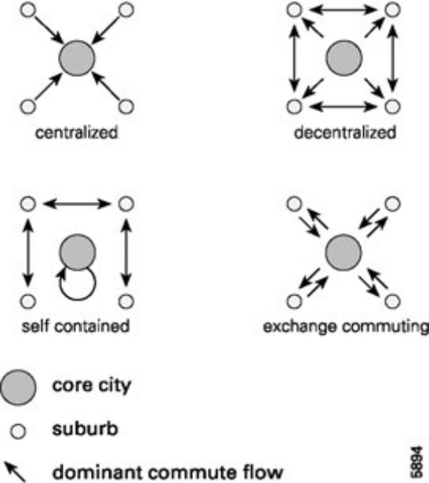

Figure 3.1: Types of DUS (Schwanen et al., 2004, p. 313)
Figure 3.1 shows which way the dominant commuting flows go. However, this picture shows these flows between the core city and the suburbs. Chapter 2 showed that a polycentric region in characterized by a similar distribution of cities, which corresponds with morphological polycentricity. The difference in the circles must therefore be ignored if morphological polycentricity is high.
The centralized system corresponds to the traditional monocentric model (N1). The decentralized system shows ‘that the suburbs are complementary to the central city and important for job supply’ (Van der Laan, 1998, p. 239) (N2 and 1-N1). In this system the commuting flows are multi-directional. The self contained system resembles cross-commuting and locally employed commuting, where the central city is contained and the suburb commuters commute to other suburbs (1-N2 and 1-N1). Finally, in the exchange commuting system there are reciprocal commuting flows corresponding to the emergence of employment in the suburbs (N1 and N2).
Furthermore, functional polycentricity shows a multi-directional pattern of commuting flows. Figure 2.1 showed how this looks like. When functional polycentricity is established, it means that the commuting flows within are multi-directional. The decentralized system shows functional polycentricity. This thesis argues that the Veneto region is undergoing a move to a more polycentric structure.
This chapter identified commuting as the journey from home to work with crossing at least one municipality border. It showed why commuting flows are used to analyze the urban structure. It argued that in a polycentric region commuting flows are multi-directional which refers to multi-nodality. Four levels of nodality are introduced. Based on the relationship between these two nodalities four different kinds of systems are presented where the decentralized system corresponds with a polycentric region.

Chapter 4: Veneto

This chapter will introduce the Veneto region. The specialization of the different cities will first be discussed (section 4.1) where after the FURs in this region will be defined (section 4.2). This chapter will finalize the theoretical part of this thesis and chapter 5 will continue with the empirical part.

4.1 Veneto
For this thesis, the Veneto region will be analyzed in two time periods; 1991 and 2001. The Veneto region contains similarities with the Randstad, because both regions have multiple neighboring cities (Treviso, Vicenza, Verona, Padova, Venice, Belluno and Rovigo in Veneto and Rotterdam, Utrecht, Den Haag and Amsterdam in the Randstad) with no city as the dominant one. The cities of both regions have specialized in different functions: Kantor (2006) argues that Amsterdam has developed new economic activities, especially in the financial sector. Furthermore, Amsterdam is the most cultural city (Van Oort et al., 2010). Rotterdam relies on their port activities for entry and distribution to Europe, and for port-related trade (Ploeger, 2004). Van Oort et al. (2010) show that The Hague is the political capital of the Netherlands and Ploeger (2004) shows that Utrecht serves as a commercial center for the domestic service economy.
Travisi et al. (2010) argue that the Padova region shows a polycentric structure and Bramezza (1996) shows that the Veneto region is organized by a classic model of cities with their own specialization, which are related through, among others, complementarity. The Espon project (2007) identified the North Eastern part of Italy as the most polycentric region of Europe. Venice is the city with a port and with the most cultural value. Padova is the main trade and industrial center, especially because of their links with central Eastern Europe. The agricultural market is most present in Treviso. Verona serves as a major link with northern Europe with their road and rail communications (Eurostat, 1993) and Vicenza differs from the other areas as it is the most advanced and dynamic manufacturing area. Rovigo has a mixed economy with agriculture and industry as most dominating. The Central Veneto region (Padova, Treviso and Venice) is argued to be the most important area of the Italian economy (Bramezza, 1996; Besussi et al., 1998). Camagni and Salone (1993) argue that the Central Veneto region is characterized by polycentricity where the functions between these cities are efficient organized. Cosgrove (2007) argues that Vicenza also comprises the wealthy Veneto region, as it dominates the manufacturing of gold in Europe and he also argued that Verona is one of the larger cities in this region. Figure 4.1 shows that the northern part of the province of Belluno is characterized by mountainous areas, where population is gradual diminishing (Eurostat, 1993). This region and Rovigo both ‘have declining and ageing population’ (Eurostat, 1993, p. 187). It is for all these reasons that Rovigo and Belluno are not part of the wealthy economy of the Veneto region. They are therefore excluded from the analysis in this thesis (see also chapter 5). Figure 4.1 shows the Veneto region and where the different (central) cities are located:
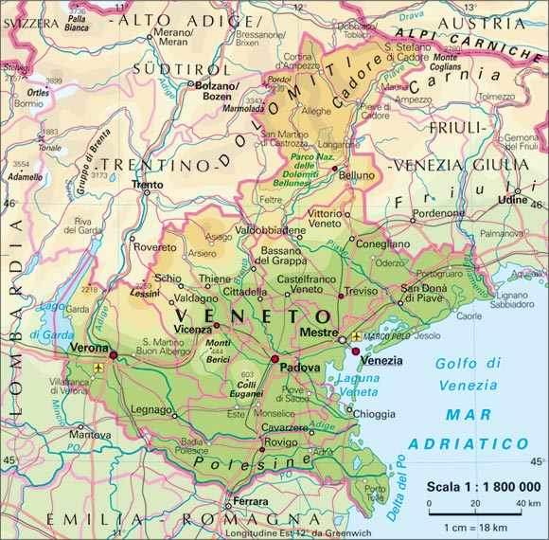
Figure 4.1: Map of Veneto (http://viaggi.virgilio.it/images/cartine/veneto.jpg)

4.2 FURs in Veneto
Section 2.7 provided the general definition of the FUR. This paragraph will define the FURs in Veneto. For the FURs in Veneto, ‘municipalities that exchange more than 75 percent of their daily home-work trips are aggregated’ (Cristaldi, 2005, p. 271) in one FUR. This implies that at least 75 percent of the commuters have a destination within the same FUR; i.e. the commuting flows are self-contained such that 75 percent of the employed also live in the same area and 75 percent of the residents also work in that area. Van der Laan (2010) uses almost the same classification, but takes 70 percent as a threshold for delimiting the FUR. The Italian National Institute for Statistics (ISTAT) began in 1981 with defining FURs in Italy and did so every 10 years. There are currently 34 FURs in Veneto:
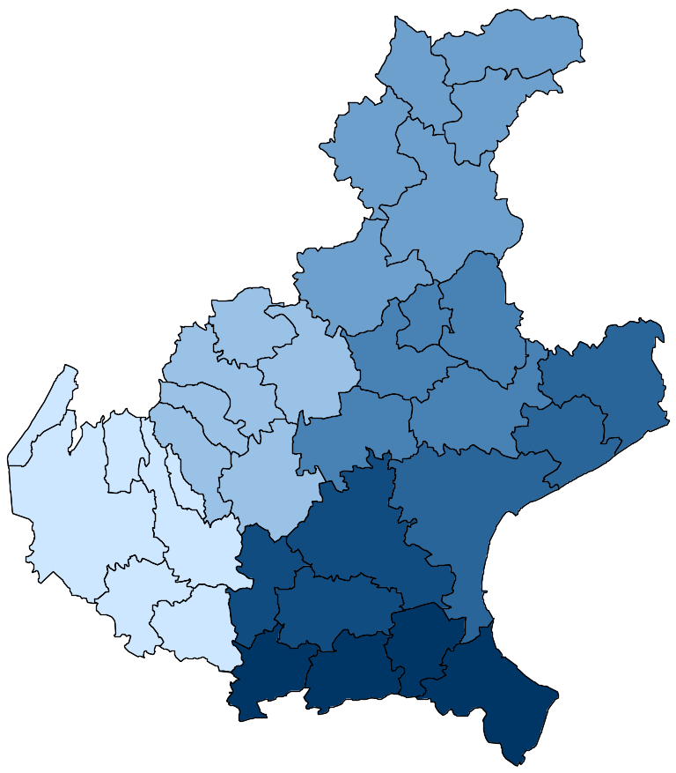

Figure 4.2: FURs in Veneto. Stata output. Colored are the different provinces.
For example, the two figures below show the FURs of the province of Verona (4.3) and the municipalities of the province of Verona (4.4). In some cases the administrative boundaries of a municipality belong to one province, but it belongs to a FUR of a different province. This follows from the definition of the FUR that at least 75 percent of the local commuters have a destination within the FUR the municipality belongs. The full list of municipalities and FURs in the Veneto region is found here.

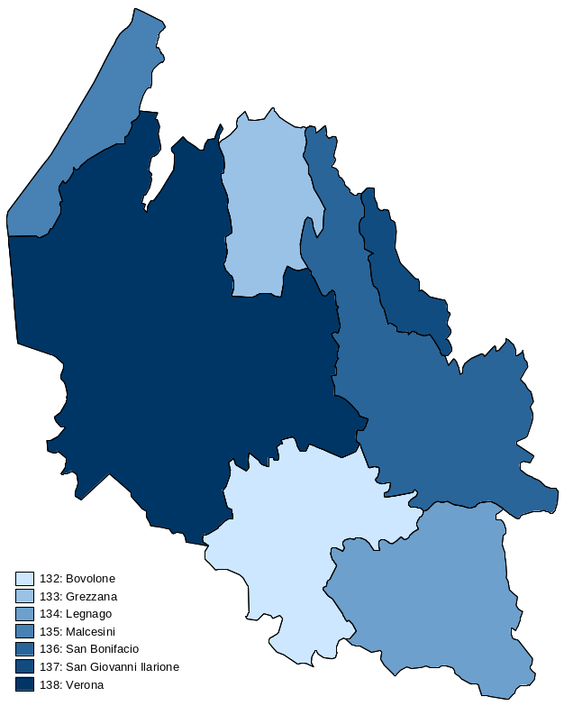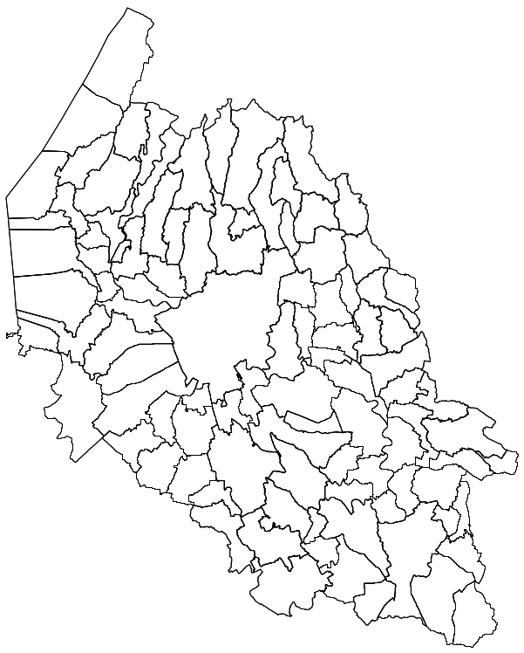
Figure 4.3: FURs in Verona. Stata output Figure 4.4: Municipalities in Verona. Stata output

This chapter introduced the Veneto region. Veneto consists of several neighboring cities of similar size, which are characterized by their own specialization. The peripheral provinces of Belluno and Rovigo are excluded from the analysis. Hence, the Veneto region consists of 24 FURs in which 75 percent of the commuters have a destination within the same FUR.

Chapter 5: Data

The previous chapters investigated the necessary concepts to study the development of the urban structure of Veneto. This chapter will show how the data looks like (section 5.1) and it will present the methodology this thesis uses to investigate morphological and functional polycentricity at the intra- and inter-urban scale (section 5.2).

5.1 Description of data
The ISTAT collects every 10 years a ‘census’ on commuting patterns. Although a census is usually at the individual level, this particular census aggregates the number of persons when they make exactly the same trip. The second and fourth row of table 5.1 are examples of these aggregate numbers. This thesis uses 4 sets of those data, namely both in- and outgoing commuting in the years 1991 and 2001. It means that for all people commuting to and from one specific municipality data is collected. The following table presents a minor piece of the ingoing data from 1991:
Prov. of origin | Mun. of origin | Gen-der | Modal  split | Occupatio-nal status | Time of departure | Travel time |  | Prov. of dest. | Mun. of dest. | Number of  persons
23 | 6 | 1 | 1 | 2 | 2 | 3 | 23 |  | 6 | 1
23 | 6 | 1 | 1 | 2 | 3 | 1 | 23 |  | 6 | 64
23 | 6 | 1 | 1 | 2 | 3 | 1 | 23 |  | 43 | 1
23 | 6 | 1 | 1 | 2 | 3 | 1 | 23 |  | 91 | 1
23 | 6 | 1 | 1 | 2 | 4 | 1 | 23 |  | 6 | 38
23 | 6 | 1 | 1 | 2 | 4 | 1 | 23 |  | 91 | 1
23 | 6 | 1 | 2 | 1 | 1 | 4 | 23 |  | 42 | 2

Table 5.1: Example of commuting pattern matrix
The first two columns rank the province and municipality of origin from the commuter. The provinces of Veneto are: Verona (23), Vicenza (24), Belluno (25), Treviso (26), Venice (27), Padova (28) and Rovigo (29). Gender is either male (1) or female (2). The modal split refers to the means of transport: on foot, bike or other (1), train, tram or subway (2), bus (3), private car as driver (4), private car as passenger (5) or moped (6). The 2001 database contains more variables for modal split, especially for public transport. However, this thesis does not use public transport. The few other variables the 2001 database contains that the 1991 database does not contain are also not used for this thesis. For the occupational status, the only difference is if the commute is made for study (1) or work (2) purposes. For the time of departure four classifications are used: before 7:14 (1), between 7:14 and 8:14 (2), between 8:14 and 9:14 (3) and after 9:14 (4). For travel time it is: less than 15 minutes (1), between 15 and 30 minutes (2), between 31 and 60 minutes (3) and more than 60 minutes (4). The last three columns are the province and municipality of destination of the commuter and the number of persons that made that particular trip. For example, the third row shows a commute from Verona, Bardolino to Verona, Lazise. One male made this commute on foot, by bike or some other way for work purposes. He left between 8:14 and 9:14 and it took him less than 15 minutes.
The exclusion of Rovigo and Belluno is also marked by the total number of persons commuting into and out of these two provinces because that number is about four to five times as small as it is for the other provinces, which is shown in table 5.2:
Province | Year | Ingoing | Outgoing
Belluno | 1991 | 27888 | 28410
 | 2001 | 33888 | 34131
Rovigo | 1991 | 27488 | 30835
 | 2001 | 31022 | 37220
Verona | 1991 | 107194 | 107809
 | 2001 | 124031 | 124337
Vicenza | 1991 | 138287 | 133033
 | 2001 | 163244 | 154250
Treviso | 1991 | 139093 | 140727
 | 2001 | 162108 | 160383
Padova | 1991 | 149607 | 148844
 | 2001 | 166832 | 164890
Venice | 1991 | 103754 | 108149
 | 2001 | 108271 | 118833

Table 5.2: Total number of persons commuting into or out of the different provinces

5.2 Methodology
This section will discuss the methodology for measuring polycentricity in the Veneto region and will present the corresponding hypotheses. Morphological polycentricity will first be addressed and functional polycentricity secondly. In turn, these sections are divided in the analysis at the intra- and inter-urban scale.
Morphological polycentricity
Intra-urban scale
To measure morphological polycentricity at the intra-urban scale, this thesis uses three methods: the HHI, Moran’s I and LISA. The field of ‘industrial organization’ developed the HHI (Van der Laan, 2010), but can also be used to measure spatial patterns (Guillain and Le Gallo, 2006). Other existing indices to measure spatial patterns are the Krugman Specialisation Index, the Ellison and Glaeser index or the locational Gini coefficient (Guillain and Le Gallo, 2006; Dominics et al., 2007). The HHI is used in this thesis because of its easy way to compute. It directly shows the level of morphological polycentricity of a region. The HHI is ‘a concentration measure based on the sum of the squared market changes of all firms in the industry’ (Lipczynski et al., 2005). For this thesis, the HHI is measured as the sum of the squared total number of ingoing commuting of the municipalities in the FURs. The HHI ranges from 0 to 1, where 1 means a concentrated spatial pattern (Van der Laan, 2010). Therefore, low values of the HHI mean high morphological polycentricity. The formula for the HHI is:
$$HHI=\sum_{i=1}^{N}{Si^{2}}$$
N refers to the total number of regions or municipalities used and Si to the market share, calculated as the share of employment in one municipality, of region i in the total region. Although the data provided the trips made for study reasons, they are not used here because for the HHI this thesis is concerned about whether employment is concentrated or dispersed. If there are N regions, the maximum of the index is 1 which indicates a concentrated spatial pattern; i.e. there is one city in the region where all commuters are going to. This is the lowest level of morphological polycentricity possible. The minimum is 1/N, which indicates that the N regions are of similar size. In the analysis only the five largest municipalities are taken into account for calculating the HHI, because the HHI is sensitive to the number of municipalities used (Van der Laan, 2010). Furthermore, the difference between the HHI of the 5 largest municipalities of a FUR and the HHI of all municipalities of that same FUR stayed constantly very small.
For example, for two municipalities (001 Affi and 021 Castel d'Azzano) in the province and the same FUR of Verona N is 2. There are 853 people who are commuting to and within Affi and 2627 people who commute to and within Castel d'Azzano. The total number of people working in these two municipalities is thus 3480. The minimum of the HHI is then 1/2= 0.50.
$$HHI=\sum_{i=1}^{2}{{\left(\frac{853}{3480}\right)}^{2}+{\left(\frac{2627}{3480}\right)}^{2}=0.630}$$
The HHI gives 0.630 where the minimum is 0.50. The level of morphological polycentricity is in this example not that high: Affi and Castel d'Azzano are not of similar size. However, the HHI is also not so high to indicate a concentrated structure of employment.
The disadvantage of the HHI is that it does not show where employment is spatially clustered. Therefore, Moran’s I will also be used to show morphological polycentricity. Riguelle et al. (2007) argue that to understand the urban structure of cities Moran’s I can be used and that it provides an idea of how employment is spatially organized. Nevertheless, Moran’s I does not ‘identify local spatial patterns of agglomeration’ (Guillain et al., 2006, p. 8).

Moran’s I indicates spatial autocorrelation (SA). SA measures the way observations are distributed (Goodchild, 1986). It reflects Tobler’s (1970, p. 236) first law of geography: ‘everything is related to everything else, but near things are more related than distant things’. SA shows if objects or activities in one place are (dis)similar to other objects or activities located nearby where the proximity between the places where the object or activity is located will determine the level of SA (Goodchild, 1986). In this thesis Moran’s I indicates if employment in the different municipalities of one FUR is spatially autocorrelated. This means that if Moran’s I indicates positive and significant SA employment in the municipalities is clustered in space, i.e. employment is concentrated. The null hypothesis of Moran’s I is no (global) SA where the expected value of Moran’s I is: E (I) = -1/ (N-1) (Pisati, 2001). The values of Moran’s I lie between 1 and -1 (Vasiliev, 1996). If it approaches 1 it means strong positive SA which indicates concentration of employment. This means that one location has neighboring locations with similar low or high employment values. If it approaches -1, it means strong negative SA which indicates a dispersed structure of employment. In other words, the location with negative SA has neighboring locations with dissimilar values. When Moran’s I approaches the expected value, -1/ (N-1), employment is randomly distributed. High levels of morphological polycentricity intuitively correspond with negative SA. The formula for Moran’s I is shown in the appendix.
Moran’s I requires a spatial weights matrix to define which observations are neighbors. This matrix ‘allows formalizing the contiguity between spatial observations and assesses the significance of the results produced’ (Baumont et al., 2004, p. 12). However, this implies that Moran’s I is very sensitive to the definition of neighborhood (Riguelle et al., 2007). This is solved by using several levels of separation, which is shown in figure 5.1:
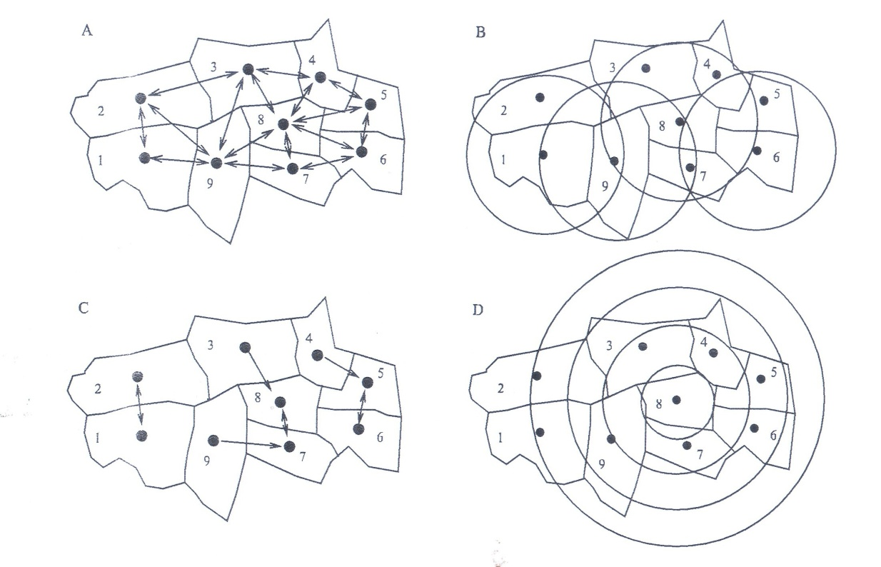

Figure 5.1: Neighborhood definitions (Bivand and Portnov, 2004, p. 3)
This thesis uses a combination of B and D. The definition of neighborhood is selected using distance bands in Stata. Moran’s I takes for every individual location the same distance band (B). However, if the distance band is set too small some observations may have no neighbors. The distance band can also not be too large because no observation should have all other observations as a neighbor. This is observed in Stata when creating the weights matrix; it gives the largest minimum distance and the smallest maximum distance. The former indicates at which distance all municipalities have at least one neighbor and the latter shows at which distance at least one municipality has all other municipalities as a neighbor. Therefore a combination of B and D is used. A and C from figure 5.1 are for these reasons not useful. The latter defines neighbors based on distance contiguity and the former defines neighbors when regions have adjacent borders. Both can give biased results.

It implies that for every province there is one unique distance band which serves best for that province. For example, for the province of Verona the municipality of Verona is centered in that province and it is the biggest municipality (see figure 4.4). The distance band used is somewhat bigger than the largest minimum distance so that this municipality has enough neighbors. The province of Venice has another structure (see figure 1 in the appendix). First of all, it is positioned at sea and secondly, it is characterized by multiple larger municipalities around Venice and smaller ones on the edges of the province. The distance band for the province of Venice thus has to be larger than the largest minimum distance.

Intuitively, for the FURs which have low levels of the HHI (which indicates a dispersed pattern of employment) Moran’s I should indicate negative SA and vice versa. The results of the analysis will indicate whether this is true, as this has not been previously tested.

To identify local spatial patterns of agglomeration, LISA are used for the ‘assessment of significant local spatial clustering around an individual location’ (Anselin, 1995, p. 94). In other words, for the measurement of employment concentration the ‘relative position between the spatial units and the distance between them matters’ (Baumont et al., 2004, p. 6). LISA indicates SA at the local level, i.e. it indicates SA of each individual observation (Anselin, 1995). Hence, this thesis uses LISA to detect significant spatial concentration patterns around each observed location, which are also called hotspots (Pisati, 2001).
LISA computes four different local SA statistics: the local Moran’s I, Geary’s C, Getis and Ord’s G and Ord’s G*. These statistics should satisfy two requirements (Anselin, 1995, p. 94): ‘1) the LISA for each observation gives an indication of the extent of significant spatial clustering of similar values around that observation and 2) the sum of LISAs for all observations is proportional to a global indicator of spatial association’. The null hypothesis and the values of the LISAs are interpreted in the same manner as Moran’s I. Negative SA should thus indicate high levels of morphological polycentricity.

Calculating Getis and Ord’s G and Ord’s G* requires using a non-standardized binary weights matrix. A binary weights matrix takes the value of 1 if locations are within a pre-specified band width (distance) and 0 otherwise. This thesis only has access to X and Y coordinates given in meters. The binary option will not be used to avoid problems converting these coordinates. This means that the computed weights matrix is based on distance contiguity (Anselin, 1993). The several levels of separation used with Moran’s I will determine which band width serves best for the LISA. Furthermore, the weights matrix constructed will be row-standardized which means that all the elements in each row sum to 1 (Anselin, 1993). This is performed such that the Moran scatterplot can also be visualized. This scatterplot can be interpreted as a normal linear regression model and can therefore ‘indicate observations that do not follow the overall trend which represents useful information on local instability and non-stationarity’ (Anselin, 1993, p. 9). However, interpreting local instability and non-stationarity is beyond the scope of this thesis.

Important in the interpretation in the LISA is that significance testing for local SA can be problematic and ‘the reported p-values should be regarded as an approximate indication of statistical significance. However they are informative when employed in an exploratory manner’ (Sokal et al., 1998 cited in Pisati, 2001, p. 29). The Moran scatterplot is of relevance, because it can be presented in two ways: 1) divided into four quadrants which all indicate different levels of spatial association for each individual observation and 2) the Moran scatterplot values can be easily mapped to explore where and how the SA is located (Pisati, 2001). The Moran scatterplot is thus used in this thesis to explore the spatial data.

This thesis expects that the Veneto region is growing towards a more polycentric structure at the intra-urban scale:

Hypothesis 1: the level of morphological polycentricity has increased in the FURs between 1991 and 2001.
Inter-urban scale
Morphological polycentricity at the inter-urban scale can only be measured using the HHI. The HHI will be calculated for the different provinces. This index is explained in the previous section. Moran’s I and LISA cannot be calculated due to limits of Stata in the size of the weights matrix. Employment and households are becoming more dispersed over an area when polycentricity develops. Therefore:
Hypothesis 2: the level of morphological polycentricity has increased in the different provinces in Veneto between 1991 and 2001
Functional polycentricity
Intra-urban scale
Functional polycentricity at the intra-urban scale is measured using two levels of nodality. Section 3.1 introduced N1 which indicates the importance of central cities:

$$Nodality 1=\frac{{IC}_{c}}{{IC}_{t}}*100$$
${IC}_{c}$ = Incoming commuting in the central city emerging from the FUR
${IC}_{t}$ = All incoming commuting in the areas of the FUR, emerging from the FUR.

N2 is calculated as follows:
$$Nodality 2=\frac{{OC}_{c}}{{OC}_{t}}*100$$
${OC}_{c}$ = Outgoing commuting of the central city directed at the FUR.
${OC}_{t}$ = All outgoing commuting of all areas of the FUR, directed at the FUR.

These nodalities measure functional polycentricity at the intra-urban scale. Four different kinds of commuter flows are separated which are presented in table 5.3:

From / to | Central City | Suburbs
Central City | 1-N2 | N2
Suburbs | N1 | 1-N1

Table 5.3: Overview of the direction of N1 and N2 (Van der Laan, 1998, p. 239)
This table shows the direction of the commuting flows and which nodality belongs to it. Functional polycentricity refers to the decentralized system, where the commuting flows are multi-directional. Functional polycentricity also reflects the exchange commuting and self-contained system. The former shows reciprocal commuting flows between the central city and the suburbs and the latter multi-directional commuting flows between the suburbs (1-N1). However, functional polycentricity is the highest when FURs show the decentralized system. The other two correspond with the emergence of polycentricity, especially in the suburbs. Finally, in the centralized system the central city is the most important for employment: the commuting flows are from the suburbs to the central city and individuals living in the central city also work there.

Figure 5.2: Types of FUR based on N1 and N2.

Figure 5.2 shows these systems distinguished based on the relationship between N1 and N2. Van der Laan (1998) takes the average as a threshold for N1 and N2, which are 65 percent and 25 percent. This thesis will also use the average of the results to determine the threshold. These are 36 percent for N1 and 19 percent for N2.
Hypothesis 3: the level of functional polycentricity has increased in the FURs between 1991 and 2001.
Hypothesis 4: the FURs in the Veneto region show the decentralized system.
Inter-urban scale
Section 2.5 argued that a true PUR is characterized by a high degree of inward and outward openness. This implies that between the different FURs reciprocal commuting flows exist. Furthermore, chapter 2 argued that the urban spatial structure of cities and regions is changing. The monocentric model appears to be transcended by the polycentric model because of the dispersion of employment and households:
Hypothesis 5: the level inward and outward openness has increased in the different FURs between 1991 and 2001.
IO and OO is defined and measured as follows: IO is the total number of ingoing commuters into each municipality of the FUR coming from outside the FUR as a share of the total number of ingoing commuters into the municipalities of the FUR (Van der Laan, 1998; Van Nuffel and Saey, 2005):
$${IO=(IC}_{o}- {IC}_{ti})*100$$
$ICo$= ingoing commuters into the FUR from outside the FUR
$ICt$i = ingoing commuters into the FUR
OO is the total number of outgoing commuters originating from the FUR directed outside the FUR as a share of the total number of outgoing commuters originating from the FUR (Van der Laan, 1998; Van Nuffel and Saey, 2005):
$${OO=(OC}_{o}- {OC}_{to})*100$$
$OCo$ = outgoing commuters originating from the FUR directed outside the FUR
$OCto$ = outgoing commuters originating from the FUR
The definition for the FURs in Veneto (see section 4.2) states that at least 75 percent of the daily commuting flows are within the FUR. This means that there has to be two thresholds, one for IO and one for OO, to determine whether the Veneto region is characterized by a polycentric structure at the inter-urban scale. Patuelli et al. (2009; 2010) determine the cut-off at 37 percent for IO and 38 percent for OO. Van Nuffel and Saey (2005) find high IO from 40 percent and high OO from 36 percent. Van der Laan (1998) finds a multi-nodal system with values for IO from 25 percent (but none higher than 36 percent) and for OO from 30 percent. All these studies determine their cut-off afterwards. This thesis does the same and takes the mean of IO and OO as thresholds. It resulted in 38 percent for IO and 42 percent for OO.
Table 5.4 gives an overview of the methods this thesis uses to measure both aspects of polycentricity:

 | Morphological  polycentricity | Functional  polycentricity
Intra-urban scale | HHI, Moran’s I and LISA  (Hypothesis 1) | N1 and N2  (Hypotheses 3 and 4)
Inter-urban scale | HHI  (Hypothesis 2) | IO and OO  (Hypothesis 5)

Table 5.4: Methods used to measure polycentricity

Chapter 6: Results

This chapter will discuss the results of the tested hypotheses. First, the results of morphological polycentricity at the intra- and inter-urban scale will be presented (section 6.1). That is because the results of the HHI at the inter-urban are calculated together with the HHI at the intra-urban scale. Second, the results of functional polycentricity will be presented in the same order (section 6.2). An overview of the results will be presented thirdly (section 6.3), where also morphological and functional relationships will be investigated. Fourthly, the results will be discussed (section 6.3). Limitations of this thesis will conclude this chapter (section 6.4).

6.1 Morphological polycentricity
Intra-urban scale
1991
The results of the HHI are presented in tables 1 - 5 in the appendix. In 1991 the FURs of the main central cities have relatively high levels of the HHI indicating a clustered pattern of employment. Although the FUR of Treviso has a relatively low HHI, it is still higher in comparison with the other FURs in the same province. The main central cities thus seem to be important for employment. The results of the nodalities – functional polycentricity in section 6.2 – will show whether this can be confirmed.
The FURs of Malcesini, San Giovanni Ilarione, Grezzana (all Verona) and Asiago (Vicenza) consist of respectively three, four, six and five municipalities. This could be an indication of why all four FURs have high levels of the HHI. Results of the LISA will show if the employment in these FURs have a ‘pure’ employment concentration structure. In other words, it will show whether these FUR are local economic centers.
Leaving these four FURs aside, almost all of the FURs surrounding the FURs of the main central cities have lower levels of the HHI than the FUR of the main central city. This indicates a dispersed structure of employment. However, the FURs of Legnago (Verona), Schio (Vicenza) and San Dona’ di Piave (Venice) still have a high level of the HHI (over 0.20). This indicates that employment in these FURs is less dispersed or even concentrated in comparison with all the other FURs. The results of the LISA will again be used to show whether employment in these three FURs serve a true concentrated structure.
2001
Turning to the results of the HHI for 2001, the main point arising is that in all FURs of the main central cities the HHI has decreased with more than 10 percent. Employment here is thus less concentrated than 10 years before. However, with only three exceptions, the FURs surrounding the FURs of the main central cities still have lower levels of the HHI. It thus seems that the FURs of the main central cities became less concentrated but the surrounding FURs still remain more dispersed. There appears to be no clear structure in the in- or decreasing levels of the HHI in these FURs. On top of that, both the in- and decreases for the surrounding FURs are small, either relatively or absolutely.
The FURs with the small number of municipalities have all increasing levels of the HHI; Malcesini even with an increase of 21.5 %. The same reasoning as before holds here. The results of the LISA will show whether these levels are accurate.
In sum, the HHI shows that the level of morphological polycentricity has increased in the FURs of the main central cities between 1991 and 2001 indicating a less concentrated pattern of employment. The surrounding FURs are all more dispersed in 1991 and almost all more dispersed in 2001 than the main central city FURs, with the exception of three FURs. However, these consist of a small number of municipalities.
Moran’s I
The results of Moran’s I are presented in table 7 in the appendix. A positive Moran’s I (second column) refers to positive SA which indicates a clustered structure of employment; i.e. one location has neighboring locations with similar low or high employment values. A negative Moran’s I refers to a dispersed structure; i.e. one location has neighboring locations with dissimilar values. When Moran’s I approaches the expected value (E (I), third column) employment is randomly distributed. The last two columns rank the z-score and the p-value. Interpretation of these values is according to the normal distribution (see notes table 7).
For both 1991 and 2001 Moran’s I is significant for Verona, Venice and Padova. The null hypothesis of no global SA can thus be rejected. The index is just above the expected value which indicates a limited amount of positive SA. However, for Verona and Padova the z-score is very high which means that employment in these two provinces is spatially clustered. The z-score of Venice is not high (1.789 and 1.832, with a normal distribution the critical value is 1.96 when significant at the 0.05 level) which means that employment in the province of Venice is not as spatially clustered as it is for Verona and Padova. This result could be influenced by the particular structure of the province of Venice (see figure 4.2). The LISA will investigate this further.
For Treviso and Vicenza in 1991 the null hypothesis cannot be rejected. The spatial pattern of employment can be a result of spatial randomness. This means that employment in these two provinces appears not to be clustered or dispersed. In 2001 Moran’s I is significant at the 0.10 level for both provinces. However, Moran’s I is very small and the z-score is below 1.65 but did increase in both provinces. This result seems to indicate a small amount of spatial clustering of employment in 2001.
LISA
The results of the LISA are shown in table 8 - 12 in the appendix and will be discussed per province. The same interpretation of Moran’s I is applied for the LISA. As section 5.2 argued LISA calculates four different indices. Only the local Moran’s I is shown as the others cannot be used to visualize the Moran scatterplot and because interpretation is then more comparable with Moran’s I.
Verona
The results of Moran’s I are confirmed by the LISA. Where Moran’s I shows significant spatial clustering, the LISA indicate significant positive spatial autocorrelation in three municipalities in 1991; i.e. Verona, San Giovanni Lupatoto and San Martino Buon Albergo (B.A). The latter two are located just south and east of the city of Verona respectively. For 2001 the same results holds with increasing clustering of employment in Verona and San Giovanni Lupatoto and a small decrease in San Martino B.A. Also the municipality of Bussolengo seems to be spatially clustered, which is located between Verona and ‘Lake Garda’. However, it is only significant at the 0.10 level and the z-score is only 1.302. It seems like that employment here is growing as in 1991 there was no significant result.
Where the results of the HHI show an increase in morphological polycentricity in the FUR of Verona, the results of Moran’s I and the LISA show an overall decrease in morphological polycentricity. In other words, the former reflects a dispersion of employment and the latter reflects clustering. However, the clustering of employment is found in three municipalities. There seems to be no other clusters or outliers in the rest of the province. What the results of all three methods do show is a clustered structure of employment which is revealed near and in the city of Verona. This clustering will be investigated further in section 6.2 where functional polycentricity is addressed.
Vicenza
The results of the LISA explain the not significant result of Moran’s I. In 1991, there is significant negative spatial autocorrelation in the municipalities of Vicenza and Bassano del Grappa. Both municipalities seem to have a dispersed structure of employment, with a high level of employment in these two municipalities and low levels in the surrounding municipalities. The results of the HHI confirm this for Vicenza, but not for Bassano del Grappa. However, the HHI is measured at the FUR level where the LISA looks at each municipality for the entire province. Furthermore, Arzignano and Montecchio Maggiore seem to be positive spatially autocorrelated in 1991 (the latter at the 0.10 level). Employment in both municipalities is clustered. However, the z-score is below the critical value. These municipalities both belong to the FUR of Arzignano which has an HHI of 0.134. Both LISA and the HHI thus show a clustered structure to a limited extent.
For 2001, employment in Bassano del Grappa has become more spatially dispersed. This means that in this municipality employment has grown and in the surrounding municipalities there are low levels of employment. This result is confirmed by the HHI which shows a two percent increase. The LISA of Vicenza has decreased and is only significant at the 0.10 level. Employment in 2001 is thus not that dispersed as it was in 1991. The results of the HHI confirm this as the HHI decreased with 14.1 percent. In other words, the LISA and the HHI show that the distribution of employment has become more balanced throughout the FUR of Vicenza. Further, employment in Arzignano and Montecchio Maggiore has become more positively spatial autocorrelated where the latter is now also significant at the 0.05 level. This means that employment is in 2001 more clustered than it was in 1991, indicating a growing difference in the distribution in size of municipalities in the entire FUR. This result is not confirmed by the HHI. However, the decrease is not large and the HHI remains above 0.12 which is three times as large as it is for the entire province (see results inter-urban scale).
Furthermore, the results of the HHI for the FURs with a small number of municipalities are not confirmed with the LISA in both 1991 and 2001. This implies that the high levels of the HHI for these FURs are biased and that these FURs do not have a ‘pure’ concentration of employment; i.e. they cannot be characterized as a local economic center. The high level of the HHI for the FUR of Schio is also not confirmed with the LISA. It does indicate negative SA, but not significant. It is assumed that the results of the HHI for Schio are biased because Schio is also characterized by a (relative) small number of municipalities (eight).
Treviso
For 1991 and 2001 the LISA show high and increasing levels of significant positive spatial autocorrelation in the municipality of Treviso and Villorba. Villorba is located just north of the city of Treviso. This result can be confirmed with the HHI, because the HHI of the FUR Treviso is (one of) the highest of the FURs in the province of Treviso. Additionally, the HHI at the inter-urban scale will show that the entire province has a very low HHI which means that the HHI of the FUR of Treviso is relatively high.
For Vittorio Veneto the LISA in 1991 and 2001 show high and increasing levels of negative spatial autocorrelation; Vittorio Veneto has a high level of employment and the surrounding municipalities have low levels. However, the results of the HHI show an increase in morphological polycentricity in the FUR of Conegliano. Investigating this FUR shows that there is another municipality (Conegliano) that has a high absolute number of employment. LISA does not show this probably because the surrounding municipalities have also (relatively) high levels of employment. This could be a reason why the HHI is low and decreasing in the FUR and the LISA is negative, high and increasing in the municipality of Vittorio Veneto. Another reason could be that the distance band is too small. Increasing the distance band to 15000 resulted also in significant negative spatial autocorrelation for Conegliano, but yielded odd results for the rest of the province. Therefore the same distance band is used as with Moran’s I.
The results of the LISA confirm the result found with Moran’s I in the province of Treviso. Moran’s I indicated in 2001 positive SA at the 0.10 level, but not in 1991. Employment seems to be clustering. The LISA increases more for Treviso and Villorba, with positive SA, than it decreases for Vittorio Veneto and the increasing values of the LISA are even significant at the 0.01 level where the decreasing value is not.
Venice
In the province of Venice only the municipality of Venice shows high, but decreasing levels of negative SA between 1991 and 2001. The scatterplot for both years (figure 2 and 3 in the appendix) show that there is a high level of employment in Venice. The municipalities surrounding Venice have low levels of employment in 1991, which intuitively indicates that the city of Venice is attracting a lot of employment. For 2001 the result is different because the scatterplot now indicates (relatively) high levels of employment in the surrounding municipalities. It seems like that the city of Venice thus became less important for job supply. The results from N1 in section 6.2 will confirm or reject this.
For San Dona’ di Piave, which yielded a high level of the HHI, the results of the LISA show negative SA but not significant. The scatterplot shows that in 1991 the municipality of Venice is an outlier but in 2001 it is part of a cluster, probably together with San Dona’ di Piave. The particular structure of the province of Venice is likely to influence the result of the LISA here, because the municipality of Venice is closely located. Therefore it can be assumed that that the distribution of employment became more dispersed.
The low z-score found with Moran’s I can be explained by the FUR in the north east of the province of Venice; Portogruaro. The scatterplot in 1991 and 2001 both indicate, although not significant, high levels of employment in this FUR. This probably influences Moran’s I.
Padova
The significant results found for the province of Padova are for the municipality of Padova and four other municipalities, which are surrounding the city of Padova itself. Only two of these are significant for both years: Abano Terme and Rubano. Where Padova has a high I, these two have smaller I’s. Further, for Abano Terme the positive AC is decreasing. These results seem contradictory with the HHI result. However, the HHI measures at the FUR level. The LISA for the other two municipalities – Selvazzano Dentro and Vigonza – is significant at the 0.10 level in 1991 but not significant anymore in 2001. This, in combination with the decreasing AC for Abano Terme, could explain the decreasing HHI from 0.249 in 1991 to a 0.222 in 2001. This means that although the municipality Padova is becoming more important for job supply, the other municipalities of the FUR are becoming more alike in terms of employment.
Overall, hypothesis 1 cannot be rejected for the main central city FURs. It can be supported with the results of the HHI and the LISA for these FURs. Further, hypothesis 1 cannot be rejected for some, but not all FURs. For the FUR of Conegliano (Treviso) the LISA is showing a more equal distribution of municipalities which is confirmed by the increasing level of the HHI. The results also support this hypothesis for San Dona’ di Piave (Venice).
Hypothesis 1: the level of morphological polycentricity has increased in the FURs between 1991 and 2001.
Inter-urban scale
The results of the HHI at the inter-urban scale are presented in table 6 in the appendix. In 1991, the most concentrated province is Venice with an HHI of 0.263; it shows that employment here is clustered. Intuitively this is because the city of Venice attracts a lot of workers in the tourist industry. Results of N1 will confirm or reject this. After Venice, Padova and Verona are less concentrated with an HHI of 0.162 and 0.140 respectively. This can be a result of the FURs of Padova and Verona having high levels of the HHI at the intra-urban scale. The most dispersed pattern is found in Treviso (0.031) followed by Vicenza (0.048). Employment in these provinces seems to be dispersed. This confirms the results of Moran’s I and the LISA.
The same results hold for 2001. However, all levels of the HHI at the inter-urban scale have decreased with more than 10 percent, Treviso and Venice even with 25 percent. This indicates that in all provinces employment has become more dispersed over the area.
Hypothesis 2: the level of morphological polycentricity has increased in the different provinces between 1991 and 2001
Hypotheses 2 thus cannot be rejected. The level of morphological polycentricity did increase in the different provinces in Veneto between 1991 and 2001 at the inter-urban scale.

6.2 Functional polycentricity
Intra-urban scale
Functional polycentricity at the intra-urban scale is measured with N1 and N2. The relationship between these two results in four different kinds of systems as showed in section 3.2. Figure 4 and 5 in the appendix show the results. Three FURs with the small number of municipalities – Asiago, Malcesini and San Giovanni Ilarione – all show the exchange commuting system in both 1991 and 2001 and will not be further discussed. The FURs with nodalities around the average will be shortly discussed. Important to note is that there is no relationship between the two types of nodalities, in 1991 $R^{2}$ is 0.0054 and in 2001 it is 0.0227. The following table shows the number of systems present in the Veneto region in both years and the in- or decrease:
 | Centralized | Exchange commuting | Self contained | Decentralized
1991 | 5 | 7 | 6 | 6
2001 | 5 | 6 | 9 | 4
Difference (%) | 0 (0%) | -1 (-17%) | +3 (+50%) | -2 (-25%)

Table 6.1: Different systems in Veneto

Table 6.1 shows that there is a clear increase towards the self-contained system and decreases for the exchange commuting and the decentralized system. The existence of a dual spatial labor market (Van der Laan, 1998), one in the central city and the other in the suburbs, has grown between 1991 and 2001. Section 5.2 argued that high functional polycentricity corresponds with the decentralized system and that the exchange commuting and self contained system are more likely to reflect the emergence of polycentricity. Hence, ‘true’ functional polycentricity decreased in Veneto between 1991 and 2001. The presence of the self contained system, where the suburbs are complementary to each other and the central city is contained, increased. However, the presence of the exchange commuting system with reciprocal commuting flows between the central city and the suburbs, decreased. Hence, lower levels of functional polycentricity increased in Veneto between 1991 and 2001. To investigate these results more in-depth, the following two paragraphs will discuss the results in more detail for both years and the end of this section will conclude and will thereby answer the hypotheses.
1991
First of all, there is a clear centralized system in Venice and Grezzana (Verona). This result is in line with the HHI which shows an unequal employment distribution. For both FURs the central city seems to be important for job supply. Thiene (Vicenza) has an average level of N1 but a low level of N2. This means that central city commuters stay in the central city, but that the suburbs are not relying highly on the central city for their job supply. The centralized system is thus only present to a limited extent in Thiene. Secondly, the exchange commuting system, with reciprocal commuting flows between the city and the suburbs is present in Schio (Vicenza) and San Dona’ di Piave (Venice). In both FURs especially N2 is high, which means that the suburbs are important for the commuters coming from the central city. The results of 2001 will show whether these two FURs have developed towards a more polycentric region. Thirdly, there is a clear functional polycentric structure in Castelfranco Veneto (Treviso) and Bovolone (Verona) and somewhat less in Legnago (Verona) and Conegliano (Treviso). The HHI confirm this as the HHI of the former two is relatively low and of the latter two relatively higher in comparison with the result of the HHI at the inter-urban scale. Fourthly, there seems to be a dual spatial labor market in four FURs: Arzignano (Vicenza), San Bonifacio (Verona), Este and Montagnana (both Padova). It resembles the cross commuting system which means that individuals mostly are locally employed, in the central city or in the suburbs. Finally, the main central cities – Verona, Vicenza, Treviso and Padova – all serve average levels of N2 and just above average levels of N1. The central city thus seems to be somewhat important for commuters.
2001
First of all, the same FURs as in 1991 show the centralized system. Grezzana (Verona) reveals the most change which shows that the central city became less important for labor. Secondly, the FURs which show the exchange commuting (Schio and San Dona’ di Piave) all have less N2 which means that less central city commuters are commuting to the suburbs. These FURs have not developed towards a more polycentric structure. Thirdly, only three FURs now show the exchange commuting system, because the FUR of Conegliano has become more self-contained. The other three FURs all show growth towards the middle of the figure. Fourthly, the same FURs as in 1991 show the cross commuting system; all with little change. The commuting flows thus did not really change in ten years. Finally, for all the FURs of the main central cities N2 decreased which means that commuting is more locally employed in the central city.
The results from N1 in Venice confirm the significant SA found with the LISA for both years. The city of Venice is important for job supply. This is also marked with the HHI at the inter-urban scale which shows a low level of morphological polycentricity. However, the increase in morphological polycentricity is not confirmed with this HHI. It is confirmed with the LISA because in 2001 the LISA indicates that the municipality of Venice is part of a cluster of employment. The municipality of San Dona’ di Piave is likely to be the reason for this result. Furthermore, the high, but decreasing HHI level of Grezzana is confirmed with N1; the level of N1 is high in 1991, but lower in 2001. Schio also has high, but increasing levels of the HHI. It corresponds with the exchange commuting system. The reason for the high level of the HHI lays probably in the employment figures in the suburbs. It is likely to be unequal. Investigating these numbers show that this is true: 825 – 12713 – 13343 – 20086 for 1991 and for 2001 944 – 14793 – 15337 – 22961 persons employed in the suburbs of Schio. This shows an unequal distribution of employment in the suburbs
Furthermore, the results from the HHI at the intra-urban scale for the FURs of the main central cities (without Venice) are partly confirmed with N1. N1 is for all four FURs higher as the average but it decreased in 2001. The large decrease of the HHI, which indicates a more equal distribution of employment, seems to be going along with a decrease in N1.
Hypothesis 3: the level of functional polycentricity has increased in the FURs between 1991 and 2001.
Hypothesis 4: the FURs in the Veneto region show the decentralized system.
In sum, there is no functional polycentric structure at the intra-urban scale in most of the FURs of Veneto. The decentralized system is actually underrepresented just as the centralized system. Dropping the N1 and N2 values of 4 FURs, which clearly show both systems, leads to an $R^{2}$of only 0.3604 in 1991 and 0.3184 in 2001. This implies that there is no relationship between the levels of nodalities and even when some outliers are dropped the relationship is weak. Low levels of N1 are thus not followed by low levels of N2. Hypotheses 3 can be rejected. The level of functional polycentricity at the inter-urban scale did not increase. Moreover, the overall trend is towards the self contained system which indicates that the suburbs are complementary to each other. Hypothesis 4 cannot be rejected. However, it can only be supported for a few FURs. The presence of the decentralized system in these FURs even decreased towards 16 % in 2001. In other words, the presence of true functional polycentric regions decreased while the presence of a dual spatial labor market increased.
Inter-urban scale
For measuring functional polycentricity at the inter-urban scale both inward and outward openness are calculated for the 24 FURs in the 5 provinces of Veneto. Figure 6 and 7 in the appendix show the results. Overall, the results show that only 5 FURs have above average degrees of IO and OO in both years. The FURs of the main central cities have low degrees of IO and OO with a slight increase in 2001. The other FURs all have average degrees of IO and OO in both 1991 and 2001. In other words, functional polycentricity at the inter-urban scale is only present for 20.8 % of the FURs. Hence, the Veneto region cannot be characterized as a PUR. The following two paragraphs will discuss the results in more detail and this section will close with answering the hypothesis.
1991
For the FURs in Verona, four of the five FURs surrounding the FUR Verona (Bovolone, Grezzana, Legnago and Malcesini) and the FUR of Montagnana (Padova) have high degrees of in- and outward openness. Only San Bonifacio (Verona) has a just above average degree of outward openness and an average degree of inward openness. However, the FUR of Verona has one of the lowest in- and outward openness of all the 24 FURs. This last result holds for every FUR of the main central cities; Vicenza, Treviso, Padova and Venice. Further, Pieve di Soligo and Montebelluna (both Vicenza) have above average degrees of IO but not of OO. This implies that they attract more commuters from outside their FUR than they have commuters that go outside their FUR. Este (Padova) and San Dona’ di Piave (Venice) have low levels of IO, which implies that they do not attract a high number of commuters from outside their FUR, and higher levels of OO which indicates that commuters from both FURs go outside their own FUR.
The$R^{2}$ is 0.8671. This means that there is a strong relationship between the levels of in- and outward openness. However, most of the FURs have relative low degrees of (both) IO and OO. This implies that functional polycentricity at the inter-urban scale is low in 1991. For 2001 $R^{2}$ decreased to 0.807. The same results are observed; a strong relationship between IO and OO but low functional polycentricity. This implies that the Veneto region cannot be characterized as a PUR.
2001
For 2001 the same FURs as in 1991 have high degrees of IO and OO. It has declined for Malcesini but this is a FUR of only three municipalities so a small absolute number will give big results. The FURs of the main central cities have all risen in their IO and OO. However, this result cannot wholly confirm the result of morphological polycentricity at the inter-urban level because the HHI there decreased between 10 and 25 percent. The IO and OO only rose with a maximum of 4.4 percent. Although these numbers are not (perfectly) comparable, the difference is large enough to assume that there is no strong relationship between morphological and functional polycentricity at the inter-urban scale.
For Asiago (Vicenza) the level of IO has fallen. Results at the intra-urban level show that the central city has become more important and that morphological polycentricity has decreased slightly. However, this FUR consists of only five municipalities and it is likely to be biased. Schio (Treviso) has become more polycentric in 2001. Their level of IO and OO has increased.
Furthermore, the clustering of employment near and in Verona seems to be supported because the surrounding FURs of Verona have high degrees of OO and the FUR of Verona itself is found in the bottom region of IO and OO. The direction of these flows is particularly coming from the FURs Grezzana (around 80 percent for both years), Bovolone and San Bonifacio (around 40 percent for both years) and less from Legnago (20 percent for both years). Legnago is further located from Verona which is assumed to explain this result
Aggregating the differences of both years leads to a decrease of IO of -0.8 percent and an increase of 5.5 percent for OO (see table 13 in the appendix). The decrease of IO is influenced by (large) decreases in IO for Grezzana (6 percent), Malcesini (10 percent), San Giovanni Ilarione (3.2 percent) and Asiago (11 percent). If these are left out, because these are the FURs with the small number of municipalities, than the level of IO increased with 29.5 percent. This does not hold for OO where there is only a little change when these FURs are left out.
Hypothesis 5: the level of inward and outward openness has increased in the different FURs between 1991 and 2001.
Overall, the level of functional polycentricity at the inter-urban scale did increase when looking at the aggregate numbers. However, only four FURs have high levels of IO and OO in 1991 and 2001. The other FURs are around the average or well below the average. The FURs of the main central cities all have low levels of IO and OO, but it increased slightly between 1991 and 2001. Although hypothesis 5 can therefore not be rejected, it can only be supported for the FURs surrounding the FUR of Verona and for the FUR of Schio, which shows higher IO and OO in 2001. In other words, the FURs of the province of Verona surrounding the FUR of Verona show functional polycentricity at the inter-urban level. This cannot be supported for the other provinces, where the level of functional polycentricity is low at the inter-urban level. It implies that, as argued before, the Veneto region is not a PUR.

6.3 Overview
The following table summarizes the results for the tested hypotheses:
 | Morphological polycentricity |  | Functional  polycentricity
Intra-urban scale
Hypothesis 1  Increasing morph. poly. | Cannot be rejected for main central city FURs, Conegliano and San Dona’ di Piave | Hypothesis 3  Increasing funct.  poly.  Hypothesis 4  Presence decentralized system | Rejected  Supported for a decreasing number of FURs between 1991 and 2001
Inter-urban scale
Hypothesis 2  Increasing morph. poly. | Cannot be rejected for all provinces | Hypothesis 5  Increasing IO and OO | Only supported for FURs surrounding the FUR of Verona and for the FUR of Schio.

Table 6.2: Summary of the results of the hypotheses

Table 6.2 shows that hypothesis 1 cannot be rejected for some FURs, which means that in these FURs the distribution of employment became more balanced between 1991 and 2001. Hypothesis 2 shows that all provinces became more polycentric at the inter-urban scale in terms of the employment distribution throughout the province. However, Venice became less monocentric. Hypothesis 3 is rejected which indicates that the commuting flows in all FURs did not disperse between 1991 and 2001. However, the commuting flows are multi-directional for a decreasing number of FURs which implies that hypothesis 4 can therefore not be rejected. Hypothesis 5 can also only be supported for some FURs which means that these FURs became more inward and outward open between 1991 and 2001. However, as this is measured at the inter-urban scale high IO and OO should be present between FURs.
Morphological and functional relationships
This section will argue whether the methods used and whether the two aspects of polycentricity are related with each other. The inter-urban scale reflects the relationships between FURs and the intra-urban scale the relationships within FURs. It was argued in section 5.2 that high levels of morphological polycentricity measured with the HHI correspond with negative SA at the intra-urban scale. However, this relationship is more refined. The FURs of the main central cities all have a high HHI which indicates a low level of morphological polycentricity. The LISA on the other hand showed only decreasing negative SA for Venice and Vicenza. The other main central city FURs showed increasing positive SA. This implies that there is clustering of employment in the neighboring municipalities of the main central city itself which is confirmed with the LISA: Verona, Treviso and Padova all three have neighboring municipalities with significant and positive SA. The cities of Venice and Treviso do not show this, both cities have high employment concentration and the neighboring municipalities have low employment concentration. This is confirmed with N1, where especially the city of Venice has high N1 and the FUR of Vicenza has a high level of N1 relative to the other main central city FURs. For both FURs the level of N1 also decreased. However, the clustering of employment near and in Verona, Treviso and Padova is only to some extent supported with the results of functional polycentricity at the intra-urban scale: for all three provinces there seemed to be a development towards the self-contained system. However, this development is very weak. These results do seem to confirm the weak relationship between the level of morphological and functional polycentricity, previously reported by Van der Laan (2010). This thesis did found a clear relationship between high levels of the HHI and both positive and negative SA. It can thus be assumed that the LISA is complementary to the HHI.
The methods used to measure morphological polycentricity at the inter-urban scale do not seem to have a clear relationship with morphological relationship at the intra-urban level. A correlation coefficient is lacking because the former is measured at the province level and the latter at the FUR level, which means that there is no equal amount of numbers necessary to perform a regression. There seems to be a relationship with the increase of morphological polycentricity at the inter-urban scale and the increase of Moran’s I. However, this latter increase is very small and the relationship is therefore not further investigated. What the LISA does show is the existence of multiple employment centers in the provinces of Vicenza and Treviso. This confirms the high level of morphological polycentricity at the inter-urban level. For these reasons, only a weak relationship between morphological polycentricity at both levels can be supported. Additionally, this thesis assumes that the morphological polycentricity at the inter-urban level is better explained by the indices used to measure it at the intra-urban level because at the intra-urban level the methods used are more in-depth, more clarifying and more conclusive. The results at the inter-urban level do show that all five provinces are becoming more polycentric, or in the case of Venice, less monocentric.
Functional polycentricity at the intra-urban level appears to have no clear structure (very low$R^{2}$). For functional polycentricity at the inter-urban level there is a strong relationship between the level of IO and OO. As the FURs surrounding the FUR of Verona have high levels of IO and OO investigating the specific direction of the commute shows for which FUR the employment concentration near and in Verona is important for job supply. The following table shows the importance of the municipalities of Verona, San Giovanni Lupatoto and San Martino B.A. for the FURs surrounding them since the LISA gave significant results for these municipalities:
 | 1991 (%) | 2001 (%) | Difference
132: Bovolone | 44.9 | 36.9 | - 8.0
133: Grezzana | 80.5 | 78.3 | - 2.2
134: Legnago | 21.8 | 19.6 | - 2.2
135: Malcesini | 24.7 | 16.2 | - 8.5
136: San Bonifacio | 43.3 | 37.8 | - 5.5
137: San Giovanni Ilarione | 10.9 | 7.3 | - 3.6
Table 6.3: Percentage of outgoing commuting to Verona, San Giovanni Lupatoto and San Martino B.A.
Table 6.3 shows the percentage of outgoing commuting, which is directed outside the FUR, towards those municipalities for 1991, 2001 and the difference. It shows that especially for Grezzana and to a lesser extent for Bovolone and San Bonifacio the outgoing commuting is going to the clustering of employment near and in Verona. This indicates a spatial mismatch between housing and jobs which makes inter-urban commutes necessary (Giuliano and Small, 1993). This mismatch did decrease for all FURs implying that the employment concentration near and in the central cities became less important for job supply.
Furthermore, the high level found in Grezzana corresponds with a high level of N1 at the intra-urban level. However, the smaller level found in Bovolone and San Bonifacio corresponds with low levels of N1. Because only the FURs with a small number of municipalities have higher levels of N1, the last relationship will be further explored. This means that for FURs with (relatively) low levels of N1 (below 25 percent) the direction of outgoing commuting towards the employment concentration near and in the main central cities the percentage will be calculated. The following table shows this result:
 | 1991 (%) | 2001 (%) | Difference
139: Arzignano | 50.5 | 43.9 | - 6.6
151: Castelfranco Veneto | 12.8 | 9.9 | - 2.9
152: Conegliano | 16.7 | 12.8 | - 3.9
159: Este | 42.2 | 38.9 | - 3.3
160: Montagnana | 7.2 | 6.1 | - 1.1

Table 6.4: Percentage of outgoing commuting from FURs with low N1 to main central city
Table 6.4 shows that only for Arzignano and Este the relationship seems to hold and both show the self-contained system. Furthermore, the FUR of Montagnana has the highest level of IO and OO at the inter-urban level. The FUR of Este seems to be important for the job supply of commuters from Montagnana instead of the city of Padova (75 percent for 1991 and 2001). For the commuters coming from Este also Montagnana is important (80 percent for 1991 and 2001). There thus seems to be exchange commuting between these FURs. However, the FUR of Montagnana also shows the self-contained system. Hence, there seems to be no clear relationship between the level of outgoing commuting directed towards the employment concentration near or in the main central cities and the (low) level of N1. In other words, the level of functional polycentricity at the inter-urban level does not relate with the level of functional polycentricity at the intra-urban level.

6.4 Discussion
The monocentric model indeed seems to be a model from the past with the exception of Venice and Grezzana. However, Grezzana shows a high level of functional polycentricity at the inter-urban level and is characterized by a small number of municipalities. Venice is the most cultural city of the Veneto region and attracts a lot of tourists. It is likely that for this reason Venice attracts a lot of commuters and employment; the monocentric model is prevailing in Venice. In other words, in the province of Venice the results support the argument from the central place model that the smaller cities are dependent on the larger city. Governa and Salone (2005) emphasize that changes in the urban organization in Italy has developed because of historical processes rather than explicit polycentric policy planning; Venice serves as a good example of such a process.
Although the concept of the monocentric model is surpassed, it is not the polycentric model that is getting its grip on the Veneto region. This confirms earlier research from Anderson and Bogart (2001) who argue that to understand the employment structure of urban regions the polycentric model is incomplete. Furthermore, a recently published study by Garcia-López and Muñiz (2010, p. 2) argues that ‘polycentricity might be an intermediate spatial stage between monocentricity and scatteration’. The results of the HHI, Moran’s I and LISA cannot support high or increasing levels of morphological polycentricity at the intra-urban scale for the majority of the FURs, it can support such levels for the main central city FURs. For all FURs the results do not support increasing levels of functional polycentricity at the intra-urban scale. Even more, the decentralized system with multi-directional commuting flows is only really present in two FURs. Just as in the Netherlands, only between a few FURs in the Veneto region a polycentric region has developed. Although, the results showed that the systems which reflects lower levels of functional polycentricity at the intra-urban scale (the exchange commuting and self contained system) increased in number between 1991 and 2001. However, it seems like that there is an overall trend towards the self contained system which indicates the existence of a dual spatial labor market. This is not confirmed with the results from morphological polycentricity at the intra-urban level; i.e. the LISA did not show the existence of multiple local economic centers. Only for Vicenza there seems to exist a dual spatial labor market at the inter-urban level.
Overall, polycentricity is only developed to a limited extent in the Veneto region. Where the main central cities are geographically well-connected, within proximity of each other and no city is the dominant one, the results at both the intra- and inter-urban scale showed that polycentricity only developed within and between some FURs. Furthermore, in the different provinces only a very small number of local economic centers are present. Only these centers should be able to compete with the main central city. Furthermore, the commuting flows are only in Venice for the bigger part mono-directional; i.e. from the suburbs to the central city. The other FURs did show commuting flows in multiple directions, implying that the CBD is not the most important provider of employment anymore. However, these commuting flows are not that multi-directional to argue that all FURs can be characterized as a polycentric region. It is assumed that the province of Verona is the most polycentric region in Veneto at the inter-urban scale.
Exceptions are found in the FURs surrounding the FUR of Verona and in the FUR of Montagnana (Padova) where the former shows functional polycentricity at the inter-urban level. This implies a spatial labor mismatch because of high IO and OO (Giuliano and Small, 1993). It means that for people living in one FUR the employment opportunities are not enough to employ the local residents. Furthermore, the province of Verona shows increasing morphological polycentricity at the same scale. However, as the FUR of Verona has a low level of both IO and OO, the province of Verona is no true polycentric region. It can although be assumed that at the inter-urban scale the province of Verona is the most polycentric region in Veneto.
The FUR of Montagnana is also functional polycentric at the inter-urban level. However, the majority is commuting towards the FUR of Este and vice versa. At the intra-urban level there seems to be a dual spatial labor market; i.e. between the central city and the suburbs. At the inter-urban level there are imbalances between employment and residential locations. Hence, on the local level it can be assumed that the commuter has minimized their commuting cost trough, for example, changing his place of residence. On the regional level this effect is assumed not to be found. This could be an indication of the wealth of the region, because ‘long distance travel tends to be more prevalent among people with more resources’ (Limtanakool et al., 2007a, p. 2128). However, this thesis does not investigate commuting time and these two assumptions should be interpreted with caution.
Another exception is found in increasing levels of morphological polycentricity at the inter-urban level. Where the Espon report (2007) states that the north east of Italy has a high level of morphological polycentricity this thesis finds that morphological polycentricity is unbalanced in terms of the distribution of regions (see tables 1 - 5 in the appendix). Meijers (2008) argues that a balanced distribution of regions is considered polycentric at the spatial scale of the FUR. The results cannot confirm such polycentricity, although there seems to be an increase towards morphological polycentricity. Where the provinces of Vicenza and Treviso are well and more balanced, the province of Venice is not well balanced (although it became less monocentric). The provinces of Verona and Padova lie in the middle of these two ends. Combining morphological polycentricity at the intra- and inter-urban level there only seems to be the existence of multiple local economic centers in Vicenza. However, multiple is overestimated; only one extra center is developed next to the main central city.
Alternative interpretations
Meijers and Burger (2010) argue that cities in smaller FURs are more functionally related than cities in larger FURs. Figure 8 in the appendix shows the map for the HHI in 1991 and 2001. With some exceptions, the larger FURs have a higher HHI than the smaller FURs. This more unequal distribution in terms of size can be supported with lower levels of N1. Capello and Camagni (2000) show that there seems to be a threshold in the urban size of regions. This means that when cities become too large, urban overload is expected. This view is supported by Meijers (2008) who finds that more polycentric regions cannot gain from urban size. For example, high N1 can result in congestion and high commuting costs. As the smaller FURs have low levels of the HHI and N1, it could be assumed that there is a relationship between functional polycentricity and urban size.
The correlation coefficient between the HHI and N1 gives 0.84 for 1991 and 0.86 for 2001 which indicates a strong relationship between the two. However, the HHI does not measure urban size. Furthermore, there is no relationship between the HHI and N2 (very low $R^{2}$). As morphological polycentricity is also measured with two other indices, the weak relationship between morphological and functional polycentricity, as argued before, seems to hold.
The results of functional polycentricity at the intra-urban level seem to show a slight movement of the average FURs, in terms of the level of N1 and N2, towards the self-contained system. This includes the main central city FURs. If anything, this could be an indication of ‘reurbanisation’ or the ‘resurgent city’ (e.g. Glaeser and Gottlieb, 2006; Kabisch et al., 2010). This implies that the population is moving back to the city, because of ‘advantages of inner-city areas, like the specific housing available, the good location and diverse amenities, which are becoming increasingly attractive for a wide range of population groups, living arrangements and lifestyles’ (Kabisch et al., 2010, p. 970). These groups seem to include the increase in two-earner households. Changes in the structure of households influence the spatial behavior of households (Van der Knaap, 2002). However, this is just a cautious attempt to shed some new light of recent research on the results.

6.5 Limitations
This thesis used commuting flows and employment figures to analyze the development of the urban spatial structure of the Veneto region. However, as Schwanen et al. (2001) and Bogart (2006) among others rightly show commuting only accounts for one fifth of all personal trips. Bogart (2006) argues that accessibility should include other measures such as the cultural and shopping amenities offered. Furthermore, since FURs ‘encompass multiple functions’ (Limtanakool et al., 2007a, p. 2124) these other personal trips may reveal another insight of the urban structure. However, this thesis only focused on commuting because only these flows show the relationship between employment and residential locations. This is confirmed by Limtanakool et al. (2007b, p. 27) who argue that commuting flows are ‘pertinent to the development of urban systems’ as opposed to other daily journeys. Even more, Parr (2005) argues that commuting flows do represent the same urban structure other types of interaction reveal.
There is more to commuting than only the flows. Even more, the used data sets contained more variables. For example, results of empirical research on the influence of commuting time on the urban spatial structure are mixed (Schwanen et al., 2001). Changes in the spatial mobility and flexibility of households and firms can shorten commuting times. This reflects the co-location hypothesis which states that households change their live- or workplace in order to avoid time penalties, caused by congestion (Schwanen et al., 2004). However, because of time limits this thesis did not investigate commuting time. This topic is although important in the field of research regarding commuting.
This thesis did also not investigate the level of specialization of the employment centers near and in the main central cities. Characteristics of an employment center are argued to tell more about the interaction patterns (Limtanakool et al., 2007a). This is argued to be an important question (Anderson and Bogart, 2001). Proper knowledge of the characteristics of the Veneto region or field research is needed to investigate this manner further. Furthermore, lack of English literature regarding Italian development policy and economy limited this thesis in understanding the regional and local structure of the Italian economy, especially for that of the Veneto region.

Chapter 7: Conclusion
This thesis analyzed the development of polycentricity in the Veneto region between 1991 and 2001. Commuting flows are used to determine morphological and functional polycentricity at the intra- and inter-urban scale, because they are an appropriate measure to determine the location and structure of employment. Where in the monocentric model commuting is aimed at the CBD, the polycentric model implies that cities and regions are changing towards a multi-faceted urban structure.
The results of this thesis show that the polycentric model is incomplete in determining the urban structure of Veneto. This thesis expected however that polycentricity did develop in the Veneto region. The results showed that polycentricity is only developed to a limited extent.
At the intra-urban scale, hypothesis 1 – increasing levels of morphological polycentricity - cannot be rejected for the main central city FURs, Conegliano and San Dona’ di Piave. Hence, at the local level only some morphological polycentricity developed; i.e. the employment distribution became more balanced between 1991 and 2001 in these FURs. At the inter-urban scale, hypothesis 2 – increasing levels of morphological polycentricity – cannot be rejected for all provinces. This indicates a more balanced distribution of employment between 1991 and 2001 within all provinces. However, the levels of morphological polycentricity did vary in size. Furthermore, for various reasons, this thesis assumes that morphological polycentricity is better explained with the methods used to measure it at the intra-urban scale.
Hypothesis 3 – increasing levels of functional polycentricity at the intra-urban scale – is rejected which means that commuting flows within the FURs in Veneto are not increasing multi-directional as the theory of polycentricity predicts. However, the results did support hypothesis 4 – presence of the decentralized system – for some FURs, although it is supported for a decreasing number of FURs between 1991 and 2001. It also indicated an increase in the presence of a dual spatial labor market where especially the suburbs within these labor markets are important for employment. At the inter-urban scale, hypothesis 5 – increasing levels of IO and OO – is only supported for the FURs surrounding the FUR of Verona and for the FUR of Schio. However, the latter is an outlier, because functional polycentricity at the inter-urban scale should be present between FURs. Hence, it can be supported that the province of Verona is a functional polycentric region and thereby excludes itself from the rest of the Veneto region. However, the FURs of the province of Verona are not functional polycentric at the intra-urban scale. This implies a spatial labor mismatch in the province of Verona. Furthermore, such a mismatch is also found for two neighboring FURs (Este and Montagnana) at the regional level. However, on the local level there seems to be the presence of a dual spatial labor market for these two FURs.
The results show that the city of Venice is still important for job supply. To clarify this with the example from the introduction, merchants still move to the market in Venice to sell their products. However, Venice became less monocentric through the more balanced employment distribution in one neighboring FUR, San Dona’ di Piave. The province of Venice is although no polycentric region.
Furthermore, the results show that at the local level only some polycentricity developed. Where morphological polycentricity shows increasing levels for the main central city FURs (except for Venice), functional polycentricity shows a trend towards the self contained system. The latter implies that especially the suburbs are complementary to the central city in terms of employment. Additionally, for the FUR of Conegliano with increasing levels of morphological polycentricity the level of functional polycentricity actually decreased. This indicates that, as employment becomes more distributed over the FUR, commuting flows are diminishing multi-directional. This could point to the increasing spatial mobility and flexibility of households or firms. In other words, the demand for labor is following the supply of labor or vice versa. However, this should be interpreted with caution as this thesis did not investigate this specific relationship.
Overall, the deconcentration of employment – a more balanced distribution of employment which indicates morphological polycentricity - is only found in 25 % of the FURs in the Veneto region (excluding the main central city FURs). This confirms to a limited extent the trend towards the self contained system. It means that the suburbs at the province level are becoming more important for job supply. However, the LISA showed that these suburbs cannot be characterized as local economic centers. This implies that functional polycentricity at the intra-urban scale is only developed to a limited extent. As the results showed functional polycentricity at the inter-urban scale is also weakly developed. Only the FURs surrounding the FUR of Verona can be characterized as polycentric. In other words, for these FURs the commuting flows are multi-directional. However, this does indicate a spatial labor mismatch.
So, to answer the research question: commuting flows only weakly support (the development of) polycentricity as polycentricity is weakly developed in the Veneto region. At both the intra- and inter-urban level some polycentricity is revealed, morphological as well as functional. The Veneto region can therefore not be characterized as a PUR. Furthermore, a polynuclear (multi-directional) distribution (commuting) pattern is only present to a limited extent in the FURs in the Veneto region. The results revealed only within a few FURs a polycentric structure. This is also, together with the polycentric structure found in Verona, the only two similarities this thesis finds the Veneto region has with the Randstad on a polycentric level. However, investigating the specific direction of where all commuting flows are heading should confirm or reject this. It may be true that the Veneto region is evolving towards polycentricity although this is not supported with the results of this thesis. This should be revealed over time as this thesis only used two points in time.
The results imply that the Veneto region is not the Veneto region as one; it is merely the administrative boundaries that make the different municipalities and provinces one entire region. The argument that urban regions have become border and centre less does not hold for the Veneto region. It can better be exemplified as different entities because the different provinces only interact to a small extent with each other in terms of commuting. However, this implies that there lies a challenge in defining the urban structure of these regions or even in re-defining the borders of urban regions to investigate the urban structure. When monocentricity and polycentricity are both surpassed in these regions what does urban theory than propose? Phelps et al. (2010) put forward ‘postsuburbia’ to begin comparative research. They put different meanings to the concept itself. Reurbanisation and the resurgent city are two other concepts developed in urban theory. Gordon and Richardson (1996) propose an alternative view on the urban spatial structure, one in where employment is increasingly unstructured. However, all these concepts do not catch the full urban structure of Veneto. Hence, today’s urban theory seems to be limited in explaining the urban structure in the Veneto region. However, this thesis cannot defend this as it used commuting flows to measure polycentricity. There is more to commuting and to polycentricity, at various scales. So, ‘location, location, location’ seems to apply for this thesis in that sense that all three have different meaning and must be interpreted in a different context within the Veneto region.

Policy implications
Giuliano and Small (1993) argue that policy aiming at influencing the urban structure can only reach a small effect, especially if it is aimed at altering commuting patterns. However, the results from this thesis do show some policy implications. First of all, the city of Venice remains important for employment as its cultural value is immense. Attracting tourists should be on top of the list of policymakers, whether national, regional or local.
Second, regional policy makers ‘often have the explicit intention of economic deconcentration and urban network formation’ (Van Oort et al., 2010, p. 731). The low level of polycentricity found in this thesis indicates that the Veneto region as a whole cannot be steered by one general policy. At the local level (intra-urban) the results show little morphological as well as functional polycentricity. However, these results did vary in size. For example, for the province of Verona in general there seemed to be a mismatch between employment and residential locations. Furthermore, at the regional level, only between a few FURs there is the development of functional polycentricity. Transport planning policy in Verona therefore should focus on investments in the local transportation network, and not on long distance commuting. Additionally, building sites for employment and housing should be located more near to each other. In other words, as the demand for labor is argued to follow the supply for labor, ‘the planning of population development becomes more steering in the planning process’ (De Goei et al., 2010, p. 15).
Furthermore, a clear understanding of the urban spatial structure gives political institutions the idea on how to create more effective governance and better policy (Goetz et al., 2010), which can ‘allow a better targeting of policies to local needs’ (Rodríguez-Pose, 2008, p. 1035). This can strengthen specialization and complementarity of regions (see section 2.3). Complementarity can be based on the functional relationships between regions (Halbert et al., 2006). The results of this thesis show functional relationships between and within FURs of the Veneto region; these can be ‘hidden’ for urban policy makers. When these are properly understood, it can lead to better co-operation between local and regional institutions. This can strengthen the base for increasing regional competitiveness through economies of scale and agglomeration benefits (see section 2.3). In other words, it can strengthen the functional relationships between places and thereby enhance their interrelated trade (Kloosterman and Lambregts, 2001). Additionally, ‘policy measures undertaken in an individual FUR may or may not hinder or damage the development process in neighboring FURs’ (Halbert et al., 2006, p. 202). In other words, the results can lay new foundations for ‘creating new forms of regional governance that better reflects local realities of cross-county flows of workers and economic activity’ (Goetz et al., 2010, p. 276)
Finally, the European Spatial Development Perspective (ESDP) promotes polycentric spatial planning to achieve sustainable development (Halbert et al., 2006; Sýkora et al., 2009). However, the results of this thesis show that polycentricity is only developed to a limited extent and policy makers should question whether polycentric spatial planning is the best spatial planning. Even more, it is argued in section 2.3 that it is not sure whether the belief that polycentricity leads to regional economic competitiveness and sustainable development is justified. This is emphasized by Cheshire (2006, p. 1237) who argues that evidence regarding whether it is possible to stimulate polycentricity is very small; even when it is possible, it is unknown that ‘doing so would make Europe’s cities more competitive’. These results thus do not support the European view of promoting polycentricity (Governa and Salone, 2007). A better view should be that of territorial cohesion, according to Cattan (2007).
Recommendations for future research
There are three directions for future research which this thesis can identify. First of all, commuting time can be explored. Anderson and Bogart (2001, p. 167) argue that ‘an important finding with implications for future research is our confirmation of previous research by Anas et al. (1998) that concluded that less than 50 percent of metropolitan employment is concentrated in employment centers’. Less employment in employment centers can have different results for commuting time. Moreover, imbalances between the locations of employment and households have a strong influence on the commuting pattern of people (Giuliano and Small, 1993). Secondly, as already mentioned in the previous chapter, future research ‘should concentrate on less frequent types of trips such as leisure or business trips’ (De Goei et al., 2010, p. 15). Commuting only accounts for one fifth of all personal trips and therefore another urban structure can be revealed when the remaining trips are included. As the data contained also trips made for study reasons one possible type of trip should be easily implemented. Third of all, the benefits related to polycentricity are worth investigating as the results of this thesis showed little polycentricity. Such research can be performed through, for example, studying business start-ups (Van Oort et al., 2010) which can show inter-urban trade (De Goei et al., 2010). Inter-urban trade is believed to be economically beneficial. Furthermore, it can indicate whether these benefits hold for the Veneto region or, when they are absent, it could support the findings of this thesis.

Reference list
Albrechts, L., 1998, the Flemish diamond: Precious gem and virgin area, European Planning Studies, Vol. 6, No. 4, pp. 411-424
Aguilera, A., 2005, Growth in Commuting Distances in French Polycentric Metropolitan Areas: Paris, Lyon and Marseille, Urban Studies, Vol. 42, No. 9, pp. 1537-1547
Anas, A., Arnott, R. and Small, K.A., 1998, Urban Spatial Structure, Journal of Economic Literature, Vol. 36, No. 3, pp. 1426-1464
Anderson, N.B. and Bogart, W.T., 2001, the Structure of Sprawl; Identifying and Characterizing Employment Centers in Polycentric Metropolitan Areas, American Journal of Economics and Sociology, Vol. 60, No. 1, pp. 147-169
Anselin, L., 1993, the Moran Scatterplot as an ESDA Tool to Assess Local Instability in Spatial Association. Paper presented at the GISDATA Specialist Meeting on GIS and Spatial Analysis, Amsterdam, The Netherlands, December 1-5. West Virginia University, Regional Research Institute, Research Paper 9330.
Anselin, L. 1995, Local Indices of Spatial Association – LISA, Geographical Analysis, Vol. 27, No. 2, pp. 93-115
Aujean, L., Castiau, E., Roelandts, M. and Vandermotten, C., 2005, Commuting & the Definition of Functional Urban Regions; Central Belgium. POLYNET Action 1.1, Institute of Community Studies / the Young Foundation and Polynet Partners, London.
Bailey, N. and Turok, I., 2001, Central Scotland as a Polycentric Urban Region: Useful Planning Concept or Chimera?, Urban Studies, Vol. 38, No. 4, pp. 697-715
Batten, D.F., 1995, Network Cities: Creative Urban Agglomerations for the 21st century, Urban Studies, Vol. 32, No. 2, pp. 313-327
Baumont, C., Ertur, C. and Le Gallo, J., 2004, Spatial Analysis of Employment and Population Density: The Case of the Agglomeration of Dijon 1999, Geographical Analysis, Vol. 36, pp. 146–175.
Berg, van den L. and Klink, van H.A., 1995, Regional Competition, City Marketing and Strategic Urban networks. In: Cheshire, P. C. and Gordon, I. R. Eds. Territorial Competition in an Integrating Europe, Aldershot: Avebury. Ch.10.
Bertaud, A., 2004, the Spatial Organization of Cities: Deliberate outcome or unforeseen consequence? World Development Report 2003, Dynamic Development in a Sustainable World, Background paper
Besussi, E., Cecchini, A. and Rinaldi, E., 1998, the Diffused City of the Italian North-East: Identification of Urban Dynamics using Cellular Automate Urban Models, Computers, Environment and Urban Systems, Vol. 22, No. 5, pp. 497-523
Bivand, R.S. and Portnov, B.A., 2004, Exploring Spatial Data Analysis Techniques using R: the Case of Observations with no Neighbours. In Anselin, L., Florax, R.J. and Rey, S.J. Eds. Advances in Spatial Econometrics: Methodology, Tools and Applications. Berlin: Springer Verlag, pp. 121-142
Bogart, W.T., 2006. Don’t call it Sprawl: Metropolitan structure in the twenty first century, New York, Cambridge University Press
Bramezza, I., 1996, The Competitiveness of the European City and the Role of Urban Management in Improving the City’s Performance. Amsterdam: Thesis Publishers.
Cattan, N., 2007. Cities and Networks in Europe, a Critical Approach of Polycentrism, John Libbey Eurotext
Camagni, R.P. and Salone, C., 1993, Network Urban Structures in Northern Italy: Elements for a Theoretical Framework, Urban Studies, Vol. 30, No. 6, pp. 1053-1064
Capello, R. and Camagni, R., 2000, Beyond Optimal City Size: an Evaluation of Alternative Urban Growth Patterns, Urban Studies, Vol. 37, No. 9, pp. 1479-1496
Champion,A.G., 2001, a Changing Demographic Regime and Evolving Polycentric Urban Regions: Consequences for the Size, Composition and Distribution of City Populations, Urban Studies, Vol. 38, No. 4, pp. 657-677
Cheshire, P.C., 2006, Resurgent cities, Urban Myths and Policy Hubris: what we need to know, Urban Studies, Vol. 43, No. 8, pp. 1231-1246
Clark, W.A.V. and Kuijpers-Linde, M., 1994, Commuting in Restructuring Urban Regions, Urban Studies, Vol. 31, No. 3, pp. 465-483
Cosgrove, D.E., 2007, From Palladian Landscape to the Città Diffusa: The Veneto and Los Angeles. In: Roca, Z., Spek, T., Terkenli, T., Plienninger, T. and Höchtl, F., Eds. European Landscapes and Lifestyles: The Mediterranean and Beyond, Lisbon: Edições Universitárias. Ch. 2
Cowell, M., 2010, Polycentric Regions: Comparing Complementarity and Institutional Governance in the San Francisco Bay Area, the Randstad and Emilia-Romagna, Urban Studies, Vol. 47, No. 5, pp. 945-965
Cristaldi, F., 2005, Commuting and Gender in Italy: a Methodological Issue, The Professional Geographer, Vol. 57, No.2, pp. 268-284
De Goei, B., Burger, M.J., Oort, van F.G. and Kitson, M., 2010, Functional Polycentrism and Urban Network Development in the Greater South East, United Kingdom: Evidence from Commuting Patterns, 1981-2001, Regional Studies, pp. 1-22, iFirst article
De Graaff, T., Oort, van F.G. and Boschmann, S., 2008, Woon-werkdynamiek in Nederlandse Gemeenten, Ruimtelijk Planbureau, Den Haag. NAi Uitgevers, Rotterdam
Dieleman, F.M. and Faludi, A., 1998, Polynucleated metropolitan regions in Northwest Europe: Theme of the special issue, European Planning Studies, Vol. 6, No. 4, pp. 365-377
Dominics, L. de, Arbia, G. and Groot, H.L.F. de, 2007, The Spatial Distribution of Economic Activities in Italy, Tinbergen Institute Discussion Paper 2007-094/8
Eck, van J.R., Oort, van F.G., Raspe, O., Daalhuizen, F. and Brussel, van J., 2006, Vele Steden maken nog Geen Randstad, Ruimtelijk Planbureau, Den Haag, NAi Uitgevers, Rotterdam
Eskelinen, H. and Fritsch, M., 2009, Polycentricity in the North-eastern Periphery of the EU Territory, European Planning Studies, Vol. 17, No. 4, pp. 605-619
Eurostat, 1993, Portrait of the Region: Volume 3. Portugal, Spain, Italy, Greece, Luxembourg: Office for Official Publications of the European Communities, UK.
Fischer, M.M., 2006, Spatial Analysis of Geography. In: Fischer, M.M., Spatial Analysis and Geocomputation: Selected Essays. Berlin Heidelberg: Springer.
Garcia-López, M-À and Muñiz, I., 2010, Employment Decentralisation: Polycentricity or Scatteration? The Case of Barcelona, Forthcoming in Urban Studies
Giuliano, G. and Small, K.A., 1991, Subcenters in the Los Angeles Region, Regional Science and Urban Economics, Vol. 21, pp. 163-182
Giuliano, G. and Small, K.A., 1993, Is the Journey to Work explained by Urban Structure, Urban Studies, Vol. 30, No. 9, pp. 1485-1500
Glaeser, E.L. and Gottlieb, J.D., 2006, Urban Resurgence and the Consumer City, Urban Studies, Vol. 43, No. 8, pp. 1275-1299
Goetz, S.J., Han, Y., Findeis, J.L. and Brasier, K.J., 2010, U.S. Commuting Networks and Economic Growth: Measurement and Implications for Spatial Policy, Growth and Change, Vol. 41, No. 2, pp. 276-302
Goodchild, M.F., 1986, Spatial Autocorrelation, 1st ed. Norwich. Geobooks
Gordon, P. and Richardson, H.W., 1996, Beyond Polycentricity: the Dispersed Metropolis, Los Angeles, 1970-1990
Gordon, P., Richardson, H.W. and Wong, H.L., 1986, the Distribution of Population and Employment in a Polycentric City: the Case of Los Angeles, Environment and Planning A, Vol. 18, pp. 161-173
Governa, F. and Salone, C., 2005, Italy and European Spatial Policies: Polycentrism, Urban Networks and Local Innovation Practices, European Planning Studies, Vol. 13, No. 2, pp. 265-283
Governa, F. and Salone, C., 2007, Networking Italy. Polycentrism and Networks in Italian Regional Policies. In: Cattan, N. Eds. Cities and Networks in Europe, a Critical Approach of Polycentrism. John Libbey Eurotext. Pp. 113-122
Guillain, R. and Le Gallo, J., 2006, Measuring Agglomeration: an Exploratory Spatial Analysis Approach applied to the Case of Paris and its Surroundings, The International Workshop in Spatial Econometrics and Statistics, Rome, May 25-27 2006.
Guillain, R., Le Gallo, J. And Boiteux-Orain, C., 2006, Changes in Spatial and Sectoral Patterns of Employment in Ile-de-France, 1978-97, Urban Studies, Vol. 43, No. 11, pp. 2075-2098
Halbert, L., Pain, K. and Thierstein, Al, 2006, European Polycentricity and Emerging Mega-City Regions: “One Size Fits All Policy”?, Built Environment Special Issue, Reflections on the Polycentric Metropolis, Vol. 32, No. 2, pp. 194-218
Hall, P., Pain, K. and Green, N., 2006, Anatomy of the polycentric metropolis: Eight mega-city regions in overview. In: Hall, P. and Pain, K. Eds. The Polycentric Metropolis: Learning from Mega-city Regions in Europe, Earthscan Publications, London, pp. 19-64
Hincks, S. and Wong, C., 2010, the Spatial Interaction of Housing and Labour Market: Commuting Flow Analysis of North West England, Urban Studies, Vol. 47, No. 3, pp. 620-649
IGEAT (Lead Partner), 2007, ESPON project 1.4.3: Study on Urban Functions, Luxembourg, Available at: http://www.espon.eu/main/Menu_Projects/Menu_ESPON2006Projects/Menu_StudiesScientificSupportProjects/urbanfunctions.html [Accessed 01 June 2010]
Jansen, G.R.M., 1993, Commuting: Home sprawl, job sprawl, traffic jams, In: Salomon, I., Bovy, P. and Orfeuil, J.P., Eds. A Billion Trips a Day: Tradition and Transition in European Travel Patterns, pp. 101-127. Dordrecht: Kluwer Academic Publishers. Ch. 7.
Kabisch, N., Haase, D. and Haase, A., 2010, Evolving Reurbanisation? Spatio-temporal Dynamics as Exemplified by the East German City of Leipzig, Urban Studies, Vol. 47, No. 5, pp. 967-990
Kantor, P., 2006, Regionalism and Reform: a Comparative Perspective on Dutch Urban Politics, Urban Affairs Review, Vol. 41, No. 6, pp. 800-829
Kloosterman, R.C. and Lambregts, B., 2001, Clustering of Economic Activities in Polycentric Urban Regions: The Case of the Randstad, Urban Studies, Vol. 38, No. 4, pp. 717-732
Kloosterman, R.C., Musterd, S., 2001, the Polycentric Urban Region: Towards a Research Agenda, Urban Studies, Vol. 38, No. 4, pp. 623-633
Knaap, van der G.A., 2002, Stedelijke Bewegingsruimte: Over veranderingen in stad en land, Sdu Uitgevers, Den Haag.
Laan, van der L., 1998, Changing Urban Systems: An Empirical Analysis at Two Spatial Levels, Regional Studies, Vol. 32, No. 3, pp. 235-24
Laan, van der L., Vogelzang, J. and Schalke, R., 1998, Commuting in Multi-Nodal Urban Systems: an Empirical Comparison of Three Alternative Models, Tijdschrift voor Economische and Sociale Geografie, Vol. 89, No. 4, pp. 384-400
Laan, van der L., 2010, the Development of Functional Polycentricity in the Netherlands, Forthcoming.
Lambooy, J.G., 1998, Polynucleation and Economic Development: The Randstad, European Planning Studies, Vol. 6, No. 4, pp. 457-466
Levinson, D. and Wu, Y., 2005, The Rational Locator reexamined: are travel times still stable?, Transportation, Vol. 32, pp. 187-202
Limtanakool, N., Dijst, M. and Schwanen, T., 2007a, a Theoretical Framework and Methodology for Charcatrising National Urban Systems on the Basis of Flows of People: Empirical Evidence for France and Germany, Urban Studies, Vol. 44, No. 11, pp. 2123-2145
Limtanakool, N., Schwanen, T. and Dijst, M., 2007b, Ranking Functional Urban Regions: a Comparison of Interaction and Node Attribute Data, Cities, Vol. 24, No. 1, pp. 26-42
Lipczynski, J., Wilson, J. and Goddard, J., 2005, Industrial Organization – competition, strategy, policy. 2nd ed. Harlow; England. Financial Times Prentice Hall.
McMillen, D.P. and Smith, S.C., 2003, the Number of Subcenters in Large Urban Areas, Journal of Urban Economics, Vol. 53, pp. 321-338
Meijers, E., 2005, Polycentric Urban Regions and the Quest for Synergy: Is a Network of Cities More than the Sum of the Parts?, Urban Studies, Vol. 42, No. 4, pp. 765-781
Meijers, E., 2007, Synergy in Polycentric Urban Regions; Complementarity, organizing capacity and critical mass, Sustainable Urban Areas, Vol. 13
Meijers, E., 2008, Summing Small Cities Does Not Make a Large City: Polycentric Urban Regions and the Provision of Cultural, Leisure and Sports Amenities, Urban Studies, Vol. 45, No. 11, pp. 2323-2342
Meijers, E. and Burger, M.J., 2010, Spatial Structure and Productivity in US Metropolitan Areas, Environment and Planning A, Vol. 42, No. 6, pp. 1383-1402
Meijers, E. and Lambregts, 2009, Shifting Fortunes of Neighbouring Cities, Paper to be presented at the North American Regional Science Council Annual Meeting, San Francisco, 18-21 November 2009
Mieszkowski, P. and Mills, E.S., 1993, the Causes of Metropolitan Suburbanization, The Journal of Economic Perspectives, Vol. 7, No. 3, pp. 135-147
Nordregio (Lead Partner) (Ed), 2005, ESPON 1.1.1: Potentials for polycentric development in Europe. Project Report. Stockholm/Luxembourg: Nordregio/ESPON Monitoring Committee. Available at: http://www.espon.eu/main/Menu_Projects/Menu_ESPON2006Projects/Menu_ThematicProjects/polycentricity.html [Accessed 20 May 2010]
Nuffel, van N., 2007, Determination of the Number of Significant Flows in Origin-Destination Specific Analysis: The Case of Commuting in Flanders, Regional Studies, Vol. 41, No. 4, pp. 509-524
Nuffel, van N. and Saey, P., 2005, Commuting, Hierarchy and Networking: the Case of Flanders, Tijdschrijft voor Economische and Sociale Geografie, Vol. 96, No. 3, pp. 313-327
Orfeuil, J.P. and Salomon, I., 1993, Travel Patterns of the Europeans in Everyday Life. In: Salomon, I., Bovy, P. and Orfeuil, J.P., Eds. A Billion Trips a Day: Tradition and Transition in European Travel Patterns, pp. 33–50. Dordrecht: Kluwer Academic Publishers. Ch. 4.
Oort, van F.G., 2004, Urban Growth and Innovation; Spatially Bounded Externalities in the Netherlands, Aldershot: Ashgate
Oort, van F.G. and Ritsema van Eck, J., 2010, De Economische Transformatie van Historische Binnensteden. In: Planbureau voor de Leefomgeving. De Staat van de Ruimte: de Herschikking van Stedelijk Nederland. Den Haag / Bilthoven. Ch. 1
Oort, van F.G. Burger, M. and Raspe, O., 2010, On the Economic Foundation of the Urban Network Paradigm: Spatial Integration, Functional Integration and Economic Complementarities within the Dutch Randstad, Urban Studies, Vol. 47, No. 4, pp. 725-748
Parr, J.B., 2004, The Polycentric Urban Region: A Closer Inspection, Regional Studies, Vol. 38, No. 3, pp. 231-240
Parr, J.B., 2005, Perspectives on the City-Region, Regional Studies, Vol. 39, No. 5, pp. 555-566
Patuelli, R., Reggiani, A., Nijkamp, P. and Bade, F-J., 2009, Spatial and Commuting Networks. In: Reggiani, A. and Nijkamp, P., Eds. Complexity and Spatial Networks, pp. 257-271. Berlin Heidelberg: Springer-Verlag. Ch. 18.
Patuelli, R., Reggiani, A., Nijkamp, P. and Bade, F-J., 2010, the Evolution of the Commuting Network in Germany: Spatial and Connectivity Patterns, Journal of Transport and Land Use, Vol. 2, No. ¾, pp. 5-37
Phelps, N.A., Wood, A.M. and Valler, D.C., 2010, A Postsuburban World? An Outline of a Research Agenda, Environment and Planning A, Vol 42, No.2, pp. 366-383
Pisati, M., 2001, sg162: Tools for Spatial Data Analysis, Stata Technical Bulletin, Vol. 60, pp. 21-37
Ploeger, R., 2004, Regulating Urban Office Provision: A study off the ebb and flow of regimes of urbanization in Amsterdam and Frankfurt am Main, 1945-2000. Doctoral dissertation. Universiteit van Amsterdam.
Riguelle, F., Thomas, I. and Verhetsel, A., 2007, Measuring Urban Polycentrism: a European case study and its implications, Journal of Economic Geography, Vol. 7, pp. 193-215
Reijs, A.M., Boonstra, B. and Jonkhoff, W., 2008, Benchmark Randstad; Leefomgeving, Economie en Bereikbaarheid Internationaal vergeleken, Netherlands Organization for Applied Scientific Research.
Renkow, M. and Hoover, D., 2000, Commuting, Migration, and Rural-Urban Population Dynamics, Journal of Regional Science, Vol. 40, No. 2, pp. 261-287
Rodríguez-Pose, A., 2008, the Rise of the “City-Region” Concept and its Development Policy Implications, European Planning Studies, Vol. 16, No. 8, pp. 1025-1046
Romein, A. and Verkoren, O., 2007, Polycentric Metropolitan Structures in the Americas: a Preliminary Review, Geographical Studies of Development and Resource Use, Vol. 3, pp. 3-19
Schabenberger, O. and Gotway, C.A., 2005, Statistical Methods for Spatial Data Analysis, New York, Champman & Hall/CRC
Schwanen, T., 2002, Urban Form and Commuting Behaviour: A Cross-European Perspective, Tijdschrift voor Economische en Sociale Geografie, Vol. 93, No. 3, pp. 336-343
Scwhanen, T., Dieleman, F.M. and Dijst, M., 2001, Travel Behaviour in Dutch Monocentric and Policentric Urban Systems, Journal of Transport Research, Vol. 9, pp. 173-186
Schwanen, T., Dieleman, F.M. and Dijst, M., 2004, the Impact of Metropolitan Structure on Commute Behavior in the Netherlands: A Multilevel Approach, Growth and Change, Vol. 35, No. 3, pp. 304-333
Sebastiani, M.R., 2003, Markov Random-field Models for Estimating Local Labour Markets, Applied Statistics, Vol. 52, Part 2, pp. 201-211
Shearmur, R., Coffey, W., Dubé, C. and Barbonne, R., 2007, Intrametropolitan Employment Structure: Polycentricity, Scatteration, Dispersal and Chaos in Toronto, Montreal and Vancouver, 1996-2001, Urban Studies, Vol. 44, No. 9, pp. 1713-1738
Sohn, J., 2005, Are Commuting Patterns a Good Indicator of Urban Spatial Structure?, Journal of Transport Geography, Vol. 13, pp. 306-317
Sýkora, L., Mulíček, O. and Maier, K., 2009, City regions and polycentric territorial development: concepts and practice, Urban Research and Practice, Vol. 2, No. 3, pp. 233-239
Tobler, W.R., 1970, a Computer Movie Simulating Urban Growth in the Detroit Region, Economic Geography, Vol. 46, Supplement: Proceeding. International Geographic Union. Commission on Quantative Methods (Jun., 1970), pp. 234-240
Travisi, C.M., Camagni, R. and Nijkamp, P., 2010, Impacts of Urban Sprawl and Commuting: a modeling study for Italy, Journal of Transport Geography, Vol. 18, pp. 382-392
Vasiliev, I.R., 1996, Visualization and Spatial Autocorrelation. In: Arlinghaus, S.L., Griffith, D.A., Arlinghaus, W.C., Drake, W.D. and Nystuen, J.D. Eds. Practical Handbook of Spatial Statistics. CRC Press. New York. Ch. 2

Appendix

Formula Moran’s I:
$$I_{m}=\frac{n}{S_{0}} \frac{\sum_{i=1}^{n}{ }\sum_{j=1}^{n}{w_{ij} (x_{i}- }{\overline{μ}}_{x}) (x_{j}-{\overline{μ}}_{x})}{\sum_{i=1}^{n}{(}x_{i}- {\overline{μ}}_{x})^2}$$

N = number of communes
i and j are indices for communes
$x_{i}$= Commune I’s share of employment in m / communes I’s share of total employment
${\overline{μ}}_{x}$ is the mean of $x_{i}$ = $\sum_{i=1}^{n}{{ x}_{i}/n}$
$w_{ij}$is an element of the spatial weights matrix W, which indicates the way the region is spatially connected to the region j
$S_{0}$ is a scaling factor equal to the sum of all the elements of W

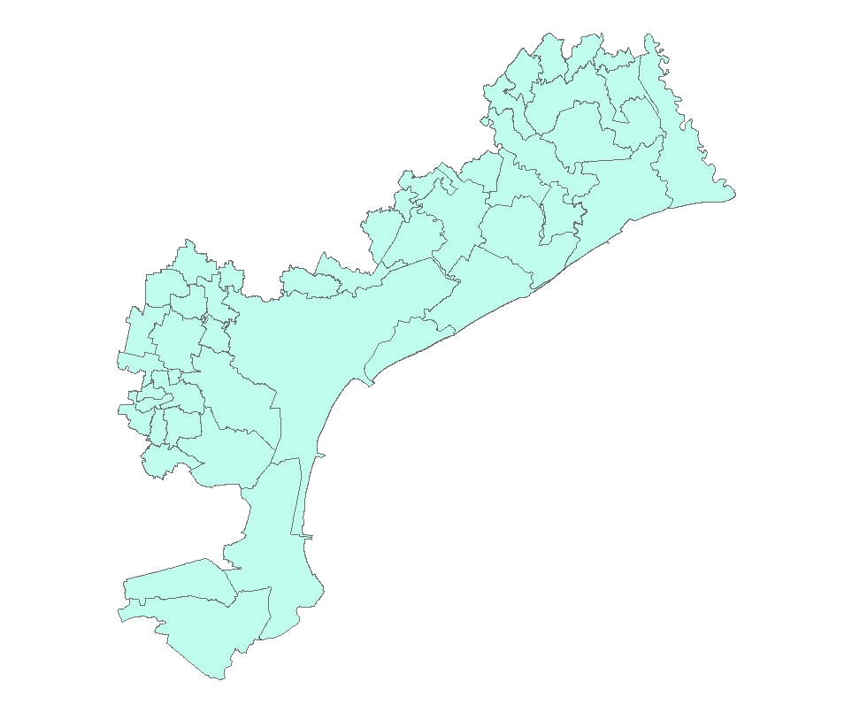
Figure 1: Municipalities of Venice. ArcGis output.

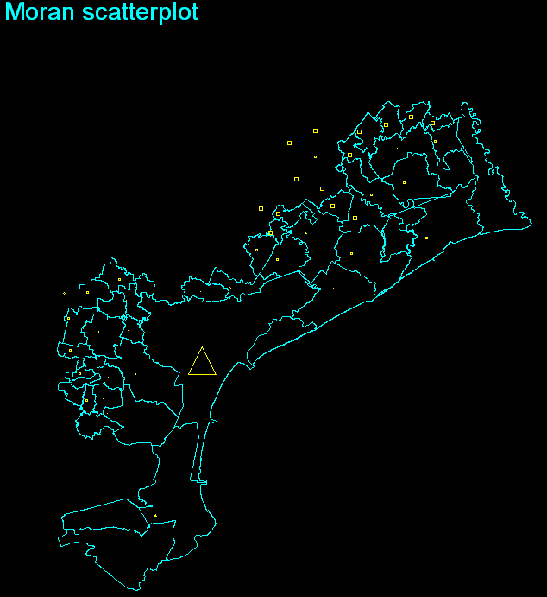
Figure 2: Moran scatterplot for Venice, 1991. Stata output.
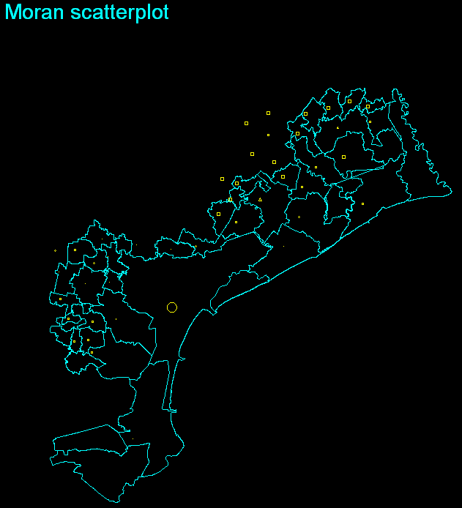
Figure 3: Moran scatterplot for Venice, 2001. Stata output.
Notes figure 2 and 3: A circle indicates spatial clustering of high values around a high value location (high-high spatial association), a square indicates low-low spatial association, a triangle means high-low spatial association and a diamond means low-high spatial association (Pisati, 2001).

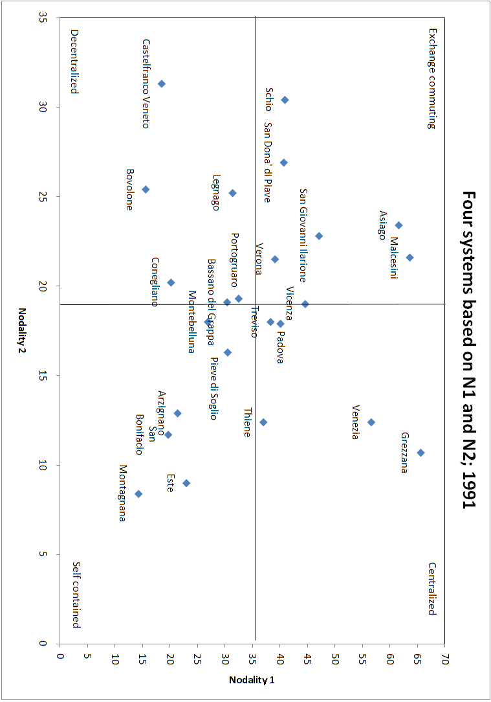
Figure 4: Types of systems based on N1 and N2, 1991.
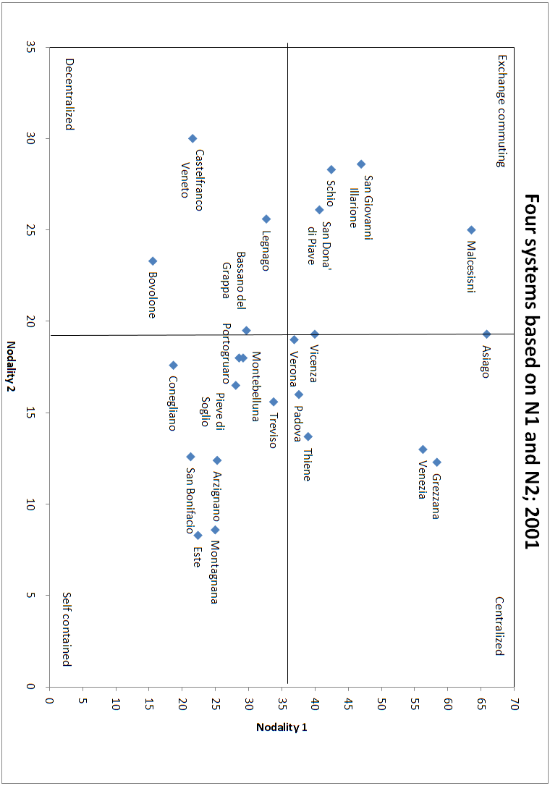
Figure 5: Types of systems based on N1 and N2, 2001.
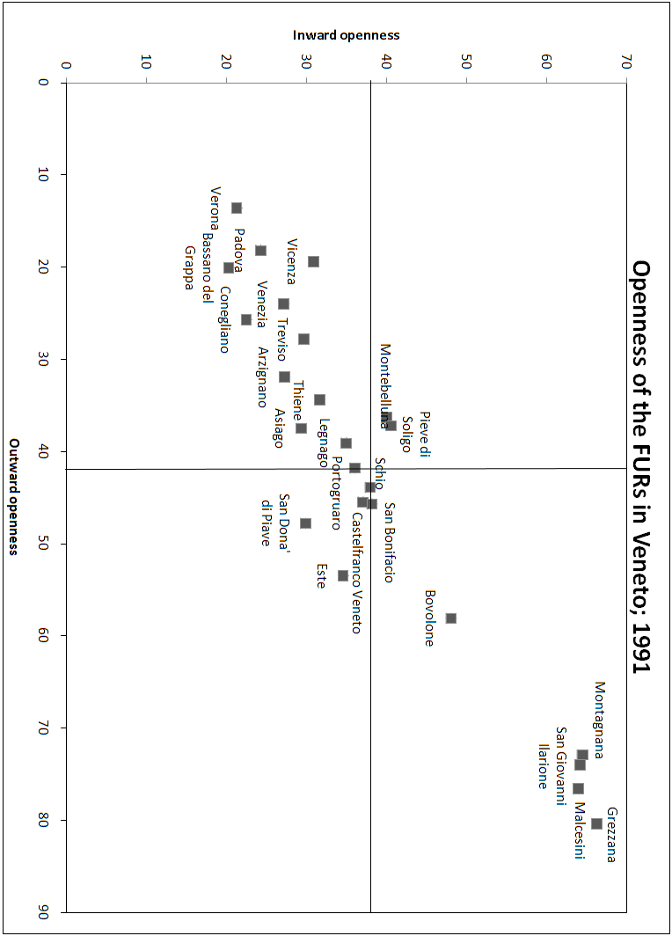
Figure 6: Openness of the FURs in Veneto, 1991.
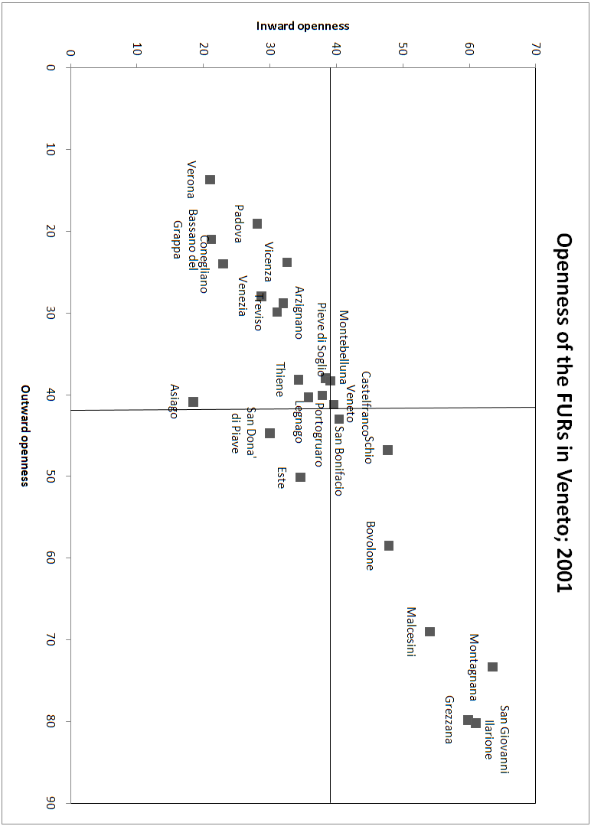
Figure 7: Openness of the FURs in Veneto, 2001.
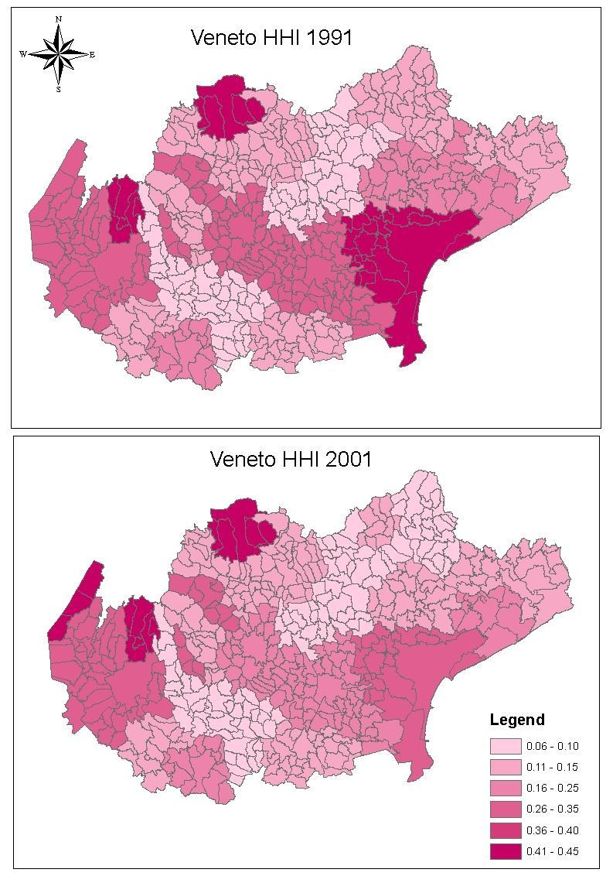
Figure 8: Maps of the HHI for the FURs in Veneto, 1991 and 2001. ArcGis output.
 | HHI
FUR | 1991 | 2001 | Difference (%)
132: Bovolone | 0.124 | 0.114 | - 7.5
133: Grezzana | 0.433 | 0.414 | - 4.2
134: Legnago | 0.206 | 0.198 | - 4.1
135: Malcesini | 0.334 | 0.406 | + 21.5
136: San Bonifacio | 0.068 | 0.068 | + 1.3
137: San Giovanni Ilarione | 0.287 | 0.296 | + 3.2
138: Verona | 0.308 | 0.277 | - 10.1
Table 1: HHI of the FURs in the province of Verona. 1991, 2001 and the difference.
 | HHI
FUR | 1991 | 2001 | Difference (%)
139: Arzignano | 0.134 | 0.128 | - 4.2
140: Asiago | 0.439 | 0.443 | + 0.8
141: Bassano Del Grappa | 0.104 | 0.106 | + 2.0
142: Schio | 0.327 | 0.343 | + 5.1
143: Thiene | 0.122 | 0.118 | - 3.9
144: Vicenza | 0.261 | 0.224 | - 14.1
Table 2: HHI of the FURs in the province of Vicenza. 1991, 2001 and the difference.

 | HHI
FUR | 1991 | 2001 | Difference (%)
151: Castelfranco Veneto | 0.064 | 0.064 | - 0.4
152: Conegliano | 0.101 | 0.089 | - 12.2
153: Montebelluna | 0.094 | 0.099 | + 5.2
154: Pieve Di Soligo | 0.145 | 0.152 | + 4.9
155: Treviso | 0.168 | 0.135 | - 19.9
Table 3: HHI of the FURs in the province of Treviso. 1991, 2001 and the difference.

 | HHI
FUR | 1991 | 2001 | Difference (%)
156: Portogruaro | 0.129 | 0.116 | - 9.9
157: San Dona’ Di Piave | 0.221 | 0.230 | + 4.0
158: Venezia | 0.423 | 0.337 | - 20.3
Table 4: HHI of the FURs in the province of Venezia. 1991, 2001 and the difference.
 | HHI
FUR | 1991 | 2001 | Difference (%)
159: Este | 0.116 | 0.125 | + 8.1
160: Montagnana | 0.077 | 0.078 | + 1.4
161: Padova | 0.249 | 0.222 | - 10.9
Table 5: HHI of the FURs in the province of Padova. 1991, 2001 and the difference.
 | HHI
Province | 1991 | 2001 | Difference (%)
Verona | 0.048 | 0.043 | - 11.8
Vicenza | 0.048 | 0.043 | - 11.8
Treviso | 0.031 | 0.023 | - 25.0
Venice | 0.263 | 0.198 | - 25.0
Padova | 0.162 | 0.145 | - 10.2
Table 6: HHI of the different provinces at the inter-urban scale. 1991, 2001 and the difference.
Notes: An HHI of about 0.20 is assumed to be (relatively) high. Low values of the HHI mean high morphological polycentricity. A decrease of the HHI thus means more morphological polycentricity. The calculated differences can deflect because of rounding errors.

 | Distance band | I | E (I) | Z | p-value
Verona
1991 | 12500 | 0.028 | -0.010 | 3.433 | 0.000*
2001 | 12500 | 0.032 | -0.010 | 3.501 | 0.000*
Vicenza
1991 | 25000 | 0.006 | -0.009 | 1.224 | 0.110
2001 | 25000 | 0.011 | -0.009 | 1.521 | 0.064**
Treviso
1991 | 9500 | 0.032 | -0.010 | 1.218 | 0.112
2001 | 9500 | 0.041 | -0.010 | 1.325 | 0.093**
Venice
1991 | 21000 | 0.000 | -0.021 | 1.789 | 0.037*
2001 | 21000 | 0.005 | -0.021 | 1.832 | 0.033*
Padova
1991 | 10000 | 0.035 | -0.011 | 4.127 | 0.000*
2001 | 10000 | 0.037 | -0.011 | 4.051 | 0.000*
Table 7: Results Moran’s I.
Notes: I = Moran’s I. E (I) = the expected value of Moran’s I, thus indicating a randomly distribution of values. The z-score refers to the normal distribution: 1.65 for the 0.10 level, 1.96 for the 0.05 level and 2.58 for the 0.01 level. * meaning that the p-value is significant at the 0.05 level and ** for the 0.010 level.
Verona:
 | I | E(I) | Z | p-value
1991
San Giovanni Lupatoto | 0.408 | -0.010 | 3.338 | 0.000*
San Martino Buon Albergo | 0.272 | -0.010 | 2.303 | 0.011*
Verona | 0.788 | -0.010 | 6.409 | 0.000*
2001
Bussolengo | 0.158 | -0.010 | 1.302 | 0.096**
San Giovanni Lupatoto | 0.470 | -0.010 | 3.723 | 0.000*
San Martino Buon Albergo | 0.266 | -0.010 | 2.190 | 0.014*
Verona | 0.947 | -0.010 | 7.472 | 0.000
Table 8: Results LISA Verona.

 | I | E(I) | Z | p-value
1991
Arzignano | 0.186 | -0.009 | 1.730 | 0.042
Bassano del Grappa | -0.335 | -0.009 | -3.039 | 0.001*
Montecchio Maggiore | 0.165 | -0.009 | 1.589 | 0.056**
Vicenza | -0.291 | -0.009 | -3.060 | 0.001*
2001
Arzignano | 0.236 | -0.009 | 2.127 | 0.017*
Bassano del Grappa | -0.357 | -0.009 | -3.192 | 0.001*
Montecchio Maggiore | 0.195 | -0.009 | 1.835 | 0.033*
Vicenza | -0.131 | -0.009 | -1.328 | 0.092**
Table 9: Results LISA Vicenza.

 | I | E(I) | Z | p-value
1991
Treviso | 0.995 | -0.010 | 4.532 | 0.000*
Villorba | 0.856 | -0.010 | 3.712 | 0.000*
Vittorio Veneto | -0.406 | -0.010 | -1.763 | 0.039*
2001
Treviso | 1.362 | -0.010 | 5.741 | 0.000*
Villorba | 0.988 | -0.010 | 3.960 | 0.000*
Vittorio Veneto | -0.465 | -0.010 | -1.879 | 0.030*
Table 10: Results LISA Treviso.

 | I | E(I) | Z | p-value
1991
Venice | -0.677 | -0.021 | -4.239 | 0.000*
2001
Venice | -0.512 | -0.021 | -3.100 | 0.001*
Table 11: Results LISA Venice.

 | I | E (I) | Z | p-value
1991
Abano Terme | 0.325 | -0.011 | 2.732 | 0.003*
Padova | 0.916 | -0.011 | 7.810 | 0.000*
Rubano | 0.211 | -0.011 | 1.801 | 0.036*
Selvazzano Dentro | 0.155 | -0.011 | 1.326 | 0.092**
Vigonza | 0.182 | -0.011 | 1.512 | 0.065**
2001
Abano Terme | 0.259 | -0.011 | 2.200 | 0.014*
Padova | 1.009 | -0.011 | 8.486 | 0.000*
Rubano | 0.226 | -0.011 | 1.895 | 0.029*
Vigonza | 0.177 | -0.011 | 1.441 | 0.075**
Table 12: Results LISA Padova.
Notes: I = Local Moran’s I. E (I) = the expected value of Moran’s I, thus indicating a randomly distribution of values. * meaning that the p-value is significant at the 0.05 level and ** for the 0.010 level.
The interpretation of the LISA is actually more refined as was set forth in chapter 5; it is therefore possible that the local Moran’s I is larger (smaller) than 1 (-1).
 | Inward Openness |  |  | Outward Openness
 | 1991 (%) | 2001 (%) | Difference | 1991 (%) | 2001 (%) | Difference
132: Bovolone | 48.1 | 47.9 | -0.2 | 58.1 | 58.5 | 0.4
133: Grezzana | 66.3 | 59.8 | -6.4 | 80.4 | 79.8 | -0.7
134: Legnago | 35.0 | 35.8 | 0.8 | 39.1 | 40.3 | 1.2
135: Malcesini | 64.0 | 54.1 | -9.9 | 76.6 | 69.0 | -7.6
136: San Bonifacio | 38.2 | 40.4 | 2.1 | 45.7 | 43.0 | -2.7
137: San Giovanni Ilarione | 64.2 | 61.0 | -3.2 | 74.0 | 80.2 | 6.3
138: Verona | 21.3 | 21.0 | -0.4 | 13.6 | 13.7 | 0.1
139: Arzignano | 27.3 | 32.0 | 4.7 | 31.9 | 28.8 | -3.1
140: Asiago | 29.4 | 18.5 | -10.9 | 37.5 | 40.9 | 3.4
141: Bassano del Grappa | 20.3 | 21.2 | 0.9 | 20.1 | 21.0 | 0.9
142: Schio | 38.0 | 47.7 | 9.7 | 43.9 | 46.8 | 2.9
143: Thiene | 31.7 | 34.3 | 2.6 | 34.4 | 38.2 | 3.8
144: Vicenza | 30.9 | 32.6 | 1.7 | 19.4 | 23.8 | 4.4
151: Castelfranco Veneto | 37.1 | 39.6 | 2.5 | 45.5 | 41.2 | -4.3
152: Conegliano | 22.5 | 23.0 | 0.5 | 25.7 | 24.0 | -1.7
153: Montebelluna | 40.0 | 39.1 | -0.9 | 36.3 | 38.3 | 2.0
154: Pieve di Soligo | 40.6 | 38.4 | -2.1 | 37.2 | 38.0 | 0.8
155: Treviso | 29.7 | 31.1 | 1.5 | 27.8 | 29.9 | 2.1
156: Portogruaro | 36.1 | 37.9 | 1.8 | 41.8 | 40.1 | -1.7
157: San Dona’ di Piave | 29.9 | 30.0 | 0.1 | 47.8 | 44.7 | -3.1
158: Venezia | 27.2 | 28.7 | 1.5 | 24.0 | 28.0 | 4.0
159: Este | 34.6 | 34.6 | 0.0 | 53.5 | 50.1 | -3.4
160: Montagnana | 64.5 | 63.5 | -1.0 | 72.9 | 73.3 | 0.4
161: Padova | 24.3 | 28.1 | 3.8 | 18.2 | 19.1 | 0.9
Aggregated difference |  |  | 5.5 (4.0) |  |  | -0.8 (29.5)
Table 13: IO and OO of the FURs in Veneto. 1991, 2001 and the difference.
Notes: the calculated difference can deflect because of rounding errors. The number between brackets is the aggregated difference when four small FURs are left out.

Other mechanisms are: unexpected creativity and reciprocity (Batten, 1995).
Other characteristics are: A number of historically distinct cities, lack of a clear leading city, consisting of a small number of larger cities, located in close proximity, constitute independent political entities.
http://www.sapere.it/enciclopedia/Rovigo+%28provincia%29.html
http://dawinci.istat.it/daWinci/jsp/MD/misc.jsp?p=2&pd=610 and http://www.istat.it/ambiente/cartografia/
http://dawinci.istat.it/daWinci/jsp/MD/download/sll_sist_loc_lav.xls and http://www.istat.it/strumenti/definizioni/comuni/elenco_comuni_italiani_30_giugno_2010.xls
This includes the people ‘commuting’ inside one municipality. Therefore, the HHI indicates employment.
http://help.arcgis.com/en/arcgisdesktop/10.0/help/index.html#//005p00000012000000.htm
Idem
http://help.arcgis.com/en/arcgisdesktop/10.0/help/index.html#//005p00000012000000.htm
Verona, Vicenza, Treviso, Venice and Padova.
http://help.arcgis.com/en/arcgisdesktop/10.0/help/index.html#//005p0000000t000000.htm
Idem

