Determinants of organ donation
Explanation of variables influencing cross-country differences
7-7-2010

Loes Stevens, 311014
Supervisor: Pilar García Gómez
7-7-2010

Section Health Economics

Index

1. Introduction 1

2. Problem of donor organ shortage 2

3. Overview of determinants of organ donation, according to several studies 4
3.1 Presumed versus informed consent 5
3.2 Donation potential 6
3.3 Religion 7
3.4 Other factors 8
3.5 New factors of importance 9
3.6 The ‘Spanish model’ 10

4. Empirical study of the influencing factors 11
4.1 Data sources and selection of countries included in the analysis 11
4.2 Variables used and descriptive statistics 12
4.3 Multiple regression results 15
4.4 Policy implications 18
4.5 Limitations of the analysis 19

5. Discussion and conclusion 20

6. References 22

7. Appendix 25

1. Introduction

In many developed countries, increasing the number of donors and thereby decreasing waiting lists for donor organs is an important subject on the health policy agenda as organ transplantation is an important, and sometimes even the only, option to treat organ failures (Cameron and Forsythe, 2001). Donor organs can save lives, but supply cannot keep up with demand, creating and increasing waiting lists. Still, when comparing cadaveric donation rates of different countries, large differences exist. The Netherlands for example, had a cadaveric donation rate of 13 donors per million people in 2009, while neighbouring country Belgium had 25 cadaveric donors per million people; meaning Belgium had more than two times as much cadaveric donors per million inhabitants than the Netherlands last year (Transplant procurement management, 2010). This implies it might be instructive to look the way to deal with this problem of other countries when trying to increase donation rates. But it also raises questions on what determinants are actually influencing these donation rates.
Existing studies on this subject mainly focus on the effect of different legislative systems on donation rates (For example; Gimbel, 2003; Abadie and Gay, 2006; Neto, 2007; Healy, 2005; Johnson and Goldstein, 2003). Two of those systems exist; presumed consent policy and the informed consent system. A presumed consent system implies inhabitants of a country should opt-out if they do not want their organs to be used for donation purposes after their death. If they do not opt-out, they are considered to have permitted they want to be donors. In countries applying an informed consent system, people are expected to opt-in if they do want to be a donor. In daily practice, differences between the systems are faded as in both systems family consent is often a condition for extracting organs (Cameron and Forsythe, 2001). These between country comparisons try to study the effect of presumed consent law on donation rates and correct for other variables, such as GDP, predominant religion in a country, the number of traffic deaths and health expenditure. Countries with a presumed consent system often do show significantly higher donation rates than countries using an informed consent system to register donors.
In this thesis the goal is to study a broader range of determinants and to check their influence on donation rates. In the studies mentioned before that study the effect of presumed consent law, just a few factors are studied in isolation. In this thesis, the factors taken account for in other studies are studied jointly and some new factors, such as population density and acute care beds, are included in the analysis. The main question of this thesis therefore is: what are the determinants of organ donation? Using ordinary least squares regression method, the analysis shows that GDP, the number of traffic deaths, religion, population density and acute care beds have the strongest effect on a country’s donation rates. Also, confirming other studies, countries with presumed consent systems have significantly higher donation rates (Gimbel, 2003; Abadie and Gay, 2006; Neto, 2007).
After this introduction, the organ shortage problem will be stressed in chapter two. In chapter three, an overview will be presented on articles studying which variables might influence donation rates. In paragraph 3.5, the so called ‘Spanish Model’ will be explained. In chapter four, a multiple regression will be performed, using independent variables discussed in chapter three together. Also, limitations of this analysis will be discussed. Chapter five concludes.

2. Problem of donor organ shortage

In the Netherlands, waiting lists exist for every organ suitable for transplantation. For example, at this moment 952 people are waiting for a kidney and they will have to wait on average four years before transplantation will take place (Nierstichting Nederlandª, 2010). For other organs than kidneys, this waiting time is about one year. In 2007, 152 people in the Netherlands died while being on the waiting list for an organ that could have saved their lives (NRC Handelsblad, June 11 2008). The large gap between supply and demand of donor organs prevented them from getting one. This is not a problem only occurring in the Netherlands. Everywhere in the world, this shortage of organs is present and countries are trying to cope with it. In the European Union, 60.000 people are on waiting lists, twelve of which die each day (European Parliament, 2010).
The first organ transplant in the Netherlands, a kidney, was performed in 1966 (Nierstichting Nederland^{b}, 2010). Since then, demand for organs has kept on rising. The main reason for this ascension is that risks attached to organ transplantation have been reduced, in particular due to improved medicines available to reduce rejection of the donor organ by the patient. This makes organ transplantation an increasingly good alternative for other treatments diseases damaging organs. Also, patients who would not have been placed on the waiting list a few years ago because they were too weak to undergo the transplantation process now do qualify for one of the scarce donor organs, thereby increasing the waiting lists (Howard, 2007). Another reason is that asking payments for donor organs is against the law in almost every country in the world (Becker and Elias, 2007).
Organs available for transplantation are the kidney, skin, pancreas, liver, heart, lungs, bone marrow and intestines. For people who suffer from a renal disease, kidney transplant can result in a longer and healthier life. Dialyses can take over the kidney function, but it is a major restriction of daily life, as it means three to five hospital visits a week are necessary to filter the blood (Nierstichting Nederland^{c}, 2010). For some diseases of the heart, lung, liver, pancreas and bone marrow, where no other treatment or medicine is available, transplantation can not only grant patients a healthier life, but it will also be the last option to save the patients lives (Neto, 2007).
A problem in supply of donor organs is, that only a small portion of the group of people who are registered as donors, will actually become donors after death. One condition is that the potential donor often must be brain dead (Nierstichting^{e}, 2010). Donor organs need blood that is full of oxygen, so once the potential donor is declared brain dead, artificial respiration will be applied in order to satisfy this condition. Also, family consent must be given, which also greatly reduces the number of actual donors.

2.1 Options to increase supply of donor organs

Donor organs can be granted while alive or after death. Live donation is only possible for kidneys and a liver. In the Netherlands, more than half of the total numbers of transplanted kidneys are donated by living donors (Nierstichting Nederland^{d}, 2010). Often, close family of the patient is donating an organ. As payments are often not allowed, altruism is the driving force behind the decision to donate. A reason why asking money for organs is prohibited in a lot of countries is that poor people might otherwise be persuaded by the money to ‘sell’ their organs (Becker and Elias, 2007). In Iran however, waiting lists were resolved after introducing a ‘compensated and regulated living-unrelated donor renal transplant program’ in 1988 (Ghods and Savaj, 2006). These authors state that this system actually decreased persuasion of unpaid related donors, who otherwise might have felt obligatory to donate. Some authors therefore explore whether monetary incentives would be a way in which waiting lists might decrease (Becker and Elias, 2007).
Another method in trying to increase living donation rates is by introducing a ‘barter system’. If someone wants to donate his or her kidney to someone, there has to be a match in blood-types. This might work as a large restriction. Therefore, a cross-over system exists in some countries, including the Netherlands, in which two incompatible couples donate to each other in order to make donation possible despite non-matching blood types (Roth, 2007).
As living donation is possible only for the kidney and the liver and as even for these organs supply does not meet demand, cadaveric organ donation also is necessary. There are also a few options to increase the cadaveric donation rate in a country.
As a dead person will not be able to give his or her consent to extraction of the organs, his or her opinion on organ donation needs to be registered during his or her life. Two systems can be distinguished. The opt-in, or the informed consent system, requires people to state they want to be a donor during their lives. If they do not register their choice, they will not be a donor or their family decides. The opt-out, or presumed consent system, enhances exactly the opposite situation. Every person is registered as a donor automatically, unless they register during their lives they do not want to be a donor when they die. Although differences between those systems might seem large, there still is discussion whether changing the system from an opt-in version to an opt-out system will actually raise donation rates. In most countries, family consent is still required, no matter what the deceased registered during his life. This flattens out differences that occur between the systems.
Before and after studies of countries that changed from an informed to a presumed consent system show an increase in donation rates. In Belgium for example, kidney donation went from 18.9 to 41.3 per million people in just three years (Roels, 1991). However, it is difficult to control these results for changes of other factors in the same time as the change in legislative system, for example changes in the organization of organ donation in that country (Rithalia, 2000).
Other options that are mentioned in literature that might increase supply of organs without using organs from another human being, include xenotransplantation, which means organs from animals are treated in such a way they can be transplanted into human corpses. This is not possible until this very moment and will certainly take many more years of research. The same counts for stem cells that can be used to fix or create organs. Authors estimate decades of research are still needed before stem cells can actually be a solution to the organ shortage problem (Cameron and Forsythe, 2001).
So, although the problem of the shortage of donor organs and its consequences are quite clear, every country is struggling to increase donation rates. As these rates still differ significantly between countries, it looks like countries can learn from each other. Identifying the determinants of these differences might help finding out what factors might improve donation rates.

3. Overview of determinants of organ donation, according to several studies

In this chapter, an overview of factors is presented which, according to four different studies on the subject, are of significant influence in explaining the differences in donation rates between countries (Gimbel, 2003; Abadie and Gay, 2006; Neto, 2007; Healy, 2005). A systematic review on this topic (Rithalia et al, 2008) identified these four studies as being statistically well performed and of good quality in terms of data collection and other criteria. The four studies each examine whether the impact of a presumed consent system is significant in explaining the differences in donation rates between countries.
The studies use data of different countries. Healy (2005) and Abadie and Gay (2006) use 17 and 22 OECD countries respectively and Gimbel (2003) includes 28 European countries. Neto (2007) uses the most heterogeneous sample with 34 countries, including OECD countries, but also Latin countries with low cadaveric donation rates, like Argentina, Brazil, Chile and Venezuela. Gimbel (2003) excludes Spain in their analysis, because of the country being a large outlier. Healy (2005) excludes both Spain and Italy, as these countries have the highest growth rate in donation rates, causing the residuals for these countries are not evenly distributed around zero.
The data used in these studies also cover different time spans. Gimbel (2003), because of data availability problems, uses data collected from several years, ranging from 1995-1999. Neto (2007) uses data of between 1998-2002, Abadie and Gay (2006) between 1993-2002 and Healy (2005) between 1990-2002.
In their statistical analyses, they each correct for a different set of factors that, according to them, also influence differences in donation rates. The influence of these factors is explored in this chapter. Also, the influence of some new factors is explained, which are suggested by other studies and might influence donation rates, but which are not included in any existing study.

3.1 Presumed versus informed consent

The implementation of presumed consent law is a huge subject in a lot of countries trying to improve their donation rates. In the OECD, a majority of the countries has a system of presumed consent law, but large countries as the USA, Australia, Canada and New Zealand still have an informed consent system (Abadie and Gay, 2007). The difference between the systems is the default option. When someone does not make a choice, he will be a donor in the presumed consent system, but he won’t be one in the informed consent system. Setting of defaults can influence behavior as accepting the default will cost no effort and people may see it as the recommended option to choose (Johnson and Goldstein, 2003). This implies changing the system could help increase donation rates in a country.
There are only a few countries where this presumed consent system exists as described. ‘Weaker’ versions of these systems exist in almost every country; in these ‘weaker’ systems, families have veto in whether the organs are donated or not (Healy, 2006). Austria is one of the only countries where families do not have a veto in whether the organs are donated. So Austria really applies the presumed consent rule; if you are not registered as being opposed to donation, you will be a donor. It therefore has a stronger version of the presumed consent system, with a high cadaveric donation rate of 25 per million people in 2009 (TPM, 2010). The Netherlands are an example of a ‘strong’ informed consent system in which less emphasis is placed upon the opinion of the family, but only if someone is registered in the donor registry, which is about one third of the population. If not registered, the family does decide what happens with the organs of the deceased. As in all presumed consent countries, except for Austria, the family can refuse donation, even if someone was not registered as opposed to donation, this family consent weakens the differences between both systems and it has implications for the impact of legislation on donation rates (Healy, 2006). In informed consent systems, the family knows whether the deceased has agreed to donate or not. In presumed consent, the family only knows whether they did or did not opt out. This might be a weaker sign, leading to decreasing family consent rates (Howard, 2007). This suggests changing toward a presumed consent system will not result in a significant increase in donation rates. Arguments for an influence in the opposite direction are also provided, as in presumed consent systems, choosing for organ donation might be considered as the status quo, leading to higher rates of family consent (Johnson and Goldstein, 2003).
Three of the studies found a significant positive influence of countries with a presumed consent system on donation rates, ranging from 21% to 30% higher donation rates and 2.7 to 6.14 more donors per million population (Neto, 2007; Abadie and Gay, 2006; Gimbel, 2003; Healy, 2005). Different reasons are given for the results however. Abadie and Gay (2006) point at the signaling function of the opt-out system, which they think works opposite as stated by Howard (2007). As people who have a strong aversion towards donation can opt out, family of the remaining people will assume their relative had a preference to donate. In the opt-in system, if someone does not register, often the large part of the population, the family assumes they did not have a preference to donate.
Healy (2005), who did not found a significant impact, argues that the fact that donation rates are a little higher on average in countries with an opt-out system, is not due to the ‘default effects’ described by Johnson and Goldstein, but because these countries are paying closer attention to the way they organize their transplant system. He points at Spain and Italy; countries with a presumed consent system and with high donation rates that are increasing since 1990, not due to their system that has existed since 1979, but due to changes in the way of handling organ donation in hospitals, the so called ‘Spanish system’.
So, of the four studies, in three presumed consent systems has a significant effect; only Healy (2005) does not find a positive effect which is significant at conventional levels. The differences in countries and years included in the analysis were discussed in the beginning of this chapter. Healy (2005) excludes Spain and Italy from his analysis, which, being presumed consent countries with high donation rates, might have a large impact on the significance and size of the effect.

3.2 Donation potential

There are globally three main factors influencing the amount of donors in a country. The chosen presumed or informed consent system in a country, the organization of the donation process and the donation potential. Not every dead person’s organs can be used for donation. Most organs can only be donated if a person is declared brain dead and their blood circulation is maintained artificially (Neto, 2007). The donor potential of a country is the number of people in that country who die because of a specific cause of death, of which the organs might apply for donation. The main causes of death for donors are cerebrovascular diseases and traffic accidents, together taking account of a large part of donors (NIVEL, 2003).
It is argued that this is one of the explanations of the low donation rates of the Netherlands. In a study performed by NIVEL on donor potential of ten European countries, the Netherlands have the lowest number of people dying of three specific causes of death making organ donation possible. Especially traffic deaths and accident deaths are low in the Netherlands, which might be because of strict regulations concerning (car) safety (NIVEL, 2003).
Most of the studies include a variable as ‘cerebro-vascular diseases and motor vehicle deaths per million inhabitants’ in their analysis. Donation rates are expected to be higher if more people in that country die as a result of these causes. In two of three studies, the amount of cerebro-vascular deaths per 100 000 inhabitants were of significant positive influence on donation rates, while road traffic mortality per 100 000 inhabitants was significant in all three studies. It looks like traffic mortality is of greater impact on donation rates than cerebro-vascular deaths (Healy 2006, Abadie and Gay, 2006 and Neto, 2007).

3.3 Religion

The effect of religious beliefs on organ donation is a widely studied subject. Historically, most religions were against organ donation, as it is a way of mutilating one’s body, given by God (Rumsey et al, 2003). Altruistic gestures are valued in every religion however. Now, most religions see organ donation as an act of love and generosity and it is allowed as long as the cadaver is treated with respect. Still, some religions are more positive towards it than others. The views of the largest religions on cadaveric organ donation are discussed here.
Christianity, the largest religion in the Western world, has a fairly positive view on organ donation. The human cadaver deserves respect, but mutilation of the body is not an obstruction of being close to God. Organ donation is an act of love, and therefore a good thing. The Islam, an upcoming religion in all European countries, is more divided on this subject. Under certain circumstances, it does allow transplantations. It is only allowed if physicians decide it is the best treatment for the patient. If a living donor is used, he should do this out of his own free will and there should be no significant risk involved for him. In Judaism, being buried while missing parts of the body is a problem. Also, it is seen as exploitation of the corpse. However, if organ donation is necessary to save a life and it incurs no risk for the donor, it is allowed. Shintoism, which is a very large religion in Japan, does not approve of cadaveric organ donation as mutilating a corpse is seen as a crime. This is one of the reasons why donation rates in Japan are very low; about 0.9 per million inhabitants in 2008 (Martinelli, 1993).
Three out of four studies included a dummy variable for religion in their analysis. However, only the influence of Catholicism is studied, as the group of countries studied were mostly western, Christian countries (Neto, 2007; Abadie and Gay, 2006; Gimbel et al, 2003). The outcomes are not very convincing; although influences seem to be positive, they are not significant (Abadie and Gay, 2006) or only for certain centiles (Neto, 2007). In one study the effect is significant and positive. Here, percentages of the Catholic population, instead of a dummy, were used (Gimbel et al, 2003).
In other studies searching for the effects of other religions as the Islam and Judaism, a significant negative effect was found (Anbarci and Caglayan, 2005). This is conform expectations, as the Islam and Judaism have a more negative point of view on organ donation than Catholicism.

3.4 Other factors

Apart from these factors, there are others that, according to these studies, influence donation rates. Gross domestic product is included in three out of four studies, and found of significant positive influence in all of them. Performing organ transplants requires an expensive process and infrastructure and is therefore more efficiently performed in wealthy countries, which have a higher GDP, therefore also more money to spend on health care and on the organ transplantation process (Healy, 2006).
The influence of healthcare expenditure has a similar line of reasoning as the gross domestic product variable. One would expect donation rates to be higher if a country is spending more of its resources on health care. Three studies investigate this influence. Abadie and Neto use health expenditure per capita as their independent variable, while Healy chooses for public health care spending as a percentage of GDP. Because of collinearity problems, in both studies the effects of health care expenditure and GDP are investigated in different models. In one study, a positive and significant influence is found (Abadie and Gay, 2006). In the other study, the impact of health expenditure per capita is positive but not significant (Neto, 2007).
Healy chose to look at public healthcare spending as a percentage of GDP. Both positive as negative effects would be arguable. People will be inclined to volunteer to be a donor if they know there is a decent, reliable system of financing organ transplantation. On the other hand, as stated before, organ donation is an expensive process; patients need a difficult operation and the treatment does not stop there but will continue for the rest of their lives, hoping the organ is not being rejected by their bodies. As public healthcare often only provides for basic healthcare, one could argue organ donation is not a form of basic healthcare. Therefore, higher public spending on healthcare as a percentage of GDP could also have a negative effect on donation rates (Healy, 2006). Indeed, a significant negative effect is found in the analysis performed.
Also, the legislative system is an indication of how it performs on organ donation. This variable is studied in two studies and is found of significant positive influence in both of them. Countries having a common law system have significantly higher organ donation rates than countries with a civil law system. The explanation given by Neto (2007) is that common law puts more emphasis on individual rights, while civil law is more focused on state rights.
Acquisition of donors is also a matter of making people understand the importance of the problem of a shortage of donor organs and increasing knowledge on how to become a donor. Increasing this knowledge might increase donation rates (Neto, 2007). To measure this effect, two studies include variables that approximate this knowledge. Access to the internet is a proxy for access to information about organ donation (Neto, 2007) and is indeed found of significant influence. Gimbel (2003) includes as an independent variable, the part of the population that has a higher education, assuming they have better knowledge about the organ shortage problem than people with less or lower education. This variable is also found of significant impact on donation rates, meaning information and knowledge of organ donation might increase the willingness to register oneself as a donor.
Gimbel (2003) includes a capacity variable in his analysis; the number of organ transplantation programs per million population. This captures the importance of the supporting infrastructure which is necessary in order to perform organ transplantation. This variable is of significant positive influence in the analysis (Gimbel, 2003).

3.5 New factors of importance

Smaller countries have higher donation rates than countries of greater size (Cameron and Forsythe, 2001). No explanation is given, but one could assume this has something to do with the organization of the organ transplantation process. This is a long process involving time limits, making it harder for countries with a lot of remote, rural, areas. In the analysis of next chapter, I will include a measure of population density, people per square kilometer, to capture this effect. The expectation is that countries with lower population density also have lower donation rates.
Another variable not used in one of the studies, but suggested by Rafael Matesanz, director of the ‘Organizacion Nacional de Trasplantes’ (National Transplant Organization in Spain), are acute care beds. He describes the importance of the number of acute care beds for the number of organ donations. As stated before, for a large part, cadaveric donors are people who are declared brain dead. Those people need to be taken care of adequately, in order to complete the process of organ procurement (Matesanz, 2003). The differences in number of intensive care unit beds between countries are an indication of the capacity to take care of the potential donors. He suggests the number of intensive care unit beds is relevant for organ donation (Matesanz, 2003). Therefore, a variable of acute care beds per 1000 population is included in the analysis.

3.6 The ‘Spanish model’
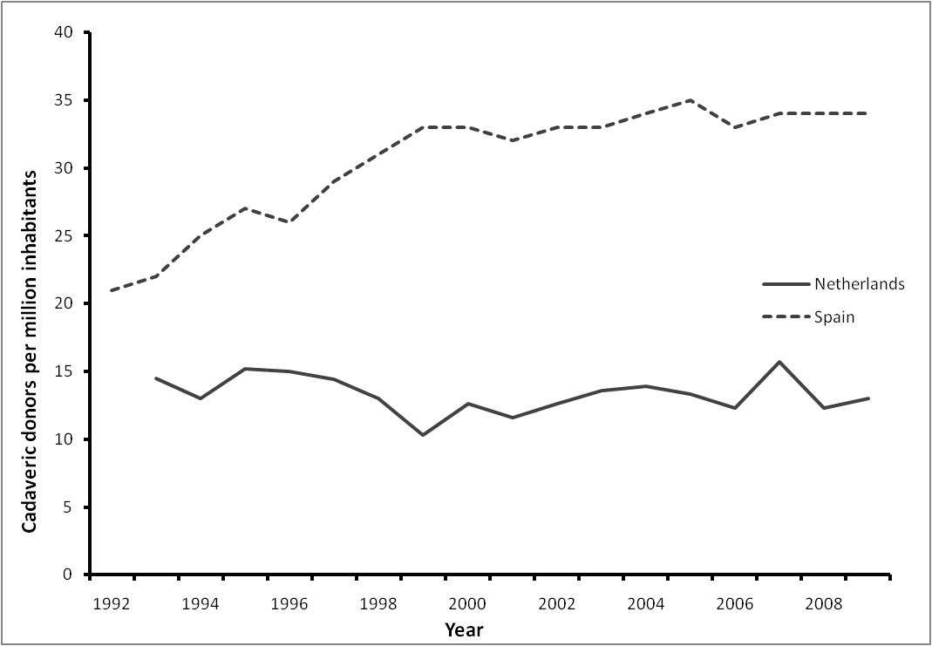
Figure 1: Cadaveric donors per million inhabitants in Spain and the Netherlands

A permanent outlier in all studies is Spain. With donation rates of more than 30 cadaveric donations per million inhabitants, it has by far the most efficient donation system in the world. As can be seen in figure 1, in the Netherlands donation rates are being stable or even slightly decreasing for the last 20 years. In Spain, donation rates have been rising in the same period of time. Waiting lists have decreased steadily during the 90s after a rise in the 80s (Cameron and Forsythe, 2001). Spain has a presumed consent system, but this is not seen as the reason of its high donation rates. In 1989, the ‘Spanish system’, as it is called in literature, was introduced. The system focused not especially on
increasing the number of people allowing for organ donation, but on actually using the existing donors more efficiently. In 1989, the National Organization of Transplants was introduced. So called ‘transplant coordinating teams’ are used on a hospital level, consisting of doctors and nurses in hospitals who are responsible for the coordination of the organ transplantation process. These teams are being trained. This helps overcoming problems leading to missed donation opportunities that occur in other countries of not identifying donors, or not asking families of a deceased person about whether they allow for organ donation (Matesanz, Miranda and Felipe, 1994; Matesanz, 2003).
Looking at the success of Spain, other countries studied whether they could implement parts of this system in their country. A number of factors are important when considering this. First, a country should have a public health sector covering all inhabitants. Also, there should be many doctors, nurses and intensive care unit beds available. Australia and Italy have tried increasing their donation rates using elements of the Spanish Model. In Tuscany, this led to an increase of the donor rate to more than 30 donors per million people in this region in just a few years (Matesanz, 2003).

4. Empirical study of the influencing factors
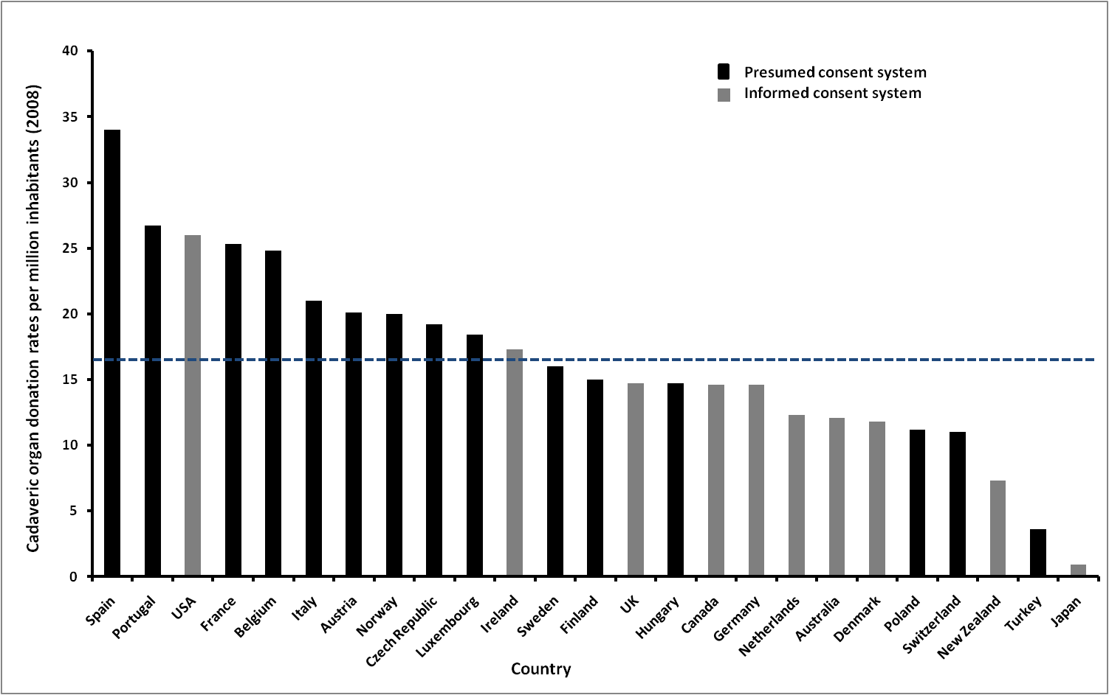
Figure 2: Cadaveric donation rates per million people (2008). The blue, dashed line indicates the average value.

In figure 2, donation rates for 2008 are given for a selection of 25 countries. Most of the countries in this sample are western, OECD countries. This figure shows a variation in donation rates of 0.9, in the case of Japan and 34, in the case of Spain, cadaveric donors per million inhabitants. An exploration of the ‘Spanish model’, explaining the high donation rate in Spain, was given in paragraph 3.5. In figure 2, the presumed and informed countries are presented in a different color. At first glance, it looks like presumed countries on average have higher donation rates than informed countries. Also, there are more countries with a presumed consent system included in the selection than countries with an informed consent system. In the previous chapter, a few studies that tried to identify the sources of the variation visible in figure 2 were discussed. In this chapter, an analysis with a combination of these variables will be performed to check their influence.

4.1 Data sources and selection of countries included in the analysis

The data on organ donation rates are from the Transplant Procurement Management Organization (TPM, 2010). Data on religion and legal systems come from CIA fact book (CIA, 2010). Causes of mortality are from the OECD health data (OECD, 2010). The other variables are from World Bank development indicator’s index (World Bank, 2010). All data refer to the period 2000-2007.

4.2 Variables used and descriptive statistics

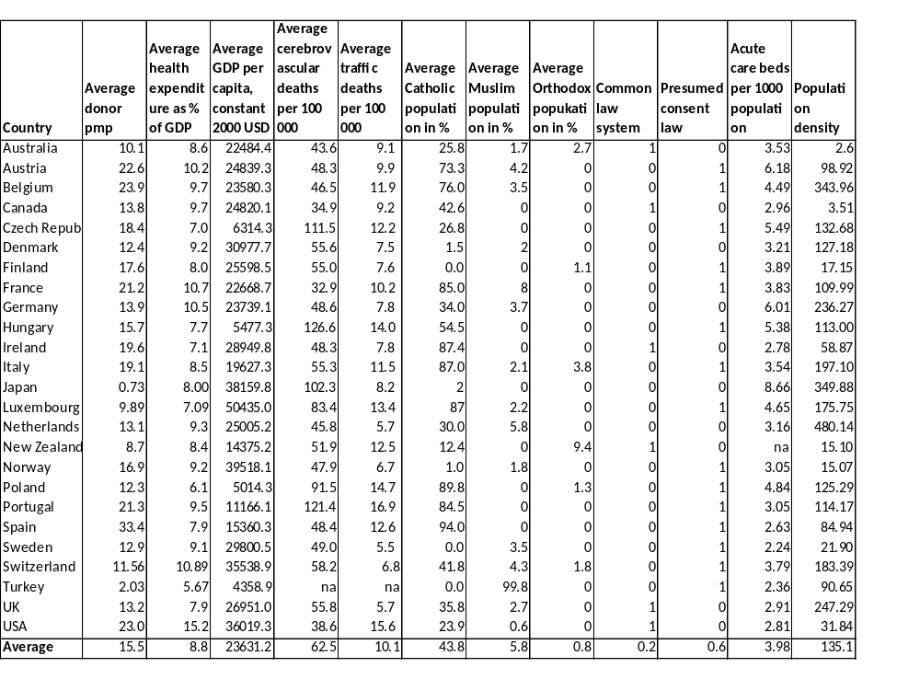
The dependent variable is the cadaveric donation rate per million people. This does not cover how many organs are actually retrieved, as often multiple organs are extracted from a cadaver. This rate also differs between countries. The dependent variable therefore only stresses how many people per million inhabitants are used for donation purposes in one particular year.
Table 1: Average values of the variables per country

The independent variables used are: a trend variable (year); GDP per capita (constant 2000 USD); health expenditure as a percentage of GDP; cerebrovascular deaths per 100 000 population; deaths resulting from traffic accidents per 100,000 population; percentage of population that is Catholic; percentage of the population that is Muslim; percentage of the population that has an orthodox religion; a dummy for legal system of a country (1 = common law system); a dummy for presumed consent system (1 = presumed consent system, 0 = informed consent system); acute care beds per 1000 population and the population density (people per square kilometer).
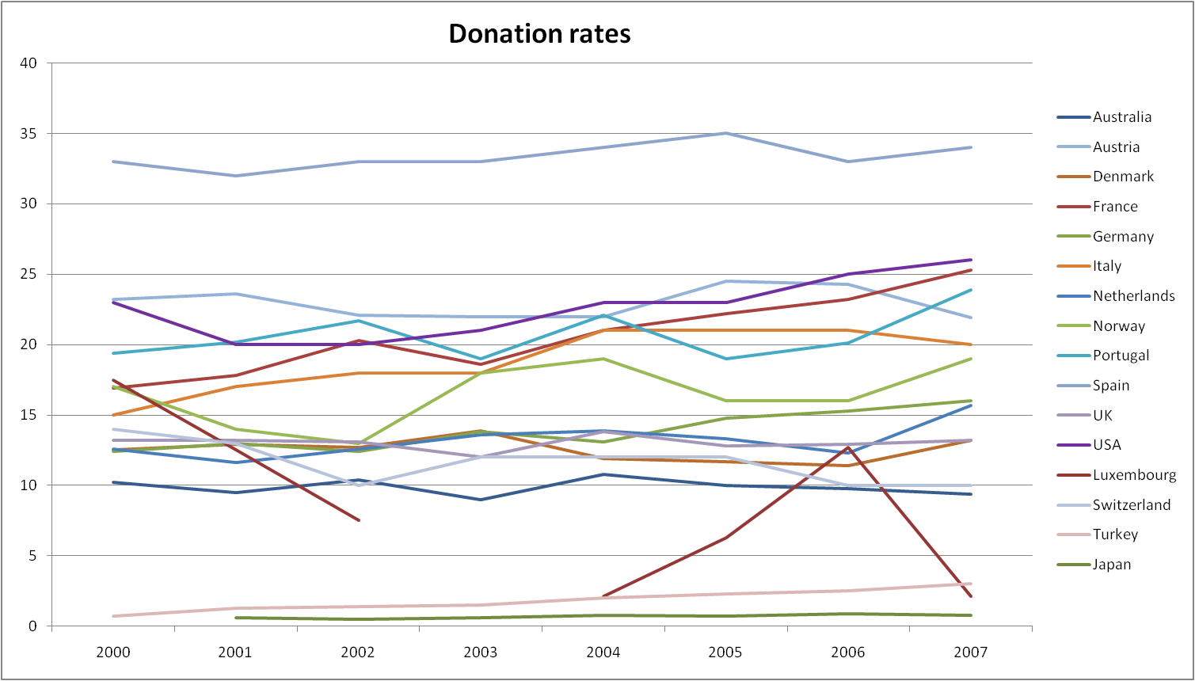
In table 1, average values of the variables are described for each country. Looking at health expenditure, the USA stands out with 15.2% of GDP spend on health care. Differences in GDP are large, varying from $5014 (Poland) to $50435 (Luxembourg); almost ten times as much. Of cerebrovascular deaths, four countries reach more than a hundred deaths per 100,000 population; Czech Republic, Japan, Hungary and Portugal. Most countries have a large part of their population being Catholic. This is not surprising, as the sample mainly contains western countries. Almost 20% of the countries have a Common Law system, and 60% of the countries in the sample have a presumed consent system. In population density, Belgium and the Netherlands both have a high number of people per square kilometer of almost three, respectively four times the average value.

Figure 3: Trend in donation rates

The sample contained 26 countries, 5 of which are discarded in the analysis. In figure 3, the trend of cadaveric donation rates for a few countries are plotted in a graph. One can see most countries are between 10 and 25 donors per million people and have slowly growing donation rates. The average growth rate of the countries, including the ones that are discarded in the analysis, in the period 2000 until 2007 was 2,6%. Japan and Spain were not included, as these are, both in opposite directions, large outliers concerning donation rates. Turkey, also an outlier with very low donation rates, was also discarded because of unavailability of data. Switzerland was excluded as it has an informed consent system officially, but because this varies per region of the country. Luxembourg was removed as it has a very small number of inhabitants (less than half a million) and greatly varying donation rates and a missing value, as can be seen in figure 3.
The remaining countries included in the analysis are: Australia, Austria, Spain, Portugal, USA, France, Belgium, Italy, Norway, Czech Republic, Ireland, Sweden, Finland, UK, Hungary, Canada, Germany, Netherlands, Denmark, Poland and New Zealand. The data concerns the period 2000-2007.
 |  | DMP (ln)
 | Year (2000 = 0) | 0.119
 | GDP (ln) | 0.108
 | Health expenditure | 0.3420**
 | Cerebrovascular deaths (ln) | -0.072
 | Traffic deaths (ln) | 0.2511**
 | Catholics | 0.461**
 | Muslims | 0.128
 | Orthodox | -0.4811**
 | Common Law | -0.2873**
 | Acute care beds (ln) | 0.1683*
 | Population density (ln) | 0.3377**
 | Presumed consent | 0.4820**

Table 2: correlation of all the independent variables on the number of cadaveric donors per million people

Before moving to the regression results, a bivariate correlation for each of the independent variables on the donation rate is produced, the results of which can be found in table 2. This correlation looks at the effects of each factor individually. Most variables are significantly correlated with the number of donors per million people and have their expected signs. The number of cerebrovascular deaths however, shows a negative correlation with the donation rate. This is remarkable, as these deaths constitute a great part of the deceased who can be converted into donors. The number of traffic deaths does show a positive and significant correlation. Comparing this outcome to other studies, it is often found that the number of traffic deaths have a greater impact on donation rates than the number of cerebrovascular deaths (Abadie and Gay, 2006; Neto, 2007; Healy, 2005). In the analysis performed in the next paragraph, regression techniques are used, in which the influence of these variables are corrected for the influence of other factors.

4.3 Multiple regression results

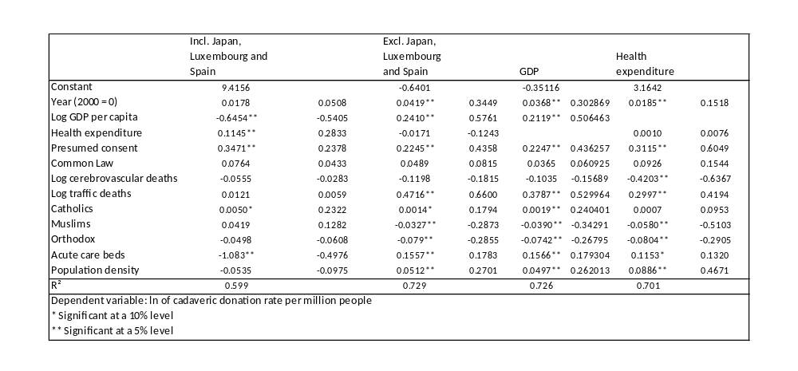
The method used in this analysis is linear multiple regression, using SPSS© version 15.0. All variables are included to check their influence, sign and significance. The next paragraph will look at the assumptions and whether they are met. Here, the results will be discussed. The main results can be found in table 3. In this paragraph, the outcomes per model and per variable will be discussed.
Table 3: Regression results, influence of independent variables on the number of cadaveric donors per million people
Four different models have been used. In the first one, the outliers Japan, Luxembourg and Spain are included. In the second model, they have been excluded. We can see that the R² increases by almost 13%. The model therefore better fits the data if the outliers are excluded. Also, the sign and influence of some of the variables change. The influence of a presumed consent system decreases from 35% to 22%, which is conform expectations as Spain is excluded, which is a presumed consent country with very high donation rates. GDP per capita changes sign; once the outliers are excluded, the influence of GDP becomes positive. This is probably as Luxembourg, with its enormously high GDP but variable donation rates, is excluded. The number of traffic deaths, acute care beds and population density become significantly positive too, which is probably because the removed outliers have high or low donation rates because of other reasons than donation potential or other factors. Spain introduced a model in which potential donors are more effectively procured into actual donors. In Japan, donation rates are low, not because the donor potential is low, but as Shintoism is a large religion and because heart beating cadaveric donation was forbidden by law until recently (Abadie and Gay, 2006).
In the third model, health expenditure is excluded, while in the fourth model, GDP is excluded. Excluding GDP decreases R² from 72,9% to 70,1%, while excluding health expenditure hardly decreases R². Excluding GDP does not make the influence of health expenditure significant.
Next, the outcomes per variable will be discussed. The second model, in which the outliers are removed, is used to interpret strength and significance of these variables.
First, the trend variable (‘year’) is of significant positive influence. This is as was to be expected, as the organ shortage problem is getting more attention and countries are trying to improve their donation rates. In the Netherlands for example, the law on organ donation was implemented in 1998. In the elections, some of the political parties stated they want to reform this law to a presumed consent law in order to increase donation rates (D66, 2010). The average growth rate per year of the countries included in the analysis from 2000-2007 is 2,6%. This trend variable was used to correct the other independent variables for differences between the years.
The logarithm of GDP also has significant positive influence on donation rates. This is also conform expectations, looking at the results of other studies. This confirms the assumption that wealthier countries are more likely to carry out a good transplantation process and therefore have higher donation rates. A one percent increase of GDP per capita will result in a 24,10% increase in donation rates.
Health expenditure as a percentage of GDP shows a negative, though not a significant effect. As influences were not clear in other studies, this might not be a surprising outcome. In table 2 however, the correlation of health expenditure on donation rates was significantly positive. Apparently, correcting for other factors, health expenditure does not influence donation rates. In the other studies, health expenditure was not measured together with GDP influence, because of multicollinearity problems. Using health expenditure as a percentage of GDP, like Healy (2005) did with public health expenditure, this problem was overcome.
The donation potential is estimated by the number of traffic deaths and cerebrovascular deaths per 100,000 inhabitants of a country. The number of cerebrovascular deaths per 100,000 inhabitants is negatively related to the number of cadaveric donors per million inhabitants. This influence is not significant however. This is an unexpected outcome, as cerebrovascular deaths constitute a large part of cadaveric donors. Therefore, a positive influence was to be expected. Most other studies also found the number of traffic deaths to have a stronger effect than cerebrovascular deaths. An explanation might be that traffic accident victims are more efficiently converted into donors (Healy, 2005).
The number of traffic deaths has a positive and significant influence on donation rates, confirming the results of other studies in which this variable was always positive and significant. In one case it was even the only variable of significant influence (Healy, 2005). A 1% increase in traffic deaths per 100,000 people results in a 47,16% increase in donation rates. It therefore has the largest impact of all variables included. In the Netherlands, the low number of traffic deaths is often used as an explanation of low donation rates. Studies do show the Netherlands have low donation potential, compared to other European countries (NIVEL, 2003). In the data used for this regression, the Netherlands also show very low rates of traffic deaths and cerebrovascular deaths compared to other countries. Countries with a higher donation potential, like Belgium, France and Spain, also show very high donation rates, as can be seen in figure 3 in the beginning of this chapter (NIVEL, 2003). Of course, this is not the only explanation, as more factors differ between these countries. They for example also all have presumed consent systems. And especially in the case of Spain, where a large part of their high donation rates can be explained by their efforts put into a more effective transplantation system, the reason of their high donation rates should be sought into a combination of factors.
Three variables try to catch the influence of religion on donation rates. Because of multicollinearity problems, not all religions can be included in the analysis. Three are used here; as most countries included in the analysis are western, Catholic countries, this religion is included. This is also the religion mostly studied (Abadie and Gay, 2006; Neto, 2007; Gimbel, 2003). In those studies however, a dummy was included in the analysis, being set on 1 if the country had more than 50% of their population being Catholic. In this analysis, percentages are used to differ more precisely. Also, the Islam is included, as this is a religion coming up in a lot of countries, covering a few percent of the population, due to immigration. As stated before, Muslims have different opinions on whether organ donation is allowed or not. Orthodox religions are mostly present in Eastern Europe and represent more conservative ideas. Therefore a negative influence of the prevalence of this religion on donation rates is to be expected. These expectations are confirmed by the outcomes of the regression. The Catholic religion is of positive and significant influence. This influence is very small however. An increase of 1 percent point Catholics in a country results in a 0,14% increase in donation rates. The Islamic religion shows a negative and significant association with donation rates of 3,27% decrease in donation rate if the Muslim population in a country increases by 1%. The impact of Orthodox religion seems to be the largest. An increase of this religion by 1 percent point in a country will result in a 7,9% decrease in the donation rate.
The influence of a Common Lawn system on donation rates is positive though not significant, as it was in other studies (Abadie and Gay, 2006; Neto, 2007). Although all countries having a Common Law system also have informed consent systems, which are on average countries with lower donation rates, corrected for this informed consent system it has a positive influence on the number of cadaveric donors per million population. No research has yet been done on this relationship, but a possible explanation is that the common law system puts more emphasis on individual rights, while civil law systems put more emphasis on the citizen’s duties to the state (Neto, 2007; Cameron and Forsythe, 1999).
As explained before, the differences in number of intensive care unit beds between countries are an indication of the capacity to take care of the potential donors. The variable for acute care beds is indeed of positive and significant influence on donation rates. A 1% increase in the number of acute care beds per 1000 people results in a 15,6% increase in the donation rate.
According to Cameron and Forsythe (2001), there is a correlation between the size of countries and their donation rates. Larger countries have lower donation rates than smaller ones. An explanation for this could be the difficult process from identifying a potential donor, to finding a possible recipient, to actually performing the surgical procedures. A large country with a lot of distant, rural areas might hamper this process. The variable of population density, the number of people living per squared kilometer, indeed shows a positive and significant association with donation rates. The magnitude of this influence is a 5,12% increase in donation rate after a 1% increase in population density.
The influence of a presumed consent system on donation rates is the most studied subject of these variables. It is highly significant and has a positive effect on donation rates according to this analysis, thereby confirming the results of other studies. According to this analysis, countries with a presumed consent systems have, corrected for other factors, 22,5% higher donation rates than countries with an informed consent system. This result is in the range of outcomes the other studies have found (Abadie and Gay, 2006; Neto, 2007; Healy, 2005; Gimbel, 2003). This outcome does not mean however, that changing the system from informed to presumed consent will increase donation rates by instant.

4.4 Policy implications

Of all independent variables used in the last paragraph, the one that is easiest to change for a government is the presumed consent variable. According to the regression, this would result in an increase of donation rates of about 22,5%. Taking the Netherlands as an example, this means that in 2007, donation rate could hypothetically have been 19,2 instead of 15,7 donors per million people. This would mean an additional 58 donors that year. With 1284 people on the waiting list that year, this increase would really have a significant impact on reducing the waiting list (Annual report Dutch Transplant foundation, 2007). By how much the waiting list would be reduced is hard to tell, as often multiple organs are extracted from one single body.
Another variable of the analysis that can be used to increase donation rates are the number of acute care beds. Holding the other variables fixed at their level of 2006 and assuming a presumed consent system is introduced and the number of acute care beds per 1000 inhabitants is increased from 3 to 4, the level neighbouring country Belgium has. In 2006, the regression model is predicting the donation rate for the Netherlands quite well. Filling in all the values gives a donation rate of 12,14 donors per million people, while in reality a rate of 12,3 was measured. Changing the variables of presumed consent and acute care beds increases this rate to 15,9 donors per million people. This is an increase of almost 30%. In 2006, 567 transplants were performed with organs from deceased donors and the waiting list consisted of 1441 people (annual report Dutch transplant foundation, 2007). An increase of 30% in donation rate would therefore mean an extra 170 transplants from cadaveric donors.

4.5 Limitations of the analysis

In this analysis, ordinary least square regression was performed using SPSS version 15.0. The main assumptions of least square regression are that there is no multicollinearity present between independent variables, that variance of residual terms are homoscedastic and that the residual terms should be independent (Field, 2005).
The assumption of no multicollinearity is the most problematic one in this analysis. Variance Inflation Factors (VIF values) of the independent variables are presented in table 5 in the appendix. When looking at these VIF values, one can see that two variables stand out. The number of cerebrovascular deaths per 100,000 inhabitants and GDP have VIF values of 13.48 and 11.81 respectively. This means the assumption of multicollinearity is violated, which is probably biasing this model. This means it is harder to interpret the importance of each independent variable, as there is some correlation between the different variables, especially GDP. The fourth model of the analysis excluded GDP. This greatly reduces the multicollinearity problem. As can be seen in table 6 in the appendix, none of the variables now have VIF factors higher than 7.
When plotting the residuals, it is clear that the assumption of homoscedastic variance of the residuals is met. Also, the errors are about normally distributed, as can be seen in the histogram plot of the residuals. These plots are included in figure 4 and 5 the appendix.
To check whether the residual terms are independent, a Durbin-Watson test is performed. The outcome is 1.183, as can be seen in table 4 of the appendix. As values lower than one or higher than three are cause for concern, this value, although being a bit low, proves the assumption of independent residuals is fulfilled (Field, 2005).
As the data collected are longitudinal data, performing this analysis using a panel data analysis in EViews or Stata might result in a more reliable outcome. In panel data analyses, a distinction is made between the idiosyncratic error and the fixed effect. The idiosyncratic error represents factors not included in the analysis that do have an effect on the dependent variable and that change over time. The fixed effect represents the factors that are not included in the analysis but which do influence the dependent variable, and which do not change over time (Woolridge, 2009). This fixed effect might be useful for this analysis to indentify country specific fixed effects not included in the analysis. It is for example possible that factors intrinsically related to countries determine for a large part whether the country has an informed or presumed consent system and how high the donation rate will be. However, as no country switched system in the period of 2000 until 2007, it would not be possible to include this fixed effect and also look at the presumed consent system effect. The same counts for the effect of the common law system on donation rates.

5. Discussion and conclusion

The main goal of this thesis was to determine which factors explain the large differences in donation rates between countries. Using data from 20 countries of the period 2000 until 2007, twelve variables were included in a regression model to check their influence on donation rates. The trend variable, GDP, number of traffic deaths, religion, the number of acute care beds and population density all had significant outcomes and their expected signs. The influence of health expenditure and Common Law system were not significant and not conform expectations and differed from the outcomes of other studies. Health expenditure was negative and non significant in the analysis. It was not significant either in two of three studies that included this variable, but did have a positive influence (Abadie and Gay, 2006; Healy, 2005). This might be because those studies included this variable not in percentages, as was done in this thesis, but in health expenditure per capita. It then highly correlates with GDP and in the study by Neto (2007) it was tested in a model without GDP. In this analysis, its influence was corrected for the influence of GDP, which might explain why the influence of health expenditure is not significant anymore. The influence of common law is positive but not significant in the analysis, while it was both significant and positive in both studies that included this variable. They could not give a sound explanation how this factor influences donation rates however (Abadie and Gay, 2006; Neto, 2007).
Presumed consent system shows a significant and positive association with donation rates, confirming the other studies on this subject. We should be careful however to interpret this outcome. Just changing legislation on organ donation will probably not have a strong effect unless the whole system is changed. A law should represent the status quo of the way of thinking in a country, instead of trying to modify actions of its inhabitants. Matesanz states more time should be spend on decreasing the number of ‘non-detected donors’, as this is the major cause of loss of donor organs (Matesanz, 1998). As the Spanish model shows, increasing the pool of donors will be useless unless these donors are identified and procured in an efficient manner. It is likely that people in countries with a presumed consent system on average look at organ donation in a more positive way, and more attention has been paid to the procurement system. Just changing the law will not be enough to close the gap between demand and supply of donor organs and to shorten waiting lists, but changing the law in combination with restructuring the way organ donation is handled in a country is likely to result in higher donation rates.
This thesis added the variables used in other studies and put them in one model to check their influence. While in the other studies, 5, 6 and 7 variables are used in one model at the same time, this regression included 12 variables (Gimbel, 2003; Abadie and Gay, 2006; Healy, 2005; Neto, 2007). This raised R², from 0,37 in the study by Abadie and Gay (2006), to 0,73; almost two times as much. This means 73% of all variance is explained by this model.
Variables as religion, population density, legislative system and GDP are not easy to change by a government, but they do show a significant impact on donation rates. Just a small portion of registered donors actually end up as donors, as death needs to occur under certain circumstances to make organ retrieval possible. Traffic deaths are often appropriate for organ donation. The number of traffic deaths, of all independent variable used in the analysis of chapter 4, had the greatest influence on donation rates. Here, government intervention might have unwanted and contrary effects; as measures are introduced to decrease the number of traffic deaths, the pool of organ donors is decreasing, thereby increasing waiting lists.
This analysis shows that a lot of different factors influence cadaveric donation rates. Therefore, policymakers should take these factors into account when trying to increase donation rates. As explored in paragraph 4.4, the factors which have a large impact and are controllable by the government are the presumed consent system and the number of acute care beds.
This thesis only focused on cadaveric donors. Raising the number of cadaveric donors will lower waiting lists on organ transplantation. However, increasing the number of cadaveric donors and decreasing waiting lists could also mean a decrease in the number of living donors. Michielsen (1996) showed that when in Belgium the presumed consent system was introduced, the cadaveric donation rates were increasing, but compared to the Netherlands, where cadaveric donation rates were remaining stable over the years, the number of living donors decreased.

6. References

- Abadie, Gay, 2006. “The impact of presumed consent legislation on cadaveric organ donation: a cross-country study.”, Journal of Health economics (2006), July, 25 (4): 599-620.

- Anbarci, Caglayan, 2005. “Cadaveric vs. live-donor kidney transplants: the interactions of institutions and inequalities.” Public administration and management (2005), 12 article 3.

- Becker, Elias, 2007. “Introducing incentives in the market for live and cadaveric organ donations.” Journal of economic perspectives (2007), 21 no 3: 3-24.

- Cameron, Forsythe, 2001. “How can we improve organ donation rates? Research into the identification of factors which may influence the variation.” Nefrologia (2001), 68-77.

- CIA Factbook; https://www.cia.gov/library/publications/the-world-factbook/

- Coppen, Marquet, Friele, 2003. “Het donorpotentieel: een vergelijking van het donorpotentieel in Nederland en 9 andere West-Europese landen.” NIVEL (2003).

- D66; http://www.d66.nl/9359000/1/j9vvi0vj881cqtt/vhdskr71bszj. Downloaded July 2010.

- European Parliament; http://www.europarl.europa.eu/news/public/story_page/066-70539-067-03-11-911-20100312STO70510-2010-08-03-2010/default_en.htm

- Ghods, Savaj, 2006. “Iranian model of paid and regulated living-unrelated kidney donation.” Clin J Am Soc Nephrol (2006), 1136-1145.

- Gimbel, Strosberg, Lehrman, Gefenas, Taft, 2003. “Presumed consent and other predictors of cadaveric organ donation in Europe.”Progress in transplantation (2003), 13 no 1: 17-23

- Healy, 2006. “Do presumed-consent laws raise organ procurement rates?” Depaul law review, 55(3): 1017-1043.

- Howard, 2007. “Producing organ donors.” Journal of economic perspectives (2007), 21 no 3: 25-36.

- Johnson, Goldstein, 2003. “Do defaults save lives?” Science (2003), 302: 1338-1339.

- Field, Andy. 2005. Discovering statistics using SPSS, second edition. SAGE.

- Martinelli, 1993. “Organ donation; barriers, religious aspects.” AORN journal (1993) 58 no 2: 236-252

- Matesanz, “Cadaveric organ donation: comparison of legislation in various countries of Europe. Transplantation 1998. Nephrol Dial Transplant 13: 1632-1635. 1998.

- Matesanz, Miranda, Felipe, 1994. “Organ procurement and renal transplants in Spain: the impact of transplant coordination.” Nephrol Dial Transplant (1994), 9: 475-478.

- Matesanz, 2003. “Factors influencing the adaptation of the Spanish Model of organ donation.” Transplant international (2003), 16: 736-741.

- Michielsen, 1996. “”Presumed consent to organ donation: ten years’ experience in Belgium.” J Roy Soc Med (1996), 89: 663-666.

- Nederlandse Transplantatiestichting, annual report of 2007; www.transplantatiestichting.nl/cms/mediaobject.php?file=ntsjaarverslag_2007.pdf (Downloaded July 4th)

- Nierstichting Nederland; http://www.nierstichting.nl
ª http://www.nierstichting.nl/collectanten/collecte/veelgestelde-vragen?id=836f40d0-2fcc-4c7a-a7ff-37e1d58ab02c#836f40d0-2fcc-4c7a-a7ff-37e1d58ab02c
^{b} http://www.nierstichting.nl/nieren/onzenieren/feiten-en-cijfers
^{c} www.nierstichting.nl/.../1uw-nieren-zijn-van-levensbelang.pdf
^{d} www.nierstichting.nl/asset/folders/nierdonatie-bij-leven.pdf
^{e} http://www.nierstichting.nl/nieren/orgaandonatie/wat-is-orgaandonatie

- Neto GB, Campelo AK, da Silva EN. “The impact of presumed consent law on organ donation: an empirical analysis from quantile regression for longitudinal data.” eScholarship Repository; 2007. URL: http://repositories.cdlib.org/bple/alacde/050107–2 Downloaded June 2010

- NRC Handelsblad. “Klink wil nabestaanden meer invloed geven.” June 11, 2008.

- OECD health data, 2010; http://lysander.sourceoecd.org/rpsv/cgi-bin/fastforward?http://www.ecosante.org/sourceoecd.php (Downloaded, June 2010)

- Rithalia, McDaid, Suekarran, Myers, Sowden, 2009. “Impact of presumed consent for organ donation on donation rates: a systematic review.” BMJ 2009; 338:a3162

- Roels, Vanrenterghem, Waer, Christiaens, Gruwez, Michielsen, 1991. “Three years of experience with a 'presumed consent' legislation in Belgium: its impact on multi-organ donation in comparison with other European countries.” Transplant Proceedings (1991), 23: 903-4.

- Rumsey, Hurford, Cole, 2003. “Influence of knowledge and religiousness on attitudes toward organ donation.” Transplantation proceedings (2003), 35: 2845-2850.

- Transplant Procurement Management; www.tpm.org

- Woolridge, Jeffrey M. 2006. Introductory Econometrics, a modern approach, fourth edition. South-Western Cengage Learning.

- World Bank. World Bank Development Indicators; http://ddp-ext.worldbank.org/ext/DDPQQ/member.do?method=getMembers&userid=1&queryId=6

7. Appendix

Model Summary

 | Model | R |  | R Square | Adjusted R Square |  | Std. Error of the Estimate |  | Change Statistics |  |  |  |  |  |  |  |  |  |  |  |  | Durbin-Watson
 |  |  |  |  |  |  |  |  | Sig. F Change |  |  | R Square Change |  |  | F Change |  | df1 |  |  | df2
 | 1 | .854(a) |  | .729 | .700 |  | .14122156651251 |  | .729 |  | 25.743 |  |  | 12 |  | 115 |  |  | .000 |  |  | 1.183
Table 4: Durbin-Watson test
 |  |  |  |  |  | Collinearity Statistics |  |  |  |  |  |  |  |  |  |  |  | Collinearity Statistics
 |  |  |  |  |  | Tolerance |  | VIF |  |  |  |  |  |  |  |  |  | Tolerance |  |  | VIF
 |  |  | Year |  |  | 0.32 |  | 3.13 |  |  |  |  | Year |  |  |  |  | 0.55 |  |  | 1.80
 |  |  | Ln GDP |  |  | 0.08 |  | 11.81 |  |  |  |  | Health expenditure |  |  |  |  | 0.24 |  |  | 4.20
 |  |  | Health expenditure |  |  | 0.21 |  | 4.82 |  |  |  |  | Ln CVD |  |  |  |  | 0.16 |  |  | 6.11
 |  |  | Ln CVD |  |  | 0.07 |  | 13.48 |  |  |  |  | Ln TD |  |  |  |  | 0.16 |  |  | 6.34
 |  |  | Ln TD |  |  | 0.12 |  | 8.40 |  |  |  |  | Catholics |  |  |  |  | 0.24 |  |  | 4.23
 |  |  | Catholics |  |  | 0.22 |  | 4.48 |  |  |  |  | Muslims |  |  |  |  | 0.24 |  |  | 4.23
 |  |  | Muslims |  |  | 0.17 |  | 6.00 |  |  |  |  | Orthodox |  |  |  |  | 0.77 |  |  | 1.30
 |  |  | Orthodox |  |  | 0.77 |  | 1.30 |  |  |  |  | Common law |  |  |  |  | 0.25 |  |  | 3.97
 |  |  | Common law |  |  | 0.24 |  | 4.16 |  |  |  |  | Ln Acute care beds |  |  |  |  | 0.52 |  |  | 1.92
 |  |  | Ln Acute care beds |  |  | 0.50 |  | 2.00 |  |  |  |  | Ln Population density |  |  |  |  | 0.30 |  |  | 3.36
 |  |  | Ln Population density |  |  | 0.21 |  | 4.74 |  |  |  |  | Presumed consent |  |  |  |  | 0.45 |  |  | 2.24
 |  |  | Presumed consent |  |  | 0.31 |  | 3.26
Table 5: VIF values Table 6: VIF values, GDP excluded

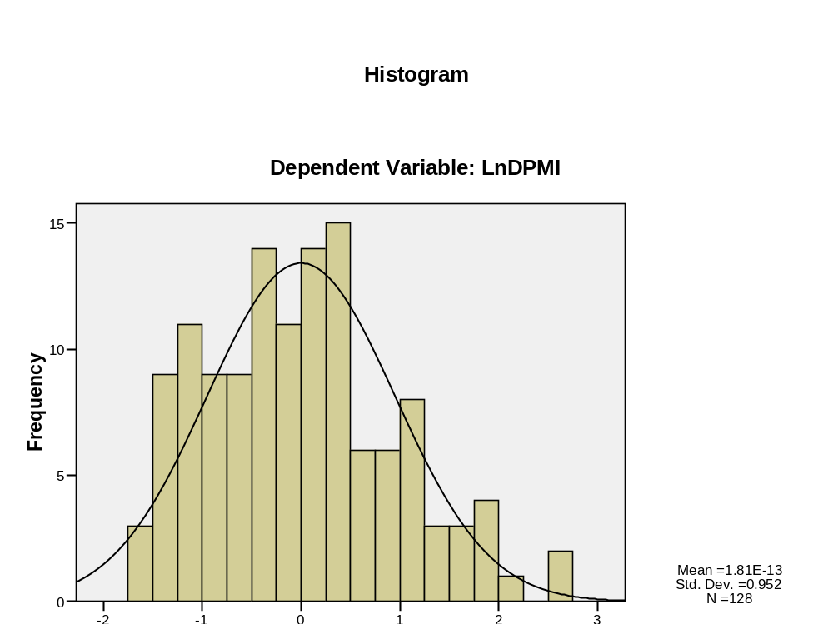
Figure 4: Histogram of residuals
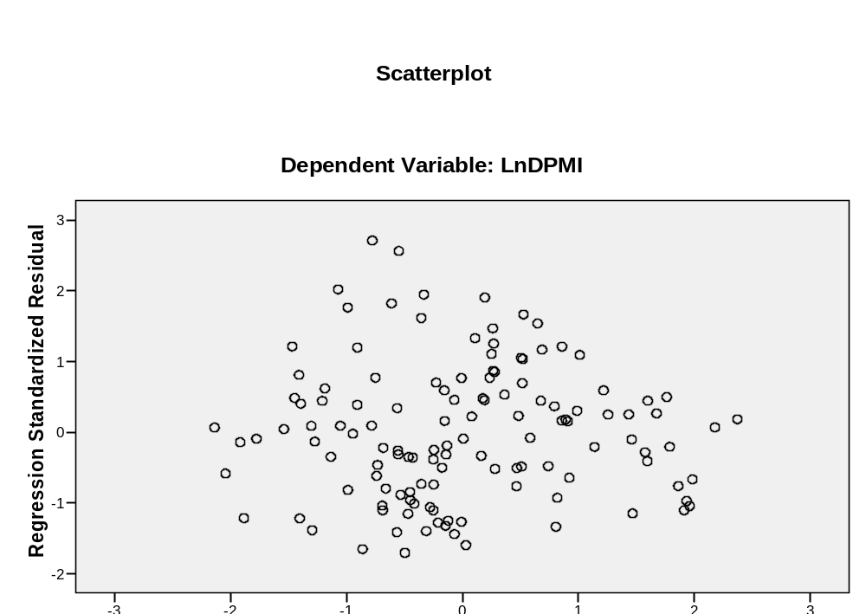
Figure 5: Distribution of residuals

The Netherlands had 16,382 thousand inhabitants in 2007 (OECD, 2010)

