Abstract

The purpose of this study was to investigate the ranking reports about healthcare systems of different nations. Thereby was researched the health performance monitoring, the data quality and the data quality dangers at those ranking reports.
The method of this bachelor thesis was a qualitative research. The thesis carried out own literature reviews of three ranking reports. The involved ranking reports are the World Health Report 2000, the Euro Health Consumer Index 2005 and the Euro Health Consumer Index 2009. At every single report the thesis provided how the reports managed to get towards the results. This was performed on a critical way, which is the epistemological of this thesis.
The results of the study were that all the ranking reports have many imperfections. On the health performance monitoring is noticed that the reports lack some categorizations about this topic. Also there were many data quality factors discovered in the three reports that lowers the data quality. About the data quality dangers the study has also identified some weaknesses.
One conclusion was that it is a tough job to perform a research that ranks different countries based on their healthcare system. It is very difficult to take every single detail into account of the research, which can be blamed by the enormous complexity of healthcare systems.

Acknowledgement

The possibility to make this thesis was hardly succeeded, where it not for the help of some external factors. First of all I would like to thank Prof. Matthew Guah for teaching me some things about the world of health care before I started with my thesis. I would also thank the documentary “Sicko” of Michael Moore for giving me the inspiration to research something about the rankings of the healthcare systems of different nations. Next I would thank the Erasmus University Rotterdam for the possibility to get access to a lot of different research papers that I have used for this thesis. Next I want to thank the World Health Organization and Health Consumer Powerhouse for publishing their reports, where they rank the healthcare systems of different nations. I also want to thank Prof. Matthew Guah again for guiding me with this Bachelor thesis and for getting that unique research question.

Table of Contents

Chapter 1: Introduction 6

1.1 Introduction 6

1.2 Thesis background 6

1.3 Research, aim, objective and scope 7

1.4 Thesis structure 7

1.5 Chapter summary 9
Chapter 2: Literature review 10
2.1 Introduction 10
2.2 Health performance monitoring 10
2.3 Data quality factors 13
2.4 Data quality dangers 17
2.5 Selected models 21
2.6 Chapter summary 23
Chapter 3: Methodology 24
3.1 Introduction 24
3.2 Details of specific methodology used 24
3.3 Main research questions & sub questions 24
3.4 Epistemological stance 25
3.5 Fieldwork research procedure 25
3.6 Data analysis technique 26
3.7 Overview of alternative strategies 26
3.8 Chapter summary 27
Chapter 4: Data 28
4.1 Introduction 28
4.2 World Health Report 2000 28
4.2.1 The results 29
4.3 Euro health Consumer Index 2005 37
4.3.1 The results 38
4.4 Euro Health Consumer Index 2009 42
4.4.1 The results 43
4.5 Chapter summary 51
Chapter5: Data analysis 52
5.1 Introduction 52
5.2 Basic comparisons of the reports 52
5.2.1 World Health report 2000 versus Euro Health Consumer Index 2005 52
5.2.2 Euro Health Consumer Index 2005 versus Euro Health Consumer Index 2009 54
5.2.3 Euro Health Consumer Index 2009 versus World Health Report 2000 55
5.3 The health performance monitoring of the reports 57
5.3.1 World Health report 2000 57
5.3.2 Euro Health Consumer Index 2005 59
5.3.3 Euro Health Consumer Index 2009 61
5.4 The data quality dimensions of the reports 62
5.4.1 World Health report 2000 63
5.4.2 Euro Health Consumer Index 2005 64
5.4.3 Euro Health Consumer Index 2009 65
5.5 The handling of the reports about the ten data quality dangers 67
5.5.1 World Health report 2000 67
5.5.2 Euro Health Consumer Index 2005 68
5.5.3 Euro Health Consumer Index 2009 69
5.6 External criticism about the World Health Report 2000 71
5.6.1 Misleading performance indicators 71
5.6.2 Influence of external factors 72
5.7 Chapter summary 72
Chapter 6: Conclusion 74
6.1 Introduction 74
6.2 Main findings 74
6.3 Lessons learnt 77
6.4 Research limitations 77
6.5 Thesis conclusion 77
References 79
Appendix A 81
Appendix B 83
Appendix C 85

Chapter 1: Introduction

1.1 Introduction
This thesis will start with an introduction chapter. In this chapter I will provide a background of the topic that I will research. I continue with the research, aim, objective and scope of this thesis. Next I discuss the structure of thesis, where I enlighten the content of every chapter of this thesis. I finish this introduction chapter with a chapter summary.

1.2 Thesis background
The healthcare sector is a popular topic the last few years. Also we are all involved in the world healthcare or we know at least a relative, who is involved with it. Al countries are trying to improve their own healthcare system as much as possible. This requires an international data analysis of the performance of the healthcare systems. With those data it will be able to identify the most ideal system for the healthcare sector. It also makes it possible to rank every country with regard to their performance of the healthcare system.
At the moment there happen to be a lot of differences between the healthcare systems of different countries. So have some countries a universal healthcare system. With this universal system every employed person pays for the care of the whole population in the country. Another big difference that split countries in two different groups is the type of healthcare system they use. The two most used types are the Bismarck healthcare system and the Beverage healthcare model. With the Bismarck healthcare system, there are a multitude of insurance companies who are organizationally independent of the healthcare providers. This system is based on social insurance. With the beverage healthcare system, the systems financing and the providing of health is taken care partially or fully within one organization. Thanks to the reports that rank different healthcare systems, it seems that the countries that are using the Bismarck model are performing better. This should be an eye-opener for the countries that use a beverage model. Also when there is a comparison of the different countries about their healthcare systems, they notice the weaknesses in a specific area in the healthcare system of the particular country. They could improve the weaknesses of that specific area by looking at the healthcare systems of the countries that score strong on that specific area. Next thing that will make a difference in the healthcare systems of different countries is about the investments that a country make for their healthcare sector. Some countries happen to invest or pay the same amount of money in their healthcare sector, but the results of those similar countries are sometimes in practice unluckily very large.
So it is very good that there are researches performed to compare the healthcare systems of different countries and to publish reports about the performed research. But how good are the data analyses of those reports? It is important to have a critical look on those reports. Thereby the quality of the data is for example of great importance.
The most famous report about the ranking of the healthcare systems of different countries is the report of the World Health Organization. However, there are also a lot of criticisms about this report. In the appendix of this thesis I putted two articles and one paper that are criticizing the report of the World Health Organization. The first article from the Wall street journal states that the ranking is outdated and flawed. It also suggests that the WHO should investigate more variables. The second article discusses the measurements of all the variables. It criticizes some of the investigated variables. Notice that this article tells that the World Health Organization ranked 192 countries, while the World Health Organization actually ranked 191 countries. The third source is a paper. According to the research of the World Health Organization, Italy has the second best healthcare system of all the 191 countries. However, the paper in the appendix tells that the healthcare system in Italy isn’t so great at all. Notice that this paper is written by two Italian researchers.

1.3 Research, aim, objective and scope
The aim of this research is to answer the main research question. In order to fulfill this, the main research question is supported by three sub questions. They will all be answered in the conclusion. In this Bachelor thesis, I will focus on three different reports that are ranking the healthcare system of different countries. They are as followed:
- “The World Health Report 2000. Health systems: Improving performance.” A report of the World Health Organization (WHO);
- “Euro Health Consumer Index 2005”. A report of the Health Consumer Powerhouse.
- “Euro Health Consumer Index 2009”. A report of the Health Consumer Powerhouse.
I will investigate the report of the Health Consumer Powerhouse at the time they first published a report about the ranking of the healthcare systems of the different nations and I will investigate the newest version available. The newest version that is available at the time that I write this thesis is the Euro Health Consumer Index 2009. The Health Consumer Powerhouse research and publish a Euro Health Consumer Index every year since 2005. Thereby there have been a lot of changes between the version from 2005 and the version from 2009. In this way I have the most famous healthcare ranking report, which is the World Health Organization report of 2000. And I have two ranking reports from 2005 and 2009.

1.4 Thesis structure
I will now discuss about the structure of this thesis. The following figure should create a well placed overview of the thesis structure, which is stated below.
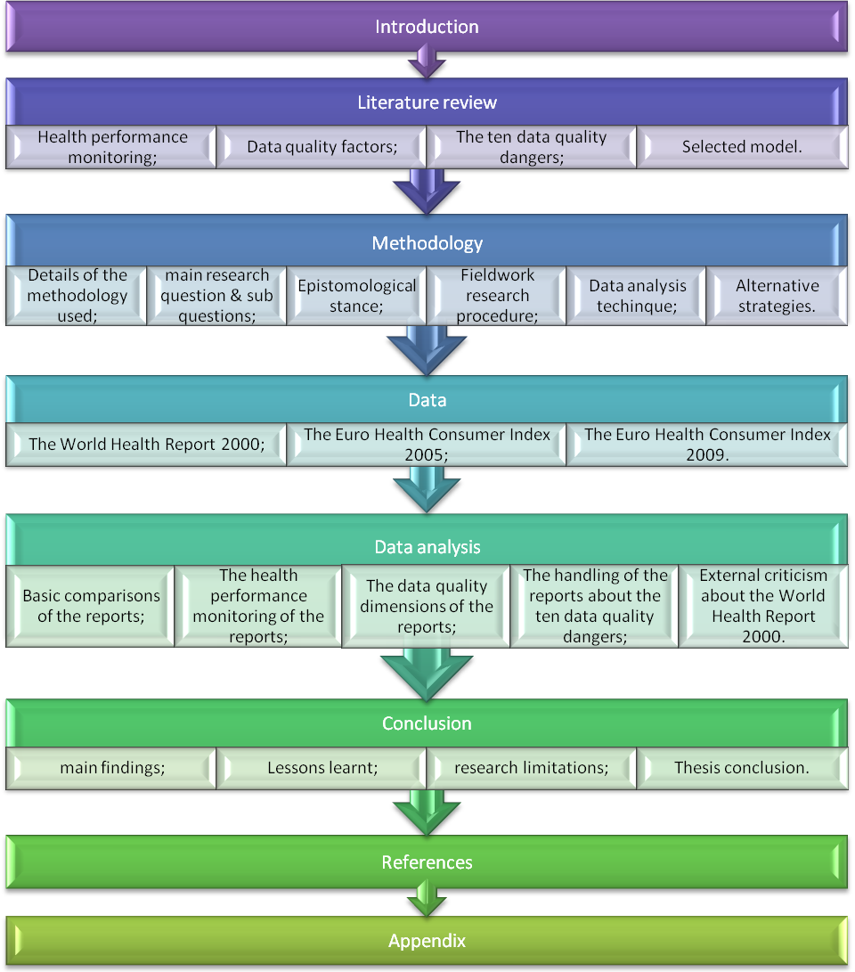
Figure 1.1: The structure of this bachelor thesis.

This thesis is split into six chapters. I will, after the introduction chapter, begin with the literature review chapter. In this chapter I discuss some things about health monitoring. I also discuss the current available information about data quality. Thereby I start with summing the factors that determine the quality of data. Then I discuss the ten dangers that could harm the quality of the research data and at the end of the literature chapter I will provide a selected model, where I integrate all the topics of the literature review in a model.
The next chapter will be about the methodology of this thesis that has been performed. I will begin with the decision between qualitative research and quantitative research. Then I discuss the main research question that I have defined. Thereby I also defined three sub questions. Next I discuss my epistemological stance that I used for my research. Then I continue with the fieldwork research procedure. Thereby I specify my research method. After that I discuss the data analysis technique of my performed research. I will finish by discussing the alternative strategies of the epistemologies, research methods and data analysis techniques.
After the methodology chapter, the data chapter will follow. In the data chapter I will write three own literature reviews of three different reports that rank countries with the performance of their healthcare systems. The names of all the reports are already summed at the research, aim, objective and scope part above in the introduction.
With the own literature reviews I can perform a data analysis, which occurs in the data analysis chapter. Thereby I look at five different themes. With the first theme I compare every time two different reports based on the basic information provided in each report. The second theme will discuss about the health performance monitoring regarding the three reports. Next I look at the data quality dimensions of the three ranking reports. The fourth topic is about how the reports handle the ten data quality dangers, which I stated at the literature review. The last topic will I look at some external criticism about the report of the World Health Organization.
When the data analysis has been performed, I continue with the conclusion. In the conclusion I will answer the main research question and the supporting sub questions. I will also provide the lessons learned and the research limitations.
After the six chapters I continue this thesis with the references of all the data I used in order to write my bachelor thesis. Thereby I used sources from internet sites, books, articles and research papers.
The thesis will be finished with the appendix. In the appendix I put the three sources that are criticizing the ranking report of the World Health Organization.

1.5 Chapter summary
So this thesis will perform some research in the area of the healthcare systems. Thereby I will look at three different reports. Those reports are about the ranking of the healthcare systems of different nations. I will write a literature review about each of those ranking reports and I will analyze the content, mainly based on the data quality and about the way how the research has been performed.
Chapter 2: Literature review

2.1 Introduction
In this chapter I will investigate the already available information about three different areas. These topics are related how a researcher should take into account how he performs a research, where he ranks healthcare systems from different nations. First I discuss something about the area of health performance monitoring. Then I discuss the importance of the data quality factors. With the third theme, I will state some dangers about data that is able to inflict some damage regarding the data quality of the performed research. When I am done discussing these three areas, I will combine them into a model in order to get a better connection between the different topics. I finish this chapter with a chapter summary.

2.2 Health performance monitoring
When you want to rank different countries based on their healthcare systems, you need to investigate the performance of every healthcare system. So the question is: How do you measure the performance of a healthcare system? The answer is that you have to investigate all kinds of performance indicators of that particular healthcare system. By analyzing all those performance indicators you are able to rate the particular healthcare system. However, there is a distinction in the types of performance indicators. According to Kruk and Freedman, 2008 you need to focus on output indicators. They split performance indicators into input indicators and output indicators. Broemeling et al, 2006 also make this kind of distinction, but go a step further. They divide the performance indicators into inputs, activities, outputs and outcomes. Thereby they divide the outcomes even in three different categories, namely immediate outcomes, intermediate outcomes and final outcomes. They created a model that gives a clear overview of all their components about this topic. Below you can see this model, which is a result-based logic model about healthcare.
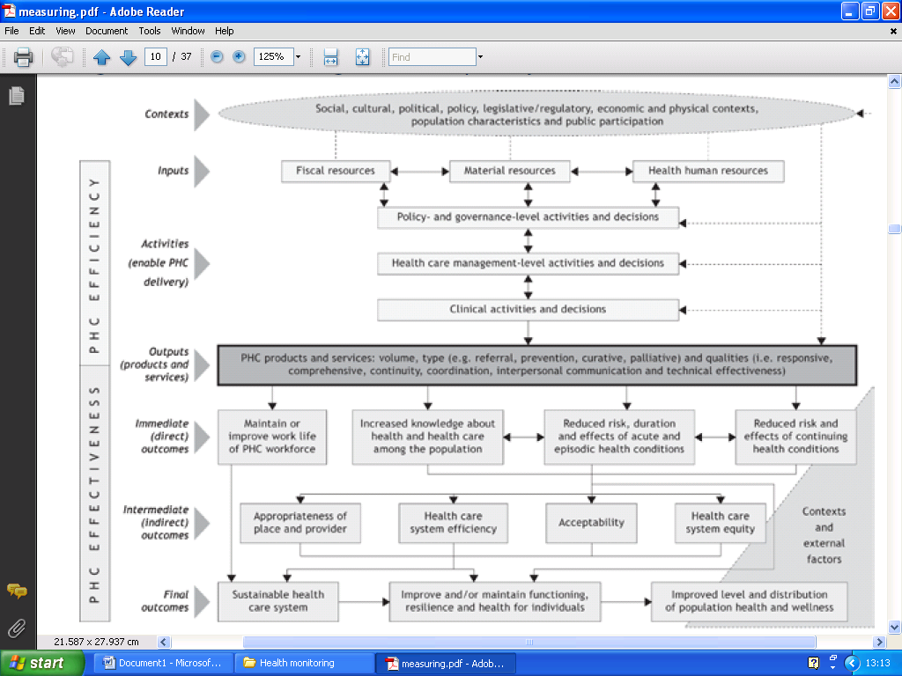
Figure 2.1: A result-based logic model about healthcare. (Broemeling et al, 2006)

On the figure, every arrow shows a category of the performance indicator I discussed above. Notice that there is also an extra indicator, which is called contexts. This isn’t really a type of performance indicator, but it provides all kinds of areas that the performed research should take notice of. According to Broemeling et al, 2006 input indicators describe the human, material and fiscal resources that a healthcare system rely on in order to carry out all kind of activities, deliver care and to achieve results. Next are the healthcare activities. The healthcare activities are basically a linkage between the input indicators and the output indicators. They consist of decisions and actions of policy and governance, healthcare management and on clinical level. A few examples in this area would be the coverage and costs of the medical and pharmaceutical services, the collaboration between the nurses and physicians or the physician chronic disease management. After the healthcare activities are the output indicators. The output indicators are about the products and services that are provided by the healthcare system towards the patient. This has been divided by volume, types and qualities. With volume you have to think for example about the patient visits at the GP or about the use of emergency services. With types you have to think about the use of preventive care. With qualities you have to think about the difficulty the obtain health information. Next are the outcomes of the healthcare systems. Hereby there are three types of outcomes as mention before. The first type of outcomes is the immediate outcomes. This type is focused on immediate or direct outcomes towards the patients. For instance, the increased knowledge of health and healthcare falls under this type of outcome. The second type is the defined as the intermediate outcomes. With this kind of outcomes you should think about the acceptability of the healthcare. Like the satisfaction of a patient or the confidence into the healthcare system. The last type of outcomes is known as the final outcomes. The source of this model only sums the three components of this type, which you also can see on figure 2.1.
All these different types of indicators are split in two dimensions, which you can see at the left of figure 2.1. Input and activities both belong about the efficiency of primary health care. All of the three kinds of outcomes belong to the effectiveness of primary health care. The output indicators belong to both efficiency and effectiveness. With all those categories of healthcare performance indicators, it is important to evaluate the linkages between all those categories. After that the researcher should be able to conduct a suitable data collection strategy.
I already mentioned something about Kruk and Freedman, 2008. They divided performance indicators only into input and output indicators. However, they have also a model divined about this topic, which you can see below.
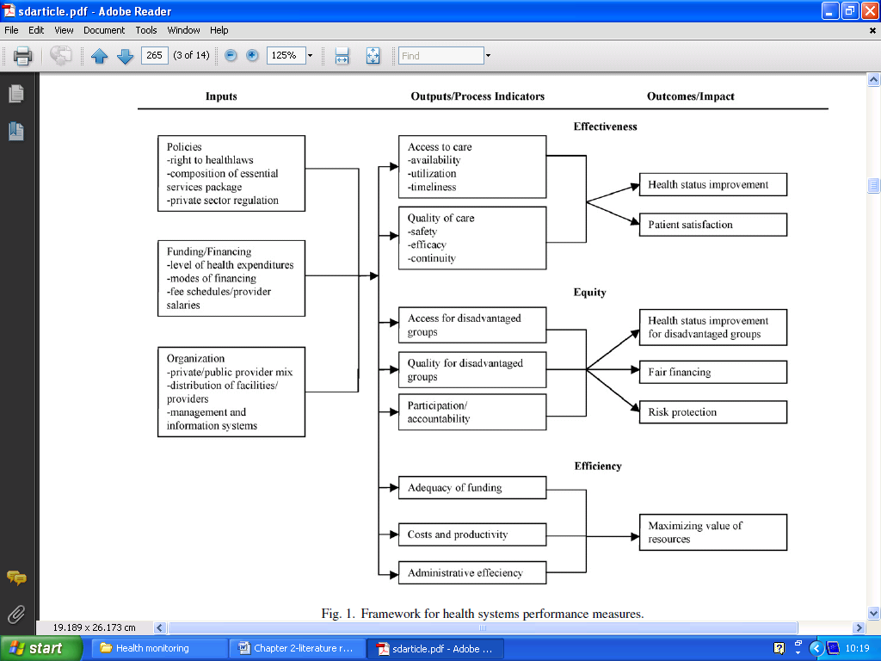
Figure 2.2: The framework of the health systems performance measures. (Kruk and Freedman, 2008)

Notice on the figure that they also split the type of indicators into the dimensions of efficiency and effectiveness. They even have a third dimension, which is equity. All the output indicators and all the outcomes that are related to the dimension of equity are about fairness. It focuses on the disadvantaged groups and individuals and it focuses on the fairness of the financing. Certain elements in the healthcare system that are unfair and could be eliminated should be removed. So could there be unfairness in the access to services or unfairness in the unhealthy living or working conditions. These kinds of disadvantages are caused by differences in wealth, race, gender or ethnicity. A few examples about the outputs of the equity dimension as stated by Kruk and Freedman, 2008 are the utilization of essential health services by disadvantaged groups, the perception of being included/excluded from the healthcare system and the efficacy, safety and continuity indicators for the disadvantaged groups. Some examples about the outcomes of the equity dimension are the mortality rates for lowest income quintile, the proportion of the government financing that reaches the poorest income quintile and the proportion of the population with catastrophic health expenditures.
The second dimension they discuss is the effectiveness dimension. With the effectiveness dimension they discuss different kinds of variables about the access of healthcare and the quality of healthcare. Some examples that they discuss about the output indicators of the effectiveness dimension are physicians, nurses and hospitals availability per 1000 population, TB case detection rates, effective treatment for malaria within 24 hours, rate of avoidable hospitalizations and the infection and complication rates of surgery. Some examples regarding the outcomes of the effectiveness dimension are infant mortality, being treated with respect and the length of waiting for healthcare.
The third dimension is about the efficiency dimension of the framework of Kruk and Freedman, 2008. With the efficiency of a particular healthcare system you have to think about getting the maximum attainable health gains with the limited set of inputs. A few examples about the output indicators of the efficiency dimension would be the per capita healthcare spending, the costs per case treated and the health worker attrition rates and morale. A particular example regarding the outcomes of the efficiency dimension is the mortality rates for different financing structures.
So as you may notice by now there a lot of different ways to measure the performance of a particular healthcare system. There are many performance indicators involved to be measured. Al those performance indicators can be categorized in multiple types and in multiple dimensions. The models provided in this part of the literature review should give a policy maker or a researcher about the performance of healthcare systems a better view what they specifically need to research in order to make their conclusions.

2.3 Data quality factors
These days, there are many researches performed that requires collecting data and data analyses. It is very important that the quality of the collected data is in an excellent state in order to have a good and useful research. If the collected data have a poor quality, the research will be basically useless. In some cases it could even lead to wrong conclusions that may have a great impact. So what determines the quality of data and how can you improve it? The quality of data depends actually on many different factors. Below you can see a clear overview of the different dimensions that determine the quality of data. There are 16 different factors summarized with a definition behind it.
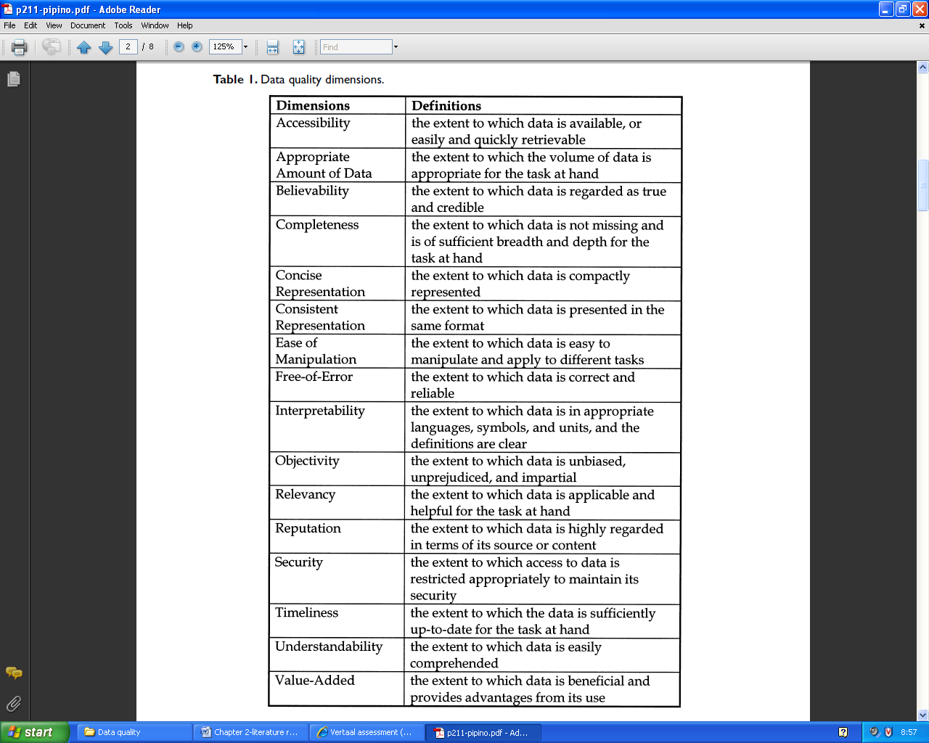
Figure 2.3: Data quality dimensions (Pipino et al, 2002)

It is the task of the researcher to fulfill every single dimension in order to improve the quality of the data. Notice that the dimension ‘free-of-error’ is the same as accuracy. They used the term free-of-error instead accuracy, because the term accuracy has more definitions than the correctness of data. The figure doesn’t further add anymore explanation. It gives also a clear explanation of the data quality factors.
A different source by Pinto, 2005 states six different sources of data quality dimensions. They are summed below:
- Relevance;
- Consistency;
- Accuracy;
- Comprehensiveness;
- Format;
- Currentness.
The first three are already stated and explained by figure 2.3. However, the last three does require some enlightenment. “Comprehensiveness” is about the scale of data used in order to perform and to cover the research area in a complete way. So basically this data quality dimension is the same as the appropriate amount of data dimension of figure 2.3. Next is the “format” dimension. This data quality dimension is about issues how the data is represented (formatted) as a medium towards the researcher. So this data quality dimension falls actually under the concise representation dimension and under the consistent representation dimension of figure 2.3. This dimension is also related with accessibility. Because the better the format of the data, the better the data is accessible for the researcher. The sixth dimension is called “currentness”. This dimension can be measured by looking how outdated the collected data is. Also this data quality dimension is processed in figure 2.3 as the timeliness dimension.
Some of those dimensions about data quality have an equation available in order to calculate the value of that specific data dimension. The first equation of a data dimension that I will discuss is about the free-of-error dimension. The suitable equation of this data dimension is stated as:
Free-of-error rating = 1 – 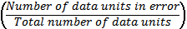
This equation will result in a number between 0 and 1, where a number close to 1 will state that there is a low free-of-error rate.
The next equation is about the data dimension completeness. The suited equation is as followed:
Completeness rating = 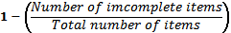
This equation looks like the same as the previous equation, whereby here also the result will be a number between 0 and 1. If a number is close to 1, it means that there is a high completeness of the data.
The third equation of a data dimension has also the same type of structure. This data dimension is about the consistency of the data. The equation is defined as:
Consistency rating =
A number between 0 and 1 will be the result, where a number close to 1 means that there is a high consistency.
The next equitation looks different then the equations above. This equation will rate the believability data dimension. The equation is as followed:
Believability = Min (Believability of source, Believability when compared to internal commonsense standard, Believability based on age of data)
This equation looks at three different areas regarding the believability of the data. Every single area is rated with a score between 0 and 1. The lowest value is the final outcome of this equation and will represent the believability of the particular data.
I continue with the equation about the appropriate amount of data. This data dimension looks that the amount of data is appropriate for the amount that is actually needed for the research. The equation is defined as:
Rating of appropriate amount of data =
Min
It is important to know that the appropriate amount of data can be either too low or too high. This is reflected in equation by using the division twice, but at the second division the variables are turned around. The minimum value of one of those two divisions will represent the rating of the appropriate amount of data.
The last equation that I will discuss here is about the timeliness data dimension. This data dimension gives an insight if the used data of the research is up-to-date. The equation to rate this dimension is quite complex. It is stated as followed:
Timeliness rating = 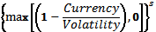
Where, currency stands for the delivery time – input time + age. Delivery time stands for the time that the data was delivered towards the user, input time stands for the time that the data was received by the system and age stands for the age of data when it was received by the data. Volatility stands for the length of time that the data remains valid. This value between the “()” could reach a number below zero, so a zero value is added that will be compared by using a max operator. Notice that in this equation there is also an exponent added, which is defined as s. This variable is representing the sensitivity of the timeliness rating. This particular variable is added, because certain researches have different tasks that require a different sensitivity of the data.
In total I discussed six different kinds of equations that are available in order to calculate the rate of a particular data quality dimension. A researcher should perform these kinds of calculations so that it has a better view of the quality of the collected data.

2.4 Data quality dangers.
So far I discussed the factors that are important for data quality and I discussed some equations to rate data quality. Next I will focus on the ten root conditions that will endanger the quality of the data, as stated by Lee et al, 2006.
- Multiple data sources;
- Subjective judgment in data production;
- Limited computing resources;
- Security/accessibility trade-off;
- Coded data across disciplines;
- Complex data representations;
- Volume of data;
- Input rules too restrictive or bypassed;
- Changing data needs;
- Distributed heterogeneous systems.
I will now enlighten every condition. The first condition that will lead towards data quality dangers is by using multiple data sources. You can split this point actually in two ways. You could use different processes to get towards the same information and you could use multiple databases to store your information. With the first point, there will be a high change that the concluding information of the different processes will lead to different conclusions about the same information. For example, if you research the fairness of the financial contribution of a healthcare system of a nation and you use a survey with both the healthcare insurance companies and the healthcare patients. This would very unlikely lead to the same results although you are investigating the same information. With the second point, you have to think about using multiple databases to store the results of certain values. This will also lead very likely towards differences, while it is about the same information. This is mainly caused by updates that constantly may occur. It is very difficult to update constantly every single database, when there is a change happening about the information. So this may also cause inconsistencies about the same information.
The second root condition is about the subjective judgment in data production. When you collect your data for your research, data consumer will interpretive the data as facts. But sometimes is the collected data subjective. A good example would be the example I gave above with the first danger, which is about researching the fairness of the financial contribution of a healthcare system of a nation. By asking a certain group of people about this, you will get a biased result as information. So the research should avoid subjective judgment. In reality some researches will often hidden this data problem from the data consumer, so that the subjective judgment stays unknown for the data consumer. In some cases the human subjective judgment is the only way to research certain information. So this explains why subjective judgment occurs a lot in many researches, because there is no other way to research that particular information.
The third danger or root condition is the limitation of the computing resources. When you perform your research it is of great importance that your research material is in a perfect state. If you use unreliable computational resources you will increase the inaccuracy and the incompleteness of the data. This will then also harm the believability of the research. This root condition can however easily be solved by providing more or better computing power and resources. Also a research facility should periodically update its computational resources. But if your budget of your research is limited, it can become a big problem.
Let’s continue with the fourth condition. This condition is about the security accessibility trade-off. When you want to perform your research and you need data, it is necessary that you have a good accessibility towards it in order to collect it and to analyze it. But most of the time the collected data can be secured. The reason for this can be for example to ensure the privacy, confidentially or the security of the information. These security reasons will form a large barrier for the researcher, because it will limit the accessibility of the particular information. So basically, there is a conflict between the security of the data and the accessibility of the data.
The next root condition is about the coded data across disciplines. This is the fifth condition as stated by the list. Sometimes the collected data is from an expert of a certain professional area. This data can be hard for the researcher to decipher and to understand. A good example for this kind of condition would be the research of patient care through the eyes of medical doctors. The doctors will make some notes about the patient care in the hospital. Thereby there will probably some difficult terms being used that the researcher needs to decipher and to understand. There could be a misunderstanding occur, which will lead to wrong data for the research.
The sixth condition that endangers the data quality is about complex data representations. Numerical data can be easily stored and analyzed. Non-numerical data, however, is a different story. This type of data may be difficult to store, but the real problem is how to index it and how to analyze it. A solution for this problem could be to use advanced technology, like a data warehouse. It can structure the collect non-numerical data in order to analyze the particular data.
Number seven of the root conditions list is about the volume of data. When the collected data becomes very large, it will be very complicated to store it and to maintain it. Also searching through the large amount of data will be very difficult. This all could lead to a very large delay for the whole process of the research, which could lead to outdated data by the time the research is finished. In order to handle this danger of a large amount of data, it is important to organize and to categorize the data in a perfect way or else the researched data will have a poor timeliness. Thereby it will lower the quality of the data and the data consumer will have the tendency to use the data not at all or it will have a difficulty to access the large amount of data.
The eight root condition is about the input rules that could be too restrictive or bypassed. By having to restrict the input rules on a high intensity, it will give a lot of problems. For example, it could by those high input rules restrict very important data that will be lost or certain values will turn out to be missing. This is very annoying for the research, because all the hard work of collecting the particular data was for nothing if it doesn’t fit with the high restrictive input rules. A different problem that could occur is that data entry clerks will change the data in order to actually fit to the input rules. This will lead to manipulated or biased data, which will really lower the data quality of the research.
We continue now with the ninth condition. This root condition is about the changing data needs. The information that will result from the data research is only of high quality if it meets the requirements of the data consumer. It happens, however, that by certain changes the data will not be relevant anymore. Also it is very difficult to provide information to a lot of different data consumers and to satisfy all their needs. Moreover those needs could change in time. Summarized, this root condition is about the mismatch between the data provided and the data consumed by the data consumer. The data would then not be relevant for the data consumer anymore and there will be a need for new data.
We finally arrived at the tenth and final root condition. This root condition is about the distributed heterogeneous systems. When distributed systems are heterogeneous, they need a proper integration mechanism. Without this, it will lead to inconsistencies in definitions, values and formats. An example would that one distributed systems uses a lot of decimals for many values, while a different distributed system uses fully rounded numbers for many values. This inconsistency will lower that data quality of the research and it should be avoided.
By the ten dangers to data quality that we discussed above, we now know that a lot of different problems could occur with data researches. This should not let the data researcher to be discouraged to perform the data research. There a lot of different solutions for all those root conditions. Below you will see a giant figure that will give an overview of all the problems and it provides the positive and negative paths of those conditions.
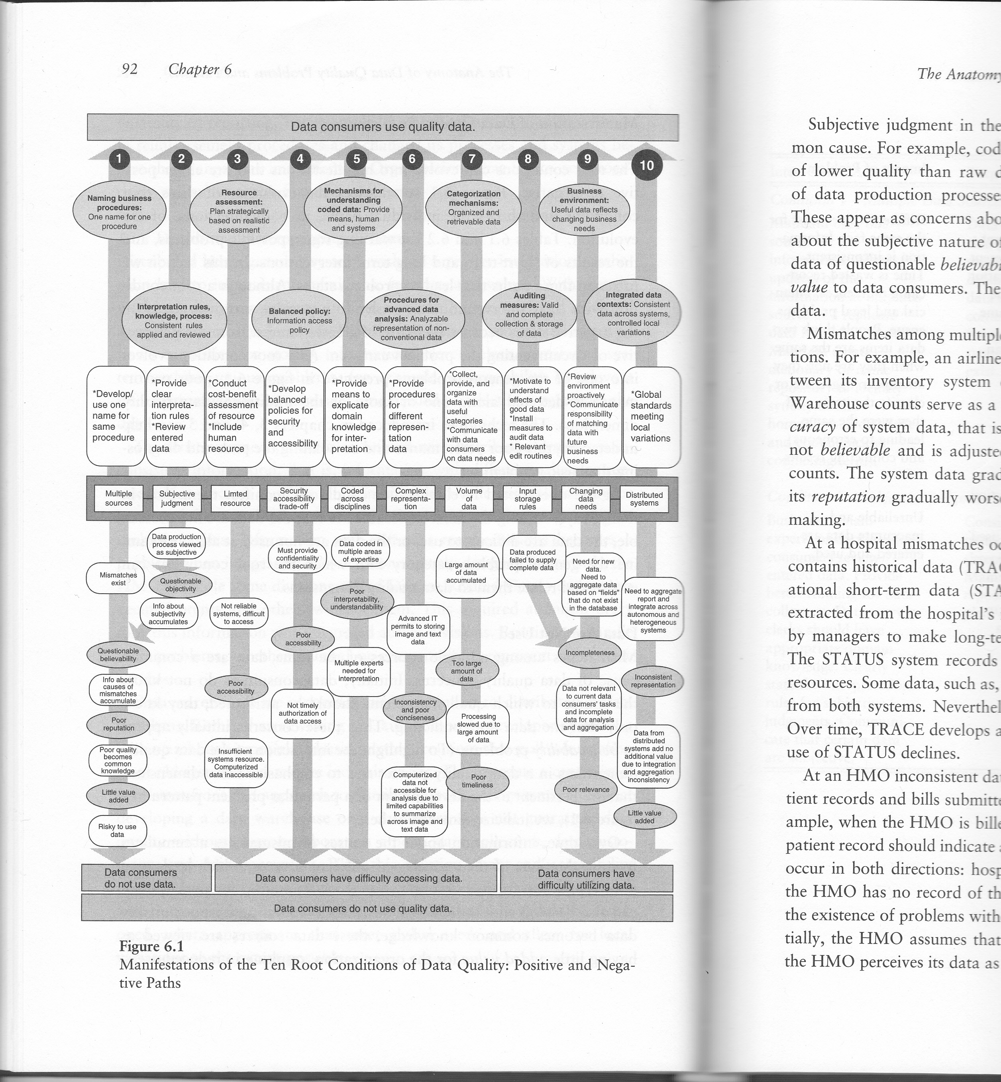
Figure 2.4: Manifestations of the ten root conditions of data quality: Positive and negative paths. (Lee et al, 2006)
On the huge figure of the previous page you see the ten root conditions in the middle in the square boxes. Above the root conditions you can see the positive path of the particular condition. Notice that some solutions are given at every condition in order to succeed the data quality of that particular condition. At the top you see the result when you fulfill every condition in a correct way. The data consumer will then use data that is of high quality. Below the root conditions you can see the negative paths that at every condition appear, when you not fulfill the root conditions. On every specific condition you can see some statements that appear, when that particular condition is not fulfilled. At the bottom you see the result of the negative paths. The data consumer will then not consume data that is of high quality. Also notice that the result of the negative paths is categorized into three smaller groups. When you fail at one of the first two root conditions, the data consumer will not use qualitative data and it even will not use the data at all. When you fail at one of the root conditions between the third and seventh root condition, the data consumer will not use qualitative data and it also will have difficulty to access data. When the data research fails at one of the last three root conditions, the data consumer will not use quality data and it will have a difficulty to utilize the data.

2.5 Selected model
I have now discussed three different kinds of topics. They are health performance monitoring, data quality factors, and data quality dangers. But how are these topics related to each other? That will become clear in this part of the literature review. I have created a model that will bind the three topics together in order to get a clear overview of how the researcher of ranking healthcare systems should perform the research. The created model is shown below:
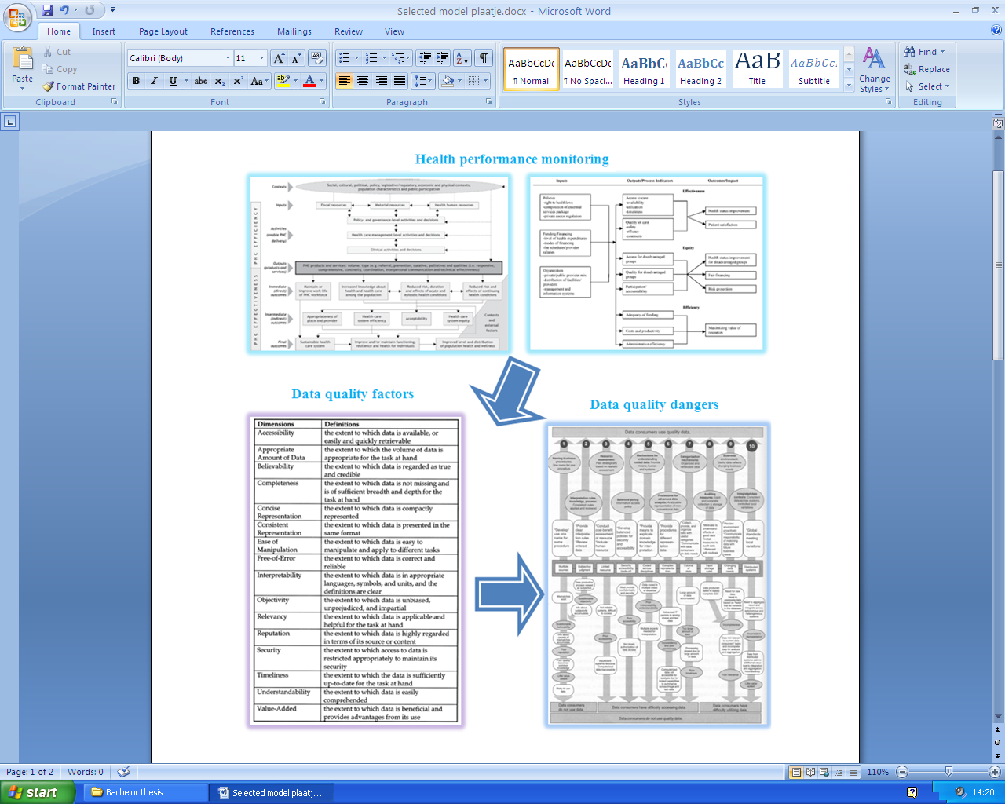
Figure 2.5: A model that combines health performance monitoring, data quality factors and data quality dangers together.

The researcher first needs to decide what type of data he will collect in order to perform his research about the ranking of the performance of different healthcare systems of different nations. So this means he needs to consider the models I discussed at the health performance monitoring section. With those models the researcher can decide all kinds of performance indicators to research and rank a healthcare system. After the researcher has decided all the types of performance indicators for the research, the researcher needs to focus on the data characteristics. Thereby is the quality of the data of great importance. The best to handle the data quality is by looking at the figure that sums 16 different data quality dimensions. But even after looking at all the different kinds of data quality characteristics, there is still room for error regarding the data quality. So the researcher should focus on the ten dangers of data quality. The huge figure as shown at the bottom right corner of the model gives an insight about these dangers and it shows the consequences of those data quality dangers.

2.6 Chapter summary
In this chapter I focused on three different topics, which are related with performing a research about the ranking of healthcare systems of different countries. Firstly, I discussed about some models related to the performance of a healthcare system. Thereby there are different performance indicators in different ways by the different models. So are there categorizations between input and output factors or between effectiveness and efficiency dimensions. Secondly, I discussed something about the data quality factors. Thereby I showed a figure that gives an image of many different data quality dimensions that are involved in order to get an excellent state of data quality. Next I explained some equations that are able to rate the data with a specific data quality dimension. Thirdly, I told something about the data quality dangers. Although you try to fulfill all the data quality factors, there are still all kinds of dangers lurking around at a complex data research. At the end of this literature review chapter I integrated the three topics together in a large model.

Chapter 3: Research methodology

3.1 Chapter introduction
In this chapter I will discuss the methodology that I will use for this thesis. I begin by making a decision between quantitative research and qualitative research. Then I discuss my main and sub research questions. I continue with the epistemological stance of this thesis. Afterwards I discuss the specific fieldwork procedure and then I make a decision about the data analysis technique. Next I also discuss all the alternative decisions for the epistemological stance, the specific fieldwork procedure and the data analysis technique. I finish this chapter with a chapter summary.

3.2 Details of the specific methodology used.
With a research you can categorize two different ways to perform your research. They are called quantitative research and qualitative research. Quantitative research is characterized by its large amounts (quantities) of data that is capable to be measured. With quantitative research you have to think about performing surveys or laboratory experiments. With the collected data there can be all kinds of mathematical calculations be performed in order to get information out of the collected data. The most familiar mathematical method with quantitative research is statistical calculation. With these kinds of calculations a researcher can use it to estimate future events or quantities. With qualitative data you have to think about data as for instance like a brand image, a certain expertise or a firm’s reputation. Qualitative data can be obtained for example by performing observations or by performing interviews. A big difference between quantitative data and qualitative data is that quantitative data is measurable and qualitative data is non-measurable. Quantitative data defines whereas qualitative data describes.
With this thesis I have chosen for a qualitative research approach, because the qualitative research characteristics fit better with the research that will be performed with this thesis. In this thesis there will be no need to collect data and performing statistical analysis on it. The best way to investigate this research question would be to use data in words. With quantitative research the researcher mainly uses numerical data. I will investigate multiple reports that performed a research in order to rank the different healthcare systems of nations. So performing a qualitative research would be the best fit.

3.3 Main research questions & sub questions
In this thesis I will focus my research on the ranking of the healthcare systems and the reports that investigate those healthcare systems. I look at the data the researchers have used in their reports and on the results of those researches that are presented at the reports. Thereby I have defined the following research question:
- What are the most important characteristics of a very healthy nation?
To answer this research question, I have also defined three sub questions to support the main research question. They are summed up below:
- How does the World Health Organization determines its ranking of healthy nations?
- How does different national health rankings statistics compare?
- What makes people feel healthy in different environments?
After the data analysis of this thesis, I will answer first the sub questions in the conclusion. With the answers of the sub questions I will focus on answering the main research question. The answers are mainly based on the data analysis chapter, but also on the data chapter.

3.4 Epistemological stance
There are three kinds of epistemologies for qualitative research. They are positivist, interpretive and critical. Each type has its own orientating that may influence the end result of the research. I will use the critical approach as the epistemology. The critical approach assumes that social reality is produced and reproduced by people. Its focus is on conflicts and contradiction in society. The main task of this epistemology is a social critique. With this type it should be able to eliminate certain causes of alienation and domination.
There quite some problems happening in the healthcare sector. The ranking of healthcare systems of different nations will give an insight in the ideal healthcare system. However, it is of great importance that the quality of those reports is in an excellent state or else the research is basically useless. The data consumer will use the data of the report and some of them even make some decisions based fully or partly of the report. If for instance the conclusions of the report are wrong, it could have some bad influences on the data consumers. So I will critically investigate the reports and look how it is stated with the quality of the reports.

3.5 Fieldwork research procedure
In this part I discuss the type of fieldwork research approach I will use for my thesis research. There are four possibilities that can be chosen, when you perform qualitative research. They are action research, case study research, grounded theory research and ethnographic research. I have decided to use the case study research method. With a case study research the researcher will study one specific kind of real life situation or a certain imagined scenario. This could be for example a company or a corporate division. The case study research method happens to be the most used qualitative research method. It is used to explore certain causation in order to learn the underlying principles. This fits with my research. With my research I will investigate multiple reports (cases) about the ranking of the healthcare systems of different countries.

3.6 Data analysis technique
The next area where I specify my research methodology is the data analysis technique. There are three common data analysis techniques available that falls under qualitative research. They are hermeneutics, semiotics and narrative & metaphor. Based on the characteristics of each of them I decided to use the narrative & metaphor. Narrative is something told in a first person perspective. Metaphor is an expression where a certain characteristic is given to a person or thing by using for example an adjective or a name that is normally used for something else but has similar characteristics. An example would be ‘tiger’ in the sentence: “He’s a tiger when he’s angry.” Or like ‘windows’ in the product: “Windows OS”. Narrative & metaphor has recently an increased recognition of the role they play in social practice and in all types of thinking.

3.7 Overview of alternative strategies
Of course, there some other types of approaches, techniques and research methods to perform this research. For example, I could decide to use a different epistemological approach than the critical approach. The other two possibilities are the positivism approach and the interpretive approach. The positivism is characterized by the fact that the research is executed as objectively as possible. It hardly has any interactions between the researcher and the performed observation or the performed experiment. It often starts by a hypothesis and then the researcher collects and analyzes data to compare it with the stated hypothesis. The interpretive approach is in contrary with the positivism approach subjective. This type of research will start with an assumption. The researcher becomes part of an interaction or communication with the performed research. With interpretive studies certain phenomena will be understandable by the meanings that people assign to them. When I compare this with my research, I think they are less suitable than the critical approach. I am not using a hypothesis and I not perform any interaction with the research. These arguments will make clear that the other epistemologies don’t fit with my research. I already discussed at the epistemological stance why the critical approach actually does fit for my research, making it the right decision.
The next decision is about the alternative qualitative research methods. They are action research, grounded theory research and ethnographic research. Action research is a qualitative research method where the researcher itself participates in the research area. For example, if the researcher wants to research the brand image of the healthcare providers in the healthcare market, the researcher could start an own healthcare providing company to figure this out. With this own healthcare providing company, the researcher could conduct experiments or constantly observe the results. Next is the grounded theory research method. With the grounded theory research method the data is systematically collected and analyzed to form a theory. In the other qualitative research methods the researcher first investigates through theories and then he starts collecting the data. However, with the grounded theory the researcher collects first the data and then he forms the theory based on the collected data. This kind of research often occurs in areas that have very little or no theories about the particular research area available. The third alternative qualitative research method is the ethnographic research method. With the ethnographic research method the researcher studies a particular human society. This type of research requires a lot of time to spend on its field work. With this research the researcher actually lives among a targeted group of people who the researcher studies for a long period of time. You have to think about at least a year or more as the length of the fieldwork. Thereby the researcher discovers a lot about the target people, but the researcher must always try to maintain a certain degree of objectivity. When looking at the characteristics of all the alternative qualitative research methods, I am not surprised that the case study research method is the most used qualitative research method. Two of the alternative qualitative research methods requires lots of time, which is something I don’t have based on my approximately two à three months deadline. The third one also doesn’t fit with my research, because there are already healthcare systems ranking reports and data available in my research area. I already gave the reason to use the case study research method at the fieldwork research part.
At the data analysis techniques there are also some alternative techniques available. They are hermeneutics and semiotics. Hermeneutics focus primary on the meaning of the collected information. In short, it is used to make some sense out of the data. Thereby the researcher will look at the text as a whole and it looks at the meaning of the parts. Hermeneutics has a circular relationship, where the meaning of the whole text forms an understanding for the parts. Afterwards, those parts that have been understood will determine the whole. Hermeneutics happens to have a lot in common with the philosophical stance: Interpretive research. The other choice is semiotics. Semiotics focus primary on the meaning of signs and symbols in language. Thereby the signs or words can be assigned to some conceptual categories. These specific categories will represent important aspects of the theory to be tested. By looking at the characteristics of these data analysis techniques, I have not chosen for these alternatives. Also notice that hermeneutics fits better with the interpretive approach, while I have decided to use a critical approach.

3.8 Chapter summary
I have decided to use a qualitative research, based on the better suiting characteristics of a qualitative research. Next I defined my main and research questions and I chose to use a critical approach as my epistemological stance. With the specific fieldwork technique I decide to use a few case studies. The data analysis technique will be narrative & metaphor. In order to support every decision I also discussed the alternatives.
Chapter 4: Data

4.1 Introduction
In this chapter I will discuss three different reports about the ranking of the healthcare systems of different nations. I will start with the most famous report, which is the report of the World Health Organization from 2000. The next report is the first report of the Health Consumer Powerhouse from 2005. This report focuses only on some countries from Europe. The third report is also from the Health Consumer Powerhouse. Only this is the latest report from 2009. At every report I will give first an introduction of the reports and the companies involved. All the information that I discuss here in this chapter are data from the reports. There are no external sources used in order to discuss some specific elements of the reports or the results. With every report I will show the results and I will tell you the performance indicators that are used. I will do this with a critical look. I will also discuss some information about the data and I discuss some overall information.

4.2 The World Health Report 2000
The first report that has been published about the ranking of the healthcare systems of different countries is from the World Health Organization. Their overall mission is to reach the highest possible level of health for every single person. Thereby they also focus on closing the gap between different nations and between different individuals. The World Health Organization has also three other missions. They are reducing the excess of mortality of poor and marginalized populations, dealing effectively with the leading risk factors and placing health at the centre of the broader development agenda. These three missions fit well with the first mission and they will also be improved by looking at the performance of healthcare systems. The World Health Organization publishes every year a report about healthcare. However, in the year 2000 they published a special report, where they rank different countries regarding their healthcare systems. The amount of countries they investigated is huge. They tried to investigate every single nation in the world. The result is that their research exists of 191(!) countries. It’s an impressive amount, but it’s also very time-consuming. The collected data from their research is partly from 1997. So this means that the research took at least three years, because the report was published in 2000. The World Health Organization thinks that two factors are very important with a healthcare system. They are goodness and fairness. With goodness they mean the best attainable average level and with fairness they mean the smallest feasible differences between individuals or groups. So the point that they are trying to make is that a strong healthcare system not only should focus on providing very healthy people, but it must also be fair for every single individual.

4.2.1 The results
We already discussed that the World Health Organization globally focuses on two factors. They were goodness and fairness. However, this should be split into smaller indicators to get a better and a more precisely research result. So they changed these two factors into three overall goals. They are summed below:
- Good health;
- Responsiveness to the expectations of the population;
- Fairness of financial contribution.
According to the World health Organization, these overall goals can reach progressions mainly by four vital functions. These are summed in order:
- Service provision;
- Resource generation;
- Financing;
- Stewardship.
I will now enlighten briefly every vital function. The service provision function is the most known function. This function is about all the services that are provided for the healthcare sector. With this function it is important that it must be specifically clear which services are provided and how they are organized. One of the reasons why it is important is by the fact that the created resources aren’t unlimited, which is the second vital function of the healthcare systems. With created resources you should think about investments and training in people, buildings, equipment and knowledge. However, both the services and the resources need to be financed, which is the third vital function. With the financing it is important how the financing is divided and if it is fairly distributed. There must be strategic purchasing and also the poor should be subsidized to make the healthcare system fairer. All these three vital functions need a proper stewardship, which is the fourth and final vital function of a healthcare system. According to the World Health Organization, this is actually the most important vital function. With stewardship you have to think about governments, who should manage the resources, services and finances of the healthcare sector. They are the one that should be in charge and they should be responsible for the health and wellbeing of the population.
Below I show you an overview how the World Health Organization sees the relation with the four vital functions internally and with their three overall goals, which I have discussed and they have defined:
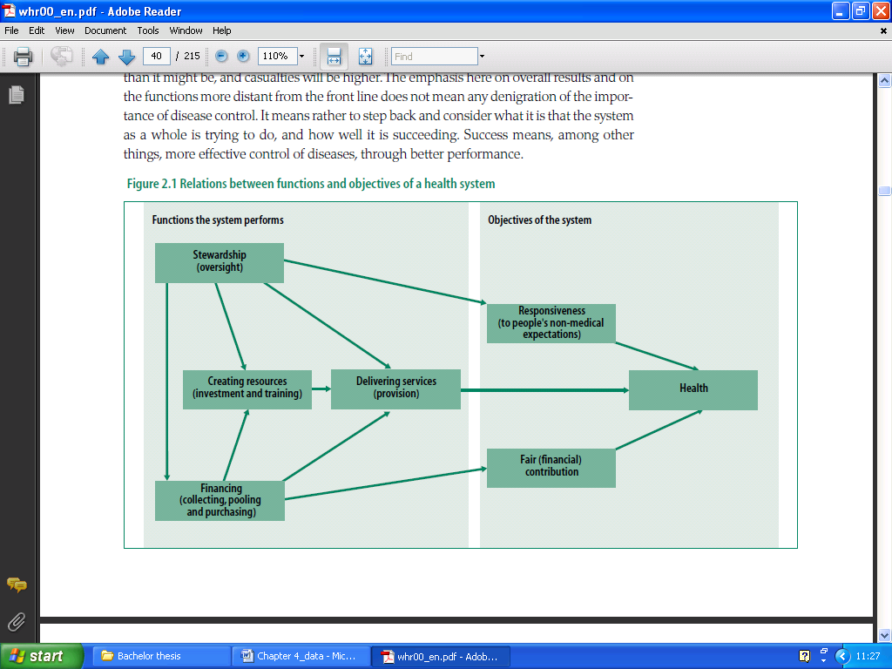
Figure 4.1: Relations between the functions and the objectives of a healthcare system. (WHO, 2000)

The report of the World Health Organization from 2000 focuses mainly on those four vital functions. They discuss briefly at the statistical annex little facts about how the research of the data collection is performed or about the results of the data research.
Below I will show a small part of the results of the performed research, which is sorted alphabetically by country. This part only shows 15 countries of the large total of 191 countries.
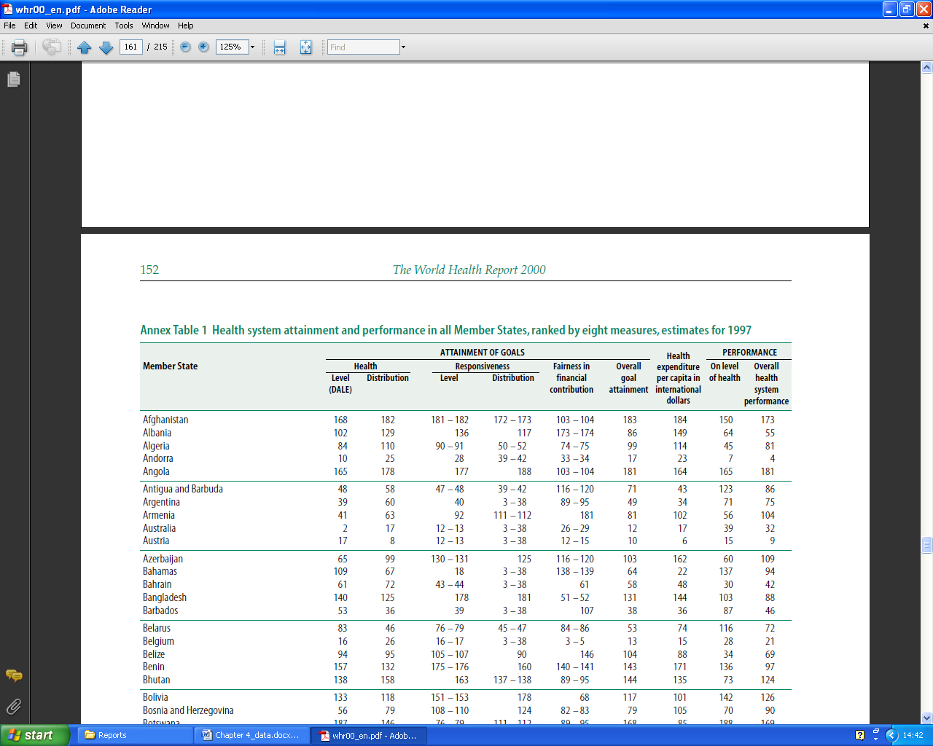
Figure 4.2: A part of the health system attainment and performance in all the countries, ranked by eight measures, estimates for 1997. (WHO, 2000)

Notice that all the performance indicators of the results are related to the three overall goals of the World Health Organization. I will explain now every performance indicator. The first one is the overall level of health. With this research the World Health Organization decided to use the measure of the disability adjusted life expectancy (DALE). A reason is for the easy comparability between the different countries. Also the DALE is easily to be calculated by using the Sullivan method based on age specific information on the prevalence of the nonfatal health outcomes. The second indicator is the distribution of health in the populations. Thereby the second major focus of the World Health Organization comes in hand, namely fairness. Although it is good that the level of health in a country is alright, but it is fair that the differences between individuals in country are evenly distributed. Most of the time, the poor are a victim of bad health. This even accounts in countries, where the level of health is very good. Countries who have very good overall level of health, but also a large distribution of health between people in their country will rank very poor on this indicator based on the fairness of health. It happens a lot that countries improve one of two indicators, but thereby decrease the other indicator. It is the job of a country to increase one of the two indicators without decreasing the other. The WHO based the distribution of health on the index of equality of child survival. This has the advantage that this information is widely available including the small area registration data about child mortality. The child survival is calculated with the following formula:
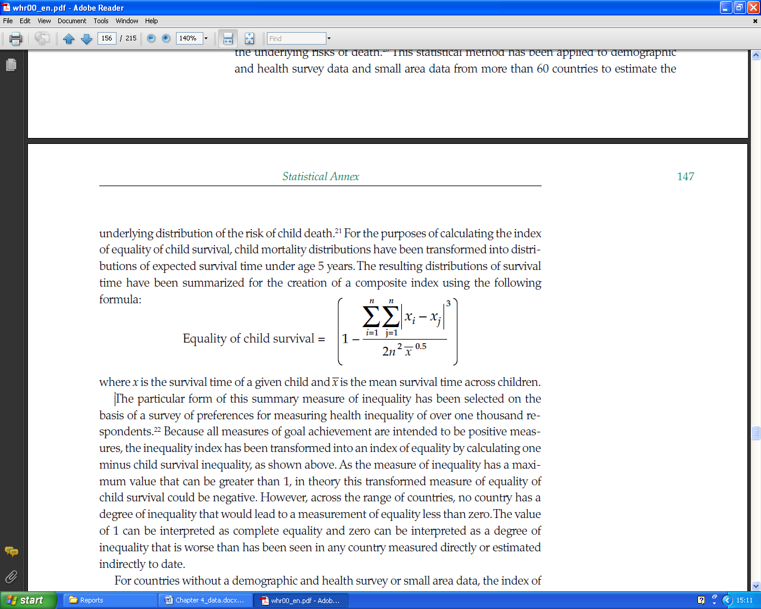
Figure 4.3: The formula of the equality of child survival. (WHO, 2000)

Thereby is x the survival time of a given child and  is the mean survival time across the children. However, some countries don’t have this small area data. Thereby they estimated the index by using indirect techniques and information on important covariates of health inequality like poverty, the level of child mortality and educational attainment.
Below you can see the results of the top ten scoring countries of both the health level health distribution. You should see the figure as one long extension. Also notice that the data is from 1997 and apparently from 1999.
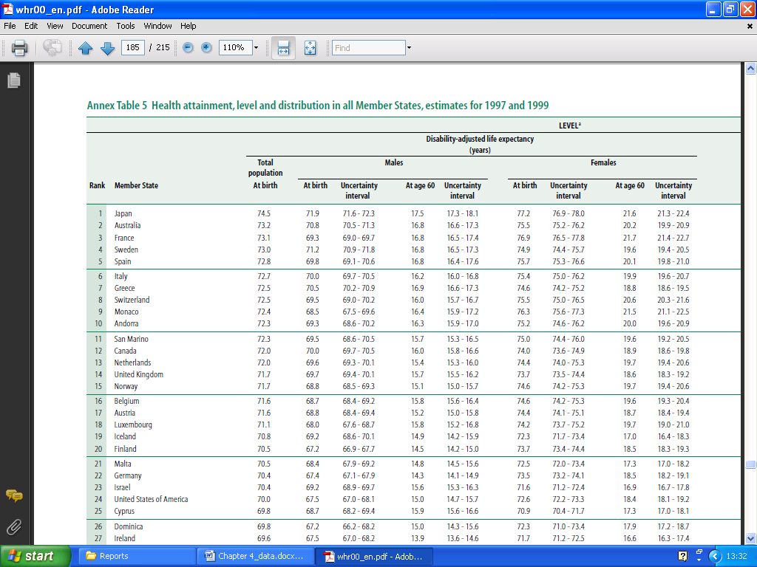
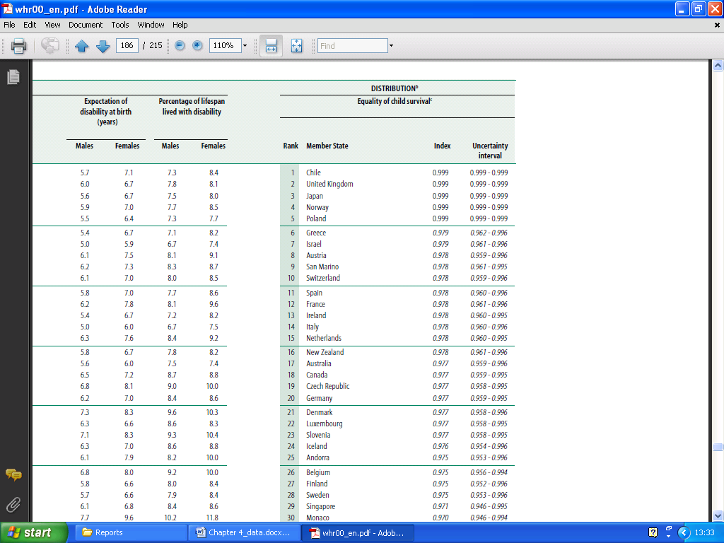
Figure 4.4: The top ten ranked countries based on health level and health distribution of all the nations, estimates for 1997 and 1999. (WHO, 2000)

The third and the fourth indicators are also a split of an overall goal, namely responsiveness. Thereby they also decided to look at the level of responsiveness (goodness) and at the distribution of responsiveness (fairness). With responsiveness the World Health Organization means respect for the person and client orientation. With respect for the person you have to think about confidentially, dignity and autonomy of a person in order to decide his own health. With client orientation you have to think about prompt attention, access to social support networks during care, choice of the provider and the quality of basic amenities. The level of responsiveness has been measured based on a survey of almost two thousand key informants in every single country. Those key informants had to evaluate on the performance of their healthcare system, which were related to seven topics about responsiveness that I just discussed above. Below I will give for both responsiveness indicators the top ten ranked countries.
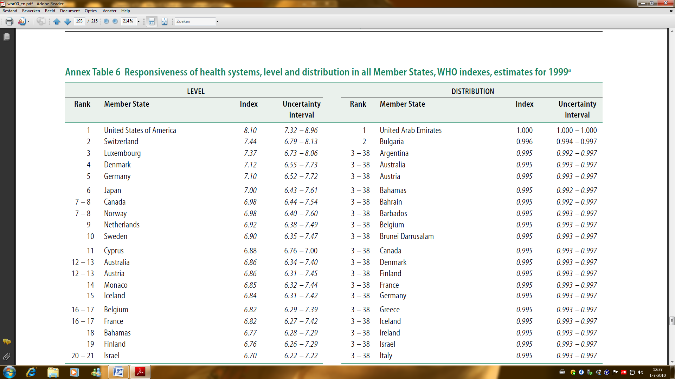
Figure 4.5: The top ten ranked countries based on the responsiveness of the healthcare systems, level and distribution. WHO indexes, estimates for 1999. (WHO, 2000)

Notice that some countries are sharing a spot in the rank at the level of responsiveness. Also notice the large amount of countries who share the third position till the 38th position at the distribution of the responsiveness. Furthermore, the data seems to be from 1999, while the other data is from 1997.
Next indicator is about the fairness of financial contribution. This indicator measures both the fairness of the financial contribution and the financial risk protection. Thereby forms the financial contribution of a household towards the healthcare system the basis for this indicator. The total spending of a household towards the healthcare systems can go via many ways. The examples that the World Health Organization provides are taxes, value-added taxes, excise tax, social security contributions, private voluntary insurance and the out-of-pocket payments towards the healthcare sector. Below I will give you the countries that are ranked in the top ten regarding the fairness of financial contribution.
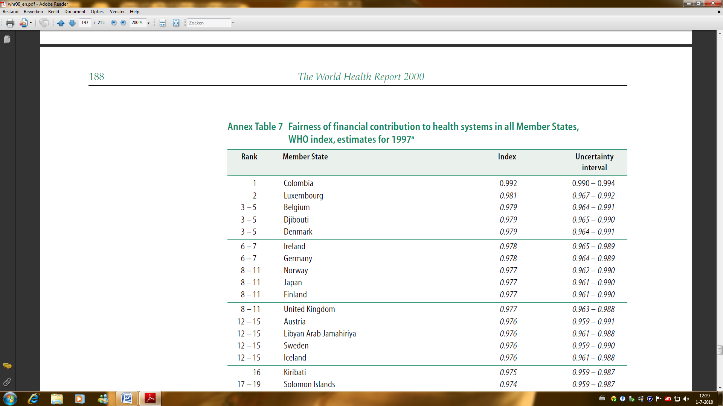
Figure 4.6: The top ten of the fairness of financial contribution to health systems in all the countries, WHO index, estimates for 1997. (WHO, 2000)

Notice that this ranking list also has some countries that share the same position. The index is calculated by using household survey data. The calculations also needed the governmental tax documents. Below you see the formula the World Health Organization used to calculate the fairness of the financial contribution.

Figure 4.7: The formula of the fairness of financial contribution. (WHO, 2000)

HFC is the financial contribution of a given household and  is the average financial contribution across households. This complicated in-depth analysis, however, couldn’t be performed on every country. For the countries where the analysis couldn’t be performed, they calculated the estimations of the distribution of health financing contribution by using indirect methods and information on important covariates.
I continue with the overall goal attainment. This ranking indicator is the combination of the five previous indicators. Thereby they have put a weight at every single indicator. These weights are determined by the use of a survey that consists of 1006 respondents of 125 countries. The results of the determined weights of the indicators are stated below.
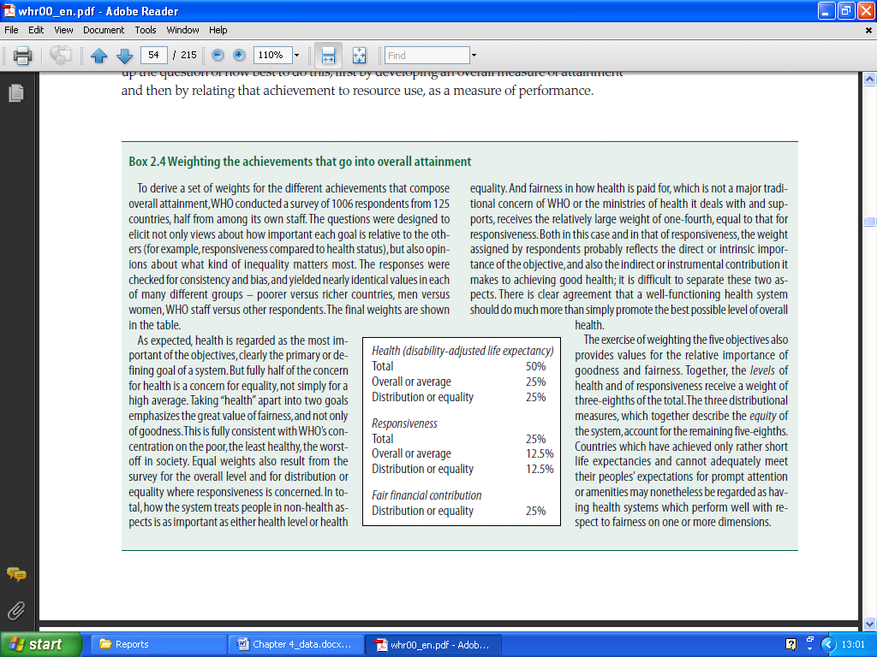
Figure 4.8: The weights of the five indicators that are determined by a survey. (WHO, 2000)

The results of the survey show that the two health indicators and the fairness of the financial contribution (all three 25%) are stated as more important than the two responsiveness indicators (both 12, 5%). So with the determined weights and with the results of the previous five indicators, they were able to calculate and to rank the overall goal attainment of the different nations. I will show below the countries that scored the top ten of the overall goal attainment.
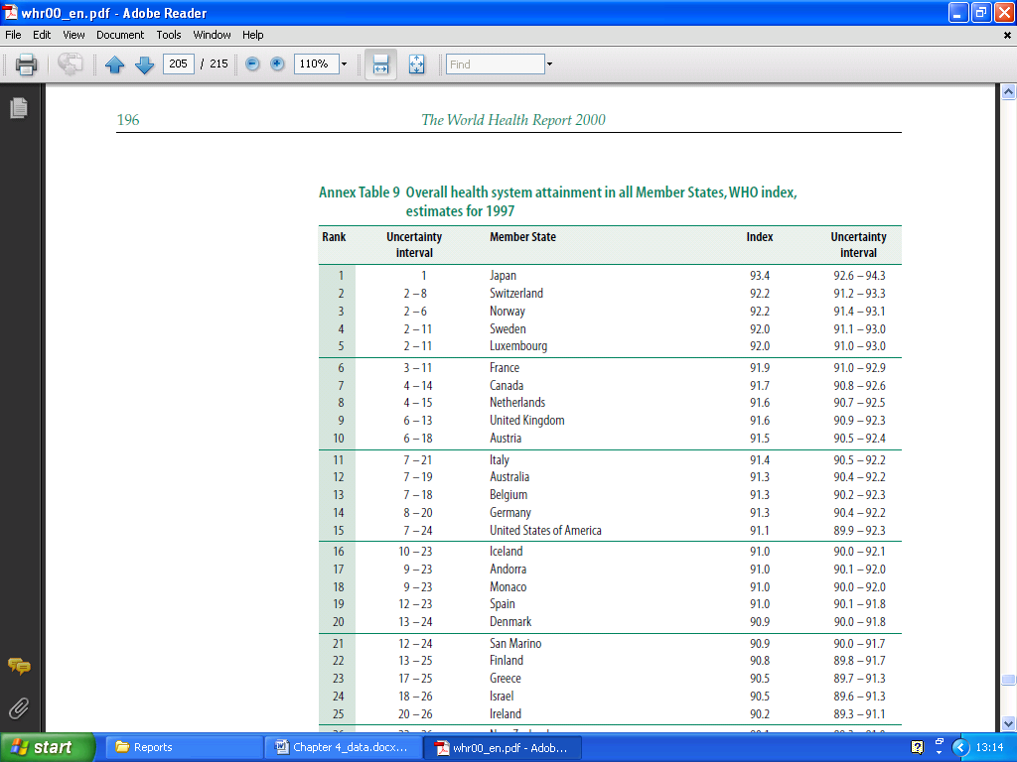
Figure 4.9: The top ten countries of the overall health system goal attainment in all the nations, WHO index, estimates for 1997. (WHO, 2000)

It seems that the Japanese have the best overall goal attainment by looking at the five different indicators with their corresponding weights. Also notice two strange things in this ranking list. Firstly, the number two (Switzerland) and the number three (Norway) have the same index as result. However, the only difference is that Switzerland has a larger uncertainty interval. Still they ranked Switzerland as number two, so they probably looked in those cases at the maximum value of the uncertainty interval. Secondly, the estimates are from 1997. However, the data from the two health indicators are from both 1997 and 1999. Also the data from the two responsiveness indicators are from 1999. So it is kind of strange that then the overall goal attainment calculations are from 1997.
After the overall goal attainment they stated the health expenditure of each country as the next indicator. There is also a list available in the report of the World Health Organization that shows some information of the health expenditure. Below I will show you the first ten countries of that list, which is sorted alphabetically.
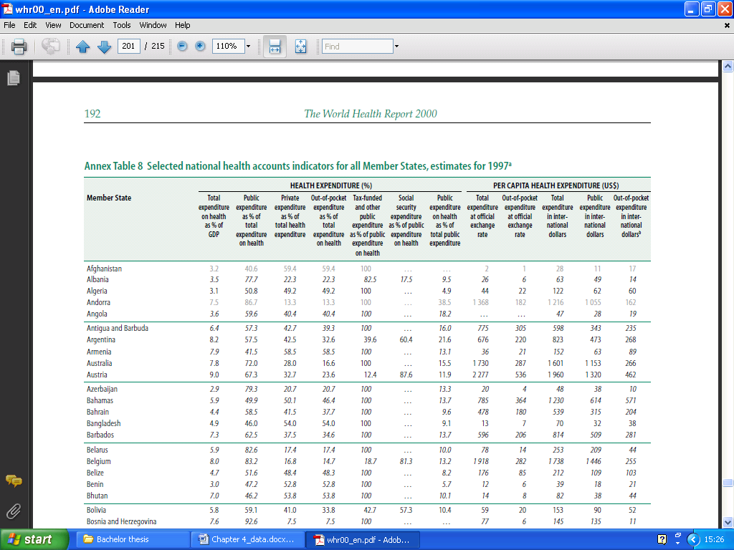
Figure 4.10: A part of the selected national health accounts indicators of all the countries, estimates for 1997. (WHO, 2000)

With this figure there are some footnotes added in the report of the World Health Organization. They state that the numbers who are printed in italics are incomplete data with a high to medium reliability. Further they state that the numbers who are printed in a grey color are incomplete data with a low reliability. Areas that are stated with three dots are not available or not applicable. So all the data of Albania is incomplete and with a high to medium reliability and all the data of Afghanistan is incomplete and with a low reliability. The data is mostly gathered from the IMF and from national sources. Also the United Nations and consistent domestic sources has been used to complete this list about health expenditure as much as possible.
I now arrived at the most interesting part of the research about the ranking of the healthcare systems of different nations. I will show the results of the overall performance of all the nations based on their healthcare systems. This list has been used and referred by a large amount of sources on the internet and in research papers. Also the documentary “Sicko” from Michael Moore refers to this list. With this ranking list I will also show the performance on health level. Below you can see the ranking results of the nations with the best performing healthcare system.
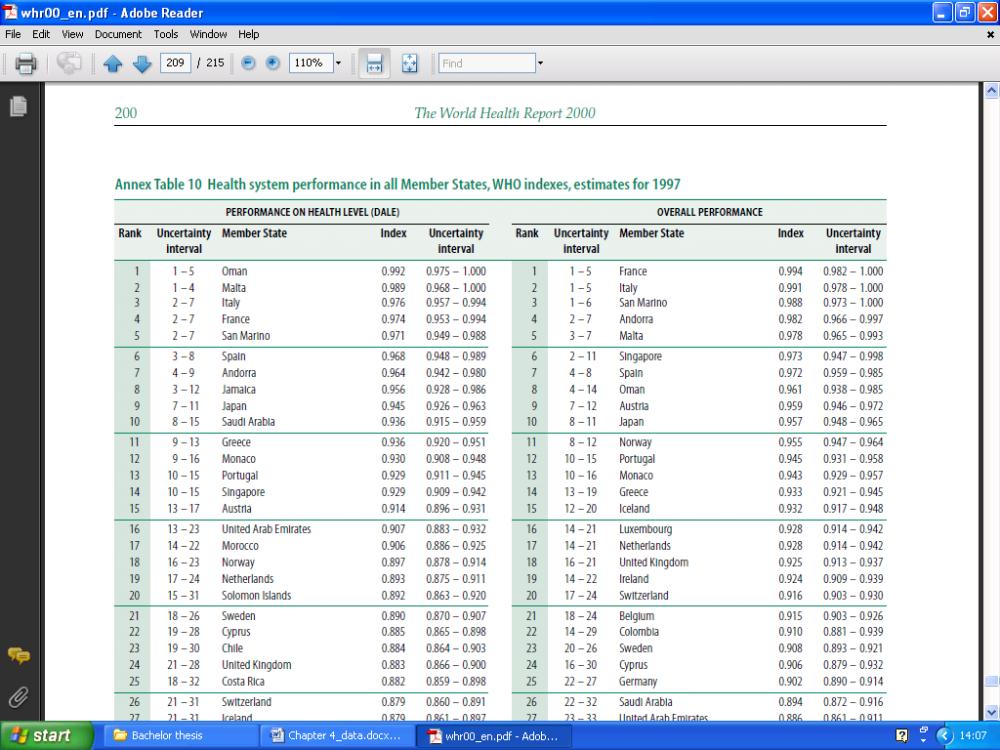
Figure 4.11: The top twenty countries of the health systems performance of all the 191 countries, WHO indexes, estimates for 1997. (WHO, 2000)

On the right list you can see that France has the best overall performance regarding their healthcare system according to the World Health Organization. Japan dropped suddenly to the tenth place, when you compare it with the overall goal attainment. The United States of America didn’t make it to the top twenty of the overall performance list. They are ranked as number 37.
So how did they calculate these two ranking lists? Well the report of the World Health Organization is actually very vague about this. They say that the left ranking list is determined by how efficiently the healthcare systems translate the expenditure into health as measured by the DALE. Thereby they look at the ratio between the achieved level of health and the level of health that could be achieved. The level of health that could be achieved is determined by the DALE that would be observed by the absence of a modern functioning healthcare system given the health expenditure and other non-healthcare system determinants that influence health. Those other non-healthcare system determinants are represented by educational attainment. The World Health Organization state that they used econometric methods to determine the maximal level of DALE. The list on the right about the overall performance is measured the same kind of way as the ranking list on the left. Hereby they relate the overall goal attainment with the health expenditure and other non-healthcare system determinants, which are represented by educational attainment.
There is also some overall information available about the whole research of the World Health Organization. The collection of the research data is performed mostly by the WHO Global Program on Evidence for Health Policy in collaboration with the counterparts from the Regional Offices of the World Health Organization. After collecting the data, the analyzing of the data has been performed. This was performed in eleven working groups.
The World Health Organization stopped with ranking the healthcare systems of the different nations after the report of 2000. The main reason is caused by the large complexity in order to perform the research. They do publish some new statistical data in some reports after the report of 2000, but those are only about some basic health indicators. For example, the life expectancy or the death causes. They didn’t collect all the data just like the research published in the report of 2000 and they also didn’t perform any ranking of the countries based on the collected data. However, some of these newer other statistical data has been used by the reports of the Health Consumer Powerhouse, which is a different organization that investigates countries and rank them based on the performance of the healthcare systems.

4.3 Euro health consumer index 2005
Ranking the health care systems of the different countries is important in order to make improvements in the healthcare sector. But you need multiple researches in order to get a new and a better insight about the different healthcare systems. We already focused on the report of the World Health Organization. However, there are more researches about the ranking of healthcare systems of different countries. A second report that we will discuss in this thesis is the “Euro health consumer index 2005”, which is a report created by the Health Consumer Powerhouse (HCP). In contrary with the WHO report, this report of the HCP only focuses on 12 countries of Europe instead of almost all the countries in the world. The Health Consumer Powerhouse calls themselves a centre for visions and action where they focus on consumer-related healthcare in Europe. So they focus on the consumer as an important actor that should increase his power in the healthcare sector. By reaching this goal they build the necessary reform pressure from the consumer by looking at all kinds of factors. An example would be the access of consumers towards knowledge in order to compare health policies, the services of consumers and the quality outcomes. These are all examples that improve value for the consumer in the healthcare sector. A lot of modern researches (Like Herzlinger or Porter and Teisberg) also confirm that the power of the consumer should increase so that the value of the consumer really will improve. In this way you will create value based on the results of the healthcare system. One of the steps that the Health Consumer Powerhouse has taken is the publishing of a yearly report since 2005 about comparing the healthcare systems. These comparisons were based on the focus of the consumer. The first report in 2005, which I will discuss first, ranked 12 countries in Europe. Thereby they used 20 basic indicators to relate to the consumer choice. As the years has past they also starting to publish other kind of reports. So they started publishing in 2008 the first Euro-Canada Health Consumer Index, where they compared the healthcare systems of 29 European countries and the healthcare system of Canada. They also started publishing in the year 2008 the Euro Consumer Heart Index, where they compared 29 European countries regarding the cardiovascular healthcare systems. Thereby they looked at 28 performance indicators. They apparently were quite energized in the year 2008, because they started publishing even one more report. This report is the Euro Consumer Diabetes Index, where they look at five important key areas so that they can compare the European countries about the diabetes part. The latest Euro Health Consumer Index is the EHCI 2009 at the moment that I write this thesis.

4.3.1 The results
Below you can see the results of the first attempt of the research from the Health Consumer Powerhouse.
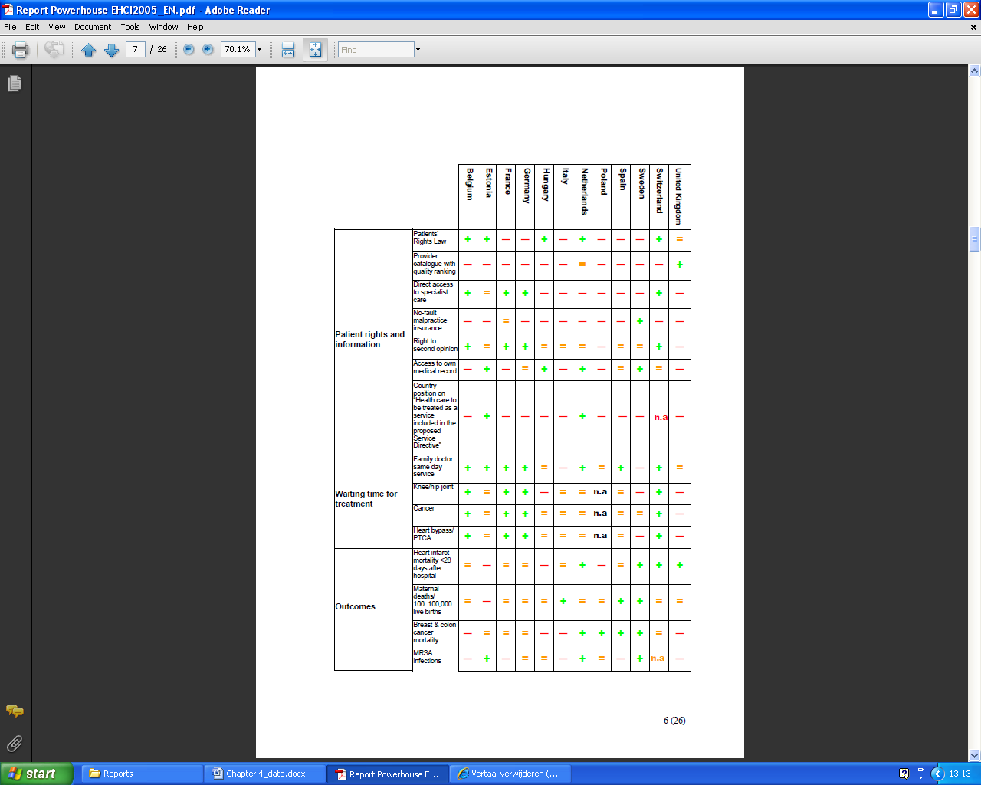
Figure 4.12: The first part of the results of the Euro Health Consumer Index 2005. (HCP, 2005)

Figure 4.13: The second part of the results of the Euro Health Consumer Index 2005. (HCP, 2005)

At the left you see the five categorizations of all the performance indicators. At the right of those categorizations you can see all the 20 indicators. Every country is rated on every single indicator. Thereby there are three different types of outcomes at every spot in the matrix. You could have a green plus sign, which means that the specific indicator of the specific country is rated as ‘good’. You could have an orange is sign, which means that the specific indicator of the specific country is rated as ‘so-so’. The third possibility is a red minus sign, which means that the specific indicator of the specific country is rated as ‘not-so-good’. Every sign is also equal in a scoring number. For the green, orange and red they are respectively 3, 2 and 1. They were thinking about putting weights on every indicator, where the more important indicators will score higher. However, they decided not to do this and to take this idea in consideration for the later versions of the Euro Health Consumer Index. At the bottom of the matrix you can see the total scores of each country. Based on those scores the ranking of the countries are created. Notice two things about the figure with the results of the ranking of the different countries. First notice that there is sometimes not a plus sign, an is sign or a minus sign in the matrix available. Instead it has a “n.a.” stated in that particular position. These “n.a.” statements are also even in a different color. The report does not enlighten these statements. The abbreviation “n.a.” probably stands for not available. By counting the total scores, it seems that every “n.a.” is scored as one point, despite of the different colors. The second thing that you should notice is about the rankings of the countries at the bottom of the figure. It seems that three of the twelve countries have the same rank. Belgium, Estonia and Sweden all are sharing the 4th position in this ranking list.
The research has been performed in four different project phases. The first phase was about the mapping of the existing information. Thereby they spend a lot of time to investigate which relevant information is available and accessible of the twelve countries they have investigated. Thereby they used web searches, personal visits and telephone and e-mail interviews with key individuals. The information providers they found are national and regional health authorities, institutions, patient associations and private enterprises. The second phase is about the data collection and the panel recruitment. Hereby they also identified the vital areas that they wanted to investigate. In the third phase they focused on the EHCI construction, the web solution building and the EHP feedback. They also received some consulting by using surveys, which were performed by external research facilities. In the fourth and final phase they presented the results and the report. Thereby they also launched an internet site for easy access towards their report.
Health Consumer Powerhouse makes clear that the results should be interpreted with great care and it restricts to draw drastic conclusions. They admit that this first version does have some data quality problems. The report of the Health Consumer Powerhouse tells namely that there is a shortage of the data from the Pan-European countries that have set uniform procedures for data gathering. Also the research has used the latest available information of a certain topic. However, this latest available information could be from different years. For example, the comparison of the cancer survival rates that the Health Consumer Powerhouse used in the research. Thereby is the data from one country from 1997, while the data from a different country is from 2003. This does not really well compare the different countries, because of the differences of time of the collected data. So they want to stimulate and even push the data sources to improve these data quality problems in order to improve the quality of the research about the European Health Consumer Index. Next they wanted to get 25 of the European Union countries to research, but at that time at 2005 there were many countries just new members of the European Union. This would cause problems with the statistical difficulties and methodology problems. So the result is that they researched ‘just’ 12 countries. This is 179 less countries than the amount of researched countries of the World Health Organization. Further the Health Consumer Powerhouse does some complaining in their report. They state that most countries have a lot of suitable data available that are about input. You have to think about all kinds of resources, like the number of hospital beds, the number of doctors per capita or health expenditure. However, the countries hardly have any output data about the healthcare systems available. These output variables are way more important than the input variables, because the output variables are able to measure the productivity, the cost-effectiveness and the quality of health. The output variables of healthcare are according to the Health Consumer Powerhouse the most interesting data in order to analyze the performance of the different healthcare systems.
I will now discuss how the collected data has been transferred towards a score on every performance indicator. The Health Consumer Powerhouse has collected the data and then created the definitions of the performance indicators. I will enlighten the definitions of the performance indicators with a figure.
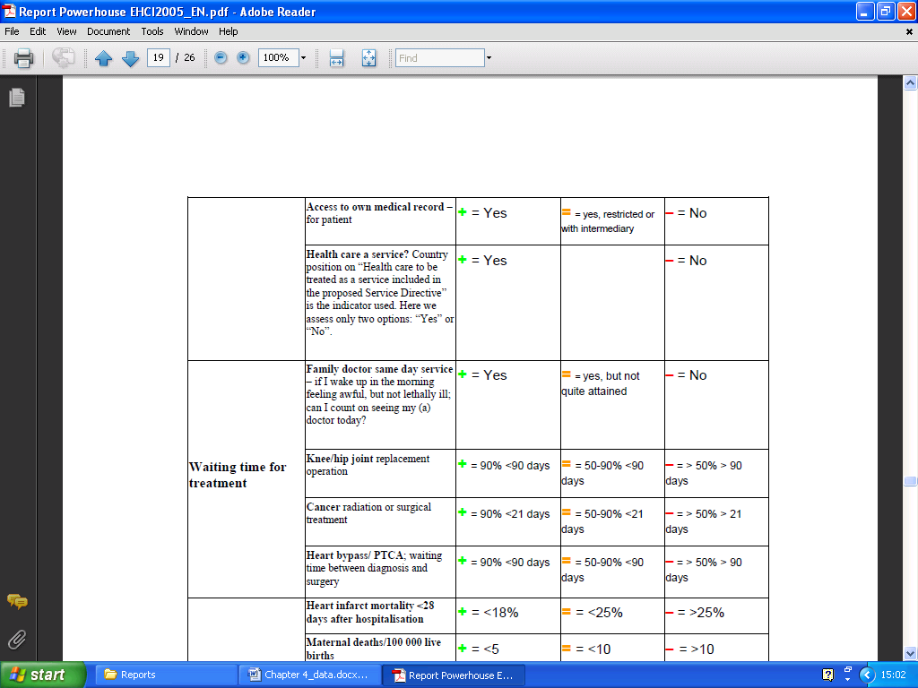
Figure 4.14: A part of the definitions of the indicators. (HCP, 2005)

On this figure you see clearly how the collected data is transferred into a score. The collected data of a particular indicator will be checked what kind of requirement fulfills of the three possible scoring areas. The requirement in a certain color that suits the collected data, will then determine the score. These requirements are sometimes a yes, a no or something in between and sometimes they are a particular percentage. The performance indicators and the corresponding scoring areas have been defined by an expert panel.

4.4 Euro health consumer index 2009
We already discussed the background of the Health Consumer Powerhouse. In short, they focus on improving the healthcare system for the end-user, which is the consumer. In the Euro Health Consumer Index of 2005 they researched the healthcare systems of only 12 countries. Thereby they researched 20 different performance indicators categorized in five different areas. In contrary with the World Health Organization, the Health Consumer Powerhouse performs their research about the ranking of the healthcare systems of different nations every single year since 2005. Thereby they are trying to improve their approach every year. They also extent or discard certain performance indicators. Also the number of the countries that they researched has extended as the years has past. It has increased from 12 European countries in 2005 till 33 European countries in 2009.

4.4.1 The results
With the research that has been performed, they also clearly stated the aim of the research in the report. The aim of the research is to select a limited number of indicators, within a definite number of evaluation areas, which will in combination provide how the healthcare consumer is treated by the respective healthcare systems. In this 2009 version of the report they focused on 33 countries of Europe. These European countries consist of 27 European Union countries and 6 other European countries. Thereby they ranked the healthcare systems in six different sub disciplines where in total 38 indicators are used for the ranking of the European countries. On the next two pages you can see the results of the research of the Euro Health Consumer Index 2009.
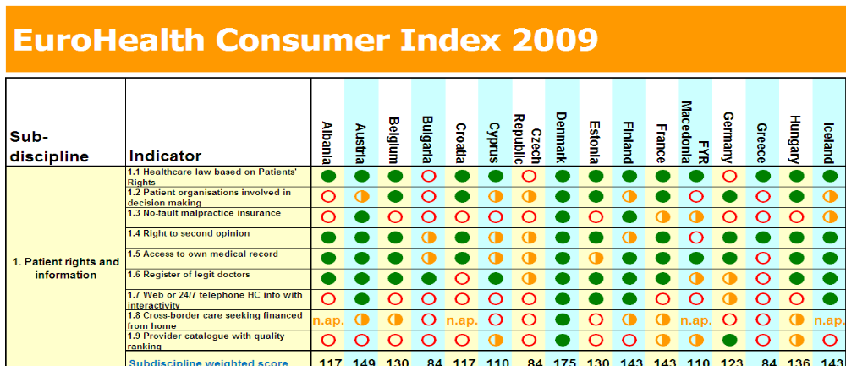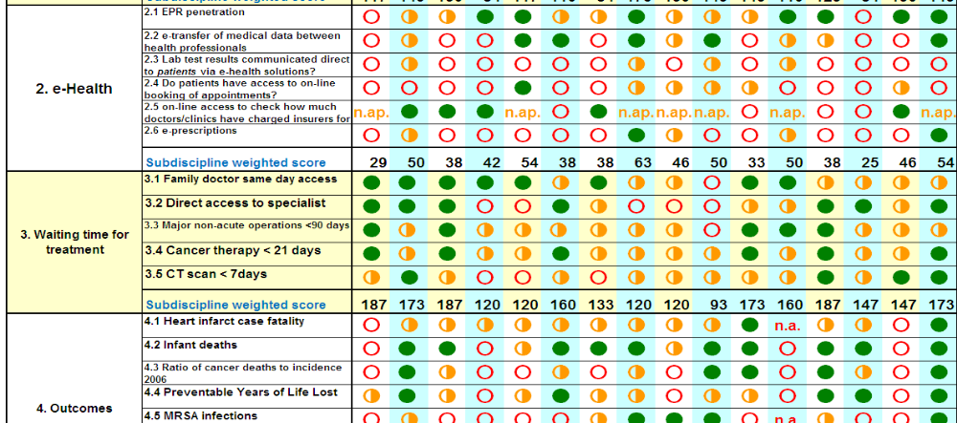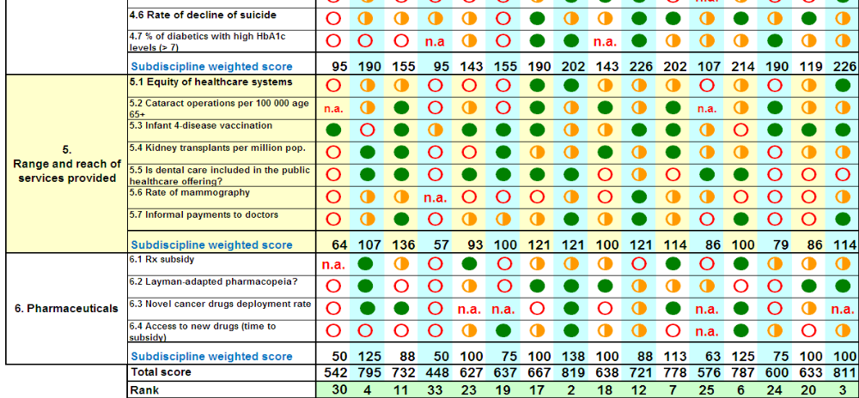
Figure 4.15: First part of the results of the Euro Health Consumer Index 2009. (HCP, 2009)
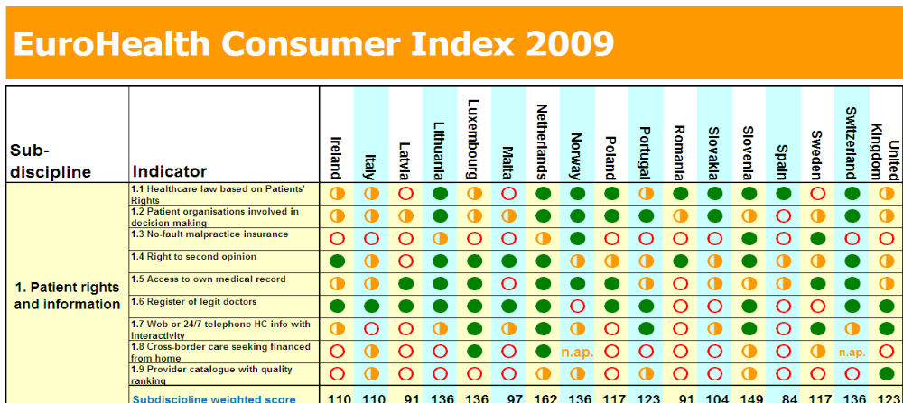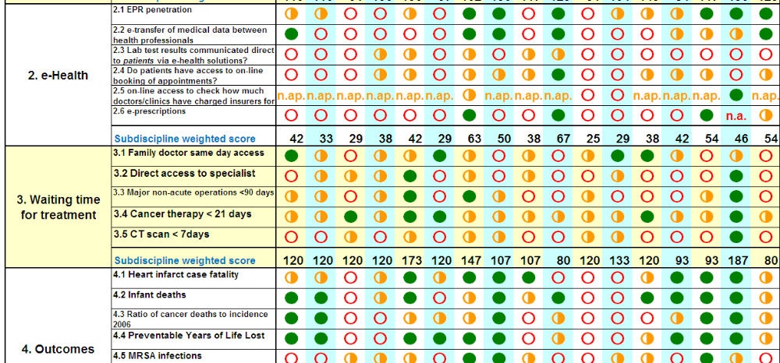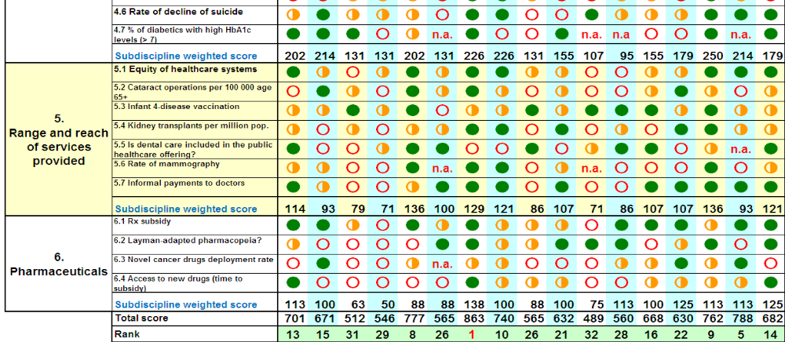
Figure 4.16: Second part of the results of the EHCI 2009. (HCP, 2009)
On the left side of the figures you see the six sub disciplines and the 38 indicators. Next you see that all the 33 countries are ranked at every single indicator. To keep the figures as a clear overview they give every indicator of every country a color. There are three kinds of colors, which are similar to a traffic light. You have the red empty circle, which means that the specific indicator of the particular country is “not-so-good”. There is also the orange half full circle, which means that the specific indicator of the particular country is “intermediary”. Next there is the green full circle, which means that the specific indicator of the particular country is “good”. Notice that sometimes there are two kinds of abbreviations used instead of the traffic light ranking style. One of them is the “n.a.”, which is printed in red letters. This stands for that the data is not available. The other is the “n.a.p.”, which is printed in orange letters. This stands for that the specific area is not applicable. The scores are determined by the colors of the indicators. Green, orange and red will respectively lead to the scores of 3, 2 and 1. The abbreviations ‘n.a.’ and ‘n.a.p.’ will lead respectively to the scores of 1 and 2. Those scores are multiplied by a weighted coefficient. At every sub discipline the figure provides at the same time the weighted score of every single country. The sum of all the sub disciplines of a specific country will lead to the total score of that certain country, which is shown at the bottom of the figures. Every country is ranked based on this total score. The scoring is based on such a way that the lowest possible score is 333 points and the highest possible score is 1000 points. The weights are the same for every performance indicator in a specific sub discipline. Below I will give the weights of every sub discipline.
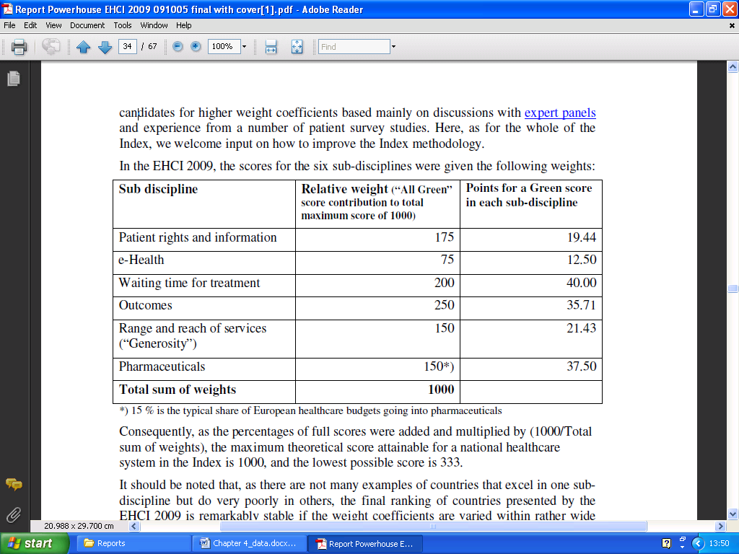
Figure 4.17: The determined weights of all the sub disciplines. (HCP, 2009)

These weights are determined mainly by multiple expert panels. Also they used patient surveys to influence these weights. At the World Health Organization they also used weights to determine the overall goal attainment. Thereby the WHO only used a survey to a large amount of people to determine the weights. With the results you can see at the bottom how every country is ranked based on all those performance indicators. However, you don’t easily see an overview of the sequence of all the ranking countries. That’s why they included a different figure about the sequence of the ranking countries. Below I will give a clear overview of the total scores of the countries.
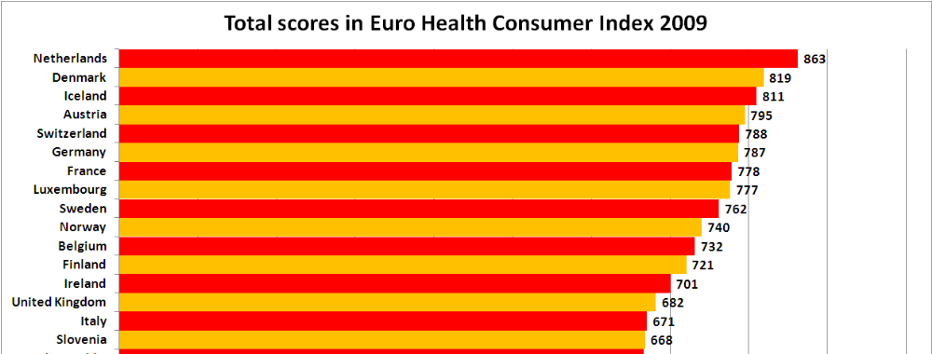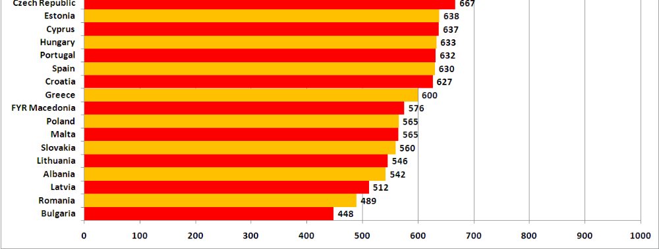
Figure 4.18: The total scores of the countries in the EHCI 2009. (HCP, 2009)

This figure does not require any further explanation. It clearly provides the scores of all the 33 countries. So apparently the Dutch seems to be the winner in this research, followed respectively by Denmark and Iceland. They have the highest score based on all the 38 indicators categorized over the six sub disciplines in the healthcare systems that the research has investigated. The scoring is performed in such way that it is almost impossible that two countries would score exactly the same amount. The researchers also make clear that you should not perform great efforts to analyze why a country on the 11th place scored higher than a country on the 14th place. They state this, because very subtle changes in singles scores may influence the order of the country, especially the countries in the middle of the ranking list. The research also shows the best countries of every sub discipline. Below you can see the best countries of every sub discipline.
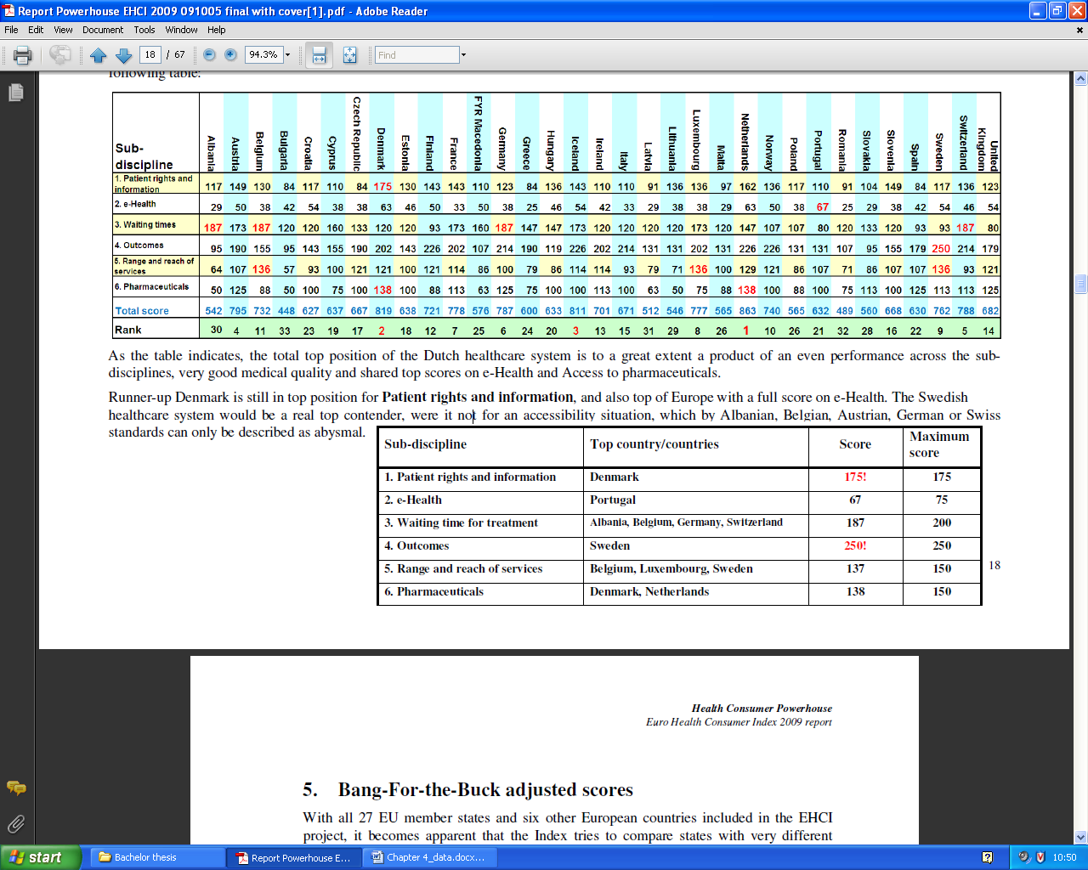
Figure 4.19: The highest scoring countries of the sub disciplines. (HCP, 2009)

Notice on this figure that on some sub disciplines, like the third sub discipline, there are multiply countries scoring the same score. Also notice that on the first and the fourth sub disciplines the winning countries managed to get the maximum scores.
A different thing that the Health Consumer Powerhouse has investigated is what they refer to as the ‘bang-for-the-buck’ score. Thereby they use the scores of the main results of their research and then they adjust this with the amount of money that has been used to invest in the particular healthcare system. To be more specific about the amount of money, this is the annual amount of healthcare spending in purchasing power parity. This will provide quite different results, because some countries have way different amounts of money invested in the healthcare sector than other European countries. The report also shows the results of this particular research, but I will not show the results in this thesis. But I do discuss some interesting stuff about the performed research in order to get those results. So is the data of the purchasing power parity from 2007. At least, the majority of the data is. By some countries this data is older than 2007. What also interesting is to mention, is the number one scoring country in this ‘bang-for-a-buck’ ranking list. That country seems to be Albania. This is kind of strange, because Albania scored as “n.a.” on many performance indicators. Albania also happens to be the country that has the lowest amount of purchasing power parity. The report actually does make a notice of this and tells that the result of Albania should be kind of ignored. But at the majority of the other countries, it does make a global overview about the relation between the performance and the money involved in it.
The Health Consumer Powerhouse gave some interesting information about the reliability of the data. They state that the collected data mostly comes from publicly available statistics. Some data is from own independent research of HCP. They honestly state that the access towards to public data were sometimes unfortunately slow and in some cases of poor quality. This means that they had from some countries more recent data than other countries. But the HCP has a system in place for assessing and validating all the data. They are confident that their methodology is an effective approach for providing overall measure of consumer friendliness in every country. Next just like the report from 2005 they warn about the Pan-European data shortages. This report also state just like the report from 2005 that they complain that the available data is mostly input data. However, the interesting stuff is actually the output data in order to rank the performance of a healthcare system. With output data you have to think about productivity variables, cost-effectiveness variables and quality variables. It is a good thing that the Health Consumer Powerhouse notices this weakness in the research. However, they are not the one that is producing the collected data. The Health Consumer Powerhouse collects the data from external sources (including the statistics of the World Health Organization). They made this statement already in the report in 2005. But now in the report of 2009 they still make this statement. So it seems that it hasn’t improved after all those passed years.
Next I discuss how every performance indicator has got his score based on the green, orange or red circles. This can be best explained by a figure. The figure below shows a part of the performance indicators and how a particular country will earn his score.

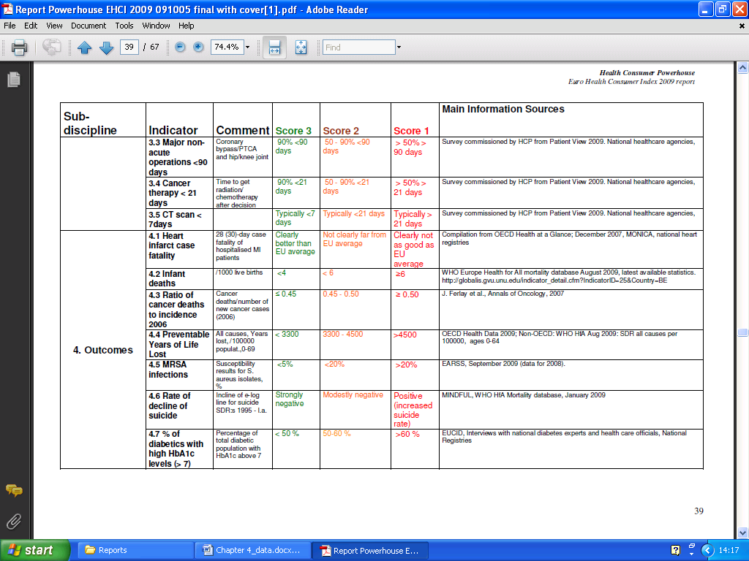
Figure 4.20: A part of the indicator definitions and the data sources. (HCP, 2009)

With the collected data they can use these indicator definitions to score a country on a specific performance indicator. There are three possible scoring areas. Sometimes these scoring areas are differentiated with a yes, a no or something in between. Sometimes the scoring areas are based on a percentages or a number as you can see in the figure. These indicator definitions are defined by an expert panel.
The report of the Health Consumer Powerhouse also stated an analysis of the progression of the scores of the different European countries. Thereby they started looking at the scores of the report from 2006 till the scores of the report from 2009. The results are stated in the figure below.
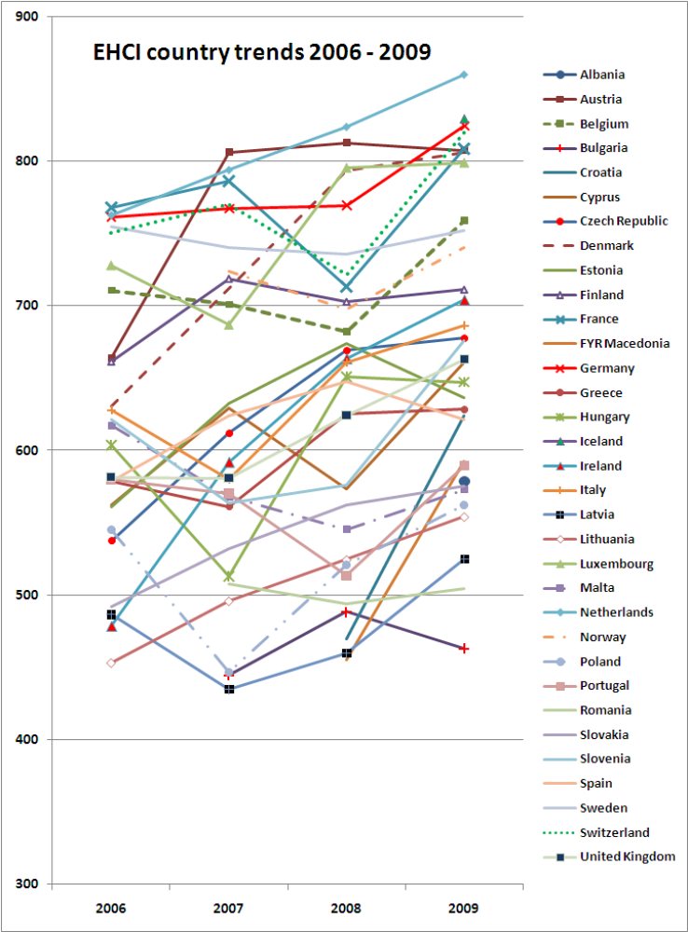
Figure 4.21: The results of the countries overviewed over a four year period. (HCP, 2009)

There have been changes every year regarding the number performance indicators and sub disciplines. So the results are normalized by the results of 2007 and calculated the same way as that particular report. However, in the report of 2007 there are only five sub disciplines. The sub discipline e-health didn’t exist back then. So they decided to remove this whole sub discipline in the comparison research with the results of four years. When you look at the results you see that almost every country has an improvement of their score if you compare the beginning score with the final score. It is kind of strange that they didn’t add the results of 2005 in this investigation with the results of the other years. They don’t explain this in their report. A possible reason could be the low amount countries involved in the report of 2005 and the absence of weights. In the report of 2005 they researched 12 European countries. In 2006 this amount already improved to 26 European countries. Also the number of indicators was increased from 20 to 28. The next difference is that the sub discipline ‘consumer friendliness’ has been removed. That sub discipline is replaced by the new sub discipline ‘generosity’. This new sub discipline has his name changed into ‘range and reach of services’ in the newer versions of the European Health Consumer Index. In 2008 they introduced the new sub discipline ‘e-health’. As the years has past there were also some minor changes, like introducing a small amount of extra countries and introducing a small amount of extra performance indicators. They reconsidered the countries and performance indicators every single year.

4.5 Chapter summary
I give you an extensive insight about the reports of the three different sources. The first report was from the World Health Organization. This report didn’t use the results of the ranking of the different healthcare systems of different nation as the main focus. It was mainly focused on the four different vital functions of a healthcare system. The research involved all 191 nations in the world (at that time). The WHO makes clear that not only the goodness of a healthcare system is important, but also the fairness is important. It researched a lot of different performance indicators. They researched the health level, the health distribution, the responsiveness level, the responsiveness distribution, the fairness of the financial contribution, the overall goal attainment, the health expenditure, the health performance level and the overall health system performance. The second report is from the Health Consumer Powerhouse. They investigated 12 European countries based on 20 different performance indicators. The report also quite clearly explains how they calculated every single performance indicator. Further it also gives some interesting information about the performed research. The third report is also from the Health Consumer Powerhouse. However this is the newest report at this moment. They really expanded their research by involving 33 countries and by researching 38 performance indicators. Also this report tells quite clearly how they researched every performance indicator and it also gives some interesting details about the data. Next they researched the performance in proportion with the healthcare spending. Finally it discusses some information about the differences between the yearly versions of the performed research.

Chapter 5: Data analysis

5.1 Introduction
This chapter will start with a basic comparison between the three ranking reports. Next I discuss how every report has taken care of the health performance monitoring. I also discuss how the three reports perform based on the data quality dimension. I continue by looking how the three reports are handling the ten dangers that influence the data quality of the performed research. Then I look at three external sources that criticize the World Health Report 2000. I will finish this chapter with a chapter summary. I added at every section of this chapter a specific introduction in order to give a clear prescription of every single section in this chapter.

5.2 Basic comparisons of the reports
In this section I will compare the reports on many different basic characteristics based on the data from the data chapter. I will look at the differences between the amount of countries and performance indicators that have been used in the reports. I will also compare the results of the reports. Next I will look at the differences of the data characteristics that have been used for the performed researches. All these comparisons will be performed by comparing continuously two reports. So first I will compare the World Health Report 2000 with the Euro Health Consumer Index 2005. Then I will compare the Euro Health Consumer Index 2005 with the Euro Health Consumer Index 2009. Next I will compare the Euro Health Consumer Index 2009 with the World Health Report 2000 in order to complete the circle.

5.2.1 World Health Report 2000 versus Euro Health Consumer Index 2005
The reports of the World Health Organization and the Euro Health Consumer Index of 2005 are both first attempts to rank the healthcare systems of different nations. However, there is a huge difference between the amount of countries that have been investigated and ranked between the reports. The World Health Report 2000 has investigated 191 different countries, which are all the nations in the world at that time in the year 2000. The Euro Health Consumer Index has ‘only’ investigated and ranked 12 different countries in Europe. So performing the research of the World Health Organization is way more complex based on the enormous amount of data that has been involved in the research. This actually doesn’t mean that the performed research of the Health Consumer Powerhouse was just an easy task. They do just researched 12 different countries, but in their research is also a large amount of data involved in the process ranking the performance of healthcare systems. The next point I would like to discuss is the fact that the organizations had a different view about their own ranking reports. The World Health Organization only performed the ranking of the different healthcare systems once and they decided to not perform this kind of research again based on the complexity of the research. At the Health Consumer Powerhouse were other plans. They saw this report of 2005 just as a basis for the ranking reports that were to follow the report of 2005. With this different mentality the Health Consumer Powerhouse didn’t tried to get a performed research, which is complete and perfect.
Another difference is the focus of both organizations. The World Health Organization performs this research, where it focuses on both the goodness and fairness of the healthcare systems. The Health Consumer Powerhouse performs this research, where it focuses on the patient and the outcomes of the healthcare systems. An advantage for the World Health report 2000 is that they also researched the fairness of the healthcare systems very well, while the Health Consumer Powerhouse hasn’t investigated the fairness at all. But there is also an advantage for the Health Consumer Powerhouse. They investigated the accessibility of healthcare very well with multiple performance indicators, while the World Health Report 2000 hasn’t investigated anything about the accessibility of healthcare at all.
Next I would like to notice that the World Health Organizations collected the large amount of data by its own organization. This organization has a large amount people working in a large number of different countries. The Health Consumer Powerhouse has gathered the majority of the data from external sources. So this is also a difference between both reports. With this difference I would also like to note that one of the external sources that Health Consumer Powerhouse used for its data collection is actually the statistical data from the World Health Organization.
I finish this comparison by showing the top 10 countries of both ranking lists. Because the fact that the Euro Health Consumer Index 2005 only exists of 12 European countries, I only look for those 12 countries in the ranking list of the World Health Report 2000. The highest ten countries of those twelve countries will I show in the top 10 of the World Health Organization ranking list. The result can be seen in the table below.
The top ten of the World Health Report 2000 (filtered) | The top ten of the Euro Health Consumer Index 2005
1) France | 1) Netherlands
2) Italy | 2) Switzerland
3) Spain | 3) Germany
4) Netherlands | 4) Sweden
5) United Kingdom | 4) Belgium
6) Switzerland | 4) Estonia
7) Belgium | 7) France
8) Sweden | 8) Spain
9) Germany | 9) United Kingdom
10) Poland | 10) Hungary
Figure 5.1: The top 10 of the ranking list of both the World Health Report 2000 and the Euro Health Consumer Index 2005, where the ranking list of the World Health Report 2000 is filtered by the researched countries of the Euro Health Consumer Index 2005.

By looking at the comparisons the results seems to be very different. So based on the results there are very large differences between the two ranking lists. This is not a surprise, when you consider all the other differences between both reports.

5.2.2 Euro Health Consumer Index 2005 versus Euro Health Consumer Index 2009
Now this will be an interesting comparison, because both ranking reports belong to the same company. The Euro Health Consumer Index of 2005 was their first attempt to rank the healthcare systems of different nations and the Health Consumer Powerhouse performed a research every year since 2005. So this makes the Euro Health Consumer Index of 2009 their fifth attempt. You would think that they quite improved the report of 2009 in comparison with the report of 2005, but there aren’t large differences. The most noticeable difference is the quantity of the performed research. In 2005 they researched 12 different European countries based on 20 different performance indicators. But in 2009 Health Consumer Powerhouse has investigated 33 European countries based on 38 performance indicators. So they almost doubled the amount of performance indicators and they even almost tripled the amount of European countries in their research of 2009.
Next they changed significantly the way of the scoring of the performance indicators since the report from 2006. So the report from was rated by only counting the scores, while every report since 2006 has a different scoring way. With this different scoring way the final score of a country will always be a number that can maximal reach the amount of a 1000. This method will catch up the small differences in the performed research every year. With this revised scoring method it is impossible to have two or more countries sharing the same position. They fixed this problem very well in the report of 2009, where none of the countries have an even score. In the report of 2005 were namely three countries sharing the third position. But one important problem didn’t change after the years that have been passed. They already stated clearly in the report of 2005 that they are complaining that the data sources have a large amount of input data of healthcare systems available, but hardly any output data of healthcare systems available. In 2009 they stated this problem again. In that report they are complaining again about this problem. This problem should have been solved after all those years.
I finish the comparison by stating the top 10 of both ranking lists again. Hereby I needed to filter the countries from ranking list of 2009 with the researched countries of the report from 2005. Because all the countries of the report from 2005 are involved with the report from 2009, but not all the countries from the ranking list of 2009 are involved with the report from 2005. The results are in the table below.
The top ten of the Euro Health Consumer Index 2005 | The top ten of the Euro Health Consumer Index 2009 (filtered)
1) Netherlands | 1) Netherlands
2) Switzerland | 2) Switzerland
3) Germany | 3) Germany
4) Sweden | 4) France
4) Belgium | 5) Sweden
4) Estonia | 6) Belgium
7) France | 7) United Kingdom
8) Spain | 8) Italy
9) United Kingdom | 9) Estonia
10) Hungary | 10) Hungary
Figure 5.2: The top 10 of the ranking list of both the Euro Health Consumer Index 2005 and the Euro Health Consumer Index 2009, where the ranking list of the Euro Health Consumer Index 2009 is filtered by the researched countries of the Euro Health Consumer Index 2005.

By filtering the ranking list of 2009 I suddenly see many similarities between the two reports. This is not really a surprise, because a lot of the performance indicators of 2009 are the same as the performance indicators from 2005. Still, there are quite some differences between the reports. For instance, the report of 2009 did investigate the countries with almost twice as much performance indicators. So it seems that those new indicators don’t have a significant influence on the results of the ranking list.

5.2.3 Euro Health Consumer Index 2009 versus World Health Report 2000
There is a large time difference between the report of the World Health Organization and the Euro Health Consumer Index of 2009. This has a big influence on the timeliness data quality dimension. This data quality dimension looks at the fact that the data is up-to-date for the data consumer or data user. There are nine years between both reports and a lot have changed between those nine years. Many reforms in healthcare appeared in a lot of countries. Also there are some technological improvements present at the year 2009. These technological improvements were not available in the year 2000.
Next large difference is the focus of both reports. Just like the report of 2005 Health Consumer Powerhouse is focused on the healthcare performance based on the patients. The World Health Organization is focused on both the goodness and fairness of the healthcare systems. You can see the effect of these differences by looking at the performance indicators of both reports. All the performance indicators are quite suited with the focus of both organizations. This will also not be a surprise that the results are very different.
I continue with the amounts of countries and the amounts of performance indicators of both ranking reports. The World Health Report 2000 has investigated 191 different nations in the whole world. The Euro Health Consumer Index 2009 has limited this amount at 33 European countries. So the World Health report 2000 has investigated a much larger amount of countries. When you look at the amount of performance indicators you will notice that the Euro Health Consumer Index 2009 has a larger amount.
I go on with the comparison of the top 10 of both ranking lists. Hereby I needed to filter the ranking list of the World Health Report 2000 in order to fit with the researched countries of the Euro Health Consumer Index 2009. All the countries from the ranking list of 2009 also exist in the ranking list of the World Health Report 2000, so this report doesn’t need to be filtered. You can see the results below in the table.

The top ten of the Euro Health Consumer Index 2009 | The top ten of the World Health Report 2000 (filtered)
1) Netherlands | 1) France
2) Denmark | 2) Italy
3) Iceland | 3) Malta
4) Austria | 4) Spain
5) Switzerland | 5) Austria
6) Germany | 6) Norway
7) France | 7) Portugal
8) Luxembourg | 8) Greece
9) Sweden | 9) Iceland
10) Norway | 10) Luxembourg
Figure 5.3: The top 10 of the ranking list of both the Euro Health Consumer Index 2009 and the World Health Report 2000, where the ranking list of the World Health Report 2000 is filtered by the researched countries of the Euro Health Consumer Index 2009.

By comparing these results there are really very different results from the two ranking reports. There are hardly any similarities available in both ranking lists. This is not a surprise, when you consider the difference in the performance indicators and the differences in time of both reports. Also the other factors as stated above influence these large differences in the results.

5.3 The health performance monitoring of the reports
On the literature review chapter I started by discussing some information about health performance monitoring. Thereby are categorizations available with the healthcare performance indicators, like the input performance indicators and output performance indicators. In this section of the data analysis chapter I investigate how every report has based their decisions on the performance indicators that they have researched in order to rank the healthcare systems of different nations. I will look at the model of Broemeling et al, 2006. Thereby I compare every report with the types of output indicators. At the output indicators they state about the volume, types (Like referral, prevention, curative or palliative) and the qualities (Like the responsive, comprehensive, continuity, coordination, interpersonal communication or technical effectiveness). I will also look at the model of Kruk and Freedman, 2008. Thereby I compare every report with the three different categorizations of the output indicators that are stated in this model. Those three categorizations are about the effectiveness, equity and efficiency of the healthcare systems. I present all the comparisons of the reports and models in six clearly tables.

5.3.1 World Health Report 2000
I will start comparing the two models about the health performance indicators with the World Health Report 2000. Remember that the World Health Report 2000 doesn’t have a large amount of performance indicators, so expect some limitations when they are compared with the two models. The model of Broemeling et al, 2006 state at the output indicators about the volume, the types and the qualities of the healthcare products and services. How the World Health Report 2000 fulfills this model, is clearly seen at the table below.
Categorization of the output performance indicators | Output performance indicators | Availability in the World Health Report 2000
Volume: | Volume | Yes
Type’s: | Referral | No
 | Prevention | No
 | Curative | Yes
 | Palliative | No
Qualities: | Responsive | Yes
 | Comprehensive | Maybe in survey
 | Continuity | No
 | Coordination | Maybe in survey
 | Interpersonal communication | Yes
 | Technical effectiveness | No
Figure 5.4: The way how the performance indicators of the WHR 2000 fulfill with the output performance indicators of the model of Broemeling et al, 2006.

Notice that sometimes I added a “Maybe in survey”. With this statement I mean that the particular performance indicator might have been investigated by the World Health Organization at the responsiveness surveys. They namely don’t provide the precise questions of the survey, so it could that those indicators are also researched in the survey based on the close relation of both topics. Next I would like to notice that at the “type’s” categorization only one indicator fulfills. Also there isn’t much investigated at the performance indicators about qualities even though the responsive indicator has been researched very extensively. Overall, the World Health Report has less than halve of all the output performance indicators of the model from Broemeling et al, 2006.
Next I show how the World Health Report 2000 fulfills all the output performance indicators of the model of Kruk and Freedman, 2008.
Categorization of the output performance indicators | Output performance indicators | Availability in the World Health Report 2000
Effectiveness: | Access to care | No
 | Quality of care | Yes
Equity: | Access for disadvantaged groups | No
 | Quality for disadvantaged groups | Yes
 | Participation/accountability | No
Efficiency: | Adequacy of funding | Yes
 | Costs and productivity | Yes
 | Administrative efficiency | Maybe in survey
Figure 5.5: The way how the performance indicators of the WHR 2000 fulfill with the output performance indicators of the model of Kruk and Freedman, 2008.

Some noticeable things about the results are that the report of the World Health Organization doesn’t focus on access of care. Also notice that the WHO is focused on the fairness of healthcare, but they only fulfill one of the three performance indicator about the equity categorization. The equity categorization is namely focused on fairness. Overall, the World Health Report 2000 fulfills just halve of all the output performance indicators of the model from Kruk and Freedman, 2008.

5.3.2 Euro Health Consumer Index 2005
I go on with the first report of the Health Consumer Powerhouse from 2005. This report investigated 20 different performance indicators, so with this report you could expect a higher fulfillment with the two models. First I show how the Euro Health Consumer Index 2005 compares with the output performance indicators of the model of Broemeling et al, 2006.
Categorization of the output performance indicators | Output performance indicators | Availability in the Euro Health Consumer Index 2005
Volume: | Volume | Yes
Type’s: | Referral | Yes
 | Prevention | Yes
 | Curative | Yes
 | Palliative | No
Qualities: | Responsive | Yes
 | Comprehensive | Yes
 | Continuity | Yes
 | Coordination | Yes
 | Interpersonal communication | Yes
 | Technical effectiveness | No
Figure 5.6: The way how the performance indicators of the EHCI 2005 fulfill with the output performance indicators of the model of Broemeling et al, 2006.

Notice that the Euro health Consumer Index 2005 covers almost every output performance indicator of the model from Broemeling et al, 2006. They only didn’t investigate something about the palliative type of healthcare and the technical effectiveness.
Next I show how the report from 2005 compares with the performance indicators of the model of Kruk and Freedman, 2008.
Categorization of the output performance indicators | Output performance indicators | Availability in the Euro Health Consumer Index 2005
Effectiveness: | Access to care | Yes
 | Quality of care | Yes
Equity: | Access for disadvantaged groups | No
 | Quality for disadvantaged groups | No
 | Participation/accountability | No
Efficiency: | Adequacy of funding | Yes
 | Costs and productivity | Yes
 | Administrative efficiency | Yes
Figure 5.7: The way how the performance indicators of the EHCI 2005 fulfill with the output performance indicators of the model of Kruk and Freedman, 2008.

In this model you can clearly see a distinction made by the categorizations of the performance indicators. The Euro Health Consumer Index 2005 researched a lot of performance indicators that are related with the effectiveness and efficiency of a healthcare system, but they didn’t investigate any type of the equity categorization.

5.3.3 Euro Health Consumer Index 2009
I now compared the report of the World Health Organization and the first report of the Health Consumer Powerhouse with the two models. But how does the two models compare with the latest report of the Health Consumer Powerhouse? I would expect that this model would perform the best with the comparisons of the two models based on the fact that this report has investigated a lot of performance indicators. The total amount of the investigated performance indicators are 38. So let’s see if this assumption is true. Again I begin with the comparison of the report with the model of Broemeling et al, 2006.
Categorization of the output performance indicators | Output performance indicators | Availability in the Euro Health Consumer Index 2009
Volume: | Volume | Yes
Type’s: | Referral | Yes
 | Prevention | Yes
 | Curative | Yes
 | Palliative | No
Qualities: | Responsive | Yes
 | Comprehensive | Yes
 | Continuity | Yes
 | Coordination | Yes
 | Interpersonal communication | Yes
 | Technical effectiveness | Yes
Figure 5.8: The way how the performance indicators of the EHCI 2009 fulfill with the output performance indicators of the model of Broemeling et al, 2006.

Just like the report from 2005 they cover almost every output performance indicator of the model from Broemeling et al, 2006. The report of 2005 only lacked two performance indicators, where this report from 2009 only lacks one performance indicator. This performance indicator is about the palliative care, which is a type of care that is focused on loosens of pain for patients who are camping with some serious illness.
I continue with the comparison of the report from 2009 with the model of Kruk and Freedman, 2008. The table with comparisons is shown below.
Categorization of the output performance indicators | Output performance indicators | Availability in the Euro Health Consumer Index 2009
Effectiveness: | Access to care | Yes
 | Quality of care | Yes
Equity: | Access for disadvantaged groups | No
 | Quality for disadvantaged groups | No
 | Participation/accountability | No
Efficiency: | Adequacy of funding | Yes
 | Costs and productivity | Yes
 | Administrative efficiency | Yes
Figure 5.9: The way how the performance indicators of the EHCI 2009 fulfill with the output performance indicators of the model of Kruk and Freedman, 2008.

The results of this model are actually the same in comparison with the report of 2005. Again the Health Consumer Index didn’t investigate anything about the equity categorization of the output performance indicators. If the Health Consumer Powerhouse wants to improve their report every year, then I have a very useful recommendation for them. They should also focus on the healthcare performance of disadvantaged groups and investigate the fairness. So this makes my assumption that this report would perform the best based on the performance indicators true. But it performs only one more indicator better than the report from 2005, which is actually not so fantastic.

5.4 The data quality dimensions of the reports
In this section I will discuss how all the three different healthcare performance ranking reports perform based on the data quality dimensions. I will discuss the sixteen different data quality dimensions that I showed at figure 2.3 of the literature review chapter. I will look at every single data quality dimension for as far the reports are able to provide that information.

5.4.1 World Health report 2000
I will start again with the World Health Report 2000. I found some information in the report that is related about the following data quality dimensions: Completeness, consistent representation, Free-of-error, reputation, timeliness and value-added. I begin with the completeness data quality dimension. This data quality dimension is about the fact that data is not missing and the data is of sufficient breadth and depth of the task. At the research of the World Health Organization regarding the data collection, there is a lot of data missing. Let’s take the calculation of the distribution of health as an example. The distribution of health has been calculated by using the equity of the child survival of a country. This data involves the small area data of a specific country. However, in some countries these small area data wasn’t available. As a solution the World Health Organization used an alternative calculation method in order to calculate the health distribution in those countries where the small area data isn’t available. So this may be a solution for fulfilling the completeness data quality dimension, but this measurement will cause a problem at a different data quality dimension, which is the consistency representation. By using different calculations for the same target causes an inconsistent data research.
At the completeness data quality dimension I already mentioned a problem about the consistency of the performed research. There is also another point I would like to notice about the consistency of the performed research. At the data chapter I showed some parts of all the data that has been used in order to rank the healthcare systems of different nations. Some of those figures used data from 1997, like the fairness of the financial contribution. But other figures use data from 1999, like the responsiveness of healthcare systems level and distribution. Even other figures used data from both 1997 and 1999, like the health level and distribution. But all those have been combined in order to calculate the overall health attainment. So they used data from different time periods.
The next point I noticed is about the free-of-error data quality dimension. This dimension states that the data is correct and reliable. The data of the performed research are most of the time estimates, so they aren’t for a 100% correct. Also in the case of the healthcare expenditures, there is data available that has a low level of reliability. That list also shows that some data in some countries are not available, which is also related with the completeness data quality dimension. A good thing about some lists with data is that they also show the uncertainty intervals. This way they show that they have taken into account that some data and the performed calculations aren’t for a 100% correct.
I continue with the reputation of the data. The Word Health Organization used mostly data gathered from their own organization. These statistical data have quite a good reputation and is also used by a lot of other researches.
Next is the timeliness of the performed research. The timeliness data quality dimension is about the fact that the data is up-to-date. This is may be a big weakness with this performed research of the World Health Organization. The data is represented at the year 2000. This is already quite a few years ago. In those years there have been a lot of differences occurring regarding the performance of the healthcare systems. For instance, there have been many reforms occurred that a high impact on the healthcare sector and the performance of it. These reforms happened at many different countries. So this really makes the data of the World Health Organization outdated for now.
The last data quality dimension is the value-added dimension. This a positive point for the performed research of the World Health Organization. The research shows quite precisely on which performance indicator the weaknesses are of a particular country. In this way the country could consider some measurements to improve these weaknesses in order to improve the performance of the particular healthcare system. So the research has absolutely a high impact on the value-added data quality dimension.

5.4.2 Euro Health Consumer Index 2005
About the Euro Health Consumer Index of 2005 I want to discuss the following data quality dimensions: Accessibility, appropriate amount of data, completeness, consistent representation, free-of-error, reputation, timeliness and value-added. This is quite a large amount of dimensions, so let’s start right away with the first one. This is the accessibility of the data, which means that the data is easily and quickly retrievable. This was according to the Health Consumer Powerhouse a large problem. They stated in the report that there was a large availability of input performance indicator, but that there was a small amount of output performance indicators available. The output performance indicators are actually the most important performance indicators. So in this way they had some data accessibility problems.
Next I noticed something about the appropriate amount of data. They only investigated twelve countries in Europe in order to investigate and to rank the performance of healthcare systems of different nations. This is not a large amount if you consider that there are approximately 191 nations in the world. But this point is related to the scope of the performed research and with the mentality of the Health Consumer Powerhouse. Their scope is the ranking of different nations on their healthcare systems, which is limited to only European countries. But still there are many more countries in Europe then only twelve. This can be explained by the second point, which I mentioned. The report of 2005 states multiple times that this particular report must been seen as a first basic attempt to rank European countries on their healthcare systems. They state that next year they would really improve this fact, which they actually did by expanding the amount of countries to 26. Nevertheless this makes the data quality of the performed research of the report from 2005 quite poor based on the appropriate amount of data.
I continue now with the completeness of the data quality. At the results of the Health Consumer Powerhouse you can see that there is sometimes a “N.A.” appearing. Also the report states that there is a data shortage in the performed research. These are both factors that have a bad influence on the completeness data quality dimension.
Next is the consistency representation. The reports state that there are some huge differences between the data from different countries. So are the cancer rates from some countries actually from 1997(!), while in other countries it is up-to-date from 2005. This really causes an inconsistency in the data quality of the performed research.
I go further with the free-of-error dimension. With this dimension I want to repeat the fact that there is a lot of “N.A.” available. This will influence the score and endangers the free-of-error rate of the results of the performed research. I also noticed that there are a lot of countries ranked at the same positions, because they have an equal score. This gives some doubts about the reliability of the research.
Next I discuss something about the reputation of the performed research. The data has been gathered from trustful resources that has a good reputation. One of those sources is the statistics from the World Health Organization. Health Consumer Powerhouse also used an expert panel to help their research and they did a lot of effort in consultancy about the research. Al these factors give the research a good data quality based on the reputation dimension.
Next I focus on the timeliness of the research. About this dimension I would like to notice two things. First I noticed that some data of the report from 2005 is from 1997. Health Consumer Powerhouse stated this problem very well in their report with an example with the cancer rates. This means that there has been a research performed where even eight year old data has been used in order to get the conclusions. Next thing about the timeliness data quality is the fact that Health Consumer Powerhouse performs a research every year. So in 2006 they published a new report, which makes the report of 2005 kind of outdated. Still it is very useful for comparisons, but it will also be outdated.
The final dimension I discuss is the value-added data quality dimension. This is very well in this research. Just like the World Health report 2000 it is able to show the weaknesses of a particular country, but this report is more specific about what kind of performance indicators are the weaknesses of a particular country.

5.4.3 Euro Health Consumer Index 2009
The third report has 9 data quality dimensions that I would like to discuss. They are: Accessibility, appropriate amount of data, completeness, consistent representation, free-of-error, relevancy, reputation, timeliness and value-added. I begin with the accessibility of the report from 2009. Health Consumer Powerhouse stated in this report again that they are criticizing about the fact that there is a large availability of input performance indicators available, but hardly any output performance indicators. That they state this problem in 2005 is understandable, but that they still state this problem four years later is kind of strange. You would expect that this problem would have been solved after all those years. Although the data collection is mostly gathered from external sources, it shouldn’t be solved after all those years. They should put some pressure on the sources where they gather the data from.
Next is the appropriate amount of data. This is actually very well in this report of 2009. Their target was to investigate as much European countries as possible. They investigated 33 European countries, which is an impressive amount. Also when you look at the amount of performance indicators you notice that the amount of it is alright. They investigated the healthcare systems on 38 performance indicators.
The following data quality dimension where I notice something in the report of the Euro Health Consumer Index 2009 is about the completeness dimension. It seems that also the results of this report from 2009 have some “N.A.” available in it. This makes the results incomplete. There is also in this report something noticed about the data shortage.
I continue with the consistency representation data quality dimension. Just like the report from 2005 it has in some areas of the performance indicators some collected data that is from different years. But in this report they don’t state how old the oldest data is or what the differences in years are between data about the same indicator. Let’s hope that they haven’t use the data from 1997 again from some countries. In this report they do state a solution for this particular problem. It seems that the Health Consumer Powerhouse have a system that is capable to assess and validate all the data. According to them this inconsistency will not be a problem anymore.
Next is the free-of-error dimension. With this dimension I recall the point about the appearance of the “N.A.” at the results. At the report of 2005 I also noticed something about even scores at some countries. This problem is actually fixed in the report of 2009.
The sixth data quality dimension is about the relevancy of the report. About this data quality dimension I am quite positive. They perform the research every year, where they always revise the performed research with an expert panel. They also call in some consultancy every year. A very well example of these revisions is the result of a whole new sub discipline, which is about E-Health. These revisions will make the performed research every year always very relevant.
Next data quality dimension is about the reputation. Just like the report from 2005 they gathered their data from respectable sources with a good reputation. Like I mentioned before, one of those sources are the statistics from the World Health Organization.
I continue with the timeliness data quality dimension. The research is performed in 2009. The time that I write this bachelor thesis, it is the year 2010. So this research is less than a year old. Based on this fact the timeliness is very well. But there is one problem regarding this dimension. With the report from 2005 Health Consumer Powerhouse stated that there was data used that actually came from 1997. So is this problem also present in the report of 2009? Well, they do state again that they are dealing with this problem, but this time they don’t name a year of how old the oldest data actually is. This kind of endangers the timeliness data quality dimension.
Finally the last data quality dimension that I would like to discuss is about the value-added of the research. This report gives just like the other two reports very clear the weaknesses of a particular country based on their healthcare system.

5.5 The handling of the reports about the ten data quality dangers
In this section of the data analysis I investigate how well the reports are handling the ten dangers that really can influence the data quality of the performed researches. Just like the data quality factors section I discuss these data quality dangers for as far the reports are able to provide the specific information in order to investigate these ten data quality dangers.

5.5.1 World Health report 2000
So how does the World Health report 2000 handle the ten dangers that influence the data quality? With the provided information in this report I am able to discuss the following two dangers:
- Subjective judgment;
- Volume of data.
I will begin with the first danger about subjective judgment. With subjective judgment you have to think about research data that has been influenced by the opinion of a certain group of people. This is the case with some areas of the research from the World Health Organization. An example is the investigation about the responsiveness level of health. This has been investigated by using a survey at the population of all the nations. This will lead to a human subjective judgment. This data quality danger will question the objectivity of the performed research. It also sets of a chain reaction at other data quality dimensions, which is showed at the figure below.
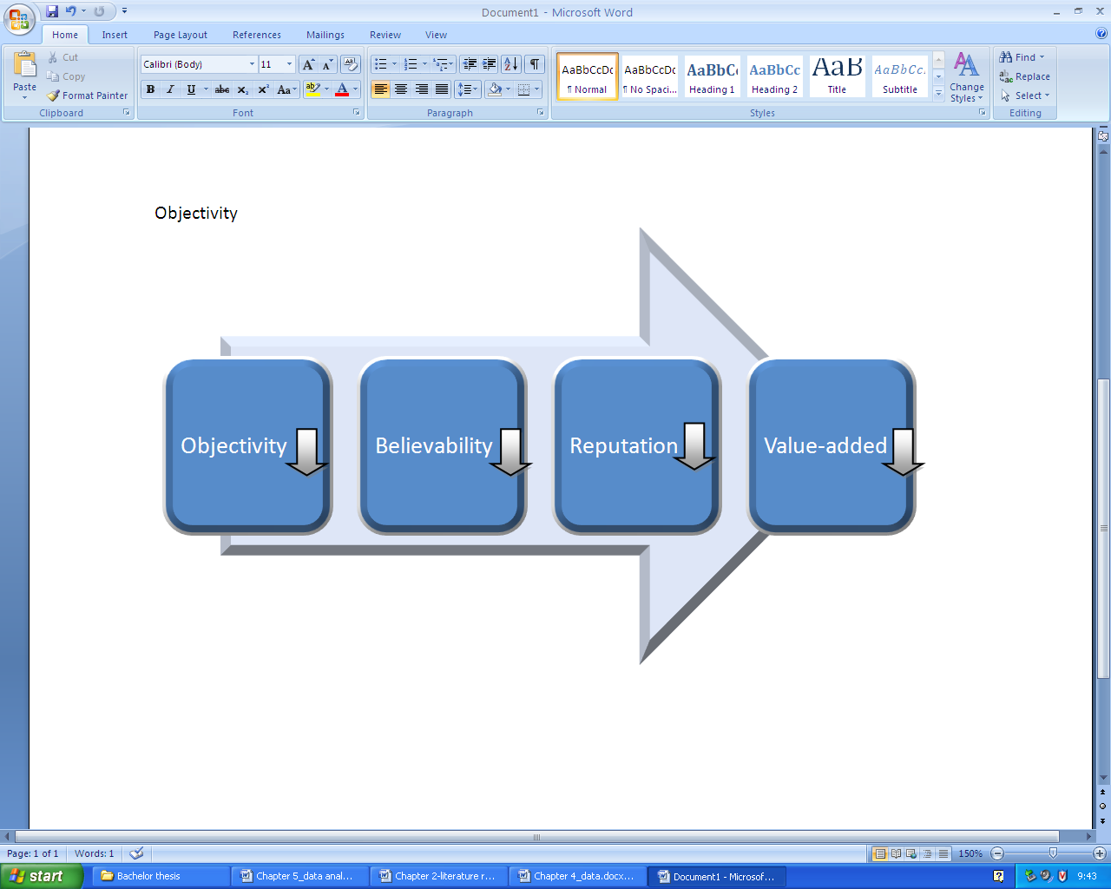
Figure 5.10: The chain reaction of data quality dimensions that is caused by having a subjective judgment present in the performed research.

The believability is another data quality dimension that will be lowered by this subjectivity. This will also lead to a poor reputation about the research, which is another data quality dimension. This poor reputation about the research will again lead towards damage on the value-added data quality dimension of the research. All this together would results that the data consumer will not use the data at all. However, in some cases there is no other way to research a specific topic. If we look at the World Health report 2000, there is no other way to investigate the responsiveness level of health. This performance indicator states how the population interpreters the level of health. This can only be investigated with the human subjective judgment. In those cases we should realize that there is no other option to research that specific topic and in those cases it should not damage all the data quality dimensions as stated above in figure 5.10.
The second data quality danger is about the volume of data. When there is a large amount of data involved in the research it could lead to some serious problems. It may cause a complete chaos regarding the storage and processing of all the collected data. What are the consequences of this danger? Well, it will lead to a poor timeliness. The large amount of data will massively slow down the progress of the performed research. So this will inflict some problems about the timeliness data quality dimension. By the time that the performed research is done, it may be already outdated. This is really a frustration for the researcher, because the outdated research will not be interesting at all for a data consumer. When I look at the World Health Report 2000, I see that they really had some problems with this danger. This can for example be seen by the fact that the data was already three years old when the report was published. Also all the data results are together a very massively amount of data. This is not strange, when you know that they investigated the performance of the healthcare systems from 191 different nations. They also stated that the research will not be repeated, because of this complexity that is involved by this research. Good solutions for this problem is to collect, provide and organize all the data extremely well in specific categorizations. This is easily said than done, when you are handling these types of huge amounts of data.

5.5.2 Euro Health Consumer Index 2005
So how does the Euro Health Consumer Index of 2005 handle the quality dangers? With the provided information in the report I will discuss the following data quality dangers:
- Subjective judgment;
- Volume of data;
- Input storage rules.
Just like the World Health Report 2000 this report also consist of some subjective judgment. For instance, they have investigated the right of having a second opinion for patients. They used a survey that has targeted patients to fill in. A different example is the investigation of all the customer friendliness performance indicators. All the results of this sub discipline are based on a survey that has also been filled in by patients. This creates a subjective judgment regarding these topics. The result will be a negative chain reaction of multiple data quality dimension as stated in figure 5.10. In these kinds of cases there is just no other way to investigate these particular performance indicators. These kinds of situations should be seen as exception regarding this data quality danger.
I continue with the volume of data. This is the second data quality danger that I would like to discuss for the Euro Health Consumer Index 2005. Although this research seems much smaller compared to the research of the World Health Organization, still it involves a large amount of data in it. At this report of 2005 they tried to investigate every country that is a member of the European Union and they added Switzerland as a nonmember for comparisons. The result is that they limited it to only 12 countries, while there are approximately 25 European countries available that are a member of the European Union. So they also had a problem with the large amount of data that is involved in their performed research. They used the limitation of just 12 European countries as a solution to handle this problem. They also knew that they would produce a new report the next year, so they had to prevent any large progress delays. About this problem they also state that a lot of European Union countries in 2005 were just fresh new members, which causes also some problems about the data collection.
The third data quality danger that I involve with the Euro Health Consumer Index 2005 is about the input storage rules. About this danger I would actually compliment the Health Consumer Powerhouse, because they stated their input storage rules very clear and they also show these in the report. At figure 4.14 of the data chapter I already showed a part of how the collected data will result to the final scores of a particular performance indicator of a country. So by handling this data quality danger very well, it will result in an increase of the data quality of the performed research.

5.5.3 Euro Health Consumer Index 2009
Regarding the Euro Health Consumer Index 2009 I noticed something about the following data quality dangers:
- Subjective judgment;
- Volume of data;
- Input storage rules;
- Changing data needs.
The first data quality danger that is involved at the Euro Health Consumer Index 2009 is again about the subjective judgment. Just like the other two reports, there are some specific performance indicators that can only be investigated with the human subjective judgment. So in those cases the data quality dimensions shouldn’t be lowered. Also notice that the focus of the Health Consumer Powerhouse is about the patient. So the research is mainly based on the performance of the healthcare systems with relation to the outcomes for the patient. This fact really requires some human subjective judgment from the patients in order to get a relevant research.
The second danger I discuss is about the volume of data. The Euro Health Consumer Index 2009 has involved 33 different European countries, where they research at every country 38 different performance indicators. This requires also a very large amount of data. It could lead to outdated data, which is caused by the delays of the progress. However, they perform this type of research for the fifth time, so you would suggest that they have quite some experience about the whole process of the research. They managed to finish the research in a year so this results not in outdated data problems. Also they managed to research many European countries who are a member of the European Union and they even researched quite some other nonmember European countries. So this means that they handled the large volume of data actually very well.
I continue with the third danger. This danger is about the input storage rules. I mentioned this danger already at the Euro Health Consumer Index of 2005, but this also accounts for the Euro health Consumer Index of 2009. They stated very clearly the way how the collected data will result to the final scores that determine the ranking of every country in relation with their healthcare system performance.
The final data quality danger is about changing data needs. This danger describes that the needs of a data consumer tends to change in a period of time. The researcher should take this into account, when performing the research. In the case of the healthcare systems it could happen that there are sudden changes appearing that also change the way of how certain healthcare performance indicators should be researched. With changes you could for example think about healthcare reforms in a country or about technological changes. These technological changes may appear new kinds of performance indicators that should be researched. The organization of the Health Consumer Powerhouse did this very well. Although they performed the research every year, they always used an expert panel and some external consulting every year since 2005. This revision every year will handle the appearing changing needs of the data consumers very well. The result will be an increase in the completeness of the research. Also the relevance of the research will be in an excellent quality. The report of 2009 does discuss some results of those yearly revisions. So there are some changes about the amount of performance indicators, because some performance indicators are added for the research and some performance indicators have been decided to discard. There are also some changes about the names of some indicators and sub disciplines. They also yearly revise the way how the scores are determined. All those factors increase the quality of the data. The best example of such a change is the introduction of the new sub discipline about E-Health. This is a new area in the healthcare systems, which is resulted from technological improvements. So you could state that the relevance of this research is in an excellent state.

5.6 External criticism about the World Health Report 2000
In the appendix I added three sources that are criticizing the World Health Report. I will discuss their criticism about the World Health Report and I will also look critically at some of those external sources.

5.6.1 Misleading performance indicators
The first large criticism of the World Health Report 2000 is about the performance indicators. The criticism states that the performance indicator of the research is misleading. Especially the article that I added at appendix B makes this statement very firmly. Firstly, the article tells that the overall performance is calculated with the overall goal attainment and the influence of the health expenditures, which will make the results misleading. This is not completely true. The overall performance is not only influenced with the health expenditures. It also involves the non-healthcare system determinants, which are represented by educational attainment. But this is also quite vague and it might be misleading. The next comment of the article regarding the misleading performance indicators is about the overall goal attainment. It tells that the overall goal attainment is calculated with five indicators, while only one indicator is actually about the performance of the level of health. This is in a certain way kind of correct, because only the level of health is one of the five indicators that determine the overall goal attainment. But this is not misleading, because the other indicators are also about health performance monitoring. So they need to be included as well. Next I would like to notice the comment about the calculation of the health distribution. The article tells that the health distribution is calculated with the distribution of the infant survival. Thereby it states that some countries don’t have this data available and thereby they just based this performance indicator on variables such as poverty level. All these statements are actually true and they do influence the performance indicators based on misleading.
The data of the article from appendix B isn’t free-of-error. I already noticed some errors above, but there is also another error in it. It states the whole time that the World Health Organization has researched 192 different countries, but this is not true. The report states multiple times that they researched 191 different nations. Also all the data that is shown in the report has provided the data of every country they researched. When you count all the countries you will also end up with 191 countries. This article is also not objective. The writer is an American and he is complaining that the healthcare system of America should be ranked higher in the list. You can clearly notice that he involves his opinion in the article. If the writer was for example a German and he would say that the American healthcare system should be ranked higher, it would be a more valuable statement than the statement of the American writer. Still, the author makes quite a good point about the performed research of the World Health Organization.
The research paper from appendix C also tells in an indirect way that the performed research of the World Health Organization is kind of misleading. The paper is about the healthcare system of Italy. According to the ranking list of the World Health Report 2000, Italy has the second best healthcare system of the world. This paper investigated, however, that the healthcare system in Italy isn’t so perfect at all based on the public perception. So in this way it kind of tells that the results of research from the ranking report is misleading based on the reality.

5.6.2 Influence of external factors
I will now discuss a second large criticism about the World Health Report 2000. This criticism is about that the World Health Organization doesn’t involve the influence of external factors in the performed research that also influence the results. According to the article from appendix A, it makes the performed research of the World Health Organization flawed. With flawed it means that there are defects in the research. This article tells some examples about those external factors like, tropical climate, distance from coast and violence. This article also states that the research of the World Health Organization is outdated, but it doesn’t clarify this statement.
The article from appendix B is also critical about this topic about the influencing external factors. This influence of external factors will also indirectly lead to misleading performance indicators. It provides quite some examples about those external factors. For instance, the article tells that all kinds of lifestyle variables are examples of the influencing external factors, like smoking and obesity. Next it states that death rates, like murder and traffic accidents also are influencing external factors.
It is hard to be critical about this criticism about the influence of external factors. The World Health Report 2000 based the level of health with the disability adjusted life expectancy (DALE). However, the DALE is not only influenced with the performance of the healthcare system. There are other variables that influence this DALE, which the articles state about. But those other variables have no influence on how well the healthcare system performs.

5.7 Chapter summary
In this chapter about the data analysis I investigated the three ranking reports based on four different themes. These themes are respectively basic comparisons, health performance monitoring, data quality factors and data quality dangers. I also added a fifth theme. At this theme I investigated some criticism about the World Health Report 2000.
About the basic comparisons I discovered that there were a lot of differences between the World Health Report 2000 and the Euro Health Consumer Index based on the amount of countries, the amount of performance indicators, the view of the research, the focus of the research, the (own) data sources and the results. There are also a lot of differences between the Euro Health Consumer Index 2005 and the Euro Health Consumer Index 2009 based on the amount of countries, the amount of performance indicators and scoring method. However, the results seem to be almost the same when you filter it. There are also basic differences available at the Euro Health Consumer Index 2009 and the World Health Report 2000 based on the amount of countries, the amount of performance indicators, the focus and the results. The large time differences should be noticed as well.
Next I investigated the fact that every report has covered every kind of health performance monitoring based on the two models of Broemeling et al, 2006 and Kruk and Freedman, 2008. The World Health Report 2000 misses quite some types of health performance indicators to cover everything at the two models about health performance monitoring. The Euro health Consumer Index 2005 covers the two models very well. However, it covers noting at the equity categorization. This also exactly accounts for the Euro Health Consumer Index 2009.
I go on with the data quality factors of the three ranking reports. At the World Health Report 2000 I mentioned something about the following data quality factors: Completeness, consistent representation, Free-of-error, reputation, timeliness and value-added. With the Euro Health Consumer Index 2005 I mentioned something about the following data quality factors: Accessibility, appropriate amount of data, completeness, consistent representation, free-of-error, reputation, timeliness and value-added. Finally at the Euro Health Consumer Index 2009 I mentioned something about the following data quality factors: Accessibility, appropriate amount of data, completeness, consistent representation, free-of-error, relevancy, reputation, timeliness and value-added.
I continued with the investigation of the three ranking reports about the ten dangers of data quality. At the World Health Report 2000 I noticed that they have a subjective judgment involved in the research and they have also encountered the danger about the volume of data. With the Euro Health Consumer Index 2005 I noticed something about the subjective judgment, the volume of data and the input storage rules. Finally at the Euro Health Consumer Index 2009 I noticed something about the subjective judgment, the volume of data, the input storage rules and the changing data needs.
At the fifth theme I looked at the criticism of the World Health Report 2000 about the misleading performance indicators and the influencing external factors that wasn’t involved in the research. By investigating my own findings I agree with both criticism, but I don’t agree for a hundred percent about the first criticism. Yes, there is some misleading available at the performance indicators, but not as much as stated in the sources where I found this criticism.

Chapter 6: Conclusion

6.1 Introduction
In this chapter I will provide first the answers of the sub questions of this thesis at the main findings. Then I will provide some information in the lessons learnt part. I continue with the research limitations. In this part I will also discuss some ideas for future researches about this topic. As last I will answer the main research question of this bachelor thesis.

6.2 Main findings
In this part I will answer all the sub questions that I stated in the methodology chapter.
- How does World Health Organization determines its ranking of healthy nations?
The World Health Organization determines its ranking based on the performance indicators of the healthcare systems of different nations. These performance indicators are based on the main focus of the World Health Organization. This main focus consists of goodness and fairness. With goodness they mean the best attainable average level and with fairness they mean the smallest feasible differences between individuals or groups. So the point that they are trying to make is that a strong healthcare system not only should focus on providing very healthy people, but it must also be fair for every single individual. Based on this main focus they researched in total nine performance indicators, where the ninth performance indicator is the final result. They researched the health level, the health distribution, the responsiveness level, the responsiveness distribution, the fairness of the financial contribution, the overall goal attainment, the health expenditure, the performance on health level and the overall health system performance.
Thereby the level of health is determined by the disability adjusted life expectancy (DALE). A reason is for the easy comparability between the different countries. Also the DALE is easily to be calculated by using the Sullivan method based on age specific information on the prevalence of the nonfatal health outcomes. The distribution of health is determined with the child survival rates. In some cases this data is not available. Thereby they estimated the index by using indirect techniques and information on important covariates of health inequality like poverty, the level of child mortality and educational attainment.
The third and fourth performance indicators are the responsiveness level and the responsiveness distribution. With responsiveness the World Health Organization means respect for the person and client orientation. With respect for the person you have to think about confidentially, dignity and autonomy of a person in order to decide his own health. With client orientation you have to think about prompt attention, access to social support networks during care, choice of the provider and the quality of basic amenities. The level of responsiveness has been measured based on a survey of almost two thousand key informants in every single country. Those key informants had to evaluate on the performance of their healthcare system, which were related to the seven topics about responsiveness that I just discussed above.
Next is the fairness of the financial contribution. This indicator measures both the fairness of the financial contribution and the financial risk protection. Thereby forms the financial contribution of a household towards the healthcare system the basis for this indicator. The total spending of a household towards the healthcare systems can go via many ways. The examples that the World Health Organization provides are taxes, value-added taxes, excise tax, social security contributions, private voluntary insurance and the out-of-pocket payments towards the healthcare sector. For the countries where the analysis couldn’t be performed, they calculated the estimations of the distribution of health financing contribution by using indirect methods and information on important covariates.
I continue with the overall goal attainment. This performance indicator is actually a combination between the previous five indicators. Thereby has every indicator a certain weight, which has been determined by a large scale survey.
The following performance indicator is about the health expenditures of a nation. Thereby they look at all kinds of health expenditures, like out-of-pocket expenditure or public expenditure.
The last two performance indicators are the performance on health level and the overall performance. Hereby must be stated that the World Health Report 2000 is very vague about these two indicators. The performance on health level determined how efficiently the healthcare systems translate the expenditure into health as measured by the DALE. Thereby they look at the ratio between the achieved level of health and the level of health that could be achieved. The level of health that could be achieved is determined by the DALE that would be observed by the absence of a modern functioning healthcare system given the health expenditure and other non-healthcare system determinants that influence health. Those other non-healthcare system determinants are represented by educational attainment. The World Health Organization state that they used econometric methods to determine the maximal level of DALE. The overall performance is measured the same kind of way as the performance on health level. Hereby they relate the overall goal attainment with the health expenditure and other non-healthcare system determinants, which are represented by educational attainment.
- How does different national health ranking statistics compare?
In this bachelor thesis I researched three reports about the ranking of healthcare systems of different nations very extensively. The reports are the World Health Organization 2000, the Euro Health Consumer Index 2005 and the Euro Health Consumer Index 2009. Thereby are the results very different. Even if you filter the ranking lists in such way that the same countries are involved with the lists, you will still see very different results. But the comparison of the ranking report from 2005 and the ranking report from 2009 is hereby an exception, when you filter the lists. Further there are many more basic differences between the three reports. About the basic comparisons I discovered that there were a lot of differences between the World Health Report 2000 and the Euro Health Consumer Index based on the amount of countries, the amount of performance indicators, the view of the research, the focus of the research and the (own) data sources. There are also a lot of differences between the Euro Health Consumer Index 2005 and the Euro Health Consumer Index 2009 based on the amount of countries, the amount of performance indicators and scoring method. There are also basic differences available at the Euro Health Consumer Index 2009 and the World Health Report 2000 based on the amount of countries, the amount of performance indicators and the focus. The large time differences should be noticed as well.
Next there are some differences between the reports based on the health performance monitoring. I investigated the fact that every report has covered every kind of health performance monitoring based on the two models of Broemeling et al, 2006 and Kruk and Freedman, 2008. The World Health Report 2000 misses quite some types of health performance indicators to cover everything at the two models about health performance monitoring. The Euro health Consumer Index 2005 covers the two models very well. However, it covers nothing at the equity categorization. This also is exactly the case for the Euro Health Consumer Index 2009.
- What makes people feel healthy in different environments?
This question can be answered by the use of health performance indicators. By looking at those performance indicators we will have a better view how well the healthcare systems performs. And an excellent performing healthcare system will make people feel healthy. Thereby it is of great importance that the amount of health performance indicators isn’t limited by a low number. Also it is important that the performance indicators cover all the different categorizations, which I discussed in this thesis. For instance, the healthcare system must also perform well for disadvantaged group of people in order to make all the people of the population feel healthy.
But there is one thing that should be taken into account. You shouldn’t take the results of a ranking research not to seriously. If a country end up number one, it doesn’t mean that the specific country will provide the healthiest life for the people who live there in comparison with other countries. This can be blamed by the fact that the performance indicators of a healthcare system don’t cover everything that decides the health of people. There are a lot of external factors that are involved with the healthiness with people, but aren’t involved with the healthcare system. Some examples are eating habits, violence and traffic intensity. They all influence the level of health, while the healthcare system of that particular country doesn’t have any influence on it at all. So to conclude this answer of the third sub question: People will feel healthy in an environment where the healthcare systems performs very well, which must be measured properly with health performance indicators. But remember that there are also external factors involved that influence the healthiness of people.

6.3 Lessons learnt
The first time when I saw every report, I was very impressed. They looked very well and the large amount of data was impressive. But the more I investigated all the reports, the more weaknesses I started to see. Still, I think that those reports are very useful for every country that has been involved in the research. I also would recommend more of those kinds of researches to be performed. However, thereby must be very carefully being looked at many factors that improve the quality of the research. I noticed at the three reports that they all aren’t perfect. This made me realize that we should be careful at what kinds of sources we base our own conclusions.
Further I learned a lot about the world of healthcare systems. I learned about all the different kinds of performance indicators that are involved in healthcare systems and how they are categorized. Next I learned many things about data quality. So I learned about the existence of the large amount of data quality dimensions and I learned about all the dangers that could appear in a data research that could harm the data quality. Next I learned more about all the three reports that I have investigated. It is very tempting to look right away at the results and to see which country is ranked first in those researches, but it is also important how those results were created and what kind of processes were involved in this research.

6.4 Research limitations
In the literature review I discussed ten dangers or so called root conditions that will lead to data quality problems. However, with the World Health Organization I only had the report as a source about their research. They do explain about the approach of their research in the report, but there are some things still unknown about the research. For future research I would recommend to contact some people of the World Health Organization in order to interview them about the research approach and to consider every danger that will lead to data quality problems with their research. This will give even a better view of the quality of the report about the performance measurements of the healthcare systems of different countries. This does not only account for the World Health Organization. Also the two reports from the Health Consumer Powerhouse are still not providing every single detail of the performed research. So I would also recommend to contact or interview some people in that organization in order to get more information out of their researches.

6.5 Thesis conclusion
Based on the answers of the sub research questions and the data analysis I will now answer the main research question of this bachelor thesis. The main research is as followed:
- What are the most important characteristics of a very healthy nation?
There are actually a lot of different factors that are important in order to have a very healthy nation. A well performing healthcare system plays a large role in this. The performance of a healthcare system can be measured by health performance indicators. It is of great importance that the healthcare system performs very well on a large variety of categorizations of performance indicators. Examples hereby are health types like referral, prevention, curative and palliative. Also health qualities like responsiveness, comprehensiveness, continuity, coordination, interpersonal communication and technical effectiveness play a big influence on how well the healthcare system performs. Next there are efficiency, effectiveness and equity. With efficiency you have to think about the adequacy of funding, the costs and productivity and the administrative efficiency. With effectiveness you should think about the access to care and the quality of care. And with equity you should think about the access and quality of care for disadvantaged groups.
Ranking reports actually help identifying those health performance indicators and they tell where the weaknesses are of a healthcare system. They also compare all the performance indicators internationally with different nations. Not only will a country have the advantage of having its weaknesses identified. But also a country that performs bad on a particular performance indicator can then look at how other countries handle this particular indicator who score high regarding this particular indicator. So these reports that rank healthcare systems of different nations are very useful. But remember that those ranking reports are far from perfect. Especially the results should be taken with a grain of salt. In this bachelor thesis I identified many weakness and imperfections in all the three ranking reports that I have investigated. It is a tough job to perform a research that ranks different countries based on their healthcare system. It is very difficult to take every single detail into account of the research, which can be blamed by the enormous complexity of healthcare systems. And even if you manage to research a perfect ranking report about the healthcare systems of different nations, you still haven’t fully researched the healthiness of people. There are also external factors that influence the healthiness of people. Adding this in the research will be even more complex. Still the benefits of those researches are significant. They improve our healthiness and that is in my eyes a very important thing in life.

References

Bialik, C., 2009, “The trouble with ranking national healthcare systems.” Available at: http://blogs.wsj.com/numbersguy/the-trouble-with-ranking-national-health-care-systems-819/
Boerma, T., Chopra, M. and Evans D., 2009, “Health systems performance assessment in the Bulletin.” Bull world health organ 2009; 87: 2.
Broemeling, A., Watson, D. E., Black, C., Reid, R. J., 2006, “Measuring the performance of primary health care.” The University of British Columbia.
Dream Essays, 2010, “Essay/term paper: Sociological theory: positivism, interpretative and critical.” Available at: http://www.dreamessays.com/customessays/Humanities%20Essays/13138.htm
Friedman, D., 2009, “International healthcare comparisons: The WHO numbers.” Available at: http://daviddfriedman.blogspot.com/2009/09/international-health-care-comparisons.html#links
Health Consumer Powerhouse, 2005, “The Euro Health Consumer Index 2005.”
Health Consumer Powerhouse, 2006, “The Euro Health Consumer Index 2006.”
Health Consumer Powerhouse, 2009, “The Euro Health Consumer Index 2009.”
Health Consumer Powerhouse, 2009, “The Euro Health Consumer Index 2009 matrix.”
Herzlinger, R. E., 2002, “Let’s put consumers in charge of healthcare.” Harvard business review. Vol. 80, issue 7, page 44.
Kruk, M. E. and Freedman, L. P., 2008, “Assessing health system performance in developing countries: A review of the literature.” Health policy 85 (2008) 263-276.
Lee, Y. W., Pipino, L. L., Funk, J. D., Wang, R. Y., 2006, “Journey to data quality.” The MIT Press (October 1, 2006).
Maio, V. and Manzoli, L., 2002, “The Italian health care system: W.H.O. ranking versus public perception.” P & T. Vol. 27 No. 6, June 2002.
Myers, M. D., 2004, “Qualitative research in information systems.” Available at: http://www.qual.auckland.ac.nz/
Myers, M. D. and Avison, D., 2002, “Qualitative research in information systems: A reader.” Sage Publications Ltd; 1 edition (July 15, 2002).
Neils, J., 2007, “Qualitative versus quantitative research: key points in a classic debate.” Available at http://wilderdom.com/research/QualitativeVersusQuantitativeResearch.html
Photious coutsoukis, 2010, “22 years of world facts.” Available at: http://www.theodora.com/wfb/#S
Pinto, M., 2005, “Data representation factors and dimensions from the quality function deployment (QFD) perspective.” Journal of information science, 32 (2) 2006, pp. 116-130.
Pipino, L. L., Lee, Y. W. and Wang, R. Y., 2002, “Data quality assessment.” Communications of the ACM. April 2002/Vol. 45, No 4ve.
Porter, M. E. and Teisberg, E. O., 2006, “Redefining health care: Creating value-based competition on results.” Harvard Business Press; 1 edition (May 25, 2006).
Wang, R. Y., 1998, “A product perspective on total data quality management.” Communications of the ACM. Feb 1998/Vol. 41, No. 2.
World Health Organization, 2000, “The World Health Report 2000.”
World Health Organization, 2000, “World Health Organization assesses the world’s health system.” Available at: http://www.who.int/whr/2000/media_centre/press_release/en/index.html

