WTO Dispute Settlement:
A Literature Survey on the Criticism on Retaliation
Bachelor thesis

July 2010

Peter Tacken
Student number: 287837
Erasmus University Rotterdam
Erasmus School of Economics
Bachelor: Economics and Business Economics
Major: International Economics and Business Studies
Thesis Supervisor: Dr. J. Emami Namini

Content
- Introduction
- Principle of retaliation
- Criticism on retaliation
- Equivalence
- Injustice
- Information asymmetry
- Reach of retaliation
- Summary
- References
1. Introduction

Brazil Threatens Retaliation in Dispute on Cotton Subsidies

By REUTERS

Published: March 8, 2010
BRASÍLIA (Reuters) — Brazil detailed its planned retaliation against the United States over American cotton subsidies on Monday, but said that Washington still had a chance to settle the trade dispute through negotiations.
The Brazilian government published on Monday a list of American goods subject to import tariffs that will go into effect in 30 days, unless the governments can reach an accord by then.
The World Trade Organization gave Brazil the go-ahead last year to impose sanctions on American imports after the body ruled that Washington spent too much subsidizing cotton farmers and on an export credit guarantee program.
The United States said Monday that it was disappointed by the move. A spokeswoman for the Office of the United States Trade Representative, said: “U.S.T.R. has worked to reach a solution to the issues in this dispute without Brazil resorting to countermeasures and we continue to prefer a negotiated solution.”
The Commerce secretary, Gary F. Locke, may try to resolve the matter when he visits Brazil on Tuesday.
Bilateral trade between the two countries fell to $36 billion in 2009, from $53 billion in 2008.
The trade dispute began in 2002 and is one of the few in which the W.T.O. allowed cross-retaliation — that clears the way for the wronged party to retaliate against a sector not involved in the case.
“Retaliation is not the best way to reach fair international trade but after nearly eight years and no concrete proposals to help solve this dispute, Brazil must insist on its rights,” Lytha Spíndola, executive secretary of the Brazilian government’s Foreign Trade Chamber, said.
The list of around 100 items includes a tariff increase on cars to 50 percent, from 35 percent; a rise on wheat tariffs to 30 percent, from 10 percent; and a 48 percent levy on milk powder, up from 28 percent. Cotton and cotton products would be charged a 100 percent import tariff, the highest on the list. Brazilian officials have intentionally chosen a wide range of products with relatively small tariff increases to affect a broad range of producers in the United States.
Box 1.1 Article in the New York Times 8 march 2010.
This thesis deals with the topic of the news article above. As you can read nations have the possibility to complain at the World Trade Organization (WTO) about trade policies of other member states. If a nation is injured by the consequences of the policy of another nations or rules are violated it can start a procedure at the WTO. In that case the WTO will judge if the complaint is valid. A special body at the WTO will decide. The decision is binding. An allowance to impose sanctions on the receiving nation is a possible outcome. These sanctions are meant to compensate for the direct disadvantages of the initial measures. This is called; retaliation.
The World Trade Organization (WTO) is the only global international organization dealing with the rules of trade between nations. At its heart are the WTO agreements, negotiated and signed by the bulk of the world’s trading nations and ratified in their parliaments. The goal is to help producers of goods and services, exporters, and importers conduct their business.
Box 1.2 What is the WTO?
The goal of the WTO is to improve welfare of the people in the member state nations. In order to reach this goal the WTO promotes free trade. Free trade implies the reduction of all the trade barriers. For an organization that promotes free trade it seems contradictionary to allow nations to retaliate. Take for example the Bananas Case, discussed in more detail in paragraph 4.2, which is an example of a case with the outcome of retaliation. This case shows that retaliation is not a solution for a trade dispute. It does not contribute to a favorable trading environment without trade barriers. Therefore it seems not to contribute to the goal of the WTO. This remarkable observation brings us to the research question of this thesis. Is retaliation an economic efficient way to solve trade disputes at the WTO?
Back in 2001 the WTO started its new trade-negotiations round in Doha, Qatar. These negotiations are called the Doha Development Agenda and are not finished until today. Big differences between developed nations and developing nation cause the slow progress of the agenda. One of the major topics are the trade remedies. The trade remedies are the means by which members can require other member states to operate in compliance with the rules of the WTO. Within this topic of trade remedies, retaliation is a major issue. It is a current issue and on the basis of research changes in the rules will be adopted at the negotiations. In this light, I would like to contribute to the discussion about retaliation with my thesis.
The effects of retaliation will be examined in order to find an answer on the research question. Especially in the field of economics it is important to examine effects. On the basis of different studies the principle of retaliation will be discussed. In order to find an answer on the central question, there are two sub-questions. The two questions are: Is the principle of retaliation economically efficient? And is retaliation an efficient instrument within the WTO? Retaliation is one of the possible outcomes of the Dispute Settlement Mechanism (DSM) at the WTO. Currently, the functioning of the DSM is a subject of discussion in the negotiating round at the WTO for new procedures and rules. This research can contribute to the discussion in the light of these negotiations. Mostly, qualitative data like discussion papers, studies and text books will be used for the research. This literature will be the basis of this thesis.
This thesis will start with an introduction of retaliation in the second part. The procedures will be explained and the economic consequences will be discussed. Some statistics will provide a clear picture of the concept of retaliation. The discussion on retaliation will be in the fourth part. The discussion deals with the next topics: equivalence of retaliation, the inherent injustice of the principle, information asymmetry between disputing parties and the reach of retaliation. The last part is the summary.

2. Principle of retaliation
Retaliation is one of the possible outcomes of dispute settlement under the WTO. To explain retaliation it is helpful to start with the procedure of the Dispute Settlement Body of the WTO. In the following section a brief summary will give an insight in the way disputes are settled and the timetables for completion. Retaliation will be explained in detail afterwards. Also some important and known cases of retaliation will be presented for further explanation. The Dispute Settlement Body of the WTO is responsible for the handling of disputes between member states. The rules and procedures of dispute settlement are known as Dispute Settlement Understanding. The Dispute Settlement Understanding came into force in 1995 after the Uruguay negotiations rounds of the WTO. We start with a timetable for completion of the cases to get familiar with the principle.
Stage 1: Consultation and mediation
Before any action is undertaken the nations have to try to solve their disputes bilaterally by consultations. Help from the WTO or other member states is possible. Mediation by the Director-General is often a helpful matter. If nations fail to solve the dispute, they can request for a panel. They have 60 days to solve their dispute bilaterally.
Stage 2: Request for a panel
A panel is established by the DSB from a roster of potentials. Both parties have the right to reject one of the nominees. The potentials are all persons with knowledge of trade issues. They work as independent judges on the issues and are not subject to any governmental pressure. The DSB has 45 days to establish a panel.
Stage 3: Report of the panel
The panel will start with hearings of the parties and third parties involved. It wills exam the arguments and facts of the case. An interim report will be send to the parties, whom can request for a review meeting. Finally, a draft of conclusions and recommendations will be send to both parties. The panel has 6 months to finalize the report. Three weeks after the report to the parties, the other WTO member states are informed.
Stage 4: Adoption or appeal
The DSB has 60 days to adopt the results and recommendations of the panel. It can also reject the conclusions of the panel if one, or both parties, appeal. If the DSB adopts the findings, they become a ruling. In the case of appeal a new panel is selected. This Appellate Body consists of representatives of members. Within 90 days a new report has to be made. The DSB will adopt the conclusions of the body, it is final and they become a ruling.
Stage 5: Implementation of the ruling
The defendant has to implement the recommendations within a reasonable amount of time. If some time is needed, the defendant may request for implementation time. The time is determined by the DSB. If a certain period is chosen, the defendant has to comply with the recommendations within this period. If it fails to comply, parties have to start negotiations on the amount of compensation. If both parties do not agree on compensation, the complainant can request for authorization for retaliatory measures of equal value. This amount is determined by the DSB and this principle is called retaliation. If the complainant questions the measures of compliance of the defendant, arbitration in the dispute settlement procedures start over again and can lead to a new process at the DSB.
Retaliation
The rules and procedures of the WTO are written in the Dispute Settlement Understanding (DSU). Article 22 is the base of compensation within the DSU, in paragraph 2 the condition for retaliation are written. In article 22.6 retaliation and its implementation is described.
Article 22.2 If the Member concerned fails to bring the measure found to be inconsistent with a covered agreement into compliance therewith or otherwise comply with the recommendations and rulings within the reasonable period of time determined pursuant to paragraph 3 of Article 21, such Member shall, if so requested, and no later than the expiry of the reasonable period of time, enter into negotiations with any party having invoked the dispute settlement procedures, with a view to developing mutually acceptable compensation. If no satisfactory compensation has been agreed within 20 days after the date of expiry of the reasonable period of time, any party having invoked the dispute settlement procedures may request authorization from the DSB to suspend the application to the Member concerned of concessions or other obligations under the covered agreements. (DSU, article 22)
Article 22.6 When the situation described in paragraph 2, the DSB, upon request, shall grant authorization to suspend concessions or other obligations within 30 days of the expiry of the reasonable period of time unless the DSB decides by consensus to reject the request. However, if the Member concerned objects to the level of suspension proposed, or claims that the principles and procedures set forth In paragraph 3 not been followed where a complaining party has requested authorization to suspend concessions or other obligations pursuant to paragraph 3 (b) or (c), the matter shall be referred to arbitration. Such arbitration shall be carried out by the original panel, if members are available, or by an arbitrator appointed by the Director-General and shall be completed within 60 days after the date of expiry of the reasonable period of time. Concessions or other obligations shall not be suspended during the course of the arbitration. (DSU, article 22)
Box 2.1 DSU Article 22
Retaliation is the instrument of the DSB to deal with noncompliance in disputes. It is a last resort if nations fail to comply with rulings and rules, but only used after several rounds of negotiations between parties. It allows the complainant to impose measures which compensate to the equivalent of the damage caused by the barriers of the defendant. In the following figures a trade barrier in the form of a tariff is graphically explained.
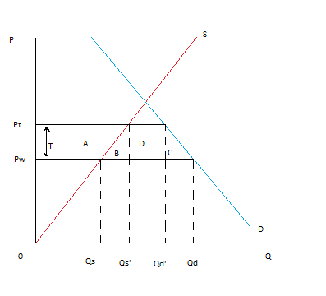
Figure 2.1 Tariffs
The above figure shows a tariff or a quota. As a result of the tariff of size T, domestic producers can now sell Qs’ instead of Qs. But the domestic consumers will only consume Qd’ instead of Qd. The direct effect of the tariff is that the imports of this nation will decrease. The price of this product will increase from Pw to Pt and the producers seem to be better off. However, the national economic welfare is not helped by this measure.
Quota or tariffs are trade barriers. If trade barriers are not in compliance, in general they are not, with the DSU an injured nation can complain at the DSB under the WTO. As explained in the section of the timetable of the DSB, parties are encouraged to solve it in negotiations. If however negotiations are failing and the defendant is not making the effort needed to comply with the rulings and rules, the complainant can obtain the right to retaliate the economy of the defendant. The retaliation is mostly imposed in the most important sectors for either the complainant or the defendant. It has an equal value of the damage caused by the tariff. Because the retaliatory measure has the same character as the original tariff, the effects are comparable with the figure shown above. The WTO decided in the Uruguay Round that a tariff is the only way to retaliate. Therefore the other trade barriers, like quota’s, are not very common as retaliatory measures.
In the following section some statistics are shown to give a view of the users of the possibility to complain and to retaliate. It is also interesting to take a look at the respondants of the cases under the DSB. They are the ones who give rise to the need of complainment and the possible outcome of retaliation.
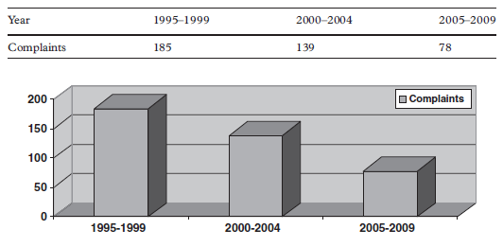
Figure 2.2 Complaints in disputes at the WTO
The above figure gives an outline of the years in which the most complaints were submitted at the DSB. The introduction of the WTO and the DSU took place in 1995. In the first five years relatively the most complaints have been submitted. The following years the numbers went down, but since the introduction in 1995 there have been 402 cases brought to the DSB (December 2009). There are some cases which have the same matter, but have multiple complainants. An example is the Bananas Case, in which both the US and Ecuador complained about the import policy of bananas of the EU. The following table shows an overview of the complaining countries in the last 15 years of Dispute Settlement Understanding.
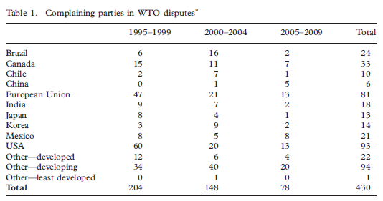
Figure 2.3 Complaining parties in disputes at the WTO
Besides the declining number of cases during the years, this table shows that the major users of the Dispute Settlement are the two most powerful economies of the world. Both the US and the EU are responsible for almost half of the cases. The other quarter of the cases are brought forward by the other big economies of the world and the last 25% by developing nations. There is also a small growth in the involvement of China, although still a minor player in this case. The major economies are the dominant users of retaliation.
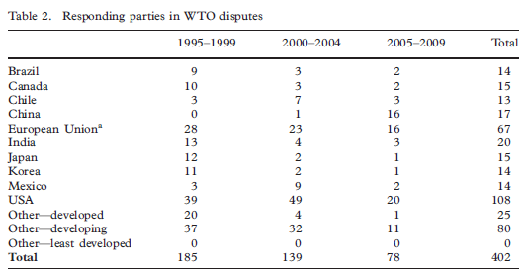
Figure 2.4 Responding parties in disputes at the WTO
In table 2 are the responding countries of the cases defined. Again the US and the EU are major responding economies, but now the US is by far the biggest in numbers with 108 cases out of 402. Originally the US and the EU are the major respondents, but in recent years China had to defend its policy more often as well. At the start of the WTO the EU was the major respondent with the US as complainant. But in the beginning of the millennium, this general idea changed completely. The EU started more and more cases with the US as the respondent. In recent years, the US, the EU and China are the ones whose policies are contested the most at the DSB.
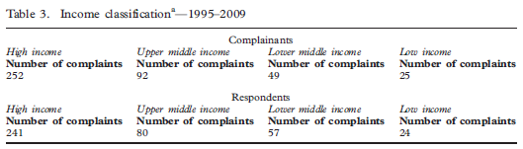
Figure 2.5 Income classifications of complainants and respondents
Table 3 gives a spread between nations on income classes. High income economies are more active in dispute settlement than lower income economies. The lower the income the less active they are, which also can be explained by the idea that lower income economies are less open than higher economies. Also the volume of trade of these nations is smaller. With the information of this table we can conclude that high income nations are the main actors in the field dispute settlement at the WTO.
Complainant country |  |  |  | Respondent country
Brazil |  | 4 |  | US |  | 13
Canada |  | 3 |  | EU |  | 4
EU |  | 3 |  | Brazil |  | 1
US |  | 2 |  | Canada |  | 1
Chile |  | 1
Ecuador |  | 1
India |  | 1
Japan |  | 1
Korea |  | 1
Mexico |  | 1
Antigua |  | 1 |  | Total 19 cases
Box 2.2 Data on retaliation (article 22.6)
The above table shows the amount of 22.6 arbitration decisions made under the DSU. These decisions gave the complainant country the right to suspend concessions to the respondent. In other words, the complainant obtained the right to impose retaliatory measures against the respondent, so to retaliate the nation who did not comply with the rulings or rules of the WTO and/or the panel. It is very interesting to see that the most powerful economies are the most retaliated economies according to Dispute Settlement Understanding. The US was respondent in almost 70 percent of the cases. The other economies were the EU, Brazil and Canada. There is a broad spectrum of nations at the complaining side, with Brazil as number one. Retaliation has taken place 19 times out of more than 400 cases in the 15 years history of DSU. That makes it an instrument not very often used, but essential in the combat of non-compliance.
Some of the 19 cases are special and set an example for comparison and educational matters. These cases can serve as a benchmark for trade policies and as examples to explain the DSU. In this section some cases are discussed to get an idea of the DSU in practice. The first case under the DSB is the Bananas Case. It is the most known case under the DSU. In 1993 the EU imposed a policy that blocked imports of bananas from the complaining countries. Later in 1996 the US and banana exporting countries like Mexico, Honduras, Ecuador and Guatemala complained at the DSU for arbitration of this policy. The panel found the policy in violation of the WTO rules for non-discrimination. It gave the EU time to change the regime in order to comply with the WTO rules. But the EU was not able to change the policy within the period and the US and Ecuador requested for authorization for the suspension of concessions. The US and Ecuador had obtained the right to retaliate the EU. Later in the discussion of the research question, the Bananas Case is explained in detail. This case was the start of the DSU under the WTO.
The United Stated gave US companies in the nineties a reduction in US taxes on income provided by exports if they used a Foreign Sales Corporation (FSC) for their businesses abroad. Those FSC’s are branches in other countries to support exports, so by excluding the income by foreign source from US taxes the US supported the exports for US companies. In 1998 the EU complained about this policy. From their point of view it was in violation of the rules on export subsidy. They requested for a panel at the DSB in 1998 and a year later in October 1999 the panel reported. The panel found the policy of the US in violation with the rules on export subsidies. A request for the Appellate Body was made. The AB reported in the beginning of 2000 that the policy was in violation of the rules of the WTO. Later in 2002 the EU challenged the US again for not properly implementing the decision of the Appellate Body. The EU was vindicated and obtained the right to implement retaliatory measures against the US. They were allowed to suspend concessions to the US for an amount of USD 4 billion a year to compensate for the damage caused by the policy.
In 2002 Brazil started a dispute at the WTO for the subsidies of the US for exports on cotton. In previous years, the US subsidies accounted for about USD 3 billion. In 2003 Brazil requested for a panel after the consultation round was not fruitful. When the results of the research of the panel were appealed in 2004, the appellate body found the subsidies of the US in violation of the WTO rules in 2005. But the US did not impose measures to remove the adverse effects of the subsidies within the period of six months. Brazil obtained the right to retaliate the US for being not in compliance with the decision in 2009 for an amount of USD 4 billion. Brazil was even allowed to cross-retaliate the US. The retaliatory measures did have to be imposed in the cotton sector. The size of the cotton sector is not as big as in the US, so direct retaliation was not an option. In November 2009 Brazil was allowed to retaliate in intellectual property rights to compensat1e for the loss caused by the US subsidies. These are two examples of retaliation under the DSB of the WTO to give to give the reader a clear view of the cases, procedures and countries involved at the DSU at the WTO.

3. Criticism on Retaliation
Equivalence
The principle of retaliation is not necessarily a form of equivalence. The rule in retaliation is that the complainant, who obtained the right to retaliate, retaliates for the equivalent of the damage caused by the trade barrier of the respondent. But the effects of the retaliatory measures, imposed by the complainant, do not necessarily have the same economic welfare effect on the respondent. For example, nation A imposes a trade barrier on products from country B for an amount of 100 million. As a result of the trade barrier nation B has a loss of 200 million in economic welfare. Now nation B obtained the right to retaliate for an equivalent amount of the damage caused by the respondent’s trade barrier. But the effect in the economic welfare of nation A is not necessarily the same as the amount of the retaliatory measure. As you can see in this small example, the damage caused by the initial trade barrier of the responding nation is an essentially different measure than the damage caused by the retaliatory trade barrier of the complaining nation. In addition, the complaining nation itself will lose from the retaliatory trade barrier. A retaliatory trade barrier can only be a tariff, as is decided under the Uruguay trade negotiations. The result of a tariff is shown in the graph below (same graph as figure 2.1.) The effects on economic welfare for the complaining nation are negative.
Figure 3.1 Loss of economic welfare as a result of a tariff
Figure 3.1 shows the effects of a tariff or a quota for the domestic economy. The direct effect of the tariff is that the imports of this nation will decrease. The price of this product will increase from Pw to Pt. The difference between Pw and Pt is T, the tariff imposed. Because of the tariff the domestic producers benefit, they will gain A from the measure. But the domestic consumers loose, they lose the area’s A+B+C+D. The revenue of the tariff is tax revenue for the government of size D. In total the domestic economy looses net part B+C because of the tariff. Nations are not better off in general, in trying to protect a sector.
The idea of retaliation is in a big contrast with the primary purpose of the World Trade Organization. The WTO strives for a world of free trade for the benefit of all. And free trade means no trade barriers. So the WTO aims to eliminate all obstacles to free trade to make trade possible for all. As explained before, retaliation is a tariff. In the principle of retaliation, it is used to protect the domestic sector from the consequences of the imposed trade barrier of the responding country. Thus, retaliation is a principle, allowed by an organization that strives for the reduction of international trade barriers, to impose trade barriers as a counteraction to trade barriers. One can feel the contradiction by reading the previous phrase.
Sanctions create the misconception that nations are helped by imposing retaliatory trade measures. Nations can obtain the right to retaliate if the respondent does not make an effort to comply with the ruling. As you can read in the above part, nations obtain the right to retaliate as a reaction to and to protect from a trade barrier. This might give the complainant the idea that it compensates for the damage caused. However, retaliation does not compensate the damage; it actually harms the economy. By imposing a tariff a nation looses economic welfare. See graph 3.1 for graphical explanation.
Mercantilism is an economic theory from the seventeenth century. The Mercantilist believed that in order to make the state wealthy they had to maximize their exports and minimize their imports. Their idea was that trade is a zero-sum game, where the gain of one nation has to be the loss of another nation. All measures like subsidies, quotas and tariffs were allowed and from their point of view contributive to the wealth of the nation. The economic theory of free trade and the resulting gains from trade evolved later in the period after the Mercantilism. The concept of equivalence in the trade agreements is based on the legal concept of balance, very common with the Mercantilist point of view. That is, on the basis of gains from export and losses from import. However, the economic theory according to the Mercantilists is outdated. For outsiders, the idea of balance sounds very rational. From this point of view one could say be an idea to retaliate in the multiple amount of the damage to influence one nation its behavior. But it would be very hard to get political support for targeted governments to comply with trade rules in those cases. The concept of equivalence in trade agreements is economically irrational.
Injustice
The rules and procedures of dispute settlement at the WTO are written in the Dispute Settlement Understanding (DSU). One can find examples of the articles in the DSU in the second section in which retaliation is introduced. Articles 22.2 and 22.6 are essential articles for the principle of retaliation. With the experience of retaliation in the last 15 years some flaws of injustice became clear. One example to start with is that damage caused by trade barriers will not be compensated retrospectively. Nations harmed by trade barriers can obtain the right to retaliate, but the loss of preceding years will not be compensated. This is simply not part of the rules and procedures of the DSU. This is also one of the causes that responding nations do not have a strong incentive to change their policies quickly to become in compliance with the agreements. There is a lack of threat from the retaliatory measures and possibilities of compensation. The possibility for the respondent to enjoy the gains from the trade barrier for a longer period of time, without a punishment, makes it attractive to actually delay the procedures. Other incentives for delay are; the government of the respondent nation has time to collect support for the change in policy and finally there is always a small change that in the case of an appeal the Appellate Body decides in your favor.
Another form of injustice is similar to an argument on equivalence. If the panel decides that the complaining nation obtains the right to retaliate the responding nation, it will not help its own economy by the action. Thus, the offered ´solution´ does not soften the grief but actually harms the complainant.
Retaliation gives the complainant the right to impose measures to literally retaliate the respondent´s economy. For example, when the car industry of nation A is harmed by the export subsidy of nation B, nation A (when they obtained the right to retaliate) imposes a tariff on products from a certain industry from nation B. It could be the car industry, but that is not necessarily the case. As you can see in this simple example nothing is done to help the industry harmed in the first place. An idea would be to implement a control mechanism to identify the companies that are harmed by the measures.

What also became clear by the small example of nation A and B, is that sanctions are not necessarily imposed in the disputed industries. The effect can be that industries, that did not enjoy any gains from the non-compliance policy of the responding nation, have to deal with the sanctions. These industries are discriminated by the retaliation. Because by blocking these industries, the complaining nation harms the ‘innocent’ industry and not the industry that violated the trade rules. Industries that are not in compliance can be retaliated under the DSU. If the industry is not disputed, it is discrimination.
David Ricardo is one of the most influential classical economists. He was a great opponent of protectionism for countries in international trade. He was a great believer in free international trade. In the seventeenth century he wrote the book Principles of Political Economy and Taxation. He spends an important part in his book on trade theory and policy. In this part he explains the theory of comparative advantage, his most important contribution to economics. The essence of the theory about comparative advantage is that nations should specialize themselves in products which they can produce relatively the most efficiently. For example, nation C and D produce both cars and wine. But nation C can produce both products more efficient than nation D. But if nation D produces wine relatively more efficient than cars, compared domestically, than nation C relatively can, than nation D should produce wine and nation C should produce cars. Nation C has a comparative advantage in producing cars and nation D in wine, although nation C can produce both products more efficiently in absolute measures. This example illustrates the idea of Ricardo that nations that can produce a product the most efficient should produce them. Barriers that would block this principle will harm the nations’ welfare. Retaliation is an authorized form of a trade barrier and therefore hampers the market of international trade. It is clear, that it is really hard to justify the use of sanctions from this point of view.
Retaliation does not always work as an instrument for the enforcement of the rules of the agreements under the WTO for poor and small countries. First reason is that, developing nations did not fully sign all the agreements under the WTO. Secondly, they do not trade as much as the bigger and richer countries. Therefore, their economies are relatively autarkic and international trade is scarce. Retaliation works with sanctions on mutual international trade flows. But if those flows are not available, the use of the system and therefore the enforcement fails. Their international trade power is too small to make effective use of the principle of retaliation. Therefore, the other nations who are able to use the retaliation principle effectively will neither use them against poor and small economies. This causes that these smaller nations do not feel the need to put effort in the compliance of the rules and the organization in general. And the effect is that the economic actors in those nations are not able to enjoy gains from (free) trade.
As shown before, nations who impose retaliation on responding nations harm their own economy. To explain this argument on injustice let’s first briefly introduce the Bananas case. June 1993 the EU implemented a new common imports policy on bananas. According to this policy the EU appointed some countries as preferred suppliers for bananas. These countries were mostly ACP (African, Caribbean and Pacific) countries, the traditional banana producers. Producers of bananas from outside these preferred countries had to deal with a higher tariff. The results of this policy were declining revenues for the injured countries. The complaint was that the EU did not allocate the quotas according to the WTO rules. The EU was accused of discrimination in the allocation of their quotas to the ACP (African, Caribbean and Pacific) countries. The US, Mexico, Honduras, Guatemala and Ecuador contested at the WTO. The panel at the WTO found the import policy of the EU in violation with the rules. It was inconsistent with GATT (General Agreement on Tariffs and Trade) rules on non-discrimination in the allocation of quantitative restrictions and with the GATS (General Agreement on Trade in Services) rules on non-discrimination. The EU appealed, but the appellate body confirmed the panel’s findings. The EU had to revise its policy, but did it partly. The US obtained authorization for retaliation because of the unwillingness of the EU to comply with founding of the panel. A new panel of the WTO found, after being requested by the US, the US authorized to implement retaliatory measures to an equivalent of 191.4 million USD. This amount was chosen to nullify the effects of the import restrictions of the EU. Also Ecuador requested for authorization of retaliatory measures. They were allowed to implement measures to an equivalent of 201.6 million USD against the EU, but their imports from the EU were too small. Therefore, Ecuador obtained the right to retaliate the EU under other agreements than the GATT or the GATS. An example of another agreement is TRIPs (Agreement on Trade Related aspects on Intellectual Property Rights), which covers rules on trade in property intensive sectors. Eventually, the US imposed retaliatory measures on EU industries. Because of this measure, substitutes in the US became more expensive and the US costumers were hurt economically. Clearly, the economy of the EU and the US are harmed. But the costumers in the US, who lose economic welfare, have to pay the price for the sanctions.
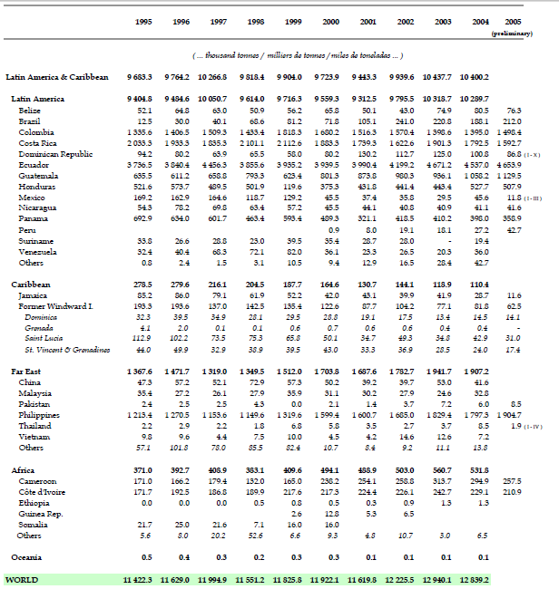
Figure 3.2 World gross exports per country
This figure displays the world gross export in bananas per country. As you can see Ecuador, Guatemala, Honduras and Mexico are major banana exporters. The figure shows the effects of the implementation of the retaliatory measures by the US. If we first take a look at the biggest exporter Ecuador, we can see that after the introduction of the measures in 1999, figures on export in bananas have no clear effects. Note that Ecuador obtained the right to retaliate the EU individually, but never implemented them. Guatemala’s export shows a big decrease in 1999, but one year later exports are growing rapidly again. The export of bananas from Honduras was falling in 1999 and it needed five years to recover for being on the same level again as in 1998. Finally, Mexico’s export is shrunk to one third in just one year. The effect is so big, that after 1999 the export is decreasing even more and Mexico has become a minor banana exporter. So there is an effect in 1999 after the introduction of the retaliatory measures by the US. But the effects are not in the interest of the complaining countries, their exports are decreasing and therefore their economy is harmed by the measures imposed. Guatemala, Honduras and Mexico harmed their own economy by complaining about the import policy of the EU. The effects of the sanctions are that the domestic banana exporters export less to the world than before, while world trade overall was growing in that year in their regions (as seen in the following figure).
Exports
1990-99 | 1998 | 1999
6,5 | 5,0 | 5,0 |  | World
7,0 | 3,5 | 6,0 |  | North America a
8,5 | 7,5 | 7,5 |  | Latin America
6,0 | 6,0 | 4,0 |  | Western Europe
6,0 | 6,5 | 3,5 |  | European Union (15)
4,0 | 5,0 | -1,5 |  | C./E. Europe/Baltic States/CIS
7,5 | 3,5 | 7,5 |  | Asia
2,5 | -1,5 | 2,0 |  | Japan
10,0 | 5,0 | 9,0 |  | Six East Asian traders
Box 3.1 Growth in the volume of world merchandise trade by selected region, 1990-99 (Annual percentage change)

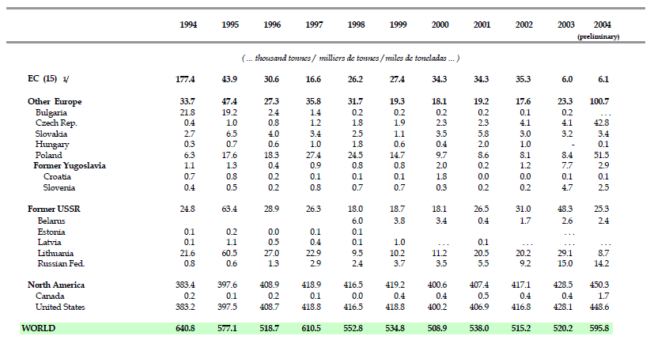
Figure 3.3 World re-export per country
The figure above shows the world re-export per country, that are countries that import bananas not for own consumption, but for export. As you can see the US is by far the biggest re-exporter. This explains the involvement in the bananas case, as the US is not a big producer of bananas. After the US implemented the retaliatory measures there is small decrease in exports of roughly 4 percent. Although the effect is small, it is clear that retaliatory measures on other nations injure the domestic economy.

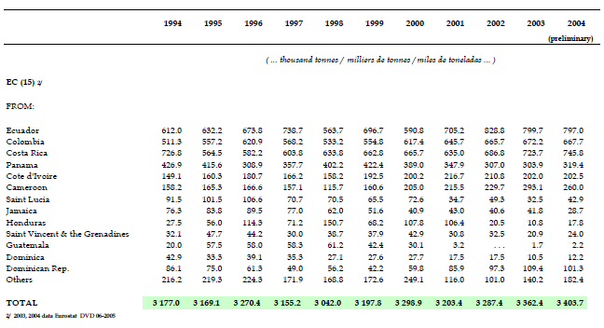
Figure 3.4 Gross imports by country of origin
The figure above shows the gross import by country of origin for the EU. Ecuador, Guatemala and Honduras are countries of origin for the import of the EU. The import from Ecuador shows a small decline after 1999, but again recovers in one year to the level of a year before. Both Honduras and Guatemala are faced with big declines in exports to the EU in the years after 1999. Guatemala is hardly exporting to the EU anymore. So in the direct trade with the EU there is a negative effect noticeable after the introduction of the sanctions by the US on the EU. So complaining about and retaliate a country can have negative effects on the export to the respective trading partner. On the other hand is Ecuador able to maintain its position as the major banana exporter both to the world as to the EU. As mentioned before, Ecuador obtained the right to retaliate the EU too. However, they did not impose any retaliatory measures. Ecuador did not experience major difficulties after complaining about the EU and the implementation of the sanctions by the US, although it had the right to retaliate the EU as well, it did not.
Information asymmetry
Governments need perfect information to make rational decisions on the implementation of retaliatory measures. As it is unlikely that nations have access to perfect information, it is very hard to use the principle of retaliation effectively. As you can see graph 2.1 is a model. In reality the information is not always available and in order to use a retaliatory measure, you need to be aware of the size of your and the responding nation’s economy and its sectors. Even in some cases, there is hardly any information available to make a rational decision.
The introduction of the Dispute Settlement Mechanism, and therefore retaliation, after the Uruguay negotiating round meant a change in the fundaments of solving disputes. A change took place from reciprocity to status-quo reciprocity. Settlement became a zero sum game. That means nations were able to indentify Pareto-deteriorating changes in their trade policy. Changes in trade policies, where the improvement in welfare leads to a loss in welfare for the other nation. Under reciprocity countries were able to identify Pareto-improving changes in trade policies.
Because complaining nations do not have access to perfect information, nations would be helped by transparency of the responding nation. However, it is very unlikely that a respondent is willing to help with the search for alternative policies. Options for other policies will not be brought forward by them, because all the other options did not find enough domestic support. Otherwise, they would have been introduced already. Political arguments and short term objectives can cause these flaws. This situation implicates that the complaining country has to estimate the alternatives for the complainant and the effects caused by them. Because the decisions are not based on factual information, the effects can be different than intended.
The procedures include negotiation rounds. These situations need the consent of both parties. While parties at the stage of negotiating may have different opinions on how to proceed. This can cause unpredictable situations. Whereas the defendant should be forcible to get in compliance on lucid rules, rather than negotiating for a settlement.
Rent-seeking behavior in the sectors that enjoy the gains from the retaliatory measures could be encouraged by the principle of retaliation. Rent-seeking behavior is the situation if one is seeking for profits through manipulation of the economic environment instead of creating added value and by selling it on the market.

Rent-seeking Behavior
Cutting yourself a bigger slice of the cake rather than making the cake bigger. Trying to make more money without producing more for customers. Classic examples of rent-seeking, a phrase coined by an economist, Gordon Tullock, include:
• a protection racket, in which the gang takes a cut from the shopkeeper’s profit;
• a cartel of firms agreeing to raise prices;
• a union demanding higher wages without offering any increase in productivity;
• lobbying the government for tax, spending or regulatory policies that benefit the lobbyists at the expense of taxpayers or consumers or some other rivals.
Whether legal or illegal, as they do not create any value, rent-seeking activities can impose large costs on an economy.
Box 3.2 Explanation on Rent-seeking behavior

Rent-seeking behavior in the light of the trade disputes under the WTO is the possibility of an industry which will complain at the WTO to obtain the right to implement a protective measure in the advantage of itself. In this way the retaliation system can promote the behavior of rent-seeking and give industries the possibilities to influence their business environment and therefore their market power. This will have the effect of a company not being challenged by the market and so losing its competitiveness. The artificial market does not have the same features as a competitive market and thus its corrective possibilities. The industry will not be able to adapt to a competitive market and therefore loses its competitiveness on the long term.
Retaliation can also have negative effects on countries that are not directly involved in the dispute. Take for example the suppliers of an industry in the defending country. If the panel decides to allow retaliatory measures and that industry becomes the target of the complaining government. The suppliers may see their exports to the defendant country decline. This effect and the possibility that every trade rule can be violated under the DSU cause the reduced predictability of the economic conditions on international trade.

Reach of retaliation
The earlier economists did not support the idea of sanctions. They already found out that the breadth of coverage was too comprehensive. Initially sanctions were intended to influence other nation’s actions. However, they could also have negative effects on the economies of the concerned nations. Adams Smith made this statement already in his book The Wealth of Nations.
The amount that can be taken in consideration in disputes should be better specified in the DSU. Only the direct exports from the complaining nation to the responding nation should count. Otherwise double counting is possible with the accumulation of the exports from third countries. The boundaries can be arbitrated, but added value by other nations should not be counted as damage for the complaining nation. Also in the case of services, there should be a clear distinction what value nations add. However, there is still room for improvement. Take for example, the export of a product from the US to China and is sold on the Chinese market by a European wholesaler. The service of wholesaling is the value added by Europe. If China would impose restrictions on imports from the US and the US therefore starts a procedure at the WTO, they cannot claim the loss for Europe in this dispute as part of the damage. But the damage for Europe is a direct effect of the Chinese measure. Although this service is directly linked to the exportation of the products from the US, it is not taken into account. Europe is under the current DSU not allowed to impose any measures to China.
The competitiveness of the domestic industry weakens. Because of the protection by the measure, the industry does not face competition and is therefore poorly challenged. The result of the lack of incentives is that the market does not correct for flaws anymore. Another reason for the loss of competitiveness is that the sanctions cause an increase in the price for raw materials and other imports needed for the production in the domestic industries. This increase raises the price of the products produced, which are therefore less attractive.

In article 22.3 of the DSU there is a rule for retaliation that states that sanctions have to be laid out in the same sector. You can read the article in the box below.
Article 22.3 (a) - In considering what concessions or other obligations to suspend, the complaining party shall apply the following principles and procedures:
The general principle is that the complaining party should first seek to suspend concessions or other obligations with respect to the same sector(s) as that in which the panel or Appellate Body has found a violation or other nullification or impairment
Box 3.3 DSU Article 22.3(a)
So a violation in services has to be retaliated with a sanction in the service sector as well. In article 22.3 of the DSU, the service sector and TRIP’s (Trade Related Intellectual Property rights) are divided in categories. However, goods count as just one sector while goods have a bigger share in the international trade than services and TRIP’s. That makes it harder for complainants of violations on services and TRIP’s to impose sanctions. The categories are smaller and industries might be too small to impose sanctions effectively. In the case of non-compliance in the goods sector, the complainant can impose measures in the goods sector of their interest. Therefore, virtually cross-retaliation is possible because there are no subdivided categories compared to services and TRIP’s.
The system does not have a protectoral system for the harmed private economic actors. They can suffer directly from retaliation. The measures can cause blockades to bring their products to the markets. These hinders can injure entities. But these parties do not receive compensation or protection from the government. However, the decisions which can lift sanctions are made on governmental level.
The drawback of cross-relation is that branches initially not involved in the case may have disadvantages caused by the ruling of the panel. There is a range for the complaining nation in which it can make political decisions. Within this range nations or sectors can be saved or get involved whether or not they are in compliance with the rules. Take for example the Beef Case between the US and the EU. The countries of the EU refused to accept anymore beef from the US treated with hormones. The opinion of the US was that the EU only wanted to protect its own beef producers. However, the EU imposed a policy to reject the import of beef from the US. The UK voted against a common EU policy for supporting its beef sector. After the penal at the WTO ruled in favor of the US, it started preparing sanctions for the EU. In their plans they saved the UK and imposed measures against them.
Retaliation was designed as a tool for parties in a dispute to settle their dispute and to propose remedies. However, the system does not ensure compliance. In reality, the system does not solve the issues. It gives complainants the right to suspend its obligations. Injured economies should be compensated for their damage as a result of violating trade policies, but that does not implicate that the complainant should also suspend their obligations towards the trade rules. This suspension is not a solution to the dispute.
Empirical studies have shown that a country’s trade share is an indicator of its likelihood to be either a respondent or a complainant in a WTO dispute. Therefore small economies are less participating in the DSM. We can conclude that the less and least developed economies do not use the DSM and retaliation often as a tool to dispute a trade policy. The size of the economy and harmed sectors of small nations are relatively small for the big economies. The incentive to change their policies because of a retaliatory measure imposed by a small nation is therefore weak. The power of the remedy is minimal. Trade wars can only be won by large countries. It would be a solution if smaller economies could use cross-retaliation in general to bring bigger economies in compliance in its disputes.

The figure below explains why retaliation, and therefore tariffs, is a cause of trade reduction in the international economy.
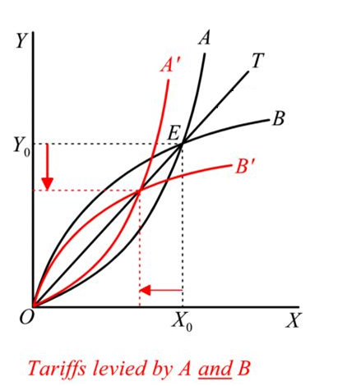
Figure 3.5 Tariffs as a cause of trade reduction

The figure shows the offer curves of the exporting nations A and B producing respectively goods X and Y. Curve A is the offer curve for good X and the same goes for B and Y. Point E in the graph represents the equilibrium of trade with the absence of tariffs. Points Xo and Yo represent the export volume of the products for both products in equilibrium. Both trading nations did not have imposed tariffs and therefore represent the world in free trade. This is the aim of the WTO; a world without trade barriers. If a nation is seeking for protection for its domestic produced products, it will calculate an optimal tariff to maximize their national welfare. If nation A will impose a tariff, the offer curve shifts to curve A’. The traded amounts of both X and Y will go down, as offer curve B will now intersect with curve A’. Nation B is injured by the tariff and starts to complain at the DSB at the WTO and requests for retaliation. If nation B has obtained the right to do so, it will impose retaliatory measures. Because of the measures, offer curve B shifts to curve B’. The effect of the shift is that trade is getting more restricted. The intersection of curve A’ and curve B’ results to an amount of trade at the end of the red arrows in the figure. Here you can see that because of the retaliation the amount of traded goods of both nations is decreasing. So the direct effect of retaliation is trade reduction.
Nations choose a tariff to maximize their national welfare. To do so a nation has to calculate its optimal tariff. If a nation imposes its optimal tariff it enhances its own welfare, but harms the welfare of its trading partner, the importing nation. The reaction of the importing nation will be an optimal tariff as well. In the end, trade is being restricted and the welfare has decreased as a result of both tariffs. Nations can enjoy the biggest welfare with trade at their optimal tariff. But this is not equilibrium, thus it is not likely that it can enjoy this welfare on the long term. The best solution would be for both nations not to impose any tariffs, or other trade restrictions, in order to enjoy a higher welfare for the long term. If nations know if they impose a tariff, that their trade partner will do the same and that they will end up with both less welfare and trade. The trading nations are in a prisoner’s dilemma and are better off if they would cooperate in free trade. In the case of cooperation both nations do not have an incentive to maximize their welfare by a tariff, because they know that it will result in retaliation and retaliation will result in less welfare and less trade.
4. Summary
Although retaliation under DSU has been welcomed by academics at the time of its introduction, it faces a lot of criticism nowadays. On the basis of the literature we can conclude that the principle of retaliation has flaws, both in the procedures as in the consequences.
The welfare effect as a result of retaliation is different than the damage caused by the initial measure in non-compliance. Nations are not better of protecting their sectors via retaliation. It is very contradictionary that the WTO its members can use trade barriers as an instrument. Retaliation is based on the concept of balance, typically from Mercantilism. However, this economic theory is considered to be outdated. The idea of equivalence in retaliation is economically irrational.
The rules of retaliation forget the losses from the past. Forgone losses will not be compensated. Therefore, procedures are delayed to enjoy the gains from the measure in non-compliance even longer. Furthermore, if a nation retaliates, there is a change that the receiving industry is not an equivalent of the protected industry. That makes the principle unpredictable.
David Ricardo already stated in the seventeenth century that trade barriers like (retaliatory) tariffs are harming the welfare of trading nations. From research we have learned that small economies are not able to make use of retaliation as an instrument because of the size of their economy. And that in the end consumers pay for the costs of the retaliatory measures. Retaliation inherence injustice.
Sometimes it is hard for decision makers to identify the information needed to make the right decisions in the case of retaliation. Nations are also able to indentify Pareto-deteriorating changes in their trade policy since the introduction of retaliation. And rent-seeking behavior can be encouraged by it.
Third nations can experience negative effects if sectors are in the supply chain of the receiving industry. A protected industry looses competitiveness, because the market can not correct for flaws anymore. Cross-retaliation can be a solution for smaller nations with small industries, but it can also get sectors involved which, at first hand, do not have a link with the case. Finally, retaliation should be a basis for compensation for the loss of welfare. The suspension of duties is not a solution to the disputes and should not be allowed anymore.
References
Kym Anderson, Peculiarities of retaliation in WTO dispute settlement, World Trade Review 2002, Vol 1(02), pages 123-134
Banana Statistics 2005, Food and Agriculture Organization of the United Nations (FAO), May 2006
Chad P. Bown and Meredith A. Crowley, Trade Deflection and Trade Depression, Journal of International Economics 2007, vol. 72, issue 1, pages 176-201
Chad P. Bown and Bernard Hoekman, Developing Countries and enforcement of trade agreements: Why dispute settlement is not enough, Center for Economic Policy Research (CEPR) discussion papers 2007, No. 6459
Fritz Breuss, WTO Dispute Settlement: An Economic Analysis of four EU-US Mini Trade Wars, WIFO Working papers 2004, 231
Monika Butler and Heinz Hauser, The WTO Dispute Settlement System: A first assessment from an economic perspective, Cahiers de Recherches Economiques du Departement d’Econométrie et d’economique politique (DEEP) Université de Lausanne
Steve Charnovitz, Rethinking WTO trade sanctions, The American Journal of International Law, Vol. 95, No. 4 (Oct., 2001), pp. 792-832
Steve Charnovitz, The WTO’s problematic ‘last resort’ against non-compliance, Aussenwirtschaft 2002, 57(4), page 407
Carsten Herrmann-Pillath, Reciprocity and the hidden constitution of world trade, Constitutional Policital Economy 2006, Vol. 17(3), pages 133-163
Bernard Hoekman and Michel Kostecki, The political economics of the World Trading System, Oxford University Press, 2nd
Peter Holmes et al., Emerging trends in WTO Dispute Settlement, Back to the GATT?, World Bank Policy Research paper 3133, September 2003
Robert E. Hudec, Broadening the Scope of Remedies in WTO Dispute Settlement System, published in Improbing WTO Dispute Settlement Procedures (Friedl Weiss and Jochem Wiers), Cameron May Publishers 2000, pages 345-376
Anne Kreuger, The Political Economy of the Rent-Seeking Society, American Economic Review 1974, 64, pp. 291-303
Charles van Marrewijk, International Economics, Oxford University Press, 7th
Charles van Marrewijk, International Trade & the World Economy, Oxford University Press, 6th
Willem Molle, The economics of European integration, Ashgate publisher, 5th
Joseph Pelzman and Amir Shoham, WTO Enforcement Issues, Global Economy Journal 2007, Vol. 7, Issue 1, Art. 4
Mauricio Salas and John H. Jackson, Procedural overview of the WTO EC-Banana dispute, Journal of International Economic Law 2000, Vol. 3, pp. 145-166
Cherise M. Valles and Brendan P. McGivern, The right to retaliate under the WTO agreement, The sequencing problem, Journal of Trade Law 2000, Vol. 34(2), pp. 63-84
Website World Trade Law.net (Kara Leitner and Simon Lester)
Website WTO (wto.org)
Thomas A. Zimmermann, WTO Dispute Settlement at Ten: Evolution, Experiences, and Evaluation, The Swiss review on international economic relations, Vol. 60 (2005), No. 1, pp. 27-61

NYTimes.com
WTO.org
Doha Ministerial Round of Negotiations
See the article by Kym Anderson (Peculiarities of retaliation in WTO dispute settlement), he discussed the principle of retaliation on the basis of five concepts. Equivalence, inherent injustice of retaliation, breadth of coverage, counterfactual to the present regime and the limitations on cross-retaliation.
The procedures are explained in detail on the website of the WTO (WTO.org)
Wto.org
World Trade Law.net (Kara Leitner and Simon Lester)
World Trade Law.net (Kara Leitner and Simon Lester)
World Trade Law.net (Kara Leitner and Simon Lester)
World Trade Law.net (Kara Leitner and Simon Lester)
World Trade Law.net/wto.org
Kym Anderson, Peculiarities of retaliation in WTO dispute settlement, World Trade Review 2002, Vol 1(02), pages 123-134
Fritz Breuss, WTO Dispute Settlement: An Economic Analysis of four EU-US Mini Trade Wars, WIFO Working papers 2004, 231
Wto.org
Steve Charnovitz, The WTO’s problematic ‘last resort’ against non-compliance, Aussenwirtschaft 2002, 57(4), page 407
Robert E. Hudec, Broadening the Scope of Remedies in WTO Dispute Settlement System, published in Improbing WTO Dispute Settlement Procedures (Friedl Weiss and Jochem Wiers), Cameron May Publishers 2000, pages 345-376
Fritz Breuss, WTO Dispute Settlement: An Economic Analysis of four EU-US Mini Trade Wars, WIFO Working papers 2004, 231
Monika Butler and Heinz Hauser, The WTO Dispute Settlement System: A first assessment from an economic perspective, Cahiers de Recherches Economiques du Departement d’Econométrie et d’economique politique (DEEP) Université de Lausanne
Kym Anderson, Peculiarities of retaliation in WTO dispute settlement, World Trade Review 2002, Vol 1(02), pages 123-134
Fritz Breuss, WTO Dispute Settlement: An Economic Analysis of four EU-US Mini Trade Wars, WIFO Working papers 2004, 231
Steve Charnovitz, Rethinking WTO trade sanctions, The American Journal of International Law, Vol. 95, No. 4 (Oct., 2001), pp. 792-832
David Ricardo, British economist 1772 – 1823, who published the concept of comparative advantage in his book: On the principles of political economy and taxation (1817)
Chad P. Bown and Bernard Hoekman, Developing Countries and enforcement of trade agreements: Why dispute settlement is not enough, Center for Economic Policy Research (CEPR) discussion papers 2007, No. 6459
Wto.org
Steve Charnovitz, The WTO’s problematic ‘last resort’ against non-compliance, Aussenwirtschaft 2002, 57(4), page 407
Banana Statistics by FAO (UN)
Wto.org
Banana Statistics by FAO (UN)
Banana Statistics by FAO (UN)
Carsten Herrmann-Pillath, Reciprocity and the hidden constitution of world trade, Constitutional Policital Economy 2006, Vol. 17(3), pages 133-163
Kym Anderson, Peculiarities of retaliation in WTO dispute settlement, World Trade Review 2002, Vol 1(02), pages 123-134
Cherise M. Valles and Brendan P. McGivern, The right to retaliate under the WTO agreement, The sequencing problem, Journal of Trade Law 2000, Vol. 34(2), pp. 63-84
Gordon Tullock on Economist.com, Gordon Tullock is a nominee for the Nobel Prize in 2003 and kwon for his article ‘The Welfare Costs of Tariffs, Monopolies and Theft’ in the Western Economics Journal, 1967 5, pp. 224-232
Anne Kreuger, The Political Economy of the Rent-Seeking Society, American Economic Review 1974, 64, pp. 291-303
Chad P. Bown and Meredith A. Crowley, Trade Deflection and Trade Depression, Journal of International Economics 2007, vol. 72, issue 1, pages 176-201
Adan Smith, Scottish Economist 1723 – 1790, pioneer of political economics and mostly known for his book ‘The Wealth of Nations’ 1776
Mauricio Salas and John H. Jackson, Procedural overview of the WTO EC-Banana dispute, Journal of International Economic Law 2000, Vol. 3, pp. 145-166
Steve Charnovitz, The WTO’s problematic ‘last resort’ against non-compliance, Aussenwirtschaft 2002, 57(4), page 407
Thomas A. Zimmermann, WTO Dispute Settlement at Ten: Evolution, Experiences, and Evaluation, The Swiss review on international economic relations, Vol. 60 (2005), No. 1, pp. 27-61
WTO.org
Kym Anderson, Peculiarities of retaliation in WTO dispute settlement, World Trade Review 2002, Vol 1(02), pages 123-134
Fritz Breuss, WTO Dispute Settlement: An Economic Analysis of four EU-US Mini Trade Wars, WIFO Working papers 2004, 231
WTO.org
Steve Charnovitz, Rethinking WTO trade sanctions, The American Journal of International Law, Vol. 95, No. 4 (Oct., 2001), pp. 792-832
Joseph Pelzman and Amir Shoham, WTO Enforcement Issues, Global Economy Journal 2007, Vol. 7, Issue 1, Art. 4
Peter Holmes et al., Emerging trends in WTO Dispute Settlement, Back to the GATT?, World Bank Policy Research paper 3133, September 2003
Chad P. Bown and Bernard Hoekman, Developing Countries and enforcement of trade agreements: Why dispute settlement is not enough, Center for Economic Policy Research (CEPR) discussion papers 2007, No. 6459
Prof. Alan Deardorff, University of Michigan

