The relationship between average income and health: why do some countries exceed expectations?

Erasmus University Rotterdam
Department of Economics

Supervisor: Eddy van Doorslaer

Name: Jeroen Heun
Exam number: 299550jh
Email address: jeroen_heun@yahoo.com

Abstract
Since infectious diseases in developing countries continue to be widespread they are a cause of both health problems and mortality. Controlling them should be the first step in improving health, but how to effectively do this remains unclear. If income is the cause of health gains, then policies should target growth. But if income is not the cause then deliberate action aimed at health improvements should be the focus of policies. We find that that the arguments for income as the cause of health are weak and we find no relationship between inequality and health differences between countries. When testing the impact of key social services like education, sanitation and water we find a very weak relationship. But that can easily be explained by interaction mechanism. The case study of Costa Rica shows that the structural changes made in its health care system are an important factor in explaining health gains. These changes were mainly targeted at the ability of the health care system to provide good quality care for all, which included actively reaching out to the underprivileged sections of society. We conclude that income inequality is not a cause of poor health but health care inequality is. Political determination played an important role in the structural changes made and it is doubtful that these changes could have been made without the consistent long term political determination. We can conclude that deliberate actions does cause health gains but requires significant political power.

Introduction

Poor health continues to plaque developing countries despite recent improvements. Efforts to improve the health of developing countries continue but large differences between the industrialized and developing world remain. Improving the health of people living in these countries continues to be a goal of development as is expressed in the UN millennium development goals, but how to achieve that remains a heavily debated topic.

Since the worst off countries in health terms are also the poorest, it seems logical to assume that lack of money is the cause of poor health. This is further suggested by the relationship that was first demonstrated by Samuel H. Preston when he in 1975 plotted average income of a country against the life expectancy at birth and found the relationship which is now called the Preston curve. When using data from 2008 in Figure 1, we see that the relationship as was first discovered in 1975 still applies.
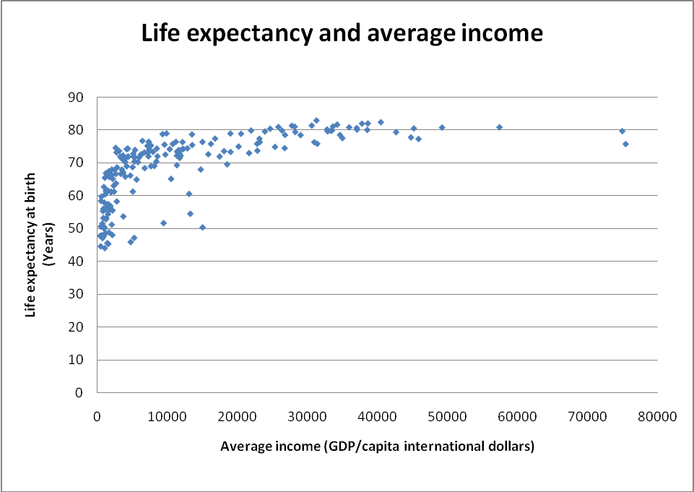
Figure 1: Preston curve 2008
We see that the relationship between income and health remains strong but what that relationship means to policy decisions continues to be heavily debated. At the core of the debate are two rivalling policies, on one side is direct investment into public actions aimed at improving health, and on the other side is investment in economic growth. The policy of investing in growth is defended by a number of economists who argue in line with Pritchett and Summers (1996) [1] who say that income is the most important factor in explaining health. They state that although they do not exclude the role of other factors, the relationship is indeed causal and is the most important cause of health gains. If what they say is true, the policy implications would be that international organisations and indeed governments should prioritise growth policies over health policies for when the average income in countries rise health will follow.

Cutler, Deaton and Lleras-Muney(2006)[4] downplay the role of income and do not support the hypothesis that income causes health gains. Instead they state that lurking variables are the cause of the correlation between income and health. From their review of research on the determinants of mortality, they conclude that improvements in health and income are both the consequence of new ideas, and one does not necessarily cause the other. According to them health differences between countries come from institutional ability and political willingness to implement known technologies, neither of which is an automatic consequence of rising income. Furthermore they state that the correlation might well be explained by inverse causality in the sense that the sick people have lower earnings and not the other way around.
Anand and Ravallion (1993)[5] also oppose the relative importance of growth by testing if income has an impact on health or that income enables poverty reduction and finances key social services. Their logic is that when essential goods like clean drinking water, sanitation and health care are available social outcomes like life expectancy improve. This does not dispute the importance of economic growth, but rather says that the importance lies not only in growth itself but in the way that growth benefits these services. Simply put, growth is not a sufficient condition to explain health.

While the topic remains heavily debated, the importance has not changed and finding an answer to the question remains imperative. Only if we understand what causes the relationship, we will be able to make the right policy decisions that are likely to determine the health of millions of people. This paper will look at why some countries, compared to countries with similar average incomes, achieve such extraordinary health levels. We will first look at some of the research mentioned surrounding income and health and investigate some of the ideas put forward. Finally we will look at Costa Rica and look into what this country did to improve its health levels.

Income and health

The first to notice the strong relationship between income and health was Samual H. Preston who in his 1975 paper “The changing relation between mortality and level of economic development” was able to demonstrate the relationship with the graph below. It shows a Scatter-diagram of relations between life expectancy at birth and national income per head for nations in the 1900s, 1930s and 1960s.
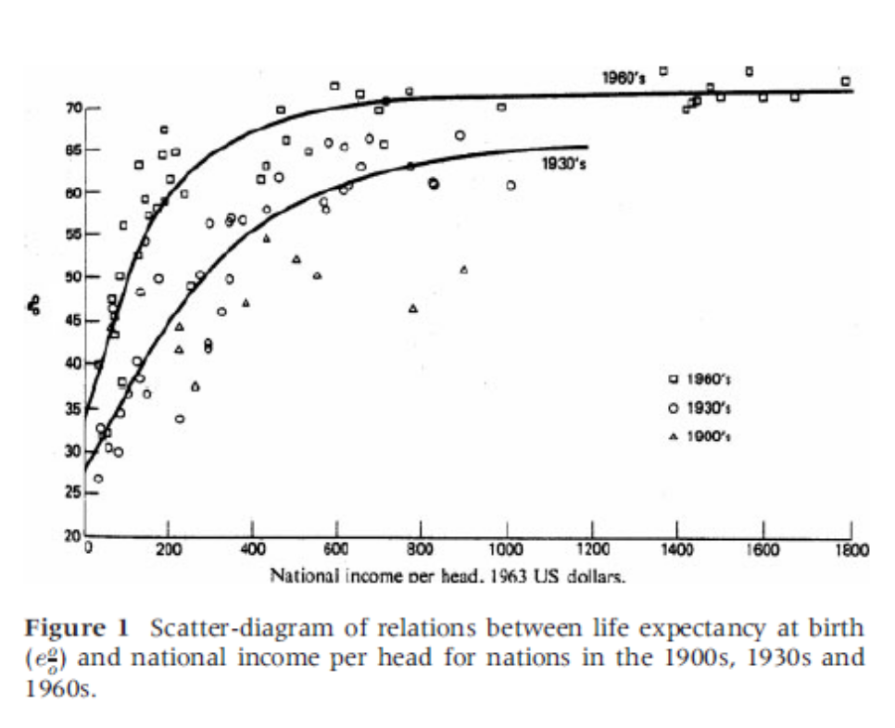
Figure 2: Original 1975 Preston curve [2]

In his work, Preston was able to show two things: first, that there is a strong positive but concave relationship between national income and life expectancy; and secondly, that the relationship is changing over time. [2] The non linearity of the relationship means that life expectancy is less sensitive to changes in average income in rich countries then in poor countries. This would mean that an increase in average income in a low income country would produce a greater increase in life expectancy than in a high income country. If that were true, then redistribution of income between countries would increase health averages between countries, as the loss of income would cause a decrease in rich countries but would cause a much greater increase in poor countries. This is often used as an argument for development aid as the transfer of funds would lead to a world increase in average health levels. Similarly the incidence of reduced marginal return of health from income can also be used to argue redistribution within countries; if income is indeed the cause of health, redistribution would cause a change in a countries average health without changing the average income (redistribution changes individual income but leaves national income equal). In order for this to be true income must be the cause of health changes and not just correlated to health changes.
Preston himself attributed only 10-25 percent of health changes to income and 75-90 percent to other exogenous factors [2]. The reason for this conclusion was that if income were responsible for the health gains, countries would develop along the line of the Preston curve. Instead he found that the curve itself differed over time which would indicated that large health gains are caused by other factors like implementation of new technology and other measures which cause more effective use of resources. To test whether there is a relationship between income equality and health we made a scatter-plot for life expectancy and inequality, the resulting is shown in figure 3. Life expectancy at birth data was drawn from gapminder.org who compiled various sources; inequality data was also drawn from gapminder.org but had only one source which was the World Bank. Due to the limited availability of data about inequality we used the average of the years 2001-2003. If data was only available for one of the three years we used that year as the average, if data was available for two or three years we computed the average of the available data. To make sure life expectancy data matched the inequality data, we also used the average for life expectancy over three years even though data was available for all years.
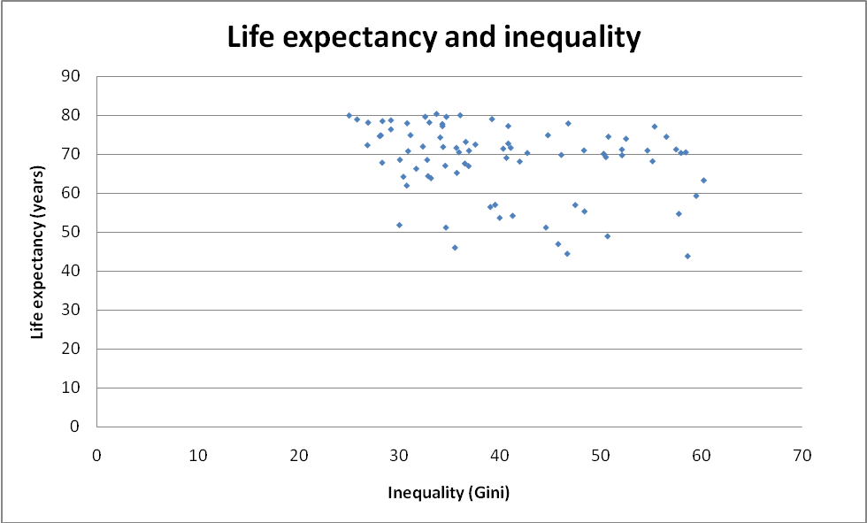
Figure 3: health and Inequality
Source: gapminder.org (26th august 2010) which uses various sources for life expectancy and World Bank for Gini.

In figure 3 we see that it is unlikely that inequality has a relationship with health. We see that there are countries with equal life expectancy but very different inequality. Similarly we see that there are countries with similar inequality but very different life expectancy. Equality does not appear to be a condition necessary for high life expectancy. This seems to suggest that inequality may not explain life expectancy and if that is true reducing inequality through redistribution will not increase average life expectancy. It may still be the case that specific inequality like poverty may have an impact on life expectancy but general inequality most likely doesn’t.

Cutler et. Al (2006) [4] looked at the determinants of mortality and found that in developing countries infectious diseases are responsible for most deaths. The historic drop in Europe’s child mortality rate significantly improved life expectancy at birth and was accompanied by a sharp drop of infection rates. Child mortality makes up 30 percent of deaths in poor countries compared to less than 1 percent in rich countries. This all seems to support the notion that infectious diseases are a major cause of poor health levels, and since the cure for many of these diseases are cheap, spending capabilities in the form of income seems to only be able to explain a small portion of health. The logical conclusion would be that the way of dealing with health would be direct interventions aimed at preventing and curing these diseases. A counter argument to that is the effect of nutrition on disease rates and improved nutrition may well be the cause of the drop in infections. If better nutrition is indeed the cause of better health increasing income would increase health. A number of studies have shown that calorie intake in Europe did increase during the historic period of great health improvements, and that mortality rates of infectious diseases like cholera dropped long before there was an effective cure. But if an increase in income was really the cause of better health then we would see that countries that grow faster get better health but this doesn't hold, as there are countries who are unable to attain better health despite growth and more importantly that there are countries who without growth attain improvements in health. China's remarkable decline in infant mortality was before it showed economic acceleration in 1980. For both India and China decade growth rates are even negatively correlated to progress in infant and child morality [4]. The authors even go as far as to say that the switch in policy in china from health to stimulating growth may be the cause of the slowdown in health development. For this to be true it isn't necessary for income to have no effect, only that growth also has negative effects on health. The onset of urbanisation often accompanies growth and generally speaking has a negative effect on health. This may cause the positive effect from increased income to be negated by the negative effect resulting in no effect at the aggregate level. Another argument brought forward by cutler et al. (2006) is that he correlation found between income and health may well be the result of a two way interaction caused by the fact that children with diarrhoea may digest as little as 80 percent of consumption. This would mean that being sick may well be the cause of reduced intake of calories instead of the reduced intake causing sickness. Since many treatments for the most common causes of death in developing countries are cheap and readily available, the authors believe that it is not income which determines health but political capabilities and willingness to implement new technologies.

Anand and Ravallion propose in their 1993 paper [5] that income has an impact on health in so far as it does two things, one reducing poverty incidences and two financing key social services like health care, clean water and education. The reason behind that is when essential goods like clean drinking water, sanitation and health care are available, social outcomes like life expectancy improve. If those services reduce infection rates, it is in line with what cutler et al (2006) found. This idea of income being a condition for health but only as a proxy of another cause does not dispute the importance of economic growth. Rather it says the importance lies not only in growth itself but also in the way in which growth benefits poverty reduction and supports public health services. From their research in both a cross country analysis and a Sri Lanka case study, they conclude that it is indeed the case that growth matters, but also the extent to which it enhances poverty reduction and health spending.

To test the hypothesis that income leads to health through the spending on critical services we created scatter plots of life expectancy and access to sanitation and education. The results are depicted in the figures on the next page.
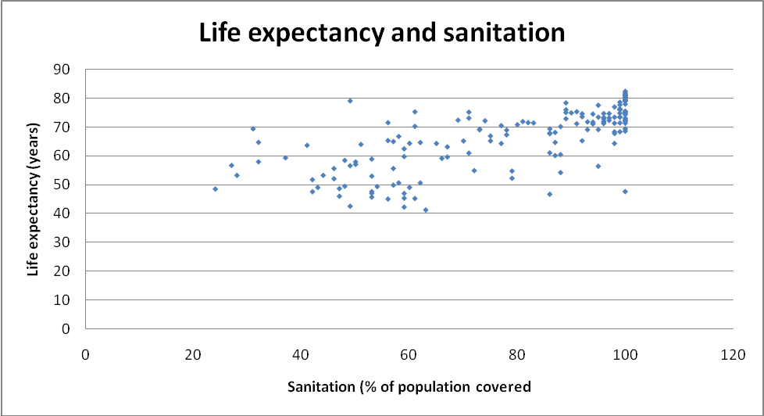
Figure 4: Health and sanitation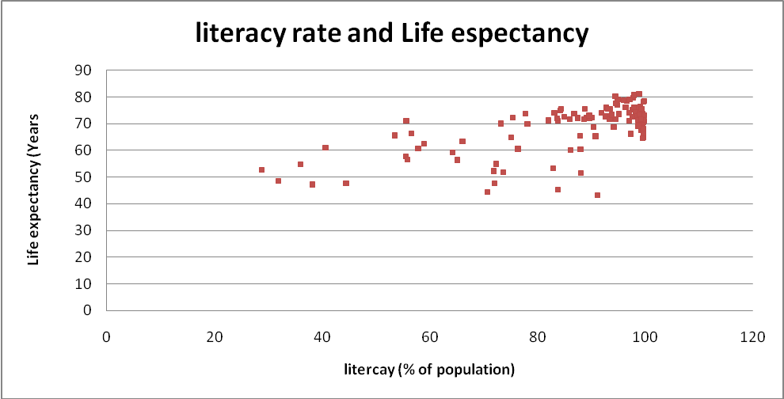
Figure 5: Health and literacy rate
We found similar relationship for both indicators, namely that that life expectancy most likely has a relationship but that this relationship was weak at best. There are countries that have Sanitation coverage below 30% yet achieve life expectancies higher than countries with water coverage above 70%. So if there is a causal relationship, it is weak at best. Since most infectious diseases are waterborne, we have no doubt that clean water could help to decrease infections and thus increase health. The results found may merely be evidence that clean water alone cannot achieve health benefits, disease may happen despite clean water for a number of reasons. Having clean water may cause a shift in diseases, as clean water reduces only water carried infections it does not prevent others diseases. And without an effective system of curative care will only lead to a shift in cause of mortality instead of a reduction in overall mortality. Another possibility is that water by itself doesn't help if other criteria aren't met. If for instance a lack of sanitation still causes sources of infections to be close or that when people continue display unhygienic behaviour. Clean water may only help decrease disease if it is used properly; leaving water in the sun for a long time or drinking water that is days old may still cause infectious diseases despite the original clean source.

Education might play an important role in this as a study done in India [7] found that poor education of a child’s mothers negates the positive effects of having access to clean water. Having an understanding of germs theory may be necessary in order for clean water to have an effect. The other way around may also be the case where knowing what to do in the form of education without having the means in the form of clean water does little good for your health.
Even though we did not find evidence to support the notion that critical services are the cause of health gains, there are plenty of mechanisms unexplored in order to say that the provisioning of critical service is not a requirement for increasing health.

Factors of success in Costa Rica

When we look at the Preston curve, we see that some countries are able to achieve great health levels with very limited income. Understanding how these countries do so could be an important step in understanding how to improve the health in other developing countries. One of the countries who manage to do so is Costa Rica, with an average income in 2008 of 9552 (GDP/capita, inflation adjusted dollar) Costa Rica had a life expectancy at birth of 79 and child mortality of 11 (per 1000 live births). Costa Rica achieves this despite a fairly high inequality of 47(Gini coefficient) and 7.4 percent of its population living in extreme poverty (less than 1.25 dollars a day). When using the national poverty line we find that an even greater number of 22.8 percent of its rural population and 21 percent of its urban population live in poverty. Yet despite this, Costa Rica is able to achieve a life expectancy and child mortality on par with most western countries. In recent history, Costa Rica has managed to achieve a number of things which helped improve its health levels, including high literacy rates, disease prevention, widespread access to care, near universal coverage of health insurance and high quality care.

In 1869, education became both free and obligatory; at that point the literacy rate was 10 percent. By 1920 that number had gone up to 50 percent and by 1970's, during which a large drop in child mortality was measured, literacy rate had reached 89 percent. Costa Rica continues to improve with slow but steady advances in literacy and in 2006 literacy was 94 percent. A reason for why Costa Rica put such a high priority on education can be found in the fact that many of its early presidents were former teachers. Their background in education has probably helped in making education a priority and gave political willpower to educational reforms.
In the 1970's, Costa Rica was able to control malaria, tuberculosis, tetanus, measles, diarrheal and respiratory infections deaths. Infectious diseases are a major cause death in developing countries and controlling them has probably played an important part in the decline of mortality. Costa Rica managed to achieve this due active outreach of its facilities which characterizes the 1970's, this lead to the immunization of 95 percent of the population and 96 percent of homes having sanitation [8]. New laws made centralization of health care possible and at the start of the 1970's all hospitals were put under control of same institution. The heavy reorganisation of healthcare helped achieve practically equal access to medical care, as centralization allowed better information gathering which showed where and who had poor access to care. A study in 1998 found that rural and urban sectors had nearly equal access and that average travel distance to the nearest medical facility was 1.28 km for rural areas and 1.10 urban area's [9]. In line with that a 2004 study showed that 50 percent of Costa Ricans living less than 1 km from an outpatient facility and only 5 km from a hospital [10]. Although the study also found that still 12-14 percent of the population are under served in terms of distance to care and yearly use of medical services, this is still an amazing performance which without a doubt helped increase the health of its population. Providing access to care is a basic requirement to improve health because only if people have access can available medical treatments impact health. To assure access universal coverage was set as a goal of policy and new laws made coverage mandatory on both the supply and demand side, this led to a steady increase of coverage with in the end almost universal coverage, something which is unique for the region.

Costa Rica was able to achieve what it did because of, political determination, deliberate targeting of the poor, limiting costs and high quality care The first thing that you notice is the great political determination Costa Rica showed in restructured its institutions, new laws and centralization of the fractured public and private providers took great political efforts and took many years to complete. Both of them were crucial in creating the health care system it has today.
Centralizing most of the services provided allowed the country to increase quality as it had direct control and effectively gather information as institutions were now working together. This helped identify and solve problems which helped improve the reach and the quality of the provided care [13] [15]. Deliberate targeting of the countries’ poor and underprivileged became a priority of the medical institutions and caused medical centres to be created which deliberately targeted poor areas [10]. Primary health care in the form of quarterly home visits to disadvantaged rural and urban areas helped equalised health levels [8]. This was possible due to the centralization and focus on improved information gathering which allowed problem areas to be identified and led to the creation of new facilities to reach those area’s [14]. Implementation of mostly imported low cost, high-effectiveness health technologies allowed a high quality of care to be offered for a moderate cost. In combination with great access to primary care this led to high utilization of these treatments and an overall high effectiveness of the care provided. This is likely to be a key factor in raising the health level of a population. Costa Rica uses a medical system in which there is a relatively large number of auxiliary staff (compared to most western countries) in the form of nurses and health technicians, they are employed at all health care levels including rural health post, health centres and hospitals [14][15]. These Mid-level health workers allow care to be extended to rural areas with relative low cost. Due to the low level of education needed it is easier to recruit and train medical personal allowing effective care to be given and keep cost down.
All of this paints a pretty persuasive picture for a health care oriented approach to improving country wide health levels. Its ability to control infectious diseases is most likely the result of its health care being able to effectively provide quality treatments. Getting care out to people and offering quality seem to be imperative in order to impact health. But none of that would be possible without the restructuring done to its health institutions making political ability and willingness indeed important factors for achieving health.

Conclusions
In the case of Costa Rica we can conclude that the country’s political willingness and capabilities to implement change were very important in achieving the health gains. Although political willingness does not improve health by itself, it is necessary in order to create an effective health care system, something which most developing countries lack. Off course it is not possible to conclude that this would result for the same gains in other countries but given the lack of political determination it seems likely and a good subject of further investigation. The case of Costa Rica shows that the control of infectious diseases plays a major role in improving health, and seems to suggest that a strong focus in doing this is needed in other developing countries. The provisioning of services like clean water, sanitation, education and health care may not necessarily be sufficient by itself but are part of a total war on infectious diseases.
Inequality does not explain the differences between countries and Costa Rica still has a significant portion of people living in poverty. Yet it manages to achieve high health levels for its entire population. This can largely be explained by the active role of care facilities in reaching out to underprivileged sections of society. We can conclude that reducing health care inequality is the cause of improvement of average health. It seems that Costa Rica's health policies acted in the spirit of reducing inequality but not in the letter, in the sense that it gave them what they needed and not what they wanted. Quality health care played a particularly important role as the deliberate targeting of the populations poor is only possible with good information and effective delivery. Money was needed to do so and in Costa Rica this was mainly done through collective spending. Costa Rica’s economy allowed effective taxation to support its collective spending, and supported by loans it was able to reform its health care system. This may not be possible in other countries where there is a large informal economy and low tax income, or when the country is burdened by debt already. But development aid may still be used to support the construction of a health delivery system like Costa Rica as long as there is political willingness.

The case of Costa Rica does not disprove the role of income in increasing health. It merely shows that health gains can be achieved without income increases. For all we know the same increases would have been achieved once income would rise and without deliberate actions. But it does prove that deliberate actions targeting public health is an effective method in enhancing average health. This provides hope to other countries in the sense that achieving health gains are possible without having to wait for average income to rise and that government and institutions can make a difference.

Although political power and capabilities are often lacking in developing countries does not mean that the method of delivery cannot be copied. Using high numbers of auxiliary staff could be a solution to other developing countries in providing effective care at low cost. But a number of factors set the case of Costa Rica apart from others; it is a fairly small country with a largely homogeneous population. This is often not the case in other developing countries. High education and a tradition of higher education provide Costa Rica with a steady flow of medically trained personal available for its health services.
Research and test studies should try to find if the methods used to deliver health in Costa Rica can be copied by others countries, either by governments themselves or international institutions.

Literature

[1]Pritchett, Lant and Lawrence H. Summers. 1996. “Wealthier is Healthier.” Journal of Human Resources. 31:4, pp. 841–68.

[2] Samuel H Preston. 2007. The changing relation between mortality and
level of economic development. International Journal of Epidemiology. 2007; 36:484–490.

[3] Fogel, Robert, W. 1997. “New Findings on Secular Trends in Nutrition and Mortality: Some Implications for Population Theory,” in Handbook of Population and Family Economics. Mark R.
Rosenzweig and Oded Stark, eds. New York: Elsevier Science, North Holland, pp. 433–81.

[4] Cutler, D. Deaton, A and Lleras-Muney, A. 2006. “The Determinants of Mortality”.
Journal of Economic Perspectives, Volume 20, Number 3 pp. 97–120.

[5] Anand, S and Ravallion, M. 1993. “Human Development in Poor Countries: On the Role of Private Incomes and Public Services” The Journal of Economic Perspectives, Vol. 7, No. 1 pp. 133-150.

[6] Gravelle, H. 1998 “How much of the relation between population mortality and unequal distribution of income is a statistical artefact?” BMJ 1998; 316 : 382 (Published 31 January 1998)

[7] Jalan, J. Ravallion, M. 2001. Does Piped Water Reduce Diarrhoea for Children working paper.
The World Bank Development Research Group poverty august 2001.

[8] Rosero-Bixby L. Socioeconomic development, health interventions, and mortality decline in Costa Rica. Scandinavian Journal of Social Medicine. 1991;(Suppl. 46):33–42.

[9]“Profile of the Health Services System of Costa Rica.” PAHO. May 27, 2002. Pg. 1.

[10] Rosero-Bixby, L. 2004. “Spatial access to health care in Costa Rica and its equity: a GIS-based study” Social Sciene & medicine Volume 58, Issue 7, april 2004, Pages 1271-1284

[11] Unger, J. De Paepe, P. Buitrón, R. and Soors, W. 2008. “Costa Rica: achievements of a heterodox health policy”. Am J Public Health. April 2008; 98(4): 636–643.

[12] International Journal of Epidemiology. 2007 “Commentary: The Preston Curve 30 years on: still sparking fires ” International Journal of Epidemiology. 36(3):498-499

[13] Mesa-Lago, C. 1985. “Health care in Costa Rica: Boom and crisis”. Social Science &medicine. Volume 21 , Issue 1, Pages 13-21

[14] Roemer, M. 1991. “National Health Systems of the World – Volume I. New York. Oxford University Press.

[15] Connolly, G. 2002. “Costa Rican Health Care A Maturing Comprehensive System” Global Health Council. http://www.cehat.org/rthc/paper5.htm (downloaded on 24th august 2010)

