Which Criteria Can Influence One’s Trust in Prescribed Medicine?

Thesis Master Marketing 2009-2010
Evelien Vonk
326028ev
Supervisor: Isabel Verniers
Date: October 7, 2010

This thesis is written by Evelien Vonk for the 2009-2010 Master Marketing of the department Business Economics of the Erasmus University Rotterdam.

Outline
Page
1 . Introduction 6

2 . Theory 7
2.1. The Pharmaceutical Industry, How It Is Different 7
2.2. Proposed Model 8
2.3. Loyalty 8
2.3.1. Loyalty In Previous Research 8
2.3.2. Definition Of Loyalty 10
2.3.3. Types Of Loyalty 10
2.3.4. Why Loyalty 11
2.4. Trust 12
2.4.1. Trust In Previous Research 12
2.4.2. Importance Of Trust 12
2.5. Trust and (Medicine) Brand Trust 13
2.5.2. A Brand, What Does It Do 14
2.5.3. Trust In A Brand 14
2.6. Physician Trust And Medicine Trust 15
2.6.1. Medical Trust 15
2.6.2. Interactions In The Pharmaceutical Industry 15
2.6.3. Drivers Of Physician Trust 16
2.6.4. Why Trust Is Important In A Physician (Seller)-Buyer Relationship 18
2.6.5. Predictors Of Trust 19
2.7. Company Trust And Medicine Trust 19
2.7.1. Ethics 19
2.7.2. Business Ethics 20
2.7.3. The Importance Of Business Ethics 20
2.7.4. Importance Of Business Ethics For Pharmaceutical Companies 21
2.7.5. Formation Of Ethical Behavior 21
2.7.6. Examples Of Bad Ethics 21
2.7.7. Ethics And Trustworthiness 22

3. Hypotheses 24
3.1. Medicine (Brand) Characteristics 24
3.1.1. Brand Predictability 24
3.1.2. Brand Competence 24
3.1.3. Brand Reputation 25
3.2. Physician Characteristics 25
3.2.1. Physician Competence 25
3.2.2. Physician Benevolence 25
3.2.3. Problem-Solving Orientation 26
3.3. Medicine Company Characteristics 26
3.3.1. Openness 26
3.3.2. Integrity 26
3.3.3. Benevolence 27

4. Data 28

5. Analyses and Results 34
5.1. Factor Analysis 34
5.1.1. Medicine 34
5.1.2. Physician 35
5.1.3. Pharmaceutical Company 35
5.1.4. Health Consciousness 36
5.1.5. Factor Conclusion 37
5.2. Revised Model And Hypothesis 38
5.3. Regression Analysis 39
5.3.1. Medicine Trust 39
5.3.2. Physician Trust 40
5.3.3. Pharmaceutical Company Trust 41
5.3.4. Conclusion 41
5.4. Regression Analysis 2 41
5.4.1. Medicine Trust With All Predictors 41
5.4.2. Physician Trust With All Predictors 42
5.4.3. Pharmaceutical Company Trust With All Predictors 42
5.4.4. Medicine Trust And Health Consciousness 43
5.4.5. Physician Trust And Health Consciousness 43
5.4.6. Pharmaceutical Company And Health Consciousness 44
5.4.7. Conclusion 44
5.5. T-Test And ANOVA Analysis 44
5.5.1. Gender T-test 45
5.5.2. Age ANOVA 45
5.5.3. Occupation ANOVA 46
5.5.4. Living Situation ANOVA 48
5.5.5. Exercise ANOVA 49
5.5.6. Conclusion 50

6. Discussion 51
6.1. Discussion And Implications 51
6.1.1. Conclusion 53
6.2. Limitations and Future Research 53

7. Resources 56

8. Appendix 58
Appendix 1: Factor Analysis Results 58
Appendix 2: ANOVA 59
Appendix 3: Pictures 64
Appendix 4: Survey 65

1. Introduction

The pharmaceutical industry is an interesting market where it is generally believed that marketing plays a different role in contrast to other consumer goods industries. Furthermore, an interesting aspect of the pharmaceutical industry with regards to marketing, is that before patent expiry medicine have to recover huge research and development (R&D) costs and have to be a success, and after patent expiry all resources are pulled from the medicine and is treated as a “cash cow”. In addition, in recent times much has been written about the lacking trust that consumers have in pharmaceutical companies and their medicine. Moreover, the recent swine flu has once again raced the issue of trust in medicine; consumers questioned whether the drug was safe enough for their children. Also, the pharmaceutical industry is often criticized about their production focus of developing molecule vs. brands. Finally, the behavior of pharmaceutical companies are often ethically questioned, as well as the prescribing behavior of physicians. For the reasons mentioned above, it would be interesting to research the concepts of trust and loyalty in the pharmaceutical industry.
In this research study, the main research topic is to investigate which items can influence one’s trust in a prescribed medicine and as a result one’s loyalty to that medicine. In relation to this main topic, consumer’s opinion about pharmaceutical companies, medicine in general, and their physician will be investigated. Moreover, consumers are asked whether they know the producers behind the medicine.
Concepts relating to trust and loyalty will be discussed in the theory section. The discussion of the concepts also lead to the formation of the concepts to be used in the conducted research.
The method used for the research is that of a survey. Of the designed survey, 172 people filled out the survey, however, 160 of these completed surveys were used in a factor, regression, t-test, and ANOVA analysis.
The research study will complete with an analysis and discussion of the research results including managerial implications and suggestions for future research.

2. Theory

2.1. The Pharmaceutical Industry, How It Is Different

The pharmaceutical industry is often seen as a difficult industry for marketers to operate in because of the two opposing marketing aspects of it. In this paper will be focused on prescription drugs instead of both over the counter and prescription drugs. Reason for this is that conclusions will be made about the difference between the pharmaceutical industry and other consumer goods industries and that in this context over the counter drugs are often regarded to as fast moving consumer goods (Blackett and Harrison 2001, p.37). The next section will provide an overview of in which manners the pharmaceutical industry differs from other consumer goods industries.

To begin with, the pharmaceutical industry differs in that consumer brands are suggested to have a different lifetime than pharmaceutical brands. Pharmaceutical brands are only thought to last a short period of time while consumer brands can last for a long time (Moss 2007, p.315). As Moss (2007, p.316) states, pharmaceutical brands generally have a period of 10-15 years of sales until their patent expires and generics take over the market. In contrast, as Moss (2008, p.287) suggests, consumer brands usually exist over 50 years.
Another dissimilarity concerns the research and development. Moss (2007, p.315) states that in relative terms there is a shorter research and development (R&D) cycle for consumer brands. Reason for this difference are the time consuming clinical trials that the FDA requires pharmaceutical companies to complete before approval for a drug can be given. In addition to the time, Moss (2007, p.316) states that the R&D cycle in the pharmaceutical industry is also risky and extremely expensive.
A third difference between the pharmaceutical industry and other consumer goods industries is that of brand name leveraging. With regards to brand name leveraging Moss and Schuiling (2003, p.60) state that it is difficult to transfer a brand name from one molecule to another, since with patent expiry a new molecule needs to be registered. In addition, it might not be smart to leverage certain side effects of safety risk associated with one molecule to another.
Moreover, a critical variation of the pharmaceutical industry is that consumers do not have direct access to the product. There is always a role of the physician who needs to prescribe the medicine and the pharmacist who needs a prescription to sell to the consumer.
The contrasting focus with regards to strategy is a fifth difference between the industries. As Moss (2007, p.315) states, pharmaceutical companies are believed to have a product creation focus in contrast to the brand creation focus of other consumer goods markets.
Furthermore, in contrast to the other consumer goods markets, the pharmaceutical industry needs to account for heavy regulation regarding their marketing efforts. For example, the number of sales visits and direct to consumer advertising are heavily regulated by governments.
Another distinction for the pharmaceutical industry in comparison to that of other consumer goods industries is that with the purchase of the drug you also receive a guideline for the treatment. Which means satisfaction of the use of a good may also depend on the compliance of the user to the suggested treatment. However, as Blackett and Harrision (2001, p.48) suggest, the physician and pharmaceutical company play a role in the provision of compliance information and, therefore, the success of a drug depends both on compliance and information provision.

To conclude, there are various contrasts between the pharmaceutical industry and that of other consumer goods industries. These differences make it interesting to investigate the pharmaceutical industry in more detail, including the importance of trust and loyalty in the industry.

2.2. Proposed Model

Picture 1: Proposed Model of factors that can influence one’s trust in a prescribed medicine

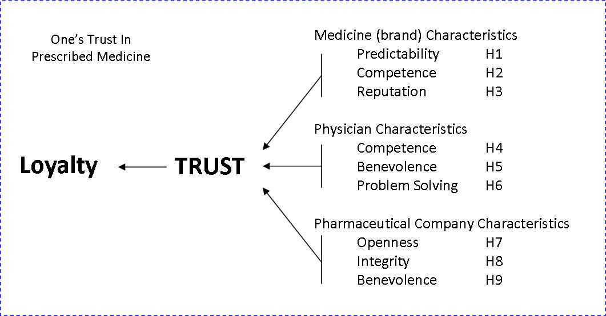

2.3. Loyalty

Trust is suggested to be a driver for loyalty. To better understand the influence of trust on loyalty, the concept of loyalty will be explained in this section.
Loyalty is suggested and proved to be of importance in business but also in everyday life. Besides the business world and a person’s everyday life, I believe loyalty also to be of importance in the pharmaceutical industry. There are many visions of what loyalty depends on. The antecedent of loyalty, trust, is relevant in this research and will therefore be discussed in more detail.

2.3.1. Loyalty In Previous Research

Brand loyalty is a widely discussed item. However, no such unified definition of brand loyalty has been formed. In the section below, I will discuss different views and definitions of the term brand loyalty.
It is generally believed that brand loyalty leads to certain marketing advantages. In the article of Chaudhuri and Holbrook (2001, p.81) they discuss Aaker’s findings that brand loyalty may lead to more new customers, reduced marketing costs, and greater trade leverage. The writers furthermore suggest, based on Dick and Basu’s work, that other marketing advantages can be that there is greater resistance among loyal consumers to competitive strategies and favorable worth of mouth.
In the article by Chaudhuri and Holbrook (2001, p.82) the work of Oliver is quoted in defining brand loyalty as: “A deeply held commitment to rebuy or repatrionize a preferred product/service consistently in the future, thereby causing a repetitive same-brand or same brand-set purchasing, despite situational influences and marketing efforts having the potential to cause switching behavior”.
George Day (1969, p.29) suggests that “there is more to brand loyalty than just consistent buying of the same brand-attitudes, for instance”. This statement is in line with Chaudhuri and Hollbrook (2001, p.81) who suggest that brand loyalty consists of both purchase loyalty and attitudinal loyalty, which are in turn influenced by brand trust and brand affect.
Furthermore, Day (1969, p.30) states the importance of measuring loyalty in both behavioral and attitude components. One reason for this is that there is a difference between true and spurious loyalty. As such, that, as Day (1969, p.30) describes, “spurious loyal buyers lack any attachment to brand attributes, and they can immediately be captured by another brand that offers a better deal, a coupon, or enhanced point-of-purchase visibility through displays and other services”. Day (1969, p.30) further describes, that when attitudinal components are involved in the criteria, loyalty is not a general concept describing the over-all behavior pattern anymore, but it becomes a brand-specific concept.

In general, Day (1969, p.34) describes brand loyalty as follows: “true brand loyal buyers are committed to the value and price appeal of the brand by being confident that they have judged the brand correctly, coupled with a perceived need to economize”.
Day (1969, p.34) provides some characteristics of the true brand-loyal consumer:
- Very conscious of the need to economize when buying
- Confident of her brand judgments
- A heavy buyer of the product
- An older housewife in a smaller than average household (who needs to satisfy the preferences of fewer family members)
- Apparently less influenced by day-to-day price fluctuations, as evidenced by the fact that while the price paid per unit is close to average, the range of prices is quite narrow, and fewer purchases tended to be made on deal.

Lau and Lee (1999, p.341) argue that the first definitions of brand loyalty were based on behavior. When citing Brown and Cunningham, they suggest that brand loyalty was seen as a subset of repeat purchase behavior and intention to repurchase. Later research found that brand loyalty is based on brand loyal behavior and brand loyal attitudes. As Lau and Lee (1999, p.341) describe, “the attitude behind the purchase is important because it drives behavior. While brand loyal behavior is partly determined by situational factors such as availability, attitudes are more enduring.” As Aaker (Lau and Lee 1999, p.341) explains, “brand loyalty is a measurement of the attachment that a customer has to a brand”.
Oliver (1999, p.34), taken from Tellis, defines loyalty as “a repeat purchasing frequency or relative volume of same-brand purchasing”. Also in the article by Oliver (1999, p.34), the definition by Newman and Werbel, is provided as “consumers who rebuy a brand, consider only that brand, and no brand-related information seeking is needed”. Oliver himself (1999, p.34) defines loyalty as “a deeply held commitment to rebuy or repatrionize a preferred product/service consistently in the future, thereby causing repetitive same-brand or same brand-set purchasing, despite situational influences and marketing efforts having the potential to cause switching behavior”.
Mittal and Lassar (1998, p. 182) take a perspective of loyalty from that of the consumer and use the definition by Dick and Basu in their article. The definition is described as “the preponderance or bias of past behavioral frequency in favor of a specific brand.
As Mellens et al (1996, p.509) discuss, there are various definitions of brand loyalty. In their opinion the best definition that covers most essential aspects of brand loyalty and has been used in other literature is that by Jacoby and Chestnut in 1978. Jacoby and Chestnut define brand loyalty as: “The biased, behavioral response, expressed over time, by some decision-making unit, with respect to one or more alternative brands out of a set of such brands, and is a function of psychological (decision-making, evaluative) processes” (Mellens et al 1996, p.509).

2.3.2. Definition Of Loyalty

Hereafter, when the term brand loyalty is used it will have the meaning as that of the definition by Jacoby and Chestnut. Reason for this is that in most literature related to brand loyalty, this definition has been used.
To begin with once more the definition of loyalty by Jacoby and Chestnut is provided below:
“The biased, behavioral response, expressed over time, by some decision-making unit, with respect to one or more alternative brands out of a set of such brands, and is a function of psychological (decision-making, evaluative) processes” (Mellens et al 1996, p.509).

2.3.3. Types Of Loyalty

Armstrong and Kotler (2005, p.195) describe that there are 3 types of loyalty among consumers: completely loyal, somewhat loyal, and no loyalty. Completely loyal buyers purchase one brand all the time. Somewhat loyal consumers purchase one brand while other times purchase supplementary brands or are in favor of two or three brands of a particular product. Consumers that have no loyalty to a brand prefer variation each time or they favor what is on sale.
Chaudhuri and Holbrook (2001, p.82) suggest that previous research on loyalty has focused mainly on the behavioral aspect of loyalty and therefore neglecting the attitudinal components that are involved. Therefore, they propose there to be two types of brand loyalty, namely purchase loyalty and attitudinal loyalty. The writers (2001, p.82) define purchase loyalty, or behavioral loyalty, as “the willingness of the average consumer to repurchase the brand. Moreover, they define attitudinal loyalty as “the level of commitment of the average consumer towards the brand”.
As described before, Day (1969, p.30) believes there to be two types of loyalty; true or intentional loyalty and spurious loyalty. There is a difference between true and spurious loyalty. As such that, as Day (169, p.30) describes, “spurious loyal buyers lack any attachment to brand attributes, and they can be immediately captured by another brand that offers a better deal, a coupon, or enhanced point-of-purchase visibility through displays and other services”.

2.3.4. Why Loyalty

Lau and Lee (1999, p.341) suggest that brand loyalty has a great arsenal in benefits for the firm. F.e. the referrals among friends and relatives but also repeat purchases.
As Lau and Lee (1999, p.344) describe in their article, in recent years the consumer goods market has become more crowded with consumers who are loyal to deals. To overcome these deals, it is important to create relationships with your customers and winning their trust. Because it is difficult to create a relationship on a personal basis with consumer-goods consumers, the brand or symbol comes in place to provide communication between an organization and consumer. We could expect that regarding medicine a relationship with consumers or trust in the company is of much importance. Herewith, is meant that usually a pharmaceutical drug is a product of which people don’t know exactly what is in it and the working of it. We have to trust the company that it is a safe product and trust the doctor that he prescribes the right drug. Therefore, in the pharmaceutical industry the use of a corporate brand for communication could be a very valuable asset to a company in creating a relationship with the consumer which turns into trust, which in turn affects brand loyalty positively.
One of the most widely known reasons for the move towards the creation of loyalty between consumers and companies and their brands is the cost efficiency. It is widely believed that it costs less to retain customers than capturing new customers. In more detail, it has been found, by Rosenberg and Czepiel (1984, p.47) and various authors (Mittal and Lassar 1998, p.177), that the attraction cost of a new customer are six times as much as that of retaining one customer.
In addition to this number, Oliver (1999, p.33) describes the impact of having a loyal customer base on the profits, by the results of figures by Bain and Company. It is here suggested that “the net present value increase in profit that results from a 5% increase in customer retention varies between 25 and 95% over 14 industries”.

In support of the idea that retaining customers is more cost effective, Mittal and Lassar (1998, p.177) provide the following list of general cost savings of doing business with continuing customers.
- costs of advertising to entire new customers;
- costs of personal selling pitch to new prospects;
- costs of setting up new accounts;
- costs of explaining business procedures to new clients; and
- costs of inefficient dealings during the customer’s learning process.

Besides the cost minimization importance of creating a loyal relationship with your customers, Mellens et al (1996, p. 507) also describe the effect on the product mix by stating that loyal consumers are less price sensitive and are willing to pay higher prices. In addition, Aaker (Mellens et al 1996, p.507) suggests companies with loyal customers to have more time to react to competitive moves and that they also have trade leverage.

2.4. Trust

The main topic of this study surrounds the element of trust. Therefore, in this sections a glimpse of the definitions of trust are provided.

2.4.1. Trust In Previous Research

Chaudhuri and Holbrook (2001, p.82) provide a definition of trust in their article by Doney and Cannon. The definition is as follows: “the concept of trust involves a calculative process based on the ability of an object or party (e.g. a brand) to continue to meet its obligations and on an estimation of the costs versus rewards of staying in a relationship”.
Doney and Cannon (Chaudhuri and Holbrook 2001, p.82), furthermore, suggest that trust involves an inference regarding the benevolence of the firm to act in the best interests of the customer based on shared goals and values. Especially in the medical industry companies are often questioned about their integrity. Therefore, a brand that allows for trust among consumers can be of much importance in the medical industry.
Chaudhuri and Holbrook (2001, p.82) conclude by suggesting that reliability, safety, and honesty are important components of trust.
Brand trust is defined by Chaudhuri and Holbrook (2001, p.82) as “the willingness of the average consumer to rely on the ability of the brand to perform its stated function”. Furthermore, they view brand trust as involving a process that is well thought out and carefully considered.
Another definition by Doney and Cannon (1997, p.36) of trust is “the perceived credibility and benevolence of a target of trust. Here, several dimensions are important”. Where focusing on the objective credibility of an exchange partner or brand is the first dimension, which means that you can rely on the brand’s or partner’s word or written statement. Benevolence is the second dimension in this definition of trust. It is said to be the “extend to which one partner [or brand]is genuinely interested in the other partner’s welfare and motivated to seek joint again”.
Lau and Lee (1999, p.343) provide a definition of trust by Deutsch as follows: “Trust is the expectation of the parties in a transaction and the risks associated with assuming and acting on such expectations”. Furthermore, the writers (Lau and Lee 1999, p.343) use Worchel’s research in further discussing the concept of trust: “An individual has trust in the occurrence of an event if he or she expects its occurrence. Trust is the willingness to rely on another party in the face of risk. This willingness stems from an understanding of the other party based on past experience. It also involves an expectation that the other party will cause a positive outcome, despite the possibility that the action may cause a negative outcome”.
In the article by Lau and Lee (1999, p.343) they provide the definition of trust of Boon and Holmes as “a state involving confident positive expectations about another’s motives with respect to oneself in risky situations”.

2.4.2. Importance Of Trust

Chaudhuri and Holbrook (2001, p.82) suggest that trust reduces the uncertainty in an environment in which consumers feel especially vulnerable because they know they can rely on the trusted brand. If we apply this concept to the medical industry, we can state that in this industry consumers feel especially vulnerable because they do not have much knowledge about what they consume.
Lau and Lee (1999, p.344) define trust in a brand as a consumer’s willingness to rely on the brand in the face of risk because of expectations that the brand will cause positive outcomes.

2.5. Trust And (Medicine) Brand Trust

2.5.1. Brand

The name ‘brand’ originally came from Norway. Blackett and Harrison (2001, p.33) provide in their article the old fashion definition of the word brand. The word brand is actually derived from the word “to burn” in the Old Norse language. In that language to burn meant “brandr”. A long time ago, man would stamp their cattle for the reason that they could show their ownership of their livestock. In the event of a trade these stamps were used to distinguish one cattle from another, and the stamped brands became a means of quality and reliability. As Blackett and Harrison (2001, p.33) suggest, “brands provided buyers with a guide to choice, a role that has remained unchanged to the present day”.
Blackett and Harrison (2001, p.33) state that the first used brands were those on clay pots during the Roman Empire. On the bottom, the potter would place his name and later on it would become a more sophisticated sign.
The rise of the use of brands began in the late 19th and the 20th century with the industrial revolution. This industrial revolution made mass production and marketing of goods easier. Furthermore, the first trademark legislation to protect brands was established in 1876 (Blackett and Harrison 2001, p.34).

In marketing literature, Schuiling and Moss (2004, p.2) define the term brand as “a name or symbol that is given to a product that will differentiate it from other products and that will register it in the minds of consumers as a set of tangible (rational) and intangible (irrational) benefits”.
Regarding the use of a brand, Moss and Schuiling (2004, p.3) suggest that where a product only conveys tangible benefits, both intangible and tangible benefits are provided by a brand.
Kotler et al (2005, p.555) suggest the importance of brands as that they are “the major enduring asset of a company, outlasting the company’s specific products and facilities. The CEO’s of Quaker Oats and McDonalds agree with their view point. It is necessary to develop and maintain brands carefully because the “real value of a strong brand is its power to capture consumer preference and loyalty” (Kotler et al 2005, p.555). Before we can develop and maintain a brand, to create for example loyalty, it is important to know what stimulates loyalty and in more detail what is involved in trust.
Lau and Lee (1999, p.344) describe a brand as “a name, term, sign, symbol, or design (or a combination) intended to identify a seller’s goods or services, and to differentiate them from competitors”. The writers further suggest that in trust in a brand, the symbol is trusted, instead of the person.
Lau and Lee (1999, p.344) define trust in a brand as “a consumer’s willingness to rely on the brand in the face of risk because of expectations that the brand will cause positive outcomes”.
2.5.2. A Brand, What Does It Do

A brand is not just a name or a symbol. If a brand is managed well it can lead to much more than being just a name; for example brand equity and brand loyalty.
As Kotler et al (2005, p.556) suggest, brand equity is an important aspect of a brand. Their definition of brand equity is as follows:
“Brand equity is the value of a brand, based on the extent to which it has high brand loyalty, name awareness, perceived quality, strong brand associations, and other assets such as patents, trademarks and channel relationships”.
A powerful brand is expected to have high brand equity, as the writers (Kotler et al 2005, p.556), furthermore, state that “brand equity is the positive differential effect that knowing the brand name has on customer response to the product or service.” It is believed that you can measure brand equity by researching whether people would pay more for a brand than for others.
Furthermore, Chaudhuri and Holbrook (2001, p.81) suggest brand loyalty to be a component of company success. In more detail market share and relative price.
Kotler et al (2005, p.556) provide some benefits of brand equity. Since brand loyalty is part of brand equity, some of these benefits are in line with those of brand loyalty. Below are the suggested brand equity benefits by Kotler et al.
- A powerful brand enjoys a high level of consumer brand awareness and loyalty
- The company will incur lower marketing costs relative to revenues
- Because consumers expect stores to carry the brand, the company has more leverage in bargaining with retailers
- Because the brand name carries high credibility, the company can more easily launch and lone brand extensions
- A powerful brand offers the company some defense against fierce price competition

In summary
The importance of developing and managing a brand has been discussed before. Some companies even hire brand managers to solely watch over the brand. Reason for this brand management is of course to achieve the advantages of brand equity as explained above, but also to manage any negativities that might have an effect on the brand in the consumers mind.

2.5.3. Trust In A Brand

Various research indentified the importance of the link between trust and loyalty. In 1992 O’Shaughnessy (Lau and Lee 1999, p.342) argues that trust always underlines loyalty, in which he describes loyalty as “a willingness to act without calculating immediate costs and benefits.”Therefore, loyalty to a brand includes trusting it.
Furthermore, Chaudhuri and Holbrook (2001, p.81) argue the link of brand loyalty between brand trust and company success. Chaudhuri and Holbrook (2001, p.81) suggest brand loyalty to guide as a link between brand trust and brand affect to that of brand performance. Here, brand performance is seen as market share and relative price. In their (Chaudhuri and Holbrook 2001, p.83) model they suggest brand trust to influence both purchase loyalty and attitudinal loyalty. Moreover, they also believe brand affect to have an influence on both purchase loyalty and attitudinal loyalty. As the writers (Chaudhuri and Holbrook 2001, p.83) suggest, trust creates exchange relationships that are highly valuable and therefore brand trust leads to brand loyalty.
Moreover, Lau and Lee (1999, p.342) argue that the concept of the trust and loyalty link has been researched quite adequate in the industrial marketing. However, as a response to the lack of research in the link between trust and loyalty in consumer goods, Lau and Lee investigate factors affecting the development of trust in brands of consumer goods, and to explore how that trust relates to brand loyalty.
The study of Lau and Lee (1999, p.344) proposes that “trust in a brand is important and is a key factor in the development of brand loyalty”. Consumer-brand characteristics, brand characteristics, and company characteristics are proposed by Lau and Lee to influence trust in a brand.

2.6. Physician Trust And Medicine Trust

As discussed before, trust is of importance in so many aspects of a person’s life when building relationships. The to be build relationship can be with a friend, with a company, with a brand, but also with your physician.
In the next section the role of the physician will be explained. In more detail, the following will be discussed: medical trust, physician’s interactions in the pharmaceutical industry, drivers of physician trust, the importance of trust in a physician-patient relationship, and the predictors of trust.

2.6.1. Medical Trust

To begin with, the medical definition of trust by Hall et al (2001, p.615), that was provided in an earlier section, will be recalled. After extensive conducted research, they have come up with a definition of trust with a medical focus. The definition is as follows: “the optimistic acceptance of a vulnerable situation in which the truster believes the trustee will care for the truster’s interests”.
In this context, the writers (Hall et al 2001, p.615) argue vulnerability to be an important concept and which is even inseparable from trust. In more detail “there is no need for trust in the absence of vulnerability. The greater the risk, the greater the potential for either trust or distrust”. If you apply this to the doctor patient relationship, there is much potential for trust. Reason for this is that in the case of an illness or treatment, a person is quite vulnerable. Furthermore, it is suggested that the potential for trust is greater when the vulnerability becomes greater. In this context, the writers (Hall et al 2001, p.615) argue that “trust is said to be inevitable or unavoidable in treatment relationships”.

2.6.2. Interactions In The Pharmaceutical Industry

Before we continue with more on the topic of trust and physicians, it is important to understand how a physician interacts in the pharmaceutical industry and herewith in which manners he can be influenced in his prescribing manners. Therefore, in the next section, a discussion of a physicians interactions in the pharmaceutical industry (Breen 2004, p.409-410) will be provided.

As Breen (2004, p.409) suggests, the first manner in which physicians and doctors interact in the pharmaceutical industry are the visits by company representatives. These visits are the so called direct face-to-face visits by the company representatives, also named as drug reps.
A second common method (Breen 2004, p.409) of interaction is via marketing means; such as direct mailing, sponsorship of medical conferences and medical products, and the advertising in medical journals and medical newspapers.
Some physicians are asked to be involved in clinical trials, speaker’s panels, or industry advisory groups. This involvement is a third, but less common, way of interaction.
Besides the focus on the interaction with the doctor or physicians, medical companies also attempt to involve the patient in the prescribing process by encouraging the patient to present their illness and the desired drug treatment to the physician, instead of the doctor diagnosing the patient. They try to achieve this by supporting organizations that raise awareness for diseases and the treatments that can solve them. Furthermore, medical companies also attempt to stimulate that more people seek treatment, also for new diseases. They try to do this by the promotion of illnesses or using the media in combination with public awareness campaigns (Breen 2004, p.410).

2.6.3. Drivers Of Physician Trust

Often said before, is that the relationship of trust and loyalty is expected to have different drivers in the pharmaceutical industry than that of other industries such as fast moving consumers goods. A possible reason for this difference is given by Breen (2004, p.410) as follows: “the impropriety of this stance is compounded by the information asymmetry (where the patient is almost always dependent upon the doctor for information and guidance about medications) and by the fact that the prescribed drugs are usually subsidized by public funds”.
To begin with, a general vision, by Sirdeshmukh et al (2002), on the dimensions of trust in a seller-buyer relationship will be provided. In this context we replace the buyer by the physician. Even though the physician does not sell the actual drug to the patient, he does prescribe the drug that will be bought. Hereafter, a discussion of dimensions found to be of importance in building a relationship with the consumer in the pharmaceutical industry will be given.

General Dimensions Of Physician Trust
Sirdeshmukh et al (2002) provide in their article, Consumer Trust, Value, and Loyalty in Relational Exchanges, interesting dimensions of trust in relational exchanges that gives a better idea of what a person’s trust in a physician might depend on.
The authors (Sirdeshmukh et al 2002) suggest there to be three components of importance in trust of the seller-buyer relationship. Even though their article is based on the actual seller-buyer relationship and a doctor does not actually sell the drug, the doctor does prescribe a drug which the patient is more or less required to buy. Therefore, in the case of the doctor-patient relationship we can refer to a seller-buyer relationship as well and use the theory of Sirdeshmuk et al.
The three components of importance, which will be discussed next in more detail, are operational competence, operational benevolence, and problem-solving orientation.

Operational competence
In their article, Sirdeshmukh et al (2002, p.17), have justified, by providing statements from various literature, that the expectation of consistently competent performance from an exchange partner has been accepted to be a factor in the development of trust.
In detail, with operational competence is meant “the competent execution of visible behaviors as an indication of ‘service in action’ (e.g. response speed) and distinguish it from the inherent competence (e.g. knowledge)” (2002, p.17) of the provider.
Here an example of the concept is that a physician can have the knowledge to play his role, but only if this knowledge results into observable behaviors it can be processed as a signal of trustworthiness. With observable behaviors is meant for example diagnosing the patient truthfully and helping find the desired drug for the right treatment.

Operational benevolence
Sirdeshmukh et al (2002, p.18) explain benevolence as “ behaviors that reflect an underlying motivation to place the consumer’s interest ahead of self-interest”. They (Sirdeshmukh et al 2002, p.18) further explain their notion of operational benevolence as “simply having a benevolent motivation is not sufficient; rather, this motivation needs to be operationalized in visible behaviors [of the doctor] that unambiguously favor the consumer’s interest, even if a cost is incurred in the process.” Furthermore, they (Sirdeshmukh et al 2002, p.18) state that benevolent behaviors and practices are often regarded to as ‘extra-role’ actions that are performed at a cost to the service provider with or without commensurate benefits.
An example of a doctor in this context can be that the doctor not only goes by what the patient tells him, but he also goes a step further by thinking of extra causes or illness than just what the patient thinks. Also, a doctor can think of other treatments than what the patient simply suggests himself.

Problem-solving orientation
The writers (Sirdeshmukh et al 2002, p.18) define problem-solving orientation as “the consumer’s evaluation of [the service providers] motivations to anticipate and satisfactorily resolve problems that may arise during and after a service exchange.” When problems arise during or after delivery, the manner in which the service provider handles the problems provides insight into the character of the service provider.
In the context of a doctor, for example if a problem arises after selecting a treatment with a certain drug that causes certain side affect, a doctor can approach this problem by stating the side effects will lessen soon or he can approach the problem by looking into a new solution by thinking of other drugs that can support the same treatment or move to a different treatment.

Pharmaceutical Related Dimensions Of Physician Trust
In the context of doctor-patient encounter, Hall et al (2001) suggest various dimensions of trust to be of importance. Hereafter, four of the dimensions will be named. The dimensions are fidelity, competence, honesty, and confidentiality. With fidelity is meant “pursing a patient’s best interest and not taking advantage of his or her vulnerability” (Hall et al 2001, p.621). According to the authors this entails avoiding conflicts of interest, respect, caring, and advocacy.
“Avoiding mistakes and producing the best achievable results” is the definition of competence (Hall et al 2001, p.621). The writers suggest that it might be difficult for a patient to assess the competence of their doctor, and therefore, they might base their judgment on the interpersonal competence of the doctor which entails his communication skills and manners.
Honesty is defined by Hall et al (2001, p.622) as “telling the truth and avoiding intentional falsehood”. There are several levels of dishonesty. These are: deception of silence, half-truths, and outright lies.
With confidentiality is meant “the protection and proper use of sensitive or private information” (Hall et al 2001, p.623). Here the importance is that medical information is only used when necessary for the appropriate medical care, and not necessarily the complete silence of information.

2.6.4. Why Trust Is Important In A Physician (Seller)-Buyer Relationship

With regards to the importance of trust in a usual seller-buyer relationship, Sirdeshmukh et al (2002, p.15) have formed an opinion that in relationship marketing between two people, usually focused on a buyer and seller, the factor of trust has become an important matter of research. To verify their opinion, the authors summarize various writer’s statements about the factor of trust in relationship building. First they (Sirdeshmukh et al 2002, p.15) quoted Berry with “the inherent nature of services, coupled with abundant mistrust in America, positions trust as perhaps the single most powerful relationship marketing tool available to a company”. Of others the writers (Sirdeshmukh et al 2002, p.15) summarize that trust is the cornerstone of long-term relationships and of relational commitment. They (Sirdeshmukh et al 2002, p.15) further quote Reichfield and Schefter in that “to gain the loyalty of customers, you must first gain their trust.”

If we apply the importance of trust in general relationship building to relationship building in the pharmaceutical industry, and especially to that of between a physician and a patient, various positive consequences of a trustworthy relationship arise. In this context, Hall et al (2001, p.629) provide several consequences of trust that show the importance of trust and what it may lead to. These consequences of trust in physicians are:
- A positive adherence of treatment recommendations
- Not changing physicians
- Not seeking second opinions
- Willingness to recommend a physician to others
- Fewer disputes with the physician
- Perceived effectiveness of care
- Improved self-reported health

Furthermore, it is suggested by Hall et al (2001, p.613) that trust is of importance for both intrinsic and instrumental reasons in a physician-patient relationship. In more detail, the intrinsic driver is the “defining characteristic that gives the doctor-patient relationship meaning, importance, and substance-the way love or friendship defines the quality of an intimate relationship” (Hall et al 2001, p.613). Trust is also believed to guide as an instrumental value. As Hall et al (2001, p.614) suggest, this instrumental value is believed to be a driver for an effective encounter with the physician. The trust involved in the relationship between a doctor and patient is likely to host several behaviors and attitudes. According to Hall et al (2001, p.614) some of these important behaviors and attitudes are: “patients willingness to seek care, reveal sensitive information, submit treatment, participate in research, adhere to treatment regimens, remain with a physician, and recommend physicians to others”.

2.6.5. Predictors Of Trust

There are several possible predictors of trust, such as the characteristics of the patient and physician, but also the relationship or situational factors. Hall et al (2001, p.627) suggest that of the patient characteristics only age is a positive factor. The authors state that the reason for age being a factor, might be a generational effect or that with the years there is more intensive contact with a doctor.
Regarding the physician characteristics, Hall et al (2001, p.628) suggest the physician’s personality and behavior to be the strongest forecasters of trust. In more detail, here the important factors are the communication style and the interpersonal skills of the physician.
As Hall et al (2001, p.628) suggest, the strongest predictors of trust regarding the relationship between a doctor and patient are those that in the patient’s opinion they had enough choice to choose their physician and whether patients selected their physician because of convenience of personal recommendation from others. Hall et al (2001, p.628) find it surprising that the length of a doctor-patient relationship is weakly associated as well as the total number of visits.

2.7. Company Trust And Medicine Trust

Now that we have discussed the trust involved in a brand and in a physician, we will continue with a discussion of what trust in a company entails and how this affects the trust in a prescribed medicine.
In this section of Company Trust, various topics will be discussed. To begin with business ethics. Which will be followed by the importance of business ethics in business in general and in the pharmaceutical industry. Furthermore, the formation of ethics and examples of bad ethics will be discussed. Finally, ethics and trustworthiness are discussed.

A business or company is often seen by a consumer as an entity of itself and often judged by the consumer as of it is a person as well. There are many stakeholders involved in the environment of a company. These stakeholders can be for example the shareholders, the employees, the suppliers, the society, and also the consumers. All these stakeholders base their judgment on a company on different factors. One might look at a company from a financial view point, from an employee view point, or from an ethical view point. The consumer is most likely to base his or her judgment on the latter, the ethical behavior of a company. Therefore, in the next section the main focus will be on what business ethics is, what can it do for a company, and how ethical behavior (or unethical behavior) can benefit (or hinder) the trust one person has in a prescribed medicine.

2.7.1. Ethics

The general definition of ethics as given in the Oxford Dictionary (Soanes and Stevensons 2005, p.595) is as follows “a set of moral principles, especially ones relating to or affirming a specified group, field, or form of conduct”. Furthermore, behaving ethical means according to the Oxford Dictionary (Soanes and Stevensons 2005, p.595) “relating to moral principles or the branch of knowledge dealing with these”.
Furthermore, Creyer ( 1997, p.422) quotes Sherwin in that the general definition of Ethics is: “the set of moral principles or values that guide behavior”. However, she (1997, p.422) argues that “what constitutes ethical and unethical behavior can differ depending on the set of moral principles used as the basis for judgment”.

2.7.2. Business Ethics

In a study of 158 textbooks, Lewis (1985, p.381) synthesized the definition of business ethics and incorporated the four concepts that were mentioned most often. Lewis’s (1985, p.381) definition of business ethics is: “business ethics’ is rules, standards, codes, or principles which provide guidelines for morally right behavior and truthfulness in specific situations.”
Here, as Lewis (1985, p.381) suggests, the rules, standards, codes or principles are viewed as moral guidelines that when followed will avert unethical behavior. In turn, the morally right behavior refers to the individual actions that conform to justice, law or another standard. Furthermore, truthfulness is defined (Lewis 1985, p.381) as the statements and/or actions that confirm with facts that have the appearance of reality. Finally, in Lewis’s definition of business ethics, specific situations is referred to as the occasions of personal moral dilemma calling for ethical decisions.

2.7.3. The Importance Of Business Ethics

It is often questioned why business ethics is important. Some even say that legally, a manager often doesn’t have to act ethically or morally. Even though a manager or company might not be legally obliged to act ethically or morally, there are advantages to do so.
As Joyner and Payne (2002, p.298) argue, some believe that acting ethically, you can actually maximize share holder value and the economic wealth of a company. The writers (Joyner and Payne 2002, p.298) furthermore argue, that a company with ethical standards and behaving on those standards has employees working for the company who are committed more to their job than without the ethical intentions of a company. Moreover, Joyner and Payne (2002, p.298) argue that there is a realization among companies that they cannot succeed without their society and that society cannot succeed without the businesses. Therefore, companies have become aware of caring about or building a relationship with society.
To narrow it down, Joyner and Payne (2002, p.298,299) argue that businesses act ethically for two reasons: one reason is being ethical in nature and the second is the Machiavellian approach. The first approach entails “to a desire to do the right thing, without external pressure or governmental constraint.” The second approach called Machiavellian comes from “a desire to convince the stakeholder that the firm is doing the right thing.”
As mentioned before, it is important for companies to behave ethically but also manage unethical behavior if it occurs. Reason for a closer look into managing unethical behavior of companies is the, as Creyer (1997, p.421) describes, increasing lack of respect among people towards business today, an increase of insiders who are willing to blow the whistle on unethical behavior, and a press that also has a focus of investigative reporting now and takes advantage of scandals.

Even though there has been an increase in awareness of ethical behavior among companies, questions arise whether consumers are actually concerned about the ethics of a company and involve this matter in their decision making. In response to these concerns, Creyer (1997, p.425) researched this matter and found that:
- The ethicality of a firm’s behavior is an important consideration during the purchase decision
- Ethical corporate behavior is expected
- They will reward ethical behavior by a willingness to pay higher prices for that firm’s product, and
- Although they may buy from an unethical firm, they want to do so at lower prices which in effect, punishes the unethical act

2.7.4. Importance Of Business Ethics For Pharmaceutical Companies

Involving ethics in your decision making as a company can have two positive effects, as Creyer (1997, p.421) suggests. One, it may prevent or minimize the practice of unethical behavior, and two, it facilitates recovery of a discovered ethical behavior. Both effects are important for any business, but for medical companies bad press can have an even greater effect on the consumers perception of that company since you are dealing with a product such as drugs of which a usual consumer does not understand its specifications and needs an in between person for usage information. But most importantly, the products of drug manufacturing companies, the drugs, have an effect on your health. Therefore, consumers will most likely favor a company that is ethically in their business processes.

2.7.5. Formation Of Ethical Behavior

As Creyer (1997, p.422) also mentioned, a firm needs the trust of its stakeholders. Unethical behavior can violate this trust, and ethical behavior can strengthen this trust.
Furthermore, Creyer (1997, p.422) discusses the role of expectations and beliefs in the formation of perceptions of ethical behavior of the company. An expectation here is defined as “beliefs concerning what is to be expected, or anticipated”( 1997, p.422). In turn, Creyer (1997, p.422) states that beliefs may be formed in three manners. Namely through direct experience, information from outside sources (media or word-of-moth), and inferential information which is seeking information beyond direct experience and the outside information sources. These different ways of forming a belief and in turn an expectation of a product or company, results into many potential situations in which the consumer’s perception can be formed or influenced.

2.7.6. Examples Of Bad Ethics

Besides the reasons named by Joyner and Payne, Cleek and Leonard (1998) provide various examples that illustrate the importance of ethical decisions in the business world. Their (Cleek and Leonard 1998, p.619) first example is the insider trading scandals on Wall Street. Here with is meant the trading of stocks and shares while important information is only available to the trader or a few people. While insider trading is going on, it is seen as a illegal by the Securities and Exchange Commission.
Another example of a bad ethical decision, presented by Cleek and Leonard (1998, p.619), is that of the marketing department of Beech-Nut Corporation that marketed their apple juice as 100% pure apple juice which in turn was 100% synthetic. Two final examples are that of Nestle and S&L. Nestle decided to sell baby formula to mothers in third-world countries. In an attempt to prevent their company of being taken-over, the managers of S&L attempted to ruin their own corporation (Cleek and Leonard 1998, p.619).

2.7.7. Ethics And Trustworthiness

In the following section, a discussion will be provided about the dimensions of trustworthiness that can be obtained by ethical behavior of companies. But first, the definition of trustworthiness will be provided.

As Bews and Rossouw (2002, p.378) describe, “trust refers to the act of trusting or not trusting, trustworthiness entails an evaluation of those criteria that constitute trust and consequently, influences both the direction and intensity of any decision to act in a trusting manner. Trustworthiness, is those characteristics that one perceives in another or group that elicits a belief that trust can, or cannot, be placed in that other group while taking into account both personal risk and vulnerability regards trustworthiness as ‘..the evaluative appraisal that an individual is worthy of trust’ “.
After extensive research and stating the distinction between trust and trustworthiness, Bews and Rossouw (2002, p.378) suggest the following operational term of trustworthiness:
“the trustor’s (trusting party’s) evaluation, based on certain facilitators, of the likelihood of the trustee (focus of trust) acting in her or his interests in a situation entailing risk.”
Bews and Rossouw (2002, p.379) suggest there to be certain dimensions of trustworthiness that can be influenced by ethical behavior. A selection of the dimensions that will be discussed are openness, integrity, and benevolence. The final two dimensions of personality factors and history of interactions will not be discussed for the reasons that I find these not applicable in the discussion about a company or business.
Even though the to be discussed dimensions are based on an employer-employee relationship, these dimension are quite in common with the work by Sirdeshmukh et al (2002), and therefore the dimensions will be considered in the formation of the model for this study.

Openness
When transforming the statement by Bews and Rossouw (2002, p.382) that in openness the two facets of functional and personal information are of importance, to the relation between a medical company and the consumer, the following is a description.
Functional information could be that the company provides information on how to use a drug on its website or through other channels. The more personal information could be the provision of information how it tested a certain drug accompanied by its test results.

Integrity
Bews and Rossouw (2002, p.382) state, based on previous literature that integrity is evolved around the features of fairness, consistency, and reliability. Here, Bews an Rossouw (2002, p.382) define integrity as: “the application of a set of moral and ethical principles, acceptable to both trustor and trustee, which are predictable and reliable and which lead to equity”.
In the pharmaceutical industry we could provide an example of integrity in that it is important to explain to the consumer the prices of medicine. Often the level of prices are questioned and suggested to be too high. However, pharmaceutical companies need to communicate that their prices are fair because the profit of the medicine needs to cover the research costs. Additionally, it is important for a consumer to be able to trust on the reliability and consistency of the products that pharmaceutical companies produce. Each time you use a certain medicine you want it to have the same results.

Benevolence
Bews and Rossouw (2002, p.383) describe benevolence as follows: “the issue of concern for another, or the whole, is a further facilitator of trust. Rather than limiting the issue of concern to that of not taking advantage of the vulnerability of another, concern can be expanded to include acts that are undertaken in the interests of another and, as such, reference can then be made to benevolence as a facilitator of trust.”
Here we can link their definition to an example in the medical industry as how benevolence could negatively influence the consumer’s trust. It is important for a company, that even though they need to make profit, they do work in the best interest of the consumer while producing drugs or designing treatments. Sometimes, drug manufacturing are even accused of making people believe that there is a new disease so they can sell a treatment for that. An extreme example might be the plastic surgery industry. For some reason some people believe that they are not beautiful the way they are and therefore they seek treatment in the form of plastic surgery. It is questionable how they got this idea, but the medical companies for sure take advantage of this. Another example is the treatment of anti aging in the form of creams, pills, or also plastic surgery. It is quite normal to become older, but companies have decided to promote a treatment for staying younger.

3. Hypotheses

3.1. Medicine (Brand) Characteristics

The brand characteristics are important in the decision whether someone will trust a person or brand. Before one becomes friends he will judge the other person, similar judging is involved in the selection of a brand. As Lau and Lee (1999, p.345) suggest, previous research suggests that brand reputation, predictability, and competence are involved in the formation of trust.

3.1.1. Brand Predictability

Doney and Cannon (Lau and Lee 1999, p.346) state that predictability refers to one party’s ability to forecast another party’s behavior. Lau and Lee (1999, p.346) furthermore state that “a predictable brand is one that allows the brand user to anticipate, with reasonable confidence, how it will perform at each usage occasion”. This predictability may be due to a consistent level of product utility. Predictability comes from repeated interaction, whereby one party makes promises and delivers on them; and courtship, where one party learns more about the other.
In general predictability is important, but in the medical industry it is very much of importance to know how a medicine is going to perform and if we can expect consistent behavior. Hence, a positive brand predictability is suggested to enhance trust in a brand, and also loyalty, for the reason that positive expectations are build by predictability. Therefore, the first hypothesis sounds:

H1: The predictability of the medicine brand is anticipated to have a positive influence on the trust a person has in that medicine

3.1.2. Brand Competence

As Lau and Lee (1999, p.346-347) describe “a competent brand is one that has the ability to solve a consumer’s problem and to meet his or her need. [Here], ability refers to skills and characteristics that enable a party to have influence within a domain”.
Normally, medicine are taken to either solve or reduce the symptoms of an illness or disease. Therefore, it is of importance to be able to predict whether a person can predict if the brand will be the solution to his or medical problems. The ability to predict the competence of a brand can be either through previous usage of the product or via word-of-mouth. A positive evaluation of this competence is believed to enhance trust in the brand, and therefore also loyalty in a brand. As a result is hypothesized:

H2: The competence of the medicine brand is anticipated to have a positive influence on the trust a person has in that medicine.

3.1.3. Brand Reputation

Suggested by Lau and Lee (1999, p.346), “a brand’s reputation refers to the opinion of others that the brand is good and reliable. Brand reputation can be developed through advertising and public relations, but is also likely to be influenced by product quality and performance”. Other people and previous usage can influence the reputation of a brand. In the occasion of medicine, if other people are convinced a medical brand is a good brand, people will develop a positive reputation about the brand. However, negative referrals and news can also easily create a negative reputation, especially the medical industry is very much vulnerable of negative press and referrals since medicine affect your health.
If during previous usage of the brand the medicine lived up to its expectations, it is likely to create a positive reputation, influence trust positively and as a result influence loyalty.
The third hypothesis states:

H3: The brand reputation of the medicine brand is anticipated to have a positive influence on the trust a person has in that medicine

3.2. Physician Characteristics

3.2.1. Physician Competence

With operational competence (Sirdeshmukh et al 2002, p.18) is meant “the competent execution of visible behaviors as an indication of ‘service in action’ (e.g. response speed) and distinguish it from the inherent competence (e.g. knowledge)”of the provider.
Here an example of the concept is that a physician can have the knowledge to play his role, but only if this knowledge results into observable behaviors it can be processed as a signal of trustworthiness. With observable behaviors is meant for example diagnosing the patient truthfully and helping find the desired drug for the right treatment. The physician is able to practive his job for the reason that he has obtained a certified license showing that he has completed the adequate education. This license gives the consumer the confidence that the physcian has the knowledge. However, it is also of importance for a consumer to trust that the physician has the competence to use his knowledge to form the right conclusion. Furthermore, the trust one receives from the physician competence can stimulate the patient’s loyalty towards its physician.
The fourth hypothesis states:

H4: The competence of the doctor is anticipated to have a positive influence on the trust one has in the prescribed medicine

3.2.2. Physician Benevolence

Sirdeshmukh et al (2002, p.18) explain benevolence as “ behaviors that reflect an underlying motivation to place the consumer’s interest ahead of self-interest”. An example of a doctor in this context can be that the doctor not only goes by what the patient tells him, but he also goes a step further by thinking of extra causes or illness than just what the patient thinks. Also, a doctor can think of other treatments than what the patient simply suggests himself.
It is of importance for the consumer to trust their physician in that he or she prescribes the medicine that is best for the consumer and that his decision is not influenced in any other way. The trust one receives from the benevolence of the physician can also effect loyalty towards the physician and the prescribed medicine.

H5: The benevolence of the doctor is anticipated to have a positive influence on the trust one has in the prescribed medicine

3.2.3. Problem-Solving Orientation

Problem-solving orientation is explained, by Sirdeshmukh et al (2002, p.18), as “the consumer’s evaluation of [the service providers] motivations to anticipate and satisfactorily resolve problems that may arise during and after a service exchange.” When problems arise during or after delivery, the manner in which the service provider handles the problems provides insight into the character of the service provider.
In the context of a doctor, for example if a problem arises after selecting a treatment with a certain drug that causes certain side affect, a doctor can approach this problem by stating the side effects will lower soon or he can approach the problem by looking into a new solution by thinking of other drugs that can support the same treatment or move to a different treatment. It is of importance for a consumers trust in, and loyalty to, prescribed medicine, to know that when problems arise during or after the use of the drug, the physician is able to look for alternatives and help solve the problem.

H6: The problem solving qualities of the doctor is expected to have a positive influence on the trust one has in the prescribed medicine

3.3. Medicine Company Characteristics

3.3.1. Openness

Openness, or honesty, “entails telling the truth and avoiding intentional falsehood” (Hall et al 2001, p.622). Based on this definition we can suggest that a person’s trust in the pharmaceutical company and as a result in its medicine would increase when a pharmaceutical company tells the truth by publicly providing information on how a certain medicine is developed, on its treatment results, and how to adequately use a certain medicine. It is furthermore important for a consumer to know that a pharmaceutical company is not withholding important information or avoiding intentional falsehood. For this reason we suggest:

H7: The openness of the medicine company is expected to have a positive influence of the trust a person has in that medicine

3.3.2. Integrity

Bews an Rossouw (2002, p.382) define integrity as: the application of a set of moral and ethical principles, acceptable to both trustor and trustee, which are predictable and reliable and which lead to equity. In the pharmaceutical industry we could provide an example of integrity in that it is important to explain to the consumer the prices of medicine. Often the level of prices are questioned and suggested to be too high. However, pharmaceutical companies need to communicate that their prices are fair because the profit of the medicine needs to cover the research costs. Additionally, it is important for a consumer to be able to trust on the reliability and consistency of the products that pharmaceutical companies produce. Each time you use a certain medicine you want it to have the same results. One’s trust based on the company’s integrity might also result in more loyalty towards it products.
These examples of integrity of pharmaceutical company can have a serious influence on the trust one has in the pharmaceutical company and in turn in the medicine itself. Therefore, we state:

H8: The integrity of the medicine company is anticipated to have a positive influence of the trust a person has in that medicine

3.3.3. Benevolence

Benevolence is described by Bews and Rossouw (2002, p.383) as follows: “the issue of concern for another, or the whole, is a further facilitator of trust. Rather than limiting the issue of concern to that of not taking advantage of the vulnerability of another, concern can be expanded to include acts that are undertaken in the interests of another and, as such, reference can then be made to benevolence as a facilitator of trust.”
It is important for a company to have consumers understand, that even though they need to make profit, they do work in the best interest of the consumer while producing drugs or designing treatments. The benevolence of pharmaceutical companies, or the well meaning and serving with integrity of pharmaceutical companies can have an influence in one’s trust a person has in the producer of the medicine and the medicine itself, and might strengthen its loyalty towards the producer and its medicine. For this reason, it is suggested:

H9: The benevolence of the medicine company is anticipated to have a positive influence of the trust a person has in that medicine.

4. Data

The method chosen to gather data was that of a Survey. The online survey was extended among friends and family over the age of 18, who in turn also contacted people to complete the survey. Furthermore, the members list of the Dutch Base-and Softball Club Twins was used to recruit respondents. Approximately 350 people were contacted, of which 180 were members of the club Twins; 100 people consist of friends and family; and the final 70 were in turn recruited by family and friends. Of the 350 contacted individuals, 172 people completed the online survey, however only 160 of these completed surveys were adequate enough to include in the analysis. The survey consists of various 5-point liker scale section as well as a multiple choice section. The survey is presented in appendix 3.

The table below provides an overview of the descriptive data of the respondents.

Question | Item |  | Percent | Frequency
13 | Gender | Male | 42,5 | 68
 |  | Female | 57,5 | 92
14 | Age Group | 18-25 | 11,3 | 18
 |  | 26-35 | 28,1 | 45
 |  | 36-45 | 18,1 | 29
 |  | 46-55 | 21,9 | 35
 |  | 56-65 | 14,4 | 23
 |  | 66-or older | 6,3 | 10
15 | Occupation | Student | 10,0 | 16
 |  | Working | 75,0 | 120
 |  | Retired | 9,4 | 15
 |  | Volunteer | 1,3 | 2
 |  | Other | 4,4 | 7
16 | Living Situation | Alone | 14,4 | 23
 |  | Cohabiting | 42,5 | 68
 |  | With Family | 39,4 | 63
 |  | With Students | 3,8 | 6
17 | Exercise | 1-2 Hours | 44,4 | 71
 |  | 3-4 Hours | 32,5 | 52
 |  | 5-6 Hours | 12,5 | 20
 |  | 7-Hours or more | 10,6 | 17

Respondents were directly asked to rate their current trust in medicine in general, in their physician, and pharmaceutical companies in general; on a scale of Very Little to Very Much. The data of the answers are below. As we can conclude from the table, in general people have the highest trust in their physician. In contrast, they have the lowest trust in pharmaceutical companies.

Survey
Question | Item | Mean | St. Deviation
1A | Medicine Trust | 3,89 | 0,64
1B | Physician Trust | 4,07 | 0,645
1C | Pharmaceutical Company Trust | 2,78 | 0,895

Next, respondents were asked to rate whether their trust in prescribed medicine would increase if certain events would occur; ranging from Very Little to Very Much. The corresponding data are presented in the table below. We can conclude from the table that when the physician suggestibility and competence improve, the trust in prescribed medicine increases the most. In contrast, pharmaceutical company benevolence and openness have the least effect on one’s trust in prescribed medicine.

 | Survey
 | Question | Item | Mean | St. Deviation
 | 2A | Medicine Predictability | 3,52 | 0,727
Medicine | 2B | Medicine Competence | 3,66 | 0,699
 | 2C | Medicine Reputation | 3,61 | 0,777
 | 2D | Physician Competence | 3,91 | 0,695
Physician | 2E | Physician Benevolence | 3,56 | 0,822
 | 2F | Physician Problem Solving | 3,89 | 0,663
 | 2G | Physician Suggestibility | 4,06 | 0,806
 | 2H | PC Openness | 3,33 | 0,902
PC | 2I | PC Integrity | 3,42 | 0,942
 | 2J | PC Benevolence | 3,13 | 0,867

Moreover, respondents rated whether they found certain items of medicine (brands) important; ranging from Very Unimportant to Very Important. The data is presented in the table on the next page. It can be concluded from the table that in general people find it most important to know what to expect from a medicine brand, that it performs consistent, and it treats the symptoms. In general, they find it least important that their peers support their purchase decision of the medicine.

 | Survey
Medicine | Question | Item | Mean | St. Deviation
 | 3A | Know Expectation | 4,38 | 0,536
Predictability | 3B | Consistent | 4,37 | 0,568
 | 3C | Meet Expectation | 4,26 | 0,588
 | 3D | The Best | 4,09 | 0,791
Competence | 3E | Most Efficient | 4,26 | 0,609
 | 3F | Treat Symptoms | 4,37 | 0,706
 | 3G | Good Reputation | 3,78 | 0,824
Reputation | 3H | Trustworthy | 3,19 | 0,994
 | 3I | Negativity | 3,8 | 0,957
 | 3J | Peer Support | 3,03 | 0,958

Furthermore, respondents were asked to provide their opinion about the importance of certain items regarding their physicians; ranging from Very Unimportant to Very Important. Below the data is represented in the table. As shown in the table, people find it very important that they can trust their physician with their personal information. Furthermore, people find it important that physicians look at the big picture and think through, meaning not settling for the easy answer. The least important characteristic of a physician was that of speed.

 | Survey
Physician | Question | Item | Mean | St. Deviation
 | 4A | Speed | 3,38 | 1,068
Competence | 4B | Efficiency | 4,21 | 0,71
 | 4C | Competence | 4,2 | 0,708
 | 4D | Values Patient | 4,26 | 0,712
Benevolence | 4E | Accuracy | 4,6 | 0,491
 | 4F | Respect | 4,4 | 0,626
 | 4G | Patient Relationship | 3,86 | 0,808
Problem | 4H | Trustworthiness | 4,64 | 0,482
Solving | 4I | Problem Solving | 4,15 | 0,693
 | 4J | Big Picture (taken out) | 4,46 | 0,548
 | 4K | Think Through | 4,42 | 0,532

Afterwards, respondents were asked if they agreed with statements about the suggestibility of a physician; ranging from Not At All Annoying to Very Annoying. The data is presented in the table on the next page. Regarding the suggestibility of the physician, or the ease of being influenced, in general people find the influence of sales representatives on the prescribing efforts of the physician most annoying. The influence of the insurance companies on the prescribing habits of the physician were found less annoying.

 | Survey
Physician | Question | Item | Mean | St. Deviation
 | 5A | Insurance | 4,11 | 0,915
Suggestibility | 5B | Marketing | 4,33 | 0,799
 | 5C | Sales Reps | 4,39 | 0,809

Next, opinions were asked about items relating to pharmaceutical companies; ranging from Very Unimportant to Very Important. The data is presented in the table below. In general regarding ethics, people find it most important that the products produced by pharmaceutical companies are known to work and treat the symptoms. In contrast, in general people find it least important for a company to provide information about side effects.

Pharmaceutical | Survey
Company | Question | Item | Mean | St. Deviation
 | 6A | User Info | 4,35 | 0,636
Openness | 6B | Info Side Effects | 3,48 | 0,663
 | 6C | Testing Info | 4,01 | 0,854
 | 6D | Complains Possible (taken out) | 4,18 | 0,678
 | 6E | Ethical | 4,3 | 0,671
Integrity | 6F | Working Medicine | 4,49 | 0,682
 | 6G | Profit Focus | 4,08 | 0,929
 | 6H | Account For Consumer | 3,97 | 0,695
 | 6I | Interest Of Consumer | 4,35 | 0,675
Benevolence | 6J | Respect For Consumer | 4,24 | 0,742
 | 6K | Consumer Is King | 4,01 | 1,009

Moreover, the respondents were presented with the five most purchased prescription drugs in the Netherlands (GIPdatabank). They were asked if they knew the producer of the drug and if so to name it. Where Yes was coded with 1 and No was coded with 2. The data is presented in the table below. As we can conclude from the tables, of the five provided drugs, people thought to know the producer most often of the drugs Diclofenac and Oestrogeen. However, the most correct answers were given for the drug Diclofenac.

 | Survey
 | Question | Item | Mean | St. Deviation
 | 7A | Diclofenac | 1,89 | 0,336
Know | 7B | Omeprazol | 1,93 | 0,229
Pharmaceutical | 7C | Amoxicilline | 1,98 | 0,157
Company | 7D | Oestrogeen | 1,89 | 0,336
 | 7E | Doxycycline | 1,98 | 0,136

The tables on the next page provides the answers given of the people who said yes. Also, the table provides the possible correct answers for producers, as provided by CBG (College ter Beoordeling van Geneesmiddelen, www.cbg-meb.nl).

Diclofenac |  | Correct Possible Answers
2 | Actavis BV. | Actavis
1 | Italie. | Novataris
1 | Novataris of Zydus-Cadila | Pharmachemie B.V.
1 | Panadol | Pfizer B.V.
2 | Pharmachemie BV (Pharmachemical)

Omeprazol |  | Correct Possible Answers
1 | Katwijk | Sandoz B.V.
1 | Lalm | Ratiopharm Nederland B.V.
1 | Nexium | Bayer B.V.
 |  | Mylan B.V.

Amoxicilline |  | Correct Possible Answers
1 | GSK | Sandoz B.V.
1 | Sandoz | Pharmachemie B.V.
 |  | Actavis
 |  | Mylan B.V.

Oestrogeen with Levonorgestel |  | Correct Possible Answers
2 | Bayer (Shering) | Pfizer B.V.
1 | Centrapharm | Delphi Pharmaceuticals B.V.
1 | Diane 35
1 | Mycrogenon 30
4 | Organon
1 | Pil
1 | Tryginon

Doxycycline | Correct Possible Answers
None | Pharmachemie B.V.
 | Actavis
 | Sandoz B.V.
 | Ratiopharm B.V.

Additionally, respondents were asked about the influence of commercials and of their pharmacist regarding their own purchase habits; with a range from Completely Disagree to Completely Agree. The data is presented on the next page. We can conclude from the table on the next page that in general, people do not believe commercials or their pharmacist’s advise to influence their purchase habits.

 | Survey
 | Question | Item | Mean | St. Deviation
Commercial 1 | 8 | Sick And See Commercial | 2,57 | 1,185
Commercial 2 | 9 | Commercial of Different Med | 2,86 | 1,207
Pharmacist | 10 | Pharmacist Advise | 2,57 | 1,142

Finally, a health conscious scale was presented to the respondents. Here, they were asked to give their opinion about their own health; with answers ranging from Completely Disagree to Completely Agree. The data is shown in the table below. From the table we can conclude that in general people feel that they have a good awareness of their health and that they actively participate in being healthy. In contrast, in general people feel that they worry less about health and they do not feel that they are more conscious about their health than other people do.

 | Survey
 | Question | Item | Mean | St. Deviation
 | 11A | Aware of Health | 4,17 | 0,585
 | 11B | Think About Health | 3,67 | 0,822
 | 11C | Worry About Health | 2,91 | 0,93
Health | 11D | Health Responsibility | 3,96 | 0,676
Conscious | 11E | Health Participation | 4,16 | 0,61
Scale | 11F | Worry When Sick | 2,86 | 0,974
 | 11G | No Illness Is Important | 3,89 | 0,782
 | 11H | Personal Care | 3,66 | 0,889
 | 11I | Healthy Life | 3,89 | 0,866
 | 12A | Preventive Intention | 3,86 | 0,828
Health | 12B | Stay Healthy | 3,36 | 0,819
Conscious | 12C | More Conscious | 2,94 | 0,826
Scale | 12D | Healthy Food | 3,66 | 0,838
Continued | 12E | Exercise | 3,44 | 1,131
 | 12F | Actively Diet | 3,34 | 1,015

5. Analyses and Results

Four analyses were used for this study. These analyses are the factor, regression, t-test, and ANOVA. To begin with, the factor analysis was used to test whether there would be groupings among the data. The regression analysis was used to test the hypothesis. Finally, the t-test and ANOVA analyses were used to test for any remaining interesting information.

5.1. Factor Analysis

To test which items are of importance when testing for one’s trust in a prescribed medicine, a factor analysis was conducted for each scale of the three main topics, medicine (brands); physician; and pharmaceutical company, but also for the health conscious scale. An explanation of each conducted analysis and its results are below.

5.1.1. Medicine

A principal component analysis (PCA) was conducted on the 10 Medicine items with orthogonal rotation (varimax). The Kaiser-Meyer-Olkin measure verified the sampling adequacy for the analysis, KMO = .809 (‘great’ according to Field, 2009 p.671), and all KMO values of individual items were > .5, and of which 6 items were above .6. This is above the acceptable limit of .5 (Field, 2009 p.671). Barlett’s test of sphericity is 494,015 with a significance of p < .000, indicating that correlations between items exist. The scree plot showed clearly the division between the two components. Given the large enough sample size, and the convergence of the scree plot and Kaiser’s criterion on two components, this is the number of components that were retained in the final analysis. Table 1 in the appendix shows the factor loadings after rotation. The items that cluster on the same components suggest that component 1 represents Expectation and component 2 represents Reputation. The table below shows what the factors consist of with their corresponding Cronbach alpha.

Medicine | Cronbach | Survey |  | Cronbach
Factor | Alpha | Question | Item | Alpha
Expectations | 0,799 | 3A | Know Expectation | 0,499
 |  | 3B | Consistent | 0,628
 |  | 3C | Meet Expectation | 0,538
 |  | 3D | The Best | 0,61
 |  | 3E | Most Efficient | 0,566
 |  | 3F | Treat Symptoms | 0,522
Reputation | 0,776 | 3G | Good Reputation | 0,557
 |  | 3H | Trustworthy | 0,637
 |  | 3I | Negativity | 0,512
 |  | 3J | Peer Support | 0,584

5.1.2. Physician

A principle component analysis (PCA) was conducted on the 11 Physician items with orthogonal rotation (varimax). The Kaiser-Meyer-Olkin measure verified the sampling adequacy of the analysis, KMO = ,842 (‘great according to Field, 2009 p.671). However, not all individual KMO items were above the required .5. Therefore, the item Physician Big Picture was excluded from the analysis and a new analysis was conducted.
With the second conducted PCA analysis, 10 Physician items were analyzed with orthogonal rotation (varimax). The Kaiser-Meyer-Olkin measure verified the sampling adequacy of the analysis with KMO being ,839 (‘great’ according to Field, 2009 p.671), and all KMO values of individual items were > .5, and of which 6 items were above .6. This is above the acceptable limit of .5 (Field, 2009 p.671). Barlett’s test of sphericity is 424,861 with a significance of p<.000, indicating that correlations between items exist. The scree plot shows clearly the division between 3 components. Given the large enough sample size, and the convergence of the scree plot and Kaiser’s criterion on three components, this is the number of components that were retained in the final analysis. Table 2 in the appendix shows the factor loadings after rotation. The items that cluster on the same components suggest that component 1 represents Skillful, component 2 represents Relationship, and component 3 represents Productivity. The table below shows what the factors consist of with their corresponding Cronbach alpha.

Physician | Cronbach | Survey |  | Cronbach
Factor | Alpha | Question | Item | Alpha
Skillful | 0,743 | 4C | Competency | 0,486
 |  | 4E | Accuracy | 0,545
 |  | 4H | Trustworthiness | 0,584
 |  | 4I | Problem Solving | 0,463
 |  | 4J | Think Through | 0,528
Relationship | 0,736 | 4D | Values Patient | 0,586
 |  | 4F | Respect | 0,594
 |  | 4G | Patient Relationship | 0,521
Productivity | 0,509 | 4A | Speed | 0,37
 |  | 4B | Efficiency | 0,37

5.1.3. Pharmaceutical Company

A principle component analysis (PCA) was conducted on the 11 Pharmaceutical Company items with orthogonal rotation (varimax). The Kaiser-Meyer-Olkin measure verified the sampling adequacy of the analysis, KMO = ,850 (‘great according to Field, 2009 p.671). However, not all individual KMO items were above the required .5. Therefore, the item Pharmaceutical Company Complains was excluded from the analysis and a new analysis was conducted.
With the second conducted PCA analysis, 10 Pharmaceutical Company items were analyzed with orthogonal rotation (varimax). The Kaiser-Meyer-Olkin measure verified the sampling adequacy of the analysis with KMO being ,837 (‘great’ according to Field, 2009 p.671), and all KMO values of individual items were >.6, and of which 2 items were above .7. This is above the acceptable limit of .5 (Field, 2009 p.671). Barlett’s test of sphericity is 398,405 with a significance of p<.000, indicating that correlations between items exist. The scree plot shows clearly the division between two components. Given the large enough sample size, and the convergence of the scree plot and Kaiser’s criterion on two components, this is the number of components that were retained in the final analysis. Table 3 in the appendix shows the factor loadings after rotation. The items that cluster on the same components suggest that component 1 represents Facts and component 2 represents Functioning. The table below shows what the factors consist of with their corresponding Cronbach alpha.

Pharmaceutical
Company | Cronbach | Survey |  | Cronbach
Factor | Alpha | Question | Item | Alpha
Facts | 0,699 | 6A | User Info | 0,591
 |  | 6B | Info Side Effects | 0,578
 |  | 6C | Testing Info | 0,44
 |  | 6F | Working Medicine | 0,368
Functioning | 0,763 | 6E | Ethical | 0,499
 |  | 6G | Profit Focus | 0,48
 |  | 6H | Account For Consumer | 0,574
 |  | 6I | In The Interest of Consumer | 0,562
 |  | 6J | Respect For Consumer | 0,553
 |  | 6K | Consumer Is King | 0,448

5.1.4. Health Consciousness

A principal component analysis (PCA) was conducted on the 15 Health Consciousness items with orthogonal rotation (varimax). The Kaiser-Meyer-Olkin measure verified the sampling adequacy for the analysis, KMO = .786 (‘good’ according to Field, 2009 p.671), and all KMO values of individual items were > .5, and of which 11 items were above .7. This is above the acceptable limit of .5 (Field, 2009 p.671). Barlett’s test of sphericity is 484,813 with a significance of p < .000, indicating that correlations between items exist. The scree plot showed clearly the division between the five components. Given the large enough sample size, and the convergence of the scree plot and Kaiser’s criterion on five components, this is the number of components that were retained in the final analysis. Table 4 in the appendix shows the factor loadings after rotation. The items that cluster on the same components suggest that component 1 represents Involvement, component 2 represents Reflect, component 3 represents Good Life, component 4 represents Examine, and component 5 represents Active. The table on the next page shows what the factors consist of with their corresponding Cronbach alpha.

Health
Consciousness | Cronbach | Survey |  | Cronbach
Factor | Alpha | Question | Item | Alpha
Involvement | 0,747 | 12B | Stay Healthy | 0,6
 |  | 12C | More Conscious | 0,504
 |  | 12D | Healthy Food | 0,59
 |  | 12F | Actively Diet | 0,494
Reflect | 0,576 | 11A | Aware of Health | 0,355
 |  | 11D | Health Responsibility | 0,412
 |  | 11E | Health Participation | 0,393
Good Life | 0,407 | 11G | No Illness Important | 0,188
 |  | 11H | Personal Care | 0,255
 |  | 11I | Healthy Life | 0,286
Examine | x | 11B | Think About Health | x
 |  | 11C | Worry About Health | x
 |  | 11F | Worry When Sick | x
Active | 0,354 | 12A | Preventive Intention | 0,226
 |  | 12E | Exersise | 0,226

5.1.5. Factor Conclusion

The result of the factor analysis was that the proposed scales for trust testing could be reduced to fewer items of each scale. The reduced scale consist of the following items:
Medicine Expectations, Medicine Reputation, Physician Skillfulness, Physician Relationship Focus, Physician Productivity, Pharmaceutical Company Manner of functioning, Pharmaceutical Company Provision of Facts.
These reduced factors ask for a revised model and hypotheses before conducting any other analyses. The revised model and hypotheses are shown on the next page.

5.2. Revised Model And Hypothesis

Picture 2.
The Revised Model of factors that can influence one’s trust in a prescribed medicine

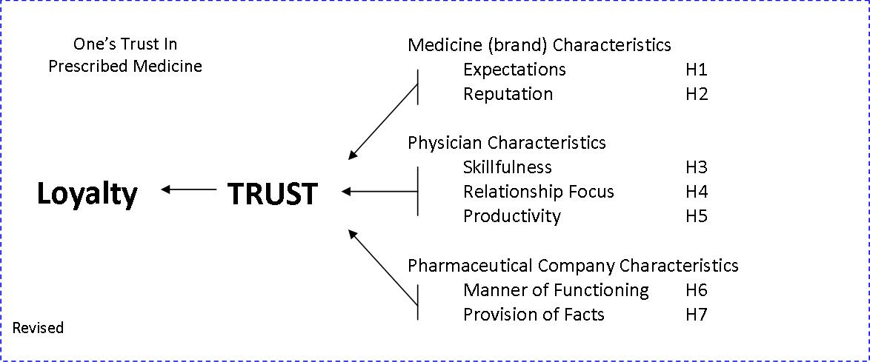

Based on the factor analysis, the original hypotheses could be revised into the hypotheses below.

H1: The expectation of the medicine brand is anticipated to have a positive influence on the trust a person has in that medicine.

H2: The reputation of the medicine brand is anticipated to have a positive influence on the trust a person has in that medicine.

H3: The skillfulness of the physician is anticipated to have a positive influence on the trust one has in the prescribed medicine.

H4: The relationship focus of the physician is anticipated to have a positive influence on the trust one has in the prescribed medicine.

H5: The productivity of the doctor is anticipated to have a positive influence on the trust one has in the prescribed medicine.

H6: The manner of functioning of the medicine company is anticipated to have a positive influence of the trust a person has in that prescribed medicine.

H7: The provision of facts by the medicine company is anticipated to have a positive influence of the trust a person has in that prescribed medicine.

5.3. Regression Analysis

The regression analysis is used to test the hypothesis. In more detail, a regression analysis tests for the relationship between the dependent variable (trust) and the independent variables (factors). Herewith, it is important how the dependent variable value changes when an independent varies and the others are held constant. Of the extended output, the correlations table, coefficients table, and model summary table were used to evaluate the analysis. Only regarding the first regression both a discussion of the three evaluative tables and the summary of results table will be included. The following regressions will only include the discussion of the evaluative tables once a relationship was found significant.

For each regression a summary table of that regression is provided with four values, namely the b-values, the standard error of the b-values, the Beta values, and the P-value or significance value. An explanation of these values are provided in short next.
The general model of a regression is that of: Yi=(b0+b1Xi)+ei.
As Field (2009, p.199) suggests, “Yi is the outcome that we want to predict and Xi is the ith participant’s score on the predictor table. Here b1 is the gradient of the straight line fitted to the data and b0 is the intercept of that line. These parameters b1 and b0 are known as the regression coefficients”, and are generally referred to as b. Field (2009, p.204) furthermore suggests that “the value of b represents the change in the outcome resulting from a unit change in the predictor”. The described regression coefficient b here, is shown in the table as B. The standard error of the b-value is provided in the table next to the B column labeled as SE B. The table furthermore provides the value of Beta in the fourth column. Herewith is meant the “standardized versions of the b-values” (Field 2009, p.239). As Field (2009, p.239) suggests, these values are also used because these are easier to interpret than the b-values, for the reason that “they are not dependent on the units of measurement of the variables”. Moreover, the standardized Beta values indicate “the number of standard deviations that the outcome will change as a result of one standard deviation change in the predictor”(Field 2009, p.239). Finally, the fifth column represents the p-value, or significance value, of the b-value: where ,05 represents marginal significant; ,01 represents significant; and ,001 represents highly significant (Field 2009, p.237).

5.3.1. Medicine Trust

To begin with, the relationship between the dependent variable medicine trust and the independent factors expectation and reputation were tested. A description of the three evaluative tables accompanied by a table with an overview of the results are shown below.

The Correlations Table suggests medicine expectation to have a positive correlation to medicine trust of ,042 and medicine reputation to have a negative correlation to medicine trust with -,005. However, both correlations were not found to be significant at either p<,001, p<,01, or p<,05.
From the coefficients table it is illustrated that medicine expectation has a positive b-value of ,027, which means that there is a positive relationship between the predictor and the outcome. This positive relationship is not found to have a significant t-test at either p<,001, or p<,01, or p<,05, therefore, the predictor is not making a significant contribution to the model.
Medicine reputation has a b-value of -,003. Which means there is suggested to be a negative relationship between medicine reputation and medicine trust. However, this negative relationship is not found to have a significant t-test at either p<,001, or p<,01, or p<,05, therefore, the predictor is not making a significant contribution to the model.
R square is provided in the Model Summary Table. The first model, where only medicine expectation is included as a predictor, has a R-square of ,002. This means that medicine expectation accounts for ,2% of the variability in the outcome of medicine trust. When adding medicine reputation to the model, Model 2, R-square remains at a score of ,002, which means that medicine reputation does not account for any variability in the outcome. Though, both scores were not found to be significant.

Summary of Medicine Trust Regression
 | B | SE B | Beta | P-Value (Sig)
Step 1
Constant | 3,894 | ,051 |  | ,000
Medicine Expectation | ,027 | ,051 | ,042* | ,594
Step2
Constant | 3,894 | ,051 |  | ,000
Medicine Expectation | ,027 | ,051 | ,042* | ,595
Medicine Reputation | -,003 | ,051 | -,005* | ,949
Note: R-squared = ,002 for Step 1, R-squared Change = ,000 for step 2. *not significant

The first regression on the previous page did not result in any significant relationships between the dependent variable medicine trust and the independent variables of expectation and reputation. Therefore, hypotheses 1 and 2 are rejected.

5.3.2. Physician Trust

Summary of Physician Trust Regression
 | B | SE B | Beta | P-Value (Sig)
Step 1
Constant | 4,069 | ,051 |  | ,000
PH Skillfulness | -,018 | ,051 | -,027* | ,733
Step2
Constant | 4,069 | ,051 |  | ,000
PH Skillfulness | -,018 | ,051 | -,027* | ,733
PH Relationship | ,079 | ,051 | ,123* | ,125
PH Productivity | ,021 | ,051 | ,033* | ,676
Note: R-squared = ,001 for Step 1, R-square Change = ,016 for step 2. *not significant

The 2nd conducted regression analysis above did not result in any significant relationships between the dependent variable physician trust and the independent variables of skillfulness, relationship and productivity. Therefore, hypotheses 3, 4, and 5 are rejected.

5.3.3. Pharmaceutical Company Trust

Summary of Pharmaceutical Company Trust Regression
 | B | SE B | Beta | P-Value (Sig)
Step 1
Constant | 2,781 | ,070 |  | ,000
PC Functioning | -,105 | ,071 | -,117* | ,141
Step2
Constant | 2,781 | ,070 |  | ,000
PC Functioning | -,105 | ,070 | -,117* | ,140
PC Facts | ,103 | ,070 | ,115* | ,146
Note: R-square = ,014 for Step 1, R-square Change = ,013 for step 2. *not significant

The 3rd conducted regression analysis above did not result in any significant relationships between the dependent variable pharmaceutical company trust and the independent variables of manner of functioning and provision of facts. Therefore, hypotheses 6 and 7 are rejected.

5.3.4. Conclusion
The regression analysis so far have rejected all hypothesis. In an attempt to discover significant information, a new series of regression will be conducted. These regressions entail including all the factors for one dependent variable. Also, the health conscious factors and their relationship to the dependents of trust are analyzed with a regression.

5.4. Regression Analysis 2

5.4.1. Medicine Trust With All Predictors

Summary of Medicine Trust Regression with all predictors
 | B | SE B | Beta | P-Value (Sig)
Constant | 3,894 | ,052 |  | ,000
Medicine Expectation | ,030 | ,065 | ,048* | ,640
Medicine Reputation | -,003 | ,055 | -,005* | ,955
PH Skillful | -,003 | ,062 | -,005* | ,959
PH Relationship | ,010 | ,056 | ,016* | ,858
PH Productivity | ,020 | ,055 | ,031* | ,716
PC Functioning | -,030 | ,056 | -,047* | ,592
PC Facts | -,006 | ,059 | -,009* | ,920
Note: *not significant

The conducted regression analysis above did not result in any significant relationships between the dependent variable medicine trust and the independent variables of all the predictors. Therefore, no significant information was discovered.

5.4.2. Physician Trust With All Predictors

Summary of Physician Trust Regression with all predictors
 | B | SE B | Beta | P-Value (Sig)
Constant | 4,069 | ,052 |  | ,000
Medicine Expectation | -,008 | ,065 | -,013* | ,899
Medicine Reputation | -,014 | ,055 | -,021* | ,804
PH Skillful | -,002 | ,062 | -,002* | ,980
PH Relationship | ,103 | ,056 | ,159* | ,069
PH Productivity | ,032 | ,055 | ,050* | ,558
PC Functioning | -,059 | ,056 | -,092* | ,292
PC Facts | -,012 | ,059 | -,019* | ,835
Note: *not significant

The conducted regression analysis above did not result in any significant relationships between the dependent variable physician trust and the independent variables of all the predictors. Therefore, no significant information was discovered.

5.4.3. Pharmaceutical Company Trust With All Predictors

Summary of Pharmaceutical Company Trust Regression with all predictors
 | B | SE B | Beta | P-Value (Sig)
Constant | 2,781 | ,065 |  | ,000
Medicine Expectation | ,001 | ,082 | ,001* | ,992
Medicine Reputation | ,224 | ,069 | ,251 | ,001
PH Skillful | ,060 | ,078 | ,067* | ,443
PH Relationship | ,156 | ,071 | ,175 | ,029
PH Productivity | ,203 | ,069 | ,227 | ,004
PC Functioning | -,218 | ,071 | -,244 | ,003
PC Facts | ,006 | ,075 | ,007* | ,937
Note: *not significant

From the table we can conclude that there are 4 significant relationships between an independent variable and the dependent variable of pharmaceutical company trust. These independent variables are: medicine reputation, physician relationship, physician productivity, and pharmaceutical company functioning. Note that the correlation between pharmaceutical company trust and the manner of functioning (ethical) for a pharmaceutical company represents a negative relationship. Which means, regarding ethics, the more we know about the manner of functioning of the pharmaceutical companies the more it negatively influences our trust in the pharmaceutical company.
Three predictors were found to have a significant R-Square Change. Namely medicine reputation, which accounts for 8,2% of the variability in the outcome of pharmaceutical company trust; PH productivity with 4,4%; and PC functioning with 5,1%. With respectively the significance scores of ,000 (p<,001); ,006 (p<,01); ,002 (p<01).

5.4.4. Medicine Trust And Health Consciousness

Summary of Medicine Trust and Health Consciousness Regression
 | B | SE B | Beta | P-Value (Sig)
Constant | 3,894 | ,051 |  | ,000
Involvement | -,051 | ,051 | -,080* | ,321
Reflect | ,018 | ,051 | ,028* | ,726
GoodLife | -,006 | ,051 | -,010* | ,904
Examine | ,024 | ,051 | ,037* | ,644
Active | -,033 | ,051 | -,051* | ,522
Note: *not significant

The conducted health consciousness regression analysis above did not result in any significant relationships between the dependent variable medicine trust and the independent variables of the health consciousness predictors. Therefore, no significant information was discovered.

5.4.5. Physician Trust And Health Consciousness

Summary of Physician Trust and Health Consciousness Regression
 | B | SE B | Beta | P-Value (Sig)
Constant | 4,069 | ,050 |  | ,000
Involvement | ,043 | ,051 | ,067* | ,395
Reflect | ,055 | ,051 | ,086* | ,276
GoodLife | -,038 | ,051 | ,059* | ,451
Examine | ,047 | ,051 | ,072* | ,359
Active | ,114 | ,051 | ,177 | ,025
Note: *not significant

From the table we can conclude that there is one significant relationship between the dependent variable of physician trust and that of an independent variable, active. Note that being actively involved with your own health was found to have a positive relationship with the trust one has in their physician. Which means, when one becomes more actively involved with their health, one’s trust in their physician will increase, and maybe as a result one’s loyalty toward their physician.
With regards to the R-square, active was also found to be significant (p<,05) and therefore significantly contributes to the model. Which means, that active accounts for 3,1% of the variability in the outcome of physician trust.

5.4.6. Pharmaceutical Company And Health Consciousness

Summary of Pharmaceutical Company Trust and Health Consciousness Regression
 | B | SE B | Beta | P-Value (Sig)
Constant | 2,781 | ,070 |  | ,000
Involvement | -,116 | ,071 | -,129* | ,103
Reflect | -,123 | ,071 | -,137* | ,085
GoodLife | -,028 | ,071 | -,032* | ,699
Examine | -,040 | ,071 | -,044* | ,575
Active | ,035 | ,071 | ,040* | ,617
Note: *not significant

The conducted health consciousness regression analysis above did not result in any significant relationships between the dependent variable pharmaceutical company trust and the independent variables of the health consciousness predictors. Therefore, no significant information was discovered.

5.4.7. Conclusion

With regards to the regression analyses in the second section, five significant relationships between a dependent and independent variables were discovered. When analyzing the dependent pharmaceutical company trust with all the independent variables, four significant relations were discovered. These independent variables are: medicine reputation, physician relationship, physician productivity, and pharmaceutical company functioning. Note that the correlation between pharmaceutical company trust and the manner of functioning (ethical) for a pharmaceutical company represents a negative relationship. When analyzing the dependent physician trust with all independent health consciousness variables, one significant relationship was discovered: between the dependent variable of physician trust and that of a independent variable, active. Note that being actively involved with your own health was found to have a positive relationship with the trust one has in their physician.

5.5. T-Test And ANOVA Analysis

The next two analyses were used to test whether there would be significant differences between respondents based on their descriptive information. For the purpose of this study, the T-test is used to test whether two groups of means are significantly different. In relation to this, the ANOVA analysis is used to test for significant differing means of various groups (more than two). In the case of this study, the t-test will be used for the age descriptive, since there are only two possible answers (Male or Female). The ANOVA will be used for age, occupation, living situation, and exercise.
The means of the descriptive are compared against medicine trust, physician trust, pharmaceutical trust, and the health consciousness predictors. Herewith, only the significant differences in means will be discussed.

5.5.1. Gender T-test

Besides the t-test outcome, the r-value is calculated. Reason for converting the t-statistic into a value r is to discover whether the effect is substantive. The motivation for using effect size r is because it’s widely understood and used. Herewith, the equation is used of Rosenthal, 1991 (Field 2009, p.332).

On average, Men have a higher trust in medicine (M=4,03, SE=,072) than Women (M=3,79, SE ,068). This difference is significant t(158) = 2,34, p<,05. It also represents a below medium sized effect r=,18.
On average, Women (M=3,47, SE ,084) tend to find it more important to stay healthy than Men (M=3,21, SE=,100). This difference was significant t (158)= -2,015, p<,05.
With regards to healthy food, on average Women (M=3,85, SE= ,080) tend to pay more attention to what they eat than Men (M=3,47, SE= ,105) do. This difference was significant t (134,2)= -3,295, P<,001.
On average, it shows that Women (M=3,52, SE ,102) more actively diet than Men (M=3,09, SE= ,123) do. This difference was significant t (158)= -2,724, P<,05.

5.5.2. Age ANOVA

Only for the first test with medicine trust and Age, a full discussion of the evaluative tables will be provided. For the other tests the full discussion will only be provided if a significant difference was found.

The test for Homogeneity of Variances tests whether the variance of the groups are significantly different. With regards to the means of the age groups for medicine trust, the statistic is 1,876. However, this statistical score is not significant at p<,05 with a significance score of ,102. Therefore, the variances of the different age groups are not significantly different.
The ANOVA table compares several means coming from different groups of people. The table provides significance scores illustrating whether the means of the groups are significantly different. (p<,05). In this case, no scores were significant.
The Descriptives table illustrates that the age group of 56-65 years old have the highest Mean (M=4,04, SE=,117) with regards to their trust in Medicine. The group of people that are 66 or older have on average the lowest trust in Medicine (M=3,60, SE ,221). However, these differences were not found to be significant as explained above.

For both physician trust and pharmaceutical company trust, no significant differences in means were found among the age groups regarding the test for Homogeneity of Variances, with respectively significant scores of ,127 and ,547. In contrast, regarding the health consciousness predictors there were significant differences in means among the age groups.

With regards to the health consciousness of the respondents, four predictors were found to have a significant difference in means, with regards to the Test of Homogeneity of Variances.
These four predictors are healthy life (p<,001) with a Levene’s score of 5,243; more conscious (p<,05) with a Levene’s score of 2,308; healthy food (p<,001) with a score of 4,154; and actively diet (p<,05) with a Levene’s score of 2,477.
The only significant (p<,05) health consciousness predictor in the ANOVA table was that of healthy food with an F-score of 2,370 and a significance score of ,042.
Based on the descriptives and ANOVA table, a representation will be provided in table 5 of the appendix, of the four health conscious predictors that were found to have a significant Levene’s score, and therefore have a significant difference in the means between the age groups with regards to the various significant health consciousness predictors.

5.5.3. Occupation ANOVA

No significant differences in means among the occupation groups were found for all three trust dependents; namely medicine trust, physician trust, and pharmaceutical company trust, regarding the test for Homogeneity of Variances, with respectively significant scores of ,131; ,228; and ,085. However, regarding the health consciousness predictors there were significant differences in means among the occupation groups.

With regards to the health consciousness of the respondents, five predictors were found to have a significant difference in means, with regards to the Test of Homogeneity of Variances.
These five predictors are: no Illness is important (p<,05) with a Levene’s score of 3,022); healthy life (p<,01) with a Levene’s score of 4,055; more conscious (p<,01) with a Levene’s score of 3,428; healthy food (p<,05) with a score of 2,835; and actively diet (p<,05) with a Levene’s score of 3,159.
However, the only significant (p<,05) health consciousness predictor in the ANOVA table was that of worry when sick with an F-score of 2,596 and a significance score of ,039.
Based on the descriptives table, a representation will be provided in the table on the next page of the four health conscious predictors that were found to have a significant Levene’s score and F-score, and therefore have a significant difference in the means between the occupation groups with regards to the various health consciousness predictors.

Occupation ANOVA Table

 | Levene | Levene St. |  | N | Mean | Std. Deviation | Std. Error
 | Statistic | Sig. | Category
Worry When Sick | 1,245 | ,294 | Student | 16 | 2,81 | ,750 | ,188
Worry When Sick |  |  | Working | 120 | 2,82 | ,935 | ,085
Worry When Sick |  |  | Retired | 15 | 3,47 | 1,187 | ,307
Worry When Sick |  |  | Volunteer | 2 | 1,50 | ,707 | ,500
Worry When Sick |  |  | Other | 7 | 2,86 | 1,215 | ,459
Worry When Sick |  |  | Total | 160 | 2,86 | ,974 | ,077
No Illness is Important | 3,022 | 0,020 | Student | 16 | 3,94 | ,772 | ,193
No Illness is Important |  |  | Working | 120 | 3,87 | ,766 | ,070
No Illness is Important |  |  | Retired | 15 | 4,27 | ,458 | ,118
No Illness is Important |  |  | Volunteer | 2 | 3,50 | 2,121 | 1,500
No Illness is Important |  |  | Other | 7 | 3,57 | 1,134 | ,429
No Illness is Important |  |  | Total | 160 | 3,89 | ,782 | ,062
Healthy Life | 4,055 | 0,004 | Student | 16 | 3,94 | ,680 | ,170
Healthy Life |  |  | Working | 120 | 3,97 | ,755 | ,069
Healthy Life |  |  | Retired | 15 | 3,47 | 1,552 | ,401
Healthy Life |  |  | Volunteer | 2 | 4,00 | ,000 | ,000
Healthy Life |  |  | Other | 7 | 3,43 | ,976 | ,369
Healthy Life |  |  | Total | 160 | 3,89 | ,866 | ,068
More Conscious | 3,428 | 0,010 | Student | 16 | 3,13 | 1,025 | ,256
More Conscious |  |  | Working | 120 | 2,97 | ,755 | ,069
More Conscious |  |  | Retired | 15 | 2,93 | ,799 | ,206
More Conscious |  |  | Volunteer | 2 | 3,00 | ,000 | ,000
More Conscious |  |  | Other | 7 | 2,14 | 1,345 | ,508
More Conscious |  |  | Total | 160 | 2,94 | ,826 | ,065
Healthy Food | 2,835 | 0,026 | Student | 16 | 3,50 | ,966 | ,242
Healthy Food |  |  | Working | 120 | 3,66 | ,815 | ,074
Healthy Food |  |  | Retired | 15 | 3,93 | ,704 | ,182
Healthy Food |  |  | Volunteer | 2 | 4,00 | ,000 | ,000
Healthy Food |  |  | Other | 7 | 3,43 | 1,272 | ,481
Healthy Food |  |  | Total | 160 | 3,66 | ,838 | ,066
Actively Diet | 3,159 | 0,016 | Student | 16 | 3,13 | 1,204 | ,301
Actively Diet |  |  | Working | 120 | 3,30 | 1,017 | ,093
Actively Diet |  |  | Retired | 15 | 3,73 | ,594 | ,153
Actively Diet |  |  | Volunteer | 2 | 4,00 | ,000 | ,000
Actively Diet |  |  | Other | 7 | 3,43 | 1,272 | ,481
Actively Diet |  |  | Total | 160 | 3,34 | 1,015 | ,080

5.5.4. Living Situation ANOVA

No significant differences in means among the occupation groups were found for all three trust dependents; namely medicine trust, physician trust, and pharmaceutical company trust, regarding the test for Homogeneity of Variances, with respectively significant scores of ,908; ,939; and ,280. However, regarding the health consciousness predictors there were significant differences in means among the occupation groups.

With regards to the health consciousness of the respondents, five predictors were found to have a significant difference in means, with regards to the Test of Homogeneity of Variances.
These five predictors are: health responsibility (p<,05) with a Levene’s score of 3,240; no illness is important (p<,05) with a Levene’s score of 2,775; preventive intention (p<,05) with a Levene’s score of 3,078; healthy food (p<,05) with a score of 3,718; and exercise (p<,05) with a Levene’s score of 3,157.
However, the only significant (p<,05) health consciousness predictor in the ANOVA table was that of exercise with a F-score of 2,832 and significance score of ,040.
Based on the descriptives table, a representation will be provided in the table on the next page of the five health conscious predictors that were found to have a significant Levene’s score and F-score, and therefore have a significant difference in the means between the Living Situation groups with regards to the various health consciousness predictors.

Living Situation ANOVA Table

 | Levene | Levene St. |  | N | Mean | Std. Deviation | Std. Error
 | Statistic | Sig. | Category
Health Responsibility | 3,240 | 0,024 | Alone | 23 | 3,78 | ,951 | ,198
Health Responsibility |  |  | Cohabiting | 68 | 3,99 | ,702 | ,085
Health Responsibility |  |  | With Family | 63 | 3,97 | ,507 | ,064
Health Responsibility |  |  | With Students | 6 | 4,17 | ,753 | ,307
Health Responsibility |  |  | Total | 160 | 3,96 | ,676 | ,053
No Illness is Important | 2,775 | 0,043 | Alone | 23 | 3,91 | ,900 | ,188
No Illness is Important |  |  | Cohabiting | 68 | 3,97 | ,646 | ,078
No Illness is Important |  |  | With Family | 63 | 3,86 | ,877 | ,111
No Illness is Important |  |  | With Students | 6 | 3,33 | ,516 | ,211
No Illness is Important |  |  | Total | 160 | 3,89 | ,782 | ,062
Preventive Intention | 3,078 | 0,029 | Alone | 23 | 3,78 | ,951 | ,198
Preventive Intention |  |  | Cohabiting | 68 | 4,01 | ,743 | ,090
Preventive Intention |  |  | With Family | 63 | 3,76 | ,817 | ,103
Preventive Intention |  |  | With Students | 6 | 3,50 | 1,225 | ,500
Preventive Intention |  |  | Total | 160 | 3,86 | ,828 | ,065
Healthy Food | 3,718 | 0,013 | Alone | 23 | 3,70 | ,926 | ,193
Healthy Food |  |  | Cohabiting | 68 | 3,53 | ,906 | ,110
Healthy Food |  |  | With Family | 63 | 3,76 | ,712 | ,090
Healthy Food |  |  | With Students | 6 | 4,00 | ,894 | ,365
Healthy Food |  |  | Total | 160 | 3,66 | ,838 | ,066
Exercise | 3,157 | 0,026 | Alone | 23 | 3,57 | ,992 | ,207
Exercise |  |  | Cohabiting | 68 | 3,24 | 1,259 | ,153
Exercise |  |  | With Family | 63 | 3,68 | ,997 | ,126
Exercise |  |  | With Students | 6 | 2,67 | ,816 | ,333
Exercise |  |  | Total | 160 | 3,44 | 1,131 | ,089

5.5.5. Exercise ANOVA

The test for Homogeneity of Variances tests whether the variance of the groups are significantly different. With regards to the means of the hours of sports groups for medicine trust, the statistic is 2,970 and was found significant (p<,05) with a significance score of ,034. Therefore, the variances of the different hours of sports groups are significantly different according to the Levene’s statistic.
The ANOVA table compares several means coming from different groups of people. The table provides significance scores illustrating whether the means of the groups are significantly different. (p<,05). In this case, the quadratic trend was found significant (p<,05) with a significant score of ,032, which means a curvilinear pattern with a drop from 1-2 hours of sports to a rise with 7 or more hours of sports. The exact numbers can be found in table 8 of the appendix.

No significant differences in means among the hours of sports groups were found for physician trust and pharmaceutical company trust regarding the test for Homogeneity of Variances, with respectively significant scores of ,592 and ,643. However, regarding the health consciousness predictors there were significant differences in means among the living hours of sports groups.

With regards to the health consciousness of the respondents, one predictor was found to have a significant difference in means, with regards to the Test of Homogeneity of Variances.
This predictor is: healthy food (p<,01) with a Levene’s score of 4,572.
However, there are three health consciousness predictors in the ANOVA table that have a significant F-score. These are aware of health (p<,05) with an F-score of 2,859 and significance score of ,039 ; preventive intention (p<,05) with an F-score of 2,667 and significance score of ,050; and exercise (p<,001) with an F-score of 27,766 and significance score of ,000 .
Based on the descriptives table, a representation will be provided in table 9 of the appendix, of the four health conscious predictors that were found to have a significant Levene’s score and F-score, and therefore have a significant difference in the means between the hours of sports groups with regards to the various health consciousness predictors.

5.5.6. Conclusion

With regards to the t-test and ANOVA analysis most significant results found were regarding the health consciousness predictors. Though, the t-test also resulted in a significant difference of means between male and female regarding medicine trust. Healthy food and actively diet were found to have most often a significant difference of means between the several groups.

6. Discussion

Now that the literature research, the conducted research, and its results have been covered, a section with discussion of the results and the implications of this study for managers in the pharmaceutical industry will be provided. Here, the most important implications will be discussed. Finally, limitations and future research ideas will be provided.

6.1. Discussion And Implications

What we have already concluded from the results section is that all hypotheses are rejected. Which means that of the predictors tested, none are suggested to have a significant positive relation to their dependent variable, or even a negative relationship even though that was not hypothesized. These dependents were medicine trust, physician trust, and pharmaceutical company trust. A reason for the rejection might be one that many respondents have commented on after completion. The general respondent commented that they find the pharmaceutical industry a difficult market and had to think carefully about their survey answers, because they haven’t had to think about their opinion about medicine much before. For example answering questions about a can of coke and the company coca cola would be much easier for them. The statement I would like to make here is that because it is such a difficult market for the respondents, they might find it difficult to provide explicit answers and therefore stay in the middle of ranging their answers.
Though, when including all predictors for just one dependent, four significant relationships were suggested for the dependent pharmaceutical company trust. Herewith, the positive relationships were that of medicine reputation, physician relationship, and physician productivity. A negative relationship was found with pharmaceutical company functioning.
Of the three trust dependent variables, pharmaceutical company trust was the only one with a mean score which falls between having little trust in pharmaceutical companies and having neither much or little trust. What we can imply from the combination of these results is that there is an opportunity for pharmaceutical companies to improve their ethical image; with a focus on creating trust among consumers which in turn may have as a result a greater loyalty towards the company and its products. When striving for a better image concerning the trust of people in the pharmaceutical company, marketers should incorporate ethics and focus in their message on the medicine’s reputation; how the company supports the relationship between you and your physician; how the company improves the productivity of your physician with their products or training; but, finally, they should minimize the use of information about the company itself and its functioning.
When testing for a relationship between the health consciousness predictors and the three trust dependent variables, a positive relationship was found. Based on the results, it was suggested that the more you are actively involved with your health the more you trust your physician and as a result might be loyal to your physician. This could imply that people who are more actively involved in their health might have more knowledge about their health and could therefore verify more easily what the doctors suggests about their health. From a marketing perspective, you, can based on these results, decide to train physicians to incorporate the consumer who is more actively involved in their health into the discussion or decision making for a diagnose or treatment. This involvement of the consumer in decision making could increase the trust a person has in the decision made and his physician. As a result of this trust a person might become more loyal to the physician and the medicine he prescribes. Furthermore, in the future when direct to consumer advertising might be more broadly allowed also outside of the USA. At that moment marketers could focus in their messages, geared towards people who are actively involved in their health, on a more in-depth provision of information.
With regards to the comparing of means, a significant difference was found between trust of men and women into medicine. It was found that men have a higher trust in medicine than women do. As a result, when introducing a new drug or treatment marketers could focus their message more towards men because it is suggested that men would trust this new medicine more than women. A marketer could also see this difference as an opportunity to raise the general trust in medicine among women, and also maybe as a result raise the level of loyalty towards medicine.
Moreover, with regards to age, women tend to find it more important to stay healthy, eat healthy food, and to actively diet. When launching a new product or marketing a current product that is related to the three described health predictors, pharmaceutical companies should gear their message towards women. For example, a new vitamin tablet that improves one’s health for both children and adults should be geared towards women, in which a female is the main character of the message.
With regards to the different age groups, significant differences in means were found in four cases: healthy life, more conscious, healthy food, and actively diet. For example, the age group of 66-or older finds a healthy life least important; finds eating healthy food the most important; and also finds actively dieting the most important. What we can conclude from this is that people of 66 or older might be more receptive for a marketing message that includes information about the workings of for example vitamin pills or a drug that lowers blood pressure.
In the analysis regarding the several occupation groups and health consciousness, five significant differences in means were found. These are with the independent variables: no illness, healthy life, more conscious, healthy food, and actively diet. When using for example the retired group, we can conclude that they worry most when sick and find it most important to have no illness. If a marketer would want to reach the retired group with their marketing message for a drug, they should focus on the fact that a certain drug prevents illnesses and has proven to work when sick as well.
Additionally, significant differences were found in the means of the living situation groups and health consciousness. Herewith, the predictors with significant differences in means were that of health responsibility, no illness is important, preventive intention, healthy food, and exercise. Here, as an example the group of people who cohabit with others will be discussed. The cohabiters find it most important to have no illness and also find taking preventive action most important. Regarding this group, a marketer who wants to sell flu vaccinations can reach these people by implying that this vaccination is necessary to prevent you from having the flu when everyone else is, for example during the fall and winter when everyone spends more time inside.
With regards to the hours of exercise or sports, significant differences between means were found for both medicine trust and predictors of the health consciousness scale.
It was found that people who exercise 7-or more hours of sports have the most trust in medicine. We do not know the underlying driver for this trust, but we can anticipate that because their body is in a better shape, their body will also have faster recovery of an illness. However, these people might believe the medicine have caused this illness to dissolve and therefore trust it and might become loyal to the drug. Marketers, could focus in their message on the proven fast recovery in the past by people who exercise actively.
Regarding the health consciousness scale, four variables were found to have significant differences in their means between the various hours of sports group. In this case, the group who exercises 1-2 hours will guide as an example. This group is the least aware of their health status and also cares least about eating healthy food. Based on this information, a marketer could gear his message for a new vitamin supplement to the 1-2 hours exercise group and focus in his message on how it contains all the essential vitamins. Reason for this is that because the people who exercise 1-2 hours are not as aware of their health status, and therefore you can make them believe they need the vitamins. Furthermore, this group is aware they do not eat the most healthy food and, therefore, they can use some extra vitamins.

6.1.1. Conclusion
For this study 160 adequate completed surveys were used that were extended among friends, family, and a Baseball and Softball Club. To begin with, a factor analysis was conducted that extracted new factors. These new factors were used for a revision of the hypotheses. In turn, these hypotheses were tested with a regression analyses. To gather additional information a T-test and ANOVA were conducted.
The regression analysis resulted in a rejection of all hypotheses. However, when including all predictors for the dependent pharmaceutical trust, significant relationships were found. The t-test and ANOVA analysis resulted in valuable information, mostly regarding the health consciousness scale.

6.2. Limitations And Future Research

In the final written section of this study, a few research limitations and suggestions for further research will be given.

A great limitation of this thesis was, in general, the respondent’s knowledge about medicine and pharmaceutical companies. Several respondents pointed out that they were able to form an opinion about their physician, however, they find it difficult to easily form an opinion about medicine and their producers for the reason that they do not know much about these two topics. The respondents felt they really had to think about their answers and also felt that sometimes they didn’t feel capable of even answering them. I believe the knowledge gap might have limited the respondents in the provision of more extreme answers and, therefore, resulted in a limitation in the extracted information from the analysis.
Furthermore, the decision of extracting the survey online on a free website with no paid respondent panel, resulted in two limitations. First, extracting the survey among a paid panel base could have resulted into a more diverse and also larger respondent group. A more diverse group of respondents regarding age, occupation, and geography would have been welcome. In this instance the respondents were all people I know either directly or indirectly and are from either the regions Zuid-Holland or Brabant. Secondly, a paid panel might be more willingly to fill out surveys that for example take more time. Therefore, more items could have been included in the survey that ask about the respondent’s loyalty.
A general limitation of this thesis is the factor of time. To begin with, if more time was available it could have been helpful to conduct more in-depth interviews with a small base of the survey respondents. Reason for this is, as explained before, the limited knowledge of the respondents about medicine and its producers. I became aware of this matter after the survey was filled out by respondents. If more time was available, it would have been helpful to interview a small base of the respondents in which I could assist them with answering in answering the questions if needed.
A second limitation as a result of time is that of the broadness of the topic. It was difficult to narrow down the topic to a form that could be researched in the time span given of the thesis for this degree. There were several sub-questions that I would have liked to research as well but that would have made the topic to broad and time consuming. An example of such a sub question is that of what type of brand architecture pharmaceutical companies use and how this should be modified based on what consumers find important regarding the medicine brand and the pharmaceutical companies.
The factor of time resulted into a third and final limitation. Because of the time-span of the thesis, you are more or less limited to conducting a survey or interviewing people at one point in time, instead of two or even three moments in time. This limits your ability to test whether people adjust their behavior based on a certain event.
This limitation also results into a suggestion for future research. It would be interesting to research whether a change in marketing communication of pharmaceutical companies would result in a higher trust that one person has in prescribed medicine. An example of such a change can be the radical change of using a corporate brand. Additionally, an example could be that the internet will be used more for the communication about the provision of test results, user guides, and about new diseases.
Moreover, in this research study one’s trust in a prescribed medicine was treated as one’s trust in prescribed medicine in general. In future research, this general trust could be separated into one’s trust in a prescribed branded brand and one’s trust in a prescribed generic brand. Additionally, the influence of generic products in the pharmaceutical industry are an interesting topic nevertheless.
Additionally, it would also be interesting to investigate one’s trust in medicine and the important characteristics for that trust and as a result one’s loyalty in a country where the healthcare system works differently. For example the USA and compare the results with Holland.
Furthermore, a suggestion for future research is to investigate in more detail the opinion of consumers regarding ethical performance of pharmaceutical companies. Herewith, I suggest to use an online survey where articles about pharmaceutical companies are presented, as well as snapshot of their websites. Herewith, information can be gathered about how consumers feel regarding the ethics of pharmaceutical companies.
Finally, it would be interesting to present the results of the study to managers of pharmaceutical companies. Herewith, it would be fascinating to study whether the view of the managers of pharmaceutical companies regarding what consumers find important in medicine, their physician and the producer of the medicine, are in line with the outcome of this study.

7. Resources
Armstrong, G. & Kotler, P. Marketing: an introduction, Pearson Education Inc, 7th edition, 2005. Upper Saddle River, New Jersey, USA.

Bews, N.F., and Rossouw, G.J. A role for Business Ethics in Facilitating Trustworthiness. Journal of Business Ethics. 2002 Vol. 39. Pg 377-390.

Blackett, T., and Harrison, T. Brand medicine: Use and future potential of branding in pharmaceutical markets. International Journal of Marketing, June 2001, Vol. 2, No.1 pg 33-49..

Breen, K.J. The medical profession and the pharmaceutical industry: when will we open our eyes? MJA 2004, 180: 409-410

CBG. Geneesmiddelen voor mensen, Geneesmiddeleninformatiebank. College ter Beoordeling van Geneesmiddelen (CBG). September 22, 2010. http://www.cbg-meb.nl/CBG/nl/humane-geneesmiddelen/geneesmiddeleninformatiebank/default.htm

Chaudhuri, A. and Holbrook, M.B. The chain of Effects from Brand Trust and Brand Affect to Brand Performance: the Role of Brand Loyalty. Journal of Marketing, April 2001, Vol. 65, , p 81-93.

Cleek, M,A.,Leonard, S,L. Can Corporate Codes of Ethics Influence Behavior? Journal of Business Ethics. 1998, Vol. 17 pg 619-630.

Creyer, E, H. The influence of firm behavior on purchase intention: do consumers really care about business ethics? Journal of Consumer Marketing. 1997, Vol. 14, nr 6, pg 421-432.

Day, G.S. A Two dimensional Concept of Brand Loyalty. Journal of Advertising 1969, Vol. 9, No.3.

Doney, P.M. and Cannon, J.P. An examination of the nature of trust in buyer-seller relationships. Journal of Marketing, April 1997, Vol.61., p 35-51

Dutta, M. J. Health information processing from television: The role of health orientation. Health Communication, 2007. 21(1), 1-9.

Dutta-Bergman, M. J. Primary sources of health information: Comparisons in the domain of health attitudes, health cognitions, and health behaviors. Health Communication, 2004b. 16(3), 273-288.

Field, A. Discovering Statistics Using SPSS. SAGE Publications Ltd, 3rd edition, 2009. London, England.

GIPdatabank. Top 100 van geneesmiddelen o.b.v. het aantal gebruikers in 2008. College voor zorgverzekeringen. http://www.gipdatabank.nl/index.asp?scherm=homepage&infoType=g

Gould, S. J. Consumer attitudes toward health and health care: A differential perspective. Journal of Consumer Affairs, 1988. 22(1), 96-118.

Hall, M, A., Dugan, E., Zheng, B., and Mishra, A,K. Trust in Physicians and Medical Institutions: What Is It, Can It Be Measured, and Does It Matter? The Milbank Quarterly, 2001, Vol. 79, No.4.

Hong, H. Scale Development for Measuring Health Consciousness: Re-conceptualization. University of Missouri. 12th Annual International Public Relations Research Conference. March 2009. (Edited by Yamamura, K)
Joanes, C. and Stevenson, A. Oxford Dictionary of English. Oxford University Press, 2nd edition revised, 2005. Oxford, England.

Joyner, B,E. , Payne, D. Evolution and Implementation: A study of Values, Business Ethics and Corporate Social Responsibility. Journal of Business Ethics. 2002, Vol 41, pg 297-311

Kotler et al, Principles of Marketing, Pearson Education Limited, 4th edition, 2005. Essex, England

Kraft, F. B., & Goodell, P. W. Identifying the health conscious consumer. Journal of Health Care Marketing, 1993, 13(3), 18-25.

Lau. G,T. and Lee, S.H. Consumer’s Trust in a Brand and the Link to Brand Loyalty. Journal of Market Focused Management. 2000, Vol. 4, p341-370 (1999), Kluwer Academic Publishers, Boston.

Lewis, P,V. Defining ‘Business Ethics’: Like Nailing Jello to a Wall. Journal of Business Ethics. 1985 Vol. 4. Pg 377-383.

Mellens, M, DeKimpe, M.G., and Steenkmap, J-B.E.M. A Review of Brand-Loyalty Measures in Marketing, Tijdschrift voor Economie en Management. 1996, Vol. XLI, 4,.

Michaelidou, N., & Hassan, L. M. The role of health consciousness, food safety concern and ethical identity on attitudes and intentions towards organic food. International Journal of Consumer Studies, 2008, 32(1), 163-170.

Mittal, B. and Lassar, W.M. Why do customers switch? The dynamics of satisfaction versus loyalty, The Journal of Services Marketing. 1998, Vol. 12 No. 3. Pp 177-194.

Moss, G,D. Brand domination vs brand decline. Journal of Medical Marketing. 2008, Vol.8, page 287-292.

Moss, G,D. What can the pharmaceutical World learn from consumer branding practice? Journal of Medical Marketing. May 2007, Vol. 7, page 315-320.

Moss, G,D., and Schuiling, I. How different are branding strategies in the pharmaceutical industry and the fast-moving consumer goods sector? Brand Management. May 2004, Vol. 11. No. 5, pg 366-380.

Moss, G., and Schuiling, I. A brand logic for pharma?: A possible strategy based on FMCG experience. International Journal of Medical Marketing, September 2003, Vol. 4, No.1 pg 55-62.

Nguyen, N., LeBlanc, G. The mediating role of corporate image on customers’ retention decisions: an investigation in financial services. International Journal of Bank Marketing. 1998, 16/2 pg 52-65

Oliver, R.L. Whence Consumer Loyalty?, Journal of Marketing. 1999, Vol. 63, pp33-44.

Sirdeshmukh, D., Singh, J., Sabol, B. Consumer Trust, Value, and Loyalty in Relational Exchanges. Journal of Marketing. January 2002, Vol 66., 15-37.

Tai, S. H. C., & Tam, J. L. M. A lifestyle analysis of female consumers in Greater China. Psychology & Marketing, 1997, 14(3), 287-307.

8. Appendix

Appendix 1: Factor Analysis Results
Table 1
Medicine Rotated Component Matrix
 | Component
 | 1 | 2
Know Expectation Medi | ,659 | ,066
Consistent Medi | ,747 | ,121
Meet Expectation Medi | ,620 | ,318
The Best Medi | ,729 | ,184
Most Efficient Medi | ,739 | ,006
Treat Symptoms Medi | ,684 | ,083
Good Reputation Medi | ,354 | ,668
Trustworthy Medi | ,115 | ,842
Negativity Medi | ,037 | ,735
Peer Support Medi | ,069 | ,778

Table 2
Physician Rotated Component Matrix
 | Component
 | 1 | 2 | 3
Physician Speed | ,033 | ,079 | ,787
Physician Efficiency | ,113 | ,250 | ,734
Physician Competence | ,547 | ,295 | ,279
Physician Values Patient | ,130 | ,780 | ,250
Physician Accuracy | ,694 | ,346 | -,161
Physician's Respect | ,289 | ,801 | ,011
Physician and Patient Relationship | ,153 | ,693 | ,219
Physician Trustworthiness | ,674 | ,457 | -,148
Physician Problem Solving | ,682 | -,017 | ,375
Physician Think Through | ,738 | ,097 | ,101

Table 3
Pharmaceutical Company
Rotated Component Matrix
 | Component
 | 1 | 2
PC User Info | ,171 | ,782
PC Info Side Effects | -,015 | ,809
PC Testing Info | ,200 | ,655
PC Ethical | ,548 | ,416
PC Working Medicine | ,196 | ,590
PC Profit Focus | ,658 | ,096
PC Account for Consumer | ,672 | ,315
PC in the Interest of Consumer | ,667 | ,290
PC Respect for Consumer | ,710 | ,138
PC Consumer is King | ,690 | -,061

Table 4
Health Consciousness Rotated Component Matrix
 | Component
 | 1 | 2 | 3 | 4 | 5
Aware of Health | ,020 | ,735 | -,027 | ,014 | ,206
Think About Health | ,056 | ,491 | ,151 | ,633 | ,129
Worry About Health | ,025 | -,070 | ,171 | ,824 | -,159
Health Responsibility | ,298 | ,695 | -,008 | ,092 | -,191
Health Participation | ,109 | ,654 | ,185 | ,137 | ,136
Worry When Sick | -,098 | -,167 | ,239 | -,656 | -,143
No Illness is Important | -,172 | -,066 | ,660 | ,080 | ,060
Personal Care | ,324 | ,257 | ,571 | -,100 | -,040
Healthy Life | ,353 | ,073 | ,553 | -,010 | -,002
Preventive Intention | ,036 | ,111 | ,435 | ,128 | ,667
Stay Healthy | ,687 | ,143 | ,282 | ,087 | ,272
More Conscious | ,545 | ,286 | ,361 | ,085 | ,104
Healthy Food | ,775 | ,214 | -,029 | -,065 | ,116
Exercise | ,320 | ,115 | -,193 | -,069 | ,758
Actively Diet | ,778 | -,031 | -,039 | ,137 | ,019

Appendix 2: ANOVA

Table 5
Age ANOVA
 | Levene | Levene St. |  | N | Mean | Std. Deviation | Std. Error
 | Statisitic | Sig. | Category
Healthy Life | 5,243 | 0,000 | 18-25 Years Old | 18 | 3,83 | ,707 | ,167
Healthy Life |  |  | 26-35 Years Old | 45 | 4,00 | ,603 | ,090
Healthy Life |  |  | 36-45 Years Old | 29 | 3,83 | ,889 | ,165
Healthy Life |  |  | 46-55 Years Old | 35 | 3,94 | ,802 | ,136
Healthy Life |  |  | 56-65 Years Old | 23 | 4,09 | ,793 | ,165
Healthy Life |  |  | 66 Or Older | 10 | 3,10 | 1,792 | ,567
Healthy Life |  |  | Total | 160 | 3,89 | ,866 | ,068
More Conscious | 2,308 | 0,047 | 18-25 Years Old | 18 | 3,17 | ,985 | ,232
More Conscious |  |  | 26-35 Years Old | 45 | 2,93 | ,863 | ,129
More Conscious |  |  | 36-45 Years Old | 29 | 2,83 | ,711 | ,132
More Conscious |  |  | 46-55 Years Old | 35 | 2,91 | ,951 | ,161
More Conscious |  |  | 56-65 Years Old | 23 | 3,00 | ,522 | ,109
More Conscious |  |  | 66 Or Older | 10 | 2,90 | ,876 | ,277
More Conscious |  |  | Total | 160 | 2,94 | ,826 | ,065
Healthy Food | 4,154 | 0,001 | 18-25 Years Old | 18 | 3,61 | ,850 | ,200
Healthy Food |  |  | 26-35 Years Old | 45 | 3,40 | 1,031 | ,154
Healthy Food |  |  | 36-45 Years Old | 29 | 3,72 | ,751 | ,139
Healthy Food |  |  | 46-55 Years Old | 35 | 3,80 | ,632 | ,107
Healthy Food |  |  | 56-65 Years Old | 23 | 3,65 | ,775 | ,162
Healthy Food |  |  | 66 Or Older | 10 | 4,30 | ,483 | ,153
Healthy Food |  |  | Total | 160 | 3,66 | ,838 | ,066
Actively Diet | 2,477 | 0,034 | 18-25 Years Old | 18 | 2,94 | 1,211 | ,286
Actively Diet |  |  | 26-35 Years Old | 45 | 3,24 | 1,111 | ,166
Actively Diet |  |  | 36-45 Years Old | 29 | 3,24 | ,872 | ,162
Actively Diet |  |  | 46-55 Years Old | 35 | 3,49 | 1,067 | ,180
Actively Diet |  |  | 56-65 Years Old | 23 | 3,48 | ,790 | ,165
Actively Diet |  |  | 66 Or Older | 10 | 3,90 | ,568 | ,180
Actively Diet |  |  | Total | 160 | 3,34 | 1,015 | ,080

Table 6
Occupation ANOVA
 | Levene | Levene St. |  | N | Mean | Std. Deviation | Std. Error
 | Statistic | Sig. | Category
Worry When Sick | 1,245 | ,294 | Student | 16 | 2,81 | ,750 | ,188
Worry When Sick |  |  | Working | 120 | 2,82 | ,935 | ,085
Worry When Sick |  |  | Retired | 15 | 3,47 | 1,187 | ,307
Worry When Sick |  |  | Volunteer | 2 | 1,50 | ,707 | ,500
Worry When Sick |  |  | Other | 7 | 2,86 | 1,215 | ,459
Worry When Sick |  |  | Total | 160 | 2,86 | ,974 | ,077
No Illness is Important | 3,022 | 0,020 | Student | 16 | 3,94 | ,772 | ,193
No Illness is Important |  |  | Working | 120 | 3,87 | ,766 | ,070
No Illness is Important |  |  | Retired | 15 | 4,27 | ,458 | ,118
No Illness is Important |  |  | Volunteer | 2 | 3,50 | 2,121 | 1,500
No Illness is Important |  |  | Other | 7 | 3,57 | 1,134 | ,429
No Illness is Important |  |  | Total | 160 | 3,89 | ,782 | ,062
Healthy Life | 4,055 | 0,004 | Student | 16 | 3,94 | ,680 | ,170
Healthy Life |  |  | Working | 120 | 3,97 | ,755 | ,069
Healthy Life |  |  | Retired | 15 | 3,47 | 1,552 | ,401
Healthy Life |  |  | Volunteer | 2 | 4,00 | ,000 | ,000
Healthy Life |  |  | Other | 7 | 3,43 | ,976 | ,369
Healthy Life |  |  | Total | 160 | 3,89 | ,866 | ,068
More Conscious | 3,428 | 0,010 | Student | 16 | 3,13 | 1,025 | ,256
More Conscious |  |  | Working | 120 | 2,97 | ,755 | ,069
More Conscious |  |  | Retired | 15 | 2,93 | ,799 | ,206
More Conscious |  |  | Volunteer | 2 | 3,00 | ,000 | ,000
More Conscious |  |  | Other | 7 | 2,14 | 1,345 | ,508
More Conscious |  |  | Total | 160 | 2,94 | ,826 | ,065
Healthy Food | 2,835 | 0,026 | Student | 16 | 3,50 | ,966 | ,242
Healthy Food |  |  | Working | 120 | 3,66 | ,815 | ,074
Healthy Food |  |  | Retired | 15 | 3,93 | ,704 | ,182
Healthy Food |  |  | Volunteer | 2 | 4,00 | ,000 | ,000
Healthy Food |  |  | Other | 7 | 3,43 | 1,272 | ,481
Healthy Food |  |  | Total | 160 | 3,66 | ,838 | ,066
Actively Diet | 3,159 | 0,016 | Student | 16 | 3,13 | 1,204 | ,301
Actively Diet |  |  | Working | 120 | 3,30 | 1,017 | ,093
Actively Diet |  |  | Retired | 15 | 3,73 | ,594 | ,153
Actively Diet |  |  | Volunteer | 2 | 4,00 | ,000 | ,000
Actively Diet |  |  | Other | 7 | 3,43 | 1,272 | ,481
Actively Diet |  |  | Total | 160 | 3,34 | 1,015 | ,080

Table 7
Living Situation ANOVA
 | Levene | Levene St. |  | N | Mean | Std. Deviation | Std. Error
 | Statistic | Sig. | Category
Health Responsibility | 3,240 | 0,024 | Alone | 23 | 3,78 | ,951 | ,198
Health Responsibility |  |  | Cohabiting | 68 | 3,99 | ,702 | ,085
Health Responsibility |  |  | With Family | 63 | 3,97 | ,507 | ,064
Health Responsibility |  |  | With Students | 6 | 4,17 | ,753 | ,307
Health Responsibility |  |  | Total | 160 | 3,96 | ,676 | ,053
No Illness is Important | 2,775 | 0,043 | Alone | 23 | 3,91 | ,900 | ,188
No Illness is Important |  |  | Cohabiting | 68 | 3,97 | ,646 | ,078
No Illness is Important |  |  | With Family | 63 | 3,86 | ,877 | ,111
No Illness is Important |  |  | With Students | 6 | 3,33 | ,516 | ,211
No Illness is Important |  |  | Total | 160 | 3,89 | ,782 | ,062
Preventive Intention | 3,078 | 0,029 | Alone | 23 | 3,78 | ,951 | ,198
Preventive Intention |  |  | Cohabiting | 68 | 4,01 | ,743 | ,090
Preventive Intention |  |  | With Family | 63 | 3,76 | ,817 | ,103
Preventive Intention |  |  | With Students | 6 | 3,50 | 1,225 | ,500
Preventive Intention |  |  | Total | 160 | 3,86 | ,828 | ,065
Healthy Food | 3,718 | 0,013 | Alone | 23 | 3,70 | ,926 | ,193
Healthy Food |  |  | Cohabiting | 68 | 3,53 | ,906 | ,110
Healthy Food |  |  | With Family | 63 | 3,76 | ,712 | ,090
Healthy Food |  |  | With Students | 6 | 4,00 | ,894 | ,365
Healthy Food |  |  | Total | 160 | 3,66 | ,838 | ,066
Exercise | 3,157 | 0,026 | Alone | 23 | 3,57 | ,992 | ,207
Exercise |  |  | Cohabiting | 68 | 3,24 | 1,259 | ,153
Exercise |  |  | With Family | 63 | 3,68 | ,997 | ,126
Exercise |  |  | With Students | 6 | 2,67 | ,816 | ,333
Exercise |  |  | Total | 160 | 3,44 | 1,131 | ,089

Table 8
Exercise and Medicine Trust ANOVA
Levene | Levene |  | N | Mean | Std. Deviation | Std. Error
Statistic | Sig. | Category
2,970 | 0,034 | 1-2 Hours of Sports a Week | 71 | 3,94 | 0,63 | 0,075
 |  | 3-4 Hours of Sports a Week | 52 | 3,88 | 0,511 | 0,071
 |  | 5-6 Hours of Sports a Week | 20 | 3,6 | 0,995 | 0,222
 |  | 7 or More Hours of Sports a Week | 17 | 4,06 | 0,429 | 0,104
 |  | Total | 160 | 3,89 | 0,64 | 0,051

Table 9
Exercise ANOVA
 | Levene | Levene St. | F-Score | F-Score |  | N | Mean | Std. Deviation | Std. Error
 | Statistic | Sig. |  | Sig. | Category
Aware of Health | 1,442 | 0,233 | 2,859 | 0,039 | 1-2 Hours of Sports a Week | 71 | 4,03 | ,676 | ,080
Aware of Health |  |  |  |  | 3-4 Hours of Sports a Week | 52 | 4,33 | ,474 | ,066
Aware of Health |  |  |  |  | 5-6 Hours of Sports a Week | 20 | 4,25 | ,550 | ,123
Aware of Health |  |  |  |  | 7 or More Hours of Sports a Week | 17 | 4,18 | ,393 | ,095
Aware of Health |  |  |  |  | Total | 160 | 4,17 | ,585 | ,046
Preventive Intention | 0,412 | 0,745 | 2,667 | 0,050 | 1-2 Hours of Sports a Week | 71 | 3,77 | ,831 | ,099
Preventive Intention |  |  |  |  | 3-4 Hours of Sports a Week | 52 | 3,75 | ,837 | ,116
Preventive Intention |  |  |  |  | 5-6 Hours of Sports a Week | 20 | 4,25 | ,639 | ,143
Preventive Intention |  |  |  |  | 7 or More Hours of Sports a Week | 17 | 4,12 | ,857 | ,208
Preventive Intention |  |  |  |  | Total | 160 | 3,86 | ,828 | ,065
Healthy Food | 4,572 | 0,004 | x | x | 1-2 Hours of Sports a Week | 71 | 3,56 | ,982 | ,117
Healthy Food |  |  |  |  | 3-4 Hours of Sports a Week | 52 | 3,79 | ,667 | ,092
Healthy Food |  |  |  |  | 5-6 Hours of Sports a Week | 20 | 3,60 | ,754 | ,169
Healthy Food |  |  |  |  | 7 or More Hours of Sports a Week | 17 | 3,76 | ,752 | ,182
Healthy Food |  |  |  |  | Total | 160 | 3,66 | ,838 | ,066
Exercise | 1,157 | 0,328 | 27,766 | 0,000 | 1-2 Hours of Sports a Week | 71 | 2,73 | ,940 | ,112
Exercise |  |  |  |  | 3-4 Hours of Sports a Week | 52 | 3,77 | ,942 | ,131
Exercise |  |  |  |  | 5-6 Hours of Sports a Week | 20 | 4,20 | 1,056 | ,236
Exercise |  |  |  |  | 7 or More Hours of Sports a Week | 17 | 4,47 | ,514 | ,125
Exercise |  |  |  |  | Total | 160 | 3,44 | 1,131 | ,089

Appendix 3: Pictures
Picture 1: Proposed Model

Picture 2: Revised Model

Appendix 4: Survey

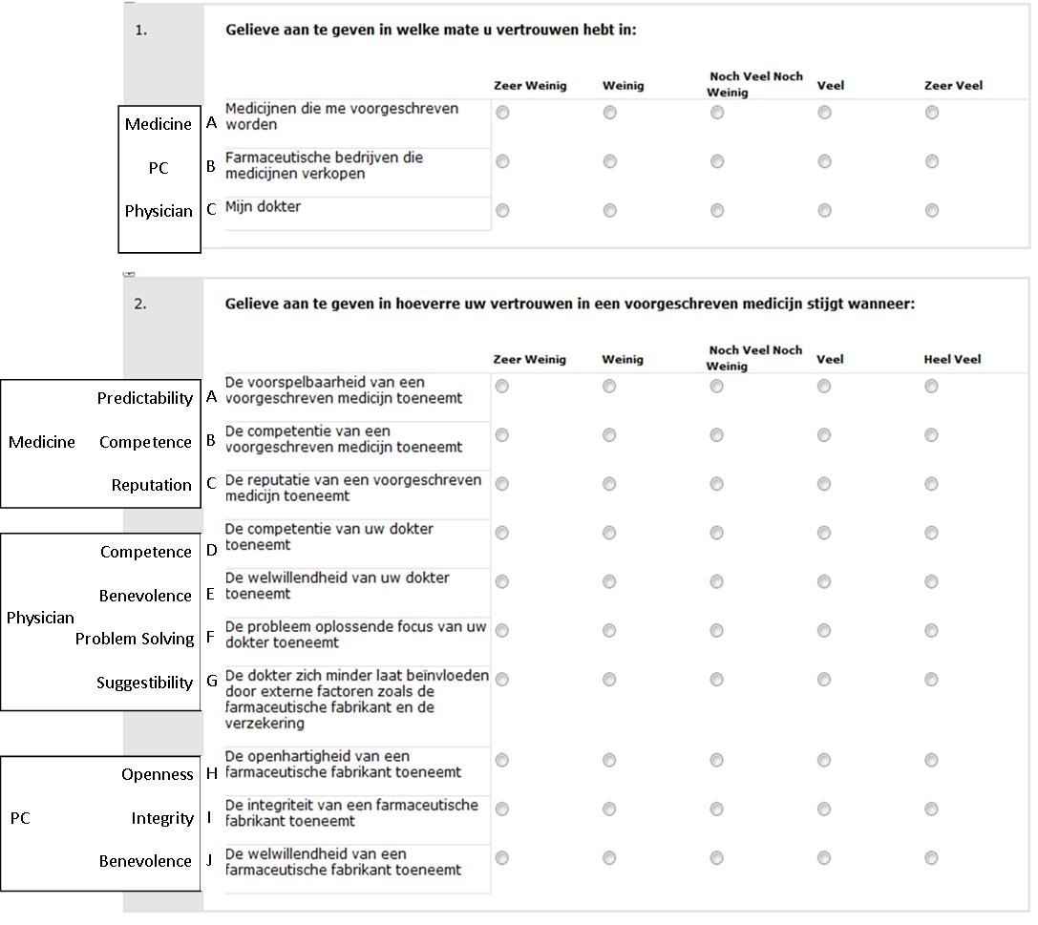
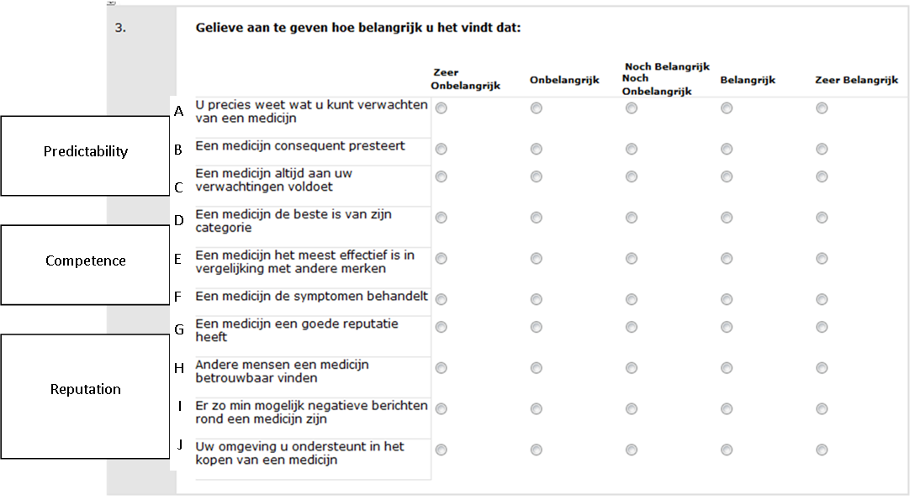

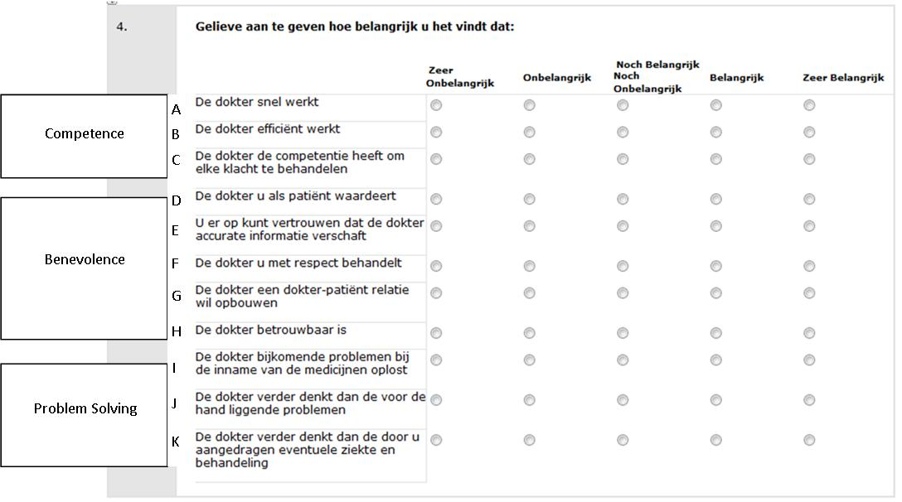

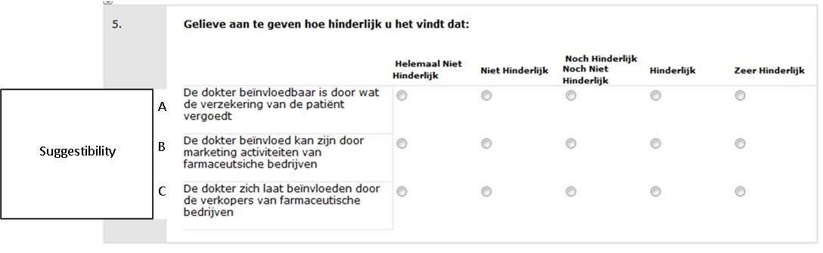

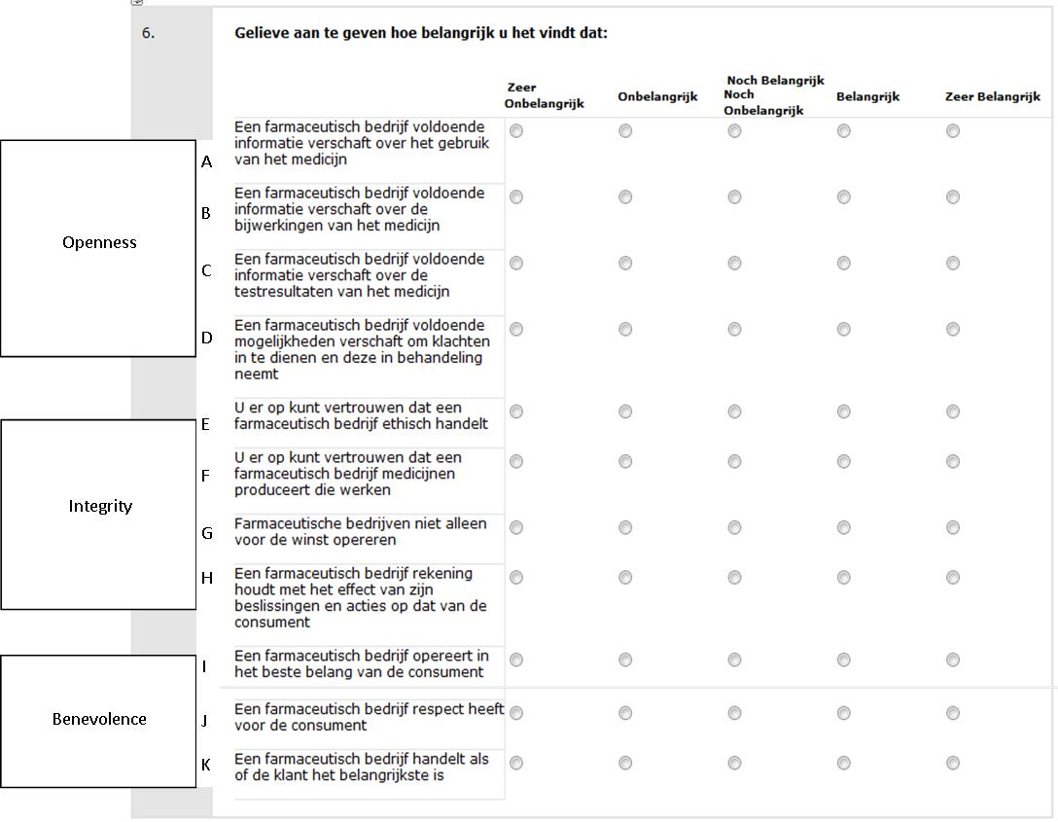
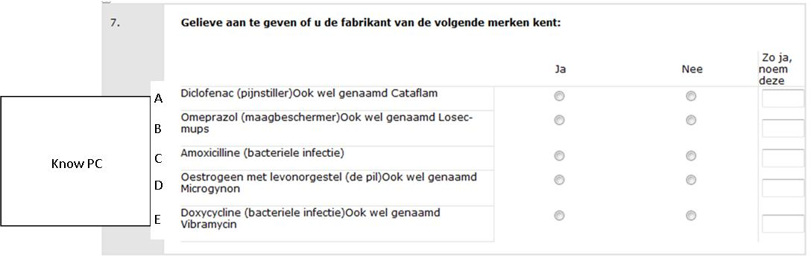

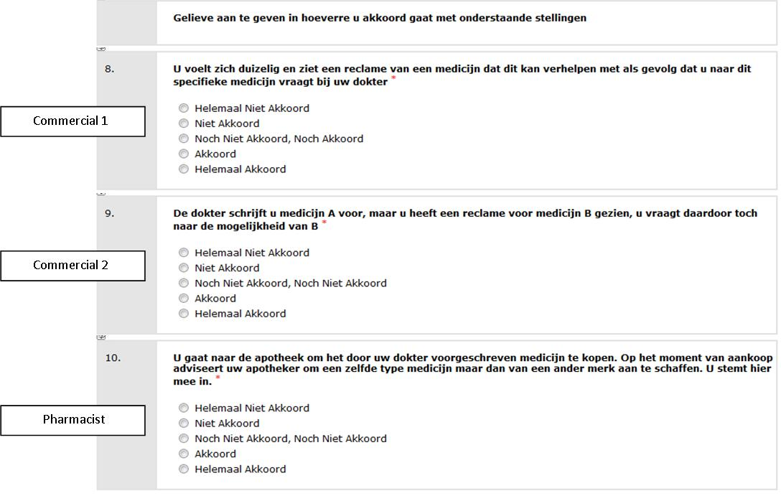
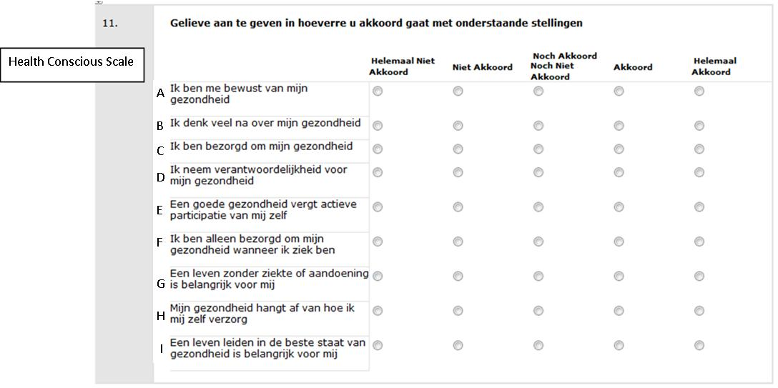

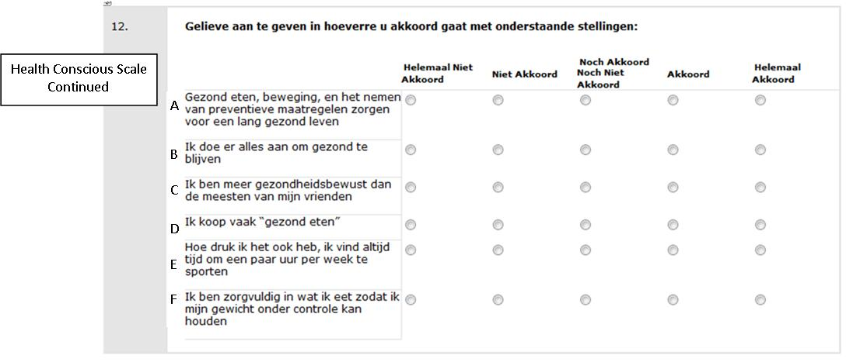
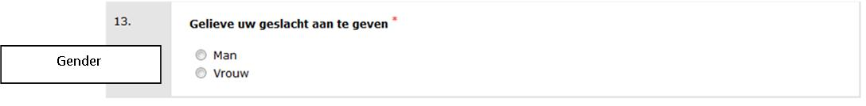
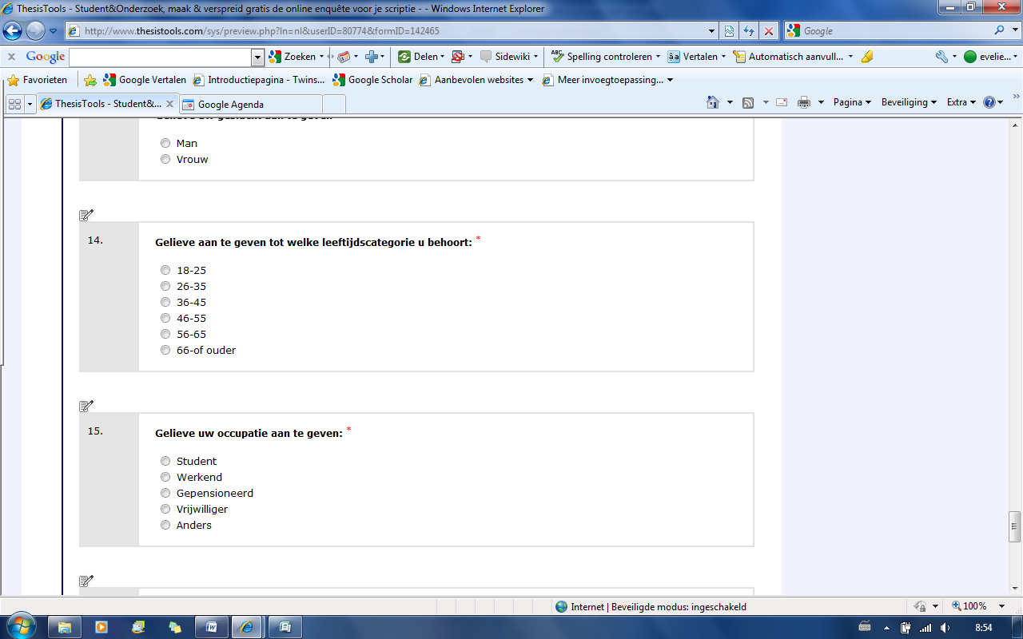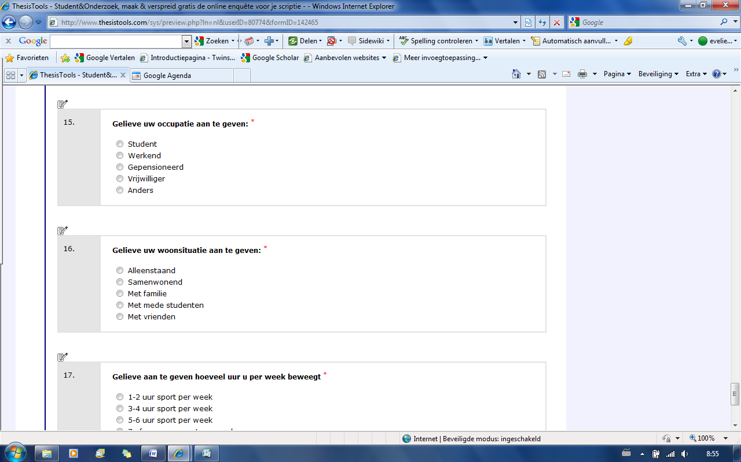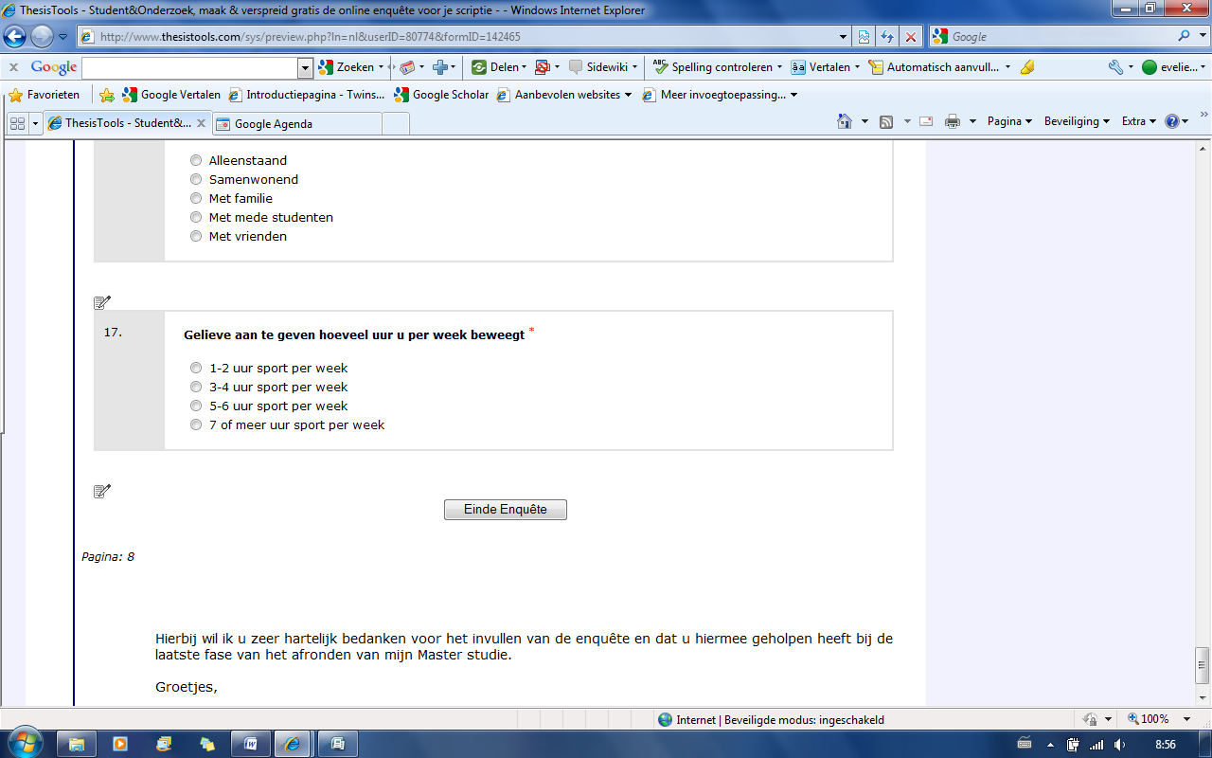
Age
Occupation
Living Situation
Exercise

