Third and fourth party logistics as the next growth pole for the Rotterdam region: a theoretical review

Nikolay Zlatev
314014

Supervisor:
Dr. Bart Kuipers

Erasmus School of Economics
Erasmus University Rotterdam

- Introduction
The theory of economic growth is probably the one with the most contributions to it in economics. A lot of the Nobel prizes for contributions to the field of economics have been awarded to researchers that enriched the theory of economic growth. From the father of economics Adam Smith, to such proclaimed economists as Robert Solow and Wassily Leontief, they have all acknowledged the importance of studying economic growth.
Adam Smith started the subject of economics by emphasizing the effect which free markets, the investment of savings and ‘laissez faire’ had on growth. Taking a dynamic view, Smith argued that trade is beneficial for the development of technology through stimulating the division of labour and the specialization of the work-force and therefore encourages growth in the economy as a whole (Landreth et al., 2002). This view was ignored by Smith’s followers, who focused on microeconomics and the distribution of income, and his macroeconomic views were only remembered in the 1930s during the Great Depression. Since then, several contributions were made to develop growth models, but the most notable are those of Robert Solow (Solow, 1956) and Wassily Leontief (Leontief, 1951). Solow was the first to build a macroeconomic model suggesting that the economy is growing in the long run influenced by various factors, the most notable of which labour, capital and the state of technology. He essentially focused on the supply side, while criticizing the Harrod-Domar model about its wrong conclusions, that if the factors of growth deviated slightly from their equilibrium rates, ‘the consequence would be either growing unemployment or prolonged inflation’ (p.65, Solow , 1956). The idea of Solow to include factor substitution into the model of economic growth has led his theory to become one of the most influential for modern macroeconomics and has started what has been called on several occasions ‘the era of modelling’. Wassily Leontief produced a conceptually different model in his input-output economics. Influenced by Leon Walras’ Elements of pure economics or the theory of social wealth (1954), Leontief’s input-output model classifies the interactions between the different sectors in the economy in one table and makes the demand and supply of output produced from these sectors measureable (Leontief, 1986). This technique is a huge contribution to the theory of growth, because it makes empirical testing much easier in a sense that it provides relevant data and statistics for testing.
Another branch of economic theory which is more explanatory than prescriptive in nature is one initially started by Alfred Marshall in 1920(Marshall, 1920) and later elaborated upon by Hoover (1948) and Krugman (1991). The theory of agglomeration economies aims to describe the clusters of firms formed in different parts in the world, while giving different sources and types of them and explains the reasons for their success. Porter (1998) further enriched the cluster theory by claiming that competitive advantage is the main engine of growth and it is derived from continuous innovation, mostly facilitated by small and medium enterprises (SMEs).
The concept of growth poles was first proposed by the French economist Francois Perroux (Dicken & Lloyd, 1990). He stated that poles of growth are industries or firms, which exhibit extraordinarily high growth rates. Four criteria have to be met in order for an industry or a firm to be a growth engine: it should be relatively large; it should be relatively fast-growing; it should be relatively well-linked to the rest of the economy as to cause spreading growth; and it should be innovative (Dicken & Lloyd, 1990:234). The concept was developed into a regional economics theory by Boudeville (McCann, 2007), who argued that the prosperity of an area depends on the location decisions of major firms, plants, clusters or industries.
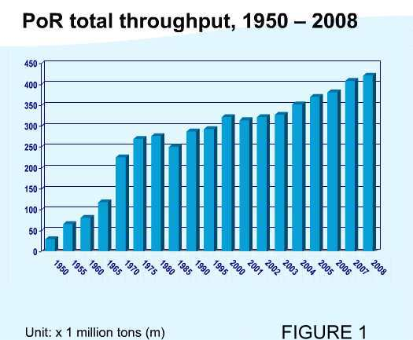
The Port of Rotterdam has been a catalyst for the expansion of the Rotterdam regional economy since the industrial revolution in the 19th century (Anon 1). This has especially been the case since its reconstruction after the Second World War. Two major trends have fueled its expansion and the expansion of Rotterdam as a region. First, the petrochemical boom in 1970s and 1980s and the subsequent specialization of the port in that sector greatly increased the throughput and profitability of the harbour (Figure 1). A lot of investment was drawn to the region in oil refining, oil storage and petrochemical industries that resulted in increased employment and added value. The second trend was the boom in containerization and trade that started in the early 1980s and continued until the financial crisis in 2008 and also caused substantial expansion in operations for the port and regional growth through increased benefits for other support industries such as stevedoring, hinterland transport, insurance etc. The regional economy kept expanding as the port was its main engine, but some problems already started to emerge, such as decreasing market share in the container sector and infrastructure congestion. To stay competitive a modern port should achieve low cost and high productivity, along with flexibility to tailor transport offers to the customer needs (Kuipers, 2002). However, such low cost operations are not profitable enough for the further growth of the Rotterdam region and it has been argued that port investment should be deterred and those funds should be redirected towards more profitable industries. After the end of the containerization boom the Rotterdam region has to find another growth pole if it wants to keep expanding.
What is the next growth pole for the Rotterdam region? The regional government has outlined three potential sectors to develop further the economy: the Port and Related Industrial sector – clustered around the port and including such activities as the petrochemical industry, energy and hinterland transport, focusing on the objective of becoming the most ecological friendly port in Europe; the Medical and Care Sector – clustered around Erasmus Medical Centre, which is the largest hospital in the Netherlands; and the Creative sector – including such markets as architectural services, design and the media sector (EDBR, 2008). However, the policy makers may have overlooked a major opportunity for regional growth, which is the third and fourth party logistics sector.
For the purpose of the current study, the sectors of third and fourth party logistics should be defined broadly in order to incorporate all the relevant logistics services associated with the port, not limiting the scope of the industry by the sophistication of the services or the duration of the buyer-seller relationship. Therefore, an appropriate characterization is stated by Bask (2001, p. 474), who defines third party logistics as “relationships between interfaces in the supply chains and third-party logistics providers, where logistics services are offered, from basic to customized ones, in a shorter or longer-term relationship, with the aim of effectiveness and efficiency”. Such services include but are not limited to warehousing, handling and storage, freight consolidation, supply chain design and management etc. Fourth party logistics on the other hand deals with overall supply chain design. Such companies does not possess capital such as ships, cranes, warehouses, trucks or any other equipment used for transportation or storage purposes. Fourth party logistics businesses are housed in an office with computers and their activities relate to organizing supply chains for their customers by hiring other transport firms’ facilities.
By stimulating the presence of such firms in the region, the captured added value along the supply chain will be greatly increased, causing much more profitable transport activities. If such businesses are located in Rotterdam, they will receive revenues from a transport operation from the point of origin to the cargo final destination and will pay out fees to different operators who perform the actual transport. In this way not only the company makes a profit, but it might steal away some profits from foreign transport corridors as it is able to negotiate better prices and minimize costs on the overall transport. These companies will also increase customer service and customer satisfaction through better tailored transport offers, as their main business is overall supply chain design, aiming at either minimizing total cost or travel time or a trade-off between the two. They focus on low capital activities and operate very profitably while creating employment not only in their expertise, but also in the related transport activities.
This paper aims at proposing a framework for evaluating on a theoretical basis the sectors of the economy in the Rotterdam region which have been key for its development and the sectors that are most likely to bring sustainable growth, while focusing on the sector of third- and fourth-party logistics and evaluating it as a growth pole. First, a background of the economic environment is outlined as to gain insight in the present situation. In the next section, several sectors which are likely to be key for sustainable growth in the Rotterdam region are presented and a theoretical framework is used to evaluate them. In the fourth section the third and fourth party logistics sector is explored and arguments are given for its potential to become the new growth pole in the Rotterdam region. Finally, the paper ends with a conclusion and some recommendations for further research.

- Economic environment
Ports in the past were experiencing great natural monopolies from geographical locations. Port competition was not an issue, as the cargo was not foot-loose and the activities performed in the ports where very labour-intensive, providing for high added value. Along with the facilitation of international trade, these functions of ports led national governments to use them to boost regional and national economic development. The major ports were developed by investing largely public money without questioning the efficiency of the investment. It was argued that there were too many positive externalities which would be ignored if left to the private sector (Haralambides, 2002). Therefore, investment costs did not have to be recovered and several large ports benefited by these policies.
During World War II the Port of Rotterdam was nearly destroyed by the bombings of the German military force. After the war it was reconstructed to become the largest port in the world (Anon 1). Several factors such as the favourable location and the specialization of the port in petroleum products contributed to the successful redevelopment of the port complex, but still it would not be possible without the great amount of public funds expenditure. In the 1960s and 1970s the government stimulated the expansion of the port and its specialization in petroleum by constructing the Europoort (Anon 1). It greatly decreased the draft restrictions for entering ships, making the port accessible for the largest tankers that were built in that time. Petroleum traffic was quickly drawn into Rotterdam and a lot of petrochemical companies housed in the vicinity of the new Europoort terminal, creating employment and becoming a growth cluster for the regional economy. Unfortunately, regional public resistance and the oil crisis in 1973 put an end to the expansion of the petrochemical sector near the port and forced different policies to facilitate further growth.
The Dutch government was always aware of the opportunities the port provides for regional growth and it introduced a new policy regarding the Port of Rotterdam as a ‘mainport’ and providing large subsidies for its development. In the 1980s the Netherlands adopted the economic perspective of a ‘Distribution country’ (Kuipers, 2002). Based on a number of factors, including the position of the Netherlands in European distribution networks and the concentration of European Distribution Centres in the vicinity of the mainport, the policy implied that this mainport will act as growth poles of the Dutch economy. The policy provided a great competitive advantage for the Port of Rotterdam as compared to its competing ports in the Hamburg – Le Havre range, as it meant that the government was planning large infrastructure projects financed publicly (Kuipers, 2002).
Examples of such projects that are greatly contributing to the prosperity and competitiveness of the Port of Rotterdam are the construction of the Maasvlakte 2 (Anon 2) and the Betuweroute (Anon 3). The first project is the construction of a new port area by reclamation of land from the sea. This activity is extremely expensive and no single private company will be able to complete such an investment. The Betuweroute is a dedicated train track leading from the port to the hinterland of Germany. Its Dutch part was completed in June 2007 and had an estimated cost of 4.7 billion Euros (Anon 3). Again, such a costly project can only be undertaken by a public body, because it suffers greatly from a cost-benefit analysis perspective and an estimated breakeven point would be far in the future (Hesse, 2008).
The introduction of the container and its wide adoption widely shifted the trend of spending public money on the ports to market-driven investments. The natural monopolies of the ports disappeared as the mobility of the cargo greatly increased. Essentially there is no significant difference for a container from China destined for Geneva if it passes through the ports of Rotterdam, Antwerp or Hamburg. Nowadays a change of the costs of a given port or the timing and frequency of service to and from that port will cause a change in the behavior of the shippers that use the port, as they may even shift to another port with more favorable conditions – a far more competitive environment in the port industry. In such environment, large public investments in infrastructure are no longer efficient, as they cause market disruptions in a competitive market, which internalizes the positive externalities (Haralambides, 2002).
However, some ports benefited from the previous policy of public investment, as they had accumulated a lot of capital and had gained a competitive advantage before the present trends appeared. As already mentioned, Rotterdam is one of these ports where the government has invested heavily and the facilities of the port are advantageous over its competitors and especially over greenfield projects in the region, as the port infrastructure allow it to achieve economies of scale and scope not possible for an upcoming port which has to be financed mostly privately.
Another trend that the container brought to the transport market is the different pattern of transportation. Unlike general cargo ships, containerships tend to aim for economies of scale through size and generally stop at a few major ports along the way, exploiting the hub-and-spoke concept and transshipping the containers not destined for those ports on their route (Stopford, 2009). Making an extra call in a port may be extremely costly in terms of time and the big containerships only stop at a few major ports and load and unload in big batches. Although facing competition from neighbouring ports, these major hubs have enjoyed benefits similar to the time when the port had a natural monopoly on its hinterland, as they have become facilitators and main actors providing services for international trade (Haralambides, 2002). However, to keep their competitive edge, gateways must constantly strive to improve their service and enrich their transport destination offers, rates and different modes of transport to the hinterland (Kuipers, 2002). Ports are usually clustered together as is the case with the Hamburg – Le Havre range, and one port retaining its competitive advantage is not an easy job as there is a constant threat from the competitors in the region. Such is the case with the Port of Rotterdam.
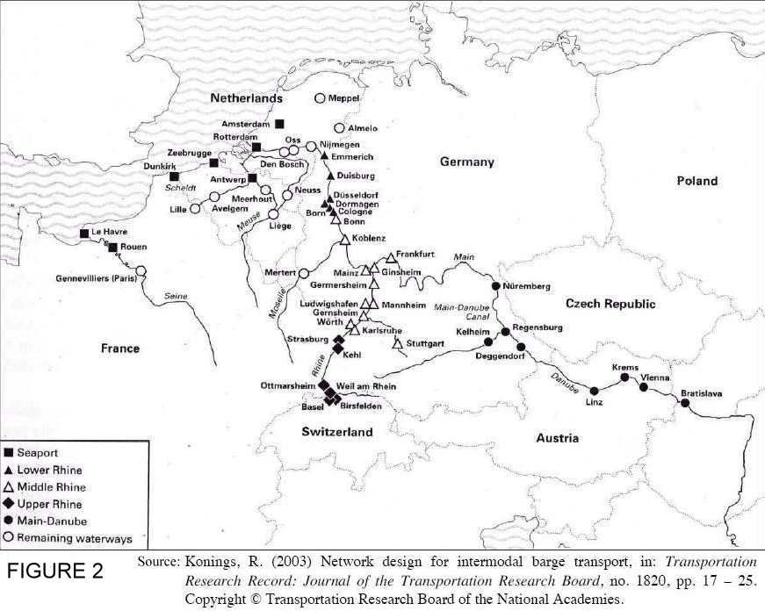
The river Rhine has been the main hinterland distribution channel for the port of Rotterdam and the main reason it managed to achieve such growth and become the leading port of Europe. When the Industrial Revolution began in 19th century, the rise of the German Ruhr Area and its huge demand for ores meant that the Port of Rotterdam could exploit the opportunity to supply the region through barges along the river (Anon 1). The low cost transport of bulk commodities to the most prosperous and populated European region and the dense inland waterway network (Figure 2) allowed Rotterdam to serve most of Europe with a cost advantage compared to its competitors. Nowadays, the barge network is greatly extended through canals and locks between the different waterway and it is now possible to sail by barge from Rotterdam all the way to Black Sea, passing through several countries in Central and Eastern Europe. Although this trip is not served regularly, it provides an example of the high penetration of the inland waterway network and the great hinterland accessibility of the Port of Rotterdam. The penetration would not be so great without the numerous inland waterway intermodal terminals constructed in the network. They greatly increase the accessibility of the transport as cargo can be unloaded as close to its final destination as possible to minimize or eliminate the distance covered by other means of transport and therefore reduce costs. The great depths of the port basin and no tide restrictions also assisted the uprising of the Netherlands as a ‘Distribution country’.
However, the changing demand conditions in the economy had profound effects on the undisputed leadership of the Port of Rotterdam in Europe. The individualization of demand (Van Winden and Van Klink, 1998, p.8) means that customers have become much more quality demanding and logistics chains have been reversed to reflect consumer preferences. Nowadays, it is far more difficult to assess who are the potential port customers and what are their logistic needs. Shippers demand higher flexibility of transport modes, rapidity, reliability, fast delivery and low rates. These conditions allow competing ports to serve the hinterland better than Rotterdam and steal market share (Van Winden and Van Klink, 1998).
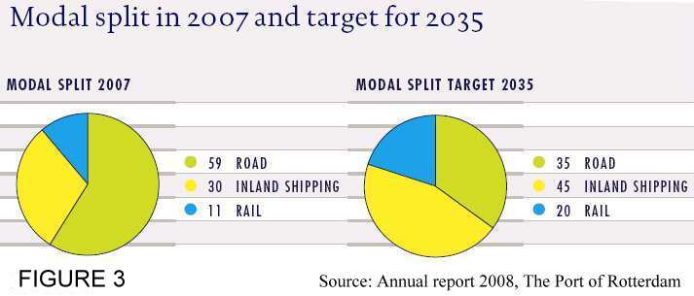
In theoretical terms these phenomena are explained by Van den Berg (1987, p.6) as generalized transportation costs. These represent the physical and psychological costs to bridge a certain distance, taking into account the cost of money, time, perceived risks and effort and also the supply and demand of transport infrastructure to include the effects of congestion. This concept has been referred to in much academic literature on ports and regions such as Van Winden and Van Klink (1998), Van Klink and Van den Berg (1998) etc. In this way, a customer who has been using the barge service from the Port of Rotterdam to receive containers in Frankfurt may opt to switch to the Port of Hamburg and rail service in the hinterland to decrease overall generalized transportation costs – although the monetary price may be higher, the shipper will decrease his cost in terms of time and effort and at the same time increase reliability. In general, the trend of the change in generalized transportation costs has been away from monetary costs and into psychological costs such as time, perceived risks, flexibility and reliability.
The emergent problem for Rotterdam in these terms is its modal split. The high share of road transport (Figure 3) brings too much congestion in the port area and decreases the reliability of the mode. It also causes too much negative externalities such as environmental problems and mobility constraints for private citizens. Some European countries have already put constraints on road traffic during certain hours and in the weekends (Van Winden and Van Klink, 1998) and others are holding discussions to introduce them. Not only road transport is the most expensive one, but due to these externalities, especially in the region of Rotterdam, its efficiency has decreased.
The inland shipping for containers from the Port of Rotterdam is very unreliable and inefficient. The barges call at several terminals to load a small number of containers. These terminals also serve deep sea vessels with priority to barges, and the inland waterway ships encounter huge waiting times and delays along their route in the port (Konings and Priemus, 2008). These inefficiencies together with the low speed of the barges completely offset the advantages of safety and low cost of this mode of transport and greatly decrease its competitiveness for hinterland distribution of containers.
Rail transport has the lowest share in the modal split of the Port of Rotterdam hinterland distribution (Figure 3). The plan to achieve a substantial growth in the share is through the construction of the Betuweroute rail track leading to Duisburg in Germany. The Dutch part has been finished, but the German government is deterring investments, as it favours its own national ports of Hamburg and Bremen, whose modal share in rail is substantially higher than Rotterdam. Unless the German government assists the project, the share of rail transport is likely to stay low. Moreover, the long distance distribution by rail is already served by the German operators, as they are closer in physical distance and have a traditionally bigger expertise in using this mode of transport and better relationships with rail operators. 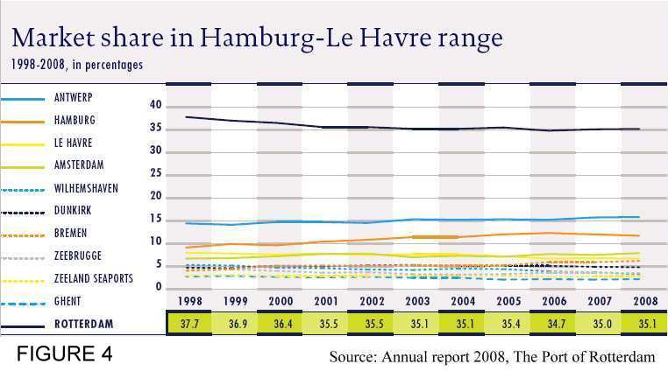
These problems with hinterland transportation and the demand for better tailored and more flexible transport solutions have reshaped the picture in the maritime transport market in Europe and undermined the undisputed leadership of the Port of Rotterdam. Rotterdam could not adapt to the changes and has been slowly, but steadily, losing market share to its main competitors (Figure 4). Although the year 2009 has been good in terms of market share for the Port of Rotterdam, this is mainly attributed to the economic crisis and the absolute fall in quantity transported. Rotterdam was able to keep a bigger proportion of the traffic, because of the regular liner services that are using the port. It remains unclear whether an expected growth in traffic will lead to a growth in the market share of the port, but even if the construction of the Maasvlakte 2 terminal (Anon 2) manages to draw more traffic to the port, the congested and inefficient hinterland network and the low added value of the high proportion of transit goods are factors that will prevent the port from being a growth pole to the Rotterdam region or the Dutch economy. The Port of Rotterdam clearly needs a new growth mechanism to reclaim its lost market shares. A radical innovation – leadership in a fairly new industry is needed for it to regain the markets it used to serve with a competitive advantage to its competitors.
In theoretical terms, Boston Consultancy Group created the BCG Matrix (1970) which classifies products or product lines in one of four groups depending on their growth potentials and market shares. Although this concept was originally created to analyze companies, it can also be used to evaluate all kinds of economic entities on different markets. The Port of Rotterdam can be classified as a cash cow in this matrix as it has a relatively low growth potential and a high market share. While this means that a lot of profits are expected, the growth opportunities are low and therefore alternative investments should be considered.
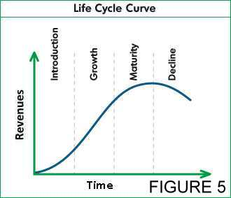
To add to the explanations of the problems that the Rotterdam region has experienced in connection with economic growth, the theory of cluster life-cycle (Chapman, 2005; Hudson, 2005) can be used to evaluate the current condition of the old growth clusters. As already explained in the introduction, the Port of Rotterdam has been a regional growth pole through two main industries – the petroleum and related industries and the container transshipment and distribution industries. With the maturing of the petroleum and petrochemical industries, the regional expansion came to a halt and a new growth pole had to be established to achieve persistent development. The container transshipment industry took the place of petrochemicals in the regional expansion. However, the recent events in the container market seem to have put an end to its growth and the industry is going into maturity. The similarities between the two industries acting as growth poles are obvious. Like every product, every industry essentially fulfils its potential and goes into maturity (Figure 5), and unless there are radical innovations, it seizes to cause regional economic expansion. However, clusters in mature industries contain some hidden traps that can be problematic if the region is too much specialized in or dedicated to the industry. A maturing industry may mean that innovation is directed through very narrow paths to achieve lower cost or automatization and that mechanisms of growth are no longer functional. Maturing also inevitably leads to less employment and reduced regional living standards, competitiveness and attractiveness.
The concept of lock-in refers to specific public, private and human-capital investments in infrastructure, assets or knowledge which tie a region to the industry of its specialization (Hudson, 2005). These sources of competitive advantage act both as catalysts of economic growth in times of industry expansion and as the main reason for stagnation when the industry starts to mature or decline. Another form of lock-in is that of political support. As clusters become embedded in an area, the regional government starts to implement policies to support their development and expansion. However, past experiences have proved that politicians had failed to recognize the need to let go and the necessity to introduce policies in time which discourage further lock-in and promote diversification (Chapman 2005; Hudson, 2005).
The growth pole and cluster concepts both emphasize reliance on a key sector to facilitate rapid economic growth. However, they do ignore the problems that specialization in a maturing industry can cause. There are numerous regions around the world, which even though were once prosperous, have now gone into relative or absolute decline. Their specialization at specific industries and the executed policies of specific clustering stimulation have been directed at maximizing the effects of agglomeration economies, but contrarily have caused stagnation due to regional lock-in into a declining industry (Chapman, 2005).
Innovation is at the heart of a cluster and its main engine of growth. However, the possibility that expertise and knowledge is directed into radically diversifying the cluster is very unlikely. Research is mostly conducted within the established framework and with the purpose of upgrading current activities and not creating new ones. As Chapman (2005) put it “path dependence privileges continuity over radical change in economic evolution”. Such clusters that are incapable of change inevitably deteriorate as the industry they operate in matures and their knowledge becomes if not obsolete, then incapable of causing expansion. A prevention of this problem is the increased cluster heterogeneity. As firms are deeply embedded into their processes and specific knowledge, it is difficult to achieve a smooth change to another set of capabilities (Langen, 2003). Through high cluster heterogeneity, the risks of a region becoming obsolete are decreased as those firms have more opportunity for cooperation and innovation. Through a more diversified knowledge base, the firms are able to achieve new combinations of technologies and create radical and fundamental innovations for cluster evolution. However, if the firms are unable to produce such winning innovations, it is easy to see how dedication to a specific cluster can lead to its strengths causing a lock-in to a declining industry and become regional weaknesses when viewed from a long-term perspective (Chapman, 2005).
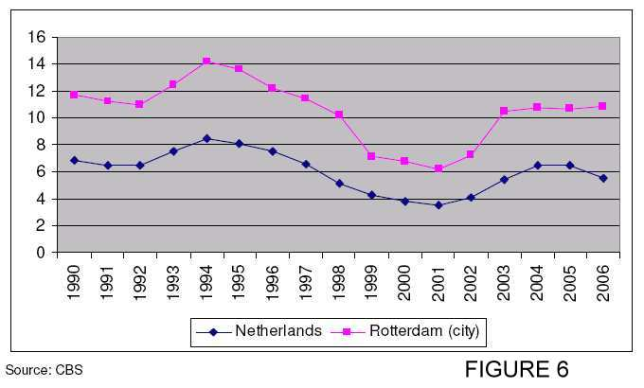
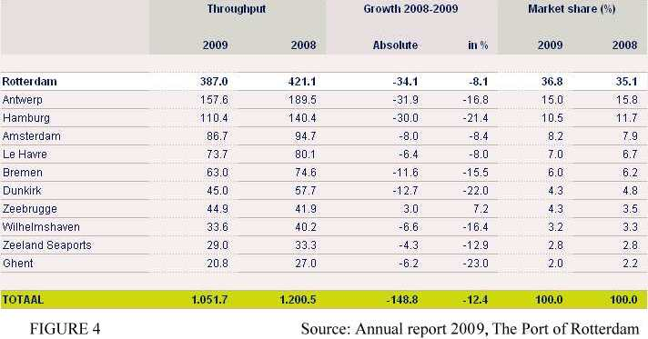
Moreover, to create a cluster that is a regional growth pole several intangible conditions must be in place. First, the institutional support should be great enough for the right policies to be implemented to allow the cluster to expand and operate efficiently. Second, inter-firm connections are established, which facilitate the exchange of information and strategic and technical collaboration, leading to the creation of trust and partnership. Third, social and cultural support and interest should be relatively adequate, in order to ensure at least a competent workforce. When these conditions are established radical innovations come even harder, as political, social and business entities become embedded in the cluster and some of them may even show resistance to the changing environment. Such ties may even act as a barrier to the transition to different growth poles, as even with the introduction of new government policies that encourage radical innovation and redirection of public and private investment flows, concentration of expertise may try to oppose any suggested changes and keep the status quo (Hudson, 2005).
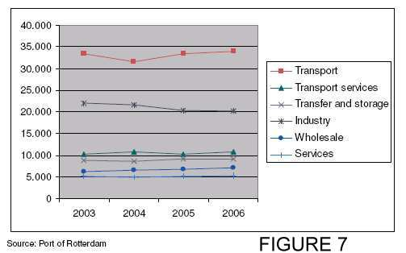
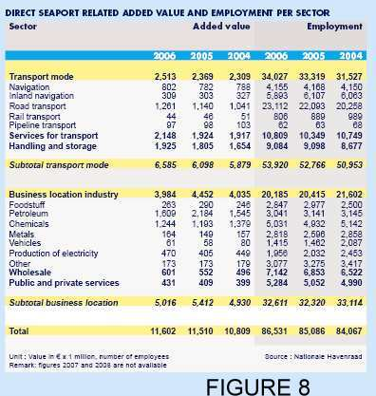
Rotterdam has had problems with regional unemployment for a long time. Its unemployment rate has been higher than the average for the Netherlands for two decades now (Figure 6) and the regional government has set objectives to decrease this imbalance (City of Rotterdam Regional Steering Committee, 2009). The port and transport industry are one of the biggest employers in the region (Figure 7) and they also contribute to some other industrial and service sectors. The import of goods, which need further processing generate added value through manufacturing and also create demand for fringe services such as warehousing and storage, insurance etc. The regional government has already locked in to the port on several levels, providing huge public investments, as well as introducing policies to support its development as a growth pole. However, if the municipality is to achieve its objectives of decreased unemployment and increase added value within the regional economy, it is hard to imagine that it can rely solely on the established growth mechanisms of the port. The added value and employment from the traditional port operations has been rising, but the growth seems to curtailing with the slowing down of the container shipping market (Figures 8, 9). It seems as the port industry sector altogether is going into maturity (Figure 7) and although container transshipment is not likely to decline, because of stable international trade and the derived nature of the demand for transport services, the traditional growth pole function of the industry is likely to halt.
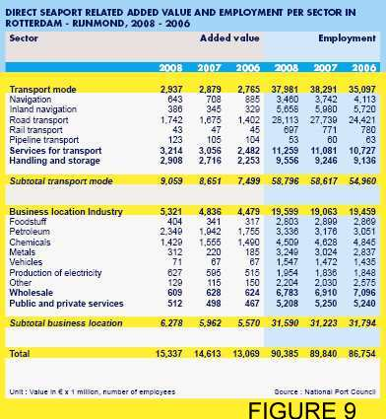
The construction of an enormous new terminal by land reclamation from the sea – Maasvlakte 2 – has proven to be a very costly public investment, which will tie the region’s fortunes to the container transshipment industry. The low growth and high competition of this industry makes it inappropriate for a regional lock-in of this scale, and the municipality has to act to diversify the activities and clusters while exploiting the created infrastructure. This can be done by stimulating radical innovations of the port clusters and putting incentives to draw new port-related industries to the region. A fruit port has already been established, with the objective to diversify the activities from traditional cargo. However, the project only causes growth on a low scale as it is small in size and the fruit delivery market in Europe is not one of the most rapidly expanding ones. Another specialization of the port is environmental-friendly energy, which has a high growth potential, but this sector is very unreliable as, first it is hard to predict the way in which technology is going to develop, and second the Netherlands do not have strategic advantages in terms of energy creation and energy industries, except for wind energy. These factors accrue to the point that if the region wants to keep growing, it has to find an alternative industry which it could exploit. The statistics show that another sector related to the port is expanding – the port services (Figures 8, 9). The 68% growth in added value of the sole Services for Transport indicator for the period 2004-2008 (Figures 8, 9) reveals the opportunity for further regional expansion – third and fourth party logistics. Excellent forward and backward linkages to the port cluster ensure that the lock-in to the traditional port industries will only assist the future growth of the transport services sector, as the existing infrastructure is essential for the provision of those services.
The low growth opportunities of the industry in the Port of Rotterdam and the high amount of transit goods, which create negative environmental and social externalities (pollution, congestion) account for the end of an era of the growth pole for the Rotterdam region and the Dutch economy. The constantly higher regional unemployment than the rest of the country brings social and political problems and burdens public expenditure. The traditional services of the Port of Rotterdam have no opportunity to sustain the economic growth they have brought in the past and new growth poles should be explored. As Langen (2003, p.213) also put it: ‘In Rotterdam, the need to attract “new growth activities” in the cluster, in order to counterbalance the loss in value added and employment in cargo handling and transport, is widely accepted’. However, caution should be taken to avoid future lock-ins by developing the existing strengths in a way, which allows several growth paths to be taken. When thinking about new clusters, using the existent knowledge, expertise and infrastructure is one of the possibilities, while there are also several others which are not connected to the transport industry. Therefore, the regional governments should not limit its choice to just one of the, but stimulate the potential growth poles simultaneously and diversify the local economy.

- Methodological framework for industry evaluation
There are many definitions of a cluster in the academic literature (Marshall, 1920; Hoover, 1948; Porter, 1998 and many others), but in this paper the definition of van den Berg, Braun and van Winden(2001) is used. These authors define clusters as ‘localised networks of specialized organisation, whose production processes are closely linked through the exchange of goods, services and/or knowledge’.
The purpose of this paper is to conclude whether a cluster could become an engine of growth for the regional economy. Therefore, it will be assumed that the all the necessary conditions for a specified cluster to exist are present and the sources of an agglomeration economy (McCann, 2007) are not going to be discussed, because they are relevant to all the clusters presented. The focus of the paper is evaluating how efficient a given sector can be as to cause growth in the economy of the Rotterdam region. Thus, in this section a methodological framework will be outlined, which will assist the identification of a sectoral cluster as a growth engine.
  - Demand conditions
Demand is essential for the existence of any economic entity, be it a firm, an industry or a cluster. Without local demand for the products of a cluster, it is unlikely to survive, let alone grow. If a cluster is to grow, a strong local demand needs to exist in order to stimulate the firms to compete and collaborate between each other, and to allow them to be profitable and reinvest their proceedings into the business (Porter, 1998). The demand could come from local businesses or consumers, but also from public bodies, such as regional or national governments. Some industries that are greatly specialized and using knowledge and expertise not widely available anywhere else can also expand with little local demand. However, such knowledge is unlikely to be created without local interest. Examples of such industries using highly specialized knowledge are space travel, underground construction, water technology etc. Another case is an industry that operates internationally as its scope is wider that the local economy. It can still be embedded in the region because of the network it has engaged in. Examples of such industries are related to transport or financial services and the nature of their demand is mostly derived.
  - Competitive advantage
A cluster’s competitiveness is determined by its relative productivity. Every cluster possesses specific knowledge or expertise deeply rooted within it, which should be only available in its local circumstances, if the cluster is going to be successful. In this way, competitive advantage is created and the cluster is able to attract interest from customers by being more productive and providing superior products or services. In most cases, the expertise originates from historical knowledge or tradition in the field, but in innovative industries it can also arise from entrepreneurial spirit or a scientific discovery with a profound effect on technology (Porter, 1998). In the former case, an example is the clothing industry in the region of Milano, Italy. It has the structure of interconnected family businesses that have been producing clothing apparel in the region for centuries. In the latter case, an example is the Silicon Valley, which arose after the invention of the microchip. Without such specific competitive advantage-providing expertise, a cluster is unlikely to become a growth engine, as it will not be able to excel and will just be an average performer. Porter (1998) has suggested that even in the case of innovations, ‘clusters require a decade or more to develop depth and real competitive advantage’.
  - Cluster-specific conditions
Although all conditions listed in the framework for growth engine evaluation are specific to the cluster discussed, the classification of Van den Berg, Braun and Van Winden (2001) about cluster-specific conditions is going to be adapted to the needs of the current evaluation.
The first condition to assist growth of the regional economy is the size of the cluster. It is much more probable for a large, or a potentially large cluster to affect growth positively, because it constitutes a market in itself. The interconnection of the firms inside the cluster creates local demand for their services and helps them to gain expertise in their field. A better choice of suppliers, a large specialized work force and dedicated education facilities are only a share of the benefits that a large cluster brings to a region. By utilizing these benefits, businesses become more competitive and are able to create more work-places, more added value and cause regional growth. A big cluster also means more local competition and forces higher productivity as it rules inefficient operations out of the market.
The second condition, which is important for the development of a cluster as a growth pole is the presence of a cluster engine. Such engines can be either large companies or educational institutions, which stimulate expansion of the cluster competitiveness. A large company will create demand for the sources of agglomeration economies (McCann, 2007) and stimulate the creation of expertise. An educational facility will create cluster-specific knowledge and human capital for the development of the agglomeration economy. This cluster engine will act as a leader and will promote the development of the cluster in the desired direction (Van den Berg, Braun, Van der Meer, 1997). Another characteristic of a cluster engine is positive externalities for the other cluster actors caused by investment of the leader firm (Langen, 2004). Such investments include innovations and internationalizations which spread within the cluster bringing increased benefits and fast growth through technology diffusion or penetration of new markets.
The final cluster-specific condition is the level of new firm creation. Young firms are often more dynamic than large organizations and can exhibit large growth potentials, causing opening of new employment opportunities and innovations (Van den Berg, Braun, Van Winden, 2001). New firms also help to keep human capital within the region, as they will inevitably need young university graduates as their employees. These firms will recognize gaps in the clusters and exploit them to add value to the regional economy (Porter, 1998).
  - Growth pole conditions
The ultimate evaluation of a cluster for its possibility to cause spreading growth throughout the economy is when applying the conditions of a growth pole, adapted for the current needs. Although some of the conditions already overlap with the so far stated characteristics of a growth cluster, they are not going to be omitted in the discussion in order to keep the consistency of the theory.
Francois Perroux essentially referred to a growth pole as an industry or firm, not a geographic location or a cluster (Dicken and Lloyd, 1990). However, the characteristics that the French economist gave to a growth pole can be easily applied to a cluster as to examine the possibility for it to serve the purpose of a source of growth to a regional economy. First of all, the cluster should be relatively large, as if its size is not sufficient it could only grow on a small scale, unaffecting the rest of the region. Second, the rate of growth should be relatively high compared to the surrounding economy. Third, it should be well connected to the rest of the economy, having forward and backward linkages with other firms and economic entities, such as public authorities or private citizens. To measure the connectivity of the firm, it is highly recommended to use an input-output analysis (Leontief, 1986) and although the scope of this study does not allow such a thorough analysis to be performed, it is recommended for future researches to conduct such analysis as to confirm the results. The high intensity of connections to the rest of the economy is important, because growth in just one sector, which is isolated, will not affect overall wealth. Last but not least, the cluster should be innovative, as only an innovative industry can cause greater growth than the rest of the economy. Moreover, radical innovation is needed to ensure the sustainability of growth – several growth paths should be distinguished and the region should avoid a lock-in into a specific industry, as this could be risky for the future growth opportunities, when this industry matures.

Demand conditions | - local demand  - international demand
Competitive advantage (knowledge or expertise) | - tradition  - entrepreneurial spirit /  scientific discoveries
Cluster-specific conditions | - size  - presence of a cluster engine  - level of new firm creation
Growth pole conditions | - relatively large  - rate of growth higher than the rest of the economy  - well connected to the rest of the economy  - innovative

- Evaluation of alternative industries
The constructed framework will now be used to evaluate the sectors that are outlined by the regional government as possible clusters to cause growth and prosperity in the Rotterdam region (EDBR, 2008). The clusters are going to be assessed on the basis of how likely is that they will contribute positively to the development of the region of Rotterdam as one of the hot spots in North-Western Europe. In the final part of this section the analysis will be extended to the third and fourth party logistics sector to check whether it has a place in the discussed growth cluster portfolio.
  - Creative
The creative sector is characterized by high interconnections to the rest of the economy. It provides a lot of services to other industries and has a high growth potential, as it contains some fairly new industries and innovative activities. Two subsectors of the creative industry in Rotterdam are discussed in turn in order to gain an insight into the sector structure and growth opportunities.
    - Media and design
The media and design sector was long on the agenda of the Rotterdam municipality as a potential growth cluster for the regional economy and a possible diversification strategy. Several policies were issued supporting its development, including the establishment of certain media sector-specific sites to stimulate the development of the cluster. However, these policies are characterized by researchers as ‘wishful thinking’ (Erik Braun, personal communication 13.07.2010), as the condition for the development of such a cluster are very unfavorable.
First of all, the absence of tradition and history of the media and design sector in the region proved to be a major setback for its development, as the region was not perceived by media and design firms and their customers as a media location (Van den Berg, Braun and Van Winden 2001). The cluster has little infrastructure and no large cluster engine and although the regional government tried to stimulate educational programs in the field (Van den Berg, 2005), the sector failed to attract large players and develop as an engine of growth. One of the main reasons, that was ignored by the policy makers is the established competition in the vicinity of the region. The presence of developed media and design clusters in Hilversum and Amsterdam is an impediment to the development of the Rotterdam cluster, because not only they have the tradition of being the Dutch media and design centres, but they also have most of the major Dutch media producers and the power to attract new ones.
Local demand for media and design products is low and the industry relied too heavily on government funding (Van den Berg, 2005). This local demand is especially important for the cluster, as traditionally such clusters have grown to a reasonable level through local firms demanding their services. However, Rotterdam businesses prefer to buy media products from established producers located in the old developed clusters and rarely source from domestic suppliers.
The Dutch media and design producers are well known for their high quality productions. However, the Rotterdam region does not possess any specific expertise in the field. The regional government and knowledge institutes have committed to create such a knowledge base and infrastructure, with Erasmus University Rotterdam, Willem de Kooning Academy and INHolland leading the way in graduate and post-graduate education (City of Rotterdam Regional Steering Committee, 2009). Unfortunately, the process of knowledge accumulation has been slow and it has been further decelerated by the outflow of talent to the established media clusters.
The extent to which the cluster-specific conditions for the media and design cluster are favorable for its establishment and growth is controversial. First of all the cluster is relatively small and is not likely to grow substantially in the foreseeable future. The small size does not allow the cluster to entice support activities to the region, such as directors, actors, cameramen and roaming creative designers, and it has to recruit these from the neighbouring clusters (Van den Berg, Braun and Van Winden 2001). Second, the absence of one or several cluster engines greatly reduces the visibility of the cluster. There have been some attempts by RTV Rijmond to take the role of such an engine, but it has not succeeded. Moreover, the attempt of the cluster to position itself as a popular movie shooting location has failed, not being able to attract enough producers. The last cluster specific condition for the media and design cluster is very favorable as there are a high number of new firms created. This can be partly attributed to the fact that the entry barriers for a new firm are very low, as there are no capital, technology or scale requirements and as the industry is not yet mature and there are fewer regulations in the market.
Applying Perroux’s conditions for the design and media sector to examine whether it could act as a growth pole only confirms the conclusion that can be reached in the analysis so far and advocates the decision of the regional government to partly withdraw its support from the sector and also direct policies towards other potential growth clusters. Although the cluster is fairly interconnected to the rest of the economy, providing services for other businesses in different industries, is innovative and offers several possible future expansion paths, its relatively small size and low growth level limits the opportunity for media and design to become the next growth pole for the Dutch economy. However, the cluster is kept into the portfolio of Rotterdam as it provides diversification and exploits niche markets that are otherwise stolen from other regions.
    - Architecture
The architects of Rotterdam are one of the most proclaimed around the world. Their authority and abilities can be a great selling point for the city and the municipality has great support of the sector in terms of allowing the architects to express their talents. Larry Beasley (2009) recommends that complete freedom is given to them so that they can display their ideas and capabilities and in this way draw attention to the architecture cluster. The International Advisory Board (IAB, 2008) recommends that architecture is used to provide three distinct economic to the city: architecture as an export product – to raise awareness of Rotterdam around the world not only as an industrial port city but also as a creative and attractive agglomeration; architecture as a magnet for visitors and investors – to provide a better physical image of Rotterdam to its visitors and a better psychological image for investors in different fields; architecture as making a difference in the standards of living and living environment of its citizens – to attract talented individuals to the city, who would value highly its environment and in this way greatly broaden the economic and knowledge base and the job markets.
The local demand for architecture is moderately high as currently several public and private projects are being executed in the city, such as the new train station, Koop van Zuid and several other architectural wonders as the new Markthal etc. However, to thrive and expand, the cluster needs demand from other regions and from abroad, which should be generated by further expanding the awareness and visibility of the talents.
The knowledge base and expertise of the cluster is very high. As already mentioned, the architects based in the city are some of the best in world. However, this competitive advantage is very vulnerable as, they can easily be drawn from other cities, which are in their development phase. Therefore, incentives have to be created for them to stay in Rotterdam, while undertaking foreign projects. One possible incentive can be the creation of networks and personal lock-ins with institutes and other architects, which are not easily copied anywhere else. Another caution should be taken into investing into expanding the knowledge base. Delft University of Technology and the RDM campus for Research, Design and Manufacturing offer graduate and post-graduate studies in the field of architecture (City of Rotterdam Regional Steering Committee, 2009). Awareness should be created about these educational programs and more young talents should be drawn to the region.
The cluster specific conditions for the architecture cluster are favorable for its development. The size is moderate, but architecture clusters are generally not large in size, because the over-clustering of architects creates destructive competition for their services. However, the famous and talented architects act as a cluster engine to other less pronounced ones, as it is their desire to work alongside their proclaimed colleagues in order to enrich their talents. The level of new firm creation is also moderately high as a lot of young architects graduate each year and, as in the media sector, virtually no capital is needed to create a new venture.
Unlike the positive expectations of the analysis so far, some hidden factors hinder the categorization of the architecture cluster as a growth pole. First of all, the size of the cluster does not allow it to cause enough economic impulses to induce the economy to expand. Second, the architectural industry is a special case of growth potential, as it has a derived demand caused by the number of construction projects. Therefore, even though it is a fairly innovative industry in the sense that it challenges new construction technologies with extraordinary ideas and concepts, it cannot be categorized as fast growing as it largely depends on the state of the economy and on the need to develop new construction sites. The industry has some forward linkages into the economy, but it generally cannot be regarded as a growth pole on its own, but as a source for attraction of other industries and clusters to a region (Erik Braun, personal communication 13.07.2010). However, the architecture cluster can be a very valuable asset for the development of the city by providing fringe benefits that assist the other potential growth clusters and provide better conditions for their expansion.
  - Medical
The medical sector in Rotterdam is housed around the facilities of Erasmus MC – a university medical centre. Created in the end of 1960s under the name Dijkzigt University Medical Centre and later Academic Hospital Rotterdam, it was the seventh Dutch medical faculty supported by a hospital in the time of establishment (Anon 4). In 2005 the health and welfare sector employed over 47000 people, which was 15.8% of total employment in the region and, possessing high growth potential, it is a promising cluster for the further development of the region (COS, 2006). The Economic Development Board Rotterdam (EDBR) also recognized the need to support the cluster, by stimulating the creation of more work places, enhancing the cooperation between organizations and establishing more space for the industry to develop (EDBR, 2008).
There are several possible growth paths the medical and care cluster can adopt in order to become a growth pole for the Rotterdam region. First of all, it is possible to start a pharmaceutical cluster, attracting a number of large pharmaceutical companies. However, success in the field is highly controversial, as there is such a cluster already present in Leiden and competition from it is likely to cause a pharmaceutical cluster in Rotterdam to take the path of the already discussed media and design cluster. Moreover, cooperation between the clusters in Leiden and Rotterdam is improbable as the distance of 40 minutes by train may prove an impediment. Another option is developing a cluster of private hospitals specializing in various medical niche markets and private care. Although the opportunity seems appealing, the Dutch legislation and health-care system hinder the creation of such businesses and therefore limits the ability of such a cluster to become a growth pole (Erik Braun, personal communication 13.07.2010). Removing such political obstructions and the stronger involvement of educational institutions may help to exploit a high growth market, removing the competence mismatch and greatly increasing employment opportunities in the field. OECD’s review on the city of Rotterdam (City of Rotterdam Regional Steering Committee, 2009) forecasts that, while now there is one care provider in every ten working people, the potential is as high as four in every ten.
The demand conditions of the local market are favorable for the development of the cluster. The ageing population and the objective of the municipality to provide better living conditions combine to create an advantageous economic environment for an expansion of supply of medical and care services. The forecast of the OECD (City of Rotterdam Regional Steering Committee, 2009) also confirms the conclusion about positive demand conditions in the local market. The nature of demand is also favorable for the cluster development, as there is a share of natural monopoly for the provision of medical services. On the international stage demand is structured in a different way – there is little or no opportunity for care provision to patients, except for specialized hospitals with great expertise in a field. However, the Rotterdam region does not house such entities and moreover the quality of the medical staff is far from world-class doctors (City of Rotterdam Regional Steering Committee, 2009). Other opportunities for Rotterdam in the international medical sector include the infeasible pharmaceutical cluster and innovative technological combinations between medical research and hi tech solutions, achieved in collaboration between Erasmus MC and Technological University of Delft. However, such cooperation has been sluggish and fostering it is one of the things on the agenda of developing the medical cluster.
Experience shows that tradition is very important in medical clusters. The clusters in Lyon and Vienna are two of the most successful in Europe and they both have a historical background in the field (Van den Berg, Braun, Van Winden, 2001). In the case of Rotterdam, there is little tradition in the medical field and the region does not possess any competitive advantages. Although Erasmus MC researchers perform well in the fields or virology, cellular biology and immunology (Van Den Berg, 2005), the entrepreneurial spirit has been low and the patented discoveries have not resulted in high profit businesses. A recent development in the sector is the creation of the Medical Delta. An alliance between academic institutions in Rotterdam, Delft and Leiden and the business communities in the area, it has the objective to foster knowledge creation in the medical field and to support the cooperation between academic and technical staff in order to develop innovative medical technology. However, Rotterdam’s role in the Medical Delta has been set to provide education and remove the qualitative and quantitative mismatch between supply and demand in the labour market for medical and care staff (City of Rotterdam Regional Steering Committee, 2009). To boost the entrepreneurial spirit there have been suggestions to set up an Erasmus MC incubator to house economic spin-offs from scientific discoveries (Van Den Berg, 2005). However, since the withdrawal of Erasmus MC from the Schieveen science park project, Leiden Bio Science Park nearby and the functioning of the Medical Delta, a new Erasmus MC science park seems unfeasible. In conclusion, Rotterdam region does not possess competitive advantage, which it could exploit to establish itself as a leading national or international cluster.
Considering the cluster-specific conditions, a medical cluster is likely to be successfully created in the Rotterdam region. The size is relatively large, as already mentioned 15.8% of total employment in 2005, bringing significant cluster-related benefits to the sector. A cluster engine is present in Erasmus MC and, although currently it is not efficient in providing leadership, it has the capacity to do so. The entrepreneurial spirit in the sector has been an apparent weakness and therefore new firm creation has been lagging behind. However, with the necessary political support in providing adequate facilities and stimulus to the cluster, the new firm creation is likely to improve.
When examining the growth pole theory, the medical and care cluster actually possesses some of the Perroux’s characteristics of a growth pole. The sector is relatively large, making it possible for it to spur growth in the regional economy. The OECD forecast (City of Rotterdam Regional Steering Committee, 2009) of 40% growth in employment in the sector is a clear indicator of the pace of development of the medical and care industry – even if the forecasts results in a twice lower growth the industry can still be categorized as fast-growing. However, it is evident that a large expand in the industry will demand a great increase in the number of higher-educated professionals in the field and caution should be taken in satisfying this demand. The medical and care cluster has excellent forward linkages to the economy, providing services to virtually all the citizens, and some backward linkages from suppliers. Last but not least, there are some activities in the industry that can be classified as innovative, such as pharmaceutical and technological research and development. However, the lack of entrepreneurial spirit along with the participation of the cluster in the Medical Delta and its role of education provision and staff training means that the activities which are likely to be the catalysts of regional growth and going to be shared with the other regions in the Delta, more specifically, the medical cluster already operating in Leiden. Although this does not mean the sector should be abandoned as it will undisputedly bring increased employment and some economic benefits to the region, along with better living condition to attract high-skilled labour, the medical cluster is unlikely to be the single growth pole that will help the Rotterdam region to become one of the hot-spots in Western Europe.
  - Port-related growth and third- and fourth-party logistics
Along with the attempts to diversify the regional growth base the municipality and the national government have dedicated a lot of policies to support the Port of Rotterdam and growth related to it. As already discussed in chapter 2, the traditional growth mechanisms in the port have deteriorated and new ones should be explored if the port is to continue to be a growth pole for the region. The dedication to the port industry has caused considerable regional development in the past, but now those mechanisms seem to have expired, causing a slight decline in employment (Figure 7). Though this decline is not essential for the structure of the labour market presently, its structural nature may bring a cyclical trend which will lead to regional contraction of economic activity.
The restructuring of value-adding supply chains has brought a shift away from the ports for the value-added activities. Some of the traditional port services associated with storage, assembly and further processing of goods have now moved to locations with lower land prices and production wages, as the ports are being integrated in increasingly complicated transport and production systems. The sector of logistics outsourcing has expanded tremendously worldwide and its role in the organization of transport flows has become so fundamental that the decisions of some major players on this market can influence the prosperity of an established port or even whole regions of economic activity. These companies now have enough market power to orchestrate sufficient transport flows to operate a middle-sized feeder port on the Asia-Europe route. The present situation has led to turbulent competition between the major ports for the operation of international centres for logistics activities (Hesse, 2008). The ports have seen the change in the trend of supply chain organization as an opportunity to improve their position in terms of market share and profitability. Attracting logistics companies to a port and forming a cluster of third- and fourth-party logistics companies will draw additional traffic and cause growth both in terms of traffic revenues and value captured along the supply chains operating through the port.
The political support for the Port of Rotterdam has been enormous and recent policies have been directed to achieving the objectives of being the cleanest, safest and most sustainable port in the world, while also focusing on alternative energy sources (City of Rotterdam Governmental, Legal and International Department, 2009). Although these objectives are likely to diversify the declining industrial activities that no longer cause regional expansion, the policy makers may be overlooking a major growth pole opportunity, which is a logistics cluster. As one of the world’s largest ports in terms of cargo throughput and the port with the highest market share in Europe, the Port of Rotterdam will greatly benefit from a regional specialization in logistics services. The International Advisory Board Rotterdam (IAB, 2008) has already recognized the importance and capability of developing a knowledge centre on logistics. In their recommendation from the IAB 29-30-31 October 2008 meeting they state that: “Rotterdam has the most excellent facilities to build a world renowned knowledge centre on logistics. This can be achieved by setting up a cooperation between the technical universities in the Netherlands, the Erasmus University, the Rotterdam Port Authority and the knowledge centre on logistics in Shanghai.” (IAB, 2008, p. 8). By creating such a centre, Rotterdam will facilitate the unique knowledge creation and expertise in the field of logistics and supply chain management and the emergence of a logistics cluster. The construction of Maasvlakte 2 will free up some space from the Stadshavens from container transshipment activities, as those activities will be moved to the new terminal (City of Rotterdam, 2007). The newly available space will be perfect for housing a knowledge centre on logistics and the establishment of a site of a logistics cluster. The City of Rotterdam Regional Steering Committee (2009) has identified some weaknesses of the Port and Industrial sector in Rotterdam: lack of organizing capacity to support cluster creation and implementation of new business ideas and practices; and insufficient attention on knowledge-intensive, urban and port-related activities, resulting in high quality service provision. Therefore, dedication from policy-makers is needed to facilitate better utilization of cluster-related economic advantages and to strengthen the knowledge base and consequently increase the quality of the offered logistics services.
Demand conditions for logistics services in the Rotterdam region are very strong. An annual throughput of 387 million metric tons including 9,743,000 TEUs in 2009 makes the Port of Rotterdam the biggest transport node in Europe (Port of Rotterdam Authority, 2010). A big share of this traffic is already using logistics services and establishing a dedicated cluster in the port will capture a part of this share of traffic while also attracting interest from other cargo owners who are not currently using outsourced logistics services. If a company is considering outsourcing a part of its supply chain, it would make most sense to first contact a provider from a logistics cluster operating in the port.
As already explained in chapter 2, tradition may prove very important for a seaport as it may have brought invaluable competitive advantages. The Port of Rotterdam is one of these ports where past public investments and policies have contributed greatly to a present infrastructure and distribution channels that are difficult if not impossible to copy. The tradition in port operations has also brought some expertise in the logistics field. To support the port sector, several universities and schools have specialized education programs in logistics and sea-port management. Erasmus University Rotterdam, STC group, Technical University of Delft and Rotterdam University have all contributed to work force development and logistics and maritime knowledge and expertise creation (City of Rotterdam Regional Steering Committee, 2009). An example of a project applying knowledge to solve a problematic area from the port is the Port infolink (Van den Berg, 2005). It is an ICT system created to optimize logistics chains in the port and increase customer satisfaction and service quality. The creation of a knowledge centre on logistics will further boost the scientific and practical expertise in the field and facilitate the collaboration between the knowledge institutions that already play a role. These factors will inevitably boost the image of Rotterdam as a logistics location and will prove difficult to reproduce for its competitors.
When considering cluster-specific factors, a logistics cluster in Rotterdam shows promising results. Housed in the biggest port in Europe and employing 11,259 people in 2008 (Figure 9), it is relatively large and has an enormous growth potential – it has shown a steady growth in employment and added value (Figure 8, 9). The Port of Rotterdam can also act as a cluster engine in logistics, providing demand and supply of the needed services and increasing the awareness of the cluster. However, the creation of a knowledge centre on logistics is likely to act as an even bigger catalyst for drawing logistics companies. World-class research in the field will greatly contribute to the recognition of Rotterdam as one of the top destinations for logistics specialists. The level of new firm creation is moderate, but the nature and development of the business has come to a level where a new firm can be created with virtually no capital requirements, everything a fourth-party logistics company needs is an office, a few computers and a lot of expertise and contact with clients and suppliers of logistics services. Therefore, the creation of a logistics cluster may spur a wave of new firm creations that aim to take advantage of the newly opened market opportunities.
If the cluster is evaluated as a growth pole based on Perroux’s conditions, the outcomes look fairly promising. The third and fourth-party logistics sector is relatively large and, as a part of the business services sector, possesses a high growth potential. The cluster has excellent backward and forward linkages to the economy, providing services to a wide range of businesses and also employing the transport sector which plays a significant part in the Dutch economy. Last but not least, the third and fourth-party logistics sector may prove an innovative regional solution as a knowledge centre on logistics will facilitate scientific discoveries in the field and improve the problem solving skills of logistics specialists.

Sector |  | Media & Design | Architecture | Medical | Third- and Fourth-party logistics
Demand conditions | - local demand  - international demand | -  -- | +  + | ++  - | +  ++
Competitive advantage (knowledge or expertise) | - tradition  - entrepreneurial spirit /  scientific discoveries | --  + | ++  + | 0  -- | +  ++
Cluster-specific conditions | - size  - presence of a cluster engine  - level of new firm creation | -  --  + | -  +  + | ++  ++  -- | +  ++  +
Growth pole conditions | - relatively large  - rate of growth higher than the rest of the economy  - well connected to the rest of the economy  - innovative | --  0  ++  ++ | --  +  +  + | ++  ++  +  + | ++  +  ++  +

- Conclusion
In this paper the regional problems or Rotterdam and the Port of Rotterdam are briefly explored, focusing on the perspective of finding a new growth pole for the region after the decline in expansion of the port industrial activities. After a concise introduction and background of the port, some theoretical models are presented, explaining the industry decline and giving recommendations for possible solutions of the problems that have arisen. The next step of the analysis has been the creation of a theoretical framework for the evaluation of the contribution of alternative clusters as creating growth in the regional economy and the actual evaluation of those clusters.
To conclude, the media and design sector has no chance of becoming a growth pole in Rotterdam, but its presence in the local economy provides a valuable addition to the regional portfolio of industries and supplies services to a range of local businesses. The architecture cluster is also not likely to become a growth pole. However, it greatly contributes to the image and attractiveness of the city, while also creating better living conditions and making Rotterdam famous around the globe for its proclaimed architects. The medical cluster on the other hand has great potential in causing regional expansion. The high growth and large size of the private care sector is a promising prospect for the growth of the region. However, the creation of the Medical Delta is likely to attract some of the most profitable activities of the medical cluster towards other cities in the Delta and although this does not necessarily mean that the sector could not be a growth pole, different expansion paths should also be sought to ensure the regional specialization into high-profit activities.
The analysis so far proves that the third and fourth-party logistics cluster could be the next growth pole for the Rotterdam regional economy. While it utilizes and even facilitates the already created competitive advantages of the port, it also possesses great potential of becoming a top world location for the industry innovation and knowledge creation. The local government and authorities should be strongly encouraged to undertake projects to gain further insight into the topic and create policies that assist the creation of an advantageous environment for the development of a third and fourth-party logistics cluster.

- References:
Anon 1: Toekomst van de haven, de haven van de toekomst. Web. 28 June 2010. <http://www.havenvandetoekomst.nl/eng/geschiedenis.html>.
Anon 2: Maasvlakte 2. Web. 28 June 2010. <http://www.maasvlakte2.com/en/index>.
Anon 3: "Betuweroute Double-Track Freight Line." Railway Technology. Web. 28 June 2010. <http://www.railway-technology.com/projects/betuweroute/>.
Anon 4: Erasmus MC : history of the hospital. Web. 22 October 2010. <http://www.erasmusmc.nl/overerasmusmc/historie/geschiedenis_ziekenhuis/?lang=en>.
Bask, A.H. (2001) “Relationships among PL providers and members of supply chains – A strategic perspective”. Journal of Business & Industrial Marketing 16 (6), 470-486.
Beasley, Larry (2009) “Smart growth in Rotterdam: Considerations from a Vancouver perspective”. Van der Leeuwkring, private initiative for public space 28.09.2009.
Boston Consulting Group, Inc. (1980) The Product Portfolio.
Centrum voor Onderzook en Statistiek (COS) (2006) “Key figures Rotterdam 2006”.
Chapman, Keith (2005) "From 'growth centre' to 'cluster': Restructuring, Regional Development, and the Teesside Chemical Industry." Environment and Planning 37, 597-615.
City of Rotterdam (2007), “Rotterdam Urban Vision: Spatial Development Strategy 2030. Summary/ draft.”.
City of Rotterdam Governmental, Legal and International Department (2009), “Rotterdam World City: fixed direction, new ambitions”, Programme for International and European Activiries 2009-2010.
City of Rotterdam Regional Steering Committee (2009), “The City of Rotterdam, The Netherlands: Self-Evaluation Report”, OECD Reviews of Higher Education in Regional and City Development, IMHE, http://www.oecd.org/edu/imhe/regionaldevelopment
Dicken, Peter, and Peter E. Lloyd (1990) Location in Space: Theoretical Perspectives in Economic Geography. 3rd ed. New York U.a.: Harper & Row. Print.
EDBR (Economic Development Board Rotterdam) (2008), Maintain course, persevere and execute. Update economic vision Rotterdam 2020.
Haralambides, H.E. (2002) “Competition, Excess Capacity and the Pricing of Port Infrastructure”. International Journal of Maritime Economics 4, 323-347.
Hesse, Markus (2008) The City as a Terminal: the Urban Context of Logistics and Freight Transport. Burlington, VT: Ashgate.
Hoover, Edgar M. (1948) The Location of Economic Activity. New York ; Toronto ; London: McGraw-Hill.
Hudson, Ray (2005) "Rethinking Change in Old Industrial Regions: Reflecting on the Experiences of North East England." Environment and Planning 37, 581-96.
International Advisory Board (IAB) (2008) “Report IAB Conference 2008” Rotterdam 2008.
Konings, R. and H. Priemus (2008) “Terminals and the competitiveness of container barge
transport”. Transportation Research Record: Journal of the Transportation Research
Board, no. 2062, 39 – 49.
Krugman, Paul R. (1991) Geography and Trade. Cambridge, Mass.: MIT.
Kuipers, Bart, TNO Inro, Delft, the Netherlands (2002) "The Rise and Fall of the Maritime Mainport" Proc. of European Transport Conference.
Landreth, Harry, and David C. Colander (2002) History of Economic Thought. Boston: Houghton Mifflin.
Langen, Peter W. De (2004) The Performance of Seaport Clusters: a Framework to Analyze Cluster Performance and an Application to the Seaport Clusters in Durban, Rotterdam and the Lower Mississippi. Delft, the Netherlands: Netherlands TRAIL Research School.
Leontief, Wassily (1986) Input-output Economics. Second ed. New York: Oxford UP.
Marshall, Alfred (1920) Principles of Economics. 8th ed. London: Macmillan.
McCann, Philip (2007) Urban and Regional Economics. Oxford: Oxford UP.
Port of Rotterdam Authority (2010), “Port Statistics”.
Porter, Michael (1998) Clusters and the new economics of competition, Harvard Business Review, (Nov/Dec), 77-90.
Solow, Robert M. (1956) "A Contribution to the Theory of Economic Growth." The Quarterly Journal of Economics 70 (1), 65-94.
Stopford, M. (2009) Maritime Economics, Routledge, New York.
Van den Berg, Leo (1987) Urban Systems in a Dynamic Society. Aldershot, Hampshire, England: Gower.
Van den Berg, Leo, Erik Braun, and Jan Van Der Meer (1997) Metropolitan Organising Capacity: Experiences with Organising Major Projects in European Cities. Aldershot: Ashgate.
Van Den Berg, Leo, Erik Braun, and Willem Van Winden (2001) "Growth Clusters in European Cities: An Integral Approach." Urban Studies 38 (1), 185-205.
Van Den Berg, Leo (2005) European Cities in the Knowledge Economy: the Cases of Amsterdam, Dortmund, Eindhoven, Helsinki, Manchester, Munich, Münster, Rotterdam, and Zaragoza. Aldershot, Hants, England: Ashgate.
Van Klink, H. Arjen, and Geerke Van Den Berg (1998) "Gateways and Intermodalism." Journal of Transport Geography 6 (1), 1-9.
Van Winden, Willen, and H. Arjen Van Klink (1998) Towards a New Hinterland Orientation for Rotterdam: the Entrepreneurial Port. Paper for the 38th congress of the European Regional Science Association, Vienna.
Walras, Leon (1954) Elements of pure economics, or, The theory of social wealth / Leon Walras ; translated by William Jaffe Published for the American Economic Association and the Royal Economic Society by Allen and Unwin, London.

