Business cycle synchronization:
An application to BRIC economies

Alexandros Plakidis
October 2010

Msc in Economics and Business:
Financial Economics
Erasmus School of Economics
Erasmus Universiteit Rotterdam

Abstract

Economists often claim that emerging economies have decoupled from the advanced economies during the recent years and thus follow different business cycle paths than the advanced economies. This paper is a research in which it is tested the decoupling hypothesis between the emerging economies from the advanced ones with respect to business cycle co movement. The tests conducted consist of two parts: a graphical and an econometric one. The graphical is an innovative measure of interdependence called Euclidean distance and the econometric consists of numerous regressions that provided descriptive coefficients. Both kinds of results showed rejection of the decoupling hypothesis (null hypothesis) between emerging- and advanced economies while at the same time confirmation of the decoupling hypothesis between emerging- and the USA as an individual country.

Acknowledgements

Contents

Abstract 3
Acknowledgements 5
Contents 6
List of figures 7
Introduction 9
PART I: Review of the Literature 12
1. Previous studies 12
2. Measure of the business cycle 18
3. Econometric evidence of business cycle synchronization 20
PART II: Data and Methodology 22
1. Four strong emerging economies 22
2. Data 25
3. Methodology 26
PART III: Results 29
a. Graphical Testing 29
b. Econometric testing 42
Conclusion 50
References 52
Appendix 54

List of figures
Figure 1: Table representation of China's GDP growth rates between 1980 and 2009 23
Figure 2: Graphical representation of China's GDP growth rates between 1980 and 2009 24
Figure 3: Graphical representation of Russian subdivisions by GDP 25
Figure 4: Graphical representation of the Euclidean distance between Brazil and EU 30
Figure 5: Graphical representation of the Euclidean distance between Brazil and USA 30
Figure 6: Graphical representation of the Euclidean distance between Brazil and World's advanced economies 31
Figure 7: Graphical representation of the Euclidean distance between Brazil and G7 31
Figure 8: Graphical representation of the Euclidean distance between China and EU 32
Figure 9: Graphical representation of the Euclidean distance between China and USA 33
Figure 10: Graphical representation of the Euclidean distance between China and World's advanced economies 33
Figure 11: Graphical representation of the Euclidean distance between China and G7 34
Figure 12: Graphical representation of the Euclidean distance between India and EU 35
Figure 13: Graphical representation of the Euclidean distance between India and USA 35
Figure 14: Graphical representation of the Euclidean distance and the World's advanced economies 36
Figure 15: Graphical representation of the Euclidean distance between India and G7 37
Figure 16: Graphical representation of the Euclidean distance between Russia and EU 38
Figure 17: Graphical representation of the Euclidean distance between Russia and USA 38
Figure 18: Graphical representation of the Euclidean distance between Russia and World's advanced economies 39
Figure 19: Graphical representation of the Euclidean distance between Russia and G7 39
Figure 20: Graphical representation of the Euclidean distance between Emerging Markets and EU 40
Figure 21: Graphical representation of the Euclidean distance between Emerging Markets and USA 40
Figure 22: Graphical representation of the Euclidean distance between Emerging Markets and World's advanced economies 41
Figure 23: Graphical representation of the Euclidean distance between Emerging Markets and G7 41
Figure 24: Table representations of econometric tests between Brazil and advanced economies 43
Figure 25: Table representations of econometric tests between China and advanced economies 45
Figure 26: Table representations of econometric tests between India and advanced economies 46
Figure 27: Table representations of econometric tests between Russia and advanced economies 47
Figure 28: Table representations of econometric tests between Emerging Markets and advanced economies 48

Introduction

Economic theories regard that during the last years, emerging economies have accomplished to decouple from the advanced economies of the world. In other words business cycles of the emerging are not following the business cycles of the advanced economies anymore. Crises, recessions and numerous fluctuations influencing the business cycles of the advanced economies that used to affect in the same or even in greater degree the business cycles of the emerging economies because of the increasing economic interrelations among countries in the past is not the case anymore. So according to the decoupling theory emerging economies have developed the mechanisms that allow them to detach from the advanced economies’ business cycles and become less dependent to their fluctuations.
While the degree of interdependence among countries appears to be a macroeconomic problem of study, it can at the same time provide economists with a lot of information necessary for financial markets. Since international investments become day by day more attractive to investors, such information would be of superior importance for portfolio optimization within the scope of international investments.
In this thesis the decoupling problem is specified in four emerging countries, Brazil, China, India and Russia. These four countries are the largest emerging economies of the world at present and play an important economic role globally while they already provide a famous investment choice. Thus they draw the attention among the rest of the emerging economies. All the four of them have very high rates of economic development (higher than the advanced economies). Therefore it will be interesting to watch their economic evolution during the next few years.
The main literature used in this thesis is the paper “No decoupling more interdependence: business cycles co movements between advanced and emerging economies” from Walti S. (2010) which is an improved edition of his own previous research on the decoupling of emerging economies which was first published in 2009. So in the first part of the thesis it is presented a brief overview of the recent literature that Walti S. also used in his last paper (2010). It is presented the transition from the “traditional way” of measuring business cycle synchronization, the use of correlations between the business cycles as the measure of interdependence, to the “modern way” Walti S. used to avoid biases and other econometric flaws that correlation coefficients created.
This was accomplished by the use of Euclidean distance which was the absolute value of a simple mathematical difference between the output gaps of the business cycles and provided the researcher with the same qualitative information as the correlation coefficient (demonstration details of the relationship between the correlation coefficient and Euclidean distance can be found on Walti S. (2010), No decoupling, more interdependence: business cycle co movements between advanced and emerging economies, Swiss National Bank at p. 20). Furthermore he supported the graphical evidence that was produced from the Euclidean distance measures with econometric evidence that were following the pooled regression analysis that Levy-Yeyati E. in his paper “On emerging markets decoupling and growth convergence” (2009) had introduced.

In the second part of the thesis the methodology followed is presented step by step. To begin with, little statistical information about the four emerging countries used in the analysis is provided and thus reflect the importance and the reason of testing them. Then it is presented the specification about the data and the sources used to obtain them. Last but not least there is a detailed analysis of the procedure followed to find evidence (both graphical and econometrical) of the decoupling hypothesis.

The third part includes the results of this research. Both graphical and econometric proof of the decoupling hypothesis and the degree of interdependence are presented in detailed manner while the results are mostly clear-cut even though there have been some flaws. In the case of the graphs, the decoupling hypothesis is widely rejected while observing the tension of all the emerging-market economies to appear decoupled from the USA. This result contradicts to Walti’s research that had concluded in rejection of the decoupling hypothesis among all the groups of countries that he used, including the USA alone. Nevertheless the econometric evidence of decoupling matches with the graphical one in most of the cases leading to reinforcement of the results.

Towards the end is the conclusion of the thesis in which an aggregate result of the research is described and within the last pages can be found the references and the appendix.

PART I: Review of the Literature

1. Previous studies

Many researchers have tried to give answer to the problem of interdependence and to measure business cycle synchronicity among countries. Artis and Zhang (1997) studied the linkage and synchronization of cyclical fluctuations between countries in terms of the Exchange rate mechanism (ERM) of the European Monetary system (EMS). They used the US and the German business cycle as benchmarks and divided the sample in two periods the pre-ERM and the ERM period and thus created two groups of countries, the ERM and the non-ERM group. In their results they observed business cycles being more synchronized with the German business cycle (benchmark) and less synchronized with the US business cycle (benchmark) during the ERM period. In addition this result was not faced between the ERM and non-ERM countries.
Two years later in 1999 Artis and Zhang extended the paper using latest data captured by OECD with 19 countries instead of 15 used in the previous research. The sample period was also extended by up to 22 months and last but not least their methodology was differentiated since they used measures of exchange volatility and a non-parametric rank correlation approach to study if business cycle affiliation was connected to relative exchange rate fixity.
They found that synchronization of business cycles was linked to lower exchange rate volatility and further evidence to their first research that business cycles of the ERM countries had become more synchronized with the German cycle in comparison to the US business cycle.
Inklaar and de Haan (2001) however presented results different from Artis and Zhang. In their research, which was replicating Artis and Zhang, tried to focus on a slightly different level; so from their perspective they examined not whether the business cycle of a country is affiliated to the US or the German cycle but whether exchange rate volatility has led to synchronization of business cycles in Europe. Therefore they compared the correlations with the German cycle before and after the institution of the ERM.
Consequently they found intense differences with Artis and Zhang in their results. Correlations of the ERM countries with Germany were not found increased in average after the institution of the ERM. While some correlations were found increased, others were decreased, offsetting the average. As an explanation for the striking difference of the results, Inklaar and de Haan explained firstly that their source of data was the IMF instead of the OECD and secondly that their post-ERM period has been longer. On the other hand, even when they corrected for the longer period, substantial differences to Artis and Zhang were still present. Therefore Inklaar and de Haan’s results do not support the view that exchange rate stability is related to business cycle synchronization.
Frankel and Rose (1998) investigated the endogeneity of international trade patterns and international business cycle correlations in a sample of thirty years for twenty industrialized countries in line with the newly created European economic-monetary union (EMU). This research targeted on the advantages such as lower transaction costs related to trading goods among countries and disadvantages such as the instability that may be created if they join the EMU.
Thus when a country enters a currency union, trade linkages will probably raise. Business cycles are then expected to change sharply as a simultaneous result of the adoption of the common currency and of the tighter international trade. Closer trade relations among countries can lead them to specialize more in their comparative advantage and therefore become more sensitive to industry-specific shocks. As a result business cycles become idiosyncratic for individual countries but together with tight trade relations among them, business cycles become more alike.
They concluded through strong empirical evidence that countries with closer trade links tend to have more tightly correlated business cycles even though large part of economists since then did not support the idea. Specifically countries that share borders or have a common language have higher degree of trade relations than with others that do not share anything.
Rose and Engel (2002) examined the hypothesis that the “border effect”, the effect of internal trade being more stable inside a country than across national boundaries, results from the exchange rate volatility, the consequence of having different currency in other words. They took into account political unions as well as currency unions into their data (USA, France, UK) and examined if currency unions exhibit economic integration which is desirable for an ‘’optimum currency area’’. To achieve it they used a lot of economic characteristics for international monetary and political unions. They found that trade between countries participating in a currency union is much higher than trade between countries that do not share a common currency.
Moreover, more intense than the “border effect” is the “home market bias effect” which revealed that international trade is much higher than international trade even for units of comparable economic size. To do so they examined real exchange rates and deviations from purchasing power parity. They found that volatility of real exchange rates is lower for members of currency unions than for countries with individual currencies. In their tests business cycles have been found highly correlated among members of a currency union while countries with individual currencies were less correlated.
Their target was to see whether members of a common currency area really experience more synchronized business cycles. They resulted that no clear answer to business cycle synchronization can be given due to membership in a monetary union even though members of a common currency appear more economically integrated than non-currency union members.
Kose et al. (2003) used twenty one industrialized and fifty five developing countries in their sample of 1960-1999 annual per capita GDP and real private consumption as data for their empirical analysis to measure national output and consumption. Furthermore they measured trade openness and financial integration using a standard openness ratio and an indicator measure of restrictions on capital account transactions respectively.
In order to measure correlations of individual country output and consumption growth fluctuations with their corresponding “world” aggregates they minimized the effects of the large economies using PPP-weighted aggregates of output and consumption in the G7 countries as measures of the relevant world aggregates. These countries were then excluded from the empirical analysis.
In their results they found that industrialized countries have higher correlations with world output than the developing countries have. These correlations increased intensively in the 1970’s and rise further after 1990’s for the industrialized countries whereas for the developing countries these correlations declined especially after the 1990’s. In addition their results do not offer clear-cut evidence that globalization leads to an increase in the degree of synchronization of business cycles while they found some evidence that trade and financial market integration enhance global spillovers of macroeconomic policies. Surprising is the fact that they come up to that correlations have not increased in the 1990’s especially then that financial integration for developing countries was expected to provide better opportunities.
Imbs (2004) studied the combinations and the relations among trade, specialization and synchronization. In his complex analysis Imbs found that both goods and assets have both direct and indirect influence on business cycles synchronization. The overall impact can be characterized ambiguous while specialization may mitigate the direct impact of openness to goods trade. Financial integration may cause a decline to synchronization but will also induce specialization.
Through a simultaneous equations methodology to assess the magnitude of each channel, Imbs is the first to approach these linkages simultaneously. One of the reasons of the simultaneous estimation method is the lack of exact quantification of the magnitude of the indirect influence of trade on the business cycles correlations. Secondly the link between finance and business cycle correlations is not clear since the sign of the direct link is unambiguous and the indirect specialization influence can mitigate or reinforce the direct link. Thirdly none of the existing researchers has explored the possibility that specialization is an indirect manifestation of trade or financial integration and amend the estimated effects of trade, finance and specialization accordingly.
The paper’s results point to the necessity of simultaneity in the equations methodology. A substantial share of the measured effect works through intra-industry trade. In addition the evidence that trade induced specialization affects cycles synchronization is weak. Financial integration leads to positively correlated business cycles while the correlation coefficient could be higher if finance-induced specialization was held constant. Moreover synchronized business cycles are not observed between trade partners only because they follow the same monetary policy in terms of cross-country and cross-state data. Specialization patterns are not important in affecting cycles due to the choice of a time period or geographic coverage since the results cannot come out of one given type of shock in a given sample. In aggregation theories of the international business cycle should build on sectoral heterogeneity, trade within and between industries and some herding in international capital flows.
Another paper examining the robustness of correlations between business cycle co-movement and economic variables was published from Baxter and Kouparitsas (2005) in which they found some interesting results. Higher bilateral trade between two countries is correlated with a higher business cycle correlation between the countries (robustness of trade). Furthermore the industrial structure is not robustly correlated with business cycle correlations, results that indicate the fragility of Imbs’s results.
Another result confronting with previous studies and more specifically the one from Rose and Engel (2002) is that countries belonging to a currency union do not have significantly more highly correlated business cycles than countries that do not share a common currency.
In addition, a lot of their coefficients were found negative, meaning that the corresponding variables were not robust enough to support the theory.
Imbs (2006) examines the effects of financial integration on the international correlations in output and consumption while at the same time tries to quantify them. In his consistent with theory results he founds financial linkages increasing consumption correlations while on the other hand other measures showed that more integrated economies have more synchronized GDP fluctuations. The second effect is larger than the first, explaining shortly why GDP fluctuations are more correlated on average than consumption plans. Consequently financial integration has a larger impact on GDP correlations and this is why a quantity puzzle arises.
Doyle and Faust (2005) examined the changes in variability and co-movement among growth rates of G7 countries. They differentiated their analysis in comparison to other researchers by considering consumption and investment growth together with GDP growth. Thus they were able to distinguish the source of changes. Then they focused in tests for changes in various measures of co-movement actually by testing the significance of these measures.
They found that the growth variation reduction for the US was at the same time present in all of the G7 countries with the exception of Japan. Therefore they did not reject the hypothesis of no change in correlation even for Canada and for the US that had a substantial increase in trade as well as the euro countries. Similarly they did not reject the hypothesis for consumption and growth rates despite the fact that higher integration might lead to higher correlation that reflects consumption insurance.
Fidrmuc and Korhonen (2006) in their paper gathered the existing literature concerning the measurement of correlations and business cycles analyzing the fulfillment of the OCA criteria by the CEECs. In their survey they found a lot of significant differences among the existing publications although the meta-analysis they conducted confirmed that the economic cycles in many candidate countries are highly correlated with the euro area cycle.
Furthermore they observed that studies using quarterly data report lower correlations than those analyzing monthly data and simple growth rate correlations are higher than correlations calculated from models with more economic structure. Home bias of the researcher is not met and central bankers tend to present more modest estimates.
In addition to this, from their analysis it is implied that business cycle correlation of most EU member countries is sufficiently high, while business cycle correlation is only one criterion of successful participation in a monetary union.
Kose et al. (2008) in their study provide an empirical characterization of global business cycle linkages among a large and diverse group of countries. They focus on the factors driving business cycles in different groups of countries and the reasons that these factors evolved as the process of globalization increased its pace during the last two decades.
In their results they found that there is no evidence of global convergence of business cycles during the recent period of globalization. However there has been a convergence of business cycles among industrial countries revealing that group-specific factors became more important than global factors in affecting fluctuations. On the other hand country-specific factors gained importance in the case of the group of emerging market economies in comparison to the group of industrial economies during the recent period of globalization. Moreover in the financial level, countries with high levels of financial integration were able to use the international financial markets more efficiently so that they could share risk and delink consumption and output.
Flood and Rose (2009) introduce in their paper the phenomenon of inflation targeting, a policy that allows the monetary authority to focus on purely domestic inflation. Thus they investigated whether inflation targeting can be linked to business cycle synchronization and consequently decoupling (decoupling is the idea that business cycles are becoming more independent across countries).
They found from an empirical perspective that inflation targeting leads to cross-country synchronization of business cycles and therefore decoupling does not exist at all in their data sample.

2. Measure of the business cycle

Mink et al. (2007) introduce an innovative way to measure business cycle synchronization. While they use GDP as the threshold measure, they differentiate the procedure. Instead of using correlations like the rest of the preceding studies, Mink et al. compute output gaps of the GDP as indicators of the business cycle. Output gaps are defined as the difference between real and trend GDP and synchronization is thus computed by examining the similarity of the output gaps among relevant countries.
Their application in the euro area during 1970-2005 resulted that the business cycle of France, Germany and the Netherlands are similar to the rest of the union, while Finland, Greece and Italy performed worse. Moreover heterogeneity of the business cycle within the region increases when they took into account that economic developments in large European countries get more weight when ECB decides upon its monetary policy.
Walti’s (2009) research was based on proving the rejection of the hypothesis of the decoupling view. In his paper he used the way Mink et al. calculated business cycle synchronization. Correlation coefficients among business cycles that other previous studies used to calculate synchronization suffer from significant disadvantages even though they are easy to interpret. The choice of sub-sample in the data is tricky since different sub-samples can result in different conclusions. Therefore “rolling correlation coefficients avoid the need for defining arbitrary sub-periods so that one must define a moving window over which correlations are calculated and decide around which year this window is centered”.
In addition overlapping windows lead to serial correlation while the most important difficulty of correlation coefficients is that they mix two characteristics of the business cycle; synchronization and amplitude. Thus changes in correlation coefficients while volatility changes could be wrong interpreted only due to changes in the degree of synchronization.
His data consisted of groups of countries both emerging and advanced from all over the world. Walti used a sample of 34 emerging-market countries and four groups of advanced-market economies. He compared this large sample of emerging economies against each group of advanced economies from 1980 onwards excluding 2008 data because of potential bias due to the recent financial crisis.
The results for emerging-market economies are clear-cut; there is no evidence of decoupling during the recent years and business cycle synchronization between the large group of emerging-market economies and each group of advanced-market economies has not decreased over time. Qualitatively his results are consistent with the view that globalization has contributed to stronger business synchronization.
Walti’s (2010) paper improves his previous methodology in the calculation of business cycle synchronization with two approaches. Firstly business cycle interdependence is easier calculated by Euclidean distance. Euclidean distance is simply the absolute value of the numerical distance between two business cycles. It takes into account the difference in amplitude and thus offers an innovative way of measuring synchronization. When Euclidean distance equals to zero, the business cycles are perfectly synchronized. Any other value (positive due to absolute sign) means imperfect synchronization and therefore the larger the distance, the larger the business cycle interdependence.
Secondly he follows Levy-Yeyati’s (2009) pooled regression methodology to confirm the graphical evidence of the Euclidean distance approach. Walti “regresses pooled business cycles of emerging markets on the business cycle of advanced economies as well as an interaction term between the business cycle of advanced economies and a dummy variable taking a value of one from a recent chosen year (between 1999 and 2007) until the last year of the sample”. When this coefficient is negative and statistically significant, business cycle interdependence is lower and so the decoupling hypothesis is confirmed. His sample of countries and year data remained the same.
The results have been here also clear since there has been no evidence of decoupling in the recent years while testing both approaches. In other words both methodologies point to the same conclusion in that the degree of business cycle synchronization has become tighter between emerging and advanced economies especially during the recent years.

3. Econometric evidence of business cycle synchronization

Levy-Yeyati (2009) in his effort to find evidence for decoupling of emerging economies from the advanced ones states that the standard measure of synchronization of the existing literature, the business cycle correlation, mixes sensitivity and amplitude like two different factors affecting the decoupling argument. Practically business cycle correlation can increase either with the beta between emerging-advanced or with the ratio of output volatilities.
However sensitivity is his major concern since he considers that “emerging economies’ resilience must be judged by the relative size and duration of their responses”. In order to test whether emerging market sensitivity has changed over the years he regress emerging market growth on G7 growth using a split in two periods sample (1993-1999, 2000-2009) and thus evaluates the evolution of the coefficients. In addition he introduces an interactive dummy corresponding to the late period (2001-2009) in the regressions he used.
To sum up, he found little evidence of decoupling while from 2000 onwards there has been an increase in the correlations of business cycles between the emerging and the G7. On the other hand he came across exceptions in which emerging markets have shown growth outperformance.

PART II: Data and Methodology

This research is an effort to test the synchronization of business cycles following the methodology of Walti. At first place, it focuses on extracting results for synchronization from a graphical depiction of the business cycles of the countries. Secondly with the use of a simple econometric model the way Walti uses it, he aims to acquire coefficients that can explain the existence of possible business cycle synchronization. The target of this research is to find potential business cycle interdependence between strong emerging-market economies and the advanced-market world. In this effort, there were elected four individual emerging economies; Brazil, China, India and Russia against four groups of advanced economies; E.U. (excluding Malta, Slovakia, and Slovenia due to lack of data), G7, USA and a group of worldwide advanced economies (according to IMF). In order to support the individual results, the four emerging economies are put together and thus it is created a group of emerging market economies that is tested against the same four groups of advanced economies.

1. Four strong emerging economies

- Brazil is the largest economy in Latin America and the eighth largest in the world based on nominal GDP. Brazil is one of the fastest growing emerging-market economies according to the International Monetary Fund and the World Bank acquiring a very high annual GDP. Brazil’s booming economy is based on its large amount of exports in a variety of products both agricultural and industrial such as textiles, aircrafts, steel, and coffee being the most important. Brazil has been a country that pegged its currency, real, to the US dollar but financial circumstances later on gave to the Central Bank of Brazil the chance to definitely change the exchange regime to free-float.

- China or People’s Republic of China is currently the second largest economy in the world following the USA. Nominal GDP amounts to $4.99 trillion and China is considered to be the fastest-growing emerging market economy with an average growth rate of 10% (see Figure 1a, 1b below). At the same time China is the largest exporter and the second largest importer of goods. The most important sectors of the Chinese economy are agriculture and industry that together produce approximately 60% of the GDP. China is the world’s largest producer of rice and among the largest in wheat as far as it concerns the agricultural products and one of the largest producers of a vast number of industrial and mineral products such as cotton, coal and crude oil.

China GDP growth rates

Year | Growth Rate % | Year |  | Growth Rate % | Year |  | Growth Rate % | Year | Growth Rate % | Year | Growth Rate %
2010 | - | 2003 |  | 9.5 | 1996 |  | 9.6 | 1989 | 4.1 | 1982 | 9.1
2009 | 9.1 | 2002 |  | 8.3 | 1995 |  | 10.5 | 1988 | 11.3 | 1981 | 5.2
2008 | 9 | 2001 |  | 7.5 | 1994 |  | 12.6 | 1987 | 11.6 | 1980 | 7.8
2007 | 13 | 2000 |  | 8 | 1993 |  | 13.5 | 1986 | 8.8
2006 | 11.6 | 1999 |  | 7.1 | 1992 |  | 14.2 | 1985 | 13.5
2005 | 10.4 | 1998 |  | 7.8 | 1991 |  | 9.2 | 1984 | 15.2
2004 | 10.1 | 1997 |  | 8.8 | 1990 |  | 3.8 | 1983 | 10.9

Figure 1: Table representation of China's GDP growth rates between 1980 and 2009

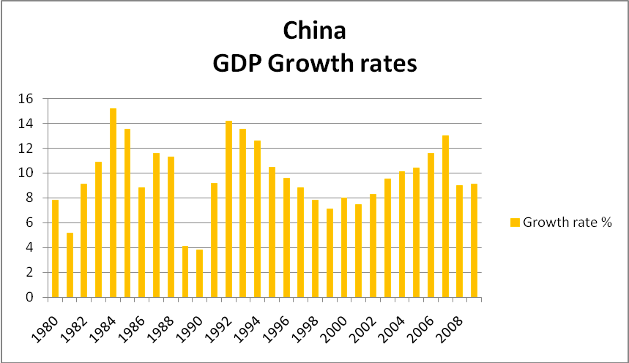
Figure 2: Graphical representation of China's GDP growth rates between 1980 and 2009

- India’s nominal GDP reached $1.243 trillion in 2009 and thus India is currently the eleventh largest economy in the world. While being one of the fastest growing emerging markets in the world, India’s GDP output comes from 28% agriculture, industry 54% and service 18%. The most significant agricultural products are rice, wheat and tea while India’s industry includes chemicals, machinery and telecommunications. Therefore India is a large exporter that has obtained a very high share of world trade. In 2007 a report from Goldman Sachs projected that “from 2007 to 2020 India’s GDP per capita will quadruple and that Indian GDP will surpass that of the USA before 2050”.

- Russia has a 7% average growth rate since 1998 while Russia’s GDP was $2.076 trillion in 2007. This brings Russia to the 6th largest economy in the world and one of the largest emerging markets worldwide. Russia is among the richest countries in mineral products, since natural gas, metals and timber account for the 80% of Russian exports. However oil and gas exports contribute only to 5.7% of Russia’s national GDP due to the intense growth of the internal market during the recent years. Important also to refer to is the unequal geographical contribution in the GDP of Russia. Moscow region contributes disproportionally higher to Russia’s GDP in comparison to Siberian rural regions of the large country (see Figure 3).

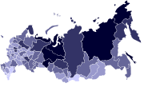
Figure 3: Graphical representation of Russian subdivisions by GDP

2. Data

The basic data used in this research is of nominal GDP which was acquired from the IMF website. Nominal GDP is derived in an annual basis and projected in current prices in US dollars for all countries involved. In this way any currency differences are vanished while inflation’s influence on the GDP values is incorporated. The sample period chosen in this paper is from 1980 to 2007 (except for Russia which is 1992-2007 due to lack of data before), just before the recent crisis which is implicitly assumed during 2007-2008. This crisis period is excluded from my analysis because of the potential bias it may cause in the results. Groups of advanced economies were formed by IMF itself. European Union countries are from the current extended form of the Union (25 members), however three new-joined countries were excluded because the GDP values were not starting from 1980 (like the rest of the countries) and thus there would be a mismatch later in the calculations. Additionally, the group of “world’s advanced economies” was formed by IMF and thus it was used the way it was.

3. Methodology

The first approach of testing the decoupling hypothesis was the graphical evidence. So after gathering the data from the IMF website, the first step was to calculate the trend of the GDP. Trend GDP is calculated with the Hodrick-Prescott filter (λ=100 since I use annual frequency in the data). To avoid end-point bias problem of the filter and according to existing literature that adjusts the HP filter in similar circumstances, GDP data are extended from 2007 (sample period) to 2010 (3 more years with 2010 being expected value) in order to calculate the trend for the sample.
The task to calculate the trend was easy for the emerging market economies since they were individually filtered and thus trend GDP was simply the product of GDP values of each country. On the other hand the procedure was more complicated for groups of countries since trend GDP had to be calculated for every single country that filled in the corresponding group (Applied to the four groups of advanced market economies and the group of emerging market economies).
The second step was to produce the output gap of each country. According to Walti (2009), output gaps represent business cycles for a country. The output gap = (nominal GDP-trend GDP)/trend GDP (Output gaps can be found in the Appendix page 59 and 60). While output gap calculation for a single country needs only the above formula to be applied, the case was different for groups of countries. Therefore in the case of groups I assumed that the output gap for a group of countries is the unweighted average of the individual output gaps of the countries inside the group. To elaborate it more, the output gap of a group for example in 1995 was the unweighted average of the output gaps of the individual countries in 1995. Even if this assumption may seem to provoke flaws from reality, it can be regarded as a rational choice since large countries’ business cycles affect equally to the small ones, the accumulated group’s output gap.
In addition, the output gaps were standardized, meaning that I discounted from each output gap the mean of the output gaps and then I divided this difference with the standard deviation of the output gaps. (Standardized output gap = (output gap-average output gap)/standard deviation of output gaps).
Having acquired the output gap of the emerging-market (EM) countries, the next step was to calculate the degree of interdependence between the tested countries. Interdependence of business cycles according to Walti (2010) is measured by Euclidean distance (Euclidean distance values can be found in the Appendix page 54-58). Euclidean distance equals to the absolute value of the difference between the output gap of the emerging-market economy (either individually or as a group) and the output gap of a group of advanced-market economies (). When Euclidean distance equals to zero, business cycles are perfectly in tune/synchronized. Any positive value being different from zero means less than perfect synchronization. In other words the larger the numerical distance is between the two countries/groups, the less synchronized they are.
Finally the degree of interdependence and thus the decoupling hypothesis can be assessed with the graphical depiction of the Euclidean distance between two countries/groups and its trend. Hence a first assessment of the results was produced from the two lines of the graph based on two criteria that would determine the degree of interdependence. Firstly it is the average distance between the two lines (Euclidean distance and its trend) and secondly the simultaneous alignment of the direction of the lines (positively-negatively sloping simultaneously) that determine the degree of interdependence and consequently the decoupling matter.
The second approach of testing was the econometric evidence of the decoupling hypothesis. Following Walti (2010), the procedure consisted of a series of regressions that included three variables for each regression; the EM output gap, the AM output gap and a dummy variable which was constructed to check for a structural break during a sub-sample of recent years (2000-2007).
To be more specific, the independent variable was the EM output gap, and the other two (AM output gap and the dummy variable) were the dependent ones (). The dummy variable was an artificial variable that was taking the value of one for observations within the sub-sample of the recent years. However the dummy variable was not fixed at the value of one for a specific year within the sub-sample, rather it was allowed to become one for each year within the sub-sample. So for each regression, the dummy variable was taking the unity value for the year which was tested for a structural break and zero for all other years within the sub-sample.
Consequently each regression provided me with three variables, the intercept α (alpha) and two coefficients β (beta) and γ (gamma), for each year within the sub-sample I tested for a structural break. The gammas are a direct test of the decoupling hypothesis provided that they are statistically significant. Thus when the coefficient gamma is negative, there is lower degree of business cycle interdependence between the tested countries/groups and decoupling hypothesis is confirmed.

PART III: Results

The first part of the results (subpart a) consists of the graphical evidence of the decoupling hypothesis. In the following graphs it is depicted the Euclidean distance and the corresponding trend between emerging countries (both individually and as EM economies group) and each group of advanced economies one by one. Decoupling of an emerging from the advanced is observed when the two criteria referred above concerning the lines (Euclidean distance and trend) is fulfilled.
The second part (subpart b) of the results is based on the econometric model proposed by Walti (introduced by Levy-Yeyati) in which statistically significant and negative gammas are indicating lower degree of interdependence of the business cycles (structural break within the sub-sample). The tables (Figures 24, 25, 26, 27 and 28) present in compact form the coefficients produced from the regressions. All regressions were performed in 95% significance level.

a. Graphical Testing

- Brazil
Firstly, it is depicted Brazil against the four advanced groups of countries. The blue line is the Euclidean distance for each combination (Brazil-USA, Brazil-E.U etc) and the red line is the trend of the Euclidean distance (Hodrick Prescott filter used). Horizontal axis shows the sample years (until 2007), while the vertical the measure of interdependence (Euclidean distance).
Brazil is a country showing a significant degree of non-dependence throughout the sample years for all the groups of advanced economies; however this degree seems to follow a slightly declining rate of interdependence from 1999 till 2007 (the fluctuation of the Euclidean distance moves closer to its trend in average than in the rest of the years), however even if there is a tension of moving closer, clear results about the decoupling hypothesis cannot safely be obtained since the Euclidean distance line fluctuates both positively and negatively compared to its trend.
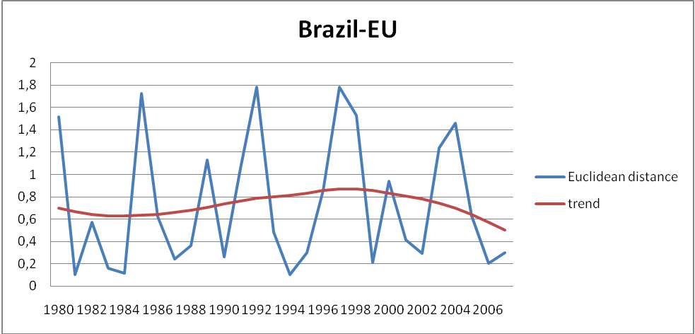
Figure 4: Graphical representation of the Euclidean distance between Brazil and EU
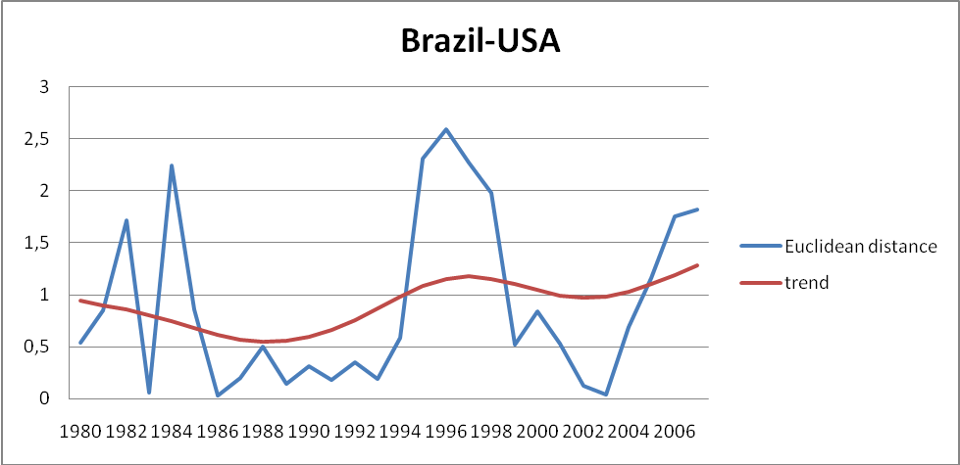
Figure 5: Graphical representation of the Euclidean distance between Brazil and USA
Furthermore it is quite clear how similar the Euclidean distance lines among all the AM groups (Figures 4, 6 and 7) are, except when the USA is tested alone (Figure 5). Euclidean distance lines appear to follow the same lows and highs at the same years throughout the sample period.
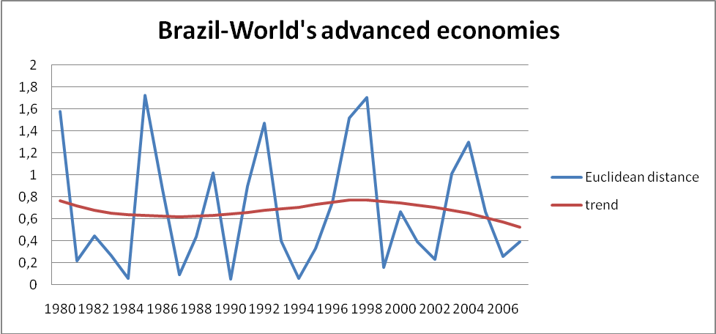
Figure 6: Graphical representation of the Euclidean distance between Brazil and World's advanced economies
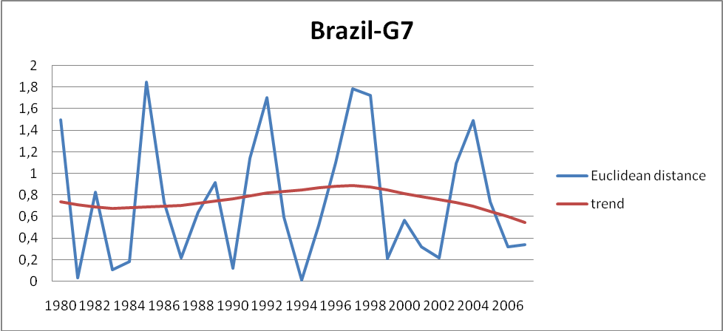
Figure 7: Graphical representation of the Euclidean distance between Brazil and G7
On the other hand, Euclidean distance between Brazil and USA appears to be different from all the other groups’ Euclidean distances. The fact that USA’s Euclidean distance is not the same as the other groups’ lines, even if USA is a large economy that is included in all three groups of AM economies, depicts the use of unweighted average of the individual output gaps in the calculation of the groups’ output gaps (business cycles). Thus a large economy as the USA affects equally to a small economy the business cycles of the advanced groups.

- China
The graphs concerning China point also to the same direction as Brazil’s graphs do. Judging from the Euclidean distance and its trend, China’s degree of interdependence implied in the recent years (1999-2007) in relation to the years 1980-1998 is in average more stable or increasing with all of the advanced groups of countries (Figures 8, 10 and 11) but with the USA (Figure 9) .
However in 2001-2002, the Euclidean distance from all the AM groups tends to increase and thus the degree of interdependence with China decreases (Figures 8, 9, 10 and 11).
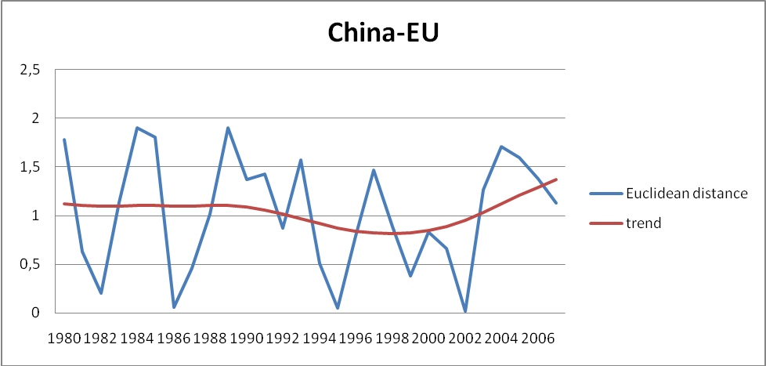
Figure 8: Graphical representation of the Euclidean distance between China and EU
Nevertheless safe conclusions about the decoupling hypothesis cannot be provided because the fluctuations of the Euclidean distances in all of the figures are not always moving to the same but also to the opposite direction from their trends.
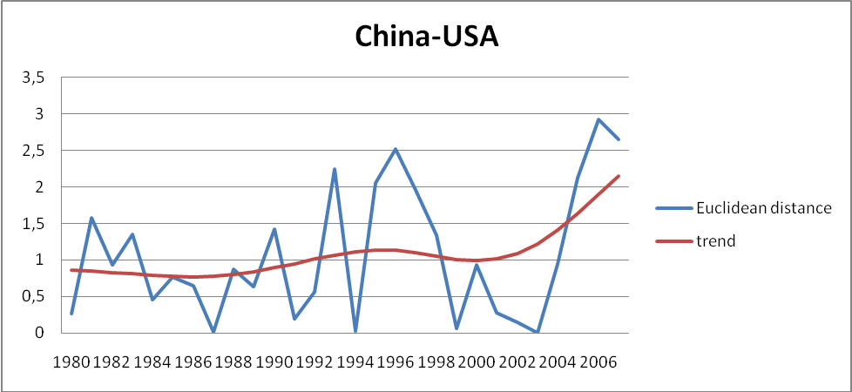
Figure 9: Graphical representation of the Euclidean distance between China and USA
China’s Euclidean distance from the USA on the other hand presents exactly the opposite case (Figure 9). Euclidean distance moves closer to its trend during the sub-period 1980 - 1992 implying higher degree of interdependence between their economies while from 1993 to 2007 fluctuates a lot more in average indicating that China has a tendency to decouple more from USA’s economy during the subsample’s period.
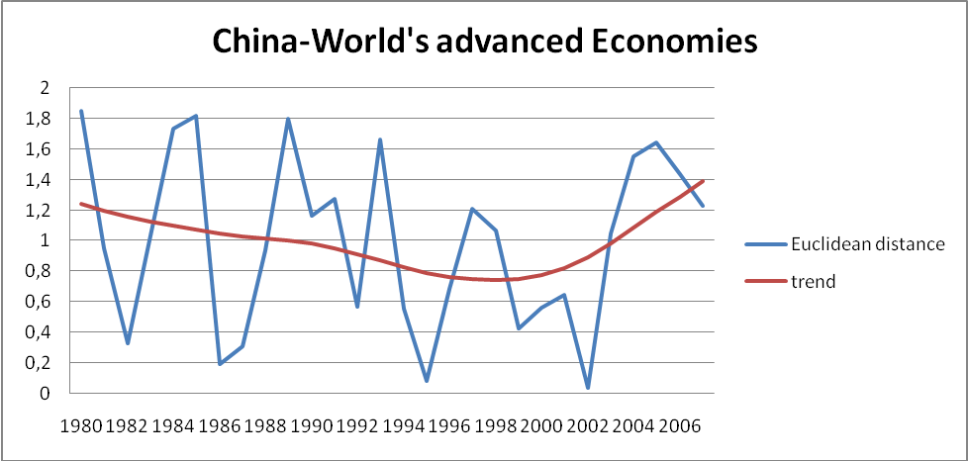
Figure 10: Graphical representation of the Euclidean distance between China and World's advanced economies
USA’s results are again differentiated from the other groups of AM economies for the same reason as before (unweighted average of individual output gaps as output gap of a group).
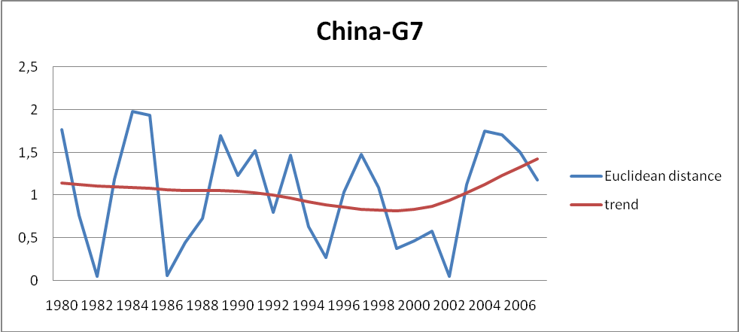
Figure 11: Graphical representation of the Euclidean distance between China and G7

- India
India appears to be very interdependent with all groups of advanced-market countries but with USA alone. Interdependence between India and all these three groups remains high and stable throughout all the sample years since the Euclidean distance is continuously closely moving to its trend (Figure 12, 14 and 15).
However according to the second criterion, the one that states that interdependence is also a function of the direction of India’s Euclidean distances compared to their trends, decoupling hypothesis cannot be safely accepted or rejected since in every Figure of India trends are moving to the opposite direction from Euclidean distances.
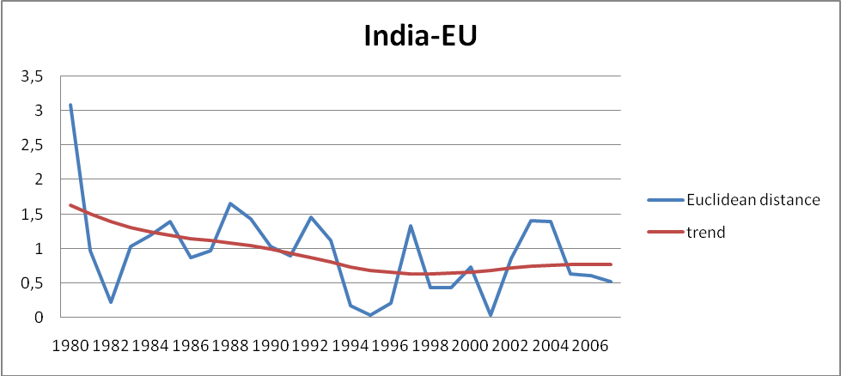
Figure 12: Graphical representation of the Euclidean distance between India and EU
On the other hand Euclidean distance between India and the USA appears to fluctuate a lot (Figure 13). The degree of non-interdependence seems to be stable and with high rate throughout the sample years including the recent years for which it can be regarded that the decoupling hypothesis partly confirms.
Therefore India’s business cycles are detached from the business cycles of USA in the majority of the sample years.
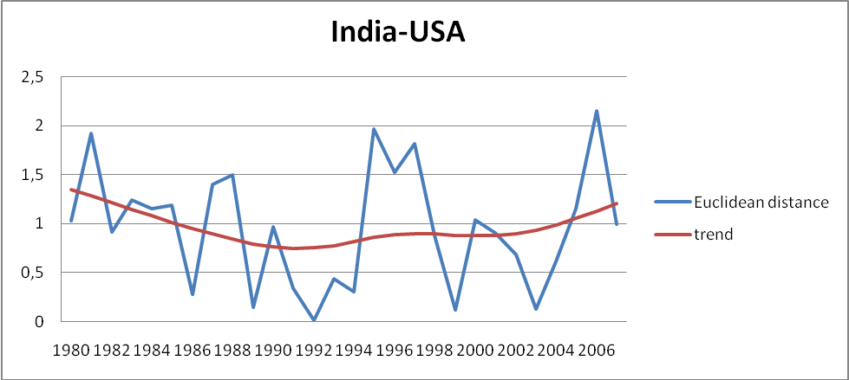
Figure 13: Graphical representation of the Euclidean distance between India and USA
Less degree of interdependence with the USA is also present here and the reason of the difference from the output gaps’ fluctuations of the other three groups is probably the same as with the other two EM economies, Brazil and China (unweighted average of individual output gaps as output gap of a group).

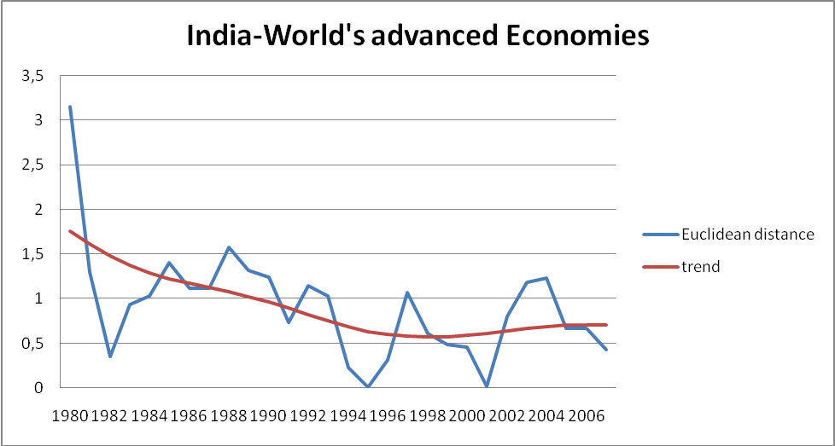
Figure 14: Graphical representation of the Euclidean distance and the World's advanced economies

The fluctuation of the Euclidean distance from its trend is smaller from 1999 onwards than it was during 1992 to 1998. Therefore although India’s Euclidean distance with the USA is fluctuating much more in comparison to the Euclidean distance from the other AM groups, it shows an increasing rate of interdependence in the last years of the sample. Therefore a safe conclusion about the decoupling hypothesis cannot be provided simply from the Euclidean distance.
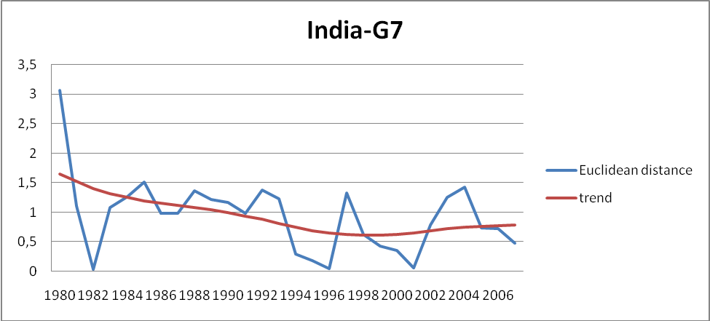
Figure 15: Graphical representation of the Euclidean distance between India and G7

- Russia
Russia appears to have the same attitude as India. Even though the data are less starting from 1992 instead of 1980 (which is the case for the other emerging countries) due to lack of GDP values in the years before 1992, the degree of interdependence is lower with the USA, while appears to show an increased rate of interdependence with the other three groups of countries implying rejection of the decoupling hypothesis in their cases (Figures 16, 18 and 19). At the same time however Euclidean distances are not always moving towards the same direction as their trends do so that clear-cut conclusions are not feasible to provide.
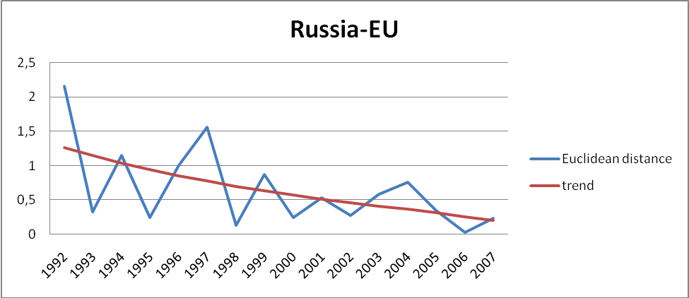
Figure 16: Graphical representation of the Euclidean distance between Russia and EU
Euclidean distance of Russia from the USA is similarly to the other EM countries’ corresponding Euclidean distances from the USA fluctuating a lot and simultaneously moving to different directions from its trend, implying non-interdependence (Figures 17 and 5, 9, 13).
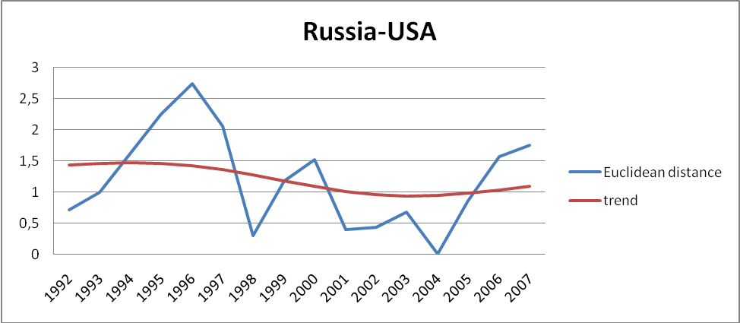
Figure 17: Graphical representation of the Euclidean distance between Russia and USA
Nevertheless the Euclidean distance between Russia and USA is in average lower during the recent years in comparison to older ones and thus meaning that interdependence is higher.
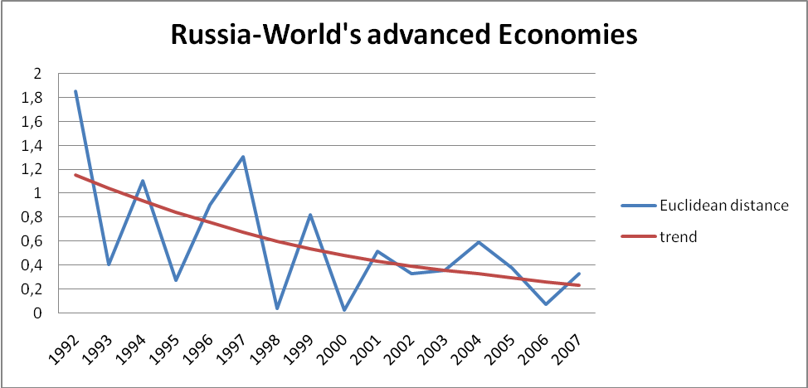
Figure 18: Graphical representation of the Euclidean distance between Russia and World's advanced economies
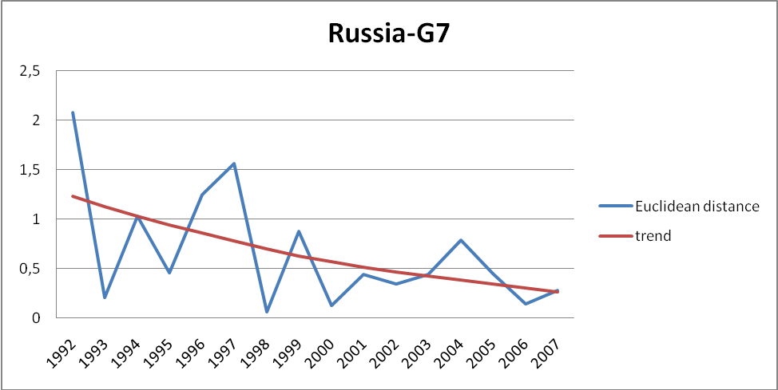
Figure 19: Graphical representation of the Euclidean distance between Russia and G7

- Emerging Markets
Supporting the graphical evidence of the individually tested countries, the graphical depiction of the EM countries as a group presents similar results to the preceding graphs.
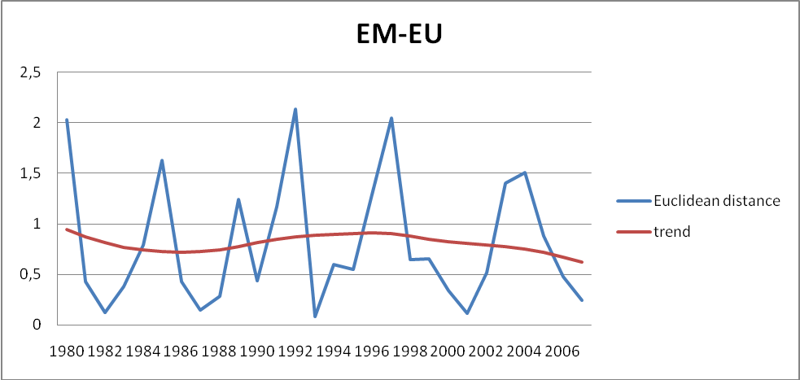
Figure 20: Graphical representation of the Euclidean distance between Emerging Markets and EU
EM economies against EU, World’s advanced economies and G7 show the same attitude as far as the degree of interdependence concerns (Figures 20, 22 and 23). Even though there is a tendency of less average distance between the Euclidean distance and its trend, clear-cut results about the decoupling hypothesis cannot be provided since the fluctuation of the line is not only downward sloping during the recent years (from 2000 onwards) but also upward sloping in a steep manner.
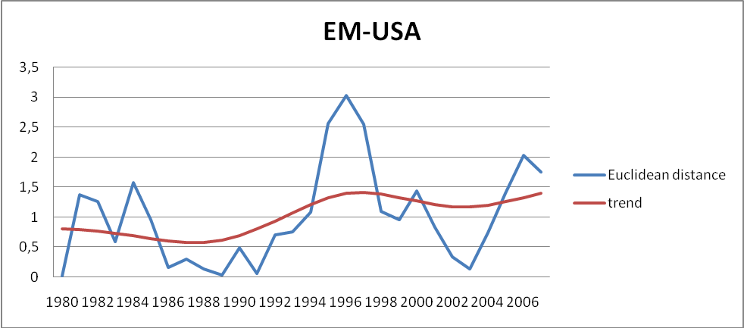
Figure 21: Graphical representation of the Euclidean distance between Emerging Markets and USA
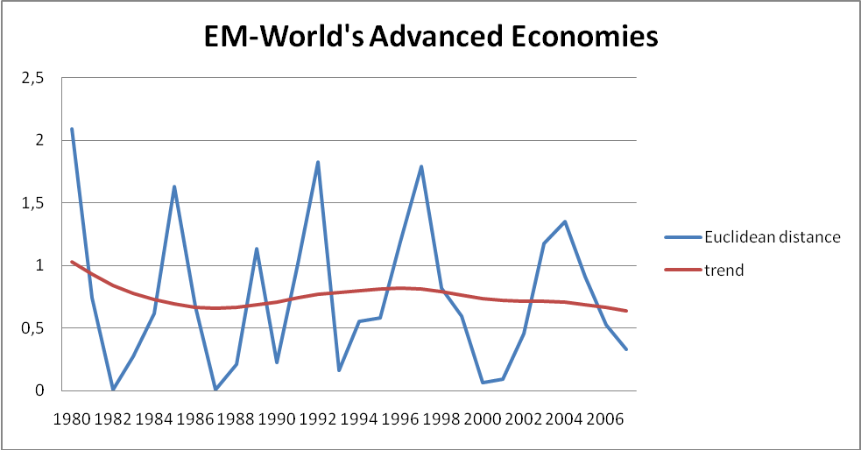
Figure 22: Graphical representation of the Euclidean distance between Emerging Markets and World's advanced economies
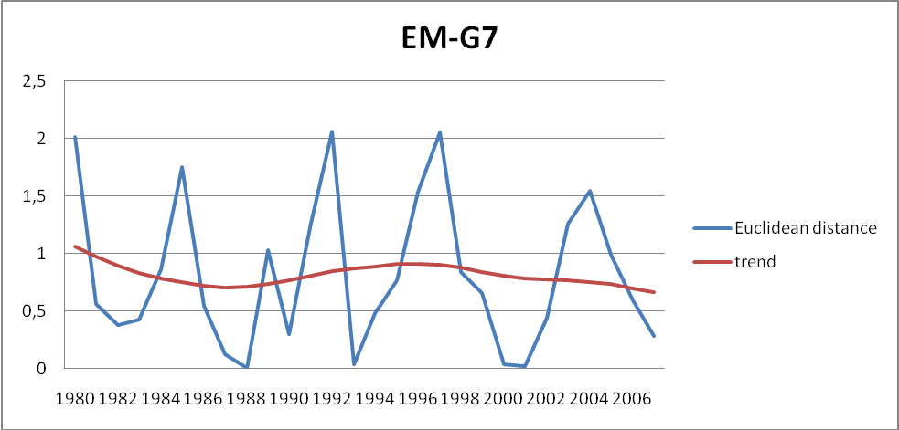
Figure 23: Graphical representation of the Euclidean distance between Emerging Markets and G7
On the other hand, Euclidean distance from the USA is consistent with all three EM countries’ relationship with the USA when are tested individually which present lower degree of interdependence since both the average fluctuations of the Euclidean distance are more intense throughout the sample years and the opposite sloping Euclidean distance from the trend are fulfilled (Figure 21).
Graphical depiction of the degree of interdependence does not lead up to safe results about the decoupling hypothesis because they need to be combined with econometric tests and in case they are aligned, they could possibly reveal the outcome and hence the decoupling hypothesis matter.

b. Econometric testing

- Brazil
The econometric tests for Brazil are gathered in the following table (Figure 24). In this table the coefficients of the regressions of the Brazilian business cycles on each of the advanced economies’ business cycles are depicted. The gammas are a direct test for the decoupling hypothesis. In order to support the decoupling hypothesis gammas need to be negative and statistically significant. Otherwise the decoupling hypothesis fails to be confirmed.
In these tests and when checking the values vertically (year by year), gammas are valued not only positive but also negative, implying confirmation of decoupling because a structural break takes place in 2000 against all the advanced economies.
 |  |  | Brazil
 | 2000 | 2001 | 2002 | 2003 | 2004 | 2005 | 2006 | 2007
USA β | 0,25 (0,02) | 0,22 (0,003) | 0,17 (0,004) | 0,17 (0,04) | 0,22 (0,003) | 0,25 (0,002) | 0,27 (0,01) | 0,25 (0,02)
structural break γ | -0,48 (0,008) | 2,14 (0,004) | 0,95 (0,02) | 0,84 (0,002) | 2,24 (0,003) | 1,15 (0,004) | 0,36 (0,06) | 0,07 (0,008)
E.U. β | 0,58 (0,02) | 0,55 (0,003) | 0,52 (0,004) | 0,55 (0,001) | 0,57 (0,001) | 0,56 (0,002) | 0,56 (0,002) | 0,56 (0,002)
structural break γ | -0,46 (0,005) | 0,15 (0,008) | 0,75 (0,003) | 0,60 (0,01) | 0,52 (0,01) | -0,62 (0,04) | 2,18 (0,008) | 0,02 (0,009)
World’s advanced Economies β | 0,63 (0,006) | 0,61 (0,001) | 0,58 (0,001) | 0,59 (0,006) | 0,62 (0,003) | 0,62 (0,006) | 0,61 (0.006) | 0,62 (0,007)
structural break γ | -0,46 (0,07) | 0,10  (0,09) | 0,63 (0,004) | 2,75 (0,01) | -0,12 (0,01) | 0,48 (0,04) | 1,59 (0,08) | 0,11 (0,009)
G-7 β | 0,54 (0,04) | 0,52 (0,006) | 0,49 (0,008) | 0,52 (0,004) | 0,55 (0,002) | 0,54 (0,004) | 0,54 (0,004) | 0,53 (0,004)
structural break γ | -0,34 (0,08) | 0,23 (0,007) | 0,71 (0,03) | 0,36 (0,01) | 0,46 (0,011) | -0,33 (0,046) | 1,20 (0,079) | 0,01 (0,009)
Figure 24: Table representations of econometric tests between Brazil and advanced economies
Significance level 95%, p-values in the parentheses

A possible explanation for a structural break in 2000 could be the dot-com bubble burst in the stock markets that started from the USA and from which all the AM economies suffered while the EM economy of Brazil might not participate and thus there is a decoupling sign; however from year 2000 onwards the decoupling hypothesis is rejected.
When checking the values horizontally (by group of advanced countries), we observe negative values of gammas basically in the year 2000 and during years 2004 and 2005. These results are partly aligned with the graphical results of the Euclidean distance that showed in average higher degree of interdependence during the years 1999 to 2007. Negative values in 2000 can be accepted but this cannot be the case for the values in 2004 and 2005 which imply less degree of interdependence, where Euclidean distance has been in average lower and thus point to the opposite result.

- China
When checking the coefficients’ values horizontally (Figure 25), we observe negative betas when China’s output gap is regressed against the USA, something that was not supposed to happen. However these negative betas have proved statistically insignificant so we can simply ignore them. As far as the gammas concerns, we can safely say that USA appears to have the most negative values, indicating that interdependence with China is lower (especially during the most recent years including those I tested for a structural break), result which is consistent with the graphical evidence before.
From an economic perspective it is rational since the Chinese economy continued booming the last decade showing high rates of GDP growth independently from the global recession while the low GDP growth rates of the US economy were dominant due to the same reason.
When we check for the coefficients’ values vertically, we can see gammas for the first (2000) and the last year of the tested sample (2007) for all the groups of advanced economies are negative (except for G7 gamma). So it seems that a structural break may have happened during each of these years. This can be consistent with the graphical depiction of interdependence since the lines around 2000 change sharply their slope in all of the graphs.
On the other hand 2007’s negative gamma cannot be observed clearly from the graphs, however economically may be caused by the recent financial crisis since some of its signs may have influenced GDPs earlier than the beginning of 2008, even if the years after 2007 have been excluded from the sample to avoid such a bias. Furthermore there have been some gammas which are inexplicably high.
 |  |  | China
 | 2000 | 2001 | 2002 | 2003 | 2004 | 2005 | 2006 | 2007
USA β | 0,02 (0,09) | 0,00 (0,09) | -0,06 (0,78) | -0,08 (0,68) | -0,02 (0,93) | 0,05 (0,008) | 0,10 (0,006) | 0,06 (0,008)
structural break γ | -0,40 (0,08) | 1,73 (0,005) | 0,98 (0,02) | 1,12 (0,001) | 3,01 (0,01) | -2,56 (0,01) | -0,94 (0,02) | -0,26 (0,006)
E.U. β | 0,27 (0,01) | 0,25 (0,021) | 0,23 (0,02) | 0,26 (0,01) | 0,29 (0,01) | 0,28 (0,014) | 0,28 (0,01) | 0,29 (0,01)
structural break γ | -0,04 (0,009) | 0,26 (0,007) | 0,82 (0,003) | 6,48 (0,001) | 5,89 (0,008) | 6,27 (0,002) | 0,71 (0,014) | -0,91 (0,007)
World’s advanced Economies β | 0,33 (0,095) | 0,32 (0,01) | 0,29 (0,015) | 0,31 (0,01) | 0,34 (0,072) | 0,34 (0,069) | 0,34 (0,07) | 0,35 (0,073)
structural break γ | -0,02 (0,009) | 0,20 (0,008) | 0,70 (0,004) | 3,12 (0,015) | 4,40 (0,01) | 2,12 (0,01) | 0,40 (0,015) | -0,91 (0,005)
G-7 β | 0,27 (0,002) | 0,25 (0,021) | 0,22 (0,003) | 0,25 (0,018) | 0,29 (0,012) | 0,28 (0,013) | 0,28 (0,014) | 0,29 (0,015)
structural break γ | 0,09 (0,009) | 0,30 (0,007) | 0,76 (0,004) | 3,95 (0,015) | 5,23 (0,011) | 0,80 (0,001) | 0,71 (0,016) | -0,88 (0,005)
Figure 25: Table representations of econometric tests between China and advanced economies
Significance level 95%, p-values in the parentheses

- India
When we take a closer look to the gammas horizontally we can see some negative values in 2000, 2005 and 2006 (Figure 26) which confirms the graphical evidence for lower degree of interdependence between India and USA (Figure 13). So in combination with the graphical depiction of the Euclidean distance we can conclude to confirmation of the decoupling hypothesis between India and the USA.
Against all other groups of countries, India appears to have a high degree of interdependence. Some individual negative and very high positive gammas have appeared in the regressions as well but they have proved statistically insignificant (high p-values) so we can ignore their influence.
Economically, Indian economy depends a lot to the AM economies. The economic bond through imports and exports with the UK and thus with the rest of Europe provokes the high degree of interdependence with all the groups of AM economies. On the other hand the economy of India appears to decouple from the USA’s economy since both types of testing (graphical and econometric) indicate less degree of interdependence implying the detachment of the two economies during the sample years.
 |  |  | India
 | 2000 | 2001 | 2002 | 2003 | 2004 | 2005 | 2006 | 2007
USA β | 0,35 (0,07) | 0,32 (0,009) | 0,25 (0,018) | 0,27 (0,017) | 0,32 (0,09) | 0,36 (0,06) | 0,41 (0,04) | 0,29 (0,017)
structural break γ | -0,91 (0,005) | 2,98 (0,02) | 1,30 (0,08) | 0,85 (0,021) | 1,99 (0,003) | -1,26 (0,043) | -0,77 (0,023) | 0,28 (0,005)
E.U. β | 0,35 (0,07) | 0,30 (0,012) | 0,27 (0,014) | 0,34 (0,06) | 0,36 (0,05) | 0,35 (0,06) | 0,35 (0,06) | 0,32 (0,09)
structural break γ | -0,02 (0,009) | 0,69 (0,003) | 1,50 (0,07) | 1,70 (0,09) | 4,71 (0,02) | 0,61 (0,055) | 0,72 (0,005) | 1,47 (0,003)
World’s advanced Economies β | 0,38 (0,05) | 0,34 (0,08) | 0,30 (0,01) | 0,36 (0,05) | 0,39 (0,041) | 0,38 (0,046) | 0,38 (0,047) | 0,35 (0,06)
structural break γ | 0,06 (0,09) | 0,67 (0,037) | 1,39 (0,07) | 3,38 (0,01) | 1,28 (0,021) | 1,59 (0,05) | 2,47 (0,005) | 1,23 (0,003)
G-7 β | 0,35 (0,07) | 0,31 (0,01) | 0,27 (0,014) | 0,33 (0,07) | 0,37 (0,05) | 0,36 (0,06) | 0,36 (0,06) | 0,32 (0,09)
structural break γ | 0,16 (0,009) | 0,76 (0,034) | 1,41 (0,07) | 4,24 (0,11) | -0,420 (0,19) | 0,31 (0,02) | 0,31 (0,005) | 1,36 (0,03)
Figure 26: Table representations of econometric tests between India and advanced economies
Significance level 95%, p-values in the parentheses
- Russia
Russia’s results also comply with the corresponding graphical evidence. Negative gammas are met only in the regressions against the USA that indicate decreased degree of business cycle interdependence between the two countries. However there have been some statistically significant negative betas as well, whose values cannot be rationally explained (Figure 27).
Against all other groups of advanced economies, Russia indicates higher degree of business cycle interdependence, rejecting the null hypothesis of decoupling and confirming the graphical evidence of Euclidean distance as the measure of interdependence.
The econometric evidence below enhances the ambiguous result of the Euclidean distance between Russia and the USA that now is clear-cut confirmed. Decoupling of Russia from the USA is present.
 |  |  | Russia
 | 2000 | 2001 | 2002 | 2003 | 2004 | 2005 | 2006 | 2007
USA β | 0,00 (0,009) | -0,03 (0,008) | -0,10 (0,007) | -0,11 (0,071) | -0,03 (0,09) | -0,01 (0,009) | -0,04 (0,09) | -0,17 (0,063)
structural break γ | -0,02 (0,008) | 2,14 (0,043) | 0,81 (0,034) | 0,68 (0,039) | -1,05 (0,006) | -0,41 (0,08) | -0,08 (0,09) | 0,42 (0,05)
E.U. β | 0,68 (0,08) | 0,73 (0,07) | 0,68 (0,08) | 0,68 (0,05) | 0,73 (0,04) | 0,70 (0,05) | 0,70 (0,05) | 0,70 (0,06)
Structural break γ | 0,11 (0,009) | 0,12 (0,008) | 0,10 (0,009) | 3,09 (0,04) | 2,75 (0,05) | 3,58 (0,07) | 0,15 (0,009) | 0,05 (0,009)
World’s advanced Economies β | 0,87 (0,02) | 0,98 (0,01) | 0,93 (0,02) | 0,86 (0,01) | 0,90 (0,01) | 0,90 (0,01) | 0,89 (0,01) | 0,93 (0,02)
structural break γ | 0,20 (0,008) | 0,37 (0,006) | 0,19 (0,008) | 1,05 (0,005) | 0,61 (0,045) | 3,16 (0,063) | 0,71 (0,009) | 0,39 (0,007)
G-7 β | 0,70 (0,09) | 0,77 (0,09) | 0,74 (0,01) | 0,71 (0,076) | 0,78 (0,05) | 0,75 (0,06) | 0,74 (0,06) | 0,75 (0,074)
structural break γ | 0,53 (0,07) | 0,12 (0,009) | 0,01 (0,09) | 1,62 (0,054) | 2,56 (0,042) | 2,15 (0,065) | 0,54 (0,009) | 0,14 (0,008)
Figure 27: Table representations of econometric tests between Russia and advanced economies
Significance level 95%, p-values in the parentheses
From an economic perspective Russia’s decoupling indication from the USA and the rejection of this hypothesis against the other AM groups is based on the lower degree of economic relations between these two countries which have been undeniably affected by their political relations during all the preceding years. Therefore the business cycles of these two countries are differentiating in high rate.
In contradiction to this result the highly developed economic relations between Russia and the rest of the AM world creates an obviously higher degree of interdependence.
- Emerging Markets
The results in the table below (Figure 28) are also aligned with the results on the preceding tables and the graphical depiction of the Euclidean distance of the EM simultaneously.
 |  |  | Emerging Markets
 | 2000 | 2001 | 2002 | 2003 | 2004 | 2005 | 2006 | 2007
USA (β) | 0,18 (0,036) | 0,15 (0,047) | 0,08 (0,068) | 0,08 (0,07) | 0,14 (0,048) | 0,18 (0,037) | 0,21 (0,034) | 0,15 (0,052)
structural break (γ) | -1,25 (0,042) | 2,84 (0,027) | 1,17 (0,014) | 1,01 (0,017) | 2,32 (0,027) | -1,40 (0,041) | -0,43 (0,043) | -0,09 (0,008)
E.U. (β) | 0,49 (0,01) | 0,47 (0,02) | 0,44 (0,02) | 0,48 (0,009) | 0,51 (0,007) | 0,50 (0,009) | 0,50 (0,01) | 0,49 (0,01)
structural break (γ) | 0,16 (0,009) | 0,43 (0,055) | 0,98 (0,023) | 6,62 (0,10) | 5,13 (0,014) | 4,24 (0,039) | 4,93 (0,067) | 0,26 (0,009)
Advanced Economies (β) | 0,55 (0,003) | 0,54 (0,005) | 0,51 (0,005) | 0,54 (0,03) | 0,56 (0,002) | 0,56 (0,002) | 0,56 (0,003) | 0,56 (0,003)
structural break (γ) | 0,31 (0,008) | 0,37 (0,06) | 0,84 (0,026) | 3,07 (0,012) | 2,16 (0,014) | 6,27 (0,036) | 3,22 (0,06) | 0,10 (0,009)
G-7 (β) | 0,46 (0,01) | 0,44 (0,025) | 0,42 (0,003) | 0,45 (0,01) | 0,49 (0,009) | 0,48 (0,01) | 0,48 (0,01) | 0,47 (0,01)
structural break (γ) | 0,53 (0,007) | 0,52 (0,05) | 0,92 (0,024) | 3,97 (0,012) | -4,57 (0,14) | -4,20 (0,37) | -2,27 (0,64) | 0,24 (0,009)
Figure 28: Table representations of econometric tests between Emerging Markets and advanced economies
Significance level 95%, p-values in the parentheses
Figure 28 shows coefficients that come from the standardized output gaps of the individual EM countries that were regressed against the output gaps of the AM economies groups. Through this effort it is accomplished a more integrated view of the decoupling hypothesis, since the previous results that show each individual country’s degree of interdependence with the AM groups, can be now supported by a more aggregate way of testing.
The gammas we observe are mostly positive with the exception of USA in which four out of eight years of the sample indicate the presence of a structural break and thus a lower degree of business cycle interdependence. This result provides additive proof for the acceptance of the decoupling hypothesis that all the EM economies individually showed against the USA.
From an economic rational this result can be explained by the same reasons that each of the four EM countries tested are decoupling from the USA (The dot-com bubble for the case of Brazil, the high growth rates of GDP for the case of China, the detachment of India from the US economy and the lower degree of economic relations due to political relations with the USA for the case of Russia).
Nevertheless the econometric tests of the EM output gap showed unexpectedly high and negative coefficients in the case of G7 indicating structural breaks. However the coefficients were not statistically significant and thus the misalignment with the graphical evidence of G7 cannot be explained.
To sum up, these last results (EM economies against AM economies) depict that the possible explanations given earlier for the indications of decoupling of the individual EM countries from the USA (the reason given was that single country was tested against group) are rejected. Even after the data were pooled and the output gap expressed the business cycle of four EM countries simultaneously, the decoupling indication sustained.

Conclusion

All in all, both kinds of testing showed that the decoupling hypothesis of these four strong emerging economies is widely rejected during the sample years while at the same time decoupling of the business cycles is confirmed against the USA according to the data and the methodology which was followed. This result contradicts to previous studies and especially to Walti’s research that have shown no signs of decoupling between emerging- and advanced-market economies in any of the tested groups of advanced economies.
Furthermore Russia shows the higher degree of business cycle interdependence with the three groups of advanced economies (not with USA) and India the second higher degree of interdependence again with the same three groups for all the sample years (especially during the recent years) in comparison to Brazil and China which show lower degree of business cycle synchronization throughout the sample years.
However even with lower degree of interdependence Brazil and China still show tension of decoupling during the recent years since their Euclidean distance from each of the three groups of advanced economies are in average declining from year 2000 onwards.
Moreover exceptions from the decoupling-hypothesis rejection in which emerging markets have shown growth outperformance have been also met by Levy-Yeyati (2009), whose econometric methodology is followed in this research. The four emerging economies that were tested in this research are definitely regarded to outperform with their high GDP growth rates and thus are likely to match with the exceptions observed from Levy-Yeyati (2009).
One possible reason for the decoupling signs between the emerging economies and the USA is that in this thesis are used single emerging countries to test against groups of countries (advanced-market economies). Walti in his research tests groups of emerging economies (separated by region e.g. Latin America, Asia and Eastern Europe). Therefore the output gap of a group can have a different effect on the final value and the result is to influence the Euclidean distances that show higher degree of interdependence.
However this reason is obviously rejected since the emerging market countries showed significant degree of non-dependence also when tested in an aggregate manner (as a group of countries).
Therefore it can be supported that decoupling of these four emerging market economies from the USA is a fact since all of the indications lead to the same conclusion.
To conclude, further research in the decoupling hypothesis needs to be conducted in the next years and upcoming results would be quite interesting when researchers use data in their samples that include the recent financial crisis and the worldwide recession that followed.

References

- Artis, M. and Zhang, W. (1997) International business cycles and the ERM: is there a European business cycle?, International Journal of Finance and Economics 2, 1-16.

- Artis, M. and Zhang, W. (1999) Further evidence on the international business cycle and the ERM: is there a European business cycle?, Oxford Economic Papers 51, 120-132.

- Baxter, M. and Kouparitsas, M. (2005) Determinants of business cycle co movement: a robust analysis, Journal of Monetary Economics 52, 113-157.

- Doyle, B. and Faust, J. (2005) Breaks in the variability and co movement of G-7 economic growth, Review of Economics and Statistics 87, 721-740.

- Fidrmuc, J. and Korhonen, I. (2006), Meta-analysis of the business cycle correlation between the euro area and the CEECs, Journal of Comparative Economics 34, 518-537.

- Flood, R. and Rose, A. (2009), Inflation targeting and business cycle synchronization, CEPR Working Paper 7377.

- Frankel, J. and Rose, A. (1998) The endogeneity of the optimum currency area criteria, The Economic Journal 108, 1009-1025.

- Imbs, J. (2004) Trade, Finance, specialization, and synchronization, Review of Economics and Statistics 86, 723-734.

- Imbs, J. (2006) The real effects of financial integration, Journal of International Economics 68, 296-324.

- Inklaar, R. and de Haan, J. (2001) Is there really a European business cycle? A comment, Oxford Economic Papers 53, 215-220.

- Kose, M., Prasad, E. and Terrones, M. (2003) How does globalization affect the synchronization of business cycles? , American Economic Review 93, 57-62.

- Kose, A., Otrok, C. and Prasad, E. (2008) Global business cycles: convergence or decoupling? , NBER Working Paper 14292.

- Levy-Yeyati, E. (2009), On emerging markets decoupling and growth convergence, VoxEU.org.

- Mink, M., Jacobs, J. and de Haan, J. (2007) Measuring synchronicity and co movement of business cycles with an application to the euro area, CESifo Working Paper 2112.

- Ravn, M. and Uhlig, H. (2002) On adjusting the Hodrick-Prescott filter for the frequency of observations, Review of Economics and Statistics 84, 371-375.

- Rose, A. and Engel, C. (2002) Currency unions and international integration, Journal of Money, Credit and Banking 34, 1067-1089.

- Walti, S. (2009), The myth of decoupling, manuscript, Swiss National Bank.

- Walti, S. (2010), No decoupling, more interdependence: business cycle co movements between advanced and emerging economies, Swiss National Bank.

- http://www.imf.org/external/index.htm

- http://www.wikipedia.org/

Appendix

Euclidean distances between Brazil and groups of Advanced-market economies | year | U.S.A. | E.U. | Advanced economies | G-7
 | 1980 | 0,54 | 1,51 | 1,58 | 1,50
 | 1981 | 0,85 | 0,10 | 0,22 | 0,04
 | 1982 | 1,71 | 0,57 | 0,44 | 0,83
 | 1983 | 0,05 | 0,16 | 0,26 | 0,11
 | 1984 | 2,24 | 0,12 | 0,06 | 0,19
 | 1985 | 0,86 | 1,72 | 1,73 | 1,85
 | 1986 | 0,03 | 0,62 | 0,87 | 0,73
 | 1987 | 0,20 | 0,24 | 0,09 | 0,22
 | 1988 | 0,50 | 0,36 | 0,44 | 0,65
 | 1989 | 0,15 | 1,13 | 1,02 | 0,91
 | 1990 | 0,31 | 0,26 | 0,05 | 0,12
 | 1991 | 0,18 | 1,05 | 0,89 | 1,14
 | 1992 | 0,34 | 1,78 | 1,47 | 1,70
 | 1993 | 0,19 | 0,48 | 0,40 | 0,60
 | 1994 | 0,59 | 0,10 | 0,06 | 0,01
 | 1995 | 2,31 | 0,30 | 0,33 | 0,52
 | 1996 | 2,59 | 0,86 | 0,75 | 1,10
 | 1997 | 2,27 | 1,78 | 1,52 | 1,78
 | 1998 | 1,97 | 1,53 | 1,70 | 1,73
 | 1999 | 0,52 | 0,21 | 0,16 | 0,22
 | 2000 | 0,84 | 0,94 | 0,67 | 0,57
 | 2001 | 0,53 | 0,41 | 0,39 | 0,32
 | 2002 | 0,12 | 0,29 | 0,23 | 0,22
 | 2003 | 0,03 | 1,23 | 1,01 | 1,10
 | 2004 | 0,69 | 1,46 | 1,30 | 1,49
 | 2005 | 1,15 | 0,63 | 0,66 | 0,74
 | 2006 | 1,75 | 0,20 | 0,26 | 0,32
 | 2007 | 1,82 | 0,30 | 0,39 | 0,34

Euclidean distances between China and groups of Advanced-market economies | year | U.S.A. | E.U. | Advanced economies | G-7
 | 1980 | 0,27 | 1,78 | 1,85 | 1,77
 | 1981 | 1,58 | 0,63 | 0,95 | 0,77
 | 1982 | 0,94 | 0,21 | 0,33 | 0,05
 | 1983 | 1,35 | 1,14 | 1,03 | 1,19
 | 1984 | 0,45 | 1,90 | 1,73 | 1,98
 | 1985 | 0,77 | 1,81 | 1,82 | 1,94
 | 1986 | 0,65 | 0,06 | 0,19 | 0,06
 | 1987 | 0,02 | 0,46 | 0,31 | 0,44
 | 1988 | 0,87 | 1,02 | 0,94 | 0,73
 | 1989 | 0,63 | 1,90 | 1,80 | 1,69
 | 1990 | 1,43 | 1,37 | 1,16 | 1,23
 | 1991 | 0,20 | 1,43 | 1,27 | 1,52
 | 1992 | 0,56 | 0,87 | 0,57 | 0,80
 | 1993 | 2,25 | 1,58 | 1,66 | 1,46
 | 1994 | 0,03 | 0,51 | 0,56 | 0,63
 | 1995 | 2,06 | 0,05 | 0,09 | 0,27
 | 1996 | 2,52 | 0,79 | 0,69 | 1,03
 | 1997 | 1,96 | 1,47 | 1,21 | 1,47
 | 1998 | 1,34 | 0,89 | 1,06 | 1,09
 | 1999 | 0,07 | 0,38 | 0,43 | 0,37
 | 2000 | 0,94 | 0,84 | 0,56 | 0,46
 | 2001 | 0,27 | 0,67 | 0,65 | 0,58
 | 2002 | 0,15 | 0,02 | 0,04 | 0,05
 | 2003 | 0,00 | 1,27 | 1,04 | 1,13
 | 2004 | 0,94 | 1,71 | 1,55 | 1,75
 | 2005 | 2,13 | 1,60 | 1,64 | 1,71
 | 2006 | 2,93 | 1,38 | 1,43 | 1,50
 | 2007 | 2,65 | 1,13 | 1,23 | 1,18

Euclidean distances between India and groups of Advanced-market economies | year | U.S.A. | E.U. | Advanced economies | G-7
 | 1980 | 1,03 | 3,08 | 3,15 | 3,07
 | 1981 | 1,92 | 0,97 | 1,29 | 1,11
 | 1982 | 0,92 | 0,23 | 0,35 | 0,03
 | 1983 | 1,25 | 1,04 | 0,93 | 1,08
 | 1984 | 1,16 | 1,20 | 1,02 | 1,27
 | 1985 | 1,19 | 1,39 | 1,40 | 1,52
 | 1986 | 0,28 | 0,87 | 1,12 | 0,99
 | 1987 | 1,40 | 0,96 | 1,12 | 0,98
 | 1988 | 1,51 | 1,65 | 1,57 | 1,36
 | 1989 | 0,15 | 1,43 | 1,32 | 1,21
 | 1990 | 0,97 | 1,03 | 1,24 | 1,17
 | 1991 | 0,34 | 0,89 | 0,74 | 0,98
 | 1992 | 0,02 | 1,45 | 1,15 | 1,38
 | 1993 | 0,44 | 1,12 | 1,03 | 1,23
 | 1994 | 0,31 | 0,18 | 0,22 | 0,29
 | 1995 | 1,97 | 0,04 | 0,01 | 0,18
 | 1996 | 1,53 | 0,20 | 0,31 | 0,04
 | 1997 | 1,82 | 1,33 | 1,07 | 1,33
 | 1998 | 0,88 | 0,43 | 0,61 | 0,63
 | 1999 | 0,12 | 0,44 | 0,49 | 0,43
 | 2000 | 1,04 | 0,73 | 0,46 | 0,36
 | 2001 | 0,91 | 0,04 | 0,02 | 0,05
 | 2002 | 0,69 | 0,86 | 0,80 | 0,79
 | 2003 | 0,13 | 1,40 | 1,18 | 1,26
 | 2004 | 0,62 | 1,39 | 1,23 | 1,42
 | 2005 | 1,16 | 0,63 | 0,67 | 0,74
 | 2006 | 2,15 | 0,61 | 0,66 | 0,73
 | 2007 | 0,99 | 0,52 | 0,43 | 0,48

Euclidean distances between Russia and groups of Advanced-market economies | year | U.S.A. | E.U. | Advanced economies | G-7
 | 1992 | 0,72 | 2,16 | 1,85 | 2,08
 | 1993 | 1,00 | 0,33 | 0,41 | 0,21
 | 1994 | 1,63 | 1,15 | 1,10 | 1,03
 | 1995 | 2,25 | 0,24 | 0,27 | 0,46
 | 1996 | 2,74 | 1,01 | 0,90 | 1,25
 | 1997 | 2,06 | 1,56 | 1,30 | 1,56
 | 1998 | 0,31 | 0,13 | 0,04 | 0,06
 | 1999 | 1,18 | 0,87 | 0,82 | 0,88
 | 2000 | 1,53 | 0,24 | 0,03 | 0,13
 | 2001 | 0,41 | 0,53 | 0,52 | 0,44
 | 2002 | 0,45 | 0,27 | 0,33 | 0,34
 | 2003 | 0,69 | 0,58 | 0,36 | 0,44
 | 2004 | 0,02 | 0,75 | 0,59 | 0,79
 | 2005 | 0,87 | 0,35 | 0,38 | 0,45
 | 2006 | 1,57 | 0,03 | 0,08 | 0,14
 | 2007 | 1,75 | 0,24 | 0,33 | 0,28

Euclidean distances between Emerging-Market economies group and groups of Advanced-Market economies | year | U.S.A. | E.U. | Advanced Economies | G7
 | 1980 | 0,02 | 2,03 | 2,09 | 2,02
 | 1981 | 1,37 | 0,42 | 0,74 | 0,56
 | 1982 | 1,26 | 0,12 | 0,01 | 0,38
 | 1983 | 0,59 | 0,38 | 0,27 | 0,42
 | 1984 | 1,57 | 0,79 | 0,61 | 0,86
 | 1985 | 0,95 | 1,63 | 1,63 | 1,75
 | 1986 | 0,17 | 0,42 | 0,67 | 0,54
 | 1987 | 0,30 | 0,14 | 0,01 | 0,13
 | 1988 | 0,14 | 0,28 | 0,21 | 0,00
 | 1989 | 0,03 | 1,24 | 1,14 | 1,03
 | 1990 | 0,49 | 0,44 | 0,22 | 0,30
 | 1991 | 0,06 | 1,17 | 1,01 | 1,26
 | 1992 | 0,70 | 2,14 | 1,83 | 2,06
 | 1993 | 0,76 | 0,08 | 0,16 | 0,04
 | 1994 | 1,08 | 0,60 | 0,56 | 0,48
 | 1995 | 2,56 | 0,55 | 0,58 | 0,77
 | 1996 | 3,02 | 1,29 | 1,19 | 1,54
 | 1997 | 2,54 | 2,05 | 1,79 | 2,05
 | 1998 | 1,09 | 0,64 | 0,82 | 0,84
 | 1999 | 0,96 | 0,65 | 0,60 | 0,65
 | 2000 | 1,44 | 0,34 | 0,07 | 0,04
 | 2001 | 0,83 | 0,11 | 0,09 | 0,02
 | 2002 | 0,34 | 0,51 | 0,45 | 0,44
 | 2003 | 0,13 | 1,40 | 1,18 | 1,26
 | 2004 | 0,74 | 1,51 | 1,35 | 1,55
 | 2005 | 1,40 | 0,88 | 0,91 | 0,98
 | 2006 | 2,02 | 0,47 | 0,53 | 0,59
 | 2007 | 1,76 | 0,24 | 0,33 | 0,28

Output gaps of Emerging-market Economies | year | Brazil output gap | China output gap | India output gap | Russia output gap | EM output gap
Output gaps of Emerging-market Economies | 1980 | 1,45 | 1,18 | -0,12 | - | 0,94
Output gaps of Emerging-market Economies | 1981 | 1,13 | 0,40 | 0,05 | - | 0,60
Output gaps of Emerging-market Economies | 1982 | 0,59 | -0,19 | -0,21 | - | 0,14
Output gaps of Emerging-market Economies | 1983 | -1,04 | 0,25 | 0,15 | - | -0,51
Output gaps of Emerging-market Economies | 1984 | -1,53 | 0,26 | -0,44 | - | -0,86
Output gaps of Emerging-market Economies | 1985 | -0,26 | -0,17 | -0,59 | - | -0,35
Output gaps of Emerging-market Economies | 1986 | -0,13 | -0,81 | 0,12 | - | -0,33
Output gaps of Emerging-market Economies | 1987 | -0,26 | -0,48 | 0,95 | - | -0,16
Output gaps of Emerging-market Economies | 1988 | -0,22 | 1,15 | 1,78 | - | 0,42
Output gaps of Emerging-market Economies | 1989 | 0,90 | 1,68 | 1,20 | - | 1,02
Output gaps of Emerging-market Economies | 1990 | 0,64 | -0,47 | 1,93 | - | 0,46
Output gaps of Emerging-market Economies | 1991 | -0,36 | -0,74 | -0,20 | - | -0,48
Output gaps of Emerging-market Economies | 1992 | -0,81 | 0,09 | -0,48 | 3,02 | -1,17
Output gaps of Emerging-market Economies | 1993 | -0,59 | 1,47 | -1,22 | 1,95 | -0,03
Output gaps of Emerging-market Economies | 1994 | 0,17 | -0,45 | -0,11 | -1,71 | 0,66
Output gaps of Emerging-market Economies | 1995 | 1,32 | 1,08 | 0,99 | -7,30 | 1,57
Output gaps of Emerging-market Economies | 1996 | 1,67 | 1,60 | 0,61 | -8,99 | 2,11
Output gaps of Emerging-market Economies | 1997 | 1,78 | 1,47 | 1,32 | -9,50 | 2,05
Output gaps of Emerging-market Economies | 1998 | 1,49 | 0,85 | 0,39 | -8,10 | 0,60
Output gaps of Emerging-market Economies | 1999 | -0,46 | 0,12 | 0,18 | 1,33 | -0,90
Output gaps of Emerging-market Economies | 2000 | -0,15 | -0,25 | -0,36 | -0,18 | -0,75
Output gaps of Emerging-market Economies | 2001 | -0,94 | -0,69 | -1,32 | 3,64 | -1,24
Output gaps of Emerging-market Economies | 2002 | -1,48 | -1,21 | -2,05 | 6,24 | -1,70
Output gaps of Emerging-market Economies | 2003 | -1,46 | -1,50 | -1,63 | 6,17 | -1,63
Output gaps of Emerging-market Economies | 2004 | -1,19 | -1,45 | -1,12 | 4,83 | -1,24
Output gaps of Emerging-market Economies | 2005 | -0,53 | -1,50 | -0,54 | 1,66 | -0,78
Output gaps of Emerging-market Economies | 2006 | -0,12 | -1,30 | -0,53 | -0,31 | -0,39
Output gaps of Emerging-market Economies | 2007 | 0,41 | -0,42 | 1,24 | -2,91 | 0,48
Output gaps of Emerging-market Economies | 2008 | 0,79 | 1,17 | 1,17 | -4,72 | 1,21
Output gaps of Emerging-market Economies | 2009 | 0,07 | 0,82 | 0,24 | -1,24 | -0,06
Output gaps of Emerging-market Economies | 2010 | 0,58 | 0,65 | 0,51 | -3,70 | 0,33

Output gaps of Advanced-market Economies | year | USA output gap | E.U. output gap | Advanced Economies output gap | G-7 output gap
Output gaps of Advanced-market Economies | 1980 | 0,92 | 2,97 | 3,03 | 2,95
Output gaps of Advanced-market Economies | 1981 | 1,98 | 1,03 | 1,35 | 1,17
Output gaps of Advanced-market Economies | 1982 | -1,13 | 0,02 | 0,15 | -0,24
Output gaps of Advanced-market Economies | 1983 | -1,10 | -0,89 | -0,78 | -0,94
Output gaps of Advanced-market Economies | 1984 | 0,71 | -1,64 | -1,47 | -1,72
Output gaps of Advanced-market Economies | 1985 | 0,60 | -1,98 | -1,98 | -2,11
Output gaps of Advanced-market Economies | 1986 | -0,16 | -0,75 | -1,00 | -0,87
Output gaps of Advanced-market Economies | 1987 | -0,46 | -0,02 | -0,17 | -0,03
Output gaps of Advanced-market Economies | 1988 | 0,28 | 0,13 | 0,21 | 0,42
Output gaps of Advanced-market Economies | 1989 | 1,05 | -0,22 | -0,12 | -0,01
Output gaps of Advanced-market Economies | 1990 | 0,95 | 0,90 | 0,69 | 0,76
Output gaps of Advanced-market Economies | 1991 | -0,54 | 0,69 | 0,54 | 0,79
Output gaps of Advanced-market Economies | 1992 | -0,47 | 0,97 | 0,66 | 0,89
Output gaps of Advanced-market Economies | 1993 | -0,78 | -0,11 | -0,19 | 0,01
Output gaps of Advanced-market Economies | 1994 | -0,42 | 0,07 | 0,11 | 0,18
Output gaps of Advanced-market Economies | 1995 | -0,98 | 1,02 | 0,99 | 0,80
Output gaps of Advanced-market Economies | 1996 | -0,92 | 0,81 | 0,92 | 0,57
Output gaps of Advanced-market Economies | 1997 | -0,50 | 0,00 | 0,26 | 0,00
Output gaps of Advanced-market Economies | 1998 | -0,49 | -0,04 | -0,21 | -0,24
Output gaps of Advanced-market Economies | 1999 | 0,06 | -0,25 | -0,30 | -0,25
Output gaps of Advanced-market Economies | 2000 | 0,68 | -1,09 | -0,82 | -0,72
Output gaps of Advanced-market Economies | 2001 | -0,41 | -1,35 | -1,34 | -1,26
Output gaps of Advanced-market Economies | 2002 | -1,36 | -1,19 | -1,25 | -1,26
Output gaps of Advanced-market Economies | 2003 | -1,50 | -0,23 | -0,45 | -0,37
Output gaps of Advanced-market Economies | 2004 | -0,50 | 0,27 | 0,11 | 0,30
Output gaps of Advanced-market Economies | 2005 | 0,62 | 0,10 | 0,13 | 0,20
Output gaps of Advanced-market Economies | 2006 | 1,63 | 0,08 | 0,13 | 0,20
Output gaps of Advanced-market Economies | 2007 | 2,23 | 0,71 | 0,81 | 0,76
Output gaps of Advanced-market Economies | 2008 | 1,46 | 1,04 | 0,93 | 0,92
Output gaps of Advanced-market Economies | 2009 | -1,54 | -0,11 | -0,34 | -0,32
Output gaps of Advanced-market Economies | 2010 | -1,34 | -0,50 | -0,37 | -0,37

