 | 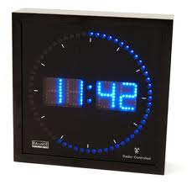 |  |  |  |  | 
 |  | Continuous Auditing/ Continuous Monitoring
 |  | The use in practice in The Netherlands
 | Erasmus School of Economics | K.B.Khargi
 | Erasmus School of Economics |  |  | 
 | Erasmus School of Economics |  |  | 
 | Erasmus School of Economics |  |  |  |  |  | 
 |  | Bachelor Thesis Economics & Informatics
 |  | Economics & ICT programme  Student ID: 275859  EUR Supervisor:  Prof. Dr. G.J.van der Pijl  Co-reader: Ing.A.A.C. de Visser  16 November 2010  Thesis ID |  |  |  | 

Bachelor Thesis Economics & ICT
Continuous Auditing/ Continuous Monitoring:
The use in practice in The Netherlands




Acknowledgement
Name: Kavita Khargi
Student ID: 275859
E-mail: kavitakhargi@hotmail.com
275859kk@student.eur.nl
version: Final draft

I thank my parents for my careless childhood and stimulating me during education and giving me space to succeed in everything I was doing. When I was without it, then I knew what I was missing.

This thesis would not have been possible without the interviewees. I thank them for their precious time, and for sharing their experience with CA/CM with me: Erwin Albers, Farida Chotkan. Ad van Dijke, Marco Hill, Faried Ibrahim, Anton Lissone, Mark Lof and Eric Pols.

I thank the people of KPMG forensic technology for giving me the opportunity to do an internship and meet professionals in CA/CM.

When I was down-hearted and had absolutely no hope for my study I turned to the ESSC. I really appreciate the help I got from Wendy Pelkmans, Sachlan Apil and Mr. B. den Boogert.

Furthermore I thank my friends and family for being patience when I was rude and moody sometimes during the time I wrote this thesis.

Abstract
Already since the 1970s there has been an aspiration among internal auditors to be able to audit on a continuous basis. Almost two decades later the first commercial continuous auditing (CA) project started. During 2 decades since the first project, it seems the concept of CA is now moving from theory into practice. But today it is still not widely integrated and people face difficulties when defining whether a project is a CA/CM (continuous monitoring) project.
The papers found during the literature study, were often case studies conducted in the USA or UK. Not much was found about CA/CM in other parts of Europe. With the research for this thesis a contribution is made to the scientific field in the Netherlands.
In order to gather qualitative data interviews were held with employees of CA/CM tool suppliers, and also with IT-auditors of different levels (junior- medior- senior).
The interviews have been analyzed and these are the findings:
- The main reason for companies for implementing CA/CM is staying in control.
- Before implementing CA/CM the company must be in the managed or optimized phase of the maturity model.
- It is not feasible to have 100% automation. Some controls need to be checked manually.
- Real time monitoring or auditing is not feasible within an ERP system. This will have an impact on the performance level.
- No prescribed audit procedures or internal audits are required for implementing CA/CM. But in practice companies listed on the stock market are ahead in the implementation of CA/CM. Those companies have an IA department and have to comply with regulations as SOX or Tabaksblat.
- Management support and peoples’ willingness and their awareness to cooperate are of importance for succeeding a CA/CM project.
- Financial institutions are ahead in implementing CA/CM because of their experience of risk mitigation for decades, and because of compliance with regulations. Production companies are also far, because of their business processes with relative ease of risk analysis and risk mitigation.
- For the future of CA/CM it depends on the economical situation and the level of maturity of the companies whether and how fast there will be an increase in the implementation of CA/CM.
Table of Contents

1 Introduction 5
1.1 Background 5
1.2 Research Objective 7
1.3 Research Question 8
1.4 Research Methodology 9
1.5 Thesis Construction 10
2 Internal Audit Studies 12
2.1 Big4 Studies 12
2.2 Continuous Auditing: getting to an improved audit of internal controls 20
3 Literature review 22
3.1 Continuous Auditing/Continuous Monitoring 22
3.2 Framework for defining CA/CM 25
4 Empirical Data Gathering 32
4.1 Interviews with suppliers 32
4.2 Interviews with medior / junior IT-auditors 40
4.3 Interviews with senior IT-auditors 47
5 Analysis 54
5.1 Reasons for implementation 54
5.2 Conditions for implementation 55
5.3 Successes/ pitfalls 57
5.4 Rate of automation 58
5.5 Frequency 58
5.6 Audit procedures 59
5.7 Differences in Sectors 61
5.8 View of the future 63
5.9 Overview of the Analysis 64
6 Conclusion 66
6.1 Main Findings 66
6.2 Research Limitations 67
6.3 Recommendations for further research 68
6.4 Lessons Learnt 68
Sources 69
Appendix A: The Hype Cycle 71
Appendix B: Pilot Survey Results 75
Appendix C: Questionnaire for the interviews 77

Table of Figures
Figure 1: Hype Cycle for Data and Application Security, 2008 7
Figure 2: Scheme of Methodology and Thesis Construction 10
Figure 3: Expected use of CA 12
Figure 4: Factors driving greatest projected increases in responsibility 16
Figure 5: Changes in importance of internal audit technologies 17
Figure 6: Traditional Auditing vs. Continuous Auditing 22
Figure 7: Three Components of Continuous Monitoring 25
Figure 8: Integrated CA/CM model 26
Figure 9: Maturity Model for CM 30
Figure 10: Leveraging CM for Audit 33
Figure 11: CA/CM and Business Risk 42
Figure 12: Gartner's Hype Cycle for emerging technologies 71
Figure 13: Hype Curve and technology information 73
1 Introduction
In this chapter the motivation of this research is given in the section Background. The research objective is described. The research question and sub questions are presented. The methodology is set out in section 1.4. And in the end of the chapter the construction of this thesis and its further chapters are briefly mentioned.

Background
Internal auditing has traditionally been performed on a retrospective and cyclical basis, often months or longer terms. It took place after business activities had occurred. The procedures of testing controls were often based on sampling and included activities such as reviews of policies, procedures, approvals and reconciliations. But, this approach gives internal auditors a narrow scope of evaluation that is often too late to be of real value to the business performance or regulatory compliance (Coderre, 2005).
Auditing has experienced a major shift in automation over de last past decades. This was caused by several events that made an impact on the audit profession. Sarbanes-Oxley (SOX) and other regulations have created new demands and opportunities for internal auditing to meet the challenging requirements of compliance. Not only evolving regulatory, but also increased globalization, market pressure to improve operations, and a rapidly changing business environment, had an impact on organizations. These developments required internal controls to be effective and risk to be properly mitigated.
Companies were used to take an annual look at the way their businesses were running, but nowadays pressured by new regulations and using new technologies, auditing is becoming almost a continuous process, according to a 2006 study by PWC. Already since the 1970s there has been an aspiration among internal auditors to be able to audit on a continuous basis. Almost two decades later the first commercial continuous auditing (CA) project started (Alles 2008).
The concept of CA is now moving from theory into practice. This process is accelerated by three types of developments (KPMG Whitepaper 2008):
- Advances in technology. Many applications have been developed that can analyze significant amounts of data on a frequent and almost continuous basis and that can provide dashboard reporting and alerts.
- A dynamic and more complex business environment. A complex business environment causes companies exposure to new risks, errors, fraud, and inefficiencies that can lead to financial losses or damage reputation.
- Social pressure for transparency. The need for transparency is high because of social pressure. Management and internal audit efforts of assessing and managing risks and enhancing performance are now more critical than ever. There is need for real-time based data and risk events being addressed before issues arise.

But in spite of the shift from theory to practice, there are very few companies that have a fully automated CA process implemented, as reported in the study performed by PWC in 2006. Two key indicators of this study about CA are:
- 81% of 392 companies surveyed about CA responded that they either had a continuous auditing (CA) or continuous monitoring (CM) process in place or were planning to develop one.
- 56% said their CA processes include both manual and automated elements, 41% had entirely manual processes and only 3 % fully automated processes.

Although the concept of CA/CM is known at companies, there still is a lot of work left to bring this concept into practice. The question arises why only that few organizations have fully automated CA/CM processes integrated. One would expect this number to be higher as a result of the three developments mentioned before. So, why are there not more companies that have implemented CA? Is it a financial matter and are the expected costs to high compared to the expected return on investments? Is the current technology still lacking, in spite of rapid development? Is there actually a need for CA/CM from organizations or is this concept just being hyped?
The challenge could be lying in the matter of defining CA/CM; companies could have already implemented CA/CM, but this project has been named differently. Enterprise risk management (ERM), business intelligence (BI) and governance, risk & compliance (GRC), all of these concepts have overlap with CA/CM.
In literature it seems clear what CA/CM is, but when Big4 partners working in the field of CA/CM, from all over the world attend a meeting on their CA/CM project, they still find difficulties what projects could be named a ‘ CA/CM project’.
With this thesis an attempt is made to come with a clear description of when CA/CM is used in practice.

Research Objective
Though research has been conducted on the topic continuous auditing, there still are differences in the definition of CA/CM found in literature, but moreover in practice. Even experts find difficulties placing a project in the category CA/CM. The research for this thesis was conducted in order to provide a description of the correct use of CA/CM in practice.

1.2.1 Scientific Relevance
In general, not much research has been conducted on the subject of continuous auditing/ monitoring. The papers found during the literature study, were often case studies conducted in the USA or UK. Not much was found about CA/CM in other parts of Europe. With the research for this thesis an attempt is made to contribute to the scientific field in the Netherlands.
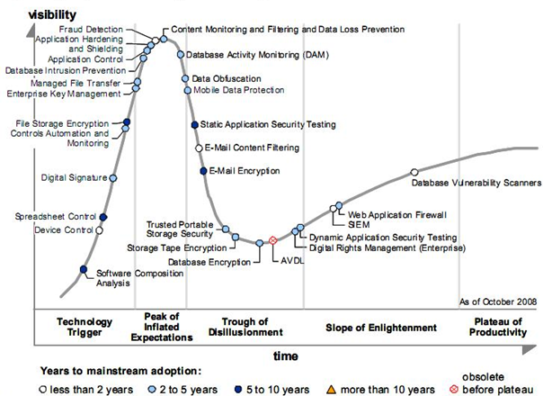
Figure 1: Hype Cycle for Data and Application Security, 2008
Source: Gartner, October 2008

1.2.2 Business Relevance
Though the objective of the research is not business oriented, this has relevance for business. Research in the field of CA/CM is relevant for businesses, because it has not yet been implemented much. As can be seen in figure 1; the fourth dot from the left on the Hype Cycle is Controls Automation and Monitoring. This says something about the status of CM; the dot is in the phase after the trigger and towards the peak of inflated expectations. This means that media attention is increasing and this raises expectations of an innovation.

This research may contribute to the awareness of CA/CM within companies and what the advantages and disadvantages of implementation are. It may contribute to create clarity in defining what CA/CM in practice is and how it is used.

Research Question
The research question is:

When and how is Continuous Auditing/ Continuous Monitoring used in practice in the Netherlands?

In order to answer this research question, some sub questions need to be answered.
- What are reasons for implementation?
- What are conditions for companies to implement CA/CM?
  - Maturity level
  - ERP
- How to frame CA/CM by some relevant factors?
  - Rate of automated- manually testing
  - Frequency of testing controls
  - Audit procedures
- What tools are used for CA/CM?
- Are there differences in sectors?
- Geographical
- Between Branches
A framework was build using information found in literature, then to match the outcomes with the practice, it was tested by an expert panel; the interviewees.

Research Methodology
At first, literature study was conducted in order to orientate on the topic and to find a motivation for this research. After reading some papers, the objective for this research was defining the status of CA/CM in the Netherlands. After a pilot survey, it was clear that the concept of CA/CM is not generally defined. There are different definitions found in literature, but there are certain comparisons.

After the pilot survey, it was clear that a survey was not a right approach for this research. For conducting this research in a valid way qualitative data was needed, instead of quantitative data.
So, more literature study was conducted in order to define a framework for CA/CM. This framework was the base for the questionnaire presented to the interviewees.

In order to gather qualitative data interviews were held with employees of CA/CM tool suppliers, and also with IT-auditors of different levels (junior- medior- senior). This choice of interviewing IT-auditors of different levels was made, for the purpose of gathering information from a broader view. The number of interviews held depended on the answers: as more interviews were held, the answers resembled more and more, and no new information was gathered.

After the interviews, the analysis was conducted. Statements on a certain topic were grouped and compared. On some topics the interviewees agreed and the answers resembled. On some subjects there were differences. The analysis of the data was done by means of the framework defined after the literature study.

From the analysis the results of the research were formed and the sub questions could be answered. By means of the analysis the research question could be answered.
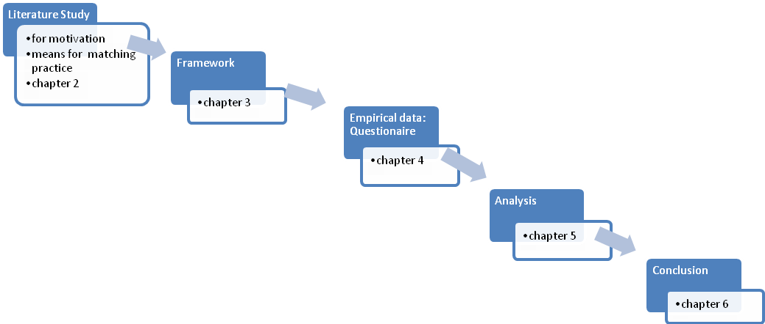
Figure 2: Scheme of Methodology and Thesis Construction

Thesis Construction
In chapter two summaries of internal audit studies conducted by Big4 Companies are found. Especially, the ones done by PWC every year since 2005 are interesting. The one held in 2006 had the focus on CA, so these studies were used to look for a trend in the implementation of CA processes. Furthermore, the dissertation by Scheeres (2005) was studied for the literature review. This research had been done in the Netherlands and is suitable as a benchmark for the current status CA implementation. These papers formed the motivation for this research.

In chapter three, definitions of used concepts are given. What is continuous auditing/ continuous monitoring? What is the difference between both these concepts? Questions like these are answered, by means of a literature review. Important papers regarding CA/CM are briefly discussed. The paper, Putting Continuous Auditing Theory into Practice: Lessons from Two Pilot Implementations by Alles, Kogan and Vasarhelyi (2008), is considered in the review, because it is the one of the most recent studies on CA and it gives detailed information of two CA pilot implementations. This provides insight in the theoretical background, from which a framework was deducted.

In chapter four the methodology of the gathering data for this research is set out. At first, a survey was conducted. There was not much response, and after deciding that qualitative research was needed, interviews were held. This process for gathering empirical data is described in this chapter. Interviews were held with employees of CA/CM tool suppliers, and with IT-auditors.

The analysis of the interviews and other gathered information is found in chapter 5. The structure of the framework is used for the elaboration of the analysis.

In the end there is a conclusion with the main findings of this research, the limitations of the research and future recommendations. Furthermore, the lessons learnt during the study are mentioned.

Internal Audit Studies
Different surveys have been held among internal auditors, like the ones by PricewaterhouseCoopers (PWC), Ernst & Young (E&Y) and Deloitte and IIA. The outputs were pretty much comparable: continuous auditing has an impact on internal audit’s efficiency. Also, a summary of a Dutch survey is given in section 3.2.

Big4 Studies
In this section the Big4 companies’ researches and surveys with the topic CA/CM are summarized. These were found during the literature study.

2.1.1 Ernst & Young
In the E&Y 2007 survey 44% of the respondents said internal audit utilizes continuous auditing, 56% said not to. But of these that have not implemented CA, half replied to have plans for implementing in the future. The reasons for not implementing were:
- Lack of value (40 %)
- Lack of relevant skills (25%)
- Budget constraints (16%)
- Other reasons (34%)

Of the 44% that had CA implemented in their business processes, the key objectives were:
- Follow-up on implemented recommendations
- Identity control gaps/ deficiencies
- Monitor risk
- Identify potential fraud

2.1.2 Deloitte and IIA
The survey held by Deloitte and IIA in 2007 showed an expected increase in the use of continuous auditing techniques: from 28% now to 51% expected in 2012.
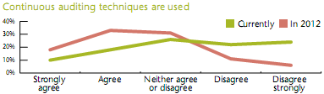
Figure 3: Expected use of CA
Source: Deloitte/IIA 2008

2.1.3 PricewaterhouseCoopers State of the internal audit profession
Next, a review is given of the PWC surveys. Since these have been held every year since 2005, it was interesting to look for a trend in CA/ CM implementation.
The study done by PWC in 2006 was found after searching at the site of Google on the term continuous auditing. It gives an overview of the status of CA/CM, why companies implemented CA/CM and how they look at CA/CM. And, although 81% of the companies surveyed had or were planning to implement CA/CM, only 3% say CA/CM was fully automated in their company. The results of this study were presented in PricewaterhouseCoopers 2006 State of the internal audit profession study: Continuous auditing gains momentum.
Since 2005 PWC has held a survey among internal auditors to define the state of the profession. Each year the focus was slightly different:
2005 – Internal audit post Sarbanes-Oxley
2006 – Continuous auditing gains momentum
2007 – Pressures build for continual focus on risk
2008 –Targeting key threats and changing expectations to deliver greater value
2009 – Business upheaval: internal audit weighs its role amid the recession and evolving enterprise risk

In the 2005 survey the respondents were asked about the impact of compliance regarding Sarbanes-Oxley. The findings about CA are the future trend and that CA/CM techniques gained momentum. One key indicator was that 34% of the respondents use CM techniques as a part of their audit plan. This trend was further explored in the 2006 survey.

Key indicators with regard to CA of the 2006 survey were:
- 81% of 392 respondents reported that they had either a CA or CM process in place or were planning to develop one. Only 19% said they didn’t have any CA processes and neither had any plans to implement.
- In one year, from 2005 to 2006, the percentage of respondents saying they had some form of CA or CM process within their internal audit function increased from 34 % to 50%. Of these who were active with CA in 2006, 13 % said to have a fully operational process, 37% had a process, but not yet fully developed, and 31% had plans to extend CA or CM capability.
- 56% said their CA processes included both manual as well as automated elements. In 41% of the cases the processes were entirely manual and 3% had fully automated CA processes.
- With 57% of the respondents the most common CA cycle was quarterly. 34% focused on monthly monitoring activities and 9% focused on daily applications of their CA processes.

To the question to indicate what the primary focus of the CA processes was, the distribution of the answers of the respondents was as follows:
- 27% selected risk monitoring,
- 26% audit testing,
- 20% fraud detection,
- 17% monitoring individual controls,
- 10% monitoring key performance indicators.

In practice, with internal audit those, who own an audit in a particular business unit, are also responsible for the continuous auditing activities for that unit. This was the case with 72% of the respondents. Of the other respondents active in CA, 22% placed responsibility for CA/CM with a separate group within internal audit. This responsibility was placed with the organization’s IT group at 6% of respondents active in CA. This relatively low number suggests that technology-based auditing is not being treated as an “IT only” issue.

For 49% of the respondents who said their CA processes include automated elements, purchases software provided the basis for automation. Nearly a third (32%) relies upon custom-build and custom-programmed applications for their automation. For a group of 19% report writer/ retrieval software forms the basis for automation. This kind of software is frequently deployed with large enterprise resource planning (ERP) programs.

The adoption of CA is a major challenge for the internal audit. It requires the support of the audit committee and senior management. To the question to describe their principal challenge this were the answers:
- 37% of 380 respondents said defining activities to be audited,
- 20% mentioned deploying technology,
- 18% said obtaining internal support,
- 13% answered determining whether a business unit or internal audit should conduct the monitoring, and
- only 12% mentioned cost as primary challenge.
This was a brief overview of the outcomes of the 2006 PWC internal audit survey.

The subtitle of the 2007 survey by PWC is: pressures build for continual focus on risk. Continuous auditing is only mentioned in chapter 6 with other trends and issues. It is stated that 43% of the 2007 respondents reported using some form of CA or CM. Of these, 11% said their CA processes to be fully operational. Of the overall respondents 32% reported that their processes were not fully developed, this was 42% for the Fortune 500 respondents. Another 38% said they were planning to develop some form of continuous auditing or monitoring. No plans in this area had 18% of the respondents.

Most continuous auditing is a blend of automated and manually operations. The 2007 respondents described the following in this context:
- 8% said their process is (likely) to be fully automated.
- 81% answered it is part automated and part manually.
- 11 % reported the CA processes were entirely manual.

Concerning the frequency of the continuous auditing, this was the answer of the 2007 respondents:
9% - daily
7% - weekly
38% - monthly
46% - quarterly

In 2007 PWC also presented a forward looking study Internal Audit 2012: A study examining the future of internal auditing and the potential decline of a controls centric approach. Study results indicate five identifiable trends that will have impact on internal audit. These trends are: globalization, changing internal audit roles, changes in risk management, talent and organizational issues, and advances in technology. These are also chapters of the report.

In the chapter changing internal audit roles it is said that continuous auditing or monitoring is the top factor predicted that will produce additional responsibilities for the internal audit. Of all the respondents, 90% thought so. Of this percentage, 37% expected much more of an increase from continuous auditing and monitoring activities. And 53% predicted somewhat more of an increase. These numbers are found in the figure below.
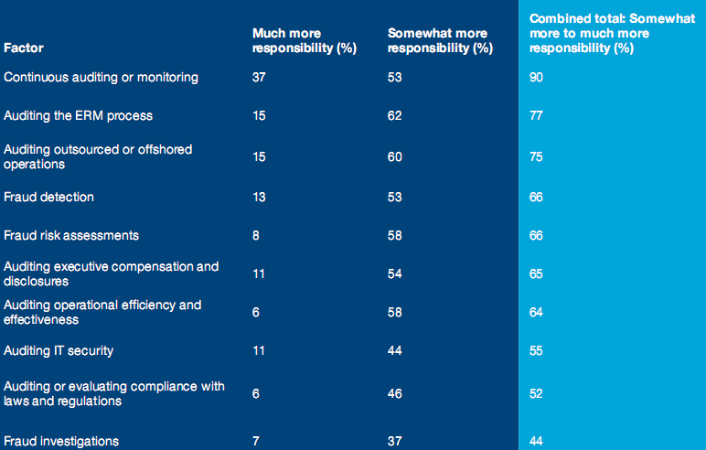
Figure 4: Factors driving greatest projected increases in responsibility
Source: PwC/IAS 2007

In the chapter changes in risk management the prediction is made that internal auditors will be sharpening their focus on continuous and assessment concepts, while trying to streamline and improve the audit process. As risk assessment and risk monitoring requires more real-time approach, audit time will become more dynamic. Audits will be conducted whenever needed, triggered more by changes to organizational risk profiles than, as with traditional auditing practices, by set plans or schedules.

To the question what they expect their internal audit planning to look like in 2012, 13 % of the respondents expected to employ CA or risk assessment methodologies without a formal audit plan as part of an ongoing continuous audit and risk assessment process.
The respondents were asked to project the relative importance of specific technologies related to internal audit over the years till 2012. Nearly 9 out of 10 rated continuous monitoring and auditing software applications as most important. Respondents expect a sharp surge in the importance of continuous monitoring and fraud detection when compared to current usage patterns. The figure below shows the difference between 2007 use of technology and the predictions for 2012.
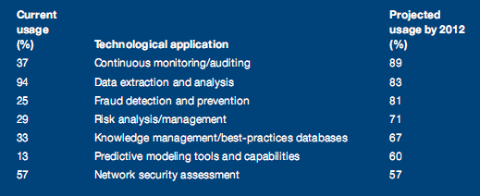
Figure 5: Changes in importance of internal audit technologies
Source: PwC/IAS 2007

In this PWC study was sought to predict which aspects of technology were most likely to create an increase in internal audit responsibilities by the year 2012. Ranked first was continuous auditing or monitoring with 90% of the respondents projecting an increase in responsibilities by 2012. Of this total, 37% anticipated much more of an increase from CA/CM activities.

Nearly half of the respondents (49%) expected CA to be fully operational within their organizations by 2012. Another 35% expect that CA will be a work in progress, but not fully developed by then. And 10% expect that CA will be in some stage of planning or development. Of those who answered that their CA operations will be fully implemented, 64% expect the CA process to be largely automated. But, 32% expect this to be both manual and automated.

Respondents were asked to project the primary focus of their CA operations for 2012. The answers were as follows:
- 25% monitoring KPIs
- 24% monitoring risk attributes to identify changes in risk profiles
- Searching for fraud and control deficiencies was also ranked high.

In the report there is also a section included with opinions on the subject CA/CM. These varied among the interviewees. One of them said he thought that CA does not exist: management should be responsible for monitoring, not internal audit. Another one said he avoids using the word continuous, because none of auditing activities are really continuous; the term builds unrealistic expectations in the eyes of management. One positive reaction of a global airline CAE: “Whether it’s called continuous monitoring or data mining, technology enables us to do a better job of extracting data and auditing more effectively.” Another CAE said that data mining and CM are the enterprise risk management of the future for both management as well as internal audit. One CAE of an insurance company said CA is a must for the future as part of the general movement toward more extensive testing of all transactions.

Although in the previous years CA was a hot topic, in PricewaterhouseCoopers 2008 State of the internal audit profession study: Targeting key threats and changing expectations to deliver greater value the term continuous auditing is not mentioned at all. In the introduction in a section about higher goals for the internal audit by audit committees, it is stated that “internal auditors are being pressed by audit committees and senior management for more timely information about major risks and for faster and more actionable audit results”. Here, it seems that there is a demand for CA, but it is not mentioned any further in the report.

Another subject, that seems to cover continuous auditing in the 2008 PWC survey, is shortening audit cycle time. This is in contradiction with sufficient time for the internal auditor to conduct audits that are well planned, well executed and well documented. But, there is an essential demand for access to real-time data from directors and senior management. It seems like CA/CM can provide the solution to this problem. But again, CA/CM is not mentioned any further in the 2008 survey.

In PricewaterhouseCoopers 2009 State of the internal audit profession study – Business upheaval: internal audit weighs its role amid the recession and evolving enterprise risk there is again a section dedicated to ERP implementations where continuous auditing is mentioned. As business processes and underlying technologies evolve, so do the risk assessment responsibilities of internal audit. In this case, more-automated control environments and continuous auditing tools can contribute to internal audit’s productivity level, if it intends to maintain or increase coverage with fewer resources.

The current global economic crisis has exposed a number of exceptional fraud schemes. Internal audit must be more vigilant in its fraud detection activities. Using data-mining and data-analysis tools to efficiently examining large volumes of data readily accessible through ERP systems is now more critical. However, the survey reveals that internal auditors are still struggling with a skills gap in technology, particularly in major ERP systems. Half of the respondents said that less than 25% of their non-IT auditors have experience with the company’s ERP system. Only 28% reported incorporating data-mining and data-analysis tool for more than 25% of their audit work.

For the 2009 survey the respondents were asked to indicate the percentage of non-IT auditors who have experience in specific technology-related areas. Two results regarding CA/CM are:
- 75% indicated that less than 25% have experience in the use of systems or live data feeds to regulatory monitor business performance and risk indicators.
- 87% said that less than 25% have experience in the maintenance and use of systems such as SAP GRC, Oracle’s Governance Risk & Compliance module or Approva.

These low numbers of experience seem to contradict the results of the 2006 survey, where continuous auditing was seen as the upcoming technology for internal auditors for effectiveness and efficiency gains. But, the last mentioned results of the 2009 survey are about the non-IT auditors and the 2006 survey was about the internal auditors themselves. This could explain the difference in the results.

The next paper in this literature review is by Scheeres. He has also held a survey in 2005, but he grouped his respondents in internal IT auditors, IT auditors and financial auditors. So, in contrast with the PWC survey a difference is made. A summary and review of the paper is given beneath.

Continuous Auditing: getting to an improved audit of internal controls
In De EDP-Auditor, issue 3 of 2007 a summary of the results of a survey about CA held among auditors is published. The research had been done by Scheeres in 2005 and was about the perspectives of a tool for judging the internal control environment implemented in an ERP system. There were two principal research questions:
- Is there from the audit profession a need for a more efficient en effective way to test the internal control framework?
- What are the barriers that have to be taken in order to implement a CA application for evaluating the internal control framework?

Scheeres divided the 154 respondents into three subclasses: 46 internal IT auditors, 55 IT auditors and 53 financial auditors. Of these respondents 40% said to be fairly to fully familiar with the concept of continuous auditing. 60% said to lack knowledge regarding CA. Only 3 of the financial auditors responded to have experience with CA in practice. From both the internal IT auditors and IT auditors groups there were 19 that had experience with CA. From this Scheeres concludes that CA is fairly well-known, but there are few financial auditors that have experience with CA in practice.

Using a tool for CA is a form of audit software. This software is also not used very often by auditors in practice. Another conclusion from the survey was that it seems that audit tools provided by ERP systems are not optimally utilized.

There is a desire for audit software that could test the internal control in an independent an continuous way. Many respondents think the efficiency and effectiveness of the internal control could be better, because a lot is still done manually.
But when it comes to doing this in practice, 57% don’t feel like testing more than once a year, because of lack of time and money.

Most of the respondents say that the time between the fiscal year and the report could be shortened. And in the near future they see the need for online reporting.

Gathering data and analyzing and document this are the most time consuming activities according to the respondents. But when this is automated it will take less time, but on the other hand the complexity will increase. This is because the auditor is provided more detailed information.

A hurdle for auditors is having access to data; 55 % of the respondents think the process owner can be convinced of granting access. And when access involves a secured internet connection only 27 % think they can. From this, Scheeres concludes that, although there is opportunity to use the audit tools, auditors don’t use these.

Because in the audit procedure a lot is still done manually, the desire for higher efficiency exists with 87% of the respondents and for higher effectiveness with 77% of the respondents. But only 43% want to test the internal controls more than once a year. The means the urge is not acknowledged.

Of the respondents 72% says that the time between the end of the financial year and publishing the report can be reduced. And 62% thinks for the near future is it necessary to have an online financial report.

According to auditors activities that take the most time are testing the internal control measures, but also gathering data and analyzing and documenting the data. In order to calculate the financial feasibility, it must be known what the significant controls are and what benefits automation can gain. But IT auditors and internal auditors have a different view on the number of significant controls per process than financial auditors.

The time and cost of implementations depends on the number of significant controls. There is a difference in the view of IT-auditors an internal auditors on one hand and financial auditors on the other hand, regarding the number of controls per process: the financial auditor estimates this number lower. This could be because of their view of budget constraints.

Communication between IT-auditor and financial auditor regarding the audits of the year report could be improved, according to the respondents. An integrated audit could improve this. This will also benefit the involvement of the IT-auditor.

Literature review
The terms continuous auditing and continuous monitoring are explained; a brief history of these concepts and the differences between them are set out.

Continuous Auditing/Continuous Monitoring
Some aspects of continuous auditing and continuous monitoring are dealt with in this section. A brief history of CA is presented. Some definitions of continuous auditing and monitoring from literature can be found in this section, and also the differences between CA and CM.

3.1.1 History
Traditionally, accounting was done throughout a basic period of time. The financial reports could only be produced based on information which was too costly to obtain on a real-time basis. Hence, reports have been issued months after the occurrence of the actual events these represent. In this setting, auditing is mostly a backward-looking exercise testing the accuracy of the reported numbers (Rezaee, 2002).

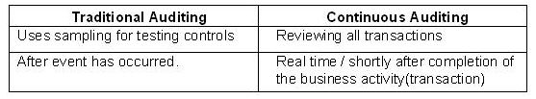
Figure 6: Traditional Auditing vs. Continuous Auditing
Nowadays, because of developments in technology, organizations are able to produce standardized financial information on a real-time, online basis. But, there is also a demand from stakeholders for transparency. And also, the alignment with regulatory compliance for financial reports has had great influence on the evolvements in accounting. Continuous auditing enables auditors to be transparent and to significantly reduce and perhaps eliminate the time between occurrence of the client’s events and the auditor’s assurance service (Rezaee, 2002).

The origins of automated control testing started with the implementation of embedded audit modules (EAM) in the 1960s. By the late 1970s this development was fading away and auditors begun moving away from this approach. Early adopters among auditors began using computer assisted audit tools and techniques (CAATTs) in the 1980s. This was used for ad hoc investigations and analyses. In that same period, continuous monitoring was being introduced to auditors in a largely academic context. But, auditors were not yet ready; they lacked easy access to appropriate software tools, technical resources and organizational commitment (Coderre, GTAG 2005).

During the 1990s, the adoption of data analysis solutions within the global audit profession increased. These solutions were seen as critical tools to support the testing of the effectiveness of internal controls. Data analysis supported the testing of controls not directly evidenced by transactional data. And, in spite of the technology, analyses took place sometime after the completion of the business activity and only for representative samples. (Coderre, GTAG 2005)

Today, rapid growth of information systems in the business environment gives auditors easier access to more relevant information. This is needed, because today’s internal auditors do not just audit control activities. They also play a role in enterprise risk management and how to improve this. If they don’t have a thorough understanding of the business processes and associated risks, auditors can only perform traditional audit checklist tasks.

3.1.2 Continuous Auditing
There are various definitions of continuous auditing found in literature: definitions where CA is seen as a method or framework used by auditors, but also definitions where CA is a technology.

Rezaee(2002) defines continuous auditing as “a comprehensive electronic audit process that enables auditors to provide some degree of assurance on continuous information simultaneously with, or shortly after, the disclosure of the information”. He speaks of continuous auditing as a process.

The definition of continuous auditing used by the AICPA and CICA: “a methodology that enables independent auditors to provide written assurance on a subject matter using a series of auditors’ reports issued simultaneously with or a short period of time after, the occurrence of events underlying subject matter.”

In the Global Technology Audit Guide (GTAG) Coderre (2005) says CA is an umbrella for two main activities: continuous control assessment and continuous risk assessment. With control assessment audit’s attention is focused on possible control deficiencies. With continuous risk assessment processes or systems that are experiencing higher than expected levels of risks are highlighted.
Continuous auditing = continuous control assessment + continuous risk assessment
Coderre mentions that the frequency of the continuous activity will depend on the risk inherent to the process or system.

Continuous audit procedures can be designed to test internal controls, by analogy with traditional auditing. This is called continuous control monitoring. CA procedures can also be designed to execute substantive testing, including analytical procedures. This is then called continuous data assurance. (Alles et al. 2008)
Continuous auditing = continuous control monitoring + continuous data assurance

3.1.3 Continuous Monitoring
The definitions of continuous monitoring found in literature resemble much. Continuous monitoring can be placed in the monitoring component of the COSO model, and other internal control frameworks like COSO that have a monitoring component.

That there is agreement on the definition of continuous monitoring can be concluded from the number of hits in a search engine, when entering the term. This only results in continuous monitoring in the medical and healthcare branch. Continuous monitoring as meant in this thesis is only found in combined with ‘assurance’, ‘audit‘ or ‘business process’. It is then called ‘continuous controls monitoring’ (CCM). Beneath some definitions found during the literature study are presented.

In the Gartner publication regarding continuous controls monitoring for transactions (CCM-T), the authors state that CCM-T and other CCM sub segments support both CM for management and CA for internal auditors. In this paper CM is defined as:
“A business management monitoring function used to ensure that controls operate as designed and that transactions are processes appropriately. CM uses control automation to reduce fraud and improve financial governance, typically resulting in an immediate return in investment“. (Gartner 2009).

“Continuous monitoring is a feedback mechanism used by management to ensure that controls operate as designed and transactions are processed as prescribed. This method is the responsibility of management and can form an important component of the control structure”.
(KPMG LLP 2008) In this whitepaper CM is dived into 3 components which overlap: CCM, continuous transaction monitoring, and macro-level trends and results monitoring.

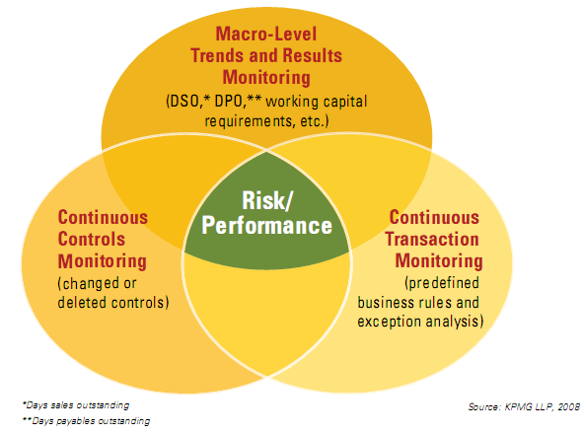
Figure 7: Three Components of Continuous Monitoring

In the picture above the three areas of monitoring are drawn and the tools or analytic technique for that particular area are in it.

Framework for defining CA/CM
After having read about the internal audit studies conducted by the Big4 Companies (chapter 2 in this paper) and after the literature study (section 3.1 in this paper), a framework was constructed. This was done by using the information of different aspects on CA/CM found in papers. From this information a general view is given, in order to construct the framework. This framework, as a hypothesis, was tested by interviewees. The interviews are found in chapter 4 and the analysis is found in chapter 5.

3.2.1 Frequency
When thinking of ‘continuous’ it seems logic that by this it is meant: all the time – real time. But this is not the case with continuous auditing and continuous monitoring. There are different definitions found in literature for continuous auditing/ continuous monitoring. Some of which have slightly different meanings with regard to the term continuous. In most companies a quarterly audit is already mentioned as being continuous. In some companies monitoring is done monthly and fewer companies do this daily.

There are various reasons for auditing quarterly, monthly or daily. When the focus is quarterly, auditors are typically looking for entries or transactions of unusual size that could affect quarter-end reports. When the focus is monthly, auditors are looking for management accounting information. And when the focus is on daily auditing, organizations are typically conducting high volume transaction activity (PWC 2006).

3.2.2 Rate of automated- manually testing
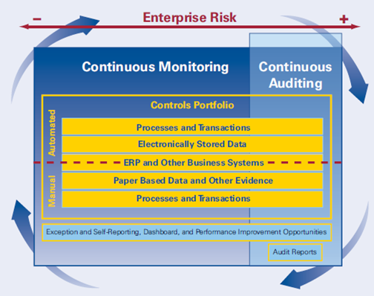
Figure 8: Integrated CA/CM model
Source: KPMG 2008

The integrated CA/CM model on the previous page displays the integration of managements’ responsibility to monitor risk and internal control with the way the auditor (both internal and external) needs to provide a risk-based level of assurance on management’s controls and monitoring capabilities. The part of continuous monitoring regards management’s control portfolio. This includes both automated and manual controls designed to mitigate risk. Depending on the extent controls are automated, or could be automated. As one can see, some controls in the portfolio are done manually. These include paper based data that cannot be processed by machine (yet). CA/CM is a cyclical process for both management and the auditors to assess risks, design controls, and implement corrective actions.

3.2.3 Conditions for companies to implement CA/CM
ERP system
The paper Putting Continuous Auditing Theory into Practice: Lessons from Two Pilot Implementations by Alles, Kogan and Vasarhelyi (2008) was found by searching in the digital database of the Erasmus University in the EBSCO database. This paper was placed in the Journal of Information Systems of Fall 2008. It is reviewed for this thesis, because it is a recent study about CA. It gives clear definitions of the used concepts and a short overview of the history of CA. Also the authors have been cited often in other papers with the topic CA. They have done quite some research on CA over the past decades.
In this paper the writers survey the state of CA after two decades of research into CA theory and practice and draw out the lessons learned in recent pilot CA projects at two major firms. One pilot was held at Siemens USA and one at a major Health Services Provider (HSP). The two studies were chosen to investigate two different environments for CA: one with highly automated business processes with modern integrated ERP systems (Siemens) and the other with a fairly low level of automation and mostly legacy system landscape (HSP).

The Siemens Project
Because of the modern integrated ERP systems the focus for this pilot at Siemens was on continuous control monitoring. Siemens had two drivers for implementing: increase efficiency of the concerned process and implementing SOX 404. At first, the audits of each SAP instance was based on an audit manual consisting of procedures called Audit Action Sheets (AASs). The pilot aimed at automating the existing AASs. But, not all AASs were suitable for automation, some controls still needed to be done manually. The implementation of the CA pilot followed these six steps:
- S1: Determine the best mode for the continuous monitoring of the chosen controls.
- S2: Develop system architecture.
- S3: Determine interaction and integration between the CA mechanism and the ERP system.
- S4: Develop guidelines for the formalization of the AASs into a computer-executable format.
- S5: Create process for managing the alarms generated by the automated CS system.
- S6: Formulate a change-management plan to move the project from the pilot stage to industrial strength software.
After examination of 25-30 AASs, 12 were chosen to for automating and reengineering.

The lessons learned from the project at Siemens according to the authors of the paper:
- Some critical issues regarding the use of an automated CA system are: how to deal with detected exceptions and alarm floods because of the complexity of ERP systems? This alarm handling process is a complex subject that requires further research. The insight into the role of alarms was one important finding from the Siemens project.
- What was accomplished was the proof of concept that manual procedures can be a start towards the automation. The project provided empirical evidence that for an organization being ERP-enabled helps to implement CA.
- Another lesson learned was that tools and CA software by themselves are insufficient without an audit model. Also, a clear change management plan with acceptation of the various stakeholders is needed for successful implementation.
- When it comes to implementing CA within ERP-systems, it may be cost efficient to reengineer the audit program to match the software than to customize the CA package. The customization takes too much time and is hard to maintain.

The HSP Project
HSP is a large American provider of healthcare services, composed of locally managed facilities that include hospitals and outpatient surgery centers in the U.S. and overseas. HSP provides its clients with everything from paper towels to heart/lung machines. The project to improve the assurance provided over their supply chain, started in 2002. They could provide extracts from their corporate data warehouse.

HSP has many legacy systems which are loosely linked. Because of this, a continuous control monitoring approach towards CA is not feasible. So, in this case the CA approach is based on continuous data assurance. Because of access to rich data, continuity equations are used as benchmarks for the process-based audit models. An example of such an equation is:

# of shipments received = # of purchase orders sent.

But this is not as simple as is seems; in practice there is a time lag between the two. So, the equations use aggregated data over a period of time. And time is not the only mode of aggregating data; sometimes data of subdivisions are required of geographical data. These other methods of aggregating were also studied during the project.

Some results of this project:
- The need to develop new audit methodologies to deal with large scale data.
- With continuity equations there is a chance of using contaminated data. Cleaning up data is a challenge: because of the legacy systems violations of data integrity and referential integrity may occur.
- It is an issue to use the CE models in practice.

Lessons learned from both projects
According to Alles et all CA tends to overlap with operational monitoring by management: CA is a subset of continuous management monitoring.

3.2.4 Maturity Level

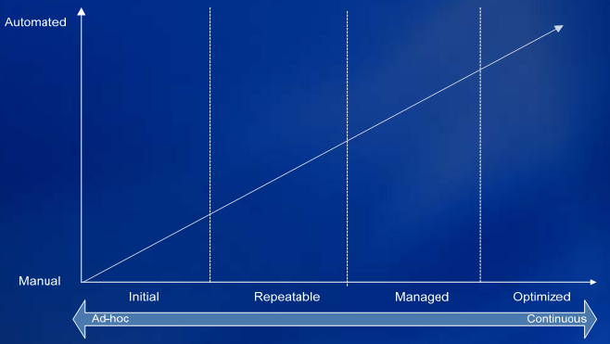
Figure 9: Maturity Model for CM
Source: Sheets KPMG 2008
This is the maturity model for CA/CM. On the horizontal axis the stages are displayed. On the vertical axis the rate of automation is displayed. The next scheme explains the different maturity phases.

↓Parameters\Phase→ | Initial | Repeatable | Managed | Optimized
Risk Identification | Informal/ Undefined | Risks have been identified and documented | Risk workshops held regularly | Risk identification is embedded in business
Analysis of risk and Control Deficiencies | Causes not understood | Cause analysis has been performed | Causes analyzed for all major risks | Root causes and sources integrated into thinking
Content Aggregation | Informal and inconsistent | Risk and Controls categorized | Broad categories defined and risk and controls allocated | Risk categorization aligned to business model
Roles & Responsibilities | External Auditor / SOX Lead | Partially managed by IA/ Business | Risk accountability well understood and evaluated | Risk accountability embedded in day to day operations
Tools | Mostly manual approach | Limited use of Ad-hoc tools and scripts | Tools are identified and implemented | CM tool is fully integrated with ERP and other systems
Reporting | Haphazard, largely by exception | Reports are defined and systemized | Frequent reporting, follow up processes in place | Key risk indicators linked to business strategies

3.2.5 Tooling for CA/CM
CA/CM needs to include all ERP and other financial and information management systems the company operates, so the related transaction and configurable data can be analyzed and monitored with CA/CM tools. These tools should help detect data integrity issues, provide scalability, identify performance cost savings and enhance cycle time for detection, correction, and improvement (KPMG Whitepaper, 2008).

Tools that focus on access rights and conflicts in segregation of duties are: SAP GCR Acces Controls, Approva Bizrights, Security Weaver, CSI Authorization Auditor and SecurInfo.
There are tools on the market that have features for process controls like: document internal control measures, clarify and define control measures that cover all risks, facilitate the testing the controls’ effectiveness. These tools are the solution of Bwise, that ARIS audit manager, and SAP GRC Process Controls.
Other tools for GRC are: ACL Services, D2C Solutions, LogicalApps, Oracle, and Oversight Systems. (Ibrahim 2008)

Empirical Data Gathering
In order to answer the research question, interviews had been held. Also, a CA/CM meeting with Big4 partners was attended. A summary of this meeting is also included in this chapter. The interviews have been held with employees of three different CA/CM suppliers, in order to capture their view. Furthermore, three medior/junior IT auditors have been interviewed, and two senior IT auditors.

Interviews with suppliers
In this section the interviews with employees of CA/CM suppliers are elaborated. Three different interviews were held. In order to be objective, the names of the employees and the company they work for have been held anonymous.

4.1.1 Interviewee1
Background Company
Supplier1 is a provider for enterprise risk management (ERM), corporate compliance and internal control solutions for Sarbanes Oxley/ corporate governance compliance. In The Forrester Wave: Enterprise Governance, Risk, and Compliance Platforms Q3 2009 the platform is mentioned as “one of the most impressive products in the GRC platform market, with strong technical capabilities in all the categories evaluated”.

Background Interviewee
Before he started at supplier1 interviewee1 has worked at a Big4 company. He has published some articles about CA/CM in a specialist journal.
He places CA/CM within GRC (Governance Risk and Control). In a way, it is also part of ERM (Entreprise Risk Management). It can be a kind of a BI tool for a framework as COSO.
According to him CM is easier accessible than CA, because this is used operational in the business. People work with it in their routines.

Place of CA/CM
Interviewee1 draw the picture shown on the next page in order to clarify his view of the place of CA/CM for management and audit within continuous assurance.
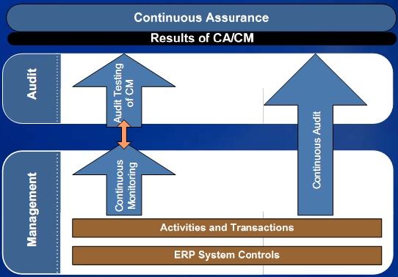
Figure 10: Leveraging CM for Audit
Source: Sheets KPMG 2008
Conditions for implementing
Interviewee1 said that one system is not necessarily a condition for CA/CM, but it is easier to handle if there is only system. It does not matter what system is implemented, as long as it is one system and not multiple combined systems. Regarding ERP systems, there are differences in capabilities among the various systems; one system is able to gather more data than the other. Before choosing a system, the client needs to consider which data he wants to gather for management report or other reports.
An example of implementation of a single system is the implementation of SAP at DSM.

Another condition is that every user must cope with the system consequently. If one control in the system is handled by multiple people, the routine needs to be done in the same way in order to get reliable data.

The third condition, actually the most important, is the level of maturity. There have to be decent procedures described for the company. A separate Internal Audit department is not needed within the company. Although, companies that have implemented CA/CM are big organizations and listed on the stock market.
Frequency
Real time monitoring or auditing is not feasible within an ERP system. It will have an impact on the performance level. It also not needed to do so, e.g. with sending invoices once a month. For generating reports aggregated data is needed weekly or monthly, and not real time.

Another aspect why real time is not desired is the fraud aspect. For example, when paying invoices to creditors, it is not desired that the employee can sent money to his own bank account. Some checks and controls will be built in before the payment can actually be done.

Implementation
Implementing a tool is often an illusion. Organizations often underestimate the time needed to prepare for implementing. And also, the costs are higher than expected. Good preparation is of utmost importance for a successful implementation.

With regard to the reasons why companies implement CA/CM interviewee1 mentions monitoring Critical Risk Indicators (instead of critical performance indicators) or stock levels, besides the given reasons monitoring risks, identifying/ detecting fraud and failures within the internal control.

A success factor is the maturity level of the client/ the organization that wants to implement CA/CM. Also important for successful implementation is the willingness to cooperate, not only on management level, but also the lower level in the organization. Another factor is the knowledge of and skills with the system within the company: defining the contents in an early stage, before implementation is absolutely necessary for success and a very big challenge for most companies.

Level of automation
When a company wants to implement CA/CM, there has to be taken a critical look at controls; what needs to be done manually and what can be done automatically. It is not feasible to have 100% automation. Some controls need to be checked manually.

Fraud
When people really want to commit fraud, they will find a manner to do this outside of the system. For organizations risks which are not comprehensible are a threat. These are usually risks outside GRC. So, for organizations it will be a good thing if they look outside the box when defining risks.

Branch of Industry
Financial organizations are most mature. This is because of the legislation they have to comply with for decades. Risks are better measurable compared to other branches, because of the experience. Therefore, CA/CM is more implemented within these types of organizations.

Production companies as DSM, that have elaborated procedures and guidelines and well described risks, are also in a more mature stage. It is easier to implement CA/CM in these branches.

Geographic differences
In the USA, they are precursors with regard to continuous control monitoring (CCM). But often multiple systems are used for generating reports, not one single system. In the USA CA/CM is implemented for compliance with regulations. Most often CCM is done manually.

In Europe, organizations use tools like ACL or IDEA. Companies do not implement for compliance reasons, but because they want to gain value out of the system. They want to be in control, themselves.

Tooling
For testing security tools like CSI, Security Weaver or Approva are on the market. These are used in combination with SAP. The problem with these standard tools is that some features that the customers want are not feasible.
For role-based access control (RBAC) tools like Behold or Beyond are suitable.
Every Angle is a tool which is efficient and effective with supply chain management and stock levels.
Oversight is suitable for automated testing on fraud.

Future
For the future, interviewee1 sees an evolvement where suppliers of tools are being merged with or acquired by big (ERP) suppliers, and integrated with their systems. Actually, this process is already going on for 2 years now. Eventually, all will be integrated and there will be no differences among tools; all will be able to send alerts by e-mail and these instructions need to be followed. Condition for this evolvement is a high maturity level for organizations. This process will at least take 10 years.

4.1.2 Interviewee2
Background Company
As is stated on their website; this company is an independent partner in the areas of data integration and information analysis and reporting. They are specialists in data extraction and mining from source systems.

After merging with another IT company, they gained knowledge of specialized business software and certain content focused on the clients’ demand in the area of business process management, and governance risk and control (which includes CA/CM). About 25 employees work for the company now.

Their software works with the Windows operating system and is linked to a database. The CA/CM tool is mostly detective.

Background Interviewee
Interviewee2 is working at the company, described previously, as a senior consultant .His tasks for his position include activities in Sales, functional product development, marketing and implementation. He is not involved in maintenance and programming activities.
Before he started at this company, interviewee2 worked at a Big4 company in an IT audit department.

Reasons for implementation
For now, the main reason why companies implemented CA/CM was external compliance. Recently 2 multinationals have approached interviewee2’s company, because the accountants demand compliance. These enterprises had the feeling that they were less in control. One of the multinationals has an internal audit group where they have to report to. This audit group is established for internal purposes.

For a number of middle managers, controllers and local CEOs the reason for implementing CA/CM is not merely compliance, but also cost savings.

Increase in CA/CM
According interviewee2 there is an increase in the demand for CA/CM tools. It is a topical issue and people talk about it. CA/CM is a hype now and companies are willing to implement because of testing efficiently of external compliance, and because of lower audit fees.

Conditions for implementing
Willingness is a condition for implementation. CA/CM has to be one of the goals of the management and everyone involved should agree. One should not see the implementation as an extra activity, but as an essential one, integrated with the business processes.
Management support is crucial and so is internal knowledge and skills. So, training people is very important.

There are no technical conditions for companies. We can always start from scratch. But it is required for an organization to have the business processes harmonized and to know that and how data is stored. These conditions are not necessarily CA/CM dependent.
Before implementation it must be clear how the processes are organized; the people and structures for one happy organization. But, the bigger the company, the harder this is. And, it also depend on the kind of organization; at governmental institutions things are more structured, with companies often outsourcing is involved, which makes the project more complicated.

It is important to start implementing with one business process, for CM, or one point of segregation of duties, for CA. Starting small and expand later.

Successes and Pitfalls
For success, having management support and support of users and all parties, is important. Having people available that have the right knowledge and insights is also a pre.
Also necessary for successful implementation is actually taking actions; one could have nicely documented who does what, why and when, but when follow ups are neglected they have no use. Above all, this leads to data pollution, for instance sales orders that are still open. This data pollution is already a problem with current data systems; real numbers could give a different view. Unfortunately, cleaning up is not an issue for clients, because having data available when checking.

A pitfall is starting too broad; with all or multiple processes. But in practice this hardly occurs.

Audit procedure
For companies listed on the stock market, it is not very clear where monitoring ends and auditing starts. Internal audit checks the monitoring. There is a difference between internal control and internal audit; internal control is for the business processes (on operating level) and internal audit is for the compliance (at central / head quarter level).

Tools used in auditing are data analysis tools; IDEA and ACL. It depends on whether the audits are for internal or external purpose. There are mature GRC solutions available on the market. The tool of the company of interviewee2 is one that generates information out of data.

Differences in branches
In the logistic sector CA/CM is very suitable to apply, for instance the container terminal in the port of Rotterdam, ECT. These sector is suitable because not much is processed in retrospect, a lot is done real time. In this sector companies are ahead in the field of information technology.
Real time CA/CM is compatible for this branch because, there is no ambiguity involved with the business processes. So, not in all circumstances real time monitoring or auditing is possible.

Future
As it is now, there are still a lot of questions and uncertainties about CA/CM; is it part of GRC or BPM? It is on the edge of accounting, operational excellence and informatics. There is not done much in the scientific area with CA/CM.

For the future of CA/CM it depends on the economical situation which way it will go. If the economy will be better, the position of CA/CM in The Netherlands will flourish. When operational excellence is applied at companies, then (under certain circumstances) it is interesting for them to consider CA/CM as a supporting tool.

4.1.3 Interviewee3
Background Company
Interviewee3 works at a company that is market leader in ERP systems. Supplier3 has a software tool for governance, risk and control. As is stated on the website: the tool offers automation for GRC processes, from the beginning till the end, risk management, corporate governance and reports, and compliance management and reports, included.

Background interviewee
The position of interviewee3 is between the sales department and their customers; the presales department.

Reason for implementing
Monitoring risk could also be done without CA/CM, only CA/CM can provide efficiency gains. Detecting flaws within the internal control need not necessarily be ‘continuous’. However, the continuous aspect makes this process proactive instead of reactive. Gathering real time data is only possible with transaction systems.

The reason why companies could implement CA/CM are efficiency gains and cost reductions. The implementations must provide assurance. The company must check regularly whether the risks still apply. And they have to think about controls on the monitoring controls.

Increase in implementation
Because of regulations and the situation of the economy there is a fast return on investment (ROI). There are mostly financial institutions that are interested in CA/CM.

Conditions for implementing
Companies must have reached a certain level of maturity. They must have grown from an ad hoc phase, where rules and procedures are not described, into a mature phase, where there are guidelines for procedures.
Most companies are still in the ad hoc phase.

Successes and pitfalls
Actually, for a successful implementation the same things apply as for a regular IT-project. There has to be a balance in business and IT and people have to bear in mind that IT only supports the business.

The pitfalls are knowledge transfers and documentation. These go often wrong in projects. And especially for the continuous process these are pitfalls.
Future
Eventually, there will be a shift in the maturity model; where most companies are now down in the corner in the ad hoc phase, they will grow and shift to the mature phase.

4.1.4 Summary of interviews with suppliers
A remarkable fact is that two of the three interviewees had a background at the same Big4 Company. They both had written articles on the subject CA/CM in a journal for specialists.

Interviews with medior / junior IT-auditors
In this section the interviews with medior and junior IT-auditors are elaborated. Three interviews were held. In order to be objective, the names of the employees and the company they work for have been held anonymous.

4.2.1 Interviewee4
Background Interviewee
Interviewee4 has been working as a compliance consultant for 5 years at a small consultancy office. Her job is to help organizations to prepare their IT environment for the actual audit. This is done by implementing internal controls within their processes, systems and data. According to interviewee4 CA could then be implemented better in such an (IT) environment than it is done now. With CM it is possible for the management to measure the effectiveness and efficiency of the internal controls. This is because performance of processes and systems and other data can be better provides this way.

Implementation
The main reason why organizations implement CA is the increasing demand for more reliable, relevant and up to date information for decision making. CA is a continuous test of the internal control system. CA is used more often by the audit department as a method to execute audits on a continuous base.

Another reason why organizations implement is the use by management in order to gain control aims. CM is actually a part of the COSO model, within the monitoring component. CM is for assuring the management. For CA the auditors are responsible for auditing whether the management is executing its control in a responsible manner. The auditors may use results gained by CM.

Conditions for implementation
First organizations need to know their priority areas and consider in which business processes they want to implement CA/CM e.g. daily production, sales, shipping, procurement etc. When they know the scope they have to scan that environment, have a thorough look at the processes, systems and data. They have to check whether there are strong internal controls implemented in the environment, because only then CA can gain improvements. Organizations must be aware of the CA/CM rules and procedures that the continuous process will bring along.

Another condition is being aware of the frequency. It is in the name: monitoring and auditing on a continuous base. But, what frequency is considered continuous? That depends on the process and it is up to the organization/ management to determine the frequency of monitoring/ auditing.

For successful implementation, organizations must be prepared to do the follow ups; who takes actions, when there is a gap found in the internal control environment, who will report and who will communicate this. From this can be stated, that having the processes organized in such a way that no delays can occur, is also a condition.

Factors for successful implementation/ pitfalls
By means of the picture of the dependence of the technology, processes and people aspects, interviewee4 explains her opinion successful implementations and pitfalls of it. Factors which contribute to successful implementation are found in the technology and process aspects. Organizations don’t lack technology; all kinds of systems can be purchased, as long as the budget does not restrain. A pitfall concerning technology is that organizations want to design their processes around IT. They have to bear in mind that technology is merely a means and it supports the existing (core) business processes. Within the process aspect not many challenges will occur either, adapting processes and create stronger internal control should be possible during implementation.
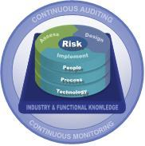
Figure 11: CA/CM and Business Risk
Source: KPMG 2008

The pitfall will be in the people aspect. A condition for CA is having strong internal controls within the audit environment. The challenge lies in the human aspect, to get the people’s cooperation and the willingness to adapt. It is important to create awareness among the users. Because, then they will know why they have to do certain checks and what the consequences are if there is no presence of internal control within processes, systems or data .

Audit Procedures
Audit procedures in companies that have implemented or are to implement CA/CM may differ. Obviously, there will be prescribed audit procedures, but in practice auditors or the audit organization will have their own approach.
There is no need for companies to comply with regulations like SOX or Tabaksblat in order to be audited.
When companies or their management want to have assurance about their internal controls, they are free to invite an auditor and have the environment tested. A company need not necessarily have an internal auditor or IA department. Companies that have these departments are multinationals or big companies that operate on global level. These companies have an obligation to have them audited.
Tools which are used often for audits are: audit scope plan, self-assessment audits (if there are any), checklists, risk analyses, audit reports.
Interviewee4 performs IT audits for a production company that uses a partly automated self-assessment tool. This tool was internally developed.

Development in adoption
CA/CM appeared in the 90s, the end of that decade. When we look at the status as it is now, there has been an increase since then. This increase can be seen particularly in the supply side; many publications on the topic CA/CM are from the supply side (E.g. Big4 companies), rather than the demand side. Hence, it can be said that the increase of CA/CM is being ‘pushed’ by the supply side.

When we look at factors that may have caused this increase in use, these are also found at the supply side.
From the demand side factors for the increase could be; monitoring risks, detecting fraud, but more important, the demand for reliable, relevant an up to date (real time) data. This can be seen in the use of XBRL that is already in use in the fiscal world.

Future
In the future the number of CA/CM implementations will increase. By influences from the economy, one will more often have the urge to assure the internal control environment, and the need to have real time business data available for decision making. Every organization wants to react as soon as possible to changes in the market and in order to be able to do so, with the accurate, up to date information, they will more and more implement CA/CM.

At the supply side everything is already set for the future. The challenge is in creating awareness at organizations. And these companies themselves need to create awareness among their own people. This development in increase can go fast, but could also take a very long time, depending on the time it takes to create awareness. Most companies now are still in the ‘ad hoc’ phase of maturity. They do not see the benefits or added value of implementing CA/CM. Also, prices of attending seminars are high. So, the challenge for suppliers of CA/CM tools is in bringing a shift into this awareness for the years to come.

4.2.2 Interviewee5
Background Interviewee
Interviewee5 is an IT advisor at a Big4 company. He scans companies on IT systems. This happens on ad hoc basis, when the company wants this. It is possible that CA/CM is involved with this. Interviewee5 was involved with some CA/CM projects;
- In 2002 a ministry was close to implementing CA/CM. A lot was still done manually, but every month an error list was generated. There was no tool implemented, they used Excel.
- In 2007 a psychiatric institution made a beginning with CA/CM.
- A Company in Household and Body care implemented SAP GRC in January 2009. They did this as a ramp up client; for testing SAP GRC.

Reasons for implementing
From his experience interviewee5 can tell that for production companies risk monitoring and assurance is a major reason. Risk mitigation is done for safeguarding the continuity of the business. Within production companies there is already a lot done from the control viewpoint.

Another reason for implementing is standardizing processes worldwide. Multinationals have departments all over the world and about 80% of the used systems are common. A tool can support this, for example with consolidation. Most of these shared systems are back office systems.

Conditions for implementing
- There have to be guidelines and regulations, well documented business processes.
- A certain level of maturity has to be reached, compared to CMM 2-3.
- An ERP system or workflow is not necessary for implementing CA/CM. But it is easier if there is ERP.

Critical Success Factors
Creating awareness of risks among employees is crucial for success. This is a task for the business side, the suppliers of CA/CM.
For clients, change management is important.

Audit procedures
It is in favour of the company when there is an internal audit department. The company in household and body care has a Risk Management Department, which can be compared to an internal audit department.

Using tools for audits is a matter of converting control frameworks, as CoBIT, COSO or ITIL, into audit plans.

With integrated audits multiple regulations apply. There will be an overlap in control, so CA/CM can be useful in such a case, for example when SOX and BaselII are used. CA/CM will contribute to a more efficient audit in such a case.

Differences in branches
Interviewee5 has only experience with large production companies and government regarding CA/CM. So, he can only say something about those two branches.

When large production companies are involved with CA/CM, it usually has to do with standardization. As explained before, systems that are used for common purposes in different countries are rolled out.

As for the government, there is no standardizing here in the business processes. Different departments are like little islands and tools are developed internally. They cannot work with standard tools. This is also caused by the particular way of accounting; they work with budgets for a period of time, there is no such thing as profit or loss.

Future
For the future of CA/CM, in 10-20 years, interviewee5 sees too many changes which companies have to comply with. In order to survive companies need to stay flexible. So, this will bring the rise of flexible automation, where users have more opportunities (empowerment) and are more involved.
So, the focus for the future will be on fast adaptation to changes.

4.2.3 Interviewee6
Background Interviewee
Interviewee6 is a junior IT advisor at a Big4 company. He is involved with a new project regarding the implementation of SAP GRC. The client wanted to automate controls that were done manually. They wanted SAP GRC to report violations with segregation of duties. In the tool a request for authorization was generated.
In order to check the outcomes in the early stage of implementation, the tool CSI was used to match the reports. Interviewee6 tells they were not very familiar with SAP GCR, so they used CSI to match results. There were actually some significant differences found between both tools.

Conditions for implementing
Organizations have to be mature enough before they can implement CA/CM; first organize, then implement.
Companies must be prepared to do the follow ups when violations have been detected; remediation.
Implementation has to have added value; when processes are 100% fine and everything works as it should, there is no need for it.

Success factors for implementation
Organizations must know and consider what risks need to be covered, what the controls are and which users are involved.
It is important to have trainings for the end users.

Pitfalls
What interviewee6 encountered with the SAP GCR project were technical flaws; the client wanted to have certain results, but it was technically not possible to execute that with the tool. The client did not have enough knowledge of the possibilities of the tool. This is a major pitfall for many companies. They choose a tool, because it is widely used. But they don’t investigate whether a tool is suitable for their business and whether it shows the result is the way they want to; e.g. data export to Excel or drill down function.

Future
For companies, the desire to stay in control will grow, so an increase of CA/CM is possible. Only, for organizations it is important to know what the possibilities of tools are. And companies have to grow towards a certain level of maturity, before this can happen.

4.2.4 Summary of interview with medior/ junior IT auditors
Compared to the other interviews, the junior and medior employees were able to tell in more detail about the operational site of CA/CM implementations. They gave vivid and clear examples, because of their experience with CA/CM projects.

Interviews with senior IT-auditors
In this section the interviews with senior IT auditors are elaborated. Two interviews were held, the intention was to interview three, but it was hard to make an appointment with a partner or director, during the period the interviews were held. In order to be objective, the names of the employees and the company they work for have been held anonymous.

4.3.1 Interviewee7
Background Company
The company interviewee7 works for is a medium sized accountancy/ consultancy office. They try and make a difference by gaining clearance in transactions, keeping focus on managing and measuring performance. The company invests in tools, knowledge and architecture for continuous assurance solutions, data analysis applications and dashboards.

Background Interviewee
Interviewee7 is partner at this company and has been working almost 6 years as an EDP-auditor. He is responsible for data analysis within auditing and internal control department.
According to him about 60% of the controls are IT related.

View on CA/CM
CA/CM seems a utopia; the definitions used are too narrow, because the presumption is made that it is automated, but in practice this is hardly the case. Most it is done manually.

The viewpoint of the management is a guideline for the rest of the organization.

The assembly of the annual account is done in retrospect. CA in this case can contribute in making a prognosis which can be adjusted later on. But first monitoring is needed for management and the internal control.

CM and CA differ by the users: CM for management and CA for judging by the audit. The critical performance indicators could be the same. The power or synergy can be found in a good monitoring system; then accounting need not look at the critical performance indicators that have handled by the management.

The Rise of CA/CM
CA/CM is still in its infancy. In 2003 searching with search machines the term produced not many hits. It is like the Dutch saying “old wine in new barrels”: the actual concept was already there for a longer time; half of it is about internal control.

Regarding the control frameworks; the older ones are perhaps better than the recent ones. Those are better able to capture the essence.

The success of CA/CM can be attributed to the increased accessibility if IT; more advanced data, use of laptops and other portable gadgets.

The increase in number of hits can be explained by the introduction of SOX. From end 2004 CA/CM became a topical issue, but mostly on the agenda of the specialists.

Business Intelligence is used by management for gathering information about processes. The focus here is not necessarily on internal control. The tools are powerful, but interviewee7 doubts the reuse for internal control.

Transparency decreases by use of various tools. These tools are pushed by the experts and not much by management. More awareness needs to be created on the demand site. Controllers can do this by informing the CFOs. And it is the CFOs job to create awareness to the board.

On the demand side there are suspicions regarding the costs of CA/CM. Are there benefits when implementing this? It is difficult to capture the benefits and often the benefits are intangible. And there are already means for measuring assurance; hence the added value of CA/CM is not very clear to management or the deciding parties.
As is seen, the method the company of interviewee7 uses for CA/CM is also not often asked for. This is used for long term purposes mostly. But this method does not require all steps.

Implementation
Before implementing companies must know what the procedures of the organization are (systems), what needs to be measured (data) and the people need to be informed.

A reason for implementing CA/CM could also be adding value to the company. Preventive and detective measures are insufficient, but management has to decide whether CA/CM is efficient. More control means less flexibility. So, management needs to consider that.

Increase
Interviewee7 has his doubts regarding an increase in implementation. There are more and more discussions with customers, but these happen occasionally in order to “prove that is works”. Companies appeal to us when problems occur. Internal control means expenses and when benefits are provable there may be interest in CA/CM.

Another reason could be the increase in regulations. This brings an increase in transparency.

Conditions
First of all, within the organization there has to be taken al critical look at data and the dataflow. Then the question comes what can be done with that data. The company must start with a risk analysis with the focus on processes, systems and data. A pitfall for this analysis is that minor things are taken into account, and main focus is lost out of sight.

Involvement of the management and their thought of the goals are important issues for the success of implementation.

The time it costs for developing a prototype is also a success determining factor. When enough time is spent on the development, the quality will be higher. The use of a feedback loop in order to test the quality will also be beneficial for the success.

For implementing parties having access to data is also a hurdle. It takes a lot of effort in order to gain access, because of information security policies of the company.

Audit procedure
There are no conditions for CA/CM regarding the organization of the audit procedure. There could be an audit plan present. When we start with implementation at customer, we follow a number of steps; one of these steps is for the organization to set a goal regarding the audit procedure, partly about the data analysis. But these steps to be taken depend on the customer; it is different for a multinational in petro chemistry than for a bank.

There are differences for various branches. For trading companies the focus is on transactions. For banks it is about whether the transactions are within a certain boundary. It is hard to say that this is related to a certain maturity level. Within business intelligence the opportunities for CA/CM in the financial branch are better.

Future
Because of the Internet and certain information being available for everyone, there is a need for organizations of being transparent. For the future evolvement of CA/CM it depends on top management which way it will go and how fast. When their focus will be on internal control, CA/CM will flourish. When they will find that internal control is an obliged vice and their focus is not on it, CA/CM will grow less fast.

4.3.2 Interviewee8
Background Interviewee
Interviewee8 is IT auditor and partner at a Big4 company. His department was involved with several CA/CM projects over the past years.
- Three years ago a project was started to extend the SAP system, because of SOX compliance. For a pilot Approva Business Rights was used, but only the part for data extraction; this tool was too extensive. For generating reports the department developed an own tool, because Approva’s reports were too complex.
- There is a major chemical enterprise that uses multiple CA/CM tools. Their internal audit department uses CSI for authorization purpose. The Big4 Company supports with the use of this tool for the audits. For the business units the enterprise uses SAP GRC.
- A global publisher has implemented the tool Synaxion for the legal tax and regulatory department in Europe. The Big4 Company helps to guide this process at the publisher for Synaxion. For its shared service centre there is SAP in Belgium, France, The UK and The Netherlands.
Interviewee8 tries to stimulate CA/CM at audit clients and let them know that CA/CM exists and inform them about the benefits.
CA/CM now can be found at major and globally operating corporations. The status is: they are in a phase where CA/CM is supporting the enterprise. Authorization in this process is less of relevance.

Reasons for implementation
Organizations want to have control on authorizations and want assurance.

Increase in CA/CM
Interviewee8 does not see an increase for CA/CM as integral, but parts of it are wanted; there is demand for the part regarding authorization, report generation or credit quality. Implementing CA/CM is expensive and it is quite an investment to organize. Benefits lie in SOX or Tabaksblatt compliance, but in the Netherlands they are through with it, there is no demand for it. The financial crisis does not help either. A pragmatic solution could be developing a tool internally.
At multinationals there is still demand for CA/CM.

Conditions for implementing
One condition for implementing CA/CM is having a mature internal control framework, with programmed controls and uniform business processes. Of this control framework parts can be implemented manually and parts automatically.
Implementation is also less complicated when there is a convenient ERP system with not much peripheral equipment.
It is also helpful when the tool is suitable for multiple entities/ business units or processes.

Successes and Pitfalls
It helps when a company starts small with implementation and slowly extends it to other business units. In this way one can focus on the core controls and learn about the weaknesses and strengths.

The project has to be taken serious and not as a business case. It has to be a conscious decision of the management. The worlds of IT and control are close.

For CM management should be aware that the tool is not only reliable and efficient for them, but also for (internal) audit. And the other way around CA is not only useful for audit, but management can also benefit from it.

The client has to bear in mind not to want too much information out of one system where it is not necessary, for example sales data from all countries. That can have impact on the level of performance.

Audit procedure
Having regulatory compliance for a company is not required for CA/CM implementation, but it is useful. A lot of effort and costs could be saved when cooperating with an internal audit department during implementation. They could provide a clear overview.

Having a separate internal audit department is not required for CA/CM implementation; however in practice many organizations, who have implemented CA/CM, have one. Companies that are listed in the stock market have to deal with internal control and have to comply with SOX or Tabaksblat. Hence, it is easier for them to have CA/CM tool implemented.
In practice many internally developed tools are used. There are not many standard CA/CM tools implemented yet.

Differences in branches
In general, production companies don’t have a separate internal audit department, however in the financial world this is a common thing. Both these sectors are ahead in CA/CM, but interviewee8 thinks decades of experience are the reason for this, and not so much regulations.
For production companies the core business is selling the product, for financial businesses this is strictly administration.

In the Netherlands and Europe organizations are entrepreneurial focused; they are prepared to make decisions when they have proves that a concept is working. Reports of business units go to the top; principle based.
In Anglo Saxon countries organizations are more directive; they are used to roll out a concept. This is what suites CA/CM. This viewpoint is a positive thing for the future of CA/CM, especially now, during the crisis.
For the European countries, the crisis causes an obstacle for the increase of CA/CM; companies are reluctant to invest in CA/CM tools. But, when they hear about success stories, this can change and the willingness to invest in CA/CM can be brought back.

Future
Organizations are using more and more systems to stay in control. Only the very large organizations, multinationals who have to consolidate strive for less IT systems, for the sake of simplicity.

Still, awareness for internal user’s awareness need to be created. This could be done by leaflets to talk it over at clients.

4.3.3 Summary of interviews with senior IT auditors
It was remarkable that the seniors could not give examples as lucid as the juniors did. The seniors remained very close to what was found in the literature. Although they remained close to the literature, they still were able to provide new information and different, innovative views, which was not found during the literature study.

Analysis
In this chapter the analysis of the gathered data from the interviews is elaborated. This chapter is divided into sections corresponding to the aspects of the framework in chapter 2. Per aspect is presented what was mentioned during the interview about that certain topic. These topics are underlined and marked bold. In order to have a quick view of who made the remark, this is underlined. An overview in a table is presented in section 5.9.

Reasons for implementation
The main reason for implementing CA/CM for a company is to gain and stay in control. This reason was mentioned by 6 out of 8 interviewees. CM is actually a part of the COSO model, among the monitoring component. CM is for assuring the management. For CA the auditors are responsible for auditing whether management is executing its control in a responsible manner. The auditors may use results gained by CM. Thus, in this way CM enables the company to be in control.

Some of the other reasons are related to ‘staying in control’. One of these is monitoring Critical Risk Indicators. Also related to this is risk monitoring and assurance, this reason was mentioned by two interviewees, one senior and one junior consultant. Risk mitigation is done for safeguarding the continuity of the business and therefore related to ‘staying in control’.

Another reason for implementation is that accountants demand external compliance. This reason was mentioned by one senior consultant of a supplier. He experienced that some enterprises had the feeling that they were less in control. One of the multinationals has an internal audit group where they have to report to.

Having reliable, relevant and up to date information is also a reason according to one interviewee, a medior consultant. This information is then used for decision making. Therefore the data needs to be as accurate as possible.

Cost savings and efficiency gains are mentioned by two interviewees. For a number of middle managers, controllers and local CEOs the reason for implementing CA/CM is not merely compliance, but also cost savings. Because, when it is well implemented, efficiency gains will lead to cost savings.

A reason for implementing CA/CM could also be adding value to the company. This was mentioned by a senior consultant. Preventive and detective measures are insufficient, but management has to decide whether CA/CM is efficient. More control means less flexibility. So, management needs to consider that.

The last reason noted here, was mentioned by a junior consultant. It was an important reason, but not mentioned by any other interviewee. This reason is standardizing processes worldwide for major enterprises. Multinationals have departments all over the world and about 80% of the used systems are common.. Most of these shared systems are back office systems. A CA/CM tool can support this, for example with consolidation.

Concluding
Since most interviewees mentioned “staying in control” as the main reason for implementing CA/CM in a company, for this research this reason is chosen as the most important one.

Conditions for implementation
The most important condition, mentioned by almost every interviewee, is the level of maturity. There have to be decent procedures described for the company. When they know the scope they have to scan that environment, have a thorough look at the processes, systems and data. They have to check whether there are strong internal controls implemented in the environment, because only then CA can gain improvements. Organizations must be aware of the CA/CM rules and procedures that the continuous process will bring along.

The first step of the implementation is, take a critical look at data and the dataflow within the organization. Then the question arises what are the possibilities with that data. The company must start with a risk analysis with the focus on processes, systems and data. A pitfall for this analysis is that minor things are taken into account, and main focus is lost out of sight. This reason was mentioned by one medior and one senior consultant.

Another condition is being aware of the frequency. This is mentioned by a medior consultant. It is in the name: monitoring and auditing on a continuous base. But, what frequency is considered continuous? That depends on the process and it is up to the organization/ management to determine the frequency of monitoring/ auditing.

Every user must cope with the system consequently. If one control in the system is handled by multiple people, the routine needs to be done in the same way in order to get reliable data. Companies must be prepared to do the follow ups when violations have been detected; remediation: who takes actions, when there is a gap found in the internal control environment, who will report and who will communicate this. This condition was mentioned by 4 interviewees, two of the consultants of suppliers and one junior and one medior consultant.

One system is not necessarily a condition for CA/CM, but it is easier to handle if there is only one system. It does not matter what system is implemented, as long as it is one system and not multiple combined systems. Regarding ERP systems, there are differences in capabilities among the various systems; one system is able to gather more data than the other. Before choosing a system, the client needs to consider which data he wants to gather for management report or other reports. This ERP topic was mentioned by 3 interviewees, one out of every category.

Another condition that is not necessary, but helpful is when the tool is suitable for multiple entities/ business units or processes. This was mentioned by one senior consultant. By this he meant that some tools are more suitable for a certain business process and less for another process. His remark is an issue that considers every implementation. There are always processes that benefit less or are less suitable. It is up to the decision makers whether or not to implement for that particular process, or to choose another option.

Willingness is a condition for implementation. CA/CM has to be one of the goals of the management and everyone involved should agree. One should not see the implementation as an extra activity, but as an essential one, integrated with the business processes. Management support is crucial and so is internal knowledge and skills. So, training people is very important.
This was mentioned by one consultant of a supplier during this section of the interview. Other interviewees have also mentioned this point in other parts of the interviews (successes and pittfalls). Therefore, this topic of management support can be considered as important.

Concluding
The condition that can be considered as the most important one is the level of maturity. Almost every interviewee had mentioned this, and from the literature can be concluded that before implementing CA/CM the company must be in the managed or optimized phase of the maturity.

Successes/ pitfalls
According to a consultant of a supplier, a factor that determines success is the maturity level of the organization that wants to implement CA/CM. He had mentioned it already at conditions for implementing, but again with pitfalls. Good preparation is of utmost importance for a successful implementation.

The same person also said that another factor is the knowledge of and skills with the system within the company: defining the contents in an early stage, before implementation is absolutely necessary for success and a very big challenge for most companies.

Also important for successful implementation is the willingness to cooperate, not only on management level, but also the lower level in the organization. The pitfall will be in the people aspect. A condition for CA is having strong internal controls within the audit environment. The challenge lies in the human aspect, to get the people’s cooperation and the willingness to adapt. This people aspect was mentioned by several interviewees, from all levels.

It is important to create awareness among the users. Because, then they will know why they have to do certain checks and what the consequences are if there is no presence of internal control within processes, systems or data . All junior/ medior share this point of view.

Also necessary for successful implementation is actually taking actions; one could have nicely documented who does what, why and when, but when follow ups are neglected they have no use. Above all, this leads to data pollution, for instance sales orders that are still open. This problem of follow ups were mentioned by one junior auditor and one consultant, but were also remarked by one medior auditor and one other consultant in the section conditions.

A pitfall is starting too broad; with all or multiple processes. But in practice this hardly occurs. It helps when a company starts small with implementation and slowly extends it to other business units. In this way one can focus on the core controls and learn about the weaknesses and strengths. This was mentioned by one senior auditor and one consultant of a supplier.

A pitfall concerning technology is that organizations want to design their processes around IT. They have to bear in mind that technology is merely a means and it supports the existing (core) business processes. The organization implementing CA/CM need not want too much information out of one system where it is not necessary, for example sales data from all countries. That can have impact on the level of performance. These pitfalls regarding technology were mentioned by a medior and a senior auditor.

The next pitfall is also technology oriented and a problem for many companies. It was mentioned by a junior auditor: the organization choose a tool, because it is widely used. But they don’t investigate whether a tool is suitable for their business and whether it shows the result is the way they want to; e.g. data export to Excel or drill down function.

Concluding
Implementing CA/CM will be a success when there is willingness from all the parties involved, from the management at the top to the employee pressing a button at the bottom. And awareness is important for the users for their understanding why they have to follow certain procedures.

Rate of automation
When a company wants to implement CA/CM, controls need to be evaluated; what needs to be done manually and what can be done automatically. It is not feasible to have 100% automation. Some controls need to be checked manually. This remark was made by a consultant of a supplier. During the other interviews this statement was presented and all agreed on this.

Frequency
For a company implementing CA/CM being aware of the frequency is very important. But, what frequency is considered continuous? That depends on the process and it is up to the organization/ management to determine the frequency of monitoring/ auditing. This was mentioned by one medior consultant.
Real time monitoring or auditing is not feasible within an ERP system. It will have an impact on the performance level. It is also not needed to do so, e.g. with sending invoices once a month. For generating reports aggregated data is needed weekly or monthly, and not real time.
Another aspect why real time is not desired is the fraud aspect. For example, when paying invoices to creditors, it is not desired that the employee can sent money to his bank account. Some checks and controls will be built in before the payment can actually be done. This was mentioned by a consultant of a supplier.

Audit procedures
Audit plan
One medior auditor and one senior made some remarks about having an audit plan. These remarks are described beneath.
Audit procedures in companies that have implemented or are to implement CA/CM may differ. Obviously, there will be prescribed audit procedures, but in practice auditors or the audit organization will have their own approach.
There are no conditions for CA/CM regarding the organization of the audit procedure. There could be an audit plan present. When starting implementation at customer, a number of steps is followed; one of these steps is for the organization to set a goal regarding the audit procedure, partly about the data analysis. But these steps taken depend on the customer; it is different for a multinational in petro chemistry than for a bank.

Internal audit
When companies or their management want to have assurance about their internal controls, they are free to invite an auditor and have the environment tested. A company need not necessarily have an internal auditor or IA department. Companies that have these departments are multinationals or big companies that operate on global level. These companies have an obligation to have them audited. This was said by a medior auditor.

For companies listed on the stock market, it is not very clear where monitoring ends and auditing starts. Internal audit checks the monitoring. There is a difference between internal control and internal audit; internal control is for the business processes (on operating level) and internal audit is for the compliance (at central / head quarter level). This was mentioned by a consultant of a supplier

One senior auditor said that having a separate internal audit department is not required for CA/CM implementation; however in practice many organizations, who have implemented CA/CM, have one. A lot of effort and costs could be saved when cooperating with an internal audit department during implementation. They could provide a clear overview.

One of the junior auditors said that it is in favour of the company when there is an internal audit department. His experience at a client was with their risk management department. This department can be compared with internal audit.

Compliance
Remarks about compliance are made by one medior auditor, one senior and one consultant of a supplier. There is no need for companies to comply with regulations like SOX or Tabaksblat in order to be audited. Having regulatory compliance for a company is not required for CA/CM implementation, but it is useful. Only, companies that are listed in the stock market have to deal with internal control and have to comply with SOX or Tabaksblat. Hence, it is easier for them to have CA/CM tool implemented.

Integrated audit
With integrated audits multiple regulations apply. There will be an overlap in control, so CA/CM can be useful in such a case, for example when SOX and BaselII are used. CA/CM will contribute to a more efficient audit in such a case. This was noted by a junior auditor.

Tools
Two consultants of suppliers made the most elaborated remarks about tools that are now used in practice for CA/CM.
For testing security tools like CSI, Security Weaver or Approva are on the market. These are used in combination with SAP. The problem with these standard tools is that some features that the customers want are not feasible.
For role-based access control (RBAC), tools like Behold or Beyond are suitable.
Every Angle is a tool which is efficient and effective with supply chain management and stock levels.
Oversight is suitable for automated testing on fraud.

Tools used in auditing are data analysis tools; IDEA and ACL. It depends on whether the audits are for internal or external purpose. There are mature GRC solutions available on the market. The tool of the company of interviewee2 is one that generates information out of data.
Tools which are used often for audits are: audit scope plan, self-assessment audits (if there are any), checklists, risk analyses, audit reports.

Using tools for audits is a matter of converting control frameworks, as CoBIT, COSO or ITIL, into audit plans. This is the opinion of a junior auditor.
In practice many internally developed tools are used. There are not many standard CA/CM tools implemented yet. This is what a senior auditor said.

Concluding
No prescribed audit procedures or internal audit are required for implementing CA/CM. But in practice companies listed on the stock market are ahead in the implementation of CA/CM. And those companies have an IA department and have to comply with regulations as SOX or Tabaksblat.

Differences in Sectors
This aspect is divided in two sections; differences in branch of industry and geographic differences. Only the experiences of the interviewees are taken into account for this analysis; thus the sectors they have experience with.

5.7.1 Branch of Industry
Financial organizations are most mature. This is because of the legislation they have to comply with is already known for decades. Risks are better measurable compared to other branches, because of the experience. Therefore, CA/CM is more implemented within these types of organizations.

Production companies as DSM, that have elaborated procedures and guidelines and well described risks, are also in a more mature stage. It is easier to implement CA/CM in these branches. When large production companies are involved with CA/CM, it usually has to do with standardization. Systems that are used for common purposes in different countries are rolled out.
In general production companies don’t have a separate internal audit department, however in the financial world this is a common thing. Both these sectors are ahead in CA/CM, but experience is the reason for this and not so much regulations.
For production companies the core business is selling the product, for financial businesses this is strictly administration.

For trading companies the focus is on transactions. For banks it is about whether the transactions are within a certain boundary. It is hard to say that this is related to a certain maturity level. Within business intelligence the opportunities for CA/CM in the financial branch are better.

In the logistic sector CA/CM is very suitable to apply, for instance the container terminal in the port of Rotterdam, ECT. These sector is suitable because not much is processes in retrospect, a lot is done real time. In this sector companies are ahead in the field of information technology.
Real time CA/CM is compatible for this branch because, there is no ambiguity involved with the business processes. So, not in all circumstances real time monitoring or auditing is possible.

As for the government, there is no standardizing here in the business processes. Different departments are like little islands and tools are developed internally. They cannot work with standard tools. This is also caused by the particular way of accounting; they work with budgets for a period of time, there is no such thing as profit or loss.

5.7.2 Geographic differences
There are two interviewees, one senior consultant and one consultant of a supplier, which made remarks about geographic differences. These remarks are elaborated below.

In the USA, they are precursors with regard to continuous control monitoring (CCM). But often multiple systems are used for generating reports, not one single system. In the USA CA/CM is implemented for compliance with regulations. Most often CCM is done manually.

In Europe, organizations use tools like ACL or IDEA. Companies do not implement for compliance reasons, but because they want to gain value out of the system. They want to be in control, themselves.

In Anglo-Saxon countries organizations are more directive; they are used to roll out a concept. This is what suites CA/CM. This viewpoint is a positive thing for the future of CA/CM, especially now, during the crisis.

In the Netherlands and Europe, organizations are entrepreneurial focused; they are prepared to make decisions when they have proves that a concept is working. Reports of business units go to the top; principle based.

For the European countries, the crisis causes an obstacle for the increase of CA/CM; companies are reluctant to invest in CA/CM tools. But, when they hear about success stories, this can change and the willingness to invest in CA/CM can be brought back.

Concluding
From the analysis regarding the differences in sectors and the literature one can conclude that financial institutions are ahead in implementing CA/CM because of their experience of risk mitigation for decades, and because of compliance with regulations. Production companies are also far, because of their business processes with relative ease of risk analysis and risk mitigation.

View of the future

Analyzing the interviewees’ view of the future results in three topics. The first topic is the wish for companies to stay in control and the increase of CA/CM implementation. Secondly, remarks regarding software features are noted. To finish some remarks about creating awareness are elaborated.

5.8.1 Increase of implementation
More than half of the interviewees share the opinion that companies want to stay in control. Three of them, one consultant of a supplier an two junior/ medior consultants, say that from this CA/CM will benefit and the number of implementation will increase (+). But only, when a certain level of maturity is reached by the companies, and most companies are in the “ad hoc” phase now.

Two of the interviewees, one senior and one consultant of a supplier, say that it depends on the economical situation and the focus of management on internal control and operational excellence whether CA/CM will increase (+/-).

One senior interviewee said that organizations more and more use software in order to stay in control, but the larger companies, who have to consolidate, want less IT, for the sake of simplicity. (+/-)

5.8.2 Feature of software
Two interviewees made a remark about the future of CA/CM regarding the software.
One consultant of a supplier said suppliers of tools are being merged with or acquired by big (ERP) suppliers, and integrated with their systems. This process is already going on for 3 years now. Eventually, all will be integrated and there will be no differences among tools; all will be able to send alerts by e-mail and these instructions need to be followed.

The other junior interviewee said, for the future of CA/CM, in 10-20 years, too many changes will appear which companies have to comply with. In order to survive companies need to stay flexible. So, this will bring the rise of flexible automation, where users have more opportunities (empowerment) and are more involved. So, the focus for the future will be on fast adaptation to changes.

5.8.3 Awareness
Two of the interviewees, one medior and one senior, mentioned creating awareness at the demand side of CA/CM is needed. This can be done in the form of trainings or presentations with leaflets. The supply side is ready for CA/CM, but they have to bring the shift in de demand.

Concluding
For the future of CA/CM it depends on the economical situation and the level of maturity of the companies whether and how fast there will be an increase in the implementation of CA/CM.

Overview of the Analysis
On the next page a table is presented for a summarizing overview of this chapter.
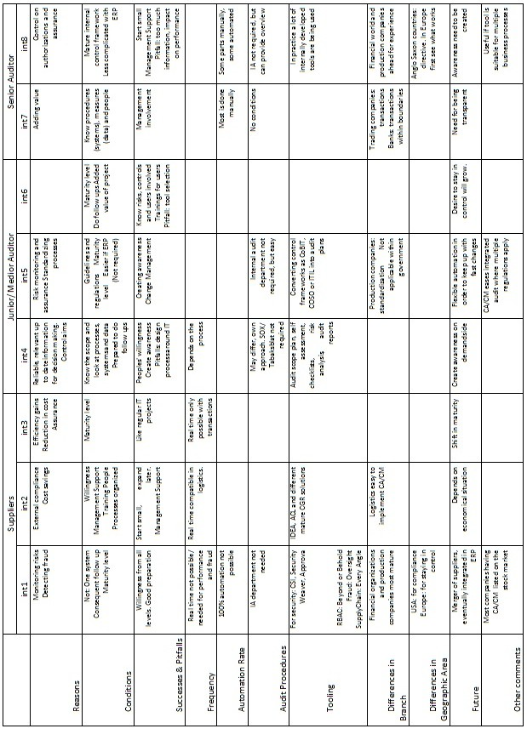Table 1 Summary of Analysis

Conclusion
This is the final chapter of this thesis. The results or main findings of the study are displayed beneath. Some research limitations are presented. Also recommendations and lessons learnt are included in this chapter.

Main Findings
Here the main findings with regard to the aspects of the theoretical model are presented. These findings are results of the analysis of the interviews that have been held for this study.

The research question for this thesis has been:

When and how is Continuous Auditing/ Continuous Monitoring used in practice in the Netherlands?

The answers can be found when a company requires to the following points. These are the answers to the sub questions from section 1.3.

These aspects answer the question when CA/CM is successfully used in practice:
- Reasons for implementing
The main reason for companies for implementing CA/CM is staying in control.
- Conditions for implementing
Before implementing CA/CM the company must be in the managed or optimized phase of the maturity model.
- Successes/ pitfalls
Management support and peoples’ willingness and their awareness to cooperate are of importance for succeeding a CA/CM project.

These aspects answer the question how CA/CM is used in practice:
- Rate of automation
It is not feasible to have 100% automation. Some controls need to be checked manually.
- Frequency
Real time monitoring or auditing is not feasible within an ERP system. It will have an impact on the performance level.

- Audit procedures
No prescribed audit procedures or internal audit are required for implementing CA/CM. But in practice companies listed on the stock market are ahead in the implementation of CA/CM. And those companies have an IA department and have to comply with regulations as SOX or Tabaksblat.
- Differences in sectors
Financial institutions are ahead in implementing CA/CM because of their experience of risk mitigation for decades, and because of compliance with regulations. Production companies are also far, because of their business processes with relative ease of risk analysis and risk mitigation.

View of the future
For the future of CA/CM it depends on the economical situation and the level of maturity of the companies whether and how fast there will be an increase in the implementation of CA/CM.

Research Limitations
There are some limitations to this research. The reader must be aware that these limitations may have had an influence in the outcome of the study.

For this research 8 professionals had been interviewed. These interviewees can be categorized in 3 groups: 3 employees of CA/CM suppliers, 3 junior/medior IT-auditors, and 2 senior IT-auditors. These number of interviews held may seem low, but as these interviews were held, the answers to the questions resembled more and more and no new information was given.

Another limitation could be that all the IT-auditors, except for one, were from one Big4 Company. Also 2 of the suppliers’ employees had been working for this company. Had IT-auditors from other companies been interviewed, the results could have been different. Although, an attempt was made to plan interviews, there was no response to the request.

The two interviewees that had experience with geographic differences knew only the current situation of (West) Europe and Anglo-Saxon countries. It would have been interesting to learn more about CA/CM in Asia and other parts of the world. But especially Asia, since technology in countries like South Korea and Japan is well developed and in some cases far ahead of what is known in Europe and the USA. Even a study about CA/CM in the port of Shanghai or Singapore would be very interesting.

Recommendations for further research
One interviewee mentioned the problem when follow ups are neglected. This leads to data pollution, for instance sales orders that are still open. This data pollution is already a problem with current data systems. Unfortunately, cleaning up is not a priority for companies, because they want to have data available whenever they want to check.

Another field for future research is the impact of XBRL on the implementation of CA. Since companies in the Netherlands are required to deliver their data in XBRL to the fiscals, it would be interesting to study whether this has impact on the use of CA.

Lessons Learnt
During the research some lessons were learnt.
In an early stage of the study a survey had been held. This was no success; there was hardly any response. One lesson learnt from this experience was that one should always have a pilot survey or a trial before the actual survey.

Another lesson was that a survey was not the tool for this subject, because not many people have experience with CA/CM in practice. Financial auditors only know what they read in journals. IT-auditors often said that they didn’t have experience in practice.

During the interviews the answer to the questions regarding the conditions of implementation and successes and pitfalls overlapped. This could mean that the questions asked were ambiguous. For this research it was not problematic, but for future studies the interview questions must be formulated in a clear way.

The answers regarding tooling gained during the interviews were too broad. The answers diverted from real software tools to models and frameworks like audit plans. For the sake of the ‘open’ answers the questions were not rephrased during the interviews, but for the future this must be taken into consideration.

Sources
Papers
- Alles, Michael et all (2006) – Continuous monitoring of business process controls: a pilot implementation of a continuous auditing system at Siemens – International Journal of Accounting Information Systems 7, 2006, p 137-161.
- Alles, M.G. et all (2008)- Putting Continuous Auditing Theory into Practice: Lessons from Two Pilot Implementations – Journal of information Systems vol. 22, no 2 pp.195-214
- Coderre, David G. (2000)- Computer assisted Fraud Detection- The Internal Auditor, Aug.2000, p25-27
- Coderre, David (2005)- Continuous Auditing: Implications for Assurance, Monitoring, and Risk Assessment – White Paper ACL, 14 pages (Summary of GTAG)
- Coderre, David G.(2005) – Continuous Auditing: Implications for Assurance Monitoring and Risk Assessment - Global Technology Audit Guide
- Gartner (2008) - Hype Cycle for Data and Application Security
- Green, Meg (2006) - Businesses Look to Continuous Auditing, Monitoring Best's Review, Aug2006, Vol. 107 Issue 4, p76-76.
- Ibrahim, F. and Hallemeesch, D. (2008)- Het effect van GRC op de jaarrekeningcontrole –Compact, issue 3, P3-7.
- Isaca Standards Board (2002) - Continuous Auditing: Is It Fantasy or Reality? – Information Systems Control Journal, Volume 5, 2002
- KPMG(2008)- Continuous Auditing and Continuous Monitoring: Transforming Internal Audit and Management Monitoring to Create Value - 4 pages
- KPMG Whitepaper (2008)- Continuous Auditing/ Continuous Monitoring : Using Technology to Drive Value by Managing Risk and Improving Performance – 16 pages
- Rezaee, Zabihollah et all (2001) – Continuous auditing: the audit of the future - Managerial Auditing Journal 16/3, 2001, p.150-158.
- Rezaee, Zabihollah et all (2002) – Continuous Auditing: Building Automated Capability – Auditing: A Journal of Practice & Theory, Vol. 21, no.1, March 2002. p 147-163
- Scheeres, Willem (2005) – How continuous auditing could support the process of internal control evaluation- a dissertation submitted to The University of Liverpool
- Scheeres, Willem (2007) - Naar een verbeterde audit van de interne controle: Continuous auditing - De EDP-Auditor, nummer 3, 2007, p. 10-17

Internal Audit Survey Reports
- ACL (2006) –The 2006 internal Auditor Software Survey Results (Summary)
- Deloitte / IIA(2008) - Towards a blueprint for the internal audit profession
- Ernst&Young (2007) – Global Internal Audit Survey: A current state analysis with insights into future trends and leading practices
- KPMG(2009)- KPMG’s IT Internal Audit Survey: The status of It Audit in Europe Middle East and Africa
- PWC(2005)- State of the internal audit profession study: Internal audit post Sarbanes-Oxley
- PWC (2006) – State of the internal audit profession study: Continuous auditing gains momentum
- PWC (2007) – State of the internal audit profession study: Pressures build for continual focus on risk
- PWC (2008) – State of the internal audit profession study : Targeting key threats and changing expectations to deliver greater value
- PWC (2009) – State of the internal audit profession study : Business upheaval: internal audit weighs its role amid the recession and evolving enterprise risk
- PWC(2010)- State of the internal audit profession study: A future rich in opportunity: internal audit must seize opportunities to enhance its relevancy
- PWC/IAS (2007) –Internal Audit 2012: A study examining the future if internal audit and the potential decline of a controls-centric approach

Books
Fenn, Jackie and Raskino, Mark (2008) – Mastering the Hype Cycle – Harvard Business Press, 237 pages.

Sheets
- Jacobs, J. and Hoetjes, M. (2006) Continuous auditing and continuous monitoring: continuous solutions? - CSI
- KPMGSheets (2008) – Sustaining compliance in ERP systems through Continuous Monitoring
- Sussman, Lester (2008) Continuous Monitoring/Auditing: A practical approach- Sacramento IIA, Resources Global Professionals

Appendix A: The Hype Cycle

What is the hype cycle?
The hype cycle was introduced by Gartner in 1995. It is used to characterize a typical progression of an emerging technology to its eventual position in a market or a domain (Fenn 2007). An example is given in the picture below.
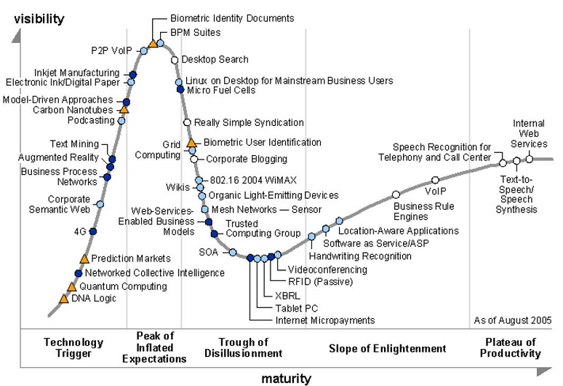

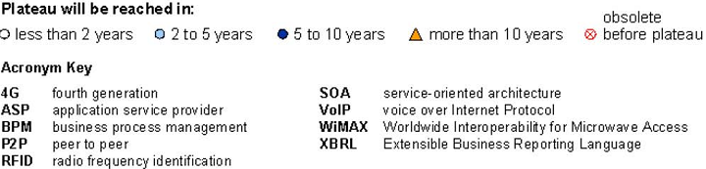

Figure 12: Gartner's Hype Cycle for emerging technologies
Source: Hype Cycle for Emerging Technologies 2005
On the vertical axis the visibility of a technology is given. This is the visibility in de media and other open sources which publish expectations around an innovation. The horizontal axis shows the maturity of a technology. The maturity is not measured in time; these are stages in the lifecycle of the technology. Some innovations may go faster along the hype cycle than others. The place of a particular technology on the hype cycle is indicated by a colored dot or triangle. This colored figure indicates the expected time for the technology to reach the plateau of productivity and be accepted.

The progression consists of five stages which the technology has to go through: technology trigger, peak of inflated expectations, through of disillusionment, slope of enlightenment and plateau of productivity. It is not necessary for different technologies to move at the same speed through the curve. It is also possible for a technology to be pushed back from one stage to a previous one. This may occur when a technology has new relevant developments.

The use of the hype cycle in practice
In practice, the hype cycle is designed to help companies decide when they should invest in a technology. One of the basic lessons is that companies should not invest in a technology because it is being hyped (O’Leary 2008). The hype cycle allows organizations to see through the hype and determine how many firms are employing a technology. Companies can also use the curve to understand what their competitors are doing with a specific technology. They can then determine their own strategy regarding particular technologies.
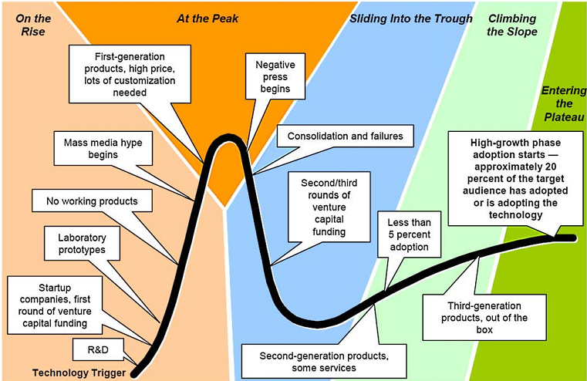

Figure 13: Hype Curve and technology information
Source: Fenn 2008

Stages of the hype cycle explained
The previous figure summarized some information available about the technologies along the curve and the status as the move along the curve. There are five stages to be distinguished that potentially can occur. All of the steps do not necessarily occur for each technology. Sometimes, an extra phase is added to the original five, this is called the Rapid Growth Phase. Each stage has different information being promoted by the media, and different numbers of companies adopting it. Next, the various stages are explained.

Technology Trigger
The technology trigger is the stage where a breakthrough, public demonstration, product launch or other event catches the attention of significant press and industry. There might be a prototype in this stage. The technology has not been placed in an organizational setting. Research done in this stage will be about experts opinion of what will happen with the technology.

Peak of Inflated Expectations
There is still limited information about and how the technology will be applied in organizations. Expectations are high and the information that is available is positive. First detailed prototypes and implementations are made during this phase. There are few firms doing the implementations, so research questions are likely to be narrowed to particular company situations. Students, faculty and other researchers are likely to begin to ask how the technology will influence companies.

Trough of Disillusionment
When the very high expectations are impossible to live up to, the stage ‘trough of disillusionment’ is reached. Because of negative information flow, research is likely to focus on the technology’s limitations. Also at this stage, there is still not much information available. Because of that, descriptive research is done in the form of case analysis. ‘Things gone wrong’ can also provide motivation for best-practices to mitigate problems.

Slope of Enlightenment
In general, there is an adoption rate of only 5% in the slope of enlightenment phase. Researchers are in position to talk with the limited number of companies that actually are implementing the technology. And there is even an opportunity to help design and implement, because of the limited implementations. At this stage researchers begin to assess realistically what went wrong and what went right. This can be done, because of the increased amount of information available.

Plateau of Productivity
Organizations are now fully aware of the benefits, these are demonstrated and accepted. Risks of adoption of the technology have been reduced. And, researches on technologies are usually descriptive about how it is used and if the use creates value to the organization. The technology may have slipped into traditional information systems classes and the teaching curriculum.

Rapid Growth phase
Many firms now begin to adopt the technology, because much of the risk has been reduced. So, the rapid growth begins. For research there is now sufficient data, so descriptive empirical analysis can be done.

Appendix B: Pilot Survey Results
 | Q1-2 | Q3-5 | Q7 autom. | Q8 ERP? | Q9 | Q10-11 CA | Q12 CA in comp
Ak | 1-4 IT ext | mult.prod. | 4 | yes | Oracle | yes / yes | no
Anon1 | 6+ Op. Aud | gov. | 3 | no |  | no / no | yes
Anon2 | 1-4 IT ext/adv | consultancy | 3 | no |  | yes / no | no
Anon3 | <1 Aud. Cons. | nl small consultancy | 3 | yes | Ipower | no / no | no
Ba | 1-4 IT ext | European Telecom provider | 4 | yes | Oracle | yes / yes | no
Ca | 1-4 IT intern. | gov. | 3 | yes | Oracle + SAP | yes / yes | no
Ch | 1-4 IT ext | mult.prod. | 5 | yes | Oracle | yes / yes | yes
Go | 1-4 IT ext | mult.prod. | 4 | yes | SAP | yes / yes | no
Ib | 1-4 IT ext | consultancy | 3 | no |  | yes / no | yes
Ju | 5-9 CEO | ICT Service- Europe | 3 | yes | Exact | yes / no | yes
Ma | 10+ ITaud/cons | consultancy | 3 | yes | Oracle | yes / no | no
Ro | 10+ IT intern. | gov. | 4 | yes | SAP | yes / no | don't know
Sa | 5-9 Compl coor | mult.prod. | 4 | yes | Oracle | yes / no | no
Ta | 1-4 IT ext | Accounting | 2 | yes | Customized | yes / yes | no
Be | 5-9 Service Line Mgr Archi. | IT Services | 4 | yes | Inhouse dev.+ Fin.package | yes / no | no
Ze | 1-4 IT intern. | mult.prod. | 4 | yes | SAP | yes / no | no
Zu | <1 IT ext | consultancy | 3 | yes | SAP | yes / no | no

Ro | Ju | Ib | Ch | Anon1
don't know | yes | yes | yes | yes | Q12 CA in comp
no | no | no | no | n/a | Q13 integr.
pur: rel. low, sales: fairly high, pay+ fin ad: high | pur, pay, sales: low fin admin: med | Not known | all processes 4 | for core bussiness | Q16CA autom.
once a half year for all processes | all except prod: monthly , prod; daily ?? |  | all proc. real time | weekly | Q25 freq.
yes | yes | yes | yes | no | Q26 impl.
adv. | project leader | adv. | adv./coord. |  | Q27 Role
risks | risks | risks | all reasons |  | Q28 reasons
5 | 6 | 8 | 7 |  | Q29
Mgt. Com | User Com | Mgt. Com | Mgt. Com |  | Q30 suc.
Duration | Mgt Com | Duration | User Com. |  | Q31 fail.
slope | plateau | slope | peak | slope | Q32 where HC
yes | yes | yes | yes | no | Q33 knew HC?
 | yes | yes | yes |  | Q34 contact?

Appendix C: Questionnaire for the interviews

- Wat is uw functie en wat voor rol speelt CA/CM daarbij?
What is your position and how is CA/CM involved?

- Waarom implementeren bedrijven CA/CM?
Why do companies implement CA/CM?

- In hoeverre is er sprake van een toename in het aantal uitgevoerde CA/CM implementaties?
Would you say there is an increase in the number of CA/CM implementations?
  - Is er een toename?
Is there an increase?
  - Welke factoren zorgen voor een toename?
What factors cause an increase?

- Aan welke voorwaarden moeten bedrijven voldoen alvorens CA/CM te implementeren?
To which conditions should companies apply to before implementing CA/CM?

- Wat zijn de succesfactoren van een CA/CM Implementatie?
What are the factors that define success of a CA/CM implementation?

- Wat zijn de valkuilen van een CA/CM implementatie?
What are the pitfalls of a CA/CM implementation?

- Hoe is de audit procedure ingericht?
How are the audit procedures organized?
  - Moet men voldoen aan compliance reglementen zoals SOX etc.?
Does one have to comply with regulations, such as SOX etc?
  - Heeft de organisatie een interne auditor of interne audit afdeling?
Does the organization have an internal auditor or IA department?
  - Welke tools (audit plan etc) worden gebruikt tijdens een audit?
Which tools are used during an audit?

- Hoe ziet u de toekomst van CA/CM en hoe komen we daar?
How do you see the future of CA/CM and how will we get there?

The Hype Cycle was introduced by Gartner in 1995. More on this subject is found in the appendix.
More about the pilot survey is found in the appendix.
CAE = Chief Audit Executive
ERP = Enterprise Resource Planning
These systems are all examples of Computer Assisted Audit Tools (CAATs)
During the interviews the answer to this question resembled the answers given to ‘conditions’. Because of this overlap between the answers for the analysis those two aspects were merged.

