
Graduate School of Development Studies
Environmental nuances in an armed
conflict scenario: the ‘War on Drugs’
discourse landing on Colombian territories

A Research Paper presented by:
Martin Bermudez
(Colombia)
in partial fulfilment of the requirements for obtaining the degree of
MASTERS OF ARTS IN DEVELOPMENT STUDIES
Specialization:
[Development Research]
(DRES)
Members of the examining committee:
Prof. John Cameron [Supervisor]
Prof. Lorenzo Pellegrini [Reader]
The Hague, The Netherlands
November, 2010
Disclaimer:
This document represents part of the author’s study programme while at the Institute of Social Studies. The views stated therein are those of the author and not necessarily those of the Institute.
Research papers are not made available for circulation outside of the Institute.

Inquiries:
Postal address: Institute of Social Studies
P.O. Box 29776
2502 LT The Hague
The Netherlands
Location: Kortenaerkade 12
2518 AX The Hague
The Netherlands
Telephone: +31 70 426 0460
Fax: +31 70 426 0799

Contents

List of Acronyms v
Abstract vi
Chapter 1 INTRODUCTION 7
1.1 Research topics 7
1.2 Research questions as objective to look through 8
1.3 Overview 10
Chapter 2 FOCUS: epistemological and methodological stances 13
2.1 Political Economy as standpoint and Political Ecology as viewpoint 13
2.2 Discourse analysis as lenses to read policy documents 14
Chapter 3 Satellite PERSPECTIVE over the geopolitical landscape of War on Drugs: frames 19
3.1 Context and co-text 19
3.2 Authorship and audiences 25
Chapter 4 Airplane PERSPECTIVE above Plan Colombia and Colombia’s Strategy documents: structures and metaphors 31
4.1 Genre, structure and metaphors 31
4.2 Temporal and spatial boundaries 37
Chapter 5 Helicopter PERSPECTIVE on top of people and nature: narratives and categories 42
5.1 Policy objectives and categories 42
5.2 Data as storyteller and other narratives 45
Chapter 6 INSIGHTS gained from PERSPECTIVES and REFLECTIONS 50

References

List of Acronyms
CS: Colombia’s Strategy
PC: Plan Colombia
CAD: Comprehensive Action Doctrine
CDA: Critical Discourse Analysis
IDEAM: Institute of Environmental Studies
IIAH: Research Institute Alexander von Humboldt
FARC Revolutionary Armed Forces of Colombia
SINA: Environmental National System
SAICA: Social Action and International Cooperation Agency
UNDCP: United Nations Office on Drugs and Crime
Abstract
This paper is a discursive approach to a set of governmental (hence public) texts commonly known as Plan Colombia Initiative. The two main texts under study are Plan Colombia (2000) and Colombia’s Strategy (2007). The Critical Discourse Analysis (CDA) methodology used frames texts in global discourse of ‘War on Drugs’, national urgencies and demands regarding the internal armed conflict and narratives of drug traffic, environmental protection, and local people. The time frame of the study is from 2000-2009 while the intended spatial focus is Amazon region, although the contextualization needed for discourse analysis purposes, and the spatial evolution of armed conflict, convey wider historical and geographical boundaries.

Relevance to Development Studies
From a development-studies research framework one can highlight and discuss intended and unintended consequences of policies amidst a long lasting armed conflict. These policies are discursively framed in a purposefully way to address a problem or set of problems including and excluding issues, highlighting and obscuring social groups and natural resources. The process of structuring this multi-level set of issues in a War on Drugs frame has international, regional, national and local perspectives, holding a geopolitical structure within States and powers that can be unveiled from a discourse analysis approach. The republican history of Colombia is characterized for a long lasting dependence with USA especially set in the last 20 years in a developmental economic sphere and a military approach: a counter-insurgent strategy and a fight against illicit drugs. This presence can be gauged discursively by examining thoroughly overarching policies as Plan Colombia initiative.
Keywords
Plan Colombia, armed conflict, war on drugs, alternative development, environmental institutions, Critical Discourse Analysis

Acknowledgements
To John Cameron, Lorenzo Pellegrini and Des Gasper for the guidance. To Anna, Badiuzzaman, Daniel, Duygu, Lauren, Mauro and Natalia for their company. And to Susana, for all that love.

“Marlow ceased, and sat apart, indistinct and silent, in the pose of a meditating Buddha. Nobody moved for a time. ‘We have lost the first of the ebb,’ said the Director, suddenly. I raised my head. The offing was barred by a black bank of clouds, and the tranquil waterway leading to the uttermost ends of the earth flowed sombre under an overcast sky - seemed to lead into the heart of an immense darkness” (Joseph Conrad)

INTRODUCTION
Colombia is internationally well known for two facts: first, the production and traffic of illicit drugs (especially cocaine) and second, being the host and hostage of a long-lasting internal armed conflict. Ironically, it is also known for being the second largest and one of the finest exporters of caffeine and the most stable democracy in Latin America. To add up onto this contradictory landscape, these ironies blend together in one of the richest territories of biodiversity worldwide. This research paper explores the relationship between State policies and strategies that from one side are fighting against illicit crops, and on the other, are willing to protect natural resources in an ongoing and intriguing colonization frontier. The study highlights the existing tension of official discourses and practices on development, conflict and environmental conservation, with an explicit reference to environmental richest territories involved in the national armed conflict.
This paper is divided into 6 chapters including this introduction to topics, objectives and overview of the research. The second explains the focus adopted for observing contexts and texts, consisting in a Political Economy standpoint, a Political Ecology viewpoint and Discourse Analysis lenses. The following three chapters consist in different perspectives obtained from dissimilar distances and angles from the documents. The concluding chapter presents the main insights gained from the perspectives and the reflections I made of them.

Research topics

Environmental conflicts are widespread problems around both the globe and development studies field. While some research has shown how environmental struggles can turn into violent conflicts (Hartmann, 2001), this paper analyzes the case of Colombia, where the policies to diminish intensity of an on-going and long lasting internal armed conflict, have affected those environment assets that are supporting livelihoods of local communities.
One interesting economic process of redistribution of land has been occurring in Colombia along both armed conflict recent evolution and war on drugs. The redistribution is related with land change and use. From a political economy position that assumes a political ecology perspective, the comparison between public policies related with territorial control, environmental protection and land use, is quite interesting to unveil power relations exert from the State in the framing of nature and livelihoods. This argumentation can be constructed based on institutional discourses, specifically those defined and exhibit in policy documents.
The environmental institutional framework of Colombia, namely the Environmental National System (SINA in Spanish) has been fairly research but rather from an official perspective (internal or external consultancies like (Rodriguez, 2008; Rudas, 2005), overemphasizing the role of the State in budgeting public organizations or assessing results from an ecological viewpoint (IIAH, 2009; IDEAM, 2009). Internal armed conflict has been an intriguing topic for conflict research (Mazzuca, 2009; Ibañez 2009). Nevertheless, the encounter of environmental and conflict discourses has not been addressed from a Discourse Analysis perspective in Colombia.
Methodological speaking, the research is set as an optical metaphor of topics as the elements selected to observe, focus as the point from which an image starts to be seen through the lens. Likewise, the set of lenses constitutes the objective, or the technical device that gathers and frames the evidence from reality, whereas the overview is a preliminary approach to the three perspectives gained from using the epistemological and methodological tripod of Political Economy, Political Ecology and Discourse Analysis.

Research questions as objective to look through
The set of lenses is constituted by the set of research questions because situates the topics under research in the position selected by the observer, say, the reader of public documents.Henceforth, the objective of this research paper is to give a particular account of how one specific official discourse is constructed and presented to the public domain, framing and offering one singular, static and prescriptive image of a multi-layered, vivid and also conflictive territory, as Colombia is. Likewise, the following set of questions constitutes this technical device to collect an image of the public-policy landscape, specifically on the intersection of the topics presented above: war on drugs, armed conflict, alternative development and environmental protection.
In this sense, the general research question of the study is to examine how do the tensions between ‘war on drugs’ and environmental protection discursively intersect in Plan Colombia initiative and what are the implications for people living in these policy-targeted zones. By doing this descriptive approximation to Plan Colombia documents, I can give account of some economic, political and social understandings over armed conflict, drug traffic and alternative development, and relate these findings with those specific claims over environmental protection that are addressed in Plan Colombia.
Then, the idea would be to research the Colombian case with a thorough methodology of discourse analysis over Plan Colombia and Colombia’s Strategy to discuss the main critics of both documents in light of what it is actually framed on them. The literature review about Plan Colombia shows two main trends of analysis: one discussing the ‘real’ intentions of the initiative beyond the texts in themselves and underscoring the geopolitical setting, meaning scholars underscoring USA global interests on the topic and henceforth, depicting the counter-drug policy either as yet another counter-insurgent Cold-War-type initiative, or a hegemonic attempt to gain control over Colombian territory and natural resources, or an imperialist strategy to have military presence in the Andean sub-region, and consequently, to control the Americas by framing illicit drugs as the main geopolitical feature of the hemisphere.
The other academic trend of research directly stretches the local importance of Plan Colombia in the evolution of the internal armed conflict, focusing either strictly in counter-drug results or in spill-over effects of the policy in human rights concerns (Brysk, 2005 and 2009), human displacement (Ibañez, 2009) or environment (Angrist and Kugler, 2008). Nevertheless, there is a gap in this literature in addressing Plan Colombia texts as explicit manifestations of political interests from both USA and Colombia, from which one can examine different discursive layers in an integrative mode. This research aims to do so, by setting global discourses (so-called ‘Big-D discourses’), overarching textual analysis of claims and logics expressed in Plan Colombia documents and track the evolution of a particular sectorial concern: the environmental one.
Accordingly, the research will turn around a set of specific or ancillary questions in order to address coherently the general or central one in looking how is nature framed within counter-narcotics policies enforced in Colombia. The first specific question would be then what are the international discursive influences that frame Plan Colombia initiative. In doing so, I want to examine similarities and differences from other counter-drug initiatives to see the specificity of Colombian experience, given for example, the particularity of its internal armed conflict. The second question is to see the position and role of environmental concerns in the overall framing of Plan Colombia initiative; this assessment can give account of the position environment plays in general policy framework and reflect some insights on institutional struggles involving Colombian governmental sectorial agencies, and international stakeholders. Finally, I want to see how official narratives on conflict and drug-business are framed and overlapped (or completely downgraded by silence) amongst them in the texts and affected local populations and territories. My purpose in analyzing this is to study the intersectional nature of environment and development in a conflictive scenario like Colombia.

Overview

The purpose of this sub-chapter is to give a brief account of the historical processes surrounding the topics explained before. Rather than a self-contained context of the research problem, the idea is to have one general overview to present some overarching dynamics of and interactions between topics of the study. This is because the methodology of discourse analysis applied more systematically in chapters 3, 4 and 5 relies heavily on contextualization exercises, which would frame topics further from the selected theoretical angles.
This research can be broadly describe as an attempt to study how very singular discursive devices and manners structuring Plan Colombia initiative texts, are building a sense of territory that although has a factual reality on ground, or metaphorically speaking, a massive bloody outcome on Colombian soil, is rooted and branched at the same time, with wider geopolitical discourses and initiatives. Hence, in order to build a more meaningful contextualization of the problem, I would attempt to frame it both geographically and historically before working more steadily in a proper contextualization of the texts in following chapters.
Some of those critics (Chomsky, 2000; Molano, 2000) are focused either on the heavy influence of USA over Colombian situation, or the competing proposals from USA and Europe to address Colombian problematic. The objective of this research is to see how military strategic actions to control cocaine production and traffic were conceptualized and framed in such a way, they hampered environmental protection and institutional enforcement and furthermore, affected people’s livelihoods by producing massive forced displacement. The way nature is framed in this State discursive practice is related with the institutional struggles of different State agencies, armed groups and communities, regarding nature, land, territory and environment.
The institutional tension can be observed in the intersection of three processes: the military one of constituting a legitimate presence of the national State through the midst of a violent history of more than 60 years of internal armed conflict, the economic dynamic of developing Colombian economy with its own national natural resources, and finally, the political process of protecting the environmental richness that is still standing on Colombian territory.
Illicit crops of coca have developed intensively in Colombia since the late 70's in response to which several anti-drug policies have been implemented since the 80's. Despite these efforts, Colombia has remained as the largest cultivator of coca bush in the world: according to the United Nations Office on Drugs and Crime – UNODC, 48% of the 167,600 hectares cultivated in the world were located in Colombia in 2008, representing 51% of the global cocaine supply (UNODC, 2009). The war on drugs has intensified since 1999 when Plan Colombia appeared as an integrated policy to fight against production and trafficking of illicit drugs, endorsing combined strategies of manual eradication, aerial aspersion, interdiction, and alternative development support for small peasants involved in the production process.
Given that cocaine production and commercialization is a valuable financial source of income because of its illegality, FARC (Spanish acronym of Armed Revolutionary Forces of Colombia), ELN and most of so-called ‘new’ paramilitary groups have engaged in its control around the entire geography (Map 1 in Annex). As a consequence, Plan Colombia (PC) and Colombia’s Strategy (CS) include explicit mentions on counter-insurgency and counter-terrorism strategies to be held with joint resources from USA and Colombia.
These policy documents include frameworks of defining nature in order to be sustainable in economic, social and ecological terms. Alternative Development is a crucial concept to understand the discursive power exert over territory, local economy and environmental assets. According to the United Nations General Assembly, alternative development is "a process to prevent and eliminate the illicit cultivation of plants containing narcotic drugs and psychotropic substances through specifically designed rural development measures in the context of sustained national economic growth and sustainable development efforts in countries taking action against drugs, recognizing the particular socio-cultural characteristics of the target communities and groups, within the framework of a comprehensive and permanent solution to the problem of illicit drugs" (UNGASS, 1988, pg. 8).
Currently, the Colombian government has three alternative development programs: the Productive Projects, the Forest-Warden Families and the Institutional Strengthening and Social Development. Their objective is to “consolidate the illicit crops eradication process and prevent its expansion, to provide stable income alternatives, employment and asset valuation to families and peasant communities involved, to promote institutional development processes and State legitimacy, and to support social capital strengthening, by means of stimulation of the organization, participation and community accountability” (DNP, 2005, pg. 5).
The Political Constitution of 1991 has a clearly defined emphasis on protecting the national environment as a fundamental part of social and economic collective rights. Nevertheless, the administration and protection of rainforests and biodiversity (especially in Amazon and Choco regions), is extremely complex due to the intensity of the armed conflict in these remote areas. The Environmental Law of 1993 stated differentiated aims and resources for a whole range of environmental authorities that were facing different challenges: urban industrial and transport pollution; regional development based in agriculture, mining or industry sectors; and environmental conservation.
This last objective of environmental conservation is especially important for the remote southern territories of the country (Amazon basin or Choco region) that is rich in natural resources, but at the same time, have no nearby industries or cities for the environmental institutions to regulate and tax in order to finance their organizational goals. While from the governmental perspective this 'unbalanced' situation has to be rearranged from a public budget perspective (Mena, 2002), critical approaches (v.g. Rudas, 2005) have pointed out the perverse incentive entangled in the whole environmental institutional framework: develop first to protect after.
Furthermore, there is a complex scenario for developing institutional strength for environmental policies at national, regional or local institutions. At the macro-level the Ministry of Environment was merged in 2002 with the Ministry of Economic Development downgrading the environmental tasks within the central government. At the micro-level, the Regional Autonomous Corporations in charge of environmental protection have decreased public expenditure resulting from the economic crisis of the end of 20th century. The re-allocation of resources involved in the war on drugs, have resulted in a diminishing budgeting support to fulfill their institutional objectives. Additionally, they have seen their institutional mission (sustainable development) far exceeded by the escalation of armed conflict, the displacement of illicit crops to new rainforest spots, and the increasing use of pesticide on these crops by cultivators or Colombian government.

FOCUS: epistemological and methodological stances

Political Economy as standpoint and Political Ecology as viewpoint
A political economy theoretical standpoint complemented by a political ecology approach is a suitable entry point to study environmental conflicts. In both cases, power-relations are addressed by institutional settings conform by National States and regional representatives through processes of decentralization and local governments. Social participation is also enhancing by States, although in a wide different manner according to each political history.
State policies, priorities and actions are manifestations of a legitimized power, which in turn is exercised by dominant groups in society that control institutional and legal frameworks. Such policies are explicitly framed in documents, which at the same time, can be addressed by the social scientist as a public expression of tacit power struggle of economic actors.
Political economy stands for an inseparability of economic and political spheres. The interactions between Markets and State evolving along capitalism has been studied in terms of social classes clashing, land being appropriated by violent means and playing an utmost role in accumulation of wealth by dominant groups in each society. Henceforth, State is an instrument of class domination framing land titling, offering security and enhancing specific economic projects like agribusinesses.
Political economy and political ecology intertwine also at an international scale. In the case of Colombia, its relations with USA and struggling with left-wing guerrillas around natural resources have situated environmental conflicts in a competition for land to cultivate legal and illegal crops and to hold territorial power to discover, exploit and obtain economic revenues. The hegemonic presence of USA in Colombian politics, economy and territory have definitely shaped national history, as it has do at a globalized level of post-colonial struggles (Silver and Arrighi, 2003)
Land, displacement, soil, pollution, biodiversity, poverty, illicit crops, inequality, interdiction and discursive domination can be studied altogether by holistic approaches like political ecology. This kind of paradoxes as in Colombia can be understood with a more causal and explicative pattern perspective. Following Martinez-Alier (2002): “[...] the relentless clash between economy and environment cannot be permanently silenced by socially-constructed hopes of an angelical dematerialization. This clash goes together with the displacement of costs to weaker partners, with the exercise of de facto property rights on the environment, with the disproportionate burden of pollution which falls on some groups, with the dispossession of natural resources for other groups. All this gives rise to real grievances over real issues” (Martinez-Alier, 2002: 70).
The political ecology approach also follows closely the discussion on the ecological perspective of the agrarian question around the interlinks between environmental protection and rural development (Sinha, 2000; and Akram-Lodhi, 2009), the forestry question of State rule reforms in other countries of Latin America (Pellegrini and Dasgupta, 2009 and Pellegrini, 2009) and the way exclusion and marginalization on State interventions can be studied in explicit emphasis or implicit silences in the arenas of planning (Winship, 2006). Bloomer (2009) uses a political ecology framework to study the Lesotho case of illegal cannabis cultivation and commercialization. He finds out that most of involved peasants are trying to complement their legal income involving cannabis as a coping activity, with a noticeable aid from governmental officers in doing so.
Linking these perspectives on the relationship between some policies against illicit crops and some others advocating environmental conservation, this research aims to investigate both contradictions and convergences between sustainable development goals and practices discourses regarding the fight against illicit crops in Colombia.

Discourse analysis as lenses to read policy documents

The relevance of discourse analysis on researching environmental policies at different locations and levels of policy-making has been proved by scholars at Europe (Hajer, 1995; Fischer and Hajer, 1999; Hajer and Laws, 2009), Central America (Almaguer-Kalixto, 2008) and Colombia (Galvis, 2009 and Asher and Ojeda, 2009). Consequently, Discourse Analysis methods can be applied on public policy texts as valid coherent statements representing the political struggles and emphasis to allocate public institutional priorities: general framing, specific structure of text, narrative and values overarching policy, phrasing of nouns within the texts related to nature (environment, ecology, biodiversity, natural resources, territory), and co-text relations of analyzed excerpts to the whole document.
Hence, I specially concentrated in environmental claims in public policy documents addressing the so-called war on drugs in Colombia, alternative development, and compare them with practices and results of the institutions in charge of these responsibilities. A discursive analysis of key policy documents as Plan Colombia, is essential to gain insights on environmental claims, procedures, and results of the institutions involved in a war strategy, whose actions had consequences.
The intention on criticism on a public policy is justified by Gasper and Apthorpe (2000) when state: “Policy as proposition, statement and style, is indeed not policy as decision as decision-making, interrelated though the two are […] Crucial in all policy practice is framing, specifically what and who is actually included, and what and who is ignored and excluded. This framing cannot be settled by instrumental rationality, precisely because it frames that” (Gasper and Apthorpe, 2000: 6). According to Dunn (2004) the policy-making process has multiple cycles involving various moments of adaptation: agenda setting, formulation, adoption, implementation, and appraisal. In this case, Plan Colombia is discussed more isolated in the process than gathering information of an endless perspective of a multiparty policy. The context involves what Dunn calls 'systemic agenda' and 'policy agenda' in which the systemic part shows the great influence of USA in Colombian Society and the dismissal of any negotiation from the part of executive branch within the Colombian political system. The structuring of the problem in this policy analysis is being settled by USA.
Widdowson (1998) advices us for not taking causes and pushing too hard and lose rigor for defending them, for trying to give a call from an assumed higher moral values standard. We need to be critical with power, with exercise of power through discourse, especially relevant with policies. According to van Dijk (2001) attitude on scholarly efforts of analyzing discourses, against power is determining Discourse Analysis.
Schmidt (2006) asks about values to examine, but here we are not in front of a marginal text: meaning that the multiplicity of powerful voices is part of the difficulty of analysis. But no participation is allowed. As Gasper and Apthorpe (2001) warned us before: there are no doubts that policies have to be authoritative, with no room to doubt against its internal logic. Hence, we have an assertion about language used in policy to set hierarchies of institutions, according to dominance priorities, which in turn are define by broader national and international systemic agendas. For Chouliaraki and Fairclough (1999) the participation is widely unveil by doing intertextuality analysis: “In the more general terms, intertextuality is the combination in my discourse of my voice and the voice of another [...] the presence in my discourse of the specific words of the other mixed with my words [and] the combination in discourse of different genres [or interdiscursivity]” (Chouliaraki and Fairclough, 1999: 49)
The objective of the following three chapters is to apply a combined methodological approach of Critical Discourse Analysis upon the two main policy documents regarding the war on drugs: PC and CS. The approaches selected rely on methods used in Frame Analysis and Narrative Analysis to obtain an account of how the (mostly institutional) authors crafted these two official documents for determined audiences, using specific discursive devices and persuading certain communicative goals. As long as the framing, structuring and narrating processes are unfolded, the relationship between Colombian armed conflict, its related environmental degradation and the ‘War on Drugs’ should be exposed from three different perspectives, allowing a closer look to the interconnection between conflict, development and environment.
The highlighted results of the analysis can be contrasted with the literature regarding war on drugs and environment, and also with the way convergent policies are assuming (framing) the war on drugs and the internal armed conflict in their own objectives. As explained above, one objective of the study is to discursively track the ecological nuance of the ‘War on drugs’, and in this way attempting to asses Plan Colombia initiative on this regard, especially after the public debate was placed by some critics of PC at its formulation and decision stages in 1999 and 2000 and fade afterwards in a technical discussion over different studies (Solomon et. al. 2007 for extensive review).
The combination of discourse analysis techniques proposed in this research is due to the high complexity and significant extension of the documents as texts subject of analysis. As a methodological discursive exercise of creating this approach, I decided to add a reflective metaphor over the object of study: I named the following three parts of this chapter as satellite, airplane and helicopter perspectives of the documents, depending on the ‘scoping distance’ taken from each of them. Consequently, I explicitly assume my own position as observer/reader of the documents, both engaging myself with them as meaningful arenas of research but also drawing an image of my own detached position from ‘fieldwork reality’ or what we can called ‘grounded stages’.
The satellite perspective has a wider scope of framing, and concentrates in the global and local contexts (Schmidt, 2006 and van Dijk, 2001) of the policies, especially regarding wider international arena and longer historic dynamics than those present in the documents. In doing so, we observe the location of this initiative in the Colombian public domain but taking distance from its explicit scopes, and henceforth, almost assuming a passive role of the texts in Colombian political landscape. The airplane perspective explores the inside structure of the documents under research, depicting macrostructures, time and space frames and general metaphors used in the documents to frame the war on drugs problem in Colombian historical conflict and development (Hansen, 2006). In this sense, this perspective assumes texts are autonomous, yet artificial and purposeful constructions of messages, and meant to describe and create an official account of Colombian reality.
Finally, the helicopter perspective is the closest approach to texts, specifically to analyze categories and narratives in which is discussed the environmental topic in the whole strategy of territorial control in the war on drugs (Alexander, 2009). Furthermore, classification of social actors (peasants, indigenous, traffickers, etc.) and presentation of claimed objectives and considered effects are helpful to discuss how those rhetoric devices have an active role in narrating stories on Colombian conflict, drug traffic and related ecological damage. Metaphorically speaking, this steady observation over narratives involving natural resources amidst an armed conflict is done like a helicopter trying to land in some clearings in the middle of the discursive jungle of this extensive documents.

Satellite PERSPECTIVE over the geopolitical landscape of War on Drugs: frames

Context and co-text

This first approach to contextualize the researched documents is a dialogical process of revealing and discussing some framing devices used in the production of the two texts under revision, and at the same time, unveiling the process of framing this research in itself. In this sense, the contextualization of Plan Colombia and Colombia’s Strategy is driven by two elements: those explicit discursive devices present in the documents (topics, genre and references to other texts) and the selected angle of this study: environmental claims within a counter-drug policy in an armed conflict.
Following van Dijk (2001) on how Critical Discourse Analysis must track exertion of power in framing processes, the focus has to be spotting those elements written and those ones unspoken in the texts. Clearly, the spotting task is also framed by the research question and epistemological and methodological standpoints. Therefore, this dialogical process is oscillating between pinning down power exercises through spotting and discussing authorship, intended audiences and explicit references from the texts, and highlighting historical, geographical, political and economic features of Colombian history according to my own perspective and research interests on how Plan Colombia initiative framed people and nature to justify ecological actions or downplay environmental complaints on this matter.
Geographically speaking, Colombia has had a crucial role in USA hegemonic control over the Americas: is located at the intersection of South and Central America, at the centre of Andean Community of Nations, with shores in both Atlantic and Pacific oceans, considerable territories over Amazon and Orinoco rivers, and respectable amount and quality of natural resources. It must be said as well, all these characteristics are likely to spot Colombia as a quite suitable place for illicit agricultural activities relying on USA internal demand: relatively closeness to the market, variety of routes to access it, remote and complex areas to cultivate, and soil, water and sunlight enough to have outstanding biomass production.
Historically, USA and Colombia have been hemispheric allies since independence campaign against Spanish Empire in early 19th Century. Despite USA outrageous intervention in Panama’s secession in early 20th Century, and the violent civil life of Colombia during 200 years of independent territory, Colombia has remained as a reliable ally of USA in the region. Furthermore, USA has been the largest buyer of Colombian production, and Colombia is one of most obedient receivers of American assistance.
The so-called ‘War on drugs’ discourse was launched by USA president Richard Nixon in 1971 both setting the scene at the early 70s and acting on it when it gained international status after the United Nations Convention of Psychotropic Substances was signed in 1971. Although cannabis, coca and opium related drugs were already banned since 1961 by UN first Vienna Convention, the offspring of widespread consumption in USA and worldwide production and traffic in Latin America of illegal drugs (mainly in global south communities) occurred at the end of 60s and throughout 70s, 80s and 90s, paralleling the American counter-culture upraising of the 60s. The steady increment of cocaine consumption gave USA the perfect excuse to increase the depth and width of the prohibition and criminalization of drug businesses and uses. This political decision was taken when the diversification of substances demanded in the global North, and the consequent generation of criminal supply chains in the global South were already settled and internationalized (Thoumi, 1995).
It is important to mention that USA worldwide hegemonic role during the first half of 20th Century has included a wide setting of global consumption patterns (e.g. American way of life) and a consequent thorough surveillance over permitted and prohibited uses and abuses of substances, perhaps as an endemic evolution of Victorian morality of the British Empire. One openly relevant initiative to this research is the USA prohibition of alcohol during 30s, and its subsequent criminalization of illegal business. Although, there are older international (Paris, 1912) and national (USA, 1914) prohibition acts against drugs, psychotropic and narcotic substances have been addressed in a globalized manner in three international conventions in 1961, 1971 and 1988.
According to Thoumi (1995) and Stokes (2005), the geopolitical importance of these conventions in the middle of Cold War scenario, was to have an overarching assessment of each block capacity to build chemical and biological weapons (drugs known as psychochemical weapons for use in battlefield and interrogatories rooms use). In most cases, these banning have mimicked the same perverse market logic of any trade barrier: isolated and desperate demand, high risk and higher profits, black markets and darker gangs, and in general, the criminalization of the whole commodity chain (Thoumi, 1995).
Besides the Marshall Plan discourse proposed by Colombia and USA, Plan Colombia initiative is rooted in the intersection of two main global discourses: 1971 UN call for a frontal fight in the so-called war on drugs and 1988 Convention of Vienna. Ironically, during 70s was the booming of cocaine consumption in USA and blooming production in South America, mainly in Peru and Bolivia. From Colombia to Mexico, the so-called Mesoamerica has been the disputable territories for transport and smuggling of marijuana, cocaine and heroin to USA market.
Plan Colombia is a fair example of a national counternarcotic policy tailored after 1988 Vienna Convention: it strongly advocates for Alternative Development as an economic and social strategy to assured interdiction actions in a militaristic approach, but widening enforcement from cultivation, processing and distributing sites and networks, to enhance governments capacities to tackle down criminal, financial and commercial enterprises related with money laundering and coordination of judicial frameworks. Homogenized rules for extradition, information sharing and legal assistance to were common practice during afterwards of Vienna Convention practices.
The United Nations Office on Drugs and Crime (UNODC) is the multilateral institution in charge of improving and technically supporting country policies in illicit drug control from Vienna Convention, but also in charge of a wide range of topics. Its branches are: 1) alternative development, 2) corruption, 3) drug prevention, treatment and care, 4) HIV and AIDS, 4) human trafficking and migrant smuggling, 5) criminal justice, prison reform and crime prevention, 6) money-laundering, 7) organized crime, 8) piracy and 9) terrorism prevention (UNODC website). UNODC was born from merging UN Drug Control Program (technical body from previous two Conventions) and Centre for International Crime Prevention (set in 1948) as an attempt to tackle both strings of commodity flows: illicit drugs coming out of Global South and smuggling in weapons, contraband, and more sophisticated money laundering procedures (Bates, 2001).
Further justification for this merge was the fact of illegal drug enterprises becoming global and widespread around the globe amongst both commodity chains between producer and consumer countries. According to Centre for International Crime Prevention (UNCJIN): “Crime is increasing in scope, intensity and sophistication. It threatens the safety of citizens around the world and hampers countries in their social, economic and cultural development. Globalization has provided the environment for a growing internationalization of criminal activities. Multinational criminal syndicates have significantly broadened the range of their operations from drug and arms trafficking to money laundering” (UNCJIN website).
It is worth noting two issues from a Discourse Analysis perspective: first, how UNODC categories are combining alternative development with criminal activities (or counter measures against them), framing by default drug traffic with terrorism, money-laundering, and justice and prison reforms, setting an integrative approach that in practice, represents a need of developing national policies coherent with this framing (as Plan Colombia turned out to be); second, the equalization of effects between ‘citizens around the world’ and ‘hampering consequences to countries’ as a shared ‘macro’ menace for all citizens and countries. Nonetheless, this threatening global scope of organized (hence rational) and increasingly powerful of criminal syndicates tends to affect “those most seriously affected – from poor farmers who cultivate it, to desperate addicts who consume it, as well as those caught in the cross-fire of the traffickers” (UNODC, 2010: 4). The drug chain is still envisioned only from production to consumption, forgetting not only the correspondent chain of illegal activities to achieved legal revenues from illicit drug traffic (oh, those ‘rich bankers’ and ‘desperate arm dealers’), but also the active role of governments involved in the ‘cross-fires’.
The discourse claimed is perfectly suitable with the open markets recommendations as part of a moral crusade: according to UNODC public mandate, this rising “problem without borders” needed a medium-term strategy based in economic approaches beyond the militaristic one used previously, useless “in a context of a changing world”. On the other side, it is stated that unstoppable consumption of illegal drugs, or “the scourge of drug abuse […] had reached epidemic proportions in many parts of the world” not only to “menace health and well-being, spread corruption, abet criminal conspiracy and subvert public order” (UNODC, 2010: 6). This commonly-used metaphor of ‘scourges’ and ‘sickness’ “increasingly becoming a worldwide business”, financing and strengthening other crimes such as weapons or human contraband, depicts a black-hand behind market logic that must be replaced for a cleaner, even pristine, version of coordination mechanism: an invisible hand.
Nevertheless, there are two discursive issues going on here: first, the ‘Alternative’ is hindering the fact that given the current state of affairs in producing (and conflicting) countries like Colombia, the conventional, traditional, typical development is not including all inhabitants. The alternative for them, then, is illegality. But taking into account that illegality is driven by a geopolitical definition set by consuming countries the market is heavily relying by demand and high-profit opportunities for reacting suppliers. The question hence, is who can supply a niche market created by developed ones in terms of demand and then, illegal supply. Arguably, there is a geographic explanation (agronomical and territorial features), but the opportunity was created by one-side definition of normality, morality or the alike. Someone decides what the norm is, and then, in a very ironic twist, criminalizes any deviance and sets their norm as an ‘alternative’ for the others.
Consequently, the causality of a war on drugs is then started with prohibition in developed-consuming ones, upheaval of criminality in developing-producing countries (those requiring an alternative tends to be limited for a excluding group of legal and formal organizations or firms, reinforcing a vicious circle of institutional informality, or even more, a criminal institutionalization.
Nevertheless, despites Convention was broadening policy scope by explicitly including consumer countries dynamics and parallel financial activities related with organized crime, the more white-collar workers were added as enforcement targets, more peasants were involved in cultivation, more blue-collar workers were involved in processing and arms were needed to protect illegal and profitable assets like cultivation fields.
The increasing demand and outlawing state of supply and commercialization of banned drugs tighten up the linkage between prohibition and criminalization at national jurisdiction, and military operations or intelligence missions abroad national frontiers. Evidently this tandem phenomenon of internal illegalization and foreigner militarization fitted perfectly with the Cold War scenario. As any American initiative ‘war’ implies, short after designating DEA and Department of State in charge of protecting American streets from drugs inflows, in 1982 CIA and Department of Defence joint efforts (through Southern Command of US Army and US Navy forces) to protect Latin American jungles from drug outflows and traffic. Whilst in 1988 the current Convention of Vienna was reviewed, updated and expanded for new coming drugs, in 1989 USA decided to coordinate its hemispheric efforts under the Andean Counterdrug Initiative, which includes Bolivia, Peru, Ecuador, Colombia, Venezuela, Brazil and Panama.
Plan Colombia was an initiative created by the Colombian and American governments during 1998 and 2000. It appears in a decisive and increasing political scenario, with the Colombian Armed Forces and Police Corps suffering heavy attacks by the Revolutionary Armed Forces of Colombia (FARC) widespread in the countryside and some medium-size cities and an increasing cultivation of coca and production of cocaine. President elected Pastrana invited the international community in a public speech in June 1998 (a month and a half before assuming presidential position) to participate in the forthcoming Peace negotiations, which in effect were held from November 1998 to January 2002. At that time, he proposed a Marshall Plan for the reconstruction of Colombia as a compensation for collaborating in War on Drugs.
During 1999 there were numerous discussions and meetings with interested parties on the document, especially as a central input for the Peace negotiations in its optimistic phase. Nevertheless, American government changed the initial proposal to one with an evident more militaristic approach, and addressing explicitly the increasing involvement of FARC in drug traffic and the difficulties of Colombian forces to halt their raising power. For this reason, a schizoid setting of multilateral discussion was in place during 1999 and 2000: apart from the original Colombian version, there is one discussed in the framework of the Peace negotiations and one addressed at the American congress. After diplomatic, political and institutional debates, the American version was formally accepted as the general framework for re-launching the war on drugs for the next years.
Plan Colombia is claimed to be an integrated policy to fight against production and trafficking of illicit drugs, endorsing combined strategies of manual eradication, aerial aspersion, interdiction, and alternative development support for small peasants involved in the production process. Its original proposal was made by President Pastrana in 1998, final version approved in 1999 and was prolonged several periods of under the name of “Plan Colombia and Beyond (2003-2006)”, and “Plan Colombia Consolidation (2006-2010)” or “Colombia’s Strategy (2007-2013)”.

Authorship and audiences

It must be stated that Plan Colombia (PC) and Colombia’s Strategy (CS), as autonomous texts to be researched, are outcomes of two fair different crafting processes. On the contrary of PC, CS is a prototypical technocratic product of the National Planning Department (NPD), the technical Colombian institution for researching, preparing, monitoring and assessing all municipal, regional or national policies. It has ministerial range and one of its main objectives is to centralize, assess, generate or improve technocratic information for the National Council of Economic and Social Policy (CONPES), which is ruled by the President and includes all ministers, chief of Central Bank and some key directors for social policy.
NPD is the heart of the technocratic power of the Executive branch of national government, and advices, defines and assesses each public plan, policy or program. Since 1968 is in charge of structuring each governmental 4-year National Development Plan and afterwards, to implement and control every component of each, including the technical and financial characteristics of all national, regional or local project. That is why a “CONPES-approved document” is a policy document created or reviewed by NPD staff and ready to discuss in Congress (like a National Development Plan) or simply to enforce and follow a program within the Executive branch. Depending on the content and scope of each initiative, these documents are discussed by the Legislative power and evaluate by the judicial one. Interestingly, despite the broad scope and sensitive content of Plan Colombia, it was not discussed as a NPD product nor addressed in the Colombian Congress. Nevertheless, monitoring and assessing progresses of its components was a NPD responsibility, as well as the design of the following up policy, namely Colombia’s Strategy.
It is interesting to see from this satellite contextualization that the only 'fully' Colombian input in PC is the Speech of the former president Pastrana: the so-called Text A. Two consequences arose from this clumsy insertion of the presidential speech within the whole plan: first, there is no logic connection between his last sentence in this ‘Preface’ and the text B. Second, the rhythm and style are quite different: the speaker conjugates in first person (singular or plural) but the rest of the document says 'The Pastrana Administration', just as a third-person (outsider of the government) observer would do. Same happens when stating role of ‘Colombian armed forces and polices to protect landing of our forces’.
Colombia’s Strategy was written within the core of technocracy of the executive power: National Planning Department (NPD), specifically from Office of Justice, Security and Government, conserving military strand. Other institutions involved in crafting this document are two Ministries (Defence and Foreign Affairs), Chief of Social Action and International Cooperation Agency (SAICA) and only one Colombian Ambassador: that appointed in Washington. Finally, there is one acknowledgement: to the former NPD Director, who was in charge of “planning” and enforcing Plan Colombia during Pastrana Administration.
The very fact of having an explicit list of institutions that “wrote” the text, all of them depending heavily in the presidential power, highlights the absence of representatives in other ministries which respective missions are involved in CS: Justice and Internal Affairs (in charge of National Police), Finance, Agriculture or Environment (including Housing and Territorial Development), to name a few. As it is an Executive initiative, neither Legislative or Judicial representatives are included, although some parts of CS (non-PC related) were discussed latter in Congress and CS indeed has a strong emphasis in judicial state structure. No members of USA or international community were appointed, as well as any member of private sector, civil society or particular communities framed (and affected) by the CS. It is clearly a governmental policy of authoritative sort and executive scope, covering a broad agenda of economic and social policies besides the military proposed actions as continuation of PC guidelines.
One special insight from frame analysis is to discuss on the intended audience(s) of a text, going beyond the explicit or rather obvious mentions in the text. In this case, although PC and CS are public documents, the latter is far more visible and accessible than the first. The case of PC can be assumed that secrecy was fairly enhanced beyond the usual side-room negotiations between USA and Colombia as sovereign States, given the militaristic approach and the on-going peace negotiations.
Regarding the intended audience of the PC, given the structure of argumentation and the contextualization of the situation, we can conclude that the included audience is US Congress instead of other potential stakeholders of such an integrated approach to Colombian situation. Within those groups, trade unionists, NGOs and few environmentalists were especially visible in their critics: strategies of spreading herbicides from planes were compared with effects of cultivation and processing of coca leaf.
Debate continued and today, the environmental claim is being held in international arena: coca bushes are assumed to be the most harmful biological agent in Colombian areas, without acknowledging chemicals used in Plan Colombia's strategies or the ‘balloon effect’ caused by the mobilization of crops due to aerial spraying patterns (Dion and Russler, 2008). These patterns were easily assumed by peasants and armed actors because of the technical autonomy of spraying planes and availability of armed escorts in their flights. In other words, aerial spraying was indeed as effective on destroying crops as in causing their displacement to different areas of Colombia (see maps 2, 3 and 4 in Annex).
But as a public policy document, more stakeholders are involved. The texts become the disputable and contestable field of interaction for politicians pro and against in USA and Colombia, and all those others involved in conflict, drugs, environment, human rights, and trade. Prominently, the FARC, and European countries involved in Peace negotiations and international cooperation with Colombia (European Parliament, 2001). Civil society included is national and international NGOs, trade and labor unions. Nevertheless, mass media not only has a wide range of communicative discourse to (in)form common opinions, but also its messages regarding public policies are generally uncritical or openly critical beyond the text in itself.
For good or bad, that means a wider audience is mediated by press releases over publication, launching or discussion of public documents. More informed audiences like specialized NGOs and academics, are addressed also, but its political influence is rather reduced and its rhythm of thorough evaluations lost momentum, especially when the reality depicted in these documents is as urgent and important as the resolution of an armed conflict is.

3.3 Intertextuality

As stated before, intertextuality is important to analyze texts because claims of authority are coded in the other texts and discourses acknowledge explicitly or implicitly. In this case the expected intertextuality consisted in Colombian Political Constitution of 1991 and several Laws and Regulations, Policies and Plans, and international discourses and documents related with the UN system on war on drugs, cooperation, trade, human rights, justice, institutional strengthening) and also, an overrepresentation of USA references. Surprisingly, there is no mention of Colombian Constitution in PC or CS. General framework of State, more visible when not accomplished at all (pre-2000) but still, valid for addressing topics as human rights, military cooperation, economic, environmental rights, etc. In CS there is almost not one mention of international documents or discourses. It is a more autonomous, but also more parochial policy (see Tables 1 and 2).
This parochialism can be asserted from the fact that despites the call for solidarity is addressed to ‘international’ or ‘global community’, it is always framed to be used in fight against drug problem and terrorism, a double-conflicting meaning: uses war on drugs old-American perspective, and holds position of USA post 11/9, to frame policies as counter-terrorist in the so-called Bush Doctrine (Colombia was amongst the 49 countries of the Coallition of the Willing that supported USA-leading invasion to Iraq). In general, PC depends more in international texts to claim authority on addressing the specific case of Colombia within the external globalization, and internal deterioration process of security and humanitarian standards in civil war.
Interestingly, CS relates PC with 2002-2006 NDP and so-called Democratic Security, the main component of Uribe-1 plan. The lack of acknowledgement to Pastrana administration to build and start PC and stating such an inexact procedure, to relate all success of PC with his government is controversial, to say the least. PC only relates with national policies twice, to justify Distension Zone were negotiations with guerrilla were taken place (based in Law 418 of 1997, in Samper government, not Pastrana) and the National Alternative Development Plan (2000-2003), which consists in complementary and expanded actions towards social policies in zones extensively cultivated with coca or under social upheaval (Putumayo). Meanwhile, CS has 14 mentions to 2002-2006 NDP (3 direct, 11 indirect referring to Democratic Security doctrine) and 16 to 2006-2010 NPD, creating a gap in sequence of State reforms and efforts in counter-drug policies and counter-guerrilla actions. Not very State building, by the way.
CS differs from PC of quoting several legal framework for attending necessities regarding war on drugs, armed conflict, territorial control that were created after PC: while PC only has one mention of a Law (and is from previous Samper Adminsitartion), CS quotes 19 times National Development Plans, 14 times national sectorial policies (Laws, CONPES documents or policies). Rather executive government and armed forces were strengthen than whole State.
In chapters 4 and 5 there are more insights gather from some texts, but is important to mention that PC, with double text structure (A and B) is richer in intertextuality, more open to lecture (more metaphoric), less structured than CS, less self-contained and more aware of external influences: it mentions Cold War, War on drugs and Prohibition in America, which is a rare but accurate quote.
On the other side, CS mentions MDG (launched at the same time of PC) but does not develop suffice interconnections with them, despite it could with several goals: MDG1 (end hunger and poverty), MDG2 (universal education) and MDG4 and MDG5 (child and maternal health). Actually, a repetitive call for shared responsibility on war on drugs (12 mentions) is always understood as bilateral and no connected with MDG8. Moreover, there is not relationship with MDG7 on environmental sustainability, but rather an explicit mention on environmental care as subsidiary of fight against world on drugs.
Regarding a big-discourse as ‘war on drugs’, PC has two mentions, whereas CS does it explicitly 19 times as an American caveat. But in CS, the war-viewpoint against drugs seems to spill-over excessively: there are declarations of war against terrorism (12), against poverty (2) and impunity (2). Close to American doctrine after 2001, the document is clearly a militaristic effort, despite the outstanding successes in retreating FARC and ELN in the previous 7 years of PC and announced in same text.
Interestingly, the mention on Comprehensive Action Doctrine (CAD) in CS links our war on drugs in Colombia with strategic documents in USA’s campaign in Afghanistan. The Comprehensiveness has a special virtue: it is militaristic in essence (how to hold positions, while fighting a guerrilla war). Instead of ‘Search and Destroy’ counter-insurgent tactic, CAD is more ‘Clear and Hold’ regular type. Still, CAD goes beyond to social expenditure, social development, which is purposefully also, for militaristic reasons: the recommendations are roads, civil sympathy from social expenditure, coordination of actions (following military protocols) and control of territory.
Still, it is quite shocking to see the straightforward transplantation of CAD from Afghanistan to Colombia. “The underlying idea is that Colombia’s historically neglected rural areas will only be taken back from illegal armed groups if the entire government is involved in “recovering” or “consolidating” its presence in these territories. While the military and police must handle security, the doctrine contends that the rest of the government must be brought into these zones in a quick, coordinated way” (Isaacson, 2009). Nevertheless, the vast amount of covered terrain in Amazon and Choco regions, has hampered second phase CAD in terrain and let to only military actions (Ibañez, 2009; Isaacson, 2009; CODHES).
It can also be observed how economic texts and discourses are framed in neoliberal spirit, addressing structural reforms in PC and gaining access to international markets by downgrading trade barriers and bottlenecks for free trade. Nevertheless, one old promise of PC was to establish more formal trade mechanisms, as a FTA, and in CS is not already signed. The claim sharing spirit and alliance of USA is under debate.
Typical from Critical Discourse Analysis approach, sometimes are more disputable the claims when intertextuality is weak, when there is need to justify but lack of means to do it, when instead of the norm, the exception enhances the anomaly in the documental justification. Regarding this, is worthy to mention one marginal intertextuality moment in each text in PC, there are some anonymous National polls to ‘prove’ the lack of support of FARC within Colombian population and some ‘anonymous’ technical/Colombian studies to ‘prove’ trade benefits for Colombia entering in a FTA with USA.
As a general assessment of intertextuality, I can say that CS is more self-contained within Colombian governmental institutions, but at the same time, more parochial, less aware of international stances. Partially this can be explained in the fact that some international recommendations evolved during PC phases into national policies or regulations, partly quoted as such in CS, international demands were addressed indeed in the period 2000-2006, for PC and first extension of it. But also there must be a quite significant influence from USA in the fact that CS is even more clear Colombian dependency from USA.

Airplane PERSPECTIVE above Plan Colombia and Colombia’s Strategy documents: structures and metaphors
As stated in the methodology, the objective of this chapter is to have a closer perspective of the two documents after previous chapter, in which some generalities and particularities of this type of policies were acknowledged in a wider international and historical stance. This second round of description and analysis consists in flying by the structures of the texts and pinpointing four different discursive devices: genre, metaphors, time and space frames. This closer framing contemplates in a more isolated perspective the documents than that in previous chapter, because the relative passivity of the texts in the latter evolves now into a more autonomous perspective of the texts in this chapter. Still, when relevant, the objective will focus especially on those visible environmental nuances of the documents.

Genre, structure and metaphors

The purpose of this section is to get an overall image of the documents by analyzing their structures and rhetorical composition. Special attention will be given to titles (of documents, chapters and subchapters) and ‘quantitative’ importance of topics divided and presented as such units of structure. Two methodological notes have to be done so far: although most of the following discussions are based on ‘labels’ (as presented in tables), the argumentation of criticisms are based above all, in the content of each part, hence, each title in index/table is used as ‘pre-text’ of the whole factual part of document I read. Secondly, despite this ‘structural’ exercise might seem somehow arid or static, relying on categorizations and descriptions of policies given by Kovacsesz (2002), Linde (2001) and McCloskey (1994), it must also be acknowledged the importance of metaphors, time and space frames as ‘organic devices’ that complements ‘qualitatively’ the (rigid) structures and constitutes the essence of public policies as a genre full of optimism and authoritative diagnosis and prescription for problems.
Within the genre of public policy, plans stand as the ultimate narrative (Johnstone, 2001) because are built to congregate efforts from all society in a common (mostly national) task as development, and also to hold a plausible explanation of social, political or economic malaises, in order to give a subsequent and coherent prescription of the present in order to sketch a feasible solution for the unknown future: another plan. The genre uses multiple metaphors of change or movement to depict the motion message of development.
To address a rhetorical comparison between Plan Colombia and Colombia’s Strategy, I concentrate the analysis in three metaphors: State – Economy, War – Peace and Environment – Economy. The first one is entangled along both documents when both Colombian State and economy are depicted as weak, or rather, needed of been strength; the second one is related with conflict and more than a metaphor in itself of the Colombian situation, is a military reality spilling-over other national spheres. Finally, the third one is interesting in terms of localizing (or ‘missing’) discourses on sustainability.
The first metaphoric moment is rather common: using construction or building processes as source to target State, and slightly changing from this solid/structural image of the State, as basis for an economic realm depicted from a more organic source: while State must be strengthen as a building, economy must be strong as a healthy organism. In Plan Colombia the necessity of a stronger State is drew on the use of the verb ‘consolidate’ 14 times and to strength 40 times. Ironically, after seven-years of so-called successful enforcement of Plan Colombia, in Colombia’s Strategy the State (central government and armed forces especially) must be ‘consolidate’ (67 times) and ‘strengthen’ (120 times!) yet again in an everlasting process of asking for external aid: seems like all solidification process during 2000-2006 just melt into the air.
Regarding economic realm a similar rhetoric process is witness: after the 1997-1999 economic crisis, Colombian economy is diagnose as weak (8 times) or young (5 times) and even as a ‘potential prey’; after Plan Colombia, once again, all those vitamins and nutritive meals given during seven years are not enough though: weakness is widespread around territory (12 times) and youth (12 times) still remind us how dubious and ephemeral are development promises on enfant industries. Even more interesting to see, is how the presence of an economic success like drug industry, indeed the prey of PC and CS, is not depicted with the same metaphor: all references to illegal businesses or black markets are set as networks, a fuzzy term as blurry are the structures of crime.
The second metaphoric insight when comparing PC and CS is dichotomy War – Peace. The Low Intensity Conflict of Colombia has never reach a level of civil war, but at the same time, contemporary peace negotiations and accords have ended up, all of them (1952, 1964, 1978, 1982, 1984, 1990 and 1999-2002) in new disrupts of hostilities between government forces, leftist guerrillas and (since late 80s) with rightist paramilitaries. Nevertheless, the war-on-drugs framing metaphor seems to spill-over all civil spheres of Colombia according to PC and CS: whereas in PC ‘war’ is mentioned 3 times (twice referring Cold War) in CS ‘war’ is widespread 18 times against drugs, impunity, poverty and discrimination. Same happens to ‘terrorism’ that turns from 4 marginal mentions to 55 (!), crime from 27 to 35 and ‘fight against’ from 16 to 27. The ironic twist here, is that Uribe’s administrations, in order to avoid any possible negotiation with guerrillas, and attending to international legislation, decided to withdraw political status to FARC and forbidden the use of ‘armed conflict’ by all State offices. As reward, we have war, terror, fight and crime trenched around every corner and page of CS, as scattered as in the national territory.
One interesting use of discourses and genres as methodological concepts is the identification of sources and targets realms to give account of transdisciplinarity (Chouliaraki and Fairclough, 1999). The most common use is using categories of economics to explain different social subjects. Nevertheless, in this particular case, is outstanding how ecological terms are extensively use to denote economic stances: ‘environment’ is used 6 times in PC and 8 times in CS but only 1 in the former and none in the latter are biological: all Colombian efforts are towards a prosper ‘economic environment’; same happens with ‘climate’ as surrounding space of businesses: 3 times in PC, twice in CS.
Afterwards, the text of PC explains the activities addressed by Colombia in the past, as if they were Colombian initiatives. The next three sections build the framework of the general argumentative big-discourse: national problems of enforcement of law and justice, American willingness of help Colombian inhabitants, and the American actual involvement in the Peace process. This Peace process was being negotiated during the Pastrana Administration at the same time the Plan Colombia, with its emphases in military actions. Tables 3 and 4 show the overall structures of PC and CS.
In order to focus the analysis on the ways people and nature are being frame in policy documents as CS, it is needed first to have a glimpse on the overall structure of the document, make a contrast with PC structure and acknowledge the changes to see where the new frame is emphasizing or deemphasizing subjects of policy. This contrast is expected to highlight the (positive and negative) evolution of policy in itself as assessed by the government, transformation in language due to change in presidency and the results of background negotiations of different stakeholders, USA in the first place, but also other foreign countries, governmental institutions, contesting political parties, and civil society amongst others.
First, general feature of contrast between PC and CS assessment of PC, is that those achievements of PC are reframed as ‘supporting’ the Democratic Security doctrine of presidency Uribe (2002-2006), despites it is still holding a time-frame of 1999-2006. The lead of merging the 2002-2006 National Development Plan and PC will be explained further in this research. The economic achievements are settled in first place out of the 5 components, and packed in 2.1 as ‘economic revitalization’, hence replacing the PC tone of an ‘Approach to Colombian economy’ as a setting moment of the text, to be a constitutive component of PC.
CS document consists of six parts, being second and third the central ones: Chapter 2 (16% of text’s pages) is an overall assessment of “Plan Colombia” and Chapter 3 (54% of text’s pages) the detailed explanation of each one of the six components of Colombia’s Strategy”. The other 4 parts (Executive Summary, Introduction, Closing remarks and Annexes) are ancillary parts for the core of the presentation, although the 3 first sometimes exhibit important nuances on the intentions of communication from the authors. As expected, repetition of cue messages explained in chapters 2 and 3 is recurrent in parts 0, 1 and 4, whereas the 3 attachments of part 5 are, all of them, complementing the explanation on militaristic component 3.1. For the purpose of this research, those relevant environmental nuances and changes found in parts 0, 1, 4 and 5 as independent texts, will be addressed in chapter 5.
Consequently, in order to have a meaningful assessment of text blocks (266 units of analysis, mostly paragraphs but also 16 graphs and tables) rather than pages, and unveiling plane quantitative emphasis between CS components, Table 4 shows a transformation dismissing contents of parts 0, 1 and 4 and allocating text blocks of part 5 as a set of functional pieces of Component 3.1, only subchapter where they are used. This increases participation of the militaristic component (fight on terrorism and drug problem) from 16% of potential units of analysis, to 29%, whereas the other 5 components sum 35%.
Nevertheless, it should be noted that from an AIRPLANE perspective of the text is interesting to recognise the fact of repetition of some specific ‘bullet points’ throughout the document. Indeed, the Index reveals a managerial structure of the document, in line with the dominant trend of understanding and leading public institutions (States) as ‘particular’ private enterprises: maximising “Achievements”, designing “Strategies” and presenting an “Executive summary” to simplify the conveyed message to the intended audience: an Executive Board of interested parties (presumably American government and Congress), prospected new investors (the “international community”) and other stakeholders (for example mass media).
The authoritative tone of ‘achieving’ is maintained in section 2.3 regarding war on drugs, but not in section 2 were only ‘progress in social revitalization’ are explained. The dubious progress will be extendedly explained afterwards, specifically because Warden-Forest Family Program is assessed here. The notion of crisis, difficulties and conflicts framed in PC are framed as previous death moments in both economic and social spheres: revitalization has this sense of Emergency room and Intensive attention needed. Apparently, the weak previous stage was rather an agonistic one. Interestingly, comparatively to PC, where social topics were 4th in text as a possible outcome of counter-drug strategy moment of PC, here are assessed in 2nd place, but as it will be discussed after, social component ‘re-gains’ its 4th place in CS components.
Regarding war on drugs in 2.3, what was called in PC as “Colombian counter-drug strategy” is widen eloquently in a broader fight against terrorism and a worldwide illegal problem. From a national strategy to a global problem, presumably related with terrorism does not announces a local success but a worldwide failure. This post 9/11 framing on terrorism is repeated in CS as the first component of the re-launched strategy. It will be addressed furthermore in the upcoming section, especially because the dynamic of hectares sprayed is addressed here.
The fourth assessment regarding Institutional strengthening includes explanations about ‘Justice sector reform’ of PC but merges also results in the sub-component of human rights and attention to displaced populations that were part of social component of PC. The emergence of these two topics is insightful of the changing flows of the armed conflict: what in PC could be a possibility of displaced populations due to the ‘push in the southern Colombia’, in CS is a reality that must be attended all around the country (component 5 of CS).
Finally, there is an odd assessment of demobilization, disarmament and reintegration process of illegal groups, which unveils the quite opposite outcome of peace-war dynamics between PC and CS: peace negotiations with left-wing FARC movement (as 5th component of PC) is assessed through a DDR process from 2003-2005. This sort of peace process (several assessments have showed intimate relations between government Uribe and paramilitaries) is included as part of CS (6th component). The name of ‘illegal armed groups’, although ample to include political/criminal contesting factions of violent actors in Colombian landscape, undermines the fact that negotiations were extendedly held with right-wing paramilitaries.
From the presentation of the 6 components of CS, several points must be raised: all six components are explained through an exposition of ‘Objectives’ and ‘Lines of action’, but only three have a background: fight on drugs and terrorism (3.1), open markets (3.3) and DDR (3.6). It’s strange how Justice and HR (3.2) and Social Development (3.4) do not have despites they were treated explicitly in PC, and Displaced population (3.5) is not, although it was announced in PC and it’s a crucial element of the armed conflict after 2006.
The percentages in Table 4 are showing this unbalanced: 3.2, 3.3 and 3.4 have on average 12% of text coverage whereas 3.5 and 3.6, as ‘added’ elements of SC have only between 2 and 3%. As expected, those uncertain components, widely criticized as poorly addressed by the government, do not have any line of action explained. Needless to say, component 3.1 is generously explained in 29% of the text.
CDA strongly recommends analysing introductions and presentations of policies because they reveal those core value definitions suitable to understand stakeholders positions (Schmidt, 2006) (Linde, 2001). In this ‘Preface’ there are indirect mentions to nature as “national patrimony” and “territorial integrity” avoiding an explicit addressing on environment and undermines the autonomy and presence of regional and national authorities already present in these regions (Amazonia, for example) depicted in the document as beyond control of the state.
Tone is authoritarian by default in public policies and documents tend to be self-contained and entangled in public sphere intertextuality: other policy documents, laws, official sources. Nevertheless, an important difference arises in comparing PC and CS, or observing the evolution of PC in CS: from a Text A announcing a rather unknown policy in B, we change completely to a shallow and plain Executive summary in CS.
Public policy as genre is a structuring device that frames intentions or actions as public problems, presents them in manageable scope and depth, important enough to be treated urgently, delegating institutions, budgets and human resources to be accounted as such by public institutions, stakeholders and other interested parties. As a consequence of arise of governance and social accountability demands to state actions, most of the times the documents in themselves contain those elements that are going to be assessed, making the texts a platform for internal evaluations and external criticisms. Public policy as genre states also a rather optimistic prospective (time frame widely incline to prospective planning instead of retrospective explanations) and its geographical scope is openly dependent on the political-administrative setting of each nation.

Temporal and spatial boundaries
Time and space frames are two crucial elements on defining intentions, scopes and limitations of plans. Clearly, these two dimensions are embedded in every aspect of public policies as long as actions, resources and institutional or individual stakeholders must be put into motion in a defined timeline and geographical bounded space. In terms of public policy analysis, both dimensions most be seen as prospective framing and hence time and space shall be treated as active categories in exposing political positions towards new politics “which are not just derivative of political forces but represent new and vibrant political terrains and gains” (Thrift, 2006: 547).
These boundaries are important for an environmental assessment in different but complementary ways: spatial definitions on territorial terms demarcate with clarity or obscurity the area to be intervened, and often fixed political-administrative or institutional jurisdictions do not correspond with changing cultural, bio-geographical or ecosystemic limits. Due to this, mismatching or overlapping are common in ecological and geopolitical arenas. In this study, interest set in Amazon and Choco basins are quite different examples: Colombian Amazon region comprises exactly 6 departments but only 5.18% of Amazon basin, whereas Choco region is spread in parts of 5 Colombian departments but quite enclosed in Colombian territory (Institute von Humboldt, 2009).
Regarding time, at least two ecological considerations can be done: first, as it is expected a coordination of timeframes along any policy in order to have a coherent argumentation of causes and effects, a sound recommendation for actions, and a plausible horizon for forecasting simulations, ecological processes tend to evolve and unfold in long-term frames with a high degree of indeterminacy, whilst policies are dependent on short-run efforts and commonly over-confident on certainty on the future; second, due to the latter, environmentalism tends to overemphasize prospective, regularly in pessimistic terms.
Unexpectedly in terms of these two texts that predominantly frame national space as territory to control strategically, most geographical references are related with countries and international arenas instead of provinces with coca crops, guerrilla or paramilitaries. This is quite distinctive if we see how the most salient result of Plan Colombia is the so-called ‘ballon-effect’ (see changing patterns scattering around Colombian geography in maps 2, 3 and 4), namely the displacement of coca crops around the national geography due to aerial and manual eradication and dynamics of conflict and colonization (Thoumi, 2005, Vargas, 2010). In fact, a more comprehensive policy would addressed the regional ‘ballon-effect’, a constant concern in terms of a reversal process of displacement of coca crops around Andean region since launching of Plan Colombia, in which principally Peru and Bolivia (Ecuador, Venezuela and Brazil in minor amounts) are seeing an increment in coca crops (UNODC, 2010).
As observe in the sequence of maps annexed, by 2000 a high concentration of coca crops were located at the Southern part of Colombia, namely departments of Putumayo, Caquetá and Guaviare. Actually, Putumayo is the only province explicitly mentioned in Plan Colombia, and it is the only singular target of Plan Colombia: “Phase 1: Short-range military, police and judicial effort aimed at Putumayo and the south and planned for one year” (Colombian Government, 2000). It must be said that Putumayo is fifth in producing oil departments, was host of massive mobilizations of peasants against aerial spraying prior Plan Colombia (1996-7) and holds one of the five national oil-pipelines, which transports Ecuadorian oil as well. Then, its strategic importance goes beyond having the biggest share of coca crops in 2000 .
Table 5 shows how Plan Colombia has only 10 specific mentions of geographical local regions, all concentrated in Amazon basin (South, East and Amazon). The local shift in Colombia’s Strategy goes to Pacific region, just as the ‘ballon-effect’ shows in sequence of maps. It is important to mention that out of 32 provinces or departments in Colombia, 11 of them counted coca crops in their limits by 2000, while in 2009 almost all had coca crops (only San Andrés, a group of islands in the Caribbean did not, although most of Caribbean fast-boats transporting cocaine had to stop by regularly on its shores). As showed in the maps, Plan Colombia ‘succeeded’ in the ‘Push to the South’ regarding eradicating coca crops in Putumayo, but with the collateral damage of spreading coca all around the Colombian landscape, and changing average size of fields from 3.5 hectares to 1.2 (UNODC website).
In a general assessment of discursive mentions of geopolitical entities and geographical spaces throughout PC and CS, one can notice four main features in the evolution of the public policy: 1) there is a steady high degree of referring to international/world arena (37%-41%) and a low degree for regional/neighboring geopolitical concern (6%-7%); 2) an increase in discursive participation of USA (17%-23%); 3) a decrease in Colombian local situation, although is visible the ‘ballon-effect’ from Putumayo and South-East (21%-4%) to Choco and North-West (0%-13%); and 4) from a mainly ‘peaceful’ framing of geography as country and rural/forest/cultivating areas (39%-16%) to a ‘war-like’ scenario of territories and zones, widely used in strategic/military terms (14%-49%).
Points 1 and 2 fit in historical tendency of international isolation and USA-dependency of Colombia (Bushnell, 1993) particularly worrying in the case of Latin American and Andean Community, because armed conflict and drug business is one of the central topics to be addressed regionally (Tickner, 2009). Point 3 not only stresses the mobility of coca crops (and conflict), but also has a particularity: the mentions of departments in Northern region of Colombia are in lists of alternative development aid receivers confirming another critique of Plan Colombia: how the unintended (but foreseeable) consequence of mobility of illicit crops and offspring of armed conflict around the country turned into using majority of funds (up to 68%) of social component in already developed regions (mainly Antioquia and Atlantic departments). Finally, the fourth point is just a spatial confirmation of the overemphasized militaristic approach of Uribe administration on war on drugs and increasing power of armed forces in representing State in conflicting regions.
Nevertheless, the recovery process (eradication or cross-fire) is also the one generating human displacement, which in turn, is also framed as part of the comprehensiveness of CS. Actually, as it happens with ‘war’ expression, ‘comprehensive’ action blooms in every corner of other policy-fields: social development, displaced population, human rights, investment, and special attention to Afro-Colombian population.
Regarding temporal dimension, ‘Preface’, Introduction, Elements and Approach sections of PC have two different time-frames: one rather vague about past and future but over-stating the historical nature of the moment, and one fairly precise addressing current circumstance to overcome in the near future. Regarding the first one, expressions like ‘will take several years’, ‘over the years’, ‘next few years’ are common, but pointing out the contrast with the urgent action needed in the present: ‘closing days of the second millennia of the Christian era’, ‘worst crisis in 70 years’, ‘unemployment is at an historic high’, ’40 years of continual growth’, ‘40 year-old historical conflicts’. Whilst time-frame for economic terms is rather manageable and forecasted: ‘third quarter of negative growth’, ‘past 5 years’, ‘3-year assistance [IMF] program’, ‘10-year strategic plan to expand trade’.
The accuracy of the future-framing is enhanced in the ‘Counter-drug strategy’ addressing the counter-drugs strategy (‘over the next 6 years’, ‘Phase 1 […] for 1 year, Phase 2 […] for 2-3 years, Phase 3 […] for 3-6 years’) but definitely vague on the justice chapter: not even one precise measurement and only verbs conjugated in future (‘will investigate’, ‘will move as quickly as possible’, ‘will seek to reduce impunity’.
Finally, when it comes to the Democratization, Social Development and Peace process, the time-frame fades in an erratic manner of either a certain future regarding the social component (‘government will establish’, ‘Colombia will also invite’) or a fairly precise present (‘last year’, ‘by the end of this year’). Interestingly, 3 exceptions confirm the rule about mismatching between distinct moments of the plan: when addressing the national contribution to the Plan related to the alternative component, the 2000-2003 time period does not go along with 2000-2005 counter-drug strategy; when addressing environmental effects of illegal crops, a rather awkwardly ample time frame is used to blame it for destruction of ‘close to one million of hectares of forest between 1974 and 1998’; and when slightly mentioning the climate change issue (not precisely the most comfortable topic for American international diplomacy), appears the only footnote of the whole PC explaining how an USA presidential initiative of July 29 of 1999 “facilitates the protection of the tropical forests” as a contribution to the global attempt of preserving the Amazon Delta and the Convention on Climate Change.
Finally, is noticeable how the time period coincides with National Development Plan official launching but also extends beyond it. Change from (intended) multi-lateral one-time aid package to a government in order to build peace, to a (tacit) bi-lateral everlasting militaristic package to a State in order to improve warfare and attend unintended (but somehow forecasted) civil consequences.

Helicopter PERSPECTIVE on top of people and nature: narratives and categories
The objective of this chapter is to analyse data referring explicitly on nature and people living in those territories that are or will be under intervention and influence of the governmental actions as framed in Plan Colombia and Colombia’s Strategy documents. Moreover, the environmental interest of this research is also placed in studying how nature, biodiversity, natural resources, ecosystems and landscapes are framed as well, in order to see how this physical environment is conceptualized in the public initiative called Plan Colombia. Nonetheless, although ‘territory’ is the most likely term to describe the inextricable link between countryside dwellers and their surrounding natural environment, previous chapters have shown how this word has been discursively (and literally) hijacked by a militaristic speech of strategic territorial control. This chapter will present then, the way people and nature have been discursively labelled at some extent and primarily marginalized from Plan Colombia framing.

Policy objectives and categories
Territory is then, the main support for local people from rural areas, especially so at the outskirts of modern development of infrastructure and social services given by the State. Thus, ‘territory’ is not only the physical terrain and its intrinsic powers for sustaining live, but also the surrounding community space that contents a vast amount of cultural meanings and socio-political implications for rural, indigenous and Afro-Colombian communities.
First noticeable discursive highlight regarding Plan Colombia multi-dimensional approach to Colombian situation is the ‘screaming silence’ of rural, indigenous and Afro-Colombian communities, despite they are the main ‘objectives’ of the policy: either they are cultivating coca crops or are caught in the middle of the ‘cross-fire’. Of course, as any military campaign or diplomatic negotiation, open discussion or consultation is rather unlikely to happen. Nevertheless, the interest of Plan Colombia in strengthening the State is never relying in a socioeconomic diagnosis of communities or planning and negotiating legislative process. The task of re-gaining legitimacy amongst communities whose livelihoods have been historically related with guerrilla territorial control (PC), and whose demands of meaningful State presence are presumably addressed in CAD, is just assumed as a subsequent step in consolidating military presence.
That does not mean there are not proposals for participation stances in Plan Colombia or Colombia’s Strategy. In the former there are two subchapters (4.5 and 5.2, see in Table 3) indicating the importance for ‘citizens’ to embrace democratic participation as means to have social accountability of their local governments. Nevertheless, the insistence in ‘citizens’ and municipalities dismiss the fact that those more affected for the conflict and eradication methods are located in rural areas. Clearly, those ones dominated by guerrillas or extensively cultivated through informal tenancy contracts do not allow or permit participation beyond the narrow civil control FARC, ELN or paramilitaries permit.
As explained by Sanin (2004), the vagueness of civil society definition and lack of clarity for social participation, as framed in Plan Colombia, ended with extended failures in local participation in coca areas. Furthermore, the chaotic ending of the Peace process in early 2002 and arrival of different paramilitary armies to the Southern part of Colombia generated bloodshed in the period 2002-2004, which in turn, discarded civil participation in any way.
The categories used for people located in red zones vary from (small) ‘farmers’ to ‘local communities’. ‘Peasant-economy’ and ‘indigenous-groups’ are only used once throughout the text, whereas settlers, colonizers and coca-growers, the majority of population in Amazon region (estimated 54% of 960.239 inhabitants for 2005, DANE website) are not mentioned at all. As in many parts of the world, settlers and indigenous live in fragile equilibrium over land ownership rights. Colombia is one of the leading countries in collective property titles with almost 14% of land protected under this figure, which can be added to 10% of protected parklands to sum up an apparently outstanding amount of land ‘protected’ (DANE, website).
Nonetheless, this collective property is a de jure manifestation for a territory that precisely, is under dispute before and during Plan Colombia and Colombia’s Strategy implementation. Not surprisingly, one of the main criticisms from national NGOs and Democratic Party of USA is the constant violation of inalienability of this collective titles and the uprising assassination of leaders from indigenous and Afro-Colombian communities in Choco region. Civil leaders have been murdered all around the country as well, impeding, in a cruel and ironic twist, the definitive sign of Free Trade Agreement between USA and Colombian for opposition of Democratic Party until Colombian Government shows feasible and demonstrable results in human rights and protection of civil leaders.
This insistent demand can be observed in the repetitive message of Colombia’s Strategy of protecting labour-unionists, assuring protection to Afro-Colombian leaders and defending collective land titling (see tables 2 and 4).
A short comment on the main objective of Plan Colombia must be made, as an essential discursive moment of both texts to discuss around invisibility of local people, or disinterested attitude of Plan Colombia initiative in population to be affected. Objective expressed is that “Over the next six years, the goal is to reduce the cultivation, processing and distribution of narcotics by 50%”. Laconically, the objective does not addressed if that quantity is measured in hectares or tons, and even more, given the steep ascendance of risks and price along the commodity chain, if the 50% is at local markets, Colombian frontiers or open-sea. The lack of clarity in this objective has been criticized by several observers (Chomsky, 2000; Isaacson, 2009, Thoumi, 2005, Vargas, 2010) and in Colombia’s Strategy by the same Colombian government:
“Flexibility should also apply to the establishment of much more comprehensive goals that take into account not only the number of hectares planted or sprayed, but also include and stimulate results in other areas of the anti-drug strategy such as interdiction, the dismantling of networks and groups of drug traffickers, the dismantling of financial, administrative, and armed structures at the service of drug trafficking, or the number of villages or towns that can certify that they are free from illegal activities associated with the production and trafficking of drugs” (DNP, 2007: 55).

This metaphor of flexibility in a pretended ‘solid’ strategy of a re-structured State is repeated along the text unveiling a double discomfort of Colombian government: the rigid but undetermined main objective of Plan Colombia and the increasing demands from Democrats to diminish USA funds to military aid (due to high levels of human rights violations and criminal relations of Colombian army with paramilitaries). Indeed, the Colombian government claims late successes due to increasing autonomy of Colombian army: “In 2005, the cultivated area increased by 6,000 hectares, making it necessary to increase the efforts and develop greater flexibility in the use of means and resources” (DNP, 2007: 46).
Another metaphoric nuance is that while Plan Colombia pinpointed armed conflict and drug business as ‘roadblocks’ for Colombian development, ‘pathos’ emerges in Colombia’s Strategy when 3 times it is stated that despite the visible successes in counter-drug and counter-insurgent policies, Colombia is at ‘crucial crossroads’ and hence, metaphorically speaking, without the support, Colombia could move otherwise than expected by its international partners. Addressing pathos or emotional claim, it states: “Just one year without that support would imply backwards movement on the important advances obtained so far” (DNP, 2007: 38).
The question moreover, is that despites the ‘advances so far’ have also included a high intensity conflict in those agrarian frontier zones were coca has been used as main or supplementary source of income for peasants, settlers or indigenous groups. What these broad categories on people and nature show, is that there is a country of Colombians asking for international aid to fight a war on drugs in certain distant zones, namely Putumayo in 2000 or Choco in 2007, were other Colombia was unfolding an illegal behaviour in cultivating coca or benefiting from it to fight against the State. The inclusion of rules to respect their human rights and attend them if displaced seems to cover with humanitarianism a set of actions that as framed as they were, convey the very act of conflict brought to those zones and as seen in the maps, spread around the national geography.
This pervasive effect of Plan Colombia has lead studies like Dion and Russler (2008), statistically asserting for effective reductions of coca crops by causing collateral costs as human displacement and hampering a sort of development for those more likely cultivating zones: medium levels of poverty amidst low State presence. Henceforth, this study calls for more access to markets and better public infrastructure, but as this research is arguing, those collateral damages were framed since the beginning by the policy makers, and alternative development, as framed in Vienna Convention is precisely intended in tackling this reality. The point, once again, is that conflict adds too much blast to have smooth investments in access and non-conventional development. The vicious circle is set already, not as ‘collateral damages’ but as a chain of suitable consequences overreaching rural communities perspectives or dynamics.

Data as storyteller and other narratives

The environmental discussion over illicit crops has always stayed in the technical definition of chemical components used in cultivation, processing or aerial aspersion, and their related biological and health effects on human beings and environment (Solomon et. al. (2007) have an extensive scientific literature review). Nevertheless, the analysis of broader environmental consequences is lacking in reports, public policies assessments and the alike. As seen in previous section, the main focus on the argumentation regarding Plan Colombia results is set in hectares, and hence in its environmental effects to compare with coca cultivation, cocaine production and distribution.
Colombia’s Strategy reports a decrease of 46.4% in area cultivated in 2005 compared to 1999, a fair accomplishment of main goal at first glimpse. The secondary objectives, related with economic stabilization, social development, strengthening of armed forces (including police corps for counter-drug actions) are also explained. Regarding environmental variables, it is stated that 26.400 families have settled in 65.000 hectares free of coca crops and engaged in Productive Projects Program, while 51.000 families are in Forest Warden Families Program which “has kept 1,250,000 hectares free from illicit crops and recovered and conserved more than 330,000 hectares of primary and secondary forest, and cleared fields”.
In the evaluation of public policies the quantitative moment is always crucial because it has an authoritative tone for assertions, forecasting and ‘objective’ assessments. According to Dunn (2004), Hajer and Laws (2006), the quasi-scientific air that descriptive statistics give to policies are the paramount of methodological and also discursive discussions. In this case, a quantitative narrative is built and illusion of accuracy immediately narrows the arguments in obscure methodological critics. Nevertheless, the discursive device is vital because as Linde (2001) explains, it results in the institutional flag (political motto) to refer unanimously about a definitive stage of policy, never mind the data is constantly changing or the methodology is disputable. The institutional narrative turns in the narrative, and reproduces the institutional spirit of success with the simplicity of ‘accuracy’ of official data.
As expected from previous subchapter in which local inhabitants of coca crops areas are not regarded as explicit subjects of the policy, the data in CS is more prone in showing advances in three differing fronts complementary of coca area reducing: drug dealers, guerrilla and criminals terminated, prosecuted or extradited, and macroeconomic variables recovering, public expenditure (education and health) rising in the entire territory, and some discursive advances in social policies: legislative acts and technocratic documents produced.
Data becomes story-teller in the sense that concepts to measure, methodologies to gather, results to understand, advances to present become the backbone of enforcement, assessment and debate, focusing and narrowing a reality that can strike when observed with different data. It must be said, there are a myriad of different approaches to contest reliability of data (Olsen, 2003). But in this analysis, my attempt is to show the discursive decision of putting in or out data from State offices in a document. For example, one that can be a counter-narrative of Plan Colombia is displacement. Returning to Colombia’s Strategy six components, it is quite telling that only the ‘comprehensive attention to displaced persons (sic)’ does not stands with statistics and graphics as the other five. An assessment of Plan Colombia on this regard would indeed be depressing (see Graph 1). It is noticeable how a totally different story is announced by this official graph from the same office in charge of Alternative Development projects (SAICA). Even more, independent sources have higher estimates on each year, for a total of 3.5 million people in this period (CODHES website), instead of 2.8 in official accounts as showed in Graph 1 .

Source: SAICA, 2010

Data as story teller is also interesting in terms of areas affected by eradication and as cause of deforestation. Unfortunately, Plan Colombia and Colombia’s Strategy does not include information gather by the same UNODC in the assessment framework of war on drugs (mind UNODC is government official consultancy financed in 90% by public funds). As explained before, the United Nations Office against Drugs and Crime (UNDCP) is in charge of evaluating the worldwide results of the war on drugs. As general rule, 90% of all UNDCP system, including each office is financed by the correspondent government, which sets certain political pressure in its mandate. Nevertheless, its methodology satellite methodology has cutting edge technology and World Drug Report of UN is the authorized source for academics worldwide. Debates over accuracy and interpretation are common but more interesting is the ongoing competence with Department of State of US, which in turn has different technology and methodology, although usual argument of ‘national security’ has halted any further explanation to contrast methodologies (Graph 2).
This fact has raised serious suspicions on some observers (Vargas, 2010, Dion and Russler, 2008) and even in UNDCP system of monitoring (SIMCI, 2007), regarding the (mis-)use of geographical information with political purposes. Dion and Russler also point out the fact of lack of American discussion on war on drugs with different data than areas on producing countries like retail prices on USA streets. The discussion every year between USA and Colombian governments is precisely about mismatching measurements.

Graph 2: Coca crops differing estimations and sprayed area in Colombia

Sources: UNDCP, Department of State and National Police of Colombia

Nevertheless, as a producing country Colombia is framed in geographical patterns of crops and not prices. Thus, the environmental discussion should not been downplayed and on the contrary, more data from UNDCP could be used for this. For example, the fact that each yearly measure is taken in December and analyzed thoroughly but coca crops are easily moved as each plant can grow in 6 months and be harvested for 2 years each 2 months (UNDCP, website). Moreover, UNDCP is still working on updating productivity measures from 1996 (!) based on field experiments to gauge weight approximations of tons of cocaine being processed. Finally, adding to this dubious accuracy of data presented on war on drugs Boekhout (1998) states that for all illegal drugs around the globe, from marijuana to heroin, LSD to cocaine, Interpol set a rule in 1989 (just after Vienna Convention) that seizures must be accounted as 10% of total produced. No scientific base or whatsoever is acknowledged and updating of this approximation is not announced until today.
And still, another data story is told in the previous graph: the amount of hectares sprayed with glyphosate according to National Police. Given the fact of mobility of crops, the ‘smooth’ diminishing reality of crops showed in last graph, does not include that more than existent hectares cultivated are being sprayed, with a toxic outcome for 2 years in-soil, according to UNODC (2010) and Solomon et. al. (2006). And yet another environmental story can be told: according to UNODC overall observations of vegetation coverage in the entire country, in the period of 2000-2006, up to 2.6 million of hectares of primary and secondary forests have been deforested. Coca crops measured by UNDCP are responsible of 137.000 of this process, 5.3% of the total. In the Colombian Amazon region, 938.593 of hectares have been cut down for different uses: timber, (legal and illegal) agriculture, and cattle ranching. Out of this amount, coca represented 55.000 hectares during the whole period (36.303 of primary forests and 18.574), meaning almost 6% of deforestation in Amazon region. The previous, existent and prevalent hectares sprayed, manually eradicated, cultivated, intoxicated and re-cultivated were used for other agricultural purposes, including surely replantation of coca. But also, it must be said, configures a whole puzzle of statistics and realities that must be observed on the field and not from a distant and comfortable metaphoric helicopter.

INSIGHTS gained from PERSPECTIVES and REFLECTIONS
The objective of this study was to understand how environmental concerns were addressed, framed and presented in two policy documents known broadly as the Plan Colombia initiative. In doing so through discourse-analysis perspectives, the contextualization of the documents show which features and angles are left out in the general framework of the policy, which others are included in a quite particular crafting procedure of structuring a multipurpose initiative and which specific understanding of environment was included. The fate of national natural resources and their ecological value are inextricably linked to the political process of State building through territorial control. The prioritization of military actions corresponds to the strategic emphasis in the fight against drugs and illegal armed groups. Nevertheless, the motivation for upgrading the importance of environmental policies, institutions and issues in the middle of an armed conflict, is to explore the possibility of considering the environment not as a luxury good that can be obtained (and therefore, must be addressed only) after peace and development, but as a central topic linked with the dynamics of the national conflict.
As a matter of fact, the dynamics of the Colombian agrarian frontier are properly depicting the violent process of commoditization of livelihoods through the change in land use, the arrival of massive agribusiness initiatives and the settling of sustainable development discourse. What we can see is that discursively speaking, the Marshall Plan and War on Drugs frames made expectable that Plan Colombia had an American intervention spirit, neoliberal economic goals, militaristic means and territorial control perspective. Indeed, once this situation was stated, human rights and displacement attention were intended issues to attend, to say the least. Sadly, the environment per se is in an uncomfortable situation, as it plays a role as guerrilla tactic advantage, host of financing sources like coca and marginal victim as territory.
Following this rationale, is disputable, that we are witnessing failures in both the global fight against drugs or the Colombian local war on drugs, which indeed, has been fought in the middle of a long-lasting armed conflict. The discursive devices that craft Plan Colombia and Colombia’s Strategy are all announcing territorial control, military enforcement, humanitarian attention of foreseen human displacement, land dispossession, opening agrarian frontier, and clearly, environmental degradation. In this sense, most of the critics to Plan Colombia fail in two discursive traps: delivering automatic criticisms to the usual discourse from the usual suspect, or concentrating excessively in the micro-evaluation of hectares of coca crops.
The methodical reading of PC and CS can add to the academic discussion a different scope of criticisms on how people and nature in Amazon and Choco regions were conceptualized. The complexity of a wider painting, with more discourses interlinking, metaphorical stains and rhetorical dots all over, permits to observe some general patterns and perhaps to distinguish which details are truly peculiar of Colombian violent landscape. According to the exploratory insights and reflections obtained in this paper, for example, we can directly question Colombian recent administrations in their role of allowing (Pastrana) or advocating (Uribe) for a foreign discursive and factual intervention to disguise, yet again, the historical conflict of Colombia, rooted in unequal land distribution, human displacement or weak/shallow/hollow State.
Regarding ecological considerations, the exercise of framing at different levels Plan Colombia initiative shows that environmental considerations were explicit only in the detailed (and misleading) explicit objective of reducing hectares of coca crops. A more (indeed) comprehensive ecological framework like ecosystem management, complemented by conflict theorizations, will show that ecological harm is placed not only by coca cultivation, processing, distribution, aerial/manual eradication, interdiction (regardless of aftermath of winners and losers on this issue) and its consequent displacement throughout the country (‘ballon effect’), but also by alternative development for peasants, canonical development for powerful entrepreneurs in post-conflict scenarios and more importantly, by conflict in itself: concentrated aerial bombing or extended landmines field, human displacement further into the jungle (Amazon or Pacific basin) or outskirts of crowded cities, diplomatic insensitiveness towards environmental cooperation with neoighbouring countries or internal downgrading of environmental institutions in political agenda.
And as assumed previously the combined epistemological stance of political economy and political ecology is not naively praising environmental protection for nature in itself or the future of our sons. Instead, I ground myself on them to recall land as the past and current reason for actions from all sides in either conflict or development.
I also attempted to point out how an apparently overarching ‘Colombian’ policy is yet again, representing foreign interests and taking advantage of them to benefit that modern urban Colombia that sees the remote Colombian territories in Amazon, Orinoco or Pacific basins as a stubborn and lawless weight, distant and violent, without acknowledging the historical process of postponing eternally a solution on land problem and State building, precisely because land uneven accumulation and weak State are instrumental cornerstones of current political economy of Colombia.
Alternative or canonical development can both be harmful for the environment, but as it stands today, the alien, militaristic and developmental solution enforced so far in the last 10-years, are worsening the national, sociopolitical and ecological situation far beyond expected, forecasted or criticized.
Further research can go in at least two directions: understanding the intertextuality of other documents related with the war on drugs and the armed conflict (displaced populations, reintegration, amongst others) and deepening on this topic by triangulating this type of methodological approach with quantitative research (such as statistical accounts) or in-field gathering information from communities, bureaucrats and stakeholders involved in the unfolding process of economic development.
There are several methodological limitations of this study to achieve a better understanding of the relationship between armed conflict and environment amidst the war on drugs in Colombia. These limitations are linked with the chain of decisions made to focus the research and therefore can be unfolded mimicking the three stages of Chapter 2: first, in terms of depth, Discourse Analysis methods over PC and CS can be enhanced by contrasting them with other official statements (for example, related with guidelines and assessments of alternative development programs) and with critical perspectives that were left out of the frame, but whose inputs shaped the selection and presentation of topics. That other side of the policy-making process is represented by opposing political parties and social organizations (in Colombia and USA), humanitarian, ecological, and scientific/academic institutions, and technocrats and regional authorities which opinions were discussed but not included in the final version of PC and CS documents. The intersection of opinions and acts of speech deviant of the official position would reveal insightful details of the reasons for choosing (or dismissing) different ways of conveying the multiplicity of messages explicit in documents like PC and CS.
Second, in terms of width of the research, the lack of fieldwork hinders the political ecology aim of the research because it yields excessively in the official formal institutional act of proclaiming a framing policy of different (and even sometimes contradictory) actions. It would be an expected further methodological step to interact with dwellers affected or (somehow) involved in the armed conflict, the coca or poppy cultivations, the eradication and alternative development programs, and with members of enforcement institutions or agencies in charge of applying the programs in the field (Police and Army officers, local majors, bureaucrats from regional environmental agencies, park guardians, etc.).
Although it still seems evident to me that a critical and thorough reading of the cornerstone documents of war on drugs is the first step in unveiling power exercises over people, nature and institutions, it must be said that regarding political ecology, another necessary trend for further research is the combination of qualitative and quantitative research by critically using the available geographical information.
Finally, regarding the political economy standpoint as definitive to approach social struggles over land, natural resources and human livelihoods, the process of accumulation by dispossession and wealth distribution amongst social groups should be also tracked down by using economic categories such as inequality, poverty, employability and creation of business due to ‘alternative’ or ‘canonical’ development.
War on drugs in this redux version of a quite planned walk towards no man’s land, is a contemporary version of development, a ‘sustainable’ one, searching and destroying warlords and illegal crops, reaching the heart of the utmost valuable environmental assets for international and Colombian large companies in order to protect them by military tactics and conserve them by liberal economics. The angle with which the counter-drug policies have frame the doomsday situation of Colombia, embedded discursively in Plan Colombia documents as this research has reflected upon, to rescue peasants, settlers, indigenous and Afro-colombians from a conflict, seems more apocalyptical now.
Unfortunately, as long as discourses of ‘war on drugs’ are still on use from global North to actually control territories at the Global South, one can only expect from the distance that populations marginalized spatially from main development trends, will experience more marginalization in both discourses and practices of pacification, development or conflict. Development, conflict and war are entangled discursively and practically in the boundaries of colonization frontiers in Colombian jungles. The second phase of Plan Colombia, more directed by Colombian government than USA one, with a tactical advantage not witnessed before, while spotting coca crops and chasing terror, has bring to local communities the horror of war, the horror.

REFERENCES

Alexander, R.J.(2009). Framing Discourse on the Environment – a critical discourse approach. London: Routledge
Angrist J. and A. Kugler (2008). Rural Windfall or a New Resource Curse? Coca, Income, and Civil Conflict in Colombia. Journal of Economics and Statistics
Almaguer-Kalixto, P. (2008). “The politics of sustainable development: analysing exclusion at multiple levels in the environmental policy process”. Doctoral dissertation for the School of Development Studies, University of East Anglia, Norwich
Akram-Lodhi, A. H. and C. Kay (2009). ‘The agrarian question: peasants and rural change’, in A. H. Akram-Lodhi and C. Kay (eds.), Peasants and Globalization: Political Economy, Rural Transformation and the Agrarian Question, London: Routledge
Asher, K. and Ojeda, D. (2009). “Producing nature and making the state: ordenamiento territorial in the Pacific lowlands in Colombia” in Geoforum 40, pp. 292-302
Bates, R. (2001). “Prosperity and violence. The political economy of development”, Norton publishers, New York, 2001
Bloomer, J. (2009) “Using a political ecology framework to examine extra-legal livelihood strategies: a Lesotho-based case study of cultivation and trade in cannabis, in Journal of Political Ecology, Vol 16, (49-69)
Brysk, A. (2009) “Communicative action and human rights in Colombia” in Colombia Internacional, January-June 2009, Number 69, pg. 36-49
_________ (2005). “Human rights and private wrongs: constructing global civil society”, Routledge, New York, 2005
Boekhout, T. (1998). “Drug use and drug trafficking in Europe”, Tijdschrift voor Economische en Sociale Geografie, 1998 1: 100-105
Bushnell, D. (1993). “The Making of Modern Colombia: A Nation in Spite of Itself”, University of California press, L.A.
Castrillon, A. “Migrantes o desplazados?”, in Revista de Economia Institutcional, vol. 11, issue 20, Universidad Externado de Colombia, 2009
Centre for International Policy website: www.ciponline.org
CODHES (Consultancy for Human Rights and Displacement) website: www.codhes.org
Colombian Government, (1999) Plan Colombia: PLAN FOR PEACE, PROSPERITY, AND THE STRENGTHENING OF THE STATE. Visited in http://www.ciponline.org/colombia/plancolombia.htm
Chouliaraki and Fairclough (1999). “Discourse in Late Modernity - Rethinking Critical Discourse Analysis. Edinburgh: Edinburgh University Press, 1999
Chomsky, N. “The Colombia Plan: April 2000”, in Z Magazine, June 2000
DANE (Administrative Department of National Statistics) website: www.dane.gov.co

Department of State (USA) website: www.state.gov

Dion, M. and C. Russler. Eradication Efforts, the State, Displacement and Poverty: Explaining Coca Cultivation in Colombia during Plan Colombia” in Journal of Latin American Studies, 2008, Vol. 40, Issue 3, Cambridge University Press
DNP - National Planning Department (2007). “Colombia's strategy for strengthening democracy and promoting social development (2007-2013)”, DNP, Bogota
________________________________________ (2006). “Plan Colombia progress report, 1999-2005”, DNP, Bogota
_________________________________________ (2005). “2019 Vision Colombia II Centenario”, DNP, Bogota
Dunn, W. (2004). Public Policy analysis. An introduction, Prentice Hall, Third edition, New Jersey
European Parliament (2001). Resolution on Plan Colombia and support for the peace process in Colombia, February 1st 2001
Fischer, F. and Hajer M. (1999). “Living with nature. Environmental politics as cultural discourse”, Oxford University Press, Oxford
Galvis, J. (2009). “Developing Exclusion: The Case of the 1961 Land Reform in Colombia, Development and Change 40(3): 509–529
Gasper, D. and Apthorpe (2000) Structures And Meanings - A Way To Introduce Argumentation Analysis In Policy Studies Education. ISS Working Paper 317
Hajer, M. (1995). "The politics of environmental discourse. Ecological modernization and the policy process". Oxford University Press, Oxford
Hajer, M. and D. Laws (2006). "Ordering through discourse", in M. Moran, M. Rein and R. Goodin, The oxford handbook of public policy, Oxford University press, 2006
Hanes, T and F. Sanello (2002). “The opium wars. The addiction of one empire and the corruption of another”, Sourcebooks Inc., Illinois, 2002
Hansen, L. (2006). “Security as practice: discourse analysis and the Bosnian war”, Routledge, New York
Hartmann, B. (2001) “Will the circle be unbroken? A critique of the project on environment, population, and security” in N.L. PELUSO and M. WATTS (eds) Violent Environments, Cornell University Press, Ithaca NY
Ibáñez, A.M. (2009). "Forced displacement in Colombia: magnitude and causes" in Economics of Peace and Security Journal, vol. 4(1), pages 48-54, January 2009
IDEAM (Institute of Environmental Studies of Colombia) (2009). “Informe anual sobre el estado del medio ambiente y los recursos naturales renovables en Colombia: bosques”, IDEAM editorial, 2009
IIAH (Research Institute Alexander von Humboldt) (2009). “Informe anual del estado de los recursos naturales – biodiversidad”, IIAH publications, 2009
Isaacson A. (2009). “Evaluating "Integrated Action," the next phase of U.S. assistance”, www.ciponline.org, http://justf.org/content/after-plan-colombia
Johnstone, B., (2001). “Discourse Analysis and Narrative” in Schiffrin, D.; Tannen, D.; Hamilton, H.E. (eds, 2003), Handbook of Discourse Analysis, Blackwell Handbooks, 2003
Kovacsesz Z. (2002) Metaphor: a practical introduction. Oxford University Press
Linde, C. (2001). “Narrative in Institutions” in Schiffrin, D.; Tannen, D.; Hamilton, H.E. (eds, 2003), Handbook of Discourse Analysis, Blackwell Handbooks, 2003
Martinez-Alier, J. (2002). “The environmentalism of the poor. A study of ecological conflicts and valuation”, Edward Elgar, Cheltenham
McCloskey, D. (1994). “How to Do a Rhetorical Analysis, and Why" in Roger Backhouse (ed.) New Directions in Economic Methodology. London: Routledge
Mena, D. (2002). “Situacion ambiental institucional: retos y desafios”, en Garay, L. J. Colombia: entre la exclusion y el desarrollo: propuesta para la transicion al Estado Social de derecho, contraloria general de la nacion, 2002
Mazzuca, S. and J. Robinson (2009). “Political conflict and power sharing in the origins of modern Colombia”, in Hispanic American Historical Review, vol. 89, issue 2, 2009
Molano, A. (2000). “El Plan Colombia y el conflicto armado”. Revista Numero, Number 27, Bogota. Document was read at the European Parliament (Brussels), September 12, 2000
Olsen, W. (2003). “Triangulation, time and the social objects of econometrics” in P. Downward (ed.) Applied economics and the Critical Realist critique, Routledge, London
Pellegrini, L. (2009). "Forest management in Bolivia, Honduras and Nicaragua: reform failures?”, Institute for Social Studies, The Hague
Pellegrini, L. and Dasgupta A. (2009). "Land reform in Bolivia: the forestry question", Working paper 480, International Institute of Social Studies, The Hague, The Netherlands
Rodriguez, M. (2008). “Gobernabilidad, instituciones y medio ambiente en Colombia” (ed.), Bogota, Foro Nacional Ambiental, 2008
Rudas, G. (2005). Financiacion de la politica ambiental regional en el marco del Sistema Nacional Ambiental de Colombia", Fondo Nacional Ambiental, 2005
Sanin, M.C. (2004). Participation mechanisms in Plan Colombia and Peace Laboratories: new alternatives for Colombian civil society. Research Paper, International Institute of Social Studies, The Hague, The Netherlands
Schmidt, R. Sr. (2006). Value-Critical Policy Analysis – The Case of Language Policy in the United States. In D. Yanow & P. Schwartz-Shea (eds.), Interpretation and Method
Silver and Arrighi (2003). “Polanyi's "Double Movement": The Belle Époques of British and U.S. Hegemony Compared”, in Politics Society 2003; 31; 325
SIMCI - Sistema Integrado de Monitoreo de Cultivos de Coca (2007). “Colombia: Monitoreo de cultivos de coca. Censo de cultivos de coca 2006”, UNODC, Bogota
Sinha, S. (2000). "The 'other' Agrarian transition? Structure, institutions and agency in sustainable rural development" in Journal of Peasant Studies 27, 2: 169-204

Solomon, K., A. Anadon, G. Carrasquilla, A. Cerdeira, E. Marshall and L. Sanin. Coca and poppy eradication in Colombia: environmental and human health assessment of aerially applied glyphosate” in Reviews of environmental contamination and toxicology, 2007, vol. 190
Stokes, D. (2005). America's Other War. Terrorizing Colombia”, McMillan, New York, 2005
Thoumi, F. (1995) “Political economy and illegal drugs in Colombia”, United Nations University, New York, 1995
Thoumi, F. (2005) “The Colombian Competitive Advantage in Illegal Drugs: The Role of Policies and Institutional Changes”, in Journal of Drug issues, vol 35, number 1, Florida State University, 2005
Thrift, N. "Space, place and time", in R. GOODIN and C. TILLY, The oxford handbook of contextual political analysis, Oxford University press, 2006
Tickner, A. (2009). “Latin America: Still Policy Dependent after all these Years?”, in Arlene B. Tickner and Ole Wæver, eds. International Relations Scholars around the World. London: Routledge, 2009, pp. 32-51
United Nations General Assembly Special Session - UNGASS (1988). Action Plan on International Cooperation on the Eradication of Illicit Drug Crops and on Alternative Development, in www.unodc.org
UNCJIN (Centre for International Prevention of Crime) website: www.uncjin.org
________________________________________ (2009). “Analisis Multitemporal de Coca. Periodo 2007-2008”, UNODC, Bogota
UNODC (2010). “2010 World Drug Report”, United Nations Publications, New York, 2010
UNODC (United Nations Office on Drugs and Crime) website: www.unodc.org
van Dijk, Teun, 2001, ‘Multidisciplinary CDA: a plea for diversity’, in Methods of Critical Discourse Analysis Wodak, Ruth & Meyer, M., eds.
Vargas, R. (2010). “Desarrollo Alternativo en Colombia y participacion social: porpuestas hacia un cambio de estrategia”, DIAL, WWF Colombia, Bogota, 2010
Widdowson, H.G. (1998), The Theory and Practice of Critical Discourse Analysis, in Seale, Clive, (ed.) 2004. Social Research Methods: A Reader. London: Routledge
Winship, C. (2006). "Policy analysis as puzzle solving", in M. Moran, M. Rein and R. Goodin, The oxford handbook of public policy, Oxford University press, 2006

Map 1:
Coca crops and illegal groups (2006)

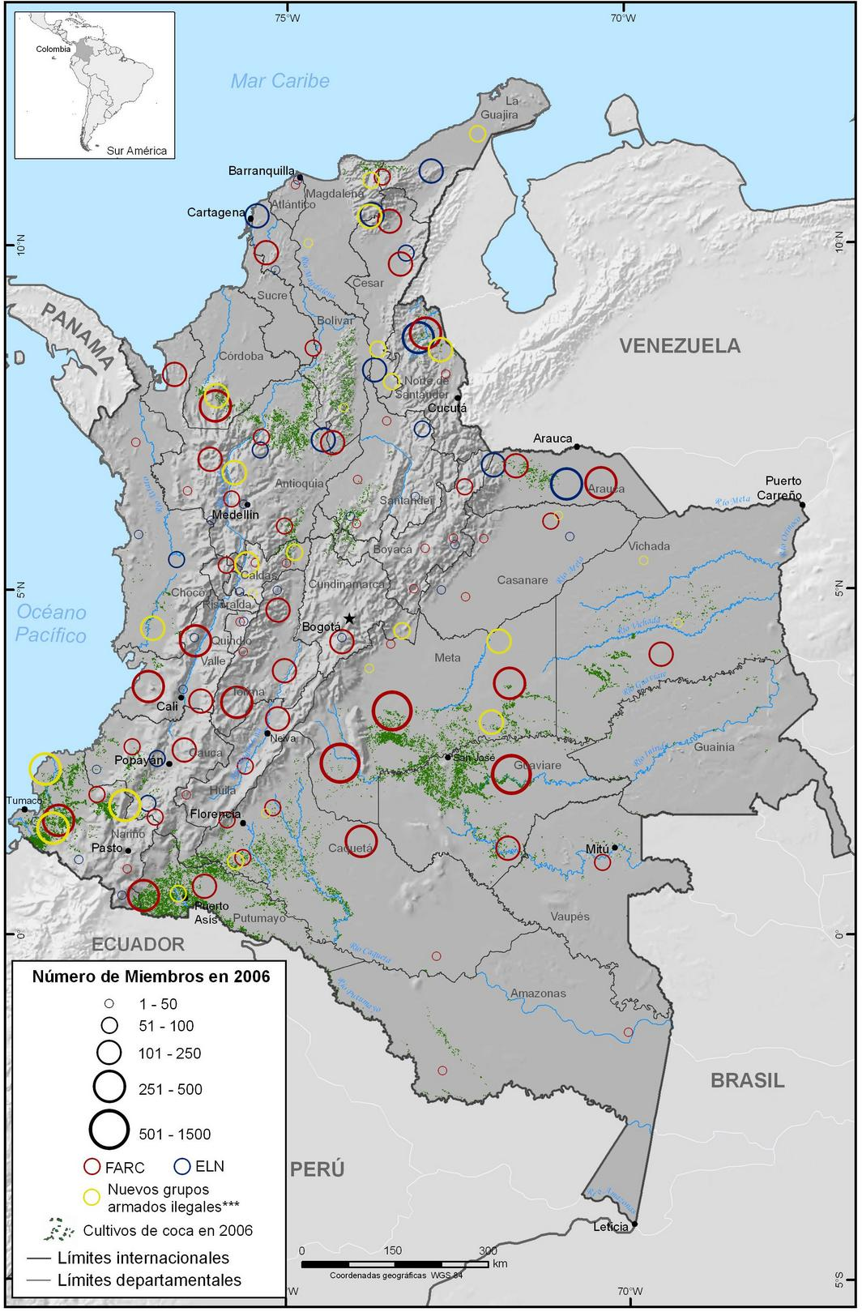
Coca crops

FARC

ELN

Paramilitaries

Source: UNDCP website
Map 2:
Coca crops (2000)
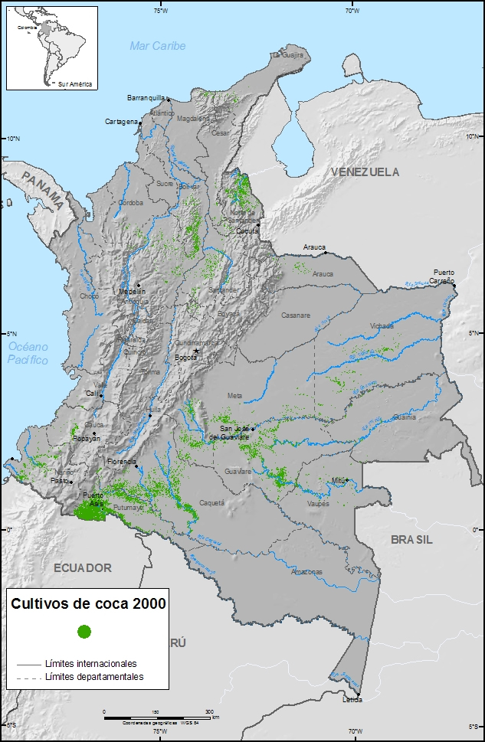
Source: UNDCP website

Map 3:
Coca crops (2003)

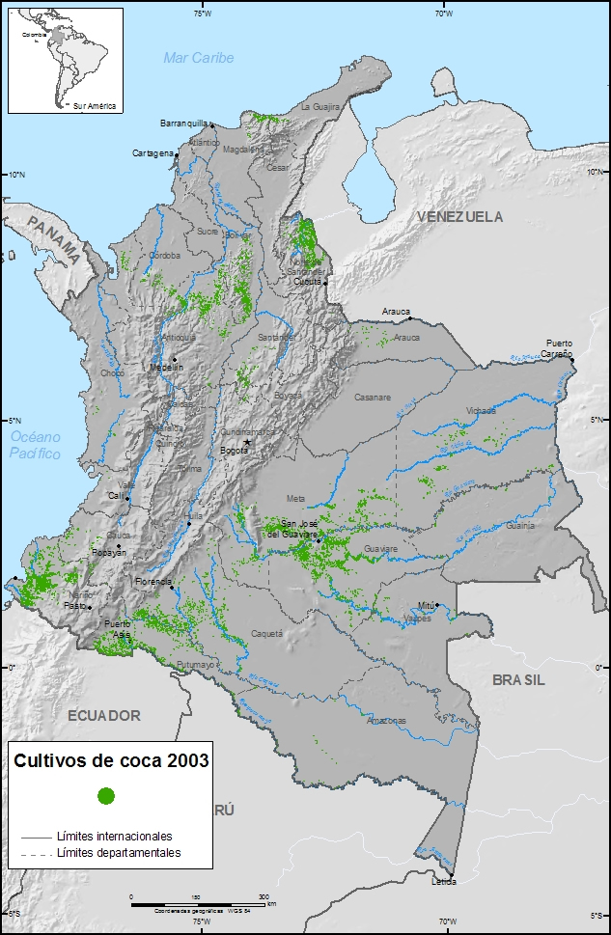
Source: UNDCP website
Map 4:
Coca crops (2006)
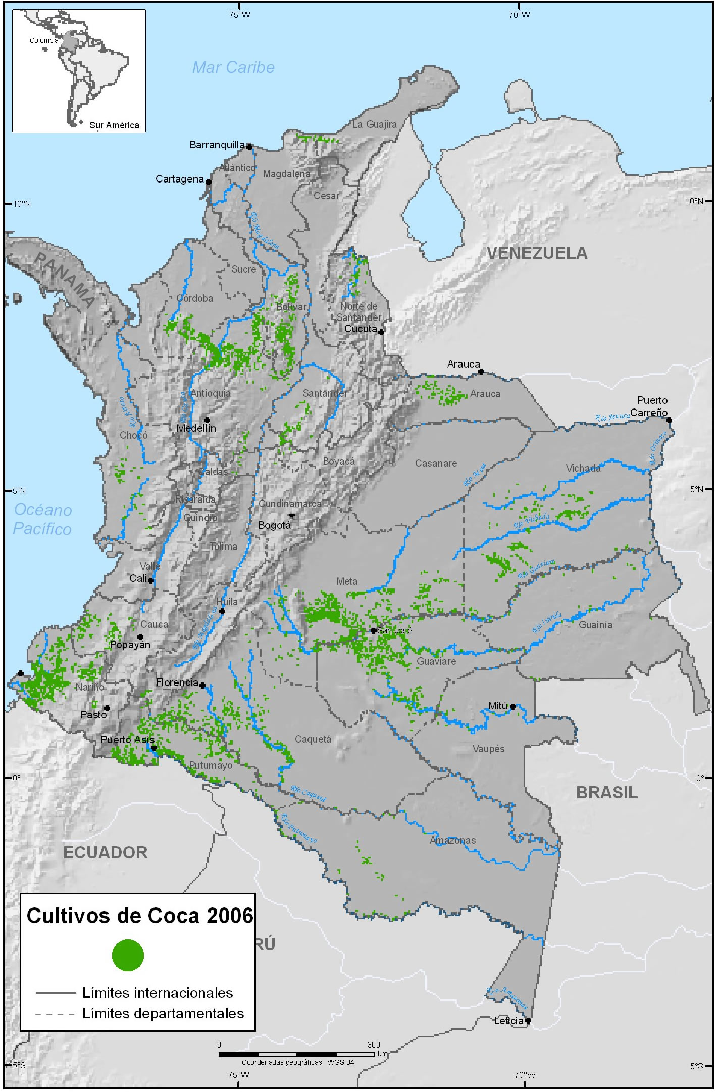
Source: UNDCP website

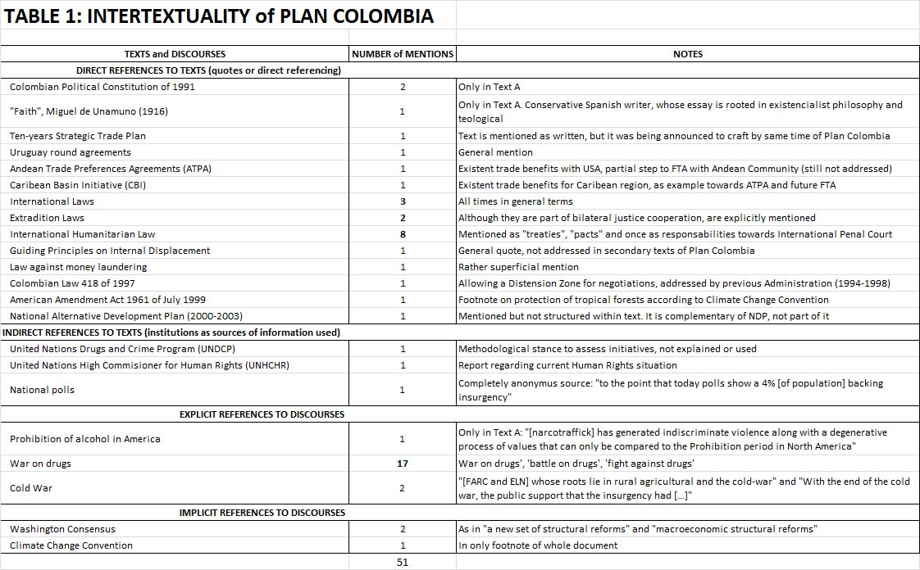
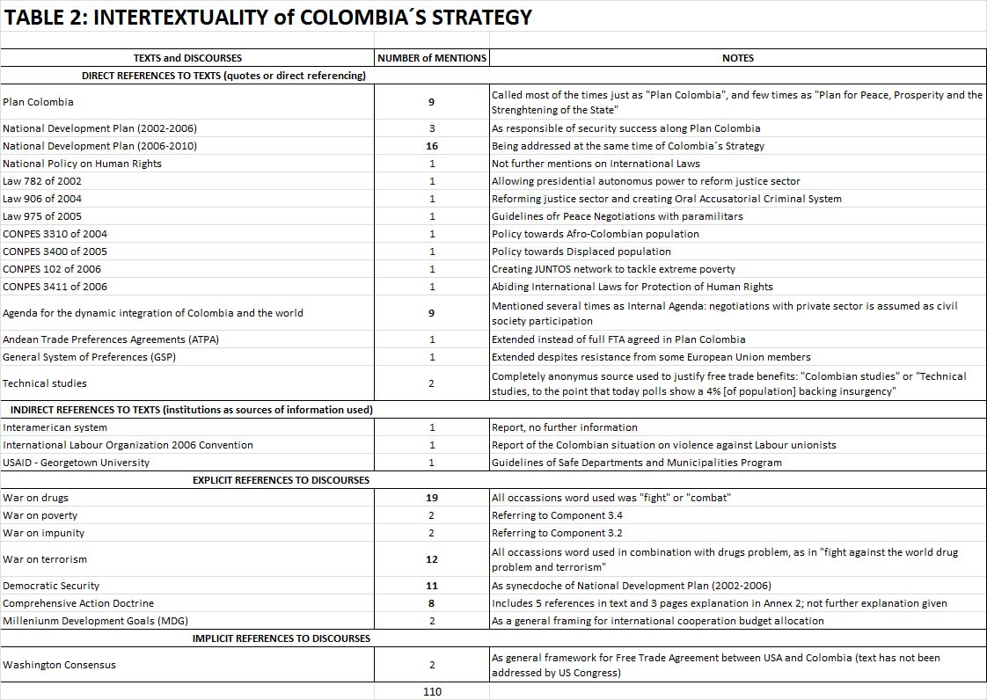
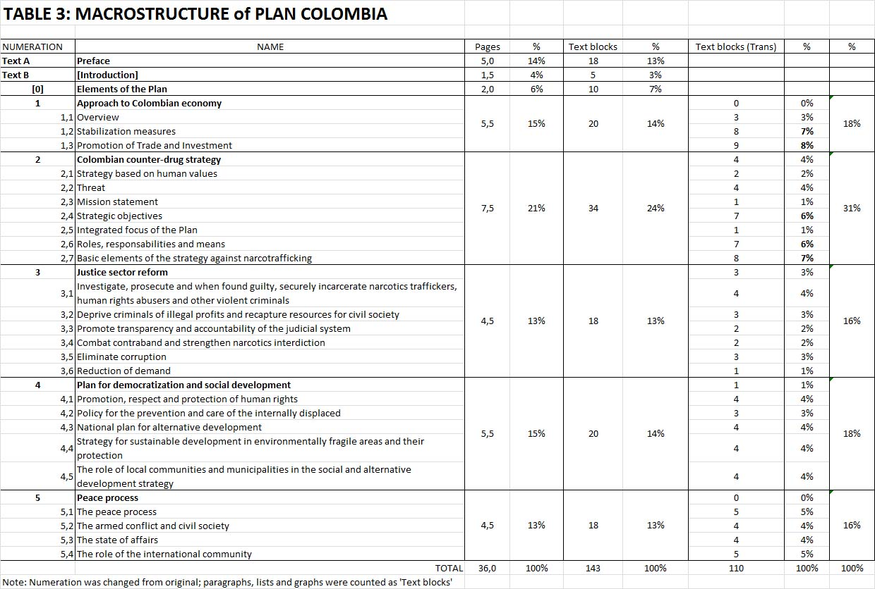
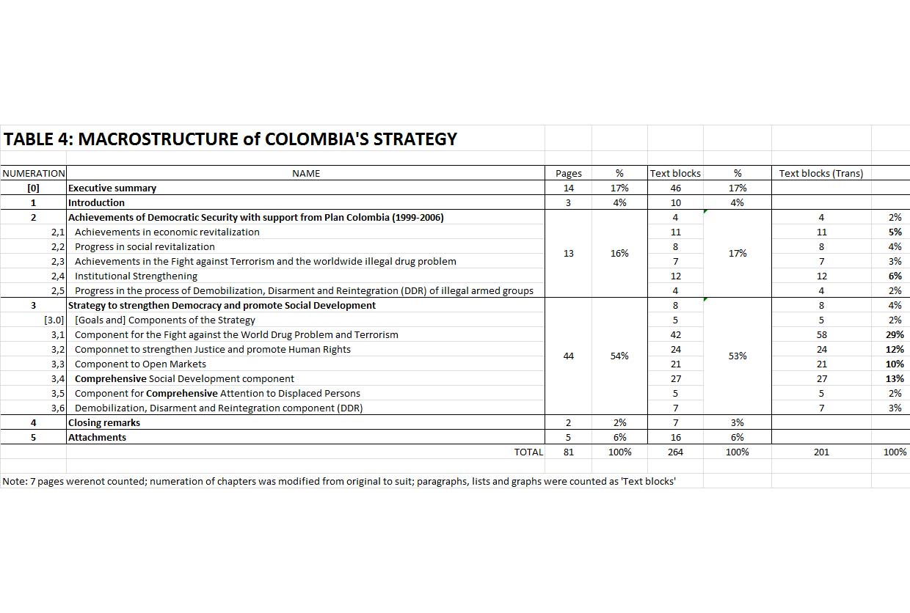
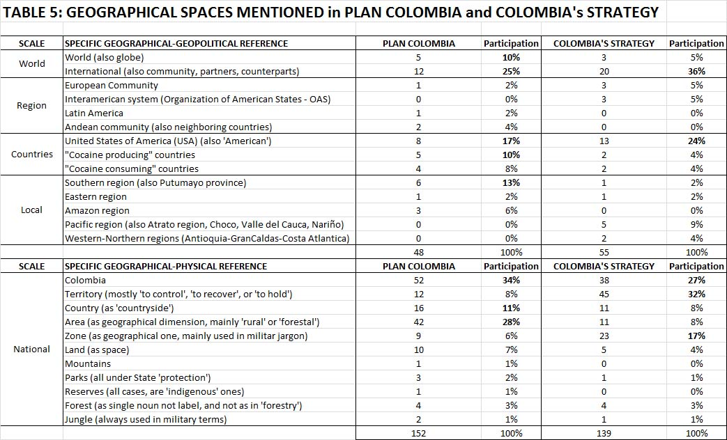

Prohibition and control have two faces in hegemonic geopolitical discourses: the core of moral power exercise by empires, and the menace for open markets: the case of Opium Wars between Britain and China is legendary in both senses (Hanes and Sanello, 2002)
Single Convention of Vienna represented in amendments made in 1971 and 1988 over first proposal in 1961
Interestingly, very similar experiences of the USA–Colombia type were happening at the same time behind the Iron Curtain: Czech Republic and Afghanistan political landscapes were shaped by URSS internal interests or international struggle with USA over control of poppy crops, amongst a myriad of other objectives (Thoumi, 2005). Hungary was also an industrial hub for drug experimentation and synthetization processes of drugs
Whereas the first five countries are indeed part of the Andean Community of Nations, Panama and Brazil are included because their neighbouring condition to Colombia. By 1989 was quite clear that the conflictive political scenario of Colombia was suitable for criminal activities
Although the dispute over the origin and changes on the documents, it is nearly impossible to set a position due to an odd fact: via internet most of the links to the Plan Colombia document are broken. The version analysed here is in www.ciponline.org, an American NGO which website claims to have the same English version once uploaded in the Colombian Embassy in Washington. Furthermore, the detail on the document’s authority is quite strange as no person or institution is cited in it. Interestingly, the Discourse Analysis made here, gives some arguments to believe the document is an American creation [details should be delivered on this... an anonymous document is an even richer detail than a full-credited one...]
There are 10 different offices in NDP and given the broad scope of the CS, all of them could be included, or none announced
Oil production and distribution in Putumayo is directly linked with USA interests in Plan Colombia in several Congresses of International Drug Control Caucus of the US Senate: 106th (September 21 - 1999), 107th (February 28th - 2001) and 108th (June 3rd – 2003)
Furthermore, in Plan Colombia both regional references are phrased in negative or threatening terms, contrasting with calls for international ‘solidarity’ or ‘responsibility’: “Collective action by neighbouring countries is not only less effective than bilateral action, but it can serve to obstruct the negotiating process” and “Referring to diplomatic action by neighbouring countries, at the present stage, the Colombian government prefers bilateral dialogue and confidential consultations with countries interested in the process”
A quite cruel discursive element regarding public policies is that after UN Human Rights Office reported the outrageous conditions of displaced population, Colombian Presidential Office tried to point out how the matching of geographical movement patterns of both coca crops and displaced population was showing than rather than displaced population, Colombia has a vast amount of ‘internal migrants’ (Castrillon, 2009)

