ERASMUS UNIVERSITY ROTTERDAM
ERASMUS SCHOOL OF ECONOMICS
MSc Economics & Business
Master Specialisation Financial Economics

International Diversification and the Currency Hedging Decision
The U.S. Perspective


Author: K.V. Sigeris
Student number: 334959
Thesis supervisor: Dr. A.P. Markiewicz
Finish date: December 2010

Preface and Acknowledgements

Firstly, I would like to thank my thesis coach Agnieszka Markiewicz for her help and supervision on the Master Thesis. Her seminal, International Investments, and especially the seminar’s investment assignment, gave me the incentive to research this topic.

Secondly, I would like to thank Panagiotis Tegos for his comments on my thesis and for all these years we spent together during our studies. Furthermore, I would like to thank Tasos Arampatzis and Stamatis Angelinas for their grammatical corrections.

Last but not least, I would like from the bottom of my heart to thank my family, for their undoubtedly and selflessness support throughout all these years of studies.

NON-PLAGIARISM STATEMENT
By submitting this thesis the author declares to have written this thesis completely by himself/herself, and not to have used sources or resources other than the ones mentioned. All sources used, quotes and citations that were literally taken from publications, or that were in close accordance with the meaning of those publications, are indicated as such.
COPYRIGHT STATEMENT
The author has copyright of this thesis, but also acknowledges the intellectual copyright of contributions made by the thesis supervisor, which may include important research ideas and data. Author and thesis supervisor will have made clear agreements about issues such as confidentiality.
Electronic versions of the thesis are in principle available for inclusion in any EUR thesis database and repository, such as the Master Thesis Repository of the Erasmus University Rotterdam
Abstract

This thesis investigates how U.S. investors can benefit from international diversification and how currency hedging affects internationally diversified portfolios. Based on data from 2004-2010, international hedged and unhedged efficient frontiers are formatted. Two optimization processes are performed, using twenty national stock index portfolios and fifteen currencies. Moreover, three different hedging strategies are tested. The results show that hedging one individual country index portfolio leads in general to lower levels of standard deviation (risk), but also to lower level of excess returns. Furthermore, in the presence of short sales constraints, there is evidence that U.S. investors, who diversify their portfolios in developed and emerging markets simultaneously, should hedge their exchange rate exposure for low levels of risk, but not for higher levels of risk. When comparing the unitary hedging strategy to the Black’s universal hedging strategy, the unitary hedging strategy performs slightly better.

Keywords: International Diversification, Exchange Rate Risk, Currency Hedging
JEL class.: G11, G15

Table of Contents

Preface and Acknowledgements ii
Abstract iii
Table of Contents iv
List of Tables vi
List of Figures vii
1. Introduction 1
2. Literature Review 3
2.1 International Diversification 3
2.2 Emerging Markets 4
2.3 Currency Hedging 6
3. Methodology 12
3.1 Country’s index portfolio dollar excess returns 12
3.2 Hedging with Forward Contracts 13
3.3 Black’s Universal Hedging Ratio 14
3.4 Portfolio’s Dollar Return and Return Variance 15
3.4.1 Unhedged Portfolio 15
3.4.2 Hedged Portfolio 16
3.5 Optimization 16
3.6 Sharpe Ratio 17
4. Data 18
5. Results 20
5.1 Black’s Universal Hedging Ratio Computation 20
5.2 Index Returns 2004-2006 21
5.3 Index Returns 2007-2010 22
5.4 Sharpe Ratio 26
5.5 Analysis of Efficient Frontiers Derived from Internationally Diversified Portfolios 28
5.5.1 International Portfolio, 2004-2006 Testing Period 28
5.5.2 International Portfolio, 2007-2010 Testing Period 30
5.6 Efficient Frontiers’ Sharpe Ratio 32
5.7 Currency Trends and Results 33
6. Conclusion 35
References 37
Appendix A: Black’s Universal Hedging Formula, Data Inputs 42
Appendix B: Correlation Tables 45
Appendix C: Optimal Portfolio Weights & Efficient Frontiers’ Sharpe Ratio 46
Appendix D: Short Sales Optimization 52
Appendix F: Correlation & Covariance Tables 57
Appendix E: Risk Free Rates and DataStream Codes 63

List of Tables

Table 1 | Country Index Portfolios used in the Optimization Process……………………………………. | 18
Table 2 | World Average Values…………………………………………………………………………………………….. | 20
Table 3 | STOCK INDEX PORTFOLIOS, 2004-2006…………………………………………………………………… | 24
Table 4 | STOCK INDEX PORTFOLIOS, 2007-2010…………………………………………………………………… | 25
Table 5 | Sharpe Ratio - STOCK INDEX PORTFOLIOS, 2004-2006……………………………………………. | 27
Table 6 | Sharpe Ratio - STOCK INDEX PORTFOLIOS, 2007-2010……………………………………………. | 27
Tables 7-8 | Exchange Rate Volatilities………………………………………………………………………………………. | 42
Tables 9-10 | Country Weights on World Market Portfolio…………………………………………………………… | 43
Tables 11-12 | World Market Excess Returns and Return Volatilities in Different Currencies………… | 44
Tables 13-14 | Correlation Matrix – Local MSCI Index Return…………………………………………………………. | 45
Tables 15-20 | Correlation & Covariance Matrix – Dollar MSCI Index Excess Return, 2004-2006……. Portfolio | 57
Tables 21-26 | Correlation & Covariance Matrix – Dollar MSCI Index Excess Return, 2007-2010……. Portfolio | 60
Table 27 | Proxy of Risk Fee Rate…………………………………………………………………………………………….. | 63

List of Figures

Chart 1 | Optimization 1: Efficient Frontiers, 2004-2006………………………………………………………… | 29
Chart 2 | Optimization 2: Efficient Frontiers, 2004-2006……………………………………………………….. | 29
Chart 3 | Optimization 1: Efficient Frontiers, 2007-2010……………………………………………………….. | 31
Chart 4 | Optimization 2: Efficient Frontiers, 2007-2010……………………………………………………….. | 31
Charts 5-7 | Optimization 1: Optimal Portfolio Weights 2004-2006…………………………………………… | 46
Charts 8-10 | Optimization 2: Optimal Portfolio Weights 2004-2006…………………………………………… | 47
Charts 11-13 | Optimization 1: Optimal Portfolio Weights 2007-2010…………………………………………… | 48
Charts 14-16 | Optimization 2: Optimal Portfolio Weights 2007-2010…………………………………………… | 49
Chart 17 | Optimization 1: Efficient Frontiers’ Sharpe Ratio, 2004-2006…………………………………. | 50
Chart 18 | Optimization 2: Efficient Frontiers’ Sharpe Ratio, 2004-2006…………………………………. | 50
Chart 19 | Optimization 1: Efficient Frontiers’ Sharpe Ratio, 2007-2010…………………………………. | 51
Chart 20 | Optimization 2: Efficient Frontiers’ Sharpe Ratio, 2007-2010…………………………………. | 51
Chart 21 | Short Sales Optimization: Efficient Frontiers, 2004-2006……………………………………….. | 53
Chart 22 | Short Sales Optimization: Efficient Frontiers, 2007-2010……………………………………….. | 53
Charts 23-25 | Short Sales Optimization: Optimal Portfolio Weights, 2004-2006………………………….. | 54
Charts 26-28 | Short Sales Optimization: Optimal Portfolio Weights, 2007-2010………………………….. | 55
Chart 29 | Short Sales Optimization: Efficient Frontiers’ Sharpe Ratio, 2004-2006…………………. | 56
Chart 30 | Short Sales Optimization: Efficient Frontiers’ Sharpe Ratio, 2007-2010…………………. | 56

1. Introduction

The lower correlation between foreign assets is the main advantage of international investing and the key point that led most investors adapt this investment strategy, which was first established in the 1960s and 1970s. However, while international diversification leads to significant risk reduction, namely idiosyncratic and systematic risk, it also leads to exposure to another source of risk, foreign exchange rate risk. Currency fluctuations have a great impact on total portfolio return and risk, thus it becomes very important on how this risk can be managed properly.

One way to control for currency exposure is through multicurrency diversification, where in total currency fluctuations seem to cancel one another. An alternative way to achieve it is through currency derivatives, were exchange rate fluctuations can be hedged away. It is well known that the use of currency derivatives can reduce risk in internationally diversified portfolios and improve the risk adjusted performance of a portfolio. However, Abken and Shrikhande (1997) showed that currency hedging does not always reduce risk of efficient international portfolios.

The goal of this Master Thesis is to research how currency hedging affected international efficient equity portfolios, for the sample period January 2004 until August 2010. To do so, twenty national MSCI index portfolios and fifteen currencies are used. Among these countries, thirteen are developed and seven emerging. The effect of currency hedging is examined by comparing efficient frontiers, which are derived by optimizing these individual country index portfolios. The comparison of the efficient frontiers is based on three hedging strategies; unhedged, unitary hedged and optimally hedged using Black’s universal hedging formula. Furthermore, the research is conducted by taking the view of an American investor, and for this reason, the base currency is U.S. Dollar.

The whole sample period is split in two testing periods; the first lasts from January 2004 to December 2006 and the second from January 2007 to August 2010. The two sub periods are chosen in such a way, so as the first represents a period of positive market returns, while the second the recent financial crisis period.

The results show that simply hedging one individual country index portfolio not only leads to lower levels of standard deviation (risk), but also to lower levels of excess returns. Only three countries display higher excess return when hedged, during the first testing period, regardless of the type of hedging.

Contrary to previous studies, this is one of the few that uses more than eight countries in the optimization process of internationally diversified portfolios and also multicurrency diversification. Furthermore, this is the first study suggesting that U.S. investors who diversify their portfolio abroad, using both developed and emerging countries, should hedge their exchange rate exposure for low levels of risk, but not for the higher levels of risk, if short sales restrictions are posed. Results show that hedged international efficient frontiers dominate the unhedged for the low levels of standard deviation, but not for the higher levels. Furthermore, unitary hedged strategies perform better than the Black’s universal hedged strategies.

This Master Thesis is structured as follows: Chapter 2 provides the literature review of previous studies, concerning diversification, emerging markets and currency hedging. Chapter 3 describes the methodology used to calculate the index dollar excess returns for every country, how these returns are hedged using forward contracts and how the Black’s universal hedging formula is derived. Moreover, Chapter 3 provides the methodology used to calculate the international portfolio return and return variance, the optimization process and the Sharpe ratios. Chapter 4 presents the data, which are used in this study, and Chapter 5 describes the results. Finally, the last chapter concludes the findings of this research, and topics for future research are suggested.

2. Literature Review

This chapter discusses the literature review used to conduct this thesis; concerning international diversification, the case of emerging markets and finally the effect that currency hedging has in international investment strategies.

2.1 International Diversification
Does international diversification improve the risk-return relation for investors? This question has deserved much attention from academics and investors trying to exploit the benefits and threats from such an investment policy.

The uncertainty of expected returns can be reduced through diversification (Markowitz, 1991). This is the principle of Modern Portfolio Theory first established by Markowitz (1952), who recommended the use of variance returns as a measure of portfolio riskiness, and also, using this point as an assumption he states that the portfolio selection is driven by the risk-return relation between the assets in the portfolio. He showed that a diversified portfolio not only can have risk-return combinations that are not found in individual securities, but also that, in most of the cases, will have higher expected return for the same level of variance (risk), or lower risk for the same level of expected return than single securities. The only case that the variance will not be decreased is if the returns of the portfolio securities are perfectly correlated.

The idea that diversification can improve the portfolio performance in terms of risk-return tradeoff is well understood and is based on the fact that portfolio security returns are less than perfectly correlated; the lower the correlation of security returns the better the diversification. Thus, a reasonable investment practice is turning from local to international investing. This case for international portfolio diversification was established in the 1960s and 1970s. Lessard (1976) and Solnik et al (1996), state that the main advantage of international diversification is the low correlation between countries. Grubel (1968) is the first who finds that US investors could have achieved a superior risk-return tradeoff by diversifying part of their assets in other countries between 1959 and 1966. Levy and Sarnat (1970) demonstrated the gains from diversification in developed and developing markets by analyzing international correlations. Moreover, Solnik (1974) showed that more risk seduction can be attained with international diversification by comparing domestic and international portfolios for the period 1966-1971. Finally, using the international CAPM, De Santis and Gerard (1997) estimated that a U.S. investor can expect an annual gain of 2.11 on average from international diversification and that the long-term gains from international diversification remain economically attractive. Putting it in another way, Fletcher and Marshal (2005), took the view of a U.K. investor for the period 1985-2000, and found a significant increase in the Sharpe ratio by adding foreign equities in U.K. domestic portfolios and significant diversification benefits even if short selling constraints are present.

As already stated, the key factor of international diversification is the low correlation between foreign equities. However, correlations change over time affecting the risk reduction concept. In the recent decades, globalization has taken place, thus rising correlations between foreign markets. Although King, Sentana and Wadhwani (1994) tried to shed some light on this, they couldn’t find strong evidence of a trend increase in correlations while Solnik et al. (1996) by examining monthly data for stocks between 1959 and 1995, found that for the last 10 years the correlations between foreign stocks markets and the U.S. stock market didn’t seem to increase, unlikely with the whole data period. However, they state that international correlations increase during periods of high market volatility and according to Forbes and Rigobon (2002), there is a high level of international market comovements (interdependence) during stable periods as well as during crises, which can lead to some benefits of diversification being lost.

2.2 Emerging Markets
To exploit more diversification benefits, emerging markets are also used in this study. Emerging markets are characterized by rapid economic growth and have investment possibilities that offer a risk-return tradeoff not easily found in developed countries, thus providing high incentives for including them in the portfolio selection when constructing international portfolios. A key characteristic of emerging markets is their lower correlation with other markets, thus offering bigger diversification benefits. However, the volatility of their asset returns is higher when compared to developed markets, a fact which could mitigate the diversification benefits, but De Santis and Imrohoroglu (1997) couldn’t find any empirical evidence that this market volatility has increased due to liberalization.

Gilmore and McManus (2001) using the method of cointegration and examining weekly data for the period 1995-2001 on three Central European emerging markets, namely Czech Republic, Hungary and Poland, found that these markets are not integrated with the U.S. market and that the low correlation between those markets with the U.S. market provide diversification benefits for U.S. investors for both short and long horizon. Furthermore, Gupta (2006, 2008) found that although world markets move towards integration reducing the benefits, there are still unrealized gains to be made by Australian investors by incorporating emerging markets in their portfolios, even if short sales constraints are present.

The drawback of investing in emerging markets though, is the restrictions on short selling. Short sales and even transaction costs counter contrary on the return of a portfolio and mitigate the benefits of diversification. Using mean-variance spanning tests, De Roon, Nijman and Werker (2001) find that although there are significant diversification benefits by adding emerging markets to the portfolio, these benefits disappear if short sales constraints or small transaction costs are present. On the contrary, Li et al. (2001, 2002) found that emerging markets are still a valuable opportunity for U.S. investors as they offer substantial diversification benefits when imposing short sales constraints. They also argue that De Roon et al. findings are not sensible because they are based on some individual Latin American or Asian countries and not on the optimal combination of those emerging markets.

Diversification benefits are attained not only by developed countries, but also by investors from the emerging markets. Bugar and Maurer (2002) concluded that Hungarian investors can drastically reduce the risk of their domestic stock investment by diversifying their portfolio globally. Furthermore, Goriaev and Prikhodko (2004) by taking the view of a Russian investor for the testing period 1999-2003, when Russian stock market experienced exceptional returns with an average of 40% per annum, found substantial benefits for Russian investors from international diversification, which remain statistically and economically significant even in the presence of short selling constraints and transaction costs.

2.3 Currency Hedging
There are three important ways that international investments differ from national investments (Lessard, 1976). First, the covariances among international markets are much lower than those in domestic markets. Second, barriers imposed by taxation, currency controls or investor home bias can lead to further segmentation of national markets causing assets to be priced in a domestic rather than in an international milieu. Third, floating exchange rates between different currencies may give rise to currency risk on international portfolios.

Fluctuations in exchange rates have become very important in international investing because these changes may offset any benefits from diversification and have a significant effect on the returns when translated into home country. Any depreciation of the foreign currencies included in the portfolio, leads to lower return when translated back to the domestic. The importance of the currency risk management can be pointed out by the fact that currency risk accounts for about forty to fifty percent of the total risk of a single-country investment in multicurrency stock portfolios (Eun and Resnick, 1988; Schmittmann, 2010).

For all the above reasons currency risk should be of major importance for international investors and their strategies should be designed in order to control the adverse effects that the unpredicted exchange rate fluctuations can have on foreign market returns.

One way to control exchange rate uncertainty is through multicurrency diversification, but it is shown that exchange rate uncertainty is a largely nondiversifiable factor adversely affecting the performance of international portfolios (Eun and Resnick, 1988). For that reason the most proper and widely used instruments for managing currency risk are currency derivatives. Using currency derivatives, hedging strategies can be designed and incorporated in the international investment practice, as the primary objective of hedging is to reduce the risks produced from price movements of assets by taking an offsetting position in the underlying asset.

The three most common types of derivatives used to hedge currency risk are currency forwards, currency futures and currency options. Currency forwards are private agreements between two parties to buy or sell a currency at a pre-specified price and date. Futures on the contrary, are publicly traded on exchanges and also standardized in quantity, delivery date and place. Moreover, futures are characterized by daily marking-to-market which gives the right for settlement prior to the delivery date. Finally, currency options give the owner the right, but not the obligation to buy or sell currency at a predetermined price and time in the future.

Hedging the currency risk of foreign equity returns can reduce both systematic and unsystematic risk for local investors who diversify their portfolio in foreign equity markets (Lee, 1988). Eun and Resnick(1988) investigated the effects of floating exchange rates on multicurrency portfolios by developing ex ante unhedged and fully hedged strategies from the U.S. investor perspective for the testing period 1980-1985. They state that exchange rate uncertainty is largely undiversifiable due to the high correlations among the exchange rate changes. For that reason, they employed simultaneously multicurrency diversification and forward hedging to reduce exchange rate risk. Their findings suggest that U.S. investors can substantially benefit by using a hedging strategy in their international investments, as all hedging strategies performed far better than the unhedged in out-of-sample periods.

One of the most important papers in the currency hedging debate is that of Perold and Schoulman (1988). They claim that in the long run investors should take currency hedging as having zero expected return, introducing the term “free lunch”, which means that hedging can provide you risk reduction without any repercussion on expected returns. They based their results by comparing historical volatilities of hedged and unhedged portfolios including US, UK, Japan and West Germany stock and bond markets during the testing period 1978-1987 and concluded that a “free lunch” exists at no significant costs.

This argument of Perold and Schoulman gave the incentive to many authors to investigate if “free lunch” really exists. Froot (1993) claims that free lunch exists only in short term investing and if exchange rates follow a random walk and are not mean reverting. The same evidence of no “free lunch” existence is provided by Walker (2007) who takes the view of a global investor based in emerging markets and results that currency hedging increases volatility, and also by Chang (2009) who finds that less risk is associated with lower returns. Moreover, De Santis et al. (1999) claim that the inclusion of the euro-currency in international portfolios will lead to small benefits, but also costs for investors.

As the evidence of “free lunch” in currency hedging appears to be weak -Froot (1993) and Walker (2007) base their findings on the fact that the unhedged portfolios perform better than the hedged ones- another controversial issue arises, which is the proper amount of currency exposure that should be hedged in order to achieve the greatest possible risk reduction arising from exchange rate fluctuations. A widely examined hedge policy in the literature is that of full or unitary hedging. Eun and Resnick (1988) using this policy, conclude that hedging results in lower variance and covariance, and furthermore Perold and Schoulman (1988) suggest that although a full hedge strategy may not lead to the optimal risk reduction, it always leads to a significant reduction of currency risk.

Fung and Leung (1991) tried to derive an optimal hedge ratio in a general utility framework, and using 1-month, 2-month and 3-month forward contracts for the period 1979-1987, found this ratio to be very close to one, and suggested that financial managers should adopt a unitary hedging strategy, without having to spend time and resources for hedging currency exposure. Moreover, Glen and Jorion (1993) provide statistical tests where full hedged strategies perform better than the unhedged. The same results are provided by Bugar and Maurer (2002). In addition, Abken and Shrikhande (1997) using the testing period 1980-1996, and splitting the data into three sub periods 1980-1985, 1986-1990 and 1991-1996, conclude that U.S. investors, through unitary currency hedging, can achieve a risk reduction in their international equity portfolios only in the first period and not in the other two. Possible explanations for this can be that during the 1980-1985 testing period, there was a large appreciation of the U.S dollar against most major currencies, followed by a long lasting depreciation, and also the different structure of security returns and exchange rate correlations for the 1986-1996 testing period.

Unitary hedging turns out to be beneficial for the risk-reward ratio in an international context, however there is research to claim the opposite. Based on studies for UK investors covering the 1802-1990 testing period and giving more attention on the last 20 years, Froot (1993) finds that at long horizons (5 years for stocks, 8 years for bonds), the value of hedging disappears as currency returns display mean reversion. His results indicate that in long horizon, complete hedging does not reduce the return variance, but in some cases it even enhances it, thus he proposes a zero hedge ratio. Contrary to Froot, Schmittmann (2010) couldn’t find any evidence that over long horizons mean reversion provides a “natural hedge” and concludes that the investment horizon should have small impact in the hedging decision.

In line with Froot’s paper, Valera and Naka (1997) do not favor hedging, as their results, based on 1983-1988 testing period for U.S. investors diversifying in the U.K., Germany and France, suggest that the risk-return trade-off of an unhedged strategy is better than a hedged, owing to transaction and other costs associated with hedging. In addition, Morey and Simpson (2001) and Simpson (2004) by following five different hedging strategies found that on average the performance of an unhedged strategy is superior to the performance of a hedged strategy, regardless of the time horizon. They also found that always hedging using futures contracts produces the best efficient frontiers for small levels of risk.

Full hedging at one and no hedging at the other seems to be as the two sides of the same coin. Black (1990) extenuated somewhat the large difference between these two policies. Based on the assumption that all investors across the world have the same level of risk tolerance, he derives a universal hedge ratio that should be applied to all investors, irrespectively of their country of origin. The universal optimal hedge ratio should always be less than 100% (Black in his examples found ratios between 0.30 and 0.77) because of Siegel’s paradox. Siegel’s paradox shows that percentage changes in exchange rates are not the same for the local and the foreign currency, thus investors try to bear some currency risk in their portfolios.

However, this universal hedge ratio was strongly criticized by Solnik (1993) because of the unrealistic assumption that investors around the world have the same risk tolerance. Solnik claims that although the hedge ratios are on average less than one, they are not universal, depending on risk aversion and relative wealth of investors from different countries. Also, the ratio is a function of many parameters that are significantly unstable over different time horizons (Gastineau, 1995).

By adopting the idea that the optimal currency hedging decision lies between zero and one, Gastineau (1995) suggested a 50% hedge ratio driven by regret theory. He claims that a half-hedged half-unhedged investment policy is an improvement because it pays attention to stock and bond allocations, as well as to currency allocations. The results of the research show a significant increase in portfolio performance, especially in the long run, and suggest that 50% hedge ratio will at least have a modest increase in the performance of portfolios with static hedging, or provide a reasonable starting point for portfolios with active currency management. Moreover, Gartner and Wuilloud (1995) point the advantage of a 50% hedge ratio in terms of regret when another hedge policy performs better. However, they say that this strategy almost never leads to maximum currency risk reduction, but it minimizes regret.

Regardless of the type of hedging used to reduce the adverse effects of unexpected exchange rate fluctuations, at the end what matters is if the type of hedging policy chosen could indeed improve the risk-return performance of the portfolio.

Glen and Jorion (1993) were the first to provide statistical tests for the portfolio performance, by applying four different types of hedging. Their results show that for the 1974-1990 period used for their tests, adding forward contracts to international bonds and stocks, improves performance significantly. Furthermore, Kaplanis and Schaefer (1991) point the importance of currency hedging, especially in periods of high exchange rate variability, to capture the benefits of international diversification.

Eaker, Grand and Woodard (1991) investigate a different aspect of currency hedging, that is the impact that currency hedging has to investors from different countries, and conclude that the direction of the effect is the same but the magnitude is not. In addition, Schmittmann (2010) takes the view of German, Japanese, U.K and U.S. investors for the testing period 1975 to 2009 and concludes that currency hedging reduces the volatility of international investments significantly. Moreover, trying to find the reason for currency hedging use, Allayannis and Ofek (1998) suggest that firms use currency derivatives for hedging rather than for speculation.

Although evidence on international diversification and foreign exchange hedging appears to be somewhat mixed, the existing literature in general favors both these investment policies. The objective of this thesis is to shed more light on these aspects and how they affect international investing in the last few years.

3. Methodology

In this chapter, the methodology that was used to calculate the results is described. Firstly, it is explained how the dollar excess returns are calculated for every country, how these returns are hedged and how the Black’s universal hedging formula is derived. Then, the international portfolio return and return variance is discussed, and finally, the optimization processes used to format the efficient frontiers and the Sharpe ratio are explained.

3.1 Country’s index portfolio dollar excess returns
The purpose of this thesis is to investigate how currency hedging affects actual historical returns of internationally optimized portfolios that generate an efficient frontier, which is a graph of optimal portfolios that have the highest return for a given level of risk (standard deviation). An investor will choose a portfolio on the efficient frontier according to his risk appetite. For the construction of efficient portfolios, the equity index returns of twenty countries will be used. These equity indices are the indices compiled by Morgan Stanley Capital Investment (MSCI).

The comparison of optimal universally diversified portfolios, both in cases of hedged and unhedged, will be based in monthly excess returns. Kaplanis and Schaefer (1991) found that the difference in portfolio risk is marginal, when comparing continuously hedged exchange risk with monthly hedge adjustments; thus, the choice of monthly data intervals is based in that finding.

Excess return is the return of each individual country MSCI index above the risk free rate. In order to compute the monthly excess return for every country, the specific country monthly risk free yield is deducted from its MSCI index. Then, excess returns are translated into dollar excess returns, by using the exchange rates, as the base country is United States. Finally, the monthly mean dollar excess return and the standard deviation of the monthly dollar excess return for every country is calculated and annualized.

This method applies for unhedged returns from currency risk. For the calculation of unitary hedged exchange rate returns, the methodology is very similar. What changes is that instead of using spot exchange rates, forward premiums are used. This is because unitary currency hedging is used, which assumes that all currency risk is eliminated. When the Black’s universal hedging formula is used, the method is a combination of the two above methods (unhedged – unitary hedged), in the proportions of the hedge ratio.

Taking all these into account, the unhedged and hedged portfolio frontiers are derived from the unhedged and hedged annualized dollar excess returns respectively. Using Microsoft’s Excel Solver, the optimal portfolios, which constitute the efficient frontier, can be derived. These frontiers can then be compared. Noteworthy is that the exchange rate uncertainty is controlled in this research not only through currency hedging, but also through multicurrency diversification, as in total 15 different currencies are used.

3.2 Hedging with Forward Contracts
The uncertainty that foreign currencies might depreciate against local currency leads investors to short forward contracts to hedge. By doing so, exchange risk is eliminated because the foreign currency is sold at the end of the contract for a certain price predefined by the contract. In that way, protection against an appreciation of the local currency is provided to foreign investments when translated back to the domestic currency, as the future spot exchange rate becomes certain by shorting forwards.

For the purpose of hedging, forward contracts are assumed to be used. Because forward contracts are private contracts not publicly traded on stock exchanges it is very difficult to find the prices of these contracts. For this reason covered interest parity is assumed to hold.
- f/s = (1 + r_{dc})/(1 + r_{fc})

Interest rate parity is a relationship linking spot exchange rates, forward exchange rates and interest rates. Using the parity relation the forward premium (fp) is defined as:
- fp = (f –s)/s = f/s – 1

For two currencies, the interest rate parity relation states that the forward premium/ discount equals the interest rate differential between these currencies. Because we assume that 1-month forward contracts are used, then the calculation of the forward premium/ discount can be defined as the difference between the 1-month bond yields of the domestic and foreign country which matches the maturity of the forward contract.

3.3 Black’s Universal Hedging Ratio
The Black’s universal hedging formula is:
- 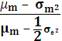

where stands for the average expected excess return on the portfolio, for the average volatility of the portfolio and stands for the average exchange rate volatility across all pairs of countries. Historical data are used to create inputs for the formula. Using the above formula, the optimal hedge ratio is computed, which applies to all country indices.

The steps for the calculation of the formula are:
- Find country weights in the world market portfolio
- Calculate excess return for every country and the average excess return of the portfolio
- Calculate the return volatility for every country and the average volatility of the portfolio
- Calculate exchange rate volatilities across all pair of countries and the average of these volatilities

Black’s universal hedging formula requires the use of one world market portfolio to get the average inputs of it. For this reason, the country weights of the MSCI All Country World Investable Market Index (ACWI IMI) are used. When comparing it to our portfolio, we observe that our portfolio constitutes 90.15% of the MSCI ACWI IMI. Thus, our portfolio is assumed to be the world market portfolio and the weights are adjusted from 90.15% to 100% using the country weights of MSCI ACWI IMI.

The annual excess return for every country is calculated by deducting from every country’s annual return its average risk free rate for that year. The return volatility for every country is calculated as the standard deviation of the daily returns for these years. Then, these standard deviations are annualized by multiplying with the square root of 260. Then, the average excess returns and average return volatilities for every country are calculated by using the sum of the weighted average of the excess return and the sum of the weighted average of the return volatility of every country respectively.

Finally, exchange rate volatilities across all pairs of countries in our portfolio are needed. However, because exchange rates are not available for all countries in the portfolio, these rates are calculated using cross rates. Then for every pair the exchange rate volatility are calculated, as well as the average of these volatilities.

3.4 Portfolio’s Dollar Return and Return Variance

3.4.1 Unhedged Portfolio
When someone invests abroad, he is exposed in two sources of risk: the volatility of local returns and the exchange rate volatility. The local security index return (r_{lt}) is calculated in this paper as r_{lt} = 100(lnp_{t} –lnp_{t-1}), with p_{t} being the security index price at time t, while the exchange rate return (e_{t}) is calculated as e_{t} = 100(lns_{t}-lns_{t-1}), with s_{t} being the spot exchange rate at time t.

Using these two, the unhedged portfolio dollar return can be defined as:
- = (1 + r_{lt})(1 + e_{t}) – 1 = r_{lt} + e_{t} + r_{lt}e_{t}

where, after removing the r_{lt}e_{t} product, because is very small, it takes the simple form:
- r_{lt} + e_{t}

The variance of the returns of the unhedged portfolio consisting of several multicurrency securities is that derived from Eun and Resnick (1988):
- 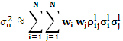 + 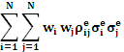 + 2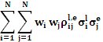

with the first term being the security-return covariances, the second the foreign exchange rate covariances and the third term the local return-foreign exchange rate covariances.

3.4.2 Hedged Portfolio
Similarly, the dollar return on a hedged portfolio can be defined as:
- r_{lt} + fp

As already stated, the difference between unhedged and hedged returns is that the exchange rate movement is replaced by the forward premium fp. This also holds for the variance of a hedged multicurrency portfolio:
- 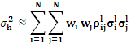 + 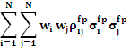 + 2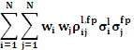

where the forward premium standard deviations and correlation coefficients replace those of the foreign exchange rates that appear in equation 6.

3.5 Optimization
The final step, after having the dollar excess returns and standard deviations of the individual country MSCI index portfolios, is to optimize these portfolios, for all the three hedging strategies (unhedged, unitary hedged and universally hedged using Black’s formula). Optimization is performed using Microsoft’s Excel Solver. Correlation and covariance matrices of dollar excess returns across all pairs of countries are also computed, for the three types of dollar returns; unhedged, unitary hedged and Black’s universally hedged returns (Appendix F).

In the portfolio optimization process some restrictions and assumptions are posed:
- The sum of the N index portfolio weights should equal to one:
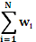= 1
- No shortselling allowed. This means that one cannot sell an index short. In other words, the index portfolio weights cannot be negative in the optimization process, nor bigger than one:
0 ≤ wi ≤ 1
- Transaction costs are assumed to be zero

After that, for every testing period two optimization processes are performed, using the twenty individual country index portfolios considered in this study.
Optimization 1:
- Minimize standard deviation for a given level of required return subject to the constraint that country portfolio weights cannot be negative, nor bigger than one.
0 ≤ wi ≤ 1
However, in this process, there are no restrictions to individual portfolio weights, meaning that this may lead for a given level of risk/return tradeoff to investment in only one specific country index. Such a situation however can lead to exposure to one specific country and raise systematic risk, and in practice may not be cost effective. This reason gave the incentives for the second optimization process.

Optimization 2:
- Minimize standard deviation for a given level of required return subject to the constraint that country portfolio weights are between 1% and 50%
0.01 ≤ wi ≤ 0.5
The maximum of 50% individual country index portfolio weight posed in this optimization limits the exposure of systematic risk.

Furthermore, a third optimization process is performed allowing shortselling the national equity portfolios. This optimization process is presented in Appendix D.

3.6 Sharpe Ratio
In addition, one should check if more return comes from taking more risk. Evaluating the performance of the portfolio, both in cases of hedged and unhedged portfolios, based only on returns ignores the risk in total. For that reason the Sharpe ratio is computed. The Sharpe ratio is a ratio of reward (average excess return or risk premium) per unit of total risk. The ratio is defined as:
- 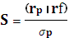

where r_{p} stands for the portfolio return, r_{f} for the risk free rate of return, and stands for σ_{p} the standard deviation of the portfolio.

4. Data

All the data needed for this topic research are obtained from DataStream. Twenty countries are used in this study and the performance is examined on a monthly basis. Taking the view of an American investor diversifying his portfolio internationally, the countries considered are:
Table 1: Country Index Portfolios used in the Optimization Process
Developed | Emerging
Australia | Brazil
Canada | China
France | India
Germany | Mexico
Greece | South Africa
Japan | South Korea
Netherlands | Turkey
Portugal
Singapore
Spain
Switzerland
United Kingdom
United States

Morgan Stanley Capital International (MSCI) provides stock indices that represent a well-diversified portfolio for every country. These indices are value-weighted, based on market capitalization of all the listed firms, and include the reinvestment of dividends and capital gains

The data period examined in this study is from January 2004 to August 2010. This sample period is split in two testing periods, from January 2004 to December 2006 and from January 2007 to August 2010. All data, Morgan Stanley Capital International (MSCI) stock index values, spot exchange rates, one-month forward rates and risk free rates, are at the last trading day of every month of the sample period.

Spot exchange rates and one-month forward rates were carefully selected in order to be expressed as the value of one foreign currency equals the U.S. Dollar. Because the study is based on excess returns rather than returns, for every country the one-month excess returns are computed by subtracting its one-month risk-free yield from its MSCI index return. However, because not all countries issue one-month Treasury bills, wherever these weren’t available, one or three-month Treasury bills or interbank rates are used as a proxy for the one-month risk-free yield. The proxies of risk-free yield for every country can be found at Appendix E.

For the Black universal hedge ratio computation, the past two years’ daily data are used, again obtained from DataStream. This means that the 2002-2003 data sample is used to compute the hedge ratio of the 2004-2006 testing period, and the 2005-2006 data sample for the 2007-2010 testing period. The MSCI All Country World Investable Market Index (ACWI IMI) is used as proxy of the world market portfolio and the country weights in the world market portfolio are derived from it.

5. Results

In this chapter the results are shown. Firstly, the Black’s universal ratios are discussed, and then the index returns and the Sharpe ratios of these returns are explained. Furthermore, the efficient frontiers derived from the internationally diversified portfolios and the Sharpe ratios of these frontiers are explained in detail and finally the effects of currency trends are discussed.

5.1 Black’s Universal Hedging Ratio Computation
Table 2 presents the world average values used as inputs for the ratio after adjusting our portfolio to the world market portfolio. The hedge ratios for the 2004-2006 and 2007-2010 portfolios are equal to 0.615 and 0.906 respectively. As already stated in the methodology part, for the ratio calculation of the first portfolio data of 2002-2003 are used, while for the second portfolio, data of 2005-2006 are used.

However, the weighted average excess return across all countries in 2002 is negative because stock markets performed poorly that year. On the contrary, in 2003 the excess return is highly positive. This leads as to the conclusion that the average of these two years cannot be used as an indication of future excess return. A better estimate of future excess return would be to arbitrarily use the half of the excess return of 2003, which is 12.09%. As Black (1995) states, the universal hedging formula assumes that investors put into the formula their opinions about what other investors around the world expect for the future, so the negative excess return of 2002-2003 is clearly not a good indicator for the future as 2003 performed with flying colors.

Table 2: World Average Values
 | Excess Return μ_{m} | Return Volatility σ_{m} | Exchange Rate Volatility σ_{e}
2002 | -25.40% | 26.18%
2003 | 24.18% | 18.85%
2005 | 13.63% | 11.21%
2006 | 11.60% | 13.52%
2002-03 | -0.61% | 22.51% | 11.65%
2005-06 | 12.61% | 12.37% | 8.75%

Appendix A presents all the computations performed to arrive the inputs of table 2 that are used in Black’s universal hedging ratio.

5.2 Index Returns 2004-2006
Table 3 presents the average excess returns and standard deviations of all country stock indices included in the portfolio for the 2004-2006 testing period. When dollar stock index returns are unitary hedged against exchange rate exposure, their standard deviation is lower for all countries, leading to an average decline in standard deviation of 14.29% across all countries. However their mean excess return is also lower for all the country equity indices, except for Japan, Switzerland and China. The overall unitary hedged average excess return across all countries is 19% lower when is compared to the unhedged. This finding is consistent with previous findings (see Chang, 2009) and suggests that higher return comes by taking more risk when using just one equity or index.

Moreover, when the dollar unhedged returns are compared with the Black’s universal hedged returns, the standard deviation is again lower for all country indices, leading to a 12.24% average decline in standard deviation across all countries. The mean excess return is again lower for all country indices, except for Japan, Switzerland and China, and results on average in a 12% decline in excess return across all countries.

During the 2004-2006 period, the foreign exchange returns of all countries are positive, except for Japan, South Africa and Turkey, meaning that if these returns hadn’t been hedged they would have led to higher dollar excess returns when denominated back to the domestic currency. Furthermore, the standard deviation of the U.S. equity portfolio excess return is substantially lower than the standard deviation of the rest equity portfolios dollar unhedged returns, meaning that the standard deviation of the exchange rate, which is on average 8% for all countries, has added up to the variability of the non-U.S. equity portfolios.

Most of the currencies, except for Australia, U.K., Brazil, India, Mexico, South Africa, South Korea and Turkey, are sold forward with premium, resulting in higher dollar hedged excess returns compared to unhedged. The standard deviations of the forward premiums is very low and substantially lower than that of the exchange rates, meaning that they do not have any substantial impact on the variability of the hedged returns.

The formulas of Eun and Resnick (1988) used in this paper to compute the dollar excess returns indicate that the unhedged portfolio’s standard deviation depends on the exchange rate variance and on the excess local return-foreign exchange rate covariances, while the hedged portfolio’s standard deviation depends on the forward premium variance and the excess local return-forward premium covariances. The same holds when computing the dollar excess returns. For that reason, Japan, Switzerland and China have higher hedged returns compared to unhedged, as their forward premiums are the highest of all countries, while their exchange rate returns are hedged. Furthermore, the standard deviation of the unhedged dollar excess returns is always higher from that of the hedged dollar excess returns, partly because the correlation coefficient between local excess return and foreign exchange return is positive for most of the countries, leading to higher standard deviations of unhedged dollar excess returns, and partly because the correlation coefficient between local excess return and forward premium is low or even negative.

5.3 Index Returns 2007-2010
Information about the second period country equity portfolios concerning dollar excess returns, standard deviations, forward premiums and exchange rate returns can be found in Table 4. For the 2007-2010 testing period the picture is totally different. Financial markets experienced the biggest crisis since 1929 resulting in negative returns around the globe and significantly higher market volatility. The correlation between local MSCI monthly Index returns is on average 0.75 for 2007-2010 period, 31.2% higher than the 2004-2006 period, when the average correlation is equal to 0.57. This finding of higher international correlations during periods of high market volatility is in line with Solnik et al. (1996), and also Schmittmann (2010) found that correlations were higher during 2007-2009 testing period. Correlation matrices can be found at Appendix B.

The standard deviation of the unitary hedged dollar excess returns is lower than the unhedged for all national equity indices in the portfolio, leading to an average decline in standard deviation of 21.46% across all countries. The same results arise when comparing Black’s universal hedged excess returns with the unhedged, as the average decline in standard deviation is 20.06% across all the countries included in this study. Only Japan and China display higher standard deviation of their dollar excess returns when hedged, regardless of the type of hedging. However, this standard deviation is again high, as it is on average equal to 24.83% when unitary hedged, 32.04% when it is unhedged and 25.33% when it is optimally hedged using Black’s universal hedging formula.

The unhedged dollar excess returns of all countries are negative, except for Singapore, China and India. The same holds when returns are hedged, regardless of the type of hedging, but now only except for China and India. Hedging has a negative impact on national excess index returns, as the returns on average decline by 30% across all countries when unitary hedging is used, and by a 27.8% decline when returns are hedged using the universal hedge ratio. On average, the unhedged dollar excess return across all countries is -7.21%, with the unitary hedged returns being -9.41% and the universal optimally hedged being -9.21%.

The standard deviation of the U.S. equity portfolio excess return is again lower than that of the rest equity portfolios unhedged return, leading to the conclusion that also in this period the exchange rate standard deviation, which is on average 12.83% across all countries, has added up to the variability of the non-U.S. equity portfolios. The only exception is Japan and China, which exhibit strong negative correlation between local excess returns and foreign excess returns. Furthermore, emerging markets, as well as Japan, display large depreciation of their currencies, a fact that favors hedging the currency exposure. In total, all currencies in our portfolio depreciated against U.S. Dollar, except for the euro and U.K. pound. Forward premiums are again characterized by minor variability and their correlation with the local excess return is small, or even negative.

Table 3: STOCK INDEX PORTFOLIOS, 2004-2006
 | US | AUS | CAN | JAP | SING | SWI | UK | FRA | GER | GRE | NETH | PORT | SPA | BRA | CHI | IND | MEX | SAFR | SKOR | TUR
 | Unhedged Stock Index Portfolio Dollar Excess Returns
Mean Excess Return | 5.4 | 15.3 | 17.6 | 14.3 | 20.8 | 17.1 | 9.8 | 15.5 | 15.1 | 24.7 | 13.0 | 15.8 | 19.8 | 19.5 | 27.0 | 26.0 | 32.7 | 18.2 | 22.5 | 3.8
Standard Deviation | 6.9 | 13.6 | 14.3 | 14.5 | 12.2 | 9.5 | 8.7 | 10.5 | 13.2 | 17.2 | 11.6 | 13.3 | 12.0 | 28.9 | 21.6 | 23.5 | 18.6 | 26.3 | 21.0 | 38.2
 | Fully Hedged Stock Index Portfolio Dollar Excess Returns
Mean Excess Return | 5.4 | 11.0 | 14.0 | 22.6 | 18.1 | 19.6 | 5.2 | 14.9 | 14.6 | 24.1 | 12.4 | 15.3 | 19.2 | -4.6 | 29.4 | 22.5 | 24.9 | 15.2 | 12.2 | -10.3
Standard Deviation | 6.9 | 8.5 | 10.6 | 13.4 | 10.8 | 9.1 | 7.5 | 9.0 | 11.4 | 15.6 | 11.2 | 12.3 | 10.4 | 22.7 | 21.3 | 20.9 | 16.4 | 16.2 | 18.6 | 27.6
% change in st.dev. of hedged returns to unhedged | 0.0 | -37.0 | -26.1 | -7.7 | -11.6 | -4.0 | -14.1 | -14.7 | -13.5 | -9.3 | -3.4 | -7.3 | -13.7 | -21.5 | -1.5 | -11.0 | -11.5 | -38.3 | -11.7 | -27.9
 | Hedged Stock Index Portfolio Dollar Excess Returns using Black's Optimal Hedge Ratio
Mean Excess Return | 5.4 | 12.7 | 15.4 | 19.3 | 19.1 | 18.6 | 6.9 | 15.2 | 14.8 | 24.4 | 12.6 | 15.5 | 19.5 | 4.0 | 28.5 | 23.9 | 27.8 | 16.3 | 16.1 | -5.1
Standard Deviation | 6.9 | 9.9 | 11.6 | 13.3 | 11.2 | 8.3 | 7.1 | 8.9 | 11.6 | 15.9 | 10.8 | 12.2 | 10.4 | 24.6 | 21.4 | 21.8 | 17.1 | 18.8 | 19.3 | 31.2
% change in st.dev. of hedged returns to unhedged | 0.0 | -26.8 | -19.2 | -8.6 | -8.3 | -12.9 | -19.0 | -15.3 | -12.2 | -7.9 | -7.0 | -8.3 | -13.1 | -14.9 | -1.0 | -7.3 | -8.1 | -28.5 | -8.2 | -18.2
 | Forward premium
Mean |  | -2.3 | 0.3 | 3.5 | 1.1 | 2.6 | -1.3 | 1.0 | 1.0 | 1.0 | 1.0 | 1.0 | 1.0 | -11.8 | 3.9 | -1.8 | -4.7 | -4.4 | -0.5 | -13.9
Standard Deviation |  | 0.4 | 0.3 | 0.5 | 0.2 | 0.3 | 0.4 | 0.4 | 0.4 | 0.4 | 0.4 | 0.4 | 0.4 | 1.0 | 0.7 | 0.4 | 0.6 | 0.5 | 0.5 | 1.3
Correlation between local excess return and forward premium |  | 0.01 | 0.09 | 0.08 | 0.08 | 0.22 | 0.07 | 0.11 | 0.18 | -0.04 | 0.18 | 0.09 | 0.14 | 0.04 | 0.10 | -0.30 | 0.06 | 0.17 | 0.09 | 0.02
 | Foreign Exchange Returns
Mean Return |  | 1.5 | 3.6 | -3.5 | 3.4 | 0.4 | 3.0 | 1.5 | 1.5 | 1.5 | 1.5 | 1.5 | 1.5 | 10.6 | 2.0 | 1.0 | 1.2 | -1.8 | 8.6 | -0.3
Standard Deviation |  | 8.5 | 7.7 | 8.1 | 3.9 | 8.6 | 7.7 | 7.4 | 7.4 | 7.4 | 7.4 | 7.4 | 7.4 | 11.8 | 1.3 | 5.3 | 5.5 | 17.7 | 6.3 | 14.7
Correlation between local excess return and foreign exchange return |  | 0.27 | 0.22 | -0.15 | 0.21 | -0.42 | -0.34 | -0.18 | -0.05 | -0.01 | -0.27 | -0.16 | -0.11 | 0.34 | 0.30 | 0.37 | 0.26 | 0.21 | 0.26 | 0.60

Table 4: STOCK INDEX PORTFOLIOS, 2007-2010
 | US | AUS | CAN | JAP | SING | SWI | UK | FRA | GER | GRE | NETH | PORT | SPA | BRA | CHI | IND | MEX | SAFR | SKOR | TUR
 | Unhedged Stock Index Portfolio Dollar Excess Returns
Mean Excess Return | -9.0 | -7.2 | -0.1 | -9.4 | 2.2 | -5.3 | -13.3 | -13.0 | -8.5 | -28.8 | -10.6 | -14.6 | -10.8 | -0.6 | 6.3 | 0.5 | -7.2 | -7.0 | -2.9 | -5.0
Standard Deviation | 20.1 | 32.1 | 30.3 | 19.0 | 32.1 | 20.8 | 23.6 | 28.3 | 30.7 | 46.3 | 30.0 | 28.5 | 32.8 | 40.1 | 36.4 | 40.6 | 31.2 | 32.0 | 38.1 | 47.8
 | Fully Hedged Stock Index Portfolio Dollar Excess Returns
Mean Excess Return | -9.0 | -13.5 | -3.4 | -17.1 | -1.4 | -9.2 | -8.3 | -13.0 | -9.7 | -28.6 | -10.6 | -14.6 | -10.2 | -11.7 | 3.9 | -2.2 | -7.7 | -12.1 | 3.0 | -12.8
Standard Deviation | 20.1 | 17.7 | 19.3 | 22.7 | 28.2 | 16.2 | 18.4 | 20.8 | 23.0 | 39.0 | 23.6 | 21.9 | 24.2 | 27.7 | 36.9 | 34.6 | 22.6 | 18.3 | 25.4 | 35.9
% change in st.dev. of hedged returns to unhedged | 0.0 | -44.8 | -36.2 | 19.1 | -12.3 | -22.1 | -21.9 | -26.4 | -25.2 | -15.9 | -21.4 | -23.3 | -26.1 | -30.9 | 1.5 | -14.8 | -27.6 | -42.7 | -33.4 | -24.9
 | Hedged Stock Index Portfolio Dollar Excess Returns using Black's Optimal Hedge Ratio
Mean Excess Return | -9.0 | -12.9 | -3.1 | -16.4 | -1.1 | -8.8 | -8.7 | -13.0 | -9.6 | -28.6 | -10.6 | -14.6 | -10.3 | -10.7 | 4.1 | -2.0 | -7.6 | -11.6 | 2.4 | -12.1
Standard Deviation | 20.1 | 18.8 | 20.2 | 22.1 | 28.5 | 16.2 | 18.7 | 21.3 | 23.5 | 39.5 | 23.9 | 22.3 | 24.9 | 28.7 | 36.9 | 35.1 | 23.3 | 19.3 | 26.3 | 36.9
% change in st.dev. of hedged returns to unhedged | 0.0 | -41.5 | -33.2 | 16.1 | -11.3 | -22.0 | -20.8 | -24.7 | -23.5 | -14.7 | -20.2 | -21.9 | -24.1 | -28.4 | 1.4 | -13.5 | -25.4 | -39.7 | -31.0 | -22.8
 | Forward premium
Mean |  | -3.0 | 0.1 | 2.1 | 0.9 | 1.2 | -0.7 | 0.0 | 0.0 | 0.0 | 0.0 | 0.0 | 0.0 | -7.5 | 1.8 | -3.4 | -4.6 | -7.0 | 0.7 | -10.1
Standard Deviation |  | 0.4 | 0.2 | 0.6 | 0.4 | 0.4 | 0.3 | 0.3 | 0.3 | 0.3 | 0.3 | 0.3 | 0.3 | 0.8 | 1.3 | 0.6 | 0.7 | 0.6 | 0.7 | 0.9
Correlation between local excess return and forward premium |  | 0.12 | -0.04 | -0.14 | -0.14 | -0.12 | 0.01 | 0.05 | 0.12 | 0.17 | 0.03 | 0.27 | 0.14 | 0.25 | 0.15 | 0.26 | 0.17 | 0.24 | -0.2 | 0.27
 | Foreign Exchange Returns
Mean Return |  | -3.1 | -1.7 | -70.1 | -7.9 | -0.4 | 12.4 | 6.8 | 6.8 | 6.8 | 6.8 | 6.8 | 6.8 | -14.2 | -40.7 | -65.0 | -50.5 | -42.0 | -85.5 | -10.8
Standard Deviation |  | 18.3 | 13.2 | 11.4 | 6.5 | 13.4 | 11.2 | 13.0 | 13.5 | 13.0 | 13.0 | 13.0 | 12.9 | 16.4 | 1.8 | 8.9 | 12.0 | 18.3 | 18.4 | 15.7
Correlation between local excess return and foreign exchange return |  | 0.59 | 0.73 | -0.57 | 0.52 | -0.02 | 0.22 | 0.36 | 0.38 | 0.45 | 0.28 | 0.29 | 0.52 | 0.65 | -0.2 | 0.64 | 0.60 | 0.55 | 0.52 | 0.69

5.4 Sharpe Ratio
As already stated in the methodology, Sharpe is a portfolio performance ratio which takes into account both the return and the risk of the portfolio. Thus it is interesting to see how is the Sharpe ratio affected by the exchange rate fluctuations and also by hedging these exchange rate fluctuations.

During the first period portfolio (2004-2006), the average across all countries local returns Sharpe ratio is 1.21, with the unhedged and unitary hedged dollar returns Sharpe ratio being slightly lower, 1.17 and 1.16 respectively, while Black’s optimally hedged dollar returns Sharpe ratio is slightly better and equal to 1.22 on average. The return and return volatility of the exchange rates had a negative impact on the unhedged dollar returns Sharpe ratio, as for 13 out of 19 countries is lower when comparing them with the local returns Sharpe (see Table 5) .

As noted in the previous section, hedging results in lower standard deviations for all the country indices, but also in lower returns for almost all the countries. The risk-return relation between these two results in higher ratio for 11 out of 19 countries when comparing hedged with unhedged dollar returns, irrespectively of the type of hedging. However, hedging in a few cases results in negative ratios and the slightly lower average ratio of unitary hedged dollar returns to local returns is mainly driven by the substantial shift in the ratio of Brazil and Turkey.

For the 2007-2010 portfolio the average across all countries Sharpe ratios are negative, the local returns Sharpe ratio is -0.35, and the unhedged, unitary hedged and Black’s optimally hedged dollar returns Sharpe ratios are -0.25, -0.41 and -0.39 respectively. The unhedged dollar returns Sharpe ratio exhibits the best performance, meaning that the return and return volatility of the exchange rates had a positive impact on the unhedged dollar returns ratio, as 14 out of 19 countries have a higher ratio when comparing them with the local Sharpe. Both types of hedging lead in better Sharpe performance only for two countries, namely UK and Korea, when comparing unhedged with hedged dollar returns Sharpe ratios (see Table 6).

Table 5: Sharpe Ratio - STOCK INDEX PORTFOLIOS, 2004-2006
 | Sharpe Ratio-Local Returns | Sharpe Ratio-Unhedged Dollar Returns | Sharpe Ratio-Fully Hedged Dollar Returns | Sharpe Ratio-Black's Ratio Dollar Returns
USA | 0.78 | 0.78 | 0.78 | 0.78
AUSTRALIA | 1.60 | 1.13 | 1.29 | 1.28
CANADA | 1.29 | 1.23 | 1.32 | 1.33
JAPAN | 1.38 | 0.98 | 1.68 | 1.45
SINGAPORE | 1.56 | 1.71 | 1.68 | 1.71
SWITZERLAND | 1.83 | 1.79 | 2.15 | 2.25
UK | 0.88 | 1.12 | 0.69 | 0.98
FRANCE | 1.55 | 1.48 | 1.67 | 1.71
GERMANY | 1.19 | 1.15 | 1.28 | 1.28
GREECE | 1.46 | 1.43 | 1.54 | 1.53
NETHERLANDS | 1.01 | 1.12 | 1.11 | 1.17
PORTUGAL | 1.15 | 1.19 | 1.24 | 1.27
SPAIN | 1.75 | 1.65 | 1.85 | 1.86
BRAZIL | 0.42 | 0.67 | -0.20 | 0.16
CHINA | 1.16 | 1.25 | 1.38 | 1.33
INDIA | 1.18 | 1.11 | 1.08 | 1.10
MEXICO | 1.89 | 1.76 | 1.52 | 1.63
SOUTH AFRICA | 1.27 | 0.69 | 0.93 | 0.87
KOREA | 0.69 | 1.07 | 0.66 | 0.83
TURKEY | 0.15 | 0.10 | -0.37 | -0.16

Table 6: Sharpe Ratio - STOCK INDEX PORTFOLIOS, 2007-2010
 | Sharpe Ratio-Local Returns | Sharpe Ratio-Unhedged Dollar Returns | Sharpe Ratio-Fully Hedged Dollar Returns | Sharpe Ratio-Black's Ratio Dollar Returns
USA | -0.45 | -0.45 | -0.45 | -0.45
AUSTRALIA | -0.61 | -0.22 | -0.76 | -0.69
CANADA | -0.18 | 0.00 | -0.17 | -0.15
JAPAN | -0.83 | -0.49 | -0.75 | -0.74
SINGAPORE | -0.08 | 0.07 | -0.05 | -0.04
SWITZERLAND | -0.64 | -0.25 | -0.57 | -0.55
UK | -0.41 | -0.57 | -0.45 | -0.47
FRANCE | -0.62 | -0.46 | -0.62 | -0.61
GERMANY | -0.43 | -0.28 | -0.42 | -0.41
GREECE | -0.74 | -0.62 | -0.73 | -0.72
NETHERLANDS | -0.45 | -0.35 | -0.45 | -0.44
PORTUGAL | -0.67 | -0.51 | -0.67 | -0.66
SPAIN | -0.43 | -0.33 | -0.42 | -0.41
BRAZIL | -0.17 | -0.01 | -0.42 | -0.37
CHINA | 0.06 | 0.17 | 0.11 | 0.11
INDIA | 0.04 | 0.01 | -0.06 | -0.06
MEXICO | -0.14 | -0.23 | -0.34 | -0.33
SOUTH AFRICA | -0.30 | -0.22 | -0.66 | -0.60
KOREA | 0.09 | -0.08 | 0.12 | 0.09
TURKEY | -0.08 | -0.10 | -0.36 | -0.33

5.5 Analysis of Efficient Frontiers Derived from Internationally Diversified Portfolios
Charts 1-4 display the efficient frontiers of internationally diversified equity portfolios for the 2004-2006 and 2007-2010 data periods examined in this thesis. For every data period two optimization processes are performed.

Every chart shows three efficient frontiers presenting the unhedged, the unitary hedged and the Black’s universal optimally hedged efficient portfolios. In addition, the excess return and standard deviation of the U.S. equity portfolio is presented in every graph. The horizontal axis presents for every point the standard deviation, while the vertical axis the dollar excess return, both being in percent and on an annual basis. Every efficient frontier shows the possible optimal outcomes that result from the twenty individual country index portfolios that are used in the optimization process.

5.5.1 International Portfolio, 2004-2006 Testing Period
Charts 1 and 2 present the efficient frontiers for the 2004-2006 data period derived from optimization processes 1 and 2 respectively.

Simply investing in U.S. MSCI index is not optimal, especially in optimization process 1, because in that level of standard deviation, there is always a higher level of excess return attained by diversifying internationally, irrespective if the international portfolio is hedged or not. In the second optimization, the risk reward ratio of the U.S. equity index is not feasible due to the maximum of 50% constraint posed in individual country index portfolio weights.

Moreover, although twenty country index portfolios entered the portfolio optimization, in the first optimization process, at maximum eight consist the efficient frontier. However these country indices are not the same, but change as the required level of excess return changes. The picture of the second optimization process is the same, as at maximum only eight out of twenty country indices have weights in the frontier more than the minimum 1%. The restrictions posed in the second optimization have narrowed the investment opportunity set that is offered in the first optimization.

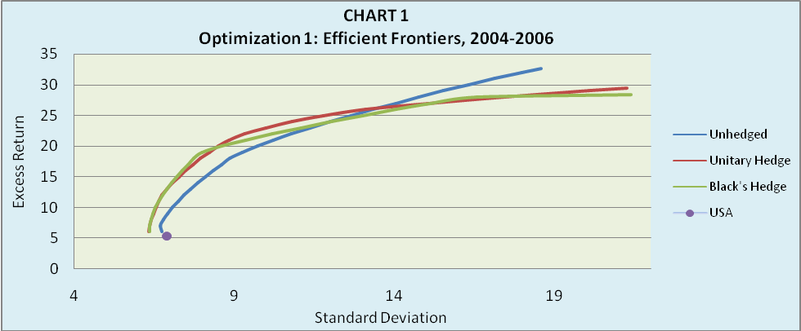
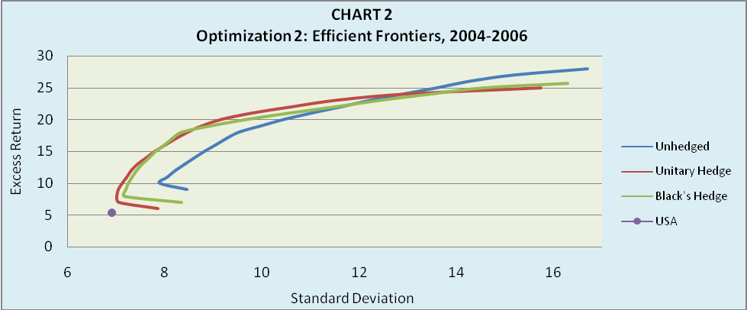

As it can be seen from the country weights presented in the Appendix C, for low levels of risk the U.S. equity portfolio dominates in the efficient frontiers, especially in the first optimization process. This is because the U.S. equity portfolio, irrespective of the type of the hedging strategy, displays the lowest standard deviation among the 20 country indices used in this thesis, but also one of the lowest excess returns, when compared with other countries’ dollar excess returns. This relatively low risk-return relation of the U.S. equity index is the key factor that led the weight of the U.S. equity index to be very high in the frontiers for the low levels of risk, irrespective of the hedging strategy. As the curve moves to the northeast, the risk increases, as also does the excess return. At higher levels of standard deviation, the weights change and the frontier consists mainly of emerging markets equity indices. Especially at the highest levels of standard deviation, emerging markets such as China and Mexico are heavily weighted.

The evidence weather hedging produced better efficient frontiers is mixed. Clearly for low levels of risk the hedging strategies dominate the unhedged, as their efficient frontiers are to the northwest of the unhedged. For higher levels of risk the picture changes, as the unhedged portfolios have higher excess return for the same level of standard deviation than the hedged portfolios.

When comparing the two types of the hedged frontiers, the evidence shows that the difference of the hedging outcome is minor; the unitary hedged frontiers perform in general slightly better than the Black’s optimally hedged frontiers. One possible explanation for this is that the optimization process is performed using 20 individual country portfolios and fifteen currencies. The optimal allocation between the hedging outcome and multicurrency diversification is possible to have led to almost similar types of hedged efficient frontiers.

5.5.2 International Portfolio, 2007-2010 Testing Period
Charts 3 and 4 present the efficient frontiers for the 2007-2010 data period derived from optimization processes 1 and 2 respectively.

The 2007-2010 efficient frontiers advocate the great impact that the crisis had on equity returns. The curves represent mainly negative excess returns for different levels of risk. Only for the highest levels of standard deviation the frontiers are above the x-axis. Attaining positive excess returns seems very difficult for that period and these returns will be marginal.

Simply investing in U.S. MSCI index is again for this period not optimal, because international diversification can always offer a higher excess return for the level of standard deviation that the U.S. equity index has, irrespective if the international portfolio is hedged or not.

As for the 2004-2006 testing period, twenty country index portfolios entered to the portfolio optimization for 2007-2010. However, for the first optimization process, at maximum only six countries are enough at any level of required excess return to produce the efficient frontier. The same holds also for the second optimization process, as at maximum only six out of twenty country indices have weights in the frontier more than the minimum 1%. Again, as for 2004-2006, the investment opportunity set in the second optimization is less than in the first, due to the restrictions in country portfolio weights.

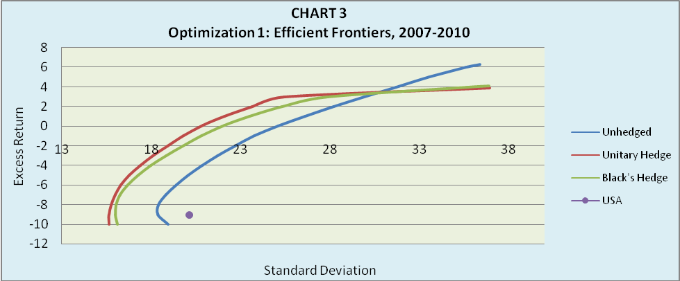
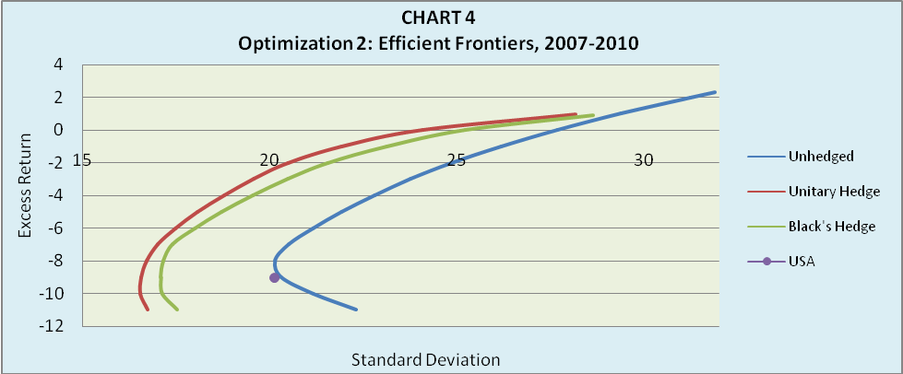

At low levels of standard deviation, the efficient frontiers consist mainly of countries like Switzerland, Japan, U.S., Canada, U.K. and South Africa. At higher levels of standard deviation, the weights change and the frontier consists mainly of emerging markets equity indices and at the highest levels of standard deviation, emerging markets such as China and South Korea dominate the frontiers.

For the 2007-2010 testing period, again the evidence if hedging produced better efficient frontiers is mixed. At low levels of risk the hedged frontiers perform better than the unhedged, as they are to the northwest of the unhedged. However as the standard deviation rises the difference disappears and at the higher levels of risk the unhedged frontiers dominate the hedged ones.

Furthermore, when comparing the two types of hedged frontiers, it is more apparent that the unitary hedged frontiers perform better than the Black’s optimally hedged frontiers. However, the difference between the two hedging outcomes is generally small. Using fifteen currencies and 20 individual country portfolios in the optimization process might have minimized the difference between these two hedging outcomes, due to the optimal allocation between the hedging outcome and multicurrency diversification.

5.6 Efficient Frontiers’ Sharpe Ratio
Appendix 2 presents also charts concerning the Sharpe ratio curves derived from the efficient frontiers that are generated through the optimization process one and two. In every chart the Sharpe ratio is functioned against the excess return. Excess returns in the charts are in percentage and on an annual basis, while Sharpe ratios are straight numbers.

During the 2004-2006 testing period, the Sharpe ratio is maximized when the excess return is around 20%, irrespective of the optimization process and whether the frontiers are hedged or not. This means that the optimal risky portfolios, or tangency portfolios, lye in the frontiers for values of excess return around 20%. Clearly investing only in the U.S. equity index portfolio is an inefficient choice, as international diversification can offer much higher values or Sharpe ratios.

Moreover the Sharpe ratios of unitary hedged efficient frontiers are slightly better than those of the Black’s universal optimally hedged efficient frontiers. Both these ratios have higher values than the ratios of the unhedged efficient frontiers. However, for the highest levels of excess returns, the unhedged frontiers display better ratios than the hedged ones.

During the 2007-2010 testing period, the Sharpe ratios are mainly negative, driven by the negative excess returns that the frontiers had in this period. As the excess returns accelerate, the ratios also accelerate until the point of the highest possible excess return. Furthermore, during this period the unhedged Sharpe is slightly better for every level of excess return, while the difference between the two types of hedged ratios appears to be close to zero.

What can be concluded from all the results is that if U.S. investors decide to invest their money abroad then the decision to hedge their foreign holdings depends on their risk aversion. As no international investment strategy examined in this study continuously dominates the others for every level of risk, then results show that U.S. investors should hedge their exchange rate exposure if they are risk averse, otherwise if they are seeking high returns they should not hedge.

Moreover, if they decide to hedge, then the unitary hedging strategy should be chosen. There are two reasons that justify this argument. The first reason is that unitary currency hedging performs slightly better, as its frontiers are slightly dominating the Black’s hedged frontiers, and the second is that the computation of Black’s universal hedging ratio is time consuming as it requires a lot of data to implement it. Furthermore, other disadvantages are also pointed in the past, as it is based in the unrealistic assumption that all investor across the world have the same risk tolerance (see Solnik, 1993).

5.7 Currency Trends and Results
One crucial point under consideration is how the appreciation/ depreciation trends of foreign currencies relative to U.S. Dollar have affected the results. If the testing period is chosen in such a way that all foreign currencies have appreciated or depreciated against the home currency, favoring not hedging or hedging respectively, then is at least naïve to say that the evidence provided by such an analysis is robust.

Abken and Shrikhande (1997) based their findings by splitting their testing period in sub periods that in such a way that the U.S. Dollar depreciated or appreciated against all other currencies during these periods. However, in this thesis, the choice of the testing periods was based in the criterion that the first period to presents a prosperity period and the second the crisis period. No trends in exchange rate fluctuations were considered for this choice.

During the 2004-2006 period all foreign currencies, except for Japanese Yen, South African Rand and Turkish Lira, appreciated against Dollar, a fact that would not favor hedging. On the contrary, during the 2007-2010 period the emerging markets currencies and the Japanese Yen display large depreciation, a fact that would strongly favor hedging. In that period only Euro and U.K. Pound appreciated against U.S. Dollar.

Based on these currency trends one would expect the unhedged frontiers to dominate the hedged during the 2004-2006 testing period, while for the 2007-2010 testing period the opposite to happen. However, for both periods, the evidence provided by the frontiers is the same; hedge for low levels of risk and don’t hedge for the high levels.

This finding makes the advantage of multicountry-multicurrency diversification more obvious. The currency risk and return is just one part of the total risk and return of the portfolio. The efficient frontier consists in every level of risk of countries that produce the best risk-return trade-off. In total, only the countries that display the best risk-return relation are used to form the frontiers. The rest are omitted. This is why only less than half of the twenty countries are used every time and for every level of risk to produce the efficient frontiers. However, this argument should not be confused and naively say that appreciation/depreciation trends do not affect the portfolios in total and the results. What can be concluded is that though this investment strategy, these effects are diminished. As Gastineau (1995) felicitous stated: “No one can harbor illusions that this study, or any similar effort, can completely eliminate currency-hedging controversies”.

6. Conclusion

This Master Thesis has examined how U.S. investors can benefit by diversifying their portfolios internationally, and how exchange rate exposure affects their risk-return trade-off. For that reason, internationally diversified equity portfolios were formatted and compared with the U.S. equity MSCI index, both in cases when these portfolios are unhedged against exchange rate risk and when hedged.

The internationally diversified equity portfolios were formatted using thirteen developed and seven emerging country equity indices. Then, these indices entered the portfolio optimization process, producing the efficient frontier which a figure presenting all the possible optimal outcomes of the international portfolio’s dollar excess return against its standard deviation. Two optimization processes were performed; the first by posing the restriction that individual country portfolio weights are between 0% and 100%, and the second by posing the restriction that individual country portfolio weights are between 1% and 50%. The two testing periods used to derive the results are 1/12004-12/31/2006 and 1/1/2007-8/31/2010. For every testing period and optimization process, three efficient frontiers are produced with each one derived from the unhedged dollar excess returns, the unitary hedged dollar excess returns and the Black’s universal hedged dollar excess returns during that testing period.

The results show that simply hedging one individual country index portfolio leads to lower level of standard deviation (risk), but also leads to lower level of excess return. Only three countries display higher excess return when hedged, in the 2004-2006 testing period, regardless of the type of hedging.

Furthermore, regardless of the testing period and whether the international portfolios are hedged against currency risk or not, simply investing in the U.S. equity index is not optimal for U.S. investors, as for the same level of risk (standard deviation) there is always a higher level of excess return attained by diversifying the portfolio internationally. This is true for the first optimization process, while for the second the relatively low risk-reward ratio offered by the U.S. equity index is not always feasible, when investing internationally, due to the constraints posed to country portfolio weights.
When it comes to the hedging decision, the evidence is mixed, as for both testing periods and optimization processes there is no hedging strategy that continuously outperforms the others for every level of risk. However, at low levels of risk the hedged frontiers perform better than the unhedged, as they are to the northwest of the unhedged frontiers. For higher levels of risk the picture changes, because as the standard deviation rises the difference disappears and at the higher levels of risk the unhedged frontiers dominate the hedged ones. This evidence proposes that U.S. investors that are willing to bear high amount of risk in their portfolio, in order to gain the higher possible dollar excess returns, should not hedge the exchange rate exposure, while the rest should hedge it.

Moreover, if they decide to hedge their currency risk, the results show that if they have to choose between the two hedging strategies used in this study, then they should use the unitary currency hedging strategy as it performs better than Black’s hedging strategy.

This research does not take into account the transaction costs associated with hedging the currency exposure. Although hedging is assumed to be rebalanced in a monthly basis and Perold and Schoulman’s study (1988) indicates that transaction costs are very low, it is possible that they can have a negative impact on results; thus, is proposed that further research can study the effect caused by transaction costs. Moreover, currency risk is not the only risk that comes into play when investing abroad. By simply taking into account only numbers that promise exceptional returns totally ignores other sources of risk that might exist, suggesting that future research should also examine this aspect.

References

Abken, A., Shrikhande, M.M., 1997, “The Role of Currency Derivatives in Internationally Diversified Portfolios”, Economic Review, Fed. Res. Bank of Atlanta, 3rd Quarter, pp. 34-58

Allayannis, G., Ofek, O., 1997, “Exchange Rate Exposure, Hedging, and the Use of Foreign Currency Derivatives”, Stern School of Business, New York University

Black, F., 1989, “Equilibrium Exchange Rate Hedging”, The Journal of Finance, Vol. 45, pp. 899-907

Black, F., 1995, “Universal Hedging: Optimizing Currency Risk and Reward in International Equity Portfolios”, Financial Analysts Journal, pp. 161-167

Bugár, G., Maurer, R., 2002, “International Equity Portfolios and Currency Hedging: The Perspective of German and Hungarian Investors” Astin Bulletin, Vol. 32, pp. 171-197

Chang, K.H., 2009, “Currency Hedging: A Free Lunch?”, MSCI Barra Research Insights

De Roon, F.A., Nijman, T.E., Werker, B.J.M., 2001, “Testing for Mean-Variance Spanning with Short Sales Constraints and Transaction Costs: The Case of Emerging Markets”, The Journal of Finance, Vol. 56, pp. 721-742

De Santis, G., Gerard, B., 1997, “International Asset Pricing and Portfolio Diversification with Time-Varying Risk”, The Journal of Finance, Vol. 52, pp. 1881-1912

De Santis, G., Gerard, B., Hillion, P., 1999, “International Portfolio Management, Currency Risk and the Euro”, Finance, Anderson Graduate School of Management, UC Los Angeles

De Santis, G., Imrohoroglu, S., 1997, “Stock returns and volatility in emerging financial markets”, Journal of International Money and Finance, Vol. 16, pp. 561-579

Eaker, M., Grant, D., Woodard, N., 1991, “International Diversification and Hedging: A Japanese and U.S. Perspective”, Journal of Economics and Business

Eun, C.S., Resnick, B.G., 1988, “Exchange Rate Uncertainty, Forward Contracts, and International Portfolio Selection”, Journal of Finance 43, pp. 197-215

Fletcher, F., Marshall, A., 2005, “An empirical examination of the benefits of international diversification”, Journal of International Financial Markets, Institutions and Money, Vol. 15, pp. 455–468

Forbes, K.J., Rigobon, R., 2002, “No Contagion, Only Interdependence: Measuring Stock Market Comovements”, The Journal of Finance, Vol. 57, pp. 2223-2261

Froot, K.A., 1993, “Currency Hedging Over Long Horizons”, NBER Working Paper No. 4355

Fung, H.G., Leung, W.K., 1991, “The Use of Forward Contracts for Hedging Currency Risk”, Journal of International Financial Management and Accounting, Vol. 3

Gardner, G.W., Wuilloud, T., 1995, “Currency Risk in International Portfolios - How Satisfying is Optimal Hedging?”, The Journal of Portfolio Management, Vol. 21, pp. 59-67

Gastineau, G.L., 1995, “The currency hedging decision: A search for synthesis in asset allocation”, Financial Analysts Journal, Vol. 51, pg. 8

Gilmore, C.G., McManus, G.M., 2002, “International portfolio diversification: US and Central European equity markets”, Emerging Markets Review, Vol. 3, pp. 69-83

Glen, J., Jorion, P., 1993, “Currency Hedging for International Portfolios”, Journal of Finance 43, pp. 1865-1886
Goriaev, A., Prikhodko, S., 2004, “Should emerging market investors diversify abroad despite superior domestic performance?”, New Economic School

Grubel, G.H., 1968, “Internationally Diversified Portfolios: Welfare Gains and Capital Flows”, The American Economic Review, Vol. 58, pp. 1299-1314

Gupta, R., 2006, “Benefits of diversification into emerging equity markets with changing correlations: An Australian perspective”, International Review of Business Research Papers, Vol. 2, pp. 22-38

Gupta, R., 2008, “Time-varying Correlations and Optimal Allocation in Emerging Market Equities for Australian Investors”, AFFANZ conference

Kaplanis, E., Schaefer, S.M., 1991, “Exchange Risk and International Diversification in Bond and Equity Portfolios”, Journal of Economics and Business

King, M., Sentana, E., Wadhwani, S., 1994, “Volatility and Links between National Stock Markets”, Econometrica, Vol. 62, pp. 901-933

Lee, T., 1988, “Technical Notes: Currency Risks In International Equity Portfolios”, Financial Analysts Journal, Vol. 44, pg. 68

Lessard, D.R., 1976, “World, Country, and Industry Relationships in Equity Returns: Implications for Risk Reduction Through International Diversification”, Financial Analyst Journal

Levy, H., Sarnat, M., 1970, “International Diversification of Investment Portfolios”, The American Economic Review, Vol. 60, pp. 668-675

Li, K., Sarkar, A., Wang, Z., 2001, “Diversification benefits of emerging markets subject to portfolio constraints”, University of British Columbia, Working paper

Li, K., Sarkar, A., 2002, “Should U.S. Investors Hold Foreign Stocks?”, Current Issues in Economics and Finance, Vol. 8, Federal Reserve Bank of New York

Markowitz, H., 1952, “Portfolio Selection”, Journal of Finance, Vol. 7, pp. 77-91

Markowitz, H.M., 1991, “Foundations of Portfolio Theory”, The Journal of Finance, Vol. 46, pp. 469-477

Morey, M.R., Simpson, 2000, M.W., “To hedge or not to hedge: the performance of simple strategies for hedging foreign exchange risk”, Journal of Multinational Financial Management, Vol. 11, pp. 213–223

Perold, A.F., Schulman, E.C., 1988, “The Free Lunch In Currency Hedging: Implications For Investment Policy and Performance Standards”, Financial Analysts Journal; Vol. 44, pg. 45

Solnik, B., 1974, “Why Not Diversify Internationally Rather Than Domestically?”, Financial Analysts Journal pg. 48-54

Solnik, B., Cyril, B., Yann, L.F., 1996, “International Market Correlation and Volatility”,
Financial Analysts Journal, Vol. 52, pg. 17

Solnik, B., 1993, “Currency Hedging and Siegel’s Paradox: On Black’s Universal Hedging Rule”, Review of International Economics, Vol. 1, pp. 180-187

Simpson, M.W., 2004, “Selectively hedging the US dollar with foreign exchange futures contracts”, Journal of International Financial Markets, Institutions and Money, Vol. 14, pp. 75–86

Schmittmann, J.M., 2010, “Currency Hedging for International Portfolios”, International Monetary Fund, Working Paper 10/151

Valera, O., Naka, A., 1997, “Forward Hedging the Exchange Risks of U.S. Equity Investments in the U.K., Germany and France” The Financial Review, Vol. 32, pp. 527-544

Walker, E., 2007, “Strategic currency hedging and global portfolio investments upside down”, Journal of Business Research, Vol. 61, pp. 657–668

www.mscibarra.com “MSCI All Country World Investable Market Index (ACWI IMI): A New World - A New Benchmark. Capturing the global equity investment opportunity set across size, style and sector segments in 45 Developed and Emerging Markets”

Appendix A: Black’s Universal Hedging Formula, Data Inputs

Exchange Rate Volatilities
Table 7: Exchange Rate Volatilities, 2002-2003
 | U.S. | Australia | Canada | Japan | Singapore |  |  | Switzerland |  | U.K. |  | Eurozone |  | Brazil |  | China |  | India |  | Mexico |  | South Africa |  | Korea |  | Turkey
U.S. | 0% | 10% | 7% | 9% | 4% |  |  | 10% |  | 7% |  | 9% |  | 22% |  | 0% |  | 2% |  | 9% |  | 18% |  | 7% |  | 16%
Australia | 10% | 0% | 8% | 12% | 9% |  |  | 10% |  | 9% |  | 10% |  | 22% |  | 9% |  | 10% |  | 16% |  | 22% |  | 12% |  | 17%
Canada | 7% | 8% | 0% | 10% | 8% |  |  | 10% |  | 9% |  | 9% |  | 22% |  | 8% |  | 8% |  | 12% |  | 18% |  | 10% |  | 15%
Japan | 9% | 12% | 10% | 0% | 7% |  |  | 10% |  | 9% |  | 9% |  | 21% |  | 9% |  | 9% |  | 13% |  | 23% |  | 10% |  | 17%
Singapore | 4% | 9% | 8% | 7% | 0% |  |  | 15% |  | 7% |  | 8% |  | 20% |  | 4% |  | 4% |  | 14% |  | 21% |  | 6% |  | 17%
Switzerland | 10% | 10% | 10% | 10% | 15% |  |  | 0% |  | 7% |  | 3% |  | 22% |  | 11% |  | 11% |  | 15% |  | 22% |  | 12% |  | 17%
U.K. | 7% | 9% | 9% | 9% | 7% |  |  | 7% |  | 0% |  | 6% |  | 21% |  | 7% |  | 8% |  | 12% |  | 18% |  | 9% |  | 16%
Eurozone | 9% | 10% | 9% | 9% | 8% |  |  | 3% |  | 6% |  | 0% |  | 24% |  | 9% |  | 10% |  | 14% |  | 22% |  | 10% |  | 17%
Brazil | 22% | 22% | 21% | 21% | 20% |  |  | 22% |  | 21% |  | 24% |  | 0% |  | 20% |  | 20% |  | 22% |  | 27% |  | 23% |  | 24%
China | 0% | 9% | 8% | 9% | 4% |  |  | 11% |  | 7% |  | 9% |  | 20% |  | 0% |  | 4% |  | 13% |  | 22% |  | 12% |  | 17%
India | 2% | 10% | 8% | 9% | 4% |  |  | 11% |  | 8% |  | 10% |  | 20% |  | 4% |  | 0% |  | 13% |  | 22% |  | 12% |  | 17%
Mexico | 9% | 16% | 12% | 13% | 14% |  |  | 15% |  | 12% |  | 14% |  | 22% |  | 13% |  | 13% |  | 0% |  | 24% |  | 21% |  | 21%
South Africa | 18% | 22% | 18% | 23% | 21% |  |  | 22% |  | 18% |  | 22% |  | 27% |  | 22% |  | 22% |  | 24% |  | 0% |  | 24% |  | 25%
Korea | 7% | 12% | 10% | 10% | 6% |  |  | 12% |  | 9% |  | 10% |  | 23% |  | 12% |  | 12% |  | 21% |  | 24% |  | 0% |  | 20%
Turkey | 16% | 17% | 15% | 17% | 17% |  |  | 17% |  | 16% |  | 17% |  | 24% |  | 17% |  | 17% |  | 21% |  | 25% |  | 20% |  | 0%
Average Exchange Rate Volatility 2002-03 |  |  |  |  |  |  |  |  |  |  |  |  |  |  |  |  |  |  |  |  |  |  |  |  | 11.65%

Table 8: Exchange Rate Volatilities, 2005-2006
 | U.S. | Australia | Canada | Japan | Singapore |  |  | Switzerland |  | U.K. |  | Eurozone |  | Brazil |  | China |  | India |  | Mexico |  | South Africa |  | Korea |  | Turkey
U.S. | 0% | 8% | 8% | 9% | 4% |  |  | 9% |  | 8% |  | 8% |  | 14% |  | 2% |  | 4% |  | 7% |  | 15% |  | 7% |  | 13%
Australia | 8% | 0% | 8% | 10% | 7% |  |  | 7% |  | 7% |  | 7% |  | 13% |  | 9% |  | 8% |  | 10% |  | 13% |  | 10% |  | 13%
Canada | 8% | 8% | 0% | 9% | 7% |  |  | 7% |  | 8% |  | 8% |  | 14% |  | 8% |  | 8% |  | 9% |  | 14% |  | 9% |  | 14%
Japan | 9% | 10% | 9% | 0% | 6% |  |  | 8% |  | 7% |  | 7% |  | 14% |  | 8% |  | 8% |  | 11% |  | 18% |  | 10% |  | 14%
Singapore | 4% | 7% | 7% | 6% | 0% |  |  | 7% |  | 6% |  | 7% |  | 12% |  | 4% |  | 5% |  | 7% |  | 14% |  | 6% |  | 13%
Switzerland | 9% | 7% | 7% | 8% | 7% |  |  | 0% |  | 5% |  | 3% |  | 15% |  | 10% |  | 9% |  | 11% |  | 13% |  | 11% |  | 14%
U.K. | 8% | 7% | 8% | 7% | 6% |  |  | 5% |  | 0% |  | 5% |  | 14% |  | 8% |  | 7% |  | 10% |  | 13% |  | 9% |  | 14%
Eurozone | 8% | 7% | 8% | 7% | 7% |  |  | 3% |  | 5% |  | 0% |  | 15% |  | 8% |  | 8% |  | 10% |  | 13% |  | 9% |  | 13%
Brazil | 14% | 13% | 14% | 14% | 12% |  |  | 15% |  | 14% |  | 15% |  | 0% |  | 13% |  | 13% |  | 12% |  | 16% |  | 15% |  | 13%
China | 2% | 9% | 8% | 8% | 4% |  |  | 10% |  | 8% |  | 8% |  | 13% |  | 0% |  | 4% |  | 7% |  | 15% |  | 10% |  | 14%
India | 4% | 8% | 8% | 8% | 5% |  |  | 9% |  | 7% |  | 8% |  | 13% |  | 4% |  | 0% |  | 8% |  | 15% |  | 10% |  | 14%
Mexico | 7% | 10% | 9% | 11% | 7% |  |  | 11% |  | 10% |  | 10% |  | 12% |  | 7% |  | 8% |  | 0% |  | 13% |  | 12% |  | 12%
South Africa | 15% | 13% | 14% | 18% | 14% |  |  | 13% |  | 13% |  | 13% |  | 16% |  | 15% |  | 15% |  | 13% |  | 0% |  | 16% |  | 15%
Korea | 7% | 10% | 9% | 10% | 6% |  |  | 11% |  | 9% |  | 9% |  | 15% |  | 10% |  | 10% |  | 12% |  | 16% |  | 0% |  | 16%
Turkey | 13% | 13% | 14% | 14% | 13% |  |  | 14% |  | 14% |  | 13% |  | 13% |  | 14% |  | 14% |  | 12% |  | 15% |  | 16% |  | 0%
Average Exchange Rate Volatility 2005-06 |  |  |  |  |  |  |  |  |  |  |  |  |  |  |  |  |  |  |  |  |  |  |  |  | 8.75%

Country Weights on World Market Portfolio
Table 9: MSCI All Country World Investable Market Index (ACWI IMI)
Country Weights |  |  |  | As of 30 September 2009
Developed Markets | # of Securities | Weight |  | Emerging Markets | # of Securities | Weight
Australia | 236 | 3.37% |  | Brazil | 157 | 1.84%
Austria | 33 | 0.20% |  | Chile | 33 | 0.17%
Belgium | 50 | 0.44% |  | China | 309 | 2.08%
Canada | 306 | 4.12% |  | Colombia | 12 | 0.08%
Denmark | 43 | 0.41% |  | Czech Republic | 7 | 0.06%
Finland | 46 | 0.52% |  | Egypt | 41 | 0.08%
France | 182 | 4.24% |  | Hungary | 8 | 0.07%
Germany | 164 | 3.21% |  | Indonesia | 41 | 0.23%
Greece | 57 | 0.31% |  | India | 285 | 0.99%
Hong Kong | 134 | 0.95% |  | Israel | 79 | 0.32%
Ireland | 21 | 0.19% |  | Korea | 388 | 1.69%
Italy | 146 | 1.51% |  | Malaysia | 120 | 0.34%
Japan | 1160 | 9.14% |  | Mexico | 48 | 0.50%
Netherlands | 58 | 1.04% |  | Morocco | 13 | 0.04%
New Zealand | 22 | 0.07% |  | Peru | 7 | 0.07%
Norway | 56 | 0.38% |  | Philippines | 28 | 0.06%
Portugal | 25 | 0.14% |  | Poland | 63 | 0.15%
Singapore | 96 | 0.60% |  | Russia | 42 | 0.69%
Spain | 86 | 1.83% |  | South Africa | 119 | 0.89%
Sweden | 104 | 1.10% |  | Taiwan | 479 | 1.54%
Switzerland | 118 | 3.03% |  | Thailand | 79 | 0.18%
United Kingdom | 384 | 8.52% |  | Turkey | 83 | 0.20%
United States | 2494 | 42.41%
Total | 6021 | 87.73% |  | Total | 2441 | 12.27%
Data Source: http://www.mscibarra.com/

Table 10: Country Weights Assuming our Portfolio Is the World Market Portfolio
Developed Markets |  | Weight |  | Emerging Markets |  | Weight
United States |  | 47.04% |  | Brazil |  | 2.04%
Australia |  | 3.74% |  | China |  | 2.31%
Canada |  | 4.57% |  | India |  | 1.10%
Japan |  | 10.14% |  | Mexico |  | 0.55%
Singapore |  | 0.67% |  | South Africa |  | 0.99%
Switzerland |  | 3.36% |  | Korea |  | 1.87%
United Kingdom |  | 9.45% |  | Turkey |  | 0.22%
France |  | 4.70%
Germany |  | 3.56%
Greece |  | 0.34%
Netherlands |  | 1.15%
Portugal |  | 0.16%
Spain |  | 2.03%
Total |  | 90.92% |  | Total |  | 9.08%

World Market Excess Returns and Return Volatilities in Different Currencies
Table 11: World Market Excess Returns and Return Volatilities in Different Currencies, 2002-2003, 2005-2006
 | Excess Return |  |  |  |  | Return Volatility
Country | 2002 | 2003 | 2005 | 2006 |  | 2002 | 2003 | 2005 | 2006
United States | -26% | 26% | 2% | 9% |  | 26% | 17% | 10% | 10%
Australia | -17% | 4% | 15% | 12% |  | 12% | 11% | 10% | 14%
Canada | -18% | 22% | 21% | 12% |  | 18% | 10% | 12% | 14%
Japan | -19% | 22% | 43% | 6% |  | 23% | 21% | 13% | 19%
Singapore | -19% | 31% | 11% | 28% |  | 20% | 19% | 10% | 14%
Switzerland | -27% | 18% | 31% | 15% |  | 28% | 22% | 9% | 13%
United Kingdom | -30% | 11% | 11% | 6% |  | 27% | 19% | 9% | 12%
France | -37% | 12% | 21% | 14% |  | 34% | 26% | 11% | 15%
Germany | -47% | 31% | 21% | 15% |  | 39% | 31% | 12% | 16%
Greece | -42% | 33% | 25% | 15% |  | 19% | 21% | 15% | 19%
Netherlands | -38% | 1% | 24% | 11% |  | 36% | 29% | 11% | 14%
Portugal | -32% | 14% | 8% | 26% |  | 21% | 14% | 9% | 10%
Spain | -33% | 26% | 14% | 26% |  | 33% | 22% | 10% | 14%
Brazil | -18% | 42% | 14% | 13% |  | 27% | 19% | 23% | 24%
China | -19% | 78% | 13% | 76% |  | 22% | 23% | 16% | 22%
India | 0% | 60% | 33% | 40% |  | 17% | 19% | 17% | 26%
Mexico | -10% | 33% | 28% | 33% |  | 23% | 15% | 17% | 23%
South Africa | -23% | -2% | 31% | 23% |  | 21% | 19% | 14% | 24%
Korea | -8% | 29% | 47% | -3% |  | 35% | 28% | 17% | 18%
Turkey | -76% | 50% | 33% | -22% |  | 45% | 42% | 26% | 33%

Table 12:
WEIGHTED World Market Excess Returns and Return Volatilities in Different Currencies, 2002-2003, 2005-2006
 | Excess Return |  |  |  |  | Return Volatility
Country | 2002 | 2003 | 2005 | 2006 |  | 2002 | 2003 | 2005 | 2006
United States | -12.03% | 12.13% | 0.82% | 4.01% |  | 12.44% | 8.04% | 4.84% | 4.79%
Australia | -0.64% | 0.13% | 0.55% | 0.46% |  | 0.47% | 0.40% | 0.39% | 0.51%
Canada | -0.81% | 1.00% | 0.96% | 0.54% |  | 0.83% | 0.47% | 0.53% | 0.62%
Japan | -1.97% | 2.18% | 4.35% | 0.60% |  | 2.29% | 2.11% | 1.30% | 1.91%
Singapore | -0.13% | 0.20% | 0.07% | 0.19% |  | 0.13% | 0.13% | 0.07% | 0.10%
Switzerland | -0.90% | 0.61% | 1.03% | 0.51% |  | 0.95% | 0.74% | 0.31% | 0.43%
United Kingdom | -2.79% | 1.02% | 1.08% | 0.57% |  | 2.57% | 1.80% | 0.82% | 1.17%
France | -1.75% | 0.58% | 0.99% | 0.66% |  | 1.61% | 1.20% | 0.52% | 0.69%
Germany | -1.69% | 1.10% | 0.75% | 0.54% |  | 1.39% | 1.09% | 0.43% | 0.55%
Greece | -0.14% | 0.11% | 0.09% | 0.05% |  | 0.07% | 0.07% | 0.05% | 0.07%
Netherlands | -0.43% | 0.01% | 0.28% | 0.12% |  | 0.42% | 0.33% | 0.12% | 0.17%
Portugal | -0.05% | 0.02% | 0.01% | 0.04% |  | 0.03% | 0.02% | 0.01% | 0.02%
Spain | -0.67% | 0.53% | 0.29% | 0.53% |  | 0.67% | 0.44% | 0.21% | 0.28%
Brazil | -0.37% | 1.58% | 0.29% | 0.26% |  | 0.55% | 0.38% | 0.47% | 0.44%
China | -0.43% | 1.39% | 0.30% | 1.76% |  | 0.51% | 0.52% | 0.36% | 0.60%
India | 0.00% | 0.36% | 0.36% | 0.44% |  | 0.19% | 0.21% | 0.19% | 0.26%
Mexico | -0.06% | -0.01% | 0.16% | 0.18% |  | 0.13% | 0.08% | 0.10% | 0.13%
South Africa | -0.23% | 0.29% | 0.31% | 0.23% |  | 0.21% | 0.19% | 0.14% | 0.18%
Korea | -0.15% | 0.93% | 0.88% | -0.05% |  | 0.65% | 0.53% | 0.32% | 0.61%
Turkey | -0.17% | 0.00% | 0.07% | -0.05% |  | 0.10% | 0.09% | 0.06% | 0.00%
AVERAGE VALUES | -25.4% | 24.18% | 12.63% | 11.6% |  | 26.18% | 18.85% | 11.21% | 13.52

Appendix B: Correlation Tables
Correlation Matrix – Local MSCI Index Return
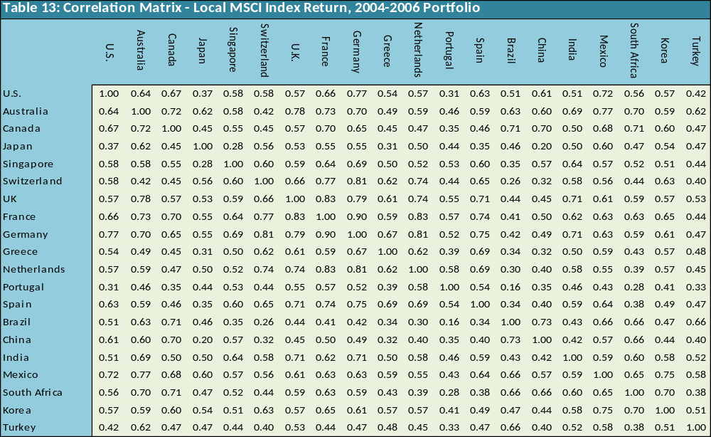
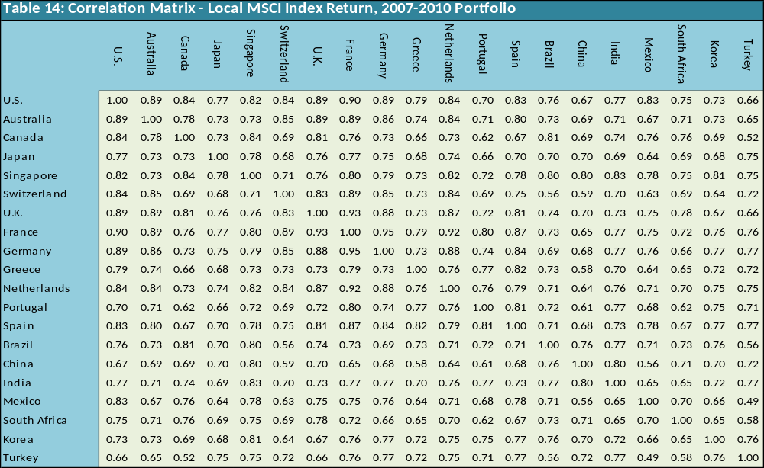

Appendix C: Optimal Portfolio Weights & Efficient Frontiers’ Sharpe Ratio
Optimization 1: Optimal Portfolio Weights, 2004-2006
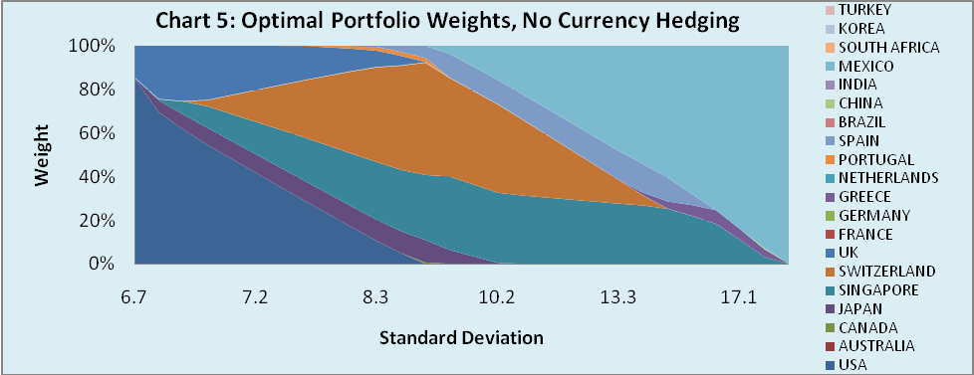
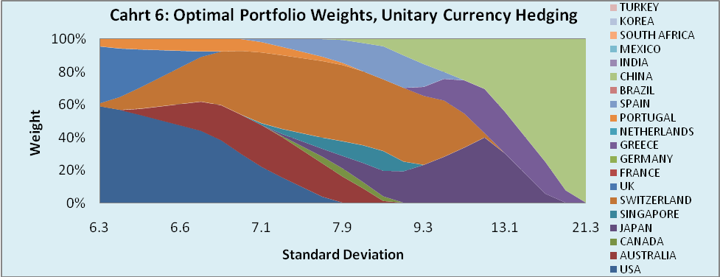
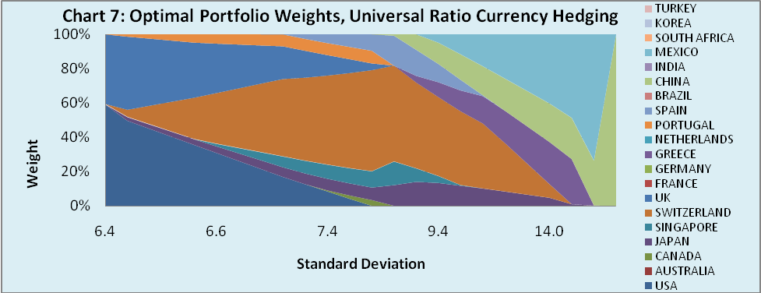
Note: Standard deviations on portfolio weight charts are not measured in equal intervals.

Optimization 2: Optimal Portfolio Weights, 2004-2006
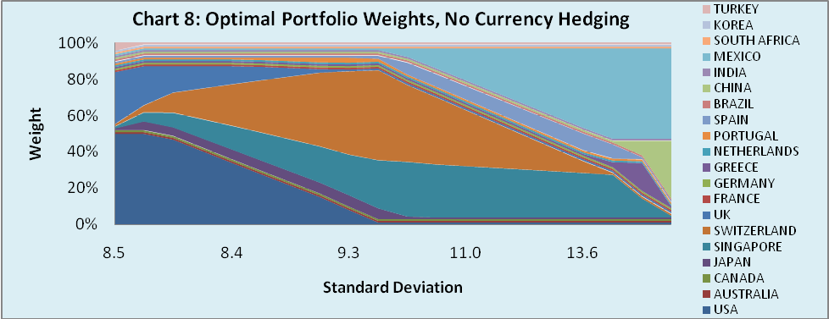
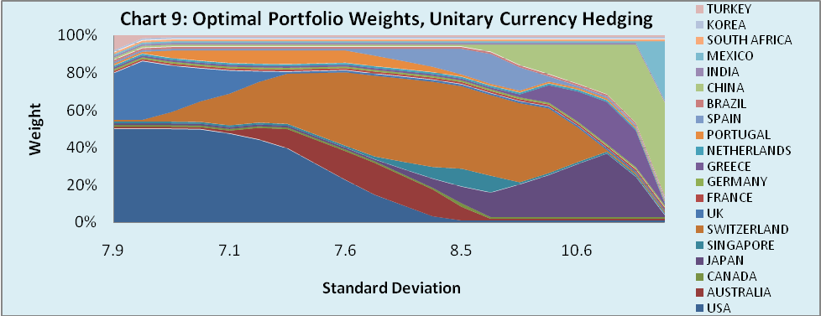
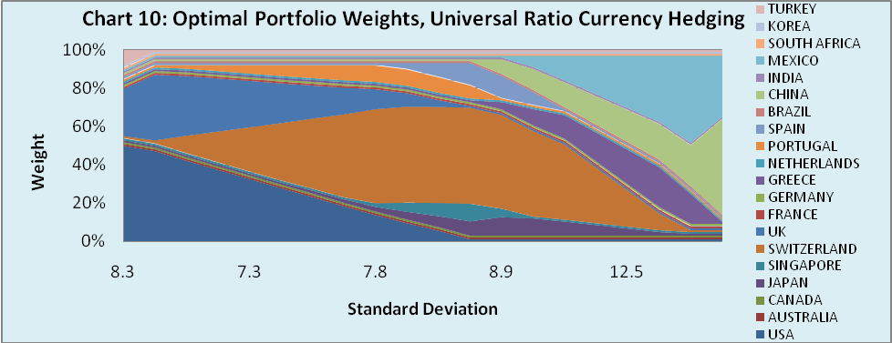
Note: Standard deviations on portfolio weight charts are not measured in equal intervals.

Optimization 1: Optimal Portfolio Weights, 2007-2010
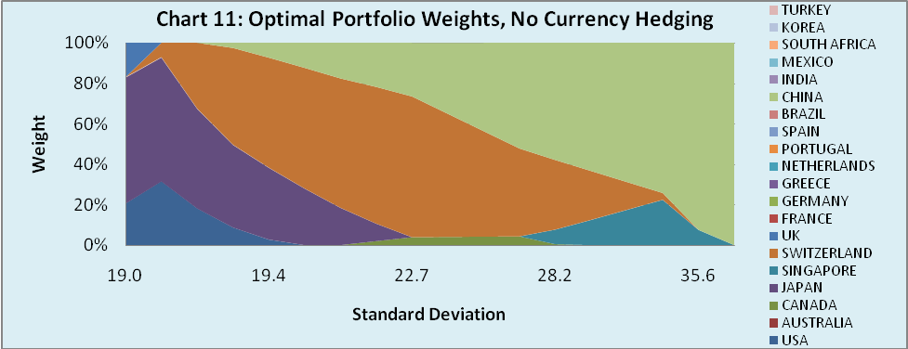
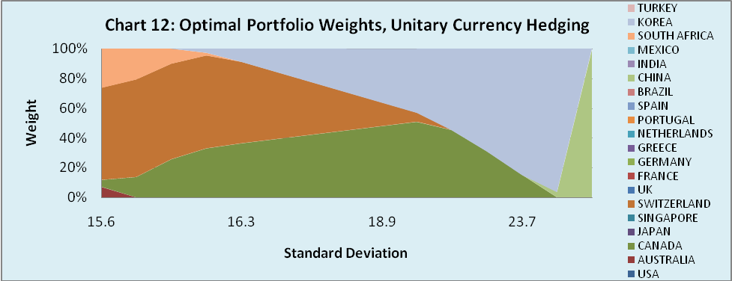
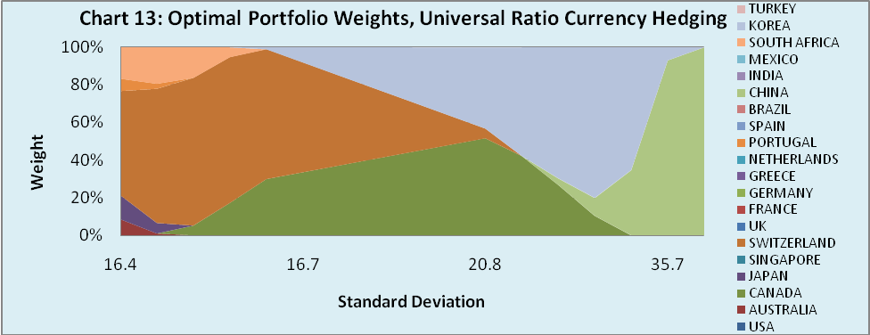
Note: Standard deviations on portfolio weight charts are not measured in equal intervals.

Optimization 2: Optimal Portfolio Weights, 2007-2010
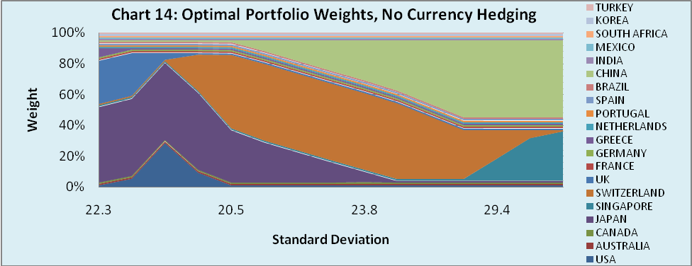
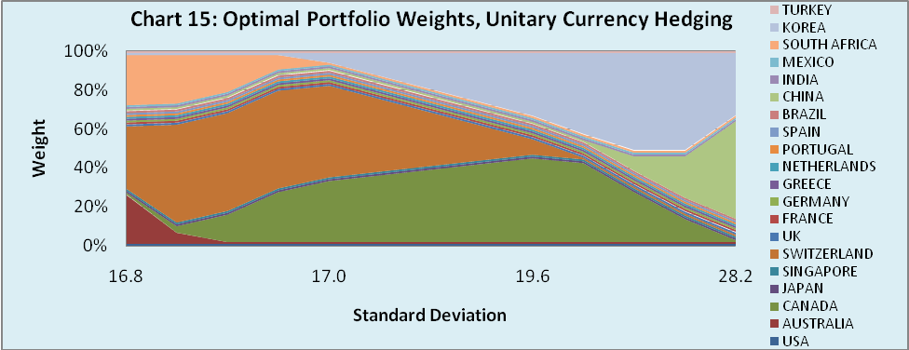
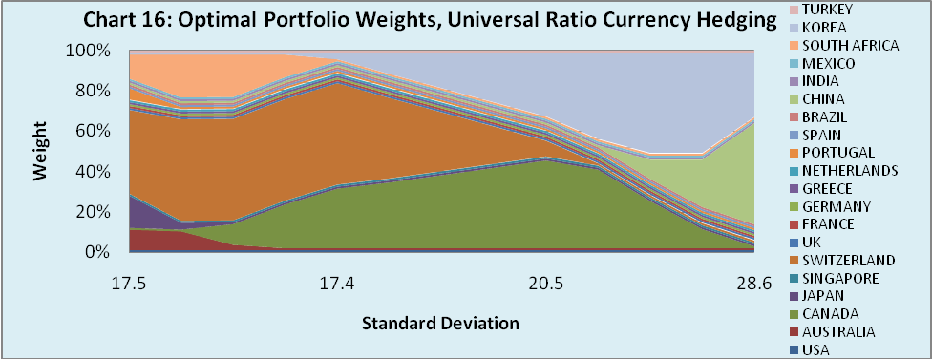
Note: Standard deviations on portfolio weight charts are not measured in equal intervals.

Efficient Frontiers’ Sharpe Ratio, 2004-2006

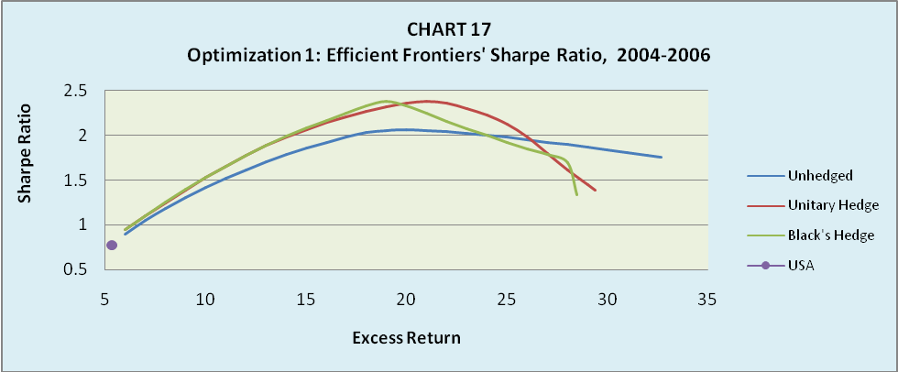

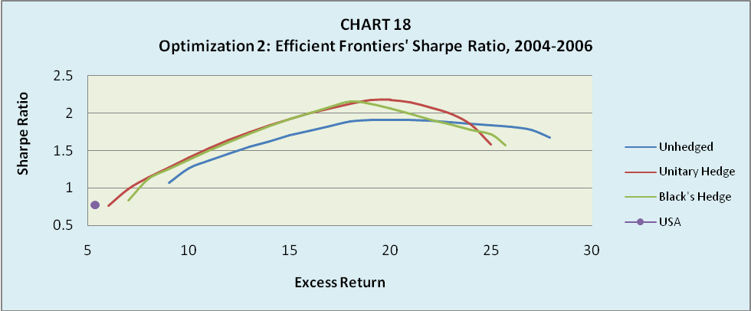

Efficient Frontiers’ Sharpe Ratio, 2007-2010

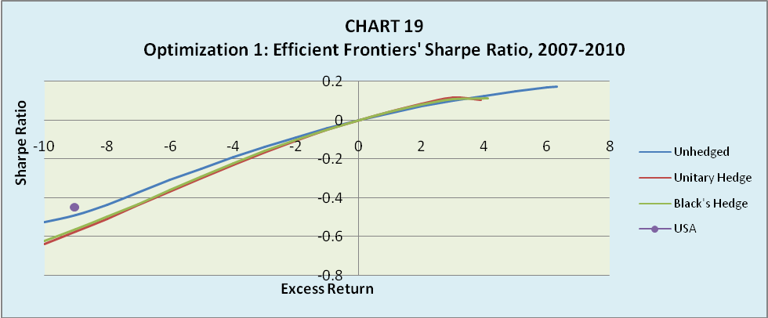

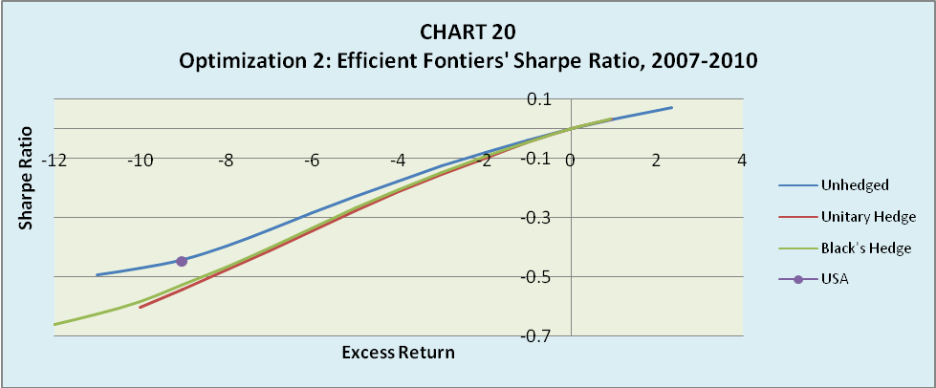

Appendix D: Short Sales Optimization

The third optimization process performed in this thesis allows for shortselling the national equity index portfolios up to 50%. This optimization is performed under the restrictions:

Short Sales Optimization:
- Minimize standard deviation for a given level of required return subject to the constraint that country portfolio weights are between -50% and 100%
-0.5 ≤ w_{i} ≤ 1
This means that individual country portfolio indices can be sold short up to 50% of their value, but also bought up to 100% of their value.

Charts 21 and 22 present the efficient frontiers for the 2004-2006 and 2007-2010 testing period respectively, derived from the short sales optimization process.

Simply investing in U.S. MSCI index is clearly not optimal, irrespective of the period, as can be seen from all the international efficient frontiers. In this case, the positive effect that hedging has on international efficient frontiers is clear. For both testing periods, the hedged portfolios’ efficient frontiers are to the northwest of the unhedged portfolios’. Only for the very low levels of standard deviation the unhedged frontiers dominate the hedged ones. Furthermore, for the 2004-2006 testing period, the unitary hedged portfolio frontier produces better results than the Black’s universal optimally hedged frontier, while for the 2007-2010 testing period the outcome is almost the same.

This optimization allowing for selling short the national equity indices up to 50% of their value advocates enthusiasm. This is because the excess returns derived from every efficient frontier for every level of standard deviation are positive and substantially higher than those of the other optimization processes. This fact is true not only for the 2004-2006 testing period, but also for the 2007-2010 testing period, were the twenty individual country index portfolios that entered the optimization process experienced large negative dollar excess returns in general.
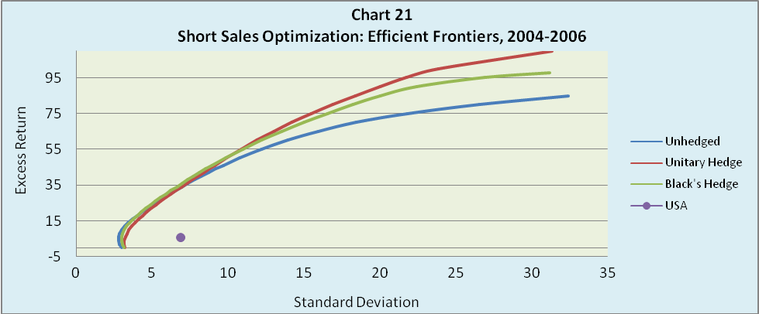
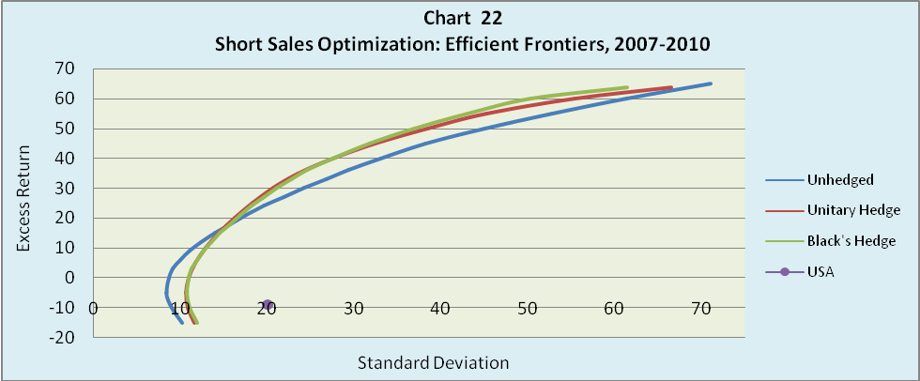

Unlikely the optimization process one and two, all the twenty individual country index portfolios that entered the short sales portfolio optimization process have weights different than zero for any level of standard deviation (risk). During the 2004-2006 testing period, for low levels of standard deviation, countries like U.S., Australia, Singapore, Switzerland and U.K. are highly positive weighted, and countries like Germany and emerging markets are highly negative weighted. For high levels of risk, Greece, Spain, India, China and Mexico are highly positive weighted and the rest mainly negatively weighted. During the 2007-2010 period Australia, Japan, Switzerland, U.K. and Portugal are highly positive weighted for low levels of risk, and Canada, Singapore, Brazil, China, India and Korea for high levels of risk. Large negative weights display almost all emerging markets, as also Greece, Germany and Netherlands for low levels of risk, and for high levels of risk, all the rest that weren’t positively weighted (Charts 23-28).
Short Sales Optimization: Optimal Portfolio Weights, 2004-2006
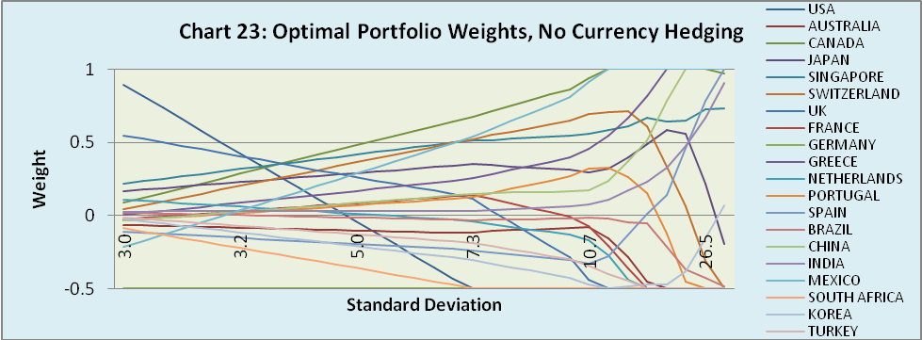
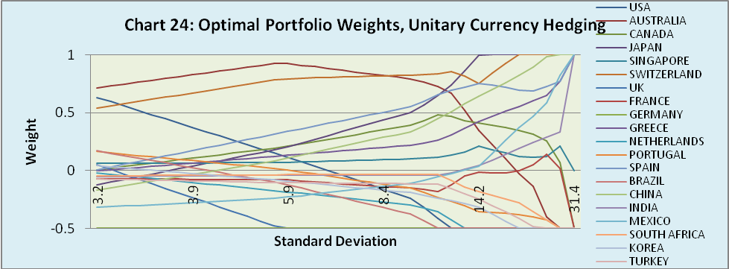
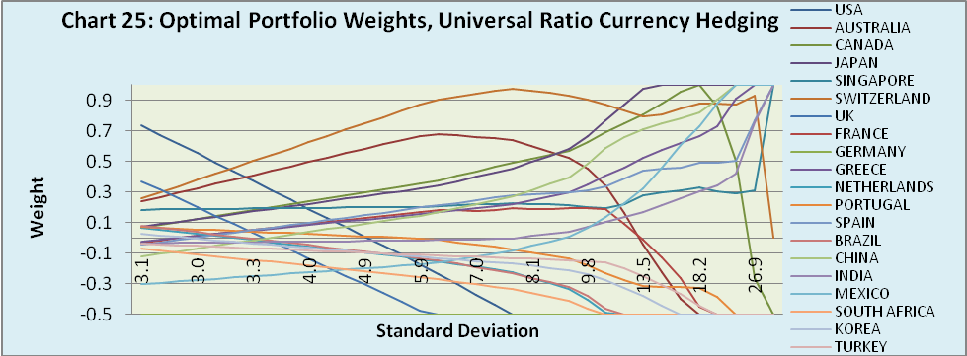
Note: Standard deviations on portfolio weight charts are not measured in equal intervals.

Short Sales Optimization: Optimal Portfolio Weights, 2007-2010
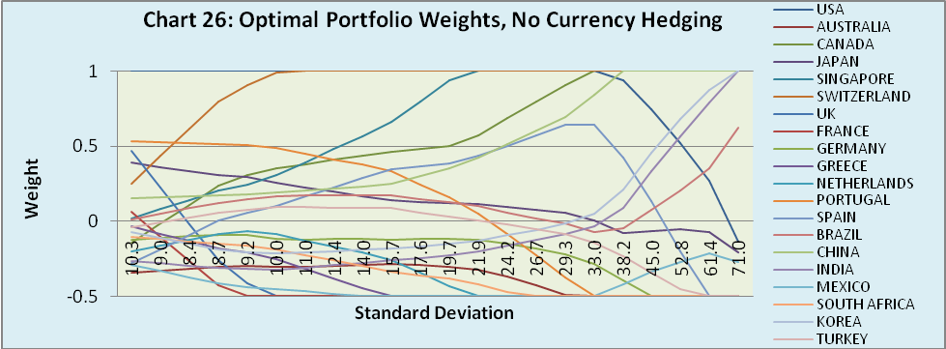
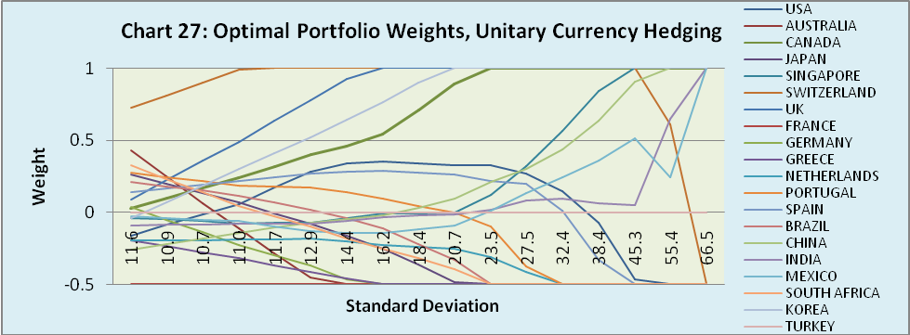
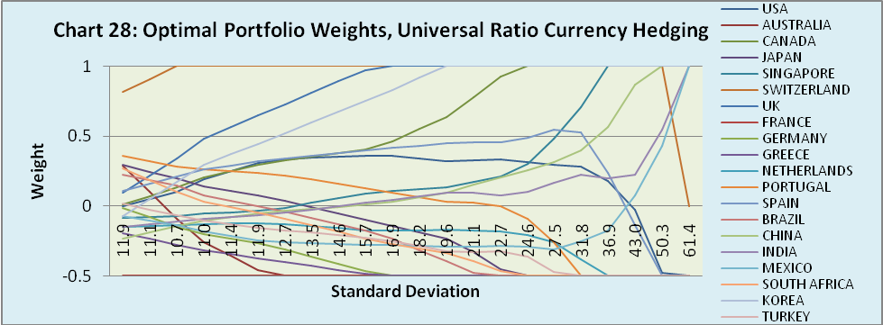
Note: Standard deviations on portfolio weight charts are not measured in equal intervals.

During the 2004-2006 and 2007-2010 testing periods, the Sharpe ratio is maximized when the excess return is around to 35%, irrespective of the optimization process and if the frontiers are hedged or not. This means that the optimal risky portfolios, or tangency portfolios, lye in the frontiers for values of excess return around to 35%. Clearly investing only in the U.S. equity index portfolio is an inefficient choice according to Sharpe ratios, as international diversification can offer much higher values or Sharpe ratios.

Furthermore, during these testing periods the hedged Sharpe is generally higher than the unhedged, while the unitary hedged Sharpe ratio appears to be better than the Black hedged Sharpe, especially during the 2004-2006 testing period (Charts 29-30).
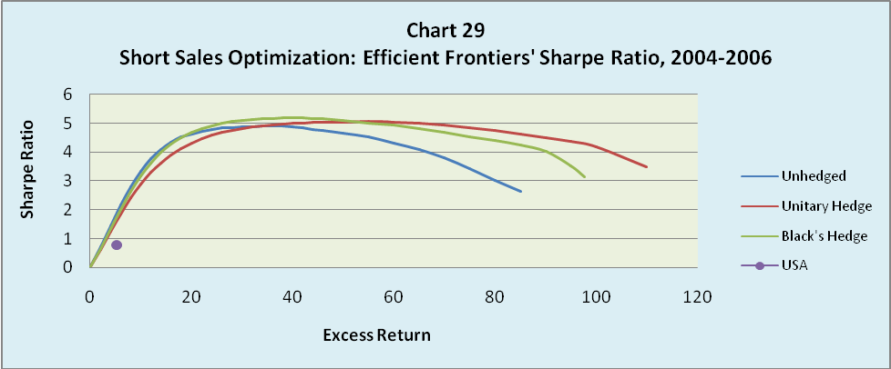
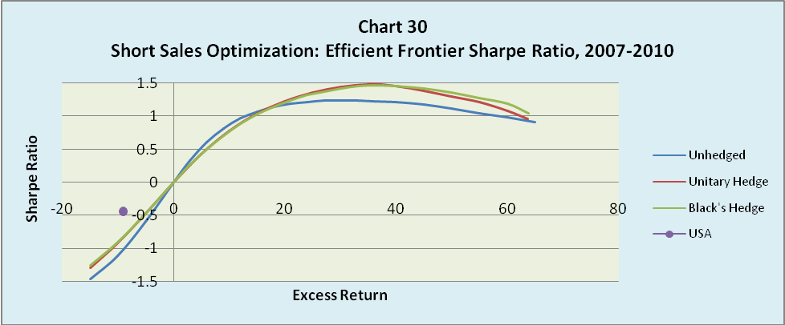

Appendix F: Correlation & Covariance Tables
Correlation & Covariance Matrix - Unhedged Dollar MSCI Index Excess Return, 2004-2006
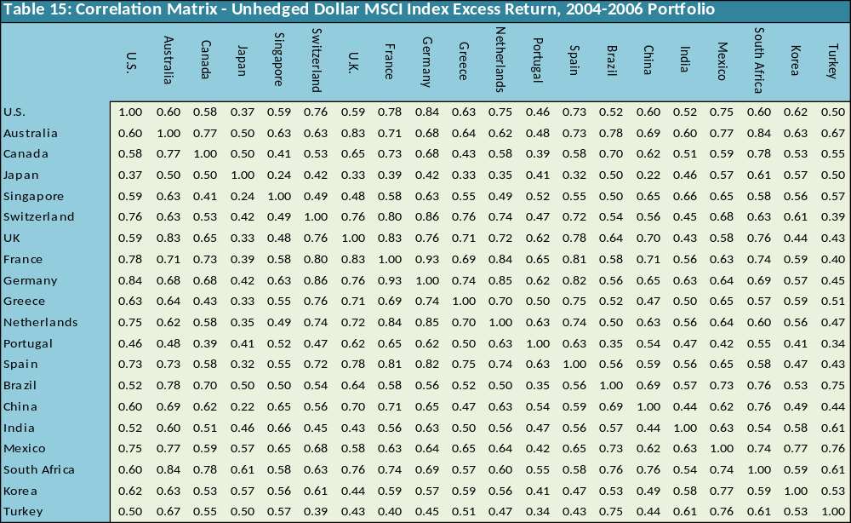
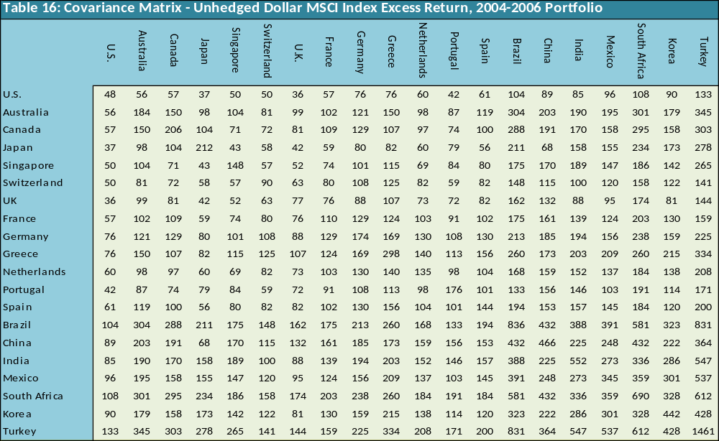
Correlation & Covariance Matrix- Unitary Unhedged Dollar MSCI Index Excess Return, 2004-2006
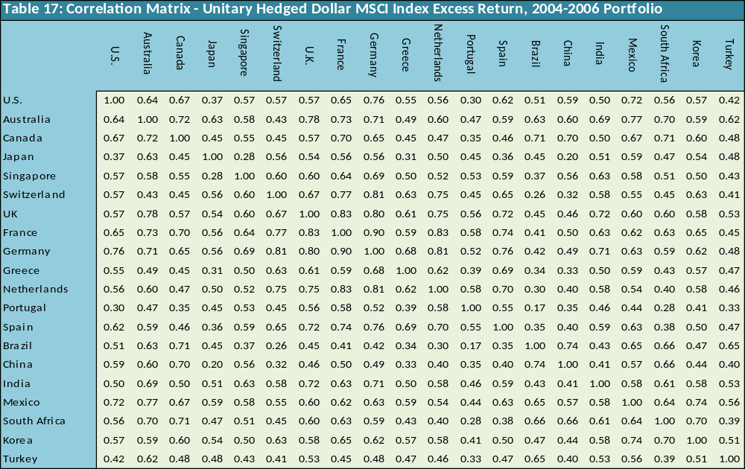
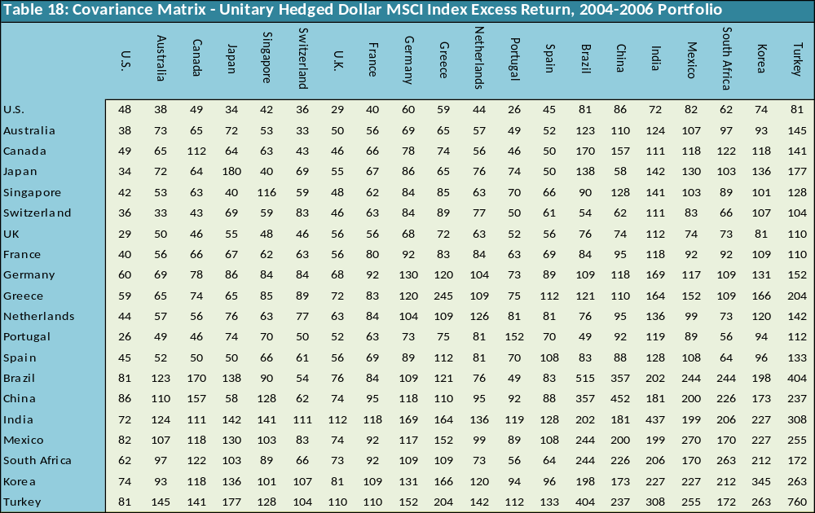
Correlation & Covariance Matrix- Black’s Hedge Ratio Dollar MSCI Index Excess Return, 2004-2006
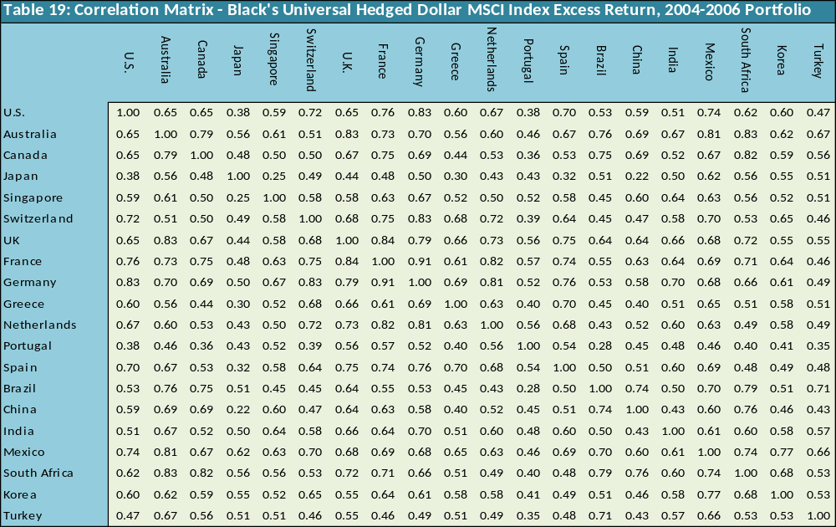
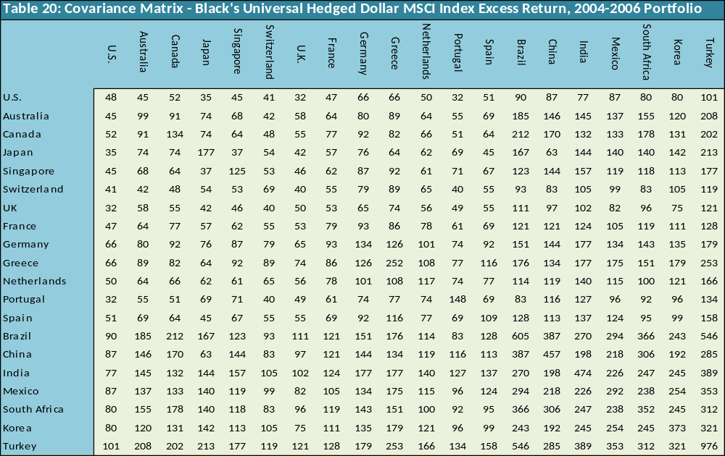
Correlation & Covariance Matrix- Unhedged Dollar MSCI Index Excess Return, 2007-2010
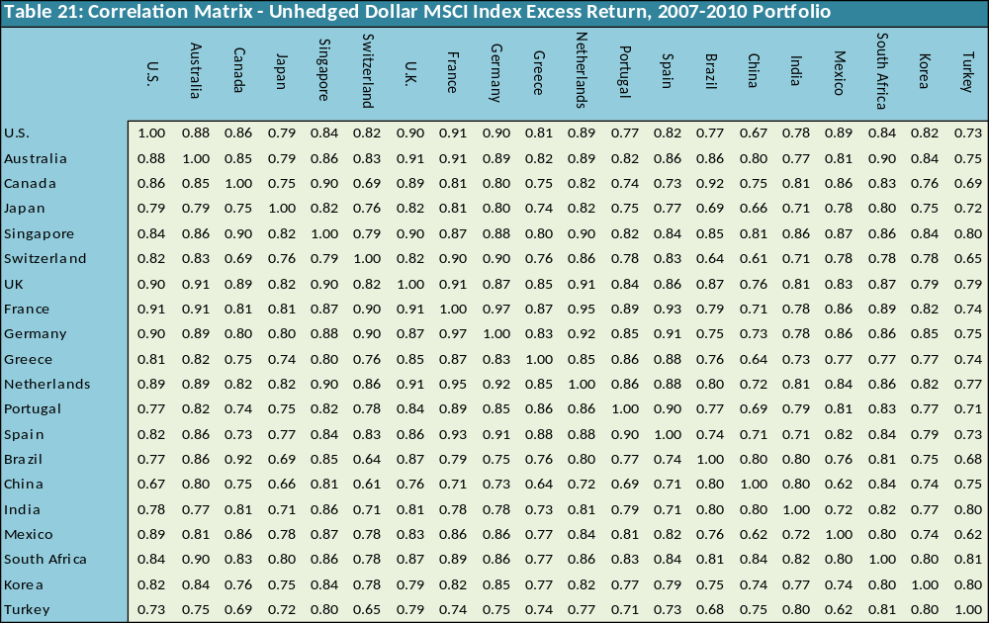
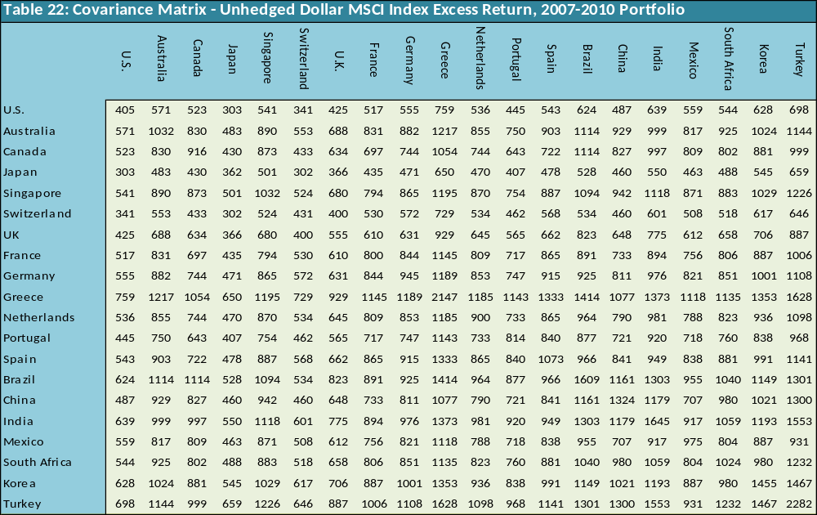
Correlation & Covariance Matrix- Unitary Unhedged Dollar MSCI Index Excess Return, 2007-2010
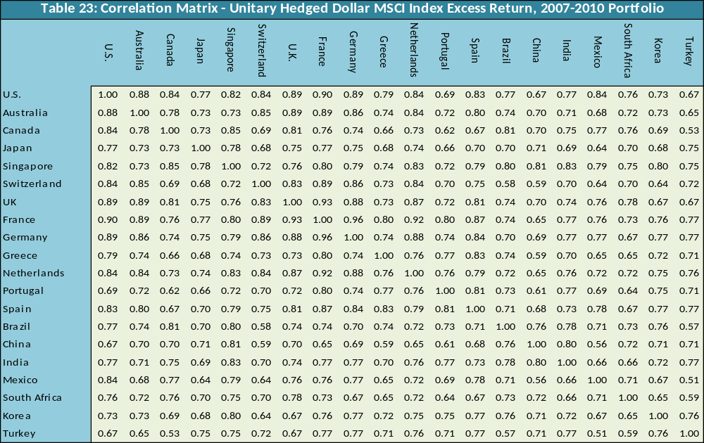
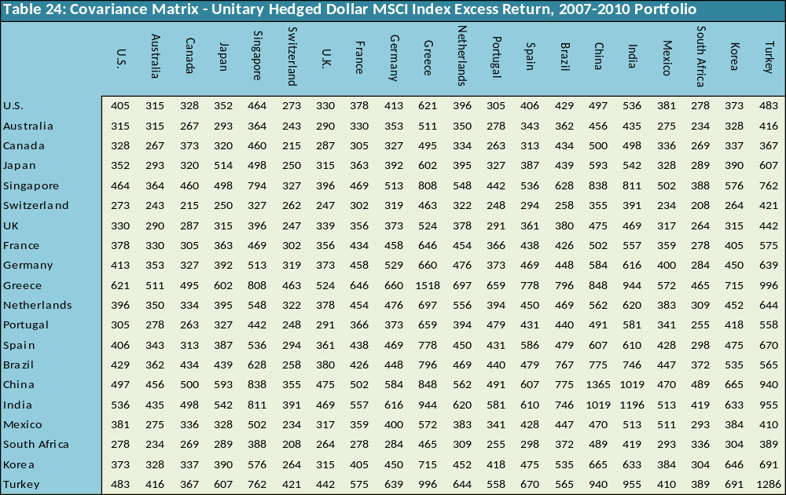
Correlation & Covariance Matrix- Black’s Hedge Ratio Dollar MSCI Index Excess Return, 2007-2010
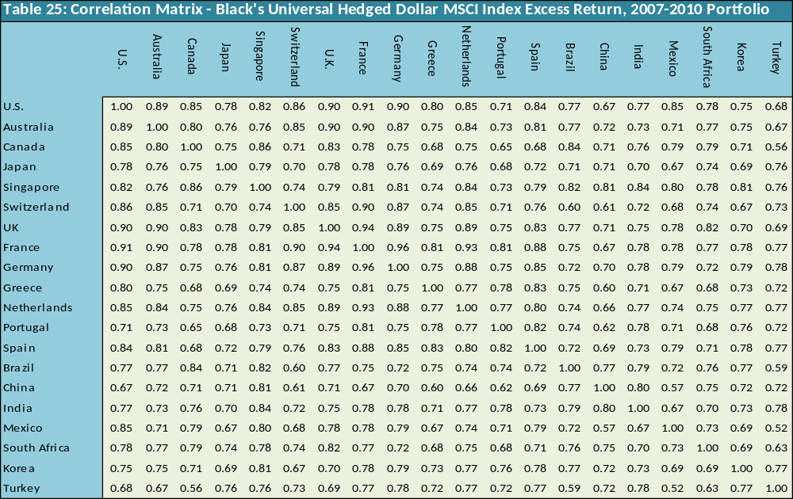
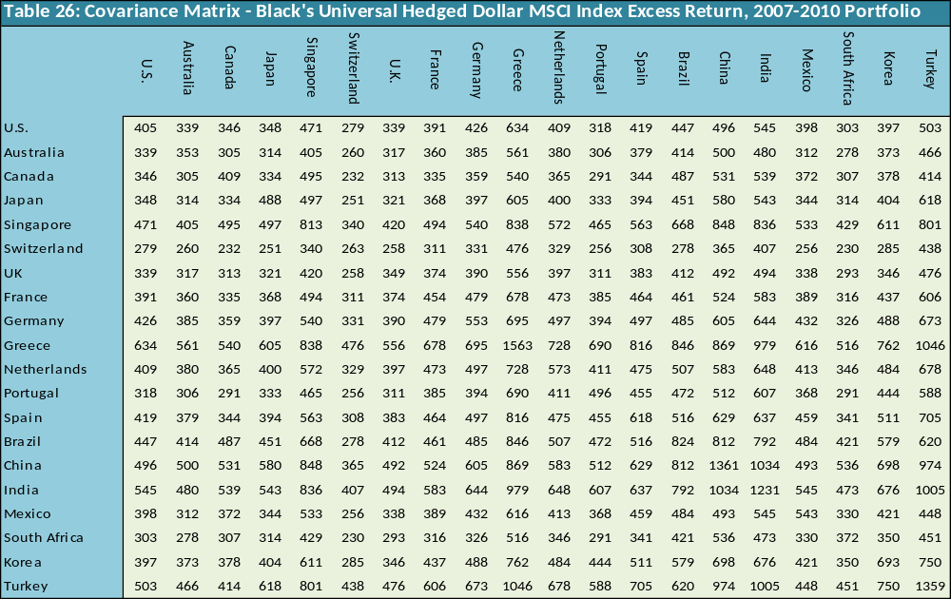

Appendix E: Risk Free Rates and DataStream Codes
Risk Free Rates
Table 27: Proxy of Risk Fee Rate
Country | Risk free rate used for every country | DataCode
Brazil | BRAZIL CDB (UP TO 30 DAYS) - MIDDLE RATE | BRCDBIR
Canada | CANADA TREASURY BILL 1 MTH. (BOC) - MIDDLE RATE | CNTBB1M
France | FRANCE TREASURY BILL 1 MONTH - BID RATE | FRTBL1M
Germany | MNY MKT - 1-MONTH FRANKFURT BANKS - MIDDLE RATE | BDMNY1M
Japan | JAPAN GENSAKI T BILL 1 MONTH - MIDDLE RATE | JPTBG1M
Korea | SEOUL INTERBANK 1 MONTH - OFFERED RATE | KRIBK1M
Netherlands | NTHRLAND EU-GLDR 1M (FT/ICAP/TR) - MIDDLE RATE | ECNLG1M
Switzerland | SWTZRLAND EU-FRC-1M (FT/ICAP/TR) - MIDDLE RATE | ECSWF1M
UK | UK TREASURY BILL TENDER 1M - MIDDLE RATE | UKTBT1M
United States | US TREASURY BILL 2ND MKT 4-WK - MIDDLE RATE | FRTBS4W
Australia | AUSTRALIA DEALER BILL 30 DAY - MIDDLE RATE | ADBR030
Mexico | MEXICO CETES 2ND MKT. 28 DAY - MIDDLE RATE | MXCSM28
Portugal | PORTUGAL LISBOR 1 MONTH - OFFERED RATE | LISBO1M
South Africa | SOUTH AFRICAN JIBAR 1 MONTH - MIDDLE RATE | SAJIB1M
Turkey | TURKISH INTERBANK 1 MONTH - OFFERED RATE | TKIBK1M
Spain | SPAIN TREASURY BILL 1-3 MONTH - RED. YIELD | ESTBL3M
China | CENTRAL BANK BILL 3 MONTHS - MIDDLE RATE | CHBNK3M
Greece | GREECE TREASURY BILL 3 MONTH - MIDDLE RATE | GDTBL3M
India | INDIA T-BILL PRIMARY 91 DAY - RED. YIELD | INPTB91
Singapore | SINGAPORE T-BILL 3 MONTH - MIDDLE RATE | SNGTB3M

