

Local Networks of Collective Learning
A case study of the Leiden Bioscience Park


Edgar Louwerse
314941

Supervisor
Dr. S. Phlippen

Master Entrepreneurship,
Strategy & Organization
Economics

Erasmus University
December 2010
Abstract
This thesis aims to demonstrate to what extent local networks of collective learning appeared at the Leiden Bioscience Park. The concept of collective learning, which enables actors to generate or facilitate innovative behaviour, is seen as an important approach for explaining the causes of innovative capabilities within a cluster. The Leiden Bioscience Park, which originates from the 1980’s onwards, is a highly facilitated knowledge cluster that is fully dedicated to life sciences. It shows an ongoing growth in terms of employment and number of firms. On the basis of patent data, a longitudinal analysis of the co-inventorship network of the Leiden Bioscience Park is constructed. By using network properties a reconstruction of the development of the park is made in order to determine the potential networks of local collective learning. However, this study indicates that the potential for local collective learning is far from being exhausted.

Table of Contents

Introduction ……………………………………………………………………………………………………. 4
Research Question …………………………………………………………………………………. 5
- Theoretical Framework ……………………………………………………………………………… 6
1.1 The Emergence of Agglomeration Economies ……………………………… 6
1.2 Concept of Collective Learning and its Preconditions …………………. 7
1.3 Network Emergence and Cluster Evolution ………………………………… 12
2. The Leiden Bioscience Park …………………………………………………………………… 15
3. Hypotheses …………………………………………………………………………………………. 19
4. Methodology ………………………………………………………………………………………. 21
4.1 Data …………………………………………………………………………………………… 22
4.2 Fragmentation Measures …………………………………………………………… 24
4.3 Static Connection Measure ………………………………………………………… 27
4.4 Dynamic Connection Measure …………………………………………………… 28
5. Results …………………………………………………………………………………………………. 29
5.1 Network Fragmentation ……………………………………………………………… 29
5.2 Network Connections ………………………………………………………………… 36
6. Conclusion and Discussion …………………………………………………………………… 39
Acknowledgements ………………………………………………………………………………………… 41
References ………………………………………………………………………………………………………. 42
Appendix …………………………………………………………………………………………………………. 46
Attachment 1: Cumulative networks of main components …………………… 46
Attachment 2: Example distance-weighted fragmentation measures …… 47

Introduction
In today’s economy, it is widely agreed that innovation fosters competitiveness, economic growth and, therefore, employment. As a result, economists have shown increased interest on the innovation phenomenon and its determinants. At first, the ‘intra-firm’ determinants of innovation were considered as the main reason for the difference in innovative performances. Particularly firm size and R&D expenditures accounted for a crucial role explaining the innovative performance of firms (e.g.: Sherer, 1982, Acs and Audretsch, 1993). However, empirical analyses that followed often resulted in contrasting results, emphasizing the need for introducing other variables explaining the difference in innovative behavior. From the 1970’s onwards, economic geographers created more and more awareness about the importance of proximities and its effect on learning, knowledge creation and innovation. Several authors empirically found that firms located within a cluster generate a higher innovative capacity as compared to isolated firms (e.g.: Porter, 1990; Baptista, 2000). In this way, the innovative activities of firms were less associated with internal factors, but became more associated with high-tech innovative regional clusters, such as Silicon Valley and Boston’s Route 128. Nowadays, policy-makers all around the world are triggered by the economic strength of these regions and are all committed to create the ‘next Silicon Valley’, hereby rising the interest and importance of agglomeration economics.

The Bioscience Park in Leiden, which originates from the 1980’s onward, is one of those clusters that is currently supported by several (governmental) institutions, which all aim to rank the park among the top life science parks in the world. The park is already a high facilitated knowledge cluster with a large concentration of firms, which are all dedicated to the life science industry. Since empirics showed that firms in clusters exhibit stronger growth and show a more rapid process of innovation than those outside a cluster (Audretsch and Feldman, 1996; Baptista and Swann, 1998), several economic geographers have tried to explain the causes of these cluster advantages following different perspectives. These perspectives range from the industrial dimension in the early 1970’s till the integrated approach of the industrial and geographic dimension in the late 1990’s (Capello, 2008). This thesis follows a cognitive approach that was introduced about two decades ago by the GREMI (Groupe de Recherche Européen sur les Milieux Innovateurs) Association. They introduced the concept of collective learning, which Capello (1999, p.2) defined as “a social process of cumulative knowledge, based on a set of shared rules and procedures which allow individuals to coordinate their actions in search for problem solutions”. Hence, it enables actors within a specific cluster to generate or facilitate innovative behavior. A further explanation of this concept will be given in the next section.

Research Question

The aim of this thesis is to demonstrate to what extent local networks of collective learning appeared at the Leiden Bioscience Park. In addition it is argued that the concept of collective learning is a process in constant evolution, in disequilibrium, and is greatly dependent on its past. Throughout the stages of the cluster life cycle, conditions change and have their effect on the continuous interaction of firms and individual inventors. Therefore, this thesis consists of a longitudinal analysis to identify the evolutionary development of networks of local collective learning in the Science Park, hereby deviating from the predominant static cluster literature and responding to the rising need for more dynamic agglomeration studies. Accordingly, the following research question will be answered in this thesis:

Research Question:
What is the evidence on local collective learning in the Leiden Bioscience Park through time?

This thesis is structured as follows. In the first part I will give a review on the literature of agglomeration economics. In the following section I will elaborate on the concept of collective learning and its preconditions, followed by a short section concerning the cluster life cycle. In the second part I will elaborate on the development of the Leiden Bio Science Park, followed by some propositions. In the third part I will introduce my methodologies and clarify the reasons for using these approaches, followed by the testing of my propositions. In the last part I will state my conclusions and several limitations will be discussed.

- Theoretical Framework

1.1 The Emergence of Agglomeration Economies

The concept of agglomeration economies date back at least to Marshall (1919), who argued that firms benefit from a regional specialized, sector specific knowledge base. He provides three factors favoring the geographic concentration of industries. First is the development of a local pool of specialized labor, which could benefit both workers and firms. This specialized labor market pool could reduce the search costs for both parties, since it maximizes the job-matching opportunities (Simpson, 1992). This entails that concentrated firms are able to hire workers and adjust their labor-employment levels in response to market conditions in a more efficient manner than would be the case if the firm was more regionally isolated (Gordon and McCann, 1999). A second factor, favoring the geographic concentration of industries, is the growth and development of various intermediate and subsidiary industries which provide specialized inputs at a lower cost. The third and final factor is that firms inside a local cluster could benefit from so called technological spillovers, in which knowledge flows more easily between agents located within the same area, due to an ‘industrial atmosphere’ that fosters mutual trust and increases face-to-face contacts (Krugman, 1991). In this way, firms are confronted with higher innovation opportunities as opposed to remote firms. Although these knowledge spillovers are widely discussed in literature, and unanimous seen as important for regional clusters, its concept has been often abused by economists, resulting in great conceptual confusion (Breschi, 2000). Furthermore, Krugman (1991) points out that these knowledge flows are invisible and thus hard to track and difficult to measure.

Over time, the original insights of Marshall are reshaped and revised, but still appear to be valid in today’s economy. One of these re-interpreted approaches was conducted by the GREMI-school of thought, founded in 1985. This approach, which takes the existence of a concentrated and specialized area for granted, emphasized on the role of the local ‘milieu’ as the driver of innovative activities, thus creating an ‘innovative milieu’. Though this milieu has a geographical dimension, it does not bind itself to a clear defined spatial area; the milieu is an organic phenomenon involving market and non-market interactions (Maillat and Lecoq, 1992). Camagni (1991) defines this ‘milieu’ as a multifaceted network of primarily informal social relationships within a specific localized area, characterized by a sense of belonging due to a common culture, which fosters the local innovative capacity through synergy effects and collective learning processes. Thus, besides the physical proximity of firms, a relational proximity is introduced to explain the increasing returns in innovation processes. In this way, agglomeration economies were no longer associated with sources of increased efficiency, as explained by Marshall, but they became sources of increased innovative capabilities. Furthermore, since firms are faced with inescapable uncertainty, especially in their innovation processes, the local milieu could serve as an important uncertainty-reducing operator by supporting the organized interdependence of firms. As collective learning processes are at the basis of a successful regional innovative milieu and are central to this thesis, its concept will be further explained in the next section.

1.2 Concept of Collective Learning and its Preconditions

The concept of collective learning is used in multiple ways in literature and is not always clearly defined by its authors. Hence, for the purposes of this thesis I will first give a brief clarification on the subject of collective learning as mentioned by the GREMI Association. First of all, collective learning is a process that shows some similarities with simple learning since it is cumulative and interactive in nature. It is a dynamic process, which shows an element of continuity that guarantees the transfer of knowledge over time. However, there is also a clear distinction between collective learning and simple learning in the fact that collective learning could be seen as a club good, in a social sphere, as it is characterized by its non rivalry and non excludability to members within the local milieu (Cappello 1999). Actors outside the milieu are unable to take advantage of the collective learning processes, making it a territorial club externality. According to Maskell (1999), geographical proximity enables firms to maintain a degree of continuity and stability in inter-firm relations which is necessary for the development of collective learning. Smaller firms have higher incentives for this, since they generally lack the knowledge and scale economies of larger firms. In addition, Capello (1999) empirically found a positive and significant correlation between collective learning and radical innovation activities of small firms and concludes that collective learning improves the innovative capacity of smaller firms. Lorenz (1996) argues that trust between actors in a milieu is essential as it fosters the collective learning activities. Firms within networks of high trust take advantage from mutual exchange of information and know-how, and at the same time, the strong connection among actors prevents for misbehavior.

In literature, three key mechanisms are identified as preconditions for local collective learning to take place (Keeble, 1998). The first one usually refers to the degree and importance of inter-firm networking and interaction. It is strongly related to the institutional and social elements of a territorial cluster, as was stressed by the concept of the “innovative milieu” which was explained earlier. For example, Cooke and Morgan (1998) argue that the Baden-Wurttemberg region was distinguished by its dense infrastructure of governmental and non-governmental agencies that were all dedicated to support the local firms. These institutions not only encouraged inter-firm relationships, but also encouraged relationships between firms and universities or research institutes.

A second collective learning process on which the theoretical literature draws attention involves the existence of a local knowledge base, which in turn is fostered by the emergence of local spin-offs. A spin-off is considered to be a new business stemming from a local firm, by which the founder has derived its business idea from his former employment (Perhankangas and Kauranen, 1996), most likely locating itself in close geographical proximity to the parent firm (Klepper, 2001). Thus, the spin-off can take advantage of interactive linkages that were established by its founder in his previous job, giving it a higher chance of survival on the local market. Silicon Valley, for example, is characterized by its continuous establishment of new firms, stemming from former employees working at larger companies located in the region. These spin-offs are often attractive to other firms, and sell themselves in order to capture the innovative quasi-rents. In this way, the development of spin-offs and sell-outs largely stimulates the generation of local collective learning as the knowledge embodied in the entrepreneurs and scientists flows from one firm to another. Similar evidence could be found in the Cambridge region, in which the University played a central role by initiating academic spin-offs which in turn resulted in the diffusion of technological expertise (Keeble, 1998). In another study, Ter Wal (2008) argued that the absence of high-tech start-ups and spin-offs in the Sophia-Antipolis region hindered the emergence of a local collective learning milieu.

A final element emphasized in the literature refers to the existence of a high degree of skilled labor mobility within the region, again generating the diffusion of tacit expertise and technological know-how that is embodied within the entrepreneurs or scientists (Camagni, 1991). The presence of a local social network guarantees that information regarding new job opportunities spreads quickly through the park. According to Capello (1999), the shortening and volatile nature of production life cycles causes an unavoidable high circulation of employees in local firms. Moreover, this local labor force creates specific technical skills which can only be put in use in the local labor milieu, thus decreasing labor opportunities outside the area, resulting in more or less a lock-in mechanism of the local labor force to its spatial origin. Research institutes serve a specific role, as they might generate a highly skilled labor force capable of fulfilling these high technological jobs (Fritsch and Schwirten, 1999).

Although the knowledge created within the milieu is freely available to all its actors, it still depends on the internal capacity of firms and private strategy of each local agent to take advantage of this knowledge. As firms are heterogeneous and differ in their knowledge and competence base, they are in some way cognitively restricted because they greatly rely on the know-how and information they have obtained in the past. Hence, firms differ in their absorptive capacity, indicating that they have different abilities to understand, assimilate and exploit external know-how (Cohen and Levinthal, 1990). Thus, if the absorptive capacity of a firm is related to its prior stock of knowledge, it is only able to learn from other firms if the cognitive distance is not too great. Morrison (2004) and Owen-Smith (2004) argue that leading firms within a district may act as ‘bridging enterprises’, as they absorb non-local knowledge and spread it into the district, favoring weaker firms that lack the capabilities to connect themselves with the outside world. However, local firms still need an acceptable degree of absorptive capacity to effectively facilitate such interactive learning (Giuliani and Bell, 2005).

For a district it is important to establish local as well as non-local linkages as sources for interactive learning. In this way, essential information concerning market trends and new technologies are not overlooked and the danger of lock-in can be avoided (Bathelt et al., 2004). For instance, Hudson (1999) considers the failure of the UK’s old industrial region in the twentieth century due to an inability to modernize in times of changing economic conditions caused by an ‘institutional lock-in’. The GREMI-school of thought also advocates the importance of external energy and argues that non-local relationships not only prevent lock-in at the firm level, but also at the district level, making it an essential mechanism for the innovative milieu (Camagni, 1991). Capello (1999) argues that if the innovative milieu lacks external learning, it could face an increasing risk, since it leads the milieu into an increasingly limited specificity, which in turn may lock the local agents in a technological direction that becomes obsolete in the long run, making the milieu less competitive and inferior.

An important distinction, within learning regions, should be made between tacit and codified types of knowledge. Codified or explicit knowledge can readily and easily be transmitted to others, as it is easy to communicate. Tacit knowledge, on the other hand, is difficult to transfer to other persons by means of writing it down or verbally expressing it. Michael Polanyi (1966, p.4) phrases it as: “we can know more than we can tell”. Maskell and Malmberg (1999) argue that in today’s economy, where improvements in information technology have simplified and accelerated the diffusion process of explicit knowledge, tacit knowledge becomes a more essential cause for competitive advantages, since it needs regular and close face-to-face contacts. Geographical proximity becomes much more important in this way, since interactive cooperation is less expensive and advances more easily when the physical distance between actors is small. However, geographical proximity is a necessary, but not a sufficient condition for the transfer of tacit knowledge. Relational proximity, as was introduced earlier in this thesis, is a second important condition in order to effectively communicate tacit knowledge. This proximity relates to the aspects of the innovative milieu, namely a common culture and social coherence among actors, which causes that knowledge becomes embedded in individuals and organizations active within the milieu, creating sustainable competitive advantages in case the knowledge is rare, valuable and difficult to imitate by firms located in other places.

As was shown in the previous sections, relational capital is considered as the foundation for local collective learning to take place. High relational capital generates sustainable collaborations between firms, a high level of skilled labor mobility and local spin-offs, which are regarded as the main channels through which knowledge spreads within a local ‘territory’ (Aydalot and Keeble, 1988; Camagni, 1991). As is depicted in figure 1, regional economists that advocate the relational space theory clearly define the channels through which knowledge spills to explain the concept of collective learning.

Figure 1: Physical space versus relational space by Roberta Capello (2003).
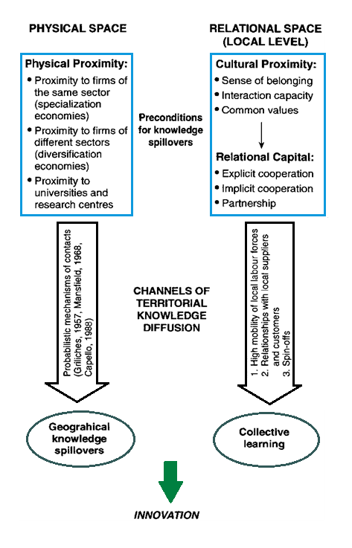
This in contrast to another school of thought that only recommends physical proximity as an important aspect maximizing the incentive to innovation. This latter school of thought, that advocates the physical space theory, uses a definition of spillovers that is less comprehensive. For example, Audretsch and Vivarelli (1994) use the physical distance, measured by new patents, to universities or research centers as a proxy for knowledge spillovers. They find a significant and positive effect of these spillovers on small and medium sized enterprises. Although it could be acknowledged that physical closeness of firms to universities and research centers is important, the concept of knowledge spillovers is much more complicated than that. The simple agglomeration of specialized firms in a cluster is not sufficient to justify the high innovation of the cluster itself. Therefore the concept of relational space provides a better understanding of the mechanisms that connect geography and innovative performances of firms as the simple physical space does.

Nonetheless, some authors have recently expressed their dissatisfaction to the approach of economic geographers, arguing that cluster literature is focusing too much on ‘territorial learning’, while completely disregarding the importance of a firm’s internal organization (Martin and Sunley, 2003). Giuliani (2005) argues that the knowledge base of a firm is the result of a process of cumulative learning, which essentially is imperfect, complex and path-dependent, thus resulting in continual heterogeneity between firms within a cluster. As a consequence, firms differ in their cognitive abilities and in their positions they take within the network of knowledge exchange, making them unequally and selective in their capability to access the knowledge within a cluster. Ter Wal (2008) argues that a network of knowledge exchange might include local actors as well as non-local actors, indicating that the collective learning processes are not necessarily geographically bounded. In addition, Giuliani (2007) empirically found that firms within a Chilean wine cluster showed different positions of centrality in the local network of knowledge diffusion, and a considerable number of firms even appeared to be completely isolated from the network. Moreover, he observed that a number of firms within the cluster were also active and well connected to firms outside the cluster boundaries. In this respect it could be argued that clusters and networks do not necessarily coincide, and as was emphasized by Malmberg (2003), local and non-local linkages of interactive learning might equally be important to firms.

1.3 Network Emergence and Cluster Evolution

Almost all existing empirical literature, regarding the network of clusters, follows a static approach, generating a cross-section analysis that, consequently, only focuses on a single point in time. However, as was already mentioned, the concept of collective learning is a dynamic process that changes as a cluster emerges, grows and ultimately declines. Since knowledge is cumulative in nature and firms thus follow a certain technological trajectory over time, obtaining only the knowledge that is relevant for them, it is interesting to find out if and at what stage of the cluster life cycle evidence on local collective learning could be found. As several authors have shown, it cannot be taken for granted that clusters at all times exhibit a dense local collective learning milieu (Giuliani, 2007; Ter Wal, 2008).

In general, four different stages of a cluster life cycle could be identified, namely embryonic, growth, mature and decline (Klepper, 1997; Menzel, 2009). However, it could be difficult to define at what stage of development a cluster currently is, as it might not advance evenly or as a whole (Menzel, 2009). The emergence or embryonic stage of a cluster is characterized by a few but growing number of mainly small firms, the growth stage is defined by its growing number of employees and the mature stage appears when the cluster is capable to sustain its (high) employment level. The stage of decline could appear if a cluster is not able to maintain its comparative advantage. However, by appropriating and assimilating new knowledge and technologies, clusters could renew themselves and avoid this latter stage. An example of this could be found in the accordion cluster in Italy, which renewed itself by introducing electronics into their instruments (Tappi, 2005).

Audretsch and Feldman (1996) found evidence that firms within a cluster outperform non-clustered firms at the emerging and growth stages of the industry life cycle and show a worse propensity for innovation in later stages. Pouder and St. John (1996) found similar evidence, suggesting that as a cluster grows, it does so in a more rapid and effective way as opposed to the rest of the industry due to the existence of a creative environment. However, as it advances, the cognitive direction of the actors within the cluster becomes too much focused on the followed successful trajectory. As a consequence, the technological base that once marked the success of the cluster could now turn into a disadvantage as the actors become locked-in into this knowledge trajectory. Evidently, the latter results point out that a cluster life cycle differs from the industry life cycle.

The size of a cluster could influence the awareness and impression of external actors. Larger clusters have a higher probability of being noticed, which in turn could result in better political support or the attraction of leading firms. For example, Prevezer (1998) showed that the North Carolina biotechnology cluster already had over 100 firms before the first incubator building was built. The latter circumstances could all affect the propensity for local collective learning and are thus important when investigating cluster dynamics.

In the next section I will give a brief review on the development of the Leiden Bioscience Park. After that I will state my hypotheses, which are based on the previous explained literature as well as on the factual development of the park.

- The Leiden Bioscience Park

The Leiden Bioscience Park originates from the 1980’s onwards and is founded in a joint effort between the Leiden City Council and Leiden University. In 1984, the city council decided that the park should fully commit itself to the life science industry, hereby prohibiting other types of industry to settle within the park boundaries. In this way, a highly specialized knowledge cluster could emerge. Nowadays, the parks primary focus is on “red” biotechnology, which entails the use of biotechnology for healthcare or biopharmaceutical purposes. However, some firms on the park are also active in “green” agro-food related biotechnology or “white” industrial biotechnology. The Science Park is located next to the Leiden University, which is the oldest university in the Netherlands (1575), and Leiden University Medical Center (LUMC), which is a merger between the Leiden Academic Hospital (1873) and the Leiden University medical faculty.

From its start, the park followed the so-called “Triple-helix” model, which comprises the close collaboration between firms, governments and knowledge institutions (Etzkowitz, 2002). It creates a knowledge infrastructure in terms of overlapping institutional spheres, which often results in the emergence of hybrid organizations. These hybrid organizations aim to encourage the parks’ business climate, by providing various service and support facilities, such as incubator buildings.

Throughout the years, several incubator foundations and other hybrid organizations emerged at the Leiden Bio science Park. The academic Business Center (ABC) building, established in 1984, was the first active incubator building on the science park. It aim is to support start-up companies by providing them office space and conference rooms. In 2003, a second incubator building ‘BioPartner’ was build, expanding the support for young life science start-ups by offering them laboratories, central facilities and IT support. Already more than 50 firms have used the facilities of this foundation and many of them have moved on independently, locating themselves on the park or elsewhere. At the end of 2010, even a third incubator building ‘BioPartner Accelerator’ should be finished, hereby creating the largest business center for red biotechnology start-ups in the Netherlands. In 2006, the multi-tenant building ‘Beagle’ opened its doors. It is build for those companies who are passed the stage of ‘start-up’ and have become too big for the incubator buildings. Most of these firms are yet unable to make large scale investments in housing facilities and in this way are kept within the park boundaries. Other important service and support facilities on the park include the Leiden University Research and Innovation Services (LURIS), which assist scientists to commercialize their invention, and the Expat Centre, which helps high skilled labor migrants living in the Leiden region.

The previous paragraphs all indicate that there could be an increased chance of local collective learning to take place. Since only biotech companies are allowed on the park, a large pool of scientists within the same field of technology exists, thus increasing the probability on face-to-face contacts, knowledge sharing and, ultimately, the chance of collaboration. Furthermore, the geographical proximity of firms with related technologies causes an increased chance on knowing about each other activities, either by intentionally monitoring others or by unintentional contacts, thus providing greater opportunities for interactions and collaborations. The incubator facilities stimulate an innovative environment, and since multiple new start-ups share the same facilities, the probability on face-to-face contacts increases. This could also result in increased relational capital, as the frequent interactions foster social relationships. Finally, by offering firms housing facilities even after their start-up phase, it makes sure that knowledge which is created and developed by these firms also remains within the park boundaries.

Figure 2 depicts the emergence and growth of the Leiden Bioscience Park, measured in terms of employees and number of firms. In 1984, three organizations were already located on the park: the Leiden University, LUMC and a division of the Dutch research institute TNO. Since its initiation, 94 firms have entered the park and 19 have exited the park. The growth, in terms of new businesses, mostly comes in the form of new start-ups and spin-offs (see figure 3). The growth in terms of employees, however, is mainly caused by relocations and the start of new divisions. Thus, this exogenous growth played an essential role in the development of the park, indicating that the supposed self-renewal of firms does not significantly contribute to the growth of employment on the park. It could be argued from the figure depicted on the next page, that the park has passed the embryonic stage and is now in its growth stage as it shows a continuous increase in employment and firm growth. This is relevant to know, as the hypotheses are partly based on the factual development of the park.

Figure 2: Emergence of the Leiden Bioscience Park (Source: Jousma and Scholten, 2009)

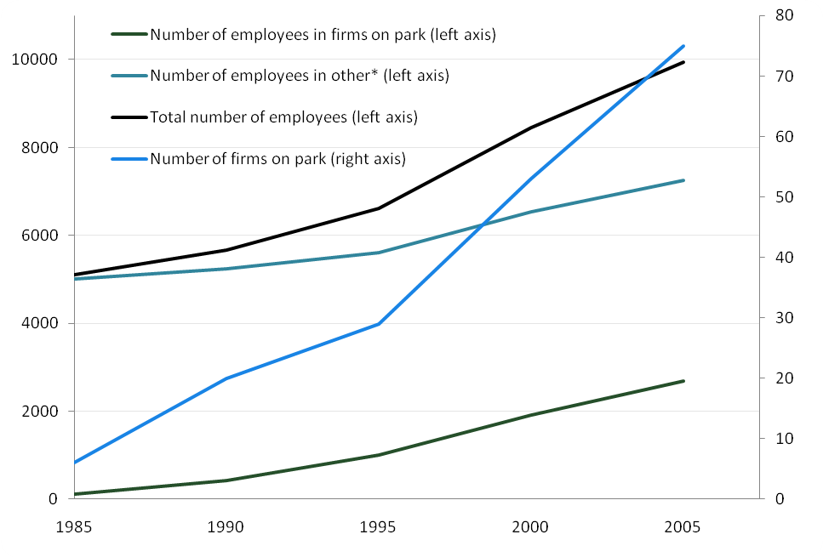
*not-for-profit, education & research institutes (e.g.: Leiden University and LUMC).

Figure 3 displays the types of entry on the park. As can be seen from this figure, the new century entails an increase in new company formation in the form of start-ups and spin-offs. According to Jousma and Scholten (2009), this is mainly the result of a governmental program (BioPartner program 2000-2004) which stimulated the involvement of researchers in entrepreneurial activities, and motivated Universities to set up incubator facilities. Practically all of the 34 spin-offs, in the exception of 3, are generated by either the University or the LUMC. In addition, all of the spin-offs stemming from the Faculty of Science of the Leiden University located themselves within the park boundaries, most of them utilizing the incubator facilities that are present on the park. The growing number of spin-offs stimulates the presence of a local knowledge base, thus favouring the probability on local collective learning.

Figure 3: Type of entry (Source: Jousma and Scholten, 2009)
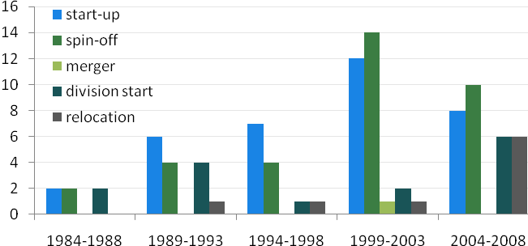

As is mentioned earlier in this thesis, new start-ups and spin-offs generally lack critical resources. By providing new firms, stemming from Leiden University or LUMC, facilities within the incubator buildings, it makes sure that knowledge, which is generated or acquired by these institutions, remains in the local region. In this way the existence of a local knowledge base is even more stimulated. Although these spin-offs might appear small in aggregate employment on the park, they may significantly contribute to the creation of new high-tech jobs (Shane, 2004).

- Hypotheses

Several hypotheses have been formulated in order to answer the research question. These hypotheses all relate to the previous explained sections. As mentioned before, three key mechanisms are identified as preconditions for local collective learning to take place. The foregoing section demonstrated that due to the growing number of spin-offs and presence of hybrid organizations a local knowledge base could exist. By finding evidence on the remaining preconditions, sufficient evidence is expected to be found in order to answer the research question. The following hypotheses refer to the degree and importance of inter-firm networking and inter-personnel interactions.

Local collective learning can only take place if there is a dense network of inter-personnel interaction. A great example for this is the San Diego biotech cluster, which was able to maintain a high degree of connectivity among local managers, despite the enormous growth of the cluster (Casper, 2007). In line with this study, I suggest the following hypothesis:

Hypothesis 1: A dense network of inter-personnel interactions can be observed through time at the Leiden Bioscience Park.

The second hypothesis refers to the level of connections between actors present on the park in terms of labor mobility and inter-firm collaborations. The presence of a high degree of skilled labor mobility and existence of inter-firm collaborations both nurture the diffusion of tacit expertise and technological know-how that is embodied within the entrepreneurs or scientists. The knowledge base of the park is built up by the firms and research institutes involved and their unique knowledge stocks. This knowledge is often tacit and hard to imitate by external actors. Hence, the exchange of knowledge between actors on the park is of utmost importance for local collective to take place.

Since the park has past its embryonic stage and shows a significant growth in employment, indicating the existence of multiple job opportunities, an increasing trend of labor mobility could be presumed. In addition, the growing number of spin-offs can also be considered as an accelerator for the increase in the level of labor mobility, as these new firms are stemming from firms or institutions that were already active on the park. Furthermore, the geographical proximity of industry-related firms and presence of hybrid organizations foster the potential for local research collaborations. Therefore, the following hypothesis is constructed:

Hypothesis 2: A high level of connections among actors located on the Leiden Bioscience Park can be observed.

The final hypothesis tries to cover the dynamic nature of local collective learning and takes into account the path dependent nature of knowledge, suggesting that firms with previous linkages have a higher probability on working together in later stages of their development, as their narrow cognitive distances allows them to collaborate in research and development. In this way, an increasing level of connectivity among firms on the park could be realized. Since the park has shown an increasing growth in number of firms, especially in the form of start-ups and spin-offs, the potential for collaboration could grow accordingly. Hence, I expect the following:

Hypothesis 3: An increasing level of inter-firm connections can be observed throughout the growth of the Leiden Bioscience Park.
In the next section, the methodologies for answering the latter hypotheses will be discussed. The data as well as the various measurement tools that are used for this thesis will be thoroughly explained. After this, the results as well as the conclusions will be stated.

- Methodology

This thesis uses co-inventorship networks in order to determine the potential network of local collective learning in the Leiden Bioscience Park. This approach captures two essential aspects of a local network of collective learning. First, a co-inventorship network represents the intended knowledge exchange between scientists on the park, whether they work for the same firm or not (Ejermo and Karlsson, 2006). Multiple inventors that are listed on a single patent have clearly shared their knowledge in order to come to their invention. In this way, these interactions could contribute to the existence of a common knowledge base, hence the potential of a local network of collective learning. Second, knowledge intensive team work, which originates from the collaboration of inventors on a single invention, fosters a social coherence. This coherence is important as relational capital is considered as the foundation for local collective learning to take place. The social ties between inventors tend to be of a long term nature, even when labor mobility causes inventors to move on to separate places (Agrawal et al., 2006). In addition, it is argued that these interpersonal networks significantly contribute to the diffusion of technological know-how (Dahl and Pedersen, 2004). Thus, the presence of a cohesive network of inventors, via direct or indirect linkages between inventors, and existence of multiple interactions between firms on the park is essential for the emergence of a common knowledge base with a social connotation, and thus can be regarded as a fair benchmark for the existence of a local collective learning milieu.

The empirical analysis of this thesis is based on secondary data sources. Patent data is acquired in order to make a reconstruction of the inventor’s network of the Leiden Bioscience Park. However, in order to get a better understanding of the various actors that are (or were) present on the park, a second source of data was also used. This latter dataset was provided by the park management of the Leiden Bioscience Park, and consisted of a list with all the firms that are (or were) active on the park, and included attributes such as type of firm, type of entry and exit, year of entry and number of employees. Although it could be argued that patents are not the ideal source of measuring interpersonal and inter-firm linkages, it still remains a commonly used and reliable source for longitudinal analyses. In addition, the biotechnological industry is characterized by its’ frequent innovations, in which firms are strongly inclined to protect their inventions through patents (Blind et al., 2006). Furthermore, patent data provide highly detailed information on the assignee, inventor and invention, making it an accurate measurement for studying relational data. The limitations for the use of patents are discussed in a later section.

4.1 Data

The patent data was obtained from the OECD REGPAT database (January 2010 edition). This database consists of ‘regionalised’ patent data derived from the European Patent Office’s (EPO) Worldwide Patent Statistical Database and Patent Co-operation Treaty (PCT). Patents from all the 27 European countries, as well as China, India, USA and Japan are included in this dataset. These countries are divided in approximately 5.400 regions by inventor and applicant address. For this analysis region NL331, “Leiden en Bollenstreek” was taken in order to locate the patents that were created on the Leiden Bioscience Park.

A common applied method is to take the inventor home address as a selection criterion for the reconstruction of an inventor network (Ter Wal, 2008). In this way, patents are allocated to the geographical origin in which they have been developed. However, the spatial unit of analysis (the Science Park) is too small in order to apply this method and therefore patents are selected on basis of assignee address. By making use of the Park management’s dataset, it was possible to verify which firms were active on the park and at what time. However, a major drawback for this method is that patents which are developed by a subsidiary (located on the park), might be assigned to its headquarters which is located elsewhere. Since the unit of analysis is only restricted to the boundaries of the park, and a dataset on firm characteristics was available, it was possible to control for missing or unjustly filed patents. Each firm is manually checked for firm property rights and several adjustments have been made. For example, several patents of Galapagos were assigned to its’ headquarter in Belgium and several patents of Genencor and Centocor were assigned to its’ headquarters in the USA. By checking for inventor address, missing patents were manually added to the dataset by using the patent database of Espacenet. Conversely, it appeared that through mergers and acquisitions, patents were assigned to firms on the Leiden Bioscience Park, but were not actually developed on the park itself. For example, patents of PPL Therapeutics which were acquired by Pharming, and patents of ChromaGenics which is a subsidiary of Crucell were initially also included in the dataset. By checking the inventor address (or original applicant name), several patents are deleted from the dataset.
The procedure for granting a patent could take two to ten years, therefore the priority year, which is the year of first filing a patent, is chosen as reference date, since this date is closest to the actual date the invention was developed. Given that the park was officially opened in 1984, patents with priority years ranging from 1984 till 2006 have been used. All inventor names have been carefully checked on typing errors, and each inventor has been given a unique numerical code. This is important as the reconstruction of the network within the UCINET software program (Borgatti et al., 2002) is based on the linking algorithm of unique inventor name codes.

The patent data that was obtained this way covered 522 distinct patents, involving 940 unique inventors. The dataset also includes foreign or non-local inventors that collaborated with inventors working on the Leiden Bioscience Park. Thus, if at least one inventor came from the Leiden Bioscience Park, and worked together with several other foreign or non-local inventors, the patent as well as all of its inventors was included in the dataset. Since networks do not necessarily need to be spatially bounded, these inventors were added as to show to what extent external sources are used. The percentage of foreign inventors increases from 5% until the beginning of the 1990’s, through 20% until the beginning of the new century to approximately 25% onwards. In addition, it needs to be taken into account that some foreign inventors might represent expats living within the Leiden region (checking the inventor home address sometimes resulted in ambiguous outcomes). The share of non-local inventors is difficult to determine, as it is unclear how many and which inventors belong to what firm on a co-patent. In most cases, the home address of the inventor provides insufficient evidence on where the inventor works as many of the inter-firm collaborations are within the same region. Though, based on the number of foreign inter-firm collaborations, the number of non-local inventors is expected to be slightly less as compared to foreign inventors.

Figure 4: Number of inventors and patents stemming from the Leiden Bioscience Park
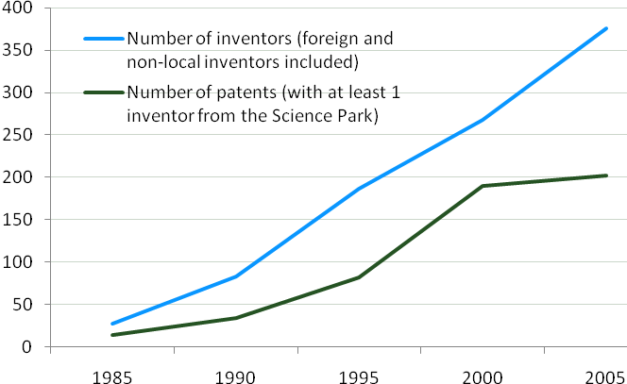
A 5-year moving window procedure was applied to reconstruct the inventor network. This implies that each yearly network observation includes all co-invention links for that year and the prior four years. As was mentioned earlier, it is assumed that social ties tend to endure over time, even when the formal collaboration has been terminated. Therefore, in accordance with other studies on inventor networks (e.g.: Ter Wal, 2008; Fleming et al., 2007), I also assumed that these linkages exist for approximately five years.

For answering the first hypothesis, several fragmentation measures (as inverse of density) are applied in order to measure the cohesiveness of the co-inventorship network. These methods will now be explained, followed by the methods that are used in order to answer the second hypothesis. Finally, the methods for answering the third hypothesis will be discussed.

4.2 Fragmentation Measures

The co-inventorship network can only have so many lines (i.e. connections between inventors). The maximum number of lines is determined by the number of inventors present on the park. It would be unrealistic to assume that each inventor should be directly connected to every other. However, via indirect linkages and inter-firm collaborations, a cohesive network of inventors still could appear. Moreover, Nooteboom and Klein-Woolthuis (2005) argue that high connectivity among inventors allows knowledge to flow through direct, as well as, indirect linkages. The co-inventorship network initially consists of two modes, namely inventors and patents. This affiliation network is turned into a one mode projection using the social network analysis program UCINET (Borgatti et al., 2002). In this way, the inter-personnel network represents subsets of inventors that worked on the same patent. By looking at various fragmentation properties (Borgatti, 2006), evidence on the cohesive nature of the inventor network is expected to be found.

An apparent method for measuring network fragmentation is a count of the number of components. Inventors are member of a similar component if they are directly or indirectly connected to each other. This method could be normalized by dividing the number of components (k) by the number of nodes (n) present in a network, thus resulting in the following equation:
C = (eq. 1)

This rather limited measure doesn’t take into account the size and internal structure of its components. Nonetheless, it is used as first indicator for the overall density of the network. If a graph solely consists of isolates then C will show a value of 1, and if a graph consists of a single component, C will show a value approximating zero, depending on the number of nodes. As should be obvious, a superior collective learning network should show values that are decreasing to zero.
By using a fragmentation measure that counts the number of pairs of nodes that cannot reach each other, the latter problem concerning component size is solved. In a network, there can be as many as ordered pairs, and as few as 0. However, as both inventors relate to each other in the same way, because they have worked together on a similar invention, their relationship is non-directional. This implies that the maximum number of possible lines contains at most 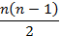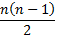 pairs.

Now, if = 1 when node i can reach node j by a path of any distance, and = 0 otherwise (i.e. if two nodes are unable to reach each other), it is possible to formulate the following equation:
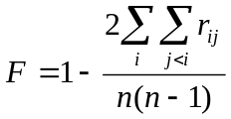 (eq. 2)
Again, the fragmentation of a graph goes from 0, when all nodes are connected to each other, to 1, when all nodes are isolates. Still, the latter equation does not take into account the shape of the components. An implication of the latter problem could be illustrated with an example shown in the second attachment of this thesis. As a solution, it would be to measure the total distance between all pairs of nodes within a network. By setting unconnected pairs of nodes equal to zero and summing reciprocals of distances, an equation based on the latter fragmentation measure could be constructed:
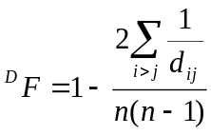 (eq. 3)
This distance-weighted fragmentation measure also moves from 0 to 1, only this time the relative cohesion of the components is taken into account. It is only equal to the fragmentation index in case all components are complete (i.e. if within a component, each node is adjacent to each other; also called a ‘clique’). Hence, the distance-weighted fragmentation index realizes a maximum value of 1 when all nodes are isolates.

Each 5-year moving window has a different amount of nodes and linkages, hence resulting in different property values. It has to be taken in mind that it is difficult to make statements regarding the comparison of time frames, since a linear growth of inventors causes a quadratic growth of possible linkages. In this way, it is harder for large networks to retain a high level of connectivity as opposed to smaller ones. In an empirical study of Casper (2007), though, the connectivity among managers within the San Diego biotech cluster remained high, despite the enormous growth of the network.

Besides the various fragmentation measures, the share of the main component as well as the share of the 3 largest components will be calculated. The main component refers to the largest component of related nodes in a network and is a common applied measure for network connectivity (Casper 2007, Fleming et al., 2007).

4.3 Static Connection Measure

Because patent data consists of detailed information regarding names of inventors, as well as names of applicants, it is possible to construct a network of actors containing two specific relationships. First, joint research between multiple firms might result in a co-patent application. In this case, the participants are indicated as patent applicants, thus demonstrating the intentional transfer and exchange of, mainly tacit, knowledge. The second relationship that entails a transfer of knowledge between firms is caused by labor mobility of inventors. The relationship established this way is directional, as only the new firm can take advantage of the former scientists’ employer knowledge base.

It must be acknowledged that not all cases of inventors showing up on patents of different firms might be the result of labor mobility. In some cases, firms prefer to allocate the patents resulting from their cooperation among themselves, rather than co-applying the patents due to the complex legal nature of holding a co-patent (Hagedoorn, 2002). Though aware of the problem, it still results in the exchange of knowledge, hence contributing to the emergence of a local collective learning network.

By taking the aggregate of both relationships, it is possible to retrace the inter-firm connections that exist within the park boundaries, hence to find evidence on the second hypothesis of this study. The measurement that will be applied is of a static nature and takes into account all connections that exist between the period of 1984 and 2006. Again, an affiliation network is created in order to reconstruct the network. Only this time, the two modes represent the firms and their inventors. The inventors are affiliated with a firm, if they are connected either via labor mobility or by co-applications. The only weakness of this method is that we do not take into account the one-sided direction of labor mobility, but consider it to be undirected. Nonetheless, according to a study of Ter Wal and Boschma (2009), employees often tend to maintain their social relationships with their former colleagues, thus causing the potential establishment of a bilateral relationship between the firms involved.

4.4 Dynamic Connection Measure

While the previous network property provided a static representation of the various inter-firm connections that appeared on the park, the following method tries to capture the dynamic nature of knowledge sharing and inter-firm interactions. By constructing a component/firm ratio that sums the number of components, and divides it by the total amount of firms present within a specific time period, a decent approximation for the level of inter-firm connectivity could be created. For this measure, the same data that was obtained from the first network property will be used (i.e. an affiliation network with inventors and patents), only this time the focus will be on the firms involved instead of on inventors. An important assumption for constructing this ratio is that each firm is considered to be a fully connected component, since it could be assumed that knowledge is able to flow freely within the boundaries of a firm.

For example, in case three firms are in some way connected to each other, it will be counted as one component. If in the same period also three other firms are present, but not connected to each other in any way, then three firms and three components will be counted. In this way, a total of six firms and four components can be counted, resulting in a ratio of .667. In line with the previous network properties, a value of 1 indicates that none of the firms are connected and, depending on the number of firms, values close to zero indicate a high level of inter-firm connectivity. Since the number of firms is increasing throughout the development of the park and a high level of connectivity among firms on the park is expected, a declining trend of the ratio is expected to be observed. Again, the 5-year moving window procedure will be applied to reconstruct the network properties.

- Results

5.1 Network Fragmentation

Table 1 contains information on the number of nodes (i.e. inventors), number of components, number of isolates, the component/node ratio, number of (reciprocal) ties and their development over time. As mentioned before, an increasing trend in number of inventors can be observed, resulting in an increase in the number of inter-personnel linkages. In this way, it has to be acknowledged that the network will have more difficulty in retaining a high level of connectivity over time, since the linear growth in inventors will cause a quadratic growth in the potential number of linkages.

Table 1: Descriptive Statistics of the co-inventorship networks

Years* | ’82-‘86 | ‘87-‘91 | ‘89-‘93 | ‘92-‘96 | ‘94-‘98 | ‘97-‘01 | ‘99-‘03 | ‘02-‘06
Count of Nodes | 27 | 83 | 115 | 186 | 232 | 268 | 327 | 376
Count of Components | 7 | 19 | 20 | 35 | 43 | 46 | 45 | 48
Count of Isolates | 3 | 4 | 2 | 2 | 4 | 9 | 12 | 5
Component/Node Ratio | .259 | .228 | .174 | .188 | .185 | .172 | .138 | .128
Count of Undirected Ties | 45 | 169 | 315 | 432 | 530 | 584 | 839 | 974
*please notice overlapping time fragments starting from third column

The number of components (isolates included) also increases over time, however from the mid 1990’s onwards this trend seems to stagnate. More interesting is the sudden increase in isolates, in the beginning of the new century. These isolates are inventors that solely have applied for a patent, and have not collaborated with other inventors in the preceding four years. According to our data this is mainly due to the emergence of new start-ups, stimulated by the BioPartner program (2000-2004), which aimed to encourage scientists to commercialize their inventions. This resulted in the emergence of new firms, such as Viruvation (2002), Deltacell (2004) and Cyto-barr (2000). Despite the increase in isolates, the number of components remains on a fairly constant level, resulting in a declining trend of the component/node ratio (eq. 1). The latter is a positive sign for the potential of local collective learning, although not an appropriate measure for the cohesiveness of a network over time. The fragmentation properties, which are used in order to calculate the cohesiveness of the inventor network, are depicted in figure 5. It also indicates the share of the main component as well as the share of the three largest components present within a specific 5-year moving window.

Figure 5: Development of cohesiveness of the Leiden Bioscience Park inventors’ network

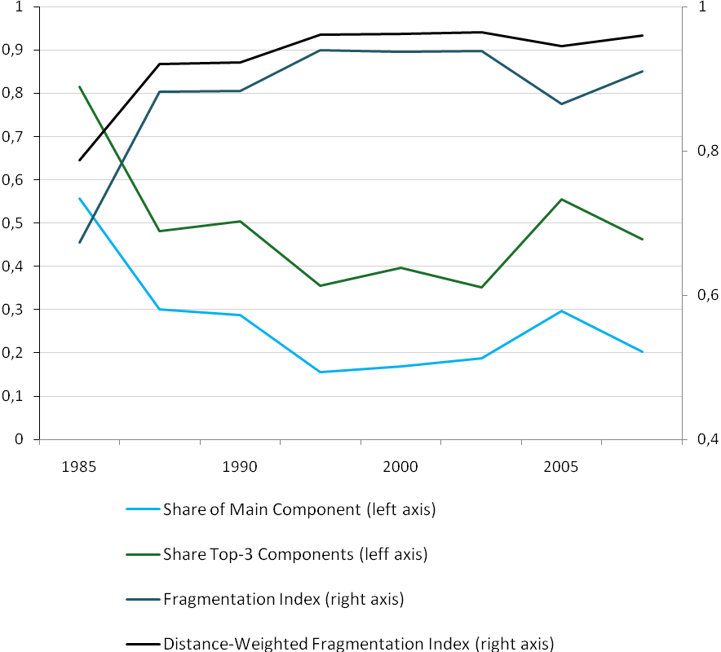

Throughout the years, the fragmentation index (eq. 2) shows high values, indicating low connectivity among inventors. Only at the start of the park the fragmentation index shows a value which is below 0.7. In later stages, only a slight increase in connectivity could be observed halfway into the new decade. A closer look reveals that Crucell and Galapagos formed a large component, which comprised 30% of the total co-inventorship-network. The distance-weighted fragmentation measure (eq. 3), however, doesn’t completely moves along with the fragmentation measure, indicating a marginal decrease in the relative cohesion of the components. To put things in perspective, five different time frames of the co-inventorship network are illustrated on the following pages.

Figure 6: 5-year moving window ranging from 1982 till 1986
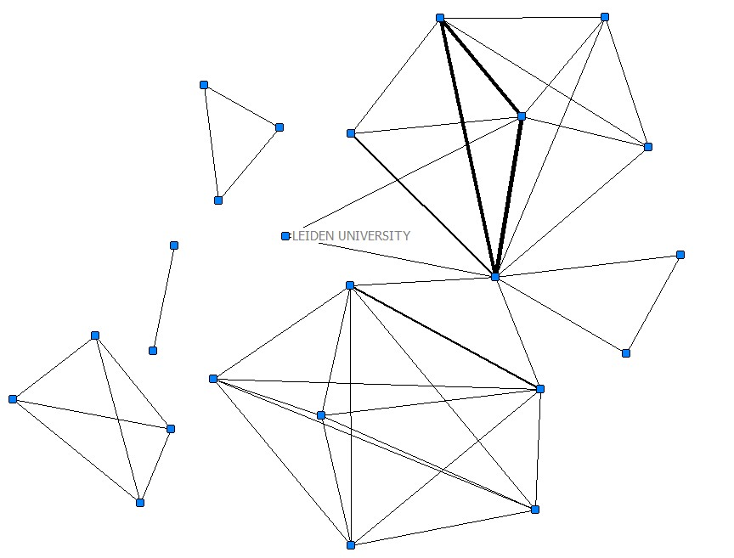

The first five-year moving window solely consists of inventors from the Leiden University (each node represents a unique inventor). The main component of this graph consists of several cliques, with one inventor in the middle (Prof. dr. Robbert A. Schilperoort, founder of the Leiden Bioscience Park). In case some inventors have worked together on multiple patents within the same 5-year period, the line which connects them will increase in size in accordance with their relative frequency of patenting.

Figure 7: 5-year moving window ranging from 1987 till 1991
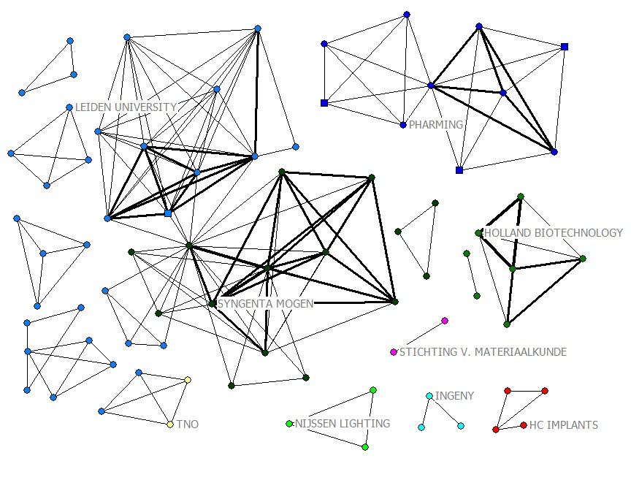

The second 5-year moving window illustrated on this page shows a significant increase in firms that are active on the park (each firm is distinguished by a specific color). Pharming was established in 1988 as spin-off from the Leiden University. The component of Pharming also includes foreign inventors, which are indicated by the square shaped nodes (which will be used from now on to indicate foreign inventors). The main component consists of the Leiden University and Syngenta MoGen. This time Dr. van den Elzen, co-founder of MoGen, is located in the center of the component and responsible for indirectly connecting several inventors.

Figure 8: 5-year moving window ranging from 1992 till 1996

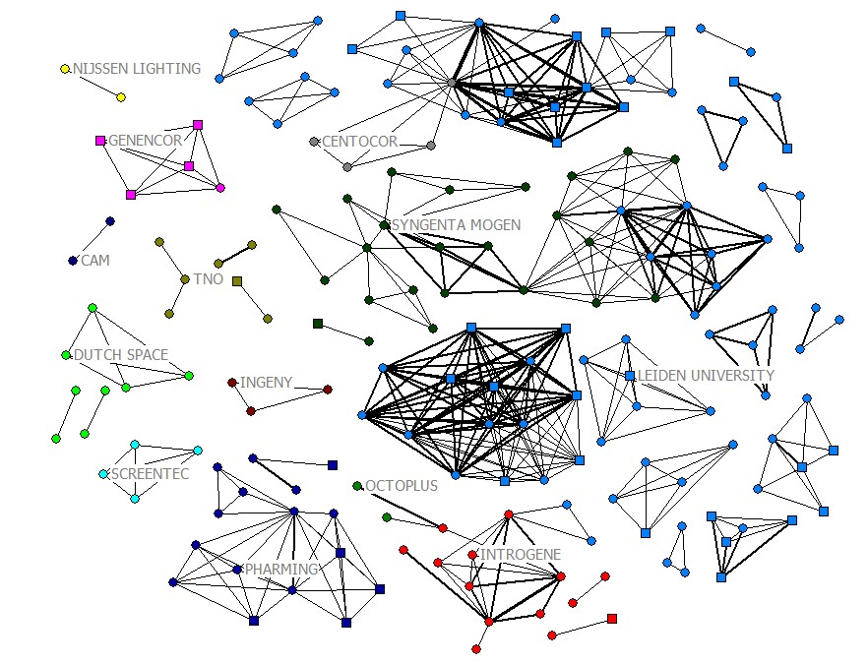

In 1993 the biotech company Introgene was founded, which also originates from the Leiden University. As is shown in the graph, a connection between the two actors could be observed. Also the industrial biotech firm Genencor starts a division within the Leiden Bioscience Park in 1993. Furthermore, some scientists from the Leiden division of Centocor can be observed, and although they already were active on the park since 1985, their contribution in terms of patents (with at least one Dutch inventor) is surprisingly low throughout the years.
Figure 9: 5-year moving window ranging from 1997 till 2001
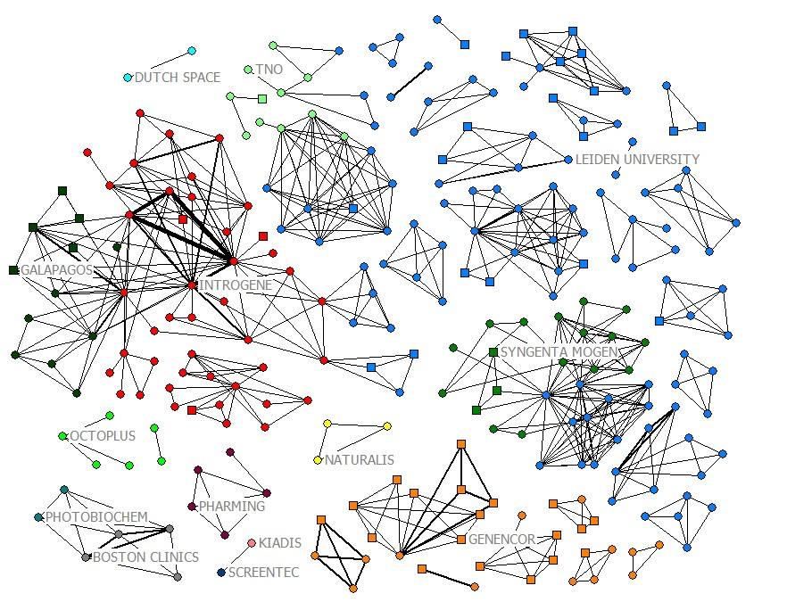

In 2000, Introgene merges with the Dutch biotech company U-BiSys (spin-off from the University of Utrecht and University Medical Center Utecht) to form Crucell. In 1999, Galapagos is founded as a joint venture between Introgene and the Belgium biotech firm Tibotec. In 2005, Crucell retains a 10% share in Galapagos.

Figure 10: 5-year moving window ranging from 2002 till 2006
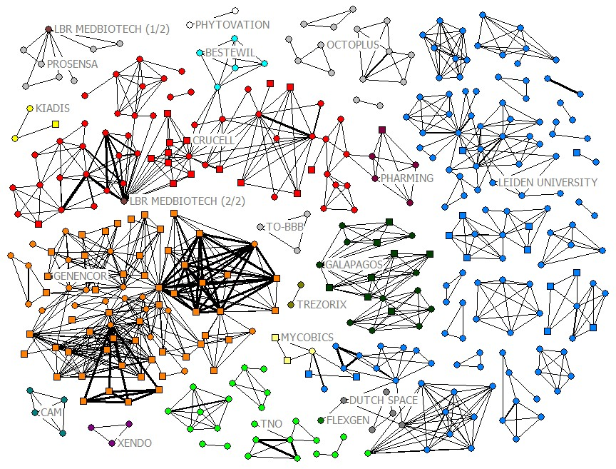
The last graph shows a high level of internal connectivity among inventors of Genencor. However, connections with other firms or research institutes that are located within the park remain absent. Furthermore, again many of the inventors within the component of Genencor have a foreign home address. Also Crucell shows high internal inventor connectivity, and is even connected to several other firms located on the park.

From the foregoing it has become clear that the Leiden Bioscience Park clearly lacks a cohesive structure of its co-inventorship network. Especially Genencor, which is only internally well connected, fails to establish connections to other inventors on the park. A closer look to Genencor reveals that most foreign inventors have an American home address, indicating that they most probably work for the research facilities of the American division (as most patents are not co-applied). This results in the close collaboration between Dutch and American inventors from Genencor and proves once again that networks not necessarily need to be spatially bounded.

Another clear outcome is the relative large fragmentation between inventors from the Leiden University. Throughout the years several subgroups of inventors emerged, mostly forming cliques which indicate that these inventors worked together on the same patent(s). As seems obvious, a University usually focuses on a broad field of interests hereby creating a diversified portfolio of different technologies which are being studied. This opposed to private firms who often are specialized in a limited number of technological fields.

The inventor network of the Leiden Bioscience Park has also become more outward oriented from the 1990’s onwards. As was pointed out earlier this thesis, it is important for a cluster to establish local as well as non-local linkages as sources for interactive learning. In this way, essential information concerning market trends and new technologies are not overlooked and the danger of lock-in can be avoided. Especially firms with divisions in other parts of the world seem to rely more on external sources of knowledge.

Only in some cases a connection between inventors of different firms can be observed. A scarce example of this is the collaboration between the University of Leiden and space technology firm Dutch Space which is depicted in the last 5-year moving window. Hereby, scientists from both firms collaborated, which resulted in the foundation of Flexgen. Unfortunately, an overall stable trend towards increasing connectivity clearly cannot be detected. Hence, hypothesis 1 will be rejected.

5.2 Network Connections

Figure 11 depicts the connections that were established between firms or institutions that are located on the Leiden Bioscience Park in terms of co-applications and labor mobility of inventors. As is mentioned earlier, it is assumed that these relationships are all two-sided. The size of a tie increases in accordance with the frequency of connections.

Figure 11: Connections within the Leiden Bioscience Park

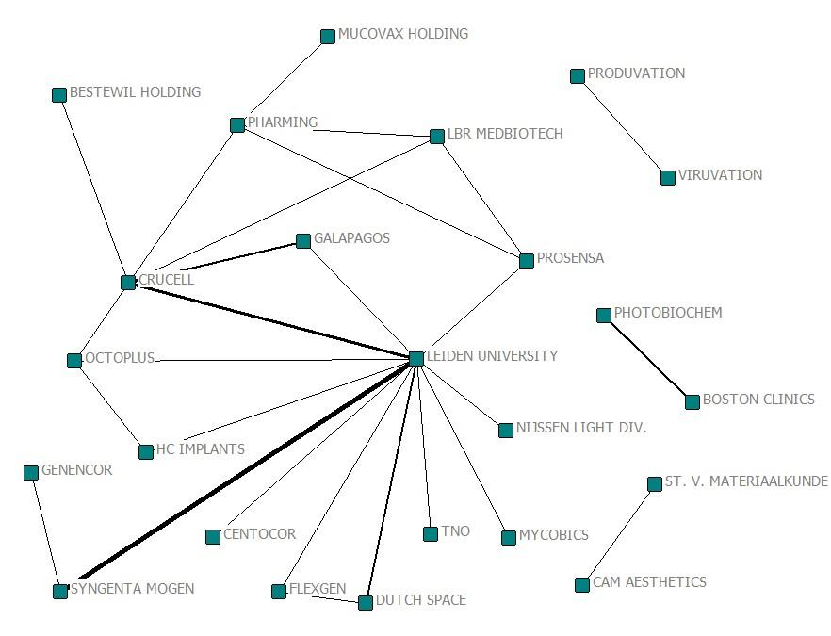

Four components can be observed in this graph, of which one clearly stands out as the main component. In chapter 2 of this thesis it is explained that, since its initiation, 94 firms had entered the park and 19 have exited the park. However, this figure only shows a total of 24 firms, of which 18 are part of a single component. The Leiden University has most connections to other firms on the park and in particular Syngenta Mogen and Crucell share multiple connections with the University. The University is clearly a key player within the inter-firm network of the Leiden Bioscience Park, and taking the University out of the graph will cause a dramatic decrease in the overall connectivity of the network. Besides the connections with the Leiden University, few connections exist between other actors that are present on the park. In addition, the dynamic nature of collective learning and knowledge in general, requires that firms keep participating in the exchange of knowledge and ideas. However, frequent connections cannot be observed in the graph, indicating that there exists no high level of labor mobility or frequent research collaborations. In conclusion, a high level of connections among actors located on the park cannot be observed. Hence, also hypothesis 2 will be rejected.

Table 2 shows the results for the third network property, namely the component/firm ratio. While an increase in the amount of firms from the start of the park clearly can be detected, the number of components remains almost on the same level from the 1990’s onwards, resulting in a declining trend of the ratio. Hence, there is some support for the third hypothesis.

Table 2: Connection ratio
Years* | ’82-‘86 | ’87-‘91 | ‘89-‘93 | ’92-‘96 | ’94-‘98 | ‘97-‘01 | ‘99-‘03 | ‘02-‘06
Count of Firms | 1 | 9 | 8 | 13 | 12 | 14 | 13 | 19
Firm Components** | 1 | 7 | 6 | 9 | 7 | 8 | 8 | 11
Ratio | 1.00 | .778 | .750 | .692 | .583 | .571 | .615 | .579
*please notice overlapping time fragments starting from third column
** Isolates not taken into account

- Conclusion and Discussion

This thesis aims to demonstrate to what extent local networks of collective learning appeared at the Leiden Bioscience Park. The concept of collective learning, which enables actors to generate or facilitate innovative behaviour, is seen as an important approach for explaining the causes of innovative capabilities within a cluster. The Leiden Bioscience Park, which originates from the 1980’s onwards, is a highly facilitated knowledge cluster that is fully dedicated to life sciences. It shows an ongoing growth in terms of employment and number of firms. However, this study indicates that the potential for local collective learning is far from being exhausted.

On the basis of patent data, a longitudinal analysis of the co-inventorship network of the Leiden Bioscience Park is constructed. By measuring several network properties a reconstruction of the development of the park is made in order to determine the potential networks of local collective learning. Outcomes of these properties indicate that an overall trend towards the emergence of local collective learning cannot be observed on inventor level even though the start of the century shows a slight, though temporary, increase in connectivity among inventors. In addition, throughout the development of the park an increasing trend in inter-firm connectivity can be observed on firm level, indicating an increase in the potential of local collective learning. However, the frequency of these inter-firm interactions seems to be insufficient in order to establish a local collective learning milieu. Furthermore, it could be argued that firms with a locally based origin contribute most to the potential of local collective learning, with Crucell as archetype. Firms with an external origin seem to rely most on non-local resources (e.g. Genencor), thus hindering the emergence of local collective learning.

An important and distinct role within the park is played by the Leiden University. Although it has by far most connections to other firms located on the park, on the same time the high internal fragmentation among inventors does not contribute to the cohesiveness of the overall network. Hence, the latter implication hinders the emergence of local collective learning. In addition, almost all spin-offs stem from the Leiden University, thus it also could be argued that the University plays a crucial role in the diffusion of knowledge and contributes most to the existence of a local knowledge base. If the distances between these technologies are not too great, then there could be an increased potential in the emergence of local collective learning.

It needs to be acknowledged that patents only capture the successful collaboration between firms and scientists. It seems obvious that there exist much more interaction among actors present on the park. In this way, the presented inventor network could be considered as the “lower barrier of actual relationships” (Cantner and Graf, 2006, p. 11).

As the start of the new century entails a sharp increase in the number of spin-offs and start-ups, it is interesting to find out what the effects of these firms will be on the potential of local collective learning in later stages of their development. Future studies should point this out.

Acknowledgements

First of all I would like to thank Sandra Phlippen for her comments and supervision during the writing process of this thesis. I also thank Anet Weterings for her help in obtaining the REGPAT patent data and Harmen Jousma for providing us detailed information on the Leiden Bioscience Park. Finally, I would like to thank Fleur de Groot, Jelte Dijkstra, Gijs Janssen, Leon Wiendels, Pieter-Bart Visscher and Thijs Wolters for their contributions during the group sessions.

References

Acs, Z. & Audretsch, D.B. (1993). ‘Analyzing innovation output indicators: the US experience’. In: Kleinknecht, A., Bain, D. (Eds.), New Concepts in Innovation Output Measurement. St. Martin Press, New York.

Agrawal, A., Cockburn, I. & McHale, J. (2006). ‘Gone but not forgotten: Labor flows, knowledge spillovers, and enduring social capital’. Journal of Economic Geography, 6 (5), 571–591.
Audretsch, D.B. & Feldman, M.P. (1996). ‘R&D spillovers and the geography of innovation and Production’. American Economic Review, 86 (3): pp. 630-640.

Audretsch, D. & Vivarelli, M. (1994). ‘Small-firms and R&D spillovers: evidence from Italy’. Discussion Paper 953. Centre for Economic Policy Research.

Aydalot, P. & Keeble, D. (1988). ‘High Technology Industry and Innovative Environments: The European Experience’. Routledge, London.

Baptista, R. & Swann, G.M.P. (1998). ‘Do firms in clusters innovate more?’ Research Policy, 27(5): pp. 527-542.

Baptista,R . (2000). 'Do Innovations Diffuse Faster within Geographical Clusters?' International Journal of Industrial Organization, 18: pp. 515-535.

Bathelt, H., A. Malmberg and P. Maskell (2004). ‘Clusters and knowledge: local buzz, global pipelines and the process of knowledge creation’. Progress in Human Geography 28, pp 31-56.

Borgatti, S.P. (2006). ‘Identifying sets of key players in a social network’, Comput. Math. Organiz. Theor., Vol. 12, pp.21–34.
Borgatti, S.P., Everett, M.G. & Freeman, L.C. (2002). UCINET for Windows: Software for Social Network Analysis. Analytic Technologies, Harvard.
Breschi, S. & F. Lissoni (2001). ‘Knowledge spillovers and local innovation systems: a critical survey.’ Industrial and Corporate Change 10 (4): pp. 975-1005.
Camagni, R. (ed.) (1991). ‘Innovation networks: spatial perspectives.’ London/New York: Bellhaven Press.
Cantner, U. & Graf, H. (2006). ‘The network of innovators in Jena: an application of social network analysis,’ Research Policy, 35: 463–480.
Capello, R. (1999), ‘Spatial Transfer of Knowledge in High-technology Milieux: Learning vs. Collective Learning Processes’, Regional Studies, vol. 33, n. 4, pp. 353-365.
Capello, R. (2008). ‘Indivisibilities, synergy and proximity: the need for an integrated approach to agglomeration economies.’ Royal Dutch Geographical Society KNAG, vol. 100, n. 2, pp. 145-159.
Casper, S. (2007a). ’How do technology clusters emerge and become sustainable? Social network formation and inter-firm mobility within the San Diego biotechnology cluster.’ Research Policy 36: 438-455.
Cohen, W. & Levinthal, D. (1990). ‘Absorptive capacity: A new perspective on learning and innovation.’ Administrative Science Quarterly, 35, pp. 1288-1352.
Dahl, M. S. & Pedersen, C. O. R. (2004). ‘Knowledge flows through informal contacts in industrial clusters: myth or reality?’ Research Policy, 33(10), 1673-1686.
Ejermo, O. & Karlsson, C. (2006). ‘Interregional Inventor Networks as Studied by Patent Co-inventorships’. Research Policy, vol. 35, 412-430.
Etzkowitz, H. (2002). ‘Incubation of incubators: innovation as a triple helix of university-industry-government networks’, Science and Public Policy, 20 (2): pp. 115-128.
Fleming, L., C. King & Juda, A. (2007a). ‘Small Worlds and Innovation’. Organization Science, Forthcoming.
Giuliani, E. (2007). ‘The selective nature of knowledge networks in clusters: evidence from the wine industry.’ Journal of Economic Geography 7 (2): pp. 139-168.
Giuliani, E. & M. Bell (2005). ‘The micro-determinants of meso-level learning and innovation: evidence from a Chilean wine cluster.’ Research Policy 34 (1): pp. 47-68.
Gordon, I.R. & P. McCann (2000). ‘Industrial clusters: Complexes, agglomeration and/or social networks?’ Urban Studies 37 (3): pp. 513-532.
Hagedoorn, J. (2002) 'Inter-firm R&D partnerships: an overview of major trends and patterns since 1960', Research Policy, 31(4): 477-492.
Hudson, R. (1999). ‘The learning economy, the learning firm and the learning region. A sympathetic critique of the limits of learning.’ European Urban and Regional Studies, 6: pp. 59–72.
Jousma, H., Scholten, V. & Van Rossum, P. (2009). ‘Framework For Analyzing the Growth of University Research Parks Applied to the Bioscience Park in Leiden, the Netherlands’, Triple Helix VII International Conference 17-19 June 2009, Glasgow: Scotland.
Keeble D., Lawson C., Moore B. and Wilkinson F. (1999) ‘Collective learning processes, networking and 'institutional thickness' in the Cambridge region’, Regional Studies; 33 pp. 319-32.
Klepper, S. (1997). ‘Industry life cycles,’ Industrial and Corporate Change, 6, 145–181.

Krugman, P. (1991). ‘Increasing returns and economic geography.’ Journal of Political Economy; 99, pp. 483-499.

Lorenz, E. (1996). ‘Collective learning processes and the regional labor market’, unpublished research note, European TSER Network on 'Networks, collective learning and RTD in regionally-clustered high-technology SMEs'.
Maillat, D. & Lecoq, B. (1992). ‘New technologies and transformation of regional structures in Europe: the role of the milieu’, Entrepreneurship and Regional Development, 4: pp. 1-20.
Malmberg, A. (2003). ‘Beyond the cluster: local milieus and global connections’. In: Peck, J. and Yeung, H. W.-c. (Eds.): Remaking the global economy. London: Sage.
Marshall, A. (1919) ‘Industry and Trade’. London: Macmillan.
Martin, R. & Sunley, P. (2003). ‘Deconstructing clusters: chaotic concept or policy panacea?’ Journal of Economic Geography 3 (1): pp. 5-35.
Maskell, P. & Malmberg, A. (1999). ‘The competitiveness of firms and regions: ‘ubiquitification’ and the importance of localized learning’. European Urban and Regional Studies 6: pp. 9-25.
Malmberg, A. (1999). ‘Localized learning and industrial competitiveness’. Cambridge Journal of Economics 23 (2): pp. 167-186.
Menzel M.P., Fornahl, D. (2009). ‘Cluster life cycles--dimensions and rationales of cluster evolution’. Industrial and Corporate Change; 18(6), pp. 1-34.
Morrison, A. (2004). ‘Gatekeepers of knowledge within industrial districts: who they are, how they interact’. CESPRI Working Paper, No. 163, Milano, Italy.
Nooteboom, B. & Klein-Woolthuis, R. (2005). ‘Cluster Dynamics. In: Learning from Clusters: A Critical Assessment from an Economic-Geographical Perspective’, edited by R. A. Boschma and R. C. Kloosterman. Dordrecht: Springer Verlag, pp. 51-68.
Owen-Smith, J. & Powell, W.W. (2004). ‘Knowledge networks as channels and conduits: the effects of spillovers in the Boston biotechnology community’. Organization Science 15 (1): 5-21.
Perhankangas, A. & Kauranen, I. (1996). ‘Spin-offs from Established Corporations – A Systematic Classification of Spin-off Firms and a Study of their Contribution to Industry Growth’, paper presented at the European Network Meeting on Networks, Collective Learning and Research and Technology Development in Regionally Clustered High-Technology SMEs, Nice, september 27-28.
Polanyi, M. (1966). ‘The Tacit Dimension’, New York: Anchor Day Books.
Porter, M.P. (1990). ‘The Comparative Advantage of Nations’. The Free Press, New York.Sherer, 1982.
Shane, S. (2004). ‘Academic Entrepreneurship: University Spinoffs and Wealth Creation’. Edward Elgar, Aldershot, UK.
Simpson, W. (1992) ‘Urban Structure and the Labour Market: Worker Mobility, Commuting and Underemployment in Cities’. Oxford: Clarendon Press.
Wal, A.L.J. ter (2008). ‘Cluster emergence and network evolution: a longitudinal analysis of the inventor network in Sophia-Antipolis’. Papers in Evolutionary Economic Geography. Nr. 08.10.
Wal, A.L.J. ter & Boschma, R.A. (2009). ‘Applying social network analysis in economic geography: framing some key analytic issues’. Annals of Regional Science 43 (3): in press.

Appendix

Attachment 1: Cumulative networks of main components (1984-2006).

Figure 12: Cumulative network of main component

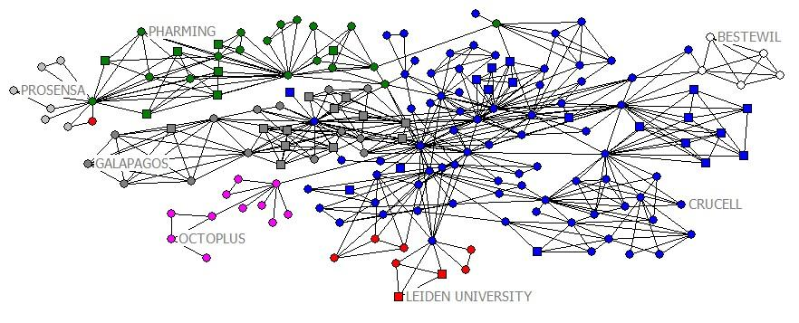

Figure 13: Cumulative network of second best main component
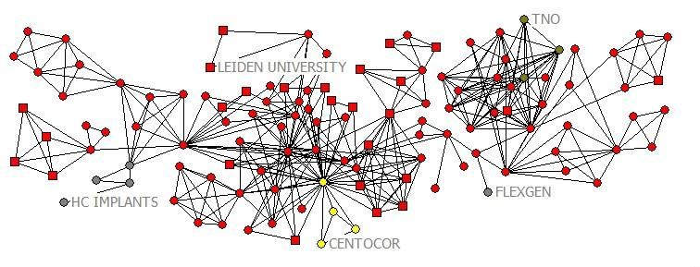
Attachment 2: Example distance-weighted fragmentation measures (Borgatti, 2006)

Figure 14; example of different distance-weighted fragmentation measures

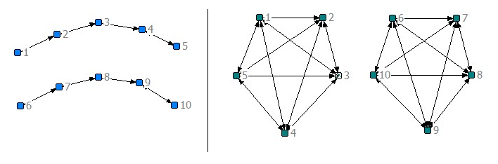

Consider two networks each containing ten different nodes, which form two components of equal size (see figure 5). One of them represents two components that are connected in the form of a line, and one of them represents two different cliques, suggesting that all five nodes within the components are connected to each other. Both networks are seen as equally fragmented, since they both consist of two components. However, the densities and distances between the nodes differ significantly. Furthermore, the removal of a node could have different implications for each network. In the line graph, the removal of a node could lead to a higher component fragmentation of the network, as opposed to the clique network, where the removal of a node surely has no further implications. In this way, the distance-weighted fragmentation index controls for this problem.

In the second attachment of this thesis, the main components over the entire period could be found.
No non-local or foreign inventors present in this graph. Three isolates not included in this graph.
- Includes regional inventors from: Instituut voor Agrotechnologisch Onderzoek, Staat der Nederlanden (Wageningen); Mallinckrodt Diagnostica B.V. (Petten); DSM Gist Holding B.V. (Delft); Gist-Brocades N.V. (Delft); Stichting Klinische Research Academisch (Amsterdam). - Syngenta Mogen was actually called MoGen at that time; it has been taken over by Zeneca in 1997, and merged with Novataris to form Syngenta-MoGen in 2000. Unfortunately, the research centre in Leiden was closed in 2001. - Four isolates not included in this graph.
- Includes regional inventors from: Nederlandse Hartstichting (Den Haag); Bouma, Bonno Nammen (Baarn); Erasmus University Rotterdam (Rotterdam); Academic Hospital Rotterdam (Rotterdam); University of Utrecht (Utrecht); Seed Capital Investments (SCI) B.V. (Utrecht); Duphar International (Weesp). - Includes foreign inventors from: Medical Research Council (London, UK); University College Cardiff Consultants Ltd. (Wales, GB); Ludwig Institute For Cancer Research (New York, US); The Chancellor, Masters and Scholars Of The University of Oxford (Oxford, GB); Collagen Corporation (California, US); Novo Nordisk A/S (Bagsvaerd, DK); The University of Virginia Patent Foundation (Charlottesville, US); Beiersdorf Aktiengesellschaft (Hamburg, DE); Schwarz Pharma AG (Monheim, DE); Maxygen, Inc. (Redwood City, US); E.I. Du Pont de Nemours (Wilmington, US). - Two isolates not included in this graph.
- Includes regional inventors from: Vrije Universiteit Medisch Centrum (VUMC) (Amsterdam); Stichting voor de Technische Wetenschappen (Utrecht); Seed Capital Investments (SCI) B.V. (Utrecht);Avantium Technologies B.V. (Amsterdam); N.V. Organon (Oss); Katholieke Universiteit Nijmegen (Nijmegen); Het Nederlands Kanker Instituut (Amsterdam). - Includes foreign inventors from: Katholieke Universiteit Leuven R&D (Leuven, BE); Universita Degli Studi di Brescia (Brescia, IT); Forschungszentrum Karlsruhe GmbH (Karlsruhe, DE); The Rockefeller University (New York, US); Boehringer Ingelheim International GmbH (Ingelheim am Rhein, DE); Ludwig Institute For Cancer Research (New York, US); Gruenenthal GmbH (Aachen, DE); Xenova Research Limited (Cambridgeshire, GB); E.I. De Pont De Nemours (Wilmington, US). - Nine isolates not included in this graph.
- Includes regional inventors from: Academisch Ziekenhuis bij de Universiteit van Amsterdam (Amsterdam); Stichting Klinische Farmacologie Groningen (Groningen); Stichting voor de Technische Wetenschappen (Utrecht); Universiteit Utrecht Holding B.V. (Utrecht); Solvay Pharmaceuticals B.V. (Weesp) - Includes foreign inventors from: Gruenenthal GmbH (Aachen, DE); Danisco A/S (Copenhagen, DK); Johns Hopkins University (Baltimore, US); The Proctor & Gamble Company (Ohio, US); Aeras Global TB Vaccine Foundation (Rockville, US); The Government of the United States, Walter Reed Army Institute (Silver Spring, US); GlaxoSmithKline Biologicals SA (Rixensart, BE); Beth Israel Deaconess Medical Center, Inc. (Boston, US) Biolex Therapeutics, Inc. (Pittsboro, US); University of Liëge (Liëge, BE); Douthwaite (Odense, DK); The University of British Columbia (British Columbia, CA); Friedrich-Alexander-Universität (Erlangen, DE); University Of Padua (Padua, IT). - Five isolates not included in this graph.

