 |  | 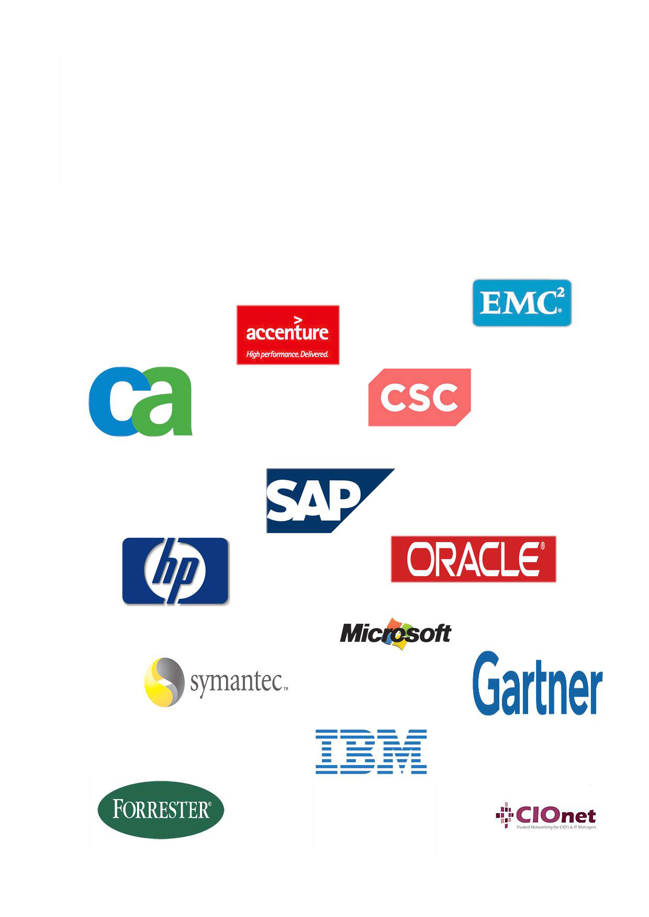
 |  | Understanding the quality of IT trends analysis; who gives better insight regarding future investments on IT?
 | Erasmus School of Economics
 | Erasmus School of Economics |  |  |  |  |  |  | Dimitrios Fragkos  Name
 |  | Master Thesis Economics & Informatics
 |  | Economics & ICT programme  studentid 332998  supervisor Prof. dr. E. W. Berghout  2nd supervisor Prof. dr. G.J. van der Pijl  November 2010  thesis-id |  |  |  |  | 

Table of Contents
Abstract 8
Preface 9
Chapter 1 - Introduction
Introduction 10
Literature - Theory 10
Importance of the research 12
Scope 13
Chapter 2 – Methodology
Introduction 14
Desk Research 14
Empirical Research 15
Analysis 16
Limitations of the research 16
Chapter 3 – Literature Review
Introduction 18
A. Information Technology trends 18
Enterprise Portal Deployment/Web Services 18
Application Integration/Middleware 21
SAN/NAS Storage Management 23
Service Oriented Architecture (SOA) 23
Software-as-a-Service (SaaS) 23
Business Intelligence (BI) 25
Enterprise Resource Planning (ERP) 28
Customer Relationship Management (CRM) 32
Supply Chain Management (SCM) 33
Grid Computing 33
Linux, UNIX and open source software 34
Virtualization 35
Cloud Computing 36
On demand 37
Green IT 37
Outsourcing 38
Business Process Outsourcing 38
Application Outsourcing 38
Infrastructure Outsourcing 39
Wireless/Mobile Solutions 40
Web 2.0 42
B. Prediction Methods 43
Forrester’s Methods for predictions 43
The Wave Participants 43
Preparation before creating the Wave 44
Forrester Wave Process Road Map 44
Benefits of the Wave Evaluation Process 50
Gartner’s Methods for predictions 50
The Hype Cycle 50
Components of the Hype Cycle 53
Deeper into the Hype Cycle 54
Traps, opportunities, challenges, advantages 56
Behavior of the Hype Cycle 57
The Priority Matrix 58
Chapter 4 – Empirical Data
Semi-structured interviews 60
Enterprise Portal Deployment/Web Services/Web 2.0 61
Application Integration/Middleware 61
NAS/SAN Storage Management 62
Service-Oriented Architecture (SOA) 62
Software-as-a-Service (SaaS) 63
Business Intelligence (BI) 64
Enterprise Resource Planning (ERP) 64
Customer Relationship Management (CRM) 64
Supply Chain Management (SCM) 65
Linux/UNIX and Open source software 65
Virtualization 65
Cloud Computing 66
Green IT 66
Outsourcing 67
Wireless/Mobile technology 67
Radio-Frequency Identification (RFID) 67
Messaging 68
Questionnaires 68
Question1 – Business impact of trends 68
Part 1 68
Enterprise Portal Deployment/Web Services 69
Application Integration/Middleware 69
Service-Oriented Architecture (SOA) 70
Business Intelligence (BI) 71
Enterprise Resource Planning (ERP) 72
Customer Relationship Management (CRM) 72
Supply Chain Management (SCM) 73
Grid Computing 74
Linux/UNIX and Open source software 74
Cloud Computing/Virtualization 75
Green IT 76
Outsourcing 77
Wireless/Mobile technology (Radio-Frequency Identification included) 78
Part 2 – Which trends were missing? 78
Question 2 – Which sources do you use? 79
Newsletters (including international IT magazines, CIO.com, blogs, linkedin) 79
RSS/Feeds 80
Events (organized by CIOnet, Gartner, Forrester, IDC or other) 80
Other sources 81
Question 3 – Who do you trust more in forecasting? 81
Gartner’s predictions 82
Forrester’s predictions 82
Predictions made by the International Data Corporation (IDC) 83
Giarte’s predictions 84
IT Trends Institute predictions 85
CIOnet’s predictions 85
IT-related journal predictions 86
Business-related journal predictions 87
Predictions made by colleagues 87
Predictions made through the new strategic products and services offered by well known IT companies 88
Predictions made through the new products and services developed by smaller IT companies but innovative in their field of expertise 89
Question 4 – Decision making 90
1st alternative – Wait until success of an IT technology is proven and then persuade business partners 90
2nd alternative – Wait until being pushed by other business departments 91
3rd alternative – Invest and try to gain the competitive advantage the new technology offers 92
Question 5 – Is there a clear vision? 92
Chapter 5 – Analysis
Introduction 94
Part A: General Observations and Analysis of the questionnaires 94
Observation 1: The interrelations among trends are in many cases extremely complicated and ambiguous. 94
Observation 2: The technological advantages and the potential business value of certain technologies are not appropriate for the decision-making process since external factors play an important role as well. 96
Observation 3: Different sources emphasize on different aspects of the technologies. In order for valuable decisions to be taken, more than one aspect need to be taken into consideration. 97
Observation 4: Technology alone is not a problem solver. 99
Observation 5: Companies’ priorities play an important role in which technologies are considered as trends by them. 100
Analysis of CIOs’ beliefs concerning the forecasting companies and evaluation methods according to the questionnaires 101
Part B: Answer to the main question and causality 106
Evidence derived from the interviews and questionnaires 107
Analysis of Gartner’s and Forrester’s prediction methods 108
Difference between Gartner’s and Forrester’s analysis 109
Similarities of Gartner’s and Forrester’s analysis 109
Importance of identifying the business needs 109
Future Research 111
Summary 112
Appendixes
1. Enterprise Portal Deployment/Web services 115
2. Application Integration – Middleware 115
3. Customer Relationship Management 115
4. NAS/SAN Storage Management 115
5. SOA 116
6. SaaS 116
7. Business Intelligence 116
8. Enterprise Resource Planning 116
9. Grid Computing 116
10. Pervasive Computing 117
11. Linux – UNIX 117
12. Virtualization 117
13. Outsourcing 117
14. On demand 117
15. Cloud Computing 118
16. Green IT 118
17. Supply Chain Management (SCM) 118
18. RFID 118
19. Messaging 118
Bibliography 120

Abstract
The evolution of technology has a major impact on the way the world conducts business today. As a result of it, business organizations are trying to identify which are the technology opportunities, usually called as trends, and the way they are going to invest on them subsequently. However, the decision upon which technology trends the companies will invest is not an easy task and has to be thoroughly examined. Despite the fact that many sources are taken into consideration by the CIOs and IT managers, none of them knows exactly which of the sources used is accurate enough and thus what the impact of the technology will actually be. There are a lot of real-life examples which depict the difficulty described above since an Information Technology (IT) investment apart from the potential embedded advantages, poses great risks, which can even lead a firm to collapse. As a consequence of the above, this research is aiming to evaluate the way decisions, regarding the investment on a specific technology, are taken and most important to identify who is the most accurate in forecasting potential impact of technology trends and where innovation comes from; is it the big IT companies (e.g. HP, IBM, Microsoft, etc.) or is it the analysis companies such as Gartner and Forrester? The goal of this research is to end up with valuable conclusions which will assist business organizations to come up with more secure decisions regarding who they should trust more. Regarding the quality of IT trends’ analysis (which is the matter that is analyzed within this report), decision makers should trust the analysis companies, such as Gartner, Forrester and firms alike. From the overall research, it is concluded that analysis companies are the ones that should be trusted more concerning future decisions on the IT field.

Preface
The objective of this thesis report is to provide the user a clear understanding regarding the following question: “who is more successful in identifying the future potential of IT trends; is it the well-known IT companies or analysis companies such as Gartner and Forrester or other sources?”. Although, this research is limited due to time constraints, as we had to focus on the last 10 years of IT evolution mainly, and access of information in repositories such as the ones of Gartner and Forrester, we acknowledge the importance of the learning experience for us, the writers. This field of research was selected after a careful discussion and evaluation of alternative topics among our supervisor (Professor dr. E. W. Berghout), Mr. Johan de Wit and the members of CIOnet. Since our prior experience and knowledge were inadequate for this particular sector, we had to conduct an in-depth literature review, which in conjunction with the interviews and surveys made, assisted us not only in completing this paper, but most important to identify and understand the progress of IT during the past years, to distinguish trends according to the offered products and services in a more appropriate manner, and most important to identify the main question of this research, which is who forecast better.

Chapter 1 - Introduction

Introduction
The objective of this thesis is to improve our understanding of IT trend forecasting. To be more specific, our goal is to see who is more/less successful in identifying the potential impact of IT trends; is it the big/major IT companies that design and develop IT products and services, or well known forecasting analysis like Gartner, Forrester, Giarte, or media such as CIOnet, journals, websites, etc. In order to do that we will analyze the lists of successful and unsuccessful IT trends of the past ten years within the top ten IT companies worldwide (as defined by Fortune Magazine) and rate which companies predicted the future better.
The research to be done will be conducted on behalf of CIOnet (http://www.cionet.com/ ), a private and invitation-only business network for CIO's and IT managers. The thesis will be complementary with the thesis written by the master student Panagiota Georgiou (332647). Within this report, only the research question that concerns the identification of the potential impact of IT trends will be answered.

Literature - Theory
Before describing the way the above evaluation will be conducted, it is critical to define the terms product, service and trend as well as the interrelation among them, since they play a major role within the analysis that will follow.
In general, a product is defined as a thing produced by labor or effort (Costello, 1991) or as the result of an act or a process (QUASYS, 2001). For instance, in marketing, a product is anything that can be offered to a market that might satisfy a want or need (Kotler, Armstrong, Brown, & Adam, 2006). However, in IT, products are those items which either intend to fulfill the function of information processing and communication by electronic means, including transmission and display, or those that use electronic processing to detect, measure and/or record physical phenomena, or to control a physical process (OECD, 2003).
Continuing the classification, products can be further distinguished to tangible and intangible ones, depending on their nature. The intangible products are non-physical and can also be called services. A service is defined as a particular type of help or work that is provided by a business to customers, but not one that involves producing goods (Longman, 2010). Therefore, the definition of an IT service includes the services which intend to facilitate the function of information processing and communication by electronic means.
Taking the above definitions into consideration, it can be said that there is no clear distinction between IT services and products. For example, a simple e-commerce website can be perceived from some people as a product since it is tangible and exists within the worldwide web (i.e. someone can see it), while from others as a service since it offers services (e.g. e-payments) and in general facilitates customers’ needs.
During the past couple of decades, the importance paid in the industry of ICT has lead to corresponding trends. A trend, by definition, is the general tendency in the way a situation is changing or developing (Longman, 2010). In other words, a trend is simply the direction of the market, that is the new developments within the market.

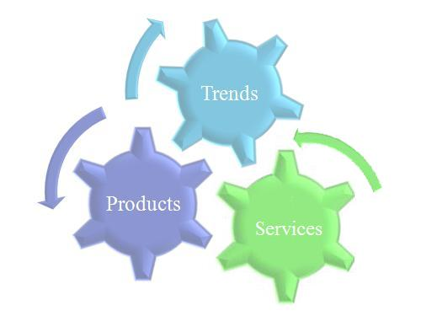
Figure 1: Interrelation among ICT products, services and trends.
The above schema can be approached both bottom up and top down. The bottom up approach suggests that the success of a product or service introduced by an IT company leads to the creation and use of similar products or services by other IT companies, thus we have a trend within the IT market. On the contrary, the top down approach suggests that a trend already exists in the market so IT companies create and/or use products or services that follow this trend. When referring to specific trends, products and services, it is very difficult to understand which came first; the trend or the product/service, which is similar to “the chicken or the egg” causality dilemma.
As it can be inferred from the above, both approaches force business organizations to invest, sometimes aggressively, in the IT field. By following the trends and investing on them, companies aim to add value to their processes and improve the overall operational excellence of their business. Within this research, an IT investment refers to any acquisition of software or hardware, according to the corresponding trends, which is expected to increase or expand the possibilities of an organization’s Information System and render long-term benefits, since business organizations aim to receive the significant consequences for the content and the shape of work in organizations (Renkema & Berghout, 1997).
The evaluation of potential IT investments greatly contributes to the decision making process and the selection among alternative improving solutions. However, the measurement of the business value of an IT investment is a considerable challenge and in order to be properly evaluated, it is needed to gain in-depth knowledge and insight in different aspects (Renkema & Berghout, 1997). In other words, the relevance between IT investments and a firm’s performance is sometimes equivocal, since an IT evaluation is difficult to be accomplished due to the intangibility and indirectness of many costs, benefits, risks and values associated with IT investments. The above is further criticized, since the relationship between Information Technology and productivity is widely discussed but little understood (Brynjolfsson, 1991).
To be more specific, despite large investments in IT, it has been difficult to determine whether IT benefits actually occurred. Many organizations claim that IT investments caused them additional problems since unexpected difficulties and failures were regularly encountered and expected business benefits were never realized. Moreover, the determination of an IT investment and its pay-off cannot be ideally accurate since the lack of a defining and measuring standard of such investments (Productivity Paradox).
The above vagueness in the IT investment evaluation procedure combined with the realization of the impact of IT on the success of an enterprise, the high costs and the complexity of IT constitute the analysis of the corresponding costs and benefits more than necessary, in order to ensure that IT supports business goals, optimizes business processes and appropriately manages IT-related risks and opportunities.
However, the intangibility and indirectness embedded in both costs and benefits makes it difficult for management to predict and assess them precisely and accurately. Thus, it is of critical importance for an IT company to know who to trust concerning future predictions since a lot of money will be invested on them without always having the possibility to evaluate them properly.

Importance of the research
As we have already mentioned above, companies invest a lot of money on new technologies (trend technologies). Nowadays, there is a whole new industry about identifying and forecasting which of the new technologies will be more successful in the future. But is there a safe way to predict the future within the IT and business sector? Furthermore, can CIOs and IT managers trust these forecasts blindly?
The importance of this research lies in the fact that the sources used by the CIOs and IT managers in order to evaluate their options and make the right decisions will be identified and the extent at which these sources are considered trustworthy by them will be measured. Since, nowadays, the information that is available to each individual is innumerous, it is critical for individuals to have knowledge on whether or not this information can be trusted.

Scope
In order to test the validity of the IT forecasting, we studied and analyzed the subject from three different perspectives: the big IT companies’ (both vendors and suppliers), the big forecasting companies’ concerning IT trends and the Chief Information Officers’ (CIOs) and IT managers’ perspective.
To be more specific, concerning the big IT companies, ten top IT companies have been selected, after taking into consideration Fortune500 annual lists for years 2009 and 2010 respectively. Subsequently, the annual reports of the above top ten IT companies have been gathered for the years 1999 – 2008, and have been reviewed in detail. The review of these annual reports resulted in the listing of the IT trends and the associated products and/or services that were suggested and used by the IT companies.
Concerning the big analysis companies, reports from Gartner and Forrester have been collected for the years 1999 – 2008 respectively. These reports refer to trends that were predicted as the most successful to be for each of the above years.
This research has been restricted to a limited number of companies from both the IT and forecasting areas; it was inevitable not to limit the sources due to time constraints, so that the overall volume of the data to be analyzed would be manageable.
Furthermore, the semi-structured interviews conducted, served as a means to test the validity of the predictions made by Gartner, Forrester and Giarte as well as the promotion of certain products/services by the IT vendors. The interviewees are CIOs or former CIOs and IT managers, who were asked to give their own opinions on the subject and describe their own experiences with the trends.

Chapter 2 - Methodology

Introduction
The following chapter describes the basic research plan followed for the completion of this report. To allow the reader obtain a deeper insight of this research, we are going to clarify the approaches adopted in order to select the employed methods used within this research. In a few words, we combined desk research and empirical research; the data needed was gathered from literature review, semi-structured interviews and questionnaires. All these are elucidated below thoroughly.

Desk Research
The desk research part consists of three sub-parts:
- Review of the annual reports of the top-10 IT companies worldwide for the past ten years;
- Review of the forecasting reports of some of the most important forecasting/ analysis companies such as Gartner and Forrester;
- Extra literature that consists of scientific publications (papers), online articles and/or other reports of IT companies.
The aim of reviewing the annual reports of the top IT companies was to create a list of IT trends and their associated products and/or services with a business impact on enterprises. Due to time constraints, we had to limit this research to the top-10 IT companies worldwide for the past ten years (1999 – 2008), after taking into consideration Fortune500 annual lists for years 2009 and 2010 respectively. In order to be as accurate as possible, we included software companies, hardware companies and IT services companies within the top-10 companies.
As far as the trends in the above list are concerned, the main goal was to identify when they were first introduced and by which company/companies; what these trends aimed at improving and/or changing; at what extent those aims were met as well as at what extent other companies invested on them.
The aim of reviewing the reports of the forecasting companies was to identify what these companies actually thought of these trends and at which stage of their lifecycle they acknowledged (or not) their potential, as well as the extent at which these predictions affected (or not) other IT companies on their investment decisions concerning new technologies.
The extra literature aimed at finding as much information as possible about the trends’ lifecycles and the correlation among them; were some of them the continuance of some other? Did some of them replace some other? In addition to these, we tried to identify the methods according to which the forecasting companies attempt to recognize potential trends. With the extra literature, we tried to evaluate the validity of the information we had already gathered, as well as examine all the different perspectives and points of view of the main topic.
A detailed description of the desk research results can be found in chapter 3 of this report.

Empirical Research
The empirical research consists of two sub-parts:
- Semi-structured interview with CIOs and IT managers
- Questionnaires to CIOs and IT managers
The conducted semi-structured interviews aimed at evaluating the list of the top-10 IT companies, the list of forecasting companies and the list of IT trends before distributing the questionnaires to the members of CIOnet. The feedback received from the interviews was used to transform and adapt the lists several times before resulting in the final ones. This way, we were persuaded that the data to be evaluated was accurate, valid and closely related to the main topic.
In addition to the above, we collected information that concerned the impact of each of these trends on the companies that invested on them; which of the trends were successful/unsuccessful for the companies and why, as well as how the trends evolved through time from the CIOs’ perspective. This information was used in the analysis part.
Regarding the empirical part, the overall number of interviews was four and the people we conducted the interviews with were the following:
- Johan de Wit, former CIO of ING Bank, owner of Nuphar.com and Associate director of CIOnet NL;
- Kostas Gerogiannis, former CIO of NS;
- Gerard van der Velde, Information Manager Distribution, KLM IMO Sales;
- Bart Luijten, VP of IT Strategy and Planning at Philips.
With the questionnaires we intended to gather the necessary information regarding the methods, means and ways used by CIOs and IT managers in order to take decisions when it comes to investments on new Information Technologies (IT trends). To be more specific, we tried to identify who influences their decision the most; is it the big IT companies or the forecasting companies merely? Besides that, how accurate do they consider the forecasting reports of such companies and who do they consult when they need to evaluate new technologies?
A detailed description of the empirical research results can be found in chapter 4 of this report.

Analysis
Upon gathering all the above data, we proceeded with the analysis of it. By taking into consideration the results obtained from the desk research as well as from the semi-structured interviews, we tried to identify the factors that affect the decisions of the CIOs and IT managers as far as technology investments are concerned, what is important to them and what kind of information they need to facilitate the decision making process. At the same time, we tried to understand who can identify the potential impact of IT trends (the IT companies or the predicting/analysis companies) and who the companies can trust when it comes to investing on the future.
More details regarding the analysis and the conclusions that occurred from it can be found in chapter 5.

Limitations of the research
While conducting this research, we had to deal with some limitations the most important of which were the following:
- As we already mentioned above, due to time constraints and in order to make the overall amount of data to be proceeded manageable, we had to limit the review of the annual reports to the top-10 IT companies and only for the past ten years.
- The second limitation occurred due to restricted access rights. In other words, some of the information we were trying to reach was not available to the public. Forecasting/analysis companies don’t easily reveal the methods and techniques with which they forecast the trends, neither the reports with the actual forecasts. We only managed to access the methodologies used by Gartner and Forrester in order for them to predict the emerging technologies; the methodologies of Giarte and/or other such companies were impossible to be reached. In addition to this, we managed to gather predicting reports only by Gartner, a few by Forrester and very few by Giarte.
- The third limitation derived from the very limited time from the part of the CIOs and IT managers, which made it difficult to arrange and conduct more than four interviews. At the same time, the final response ratio of the number of questionnaires sent to the number of questionnaires actually answered and sent back was also limited and reached only the 14% of the participants.
Despite the difficulties described above, we believe that the results of this research are still accurate for the following reasons:
- The limited review of annual reports didn’t cause any omissions or deficiencies since the list of trends that occurred was checked with the CIOs within the interviews in order not to leave important trends out of the list. The modifications we had to apply after the interviews were minor; therefore the list of trends is accurate.
- The limited access to the reports of forecasting companies is taken into consideration and companies such as Forrester, Giarte and CIOnet for which we found few or none reports are not included in the matrices of the Appendix.
- The limited availability of the CIOs and IT managers didn’t lead us to false conclusions. The answers from both the interviews and the questionnaires were compared and almost all participants agreed with the same facts and information. Therefore, we believe that, if more people had responded, we could probably reach more conclusions but the conclusions we reached under the circumstances are still correct and adequate.

Chapter 3

Introduction
The following chapter represents the literature review of this research. In order to provide results with higher robustness and validity, various sources were examined and included.
This chapter is separated into two parts; one refers to the most important trends met in the IT industry, while the second refers to the prediction methods used by Gartner and Forrester.
To be more precise, the first part of this chapter depicts the most important Information Technology trends as deduced from the annual reports of the top ten IT companies that we review within this research for the past ten years, and in the academic and business papers.
The second part analyzes and explains the two prediction methods used by Gartner and Forrester accordingly. These companies are considered as innovators in the IT consultancy and advisory field, as far as the forecasting of IT trends is concerned, so the insight in the methods they use is considered of very high importance.

A. Information Technology trends

Enterprise Portal Deployment/Web Services
This trend mainly refers to the impact the Internet had on businesses. This impact has started being visible long before the 2000s, with companies like IBM sharing their vision about the potential that the Web could have since 1995. When referring to that year, IBM states the following: “We believed that the Net would not just change technology. It would spark an all out revolution in the way the world works”, (IBM, 1998)
Even though not many companies shared the same position at that moment, it was between 1998 and 2000 that this position started to become crowded and people started to talk about this transformation in terms of a “networked society” and a “networked economy”. It was at the same time that organizations realized the importance of having an online presence for their customers in those areas of the world where the Internet was becoming readily available. With web hosting at first and portal deployment a bit later, companies started delivering solutions and services to their customers. Traditional businesses are gradually transformed to e-businesses and business processes are extended beyond company boundaries by leveraging the Internet and related technologies.
Enterprise portals are quickly becoming the central point of access within the user community. Companies can share the data with their customers and customers can access business applications through the personalized, browser-based user interfaces developed. This provides an awesome integration – integrates information and applications into one real-time collaborative environment – regardless of the operating system used by both sides.
An interesting opinion about enterprise portal deployment is given by the Indian company Aalpha Information Systems in a business white paper in 2000. According to Aalpha, web services are part of the Enterprise Information Portals (EIP) or corporate portals. Enterprise portals are in fact one of the first efforts in order to enhance communication and collaboration of the individual users, within an organization, with each other as well as with the external partners. This way, business effectiveness is improved and employees are facilitated in doing their job better.
Another important finding concerns the initiator of portal deployment. Many papers refer to the MyYahoo! application which Yahoo launched in 1996. This web application allowed users to customize their internet search and select the information that was interesting for them. Shortly after the release of this application, Information Technology vendors started considering that such developments could be used within the organizations.
A bit later, the exchange of goods and/or services electronically (e-commerce) leads to a revolution within the business sector by providing a relatively low-cost means of distributing products and expanding markets globally. The development and deployment of web-based business and commerce applications on the Internet starts to be the only way for a company to remain competitive in delivering value to its customers.
Symantec and Microsoft found an additional way to take advantage of the possibility the Web was offering. By delivering an online subscription-based service, users were enabled to download, free of charge, software corrections or “patches” that fixed reported errors (bugs) in the products, to install updates in both software and hardware, to keep the applications’ databases current and to ensure that critical system components are problem-free through checks that are conducted online.
By 2004, and as Information Technology has rapidly developed, the term “e-business” is widely used. According to the Journal of Enterprise Information Management, “e-business is an enterprise with the capability to exchange value digitally. E-business is a new way of doing business that requires the integration and alignment of business processes, technology and people with a continuously evolving e-business strategy” (Yang, Yang, & Wu, 2004).
At the same time (2004), and as digital technology is improving, next-generation appliances such as wikis, blogs, crowd sourcing (Brandel, 2008) and mash-ups (Jackson M. , 2009), are integrated within the Web services in order to create new opportunities of collaboration and sharing of information. By 2005, companies are trying to provide effective ways of connecting advertisers with audiences. This way, information search and support services will be improved leading to the enhancement of communications.
In an effort to predict the future, IBM and SAP are seeing an interesting development since 1998 and 2000 accordingly: a proliferation of new personal information devices such as Personal Digital Assistants (PDAs), mobile phones and pagers.
It is interesting to review Gartner’s opinion on this trend. Despite the fact that enterprise portal deployment and web services are considered as hot trends since 2000, the company itself seems to doubt the power and positive impact of the Web. In the annual report of 2001, Gartner says: “companies should enter the learning curve on Web services capabilities now, but because this technology is not yet mature or a proven success, they should not create mission-critical Web services projects until a clear case for revenue-generation opportunities can be made”.
In the same report, they refer to web services as a “probably underestimated technology” but their limited trust towards it becomes clear even in 2002 when they mention within the annual report: “the real value of Web services will become apparent once the technology matures, the vendors’ business model is robust enough and users have a clear understanding of the applicability”.
Some of the advantages that all the above forms of web services had within the business sector are the following:
- Enhancement of business operations;
- Improvement of productivity (through e-commerce);
- Increased efficiency;
- Customers, suppliers and trading partners are electronically connected and enabled to quickly transact business (coordination of the entire chain of commerce);
- Costs are cut up;
- New customers can be reached more easily;
- 24x7 services are managed;
- Revenue growth;
- Markets are expanded at a global level;
- Better, more personalized customer service.

Application Integration/Middleware
This trend refers to the design, development, implementation and integration of complete information systems. It depicts the effort of IT organizations to make the disparate and heterogeneous business applications and systems (provided in most of the cases by different business partners) work together consistently and, in some cases, interact in real time. With integration, companies can leverage their applications and systems as well as automating their business processes.
In general, integration can be considered as a process that has two steps: the first one refers to a company’s effort to tie together all the software, hardware and communications into a common Web platform so that the enterprise and legacy systems and processes are linked together; step two intends to link the platform with the outside world. Web services, web sites, portals and web-based applications are now used to form relationships among suppliers, customers and business partners.
The above are summarized in the scheme below:

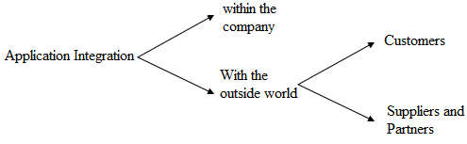
Figure 2: Integration

To support the application integration technology, vendors like HP, IBM and Oracle promote their middleware software solutions. “Middleware forms a reliable and scalable foundation on which customers can build, deploy and integrate business applications and automate their business processes” (Oracle, 2007).
It is interesting to mention that before 2000, when the impact the Web would have on businesses was not that obvious, integration only referred to the connection of hardware and software within a single organization.
Some of the most important advantages of integration are the following:
- The capacity to adapt to business changes rapidly is increased;
- User productivity is increased;
- Better business decisions are being claimed;
- Automation of certain processes;
- Increased control over operations;
- Processing time is reduced;
- Risks related to security and compliance are reduced;
- Companies continue to utilize their existing IT systems (cost-effectiveness, users don’t need to adapt to new systems).
As, by the years, processes and business in general become more demanding, integration becomes a necessary procedure in order to make the best out of the Information Technology systems. IBM states that, “integrating middleware, as a development platform, is becoming more important than operating systems”, (IBM, 2001), while the European Journal of Information Systems supports that “integration facilitates cross-functional business processes. This constitutes an important pre-requisite for effective participation in a competitive global market, where organizations need to be agile and flexible” (Umapathy, Purao, & Barton, 2008).
When it comes to the challenges of integration, the Journal of Information Systems Education distinguishes them in two categories: technical and organizational. From a technical perspective, many of the legacy systems that companies would like to integrate, were initially designed to be stand-alone so, integration will connote a lot of new investments. Furthermore, there is the risk of incompatibility between the legacy systems and the more modern ones.
Form an organizational point of view, integration means changes to the business processes, the need of realignment of the technology goals with the business goals as well as new corporate knowledge for the users of the new systems. The resistance of employees towards the change that new technologies bring along is one of the biggest challenges. In order for a smooth adaption, different parts of the company need to coordinate and communicate.

SAN/NAS Storage Management
A storage management system consists of storage elements, storage devices, computer systems and/or appliances, plus control software communicating over a network.
Some of the advantages of using storage management systems are the following:
- The growing data volumes are managed more easily;
- The availability of data for the enterprise applications is optimized;
- Control and improvement of the utilization of storage hardware;
- Data transfers are more secure and robust;
- Organizations can manage and share their critical information online; that way, they can increase their agility, lower their costs and raise their productivity;
- Business continuity is ensured.

Service Oriented Architecture (SOA)
According to Oracle, “Service Oriented Architecture (SOA) is an information technology strategy which allows users to interact with Internet-based portals and composite applications, which in turn interact with several enterprise applications.”
SOA is a means of rapidly mapping reusable enterprise services and/or components within a network regardless of the technology that animates them. This view allows companies to extend and improve existing technologies by remaining technologically neutral. It is an important way for companies to efficiently and effectively integrate previously fragmented data and business processes.
Some of the advantages that SOA offers are the following:
- Improvement in business and IT efficiency and flexibility;
- Effective alignment between business processes and applications;
- Development time and costs of business processes are reduced;
- Response time of business processes is improved;
- Customers can optimize the use of their existing systems instead of rebuilding everything from scratch;
Despite the above benefits, Forrester insists that “SOA is the approach, not the solution”, (Heffner & Peters, 2008). SOA is more than a technology that allows companies to achieve application integration and improve their web services. It is more about how to redesign the business and align business initiatives with IT than technology itself. Information Technology architects should realize the above difference in order to understand how SOA can add value to a business.

Software-as-a-Service (SaaS)
SaaS constitutes a new business model with which application software is offered to a company’s clients in the form of a service accessed via the web. The software is not physically distributed to customers; it is centrally hosted and accessed by users over the Internet. SaaS software is not sold; the rights to access it and use it are, but not in the form of software license fees. Clients are allowed to access certain IT resources and applications only when needed and pay for the services they actually consume no matter if the offerings are a simple web page or an entire application suite.
SaaS applications differ from the traditional Application Service Provider (ASP) in the following ways:
- They are designed to run over the Internet;
- A single instance of software can support many customers;
- Services are easily connected with other Web Services;
- They are provisioned by end-user action alone.
Because it can provide services that perform even a single function, SaaS individual offerings as well as vendors increase within the IT market. Besides that, providers are under pressure to improve the performance of their products quickly and according to the customers’ needs. “Being able to buy only the specific services needed – and only when needed – and being able to rapidly switch among a growing number of suppliers means customers will no longer wait for overpromised-but-under-delivered software from a handful of established players”, (Computer Sciences, 2006). If a specific vendor does not provide what the customers exactly want, someone else will.
Some of the main advantages of SaaS are the following:
- Customers can adapt technology usage to current needs;
- Flexibility from the part of the customers is increased;
- Total costs of computing are decreased (transaction-based pricing, much less expensive IT infrastructures);
- The operating results are improved;
- It is quicker to deploy than traditional licensed software;
- No need for supporting hardware since there is no physical software within the company (eliminated dependence on IT).
The idea of SaaS was more or less present within Symantec since 1999 (even though the term itself was not used), with the online and subscription-based service via which customers could download and install updated and patches for the company’s products. Another term for SaaS applications is given by HP and is the term “Utility Computing”. With Utility Computing, HP means “the software and hardware that customers will rent instead of buying – paying only for what they use”, (HP, 2000). Utility Computing is an immature concept of SaaS but the main idea is the same.
An interesting opinion about SaaS is given by CSC which describes it as an innovation enabled by the Web 2.0 and as the continuance of Web Services. Another interesting opinion is given by Gartner which supports that the interoperability offered by SaaS is cheaper than integration, thus this trend is becoming more and more important. Gartner also considers that SaaS consists of:
- those tasks that focus on the development of the applications and are referred to as Service-Oriented Development of Applications (SODA), and
- those tasks that focus on the deployment of the applications and are referred to as Service-Oriented Architecture (SOA).
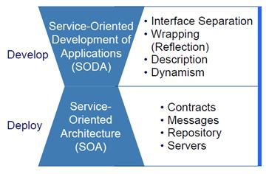
Figure 3: Software-as-a-Service
Trying to describe the business value of SaaS, Forrester refers to it as an attractive alternative technology that allows companies to focus on their core business processes by asking from other companies (SaaS providers) to undertake the development of non-key processes and deliver them in the form of services.

Business Intelligence (BI)
Business Intelligence (BI) solutions usually consist of a flexible, scalable platform with back-end integrated services; this intelligence platform can provide the decision makers within a business network with information that improve and fasten the decision making processes, while all users can access, analyze and share trusted business information.
Business intelligence technology has coalesced in the last decade around the use of data warehousing and on-line analytical processing (OLAP) (Cody, Kreulen, & Krishma, 2002). Data warehouses provide decision support to organizations with the help of analytical databases and online analytical processing (OLAP) tools. The process of discovering valuable knowledge from large amounts of data stored in databases, data warehouses, or other information repositories is called data mining (Sumathi & Esakkirajan, 2007).
Today all the above are referred to with one single term, the term “Business Intelligence”. According to H. J. Watson from the University of Georgia and B. H. Wixom from the University of Virginia, Business Intelligence consists of two basic activities: getting data in and getting data out. The scheme below depicts these activities.
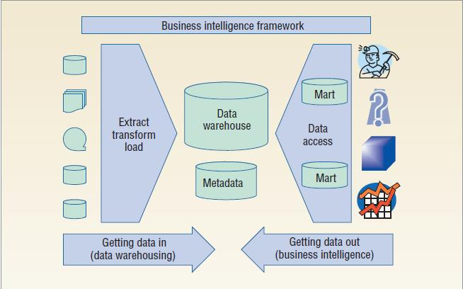
Figure 4: Business Intelligence Framework (Watson & Wixom, 2007)
The “getting data in” process, also referred to as “data warehousing”, involves the gathering and merging of data from every useful source into the integrated data warehouse. The sources can be internal within the organization, or external from a business partner or other source. Key performance indicators, alerts, unstructured news and/or any other predefined business content are taken into consideration.
The “getting data out” process, or “business intelligence”, involves the users’ (planners, decision makers and information consumers) enablement to access and use the initially raw data that are now transformed into useful business information. This data is necessary in order to report and analyze critical business areas, as well as improving the decision making processes. Moreover, strategy management and real-time predictive intelligence are provided. By using Business Intelligence, companies can gain a real competitive advantage.
Gartner gives some interesting insight in two of its reports regarding the Business Intelligence technology. In 2007, it is stated that “BI has become a strategic initiative and is recognized by CIOs and business leaders as instrumental in driving business effectiveness and innovation”, (Gartner, 2007). In 2008, it is stated that “tools that let business managers and knowledge workers make faster, better and more-informed decisions are particularly valuable in a difficult business environment”, (Gartner, 2008)
Business Intelligence solutions can directly have a positive impact on a company’s business performance by enabling users to:
- accurately answer ad hoc questions by interacting with valuable and trusted business information;
- help customers access data across all sources and formats and deliver it as useful, consumable information inside and outside the organization (SAP, 2009);
- extract, transform and load quality data in order for that data to be accurately searched and analyzed (Oracle, 2008);
- address the full range of user requirements for information publishing, data exploration, advanced analysis and data mining (Oracle, 2001);
- discover trends and patterns and use them to solve business problems;
- predict business changes and anticipate the future business conditions;
- have access to operational reports, dashboards and other sophisticated visual representations of key information;
- reach the organizational goals more easily;
- reduce IT infrastructure costs (elimination of duplicate data).
In order for the above benefits to be realized and for Business Intelligence to have a positive impact upon a company, Information Technology must be aligned with business processes and strategies. The Business Intelligence Journal suggests a six-step approach in order to manage the impact of Business Intelligence within a company. The scheme below summarized the key tasks of each step.
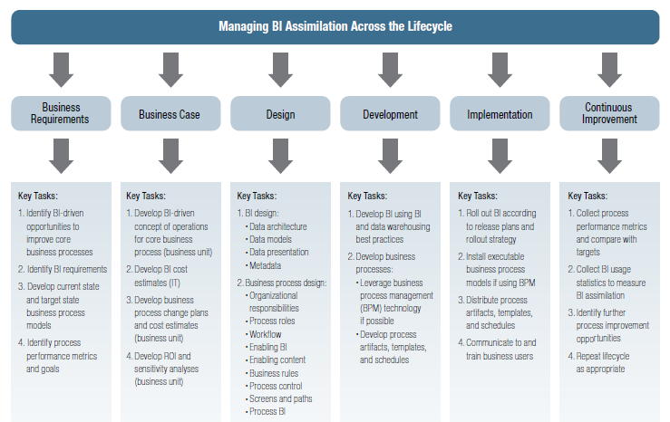Figure 5: Managing BI Assimilation across the lifecycle (Elbashir & Williams, 2007)
The first step concerns the definition of business requirements. Companies should identify and understand the business opportunities and requirements of BI within the specific business. The “Business Case” step, involves the integration of Business Intelligence into the organizational strategy and processes. Business managers must identify the changes that are needed in order for BI to be smoothly absorbed within the company and have a positive impact. The “Design the Business Process” step includes the reengineering the business processes so that BI can improve their performance. Methods that could measure this performance enhancement are also necessary. The “Develop the Business Process” step focuses on the technical and non-technical methods associated with the process development. Finally, the “implementation” and “continuous improvement” steps concern the release of business processes and the collection of performance data in order to identify the extent at which the initial targets were reached, accordingly.

Enterprise Resource Planning (ERP)
Enterprise Resource Planning (ERP) software products “allow customers to optimize critical business processes, and adapt them to ever-changing corporate needs and market conditions” (SAP, 1997).
Another interesting definition of ERP systems was submitted by Accenture in 2005, which defined ERP systems as “enterprise-wide applications that can streamline business processes, systems and information and help organizations access, manage and exploit data to make more-informed business decisions”, (Accenture, 2005).
ERP systems are used in order to automate, and integrate disparate business functions and processes, such as warehousing, financial management, supply chain management, project systems, human resources, accounting and finance into one coherent system. ERP products make data easier to find, update and analyze.
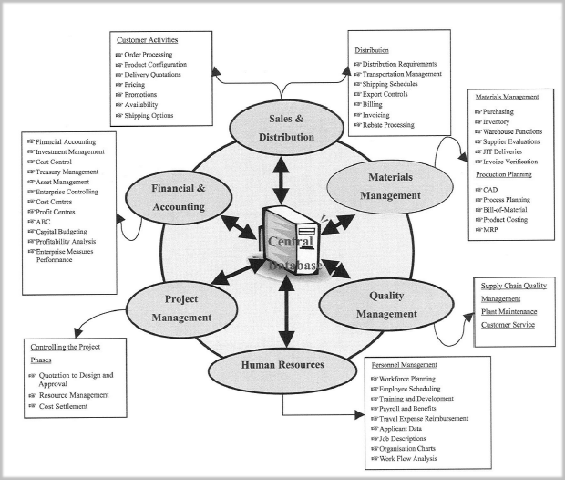
Figure 6: ERP system modules
The above picture depicts some of the most popular modules of ERP as well as the way they are centrally managed through a database. However, the names and the number of the modules may differ among the companies depending on their particular needs and/or to the different vendors. Regardless of the modules, information is shared through the central database and is distributed everywhere that it is needed.
According to the Business Process Management Journal, ERP is not just a software package. It is mainly considered as an infrastructure that “affects how people work” by “imposing its own logic on a company’s strategy, organization and culture” (Shehab, Sharp, Supramaniam, & Spedding, 2004). ERP systems do not only support the day-to-day business operations but also facilitate and improve the decision making process.
Some of the advantages offered by the ERP systems are the following:
- It contributes to the automation of the back office;
- ERP services are offered via an Internet platform, thus business operations costs are decreased since users (suppliers, customers, employees) can access all information and processes without the need of specific software or hardware;
- The same data and practices are shared across the entire organization, thus errors are reduced;
- Different types of vital information can be produced and accessed in real-time in order to improve the decision making capability;
- Customers’ satisfaction is increased;
- Flexibility is increased;
- Resources are better utilized;
- Information accuracy is increased;
- Processes such as human capital management, cash management, expense management, treasure risk and financial processes are improved.
Except for the above advantages, ERP systems also have some disadvantages the most important of which are the following:
- Huge storage needs;
- Implementation is costly and time-consuming (small businesses are usually prevented from adopting ERP solution due to the high costs);
- Lack of well-trained people leads to efficiency problems;
- Difficulty to maintain and/or integrate multiple ERP systems within the same company whether they come from the same vendor or not.
The Business Process Management Journal clustered the disadvantages into three broad categories as it can be inferred from the scheme below.
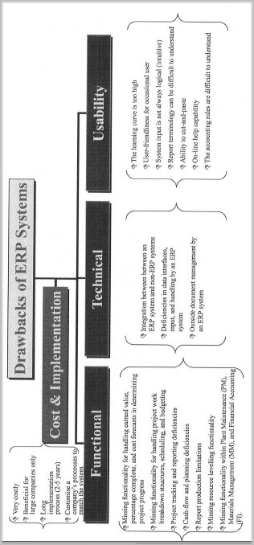
Figure 7: Drawbacks of ERP Systems
In order for companies to make the best out of an ERP system and to remain competitive, there are some selection criteria (according to the Business Process Management Journal) concerning the ERP system that have to be kept in mind. The most important are listed below:
- Matching the business processes with selected ERP system (the opposite is much more costly and time-consuming);
- Understanding several aspects of the organization such as the organizational and customer requirements, the characteristics of the manufacturing process, the supply chain strategy, the availability of resources, willingness and resistance to change, etc, very well.

Customer Relationship Management (CRM)
The Customer Relationship (CRM) system contributes to the automation of the front office by offering solutions to direct and indirect sales, marketing, customer service and customer contact challenges. “CRM is designed to align all areas of an organization to be more customer focused”, (SAP, 2000).
Forrester describes CRM as “a set of business processes and supporting technologies used to acquire, retain and enhance customer relationships. It encompasses the activities organizations use to understand, target, deliver and respond to customers across marketing, sales and services, as well as among external demand chain partners”, (Band & Gliedman, 2006).
By deploying either an on-premise implementation or an on-demand as web-based CRM, companies are enabled to capture customer data at the point of contact. By analyzing this information, they can acquire a better understanding of the customers’ purchase habits and/or service preferences.
With CRM, companies can acquire a better understanding of their current and potential customers, which leads to their building lasting relationships and improving customer loyalty. According to MIT Sloan Management Review in 2001, “getting close to your customer is the key to success in the marketplace” (Yu, 2001). Companies should keep in mind that CRM is more than just software and in order for its use to be successful, the customer’s point of view has to be taken into account.
Some of the most important advantages of CRM are claimed to be the following:
- Companies increase the value of customer relationships;
- Companies are enabled to gain a real competitive advantage by managing important aspects of business processes;
- Business processes associated with customer relationships are automated and improved;
- Customer satisfaction is increased by the service solutions.
- The firms are able to identify easier new market prospects and increase their potential sales opportunities, which in turn will create new revenue opportunities for them.

Supply Chain Management (SCM)
“Supply Chain Management (SCM) is the business process of managing the complex interaction of products, materials, equipment, labor and cash as they flow through the supply chain and fulfill customer demand”, (Connaughton, Lawrie, & Wildeman, 2008). “SCM systems transform SCM from a linear, sequential process into an adaptive supply chain network in which customers, partners and suppliers can synchronize their supply chain activities”, (SAP, 2000).
The most important advantages of the Supply Chain Management system are the following:
- Improved performance;
- Operating models are aligned to support business strategies;
- Optimization of global operations;
- Enhancement of the skills and capabilities of the supply chain workforce;
- Customers and business partners are enabled to communicate and share information more directly, hence improve their collaboration as well;
By integrating all partners in the supply chain, companies can more easily adapt to changing market conditions and proactively respond to shorter, less predictable product lifecycles.

Grid Computing
Grid software provides a cost-effective and high-performance platform (or middleware) with which companies can divide and apportion pieces of a program among several computers. This way, “a company has the ability to assign and reassign power to various applications”, (Oracle, 2005).
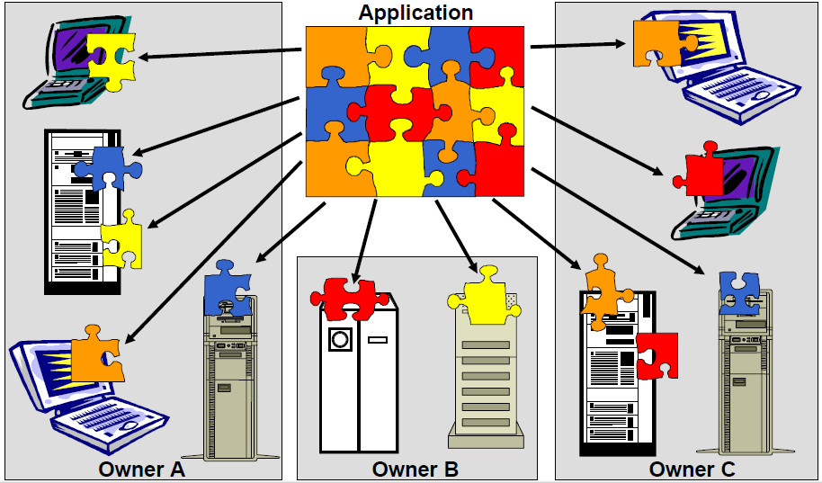
Figure 8: Grid Computing
Some of the advantages of grid computing are the following:
- There is no need for additional dedicated hardware that will support the specific applications;
- During the periods that particular business workload is increased, the risk of insufficient computer power is decreased.
The Internet is linked itself with grid computing. “Grid computing architectures will turn the Internet itself into a gigantic virtual computer that can tap and interconnect all the IT resources – not just information, but also tools – across multiple enterprises”, (IBM, 2001).

Linux, UNIX and open source software
Linux is a highly profitable platform; an alternative option to UNIX and Windows platforms. Even though Linux, like every other IT platform, poses challenges such as security, data backup and integration with existing systems in order to run key applications and access certain information, it provides customers with important benefits, some of which are:
- superior performance,
- excellent customer services, and
- reduced license costs compared to commercial software.
Forrester points out that open software is highly attractive to companies that can support in-house development. Since many of the open source are not as mature as the commercial ones when they come out, companies can alternate and customize them in order to better fit their business needs. Unfortunately, the same does not happen with smaller companies. These companies are more willing to reassure that the software to be adopted must be accompanied with support from its developers in case of need, since development problems cannot be coped with within the company (lack of in-house development).
According to Oracle, Linux offers the above advantages at a fraction of the cost of proprietary platforms. Microsoft on the other hand suggests that Windows is much less expensive. Linux and open software in general constitute a continuous challenge for Microsoft and this is obvious within the annual reports of 2002 until 2005. Bill Gates’ comment in 2003 was the following:
“Some organizations migrating from UNIX are considering noncommercial software such as Linux and Open Office. While the initial cost of acquiring a stripped-down, do-it-yourself operating system may seem attractive, a growing body of independent research shows that our integrated platform provides not only greater functionality but also lower total cost of ownership in most common business functions. […] Still, Linux and other noncommercial software present a challenge, and we are not complacent. We are working hard to ensure that our products and services continue to improve and meet customer demands for value. We are committed to exceed our customers’ expectations for product reliability, security and engineering excellence” (Microsoft, 2001).
Most of the companies have responded positively to Linux (and open software in general) since 1999, and major hardware and software providers such as Compaq, HP, IBM, Siemens and Symantec have designed and offer Linux-based systems, tools, databases and support offerings to their customers. It was only in 2005 that Microsoft admitted Linux had become competitive. The reasons that led to that were:
- IBM’s endorsement of Linux that aided it be established as an alternative to UNIX and Windows operating systems, and
- Computer manufacturers like the above that started offering hardware that was compatible with Linux operating systems.
- Computer manufacturers were also offering Linux as an option for standard operating system on their computers (Dell, HP)
By 2008, Microsoft has accepted that the company cannot lead in the operating systems sector, and collaborates with Linux providers in order to enhance the interoperability of its products with those introduced by Linux and open software manufacturers.

Virtualization
Based on the fact that leveraging the infrastructures already owned by the companies is becoming more and more important, virtualization is transforming the way computing capabilities are delivered and managed. “Virtualization technology is changing the way software is managed, delivered and consumed at the endpoint. Over time, as endpoints evolve to incorporate a range of computing and delivery models, virtualization will provide solutions to support and manage this complexity”, (Symantec, 2008).
There are many different types of virtualization: data center virtualization, server virtualization, virtualization in storage and client devices. The main usage of virtualization concerns the consolidation of multiple operating systems images onto one piece of hardware. In order to do so, Microsoft introduces Hyper-V, a technology that enables multiple operating systems to run on a single computer.
Virtualization is also used in order for the number of duplicate copies of data on a company’s storage devices to be eliminated/reduced. The accessing systems have the illusion that the files are stored as before (data de-duplication) while in fact, the data is stored only once. This reduces the cost of storage devices and media that hold information within the company.
Some of the advantages offered by virtualization are the following:
- Efficient management and flexible use of servers, endpoints and IT resources;
- Organizations are enabled to fully leverage their computing investments;
- Increased flexibility in order to adapt to changing business demands, requirements and workloads;
- Services can be managed holistically, ensuring high levels of resiliency.

Cloud Computing
Cloud computing is another Information Technology model in which providers deliver a number of IT-enabled capabilities to consumers and potentially create enormous opportunities for business growth. “Traditional enterprise IT will increasingly integrate with new cloud deployments, delivered as services via the Internet (also known as public clouds) or behind firewall (private clouds)”, (IBM, 2009).
In other words, cloud computing delivers a ubiquitous connectivity that enable users to access information, web-based applications and social networks anywhere and at any time. All the processes and services offered by cloud computing open the door to enormous productivity gains across businesses.
According to Gartner, cloud computing has four key characteristics:
- Delivery of capabilities “as a service”;
- Delivery of services in a highly scalable and elastic fashion;
- Using Internet technologies and techniques to develop and deliver services;
- Designing for delivery to external customers.
Some of the most important advantages of cloud computing are:
- Improved economics (especially for small companies);
- Flexibility, elasticity and scalability that allow companies to grow quickly.

On demand
The evolution of Internet based services introduces another new term within the Information Technology sector; on demand computing provides customers with the opportunity of meeting their IT requirements in “real-time”. Providers themselves have to “sense-and-respond” in order to gain a competitive advantage towards their rivals.
In 2004, IBM mentions: “CEOs might not use that exact term (yet), but a more responsive, virtually integrated company is increasingly what they are asking us to build. Companies like e-Bay, Bank of America and METRO Group and institutions like Miami-Dade Country and the new Museum of modern art are, on one degree or another, on demand enterprises” (IBM, 2004).
On demand computing is software delivered in a one-to-many framework (one solution served to many customers). With this technology, companies are enabled to align their Information Technology resources with the needs of the business. New technologies can be easily integrated with the existing ones in order for business goals to be achieved. On demand computing is about managing technology according to CA.
Since customers receive exactly what they are demanding for, pricing options vary. Subscription fees and/or transaction fees are the most common ways. Examples of processes that can be asked and provided on demand are the sales automation processes, core financial processes, configuration and performance analysis, personalized support and annual on-site technical services. In addition to the above, customers have access to solution support centers as well as business critical assistance.
Some of the most important advantages of on demand computing are the following:
- Information Technology costs are decreased, and
- Business efficiency is improved.

Green IT
Green IT aims at the creation of environment-friendly IT products and enterprises. Some examples of Green IT implementations are the following:
- Use of substances that exist within the environmental laws (non-toxic, easily disposable) in order for companies to produce their goods.
- Reduction of carbon emissions and overall energy consumption.
- Enterprise energy management: Companies gather information on how energy is consumed throughout the company and identify areas where the energy used can be reduced. This information is distributed across the enterprise and measures are taken in order for the company to cut the energy costs and emissions.
In view of the fact that there are more and more regulations and constraints over the years about the legal amounts of emissions that a factory can produce, and the impact that companies have on the environment are under scrutiny, some companies emphasize on their social behavior, trying to promote a more environment-friendly profile.

Outsourcing
Outsourcing is the procedure with which companies (customers) contract with other companies (providers) in order to provide certain services which would otherwise be performed within the company (customer). Outsourcing can be distinguished into three sub-categories according to the service that is being outsourced. These are: Business Process Outsourcing (BPO), Application Outsourcing and Infrastructure Outsourcing. The three sub-categories will be described separately in order to give a better insight to this trend.

Business Process Outsourcing
Business Process Outsourcing (BPO) refers to certain business processes such as finance, accounting, human resources, learning, procurement, customer contact and management services. In the case of specific businesses such as airlines or medical organizations, specialized services tailored to the customers’ specific needs can also be provided.
The most important advantages of Business Processing Outsourcing are the following:
- Service performance in core and non-core (e.g. accounts payable, policy registration, call centers) operational functions is improved;
- Productivity is improved considerably;
- The organization can focus to the core operations;
- More efficient and cost-effective solutions in general.
Except for providing BPO services for individual processes, two or more processes can also be bundled horizontally to provide customers with even greater efficiencies, control and cost savings.

Application Outsourcing
Application Outsourcing aims at helping customers to improve the overall performance of application development and maintenance by managing application services such as application testing, application management of enterprise-wide software programs, capacity services, application enhancement, development, application rationalization and consolidation, etc.
The most important advantages of application outsourcing are the following:
- Better maintenance and control of the performance of a company’s Information Technology capabilities;
- Reduction of the complexity and costs associated with managing third parties;
- Increased flexibility, predictability and security of a company’s IT infrastructures.

Infrastructure Outsourcing
Infrastructure Outsourcing delivers an integrated set of managed infrastructure services. Examples of infrastructure outsourcing include asset management, data server services, network services, desktop management, security services (firewall protection, identity management, etc), remote technology support services, etc.
The most important advantage of infrastructure outsourcing is that:
- Clients are offered a more cost-effective, secure and responsive infrastructure that can be scaled and adapted to their business needs.
An interesting opinion about outsourcing is given by CSC in 2000. CSC considers web hosting as a form outsourcing in the sense that the “host” provides the infrastructure for another company to run its web-based applications.
Outsourcing is considered a partnership by CSC and the trend itself is growing towards multisourcing (or worldsourcing). More and more processes are outsourced and more and more professionals from all over the world are offering such solutions. Outsourcing has to be a collaboration of “best-of-breed” partners that will improve the overall performance within the company. The traditional idea of outsourcing being a collection of contracts that would simply lower costs is transformed.
According to the further literature review, the current situation of outsourcing is characterized by two contradictory facts. On the one hand, the outsourcing market is growing and firms are outsourcing like never before. On the other hand outsourcing is not delivering the business value expected. To let numbers talk, CSC mentions in 2005’s white paper that “50% of the deals fail completely while 75% fail to deliver the value expected by both parties”, (Computer Sciences, 2005).
The explanation for this contradiction lays in the initial concept of outsourcing. Since businesses become more and more complicated, it becomes highly attractive for companies to transfer the load of certain processes to specialized partners. Even if the outcome is not the one initially expected (and the outsourced processes are not performed in the best possible way), companies can still reduce the costs and the risk of performing everything themselves as well as focusing on the key business goals and core competencies.
In 2005, CSC introduces a new approach of outsourcing called “Dynamic Sourcing”. This approach focuses on the long-term relationships of business partners that lead to collaborative business models aiming to accommodate innovation within the companies by focusing on business objectives rather than technological goals. There are five basic principles for dynamic sourcing to be successful:
- Focus on business outcomes: companies should define their business objectives in order to link the IT innovations with the business strategy. Each change within the IT department must add business value to the company.
- Create a collaborative Sourcing Model: Having multiple suppliers for the different outsourced processes might cause collaboration issues. In some cases different partners might have to cooperate in order for the company’s efficiency to increase. In other cases, outsourcers might have to adapt the offered processes to the client’s needs (e.g. re-engineering of a company’s internal processes leading to different outsourcing needs).
- Align client and supplier intentions: Clients must know exactly what the outsourcers have to offer from a business perspective. At the same time, they have to be realistic about what can be offered to them (maybe their goals are unrealistic and no outsourcer can reach them). Transparency, collaboration and disclosure between the suppliers and the clients are necessary.
- Build mechanisms for sustainable transformation: the transformation from the company’s initial processes to the ones delivered by the outsourcer must not be aggressive. Customers have to gradually adopt the new processes in order to make sure that they will be optimized and that their goals will eventually be met.
- Ensure appropriate systems of governance/alignment: Companies must carefully combine the capabilities offered by the various partners in order to reach their goals.

Wireless/Mobile Solutions
As businesses become more and more complicated, employees need “anywhere anytime” access to processes and information so that they can work effectively and efficiently. In order for workers to be able to remotely/wirelessly access the enterprise networks, companies started to implement wireless networks, Wi-Fi hotspots, Virtual Private Networking (VPN) and Network Service Providers (NSPs). At the same time, mobile devices such as Personal Digital assistants (PDAs), laptops, Smartphone devices, etc, are becoming a necessary part of doing business.
An interesting opinion is submitted by Gartner: “mobile devices turned on all the time are ultimately the most powerful channel of all and one that businesses cannot afford to ignore”, (Gartner, 2002). The existence of wireless Internet helps e-business to improve and become universal. With all the mobile technology and the new generation devices, all the parts and participants within a company can be better connected and synchronized. All the important tasks can be performed in real time and efficiency, as well as effectiveness, of the business is improved.
Apart from the wireless networks and devices, Radio Frequency Identification (RFID) is another important offered service of wireless/mobile technology. “RFID is a technology that incorporates the use of certain radio frequencies to uniquely identify an object or person via small tags”, (SAP, 2004). Gartner categorizes RFID under the broader category of location-aware services. Such services are useful in order to trace and find moving items, contacting persons based on their location and improve asset utilization of moving items by determining their status. Forrester, on the other hand, considers RFID as the main sub-category of the Extended Internet (X Internet). X Internet consists of these technologies that focus on connecting the physical with the digital world.
The picture below shows how RFID provides data throughout the product lifecycle.
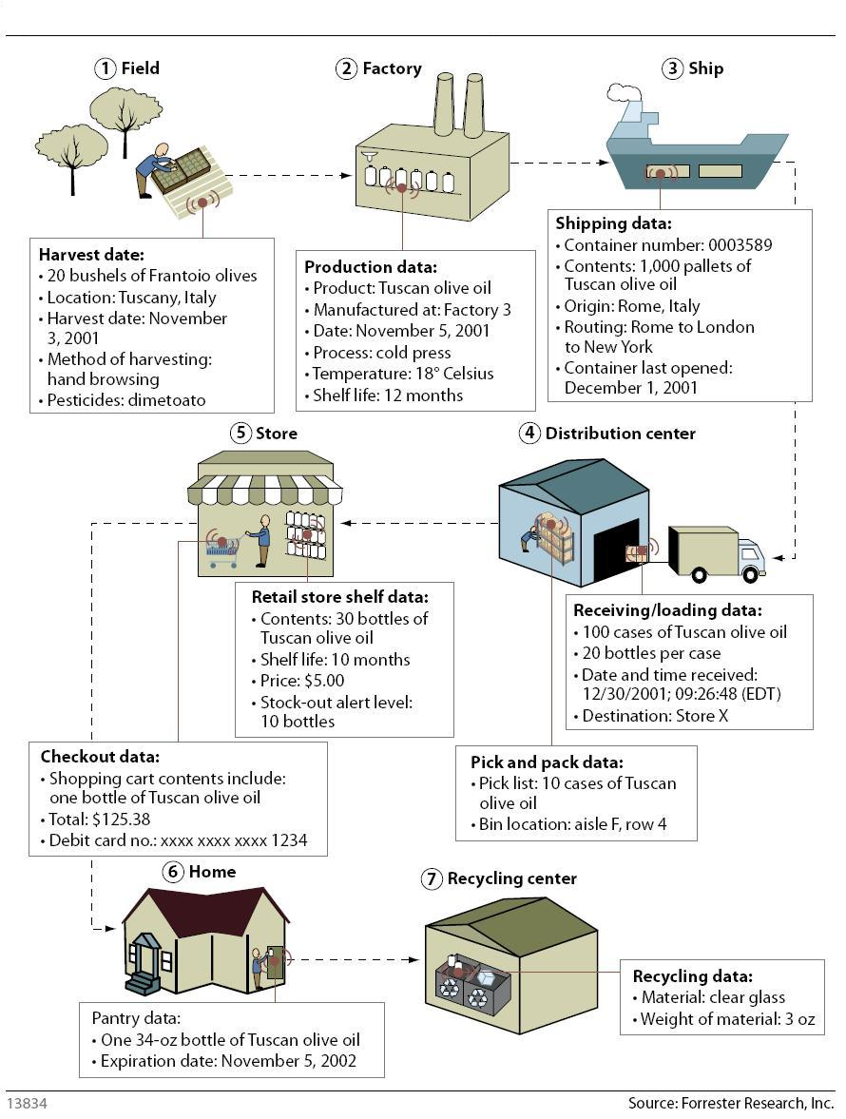 Figure 9: RFID lifecycle (Forrester)
In the annual report of 1999, IBM describes one of the initial reasons that led to the increased research and investment of IT companies on mobile and wireless technologies. The reason was the appearance of new-generation applications such as videoconferencing, virtual-reality manufacturing and telemedicine, etc. The possibility of applying the mobile and wireless technologies to many more scientific areas than just businesses was motivating for researchers and investors that would see the results of their efforts applied in some area of the everyday life.
The most important advantages of mobile/wireless technology are the ones that follow:
- Communications are improved;
- Service excellence is not compromised;
- IT departments become more effective and efficient;
- Remote professionals can remain productive by accessing applications, processes, data and information by any location and at any time;
- All offices and partners of a business are connected in a high speed and cost-effective way;
- Physical assets are managed better (RFID benefit);
- Businesses lower their costs (costs that previously occurred from expensive dial-up services and mobile phone charges).

Web 2.0
Web 2.0 refers to web technologies that facilitate the sharing of information within the Web, the collaboration, interaction and interoperability of web applications. According to Gartner, Web 2.0 has three facets:
- web technology, like Ajax;
- web communities, like mySpace or Facebook; and
- web businesses like amazon.com.
According to CSC, an example of a Web 2.0 technology is the mash-ups. In a mash-up, functionality from one source or application is mixed with functionality from other sources or applications. A transportation company, for example, is enabled to mix her schedules with maps provided by Google in order to let her customers know the exact time a medium of transportation is going to be in a certain location.
In 2007, Forrester defined Web 2.0 as “the next generation of offered web sites, applications and processes”; “the set of technologies and applications that enable efficient interaction among people, content, and data in support of collectively fostering new businesses, technology offerings, and social structures”.
According to Forrester, Web 2.0 applications are enabling a higher level of business efficiency since they provide users with easier access to enterprise data, while the human-centric processes are becoming more proficient. Moreover, Web 2.0 applications are being collaborated with traditional enterprise data sources, such as CRM and ERP, making the availability of essential business data permanent, which in turn results in better decision making.
In the same manner, “the new kinds of applications and content delivery methods (offered by Web 2.0) have revitalized web-based business models and have fed into major IT technologies, such as Service-Oriented Architecture (SOA), Software-as-a-Service (SaaS) and Open Source Software (e.g. Linux)”.
However, technology is the easy part. As stated, “while it is critical that any company investing in Web 2.0 understand and master the technologies and applications, the ultimate goal is to foster productive, advantageous behavior among employees, customers, partners and other networks”, (Young, 2007).
Another interesting finding is the impact of Web 2.0 technology to the social computing. According to Forrester, Web 2.0 is shifting the way people, content and data are interacting, since “individuals are increasingly taking cues from one another, rather than from institutional sources like corporations, media outlets, religions and political bodies”. The above is reinforced from the fact that extensive connectivity, shared computing resources and cheap devices are having a profound impact on today’s global economy and thus people are able to interact with content and with each other whenever and however they like.

B. Prediction Methods

Forrester’s Methods for predictions
Forrester is an independent research company that aims at delivering advice to major companies in order to make them leaders within their sector. Forrester’s researchers focus on the clients’ needs and by taking into consideration that each business is unique, they try to align their services to the customers’ agenda.
The methodology that Forrester uses in order to evaluate software and hardware products and services and “identify” the forthcoming Information Technology trends is called the “Forrester Wave”. In short, with the wave methodology, Forrester gathers a large number of vendors and products and creates certain criteria in order to grade both. Clients can modify these criteria according to their priorities so that in the end they get the most appropriate evaluation according to their needs.

The Wave Participants
In order for the Forrester Wave to be created, the participation of five key players is necessary:
- Analysts: they are responsible for developing the criteria and the scoring framework that will be used in order for the vendors and their products and services to be evaluated later on. They participate in the data gathering by making sure that only correct and useful information is being used.
- Research Associates (RAs): they are the main point of contact for the vendors that participate in the research. Depending on the research needs, they might also take part in customer reference calls, lab days and product demos.
- Content Editors: they are responsible for supervising the wave procedure. They take part in every step by giving or not their approval to continue.
- Vendor Response Team: the participation of the vendors whose products are going to be evaluated within the wave is necessary. The response team is responsible for giving Forrester the information about the company as well as its products and services. The information can be shared in the form of product demos, questionnaires, vendor surveys, hands-on lab evaluation. With product demos and questionnaires vendors can demonstrate details of their products’ functionality and capabilities; vendors’ surveys aim at gathering data about the vendors’ strategy as well as market presence; the hands-on lab evaluation is a scenario-based testing method within which all products are evaluated by running the same scenarios (useful in order to compare products). This way, companies can customize the information about themselves that will appear in the final Wave.
- Customer References: in order for Forrester to be able to check the validity of the information the vendors provide, she asks for customers references. By taking the customers’ experiences with the vendors and their products/ services into consideration, the information provided by Forrester is more valid.

Preparation before creating the Wave
Before start occupying with the steps that will create the Forrester Wave, analysts have two tasks to prepare. They have to research the category thoroughly as well as selecting an evaluation method. Researching the category thoroughly includes finding a market sector/area or product/service category within which clients seem to have a number of inquiries or seem to be confused about. Creating a wave about products the capabilities of which are clear to customers is of low value. The above research also refers to identifying the major players within the area as well as making sure that customers will have to make investing (or buying) decisions within the next few months.
Selecting the evaluation method concerns choosing among the product demos, questionnaires, vendor surveys and hand-on lab evaluations as they were explained in the previous sub-section. This choice depends on the market area the wave is being created for as well as the products within it.

Forrester Wave Process Road Map
The process in order for a Wave to be created consists of five key milestones each of which offers specific deliverables. Each of these steps is explained below.
Milestone 1: Create evaluation criteria
In order for the analysts to create the evaluation criteria, they have to find the elements of the products or services on which clients should focus. The criteria should provide customers not only with detailed descriptions of each product/service, but should help them distinguish products as well. Each one of the criteria should be followed by an explanation so that the users will be able to easily understand them.
In cases where the analysts have decided to conduct lab-based evaluations, the scenarios for these evaluations are also created within this first step.
Important note: when deciding the above criteria, analysts have in mind that they have to evaluate each company on their:
- Current offerings,
- Strategy,
- Market presence.
Current offerings refer to the strengths and weaknesses of each product such as the extent of reliability it offers, the usability, the support services that are offered in cases of need, the overall architecture when software products are under evaluation, the integration capabilities with already existing systems in the company, etc.
Strategy refers to the directions each vendor plans to follow in order to evolve his product/service and meet customers’ emerging demands. The commitment of vendors to both the evolution of their products as well as the customer service is a very important decision factor.
In order to evaluate the extent at which each product’s market presence will be established, analysts gather information about each company’s financials, partnerships, international presence, strength in key industries, etc.
The figure below shows how all the above criteria and information are used in order for a wave to be created.
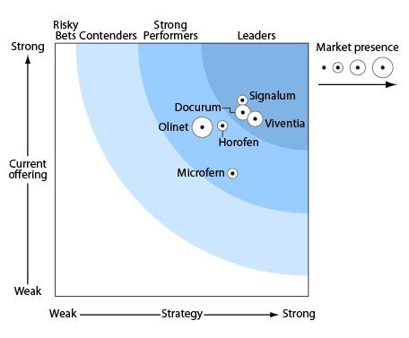
Figure 10: Example of a Wave
Milestone 2: Select Vendors
After Forrester’s researchers and analysts decide the area upon which a Wave will be created, they have to finalize the group of vendors that will be included. The main criteria that are usually followed have to do with the extent at which vendors’ products fit the general category of the wave, the vendor’s must be successful within the market and Forrester’s clients must show particular interest towards them.
When the group of vendors is finalized, Forrester sends to each one of them an invitation in order for them to participate in the evaluation process. Together with the invitation, vendors receive information about the criteria upon which their products will be criticized. In cases when vendors decide not to participate in the research procedure, Forrester might still decide to include information about them based on information already available to the analysts.
Milestone 3: Gather Evaluation Data
The third step concerns the gathering of the evaluation data with analysts conducting the following actions:
- Distribution of questionnaires to those vendors that have agreed to participate in the evaluation;
- Lab-based evaluations are conducted and product demos are presented when necessary;
- Reference calls are taking place: vendors’ customers give their own evaluation based on their personal experiences with specific vendors.
After all the information is gathered, analysts create a draft scorecard for each vendor and send it back to the vendors in order to receive their feedback. This is an effort to provide as accurate information as possible. If vendors have questions about the results that have occurred through the previous steps RAs contact them in order to resolve all discrepancies. The validity of the final information is really high since vendors not only participate in providing information about them but they are also aware of the data analysis.
Milestone 4: Create Vendor Comparison Tool and Write Forrester Wave Document
The fourth step of the Wave evaluation procedure concerns the following tasks:
- Development of a vendors’ comparison tool;
- Final scorecard review by each vendor (vendors can check for typing errors; no further adjustments can be made to the scorecards even if they do not agree with what they contain);
- Writing of the Wave document which contains Forrester’s overall overview of the market as well as comparisons of the vendors according to their strengths and weaknesses.
The comparison tool allows the users to view the scorecard of each vendor and add or remove details according to their needs. The following pictures depict the scorecards and the possibility of adding/removing details.
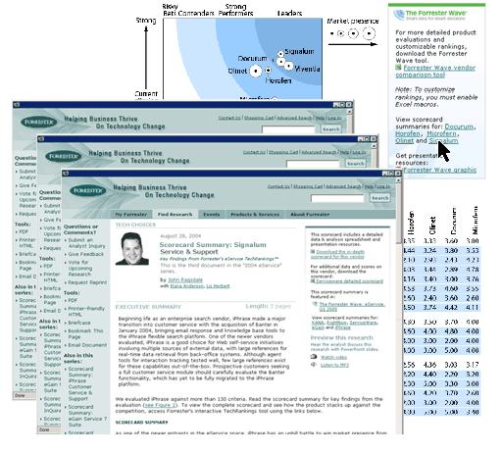
Figure 11: Vendors’ scorecards with general information about the vendors
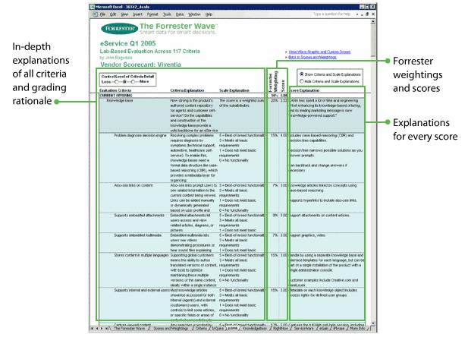
Figure 12: Scorecard details
Another possibility the users of the Wave tool have is the comparison of the vendors in the different areas.
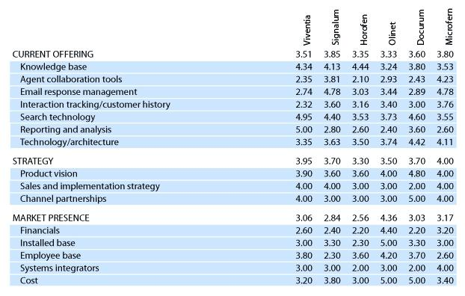
Figure 13: Vendors’ comparison scores
Finally, users can customize the criteria they use in order to receive scores according to their personal needs, thus the evaluation is personalized.
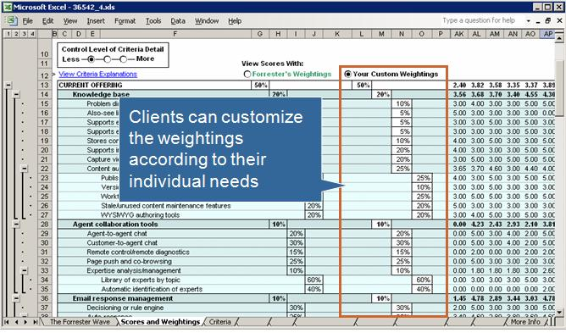
Figure 14: Customers can customize the criteria used to receive scores

Milestone 5: Publish
Forrester distributes copies of the Wave to the participating companies and a few days later, the Wave is also available on Forrester.com.

Benefits of the Wave Evaluation Process
The most important benefits of the wave evaluation process are already mentioned above but are also gathered here for facilitating reasons:
- The transparency with which the scores are created (vendors know beforehand the criteria upon which they are evaluated and they have the chance to participate in the evaluation process);
- Customers can personalize the results of the research conducted by Forrester and use the information they exactly need. They are also enabled to compare products and vendors, thus make more informed decisions that will add value to their companies.

Gartner’s Methods for predictions
Gartner is one of the largest research, consultancy and analysis firms worldwide, especially as far as the Information Technology industry is concerned. According to the company itself, their aim is to “deliver the technology-related insight (from strategy until execution) necessary for their clients to make the right decisions” (Cheng, 2006). Gartner focuses on the analysis of how to apply technology in the solution of business problems as well as how to improve business processes and optimize IT infrastructure with innovative investments.
In order for Gartner’s insight and global perspective to be easily usable for the CIOs and IT managers, the company uses some graphic representations. The representations which are related with the predictions of new technologies are the Hype Cycle and the Priority Matrix. “Hype Cycles and Priority Matrices are management models that help organizations understand the landscape of technology maturity and markets, and to decide which technology innovations to adopt, postpone or ignore, and when is an appropriate time to adopt” (Gartner, 2010).
Both methods will be described in the following subsections.

The Hype Cycle
Gartner introduced the idea of Hype Cycle in 1995, but it was not at that moment a methodology. In fact, it constituted a commentary of Jackie Fenn who observed that technologies tend to go through a cycle of over-enthusiasm and disillusionment, before their role in the market is actually understood. In the years that followed Hype Cycle became a way to track emerging technologies within the Information Technology industry.
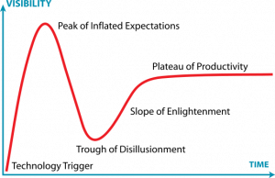
Figure 15: Simple depiction of the Hype Cycle
The five phases of the Hype Cycle are depicted more clearly in scheme 2. Each of the phases is explained as follows:
- Technology Trigger: this is the first phase of the Hype Cycle and is also referred to as breakthrough. We have a technology trigger with the launch of a new product or other event that generates significant press interest.
- Peak of Inflated Expectations: this is the next phase in which a frenzy of publicity leads to over-enthusiasm and unrealistic expectations. This leads the technology to having many failures. Even though there might be successful applications as well, the failures seem to overshadow them.
- Trough of Disillusionment: this phase is a result of the previous one. Since the expectations of a specific technology are too many (and most of them are unrealistic), it is inevitable that the technology will fail most of the expectations and will quickly become unfashionable. At this point, press loses its interest and stops paying attention to the topic.
- Slope of Enlightenment: even though the press has abandoned the topic, not all the companies have as well. Since “IT people” within the businesses continue the efforts of understanding the technology, they eventually start to understand its benefits as well as practical application.
- Plateau of Productivity: the plateau of productivity is reached once the technology has been adequately understood and its benefits have been broadly accepted. At this phase the technology becomes more and more stable and in some cases it even faces some adaptations and/or enhancements according to its usability. The final height of the plateau depends on whether the technology is widely accepted or not.
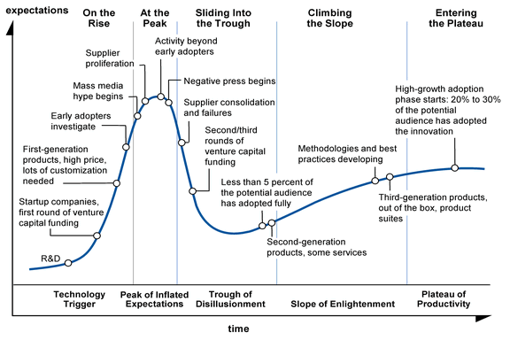
Figure 16: Analytical depiction of the Hype Cycle
Each year, Gartner creates the Hype Cycles of all the important technologies by studying the time since their introductions in the market as well as the consumers’ behavior towards them. After each technology is placed at the right position within the diagram, companies can estimate the risks they run and the benefits they will enjoy by adopting each of them. For example, if companies adopt a technology too early (before the slope of enlightenment), they will gain competitive advantage but they will probably not understand it completely. If they adopt it too late (when technology has reached the plateau of productivity) companies know exactly what to expect but the competitive advantage is gone.
In order for Gartner to give even more information about the technologies to its customers, timeframes about the speed with which each technology will reach the plateau are usually included as well, as depicted in figure 3. This is necessary since not all technologies “stay” within each phase for the same amount of time. Another important piece of information, also depicted in scheme 3, is the vertical gray lines that clearly separate the phases from one another.
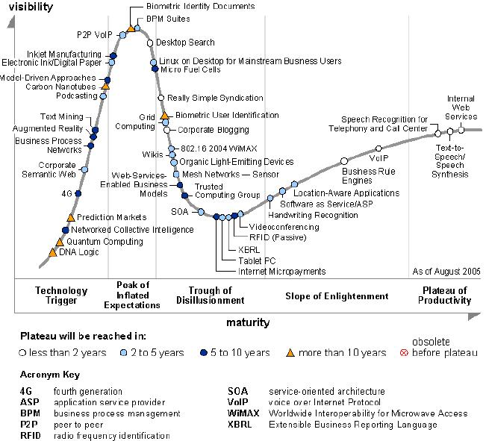
Figure 17: Example of Hype Cycle (Hype Cycle of 2005)

Components of the Hype Cycle
Public’s perception of the value of a technology is formulated by two factors:
- The expectations of people when it comes to this technology (expectations about the future value of a certain technology). These expectations might be created by people’s simple observation and understanding of the technology so far, or by the press. Usually, people become easily enthusiastic when something new is launched in the market. But enthusiasm dies as easily as it has been created.
- Real engineering or business maturity as perceived in the form of real experiences. This maturity is being built slowly and steadily via the use and the deep understanding of this technology.
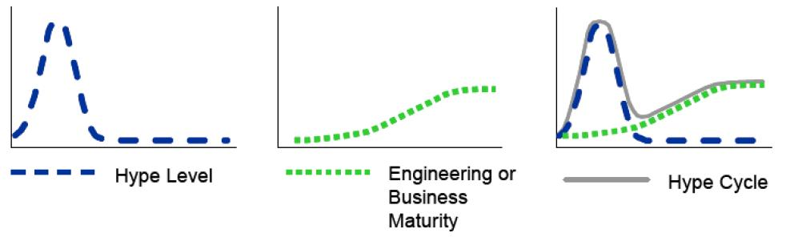
Figure 18: Components of the Hype Cycle
Enthusiasm is visualized with the first curve of scheme 4 while engineering or business maturity is visualized with the second curve. The combination (or sum) of these two curves results in the Hype Cycle. Within the Hype Cycle curve both enthusiasm and real maturity are depicted and at the right “timing” as well; maturity follows the enthusiasm (and disillusionment) as in real life.

Deeper into the Hype Cycle
Within the book “Mastering the Hype Cycle”, the authors suggest a systematic adoption model for proactive innovation management and decision making. The model is called STREET and its goal is to help customers identify and invest in the right technologies early enough so as to gain competitive advantage but at the same time, late enough so as to have enough knowledge and manage risk.
STREET is an acronym that can be explained as follows:
- S stands for Scope: companies must have a very clear mission: the objectives, strategy, needs and values must be identified and deeply understood before the business opportunities are evaluated. The scope stage is where companies decide what’s valuable for them and how much risk they’ll take to get it. They need to determine why they need to innovate as well as how aggressive the organization wants to be with respect to the innovation adoption. (Fenn & Raskino, 2009)
- T stands for Track: after defining its goals, the company should check for alternative innovation solutions in order to reach them. Apart from seeking innovations within a broad range of sources, companies should also find a way to watch the progress of each innovation through the Hype Cycle. This way, both the extent at which each innovation matches the organization’s goals and the extent of risk the company will be exposed at will be defined. To make the long story short, this stage is about “tracking” worthwhile innovations.
- R stands for Rank: after finding the alternative candidate in the above stage, it is now time for ranking. The potential of each innovation as well as its ability to be absorbed within the company will be investigated. At the same time, innovations will be compared against each other.
- E stands for Evaluate: the above ranking is not enough to decide among the top candidates. By using a range of investigation methods, important points such as the speed of progress of each innovation and the right time to adopt are defined. At the end of this stage one of the following decisions is taken:
  - The company identifies the right innovation and proceeds with adoption,
  - The company returns to the track stage and seeks for more candidates,
  - The company drops the idea of innovating.
- E stands for Evangelize: this step is only taken after an innovation is decided to be pursued. In order to overcome organizational resistance, the company needs to inspire, educate and persuade its employees about the necessity of the changes that are about to follow.
- T stands for Transfer: this stage has to do with the general acceptance of the innovation by all those that are involved in the changes. For successful transfer, the employees with key responsibilities such as driving and/or using the innovation should be involved in the early stages of the STREET process, especially in the evaluation stage (Fenn & Raskino, 2009).
An important observation is the following: STREET is not a six-step forward flow process. As it is clearly depicted in scheme 5, the six stages are not tended to be followed sequentially. The users are encouraged to move backwards whenever it is necessary and in order to make sure that only the right decision will be taken in the end.
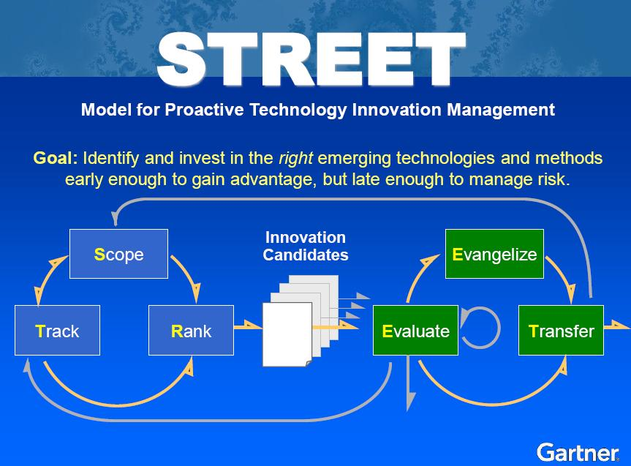
Figure 19: STREET process diagram

Traps, opportunities, challenges, advantages
Despite the fact that the Hype Cycle is considered as a very accurate analysis method by Gartner, there are still some traps that users should be aware of. Scheme 6 places the traps within the phase of the Hype Cycle that they might occur.
As it has already been explained, by adopting too early a company runs the risk of not being able to understand completely the new technology neither to be able to find experts on it. This is completely normal since the technology is newly introduced and it has not been used much in practice in order for its real possibilities to become clear. Instead, the technology is still through the stage of over-enthusiasm, which means that expectations are many more than what the technology can really offer. A company investing at this stage of the Hype Cycle is very probably that will be soon disappointed since the next phase is the one of disillusionment.
Giving up too soon is also a trap. Companies that adopted a technology too early in the Hype Cycle will be deeply disappointed since most of their expectations (those that were created during the phase of over-enthusiasm) will not be met. But giving up just when the disappointment has reached its peak is a huge mistake. Companies should be patient because soon the real possibilities of the technology will rise and they will have the competitive advantage. Of course, what the technology will be able to offer has nothing to do with the initial (false) expectations, but things cannot become any worse.
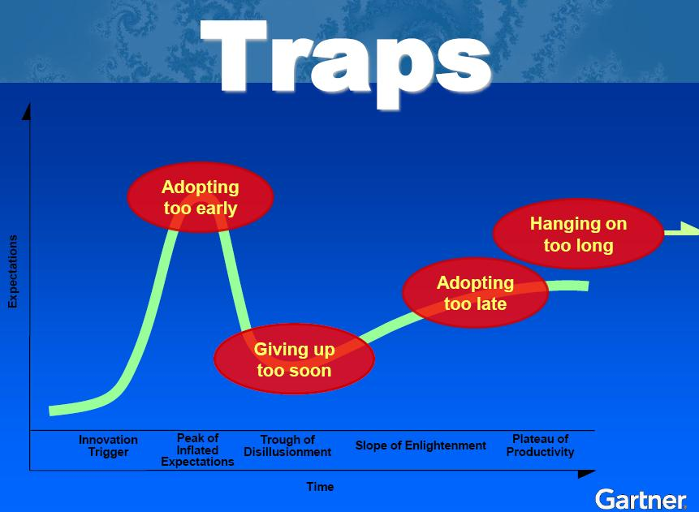
Figure 20: Traps of the Hype Cycle
Adopting too late, when the technology is completely understood and all its advantages and disadvantages have been revealed by other companies that have been using it already is a trap as well. At this moment, companies know exactly what to expect from the technology but at the same time they have lost the competitive advantage they would have if they adopted earlier.
Hanging on for too long is the last trap. No matter how much a technology has offered to an organization, it cannot be used for ever. Companies should be able to identify not only the right timing to adopt a new technology but also, when is the right timing to give up an existing one. Companies should constantly check on new technologies and should constantly update their goals. They should not blindly rely on anything that offers benefits at the moments; instead they should seek for new challenges without being afraid to invest on innovation when necessary.

Behavior of the Hype Cycle
Gartner supports that the Hype Cycle is not just scientific but also behavioral; it is about human attitudes towards innovation. Investment decisions are not taken according to economic factors only. The excitement, frustration and in general the interest within the market, also play a role.
The area of emerging technologies is not the only one that the Hype Cycle applies. As Jackie Fenn mentioned in one of her interviews, “Hype Cycle is a graphical representation which resonates with people, and applies to human attitudes beyond just technology…A client even commented once that Hype Cycle describes his personal relationships exactly!”.
To talk with more evidence, stock prices follow the Hype Cycle. Scheme 7 depicts the Amazon’s stock price for the period 1998-2005, which included the boom and bust of the Internet.
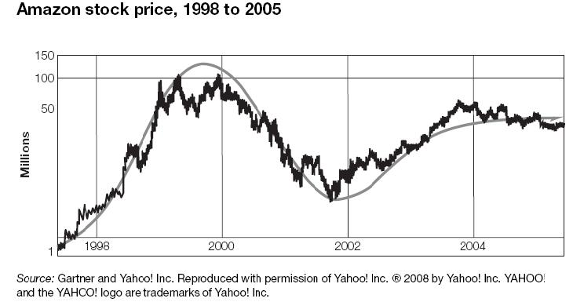
Figure 21: Stock price is another appliance of Hype Cycle
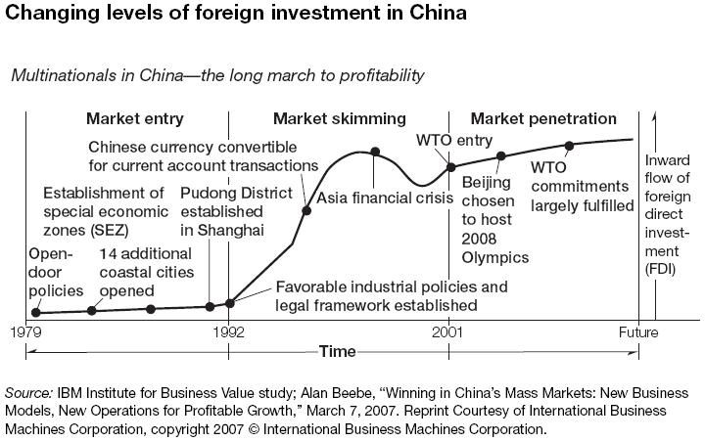
Figure 22: Investments is another appliance of Hype Cycle
This Amazon chart is not the only example. The stock price charts of other companies like Yahoo! which also invested on Web’s innovative possibilities followed exactly the same pattern within that period.
Another area where Hype Cycle can be found is macroeconomics and particularly in the recent “gold rush”. Gold rush refers to the fact that more and more multinational companies make aggressive investments in China in order to enjoy the benefits of the market’s rapid growth. The statistics for direct foreign investment are provided by the Chinese government and are depicted in scheme 8.

The Priority Matrix
The priority is another graphical method used by Gartner. The Priority Matrix is a tool for prioritizing emerging technologies by forcing technology planners to look beyond the hype and assess technology opportunities in terms of their relative impact on the enterprise and the timing of that impact (Gartner, 2010). A depiction of the Priority Matrix can be seen in scheme 9.
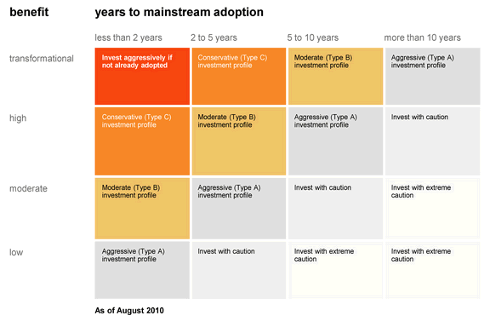
Figure 23: Gartner’s Priority Matrix
The Priority Matrix is giving information about the extent of benefits that an enterprise can gain from a technology as well as the timing upon which the technology will be able to deliver these benefits without much risk.
The vertical axis of the Priority Matrix depicts the level of the potential benefits that the technology can offer. The horizontal axis groups the technologies according to the time they need in order to become mature. The maturity has the same meaning as within the Hype Cycle. It refers to the number of years in which the technology will be mature enough to be adopted without losing completely the competitive advantage; the time when the technology will have gone through the disillusionment stage and will be moving towards the slope of enlightenment.
As its name reveals, Priority Matrix prioritizes the potential investments by placing the ones with higher priority in the top-left portion. The investments that appear in that part of the matrix will provide the organization with a high level of benefits and, these benefits will be realized at a short period of time.

Chapter 4 – Empirical Data
This chapter will focus on the empirical data that was gathered through semi-structured interviews with and questionnaires to CIOs and IT managers. In other words, the empirical research conducted can be divided into two sub-parts.

Semi-structured interviews
We conducted four interviews with the following people:
- Johan de Wit, former CIO of ING Bank, owner of Nuphar.com and Associate director of CIOnet NL;
- Kostas Gerogiannis, former CIO of NS;
- Gerard van der Velde, Information Manager Distribution, KLM IMO Sales;
- Bart Luijten, VP of IT Strategy and Planning at Philips;
The conducted semi-structured interviews aimed at evaluating the list of the top-10 IT companies, the list of forecasting companies and the list of IT trends before distributing the questionnaires to the rest of the CIOnet members. The feedback we received from the interviews was used to transform and adapt the lists several times before resulting in the final ones. This way, we were convinced that the data to be evaluated was accurate, valid and closely related to the main topic and that nothing important was missed.
The top 10 Information Technology companies are the ones below:
- Accenture
- Computer Associates (CA)
- Computer Sciences (CSC)
- EMC
- Hewlett Packard (HP)
- IBM
- Microsoft
- Oracle
- SAP
- Symantec
The list of the most important IT trends was finally formed as it follows:
- Enterprise Portal Deployment/Web Services
- Application Integration/Middleware
- Customer Relationship Management (CRM)
- SAN/NAS Storage Management
- Service-Oriented Architecture (SOA)
- Software-as-a-Service (SaaS)
- Business Intelligence (BI)
- Enterprise Resource Planning (ERP)
- Grid Computing
- Linux/UNIX and open source software
- Virtualization
- Outsourcing
- Cloud Computing
- Green IT
- Supply Chain Management (SCM)
- Mobile Technologies (including RFID)
Below, we gather the information that occurred from the semi-structures interviews and concern each of the above trends.

Enterprise Portal Deployment/Web Services/Web 2.0
According to Mr. Gerogiannis, former CIO of NS, the enterprise portal deployment helps a company improve the relations with its customers, affecting in the same manner the offered services. Mr. van der Velde, Information Manager Distribution at KLM IMO sales, confirmed the above by highlighting its crucial importance for conducting e-business, especially for companies where communication with customers is of very high importance, such as an airline company. Mr. Luijten, VP of IT Strategy and Planning at Philips, pointed out that the enterprise portal deployment and web services are considered as huge IT trends and that Philips itself has been spending millions in investing to the above technologies. In order to let numbers talk, Mr. Luijten characteristically mentioned that Philips spent two million Euros during the last two years for investigating new opportunities and further possibilities of the above technologies/trends.

Application Integration/Middleware
Regarding the application integration/middleware trends, we witnessed two different approaches from the interviewees. According to Mr. van der Velde, application integration has been ignored lately from business firms due to time constrains. He mentioned that although application integration should be important, business firms nowadays pay more attention in providing customers with a greater variety of products and services in order to achieve a higher profit than investing in integrating existing applications or middleware software. According to him, the economic crisis is the major factor for leading most of the companies in such behavior.
The second approach that was followed from the rest of the interviewees was that application integration and middleware software in general are very important trends in IT business. Specifically, Mr. Luijten highlighted their importance for multinational companies, such as Philips. In addition to the above, Mr. de Wit pointed out that there is a strong connection between the Service-Oriented Architecture and middleware software, since the latter belongs to the application management layer of the firstly mentioned. In the same manner, Mr. Luijten reported that the future of middleware lies to the Service-Oriented Architecture.

NAS/SAN Storage Management
Mr. de Wit and Mr. Gerogiannis made explicit that NAS/SAN Storage Management mainly has an IT and not a business impact to the companies. According to them, both storage management approaches solved the problems related to disk management, which resulted in more reliable data storage, which in turn resulted in better data management by the invested companies in general. Mr. van der Velde stated that although such technologies are adopted at a high rate by nearly every company, there are still many problems occurring, rendering the above technologies unstable. For Philips and large multinational companies in general, SAN/NAS Storage Management technologies are considered as irrelevant, thus the above technologies are being outsourced to third parties, as Mr. Luijten mentioned.

Service-Oriented Architecture (SOA)
Nearly every interviewee made it explicit that the Service-Oriented Architecture (SOA) has a major impact in today’s Web services. This derives from SOA’s ability to govern how external and internal systems will interact. In other words, SOA defines how Web services communicate with each other. According to Mr. Gerogiannis, the Service-Oriented Architecture (SOA) can be divided into 5 distinguishable layers, which are the following:
- Presentation layer,
- Process layer,
- Application layer,
- Communication layer, and
- Data layer.
Mr. Gerogiannis highlighted the importance of the SOA trend. According to him, this technology is capable of providing solutions for many problems and most importantly to help companies transform their processes, from using a “specific” approach, to using more “general” problem-solving approaches. Moreover, the Service-Oriented Architecture allows companies to use and exploit various applications as parts to other applications, depending on their usability.
In the same manner, he continued stating that there are two key advantages for companies which adopt the SOA technology. According to him, the Service-Oriented Architecture:
- simplifies almost every IT process; and
- enables specialization, since it can be used in combination with other technologies.
Mr. Gerogiannis supported that “another important advantage derived from the adoption of SOA technology is the flexibility it offers, since even legacy systems are allowed to be connected”. According to him, companies are simply using technology in order to solve their problems and not in order to produce or/and support new scientific knowledge. Thus, few companies pay the necessary attention to the data and process parts. In his opinion, the key is to allow new applications to communicate with older ones, which is the basic idea of the Service-Oriented Architecture. He concluded that “if a company combines the new technologies with the traditional legacy systems, and the communication between them is done properly, there would be almost a 30% decrease of its expenses. As a result, this decrease will in turn be translated to a critical benefit compared to the company’s competitors”.
Similarly, Mr. van der Velde promoted the importance of the Service-Oriented Architecture. He stated that although the Service-Oriented Architecture technology has the potential to become even more important in the future, there are, at the moment, many occurring problems that need to be solved within the companies that adopt it. He concluded that “…nevertheless, KLM considers the above technology of high importance and has already been using it for the past three years, since SOA allows companies to identify services from a business point of view”.
A totally different perspective was submitted by Mr. Luijten. Mr. Luijten declared that the Service-Oriented Architecture never reached its anticipated success and that its estimated benefits were never realized. He affirmed that Philips has never invested in the Service-Oriented Architecture and that this technology can only be successful, when combined with the Software-as-a-Service technology.

Software-as-a-Service (SaaS)
Each of the interviewees highlighted the impact of Software-as-a-Service technology to the IT industry in general. Mr. de Wit stated that SaaS technology offered great flexibility to the majority of the IT companies since they could easily access and manage available software via the Internet. He concluded that there is a link between Software-as-a-Service, On-Demand Computing and the Cloud trend. In the same manner, Mr. van der Velde supported that SaaS technology is linked with Cloud Computing, where the first (SaaS) is just a minor part of the latter (Cloud). According to Mr. Luijten, the success of the SaaS technology has just begun. He made explicit that SaaS technology can be seen as an integral part of the Cloud Computing trend and he continued by stating that the Service-Oriented Architecture and the Service-as-a-Service technologies are both linked with Cloud. According to him, we have only witnessed bits and pieces of cloud computing and its limits are still unidentified. He concluded by stating that there is still a huge progress anticipated by the whole IT industry.

Business Intelligence (BI)
Nearly every one of the interviewees highlighted the importance of the Business Intelligence trend in the IT industry. Specifically, Mr. van der Velde confirmed its importance and continued by stating that Business Intelligence software enhances the management of information for every company. In the same manner, Mr. Luijten pointed out that Business Intelligence technology is high on CIOs’ agenda every year. He continued by stating that companies invest, sometimes even aggressively, in such software despite the fact that the level of its success is not always the same as the one initially anticipated. According to him, the biggest disadvantage of Business Intelligence software is that its success cannot be predicted even with careful and detailed analysis. In addition to the above, Mr. de Wit made explicit that Business Intelligence software has a business impact mainly where predecessors like Data warehouse and Data mining were still in early stage more of an IT solution than a business solution

Enterprise Resource Planning (ERP)
An interesting point of view regarding the Enterprise Resource Planning software was submitted by Mr. Luijten. According to him, ERP software cannot be considered as a trend, since it has been a part of the IT mainstream from the 1990s. In addition to the above, a lot of companies consider the ERP software as their main application for years. Mr. de Wit verified the above comment made by Mr. Luijten. He also stated that ERP software started to be mentioned at the beginning of the 1990s and that SAP might have been one of the first to use this term.
During our interview with Mr. van der Velde, he informed us that ERP systems are necessary in order to manage and plan the company’s resources effectively and efficiently. An important finding was that although ERP technology is considered as a valuable solution to many important problems, it is very costly to integrate all the existing ERP systems that a company may have to one. Mr. van der Velde stated that since the whole world is under the economic crisis era, companies mainly focus on the Return-On-Investment in order to evaluate the efficiency of an investment; since investing on integrating ERP systems has a minimal ROI, investing on it is not of high importance for the companies at the moment.

Customer Relationship Management (CRM)
Nearly every one of the interviewees promoted the importance for business firms to invest efficiently and effectively in Customer Relationship Management (CRM) technology. According to Mr. van der Velde, CRM software is very important for improving customer relationships, something that is crucial for an airline company. In the same manner, Mr. Luijten mentioned that only 10% of the companies which adopt such software packages are not able to make any noticeable difference in their provided services to their customers, whereas the rest realize the advantages of such investments almost immediately. In addition to the above, he highlighted that although there have been huge investments by companies in Customer Relationship Management software, there is more success to come in the following years.
A very interesting opinion regarding the Customer Relationship Management software was submitted by Mr. Gerogiannis. According to him, the CRM technology itself cannot and does not solve the customer problems that a company is facing; it is the organization (within each company) and the actions taken which are capable of giving solutions. In order to add robustness to his words, he mentioned the example of Continental Airlines in the United States of America; a company which has been winning the first prize for the best customer service for 10 years in a row, without even investing in any of the available CRM software in the market.

Supply Chain Management (SCM)
Regarding the Supply Chain Management (SCM), the outcome received added value to this research since different perspectives were submitted by the interviewees. Mr. Luijten supported that this hype required a lot of investments during the prior years, like the CRM software. According to him, Supply Chain Management software, in general, can be considered only as partial successful. He concluded stating that nowadays even more companies are outsourcing this kind of applications.
According to Mr. de Wit, the Supply Chain Management applications can only be perceived as a part of the Enterprise Resource Planning software; an opinion which Mr. Gerogiannis also supported during his interview. Mr de Wit made clear that SCM applications used to be a trend; nowadays can only be seen a standard in the business industry.

Linux/UNIX and Open source software
Regarding the Linux and UNIX technologies, two different perspectives were submitted by the interviewees. On the one hand, Mr. de Wit claimed that Linux/ UNIX technology cannot be perceived as a trend but only as a standard within the IT business, while Mr. van der Velde acknowledged the impact of Linux and UNIX technologies to multinational companies with complex IT governance. Additionally, he highlighted the fact that Linux is overtaking UNIX in the IT field.
On the other hand, Mr. Luijten was surprised that Linux technology was even in the list of the top IT trends. He stated that although UNIX can be considered as a standard technology in the IT field, Linux is not really big and has not been actually adopted by many IT companies. He concluded claiming that both UNIX and Linux technologies will not have a bright future.

Virtualization
Concerning the Virtualization, the same statement was made by all the interviewees. According to them, Virtualization can promote server unification and can enable the IT administrators to reduce infrastructure costs. According to Mr. de Wit, Virtualization is the trend upon which Cloud Computing is based. In other words, virtualization has played and will continue to play a huge role in the evolution of cloud computing. Mr. de Wit referred to Citrix software as an example of a company that extended Virtualization to Cloud Computing.

Cloud Computing
As far as the Cloud computing technology is concerned, its impact and importance to the IT field is indisputable. Mr. Luijten stated that its success has only started and that until now, the IT world has witnessed only bits and pieces of its capabilities. In addition to the above, he supported that the Service-Oriented Architecture (SOA) and Software-as-a-Service (SaaS) technologies are closely linked with Cloud Computing. He concluded claiming that the Cloud Computing trend will have a huge progress in the forthcoming years and that there are a lot of new opportunities anticipated by the whole IT industry.
In the same manner, Mr. de Wit stated that the cloud technology trend hides the physical stuff. According to him, the usage of Cloud technology allows companies to provide customers with customized options. A point of concern that was raised by him is the security aspect. Additionally, he made explicit that virtualization trend is linked to cloud computing but the opposite is not happening. An opinion which Mr. Gerogiannis also supported during his interview. Mr de Wit concluded supporting that Google Inc. can only claim that has designed and developed solid products on cloud computing.
As a final point, Mr. van der Velde stated that cloud’s associated ancestor technology is on-demand technology. According to him, cloud will be really important for the future of the IT companies since it can provide companies with cost-effective solutions.

Green IT
Regarding the Green IT technology trend, the feedback received from the interviewees was of high interest. Mr. de Wit stated that Green IT as a technology trend is not on the agenda of G20 anymore, since all efforts have been devoted to limit the consumption of power within data centers. In addition to the above, he made explicit that IBM’s ‘cradle to cradle’ approach has been among the pioneers within the IT industry while, mentioning that the leader in Green IT seems Google Inc. Likewise, Mr. de Wit concluded that the Green IT as a technology trend is not just about the environment anymore; while it may disappear in the next 2 to 3 years, it has already set the standards of how things should be done in the IT industry.
However, there are companies like Philips and KLM for which Green IT is still high on their agenda. To be more precise, Mr. van der Velde made clear that KLM understands the importance and future impact of this trend. In order to confirm his words, he informed us that KLM has already allocated resources and dedicated personnel for investigating more efficient ways in order to save more energy. In the same manner, Mr. Luijten stated that Philips dedicates parts of its resources in order to produce greener and more eco-friendly products.

Outsourcing
Every interviewee highlighted the impact of Outsourcing within the IT sector. The most interesting comment was submitted by Mr. de Wit, who stated that outsourcing started to bloom in the beginning of the 1990s and it was evolved from co-sourcing to outsourcing in order to become more service-oriented. In the same manner, Mr. Gerogiannis supported that outsourcing indeed changed through the years and that it is now even related to Cloud and Grid Computing. He also referred to the “dynamic sourcing” solution provided by Computer Sciences considering it an interesting approach.
An interesting point of view was the one of Mr. van der Velde. According to him, due to the economic crisis, companies should eliminate the outsourced processes and restrict their resources nation-wide only. This way, countries will increase the employment opportunities within their borders.

Wireless/Mobile technology
Regarding the mobile technologies, Mr. de Wit supported that the majority of companies have already started integrating mobile solutions into their overall approach, rather than simply launching a few mobile initiatives. Furthermore, he supported that the mobile technology can be found in many domains nowadays, ranging from mobile phones to Radio-Frequency Identification technology. The above opinion was supported by Mr. van der Velde as well. The only addition made was that mobile technology is mainly driven by the business itself and not by IT; thus, it has a big business impact for the company since it is mainly needed by customers, in order to facilitate their purchases.

Radio-Frequency Identification (RFID)
The Radio-Frequency Identification technology had been an important hype two years ago according to Mr. van der Velde. He claimed that this technology added additional costs to the companies, and due to crisis, investments on this particular technology have been decreased. In addition to the above, he supported that the RFID technology will not reach the existing diffusion of the barcodes. He concluded that KLM is still using the barcode technology only, while only some of their competitors have adopted the RFID technology.
Mr. de Wit stated that Radio-Frequency Identification can only be perceived as a technology and not as a trend and that its main usage is to track and trace physical objects. He concluded that RFID technology is a additional option for mobile technology.

Messaging
As far as the Messaging technology is concerned, Mr. Luijten promoted its importance for a multinational company such as Philips. In addition to the above, he stated that such software enhances the communication within the business firm and facilitates the overall processes. Likewise, Mr. Gerogiannis claimed that messaging is very important for every company and supported that it is connected to the enterprise portal deployment technology trend.

Questionnaires
In the following pages, the results from the “Value of past, present and future IT trends” survey will be presented. This questionnaire was created and conducted by us in cooperation with CIOnet.
The survey has been sent to 297 members of CIOnet Nederland. The percentage which responded to the questionnaires was 14%, which is translated to 42 CIOs and IT managers in total. The survey was emailed on the 12th of June 2010 and it was concluded on the 26th of June 2010. A reminder was also scheduled on the 18th of June.
With the questionnaire we aimed at two things. The first aim was the evaluation of the list of trends in order for important technologies not to be omitted. The second aim had to do with the evaluation of the forecasting means and companies that we considered important, as well as the enrichment of our findings with the ones that CIOs actually use when it comes to real decision making.
Each of the questions, together with the results that were submitted, is described below.

Question1 – Business impact of trends
The first question of the survey consisted of two parts. The first part of the question was trying to identify the level of the business impact that some technology trends have on an enterprise and the way these firms are affected, while the second part was aiming to identify if there were any technology trends missing from the list. Both parts will be further analyzed below.

Part 1
As it was explained above, the first part of the question was aiming to identify the level of the business impact that some technology trends have on an enterprise and the way these firms are affected. In order to do so, we developed a list of trends and asked the participants to rate each of them depending on the business impact and importance within their companies. Each technology could be rated from 1 (minimal/low business impact on the enterprise) to 10 (high business impact).
The list included the following trends:
- Enterprise Portal Deployment/Web Services
- Application Integration/Middleware
- Service-Oriented Architecture (SOA)
- Business Intelligence (BI)
- Enterprise Resource Planning (ERP)
- Customer Relationship Management (CRM)
- Supply Chain Management (SCM)
- Grid Computing
- Linux/UNIX and Open source software
- Cloud Computing/Virtualization
- Green IT
- Outsourcing
- Wireless/Mobile technology (Radio-Frequency Identification included)

Enterprise Portal Deployment/Web Services
The Enterprise Portal Deployment/Web Services technologies were considered of high importance from our participants. To be more precise, the results showed that more than half of the respondents (56, 2%) acknowledged the huge business impact of these trends as they were rated with 8 and 9.
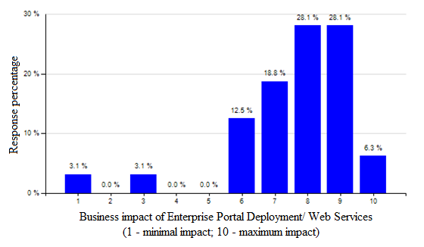
As it can be derived from the above figure, CIOs and IT managers recognized the contribution of such technologies in today’s business. The average rating of these technology trends was 7.6.

Application Integration/Middleware
As far as the Application Integration and Middleware technologies are concerned, the answers submitted by the participants demonstrated that a great majority acknowledge their importance to the business organizations. Specifically, the two thirds (65,7%) of the respondents rated the above technology above the average, resulting in a total average of 6.1.
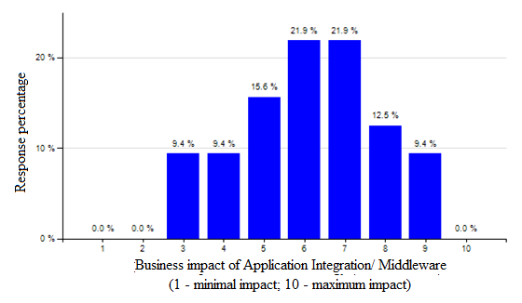
The above schema exhibits that the distribution of the answers is scattered between the ratings of 3 and 9, making clear that each of the CIOs and IT managers recognizes the impact, even in a lower scale, of the above technology. Another statement that can be made is that the Application Integration/Middleware technology is not considered as a key trend regarding its impact to today’s firms, since most of the responses (43,8%) rated the above technology between 6 and 7. However, the fact that there was not even a single response rating the above technology with 0 or 1 (minimal impact), shows that the Application Integration/Middleware technology trend had always impact on a business organization, even at a lower extent.

Service-Oriented Architecture (SOA)
A very interesting outcome was derived from the rating of the Service-Oriented Architecture (SOA) technology trend. Although during the interviews, each of the interviewees made explicit SOA’s huge impact on today’s business organizations, the same was not resulted from the answers submitted by the people responded to our survey.
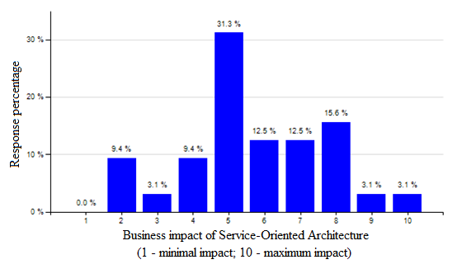
The above figure shows that almost one third (31, 3%) of the respondents rated the SOA technology with 5, resulting in an average rating of 5.7.

Business Intelligence (BI)
Regarding the Business Intelligence trend, the participants recognized its huge impact in today’s business organizations. The figure below depicts the importance given to such technology by the CIOs and IT managers, since the majority of the answers submitted ranges from 6 to 10, resulting an average rating of 7.4.
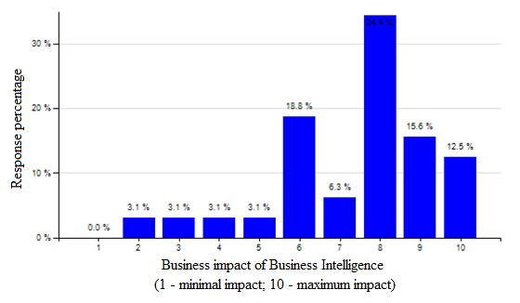
The participants who rated the Business Intelligence technology above the average were the 87, 6%, while the ones who rated it below the average were only the 12, 4%. However, almost one third of the participants (31,2%) rated the BI technology between 2 and 6, which means that CIOs and IT managers are a little to a lot disappointed on what Business Intelligence has delivered or they had difficulties to exploit the offered opportunities properly.

Enterprise Resource Planning (ERP)
As far as the Enterprise Resource Planning technology is concerned, the answers submitted by the participants showed that the greatest majority acknowledge its importance to the business organizations. Specifically, the 84, 4% of the respondents rated the above technology equal and/or above the average, resulting in a total average of 6.2.
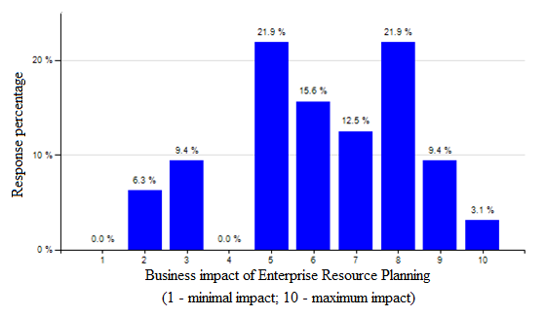
The above schema demonstrates that the distribution of the answers is concentrated on the second half of the rating making clear that the greater part of the CIOs and IT managers take into consideration the above technology. However, the overall rating is not very high since a lot of companies got into financial problems during an ERP implementation, since old systems were replaced by a new ERP system, which in the end wasn’t working properly.

Customer Relationship Management (CRM)
Regarding the Customer Relationship Management technology, the participants once more acknowledged its impact on the business firms. Specifically, the majority of CIOnet’s members voted the CRM software with 8, resulting in an average rating of 7.2.
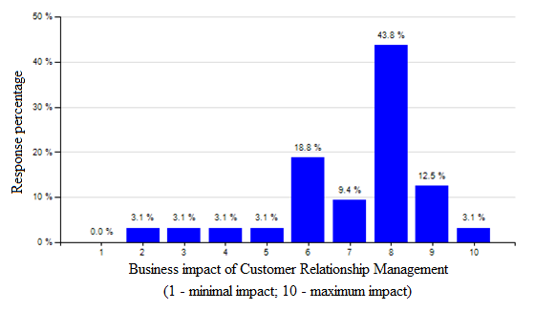
Although the distribution of the answers is bigger compared with the first figure, it is clear that the greater part of the CIOs and IT managers have taken taken into huge consideration the above technology.

Supply Chain Management (SCM)
As far as Supply Chain Management technology is concerned, the responses of the participants were almost divided. The above is demonstrated in the diagram below.
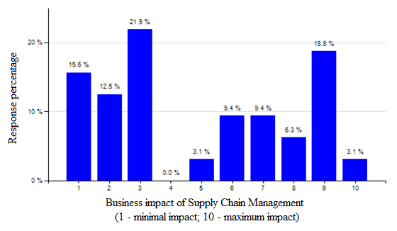
Although the distribution of the responses is bigger compared to other diagrams, the participants who rated this specific technology above the average is almost the same as the ones who rated it below. To be more precise, 50% of the respondents rated the Supply Chain Management trend among 1 and 3 (minimal business impact), while the rest half rated it equal and above the average (5 to 10). Taking into account all the above, it is clear why the overall average resulted in 4.9, demonstrating that the Supply Chain Management trend is neither considered as a high nor as a low impact trend on today’s businesses.

Grid Computing
As far as the Grid Computing technology is concerned, the collected responses demonstrated that the CIOs and IT managers do not recognize that this specific technology has a big IT impact on today’s business. To be more precise, more than two thirds (68,1%) of the participants rated Grid computing among 1 and 4.
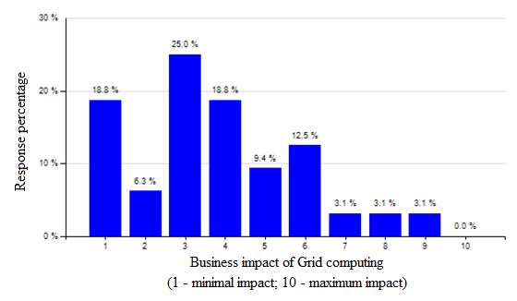
The above diagram exhibits the finding mentioned above. What can be derived is that only 21,8% of the participants rated this specific technology above the average. Taking into account all the above, it is easy to understand why the overall average number of this trend was 3.8.

Linux/UNIX and Open source software
Regarding the Linux and open source software trends, the feedback received from the participants demonstrated that the majority of the IT world does not acknowledge that both can play a significant role in today’s business, thus their impact is considered low. The above is demonstrated on the diagram that follows.
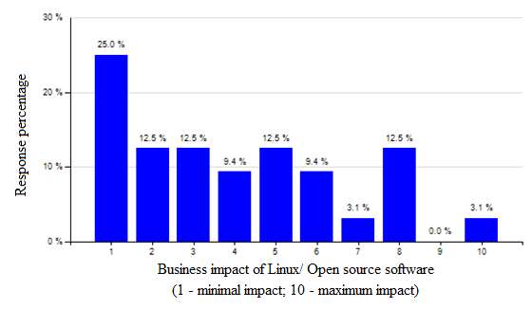
Taking the above figure into consideration, it is obvious that almost two thirds (59,4%) of the participants rated the Linux and UNIX technologies below the average. Another important finding derived from this diagram is that one out of four (25%) of the CIOs and IT managers asked reckon the business impact of these technologies as minimal. Taking into account all the above, it is obvious why the overall average resulted in 4.0, demonstrating that the Linux and UNIX technologies are not considered as technologies with a higher impact on today’s business organizations.

Cloud Computing/Virtualization
Another interesting outcome that adds value to our research occurred from the ratings of Cloud Computing and Virtualization technologies. Although the interviewees promoted their importance to the IT world in general, the respondents replied in a different manner.
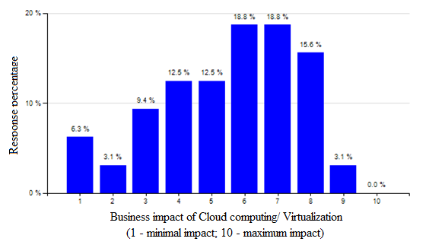
Taking the above figure into consideration, it can be said that the opinions regarding the business impact of Cloud Computing and Virtualization technology trends are almost divided. The 43, 8% of the participants rated the impact of the above trends equal or below the average rating, while the rest of them (56,2%) supported that their impact to the companies is bigger than the average. Although the higher percentages are met among the numbers 6 to 8 with 53,2%, the average rating is only 5.5 due to the many low ratings submitted by the rest of the CIOs and IT managers, which demonstrates that the participants have been hesitant about these two technologies.

Green IT
As far as the Green IT trend is concerned, the participants responded neither in a positive nor in a negative manner. To be more precise, nearly half (43,7%) of the respondents rated the impact of this technology among 1 and 5, while the rest of them (56,3%) rated it among 6 and 8. None of the participants rated Green IT with 9 or 10, which demonstrates that no one considers this trend of significant importance and role to the business organizations.
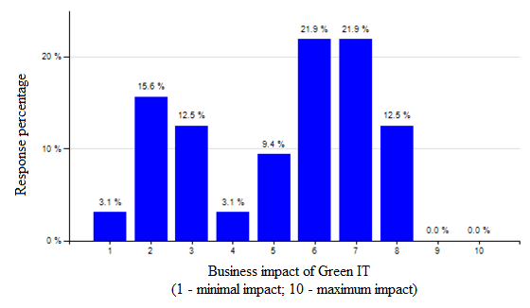
Taking all the above into consideration, it is easy to understand why the overall rating of Green IT technology resulted in 5.2.

Outsourcing
The Outsourcing technology was considered of high importance for the IT managers and CIOs who participated in our survey. In particular, almost one third (31, 3%) of the respondents rated the outsourcing technology with 8, making clear its huge impact to the business world.
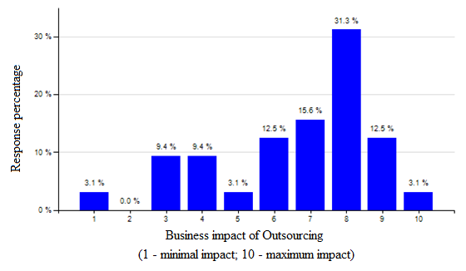
The above figure exhibits that almost half of the participants (46,9%) acknowledge the huge business impact of outsourcing, rating it from 8 to 10. The above result can be further reinforced by taking into consideration the overall percentage that responded positively for the outsourcing technology is 75%. However, 21, 9% of the participants is recognizing the impact of outsourcing as minimal to the IT world in general, which in turn demonstrates that a part of the CIOs and IT managers do not take into consideration the above technology. Taking into account the above findings, it is easy to understand why the overall average resulted in 6.6.

Wireless/Mobile technology (Radio-Frequency Identification included)
Regarding the mobile technology, although the majority of the collected responses ranged between 6 and 8, almost one third (31,2%) of the participants does not recognize at all or recognizes as minimal the impact of the above technology trend. This can be further visualized by the figure below.
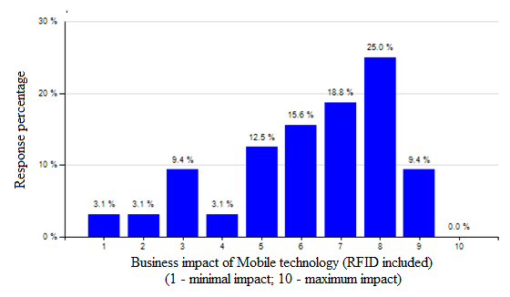
As it can be derived from the above figure, some CIOs and IT managers recognize the contribution of such a technology in today’s business. However, a noticeable percentage does not consider the impact of this technology too important for today’s businesses. Taking the above into consideration, it is easy to understand why the average rating of this technology trend was 6.2.

Part 2 – Which trends were missing?
The second part was aiming to identify if there were any technology trends missing from the list. Most of the responses included the Enterprise Content Management software, Social Networking, Planning and Forecasting, and Identity management.
Concerning the Social Networking, most of the companies that referred to it considered it as part of the Web 2.0 and web services in general. In order for our research to be more precise, we included information about the Web 2.0 as well as the Enterprise Content Management within the literature review part.
Concerning the rest of the suggested trends, the IT companies we reviewed did not refer to them with the above names but they more or less included these ideas within other technologies. To be more specific, Planning and Forecasting is conducted by the Business Intelligence software while the Identity Management is a task performed via the RFID technology.
The majority of the participants had no IT trends to add to the initial list. Thus, we strongly believe that the most important Information Technology trends are covered within this research.

Question 2 – Which sources do you use?
The second question of the survey was aiming to identify the sources which are used by the CIOs and IT managers in order to understand, analyze and decide upon the introduction of new IT products and/or services in their company. In order to do so, each of our sources listed could be rated using the scale 1 (minimum influence on decisions) to 10 (maximum influence on decisions).
The list included the following sources:
- Newsletters (including international IT magazines, CIO.com, blogs, linkedin)
- RSS/Feeds
- Events (organized by CIOnet, Gartner, Forrester, IDC or other)
- Other sources.

Newsletters (including international IT magazines, CIO.com, blogs, linkedin)
Concerning the newsletters’ influence on the decision to introduce a new IT product/ technology and/or service, the responses of the CIOs and IT managers are depicted in the schema below.
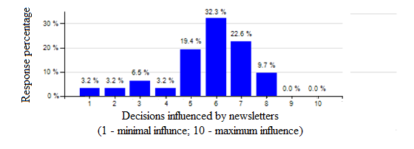
As it can be derived from the above diagram, the majority (74,3%) of the participants rated the newsletters’ influence between 5 and 7. In other words, most of the IT managers and CIOs acknowledge the influence of the newsletters, as a source, in their decisions regarding the introduction of a new IT trend in their company. Although the percentage of the participants which does not consider this source too important is quite low (16,1%), the fact that none of the CIOs and IT managers trusts completely this kind of source in order to take his/her final decisions, resulted in an average rating of 5.7.

RSS/Feeds
As far as the RSS/Feeds’ influence is concerned, the responses collected from the survey are presented below.
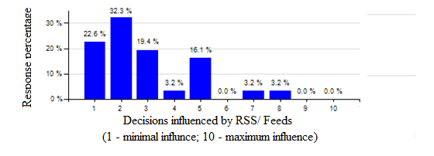
What can be derived from the above diagram is that the CIOs and IT managers who participated in this survey do not recognize the influence of the RSS/Feeds that important when deciding to introduce a new IT trend in their companies. The majority of the participants (74,3%) rated this specific influence between 1 and 3, while only the 6,4% of them replied that the RSS/Feeds have a positive influence on their decisions. Taking the above findings into consideration, it is obvious that the CIOs and IT managers prefer other sources than RSS/Feeds, which in turn resulted in a very low average of 2.9 for this specific source.

Events (organized by CIOnet, Gartner, Forrester, IDC or other)
The responses of the CIOs and IT managers, concerning the extent at which events organized by outstanding companies within the IT sector influence the way decisions are taken in order to introduce a new IT product/technology and/or service, are demonstrated in the schema below.
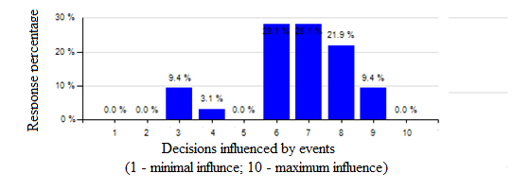
What is derived from the above diagram is that the majority of the participants (56,1%) rated this specific kind of source between 6 and 7. In addition to the above, 87,5% of them replied that the RSS/Feeds have a positive influence on their decisions, while 12,5% responded that the influence of such events on their decisions is minimal. Taking the above findings into account, it is obvious that the CIOs and IT managers trust more the outcome of such events than any of the other sources. The overall average resulted in 6.7.

Other sources
The responses of the CIOs and IT managers, concerning any other sources of influence, are depicted in the diagram below.
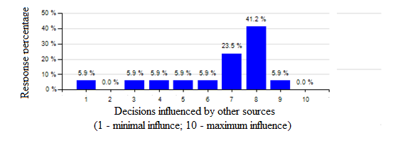
As far as other influential sources are concerned, the answers submitted by the participants demonstrated that a great majority acknowledge their importance to the business organizations. Specifically, the two thirds (64,7%) of the respondents rated other sources of influence between 7 and 8, while the overall percentage above the average rate was 82,4%. The above, in turn, resulted in a total average of 6.6.
In order to add more validity to our research, we asked from the participants to mention every source that is taken into consideration when deciding to invest in a new IT technology. The answers received varied and included consultancy agencies, computable.nl, computerworld.com, cionet.com, information provided by technology partners, vendor offerings and proposals as well as benchmark data. Predictions made by magazines such as Computable, AutomatiseringsGids and TeleCom were also promoted in the comments of the participants. In addition to the above, vendor conferences such as the ones organized by Sapphire and other customer advisory boards were mentioned. Last but not least, strategic partnerships play a significant role when CIOs and IT managers are deciding in which IT trend to invest, while some of them promoted the influential ability of their personal network of colleagues, suppliers and partners.

Question 3 – Who do you trust more in forecasting?
The third question of the survey was aiming to determine which of the sources listed below are considered as reliable by the CIOs and IT managers, according to their experience. In order to do so, each of the sources listed could be rated from 1 (minimum reliability) to 10 (maximum reliability).
The list included the following sources:
- Gartner’s predictions;
- Forrester’s predictions;
- Giarte’s predictions;
- IT trends institute predictions;
- CIOnet’s predictions;
- IT-related journal predictions;
- Business-related journal predictions;
- Predictions made by colleagues;
- New strategic products and services as offered by well known IT companies;
- New products and services developed by smaller IT companies but innovative in their field of expertise; and
- Predictions made by International Data Corporation (IDC).

Gartner’s predictions
Regarding the reliability of the predictions made by Gartner, the participants once more acknowledged their impact on the business firms. Specifically, the majority (40%) of CIOnet’s members rated the reliability of Gartner’s predictions with 7, resulting in an average rating of 6.9.
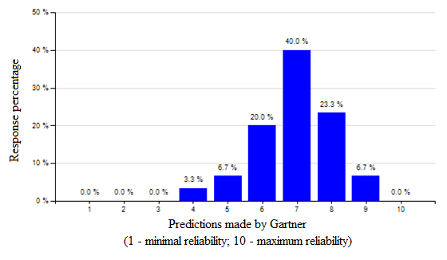
The figure above demonstrates that the distribution of the answers is not as big as in other diagrams, making it obvious that the greater part of the CIOs and IT managers takes into consideration the above forecasting company.

Forrester’s predictions
As far as the reliability of the predictions made by Forrester is concerned, the respondents reckon their impact while taking their decisions. To be more precise, once again the greater part (40,7%) of the participants rated the reliability of this specific forecasting company with 7, resulting in an average rating of 6.7.
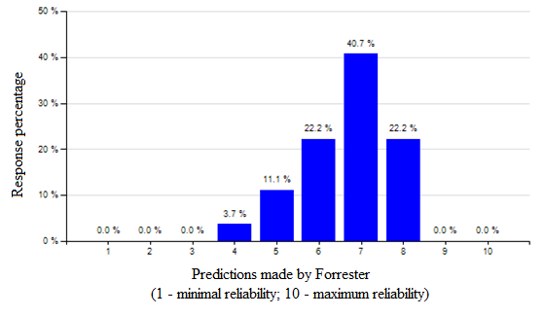
The schema above exhibits that most of the IT managers and CIOs acknowledge the predicting ability of Forrester, as a source, when deciding to invest in a new IT technology in their companies. In addition to the above, 85,1% replied in a positive manner (above 6) regarding the reliability of Forrester’s predictions, while only 3,7% rated its predicting reliability below the average (4).

Predictions made by the International Data Corporation (IDC)
Concerning the reliability of the predictions made by the International Data Corporation (IDC), the majority of the CIOs and IT managers replied in a quite positive manner. To be more precise, the majority of the responses regarding the reliability of such predictions ranged from 5 and 8, which is translated to 88% of the answers.
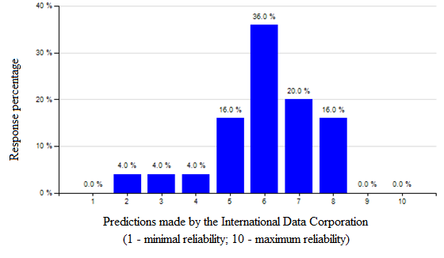
What can be derived from the above figure is that only a small percentage (12%) of the participants rated the reliability of the predictions made by IDC below the average, while the majority of the CIOs and IT managers rated the reliability of such predictions with 6. The average rate regarding the predictions made by the International Data Corporation is 6.

Giarte’s predictions
The answers of CIOnet’s members regarding the reliability of Giarte’s predictions are depicted in the following schema.
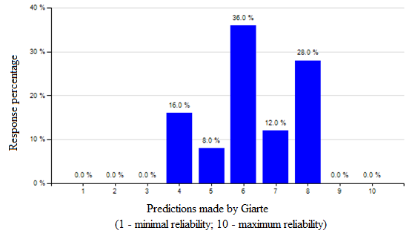
In this case, the majority of the participants (36%) rated the predicting power of Giarte with 6. In addition to the above, almost the one third (28%) of the participants rated Giarte’s reliability in predicting IT trends with 8, whereas the corresponding percentages for Gartner and Forrester were lower (23,3% and 22,2%) in the two previous schemas. However, a quite high percentage (24%) rated this specific company below and equal the average, resulting in an overall average of 6.3.

IT Trends Institute predictions
Regarding the reliability of the predictions made by the IT Trends Institute, the following diagram depicts that almost the half of the participants considers its reliability slightly above the average.
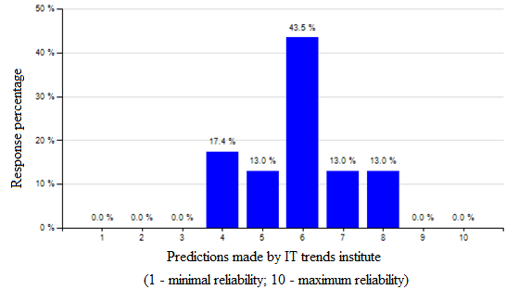
To be more precise, 43,5% of the respondents rated the reliability of the IT trends institute with 6, resulting in an average of 5.9 in total.

CIOnet’s predictions
Regarding the reliability of CIOnet’s predictions, the feedback received from the participants demonstrated that the majority of their members acknowledge CIOnet as a quite reliable predictor of new IT trends. The above is demonstrated on the diagram that follows.
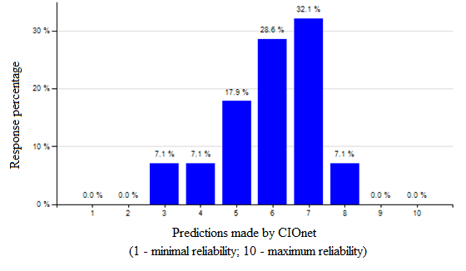
Despite the fact that almost two thirds (67,8%) rated CIOnet’s reliability in predicting new IT trends above the average, the rest (32,1%) of the participants rated its power equal and below the average. Another important finding derived from this diagram is that almost 1 out of 4 (28,6%) of the respondents rated CIOnet’s reliability slight over the average rating. Taking into account all the above findings, it is obvious why the overall average resulted in 5.9.

IT-related journal predictions
As far as the reliability of the predictions made by IT-related journals is concerned, most of the participants acknowledged their influence. To be more precise, 69,5% of the participants rated their reliability with above average, which is demonstrated in the following diagram.
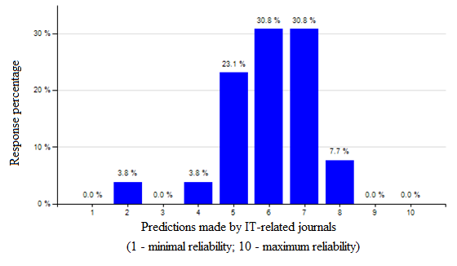
An important finding regarding the reliability of the IT journals is that only 7,6% of the participants recognize as minimal their reliability and thus rated below the average. Taking all the above into consideration, it is easy to understand why the overall rating resulted 6.0.

Business-related journal predictions
The answers of CIOnet’s members regarding the reliability of the predictions made by business-related journals are depicted in the following schema.
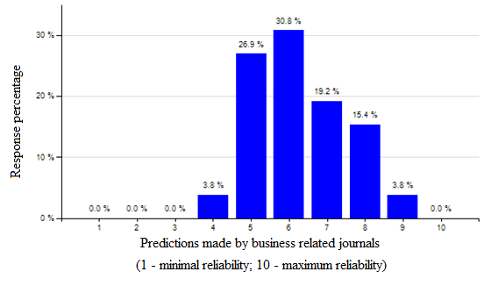
As in the case of IT-related journals, only a small percentage (3,8%) of the participants recognize their reliability below the average, while the rest acknowledge their predicting influence in their decisions. However, the fact that the majority of the answers submitted from the CIOs and IT managers are between 5 and 7, it is clear why the overall rating resulted in 6.3.

Predictions made by colleagues
Concerning the reliability of the predictions made by colleagues, the majority of the CIOs and IT managers replied in a positive manner. To be more precise, the majority of the answers given, rated the reliability of such predictions between 7 and 8, which is translated to almost the half of the participants (51,7%).
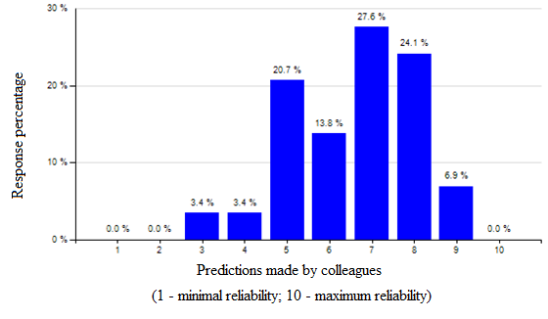
The figure above makes clear that the greater part of the CIOs and IT managers determine their final decisions when investing in a new IT trend by taking into consideration the opinions and predictions made by their colleagues. Specifically, 72,4% of the participants rated the reliability of the predictions made by their colleagues above the average, while the ones that rated these predictions below the average composed the 6,8% of them only. Taking the above findings into consideration, it is obvious why the overall rate resulted in 6.6.

Predictions made through the new strategic products and services offered by well known IT companies
Regarding the reliability of predicting new IT trends through the new strategic products and services offered by well known IT companies, the participants replied in a positive manner once more. More than the half (55,2%) of them rated these specific predictions between 7 and 8, which is demonstrated in the following figure.
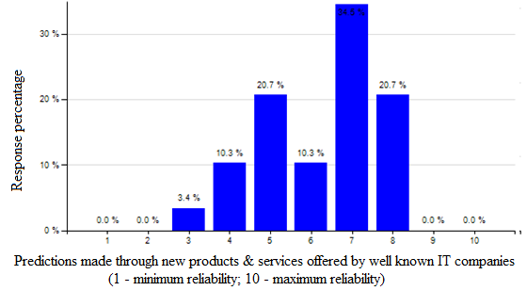
What can be derived from the above is that almost two out of three (65,5%) reckon the reliability of the predictions made through new strategic products and services offered by well known IT companies, rating them above the average. However, the rest of the participants does not recognize that such predictions have great reliability. Taking the above into consideration, it is obvious why the overall average resulted 6.2.

Predictions made through the new products and services developed by smaller IT companies but innovative in their field of expertise
The answers of CIOnet’s members regarding the reliability of the predictions made through the new products and services developed by smaller, but innovative in their field of expertise, companies are exhibited in the diagram below.
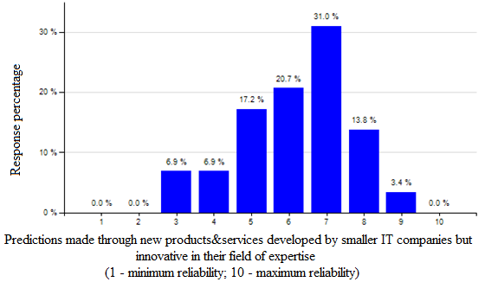
As in the case of the well known IT companies, 68,9% of the respondents rated the reliability of the predictions made through new strategic products and services offered by smaller IT companies, rating them above the average. However, 31,1% of them does not consider that such predictions have great reliability, which in turn resulted in an overall average of 6.2.

Question 4 – Decision making
The fourth question of the survey was aiming to determine the criteria and circumstances under which the CIOs and IT managers make their decisions regarding the investment in new IT trends. The criteria were the following three:
- Wait until a success of an IT trend is proven and then persuade your business partners;
- Wait until you are being pushed by other business departments; and
- Not wait at all since it might be too late; in order not to lose the competitive advantage the new technology offers, you take the risk of its implementation.
Each of the above criteria could be characterized with either a positive or negative response to each alternative, including the following options:
- 1 - Strongly disagree;
- 2 - Disagree;
- 3 - Neither agree nor disagree/Neutral;
- 4 - Agree; and
- 5 - Strongly agree.
The extent at which CIOs and IT managers follow the above criteria is explained below.

1st alternative – Wait until success of an IT technology is proven and then persuade business partners
The first alternative of this question was trying to identify whether IT managers and CIOs are waiting until a success of an IT trend is proven and then persuade their business partners. The answers submitted by the participants are depicted in the figure below.
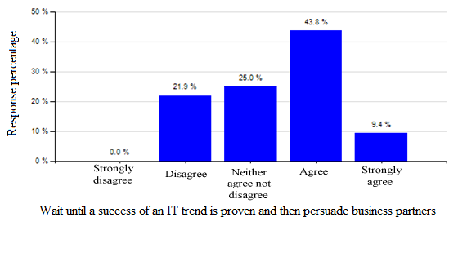
What can be derived from the above diagram is that almost the half (43,8%) of the participants agreed that they wait until a success of an IT trend is proven and then persuade their business partners. In addition to the above, one out of four claimed to be neutral, while a quite high percentage (21,9%) declined that they wait until its success is proven. In a scale from 1 to 5 (strongly disagree to strongly agree), participants agreed with the average of 3.4.

2nd alternative – Wait until being pushed by other business departments
The second alternative of this question tried to determine whether CIOs and IT managers are being pushed by other business departments in order to adopt a new IT technology trend. The collected responses are depicted in the following diagram.
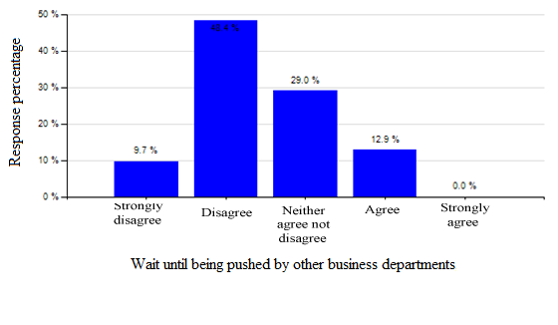
As we can see from the above figure, more than half (58,1%) of the CIOs and IT managers denied that they are being pushed by other business departments in order to adopt a new technology in their companies. However, 12,9% of them agreed that they are pushed or that they have been pushed by other departments to adopt a new IT technology. Almost one third (29%) of the respondents neither agreed nor disagreed, promoting a neutral behavior when adopting a new trend. In a scale from 1 to 5 (strongly disagree to strongly agree), participants agreed with the average of 2.5.

3rd alternative – Invest and try to gain the competitive advantage the new technology offers
The third alternative of this question aimed to identify whether CIOs and IT managers are willing to take the risk and adopt a new technology trend in their business, in order to gain the competitive advantage offered, despite the fact that its success might not be proven yet. The answers submitted are presented in the following diagram.
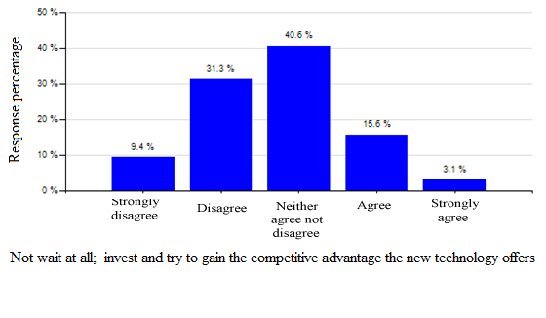
What can be derived from the figure above is that 40,7% of the CIOs and IT managers participated in this survey would not take the risk to adopt a new unproven technology despite the fact that their companies might miss any competitive advantages offered from this adoption. In addition to the above, 40,6% of the participants promoted a neutral behavior, while only 18,7% supported that they would prefer to gain the competitive advantages offered by such a technology without concerning about the embedded risks of such an investment. In a scale from 1 to 5 (strongly disagree to strongly agree), participants agreed with the average of 2.7.

Question 5 – Is there a clear vision?
The fifth question of our survey was aiming to discover whether CIOs and IT managers ever adopt technologies without a clear vision of the associated benefits, but just because most of the other competitors are already using this technology. The collected responses are depicted in the following diagram.
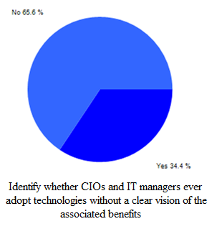
As we can see from the pie-diagram above, almost the two third (65,6%) of the participants declined that they have adopted a trend without a clear vision, whereas the rest of them accepted that they have done so at least one time.
In order to add more validity to our research, we asked from the participants to mention the reasons why they have ever adopted a technology without a clear vision. The answers we received varied and included responses such as money was available at this specific time period, promises have been done from the big IT companies (HP, IBM, etc) regarding this trend.

Chapter 5 - Analysis

Introduction
In this chapter we will analyze the information that was presented in the literature review as well as the empirical data chapters and we will answer the main research question of this research which is “who can identify the innovative IT solutions which can add business value to companies? Is it within the IT sector with IT companies keeping an eye on and evaluating what their competitors do, or is it by companies such as Gartner, Forrester, Giarte, etc which try to analyze the IT market?”
The chapter consists of two parts. The first part includes some general observations/remarks that although they do not add value to the main conclusion, they are important enough not to be ignored. In this part, we also analyzed the findings that occurred from the questionnaires within the empirical data part.
The second part of this chapter includes the answer to the main question of where innovation comes from and it consists of an analysis and comparison of all the information that occurred from the overall research and is relevant to this topic.
At the end of the chapter, suggestions that should be taken into consideration by future researchers are provided.

Part A: General Observations and Analysis of the questionnaires

Observation 1: The interrelations among trends are in many cases extremely complicated and ambiguous.
The first observation has to do with the fact that most of the trends are interrelated with others. Sometimes, these interrelations are so complicated that it becomes difficult to distinguish and define the trends. This is because of the following reasons:
- Trends rarely constitute pure innovations; most of the times a trend is an extension or improvement of an already existing technology.
- Trends might evolve and their offerings might change completely through the years; however, they might keep being referred to with the same name.
- Companies might refer to the same trend with different names.
Below, we will refer to specific findings from both the literature review and the empirical data that support the above statements.
Web services
One of the most appropriate examples to support the fact that trends which evolve over time are referred to with the same name is the one of web based technologies. According to the IT companies, during the ‘90s, web services referred mainly to simple web presence. A bit later, subsequent to Yahoo’s launching of myYahoo! application, the idea of enterprise portal deployment came to surface and the term web services became equivalent to that (CA considers portal deployment as a web service). More online services started to become available over time and nowadays we have businesses that depend at a great extent (if not completely) on the Web. Today, the term “web services” is sometimes replaced by the term “e-business”. Even though the term “web services” is used from the late ‘90s until today, its meaning is completely different through the years.
The interrelation of the terms “web services”, “portal deployment” and “e-business” becomes more complicated when Gartner’s opinion as well as the opinions of the interviewees are taken into account. On the one hand, Gartner considers “portal deployment” and “web services” as two different trends; the second one is the continuance of the first one. On the other hand, Mr. Gerogiannis, interrelates the two trends by mentioning that “portal deployment is improving the way a company’s services are offered since they are now offered in an electronic way”.
By 2004, some business journals refer to the businesses that have aligned their business processes with technology using the term “e-business”. Johan de Wit, however, had some objections concerning this date. From what he could recall, “ING had started to use the term “e-business” before the millennium and it referred to multi-channel interactions with customers. After the Internet bubble of 2001, e-business became a more normalized subject in the IT/Business portfolio” as he characteristically mentions.
On-demand, Utility Computing and SaaS
An additional example is the free of charge download of updates and the customer support that Microsoft and Symantec offered as Web Services back at the end of the ‘90s. Nowadays, such provisions are referred to as SaaS. HP refers to SaaS by using the term “Utility computing”. The idea of Utility Computing is the same as the idea of SaaS: customers are provided with the exact services they need and are willing to utilize. Other companies have also used the term “On-demand” when referring to the above before the term SaaS was established and Johan de Wit recognized the link between SaaS and On-demand. All three terms: On-demand, Utility Computing and SaaS are widely known within the IT community. However, the term SaaS is the one that prevailed in the end, thus it is the one used at the moment, while “on Demand has become a more generic term” according to Johan de Wit. Another interesting opinion mentioned by Mr. de Wit, is that “companies are willing to change the names of certain technologies in order for their products to be in the trends list”.
Note: the fact that interrelations among trends are so complicated makes it difficult to define the lifecycles of certain trends; the beginning is not necessarily the period of time that the trend was launched while its end is not when it disappears from the market.

Observation 2: The technological advantages and the potential business value of certain technologies are not appropriate for the decision-making process since external factors play an important role as well.
Investments on Information Technology do not entirely depend on the business value they are expected to bring to the company nor to the technical advantages will they provide. External factors, derived from the market or the global economy, can play an important role depending on the circumstances. Such factors are mentioned within the literature review and are emphasized by the interviewees. Examples of external factors will be described below.
One of the most important external factors is the global economy. The world today is going through an economic crisis and this seems to affect the decisions of CIOs and IT managers, as it will become clear below.
According to the IT companies, journals, and interviewees, integration of both data and systems is very important to increase business value. However, the current state of the economy prevents decision makers from considering it as a priority. As Mr. van der Velde characteristically mentions, “companies should pay attention to integration. However, due to the economic crisis, it is more important to provide customers with a bigger variety of products and services”. He explained that “it needs some time for integration’s positive results to become visible but due to current economy, it is necessary for companies to remain competitive and establish a better position within the market in the very near future”.
An area of integration that is of particular interest is the ERP integration. Concerning the ERP, some large companies nowadays own more than one ERP systems. According to the literature review, the integration of the different ERP systems is of great importance in order for a company’s resources to be managed effectively and efficiently. Referring to this, Mr. van der Velde stated that “the above integration is very costly and the ROI that occurs from it is minimal. Thus investing on ERP integration does not constitute a priority for the current time period”.
Another technology that despite its business value comes under discussion due to today’s economy is outsourcing. Mr. van der Velde comments that “Due to the economic crisis, labor positions are less; in order for each nation to increase the employment opportunities within it, thus face the counter-effects of the economic crisis, companies should (KLM already does) reduce the number of processes that are outsourced abroad. Instead outsourcing should take place nationally or processes should be conducted within the companies”.
The IT investments of business competitors constitute an additional external factor that CIOs and IT managers seem to take into account when it comes to decision making. One of the interviewees stated that within his company, they “always have somebody keeping an eye on competitors” and Mr. Gerogiannis confirmed that “companies pay much attention to what competitors do”. In the last question of the questionnaire, it was revealed that 34,4% of the participants have adopted technologies, at some point during their career, without a clear view of what these technologies were offering, simply because most of their competitors did so as well. In one of the participants’ comments, it was mentioned that “massive movements that are driven by promises being done by big parties such as IBM, HP, etc, cannot be so wrong”.

Observation 3: Different sources emphasize on different aspects of the technologies. In order for valuable decisions to be taken, more than one aspect need to be taken into consideration.
Within this research, we gathered data from four different sources: leading IT companies, forecasting companies, independent analysts and researchers (papers from business and IT journals) and CIOs and IT managers. The different sources provided us with different insight of the trends.
To be more specific:
- IT leaders describe the Information Technology trends often from a completely technical point of view. They focus much more on the technological impact, the advantages and difficulties of these trends at a technical level and much less at a business level.
- Forecasting companies & independent analysts/researchers try to identify the business impact of these trends and the value they would add to a company. The technical part is not of great importance to them; the trends’ ability to be aligned with business and added business value are.
- CIOs and IT managers try to take both the above aspects and some external factors into consideration. They are the ones that take decisions in the end and they cannot solely base on the technical and/or business-value knowledge they are provided with. Market state, global economy and competition seem to play an important role in their decision-making, as it became clear within the previous observation.

Integration
Integration represents an example of a trend about which the above sources provided us with different points of view. Concerning this trend, the only difficulty IT leaders perceive, concerns the incompatibility between legacy systems and new systems. However, the Journal of Information Systems Education refers to “user resistance to innovation” as the greatest challenge to deal with. The same journal also provides the solution of including different parts of the company to the decision making process when such radical changes are about to take place. The Journal of Information Systems Education goes beyond the technical difficulties of integration by taking into account the human factor.
At the same time, as it is already mentioned within the previous section, Mr. van der Velde pointed out the fact that “integration mainly provides internal benefits that are not at the moment a priority. The current state of the economy make CIOs focus on areas, such as the creation of more products and services that will help them establish their position in the market. The rest (technical and/or business-related benefits of integration) do not matter much at this period of time”.
SaaS
SaaS constitutes another example. Concerning its advantages, IT leaders focus on reduced costs, quicker deployment than traditional licensed software, improved operating results, etc. Forrester, on the other hand, describes its business value. SaaS’ business value lies to the fact that companies can focus on key business processes by asking from SaaS providers to undertake the development and distribution of non-key processes. Mr. Bart Luijten confirms by stating that “SaaS simplifies the everyday activities of a multinational company”.
The business value of outsourcing was also mentioned within the extra literature. IT companies focus on the reduction of costs, while the independent researchers focus on the fact that when outsourcing, companies can focus on the core business processes and improve them. Once again the CIOs identified an external factor that plays an important role at the moment. The economic situation makes Mr. van der Velde support that “outsourcing abroad should not take place at the moment; this would help increasing the working positions within one’s country, thus face the crisis at some extent”.
Trends are not just about technology. The solution they provide are not just technical and the decisions that concern them should not be based only on technical facts alone. The human factor, the company’s convenience and preferences that depend on external factors and the business value of each new technology should always be taken into consideration equally well. In fact, no business value means “skip this technology”.

Observation 4: Technology alone is not a problem solver.
Even though investments on new technologies are made in order to improve the current value of business, technology alone is incapable of solving the business problems. The alignment of technology with the business processes is essential; it can lead to success and add business value to a company. Some examples of technologies that are unable to deliver the promising results without alignment with the business processes are submitted below.
CRM systems
CRM and ERP systems became, in general, vital systems within a company. CRM is considered responsible for improving the relations with the customers while ERP is considered responsible for the data management and decision making improvement. However, “these systems alone do not solve problems”, Mr. Gerogiannis mentioned. “It is the overall actions that will take place within the company, the alignment of CRM and ERP systems with the business processes, the strategy and culture of the company as well as the willingness of employees to make them part of their responsibilities that can”.
In order to enforce the above statement, Mr. Gerogiannis referred to the example of Continental Airlines that has been winning the prize for best customer services without even having a CRM system. “In order for customer relations to be improved”, he explained, “companies have to understand their customers’ needs, habits, preferences and priorities and this cannot be succeeded by an Information System alone”.
ERP systems
Similarly, in order for ERP to deliver the expected results, businesses should be aligned with it (not the opposite) and the organizational requirements, the availability of resources, the characteristics of the manufacturing processes, etc, should be understood and analyzed according to the Business Process Management Journal. According to Mr. de Wit, “resistance to change plays an important role here as well; the success of ERP systems depends at a considerable extent on the employees tendency to accept change or not”.
Another important factor related with the above systems, also pointed out by Mr. Gerogiannis, is the existence of well-trained people. Lack of well-trained employees might not only lead to efficiency problems (as far as the business processes are concerned) but also to adaptation problems; if, in the beginning, some of the employees get to know the system well, they can also help the rest of the employees to adapt.

Business Intelligence
Business Intelligence constitutes an additional example. BI is supposed to enhance and accelerate the decision making process by providing the right information for each occasion. Within the literature review, BI systems are described as systems that consist of two basic activities: “getting data in” and “getting data out”. Nevertheless, in order for valuable information to actually occur, the following factors have to be considered:
- Useful data according to the company’s requirements has to be gathered within the “getting data in” process.
- Users have to be able to recognize the information that is useful to them after the “getting data out” process has taken place, as well as how to use it.
- Reengineering of some processes in order to align them with the BI system is necessary.
- All the changes that take place have to be followed by users’ education/training so that they can smoothly adapt.
Outsourcing
The last example of this sub-section is outsourcing. Outsourcing reduces the work load of companies but in order for the expected value to be delivered, an analysis has to take place within the company. Within this analysis, the company has to clearly define the business outcomes that need to be delivered by the outsourced processes and align its intentions with the suppliers’ ones. Nothing can constitute a guarantee that the expected results will actually be delivered, but at least possibilities are increased when the above are taken into consideration.
The CIOs and IT managers that were interviewed within this research totally agree with the fact that technology is not a problem solver itself. Mr. Gerogiannis characteristically mentioned that “we cannot have business without IT but at the same time, IT does not solve all the problems by itself”. In order to make more valuable choices, Mr. Gerogiannis suggests that “companies should find exactly which are their needs and invest in this area. Sometimes the solutions that are provided by the IT companies might be very general, and if the customers do not know the areas they need to focus on, they might create even more problems instead of solving the existing ones”.

Observation 5: Companies’ priorities play an important role in which technologies are considered as trends by them.
This observation is based on the fact that since not all companies have the same priorities and/or needs, a technology that is considered a hot trend by some, might be indifferent to some others.
Some examples of such technologies occur from the questionnaires that were distributed to the CIOs and IT managers (members of CIOnet). When the participants of the survey were asked to evaluate the trends, a lot of contradictions occurred. For certain technologies, almost half the participants rated them with average or below average while a considerable percentage of the rest rated them with almost excellent. The average and below average grades (5 or below) show that CIOs see very little or no impact of the technologies on businesses, while the excellent grades (8, 9 and 10) show the exact opposite. Some of the contradictions are the following:
- The impact of cloud computing and virtualization were rated as average or below average by 43,8% of the participants. From the rest 56,2%, 18,7% rated these technologies with 8 or 9.
- Concerning the mobile/wireless technologies, 31,2% recognizes its impact as minimal while 34,4% rates them with 8 or 9.
- Application integration and middleware are rated with average or below average by 34,4% of the participants while, 21,9% grades them with 8 or 9.
- Grid computing was considered as a technology with very little impact on businesses by 68,1% of the participants. However, a very small percentage (6,2%) considers it valuable and rated it with 8 and 9.
- As far as Supply Chain Management is concerned, 50% rated it with below average, while 28,2% rated it with 8, 9 and 10.
The comments of Mr. Gerogiannis concerning the fact that decision makers should focus on their company’s needs when evaluating potential technologies are relevant to this observation as well. The above contradictions occurred just because of this exact fact: CIOs and IT managers are evaluating according to their perceived company’s needs and priorities.

Analysis of CIOs’ beliefs concerning the forecasting companies and evaluation methods according to the questionnaires
According to the comments that were submitted by the participants when they were filling in the questionnaires, in order to evaluate predictions, CIOs pay much attention to the assumptions upon which predictions are made. However, it is mentioned that predictions are never totally reliable. Since there is always embedded risk when investing on a new technology, decisions are usually driven by the expected-to-be-delivered business value or in other words, “the willingness of taking risk depends on the assumed benefit” states one of the participants.
Within this section, we will compare the trustworthiness of a number of sources used by CIOs when it comes to decision making that concerns technology trends, as well as the circumstances (technology maturity, expected risk, etc) under which these decisions are taken.
First of all, the sources that were evaluated with the questionnaires are distinguished into groups and the data that occurred from the questionnaires is analyzed and compared. For each source, we gathered the percentage that trusts it 70% or more and the percentage that evaluates it with average or below average. Taking into consideration that CIOs consider no predictions as completely trustworthy, we believe that 70% of trust or more reveals a quite trustworthy source.
Predictions by big analysis companies
As far as the big forecasting companies are concerned, the following results have occurred:
Gartner:
- It is trusted more than 80% by 30% of the CIOs.
- It is trusted more than 70% by 70% of the CIOs.
- Only 10% evaluate this source with average or below average.
Forrester:
- It is 80% trusted by 22,2% of the participants.
- It is more than 70% trusted by 62,9% of the participants.
- Only 14,8% evaluate Forrester with average or below average.
Giarte:
- It is 80% trusted by 28% of the participants.
- It is more than 70% trusted by 40% of the participants.
- Only 22% evaluate Giarte with average or below average.
CIOnet:
- It is 80% trusted by 7,1% of the participants.
- It is more than 70% trusted by 39,2% of the participants.
- 32,1% evaluate CIOnet with average or below average.
IDC (International Data Corporation):
- It is 80% trusted by 16% of the participants.
- It is more than 70% trusted by 36% of the participants.
- 28% evaluate CIOnet with average or below average.
From the above percentages, the following observations are of great interest:
- None of the companies is rated with 10 by any participant.
- Only Gartner was graded with 9 by 6,7% of the participants.
- Most of the companies were not rated with less than 4 (Only CIOnet was rated with 3 by 7,1% of participants and IDC was rated with 2 and 3 by 8% of the participants).
The average trust that CIOs show to the forecasting companies ranges from 40% to 80%. The trustworthiness of the companies, in descending order, is presented in the following matrix.
Forecasting company | Average rating
Gartner | 69%
Forrester | 67%
Giarte | 63%
IDC | 60%
CIOnet | 59%

Predictions by Institutes and Journals
Concerning the Institutes and Journals, the following results have occurred:
Institutes:
- They are 80% trusted by 13% of the participants.
- It is trusted more than 70% by 26% of the participants.
- 30,4% evaluate this source with average or below average.
IT-related journals:
- They are 80% trusted by 7,7% of the participants.
- It is trusted more than 70% by 38,5% of the participants.
- 30,7% evaluate this source with average or below average.
Business-related journals:
- They are 80% trusted by 19,2% of the participants.
- It is trusted more than 70% by 38,4% of the participants.
- 30,7% evaluate this source with average or below average.
From the above percentages, the following observations are of great interest:
- None of the sources is rated with 10.
- Only business-related journals were rated with 9 by 3,8% of the participants.
- Institutes’ and business-related journals’ minimum rating was 4, while IT-related journals were rated with 2 by 3,6% of the participants.
According to the average ratings, the sources can be listed in descending trustworthiness as it follows:
Source | Average rating
Business-related journals | 63%
IT-related journals | 60%
Institutes | 59%

Predictions by IT companies
As far as the IT companies are concerned, the following results have occurred:
Well-known IT companies (IT leaders; those companies that are placed first in Fortune ratings):
- They are 80% trusted by 20,7% of the participants.
- It is trusted more than 70% by 55,2% of the participants.
- 34,4% evaluate this source with average or below average.
Smaller companies but innovative in their field of expertise:
- They are 80% trusted by 17,2% of the participants.
- It is trusted more than 70% by 48,2% of the participants.
- 31% evaluate this source with average or below average.
Both types of companies end up having the same average rating (62% or 6,2 out of 10). However, only the smaller IT companies are graded with 9 by a small percentage of participants (the well-known IT companies are graded with 8 at the maximum).
Predictions by colleagues
The CIOs tend to trust their colleagues; those that work in the IT field and recently had to deal with the same dilemmas concerning the technology trends. As far as colleagues are concerned, the following results have occurred:
- They are trusted by more than 80% by 31% of the participants.
- They are trusted more than 70% by 58,6% of the participants.
- 27,5% evaluate this source with average or below average.
The average rating is 6,6 out of 10 (or 66% of trustworthiness).
It is totally normal and understandable that predictions made by colleagues seem trustworthy to CIOs and IT managers. People that have already dealt with advantages, difficulties, challenges, etc, of each trend under discussion are more reliable to describe the business value finally delivered than the predicting or IT companies.
To sum up, the overall ratings concerning the trustworthiness of the different sources that occurred from the questionnaires are as follows:
Forecasting company | Average rating
Gartner | 69%
Forrester | 67%
Colleagues | 66%
Giarte | 63%
Business-related journals | 63%
Well-known IT companies | 62%
Smaller IT companies | 62%
IDC | 60%
IT-related journals | 60%
CIOnet | 59%
Institutes | 59%

From the overall ratings it occurs that CIOs and IT managers pay enormous attention to the business value of Information Technology since the sources that provide good business analysis concerning the trends are placed high in the above list. The fact that Gartner and Forrester are placed first makes sense considering the methodologies they base their analysis on.
After having analyzed the data that occurred concerning the trustworthiness of the sources that are mainly used by CIOs and IT managers in order to decide the future investments, we will now analyze the criteria and circumstances under which such decisions are taken. The circumstances that are reviewed are the following: maturity of technology, pressures from other departments that managers have to face and risk they are willing to take.
Wait until the success of the trend is proven:
This means that CIOs and IT managers are willing to wait for evaluations either by companies such as Gartner, Forrester, etc, or by colleagues in other companies that have already used the specific technology. This way, the technology will be mature enough and its potential will be deeply understood; the company is not under much risk.
- 53,2% agree with the above
- 25% are neutral
- 21,9% disagree with the above
Wait until being pushed by other departments:
This means that CIOs and IT managers are waiting to be pushed by other departments in order to invest in a new technology. This way, the full potential of the technology to be adopted is not totally known.
- 12,9% agree with this
- 29% are neutral
- 58,1% disagree with this
Take risk in order not to lose competitive advantage:
This means that CIOs and IT managers do not wait until the technology is mature and completely understood. They adopt it at an earlier stage than in the first option of this sub-section.
- 18,7% agree with this
- 40,6% are neutral
- 40,7% disagree with this
In general CIOs and IT managers seem unwilling to take high risks. This is depicted by the fact that more than half of the participants would wait until the success of a specific technology is proven, whereas only 18,7% would take the risk of adopting a technology they do not completely understand in order not to lose competitive advantage, while even less (12,9%) would let their decisions being influenced by the needs of other departments.
However, in every option, a considerable percentage of participants remain neutral. This shows that despite the fact that CIOs are in general not risk-takers, they would consider acting differently under certain circumstances. In previous sub-sections it became clear that the potential benefit is the driver in the decision making process. So, in cases when a technology seems very promising, CIOs might become more risky in order not to lose the competitive advantage.
At the same time, as it occurs from the final question of the questionnaire, 34,3% of the participants have at some point adopted trends without clear view of the offerings just because competitors already invested on them. So, potential benefit is not the only factor that affects the willingness-towards-risk of the decisions makers. Other factors such as the profile of a company within the IT community also do.

Part B: Answer to the main question and causality
Within this part, the main question of this research paper, which is “who should companies trust more when it comes to decision making that concerns IT investments; is it the IT companies or companies such as Gartner, Forrester and companies alike that provide analyses?” is going to be answered. Both IT and companies such as Gartner and Forrester suggest technologies on which firms should invest in order to solve their business problems while at the same time they describe the potential gains they will have. But who actually makes the best suggestions when it comes to IT technologies?
The information and evidence gathered from the literature review, the interviews conducted, the questionnaires answered and different reports of Gartner and Forrester themselves helped us to gain a deeper insight regarding this matter, which in turn made clear that the answer to the preceding question is Gartner, Forrester and the companies alike. These companies are capable of analyzing the potential impact of a technology, that is being developed within the IT sector, extensively and methodically.
In fact Gartner and Forrester do not predict what the new (“hot”) IT trends will be, but what they actually do is to perform an in-depth analysis of the existing technologies offered within the IT market and provide their users with an extensive review of what the added value will be in case of investment by the last. Therefore, it can be stated that the “forecasting” companies offer more of an analysis than future predictions.
To justify our implication regarding the previous statement, the fact that these respective companies state the above themselves, as well as a close analysis of the “prediction” methods they use, are. To be more specific, Forrester describes itself as “an independent research company that provides pragmatic and forward-thinking advice to global leaders in business and technology”, (Kobielus, 2010), while Gartner uses the phrase “we deliver the technology-related insight (from strategy until execution) necessary for their clients to make the right decisions”, (Cheng, 2006).

Evidence derived from the interviews and questionnaires
The comments submitted by the interviewed CIOs and IT managers confirmed the above statement and reinforced the position that Gartner and Forrester are perceived mainly as experts in analyzing existing information than being “forecasting” companies. To be more specific, Mr. Gerogiannis during his interview declared that “Gartner and Forrester are wrongly perceived as forecasting companies by some; what the companies actually do is to analyze the market information, forecasts of previous years, etc and investigate the potential impact of certain technologies”.
Mr. van der Velde empowered the opinion submitted above by mentioning that: “Forrester and Gartner are very good in collecting information related to IT technologies, which are further analyzed in order to estimate their potential impact within the business domain. Both companies cannot be perceived as followers. Gartner and Forrester have to be good to what they are doing since they are the business leaders within their field of expertise. That’s why many important business firms attend their conferences every year”.

Analysis of Gartner’s and Forrester’s prediction methods
A closer look at Forrester’s and Gartner’s “prediction” methods is sufficient to reveal that these methods are actually valid analysis methods. More specifically, Forrester acknowledges that each firm has its own business needs and therefore they have to be taken into deep consideration when it comes to decision making. As soon as these needs are being examined and further evaluated, a comparison tool is being created by its researchers in order to provide their customers with transparent criteria and information which purpose is to facilitate their decision-making.
The transparency of Forrester’s analysis can be ensured by the fact that a lot of participants take part in the evaluation method, thus they add value to the final result. To explain it further:
- Researchers and analysts find those participants and those criteria that will help users make more informed decisions. They focus on vendors with a certain reputation in the market and on specific criteria which will assist their customers to identify and comprehend thoroughly which one of the offered products or services suits their actual needs better.
- Vendors are giving their input; they can demonstrate their products and discuss the points that constitute them superior to the products of their competitors. They can also provide information about the support offered to customers. With the vendors’ participation, a better understanding of the companies and the products they offer is obtained.
- Customers that constitute vendors’ references are discussing their experiences with specific vendors. This way, the trustworthiness of the vendors and their ability to keep their promises are verified.
The comparison tool that is created in the end of the Wave procedure enables customers to customize the criteria that are used, as well as the extent of detail about each criteria that are embedded in them. This way, users can adapt the provided information to their current needs and optimize their processes (make the best out of it). The necessary prerequisite is the fact that companies need to have a clear view of their needs and goals before using the Wave comparison tool.
Gartner’s Hype Cycle represents a graphic representation of the maturity, adoption and business application of specific technologies. This analytical tool, originated by Jackie Fenn, is able to “characterize the over-enthusiasm, or “hype”, and subsequent disappointment that typically accompany the introductions of new technologies”, (Cheng, 2006) . Hype Cycle has both scientific and behavioral proof and focuses on the expectational risk and benefits of the decisions that concern the adoption of new technologies.
Gartner encourages its customers to first identify their needs as well as the amount of risk they are willing to take (STREET method) and then choose the technologies that are appropriate for them. This choice can be made either according to hype cycles or according to the priority matrix diagram. The Priority Matrix constitutes a robust tool of comparison. The companies that have potential to provide more benefits in less time are placed higher and at the left of others which offer less in more time.

Difference between Gartner’s and Forrester’s analysis
Even though both companies attempt to identify those technologies that are more appropriate for companies to adopt, there is an important difference in the two analysis methods.
Forrester focuses on adopting the technology that best fits the customer’s needs whereas Gartner focuses on adopting the solution with the minimal risk.

Similarities of Gartner’s and Forrester’s analysis
Despite the above difference, both companies encourage their customers to have a very good knowledge of:
- Their exact business needs and objectives;
- What is valuable for them (how do they measure business value); and
- Their strategy (how much risk they are willing to take in order to get the desired value).
Subsequently, business organizations can compare the different options that are offered to them. Gartner suggests the STREET process in order for users to end up to the solutions that best fit their needs while Forrester provides them with the Wave comparison tool; a tool which allows users to customize the criteria that are used to their current needs.
Therefore, both companies do not predict the future; they predict which decisions could bring better results to a company in the future. The above finding is also inferred from the answers gathered from the questionnaires, where CIOs and IT managers rated Gartner first among the other sources with 69%, while Forrester ranked second with an overall percentage of 67%. This derives from the fact that CIOs prefer to obtain a complete understanding of a new technology before selecting it and thus be endorsed.

Importance of identifying the business needs
Taking into consideration the above, it is evident that CIOs and IT managers foremost acknowledge the importance of the analyses conducted by Gartner and Forrester. However, these sources cannot be trusted blindly. Most important, CIOs have to gain a comprehensive and detailed insight of their current business needs and estimate the impact that the potential adopted IT technology will have to the existing business processes. The above parameters should be of high importance for them in order for an IT investment to add value.
In other words, each business organization has to identify its own business deficiencies and subsequently decide in which IT technologies will invest. Although Gartner, Forrester and the companies alike provide their users with valuable analyses regarding IT technologies and their potential impact, it is essential for the business organizations themselves to recognize their vulnerabilities and invest in these technologies that in turn will transform their weaknesses into core advantages.
Regarding the above issues, Mr. Gerogiannis comments “when the providers influence the business organizations about which products or services to invest, the problems that are indeed solved are very few”. This occurs from the fact that “some technologies are very general and vague when they are newly introduced. It is up to the clients to either create the rest of the picture or to compromise with what is offered. In the second case, no problems are solved and sometimes it is possible that more problems will occur”.
The opinion submitted above was also shared from the majority of the participants in our questionnaires. What can be inferred from the results is that CIOs and IT managers are trying to identify the most accurate sources in order to comprehend and gain insight of what the possible impact of a new technology will have to their organizations. This derives from the fact that “companies are afraid of investing on potential innovative solutions because they do not know what the results will be”, as Mr. Gerogiannis states.
Therefore, it is of critical importance for CIOs and IT managers to evaluate properly the company’s needs and according to them decide upon which technology they will invest. In accordance with this, Mr. Gerogiannis states that “each business organization should first identify its exact problems, needs, goals, strategy, and according to them seek for the desired solutions; which means that business firms should choose the software, hardware or other products that will help them actually achieve an effective solution (to their problems)”.
Although sources like Gartner and Forrester cannot be trusted blindly, they provide an extensive analysis of the criteria and the circumstances under which IT investments can be successful within a business firm. When these criteria and circumstances are indeed taken into consideration by the involved to the decision-making-process parties, it is inevitable that this technology will actually add value to the current business processes. The above was highlighted during the interview of Mr. Gerogiannis, who made explicit that “each company should first identify what exactly its needs are and only invest on this area; solutions should not be judged according to their prices, but according to their contribution to the overall solution; only this way the value of this investment will be clear”.
The ideal solution would be to “create a multiyear plan which is based on a strategic framework by the CIO office. Seminars from Gartner, Forrester, Giarte and other companies are taken into consideration but only those solutions that fit with the above plan are adopted and investments are made on them”. This opinion was shared by both Mr. Gerogiannis and Mr. van der Velde.
To sum up, Gartner, Forrester and the companies alike cannot predict what the best IT investments are. What they actually do is to perform an in-depth analysis of the existing technologies offered and provide their users with an extensive review of what the added value will be. Analyses conducted by Gartner or Forrester cannot guarantee that an IT investment will be successful for a business firm; they can only be valuable when CIOs and IT managers are aware of their firm’s business needs.
Both Gartner and Forrester promote the importance that each firm has its own business needs and therefore they have to be taken into deep consideration when it comes to decision making. CIOs and IT managers should get a clear insight of the current business needs, acknowledge their businesses’ vulnerabilities and deficiencies, evaluate the circumstances available and then invest on a technology. Only this way, the analyses conducted by Gartner and Forrester would be valuable and thus the newly endorsed IT technology will add value to the business organizations.

Future Research
During this research, a lot of valuable information was collected. However, some improvements could be made in case future researchers would like to occupy themselves with this area. These improvements are the following:
- Annual reports of more than ten years should be reviewed in order for the lifecycles of the trends under evaluation to be formed. The more the years to be reviewed, the more the possibilities to identify the year each technology is being introduced within the IT world, as well as the year it stops existing or is being interrelated with another technology.
- Access to Forrester’s, Gartner’s and other analysis companies’ reports. This way it would be possible to reach conclusions about the exact time within the lifecycle of certain technologies when analysis companies, such as Gartner, Forrester, etc, recognize them as trends and suggest them as possible solutions to the companies.
Apart from the above improvements, this research could be expanded as well. In order for the current findings to be fully used and make the best out of them, the a model that would facilitate the decision-making process of CIOs and IT managers could be created.
In short, this model should focus on two areas:
- Help the users (companies that are about to invest on a new IT trend) identify their actual needs and set priorities for the near future. After realizing their needs, companies should form a time plan for the years to come within which these needs will be fulfilled.
- The results of the analyses conducted by Gartner, Forrester and companies alike should be combined in order for users to take the best possible decisions.
To further explain the second area mentioned above, Gartner’s analyses helps customers identify the risk each potential investment entails, while Forrester’s analyses assists customers select the most appropriate technology for their needs. Other such companies, the aim of which is to analyze and evaluate emerging technologies, might provide companies with a different insight and demonstrate a trends’ analyses from different points of view. All the different opinions should be taken into consideration in order for business organizations to increase their chances of taking successful decisions.
In order for such a model to be successfully developed, a lot of interviews with CIOs, IT managers and other decision makers from the IT departments should take place. These people should describe the methods and criteria they acknowledge in order to identify and prioritize the company’s needs. Since most of the decision makers usually take into account more than one source before making any decisions, the value earned by each of these sources should also be described.
This way, we will have input for both stages of the model. This input will occur from real-life experience from the decision makers themselves; thus, the model will have value. The interviewees-to-be will have to share criteria they take into consideration in order to decide, as well as the difficulties and barriers usually encountered.
Taking all the above into consideration, the model that will occur will be a very useful one, since it will increase the possibilities and enhance the opportunities of CIOs, IT managers and decision makers in general, to add business value to their companies.
Last but not least, the most important advice we can provide future researchers with is that the most valuable information and evidence regarding the IT technologies derived from the interviews conducted. CIOs and IT managers offered a whole different perspective regarding how technologies are being perceived from the business side of view, while at the same time provided us with contradictory insights and opinions regarding same technologies. The latter was the most interesting since we were able to acknowledge not only the improvements offered in some cases, but also the drawbacks of certain technologies. Thus, in order for valuable results to occur in future researches as well, as many interviews as possible should be conducted.

Summary
The objective of this research is to improve CIOs’ and IT managers’ understanding of IT forecasting. To be more specific, this report aims to identify who should business companies trust more when it comes to decision making that concerns IT investments. Although companies such as Gartner and Forrester have been commonly accepted as experts in identifying the potential impact of an IT technology, they are usually perceived as “forecasters” or “predictors” within the IT world. But what is actually the truth? Are they offering more of an analysis or they predict the IT future?
In order for the above question to answered with robustness and validity, we examined evidence and information gathered from four different sources. Firstly, we selected the top 10 IT companies, according to the ratings of Fortune500 for the respective years of 2009 and 2010, and reviewed their annual reports for the last decade. Secondly, reports conducted by Gartner, Forrester and Giarte have been assessed in order to identify their methods used. Thirdly, interviews with CIOs and IT managers have been conducted, while a questionnaire has been distributed to the members of CIOnet. Lastly, we performed an extensive and thorough review of academic papers from both IT and business journals.
The information gathered from the above sources allowed us to examine the initial question under a spectrum of four different perspectives. The results obtained from the desk research as well as from the empirical data, assisted us to identify the factors that influence the decisions of the CIOs and IT managers as far as technology investments are concerned, and the information they acknowledge as trustworthy in order to facilitate their decision making process.
After analyzing the information that was presented in the literature review as well as the empirical data, we came across some general observations/remarks that although they do not add value to the main conclusion, they are important enough not to be ignored:
- The interrelations among trends are in many cases extremely complicated and ambiguous. This derives from the fact that some IT technologies are based on already existing ones or on others that have extended already existing technologies. In addition to the above, sometimes newly introduced technologies are vaguely described.
- The technological advantages and the potential business value of certain technologies are not adequate for the decision-making process since external factors play an important role as well. Factors such as the global economy, the users’ resistance to the new IT technologies, the competitors, etc. play an important role.
- Technology alone is not a problem solver. The above derives from the fact that although investments on new technologies are made in order to improve the current value of business, technology alone is incapable of solving every business problem. The alignment of technology with the business processes is of critical importance.
- Companies’ priorities play an important role in which technologies are considered as trends by them. Every company has different priorities and/or needs. A technology that is considered a hot trend by some, might be indifferent to some others.
- CIOs in general are unwilling to take high risks. What CIOs and IT managers actually do is to evaluate various sources in order to understand to a greater extent the possible impact of a new technology. The above explains the impact of Gartner, Forrester and companies alike. In general, CIOs are seeking for the most “secure” methods while investing in IT, in order to diminish the associated risks and optimize the business value.
Regarding the main question of this research, undoubtedly companies such as Gartner, Forrester and the alike are capable of analyzing the potential impact of an IT technology and at the same time can offer CIOS and IT managers an in-depth analysis of the existing technologies offered within the IT market. However, most important is CIOs and IT managers to gain a clear insight of their businesses’ current needs, acknowledge their businesses’ vulnerabilities and deficiencies and then invest on a technology. Only this way, the analyses conducted by Gartner and Forrester would be valuable and thus the newly endorsed IT technology will add value to the business organizations.

Appendix A - Trends through the years

Enterprise Portal Deployment/Web services
CA | Portal deployment: 1999-2001; Web services: 2000-2004
IBM | Mentioned as web hosting services; 1999-2004
CSC | 1999-2001
HP | 2000-2002
SAP | 1999-2004
Microsoft | 1999-2009
Accenture | 2003-2009; Mainly e-commerce
Symantec | 1999-2009
Oracle | 2000-2009
Gartner | Portal deployment: 2001-2003; Web services: 2004-2006

2. Application Integration – Middleware
IBM | 2000-2004
Oracle | 2006-2009; Middleware only
Gartner | 2001-2003

3. Customer Relationship Management
CSC | 1999-2005
HP | 2001,2002, 2009
SAP | 1999-2009
Microsoft | 2001-2009
Accenture | 2002-2009
Oracle | 2000-2009
Gartner | 2001-2003

4. NAS/SAN Storage Management
CA | 2003
EMC | 1999,2000
HP | 2001-2009
IBM | 2001-2009
Symantec | 2006-2009; SAN only
Gartner | 2003

5. SOA
IBM | Mentioned in 1999; Implemented 2001-2009
CSC | 2006,2007
SAP | 2002-2009
Microsoft | 2000-2006; .NET
Accenture | 2005-2009
Oracle | 2005-2009
Gartner | 2005, 2006

6. SaaS
CSC | 2006-2008
HP | 2008,2009
SAP | 2001-2004
Microsoft | 2001-2004 (Bcentral)
Accenture | 2008,2009
Symantec | 2008,2009
Gartner | 2005

7. Business Intelligence
HP | 2008, 2009 (Data mining – Warehouse)
SAP | 1999-2009
Microsoft | 2003-2009
Accenture | 2006-2009
Oracle | 2000-2009
Gartner | Not a trend

8. Enterprise Resource Planning
CSC | 1999-2005
SAP | 1999-2009
Microsoft | 2001-2009
Accenture | 2005-2009
Oracle | 2000-2009
Gartner | 2001

9. Grid Computing
CA | The term grid is not mentioned within CA’s reports, but some products implement the idea of grid computing as described by Gartner; 2001-2007
IBM | 2001-2003
CSC | 2005 (mentioned only)
Oracle | 2004-2009
Gartner | 2005-2007

10. Pervasive Computing
IBM | 1999, 2000, 2003
Gartner | 2006

11. Linux – UNIX
CA | 2003-2004;
IBM | 1999-2003;
CSC | 2006 (Open source software in general)
HP | 2000-2009
SAP | 1999
Microsoft | 2008,2009
Symantec | 1999-2009 (Enterprise suites based on UNIX/ Linux)
Oracle | 2000-2009
Gartner | 2006

12. Virtualization
EMC | 2005-2008; Probably 2009 as well (missing report)
HP | 2001-2009
Microsoft | 2007-2009
Accenture | 2007-2009
Symantec | 2008,2009
Gartner | 2006-2009

13. Outsourcing
IBM | 2003-2009
CSC | 1999-2008; Probably 2009 (missing report)
HP | 2001-2009
SAP | 1999-2009
Accenture | 2001-2009
Symantec | 2001-2009
Oracle | 2000-2009
Gartner | Never suggested as a trend by Gartner

14. On demand
CA | 2003-2004
IBM | 2002-2006
SAP | 2007-2009
Gartner | Never suggested as a trend by Gartner

15. Cloud Computing
IBM | 2008,2009
Microsoft | 2009
Accenture | 2008,2009
Gartner | 2009

16. Green IT
EMC | 2007, 2008; Probably 2009 as well (missing report)
HP | 2000-2003 (Power on demand; environment friendly products)
SAP | 2008,2009
Gartner | 2008,2009; 2007 – Liquid cooling in data centers

17. Supply Chain Management (SCM)
CSC | 2000-2005
HP | 2000-2002
SAP | 1999-2009
Microsoft | 2001-2004
Accenture | 2002-2009
Oracle | 2000
Gartner | Never suggested by Gartner

18. RFID
CSC | 2005
SAP | 2004-2006
Accenture | 2005-2007
Gartner | 2005

19. Messaging
Microsoft | 1999-2009
Symantec | 2006-2009
Gartner | 2004-2006

Appendix B – Trends and IT firms
 | CA | EMC | IBM | CSC | HP | SAP | Microsoft | Accenture | Symantec | Oracle
Enterprise Portal Deployment/ Web Services | √ |  | √ | √ | √ | √ | √ | √ | √ | √
Application Integration - Middleware |  |  | √ |  |  |  |  |  |  | √
Customer Relationship Management (CRM) |  |  |  | √ | √ | √ | √ | √ |  | √
NAS/SAN Storage Management | √ | √ | √ |  | √ |  |  |  | √
SOA |  |  | √ | √ |  | √ | √ | √ |  | √
SaaS |  |  |  | √ | √ | √ | √ | √ | √
Business Intelligence |  |  |  |  | √ | √ | √ | √ |  | √
Enterprise Resource Planning (ERP) |  |  |  | √ |  | √ | √ | √ |  | √
Grid Computing | √ |  | √ | √ |  |  |  |  |  | √
Pervasive computing |  |  | √
Linux/UNIX and Open source software | √ |  | √ | √ | √ | √ | √ |  | √ | √
Virtualization |  | √ |  |  | √ |  | √ | √ | √
Outsourcing |  |  | √ | √ | √ | √ |  | √ | √ | √
On demand Computing | √ |  | √ |  |  | √
Cloud Computing |  |  | √ |  |  |  | √ | √
Green IT |  | √ |  |  | √ | √
Supply Chain Management (SCM) |  |  |  | √ | √ | √ | √ | √ |  | √
RFID |  |  |  | √ |  | √ |  | √
Messaging |  |  |  |  |  |  | √ |  | √

Bibliography
Aalpha Information Systems India Pvt. Ltd. (2006). Enterprise Information Portals. Business White Paper Series.
Accenture. (2000). Annual Report.
Accenture. (2001). Annual Report.
Accenture. (2002). Annual Report.
Accenture. (2003). Annual Report.
Accenture. (2004). Annual Report.
Accenture. (2005). Annual Report.
Accenture. (2006). Annual Report.
Accenture. (2007). Annual Report.
Accenture. (2008). Annual Report.
Accenture. (2009). Annual Report.
Almeida, M. S., Ishikawa, M., Reinschmidt, J., & Roeber, T. (1999). Getting Started with DataWarehouse and Business Intelligence. San Jose, California: IBM Corporation, International Technical Support Organization.
Andresen, J., Baldwin, A., Betts, M., Carter, C., Hamilton, A., Stokes, E., et al. (2000). A framework for measuring IT innovation benefits. IT Con , 5, 57-74.
Attaran, M., & Attaran, S. (2007). Collaborative Supply Chain Management: The most promising practice for building efficient and sustainable supply chains. Business Process Management Journal , 13 (3), 390-404.
Band, W., & Gliedman, C. (2006). Topic Overview: Customer Relationship Management. Cambridge, MA, USA: Forrester Research.
Barham, P., Dragovic, B., Fraser, K., Hand, S., Harris, T., Ho, A., et al. (2003). Xen and the art of virtualization. Proceedings of the nineteenth ACM symposium on Operating systems principles (pp. 164 - 177 ). New York: ACM.
Basso, M. (2009). Emerging Trends Radar Screen. Stamford: Gartner.
Bharadwaj, A. S. (2000). A Resource-Based Perspective on Information Technology Capability and Firm Performance: An empirical investigation. MIS Quarterly , 24 (1), 169-196.
Bierberstein, N., Bose, S., Fiammante, M., Jones, K., & Shah, R. (2006). Service-Oriented Architecture (SOA) compass: Business value, planning and enterprise roadmap. Westford, Massachusetts: Pearson plc.
Bitterer, A., Rayner, N., & Neely, A. (2010). Building the “Business” in BI: Plan, Platform, People, Performance. The 11th annual Gartner Business Intelligence Summit 2010 (pp. 1-12). Lancaster London, UK: Gartner.
Brandel, M. (2008, March 3). Crowd Sourcing: Are you ready to ask the world for answers? . Computer World , 42 (10), pp. 25-28.
Brandel, M. (2008, March 3). Crowd Sourcing: Are you ready to ask the world for answers? Computerworld , pp. 25-27.
Brynjolfsson, E. (1991). The Productivity Paradox of Information Technology: Review and Assessment. MIT Sloan School of Management .
Burns, M. (2007). The Forrester Wave: Web Analytics, Q3 2007. Cambridge, MA, USA: Forrester Research .
Cardin, L. (2007). The Forrester Wave: Portfolio Management, Q4 2007. Cambridge, MA, USA: Forrester Research.
Chaves-Sanz, A., & Al-Awamy, I. (2008). BI Solutions Strategy: Business suite of Best-of-Breed? Business Intelligence Journal , 13 (2), 15-22.
Chen, H. (2010). Business and Market Intelligence 2.0. IEEE Intelligent Systems , 68-81.
Cheng, D. (2006). The value of Gartner Research. Hong Kong: Gartner.
Claunch, C. (2007). Top 10 Strategic Technologies for 2007. Gartner Symposium/ ITxpo 2007. Las Vegas: Gartner.
Claunch, C., & Cearley, D. (2006). Top 10 Strategic Technologies for 2006. Gartner Symposium/ ITxpo2006. Orlando: Gartner.
Cody, W. F., Kreulen, J. T., & Krishma, V. (2002). The integration of business intelligence and knowledge management. IBM Systems Journal , 41 (4), 697-714.
Computer Associates. (1997). Annual Report.
Computer Associates. (1998). Annual Report.
Computer Associates. (1999). Annual Report.
Computer Associates. (2000). Annual Report.
Computer Associates. (2001). Annual Report.
Computer Associates. (2002). Annual Report.
Computer Associates. (2003). Annual Report.
Computer Associates. (2004). Annual Report.
Computer Associates. (2005). Annual Report.
Computer Associates. (2006). Annual Report.
Computer Associates. (2007). Annual Report.
Computer Associates. (2008). Annual Report.
Computer Associates. (2009). Annual Report.
Computer Sciences. (1997). Annual Report.
Computer Sciences. (1998). Annual Report.
Computer Sciences. (1999). Annual Report.
Computer Sciences. (2000). Annual Report.
Computer Sciences. (2001). Annual Report.
Computer Sciences. (2002). Annual Report.
Computer Sciences. (2003). Annual Report.
Computer Sciences. (2004). Annual Report.
Computer Sciences. (2005). Annual Report.
Computer Sciences. (2006). Annual Report.
Computer Sciences. (2007). Annual Report.
Computer Sciences. (2008). Annual Report.
Computer Sciences. (2005). Shaping Deals that Last – Principles of Dynamic Sourcing. CSC White Papers.
Connaughton, P. M., Lawrie, G., & Wildeman, R. C. (2008). Topic Overview: Supply Chain Management. Cambridge, MA, USA: Forrester Research.
Costello, R. (1991). Random House Webster's College Dictionary. New York: Reed Business Information, Inc.
Currie, W., Weerakkody, V., & Wang, X. (2004). Business transformation through web services. Journal of Enterprise Information Management , 333-335.
Daniel, E., & Ward, J. (2005). Enterprise Portals: Addressing the organizational and individual perspectives of Information Systems. Proceedings of the Thirteenth European Conference on Information Systems. Regensburg, Germany: ECIS Standing Committee.
Deen, V. (2010, June 30). 10 trends in de ICT. Retrieved from Computerworld: http://computerworld.nl/article/12055/10-trends-in-de-ict.html#
DeWitt, W., Keebler, J. S., Min, S., Nix, N. W., Smith, C. D., & Zacharia, Z. G. (2001). Defining Supply Chain Management. Journal of Business Logistics , 1-26.
Drakos, N., & Paquet, R. (2009). Technology trends you can’t afford to Ignore. Gartner.
Elbashir, M., & Williams, S. (2007). BI Impact: The assimilation of Business Intelligence into core business processes. Business Intelligence Journal , 12 (4), 45-54.
EMC. (1998). Annual Report.
EMC. (1999). Annual Report.
EMC. (2000). Annual Report.
EMC. (2001). Annual Report.
EMC. (2002). Annual Report.
EMC. (2003). Annual Report.
EMC. (2004). Annual Report.
EMC. (2005). Annual Report.
EMC. (2006). Annual Report.
EMC. (2007). Annual Report.
EMC. (2008). Annual Report.
Evelson, B. (2008). Topic Overview: Business Intelligence. Cambridge, MA, USA: Forrester Research.
Fassnacht, M., & Koese, I. (2006). Quality of electronic services: Conceptualizing and testing a hierarchical model. Journal of Service Research , 19-37.
Fenn, J., & Raskino, M. (2009). Mastering the Hype Cycle. Business Harvard Press.
Fichman, R. G. (1992). Information Technology Diffusion: A Review of Empirical Research. MIT Sloan School of Management .
Firestone, J. (2003). Enterprise information portals and knowledge management. Burlington: Butterworth-Heinemann.
Forrester. (n.d.). Forrester Wave Demo. Retrieved from Forrester: http://www.forrester.com/wave/demo/flash_demo/wave_demo.html
Forrester. (2009). The Forrester Wave: Smart Data For Smart Decisions. Cambridge, MA, USA: Forrester Research.
Frauenheim, E. (2003, February 3). Outsourcing to boom in 2003. Retrieved from ZDNet: http://m.zdnet.com.au/outsourcing-to-boom-in-2003-120271724.htm
Gartner. (1999). Emerging Technologies and E-business trends for 2000. Gartner Group's Symposium/ ITxpo 99. Lake Buena Vista: Gartner.
Gartner. (2009). Gartner Hype Cycle Evaluates Technology Trends in India. Mumbai, India: Gartner.
Gartner. (2008). Gartner Hype Cycle for Emerging Technologies. Stamford: Gartner.
Gartner. (2008). Gartner Identifies Top Ten Disruptive Technologies for 2008 to 2012. Melbourne: Gartner.
Gartner. (2002). Gartner predicts 2002: Top 10 predictions. Lake Buena Vista: Gartner.
Gartner. (2010). Gartner's Hype Cycle Special Report for 2010. Stamford: Gartner.
Gartner. (2007). Hype Cycle for Business Intelligence and Performance Management. Gartner.
Gartner. (2005). Hype cycle separates IT trends from glimmers. Stamford: Gartner.
Gartner. (2010). Leading in Times of Transition: The 2010 CIO Agenda. Stamford: Gartner Executive Programs.
Gartner. (2009). Portals, Content & Collaboration Summit. 2009 Gartner Portals, Content & Collaboration Summit (pp. 1-7). Orlando: Gartner.
Gartner. (2007). Top 10 strategic technologies for 2008. Gartner Symposium/ ITxpo2008. Stamford: Gartner.
Gartner. (2008). Top 10 strategic technologies for 2009. Gartner Symposium/ ITxpo2009. Stamford: Gartner.
Gartner. (2009). Top 10 strategic technologies for 2010. Gartner Symposium/ ITxpo2009. Stamford: Gartner.
Gartner. (2001). Top 5 technology issues for IT professionals. Gartner Symposium/ ITxpo 2001. Stamford: 2001.
Gartner. (2000). Top Emerging Technologies for 2000. Gartner Symposium/ ITxpo 2000. Lake Buena Vista: Gartner.
Gartner. (2002). Top Emerging Technologies for 2002. Gartner Symposium/ ITxpo 2002. Lake Buena Vista: Gartner.
Golfarelli, M., Rizzi, S., & Cella, I. (2004). Beyond Data Warehousing: What’s Next in Business Intelligence? Proceedings of the 7th ACM international workshop on Data warehousing and OLAP. Washington: ACM.
Golfarelli, M., Rizzi, S., & Cella, I. (2004). Beyond data warehousing: what's next in business intelligence? Proceedings of the 7th ACM international workshop on Data warehousing and OLAP, (pp. 1-6). Washington.
Goulde, M. (2007). Topic Overview: Open Source. Cambridge, MA, USA: Forrester Research.
Harvey Nash. (2010). Harvey Nash CIO Survey 2010. Harvey Nash plc.
Hayward, B. (2003). Gartner Technology Trends 2004-2008. Retrieved from http://www.myplick.com/view/2yiTEfxSKn3/Gartner-Technology-Trends-2004-2008
Heffner, R., & Fulton, L. (2007). Topic Overview: Service-Oriented Architecture. Cambridge, MA, USA: Forrester Research.
Heffner, R., & Peters, A. (2008). Topic Overview: Service-Oriented Architecture for CIOs. Cambridge, MA, USA: Forrester Research.
Herbert, L. (2006). Topic Overview: Software-as-a-Service. Cambridge, MA, USA: Forrester Research.
Hidas, P. (2003). Gartner Predicts: IT and Applications - the next 5 years. Gartner.
Hitt, L., Wu, D., & Zhou, X. (2002). Investment in Enterprise Resource Planning: Business impact and productivity measures. Journal of Management Information Systems , 19 (1), 71-98.
HP. (2000). Annual Report.
HP. (2001). Annual Report.
HP. (2002). Annual Report.
HP. (2003). Annual Report.
HP. (2004). Annual Report.
HP. (2005). Annual Report.
HP. (2006). Annual Report.
HP. (2007). Annual Report.
HP. (2008). Annual Report.
HP. (2009). Annual Report.
IBM. (1994). Annual Report.
IBM. (1995). Annual Report.
IBM. (1996). Annual Report.
IBM. (1997). Annual Report.
IBM. (1998). Annual Report.
IBM. (1999). Annual Report.
IBM. (2000). Annual Report.
IBM. (2001). Annual Report.
IBM. (2002). Annual Report.
IBM. (2003). Annual Report.
IBM. (2004). Annual Report.
IBM. (2005). Annual Report.
IBM. (2006). Annual Report.
IBM. (2007). Annual Report.
IBM. (2008). Annual Report.
IBM. (2009). Annual Report.
Irani, Z. (2002). Information systems evaluation: navigating through the problem domain. Information and management (40), 11-24.
Jackson, M. H. (2009). The Mash-Up: A new archetype for communication. Journal of Computer-Mediated Communication , 730-734.
Jackson, M. (2009). The Mash-Up: A New Archetype for Communication. Journal of Computer-mediated Communication , 14 (3), 730-734.
King, W., & Rodriguez, J. (1978). Evaluating Management Information Systems. MIS Quarterly , 2 (3), 43-51.
Kobielus, J. (2010). The Forrester Wave: Predictive analytics and Data Mining Solutions, Q1 2010. Cambridge, MA, USA: Forrester Research .
Koetzle, L., & Fossner, L. (2008). Forrester Wave Methodology Guide. Cambridge, MA, USA: Forrester Research.
Kotler, P., Armstrong, G., Brown, L., & Adam, S. (2006). Marketing, 7th Ed. Pearson Education Australia/Prentice Hall.
Kromer, M., & Yu, D. (2008). Adopting BI in an organization using proof-of-concept techniques. Business Intelligence Journal , 13 (2), 7-12.
Lacity, M. C., & Willcocks, L. P. (1998). An empirical investigation of Information Technology sourcing practices: Lessons from experience. MIS Quarterly , 22 (3), 363-408.
Lam, W. (2007). Information Systems Integration and Enterprise Application Integration (EAI). Journal of Information Systems Education , 18 (2), 149-157.
Linden, A., & Fenn, J. (2003). Gartner predicts 2004: Emerging Technologies. Stamford: Gartner.
Longman. (2010). Retrieved from Longman English Dictionary Online: http://www.ldoceonline.com/
Luftman, J., & Ben-Zvi, T. (2010). Key issues for IT executives 2009: Difficult economy's impact on IT. MIS Quarterly Executive .
Martorelli, B. (2007). Topic Overview: Applications Outsourcing. Cambridge, MA, USA: Forrester Research.
Messner, W. (2005). Customer Relationship Management technology: A commodity or a distinguishing factor? Business Information Review , 22 (4), 253-262.
Micorsoft. (2005). Annual Report.
Microsoft. (1999). Annual Report.
Microsoft. (2000). Annual Report.
Microsoft. (2001). Annual Report.
Microsoft. (2002). Annual Report.
Microsoft. (2003). Annual Report.
Microsoft. (2004). Annual Report.
Microsoft. (2006). Annual Report.
Microsoft. (2007). Annual Report.
Microsoft. (2008). Annual Report.
Microsoft. (2009). Annual Report.
Nath, A. K., & Singh, R. (2010). Evaluating the Performance and quality of web services in electronic marketplaces. e-Service Journal , 1-19.
Negash, S. (2004). Business Intelligence. Communications of the Association for Information Systems , 13, 177-195.
Negash, S., & Gray, P. (2003). Business Intelligence. Americas Conference on Information Systems (AMCIS) (pp. 3190-3199). AMCIS 2003 Proceedings.
Ngai, E. (2005). Customer relationship management research (1992-2002): An academic literature review and classification. Marketing Intelligence & Planning , 23 (6), 582-605.
OECD. (2003). The economic impact of ICT: measurement, evidence and implications. Paris: OECD Publishing.
Oracle. (1997). Annual Report.
Oracle. (1998). Annual Report.
Oracle. (1999). Annual Report.
Oracle. (2000). Annual Report.
Oracle. (2001). Annual Report.
Oracle. (2002). Annual Report.
Oracle. (2003). Annual Report.
Oracle. (2004). Annual Report.
Oracle. (2005). Annual Report.
Oracle. (2006). Annual Report.
Oracle. (2007). Annual Report.
Oracle. (2008). Annual Report.
Oracle. (2009). Annual Report.
Overby, C. S. (2006). Topic Overview: RFID. Cambridge, MA, USA: Forrester Research.
Parkinson, J. (2010, January 1). The BI Challenge. CIO Insight , pp. 46-47.
Popkin, J., & Hayward, B. (2004). Top 10 Strategic Technologies for 2005. Gartner Symposium/ ITxpo 2004. Lake Buena Vista: Gartner.
QUASYS. (2001). Development of Quality Assurance System in Higher Education . Retrieved from Tempus Joint European Project: http://www.unizg.hr/tempusprojects/glossary.htm
Raskino, M. (2009). Mastering the Hype Cycle: How to Choose the Right Innovation at the Right Time. Stamford: Gartner.
Renkema, T., & Berghout, E. (1997). Methodologies for Information Systems Investment Evaluation at the Proposal Stage: A Comparative Review. Information and Software Technology , 1-13.
Romano, N., & Fjermestad, J. (2003). Electronic Commerce Customer Relationship Management agenda. Information Technology and Management , 4, 233-258.
Rosedale, P., & Wladawsky-Berger, I. (2007). Symposium/ITxpo 2007: Emerging Trends; The future of IT and business. Gartner Symposium ITXpo 2007 (pp. 1-11). San Franscisco: Gartner.
Ross, C. F. (2008). Topic Overview: Outsourcing. Cambridge, MA, USA: Forrester Research.
SAP. (1997). Annual Report.
SAP. (1998). Annual Report.
SAP. (1999). Annual Report.
SAP. (2000). Annual Report.
SAP. (2001). Annual Report.
SAP. (2002). Annual Report.
SAP. (2003). Annual Report.
SAP. (2004). Annual Report.
SAP. (2005). Annual Report.
SAP. (2006). Annual Report.
SAP. (2007). Annual Report.
SAP. (2008). Annual Report.
SAP. (2009). Annual Report.
Scott, R. (2003). Web Services: Equal to a hype? Accounting Technology Journal , 43-48.
Shehab, E. M., Sharp, M. W., Supramaniam, L., & Spedding, T. A. (2004). Enterprise resource planning: An integrative review. Business Process Management Journal , 10 (4), 359-386.
Slota, J. (2002). Effective supply chain management. Financial Executive , 57-59.
Soh, C., Kien, S. S., & Tay-Yap, J. (2002). Cultural fits and misfits: Is ERP a universal solution? Communications of the ACM , 43 (4), 47-51.
Stefanou, C. (2001). A framework for the ex-ante evaluation of ERP software. European Journal of Information Systems , 10, 204-215.
Sumathi, S., & Esakkirajan, S. (2007). Studies in Computational Intelligence: Data Mining and Data Warehousing. Berlin: Springer.
Symantec. (1996). Annual Report.
Symantec. (1997). Annual Report.
Symantec. (1998). Annual Report.
Symantec. (1999). Annual Report.
Symantec. (2000). Annual Report.
Symantec. (2001). Annual Report.
Symantec. (2002). Annual Report.
Symantec. (2003). Annual Report.
Symantec. (2004). Annual Report.
Symantec. (2005). Annual Report.
Symantec. (2006). Annual Report.
Symantec. (2007). Annual Report.
Symantec. (2008). Annual Report.
Symantec. (2009). Annual Report.
Umapathy, K., Purao, S., & Barton, R. R. (2008). Designing enterprise integration solutions: effectively. European Journal of Information Systems , 518-527.
Volkoff, O., Strong, D. M., & Elmes, M. B. (2005). Understanding enterprise systems-enabled integration. European Journal of Information Systems , 110-120.
Wang, R., & Hamerman, P. (2006). Topic Overview: Enterprise Resource Planning. Cambridge, MA, USA: Forrester Research.
Wang, R., & Hamerman, P. (2008). Topic Overview: ERP Applications 2008. Cambridge, MA, USA: Forrester Research.
Wateridge, J. (1998). How can IS/IT projects be measured for success? International Journal of Project Management , 16 (1), 59-63.
Watson, H. (2007). Understanding BI users' value proposition. Business Intelligence Journal , 12 (2), 4-6.
Watson, H., & Wixom, B. (2007). The current state of Business Intelligence. IEEE Computer Society , 96-99.
Weill, P., & Vitale, M. (1999). Assessing the health of an Information Systems application portfolio: An example from process manufacturing . MIS Quarterly , 23 (4), 601-624.
White, C. (2003, April). Determining Enterprise Portal ROI. DM Review , pp. 2-4.
White, M. (2000). Enterprise information portals. The Electronic Library , 18 (5), 354-362.
Williams, S., & Williams, N. (2003). The business value of Business Intelligence. Business Intelligence Journal , 1-11.
Yang, S.-M., Yang, M.-H., & Wu, J.-T. B. (2004). The impact of establishing enterprise information portals on e-business performance. The Journal of Enterprise Information Management , 17 (5).
Young, O. (2007). Topic Overview: Web 2.0. Cambridge, MA, USA: Forrester Research.
Yu, L. (2001). Successful Customer Relationship Management. MIT Sloan Management Review , 42 (4), 18-19.

Taking into consideration the phase in which web services and information integration are today, this opinion is quite wrong. But at the time the paper was written (2000), enterprise portals were mainly considered as means for integrating information. So, the fact that this information was distributed to the company’s users via a web browser (web service) constitutes the web services part of EIP.
In fact, MyYahoo! Application was the first web service. At that time, it led to the emergence of portal deployment but considering the situation today, Yahoo can actually be considered innovator as far as web services are concerned.
The term e-commerce starts to being used at 2000. Web services are now more complicated (compared to the initial web hosting) and this term is more appropriate in some cases.
Maybe more companies offer the same possibility but it is not mentioned within the annual reports.
Although the review of the annual reports and the academic papers acknowledge the “e-business” term by 2004, Mr. de Wit claimed that this term was popular in large companies even before the millennium. More information regarding the above can be found in the analysis part of this research.
Crowd sourcing is the act of taking a job traditionally performed by a designated agent (usually an employee) and outsourcing it to an undefined, generally large group of people in the form of an open call.
Mash-ups are communicative forms whose essential character is that they are compositions, combinations, assimilations, and appropriations of things that already exist to create something that need show no allegiance or even connection to those original works. […] They are forms of communication that depend—crucially—on unceasing transformation and accumulation of communication acts and interaction into data.
It is important to mention that the companies were absolutely right and, both wireless and mobile devices constituted key technologies a few years later.
Services that are available twenty four hours a day and seven days a week.
In fact, middleware, the software that connects the different business components, is the medium with which integration is accomplished.
More details about this service are mentioned within the description of the trend Web Services.
Back office applications concern manufacturing, supply chain, finance and human resources.
The above definition is submitted by Forrester in 2006, a year which CRM is not considered as a “hot” trend anymore. However, we believe that it is the most accurate found while reviewing the annual reports and the academic papers.
Some companies also offer a hybrid solution of the two implementations.
Jackie Fenn is a Vice President and Gartner Fellow in emerging trends at Gartner; also, author of the book “Mastering the Hype Cycle: How to choose the right innovation at the right time”.
Later in this subsection it will become clear that Hype Cycle is not used only for emerging technologies and predictions.
Here we have potential benefits while in the Hype Cycle we have expectational benefits.
The companies are alphabetically listed and not according to their ascending or descending importance.
This term, initially used from IBM, refers to all the methods used by the IT companies in order to green up their operations. Such methods include manufacturing of product that meet all the environmental and safety regulations (eco-friendly products), the design of reusable or recyclable products, the selection of non-toxic materials, the reduction of carbon emissions, etc.
In fact it was considered as one of the major opportunities offered by Web 2.0.
Gartner refers to portal deployment in the years 2001 – 2003, and to web services in the years 2004 – 2006.
Some larger companies posses older system, packages and partial ERP implementations. For these companies integration of the above systems is of great importance. Smaller companies do not face this problem since one ERP system is enough.
The top-10 IT companies the annual reports of which were reviewed in order to come up with the important trends.
Rubbish in = rubbish out, thus a lot of attention should be paid to the information that is gathered.
Within the first part of the questionnaires the participants were asked to evaluate the important trends by giving them a grade from 1 to 10.
CIOnet’s main purpose is to organize events within which its members can share experience and ideas. It is does not provide forecasts or analyses. It is included in this part of the questionnaire just because it constitute a source that CIOs and IT managers seem to take into account when it comes to decision making.
Companies such as Google is not placed among the first ones due to the fact that is quite new in the IT sector. However, it is considered an innovator regarding the Green IT and Cloud computing technologies.
An in-depth analysis about the methods that Gartner and Forrester are using is included within the complementary report of this thesis which is written by Dimitrios Fragkos.
The sub-section where they wait until the success of a trend is proven.
Although the terms “forecasting” or “predicting” are a bit vague and in our case not true, we characterize the above companies or their methods this way since the majority of the IT world refers to them with these terms.
Jackie Fenn is vice president and Gartner Fellow in emerging trends at Gartner.

