ERASMUS UNIVERSITY ROTTERDAM
ERASMUS SCHOOL OF ECONOMICS

MSc Economics & Business

The Euro area long-run M3 demand function

Analysing the long-term determinants of the Euro area M3 demand function for the period 1980Q1 - 2010Q3

ABSTRACT
In this thesis, I examine the long-term determinants of the Euro area long-run M3 demand function. I analyse the influence of the variables that have been assumed to impact the Euro area M3 demand function instability since 2001Q3. Based on a time series analysis and a Johansen VECM approach, the following conclusions emerge. The income variable real GDP, the wealth variable real house prices, an opportunity cost measure calculated as the spread between the Euro area long-term market interest rate and money’s own rate of return, and the spread between the Euro area and U.S. price-earnings ratios representing the international portfolio allocation effect, exert a significant influence on the demand for Euro area M3. On the other hand, three stock market development variables, two macroeconomic uncertainty measures, the inflation rate, the spread between the Euro area short term market interest rate and money’s own rate of return, and the spread between the Euro area and U.S. long-term market interest rates do not have a substantial impact on the demand for Euro area M3. With the exception of the recent financial crisis, these findings are confirmed by a monetary overhang measure over the 1980Q1 - 2010Q3 period.

Keywords: Money demand; VECM; cointegration; Euro area
Author: m.a.p. dek
Student number: 264830md
Thesis supervisor: Dr. D.J.C. Smant
Finish date: April 2011

PREFACE AND ACKNOWLEDGEMENTS
I would like to thank everyone that supported me writing this thesis.

Furthermore, I am grateful to my supervisor at the Dutch Central Bank, Mr. Stokman, whose valuable comments, humour and enjoyable moments spent together meant a lot.

Finally, I would like to thank my supervisor from the Erasmus University, Mr. Smant, for his help and valuable comments as well.

NON-PLAGIARISM STATEMENT
By submitting this thesis the author declares to have written this thesis completely by himself/herself, and not to have used sources or resources other than the ones mentioned. All sources used, quotes and citations that were literally taken from publications, or that were in close accordance with the meaning of those publications, are indicated as such.

COPYRIGHT STATEMENT
The author has copyright of this thesis, but also acknowledges the intellectual copyright of contributions made by the thesis supervisor, which may include important research ideas and data. Author and thesis supervisor will have made clear agreements about issues such as confidentiality.

Electronic versions of the thesis are in principle available for inclusion in any EUR thesis database and repository, such as the Master Thesis Repository of the Erasmus University Rotterdam

Table of contents

ABSTRACT 1
PREFACE AND ACKNOWLEDGEMENTS 2
Table of contents 3
1. Introduction 4
2. The theory of the money demand function 8
3. Literature overview 13
3.1 Euro area money demand functions based on data prior to 2001Q3 13
3.2 Euro area money demand functions based on data from before and after 2001Q3 19
4. Empirical approach 26
4.1 Cointegration models 26
4.2 A VECM according to the Johansen methodology 27
5. The results 29
5.1 Data-related issues 29
5.2 Data 33
5.3 Estimation results 35
5.3.1 Graphical time series analysis 35
5.3.2 Johansen VECM analysis 36
5.3.3 Monetary overhang measure 38
6. Summary and conclusions 39
References 40
Appendix A: Robustness check 58
Appendix B: Construction methodologies of the variables 61

1. Introduction

Monetary policy at the European Central Bank (ECB henceforth) is conducted through a so-called two pillar approach, i.e., an economic pillar and a monetary pillar. Whereas the economic pillar is used to analyse the risks to price stability for the short to medium term, the monetary pillar consists of an analysis that examines the risks to price stability for the medium to long term. The two pillar approach is used in the ECB’s monetary policy decision-making process to take all relevant information into account in order to achieve it’s main objective, i.e., to maintain price stability in the medium term.

Within the ECB’s monetary analysis, the close examination of developments of monetary aggregates is an important part. The ECB even announced a reference value for the growth rate of the broad monetary aggregate M3 of 4.5% on a yearly basis. This reference value is assumed to be consistent with the ECB’s price stability objective for the medium term. The importance of scrutinizing developments of monetary aggregates in the ECB’s monetary analysis is based on the empirical evidence of a stable, almost one-on-one, relationship between the growth rate of money and inflation in the long run (see, inter alios, McCandless and Weber (1995)). In other words, a central bank’s knowledge of developments of monetary aggregates could provide valuable information regarding the future path of inflation.

A popular way to examine deviations of the actual growth rate of monetary aggregates from their reference values as well as the possible consequences they constitute for future inflation, is through money demand functions. Together with judgmental analysis and indicator models for inflation, money demand functions form an important part in the ECB’s monetary analysis. Fischer et al. (2006, p. 5) explain the use of money demand functions in the ECB’ monetary analysis as follows:

“The role of money demand models may be best described as providing a semi-structural framework that allows judgemental factors stemming from a broad monetary analysis to be combined with results from standard money equations, … This approach is based on the assumption that a long-run money demand relation exists, but that the complex short-run relationships between money and it’s economic determinants makes them difficult to model in a single, consistent framework over time.”

In addition, Fischer et al. (2006, p. 6) sum up the several advantages of money demand functions. First, these functions are used to complement and verify the information coming from the economic analysis with respect to potential risks for future inflation. The role of monetary aggregates as inflation indicator variables might even be further amplified in the future as data about monetary aggregates will become available sooner and will be less subject to data revisions. Second, money demand functions are able to distinguish developments within monetary aggregates according to whether they have a temporary or a continuous impact on the demand for money. This results in the actual growth rate of M3 to be better compared as an indicator variable to it’s reference value. Third, by providing the equilibrium level of money demand in an economy, money demand functions measure the amount of excess liquidity existent in that particular economy. Excess liquidity measures are good indicator variables for future inflation as they consist of accumulations of deviations of monetary aggregates from their reference values, which are set in line with the price stability objective for the medium term. As an example, Fischer et al. (2006, p. 6) state that “…, if the money demand equation suggested that M3 growth was subdued because of a correction of excess liquidity accumulated in the past, (other things equal) this would be viewed less benignly in terms of inflationary pressures than the same subdued rate of monetary growth stemming from other determinants.”

The use of money demand functions in a central bank’s monetary policy conduct is based on the assumption of a stable demand for money relationship. Whereas the evidence of a stable short-run money demand function is rather mixed, a significant amount of empirical research does suggest the existence of a stable Euro area long-run money demand function using data for the period prior to the third quarter of 2001. A standard long-run money demand function in logarithms can be defined as follows

(1) m - p = α₀ + α₁y - α₂i

where the left-hand side denotes the amount of real money balances, often a broad monetary aggregate such as M3 for the Euro area deflated with a Gross Domestic Product (GDP henceforth) deflator, y is an income variable such as real GDP, and i an opportunity cost measure, e.g. the short- and/or long-term market interest rate. Inter alios, Fagan and Henry (1998), Brand and Cassola (2000) and Coenen en Vega (2001) all report empirical evidence of a stable Euro area standard long-run money demand function with data from before 2001Q3.

In contrast, the majority of empirical research using post-2001Q2 data as well, can not detect stable standard long-run money demand functions for the Euro area. The evidence of an unstable Euro area standard long-run money demand function led to the criticism of the application of broad monetary aggregates as inflation indicator variables in the ECB’s monetary policy conduct. Alves et al. (2007, p. 3), e.g., conclude that “In sum, we show that M3 ceased to comply with the Issing et al. (2001) criteria that “the chosen aggregate must have a stable, predictable long-run relationship with prices, as well as good leading indicator properties in the medium term.””

Figure 1 shows a scatterplot of the amount of real M3 balances and real GDP both transformed into logarithms. Prior to 2001Q3, Euro area long-run income elasticity appears stable around unity. Hereafter, income elasticity increases significantly, i.e., a clear break could be observed.

----------------------------------------
INSERT FIGURE 1 HERE
----------------------------------------

An alternative representation of a money demand function is the velocity of money. The velocity of money is obtained as follows. The quantity equation or Fisher equation states that the quantity of money times it’s velocity is equal to the price level times economic activity, or, in algebraically terms

(2) M x V = P x Y

and rewritten in natural logarithms

(3) m + v = p + y

From equations 1 and 3, the velocity of money can then be formulated as follows

(4) v = -(m - p) + y = -α₀ + (1 - α₁)y + α₂i

where all variables are as defined in equations 1 and 3. Hence, the velocity of money could be regarded as the inverse of a money demand function. Figure 2 plots the Euro area M3 velocity in logarithms.

----------------------------------------
INSERT FIGURE 2 HERE
----------------------------------------

Prior to 2001Q3, M3 velocity shows a rather stable pattern. Since then, however, this pattern has changed. Velocity has decreased considerably, or, with the assumption that the velocity of money is the inverse of the demand for money, the Euro area M3 demand has increased more rapidly.

Empirical research has been conducted to explain the instability. The majority of this empirical research is focused on a “missing variable(s) hypothesis”, in which the instability is interpreted as the lack of a standard long-run money demand function to incorporate all factors or motives that in fact determine the demand for money. Greiber and Lemke (2005), e.g., examine whether the instability results from not including a variable representing macroeconomic uncertainty. Their augmented standard money demand function with measures representing macroeconomic uncertainty does help to explain the extraordinary growth of Euro area M3 for the period between 2001 and 2004. Greiber and Lemke (2005) argue that portfolio motives caused this growth of M3, because firms and households were searching for relatively safe returns at a time of increased economic uncertainty. Boone and van den Noord (2008), on the other hand, emphasize the influence of wealth effects on the demand for money. They obtain a stable long-run money demand function for the period 1970 - 2004 if it includes variables that represent wealth effects through house and stock prices. The measure representing the opportunity costs of holding money has also been examined in several different forms in the Euro area M3 demand function. Coenen and Vega (2001), e.g., use the spread between ten-year government bond yields and three-month market interest rates. This contrasts with Calza et al. (2001), who estimate money’s own rate of return as an opportunity cost measure. It is calculated as a weighted average of the different interest rates on the various components which, together, form M3. Calza et al. (2001) then test the influence of the spread between money’s own rate of return and short- and long-term market interest rates on the demand for money. Overall, the inclusion of the aforementioned variables and how to measure them have frequently been subject to discussion.

This leads to the following main research question:

What are the determinants of the Euro area long-run M3 money demand function, and do previous explanations for (perceived) trend breaks survive the passage of time?

Hence, the aim of this thesis is to analyse which of the examined factors do survive as long-term determinants of the Euro area long-run money demand function and which factors should be considered misperceived long-term determinants of the Euro area long-run money demand function.

The remainder of this thesis will be as follows. In chapter 2, I will provide a short overview of the development of the theory on money demand functions. Chapter 3 will contain the literature overview. In this chapter, I will present a summary of previous empirical research including an overview of factors that have been analysed for their potential influence on the Euro area long-run money demand function. In Chapter 4, I will outline the methodology used in the empirical part of this thesis. Chapter 5 will contain a description of the data set and present the estimation results. Finally, in chapter 6, I will offer a summary and conclusions.

2. The theory of the money demand function

In this chapter, I will provide a short overview regarding the development of the theory on money demand functions. Starting with the money demand theory by economists from the classical tradition, I will outline the historical development of money demand models until the present.

Classical View
In classical economics, money was assumed to be neutral. Money did not have an impact on relative prices, real interest rates, the equilibrium quantity of goods where demand equalled supply and, in turn, real income. Hence, the assumption was that money did not influence real economic variables. The concept of money holding motives was not discussed by economists from the classical tradition. They regarded money basically as a means of exchange and a unit of account. In addition, the value of money was thought to be unaffected by the functions it served. Finally, money’s role as a store of value was considered as very small under the at that time prevailing assumptions of almost zero transaction costs and perfect competition (see Sriram (1999)).

Neoclassical approaches
The majority of modern day theories on the demand for money descends from a combination of the theories of Fisher (1911) and Pigou (1917). Both assume that the demand for money originates from money’s role to facilitate transactions. In contrast with the assumptions of economists from the classical tradition, Fisher (1911) and Pigou (1917) postulate a direct relationship between the amount of money and the general level of prices.

Fisher (1911)
Fisher’s (1911, p. 26) original equation of exchange implied the following formula

(5) M x V = ∑(p x Q)

where M is as defined in equation 1 and the term ∑(p x Q) represents the total of price times quantity for all goods sold in a given year in a particular economy. Furthermore, the letter V denotes the transactions velocity of circulation of money, measuring the average number of times one unit of money is used to meet the transactions conducted in a given period (see Sriram (1999)). This is because Fisher (1911) argued that the demand for money is a demand for money to carry out transactions only. Fisher (1911) postulated that V is determined by the payment mechanisms in an economy. Furthermore, Fisher (1911) regarded money as not having any intrinsic utility. In line with the assumptions of economists from the classical tradition, Fisher’s (1911) equation of exchange also indicates no interference from real economic variables with nominal economic variables, or as Müller (2003, p. 7) states it “… money could not matter less for the origin of income, and it’s exogeneity in conjunction with a static economy implies that the price level is directly linked to the stock of money in circulation.” Finally, it could be noted that interest rates do not play a role in Fisher’s equation of exchange. This is because the demand for money to facilitate transactions did not incorporate financial transactions.

Pigou (1917)
Important assumptions of Pigou (1917) and the associated Cambridge approach were the acknowledgement of a connection between the demand for money and nominal income and the significant influence of the demand for money on the interaction between the supply of money and the general level of prices. Sriram (1999) notes the following three differences between Pigou’s (1917) theory and that of Fisher (1911). First, Pigou (1917) derived his views from a microeconomic perspective. The amount of money individual economic agents are willing to hold to carry out transactions serves as a starting point herein. This is in contrast with Fisher (1911), who based his theory on a macroeconomic perspective. He argued that the demand for money was fully determined by the volume of transactions in an economy as a whole. Second, Pigou (1917) realized money was also held as a store of value. Hence, individual economic agents are willing to hold money because this would give them security and convenience. Fisher (1911), on the other hand, only acknowledged the demand for money to carry out transactions. Third, although relatively small in extent, Pigou (1917) also related the demand for money to interest rates and the amount of wealth. By rewriting Fisher’s (1911) equation of exchange, Pigou’s (1917) demand for money theory can be described as follows

(6) M = 1/V x p x Q

where all variables are as defined in equation 5. The term 1/V is regarded as “the Cambridge k” which, as noted above, Pigou (1917) assumed to be determined not only by the transaction demand for money but also by interest rates and the amount of wealth. Velocity, therefore, measured the velocity of income rather than Fisher’s (1911) transactions velocity of circulation of money. In addition, Pigou (1917) argued that the demand for money from individual economic agents, the letter M in equation 6 in nominal terms, was proportionally related to their nominal level of income or the term p x Q in equation 6. This was based on the assumption that there is a short-run stable relationship between individual economic agents’ amount of income, their level of wealth and the volume of their transactions (see Sriram (1999)). Finally, in line with Fisher (1911), Pigou (1917) also defined money’s role as neutral. More specifically, assuming V is stable and Q is determined at full employment, the general level of prices only moves in response to changes in the amount of money in circulation.

Keynes (1936)
By introducing the concept of three different money holding motives, Keynes (1936) was the first to consider interference from real economic variables with nominal economic variables. These three motives were a precautionary motive, a transactions motive and a speculative motive. The precautionary motive includes individual economic agents’ demand for money because their cash in- and outflows do not occur at the same time. In contrast with economists from the classical and neoclassical traditions, Keynes (1936) thus assumed that not all money was spent on transactions but could also be saved. The transactions motive formulates individual economic agents’ demand for money as the need for liquidity to meet their daily expenditures. The speculative motive consists of the demand for money from individual economic agents as they anticipate a decrease in the prices of alternative assets other than money. A decrease in the prices of these alternative assets, which Keynes (1936) approximated by bonds, would indicate a decrease in the opportunity costs of holding money. The first two motives relate the demand for money to economic agents’ income and consider money as a means of exchange. The speculative motive, on the other hand, relates the demand for money to the agents’ diverse expectations with respect to future interest rates and acknowledges the role of money as a store of value. Sriram (1999, p. 9) summarizes this speculative motive as follows, “Provided that there is some diversity of opinion about the expected rate of rate of interest at any moment, and the money and bond holdings of each agent are insignificant relative to the total amount in the economy, the aggregate speculative demand for money function becomes a smooth and negative function of the current level of interest rate.” Keynes’ (1936) money demand theory could be explained further with the following equation

(7) M/P = ƒ(Q, V(i))

where all variables are as defined in equations 1 and 3. In equation 7, the demand for real money balances is determined by a transactions and precautionary motive represented by Q as well as a speculative motive measured by the interest rate-dependent income velocity V. The aforementioned interaction of real and nominal variables follows from the inclusion of the interest rate as a determinant of the demand for money. This is because interest rates now influence both investment decisions and the amount of money economic agents are willing to hold (see Müller (2003)). The following money demand function models all base their assumptions either on money serving as a means of exchange or a store of value. I will briefly summarize their main elements.

Inventory-theoretic models
Inventory-theoretic models consider money as an inventory to meet economic agents’ expenditures. These models focus on money’s function to facilitate transactions and assume that this amount of transactions is known with certainty (see, e.g., Baumol (1952)). Inventory-theoretic models place the demand for money in an environment where economic agents have the option to divide their financial resources between holding money, which is the only means of exchange to facilitate their transactions, and alternative liquid financial assets that pay interest. Transaction costs, incurred if these alternative financial assets are transformed into money, justify why money is held next to the higher-yielding alternative assets. Hence, a trade-off is made between the necessity of holding money to meet regular expenditures and the interest payments earned on alternative assets.

Asset models
Asset models depict economic agents’ demand for money in a portfolio allocation context and refer to money’s function as a store of value. These models postulate that economic agents divide their wealth between different types of assets based on each type’s specific risk-return characteristics. Sriram (1999, p. 13) explains the returns of holding money as “… the ease of making transactions (as the transactions models imply), in addition to rendering liquidity and safety.” Asset models consider wealth, liquidity and interest rates as the determinants of the demand for money. These models view the risk attitude of economic agents in combination with the risk-return characteristics of the various types of assets that lead to the economic agents’ optimal portfolio allocation, which result in the negative relationship between the level of the interest rate and the demand for money (see, e.g., Tobin (1958)). More risk-averse economic agents will allocate a larger part of their overall wealth portfolio to money holdings because the returns on money are more certain than those on higher-yielding alternative assets whose prices could be rather volatile because of changing market sentiments. This contrasts with Keynes (1936), who argued that economic agents’ diverse expectations with respect to future interest rates lead to this negative relationship.

Precautionary demand for money models
The precautionary demand for money approach states that economic agents’ future cash in- and outflows are known with certainty (see, e.g., Whalen (1966)). Hence, this in contrast with inventory-theoretic models which assume that these amounts are not known. Precautionary demand for money models define the demand for money as a precautionary demand for money because economic agents fear the costs of illiquidity. Increasing the amount of money holdings at the cost of the share of alternative financial assets however also has the consequence of not receiving the interest payments which are received for these higher-yielding alternative financial assets. To determine the optimal amount of precautionary money holdings, economic agents thus have to make a trade-off between the costs of illiquidity and the opportunity costs of not allocating some of their financial resources to higher-yielding financial assets.

Cash-in-advance models
In line with inventory-theoretic models, cash-in-advance models also regard the demand for money as a transaction demand for money. These models explain economic agents’ demand for money with the so-called cash-in-advance restriction. This restriction implies that expenditures in a given period should be financed with money earned in a previous period. Economic agents therefore need to hold money before their actual transactions occur (see Clower (1967)).

Overlapping-generations models
Different consumption and savings patterns of various generations serve as starting points in overlapping-generations models (see Wallace (1977) and Sargent and Wallace (1982)). With a focus on money’s function as a store of value, overlapping-generations models assume that economic agents have a certain endowment of non-durable consumption goods at birth. These goods can not be used in future periods but can be exchanged for money from the more older generations of economic agents. Moreover, money could also be stored in anticipation of future expenditures. Expectations are that the more younger generations of economic agents will postpone their current consumption expenditures and, instead, increase their money holdings, while the more older generations will spread their consumption expenditures through several different periods. Although it appears that money thus serves as a means of exchange, Sriram (1999, p. 14) explains that money’s “… durability or it’s capacity to act as a store of value is facilitating the intertemporal shift of consumption possibilities.”

Consumer demand models
Consumer demand models place the demand for money in the context of a broader consumption portfolio context (see, e.g., Barnett (1980)). Consumer demand models assume that wealth is divided between both financial and real assets, depending on the extent of utility. Consumer demand models postulate that the demand for money is a function of wealth, interest rates and the prices of all the types of real assets which are included in economic agents’ consumption decision making process. As a result, a more broadly defined set of opportunity cost measures will enter the demand for money function, e.g., expected changes in the general level of prices (see Müller (2003)). This is in contrast with asset models which state that economic agents’ wealth is divided between financial assets only.

Comparing all the aforementioned demand for money models, the following can be noticed. Although each model is based on different underlying assumptions, the outcomes are in general quite similar. The demand for real money balances is negatively related to the yield on alternative earning assets and positively related to real income and/or wealth (see De Bondt (2009)). Differences remain in the measurement of the long-term determinants of the demand for money. In addition, the majority of money demand function models model the short- and long-run separately, or to refer to Müller (2003, p. 12) “While all models postulate long-run equilibrium on the money market, the majority also allows for deviations therefrom.” However, disagreement exists in how to model these short-run disequilibria and the adjustments back to the long-run equilibrium level. Finally, Müller (2003) notes that the more recent money demand function models apply multivariate frameworks and assume that all included variables are endogenous as a starting point. Empirical tests then determine whether the variables in fact are endogenous. According to Müller (2003), this has the advantage not to impose the restriction on the variables to be exogenous from the beginning. On the other hand, the more older money demand function theories often contain the assumption that all variables, apart from the general level of prices, are exogenous.

3. Literature overview

In this chapter, I will present a summary of previous empirical research on the Euro area long-run money demand function. This literature overview will be split in two parts. Section 3.1 reviews research based on Euro area data prior to 2001Q3. Section 3.2 will contain an overview of estimated Euro area long-run money demand functions conducted with data both from before and after 2001Q3. The money demand functions of section 3.2 thus include the observed structural break since 2001Q3. Both sections will start with a brief summary including general conclusions regarding the money demand functions. Hereafter, the individual estimation results of all examinations will be discussed in more detail. I will thereby analyze the factors that have been scrutinized in previous empirical research for their potential influence on the Euro area long-run money demand function. The focus in section 3.2 will be on the factors that have been assumed to impact the Euro area money demand function instability since 2001Q3.

3.1 Euro area money demand functions based on data prior to 2001Q3

Table 1 shows an overview of estimated Euro area long-run money demand functions based on data prior to 2001Q3.

----------------------------------------
INSERT TABLE 1 HERE
----------------------------------------

The following general conclusions can be drawn with respect to Euro area long-run money demand functions conducted with data prior to 2001Q3. First, if wealth is not measured explicitly, long-run income elasticity appears to be between 1.1 and 1.6. If wealth is included, on the other hand, the sum of the long-run wealth and income elasticities measures around unity. Second, the semi-elasticity coefficient for the long-term market interest rate varies considerably between -1.6 and -0.7. Third, the semi-elasticity coefficient for the short-term market interest rate is estimated to be in an even wider range, namely between -1.7 and 1.1. A positive coefficient can then be interpreted as the short-term market interest rate picking up money’s own rate of return, while a negative coefficient is explained as the short-term market interest rate representing the opportunity costs of holding money. Finally, most estimation results are obtained with multivariate VAR cointegration models. The Johansen Vector Error Correction Model (VECM) approach has been the dominant methodology for most of the recent examinations. In what follows, I will discuss the empirical research of Table 1 at more length.

Fagan and Henry (1998): money demand and cross-border holdings
Fagan and Henry (1998) examine the long-run money demand function for the Euro area as a whole with data from fourteen individual EU member countries. With a sample period covering the period 1980Q3 - 1994Q4, Fagan and Henry (1998, p. 490, Box 1.3) obtain the following money demand function

(8) M3HR = 1.59Y - 0.7LR + 0.6SR

where M3HR represents the harmonised broad monetary aggregate M3 in real terms, Y denotes real GDP, LR a long-term market interest rate and SR a short-term market interest rate. Fagan and Henry (1998) explain the income elasticity coefficient, which is significantly above unity, as an indication of the influence of developments in variables such as wealth or the fact that money could be considered a luxury good. Furthermore, they argue that financial innovation is a factor that could cause the income elasticity coefficient to be significantly above unity. Based on the outcomes of stability tests, Fagan and Henry (1998, pp. 491-192) conclude that “… the estimated long-run relation (between the broad monetary aggregate real M3H and real GDP) is stable over the sample period. When interest rates are added to the equation, cointegration is retained and, for the most part, the equations retain their stability properties.” Finally, they augment the money demand function with a variable representing cross-border holdings. This is because cross-border holdings in EU member countries have increased and the aggregated data series for the monetary aggregates, by definition, do not include Euro area residents’ deposits which are kept at credit institutions located outside these residents’ own countries. Based on this augmented money demand function, Fagan and Henry (1998, p. 495) conclude that “… extended aggregates including cross-border holdings do not outperform traditional simple sum aggregates …”. They relate this outcome to the fact that cross-border deposits are mainly held to avoid taxes and/or regulations and because of portfolio considerations.

Fase and Winder (1998): money demand and wealth
Fase and Winder (1998) investigate the EU long-run money demand function and the influence of wealth. With data for the period between 1972Q1 and 1995Q4, Fase and Winder (1998, p. 513, Table 1) find the following relationship

(9) M3R = 0.66Y - 1.33LR + 1.07SR - 1.33П + 0.34W

where M3R represents real M3 balances, П denotes the inflation rate, W is a wealth variable and all remaining variables are as defined in equation 8. The variables Y and W are included to reflect, respectively, the impact of the transactions volume and portfolio investment considerations. In addition, the wealth variable also measures the demand for money out of financial transactions motives. This is because the income variable does not represent the demand for money to conduct financial transactions. The inclusion of both market interest rates and the inflation rate reflect the substitution processes between physical assets and financial assets. Based on the outcomes of stability tests, a cointegration analysis and an examination of the development of wealth through time, Fase and Winder (1998, respectively, p. 517 and pp. 521-522) conclude that “For all monetary aggregates considered … there is no evidence of parameter instability.”, and “The empirical evidence shows a substantial impact of wealth on the demand for M2 and M3.”

Brand and Cassola (2000): money demand and a system of equations approach
Brand and Cassola (2000) assess the Euro area long-run money demand function while taking into account the potential existence of multiple long-run equilibrium relationships between the variables. This thus contrasts with the single equation approaches of Fagan and Henry (1998) and Fase and Winder (1998). Brand and Cassola (2000) argue that the following two relationships should also be considered when estimating a long-run money demand function. First, a constant relationship between the nominal interest rate and the inflation rate resembling the Fisher hypothesis. Second, a relationship between the short- and long-term market interest rates in line with the expectations theory of the term structure of interest rates. Brand and Cassola (2000, p. 32, Table 6) use data for the period 1980Q1 - 1999Q3 and obtain the following money demand function

(10) M3R = 1.331Y - 1.608LR
(0.03) (0.00)

where all variables are as defined in equations 8 and 9. In line with Fase and Winder (1998), Brand and Cassola (2000) consider the long-run income elasticity coefficient of above unity as an indication that wealth might have a significant impact on the Euro area M3 demand. Finally, based on the stability properties and time paths of the parameter values, Brand and Cassola (2000, p. 18) conclude that “Over the recent past (i.e., the period 1994Q1 - 1999Q3) the money demand relationship has remained stable.”

Coenen and Vega (2001): money demand and inflation
The first long-run money demand function used in the ECB’s Quarterly Monetary Assessment (QMA henceforth) was that of Coenen and Vega (2001). With data from the period between 1980Q4 and 1998Q4, Coenen and Vega (2001, p. 736) estimate the following relationship

(11) M3R = 1.125Y - 0.865(LR - SR) - 1.512П
(0.06) (0.36) (0.33)

where all variables are as defined in equations 8 and 9. The inclusion of the inflation rate is explained as follows. First, it allows to test the hypothesis of long-run price homogeneity. Common factor restrictions to test the hypothesis of short-run price homogeneity, which are often empirically rejected, then do not have to be imposed. Second, the inflation rate represents an opportunity cost measure of holding money instead of real assets. It is therefore an important determinant of the demand for money. Third, Coenen and Vega (2001, p. 727) argue that “… the inclusion or exclusion of inflation in models of real money demand is an issue of dynamic specification to be settled at the empirical level … the consideration of inflation as one of the variables entering the long-run demand for money or, alternatively, affecting only the process of dynamic adjustment to the long-run equilibrium would have little empirical content, since ... both interpretations lead to observationally equivalent empirical models.” Recursive estimates of the parameter values for the part of the sample period between 1993Q4 and 1998Q4 lead to Coenen and Vega’s (2001, p. 737) conclusion that the coefficients in their money demand function “… turn out to be pretty stable in recent times.”

Calza et al. (2001): money demand and opportunity costs
The money demand function of Calza et al. (2001) has been used in the ECB’s QMAs since 2001Q1. It focuses on the influence of the opportunity costs of holding money. Calza et al. (2001) argue that money’s own rate of return should be used as an opportunity cost measure because the majority of components comprising M3 generate interest returns. In addition, the inclusion of a short-term market interest rate as a proxy for money’s own rate of return can lead to interpretation-related problems. However, to determine the opportunity costs, the rate of return on alternative assets needs to be estimated as well. This heavily depends on the M3 holding sector’s aggregate wealth portfolio composition. Long-term financial instruments usually form an important part of investors’ wealth portfolios in low-inflation countries whereas this is true for short-term debt instruments in high-inflation countries. Hence, long-term market interest rates are a more appropriate opportunity cost measure in low-inflation countries and short-term market interest rates in high-inflation countries. For the period 1980Q1 - 1999Q4, Calza et al. (2001, p. 12) find the following Euro area money demand function

(12) M3R = 1.34Y - 0.86(SR - M3OWN)
(0.04) (0.29)

where M3OWN represents money’s own rate of return and all remaining variables are as defined in equations 8 and 9. Calza et al. (2001) test the impact of two spreads in their long-run money demand function, namely the spread between money’s own rate of return and a short-term market interest rate and the spread between money’s own rate of return and a long-term market interest rate. As the coefficient value for this last spread turned out to be not significantly different from zero, it was dropped from equation as defined in equation 12. Based on recursive estimates of the long-run coefficient values, Calza et al. (2001, p. 16) conclude that “… the long run parameters seem to be fairly stable over the period from Q1 1993 onwards.” Finally, Calza et al. (2001) compare the outcomes with those based on the FM-OLS methodology by Phillips and Hansen (1990), the Autoregressive Distributed Lag (ARDL henceforth) modelling methodology by Pesaran and Shin (1998) and the Engle and Granger (1987) single equation two-step procedure. They found that the results did not differ considerably between the various different approaches.

Kontolemis (2002): money demand and asset prices
Kontolemis (2002) urges to take into account the observed decline in the M3 velocity trend during the 1980’s and 1990’s when modelling the Euro area long-run money demand function. He gives four explanations for this declining trend. First, income elasticity might be larger than unity. With the assumption of constant interest rates, the trend of money velocity will then change in line with changes in potential GDP growth. Wealth effects might explain this trend. Second, a decreasing inflation rate. Kontolemis (2002) however notes that the trend in nominal interest rates is sufficient to partly explain the 1980’s and 1990’s protracting Euro area disinflation processes. Third, the demand for money from foreigners. Although this effect is small it could still contribute to a negative M3 velocity trend. Fourth, the influence of changing asset prices. E.g., the real rate of return on equity could rise above the real interest rate due to productivity shocks. Portfolio shifts away from money holdings into stock purchases will then lead to large shifts in money velocity. However, asset prices only impact the velocity of money in the short to medium term, because these prices will eventually decrease or the long-run real interest rate will increase. With a sample period that covers the period between 1980Q1 and 2001Q3, Kontolemis (2002, p. 19) calculates the following money demand function

(13) M3R = Y - 1.70SR - 0.08PS

where PS measures the developments of stock prices and all remaining variables are as defined in equations 8 and 9. Kontolemis (2002) finds that the restriction of a unitary income elasticity is not rejected and that the coefficient for the stock prices variable does not differ significantly from zero. Based on evidence from a VAR model in first-differences, the stock prices variable appears to have a significant impact on changes in the growth rate of M3. Kontolemis (2002, p. 19) therefore concludes that “… although asset prices are important in explaining short-run movements in M3, they are not important for the long-run determination of money demand.” Finally, Chow tests confirm the stability properties of this money demand function.

3.2 Euro area money demand functions based on data from before and after 2001Q3

As noted in Chapter 1, Euro area standard long-run money demand functions are not stable if extended beyond 2001Q2. This becomes visually clear by plotting the difference between the actual level of Euro area real M3 balances and the equilibrium level of Euro area real M3 balances as implied by a standard long-run money demand function, i.e., a monetary overhang measure. A positive difference is defined as a situation of monetary overhang and a negative difference indicates a situation of monetary shortfall. Figure 3 plots the difference between the actual level of Euro area real M3 balances and it’s implied level based on a money demand function similar to that of Calza et al. (2001) (see equation 12).

----------------------------------------
INSERT FIGURE 3 HERE
----------------------------------------

Figure 3 shows an approximately stable pattern for the period prior to 2001Q3 and an increasing monetary overhang afterwards. This monetary overhang increases sharply until 2009Q2 and decreases to some extent for the most recent part of the sample period. Empirical research has been conducted to explain this instability. Table 2 gives an overview of estimated Euro area long-run money demand functions based on data from before and after 2001Q3.

----------------------------------------
INSERT TABLE 2 HERE
----------------------------------------

Broadly similar general conclusions can be drawn with respect to Euro area long-run money demand functions obtained with data from before and after 2001Q3 as was done for Euro area long-run money demand functions based on data prior to 2001Q3. First, if wealth is not measured explicitly, the majority of long-run income elasticity coefficients is estimated to be above unity, in the range between 1.3 and 1.8. Inclusion of wealth variables results in the sum of the wealth and income elasticities of around unity. Furthermore, the long-run elasticity coefficients for the wealth variables, represented either by housing wealth and/or financial wealth, vary between 0.3 and 0.8. Second, the majority of long-run semi-elasticity coefficients for the long-term market interest rate is negative and measures between -0.9 and -0.5. Third, the long-run elasticity coefficients for the uncertainty variables differ considerably, namely between almost nil and 5.1. Fourth, the long-run semi-elasticity coefficients for the (expected) return on stock markets are in the narrow range between -0.2 and 0. Fifth, the trend in most recent empirical research appears to be the inclusion of money’s own rate of return as a determinant of the M3 demand function. Money’s own rate of return either replaced the short-term market interest rate completely or the spread between the two rates is included. Money’s own rate of return has a long-run semi-elasticity coefficient of 0.7 if it is included individually and varies between -1.9 and -1.2 when it’s difference with a short-term market interest rate is incorporated. Finally, the majority of research is conducted with multivariate VAR cointegration models, again with a special role for the Johansen VECM approach. Next, I will discuss the articles of Table 2 in more detail.

Greiber and Lemke (2005): money demand and macroeconomic uncertainty
Greiber and Lemke (2005) examine whether the Euro area long-run money demand function instability results from a lack of the inclusion of macroeconomic uncertainty measures. Greiber and Lemke (2005, p. 4) argue that “ … an environment of increased macroeconomic uncertainty in conjunction with low asset yields has enhanced the preference for liquidity.” Uncertainty is hereby explained as those forces contributing to a shift in preference for liquidity. Factors such as geopolitical turmoil, high capital losses suffered at stock markets and an increase in experienced stock market volatility contribute to a general decrease in investors’ level of confidence. This could lead to investments in low-risk financial assets, such as money or bonds, at the costs of riskier financial assets, such as stocks. With data for the period 1980Q1 - 2004Q4, Greiber and Lemke (2005, p. 16, Table 1) find the following relationship

(14) M3R = -9.39 + 1.26Y - 1.20(SR - M3OWN) + 0.71UNC
(0.05) (0.34) (0.09)

where UNC represents an uncertainty measure and all remaining variables are as defined in equations 8, 9 and 12. Greiber and Lemke (2005) also investigate whether the amount of excess liquidity, which increased sharply after 2001Q2 according to standard Euro area long-run money demand functions, constitutes any risks for price stability on the medium to long term. They therefore compare the cointegration residuals of a standard long-run money demand function with those from their own augmented money demand function. Greiber and Lemke (2005, p. 17-19) conclude that “The augmented specification … does not exhibit such a rise in excess liquidity.” and “… the extended model implies a higher demand for money in a period of increased uncertainty.” Finally, they find that the rise of M3 growth rate between 2001 and 2004 will not have an impact on medium to long-term price developments once the financial and geopolitical uncertainty will eventually decrease again.

Carstensen (2006): money demand and stock market developments
Carstensen (2006) scrutinizes the Euro area money demand function instability in relation to stock market developments. He postulates the following relationships between the demand for money and stock prices. First, a rise in real stock prices increases the attractiveness of stocks as a component of investors’ wealth portfolio. Investors will then allocate a larger portion of their financial resources to stocks. Second, increasing stock prices indicate rising expected returns on risky financial assets compared to those on safe assets, such as money holdings. Given that investors’ risk preferences do not change, investors will counterweigh this increased amount of risk by expanding the weight of safe assets in their portfolios. This second relationship thus contrasts sharply with the substitution effect underlying the first relationship. Third, if stock prices go up, nominal wealth will increase as well. The result will be a rise in the ratio of wealth to income, which is eventually reflected in the form of a decrease in money velocity or a higher ratio of money to income. This relationship is interpreted as a wealth effect. Fourth, increasing stock prices will raise the demand for money to facilitate the increased amount of financial transactions, i.e., a financial transactions effect. Overall, the first effect indicates a negative relationship between the demand for money and stock prices, while it is positive in case of the last three effects. Because the strength of these four individual effects is unknown, a definite conclusion regarding the relationship between the demand for money and stock prices is theoretically not known. Carstensen (2006, p. 398, Table 2) calculates the following money demand function the period 1980Q1 - 2003Q2

(15) M3R = 1.25Y - 1.87(SR - M3OWN) - 0.14(RST - M3OWN) + 0.04STVOL
(0.02) (0.22) (0.02) (0.01)

where RST measures the returns on stocks, STVOL represents the volatility of stock markets and all remaining variables are as defined in equations 8, 9 and 12. The estimated coefficient values imply that the M3 demand is negatively related to the returns on stocks and positively to stock market volatility. Based on the outcomes of stability tests, Carstensen (2006, p. 399) concludes that his augmented money demand function, “… that includes equity yields and stock market volatility is stable by all of the criteria applied.” He also finds that the increased amount of excess liquidity since 2001Q3 does not contain any risks for price stability on the medium to long term once stock market developments are taken into account.

Greiber and Setzer (2007): money demand and housing market developments
Greiber and Setzer (2007) examine the relationship between housing market developments and Euro area M3 based on four interdependencies. A money demand channel characterized by substitution-, transaction- and wealth effects. These effects are similar to those described by Carstensen (2006) in his assessment of the relationship between stock market developments and the demand for money. All effects within the money demand channel denote a relationship running from housing market developments to the demand for money. In contrast, the asset inflation channel states a relationship between the demand for money and housing market developments that runs in the opposite direction. This channel constitutes the assumption that real house prices will increase after an expansionary monetary policy, because of different price elasticities of supply between consumer goods and housing property. These differences lead to different responses of consumer goods’ prices and house prices to an increase of market liquidity. Overall, an expansionary monetary policy increases aggregate demand, which will result to stronger reacting house prices than consumer goods’ prices. A third relationship is the credit channel. This channel is based on the assumption that investors will be able to borrow depending on the amount of their collateral. Investors are able to obtain higher amounts of loans if the value of their collateral increases because the overall impact of asymmetric information then diminishes. This channel actually constitutes a link between the supply of money and improving lending conditions as a result of increasing house prices. Finally, Greiber and Setzer (2007) stress the impact of financial liberalisation. The amount of liquidity in the market will increase as a result of financial services related to housing market developments, e.g. mortgage-backed securities. The creation of these services has had the consequence that lending based on rising house prices became more popular. With data for the period 1981Q1 - 2006Q4, Greiber and Setzer (2007, p. 13, Table 3) obtain the following money demand function

(16) M3R = -10.21 + 0.59Y - 0.48LR + 0.48HW
(0.08) (0.17) (0.03)

where HW represents a housing wealth indicator and all remaining variables are as defined in equations 8 and 9. Hence, the negative relationship as implied by the substitution effect is dominated by the positive relationship from the wealth and transaction effects. Two explanations are given for these outcomes. First, substitution effects are of minor importance because the role of liquidity for housing assets is small compared to that for financial assets. Second, households’ wealth portfolios consist for a large part of housing wealth. Wealth effects therefore have a significant weight in the demand for money-housing market relationship. Finally, Greiber and Setzer (2007) conclude in favour of parameter constancy of their money demand function based on stability tests.

Boone and van den Noord (2008): money demand, stock market wealth and housing wealth
In line with the empirical research of Greiber and Setzer (2007), Boone and van den Noord (2008) also examine the influence of wealth on the Euro area money demand function. However, they investigate the influence of wealth through both house and equity prices. With a sample period that covers the period between 1970Q1 and 2004Q4, Boone and van den Noord (2008, p. 531, Table 2) estimate the following long-run money demand function

(17) M3R = 7.511 + 0.975Y - 0.864LR - 0.440SR + 0.003TR - 0.025RSP + 0.320RHP
(0.08) (0.20) (0.14) (0.00) (0.01) (0.02)

where TR is a time trend, RSP a wealth measure based on real stock prices, RHP a wealth measure based on real house prices and all remaining variables are as defined in equations 8 and 9. The positive coefficient for the house prices variable and negative coefficient for the stock prices variable imply that wealth and transaction effects dominate the influence from housing wealth and substitution effects characterize the influence of stock prices. In addition, Chow forecast tests are applied to examine the long-run money demand function for potential structural breaks. Based on the outcomes of these tests, Boone and van den Noord (2008, p. 535) conclude that “We indeed find evidence of a positive relationship between house prices and liquidity and a negative relationship with equity prices and liquidity in the long run. Tests suggest the relationship is stable and has not been disrupted by the introduction of the euro on 1 January 1999.” They also find that the recent M3 growth rate above the ECB’s reference value can be attributed almost entirely to developments of house prices. They therefore state that no urgent risks for price stability on the medium to long term exist once house price developments are taken into account.

De Santis et al. (2008): money demand and international capital flows
De Santis et al. (2008) place the Euro area money demand in an international portfolio allocation context. They argue that developments of M3 growth since 2001Q3 closely resemble those of net capital flows in non-Monetary Financial Institutions (MFI henceforth) portfolio investments. Moreover, they note that the international influence on domestic monetary developments is reflected in the net external assets of the MFI sector. De Santis et al. (2008) analyse the Euro area net external assets between 2001Q3 and 2007Q3 and find that “… transactions in cross-border investment have had an important role in driving monetary dynamics in the Euro area in the past few years. Therefore, the analysis of cross-border portfolio transactions may shed some light on why monetary developments at times cannot be fully explained by traditional money demand determinants, such as output and interest rates.” De Santis et al. (2008) employ a Tobin portfolio model of asset choice in an open economy in which investors divide their wealth between money holdings and/or domestic and foreign assets. Three factors then influence the money demand function. First, an international portfolio allocation effect. This effect means that investors’ wealth portfolio compositions depend on their expectations regarding the excess returns on the various assets. International capital flows are a result of different perceptions between foreign and domestic investors on the relative attractiveness of the assets. Second, a size effect. This effect acknowledges that the total amount of wealth in the Euro area is small compared to that in the rest of the world. An expected increase in the relative attractiveness of Euro area assets will lead to a rise in Euro area M3 growth as foreign investors purchase these assets from Euro area residents. Third, wealth effects. The international portfolio model of De Santis et al. (2008) does not give a definite conclusion regarding the relationship between the demand for money and the relative attractiveness of domestic and foreign assets. This is because it heavily depends on the magnitude of the three aforementioned effects versus that of a domestic substitution effect. For the period 1980Q1 - 2007Q3, De Santis et al. (2008, p. 24) observe the following money demand function

(18) M3R = 1.84Y + 0.38(P/E)^{EA} - 0.38(P/E)^{US} + 1.37LR^{EA} - 1.37LR^{US}
(0.05) (0.04) (0.04) (0.42) (0.42)

where the terms (P/E)^{EA} and (P/E)^{US}, respectively, represent the price-earnings ratios for the Euro area and the U.S., the variables LR^{EA} and LR^{US}, respectively, denote the Euro area and U.S. long-term market interest rates and all remaining variables are as defined in equations 8 and 9. The exclusion of money’s own rate of return as well as the U.S. short-term market interest rate from equation 18 are related to, respectively, rejected restrictions and the fact that short-term debt instruments only form a small part in the total of cross-border capital flows. Based on the outcomes of stability tests, De Santis et al. (2008, p. 26) conclude that “... the cointegrating relation between money and prices estimated within this system does not suffer from the problem of instability characterising the traditional CGL (i.e., Calza et al. (2001)) long-run relation over the period 2000Q1-2007Q3.”

De Bondt (2009): money demand and labour and stock market developments
De Bondt (2009) investigates the impact of developments on labour and stock markets on the Euro area money demand function. He assumes three relationships. First, a precautionary motive from the labour market. This means that increased labour market uncertainty will lead to a rise in the demand for precautionary money. Second, a speculative effect from stock market developments. If investors expect higher future stock market returns, the demand for money will decrease caused by portfolio shifts away from money holdings into stock purchases. This speculative effect is close to the substitution effect described by Carstensen (2006). Third, wealth effects initiated by developments on stock markets. With a sample period running from 1983Q1 until 2007Q2, De Bondt (2009, p. 17, Table 5) finds the following money demand function

(19) M3R = 0.16Y + 0.84FHW + 0.73M3OWN - 0.15EXPRST + 5.07UNEMPL

where FHW is a households’ wealth measure, EXPRST denotes the expected returns on stocks, UNEMPL reflects labour market conditions and all remaining variables are as defined in equations 8, 9 and 12. De Bondt (2009) reports the following findings. First, the demand for money adjusts on a one-to-one basis with changes of financial and real transactions in the long-run. Second, equity market developments have a significant impact on the Euro area demand for money. The negative long-run semi-elasticity coefficient value for the expected returns on stocks hereby indicates the dominance of a substitution effect. Third, developments on labour markets also exert a significant influence on the demand for money. A rise in annual changes of the unemployment rate leads to an increase in the demand for money. Finally, stability tests confirm the stability properties of this long-run money demand function. In the next chapter, I will explain the empirical framework which is applied to determine what factors are true long-term determinants of the Euro area money demand function.

4. Empirical approach

In this chapter, I will outline the empirical framework to examine the Euro area long-run money demand function. In section 4.1, cointegration models will be discussed. In section 4.2, I will define the specific type of cointegration model used for the empirical part of this thesis, i.e., a Johansen VECM approach.

4.1 Cointegration models

Cointegration exists when a linear combination of two or more integrated variables, results in a stationary error term. From an economic point of view, cointegration implies the existence of a long-run relationship between two or more integrated variables from which they can deviate in the short-run but must return to in the long-run, leading to stationary residuals. However, if the variables diverge without bound, the residuals are non-stationary and no equilibrium relationship exists. Stock and Watson (1988) interpreted cointegration as the phenomenon that the variables share common stochastic trends. In case of cointegration, an ECM is the preferred methodology rather than modelling the integrated data in levels or first-differences. To define cointegration algebraically, assume the following simple short-run (dynamic) model between the variables x and y in levels

(20) y_{t} = α₀ + α₁y_{t-1} + γ₀x_{t} + γ₁x_{t-1} + ε_{t}

where the solution for the long-run, i.e., if x_{t} = x_{t-1} and y_{t} = y_{t-1}, can be formulated as

(21) y_{t} = β₀ + β₁x_{t} where β₀ = α₀ / (1 - α₁) and β₁ = (γ₀ + γ₁) / (1 - α₁)

The short-run (dynamic) model could then be rearranged to

(22) ∆y_{t} = γ₀∆x_{t} - (1 - α₁) [y_{t-1} - β₀ - β₁x_{t-1}] + ε_{t}

where the term [y_{t-1} - β₀ - β₁x_{t-1}] are the stationary residuals if the variables x and y are cointegrated, and (1 - α₁) the component measuring the speed of adjustment to the long-run equilibrium relationship. It should be noted that the variables ∆y_{t} and ∆x_{t} are both stationary as well.

4.2 A VECM according to the Johansen methodology

I will use the Johansen VECM approach for the empirical part of this thesis. This approach is applied because it enables to take into account the possibility of multiple long-run equilibrium relationships between various integrated variables, and also distinguishes between the short- and long-run. Finding empirical evidence for long-run equilibrium relationships, such as the Fisher Hypothesis and the expectations theory of the term structure of interest rates states, is however rather complicated. E.g., the Fisher Hypothesis tests the assumption of a constant real interest rate. In reality, central banks’ monetary policy typically influences the real interest rate to control inflation. The expectations theory of the term structure of interest rates, on the other hand, constitutes the assumption that the spread between the short- and long-term market interest rates is a function of expected future one-period changes in the short-term market interest rate. In reality, short-term market interest rates are typically influenced by central banks’ monetary policy and long-term market interest rates by investors’ expectations with respect to future interest rates. A VECM is as a special type of VAR model, namely a VAR model that includes an error-correction mechanism to control for multiple cointegration relationships. The Johansen VECM approach could therefore best be described with a standard VAR model. Based on the assumptions that the number of variables is n, there might be n-1 number of cointegration relationships, and all variables are endogenous, the following VAR model is constructed

(23) y_{t} = A(L)y_{t-1} + ε_{t} where A(L) = A₁ + A₂L + … + A_{k}L_{k-1}

where the term y represents vectors of possibly more than one variable, A(L) is a series of coefficient matrices for all the lagged variables t-1 to t-k, and k measures the number of lags used such that the residuals of the VAR equations, the term ε_{t}, do not suffer from autocorrelation. Lags are introduced to circumvent a simultaneous equation problem. Rewriting this VAR model in a VECM form gives

(24) ∆y_{t} = Γ(L)∆y_{t-1} + Πy_{t-k} + ε_{t}

where

Γ_{i} = - (1 - A₁ - … - A_{i}),
i = 1, …, k-1,
Π = - (1 - A₁ - … - A_{k}), or, written differently
Π = αβ’

where α represents the speed of adjustment of the components of ∆y_{t} to deviations from the multiple long-run cointegration relationships defined by β’y_{t-k}, and β’ is a matrix with long-run coefficients of the cointegration relationships. The term Γ captures the effects of the time series in the short-run, the dynamic structure, and Π represents the long-run cointegration relationships between the variables. Π thus captures the error correction mechanism. The rank of matrix Π, denoted as ‘r’, measures the number of cointegration relationships. All remaining variables are as defined in equation 23. The most interesting case is when the number of cointegration relationships is equal to or smaller than the number of included variables minus one, i.e., r ≤ n – 1. This would indicate that there are up to r ≤ n - 1 rows of matrix Π forming r linear independent combinations of the variables in y that are all stationary. It is stressed that each stationary variable also creates it’s own cointegration relationship.

Procedural steps of the Johansen VECM methodology
The following steps will be employed in the Johansen VECM approach. First, the variables are tested to determine whether they are stationary or have a unit root. To test the time series properties, Ng-Perron (NP henceforth) tests and Kwiatkowski-Phillips-Schmidt-Shin (KPSS henceforth) tests are conducted. Two tests are applied to examine the time series properties to cross-check the outcomes. A known problem with unit root tests is that they are sensitive to regime shifts or trend breaks. It should be noted that the Johansen VECM approach only allows the use of stationary variables, variables defined as I(0), or variables integrated in the order of one, variables defined as I(1).

Second, given the fact that two or more variables are I(1), the possibility of multiple cointegration relationships is examined. This step requires the determination of the appropriate number of lags in the VAR model. Several information criteria are applicable for that. E.g., the preferred model maximizes the Sims Likelihood Ratio (LR henceforth) test criterion or minimizes the Final Prediction Error (FPE henceforth), Akaike Information Criterion (AIC henceforth), Hannan-Quinn Information Criterion (HIC henceforth) or SIC. In this second step of the Johansen VECM methodology, one also has to choose whether to include an intercept and/or a trend or in the VAR model and/or cointegration relationship(s). This demands a careful analysis of the data, such as the behaviour of the variables’ time series in levels or first-differences, and application of economic logic, i.e., what does economic theory say about the behaviour of these variables. Trace statistics and Maximum Eigenvalue statistics then determine the number of cointegration relationships, the rank r of matrix Π in equation 24. Trace statistics test the null hypothesis whether the number of cointegration relationships is less than or equal to r against the alternative hypothesis that the number of cointegration relationships is larger than r. Max Eigenvalue statistics, on the other hand, test the null hypothesis whether the number of cointegration relationships is equal to r against the alternative hypothesis that the number of cointegration relationships is equal to r + 1. The number of cointegration relationships to be tested for starts with r = 0 and proceeds until r = k - 1, where k is the amount of lags used in the VAR model. Both tests apply one-sided probability values from MacKinnon et al. (1999). According to Cheung and Lai (1993), Trace statistics are more robust in case of deviations from normality than Max Eigenvalue statistics. More specifically, Cheung and Lai (1993, p. 326) note that “…, the trace test shows more robustness to both skewness and excess kurtosis in innovations than the maximal eigenvalue test.”

The third step in the Johansen VECM methodology considers the estimation of the cointegration relationships, the r number of long-run equilibrium relationships between the variables. This step results in the estimation of the long-run coefficients of the cointegration relationships and their loadings in the VECM. This third step in the Johansen VECM methodology also enables to test hypotheses about the parameter values in the cointegration relationships and the short-run adjustment coefficients of each cointegration relationship. These restrictions allow the identification of the variables that should be placed on the left-hand side in the cointegration relationships, these are identifying restrictions, and those that should be on the right-hand side, so-called binding restrictions. Finally, I will cross-check the Johansen VECM-based results with the Dynamic Ordinary Least Squares (DOLS henceforth) single equation approach of Stock and Watson (1993). See Appendix A for more details on this methodology. In the next chapter, I will explain the data set and the estimation results

5. The results

This chapter contains the outcomes of the empirical part of this thesis. In section 5.1, I will discuss frequently encountered data-related issues when estimating a Euro area long-run money demand function. The data set is explained in section 5.2. Finally, in section 5.3, I will present the empirical results.

5.1 Data-related issues

Estimating a Euro area long-run money demand function, one frequently encounters several data-related issues. Müller (2003) reviews these issues, namely the data aggregation method, the incorporation of the increasing number of EMU member countries, the availability and quality of the data set and the interpretation of estimation results based on historical data. Below, I will discuss these issues in more detail and explain how they are dealt with in this thesis.

Aggregation method
An important issue in modelling the Euro area long-run money demand function is the (non-) availability of long time series data for the area as a whole. The majority of previous empirical research uses data from before and after the start of the Euro area’s single monetary policy by the ECB on the 1st of January 1999. Data aggregation methods have therefore been applied to construct synthetic aggregate Euro area data prior to 1999. Table 3 gives an overview of the different methods that have been employed in the empirical research of sections 3.1 and 3.2.

----------------------------------------
INSERT TABLE 3 HERE
----------------------------------------

It can be noticed that previous empirical research either used the ECB’s official data aggregation method, i.e., the irrevocably fixed conversion rates method, or the fixed-weight index method, which is the method applied in the ECB’s Area Wide Model (AWM henceforth) database, or a combination of these two methods. The ECB’s official data aggregation method constitutes that EMU member countries’ national data series are converted into the Euro currency with fixed exchange rates and then aggregated. The fixed-weight index method, on the other hand, uses the weighted sum of the log-levels of EMU member countries’ national data series as the log-level index for Euro area aggregate data series. The shares of these countries’ national GDP relative to the Euro area-wide GDP in a specific base year, serve hereby as weights (see Belke and Czudaj (2010)).

Analyses have been conducted to investigate whether a change in the data aggregation method would alter the estimation results. E.g., Fagan and Henry (1998) apply the method based on current exchange rates, from which the results are displayed in section 3.1, and the fixed-weight index method. With respect to the long-run relationship between the demand for money and output, Fagan and Henry (1998, p. 489) find that “This result holds for both aggregation methods …” On the other hand, Coenen and Vega (2001) examine the impact of a change in the aggregation method for the real money balances variable. Application of both the fixed-weight index method and the irrevocable fixed conversion rates method lead Coenen and Vega (2001, p. 745) to conclude that “… the change of the aggregation method for M3 does not have any noticeable impact either on the long-run or short-run parameters of money demand …” Finally, Bosker (2006) observes that differences in data series based on the fixed conversion method and those based on a variable exchange rates method are small, especially since the beginning of the 1980’s.

In this thesis, the majority of data comes from the ECB’s AWM database for the period prior to 1999Q1, while official ECB data from it’s Monthly Bulletins is used hereafter. Although both databases apply different data aggregation methods, data series in the ECB’s AWM database have been rescaled to their counterparts in the ECB’s Monthly Bulletins. Taking the aforementioned into account, I assume that the empirical results will not be heavily influenced by the underlying data aggregation methods.

EMU enlargement
A second data-related issue concerns the increasing number of EMU member countries since the start of the ECB’s single monetary policy on the 1st of January 1999. The EMU increased from it’s original number of eleven member countries to seventeen at the current moment. Three different types of data series can be distinguished with respect to this problem. First, fixed-composition data series. These data series are based on the assumption that the composition of the EMU did not change throughout the entire period. For example, data series based on the initial eleven EMU member countries for the period as a whole. Second, changing-composition data series. These data series take into account the increasing size of the EMU by simply adding data from new EMU member countries to data from already existent EMU member countries. Third, chain-linked data series. To make changing-composition data series more smooth, average growth rates are used to construct chain-linked data series.

In this thesis, I will use a data set that closely mirrors the actual size of the EMU through time and apply chain-linked data series as much as possible. Data for the first part of the sample period, the period 1980Q1 - 1998Q4, are from the ECB’s AWM database and include national data from the EMU’s original eleven member countries throughout that entire period. Data series from the ECB’s Monthly Bulletins, on the other hand, take into account the expanding Euro area since 2001. More specifically, data from the Monthly Bulletins for the period 1999Q1 - 2000Q4 are based on national data from the EMU’s original eleven member countries. Hence, this is similar to data from the AWM database. National data from the twelve EMU member countries are used between 2001Q and 2006Q4 after Greece’s EMU membership. Data for 2007 refer to thirteen EMU member countries with Slovenia’s entrance. Data for 2008 include national data from both Cyprus and Malta. Finally, data series as of 2009Q1 refer to sixteen EMU member countries with Slovakia’s EMU membership. For some variables, such as Euro area house price developments and the level of unemployment, data series from the Monthly Bulletins refer to the EMU assuming it consisted of sixteen member countries throughout the entire sample period. This is because of the non-availability of data series that take into account the EMU enlargement through time. However, I assume that the influence of data from the countries that became an EMU member in the period since 2001 is relatively small in the total of Euro area-wide data series. I do therefore not expect the estimation results to change significantly as a result.

Quality of the data set
A third data-related point is the quality of the data set. Historical Euro area-wide data series could be distorted because of different data definitions underlying the EMU member countries’ national data series. Müller (2003) argues that the quality of Euro area-wide data prior to the beginning of the 1980’s deteriorates rapidly. In this thesis, I will use data from a sample period that covers the period between 1980Q1 and 2010Q3 and hence avoid the era before the 1980’s. Furthermore, indices have been created for several variables to minimize the potential influence of structural breaks and reclassifications.

Interpretation of estimations based on historical data
A fourth issue considers the interpretation of estimation results based on historical data from sample periods that might include structural breaks. The Lucas (1976) critique states that empirically estimated relationships using historical types of policy will probably change if the type of policy changes. This is because firms and households will adjust their behaviour in response to the altered economic conditions. Changing monetary conditions in the countries joining the EMU could imply structural breaks in firms’ and households’ economic behaviour. Most of the convergence processes of monetary conditions of the EMU member countries happened during the 1980’s and 1990’s. This could exert a severe influence on the Euro area long-run money demand function. However, Müller (2003) mentions three reasons why conclusions based on data from before these potential structural breaks might be valid for some period afterwards as well. First, monetary conditions at the start of the ECB’s single monetary policy on the 1st of January 1999 resemble those after the start of the EMU in the beginning of the 1990’s. Second, the start of the EMU will only bring a temporary shock to the demand for money. Third, the adjustment process of the economic behaviour of firms and households in response to changing monetary conditions is a rather slow process. Overall, Müller (2003, p. 176) concludes that “… past experiences will be applicable to the EMU regime at least for some time.”

In line with the aforementioned arguments, I assume that the start of the EMU only caused a temporary shock to the Euro area money demand. Moreover, taking into account the slow adjustment process of the economic behaviour of firms and households in response to changing monetary conditions, I do not think that the overall results will be significantly influenced.

5.2 Data

I will use historical Euro area data for the period between 1980Q1 and 2010Q3. Unless otherwise specified, the data series refer to seasonally adjusted quarterly averages and express natural logarithms. Below, I will describe the variables in more detail. See Appendix B for information on the construction methodologies.

Real money balances
Real money balances is defined as the nominal amount of the monetary aggregate M3 deflated by a GDP price deflator. Monthly end of the period data for the nominal monetary aggregate M3 are from the ECB’s Historical Monetary Statistics and Monthly Bulletins. Data for the GDP price deflator, in turn, refer to the ratio of nominal GDP to real GDP with 2000 as the reference year. Data for this variable are from a mixture of different sources, namely the Brand and Cassola (2000) database, the Organisation for Economic Co-operation and Development’s (OECD henceforth) and Eurostat. Finally, inflation is estimated as the annualized quarterly difference of the GDP price deflator. Data for this variable express a percentage per year.

Real GDP
The real GDP data series measure GDP chain-linked volumes with reference year 2000. Data for this scale variable are from the Brand and Cassola (2000) database for the period between 1980Q1 and 1994Q4 and from Eurostat for the remaining part of the sample period.

Market interest rates
Data for the Euro area short-term market interest rate are from the ECB’s AWM database and the ECB’s Monthly Bulletins. More specifically, for the period 1980Q1 - 1993Q4, data are from the AWM database and refer to a GDP-weighted average of EMU member countries’ national three-month market interest rates. Hereafter, data are from the Monthly Bulletins and denote the three-month EURIBOR interest rate. Data for the Euro area long-term market interest rate are defined as a GDP-weighted averages of EMU member countries’ ten-year government bond yields. Data for this variable are from the AWM database and Monthly Bulletins as well. Finally, the U.S. long-term market interest rate refers to ten-year treasury note yields and is obtained from Datastream for the entire sample period. The three market interest rates express a percentage per year.

Money’s own rate of return
Data series for money’s own rate of return refer to a weighted average of the rates of return on the various components comprising M3. Data are from the database of Calza et al. (2001) for the period between 1980Q1 and 1999Q4 and based on retail interest rates data from the Monthly Bulletins afterwards. This variable measures a yearly percentage.

Price-earnings ratios
Price-earnings ratios for the Euro area and the U.S. are defined as the ratio of total market value to total earnings. Data for both variables are from Datastream for the sample period as a whole. Data series for the Euro area refer to the Datastream constituents for the EMU market, and those for the U.S. to the Datastream constituents for the U.S. market.

House price developments
Developments of Euro area house prices are approximated by data from the residential property index of the Monthly Bulletins for the entire sample period. Real house prices are obtained by deflating data from the residential property index by the aforementioned GDP deflator.

Returns and volatility on the stock market
Realized returns on stock markets measure the three-year average returns on Euro area stock markets. Data for this variable are from Datastream and the Monthly Bulletins and available from 1983Q2 onwards. Data for the expected returns on the stock market, in turn, refer to the sum of annual earnings growth and dividend yield averaged over a five-year period. Data for earnings growth and dividend yield are from Datastream’s EMU stock market index and available from 1986Q1 onwards. Finally, stock market volatility is estimated as the standard deviation of the daily returns on Euro area stock markets in one quarter. The same data sources have been applied for this variable as was done for the variable denoting the realized returns on stock markets. However, data for this variable are available from 1982Q1 onwards.

Macroeconomic uncertainty measures
Labour market uncertainty is defined as annual changes in the unemployment rate. Data for the unemployment rate are from the AWM database for the period 1980Q1 - 1994Q4 and the Monthly Bulletins afterwards. Data for the consumer confidence indicator denote an arithmetic average of economic households’ answers to questions regarding their expected financial and economic situation. Data for this variable are from the ECB’s Real Time Database for the period between 1985Q1 and 2010Q3.

5.3 Estimation results

This section will contain the empirical results. First, I will plot all variables in time graphs and check whether changes in their time paths are noticeable in the time series of money velocity. I expect that extreme turning points in the courses of the variables that do significantly influence the demand for money, will be reflected in the time path of money velocity. I will therefore search for significant peak-trough-peak patterns in the variables’ time series and examine whether they could be noticed in the velocity of money. I will particularly focus on the post-2001Q2 period, because traditional money demand function determinants were sufficient to explain the Euro area M3 demand prior to that period. Second, I will test the variables’ influence with the Johansen VECM methodology. More specifically, I will test the influence of the variables which could not be excluded as long-term money demand function determinants based on the time series analysis. Third, I will plot a monetary overhang measure to confirm whether the remaining long-term money demand function determinants indeed form in a stable long-run money demand function.

5.3.1 Graphical time series analysis

Figures 4a-l show the time series of the variables. In case of non-traditional long-term money demand function determinants, the time path of money velocity is depicted as well.

----------------------------------------
INSERT FIGURES 4a-l HERE
----------------------------------------

The following results are noticeable. First, the influence of inflation on money velocity is difficult to interpret for the post-2001Q2 period (see Figure 4e). This is because, the annual inflation rate fluctuated in a rather narrow band around the 2% level and decreased only to some extent during the recent global economic and financial turmoil. Second, international portfolio considerations and housing wealth appear to have a significant impact on the velocity of money (see Figures 4f-g). Housing market developments almost mirror developments of money velocity since the early 1990’s. Third, the stock market variables do not appear to influence the velocity of money (see Figures 4h-j). All three variables are characterized by significant peak-trough-peak patterns since the burst of the information technology bubble in the early 2000’s, which are not reflected in money velocity. Finally, the two macroeconomic uncertainty measures do also not seem to impact the velocity of money. Again, considerable peak-trough-peak patterns in these variables’ time series after 2001Q2 do not affect the time path of money velocity (see figures 4k-l).

5.3.2 Johansen VECM analysis

Based on the time series analysis above, the following augmented standard long-run money demand function will serve as a starting point for the Johansen VECM approach

(25) M3R = α₀ + α₁Y + α₂HW + α₃(I - M3OWN) + α₄INT + α₅π

where M3R is the amount of real M3 balances, Y denotes real GDP, HW a housing wealth measure, the term (I - M3OWN) the spread between a market interest rate and money’s own rate of return, INT the variables representing the international portfolio allocation effect and π the inflation rate. Furthermore, I restrict the long-run income elasticity coefficient to unity, i.e., α₁ = 1. This assumption enables to distinguish between wealth effects and income effects. Rewriting equation 25 leads to

(26) M3R - Y = α₀ + α₂HW + α₃(I - M3OWN) + α₄INT + α₅π

Equation 26 then forms an alternative representation of the inverse velocity of money. To examine the variables’ influences on the demand for money function, I will thus basically investigate their impact on the (inverse) velocity of money. Table 4 shows the outcomes of unit root and stationarity tests to determine the time series properties of the variables included in equation 26.

----------------------------------------
INSERT TABLE 4 HERE
----------------------------------------

The following outcomes result. First, the variables real M3 balances, real GDP, inflation, both price-earnings ratios and housing market developments are integrated in the order of one. Second, the market interest rates and money’s own rate of return appear to be trend stationary. Table 5 shows that the preferred lag length order is two lags for an unrestricted VAR.

----------------------------------------
INSERT TABLE 5 HERE
----------------------------------------

To determine the number of cointegration relationships, Table 6 reports Trace statistics and Maximum Eigenvalue statistics. It should be noted that the test specification excludes a deterministic trend in the cointegrating relationships and VAR. This is because the inclusion of variables such as both price-earnings ratios, makes it unrealistic to incorporate a deterministic trend in the long-run equilibrium relationships.

----------------------------------------
INSERT TABLE 6 HERE
----------------------------------------

Trace statistics and Maximum Eigenvalue statistics indicate the existence of, respectively, at least four and one cointegration relationships. As the interest of this thesis concerns the long-run money demand function, only this long-term equilibrium relationship will be identified. Table 7 shows estimates of the Euro area long-run money demand function. It should be noted that four different variants have been calculated. Differences consider the variables included. More specifically, type 1 contains the variables as denoted in equation 26. The opportunity measure is hereby expressed as the spread between the Euro area long-term market interest rate and money’s own rate of return. Type 2 excludes the inflation rate from this equation. Type 3 excludes both the inflation rate and the spread between the Euro area and U.S. long-term market interest rates. Type 4 excludes these two variables as well and adds another opportunity cost measure, namely the spread between the short-term market interest rate and money’s own rate of return.

----------------------------------------
INSERT TABLE 7 HERE
----------------------------------------

The following conclusions could be drawn. First, house price developments have a significant impact on the Euro area M3 demand. The long-run coefficient value for the housing wealth variable measures around 0.8. This might explain the increase of the long-run income elasticity coefficient significantly above unity found in previous empirical research if wealth is not measured explicitly. It could be noted that the long-run coefficient value resembles that for the wealth variable of De Bondt (2009). Moreover, the sum of the wealth and income long-run elasticity coefficients equals the long-run income elasticity coefficient of De Santis (2008). Second, the opportunity cost measure calculated as the difference between the Euro area long-term market interest rate and money’s own rate of return also appears to be a significant long-term determinant of the Euro area M3 function. The long-run semi-elasticity coefficient of around -2.9 seems high but is however comparable to those obtained in previous empirical research. On the other hand, inclusion of the other opportunity cost measure, the spread between the short-term market interest rate and money’s own rate of return, does lead to implausible results for the coefficient values of both opportunity cost measures. Therefore, I consider the incorporation of the spread between the Euro area long-term market interest rate and money’s own rate of return sufficient as an opportunity cost measure. Third, the difference between the two price-earnings ratios significantly impacts the Euro area M3 demand function. This contrasts with the spread between the Euro area and U.S. long-term market interest rates, which also represents the international portfolio allocation effect but does not have a significant influence on the demand for money. Finally, the inflation rate is also not a significant long-term determinant of the Euro area M3 demand function. Hence, I conclude that true long-term determinants of the Euro area M3 demand function are the income variable real GDP, the housing wealth variable real house prices, the opportunity cost measure calculated as the spread between the Euro area long-term market interest rate and money’s own rate of return, and the spread between the two price-earnings ratios representing the international portfolio allocation context. These results are largely confirmed by the results based on the DOLS method of Stock and Watson (1993) (see Table A1 in Appendix A).

5.3.3 Monetary overhang measure

Figure 5 plots a monetary overhang measure based on the long-term determinants and their coefficient values as obtained from the money demand function type 3 of Table 7. For comparison, the monetary overhang measure based on a standard long-run money demand function is also depicted (see Figure 3).

----------------------------------------
INSERT FIGURE 5 HERE
----------------------------------------

With the exception of the recent financial crisis, the monetary overhang measure based on the augmented money demand function shows a stable pattern. It even appears to return to it’s equilibrium value during the most recent quarters of the sample period. The difference between this monetary overhang measure and that based on a standard long-run money demand function is noticeable. For the first part of the sample period, the period until 2001Q2, the pattern of the augmented money demand function is characterized by somewhat more pronounced peak-through-peak patterns, especially during the 1980’s. These patterns could be explained by extreme developments in the Euro area long-term market interest rate and the housing wealth variable throughout this part of the sample period. For the most recent part of the sample period, the monetary overhang measure based on the augmented money demand function rapidly changes from a situation of monetary shortfall to monetary overhang at the height of the financial crisis. Hereafter, it steeply decreases during the last quarters of the sample period. Money holding motives under extreme situations such as the recent crisis, are apparently difficult to measure with the included variables. It should be noted that the monetary overhang measure based on the standard money demand function also decreases in the last quarters of the sample period. This fall is however far less pronounced. Overall, these outcomes confirm the conclusions from subsections 5.3.1 and 5.3.2., namely that true long-term determinants of the Euro area M3 demand function are the income variable real GDP, the wealth variable real house prices, the opportunity cost measure calculated as the spread between the Euro area long-term market interest rate and money’s own rate of return, and the spread between the two price-earnings ratios representing the international portfolio allocation context

6. Summary and conclusions

In this thesis, I examined the long-term determinants of the Euro area long-run money demand function. With data for the period 1980Q1 - 2010Q3, I investigated whether the variables, that have been assumed to substantially impact on the Euro area M3 demand function instability since 2001Q3, could be considered true long-term determinants of the Euro area long-run money demand function. Tests included a time series analysis, a Johansen VECM approach and a monetary overhang measure. The following outcomes were reported. First, the time series analysis excluded three stock market development variables and two macroeconomic uncertainty measures as significant long-determinants of the Euro area M3 demand. Significant peak-trough-peak patterns in the time paths of these variables in the post-2001Q2 period were not reflected in the time path of the (inverse) velocity of money. Second, results based on the Johansen VECM approach showed evidence of a significant impact of the following four variables on the Euro area long-run M3 demand; the income variable real GDP, the wealth variable real house prices, the opportunity cost measure denoting the spread between the Euro area long-term market interest rate and money’s own rate of return, and the spread between the Euro area and U.S. price-earnings ratios as a representative of the international portfolio allocation context. In addition, the Johansen VECM approach indicated an insignificant influence of the inflation rate, the spread between the Euro area and U.S. long-term market interest rates and the spread between the short-term market interest rate and money’s own rate of return. Third, these results were confirmed by a monetary overhang measure based on an augmented standard money demand function. With the exception of the recent financial crisis, this monetary overhang measure shows a stable pattern over the 1980Q1 - 2010Q3 period and appears to return to it’s equilibrium value in the last quarters of the sample period.

References

Alves, N., C.R. Marques and J. Sousa, 2007, Is the Euro Area M3 Abandoning Us?, Banco de Portugal, Working Paper, No. 20.
Andrews, D.W.K. and J.-Y. Kim, 2003, End-of-Sample Cointegration Breakdown Tests, Cowles Foundation Discussion Paper, No. 1404.
Banerjee, A., J. Galbraith and D. Henry, 1993, Cointegration, Error Correction and the Econometric Analysis of Non-stationary Data, Oxford University Press.
Barigozzi, M. and A. Conti, 2010, On the Sources of Euro Area Money Demand Stability. A Time-Varying Cointegration Analysis, European Center for Advanced Research in Economics and Statistics Working Paper, No. 2010-022.
Barnett, W.A., 1980, Economic Monetary Aggregates: An Application of Index Number and Aggregation Theory, Journal of Econometrics, Vol. 14, No. 1, 11-48.
Baumol, W.J., 1952, The Transactions Demand for Cash: An Inventory Theoretic Approach, The Quarterly Journal of Economics, Vol. 66, No. 4, 545-556.
Belke, A. and R. Czudaj, 2010, Is Euro Area Money Demand (Still) Stable? Cointegrated VAR versus Single Equation Techniques, Ruhr Economic Paper, No. 171.
Beyer, A., 2009, A Stable Model for Euro Area Money Demand: Revisiting the Role of Wealth, European Central Bank Working Paper Series, No. 1111.
Bierens, H.J. and L.F. Martins, 2010, Time Varying Cointegration, Econometric Theory, Vol. 26, No. 5, 1453-1490.
Bondt, G.J. de, 2009, Euro Area Money Demand: Empirical Evidence on the Role of Equity and Labour Markets, European Central Bank Working Paper Series, No. 1086.
Boone, L. and P. van den Noord, 2008, Wealth effects on money demand in the euro area, Empirical Economics, Vol. 34, 525-536.
Bosker, E.M., 2006, On the aggregation of eurozone data, Economic Letters, Vol. 90, 260-265.
Brand, C. and N. Cassola, 2004, A money demand system for euro area M3, European Central Bank Working Paper Series, No. 39.
Browne, F.X., G. Fagan, and J. Henry, 1997, Money Demand in EU Countries: A Survey, European Monetary Institute Staff Paper, No. 7, March.
Calza, A., D. Gerdesmeier and J. Levy, 2001, Euro Area Money Demand: Measuring the Opportunity Costs Appropriately, International Monetary Fund Working Paper, No. 01/179.
Carstensen, K., 2004, Is European Money Demand Still Stable?, Kiel Institute for World Economics, Kiele Working Paper, No. 1179.
Carstensen, K., 2006, Stock Market Downswing and the Stability of European Monetary Union Money Demand, Journal of Business and Economic Statistics, Vol. 24, No. 4, 395-402.
Cheung, Y.W. and K.S. Lai, 1993, Finite-Sample Sizes of Johansen’s Likelihood Ratio Tests for Cointegration, Oxford Bulletin of Economics and Statistics, Vol. 55, No. 3, 313-328.
Clements, M.P. and A.B.C. Galvão, 2003, Testing the expectations theory of the term structure of interest rates in threshold models, Macroeconomic Dynamics 7, 567-585.
Clower, R., A Reconsideration of the Microfoundations of Monetary Theory, Western Economic Journal, Vol. 6, No. 1, 1-8.
Coenen, G. and J.-L. Vega, 2001, The Demand for M3 in the Euro Area, Journal of Applied Econometrics, Vol. 16, No. 6, 727-748.
Dedola, L., E. Gaiotti and L. Silipo, 2001, Money Demand in the Euro Area: Do National Differences Matter?, Banca d’Italia, Temi di discussione del Servizio Studi, No. 405.
Dreger, C. and J. Wolters, 2008, Money velocity and asset prices in the Euro area, Financial Systems, Efficiency and Stimulation of Stimulation of Sustainable Growth Working Paper D.7.1b.
De Santis, R.A., C.A. Favero and B. Roffia, 2008, Euro area money demand and international portfolio allocation: a contribution to assessing risks to price stability, European Central Bank Working Paper Series, No. 926.
European Community, 1992, Treaty on European Union, Official Journal of the European Communities, No C 191/1.
ECB, 1998, The quantitative reference value for monetary growth, Press release on the 1st of December 1998.
ECB, 1999, The stability-oriented monetary policy strategy of the Eurosystem, European Central Bank Monthly Bulletin, January, 39-50.
ECB, 2005, Box 2: Recent Developments MFI Net External Assets, European Central Bank Monthly Bulletin, July, 18-22.
ECB, 2007, Box 1: MFI Net External Assets and Their Impact on Monetary Developments, European Central Bank Annual Report 2007, 34-37.
Engle, R.F. and C.W.J. Granger, 1987, Co-Integration and Error Correction: Representation, Estimation and Testing, Econometrica, Vol. 55, No. 2, 251-276.
Fagan, G. and J. Henry, 1998, Long run money demand in the EU: Evidence for area-wide aggregates, Empirical Economics, Vol. 23, No. 3, 483-506.
Fama, E.F. and K.R. French, 2002, The Equity Premium, The Journal of Finance, Vol. 57, No. 2, 637-659.
Fase, M.M.G. and C.C.A. Winder, 1998, Wealth and the demand for money in the European Union, Empirical Economics, Vol. 23, No. 3, 507-524.
Fischer, B., M. Lenza, H. Pill and L. Reichlin, 2006, Money and monetary policy: the ECB experience 1999-2006, in Beyer, A. and L. Reichlin (eds.), 2006, The role of money: money and monetary policy in the 21st century.
Fisher, I., 1911, The Purchasing Power of Money: Its Determination and Relation to Credit Interest and Crises, published by the Macmillan Company in 1912.
Friedman, M., 1970, A Theoretical Framework for Monetary Analysis, The Journal of Political Economy, Vol. 78, No. 2, 193-238.
Friedman, M., 1988, Money and the Stock Market, The Journal of Political Economy, Vol. 96, No. 2, 221-245.
Garratt, A., K. Lee, M.H. Pesaran and Y. Shin, 1998, A long Run Structural Macroeconometric Model of the UK, University of Cambridge Department of Applied Economics Working Paper, No. 9812.
Garratt, A., K. Lee, M.H. Pesaran and Y. Shin, 2000, A structural cointegrating VAR approach to macroeconometric modelling, in Holly, S. and M. Weale (eds.), 2000, Econometric Modelling: Techniques and Applications, Cambridge University Press.
Girouard, N., M. Kennedy, P. van den Noord and C. André, 2006, Recent House Price Developments: The Role of Fundamentals, Organisation for Economic Co-operation and Development Economics Department Working Papers, No. 475.
Greene, C.A., 1999, Testing for a break at an unknown change-point: a test with known size in small samples, Economic Letters, Vol. 64, No. 1, 13-16.
Greiber, C. and W. Lemke, 2005, Money demand and macroeconomic uncertainty, Deutsche Bundesbank Discussion Paper Series 1: Economic Studies, No. 26.
Greiber, C. and R. Setzer, 2007, Money and housing - evidence for the Euro area and the U.S., Deutsche Bundesbank Discussion Paper Series 1: Economic Studies, No. 12/2007.
Hayo, B., 1999, Estimating a European Demand for Money, Scottish Journal of Political Economy, Vol. 46, No. 3, 221-244.
Issing, O. , V. Gaspar, I. Angeloni and O. Tristani, 2001, Monetary Policy in the Euro Area, Cambridge University Press.
Johansen, S., 1988, Statistical analysis of cointegrating vectors, Journal of Economic Dynamics and Control, Vol. 12, 231-254.
Johansen, S., 1991, Estimation and Hypothesis Testing of Cointegration Vectors in Gaussian Vector Autoregressive Models, Econometrica, Vol. 59, No. 6, 1551-1580.
Johansen, S., 1995, Likelihood-based Inference in Cointegrated Vector Autoregressive Models, Oxford University Press.
Johansen, S., 1995a, Identifying restrictions of linear equations with applications to simultaneous equations and cointegration, Journal of Econometrics, Vol. 69, No. 1, 111-132.
Johansen, S. and K. Juselius, 1990, Maximum likelihood estimation and inference on cointegration – with applications to the demand for money, Oxford Bulletin of Economics and Statistics, Vol. 52, No. 2, 169-210.
Keynes, J.M., 1936, The General Theory of Employment, Interest, and Money, Macmillan, London.
Kontolemis, Z.G., 2002, Money Demand in the Euro Area: Where Do We Stand (Today)?, International Monetary Fund Working Paper, No. 02/185.
Kremers, J.J.M., N.R. Ericsson and J.J. Dolado, The Power of Cointegration Tests, 1992, Board of Governors of the Federal Reserve System International Finance Discussion Papers, No. 431.
Kwiatkowski, D., P.C.B. Phillips, P. Schmidt and Y. Shin, 1992, Testing the null hypothesis of stationarity against the alternative of a unit root: How sure are we that economic time series have a unit root?, Journal of Econometrics, Vol. 54, Issues 1-3, 159-178.
Lander, J., A. Orphanides and M. Douvogiannis, 1997, Earnings Forecasts and the Predictability of Stock Returns: Evidence from Trading the S&P, Board of Governors of the Federal Reserve System Research Paper Series, No. 6.
Lucas, R.E., 1976, Econometric Policy Evaluation: A Critique, Carnegie Rochester Conferences on Public Policy 1, pp. 19-46.
MacKinnon, J.G., 1996, Numerical distribution functions for unit root and cointegration tests, Journal of Applied Econometrics, Vol. 11, No. 6, 601-618.
MacKinnon, J.G., A.A. Haug and L. Michelis, 1999, Numerical Distribution Functions of Likelihood Ratio Tests for Cointegration, Journal of Applied Econometrics, Vol. 14, No. 5, 563-577.
Masuch, K., H. Pill and C. Willeke, 2001, Framework and tools of monetary analysis, in Klöckers, H.-J. and C. Willeke (eds.), 2001, Monetary Analysis: Tools and Applications, European Central Bank.
McCandless, G.T. Jr. and W.E. Weber, 1995, Some monetary facts, Federal Reserve Bank of Minneapolis Quarterly Review, Vol. 19, No. 3, Summer, 2-11.
Müller, 2003, Money Demand in Europe: an Empirical Approach, Physica-Verlag, Heidelberg.
Nautz, D. and U. Rondorf, 2010, The (In)stability of Money Demand in the Euro Area: Lessons from a Cross-Country Analysis, Sonderforschungsbereich 649: Ökonomisches Risiko, Discussion Paper, No. 2010-023.
Ng, S. and P. Perron, 2001, Lag Length Selection and the Construction of Unit Root Tests with Good Size and Power, Econometrica, Vol. 69, No. 6, 1519-1554.
Pesaran, M.H. and Y. Shin, 1998, An Autoregressive Distributed Lag Modelling Approach to Cointegration Analysis, University of Cambridge Department of Applied Economics Working Paper, No. 9514.
Pesaran, M.H. and R. Smith, 1998, Structural analysis of cointegrating VAR’s, Journal of Economic Surveys, Vol. 12, No. 5, 471-505.
Phillips, P.C.B. and B.E. Hansen, 1990, Statistical Inference in Instrumental Variables Regression with I(1) Processes, The Review of Economic Studies, Vol. 57, No. 1, 99-125.
Pigou, A.C., 1917, The Value of Money, The Quarterly Journal of Economics, Vol. 32, No. 1, 38-65.
Sargent, T.J. and N. Wallace, 1982, The Real-Bills Doctrine versus the Quantity Theory: A Reconsideration, 1982, The Journal of Political Economy, Vol. 90, No. 6, 1212-1236.
Smant, D.J.C., 2005, Lecture sheets of the course Financial Economic Analysis & Empirical Methods, Erasmus University Rotterdam.
Smant, D.J.C., 2009, Lecture sheets of the course Monetary Economics, Erasmus University Rotterdam.
Sriram, S.S., 1999, Survey of Literature on Demand for Money: Theoretical and Empirical Work with Special Reference to Error-Correction Models, International Monetary Fund Working Paper, No. 64.
Stock, J.H. and M.W. Watson, 1988, Testing for Common Trends, Journal of the American Statistical Association, Vol. 83, No. 404, 1097-1107.
Stock, J.H. and M.W. Watson, 1993, A Simple Estimator of Cointegrating Vectors in Higher Order Integrated Systems, Econometrica, Vol. 61, No. 4, 783-820.
Sutton, G.D., 2000, A defence of the expectations theory as a model of US long-term interest rates, Bank for International Settlements Working Paper, No. 85.
Tobin, J., 1958, Liquidity Preference as Behavior Towards Risk, The Review of Economic Studies, Vol. 25, No. 2, 65-86.
Wallace, N., 1977, Why the Fed Should Consider Holding the Stock of M Constant, The Federal Bank of Minneapolis Quarterly Review, Vol. 1, 2-10.
Whalen, E.L., 1966, A Rationalization of the Precautionary Demand for Cash, The Quarterly Journal of Economics, Vol. 80, No. 2, 314-324.

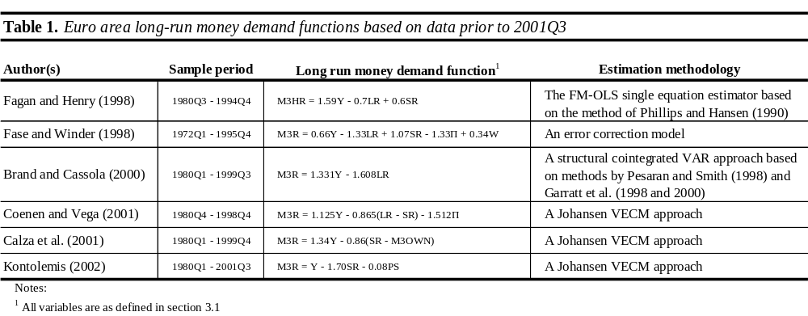

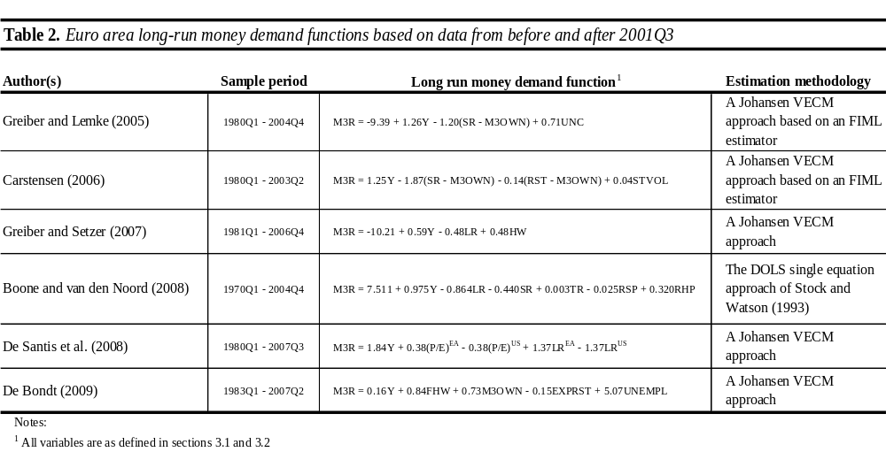

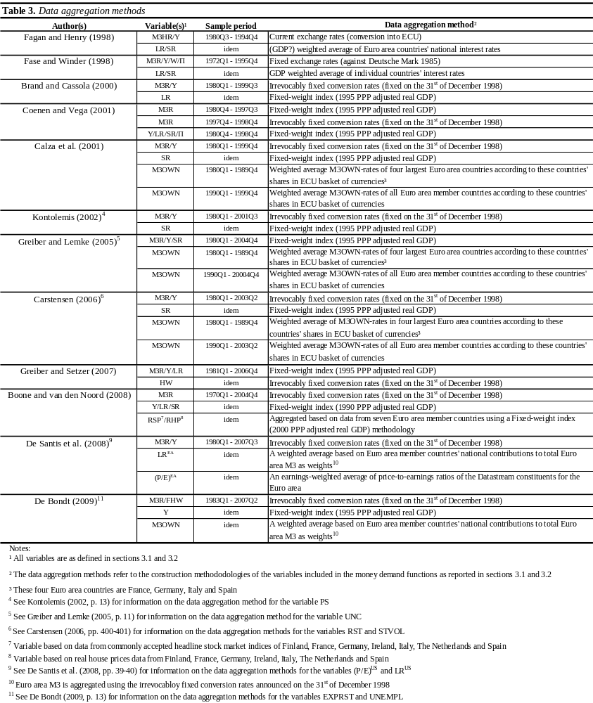
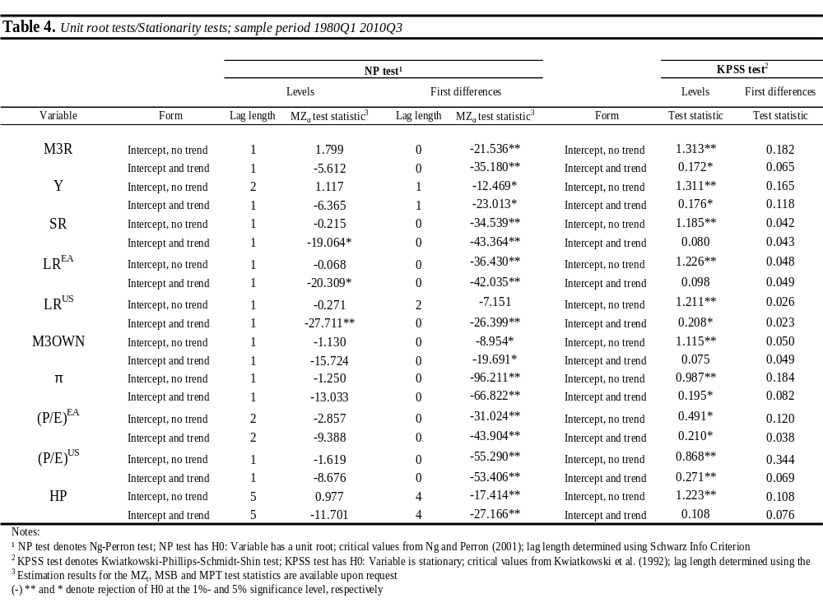

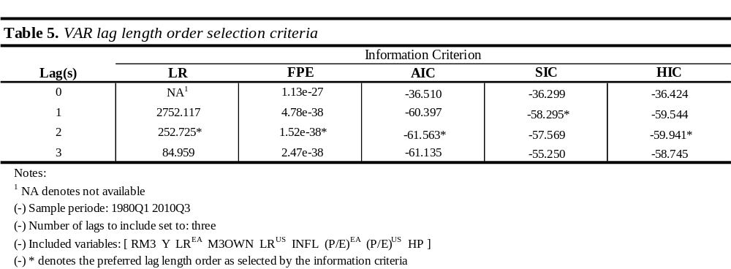

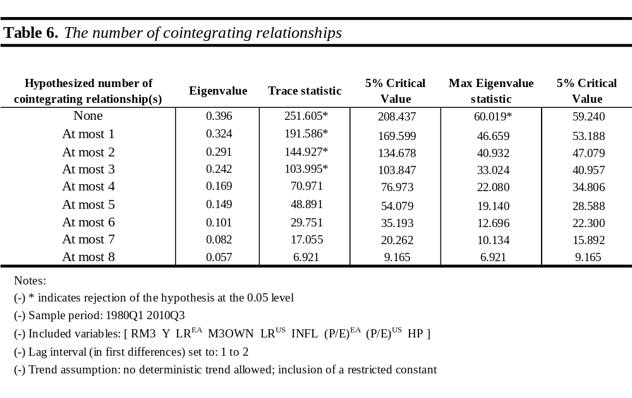

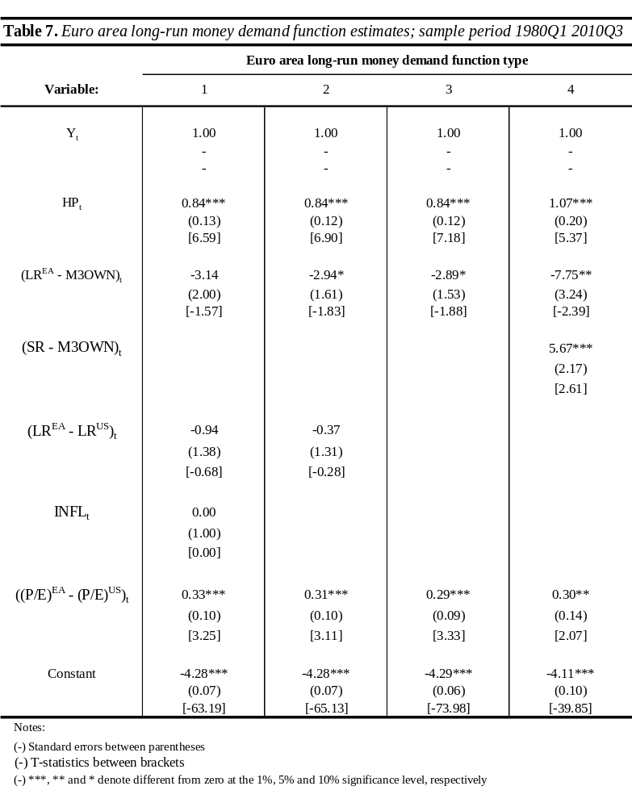

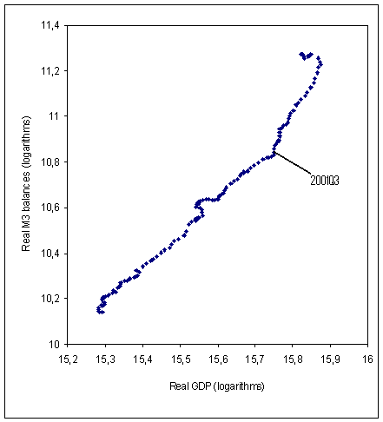
Fig. 1. Euro area long-run income elasticity.

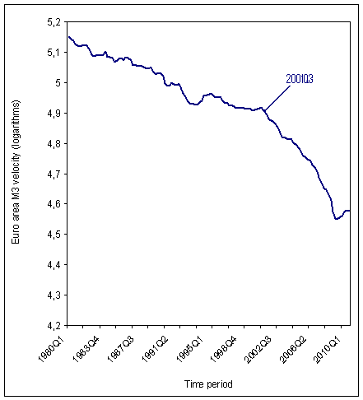
Fig. 2. Euro area M3 velocity.
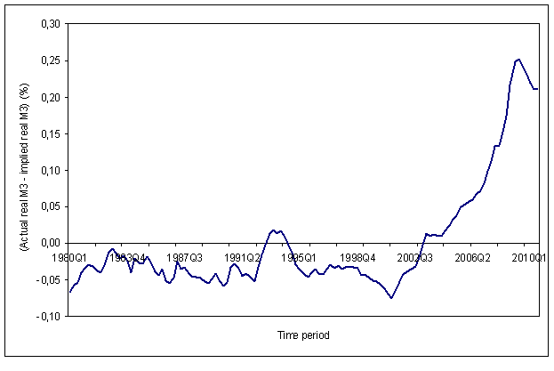
Fig. 3. Instability Euro area standard long-run money demand function.

Note:
(-) Monetary overhang measure based on the following equation (See Calza et al. (2001)),

Monetary overhang = RM3_{t} + 12.65 - 1.49Y_{t} + 0.33(RS - M3OWN)_{t}

where all variables are as defined in the text.

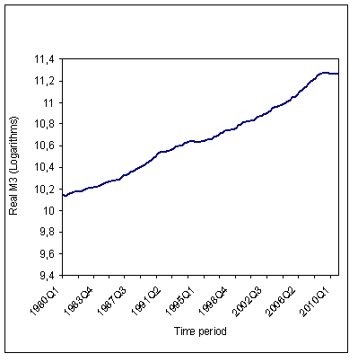
Fig. 4a. Real M3 balances.
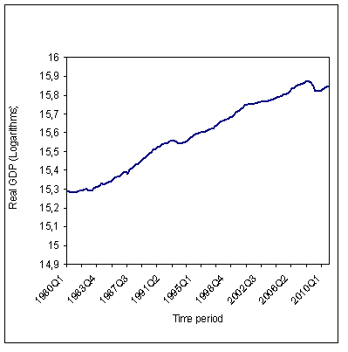
Fig. 4b. Real GDP.

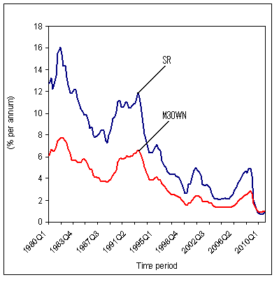
Fig. 4c. Short-term market interest rate versus money’s own rate of return.
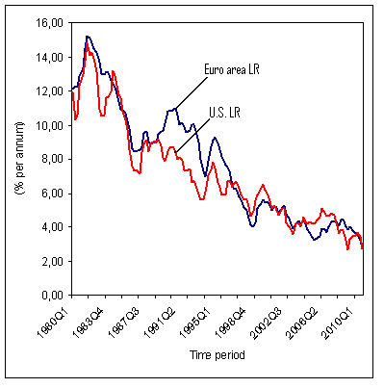
Fig. 4d. Euro area and U.S. long-term market interest rates.

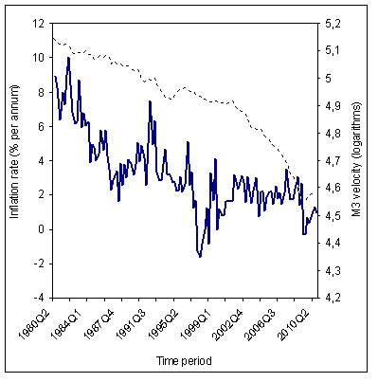
Fig. 4e. Inflation and M3 velocity.

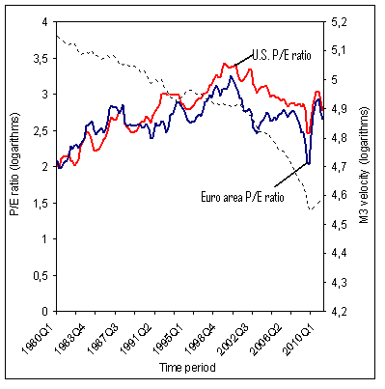
Fig. 4f. P/E ratios and M3 velocity.

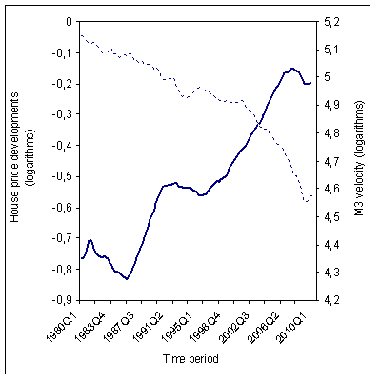
Fig. 4g. House price developments and M3 velocity.

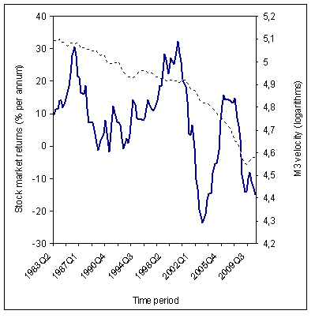
Fig. 4h. Realized stock market returns and M3 velocity.

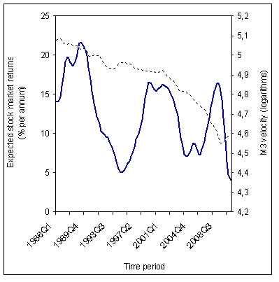
Fig. 4i. Expected stock market returns and M3 velocity.

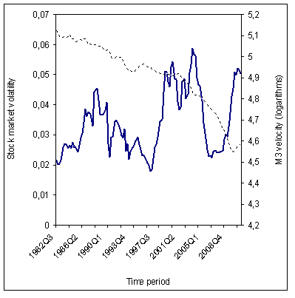
Fig. 4j. Stock market volatility and M3 velocity.

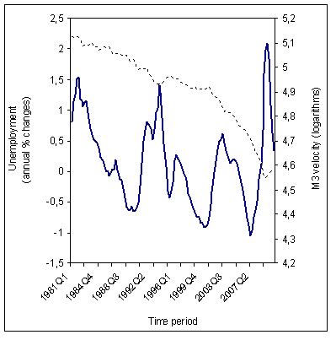
Fig. 4k. Labour market uncertainty and M3 velocity.

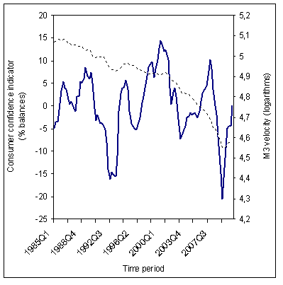
Fig. 4l. Consumer confidence indicator and M3 velocity.

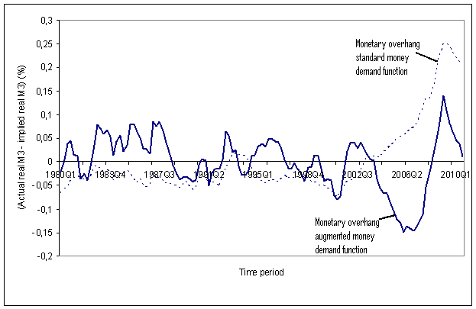
Fig. 5. Comparison monetary overhang measures.
Note:
(-) Monetary overhang measure based on the following equation (see Table 7, function type 3),

Monetary overhang = RM3_{t} + 4.29 - Y_{t} - 0.84HP_{t} + 2.89(RL^{EA} - M3OWN)_{t} - 0.29((P/E)^{EA} - (P/E)^{US})_{t}

where all variables are as defined in the text.

Appendix A: Robustness check

To cross-check the estimation results based on the Johansen VECM methodology, the Dynamic Ordinary Least Squares (DOLS henceforth) single equation approach of Stock and Watson (1993) will be applied. In short, the DOLS method consists of the following methodological steps. First, an analysis of the variables’ time series properties with unit root and stationarity tests. Second, given the fact that two or more variables are non-stationary, examine whether they are cointegrated. This step involves the estimation of the following long-run equilibrium relationship using Ordinary Least Squares (OLS henceforth)

(A1) y_{t} = α₀ + Σ^{n}_{i=1} α_{i}x_{i,t} + Σ^{n}_{i=1} Σ^{+k2}_{j=-k1} γ_{i,j}∆x_{i,t-j} + ε_{t}

where y is the dependent variable, n the number of right-hand side variables, x a vector consisting of the right-hand side variables, and k1 and k2, respectively, denote the amount of lead and lags as selected by the various information criteria. The amount of leads is frequently set equal to the amount of lags, i.e., k1 = k2. It should be noted that the long-run coefficients, the α’s, are superconsistent. Furthermore, t-statistics could be employed to determine whether the variables in vector x have a significant influence on the dependent variable. Kremers et al.’s (1992) ECM test is then applied to test the cointegration residuals from the long-run equilibrium relationship. The cointegration residuals are obtained as follows

(A2) z_{t} = y_{t} - α₀ - Σ^{n}_{i=1} α_{i}x_{i,t}

where z are the cointegration residuals and all remaining variables are as defined in equation A1. The short-run dynamic model could now be estimated with OLS. This will happen on a general-to-specific modelling base and includes the residuals as defined in equation A2. The following equation reflects the short-run dynamic model

(A3) ∆y_{t} = γ₁(L)∆y_{t-1} + ω₁(L)∆x_{t-1} + ψ₁z_{t-1} + ε_{1t}

where the term (L) denotes the amount of lags and all remaining variables are as defined in equations 23, A1 and A2. Finally, the parameter value for the lagged cointegration residuals, the coefficient ψ₁ in equation A3, is examined with standard t-tests (see Banerjee et al. (1993)). To assume a cointegration relationship between the variable y and the variables in vector x, the coefficient value of ψ₁ should be negative and significantly different from zero. The results of the robustness check are reported in Table A1.

----------------------------------------
INSERT TABLE A1 HERE
----------------------------------------

The following outcomes are noted. First, house price developments have a significant influence on the Euro area M3 demand. The long-run elasticity coefficient for this wealth variable measures between 0.6 and 0.7. Second, the spread between the Euro area and U.S. long-term market interest rates does not impact the Euro area M3 holding sector. Third, inclusion of the inflation rate and the opportunity cost measure calculated as the difference between the short-term market interest rate and money’s own rate of return, results in relationships that can not be defined as cointegration relationships (see the ECM test results). Overall, I conclude that the money demand function type 3 contains only true long-term determinants of the Euro area M3 demand function. These variables are real GDP, real house prices, the opportunity cost measure estimated as the spread between the Euro area long-term market interest rate and money’s own rate of return, and the spread between the two price-earnings ratios.
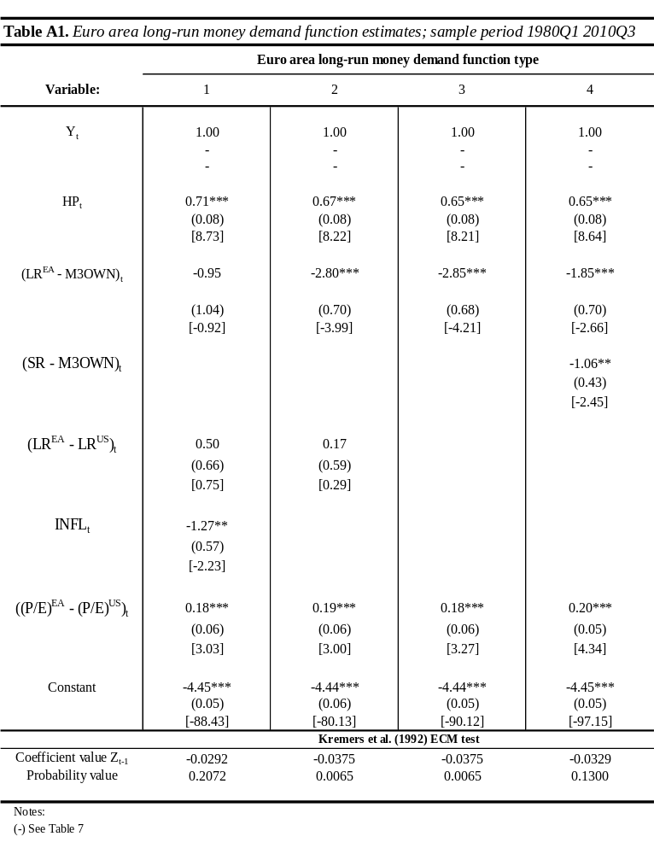

Appendix B: Construction methodologies of the variables

Real money balances
Seasonally adjusted data series for the nominal monetary aggregate M3 are reported with a monthly frequency in the ECB’s Historical Monetary Statistics and Monthly Bulletins. No adjustments have been made with respect to reclassifications and/or breaks. To correct the data for potential reclassifications and breaks, an index of notional money stock is constructed. Quarterly data series are calculated as period averages. Data series for the GDP price deflator are constructed as follows. A seasonally adjusted monthly GDP price deflator index is created with 2000 as the reference year. For the first part of the sample period, the period between 1980Q1 and 1990Q4, the index is based on data from the price level variable of the Brand and Cassola (2000) database. This variable is defined as a seasonally adjusted GDP deflator and refers to the ratio of nominal GDP to real GDP expressed in logarithms. Data from this database are transformed into their exponential values before rescaling them to index values. For the part of the sample period that runs from 1991Q1 until 1994Q4, the index is based on GDP implicit price deflator data from the OECD. For the most recent part of the sample period, the period beyond 1995Q1, the GDP price deflator index is constructed with rescaled price index data based on national currencies from Eurostat. These data series refer to the ratio of seasonally adjusted GDP series at current prices to seasonally adjusted GDP series at 1995 constant prices and are rescaled to obtain 2000 as the reference year. Figure B1 plots the resulting data series for the real M3 variable together with those from the databases of both Coenen and Vega (2001) and Calza et al. (2001) for the period 1980Q1 - 1998Q4. The different interceptions with the y-axis are related to differences in the underlying base years. Coenen and Vega (2001) use 1995 as reference year, while Calza et al. (2001) set their base year to 1998.

----------------------------------------
INSERT FIGURE B1 HERE
----------------------------------------

Real GDP
Similar to the construction of the variables real M3 and the GDP price deflator, data series for the real GDP variable are also obtained creating a seasonally adjusted quarterly index series first. For the part of the sample period between 1980Q1 and 1994Q4, this index uses rescaled exponential values from the real GDP variable of the Brand and Cassola (2000) database. For the part of the sample period between 1995Q1 and 2008Q4, data refer to GDP chain-linked volumes with reference year 2000 from Eurostat. For the period beyond 2008Q4, data are constructed by extrapolating the real GDP index value for 2008Q4 with quarterly growth rates of GDP in chain-linked volumes from Eurostat. Figure B2 plots the resulting data series with the real GDP variables from Coenen and Vega (2001) and Calza et al. (2001). Again, different interceptions with the y-axis are related to differences in the underlying base years.

----------------------------------------
INSERT FIGURE B2 HERE
----------------------------------------

Market interest rates
Quarterly average data series for the three market interest rates are calculated from monthly data and express a percentage per year. Comparing the data series for the Euro area long-term market interest rate with those from the databases of Coenen and Vega (2001) and Calza et al. (2001), differences appear very small (see Figure B3). Differences between the Euro area long-term interest rates from Coenen en Vega (2001) and Calza et al. (2001) are actually nil.

----------------------------------------
INSERT FIGURE B3 HERE
----------------------------------------

Money’s own rate of return
Data for this variable are from the database of Calza et al. (2001) for the period 1980Q1 - 1999Q4 and based on retail interest rates from the Monthly Bulletins afterwards. Quarterly data series are obtained as follows. For the part of the sample period between 1980Q1 and 1989Q4, Calza et al. (2001) estimate money’s own rate of return as a weighted average of money’s own rate of return in the Euro area’s four largest countries. Weights for these countries’ money’s own rates of return are determined on the shares of the countries in the ECU basket of currencies. For the period between 1990Q1 and 2010Q3, money’s own rate of return consists of Euro area-wide data. Money’s own rate of return is then calculated as a weighted average of the rates of return on the various components comprising M3. Weights for the components are the shares of these components within M3. Data for money’s own rate of return express a percentage per year.

Price-earnings ratios
The construction methodology for both price-earnings ratios follows that of De Santis et al. (2008). The price-earnings ratios are defined as the ratio of total market value to total earnings of the Datastream constituents. Data series for the Euro area refer to the Datastream constituents for the EMU market, and those for the U.S. to the Datastream constituents for the U.S. market. The result is an earnings-weighted average of the price-earnings ratios of the Datastream constituents for both areas.

House price developments
In line with one of the housing market variables of Greiber and Setzer (2007), developments of Euro area house prices are approximated by the residential property index variable from the Monthly Bulletins. Data for this index are published on a semi-annual basis. Missing values are therefore estimated via linear interpolation. Real house prices are obtained by deflating data from the residential property index with the aforementioned GDP price deflator.

Realized returns on stock markets
The construction methodology for this variable resembles that of Carstensen (2006). Data for this variable are from Datastream and the Monthly Bulletins. Datastream price index data from the German stock market index DAX 30 are employed for the first part of the sample period, the period 1980Q1 - 1986Q4, and price index data from the Dow Jones Euro Stoxx 50 from the Monthly Bulletins for the remaining part of the sample period. The use of data from the German DAX 30 for the first part of the sample period is explained by the non-availability of a Euro area-wide stock price index for this period. It could be noted that for most part of the sample period beyond 1987Q1, both stock price indices follow a similar trend (see Figure B4). With the assumption that data from the German DAX 30 are a good indicator for Euro area stock market developments for the period prior to 1987Q1, the returns on stock markets are constructed as follows. First, data from the DAX 30 are rescaled to the first data available from Dow Jones Euro Stoxx 50, i.e., data from 1987Q1. Second, a three-year moving average is calculated from quarterly logarithms differences. Carstensen (2006, p. 400) applies a moving average of three years “to mimic the fundamental yield path and exclude erratic short-term yield changes, which probably do not affect the long-run money demand.” Adjusting this period to respectively 2 and 2.5 years instead, Carstensen (2006) does not observe a change in the estimation results. Finally, it is noted that because of this construction methodology, data is available for the period between 1983Q2 and 2010Q3.

Expected returns on stock markets
The construction methodology for the expected returns on stock markets measure follow that of De Bondt (2009). EMU stock market data with respect to the level of the index, the price-earnings ratios and dividend yields are obtained from Datastream for the entire sample period. The amounts of earnings and dividends denominated in Euros follow from these three series. Based on the earnings-based methodology of Fama and French (2002), data series for this variable are calculated according to the following formula

(B1) A(re_{t}) = A(D_{t}/SP_{t-4}) + A(E_{t} - E_{t-4})/E_{t-4}

where A denotes an average value, re_{t} the expected return on equity at time t, D_{t} dividend yield at time t, SP_{t-4} the four-quarter lagged level of the stock price index, and (E_{t} - E_{t-4})/E_{t-4} measures the annual growth rate of earnings. An average period of five years is maintained. This is because an equity investment horizon of five years is assumed by De Bondt (2009). Based on this construction methodology, data is available from 1986Q1 onwards.

Volatility stock markets
Similar to the variable representing the realized returns on stock markets, data for the stock market volatility measure are also from the German DAX 30 for the part of the sample period between 1980Q1 and 1986Q4, and from the Dow Jones Euro Stoxx 50 hereafter. The only difference is that daily data instead of monthly data are used. Quarterly data series are obtained as follows. Again, price index data from the DAX 30 are rescaled to the first available daily observation for the Dow Jones Euro area Stoxx 50. Stock market volatility is then calculated as the standard deviation of the daily returns on these stock markets in one quarter, normalized by the average price index level in that particular quarter. To make the series more smooth, an average period of two years is maintained. Hence, data is available for this variable from 1982Q1 onwards.

Labour market conditions
Labour market uncertainty is defined as annual changes in the unemployment rate. For the part of the sample period between 1980Q1 and 1994Q4, quarterly unemployment data are from the AWM database. Afterwards, monthly data are from the Monthly Bulletins which have been transformed into quarterly data as period averages. Data from both data sources measure the seasonally adjusted total number of unemployed people with respect to the total number of civilian workforce expressed as a percentage.

Consumer confidence indicator
Data for this variable are estimated as an average value of economic households’ answers to survey questions regarding their expected financial and economic situation. Monthly data are from the ECB’s Real Time Database for the period 1985Q1 - 2010Q3 and used to construct quarterly averages. It could be noted that there is a high negative correlation between data from this consumer confidence indicator and annual changes in the unemployment rate (see Figure B5). This correlation measures -0.84 for the period between 1985Q1 and 2010Q3.
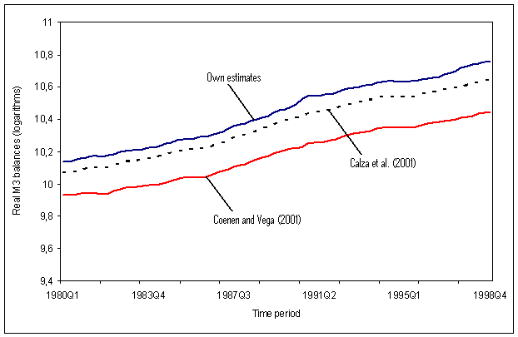
Fig. B1. Comparison of real M3 data series.

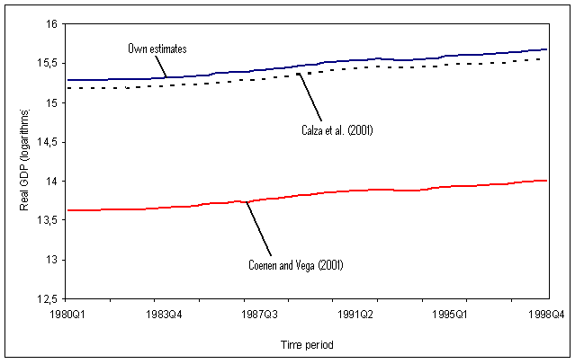
Fig. B2. Comparison of real GDP data series.

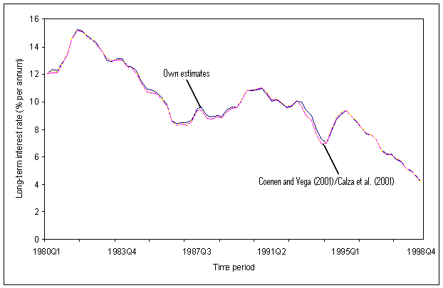
Fig. B3. Comparison of Euro area long-term market interest rates.

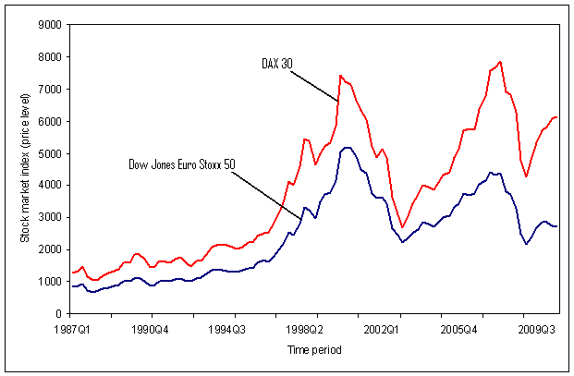
Fig. B4. Comparison of stock market indices.

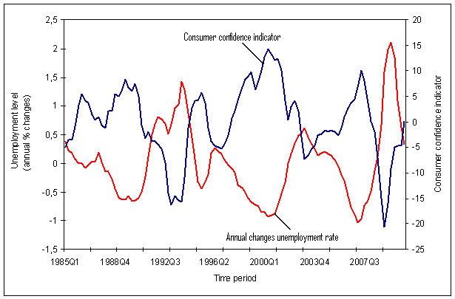
Fig. B5. Correlation consumer confidence indicator and annual changes unemployment rate.

Note:
(-) Values of the consumer confidence measure have been re-scaled to obtain an average value of zero over the entire sample period.

The ECB defines price stability in the medium term as an increase in the Harmonised Index of Consumer Prices (HICP henceforth) for the Euro area of below 2% on a yearly basis. For more information about the ECB’s monetary policy strategy and it’s objectives, see: http://www.ecb.int/mopo/strategy/html/index.en.html
For more information about the start of the use of the reference value for the monetary aggregate M3, see the ECB’s press release on the 1st of December 1998.
See, e.g., the ECB’s Monthly Bulletin of January 1999 and Masuch et al. (2001).
See, inter alios, Carstensen (2004), De Santis et al. (2008) and Nautz and Rondorf (2010).
For in-depth reviews of the development of the theory behind money demand functions, see Sriram (1999), Müller (2003) and De Bondt (2009). The majority of this chapter comes from these articles.
The only exception is the empirical research of Kontolemis (2002). His sample period runs until 2001Q3. The last observation of Kontolemis’ (2002) empirical research just includes the start of the accelerating growth of Euro area M3. However, with just one observation covering the period of Euro area long-run money demand function instability, Kontolemis’ (2002) article is discussed in section 3.1 and not in section 3.2.
Johansen (1988), (1991), (1995) and (1995a) and Johansen and Juselius (1990) published various articles dedicated to the VECM methodology. All articles apply to the statistical framework of (Quasi) Gaussian Maximum Likelihood Estimation but treat different problems relevant for inference. Taking this into account, I will, in this thesis, indiscriminately use the word Johansen VECM methodology without a specific reference to any of these articles.
Fagan and Henry (1998) analyse the long-run money demand function for three monetary aggregates. Those are the broad monetary aggregate M3H, the more narrow monetary aggregate M1, and NC representing the amount of notes and coins held by the public. See Fagan and Henry (1998, p. 490, Boxes 1.1 and 1.2) for information on the money demand functions for NC and M1.
For more details on the data aggregation method applied by Fagan and Henry (1998) as well as those used in the remaining empirical research of sections 3.1 and 3.2, see section 5.1.
In sections 3.1 and 3.2, I will report the asymptotic standard errors in parentheses below the long-run money demand functions. If the standard errors are not displayed it could mean that they are either not reported in the original article or that the content of information is questionable. This is because the quality of information from standard errors (and t-statistics) highly depends on the underlying methodology. E.g., standard errors calculated with the single equation cointegration approach of Engle and Granger (1987) are known to be unreliable. Hence, I will only report standard errors based on methodologies that deliver reliable standard errors.
Fase and Winder (1998) examine the long-run money demand function for the monetary aggregates M1, M2 and M3. See Fase and Winder (1998, p. 513, Table 1) for information on the money demand functions for M1 and M2.
This wealth variable measures the net financial wealth of the non-monetary private sector.
The Fisher Hypothesis states a one-on-one relationship between the nominal interest rate and the (expected) rate of inflation. In a situation of financial market equilibrium, investors are thought to set the nominal interest rate equal to the expected real interest rate, which includes a risk premium, plus a compensation for the expected fall in the purchasing power of money.
The expectations theory of the term structure of interest rates assumes that the n-period interest rate equals the (weighted) average of the expected future one-period interest rates plus a risk premium (see Clements and Galvão (2003)). The expectations theory of the term structure of interest rates implies that the spread between the short- and long-term interest rates is a function of expected future one-period changes in the short-term interest rate (see, e.g., Sutton (2000)).
See Brand and Cassola (2000, p. 32, Table 6) for information on the estimation results for the two remaining long-run relationships.
The QMA of 1999Q3.
A positive parameter value for the short-term market interest rate would indicate that a restrictive monetary policy will lead to rising short-term market interest rates. This, in turn, has the consequence of an increase in the demand for money. On the other hand, when the elasticity of the short-term market interest rate equals that the of long-term interest rate or, put differently, the spread between the short- and long-term market interest rates is stationary, the demand for money will not change after an upward shift in the term structure of the interest rates. Calza et al. (2001, p. 5) conclude that these problems lead to such controversial outcomes that “… the model will - under certain circumstances - represent the direct effect of monetary policy tightening as either perverse (in the first case) or ineffective (in the second case).”
Money’s own rate of return is calculated as a weighted average of the returns on the various components comprising M3.
The long-run (semi-) elasticity coefficients for the variables real GDP and the spread between the short-term market interest rate and money’s own rate of return, and the coefficient for the constant are, respectively, 1.49, -0.33 and -12.65. This money demand function specification allows the possibility of a linear trend in the cointegrating relationship. Finally, the VAR model is based on a lag order of two and has a sample period that covers the period between 1980Q1 and 1999Q4.
For an in-depth review of augmented Euro area standard long-run money demand functions to explain the Euro area money demand function instability since 2001Q3, see Barigozzi and Conti (2010, Section 3).
Greiber and Lemke (2005) estimate four different Euro area long-run money demand functions. Differences between the functions are twofold. First, the opportunity cost variable, the term (SR - M3OWN), is measured both in levels and natural logarithms. Second, the uncertainty variable UNC, is used with and without data from two survey-based confidence indicators included in the short-run dynamics of the error correction model (ECM henceforth) (see Greiber and Lemke (2005). Equation 14 contains the opportunity cost measure in levels and includes data from the two survey-based confidence indicators in the short-run dynamics of the ECM. The estimation results are quite similar to those of the alternative money demand functions. See Greiber and Lemke (2005, p. 16, Table 1) for more information on the alternative functions.
The variable UNC is an index which contains data from six financial market development indicators.
See also Friedman (1988, pp. 222-223).
Carstensen (2006) applies the FM-OLS methodology by Phillips and Hansen (1990) to cross-check the estimation results of the FIML estimator. The only difference is that the FM-OLS methodology based coefficients are somewhat more stable. See Carstensen (2006, p. 398) for more information on the estimation results based on the FM-OLS methodology.
Greiber and Setzer (2007) also discuss the influence of housing market developments on the demand for money for the U.S..
The following two reasons are given for these differences in price elasticities. First, the scarcity of input factors, such as land, restricts supply on the housing market. Second, producers of consumer goods in the more developed countries face competition from producers in less developed countries. Producers from the more developed countries will therefore not be able to raise consumer goods’ prices in response to an increase of market liquidity.
The recent financial crisis has probably altered this relationship. Lending based on expectations with respect to increasing house prices might have become more restrictive.
Greiber and Setzer (2007) estimate two Euro area money demand functions. The difference exists in the construction of the variable representing housing market developments. In equation 16, this variable is based on estimates of households’ housing wealth that include the value of the land on which the housing property is build. In the alternative money demand function, the variable is based on data from a real residential property price index. In general, the estimation results of both money demand functions are quite similar. See Greiber and Setzer (2007, p. 13, Table 3) for the estimation results of the alternative money demand function.
See, e.g., the ECB’s Monthly Bulletin of July 2005 and the ECB’s Annual Report of 2007.
These excess returns are approximated by price-earnings ratios.
The influence of cross-border capital flows on the Euro area money demand is measured with data on U.S. assets. This is because U.S. assets form such an important part of the world economy.
De Santis et al. (2008) estimate three cointegrating vectors. The long-run money demand function as defined in equation 18, a long-run equilibrium relationship between the U.S. long-term market interest rate and the U.S. price-earnings ratio, and a long-run equilibrium relationship between the Euro area long-term market interest rate, money’s own rate of return and the Euro area price-earnings ratio. See De Santis et al. (2008, p. 24) for more information on these last two relationships.
Barigozzi and Conti (2010) confirm the stability properties of the money demand function of De Santis et al. (2008) based on the outcomes of a time-varying cointegration likelihood-ratio test according to the methodology of Bierens and Martins (2010). This test is applied to examine whether the observed money demand function instability is related to changing parameter values or additional motives for holding money. Barigozzi and Conti (2010) conclude in favour of a Euro area time-invariant stable money demand function in an international portfolio allocation context.
De Bondt (2009) estimates three alternative long-run money demand functions. They differ from equation 19 either with respect to imposed restrictions, the use of different variables to represent the various money holding motives or apply a shorter sample period. In general, the outcomes of the alternative money demand functions are quite similar to those of equation 19. See De Bondt (2009, p. 17) for more information on the results of the three alternative functions.
This wealth measure includes both financial and housing wealth.
Labour market conditions are measured as annual changes in the unemployment rate.
See, inter alios, Engle and Granger (1987).
The two extreme outcomes are r = 0 and r = n. In the first case there are no linear independent combinations of the variables in y which are stationary and, hence, there are no cointegration relationships. In case of the second situation, all the variables in y are stationary.
An NP test has the null hypothesis that the variable has a unit root. Critical values are obtained from Ng and Perron (2001). In EViews 5.0, the lag length is determined using the Schwarz Information Criterion (SIC henceforth) by default.
An KPSS test has the null hypothesis that the variable is stationary. Critical values are obtained from Kwiatkowski et al. (1992). In EViews 5.0, the lag length is determined with the standard default option.
The ECB determined the irrevocable fixed conversion rates originally on the 31st of December 1998 and changed it to the 19th of June 2000, the 11th of July 2006, the 10th of July 2007 and the 7th of July 2008, with the EMU membership of, respectively, Greece, Slovenia, Cyprus and Malta and, finally, Slovakia. As of this writing, the irrevocable fixed conversion rates date with respect to Estonia’s EMU membership on the 1st of January 2011 had not yet been announced.
The ECB uses data from the AWM database for it’s macroeconomic models. For more information on the ECB’s AWM, see Fagan et al. (2001).
The data are adjusted for Purchasing Power Parity (PPP henceforth) exchange rates.
The EMU increased from it’s original number of eleven member countries to it’s current number of seventeen member countries with the entrance of Greece at the 1st of January 2001, Slovenia at the 1st of January 2007, Cyprus and Malta at the 1st of January 2008, Slovakia at the 1st of January 2009 and, finally, Estonia at the 1st of January 2011. In this thesis, the EMU data series refer to data from it’s first sixteen member countries. This is because the sample period only runs until 2010Q3.
See, e.g., the arguments of Hayo (1999).
For the definition of money velocity in algebraically terms, see equation 4.
I consider real GDP, the short- or long-term market interest rate and money’s own rate of return as the variables that have to be included in a long-run money demand function per definition.
See Dreger and Wolters (2008).
Based on the quantity equation as defined in equation 3, the inverse velocity of money could be formulated as -v = m - p - y.
This result is obtained in case the initial number of lags is set to three. The outcome does however not change if, instead, the initial number of lags is set to four.
E.g., Dedola (2001) reports a long-run semi-elasticity coefficient for the long-term market interest rate of -3.36.
In this case, the long-term determinants of the demand for money.
The general-to-specific modelling strategy is explained as follows. First, equation A3 is estimated with a specific number of lags. This amount is similar for y and the variables in vector x. Second, if there are insignificant variables and lags, these are excluded from equation A3 after which it is estimated again. Variables and lags are defined as insignificant if their t-statistics are below the critical values at the 10% significance level in absolute value.
These countries are France, Germany, Italy and Spain.
See the text accompanying footnote 28. A quarterly dataset measuring Euro area housing wealth spanning a sufficiently large sample period is unfortunately not available.

