

Erasmus School of Economics
Department of Marketing
Master’s Thesis

Country-Of-Origin-Effects in the Premium Car Market

Are Quality Perceptions and Willingness to Pay Higher for German Brands?
A Comparison of Germany and the Netherlands

Name: Tim Aumann
Student ID: 344883
Supervisor: Nuno M.A. Camacho
Date: July 19, 2011

Abstract
In this research, I use a novel and innovative approach to study one of the most important phenomena in international marketing for both researchers and managers: The country-of-origin-effect. I review literature on the effect and develop hypotheses how consumer characteristics nowadays influence the intensity of the country-of-origin-effect. I operationalize the effect measuring differences in quality perceptions and willingness to pay. My empirical research in the form of an online questionnaire studies the sector of premium automobiles and examines and compares the behavior of consumers in the Dutch and in the German market.
I find that age and the degree to which an individual tends to maximize her or his utility are both positively related to the intensity of the country-of-origin-effect. To assess the effect, I use an innovative within-subject picture experiment, capturing switching behavior depending on whether or not the country of origin of a displayed car is indicated to the respondent. Additional effects occur for gender and nationality. While both do not have a significant impact on the actual choice behavior of respondents, they clearly influence stated preferences. Males rate the country of origin of an automobile more important than females and German consumers show a significantly higher preference to buy German cars than Dutch ones. The latter however still prefer Western European countries of origin over others. Regarding the willingness to pay, I show that German consumers are willing to pay higher price premiums for German cars than Dutch consumers. Furthermore, the tendency of an individual to maximize utility is also positively related to the willingness to pay higher price premiums for vehicles of German origin.
My study thus is important both for marketing researchers and managers since I show innovative approaches on how to conduct future country-of-origin-research and deliver valuable insights for marketing communication which can be derived from my findings.

Keywords: International Marketing; Country of Origin; Country Image; Consumer Behavior; Quality Perceptions; Willingness to Pay

Table of Contents
Abstract I
Table of Contents I
List of Figures III
List of Tables IV
1. Introduction and Motivation 1
2. Literature Review and Generation of Hypotheses 5
2.1 Existence of COO-Effects 5
2.2 Defining the Country of Origin 7
2.3 Defining Country-of-Origin-Effects 8
2.4 Generation of Hypotheses 10
3. Methodology 18
3.1 Sample Selection 18
3.2 Data Collection 19
3.3 Measurement 19
3.4 Sample Descriptives and First Implications 25
3.4.1 Descriptives 25
3.4.2 Demographics 26
3.4.3 Brand Knowledge and Quality Perceptions 27
3.5 Estimation of Results 30
3.5.1 Importance of the Country of Origin and Influences on Quality Perceptions 30
3.5.2 Willingness to Pay Price Premiums for German Automobiles 35
4. Summary of Results and Discussion 38
5. Limitations and Directions for Future Research 41
List of References 42
Appendix AI

List of Figures
Figure 1: A Conceptual Model of the Quality Perception Process 9
Figure 2: Conceptual Model of the Research Structure 17
Figure 3: Comparison of Car Interiors across Questions (Jaguar XJ-Class Example) 23
Figure 4: Nationality of Respondents 26
Figure 5: Distribution of Ages across Respondents 27
Figure 6: Distribution of Gender 27
Figure 7: Knowledge of Automobile Brands sort by Country of Origin 28
Figure 8: Distribution of Preferences in the Picture Experiment 29

List of Tables
Table 1: Descriptive Statistics 26
Table 2: Logit-Model of the Choice of German Car in Question 1 (without Country Indication) 30
Table 3: Logit-Model of the Choice of German Car in Question 2 (with Country Indication) 31
Table 4: Stated Importance of the Country of Origin of a Car (Linear Regression) 32
Table 5: Stated Preference to Buy a German Car (Logit-Model) 34
Table 6: Importance of Country of Development being Country of Manufacturing (Linear Regression) 35
Table 7: Willingness to Pay Price Premiums for German Cars (Linear Regression) 36
Table 8: Group Statistics; Independent Samples t-Test for Car Recognition in Picture Experiment AX
Table 9: Independent Samples t-Test for Car Recognition in Picture Experiment AX
Table 10: GLM with Interaction Effects when Assessing the Stated Importance of the Country of Origin AXI
Table 11: One-Sample-Statistics; One-Sample t-Test for the Preferred Country of Origin (German Preferences) AXII
Table 12: One-Sample t-Test for the Preferred Country of Origin (German Preferences) AXII
Table 13: One-Sample-Statistics; One-Sample t-Test for the Preferred Country of Origin (Dutch Preferences) AXIII
Table 14: One-Sample t-Test for the Preferred Country of Origin (Dutch Preferences) AXIII
Table 15: Stated Preference to buy a British Car AXIV
Table 16: Stated Preference to buy an Italian Car AXIV
Table 17: Stated Preference to buy a Japanese Car AXV
Table 18: No stated Preference for any Country of Origin AXV
Table 19: Group Statistics; Independent Samples t-Test for the Preference to Buy a German Car AXVI
Table 20: Independent Samples t-Test for the Preference to Buy a German Car AXVI
Table 21: Willingness to Pay for Cars from Researched Countries AXVII

Introduction and Motivation
For years now, the country-of-origin-effect has been one of the big topics of interest for researchers in international marketing and consumer behavior, as well as for marketers in praxis. In a more and more globalized environment, products and companies have to increasingly rely on intangible assets like the country of origin of their brand in order to avoid brand parity and build up competitive advantages. This is due to converging qualities of products in nearly every sector, making it relevant to use other alleged benefits of a product for marketing communication.
Many studies (especially in the 1980s and 1990s) have dealt with country-of-origin-effects in various different product categories or in general. Prominent examples of countries that are connected to certain products (and used as a quality signal) in consumers’ minds are Belgian chocolates, Swiss watches, French wines, or Italian fashion design. In their review from 1993, Heslop and Papadopoulos state that more than 400 studies have been conducted on the topic. The field of research can thus be called rather mature, but prominent researchers are still attracted by the topic, reviewing the effect or introducing new measures and aspects (e.g. Verlegh, 2002; Nijssen and Douglas, 2004; Verlegh et al., 2005).
Hence, in my study I will start by reviewing studies in order to assess the extent to which the country-of-origin-effect is still in place. Based on this literature review, I build up my study design, which to the best of my knowledge significantly differs from existing studies. Many existing studies do not distinguish between different demographic groups of consumers (i.e. concerning age or gender) and measure the impact of the country-of-origin-effect across subjects and not within subjects. Another novelty of my research is the addition of the psychological maximization-scale developed by Schwartz et al. (2002). Thus, my approach contributes to marketing research in this field while also providing valuable information for marketing managers.
Customer characteristics are not static. They change due to various effects, like e.g. the ongoing technology-driven globalization, implying that cultures converge and consumers being global citizens thus might not be that “vulnerable” to the communication of the country of origin of a product as a sign of quality anymore. I will therefore review to what extent the country-of-origin-effect is still a matter of concern when evaluating the buying behavior of customers. Furthermore, globalization had and still has the effect that major parts of the production for western brands take place in emerging countries such as China or countries in Eastern Europe. It is hence very interesting to research if this change of the actual country of origin of a product has any effect on the consumers’ perceived quality. To research this and to ensure a more tangible approach than just discussing the country-of-origin-effect in general, my research will focus on the product category of automobiles.
What makes the automotive industry an interesting sector to research is that the change in competitive structures based on globalization effects has had a dramatically impact especially in the automotive industry. In past decades, severe differences in quality and reliability of cars occurred, making it relatively easy for customers to make a reasonable choice when buying a vehicle. Due to the global competition of over 60 noteworthy car-producers worldwide, this is not the case anymore. Nowadays, the presentation of a bad model in terms of quality leads to significant decreases in sales. Additionally, the producing company not only gets punished in terms of profit, but also in terms of reputation. Modern technology such as communication channels like social media and internet forums have the effect that information (e.g. such as a negative critique) is spread at an increasing speed across any kind of boundaries.
Furthermore, in the context of the country of origin as a quality signal, especially the market for luxury goods is very interesting because intangible factors like e.g. brand image or status have always been and still are very important in the buying decision of a potential customer. This is why I will put the focus of my research not on cars in general, but on the segment of high-class premium vehicles that ought to communicate a certain status of the owner/buyer. Specifically, I will compare 5 countries of origin of vendors of those premium vehicles around the globe (namely the United States, Great Britain, Germany, Italy and Japan) and how they are perceived by different groups of individuals in the two markets that are to be analyzed (more on that below). It will be interesting to reveal if and to what extent vendors of automobiles from certain countries can still benefit from the country-of-origin-effect.
As mentioned above, in order to generate useful results and keep the complexity at an appropriate level, my thesis is limited to researching two markets. Namely, these are the German and the Dutch market. Those markets are particularly interesting. The Dutch market can be seen as rather neutral because, despite being a well-developed economy with high GDP per capita, there are no noteworthy domestic car producers in the Netherlands. Thus, this paper hopefully will give some insights on how different countries of origin of a car are perceived in such a market. Germany on the other hand is the main producer of premium vehicles in the world and can be considered as one of the hardest and most competitive markets for those vehicles. It will be interesting to see in which ways the results differ and how practicing marketers can react to these differences in terms of marketing communication and price-setting.
Concluding, the goal of this thesis (as can be seen in the main research question) will be to study and shed light on how the country of origin influences potential customers when considering buying a luxury vehicle. Specifically, I will focus on the effect of the country of origin of a car on the evaluation of its quality (namely the country-of-origin-effect) and the impact of different factors (including the discussed country-of-origin-effect) on the willingness to pay price premiums for certain automobiles.
The results are thus important for marketing theory as well as for practicing marketers for several reasons. For marketing theory, this research is going to give insights on whether country-of-origin-effects still exist in a globalized environment and how the influence might be different for people with different demographics and psychological characteristics. Also, I provide suggestions for future research in the area. For managers, this thesis is going to provide information on how the country of origin drives customers’ quality perceptions. Such knowledge can then be used to streamline marketing communication in the automotive industry. Furthermore, marketing managers can gain insights on the willingness to pay for different kinds of customers, on which they can react in terms of an optimized price setting for their automobiles.
To approach the topic in a structured way, after this introductory part I will give an overview of already conducted studies in this field of research by reviewing existing literature. I will then integrate the country-of-origin-effect into a theoretical framework explaining the quality perception process. Based on this, I will formulate the hypotheses to be tested in the empirical part of my thesis and derive a conceptual model of the research structure. I will display the methodology and variables of this empirical part before discussing results and their implications. The thesis will end with a discussion of my findings, limitations of my study, and suggestions on further research in this area.

Literature Review and Generation of Hypotheses
As already discussed in the first part of my thesis, the country-of-origin-effect is a phenomenon of great interest in marketing research. Before going deeper into the effect itself, I will give a short overview of studies researching the actual existence of country-of-origin-effects. In other words, I will discuss whether or not the extant literature has found the country of origin of a product to influence consumers’ evaluation of the product quality.

2.1 Existence of COO-Effects
The first research on the effect was conducted and published in 1965 by Robert D. Schooler. In the article, published in the Journal of Marketing Research, Schooler tests if consumers in Central America are influenced by a pretended country of origin of a product in their evaluation of it. He conducts an experiment with four groups of individuals, giving them one and the same juice to drink, but labeling it in different ways for each group (i.e. putting different countries of origin on the label). Based on the outcome of this experiment, Schooler (1965) comes to the conclusion that significant differences in the evaluations of products exist, although the actual products only differ in the dimension of the name of the country of origin appearing on the label.
Following up on this initial study, a large number of papers have dealt with questions regarding the existence, variations and implications of the country-of-origin-effect (e.g., Nagashima, 1970; Bilkey and Nes, 1982; Elliott and Cameron, 1994; Liu and Johnson, 2005; Kabadayi and Lerman, 2011). Based on an extensive literature review of existing research, I can conclude that by far the most conducted studies confirm the first findings of Schooler regarding the influential effect of the country of origin of a product on its evaluation.
Although a meta-analysis conducted by Peterson and Jolibert (1995) comes to the conclusion that the existence and severity of country-of-origin-effects are only somewhat generalizable, most previous research suggests that the country of origin of a product influences consumers when making buying decisions, assuming other variables like the actual product quality and prices are equal (Elliott and Cameron, 1994). This is true for products in general (see e.g., Anderson & Cunningham, 1972; Gaedeke, 1973; Nagashima, 1977; White, 1979), as well as specifically for the automotive sector which I am going to research (see e.g., Nagashima, 1970; Etzel and Walker, 1974). Furthermore, recent research even suggests that cars as a product category are far more sensitive to the image of the country of origin than other products like e.g. television sets (Pappu, Quester, and Cooksey, 2007).
Even though the area of country-of-origin-effects can be considered a rather mature field of research in marketing, studies are still intensively conducted on the topic. This can be justified by ongoing developments like globalization and technological advances, affecting consumer behavior and making it necessary for researchers to constantly update the concept. Most of the current studies research interaction effects of the country-of-origin-effect with other product information like for example advertising claims (Verlegh, Steenkamp, and Meulenberg, 2005), or extend it to the brand level, rather than just considering the product (Thakor and Lavack, 2003). Another recent research conducted by Pharr suggests that the country of origin can have a rather weak or even insignificant effect when e.g. the brand name of a company or product is very strong and positive (Pharr, 2005). These findings however are negated by Kabadayi and Lerman (2011). They come to the conclusion that the country-of-origin-effect may have lost some importance but that it “(…) still affects consumer product evaluations and purchase intentions” (Kabadayi and Lerman, 2011, p. 121). These recent disagreements and ongoing discussions about the existence and magnitude of the country-of-origin-effect confirm my assumption that it is necessary to critically review the existence and strength of the country-of-origin-effect in today’s environment, making my study very timely.
The discussions around the existence and impact strength of the country-of-origin-effect are insofar justified, as the country-of-origin-research builds on implications concerning culture, stereotypes, and image. All of these factors are not static but very dynamic. This is especially facilitated by globalization and its impacts like outsourcing, cultural convergence and technological advancements. Inglehart and Baker (2000) for example propose that due to economic development, some norms and values within societies change and converge. Distinct traditional values (e.g. formed by religion) however persist despite modernization (Inglehart and Baker, 2000).
Based on the prior findings described above and the ongoing relevance and discussion, for my paper I for now expect that the country-of-origin-effect in general exists, influencing the evaluation of products. To find out whether or not this is also (or still) the case for the perceived quality of a car depending on its country of origin is the purpose of this thesis.
In the next section, I will review and analyze different perspectives on and definitions of the country of origin of a product.

2.2 Defining the Country of Origin
Definitions of the effect have covered a broad range in prior research. Most disagreements however concern the question, what the actual country of origin of a good is.
On the one hand, a number of authors argue that the country of origin of a product is the country where it is actually manufactured or finally assembled. For instance, referring to an at that time unpublished paper by Samiee (1987), Elliott and Cameron (1994) argue that the country-of-origin-effect is “any influence, positive or negative, that the country of manufacture might have on the consumer’s choice processes or subsequent behavior” (p. 50). This implies that the country of origin is the country where a product is ‘made in’ or ‘assembled in’, as indicated on the product (Nagashima, 1977).
On the other hand, authors like Johansson, Douglas, and Nonaka (1985) see the home country of a company (i.e. where the headquarters are located) as the country of origin for its brand and products. Since my study deals with customer perceptions, I will focus on origin effects on the brand level as opposed to the product level, meaning that the relevant dimension is where potential customers think the car comes from (Thakor and Lavack, 2003). This perception is most likely based on the origin of the brand and thus goes along the theory of Johansson and his colleagues (1985).
Although for this paper I agree with the position and definition of Johansson et al. (1985), the differences between the location of the headquarters of a company and the place of manufacturing will be incorporated in my research. In this context, the discussion is particularly interesting because it implies that customers might base their expectations on the actual country of manufacture. In the automotive industry though, the country of origin of a brand and the country of actual manufacturing often differ. My thesis will generate insights to what extent potential consumers are aware of that phenomenon and base their expectations on either one of the above.

2.3 Defining Country-of-Origin-Effects
Based on this first definition of what the country of origin of a brand is, I can now discuss what exactly country-of-origin-effects are and how they can be concretized.
Roth and Romeo (1992) offer an interesting and promising perspective, seeing the country-of-origin-effect (and with it the attribute of perceived quality of a product) as only one dimension of a whole bigger construct, namely country image. They infer that the country-of-origin-effect describes the fit between the category a product is in and the image of a country (i.e. what consumers think about the country). This is in line with studies conducted in the 1970’s by Nagashima. He finds that consumers have distinct images of different countries in their minds when evaluating products or product categories from that country, meaning not the overall country image is decisive, but associations that influence the supposed competence for making a certain product are crucial (Nagashima, 1970; 1977). The ideal situation would thus be when the perceived strengths of a country match important product benefits or attributes (Roth and Romeo, 1992). In this context, Romeo and Roth (1992) define country image as “(…) the overall perception consumers form of products from a particular country, based on their prior perceptions of the country’s production and marketing strengths and weaknesses” (p. 480).
Based on prior studies (e.g. Nagashima, 1970; 1977; White, 1979), Roth and Romeo (1992) identify four dimensions of country image that affect the country-of-origin-effect and thus consumer evaluations of products. These dimensions are the following:
- Innovativeness (technology and engineering advances)
- Design (appearance, style, colors, variety)
- Prestige (exclusivity, status, brand name reputation)
- Workmanship (reliability, durability, craftsmanship, manufacturing quality)
For the premium car segment, strong and positive perceptions of a country in all of these dimensions seem to be important in order to generate an adequate and favorable fit between the country image and the product.
As a frame of reference to situate and discuss the impact of the country of origin on the perceived quality and evaluation of a product, I use a conceptual model developed by Steenkamp (1990) (see Figure 1 for a simplified version).
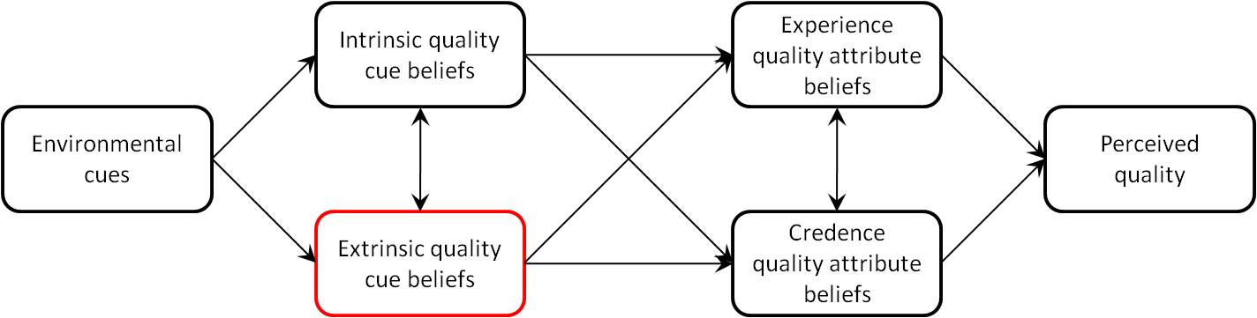
Figure 1: A Conceptual Model of the Quality Perception Process
According to Steenkamp (1990) and others (e.g. Hong and Wyer, 1989), the country of origin can be seen as a variable which consumers consider when evaluating a product or its quality, just like other variables such as the price and the brand of the particular product. Since this variable has no direct relation to the actual quality of the product (i.e. it is not a physical attribute of the product), one can describe it as an extrinsic information cue (see highlighted part in Figure 1). Although changes in those extrinsic attributes do not directly affect the actual product, they still affect consumers’ quality perceptions (Kirmani and Rao, 2000). They are thus a very crucial part in the evaluation process of a product (and its quality) since they determine what beliefs the consumer forms about the product. From the country of origin for example, consumers deduce the quality of a product. Steenkamp (1990) calls this phenomenon ‘inferential belief formulation’. Examples for other extrinsic cues are price, brand name or warranties, while intrinsic cues concern the product directly (e.g. taste, design, and fit) (Bilkey and Nes, 1982).
Furthermore, Steenkamp’s (1990) theory of interaction effects between different cues, as displayed in the model (see connections between the different boxes in Figure 1), is supported by the findings of a recent study conducted by Miyazaki et al. (2005). The authors research interactions between the different extrinsic cues and their impact on quality perceptions. They come to the conclusion that one strong cue (e.g. the country of origin alone) is not necessarily enough to drive strong quality perceptions of a product. It is far more important to ensure a consistent picture across different cues to improve quality inferences (Miyazaki, Grewal, and Goodstein, 2005). This is insofar interesting for my study, as I am going to research customers’ willingness to pay for a car, depending on the country of origin. With the results from my study, marketers will be able to adjust selling prices to the potential consumers’ willingness to pay (with consideration of the country of origin) and thereby form a consistent and appealing image in the minds of the consumers.
For my paper and based on the literature review I conducted, I define country-of-origin-effects as follows:
Country-of-origin-effects, as part of the higher-order construct of country image, describe the influence the image of a country (along the dimensions of innovativeness, design, prestige, and workmanship) has on the perception and evaluation of a product in the consumers’ minds, based on the country of origin of its brand.

2.4 Generation of Hypotheses
In the upcoming paragraph, I will develop and discuss the hypotheses for my empirical study. I will do this based on my general literature review in the previous section as well as further, more specific insights from already conducted studies and researches. At the end of this section, I present a conceptual model that summarizes the hypotheses and gives a basic outline of my empirical study that is described and conducted later.
My study mainly will deal with the question if the perceived quality of a car can be explained by the country-of-origin-effect (as suggest e.g. by Steenkamp, 1990). A recent study, in which an experiment was conducted, suggests that as soon as people have some sort of perception (e.g. a stereotype) of a country stored in their memory, they unintentionally use this as a cue to evaluate a product from that country without even realizing (Liu and Johnson, 2005). Germany is well known as the home country of some of the most sophisticated producers of premium automobiles in the world. Theory thus suggests that based on existing stereotypes (country stereotype effects), German car brands are likely to have a relatively high rating for quality attributes (Samiee, 1994).
In my study, I will examine if the perception of the quality of a car varies depending on the indication of its country of origin (i.e. if there is a country-of-origin-effect). For this, I will conduct an experiment to find out if responses concerning the perceived quality of a car differ, depending on whether or not the country of origin of a car is presented while consumers are looking at a picture of its interior. Since these differences and variations concerning the perceived quality can only be explained by the presence of the indicator for the country of origin of the car, the observed effect can be seen as the country-of-origin-effect.
I will look at how the results of the experiment differ across individuals based on demographic factors like gender, age, and nationality, as well as the psychological dimension of the tendency to maximize.
First of all, it is interesting to examine whether or not customer demographics, like age and gender, moderate country-of-origin-effects in the premium car market and if so, to what extent. Previous research suggests that the perception of brands and products is influenced by a number of factors (see e.g. Steenkamp, 1990). Although some of these factors like brand name, price, or physical appearance are considered marketing universals (Dawar and Parker, 1994), they are influenced by individual and more general culture-related values and traits.
This first sub-question thus will clarify if different clusters of individuals (i.e. regarding nationality, gender and age) have different perceptions about a product and how these differences might be explained. In this context, it is particularly interesting if the country-of-origin-effect changes with the age of the participants of the research. Some theory suggests that cultures converge due to globalization nowadays while others disagree (see Inglehart and Baker, 2000; Leung et al., 2005). If the theory of cultural convergence is true, one might expect that younger individuals (who grew up in a globalized environment) react less strongly to the communication and presentation of the country of origin of an automobile.
Based on this, concerning the influence of age, I hypothesize:

H₁: The intensity of the country-of-origin-effect in the premium car market is positively related to the age of potential customers.

The role of gender is still rather unclear and will hopefully be clarified by this study. On the one hand, one could argue that, as males are more status and power oriented than females (Ickes, 1993), they might be more likely to rely on the country of origin of a car as a quality signal. On the other hand, research suggests that the country-of-origin-effect gets stronger, the fewer a potential customer knows about the actual and tangible product characteristics (Han, 1989). Since men, on average, can be assumed to be more interested in and thus better informed about cars (Jones, Howe, and Rua, 2000), they might not build their opinion about a certain brand on its country of origin as much as women might do.
Since I expect the need for status and recognition to be bigger than the opposing theory of information asymmetry described above, I hypothesize the following:

H₂: When comparing premium cars, Males are more influenced by the country of origin of a car than females.

It also seems reasonable to assume that it is easier for companies to compete in their home market than abroad. Studies have shown that, in general, consumers show a clear preference to “buy local” if possible (Elliott and Cameron, 1994). One might thus derive that vendors of luxury automobiles have a competitive advantage in their home market. By testing the upcoming hypothesis, I am therefore trying to answer if this really is the case due to reasons like patriotism, or if the country-of-origin-effect for brands from abroad (i.e. the associated beliefs about the quality of products from that country) is stronger than the trust and belief in domestic brands. The consequence would be that they thus cannot benefit from consumers’ preference to buy local products.
Based on prior findings and the associated expertise of Germany as a producer of high quality automobiles, I for now hypothesize that

H_{3a}: When comparing premium cars, German consumers show a preference to buy German brands over foreign alternatives.

With the two markets that are part of the research, valuable insights can be generated from comparing the German results with those from the Dutch market, which (as already mentioned) has no noteworthy domestic car production. I hypothesize that

H_{3b:} When comparing premium cars, German consumers show a clearer preference for German brands than Dutch consumers.

Furthermore, I will research whether Dutch consumers have a preference for cars from certain countries. Since previous studies suggest that consumers who do not have domestic alternatives prefer to buy products from countries that are culturally similar to their home country (Watson and Wright, 2000), I hypothesize that

H_{3c}: When comparing premium cars, Dutch consumers show a higher preference for premium vehicles from Western European brands than for premium vehicles from other countries.

To generate even more customer-specific results and thus provide marketing managers as well as researchers with more valuable information on consumer behavior, I (next to the demographic differentiation regarding age, gender, and nationality) include a psychological dimension in my study that influences quality perceptions and willingness to pay.
Research has shown that when individuals have the choice between two or more options, there are two types of observable behavior: satisficing and maximizing behavior (Schwartz et al., 2002; Bruine de Bruin et al., 2007; Parker et al., 2007). Satisficers are looking for a product or service that crosses the threshold of acceptability, meaning that it is just good enough to fulfill their needs. Maximizers on the other hand review all possible options and ultimately make their choice so as to maximize their individual utility (Schwartz et al., 2002). It has to be noted though, that literal utility maximization is a rather unrealistic concept due to nearly infinite numbers of options in real-world decision making that make it almost impossible to find the optimal one (Harrison and Pelletier, 1997).
However, based on the findings of Schwartz et al. (2002), I assume that there are individuals who try to maximize their utility and those who just try to satisfy their needs. Thus, it is reasonable to believe that individuals who are trying to maximize their utility look for as many alleged beneficial attributes in a product as possible. Since a country of origin with strong and positive associations can be considered a beneficial, yet intangible attribute of a product (in this case a premium car), it seems logical to suggest that maximizers are more probable to be influenced by the country-of-origin-effect than satisficers. Furthermore, “(…) a maximizer is more likely to depend on social comparison than a satisficer” (Schwartz et al., 2002, p. 1194). Especially in the context of premium vehicles, the communication of status (and thus social comparison) is a very important argument in favor or against brands from certain countries. This further strengthens my assumption and I thus hypothesize:

H₄: When comparing premium cars, maximizers are more susceptible to country-of-origin-effects than satisficers.

Additionally, I will examine whether or not the intangible benefit of developing or producing a car in a country with a favorable and fitting image can be transformed into a monetary benefit. In other words: Does the country of origin justify price premiums for premium automobiles from certain countries?
This question is particularly important to marketers. The question that needs to be answered is if the country of origin can be used as a competitive advantage (and point of difference) for certain brands. Hence, these companies could use their country of origin e.g. in advertising and set higher prices than their competitors due to that point of difference. On the other hand, companies from countries with a relatively bad image in producing luxury cars or high quality goods in general might be better off stressing other factors like e.g. lower prices, material quality or technological innovations in their marketing communication.
Previous research comes to the conclusion that the country of origin of a product has a direct impact on the evaluation of that product concerning e.g. perceived quality (Steenkamp, 1990; Verlegh, Steenkamp, and Meulenberg, 2005). It thus seems reasonable to assume that if the country-of-origin-effect for a car vendor from a certain country is very strong and positive, potential consumers might be willing to pay for that, expecting a greater utility from that car in comparison to others. Since my study focuses on German brands in their competitive surrounding, I will study in which way the German origin of a car affects potential consumers’ willingness to pay for that car. Furthermore, I again will examine how results differ across the demographic and psychological dimensions discussed above. I expect the effects to occur in the same way as I did concerning the influence of the country-of-origin-effect. For instance, since I expected males to be more influenced by the country of origin of a car than females, I expect their willingness to pay for a car from a certain country to be higher than the one of females, too.
Therefore I hypothesize:

H_{5a}: When comparing premium cars, potential customers’ willingness to pay price premiums for German automobiles is positively related to the age of an individual.

H_{5b}: When comparing premium cars, males are willing to pay higher price premiums for German automobiles than females.

H_{5c}: When comparing premium cars, potential customers of German origin are willing to pay higher price premiums for German automobiles than those of Dutch origin.

H_{5d}: When comparing premium cars, Potential customers’ willingness to pay price premiums for German automobiles is positively related to the extent of the tendency to maximize.

H_{5e}: When comparing premium cars, potential customers’ willingness to pay price premiums for German automobiles is positively mediated by the country-of-origin-effect.

The hypotheses generated above will guide my empirical studies. To illustrate the structure of my study and the interactions, I developed the following conceptual model:
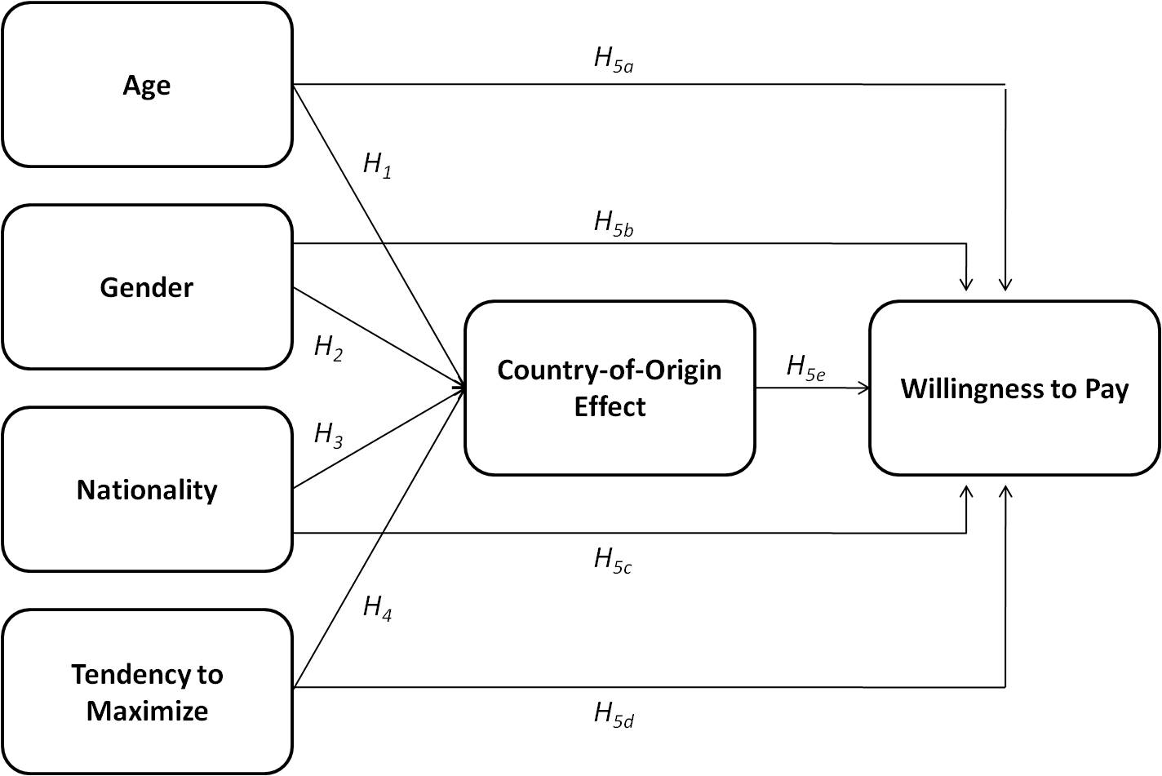
Figure 2: Conceptual Model of the Research Structure
As can be seen from the model (and discussed above), I expect the included demographic and psychological variables to affect both the intensity of the country-of-origin-effect, as well as the willingness to pay price premiums for German automobiles. Furthermore, I expect the country-of-origin-effect to have a mediating influence on potential consumers’ willingness to pay.

Methodology
In the upcoming section, I will discuss the empirical part of this thesis. I will describe how the sample was selected, as well as how data was collected and variables were operationalized in order to test my hypotheses.
After that, I will present some general insights from the survey as well the estimation of the collected data.

3.1 Sample Selection
As one of the primary objectives of my study was to gather information on how quality perceptions (as a result of the country of origin of a car) and willingness to pay vary across the markets of Germany and the Netherlands, I had to ensure that enough respondents from both relevant countries (Germany and the Netherlands) were reached and that they could be identified. For this reason, a question regarding the nationality of each respondent was included in the questionnaire.
Due to my limited resources, it was not possible to guarantee a representative sample of individuals. Therefore, respondents were contacted using a snowball sampling approach. More specifically, I relied on my personal social network contacts, university databases, as well as family and friends as initial seeds for my sample. These initial respondents (or seeds) were then asked to kindly redistribute the survey among their contacts. Although, as already mentioned, the two samples (Dutch and German individuals) are most likely not representative of the entire population in the respective countries, they are still quite comparable concerning their structure, so that results should not differ too much because of unobserved factors such as educational and social background. Comparable techniques have successfully been used in marketing research before (e.g. Johansson et al., 1985; Stremersch and Van Dyck, 2009). Furthermore, through careful choice of the seeds, I ensured that respondents from both countries exhibit enough variation in the very relevant dimensions of age and gender.

3.2 Data Collection
The data for my study was gathered using a questionnaire consisting of 13 questions. Questionnaires have been used in multiple studies researching country-of-origin-effects (e.g. Erickson et al., 1984; Johansson et al., 1985; Verlegh et al., 2005) and can thus assumed to be appropriate for my purposes.
To facilitate a high response rate, I designed my data collection as an online-questionnaire. This is more convenient for the respondents, allowing them to complete it whenever suitable for them. Furthermore, due to my limited resources, an online-questionnaire allowed me to reach a lot of individuals with an appropriate amount of effort (see 3.1 for further discussion of the distribution channels).

3.3 Measurement
In order to test my hypotheses generated in section 2.4, variables had to be operationalized in the questionnaire. For further information, a copy of the complete questionnaire can be found in the appendix.
After a short introduction, respondents were asked to indicate their nationality using a multiple choice question with only one selection possible. Possible choices were “American”, “British”, “Dutch”, “German”, “Italian”, “Japanese” and “Other”. In the latter case, the questionnaire automatically jumped to the end. A number between 1 and 7 was assigned to each answer in order to make it measureable.
$$NAT=\left\{1;…;7\right\}$$
For data analysis, the answers were transformed into dummy variables for each of the possible options.
The main objective of this first question obviously was to separate respondents’ answers based on their nationality, which is a crucial aspect for testing some of the hypotheses.

Other demographic factors that were asked from the respondents were age and gender. To respect the privacy of respondents, age was operationalized using intervals of ages, split up into eight ordinal categories (ranging from “under 20” up to “over 60”) to get a picture that is as differentiated as possible.
$$AGE=\left\{1;…;8\right\}$$
Because of the high amount of categories and the thus differentiated results, age was treated as a numerical variable in data analysis.

Gender was operationalized using a dummy variable, being 1 for male and 0 for female.
$${SEX}_{Dummy}=\{0;1\}$$

The measuring of these three demographic variables was important to test hypotheses H₁, H₂, H₃, as well as H_{5a} - H_{5c}.

After these general questions concerning the demographic factors of the respondents, I tried to assess how familiar respondents are with the automotive sector in general. To measure this, I named ten automobile companies from the five researched nations of origin and asked respondents to indicate whether or not they know them by checking a box next to the brand name. I created dummy variables for each brand j, with j running from 1 to 10:
$${KNOWL}_{j; Dummy}=\{0;1\}$$
The main purpose of this first topic-related question was to research awareness of luxury brands from different nations. For data interpretation, the brands were associated with their countries of origin to get a first impression if brands from certain countries overall have higher awareness levels than others.
In this context, to make data analysis within SPSS possible, a number i was given to each country to operationalize the researched countries of origin in alphabetical order (i.e. GER=1, GB=2, ITA=3, JPN=4, USA=5). These denotations are valid throughout the research.
$${COO}_{i}=\{1;…;5\}$$

To measure how important the country of origin of a car is for the respondents, and why, I designed a set of four questions. First of all, respondents were asked to indicate how important the country of origin is for them when buying a car, using a 5-point-Likert-scale ranging from “totally unimportant” to “very important”. Although it can be argued that equidistance cannot be assumed between answers like “rather important” and “very important”, research has shown that Likert-scales can be used as interval scales for data analysis without falsifying results (Allerbeck, 1978). The answers were thus interpreted as interval data, taking values between 1 and 5.
$${IMP}_{COO}=\{1;…;5\}$$

In the following, respondents were asked to indicate from which country they would prefer to buy a premium car, assuming the prices were equal. This question was needed to test hypothesis H₃ and was measured using a multiple choice question with only one selection possible. Possible answers were the five researched countries i, as well as “no preference”. The latter one was given the number 6.
$${PREF}_{COO i}=\{1;…;6\}$$
As with the nationality-variable, dummies were created for each preferred country and the “no preference”-option.

To get a basic idea why potential consumers preferred a car from the country they chose, an open question was incorporated into the survey, asking respondents for reasons why they chose that particular country. The answers to this question were collected and aggregated into some main factors that help to explain the motives of the respondents.

The final question of this section was to what extent it is important for respondents that the car they buy is actually manufactured in the country where it was developed. Again, a 5-point-Likert-scale was used to rate the importance from “totally unimportant” up to “very important”.
$${IMP}_{i_{manuf}=i_{develop}}=\{1;…;5\}$$
Although this question is not a direct part of any hypothesis, it still gives some important insights for managers and researchers regarding the understanding of the country of origin of a product in the consumers’ minds.

To test hypothesis H₅ (willingness to pay), I presented a fictitious story to the respondents. They were told to imagine a new luxury car was developed in Italy. In the following, I asked them to indicate how much more or less (in percent) they would be willing to pay for that particular car if it was developed in one of the other four researched countries, using a matrix table (see appendix). The nine possible answers for each country (ranging from “less than -15%” up to “more than +15%”) were transformed into interval data, taking values from 1 to 9.
$${WPAY}_{Country i}=\{1;…;9\}$$

To measure the change in the evaluation of the quality of a car depending on whether or not the respondent knows its country of origin, I developed a rather novel and innovative approach consisting of two questions. The two questions to assess quality perceptions were designed as an experiment with pictures of interiors of different cars from the five researched nations (experiments have been successfully used in country-of-origin-research by e.g. Verlegh, 2002; Liu and Johnson, 2005). Respondents were asked to indicate which one seemed to be of the highest quality. Thus, in the first set (or question), only the pictures were given whereas in a second question, the country of origin of each car was indicated by a flag of the country in the bottom right corner.
This seems to be a suitable approach, since respondents are forced to make a choice based on their supposed preferences, before they have to possibly revise and reconsider them according to their preferences with respect to the country of origin.
In order to make it harder for respondents to recognize cars across the questions, I chose different perspectives, colors, and orders in which the pictures where displayed. Furthermore, all brand names and logos were obscured (see Figure 3 for an exemplary illustration). For a detailed overview of the overall structure of the picture experiment and the according questions concerning the perceived quality, please see the appendix.
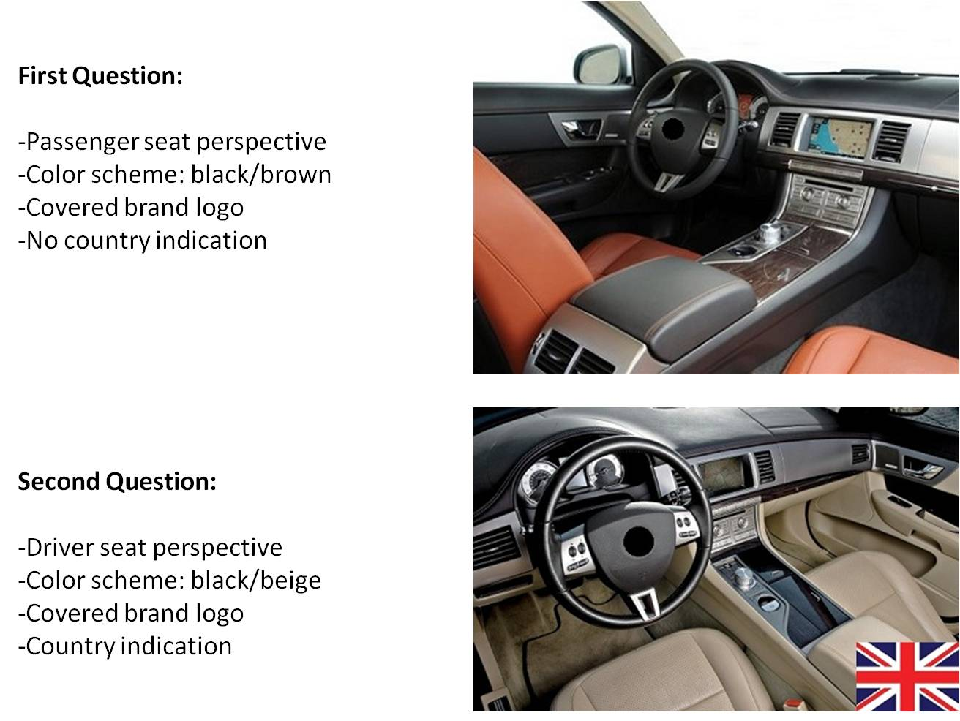
Figure 3: Comparison of Car Interiors across Questions (Jaguar XJ-Class Example)
Again, to measure in which direction absolute values of choices change and to assess switching behavior, the categories 1 to 5 (already defined above) were given to the researched countries i (i.e. pictures).
Based on these categories, I was able to compute variables for data analysis. Specifically, I created dummies for the choices in each of the questions (picture preference – PP), as well as dummy variables for whether or not a respondent changed her/his mind across questions (based on the country of origin) in general and to the German car specifically.
$${PP1}_{i}=\left\{0;1\right\}$$
$${PP2}_{i}=\left\{0;1\right\}$$
$$PP_SWITCH=\left\{0;1\right\}$$
$$PP_SWITCH_GER=\left\{0;1\right\}$$

As a control variable, a follow-up-question was added in which respondents had to indicate whether or not they recognized one, more than one, or all of the displayed cars and brands on an ordinal scale. Values from 1 (not recognized any) up to 4 (recognized all) where assigned to the possible answers.
$$RECOG=\{1;…;4\}$$

The questions and scales to measure to what extent a respondent is a maximizer or satisficer (H₄, H_{5d}) were adopted from Schwartz et al. (2002). With the goal to reduce complexity and not overburdening respondents, I simplified the maximization scale by extracting 6 key psychological questions out of the 13 questions in total. Thus, for each of the three relevant factors Schwartz et al. (2002) isolated to measure and explain the degree to which an individual is a maximizer (i.e. openness, shopping behavior, having high standards), two questions were used. Furthermore, I reduced answering possibilities from a 7-point-Likert-scale to a 5-point-Likert-scale (“Completely disagree” up to “Completely agree”). The resulting scale has an acceptable reliability with a Cronbach’s alpha of 0,659. Although this alpha is not extraordinary high, the scale is still reliable enough (see e.g. Nunally, 1967), keeping in mind that I intentionally kept it as short as possible in order not to overstress respondents.
For each of the 6 questions (i), the degree of consent was transformed into values ranging from 1 to 5.
$${MAX}_{i}=\left\{1;…;5\right\}$$
For data analysis, I generated an average by summing up the answers to each of the six questions and dividing this value by the total amount of questions regarding the tendency to maximize (i.e. 6).
$$MAXIM=\frac{\sum_{i=1}^{6}{{MAX}_{i}}}{6}$$

The survey finished with a short message, thanking the respondent for participating in the study and submitting his or her results.

3.4 Sample Descriptives and First Implications
In this section, I will give some first insights on the gathered data and discuss some visible differences, as well as general implications based on descriptive statistics.

3.4.1 Descriptives
To give a first and rather general overview, the descriptives of the demographic data (i.e. age and gender) as well as the maximization scale and the dependent variables for data analysis can be found in Table 1.

 | Minimum | Maximum | Mean | Std. Deviation
Age | 18 | 65 | 32,92 | 13,702
Gender | 0 | 1 | ,56 | ,499
Maximization Scale | 1,67 | 4,67 | 3,1702 | ,70626
Importance of Country of Origin | 0 | 5 | 3,34 | 1,363
Choice of German Car in Picture 1 | 0 | 1 | ,23 | ,424
Choice of German Car in Picture 2 | 0 | 1 | ,44 | ,498
Switching to German Car across Pictures | 0 | 1 | ,33 | ,471
Willingness to Pay for German Car | 1 | 9 | 6,56 | 1,635
Table 1: Descriptive Statistics

3.4.2 Demographics
My survey reached 157 respondents in total. After filtering out nationalities other than Dutch and German, a total amount of 116 respondents remained that were in the relevant target group of my study.
Concerning the demographics, I was successful in collecting data that allows some differentiated insights. Specifically, concerning the nationality of the respondents, of the 116 respondents reached, 44 were Dutch and 72 were German (see Figure 4).

Figure 4: Nationality of Respondents
For the distribution of ages across respondents, please see the graph below (Figure 5). As can be seen from the graph, most respondents are in the groups of up to 30 years of age (i.e. an aggregated percentage of 64%). This has to do with the initial distribution of the survey via contacts of mine, who are naturally mostly study colleagues or friends from school. Thus, they are mostly around these ages. Another peak can be seen at the group of 51-60 year old individuals. Again, this is related to the fact that I used my contacts to distribute the survey. This age group thus most likely represents my colleagues from work (e.g. superiors), as well as my parents and friends and colleagues of them.

Figure 5: Distribution of Ages across Respondents
Gender as the last measured demographic factor was relatively equally distributed with a percentage of 44.2% for females and 55.8% for males (see Figure 6).

Figure 6: Distribution of Gender

3.4.3 Brand Knowledge and Quality Perceptions
As discussed in Section 3.3, respondents were asked to indicate which car brands they know and which not to get a basic idea of their familiarity with the automotive industry and which brands might have problems with their marketing communication in terms of consumer awareness. The results of this question are summed up in Figure 7.

Figure 7: Knowledge of Automobile Brands sort by Country of Origin
Although overall values are very high, clear differences can be seen when putting attention to detail. German brands have the highest percentages when it comes to knowledge of the brands. This might already be an indicator for a strong country-of-origin-effect. On the other hand, ratios for Japanese and American brands (especially Infinity from Japan and Lincoln from the USA) are considerably lower. This might be explained by the fact that Infinity by now is just starting to sell its models in Europe and Lincoln is not present in the European market at all. Thus, cars of these brands are not that present on the roads and consumers are not that familiar with them.

For the picture experiment testing the country-of-origin effect, differences regarding the favorability of cars from the researched countries of origin are also visible (see Figure 8).

Figure 8: Distribution of Preferences in the Picture Experiment
The graph clearly indicates that the German car benefits a lot from the fact that in question 2, the country of origin of the car was displayed in the picture (see the full questionnaire in the appendix or Figure 3 for further information). The amount of respondents choosing the German car nearly doubles, just because of the indication of the car’s origin, indicating a very strong country-of-origin-effect for German cars. This result is supported by the fact that 71.2% of all respondents chose Germany when asked from which country they would prefer to buy a luxury vehicle.
The opposite seems to be true for Italian cars that suffer the most from the indication of the country of origin in the picture experiment. One might thus infer that marketing strategies for German and Italian cars should be very different in order to achieve a maximum of effectiveness in terms of communication.
However, these first implications are only some model free evidence that need to be controlled for other factors that might be drivers of the country-of-origin-effect. To research and discuss these different influences and relations between variables will be part of the next section.

3.5 Estimation of Results
Based on the first examinations from section 3.4, I will now analyze the collected data in order to test my hypotheses using statistical models included in SPSS.

3.5.1 Importance of the Country of Origin and Influences on Quality Perceptions
In order to research how the country of origin affects the quality perceptions of a car, I conducted the picture-experiment with the country indication in one question and no information on the country of origin of the car in the other.
To test whether or not the German car can benefit from the country indication in question 2 and which factors significantly influence the choice of the German car, I used two Logit models. The first had the choice of the German car in question 1 as the dependent variable and the second one the choice of the German car in question 2. Independent variables were the demographic factors (age, nationality, gender), as well as the maximization-scale and a constant. The results of the first model are summarized below (Table 2).
 | B | S.E. | Sig.
Age | -,213 | ,120 | ,076
Nationality (German) | 1,658 | ,635 | ,009
Gender (Male) | -,020 | ,498 | ,968
Maximization | -,183 | ,360 | ,610
Constant | -,820 | 1,274 | ,520
Table 2: Logit-Model of the Choice of German Car in Question 1 (without Country Indication)
As can be seen from the table, age and nationality have significant impacts on the 10%-level when the country of origin of the car is not displayed in the picture. Elderly people are less likely to choose the German car. One possible reason for this observation is that they are maybe less attracted by the design of the interior of the car. Germans however are more likely to choose the German car than Dutch respondents. An explanation might be that German respondents who recognized the car (despite the measures taken to prohibit that) already chose it in the first question out of patriotic reasons. In this context, I assessed the mean of the question whether or not respondents recognized any of the cars in the pictures using an independent samples t-test, comparing German with Dutch respondents. For German respondents, the mean is 1.77, for Dutch ones it is 1.58. However, with a significance value of 0.343, no significant differences between the two groups can be observed (see Table 8 and Table 9 in the appendix). The overall mean of 1.71 indicates that on average respondents recognized none or one of the displayed car interiors.
Table 3 below summarizes the results when the country of origin of each car is indicated in the corners of the pictures.
 | B | S.E. | Sig.
Age | ,300 | ,108 | ,005
Nationality (German) | ,061 | ,481 | ,898
Gender (Male) | -,060 | ,448 | ,893
Maximization | ,550 | ,331 | ,096
Constant | -2,751 | 1,162 | ,018
Table 3: Logit-Model of the Choice of German Car in Question 2 (with Country Indication)
The results in this second model are very different from the ones in the first equation. Significant on the 10%-level this time are age and the tendency to maximize.
Although age already was significant in the first model, it is very interesting to see that in the second one the effect turned around. While in model one the choice of the German car became less likely with increasing age, it is now the other way around. This indicates a strong country-of-origin-effect and thus supports my first hypothesis (H₁), stating that the intensity of country-of-origin-effects in the premium car market is positively related to the age of potential customers. The results clearly indicate this.
The second significant variable (degree of maximization) also supports my hypothesis. The results indicate that maximizers are more susceptible to country-of-origin-effects than satisficers, which is in line with hypothesis H₄.
Since the gender-variable is insignificant, I am forced to reject hypothesis H₂. Nevertheless, there is still an interesting result to see. When running a linear regression with the stated importance of the country of origin of a car (indicated on a 5-point-Likert-scale) as the dependent variable and keeping the independent variables as they are, the following results occur (see Table 4):
 | Unstandardized Coefficients |  | Standardized Coefficients | T | Sig.
 | B | Std. Error | Beta | T | Sig.
(Constant) | 1,955 | ,644 |  | 3,036 | ,003
Age | ,052 | ,061 | ,090 | ,857 | ,394
Gender (Male) | ,535 | ,265 | ,204 | 2,023 | ,046
Nationality (German) | ,302 | ,286 | ,111 | 1,057 | ,293
Maximization | ,247 | ,186 | ,134 | 1,325 | ,189
Table 4: Stated Importance of the Country of Origin of a Car (Linear Regression)
As can be seen from the table, gender is significant on the 10%-level (even on the 5%-level). This means that males rate the country of origin of a car as more important for their buying decision than females. However, as already mentioned, when it comes to the actual choice of the car (picture-experiment) there is no significant difference between the choice-behavior of men and women. The conclusion thus is that there is a clear disparity between stated and observed behavior when it comes to the role of gender in evaluating country-of-origin-effects. This also has implications for scholars and managers using marketing research methods, like surveys, to learn about customer behavior. It seems that what people say they do or value (i.e. their stated preference) is not what they actually exhibit in their behavior when measured in a more sophisticated manner, like I did with my picture experiment. This casts doubt in many of the methods used by marketing researchers, thus making the use of a rather innovative methodology like mine very important and interesting for future researchers.
In the context of the stated importance of the country of origin of a car, it is interesting to note that there is a significant interaction effect between age and maximization when using a Generalized Linear Model (see Table 10 in the appendix). This implies that the simultaneous influence of these two variables on the stated importance of the country of origin of a car is not additive, meaning that the value of the variable “age” depends on the value of the other interacting variable “maximization” and vice versa. In other words, age and maximization interact in some way, affecting the stated importance of the country of origin.
The other insignificant variable in model 2, which captures the observed behavior (Table 3), is the nationality-variable. This indicates that it does not matter whether a respondent is German or Dutch concerning the susceptibility towards country-of-origin-effects. However, since my hypotheses (H_{3a}-H_{3c}) dealt with question of the preference to buy from certain countries, I am not forced to reject them based on this observation yet.
To test my hypothesis that German consumers prefer to buy German cars, I isolate the German respondents from the Dutch ones and conduct a one-sample t-test with the stated preferences for the different countries of origin as the tested variables. Expecting a mean of around 0.17 (100% divided by the number of possible choices (i.e. 6)), the test shows that the preference for a car from Germany has a significantly higher mean (0.74) than the ones for the other countries (see Table 11 and Table 12 in the appendix). Furthermore, when running logistic regressions including the Dutch and the German respondents, only for the preference to buy a German car the nationality variable has a significant and positive effect (for the other countries of origin, the variable is insignificant or negative; see Table 5 and Table 15 - Table 18 in the appendix). Therefore, I can state that German consumers show a preference to buy German cars, which is in line with hypothesis H_{3a}.
Following the same principle, I test my hypothesis that Dutch consumers prefer to buy cars from Western European countries (H_{3c}). Again, I take an isolated sample only including the Dutch respondents. Beforehand, I summarized the stated preferences for the three researched Western European countries (Germany, Great Britain, and Italy) in a dummy variable. The one-sample t-test reveals that the preference for Western European cars with a mean of 0.7 significantly differs from the expected mean of 0.5 (see Table 13 and Table 14 in the appendix). Thus, I am able to confirm my hypothesis that Dutch consumers prefer to buy premium vehicles from Western European brands (H_{3c}).
In order to test whether or not German consumers show a higher preference to buy a German car than Dutch consumers, I run a Logit-Model with the stated preference to buy a German car as the dependent variable and the established independent variables. It gives the following outcome (see Table 5):
 | B | S.E. | Sig.
Age | ,308 | ,141 | ,029
Gender (Male) | 1,628 | ,556 | ,003
Nationality (German) | 1,321 | ,561 | ,019
Maximization | ,545 | ,401 | ,175
Constant | -3,450 | 1,427 | ,016
Table 5: Stated Preference to Buy a German Car (Logit-Model)
The results indicate that Germans indeed show a significantly higher preference to buy German cars than Dutch respondents, thus supporting hypothesis H_{3b}. This is also supported by an independent-samples t-test. This test reveals a significant difference between the means of the preference for a German car, depending on the nationality of the respondent (see Table 19 and Table 20 in the appendix).
Regarding the effect of the nationality of a respondent on his or her preferences for certain countries of origin, differences exist when it comes to stated behavior, while the observed choice-behavior of Dutch and German respondents did not significantly differ. Comparable results have been obtained for the effect of gender on the preferred country of origin.
Although not a direct part of one of my hypotheses, it is very interesting and relevant for marketing managers to understand why respondents prefer to buy German cars. To assess this, I included an open question in my survey, asking respondents to name reasons why they would prefer to buy a car from the country they chose. The most important factors for respondents who chose Germany as a desired country of origin were image (status and reputation), quality (engineering and reliability), as well as performance.
Furthermore, it is interesting to analyze which factors influence the stated importance of a car being actually built where it was developed. The variable (measured on a 5-point-Likert-scale) has a mean of 2.84 and a standard deviation of 1.142. Thus, overall it does not seem to be too relevant to respondents if the country of origin of the brand also is the country of manufacturing. In a linear regression with the importance of the country of development being the country of manufacturing as the dependent variable and with the same explanatory variables as used above, the following results can be observed (see Table 6):
 | Unstandardized Coefficients |  | Standardized Coefficients | T | Sig.
 | B | Std. Error | Beta | T | Sig.
(Constant) | ,427 | ,494 |  | ,863 | ,390
Age | ,087 | ,045 | ,170 | 1,928 | ,057
Gender (Male) | -,127 | ,198 | -,055 | -,643 | ,522
Nationality (German) | -,140 | ,210 | -,059 | -,668 | ,506
Maximization | ,174 | ,137 | ,108 | 1,269 | ,208
Stated Importance of CoO | ,494 | ,077 | ,562 | 6,408 | ,000
Table 6: Importance of Country of Development being Country of Manufacturing (Linear Regression)
Additionally to the independent variables already measured above, I included the stated importance of the country of origin of a car. This variable, as well as the age-variable, has a positively significant impact on the rating of the importance of the country of development being the country of manufacturing, too. This leads to the conclusion that that the more important the country of origin of a car is to a potential customer, the more important becomes the fact that this particular car is built (and not only developed) in that country, too.
Moreover, the fact that age also is a positively significant variable further supports my hypothesis H₁, stating that a particular country of origin of a premium vehicle is more important for elderly individuals than for younger ones.
In the next section, I will analyze the second set of my hypotheses, addressing effects on the willingness to pay for premium cars from certain countries.

3.5.2 Willingness to Pay Price Premiums for German Automobiles
The willingness to pay price premiums for certain cars (in this case: German ones) was measured with a hypothetical story of a new premium car being developed in Italy. Respondents were then asked to indicate how much more or less they would be willing to pay for this particular car if it was built in one of the other countries that were part of my research. Since my thesis only addresses country-of-origin-effects on German automobiles, I will only analyze the willingness to pay for German cars in depth, using a linear regression. To get an overall picture, the descriptives of the results for all countries (except Italy as the baseline) are given in Table 21 in the appendix. A value of 5 on the scale from 1-9 is associated with being willing to pay the same price as for the car when it was developed in Italy. The willingness to pay for the German car, with a mean of 6.56, is the only one that is above this value.
Willingness to pay was included in my conceptual model (Figure 2) as being mediated by the country-of-origin-effect (H_{5e}). So before checking the other hypotheses regarding the effect of age, gender, etc., I will test if this mediating effect really occurs. To do this, I will follow the procedure presented by Judd and Kenny (1981), and Baron and Kenny (1986).
I used the already established independent variables from above plus an added country-of-origin-effect-variable in a linear regression with the willingness to pay price premiums for a German car as the dependent variable. The country-of-origin-effect-variable was operationalized as a dummy, capturing if a respondent switched to the German car across the two questions or not. The following results occur (see Table 7):
 | Unstandardized Coefficients |  | Standardized Coefficients | t | Sig.
 | B | Std. Error | Beta | t | Sig.
(Constant) | 4,205 | ,799 |  | 5,266 | ,000
Age | ,012 | ,081 | ,017 | ,153 | ,879
Gender (Male) | ,091 | ,331 | ,027 | ,274 | ,784
Nationality (German) | ,706 | ,357 | ,206 | 1,979 | ,051
Maximization | ,539 | ,234 | ,232 | 2,309 | ,023
Country-of-Origin-Effect (Switching) | ,361 | ,355 | ,108 | 1,015 | ,313
Table 7: Willingness to Pay Price Premiums for German Cars (Linear Regression)
Since the supposed mediating country-of-origin-effect-variable is insignificant on the 10%-level, it does not have a mediating effect on the outcome (for further information, see Judd and Kenny, 1981; Baron and Kenny, 1986). All influences on the willingness to pay thus are direct effects and I have to reject my hypothesis H_{5e}, addressing the mediating effect of the country-origin-effect.
Significant independent variables in the model are the one capturing nationality, as well as the degree of maximization. Both have a positive direct impact on the willingness to pay for a German car.
Specifically, German consumers are willing to pay higher price premiums for a German car than Dutch ones. This confirms hypothesis H_{5c} and also is insofar interesting as that for the susceptibility to the country-of-origin-effect, nationality was insignificant and thus did not play a role. This means that German consumers do not have higher quality perceptions of a car based on its German origin but are willing to pay more for them than Dutch consumers. This is also reflected by the fact that Germans show a bigger stated preference for German automobiles than the Dutch (H_{3b}). This result leaves room for the interpretation that German consumers do not have a higher willingness to pay for German cars because they think they are better than others, but simply because of the fact that they are German. I can thus infer that there seem to be two types of country-of-origin-effects, namely quality-based ones and patriotism-based ones. This is a very interesting and rather unexpected result, which is a nice opportunity for further research in the area.
The fact that the degree of maximization has a significant positive effect on the willingness to pay confirms hypothesis H_{5d} and also is in line with my findings regarding the country-of-origin-effect. There, the degree of maximization also had a positive impact on choosing the German car when the country of origin is indicated (see Table 3).
With the other included variables (gender and age) being insignificant, I have to reject my hypotheses H_{5a} and H_{5b}. Neither age nor gender have any effect on the willingness to pay price premiums, which is contrary to my expectations.

Summary of Results and Discussion
Summarizing the results obtained and discussed in the sections above, the following can be concluded:
I was able to confirm most of my hypothesis concerning the factors that influence the importance of the country of origin of a car and how the country of origin influences quality perceptions, resulting in a country-of-origin-effect. Namely, I proved that age and the degree of maximization are both positively related to the intensity of the country-of-origin-effect. With increasing values on those variables, respondents became more susceptible to the country-of-origin-effect, measured in the picture experiment. Regarding age, this is in line with my expectation that younger individuals that grew up in a globalized world and in a rather international environment are less likely to be affected by the country of origin of a car. Regarding the impact of an individual’s tendency to maximize, it seems logical that maximizers are more susceptible to country-of-origin-effects, as those are quality cues and affect the (perceived) utility of a car.
Additional effects have been obtained for gender and nationality. While both do not have a significant impact on the actual choice behavior of respondents, they clearly influence stated preferences. Specifically, when asked about the importance of the country of origin of a premium car, males ranked it significantly more important than females. Concerning the effect of the nationality of the respondents, I showed that German consumers prefer to buy German vehicles and that this preference is significantly bigger than the one of the Dutch respondents. However, as hypothesized, Dutch consumers show a clear preference to buy Western European brands over others. Based on this, I can conclude that the country-of-origin-effect in my study is of general nature, but it is moderated and influenced by a diverse set of factors. Concerning the differences between the two researched markets, patriotism and familiarity on the German side, as well as animosity of the Dutch towards German products are possible and reasonable explanations (see e.g. Nijssen and Douglas, 2004).
Summarizing the effects on the willingness to pay price premiums for German automobiles, I had to reject my hypotheses that age and gender influence this willingness to pay. Furthermore and contrary to my expectations, the measured country-of-origin-effect did not have a mediating effect on the willingness to pay of respondents. I thus had to reject this hypothesis, too.
On the other hand, I was able to show that German consumers are willing to pay higher price premiums for German cars than Dutch consumers. Furthermore, the tendency to maximize utility is also positively related to the willingness to pay higher price premiums for vehicles of German origin. Again, these results seem logical due to reasons like patriotism of the German respondents and maximizers’ higher willingness to pay for an alleged increase in product quality. In combination with the results of the experiment regarding quality perceptions, I find that the country-of-origin-effect seems to have at least two manifestations, one being a quality-based country-of-origin-effect, the other one being driven by and based on patriotism.
For marketing research in general, I contribute to existing studies by showing that despite ongoing developments like globalization the country-of-origin-effect still is an important factor in product evaluation. Consumers are largely influenced by the country of origin of a car when rating its perceived quality and they judge it as an important factor when making a buying decision. Additionally, I show how this rather mature field of interest in marketing can be extended to gain more specific and diversified insights on consumer behavior. One important novelty of my study is the use of a picture experiment to assess the country-of-origin-effect within subjects and not across subjects, as mostly done before. Since I find significant differences between stated and observed behavior within subjects, this approach is a very good alternative to others that only measure differences across subjects. For marketing managers as well as researchers studying consumer behavior, this has the implication that data collection and the choice of methods have to be carefully thought through and designed in order to gain useful and reliable results. Furthermore, by using the maximization scale of Schwartz et al. (2002), I differentiate respondents based on a psychological dimension, getting more detailed and useful results.
For marketing managers in the automotive industry, I give a state-of-the-art overview on how the country of origin is a relevant influential factor on the buying decision of a premium car. My study gives insights which brands might benefit from stressing their country of origin in marketing communication and which ones should focus on other aspects. Moreover, by analyzing my results on the willingness to pay for cars from different countries, managers can generate useful insights for a more effective, country-specific price-setting based on the gathered data. Furthermore, using my study, marketing managers and salespeople can specifically attract different groups of customers (e.g. regarding gender or age) in marketing communication and sales conversations.

Limitations and Directions for Future Research
Despite the fact that I was able to gather some important results for marketing research and praxis, of course my research has several limitations and leaves room for other studies in this field of interest.
First of all, it has to be said that because of my limited resources, the sample I used neither was representative, nor particularly extensive. Future studies trying to replicate, review or expand my results should try to collect more data. I would not see the fact that I only researched two markets as a limitation though, since these two markets were very reasonably chosen. The German market to examine the effect a domestic production has on the perceptions of potential customers, and the Dutch market as a neutral one without any noteworthy domestic car production. Of course, other studies should vary the researched markets, but the composition should be kept.
Another limitation of my study is that it only examines a rather specific part in the big area of country-of-origin-effects. Specifically, it is limited to the sector of highly priced premium automobiles and I only studied the country-of-origin-effect for Germany (i.e. a “Germany-effect”). Future studies should try to broaden the picture and investigate to what extent the results I obtained are generalizable. Using the results of my research as a basis, it would also be very interesting to further research differences between stated and actual behavior in more detail.
Keeping my results and implications, as well as the multiple options for further research in mind, the country-of-origin-effect still is and presumably will stay a very important and interesting topic for both marketing researchers and managers in the future.

List of References
Allerbeck, K. R. (1978). Meßniveau und Analyseverfahren - Das Problem "strittiger Intervalskalen". Zeitschrift für Soziologie, Jg. 7, Heft 3 , pp. 199-214.
Anderson, W. T., & Cunningham, W. H. (1972). Gauging Foreign Product Promotion. Journal of Advertising Research, Vol. 12 Issue 1 , pp. 29-34.
Baron, R. M., & Kenny, D. A. (1986). The moderator-mediator variable distinction in social psychological research: Conceptual, strategic and statistical considerations. Journal of Personality and Social Psychology, Vol. 51 , pp. 1173-1182.
Bilkey, W. J., & Nes, E. (1982). Country-of-Origin Effects on Product Evaluations. Journal of International Business Studies, Vol. 13, No. 1 , pp. 89-99.
Bruine de Bruin, W., Parker, A. M., & Fischhoff, B. (2007). Individual Differences in Adult Decision-Making Competence. Journal of Personality and Social Psychology, Vol. 92, No. 5 , pp. 938-956.
Dawar, N., & Parker, P. (1994). Marketing Universals: Consumers' Use of Brand Name, Price, Physical Appearance, and Retailer Reputation as Signals of Product Quality. The Journal of Marketing, Vol. 58, No. 2 , pp. 81-95.
Elliott, G. R., & Cameron, R. C. (1994). Consumer Perception of Product Quality and the Country-of-Origin Effect. Journal of International Marketing, Vol. 2, No. 2 , pp. 49-62.
Erickson, G. M., Johansson, J. K., & Chao, P. (1984). Image Variables in Multi-Attribute Product Evaluations: Country-of-Origin Effects. The Journal of Consumer Research, Vol. 11, No. 2 , pp. 694-699.
Etzel, M. J., & Walker, B. J. (1974). Advertising Strategy for Foreign Products. Journal of Advertising Research; Vol. 14, Issue 3 , pp. 41-44.
Gaedeke, R. (1973). Consumer attitudes Toward Products 'Made In' Developing Countries. Journal of Retailing, Vol. 49, Issue 2 , pp. 13-25.
Han, C. M. (1989). Country Image: Halo or Summary Construct? Journal of Marketing Research, Vol. 26 , pp. 222-229.
Harrison, E. F., & Pelletier, M. A. (1997). Managerial attitudes towards strategic decisions: maximizing versus satisficing outcomes. Management Decision, Vol. 35, No. 5 , pp. 358-364.
Heslop, L. A., & Papadopoulos, N. (1993). ‘‘But who knows where or when’’: Reflections on the images of countries and their products. In N. Papadopoulos, & L. A. (Eds), Product-country images: Impact and role in international marketing (pp. 39-75). Binghamton: International Business Press.
Hong, S., & Wyer, R. (1989). Effects of Country-of-Origin and Product-attribute Information on Product Evaluation: An Information Processing Perspective. Journal of Consumer Research, No. 16 , pp. 175-187.
Ickes, W. (1993). Traditional Gender Roles: Do They Make, and Then Break, our Relationships? Journal of Social Issues, Vol. 49, No. 3 , pp. 71-85.
Inglehart, R., & Baker, W. E. (2000). Modernization, Cultural Change, and the Persistence of Traditional Values. American Sociological Review, Vol. 65, No. 1 , pp. 19-51.
Johansson, J. K., Douglas, S. P., & Nonaka, I. (1985). Assessing the Impact of Country of Origin on Product Evaluations: A New Methodological Perspective. Journal of Marketing Research, Vol. 22, No. 4 , pp. 388-396.
Jones, M., Howe, A., & Rua, M. (2000). Gender Differences in Students’ Experiences, Interests, and Attitudes toward Science and Scientists. Science Education, Vol. 84, No. 2 , pp. 180-192.
Judd, C. M., & Kenny, D. A. (1981). Process analysis: Estimating mediation in treatment evaluations. Evaluation Review, Vol. 5 , pp. 602-619.
Kabadayi, S., & Lerman, D. (2011). Made in China but sold at FAO Schwarz: country-of-origin effect and trusting beliefs. International Marketing Review, Vol. 28, No. 1 , pp. 102-126.
Kirmani, A., & Rao, A. R. (2000). No Pain, No Gain: A Critical Review of the Literature on Signaling Unobservable Product Quality. The Journal of Marketing, Vol. 64, No. 2 , pp. 66-79.
Leung, K., Bhagat, R. S., Buchan, N. R., Erez, M., & Gibson, C. B. (2005). Culture and International Business: Recent Advances and Their Implications for Future Research. Journal of International Business Studies, Vol. 36, No. 4 , pp. 357-378.
Liu, S. S., & Johnson, K. F. (2005). The Automatic Country-of-Origin Effects on Brand Judgments. Journal of Advertising, Vol. 34, No. 1 , pp. 87-97.
Miyazaki, A. D., Grewal, D., & Goodstein, R. C. (2005). The Effect of Multiple Extrinsic Cues on Quality Perceptions: A Matter of Consistency. The Journal of Consumer Research, Vol. 32, No. 1 , pp. 146-153.
Nagashima, A. (1977). A Comparative "Made in" Product Image Survey among Japanese Businessmen. The Journal of Marketing, Vol. 41, No. 3 , pp. 95-100.
Nagashima, A. (1970). A Comparison of Japanese and U. S. Attitudes toward Foreign Products. The Journal of Marketing, Vol. 34, No. 1 , pp. 68-74.
Nijssen, E. J., & Douglas, S. P. (2004). Examining the animosity model in a country with a high level of foreign trade. International Journal of Research in Marketing, Vol. 21 , pp. 23-38.
Nunally, J. C. (1967). Psychometric Theory. New York: McGraw-Hill Book Company.
Pappu, R., Quester, P. G., & Cooksey, R. W. (2007). Country image and consumer-based brand equity: relationships and implications for international marketing. Journal of International Business Studies, Vol. 38 , pp. 726-745.
Parker, A. M., Bruine de Bruin, W., & Fischhoff, B. (2007). Maximizers versus satisficers: Decision-making styles, competence, and outcomes. Judgment and Decision Making, Vol. 2, No. 6 , pp. 342-350.
Peterson, R. A., & Jolibert, A. J. (1995). A Meta-Analysis of Country-Of-Origin Effects. Journal of International Business Studies, Vol. 26, No. 4 , pp. 883-900.
Pharr, J. (2005). Synthesizing country-of-origin research from the last decade: is the concept still salient in an era of global brands. Journal of Marketing Theory and Practice, Vol. 13, No. 4 , pp. 34-45.
Roth, M. S., & Romeo, J. B. (1992). Matching Product Catgeory and Country Image Perceptions: A Framework for Managing Country-Of-Origin Effects. Journal of International Business Studies, Vol. 23, No. 3 , pp. 477-497.
Samiee, S. (1987). Customer Evaluation of Products in a Global Market. Unpublished paper, College of Business Administration, University of South Carolina .
Samiee, S. (1994). Customer Evaluation of Products in a Global Market. Journal of International Business Studies, Vol. 25, No. 3 , pp. 579-604.
Schooler, R. D. (1965). Product Bias in the Central American Common Market. Journal of Marketing Research, Vol. 2, No. 4 , pp. 394-397.
Schwartz, B., Ward, A., Monterosso, J., Lyubomirsky, S., White, K., & Lehman, D. R. (2002). Maximizing Versus Satisficing: Happiness Is a Matter of Choice. Journal of Personality and Social Psychology, Vol. 83, No. 5 , pp. 1178-1197.
Steenkamp, J.-B. E. (1990). Conceptual Model of the Quality Perception Process. Journal of Business Research, Vol. 21 , pp. 309-333.
Stremersch, S., & Van Dyck, W. (2009). Marketing of the Life Sciences: A New Framework and Research Agenda for a Nascent Field. Journal of Marketing, Vol. 73, No. 4 , pp. 4-30.
Thakor, M. V., & Lavack, A. M. (2003). Effect of perceived brand origin associations on consumer perceptions of quality. Journal of Product & Brand Managment, Vol. 12, No. 6 , pp. 394-407.
Verlegh, P. (2002). Country-of-Origin Stereotypes and the Processing of Ads: A Tomato-Field Experiment. Advances in Consumer Research, Vol. 29, No. 1 , pp. 166-167.
Verlegh, P., Steenkamp, J.-B., & Meulenberg, M. (2005). Country-of-origin effects in consumer processing of advertising claims. International Journal of Research in Marketing 22 , pp. 127-139.
Watson, J. J., & Wright, K. (2000). Consumer ethnocentrism and attitudes toward domestic and foreign products. European Journal of Marketing,Vol. 34, No. 9/10 , pp. 1149-1166.
White, P. D. (1979). Attitudes of U. S. Purchasing Managers toward Industrial Products Manufactured in Selected Western European Nations. Journal of International Business Studies, Vol. 10, No. 1 , pp. 81-90.

Appendix
Questionnaire AII
T-Test for Car Recognition in Picture Experiment AX
Generalized Linear Model with Interaction Effects AXI
T-Test for Preferred Country of Origin of German Respondents AXII
T-Test for Preferred Country of Origin of Dutch Respondents AXIII
Stated Preferred Countries of Origin of Premium Vehicles AXIV
T-Test for the Preference to Buy a German Car AXVI
Descriptives of Willingness to Pay AXVII

Questionnaire

Page: 1
Buying Behavior and Quality Perceptions in the Automotive Industry
Dear participant,
First of all, thank you very much for taking the time to fill out this questionnaire! I promise, it will not take you longer than 10 minutes.
About me, my name is Tim and I am in the final phase of my studies in the field of marketing at the Erasmus University Rotterdam. As part of my master's thesis, I am conducting a survey on the buying behavior and quality perceptions for cars. And that is where you come into play! Please try to answer all the questions as honest and spontaneous as possible.
Thanks again and have fun,
Tim

Page: 2
1.
What is your nationality?
American
British
Dutch
German
Italian
Japanese
Other 

Page: 3
2.
What is your gender?


3.
What is your age?
under 20
20 - 25
26 - 30
31 - 35
36 - 40
41 - 50
51 - 60
over 60

Page: 4
4.
Which of the following car brands do you know?
Audi
BMW
Cadillac
Infiniti
Jaguar
Land Rover
Lexus
Lincoln
Maserati
Mercedes Benz

Page: 5
Please rate how important the country of origin of a car is when you consider buying one!

 |  | Totally unimportant |  |  | Very Important
 | Importance

From which of the following countries would you prefer to buy a high-class luxury vehicle (assuming the prices are equal)?
Germany
Great Britain
Italy
Japan
The United States
No preference

Please give 2-3 reasons why you would prefer a car from that particular country!


How important is it for you that your car is produced where it is developed?
 |  | Totally unimportant |  |  | Very important
 | Importance

Page: 6
Imagine a new luxury car was developed in Italy. How much more or less would you be willing to pay for that particular car if it was developed in one of the following countries?

 | less than -15% | -15% | -10% | -5% | +/-0% | +5% | +10% | +15% | more than +15%
Germany
Great Britain
Japan
The United States

Page: 7
Please take a look at the pictures of car interiors below and indicate which one seems to be of the highest quality, given the prices of the cars are equal!
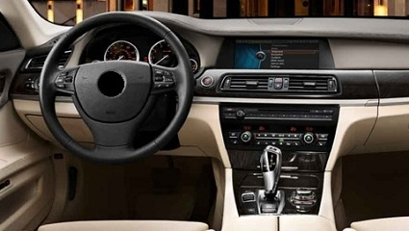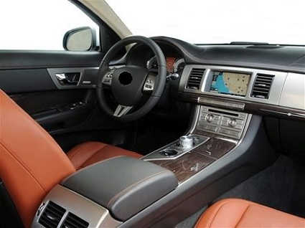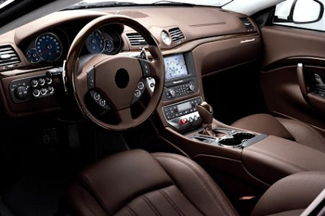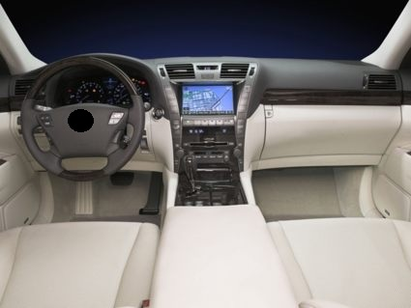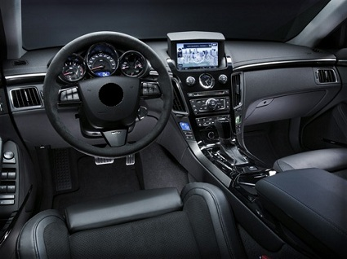

Page: 8
Here is a second sample! This time, in the bottom right corner of each picture, it is shown where the displayed car is manufactured. Please indicate again, which one (in your opinion) is of the highest quality!
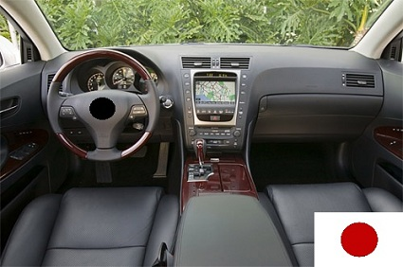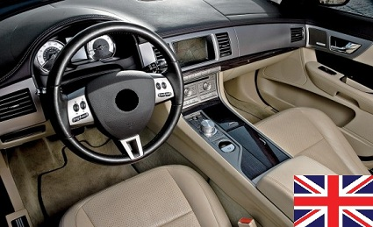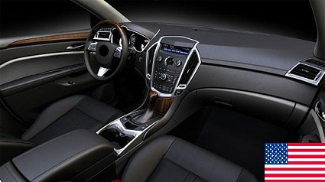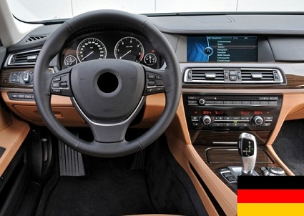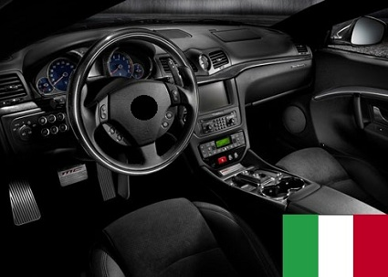

Page: 9
Did you recognize any of the cars on the pictures? *
No
Yes, one
Yes, some of them
Yes, all of them

Page: 10
Last but not least, I would like to ask you to comment on some statements about your personality. Please try to answer as spontaneous as possible!

 |  | Completely disagree |  |  | Completely agree
 | When I watch TV, I often channel surf even while attempting to watch one program.
 | No matter what I do, I have the highest standards for myself.
 | I am a big fan of lists that attempt to rate things (movies, athletes, singers, etc.).
 | I often find it difficult to shop for a gift for a friend.
 | I find that writing is very difficult because it is hard to word things just right. I often do several drafts even of simple things.
 | I never settle for the second best.

Page: 11
That was already it! Thank you for completing this survey! You have helped me a lot!

T-Test for Car Recognition in Picture Experiment

Group Statistics
 | NAT_GER | N | Mean | Std. Deviation | Std. Error Mean
RECOG | 0 | 33 | 1,58 | ,902 | ,157
RECOG | 1 | 62 | 1,77 | ,999 | ,127
Table 8: Group Statistics; Independent Samples t-Test for Car Recognition in Picture Experiment

Independent Samples Test
 |  | Levene's Test for Equality of Variances |  | t-test for Equality of Means
 |  |  |  |  |  |  |  |  | 95% Confidence Interval of the Difference
 |  | F | Sig. | t | Df | Sig. (2-tailed) | Mean Difference | Std. Error Difference | Lower | Upper
RECOG | Equal variances assumed | 3,374 | ,069 | -,953 | 93 | ,343 | -,198 | ,208 | -,612 | ,215
RECOG | Equal variances not assumed |  |  | -,983 | 71,399 | ,329 | -,198 | ,202 | -,601 | ,204
Table 9: Independent Samples t-Test for Car Recognition in Picture Experiment

Generalized Linear Model with Interaction Effects

Tests of Between-Subjects Effects
Dependent Variable: IMP_COO
Source | Type III Sum of Squares | df | Mean Square | F | Sig.
Corrected Model | 22,970ª | 8 | 2,871 | 1,808 | ,086
Intercept | 19,575 | 1 | 19,575 | 12,327 | ,001
SEX_DUMMY | ,586 | 1 | ,586 | ,369 | ,545
AGE | 5,077 | 1 | 5,077 | 3,197 | ,077
NAT_GER | ,417 | 1 | ,417 | ,262 | ,610
maximiz | 2,585 | 1 | 2,585 | 1,628 | ,205
AGE * maximiz | 6,285 | 1 | 6,285 | 3,958 | ,050
NAT_GER * maximiz | ,132 | 1 | ,132 | ,083 | ,774
SEX_DUMMY * maximiz | ,457 | 1 | ,457 | ,288 | ,593
SEX_DUMMY * AGE | 1,002 | 1 | 1,002 | ,631 | ,429
Error | 136,567 | 86 | 1,588
Total | 1292,000 | 95
Corrected Total | 159,537 | 94
a. R Squared = ,144 (Adjusted R Squared = ,064)
Table 10: GLM with Interaction Effects when Assessing the Stated Importance of the Country of Origin

T-Test for Preferred Country of Origin of German Respondents

One-Sample Statistics
 | N | Mean | Std. Deviation | Std. Error Mean
PREF_GER | 72 | ,74 | ,444 | ,052
PREF_GB | 72 | ,04 | ,201 | ,024
PREF_ITA | 72 | ,03 | ,165 | ,020
PREF_JPN | 72 | ,03 | ,165 | ,020
PREF_USA | 72 | ,00 | ,000ª | ,000
PREF_NONE | 72 | ,07 | ,256 | ,030
a. t cannot be computed because the standard deviation is 0.
Table 11: One-Sample-Statistics; One-Sample t-Test for the Preferred Country of Origin (German Preferences)

One-Sample Test
 | Test Value = 0.17
 |  |  |  |  | 95% Confidence Interval of the Difference
 | t | df | Sig. (2-tailed) | Mean Difference | Lower | Upper
PREF_GER | 10,823 | 71 | ,000 | ,566 | ,46 | ,67
PREF_GB | -5,411 | 71 | ,000 | -,128 | -,18 | -,08
PREF_ITA | -7,292 | 71 | ,000 | -,142 | -,18 | -,10
PREF_JPN | -7,292 | 71 | ,000 | -,142 | -,18 | -,10
PREF_NONE | -3,333 | 71 | ,001 | -,101 | -,16 | -,04
Table 12: One-Sample t-Test for the Preferred Country of Origin (German Preferences)

T-Test for Preferred Country of Origin of Dutch Respondents

One-Sample Statistics
 | N | Mean | Std. Deviation | Std. Error Mean
PREF_EU | 44 | ,70 | ,462 | ,070
PREF_Non_EU | 44 | ,30 | ,462 | ,070
Table 13: One-Sample-Statistics; One-Sample t-Test for the Preferred Country of Origin (Dutch Preferences)

One-Sample Test
 | Test Value = 0.5
 |  |  |  |  | 95% Confidence Interval of the Difference
 | t | df | Sig. (2-tailed) | Mean Difference | Lower | Upper
PREF_EU | 2,940 | 43 | ,005 | ,205 | ,06 | ,34
PREF_Non_EU | -2,940 | 43 | ,005 | -,205 | -,34 | -,06
Table 14: One-Sample t-Test for the Preferred Country of Origin (Dutch Preferences)

Stated Preferred Countries of Origin of Premium Vehicles

Variables in the Equation
 |  | B | S.E. | Wald | df | Sig. | Exp(B)
Step 1ª | SEX_DUMMY | -2,288 | 1,169 | 3,831 | 1 | ,050 | ,101
Step 1ª | NAT_GER | -1,228 | ,996 | 1,519 | 1 | ,218 | ,293
Step 1ª | maximiz | ,846 | ,707 | 1,429 | 1 | ,232 | 2,329
Step 1ª | AGE | ,133 | ,206 | ,418 | 1 | ,518 | 1,143
Step 1ª | Constant | -4,504 | 2,337 | 3,714 | 1 | ,054 | ,011
a. Variable(s) entered on step 1: SEX_DUMMY, NAT_GER, maximiz, AGE.
Table 15: Stated Preference to buy a British Car

Variables in the Equation
 |  | B | S.E. | Wald | df | Sig. | Exp(B)
Step 1ª | SEX_DUMMY | -,639 | ,842 | ,576 | 1 | ,448 | ,528
Step 1ª | NAT_GER | -2,413 | 1,137 | 4,502 | 1 | ,034 | ,090
Step 1ª | maximiz | -,392 | ,660 | ,353 | 1 | ,552 | ,676
Step 1ª | AGE | -,131 | ,231 | ,322 | 1 | ,570 | ,877
Step 1ª | Constant | ,385 | 2,147 | ,032 | 1 | ,858 | 1,469
a. Variable(s) entered on step 1: SEX_DUMMY, NAT_GER, maximiz, AGE.
Table 16: Stated Preference to buy an Italian Car

Variables in the Equation
 |  | B | S.E. | Wald | df | Sig. | Exp(B)
Step 1ª | SEX_DUMMY | -,769 | 1,324 | ,338 | 1 | ,561 | ,463
Step 1ª | NAT_GER | 1,714 | 1,732 | ,980 | 1 | ,322 | 5,551
Step 1ª | maximiz | -1,032 | 1,040 | ,986 | 1 | ,321 | ,356
Step 1ª | AGE | -2,431 | 1,622 | 2,247 | 1 | ,134 | ,088
Step 1ª | Constant | 4,146 | 4,441 | ,872 | 1 | ,351 | 63,210
a. Variable(s) entered on step 1: SEX_DUMMY, NAT_GER, maximiz, AGE.
Table 17: Stated Preference to buy a Japanese Car

Variables in the Equation
 |  | B | S.E. | Wald | df | Sig. | Exp(B)
Step 1ª | SEX_DUMMY | -,980 | ,717 | 1,867 | 1 | ,172 | ,375
Step 1ª | NAT_GER | -,351 | ,718 | ,238 | 1 | ,625 | ,704
Step 1ª | maximiz | -1,263 | ,608 | 4,322 | 1 | ,038 | ,283
Step 1ª | AGE | -,511 | ,255 | 4,016 | 1 | ,045 | ,600
Step 1ª | Constant | 3,976 | 2,064 | 3,709 | 1 | ,054 | 53,286
a. Variable(s) entered on step 1: SEX_DUMMY, NAT_GER, maximiz, AGE.
Table 18: No stated Preference for any Country of Origin

T-Test for the Preference to Buy a German Car

Group Statistics
 | NAT_GER | N | Mean | Std. Deviation | Std. Error Mean
PREF_GER | 1 | 72 | ,74 | ,444 | ,052
PREF_GER | 0 | 44 | ,48 | ,505 | ,076
Table 19: Group Statistics; Independent Samples t-Test for the Preference to Buy a German Car

Independent Samples Test
 |  | Levene's Test for Equality of Variances |  | t-test for Equality of Means
 |  |  |  |  |  |  |  |  | 95% Confidence Interval of the Difference
 |  | F | Sig. | t | df | Sig. (2-tailed) | Mean Difference | Std. Error Difference | Lower | Upper
PREF_GER | Equal variances assumed | 12,093 | ,001 | 2,891 | 114 | ,005 | ,259 | ,090 | ,081 | ,436
PREF_GER | Equal variances not assumed |  |  | 2,801 | 82,064 | ,006 | ,259 | ,092 | ,075 | ,443
Table 20: Independent Samples t-Test for the Preference to Buy a German Car

Descriptives of Willingness to Pay

Descriptive Statistics
 | N | Minimum | Maximum | Mean | Std. Deviation
WPAY_GER | 100 | 1 | 9 | 6,56 | 1,635
WPAY_GB | 100 | 0 | 8 | 4,90 | 1,547
WPAY_JPN | 100 | 0 | 9 | 4,29 | 1,811
WPAY_USA | 100 | 0 | 9 | 3,77 | 1,693
Valid N (listwise) | 100
Table 21: Willingness to Pay for Cars from Researched Countries

When excluding the importance rating of the country of origin of a car, the maximization-variable becomes positively significant, indicating that maximizers place value on the fact that a car is built where it is developed.

