Erasmus University Rotterdam
Developing countries´ export quality
EvelineNoordhoek
Master’s Thesis International Economics



ERASMUS UNIVERSITY ROTTERDAM
Erasmus School of Economics
International Economics

Supervisor: Dr. A. Pelkmans-Balaoing

EvelineNoordhoek
Student number: 300348en
evelinenoordhoek@hotmail.com
Kamperland, July 26, 2011

Abstract
The productivity of a country’s export basket can be seen as the quality of a country’s exports. The composition of a country’s export basket is of special interest to developing countries, since it affects economic growth. Poor countries could develop their exports to a higher level of productivity by producing and exportinghigh-income products. This shift, however, requires certain economic elements. Developing countries in South and East Asia generally export higher income products than Sub-Saharan African countries. Most emerging economies are diversifying their production range in terms of productivity levels, whereas other low-income countries keep focussing on low-income goods.

Contents
1. Introduction 2
2. Difficulties to improve countries’ productivity levels of exports 2
Cost discovery 2
Cost discovery process 2
Cost discovery externalities 2
Size of manufacturing sector 2
Level of diversification of export products 2
3. Measuring productivity levels of products and of specialisation patterns 2
Method 2
Introducing PRODY and EXPY 2
Data sources of the research 2
Productivity levels of products 2
Variation in PRODY 2
Products having the smallest and largest PRODY’s 2
4. Productivity levels of specialisation patterns 2
Variation in EXPY 2
Mean EXPY 2
Countries having the smallest EXPY’s 2
Countries having the lowest EXPY growth rates 2
Countries having the largest EXPY’s 2
Countries having the highest EXPY growth rates 2
5. Sub-Saharan African and South and East Asian export productivity levels 2
Method 2
EXPY growth 2
South Africa versus Gabon 2
6. Distribution of productivity levels within countries’ specialisation patterns 2
Method 2
Rich countries 2
Emerging countries 2
SSA bottom billion countries 2
7. Conclusion 2
References 2
Appendix 1 2
Appendix 2 2
Appendix 3 2
Appendix 4 2

Introduction
Increasing export activity is important for sustained development, though apart from the export volume, it is also the range of goods a country exports that affects economic growth (Hausmann&Rodrik, 2003; Brenton&Newfarmer, 2007).Low-income countries obviouslyexport different types of products, with also different productivity levels, than high-income countries do.
The productivity level of a product is a natural measure of performance, it is “the ratio of outputs to inputs, where larger values of this ratio are associated with better performance” (Coelli, PrasadaRao, O’Donnell&Battese, 2005, p. 1). The productivity levels of products differ; they yield different levels of profit.
It is reasonable to assume that countries export those products which have the highest productivity of the products produced domestically (Hausmann, Hwang &Rodrik, 2007). The productivity level of a country’s export basket is thus a measure of the maximum productivity of the products produced in a country. It can be said that the productivity of the products exported is the ‘quality’ of the export basket (Hausmann et al., 2007). Since one exports in what it is good at, a country’s export basket is therefore equivalent to its specialisation pattern. Naturally, rich countries have a higher productivity level of their export baskets than poor countries have, as the quality of their export baskets is higher, that is, a particular unit of investment in exports will lead to higher profits.
Poor countries could develop by exporting higher productive goods. The production of higher productivity goodsrequire certain implications though. It is not easy to produce these goods as there are certain economic elements that play an important role in the development of these products (e.g.:the position in the product space of the product in which the country has comparative advantage, cost discovery, quality of institutions and infrastructure, size of the manufacturing sector and level of diversification).
International trade can support theshift to higher-income products, as trade increases the market and enables new investments and enhanced technology (Spence, 2007). Furthermore, export sectors, like manufacturing, are more productive. Additionally, within sectors, exporters generally are more productive and more capital intensive than non-exporting firms(Hallward-Driemeier, Iarossi&Sokoloff, 2002; Brenton&Newfarmer, 2007).Openness to trade has a positive effect on productivity and GDP, as a selection process drives the least productive firms out of the market, since these firms suffer from the larger foreign competition in the domestic market and cannot access foreign markets (Mayer &Ottaviano, 2007). The most productive firms, on the other hand, benefit from the access to foreign markets and are able to deal with the additional costs of exporting.
Furthermore, countries differ in their degree of product diversification.Fast export growth is related toan increased variety of products produced and exported (Brenton&Newfarmer, 2007) and, at a certain income level, the specialisation in higher productive goods leads to a higher level of development (Imbs&Wacziarg, 2003).
What are the differences in productivity levels of exports between developing countries, and between rich countries and developing countries? Why is it so difficult for poor countries to improve the productivity of their export baskets and what elements influence such improvements? Which developing countries have been able to diversify their export structure and which have not? What are the reasons for these differences? These questions are central in the discussion of this paper. The focus will be on the productivity increase from shifting towards products that have not been produced or exported before in a particular market, and not on increases in productivity within products by means of for instance quality improvements.
Moreover, special attention will be given to Sub-Saharan Africa and South and East Asia, since the latterconsist of developing countries that are developing rapidly and of countries that are not, whereas Sub-Saharan Africa generally consists of developing countries that have low economic growth rates. Therefore, this paper attempts to give insight at differences and similarities between these groups of countries in terms of export productivities.
The organisation of this paper is as follows. The elements that influence the shift to the production of higher productive products are explained in the second part. The third part describes the differences in productivity levels of a large set of products. Furthermore, the general outcomes in terms of productivity levels of exports of a large number of countries are discussed in part four. Part five focuses on the differences in productivity of the specialisation pattern between developing countries in Sub-Saharan Africa and South and East Asia. The sixth part examines the distribution of the productivity levels of products within countries’ exports. Moreover, the difference in this export structure between rich countries and developing countries are discussed. Finally, a conclusion of the main findings is drawn.

Difficulties to improve countries’ productivity levels of exports
Why is it so difficult for poor countries to improve the productivity levels of their exports? There are various elementsthat influence the shift to the production and exports of higher productive products.
Good infrastructure increases productivity through the opportunities of trade expansion and product diversification. However, the development of infrastructure must be in good pace with the overall economic development in order to meet the changing demand. Many developing countries have made investments in infrastructure, however, the quality of infrastructure services is important too. Lack of maintenance and low operating efficiency reduce the positive impact on economic growth. Technological innovation, public-private partnerships, user involvement and commercialisation, which among others encourages competition,are measures to increase efficiency. Because countries differ in their needs for specific infrastructure services, policies must be adapted to the local conditions (World Development Report, 1994).
Furthermore, the quality of institutions explains a significant share of income variation across countries (Gwartney, Holcombe & Lawson, 2004).In addition, institutions define the structure of exchange, as they determine transaction and transformation costs (North, 1990). As a result, poor institutional quality may prevent poor countries to gain from trade (Levchenko, 2004). Improved institutional quality has a positive effect on the productivity of resources and economic growth. Nevertheless, this requires a credible commitment of governments that the policies will not be revised in the future (Gwartney et al., 2004).
Several other element are discussed more thoroughly in this part; density of the product space, the cost discovery process (which is also related to institutional quality), the size of the manufacturing sector and the level of diversification of products.
Density of the product space
Product diversification is important for economic development, because it is not only the size of the export volume that affects economic growth, but the range of commodities produced as well (Hausmann&Rodrik, 2003; Brenton&Newfarmer, 2007). Nevertheless, producing and exporting goods in and to a new market is very different from expanding the already existing production and exports of a good (Hausmann& Klinger, 2006). The production blueprint of higher-income goods could require certain skills and knowhow that are unavailable in the developing country.
Every product needs a specific set of assets,skills, knowhow,intermediate products, public services, infrastructure, etcetera. Nevertheless, there is heterogeneity in the distancebetween products; many of the inputs for certain goods can be substituted for other products, whereas some goods require very specific inputs and endowments (Hausmann& Klinger, 2006). Managerial skills and research are examples of inputs that can be used for the production and exports of various products. Moreover, when firms produce and export various products they may gain economies of scale in, for example, the promotion and distribution of the various products (Jovanovic& Gilbert, 1993).
Figure 1 illustrates the structure of the product space. Iron and steel products as well as machinery parts are goods that are in the densest part of the product space. Examples of products that are in the deserted part are live animals, castor oil, cocoa beans and copra. When a country has a relative abundant source of the required inputs of a product it can obtain revealed comparative advantage in the good. If several goods needsimilar inputs, the probability that the country has comparative advantage in all of these goods is higher (Hausmann& Klinger, 2006).In addition, when firms, or countries, diversify their production they extend their scope to products whose technologies are related to those of their existing products in order to capture technological spillovers(Jovanovic& Gilbert, 1993). The distance of inputs of products gives information of the opportunities there are in terms of scale economies and product diversification (Paul &Nehring, 2005).
Figure 1: Structure of the product space
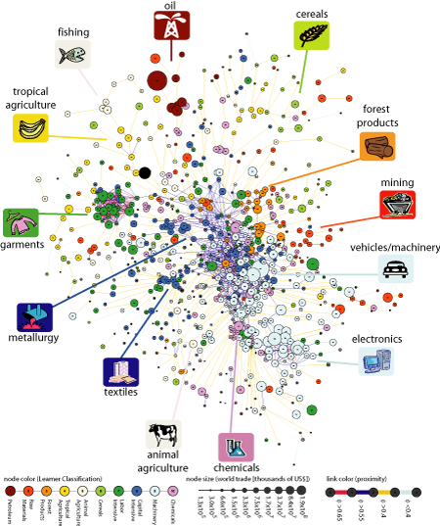
Source: Hidalgo, Klinger, Barabasi and Hausmann (2007)

The difficulty for countries to shift to the production and exports with a higher productivity level depends, among other things, on the number of higher-income products that requirecomparableinputsto the product in which the country has its comparative advantage, the cost of shifting and the income level of the new product compared to the income level associated with the country’s current export basket. Furthermore, policies such as local price controls can influence the transformation to higher-income products (Hausmann& Klinger, 2006). As a result, the speed of diversification depends on how difficult and how profitable it is for firms to exploit the technological and other similarities between various products (Jovanovic& Gilbert, 1993).
Hausmann and Klinger (2006) adopted a measure of the value of the products that are available for a country to export as the distance-weighted value of all the products it could produce. They found that the income level of new potential goods has a larger effect on the income level of a country’s export basket relative to the number of available upscale products. Furthermore,they concluded that countries differ widely in their potential for higher export sophistication. China is in a much denser part of the product space, having many machinery and capital intensive products nearby that are increasingly of higher value, than a country like Ghana, for which the nearest upscale product are farther away. As a result, China is able to transform to the production of higher-income goods at a higher speed. Also India, Indonesia and many eastern European countries have many potential products that meet the current available capabilities in these countries. On the other hand, oil exporters face a large distance between the currently exported and higher-income products; the specific assets these countries have are not very useful for the production of new, higher-income, goods, which makes it more difficult for these countries to improve the income level of their export baskets.
That the distanced-weighted value of the products a country could produce is very important for the development of export productivity becomes clear when comparing Korea with Argentina. These countries had similar income levels of their export basket in 1985, and Argentina’s GDP per capita was considerably higher than that of Korea. Nonetheless, Korea’s value of Hausmann and Klinger’s measure of the value of the unoccupied product space was60% higher, which made it possible for Korea to increase the income level of its export basket considerably the following fifteen years, whereas Argentina could not.

Cost discovery

Cost discovery process
Apart from the need for specific capabilities, there are additional difficulties for firms to shift their production and exports to a higher-income product. Even if the techniques and inputs are present, the local conditions might require adaptations, without guarantees for success (Hausmann&Rodrik, 2003). As a result, the true costs of producing under local conditions are unclear. The cost discovery process involves the search for these true costs of producing and exporting a specific product in a country in which it has not been produced or exported tobefore. The accompanying uncertainties might preventlocal entrepreneurs from producing and exporting higher-income goods.
The first-mover entrepreneur can capture only a small fraction of the social returns that the discovery generates, however, it is of great social value to learn that the local production costsof particular higher income goodsarereasonably low (Hausmann&Rodrik, 2003). By means of the cost discovery process, the developing country is able to specialise in a higher-productivity product, and by doing so, it will increase economic growth (Hausmann et al., 2007). The innovator invests in cost discovery anticipating on making a profit when discovering reasonably low local production costs, however, indirectly he invests in the productivity of the entire economy. When he discovers the possibility to bring a higher-productivity product in the market, the entire economy benefits.
Information on the costs of exporting depends on the number of exporters of other products in the particular market and on the overall experience in exporting the particular product (Brenton, Saborowski& von Uexkull, 2009). However, only truly exporting firms discover all costs, whether there is sufficient demand in the new market and whether the export of the product is profitable (Albornoz, CalvoPardo, Corcos&Ornelas, 2010). In case the estimated costs are low, firms generally enter the new market on a larger scale and have a relatively low hazard rate. On the other hand, when there is imperfect information about the costs of exporting a product to a particular market and when there are uncertainties about the demand, exporters sometimes decide to enter on a small scale, as a way to discover the total costs of exporting. If the discovered export costs are too high to be profitable, the firm will then exit the market (Brenton et al., 2009). Nevertheless, this entering on a small scale as a test is not suitable for all firms and products; for example whenthe expected sunk costs are very high.
Exporting firms that are located in developing countries face more difficulties in case of absence of good infrastructure in the developing country. Costs of logistics and telecommunications are then higher and constrain the available backbone services. These costs weaken the position of the firms in terms of competition in the export market and affect their profitability. The firms also have to take care of education for essential services that require certain skills and knowhow to be able to expand the production and exports(Brenton&Newfarmer, 2007). Moreover, buyers may hesitate to acquire heterogeneous products from these exporters when there is uncertainty about the delivery of quality (Brenton et al., 2009).
Mayer and Ottaviano (2007) called internationalised firms ‘superstars’, as they are rare and since only a small number of firms are responsible for most aggregate exports. Furthermore, they generate higher value added, have more skilled workers, are more profitable and are more productive. Only the firms that are productive enough to deal with the extra costs of exporting become exporters. The level of a country’s transformation highly depends on a few large exporting firms, as the top 5% of firms is responsible for more than 70% of a country’s total exports. Only the largest exporting firms that serve several foreign markets with several differentiated products can withstand the stronger competition of foreign markets (Mayer &Ottaviano, 2007).

Cost discovery externalities
When an entrepreneur investigates the costs of producing in the local market and discovers which product is most suitable for the production and exports in and to a particular country, taking the current comparative advantage into account, he faces another problem. This cost discovery creates an externality; when afirm discovers the cost of producing in a new market, this becomes common knowledge (Hausmann&Rodrik, 2003). This implies that every other firm from that moment on, knows whether or not it is profitable to produce that good in that particular market. This information externality brings a serious problem. Why would innovators be willing to invest in cost discovery, when the information they acquire becomes common knowledge and when the innovator is not compensated for the costs? Moreover, if the cost discovery process results in the finding that it is not profitable to produce the investigated good in the local market, that it is a dead-end, the entrepreneur will have to cover all the research costs without having the possibility to re-earn them.
These cost discovery externalities are a form of market failure asit is not likely that they will be internalised under perfect competition. Furthermore, they impede the process of product diversification and transformation to higher-income products, as they reduce discovery (Klinger & Lederman, 2004).A firm generates intra-industry spillovers when it cannot internalise the information on benefits from shifting the production to a good that has not been produced before in the countryfrom other entrants. There can also be inter-industry spillovers; when the firm adapting the productive capabilities in the country to the new good does not internalise the returns from their jump, allowing other firms to cut the distance to moving into an even higher-income good close to the new good. The market failure is even more problematic for countries that have comparative advantage in the least dense part of the product space, which slows the speed of their transformation to higher-income products even further (Hausmann& Klinger, 2006). Products differ in terms of the ability of competitors to imitate.
A solution for stimulating firms to engage in cost discovery could be to internalise the cost discovery spillovers. This way, competitors cannot enter the market or produce the product even if they see that it is profitable, and the innovator is thus the only one who can profit from this information.If the ease of firms to enter a market is made more difficult, this could have a positive effect on diversification and export growth. A government intervention such as industrial policies could stimulate firms to engage in cost discovery (Brenton&Newfarmer, 2007). Governments could implement policies that reduce first-movers experimentation costs and policies that increase innovators’ ability to capture profits of their discovery (Klinger & Lederman, 2004).East Asian governments provided cheap credits to promising sectors (Stiglitz, 1996). Mayer and Ottaviano (2007) also suggest governments not to waste too much time helping the incumbent ‘superstars’, but to nurture the superstars of the future by allowing small exporters to grow by subsidising. The incentive to innovate also depends on the market. When firms are able to sell to a larger market by means of international trade, they will be more induced to innovate, as they are able to cover their sunk and fixed costs over a larger production size (Sachs, 1998).

Size of manufacturing sector
Rodrik(2006) arguesthat non-traditional manufactures is the main driver of economic growth and development. He explained that world markets have almost limitless demand for manufactured products. Increasing the production of non-tradable goods limits development to domestic demand and also the exports of primary goods has its constraints. He stated that an increase in the production and export of manufactured products on the other hand, is likely to generate higher economic growth. A reason for this is that consumer preference changes during countries’ economic development. The income elasticity of demand of most agricultural goods is less than 1, as they are necessity goods, whereas the income elasticity of demand of many manufactured products is greater than 1. Accordingly, demand for manufactured products is expected to increase at a higher rate along a country’s development path, than demand for agricultural goods (Gehlhar, Hertel& Martin, 1994).
In addition, Manufactured products generally have a higher productivity than non-tradable and primary goods. Furthermore, within the manufacturing sector countries are able to develop more sophisticated products and thus continue shifting their scope to the production and export of higher productivity goods(Rodrik, 2006). As a result, the productivity level of these countries’ exports increase. Also raising firms’ attention to trade and greater openness to trade tends to result in higher productivity growth in manufacturing (Hallward-Driemeier, Iarossi&Sokoloff, 2002).
However, this development does not always come naturally, since the problem of cost discovery externalities comes into place again. If the discovery of higher-income manufactured products is accompanied by easy entry of competitors, firms might not be induced to involve in discovery.
Sachs (1998), as well as Rodrik (2006) stated that fast growing economies have large manufacturing sectors with high export growth.To be certain that the relationbetween income growth and increased shares of manufacturing is not only available for the now fast growing economies, Johnson, Ostry and Subramanian (2010) took a closer look at the growth accelerations and decelerations developing countries have been through. They concluded that also in developing countries, growth accelerations are accompanied by increases in the share of manufactures in total exports. Furthermore, during these growth accelerations the share of trade in GDP increased. An explanation for the high growth rates of countries that have large manufacturing sectors is that manufactured products are in the densest part of the product space. Particularly products of metal, iron or steel, machinery parts and rubber materials require little changes in inputs, skills and assets (Hausmann& Klinger, 2006).
Nevertheless, across countries there is large heterogeneity in the distance between the products in which they have comparative advantage, and manufactured products. For Eastern European and Asian countries this distance is not very large, whereas African and Latin American countries face a large distance (Hausmann& Klinger, 2006).
Figure 2 shows the manufacturing value added (MVA) as a percentage of GDP for 7 regions. Data to create this graph were retrieved from the World Development Indicators of the World Bank.The large variation in these shares between the regions is striking. In 1965 both East Asia and Latin America had a MVA share of 25% of their GDP. However, East Asia increased this share to 33% in 2008, whereas Latin America’s MVA share decreased to 17% in 2008. Also Sub-Saharan Africa faced a downward trend of the importance of manufacturing value added in its economy over the period 1965 to 2008. In 1965, 18% of Sub-Saharan Africa’s GDP was contributed by the added value of the manufacturing sector. This percentage dropped to less than 15% in 2008. South Asia showed some growth in the share of MVA; from 15% in 1965 to 17% in 2008, which is still a rather small percentage. The region Middle East & North Africa had the lowest MVA share: 12% in 1985 and 13% in 2008.
Figure 2: MVA as a percentage of GDP, per region
East Asia shifted fromlabour-intensive agricultural activities towards more capital-intensive manufacturing over the years, which in turn fostered economic growth. Moreover, East Asia has become a strong competitor of the United States, Canada and Europe in the manufacturing sector (Gehlhar et al., 1994). East Asian countries imposed financial market regulations that stimulated capital accessibility to manufacturing industries with higher technological benefits. Governments were highly adaptive and changed policies as the economic environment changed, and promoted higher value-added industries and improvements in technology. Subsidies were granted as a performance-based reward to stimulate economic growth. In addition, large investments were made in human capital. Governments supported the improvement of skills of the labour force. Education and training were mainly concentrated on engineering and science, which opened the road to more advanced technology. Furthermore, governments encouraged exports and invested in infrastructure, like ports and telecommunication, in order to reduce firms’ transport costs. Governments also established postal savings banks and development banks to increase savings and extend credit. Moreover, the manufacturing sector was able to grow as a consequence of, among other things, foreign direct investment (Stiglitz, 1996).
Regions like Sub-Saharan Africa on the other hand have not been able to reform their economic structure that way, and have not faced the corresponding income growth.Furthermore, a country like Rwanda is landlocked in Central Africa, which restricts gains from trade because of high transport costs (Sachs, 1998).
Alternatively, many countries with natural resources have not fully exploited the possibility to expand their manufacturing sector, because of Dutch disease or natural resource curse. The revenues from the natural resources often lead to appreciation of their real exchange rate, which reduces their competitiveness in other economic sectors. Thus, their specialisation in primary products, like oil or gas, limits improvements in the manufacturing sector. Persian Gulf oil exporters have large oil reserves and are not very active the manufacturing industry. Innovation and productivity improvement are more likely to occur in manufacturing, though, with corresponding long-term productivity growth. However, these economies are trapped in the specialisation of non-high-income goods and have lower long-term growth (Sachs, 1998).
In Figure 3, the percentage share of MVA with respect to GDP per capita is illustrated per income group instead. From this graph, it can be concluded that, on average, lower-middle-income countries and middle-income countries have the largest shares in MVA in relative terms;26% and 22% respectively in 2008. These shares are, in relative terms, higher than those of high-income non-OECD, 16% in 2007, as well as high-income OECD countries, 17% in 2004. These findings support Sachs (1998), and Rodrik’s (2006) stylised fact that fast growing economies have large manufacturing sectors, because most fast growing economies belong to these two former income groups.

Figure 3: MVA as a percentage of GDP, per income group
Thailand and China have the largest percentage manufacturing share of income of developing countries; 33% and 32% of their GDP’s. China and the Philippines are most specialised in exports of manufactured products; 88% and 86% of their merchandised exports consists of manufacturing. Also Pakistan, Ukraine and Malaysia have large manufacturing sectors. All of these countries are lower-middle-income countries according to the World Bank country classification. Malaysia and Romania are examples of countries that belong to the upper-middle-income group that have large manufacturing sectors (Hanson & Robertson, 2008).
The fact that the high-income countries have lower MVA shares can most probably be explained by the fact that as countries become richer their share of services in total output increases. Services have become of increased importance the past 2 decades. Because of the improvements in information and communication technology and the introduction of the internet, services are no longer solely inputs for products, but also final exports for consumption. Moreover, the tradability and productivity of services have increased. These changes in the sector explain how it is possible that a lower-middle-income country like India is so successful in the service sector (Mishra, Lundstrom&Anand, 2011).
The shift from manufacturing to services is also likely to be the reason for the decreased share of MVA of upper-middle-income countries. During the 1970s and 1980s, this country group had similar MVA shares as lower-middle-income countries and middle-income countries; 26% in 1985. In this period, this country group presumably had lower income levels than nowadays. From the late 1990s on, the upper-middle-income countries’ MVA share is more in line with high-income countries; 19% in 2004.
It is not a surprise that the poorest countries have the lowest MVA shares; 12% for the least developed countries in 2004. These countries mainly produce primary products. On average more than half of the workers in poor countriesare engaged in agriculture, whereas for rich countries this is on average only 3%. In addition, rich countries generally have, in relative terms, a 3 times larger share of workers employed in the industrial sector. The consumption pattern within these countries isalsovery different from richer countries.In poor countries farm products comprise on average 50% of household spending (Anderson, 1995). Furthermore, the poorest countries generally have protected manufacturing sectors, which leads to less efficient firms and low productivity growth (Tybout, 2000).

Level of diversification of export products
Although it is important for countries to produce and export non-traditional manufactures, it is essential that developing countries diversify the types of products they produce and export in order to grow (Rodrik, 2006). Along its development path, a country changes in the product range it produces and exports.Poor countries’ exports are generally dependent on a small range of products, whereas rich countries produce and export many different kinds of products(Bora, Grynberg&Razzaque, 2004).
Imbs and Wacziarg (2003) argued that there are two stages of diversification in the development process ofcountries. In the first stage countries diversify their production. This diversification has various causes. One of them is that consumer demand changes when income per capita increases. To be able to meet this demand a wider variety of products will be produced. Another motive for countries to diversify is to reduce risks. Extending the economic activity over a broader range of products works as a safety net, since the risk of for example falling demand for a particular product can be covered up by the other products.
At a certain per capita income level, relatively late in the development process, countries move to the second stage of diversification and start to concentrate their economic activity (Imbs&Wacziarg, 2003). As countries shift their production from agriculture to manufacturing, scale economies become more important. Firms expand their production of the higher-income product to benefit from falling average costs per unit. Moreover, scale economies in manufacturing induces producers to agglomerate. Firms benefit from a dense area of producers, because they can share labour, capital inputs and information. In addition, improvements in logistics reduce transport costs and makes it profitable to serve a larger market, and thus to increase the production of the particular good and change the pattern of trade (World Development Report, 2009). Furthermore, policies that stimulate (international) trade encourage countries to concentrate its economic activities for that reason.
As aresult, Imbs and Wacziarg (2003)discovered a U-shaped specialisation pattern in relation to income per capita, which is shown in figure 4. As income per capita increases, countries diversify in their range of products produced, but only up to a certain income level. At a particular income per capita level, countries reverse this trend and start to concentrate their economic activities. The first stage of diversification (diversifying) is the longest part of the development path as the income level at which economies stop diversifying and start concentrating is relatively high.
Figure 4: Relation between sectoral concentration and GDP per capita
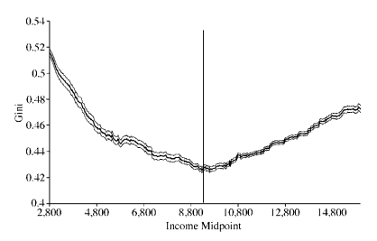
Source: ImbsandWacziarg(2003)

Accordingly, most of the countries that are diversifying their economic activity are developing countries, whereas most of the countries that are in the specialisation stage, are rich countries. Imbs and Wacziarg (2003) estimated the level of per capita income that works as a turning point in the specialisation pattern to be around 9,000 constant 1985 US dollars, which is around the income level of Ireland in 1992. This means that in current international dollars, this income level at which countries start to specialise its economy is around $15,000.
For most of the countries, the second part of the curve of sectoral diversification, where the countries concentrate, is flatter than the first part, where countries diversify. However, Imbsand Wacziarg (2003) calculated that the slope of the second part is statistically significant and positive. This difference means that a certain increase in income per capita has a larger influence on sectoral concentration in the first stage than in the second; a certain increase in income per capita leads to a higher rate of diversification in the first stage compared to the rate of concentration in the second stage.
The relation between diversification and income is comparable to the relation between the amount of discoveries and income, illustrated in figure 5. The poorest countries make the fewest discoveries, and the richest countries are not very active anymore in discovery (Klinger & Lederman, 2004). Lower middle-income countries diversify their production and exports by either discovering higher-income goods, by exporting their existing product to a new market, or by exporting a new product to their existing market. Although countries start to specialize at around 9,000 1985 US dollars, they also continue making discoveries, albeit at a lower rate as shown by the somewhat flatter slope of the second part of the specialisation curve in figure 4 and by the curve in figure 5.
Figure 5: Relation between discoveries and GDP per capita
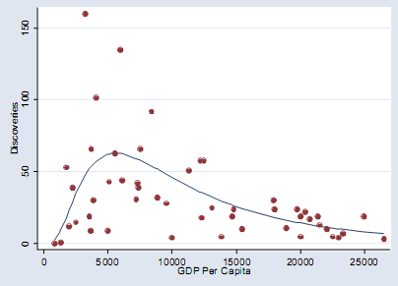
Source: Klinger and Lederman (2004)

Furthermore, according to Imbs and Wacziarg’s (2003) data, there appears to be a difference in the slope of the upward part of the curve among countries. For their data set with only OECD countries, the slope of the upward bending part is much steeper compared to their data sets that also include developing countries. OECD countries thus concentrate at higher speed than other countries.
This goes along with another difference of OECD countries when looking at value-added data; in this data the minimum point of sectoral concentration for OECD countries occurs at a lower income level than for the combined country set. Where the majority of the countries diversify up to the income level of around 9,000 constant 1985 US dollars, Imbs and Wacziarg (2003) discovered that for value-added data OECD countries started to concentrate already at an income level of around 7,000 constant 1985 US dollars, which is roughly 12,000 current international dollars. OECD countries possibly have more advantage of internal economies of scale and agglomeration economies. The OECD members cooperate by sharing experiences,research and recommendations about policies (OECD, n.d.).Although OECD countries started the second stage of diversification at a lower per capita income level than other countries, this income level is still relatively high.
An important aspect of the relationship between sectoral diversification and income is to examine whether this effect is caused by between-country or within-country variation. Since their sample of countries varies over time, the relation can to a certain extent be explained by between-country variation. Nevertheless, Imbs and Wacziarg (2003) applied a regression on sectoral concentration (as dependent variable) and income per capita (as independent variable). Their results showed statistical evidence of a significant within-country variation.
In addition, there are countries with very different country sizes and different trade policies (open versus relatively closed to trade), that have similar specialisation patterns. For example, the United States and Belgium are very different in size and openness to trade; the United States is very large and has relatively protective trade policies, whereas Belgium is small and relatively open to trade. Nevertheless, these two countries have a similar specialisation pattern, with comparable income per capita levels. The same goes for the comparison of Denmark and the United States.
Furthermore, when not comparing industrialised countries, but two developing countries like China and Malaysia, the same is true. China is very large and trade regulations are still present, although the major economic reforms since 1978 and the resulting membership of the WTO in 2001 had a positive effect on the accessibility of the Chinese market and made China very active in multilateral trade (WTO, 2006). In contrast, Malaysia is a small country but has an open economy. However, China and Malaysia are at a similar stage of diversification. To conclude, there are rich countries with very different country sizes and trade policies that are at a similar location of the specialisation path (concentrating), and also developing countries with large differences concerning country size and trade openness are located at a similar stage (diversifying) (Imbs&Wacziarg, 2003).
There is some heterogeneity in the dataofImbs and Wacziarg (2003). In resemblance to OECD-countries,countries with open trade policies tend to specialise at lower GDP per capita levels than other countries. Examples of open economies that started specialising earlier in the development process are Ireland, Singapore and Cyprus. Countries gain from trade by the increase of the market, which allows firms to increase production and benefit further from scale economies. Moreover, the extended market allows greater variety of products. Factor mobility has a similar effect, as movement of labour allows growth in the labour force (Krugman, 1979). Additionally, Klinger and Lederman (2004) revealed population to be significantly and positively related to the amount of discoveries. Furthermore, when using their populations GDP’s, Eastern Europe’s and Central Asia’s number of discoveries was above world average in the 1990s, whereas Africa’s number of discoveries was below world average.
Although open economies start specialising at lower per capita income levels, also closed economies end up concentrating in its sectors (Imbs&Wacziarg, 2003). This means that all countries have a u-shaped sectoralconcentration pattern in relation to income, but that among others, the degree of openness of the economy determines the income per capita level at which sectoral concentration is at its minimum. The interaction of income and trade openness thus determines the stages of diversification.

Measuring productivity levels of products and of specialisation patterns
To be able to analyse the differences among countries in terms of their export productivity, this part introduces a measure of the productivity level of products, as well as a measure of the productivity level of countries’ export baskets. Furthermore, the difference in productivity levels between a large set of products will be discussed, as well as the products with the smallest and largest productivity levels.

Method

Introducing PRODY and EXPY
Hausmann et al. (2007)produced a measure of the productivity level of a country’s specialisation pattern that predicts subsequent economic growth. First of all, they created an index, being a weighted average of the GDP’s per capita of countries producing a certain product. The weights reflect the revealed comparative advantage of each country in a certain good (k). The index, called PRODY gives the income level associated with that product (k); it is the income/productivity level of that product(k).
The construction of the index is as follows:
Where x_{jk} represents the export volume of a particular product k of country j, X_{j} total exports of country j:, and Y_{j} GDP per capita of country j.
Second, since the productivity level of each product is now known, the income/productivity level of a country’s export basket can now be constructed, which Hausmann et al. (2007) called EXPY. This index is defined as follows:
Where x_{il} represents the export volume of the product l of a particular country i, X_{i} total exports of a particular country i, and PRODY_{l} the productivity level of product l.
In other words; EXPY is the export-weighted average of the various PRODY of the exported productsof a particular country. Thus, PRODY measures the productivity level of a particular product k, whereas EXPY measures the productivity level of the export basket of a particular county i.

Data sources of the research
In order to be able to use the PRODY and EXPY measures for the data research of this paper,annual export data were obtained from the UN database COMTRADE for the years 1988 to 2008. Since the PRODY and EXPY indexes require countries’ total export volumes as well as their export volumes of particular products, the 6-digit level of disaggregationaccording to the Harmonised System (HS)was used. As a result, export figures for up to 5,111 products were acquired.
In order to obtain a consistent sample of countries, and to prevent bias, the sample of countries used consists of countries that reported export data in each of the years 2002, 2003 and 2004. Consequently, the annual trade data is available for up to 132 countries, as reported in appendix 1. Hence, the data file used for this paper consists of over 5,000 export records per country per year, for up to 132 countries, for a period of 21 years. GDP per capita as well as GDP per capita growth figures were obtained from the World Development Indicators (WDI) of the WorldBank. Since the sample consists of many countries, PPP-adjusted GDP per capita figures from the Penn World Tables were used.
Shortcomings of PRODY and EXPY
Although the HS is a good method to compare export structures across countries, the use of 6-digit level data has its limitations; HS6 is not disaggregated enough for high-tech products. HS6 averages products of a higher disaggregated levelalthough these products have different degrees of value added, which results in miscalculations. Consequently, EXPY underestimates the export productivity of developed countries, and overestimates the productivity of poor countries’ exports. However, the availability of more disaggregated data that is suitable to compare all countries of the large sample is limited.
The HS 6-digit commodity codes are identical across all countries in the world. In addition, countries using the HS6 classification are allowed todescribe their exports at a more disaggregated level, although they should be consistent with the 6-digit structure (Export.gov, 2011). The US Census Bureau, for example, publishes 10-digit export figures for the United States according to Schedule B classification (US Census Bureau, 2011). Furthermore, the Directorate General of Commercial Intelligence and Statistics (DGCI&S) publishes the Indian Trade Classification (Harmonised System), which is an 8-digit commodity classification. Other countries have 8 or 10-digit trade data available too; so for these countries the differences in export structure over time can be analysed. Nevertheless, since many countries within the sample do not have such disaggregated export data available, the HS 6-digit level is used in this paper, which is also commonly used as disaggregated data.

Productivity levels of products

Variation in PRODY
By means of these data, the PRODY’s for each of the products at 6-digit level were constructed. Table 1 shows the descriptive statistics for the mean of PRODY’s for the years 2002, 2003 and 2004 of 5,110 products. It shows that the income productivityassociated with particular export products varies from $671 to $56,323, with a mean of $15,646and astandard deviation of $7,399. This large variation seams to confirm the idea that the product content of a country’s export basket depends on its GDP per capita. These findings are rather similar to the ones of Hausmann et al. (2007); their minimum value of the mean of PRODY for the years 1999, 2000 and 2001 was $748, and they found a maximum of $46,860. Furthermore, they had a standard deviation of $6,110. The variation in PRODY’s in the paper of Hausmann et al. (2007) was somewhat smaller than in this paper. This could perhaps be explained by the different time period for which the PRODY means were constructed. The difference of almost $10,000 of the maximum value of PRODY is mainly responsible for this increase in variation, since the minimum value is roughly unchanged. That could mean that over time products with even higher productivity levels have been exported, but it is more probable that this can be explained by measurement differences.
Table 1: Descriptive statistics PRODY
DescriptiveStatistics
 | N | Minimum | Maximum | Mean | Std. Deviation
PRODY average of 2002, 2003, 2004 | 5110 | 671 | 56,323 | 15,646 | 7,399
Valid N (listwise) | 5110

Products having the smallest and largest PRODY’s
The five export products with the smallest PRODY’s, as well as the products with the largest PRODY values are specified in table 2. The goods with the smallest PRODY values are mainly primary products, whereas the products with the largest values of PRODY are all industrial products, mainly iron and steel products.

Table 2: Smallest and largest PRODY values

Smallest PRODY values
Product code | Product name | PRODY average of 2002, 2003, 2004
410511 | Sheep or lamb skin leather, without wool on | $671
261590 | Niobium, tantalum and vanadium ores and concentrates | $773
140310 | Broom corn used in brooms or brushes | $829
410611 | Goat or kid skin leather, vegetable pre-tanned | $838
090500 | Vanilla beans | $854
Largest PRODY values
Product code | Product name | PRODY average of 2002, 2003, 2004
590290 | Tyre cord fabric of viscose rayon | $56,323
730110 | Sheet piling of iron or steel | $53,289
721069 | Flat-rolled iron/steel, >600mm, clad, plated or coated with aluminium | $49,819
811300 | Cermets and articles thereof, waste or scrap | $48,765
721633 | Sections of iron or non-alloy steel, H, i/nas, nfw hot-roll/drawn/extruded > 80mm | $48,550

The low PRODY of niobium, tantalum and vanadium ores and concentrates, can be explained by the fact that this product is a large share of Rwanda’s exports. In 2002, this product was responsible for 31% of Rwanda’s exports. Together with the fact that Rwanda has the fifth lowest GDP per capita of the country sample in that year, $ 665, this clarifies the low PRODY value of the product. Vanilla beans, is a large share of Madagascar’s exports, 28%in 2002, which also has one of the lowest GDP’s per capita; $693 in 2002. Sheep or lamb skin leather, which has the third lowest PRODY, is mostly exported by poor countries such as Ethiopia and the Gambia.
Alternatively, tyre cord fabric of viscose rayon, the good with the largest PRODY value, is mainly exported by rich countries, such as; Luxembourg, Germany, Italy and Sweden. Sheet piling of iron or steel, is also mainly exported by high-income countries like Luxembourg, Germany, Japan and the United Kingdom. Rich countries such as Luxembourg, France, Japan, UK, Germany, are also mainly responsible for the exports of flat-rolled iron and steel. The largest shareof exports of cermets and articles thereof belong to Luxembourg, Switzerland and Sweden.
4 of the 5 products with the largest PRODY values were also in the top 5 of Hausmann et al.(2007). Only cermets and articles thereof did not belong to the largest PRODY’s of Hausmann et al. (2007). Furthermore, the order of the 4 similar products are different; in this paper tyre cord fabric of viscose rayon has the largest PRODY, whereas in Hausmann et al. (2007) flat-rolled iron and steel had the largest PRODY. In addition, all 5 largest PRODY values are considerably larger than the maximum PRODY of Hausmann et al. (2007).

Productivity levels of specialisation patterns

Variation in EXPY
After all PRODY values were known, EXPY values could be generated. The descriptive statistics of EXPY are shownin appendix 2. The table shows that the number of countries for which EXPY is available, fluctuates during the 21 years. Fluctuation was expected and was the reason to generate PRODY and EXPY values only for those countries that reported export data in each of the years 2002, 2003 and 2004, since non-reporting might be income related, which could create bias. The table shows that even after deselecting all other countries, there still is a large variation in the number of reporters over the years; from 10 in 1988 to 132 in the years 2002, 2003 and 2004.
The minimum value of EXPY tends to fluctuate over the years, whereas the maximum value increases over time, from $19,450 in 1988, to $26,462 in 2008. However, this large increase can be explained by the fact that Switzerland reported data during the entire sample period, whereas Luxembourg only for the years 1999 to 2008. From 1988 to 1998, Switzerland had the largest EXPY value. When Luxembourg entered the sample in 1999, it took over the role of reporter with the largest export productivity. Nevertheless, Switzerland continued increasing its EXPY; to $22,065 in 2008.
In their study, Hausmann et al. (2007)faced the same problem of an unsteady number of reporters. Nevertheless, they saw a decreasing trend in their mean of EXPY. They explained this decrease by the unsteady sample of countries, as well as by the fact that many countries faced decreasing EXPY values. They remarked that the trend might be specific to the time period, because, they did not find such a decrease when they used a 4-digit level of aggregation for the years 1960 to 2000.
The minimum EXPY values of Hausmann et al. (2007) mostly dropped over the research period. The maximum EXPY of their study decreased in the early-nineties and then increased, to drop again from 1999 to 2003. These differences in outcomes between these studies might be caused by a difference in availability of data, and by a difference in country composition of the samples.

Mean EXPY
The mean of EXPY, as also illustrated in figure 6, decreased in the period 1988 to 1995.The small number of reporters in the first 5 years is part of the reason for that. The small sample size of those years provide a bias caused by non-reporting poor countries, which makes the left part of the graph in figure 6 not reliable. A decrease in EXPY during the early nineties is, however, not peculiar, though not of that size, since the recession in the early-nineties might have influenced EXPY. The decrease in GDP’s per capita during that recession is not directly related to the EXPY values in those years, because the income levels of the years 2002, 2003 and 2004 are taken in the construction of PRODY, and thereof, of EXPY. Nevertheless, EXPY is indirectly affected by the recession, since during recessions exports generally fall.
Figure 6: Mean EXPY per year
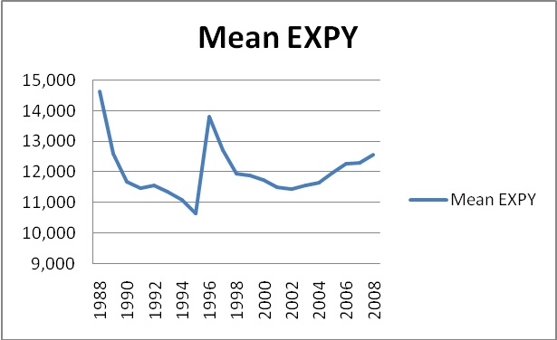
The peak in 1996, the mean of EXPY was$13,817 compared $10,641 in 1995, is also likely based on biased sample information. For 1996, there were considerably fewer reporters; only 49. When taking the year 1996 out of the discussion, the graph still shows a decreasing tendency in EXPY’s mean during the period 1997 to 2002. The mean of EXPY for 1997 was $12,703, which fell to $11,427in 2002. For this period, there is no problem with data availability. That this decrease in the mean of EXPY is firstly seen in 1997, can be associated with the East Asian financial crisis that started in mid-1997 and continued to 1998. The East Asian financial crisis in turn triggered the Russian financial crisis in mid-1998. During these crises world commodity prices dropped, especially those of primary products and petroleum (Cashin, Liang & McDermott, 2000). These price shocks persisted for several years.
The period 2002-2008 then shows an increasing mean of EXPY, as well as a decreasing standard deviation. This means, that also the variation in in export productivity across countries decreased. Also for this period, there is no problem with data availability. For each year, over 100 countries reported data. It cannot be a coincidence that the commodity price boom occurred during almost the same period; from 2003 to July 2008. During this boom period, there was a strong demand, the dollar had depreciated, and investments increased compared to the low rate in the years before (Global Economic Prospects, 2009). Although the financial crisis started in mid-2008, the mean of EXPYincreased further during that year.
The figures of 2009, beyond the extent of this paper, are likely to show decreases in EXPY’s, caused by the latest financial crisis. Enormous price drops across all sectors have likely decreased the export productivity of most countries. Furthermore, the exports of high-income countries collapsed. Especially Asia was hit hard in exports. For example, Japan’s exports decreased by 40%. Also developing countries were affected by the financial crisis, both indirectly by the downturn in high-income countries, as well as directly in the domestic market (Global Economic Prospects, 2009).

Countries having the smallest EXPY’s
Table 3 illustrates the top 5 smallest values for the years 1992, 1996, 2004 and 2008,with the corresponding country names. The country composition of the 5 smallest EXPY values differ substantially between these years. It is important to have in mind that all of the countries of the sample reported data only for 2002, 2003 and 2004. As mentioned earlier, non-reporting is likely to be income related, and since EXPY is related to income, it might also be related to EXPY. This is demonstrated by the data, because none of the five smallest EXPY countries for 1996, 2004 and 2008 reported data for 1992, except for Madagascar. In 1996, 2004 and 2008, all of the 5 smallest EXPY’s, with values between $1,800 and $5,600,belong to Sub-Saharan African countries. Some of these countries have increased their export productivity somewhat over time, like Ethiopia, however, Niger’s EXPY decreased even further.
Table 3: Smallest EXPY values
Smallest EXPY values
Year 1992 |  | Year 1996
Country | EXPY | Country | EXPY
Madagascar | $4,101 | Malawi | $3,204
Paraguay | $5,420 | Madagascar | $4,010
Bangladesh | $5,715 | Senegal | $4,834
Kenya | $6,431 | Uganda | $5,068
Sri Lanka | $6,974 | The Gambia | $5,596
Year 2004 |  | Year 2008
Country | EXPY | Country | EXPY
Rwanda | $1,849 | Niger | $2,679
Sao Tome and Principe | $2,608 | Rwanda | $2,869
Ethiopia(excludes Eritrea) | $2,759 | Sao Tome and Principe | $3,166
Niger | $2,966 | Ethiopia(excludes Eritrea) | $4,004
Benin | $3,010 | Malawi | $4,066

Countries having the lowest EXPY growth rates
In addition to looking at the absolute values of EXPY, it is also interesting to look at the growth rates of EXPY, since these describe the development of EXPY levels. Table 4 shows the countries that have the 5lowest growth rates of EXPY for the years 1992, 1996, 2004 and 2008. The country composition of the top 5 smallest varies over the years. In addition, the lowest growth rates decreased over time. Anotherinteresting element is that all countries in the top 5lowest EXPY growth rates are poor countries, except for Iceland and Norway. Since all these growth rates are negative, except for Norway, this means that these countries have decreased their export productivity in these years.Although Norway has the fifth lowest growth in export productivity in 1996, it had a positive growth rate, as well as amoderate EXPY of over $14,000. Also Iceland’s EXPY has been rather stable over the years.
Table 4: Lowest EXPY growth rates
Lowest EXPY growth
Year 1992 |  | Year 1996
Country | EXPY growth | Country | EXPY growth
Trinidad and Tobago | -7.81% | Gambia, The | -10.97%
Iceland | -5.66% | Macedonia | -4.18%
Indonesia | -5.16% | Macao | -1.99%
Madagascar | -4.85% | Madagascar | -1.44%
Tunisia | -2.73% | Norway | 0.53%
Year 2004 |  | Year 2008
Country | EXPY growth | Country | EXPY growth
Rwanda | -51.96% | Samoa | -94.40%
Gambia, The | -19.79% | Mozambique | -23.47%
Syrian Arab Republic | -18.62% | Namibia | -18.09%
Armenia | -16.89% | Malaysia | -17.06%
Zambia | -15.66% | Grenada | -15.68%

The 5% drop of Indonesia’s EXPY in 1992 can partly be explained by the reduction of petroleum oils and natural gas exports relative to total exports. Natural gas in particular has a high productivity; $29,700.The total exports share of both products decreased from 33% in 1991, to 27% in 1992.Asia, and Malaysia in particular, was hit hard by the financial crisis, mainly through decreases in trade.This was mainly caused by the falling demand for electronics and electrical machinery, which mostly comes from the United States, Europe and Japan. These latter countries’ economies were hit by the recession first, and their consumption decreased (Rahmiati, Mulyaningrum&Tahir,2010). As a result, Malaysia’s export value of electrical machinery equipment, measured at 2-digit level, decreased by 39% in 2008. Furthermore, Malaysia’s total export share of these products declined from 29% in 2007 to 16% in 2008, which was the main reason for the 17% decrease of EXPY.

Countries having the largest EXPY’s
The countries that have the largest EXPY’s in the four years, showed in table 5, are all European and/or OECD-countries, except for Qatar. Although Luxembourg is not present during the entire sample period; no trade data was available before 1999, it is reasonable to assume that it would have the largest export productivity in 1992 and 1996 too, because of the large difference in EXPY between Luxembourg and the other countries in the sample for each of the ten years Luxembourg did report.The small countries Luxembourg and Switzerland are outliers as they mainly export high-tech and knowledge based industrial products.In addition, 60% of Luxembourg’s labour force consists of foreign workers. Furthermore, both countries have a large banking sector (The World Factbook, 2011).

Ireland’s export productivity improved considerably during the sample period, resulting in a top 5 position of largest EXPY’s since 1996.Only for Qatar, which had the fifth largest export productivity in 2004, it is difficult to define if it would be one of the countries with the 5 largest EXPY’s in the other years, because the oil and gas state only reported trade data for 2001 to 2005. It is interesting to notice that 3 of 2008’s top 5countries had smaller EXPY’s compared to 2004 (i.e. Luxembourg, Japan and Finland), which could be related to the latest financial crisis.
Table 5: Largest EXPY values
Largest EXPY values
Year 1992 |  | Year 1996
Country | EXPY | Country | EXPY
Switzerland | $19,968 | Switzerland | $21,253
Finland | $17,570 | Ireland | $20,706
Sweden | $17,518 | Japan | $19,419
Iceland | $17,434 | Finland | $19,095
Germany | $16,914 | Malta | $18,967
Year 2004 |  | Year 2008
Country | EXPY | Country | EXPY
Luxembourg | $26,675 | Luxembourg | $26,462
Switzerland | $22,033 | Switzerland | $22,065
Ireland | $20,719 | Ireland | $21,700
Finland | $19,999 | Finland | $19,477
Qatar | $19,810 | Japan | $19,209

Figure 7 illustrates the differences in EXPY, GDP per capita and export share of GDP, for 2008 of 5 rich countries. Although the United States has the highest income level of these 5 countries, it has the smallest EXPY. Furthermore, the 5 countries differ substantially in export share of GDP; for Ireland and Germany this is more than 40%, whereas for the United States this is less than 10%. Though Germany’s export share of GDP is twice as large as that of France, the countries have comparable EXPY’s and income levels. In addition,Japan’s export share of GDP is 16% and also its income is somewhat lower than Germany’s, however, Japan has a larger EXPY. Thus, income levels and export shares of GDP are not always good explanations for the size of EXPY, as these former variables do not incorporate the productivity levels of products exported.

Figure 7: EXPY, GDP per capita and export share of GDP for 2008
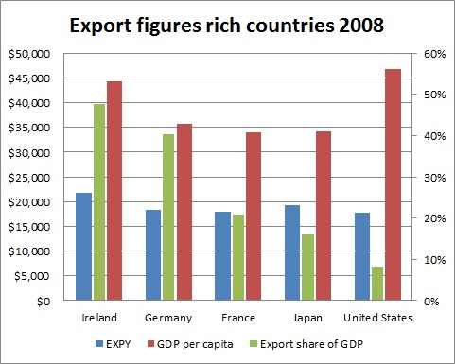

Countries having the highest EXPY growth rates
Table 6 shows the highest EXPY growth rates. While the lowest EXPY growth rates have decreased over the period 1992 to 2008, the 5highest EXPY growth rates have increased during the same period. The group of countries having the highest growth rates in export productivity is a mixture of poorand rich economies.
Table 6:Highest EXPY growth rates
Highest EXPY growth
Year 1992 |  | Year 1996
Country | EXPY growth | Country | EXPY growth
Paraguay | 11.83% | Ireland | 48.27%
Sri Lanka | 10.31% | Malta | 38.64%
Chile | 5.39% | Uganda | 33.11%
Bangladesh | 5.33% | Korea | 22.82%
Ecuador | 4.58% | Japan | 19.09%
Year 2004 |  | Year 2008
Country | EXPY growth | Country | EXPY growth
Trinidad and Tobago | 41.84% | Gambia, The | 56.46%
Oman | 26.31% | Israel | 28.60%
Madagascar | 18.36% | Rwanda | 12.38%
St. Vincent and the Grenadines | 14.72% | Madagascar | 10.89%
Ethiopia(excludes Eritrea) | 13.64% | Senegal | 10.83%

It is not very extraordinary that there are many poor countries in the top 5highest EXPY growth rates, since many of these countries have volatile export structures.Furthermore, most poor countries have relatively small total export volumes, implying that a small export increase or decrease of certain products can lead to large changes in EXPY. Madagascar, Trinidad and Tobago, The Gambia and Rwanda are in both the top 5lowest as well as the top 5highest EXPY growth rates. Nevertheless, Trinidad and Tobago’s EXPY doubled in 16 years; from $8,100 in 1992, to $17,900 in 2008.
Ireland’s high EXPY growth of 1996 is affected by measurement error, becauseforthe year 1995 the products were specified by the HS1992, whereas for 1996 and later years HS1996 was used. Nevertheless, an increase in Ireland’s EXPY is not implausible as agriculture was a large share of Irish exports in the 1960s, but had lost its importance in 1996. At the same time, the share of industrial exports increased drastically(Ireland: a Trading Nation, 1998), e.g. 24% of Irish exports in 2008 consisted of heterocyclic compounds (organic chemicals) and medicaments.

Sub-Saharan African andSouth and East Asian export productivity levels
This part focuses on the development of and differences between the export productivity of Sub-Saharan African and South and East Asian countries. Both regions consist of many developing countries. What are the differences in terms of EXPY when comparing both regions?

Method
Two country groups were created; one group of 27 developing countries of Sub-Saharan Africa and one group of 13 developing countries in South and East Asia. The construction of the groups was done according to the country group classification of the World Bank of September 2010, and subject to data availability. East Asian developed countries are not included, since developing countries across the regions are being compared. These are also not included in the World Bank country group classification. Table 7 shows the mean of EXPY and the average EXPY growth for both groups for 4 years, as well as the smallest and largest values within each group with the corresponding country names. The table also shows the number of countries per country group; these vary over the years.
Table 7: Sub-Saharan African and South and East Asian EXPY values
Year 1995
Sub-Saharan Africa |  | South and East Asia
Number of countries | 13 | Number of countries | 7
Mean EXPY | $4,727 | Mean EXPY | $9,675
Smallest EXPY | $1,613 | Smallest EXPY | $6,617
Country | Niger | Country | Bangladesh
Largest EXPY | $8,604 | Largest EXPY | $12,036
Country | South Africa | Country | China
Mean EXPY growth | 5.71% | Mean EXPY growth | 2.22%
Year 1999
Sub-Saharan Africa |  | South and East Asia
Number of countries | 17 | Number of countries | 8
Mean EXPY | $6,023 | Mean EXPY | $10,667
Smallest EXPY | $2,074 | Smallest EXPY | $6,703
Country | Niger | Country | Mongolia
Largest EXPY | $13,684 | Largest EXPY | $15,068
Country | South Africa | Country | Malaysia
Mean EXPY growth | 4.37% | Mean EXPY growth | 7.12%
Year 2004
Sub-Saharan Africa |  | South and East Asia
Number of countries | 27 | Number of countries | 13
Mean EXPY | $6,467 | Mean EXPY | $10,007
Smallest EXPY | $1,849 | Smallest EXPY | $4,361
Country | Rwanda | Country | Cambodia
Largest EXPY | $14,238 | Largest EXPY | $16,602
Country | South Africa | Country | Malaysia
Mean EXPY growth | -1.62% | Mean EXPY growth | 1.22%
Year 2008
Sub-Saharan Africa |  | South and East Asia
Number of countries | 18 | Number of countries | 8
Mean EXPY | $7,501.94 | Mean EXPY | $12,009.23
Smallest EXPY | $2,678.57 | Smallest EXPY | $5,589.57
Country | Niger | Country | Maldives
Largest EXPY | $14,124.23 | Largest EXPY | $16,375.00
Country | South Africa | Country | China
Mean EXPY growth | 2.29% | Mean EXPY growth | -1.65%

The mean EXPY of Sub-Saharan Africa increases over time, from $4,727 in 1995 to $7,502 in 2008. However, South and East Asia’s average EXPY is twice as large; $9,675, and $12,009, during the same period. Also the smallest EXPY’s of Sub-Saharan African countries are significantly smaller than those of South and East Asia. Moreover, in both 1995 and 1999, the smallest EXPY values of South and East Asia are even larger than the mean EXPY’s of Sub-Saharan Africa.

EXPY growth
Figure 8 illustrates the average EXPY growth rates of both regions, as well as those of the entire sample. For 3 of the 4 years, the world’s average EXPY growth rate is significantly lower than that of Sub-Saharan Africa and/or South East Asia. Furthermore, in 1992 and 2008 Sub-Saharan Africa’s average EXPY growth rate was significantly higher than those of South and East Asia. Nevertheless, this graph does not give insight on the dispersion and skewness of the 3 regions, which is illustrated in figure 9.
Figure 8: Average EXPY growth per region
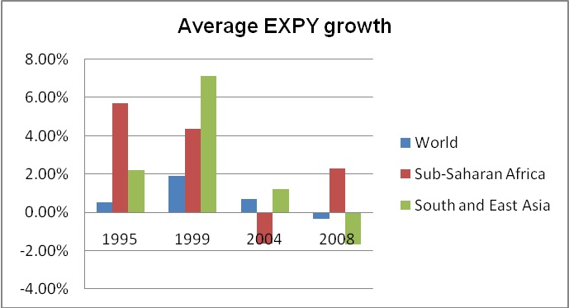
Figure 9: Dispersion of EXPY growth within the regions
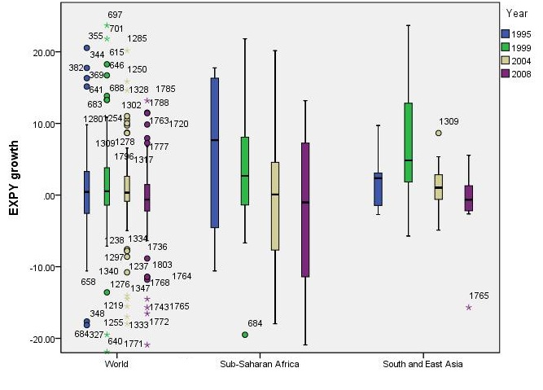
The distribution of growth of EXPY is very different across the regions. The world sample is heavy tailed, which is mostly caused by Sub-Saharan African countries’ EXPY growth rates, as most of the world’s outliers and extremes, belong to that region.These outliers and extremes are represented by the numbers in figure 9.In addition, the Sub-Saharan African boxplots cover a larger growth scale than the other regions, meaning that the variation within Sub-Saharan Africa is much larger. Furthermore, for 1999 and 2004, the distribution of this region is skewed to the right; there are relatively few high values and most Sub-Saharan African countries have lower EXPY growth rates than the mean EXPY growth of Sub-Saharan Africa.
The size of the South and East Asian sample is rather small for boxplots to make definite statements. For 2004 the size is the largest, and the distribution seems to be skewed to the left, meaning that most South and East Asian countries have higher EXPY growth rates than the region’s mean of 1.22%.
The outliers and extremes of Sub-Saharan Africa and South and East Asia are shown in table 8, some of these were removed from the graph in figure 9. The Gambia has very high EXPY growth rates in 1999 and 2008. However, for other years the country also has very low (negative) growth rates. In addition, the Gambia has very low total exports (e.g. $5 millionin 2005), which is also true for Senegal and Rwanda. Nonetheless, Senegal’s export productivity increased by 112% from 1996 to 2008, to $10,245.
Table 8: Outliers and extremes within the 2 regions
Sub-Saharan Africa |  |  | South and East Asia
Year | Country | EXPY growth | Year | Country | EXPY growth
1999 | The Gambia | 32.8% | 2004 | Philippines | 8.7%
1999 | Senegal | -19.5% | 2008 | Malaysia | -15.7%
2004 | Rwanda | -40.5%
2008 | The Gambia | 75.9%

South Africa versus Gabon
This section gives insight into the differences and similarities between South Africa and Gabon, as they have the largest EXPY’s within Sub-Saharan Africa, but also differ in their development.Figure 10illustrate the differences between South Africa and Gabon in terms of their development of EXPY and GDP per capita. South Africa’sEXPY value increased from $7,300 in 1992 to $14,658 in 2006, but then fell slightly to $14,124 in 2008. The graph shows a decrease of South Africa’s EXPY in 2000; 13.9%, which was followed by an increase of 18.3% in 2001. Conversely, Gabon’s EXPY remained around $12,500 over the years, except for the dip in 2003. As a consequence, from 2001, South Africa’s export productivity is higher than that of Gabon. In contrast, Gabon’s GDP per capita was generally twice as large as South Africa’s. South Africa’s income level seems to increase linearly, whereas that of Gabon is not.
Figure 10: EXPY and GDP per capitadevelopment of Gabon and South Africa
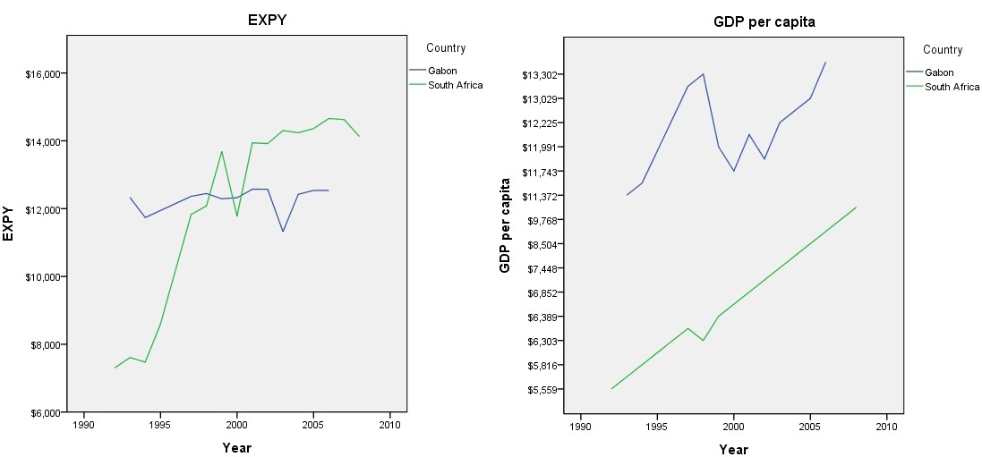

Table 9: Export shares of GDP
Gabon |  | South Africa
Year | Export share of GDP | Year | Export share of GDP
1997 | 49.4% | 1997 | 15.1%
2006 | 63.0% | 2006 | 20.2%

In addition, table 9 shows the exports-to-GDP-ratio’s for both countries. Exports is more important to Gabon’s economy than to that of South Africa; the export share of GDP of Gabon is much larger. Furthermore, the export shares of both countries have increased over time.

The products with the largest export shares of Gabon and South Africa are illustrated in figure 11. By far the largest share of Gabon’sexport basket consists of petroleum oils, with a PRODY of $12,818.In 2006 the export share of this product even increased to 84.4%. Moreover, the oil revenues comprised 53.2% of Gabon’s GDP. The stability of Gabon’s export productivity can, thus, be explained by the fact that one product is responsible for the majority of the county’s exports. However, Gabon’s diminishing oil reserves will in all probability result in a changing export structure in the next decade. Timber exports is likely to become of increased importance (Laurance, Alonso, Lee & Campbell, 2006).
South Africa’s export is much more divided over various products. Furthermore, South Africa’s exports composition changed over the years. In 1999, coal had the largest export share, with a PRODY of $13,987.In 2006, this product still had the largest share of South Africa’s exports, but was then followed by unwrought platinum, which has a considerably larger PRODY;$20,897. The product’s share of total exports increased from 2.5% in 1999 to 5.0% in 2006. Furthermore, in 2007, more platinum than coalwas exported.

Figure 11: Shares of total exports
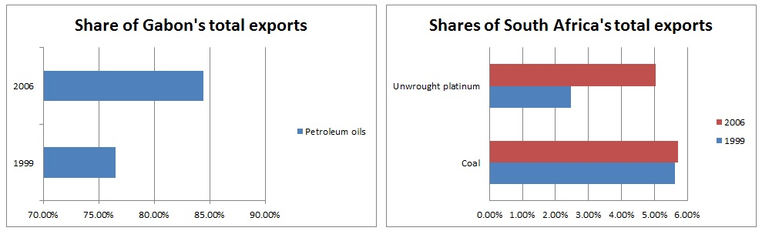

Distribution of productivity levels within countries’ specialisation patterns
EXPY measures the productivity of a country’s total export basket, but does not clarify how the products in this export basket are distributed in terms of PRODY. How are the productivity levels of products distributed within countries’ exports? Is there a difference in this distribution between rich countries and developing countries? In order to have a closer look at the productivity structure of products that countries export, this part focuses on the categorisation of PRODY’s within a country’s exports; the exported commodities are now categorised by PRODY values. For a selection of countries, graphs are made with the PRODY categories on the x-axis and the corresponding export value on the y-axis, so that thecountry’s composition of exports in terms of productivity levels of products is revealed.

Method
Countries with various income levels were selected.In order to look at the development of the productivity levels of these countries’ export baskets, graphs of this PRODY categorisation were made for 4 years, if data was available, being; 1992, 1996, 2004 and 2008. For this way of time series analysis, GDP deflators were used to adjust the export values for inflation; the export values in the graphs are measured in 2008 US dollars.Additionally, all values mentioned in this part, total exports as well as exports are corrected for inflation.
The PRODY values were split into 10 equal categories. The first category contains all products a country exports with a PRODY value of 1 to 6,000 dollars and the last category contains all exported products with a PRODY of 54,000 to 60,000 dollars. The corresponding export values belonging to each PRODY category were plotted against these categories.This was done for several countries for the 4 years. As a result, it is easy to observe what export valuesa country has within each certain PRODY category. Furthermore, the composition of the export baskets can be compared easily among countries.

Rich countries
Rich countries specialise in the exports of products with PRODY’s between $18,000 and $24,000. They have large export shares in computer parts, iron, medicaments and parts of aeroplanes. Furthermore, rich countries export products with all types of PRODY levels,but mainly between $6,000 and $42000.
A comparison of the export structures between the outliers Luxembourg and Switzerland can be found in appendix 4. Figure 12 illustrates the distribution of products in terms of PRODY values within the United States’ and Japan’s export basket.49% of Japan’s, and 39% of the United States’ total exports, comes from $18,000-$24,000 PRODY products. For Japan these are, for example, vehicles and machines, and for the United States helicopter and aeroplanes parts, vehicles, machinery and medicaments.
In 2008, the export share of this category decreased for both countries in relative terms, whereas the shares of smaller PRODY categories increased, resulting in declining EXPY’s. For example, both countries’ export shares of petroleum oils increased, which has a PRODY of $12,400. In addition, in absolute terms, the United States’ exports of this product increased by 400% from 2004 to 2008.
However, both countries have been exporting relatively more products with PRODY’s between $24,000 and $30,000 over time; from 15% of total exports in 1996 to 21% in 2008. Japan has been exporting relatively more machinery with higher PRODY values, and the United States relatively more aeroplanes and other aircrafts, vehicles and turbo-jets.
Figure 12: PRODY distribution within the United States’ and Japan’s exports
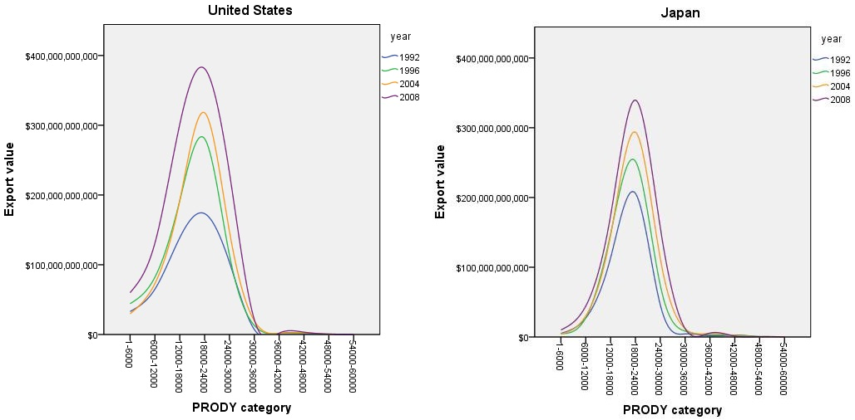

Emerging countries
The emerging countries are mainly specialised in the exports of products of a lower PRODY category than rich countries; $12,000 to $18,000. Petroleum oils and TV receivers have large export shares within the BRICs. Soya-bean oil-cake, petroleum oils, computer parts and coal are important export products of the other emerging countries. Whereas most emerging countries still have relatively high export shares in the lowest PRODY category, China’sPRODY distribution is more in line with the ones of ex-developing OECD countries.40% of China’s exports in 2008 was generated by products with PRODY’s between $12,000 and$18,000, and also $18,000-$ 24,000 PRODY products were very important; forming 31% of total exports.
Table 10shows some export figures of the 3 Emerging Tigers(Malaysia, Thailand and Indonesia) and the Philippines. Although Malaysia’s GDP per capita is twice the size of that of Thailand, Thailand has a higher export productivity. Furthermore, the income levels and export shares of GDP of Indonesia and the Philippines are considerably smaller than those of the 2 other countries, but their EXPY’s are not very different from Malaysia and Thailand.
Table 10: Export figures of 4 countries for 2008
Country | EXPY | GDP/capita | Exports share of GDP | Most important export product
Malaysia | $13,945 | $14,215 | 89.6% | Petroleum oils, natural gas
Thailand | $15,009 | $ 7,703 | 64.6% | Storage units of computers
Indonesia | $12,995 | $ 3,975 | 26.8% | Petroleum oils, natural gas
Philippines | $12,281 | $ 3,510 | 29.5% | Parts of electronic equipment

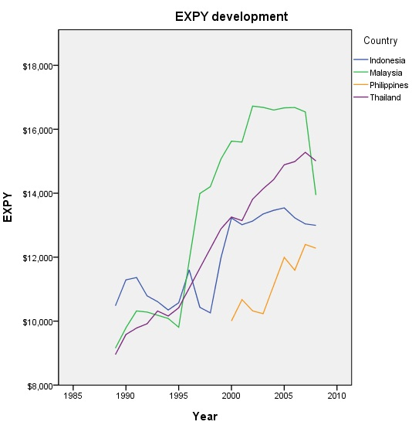Figure 13: EXPY development over time
In addition, these countries experienced rapid EXPY growth over the years, as illustrated in figure 13. However, in 2008 each of the 4 countries’ export productivity decreased, which was likely triggered by the latest financial crisis. Malaysia’s EXPY decreased the most; by 15.7%.

Figure 14illustrates the distribution of products in terms of PRODY within the countries’ exports. The shapes of the distributions of Indonesia and the Philippines differ from those of Malaysia and Thailand. In 2008, 32%of the Philippines’ exports was generated by products with PRODY’s smaller than $6,000, and 32% of the export products had PRODY’s between $12,000 and $18,000. Four years earlier, the product category with the smallest PRODY’s had a larger share; 38%. Electronic micro assemblies, with a PRODY of only $3,620, covers 22% of the Philippines’ exports in both 2004 and 2008. In addition, four other electronic products, are responsible for 20% of total exports in 2008. These products have PRODY’s between $16,000 and $23,000.
Figure 14: PRODY distribution within Malaysia’s, Thailand’s, Indonesia’s and the Philippines’ exports
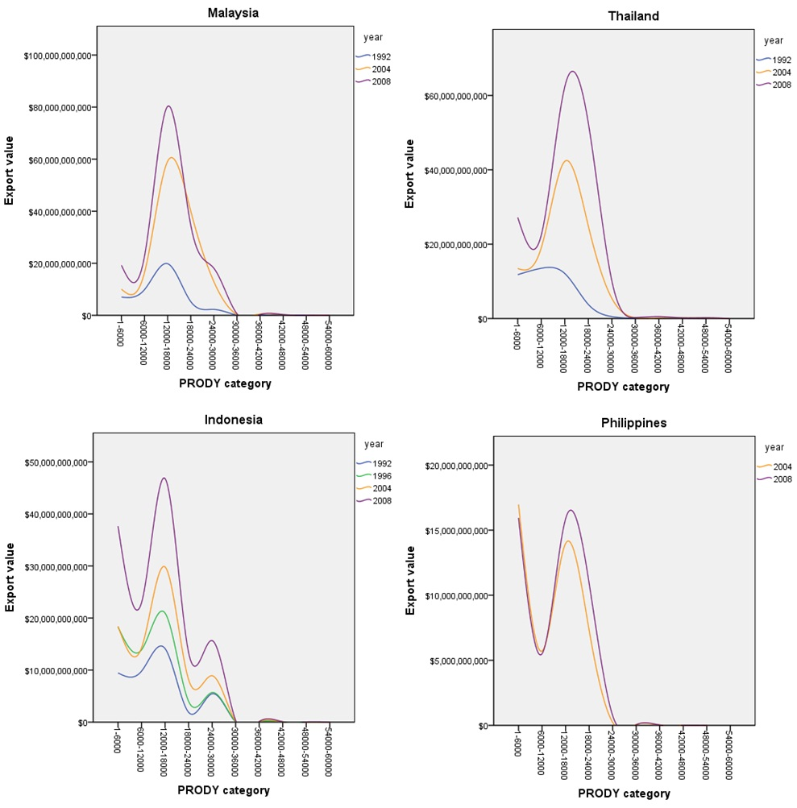
Like the Philippines, Indonesia still has a large export share in low-income products. Furthermore, the exports share of $12,000 to $18,000 products decreased from 37% in 2004, to 34% in 2008. Petroleum oils and coal have the highest export values within this category. Opposed to the Philippines and Thailand, and similar to Malaysia, 11% of Indonesia’s export products have $24,000 to $30,000 PRODY levels. This is almost entirely a result of natural gas exports.
The decreased EXPY of Malaysia in 2008 is mainly caused by products with PRODY’s between $18,000 and $24,000; the export share of these products decreased from 29% in 2004, to 20% in 2008. Though Malaysia’s total exports increased from 2007 to 2008, the export value of electrical machinery equipment, measured at 2-digit level, decreased by39%; from $51.79 billion to $31.65 billion. This enormous drop had a large effect on Malaysia’s EXPY, since these products have large PRODY’s. On the contrary, the exports shares (both absolute and relative) of some products with smaller PRODY’s increased, e.g. petroleum oils and palm oil.
Over time, Thailand has been exporting relatively more $18,000-$24,000 PRODY products. The exports of these products has increased from 24% of the country’s total exports in 2004 to 30% of 2008’s exports. Moreover, storage units of computers, which belongs to this category, had the largest export value of all products, containing 7% of Thailand’s exports. Nevertheless, $12,000-$18,000 PRODY products are still the most exported products.

SSA bottom billion countries
The entire top 6 of the smallest EXPY’s in the years 1995, 1999, 2004 and 2008 are values of Sub-Saharan African countries. This means that the Sub-Saharan African region includes countries with extremely low export productivities; the lowest of the world. Sub-Saharan Africa bottom billion countries have a very narrow distribution; they export almost only products with PRODY’s smaller than 6,000 dollars. They mainly export tobacco, coffee, tea, clothes and uranium ores.

Figure 15 illustrates the distributions within Niger’s and Rwanda’s exports, which are obviously very different from those of rich and emerging countries. Whereas Niger has increased its export share of products with PRODY’s smaller than $6,000 in 2008, Rwanda has expanded the share of products within the PRODY category of $6,000-$12,000 to 10% in 2008. Tea and coffee are still the most important to Rwanda’s exports, however, the exports of malt beer and mineral waters have increased. In contrast, 65% of Niger’s exports is generated by uranium ores, with a PRODY of $983. The country also relies on agriculture, which is affected by varying rainfall. The below average harvest of 2007 had a large influence on Niger. Furthermore, in February 2007, the criminal group Movement of Nigeriens for Justice initiated a combat in northern Niger, which discouraged investments in oil and mining (Background Note: Niger, 2010). The poor infrastructure is also a problem for investors.
Figure 15: PRODY distribution within Niger’s and Rwanda’s exports
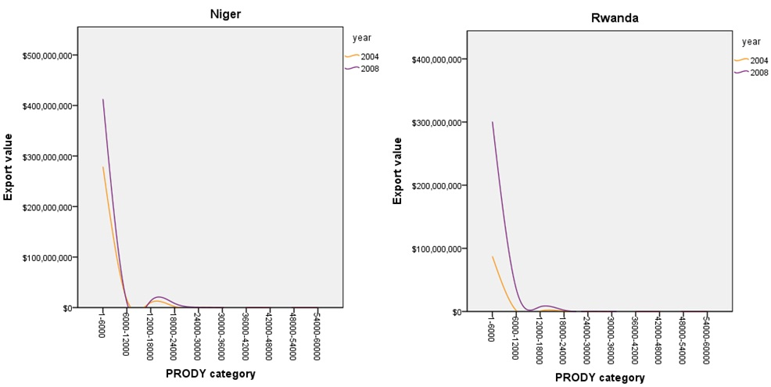

Conclusion
Shifting countries’ export structures towards higher productivityproducts has certain implications. First of all, each product requires a unique set of inputs and capabilities, however, some products are closer to one another, in terms of input similarities, than others. As a result, some countries are able to transform their export structures faster, depending on the products in which they have a comparative advantage. Second, cost discovery is needed to start the production of a good that has not been produced before in the particular country, asthe production might require adaptations to the local environment. These costs and the subsequent information externalities could prevent firms from examining the opportunities for the production or exports of higher productivity goods in or to the developing country. Third, countries that improve the productivity level of their exports tend to have a large manufacturing sector as there are more input similarities within manufacturing. Nevertheless, poor countries are mainly specialised in agriculture and natural resources. Fourth, transforming their export structure to a higher productivity level implies for poor countries diversification of their product range. It is only from a certain income level that countries start to concentrate their economic activities. Furthermore, the quality of infrastructure and institutions determines whethershifting towards higher-income products isfeasible.
There is a large difference in export productivity across countries. The index ‘EXPY’ measures the income or productivity level that is associated to a country’s export basket and was introduced by Hausmann et al. (2007). Rich countries like Ireland and Japanhave a ten times higher EXPY than poor countries like Niger and Rwanda. Rich countries mainly export industrial products that have high productivity levels; for example iron and steel products. Conversely, the poorest countries mainly export primary products, which have the lowest productivity levels.
In addition, the difference in export productivity levels as well as growth rates of EXPY among developing countries is substantial too. Certain countries have rather stable export productivity levels over time. Nonetheless, many developing countries have the highest positive, as well as negative growth rates in EXPY of the entire sample. For some countries this can be explained by volatility in their exports along with small export values, however, other countries have increased their export productivity continuously.

Furthermore, the productivity levels of the exports of developing countries in Sub-Saharan Africa differ from those in South and East Asia. Niger and Rwanda are the poorest countries of the world and have the lowest export productivities. In contrast, various developing South and East Asian countries are emerging economies and have very high export productivity levels compared to their income levels. However, there are also South and East Asian countries that have low and decreasing export productivity values over time, like Cambodia.
When categorising a country’s export products by their productivity levels with the corresponding export values, it can be concluded that the resulting export structure varies noticeably across country groups. Rich countries tend to be specialised in products with productivity levels between $18,000 and $24,000.The poorest countries of the world, on the other hand, produce and export mainly products with productivity values smaller than $6,000. Emerging economies, like the Emerging Tigers, the Philippines and China, still have rather large export shares in lower-income goods, however, they have diversified their exports and now export mainly $12,000 to $18,000 PRODY products. These countries have very large EXPY’s compared to their GDP’s per capita.

References
Agnarsson, S., Hall, A., Herbertsson, T.T., Ingólfsson, S., Magnússon, G. &Zoega, G.
(1999). EMU and the Icelandic Labour Market.Central Bank of Iceland.
Albornoz, F., CalvoPardo, H.F., Corcos, G. &Ornelas, E. (2010).‘Sequential Exporting’
CEPR Discussion Paper No. DP8103.
Anderson, K. (1995). ‘Lobbying Incentives and the Pattern of Protection in Rich and Poor
Countries.’ Economic Development and Cultural Change, 43(2): pp. 401-423. The
University of Chicago Press
Apartheid FAQ. (n.d.) About.com. http://africanhistory.about.com/library/bl/blSA
ApartheidFAQ.htm 10-01-2011
Background Note: Niger. (2010). U.S. Department of State.http://www.state.gov/r/pa/ei/bgn/ 5474.htm 06-01-2011
Bora, B., Grynberg, R. Razzaque, M.A. (2004). ‘Marginalisation of LDCs and Small
Vulnerable States in World Trade.’ Commonwealth Economic Paper Series.
Commonwealth Secretariat, London.
Brenton, P. &Newfarmer, R. (2007). ‘Watching More Than The Discovery Channel: Export
Cycles and Diversification in Development.’ World Bank Policy Research Working Paper 4302., The World Bank, Washington, D.C.
Brenton, P., Saborowski, C. & Von Uexkull, E. (2009). ‘What Explains the Low Survival
Rate of Developing Country Export Flows?’World Bank Policy Research Working
Paper 4951., The World Bank,Washington, D.C.
Cashin, P., Liang, H. & McDermott, J. (2000). ‘How Persistent Are Shocks to World
Commodity Prices?’IMF Staff Papers 47(2), 177-217.
Coelli, T.J., PrasadaRao, D.S., O’Donnell, C.J., &Battese, G.E. (2005). An
introduction to efficiency and productivity analysis.(2nd ed.). New York: Springer
Science + Business media.
Export.gov (2011). http://export.gov/logistics/eg_main_018119.asp 20-07-2011
Gehlhar, M.J.,Hertel, T.W. & Martin, W. (1994).‘Economic Growth and the Changing
Structure of Trade and Production in the Pacific Rim.’ American Journal of
Agricultural Economics, 76(5), Proceedings Issue, pp. 1101-1110. Agricultural &
Applied Economics Association. Oxford University Press, New York.

Global Economic Prospects 2009, Forecast Update (2009).World Bank.
http://siteresources.worldbank.org/INTGEP2009/Resources/5530448-1238466339289/GEP-Update-March30.pdf 29-11-2010
Gwartney, J.D., Holcombe, R.G. & Lawson, R.A. (2004). ‘Economic Freedom, Institutional
Quality, and Cross-Country Differences in Income and Growth.’ Cato Journal, 24(3):
205-233.
Hallward-Driemeier, M., Iarossi, G. &Sokoloff, K.L. (2002). ‘Export and Manufacturing
Productivity in East Asia: a Comparative Analysis with Firm-level Data.’ NBER
Working Paper 8894., National Bureau of Economic Research, Cambridge MA.
Hanson, G.H.&Robertson, R. (2008). ‘China and the Manufacturing Exports of Other
Developing Countries’NBER Working Paper No. 14497., National Bureau of
Economic Research, Cambridge MA.
Harsch, E. (2001). ‘South Africa tackles social inequalities.’ Africa Recovery, 14(4), 12.
Hausmann, R., Hwang, J. &Rodrik, D. (2007).‘What you export matters.’ Journal of
Economic Growth.12(1), 1-25. DOI: 10.1007/s10887-006-9009-4
Hausmann, R. & Klinger, B. (2006). ‘Structural Transformation and Patterns of Comparative
Advantage in the Product Space.’ KSG Working Paper No. RWP06-041; CID
Working Paper No. 128. Cambridge, MA.
Hausmann, R. &Rodrik, D. (2003). ‘Economic Development as Self Discovery.’
Journal of Development Economics, 72(2), 603-633
Hidalgo, C.A., Klinger, B., Barabasi, A-L &Hausmann, R. (2007).Science,317, 482-487
Hoogeveen, J.G. &Özler, B. (2005). ‘Not Separate, Not Equal: Poverty and Inequality in
Post-Apartheid South Africa.’ http://hdl.handle.net/2027.42/40125 09-01-2011
Imbs, J. &Wacziarg, R. (2003).‘Stages of Diversification.’American Economic Review,
93(1), 63-86.
Impact of EU membership on Ireland.(2010). European Commission.
http://ec.europa.eu/ireland/ireland_in_the_eu/impact_of_membership_on_ireland/index_en.htm03-12-2010
Ireland: a Trading Nation. (1998). Department of Enterprise, Trade and Employment.
http://www.deti.ie/publications/trade/1998/tradepolicy/ireland.htm 13-04-2010
Johnson, S., Ostry, J.D. & Subramanian, A. (2010). ‘Prospects for Sustainable Growth in
Africa: Benchmarking the Constraints.’ IMF Staff Papers 57, 119–171. DOI:
10.1057/imfsp.2009.22
Jovanovic, B. & Gilbert, R.J. (1993). ‘The Diversification of Production.’Brookings Papers
on Economic Activity. Microeconomics, 1993(1), pp.197-247, The Brookings
Institution.
Klinger, B. & Lederman, D. (2004). ‘Discovery and Development: An Empirical Exploration of ‘New’ Products.’ World Bank Policy Research Working Paper 3450., The World
Bank,Washington, D.C.
Krugman, P.R. (1979). ‘Increasing Returns, Monopolistic Competition, and International
Trade.’ Journal of International Economics, 9(1979): 469-479. North-Holland
Publishing Company.
Laurance, W.F., Alonso, A., Lee, M. & Campbell, P. (2006). ‘Challenges for Forest
Conservation in Gabon, Central Africa.’ Futures, 38 (4): 454-470. Futures of
Bioregions.
Levchenko, A.A. (2004). ‘Institutional Quality and International Trade.’ WP/04/231. IMF
Working Paper.
Mayer, T. &Ottaviano, G.I.P. ‘The Happy Few: theInternationalisation ofEuropean Firms
New facts Based on firm-Level Evidence.’ Bruegel Blueprint Series Volume III.
Bruegel, Brussels.
Mishra, S., Lundstrom, S. &Anand, R. (2011). ‘Service Export Sophistication and Economic
Growth.’World Bank Policy Research Working Paper 5606., The World Bank,Washington, D.C.
North, D.C. (1990). ‘Institutions, institutional change, and economic performance.’
Cambridge University Press.
OECD (n.d.). http://www.oecd.org/pages/0,3417,en_36734052_36734103_1_1_1_1
_1,00.html 28-06-2011
Paul, C.J.M.&Nehring, R. (2005).‘Product Diversiﬁcation, Production Systems, and
Economic Performance in U.S. Agricultural Production.’Journal of Econometrics,
126 (2005): 525–548.
Rahmiati, F., Mulyaningrum&Tahir, M.N.H. (2010). ‘How Malaysian Manufacturing
Exports Have Reacted to the Global Economic Crisis.’ AFBE 2010 Conference
Papers, 452-463.
Rodrik, D. (2006). Industrial Development for the 21st Century: Sustainable Development
Perspectives.United Nations.

Sachs, J. (1998). ‘International Economics: Unlocking the Mysteries of Globalization.’
Foreign Policy,1998 (110), Special Edition: Frontiers of Knowledge, pp. 97-111.
Washingtonpost.Newsweek Interactive, LLC
Spence, M. (2007). ‘Wealth of Nations: How Poor Countries Get Richer.’ Dow Jones Reuters
Business Interactive LLC
Stiglitz, J.E. (1996). ‘Some Lessons From The East Asian Miracle.’ The World Bank
Research Observer, 11(2): pp. 151-177. The International Bank for Reconstruction
and Development/The World Bank.
The World Factbook (2004). https://www.cia.gov/library/publications/the-world- factbook/geos/sz.html 23-07-2011
Tybout, J.R. (2000). ‘Manufacturing Firms in Developing Countries: How Well Do They Do,
and Why?’ Journal of Economic Literature, 38(1): pp. 11-44. American Economic
Association.
U.S. Census Bureau (2011). http://www.census.gov/foreign-trade/schedules/b/ 20-07-2011
World Development Report 1994. ‘Infrastructure for Development.’ The International Bank
for Reconstruction and Development /The World Bank. Oxford University Press,
New York.
World Development Report 2009. ‘Reshaping Economic Geography.’ The International Bank
for Reconstruction and Development /The World Bank. Oxford University Press,
New York.
WTO (2006). ‘Trade Policy Review Report by the Secretariat People’s Republic of China.’ WT/TPR/S/161. World Trade Organization.

Appendix 1
Countries within the sample
Albania | Algeria | Argentina | Armenia | Australia
Austria | Azerbaijan | Bahrain | Bangladesh | Belarus
Belgium | Belize | Benin | Bolivia | Botswana
Brazil | Bulgaria | Burkina Faso | Cambodia | Cameroon
Canada | Cape Verde | Chile | China | Colombia
Costa Rica | Croatia | Cyprus | Czech Republic | Denmark
Dominica | Ecuador | El Salvador | Estonia | Ethiopia (excludes Eritrea)
Fiji | Finland | France | Gabon | Gambia, The
Georgia | Germany | Greece | Grenada | Guatemala
Guyana | Honduras | Hong Kong, China | Hungary | Iceland
India | Indonesia | Iran, Islamic Rep. | Ireland | Israel
Italy | Jamaica | Japan | Jordan | Kazakhstan
Kenya | Korea, Rep. | Kyrgyz Republic | Latvia | Lebanon
Lithuania | Luxembourg | Macao | Macedonia, FYR | Madagascar
Malawi | Malaysia | Maldives | Mali | Malta
Mauritania | Mauritius | Mexico | Moldova | Mongolia
Morocco | Mozambique | Namibia | Netherlands | New Zealand
Nicaragua | Niger | Norway | Oman | Panama
Papua New Guinea | Paraguay | Peru | Philippines | Poland
Portugal | Qatar | Romania | Russian Federation | Rwanda
Samoa | Sao Tome and Principe | Saudi Arabia | Senegal | Singapore
Slovak Republic | Slovenia | South Africa | Spain | Sri Lanka
St. Kitts and Nevis | St. Lucia | St. Vincent and the Grenadines | Sudan | Swaziland
Sweden | Switzerland | Syrian Arab Republic | Tanzania | Thailand
Togo | Trinidad and Tobago | Tunisia | Turkey | Uganda
Ukraine | United Kingdom | United States | Uruguay | Venezuela
Vietnam | Zambia

Appendix 2
Descriptive statistics EXPY
Year | Number of countries | Minimum | Maximum | Mean | Std. Deviation
1988 | 10 | $8,948 | $19,450 | $14,632 | $3,682
1989 | 25 | $5,185 | $19,605 | $12,590 | $3,848
1990 | 30 | $2,982 | $19,740 | $11,670 | $4,360
1991 | 37 | $2,819 | $19,731 | $11,479 | $4,099
1992 | 50 | $4,101 | $19,968 | $11,557 | $3,657
1993 | 62 | $4,460 | $19,816 | $11,366 | $3,557
1994 | 81 | $3,016 | $20,098 | $11,085 | $3,796
1995 | 92 | $1,613 | $20,257 | $10,641 | $4,064
1996 | 49 | $3,204 | $21,253 | $13,817 | $4,328
1997 | 75 | $4,060 | $21,374 | $12,703 | $4,153
1998 | 92 | $1,871 | $21,474 | $11,939 | $4,691
1999 | 103 | $2,074 | $26,697 | $11,876 | $4,941
2000 | 117 | $2,230 | $27,095 | $11,733 | $4,767
2001 | 128 | $2,075 | $26,862 | $11,486 | $4,955
2002 | 132 | $1,683 | $26,095 | $11,427 | $5,081
2003 | 132 | $2,371 | $26,478 | $11,550 | $4,971
2004 | 132 | $1,849 | $26,675 | $11,639 | $5,067
2005 | 126 | $2,434 | $26,475 | $11,968 | $4,842
2006 | 119 | $2,425 | $26,185 | $12,255 | $4,711
2007 | 122 | $2,535 | $26,045 | $12,307 | $4,718
2008 | 103 | $2,679 | $26,462 | $12,563 | $4,675

Appendix 3
Positive outliers and extremes of figure 9
344 | Madagascar | 697 | Thailand | 1317 | Sao Tome and Principe
355 | Nicaragua | 701 | Uganda | 1328 | St. Vincent and the Grenadines
369 | South Africa | 1250 | Ethiopia(excludes Eritrea) | 1720 | Belize
382 | Uganda | 1254 | Gabon | 1763 | Madagascar
615 | Bolivia | 1278 | Kyrgyz Republic | 1777 | Panama
641 | Honduras | 1280 | Lebanon | 1785 | Rwanda
646 | Indonesia | 1285 | Madagascar | 1788 | Senegal
683 | Saudi Arabia | 1302 | Niger | 1796 | Sudan
688 | South Africa | 1309 | Philippines | Not in graph | The Gambia

Negative outliers and extremes of figure 9
327 | Honduras | 1255 | The Gambia | 1743 | Grenada
348 | Malta | 1276 | Kenya | 1764 | Malawi
640 | Guyana | 1297 | Mozambique | 1765 | Malaysia
658 | Lithuania | 1333 | Syrian Arab Republic | 1768 | Mauritius
684 | Senegal | 1334 | Tanzania | 1771 | Mozambique
1219 | Armenia | 1340 | Uganda | 1772 | Namibia
1237 | Cape Verde | 1347 | Zambia | 1803 | Uganda
1238 | Chile | 1736 | Ethiopia (excludes Eritrea) | Not in graph | Rwanda

Appendix 4
Export structures of Luxembourg and Switzerland
The graphs illustrate the distribution of products in terms of PRODY values within Luxembourg’s and Switzerland’s export basket. 27.6% of Luxembourg’s exports is generated by 18,000 and 24,000 PRODY products. Furthermore, the importance of the PRODY category $48,000-$54,000 increased from 7.0% of total exports in 2004, to 11.9% in 2008. This increase is mainly caused by the export growth of 2 products; iron and steel sections, and iron and steel sheet piling, whose joint export share increased from 6.1% to 11.0% of total exports. These products have the second and fifth largest PRODY values of all products.
Figure: PRODY distribution within Luxembourg’s and Switzerland’s exports
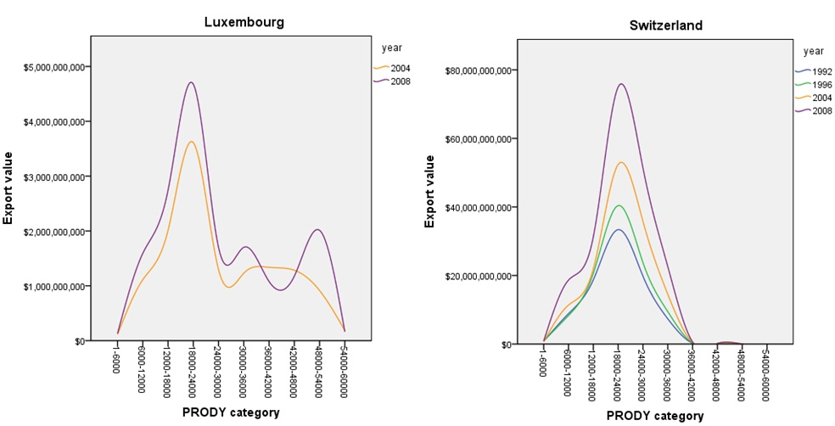

Switzerland has a different distribution of the productivity levels of products exported than Luxembourg. In addition, the distribution shifted upwards over the period 1992 to 2008. The share of PRODY category $18,000-$24,000 is around 38% for all of the 4 years. The share of products with PRODY’s between $24,000 and $30,000 increased from 22% to 26%. Medicaments are responsible for 10.5% of Switzerland’s total exports, with a PRODY of $22,236.
Switzerland’s total exports increased by 125% in the period 1992 to 2008, to $200.61 billion. Luxembourg’s exports is considerably smaller; $16.97 billion in 2008. Additionally, exports is more important to Switzerland’s economy; the exports share of GDP is 40%, whereas Luxembourg’s export share is 29% in 2008. Nevertheless, Luxembourg has a higher export productivity.

Infrastructure includes various services, e.g.: water management, electric power, telecommunications, transportation, government, financial system, industrial parks and educational system.
Here institutions refer to economic, legal and political institutions, e.g.: property rights, contract enforcement, investor protection and freedom of exchange.
Gwartney et al. (2004) used the Economic Freedom of the World index as a measure of institutional quality and found that it explained 63% of variation in GDP per capita across countries. In addition, the production function approach (which focuses on increasing human and physical capital and technological progress) explained 93% of the variation.
Here distance means the level of similarity between products in terms of the needed capabilities and inputs (Hausmann& Klinger, 2006).
The nodes represent products. Similar coloured nodes are products within the same product class according to the Leamer classification. The size of the nodes are proportional to world trade. The colour of the lines that connect the nodes represent the distance (input based similarity) between products (Hidalgo et al., 2007).
Products the country could produce given the distance between the country’s current area of comparative advantage.
Schedule B: Statistical Classification of Domestic and Foreign Commodities Exported from the United States.
Indonesia, Korea and Thailand were affected the most, followed by Malaysia and the Philippines. The depreciation of the East Asian countries have likely influenced the export productivity of these countries.
The decrease in Iceland’s EXPY in 1992 is likely to be correlated with the recession that Iceland faced during that year. This recession was mainly caused by a reduction in fish catch (Agnarsson et al., 1999).
Luxembourg mainly exports metal, machinery and rubber, and Switzerland machinery, medicaments and watches.
Starting in the 1960s, Ireland changed from a relatively closed economy to a free market economy. The country shifted from being highly dependent on agriculture and from having only export relations with the United Kingdom, to an economy that is focused on high-tech industries and global exports (Impact of EU membership on Ireland, 2010). This shift from the production and exports of primary products to high-tech products facilitates a large increase in EXPY.
Trinidad and Tobago increased the natural gas and petroleum oils production.
Because the sample sizes of countries of both regions for 1992 and 1996 are rather small, a slightly different comparison was made than in the previous parts of this paper; this part mainly examines EXPY’s for the years 1995, 1999, 2004 and 2008.
South East Asia’s export productivity declined a little in 2004 compared to 1999. However, mainly countries with lower EXPY’s, for example Cambodia, Papua New Guinea and Bangladesh did report for 2004, but did not for 1999.
The corresponding country names for these numbers are specified in appendix 3.
The Apartheid system in South Africa, which was in force for decades, ended in 1990, and the first democratic elections were held in 1994 (Apartheid FAQ, n.d.). In 1996, the government implemented the Growth, Employment and Redistribution strategy, GEAR, which is a macroeconomic policy framework and intended to gain fast economic growth by means of, among others, expanding openness to trade and foreign investment (Harsch, 2001). However, South Africa has one of the highest unemployment rates in the world, between 30% and 40%, with a mainly low-skilled population and large income inequality (Hoogeveen&Özler, 2005).
6 income groups, with 34 countries in total, were created and analysed. However, only a selection is described in this paper.
Only Luxembourg has also a large export share of products with even higher PRODY’s (18% in 2008).
I.e. input or output units of computers, storage units of computers, parts of office machines and metal oxide semiconductors.
At 6-digit level, the exports of products 854240 (hybrid integrated circuits), 854212 ("smart" cards), 854213 (metal oxide semiconductors) and 854230 (other monolithic integrated circuits) decreased by circa 80% in 1 year. These 4 products have PRODY values between 20,000 and 26,000 dollars.

