The increase of online information:
Does it help the consumer make the right decision?



ERASMUS UNIVERSITY ROTTERDAM
Erasmus School of Economics
Master Marketing

Tim Beurskens
288005

Supervisor:
Dr. A.C.D. Donkers

Rotterdam, August 2011

Preface

After putting my blood, sweat, tears, and lots of time in the document in front of you, I’m very proud to present to you my thesis, to graduate the Marketing program of the Master Economics & Business at the Erasmus University Rotterdam.

After years of study, committees, internships and volunteering in foundations the time had come to put all acquired knowledge together in one ‘Master’ – piece. My interest in the human mind, and the human way of making decisions, in combination the use of the online environment in my own decision making behaviour made me want to do research about this subject. Writing this thesis taught me a lot about the consumer decision making process and the influences the online environment has on our lives. Most of all I learned a lot about doing research and the hurdles that come with it.

First of all I’d like to thank my supervisor Bas Donkers for his useful tips during the entire process, without telling me exactly what to do. It made me find my own solutions and resulted in the fact that the piece in front of you is actually my own. I’d also like to thank Bas for his extremely fast answering to my questions, which made my working process very efficient.

I’d like to thank Nienke for listening to all my similar stories about only one subject for the last few months, and dragging me back to the library in times I’ve completely had it. I’d also like to thank Martijn, Diederik and Sjoerd, for keeping me motivated during the entire process, and giving me incentives to finish my thesis.

Finally I’d like to thank my parents for supporting me, for helping me, and for investing in me for all these years. Mom and dad, definitely a very good investment, I promise! Thank you very much!

Tim Beurskens
Rotterdam, August 2011

Executive summary

The internet has an increasing influence on our daily lives. As a tool for information search when buying an expensive product the internet has advantages and disadvantages. The enormous size of the assortment that the internet offers gives the consumer the possibility to find the perfect match between his preferences and the available products. A larger assortment increases the chance for a better fit. On the other hand, the load of information that can be found on the internet could become an overload by giving the consumer the feeling he has no clue what information is relevant for his decision.

In this research the relation between the use of the internet as an information search channel and the post-buy evaluation of the consumer is studied, under influence of the moderator ‘certainty about preferences.’ The study shows that the use of the internet doesn’t have a significant effect on the post-buy evaluation of the consumer, regardless if the consumer is certain about his preferences or not. It does seem that the certainty of preferences is a factor with a significant relation to the post-buy evaluation of the consumer. Consumers who are more certain about their preferences experience significantly less often the feeling of regret compared to people who are less certain about their preferences.

Because the internet doesn’t have to be used to make actual decisions about what product to buy, also the research-shopper phenomenon is studied. If the internet is used to extend your knowledge about the product class (increase your preferences) there is suggested that this has a more positive influence on the post-buy evaluation of the consumer comparing to when the internet is used to find channel benefits.

This relation also is not significant. Both channel benefit seekers and knowledge extenders have no influence on the possibility to regret a purchase. It does seem again that certain research-shoppers have less chance to regret their decision compared to the uncertain research-shoppers.

These results imply that ‘certainty about preferences’ is an important variable when it comes to the post-buy evaluation of the consumer. Certain people seem to regret their choice less then uncertain people. Taking a closer look at the certain and uncertain consumers shows that certain consumers make more use of the internet in their information search than uncertain consumers. Companies should use this knowledge in their approach to reach these consumers.

Table of Contents

1. Introduction 7
1.1 Theoretical relevance of the research 7
1.2 Practical relevance of the research 8
1.3 Objective 9
1.4 Concept Methodology 9
1.5 Research questions 9
2. Consumer Decision Making 10
2.1 Introduction 10
2.2 The consumer decision making process 10
2.3 Conclusion 12
3. Post-buy evaluation 13
3.1 Introduction 13
3.2 Regret 14
3.3 The consolidation theory 15
3.4 Conclusion 16
4. The rise of the online environment – the increase of available information 17
4.1 Introduction 17
4.2 Information on the World Wide Web 18
4.3 Positive effects of the information increase 19
4.4 Information overload 20
4.5 Differentiation theory 21
4.6 Certainty about preferences 22
4.7 Conclusion 23
5. Information search and product purchase: All in one channel? 25
5.1 Introduction 25
5.2 Multiple channel approach 25
5.3 Conclusion 28
6. Research Set-up 30
6.1 Hypothesis 30
6.2 Conceptual Framework 30
6.3 Data Collection 31
6.3.1 Sample 31
6.3.2 Survey 32
7. Results 34
7.1 Factor Analysis 34
7.2 Consumer Information sources 36
7.3 Consumer perceptions 36
7.4 Insecurity & Online information: Regret or no regret? 38
7.5 The research-shopper 42
7.6 Results conclusion 45
8. Discussion 46
9. Limitations and Future Research 48
10. Literature 49
11. Appendices 52
Appendix A 52
Appendix B 59
Appendix C 61
Appendix D 65
Appendix E 66
Appendix F 69

Introduction

“Laptop sale”: About 212.000.000 results (0,12 seconds)
http://www.google.com, 2011

The last ten years, the information that can be found on the internet has increased exponential. The World Wide Web gives the consumer increasing information about products and services, and increasing possibilities to find different alternatives for a product or service. This might lead to an overload of information, or maybe to a transparent overview of product attributes that a consumer prefers. The key in this case is that the online environment gives the consumer more options to find information before they make a decision. If you want to buy a laptop these days, Google gives you about 212 million sites with information about laptops.1

This increase of online information can affect the consumer decision making. But does this load of information give the consumer a confident feeling after buying a product, because a lot of information has been taken into account, or will the consumer become more insecure, wondering if some information still might be missing? This research will give an answer to these questions.

1.1 Theoretical relevance of the research
When a consumer is going to buy a product, the following steps will occur in his behaviour: (Engel, Blackwell & Miniard, 1990)
- Need recognition
- Information Search
- Evaluation
- Purchase
- Consumption
- Post-purchase evaluation
- Divestment
If the chosen alternative is only slightly better than another alternative, the risk of post-decision preference reversal is higher than if the differentiation is greater. (O. Svenson, 1992)
If a consumer is going through the Consumer Decision Making process, he will try to eliminate the alternatives until 2 to 4 alternatives are left. (Bettman, Johnson, Payne, 1991)
Due to the increasing information that can be found on the internet, the consumer might get an information overload. Dozens of alternatives that are all slightly different may occur, and it becomes harder for the consumer to eliminate the alternatives into only a few options. The differentiation between different alternatives could become slighter, what would imply that the risk of post-decision preference reversal becomes higher. In this research I will find out if the increase of online information has an effect on the post-purchase evaluation of the product.

1.2 Practical relevance of the research

Good experience with a brand will provide information that may lead the consumer to that brand when a similar product is to be purchased. (O’Keefe & McEachern, 1998) If, due to the increase if information, and the decrease of differentiation between different alternatives, post-purchase evaluation will become more negative, companies will have to focus more on product and brand diversification, mainly focused on the online channel. The points of difference become more important than the points of parity between the different brands and products.

An example of a company that tries to make itself unique is Apple. Using the example of a laptop, a consumer makes a choice: I’m going to by an Apple, or I’m going to by ‘another laptop.’ Apple has separated itself from the laptop market, by making their own product and brand completely diversified from the other laptops. This might be a way to increase differentiation again.

1.3 Objective

The goal of this research is find out what the impact is of the increasing online information on the post-buy evaluation of the consumer. Does more information, and a better view on different alternatives, give the consumer the confidence that the right decision has been made, or does it make the consumer more insecure about the decision that has been made?

1.4 Concept Methodology

This research consists of three sections. First I will do a literature research to find out what the connection between the rise of the online environment and the post-buy evaluation of a consumer could be, and what factors could be important. Second, I will do a survey over +/- 150 participants that have purchased a relatively expensive product (that is worth an intensive information search.) By adding questions about how they evaluated the product, what information sources they used, how extensive and for what purpose they have used a certain information source, where they have made the actual decision, and how much they knew about the alternatives before they started searching, I’ll try to find out if there is a significant connection between the rise of the online environment, the increase of information that goes with it, and the eventual post-buy evaluation of the consumer. This analysis of the collected data will be the third part of this research.

1.5 Research questions

Research Question:
- What is the impact of the rise of the online environment on the post-buy evaluation of consumers?
Sub Questions:
- What is the consumer decision-making process?
- What is influence of certainty about preferences on the relation between information search and post-buy evaluation?
- What is research-shopping, when does it occur and what is the influence on the consumer’s decision making process?

Consumer Decision Making

2.1 Introduction

Consumers are forced to make decisions on a daily basis. When a consumer is buying a house or a car, or even just a toothbrush, he needs to evaluate different alternatives. These alternatives change over time, because of technological changes, competitive pressures, or shifts in consumer preferences (Bettman, Johnson, Payne, 1991.) For this reason decisions will have to be re-evaluated each time a new purchase is going to be made. The consumer will try to find information about the different alternatives, so he can assess what alternative will fit his needs the best.
As Bettman, Johnson & Payne (1991) state, the consumer is often not completely certain about how a product will perform. To make this uncertainty as small as possible, the consumer searches through one or more channels for information, like advertisements, spokespersons, the internet, friends, or their own knowledge.
Eventually the consumer needs to make a decision which alternative he is going to choose. To come to this preferred alternative, the consumer follows a decision making process.

2.2 The consumer decision making process

The consumer decision making process shows how consumers purchase products to solve problems and highlight the activities that occur before, during and after the purchase of a product (Engel, Blackwell & Miniard, 1990). According to Engel, Blackwell & Miniard, the following stages occur in the consumer decision making process:

- Need recognition

Need recognition occurs when a consumer senses a difference between what he perceives to be the ideal versus the actual state of affairs.

- Search for information

The search for information can be internal or external. Internal search means retrieving knowledge from your own memory, experiences or genetic tendencies. Relevant information from long-term memory is used to determine if satisfactory alternatives exist. If Internal search is not sufficient to make a purchase decision, then the consumer will try to acquire information from external sources (Crotts, 1998). These external sources are categorized in 4 basic categories:

A Personal (advice from friends or family)
B Marketer-dominated (brochures, advertisements)
C Neutral (publications in magazines)
D Experiential sources (prepurchase checks, store contacts)
Eventually the consumer evaluates each of the alternatives on the relevant criteria.

- Pre-purchase evaluation of alternatives

Before making a purchase, consumers compare what they know about the different alternatives they have. Each consumer has different evaluation criteria. Some criteria are obvious, like price and reliability, but also style and charisma may be important criteria to some consumers.

- Purchase

After a consumer has decided to purchase a product, he still needs to make some decisions. These days you don’t have to go to a retailer or a store to buy the product. It is also possible to buy the product online.

- Consumption

The consumption is the moment when the consumer uses the product. This can be immediately or delayed.
- Post-consumption evaluation

In the post consumption evaluation, consumers experience a sense of satisfaction or dissatisfaction.

- Divestment

2.3 Conclusion

There are a lot of facets in the consumer decision making process from the moment that a need occurs until the moment a consumer divests the product. In this research we will focus on the link between information search and post-buy evaluation.

Post-buy evaluation

3.1 Introduction

The consumer has searched for information, and eventually he has come to a decision. After he has ‘consumed’ the product, the post-buy evaluation will come along (Blackwell, Miniard & Engel, 1990.) In this phase of the consumer decision making process, the consumer will evaluate if the consumption of the product matches his expectations, and he will conclude if he has made the right decision, or if maybe he should have made another decision. The rise of the online environment can have an impact on the way consumers evaluate their purchases. In this section we will focus on theories and processes that occur in the post-buy evaluation of the consumer decision making.

According to Blackwell, Miniard & Engel (1990) there are a few reasons why a satisfying post-buy evaluation is important for companies:

- It influences repeat buying
If a consumer is positive about the alternative that he has chosen, than the chances that the consumer will buy from the same company again will increase. This can reflect not only on the category where the bought product is in, but also in other categories the company is active. A satisfying post-buy evaluation is important for the entire brand.

- It shapes word-of-mouth and word-of-mouse communication
Consumers often discuss their experiences with products they have bought with other people, called word-of-mouth. Consumers that are not related to a company, but talk very positive about a company’s products like they are ambassadors are very important for a company and can give the company an increase in sales. The increase of the online environment also has an effect on the word-of-mouth communication. Because of the internet it is easier for consumers to share their experiences with other consumers, by personal blogs or by other online communication tools. This phenomenon is called word-of-mouse.

- Satisfaction lowers consumer’s price sensitivity
If a consumer values a brand highly, he is willing to pay more for it. Post-buy thoughts that he has definitely made the right choice will make him less price sensitive the next time he will buy a product from the same brand or company.

Blackwell, Miniard & Engel (1990) mention a few factors that determine a satisfactory consumption:
- Product performance
- Consumption feelings
- Expectations

The performance of the product and the feelings a product gives you are of course important factors to determine if a product is satisfying. A factor that isn’t that obvious is expectation. Satisfaction depends on a comparison of pre-purchase expectations and consumption outcomes (Oliver, 1980.) If a product is performing better than expected, the consumer will be satisfied. If a product is performing worse than expected, the consumer will be dissatisfied. If you expect a car to go 120 km/h and after purchase it seems to go 150 km/h, you will be satisfied. If you expect a car to go 180 km/h and it only goes 150 km/h, you will be dissatisfied. Even though in both cases the car goes 150 km/h, the post-buy evaluation of the consumer depends on the expectations he had in the pre-purchase evaluation.

3.2 Regret

Regret is a phenomenon that can occur when a consumer is dissatisfied when he has evaluated the purchased product. Regret occurs when a consumer believes that another alternative would have been a better option for him. Performance information about a product that is considered but isn’t chosen has a significant impact on the post-buy evaluation of the chosen alternative (Inman, Dyer, Jia, 1997.) As mentioned before, if expectations are better than the actual performance, the consumer will have a negative post-buy evaluation. The same counts for alternatives that weren’t chosen. If the chosen alternative is compared with a considered but not chosen alternative, and the chosen alternative seems to perform worse than the not chosen alternative, the consumer will experience regret (Tsiros, Mittal, 2000.) This can eventually lead to brand switching, even if the consumer is satisfied with the chosen alternative. According to Bell (1982) decision regret is consequence of making a decision that is risky and the outcomes are not completely certain. It arises when the consumer seems to have made the wrong decision, even if it was the right one at the moment that is was made.

The occurrence of regret doesn’t mean that a consumer isn’t satisfied with a product. Regret and satisfaction can occur at the same time, according to Tsiros and Mittal (2000). They give an example of an investment. If you invest €10.000 and you receive €25.000, you will be satisfied, but you will still regret your decision if another investment could have made you €50.000.

As mentioned before, regret can occur when a not- chosen alternative seems to perform better. But there isn’t always information available about the performance of another alternative. Sometimes consumers think counterfactual, which means that they imagine possible alternatives (Gleicher et al. 1990). Consumers can generate mental simulations of what might have been an alternative. The amount of risk and the personal responsibility for the decision are important criteria here. Because the internet may give the consumer the perception of a risky decision (not all the alternatives can be studied well enough), the consumer might regret his decision more easily, by thinking that one of the alternatives could have been better, or by counterfactual thinking. Just the knowledge that a lot of options weren’t evaluated well enough may increase counterfactual thinking.

3.3 The consolidation theory

Svenson (1992) studied the pre- and post-decision processes in consumer decision making, based on the consolidation and the differentiation theory. After the consumer has differentiated the alternatives so that one alternative becomes superior and he has made a decision (more information about differentiation theory in section 4.5), he will start consolidating this decision, by unconsciously increasing his attractiveness appraisal of the chosen alternative on an important attribute (Svenson, 1992.) The consumer can do this by revising memories of how they acted in the past, so that their behavior in the past is more in line with their attitudes of the present. This theory implicates that a consumer tries to focus on the attributes that differentiate their product from the competition. If the increase of online information makes the differences between the first and the second alternative negligible, it could become harder for the consumer to consolidate their chosen alternative. A negative post-buy evaluation can occur, and consumers may regret their decision more easily.

3.4 Conclusion

The post-buy evaluation of a product is very important. It can generate future sales for an entire brand or company. Therefore it is very important to find out what factors are important for the post-buy evaluation of a consumer. In this research we will focus on what impact of the rise of the online environment will have on the post-buy evaluation of the consumer.

The rise of the online environment – the increase of available information

4.1 Introduction

The World Wide Web is more and more a source for pre-purchase information and for online shopping. As the Web is expanding day by day, so is also the information that can be found on it. According to Alba et al. (1997) this has two mayor reasons. One is the increase of companies that use the World Wide Web to communicate more with their potential customers. Companies have the ability to offer the consumer a very large number of products and alternatives, because of the infinite shelf space the internet offers (Haubl & Trifts, 2000). The other reason is the quick adoption of the World Wide Web by broad consumer segments for different reasons, like information search and purchasing products online. In his quest for choosing the best alternative, a consumer will try to find all the necessary information that is relevant for him, to make the right choice eventually. It is also one of the main objectives for marketers to present consumers with information on which to base their decision (Ariely, 2000). As mentioned by Crotts (1998), the search for information can be divided into two parts: Internal search and external search. Relevant information from long-term memory is used to determine if satisfactory alternatives exist.

A crucial element in the information processing model of human behaviour is information stored in memory, prior knowledge (Brucks, 1985). Prior knowledge facilitates the acquisition of new information and increases search efficiency. For this reason, prior knowledge is a factor that should be taken into account in this research. If internal search is not sufficient to make a purchase decision, then the consumer will try to acquire information from external sources.

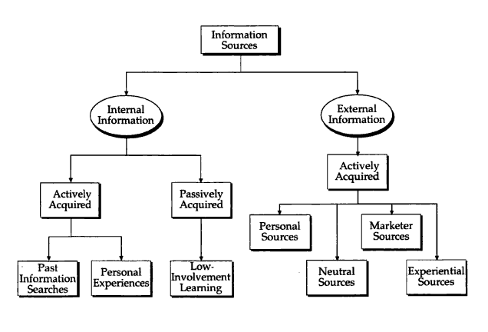

Figure 1: Sources of pre-purchase information

When a consumer is trying to acquire information from external sources, he has different possibilities to reach the information he needs. Crotts (1998) divides the external information sources in 4 basic categories:

- Personal (advice from friends or family)
- Marketer-dominated (brochures, advertisements)
- Neutral (publications in magazines)
- Experiential sources (pre-purchase checks, store contacts)

4.2 Information on the World Wide Web

When a consumer makes a purchase decision, he is often unable to evaluate all available alternatives in depth. Therefore the consumer uses two stages to come to a decision:

- They screen a large set of available products and identify a subset of the most promising alternatives.
- They evaluate the subset of most promising alternatives in depth, perform relative comparisons across products on the attributes that they think is important, and eventually make a decision which alternative to buy.
(Haubl & Trifts, 2000)

The expansion of the World Wide Web has some influence on these two stages of information search and consumer decision making. When there are lots of alternatives that are very difficult to compare, and the complexity of the decision environment increases, consumers accept less accuracy in the correctness of their decision if this implicates a reduction in effort (Haubl & Trifts 2000).
“Interactive decision aids” is a World Wide Web feature that helps the consumer compare different alternatives. Human decision makers are capable of selecting the variables that are important for them, but as will be discussed in section 4.4 on information load, they are not capable of processing large sets of information about products. These interactive decision aids can help the consumer very well in their two stages to come to the best decision, even though it helps the consumer more to reduce effort than to improve decision accuracy (Kleinmuntz and Schkade, 1993). It helps consumers mostly if consumers know what attributes are important for them. By selecting the attributes that are important for the consumer, these decision aids can sort the alternatives according to attribute importance. If the consumer doesn’t know what attributes are important for them, the help of the online decision aids can become inferior though.

The major change that the rise of the World Wide Web has initiated is the increase of the alternatives a consumer can find. The assortment that a consumer can choose from is almost unlimited due to the World Wide Web. In this research we will focus on this phenomenon in the online environment.

4.3 Positive effects of the information increase

The increase of information has a lot of positive effects for the consumer. Chernev (2003) explains that a wider assortment offers the consumer the chance to find a better fit between their own preferences and the attributes of the alternatives that can be found. A wider assortment and more alternatives also reduces the uncertainty in a consumer’s mind that not all potential available alternatives are part of the choice set where the consumer choses from. Reibstein ea. (1975) say that if the consumer can choose from a wider range of products, this will lead to an increase in preferences, because ‘option value’ will occur. The consumer likes the possibility to choose. These factors suggest that the increase of alternatives gives the consumer the possibility to make a better decision. The post-buy evaluation should be better due to the rise of the online environment then. More factors are important though.

4.4 Information overload

“The fundamental premise on which the information-load paradigm is based is that consumers have finite limits to absorb and process information during a given time, such that it exceeds their processing limits, overload occurs, leading to poorer decision making and dysfunctional performance.” (Malhotra, 1982)

According to Malhotra, more information doesn’t necessarily mean that a consumer can make a better decision. The capacity of the human mind to process information seems to be limited. Simon (1974) says that the mind can handle only five to seven alternatives. Broadbent (1975) even concludes that this number is only three or four. Dhar (1997) concludes that a larger set of alternatives confuses the consumer, what leads to weaker preferences to a certain product.

Taking these sources into account, we can conclude that more information and more alternatives don’t always lead to better decision making and better post-decision evaluations. The increase of the online environment, with all its alternatives and information, therefore may lead to confusion in the consumer’s mind, what would implicate that a consumer can make a wrong decision more easily or at least might think that he did. Jacoby, Speller and Kohn (1974) conclude that consumers make even poorer decisions when the information load increases. Haubl and Trifts (2000) even suggest that consumers are willing to settle for imperfect accuracy in their decisions, if this would implicate a reduction in search effort.

4.5 Differentiation theory

In section 3.3 the consolidation theory by Svenson (1992) was explained. As the consolidation theory applies to the post-decision process, the differentiation theory applies to the pre-decision process. In the differentiation theory, an alternative is differentiated gradually from the other available alternatives in the consumer’s mind, so that the degree of differentiation is sufficient to make a decision. According to the differentiation theory, it is not sufficient to choose an alternative that is only slightly better than the second best alternative. The preferred alternative should be so much better so that the alternative stays the best even if its relative advantage would be reduced after the purchase. Because the consumer knows that the future is unpredictable, and there might be internal changes in attitude or behaviour in the consumer’s mind, it is possible that the consumer thinks that another alternative might have been better after evaluation. By differentiating the alternatives in the pre-purchase phase, the consumer is trying to protect himself from the post-decision future. When the differentiation of alternatives is very small, the risk of post-decision preference reversal is higher than if the differentiation is larger. (Svenson, 1992)

The process of differentiation starts with the elimination of alternatives. The consumer can differentiate the preferred alternative from the other alternatives by for example restructuring the attribute importance, or by restructuring the facts, so that one example becomes the preferred alternative. When a consumer is buying a laptop, and one alternative seems best for him, but doesn’t have a build-in webcam, he can put down the webcam on his preferred attribute list in his mind, by suggesting that he doesn’t need a webcam anyway.

Dhar (1999) discusses the likelihood of decision deferral if the decision making becomes harder. If a decision is made under time pressure, or when there are so many alternatives that not all possible choices can be evaluated into deep, greater weight will be given to the attributes of the product to make a selection decision. Taking the differentiation theory in account, making a selection based on attributes becomes harder if the assortment is larger.

In a world with dozens of alternatives for each consumer good, the difference between the first and the second best alternative isn’t always large enough to come to a decision immediately. With the exponential growth of information about alternatives because of the rise of the World Wide Web, the suggestion arises that it has become even harder to make the best decision. The preferred and the second best alternatives will become too less differentiated. Post decision regret can occur, and an earlier decision can be destabilized.

4.6 Certainty about preferences

Chernev (2003) describes the importance of certainty a consumer has about product preferences. He makes a connection between the load of information (the alternatives available) and the preferences that the consumer already has before the consumer starts searching for the best alternative. According to Chernev, some consumers approach decision problems with preferences they have already formed in advance. These preferences may be attribute based, and sometimes they even know already what exact alternative they are looking for. They make a selection without considering the other alternatives in detail. These consumers that are certain about their preferences have another decision process than the consumers that are still very uncertain about their preferences for the product. Uncertain consumers, who don’t have any clue about what they are exactly looking for, still need to list the product’s attributes and they need to find out for themselves what attributes they think are important and what they prefer. Their information search is more extensive than the information search of certain consumers. The certain consumers only need to recall the evaluation about the alternatives they have made in their memory, without listing the attributes of the different alternatives. They already know what they find important, and only look for the alternative that matches their preferences the best.

The difference in decision making is that uncertain consumers need to simultaneously find out what attributes they think are important and what the ideal combination of attributes would be, in combination with finding the alternative that matches their preferences the best. This dual-processing way of information search is more intensive and harder than the information search for certain consumers, who only need to find the alternative that matches their preferences the best. The formation of attribute preferences can more easily be done when the consumer is dealing with a small set of alternatives.

Contrary, if a consumer already is certain about his preferences, and he knows what attributes are important for him and he knows exactly what he is looking for, then a large set of alternatives will be in favour of the consumer. More alternatives are available, so the chance that he finds an alternative that perfectly matches his preferences will also increase. Better products are available if there are more options.

Due to these different preferences for the size of the set alternatives, it is possible that the uncertain consumers are more insecure about their eventual choice. They need to make a decision under the circumstances that they do not even know for sure what attributes they prefer. Therefore the suggestion is made that if the set of alternatives is larger, the uncertain and uninformed consumers will have a more negative post-buy evaluation. The certain and more informed consumers on the other hand will benefit from the larger set of alternatives, and their post-buy evaluation will therefore be more positive.

4.7 Conclusion

The World Wide Web is overloaded with information. Due to the increase of information, and the possibility to compare dozens of alternatives, it becomes harder for the consumer to make a detailed comparison between all the alternatives, and to make a good differentiation between the different options. This would suggest that more often a negative post-buy evaluation could occur, when information load increases.
This increase of available information also has positive effects. Because a larger assortment is available, the chance that the consumer finds a better fit between his own preferences and the attributes of the alternatives becomes larger. A wider assortment and more alternatives also reduces the uncertainty in a consumer’s mind that not all potential available alternatives are part of the choice set where the consumer choses from.
For these reasons the proposition is made that the World Wide Web with all its information and features has a negative influence on the post-buy evaluation of a consumer, if uncertainty is high, and the consumer doesn’t have his preferences listed upfront. If uncertainty is low, and people know upfront very well what they are looking for, I’m suggesting a positive influence on the post-buy evaluation. To test these suggestions, the following hypotheses will be tested:

H_{1A}: The use of the WWW in the pre-purchase information search will have a negative influence on the post-buy evaluation of the consumer under the condition that he is uncertain about his preferences for the product.

H_{1B}: The use of the WWW in the pre-purchase information search will have a positive influence on the post-buy evaluation of the consumer under the condition that he is certain about his preferences for the product.

Information search and product purchase: All in one channel?

5.1 Introduction

If the consumer isn’t very certain about his preferences upfront, there is suggested that the use of the internet will have a negative influence on the post-buy evaluation of the consumer. But if the consumer doesn’t know anything about the product upfront, the internet could still be useful. In this section there will be focused on the effect of using different channels in the decision making process. There can be a difference in where the consumer searches for information about the product and where he eventually buys the best alternative for him at that moment.

5.2 Multiple channel approach

In their journey to make the best decision, the consumer is searching for information through different channels. Companies are adding new shopping channels like the internet to the regular database of shop-possibilities to better serve their customers (Geyskens, Gielens & Dekimpe, 2002.) Because of the different channels that can be used for information, and the different channels that can be used for actual purchase, a distinction has to be made between three different points in consumer decision making:

- Where does the consumer find his information?
- Where does the consumer make the actual purchase?
- Where does the consumer make the decision which alternative to purchase?

Verhoef, Neslin & Vroomen (2007) give an example of the difference between the source of information and the channel where the product is eventually purchased. In figure 2 the cross-channel searching and buying is shown:
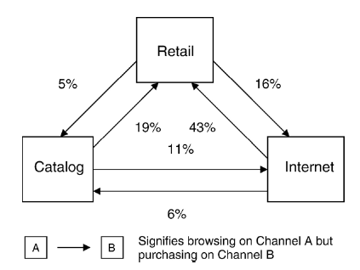

Figure 2: Cross-channel differences in searching and buying.

In figure x you can see that 43% of the shoppers that search for information on the internet eventually buy their product in the retail channel. This figure shows that many consumers have a multi-channel approach in making the decision for a specific product they are going to buy. The situation where one channel is used to gather information and another channel is used for actual purchase is called the research- shopper phenomenon (Verhoef, Neslin, Vroomen, 2007.) If a consumer is a research-shopper, he uses multiple channels in his purchase process. There are a few reasons described by Verhoef, Neslin & Vroomen why consumers are interested in research-shopping:

- Channel-attribute based decision making
Consumers may think that some channels have excellent attributes to find a lot of information about a product, but not to buy a product because it might be risky (for instance the internet), while other channels are perfect to make the final purchase, but not suitable for an intensive information search (for instance a retail store.) Each channel has different ‘specialties.’

- Lack of channel lock-in
If a consumer searches for information in one channel, and also purchases the product in that channel, this would be a channel lock-in. If a channel has a low lock-in, high search attitudes will not necessarily lead to high purchase attitudes. This is the case in research-shopping.

- Cross-channel synergy
If a consumer searches in channel A and purchases in channel B, the consumer can benefit from cross-channel synergy. For example, searching on the internet for information can get them a better price in the store, or better informed choices (Bakos, 1997.)

Now that we are aware of the fact that there is a difference between searching for information and buying the product, it also has to be taken in mind that somewhere in this track the consumer makes the decision what product to buy. Figure 2 doesn’t show where the consumer actually makes the decision what product to buy.
As stated in section 4.6 of this research, some consumers are very certain about their preferences about a product, while others still need to form their preferences. Research-shoppers that are already certain about their product preferences will use research-shopping purely to find the best alternative, and to benefit from the different advantages of the different channels. They don’t need to find information about what they prefer; they just need to find an alternative that matches their preferences the best.
In case the consumer is still uncertain about their product preferences, I assume that research-shopping can have different purposes:

- The consumer uses one channel for information search, eventually chooses the alternative he prefers, and then buys it in a different channel because that channel is a preferred channel for buying products.
- The consumer uses one channel to search for information, and then visits another channel where he evaluates the different alternatives, and makes the decision at the moment of purchase.

The major difference between these purposes is the moment of decision making. If the consumer makes the eventual decision in the same channels where he is searching for information, and uses another channel only to buy the product because of channel buying-benefits, the problem of the dual-processing of creating preferences at the same time as finding the best alternative that matches those preferences still exists. If the consumer uses one channel to create or improve their knowledge about the product, and then uses another channel for the purchase, and makes the actual decision what alternative to choose at that second channel, the dual-processing problem disappears. The consumer only uses the first channel in this case to increase their knowledge about the product, and to become more certain about what he prefers the product to be like.

If the consumer uses research-shopping to extend their knowledge, and they are not looking for the best alternative, the negative effect of information overload will disappear. Therefore I suggest that if the consumer uses the internet to create preferences, and not to make the actual decision, the influence of internet use on the eventual post-buy evaluation will become more positive if we are dealing with consumers that are uncertain about their preferences. In case that we are dealing with consumers that are more certain about their preferences upfront, the dual-processing dilemma of section 4.6 isn’t relevant. In this case I’m not expecting a significant relation between research-shopping and the influence it has on the post-buy evaluation of the consumer.

5.3 Conclusion

It can be concluded that not all consumers use channels for the same purpose. Some channels are used more for information search, while other channels are preferred more for the actual purchase. Using the internet for information search and gathering knowledge, while using another channel like the retail store for the actual decision making and the actual purchase is a form of research-shopping. Consumers extend their knowledge about the attributes of the product, and create their own preferences. They don’t necessary need to look for the alternative that matches their preferences immediately. They might do that later in the store. The suggestion rises that when the consumer makes the eventual decision in the retail store, and uses the internet only as knowledge extender, this research-shopping phenomenon influences the relation between use of internet and the post-buy evaluation positively, if the consumer is not certain about his preferences upfront. In this case, the internet is not used for finding the best alternative, but for creating preferences in attributes. If the decision is made on the internet and the consumer uses the retail store only to buy the chosen alternative, the dual-processing as described in section 4.6 still exists. Therefore a significant relation is not expected here.

H₂: The use of the internet as knowledge extender (the actual decision is made in another channel) has a positive influence on the post-buy evaluation of the consumer, under the condition that the consumer is not certain about its preferences for product.

Research Set-up

6.1 Hypothesis

H_{1A}: The use of the WWW in the pre-purchase information search will have a negative influence on the post-buy evaluation of the consumer under the condition that he is uncertain about his preferences for the product.

H_{1B}: The use of the WWW in the pre-purchase information search will have a positive influence on the post-buy evaluation of the consumer under the condition that he is certain about his preferences for the product.

H₂: The use of the internet as knowledge extender (the actual decision is made in another channel) has a positive influence on the post-buy evaluation of the consumer, under the condition that the consumer is not certain about its preferences for product.

6.2 Conceptual Framework
Certainty about preferences

Control Variables:
Age
Gender
Income

H_{1B}
H_{1A}
Research Shopping

H₂
Internet use
Post- Buy Evaluation

6.3 Data Collection

To collect the necessary data, a survey was done over 189 participants that have purchased a relatively expensive product (that is worth an intensive information search.) By adding questions about how they evaluated the product, what information sources they used, how extensive and for what purpose they have used a certain information source, where they have made the actual decision, and how much they knew about the alternatives before they started searching, there will be researched if there is a significant connection between the rise of the online environment, the increase of information that goes with it, and the eventual post-buy evaluation of the consumer. In appendix A the entire questionnaire can be found.

The data is collected via www.thesistools.com, an online tool to conduct and distribute questionnaires. After testing the survey on three individuals, some minor changes were made. After this the survey was distributed using social media like Facebook, and by using the personal network of the researcher. In the request to fill in the e-mail, people were asked to distribute the survey to parts of their network as well. This way of distributing the survey was the cheapest option. The limitation of this distribution is that there might be a lot of similar people in the sample, as well as some clusters of people that are alike by using second grade networks.

The survey has been online from July 4th 2011 until July 10th 2011.

6.3.1 Sample
189 respondents participated in the online survey. Many people failed to fill in the survey after question 2. This might indicate that the second question was too complicated, or people saw the different propositions per question and decided they didn’t have time to answer all these propositions.
The answers of the respondents were coded in SPSS. The respondents that didn’t complete the survey were deleted from the dataset. Because all respondents that didn’t complete the survey quitted after question 1, no important information is lost. The net response of the survey is 75%, which stands for a valid n of 142 respondents. These respondents were analysed to find out if the sample is representative compared to the Dutch population. These demographics of the sample compared with the Dutch population can be found in the next table.

Table 6.1: Demographics sample vs. Dutch population
 | Sample | Dutch Population*
GENDER
Male | 60,6% | 49%
Female | 39,4% | 51%
AGE
<26 | 61,3% | 20%
26-35 | 16,9% | 20%
36-45 | 1,4% | 25%
46-65 | 17,6% | 20%
>65 | 2,8% | 15%
*Source: CBS 2010

As can be seen in this table, the sample isn’t completely representative for the entire population. Especially males in the age group of <25 are overrepresented. This bias can be explained due to the fact that the personal network of the researcher is the main source for respondents. The results of this research have to be read with caution therefore.

6.3.2 Survey
As all of the participants will be Dutch, there is decided to hand out the questionnaire in Dutch as well. Although there will be a bias to Dutch consumers, the translation error will be minimalized in this manner.

To make sure the consumer has a product in mind that is worth an extensive information search, and to create not too many different options, first the participant were asked to choose from some purchases that a lot of people have made, that are over € 200,-. In this way there won’t be too large differences in purchased products, and the product was worth an extensive information search for the significant part of the sample.
To find out how certain people were about their preferences before the information search and the purchase, questions to make sure how familiar the consumer was with the product class were added.
To find out how and where the consumer searched for information, questions about information search were added. To find out in what way the consumer used research-shopping, questions about the channels that were used as information source, the channels he has used for the purchase, and the point where he has made the eventual decision were added. Eventual differences in channel use for information search and product purchase suggest research shopping.
To focus on the reasons why the consumer used the internet, and how he perceived information on the web, questions about internet use were added. To compare this with the regular store, and the consumer’s perception on information in this regular store, similar questions about the regular store were added.
To find out how a consumer evaluates his purchase, questions to gather information about if the consumer thinks he made the right decision were added.
To control different behaviours for demographic influences, control variables were added to find out if certain behaviour is dependent on a person’s characteristics.
For most questions, different propositions were made on a 5- or 7- point likert scale. These propositions are expected to be highly correlated. To measure these internal correlations for multi-items, a factor analysis with Oblimin rotation will be conducted. For each factor one score will be created, which is preferred for the analysis. The expected factors are:

- certainty about preferences
- perception of assortment online
- perception of assortment in regular store
- perception of information online
- perception of information in regular store
- regret

The complete survey can be found in appendix A

Results

7.1 Factor Analysis
As mentioned in the previous section, some constructs were measured by multi-items. For the different propositions that represent one construct one score is preferred. To find out if these items are indeed correlated and the expected factors will be found, a factor analysis with Oblimin rotation was conducted. A Varimax rotation doesn’t allow the different factors to correlate with each other. By using the Oblimin rotation, correlation is allowed until a certain degree. According to Field (2009) an oblique rotation should be used for all data that involve humans. The chance that different factors correlate in one way or another is very high if humans are involved. For this reason the Oblimin rotation is chosen.

The propositions that represent the different factors together equal a Kaiser-Mayer-Olkin value of 0.654. A value of 0.6 or higher needs to be obtained for factor analysis to proceed (Field, 2009). Bartlett’s test of sphericity has a significance level of 0.000, which means that the correlation matrix is not an identity matrix. The propositions are allowed for factor analysis. (For tables see appendix B)

At first, seven factors were found by factor analysis. Each of these factors have an eigenvalue that is larger than 1. After taking a closer look at the data, it seems that two factors for “perception of assortment online” were conducted, one for the reversed propositions and one for the not-reversed propositions. As participants of the survey may have read some of these questions not well enough, these answers can correlate less with each other. For this reason there is chosen for a fixed number of six factors. These six factors represent the expected constructs as mentioned in the previous section.

Reliability of the Scale
For the six factors is it necessary to check the reliability of the scale. The reliability is tested by using Cronbach’s Alpha. To be sure that the scale is reliable, the Cronbach’s alpha should be higher than 0.6 (Field, 2009). This is the case for all factors except one. “Perception of information in a regular store” has a Cronbach’s Alpha of 0.448. By excluding the third proposition the Cronbach’s Alpha increases to 0.508. For this reason, the third proposition about “perception of information in a regular store” is excluded. Although this is still not sufficient there is decided to keep this factor for analysis. As one of the remaining propositions is reversed, a lower Cronbach’s Alpha is accepted.

“Perception of assortment in a regular store” could have a slightly larger Cronbach’s Alpha by excluding the fourth proposition. Because the increase is only slight, there is chosen to keep the proposition in the factor, as it represents the concept more broadly.

In the table below the Cronbach’s Alpha for the different factors can be found:

Table 7.1: Cronbach’s Alpha for different factors.
Factor | Cronbach’s Alpha
Certainty about preferences | 0.789
Perception of Assortment Online | 0.712
Perception of Assortment in Regular Store | 0.748
Perception of Information Online | 0.705
Perception of Information In Regular Store | 0.508
Regret | 0.909

The tables that include the Factor Analysis and the Cronbach Alpha of the different factors can be found in Appendix C.

The scores of the six factors were computed by summing the answers to the different propositions and dividing them through the number of propositions.

7.2 Consumer Information sources

To find out how relevant this research is, an analysis of used information sources is done. Table 7.2 presents the findings.

Table 7.2: Information Channels used by consumers

As can be seen, the internet is the most important information source for consumers, followed by information of friends. This implies that internet has become the major information source. It has become very important for companies to use this channel as effective as possible to help the consumer to make the best decision. They need to make sure that the consumers feel as less regret as possible to stimulate future sales.

7.3 Consumer perceptions

To find out how the different variables in this research relate to each other, first it is important to see how the consumers in the sample perceive the differences between online information and information in the regular store. According to the theory consumers were expected to find the available assortment more fulfilling on the internet than in a regular store. They were also expected to find the information on the internet more confusing than the information in the regular store. To test these propositions, a paired sample t-test has been conducted. (See appendix D)

In the sample is found that consumers indeed perceive the online assortment to be larger than the assortment in the regular store, which implies that the consumers have a better chance to find the alternative that matches their preferences the best. There is a significant difference between perceived assortment online (M = 4.04, SD = 0.70) and perceived assortment in the regular store (M = 2.55, SD = 0.74), t (140) = 15.31, p < 0.0005. The difference in mean is 1.50 with a 95% confidence interval ranging from 1.30 to 1.68. In table 7.3 there can be found that the assortment online is perceived a lot higher.
The information online isn’t as confusing as expected though. In the sample we find that the information found online is just slightly more confusing than information in a regular store, which implies only a little effect of information overload on the internet. There is no significant difference between perceived information online (M = 2.52, SD = 0.75) and perceived information in the regular store (M = 2.46, SD = 0.66), t (138) = 0.68, p = .497.
In this part of the analysis we have to take in mind that one question on perceived information online was deleted. This question asked about perception of relevant alternatives. For this reason the results of the question on perceived alternatives is added in table 7.3. This shows that consumers do perceive the alternatives on the internet as too much comparing to the regular store. There is a significant difference between ‘alternative overload’ online (M = 3.08, SD = 1.20) and perceived assortment in the regular store (M = 2.11, SD = 0.86), t (141) = -8.73, p < 0.0005. This analysis is based on only one question “The internet/regular store offers me too much alternatives” though.

Table 7.3: Consumer perceptions online vs. regular store
These results imply that assortment size indeed is perceived larger online, what could be a benefit for the consumer. The information confusion by overload isn’t perceiver larger online. This could be explained by the fact that all people benefit from the large assortment online, but that only the insecure people find the online information confusing. The people that are more secure about their preferences were expected to perceive the information on the internet less confusing. Because the assortment size is perceived higher for the online channel, but the information confusion is perceived the same online as it is in the regular store, it is possible that the positive effect of the use of internet in information search as found in the literature (large assortment) has a larger effect on the eventual post-buy evaluation of the consumer than the negative effect of the use of internet (information overload). The use of internet should have an overall positive effect then. The relation between the use of internet and the post-buy evaluation, and the effect of certainty about preferences in this relation will be further investigated in the next section.

7.4 Insecurity & Online information: Regret or no regret?

As the hypotheses 1a & 1b are suggesting, a relation between the use of online information and the post-buy evaluation of the consumer is expected. A small recap:

H_{1A}: The use of the WWW in the pre-purchase information search will have a negative influence on the post-buy evaluation of the consumer under the condition that he is uncertain about his preferences for the product.

H_{1B}: The use of the WWW in the pre-purchase information search will have a positive influence on the post-buy evaluation of the consumer under the condition that he is certain about his preferences for the product.

To test these hypotheses, a regression is performed to assess the influence of the use of online information on the fact if the consumer has any regret at all. A lot of respondents were very satisfied with their purchase, what resulted in a very low mean for the factor “Regret” (M=1,56; SE=0,99) on a 5-point likert scale. For this reason there is chosen to make a distinction between ‘No regret at all’ and ‘at least some regret.’ A dummy for ‘regret’ is created, and there is chosen for a logistic regression to find out if internet use and certainty about preferences influence the degree of regret of the consumer.

To assess how much a participant has used the internet, a percentage of the total use of different channels that the consumer has spent on internet search is calculated by dividing the use of the internet channel by the total use of all channels.
First a multicollinearity check is done to see if the independent variables somewhat will be related to the dependent variable, and not too much with each other. As can be seen in appendix D, the control variables do not correlate significantly with the dependent variable, but they do correlate with each other. For this reason the control variables are excluded from the model.

With logistic regression the chance for one of the two categories (in this case ‘regret’ or ‘no regret’) to appear will be calculated, depending on the independent variables.

Logit = B₀ + B₁ * X₁ + B₂ * X₂ + ... + B_{k} * X_{k}

This logistic regression model contained three independent variables; Share of Internet use, Certainty about preferences, and an interaction variable Share of Internet use * Certainty about preferences. The model was not statistically significant; χ² (3, N=142) = 5.908, p=.116. This means that the model wasn’t able to make a distinction between respondents that regretted their purchase and those who didn’t. The model explained only between 4.1% (Cox & Snell R²) and 5.4% (Nagelkerke²) of the variance in regret. The model classified 57% of the cases correctly, what is only slightly better than the model without any variable has classified correctly (53.5%). Not any of the variables added to the model shows a significant influence on regret. A reason for this conclusion might be that the two predictor variables correlate highly with each other (see appendix E).

Variables in the Equation
 |  | B | S.E. | Wald | df | Sig. | Exp(B) | 95% C.I.for EXP(B)
 |  |  |  |  |  |  |  | Lower | Upper
 | Certainty About Preferences | -,234 | ,413 | ,320 | 1 | ,571 | ,792 | ,353 | 1,778
 | Share of Internet use | ,000 | ,055 | ,000 | 1 | ,995 | 1,000 | ,898 | 1,114
 | Interaction Certainty about Preferences * Share of Internet use | -,002 | ,013 | ,015 | 1 | ,903 | ,998 | ,974 | 1,023
 | Constant | ,995 | 1,711 | ,338 | 1 | ,561 | 2,704
Dependent Variable: Regret
Cox & Snell R² = 4,1%, Nagelkerke² = 5,4%

An interaction effect doesn’t exist. For this reason, the same test was done again without the interaction variable.

Without the interaction variable the model is still not significant, but the p-value has decreased though; χ² (2, N=142) = 5.893, p=.053. The model still doesn’t explain very much of the variance in regret (4.1% (Cox & Snell R²) and 5.4% (Nagelkerke²)). The model classified 57.7% of the cases correctly, what is still only slightly better than the model without any variable, that has classified 53.5% correctly. There is no significant relation between the use of internet and regret, but there is a significant relation between certainty about preferences and regret this time; (B= -.281, p < 0.05). An odds ratio of 0.755 is recorded, what implicates that every respondent that is 1 point more certain about his preferences, regrets his purchase 0.755 times less often than someone who is not.

Variables in the Equation
 |  | B | S.E. | Wald | df | Sig. | Exp(B) | 95% C.I.for EXP(B)
 |  |  |  |  |  |  |  | Lower | Upper
 | Certainty about Preferences | -,281 | ,131 | 4,641 | 1 | ,031 | ,755 | ,584 | ,975
 | Share of Internet use | -,006 | ,017 | ,134 | 1 | ,714 | ,994 | ,962 | 1,027
 | Constant | 1,188 | ,646 | 3,382 | 1 | ,066 | 3,280
Dependent variable: Regret
Cox & Snell R² = 4,1%, Nagelkerke² = 5,4%

These conclusions mean that both hypotheses H_{1A} and H_{1B} are rejected. The interaction effect that was expected isn’t found. We have found a significant relation of certainty about preferences on regret, even though this relation only explains about 5% of the variance.

The lack of a significant relation in this test doesn’t necessarily mean that internet doesn’t at all have any impact on the post-buy evaluation of the consumer. As mentioned in section 5, consumers aren’t very alike in their search behaviour. Respondents may have used the internet for different reasons, like only for knowledge extending, or to find channel benefits.

An important implication that results from the data is the difference in making use of the internet between people that are certain and people that are not certain about their preferences (certain people value >4 on 7-point likert scale). By doing a one-way anova the following differences in the means occur:

Table 7.4
We find a significant difference between both means (F (1, 140) = 8.972, p < 0.01).
From these results the conclusion can be made that certain people make more use of the internet than uncertain people. Consumers that do not know exactly what they are looking for will use other sources like friends or salespeople more to let them get informed about the product category. People only dive in to the information load of the web if they know what they are looking for.

7.5 The research-shopper

Because the use of the internet may be very different for different respondents, 4 different classes were designed to test the second hypothesis.

H₂: The use of the internet as knowledge extender (the actual decision is made in another channel) has a positive influence on the post-buy evaluation of the consumer, under the condition that the consumer is not certain about its preferences for product.

First, there is decided if someone is a research shopper or not. After that, there is decided who of the research shoppers was very certain about his preferences upfront, and who wasn’t. Last, the uncertain research shoppers are divided in knowledge-extenders and channel-benefit seekers, depending on the moment of decision making: If the consumer makes the decision during the search for information, he is expected to use a different buying channel only because of the benefits of that channel; If the decision is made at the moment of purchase, the earlier information search is used to extend the consumer’s knowledge on the product’s category. In this process of classification the following assumptions were made:

A research-shopper uses at least 2 channels (value = 3 or higher on a 5-point likert scale), or uses a different buying channel than searching channel.
Certain research-shoppers have a value for certainty about preferences higher than 4 on a 7-point likert scale. This is based on the mean of 4.08 and the possible values varying between 1 and 7 that goes with the ‘certainty about preferences’ factor.

After transforming the data, the following classes were created:

- No Research Shoppers
- Certain Research Shoppers
- Uncertain Knowledge extending Research Shoppers
- Uncertain Channel benefit Research Shoppers

To test hypothesis H₂ a logistic regression is performed.

Logit = B₀ + B₁ * X₁ + B₂ * X₂ + ... + B_{k} * X_{k}

The logistic regression model contained 3 dummy variables, with “uncertain knowledge extending research shoppers” as reference category. The dummy variables are ‘no research shopper,’ ‘certain research shopper’ and ‘uncertain channel benefit research shopper.’ The relation between the knowledge extenders and the channel benefit seekers is relevant for the hypothesis.
The model is statistically significant; χ² (3, N=142) = 11,080, p<.05. This means that the model is able to make a distinction between respondents that regretted their purchase and those who didn’t. The model explained only between 7.5% (Cox & Snell R²) and 10.0% (Nagelkerke²) of the variance in regret. The model classified 63.4% of the cases correctly, what is better than the percentage that the model without any variable has classified correctly (53,5%).

The relation that is investigated in hypothesis 2 is not significant (B = -.210, p=0.670). Therefore we have to reject the second hypothesis as well. The odds ratio of 0.811 would imply that channel benefit research shoppers are 0.811 times less likely to regret their decision for a purchase than knowledge extending research shoppers. This is the opposite compared to what the hypothesis says. Searching for channel benefits would be better for the post buy-evaluation than extending your knowledge. A possible explanation for this could be that people who only extend their knowledge are already looking for the best alternative, what still creates a dual-searching process. But as mentioned before, because of the lack of significance, no conclusions can be drawn.

Variables in the Equation
 |  | B | S.E. | Wald | df | Sig. | Exp(B) | 95% C.I.for EXP(B)
 |  |  |  |  |  |  |  | Lower | Upper
 | Knowledge Extending Research Shopper |  |  | 10,372 | 3 | ,016
 | Certain Research Shopper | -1,100 | ,460 | 5,706 | 1 | ,017 | ,333 | ,135 | ,821
 | No Research Shopper | -1,751 | ,760 | 5,312 | 1 | ,021 | ,174 | ,039 | ,770
 | Channel Benefit Research Shopper | -,210 | ,508 | ,171 | 1 | ,679 | ,811 | ,300 | 2,193
 | Constant | ,547 | ,379 | 2,081 | 1 | ,149 | 1,727
Dependent variable: Regret
Cox & Snell R² = 7,5%, Nagelkerke² = 10,0%

A significant relation is found between certain research shoppers and knowledge extending research shoppers though (B = -1.100, p < 0.05). This relation (green shading) has an odds ratio of 0.333 what implies that certain research shoppers are 0.333 times less likely to regret their decision for a purchase than knowledge extending research shoppers. The importance of certainty about preferences is also found in section 7.4.

Therefore ‘certain research shoppers’ is taken as reference category in a logistic regression. We find that certain research shoppers are significantly less likely to regret their purchase compared to uncertain research shoppers (knowledge extenders: B = 1.100, p < 0.05, odds ratio 3.004 times more likely to regret; channel benefit shoppers: B = 0.890, p < 0.05, odds ratio 2.435 times more likely to regret.)
Variables in the Equation
 |  | B | S.E. | Wald | df | Sig. | Exp(B) | 95% C.I.for EXP(B)
 |  |  |  |  |  |  |  | Lower | Upper
 | Certain Research Shoppers |  |  | 10,372 | 3 | ,016
 | No Research Shoppers | -,651 | ,708 | ,843 | 1 | ,358 | ,522 | ,130 | 2,091
 | (Uncertain) Knowledge Extending RS | 1,100 | ,460 | 5,706 | 1 | ,017 | 3,004 | 1,218 | 7,407
 | (Uncertain) Channel Benefit RS | ,890 | ,428 | 4,333 | 1 | ,037 | 2,435 | 1,053 | 5,628
 | Constant | -,553 | ,262 | 4,472 | 1 | ,034 | ,575
Dependent variable: Regret
Cox & Snell R² = 7,5%, Nagelkerke² = 10,0%

7.6 Results conclusion

The hypotheses in this research were all rejected. A relation between internet use and post- buy evaluation with a moderating effect of certainty about preferences wasn’t found. A difference between knowledge extending research shoppers and channel benefit research shoppers wasn’t found as well. The importance of certainty about preferences has come to light though. In the next section possible explanations for these results will be discussed.

Discussion

The internet has two possible effects as an information search channel, based on the literature. On one side, it offers a very large assortment of products, which results in more products where the consumer can choose from, and eventually in a better ‘best alternative.’ On the other side the internet offers so much information that the consumer can become very confused due to the overload of information, definitely when the consumer isn’t certain about what he is exactly looking for. When we take a look at the respondent perceptions in section 7.3, it seems that the respondents of the survey only perceive the benefits of the large amount of information. The differences in information confusion between the internet and the regular store are marginal. It seems that consumers find information on the web just as easy as they find it in the regular store.

This could be one of the main reasons why the relation between internet use and the post-buy evaluation, based on literature, wasn’t found by analysing the data of the respondents. The certainty of preferences didn’t have the expected moderating effect on the post-buy evaluation. Significant effects of certainty about preferences on the post-buy evaluation of the respondents were found though. There can be concluded that the certainty about preferences is the most important factor when it comes to post-buy evaluation, based on variables used in this research. People who know what they are looking for do avoid the dual-processing problem of creating preferences and finding the best alternative at the same time. This advantage doesn’t restrict itself to the World Wide Web though; it counts for the other channels as well.

There is a connection between certainty about preferences and the use of the internet though. In section 7.4 it is shown that certain people make significantly more use of the internet than uncertain people. This leads to the conclusion that people who know what they are looking for make use of the internet, while people who don’t exactly know what they want rather use salespeople or friends as information source. This might also be a reason why a significant relation between internet use and regret wasn’t found.

These results could make companies aware of the possibility that certain people are visiting their websites, while uncertain people put more trust in human experience. Making clear overviews of product alternatives with all product attributes is therefore a must for companies to put on their website if they want to attract the certain consumers. It seems that the larger the assortment, the larger the possibility for the consumer to find the perfect match for his preferences. Adding a section with references of other consumers could be a nice supplement for uncertain consumers to visit. For these uncertain consumers, trained salespersons in-store will still be necessary. As these uncertain consumers often approach their (certain) friends, it becomes even more important to satisfy the certain consumers, because uncertain consumers can be reached indirectly this way. To attract the uncertain consumers more to the World Wide Web, companies could develop programs in which the consumers are taught about what their own preferences are. A model as used in election periods for political parties could come in useful here. In these models the participants answer to several questions and eventually the party that matches their preferences the best comes out as best voting option. A same model could be constructed for consumer goods.

Limitations and Future Research

Like every other research, also this research has some limitations and disappointments when it comes to the data-set. To start off, most of the respondents that participated in the survey were approached through the private network of the researcher. The sample therefore isn’t completely random and is doesn’t represent the entire Dutch population.

By asking the respondents about their earlier thoughts about searching information, the answers of the respondents could be not entirely representative. It is hard for the consumers to think back about how they felt before a purchase, now that they are much knowledge and much time further. This problem could be resolved by using an experiment to measure the different constructs, or by doing a longitudinal study. Because of limited resources, this time a survey was preferred.

The fact that most respondents filled out that they hardly regretted their decision, might implicate that the post-buy evaluation isn’t the best construct to measure consumer’s problems with the World Wide Web. Because consumers are filling in questions after they bought a product, and they hardly ever regret a purchase, the conclusion can be made that people only buy a product after they have received enough information for a responsible choice. As Dhar and Nowlis (1999) mention, consumers defer their decision if the conflict between the alternatives is too high. They only buy the product if a right choice can be made. Because in this research there is only asked about attitudes after the product has been bought, this brings us to possible opportunities for future research. The relation between the use of the internet as information source and the time it takes a consumer to make a decision can be a very interesting research topic. Also the implication that uncertain people dodge the internet more than certain people, made in this research, could be a very interesting topic for empirical research.

Literature

Alba J, Lynch J, Weitz B, Janiszewski C, Lutz R, Sawyer A, Wood S (1997), Interactive Home Shopping: Consumer, Retailer, and Manufacturer Incentives to Participate in Electronic Marketplaces, The Journal of Marketing, Vol. 61, No. 3 (July 1997), pp 38-53

Ariely D (2000), Controlling the Information Flow: Effects on Consumers’ Decision Making and Preferences, The Journal of Consumer Research, 2000, Vol. 27, Issue 2, P.233

Bakos JT (1997), Reducing Buyer Search Costs: Implications for Electronic Marketplaces, Management Science, Vol. 43, No. 12, Frontier Research on Information Systems and Economics (Dec. 1997), pp. 1676-1692

Bell DE (1982), Regret in decision making under uncertainty, operations research, 30 (September/October), 961-981

Broadbent DE (1975), ‘The magic number seven after fifteen years,’ Studies in Long Term Memory, eds., Alan Kennedy and Alan Wilkes, London: John Wiley & Sons, pp. 1-18

Brucks M (1985), The Effects of Product Class Knowledge on Information Search Behavior, The Journal of Consumer Research, Vol. 12, No. 1 (Jun. 1985), pp 1-16

Bettman JR, Johnson EJ, Payne JW (1991), Consumer Decision Making, Handbook of Consumer Behavior. Eds. Thomas S. Robertson and Harold H. Kassarjian. Englewood Cliffs, NJ: Prentice Hall, 50–84.

Chernev A (2003), When more is less and less is more: The role of ideal point availability and assortment in consumer choice, The journal of consumer research, vol 30, issue 2, p. 170

Crotts JC (1998), Consumer Decision-Making and Prepurchase information Search, Consumer Behavior in Travel and Tourism, edited by A. Pizam and Y. Mansfeld, New York: Haworth, pp. 43-67

Dhar R, Nowlis SM (1999), The effect of Time Pressure on consumer choice deferral, The journal of consumer research, vol 25, No 4, p. 369-384

Engel JF, Blackwell DB & Miniard PW (1990), Consumer Behavior, 6th ed. Chicago: Dryden Press.

Field A (2009), Discovering Statistics using SPSS, 3 th ed.

Geyskens I, Gielens K, Dekimpe MG (2002), The Market Valuation of Internet Channel Additions, The Journal of Marketing, Vol. 66, No. 2 (Apr 2002), pp. 102-119

Gleicher, Faith, Kost AK, Baker SM, Strathman AJ, Richman SA & Sherman SJ (1990), The role of counterfactual thinking in judgement of affect, Personality and social psychology bulletin, 16 (june), 284-295

Häubl G, Trifts V (2000), Consumer Decision Making in Online Shopping Environments: The Effect of Interactive Decision Aids, Marketing Science, Vol. 19, No. 1, Special Issue on Marketing Science and the Internet (Winter, 2000), pp. 4-21

Inman JJ, Dyer JS, Jia J (1997), A Generalized Utility Model of Disappointment and Regret Effects on Post-Choice Valuation, Marketing Science, Vol. 16, No. 2 (1997), pp 97-111

Jacoby J, Speller DE & Kohn CA (1974), Brand Choice behavior as a function of Information Load, Journal of Marketing Research, 11, 63-9

Kleinmuntz DN, Schkade DA (1993), Information Displays and decision processes, Psychological Science, 4, 221-227

Malhotra NK (1982), Information Load and Consumer Decision Making, The Journal of Consumer Research, Vol. 8, No. 4 (Mar., 1982), pp. 419-430

O’Keefe RM, McEachern T (1998), Web-based Customer Decision Support Systems, Communications of the ACM, Vol. 41, No. 3

Oliver RL (1980), A cognitive model of the antecedents and consequences of satisfaction decisions, Journal of Marketing Research, 460-469.

Reibstein DJ, Youngblood SA, Fromkin HL (1975), Number of Choices and Perceived Decision Freedom as a Determinant of Satisfaction and Consumer Behavior, Journal of Applied Psychology, 60 (4), 434-437

Simon HA (1974), How big is a chunk? Science, 183, 482-8

Svenson O (1992), Differentiation and Consolidation Theory of human decision making: A frame of reference for the study of pre- and post-decision processes, Acta Psychologica 80 (1992) 143-168

Todd P, Benbasat I (1992), The use of information in decision making: en experimental investigation of the impact of computer-based decision aids, MIS Quarterly, September 1992, 373-393

Tsiros M, Mittal V (2000), Regret: A Model of Its Antecedents and Consequences in Consumer Decision Making, The Journal of Consumer Research, Vol. 26, No. 4 (March 2000), pp 401-417

Verhoef PC, Neslin SA, Vroomen B (2007), Multichannel customer management: Understanding the research-shopper phenomenom, International Journal of Research in Marketing, 24 (2007), 129-148

Appendices

Appendix A

Questionnaire

Pagina: 1
Welkom!
Alvast heel erg bedankt voor het invullen van deze vragenlijst. Voor mijn afstudeerscriptie aan de Erasmus Universiteit Rotterdam doe ik onderzoek naar het verband tussen de informatie die online gevonden kan worden en de wijze waarop consumenten hun aankoop evalueren.
Uw antwoorden zijn vertrouwelijk en zullen anoniem worden geanalyseerd. De resultaten zullen alleen worden verwerkt in dit afstudeeronderzoek.
De vragenlijst bestaat uit 19 vragen. Het invullen van de vragenlijst duurt ongeveer 5 minuten.
Met vriendelijke groet,
Tim Beurskens

Pagina: 2

1.

Kies een product dat u recent heeft aangeschaft en dat meer waard is dan €200,-. Indien u meerdere producten heeft aangeschaft kunt u er één kiezen. Dit product dient u gedurende het invullen van de vragenlijst in uw gedachte te houden. *
 Laptop
PC
Mobiele telefoon
Televisie
Anders, namelijk... 

Pagina: 3

2.

De volgende stellingen gaan over de kennis die u had voordat u op zoek ging naar informatie voor uw aankoop. Geef aan in welke mate u het eens/oneens bent met de volgende stellingen.
 |  | Helemaal mee oneens |  |  |  | Helemaal mee eens
 | Voordat ik op zoek ging naar informatie over dit product, voelde ik me al goed geïnformeerd over dit product
 | Als ik dit product direct had moeten kopen, had ik weinig aanvullende informatie nodig gehad om een goede beslissing te nemen
 | Ik voelde me erg zeker over mijn vermogen om het verschil in kwaliteit uit te leggen tussen verschillende attributen van dit product
 | Als een vriend me over dit product zou vragen, zou ik hem advies kunnen geven over de verschillende attributen van dit product

3.

De volgende stelling gaat over uw zoektocht naar informatie.

 |  | Helemaal mee oneens |  |  | helemaal mee eens
 | Voordat ik het product kocht, heb ik naar informatie gezocht om mijn kennis over de product categorie te vergroten

4.

Bekijkt u de volgende stelling, en vink aan in welke mate de antwoorden op u van toepassing zijn:
Om informatie te zoeken over het product heb ik gebruik gemaakt van de volgende informatiekanalen:
 |  | niet intensief |  |  | intensief |  | n.v.t.
 | Internet |  |  |  |  |  | 
 | Brochure
 | Verkoopmedewerker
 | Informatie op de winkelvloer
 | Vrienden
5.

Waar heeft u het product gekocht?
Via internet
In een reguliere winkel
Anders, namelijk...

6.

Wanneer heeft u de definitieve keuze voor een bepaald product gemaakt?
Op het moment van aankoop
Tijdens mijn zoektocht naar informatie
Anders, namelijk...

7.

Mijn uiteindelijke keuze voor een product was voornamelijk gebaseerd op informatie gevonden...

...in een reguliere winkel |  | ...op het internet

Pagina: 4

8.

In mijn zoektocht naar informatie heb ik het internet gebruikt...

 |  | Helemaal mee oneens |  |  | Helemaal mee eens
 | Om verschillende producten met elkaar te vergelijken
 | Om uit te zoeken welke attributen van het product ik belangrijk vind
 | Om informatie te vinden over het product
 | Om te kijken welke alternatieven er beschikbaar zijn
 | Om een product te vinden dat het beste overeenkomt met mijn voorkeuren

9.

Hoe kijkt u aan tegen het beschikbare product assortiment op internet?
 |  | Helemaal mee oneens |  |  | Helemaal mee eens
 | De keuze tussen producten op het internet is beperkt
 | Het internet beschikt niet over een breed assortiment aan producten om uit te kiezen
 | Naar mijn mening kan elk beschikbaar alternatief op het internet gevonden worden
 | Het internet biedt meer alternatieven dan de reguliere winkel

10.

Hoe kijkt u aan tegen de beschikbare informatie op het internet

 |  | Helemaal mee oneens |  |  | Helemaal mee eens
 | Op het internet vind ik makkelijk informatie die relevant is voor mijn aankoop
 | Om informatie te vinden op het internet, weet ik niet waar ik moet beginnen met zoeken
 | Het internet biedt mij te veel alternatieven
 | Vanwege de informatie op internet heb ik het idee dat ik niet alle relevante alternatieven kan beoordelen

11.

In mijn zoektocht naar informatie heb ik de reguliere winkel gebruikt...

 |  | Helemaal mee oneens |  |  | Helemaal mee eens
 | Om verschillende producten met elkaar te vergelijken
 | Om uit te zoeken welke attributen van het product ik belangrijk vind
 | Om informatie te vinden over het product
 | Om te kijken welke alternatieven er beschikbaar zijn
 | Om een product te vinden dat het beste overeenkomt met mijn voorkeuren
12.

Hoe kijkt u aan tegen het beschikbare assortiment in de reguliere winkel?

 |  | Helemaal mee oneens |  |  | Helemaal mee eens
 | De keuze tussen producten in de reguliere winkel is beperkt
 | De reguliere winkel beschikt niet over een breed assortiment aan producten om uit te kiezen
 | Naar mijn mening kan elk beschikbaar alternatief in de reguliere winkel gevonden worden
 | De reguliere winkel biedt meer alternatieven dan het internet

13.

Hoe kijkt u aan tegen de beschikbare informatie in de reguliere winkel?

 |  | Helemaal mee oneens |  |  | Helemaal mee eens
 | In de reguliere winkel vind ik makkelijk informatie die relevant is voor mijn aankoop
 | Om informatie te vinden in de reguliere winkel, weet ik niet waar ik moet beginnen met zoeken
 | De reguliere winkel biedt mij te veel alternatieven
 | Vanwege de informatie in de reguliere winkel heb ik het idee dat ik niet alle relevante alternatieven kan beoordelen

Pagina: 5

14.

In hoeverre heeft u spijt van uw keuze om het uiteindelijke product te kopen?

Helemaal geen spijt |  | Heel erg veel spijt

15.

Als u uw keuze opnieuw zou kunnen maken, zou u dan uw keuze veranderen?

Zeker niet veranderen |  | Zeker veranderen

16.

Hoe veel gelukkiger zou u zijn als u een andere keuze had gemaakt?

Niet veel gelukkiger |  | Veel gelukkiger
Pagina: 6

17.

Hoe oud bent u?
< 26 jaar
26-35 jaar
36-45 jaar
46-65 jaar
>65 jaar

18.

Wat is uw geslacht?
Man
Vrouw

19.

Wat is uw netto maandelijks inkomen?
<500 €
500-1000 €
1000-1500 €
1500-2500 €
2500-4000 €
>4000 €
Pagina: 7

Dit was de laatste vraag!
Heel erg bedankt voor het invullen van deze vragenlijst, en hiermee voor uw bijdrage aan mijn afstudeeronderzoek.
Groet,
Tim

Appendix B

Factor Analysis

KMO and Bartlett's Test
Kaiser-Meyer-Olkin Measure of Sampling Adequacy. |  | ,654
Bartlett's Test of Sphericity | Approx. Chi-Square | 1280,459
Bartlett's Test of Sphericity | df | 231
Bartlett's Test of Sphericity | Sig. | ,000

Pattern Matrixª
 | Component
 | 1 | 2 | 3 | 4 | 5 | 6
Kennis1 |  |  | ,775
Kennis2 |  |  | ,715
Kennis3 |  |  | ,816
Kennis4 |  |  | ,780
RevAssortInet1 |  |  |  | ,798
RevAssortInet2 |  |  |  | ,708
AssortInet3 |  |  |  | ,782
AssortInet4 |  |  |  | ,549
RevInfoInet1 |  |  |  |  | ,704
InfoInet2 |  |  |  |  | ,748
InfoInet3 |  |  |  |  | ,690
InfoInet4 |  |  |  |  | ,672
RevAssortRegWink1 | ,823
RevAssortRegWink2 | ,752
AssortRegWink3 | ,745
AssortRegWink4 | ,610
RevInfoRegWink1 |  |  |  |  |  | ,544
InfoRegWink2 |  |  |  |  |  | ,693
InfoRegWink4 |  |  |  |  |  | ,505
Spijt1 |  | ,897
Spijt2 |  | ,925
Spijt3 |  | ,872
Extraction Method: Principal Component Analysis.
Rotation Method: Oblimin with Kaiser Normalization.
a. Rotation converged in 9 iterations.

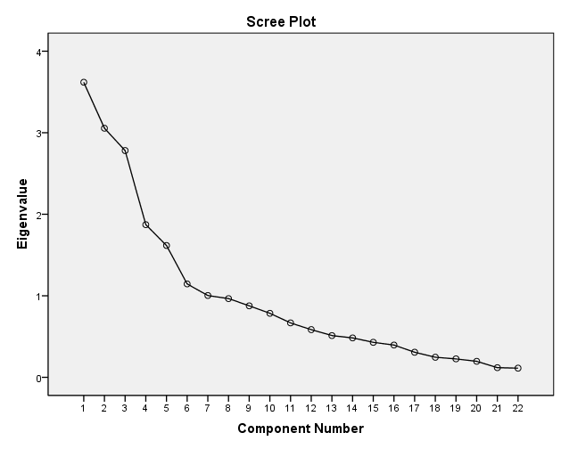

Appendix C

Reliability of the Factors

Regret reliability check

Reliability Statistics
Cronbach's Alpha | Cronbach's Alpha Based on Standardized Items | N of Items
,909 | ,915 | 3

Item-Total Statistics
 | Scale Mean if Item Deleted | Scale Variance if Item Deleted | Corrected Item-Total Correlation | Squared Multiple Correlation | Cronbach's Alpha if Item Deleted
Spijt1 | 3,2465 | 4,698 | ,846 | ,728 | ,863
Spijt2 | 2,9577 | 3,601 | ,850 | ,739 | ,850
Spijt3 | 3,1338 | 4,173 | ,790 | ,624 | ,893

Perception of information online reliability check
Reliability Statistics
Cronbach's Alpha | Cronbach's Alpha Based on Standardized Items | N of Items
,705 | ,711 | 4

Item-Total Statistics
 | Scale Mean if Item Deleted | Scale Variance if Item Deleted | Corrected Item-Total Correlation | Squared Multiple Correlation | Cronbach's Alpha if Item Deleted
RevInfoInet1 | 8,0357 | 6,322 | ,458 | ,253 | ,666
InfoInet2 | 7,8571 | 5,044 | ,533 | ,297 | ,616
InfoInet3 | 6,9714 | 5,251 | ,455 | ,237 | ,671
InfoInet4 | 7,4357 | 5,543 | ,542 | ,300 | ,612
Perception of information in regular store reliability check

Reliability Statistics
Cronbach's Alpha | Cronbach's Alpha Based on Standardized Items | N of Items
,448 | ,444 | 4

Item-Total Statistics
 | Scale Mean if Item Deleted | Scale Variance if Item Deleted | Corrected Item-Total Correlation | Squared Multiple Correlation | Cronbach's Alpha if Item Deleted
InfoRegWink2 | 7,3262 | 2,950 | ,446 | ,210 | ,181
InfoRegWink3 | 7,3901 | 4,011 | ,101 | ,126 | ,508
InfoRegWink4 | 6,8936 | 2,924 | ,299 | ,102 | ,328
RevInfoRegWink1 | 6,9433 | 3,611 | ,191 | ,150 | ,436

Perception of information in regular store reliability check excluding the 3th proposition
Reliability Statistics
Cronbach's Alpha | Cronbach's Alpha Based on Standardized Items | N of Items
,508 | ,512 | 3

Item-Total Statistics
 | Scale Mean if Item Deleted | Scale Variance if Item Deleted | Corrected Item-Total Correlation | Squared Multiple Correlation | Cronbach's Alpha if Item Deleted
RevInfoRegWink1 | 4,8156 | 2,351 | ,311 | ,101 | ,427
InfoRegWink2 | 5,1986 | 2,303 | ,352 | ,124 | ,365
InfoRegWink4 | 4,7660 | 2,009 | ,313 | ,100 | ,434

Perception of assortment online reliability check

Reliability Statistics
Cronbach's Alpha | Cronbach's Alpha Based on Standardized Items | N of Items
,712 | ,722 | 4

Item-Total Statistics
 | Scale Mean if Item Deleted | Scale Variance if Item Deleted | Corrected Item-Total Correlation | Squared Multiple Correlation | Cronbach's Alpha if Item Deleted
RevAssortInet1 | 11,8732 | 5,204 | ,567 | ,451 | ,623
RevAssortInet2 | 11,9085 | 5,332 | ,425 | ,383 | ,691
AssortInet3 | 12,3451 | 4,299 | ,582 | ,401 | ,595
AssortInet4 | 12,2958 | 4,564 | ,457 | ,327 | ,684

Perception of assortment in regular store reliability check

Reliability Statistics
Cronbach's Alpha | Cronbach's Alpha Based on Standardized Items | N of Items
,748 | ,747 | 4

Item-Total Statistics
 | Scale Mean if Item Deleted | Scale Variance if Item Deleted | Corrected Item-Total Correlation | Squared Multiple Correlation | Cronbach's Alpha if Item Deleted
RevAssortRegWink1 | 7,2766 | 4,702 | ,704 | ,746 | ,594
RevAssortRegWink2 | 7,1631 | 5,095 | ,600 | ,721 | ,658
AssortRegWink3 | 7,7730 | 5,662 | ,477 | ,278 | ,726
AssortRegWink4 | 8,3404 | 5,883 | ,407 | ,241 | ,763

Certainty about preferences reliability check

Reliability Statistics
Cronbach's Alpha | Cronbach's Alpha Based on Standardized Items | N of Items
,789 | ,789 | 4

Item-Total Statistics
 | Scale Mean if Item Deleted | Scale Variance if Item Deleted | Corrected Item-Total Correlation | Squared Multiple Correlation | Cronbach's Alpha if Item Deleted
Kennis1 | 12,1479 | 20,056 | ,577 | ,350 | ,746
Kennis2 | 12,4859 | 20,322 | ,523 | ,347 | ,774
Kennis3 | 12,1056 | 18,024 | ,722 | ,583 | ,671
Kennis4 | 11,8732 | 19,643 | ,573 | ,495 | ,749

Appendix D

Paired Sample T-test

Paired Samples Statistics
 |  | Mean | N | Std. Deviation | Std. Error Mean
Pair 1 | TOTAssortInet | 4,0426 | 141 | ,69818 | ,05880
Pair 1 | TOTAssortRegWink | 2,5461 | 141 | ,73957 | ,06228
Pair 2 | TOTInfoInet | 2,5216 | 139 | ,75029 | ,06364
Pair 2 | TOTInfoRegWink | 2,4580 | 139 | ,66337 | ,05627
Pair 3 | InfoRegWink3 | 2,1127 | 142 | ,85964 | ,07214
Pair 3 | InfoInet3 | 3,0845 | 142 | 1,19984 | ,10069

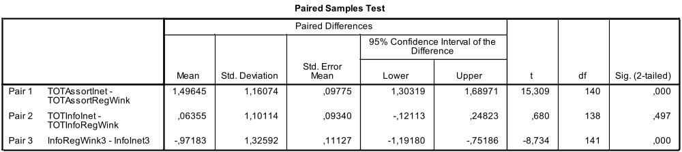

Multicollinearity check
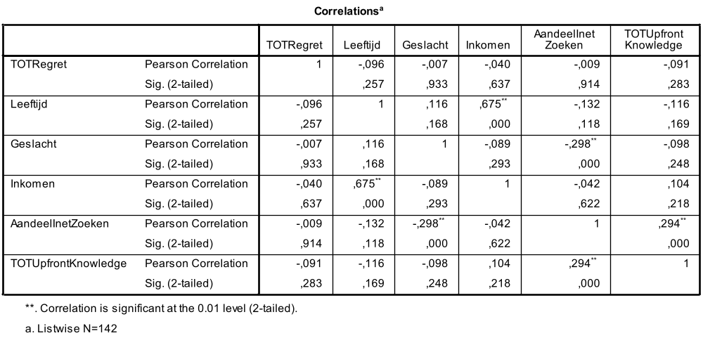

Appendix E

Logistic Regression Hypothesis 1

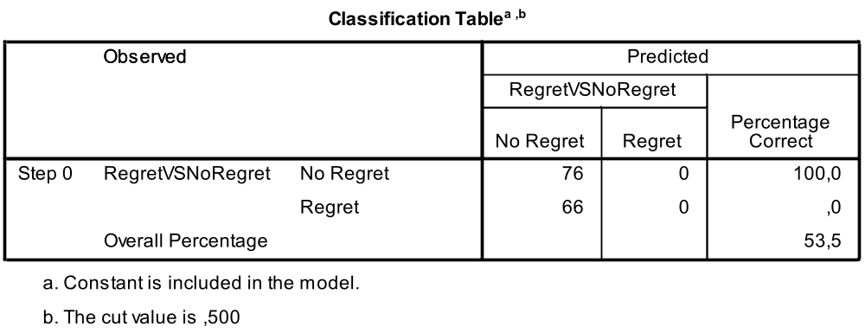

Block 1: Method = Enter

Omnibus Tests of Model Coefficients
 |  | Chi-square | df | Sig.
Step 1 | Step | 5,908 | 3 | ,116
Step 1 | Block | 5,908 | 3 | ,116
Step 1 | Model | 5,908 | 3 | ,116

Model Summary
Step | -2 Log likelihood | Cox & Snell R Square | Nagelkerke R Square
1 | 190,241ª | ,041 | ,054
a. Estimation terminated at iteration number 3 because parameter estimates changed by less than ,001.

Classification Tableª
 | Observed |  | Predicted
 |  |  | RegretVSNoRegret |  | Percentage Correct
 |  |  | No Regret | Regret | Percentage Correct
Step 1 | RegretVSNoRegret | No Regret | 53 | 23 | 69,7
Step 1 | RegretVSNoRegret | Regret | 38 | 28 | 42,4
Step 1 | Overall Percentage |  |  |  | 57,0
a. The cut value is ,500
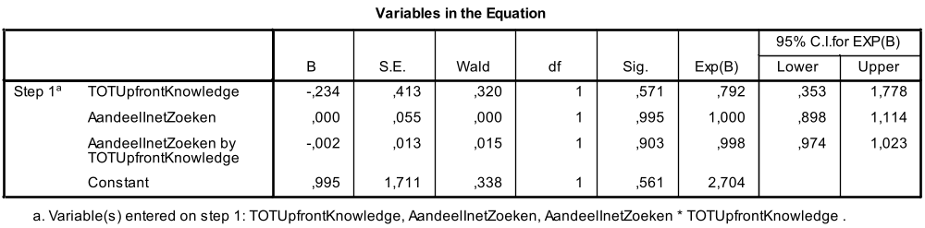

Logistic Regression Hypothesis 1 without interaction effect

Block 0: Beginning Block

Block 1: Method = Enter

Omnibus Tests of Model Coefficients
 |  | Chi-square | df | Sig.
Step 1 | Step | 5,893 | 2 | ,053
Step 1 | Block | 5,893 | 2 | ,053
Step 1 | Model | 5,893 | 2 | ,053

Model Summary
Step | -2 Log likelihood | Cox & Snell R Square | Nagelkerke R Square
1 | 190,256ª | ,041 | ,054
a. Estimation terminated at iteration number 3 because parameter estimates changed by less than ,001.

Classification Tableª
 | Observed |  | Predicted
 |  |  | RegretVSNoRegret |  | Percentage Correct
 |  |  | No Regret | Regret | Percentage Correct
Step 1 | RegretVSNoRegret | No Regret | 54 | 22 | 71,1
Step 1 | RegretVSNoRegret | Regret | 38 | 28 | 42,4
Step 1 | Overall Percentage |  |  |  | 57,7
a. The cut value is ,500
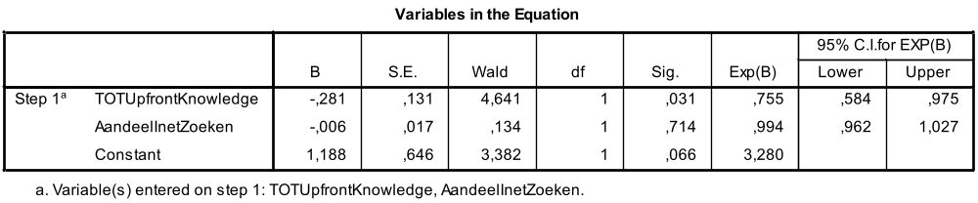

Anova Share of Internet Use VS Certainy about preferences

ANOVA
AandeelInetZoeken
 | Sum of Squares | df | Mean Square | F | Sig.
Between Groups | 990,652 | 1 | 990,652 | 8,792 | ,004
Within Groups | 15774,089 | 140 | 112,672
Total | 16764,741 | 141
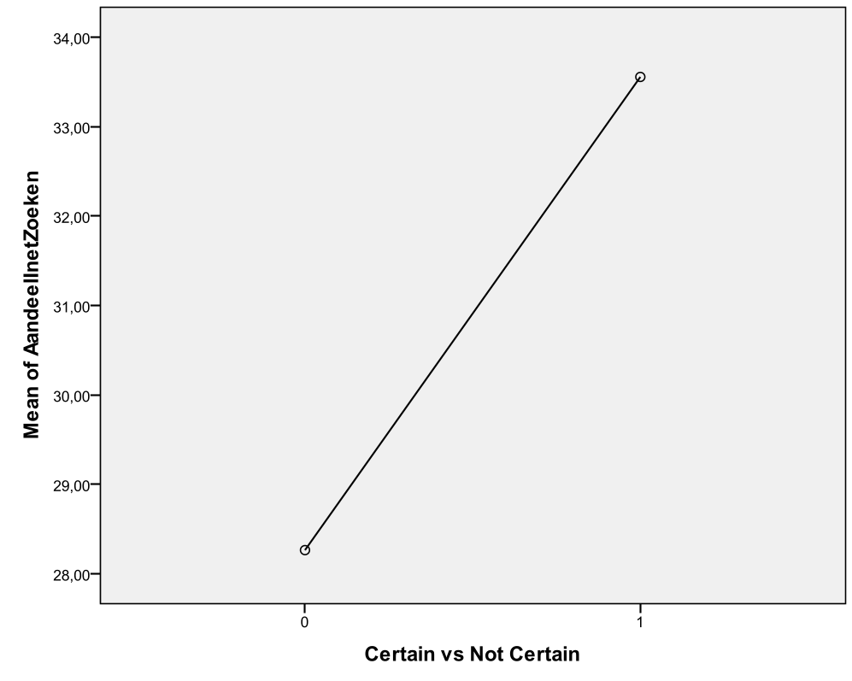

Appendix F

Logistic Regression Hypothesis 2

Block 0: Beginning Block
Classification Table^{a,b}
 | Observed |  | Predicted
 |  |  | RegretVSNoRegret |  | Percentage Correct
 |  |  | No Regret | Regret | Percentage Correct
Step 0 | RegretVSNoRegret | No Regret | 76 | 0 | 100,0
Step 0 | RegretVSNoRegret | Regret | 66 | 0 | ,0
Step 0 | Overall Percentage |  |  |  | 53,5
a. Constant is included in the model.
b. The cut value is ,500

Block 1: Method = Enter
Omnibus Tests of Model Coefficients
 |  | Chi-square | df | Sig.
Step 1 | Step | 11,080 | 3 | ,011
Step 1 | Block | 11,080 | 3 | ,011
Step 1 | Model | 11,080 | 3 | ,011

Model Summary
Step | -2 Log likelihood | Cox & Snell R Square | Nagelkerke R Square
1 | 185,069ª | ,075 | ,100
a. Estimation terminated at iteration number 4 because parameter estimates changed by less than ,001.

Classification Tableª
 | Observed |  | Predicted
 |  |  | RegretVSNoRegret |  | Percentage Correct
 |  |  | No Regret | Regret | Percentage Correct
Step 1 | RegretVSNoRegret | No Regret | 50 | 26 | 65,8
Step 1 | RegretVSNoRegret | Regret | 26 | 40 | 60,6
Step 1 | Overall Percentage |  |  |  | 63,4
a. The cut value is ,500

Variables with Knowledge Extending Research Shopper as reference category

Categorical Variables Codings
 |  | Frequency | Parameter coding
 |  | Frequency | (1) | (2) | (3)
Type Research Shopper 3 | Knowledge Extending Research Shopper | 30 | ,000 | ,000 | ,000
Type Research Shopper 3 | Certain Research Shopper | 63 | 1,000 | ,000 | ,000
Type Research Shopper 3 | No Research Shopper | 13 | ,000 | 1,000 | ,000
Type Research Shopper 3 | Channel Benefit Research Shopper | 36 | ,000 | ,000 | 1,000

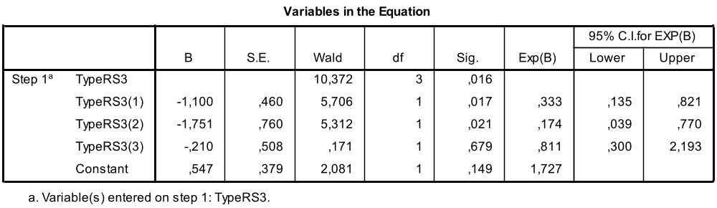

Variables with Certain Research Shopper as reference category

Categorical Variables Codings
 |  | Frequency | Parameter coding
 |  | Frequency | (1) | (2) | (3)
Type Research Shopper 2 | Certain Research Shopper | 63 | ,000 | ,000 | ,000
Type Research Shopper 2 | No Research Shopper | 13 | 1,000 | ,000 | ,000
Type Research Shopper 2 | Knowledge extending Research Shopper | 30 | ,000 | 1,000 | ,000
Type Research Shopper 2 | Channel Benefit Research Shopper | 36 | ,000 | ,000 | 1,000

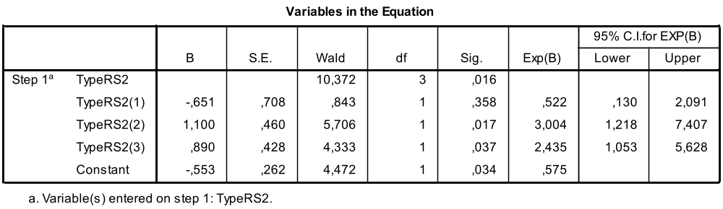

http://www.google.com, 2011
http://www.worldwidewebsize.com/
Crotts JC (1998)
Verhoef, Neslin, Vroemen (2007)

