

The effects of store differentiation factors on price levels.
Online consumer electronics stores in the Netherlands.

ERASMUS UNVERSITY ROTTERDAM
Erasmus School of Economics

Supervisor: Vijay Ganesh Hariharan

Name: Petru Didenco
Student Number: 303557pd
E-mail: p.didenco@gmail.com

Contents

Abstract 3
1. Introduction 4
2. Literature review 10
3.Data 17
4. Methodology 27
5. Regression results 31
6.Managerial and economical implications 39
6.1 Managerial importance 39
6.2 Economical and scientific contribution 39
7. Concluding discussions 40
Appendix 42
References 2

Abstract

The fundamental objective of this paper is to identify the factors responsible for the existing price differences across consumer electronics stores. The research will be concentrated on 115 online stores functioning in the Netherlands; this number incorporates both pure e-tailers and so called brick-and-click stores. By focusing just on the Dutch market I am trying to account for possible market-specific price shaping factors.
The specific emphasis of this paper is focused on firm characteristics; I distinguish three dimensions on which firms heterogeneity can be responsible for the different price levels: type (pure e-tailer or brick-and-click), size and quality. All of the three dimensions are described by more than one variable.

In this research I use linear regression and find statistical evidence suggesting that quality aspects such as process handling, aftersales service and online support do indeed have an influence on average price levels of an e-tailer.
Moreover I find supportive evidence for the hypothesis that brick and clicks are more expensive than pure play e-tailers. I also find that prices continue to rise when more employees are hired, keeping the number of offline shops the same.
Additional finding is that product spread is also a factor of influence for price levels.
I find no evidence that large number of products offered by the retailer has any influence on the price levels. Also no evidence is found to confirm the effect of additional payment methods on the average price levels.

Introduction

Internet as we know it nowadays can be rightfully considered to be one of the greatest inventions in human history. It allows connecting previously unimaginable numbers of individuals all around the world. In the early days, Internet was a luxury available just to the US government, later it also became possible for universities and libraries to: connect, share, and distribute knowledge and information. Until the early 90’s it was prohibited to use the network for purposes other than those directly contributing to or serving the research. This was mainly because the infrastructure belonged to the United States government. However in the beginning of the 90’s small commercial networks started to appear, this networks were relying on their own infrastructure and thus were fully independent from the government. As more and more of these networks appeared across the US, there was an urging necessity to interconnect them for intranet communications. Linking them together allowed the information to be routed across these networks, now however, it could be done by firms and individuals unaffiliated with these companies. In other words the networks became accessible, almost anybody could make use of the backbone infrastructure.
Around the same phase Internet was commencing to become an approachable place not just for individuals with IT back background but also for regular public. New networking protocols such as www (world wide web) were implemented.
The prevalent enhancement to the Internet development however was given by the creation of the web browser. Information could now be represented in a much more welcoming graphical way.
By the end of the 90’s Internet has become “the place” for those who wanted to cover wide territories both geographically and economically. Internet has become a market of its own.
Enormous amounts of e-shops appeared on the web but also huge amounts went bankrupt in consequent years as a result of aggressive competition and fast moving pace. This was later called the burst of the Internet bubble.

Currently, Internet retailing plays a significant role in global and local economies. In 2010 Internet retailing to general public has generated $316.9 billion, a number more than twice higher than in 2005.
In the Netherlands Internet retailing is accountable for €3 billion worth of sales (2010) a 15% the upsurge over 2009. Euromonitor prognoses that Internet retailing will continue to propagate at a persistent 10% yearly rate through the following years and will eventually reach €5 billion by 2016.

Dutch Internet retailing: Trends and predictions

Though the growth of Dutch Internet retailing is still robust, it starts to show the first signs of maturity. Growth rate is beginning to diminish as e-market reaches its saturation. According to Thuiswinkel.org (non-store retailing association) Netherlands had more than 20,000 e-shops in 2010.
The fastest growing sectors in online retailing are clothing and footwear; these sectors exhibited a 28% growth in 2010. Second place by growth belongs to consumer healthcare with 18.3%. Consumer electronics sales value has increased by 10.4% between 2009-2010.
Total growth of Internet retailing in the Netherlands consisted of 15.4% increase for the same period.
Currently population aging is considered to be one of the biggest threats Internet retailing poses. Population of senior citizens is expected to be 3 million by 2015. This presents a challenge for e-tailers because they have to somehow break the intimidation barriers seniors have towards Internet shopping.

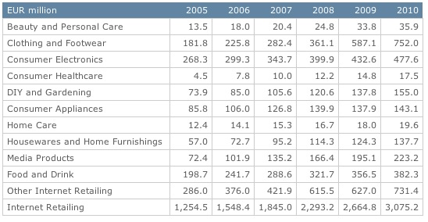
Figure1: Dutch Internet Retailing by Category: Values 2005-2010

Source: Euromonitor, www.portal.euromonitor.com

In the beginning of the last decade economists predicted the start of the Internet retail era that with no doubt would lead to the end of conventional retail stores. Experts believed that low or almost negligible search costs on the Internet would imminently lead to the reign of the law of one price. This wasn’t a totally wrong assumption to make given the openness and wide availability of information on the web. To be clear this doesn’t only relate to consumers but also to the sellers. Internet enabled businesses to better learn their environment, both from their customer and competitor’s point of view.
However, as the years passed we still didn’t see total equalization of prices. Research (discussed in the literature review section) shows that price levels vary across both online and offline stores.
There are several reasons that might explain the failure of the law of one price in this case, here are some of the possible causes: consumer search behavior, shop differentiation, product brand influence, shop image influence, market saturation and competition levels.
Consumer search behavior is an important factor that could be responsible for price differences across stores. All humans are different and so are their subjective utility functions and reservation prices for a certain product or service. In other words we do not always go for the lowest price but instead we stop searching when our internal conditions are satisfied. One more aspect of the search behavior is the amount of knowledge a customers have. One’s ability to search may be limited by the number of shops he/she knows. Usually, in real-life situations the search process goes no further than a couple of biggest or most common sellers. Moreover, a survey conducted in US has shown that for categories such as groceries most of us are one-brand consumers; meaning that most of the time we shop for groceries at the same store, although it is not economically rational in any way.

Store differentiation is yet another important factor that could influence pricing strategies. Although at the first glance it may seem that online stores offering similar products are by default alike, this is not always the case. Online retailers have several degrees on which they could differentiate themselves from competition: friendliness of the site, easiness of navigation, online support, delivery, aftersales support and return policies. Generally store differentiation factors can be seen as the quality of the retailer. If in a regular retail store the customer can address his questions to the sales force personnel, in online store on the other hand, the site itself provides the most common information about the product. The extent to which this is done can vary widely across different online stores. Some stores may help find products that satisfy specific needs of the potential customer.
Aside from the benefits of having good online support and extensive product information there is also a disadvantage to it. It can arise from a phenomenon called customer freeriding. Meaning that customers may exploit or extract all the information they need and then purchase the product from a discounter or any other shop that offers a better deal. Thus it is a dangerous practice for e-tailer and retailers in general to offer too much pre-purchase service, especially if such service requires significant time or financial investment.
Retailer image is also an important factor for the price formation process.
A branded retailer, when compared to an unknown one, can find himself in a profitable situation when it comes to pricing. Retailers with high awareness tend to charge higher prices on average (Chen, 2001).
We all know about brand loyalty, but there is also another type of loyalty, store loyalty. Store level loyalty has been shown to exist both offline and online. Unlike brand or product loyalty, this type of loyalty is not linked to the product but to the store itself.
Economic theory suggests that lower search costs should incline clients towards a more extensive pre-purchase search and make them go for the best bargain. This is under the assumption that people are economically rational. However rationality and loyalty do not live together. Severe cases of extreme loyalty may even be considered as total irrationality. Although loyalty may not be taken into majority of equations and models, it still is an important component of consumer utility.

In addition to the things mentioned above I would add that the availability of information itself does not mean that the information is perfect; more than that, the search costs are not totally absent from the equation because time too is a scarce resource.

When measuring price differences at the store level it is very important to account for product portfolio of a given store because some products have a manufacturer-enforced price. The manufacturer sets a minimum or maximum price for a certain product; the seller then agrees to sell that product without exceeding the agreed limits. Apple Corporation would be a good example of such a manufacturer; pricing policy that Apple enforces coexists in a close relation with their brand policy. Image is an important factor in Apple’s pricing, thus a low price for a laptop for example would negatively influence the overall brand image.

This paper is organized as follows: In section 2 I describe relevant literature and most important findings. Section 3 describes data collection process and the variables used in the model. Section 4 describes methodology used in this paper and shows the model improvement steps. In section 5 I present regression results and compare my expectations with the actual outcomes. Section 6 describes managerial and economic implications. Section 7 presents conclusions, discussion and drawbacks.

Literature review

This research is focused on the effects of store differentiation factors on price levels of the store. The terms “price levels” and “price dispersion” although denoting different things, may sometimes be similar depending on the context. Even in literature these terms are sometimes mixed. For the sake of clarity I will use “price dispersion” in order to denote difference in price for the same product or service sold by different retailers. I will use the term “price level” to denote the average price of the totality of products of a particular retailer.

When speaking about price dispersion and price levels in general there are several directions or streams, each focusing on important aspects of the topic. The first branch of the stream is the division into off-line and online markets. In the days when computers were not as common as today, it was very hard if not impossible for researchers to collect and analyze large amounts of data. A medium-sized research of a supermarket chain for example would require huge effort, time, labor and financial resources. Because of this there are very few works that account for the time aspect as time comparison would require repeated data collection, which is costly.
However such research exists, (Eckard, 2004) used a unique government survey conducted in 1901 to find whether price dispersion existed back then. Aside from showing that prices for identical products were also different back then, Eckard has identified the factors that influenced the price levels for several product categories; He showed that price variation between cities was higher for more expensive products because such products involved higher search and transportation costs. From this research we see that price influencing elements such as search costs and some embryonic service elements existed back then. Although these elements were not so obvious as nowadays, they have still played an important role in the price formation process.

When Internet became accessible to wider auditory it opened the floodgates of a huge information dam. Internet shops were popping up very fast. Some of these shops still exist today while some of them did not survive the shakeout phase of the Internet bubble. Information technology was evolving at a progressive rate, computing power and storage capacity were getting both better and cheaper at the same time. Breakthroughs in data storage and manipulation technologies allowed the databases to be linked directly to the store site thus giving birth to price comparison sites. The chain of events mentioned above has conditioned the start of a new wave of interest from researchers. The main focus of researchers gradually switched towards online markets.
(Baye and Morgan, 2001) provide a good theoretical background on pricing strategies and introduce the term “information gatekeeper”, authors consider a market where the keeper is a profit maximizing firm which collects product information from the sellers and then offers it to the potential buyers. This however is not done free of charge, both parties pay for the information. The seller pays a fee to get the price listings into the system. The buyer on the other hand pays to get the access to the totality of all price listings. The extent to which the system is active determines competitiveness levels in this market, which in its turn affects consumers demand for information. The findings suggest that the equilibrium is found when:

- Consumer fees are set at such a level that would motivate all the consumers in the market to subscribe, i.e. when the entry barriers for the consumers are extremely low.
- The prices for the firms willing to advertise are set above the social optimum level, such that would only induce partial participation by the firms.
- Prices listed by the sellers have to be lower than those of unadvertised sellers.

Surprising thing is that given this setting, which implies that consumers only go for the lowest price offer, prices still vary, meaning that price dispersion is a result of equilibrium.
(Pan et al., 2003) also conduct a study on price dispersion evolution. This paper is focused on price dispersion behavior after the burst of Internet bubble. Authors analyze data from years 2000, 2001 and 2003. The results have shown that price dispersion did indeed decline between the years 2000 and 2001 however this was considered to be a result of the market shakeout after the bursting of the Internet bubble. The reason for that is the fact that price dispersion started to rise again after 2001. The increase was especially large for a certain category of products such as: notebooks, desktops, PDAs and software. The results of the two articles mentioned above show once more that price dispersion is not a question with one answer. Aside from availability of information and search costs there are many other factors that could influence the dispersion of prices both online and off-line.

(Chen and Hitt, 2003) built a theoretical model including two interaction effects: brand sensitivity of the consumers and their limited knowledge about the products. Besides confirming existent theories authors have several complementary findings that shed more light on the structure of prices:

- A branded retailer will on average charge higher prices than a generic retailer, given that the pricing is not below marginal cost. In some cases e-tailers may follow the path of price randomization and use mixed pricing strategy. In this case branded retailers may offer a lower price for a certain product for a certain period of time. Sellers prefer to use randomization strategy in a case when search costs are not symmetric across customers and sellers. On average a branded retailer will charge higher prices than a generic one although his price is not always the highest.

- In this finding authors suggest a possible answer to the problem of prices in e-markets. Why is price variation so common in this market? This could be due to the fact that e-markets are not yet mature. Authors suggest that consumer awareness will never converge because it is a result of an equilibrium state. Although e-shops may improve awareness levels by advertising themselves, it makes no sense for them to do so because aside from awareness it also increases competition. Thus leading to lower prices and as a consequence lower profits.

Online retailers can differentiate themselves on several levels, this includes: overall look and feel of the site, reliability, shipping process handling, fast delivery and extensive product information.

As found by (Pan and Ratchford, 2001) market characteristics do indeed influence prices online. Authors have a four-step approach to the problem that includes using factor analysis, identifying clusters, regression analysis and hedonic regressions. Among other things they find out that shops with higher than average price levels also exhibit higher price dispersion.
In their later work (Pan et al., 2002) find evidence that service quality can only partially explain the pricing of an e-tailer. Being a brick-and-click seller is also shown to influence the final price. But the greatest driver of pricing strategy is the number of competitors.

In economics, high levels of competition are considered to be one of the most important sources influencing the price. Competitive markets are typically very beneficial for customers seeking good quality for democratic prices; competitors on the other hand have to struggle for these customers. In the early days it was considered that price is the only means of differentiation for online retailers. The reason for such beliefs was competition. Experts predicted that fierce competition would force online e-tailers to lower their prices constantly, however, what we see is that e-tailers have found other ways to differentiate themselves from their competitors. Such differentiation allowed them not to lower their prices. Moreover as found by (Venkatisan et al., 2006) e-tailers who offer better service benefit from higher competition levels through better differentiation. By using multilevel hierarchical linear models authors find out that service quality has a positive effect on retailer price levels. Using the same methods authors discover that relation between competitive intensity and the price levels can be described as an inverted parabola. These finding are nothing more than empirical proof of mixed pricing strategies.

(Venkatesan et al., 2007) have several findings one of which supports the competition idea while the other one states that service quality has a significant impact on pricing. Although the finding about service quality does not come in contradiction with any of the previous findings, the amount of influence it executes does. (Venkatesan et al., 2007) also find evidence that there is an interaction between market and e-tailer characteristics.
Authors find evidence that brick-and-click retailer charge significantly higher prices than pure e-tailers do.

The second stream of research focuses on the factors that enable both brick-and-click and pure-play players to charge certain price levels. If we take the 4 p’s (Product, Price, Place, Promotion) of marketing and try to apply them to an e-tailer, we will immediately see that Place becomes irrelevant when we move to the Internet. To compensate, e-tailers have to find new ways to differentiate themselves. (Cazier et al., 2006) focus their attention on this issue and come up with a term ”value congruence”. In simple words, value congruence is the measure of the overlap between the values of customers and the values they believe an organization has. Sharing and conveyance of these values produces trust, trust that helps building the relationship between the customer and an e-tailer. Authors believe that relationships built as a result of value congruence are stronger and thus will last longer than those created by other means.
Value congruence can be created almost from any differentiation point of a firm as long as it is steady in time. If values propagated by the firm are changed too frequently value conflicts may arise. In other words, if a firm promotes high quality service while offering slightly higher prices, it should stick to this strategy for a certain amount of time in order to let the “value-match” settle in the minds of the consumers. When the match is more or less stable, e-tailers can charge even higher prices without being punished by decreased sales.

Service quality and customer satisfaction have been shown to directly influence customer purchase intentions. (Lee and Lin, 2005) have developed an instrument to examine and measure the dimensions of service quality in order to see the effect on the buying decision. After analyzing the data authors come to a conclusion that customers see service quality as integral thing, they do not evaluate separate aspects and components prior to making a purchase decision.

Given the focus of this paper and the literature I have developed 2 hypotheses that reflect the main questions:
H1: Pure e-tailer stores are cheaper than brick-and-click stores.
H2: Stores with better service have higher prices than those with lower service.
The reviewed literature supports all of the hypotheses. However, because I focus specifically on consumer electronics retailers in the Netherlands, as a consequence of local market specifics we may witness some unexpected results.

Literature comparison can bee seen in Table1. In general there are no contradictions in the examined papers except for some minor ones. I arranged the papers in chronological order so that the time evolution of research could be seen. The fact that there are no big contradictions between the papers is due advancement of research. Later papers are usually the extension of previous work, thus giving more insights and proofs.

Table1: Literature summary

Paper | Strengths | Weaknesses
(Chen, 2001) | Theoretical analysis | No empirical support
(Baye and Morgan, 2001) | Strong Econometrical model | Only accounts for market characteristics
(Pan and Ratchford, 2001) | Extensive research using 4 methods of approach | Does not account for time
(Pan and Ratchford, 2002) | Accounts for both market and store characteristics | Executed during the shakeout period
(Chen and Hitt, 2003) | Give possible explanations of fluctuation in price dispersion | Not much empirical evidence for flexible pricing
(Pan et al., 2003) | Study of price dispersion over a period of 3 years | Products compare in time are not exactly the same
(Baye et al., 2004) | Examines over 4 million price observations | Data collected during the shakeout period
(Lee and Lin, 2005) | Uses modified SERVQUAL model adapted for online environment | Focuses only on bookstores, limited generalizability.
(Cazier et al., 2006) | Introduces a direct link between service quality and customer purchase intensions | Uses a hypothetical website in the experiment setting.
(Venkatesan et al., 2006) | Focuses on market characteristics | Does not focus on shopper characteristics
(Venkatesan et al., 2007) | Focuses on market characteristics | Does not focus on shopper characteristics

3.Data

For my research I rely on the pricewatch database of the tweakers.net site. The tweakers.net project was started in 1998. Since then it has become the biggest and most popular site in the Netherlands for everything related to computers, consumer electronics and technology in general. The sections of the site cover a very wide area of the IT world in the Netherlands, this includes: prices, reviews, demand & supply, forum, community and even a Job market for IT professionals.
I consider that tweakers.net database fits the best with my purpose of research because it is specifically focused on consumer electronics. Big advantage of tweakers.net is that they offer a software package called PWM (pricewatch manager). With the help of this package Internet retailers can connect their databases directly to the pricewatch section of the tweakers.net. This has several advantages over other price comparison sites:
- The chance of an error is reduced because the prices are updated directly through the database so there is no need to manually collect and post prices. This gives both speed and precision.
- The updates can be much more frequent than it would be possible using conventional systems. Shops decide when to update prices, product descriptions, store information etc.
- Product assortments of entire shops can be categorized and sorted, this gives the users of the site a bird’s eye view of a particular shop. Each shop listed on tweakers.net has its own page where users can read all the contact info, payment and delivery methods available, price rating and reviews.
- An e-tailer that uses the pricewatch has the possibility to track its own historical data. This useful feature gives the managers a possibility to analyze their past actions or strategies and compare them against the obtained sales numbers.
- Depending on the type of the chosen package price manager can offer the manager competitor’s prices that are sorted and linked to own prices. This allows the e-tailer to dynamically adjust their pricing policy/strategy.
- The price manager software is very flexible and can be custom tailored to the needs of a particular e-tailer. The pricing of price manager is also flexible thus allowing both big and small players to make use of it.
- The information available on the site is free to consumers as opposed to consumentenbond.nl for example.
The site generates about 3 ½ millions unique visits a day, which is a huge number considering that the population of the Netherlands is roughly 16 million. Please see figure 2 for the tweakers.net daily visits graph.

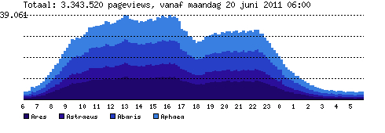
Figure 2: Tweakers.net unique daily visits graph 20th June 2011 (The different shades of blue indicate the server to which the connection was redirected.)
Source: www.tweakers.net 2011

The pricewatch section contains 572,592 products with 2,736,961 prices from 288 shops.
Shop comparison price ratings are calculated and restructured on a daily basis.
From 288 e-shops available on tweakers.net I have selected 115 sellers for whom absolutely all the data entries were available. (Please consult Figure 3 at the end of this paper).
We know that the menu costs on the Internet are considerably lower than in regular shops, e-tailers can modify their prices with any desired frequency, sometimes this can happen more than once a day. Because of this fast-paced fluctuations and the fact that tweakers.net renews their price ratings everyday, my numbers had to be collected in one day in order to preserve the desired accuracy.
For the purpose of this research and for what I planned I needed a variable that would serve as an indicator of firm size, unfortunately such information was not publicly available for all the shops in my dataset. For these reasons I had to resort to the paid data offered by KvK Netherlands, the Dutch trade organization (Kamer van Koophandel). From their database I have obtained the number of employees of each firm who are officially registered as either fulltime or part-time personnel. The data is for 2011.
In this section I will describe the shop Characteristics I use in my model as well as the notation for each variable.

Price rating- Is the dependent variable of my model, as the name suggests it symbolizes the overall shop price rating when paralleled to the average price throughout all shops. This figure is computed and revised everyday by tweakers.net. The indicator can be seen as a percentage rank, for example: a shop with a price rating is of 90 is 10% cheaper than the average shop, a rank of 110 would indicate a shop 10% more expensive than average.

Delivery rating- Represents customer’s satisfaction levels regarding provision of the ordered product. It is computed by averaging the total amount of grades left by the users who wrote a review or just left a grade. The rating is represented by number of stars from 1 to 5 including halves. The one thing that may not be clear from the name of the variable is that it does not only denote the delivery process executed by the transportation or the post company, but also the handling process of the shop itself: how fast is the order processed, how well is it done etc. For example some e-tailers offer extensive order status tracking possibilities such as: e-mail notifications and sms messages while others keep the clients in the darkness.
Another example is how well the e-tailer handles the stock. In other words this variable captures the whole order process, beginning from order placement and ending with the receipt of the goods.
Both intuitively and logically I expect delivery rating to have a positive relationship with the price rating because this variable captures the element of service quality offered by the retailer; and better service means higher prices.

Aftersales rating- Denotes customer’s satisfaction levels concerning aftersales service in case of underperforming or malfunctioning product. This includes warranty repair or return of the product. It is computed by averaging the total amount of grades given by the users who wrote a review or just left a grade. The rating is represented by number of stars from 1 to 5 including halves. This variable is yet another proxy for capturing aspects of service quality. However when compared to delivery rating we can see that it is focused on a totally aspect of service. The aftersales rating can be viewed as an indicator of the firm’s attitude to existing clients. Aside from malfunctioning or defective products it includes: servicing of products that are already out of warranty or just aftersales consultation in a case when consumers have technical difficulties with a product. From my own experience I know that some retailers handle warranty problems on their own while others tend to push the customers away to the manufacturer motivating it by saying “we are just a selling products”.
Offering great aftersales service may be costly for the retailer, it may require to have right facilities, personnel training, warranty handling outsourcing contracts etc.
For the reasons mentioned above I expect to see a positive influence of aftersales rating on the price levels.

General rating- Although I have gathered the general ratings for the shops I had to exclude this variable from the model because it was highly correlated (more than 0.6) with the two ratings mentioned above.
The economical and/or intuitive explanation for such a behavior is simple, when customers are satisfied by aftersales and handling services it is natural for them to assign the shop a high overall rating.

Total nr. of SKUs- Is the total number of products offered by a particular store. I use this variable as a partial indicator of a firm size. Economical thinking suggests that firms offering a very large amount of products would also offer lower prices because of the economies of scale, better relations with suppliers etc.
I expect to se a negative relation between total number of sku and the dependent variable in my model.

Offline presence- A dummy variable specifying whether a particular e-tailer belongs to the pure players or to the brick-and-click group.
Economical theory and existing research (Friberg et al., 2001) suggest retailer who have a multichannel distribution system will have higher prices than those who only sell online. I do not expect to find any contradicting evidence to this.
Higher prices may exist as a result of higher cost of offline presence (rents, taxes, utility costs etc.).
Thus In my result I expect to see a positive effect of offline presence on the price levels.

Number of shops- Denotes the number of offline stores available in case it is a brick-and-click store. This variable is used in the computation of the relative number of employees, it will be described later in this section.

Certificate- Is a dummy variable specifying whether the e-shop has a certificate issued either by thuiswinkel.org or qshops.org. The certificate is an indication of decent confidence towards the store, meaning that this site respects the fair code of conduct towards the customers, respects the 14-day return policy and handles all the customers correspondingly. The certificate is not an assurance against financial or other dangers, it is there to show customers that this particular shop can be trusted, that its policies/user agreements have been reviewed and are not trespassing the law.
I see two scenarios of how the presence of a certificate could or could not affect price levels of a given shop: 1.Customers may perceive the shops with certificates as high quality retailers. Thus empowering e-shops to raise their prices. 2. Majority of market players would probably choose to be certified, as this does not involve any significant costs. This in its turn would lead the absence of differentiation and thus to no means of exploiting the certificate.

Payment method- A dummy variable showing the acceptance of additional payment methods apart from Dutch iDeal, regular bank transfer, acceptgiro. Among such methods are: PayPal, rembours (payment to the courier by delivery), ClickAndBuy, Visa, MasterCard and payment in installments.
I have a mixed prediction about the effects of this factor. On the one hand additional payment methods can be interpreted as a supplement to service quality and thus cause higher expenditures for the seller. On the other hand additional payment methods can lower the entry barriers for the consumers making it easier to purchase the products. Although such a relationship may seem vague at a first glance, I believe that lower entry barriers may eventually lead to more customers, more sales and ultimately to lower prices.

Online support-A dummy variable indicating the presence of online support, this includes: online chat, Skype, callback service, and free support lines. By this variable I would like to capture yet another service aspect of the shop. Regular on-site e-mail forms are not counted, although this is a variation of online support, it is in most cases not fast enough. Online support plays a crucial role in a situation when customer’s search comes to an informational dead-end, when product information available on the site does not suffice the needs of the customers.
I predict this factor to have a positive relationship with the dependent variable because offering this kind of service requires personnel that is both knowledgeable and trained to handle customers.

Relative number of employees- As the name implies, this variable represents the relative number of employees. It is calculated by dividing the total number of employees officially registered in the firm by the number of offline shops this firm has +1. I expect this variable to be a good indicator of the firm magnitude and a cost driver eventually leading to higher product prices.
Ex ante I expect it to have a positive relationship with the price rating as more employees generate more labor costs for the firm. Of course I realize that the opposite can happen because aside from labor expense workers also generate sales and thus more profits for the firm. But, given the fact that Netherlands is a developed country and educated labor force is one of the most expensive resources I still believe I will se a positive relation between relative number of employees and price rating.

Low variety- This dummy indicates the level of variety of products available in a particular store. Variety, or in other words assortment should not be confused with total sku. Variety shows the width or spread of the shop. For example, a shop that is specialized in notebooks has a low variety. A shop that sells everything from computer mice to fridges has a high variety. Everything in between is considered to have a medium variety.
To highlight the difference from total sku indicator imagine a shop that sells only laptops but has lots of them, such a shop has low variety but high total sku. Vice versa, a shop selling a cd, a laptop and a washing machine has only three SKUs but a large variety.
Of course there are shops that have both lots of products and a high variety, for example MediaMarkt.
Generally I expect to see a negative relation with price rating because shops with low variety are specialized shops. This makes it easier for them to cope with competition and pricing strategies.

High variety- Is the direct opposite of the previously described variable.
I expect to see a positive relationship with the price because high variety involves more business difficulties such as: competing with specialized shops, developing relations with the suppliers of wide range of products, logistical difficulties etc.

Table 2 presents a clearer view of the predictions I made in this section.
Table 3 presents the descriptive statistics for the dataset; it includes a brief description of the variables and data sources that were used to collect the data.

Variable | Expected relationship | Justification
Relative number of employees | positive | Costly labor
Total number of SKUs | negative | Economies of scale
Certificate | negative/positive | No differentiation/perception of quality
Payment method | negative/positive | Lower entry barrier/supplement to service
Aftersales rating | positive | Costly quality service
Delivery rating | positive | Costly quality service
Online support | positive | Trained personnel
Offline presence | positive | Costly offline presence
Low variety | negative | Specialization
High variety | positive | Lower transition efficiency
Table2: Predictions summary

E-tailer characteristics |  | Source | Observations | Min | Max. | Mean | Std. Dev.
Total number of SKUs | Total stock keeping units available in the e-shop | tweakers.net | 115 | 32 | 26,4220 | 16,081.08 | 39,370.227
Certificate | Dummy indicating the presence of a conformity certificate | * | 115 | 0 | 1 | 0.600 | 0.492
Payment method | Dummy indicating the presence of additional payment methods | * | 115 | 0 | 1 | 0.470 | 0.501
Offline presence | Dummy indicating the offline presence of a shop | * | 115 | 0 | 1 | 0.570 | 0.498
Aftersales rating | Aftersales rating awarded by the customers | * | 115 | 1 | 5 | 3.591 | 1.160
Delivery rating | Delivery rating awarded by the customers | * | 115 | 1 | 5 | 3.865 | 0.956
Online support | Dummy indicating the presence of online support | * | 115 | 0 | 1 | 0.440 | 0.499
Low variety | Dummy indicating a narrow assortment of goods | * | 115 | 0 | 1 | 0.360 | 0.481
High variety | Dummy indicating a wide assortment of goods | * | 115 | 0 | 1 | 0.270 | 0.446
Relative nr. of employees | Number of firm's employees divided by the number of offline stores | KVK | 115 | 0.5 | 284 | 10.317 | 29.898
* tweakers.net | KVK (Kamer van Koophandel)
Table 3: Descriptive statistics

4. Methodology

The purpose of this paper is to study the relationship between the price levels and store differentiation factors in Internet retail and especially in the consumer electronics area. As shown by (Pan et al., 2002) some of the price variation is indeed explained by the differences in store characteristics. I believe store heterogeneity effects are underappreciated in in the existing research. This paper particularly focuses on three levels of store differentiation:

- Player type – pure player vs. brick-and-click. Given the fact that Netherlands is not one of the cheapest countries to live and work in, with relatively high tax rates, social security costs, real estate, transportation and holding costs. I believe that the expenses associated with offline retail may have an influence on the price levels and pricing strategies of e-tailers.
- Size of the store – measured several levels. Unfortunately not having the financial data of the firms used in my analysis makes it difficult to estimate the size basing on figures like turnover, units sold etc. However, the total amount of SKUs offered by the e-shop, the number of offline shops (if any) or the number of employees could be good indicators of company size.
- Service quality – It is always difficult to measure quality in terms of numbers especially if we talk about store quality and service quality. This is especially true online. The feeling of quality is highly subjective and can be disturbed by numerous factors. In this paper I rely on quality indicators such as: ratings given by the customers, delivery, support and aftersales. The paper by (Reibstein, 2002) sees quality and price as almost two distinctive objects. I however believe that higher store or/and service quality may result in two things: lower margins or higher prices. Given the fact that all commercial organizations are profit maximizers by nature, I believe higher service/quality levels should result in higher prices paid by customers.

For the purpose of this study I use linear regression to identify the factors that may explain existent differences in price levels between online stores selling consumer electronics in the Netherlands.
I run several variations of the model, beginning from the plainest one and progressively expanding it. The general form of the model is represented by (1).

$y_{i}=α+βx_{i}+ε_{i}$ (1)
Where y is an n-by-1 vector and x is an n-by-m matrix of retailer specific characteristics amongst which are the elements of my principal interest that were declared in the above section.

The final stage of model variation is represented by (2).

$Price rating=β_{0}+β_{1}{Relative .}_{i}+β_{2}{Total nr. SKUs}_{i}+β_{3}{Certificate}_{i}+β_{4}{method}_{i}+β_{5}{Aftersales rating}_{i}+β_{6}{Delivery rating}_{i}+ β_{7}{support}_{i}+β_{8}{presence}_{i}+ β_{9}{variety}_{i}+β_{10}{High variety}_{i}+ε_{i}$ (2)
I believe that this model should decently capture and represent the relationship between the price levels and store characteristics. It also should give an indication on the important dimensions of these characteristics and let us see which of them are important when it comes to pricing strategies.
Besides the variables mentioned in the equation there are other variables that could be of economic importance for this research. Among such variables are: free delivery and 24 hour delivery. Unfortunately these variables turned to express a high correlation with other elements of regression. For this reason I decided to eliminate them from my research in favor of the delivery rating variable, which essentially should capture the effects of both free and 24 hour delivery.
Next section presents the correlation table that depicts the correlations between all the variables used in this model. Please see Table 4.

Table 4: Correlations
Variables | Relative nr. of empl. | Total number of SKUs | Certificate | Payment method | Aftersales rating | Delivery rating | Online support | Offline presence | Low variety | High variety
Relative nr. of empl. | 1
Total number of SKUs | 0.067 | 1
Certificate | 0.099 | 0.232 | 1
Payment method | -0.094 | 0.134 | 0.341 | 1
Aftersales rating | 0.000 | -0.029 | -0.074 | -0.150 | 1
Delivery rating | -0.083 | 0.021 | 0.090 | 0.005 | 0.395 | 1
Online support | 0.203 | 0.153 | 0.300 | 0.317 | -0.033 | 0.007 | 1
Offline presence | -0.144 | 0.008 | 0.179 | 0.122 | 0.069 | -0.087 | 0.359 | 1
Low variety | -0.092 | -0.270 | -0.208 | -0.046 | 0.114 | 0.086 | -0.336 | -0.299 | 1
High variety | 0.153 | 0.284 | 0.296 | 0.292 | -0.090 | -0.048 | 0.365 | 0.256 | -0.452 | 1

As can bee seen from the table above, there are no coefficients with a correlation greater than 0.5 so it should not affect the results. As I will show in the model comparison table, the signs of the coefficients remain unchanged through the whole process of variable removal and introduction.

5. Regression results

In this section I discuss the results obtained from the model. I analyze the significance levels, coefficient magnitudes and the signs of the coefficients. For each variable I will describe things just mentioned, interpret the results from an economic standpoint of view and see whether my predictions/expectations are supported by the empirical results.

The regression results are presented in table 5. One of the first things we notice is that seven out of ten variables used in the model are statistically significant. Out of them: 5 are significant at a 5% level, 2 at 10% level and none at 1%. For certain variables the outcome is quite surprising, especially the sign.

Relative number of employees
The result is statistically significant at a 5% level. The coefficient has a positive sign, which is consistent with my initial expectations.
The magnitude of 0.045 may seem to be very small but we have to remember one thing: our dependent variable is a percentage number showing the overall price level of a shop, thus a unit increase of workers per shop would lead to almost 0.5% price rating increase all other things being equal.
I believe this to be an interesting finding especially in the case of e-tailers who do not have large networks of stores around the country. Because their employee per store ratio is small from the beginning, each additional worker increases the ratio a lot faster than it would happen for a bigger firm with more stores.
We know that doubling the number of employees does not necessarily mean double the effort or output either, but labor costs are generally doubled (if it is not performance pay). Hence the conclusion: smaller e-tailers are more sensitive to labor costs and thus have more sensitive prices.
The finding that more labor (when not exploited) leads to higher prices does not contradict any economic theory.

Total number of SKU
The resulted numbers are quite astonishing in a bad sense of this word. Coefficient magnitude is 0.000, more than that it is not statistically significant. Thus, in my model there is no statistical nor economical evidence that total amount of products has any influence on the store’s price levels.
This finding is unexpected in two ways: firstly on the theoretical level because we do not see the effect of economies of scale; secondly it does not match the finding from existing research i.e. (Baye et al., 2004).
Generally I believe the effect of the number of offered products on price should still exist although my model does not capture it. One possible reason for that could be in the fact that I use linear regression while the relation may be a non-linear one. It could be quadratic or a threshold-based one.

Certificate
I have predicted a positive relation between certificate presence and price levels. Although the coefficient is high enough to denote a relation and the sign is positive there is no statistical significance in it.
Increasing the sample size would not produce much change in the significance of the effect. I conclude that the presence of a certificate does not increase or decrease store price levels all other thing being equal.

Payment method
We see that the presence of additional payment methods has a negative relationship with the price rating. Such a sign supports the idea that extra payment methods may be responsible for an easier online purchase procedure and thus may lower the entry barrier for the customer. However the effect is not statistically significant (0.334) in this model, thus we cannot conclude anything about its actual influence on the dependent variable because there is not enough evidence.

Aftersales rating
As predicted in the Data section we observe a positive effect (0.810) that is significant both statistically (at 10% level) and economically.
However, given this relation one cannot declare that high or low rating by itself influences store prices. It is rather the cause of the rating that is positively affecting store prices. In other words higher prices are the effect of higher aftersales service levels. The rating itself is just a proxy that reflects customer’s perception of the service.
We could say that a rating increase of one star leads to a certain increase of the price but this would not be correct because a star is something subjective, something hard to measure in absolute terms.

Delivery rating
Given that delivery rating is another proxy for service, but unlike aftersales rating it focuses on the product handling process, I expected to see a positive relationship between product handling quality and store price rating. However, this is not the situation. What we witness is a statistically significant (at 5% level) effect with a negative sign (-1.197).
Such an unexpected result may be explained by several facts:

- The technological factors: More and more firms are moving to computerized and automated handling systems where less human time and effort is spent on logistical matters, meaning that in terms of order handling an additional order may produce little or no marginal cost at all.

- As the number of orders increases, a computerized of fully automated order handling system may start producing economies of scale. This way the handling investments are cancelled out by the resulting benefits.

Online support
Online support is probably one biggest service cost drivers for the retailer. A good support service requires the presence of trained and competent personnel that is able to provide solutions for the problems that may develop during the ordering process, usage of the product or just provide additional information about a product or service.
I expected to see a positive relation between online support and shop price rating. The relationship turned to be positive indeed, moreover it is significant both statistically (0.029) and economically. The magnitude of the effect is 2.720**.
Given the economical reasoning, the obtained result is not surprising, and is confirming existing research.

Offline presence
The difference between pure players and brick-and-click retailers has been widely discussed in the literature, also on the price aspect of the problem. Existing findings suggest that brick-and-click retailer’s prices are higher on average. I didn’t expect to find any evidence suggesting the opposite.
My results are consistent with existing research and theory. The effect of online presence on price levels is economically strong (2.659**) and statistically significant; the relation is a positive one, just as expected.
Having an offline store or showroom increases the average price levels of the firm by 2.659% all other things being equal.
As already mentioned in the data section, one of the several causes is the cost involved in having an offline store. Although results may vary on depending on the country, store type, industry etc. I expect the sign of the relationship to always remain positive, because having multiple channels of distribution may bring more sales but at the same time it increases the costs. Those costs are do not diminish with the increase of the number of shops. Aside from the fixed offline presence also brings many variable costs. Having more shops means more expensive logistics, longer lead times, more personnel, higher difficulty of control and lower efficiency in general.
In the near future pure player will probably continue to offer better prices than brick-and-clicks.

Low variety
A low variety of available products or in other words low spread signifies shop’s specialization in a particular product category. My expectations were to see a negative relation between low variety and average price levels. What we see from the results is indeed a negative relation with a magnitude of 3.078, which is significant at 5% level. This means that a highly specialized shop, on average, offers prices that are 3% lower than an average shop al other things being equal.
The economic reasoning behind this is that highly specialized retailers may get better deals from their suppliers because on average they sell more of the same brand’s products than an unspecialized retailer of comparable size does. Depending on the situation highly specialized shops may sometimes get favorable conditions or even exclusive rights for certain products.

High variety
For high variety I expected to see a positive relation for the reasons opposite to those named under the low variety description. If we look at the regression results we can see that my prediction did not materialize. We see that the relation is negative with a coefficient of 2.582 and a significance of (0.064).
The results are quite unexpected; the negative sign implies that retailers with a high spread of products offer prices that are 2.58 lower than in an average e-shop.
One of the possible economic explanations for this may be that the effect of economies of scope is playing a role here. Under the economies of scope here I mean the usage of already existing resources and infrastructure to expand product variety. Given that a firm started with a narrow specialization it is only natural to expand in order to reach higher margins and thus higher profits. Usually this happens when a highly specialized seller exhausts the possibilities or reaches an invisible barrier that prevents him getting more profit.
When expansion starts, the infrastructure, knowledge, business relations are already existing and working. The utilization of this existing foundation is used for future growth, hence the economies of scope.
The relation between price levels and variety of products is probably not linear; it is something with two extremes (high variety and low variety), both of which are beneficial for the retailer.

Please see Table 5 for a more visual representation of the regression results discussed above.

Table 5: Regression Results
Variable | B | Std. Error | t | Sig.
(Constant) | 96.663 | 2.483 | 38.927 | 0
Relative nr. of empl. | 0.045** | 0.018 | 2.448 | 0.016
Total number of SKU | 0 | 0 | 0.301 | 0.764
Certificate | 0.799 | 1.153 | 0.693 | 0.49
Payment method | -1.124 | 1.159 | -0.97 | 0.334
Aftersales rating | 0.810* | 0.486 | 1.667 | 0.098
Delivery rating | -1.197** | 0.586 | -2.041 | 0.044
Online support | 2.720** | 1.229 | 2.213 | 0.029
Offline presence | 2.659** | 1.176 | 2.261 | 0.026
Low variety | -3.078** | 1.252 | -2.458 | 0.016
High variety | -2.582* | 1.379 | -1.872 | 0.064
R 0.566
R² 0.321
Adj.R² 0.255

As can be seen from table 6 the model has an adjusted R² of 0.255. I consider this to be a decent result for such a simple model.
From the various combinations I tried, this model has the biggest R².

Table 6: Model Variations
 |  |  |  |  | Model
 | 1 | 2 | 3 | 4 | 5 | 6 | 7 | 8 | 9 | 10
Firm Characteristics
Relative nr. of empl. | 0.053*** | 0.052*** | 0.050*** | 0.048** | 0.048** | 0.044** | 0.029 | 0.042** | 0.040** | 0.045**
 | (.006) | (.007) | (.009) | (.013) | (.013) | (.022) | (.114) | (.027) | (.031) | (.016)
Total number of SKUs |  | 1.03E-05 | 6.83E-06 | 7.69E-06 | 7.74E-06 | 8.05E-06 | 4.73E-06 | 6.71E-06 | 2.65E-07 | 4.11E-06
 |  | (.475) | (.643) | (.603) | (.601) | (.578) | (.731) | (.619) | (.985) | (.764)
Certificate |  |  | 1.217 | 1.581 | 1.606 | 1.964 | 1.228 | 0.812 | 0.632 | 0.799
 |  |  | (.304) | (.209) | (.203) | (.115) | (.305) | (.491) | (.588) | (.490)
Payment method |  |  |  | -1.053 | -0.905 | -0.863 | -1.996* | -1.868 | -1.592 | -1.124
 |  |  |  | (.385) | (.460) | (.471) | (.093) | (.107) | (.167) | (.334)
Aftersales rating |  |  |  |  | 0.448 | 0.956* | 0.912* | 0.714 | 0.828* | 0.81*
 |  |  |  |  | (.363) | (.072) | (.071) | (.151) | (.095) | (.098)
Delivery rating |  |  |  |  |  | -1.515** | -1.506** | -1.225 | -1.192** | -1.197**
 |  |  |  |  |  | (.019) | (.014) | (.151) | (.047) | (.044)
Online support |  |  |  |  |  |  | 4.173*** | 3.014** | 2.52** | 2.72**
 |  |  |  |  |  |  | (.001) | (.016) | (.044) | (.029)
Offline presence |  |  |  |  |  |  |  | 2.921** | 2.404** | 2.659**
 |  |  |  |  |  |  |  | (.014) | (.045) | (.026)
Low variety |  |  |  |  |  |  |  |  | -2.321* | -3.078**
 |  |  |  |  |  |  |  |  | (.056) | (.016)
High variety |  |  |  |  |  |  |  |  |  | -2.582*
 |  |  |  |  |  |  |  |  |  | (.064)
Adj. R² | 0.058 | 0.053 | 0.054 | 0.052 | 0.051 | 0.089 | 0.179 | 0.218 | 0.238 | 0.255
 | * 10% | ** 5% | *** 1%

I find enough supportive evidence both of the hypotheses proposed in this paper. Namely: H1 that is saying that pure online stores are cheaper than brick-and-clicks, and H2 saying that stores with better service have higher prices than those with lower service. I also find that online support is an important component of service and can significantly influence price levels of a particular shop.
I find that total number of products alone is not a suitable measure of the firm’s size. Thus in this model it shows no effect on the price level.

6.Managerial and economical implications

6.1 Managerial importance
The findings of this paper may be very useful to the e-tailers, this is especially true for small e-tailers. Smaller firms are much more sensitive towards market situation. Market context is very important to small firms because they are the ones who can respond and mobilize quickly enough given the dynamics of today’s business environment. By adapting quickly to the situation these small companies can increase their profits by focusing on their main cost drivers.
In this research I have highlighted several aspects of store characteristics that can help firms reduce their costs and thus remain competitive on the market.
Moreover I find factors that are responsible that are positively related to the price but are an important component of the service aspect. These factors can be used as an indicator of “readiness to pay”. Not all of the consumers are bargain hunters; some are ready to pay more for higher quality service.
I believe these findings to be a good starting point for the creation or modification of the selling proposition.
I also believe that this paper may be useful to new entrants to the Dutch market of Internet retailing. Newly born entrepreneurs can use this information to gain additional insights on price forming in this particular market. By looking at the price drivers I mentioned in this paper, entrepreneurs will be able to see where they can save and where they could improve to gain more customer satisfaction.

6.2 Economical and scientific contribution
Previous works have show that retailer heterogeneity is indeed one of the components that may be responsible for variable price levels. In this paper I have specifically focused on retailer heterogeneity characteristics. As a result I have identified several additional factors driving the online price levels. These factors are: variety of products, number of employees and number of offline stores and service.
This paper may be useful for future research of price formation, especially for retailer differentiation focused research.

7. Concluding discussions

There are many factors that are influencing product-pricing strategies. By this research I try to shed additional light on the relation between store characteristics and product price. I mainly focus on service aspects of store. Existing research shows that store heterogeneity is an important driver that enables retailers to manipulate their price levels.

One unique feature of research is that I use number of employees of each firm to calculate the relative number of employees per shop. Another point of differentiation is that I use a term variety or spread, which signifies the e-tailer’s specialization in a particular product.

Table 7 compares expectations/predictions with actual results.

Table7: Predictions versus results
Variable | Expected relationship | Statistically | Economic effect
Relative nr. empl. | positive | positive/significant | moderate
Total number SKUs | negative | positive/not significant | small
Certificate | negative/positive | positive/not significant | moderate
Payment method | negative/positive | negative/ not significant | considerable
Aftersales rating | positive | positive/significant | moderate
Delivery rating | positive | negative/significant | considerable
Online support | positive | positive/significant | considerable
Offline presence | positive | positive/significant | considerable
Low variety | negative | negative/significant | considerable
High variety | positive | negative/significant | considerable

In the obtained results I find no contradiction with existing theory and research. The findings are consistent with the economic thought and common sense.

In this research I use linear regression to identify relationships between the price levels and store characteristics. Although I get pretty decent results there is still a lot of room for improvement.
First of all my dataset contains only 115 entries because not all of the information was available for each shop listed on tweakers.net. As a result I my model may not represent the entire picture in the market. It would make sense to combine the data with other price comparison sites from the Netherlands. This way it would be possible to get a bigger sample.
Second of all, my research is focused specifically on consumer electronics market, which has its own specifics regarding pricing strategies.
Because I mainly concentrate on store characteristics I do not account for product heterogeneity. Because Netherlands is a relatively small country both in area and population terms, it is hard to find exactly the same products in a large number of shops. Thus checking price dispersion on product level is more difficult than doing so in the United States for example.
I use store price level ratings in my regression, which is not as precise as price dispersion at a product level would be
It would be a great improvement to also account for time changes. Tracking the evolution of price dispersion in time would permit to gain more insights about its foundations. However this goes well beyond the scope of this particular paper, as it would require a tremendous amount of time for data collection and analysis.
There are many directions in the price formation research field. All of them focus on different aspects of the problem. Here are some examples of such focus: product characteristics, product categories, store characteristics, market characteristics, online, offline, brick-and click and consumer behavior.
It would be a huge leap-forward if someone would be able to get data that would allow combining all the enumerated directions into one big research. This would allow better explaining what is already known and maybe leading to other breakthroughs

Appendix

Internet retailing

Appendix 1: Internet Retailing by Category: % Value Growth 2005-2010

% current value growth | 2009/10 | 2005-10 CAGR | 2005/10 TOTAL
Beauty and Personal Care | 6.2 | 21.6 | 165.6
Clothing and Footwear | 28.1 | 32.8 | 313.6
Consumer Electronics | 10.4 | 12.2 | 78.0
Consumer Healthcare | 18.3 | 31.2 | 288.4
DIY and Gardening | 12.5 | 16.0 | 109.6
Consumer Appliances | 3.8 | 10.8 | 66.7
Home Care | 9.0 | 9.6 | 58.0
Housewares and Home Furnishings | 10.8 | 19.3 | 141.5
Media Products | 14.4 | 25.2 | 208.1
Food and Drink | 7.2 | 14.0 | 92.4
Other Internet Retailing | 16.6 | 20.7 | 155.7
Internet Retailing | 15.4 | 19.6 | 145.1

Appendix 2: Internet Retailing Forecasts by Category: % Value Growth 2010-2015

% constant value growth | 2010-15 CAGR | 2010/15 TOTAL
Beauty and Personal Care | 12.4 | 79.6
Clothing and Footwear | 10.2 | 62.5
Consumer Electronics | 2.9 | 15.1
Consumer Healthcare | 13.1 | 84.7
DIY and Gardening | 10.3 | 63.3
Consumer Appliances | 5.1 | 28.2
Home Care | 6.1 | 34.5
Housewares and Home Furnishings | 5.9 | 33.0
Media Products | 11.4 | 71.3
Food and Drink | 5.0 | 27.7
Other Internet Retailing | 17.5 | 123.9
Internet Retailing | 10.3 | 63.3

Appendix 3: Internet Retailing Forecasts by Category: Value 2010-2015

EUR million | 2010 | 2011 | 2012 | 2013 | 2014 | 2015
Beauty and Personal Care | 35.9 | 38.2 | 44.2 | 52.2 | 58.5 | 64.5
Clothing and Footwear | 752.0 | 1,030 | 1.096 | 1,151 | 1,190 | 1,221
Consumer Electronics | 477.6 | 500.4 | 528.7 | 544.1 | 546.9 | 549.8
Consumer Healthcare | 17.5 | 20.3 | 22.3 | 25.3 | 27.7 | 32.3
DIY and Gardening | 155.0 | 172.9 | 191.3 | 210.0 | 230.6 | 253.1
Consumer Appliances | 143.1 | 151.1 | 159.0 | 167.3 | 176.1 | 183.4
Home Care | 19.6 | 20.5 | 21.8 | 23.2 | 24.7 | 26.3
Housewares and Home Furnishings | 137.7 | 151.4 | 159.7 | 167.1 | 175.0 | 183.2
Media Products | 223.2 | 249.8 | 276.6 | 307.5 | 342.6 | 382.3
Food and Drink | 382.3 | 405.1 | 426.9 | 449.6 | 467.9 | 488.1
Other Internet Retailing | 731.4 | 712.8 | 930.3 | 1,153.8 | 1,406.3 | 1,637.8
Internet Retailing | 3,075.2 | 3,453.5 | 3,857.5 | 4,251.0 | 4,646.3 | 5,022.7

Appendix 4: Internet Retailing Company Shares by Value 2006-2010

% retail value rsp excl sales tax | 2006 | 2007 | 2008 | 2009 | 2010
bol.com BV | 6.9 | 9.3 | 11.0 | 10.6 | 10.1
Wehkamp BV | 12.3 | 11.9 | 11.0 | 10.5 | 10.1
Apple Computer Benelux BV | 7.6 | 8.5 | 10.3 | 9.5 | 8.5
Dexcom Holdings | 7.3 | 7.9 | 6.5 | 5.8 | 5.2
Neckermann BV | 7.5 | 6.8 | 5.4 | 4.8 | 4.6
Royal Ahold NV | 6.5 | 6.0 | 5.1 | 4.9 | 4.6
Coolblue BV | 2.1 | 2.5 | 3.0 | 3.5 | 3.7
Hema BV | - | - | 4.0 | 3.7 | 3.7
Retail Network Co BV | 4.3 | 4.9 | 4.1 | 3.8 | 3.4
IMpact Retail Group | 2.8 | 2.9 | 2.9 | 2.8 | 2.6
Office Depot International BVBA | 4.3 | 3.9 | 3.2 | 2.9 | 2.6
AS Watson (Health & Beauty Europe) | 2.0 | 2.6 | 2.4 | 2.4 | 2.4
Tchibo GmbH | 6.0 | 6.6 | 5.7 | 4.5 | 2.3
Dell Inc | 3.3 | 2.9 | 2.5 | 2.2 | 2.0
Amazon.com Inc | 1.5 | 1.7 | 2.0 | 2.0 | 2.0
Yves Rocher Nederland BV | 1.0 | 1.0 | 1.6 | 1.7 | 1.6
Free Record Shop Holding NV | 1.7 | 1.9 | 1.7 | 1.6 | 1.6
Blokker Nederland BV | 1.5 | 1.5 | 1.4 | 1.5 | 1.5
Intres BV | 1.1 | 1.3 | 1.4 | 1.5 | 1.3
Gsmweb.nl Nederland BV | 1.4 | 1.4 | 1.3 | 1.3 | 1.2
Alternate Computerversand Nederland CV | 2.7 | 2.4 | 2.1 | - | -
Others | 16.2 | 12.2 | 11.3 | 18.8 | 25.1
Total | 100.0 | 100.0 | 100.0 | 100.0 | 100.0

Home shopping

Appendix 5: Homeshopping by Category: Value 2005-2010

EUR million | 2005 | 2006 | 2007 | 2008 | 2009 | 2010
Beauty and Personal Care | 10.1 | 9.7 | 9.9 | 10.5 | 10.9 | 11.0
Clothing and Footwear | 296.4 | 276.8 | 263.1 | 220.4 | 182.7 | 164.9
Consumer Electronics | 192.9 | 173.7 | 160.3 | 150.5 | 134.0 | 118.4
Consumer Healthcare | 0.7 | 0.7 | 0.7 | 0.7 | 0.8 | 0.8
DIY and Gardening | 17.1 | 16.6 | 16.8 | 16.4 | 15.8 | 15.0
Consumer Appliances | 56.3 | 52.2 | 48.6 | 45.1 | 38.9 | 35.1
Home Care | 6.4 | 6.6 | 6.6 | 6.7 | 6.9 | 7.1
Housewares and Home Furnishings | 18.4 | 17.9 | 17.1 | 15.6 | 14.1 | 12.6
Media Products | 247.5 | 233.5 | 216.0 | 204.0 | 182.1 | 165.5
Food and Drink | - | - | - | - | - | -
Other Homeshopping | 92.7 | 77.8 | 60.5 | 72.1 | 106.6 | 100.5
Homeshopping | 938.4 | 865.5 | 799.5 | 742.0 | 692.7 | 631.0

Appendix 6: Homeshopping by Category: % Value Growth 2005-2010

% current value growth | 2009/10 | 2005-10 CAGR | 2005/10 TOTAL
Beauty and Personal Care | 1.0 | 1.8 | 9.1
Clothing and Footwear | -9.8 | -11.1 | -44.4
Consumer Electronics | -11.6 | -9.3 | -38.6
Consumer Healthcare | 5.2 | 2.5 | 12.9
DIY and Gardening | -4.5 | -2.5 | -11.9
Consumer Appliances | -9.7 | -9.0 | -37.7
Home Care | 3.7 | 2.2 | 11.7
Housewares and Home Furnishings | -10.6 | -7.2 | -31.2
Media Products | -9.1 | -7.7 | -33.1
Food and Drink | - | - | -
Other Homeshopping | -5.7 | 1.6 | 8.5
Homeshopping | -8.9 | -7.6 | -32.8

Appendix 7: Price ratings
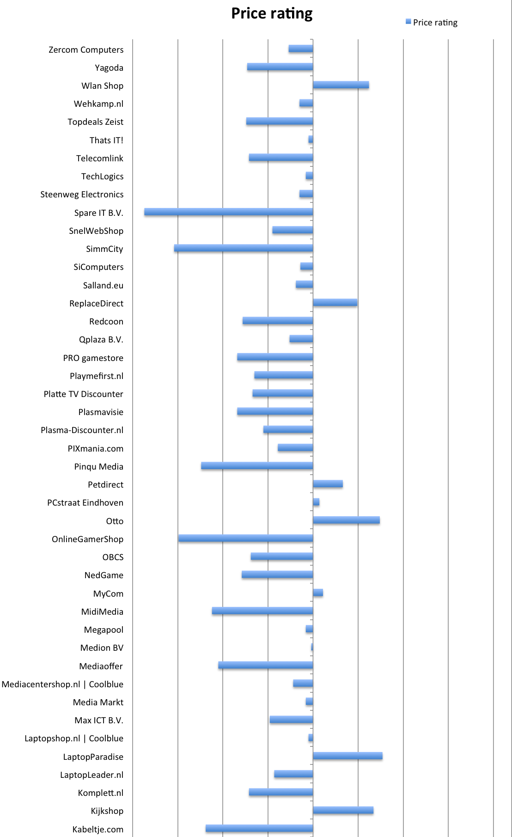

Appendix 7: Continued
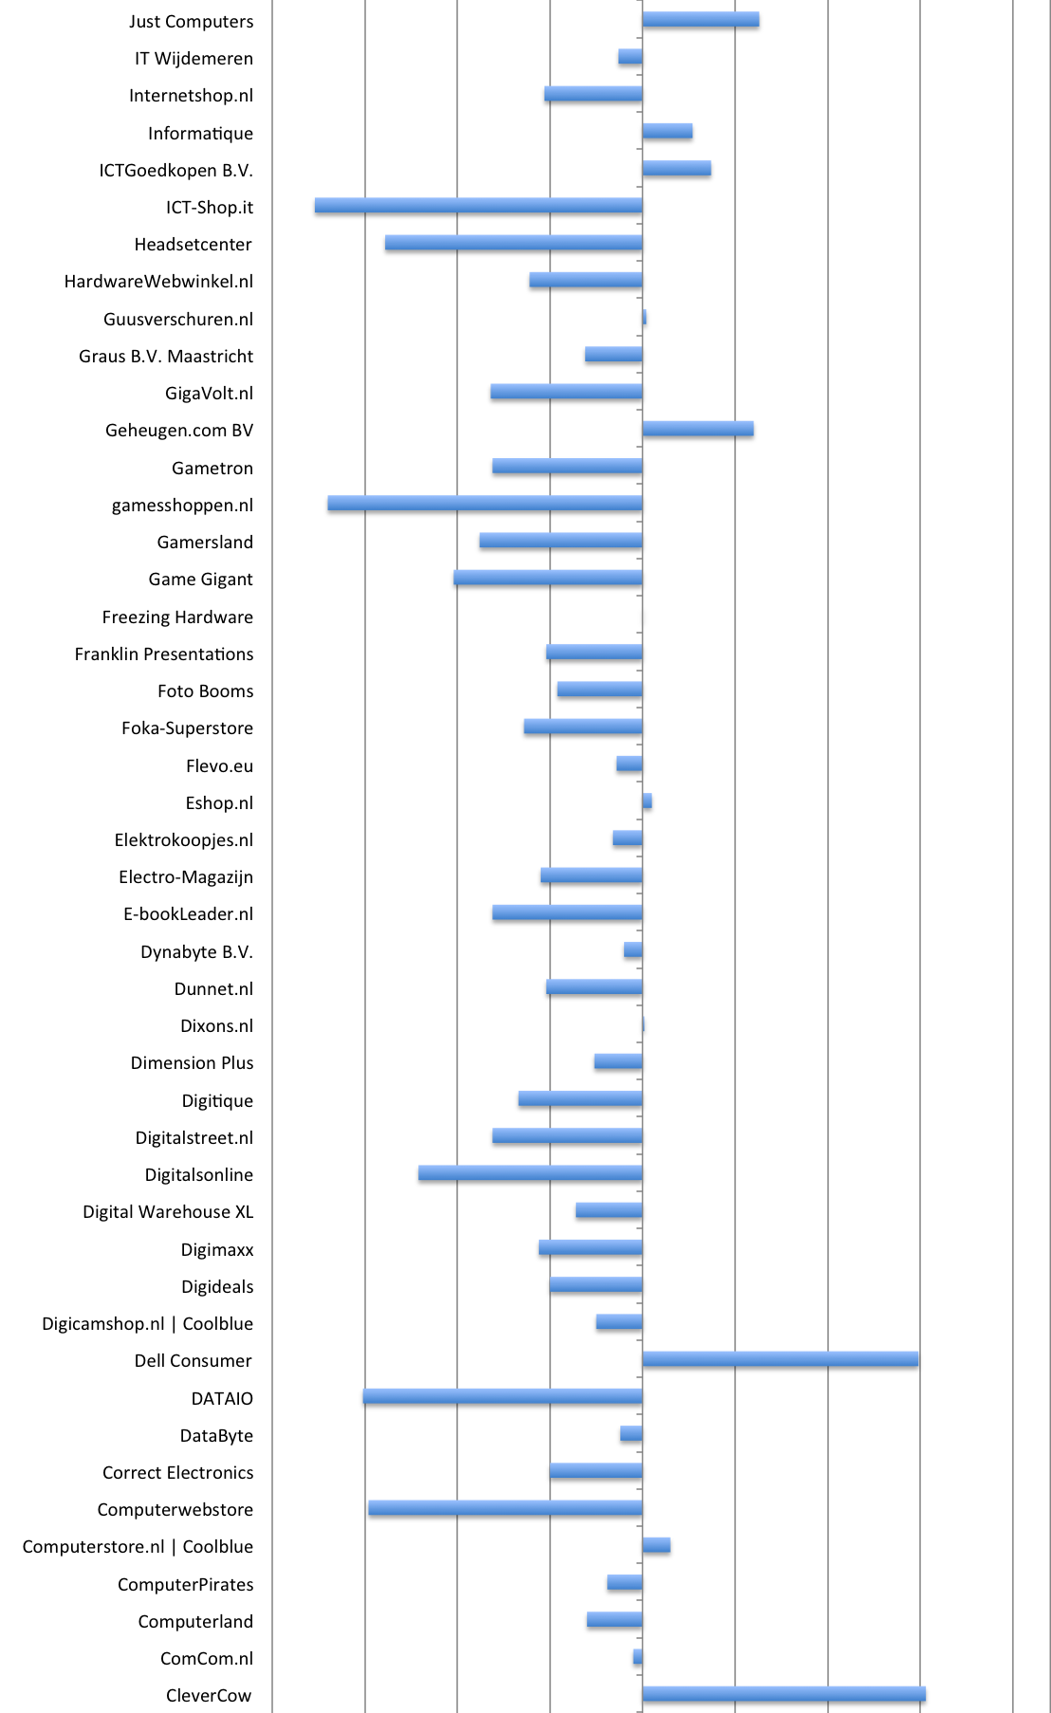

Appendix 7: Continued

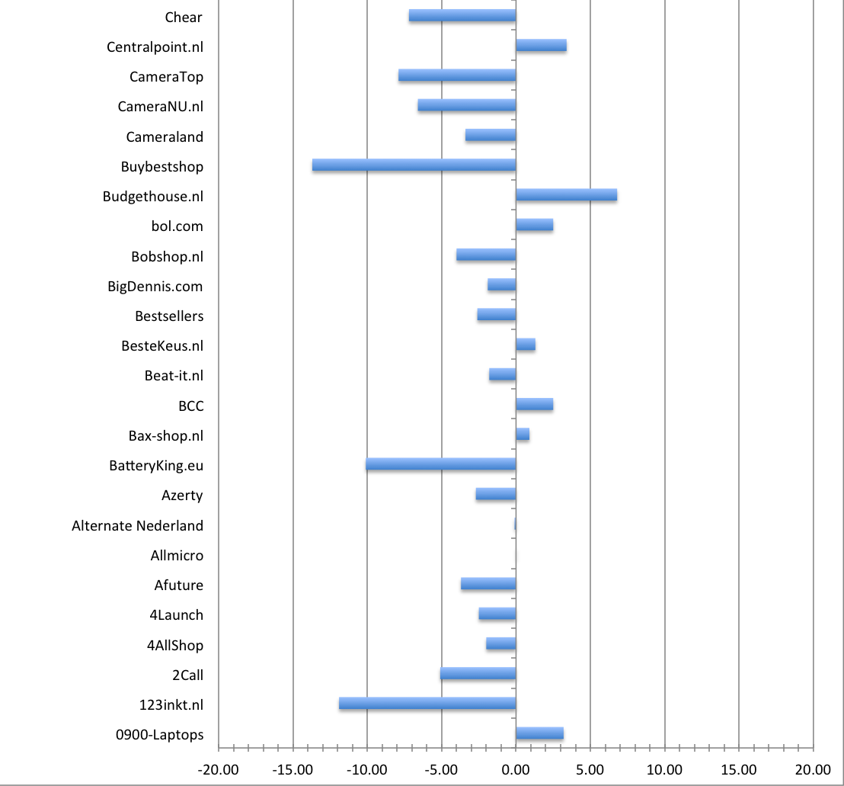

References

Baye, M. and Morgan, J. (2001) ‘Information Gatekeepers on the Internet and the Competitiveness of Homogeneous Product Markets’, The American Economic Review, 91, 454–474.
Baye, M., Morgan, J. and Scholten, P. (2004) ‘Price Dispersion in the Small and in the Large: Evidence From an Internet Price Comparison Site’, The Journal of Industrial Economics 52, 463–496.
Cazier, J., Shao, B. and Stlouis, R. (2006) ‘E-Business Differentiation Through Value-Based Trust’, Information & Management, 43, 718–727.
Chen, P.Y. (2001) ‘Brand Awareness and Price Dispersion in Electronic Markets’, Twenty-Second International Conference on Information Systems.
Chen, P.Y. and Hitt, L. M. (2003) ‘Understanding Price Dispersion in Internet-Enabled Markets’,
Eckard, E. W. (2004). ‘The ‘Law of One Price’ in 1901’, Economic Inquiry, 42 (1), 101- 110
Friberg, R., Ganslandt, M. and Sandström, M. (2001) Pricing Strategies in E- Commerce: Bricks vs. Clicks. Working Paper Series 559, Research Institute of Industrial Economics
Lee, G.-G. and Lin, H.-F. (2005) ‘Customer Perceptions of E-Service Quality in Online Shopping’, International Journal of Retail & Distribution Management, 33, 161–176.
Pan, X. and Ratchford, B. (2001) ‘Why Aren't the Prices of the Same Item the Same at Me. Com and You. Com?: Drivers of Price Dispersion Among E-Tailers’, eBusiness Research Center.
Pan, X., Ratchford, B. and Shankar, V. (2002) ‘Can Price Dispersion in Online Markets Be Explained by Differences in E-Tailer Service Quality?’, Journal of the Academy of Marketing Science
Pan, X., Ratchford, B. and Shankar, V. (2003) ‘The Evolution of Price Dispersion in Internet Retail Markets’, Advances in Applied Microeconomics, 12, 85–105.
Reibstein, D. (2002) ‘What Attracts Customers to Online Stores, and What Keeps Them Coming Back?’, Journal of the Academy of Marketing Science, 30, 465–473.
Venkatesan, R., Mehta, K. and Bapna, R. (2007) ‘Do Market Characteristics Impact the Relationship Between Retailer Characteristics and Online Prices?’, Journal of Retailing, 83, 309–324.
Venkatisan, R., Metha, K. and Bapna, R. (2006) ‘Understanding the Confluence of Retailer Characteristics, Market Characteristics and Online Pricing Strategies’, Decision Support Systems, 42, 1759–1775.

Source: Euromonitor Passport GMID
Source: Euromonitor Report 2010
Source: Euromonitor briefing 10th June 2011
tweakers.net/pricewatch
Source: Euromonitor.com
Source: Euromonitor.com
Source: Euromonitor.com
Source: Euromonitor.com
Source: Euromonitor.com
Source: Euromonitor.com

