The Growth of Southern Italy and the Euro-Mediterranean Partnership
A gravity equation approach to the study of economic integration and free trade

Antonio Cimmino (344139)
August 15th, 2011
Supervisor: Prof. Giovanni Facchini
Academic Year 2010-2011
Master in International Economics and Business Studies
Erasmus University of Rotterdam, Erasmus School of Economics
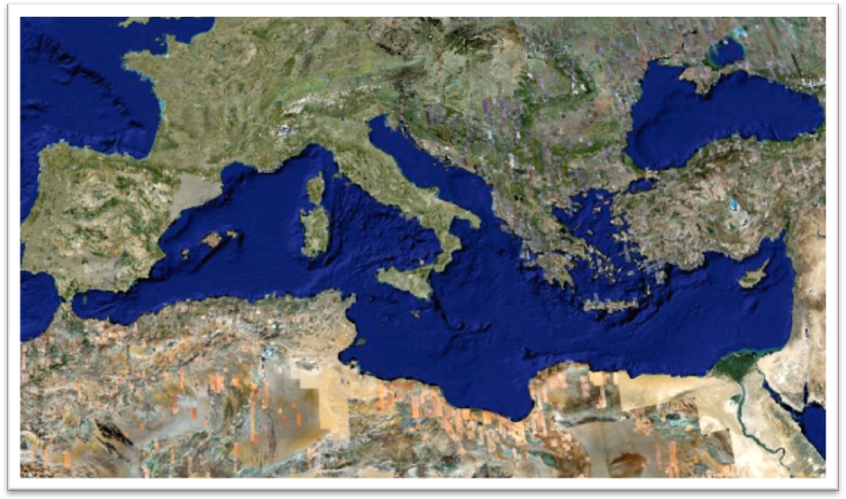



Abstract

The Italian peninsula has been suffering for decades from an internal rift that has slowed down the process of growth and development of the country. Although it is a nation-wide problem, it is often referred to only as “The Mezzogiorno’s crisis”. More than a third of the country has a socio-economic structure that is not able to grow at the same rate of the Northern regions, and that mainly absorbs and dissipates resources and funds. The Italian government has tried (and is still trying) to reverse the backwardness of Southern Italy’s economy, but so far it has not succeeded. This research follows the route of the latest public interventions and takes a snapshot of the current economic situation of the Mezzogiorno. The purpose of this territorial analysis of Southern Italy is to analyze first the region’s numerous issues, which do not allow the Mezzogiorno to grow. Subsequently the research aims to find evidence of the benefits that could be reaped from the establishment of a free trade area amongst Southern Italy and its Mediterranean partners. The gravity equation analysis of Italian provinces’ exports towards Euro-Mediterranean partners has been used to detect the importance of the country’s strategic location in order to improve trade and facilitate the development process of the Mezzogiorno.

Table of Contents

1. Introduction 2
2. Theoretical Background 2
2.1 Evidence on Growth and Inequality 2
2.2 The Benefits of Free Trade 2
2.2.1 Additional Requirements of Free Trade 2
2.3 The Gravity Equation Evolution and the Border Puzzle 2
2.3.1 Alternative Methods to the Non-Linear Estimation 2
3. The Mezzogiorno’s Problematic Growth and Potential Solutions 2
3.1 Industrial Districts and Production in Southern Italy 2
3.2 Technological Level and R&D Investments 2
3.3 Education and Labor Market 2
3.4 The Infrastructure Status 2
3.5 Public Sector Inefficiency and Lack of Co-ordination 2
3.6 Ability to Attract Business and Investments 2
3.7 The Size of Mafia Distortion on the Mezzogiorno’s Economic System 2
3.7.1 Room for Improvements 2
3.8 Short Summary 2
3.9 Exported Goods and Trade Geography 2
4. The Role of the Mediterranean Sea 2
4.1 The Mezzogiorno and Euromed countries’ economies 2
4.2 The Chance for an Economic Integration Process 2
4.3 Euromed Process Slow-down and Its Reasons 2
5. Empirical Research 2
5.1 Data 2
5.2 Model Setup 2
5.3 Main Findings 2
5.4 Discussion 2
6. Conclusion 2
References 2
Appendices 2
Appendix 1 - Acronyms 2
Appendix 2- List of Graphs 2
Appendix 3 – List of Tables 2
Appendix 4 - Eviews interface 2

Introduction

What was once called the Kingdom of the Two Sicilies, and was considered one of the wealthiest regions in the world, represents today a particular (and somewhat alarming) case of the existence of a backward and underdeveloped region within an advanced and developed country. Southern Italy today represents the largest and most populated backward area of the Euro zone (Banca d’Italia 2010). In Italy there is an internal economic division between the Center-North and the South; the former grows faster than the European Union average and it has a rate of employment that follows the Euro zone trend, while the latter has a slow economy and a critical level of unemployment. The Italian government has repeatedly tried to reduce the inacceptable gap between the two regions, but with very poor results. One of the main policies adopted in order to solve Southern Italy’s problem, has been an incentive system that has aimed to attract investments and support local firms with large sums of capital. The inability of distributing the funds in the right direction and the low transparency (and poor level of communication) toward the local population, have strongly affected the results of the government’s initiatives. Since the establishment of the European Union, in addition to financial support from the Italian government, more funds have been made available to Southern Italy; however, there has been no economic catch-up with the Center-North Italian regions or even a considerable growth boost. The Barcelona Process has been an important step toward the integration of Mediterranean countries into a free trade area. Italy has been an active member of the Euro-Mediterranean partnership, since its strategic location within the area offers the opportunity of playing an intermediary role for European trade within the Mediterranean area. On this regard, Southern Italy has a unique chance to become the principal point of access for European trade with the Mediterranean regions, and also for Northern Italian businesses that want to trade with partners in the South (mainly Middle Eastern and Northern African countries); but mainly Southern Italy could increase its production in order to reach markets in the Mediterranean area and create strong partnership for an integrated economic system.

The objective of our research is to find whether free trade integration within the Mediterranean Sea could help the Mezzogiorno develop and grow, since trade so far had played a crucial role in the enhancement of growth (Bhagwati & Srinivasan, 2002). In order to answer this question, it is crucial to run through the main findings about the positive role of free trade and the equal distribution of wealth in an economic growth context. In addition, there is a need to enhance the local infrastructure level that facilitates the transport of goods and services, to benefit from free trade and be competitive. Our research underlines the importance of contextualizing any regional analysis of the economic system development, which cannot be made without taking into account local dynamics. The implementation of measures which aim to promote growth can potentially be overruled by market distortions, as it is the case in Italy. Southern Italy cannot be compared to other less developed areas (sub-Saharan Africa, for example), nevertheless, there is a high level of inefficiency of its administrations and the structure of its production facilities (including infrastructure), which are not suitable for countries aspiring to become leaders in the Mediterranean trade regime. The issues Southern Italy is facing have taken root not only in the economic system, but also in the mentality of the individuals; therefore, the ability of the region to benefit from free trade depends upon the establishment of a system able to develop within the Mediterranean instead of being simply spectators to the rest of Europe’s growth.

With regards to the theoretical basis for free trade and growth, we have been careful to analyze the arguments brought forward by both those in favor of free trade and those against it. This approach allows for a better understanding of both the strengths and weaknesses of free trade and growth. A deductive process has been used for the examination of the main structures in support of trade and growth (such as technology, infrastructure, the labor market, etc.). In order to underline the backward status of trade in Southern Italy, we compared the Southern Italian region to other similar European regions and when possible to other Mediterranean partners.

For the analysis of trade agreements and the effect of the integration processes, numerous variations of the so-called “gravity equation” have been widely used. The original gravity equation was developed by the Dutch economist Jan Tinbergen in 1962 in order to assess the effect on trade of both economic size and geographical distance between two countries. Our research will utilize the OLS log-linear estimation of a more evolved version of the original gravity equation in order to find evidence of the positive effect of the Mediterranean Sea connection between Southern Italian provinces and their European and Mediterranean trading partners. To be more specific, the gravity equation we propose includes variables that attempt to justify the removal of trade barriers and the implementation of trade partnerships with countries that are geographically closer and that are economically more similar to Southern Italy, while also considering one of the biggest market distortions that affect Southern Italy: the mafia.

In the first section of this paper we will show the theories and evidence of the benefits of free trade and the equal distribution of growth in the world (pointing out the role of technology and human capital), and in addition underline the importance of certain features that assist development and that are problematic in the Mezzogiorno (such as FDI, infrastructure, etc.). The section will end with the theoretical background of the gravity equation and its application. The second section will show a snapshot of the current status of Southern Italy’s level of technology, human capital, foreign direct investments, and infrastructure, in addition to the problem of public sector inefficiency and crime. The third section will introduce the Euro-Mediterranean partnership agreement toward the establishment of a free trade zone in the Mediterranean, highlighting the concreteness of the project, its weaknesses and potentials. We will conclude with the fourth section, which presents an empirical analysis using the gravity equation, before ending with a discussion of the results and their implication for Southern Italy’s economic future.

Theoretical Background

The definition of economic growth can vary among individuals based on their different perceptions on life, gravitating around the concept of quantitative and qualitative social development. Throughout this paper we will refer to economic growth as the set of all quantitative and qualitative features (mainly the production level of goods and services over time in a specific region) that contribute to socio-economic development, improving the living standards of the individuals belonging to a certain region or group. The consistency of this definition stands in the long debate, still ongoing, that started since Adam Smith and David Hume introduced the concept of wealth of nations through an increase of capital and capacity to produce. Finding out what contributes to growth and quantifying the variables involved in this process has been a continuous evolvement and process of trial and error, which nevertheless has strongly influenced the global approach to and the interpretation of welfare and living.

Countries tend to raise tariffs (export and/or import) in order to protect domestic industries, generate fiscal revenues, create food security and promote a cleaner environment. Nevertheless, this protectionist attitude can have important negative effects, as it can push countries to opt for certain goods or partners rather than others, create a bandwagon effect, reduce the volume of trade, penalize national exporters and firms that need imports to produce, encourage fraud and illegal trade, and discourage local production and investment. Among all negative features related to protectionism, the fact that the tariff intervention is an untargeted operation can be a double-edged sword. Especially in time of crisis, tariff barriers expand price spikes (Fraser & Rimas, 2011), altering the price volatility and affecting the market trust.

In this section we will explain the importance of free trade in promoting growth, and in addition we will show some additional features that facilitate trade such as infrastructure, technology, and foreign direct investments. Subsequently, we will introduce the theory that stands behind our empirical analysis (and also its application), which is the gravity equation.

2.1 Evidence on Growth and Inequality

The first economists that found wide acceptance of their quantification of growth were R.Solow (1956) and T.W.Swan. The exogenous growth model (as it was renamed), examines the role that capital accumulation played in the process of economic growth in the long-term on a macroeconomic level in the presence of constant return to scale (CRTS). The model demonstrates that innovation accounts for most of the long-run per capita income growth. Although the model has inspired the research of many other economists, it did not endogenize both the saving rate and the technological process, which according to the model itself are crucial for growth both in and out of the steady state (growth at a constant rate). In addition, the Solow-Swan growth model highlights the role played by three main factors that can allow for less developed countries to catch up with developed countries (Romer, 2006):
- The transfer of technologies from richer to poorer countries.
- Less developed countries are assumed to have a lower capital per worker ratio and thus higher return on investment
- All countries converge to the steady state equilibrium
Successive theories have been developed to remedy and endogenize the knowledge and saving rate process, such as Romer’s theory on endogenous growth. Increasing human capital, furthermore, assists the technological change accounting for an important part of economic growth differentials over time.

Although there is no mention of free trade in the Solow-Swan growth model, free trade represents an instrument for technological transfer to occur, and human capital to evolve and develop. The exogenous growth model thus, underlines indirectly the importance of factor that stimulates growth in technology and human capital.

2.2 The Benefits of Free Trade

In order to overcome the lower productivity level of less development countries, with the intent of allowing for economic growth, most of the world’s economies have moved toward a system of market integration, giving birth to globalization. Trade free of barriers has been promoted since the end of World War II, with the General Agreement on Tariff and Trade (GATT) in 1947 as the main tool for promoting socio-economic development. Thus free trade is not only an instrument for encouraging economic growth but also for establishing international integration and peace through the improvement of political dialogues and coordination based on common interests. The use of free trade as a way of creating cohesion across countries was supported also by Engels and Marx, although for reasons different from the economic growth goal here presented.

In order to determine whether export increases growth or whether the reverse is true, Lopez (2005) conducted an empirical research on developing countries on both an aggregate and disaggregate level using plant level data. Two important findings arose from his research:
- Export increases productivity and growth
- Importing countries should increase profitability of exports to improve the trade situation of developing countries
The second finding will be crucial for our analysis of the outcomes of the Barcelona process.

David Ricardo established a consistent theoretical foundation to justify the abolishment of trade barriers, introducing the concept of deadweight loss of surplus when tariffs are applied on trade, and also the comparative advantage theory, which is useful to explain a country’s motivations to engage in trade. The Solow-Swan growth model suggests that technology represents the tool that allows for productivity to constantly increase (Romer, 2006), and this is also why we will later on discuss the evolution of technology in the Mezzogiorno.

Differences in factor endowments are behind trade in the Heckscher-Ohlin model (H-O). Empirical results often reject the hypothesis that labor abundant countries tend to import capital-abundant goods from capital abundant countries in exchange for labor intensive goods. The H-O model, however, offers several important insights with regards to the benefits of trading, especially in a long-run prospective. For example, a capital-abundant country specializes in the production of capital-intensive goods in order to export to its partner country, seeing that his capital-intensive production is cheaper. The intuition behind the H-O model is that, when two countries trade with each other, their welfare increase as a consequence of the factor price equalization. Although, this prediction is most likely to be supported in a North-North trade situation (since for example the assumption that the two countries have the same technology level), the so-called “factor price equalization” initially predicted that trade would increase wages in labor-intensive countries (usually poor countries), and satisfy the profit seeking nature of capitalists in the richer countries. Bhagwati (1958), a strong supporter of free trade, proposed a unique example of immiserizing growth for developing exporter countries, due to trade under circumstances such as the influence of the developing country on the price of the good and the economic dependency of the country itself on that good (mainly agrarian monocultures), but this is not the case for Southern Italy.

Dollar and Kraay (2002) studied the effect of economic growth, social policies and institutions on the poorest quintile of the populations of 92 countries in a time period of 40 years (from the 1960s). The results showed that the poorest quintile’s GDP per capita since the 1960s has grown contemporaneously and at the same level as that of the other quintiles, following the trend of the average income fluctuation (Dollar & Kay, 2002). In addition to this behavior of the income distribution, empirical results attribute the merit of such an equal distribution to the increase of private property rights, fiscal discipline, economic stability and the rate of openness to trade rather than social reforms and public intervention (Dollar & Kay, 2002). One of the main positive examples of free trade application in the real world is Chile. In spite of the fact that the monetary experiment has not given outstanding outcomes for the Chilean economy, free trade helped Chile to obtain a new level of positive growth. Now considered one of the most open countries to trade, Chile has grown for decades, becoming recently the first Latin American country to join the Organization for Economic Co-operation & Development (OECD).

Xavier Sala-i-Martin (2006) confirmed in his case study, through both a micro and macro analysis of the weighted GDP per capita at purchasing power parity (from 1970-2000) of 138 countries, that overall poverty levels have been reduced. Although this should be a positive result, it has to be said that Asian countries contributed the most in this poverty reduction, while Sub-Saharan Africa lags behind (poverty and inequality have actually increased in this region). In addition, the empirical analysis signals a growing inequality of the distribution of wealth within, and a reduction between, countries (Sala-i-Martin, 2006).

Melitz (2003) highlighted that trade also enhances competition in the domestic market. Melitz (2003) theorized that the squeezing out mechanism (with heterogeneous firms) enhances quality of goods and services, since only the more efficient firms can afford to continue to serve the market. Based on Chile’s economy sample, Emami Namini, Facchini and Lopez (2011) studied the effects of export growth on exporters and non-exporters. The main findings where that Chilean firms, committed to compete outside the domestic market, are more likely to be squeezed out of the market in a circumstance of export growth (Emami Namini, Facchini, & Lopez, 2011). The reasoning behind these findings stands on the fact that exporting firms, in a free trade regime, are supposed to be more capital intensive than labor intensive for a question of affordability to serve the foreign market (Emami Namini, Facchini, & Lopez, 2011). Competition outside the domestic market will push exporting firms to increase demand, and thus the price of capital relative to labor, allowing the labor intensive production firms instead to increase their profits and survive on the market.

2.2.1 Additional Requirements of Free Trade

The 2008 winner of the Nobel Prize in economics, Paul Krugman (1987) introduces increasing return to scale (IRTS) and imperfect competition (the trade of oligopolies accounts for the majority of global trade) in order to loosen two strong assumptions of the Heckscher-Ohlin and introduce a model that is better able to describe trade between developed countries. Once the assumptions are deleted, Krugman asserts that comparative advantage is not the only reason for trading but IRTS is a fundamental motivation for countries to exchange products. Furthermore, trading countries can specialize in several goods due to the IRTS. Despite the criticism of the comparative advantage theory as an engine of trade, Krugman supports that trade is better than no trade, but that there can be a better solution to growth: sophisticated governmental intervention. Thus, according to Krugman, under some circumstances protectionism can improve trade and national welfare. Although Krugman’s sophisticated public intervention could be currently associated with some developing countries’ strategies, it would be interesting to test how this theory reacts in a global context where all the governments apply sophisticated interventions, with the risks of a bandwagon effect and a war of bilateral restrictions. Krugman himself recognized that free trade is better adapted to a global context (rather than between a small number of countries) (Krugman, 1987). The work of Krugman confirms that, although according to him free trade is not an optimal condition but a second best, alternatives to free trade are rather complex and impossible to apply today. Nevertheless, the introduction of an industrial organization analysis of trade (as we will see below), is more adapted to the current global economic conditions (Krugman, 1987).

One of the factors that are clearly crucial for trade and economic development is infrastructure. It facilitates trade flows allowing for a more efficient transportation and distribution of goods and services on the market. Economic agreements strongly need the implementation of infrastructure in order to facilitate trade and warrant the success of the partnership. We will show for the Mediterranean analysis of trade, that the lack of an intermodal transportation system undermines local growth. Calderon and Serven (2004) suggest that a higher quantity and quality of infrastructure reduces the inequality within a country and contributes to economic growth, based on an analysis of 100 countries (from 1960-2000). Nevertheless, the short-term benefits from infrastructure are not clear, while the positive effects that it can have in the long-run have been tested by Egert, Kozluk, and Sutherland (2009). “Égert, Kozluk, & Sutherland, 2009” found that a well-connected infrastructure system facilitates the creation of economies of scale, produces positive externalities and enhances competition.

Throughout this research we will also refer to the importance of foreign direct investment (FDI), which enables countries to acquire modern technology, know-how, capital, and financial intermediation (offering both services and managing assistance), and to enhance employment and thus, growth. In this short section we will introduce some works which highlight the role of FDI, as a catalyst of growth and thus development.

Many economists have expressed their appreciation of the positive effect of FDI on development, modernization, income growth and employment. OECD (2002) lists the pros and cons of FDI concluding that the positive effects take over the negative effects. Markusen and Venables (1999) proposed a theory of three effects that FDI have on the countries that receive the investments, in a context of IRTS with an intermediary market and a final good market, where an external firm produces only the final good. Based on this theory, the settlement of a multinational enterprise’s (MNE) production plant in the home country creates an initial competition effect on final goods, squeezing out the firms with higher costs of production. Subsequently, the demand for intermediate goods increases due to the higher profitability of entering the final good production market (linkages effect). Finally, consumer prices decrease since there is more competition created by the MNE. Görg and Strobl (2002) conducted a study, based on the analysis of 68 manufacturing sectors in the UK between 1974 and 1995, in an attempt to explore the above-mentioned theory (Markusen and Venables theory). Their empirical research produced robust results only for one of the three effects: the downstream influence within the same market caused by the entrance of the MNEs. This means that much still has to be done in order to fully explain the effect of FDI on the receiving country’s market, but still several analysis of FDI positive effect on growth suggest the positive role of these.
Evidence of the effect of competition on domestic market instead, has been found by Emami Namini and Pennings (2009), in a 42 sectors study of the U.S. market from 1999 to 2005, but distinguishing between horizontal and vertical FDI. Horizontal investments are found to be complementary to the domestic market; while it is not clear whether the effects of FDI for vertical investments are substitutes or complements (it depends on the firm’s technology).
The Mezzogiorno, as underlined in one of the below sections, attracts very little FDI which does not allow for the territory to evolve, reduce its critical unemployment level and increase average incomes.

2.3 The Gravity Equation Evolution and the Border Puzzle

For the scope of this research we will apply a revised version of the gravity equation model developed by Jan Tinbergen (1962) to the trade volume of Southern Italy. The model found its inspiration from Newton’s theory of gravitation, and it argues that the trade flow among two countries depends upon the size of the two trading countries and the distance between them. We will therefore analyze whether the distance and the size (together with certain distorting factors) of economic partners plays a crucial role in the Mezzogiorno’s export as well. Since the first expression presented by Tinbergen, the gravity model has been mainly used to find empirical evidence of the main drivers of trade.

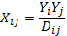

The trade flow X_{ij} between country i and country j, where i is different from j, depends positively on the product of the size of the two countries Y_{i} and Y_{j} (GDP is usually adopted as proxy), while distance D_{ij} reduces trade flow. This model will facilitate the estimation of trade potential of two countries of interest, given their characteristics. The empirical applications of the gravity equation have given very good results, which has been probably the main reason for such a wide usage of it. Through our research, we will try to justify the choice of variables, data and estimation techniques for the regression model with the theoretical approach developed by Anderson & van Wincoop (2003) with the integration of other works that we will cite as we encounter them.

Many economists have tried to analyze the border puzzle identified by McCallum (1995), according to which Canadian inter-provinces trade is 20 times higher than trade between Canada and the United States in the context of the North American Free Trade Agreement (NAFTA), signed in 1992. The data pool considers 23 cities and monthly data from 1978 to 1994. The gravity equation that McCallum uses is this simple log-linear version showed below:

Where X_{ij} represents the trade flow between countries i and j, while Y_{i} is the respective GDP of country i and Y_{j} the GDP of country j. The distance between the two countries is d_{ij} , and δ_{ij} is a border dummy; the error term is ɛ_{ij} and includes all unobservable function values. The research provides evidence of a strong effect on trade flows of the borders between states.

James Anderson suggests a specification issue in the gravity equation defined by McCallum, in order to solve his “border puzzle”. Anderson (1979) provides an additional variable in order to consider the “multilateral resistance” (MR) to trade, which derives from all other surrounding regions. The main idea of the MR is that the more resistant a country i is to trade with the other countries, the more it is “obliged” to trade with country j, given the bilateral trade and size. The trade flows between two countries, thus, depend on the output level, bilateral distance, MR and the border. In Anderson and van Wincoop (2003) the experiment is to remove the border from the McCallum gravitational model and check whether the effect persists. Anderson (1979) presented a model with constant elasticity of substitution (CES) preferences and differentiated good production for each region, in order to approximate homothetic preferences. The specialization can be either in a context of national product differentiation or intra-industry trade (Feenstra, 2002). Whether the structure is a monopolistic competition, CES preferences or a H-O one with different factor prices, they all justify specialization (Anderson & van Wincoop, 2003; Feenstra, 2002). In order to simplify the structure of the gravity model, Anderson and van Wincoop (2001) include only bilateral trade barriers between two regions, and their MR term. This model specification make a strong assumption though, that trade barriers t are symmetric (t_{ij}=t_{ji}), and includes a consumer price index P_{i} as a proxy of MR (since, according to Anderson and van Wincoop (2001), the consumer price index includes, in addition, both local subsidies and taxes, while also taking into account the price of goods that cannot be traded).

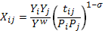

The product of the GDPs (Y_{i}Y_{j}) is now taken relative to the world GDP (Y^{w}), and there is a bilateral trade resistance relative to the product of the two countries’ consumer price indices. The assumption of homothetic preferences is captured by the exponent (1-σ). The marginal increase in cross-country trade barriers in this scenario raises all price indices above the unity. The gravity equation above tells us that weighted bilateral trade depends upon bilateral trade barriers between country i and country j, relative to the multilateral resistances. This implicates asymmetric effects, according to Anderson, which differ from country to country due to the size of the economies (Anderson & van Wincoop, 2001). The effect of the reduction of trade barriers between large countries is larger than for small countries, and raises trade more within small countries than within large countries. Thus a plausible explanation for the significant effect of borders on bilateral trade could be caused by bias created from omitted variables and the small size of the Canadian economy compared to that of the United States. The elasticity term has been taken equal to 5 but there is no significant change when other values are taken into account.

2.3.1 Alternative Methods to the Non-Linear Estimation

A simplification for the effect of prices in the gravity equation is given by Feenstra (2002), where he compares three different methods to determine price effect within the model:
- Published data on price indices
- The computational method of Anderson and van Wincoop (2001)
- Country fixed effects method
The country fixed approach is considered to be simpler and consistent, based on his empirical research, and able to deal with the average border effect across countries (Redding & Venables, 2004). In addition, Feenstra (2002) pointed out that in order to apply the gravity model to monopolistic competition, an analysis of the home-market effect is required, since it is crucial for the determination of exporting enterprises and indicates for further analysis the importance of loosening two strong assumptions of the Anderson model:
- Firms produce only a single product
- Trade barriers are symmetric
It is important to draw a line on the path of the gravity model of trade specification, since it is weakly supported theoretically (Feenstra, 2002; Santos Silva & Tenreyro, 2009). The advantage of using the gravity equation, as it has been frequently stated, is the empirical explanatory power and the regression model itself is continuously subject to changing measure and simplification.

The bias problem due to the treatment of “zero observations” has been long discussed and different arguments have been used to solve it. Baier and Bergstrand (2009) use an ordinary least squares (OLS) log-linear Taylor series expansion of the MR avoiding the non-linear least squared (NLS) model of Anderson & van Wincoop (2003) with a lower bias. The specific determination of the multilateral resistance term (for both distance and border) suggested by Baier and Bergstrand (2009), normalized by the GDP weighted average trade costs is:

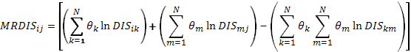

where MRDIS_{ij} is the multilateral resistance term, relative to the distance between country i and j. The third term on the right hand side (RHS) of the equation is a constant term. The “economic density” variable is θ which is the share of country i GDP of total regions considered GDP (in Anderson was Y^{w}) relative to the trading cost (t) between the two countries. The gravity equation estimated by Baier and Bergstrand (2009) in their OLS log-linear Taylor series expansion method (where MRBORDER is computed similarly to MRDIS), where in this scenario the dummy variable BORDER equals 1 is the two countries are divided by a transnational border:

X represents the trade flow between country i and country j relative to their economic size (GDPs product), and the two MR terms have the sign opposite to the one of the respective coefficient values. Santos Silva & Tenreyro (2006) suggests an alternative gravity equation approach to the OLS log-linearized model since under heteroskedasticity the true elasticity value could lead to a biased estimation, in spite of the fixed country effect. The CES model in the multiplicative form can be estimated with a pseudo-maximum likelihood technique. The independence of the error term from the regressor in fact could be too strong (Santos Silva & Tenreyro, 2006). One solution could be to drop the zero observation with the risk of an inconsistent estimator, due to the covariance effect on the expected value. The authors suggest a Poisson since the distribution gives less power to the observation with larger variance to out weight for the size (reducing outliers’ probability) (Santos Silva & Tenreyro, 2006).

Although a computational method using a Poisson distribution of the log-linear (Taylor first order expansion), could be an interesting application to our research, we instead apply a log-linear country fixed OLS estimation, preferring the simplicity of the method to a model which is difficult to adapt. Feenstra (2002) shows that for the country-fixed effect method, results are close to the computational method, but ensure a better level of robustness and does not require any complex programming computation of the border effect estimation.

The Mezzogiorno’s Problematic Growth and Potential Solutions

Despite the celebrations of the 150th anniversary of the Italian unification, the country continues to carry the weight of a divided territory. Economic indicators show that the South is struggling to catch up with the rest Italy, let alone the rest of Europe. Both per capita and absolute value added are not too difficult to interpret. The North is fairly above the EU average in most of the main indicators of growth, wealth and development, while the so-called Mezzogiorno lags behind schedule.

Graph #1. Gross domestic product per capita, Italian macro-regions from 1995 to 2008
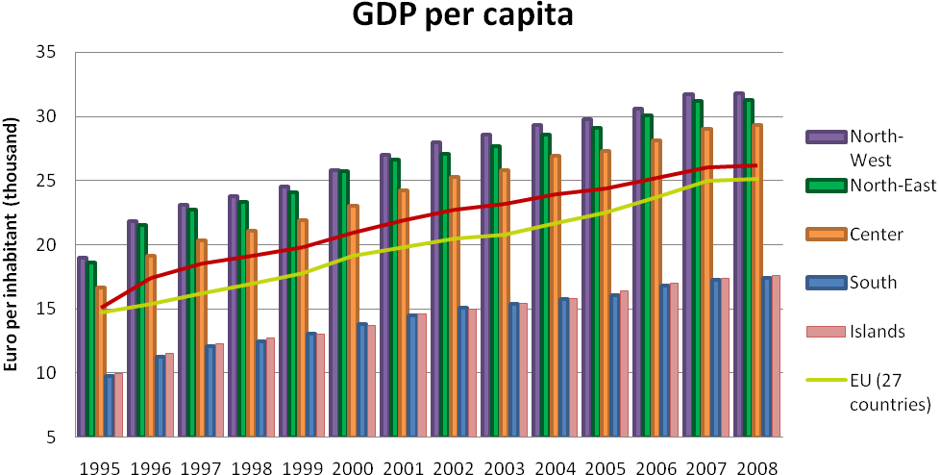
Source: Istat

In order to show the backward status of the Mezzogiorno, we will firstly discuss the level of technology and human capital of the region. Secondly we will underline the ability of the public sector to make Southern Italy appealing to investments and partnership, in order to facilitate trade and other features that allow for development. However, in order to understand better the problematic situation of the Mezzogiorno it is important to discuss the main distortions that affect doing business in the South.

3.1 Industrial Districts and Production in Southern Italy

Adam Smith was one of the first economists to introduce the importance of the industrial sector framework when analyzing the wealth of a nation and its relation with free trade. He considered industrial organization to be the engine of the efficient production that can eventually lead to export and thus growth.

In this section we will shortly present the current production patterns of Mezzogiorno, in order to better understand the context of the region. An introduction of the industrial sector will define the region’s economic status and the trading situation of Southern Italy. First we describe shortly some of the advantages and disadvantages for the Mezzogiorno having small-medium enterprises (SMEs) for local production, although SMEs are not the South’s primary exporting firms (large firms actually ensure most of the Mezzogiorno’s exports). Secondly we underline that agriculture, in addition to some outlier provinces that export energy goods, are responsible for most of the trade carried out by Southern Italy, if we consider that food processing represents a great amount of the industrial production. Thirdly, we will briefly introduce Southern Italy’s main industrial districts, arguing that although such districts can usually allow for better networking opportunities, the particularity of the production sectors (i.e. the agricultural sector) in Italy cannot generate the technological development necessary to be more competitive in a globalizing world.

The Mezzogiorno so far has been unable to maintain a positive growth rate using internal resources. Competition and innovation to better satisfy market demand are definitely lacking. SMEs, which make up the majority of all firms in the Mezzogiorno, are often unable to offer competitive products in term of price and quality for exporting on global markets, and usually have a short lifespan which so far has not allowed the Mezzogiorno to grow and stabilize its own economic structure. Nevertheless, SMEs grant the area a certain level of flexibility but do not provide innovation or a strong center of commerce and production. In addition, the SMEs are not able to take part in the national debate and make their voices heard when episodes of obstructionism arise from the incapacity of local administrations, or powerful individual corruption and the mafia.
SMEs located in the north of Italy have instead been able to establish themselves in the long-term. This has allowed Northern Italy’s SMEs to look ahead, thus begin to export and enlarge their size.

Although agriculture on its own cannot necessarily guarantee economic prosperity and technological advancement, it nevertheless has represented one of the most importance resources for Southern Italy. The role agriculture plays in the Mezzogiorno does not end with the harvesting and the subsequent export of agricultural crops, but it also has a strong presence in the industrial process, since many plants in the South are specialized in food processing (Table E – Appendix 3). Agriculture also confirms the dualism of the economies of the North and South. The Mezzogiorno’s agricultural sector is mainly focused on cultivation of crops and the subsequent export of the products. Northern Italy is primarily specialized in the food industry (including the transformation of harvested goods into packaged products, making use of the “made in Italy” concept), more so than in the regions of the Mezzogiorno. Apulia and Sicily are the leading exporters of agricultural product, while Sardinia and Molise are the net importers of agricultural goods (Table E – Appendix 3). Campania’s food industry is structured more similarly to that of Northern Italy, mainly focused on food processing. It differs from the North, however, in the types of products it processes: mainly pasta (in competition with pasta factories located in Molise, Sardinia and Abruzzo) and tomato preserves. In terms of agricultural export’s (in a broad sense) share of regional GDP, more than thirty five percent of total exports from Calabria consists of agricultural products (Henke, 2006). The base of one of the biggest iron and steel plants of Europe (ILVA) is located in Taranto, which is has been for a long time the most polluted city in Italy (and one of the most polluted in the world) and a main example of industrialization without development in the Mezzogiorno (la nuova ecologia.it, 2008). CERM (Cicciomessere, Pammolli, & Salerno, 2008) mentioned the case of the Syracuse province in Sicily, and the Potenza province in Basilicata as outliers of the regions. Augusta in Syracuse exports oil that accounts for 68% of total regional export, while for Basilicata 83% of total export outside the region (both inside and outside Italy) came from the Val d’Agri oil extraction together with Melfi FIAT’s factory (Cicciomessere, Pammolli, & Salerno, 2008). Remaining in the energy sector in addition to the already cited examples, ENI extract 16% of the national requirements of methane in Crotone (Calabria) (il Crotonese.it, 2006). L’Aquila and the Adriatic Sea area also have reserves of oil (there is an ongoing debate on whether to extract it or not) (www.abruzzo24ore.it, 2010) and there are natural gas stocks in Sicily next to the Etna volcano (Bardi, 2004). On a national level, Italy is strongly dependent upon imports of both energy and agricultural goods. Intra regional data are missing for a better comparison of the trading network within Italy of agricultural goods, but what emerges from the available data is that Southern Italy is a net exporter of agricultural goods. This could mean either that Northern Italy demand is different from the production of the South or that agricultural goods harvested in the South are too expensive. However, the agricultural sector has not allowed Mezzogiorno to grow substantially since it is a low profit activity and moreover has not permitted the South to advance its technological status as we will further explore later in the technological section.

Since the application of a set of public interventions in the last century aimed at providing financial assistance to the Mezzogiorno, the government tried to create industrial districts with the intent of allowing for the development of technology and the creation of “networks” of co-operating firms. These networks in turn were hoped to have strengthened relations between firms and creating a more stable environment in order to attract long-term investment (Ministero dello Sviluppo Economico, 2009). However, the effect of these industrial districts in the South has not been entirely positive for many reasons which we will discuss later on.

Strong economies of scale and some foreign large enterprises are the main exporters of Southern Italy. Officially registered at the Unioncamere in Southern Italy (Federazione dei distretti italiani, 2011), there are 11 industrial districts so divided:
- 3 food, agro industrial, ichthyic districts (Campania, Basilicata and Sicily)
- 3 house and furnishing districts (Sardinia and Basilicata)
- 2 fashion and apparel districts (Campania and Apulia)
- 3 automation and mechanical districts(Apulia and Sicily)
The main support to industrial districts and to the busy network of SMEs in the Mezzogiorno is represented by the important presence of the some subsidiary production plants. The ILVA factory in Taranto represents one of the largest iron producers of Europe and the same is true for the Finmeccanica naval factory in Castellammare di Stabia (in Campania, even if currently it risks to be closed). The Fiat group has a long history in the south, namely in Campania (Pomigliano d’Arco), Basilicata (Melfi) and Sicily with one of the only examples of a highly specialized design center, located in the South: the Elasis center in Pomigliano d’Arco. The most important factor to note here is that most of the industrial districts in the Mezzogiorno today are concentrated in sectors that have a relatively low profitability (Padovani & Servidio, 2009). Other important factors – including bureaucracy, cost of doing business, and criminality – will be discussed below.

3.2 Technological Level and R&D Investments

The theoretical background of this research mentioned some of the most influential works with regards to economic growth. Solow-Swan, Romer and Lucas underlined the crucial role technology plays in allowing countries to create wellness for the population (Romer, 2006). In this section we will show the technological status of the Mezzogiorno and point out possible suggestions for the future. It is also important to take into consideration the R&D expenditure of the Mezzogiorno, since it can be a good proxy of the possibility of technological advancement. The main idea here is that the greater a country’s or region’s expenditure in R&D, the greater its chances are to develop new technologies that could help to increase productivity and efficiency.

In terms of absolute value, Southern Italy only produces about a fifth of the total Italian GDP, even if almost 35% of the Italian population resides there.

Graph #2. Added Value growth from 1995 to 2009

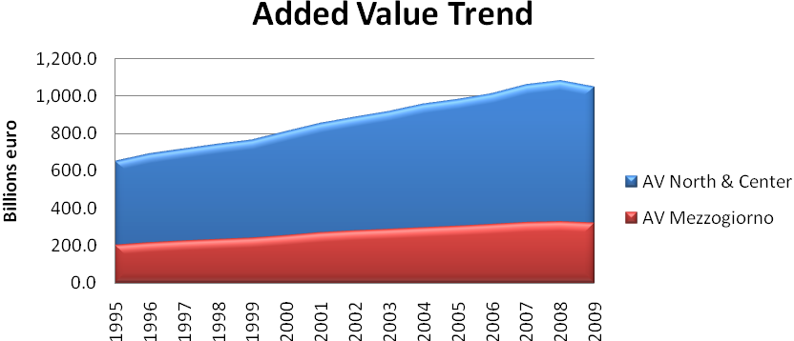
Source: Istat

Regional backwardness in Italy has conditioned over the years not only the structure of the market, which absorbs economic incentives rather than making the most out of them, but also the individuals’ capability of becoming entrepreneurs (Cannari, Magnani, & Pellegrini, 2009). The lack of technological capacity in the Mezzogiorno, together with the lack of proper funding, could very well be one the main explanations for the region’s low productivity level.
As we have previously described, Southern Italy in the early 1990s started a process of localization of its regional economies, based on the Marshallian specialization theory (according to which R&D spillovers would be better realized and absorbed in a specialized environment so as to contribute to regional growth), in accordance with public policies.

Aiello & Cardamone (2008) tested the R&D spillover effect of the localization process in Northern, Central and Southern Italy, applying a trans-log production function to the manufacturing sector. Positive and more significant results for R&D spillovers were empirically found in Central and Southern Italy, confirming that in the Mezzogiorno the industrial districts had a positive effect. This suggests that industrial districts appear to have had an encouraging effect on R&D spillovers, although one needs to recall that it could be that the level of technology in the Mezzogiorno was so low to begin with, that even the slightest improvement seems to be significant.

Eurostat indicators of the R&D expenditure’s share of GDP show Italy in 2009 to be below the European Union (EU) 27 average (2.01%) by almost a percentage point, showing a slight increase compared to the previous years but a constant gap with the European average that has persisted for years (Table C – Appendix 3). For the purpose of our research, a snapshot of the national situation of R&D expenditure will be more significant. Taking into account the local population and comparing the northern area of Italy to the southern part of the country, the division looks clear. The most virtuous region, Piedmont (54 cents per inhabitant), invests per person five times what is spent in Molise and Calabria. With regards to the rest of the Mezzogiorno, the spending for R&D is below the Italian average of 32 euro cents per inhabitant and in 2008 accounted for only 12% of the national total (Table R – Appendix 3).

On a European basis comparison of expenditure in the R&D sector, with similar regions (with an
outlet to the Mediterranean Sea) in France, Spain and Greece, we can see that Campania and Abruzzo are closer to the Spanish level but reach only about 50% of the French level of spending, while the remaining regions of Southern Italy invest much less, i.e. they are broadly comparable to the regions of Greece.

Graph #3. R&D expenditure % of local GDP in 2007, EU regions with an outlet on the Mediterranean
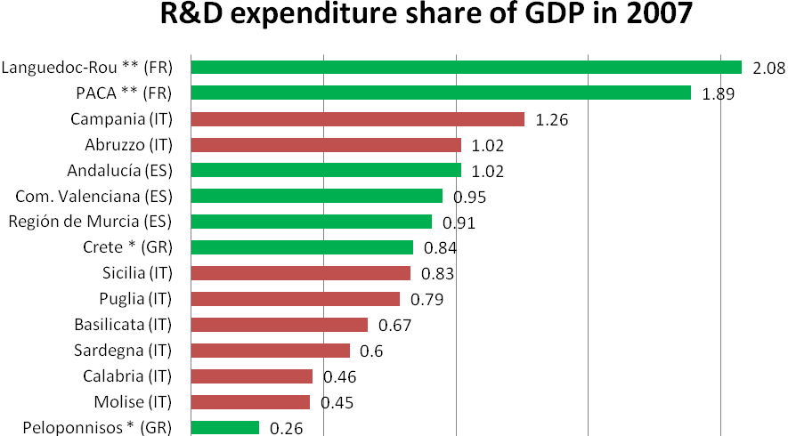
* 2005 data, ** 2004 data; PACA (Provence-Alpes-Cote d'Azur), ES (Spain), GR (Greece), IT (Italy), FR (France). Source: Eurostat

There is a strong government centralization of financing toward the R&D sector, since only a fifth of the spending comes from the local administrations (National Institute of Statistics “Istat”). In terms of regional spending, the R&D expenditure throughout the Mezzogiorno (0.91% of GDP) is lower than other Italian regions (an average of 1.33% of GDP) (Istat, 2011).

Graph #4. Total expenditure value for R&D in 2008 per region 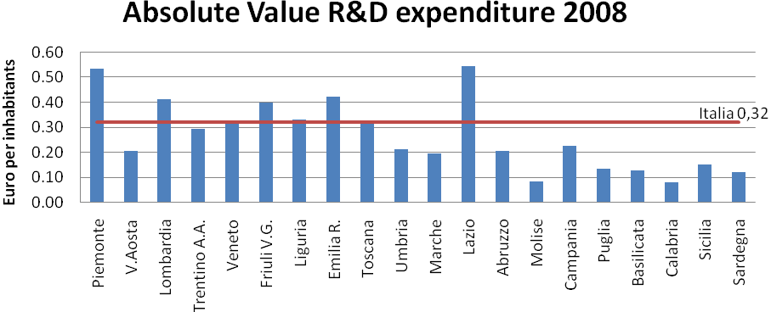
Source: Istat
The lack of expenditure for R&D and the technological sector, here above presented, does not allow the Mezzogiorno to specialize its production in highly profitable sectors since there is no opportunity for individuals to move their productive efforts towards technologically advanced industries. Currently, Southern Italy (noticing that the territory is subject to a high level of heterogeneous provincial specialization) specializes the most in low profit margin sectors such as: textiles, clothes, foods and beverages, leather, transport, agriculture and isolated cases of energy exports (Guerrieri & Iammarino, 2003). An analysis presented by Padovani and Servidio (2009) shows a disconcerting trend of export by sector. Their findings suggest that the concentration of exports in a low profit sector (such as those mentioned above) rather than a high-tech, specialized, or traditional one, can create an obstacle to growth by slowing down the development process (Padovani & Servidio, 2009). Thus, despite the regionalization (formation of industrial districts) of Southern Italy, so far there has been no technological catching-up with the northern part of Italy, probably due to the fact that the production of certain goods in the South do not allow for large spreading of technologies and involvement of other sectors, and also due to the low level of expenditure in the Mezzogiorno on technology and R&D.

3.3 Education and Labor Market

Human capital, in addition to technology, has been suggested as a source for future and constant growth, starting from the exogenous growth model (Romer, 2006). Most of the policies adopted by governments in order to sustain growth are aimed towards enhancing the local knowledge level. The Mezzogiorno presents a decent but not excellent level of education, one that is nevertheless low compared to the rest of the country. More than being a problem of privatization of tertiary education, there is an issue of opportunity cost since the high level of unemployment stimulates a brain drain effect, causing migration of educated individuals towards areas that offer better job opportunities. In this section we will analyze the human capital level, its quality, and its prospects for the future with regards to both education and employment.

Concerning the labor market, a clear disparity exists among regions. As can be seen in the graph below, nearly all of the regions with the highest rate of GDP per capita and low rate of unemployment are found in the North (shown in blue), while those with high unemployment and lower rates of GDP per capita are found in the Mezzogiorno (shown in red).

Graph #5. Income and Unemployment nexus in 2010 for Italian regions
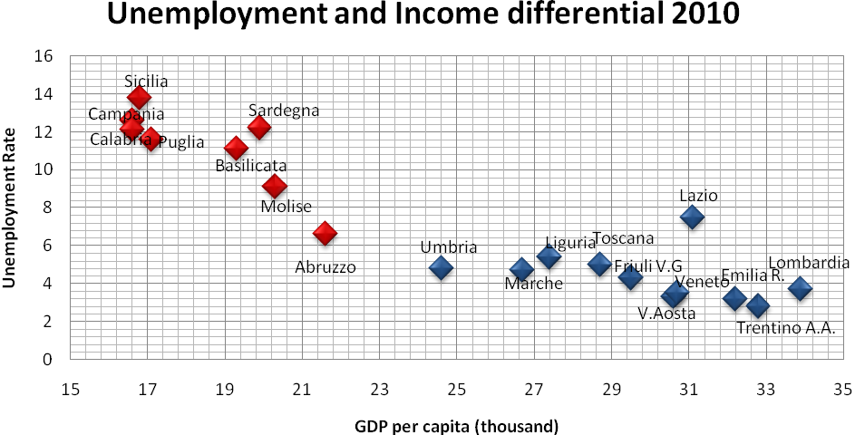
Source: Eurostat

Deepening the analysis of the regional labor market by observing the sector subdivision figures we notice a more robust industrial background in Northern Italy compared to the South. The number of people in the south employed in the agricultural sector is even higher in absolute value than in Central and Northern Italy. This graph demonstrates, as we previously underlined, the higher concentration of the Mezzogiorno in a sector that does not provide a sustained rate of growth (Guisan & Aguayo, 2002).

Graph #6. Employment in Center-North and Mezzogiorno in 2009 per sector, % of total employment (the numbers in the bars are expressed in total millions of units)
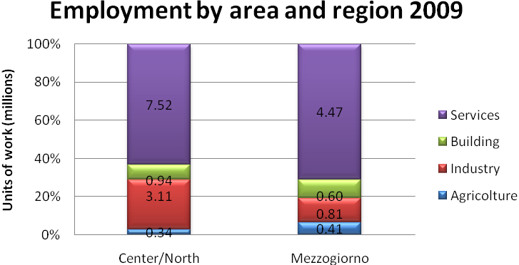
Source: Istat
Research presented in a report by the Bank of Italy (Banca d’Italia, 2010) contributed to highlight the incompatibility of the Mezzogiorno’s wages with its productivity level. Between 2000 and 2008 the production level gap between North and South did not reduce (the gap remained constant), while the Mezzogiorno’s wages have increased by 2% with respect to the Settentrione. If wage disparities within a country could seem strange, from the rest of European countries we find a wider differentiation between less developed areas and more developed areas.Southern Italy’s wages are way above the Eastern European average but nevertheless the rate of skilled workers is higher and the number of tertiary educated individuals is in line with the rest of Italy, stable at 16%, but 10% behind EU average. One historically problematic issue is that relating to the elevated portion of the labor force with only a middle school education, which is a gap that Southern Italy has not yet filled (it is 8% higher in the Mezzogiorno than in the rest of the country). This could be one of the main reasons for lower production levels, and it calls for a special effort from the government to be solved within the next generation.

Furthermore, in the recent years the number of students with university-level education in the Mezzogiorno has become higher than the Center and the North, but the demand for university graduates is too low and, as a consequence, migration occurs. AIRE (Anagrafe degli Italiani Residenti all’Estero) gathers yearly data relative to the number of Italian emigrants by region of membership, age and number of years since migration, showing that in January 2011 about 470,000 young (18-29) individuals of both genders left Southern Italy to reach a foreign country exclusively for expatriation (Table B - Appendix 3). The indicator for expats leaving Italy to find new opportunities regards older registered individuals too. Looking at Southern Italian individuals in the 18-44 age bracket, the number of emigrants grows up to 1 million, while for the North the number is 880,000 (Anagrafe Italiani Residenti all’Estero, AIRE 2011) This number – which only takes into account those Southern Italians which leave the country, not those who migrate to the North – represents the exodus of a very large number of Southern Italians that in theory should be active in the labor market.

Taking a closer look at the public support for education in Italy we find an analysis carried out by the CNVSU (2011) that shows that Italy’s expenditure in tertiary education is 0.8% of the GDP, placing it at the bottom of the OECD ranking. According to several rankings drawn by the MIUR (Ministry of Education, University and Research), institutional bodies, and private entities, Italy is far behind the top quality universities of other countries. Nevertheless, most of the rankings agree that within Italy, the highest quality institutions of tertiary education are located in the North (Corriere della sera.it, 2009; Academic Ranking of World Universities, 2010; QS Top Universities, 2010; Thomson Reuters, 2010).

Despite these rankings, however, one should not assume that the universities in the South are completely without value, although some reorganization is arguably necessary. Some of the oldest and most prestigious universities in the world are found in Naples (Universita’ degli Studi di Napoli Federico II), Catania (Universita’ degli Studi di Catania), with other notable departments found in cities such as Cagliari, Palermo, Bari, Benevento and Salerno, to mention just a few. With the intent to establish a meritocracy system, the recently created Law 133/08 addressed the possibilities for these universities to become private and to create a public funding system for the most virtuous institutes. This system, however, would not take into account the level of development of the respective regions, and would place them all on a level playing field. For this reason, a valuation method that evaluates each university relative to its region’s level of development might be more appropriate.

Studies related to the ability of private universities to offer a better quality of education offer an interesting addition to the discussion. In Checchi (2001, p. 50), the author supports the theory that private universities compared to public ones only offer an elite environment which enhance students’ self confidence but do not necessarily offer a better quality of education. Furthermore the cohabitation of both public and private tertiary education in the long term could imply the extinction of public universities, according to Checchi (2001, p.50). The reasoning behind this thought stands in the brain drain of the most talented students from public to private universities within the country, who want to signal to their future job recruiters that they have invested more in their education and thus they believe in their capabilities more than do other students. The movement of students from public to private universities will consequently require more public funds to sustain competition of the remaining public institutions.

Nevertheless, the Italian university system needs to be reformed in order to respond to global challenges and demands. The reduction of certain academic departments and maybe even entire universities could allow for a better organized and more efficient management of the university system. In addition, a financing system that is based on meritocracy (as long as it is relative, as discussed above) could help to increase competition.

Scholarship coverage is also an issue, for it is currently inadequate to the needs of Southern Italy (CNVSU, 2011). In addition, research by Checchi and Perigee (2005) shows that family background has a strong influence on both education level and future labor prospects for individuals. The analysis was an empirical application of the theory of equality of opportunities on North/South data for individual annual earnings and family background. The unequal distribution of scholarships, therefore, is a measure that goes against the idea of reducing the development gap between North and South of Italy. Ensuring that all individuals have equal opportunities for education would suggest in the long-term a better distribution of future wealth.

The prospects (or lack thereof) for youth development – including employment, political participation, etc. – are a worrying aspect of the Mezzogiorno’s backwardness. The benefits of studying in Southern Italy are fewer than the national standard due to the low expectations of first getting a loan to finance studying (if not sponsored by the government), then finding a job, and finally earning an adequate annual wage. According to World Bank and Istat regional data for Southern Italian unemployment of young (15-24 years old) individuals, the unemployment rate is even higher than that of MENA countries.

An extreme case of unemployment is shown in Sicily for the young female population, where almost 1 out of every 2 individuals is not employed (Istat, 2009). Not reported are individuals that work in the black market (estimated to have an incidence of 25% of the regulated labor market; Northern Italy too suffers a rate higher than the European average (Cannari, Magnami, & Pellegrini, 2009) or did not register with the employment office and gave up on searching for a job. Human capital (similar to technology), therefore, is in a backward state in the Mezzogiorno, and seeing the importance they both play in long-term growth processes, an immediate intervention in this field is required.

Graph #7. Total unemployment of young Italian residents in 2010 (15-24 years)
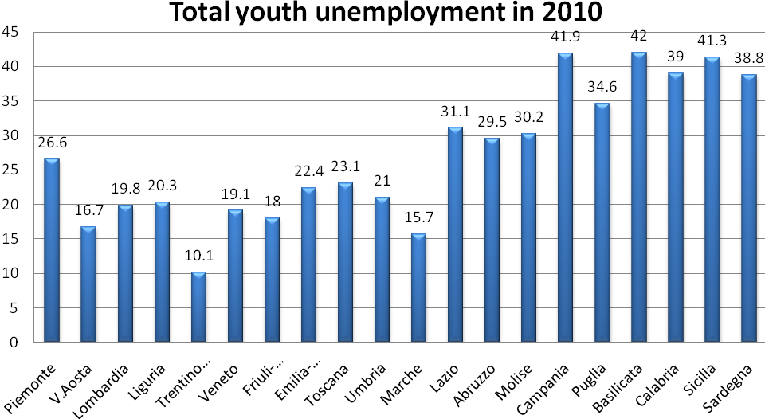
Source: Istat

3.4 The Infrastructure Status

A high level of infrastructure has almost always been considered as a necessary condition for economic growth, for it is essential to allow trade flows. For this reason, it is useful to look at the current situation pertaining to Southern Italy’s transport infrastructure, including projects for the future, keeping in mind its similarities and differences with the rest of Italy and other Euromed countries. For the purpose of this research and of the Italian case, we consider a highly developed network of highways, airports, railways and ports to be essential for development.

An interesting report presented by the Unioncamere shows the development concerning the state of Italian infrastructure in 2011. First we notice that the density of highways (km/10000 inhabitants) (Uniontrasporti, 2011) in the Mezzogiorno is quite comforting with a good traffic flow. Nevertheless, since 2003 the highway stretch from Salerno to Reggio Calabria (A3), which is supposed to be reconstructed, is absorbing an increasingly large amount of public resources due to continuous delays regarding the project’s completion (Graph A – Appendix 2) (Uniontrasporti, 2011). This inefficiency strongly affects the local population and trade along the southern coast. As a result there is an ongoing legal investigation of criminal infiltration and unconformity of various works to the original project of the A3.

When comparing Italy’s transportation system to other countries it is crucial to take into account the peculiarity of the country’s morphology, which of course makes the cost of infrastructure increase. The presence of the Apennine mountains all along Italy, for example, is a big obstacle to the possibility of building highways and railways to better serve the population. Since the emergence of the recent global interest in high speed railways (for both the transport of persons and goods), Italy has moved its first step toward the renewal of its rail transport system (Graph B – Appendix 2). For example, there is a railway link between Berlin and Palermo currently under construction (Uniontrasporti, 2011). This project should create a better trade partnership with the North Sea for the whole nation, but mainly to better involve the southern part of the country which has a different trade geography compared to the north, as we will see below. In addition to the Berlin-Palermo railway axis, currently the main priority of the Trans-European transport network, there is a project being evaluated for improving the railway link from Bari to Brindisi as part of the so called “hall 8” which is planned to connect Italy to the main Bulgarian ports Burgas and Varna (Uniontrasporti, 2011).

The subject of air transport, especially in Italy, is a marginal topic since it only accounts for less than 0.5% of total volume of goods exported (Uniontrasporti, 2011). It is noteworthy although, that in the list of the main 15 airport hubs for passengers, Southern Italy’s airports occupy 5 positions for their tourist attractiveness (Uniontrasporti, 2011). Regarding goods transportation by plane, only Catania and Naples compete with the air trade dominion of Northern Italy (Graph D – Appendix 2).

Leaving aside the absolute values of transported goods, since Northern Italy or the so-called “Settentrione” clearly outperform the Mezzogiorno, we should notice that more than a third of total freights leave from Southern Italy by maritime shipment, while for the Northern and Central regions, sea transport is marginal (Graph #8 below).

Graph #8. Average means of transport of goods % of total export, from 2000 to 2008
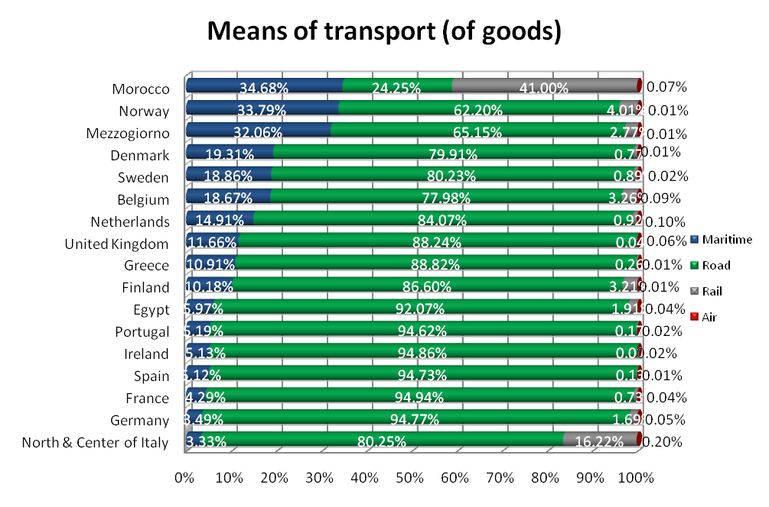
Source: Eurostat; Morocco and Algeria air data source World Bank

The Mediterranean Sea’s outlet for all regions of the Mezzogiorno already represents a key source for trade, but Italy has not yet fully realized its potential. This topic will be addressed in further detail later on.

The 2011 Uniontrasporti report presents a study conducted by the Consortium of Milan-Cremona-Po that points out the efficiency of sea transport compared to that of road and rail (air is too expensive and polluting). The study reports that with only 1KW of power a ship can carry a freight of 3,000 Kg against 370 Kg of trains and 150 Kg of trucks (Uniontrasporti, 2011). In addition, the consumption of fuel is the lowest in proportion to the other two categories studied. In terms of emissions, trains are the most efficient with 139 g CO/t*Km, but only just more efficient than ships (143 g CO/t*Km) and much more than transportation by trucks (1002 g CO/t*Km) (Uniontrasporti, 2011). Given the information above, one can see the benefits of using sea transport, which nevertheless requires a well integrated intermodal transport system and is not suitable for the transportation of certain goods that need to be shipped quickly. If one also considers Italy’s strategic location in the Mediterranean (and the fact that it is a peninsula), these benefits become even more obvious Southern Italy, because of its geographical position, has the chance to play the role of the main hub for trade between EU countries and their Mediterranean commercial partners, but in order to make this possible the Mezzogiorno has to offer an efficient infrastructure system, in addition to a skilled labor force (Bianchi, 2009).

A map of ports in Italy shows that they extend all along the country’s coasts, with the only exception being in Basilicata. Being islands, Sardinia and Sicily utilize their ports and sea connections as their main resource for both trade and tourism. Analyzing the first 20 Italian ports by gross weight of goods transported (which account for 84% of total goods transported by sea in Italy), one can see that 12 of the most active ports are located in the Mezzogiorno and are responsible for overseeing the transport of 54% of all goods transported by sea in Italy (Table Q - Appendix 3). Gioia Tauro, located in Calabria, is the most active port in Italy, by gross weight of goods transported. On a global scale, it is ranked 36th by Twenty-Foot Equivalent Units (TEUs) with a container traffic of 2,857 thousand TEUs (AAPA, 2009), and if we leave aside the Asian predominance on this field and focus on Europe, Gioia Tauro is ranked 8^{th,} but is slowly reducing its traffic from the values realized in 2004 (AAPA, 2004). Concerning other main port hubs in Italy in the World Port Ranking 2009, Genoa ranked 68th and at the bottom La Spezia, Taranto and Livorno (AAPA, 2009). In terms of trade growth by port, the most positive signals come from Savona-Vado (Liguria), Olbia (Sardinia) and Palermo (Sicily).

The Mezzogiorno has a decent distribution of ports among the coast that register a good traffic of goods. Nevertheless, the disconnection of ports from intermodal transportation systems and inefficiently articulated railways and highways, does not allow Southern Italy to fully benefit from its strategic location. The fact that Calabria, for example, has one of the most virtuous ports of Europe does not necessarily mean that the region is capable of taking full advantage of it. Effective coordination of the means of transport is crucial for businesses and trade; this, unfortunately, is one of the main failures of Southern Italy. In addition to the failure to complete the A3 highway stretch (Salerno-Reggio Calabria) on time and as it was initially planned, there is no intermodal freight transport to allow for the distribution and allocation of goods towards the rest of the country (Graph E – Appendix 2). The Ndrangheta (Calabria’s mafia) attempt to infiltrate the project and undertake the contracts surrounding the area of Gioia Tauro in order to make it complete and functional made things worse (la Repubblica.it, 2008; Lawrence, 2006).

Previous specific policies to sustain Mezzogiorno’s infrastructures were many small projects without supervision with a relatively small impact (Cannari, Magnani, & Pellegrini, 2009). Others appeared to be quite promising, such as the 21st Project (or so-called “Sea Highway”), which projected the improvement of shipping facilities along the various coasts of the Mediterranean, thereby increasing partnership and collaboration amongst the countries of the Mediterranean. Very little work has been done, however, on the project thus far, and it seems to have been pushed aside in favor of other projects. The new Plan for the South (Piano per il Sud) foresees the construction of important infrastructure (Bridge on the Messina’s Strait), and other important projects of great impact. It remains to be seen, however, whether this project will be carried out efficiently or whether it, too, will be pushed aside.

A regional analysis of Mezzogiorno’s infrastructure system shows the possibility of implementing the whole network in order to facilitate trade. More emphasis has rightly been placed on maritime transport and infrastructure since it is widely used by Southern Italy to trade and is sometimes the only way to import and export (in the case of Sicily and Sardinia). The development of a few big projects rather than multitude of small and inconclusive projects could be a better way to address the lack of infrastructure and stimulate co-ordination among local institutions and thus be more competitive with the rest of Europe’s Mediterranean countries.

3.5 Public Sector Inefficiency and Lack of Co-ordination

The lack of co-ordination between institutions has distorted the effect of policies toward the less developed areas in the south of Italy. Bureaucracy, which is particularly slow and inefficient in the South, has been an obstacle to the developing system of the Mezzogiorno rather than a regulating tool. In this section we will explain what sorts of economic measures have been adopted so far by both the central government and local administrations in order to overcome backwardness in the Mezzogiorno. In order to apply a set of economic policies, public institutions should enhance their communication with the population. The importance of showing a strong political commitment is crucial for economic incentive measures to be successful. The policies adopted for the Mezzogiorno have been too dispersive and not very transparent. As a result, the development process so far has been a failure, and in the coming future more direct approaches, when attempting to solve problems, need to be adopted so as to facilitate business and be ready to excel as a primary port on the Mediterranean for EU partner countries.
The central government so far has failed to ensure a homogenous level of development all along the peninsula. With regards to state intervention, the NRP (New Regional Policy, translated from “Nuova Politica Regionale”) has been created in order to facilitate the economic process of the less developed areas of the Italian territory, the Mezzogiorno above all. Law 488/92, followed by the implementation of rules and a financial act, were supposed to end the internal inequality issue in Italy as part of the NRP. The NRP strategy provided for the allocation of public funds to help finance small-medium enterprises – through concessionary banks and institutes appointed by the government – and offer managing support in order to develop projects in those sectors which were approved within the terms of Law 488/92. Partnership among regions has been established via bilateral agreements. Disappointing results drove the Italian government to abandon the NRP and establish a fiscal incentives policy. Unfortunately, the 4.5 billion euro available for the fiscal incentives policy intended for 2008-2013 (as established by LAW 388/00) had been already exhausted by 2008 (Ministero dello Sviluppo Economico, 2009). The fiscal incentives policy has given positive but short-term signals, but the further extension of the fund is unlikely due to the effect of the recent financial crisis (Cannari, Magnani, & Pellegrini, 2009).

A generalized incentive policy has not given the results expected also due to the great waste of funds embezzled by fraudulent individuals or criminal organizations, thus a direct incentive policy for human capital and social activities could give a better outcome but in the long-term. Cafiero, the SVIMEZ (Association for the Mezzogiorno’s industrial development “Associazione per lo sviluppo dell’industria nel Mezzogiorno”) director in 1998, often lamented the incapacity of Law 488/92 to allocate funds to high added value sectors of production (as we have already seen) and the generalization of economic incentives (as cited in Padovani & Servidio, 2009, p. 8). The lack of political will regarding the NRP, as in all kind of projects, has undoubtedly reduced the probability of success.

In 2005 the city of Taranto declared bankruptcy, introducing in this analysis another crucial aspect for the discussion: poor local administration. The graph below shows the local administration debt structure in 2009, which is similar from the north to the south of Italy and shows that the financing strategies are based mainly on money drawn from local credit institutions (banks loans).

Graph #9. Centre-North (outer circle) and Mezzogiorno debt structure of local administrations by type
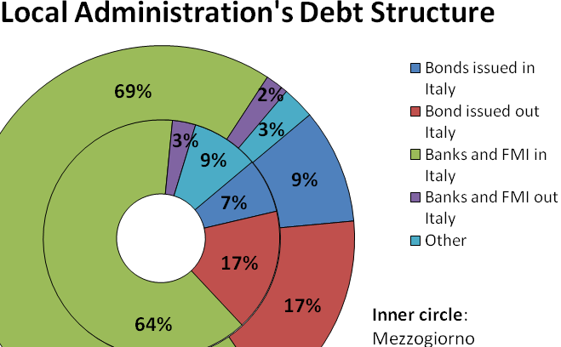
Source: Istat

In 2007 the number of local bodies in financial difficulty according to Ministry of Finance was 442 (Table D – Appendix 3). In Southern Italy alone the number was 353 municipalities which have so far required a public loan of 1.1 billion euro (Danielli & Pittalis, 2010). The worst case scenario is in Campania, which has a rate of management inefficiency that has cost all Italian tax payers about 750 million euro (Table D – Appendix 3).

Several “objective laws” have been issued for the Mezzogiorno with the intent of facilitating economic growth; to be more specific, it was supposed to guarantee a constant annual growth rate of 3.9% to catch up to the development level of the Settentrione (Cannari, Magnani, & Pellegrini, 2009). The amount of 51.2 billion euro of public resources during the period 2000-2006 has not been sufficient to sustain growth at this level, since the annual growth level has been floating around 1.23% (below the EU 15 level of 1.96%) (Cannari, Magnani, & Pellegrini, 2009). The local administrations’ inability to create a solid network of collaboration and promote policies contributed to the project’s failure (Cannari, Magnani, & Pellegrini, 2009). Constitutional Law 119 allows local administrations to finance investment through debt. The accumulation of these debts in addition to wrong investments led to bankruptcy and an increasing demand for government loans and thus an increase in expenses for the already exiguous State liquidity.

Pennella (2001) pointed out the negative effect of the public administrations when assisting private entities in projects related to structural condition problems. Italy has been involved in one of the biggest privatization processes which operate in the infrastructural sector, but despite the intent of creating a more active market, no serious competition has been born. In a recent article in la Repubblica (2011), Catricala’ (the current chairman of Italian Antitrust) showed his concern about the already precarious competition situation in Italy, lamenting the political indifference toward liberalization.

The absence of political support for policies for the less developed Italian regions was very detrimental to their outcome; in addition, the financial contribution to NRPs did not match the initial forecasted amount (Scalera & Zazzaro, 2010). A comparison of the Italian and German efforts to fight inequality within their respective borders shows that far fewer funds were allocated in Italy than in Germany with the aim of aiding development (Scalera & Zazzaro, 2010). In Germany the funds were specifically targeted towards increasing exports, improving R&D facilities, and enhancing technological development. In Italy, however, the funds were released with little or no preconditions as to how they must be spent. The result was that the funds were used by the receiving enterprises for their regular expenses, rather than using them to enlarge their production and increase development. A fund (“Fondo per le aree sottosviluppate” FAS) of 20 billion euro has recently been established by the government, 85% of which is supposed to go towards sustaining capital account (Confcommercio Palermo, 2011). Unfortunately, this money has been used by the government itself also for marginal activities such as Tirrenia Spa’s bail-out, Trenitalia capital injection, coverage for a property tax abolition and so on (Cannari, Magnani, & Pellegrini, 2009). The comparison with the German intensive and direct approach to solve the problem of the internal inequality shows that Italian funds have been a weak response to a big issue. In addition, financial aid in Italy for the less developed areas has been redirected to bail-outs that were on the brink of contradicting the ideal of free market. Knowing that strong market positions are sometimes protected is really discouraging for new entries in certain markets. Since competition is not stimulated there will be less efficiency and less probability to export.

The Mezzogiorno’s local administrations suffer from inefficiency and criminal infiltration (as we will discuss in a later section), affecting the trust of the local population in institutions and their participation in resolving public issues. Government actions so far have been incapable of substantially reducing the gap between the North and South. A stricter control of local entities is needed in order to identify and punish the misuse of public funds, and more power should be given to the Antitrust in order to abolish market abuse and to prevent some oligopolies and monopolies from blocking access to markets. These could be two starting points for renovating the old and slow public system of the Mezzogiorno.

3.6 Ability to Attract Business and Investments

One of the questions that may arise at this point is whether the conditions for doing business in the Mezzogiorno really provide incentive to investors and if there is a chance for profits so as to attract firms. In this section we will try to find some of the reasons (in this section we will only focus on corporate financial reasons and protection of business and rights) why the Mezzogiorno is not a target for growth of firms.

Banca d’Italia (2010) presents a study, which underlines the difficulty of access to credit for Southern Italy’s enterprises, since according to the costs for obtaining loans from private credit institutions is around 4% more expensive in the South than in the North, probably due to a lower EBITDA (Earnings before interest, taxes and amortization). The average enterprise in Southern Italy’s territory seems to be small, young, less reliable, and environmentally riskier, it grows thanks to export and its debt structure is strongly based on internal financing. Article 119 of the constitution (Title V) requires that backward areas receive additional funding and special intervention with the purpose of leveling the playing field. Thus so far, the Italian Government has provided the less developed regions with additional assistance in order to overcome their financial difficulties. Law n. 42 however, provides a plan for the implementation of fiscal federalism. This would mean that regional administrations are given more fiscal responsibilities in order to make them more accountable and create a regional system of funding based on good performance.
This new law could generate a conflict with the previously mentioned Art. 119 of the constitution, as it would no longer provide extra assistance to regions that fail to meet certain standards (which will most likely be the regions in the South). Seeing as no more money – which has mostly been used to pay for essential services, such as health care and education – will be arriving from the central government to these regions, local administration will, according to Bank of Italy Chairman Draghi, inevitably increase the tax burden in order to fill the gap left by the absence of central funds (Banca d’Italia, 2010). This increase in taxes is likely to slow down development, since it will largely affect the liquidity of those actors which play the largest part in the Mezzogiorno’s economy.

In accordance with the financial Law 2010 (art.2) a Bank for the Mezzogiorno will be established to give warranty and consultancy services, help in finding funds for the medium and long-term, facilitate the obtainment of credit and evaluation (Ministero dell’ Economia e delle Finanze, 2010). Sarno’s (2008) study, anyhow, reports that Southern Italy SMEs, of which short-term liabilities alone account for 53% of the total Mezzogiorno’s assets, are mainly internally financed since external financing is costly and access to the financial market problematic.
The attractiveness of Southern Italy for investment and other ambitious and enterprising initiatives is extremely low both on a national level and a foreign one (Banca d’Italia, 2010). It is essential to note that Italy receives few foreign direct investments on the whole compared to the rest of Europe; even so, the amount of FDI within the Mezzogiorno is shockingly low.

Graph #10. Net FDI flow % of total Italian per region, in 2008
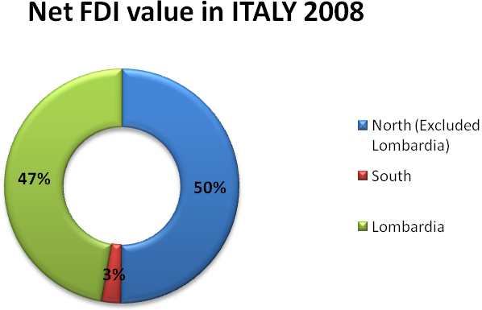
Source: Banca d’Italia

The province of Milan alone received 75 billion euro out of the 118 billion euro allocated to Italy in 2008 (Annuario Statistico Regionale, 2008). We should not consider foreign sources as the only way out for Southern Italy. A national transfer of technology to the south from the enterprises currently operating in the North could also have a significant positive effect on the Mezzogiorno’s development.
The establishment of external firms on the Mezzogiorno’s territory will of course improve the volume of trade, since intuitively the firms that will enlarge their production in the South of Italy are supposed to be highly productive and well endowed with capital.
Banca d’Italia (2010) calculated on the basis of five out of ten indicators used by the World Bank – when verifying for the easiness of doing business (DB) per country – the obstacle rate to new and already active enterprises in all Italian regions on a NUTS 3 level. The indicators with the respective results are indicated below:
- Starting a business (the South is two times slower and more expensive than the North)
- Dealing with construction permits (the Islands are the slowest while the South’s timing is shorter and less costly than other regions)
- Transfer of property rights (quite stable among all regions)
- Judicial solution to civil controversies (about 400 days slower in the South compared to the North and the most expensive, while the Islands are 100 days more than the North)
- Ending (or restructuring) of enterprises (shorter in the South but extremely expensive)
The financial costs of starting a business and pursuing a judicial solution to civil controversies (as well as the time it takes to do either of these) are particularly worrying when thinking of doing business in the south. A potential cause for the delays in solving civil controversies is suggested by Bianco and Bripi (in Banca d’Italia, 2010), where the number of state attorneys per 100,000 inhabitants is shown. Reggio Calabria, Naples and Messina are probably the outliers with figures above the average, while only Rome exceeds the average excessively. Also important is the lack of incentive given by the labor market in the South, as previously underlined, since due to national bargaining of worker salaries, the lower production level of Southern individuals is not taken into account.

Although the perception of corruption as an obstacle to investment is not clear, it is nevertheless possible that it still increases the costs of doing business, or at least it keeps honest traders away. Transparency International publishes annually a list of countries by corruption perception index (CPI) of the public sector, where the higher the score, the lower the level of corruption. In 2010 Italy was ranked 67th (out of 178 countries) with a 3.9 CPI after countries such as Croatia, Ghana, Rwanda, and Tunisia (Transparency International, 2010). Some of the less corrupted public sectors have a CPI of 9.3, while the most corrupted country is Somalia with a score of 1.1. The statistic is obviously an indication and not a condemnation but still it draws a worrying picture of the country.
A lower profitability of investments makes obtaining credit harder and more expensive for the Mezzogiorno’s enterprises. In addition, enhancing the possibility for external investors to gain large revenues in the future could be more beneficial than establishing a Bank of the Mezzogiorno. Concerning the improvement of the management abilities of public administrations in the South, fiscal federalism could be a very useful tool allowing the Mezzogiorno to emerge from static development. However, the current local administration capacity in the Mezzogiorno casts serious doubt on the success of the fiscal reform.

3.7 The Size of Mafia Distortion on the Mezzogiorno’s Economic System

The introduction of Transparency International’s concept of CPI (define it) introduces us to the presence of criminal associations in Italy, which unfortunately condition and undermine the socio-economic growth of the whole country, but particularly Southern Italy. The mafia phenomenon strongly influences development, hampering trade, and represents probably the main source of distortions since it affects most of the components contributing to growth.

The Centro Studi Investimenti Sociali “CENSIS” (2009) estimates the extent of the mafia’s presence in Italy, finding that just in the regions of Campania, Apulia, Calabria and Sicily, the mafia can be found in 610 municipalities, directly affecting nearly 13 million inhabitants, or 22% of the total Italian population in an area where 14.6% of the total national GDP is produced. According to OIPA (Osservatorio su imprese e pubblica amministrazione, “Enterprises and public administrations observatory”) the potential for business in Southern Italy could be 20% higher, estimating that the mafia is currently depriving local economies of 37 billion euro (Ruoppolo, 2011).

Confesercenti’s (2010) (an association of all entrepreneurs and dealers in Italy) estimation of all mafia activities is quite dramatic since according to their data, the mafia is one of the biggest Italian “enterprises” by number of employees and turnover. Gains from all activities are estimated to be 78 billion euro, while the total business is 135 billion euro, substantially increased from 2007 (90 billion euro) (Kiefer, 2007). It is important to know that the mafia’s economic activities are hard to measure and most of the times data founded, are simply samples based on surveys and estimation; for this reason, data could deviate substantially from the real impact of mafia. In reality the businesses that the Italian mafia are involved in could be even bigger, but concealed behind apparently legal transactions of enterprises. The current type of Italian mafia tends to be more invisible and tries continuously to find a camouflage first into the local and then into the national socio-economic system (Confesercenti, 2010). The system that the mafia has established goes beyond the idea of criminals that operate extortions, usury, receiving of stolen goods and illegal trafficking.

Confesercenti (2010) shows the slowness of the juridical system when analyzing the effectiveness of judicial processes regarding usury. A statistic demonstrates that only 20% of total reported usury crimes go to court whiles the remaining 80% of the charges have been invalidate by prescription of the terms (Confesercenti, 2010). The real mockery is the fact that before conviction most of the accused succeed in reaching a deal with prosecutors regarding their sentence, thereby avoiding jail and paying marginal financial penalties (Confesercenti, 2010). This obviously reduced incentives of the population to report crimes and co-operate with the police.

The sectors with higher profits for criminal associations is construction (mainly illegal housing and public infrastructure projects), waste management and disposal, the production and trade of fake merchandise and control over food production (Confesercenti, 2010). Some very important public infrastructure projects are under investigation for criminal infiltration, such as the construction of the underground transportation system in Naples (Linea 1), high speed train stretches, the NATO (North Atlantic Treaty Organization) military base reconstruction project in Giuliano and the already mentioned A3 highway renovation from Salerno to Reggio Calabria (Confesercenti, 2010). The government has recently launched a partnership with the police to intervene on this field trying to provide supervision and protection to all workers involved in these projects, constantly undermined by criminals to intimidate and take advantage of public funds (Confesercenti, 2010). It is now obvious why the mafia interference in the Mezzogiorno’s economic system is not just a marginal distortion but an important obstacle to development and growth which amplify its business during crises in backward areas with a great economic potential and with large populations.

We present now two empirical works carried out by Buonanno (2005) and Daniele & Marani (2010). The first observes the relationship between the crime rate and the labor market conditions, taking into account the Italian regional subdivision while the latter estimates the weight of the mafia on FDI appeal in all Italian provinces. Buonanno (2005) studied regional unemployment by age, gender and duration from 1993 to 2002 using an instrumental variables approach to investigate the relationship with crime, noticing different results when dividing the country between North and South. On a national scale, empirical evidence shows that GDP per capita, urbanization, and the clear-up rate play a crucial role on the persistence of crime (Buonanno, 2005). Unemployment, on the other hand, is shown in Buonanno’s research to have only a marginal and ambiguous effect on crime on a national scale. The Southern Italian socio-economic conditions instead (when analyzing on a regional scale) such as unemployment, level of wages, percentage of males aged 15-24, and urbanization rate seem to strongly influence the rate of crime (Buonanno, 2005). In the Settentrione the crime rate depends on the size of the city and prevalence of previous crimes, suggesting that when analyzing crime in Italy we should consider the North-South dichotomy (Buonanno, 2005).

The ability of the Mezzogiorno to attract FDI is quite low, despite various favorable economic conditions in the region, such as its wide potential market, the considerable size of its skilled (or moderately skilled) work force, benefits from the location of businesses due to non-congested industrial zones, and the possibility of financial incentives. Daniele & Marani (2010) studied the effect of criminal activities on FDI in the Mezzogiorno (where the crime rate is much higher than the rest of Italy) with the intent of finding whether this effect could be the main factor preventing foreign entrepreneurs from investing in the South. Except for the banking system merger and acquisition (M&A) in the past, the coordination of the Mezzogiorno’s enterprises with foreign capital is a rare event. In spite of the uncertainty regarding the effect of FDI on capital accumulation, employment creation and technology spillovers (two features related to growth), or at least the positive effect depending upon other components, governments often offer incentives aimed at attracting both horizontal (characteristic of advanced economies) and vertical FDI. Daniele & Marani (2010) demonstrate with a good rate of significance the negative effect of organized crime on FDI inflows in Italy on a provincial level and GDP per capita. The model suggests that the mafia represents an obstacle to foreign investors. It is not the only obstacle, however. In fact, a low level of rule of law, high levels of corruption, and inefficiency of public administrations also contribute to the scarce amount of FDI in the Mezzogiorno.

A possible short-term solution to the problem of the mafia’s effect on the Mezzogiorno’s economy could be a resolute (by tightening sanctions) and more immediate (by reducing the length of trial procedures) expropriation of property obtained illegally by criminals, and the creation of a meritocracy system for those enterprises that denounce crime. Fighting mafia infiltration could give a very beneficial outcome which is in the national interest (this is not to say that the government is not already making attempts to prevent infiltration). On the other hand, it is crucial to educate new generations in Southern Italy that criminal associations must be rejected from the society and that they do not have any positive effect on the population.

3.7.1 Room for Improvements

We have previously underlined the distortive effect of criminal association such as increasing cost of doing business, the wasting of public resources and the exploiting of unemployed individuals. In this short section we will briefly discuss one of the main social issues that affect the establishing of a competitive market in the Mezzogiorno. There are many features that strongly influenced the way citizens of Southern Italy approach business and the way they participate in the administration of the territory.

Draghi claims that criminal infiltrations in the sector of public administration diminish people’s trust in institutions, amplifies social costs, and seriously undermine competition (La Stampa.it, 2009). In such a deviated system, doing business represents a risk more than a challenge and higher marginal profit enterprises capture mafia attention. The backwardness and discomfort furthermore give criminal associations a bigger moral leverage when recruiting affiliates, possibly creating disaffection toward political participation and other aspects or values related to the “social capital”. One could suggest that citizens feel legitimated to misuse regulation to their advantage since institutions have historically failed to give them a more developed region. The behavior of Southern Italy’s citizens towards business and social life has also been observed by academics such as Banfield, who categorized their approach to a more general theory that he named “amoral familism”. By this he meant that the Mezzogiorno (although his analysis was done in Basilicata) is a victim of a system that is not able to co-ordinate for the good of the community since most of its individuals are primarily (or only) interested in ensuring the welfare of their own family. Tabellini (in Cannari, Magnani, & Pellegrini, 2009) suggested the improvement of social skills of the Mezzogiorno’s inhabitant in order to improve the local economic system, which is the removal of the amoral familism described by Banfield, by strengthening the judicial system and improving the issue of both quantitative and qualitative education in Southern Italy.

Even before the NRP, right after World War II a thirty-year-long program based on a unique and specialized fund was established with the aim of creating stable and sustained regional growth, but it ultimately failed to produce any important results (Ministero dello Sviluppo Economico, 2009). The lack of political coordination played an important role for the failure of development projects for the Mezzogiorno but furthermore they allowed involuntarily for the spreading of a vortex of political patronage. Repeatedly the Mezzogiorno’s inhabitants have been witnessed the misuse of public funds for providing favors and ensuring electoral support. In such a scenario, criminals made their way through and started a collusive connection with all organizing agents ending with a facilitation process for obtaining (in a fraudulent manner) public works contracts. In the areas where the presence of the mafia is higher, there are more episodes of fraudulent use of public funds, which creates damage to the government (CENSIS, 2009). These kinds of crimes damage the whole national population, since they cause distortion of public finances and economic integrity. One of the main examples of waste of public funding has been registered in the sanitation sector. Some associations of actual and potential victims of the mafia’s illegal economic activities do exist, but the number of associates is too exiguous. In Sicily, where 85% of all dealers are victims of extortion, an ethic code has been created which precludes the legal removal of traders that do not declare to the authorities when they become victims of the mafia (Confesercenti, 2010). The slow judicial process, as we have already noticed in the civil sector, unfortunately pervades in the penal sector.

This short analysis serves to point out the complexity of growth, which does not only depend upon economic features but also on political and popular will. Without co-operation and positive attitudes when combating criminal activities and inefficiency, it is hard to be successful. In order to trade, there needs to be an organized network which ensures quality and professionalism so as to reinforce partnerships and build solid foundations for future businesses, so as to warrant stability and certainty of a successful transaction.

3.8 Short Summary

The problems of Southern Italy in relation to missing economic growth could be summarized in a strong concentration of export in less profitable sectors, a problematic labor market characterized by a very high rate of unemployment and a low rate of productivity, a weak financial and banking system subordinated to external factors, a lack of infrastructure, low attraction level of FDI and finally the lack of adequate job opportunities for individuals more motivated and talented.

Before moving on to a discussion of the Mediterranean and how Italy might be able to take advantage of its strategic location within the region, it is necessary to take into consideration some of the strong market distortions that the Mezzogiorno is facing, for failing to do so could cause any future growth strategy to prove ineffective on the basis of the distortion we just summarized:
- Coordination among regions or provinces to empower agreements and projects
- Making public administration more responsible (strengthening penalties) for their failures, and most of all involve the citizens in the management of public issues, increasing transparency of administrative acts.
- A supervised system (also with the use of police if needed) for the allocation of contracts for work so as to minimize both mafia profits and the waste of already limited public funds.
- Involvement of young highly educated individuals in the development process in order to stop the brain drain.
- Simplify bureaucracy and reinforce rule of law as it should be done in the whole country (rights and contestations)(See Barba Navaretti, Basile, Benfratello, & Castellani, 2009, p. 6)
- Fiscal incentives both on profits and labor, connecting enterprises to the territory for a long-term project in order to attract only capital with the purpose of growing in the South, especially in more productive sectors. (UVER, 2006)

The Mezzogiorno’s strategy of growth cannot be successful without taking into consideration the issues that affect the local economy. For this reason, the analysis of the main socio-economic problems of Southern Italy has been necessary before introducing the opportunity that a free trade area could ensure to the region itself. In the next section we will point out some of the resources available in the South and its favorable location, which could be the engine of the region’s catch-up with the rest of Italy and thus with European standards.

3.9 Exported Goods and Trade Geography

After having introduced the structure of the Mezzogiorno’s production system, we are now going to discuss the strategic location of the Mezzogiorno and the goods it exports in order to point out the region’s prospect for growth and development.

The share of the Mezzogiorno’s exports (of total national exports) is just 10.5% (Istat, 2009), with a rate of openness to foreign trade which is approximately one third of that of Central and Northern Italy. The best export performers in the last decade have been Abruzzo and Molise with a positive growth level, but still a marginal one if we consider the absolute value and their share of total national trade. The two islands (Sicily and Sardinia) instead are the two negative outliers, with a strong reduction of exports since the beginning of the 21st century.

Graph #11. Export % variation from 2000-2009 per Southern Italy regions
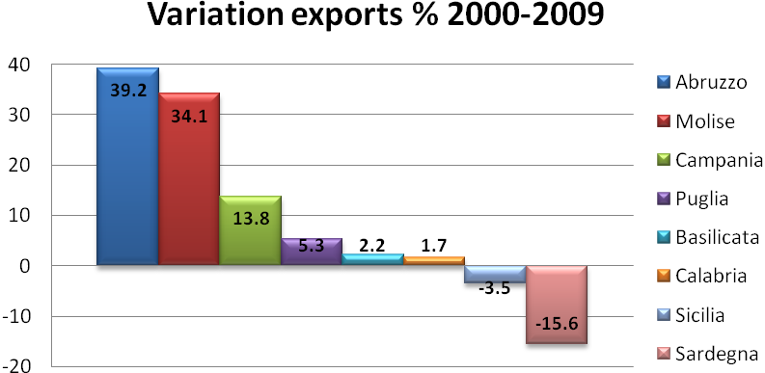
Source: Istat

Data confirms that the islands make the Mezzogiorno a net importer (just like Italy as a whole), while if we consider Southern Italy without taking into account Sicily and Sardinia, the region is a net exporter (Table F - Appendix 3). Calabria proves to be the region with the lowest capacity of exportation in the whole country, more than 6% less than the second worst exporting regions (Molise and Lazio)(Table G - Appendix 3).

The Mezzogiorno’s export toward its Mediterranean partners, has registered a strong increase of 77% from 2000 to 2007 (now representing a third of all Mezzogiorno’s extra-UE exports) (Bianchi, 2009). Understanding the destinations of Southern Italy’s exports is important for our analysis based on the gravity equation, which strongly depends upon common features of trading countries.

Graph #12. Trading volume (sum of import and export) on a macro-regional basis
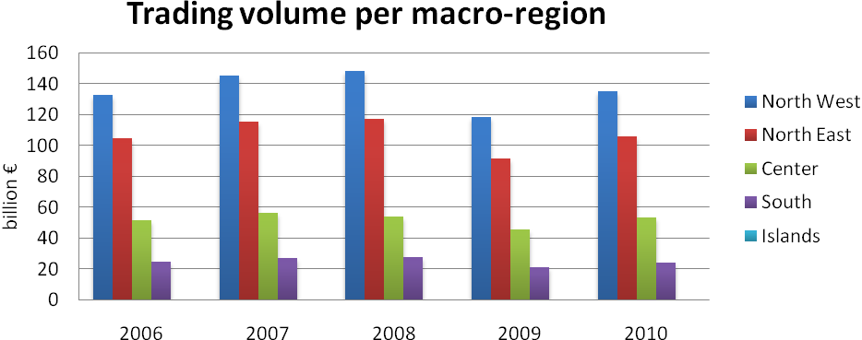
Source:ICE (Istituto nazionale per il Commercio Estero)

First of all, trading volumes show that the contribution to the Italian commercial sector from the South and the Islands is marginal. The North-West is the most active source of exports, led largely by Lombardy and Piedmont, the most productive Italian regions. Nevertheless, the recent crisis hit all the regions and all the regions have the same volatility except for the Islands, which have been more volatile in the last 5 years, losing the most during the crisis in 2009. These regions, however, were also the ones which grew the most in 2010 (30% more than other regions).

Graph #13. Trade growth in percentage of the previous year on a macro-regional basis
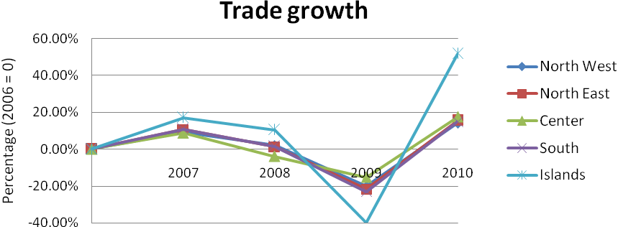
Source: ICE (Istituto nazionale per il Commercio Estero).
A geographical analysis of trade cannot be carried out without considering the various market sizes and thus demand potential for countries importing from Italy and others who export to Italy. We should immediately notice the importance of Middle Eastern and Northern African (MENA) exports to the two islands, which accounts for more than half of these regions’ total imports.

Graph #14. Import average (1999-2007) from Italian regions and macro-regions per macro-area of destination
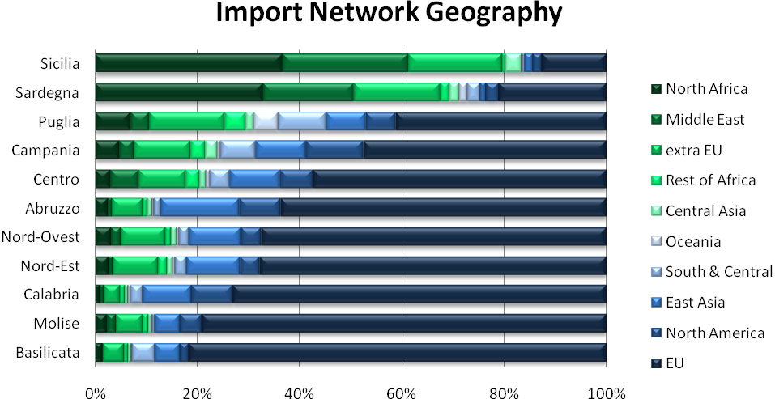
Source: Istat

Nevertheless the importance of oil imports – especially for Sicily’s relationship with Libya in this field, for example – definitely conditions the comparison. Apulia and Campania, which are two of the most regions most active in trade, are less engaged than the Islands in trade with the MENA region, but still trade with them more than the Italian average. The situation changes when considering exports, mainly due to the small market size of the MENA countries compared to EU countries (such as Germany, France and Spain), United States, United Kingdom and China. But still exports from Sicily, Sardinia, Apulia and Calabria towards the MENA region are above the Italian average. Looking at the ten best partners for each of these areas, we can notice that the importance of partner countries with an outlet to the Mediterranean Sea is small for North- Western and Eastern Italy, while for the Center and the South it is almost as important as the EU landlocked markets. Excluding the United States and Germany, all major trading partners for Sicily and Sardinia belong to the so-called Mediterranean region. Spain and France among all trade the most with the Southern regions that can make use of the cheap maritime transportation. Turkey and Greece also trade with the Southern regions, but to a lesser extent.

Graph #15. Export average (1999-2007) from Italian regions and macro-regions per macro-area of destination
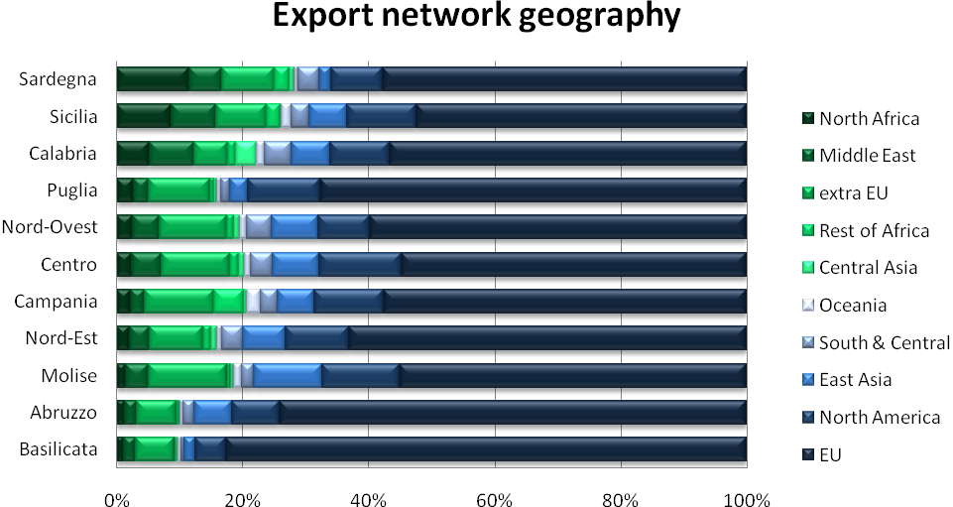
Source: Istat

The decreasing level of export of some of the Southern Italian regions has been caused by the financial crisis, since the main importing countries have been European partners such as Germany, France, United Kingdom, United States and Spain. The bad diversification of export has, in addition, slowed down trade toward the already mentioned partners. In spite of the negative trade with EU members, the positive data are instead the export toward Mediterranean partners. In light of this, our research will now focus on the possibility of implementing further economic integration between the Mezzogiorno and its southern trading partners as a way to re-launch the region’s development.

The Role of the Mediterranean Sea

The Mediterranean has been throughout history a resource of wealth for Italy, from the expansion of the Roman Empire to the birth of the prosperous trading network centered around the Maritime Republics (Pisa, Genoa, Venice and Amalfi). In addition, it attracted many foreign populations to invade the Mezzogiorno over the centuries in order to take control of it. Unfortunately, due to the difficulties encountered by the Southern Italian population first following independence and then during the reunification process much later, the population of the Mezzogiorno seems largely to have forgotten the importance of the Mare Nostrum (Mediterranean) as a source for development. This section aims to explain the main features of the Barcelona process, with the aim of shedding light on the prospect of future economic integration, as well as the strategic position of Southern Italy within the region in order to improve its trade.

4.1 The Mezzogiorno and Euromed countries’ economies

An introduction of the Euro-Mediterranean partnership will demonstrate the importance of cooperation and coordination amongst Italian institutions in order to contribute to the current process of Mediterranean integration which, despite a recent slowdown, is most likely going to be the subject of a discussion for the European Union.

We have decided to make a double comparison for the Mezzogiorno’s GDP per capita (per region) with both European regions facing the Mediterranean Sea, and with other Mediterranean countries (such as those of North Africa, the Balkans, and the Middle East). The comparison with European provinces shows that the Mezzogiorno’s growth has been slower than that of France, Spain, Greece and Slovenia, to the point that Southern Italy in 2008 ended up at the bottom of the chart (Graph #17 below).

Comparing instead the GDP per capita with that of Mediterranean countries, we notice that they have a large gap with Southern Italy, with the exception of Israel which has a GDP per capita higher than that of the Mezzogiorno. Nevertheless, the worrying aspect is the growth of the Mezzogiorno that from 2000 to 2008 stood on average at 2.9% while Israel grew 4.6% (the closest GDP per capita in
the chart), while all the other countries’ growth has been larger by far (Table O - Appendix 3). Turkey’s GDP in 2001 was 196 billion dollars while the Mezzogiorno’s at that time was

Graph #16. Euro per inhabitant in European Union regions with an outlet on the Mediterranean Sea
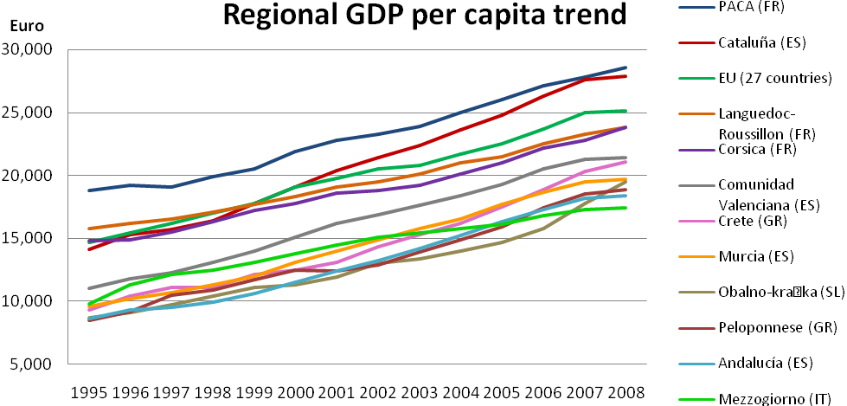
Source: Eurostat

435 billion dollars; now, the situation is inverted, since Turkey’s GDP in just 7 years grew to 730 billion dollars and the Mezzogiorno’s to just 530 billion dollars (Eurostat, 2011). The use of maritime trade and comparative advantage (mainly in textiles) has given an important boost to the Turkish economy. The fact that, in addition to the Strait of the Bosporus, Turkey is planning to create an artificial strait by 2023, confirms the interest of the country to implement sea trade, becoming a crucial port of the Mediterranean Sea, and facilitating the docking to Asia (Minella, 2011).

Although the comparison with regions, instead of countries, of the Mediterranean area as not been possible due to a lack of data, the Mezzogiorno in terms of GDP per capita is right in between European and Non-European partners with an outlet on the Mediterranean Sea (Graph #17 & Graph #18). A gravity equation model, as intended by Tinbergen (1962) (where a country’s increase in trade is based the similarity of its GDP with that of possible trade partners, as well as the distance between the two countries), could give us a better indication of whether the Mezzogiorno is already looking at Mediterranean partners as valid commerce enhancers, and whether they should continue to do so in the future.
Graph #17. GDP per capita for of the Mediterranean Countries
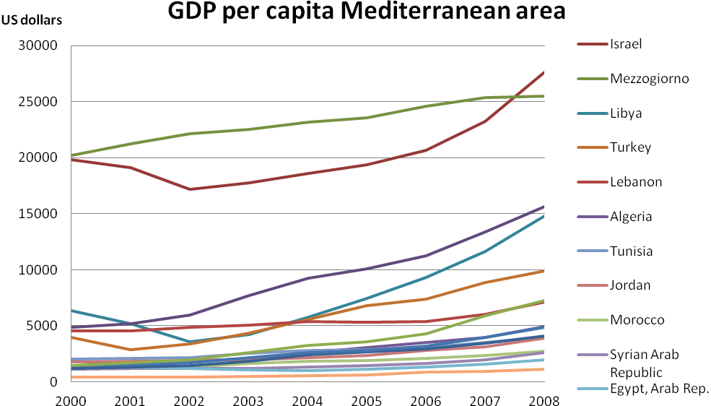
Source: Eurostat and World Bank

4.2 The Chance for an Economic Integration Process

In this section we will briefly introduce the Barcelona process and its goals in order to define whether there is a basis for the creation of a free trade area in the Mediterranean, which could allow the Mezzogiorno to go through fast development and growth.

Mediterranean integration in the socio-economic area has been recently reintroduced in the Barcelona Process in 1995. The process started as a unification process for all countries facing the Mediterranean Sea under the name of Union for the Mediterranean (UfM), and it then enlarged consequently to include the remaining EU member countries, assuming the name Euromed. The member states of the Euromed are currently the 27 EU countries, 16 partners in the Mediterranean, and Libya which acts as an observer (European Union External Action, 2011):
- 4 countries in the Maghreb (Algeria, Mauritania, Morocco and Tunisia)
- 7 countries in the Middle East (Egypt, Israel, Jordan, Lebanon, Syria, Turkey and Occupied Territory of Palestine)
- 4 countries in the Balkans (Albania, Bosnia & Herzegovina, Croatia and Montenegro)
The member states agreed in 1995, signing the Barcelona Declaration (Paris Summit for the Mediterranean, 2008), to participate in the long-term project aimed at creating sustainable socio-economic development, improving the conditions of living of the member states populations, creating a higher level of employment, leveling the playing field to thereby reduce the development gap among member countries, and encouraging regional cooperation and integration. As instruments for economic and financial cooperation and integration, the Euromed project requires the establishment of a free trade area, an increase in economic coordination, and an increase of the EU’s financial assistance to its Mediterranean partners. The foundation for a lasting free trade agreement within the Mediterranean thus was a commitment made by the EU’s institutions to contribute (financially and technically) to the growth of the less-developed areas of partner countries. The target date for countries to create a free-trade zone, from both tariff and non tariff barriers, was 2010 based on mainly regional (bilateral) trade agreements among countries. In the initial project, a progressive removal of agricultural barriers was also included. Just as in the Mezzogiorno, the economic policy signed by all participants at the Barcelona meeting was based on the establishment of a regionalized system of production amongst Mediterranean partners with the support of the EU’s more developed economies, embracing the concept of positive spillovers in localized economies and the conviction of the benefits from a market economy system.

Financing has been done by the European Investment Bank, through the Facility for Euro-Mediterranean Investment and Partnership (FEMIP). In 2010, 10 billion euro were invested to support the three main pillars of the UfM, which are: cleaning up the Mediterranean Sea (Horizon 2020 strategy to reduce pollution by 80%), promoting renewable energies, and supporting a land and sea motorways project which should integrate the Maritime highway project of the EU already mentioned for the Mezzogiorno’s development (FEMIP, 2009). The FEMIP annual report for 2009 (FEMIP, 2009) shows that the main field financed are the MBDI and the land and sea motorway (Graph #19 below).

The Mediterranean Business Development Initiative (MBDI) has been intended to give support to SMEs, since it is also the main structure of the MENA countries’ industrial system. The aim is to support the financial constraint of less developed areas in the Mediterranean Sea, giving credit facilities and supporting private equity operations (FEMIP, 2009). The amount of financing (1.6
billion) made available for the MBDI has been exiguous from 2002 to 2009 (European Investment Bank, 2010).

Graph #18. FEMIP financing breakdown by sector
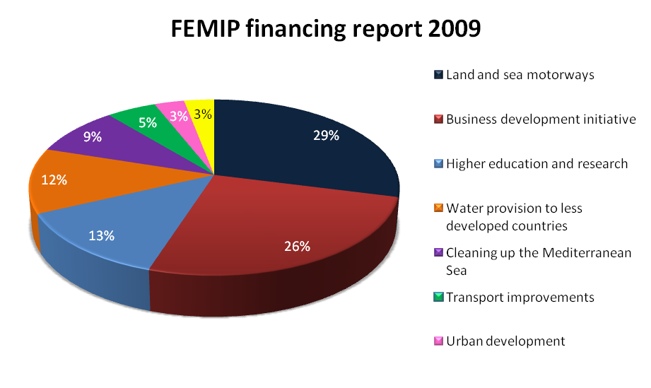
Source: FEMIP Annual Report for 2009

The funding programs, so far, have been established through 6-year projects, but there has been a change of schedule since the initial projects MEDA I and MEDA II, exclusively aimed for Mediterranean partners, were integrated in a broader project of European Neighborhood and Partnership Instruments (ENPI) (FEMIP, 2009). Initially (from 1995 to 1999) 4.7 billion euro were made available for MEDA I, while the MEDA II (from 2000-2006) funds were 5.3 billion euro. For the new period that goes from 2007 to 2013 the financing strategy is more unclear and the budget on tap for MENA and Balkan members of the Euromed partnership from the grand funding ENPI is slightly more than 4 billion euro (equals to 33 euro per inhabitant (Montanari, 2007)) (European Commission, 2007). The reason for a MBDI project is the same as for the Southern Italy SMEs problem, where banks charge interest rates out of the budget of companies due to the low bankability and high risk of operations (similar to the Mezzogiorno’s Bank project). In addition, companies tend to not save all economic information due to the cost of it, not allowing banks a more detailed and precise analysis of the risk. FEMIP tries to stimulate the private sector to intervene on the markets of all Mediterranean partners, which often are monopolized by public companies.

4.3 Euromed Process Slow-down and Its Reasons

Although we have pointed out the importance of economic integration between Mediterranean countries by way of a free trade area, the Euromed process has recently been slowing down due to an EU internal debate about the different interests of market agents and countries themselves. At the same, MENA countries have reached some agreements towards free trade, but so far the EU has been the main beneficiary of the Euromed initiatives, since the volume of exports of EU countries has increased more (by far) than that of MENA countries, since the establishment of the Barcelona Process (Jarreau, 2011). In this section we will shortly introduce the double game problem that represents one of the main obstacles to successful integration in the future, together with the existing and crucial conflicts occurring within various Mediterranean countries (which will not be directly addressed in this research).

We have already noticed that the increase in exports from the Mezzogiorno towards Euromed partners, despite the fact that the trade volume in absolute values is not very high, shows that the Southern Italian traders consider the full actuation of Euromed to be important and beneficial (SVIMEZ, 2008).The amount of goods exported from European countries nevertheless has strongly increased, while the effect on Mediterranean countries’ exports has been marginal. An analysis of the tariff barrier trend since the introduction of Euromed could be helpful to demonstrate what has been done so far in the direction of the establishment of a free trade area in the Mediterranean (Graph F – Appendix 2). The restriction on textiles and fibers, in addition to agriculture and the high cost of import licenses (CE mark for example), restrictive allocations, currency exchange rate volatility and local state monopolies, has had a generally negative impact (with the exception of Tunisia and Morocco), contributing to the asymmetric effect (Graph G – Appendix 2). Concerning the currency exchange rate volatility it is worth saying that it is obviously too costly for importing and exporting SMEs to hedge and reduce externalities on trade (especially in local financial markets without much liquidity). For crude materials and inedible goods, among which textiles fibers are included (which are crucial for a good share of MENA countries’ exports), we notice that European countries remains more skeptical in reducing such tariffs, compared to Mediterranean partner countries (Graph H – Appendix 2).

Within MENA countries since the end of 1990s, the Greater Arab Free Trade Area (GAFTA) has been active, with the purpose of abolishing trade barriers within region. Furthermore, the Agadir Agreement was also signed, serving apparently as the first step towards a Euromed free trade area; the EU, however, failed to sustain the initiative enough for it to have a strong impact on trade within the Mediterranean. Jarreau’s (2011) research on the effect of GAFTA and the Agadir Agreement found significant results (between 16-24 %) for the first agreement and poor results for the latter. Still this, does not mean that trade among MENA countries is high. On the contrary, regional trade is driven by the European market rather than neighboring countries with a South-South exchange oscillating between 5-7% of total trade (Jarreau, 2001).
Several empirical analysis have been carried out on the effects of Euromed (ex-ante and ex-post), using the gravity model, in order to quantify the benefits for MENA countries within the Euromed agreement. Although studies are not comparable, they mainly agree on the idea that import from EU countries rather than export enhances due to the Euromed agreements, and the benefits are not equal among all Middle Eastern and Northern African partners. For a more detailed analysis of this topic Jarreau (2011) provides a detailed table with a summary of main researches (with methodology used and results). Hoekman and Konan (1999) support the idea that in the North African countries, intense free trade agreements for all goods could have a significantly positive effect on welfare too, while a weak agreement could even bring deindustrialization and reduce welfare. Bilateral trade agreements, such as that adopted by Euromed members, are both more specific and more adaptable to diverse countries’ requirements, compared with broad, multilateral agreements (for example WTO) (Hoekman & Konan, 1999).

The stalemate in the Euromed process is a consequence of a double conflict game arisen within the EU member states as a consequence of different interests. The first of the two conflicts find its root in the differing interests of European agricultural producers and the willingness of the EU’s Mediterranean countries to allow for the import of agricultural goods from those Mediterranean countries that are not within the EU. Even if the initial project included the intention to abolish trade barriers on agriculture to allow Mediterranean countries to freely export to the EU, in the subsequent agreements, attention moved away from the progressive reduction of barriers and focused instead on the enhancement of the quality of agricultural goods, rural sustainable development and the importance of carrying further research on the topic (Euro-Mediterranean Conference on Foreign Affairs, 2008). Despite the fact that agricultural goods produced in the MENA countries, for example, are most of the time different from EU crops, the market entry resistance applied by European agricultural organization has been strong. In fact, the graph below illustrates food and live animals tariffs from Italy to some of the Mediterranean partners and vice versa (to the EU 27), from the beginning of the Barcelona Process to 2010 shows us two important things. The first is that the EU27 have more than halved the tariff of importing from 35% to slightly less than 15%, but still the opposition to Mediterranean partners’ imports is higher than the one applied by Mediterranean countries to Europe. The effort in reducing trade tariffs of manufacturing goods, especially from the European side, has been definitely larger.

The second conflict that has arisen is between EU countries in favor of establishing more extensive business relation with Central and Eastern European countries (CEECs) (rather than MENA countries) (Jarreau, 2011). Bringing an analysis internal to the EU, it seems obvious that countries with an outlet on the Mediterranean Sea are more involved in the Euromed project than others. With regards to the expenditure needed by the Barcelona Process, Montanari (2007) pointed out the conflict of interest of partners more inclined to move closer economically to CEECs, as opposed to those interested more in the Mediterranean area. As a result of this conflict, there has been a change of aim on the agriculture sector and a reduction of funding for the Euromed project. Agricultural protectionists’ pressure on institutions, directed the EU countries to set aside the free trade of agricultural goods, while those countries which are more inclined towards relations with CEECs moved a substantial part of EU funds to this region instead. As a result of this policy, trade with CEECs is now three times higher than trade with Mediterranean countries (MCs), even if in the 1990s CEECs trade with EU was lower than that conducted with MCs.

The double game issue can hardly be solved in the short term also because the financial crisis has made it impossible to sustain both CEECs and Mediterranean countries for future market integration. It is important to note, though, that the Mediterranean integration process should not be an alternative to the EU enlargement but a process that goes along with. In the next chapter we will attempt to determine whether the Mezzogiorno’s proximity with the Mediterranean could enhance exports, thereby eventually contributing to the growth of the region in the long term.

Empirical Research

5.1 Data

The dataset for our analysis includes the aggregate exports of 36 Italian provinces of the Mezzogiorno towards 42 Euromed member countries. The source for the exports data has been the aggregate ISTAT database on a Ateco 2007 level (national version of NACE Rev.2). Palestine has been excluded from the research for lack of data regarding its consumer price index and production value added per sector. The mean for export is ≈ 22 million euro, and the exports from Cagliari (Sardinia) to Spain have been the largest reported in 2008, while the one from Nuoro to Ireland has been the minimum (only 64 euro). For the measuring of distance between countries, through the method proposed by Andrew Gray (2001) that calculates the great circle distance, we have taken the distance among each single Italian province and the main economic center (city) of the partner country. The distance between Bari (Apulia) and Nouakchott (Mauritania) is the longest one, while the shortest is from Ragusa (Sicily) to Valletta (Malta).

The table below defines all the variable and data sources for constructing the provincial cross-section analysis for the year 2008. We have chosen to use data for 2008 as they are the most recent and complete data available.

Symbol | Description | Data Source
Xij | Natural logarithm of the exports from Italian provinces to Euromed countries | Coeweb (ISTAT)
β₀ | Gross Domestic Product of Mezzogiorno and Euromed countries (Italy excluded) in 2008 (The constant term) | Eurostat and World Bank
Y_{i} | GDP of Italian provinces in 2008 | Eurostat
Y_{j} | GDP of Euromed countries in 2008 | Eurostat and World Bank for Jordan, Libya, Mauritania and Syria.
DISTij | Bilateral distance in KM | http://argray.com/dist/
SEA | Dummy equal to 1 if both exporting province and importing country have an outlet on the Mediterranea Sea. “Mediterranean Network” | World Bank
CRIME | Sum of arson, attack, extortion and mafia association in each Italian province, as a proxy of crime per 10,000 inhabitant 2008 | (giustizia in cifre)ISTAT*
CPI | Consumer price index (annual growth) 2008 | World Bank
AGRij | Value added share of GDP (province-country) in the agricultural sector in 2008 | ISTAT and World Bank
INDij | Value added share of GDP (province-country) in the industrial sector in 2008 | ISTAT and World Bank
SERij | Value added share of GDP (province-country) in the service sector in 2008 | ISTAT and World Bank
* Penal justice, crimes that all police authorities have reported to the judging authority.

In this section we will present our regression for the analysis of the export of Italy’s Mezzogiorno toward Euromed countries. The research aims to find evidence of the effect of distance between Italian provinces and country partners, together with the size of GDP, based on a standard gravity equation framework. In addition to a basic application of Tinbergen (1962) gravity model, we introduced to our research some potential distortive features, such as crime (affecting the Mezzogiorno) and the consumer price index, in order to take into account the role played by the mafia and the inflation rate when countries trade. In addition to the country fixed effect method, we decided to implement the regression by introducing variables that could capture the economic similarities among Italian provinces and the Euromed partner countries.

5.2 Model Setup

In this section we will present our regression for the analysis of the export of Italy’s Mezzogiorno toward Euromed countries. The research aims to find evidence of the effect of distance between Italian provinces and country partners, together with the size of GDP, based on a standard gravity equation framework. In addition to a basic application of Tinbergen (1962) gravity model, we introduced to our research some potential distortive features, such as crime (affecting the Mezzogiorno) and the consumer price index, in order to take into account the role played by the mafia and the inflation rate when countries trade. In addition to the country fixed effect method, we decided to implement the regression by introducing variables that could capture the economic similarities among Italian provinces and the Euromed partner countries.

The traditional gravity equation is an econometric model that has been used to assess the importance of the size of economies and the negative effect bilateral trade costs have on trade flows. It has been recently enriched of additional variables in order to explain some puzzling results that have often been found in empirical analyses based on this framework. This research aim to find a confirmation of what gravitational model have proved so far, that is economic similarities and reduction of costs (in particular the elimination of tariff and non-tariff barriers) increase trade and thus promote growth.

To understand the structure of the equation we are proposing for our research, we will often refer to the work of Feenstra (2002). The province aggregate equation form is based on Anderson & van Wincoop (2003), where consumers have CES preferences. A simpler adaptation to the NLS analysis of Anderson & van Wincoop (2003) is the first order Taylor-series expansion log-linearized OLS, suggested by Baier and Bergstrand (2009):
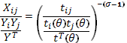
Where t_{ij} represents bilateral trade costs, and RHS denominator is a proxy for the multilateral trade costs on bilateral trade relative to GDPs. The MR (that we previously defined in the theoretical background “multilateral resistance”) is exogenous but theoretically explained, in order to remedy for the non observability of trade costs in the real world.

Feenstra (2002) compares the computational method of Anderson van Wincoop (2001) with a simple fixed effect method, and suggests to use the second since it is easier to use, gives robust results and does not contradicts the results of the computational method. For our research we decided to adopt the simpler log-linear OLS estimation model with country fixed effect, introducing from the very beginning the trade barriers (Feenstra 2002). In our model the consumer maximizes:

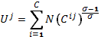

subjects to a budget constraint, where C^{ij} represents the consumption of goods of country j imported from country i (taken from Feenstra 2002). In order to further simplify the goods diversity, we assume for simplicity, based on Feenstra (2002), equal cost of transport for all products (although we have previously showed that tariff barriers are different for different goods). Here below is shown the model adopted by Feenstra (2002) with country fixed effects:

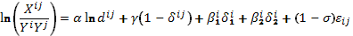

where the MR terms have been approximated by introducing the coefficient estimates of the two dummies for exporter and importer ; the border effect is represented by the δ^{ij} term.

The regression we will use for our empirical research is as follows:

Exports from country i to country j depend upon the economic size of country i and j, the trade cost, a set of dummies. The natural logarithm lnXij represents the export of province i to country j, and it represents the dependent variable we aim to study. On the basis of the traditional gravity equation, the natural logarithms of the GDP of province i and country j have been included as a proxy of the economic size (respectively Yi and Yj). In our regression, β₄ is the coefficient of interest to estimate the dummy for Mediterranean Sea network, which replace the “multilateral index” alternatively to the computational method. The dummy SEA is 1 if both province i and country j have an outlet on the Mediterranean Sea and 0 otherwise. The natural logarithm of the crime is the same as the index proposed by Daniele & Marani (2010), which is the sum of arsons, attacks, mafia crime and extortion, of province i, and it aims to introduce the mafia effect in the estimation. The variable for consumer price index is the annual growth of the country j in 2008 respect to the previous year, and it is a proxy of the role played by country j’s inflation on its imports. Cieślik (2009) stated that the factor proportion variables, in addition to bilateral trade cost, are also important for trade flows, and the omission of such variables could introduce a bias in the estimates. Although the generalized use of information on factor endowments in the gravity equation has not been fully developed and the method Cieslik (2009) used would need a deeper analysis, for our purpose the variables AGR_{ij}, IND_{ij} and SER_{ij} (the natural logarithm of value added of the sectors’ share, differential between province i and country j) would be a good indication for factor proportion role in trade.

Recall that one of the primary assumptions for the gravity equation is that trade balance holds, i.e. that X_{ij} =X_{ji} (Feenstra 2002, Anderson & van Wincoop 2003, Baier & Bergstrand 2009). Verbeek lists the advantages of using fixed effects in samples of big enterprises, countries and industrial sectors when the effects are conditional on the variable values and not the opposite (2004, p. 311).

“Zero” trade flows will be ignored in our analysis, although the cross-section approach minimizes them. The model we used for our research has been mainly inspired by the “country fixed” model for estimating the average border effect in a cross-country case scenario proposed by Feenstra (2002)

One should be careful when deals with dummies, since they increase the coefficient of determination but there is a risk than more one dummy might be correlated (i.e. we might incur in a multi-collinearity problem). In addition there is a loss of degree of freedom for any single dummy included in the model, and secondly the model could lose its generality bringing the regression to no conclusion if there is a misuse of dummies (Verbeek, 2004, p. 39). In our research we will focus only on one dummy variable, SEA (outlet on the Mediterranean Sea), in order to avoid the collinearity problem that could arise with the introduction of too many dummies into a regression model.

Since Euromed agreements are mainly bilateral the assumption of symmetric trading costs could be distortive, and for this reason Baier and Bergstrand (2009) application to our case could be a valid alternative for future researches. Although theoretically the assumption that t_{ij}=t_{ji} is not removed, the MR weighted for GDPs and asymmetric bilateral trading costs, will yield a proxy level which will indirectly take into account a certain degree of asymmetry (Baier & Bergstrand, 2009).

5.3 Main Findings

This section aims to list the results of the gravity equation analysis of the volume of exported goods from Southern Italy provinces towards Euromed partner countries. Three OLS log-linear regression have been run for different level of elasticity of substitution (respectively 5, 8 and 10), since unfortunately we do not have a direct measure for this variable. For a more detailed view of the results Figures 1-3 report the results of the analysis. In this section we will only show the main findings postponing to the next section the detailed analysis of the meaning of our research.

The results offer a broad support for both the explanatory power of the coefficient estimator and the intuition behind the negative role of distance when trading. The table below shows that all estimation coefficients reject the null hypothesis of non-effect on the volume of trade for a confidence of interval of 95%. The model determination, though, is not as high as the studies previously mentioned, since both R² and adjusted R² values are approximately 0.56. The standards errors have been reported below the coefficient estimators’ value within brackets, in order to show the volatility of such values.

Table #1. Empirical Analysis (volume of export, in euro, from all single Italian provinces towards Euromed partners in 2008)

Year of data  Elasticity (σ) | 2008  5 | 2008  8 | 2008  10
lnY_{i} | 1.490*  (0.070) | 1.490*  (0.070) | 1.490*  (0.070)
lnY_{j} | 0.970*  (0.038) | 0.970*  (0.038) | 0.970*  (0.038)
lnDist_{ij} | -1.209*  (0.010) | -0.173*  (0.014) | -0.134*  (0.011)
lnCPI | -0.112*  (0.028) | -0.064*  (0.016) | -0.050*  (0.012)
lnCrime | -0.154*  (0.020) | -0.088*  (0.011) | -0.068*  (0.009)
ΔlnAgr_{ij}  ΔlnInd_{ij}  ΔlnSer_{ij}  SEA  R²  Adjusted R²  Durbin-Watson stat  Wald test  Ramsey Reset test  White test  Observation | -0.043*  (0.007)  0.651*  (0.061)  0.484*  (0.089)  0.086*  (0.029)  0.558  0.555  1.533  0.003  0.323ª  10.356  1404 | -0.025*  (0.004)  0.372*  (0.035)  0.277*  (0.051)  0.050*  (0.016)  0.558  0.555  1.533  0.003  0.323ª  10.356  1404 | -0.020*  (0.003)  0.290*  (0.027)  0.215*  (0.040)  0.038*  (0.013)  0.558  0.555  1.533  0.003  0.323ª  10.356  1404
ª one fitted term
*significant at 95%

As previously mentioned, the White test (preferred to Breusch-Pagan test since does not requires per se normality) demonstrates that the hypothesis of homoskedastic residuals is rejected (α=0.05), since the F statistic is larger than the chi-quadratic distribution with two degrees of freedom (5.99). The null hypothesis of normality is rejected, according to the Jarque-Bera test at a significant level of 95%, as shown in the graph below.

Graph #19. Gravity equation statistics.
The log-linear approach and the cross-section analysis usually suffer from heteroskedasticity (Siliverstovs & Schumacher, 2007). Nevertheless, the Ramsey RESET test does not reject the null hypothesis of misspecification, supporting the use of the linear regression model is appropriate to the case scenario. Since the primary observed variable is the SEA (dummy for Mediterranean network), we decided to run the Wald test in order to verify the hypothesis that β₄=0. The test rejects the null hypothesis suggesting the evidence of a Mediterranean network effect within this model.

5.4 Discussion

In this section we will analyze the implication of the country fixed log-linear OLS estimation above mentioned, in order to find out what can be done in the future for the Mezzogiorno’s growth.

For a good portion of our research we focused our attention to the role of the Mediterranean prospective for Southern Italy development opportunity, and the gravity equation goes along with what has been suggested in the previous sections, when we analyzed the Mezzogiorno. The positive effect that has been offered in 2008 by the Mediterranean network, for the provinces of Southern Italy, varies between 3.8%-8.9%. The benefit of implementing the free trade zone (thus the abolition of tariff and non-tariff barriers) within the Mediterranean could increase further the current effects. Distance, in addition to the existence of a sea outlet in common, plays a crucial role for the decision of exporting for the Mezzogiorno. This is an invitation to Southern Italy’s institutions to increase relationship with neighboring countries, since in spite of the globalization process there is still evidence of the obstacle that transport represents. Concerning the magnitude of the distance effect, data need to be interpreted cautiously since the range of such an effect change from 12% to 1.3%, depending on the elasticity used. Consumer price index in country j (although a panel data could be more specific on this topic) affects negatively trade, suggesting that internal economic stability of partner countries is also important in order to guarantee the success of bilateral trade transactions.

The analyses of the data concerning the sector production similarity, which aim mainly to capture the effect of a similar economic structure to the export strategy of Mezzogiorno, are not too much conclusive. Nevertheless, data suggest a positive effect on export of the diversity of sector concentration of production for industry and services (although the estimation model with the elasticity equals to 10 seems to be more realistic on this regard). The concentration in the agriculture production, instead, for this case scenario seems to promote the importance of partnership with countries, that have a similar share of agriculture added value of total GDP.

Crime is probably the main obstacle to growth due to its domino effect on the local economy therefore, in spite of the many issues the Mezzogiorno is facing that we listed in the previous section, we decided to focus on the effect mafia could have on legal export (although is impossible to remove trade of firms with mafias infiltrations). In order to avoid an overcrowding of variable we decided to include into the regression model only crime, which probably represents the primary sore of the Mezzogiorno. The aim of introducing crime in the regression model, is to draw the attention on the importance of removing market distortion since negatively affect the growth. There is evidence of a reduction of export due to the presence of mafia around 7-14%. If we compare the reduction of 7% of export (not considering further effect), to the positive effect that the Mediterranean network has on the Mezzogiorno, we can notice that the negative effect of the mafia distortion on the export volume may decrease the positive role played by Mediterranean. On this regard there is no security that the negative effect may even increase with the implementation of a free trade area with MENA and Balkans countries.

To summarize, the data confirm in principle the main expectations of both positive and negative effect on Mezzogiorno’s trade. On one hand there is the possibility of establishing profitable partnerships for the coming years, while on the other there is a necessity to solve internal problems that may nullify any positive effort toward growth. The attempt to remit Mezzogiorno’s issue cannot be made regardless the contextualization.

Conclusion

The primary purpose of our research was to find out whether the implementation of the Barcelona Process towards the integration of all Mediterranean countries (where EU as a whole is included), could assist the Mezzogiorno’s economic growth. Over the course of our analysis we focused on the benefits of free trade and growth, aiming to contextualize the research taking into consideration the territorial features and socio-economic problems of Southern Italy. As we have many times underlined, the Mezzogiorno has peculiar aspects that may strongly condition the implementation of positive policies. In spite of the efforts (perhaps poorly targeted and supported) of both Italian government and local administrations, the objective of bringing the Mezzogiorno’s economy to the same level as Northern Italy, or at least the EU average, has failed. Analyzing internal issues and the trading potential of Southern Italy, we conclude our research with the gravity equation application to exports of the Mezzogiorno (based on the cross-country analysis in 2008) towards neighboring countries. The use of the gravity model has been widely accepted, mainly for its explanatory power, to study the effect of economic integration and tariff barriers. Therefore, the empirical model was constructed in order to find out whether there is evidence of the positive effect that the Mediterranean Sea network has on the export for the Mezzogiorno, and thus for its growth.

The results of the gravity equation research offer a very interesting starting point in both the implementation of a potential free trade area (within the Mediterranean region), and the importance of first solving internal issues of the Mezzogiorno. Firstly, the Mediterranean network has a positive effect on the volume of goods exported from the Mezzogiorno toward Euromed countries in confirmation of our initial hypothesis, and secondly the criminal effect on trade undermines the positive role played by the sea connection. Finally the analysis proves the main hypothesis of the gravity equation, that trade flows are higher between countries similar in size and closer to each other geographically. Results reported the need for institutions to implement co-ordination with neighboring partners, but also the improvement of trading infrastructure and the removal of factors causing market distortion.

The theoretical limitation of the gravity model, nevertheless, is one of the topics to be elaborated upon since there is the risk of omitting variables, which may lead to biased results. It would have been interesting to investigate whether the Mediterranean plays a positive role for Northern Italy as well, since our analysis only takes into account Southern Italian provinces. A strong assumption has been that tariff barriers are equal between countries, and this is not the case for most of the Mediterranean partners and Italian provinces. In addition, the hypothesis of homoskedasticity for the residuals is rejected, and this is a common feature of OLS log-linear estimation of the gravity equation, therefore a panel data analysis using a Poisson maximum likelihood could be more appropriate for further research. Nevertheless, the simple structure of the gravity model we adopted simplified the research and simplified the analysis of such effects. The variables that negatively affect trade and growth for the Mezzogiorno (in addition to mafia), which we mentioned in the sections above, do not have an empirical analysis that proves their role in the Mezzogiorno in this research in order to avoid the overcrowding of variables in the gravity equation. However their negative effect on Southern Italy currently remains a hypothesis that needs to be further analyzed in the future. The Euromed implementation is not an alternative to the EU enlargement to CEECs, but for the simple reason of suggesting which project should be developed first (in a context where EU finances are not extremely abundant), it could have be interesting to search for the effect of both projects for the Mezzogiorno.

Indirect incentives contribute too little to growth and for this reason it is important to create a system that stimulates individuals to actively participate in the development process. Creating opportunities (rather than searching for those which may not even exist) could be very beneficial for the Mezzogiorno. The active contribution of Italy in assisting countries that are currently in a process of renovation (such as Tunisia, Algeria, Egypt and so forth) can be the basis for future market integration. The Euromed in this regard has drafted the first important partnership, showing the will of member countries to integrate and co-operate. Although the project is currently experiencing a stalemate, efforts at establishing a Mediterranean free trade area have not been futile. The implementation today of Euromed could be a very strong signal for both individuals and the market, showing the future prospective of growth for both Mediterranean countries and the EU.

References

Academic Ranking of World Universities. (2010). [Academic Ranking of World Universities – 2010]. Academic Ranking of World Universities. Retrieved from http://www.arwu.org/ARWU2010.jsp
Aiello, F., & Cardamone, P. (2008). R&D spillovers and firms’ performance in Italy: Evidence from a flexible production function. Empirical Economics, 34, 143-166. Retrieved from http://www.springerlink.com/content/xh65m12573q57223/
American Association of Port Authorities (AAPA). (2004). [World Port Rankings 2004] Port Industry Statistics. Retrieved from http://www.aapa-ports.org/files/Statistics/WORLD_PORT_RANKINGS_2004.xls
American Association of Port Authorities (AAPA). (2009). [World Port Rankings 2009]. Port Industry Statistics. Retrieved from http://aapa.files.cms-plus.com/PDFs/WORLD%20PORT%20RANKINGS%202009.pdf
Anagrafe Italiani Residenti all’Estero (AIRE). (2011, January). [Gli emigrati Italiani nel 2011]. Rapporto migrantes Italiani nel mondo. Retrieved from http://www.italiani.lu/mmp/online/website/menu_left/associations/2760/84/file_76927/allegati_statistici.pdf
Anderson, J. E. (1979). A theoretical foundation for the gravity equation. The American Economic Review, 69(1), 106-116. Retrieved from http://www.jstor.org/pss/1802501
Anderson, J. E., & van Wincoop, E. (2001). Borders, trade and welfare. Paper prepared for the Brookings Trade Forum 2001 on globalization: Issues and implications, Washington D.C. Retrieved from https://www2.bc.edu/~anderson/Borders11.pdf
Anderson, J. E., & van Wincoop, E. (2003). Gravity with gravitas: A solution to the border puzzle. The American Economic Review, 93(1), 170-192. Retrieved from http://www.jstor.org/stable/3132167
Annuario Statistico Regionale. (2008). [Investimenti diretti esteri nelle province italiane Lombardy 2008]. Foreign Direct Investment in the Italian Provinces. Retrieved from http://www.asr-lombardia.it/ASR/lombardia-e-province/commercio-estero/investimenti-esteri/tavole/100456/
Baier, S. L., & Bergstrand, J. H. (2009). Bonus vetus OLS: A simple method for approximating international trade-cost effects using the gravity equation. Journal of International Economics, 77, 77-85. Retrieved from http://www.sciencedirect.com/science/article/pii/S0022199608001062
Banca d’Italia. (2010, June). Il Mezzogiorno e la politica economica dell’Italia, numero 4. Banca d’Italia. Retrieved from http://www.bancaditalia.it/pubblicazioni/seminari_convegni/mezzogiorno_4/4_volume_mezzogiorno_2010.pdf
Barba Navaretti, G., Basile, R., Benfratello, L., & Castellani, D. (2009). Il Mezzogiorno e gli investimenti diretti esteri. Centro Studi Luca D’Agliano. Retrieved from www.dagliano.unimi.it/media/fdi_sud_confindustria.pdf
Bardi, U. (2004, February). Un’introduzione alla geologia e estrazione del petrolio in Italia. ASPO Italia (Associazione per lo Studio del Picco del Petrolio). 15 May 2011. Retrieved from http://www.aspoitalia.it/documenti/bardi/petrolioitalia.html
Bhagwati, J. (1958). Immiserizing growth: A geometrical note. The Review of Economic Studies, 25(3), 201-205. Retrieved from http://www.jstor.org/stable/2295990
Bhagwati, J., & Srinivasan, T.N. (2002). Trade and poverty in the poor countries. The American Economic Review, 92(2). Retrieved from http://www.columbia.edu/~jb38/papers/papers.html
Bianchi, L. (2009, March). Prospettiva mediterraneo per il mezzogiorno: Non solo piattaforma logistica: il sud Italia ora punta all’integrazione economica, article 86. MedideaReview: rivista trimestrale di politica, cultura ed idee per il mediterraneo, Passaggio in Africa. Retrieved from http://www.medideareview.it/articolo/86/prospettiva-mediterraneo-per-il-mezzogiorno-di-lucabianchi
Buonanno, P. (2005). Crime and labour market opportunities in Italy (1993-2002). Quaderni di ricerca del Dipartimento di Scienze Economiche “Hyman P. Minsky” n.4. Retrieved from http://onlinelibrary.wiley.com/doi/10.1111/j.1467-9914.2006.00346.x/full
Calderon, C. & Serven, L. (2004, September). The effects of infrastructure development on growth and income distribution (working paper no. 270). Central Bank of Chile. Retrieved from http://www.bcentral.cl/estudios/documentos-trabajo/pdf/dtbc270.pdf
Cannari, L., Magnani, M., & Pellegrini, G. (2009, July). Quali politiche per il sud? Il ruolo delle politiche nazionali e regionali nell’ultimo decennio. Banca d’Italia - Questioni di Economia e Finanza (Occasional papers), 50. Retrieved from http://www.bancaditalia.it/pubblicazioni/econo/quest_ecofin_2/QF_50/QEF_50.pdf
Censis. (2009). Il condizionamento delle mafie sull’economia, sulla società e sulle istituzioni del mezzogiorno. Censis. Retrieved from http://www.censis.it/5?resource_23=64696&relational_resource_24=64696&relational_resource_26=64696&relational_resource_396=64696&relational_resource_78=64696&relational_resource_296=64696&relational_resource_342=64696&relational_resource_343=64696&relational_resource_405=64696
Checchi, D. (2001). Scuola, formazione e mercato del lavoro. In B. Luchino (Ed.), Manuale di Economia del Lavoro (p. 21-56). Bologna: Il Mulino.
Checchi, D., & Peragine, V. (2005, December). Regional disparities and inequality of opportunity: The case of Italy (discussion paper no. 1874). Institute for the Study of Labor. Retrieved from http://air.unimi.it/bitstream/2434/16127/1/regional%20disparities%20and%20inequality.pdf
Cicciomessere, R., Pammolli, F., & Salerno, N.C. (2008). Mezzogiorno d’Italia: Primo baedeker dello sviluppo territoriale e regionale. Competitività Regolazione Mercati. Retrieved from http://www.cermlab.it/_documents/RapportoCERM_2_2008.pdf
Cieślik, A. (2009). Bilateral trade volumes, the gravity equation and factor proportions. The Journal of International Trade & Economic Development, 18(1), 37-59. Retrieved from http://www.uclouvain.be/cps/ucl/doc/core/documents/ciesliek.pdf
Comitato nazionale per la valutazione del sistema universitario (CNVSU). (2011, January). Undicesimo rapporto sullo stato del sistema universitario. Ministero dell’Istruzione, dell’Universita’ e della Ricerca. Retrieved from http://www.rettore.unifg.it/dwn/Rapporto%20Stato%20Universit.pdf
Confcommercio Palermo. (2011, February 10). Fondi FAS Dirottati al Nord; al Sud Rimangono 11 Miliardi [Press Release]. 17 May 2011. Retrieved from http://www.confcommercio.pa.it/rassegna-stampa/?idnews=5716
Confesercenti. (2010, November 26). Le mani della criminalità sulle imprese: Focus Campania rapporto 2010. Retrieved from http://www.sosimpresa.it/userFiles/File/Documenti2/Rapporto_Salerno.pdf
Corriere della sera.it (2009, July 24). [Le università virtuose (e quelle “bocciate”)]. Corriere della sera.it. Retrieved from http://www.corriere.it/Primo_Piano/Cronache/2009/07/24/pop_universita.shtml
Daniele, V., & Marani, U. (2010). Organized crime and foreign direct investment: the Italian case (working paper no. 2416). Center for Economic Studies (CES) & Ifo Institute for Economic Research. Retrieved from http://www.cesifo-group.de/portal/pls/portal/docs/1/1199087.PDF
Danielli, E. K., & Pittalis, M. G. (2010). Il dissesto finanziario degli enti locali alla luce del nuovo assetto normativo. Ministero dell’Interno. Retrieved from http://finanzalocale.interno.it/docum/studi/dissesto/dissfinoggi.pdf
Di Pietro, G., & Gomez y Paloma, S. (1998). Small and medium sized enterprises and industrial models in the Euro-Mediterranean zone. European Commission Joint Research Centre, Institute for Prospective Technological Studies. Retrieved from http://ftp.jrc.es/EURdoc/EURdoc/EURdoc/eur17731en.pdf
Dollar, D., & Kraay, A. (2002). Growth is good for the poor. Journal of Economic Growth, 7(3), 195-225. Retrieved from http://www-wds.worldbank.org/servlet/WDSContentServer/WDSP/IB/2001/05/11/000094946_01042806383524/Rendered/PDF/multi0page.pdf
Égert, B., Kozluk, T., & Sutherland, D. (2009, March 13). Infrastructure and growth: Empirical evidence (working paper no. 685). OECD Publishing. Retrieved from http://dx.doi.org/10.1787/225682848268
Emami Namini, J., & Pennings, E. (2009, January 14). Horizontal multinational firms, vertical multinational firms and domestic investment (Tinbergen Institute discussion paper). Erasmus School of Economics, Erasmus University Rotterdam. Retrieved from http://repub.eur.nl/res/pub/14741/2009-0042.pdf
Emami Namini, J., Facchini, G., & Lopez, R. (2011, February). Export growth and factor market competition: Theory and evidence (discussion paper no. 8256). Center for Economic Policy Research. Retrieved from www.cepr.org/pubs/dps/DP8256.asp
Euro-Mediterranean Conference on Foreign Affairs. (2008, November). Final statement of the Marseilles meeting of the Euro-Mediterranean Ministers of Foreign Affairs, 3-4 November 2008, Marseilles, France. Union for the Mediterranean. Retrieved from http://www.parlamento.it/documenti/repository/affari%20europei/APEM/dicFinaleMarsigliaUfM.pdf
European Commission. (2007). European Neighbourhood and Partnership Instrument (ENPI): Funding 2007-2013. European Commission European Neighbourhood Policy. Retrieved from http://ec.europa.eu/world/enp/pdf/country/0703_enpi_figures_en.pdf
European Investment Bank. (2010). Union for the Mediterranean: Role and vision of the EIB. Facility for Euro-Mediterranean Investment and Partnership, European Investment Bank. Retrieved from http://www.eib.org/attachments/country/union_for_the_mediterranean_en.pdf
European Union External Action. (2011). Euro-Mediterranean Partnership (EUROMED). European Union External Action. Retrieved from http://eeas.europa.eu/euromed/index_en.htm
Eurostat. (2011). General and regional statistics – gross domestic product indicators [Data set]. Retrieved from http://epp.eurostat.ec.europa.eu/portal/page/portal/statistics/search_database
Facility for Euro-Mediterranean Investment and Partnership (FEMIP). (2010). FEMIP annual report 2010. European Investment Bank. Retrieved from http://www.eib.org/attachments/country/femip_annual_report_2010_en.pdf
Federazione dei distretti italiani. (2011, January). [mappa dei distretti associati alla Federazione, Jan. 2011]. Distretti industriali italiani. Retrieved from http://www.clubdistretti.it/mappa-dei-distretti
Feenstra, R. C. (2002). Border effects and the gravity equation: Consistent methods for estimation. Scottish Journal of Political Economy, 49(5), 491-506. Retrieved from http://onlinelibrary.wiley.com/doi/10.1111/1467-9485.00244/pdf
Fraser, E., & Rimas, A. (2011, January 30). The psychology of food riots: When do price spikes lead to unrest? Foreign Affairs. 17 May 2011. Retrieved from http://www.foreignaffairs.com/articles/67338/evan-fraser-and-andrew-rimas/the-psychology-of-food-riots
Görg, H., & Strobl, E. (2002). Multinational companies and indigenous development: An empirical analysis (discussion paper no. 3325). Center for Economic and Policy Research (CEPR). Retrieved from www.cepri.org/pubs/dps/DP3325.asp
Gray, A. (2001). Great Circle Calculator [Interactive map]. Retrieved from http://argray.com/dist/index.en.html
Guerrieri, P., & Iammarino, S. (2003, August). The dynamics of export specialisation in the regions of the Italian Mezzogiorno: Persistence and change (paper no. 105). SPRU Science and Technology Policy Research. Retrieved from http://www-sre.wu-wien.ac.at/ersa/ersaconfs/ersa03/cdrom/papers/123.pdf
Guisan, M. C., & Aguayo, E. (2002). Employment and regional development in Italy. Applied Economics and International Development, 2-1, 41-72. Retrieved from http://www.usc.es/~economet/reviews/aeid213.pdf
Henke, R. (2006). La specializzazione regionale del commercio agroalimentare italiano. agriregionieuropa, 2(6). 11 May 2011. Retrieved from http://agriregionieuropa.univpm.it/dettart.php?id_articolo=137
Hoekman, B., & Konan, D. E. (1999). Deep integration, nondiscrimination, and Euro-Mediterranean Free Trade (policy research working paper no. 2130). The World Bank. Retrieved from http://papers.ssrn.com/sol3/papers.cfm?abstract_id=604992
il Crotonese.it. (2006, January 5). Estrazioni del metano, la ricchezza fantasma. il Crotonese.it. 10 May 2011. Retrieved from http://www.ilcrotonese.it/notizia.asp?IDNotizia=11334&IDCategoria=1
Istituto Nazionale di Statistica (Istat). (2009). Commercio estero e attività internazionali delle imprese: Annuario Istat-ICE 2009, volume 2. Istat. Retrieved from http://www.istat.it/dati/catalogo/20100714_00/volume_II_annuario_2009.pdf
Istituto Nazionale di Statistica (Istat). (2011). [Spesa totale per ricerca e sviluppo per regione – 1999-2008]. noi italia – 100 statistiche per capire il Paese in cui viviamo. Retrieved from http://noi-italia.istat.it/index.php?id=7&user_100ind_pi1[id_pagina]=46&cHash=ba1c27f65f448442ce148e41bbf36236
Jarreau, J. (2011, March). Economic integration in the Euromed: Current status and review of studies (working paper no. 2011-07). Centre d’etudes prospectives et d’informations internationals. Retrieved from http://www.cepii.fr/anglaisgraph/workpap/summaries/wp_resume.asp?annee=2011&ref=7&ref=3301
Kiefer, P. (2007, October 22). Mafia crime is 7% of GDP in Italy, group reports. The New York Times. 14 May 2011. Retrieved from http://www.nytimes.com/2007/10/22/world/europe/22iht-italy.4.8001812.html
Krugman, P. R. (1987). Is free trade passe? The Journal of Economic Perspectives, 1(2), 131-144. Retrieved from http://www.jstor.org/stable/1942985
La nuova ecologia.it. (2008, October 24). Inquinamento record a Taranto. La nuova ecologia.it. 10 May 2011. Retrieved from http://www.lanuovaecologia.it/view.php?id=10094&contenuto=Notizia
la Repubblica.it. (2008, October 13). Legami tra politica e ‘ndrangheta arrestato sindaco di Gioia Tauro. la Repubblica.it. 15 May 2011. Retrieved from http://www.repubblica.it/2008/06/sezioni/cronaca/ndrangheta-3/arresti-piromalli/arresti-piromalli.html
la Repubblica.it. (2011, June 21). Antitrust, Catricalà lancia l’allarme: “Liberalizzazioni ferme, a rischio la vitalità”. la Repubblica.it. 16 May 2011. Retrieved from http://www.repubblica.it/economia/2011/06/21/news/relazione_antitrust_liberalizzazioni_ferme-17999611/?ref=HREC1-2
La Stampa.it (2009, November 26). Draghi: la mafia affossa l’economia del sud. La Stampa.it. 28 May 2011. Retrieved from http://www.lastampa.it/redazione/cmsSezioni/economia/200911articoli/49772girata.asp
Lawrence, F. (2006, December 19). Bitter harvest. The Guardian. 16 May 2011. Retrieved from http://www.guardian.co.uk/world/2006/dec/19/italy.ethicalliving
Lopez, R. A. (2005). Trade and growth: Reconciling the macroeconomic and microeconomic evidence. Journal of Economic Surveys, 19(4), 623-648. Retrieved from http://onlinelibrary.wiley.com/doi/10.1111/j.0950-0804.2005.00264.x/pdf
Markusen, J. R., & Venables, A. J. (1999). Foreign direct investment as a catalyst for industrial development. European Economic Review, 43, 335-356. Retrieved from http://www.sciencedirect.com/science/article/pii/S0014292198000488
McCallum, J. (1995). National borders matter: Canada-U.S. regional trade patterns. The American Economic Review, 85(3), 615-623. Retrieved from http://www.jstor.org/pss/2118191
Melitz, M. J. (2003). The impact of trade on intra-industry reallocations and aggregate industry productivity. Econometrica, 71(6), 1695-1725. Retrieved from http://www.jstor.org/pss/1555536
Minella, M. (2011, May 16). La Turchia lancia il Canale Istanbul: Ecco la nuova porta tra Europa e Asia. la Repubblica.it. 25 May 2011. Retrieved from http://www.repubblica.it/esteri/2011/05/16/news/canale_istanbul-16300257/
Ministero dell’Economia e delle Finanze. (2010, March 11). Banca del Mezzogiorno S.p.A.: Documento di sintesi del progetto [PowerPoint slides]. Retrieved from http://www.dt.tesoro.it/export/sites/sitodt/modules/documenti_it/progetti_speciali/Presentazione_Banca_del_Mezzogiorno_x2x.pdf
Ministero dello Sviluppo Economico. (2009). Rapporto annuale 2009 sugli interventi nelle aree sottoutilizzate. Ministero dello Sviluppo Economico. Retrieved from http://www.dps.tesoro.it/documentazione/docs/rapp_annuale_2009/Sintesi/2010_7_7sintesi.pdf
Montanari, M. (2007). The Barcelona Process and the political economy of Euro-Mediterranean trade integration. Journal of Common Market Studies, 45(5), 1011-1040. Retrieved from http://onlinelibrary.wiley.com/doi/10.1111/j.1468-5965.2007.00758.x/pdf
Organisation for Economic Co-Operation and Development (OECD). (2002). Foreign direct investment for development: Maximising benefits, minimising costs. OECD. Retrieved from http://www.oecd.org/dataoecd/47/51/1959815.pdf
Padovani, R., & Servidio, G. (2009). La crisi delle politiche industriali del Mezzogiorno. Prepared for Il Mezzogiorno tra dualismo e disoccupazione, Naples. Retrieved from http://pti.regione.sicilia.it/portal/page/portal/PIR_PORTALE/PIR_LaNuovaStrutturaRegionale/PIR_PresidenzadellaRegione/PIR_Programmazione/PIR_Biblioteca/PIR_Fileselettronici/svimez%2026_02_10_crisi_politica_industriale_Mezzogiorno.pdf
Paris Summit for the Mediterranean. (2008, July). Joint declaration of the Paris Summit for the Mediterranean, 13 July 2008, Paris, France. Union for the Mediterranean. Retrieved from http://www.eu2008.fr/webdav/site/PFUE/shared/import/07/0713_declaration_de_paris/Joint_declaration_of_the_Paris_summit_for_the_Mediterranean-EN.pdf
Pennella, G. (2001). Mezzogiorno Ondivago – The swaying south: Southern Italy from “question” to “opportunity”. The Catholic University of America, Department of Politics. Retrieved from http://unpan1.un.org/intradoc/groups/public/documents/CAIMED/UNPAN011115.pdf
Pica, F. (2010, April 9). La forbice tra le due Italie. Left, 21-23. Retrieved from http://www.avvenimentionline.it/content/view/3444/787/
QS Top Universities. (2010). [World University Rankings 2010]. QS Top Universities. Retrieved from http://www.topuniversities.com/university-rankings/world-university-rankings
Redding, S., & Venables, A. J. (2004). Economic geography and international inequality. Journal of International Economics, 62, 53-82. Retrieved from http://www.sciencedirect.com/science/article/pii/S0022199603000965
Romer, D. (2006). Advanced Macroeconomics. 3rd ed. New York: McGraw-Hill.
Ruoppolo, F. (2011, February 27). La mafia costa 37 miliardi al sud. OIPA Magazine. 17 May 2011. Retrieved from http://www.oipamagazine.eu/categoria2136/Economia-e-Finanza/Economia-e-Lavoro/la-mafia-costa-37-miliardi-al-sud.html
Sala-I-Martin, X. (2006). The world distribution of income : Falling poverty and…covergence, period. The Quarterly Journal of Economics, CXXI(2), p. 351-397. Retrieved from http://qje.oxfordjournals.org/content/121/2/351.full.pdf+html
Santos Silva, J.M.C., & Tenreyro, S. (2006). The log of gravity. The Review of Economics and Statistics, 88(4), 641-658. Retrieved from http://www.mitpressjournals.org/doi/pdf/10.1162/rest.88.4.641
Sarno, D. (2008). Capital structure and growth of the firms in the backward regions of the south Italy. Applied Financial Economics, 18(10), 821-833. Retrieved from http://www.tandfonline.com/doi/pdf/10.1080/09603100701222309
Scalera, D., & Zazzaro, A. (2010). L’economia del mezzogiorno: Nuova politica regionale, crisi globale e federalismo fiscale. Forthcoming in La finanza pubblica italiana: Rapporto 2010. Retrieved from http://dea2.univpm.it/quaderni/pdf/337.pdf
Siliverstovs, B., & Schumacher, D. (2007). Estimating gravity equations: To log or not to log? (discussion paper 739). German Institute for Economic Research. Retrieved from http://www.diw.de/documents/publikationen/73/diw_01.c.74342.de/dp739.pdf
Solow, R. M. (1956). A contribution to the theory of economic growth. The Quarterly Journal of Economics, 70(1), 65-94. Retrieved from http://links.jstor.org/sici?sici=0033-5533%28195602%2970%3A1%3C65%3AACTTTO%3E2.0.CO%3B2-M
SVIMEZ. (2008). La grande regione Mediterranea, il Mezzogiorno, l’Europa. Associazione per lo sviluppo dell’industria nel Mezzogiorno (SVIMEZ). Retrieved from http://web.mclink.it/MN8456/focus/mediterraneo/focus_mediterraneo.pdf
The World Bank. (2011). Middle East & North Africa – countries. The World Bank. Retrieved from http://web.worldbank.org/WBSITE/EXTERNAL/COUNTRIES/MENAEXT/0,, menuPK:247619~pagePK:146748~piPK:146812~theSitePK:256299,00.html
Thomson Reuters. (2010). [The World University Rankings 2010]. Times Higher Education World University Rankings. Retrieved from http://www.timeshighereducation.co.uk/world-university-rankings/2010-2011/top-200.html
Tinbergen, J. (1962). Shaping the World Economy: Suggestions for an International Economic Policy. New York: The Twentieth Century Fund.
Transparency International. (2010). Corruption perceptions index 2010. Transparency International. Retrieved January 4, 2011, from http://www.transparency.org/policy_research/surveys_indices/cpi/2010/results
Uniontrasporti (Trasporti Logistica Infrastrutture). (2011, January 31). I⁰ Rapporto sullo stato delle infrastrutture in Italia: criticità di oggi, priorità di domani. Unioncamere. Retrieved from http://www.uniontrasporti.it/writable/news/pdf/Uniontrasporti_I%20Rapporto%20sulle%20infrastrutture_Testo.pdf
UVER Unità di Verifica degli Investimenti Pubblici. (2006). La valutazione d’efficacia: primo rapporto UVER. Dipartimento per le Politiche di Sviluppo. Retrieved from http://www.dps.tesoro.it/documentazione/docs/uver/rapporto_valutazione_efficacia.pdf
Verbeek, M. (2006). Econometria. Bologna: Zanichelli.
www.abruzzo24ore.tv. (2010, October 28). Confindustria: l’Abruzzo ha bisogno del petrolio. www.abruzzo24ore.tv. 12 May 2011. Retrieved from http://www.abruzzo24ore.tv/news/Confindustria-l-Abruzzo-ha-bisogno-di-petrolio/19622.htm

Appendices

Appendix 1 - Acronyms

- AIRE (Anagrafe degli Italiani Residenti all’Estero “Registry of Italians Resident Abroad”)
- CE (Conformite’ Europeenne “European Conformity)
- CEECs (Central and Eastern Europe Countries)
- CENSIS (Centro Studi Investimenti Sociali “Research Center for Social Investment”)
- CERM (Competivita’-Regolamento-Mercati “Competivity-Regulation-Markets)
- CES (Constant Elasticity of Substitution)
- CNVSU (Comitato Nazionale per la Valutazione del Sistema Universitario “National Committee for the Evaluation of the University System”)
- CPI (Corruption Perception Index)
- CRTS (Constant Return to Scale)
- DB (Doing Business)
- EE (Eastern Europe)
- ENPI (European Neighbourhood Partnership and Initiative)
- EU (European Union)
- FAS (Fondo per le Aree Sottosviluppate “Fund for less developed areas”)
- FDI (Foreign Direct Investment)
- FEMIP (Facility for Euro-Mediterranean Investment Partnership)
- GATT (General Agreement on Tariff and Trade)
- GDP (Gross Domestic Product)
- H-O (Heckscher-Ohlin)
- ICI (Imposta comunale sugli immobile “Property Tax”)
- IRTS (Increasing Return to Scale)
- ISTAT (Instituto Nazionale di Statistica “National Institute of Statistics”)
- M&A (Merger & Acquisition)
- MBDI (Mediterranean Business Development Initiative)
- MC (Mediterranean Countries)
- MENA (Middle East and Northern Africa)
- MIUR (Ministero Istruzione Universita’ e Ricerca “Ministry of Education University and Research”)
- MR (Multilateral-Resistance)
- NAFTA (North-American Free Trade Area)
- NATO (North Atlantic Treaty Organization)
- NLS (Non-linear Least Squares)
- NRP (National Regional Policy)
- OECD (Organization for Economic Co-operation and Development)
- OIPA (Osservatorio su Imprese e Pubblica Amministrazione “Observatory of business and public administration”)
- OLS (Ordinary Least Squares)
- PTA (Preferential Trade Agreements)
- R&D (Research and Development)
- RHS (Right Hand Side)
- SHIW (Survey on the income and wealth of Italian households)
- SMEs (Small Medium Enterprises)
- SVIMEZ (Associazione per lo sviluppo dell’industria nel Mezzogiorno “Association for the industrial development of the Mezzogiorno”)
- TEUs (Twenty-foot Equivalent Unit)
- TMC (Third Mediterranean Countries)
- UfM (Union for the Mediterranean)
- VAT (value added tax)
- WITS (World Integrated Trade Solution)
- WTO (World Trade Organization)

Appendix 2- List of Graphs

Graph #1. Gross domestic product per capita, Italian macro-regions from 1995 to 2008 Source: Istat
Graph #2. Added Value growth from 1995 to 2009 Source: Istat
Graph #3. R&D expenditure % of local GDP in 2007, EU regions with an outlet on the Mediterranean. * 2005 data, ** 2004 data; PACA (Provence-Alpes-Cote d'Azur), ES (Spain), GR (Greece), IT (Italy), FR (France). Source: Eurostat
Graph #4. Total expenditure value in 2008 per region Source: Istat
Graph #5. Income and Unemployment nexus in 2010 for Italian regions Source: Eurostat
Graph #6. Employment in Center-North and Mezzogiorno in 2009 per sector, % of total employment Source: Istat
Graph #7. Total unemployment of young Italian residents in 2010 (15-24 years) Source: Istat
Graph #8. Average means of transport of goods % of total export, from 2000 to 2008 Source: Eurostat; Morocco and Algeria air data source World Bank
Graph #9. Centre-North and Mezzogiorno debt structure of local administrations by type Source: Istat
Graph #10. Net FDI flow % of total Italian per region, in 2008 Source: Banca d’Italia
Graph #11. Export % variation from 2000-2009 per Southern Italy regions Source: Istat
Graph #12. Trading volume (sum of import and export) on a macro-regional basis Source:ICE (Istituto nazionale per il Commercio Estero)
Graph #13. Trade growth in percentage of the previous year on a macro-regional basis Source:ICE (Istituto nazionale per il Commercio Estero)
Graph #14. Import average (1999-2007) from Italian regions and macro-regions per macro-area of destination Source: Istat
Graph #15. Export average (1999-2007) from Italian regions and macro-regions per macro-area of destination Source: Istat
Graph #16. Euro per inhabitant in European Union regions with an outlet on the Mediterranean Sea Source: Eurostat
Graph #17. GDP per capita for the Mediterranean Countries Source: Eurostat and World Bank
Graph #18. FEMIP financing breakdown by sector Source: FEMIP Annual Report for 2009
Graph #19. Gravity equation statistics.
Table #1. Empirical Analysis.

- Only included in the appendices
Graph A. Italian highways network
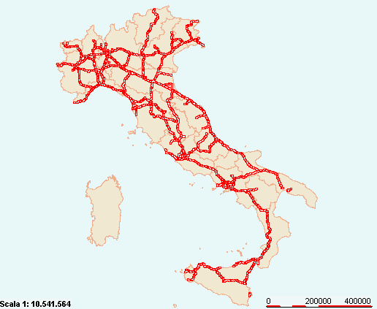
Source: Istituto Tagliacarne
Graph B. Italian railways network Source: Istituto Tagliacarne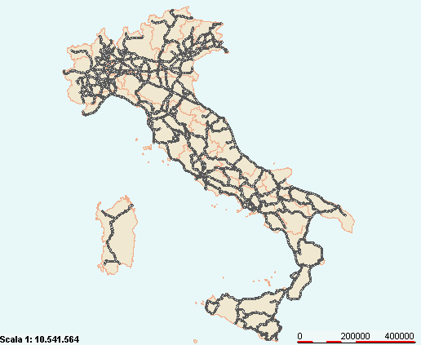
Graph C. Italian maritime ports by locations
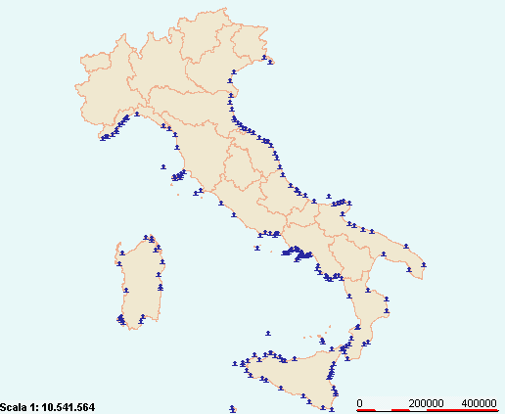
Source: Istituto Tagliacarne
Graph D. Italian total airports location Source: Istituto Tagliacarne
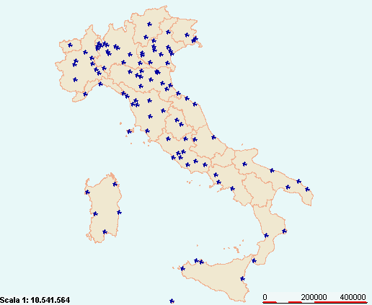
Graph E. Intermodal transportation systems in Italy by location
Source: Istituto Tagliacarne; Yellow (To be completed), Green (operating).

Graph F. Tariff % on food and live animals goods traded per country from 1995 to 2010 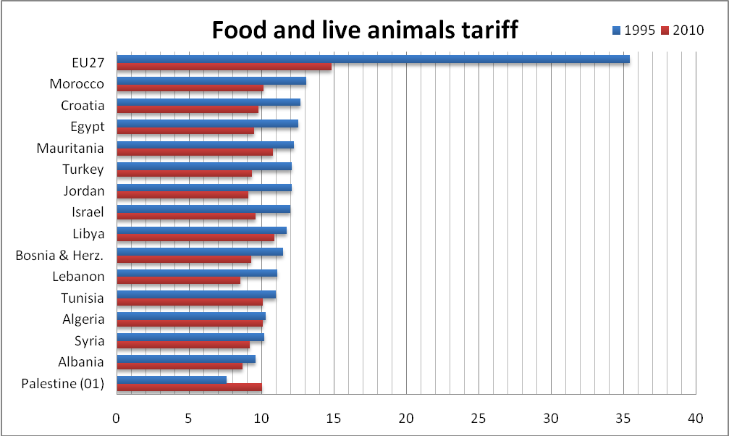
Source: WITS (World Integrated Trade Solution); From EU 27 to Mediterranean Partners and vice versa

Graph G. Tariff % on manufactured goods traded per country from 1995 to 2010
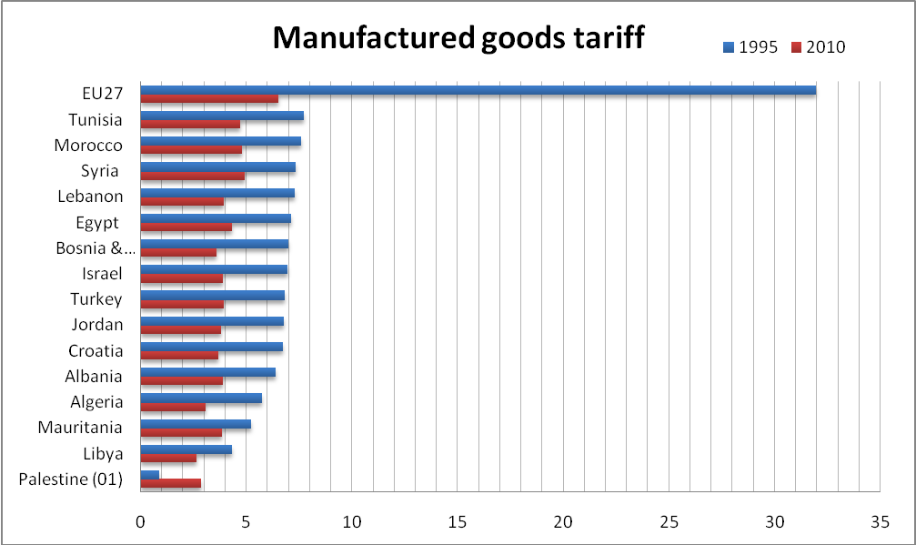
Source: WITS (World Integrated Trade Solution); From EU 27 to Mediterranean Partners and vice versa

Graph H. Tariff % on crude materials, inedible goods traded (except fuels) per countries from 1994 to 2009
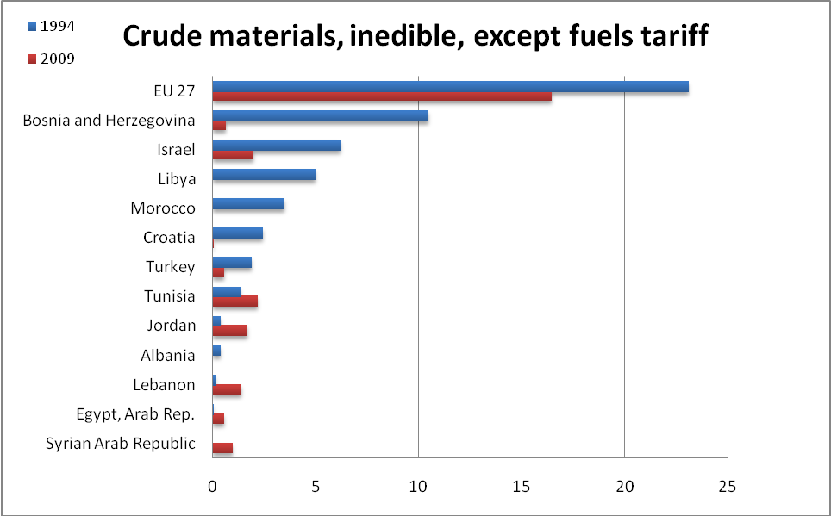
Source: WITS (World Integrated Trade Solution); from EU 27 to Mediterranean partners and vice versa

Appendix 3 – List of Tables

Table A. Public expenditure % GDP for final consumption of education and training per region
Regions and Macro-regions | 1995 | 1996 | 1997 | 1998 | 1999 | 2000 | 2001 | 2002 | 2003 | 2004 | 2005 | 2006 | 2007
Piedmont | 3,1 | 3,2 | 3,2 | 3,2 | 3,1 | 3,1 | 3,1 | 3,2 | 3,3 | 3,2 | 3,3 | 3,3 | 3,3
Valle d'Aosta | 5,2 | 5,2 | 5,6 | 5,0 | 4,9 | 4,0 | 3,7 | 4,0 | 3,4 | 3,5 | 3,7 | 4,2 | 4,2
Lombardy | 2,8 | 2,8 | 2,8 | 2,8 | 2,8 | 2,6 | 2,7 | 2,7 | 2,7 | 2,6 | 2,7 | 2,6 | 2,7
Liguria | 3,7 | 3,6 | 3,4 | 3,4 | 3,4 | 3,3 | 3,3 | 3,3 | 3,4 | 3,3 | 3,3 | 3,3 | 3,3
Trentino-Alto Adige | 4,2 | 4,2 | 4,0 | 3,7 | 3,9 | 3,5 | 3,5 | 3,6 | 3,5 | 3,7 | 4,0 | 4,4 | 4,5
Veneto | 2,9 | 3,0 | 2,9 | 2,9 | 2,8 | 2,8 | 2,9 | 3,0 | 3,0 | 2,8 | 3,0 | 2,9 | 3,0
Friuli-Venezia Giulia | 3,5 | 3,4 | 3,2 | 3,2 | 3,2 | 3,1 | 3,0 | 3,1 | 3,3 | 3,1 | 3,2 | 3,1 | 3,2
Emilia-Romagna | 3,1 | 3,2 | 3,0 | 2,9 | 2,8 | 2,7 | 2,7 | 2,8 | 2,9 | 2,8 | 2,9 | 2,9 | 2,9
Tuscany | 3,9 | 4,0 | 4,0 | 3,9 | 3,7 | 3,5 | 3,6 | 3,6 | 3,7 | 3,5 | 3,6 | 3,4 | 3,5
Umbria | 4,7 | 4,9 | 4,7 | 4,7 | 4,5 | 4,2 | 4,1 | 4,3 | 4,5 | 4,1 | 4,4 | 4,2 | 4,3
Marches | 4,3 | 4,3 | 4,3 | 4,2 | 4,1 | 4,1 | 4,1 | 4,0 | 4,2 | 4,0 | 4,1 | 4,0 | 4,0
Lazio | 4,3 | 4,4 | 4,3 | 4,1 | 4,1 | 3,9 | 3,8 | 3,7 | 3,8 | 3,6 | 3,7 | 3,6 | 3,5
Abruzzo | 5,2 | 5,4 | 5,5 | 5,5 | 5,3 | 5,1 | 5,1 | 5,2 | 5,3 | 5,1 | 5,1 | 4,9 | 4,9
Molise | 6,3 | 6,4 | 6,3 | 6,1 | 6,2 | 6,0 | 6,1 | 6,2 | 6,4 | 5,8 | 5,9 | 5,6 | 5,4
Campania | 8,1 | 8,4 | 8,3 | 8,2 | 8,1 | 8,2 | 8,1 | 7,9 | 8,2 | 7,5 | 7,8 | 7,6 | 7,5
Apulia | 7,3 | 7,4 | 7,6 | 7,4 | 7,3 | 7,3 | 7,4 | 7,4 | 7,6 | 7,0 | 7,3 | 7,0 | 7,0
Basilicata | 7,4 | 7,7 | 7,6 | 7,4 | 7,3 | 7,2 | 7,5 | 7,2 | 7,4 | 6,7 | 7,1 | 6,6 | 6,6
Calabria | 8,6 | 9,0 | 9,0 | 8,9 | 8,6 | 8,2 | 8,2 | 8,2 | 8,2 | 7,4 | 7,5 | 7,3 | 7,2
Sicily | 7,9 | 8,0 | 8,1 | 8,0 | 7,9 | 8,0 | 7,9 | 7,8 | 8,0 | 7,5 | 7,6 | 7,3 | 7,3
Sardinia | 6,6 | 6,7 | 6,4 | 6,4 | 6,2 | 6,1 | 6,1 | 6,0 | 6,1 | 5,4 | 5,4 | 5,5 | 5,3
Centre-North | 3,4 | 3,4 | 3,3 | 3,3 | 3,3 | 3,1 | 3,1 | 3,1 | 3,2 | 3,1 | 3,2 | 3,1 | 3,2
Mezzogiorno | 7,5 | 7,7 | 7,7 | 7,6 | 7,5 | 7,5 | 7,5 | 7,4 | 7,6 | 7,0 | 7,1 | 6,9 | 6,9
Italia | 4,4 | 4,5 | 4,4 | 4,3 | 4,3 | 4,1 | 4,2 | 4,2 | 4,3 | 4,0 | 4,1 | 4,0 | 4,0

Source: Istat

Table B. Italian expatriate (between 18 and 29 years) in 2010 pe regions
Regions | 18-29 year | Incidence
Molise | 13.642 | 24,50%
Basilicata | 23.838 | 18,60%
Calabria | 74.432 | 17,70%
Sicilia | 151.986 | 13,20%
Abruzzo | 29.229 | 12,10%
Friuli V.G | 28.111 | 12,00%
Puglia | 71.356 | 7,70%
Campania | 87.430 | 7,30%
Liguria | 23.441 | 6,60%
Marche | 22.351 | 6,60%
Lazio | 85.246 | 6,50%
Trentino A.A | 13.937 | 6,40%
Sardegna | 22.196 | 6,10%
Veneto | 62.847 | 6,00%
Piemonte | 44.845 | 4,60%
V.Aosta | 750 | 3,50%
Toscana | 24.661 | 3,30%
Umbria | 5.358 | 3,30%
Lombardia | 64.320 | 3,20%
Emilia Romagna | 26.678 | 3,10%

Source: AIRE (Anagrafe della popolazione Italiana Residente all’Estero)

Table C. R&D expenditure comparison on a global scale (1995-2009)
Country | Years
Country | 1995 | 1996 | 1997 | 1998 | 1999 | 2000 | 2001 | 2002 | 2003 | 2004 | 2005 | 2006 | 2007 | 2008 | 2009
EU (27 countries) | 1,8 | 1,75 | 1,78 | 1,79 | 1,83 | 1,86 | 1,86 | 1,87 | 1,86 | 1,83 | 1,82 | 1,85 | 1,85 | 1,92 | 2,01
Belgium | 1,67 | 1,77 | 1,83 | 1,86 | 1,94 | 1,97 | 2,07 | 1,94 | 1,88 | 1,86 | 1,83 | 1,86 | 1,9 | 1,96 | 1,96
Bulgaria | 0,62 | 0,52 | 0,51 | 0,57 | 0,55 | 0,51 | 0,46 | 0,48 | 0,48 | 0,49 | 0,46 | 0,46 | 0,45 | 0,47 | 0,53
Czech Republic | 0,95 | 0,97 | 1,08 | 1,15 | 1,14 | 1,21 | 1,2 | 1,2 | 1,25 | 1,25 | 1,41 | 1,55 | 1,54 | 1,47 | 1,53
Denmark | 1,82 | 1,84 | 1,92 | 2,04 | 2,18 | 2,24 | 2,39 | 2,51 | 2,58 | 2,48 | 2,46 | 2,48 | 2,58 | 2,87 | 3,02
Germany | 2,19 | 2,19 | 2,24 | 2,27 | 2,4 | 2,45 | 2,46 | 2,49 | 2,52 | 2,49 | 2,49 | 2,53 | 2,53 | 2,68 | 2,82
Estonia | - | - | - | 0,58 | 0,68 | 0,6 | 0,7 | 0,72 | 0,77 | 0,85 | 0,93 | 1,13 | 1,1 | 1,29 | 1,42
Ireland | 1,26 | 1,3 | 1,27 | 1,24 | 1,18 | 1,12 | 1,1 | 1,1 | 1,17 | 1,23 | 1,25 | 1,25 | 1,29 | 1,45 | 1,77
Greece | 0,43 | - | 0,45 | - | 0,6 | - | 0,58 | - | 0,57 | 0,55 | 0,59 | 0,58 | 0,58 | - | -
Spain | 0,79 | 0,81 | 0,8 | 0,87 | 0,86 | 0,91 | 0,91 | 0,99 | 1,05 | 1,06 | 1,12 | 1,2 | 1,27 | 1,35 | 1,38
France | 2,29 | 2,27 | 2,19 | 2,14 | 2,16 | 2,15 | 2,2 | 2,23 | 2,17 | 2,15 | 2,1 | 2,1 | 2,07 | 2,11 | 2,21
Italy | 0,97 | 0,99 | 1,03 | 1,05 | 1,02 | 1,05 | 1,09 | 1,13 | 1,11 | 1,1 | 1,09 | 1,13 | 1,18 | 1,23 | 1,27
Cyprus | - | - | - | 0,22 | 0,23 | 0,24 | 0,25 | 0,3 | 0,35 | 0,37 | 0,4 | 0,43 | 0,44 | 0,42 | 0,46
Latvia | 0,47 | 0,42 | 0,38 | 0,4 | 0,36 | 0,44 | 0,41 | 0,42 | 0,38 | 0,42 | 0,56 | 0,7 | 0,59 | 0,61 | 0,46
Lithuania | 0,43 | 0,49 | 0,54 | 0,54 | 0,5 | 0,59 | 0,67 | 0,66 | 0,67 | 0,75 | 0,75 | 0,79 | 0,81 | 0,8 | 0,84
Luxembourg | - | - | - | - | - | 1,65 | - | - | 1,65 | 1,63 | 1,56 | 1,66 | 1,58 | 1,51 | 1,68
Hungary | 0,72 | 0,63 | 0,7 | 0,66 | 0,67 | 0,79 | 0,92 | 1 | 0,93 | 0,87 | 0,95 | 1 | 0,97 | 1 | 1,15
Malta | - | - | - | - | - | - | - | 0,26 | 0,26 | 0,53 | 0,56 | 0,61 | 0,58 | 0,57 | 0,54
Netherlands | 1,97 | 1,98 | 1,99 | 1,9 | 1,96 | 1,82 | 1,8 | 1,72 | 1,92 | 1,93 | 1,9 | 1,88 | 1,81 | 1,76 | 1,84
Austria | 1,55 | 1,6 | 1,7 | 1,78 | 1,9 | 1,94 | 2,07 | 2,14 | 2,26 | 2,26 | 2,45 | 2,46 | 2,52 | 2,67 | 2,75
Poland | 0,63 | 0,65 | 0,65 | 0,67 | 0,69 | 0,64 | 0,62 | 0,56 | 0,54 | 0,56 | 0,57 | 0,56 | 0,57 | 0,6 | 0,68
Portugal | 0,52 | 0,56 | 0,57 | 0,63 | 0,69 | 0,73 | 0,77 | 0,73 | 0,71 | 0,75 | 0,78 | 0,99 | 1,17 | 1,5 | 1,66
Romania | 0,75 | 0,68 | 0,57 | 0,49 | 0,4 | 0,37 | 0,39 | 0,38 | 0,39 | 0,39 | 0,41 | 0,45 | 0,52 | 0,58 | 0,47
Slovenia | 1,53 | 1,29 | 1,28 | 1,34 | 1,37 | 1,39 | 1,5 | 1,47 | 1,27 | 1,4 | 1,44 | 1,56 | 1,45 | 1,65 | 1,86
Slovakia | 0,92 | 0,91 | 1,08 | 0,78 | 0,66 | 0,65 | 0,63 | 0,57 | 0,57 | 0,51 | 0,51 | 0,49 | 0,46 | 0,47 | 0,48
Finland | 2,26 | 2,53 | 2,71 | 2,88 | 3,17 | 3,35 | 3,32 | 3,37 | 3,44 | 3,45 | 3,48 | 3,48 | 3,47 | 3,72 | 3,96
Sweden | 3,26 | - | 3,47 | - | 3,58 | - | 4,13 | - | 3,8 | 3,58 | 3,56 | 3,68 | 3,4 | 3,7 | 3,62
United Kingdom | 1,91 | 1,83 | 1,77 | 1,76 | 1,82 | 1,81 | 1,79 | 1,79 | 1,75 | 1,68 | 1,73 | 1,75 | 1,78 | 1,77 | 1,87
Croatia | - | - | - | - | - | - | - | 0,96 | 0,96 | 1,05 | 0,87 | 0,75 | 0,8 | 0,9 | 0,84
Turkey | 0,38 | 0,45 | 0,49 | 0,37 | 0,47 | 0,48 | 0,54 | 0,53 | 0,48 | 0,52 | 0,59 | 0,58 | 0,72 | 0,72 | 0,85
United States | 2,48 | 2,52 | 2,55 | 2,58 | 2,63 | 2,69 | 2,71 | 2,6 | 2,6 | 2,53 | 2,56 | 2,6 | 2,65 | 2,77 | -
South Korea | - | - | - | 2,26 | 2,17 | 2,3 | 2,47 | 2,4 | 2,49 | 2,68 | 2,79 | 3,01 | 3,21 | 3,36 | -

Source: Eurostat

Table D. Italian bodies in financial difficulties per regions and public loans authorized until 2010
Regions | Bodies in Financial Difficulties until April 2010 | Loans authorized by the Government | % Total loans
Abruzzo | 18 | 22.929.333,82 | 1,85
Basilicata | 19 | 45.776.300,99 | 3,69
Calabria | 127 | 200.410.585,30 | 16,15
Campania | 113 | 750.506.903,13 | 60,45
Emilia Romagna | 8 | 6.053.227,71 | 0,49
Lazio | 42 | 49.497.254,72 | 3,99
Liguria | 3 | 1.510.840,74 | 0,12
Lombardy | 14 | 3.463.945,19 | 0,28
Marches | 6 | 3.199.904,66 | 0,26
Molise | 14 | 3.901.767,24 | 0,31
Piedmont | 5 | 468.478,16 | 0,04
Apulia | 35 | 59.439.302,71 | 4,79
Sardinia | 3 | 8.990.002,58 | 0,72
Sicily | 24 | 51.690.322,35 | 4,16
Tuscany | 4 | 4.268.230,92 | 0,34
Umbria | 4 | 10.994.289,83 | 0,89
Veneto | 3 | 18.208.663,15 | 1,47
Total | 442 | 1.241.309.353,20 | 100

Source: Danielli & Pittalis, 2010

Table E. Food and agricultural export % of regional GDP
Regions | 2009 | Regions | 2009
Piedmont | 2,8 | Lazio | 0,3
Valle d'Aosta | 0,9 | Center-North | 1,7
Lombardy | 1,3 | Abruzzo | 1,3
Trentino A.A. | 4,3 | Molise | 0,6
Veneto | 2,5 | Campania | 2,4
Friuli V.G. | 1,5 | Apulia | 1,3
Liguria | 1,3 | Basilicata | 0,5
Emilia-Romagna | 2,9 | Calabria | 0,3
Tuscany | 1,4 | Sicily | 0,8
Umbria | 1,6 | Sardinia | 0,4
Marches | 0,5 | Mezzogiorno | 1,3
 |  | Italia | 1,6

Source: Istat

Table F. Net import of Italian macro-regions from 2000 to 2010 (thousand euro)
Source: Istat

Table G. Export capacity (Export of goods value % of GDP) per region
Regions | 1995 | 1996 | 1997 | 1998 | 1999 | 2000 | 2001 | 2002 | 2003 | 2004 | 2005 | 2006 | 2007 | 2008 | 2009
Piedmont | 33,5 | 31,5 | 30,6 | 29,7 | 27,9 | 30,2 | 30,0 | 28,3 | 27,7 | 27,6 | 27,5 | 29,0 | 29,8 | 30,0 | 24,4
Valle d'Aosta | 14,1 | 10,0 | 8,3 | 9,4 | 9,2 | 12,4 | 11,7 | 10,5 | 10,9 | 12,3 | 12,6 | 14,5 | 20,8 | 16,6 | 10,9
Lombardy | 29,9 | 28,4 | 28,2 | 27,8 | 27,0 | 29,7 | 30,2 | 28,0 | 27,2 | 27,4 | 28,7 | 30,3 | 31,8 | 32,1 | 26,5
Trentino A.A | 18,8 | 16,3 | 16,3 | 16,3 | 16,4 | 17,3 | 17,2 | 16,8 | 17,0 | 17,2 | 17,6 | 18,4 | 19,1 | 18,4 | 15,4
Veneto | 30,7 | 30,2 | 30,1 | 30,3 | 30,9 | 33,4 | 33,9 | 33,5 | 30,8 | 30,7 | 30,3 | 33,3 | 34,8 | 33,9 | 27,7
Friuli V.G | 29,7 | 29,0 | 29,3 | 33,4 | 30,0 | 32,8 | 32,2 | 30,4 | 27,4 | 31,5 | 29,6 | 32,6 | 34,9 | 36,8 | 30,8
Liguria | 11,6 | 11,2 | 11,1 | 9,3 | 8,9 | 10,3 | 11,4 | 10,1 | 9,8 | 9,3 | 10,7 | 10,3 | 11,0 | 11,8 | 13,2
Emilia-Romagna | 26,4 | 25,8 | 26,4 | 27,0 | 26,4 | 28,2 | 28,4 | 28,0 | 27,2 | 28,6 | 30,1 | 31,7 | 34,0 | 34,4 | 27,4
Tuscany | 25,4 | 25,2 | 25,4 | 24,4 | 23,5 | 27,0 | 26,7 | 24,9 | 22,8 | 23,3 | 22,7 | 24,5 | 25,5 | 23,8 | 22,1
Umbria | 13,9 | 13,1 | 13,0 | 12,9 | 12,5 | 13,9 | 13,4 | 14,0 | 13,2 | 13,7 | 14,4 | 15,7 | 16,9 | 15,5 | 12,5
Marches | 23,9 | 23,3 | 24,9 | 25,0 | 22,2 | 24,6 | 25,9 | 25,2 | 25,4 | 24,8 | 25,6 | 29,4 | 30,4 | 25,6 | 19,8
Lazio | 6,6 | 7,0 | 7,5 | 7,8 | 8,2 | 9,7 | 8,6 | 8,6 | 7,5 | 7,4 | 7,2 | 7,7 | 8,0 | 8,4 | 7,1
Abruzzo | 19,4 | 18,2 | 19,7 | 20,9 | 18,5 | 22,5 | 22,8 | 22,4 | 21,6 | 24,3 | 24,1 | 23,9 | 25,7 | 26,4 | 18,9
Molise | 9,7 | 10,1 | 10,9 | 10,6 | 10,4 | 10,1 | 10,4 | 10,4 | 9,8 | 9,6 | 10,6 | 10,1 | 9,8 | 9,8 | 6,5
Campania | 8,4 | 8,1 | 8,5 | 9,5 | 9,2 | 10,3 | 10,5 | 9,5 | 8,1 | 8,1 | 8,3 | 8,9 | 9,6 | 9,6 | 8,3
Apulia | 10,5 | 9,4 | 9,6 | 9,9 | 9,6 | 10,6 | 10,7 | 9,7 | 9,3 | 10,1 | 10,5 | 10,1 | 10,3 | 10,5 | 8,4
Basilicata | 6,1 | 5,9 | 5,0 | 11,5 | 13,1 | 12,4 | 13,1 | 16,2 | 16,0 | 12,7 | 10,9 | 16,1 | 19,0 | 17,4 | 13,9
Calabria | 0,9 | 1,0 | 0,9 | 1,0 | 0,9 | 1,2 | 1,1 | 1,0 | 1,1 | 1,1 | 1,0 | 1,0 | 1,3 | 1,2 | 1,0
Sicily | 5,2 | 5,0 | 5,7 | 5,7 | 5,5 | 8,2 | 7,5 | 6,8 | 6,8 | 7,2 | 9,0 | 9,5 | 11,2 | 11,5 | 7,3
Sardinia | 6,8 | 6,4 | 7,4 | 6,2 | 6,3 | 9,4 | 8,3 | 7,6 | 8,4 | 9,2 | 12,1 | 13,3 | 13,9 | 17,0 | 9,8
Italy | 20,8 | 20,0 | 20,1 | 20,2 | 19,6 | 21,9 | 21,9 | 20,8 | 19,8 | 20,4 | 20,9 | 22,4 | 23,6 | 23,5 | 19,2
- North | 28,6 | 27,3 | 27,2 | 27,1 | 26,4 | 28,7 | 29,0 | 27,6 | 26,5 | 27,0 | 27,6 | 29,4 | 30,9 | 31,0 | 25,5
- Center | 15,1 | 15,1 | 15,6 | 15,4 | 15,0 | 17,3 | 16,8 | 16,1 | 14,9 | 14,9 | 14,7 | 16,1 | 16,8 | 15,8 | 13,6
- Mezzogiorno | 8,0 | 7,6 | 8,1 | 8,6 | 8,2 | 10,0 | 9,8 | 9,2 | 8,7 | 9,1 | 9,9 | 10,3 | 11,3 | 11,7 | 8,5

Source: Istat
Table H. North-West Italy best partners (billion euro)
Importing countries | Year
Importing countries | 2006 | 2007 | 2008 | 2009 | 2010
World | 132,97 | 144,96 | 147,95 | 118,18 | 134,86
Germany | 19,19 | 20,80 | 20,49 | 15,54 | 18,70
France | 17,94 | 19,07 | 18,90 | 15,05 | 16,93
Spain | 9,70 | 10,40 | 9,52 | 6,60 | 7,55
United States | 8,30 | 8,11 | 7,84 | 6,41 | 7,22
Switzerland | 6,66 | 6,81 | 7,06 | 6,34 | 7,78
United Kingdom | 7,44 | 7,65 | 7,36 | 5,56 | 6,23
Poland | 3,44 | 4,28 | 4,74 | 4,07 | 4,43
Belgium | 3,17 | 3,64 | 3,62 | 3,06 | 3,22
Netherlands | 3,18 | 3,30 | 3,48 | 2,85 | 3,34
Russia | 2,68 | 3,59 | 3,84 | 2,49 | 3,16
China | 2,76 | 3,01 | 3,10 | 3,04 | 3,80
Source: ICE (Istituto nazionale per il Commercio Estero)
Table I. North-East Italy best partners (billion euro)
Importing Countries | Year
Importing Countries | 2006 | 2007 | 2008 | 2009 | 2010
World | 104,41 | 115,50 | 116,97 | 91,60 | 105,75
Germany | 14,45 | 15,77 | 15,82 | 12,69 | 15,02
France | 10,52 | 11,79 | 11,60 | 9,78 | 11,20
United States | 8,85 | 8,57 | 7,58 | 5,36 | 6,65
United Kingdom | 6,44 | 6,97 | 6,19 | 4,46 | 6,20
Spain | 6,78 | 7,35 | 6,37 | 4,56 | 5,06
Austria | 3,55 | 4,02 | 4,12 | 3,27 | 3,78
Russia | 3,12 | 3,87 | 4,37 | 2,62 | 3,00
Switzerland | 2,91 | 3,18 | 3,38 | 2,97 | 3,16
Belgium | 2,45 | 2,88 | 2,85 | 2,21 | 2,55
Netherlands | 2,43 | 2,68 | 2,77 | 2,20 | 2,51
Poland | 2,05 | 2,63 | 2,85 | 2,14 | 2,38
Source: ICE (Istituto nazionale per il Commercio Estero)

Table J. Centre Italy best partners (billion euro)
Importing Countries | Year
Importing Countries | 2006 | 2007 | 2008 | 2009 | 2010
World | 51,62 | 56,09 | 53,80 | 45,59 | 53,53
France | 5,41 | 5,70 | 5,52 | 5,16 | 6,51
Germany | 5,40 | 5,78 | 5,84 | 4,68 | 5,89
United States | 4,46 | 4,58 | 4,26 | 3,10 | 3,70
United Kingdom | 3,32 | 3,57 | 3,06 | 2,90 | 2,97
Spain | 3,33 | 3,88 | 2,97 | 2,46 | 2,87
Switzerland | 2,24 | 2,30 | 2,21 | 2,38 | 2,85
Belgium | 2,57 | 2,86 | 2,18 | 1,78 | 1,90
Russia | 1,41 | 1,54 | 1,65 | 1,02 | 1,24
Netherlands | 1,24 | 1,36 | 1,37 | 1,24 | 1,50
United Arab Emirates | 0,84 | 1,17 | 1,34 | 0,85 | 0,97
Greece | 1,02 | 1,14 | 1,15 | 0,93 | 0,90
Poland | 0,85 | 1,01 | 1,09 | 0,88 | 0,99
Source: ICE (Istituto nazionale per il Commercio Estero)

Table K. South Italy best partners (billion euro)
Importing countries | Year
Importing countries | 2006 | 2007 | 2008 | 2009 | 2010
World | 24,48 | 27,12 | 27,51 | 21,16 | 24,31
Germany | 3,48 | 3,55 | 3,66 | 3,00 | 3,23
France | 3,04 | 3,41 | 3,32 | 2,52 | 2,96
United Kingdom | 2,29 | 2,42 | 2,06 | 1,58 | 1,68
Spain | 1,94 | 2,26 | 1,90 | 1,21 | 1,36
United States | 1,69 | 1,62 | 1,90 | 1,53 | 1,94
Switzerland | 0,67 | 0,88 | 1,53 | 1,57 | 1,90
Belgium | 0,82 | 0,87 | 0,82 | 0,68 | 0,71
Greece | 0,75 | 0,80 | 0,78 | 0,59 | 0,67
Netherlands | 0,76 | 0,88 | 0,68 | 0,51 | 0,62
Poland | 0,52 | 0,76 | 0,81 | 0,63 | 0,61
Turkey | 0,49 | 0,58 | 0,74 | 0,47 | 0,69
Source: ICE (Istituto nazionale per il Commercio Estero)

Table L. Islands Italy best partners (billion euro)
Importing countries | Year
Importing countries | 2006 | 2007 | 2008 | 2009 | 2010
World | 12,28 | 14,39 | 15,88 | 9,52 | 14,45
Spain | 2,11 | 2,93 | 2,87 | 1,49 | 2,54
United States | 1,22 | 1,36 | 1,44 | 0,70 | 0,80
France | 1,25 | 1,15 | 1,15 | 0,70 | 1,03
Libya | 0,48 | 0,69 | 0,00 | 0,80 | 0,97
Turkey | 0,40 | 0,34 | 0,76 | 0,41 | 0,76
Tunisia | 0,48 | 0,42 | 0,44 | 0,31 | 0,86
Greece | 0,35 | 0,54 | 0,53 | 0,57 | 0,41
Lebanon | 0,32 | 0,26 | 1,27 | 0,17 | 0,35
Germany | 0,44 | 0,47 | 0,46 | 0,28 | 0,50
Slovenia | 0,28 | 0,48 | 0,52 | 0,28 | 0,51
Gibraltar | 0,56 | 0,28 | 0,38 | 0,32 | 0,47
Source: ICE (Istituto nazionale per il Commercio Estero)

Table M. Crime per regions and macro-region from 2004 to 2006
Regions | Extortion | Frauds | Handling stolen goods | Usury | Damage followed by fire | Attacks | Criminal Association | Mafious Association
Piemonte | 434 | 8417 | 1491 | 32 | 530 | 66 | 52 | 1
V.Aosta | 9 | 219 | 37 | 1 | 8 | - | 3 | -
Lombardia | 813 | 17188 | 3658 | 44 | 771 | 75 | 77 | 4
Liguria | 152 | 3197 | 1445 | 10 | 227 | 5 | 20 | 1
Trentino-Alto Adige | 66 | 1272 | 152 | 1 | 66 | 8 | 13 | -
Veneto | 330 | 6485 | 1679 | 17 | 288 | 20 | 61 | -
Friuli-Venezia Giulia | 53 | 1523 | 431 | 2 | 115 | 11 | 15 | -
Emilia-Romagna | 423 | 7993 | 2100 | 18 | 409 | 17 | 38 | 1
Nord (Var.2004) | 2280 (524) | 46294 (14783) | 10993 (-1756) | 125 (1) | 2414 (162) | 202 (27) | 279 (-289) | 7 (0)
Toscana | 308 | 6590 | 2322 | 17 | 394 | 18 | 53 | -
Umbria | 75 | 1370 | 278 | 3 | 50 | 4 | 13 | 2
Marche | 165 | 2507 | 789 | 3 | 153 | 7 | 36 | -
Lazio | 585 | 9785 | 2985 | 31 | 568 | 35 | 97 | 5
Centro (Var.2004) | 1133 (266) | 20252 (8334) | 6374 (-151) | 54 (-18) | 1165 (291) | 64 (0) | 199 (-62) | 7 (3)
Abruzzo | 156 | 2025 | 619 | 23 | 131 | 8 | 34 | -
Molise | 22 | 751 | 86 | 2 | 11 | 1 | 15 | -
Campania | 1201 | 15031 | 4420 | 87 | 613 | 52 | 131 | 71
Puglia | 618 | 5726 | 1890 | 38 | 1615 | 47 | 59 | 3
Basilicata | 62 | 685 | 220 | - | 51 | - | 9 | -
Calabria | 343 | 3320 | 843 | 10 | 1294 | 19 | 43 | 12
Sicilia | 697 | 7720 | 1691 | 33 | 2699 | 42 | 87 | 25
Sardegna | 134 | 2247 | 645 | 3 | 735 | 11 | 15 | -
Mezzogiorno (Var.2004) | 3233 (443) | 37505 (14654) | 10414 (-2002) | 196 (-6) | 7149 (2207) | 180 (-39) | 393 (-166) | 111 (-16)
Italia | 6646 (1233) | 104051 (37757) | 27781 (-3910) | 375 (-23) | 10728 (2660) | 446 (-12) | 871 (-519) | 125 (-13)
Source: Istat; crime reported by the police to the judicial authority; between brackets is report the net value from 2004 (2006-2004)

Table N. Market openness grade: imports (Import % of GDP)
Source: Istat

Table O. GDP average growth 2000-2008
GDP per capita growth
Country | 00-01 | 01-02 | 02-03 | 03-04 | 04-05 | 05-06 | 06-07 | 07-08 | Average
Bosnia | 18,4% | 12,0% | 35,0% | 23,2% | 10,0% | 20,1% | 36,2% | 22,9% | 22,2%
Albania | 10,9% | 8,5% | 26,6% | 31,6% | 11,8% | 8,6% | 18,2% | 19,3% | 16,9%
Montenegro | 2,9% | 14,8% | 25,6% | 19,8% | 7,4% | 13,8% | 24,4% | 21,7% | 16,3%
Croatia | 6,9% | 15,1% | 28,7% | 20,1% | 9,2% | 11,3% | 19,1% | 16,9% | 15,9%
Libya | -17,8% | -31,6% | 18,8% | 35,9% | 29,1% | 25,8% | 24,6% | 27,2% | 14,0%
Mauritania | 0,9% | -0,3% | 8,7% | 17,2% | 16,9% | 41,6% | 2,6% | 23,5% | 13,9%
Algeria | -0,7% | 1,9% | 17,5% | 23,1% | 18,6% | 12,8% | 14,2% | 24,0% | 13,9%
Turkey | -27,5% | 17,0% | 28,6% | 27,7% | 21,6% | 8,5% | 20,4% | 11,5% | 13,5%
Syria | 6,3% | -0,5% | 0,8% | 8,3% | 10,5% | 14,1% | 18,4% | 31,2% | 11,1%
Jordan | 3,5% | 4,2% | 3,8% | 9,2% | 7,8% | 21,4% | 10,9% | 24,7% | 10,7%
Morocco | 0,7% | 5,9% | 21,8% | 13,0% | 3,3% | 8,9% | 13,2% | 16,7% | 10,4%
EU | 1,0% | 8,8% | 21,4% | 14,9% | 4,0% | 6,1% | 14,9% | 7,4% | 9,8%
Italy | 1,8% | 8,8% | 22,7% | 13,5% | 2,1% | 4,2% | 12,7% | 7,7% | 9,2%
Tunisia | 1,6% | 4,1% | 18,0% | 11,5% | 2,0% | 5,8% | 13,9% | 13,5% | 8,8%
Lebanon | 0,6% | 6,7% | 3,1% | 6,9% | -1,2% | 1,6% | 10,7% | 18,6% | 5,9%
Egypt | -4,0% | -11,7% | -7,4% | -6,7% | 11,6% | 17,6% | 19,2% | 22,6% | 5,1%
Israel | -3,7% | -10,0% | 3,3% | 4,8% | 4,0% | 6,7% | 12,5% | 18,9% | 4,6%
Mezzogiorno | 5,1% | 4,1% | 2,0% | 2,6% | 1,9% | 4,3% | 3,0% | 0,6% | 2,9%
Source: Eurostat and World Bank

Table P. Total freight handled by region in main European ports from 2000 to 2009
Region | Freight (Thousand of tons)
Region | 2000 | 2001 | 2002 | 2003 | 2004 | 2005 | 2006 | 2007 | 2008 | 2009
Zuid-Holland (Netherlands) | 311121 | 304576 | 310787 | 315803 | 338180 | 353974 | 361282 | 382118 | 391335 | 349303
Prov. Antwerpen (Belgium) | 115988 | 114777 | 113937 | 126098 | 135441 | 145817 | 151705 | 165512 | 171237 | 142116
Hamburg (Germany) | 76950 | 82948 | 86724 | 93562 | 99529 | 108253 | 115529 | 118190 | 118915 | 94762
Haute-Normandie (France) | 86831 | 86485 | 83732 | 89877 | 92512 | 93392 | 94568 | 97431 | 99350 | 92213
Andalucía (Spain) | 38796 | 78183 | 78744 | 85251 | 87392 | 95937 | 101110 | 103825 | 97705 | 83366
Noord-Holland (Netherlands) | 61691 | 67321 | 68262 | 59447 | 68254 | 69674 | 78157 | 84362 | 98035 | 82561
Provence-Alpes-Côte d'Azur (France) | 91279 | 89518 | 89244 | 92418 | 90810 | 93308 | 96512 | 92561 | 93086 | 80887
East York. and North Lincoln. (UK) | 77398 | 78291 | 79532 | 80707 | 83804 | 88439 | 90869 | 92633 | 91010 | 76676
Liguria (Italy) | 69093 | 67886 | 69846 | 73005 | 72937 | 70532 | 74856 | 80871 | 79719 | 73170
Vestlandet (Norway) | : | : | 89013 | 80218 | 81014 | 81781 | 82505 | 77785 | 68928 | 71023
Sicily (Italy) | 73396 | 75296 | 78032 | 83677 | 81950 | 92545 | 82177 | 87941 | 82157 | 69212
Cataluña (Spain) | 52860 | 53662 | 53981 | 58274 | 65521 | 67586 | 68974 | 76425 | 73575 | 68677
Västsverige (Sweden) | 58728 | 56456 | 54869 | 58392 | 62457 | 64502 | 66252 | 64894 | 69297 | 64271
Comunidad Valenciana (Spain) | 24943 | 38225 | 41715 | 43590 | 46990 | 51843 | 57064 | 61953 | 65896 | 61388
Etelä-Suomi (Finland) | 49994 | 58479 | 60901 | 63673 | 65767 | 61289 | 66250 | 70284 | 69799 | 56863
Nord-Pas-de-Calais (France) | 73266 | 58736 | 61610 | 62764 | 64097 | 66686 | 70253 | 69910 | 69145 | 56836
Sardinia (Italy) | 43818 | 40381 | 42728 | 47237 | 51723 | 49609 | 54703 | 56834 | 61163 | 54130
Bremen (Germany) | 39224 | 40066 | 40452 | 42492 | 45370 | 46655 | 55636 | 59262 | 63501 | 53941
Apulia (Italy) | 43946 | 45077 | 45268 | 50226 | 55137 | 62619 | 66265 | 65730 | 65358 | 51413
West Wales and The Valleys (UK) | 50372 | 46894 | 44279 | 45207 | 52195 | 51476 | 48343 | 49270 | 48590 | 48068
Friuli-Venezia Giulia (Italy) | 48182 | 49025 | 48504 | 46849 | 47189 | 48703 | 50366 | 45815 | 43549 | 47076
Source: Eurostat

Table Q. Main ports in Italy by goods transported in 2009.
Port | 2009 | Δ2000
Gioia Tauro | 16.867 | 0,55
Taranto | 14.096 | 0,39
Genova | 11.437 | 0,08
Porto Foxi | 10.741 | 0,07
Augusta | 10.089 | -0,23
La Spezia | 8.022 | 0,56
Livorno | 7.935 | 0,40
Santa Panagia | 6.933 | 0,04
Olbia | 5.157 | 1,46
Cagliari | 4.217 | 0,78
Ravenna | 4.170 | 0,47
Milazzo | 3.912 | -0,21
Venezia | 3.857 | 0,01
Trieste | 3.816 | -0,14
Gela | 3.424 | -0,16
Savona - Vado | 3.408 | 4,03
Napoli | 3.265 | -0,22
Salerno | 2.435 | 0,58
Ancona | 2.354 | 0,19
Palermo | 2.299 | 1,15
 | 0,65 | 0,35
 | 83.435 | 44.999
Source: Eurostat

Appendix 4 - Eviews interface

Figure #1. Eviews outcome for elasticity of substitution equals to 5
Dependent Variable: X
Method: Least Squares
Date: 08/06/11 Time: 19:28
Sample: 1 1404
Included observations: 1404
Variable | Coefficient | Std. Error | t-Statistic | Prob.
YT | 1.109936 | 0.064044 | 17.33073 | 0.0000
YI | 1.489549 | 0.069993 | 21.28147 | 0.0000
YJ | 0.970100 | 0.038122 | 25.44759 | 0.0000
DIST | -1.208987 | 0.099224 | -12.18438 | 0.0000
CPI | -0.111968 | 0.027955 | -4.005297 | 0.0001
CRIME | -0.154055 | 0.019997 | -7.703895 | 0.0000
SEA | 0.086312 | 0.028635 | 3.014213 | 0.0026
AGR | -0.043170 | 0.007144 | -6.042608 | 0.0000
IND | 0.651290 | 0.061023 | 10.67290 | 0.0000
SER | 0.484576 | 0.088642 | 5.466682 | 0.0000
R-squared | 0.557867 | Mean dependent var |  | 14.21232
Adjusted R-squared | 0.555012 | S.D. dependent var |  | 2.726682
S.E. of regression | 1.818899 | Akaike info criterion |  | 4.041437
Sum squared resid | 4611.899 | Schwarz criterion |  | 4.078809
Log likelihood | -2827.088 | Hannan-Quinn criter. |  | 4.055405
Durbin-Watson stat | 1.533298

Figure #2. Eviews outcome for elasticity of substitution equals to 8
Dependent Variable: X
Method: Least Squares
Date: 08/06/11 Time: 19:40
Sample: 1 1404
Included observations: 1404
Variable | Coefficient | Std. Error | t-Statistic | Prob.
YT | 1.109936 | 0.064044 | 17.33073 | 0.0000
YI | 1.489549 | 0.069993 | 21.28147 | 0.0000
YJ | 0.970100 | 0.038122 | 25.44759 | 0.0000
DIST2 | -0.172712 | 0.014175 | -12.18438 | 0.0000
CPI2 | -0.063982 | 0.015974 | -4.005297 | 0.0001
CRIME2 | -0.088031 | 0.011427 | -7.703895 | 0.0000
AGR2 | -0.024668 | 0.004082 | -6.042608 | 0.0000
IND2 | 0.372166 | 0.034870 | 10.67290 | 0.0000
SER2 | 0.276901 | 0.050652 | 5.466682 | 0.0000
SEA2 | 0.049321 | 0.016363 | 3.014213 | 0.0026
R-squared | 0.557867 | Mean dependent var |  | 14.21232
Adjusted R-squared | 0.555012 | S.D. dependent var |  | 2.726682
S.E. of regression | 1.818899 | Akaike info criterion |  | 4.041437
Sum squared resid | 4611.899 | Schwarz criterion |  | 4.078809
Log likelihood | -2827.088 | Hannan-Quinn criter. |  | 4.055405
Durbin-Watson stat | 1.533298
Figure #3. Eviews outcome for elasticity of substitution equals to 10
Dependent Variable: X
Method: Least Squares
Date: 08/06/11 Time: 19:44
Sample: 1 1404
Included observations: 1404
Variable | Coefficient | Std. Error | t-Statistic | Prob.
YT | 1.109936 | 0.064044 | 17.33073 | 0.0000
YI | 1.489549 | 0.069993 | 21.28147 | 0.0000
YJ | 0.970100 | 0.038122 | 25.44759 | 0.0000
DIST3 | -0.134332 | 0.011025 | -12.18438 | 0.0000
CPI3 | -0.049764 | 0.012424 | -4.005297 | 0.0001
CRIME3 | -0.068469 | 0.008888 | -7.703895 | 0.0000
AGR3 | -0.019187 | 0.003175 | -6.042608 | 0.0000
IND3 | 0.289462 | 0.027121 | 10.67290 | 0.0000
SER3 | 0.215367 | 0.039396 | 5.466682 | 0.0000
SEA3 | 0.038361 | 0.012727 | 3.014213 | 0.0026
R-squared | 0.557867 | Mean dependent var |  | 14.21232
Adjusted R-squared | 0.555012 | S.D. dependent var |  | 2.726682
S.E. of regression | 1.818899 | Akaike info criterion |  | 4.041437
Sum squared resid | 4611.899 | Schwarz criterion |  | 4.078809
Log likelihood | -2827.088 | Hannan-Quinn criter. |  | 4.055405
Durbin-Watson stat | 1.533298

Then converted into World Trade Organization “WTO”.
Chartist newspaper, (1847), in Marx Engels Collected Works Vol 6, pg 290.
In his book “On the principles of political economy and taxation” published in 1817.
Since the first elaboration of the book “Interregional and International Trade” in 1933.
The Lucas paradox is an extreme example.
See the crisis of 1982, although I would attribute it mainly to a wrong fiscal policy.
External firms enter the domestic market and therefore less efficient domestic firms do not gain positive profits anymore and so they leave the market
Such as economic development, innovation, employment, income growth and higher volume of trade.
Such as low evidence of positive linkage with local people, environmental impact, squeeze out of national enterprises and deterioration of the balance of payment.
Same industry in different countries.
Vertically integrated industries which produce different components in different countries.
As the model suggested by Krugman, where products are substitutes but brands and advertising make the difference.
Jensen’s inequality.
By northern part of Italy I mean: the Aosta Valley, Piedmont, Liguria, Lombardy, Trentino-Alto Adige/Südtirol, Veneto, Friuli-Venezia Giulia, Emilia-Romagna, Tuscany, the Marches, Umbria and Lazio. The so called Mezzogiorno or Southern Italy includes: Abruzzo, Apulia, Molise, Campania, Basilicata, Calabria, Sicily and Sardinia as suggested also by the Objective 1 Regions by the EU.
In his book “The Wealth of nations” published in 1776.
“Competivita’-Regolazione-Mercati”
Termini Imerese, which is about to be closed as the result of the company’s reconstruction and re-organization.
During the New Economic Geography process for Southern Italian industrialization.
Which, according to them is more flexible than the Cobb-Douglas function for this case scenario.
According to personal analysis of ISTAT data.
For example in France the disparity is three times higher than in Italy, source (Banca d’Italia 2010)
Which is generally completed at the approximate age of 13 years.
Comitato nazionale per la valutazione del sistema universitario, the body responsible for the valuation of Italian universities’ level of economic management and spending as established by the Ministry of Education.
Survey on the income and wealth of Italian households “SHIW.
Data trustworthiness are not completely clear for MENA, Middle East and Northern Africa.
According to many studies, of which the Solow-Swan growth model is just one example.
Definition Barcelona Process.
The union of Italian chamber of commerce.
A mountain chain that stretches across Liguria to the northern side of Calabria.
Naples, Catania, Palermo, Cagliari and Bari.
The values are 100, 28 and 23 respectively for trucks, trains and ships.
Renewing of Campania’s railway system, Palermo-Catania highway, enlargement of Augusta-Taranto-Brindisi ports and the Carlo Felice main freeway in Sardinia.
Such as the local administrations, the central government, and private sector.
Named “Patti territoriali”.
ENI, ENEL, Telecom and Ferrovie dello Stato are the main examples.
Maritime tourist transport.
Ferrovie dello Stato.
“Imposta Comunale sugli Immobili” ICI.
Enacted on May 5th 2009.
North East, North West, Center, South, Islands.
Same number as Naples, 7 state attorneys per 100,000 inhabitants.
And only 58% of those which go to court eventually end in a guilty verdict; 70% of these cases take more than four years to reach their conclusion.
This, by law, can be a maximum of 1 year and 6 months.
By imposing their material for constructions, alternatively putting pressure in order to obtain a subcontract or extorting a percentage, usually 5-7% of total business (Confesercenti 2010).
The percentage of criminals caught by police compared to the total number of crimes reported.
In his book “The moral basis of a backward society” (1967).
The existing anti-racket associations include only 1.6% of all entrepreneurs and dealers as members (CENSIS 2010) source.
Where North West includes (Valle d’Aosta, Piedmont, Lombardy,Liguria ),North East includes (Trentino Alto Adige, Veneto, Friuli Venezia Giulia, Emilia-Romagna), Center includes (Tuscany, Marches, Umbria and Lazio), South includes (Abruzzo, Molise, Apulia,Campania, Basilicata, Calabria), and Islands includes (Sicily and Sardinia).
MENA region as defined by The World Bank (2011). For the purpose of this research, I intend to refer only to those MENA countries facing the Mediterranean Sea.
In absence of data on specific provinces or regions.
Although its values were not that far behind those of the other countries.
Mediterranean Solar plan of producing 20 GW by 2020 by wind and solar energy.
The first venture capital in the Occupied Territories of Palestine has been established with the help of FEMIP.
Member states are Jordan, Tunisia, Egypt and Morocco.
Which is very powerful as explained by Olson in the logic of collective action.
one letter
_{Where θi=Yi/Y}^{T} , and t_{ij=}t_{ji} by assumption.
the computational method according to Anderson van Wincoop (2001) assume that MR replaces the price indices. The multilateral resistances depend on both bilateral resistance and the one indirect with surrounding countries. For example, the distance and the economic size of country i with country k also influence the trade between country i and country j
Which is a dummy equal to 1 if trade is within a country border and 0 otherwise

