August 2,2011

The difference between EVA and BSC

An example of the Aviation industry: KLM versus Ryanair





Student: Jeroen van Schaik
Student number: 319474
E-mail: jeroenvschaik@gmail.com
Scriptiebegeleider: Bart Snel
Abstract

This thesis addresses the difference between Economic Value Added and the Balanced Scorecard, and the way this difference reflects within the aviation industry by taking examples of Ryanair and KLM. Economic Value Added is part of Value-Based Management, a wider concept that helps to maximize shareholder value by monitoring and controlling performance. The Balanced Scorecard serves as a management tool to measure the performance of a firm while not only taking financial, but also non-financial information into account. After having discussed the theory, the two examples will be analyzed. Ryanair uses Economic Value Added while KLM uses the Balanced Scorecard. This change of management accounting measurement is affected by their view of doing business. Even though the two companies operate in the same industry, their respective strategies differ largely. In the conclusion, the research questions will be answered and a personal opinion will be given on these performance measurements and their use in the aviation industry.

Keywords: Economic Value Added (EVA), Balanced Scorecard (BSC), aviation

Table of Contents

- Opening 3
1.1 Introduction 3
1.1.1 The aviation sector 4
1.2 Motivation 5
1.3 Orientation 6
1.3.1 Aim 6
1.3.2 Problem definition 6
1.3.3 Research questions 6
- Theoretical framework 7
2.1 Theory behind Economic Value Added (EVA) 7
2.1.1 EVA and Value Based Management (VBM) 7
2.1.2 EVA explained 8
2.1.3 EVA in practice 8
2.1.4 How to calculate EVA 9
2.1.5 Advantages/Disadvantages of EVA 9
2.2 Theory behind Balanced Scorecard (BSC) 10
2.2.1 BSC and Value Based Management (Value Based Scorecard) 10
2.2.2 BSC explained 11
2.2.3 BSC in practice 13
2.2.4 How to implement BSC 13
2.2.5 Advantages/Disadvantages of BSC 15
2.3 Alternative measurements 17
2.3.1 Return on Investment (ROI) 17
2.3.2 Discounted Cash Flows (DCF) 18
2.3.3 Residual Income (RI) 19
2.4 How does Ryanair use EVA 21
2.4.1 Short introduction on Ryanair 21
2.4.2 The aviation industry and the use of management accounting 21
2.4.3 Focus on value adding activities 22
2.5 How does KLM use BSC 24
2.5.1 Short introduction on KLM 24
2.5.2 Integration of BSC 24
2.5.3 Management accounting during crisis 25
2.6 Comparison of discussed performance measurements 27
- Conclusion 28
- Reference list 30

- Opening

In this opening, a short introduction to the topic will be given, followed by the motivation to write about this topic and the problem orientation of the paper.

  - Introduction

Organizations have since decennia been seeking the ‘ultimate’ performance measurement. Performance measurement means that you can see how you are doing and with that information improve yourself. Firms are constantly looking for ways to improve themselves due to strong competition and changing business environments. Performance measurements have therefore always been an important topic of corporate discussion. The changes of a more modern business environment put more weight on the future of the company. Therefore, the backward looking performance measurements of the past are now adapted to fit the future-oriented look that firms take. This thesis will be focusing on two specific performance measurements: Economic Value Added and the Balanced Scorecard, and their use in the aviation industry in particular. In the aviation industry, Ryanair and KLM will serve as examples.

EVA is part of Value-Based Management (VBM), a wider concept that helps to maximize shareholder value by monitoring and controlling performance. VBM assists managers to make finance accessible to all of them and not only those who are specialized (Claes, 2003). Bonus plans nowadays not only rely on the manager’s personal work, but on the stock market as well. This implies that not only will the remuneration of the managers depend on their personal work, but also on macro-economic circumstances. This implies that luck also plays a crucial factor. Traditional methods, such as Return on Investment, Discounted Cash Flows and Residual Income have largely been replaced by EVA. EVA is a registered trademark of Stern Stewart & Co., and is an estimate of a firm’s economic profit. It was introduced in the 1980’s and was quickly adopted by a large number of companies (300 until 1999), under which some well-known multinationals: Coca Cola and Siemens (Biddle et. al, 1999). In the beginning, EVA was mostly used in the United States, but in the mid-90’s it also integrated in European companies. Unilever and Philips are examples of big European companies that have implemented EVA (Urff, 2001).
Society changes, and so do firms. There are firms that have the feeling that due to their use of purely financially based performance measurements, they are not completely reflecting their true performance. The Balanced Scorecard (BSC) is a performance measurement that does not only focus on financial aspects, but also tries to take into account all other aspects that drive performance. Robert S. Kaplan and David P. Norton have shed their light on the Balanced Scorecard, introducing it to the main public in 1993 in their paper “The balanced scorecard – measures that drive performance.” However, the balanced scorecard was created by Arthur M. Schneiderman in 1987 at Analog Devices, a mid-sized semi-conductor company. In 2008, about 80% of the respondents of Bain & Company¹ (the sites from which this information has been taken are in the reference list under their respective number) used BSC which a satisfaction rate of 4 out of 5. Furthermore, BSC is now ranked 6th on the ‘Top 10 Management Tools 2010’ by Bain & Company², whereas in 2006 it was not even present in the first 10. This shows its significant increase of use in recent years.
    - The aviation sector

The first airline was DELAG (Deutsche Luftschiffahrts-Aktiengesellschaft), founded on November 16, 1909. Currently, the oldest organization still operating is KLM which was founded on October 7, 1919. In the 1950’s, after the second world war, demand in this sector started to increase strongly.
The aviation section can in a broader perspective be seen in the same arm-length branch as highways and railways. These strategic forms of transport receive government funding in most places around the globe. The aviation industry has always been strongly subsidized by the government and were often governmentally owned. If governments would not have taken its place in the sector, it would probably not have persisted throughout the 20th century. Some claim that the benefits of the growth achieved due to the global mobility has outweighed the investments of governments.
However, in recent years, more and more companies within the sector are being privatized. Privately owned airlines have a focus on microeconomic terms to maximize shareholder value. Low-cost airlines such as Ryanair came on the market starting a new trend in the industry. They charge lower prices than most existing companies and with strategic cost-cutting, harsh marketing and aggressive pricing strategies, they try to grow their business. With this strategy they have become the most profitable companies in the industry, and this trend could be the solution to make the market more profitable than it has been up to date, having made a cumulative loss over its 100 year existence.

  - Motivation

Since this year, I have found interest in accounting, and management accounting in particular. Therefore, I choose to do the seminar called ¨Management Accounting & Control¨ to get a look on how management accounting is applied in practice rather than purely the theoretical approaches from previous study years. My group was chosen to write a paper and present on the topic of ¨EVA and Value-Based Management¨. We found that the paper worked out very successfully. Further in the seminar, another group made a presentation about the Balanced Scorecard and since that moment I had found the subject of my thesis. I wanted to compare 2 companies operating in the same industry, one using EVA and the other using BSC. In an industry, there are a lot of management strategies that can be applied, and different firms are successful with the help of different performance measurements. The choice of the industry to take as example for the 2 methods was a real challenge; but a case study made during my minor on Ryanair made it easier to choose since it gave me more background information. I remembered their focus on costs cutting and prices making them the most profitable firm in the industry. KLM is the oldest firm in the industry still operating and their focus is not purely financially based, but customer services play an important role as well.

  - Orientation

In this section, the problem orientation will be discussed. The aim, problem definition, research questions, limits and methodology will be discussed in further detail.

    - Aim

The aim of this thesis is to have a closer look at the difference in impact of Economic Value Added, and the Balanced Scorecard on companies in the aviation industry. These performance measurements both fall under the category of Value-Based Management. In order to make the theory practical, Ryanair and KLM will serve as real-life examples for the given theory. These two firms operate in the aviation industry and use different methods to measure and value performance. Ryanair uses EVA, whereas KLM uses BSC.

    - Problem definition

Companies want to know how they are operating, whether they are doing well and are creating value for the company. There are a lot of different methods to choose from when a company wants to perform some form of Value-Based Management. Their choice can be based on their corporate structure, strategy, or vision. The problem definition of this thesis is: What is the difference between EVA and BSC, and how does this reflect at Ryanair and KLM?

    - Research questions

The following research questions will be treated:
- What is the theory behind Economic Value Added (EVA)?
- What is the theory behind the Balanced Scorecard (BSC)?
- What are the alternative performance measurements?
- How does Ryanair use EVA?
- How does KLM use BSC?
- What are the similarities and differences of the discussed performance measurements and how they fit their strategy?

- Theoretical Framework

In the Theoretical Framework, the important theory will be explained in detail and, Ryanair and KLM will be used as examples. In the following sections, the above mentioned research questions will thoroughly be answered one by one.

  - Theory behind Economic Value Added (EVA)

In this section, the theory underlying EVA will be discussed. A clearer understanding of what EVA is, how to calculate it and its use will be given.

    - EVA and Value-Based Management (VBM)
Most companies strive to create value. Due to limited time, effort, number of employees and assets, firms have to manage resources well. VBM tries to help companies to manage, monitor and measure these sources in an improved way and thus strive to create a maximum firm value.
VBM can be described in many different ways. One of them is that VBM is "the management approach that ensures corporation are run consistently on value (in a normal state of affairs: maximizing shareholder value)". Another description made by Leahy (2000), states VMB is: "the key to increased shareholder value lies in the integration of strategic planning, performance measurement and compensation". Both mention that VBM is especially involved in the creation of shareholder value. However, this is typically the end goal and not the strategy. In order to achieve maximum shareholder value, VBM creates opportunities to improve decision making in an organization, it has a short and long-term perspective and uses both balance sheet and income statement to measure performance (Koller, 1994). Consequently, companies are more aware of the effects of their decisions and, if the right incentives are in place, managers will try to better align their decisions with the companies objectives.
Value Based Management is concerned with improving decision making in all kinds of industries. It mostly tries to maximize shareholder value by monitoring and controlling performance. Additionally, it improves the possibility to compare performance measures and serves to better indicate who is accountable for decisions. In order to achieve a successful implementation, top management should support the introduction and create incentives for management to use VBM. VBM can be useful for companies when they strive to maximize shareholder value more efficiently.
EVA is considered to be part of VBM (Urff, 2000). The core of the VBM method is that not accounting parameters (such as the profit per share) and firm results represent the value of the company, but that business economic factors such as return, risk and growth are.

    - EVA explained
“What remains of his profits after deducting interest on his capital at the current rate maybe called his earnings of undertaking or management.”
Alfred Marshall on profit

EVA, or Economic Value added, is an analytical tool commercially developed in 1982 by the advisory team of Joel Stern and G. Bennett Steward III. However, while EVA itself is now a registered trademark the quote by Alfred Marshall demonstrates that the basic idea of EVA has been around for quite some time and that EVA itself is merely a refinement of profitability measurement that pays tribute to the changing nature of economic circumstances such as deregulation of capital markets, advances in information technology and the rapid movement of capital across country borders.
EVA is a performance metric that measures the difference between the return on a company’s capital and the cost of that capital. The results of the EVA measurement itself are straightforward: a positive EVA indicates that more shareholder value has been created while a negative EVA demonstrates value destruction. The underlying foundation of EVA is the concept of residual income and therefore anything but new, but EVA, as mentioned in the introduction, pays homage to the changing circumstances of the financial world and therefore gives the concept of residual income a new twist in terms of managing a (listed) company: with EVA it is possible to align manager’s incentives with the primary management goal of increasing shareholder value. It rewards management projects that return more than the cost of capital of those projects, thereby increasing the net present value of the company. In this respect managerial behavior is sensitive to the performance measure.

    - EVA in practice

It is claimed that EVA as a performance measure is applicable in every company at every level, so it is interesting to see which companies use this measure and what their general characteristics are. The literature proposes that the organizational strategy of the company in question plays a vital role in deciding for or against an adoption of EVA (Ittner et al, 1997). The organization strategy is defined as a prospector or defender strategy. Companies that use a prospector strategy concentrate on new product development, customer satisfaction and an adaption to the market they are operating in. Defender firms are characterized as being cost leaders and focus on increasing efficiency of business processes. Keeping those two distinctions in mind, it should not be surprising that companies such as Coca Cola, Quaker Oats, Cisco or DuPont decided to implement an EVA system, while the local bakery does not. Obviously, and needless to say, the financial capability of the company in question plays a vital role for the implementation of an EVA system, since the costs are significant (Lovata et. al, 2002), it is far more likely for a multinational company to possess the necessary funds to implement such a system than it is for the local bakery. Another characteristic that lies at the very heart of EVA theory is the question of ownership in the entity and that is connected with the size of the company. In general, the bigger the company, the bigger the possibility of a potential conflict between managers and shareholders (Abdel-Khalik, 1993) and since EVA aligns the interests of managers and shareholders to create shareholder value it is quite logical that listed companies such as Coca Cola are going to enjoy a greater benefit from EVA than the local bakery whose owner/manager percentage is much higher than that of a multinational.
    - How to calculate EVA

EVA is, in words, the Net Operating Profit After Taxes (NOPAT) less a Capital Charge (Claes, 2003). The Capital Charge is the product of the cost of capital and the economic capital: EVA = NOPAT – c * k. The cost of capital can also be named the Weighted Average Cost of Capital (WACC). NOPAT represents the total amount of profits after cash taxes. This means that it is the amount that is available to serve as dividends to those who provide capital to the firm. Capital (k) represents the amount of cash invested in the business, net of depreciation. In other words, it is the sum of interest-bearing debt and equity. WACC ( c), is the minimum rate of return on capital required to compensate the investors for the risk they are taking with their investment in the company, also called ‘opportunity cost’. The Capital Charge is what is needed to remunerate investors for the risk that they are willing to take while investing in the company.

    - Advantages/Disadvantages

As with every performance measurement, EVA also has certain advantages and disadvantages. On the positive side, EVA considers the cost of all capital and is not hindered by Generally Accepted Accounting Principles (GAAP) due to the adjustments that have to be made to calculate EVA. This independence of GAAP adds to a greater and fairer comparability between companies in different countries and therefore should result in better investment decisions. Another benefit discussed in the literature is the alignment of managers’ and shareholders’ goals, thereby eliminating the moral hazard problem as EVA forces managers to act as if they were shareholder of the firm (Stewart, 1991). In addition to that, EVA can be applied in all firms and at all levels within a firm (Bouwens et. al, 2000), and therefore an EVA analysis is very useful in assessing a segmental company analysis and the respective profitability of activities, product lines or regions.
On the downside, the implementation of an EVA system in a company requires significant costs as the design and measurement systems are a complicated matter. On a theoretical level, the cost point does not undermine the applicability of EVA as argued by Bouwens, but on a practical level high implementation costs act as a barrier of entry for companies that do not have the necessary funds to implement such a system.

  - Theory behind Balanced Scorecard (BSC)

The transformation of companies around the world towards good information and a way to exploit intangible assets, is nowadays more important than the managing process of physical assets. After a two-year research study, Robert S. Kaplan and David P. Norton published an article introducing the balanced scorecard to a greater population (Kaplan et. al, 1993). It is defined as a strategic management and measuring process used to help align specific business activities with an organization’s strategy and vision. It is designed to assist firms that have in the past overlooked the importance on long-term strategy and overemphasized their financial performance on the short-term. A balanced scorecard looks at performance of a firm, or parts of the firm by using financial and non-financial performance metrics. These metrics are used to align the business with its strategic goals and to have an overview on where the firm is not meeting customer needs and improving those areas to reach their objectives.

    - BSC and Value-Based Management (Value-Based Scorecard)

In recent years, there has been an increased interest in the management control measures BSC and Value-Based Management. The BSC serves as a management dashboard in order to measure the performance of the firm while taking into account not only financial, but also non-financial performance metrics. Value-Based Management focuses on maximizing shareholder value by monitoring and controlling performance. To be able to lead a company on the basis of value creation, you need a value oriented management performance measure. The Holland Consulting Group has integrated the 2 above discussed concepts in what they call the “Value Based Scorecard” (VBS) (Jager, 2005). They thought that BSC and VBM were not integrated in a single management system that would enable firms to fully focus on value creation in reality. The Value Based Scorecard is composed of 9 steps:

1. Determining the critical success factors
2. Preparation of performance indicators based on the critical success factors
3. Establishment of standards
4. Calculation of a centralized, value-oriented performance measure
5. Designing a Value Tree: the financial and operational value drivers
6. Linking performance indicators to the Value Tree
7. Value Check: determination of the effect of an indicator value
8. Degree of influence: determining to which degree a performance indicator can be influenced by management
9. Compilation of the Value Based Scorecard

The Value Based Scorecard can be used by firms on all different levels within an organization: concern-, divisional-, as well as on an individual level. The level determines the need for information (financial versus operational) and the level of detail (specific versus general) and therefore the indicators that will have to be chosen in step 2. The implementation of a VBS cannot be seen as easy going, but rather as an extensive and incremental process. If a VBS project wants to be successful, the firm should give enough attention to some important factors. The management should be committed to the project, continuous streams of information should be provided, and an easy-to-use comprehensive performance metric and customized approach should be implemented. These aspects are very important if a firm wants to be successful at the implementation of the Value-Based Scorecard. Without a proper implementation and focus of all participants, it is likely that the VBS will not be used to its full potential. If given the needed attention and willingness to co-operate, the VBS can be successfully constructed and implemented.

    - BSC explained

Those in favor of the Balanced Scorecard state that the firm’s objective should at all times be the reflection of the interests of its stakeholders. The interests of the stakeholders are presented in the following schematic figure of the BSC:

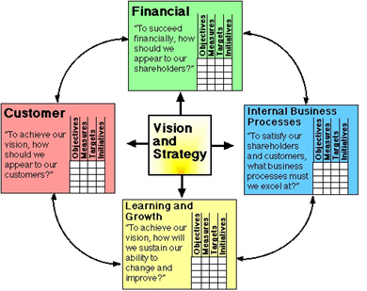

Let’s discuss the 4 different squares presented on the figure and their respective performance indicators, which present the outcomes of the vision and strategy that the firm should adopt by focusing on the interests of its stakeholders.
Financial
It shows if the company’s strategy, implementation and execution of businesses are contributing to bottom-line improvement. Its objective is to focus on profits per share. Shareholders want a return on their investment, and the firm should try to please this demand if it wants to continue operating on the stock market. Typical performance indicators are profit, growth and risk metrics.
Internal Business Processes

As is stated in the title, it is concerned with processes inside the company itself. Examples can address processes such as efficiency and quality delivery of products or services. All activities should be analyzed in order to get a full understanding of how these activities are performed on the most efficient way and if the activities add value. This check is required to identify the critical processes they must excel at in order to meet the objective of the stakeholders (Kaplan et. al, 1996). Widely used performance indicators for the internal business processes comprise number of defects, throughput time and on-time delivery.
Learning and Growth
This perspective is based on the fact that most organizations are ‘knowledge-worker’ organizations. Intangible assets play an important role. In today’s world, there are rapid technological changes which oblige companies to adapt on a fast pace in order to stay competitive. Therefore, its employees should be in a continuous learning mode. Kaplan and Norton state that learning is more than just training. It is also about the technological tools that can be used by the employees. There should be mentors and tutors available in the organization to improve the learning process. The ease of communication between workers is also of vital importance. Communication on the work floor improve the rate of problems that are resolved in co-operation, and because not everyone has the same know-how, the interaction improves the overall knowledge of the workforce. Performance indicators for this perspective include employee training efforts, information system implementations and equipment- and facility purchases.
Customer
Customers are at the basis of everything a firm does. Without customers there is no business. Customer focus and satisfaction are very important to stay competitive on the market. If a firm cannot satisfy the needs of the customers, they will find a competitor that does fit their requirements. Customers are concerned with four characteristics of a product: time, quality, performance and service (Zimmerman, 2011). Even though a company can be very profitable today, failing to fulfill customer satisfaction can have a negative bounce in relation to future periods.

The balanced scorecard is not completely new in the world of management accounting and control, but it is definitely innovative. Financial and non-financial information were already taken into consideration by firms by the use of different performance measures. However, the BSC introduces a new dimension, with the relation that the 4 perspectives have on one another. They are not to be considered separately, but in a chain of cause-and-effect relationships. By learning and growth, the skills of employees increases, meaning that internal business processes will improve in quality and cycle time, leading to a higher customer satisfaction and therefore more financial success and this will succeed in higher stakeholder satisfaction. This is displayed in the figure below (Kaplan et. al, 1996):

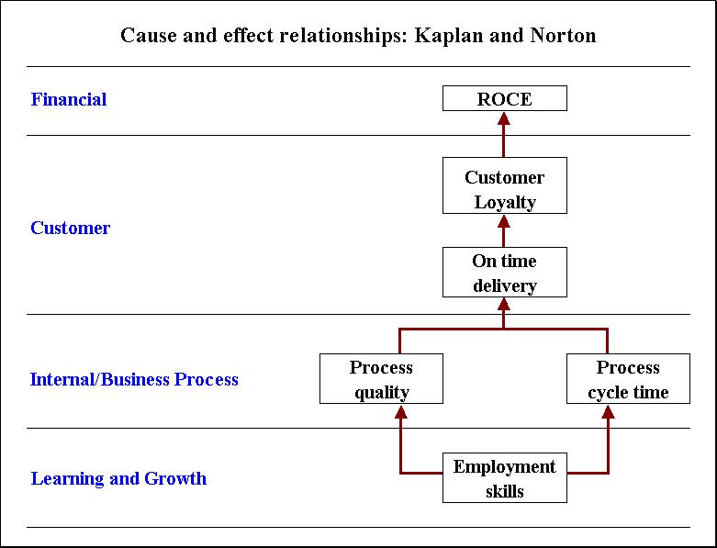

    - BSC in practice

The Balanced Scorecard can be applied within all firms. It fits the needs of product- or service oriented firms, financial or non-financial firms, listed and non-listed firms, and public or privately hold firms, because of the way companies can adapt the BSC to fit their needs. In 1997, Kurtzman found that 64% of the companies he researched were using a performance measurement that resembled the BSC (Kurtzman, 2007). It is often used in real-life for different purposes:
- Carrying out the business strategy
- Clarifying and operationalize the strategy
- Identifying and analyzing strategic opportunities
- Aligning the budget with the strategy
- Better integrate the company’s strategy
- Screen the company regularly and adapt the strategy where needed

    - How to implement BSC

In order to implement BSC several steps have to be taken. Arthur M. Schneiderman explains in “How to Build a Balanced Scorecard” how a BSC is implemented with the use of a Strategic Planning Process (Schneiderman, 2006).

Strategic Planning Process
The strategic planning process, is the process that selects the various opportunities within the operating market of the company, and which it is capable of performing, that present to the company in order to match these with the needs of the stakeholders. The corporate vision reflects the goals of the company. The level of success of this vision is measured by the value that the stakeholders receive, in the form of shares. The strategic planning process compromises the following 9 steps:
1. Choosing targeted stakeholder segments
Corporations have to choose a customer segment. They cannot be all to all customers and have to focus their resources on a more narrowed down segment to outperform other companies and gain market share. While choosing a customer segment, the growth rate and demand will be important. Satisfying its members better than the competition does will be dependent for success. To choose a market segment, you have got to understand the opportunity space (which potential market segments are present), the competitive environment, and the competencies of the firm itself.
2. Identifying their requirements
Different customer segments have different needs. Suppliers of products and services are evaluated on the basis of what they have to offer. Different requirements such as ‘price’ and ‘quality’ can be seen by a segment as most important and the company has to fulfill these in order to be successful. Selection criteria of the population of the chosen targeted stakeholder segment therefore should be known.
3. Determining performance gaps
As previously said, all customer segments have different requirements. Therefore, we need to get to know how the customer perceives our products or services. This helps to determine the performance gap. This can be done simply by asking the customer. Once the performance gap is known, to stay competitive and improve the company’s place in the market.
4. Setting stakeholder improvement priorities (external)
Improvements that do not correspond to the ones judged important by the chosen customer segment can be seen as a waste of time. Focus should be placed on where there are big gaps in customer requirement which they find very important.
5. Linking stakeholder requirements to internal processes
Linking stakeholder wants to internal processes is going from the external (step 4) to the internal processes. It links the stakeholder requirements to the internal processes. An organization can be viewed as a system of processes that work together in order to create stakeholder value.
6. Establishing process improvement priorities
In step 4, we had a look at which requirements most needed improvement. Step 5 was about linking those requirements of the targeted segment to internal processes. Step 6, is about putting priorities on internal process improvements with the information taken from step 4 and 5. The firm can now focus its resources on improving specific internal processes which will generate the highest strategic return. Employees will understand why they are performing their work routines and realize that their work is important for the success of the corporation.
7. Establishing metrics and goals for the process improvement priorities
At this point is about, what should be measured, how will success be defined, and, does the organization has the capacity to make it all happen? The company therefore has to choose metrics, set goals and make a cut-list of what is and what is not, at that particular moment, in the capacity of the company. In order to get a clear overview, all of the above mentioned information is put together in a clear and short overview, which we call the Balanced Scorecard. The Balanced Scorecard is the ‘guide’ of the organization towards its improvement priorities.
8. Improving critical processes
Individuals or groups of employees working at the company that do not have a defined role in these strategic improvements would still do good by spending some amount of time on improving their daily work routine. However, these employees have to understand and cope with the fact that scarce resources and management attention will be focused on those who work on improving the critical processes.
9. Re-assess strategy
Companies plan and act, but they are not very fond of checking the obtained results, and reflecting back to the original plan in order to take corrective action. All steps are presented schematically in the figure below.

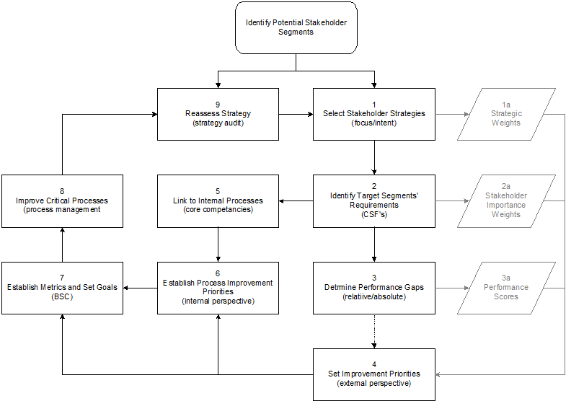

    - Advantages/Disadvantages BSC

The advantages of the Balanced Scorecard depend on what it is being used for, the way it is applied and the design that is chosen. Two manners of usage will be discussed. Firstly, the use of BSC as an operation control has several positive aspects. The management team’s awareness, understanding and alignment of the operations improves due to the meetings discussing the design process to be adopted. Furthermore, there will be an improvement in width and efficiency of monitoring the performance improvement initiatives. On top of that, there will be an improved understanding of the way the different measures are linked together which makes it easier to set targets. At last, a single management report describes the operational performance across perspectives, this makes it easier to oversee and makes all managers work with the same goal in mind.

Secondly, BSC can also be used as a strategic management tool. For this tool, the BSC has the following positive outcomes. First of all, management will have to reach an agreement upon the corporate vision and the strategy objectives to be focused on. Furthermore, there will be an increased visibility of how strategic objectives of the firm are linked to the implementation activities with the help of BSC. Last but not least, it will make employees and management throughout the whole organization be more aware and concerned with the strategic goals and expectations of the company.

There are also several disadvantages. One of them is the amount of money involved in implementing a Balanced Scorecard. There are very high costs implied at the beginning of the BSC implementation, these initial costs are added to the time and money spent on developing the employees (ex: training), and the costs of external consultants to help the firm’s implementation go with easiness. Shareholders, mostly want to have fast returns on investment, and therefore prefer to think on the short-term than the long-term while investing in a company. The BSC will cost a lot of money in the short-term, but will enable costs savings later on. This can be difficult for shareholders to accept due to the difference put on long- and short-term.

The Balanced Scorecard cannot by itself serve as complete corporate strategy. It should always be combined with the overall corporate strategy. It also does not create ideas to improve the performance of a company. The top-down overview that the BSC gives about the company it is applied at still requires the employees and management to come up with ideas on how to evaluate and create a strategy. The BSC in other words, is more like a factsheet then an actual strategy by itself.

Enterprise information systems are also needed in order to take full control of a BSC and take the best out of it. As markets change over time, business has to adapt and so has the BSC in order to fully correspond to the corporate vision. However, the choice of a wrong information system that updates the Balanced Scorecard to the new business environment can be fatal.

2.3 Alternative measurements

In this part, EVA will be compared to 3 other performance measurements of investment centers: Return on Investment (ROI), Discounted Cash Flows (DCF) and Residual Income (RI). The focus of these 3 measurements is on Value Based Management and, it helps organizations to measure and judge their performances. The specific choice of these 3 performance measurements has several reasons. First of all, EVA and ROI are most commonly used by businesses. Secondly, DCF is very close to EVA and is widely acknowledged as theoretically best analysis tools from the perspective of the shareholder. Thirdly, RI is the performance measure on which EVA is based and by which it has been succeeded. From each of the 3 performance measurements, first the definition will be given, advantages/disadvantages and the differences in relation to EVA will be discussed. Also a little will be said about if the particular method is really being applied in practice. Finally a few comments and an example will be added about the application in practice of each particular method.
2.3.1 Return on Investment (ROI)

Return on investment is the money won or lost in an investment related to the total amount of money invested and is mostly expressed as a percentage. The money won or lost is referred to as interest, profit(gain or income)/loss. The total amount of money invested is referred to as asset, capital, principal or the cost basis of the investment. There are 2 ways to calculate ROI, from which the first is:
ROI = (return on investment – initial investment)/total assets invested * (100), which in other words is: ROI = profit of investment/investment * (100).
The second way to calculate it is by using Du Pont`s formula as given by (Chandler, 1977):
ROI = (Sales/ Total Investment)(Earnings/Sales).
When the outcome of this equation is negative, then the investment has made a loss. The higher the percentage outcome, the higher the gain, and therefore the better the company was in using its invested capital.
There are several advantages of using ROI as a performance measurement:
- ROI is easy to use. Its simplicity is one of its main advantages. The calculation of ROI does not, for example, need multiple-year cash flow discounting maneuvers which would largely complicate calculations. The data needed are easy to be found and the outcome of the formula is straight forward and self-explaining.
- ROI is consistent with many management reward systems. ROI is often used as a performance measurement for management. It properly reflects the direct investment results of managers and is used to align business decisions with financial personal interests.
- Its uniformity is also a major advantage. ROI is a measure favored by investors when judging how effective management has been in utilizing company assets they have invested in. It can be compared with external market-based yields in order to give a benchmark for a division’s performance.

There are also several disadvantages of using ROI as a performance measurement:
- ROI creates an underinvestment problem out of an overinvestment problem. Managers will decline profitable projects with a rate of return lower than the ROI objective. For example, a company has an average 18% ROI, 12% cost of capital and a possible new project with a rate of return of 14%. The management will decline the project, even though it would improve firm value, because accepting it would lower the average ROI.
- If a management evaluation is based on ROI, management will have a strong incentive to boost short-term ROI. Projects boosting ROI in this short-term vision will be accepted even though they possibly could be unprofitable over the total life of the project. This can also be referred to as the ‘horizon problem’.
- ROI is not a proper measure for a division’s economic rate of return. The accounting net income excludes certain increases in value, such as the price of land. It tends to be conservative in that it recognizes most losses and defers most gains. Furthermore, total assets invested exclude some intangible assets. Patents and the brand-name capital of a firm are examples of these.
The main difference between EVA and ROI is that ROI is focused on maximizing the rate of return and does not necessarily maximize the return to shareholders by doing so. If a company wants to have an ROI of 10%, it will decline projects with a return less than that 10% even though the projects with a return of 8-9% will still be good and would increase shareholder value as well. These are now left aside. Furthermore, EVA is more practical and understandable than ROI. An additional 10 euros in costs will decrease EVA with 10 euros, so it can easily be reflected into daily activities, whereas ROI cannot and is more difficult to explain to employees. An increase in EVA always reflects into an increase in shareholder value, in contrast to ROI.
In practice, ROI is frequently used in all types of organizations in order to see if investments have good returns. This shows how well a division is handling its investments and how profitable it is. A lot of management evaluation plans are based upon this performance measurement and therefore most managers understand what this specific measurement reflects and consider it to be of meaningful importance.
An example would be to begin a new website for your company. The costs add up to $7,600 on a yearly basis ($100 for a domain name, web developer for $2,000, web writer at $3,500 and advertisement fees of $2,000 all on a yearly basis). All the sales related to the investment should also be added up, in this example say $15,000 in web sales. Subtract the total gain from the investment from the costs: $15,000 - $7,600 = $7,400. Divide the result by the total investment: $7,400/$7,600=0,97, or, 97% return on investment.

2.3.2 Discounted Cash Flows (DCF)
DCF is a valuation method using future cash flow projections estimating the attractiveness of an investment opportunity. These future cash flows are discounted to get their present value, which is used to consider the potential for investment. The formula used for its calculation is the following:

DCF = CF1/(1+r)^1 + CF2/(1+r)^2+…+CFn/(1+r)^n.
In this formula CF = Cash Flow and r = discount rate (usually Weighted Average Cost of Capital; WACC). If the outcome of the equation is higher than the current cost of the investment, than the opportunity might be a good one.
The use of the DCF method is based on 2 advantages (Urff, 2000):
- Research has proven that DCF calculations are the only indicator that consequently shows a high correlation with share values.
- Theoretically, the DCF method is superior in comparison to the other methods.
The use of the DCF method also has several disadvantages:
- The terminal value (TV: Value at the end of the Free Cash Flow projection period) is often a huge percentage of the total valuation of the DCF. Therefore, DCF in such cases, is very dependent on TV assumptions instead of operating business or asset assumptions.
- There is a high dependency on the quality of the assumptions regarding FCF, TV and the discount rate. This influences the accuracy of the valuation of the DCF method. It is therefore common to produce different case scenarios. A base case, an optimistic case, and a pessimistic case are examples of these. They make it possible to treat the sensitivity of the valuation in relation to various operating assumptions. Due to the multitude of different sources where the inputs come from, they need to be viewed objectively in the aggregate in order to finalize the DCF valuation.
The difference between EVA and DCF is in the technical aspect. The information that is required to calculate both is almost the same: expected cash flows over time and costs of capital over time. NPV analysis is the business analysts’ preferred method in order to estimate value. Also for decisions on the long run, the NPV analysis is preferred.
Discounted cash flow analysis is widely used in investment finance, real estate development, and corporate financial management.
Imagine for example that Frank buys a house for $800,000 to renovate it and he thinks he can sell it again for $1,000,000 after 1 year. This means that the return will be 200,000/800,000 = 25%. We now have to discount this value to reflect how cash could have been used during the same period. Let’s assume that the amount of $1,000,000 could also have been invested in Treasury Notes with an annual return rate of 6%. This represents $60,000 on interests made. So to get the present value of the investment: $1,000,000-$60,000= $940,000. $940,000-$800,000 = $140,000 which is the true value of the project. This represents a return of 17,5% (140,000/800,000 = 17,5) on the initial investment.

    - Residual Income

RI is the amount of profit that remains after subtracting an imputed interest charge. It has 2 definitions: 1) Net Income that an investment can earn over the minimum rate of return and 2) Royalty Income that accrues to the owner of an intellectual property, such as art, books, lyrics, music, patents etc. It is used to overcome some of the incentive deficiencies of ROI, such as underinvestment. The formula used to calculate it is the following:
RI = Operating Income – (Minimum rate of return * Average operating assets)
The result is expressed in dollar amounts. The minimum rate of return is set by the company. RI is often used as an important component of securing a loan. If a company has sufficient residual income after paying off its other loans each month, the loaning institution is more likely to grant an additional loan, because having an adequate amount of RI ensures that the borrower has sufficient funds to make the loan payment each month.
There are several advantages of using RI as a performance measurement:
- It facilitates goal congruence (responsibility accounting)
- It encourages managers to accept any project that earns about the minimum rate
- The minimum rate of return can be adapted to match the level of risk of a certain division
There are also several disadvantages of using RI as a performance measurement:
- In order to implement RI, senior management has to estimate the cost of capital for each division.
- RI is an absolute measure of profitability (meaning that direct comparison is difficult when level of investments differ). Larger divisions will have a larger RI.
- RI is measured over the period of 1 year. The daily impact of activities on firm value is not taken into account.
The difference between EVA and RI is relatively small. EVA uses the market value of total equity and interest-bearing debt, whereas RI uses the market value or book value of assets for the capital invested in the division or firm.
RI is widely used in corporate practice to measure and reward the performance of management boards. These Residual Income-based compensation plans still influence the behavior of management today. Universal Corporation, one of the world´s leading tobacco merchants, uses residual income to evaluate and reward internal performances (as stated in their Proxy Statement (2007)³). The cash related rewards in 2007 to its executive officers, were based for 50% on Earnings per Share and for 50% on economic profit.
An example would be a company that has net operating income of $15,000, operating assets amounting to $100,000 and a minimum return on assets of 15%. Filling this information in on the equation gives us: RI = 15,000 – (12% * 100,000) = 15,000 – 12,000 = $3,000.

  - How does Ryanair use EVA

In this section, Ryanair will be discussed and its use of Economic Value Added. First, there will be a short introduction on Ryanair, followed by the adoption of management accounting and control in the aviation industry. Finally, the focus of Ryanair on value-adding activities will be discussed.

    - Short introduction on Ryanair

Ryanair⁴ was founded in 1985 by the Ryan family in Ireland. The first scheduled flight was between south-eastern Ireland and London Gatwick. First crew members were required to be less than 5 foot 2 inches tall to be able to fit in the tiny cabin of the first aircraft which had only 15 seats. Soon after its launch, Ryanair receives the permission to challenge Airways and Aer Lingus on the Dublin – London route. The number of passengers grew considerably during the first 2 years of operation ,from 5.000 to 82.000. Even though the company continued to increase the number of routes, destinations and number of passengers, by 1990 the company had accumulated over 20 million in losses. Copying the South West Airlines model, Ryanair was re-launched in 1995 as Europe’s first low fare airline. To celebrate this re-lauch and to attract the attention of the people, Ryanair had some promotion going on for seat tickets of only £1. This new business model was new in the European aviation industry at the time. The new model had big impacts on the business model. Ryanair had made some drastic changes under which using the same airplanes in the entire aircraft fleet, introducing direct sales, scrapping of drinks and food served on board and cutting turnaround times and costs. In 1997, the company gets listed on the Irish Stock Exchange. Ryanair has grown since its establishment in 1985 from a small airline flying the short distance between south-earstern Ireland and London Gatwick with 1 airplane into one of Europe's largest carriers. Revenues have risen from €231 million in 1998, to €3013 million in 2010. Net profits have increased from €48 million to €339 million over the same period. Ryanair is planning on having transatlantic flights in 2014 and 72 million passengers have flown with Ryanair in 2010, a 10% increase compared to 2009 where this number was equal to 65 million.

    - The aviation industry and the use of management accounting

Management accounting in the aviation industry is a very specialized sector. There is not a lot of literature written about the use of management accounting in the aviation industry even though there are specific studies that can be done at HEC Genève⁵ “Airline Finance and Accounting Management’. The lack of literature shows the difficulty of management accounting in this sector and at the same time emphasizes the fact that there is still a lot to be done by airlines to simplify the internal accounting systems. Due to government taxes, and other external factors however, the aviation industry can be largely affected from outside its business environment. Liberalization in the aviation industry has, in combination with external factors on the market (oil prices, crises), brought increasing structural changes to the markets in previous years. The low fare airlines are examples of the recent changes which present the challenges of today’s changing market situation.

Airlines have an increasing need for management accounting now that the market has had a shock from recent crises and the introduction of low fare airlines such as Ryanair. This has led to bankruptcies such as Swissair, and Sabena. This showed the importance of internal accounting processes and the need for a good structured management accounting system. The need for constant cost control is very important in budgets, forecasts, business and flight schedule scenarios and the management and financial accounts. Not to forget the actual results. However, there is a clear separation of companies that can be made in the industry. The price fighters, how the low fare airlines are also referred as are focusing on fast financial results. The other airlines consider more than only fast results and have a tendency of looking more into the future. This future-oriented look explains the focus on customer services.

    - Focus on value-adding activities

Ryanair is a company that focuses on value-adding activities. The company in continuously seeking for ways to obtain high earnings in the short-term. Ryanair is very strict in its cost-cutting policy. All services that are asked will cost money. There is very few customer service available for free and this is to be able to realize a high profit margin. Ryanair has a plan of buying airplanes in which people will stand rather than sit during their travel. They would charge less per ticket for people with a standing place. This idea is estimated to cut costs by 20 percent and 50 percent more passengers could fit in an airplane. Furthermore, they have had ideas in the past to charge passengers for using the on-board toilets, and having a tax for overweight passengers.

In figure 1, Ryanair is the only airline out of the four that are presented that has a positive EVA (of 53,30), the other three airlines have negative EVAs. Furthermore, Ryanair does not attribute any dividends to its shareholders. Their no-dividend policy implies that the company prefers to keep the money for themselves. This money is invested in the company. These findings accentuate the short-term vision and the good financial position that Ryanair has accomplished during the years.

In figure 2, the remunerations of the Chief Executive Officers is shown. Michael Ol’Leary is the current CEO of Ryanair. The basis salaries of the CEOs on this figure are all slightly more than 500.000 euros. The point of interest here, however, is the value of the stock options that he receives. Totaling 502.000 euros in stock options, this amount is only 3.000 euros under his regular salary, and just above 40% of his total compensation. To achieve higher personal earnings, he would therefore be better off when the stock price of Ryanair goes up. This implies having a short-term corporate view, and wanting to make money fast to boost personal earnings. Activities that add value in the short-term are therefore very interesting to take into consideration. The long-term, on the other hand, becomes less important in the mind of the CEO.

Figure 1
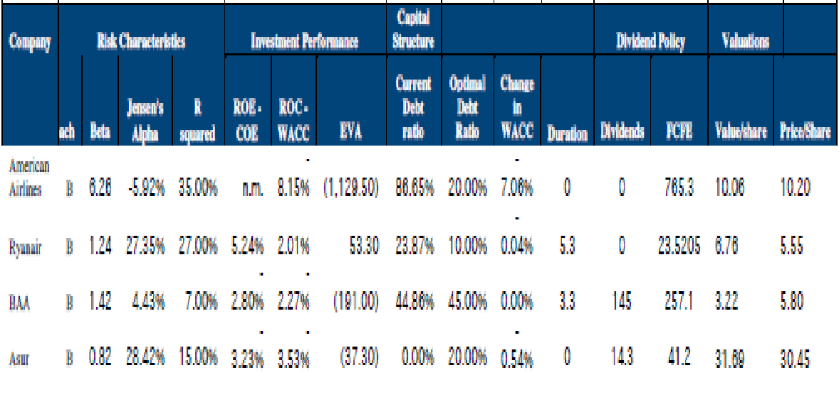

Figure 2
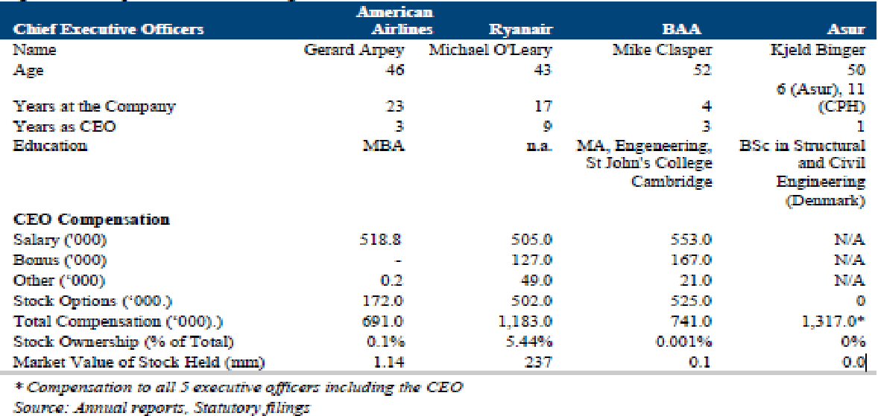

  - How does KLM use BSC

In this section, KLM will be discussed and its use of the Balanced Scorecard. First, there will be a short introduction on KLM, followed by the integration of the organization of BSC. Finally, an insight will be given in how KLM handled with the BSC during the crisis that struck the aviation industry after the attacks on September 11, 2001.

    - Short introduction on KLM
Royal Dutch Airlines NV (KLM)⁶ is the national airline of the Netherlands and is part of Air France - KLM. Its home base is Amsterdam Airport Schiphol, one of the main ports of the modern world, and its headquarter is at Amstelveen. KLM operates worldwide scheduled passenger and cargo services to more than 72 intercontinental destinations and 79 destinations in Europe. It is the oldest airline in the world still operating under its original name. On 31 March 2010, it had 31.787 employees.

KLM was founded in 1919, and made its first flight in 1920 from Amsterdam to London. In that first year, where flying was still something special, KLM carried 345 passengers and 25.000 kgs. of mail and cargo. KLM grew rapidly and spread its wings. In 1924 the first plane left for Jakarta in Indonesia. The flight to Jakarta in 1924 took some weeks, whereas the same flight nowadays only takes about 15 hours. In 1946, KLM started as first European carrier to make flights to New York across the Atlantic.

In May 2004, KLM and Air France joined their forces. The merger company was from that moment on called Air France – KLM, but both Air Franc and KLM continue to fly under their distinct brand names. The headquarters is at Paris’ airport Charles de Gaulle. Air France – KLM is part of the SkyTeam alliance with: Aeroflot, Aeroméxico, Air Europa, Alitalia, China Eastern Airlines, China Southern Airlines, Czech Airlines, Delta Airlines, Kenya Airways, Korean Air, TAROM and Vietnam Airlines.
In the financial year 2009-2010, 20,7 million passengers flew with KLM Group and 473.000 tons of cargo were carried. The income equaled 7,4 billion euros, and KLM has made a loss of 383 million euros. They use 205 airplanes with an average age of 11 years.

    - Integration of BSC

The planning and control processes of KLM are characterized by an annual budget setting for the entire organization in general and monthly review meetings between on one hand management and the divisions, and on the other hand the business units. In addition, there are quarterly called ‘Tactical Planning Meetings’ between management and core businesses (Passage, Freight and Technical Services). During these meetings there is considerable attention paid to the Balanced Scorecard, rolling forecasts and to budget discipline.

The Balanced Scorecard is a subject of very high importance within the meetings. We will go a bit deeper into that. KLM uses the Balanced Scorecard at all levels in the organization. The BSC has a monthly frequency and all scorecards in the organization have a fixed structure and presentation. At the beginning of every period, there will be determined whether any additional indicators will temporarily be included. The BSC’s goal is to provide both management and accounting information, especially focusing on performance information of a manager’s own division. The BSC used by KLM, as is often the case at a typical service oriented firm, includes a high number of non-financial performance indicators, such as punctuality, baggage performance and customer satisfaction. Key performance indicators are displayed graphically as well as numerically, with short explanations. In the analysis of these indicators, both comparisons to prior year’s budget and results, and, comparisons to the latest forecast are made. In reality, the construction of an accurate BSC report, even with numerous helpful reporting tools, stays elaborate. The information that can be taken from a BSC has a rather long expiration date, therefore the report can also be used as a “reference”, since the focus is on the long-term.

In the beginning, a BSC for the totality of KLM was only used at the level of the board of directors. This has been abolished, because it appeared that on the level of the board of directors, only the financial aspect of the BSC out of the 4 perspectives (Financial, Internal Business Processes, Learning and Growth, and, Customer) made sense while combining. The other 3 perspectives; Customer, Internal Business Processes and Learning and Growth, were too much division- and business unit related. They were not significant for KLM as a whole, but are still being used on the division- and business units.

    - Management accounting during crisis

To cope with the crisis, the governance structure had to change. The operational, tactical and management processes, became one specific process; managing the crisis. The task of the board of directors focused more to a direct, top-down approach of managing, since the existence of the organization was in danger. During this shift to a temporary, more command and control style of management, the CEO took place as chairman during daily crisis meetings. This has a large impact on the performance management process. Instead of the monthly or weekly need for information, there now was a daily need for new information. The monthly and weekly reports were not able to satisfy these new needs. Within one day, the division Corporate Control started to collect and bundle relevant information on a daily basis. This new type of information was distributed in the form of a “Daily Flash”. These “Daily Flashes” included (De Jong et. al, 2002):
- Insight in the level of occupation of the airplanes
- Insight in the reservation profile per booking class (business, tourist)
- Quality and risk of specific debtors (some travel agencies came into trouble)
- Cash balances and Cash flow forecasts
- Actions of competitors
- External parameters, such as the changes in fuel prices

The BSC report was deemed less suitable due to the needed information during the crisis. During a crisis meeting, they wanted to get an image of the market development (pace of recovery etc.) and have an insight in the fluctuations of the cash flows. The daily financial information was getting increasingly important and the competitors had to also be monitored more closely. The information required during the crisis therefore had other characteristics than those of regular management information (De Jong et. al, 2002):
- High frequency and short time for the production of information
- Free format in which the speed and relevance of issues was clearly more important than the form
- Short expiration date
- Increased focus on market environment (market, competitors, regulatory)
- Decreased focus on internal performance indicators
- Information is purely future-oriented
- Answers to ‘what if’ questions
- Ad hoc inclusion of new issues

The information needed during the crisis has differing demands on the organization in comparison to a regular planning and control process. In an unsure, unpredictable situation, the need for information becomes more ad hoc. The BSC however, did not disappear completely, it served a different purpose. The Balanced Scorecard kept its value by putting trends and forecasts in their perspective. It was more needed as an overall view on the whole situation as opposed to the daily information needs which were very particular and specialized. The importance of ‘staying in budget’ was fulfilled on a different way due to the tough and unpredictable market situation. The fact that the most important financial and non-financial performance indicators are well reflected by the BSC in relation towards each other is of great value for a good understanding, even in times of crisis.

At KLM the crisis led to a permanent, more practical attitude towards changes in the management performance system. Another new insight is that increasing the reporting rate does not explicitly have to mean that the reports therefore have a reduced quality. About half a year after September 11, 2001, the market situation was normalized in such a way that the ‘crisis information’ could be abandoned and KLM took back their regular management information system. New insights of the crisis have been incorporated in the BSC and in external reporting. Working capital, EBITDAR (Earnings Before Interest Tax, Depreciation, Amortization and Rentals) and more extensive benchmarking studies are now important elements. In the crisis time there was a return to short-term management accounting, because the focus was on surviving rather than on a long-term strategy. Other priorities were taken, but due to the retake of the BSC at KLM, it is shown how important they perceive its added value to fulfilling the corporate strategy.

  - Comparison of discussed performance measurements

EVA, ROI, RI and DCF are all used as performance evaluation measurements. They have all stood the battle of time, because they are still being used today, and therefore business thinks that they are helpful for organizations to measure and judge their performances. They do not differ in a large way from each other, but their outcomes are slightly different in meaning. There is no such as ‘best performance measurement’. All performance measurements are used in practice and mixtures of several performance measurements are also possible. Management performance largely depends on the objectives and market, in which the organization is applying them, is present. It also depends on the specific attributes of common-law (companies are very active on stock markets) and code-law countries (companies rather seek finances by banks, other financial institutions and the government) which seek different types of financial information and performance measures. These 4 performance measurements are all purely financial indicators which develop a system of financial goals.
More important, however, for this thesis, is how EVA and BSC are used in comparison towards each other. The major differences between the two methods are that where EVA’s goal is to add value to the company, BSC’s goal can be anything the company wants to achieve. BSC is way more flexible and adapts to changing circumstances, whereas EVA is fixed. EVA is only a financial indicator. In the Balanced Scorecard, the financial indicator is one out of four used perspectives (others being: Internal Business Processes, Learning and Growth, and, Customer).
These two management measurements are not mutually exclusive, meaning that they can be used together as well as separately. EVA can be used as motivation system for the management or as part of the financial indicators in the BSC. BSC is used as management tool for strategic planning processes and links the company’s processes to the needs of the customers. EVA can be a part of this as financial aspect, as the Balanced Scorecard uses financial and non-financial indicators.

- Conclusion
The theory has been discussed, and Ryanair and KLM have been analyzed, so let us get back to the problem definition: What is the difference between EVA and BSC, and how does this reflect at Ryanair and KLM?
Economic Value Added is the difference between the return on a company’s capital and the cost of that capital. If this difference is positive, shareholder value has been created, and if the outcome is negative, than value has been destroyed. When the bonuses of managers are linked to EVA, management behavioral can be quite sensitive to EVA. EVA is a purely financial performance measure.
The Balanced Scorecard is a performance metric which does not only consider financial, but also non-financial indicators. It has 4 perspectives, namely: Financial, Internal Business Processes, Leaning and Growth, and Customer. According to Arthur M. Schneiderman, there are 9 steps to be taken in order to properly implement a BSC. When using the BSC, the customer segment takes a central role in the company’s strategy.
Return on Investment, Residual Income, and Discounted Cash Flows are alternative measurements which have been discussed. They are widely used by companies as performance metrics and could be used as financial perspective in the BSC.
EVA can be used throughout the whole company. Ryanair always takes into account the added-value of activities before realizing them. Their focus is on growth in the short-term. They apply a non-dividend policy to retain more earnings and invest these in the company to secure a steady growth.
KLM is our example company that uses BSC as management accounting tool. The company’s focus is more on the long-term. Therefore, it also considers non-financial management tools. During the crisis, right after September 11, 2001, KLM had to put its regular management strategy aside due to the shock of the crisis that stroke the aviation industry. The focus shifted to the short-term survivability of the firm. After the crisis, the BSC was re-considered most important tool in the management performance system.
While comparing the performance measurements, there was a clear separation with on one hand EVA, ROI, RI and DCF as being financial indicators. On the other hand, BSC is more a dashboard with more than 1 indicator compromising the whole company on a one-page design. The financial indicators put weight on the financial results of the company. The BSC also focuses on profits, but finds it important as well to base a company’s strategy on the customer’s need.
I think that the main difference between EVA and BSC is to be found in the time-period the firms are focusing their strategies on. While using EVA, the focus is put on the short-term. This is also reflected by the example of Ryanair. Ryanair uses EVA to make money on the short-term with the help of some aggressive pricing strategies. KLM focuses on the long-term with the use of BSC. BSC enables KLM to not only orient its corporate strategy to making money, but also to think about customer satisfaction, corporate image and rising customer needs. During the crisis, KLM had to pay attention to its financial position of that specific moment. It was a question of surviving or going bankrupt. Therefore, they had to orient their corporate strategy to the very short-term and the BSC was considered less important. However, when the market situation started to recover, KLM changed back to the Balanced Scorecard and its long-term vision.

- Reference list

Abdel-khalik, A. R. (1993), Why do private companies demand an audit? A case for organizational loss of control. Journal of Accounting, Auditing and Finance (Winter) 8: 31-52.

Biddle G., Bowen, R. and Wallace, J. (1999), Evidence on EVA, Journal of Applied Corporate Finance, Vol. 12.2

Bouwens, J.F.M.G., & Lent, L.A.G.M. van (2000), De Valse Profeet: EVAngelie volgens Stern Steward & Co. (FEW Research Memorandum, 787) pp. 1-17.

Chandler, A., The Visible Hand: The Managerial Revolution in American Business (Cambridge, MA: Harvard University Press, 1977), pp. 445-49.

Claes, paul C.M. (2003), Economic Value Added (EVA): theorie en praktijk, handboek management accounting D1803-1 – D1803-23

De Jong, A.R, De Waal, A.A. (2002), Prestatiemanagement in crisistij: De balanced scorecard bij KLM na 11 september 2001, Bedrijfskunde, jaargang 74, 2002, no.4

Ittner, C.D, Larcker, D.F. and Rajan, M.V, (1997), The Choice of Performance Measures in annual bonus Contracts, The Accounting Review, April, 231-255

Jager, E., Koster, J., (2005), De value based scorecard: Integratie van BSC en VBM , Finance & Control: Management accounting en management control, Februari, 2005

Kaplan R. S. en Norton D. P., (1992), The Balanced Scorecard: Measures that drive performance,
Harvard Business Review, Vol. 70, nr. 1, januari- februari 1992, p 71-79.

Kaplan R. S. en Norton D. P., (1993), Putting the Balanced Scorecard to Work, Harvard Business
Review, september-oktober 1993, p 134-147.

Kaplan R. S. en Norton D. P., (1996) , Translating Strategy into Action: The Balanced Scorecard,
Harvard Business School Press, Boston, 322 p.

Koller, T. (1994) What is value-based management?, The McKinsey Quarterly, Nr. 3, P.87-101.

Kurtzman J., (1997), Is your company off course? Now you can find out why, Fortune, februari 17, p
128– 130.

Leahy, T. (2000) Making Their Mark, Business Finance, P. 49

Schneiderman, A.M, (2006) How to build a balanced scorecard, Part 1: The Strategic Planning Process

Stewart, G.B., (1991) The Quest for Value, New York, Harper Business

Trozzi, A., Serna, B., Platero, D.C, Petrov,D., (2003), Final project: The Air transportation industry, New York University, May 2, 2005.

Urff, E. (2000), Value Based Management: concept en toepassingen. Kluwer, Deventer.

Urff, E. (2001), Value based management: opkomst, relevantie en context, management control & accounting, nummer 2, 2001

Zimmerman, J.L. (2011), Accounting for Decision Making and Control (McGraw-Hill International Edition, seventh edition).

Internet Resources:
¹ Balanced Scorecard use and satisfaction:
http://www.bain.com/publications/articles/management-tools-2011-balanced-scorecard.aspx

² Top 10 management tools:
http://www.bain.com/management_tools/BainTopTenTools/default.asp

³ Universal Corporation 2006 Proxy Statement, June 28, 2007,
http://sec.gov/Archives/edgar/data/102037/000119312507144467/ddef14a.htm.

⁴ History Ryanair:
www.ryanair.com

⁵ HEC Genève:
http://www.aviation.unige.ch/modules/aviation/program/modules/module_5.html

⁶ History KLM:
www.klm.com

