In Which Ways Can the Channeling between Business Angels and Entrepreneurs Be Improved?

Monica Brandon

This thesis is submitted in partial requirement for the degree of Bachelor of Science in International Economics and Business Economics.

Erasmus School of Economics
Erasmus University Rotterdam
2011

Summary

Business Angels are the most important investment source in starting up new enterprises. They invest in small high risk businesses, with the purpose of creating high profits. Unlike institutional venture capital investors, they provide not only the money to start up a new company, but also their time and knowledge gained from previous, usually successful, experiences.

Although business angels, in the form that we acknowledge them currently, have existed for many decades, research in this area is limited. The knowledge gained is somewhat insufficient as it is hard to find correct data, because business angels prefer to be anonymous. Thus most research is only about a small part of the informal venture capital investors.

This lack of knowledge also contributes to the problem that makes the informal investment market inefficient. The link between these informal investors and the potential new entrepreneurs has been inefficient. Most entrepreneurs do not know where to look for business angels and business angels have trouble finding the right entrepreneur to invest in.

Governments have made some policy changes to increase informal venture investment. By creating Business Angel Networks, investors and entrepreneurs can come together and share their ideas. With fiscal incentives, it becomes easier and cheaper for the investors to invest and therefore more accessible.

However, what is essential in policymaking is the result of these policies. As the effects cannot really be measured at the moment, as most information is hidden, it is important that government and scientists focus on more research on the subject. These studies will not only show the result, but will make it easier to make the market more efficient. And as the state plays a large role in the stimulation of angel investment, it is important for governments to aid with stimulating angels to join BANs to be able to contribute to research.

Keywords: Business Angels, Informal Venture Capital Investment, Venture Capitalists, Business Angel Networks, Government Policies
Table of content

Introduction 5
What Are Business Angels? 7
Why Should Angel Investment Be Encouraged? 11
How Is Angel Investment Encouraged? 13
Improving Communication between the Business Angels and the Entrepreneurs 13
The Role of the Government 14
Government networks versus private networks 15
Other Government Policies Used to Stimulate Informal Investment 19
Tax Incentives as Government Policies 20
Financial securities Legislation 23
Investment Readiness Schemes 23
Discussion 25
Conclusion 27
References 29

Introduction

Business angels, sometimes also referred to as informal venture capital investors, are in many countries the largest investment source for new entrepreneurs, after relatives. Because of its informal form, however, it is hard to give any exact numbers on how many there are and how much they actually invest. Data shows that in the United States, between 2001 and 2003, the approximate number of business angels lies between 140,000 and 266,000 and the amount invested is estimated between $12.7 billion and $36 billion (Wong, Bhatia, & Freeman, 2009).

Owing to its informal form and the fact that angel financing is a relatively new subject, the definition of a Business Angel is quite unclear. Many people have not heard of these types of investors or they confuse them with, as we can say, the formal form of venture capital investment. However, even though there is more money put into angel investment, there is more research about venture capitalists than about business angels. This is due to the fact that most business angels prefer to be anonymous. Yet, business angels have the leading role in investment of start-up companies. In the USA, only 2% of the investment in new small to medium enterprises comes from formal venture capitalists (Sandler, 2004). In the first paragraph I will explain the definition of a Business Angels and I will try to demonstrate the differences between the two different venture capital investors.

Despite its informal form and difficulty to monitor, as most angel investors prefer to remain anonymous (Mason & Harrison, 1997b), there has been some research on the role it plays in the economy. In the second paragraph I will discuss this role and include the value added to the economy and in this way show why it is important to encourage and expand Angel financing.

As I said before, the knowledge of Business Angels is limited and therefore not a lot of people tend to know about the possibilities. For a while now governments and private parties have thought of ways to improve channeling between entrepreneurs and Business Angels. Governments have implemented different policies to encourage angel financing. However, because of lack of data, the results are not concrete. In the last paragraph we will see how this is done and point out it what ways channeling can be improved.

This paper will show how crucial business angels are for new enterprises. Why it important that it should be encouraged and how attempt has been made to encourage angel investment. Then we will discuss the methods more thoroughly and look at the possibilities for the future.

- What Are Business Angels?

The definition of the term “business angels” is relatively vague. There are a lot of grey areas when it comes to defining it. Business angels, angel investors, or informal venture capitalists are, to simplify, wealthy investors that invest in new enterprises (Wong, Bhatia, & Freeman, 2009), preferably in innovative technological firms. Figure 1 gives an example of the industries invested in by a Business Angel Network in the U.S.A, called the Orange County Tech Coast Angels, this is the largest angel investment group in the country and as can be withdrawn from its name and seen in the figure, they are mostly focused on technological firms.

Figure 1
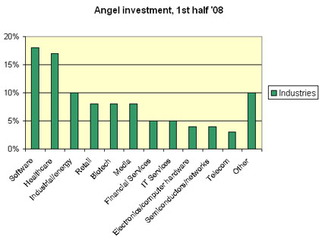
Source: http://jan.ocregister.com/tag/tech-coast-angels/

The confusion with formal venture capitalists is understandable. Because of its informal nature a not a lot is known about business angels, and therefore it is hard to define it exactly. However, scientists have established a few crucial differences.

First, business angels invest their own money into the venture, while on the other hand, a venture capitalist uses money that was pooled by investors and then chooses the investment for them (Avdeitchikova, Landström, & Manson, 2008).

Angel investors are typically middle aged, or more specifically between 35 and 65 years of age. They usually are not a lot older than that, since they want to see how the investment ends up (Arnoudt, 1999). As they like to be involved in the business, they usually choose to invest more local to their own environment (Freear, Sohl, & Wetzel Jr., 1994).

Another key feature of business angels is that they usually have had a successful business before and then commonly invest their money in their own field, as this is where they have the most experience. As their experience is what makes them so valuable, they like to be involved in the process of the business, and in this way use their experience to the benefit of the entrepreneur and the investor (Avdeitchikova, Landström, & Manson, 2008).

Business angels tend to invest in high-risk, and high-return enterprises (Freear, Sohl, & Wetzel Jr., 1994), in fact, usually the entrepreneurial ideas that they do invest in are most of the time too volatile for a bank loan. In general, formal or institutional venture capital investors invest much higher amounts then business angels. Angels, on average, spend less than 25% of their total assets on investments (Arnoudt, 1999). Which makes angel financing more attainable for the smaller enterprises, and they then also commonly prefer to invest in start-up businesses (Freear, Sohl, & Wetzel Jr., 1994).

Figure 2, below, shows the type of investors and at which stage of development of a business they most likely would invest. As displayed in the figure, business angels seek to invest in the start-up of a company, and venture capitalists tend to invest in a later stage, the early growth of a company. This makes the business angel more vulnerable to risks, as can also be seen in the figure. This is the main difference between venture capitalists and business angels. For this reason, business angels are a very important source of investment to the start-up enterprises.

Figure 2
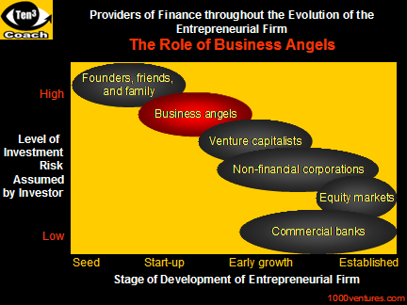
Source: http://www.1000ventures.com/venture_financing/business_angels.html

Institutional venture capitalist investors monitor the risks that are attached to the product and the economic market at that time, while business angels tend to focus on the risks that are attached to the entrepreneur (Arnoudt, 1999). They want an entrepreneur that fits with the profile they require and with whom there is the suitable chemistry. Another reason is that institutional venture capitalists are mostly interested in the rate of return. Informal investors are also interested in the finances, which is on average around 20% and lower than the average rate of return for institutional investors, but they are eager to be involved, share their knowledge, be a mentor, thus simply starting a new project (Arnoudt, 1999). Therefore, the connection with the entrepreneurs is a key aspect in searching for the right investment.

Many successful large companies these days started off with a relatively small investment. Larry Page en Sergey Brin received a check for $100,000 from angel investor Andy Bechtolsheim as an investment in Google Inc. (Wong, Bhatia, & Freeman, 2009).. In March 2010 Bechtolsheim’s share in Google was worth $ 1.7 billion.

Amazon.com was founded by Jeff Bozas. He approached many different informal investors and in the end got the investment he needed from twenty different business angels, who invested $ 50,000 each.

Ian McGlinn decided to invest £ 4000 in his friend’s business in 1976; this business was The Body Shop. When L’Oréal took over the business in 2006, his shares were worth £ 137 million.

These are a few of the major success stories that business angels had. Not only can it be very profitable for the angel investor, the investees are also getting a lot out of the experience and knowledge that the investors have and it gives them a good first step towards their goals.

More about why informal venture capital investment should be stimulated will be discussed in the next chapter.

- Why Should Angel Investment Be Encouraged?

Although it is clear that angel investment has a very important role in market entry of small and fast growing companies. The research towards the economic effects is limited, as it is relatively new to the academic field and due to its informal nature it is more difficult to find exact data on the angel finance market.

What we do know is that a large, if not the largest, amount of investment in new enterprises comes from this particular group (Wong, Bhatia, & Freeman, 2009). The actual economic effects are in a way significant, however, the most important merit of angel investors is the value it adds to the enterprise. As said before they most commonly prefer a more “hands-on” method when investing in a business and their experience is valuable to this business. They usually work close with the management of the venture and share their knowledge in different ways.

Business angels add value beyond the initial investment. One of the most common ways of facilitating the enterprise is giving strategic advice to management (Politis, 2008). This is to safeguard their investments, by having some control over the business structure and processes. Advice on strategic development includes facilitating with marketing strategies, sharing knowledge about financial and market development and sharing management experience.

Other ways they add value to the enterprises are:
- Networking: the connections the angel has obtained in previous years can be important as a source for customers, suppliers, raising funds (Politis, 2008) etc.
- Mentoring role: this includes creating a close connection to the management of the company, educating them and keeping them motivated (Politis, 2008).

A publication by the Ministry of Economic Development in New Zealand reports with data from the OECD that strong economic positioned countries do not tend to rely that much on informal investment (see figure 3). However, the graph in figure 3 represents the percentage of informal investment compared to the GDP as it is. Nevertheless, it is important that it should be kept into consideration that informal investment is usually distributed in to smaller amounts than other investments and that these results do not mean that it is less important than other investments. A large part of new enterprises can be started with these relatively small amounts and thus be very significant in other ways than when just looking at it as investment as a part of the GDP, and this is why it might be more important to look at the results as in the amount of new fast-growing ventures starting with the help of informal investors and as done above, looking at the value the angel investors add to the these businesses.

Figure 3
Informal venture capital investment as a percentage of GDP
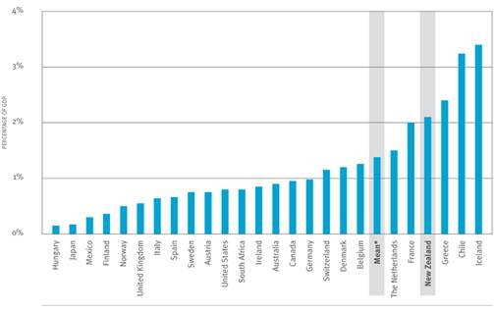
Source Global Entrepreneurship Monitor 2005 Executive Report (http://www.med.govt.nz/templates/MultipageDocumentPage____32728.aspx)

- How Is Angel Investment Encouraged?

Entrepreneurs often tend to turn to business angels as a last resort. When banks, other financial institutions and institutional venture capitalists have turned him down, the entrepreneur resorts to informal investment. A large part of the cause of this is due to the high stakes that the angels demand as condition for their aid. Clearly, entrepreneurs like to retain that for themselves (Arnoudt, 1999).

However, the value that an angel could add to the business should not be underestimated. Especially since most new technological ideas are designed or created by people with no to little experience in business and with no knowledge of markets. As most business angels choose to invest in those entrepreneurs, they are to be considered very valuable for these enterprises.

The unfortunate fact is that not a lot of new entrepreneurs know about these angel investors or know how to contact them. As the informal investment market is quite hidden, there is lack of channeling between the two parties (Sørheim, 2003), and therefore it is inefficient as the investment capital is not distributed to its full potential (Mason & Harrison, 1997a).

3.1 Improving Communication between the Business Angels and the Entrepreneurs
There have been some measures taken to improve the communication between the entrepreneurs and the business angels. Business Angel Networks (BANs) are founded by governmental or private groups to improve the “matching” process (Arnoudt, 1999).
Business Angel Networks are there to eliminate the gap between the entrepreneurs and informal investors (Mason & Harrison, 1997a). It is a usually non-profit organization, set up by the government, to get entrepreneurs in contact with informal investors. These networks often work with providing meetings between the entrepreneurs and the angels. The investors can advise on how to turn the entrepreneur’s ideas into a financial plan and to present their ideas. The entrepreneur gets a chance to present these ideas and talk with the investors. This way the business angels and the entrepreneur can decide if the other is what they were looking for aimed at their specific project (Arnoudt, 1999). The relationship between the two parties is quite important as they have to work relatively close together and share the same goals and purposes.

Another advantage of the BANs are that now these hidden informal investment activities are more visible and that thus means that it will become more conceivable to obtain correct data on this subject in the future (Mason & Harrison, 1997a). However, still a lot of these deals between informal investors and entrepreneurs are done without the help of these networks and therefore at the moment still no highly valid assumptions can be made from the current data (Mason & Harrison, 1997a). Nevertheless, it is a beginning.

3.2 The Role of the Government
The inefficiency that arises from the gap in communication between the business angels and entrepreneurs has forced the governments of developed countries to take action and include strategies of improving this situation in their policy making. Business Angel Networks are a result of these policies. Another method that governments use are tax incentives to encourage private investors to invest in unquoted businesses and aid private investment organization that aim at new businesses (Mason & Harrison, 1997a).

The policies have had a positive effect. The number of BANs has grown in the last two decades. Figure 4 displays data that was published by the OECD and contains the amount of BANs that were active in Europe and the USA in 2007. As can be seen is that France has quite an extensive volume of Angel Networks, 66 to be precise, and the UK, which has approximately the same size population as France only has 19.

But to what level do these numbers really demonstrate on in which country the policies are most effective? The UK and the Netherlands, which actually has 9 BANs in the graph and is quite a lot considering its small population, have been reported to be most far along in the process of channeling between angel investors and entrepreneurs (Arnoudt, 1999). The UK seems to have the most research done on the subject, it was also one of the first countries to start with Angel Networks in Europe and discussion in the country already arises to eliminate the government as a factor in facilitating networks as a whole and let the networks completely rely on private organization, which in economics is usually seen as more progressive than depending on a government (Mason & Harrison, 1997a).

Figure 4
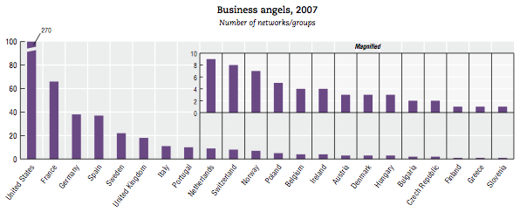
Source: http://hbe.fi/gasellit/looking-for-an-angel-investor-in-europe/

In the end, however, it is still difficult to estimate if these policies are efficient enough to make all available private capital accessible to the entrepreneurs, as it hard to measure the informal investments that are not part of the networks and even harder to measure the capital ready to be invested, but without a project to be directed to.

3.3 Government Networks versus Private Networks
In Belgium, at the start, the government created the BANs as an initiative to improve the process, and predicted that at a later stage, the networks would be able to manage on their own without government funds and sustain on membership fees (Collewaert, Manigart, & Arnoudt, 2010). However, this has not been the case.

The only thing that is not exactly clear is why this is has not worked out exactly as they planned. Is it that the state has thought the operational costs would be lower? In Belgium the subsidy between 1999 and 2004 for one deal of an informal investment project was
€ 14,800 euro and in the UK it was even € 18,900 (Collewaert, Manigart, & Arnoudt, 2010), which seems quite a lot of money. Half of the costs are operational costs.
Another reason could be that the government had forecasted the BANs to be more efficient and would have aided to the closing of more deals. In Belgium on average between 1999 and 2004, 4.5 deals were closed per year per BAN, in the Netherlands it was 4.7, in Spain it was 6 and in the UK it was 5 (Collewaert, Manigart, & Arnoudt, 2010).

The problem with the high costs could be caused by the inefficient allocation of costs. The government might not have to spend that much money on these networks. Business Angels have money and they have the knowledge. It can be that in these networks too much money is spend on training while it is more important that the investees have proper knowledge about choosing the right project and presenting it in an attractive way (Arnoudt, 1999). Although this is already one of the purposes of BANs, Arnoudt (1999) believes this has not been done most efficiently and policy of the government should be focused on this, keeping the investors and investees in touch and giving the angel investors more freedom in the process. It is important that these informal investors can exchange experience as well and thus make BANs more adapted to each region.

As pointed out before, the economic effects are hard to measure and for that no real conclusion of the efficiency increase can be made. The discussion in countries in Europe is now whether to continue funding BANs in the long term or to stop it completely. Studies in the UK have debated if the Angel Networks that have been privately set up are adequate enough to sustain and eventually grow into the same or better results. One of the arguments for the privatization of these bodies is that it gives the market more freedom. However, again, because of lack of studies, it is yet to come to any firm conclusion.

Public BANs are non-profit and only assist in the introduction or “matchmaking” of entrepreneurs to the individual private investors by publications or investment clubs. No involvement in the later process of investment is allowed by financial restrictions (Mason & Harrison, 1997a).

In the UK, there were 13 commercial informal investment networks in 1997 (Mason & Harrison, 1997a) and now most likely more.

In 1993-1995, in the UK a 51% increase occurred in the number of investments and a 32% increase in the amount invested by Angel investors that are registered in BANs. Research of Mason and Harrison (1997a) shows that in the last decade some changes in the structure of BANs have taken place.

Some BANs have changed their local or regional focus to a more national focus. In their research they study whether or not the purposes and type of investors are different in these cases. Another change that has occurred is the upcoming of private informal investor clubs (Mason & Harrison, 1997a).

In the first chapter it was pointed out that the definition of a Business Angel was relatively imprecise and this is why. The definition is commonly known as an informal investor who preferably invests in a local area and favors a more “hands-on” method of investing. However, seen from the way these new developments have been moving, this seems to be less the case. These informal investors seemed to be willing to invest further from home and thus are not as involved in the venture they invest in.

Mason and Harrison (1997a) distinguish three types of commercial investment groups. These are displayed in figure 5. The first in the list, the conventional introductory services, which resemble the before discussed public BANs, can be split up into two different groups, one that publishes investment opportunities in bulletins, such as the “Venture Capital Report”, the other keeps data bases for business angels about investment opportunities and for entrepreneurs about business angels (Mason & Harrison, 1997a).

The second is the offshoot of corporate finance activities of financial service companies. They mostly get their profits as a percentage of the business’s success. This is why they usually look and the venture itself instead of focusing on the investor, and as a consequence, the minimum investment is set higher than in public BANs (Mason & Harrison, 1997a).
The third type of commercial network assists executive and non-executive directors with experience to companies with strategic management gaps. These directors usually wish to invest in the projects they are working on (Mason & Harrison, 1997a).

Figure 5

Commercial Investment Networks
Data from (Mason & Harrison, Business Angel Networks and the Development of the Informal Venture Capital Market in the U.K.: Is There Still a Role for The Public Sector?, 1997a)

In their research Mason and Harrison (1997a) used data obtained from Business Angels Networks between 1993 and 1995. They found that most new investment projects were still done by public and other non-profit investment networks. Most of these investments were done on a local or regional scale like was preferred before as well. The difference between the public or non-profit investment networks and the commercial investment networks is that the groups are targeted to different projects. The first business angels usually invest lower amounts than the latter that have joined the commercial networks. Commonly informal investors invested less than £ 50,000 and a maximum of a £ 100,000 (Sandler, 2004), but the commercial investment networks mostly target projects that are between £ 100,000 and £ 500,000, which is usually the minimum amount of investment for institutional venture capital investments. This is generally done with co-investors or multiple business angels (Mason & Harrison, 1997a).

And thus concluding from the above and answering the initial question whether public BANs are becoming unnecessary and should make way for private investment groups, it is safe to say that neither network form is pointless, but indeed they are complementary as they serve different areas of the field.

3.4 Other Government Policies Used to Stimulate Informal Investment

In the USA, in 2002, 41% of the 500 fastest growing companies were founded with less than $ 10,000 and 14% with $ 1000 or less and only 2% was funded by institutional venture capital (Sandler, 2004). Therefore, it is clearly important that these small amounts of investment are available for those entrepreneurs. Hence, it is important that policies are focused on encouraging informal investment.

Starting new ventures is important to create more jobs (Brettel, 2003). Small and medium enterprises are the businesses that provide the most jobs. This is why the government tends to concentrate their policies on these SMEs. However, the issue lies with the type of SMEs. Not all SMEs are fast growing; most of them do not create that many job opportunities and provide bad working conditions and little benefits (Sandler, 2004). Only the fast growing SMEs, which cover only 4 to 8 percent (Sandler, 2004) of all SMEs, are worth paying attention to. They provide 70 to 75 percent of the SMEs’ new jobs.

Thus when it comes to policy making, the government should keep into consideration that these SMEs are not all the same and neither are their informal capital investors. It is crucial that the state reflects on the differences in the factors that affect investors’ decisions on when, how, why and how much to invest (Sandler, 2004).

3.4.1 Fiscal Incentives as Government Policies

One of the policies the government uses to increase angel investing are tax incentives. Research has shown that tax incentives do not encourage non-investors to invest, but it can increase the invested amount by a business angel (Sandler, 2004). Consequently, policies that contain tax incentives should be focused on already known Angel investors.

In the USA, even though the informal venture capital market is more developed than in Europe, the tax or other fiscal policies are less developed. In Europe most countries have lower interest rates to encourage investment; in Ireland, this is only 12.5% (EBAN, BDO, 2009). In Eastern Europe the interest rates are very low. However, these fiscal incentives are not particularly focused on business angels, but on general investment. In Figure 6 can be seen that there are actually only 8 countries in Europe that offer fiscal incentives for business angels (EBAN, BDO, 2009).

Figure 6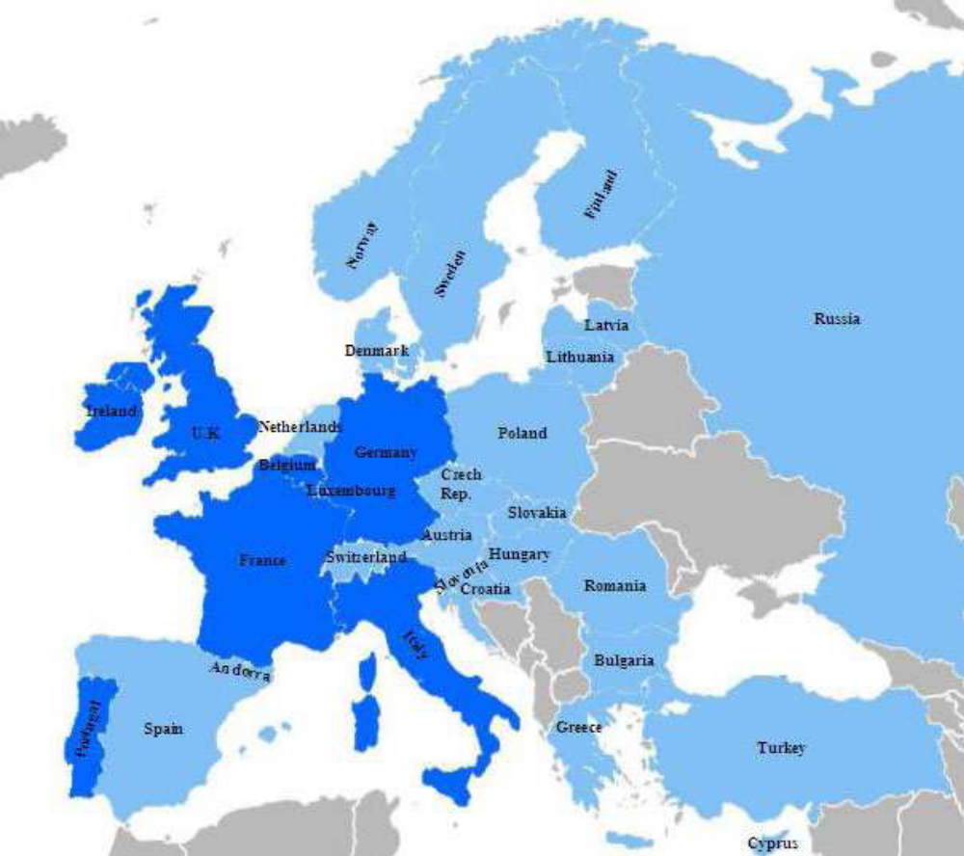
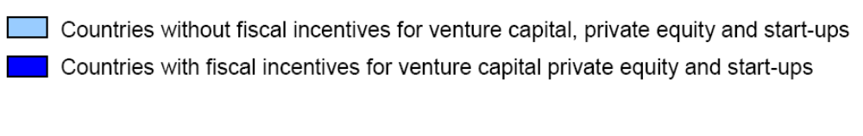
Source: Compendium of Fiscal Incentives Available to Business Angels in Europe, 2009, EBAN

In the US, there are two types of tax policies that focus on informal venture investment, which are a Federal Tax Policy and State Tax Policy.

Business angel investments are affected, not only in the US but in general, by the Federal tax policy in the following ways:
- General capital gains tax,
- Preference tax rate for small businesses,
- Tax deferral for sales from small business that are reinvested in small businesses,
- Preferential treatment for losses from small businesses (Sandler, 2004).

The US government has concentrated primarily on the preferential tax for small business in which the tax incentive focuses on investment in SME’s. However, this has resulted into little effect to the business angel market. This tax rate adjustment mostly only affects the investments in projects which already develop in large secondary markets (Sandler, 2004). If they want to encourage informal venture investment, the government will have to incorporate factors that are important for this particular group instead of generalizing for all investment areas.

The State tax policy has had a more positive effect. Several states have implemented income tax credits for start-up capital investments for new ventures. With this the government absorbs some of the risk from the investment project (Sandler, 2004). With less risk for the investors, it becomes more viable to invest.

Although the state governments did take measures in making a distinction between appropriate SMEs for fiscal incentives, by creating a “white list” which divides the potentially fast growing ones from the others, they have not taken the differences of the investors into the policy. Not all angel investors are the right investors and not all of them will help the business to a brighter future (Lerner, 1998). Sandler (2004) suggest that, since the government is not equipped to actually make the distinction between the wrong or right type of investor, it should enable intermediaries, like investment funds or BANs for that matter, to assist them in these kinds of matters.

This also might help with the information gap that has been created between Angel investors and entrepreneurs and also in research. If business angels have to be pre-approved before they can enjoy fiscal advantages, they have no choice but to register. Unless this has the adverse effect and forces investors not to invest as they value being anonymous more.

In Europe, a number of tax schemes to stimulate informal venture investment have been implemented; for example, the Enterprise Investment Scheme (EIS) in the UK and Société Unipersonnelle d’Investissements à Risque (SUIR) in France (Mason, 2009). In Europe, the same problem comes to light. Although the EIS reports that tax incentives increased investment about 50%, the issue is still that the wrong, indolent type of informal investors might be attracted.

3.4.2 Financial securities Legislation

In a lot of countries legislation prevents the promotion of investments or participation in any investment undertakings unless it has been approved by the government. However, in this case for many entrepreneurs the costs are too high and that again creates inefficiencies in the market. In some governments, like the UK, however, they now officially exempted BANs from this law (Mason, 2009). This is also another way to encourage business angels to join BANs.

3.4.3 Investment Readiness Schemes

One of the major problems, as discussed before in this chapter, is that business angels are not presented to the entrepreneurs that have the right presentation or the right subject to present as an investment project. They are not “investment ready” (Mason & Harrison, 2001). For this, the government has created investment readiness schemes. This helps improve the investment opportunities for business angels and aids in linking them with the suitable investment ideas (Mason, 2009).

The problem is that these schemes are quite costly. It requires workshops and individual support to show the entrepreneurs what investors look for in an investment project (Mason & Kwok, 2010) However, since they are necessary, some have thought of including the business angels themselves in helping the project get investment ready. This again though, costs the investor a lot of time, which might be off-putting for them.

In general, a lot of measures and changes in policy making have been taken to encourage the informal venture capital investment market. And even though there can be a lot improved in many ways, there is one thing we can be sure of: Government intervention in this case is absolutely necessary.

- Discussion

The lack of research on the subject has prevented scientist from making any firm conclusions on the effects that business angels had. However, the fact that angel investment is crucial for the new venture market is clear. Not only do business angels invest capital, they also put their time, knowledge and effort into the investment project. Hence, it is probably the most important source of investment for start-up businesses. This we can conclude from the literature.

However, the informal nature of this type of investment has hindered scientist from getting more information and data. Not only does this obstruct the channeling between entrepreneurs and angel investors, but it also makes it difficult to measure the effects of policies to improve the investment processes. Therefore it is absolutely crucial that more research is done on the subject and maybe it would be a good idea to focus policies on this as well. For example by stimulating business angels to join Angel Networks which will improve the number of valid data.

Another problem with policies is that it is made by people that have little knowledge about the market of angel investment. This can give problems in resource and cost allocation. This might be more efficiently arranged when asking the expert advice of for example business angels that have the networks. This counts for tax incentives as well as the structure of Business Angel Networks. They could help direct policies to keep out the investors that are undesired and stimulate the right type of investment to present itself accordingly.

The absence of enough data is thus the most important issue and is the largest cause of inefficiency in the informal venture capital market. Most research in Europe seems to be from the UK and the Netherlands and Belgium. From other countries there seems to be less available even though countries like France, Spain and Germany seem to have quite a large market. Research is these countries though have been more focused on general investment in SME’s. The reason is that it has been said that business angels play a larger role in the investment in SME’s in the UK (Archibugi, Howells, & Michie, 1999). Or another reason that was mentioned was that the same analysis and research of the USA and UK can be used (Stedler & Peters, 2003). However, when they acknowledge in most cases that the lack of research withholds knowledge from scientists than this might be even be more the case in these countries where there is even less research, and therefore no real conclusions should be given. Besides, even when there is more informal investment activities in countries like the UK, this might be because there is not enough encouragement and not necessarily because of the insufficient size of the market. Which means, again, more research is necessary.

To conclude, in any developed county which the resources and basic laws, like copy right laws, research should be necessary, since there are always new entrepreneurs looking for a way to find funding for their ideas. And with more information and data, knowledge on the subject will grow, and knowledge spillover between countries can always increase the pace of the research processes.

- Conclusion

Business angels are the main provider of new venture investment. They diminish the equity gap that exists for small enterprises that need financing under the minimum amount that is required for institutional venture investment. They usually seek out the potentially fast growing business ideas, which can show high returns. The primary merit of a business angel is the hands-on method they use. It is not just about capital investment, they prefer to be involved, guide management and share knowledge and experience. This way it makes them a very important player in the market for start-up enterprises.

The issue is that market development has been inefficient for several reasons. The main reason is that the channeling between entrepreneurs and angel investors is distorted by lack of information and training. The government has taken several measures to aid in this situation. These exist out of methods to improve the channeling by establishing Business Angels Networks. These provide opportunities for the business angels and the entrepreneurs to meet and share ideas. Although it has had a positive effect, it has some defects in the process. The costs have said to higher than necessary. If the government wants to improve this, it will have to change the structure of the BANs, which is most efficiently possible when it seeks aid from the business angels.

Fiscal incentives have also been effective in a different way. Although it has not attracted more informal investors in general, it did increase the amount invested and the individual business angel’s portfolio of investment.

The problem is that no one can know exactly how much of a difference these policies have made. The deficiency in research has made it impossible to know. One can only make rough estimations. Thus, it is crucial that studies on the subject increase.

The government plays a large role in encouraging angel investment. However, when there is not enough research one cannot see the actual effects of the policies. Policies should then also be focused on the stimulation of business angels joining the BANs. This way, it easier to monitor their investment behavior, obtain data, and gather information. Hence, more study material will be available.

There is a lot that can be improved and economist and governments seem to be aware of this. It is important to see that the government and its policies play very crucial roles in the informal venture capital investment market. And research is the main aspect to focus on as that can prove and improve all of this.

References

Archibugi, D., Howells, J., & Michie, J. (1999). Innovation in an Global Policy. Cambridge: The Press Syndicate of the University of Cambridge.
Arnoudt, R. (1999). Business Angels: should they fly their own wings? Venture Capital Vol. 1 No. 2, 187-195.
Avdeitchikova, S., Landström, H., & Manson, N. (2008, July). What do we mean when we talk about business angels? Some reflections on definitons and sampling. Venture Capital Vol. 10 No. 4, 371-394.
Brettel, M. (2003). Business Angels in Germany: A Research Note. Venture Capital, Vol. 5, No. 3, 251-268.
Collewaert, V., Manigart, S., & Arnoudt, R. (2010). Assessment of Government Funding of Business Angel Networks in Flanders. Regional Studies Vol. 44.1, 119-130.
EBAN, BDO. (2009). Compendium of Fiscal Incentives Available to Business Angels in Europe. European Trade Association for Business Angels.
Freear, J., Sohl, J. E., & Wetzel Jr., W. E. (1994). Angels and Non-Angels: Are there differences. Journal of Business venturing 9, 109-123.
Lerner, J. (1998). "Angel" Financing and Public Policy: An overview. Journal of Banking & Finance, 22, 773-783.
Mason, C. M. (2009). PUBLIC POLICY SUPPORT FOR THE INFORMAL VENTURE CAPITAL MARKET IN EUROPE: A CRITICAL REVIEW. International Small Business Journal, Vol 27.
Mason, C. M., & Harrison, R. T. (1997a). Business Angel Networks and the Development of the Informal Venture Capital Market in the U.K.: Is There Still a Role for The Public Sector? Small Business Economics, 111-123.
Mason, C. M., & Harrison, R. T. (1997b). Business Angels in the UK: A Response to Stevenson and Coveney. isb.sagepub.com/content/15/2/83.
Mason, C. M., & Harrison, R. T. (2001). 'Investment Readiness': A Critique of Government Proposals to Increase the Demand for Venture Capital. Regional Studies, 663-668.
Mason, C., & Kwok, J. (2010). Investment Readiness Programmes and Access to Finance: A Critical Review of Design Issues. Local Economy, Vol. 25, No. 4, 269-292.
Politis, D. (2008). Business angels and value added: what do we know and where do we go? Venture Capital Vol.10 No. 2, 127-147.
Sandler, D. (2004). Tax Incentives and Informal Venture Capital. University of Western Ontario , Faculty at Law. Onatario, USA: http://www.angelscorner.com/articles/tax_incentives_and_informal_vc.htm.
Sørheim, R. (2003). The Pre-Investment Behaviour of Business Angels: A Social Capital Approach. Venture Capital, Vol. 5, No. 4, 337-364.
Stedler, H. R., & Peters, H. H. (2003). Business Angels in Germany: An Empirical Study. Venture Capital, Vol. 5, No.3, 269-276.
Wong, A., Bhatia, M., & Freeman, Z. (2009). Angel finance: the other veture capital. Wiley Interscience (www.interscience.wiley.com), 221-230.

